Senator Mazie Hirono

Grants Assistance Information Newsletter

JUNE 2017

G.A.I.N. INDEX

Click on Index Links below to read summaries of the announcements by agency in this document. Once you reach the item, if you cannot open the links for further information, copy the selected URL website address into your browser.

Modified sections from previous listings are shown in a GREY background

Notices is Teal are items with immediate deadline dates.

Notices in Yellow are of special interest.

Notices is Green are items of special interest with immediate deadline dates.

Items in this type color are aimed at Small Businesses

Items in this type color have a Faith-Based Organization component

Special Federal Program Notices

SAM and Grants.Gov Information

SBIR – Small Business Innovation Research

Programs specific to Hawaii

Current Notices

Office of Elementary and Secondary Education (OESE): Native Hawaiian Education Program CFDA Number 84.362A

Reminders

See Individual Departments for information and webpages representing the best and most accessible information on the agency funding opportunities

Federal Grant and Cooperative Agreement Program Summaries

U.S. Department of Agriculture

Grants and Loans Overview

Programs

Utilities Programs
Distance Learning & Telemedicine Grant

Utilities Programs
Rural Community Development Initiative (RCDI)

Utilities Programs
Rural Housing Preservation Grant

Research

National Institute of Food and Agriculture
Agriculture and Food Research Initiative - Food, Agriculture, Natural Resources and Human Sciences Education and Literacy Initiative

Modifications

Utilities Programs
Community Facilities Technical Assistance and Training Grant

Risk Management Education
Risk Management Education Partnership Program

Risk Management Education
Crop Insurance Education in Targeted States

Deleted

Reminders

National Institute of Food and Agriculture
Agriculture and Food Research Initiative - Food, Agriculture, Natural Resources and Human Sciences Education and Literacy Initiative

National Institute of Food and Agriculture
Agriculture and Food Research Initiative - Childhood Obesity Prevention Challenge Area

Food and Nutrition Service
USDA FNS FY17 SNAP PTI
Synopsis 2

Fish and Wildlife Service
2017 National Fish Habitat Action Plan

Department of Commerce

Programs

FY 2017 Regional Innovation Strategies Program

Modifications

Climate Program Office 2018

Research

National Institute of Standards and Technology
Measurement Science and Engineering (MSE) Research Grant Programs

Reminders

National Institute of Standards and Technology
Embedding MEP in Manufacturing USA Institutes Pilot Projects – Round 3

National Institute of Standards and Technology
Measurement Science and Engineering (MSE) Research Grant Programs

National Sea Grant College Program 2016-17 Special Projects Grant

FY 2016 – FY 2019 EDA Planning Program and Local Technical Assistance Program Grant

FY 2016 Economic Development Assistance Programs ­ Application submission and program requirements for EDA’s Public Works and Economic Adjustment Assistance Programs

Economic Development Administration
Planning Program and Local Technical Assistance Program Grant

Deleted

Corporation for National and Community Service

General Program Overview

Programs

National Service and Civic Engagement Research Competition

Reminders

National Service in Hawaii

Department of Defense

Doing Business with the Department of Defense

DoD Small Business Opportunities and Forecasting

Research Grants

Modifications

Reminders

Department of Defense
Dept of the Army -- Materiel Command
Fiscal Year 2018 Defense University Research Instrumentation Program (DURIP) - ARMY SUBMISSION

Air Force Office of Scientific Research
Fiscal Year 2018 Defense University Research Instrumentation Program (DURIP)

Department of Education

Grant Programs Overview

Programs

Office of Elementary and Secondary Education (OESE): Jacob K. Javits Gifted and Talented Students Education Program CFDA Number 84.206A

Office of Postsecondary Education (OPE): Child Care Access Means Parents in School (CCAMPIS) Program CFDA Number 84.335A

Office of Postsecondary Education (OPE): Veterans Upward bound Program CFDA Number 84.047V

Research

Office of Innovation and Improvement (OII) Supporting Effective Educator Development Program CFDA Number 84.423A

Institute of Education Sciences (IES): Low-Cost, Short-Duration Evaluation of Education Interventions CFDA Number 84.305L-1

Institute of Education Sciences (IES): Low-Cost, Short-Duration Evaluation of Special Education Interventions CFDA Number 84.324L-2

Institute of Education Sciences (IES): Low-Cost, Short-Duration Evaluation of Education Interventions CFDA Number 84.305L-2

Institute of Education Sciences (IES): Special Education Research CFDA Number 84.324A

Institute of Education Sciences (IES): Research Training Programs in Special Education CFDA Number 84.324B

Institute of Education Sciences (IES): Low-Cost, Short-Duration Evaluation of Special Education Interventions CFDA Number 84.324L-1

Institute of Education Sciences (IES): Research Networks Focused on Critical Problems of Policy and Practice in Special Education CFDA Number 84.324N

Institutes of Education Sciences (IES): Education Research and Development Centers CFDA Number 84.305C

Institute of Education Sciences (IES): Partnerships and Collaborations Focused on Problems of Practice or Policy CFDA Number 84.305H

Institute of Education Sciences (IES): Education Research CFDA Number 84.305A

Modifications

Reminders

Office of Elementary and Secondary Education (OESE): Small, Rural School Achievement (SRSA) Program CFDA Number 84.358A

Deleted

US Department of Energy

Grants Overview

Research

Modifications

Reminders

PAMS
Department of Energy - Office of Science
Office of Science
FY 2017 Continuation of Solicitation for the Office of Science Financial Assistance Program
Synopsis 2

Environmental Protection Agency

Grants and Contracts Overview

Programs

Clean Diesel Funding Assistance Program FY 2017
Synopsis 2

Modifications

Research

Reminders

Clean Diesel Funding Assistance Program FY 2017

Department of Health and Human Services

Grants Overview

Program

Research Grants

Modifications

Deleted

Reminders

Administration for Children and Families - OCS
Community Economic Development Projects
Forecast 6

Administration for Children & Families - ACYF/FYSB
Transitional Living Program and Maternity Group Homes
Forecast 1

Department of Homeland Security
Grants Overview

Programs

FEMA
Fiscal Year (FY) 2017 Cooperating Technical Partners (CTP) Program - HQ

Modifications

Reminders

Office of Procurement Operations - Grants Division
DHS S&T Center of Excellence for Cross-Border Threat Screening and Supply Chain Defense - Partner
Synopsis 2

Department of Housing and Urban Development

HUD - Notice of Funds Available

Programs

Modifications

Deleted

Reminders

Resident Opportunity & Self-Sufficiency Program

Institute of Museum and Library Services

Grants Overview

IMLS is on Facebook!

Programs

Modifications

Reminders

Deleted

Department of Interior

Grants and Contract Overview

Programs

Modifications

Reminders

National Fish Passage Program

Fish and Wildlife Service
Fiscal Year 2017 Recovery Implementation Grants

Fish and Wildlife Service
Partners for Fish and Wildlife

Fish and Wildlife Service
Coastal Program

Geological Survey
Cooperative Research Units Program FY 2017
Synopsis 2

Deleted

Department of Justice

Grants and Contract Overview

Programs

Bureau of Justice Assistance
BJA FY 17 Second Chance Act Reentry and Mentoring Program

Office for Victims of Crime
OVC FY 17 Field-Generated Innovations in Addressing Elder Abuse and Financial Exploitation

Research

Modifications

Office for Victims of Crime
OVC FY 17 Vision 21: Advancing the Use of Technology to Assist Victims of Crime

Office for Victims of Crime
OVC FY 17 Action Partnerships for National Membership, Professional Affiliation, and Community Service Organizations: Post-Conviction Services to Victims of Crime

Office of Juvenile Justice Delinquency Prevention
OJJDP FY 2017 Second Chance Act: Implementing County and Statewide Plans To Improve Outcomes for Youth in the Juvenile Justice System

Office of Juvenile Justice Delinquency Prevention
OJJDP FY 2017 Smart on Juvenile Justice: Systemwide Reform and Reinvestment Initiative
Synopsis 4

Office of Juvenile Justice Delinquency Prevention
OJJDP FY 17 Mentoring for Child Victims of Commercial Sexual Exploitation and Domestic Sex Trafficking Program and Training and Technical Assistance
Synopsis 3 and 4

Deleted

Reminders

________________________________________________________________________

Department of Labor

Grants and Contract General Overview

Programs

Modifications

Reminders

National Aeronautics and Space Administration

Research Grant and Contract General Overview

Programs

Modifications

_______________________________________________________________
National Archives and Records Administration

Grant Opportunities General Overview

Reminders

Publishing Historical Records in Documentary Editions

EDITIONS-201710 for Publishing Historical Records in Documentary Editions

Access to Historical Records - Major Initiatives

_______________________________________________________________
National Endowment for the Arts

Grant Opportunities General Overview

Programs

NEA Our Town Application, FY2018

NEA Arts Research Labs PS Application, FY2018

Modifications

Reminders

_______________________________________________________________

National Endowment for the Humanities

Grant Opportunities General Overview

Programs

Humanities Collections and Reference Resources

Summer Stipends

Reminders

Digital Projects for the Public

Research and Development

Digital Humanities Advancement Grants

_______________________________________________________________
National Science Foundation

Grant Opportunities General Overview

Research and Program Grants

Modifications

Reminders

Deleted

Nuclear Regulatory Commission

Reminders

Small Business Administration

General Overview Finding Loans & Grants

Programs

OSBDC

Program Announcement

Modifications

Prime 2017
Synopsis 3, 6 & 7

Reminders

Deleted

Upcoming Trainings

Links Specific to Hawaii

State Department

General Overview and Resources for Program Administrators

Programs

Modifications

Reminders

U.S. Department of Transportation

General Grant Program Overview

Programs

Research

Modifications:

Reminders

Federal Transport Administration
DOT Federal Highway Administration
Advanced Transportation and Congestion Management Technologies Deployment Initiative

DOT/Federal Transit Administration
FY 2017 Competitive Funding Opportunity: Low or No Emission Grant

DOT/Federal Motor Carrier Safety Administration
2017 Commercial Motor Vehicle Operator Safety Training Grant Program

DOT Federal Aviation Administration
DOT - FAA Aviation Research Grants
FAA Aviation Research and Development Grants
Modifications 3 & 4

Deleted

Department of the Treasury

Programs

Modifications

Low Income Taxpayer Clinic
Synopsis 2

Reminders

US Agency for International Development

General Funding Opportunity Overview

Programs
Modifications

Deleted

Department of Veterans Affairs

Special Federal Program Notices
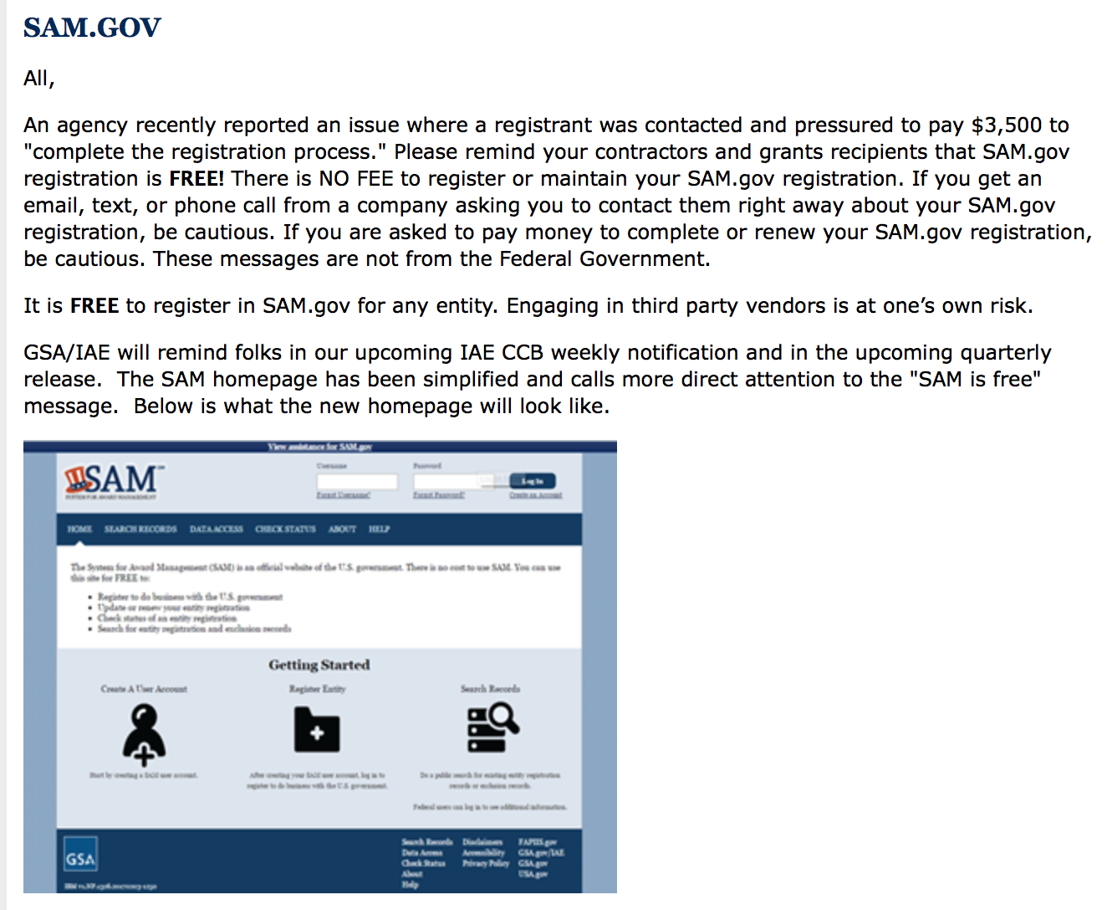

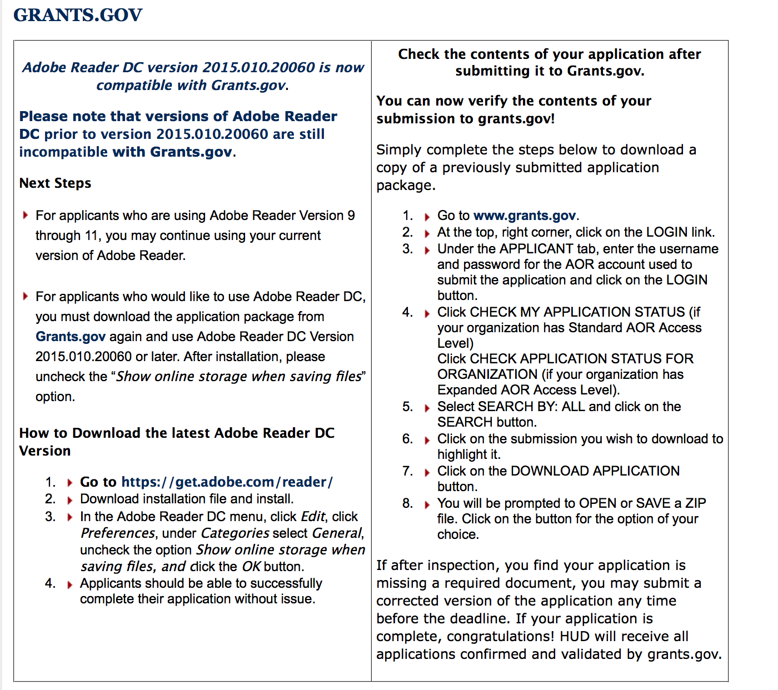

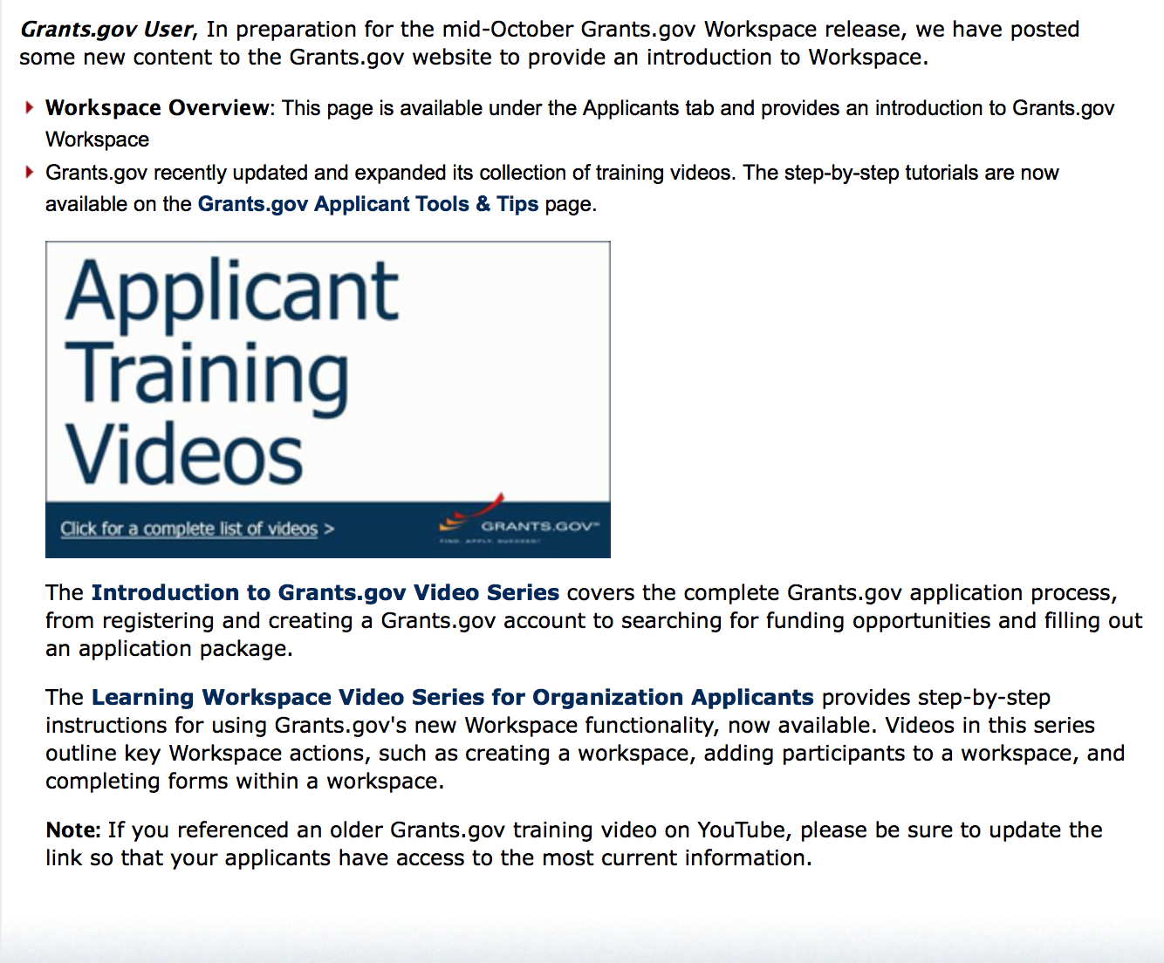
https://portal.hud.gov/hudportal/HUD?src=/program_offices/administration/grants/fundsavail

The Small Business Innovative Research Program - SBIR Program

The Small Business Innovation Research (SBIR) program is a highly competitive program that encourages domestic small businesses to engage in Federal Research/Research and Development (R/R&D) that has the potential for commercialization. Through a competitive awards-based program, SBIR enables small businesses to explore their technological potential and provides the incentive to profit from its commercialization. By including qualified small businesses in the nation's R&D arena, high-tech innovation is stimulated and the United States gains entrepreneurial spirit as it meets its specific research and development needs.

SBIR Mission and Program Goals
The mission of the SBIR program is to support scientific excellence and technological innovation through the investment of Federal research funds in critical American priorities to build a strong national economy.
The program’s goals are four-fold:
- Stimulate technological innovation
- Meet Federal research and development needs.
- Foster and encourage participation in innovation and entrepreneurship by socially and economically disadvantaged persons.
- Increase private-sector commercialization of innovations derived from Federal research and development funding.

SBIR-Participating Agencies
Each year, Federal agencies with extramural research and development (R&D) budgets that exceed $100 million are required to allocate 2.5 percent of their R&D budget to these programs. Currently, eleven Federal agencies participate in the program:
- Department of Agriculture
- Department of Commerce - National Institute of Standards and Technology
- Department of Commerce - National Oceanic and Atmospheric Administration
- Department of Defense
- Department of Education
- Department of Energy
- Department of Health and Human Services
- Department of Homeland Security
- Department of Transportation
- Environmental Protection Agency
- National Aeronautics and Space Administration
- National Science Foundation
Each agency administers its own individual program within guidelines established by Congress. These agencies designate R&D topics in their solicitations and accept proposals from small businesses. Awards are made on a competitive basis after proposal evaluation.

Three-Phase Program
The SBIR Program is structured in three phases:
Phase I. The objective of Phase I is to establish the technical merit, feasibility, and commercial potential of the proposed R/R&D efforts and to determine the quality of performance of the small business awardee organization prior to providing further Federal support in Phase II. SBIR Phase I awards normally do not exceed $150,000 total costs for 6 months.
Phase II. The objective of Phase II is to continue the R/R&D efforts initiated in Phase I. Funding is based on the results achieved in Phase I and the scientific and technical merit and commercial potential of the project proposed in Phase II. Only Phase I awardees are eligible for a Phase II award. SBIR Phase II awards normally do not exceed $1,000,000 total costs for 2 years.
Phase III. The objective of Phase III, where appropriate, is for the small business to pursue commercialization objectives resulting from the Phase I/II R/R&D activities. The SBIR program does not fund Phase III. Some Federal agencies, Phase III may involve follow-on non-SBIR funded R&D or production contracts for products, processes or services intended for use by the U.S. Government
SBIR NewsLetter

- SBIR Newsletter
Sign up for e-mail updates

HAWAII APPLICANTS ENCOURAGED

Current Notices:

Office of Elementary and Secondary Education (OESE): Native Hawaiian Education Program CFDA Number 84.362A
Synopsis 1
Document Type: | Grants Notice
Funding Opportunity Number: | ED-GRANTS-052417-001
Funding Opportunity Title: | Office of Elementary and Secondary Education (OESE): Native Hawaiian Education Program CFDA Number 84.362A
Opportunity Category: | Discretionary
Opportunity Category Explanation:
Funding Instrument Type: | Grant
Category of Funding Activity: | Education
Category Explanation:
Expected Number of Awards: | 31
CFDA Number(s): | 84.362 -- Native Hawaiian Education
Cost Sharing or Matching Requirement: | No
Version: | Synopsis 1
Posted Date: | May 24, 2017
Last Updated Date: | May 24, 2017
Original Closing Date for Applications: | Jun 23, 2017 Applications Available: May 24, 2017. Deadline for Transmittal of Applications: June 23, 2017.
Current Closing Date for Applications: | Jun 23, 2017 Applications Available: May 24, 2017. Deadline for Transmittal of Applications: June 23, 2017.
Archive Date: | Jul 23, 2017
Estimated Total Program Funding: | $21,498,999
Eligible Applicants: | Others (see text field entitled "Additional Information on Eligibility" for clarification)
Additional Information on Eligibility: | Eligible Applicants: (a) Native Hawaiian educational organizations (as defined in this notice); (b) Native Hawaiian community-based organizations (as defined in this notice); (c) public and private nonprofit organizations, agencies, and institutions with experience in developing or operating Native Hawaiian programs or programs of instruction in the Native Hawaiian language (as defined in this notice); (d) charter schools (as defined in this notice); (e) consortia of the eligible applicants listed in (a) through (c).
Agency Name: | Department of Education
Description: | Note: Each funding opportunity description is a synopsis of information in the Federal Register application notice. For specific information about eligibility, please see the official application notice. The official version of this document is the document published in the Federal Register. Free Internet access to the official edition of the Federal Register and the Code of Federal Regulations is available on GPO Access at: http://www.access.gpo.gov/nara/index.html. Please review the official application notice for pre-application and application requirements, application submission information, performance measures, priorities and program contact information. Purpose of Program: The primary purpose of the Native Hawaiian Education (NHE) program is to support innovative projects that enhance the educational services provided to Native Hawaiian (as defined in this notice) children and adults. These projects may include one or more of the activities authorized under section 6205(a)(3) of the Elementary and Secondary Education Act of 1965 (ESEA), as amended by the Every Student Succeeds Act (ESSA) (20 U.S.C. 7515(a)(3)).\1\ --------------------------------------------------------------------------- \1\ In December 2015, Congress enacted the ESSA, which reauthorized the ESEA, including the NHE program. Therefore, for purposes of this notice, all references to the ``ESEA'' are to the ``ESEA, as amended by the ESSA.'' Note: The construction of facilities that support the operation of Native Hawaiian education programs will be a permissible activity only if Congress specifically authorizes the use of FY 2017 funds for that purpose. --------------------------------------------------------------------------- Catalog of Federal Domestic Assistance (CFDA) Number 84.362A. Applications for grants under the Native Hawaiian Education Program, CFDA number 84.362A, must be submitted electronically using the Governmentwide Grants.gov Apply site at www.Grants.gov. Through this site, you will be able to download a copy of the application package, complete it offline, and then upload and submit your application. You may not email an electronic copy of a grant application to us. You may access the electronic grant application for the NHE program at www.Grants.gov. You must search for the downloadable application package for this competition by the CFDA number. Do not include the CFDA number's alpha suffix in your search (e.g., search for 84.362, not 84.362A).
Link to Additional Information: | Office of Elementary and Secondary Education (OESE): Native Hawaiian Education Program CFDA Number 84.362A; Notice Inviting Applications for New Awards for Fiscal Year (FY) 2017
Grantor Contact Information: | If you have difficulty accessing the full announcement electronically, please contact:  Julius Cotton ED Grants.gov FIND Systems Admin. Phone 202-245-6288 EducationGrantInquiries@ed.gov Program Manager: Joanne Osborne, U.S. Department of Education, 400 Maryland Avenue SW., Room 3E306, Washington, DC 20202-6200. Telephone: (202) 401-1265 or by email: Joanne.Osborne@ed.gov.  e-Mail: Program Manager

http://www.grants.gov/web/grants/view-opportunity.html?oppId=294074
Reminders:

Please review each department’s General Grant and Funding Overview. These overviews are the key web pages on each departmental website dedicated to the agency’s funding opportunities. Check back often to note the department updates and use these sources to assist you in your planning.

Federal Grant and Cooperative Agreement Program Summaries

U.S. Department of Agriculture

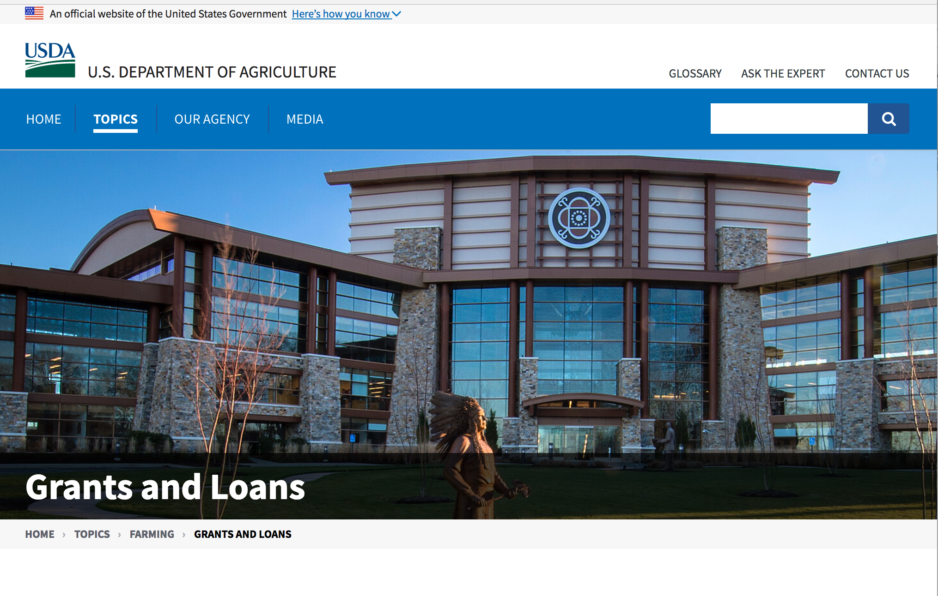

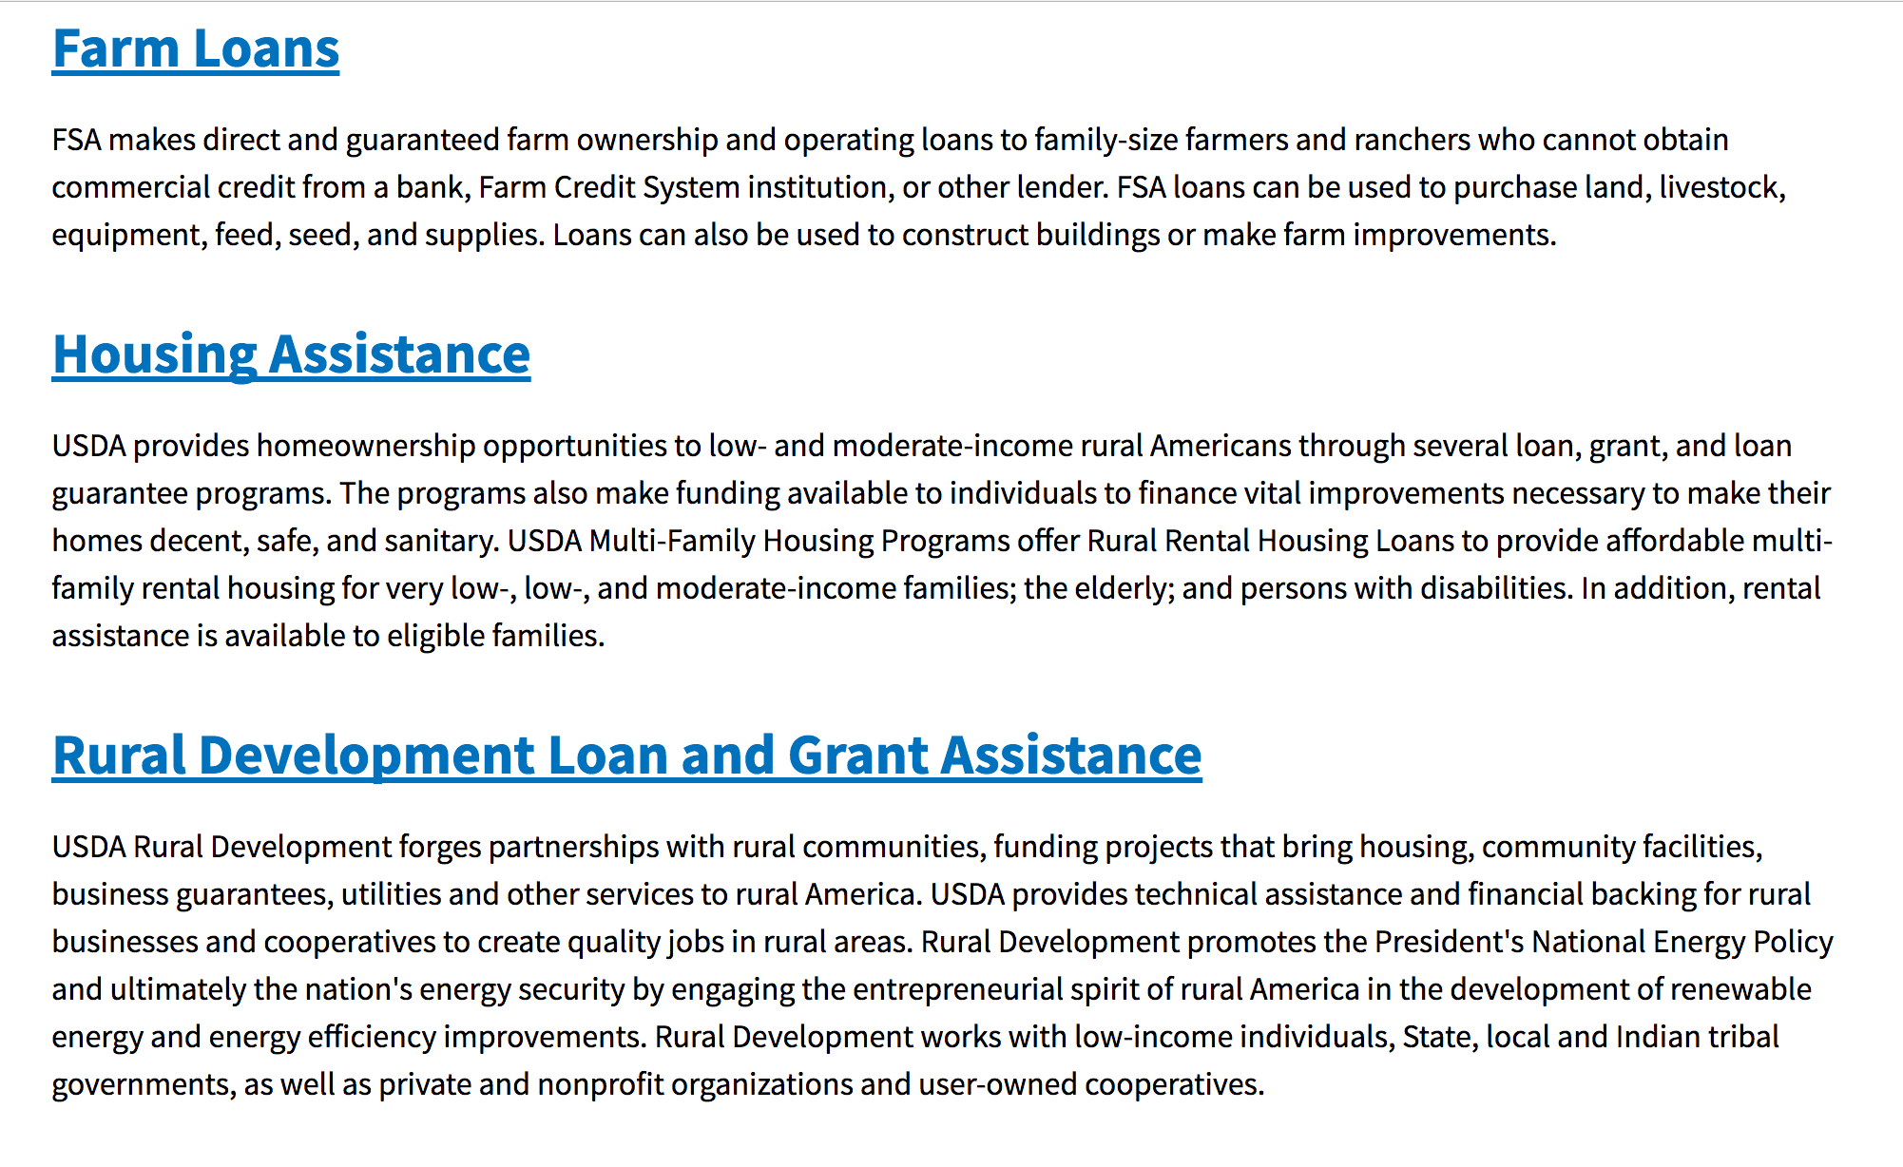

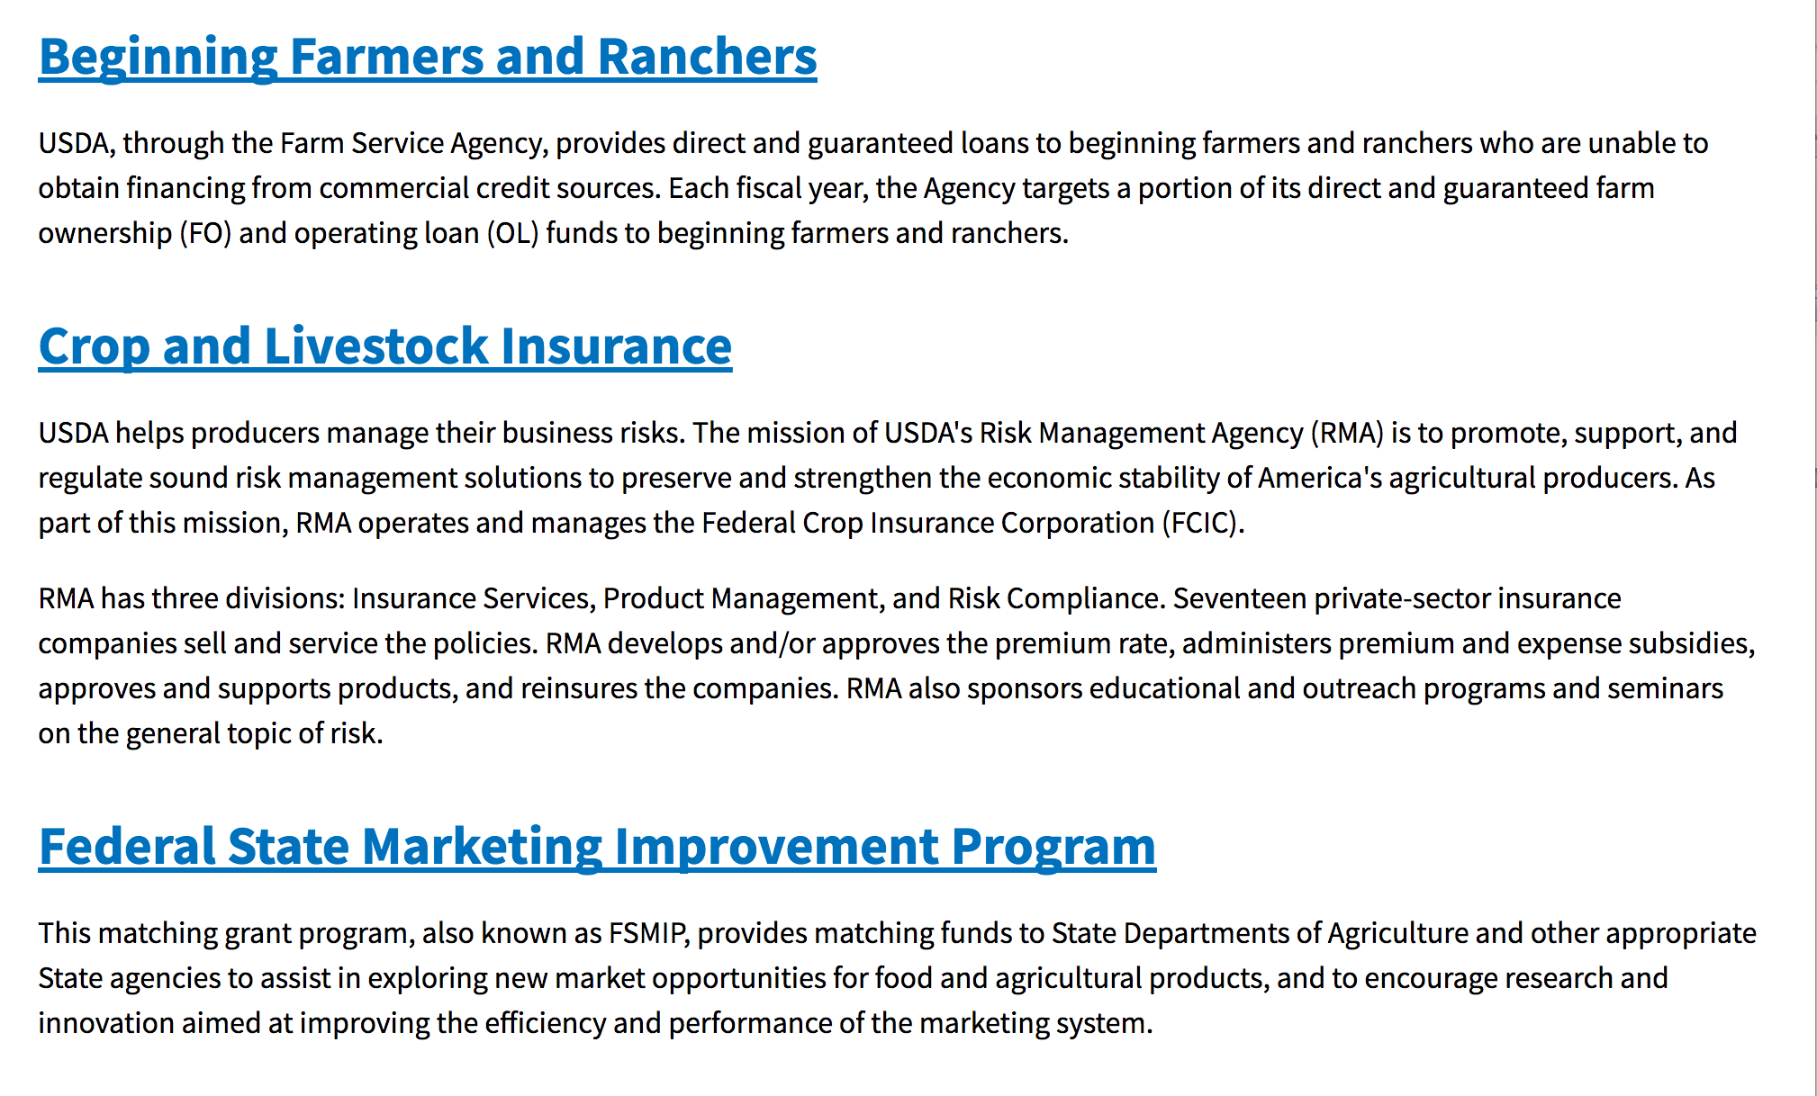
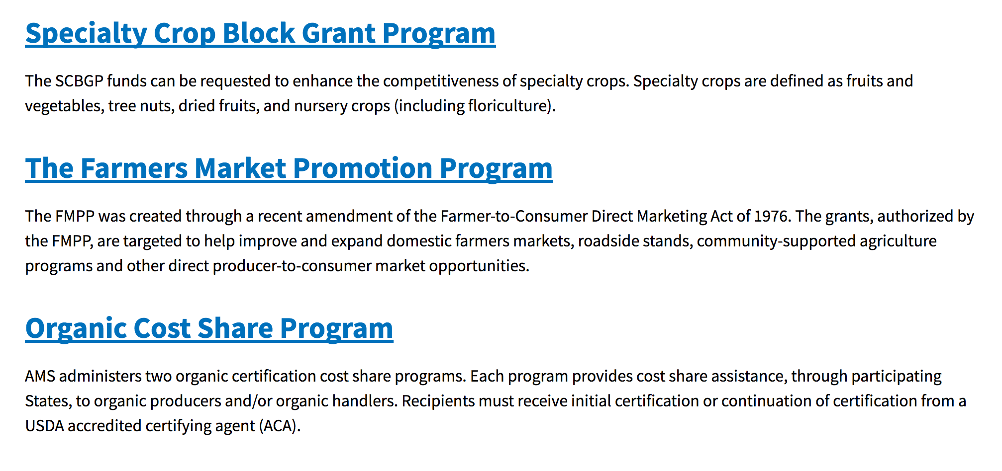
https://www.usda.gov/topics/farming/grants-and-loans

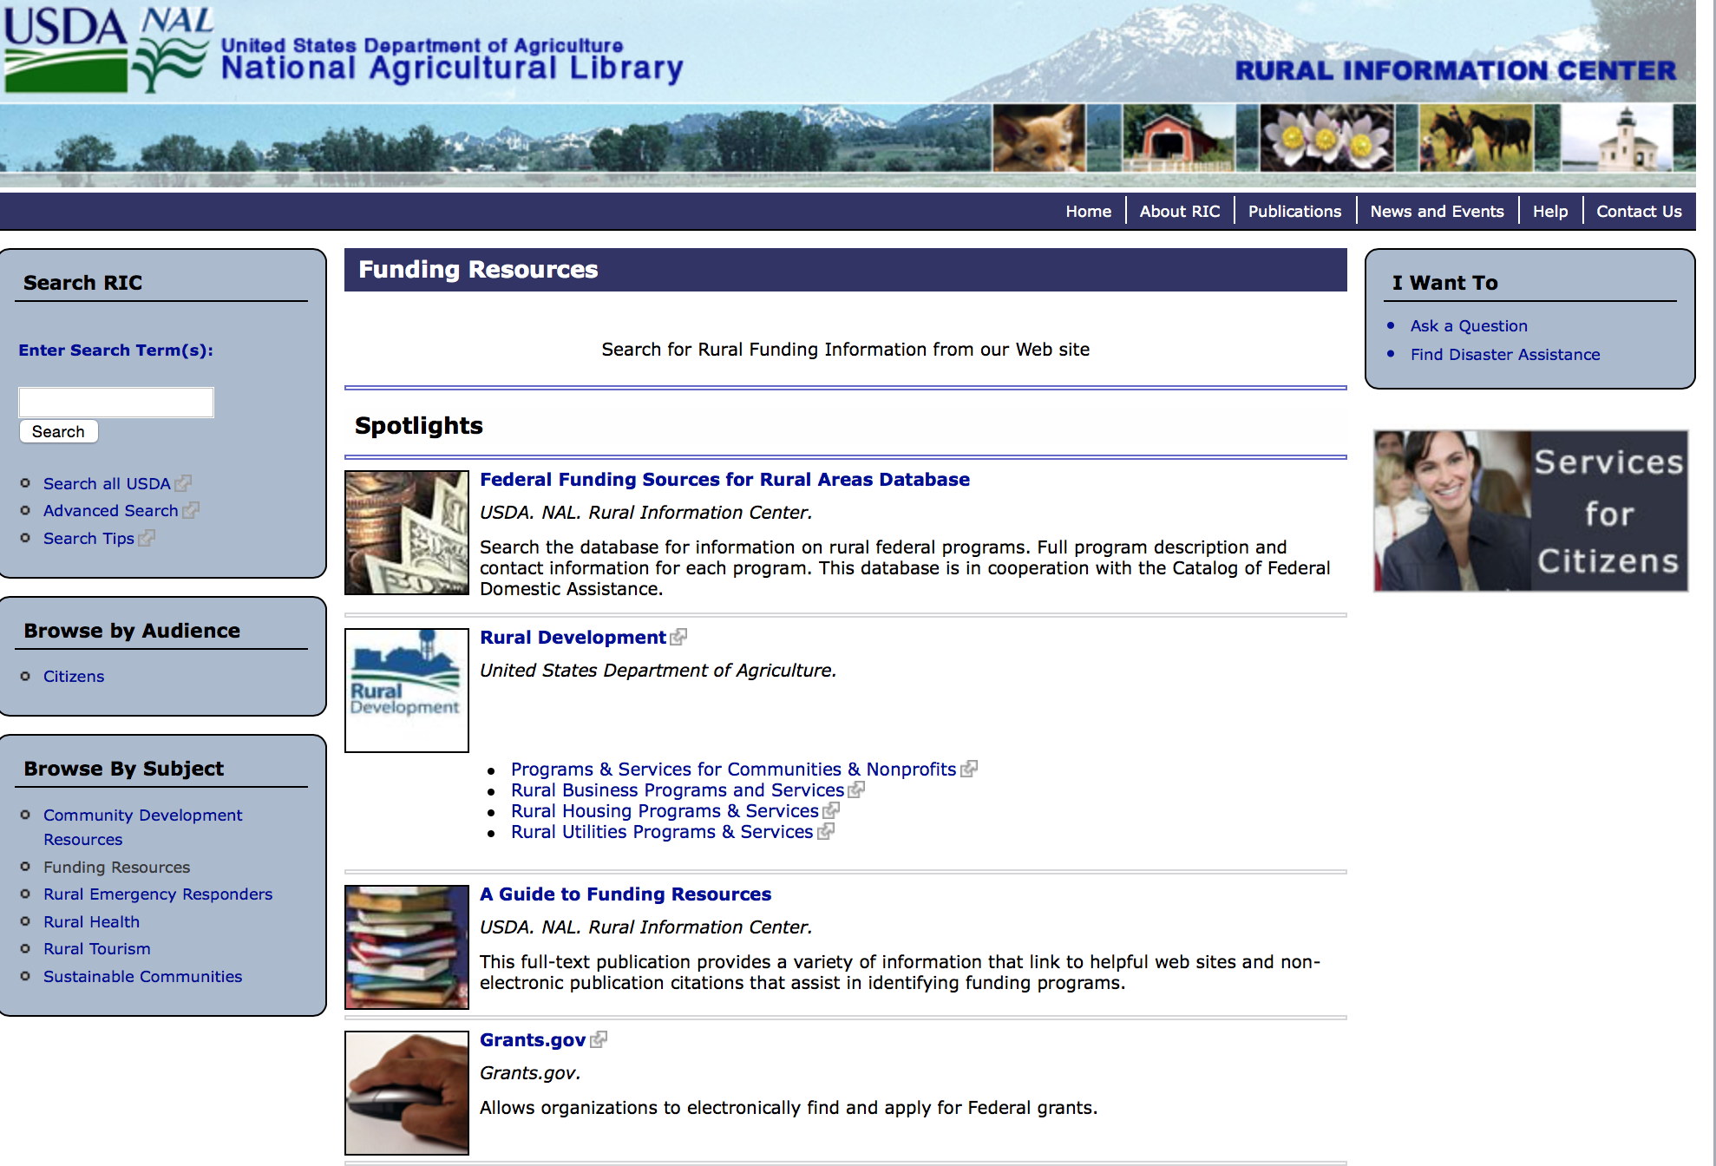

Federal Faith-Based Centers and Community Initiatives
USDA. NAL. Rural Information Center.
- Center for Faith-Based and Community Initiatives (link is external) , U.S. Department of Health and Human Services
- Center for Faith-Based and Community Initiatives (link is external) , U.S. Department of Labor
- http://www.usaid.gov/partnership-opportunities/fbci. U.S. Agency for International Development
- Faith-Based and Community Initiatives (link is external) , U.S. Department of Agriculture
- Faith-Based and Other Community Initiatives (link is external) , Corporation for National Community Service
- Task Force for Faith-Based and Community Initiatives (link is external) , U.S. Department of Justice

Grant Writing Resources
- Proposal Writing Short Course (link is external) Foundation Center.
- General Tips on Writing a Competitive Grant Proposal (link is external) U.S. Environmental Protection Agency.
- How to Write a Grant Proposal (link is external) Appalachian Regional Commission. <. li>

A Guide to Funding Resources USDA Rural Information Center.

http://ric.nal.usda.gov/funding-resources

Programs:

Utilities Programs
Distance Learning & Telemedicine Grant
Synopsis 1
Document Type: | Grants Notice
Funding Opportunity Number: | RUS-17-01-DLT
Funding Opportunity Title: | Distance Learning & Telemedicine Grant
Opportunity Category: | Discretionary
Opportunity Category Explanation:
Funding Instrument Type: | Grant
Category of Funding Activity: | Agriculture  Health
Category Explanation:
Expected Number of Awards: | 250
CFDA Number(s): | 10.855 -- Distance Learning and Telemedicine Loans and Grants
Cost Sharing or Matching Requirement: | No
Version: | Synopsis 1
Posted Date: | May 19, 2017
Last Updated Date: | May 19, 2017
Original Closing Date for Applications: | Jul 17, 2017
Current Closing Date for Applications: | Jul 17, 2017
Archive Date: | Aug 16, 2017
Estimated Total Program Funding:
Award Ceiling: | $500,000
Award Floor: | $50,000
Eligible Applicants: | Native American tribal governments (Federally recognized)  Public and State controlled institutions of higher education  For profit organizations other than small businesses  County governments  City or township governments  Nonprofits having a 501(c)(3) status with the IRS, other than institutions of higher education
Agency Name: | Utilities Programs
Description: | DLT grants are designed to provide access to education, training, and health care resources for rural Americans. The DLT Program is authorized by 7 U.S.C. 950aaa and provides financial assistance to encourage and improve telemedicine and distance learning services in rural areas through the use of telecommunications, computer networks, and related advanced technologies that students, teachers, medical professionals, and rural residents can use. The regulation for the DLT Program can be found at 7 CFR part 1703 (Subparts D through E). The grants, which are awarded through a competitive process, may be used to fund telecommunications-enabled information, audio and video equipment, and related advanced technologies which extend educational and medical applications into rural areas. Grants are intended to benefit end users in rural areas, who are often not in the same location as the source of the educational or health care service. Of the funds made available, $1,600,000.00 will be prioritized to provide for communication upgrades between ambulances, emergency transportation vehicles and medical facilities.
Link to Additional Information: | DLT Website
Grantor Contact Information: | If you have difficulty accessing the full announcement electronically, please contact:  Shawn Arner Deputy Assistant Administrator, Telecommunications Programs Phone 202-720-0800  eMail address

http://www.grants.gov/web/grants/view-opportunity.html?oppId=293962

Utilities Programs
Rural Community Development Initiative (RCDI)
Synopsis 1
Document Type: | Grants Notice
Funding Opportunity Number: | USDA-RD-HCFP-RCDI-2017
Funding Opportunity Title: | Rural Community Development Initiative (RCDI)
Opportunity Category: | Discretionary
Opportunity Category Explanation:
Funding Instrument Type: | Grant
Category of Funding Activity: | Agriculture  Community Development
Category Explanation:
Expected Number of Awards: | 25
CFDA Number(s): | 10.446 -- Rural Community Development Initiative
Cost Sharing or Matching Requirement: | Yes
Version: | Synopsis 1
Posted Date: | May 26, 2017
Last Updated Date: | May 26, 2017
Original Closing Date for Applications: | Jul 25, 2017
Current Closing Date for Applications: | Jul 25, 2017
Archive Date: | Aug 24, 2017
Estimated Total Program Funding: | $4,000,000
Award Ceiling: | $250,000
Award Floor: | $50,000
Eligible Applicants: | Small businesses  For profit organizations other than small businesses  Public and State controlled institutions of higher education  Nonprofits having a 501(c)(3) status with the IRS, other than institutions of higher education  Native American tribal governments (Federally recognized)  County governments  State governments  Independent school districts  Special district governments  City or township governments  Public housing authorities/Indian housing authorities  Private institutions of higher education
Additional Information on Eligibility: | The Intermediary will be required to provide matching funds in an amount at least equal to the RCDI grant. The respective minimum and maximum grant amount per Intermediary is $50,000.00 and $250,000.00. The Recipient and Beneficiary, but not the Intermediary, must be located in a city or town that has a population of 50,000 or less inhabitants.
Agency Name: | Utilities Programs
Description: | Qualified private, nonprofit and public including tribal intermediary organizations proposing to carry out financial and technical assistance programs will be eligible to receive the funding. The Intermediary will be required to provide matching funds in an amount at least equal to the RCDI grant. The respective minimum and maximum grant amount per Intermediary is $50,000 and $250,000. The Intermediary must provide a program of financial and technical assistance to recipients to develop their capacity and ability to undertake projects related to housing, community facilities, or community and economic development that will support the community.
Link to Additional Information: | FY2017 RCDI Notice of Solicitation of Applications
Grantor Contact Information: | If you have difficulty accessing the full announcement electronically, please contact:  Shirley Stevenson Community Programs Specialist Phone 2022059685  Email contact for Shirley Stevenson

http://www.grants.gov/web/grants/view-opportunity.html?oppId=294134

Utilities Programs
Rural Housing Preservation Grant
Synopsis 1
Document Type: | Grants Notice
Funding Opportunity Number: | USDA-RD-HCFP-HPG-2017
Funding Opportunity Title: | Rural Housing Preservation Grant
Opportunity Category: | Discretionary
Opportunity Category Explanation:
Funding Instrument Type: | Grant
Category of Funding Activity: | Community Development
Category Explanation:
Expected Number of Awards: | 100
CFDA Number(s): | 10.433 -- Rural Housing Preservation Grants
Cost Sharing or Matching Requirement: | No
Version: | Synopsis 1
Posted Date: | Jun 01, 2017
Last Updated Date: | Jun 01, 2017
Original Closing Date for Applications: | Jul 17, 2017
Current Closing Date for Applications: | Jul 17, 2017
Archive Date: | Aug 16, 2017
Estimated Total Program Funding: | $3,871,198
Award Ceiling: | $50,000
Award Floor: | $0
Eligible Applicants: | State governments  Others (see text field entitled "Additional Information on Eligibility" for clarification)  Native American tribal governments (Federally recognized)  City or township governments  Nonprofits that do not have a 501(c)(3) status with the IRS, other than institutions of higher education  Nonprofits having a 501(c)(3) status with the IRS, other than institutions of higher education  Native American tribal organizations (other than Federally recognized tribal governments)  County governments  Public housing authorities/Indian housing authorities
Additional Information on Eligibility: | Faith-Based and Community Organizations
Agency Name: | Utilities Programs
Description: | The Rural Housing Service (RHS) announces that it is soliciting applications under its Housing Preservation Grant (HPG) program. The HPG program is a grant program which provides qualified public agencies, private nonprofit organizations, which may include but not be limited to Faith-Based and Community Organizations, and other eligible entities grant funds to assist very low- and low-income homeowners in repairing and rehabilitating their homes in rural areas. In addition, the HPG program assists rental property owners and cooperative housing complexes in repairing and rehabilitating their units if they agree to make such units available to low- and very low-income persons. This action is taken to comply with Agency regulations found in 7 CFR part 1944, subpart N, which require the Agency to announce the opening and closing dates for receipt of preapplications for HPG funds from eligible applicants. The intended effect of this Notice is to provide eligible organizations notice of these dates.
Link to Additional Information: | Link to 2017 HPG NOSA
Grantor Contact Information: | If you have difficulty accessing the full announcement electronically, please contact:  Bonnie Edwards-Jackson Finance and Loan Analyst Phone 202-690-0759  For additional questions

http://www.grants.gov/web/grants/view-opportunity.html?oppId=294257

Research:

National Institute of Food and Agriculture
Agriculture and Food Research Initiative - Food, Agriculture, Natural Resources and Human Sciences Education and Literacy Initiative
Synopsis 3
http://www.grants.gov/web/grants/view-opportunity.html?oppId=293349

Modifications:

Utilities Programs
Community Facilities Technical Assistance and Training Grant
Synopsis 2
Document Type: | Grants Notice
Funding Opportunity Number: | USDA-RD-CFTAT-2017
Funding Opportunity Title: | Community Facilities Technical Assistance and Training Grant
Opportunity Category: | Discretionary
Opportunity Category Explanation:
Funding Instrument Type: | Grant
Category of Funding Activity: | Agriculture  Community Development
Category Explanation:
Expected Number of Awards: | 15
CFDA Number(s): | 10.766 -- Community Facilities Loans and Grants
Cost Sharing or Matching Requirement: | No
Version: | Synopsis 2
Posted Date: | May 26, 2017
Last Updated Date: | May 26, 2017
Original Closing Date for Applications: | Jul 24, 2017
Current Closing Date for Applications: | Jul 24, 2017
Archive Date: | Aug 23, 2017
Estimated Total Program Funding: | $1,500,000
Award Ceiling: | $150,000
Award Floor: | $0
Eligible Applicants: | Nonprofits having a 501(c)(3) status with the IRS, other than institutions of higher education  County governments  Public and State controlled institutions of higher education  Public housing authorities/Indian housing authorities  City or township governments  Independent school districts  State governments  Native American tribal governments (Federally recognized)  Private institutions of higher education  Nonprofits that do not have a 501(c)(3) status with the IRS, other than institutions of higher education  Native American tribal organizations (other than Federally recognized tribal governments)  Special district governments
Additional Information on Eligibility: | There are two types of applicants. They are Technical Assistance Providers and Ultimate Recipients. Generally speaking, both types of applicants must be a public body, nonprofit corporation, Federally Recognized Indian Tribe or Indian Tribe located on Federal and State reservations.
Agency Name: | Utilities Programs
Description: | The Agency will make grants to public bodies and private nonprofit corporations, (such as States, counties, cities, townships, and incorporated towns and villages, boroughs, authorities, districts, and Indian tribes on Federal and State reservations) to provide associations Technical Assistance and/or training with respect to essential community facilities programs. The Technical Assistance and/or training will assist communities, Indian Tribes, and Nonprofit Corporations to identify and plan for community facility needs that exist in their area. Once those needs have been identified, the Grantee can assist in identifying public and private resources to finance those identified community facility needs.
Link to Additional Information: | Notice of Solicitation of Applications for the CF TAT Grant
Grantor Contact Information: | If you have difficulty accessing the full announcement electronically, please contact:  Nathan Chitwood Regional Coordinator, RHS Phone 573 876-0965  Email contact for Nathan Chitwood

http://www.grants.gov/web/grants/view-opportunity.html?oppId=294154

Risk Management Education
Risk Management Education Partnership Program
Synopsis 4
Document Type: | Grants Notice
Funding Opportunity Number: | USDA-PP-RMED-2017
Funding Opportunity Title: | Risk Management Education Partnership Program
Opportunity Category: | Discretionary
Opportunity Category Explanation:
Funding Instrument Type: | Cooperative Agreement
Category of Funding Activity: | Education
Category Explanation:
Expected Number of Awards: | 200
CFDA Number(s): | 10.460 -- Risk Management Education Partnerships
Cost Sharing or Matching Requirement: | No
Version: | Synopsis 4
Posted Date: | May 11, 2017
Last Updated Date: | May 10, 2017
Original Closing Date for Applications: | Jul 10, 2017
Current Closing Date for Applications: | Jul 10, 2017
Archive Date: | Aug 10, 2017
Estimated Total Program Funding: | $4,000,000
Award Ceiling: | $4,000,000
Award Floor: | $0
Eligible Applicants: | Unrestricted (i.e., open to any type of entity above), subject to any clarification in text field entitled "Additional Information on Eligibility"
Additional Information on Eligibility: | ALL APPLICANTS MUST SUBMIT THEIR APPLICATION THROUGH THE RESULTS VERIFICATION SYSTEM (rvs). WE RECOMMEND ALL APPLICANTS TO USE THE MOST CURRENT VERSION OF THE REQUIRED DOCUMENTS THAT CAN ALSO BE FOUND ON THE RVS. ANY APPLICATION SUBMITTED THROUGH GRANTS.GOV WILL NOT BE ACCEPTED. The link to the Results Verification System is https://rvs.umn.edu/HOME.aspx
Agency Name: | Risk Management Education
Description: | The purpose of this cooperative agreement program is to deliver crop insurance education and risk management training to U.S. agricultural producers to assist them in identifying and managing production, marketing, legal, financial, and human risk.
Link to Additional Information: | Results Verification System
Grantor Contact Information: | If you have difficulty accessing the full announcement electronically, please contact:  Risk Management Education Division Phone 202-720-0779  Risk Management Education Division

http://www.grants.gov/web/grants/view-opportunity.html?oppId=293739

Risk Management Education
Crop Insurance Education in Targeted States
Synopsis 3 & 4
Document Type: | Grants Notice
Funding Opportunity Number: | USDA-TS-RMED-2017
Funding Opportunity Title: | Crop Insurance Education in Targeted States
Opportunity Category: | Discretionary
Opportunity Category Explanation:
Funding Instrument Type: | Cooperative Agreement
Category of Funding Activity: | Education
Category Explanation:
Expected Number of Awards: | 50
CFDA Number(s): | 10.458 -- Crop Insurance Education in Targeted States
Cost Sharing or Matching Requirement: | No
Version: | Synopsis 4
Posted Date: | May 11, 2017
Last Updated Date: | May 11, 2017
Original Closing Date for Applications: | Jul 10, 2017
Current Closing Date for Applications: | Jul 10, 2017
Archive Date: | Aug 10, 2017
Estimated Total Program Funding: | $4,850,000
Award Ceiling: | $613,000
Award Floor: | $0
Eligible Applicants: | Unrestricted (i.e., open to any type of entity above), subject to any clarification in text field entitled "Additional Information on Eligibility"
Additional Information on Eligibility: | ALL APPLICANTS MUST SUBMIT THEIR APPLICATION THROUGH THE RESULTS VERIFICATION SYSTEM (rvs). WE RECOMMEND ALL APPLICANTS TO USE THE MOST CURRENT VERSION OF THE REQUIRED DOCUMENTS THAT CAN ALSO BE FOUND ON THE RVS. ANY APPLICATION SUBMITTED THROUGH GRANTS.GOV WILL NOT BE ACCEPTED. The link to the Results Verification System is https://rvs.umn.edu/HOME.aspx
Agency Name: | Risk Management Education
Description: | The purpose of the Targeted States program is to deliver crop insurance education and information to U.S. agricultural producers in States where there is traditionally, and continues to be a low level of Federal crop insurance participation and availability, and producers are underserved by the Federal crop insurance program. These states, defined as Targeted States for the purpose of this RFA are Alaska, Connecticut, Delaware, Hawaii, Maine, Maryland, Massachusetts, Nevada, New Hampshire, New Jersey, New York, Pennsylvania, Rhode Island, Utah, Vermont, West Virginia, and Wyoming.
Link to Additional Information: | Results Verification System
Grantor Contact Information: | If you have difficulty accessing the full announcement electronically, please contact:  Risk Management Education Division Phone 202-720-0779  Risk Management Education Division

http://www.grants.gov/web/grants/view-opportunity.html?oppId=293741

Deleted:

Food and Nutrition Service
USDA-FNS-ICN-FY2017 - USDA-FNS-ICN-FY2017
Deletion Comments: Opportunity deleted

Reminders:

National Institute of Food and Agriculture
Agriculture and Food Research Initiative - Food, Agriculture, Natural Resources and Human Sciences Education and Literacy Initiative
Synopsis 1
Document Type: | Grants Notice
Funding Opportunity Number: | USDA-NIFA-AFRI-006354
Funding Opportunity Title: | Agriculture and Food Research Initiative - Food, Agriculture, Natural Resources and Human Sciences Education and Literacy Initiative
Opportunity Category: | Discretionary
Opportunity Category Explanation:
Funding Instrument Type: | Grant
Category of Funding Activity: | Agriculture  Education
Category Explanation:
Expected Number of Awards:
CFDA Number(s): | 10.310 -- Agriculture and Food Research Initiative (AFRI)
Cost Sharing or Matching Requirement: | Yes
Version: | Synopsis 1
Posted Date: | Apr 21, 2017
Last Updated Date: | Apr 21, 2017
Original Closing Date for Applications: | Jun 28, 2017
Current Closing Date for Applications: | Jun 28, 2017
Archive Date: | Jul 28, 2017
Estimated Total Program Funding: | $18,000,000
Eligible Applicants: | Others (see text field entitled "Additional Information on Eligibility" for clarification)
Additional Information on Eligibility: | Applications may only be submitted by eligible entities. Eligibility is linked to the project type. All project types are described beginning in Part II, C. of the RFA.
Agency Name: | National Institute of Food and Agriculture
Description: | In FY 2017, the National Institute of Food and Agriculture (NIFA) requests applications for the AFRI’s Food, Agriculture, Natural Resources and Human Sciences Education and Literacy Initiative (ELI) to support: (1) professional development opportunities for K-14 teachers and education professionals; (2) training of undergraduate students in research and extension; and (3) fellowships for predoctoral and postdoctoral candidates.
Link to Additional Information: | Agriculture and Food Research Initiative - Food, Agriculture, Natural Resources and Human Sciences Education and Literacy Initiative
Grantor Contact Information: | If you have difficulty accessing the full announcement electronically, please contact:  NIFA Help Desk Phone: 202-401-5048 Business hours are M-F, 7:00 am -5:00 pm ET, excluding Federal holidays  If you have any questions related to preparing application content

http://www.grants.gov/web/grants/view-opportunity.html?oppId=293349

National Institute of Food and Agriculture
Agriculture and Food Research Initiative - Childhood Obesity Prevention Challenge Area
Synopsis 1
Document Type: | Grants Notice
Funding Opportunity Number: | USDA-NIFA-AFRI-006346
Funding Opportunity Title: | Agriculture and Food Research Initiative - Childhood Obesity Prevention Challenge Area
Opportunity Category: | Discretionary
Opportunity Category Explanation:
Funding Instrument Type: | Grant
Category of Funding Activity: | Agriculture  Food and Nutrition  Health
Category Explanation:
Expected Number of Awards:
CFDA Number(s): | 10.310 -- Agriculture and Food Research Initiative (AFRI)
Cost Sharing or Matching Requirement: | Yes
Version: | Synopsis 1
Posted Date: | Apr 05, 2017
Last Updated Date: | Apr 05, 2017
Original Closing Date for Applications: | Jun 28, 2017
Current Closing Date for Applications: | Jun 28, 2017
Archive Date: | Jul 28, 2017
Estimated Total Program Funding: | $6,300,000
Eligible Applicants: | Others (see text field entitled "Additional Information on Eligibility" for clarification)
Additional Information on Eligibility: | Applications may only be submitted by eligible entities. Eligibility is linked to the project type. All project types are described beginning in Part II, C.
Agency Name: | National Institute of Food and Agriculture
Description: | The long-term goal of the Childhood Obesity Prevention Challenge Area (AFRI COP) is to reduce the prevalence of overweight and obesity among children and adolescents ages 2–19 years or any subset of this age range. In FY 2017, applications are sought by the program area priority of Integrated Approaches to Prevent Childhood Obesity under this Request for Applications (RFA).
Link to Additional Information: | Agriculture and Food Research Initiative - Childhood Obesity Prevention Challenge Area
Grantor Contact Information: | If you have difficulty accessing the full announcement electronically, please contact:  NIFA Help Desk Phone: 202-401-5048 Business hours are M-F, 7:00 am -5:00 pm ET, excluding Federal holidays  If you have any questions related to preparing application content

http://www.grants.gov/web/grants/view-opportunity.html?oppId=293001

Food and Nutrition Service
USDA FNS FY17 SNAP PTI
Synopsis 2
Document Type: | Grants Notice
Funding Opportunity Number: | USDA-FNS-FY17-SNAP-PTI
Funding Opportunity Title: | USDA FNS FY17 SNAP PTI
Opportunity Category: | Discretionary
Opportunity Category Explanation:
Funding Instrument Type: | Grant
Category of Funding Activity: | Food and Nutrition
Category Explanation:
Expected Number of Awards:
CFDA Number(s): | 10.580 -- Supplemental Nutrition Assistance Program, Process and Technology Improvement Grants
Cost Sharing or Matching Requirement: | No
Version: | Synopsis 2
Posted Date: | Apr 18, 2017
Last Updated Date: | Apr 18, 2017
Original Closing Date for Applications: | Jun 19, 2017
Current Closing Date for Applications: | Jun 19, 2017
Archive Date: | Jul 19, 2017
Estimated Total Program Funding: | $5,000,000
Award Ceiling: | $2,000,000
Award Floor: | $20,000
Eligible Applicants: | Nonprofits having a 501(c)(3) status with the IRS, other than institutions of higher education  County governments  State governments  Public and State controlled institutions of higher education
Additional Information on Eligibility: | The entities eligible to receive grants under this competition are:♣ The 53 State agencies that administer the SNAP1;♣ State or local governments1;♣ Agencies providing health or welfare services2;♣ Public health or educational entities2; and♣ Private nonprofit entities2 such as community-based or faith-based organizations, foodbanks, or other emergency feeding organizations.1 State agencies and State and local governments should have the necessary approvals of state officials (such as councils or legislatures) of funding prior to submitting the application. Applicants should also acknowledge in their application that all necessary approvals for funding have been obtained.2 Nonprofit organizations are required to submit a copy of the IRS Determination Letter, form 501(c)(3) or proof of application for exempt status under section 501(c)(3) of the Internal Revenue Code, a list of their Board of Directors if applicable, and their most recent audited financial statements signed by the Treasurer or the Treasurer of the board. Educational entities are also required to submit their most recent financial statements signed by the Treasurer or Treasurer of the board. Applications submitted without these will be considered non-responsive and eliminated from consideration. All corporations, including nonprofit corporations are required to complete the attached representation regarding felony convictions and tax delinquency.
Agency Name: | Food and Nutrition Service
Description: | The purpose of this grant competition is to support efforts by State agencies and their community-based and faith-based partners to develop and implement:♣ Simple SNAP application and eligibility determination systems; or♣ Measures to improve access to SNAP benefits by eligible applicants. This RFA seeks diverse proposals that would make the entire process easier and more efficient for SNAP applicants and participants. Grant proposals should focus on improving the quality and efficiency of operations and processes within the SNAP office. Specifically, FNS is interested in initiatives that use new technologies or examine office processes in order to improve application processing timeliness for initial or recertification applications. We encourage potential applicants to carefully read the three review criteria listed in the RFA. These criteria outline the qualities FNS expects successful proposals to have; they will also guide the reviewers’ evaluation of proposals.
Link to Additional Information: | Please Click Link for Additional Information
Grantor Contact Information: | If you have difficulty accessing the full announcement electronically, please contact:  Kimberly Shields Grants Officer  kimberly.shields@fns.usda.gov

http://www.grants.gov/web/grants/view-opportunity.html?oppId=293250

Fish and Wildlife Service
2017 National Fish Habitat Action Plan
Synopsis 1

Document Type: | Grants Notice
Funding Opportunity Number: | F17AS00016
Funding Opportunity Title: | 2017 National Fish Habitat Action Plan
Opportunity Category: | Discretionary
Opportunity Category Explanation:
Funding Instrument Type: | Cooperative Agreement  Grant
Category of Funding Activity: | Natural Resources
Category Explanation:
Expected Number of Awards: | 70
CFDA Number(s): | 15.608 -- Fish and Wildlife Management Assistance
Cost Sharing or Matching Requirement: | No
Posted Date: | Nov 08, 2016
Last Updated Date: | Nov 08, 2016
Original Closing Date for Applications: | Applications are accepted on a rolling basis.
Current Closing Date for Applications: | Applications are accepted on a rolling basis.
Archive Date: | May 31, 2017
Estimated Total Program Funding: | $0
Award Ceiling: | $300,000
Award Floor: | $5,000
Eligible Applicants: | Unrestricted (i.e., open to any type of entity above), subject to any clarification in text field entitled "Additional Information on Eligibility"
Additional Information on Eligibility: | Applications are accepted on a rolling basis.
Agency Name: | Fish and Wildlife Service
Description: | The National Fish Habitat Action Plan is a national investment strategy to leverage federal and privately raised funds to protect, restore, and enhance the nation's fish and aquatic habitats through partnerships that foster fish habitat conservation. Funds appropriated to the U.S. Fish and Wildlife Service's (Service) Fish and Aquatic Conservation (FAC) Program specifically to implement the Action Plan will be utilized in collaboration with the National Fish Habitat Board and Fish Habitat Partnerships. Fish Habitat Partnerships are the primary work units of the Action Plan, formed around distinct geographic areas, "keystone" fish species, or system types (e.g. large lakes, impoundments, estuaries). Funds will support national and regional science and coordination activities to protect, restore, or enhance fish habitats. All or a portion or project funds may be transferred to partner organizations if the Service lacks the capability to implement a project. Projects must protect, restore, or enhance fish and aquatic habitats or otherwise directly support habitat-related priorities of Fish Habitat Partnerships or the National Fish Habitat Board. Every project must be identified in the Fisheries Operational Needs System (FONS), a database that identifies the operational needs of FAC field stations, including fish habitat project needs. FAC field offices will work with Fish Habitat Partnerships to identify fish habitat projects, and enter them into the FONS. Entities that seek to propose a fish habitat conservation project for consideration should contact a local or regional office of the Service FAC Program.
Link to Additional Information: | http://www.grants.gov
Grantor Contact Information: | If you have difficulty accessing the full announcement electronically, please contact:  Cecilia Lewis 703-358-2102 Cecilia_Lewis@fws.gov  Fish Biologist

http://www.grants.gov/web/grants/view-opportunity.html?oppId=289987

Department of Commerce

Grants, Contracting, and Trade Opportunities at Commerce
Learn more information about grants, contracting and trade opportunities at the Department of Commerce using the information below.

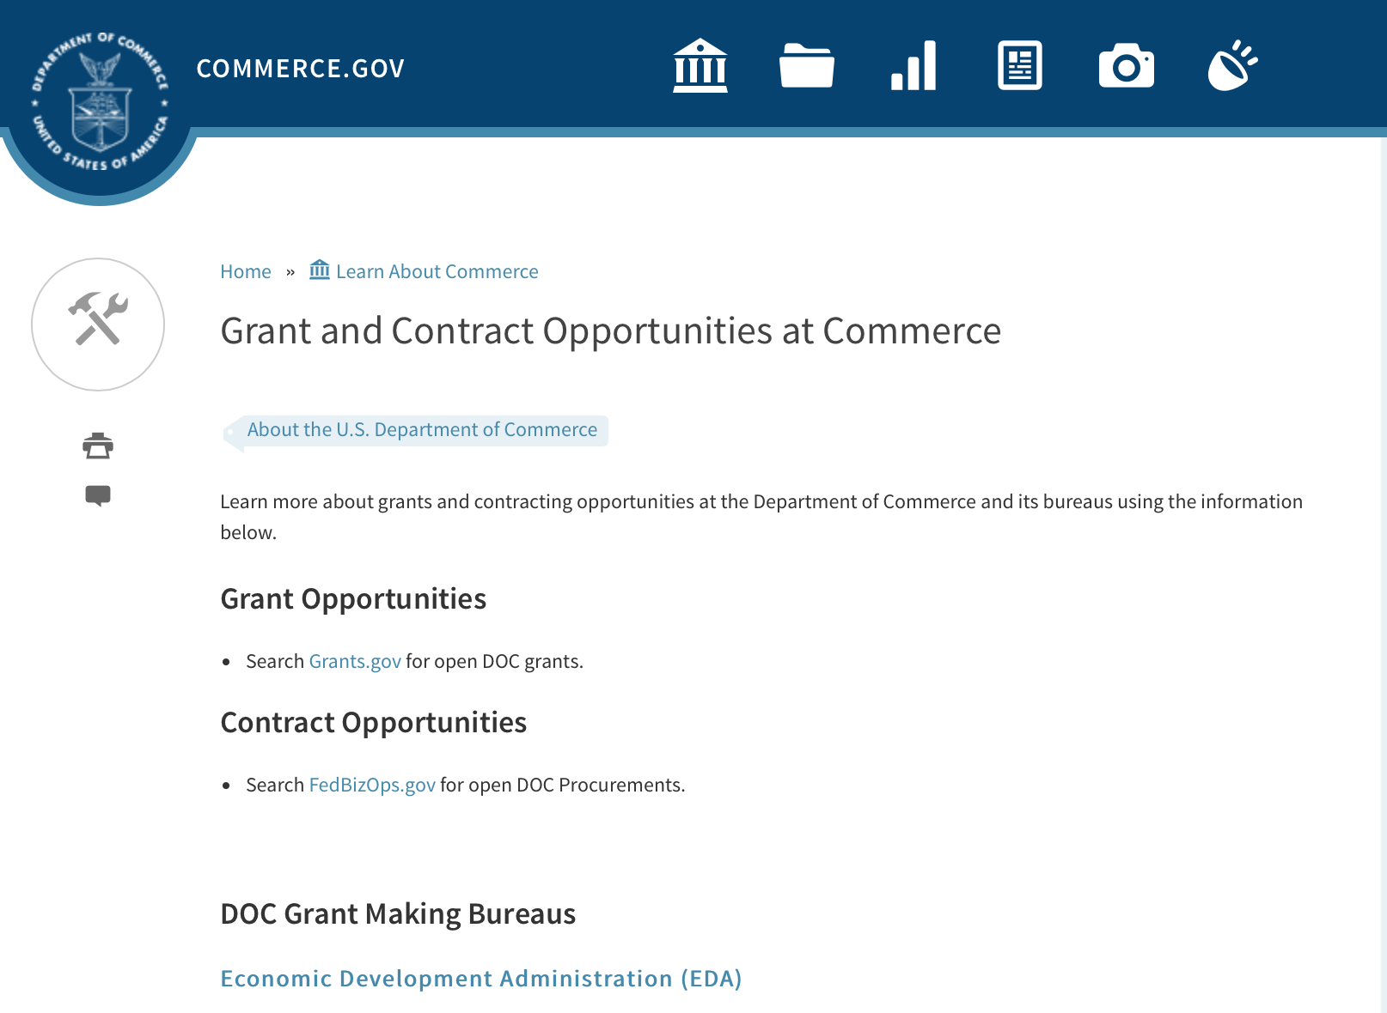
Grants at Commerce

DOC Grant Making Bureaus
Economic Development Administration (EDA)
International Trade Administration (ITA)
- Market Development Cooperator Program
- Special American Business Internship Training Program (SABIT). A technical assistance initiative of the International Trade Administration of the U.S. Department of Commerce, SABIT offers organizations competitive grants and an opportunity to host industry-specific delegations. SABIT serves as an initial entry point for U.S. businesses seeking funding to establish long-term relationships with potential customers, distributors, or partners in the former Soviet Union. The program trains Eurasian managers and scientists in commonly accepted business practices as a means of facilitating cross border relationships. In turn, these personal relationships serve as a basis for business development and reduce market access barriers for U.S. businesses
National Institute of Standards & Technology (NIST)
- Funding Opportunities
National Telecommunications & Information Administration (NTIA)
- Telecommunications Grants
National Oceanic & Atmospheric Administration (NOAA)
- Coastal Ocean Program Grant Information
- Fisheries Saltonstall Kennedy Grant Program
- National Undersea Research Program Funding Opportunities
- Grants Management Division
- Fisheries Grants Program
- National Sea Grant
- Office of Global Programs
Contracting Resources for Contractors
- Office of Small and Disadvantaged Business Utilization (OSDBU) - he Office of Small and Disadvantaged Business Utilization (OSDBU) is an advocacy and advisory office responsible for promoting the use of small, small disadvantaged, 8(a), women-owned, veteran-owned, service-disabled veteran-owned, and HUBZone small businesses within the U.S. Department of Commerce's (DOC) acquisition process.
- Business.USA.gov's Find Opportunities Wizard where in a few quick steps, it will guide you towards federal government contracting programs and opportunities for your business!
- Planned Acquisitions: the Department of Commerce's search tool for our planned acquisitions over $100,000. As requirements change, these acquisition plans are updated by department personnel and this search tool is automatically updated.
- Small Business Administration's Contracting section of their web site where you can learn about how to "Get Started" and "Contracting Support for Small Business"
- The General Services Administration (GSA) has implemented a system for vendors doing business with the Federal Government to manage their entity information in one central location. This new database is the System for Award Management (SAM).

DOC Contracting Offices
- Patent and Trademark Office (PTO)
  - Office of Procurement
- National Institute of Standards & Technology (NIST)
NIST Acquisition Management Group
Contracting Opportunities with Commerce
Trade Opportunities through Commerce
http://www.commerce.gov/about-commerce/grants-contracting-trade-opportunities

Programs:

FY 2017 Regional Innovation Strategies Program
Synopsis 1
Document Type: | Grants Notice
Funding Opportunity Number: | EDA-HDQ-OIE-2017-2005260
Funding Opportunity Title: | FY 2017 Regional Innovation Strategies Program
Opportunity Category: | Discretionary
Opportunity Category Explanation:
Funding Instrument Type: | Grant
Category of Funding Activity: | Other (see text field entitled "Explanation of Other Category of Funding Activity" for clarification)  Regional Development
Category Explanation: | Economic Development, Innovation and Entrepreneurship
Expected Number of Awards:
CFDA Number(s): | 11.020 -- Cluster Grants
Cost Sharing or Matching Requirement: | Yes
Version: | Synopsis 1
Posted Date: | May 10, 2017
Last Updated Date: | May 09, 2017
Original Closing Date for Applications: | Jun 23, 2017
Current Closing Date for Applications: | Jun 23, 2017
Archive Date: | Jul 23, 2017
Estimated Total Program Funding: | $17,000,000
Award Ceiling: | $500,000
Award Floor: | $1
Eligible Applicants: | Special district governments  Others (see text field entitled "Additional Information on Eligibility" for clarification)  Native American tribal governments (Federally recognized)  City or township governments  County governments  Private institutions of higher education  Nonprofits having a 501(c)(3) status with the IRS, other than institutions of higher education  State governments  Nonprofits that do not have a 501(c)(3) status with the IRS, other than institutions of higher education  Public and State controlled institutions of higher education
Additional Information on Eligibility: | A State; An Indian tribe; A city or other political subdivision of a State; An entity that— (a) is a nonprofit organization, an institution of higher education, a public-private partnership, a science or research park, a Federal laboratory, or an economic development organization or similar entity, and (b) has an application that is supported by a State or a political subdivision of a State; or A consortium of any of the entities described above.
Agency Name: | Department of Commerce
Description: | EDA is committed to fostering connected, innovation-centric economic sectors which support the conversion of research into products and services, businesses, and ultimately jobs through entrepreneurship. See Section 27. Funding is available for capacity-building programs that provide proof-of-concept and commercialization assistance to innovators and entrepreneurs and for operational support for organizations that provide essential early-stage funding to startups. Under the RIS Program, EDA is soliciting applications for two separate competitions: the 2017 i6 Challenge; and the 2017 Seed Fund Support (SFS) Grant competition. Applicants may, but are not required to, submit proposals for more than one competition under the RIS Program. Applicants must provide a matching share from non-Federal sources of at least 50 percent of the total project cost. See Section C.2 (p. 7) of this NOFA.
Link to Additional Information:
Grantor Contact Information: | If you have difficulty accessing the full announcement electronically, please contact:  If you have difficulty accessing the full announcement electronically, please contact:  oie@eda.gov

http://www.grants.gov/web/grants/view-opportunity.html?oppId=293716

Modifications:

Climate Program Office 2018
Synopsis 2

Document Type: | Grants Notice
Funding Opportunity Number: | NOAA-OAR-CPO-2018-2005133
Funding Opportunity Title: | Climate Program Office 2018
Opportunity Category: | Discretionary
Opportunity Category Explanation:
Funding Instrument Type: | Grant
Category of Funding Activity: | Environment  Natural Resources  Science and Technology and other Research and Development
Category Explanation:
Expected Number of Awards: | 90
CFDA Number(s): | 11.431 -- Climate and Atmospheric Research
Cost Sharing or Matching Requirement: | No
Version: | Synopsis 2
Posted Date: | May 15, 2017
Last Updated Date: | May 15, 2017
Original Closing Date for Applications: | Sep 11, 2017
Current Closing Date for Applications: | Sep 11, 2017
Archive Date: | Oct 11, 2017
Estimated Total Program Funding: | $8,000,000
Award Ceiling: | $300,000
Award Floor: | $50,000
Eligible Applicants: | Others (see text field entitled "Additional Information on Eligibility" for clarification)
Additional Information on Eligibility: | Eligible applicants are institutions of higher education, other nonprofits, commercial organizations, international organizations, and state, local and Indian tribal governments. Federal agencies interested in receiving financial support for projects should contact the appropriate competition manager.
Agency Name: | Department of Commerce
Description: | The National Oceanic and Atmospheric Administration (NOAA) is focused on providing the essential and highest quality environmental information vital to our Nation’s safety, prosperity and resilience. Toward this goal, the agency conducts and supports weather and climate research, oceanic and atmospheric observations, modeling, information management, assessments, interdisciplinary decision-support research, outreach, education, and partnership development. Climate variability and change present society with significant economic, health, safety, and security challenges and opportunities. In meeting these challenges, and as part of NOAA’s climate portfolio within the Office of Oceanic and Atmospheric Research (OAR), the Climate Program Office (CPO) advances scientific understanding, monitoring, and prediction of climate and its impacts, to enable effective decisions. These investments are key to NOAA’s mission of "Science, Service, and Stewardship" and are guided by the agency’s vision to create and sustain enhanced resilience in ecosystems, communities, and economies. Within this context, CPO manages competitive research programs through which NOAA funds high-priority climate science, assessments, decision support research, outreach, education, and capacity-building activities designed to advance our understanding of the Earth’s climate system, and to foster the application and use of this knowledge to improve the resilience of our Nation and its partners. CPO supports research that is conducted across the United States and internationally. CPO also provides strategic guidance for the agency’s climate science and services programs and supports NOAA’s contributions to the U.S. Global Change Research Program (USGCRP) and its National Climate Assessment, and similar international endeavors such as the Global Framework for Climate Services. CPO’s climate research portfolio is designed to achieve a fully integrated research and applications program. We meet this objective through a focus on climate intelligence and climate resilience, in support of NOAA’s goals. Climate intelligence defines CPO’s technical strength through its foundational capabilities, which include (1) Observations and monitoring, (2) Research to advance scientific understanding, (3) Modeling and prediction, (4) Communication, education, and engagement, and, (5) Climate and societal interactions. A focus on climate resilience leverages CPO’s climate intelligence to advance capabilities for responding to the urgent and growing demand for reliable, trusted, transparent, and timely climate information needed to sustain all sectors of our economy and environment. CPO’s strategy addresses challenges in the areas of, (1) Weather and climate extremes, (2) Climate impacts on water resources, (3) Coasts and climate resilience, (4) Sustainability of marine ecosystems, and (5) Changing atmospheric composition and its impacts. Making progress in addressing climate-related societal challenges and realizing benefits for NOAA’s public and private partners, requires that these mission-focused capabilities be integrated across CPO to align research, applications, transitions, and operations, and to meet the information needs of a resilient society. NOAA envisions a Nation that is prepared for, thriving, and resilient to climate variability and change. CPO’s activities support a unique and highly flexible climate research enterprise to improve scientific understanding of climate variability and change and to enable businesses and communities to derive the benefits of this investment in the present and into the future. Effectively coordinating across these components through the development and deployment of end-to-end research-based integrated information systems that address needs of high societal relevance, have been hallmarks of CPO’s success in linking environmental intelligence to resilience. Key components in this enterprise are annual Federal Funding Opportunities, competitive grants programs and other types of support that advance and extend NOAA’s foundational capabilities and applications research. Proficiency in these core areas ensures that CPO’s infrastructure is always in place to meet the intelligence and resilience challenges of our changing climate. NOAA, OAR, and the Climate Program Office encourage applicants and awardees to support the principles of diversity and inclusion when writing their proposals and performing their work. Diversity is defined as a collection of individual attributes that together help organizations achieve objectives. Inclusion is defined as a culture that connects each employee to the organization. By promoting diversity and inclusion you can improve creativity, productivity, and the vitality of the research community.
Link to Additional Information:
Grantor Contact Information: | If you have difficulty accessing the full announcement electronically, please contact:  Diane Brown CPO Grants Manager  work

http://www.grants.gov/web/grants/view-opportunity.html?oppId=293866

Research:

National Institute of Standards and Technology
Measurement Science and Engineering (MSE) Research Grant Programs
Synopsis 2 & 3
Document Type: | Grants Notice
Funding Opportunity Number: | 2016-NIST-MSE-01
Funding Opportunity Title: | Measurement Science and Engineering (MSE) Research Grant Programs
Opportunity Category: | Discretionary
Opportunity Category Explanation:
Funding Instrument Type: | Cooperative Agreement  Grant
Category of Funding Activity: | Science and Technology and other Research and Development
Category Explanation:
Expected Number of Awards:
CFDA Number(s):
Cost Sharing or Matching Requirement: | No
Version: | Synopsis 3
Posted Date: | Feb 19, 2016
Last Updated Date: | May 24, 2017
Original Closing Date for Applications: | Applications will be accepted and considered on a rolling basis as they are received. See Section IV.4. in the text of the Full Announcement/FFO document. Applications may be submitted by paper or electronically through Grants.gov. Carefully read Section IV. of the Full Announcement/FFO document for details applying to electronic submissions and to paper submissions.
Current Closing Date for Applications: | Applications will be considered on a continuing/rolling basis as they are received. To ensure consideration in the current fiscal year, applications should be received by 5:00 p.m. Eastern Time on June 13, 2017. Applications received after this deadline may be processed and considered for funding in the current fiscal year or in the next fiscal year, subject to the availability of funds.
Eligible Applicants: | Others (see text field entitled "Additional Information on Eligibility" for clarification)
Additional Information on Eligibility: | Eligibility for all programs listed in this FFO is open to all non-Federal entities. Eligible applicants include institutions of higher education, non-profit organizations, for-profit organizations, state and local governments, Indian tribes, hospitals, foreign public entities, and foreign governments. Applicants selected for awards are encouraged, but not required, to select underrepresented minorities for participation. In addition, NIST is not able to accept an application from an individual unaffiliated with a sponsoring applicant organization.
Agency Name: | National Institute of Standards and Technology
Description: | NIST is soliciting applications for financial assistance within the following NIST Laboratory grant programs: (1) the Material Measurement Laboratory (MML) Grant Program; (2) the Physical Measurement Laboratory (PML) Grant Program; (3) the Engineering Laboratory (EL) Grant Program;(4) the Fire Research (FR) Grant Program;(5) the Information Technology Laboratory (ITL) Grant Program;(6) the Communications Technology Laboratory (CTL) Grant Program; (7) the NIST Center for Neutron Research (NCNR) Grant Program; (8) the Center for Nanoscale Science and Technology (CNST) Grant Program;(9) the Special Programs Office (SPO) Grant Program; (10) the Standards Coordination Office (SCO) Grant Program; (11) the International and Academic Affairs Office (IAAO) Grant Program; (12) the Associate Director for Laboratory Programs (ADLP) Grant Program, and (13) the Associate Director for Innovation and Industry Services (ADIIS) Grant Program.
Link to Additional Information: | 2016-NIST-MSE-01 Amended Full Announcement/NOFO document
Grantor Contact Information: | If you have difficulty accessing the full announcement electronically, please contact:  Christopher Hunton Management and Program Analyst Phone 301-975-5718  Agency Contact

http://www.grants.gov/web/grants/view-opportunity.html?oppId=281689

Reminders:

National Institute of Standards and Technology
Measurement Science and Engineering (MSE) Research Grant Programs

Document Type: | Grants Notice
Funding Opportunity Number: | 2016-NIST-MSE-01
Funding Opportunity Title: | Measurement Science and Engineering (MSE) Research Grant Programs
Opportunity Category: | Discretionary
Opportunity Category Explanation:
Funding Instrument Type: | Cooperative Agreement  Grant
Category of Funding Activity: | Science and Technology and other Research and Development
Category Explanation:
Expected Number of Awards:
CFDA Number(s):
Cost Sharing or Matching Requirement: | No
Posted Date: | Feb 19, 2016
Last Updated Date: | Feb 19, 2016
Original Closing Date for Applications: | Applications will be accepted and considered on a rolling basis as they are received. See Section IV.4. in the text of the Full Announcement/FFO document. Applications may be submitted by paper or electronically through Grants.gov. Carefully read Section IV. of the Full Announcement/FFO document for details applying to electronic submissions and to paper submissions.
Current Closing Date for Applications: | Applications will be accepted and considered on a rolling basis as they are received. See Section IV.4. in the text of the Full Announcement/FFO document. Applications may be submitted by paper or electronically through Grants.gov. Carefully read Section IV. of the Full Announcement/FFO document for details applying to electronic submissions and to paper submissions.
Eligible Applicants: | Others (see text field entitled "Additional Information on Eligibility" for clarification)
Additional Information on Eligibility: | Eligibility for all programs listed in this FFO is open to all non-Federal entities. Eligible applicants include institutions of higher education, non-profit organizations, for-profit organizations, state and local governments, Indian tribes, hospitals, foreign public entities, and foreign governments. Applicants selected for awards under 15 U.S.C. § 278g-1 are encouraged, but not required, to select underrepresented minorities for participation. In addition, NIST is not able to accept an application from an individual unaffiliated with a sponsoring applicant organization.
Agency Name: | National Institute of Standards and Technology
Description: | NIST is soliciting applications for financial assistance for Fiscal Year 2016 (FY16) within the following NIST Laboratory grant programs: (1) the Material Measurement Laboratory (MML) Grant Program; (2) the Physical Measurement Laboratory (PML) Grant Program; (3) the Engineering Laboratory (EL) Grant Program; (4) the Fire Research (FR) Grant Program; (5) the Information Technology Laboratory (ITL) Grant Program; (6) the Communications Technology Laboratory (CTL) Grant Program; (7) the NIST Center for Neutron Research (NCNR) Grant Program; (8) the Center for Nanoscale Science and Technology (CNST) Grant Program; (9) the Special Programs Office (SPO) Grant Program; (10) the Standards Coordination Office (SCO) Grant Program; (11) the International and Academic Affairs Office (IAAO) Grant Program; and (12) the Associate Director for Laboratory Programs (ADLP) Grant Program.
Link to Additional Information: | 2016-NIST-MSE-01 Full Announcement/FFO document
Contact Information: | If you have difficulty accessing the full announcement electronically, please contact:  Christopher Hunton Management and Program Analyst Phone 301-975-5718  Agency Contact

http://www.grants.gov/web/grants/view-opportunity.html?oppId=281689

National Sea Grant College Program 2016-17 Special Projects Grant

Document Type: | Grants Notice
Funding Opportunity Number: | NOAA-OAR-SG-2016-2004772
Funding Opportunity Title: | National Sea Grant College Program 2016-17 Special Projects
Opportunity Category: | Discretionary
Funding Instrument Type: | Cooperative Agreement  Grant
Category of Funding Activity: | Environment  Natural Resources  Science and Technology and other Research and Development
Category Explanation:
Expected Number of Awards: | 30
CFDA Number(s): | 11.417 -- Sea Grant Support
Cost Sharing or Matching Requirement: | Yes
Posted Date: | Jan 7, 2016
Creation Date: | Jan 7, 2016
Original Closing Date for Applications: | Sep 30, 2017
Current Closing Date for Applications: | Sep 30, 2017
Archive Date: | Oct 30, 2017
Estimated Total Program Funding: | $4,000,000
Award Ceiling: | $1,000,000
Award Floor: | $1
Eligible Applicants: | Others (see text field entitled "Additional Information on Eligibility" for clarification)
Additional Information on Eligibility: | Sea Grant Programs (Sea Grant Colleges, Institutions, or Coherent Area Programs), the National Sea Grant Law Center, and the National Sea Grant Library.
Agency Name: | Department of Commerce
Description: | The purpose of this notice is to request proposals for special projects associated with the National Sea Grant College Program’s (Sea Grant) strategic focus areas, and to provide the general public with information and guidelines on how Sea Grant will select proposals and administer Federal assistance under this announcement. This announcement is a mechanism to encourage research or other projects that are not normally funded through Sea Grant national competitions. This opportunity is open only to Sea Grant Programs. Section III of this announcement describes eligibility requirements in more detail. Funding has not yet been made available to support applications submitted to this Federal Funding Opportunity (FFO), but such funding may become available during the year. Section II.A. below describes individual competition announcements that will be used to announce when funding is available; any restrictions or requirements on such funding, such as matching funds; and other funding details. Awards will be made under this FFO only if funds have been announced as provided in this FFO.
Link to Additional Information:
Contact Information: | If you have difficulty accessing the full announcement electronically, please contact:  Special Projects Competition Manager, NOAA R/SG National Sea Grant Office 1315 East-West Highway, Rm 11839 Silver Spring, MD 20910 301-734-1066  work

http://www.grants.gov/web/grants/view-opportunity.html?oppId=280846

FY 2016 – FY 2019 EDA Planning Program and Local Technical Assistance Program Grant

Document Type: | Grants Notice
Funding Opportunity Number: | EDA-HDQ-TA-HDQ-2016-2004759
Funding Opportunity Title: | FY 2016 – FY 2019 EDA Planning Program and Local Technical Assistance Program
Opportunity Category: | Discretionary
Funding Instrument Type: | Cooperative Agreement  Grant
Category of Funding Activity: | Other (see text field entitled "Explanation of Other Category of Funding Activity" for clarification)  Regional Development
Category Explanation: | Regional planning and local technical assistance
Expected Number of Awards:
CFDA Number(s): | 11.302 -- Economic Development Support for Planning Organizations  11.303 -- Economic Development Technical Assistance
Cost Sharing or Matching Requirement: | No
Posted Date: | Dec 10, 2015
Creation Date: | Dec 10, 2015
Original Closing Date for Applications: | Applications are accepted on a continuing basis and processed as received. This Planning and Local Technical Assistance opportunity will remain in effect until superseded by a future announcement.
Current Closing Date for Applications: | Applications are accepted on a continuing basis and processed as received. This Planning and Local Technical Assistance opportunity will remain in effect until superseded by a future announcement.
Archive Date:
Estimated Total Program Funding:
Award Ceiling: | $300,000
Award Floor: | $0
Eligible Applicants: | Nonprofits having a 501(c)(3) status with the IRS, other than institutions of higher education  City or township governments  Nonprofits that do not have a 501(c)(3) status with the IRS, other than institutions of higher education  Others (see text field entitled "Additional Information on Eligibility" for clarification)  Private institutions of higher education  Native American tribal governments (Federally recognized)  Public and State controlled institutions of higher education  State governments  Special district governments  County governments
Additional Information on Eligibility: | Pursuant to section 3 of the Public Works and Economic Development Act of 1965 (42 U.S.C. § 3122) (PWEDA) and EDA’s regulation at 13 C.F.R. § 300.3, the following types of entities are eligible to receive funding assistance from EDA: 1. District Organizations (as defined in 13 C.F.R. § 300.3); 2. Indian Tribes or a consortium of Indian Tribes; 3. States, cities, or other political subdivisions of a State, including a special purpose unit of a State or local government engaged in economic or infrastructure development activities, or a consortium of political subdivisions; 4. Institutions of higher education or a consortium of institutions of higher education; or 5. Public or private non-profit organizations or associations acting in cooperation with officials of a political subdivision of a State.
Agency Name: | Department of Commerce
Description: | Pursuant to PWEDA, EDA announces general policies and application procedures for grant-based investments under the Planning and Local Technical Assistance programs. Under the Planning program EDA assists eligible recipients in creating regional economic development plans designed to build capacity and guide the economic prosperity and resiliency of an area or region. As part of this program, EDA supports Partnership Planning investments to facilitate the development, implementation, revision, or replacement of Comprehensive Economic Development Strategies (CEDS), which articulate and prioritize the strategic economic goals of recipients’ respective regions. In general, EDA provides Partnership Planning grants to the designated planning organization (e.g., District Organization) serving EDA designated Economic Development Districts to enable these organizations to develop and implement relevant CEDS. In addition, EDA provides Partnership Planning grants to Indian Tribes to help develop and implement CEDS and associated economic development activities. The Planning program also helps support organizations, including District Organizations, Indian Tribes, and other eligible recipients, with Short Term and State Planning investments designed to guide the eventual creation and retention of high-quality jobs, particularly for the unemployed and underemployed in the Nation’s most economically distressed regions. The Local Technical Assistance program strengthens the capacity of local or State organizations, institutions of higher education, and other eligible recipients to undertake and promote effective economic development programs through projects such as feasibility analyses and impact studies.
Link to Additional Information: | www.eda.gov
Contact Information: | If you have difficulty accessing the full announcement electronically, please contact:  The EDA representative for your state. A complete list of EDA representatives is available on EDA's website at http://www.eda.gov/contact/

http://www.grants.gov/web/grants/view-opportunity.html?oppId=280447

FY 2016 Economic Development Assistance Programs ­ Application submission and program requirements for EDA’s Public Works and Economic Adjustment Assistance Programs Grant

Document Type: | Grants Notice
Funding Opportunity Number: | EDAP2016
Funding Opportunity Title: | FY 2016 Economic Development Assistance Programs ­ Application submission and program requirements for EDA’s Public Works and Economic Adjustment Assistance programs.
Opportunity Category: | Discretionary
Funding Instrument Type: | Cooperative Agreement  Grant
Category of Funding Activity: | Other (see text field entitled "Explanation of Other Category of Funding Activity" for clarification)
Category Explanation: | The Economic Development Administration's (EDA's) mission is to lead the Federal economic development agenda by promoting innovation and competitiveness, preparing American regions for economic growth and success in the worldwide economy. EDA fulfills this mission through strategic investments and partnerships that create the regional economic ecosystems required to foster globally competitive regions throughout the United States. EDA supports development in economically distressed areas of the United States by fostering job creation and attracting private investment. Specifically, under the Economic Development Assistance programs (EDAP) Federal Funding Opportunity (FFO) announcement, EDA will make construction, non-construction, and revolving loan fund investments under the Public Works and Economic Adjustment Assistance (EAA) Programs. Grants made under these programs will leverage regional assets to support the implementation of regional economic development strategies designed to create jobs, leverage private capital, encourage economic development, and strengthen America's ability to compete in the global marketplace. Through the EDAP FFO, EDA solicits applications from rural and urban communities to develop initiatives that advance new ideas and creative approaches to address rapidly evolving economic conditions.
Expected Number of Awards:
CFDA Number(s): | 11.300 -- Investments for Public Works and Economic Development Facilities  11.307 -- Economic Adjustment Assistance
Cost Sharing or Matching Requirement: | Yes
Posted Date: | Oct 26, 2015
Creation Date: | Oct 26, 2015
Original Closing Date for Applications: | There are no submission deadlines under this opportunity. Proposals and applications will be accepted on an ongoing basis until the publication of a new EDAP FFO.
Current Closing Date for Applications: | There are no submission deadlines under this opportunity. Proposals and applications will be accepted on an ongoing basis until the publication of a new EDAP FFO.
Archive Date:
Estimated Total Program Funding:
Award Ceiling: | $3,000,000
Award Floor: | $100,000
Eligible Applicants: | Others (see text field entitled "Additional Information on Eligibility" for clarification)  State governments  City or township governments  Native American tribal organizations (other than Federally recognized tribal governments)  Native American tribal governments (Federally recognized)  Private institutions of higher education  Special district governments  Nonprofits having a 501(c)(3) status with the IRS, other than institutions of higher education  County governments  Nonprofits that do not have a 501(c)(3) status with the IRS, other than institutions of higher education  Public and State controlled institutions of higher education
Additional Information on Eligibility: | Eligible applicants for EDA financial assistance under the Public Works and EAA programs include a(n): (i) District Organization of a designated Economic Development District; (ii) Indian Tribe or a consortium of Indian Tribes; (iii) State, county, city, or other political subdivision of a State, including a special purpose unit of a State or local government engaged in economic or infrastructure development activities, or a consortium of political subdivisions; (iv) institution of higher education or a consortium of institutions of higher education; or (v) public or private non-profit organization or association acting in cooperation with officials of a political subdivision of a State. See Section 3 of the Public Works and Economic Development Act of 1965 (PWEDA) (42 U.S.C. § 3122) and 13 C.F.R. § 300.3. EDA is not authorized to provide grants or cooperative agreements to individuals or to for profit entities. Requests from such entities will not be considered for funding.
Agency Name: | Economic Development Administration
Description: | Under this FFO, EDA solicits applications from applicants in rural and urban areas to provide investments that support construction, non-construction, technical assistance, and revolving loan fund projects under EDA’s Public Works and EAA programs. Grants and cooperative agreements made under these programs are designed to leverage existing regional assets and support the implementation of economic development strategies that advance new ideas and creative approaches to advance economic prosperity in distressed communities. EDA provides strategic investments on a competitive- merit-basis to support economic development, foster job creation, and attract private investment in economically distressed areas of the United States.
Link to Additional Information: | www.eda.gov
Contact Information: | If you have difficulty accessing the full announcement electronically, please contact:  the EDA representative for your state. A complete list of EDA representatives is available on EDA's website at http://www.eda.gov/contact/

http://www.grants.gov/web/grants/view-opportunity.html?oppId=279842

Economic Development Administration
Planning Program and Local Technical Assistance Program Grant

Document Type: | Grants Notice
Funding Opportunity Number: | EDAPLANNING2012
Opportunity Category: | Discretionary
Posted Date: | Aug 03, 2012
Creation Date: | Aug 03, 2012
Original Closing Date for Applications: | Applications are accepted on a continuing basis and processed as received. This Planning and Local Technical Assistance opportunity will remain in effect until superseded by a future announcement.
Current Closing Date for Applications: | Applications are accepted on a continuing basis and processed as received. This Planning and Local Technical Assistance opportunity will remain in effect until superseded by a future announcement.
Archive Date:
Funding Instrument Type: | Cooperative Agreement  Grant
Category of Funding Activity: | Other (see text field entitled "Explanation of Other Category of Funding Activity" for clarification)  Regional Development
Category Explanation: | Regional planning and local technical assistance
Expected Number of Awards: | 425
Estimated Total Program Funding:
Award Ceiling: | $100,000
Award Floor:
CFDA Number(s): | 11.302 -- Economic Development Support for Planning Organizations
 | 11.303 -- Economic Development Technical Assistance
Cost Sharing or Matching Requirement: | Yes

Eligible Applicants
State governments
County governments
City or township governments
Public and State controlled institutions of higher education
Native American tribal governments (Federally recognized)
Nonprofits having a 501(c)(3) status with the IRS, other than institutions of higher education
Nonprofits that do not have a 501(c)(3) status with the IRS, other than institutions of higher education
Private institutions of higher education
Others (see text field entitled "Additional Information on Eligibility" for clarification)

Additional Information on Eligibility:
Pursuant to section 3 of the Public Works and Economic Development Act of 1965 (42 U.S.C. § 3122) (PWEDA) and EDA’s regulation at 13 C.F.R. § 300.3, the following types of entities are eligible to receive funding assistance from EDA: 1. District Organizations (as defined in 13 C.F.R. § 300.3); 2. Indian Tribes or a consortium of Indian Tribes; 3. States, cities, or other political subdivisions of a State, including a special purpose unit of a State or local government engaged in economic or infrastructure development activities, or a consortium of political subdivisions; 4. Institutions of higher education or a consortium of institutions of higher education; or 5. Public or private non-profit organizations or associations acting in cooperation with officials of a political subdivision of a State.

Agency Name
Economic Development Administration

Description
Pursuant to PWEDA, EDA announces general policies and application procedures for grant-based investments under the Planning and Local Technical Assistance programs. Under the Planning program EDA assists eligible recipients in creating regional economic development plans designed to stimulate and guide the economic development efforts of a community or region. As part of this program, EDA supports Partnership Planning investments to facilitate the development, implementation, revision, or replacement of Comprehensive Economic Development Strategies (CEDS), which articulate and prioritize the strategic economic goals of recipients' respective regions. In general, EDA provides Partnership Planning grants to the designated planning organization (e.g., District Organization) serving EDA-designated Economic Development Districts to enable these organizations to develop and implement relevant CEDS. In addition, EDA provides Partnership Planning grants to Indian Tribes to help develop and implement CEDS and associated economic development activities. The Planning program also helps support planning organizations, including District Organizations, Indian Tribes, and other eligible Recipients, with Short Term and State Planning investments designed to guide the eventual creation and retention of higher-skill, higher-wage jobs, particularly for the unemployed and underemployed in the Nation’s most economically distressed regions. The Local Technical Assistance program strengthens the capacity of local or State organizations, institutions of higher education, and other eligible recipients to undertake and promote effective economic development programs through projects such as feasibility analyses and impact studies.

Link to Additional Information

If you have difficulty accessing the full announcement electronically, please contact:
David Ives Planning and Local TA email

http://www.grants.gov/web/grants/view-opportunity.html?oppId=189193

Deleted:

ITA-INA-OPCM-2017-2004912 - Market Development Cooperator Program 2017
Deletion Comments: Opportunity deleted. Per the Program Officer email dated 3/22/17 this FFO is being deleted.

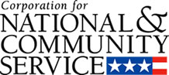

Corporation for National and Community Service

General Program Overview
AmeriCorps provides resources, both human and financial, to organizations that engage Americans in intensive service to meet our country’s critical needs.
Grantees use the funding to support AmeriCorps members for intensive service in their community. AmeriCorps grants partially cover the expense of operating an AmeriCorps program and do not cover general organizational expenses. A cash and in-kind match is required.

The main website can be accessed here: http://www.nationalservice.gov

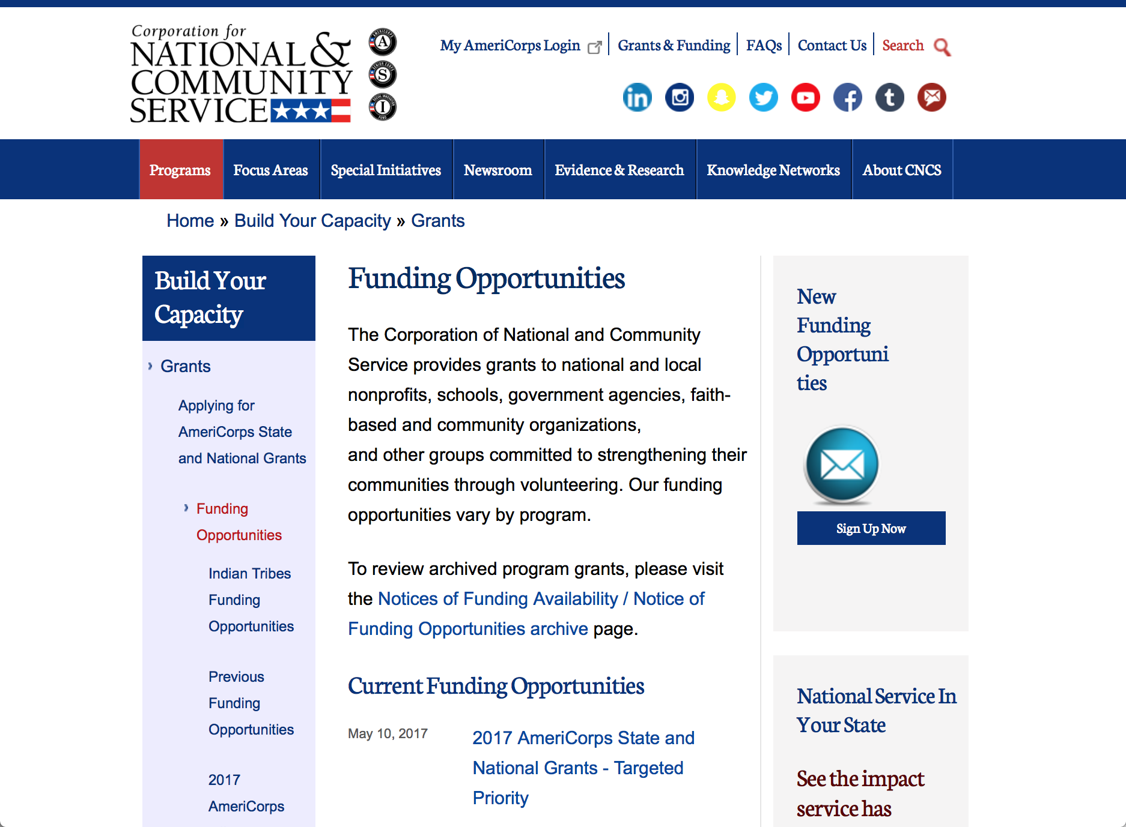

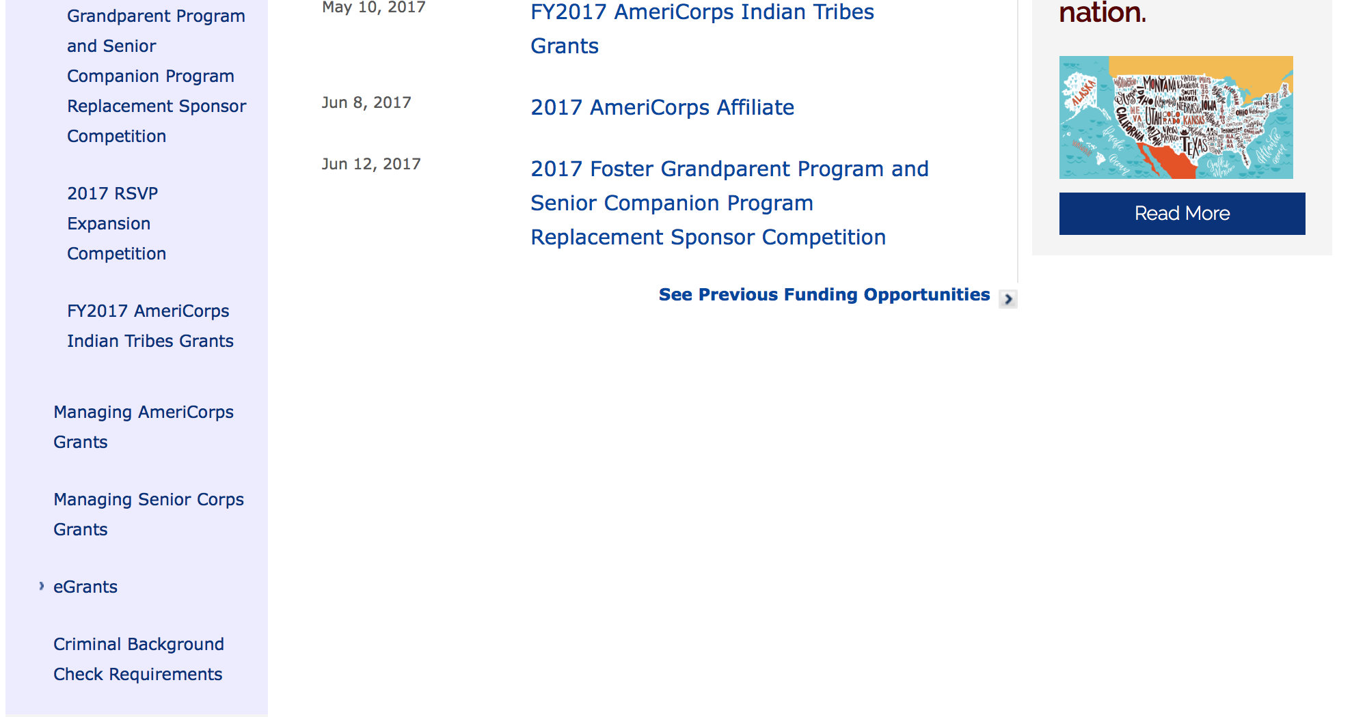
For access to further funding information: click here

http://www.nationalservice.gov/build-your-capacity/grants/funding-opportunities

Programs:

National Service and Civic Engagement Research Competition
Synopsis 1

Document Type: | Grants Notice
Funding Opportunity Number: | CNCS-05-16-2017
Funding Opportunity Title: | National Service and Civic Engagement Research Competition
Opportunity Category: | Discretionary
Opportunity Category Explanation:
Funding Instrument Type: | Cooperative Agreement
Category of Funding Activity: | Other (see text field entitled "Explanation of Other Category of Funding Activity" for clarification)
Category Explanation: | Civic Engagement and INfrastructure
Expected Number of Awards:
CFDA Number(s): | 94.026 -- National Service and Civic Engagement Research Competition
Cost Sharing or Matching Requirement: | No
Version: | Synopsis 1
Posted Date: | May 16, 2017
Last Updated Date: | May 16, 2017
Original Closing Date for Applications: | Jul 11, 2017
Current Closing Date for Applications: | Jul 11, 2017
Archive Date: | Aug 10, 2017
Estimated Total Program Funding:
Award Ceiling: | $150,000
Award Floor: | $20,000
Eligible Applicants: | Public and State controlled institutions of higher education  Private institutions of higher education
Agency Name: | Corporation for National and Community Service
Description: | This grant funds research on civic infrastructure and civic engagement and related concepts. For 2017 the three broad priority areas include how civic infrastructure and civic engagement are defined measured developed and hindered, how individuals civic engagement changes over the course of a lifetime, impacts associated with civic engagement, volunteering or national service. This competition is only open to institutions of higher education and funds projects in two categories -dissertation and scholars. Award amounts are expected to be in the range of $20,000 to $150,000 up to 2 years
Link to Additional Information: | full competition details
Grantor Contact Information: | If you have difficulty accessing the full announcement electronically, please contact:  NationalServiceResearch@cns.gov  competition mailbox

http://www.grants.gov/web/grants/view-opportunity.html?oppId=293872

Research:

Reminders:

National Service In Hawaii
National Service in Your State - Hawaii
2015-2016

Meeting Community Needs in Hawaii: More than 3,100 people of all ages and backgrounds are helping to meet local needs, strengthen communities, and increase civic engagement through national service in Hawaii. Serving at more than 450 locations throughout the state, these citizens tutor and mentor children, support veterans and military families, provide health services, restore the environment, respond to disasters, increase economic opportunity, and recruit and manage volunteers. This year, the Corporation for National and Community Service (CNCS) will commit more than $6,260,000 to support Hawaii communities through national service initiatives. Through a unique public-private partnership, this federal investment will leverage an additional $9,060,000 in other resources to strengthen community impact, build local support, and increase return on taxpayer dollars. Nationwide, CNCS, its grantees, and project sponsors generated more than $1.25 billion in outside resources from businesses, foundations, public agencies, and other sources in FY 2015.

AmeriCorps
This year, AmeriCorps will provide more than 560 individuals the opportunity to provide intensive, results-driven service to meet education, environmental, health, economic, and other pressing needs in communities across Hawaii. Most AmeriCorps grant funding goes to the Hawaii Commission on National & Community Service, which in turn awards grants to nonprofit groups to respond to local needs. Most of the remainder of the grant funding is distributed by CNCS directly to multi-state and national organizations through a competitive grants process. Other individuals serve through AmeriCorps VISTA, whose members help bring individuals and communities out of poverty by serving full-time to fight illiteracy, improve health services, create businesses, and increase housing opportunities, and AmeriCorps NCCC (National Civilian Community Corps), a 10-month, full time residential program for men and women between the ages of 18 and 24. In exchange for their service, AmeriCorps members earn an education award that can be used to pay for college or to pay back qualified student loans. Since 1994, more than 5,900 Hawaii residents have served more than 6.4 million hours and have qualified for Segal AmeriCorps Education Awards totaling more than $14,980,000.
Download: AmeriCorps in Hawaii (PDF)
Senior Corps
More than 2,500 seniors in Hawaii contribute their time and talents in one of three Senior Corps programs. Foster Grandparents serve one-on-one as tutors and mentors to more than 310 young people who have special needs. Senior Companions help more than 220 homebound seniors and other adults maintain independence in their own homes. RSVP volunteers conduct safety patrols, renovate homes, protect the environment, tutor and mentor youth, respond to natural disasters, and provide other services through more than 250 groups across Hawaii.
Download: Senior Corps in Hawaii (PDF)

The Corporation for National and Community Service is a federal agency that improves lives, strengthens communities, and fosters civic engagement through service and volunteering. CNCS annually engages more than five million Americans in service to meet local needs through Senior Corps, AmeriCorps, and national days of service; improves communities through the Social Innovation Fund, and leads President Obama's national call to service initiative, United We Serve. To learn more visit NationalService.gov or Serve.gov or call 202-606-5000 or TTY 1-800-833-3722.

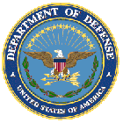

U.S. Department of Defense

Doing Business with the Department of Defense

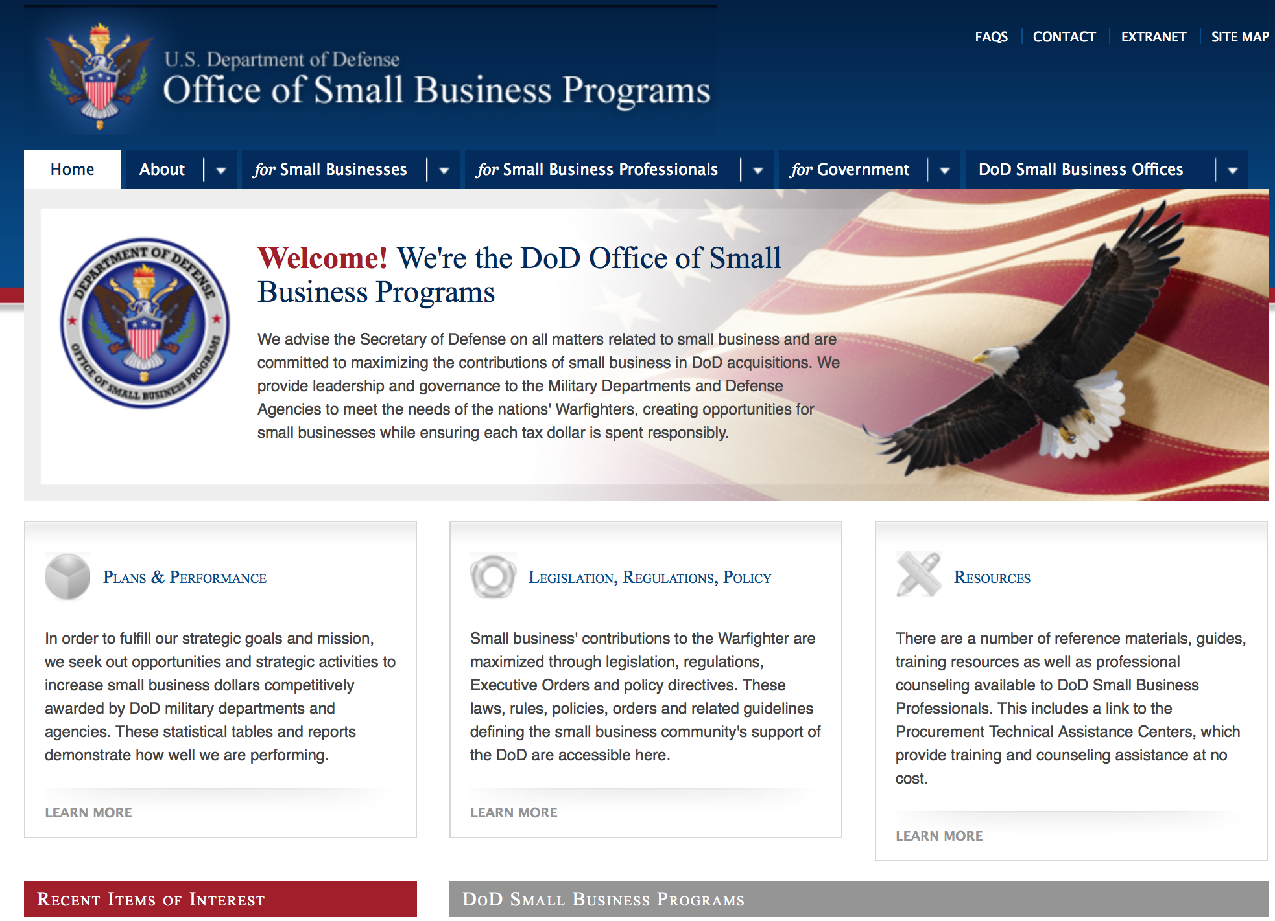
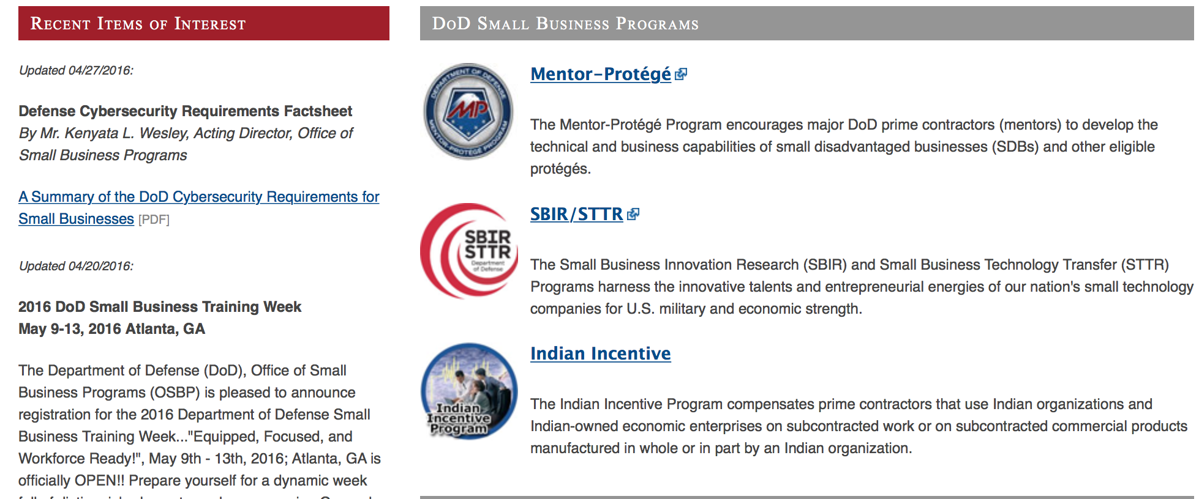

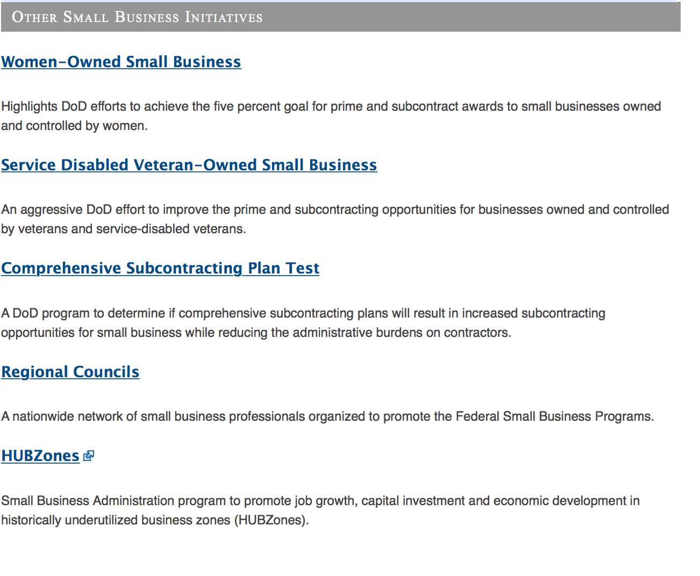
http://www.acq.osd.mil/osbp/

Doing Business with the DoD

Resources

Procurement Technical Assistance Centers (PTACs)

Procurement Technical Assistance Centers (PTACs) are charged with assisting businesses in learning how to do business with federal, state, and local governments. PTACs are a local resource available at no or nominal cost that can provide assistance to business firms in marketing their products and services. They offer training to businesses on how to research and bid on contracts, assist with registration requirements, provide bid-matching services, and assist with pre and post contracting issues.

Prime Contractors with Subcontracting Plans [xlsx]

Directory last updated 6/2017

This FY 2014 directory is intended for small business concerns seeking opportunities with DoD prime contractors. The directory is a listing of large business prime contractors who are required to establish subcontracting plans with goals. The report is generated from data contained in the Individual Subcontract Reports (ISRs) submitted in the Electronic Subcontracting Reporting System (eSRS) by contractors and from data contained in the Federal Procurement Data System (FPDS). The directory includes the name of the prime contractor; the major product/service code (PSC) provided to DoD; the major NAICS of the company; name, telephone number and email address of the company’s point of contact; contract number with the effective date and completion date, ultimate contract value and obligated dollars. In addition, many companies have websites with additional information which may be useful in your search for subcontracting opportunities or teaming arrangements.

Locate a Small Business Professional

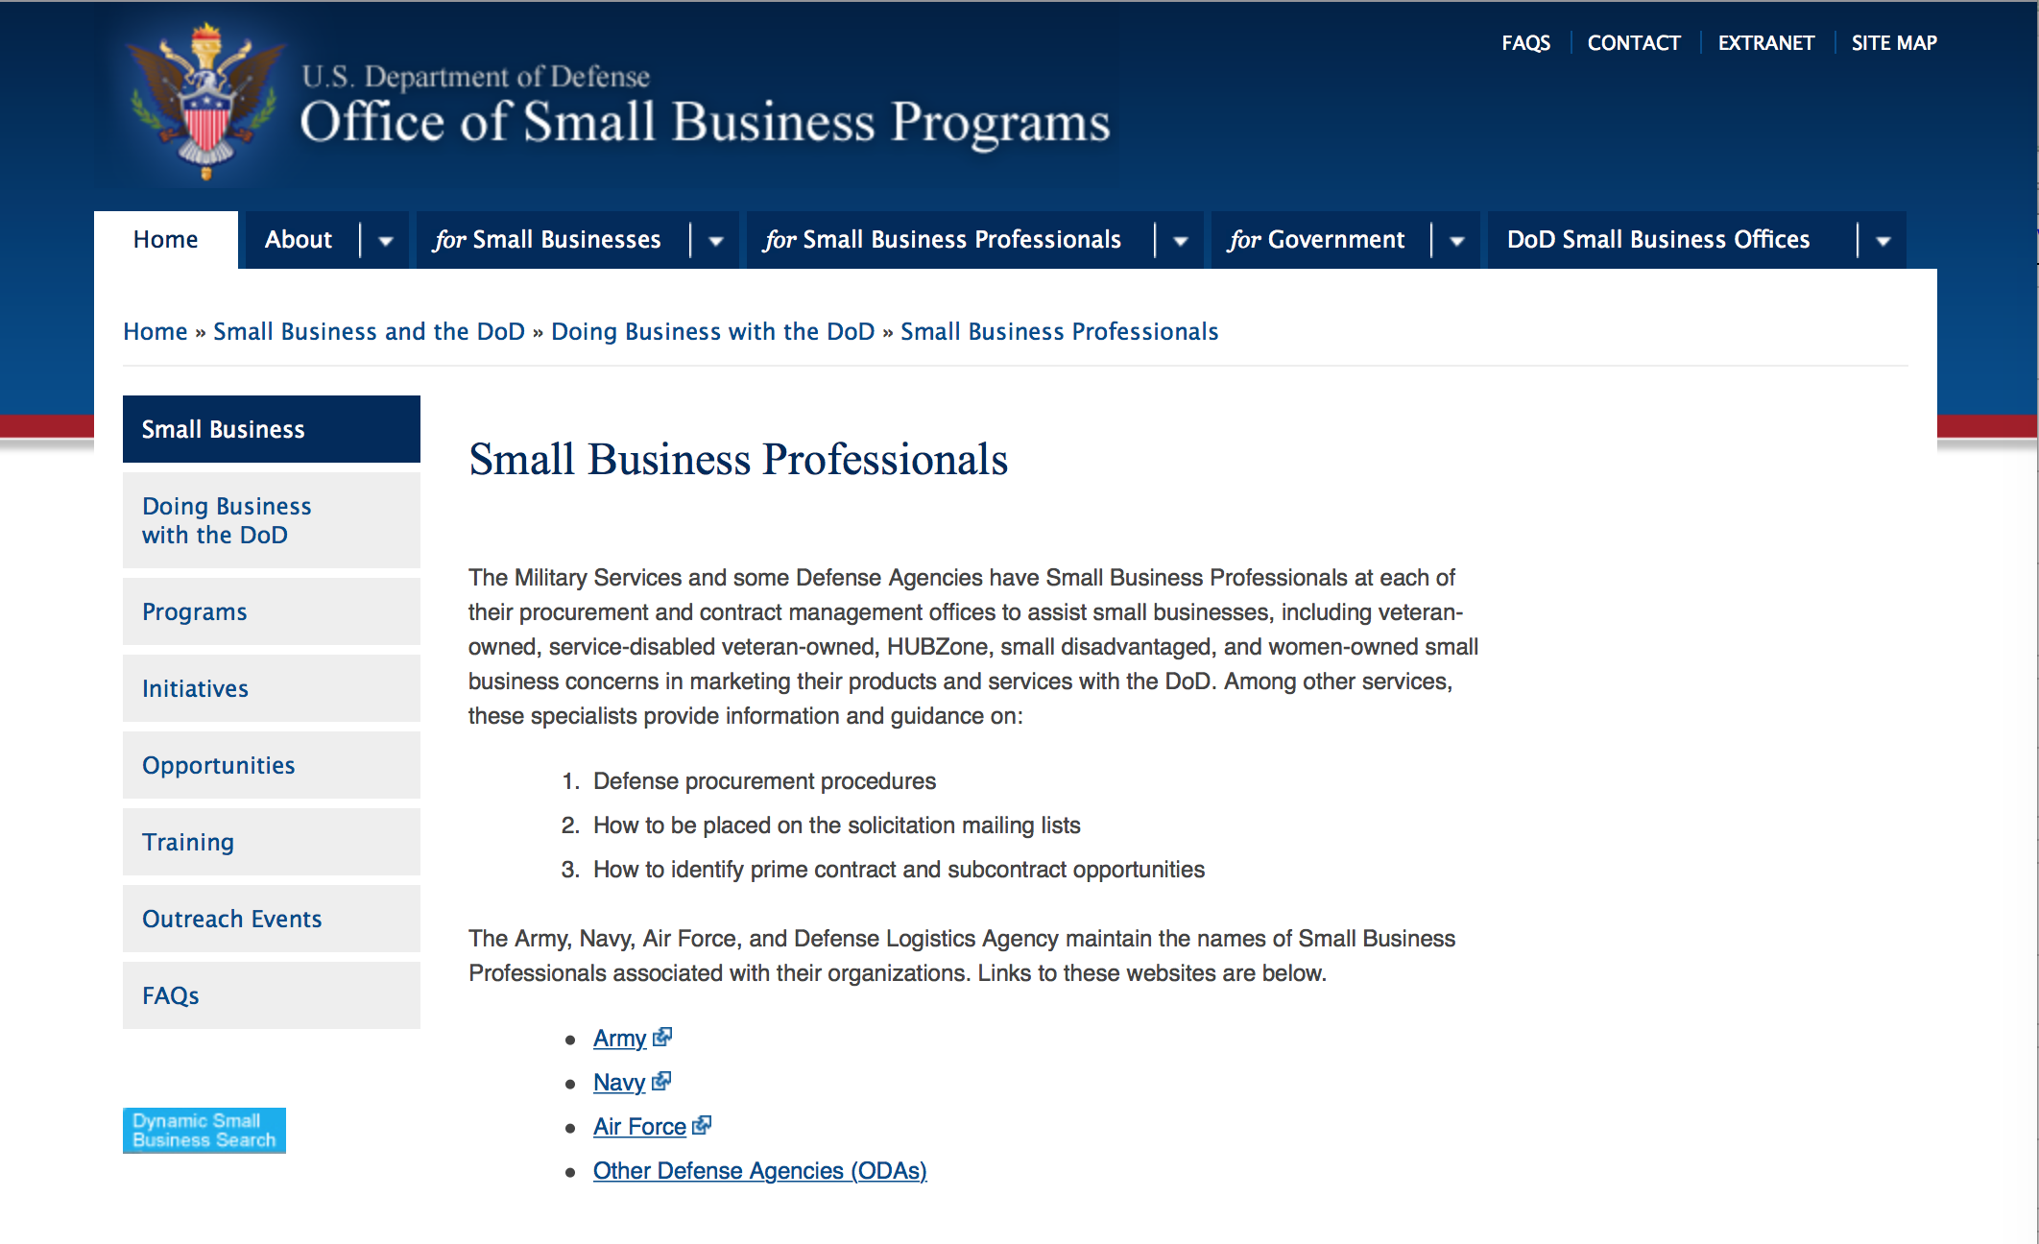

Non-Appropriated Fund Customers

Non-appropriated fund customers operate similar to non-profit organizations and include commissaries, exchanges, recreation and fitness centers, dining at officer/enlisted/civilian clubs, and barber/beauty services, just to name a few.

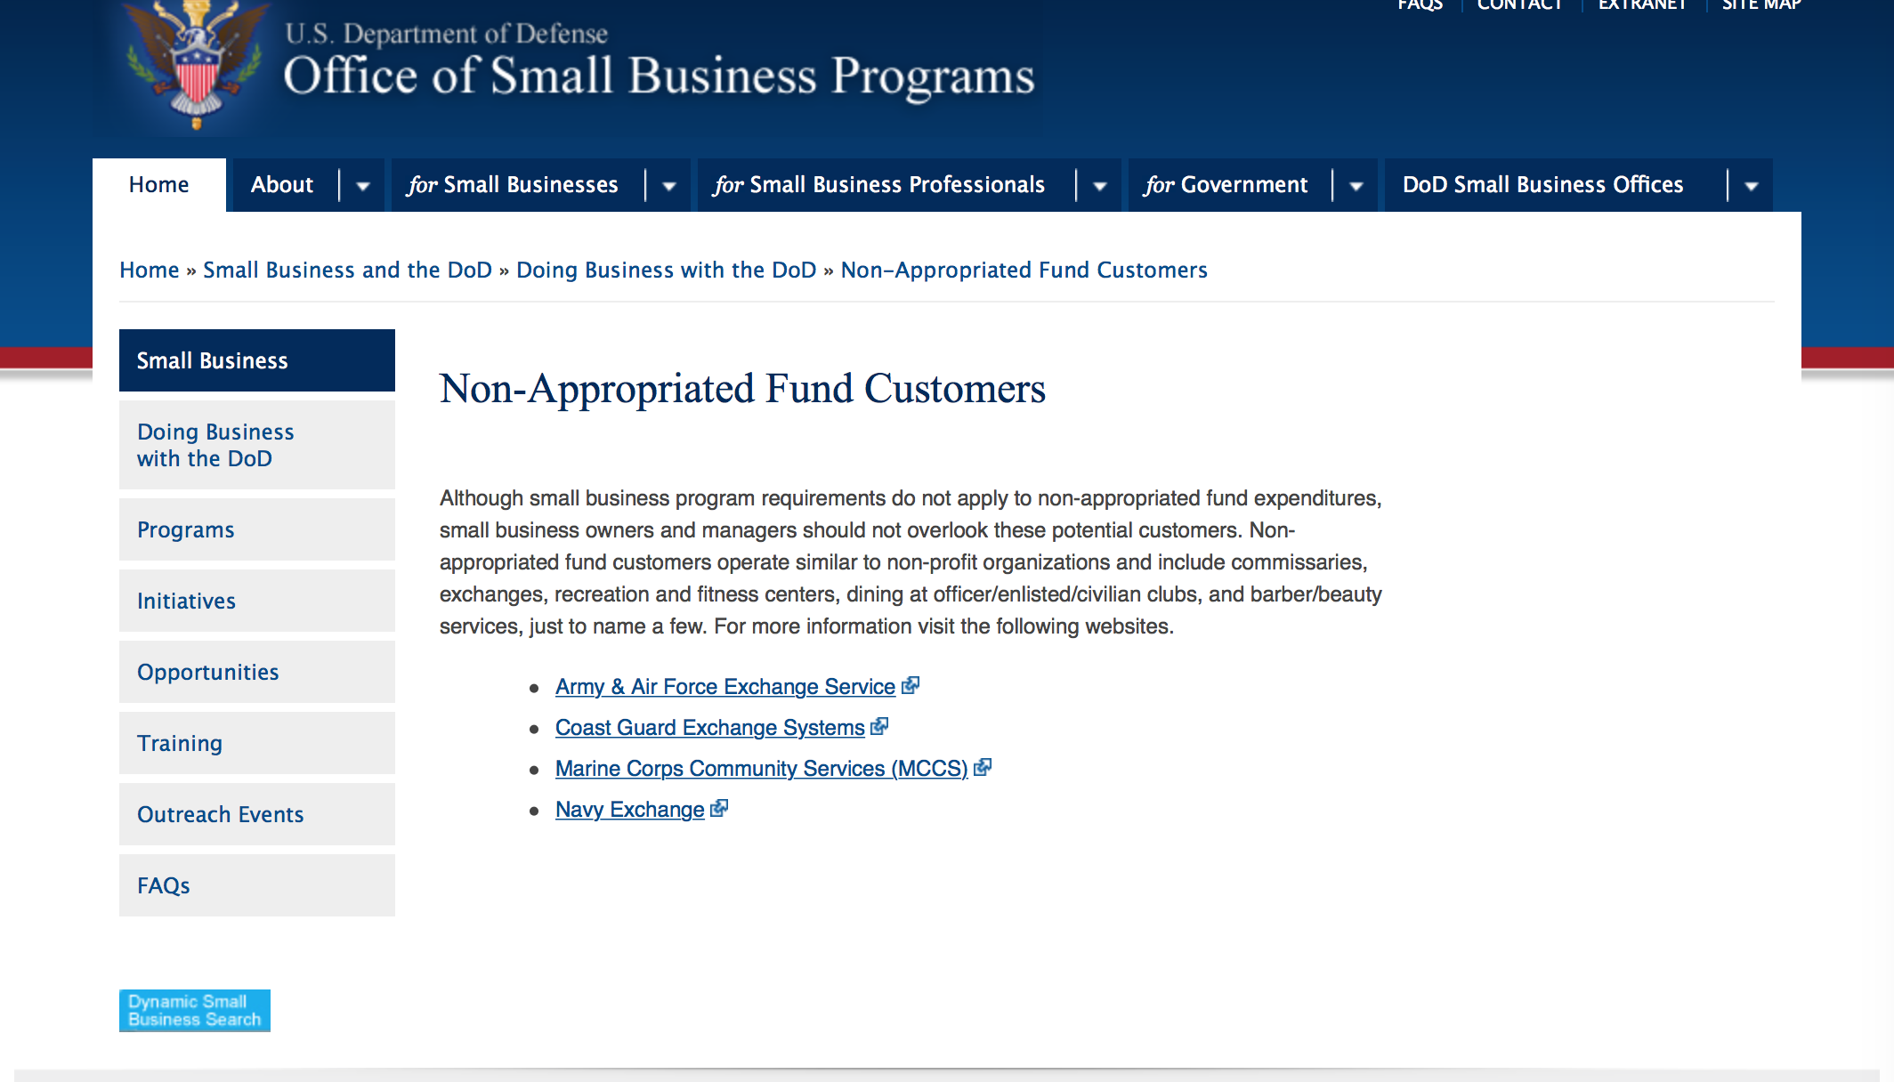

For more information click here.

Research:

THE SCIENCE, MATHEMATICS AND RESEARCH FOR TRANSFORMATION (SMART) SCHOLARSHIP FOR SERVICE PROGRAM
Synopsis 1
http://www.grants.gov/web/grants/view-opportunity.html?oppId=293738

Dept. of the Army -- USAMRAA
DoD Prostate Cancer Early Investigator Research Award
Synopsis 1
http://www.grants.gov/web/grants/view-opportunity.html?oppId=294132

Dept. of the Army -- USAMRAA
DoD Prostate Cancer Physician Research Award
Synopsis 1
http://www.grants.gov/web/grants/view-opportunity.html?oppId=294133

Dept. of the Army -- USAMRAA
DoD Prostate Cancer Clinical Consortium Award
Synopsis 1
http://www.grants.gov/web/grants/view-opportunity.html?oppId=294110

Dept. of the Army -- USAMRAA
DoD Prostate Cancer Impact Award
Synopsis 1
http://www.grants.gov/web/grants/view-opportunity.html?oppId=294109

Dept. of the Army -- USAMRAA
DoD Prostate Cancer Idea Development Award
Synopsis 1
http://www.grants.gov/web/grants/view-opportunity.html?oppId=294108

Dept. of the Army -- USAMRAA
DoD Prostate Cancer Health Disparity Research Award
Synopsis 1
http://www.grants.gov/web/grants/view-opportunity.html?oppId=294105

Dept. of the Army -- USAMRAA
FY17 DoD Tuberous Sclerosis Complex Research Program, Exploration- Hypothesis Development Award
Synopsis 1
http://www.grants.gov/web/grants/view-opportunity.html?oppId=294093

Dept. of the Army -- USAMRAA
DoD Multiple Sclerosis Research Program, Investigator-Initiated Research Award
Synopsis 1
http://www.grants.gov/web/grants/view-opportunity.html?oppId=293758

Dept. of the Army -- USAMRAA
DoD Bone Marrow Failure Idea Development Award
Synopsis 1
http://www.grants.gov/web/grants/view-opportunity.html?oppId=293681

Dept. of the Army -- USAMRAA
US Special Operations Command Broad Agency Announcement
Synopsis 1
http://www.grants.gov/web/grants/view-opportunity.html?oppId=293654

Dept. of the Army -- USAMRAA
DoD ALSRP Therapeutic Idea Award
Synopsis 1
http://www.grants.gov/web/grants/view-opportunity.html?oppId=293656

Dept. of the Army -- USAMRAA
FY17 BCRP Breakthrough Award Levels 1 & 2
Synopsis 1
http://www.grants.gov/web/grants/view-opportunity.html?oppId=293659

Dept. of the Army -- USAMRAA
DoD Breast Cancer Breakthrough Fellowship Levels 3 and 4
Synopsis 1
http://www.grants.gov/web/grants/view-opportunity.html?oppId=293660

Dept. of the Army -- USAMRAA
DoD BCRP Breakthrough Fellowship
Synopsis 1
http://www.grants.gov/web/grants/view-opportunity.html?oppId=293642

Dept. of the Army -- USAMRAA
DoD Ovarian Cancer Investigator-Initiated Research Award
Synopsis 1
http://www.grants.gov/web/grants/view-opportunity.html?oppId=293664

Dept. of the Army -- USAMRAA
DoD Ovarian Cancer Clinical Development Award
Synopsis 1
http://www.grants.gov/web/grants/view-opportunity.html?oppId=293665

Dept. of the Army -- USAMRAA
DoD Ovarian Cancer Pilot Award
Synopsis 1
http://www.grants.gov/web/grants/view-opportunity.html?oppId=293667

Dept. of the Army -- USAMRAA
DoD Multiple Sclerosis Research Program, Exploration-Hypothesis Development Award
Synopsis 1
http://www.grants.gov/web/grants/view-opportunity.html?oppId=293853

Dept. of the Army -- USAMRAA
DoD Lung Cancer, Concept Award
Synopsis 1
http://www.grants.gov/web/grants/view-opportunity.html?oppId=293854

Dept. of the Army -- USAMRAA
DoD Lung Cancer Idea Development Award
Synopsis 1
http://www.grants.gov/web/grants/view-opportunity.html?oppId=293856

Dept. of the Army -- USAMRAA
DoD Lung Cancer Investigator-Initiated Translational Research Award
Synopsis 1
http://www.grants.gov/web/grants/view-opportunity.html?oppId=293859

Dept. of the Army -- USAMRAA
DoD Vision Research Program, Technology/ Therapeutic Development Award
Synopsis 1
http://www.grants.gov/web/grants/view-opportunity.html?oppId=293862

Dept. of the Army -- USAMRAA
DoD Gulf War Illness, Investigator-Initiated Focused Research Award
Synopsis 1
http://www.grants.gov/web/grants/view-opportunity.html?oppId=293983

Dept. of the Army -- USAMRAA
Peer Reviewed Orthopaedic Applied Research Award
Synopsis 1
http://www.grants.gov/web/grants/view-opportunity.html?oppId=294143

Dept. of the Army -- USAMRAA
DoD Peer Reviewed Medical Clinical Trial Award
Synopsis 1
http://www.grants.gov/web/grants/view-opportunity.html?oppId=294147

Dept. of the Army -- USAMRAA
DoD Peer Reviewed Medical Discovery Award
Synopsis 1
http://www.grants.gov/web/grants/view-opportunity.html?oppId=294159

Dept. of the Army -- USAMRAA
DoD Peer Reviewed Medical Focused Program Award
Synopsis 1
http://www.grants.gov/web/grants/view-opportunity.html?oppId=294160

Dept. of the Army -- USAMRAA
DoD Peer Reviewed Medical Investigator-Initiated Research Award
Synopsis 1
http://www.grants.gov/web/grants/view-opportunity.html?oppId=294161

Dept. of the Army -- USAMRAA
DoD Peer Reviewed Medical Technology/Therapeutic Development Award
Synopsis 1
http://www.grants.gov/web/grants/view-opportunity.html?oppId=294162

Missile Defense Agency
Missile Defense Agency (MDA) Science, Technology, Engineering & Mathematics (STEM) Outreach Boosting Engineering Science and Technology (BEST) Robotics Grant: Local Education Agency (LEA) National Teacher Professional Development (NTPD) 2017
Synopsis 1 & 3
http://www.grants.gov/web/grants/view-opportunity.html?oppId=293587

Missile Defense Agency
Missile Defense Agency (MDA) Science, Technology, Engineering & Mathematics (STEM) Boosting Engineering Science & Technology (BEST) Robotics Grant: Higher Education Agency (HEA) Local Hub Teacher Professional Development (LHTPD) 2017
Synopsis 1 & 3
http://www.grants.gov/web/grants/view-opportunity.html?oppId=293594

Office of Naval Research
Department of Defense (DoD) Explosive Ordnance Disposal (EOD) Applied Research Program
Synopsis 1
http://www.grants.gov/web/grants/view-opportunity.html?oppId=293811

Modifications:

Air Force Office of Scientific Research
Fiscal Year (FY) 2018 Department of Defense Multidisciplinary Research Program of the University Research Initiative
Synopsis 3
http://www.grants.gov/web/grants/view-opportunity.html?oppId=292607

Dept of the Army -- Materiel Command
Air Force -- Research Lab
Composite Airframe Life Extension (CALE)
Synopsis 2
http://www.grants.gov/web/grants/view-opportunity.html?oppId=276916

Dept. of the Army -- USAMRAA
DoD Peer Reviewed Cancer, Idea Award with Special Focus
Synopsis 2
http://www.grants.gov/web/grants/view-opportunity.html?oppId=293959

Dept. of the Army -- USAMRAA
DoD Peer Reviewed Cancer, Translational Team Science Award
Synopsis 2
http://www.grants.gov/web/grants/view-opportunity.html?oppId=293961

DARPA - Tactical Technology Office
Innovative Systems for Military Missions
Synopsis 2
http://www.grants.gov/web/grants/view-opportunity.html?oppId=284170

Missile Defense Agency
Missile Defense Agency (MDA) Science, Technology, Engineering & Mathematics (STEM) Outreach Boosting Engineering Science and Technology (BEST) Robotics Grant: Local Education Agency (LEA) National Teacher Professional Development (NTPD) 2017
Synopsis 2
http://www.grants.gov/web/grants/view-opportunity.html?oppId=293587

Missile Defense Agency
Missile Defense Agency (MDA) Science, Technology, Engineering & Mathematics (STEM) Boosting Engineering Science & Technology (BEST) Robotics Grant: Higher Education Agency (HEA) Local Hub Teacher Professional Development (LHTPD) 2017
Synopsis 2
http://www.grants.gov/web/grants/view-opportunity.html?oppId=293594

Missile Defense Agency
Missile Defense Agency STEM Outreach BEST Robotics Grant
Synopsis 2, 3 & 4
http://www.grants.gov/web/grants/view-opportunity.html?oppId=293582

Dept of the Army -- Materiel Command
Fiscal Year (FY) 2018 Department of Defense Multidisciplinary Research Program of the University Research Initiative (MURI) - ARMY SUBMISSION
Synopsis 2
http://www.grants.gov/web/grants/view-opportunity.html?oppId=292649

Dept of the Army -- Materiel Command
THE SCIENCE, MATHEMATICS AND RESEARCH FOR TRANSFORMATION (SMART) SCHOLARSHIP FOR SERVICE PROGRAM
Synopsis 2
http://www.grants.gov/web/grants/view-opportunity.html?oppId=293738

Naval Supply Systems Command
FY17 ACQUISITION RESEARCH PROGRAM
Synopsis 3

http://www.grants.gov/web/grants/view-opportunity.html?oppId=292206

Reminders:

Department of Defense
Dept. of the Army -- Materiel Command
Fiscal Year 2018 Defense University Research Instrumentation Program (DURIP) - ARMY SUBMISSION
Synopsis 1

Document Type: |  | Grants Notice
Funding Opportunity Number: |  | PA-AFRL-AFOSR-2017-0001
Funding Opportunity Title: |  | Fiscal Year 2018 Defense University Research Instrumentation Program (DURIP) - ARMY SUBMISSION
Opportunity Category: |  | Discretionary
Opportunity Category Explanation:
Funding Instrument Type: |  | Grant
Category of Funding Activity: |  | Science and Technology and other Research and Development
Category Explanation:
Expected Number of Awards: |  | 100
CFDA Number(s): |  | 12.431 -- Basic Scientific Research
Cost Sharing or Matching Requirement: |  | No
Version: |  | Synopsis 1
Posted Date: |  | Mar 02, 2017
Last Updated Date: |  | Mar 02, 2017
Original Closing Date for Applications: |  | Jul 07, 2017 Pre-Proposal inquires and questions must be submitted not later than Friday, 16 Jun 2017.
Current Closing Date for Applications: |  | Jul 07, 2017 Pre-Proposal inquires and questions must be submitted not later than Friday, 16 Jun 2017.
Archive Date: |  | Jul 08, 2017
Estimated Total Program Funding: |  | $47,000,000
Award Ceiling: |  | $1,500,000
Award Floor: |  | $50,000
Eligible Applicants: |  | Others (see text field entitled "Additional Information on Eligibility" for clarification)  Private institutions of higher education  Public and State controlled institutions of higher education
Additional Information on Eligibility: |  | ELIGIBLE APPLICANTS: Accredited U.S. Institutions of Higher Education This competition is open to accredited U.S. institutions of higher education with degree granting programs in science, mathematics, and/or engineering except for-profit educational institutions.
Agency Name: | Dept. of the Army -- Materiel Command
Description: | The Department of Defense (DoD) announces the Fiscal Year 2018 Defense University Research Instrumentation Program (DURIP). DURIP is designed to improve the capabilities of accredited United States (U.S.) institutions of higher education to conduct research and to educate scientists and engineers in areas important to national defense, by providing funds for the acquisition of research equipment or instrumentation. For-profit organizations are not eligible for DURIP funding. We refer to eligible institutions of higher education as universities in the rest of this announcement. DURIP is part of the University Research Initiative (URI).
Link to Additional Information: | Funding Opportunity
Grantor Contact Information: | If you have difficulty accessing the full announcement electronically, please contact:  ANDREW FISKE PROCUREMENT ANALYST Phone (919) 549-4338  Army Point of Contact

http://www.grants.gov/web/grants/view-opportunity.html?oppId=292130

Air Force Office of Scientific Research
Fiscal Year 2018 Defense University Research Instrumentation Program (DURIP)
Synopsis 1

Document Type: |  | Grants Notice
Funding Opportunity Number: |  | PA-AFRL-AFOSR-2017-0001
Funding Opportunity Title: |  | Fiscal Year 2018 Defense University Research Instrumentation Program (DURIP)
Opportunity Category: |  | Discretionary
Opportunity Category Explanation:
Funding Instrument Type: |  | Grant
Category of Funding Activity: |  | Science and Technology and other Research and Development
Category Explanation:
Expected Number of Awards: |  | 100
CFDA Number(s): |  | 12.800 -- Air Force Defense Research Sciences Program
Cost Sharing or Matching Requirement: |  | No
Version: |  | Synopsis 1
Posted Date: |  | Mar 01, 2017
Last Updated Date: |  | Mar 01, 2017
Original Closing Date for Applications: |  | Jul 07, 2017 Pre-Proposal inquires and questions must be submitted not later than Friday, 16 Jun 2017.
Current Closing Date for Applications: |  | Jul 07, 2017 Pre-Proposal inquires and questions must be submitted not later than Friday, 16 Jun 2017.
Archive Date: |  | Jul 08, 2017
Estimated Total Program Funding: |  | $47,000,000
Award Ceiling: |  | $1,500,000
Award Floor: |  | $50,000
Eligible Applicants: |  | Public and State controlled institutions of higher education  Private institutions of higher education  Others (see text field entitled "Additional Information on Eligibility" for clarification)
Additional Information on Eligibility: |  | ELIGIBLE APPLICANTS: Accredited U.S. Institutions of Higher Education This competition is open to accredited U.S. institutions of higher education with degree granting programs in science, mathematics, and/or engineering except for-profit educational institutions.
Agency Name: | Air Force Office of Scientific Research
Description: | The Department of Defense (DoD) announces the Fiscal Year 2018 Defense University Research Instrumentation Program (DURIP). DURIP is designed to improve the capabilities of accredited United States (U.S.) institutions of higher education to conduct research and to educate scientists and engineers in areas important to national defense, by providing funds for the acquisition of research equipment or instrumentation. For-profit organizations are not eligible for DURIP funding. We refer to eligible institutions of higher education as universities in the rest of this announcement. DURIP is part of the University Research Initiative (URI).
Link to Additional Information: | AFOSR - Funding Opportunities
Grantor Contact Information: | If you have difficulty accessing the full announcement electronically, please contact:  MS. KATIE WISECARVER Phone: (703) 696-9544  Announcement Email

http://www.grants.gov/web/grants/view-opportunity.html?oppId=292128



Department of Education
Grant Programs Overview at the Department of Education

The general information page for Education Grant funding is an excellent resource describing the three types of grants awarded by the Department of Education. See the screen shot of the Department of Education web page below:

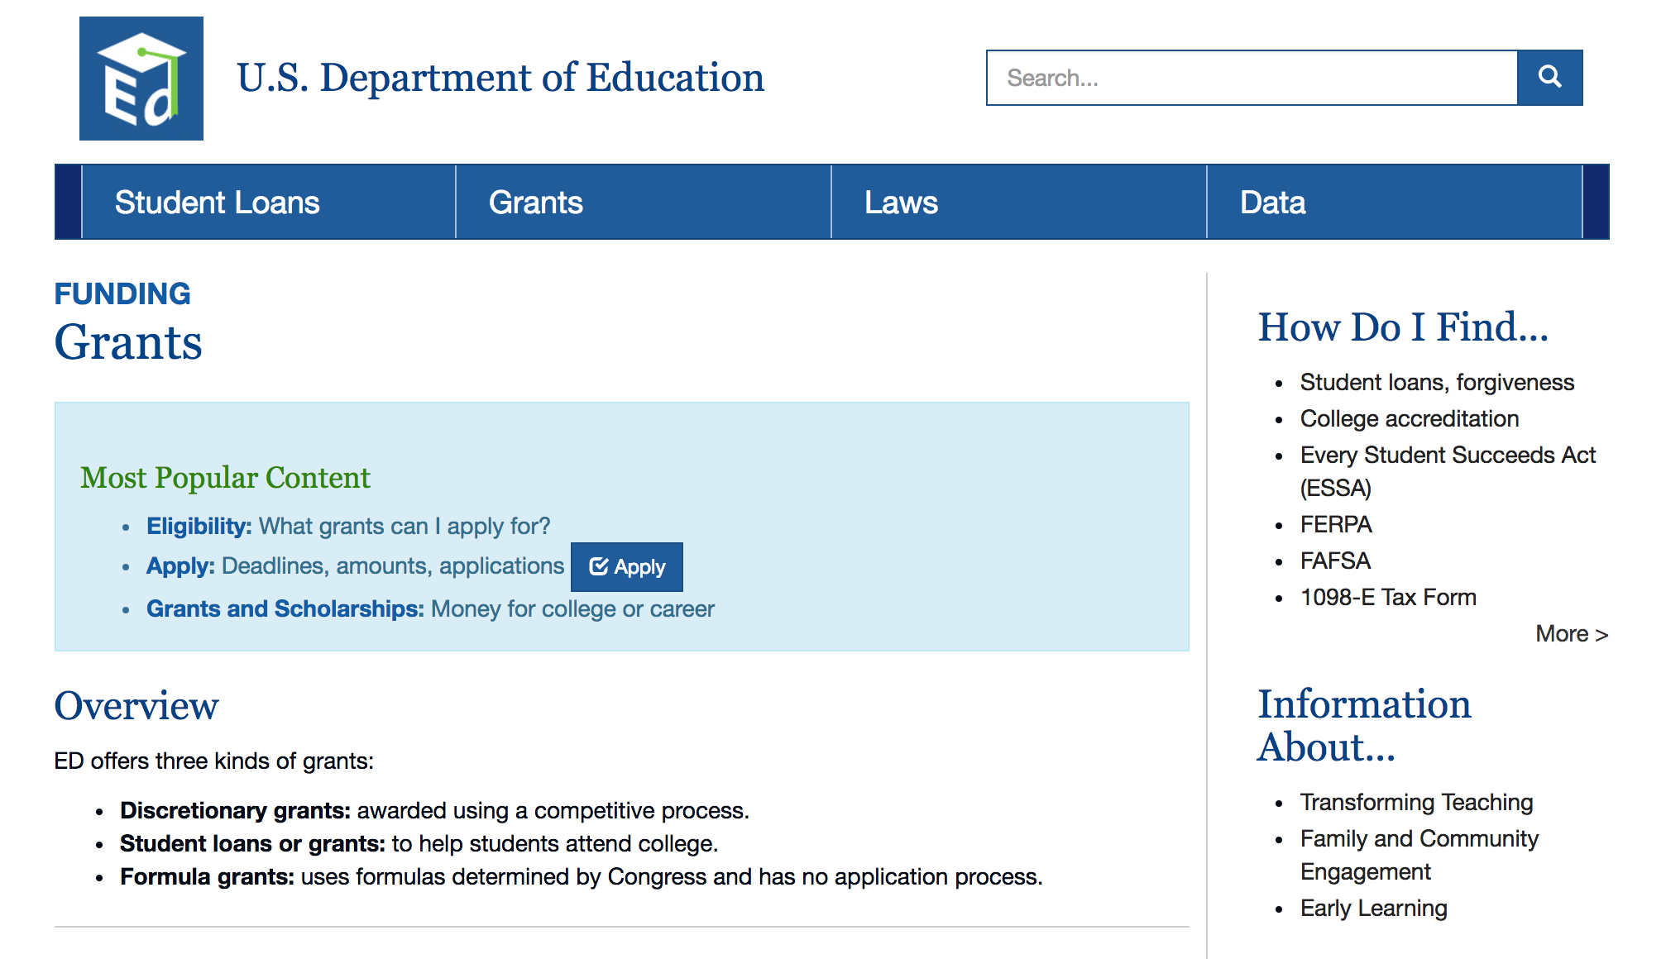
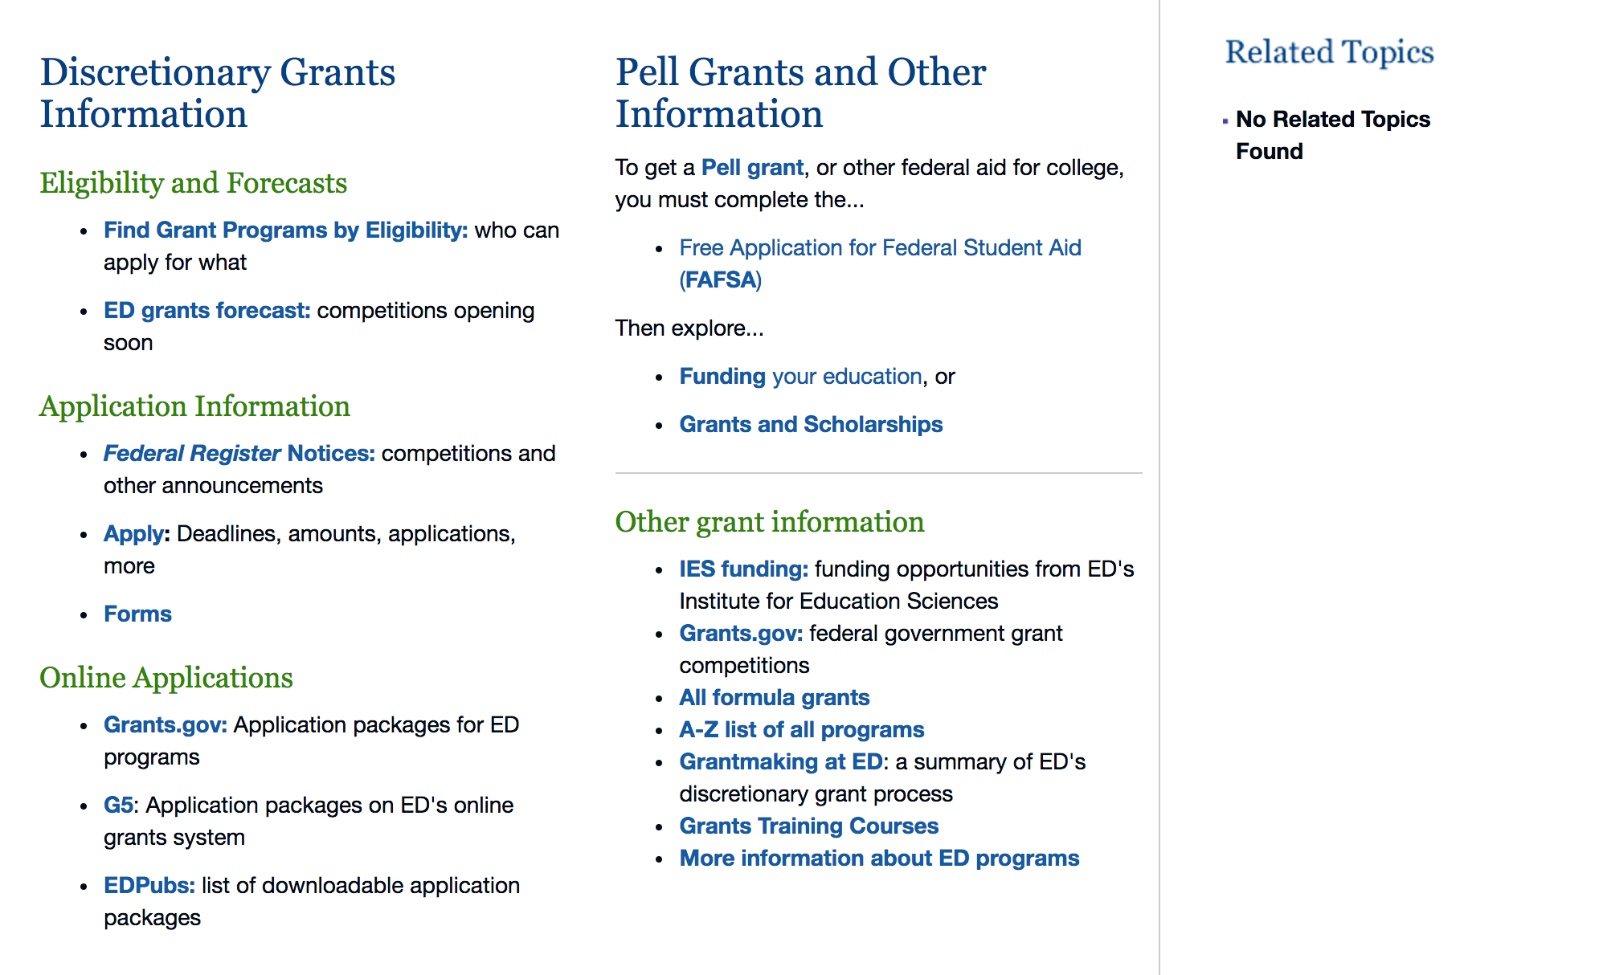

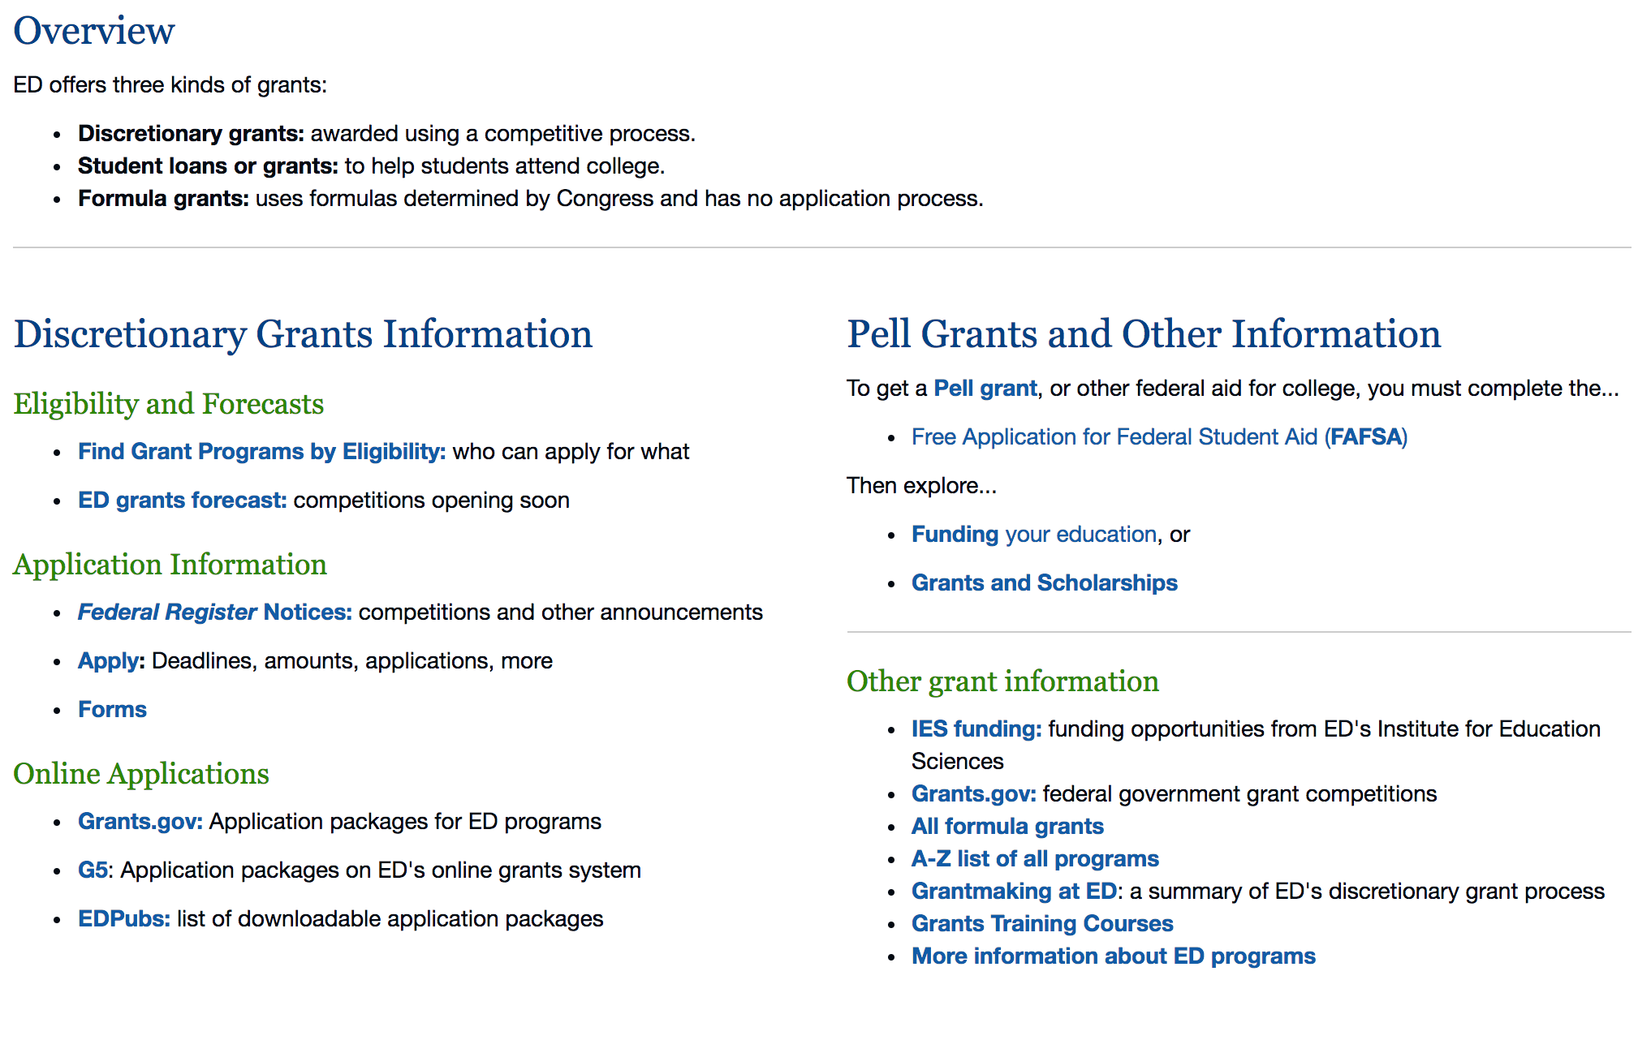

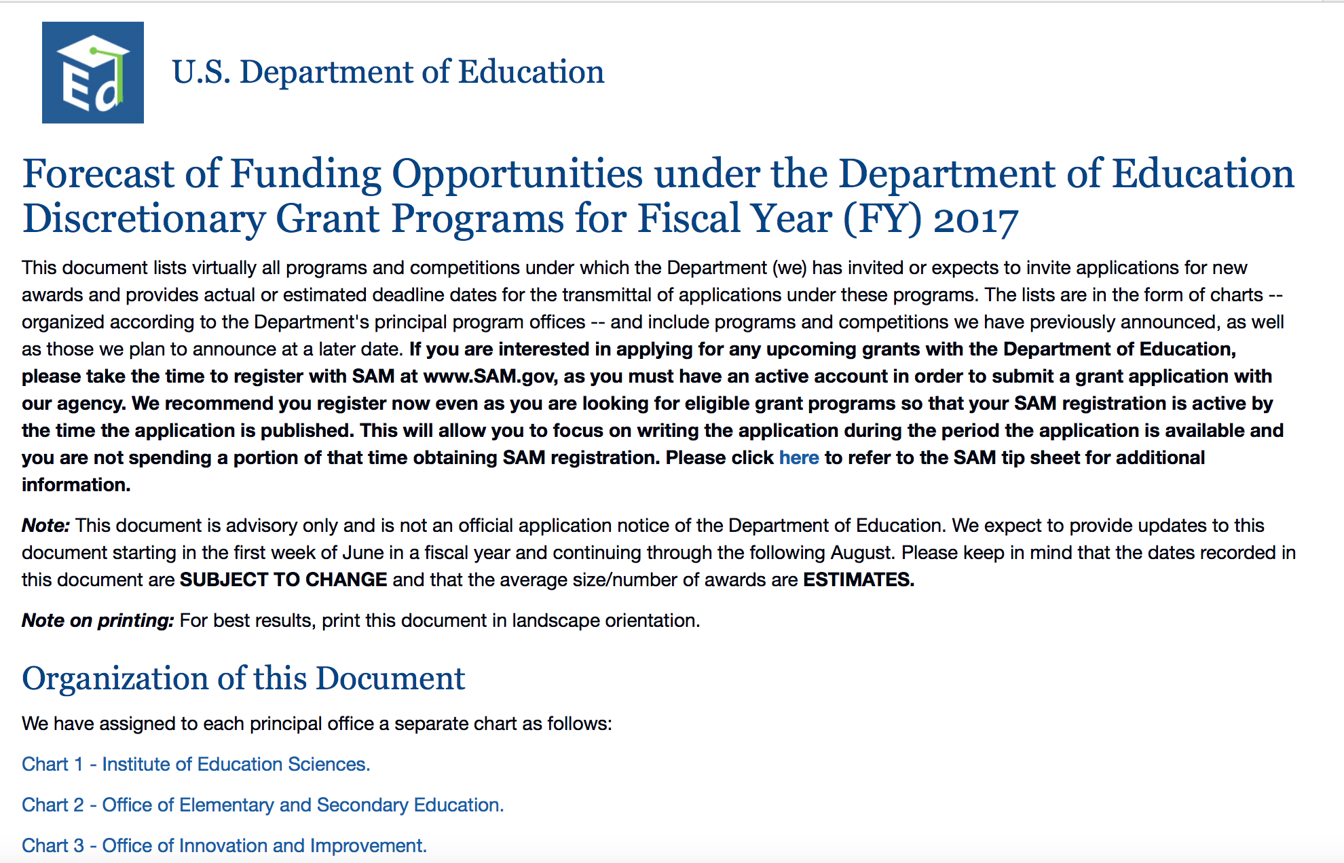
https://www2.ed.gov/fund/grants-apply.html?src=pn

Programs:

Office of Elementary and Secondary Education (OESE): Jacob K. Javits Gifted and Talented Students Education Program CFDA Number 84.206A
Synopsis 1
Document Type: | Grants Notice
Funding Opportunity Number: | ED-GRANTS-051817-001
Funding Opportunity Title: | Office of Elementary and Secondary Education (OESE): Jacob K. Javits Gifted and Talented Students Education Program CFDA Number 84.206A
Opportunity Category: | Discretionary
Opportunity Category Explanation:
Funding Instrument Type: | Grant
Category of Funding Activity: | Education
Category Explanation:
Expected Number of Awards: | 12
CFDA Number(s): | 84.206 -- Javits Gifted and Talented Students Education
Cost Sharing or Matching Requirement: | No
Version: | Synopsis 1
Posted Date: | May 18, 2017
Last Updated Date: | May 18, 2017
Original Closing Date for Applications: | Jun 22, 2017 Applications Available: May 18, 2017. Deadline for Transmittal of Applications: June 22, 2017.
Current Closing Date for Applications: | Jun 22, 2017 Applications Available: May 18, 2017. Deadline for Transmittal of Applications: June 22, 2017.
Archive Date: | Jul 22, 2017
Estimated Total Program Funding: | $5,000,000
Eligible Applicants: | Public and State controlled institutions of higher education  Special district governments  Private institutions of higher education  Others (see text field entitled "Additional Information on Eligibility" for clarification)  City or township governments  Nonprofits that do not have a 501(c)(3) status with the IRS, other than institutions of higher education  State governments  For profit organizations other than small businesses  Nonprofits having a 501(c)(3) status with the IRS, other than institutions of higher education  County governments
Additional Information on Eligibility: | Eligible Applicants: State educational agencies; local educational agencies; the Bureau of Indian Education; IHEs; other public agencies; and other private agencies and organizations.
Agency Name: | Department of Education
Description: | Note: Each funding opportunity description is a synopsis of information in the Federal Register application notice. For specific information about eligibility, please see the official application notice. The official version of this document is the document published in the Federal Register. Free Internet access to the official edition of the Federal Register and the Code of Federal Regulations is available on GPO Access at: http://www.access.gpo.gov/nara/index.html. Please review the official application notice for pre-application and application requirements, application submission information, performance measures, priorities and program contact information. Purpose of Program: The Javits program supports evidence-based research, demonstration projects, innovative strategies, and similar activities designed to build and enhance the ability of elementary and secondary schools nationwide to identify gifted and talented (as defined in this notice) students and meet their special educational needs. Catalog of Federal Domestic Assistance (CFDA) number 84.206A. Applications for grants under the Javits program, CFDA number 84.206A, must be submitted electronically using the Governmentwide Grants.gov Apply site at www.Grants.gov. Through this site, you will be able to download a copy of the application package, complete it offline, and then upload and submit your application. You may not email an electronic copy of a grant application to us. You may access the electronic grant application for the Javits program at www.Grants.gov. You must search for the downloadable application package for this competition by the CFDA number. Do not include the CFDA number's alpha suffix in your search (e.g., search for 84.206, not 84.206A).
Link to Additional Information: | Office of Elementary and Secondary Education (OESE): Jacob K. Javits Gifted and Talented Students Education Program CFDA Number 84.206A; Notice Inviting Applications for New Awards for Fiscal Year (FY) 2017
Grantor Contact Information: | If you have difficulty accessing the full announcement electronically, please contact:  Julius Cotton ED Grants.gov FIND Systems Admin. Phone 202-245-6288 EducationGrantInquiries@ed.gov Program Manager: Theda Zawaiza, U.S. Department of Education, 400 Maryland Avenue SW., Room number 3E310, Washington, DC 20202-6200. Telephone: (202) 205-3783 or e-Mail: Theda.Zawaiza@ed.gov.  e-Mail: Program Manager

http://www.grants.gov/web/grants/view-opportunity.html?oppId=293914

Office of Postsecondary Education (OPE): Child Care Access Means Parents in School (CCAMPIS) Program CFDA Number 84.335A
Synopsis 1
Document Type: | Grants Notice
Funding Opportunity Number: | ED-GRANTS-052317-001
Funding Opportunity Title: | Office of Postsecondary Education (OPE): Child Care Access Means Parents in School (CCAMPIS) Program CFDA Number 84.335A
Opportunity Category: | Discretionary
Opportunity Category Explanation:
Funding Instrument Type: | Grant
Category of Funding Activity: | Education
Category Explanation:
Expected Number of Awards: | 72
CFDA Number(s): | 84.335 -- Child Care Access Means Parents in School
Cost Sharing or Matching Requirement: | No
Version: | Synopsis 1
Posted Date: | May 23, 2017
Last Updated Date: | May 23, 2017
Original Closing Date for Applications: | Jun 22, 2017 Applications Available: May 23, 2017. Deadline for Transmittal of Applications: June 22, 2017.
Current Closing Date for Applications: | Jun 22, 2017 Applications Available: May 23, 2017. Deadline for Transmittal of Applications: June 22, 2017.
Archive Date: | Jul 22, 2017
Estimated Total Program Funding: | $8,549,000
Award Ceiling:
Award Floor: | $10,000
Eligible Applicants: | Public and State controlled institutions of higher education  Private institutions of higher education  Others (see text field entitled "Additional Information on Eligibility" for clarification)
Additional Information on Eligibility: | Eligible Applicants: Any institution of higher education (IHE) that during FY 2016 awarded a total of $350,000 or more of Federal Pell Grant funds to students enrolled at the institution. At this time, we do not anticipate conducting a competition for new awards in FY 2018. Institutions that currently have a CCAMPIS Program grant with a project ending in 2017 or 2018 are eligible to apply for a new grant during this FY 2017 competition.
Agency Name: | Department of Education
Description: | Note: Each funding opportunity description is a synopsis of information in the Federal Register application notice. For specific information about eligibility, please see the official application notice. The official version of this document is the document published in the Federal Register. Free Internet access to the official edition of the Federal Register and the Code of Federal Regulations is available on GPO Access at: http://www.access.gpo.gov/nara/index.html. Please review the official application notice for pre-application and application requirements, application submission information, performance measures, priorities and program contact information. Purpose of Program: The CCAMPIS Program supports the participation of low-income parents in postsecondary education through provision of campus-based child care services. Catalog of Federal Domestic Assistance (CFDA) number 84.335A. Applications for grants under the CCAMPIS Program, CFDA number 84.335A, must be submitted electronically using the Governmentwide Grants.gov Apply site at www.Grants.gov. Through this site, you will be able to download a copy of the application package, complete it offline, and then upload and submit your application. You may not email an electronic copy of a grant application to us. You may access the electronic grant application for the CCAMPIS Program at www.Grants.gov. You must search for the downloadable application package for this competition by the CFDA number. Do not include the CFDA number's alpha suffix in your search (e.g., search for 84.335, not 84.335A).
Link to Additional Information: | Office of Postsecondary Education (OPE): Child Care Access Means Parents in School (CCAMPIS) Program CFDA Number 84.335A; Notice Inviting Applications for New Awards for Fiscal Year (FY) 2017
Grantor Contact Information: | If you have difficulty accessing the full announcement electronically, please contact:  Julius Cotton ED Grants.gov FIND Systems Admin. Phone 202-245-6288 EducationGrantInquiries@ed.gov Program Manager: Antoinette Clark Edwards, U.S. Department of Education, 400 Maryland Avenue SW., Room 5C115, Washington, DC 20202-4260. Telephone: (202) 453-7121 or by email: antoinette.clark@ed.gov.  e-Mail: Program Manager

http://www.grants.gov/web/grants/view-opportunity.html?oppId=294026

Office of Postsecondary Education (OPE): Veterans Upward bound Program CFDA Number 84.047V
Synopsis 1
Document Type: | Grants Notice
Funding Opportunity Number: | ED-GRANTS-052217-001
Funding Opportunity Title: | Office of Postsecondary Education (OPE): Veterans Upward bound Program CFDA Number 84.047V
Opportunity Category: | Discretionary
Opportunity Category Explanation:
Funding Instrument Type: | Grant
Category of Funding Activity: | Education
Category Explanation:
Expected Number of Awards: | 49
CFDA Number(s): | 84.047 -- TRIO Upward Bound
Cost Sharing or Matching Requirement: | No
Version: | Synopsis 1
Posted Date: | May 22, 2017
Last Updated Date: | May 22, 2017
Original Closing Date for Applications: | Jun 21, 2017 Applications Available: May 22, 2017. Deadline for Transmittal of Applications: June 21, 2017.
Current Closing Date for Applications: | Jun 21, 2017 Applications Available: May 22, 2017. Deadline for Transmittal of Applications: June 21, 2017.
Archive Date: | Jul 21, 2017
Estimated Total Program Funding: | $14,220,358
Award Ceiling: | $558,804
Eligible Applicants: | County governments  Private institutions of higher education  Public and State controlled institutions of higher education  For profit organizations other than small businesses  Others (see text field entitled "Additional Information on Eligibility" for clarification)  City or township governments  Small businesses  Independent school districts  Special district governments
Additional Information on Eligibility: | Eligible Applicants: Institutions of higher education; public and private agencies; organizations including community-based organizations with experience in serving disadvantaged youth; combinations of such institutions, agencies, and organizations; and secondary schools.
Agency Name: | Department of Education
Description: | Note: Each funding opportunity description is a synopsis of information in the Federal Register application notice. For specific information about eligibility, please see the official application notice. The official version of this document is the document published in the Federal Register. Free Internet access to the official edition of the Federal Register and the Code of Federal Regulations is available on GPO Access at: http://www.access.gpo.gov/nara/index.html. Please review the official application notice for pre-application and application requirements, application submission information, performance measures, priorities and program contact information. Purpose of Program: The Upward Bound (UB) Program is one of the seven programs known as the Federal TRIO Programs. The UB Program is a discretionary grant program that supports projects designed to provide students with the skills and motivation necessary to complete a program of secondary education and to enter into, and succeed in, a program of postsecondary education. There are three types of grants under the UB Program: UB; Veterans UB; and UB Math and Science (UBMS) grants. In this notice we invite applications for Veterans UB (VUB) grants only. The invitations to apply for UB and UBMS grants were published in an earlier issue of the Federal Register. The VUB Program supports projects designed to prepare, motivate, and assist military veterans in the development of academic and other skills necessary for acceptance into and success in a program of postsecondary education. VUB grantees are required to provide the services listed in section 402C(b) and (c) of the Higher Education Act of 1965, as amended (HEA) (20 U.S.C. 1070a-13), and in 34 CFR 645.15. Grantees may also provide the permissible services in section 402C(d) of the HEA. Background: The VUB Program is a critical component of the Department's efforts to improve college readiness, college access, college selection, and degree completion for veterans. To more strategically align the VUB Program with broader reform strategies intended to improve postsecondary access and completion, and consistent with the Department's increasing emphasis on promoting evidence-based practices through our grant competitions, the Secretary will also evaluate applications on the extent to which the components of the proposed project are supported by ``strong theory''--that is, a rationale for the proposed process, product, strategy, or practice that includes a logic model. We encourage applicants to read carefully the Selection Criteria section of this notice. Resources to assist applicants in creating a logic model can be found here: http://ies.ed.gov/ncee/edlabs/regions/pacific/pdf/REL_2014007.pdf. Catalog of Federal Domestic Assistance (CFDA) number 84.047V. Applications for grants under the VUB Program, CFDA number 84.047V, must be submitted electronically using the Governmentwide Grants.gov Apply site at www.Grants.gov. Through this site, you will be able to download a copy of the application package, complete it offline, and then upload and submit your application. You may not email an electronic copy of a grant application to us. You may access the electronic grant application for the VUB Program at www.Grants.gov. You must search for the downloadable application package for this program by the CFDA number. Do not include the CFDA number's alpha suffix in your search (e.g., search for 84.047, not 84.047V).
Link to Additional Information: | Office of Postsecondary Education (OPE): Veterans Upward bound Program CFDA Number 84.047V; Notice Inviting Applications for New Awards for Fiscal Year (FY) 2017
Grantor Contact Information: | If you have difficulty accessing the full announcement electronically, please contact:  Julius Cotton ED Grants.gov FIND Systems Admin. Phone 202-245-6288 EducationGrantInquiries@ed.gov Program Manager: Kenneth Foushee, U.S. Department of Education, 400 Maryland Avenue SW., room 5E113, Washington, DC 20202. Telephone: (202) 453-7417 or by email: Kenneth.Foushee@ed.gov.  e-Mail: Program Manager

http://www.grants.gov/web/grants/view-opportunity.html?oppId=294011

Research:

Office of Innovation and Improvement (OII) Supporting Effective Educator Development Program CFDA Number 84.423A
Synopsis 2
http://www.grants.gov/web/grants/view-opportunity.html?oppId=293288

The following notices follow this general information:
Agency Name: | Department of Education
Description: | Note: Each funding opportunity description is a synopsis of information in the Federal Register application notice. For specific information about eligibility, please see the official application notice. The official version of this document is the document published in the Federal Register. Free Internet access to the official edition of the Federal Register and the Code of Federal Regulations is available on GPO Access at: http://www.access.gpo.gov/nara/index.html. Please review the official application notice for pre-application and application requirements, application submission information, performance measures, priorities and program contact information. Purpose of Program: The Institute's purpose in awarding these grants is to provide national leadership in expanding fundamental knowledge and understanding of (1) developmental and school readiness outcomes for infants and toddlers with or at risk for a disability, and (2) education outcomes for all students from early childhood education through postsecondary and adult education. The Institute's research grant programs are designed to provide interested individuals and the general public with reliable and valid information about education practices that support learning and improve academic achievement and access to education opportunities for all students. These interested individuals include parents, educators, students, researchers, and policymakers. In carrying out its grant programs, the Institute provides support for programs of research in areas of demonstrated national need. Competitions in This Notice: The Institute will conduct 10 research competitions in FY 2018 through two of its centers: The Institute's National Center for Education Research (NCER) will hold five competitions: One competition for education research; one competition for education research and development centers; one competition for partnerships and collaborations focused on problems of practice or policy; and two competitions for low-cost, short-duration evaluation of education interventions. The Institute's National Center for Special Education Research (NCSER) will hold five competitions: One competition for special education research; one competition for research training programs in special education; two competitions for low-cost, short-duration evaluation of special education interventions; and one competition for research networks focused on critical problems of policy and practice in special education. Catalog of Federal Domestic Assistance (CFDA) numbers 84.305A, 84.305C, 84.305H, 84.305L, 84.324A, 84.324B, 84.324L, and 84.324N. Applications to the grant competitions contained in this notice must be submitted electronically using the Governmentwide Grants.gov Apply site at www.Grants.gov. Through this site, you will be able to download a copy of the application package, complete it offline, and then upload and submit your application. You may not email an electronic copy of a grant application to us. You may access the electronic grant applications for the grant competitions contained in this notice at www.Grants.gov. You must search for the downloadable application package for each competition by the CFDA number. Do not include the CFDA number's alpha suffix in your search (e.g., search for 84.305, not 84.305A).
Link to Additional Information: | Institute of Education Sciences (IES): Low-Cost, Short-Duration Evaluation of Education Interventions CFDA Number 84.305L-1; Notice Inviting Applications for New Awards for Fiscal Year (FY) 2018
Grantor Contact Information: | If you have difficulty accessing the full announcement electronically, please contact:  Julius Cotton ED Grants.gov FIND Systems Admin. Phone 202-245-6288 EducationGrantInquiries@ed.gov Program Manager: Phill Gagne U.S. Department of Education HQ-PCP-4122 Telephone: (202)245-7139 or-e-Mail: Phill.Gagne@ed.gov.  e-Mail: Program Manager

Institute of Education Sciences (IES): Low-Cost, Short-Duration Evaluation of Education Interventions CFDA Number 84.305L-1
Synopsis 1
http://www.grants.gov/web/grants/view-opportunity.html?oppId=294178

Institute of Education Sciences (IES): Low-Cost, Short-Duration Evaluation of Special Education Interventions CFDA Number 84.324L-2
Synopsis 1
http://www.grants.gov/web/grants/view-opportunity.html?oppId=294184

Institute of Education Sciences (IES): Low-Cost, Short-Duration Evaluation of Education Interventions CFDA Number 84.305L-2
Synopsis 1
http://www.grants.gov/web/grants/view-opportunity.html?oppId=294199

Institute of Education Sciences (IES): Special Education Research CFDA Number 84.324A
Synopsis 1
http://www.grants.gov/web/grants/view-opportunity.html?oppId=294200

Institute of Education Sciences (IES): Research Training Programs in Special Education CFDA Number 84.324B
Synopsis 1
http://www.grants.gov/web/grants/view-opportunity.html?oppId=294202

Institute of Education Sciences (IES): Low-Cost, Short-Duration Evaluation of Special Education Interventions CFDA Number 84.324L-1
Synopsis 1
http://www.grants.gov/web/grants/view-opportunity.html?oppId=294203

Institute of Education Sciences (IES): Research Networks Focused on Critical Problems of Policy and Practice in Special Education CFDA Number 84.324N
Synopsis 1
http://www.grants.gov/web/grants/view-opportunity.html?oppId=294204

Institutes of Education Sciences (IES): Education Research and Development Centers CFDA Number 84.305C
Synopsis 1
http://www.grants.gov/web/grants/view-opportunity.html?oppId=294176

Institute of Education Sciences (IES): Partnerships and Collaborations Focused on Problems of Practice or Policy CFDA Number 84.305H
Synopsis 2
http://www.grants.gov/web/grants/view-opportunity.html?oppId=294197

Institute of Education Sciences (IES): Education Research CFDA Number 84.305A
Synopsis 2
http://www.grants.gov/web/grants/view-opportunity.html?oppId=294175

Modifications:

Reminders:

Office of Elementary and Secondary Education (OESE): Small, Rural School Achievement (SRSA) Program CFDA Number 84.358A
Synopsis 1
Document Type: | Grants Notice
Funding Opportunity Number: | ED-GRANTS-041717-001
Funding Opportunity Title: | Office of Elementary and Secondary Education (OESE): Small, Rural School Achievement (SRSA) Program CFDA Number 84.358A
Opportunity Category: | Mandatory
Opportunity Category Explanation:
Funding Instrument Type: | Grant
Category of Funding Activity: | Education
Category Explanation:
Expected Number of Awards: | 4300
CFDA Number(s): | 84.358 -- Rural Education
Cost Sharing or Matching Requirement: | No
Version: | Synopsis 1
Posted Date: | Apr 17, 2017
Last Updated Date: | Apr 17, 2017
Original Closing Date for Applications: | Jun 30, 2017 Applications Available: May 1, 2017. Application Deadline: June 30, 2017 by 4:30:00 p.m., Washington, DC time.
Current Closing Date for Applications: | Jun 30, 2017 Applications Available: May 1, 2017. Application Deadline: June 30, 2017 by 4:30:00 p.m., Washington, DC time.
Archive Date: | Jul 30, 2017
Estimated Total Program Funding: | $87,752,864
Eligible Applicants: | Others (see text field entitled "Additional Information on Eligibility" for clarification)
Additional Information on Eligibility: | Under what statutory authority will FY 2017 SRSA grant awards be made? The FY 2017 SRSA grant awards will be made under the statutory authority in title V, part B, subpart 1 of the Elementary and Secondary Education Act of 1965 (ESEA), as amended by the Every Student Succeeds Act (ESSA) (Pub. Law 114-95). Which LEAs are eligible for an award under the SRSA program? For FY 2017, an LEA (including a public charter school that is considered an LEA under State law) is eligible for an award under the SRSA program if it meets one of the following criteria: (a)(1) The total number of students in average daily attendance at all of the schools served by the LEA is fewer than 600; or each county in which a school served by the LEA is located has a total population density of fewer than 10 persons per square mile; and (2) All of the schools served by the LEA are designated with a school locale code of 41, 42, or 43 by the Department's National Center for Education Statistics (NCES); or the Secretary has determined, based on a demonstration by the LEA and concurrence of the State educational agency, that the LEA is located in an area defined as rural by a governmental agency of the State. (b) The LEA is a member of an educational service agency (ESA) that does not receive SRSA funds, and the LEA meets the eligibility requirements described in (a)(1) and (2) above. (c) The LEA meets the requirements for a hold harmless award as described in section 5212(b)(4) of the ESEA, as amended by the ESSA. These are LEAs that are no longer eligible for the SRSA program because of amendments made under the ESSA to the locale code designations referenced in section 5211(b)(1)(A)(ii) of the ESEA, as amended by the ESSA. However, these LEAs may receive a FY 2017 award at a reduced rate as described in section 5212(b)(4) of the ESEA, as amended by the ESSA.
Agency Name: | Department of Education
Description: | Note: Each funding opportunity description is a synopsis of information in the Federal Register application notice. For specific information about eligibility, please see the official application notice. The official version of this document is the document published in the Federal Register. Free Internet access to the official edition of the Federal Register and the Code of Federal Regulations is available on GPO Access at: http://www.access.gpo.gov/nara/index.html. Please review the official application notice for pre-application and application requirements, application submission information, performance measures, priorities and program contact information. Under the Small, Rural School Achievement (SRSA) program, Catalog of Federal Domestic Assistance (CFDA) number 84.358A, the U.S. Department of Education (Department) awards grants on a formula basis to eligible local educational agencies (LEAs) to address the unique needs of rural school districts. In this notice, we establish the deadline and describe the submission procedures for fiscal year (FY) 2017 SRSA grant applications. All LEAs eligible for FY 2017 SRSA funds must submit an application electronically via Grants.gov by the deadline in this notice. Catalog of Federal Domestic Assistance (CFDA) number 84.358A All LEAs eligible for FY 2017 SRSA grant funds are required to submit an electronic application using the Governmentwide Grants.gov Apply site at www.Grants.gov by June 30, 2017 by 4:30:00 p.m., Washington, DC time. SRSA applications must be submitted electronically using Grants.gov unless you qualify for an exception to this requirement, in accordance with the instructions in this section. Through the Grants.gov Web site, you will be able to download a copy of the SRSA application package, complete it offline, and then upload and submit your application. You may not email an electronic copy of a grant application to us.
Link to Additional Information: | Office of Elementary and Secondary Education (OESE): Small, Rural School Achievement (SRSA) Program CFDA Number 84.358A;
Grantor Contact Information: | If you have difficulty accessing the full announcement electronically, please contact:  Julius Cotton ED Grants.gov FIND Systems Admin. Phone 202-245-6288 EducationGrantInquiries@ed.gov Program Manager: Mr. Eric Schulz, U.S. Department of Education, 400 Maryland Avenue SW., Room 3E-210, Washington, DC 20202. Telephone: (202) 260-7349 or by email: reap@ed.gov.  e-Mail: Program Mailbox

http://www.grants.gov/web/grants/view-opportunity.html?oppId=293256

Deleted:

U.S. Department of Energy

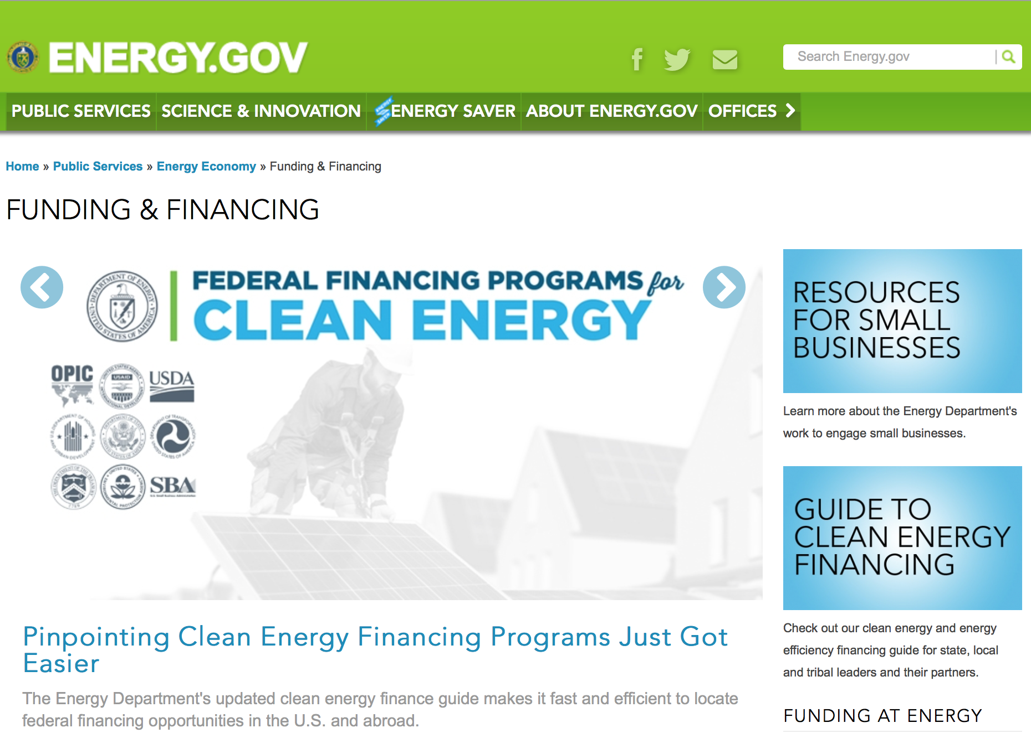
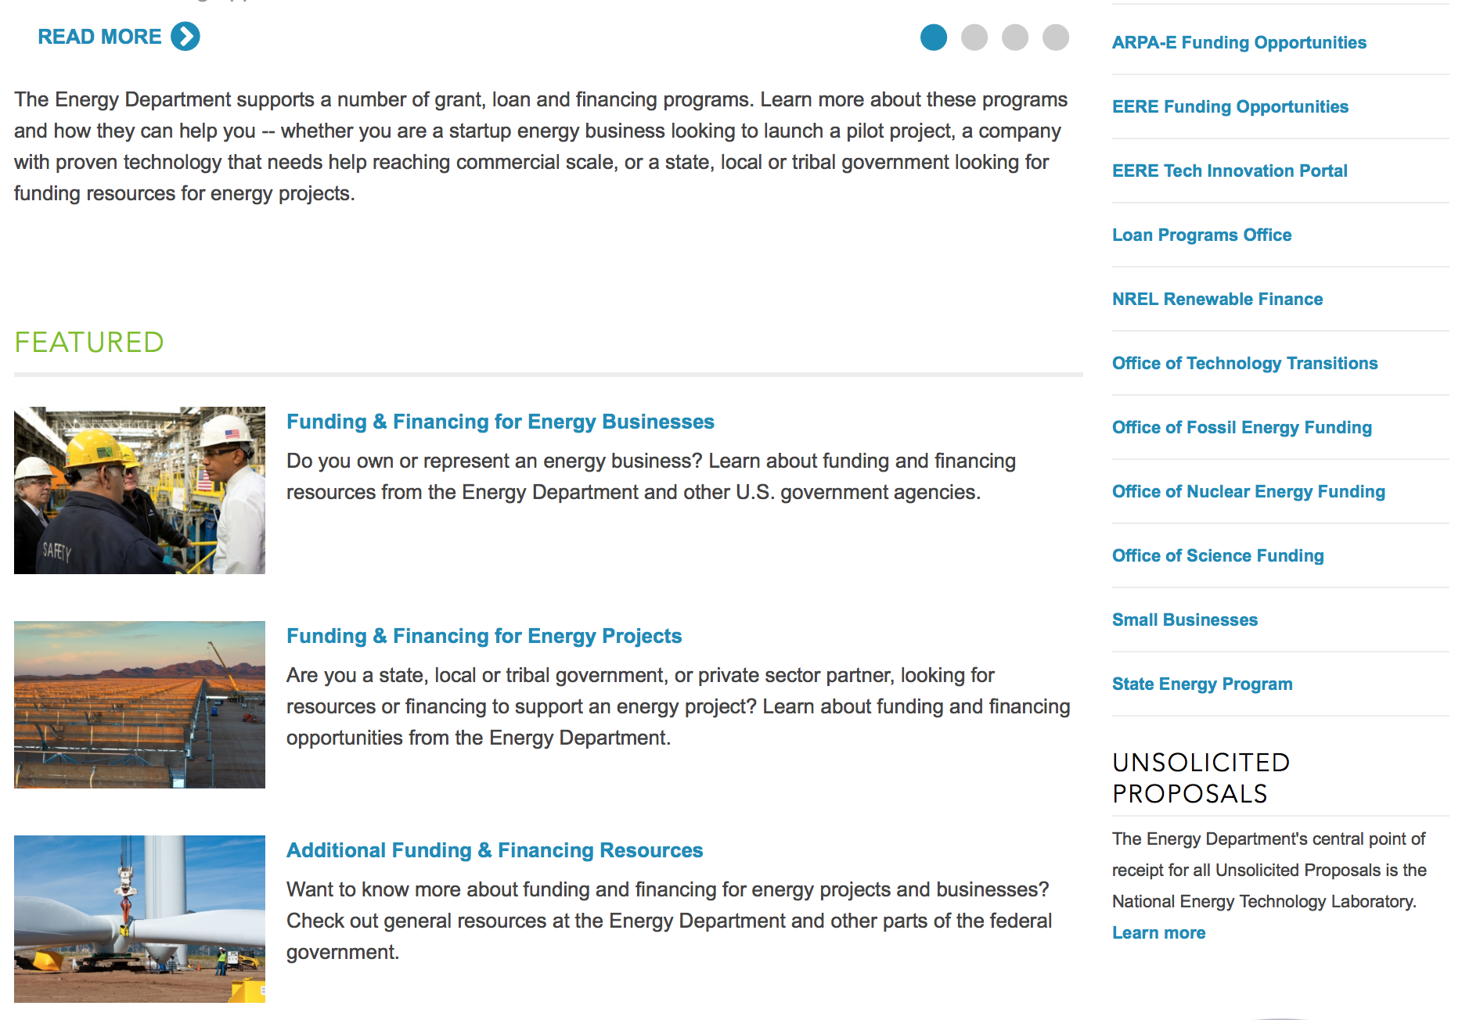
https://www.energy.gov/public-services/funding-financing

Research:

National Energy Technology Laboratory
Opportunity Notice for Partners to Assist NETL in Adapting CCSI Tool Set
Synopsis 1
http://www.grants.gov/web/grants/view-opportunity.html?oppId=294089

Golden Field Office
Request for Information (RFI): Clean Water Technologies
Synopsis 1
http://www.grants.gov/web/grants/view-opportunity.html?oppId=294177

Office of Science
FY2017 Research Opportunities in Accelerator Stewardship
Synopsis 1
http://www.grants.gov/web/grants/view-opportunity.html?oppId=294249

Modifications:

Reminders:

PAMS
Department of Energy - Office of Science
Office of Science
FY 2017 Continuation of Solicitation for the Office of Science Financial Assistance Program
Synopsis 2

Document Type: | Grants Notice
Funding Opportunity Number: | DE-FOA-0001664
Funding Opportunity Title: | FY 2017 Continuation of Solicitation for the Office of Science Financial Assistance Program
Opportunity Category: | Discretionary
Opportunity Category Explanation:
Funding Instrument Type: | Cooperative Agreement  Grant
Category of Funding Activity: | Science and Technology and other Research and Development
Category Explanation:
Expected Number of Awards: | 200
CFDA Number(s): | 81.049 -- Office of Science Financial Assistance Program
Cost Sharing or Matching Requirement: | No
Version: | Synopsis 2
Posted Date: | Sep 30, 2016
Last Updated Date: | Oct 04, 2016
Original Closing Date for Applications: | Sep 30, 2017
Current Closing Date for Applications: | Sep 30, 2017
Archive Date: | Oct 30, 2017
Estimated Total Program Funding:
Award Ceiling: | $4,000,000
Award Floor: | $2,000
Eligible Applicants: | Unrestricted (i.e., open to any type of entity above), subject to any clarification in text field entitled "Additional Information on Eligibility"
Agency Name: | Office of Science
Description: | The Office of Science (SC) of the Department of Energy hereby announces its continuing interest in receiving grant applications for support of work in the following program areas: Advanced Scientific Computing Research, Basic Energy Sciences, Biological and Environmental Research, Fusion Energy Sciences, High Energy Physics, and Nuclear Physics. On September 3, 1992, DOE published in the Federal Register the Office of Energy Research Financial Assistance Program (now called the Office of Science Financial Assistance Program), 10 CFR 605, as a Final Rule, which contained a solicitation for this program. Information about submission of applications, eligibility, limitations, evaluation and selection processes and other policies and procedures are specified in 10 CFR 605.
Link to Additional Information: | http://science.energy.gov/~/media/grants/pdf/foas/2017/SC_FOA_0001664.pdf
Grantor Contact Information: | If you have difficulty accessing the full announcement electronically, please contact:  Kimberlie Laing Grant Analyst Phone 301-903-3026  kim.laing@science.doe.gov

http://www.grants.gov/web/grants/view-opportunity.html?oppId=289281

Environmental Protection Agency

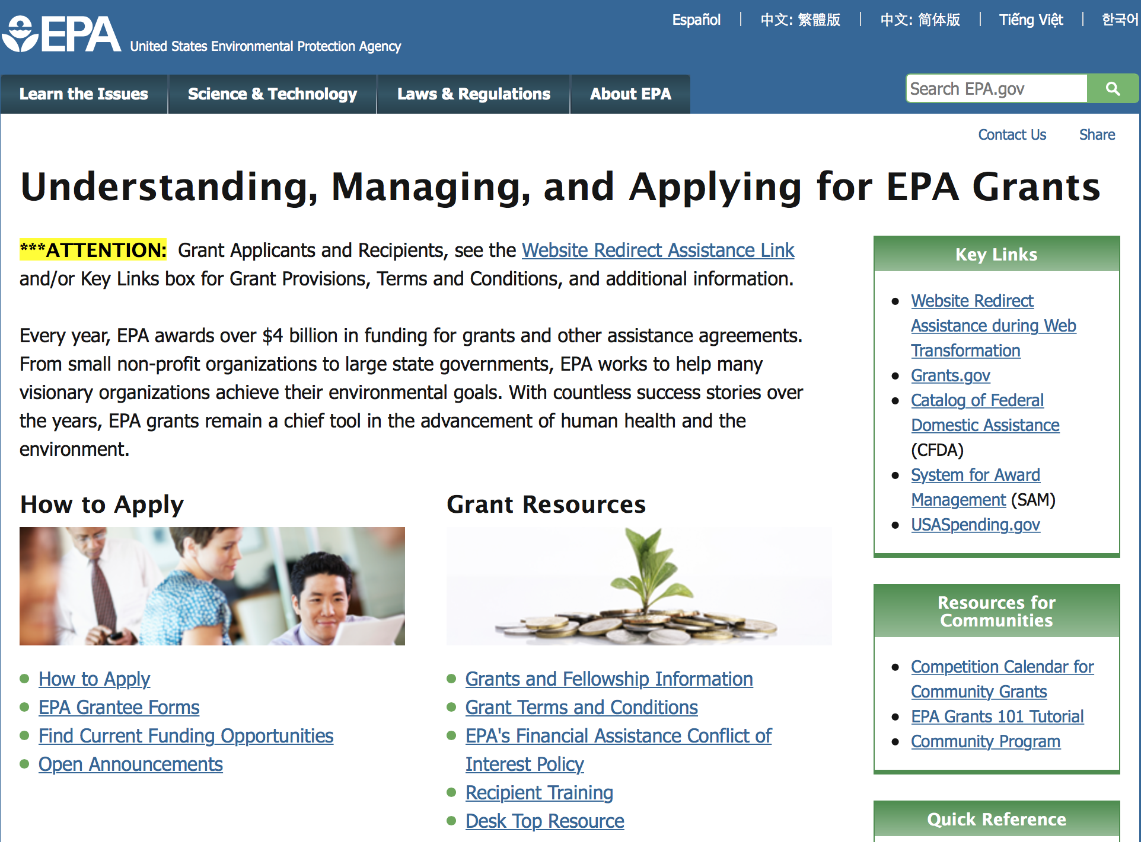

http://www.epa.gov/epahome/grants.htm

Programs:

Clean Diesel Funding Assistance Program FY 2017
Synopsis 2
Document Type: | Grants Notice
Funding Opportunity Number: | EPA-OAR-OTAQ-17-04
Funding Opportunity Title: | Clean Diesel Funding Assistance Program FY 2017
Opportunity Category: | Discretionary
Opportunity Category Explanation:
Funding Instrument Type: | Cooperative Agreement
Category of Funding Activity: | Environment
Category Explanation:
Expected Number of Awards: | 80
CFDA Number(s): | 66.039 -- National Clean Diesel Emissions Reduction Program
Cost Sharing or Matching Requirement: | Yes
Version: | Synopsis 2
Posted Date: | Apr 19, 2017
Last Updated Date: | Jun 01, 2017
Original Closing Date for Applications: | Jun 20, 2017 Please see the announcement including Section IV for additional submission information
Current Closing Date for Applications: | Jul 05, 2017 Please see the announcement including Section IV for additional submission information
Archive Date: | Jul 20, 2017
Estimated Total Program Funding: | $34,000,000
Award Ceiling: | $3,000,000
Award Floor: | $0
Eligible Applicants: | Others (see text field entitled "Additional Information on Eligibility" for clarification)
Additional Information on Eligibility: | Please see the announcement including Section III for additional eligibility information
Agency Name: | Environmental Protection Agency
Description: | EPA’s Office of Transportation and Air Quality is soliciting proposals nationwide for projects that achieve significant reductions in diesel emissions in terms of tons of pollution produced by diesel engines and diesel emissions exposure, particularly from fleets operating at or servicing goods movement facilities located in areas designated as having poor air quality. Further, priority for funding may be given to projects which result in outcomes that benefit affected communities, those that engage affected communities with respect to the design and performance of the project, and those which can demonstrate the ability to promote and continue efforts to reduce emissions after the project has ended.
Link to Additional Information: | Clean Diesel Funding Assistance Program FY 2017
Grantor Contact Information: | If you have difficulty accessing the full announcement electronically, please contact:  Faye Swift, 202-343-9147  Faye Swift

http://www.grants.gov/web/grants/view-opportunity.html?oppId=293300

Research:

Modifications:

Reminders:

Clean Diesel Funding Assistance Program FY 2017
Synopsis 1
Document Type: | Grants Notice
Funding Opportunity Number: | EPA-OAR-OTAQ-17-04
Funding Opportunity Title: | Clean Diesel Funding Assistance Program FY 2017
Opportunity Category: | Discretionary
Opportunity Category Explanation:
Funding Instrument Type: | Cooperative Agreement
Category of Funding Activity: | Environment
Category Explanation:
Expected Number of Awards: | 80
CFDA Number(s): | 66.039 -- National Clean Diesel Emissions Reduction Program
Cost Sharing or Matching Requirement: | Yes
Version: | Synopsis 1
Posted Date: | Apr 19, 2017
Last Updated Date: | Apr 19, 2017
Original Closing Date for Applications: | Jun 20, 2017 Please see the announcement including Section IV for additional submission information
Current Closing Date for Applications: | Jun 20, 2017 Please see the announcement including Section IV for additional submission information
Archive Date: | Jul 20, 2017
Estimated Total Program Funding: | $11,000,000
Award Ceiling: | $2,500,000
Award Floor: | $0
Eligible Applicants: | Others (see text field entitled "Additional Information on Eligibility" for clarification)
Additional Information on Eligibility: | Please see the announcement including Section III for additional eligibility information
Agency Name: | Environmental Protection Agency
Description: | EPA’s Office of Transportation and Air Quality is soliciting proposals nationwide for projects that achieve significant reductions in diesel emissions in terms of tons of pollution produced by diesel engines and diesel emissions exposure, particularly from fleets operating at or servicing goods movement facilities located in areas designated as having poor air quality. Further, priority for funding may be given to projects which result in outcomes that benefit affected communities, those that engage affected communities with respect to the design and performance of the project, and those which can demonstrate the ability to promote and continue efforts to reduce emissions after the project has ended.
Link to Additional Information: | Clean Diesel Funding Assistance Program FY 2017
Grantor Contact Information: | If you have difficulty accessing the full announcement electronically, please contact:  Faye Swift, 202-343-9147  Faye Swift

http://www.grants.gov/web/grants/view-opportunity.html?oppId=293300

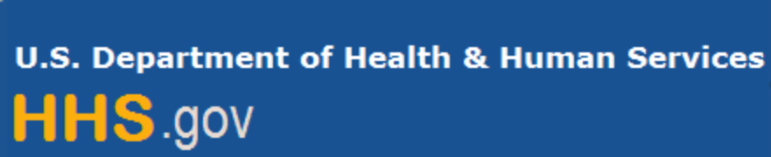

Department of Health and Human Services

Grants Forecast and Overview

The Department of Health and Human Services’ Grants Forecast is a database of planned grant opportunities proposed by its agencies. Each Forecast record contains actual or estimated dates and funding levels for grants that the agency intends to award during the fiscal year. Forecast opportunities are subject to change based on enactment of congressional appropriations.

For more general information about HHS Grants and Funding go to the website below at: http://www.hhs.gov/grants/

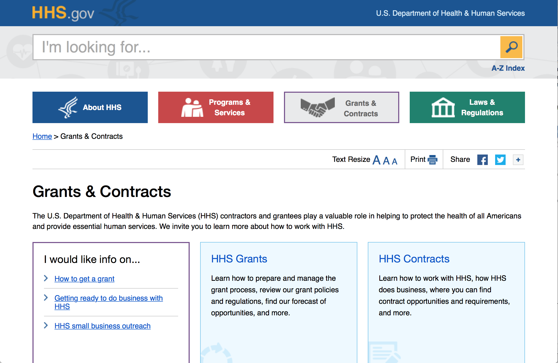

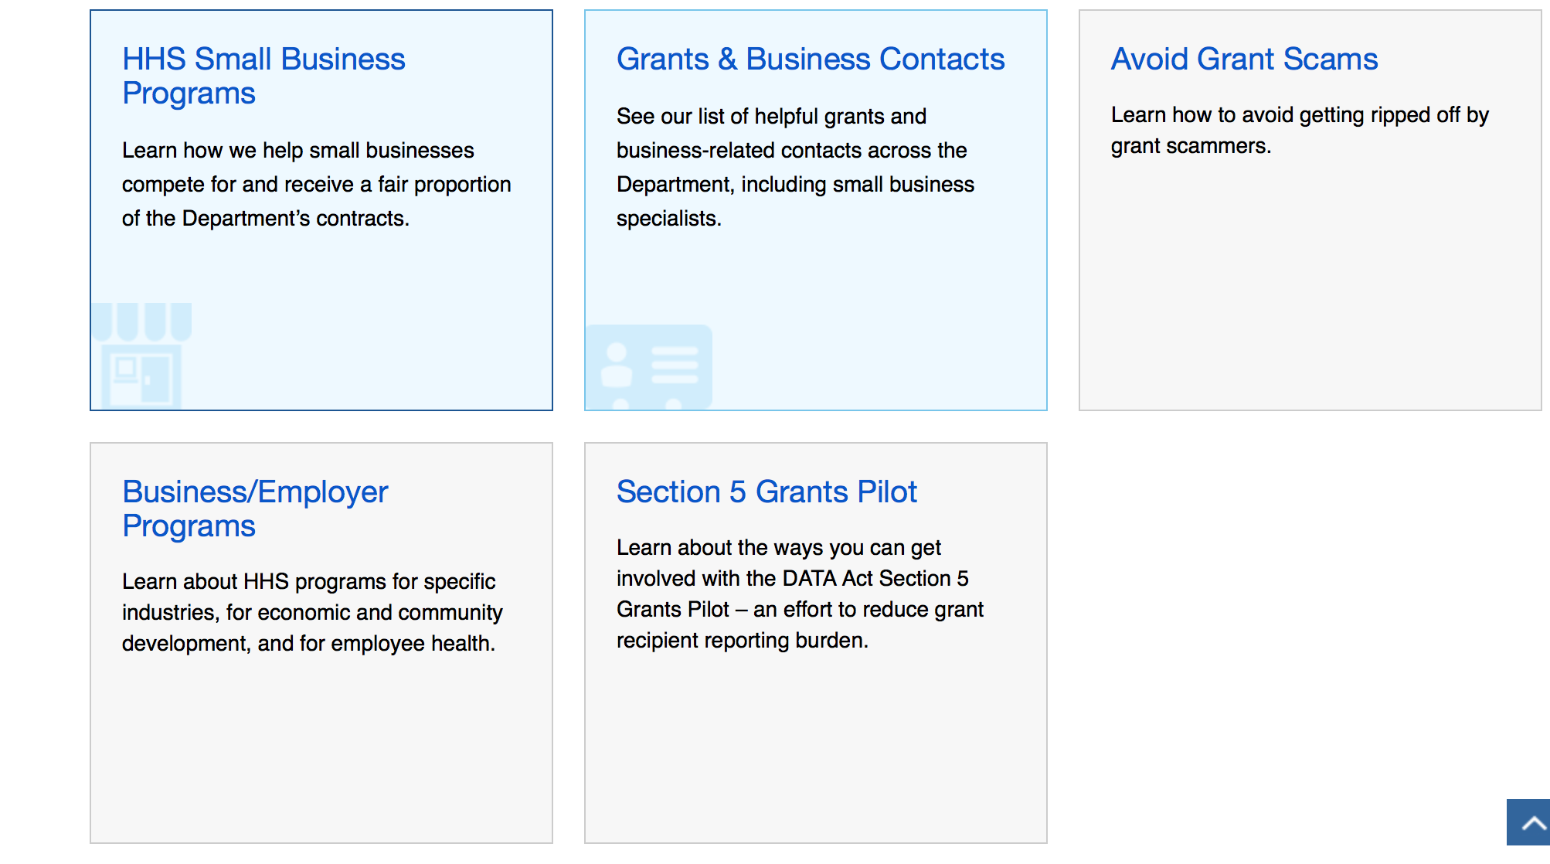

Programs:

Research:

Administration for Children and Families - ACYF/CB

Regional Partnership Grants to Increase the Well-Being of, and to Improve the Permanency Outcomes for, Children Affected by Substance Abuse
Synopsis 1& 2
http://www.grants.gov/web/grants/view-opportunity.html?oppId=288213

Administration for Children and Families - ACYF/CB
Regional Partnership Grants to Increase the Well-Being of, and to Improve the Permanency Outcomes for, Children Affected by Substance Abuse in American Indian/Alaska Native Communities
Synopsis 1
http://www.grants.gov/web/grants/view-opportunity.html?oppId=288214

Administration for Children and Families - OPRE
Behavioral Interventions Scholars
Synopsis 1
http://www.grants.gov/web/grants/view-opportunity.html?oppId=284799

Administration for Children & Families - ACYF/FYSB
Transitional Living Program and Maternity Group Homes
Synopsis 1
http://www.grants.gov/web/grants/view-opportunity.html?oppId=289165

Administration for Community Living
Living Well-Model Approaches for Enhancing the Quality, Effectiveness and Monitoring of Home and Community Based Services for Individuals with Developmental Disabilities
Synopsis 1
http://www.grants.gov/web/grants/view-opportunity.html?oppId=292514

Administration for Community Living
Elder Justice Innovation Grants
Forecast 1
http://www.grants.gov/web/grants/view-opportunity.html?oppId=294104

Administration for Community Living
Innovations in Nutrition Programs and Services
Forecast 1
http://www.grants.gov/web/grants/view-opportunity.html?oppId=294025

Administration for Community Living
University Centers of Excellence in Developmental Disabilities Diversity Fellowships
Synopsis 1
http://www.grants.gov/web/grants/view-opportunity.html?oppId=292505

Administration for Community Living
Minority Serving Institutions Partnership Planning Grants
Synopsis 1
http://www.grants.gov/web/grants/view-opportunity.html?oppId=292513

Agency for Health Care Research and Quality
AHRQ National Research Service Award (NRSA) Institutional Research Training Grant (T32)
Synopsis 1
http://www.grants.gov/web/grants/view-opportunity.html?oppId=294111

Centers for Disease Control - NCCDPHP
Guidance for Supplemental CDC/NCCDPHP/BRFSS Funding Opportunity Announcement (FOA) CDC-RFA-DP15-15130301SUPP17 Behavioral Risk Factor Surveillance System (BRFSS)
Synopsis 1
http://www.grants.gov/web/grants/view-opportunity.html?oppId=294097

Health Resources and Services Administration
Dental Faculty Loan Repayment Program
Synopsis 1
http://www.grants.gov/web/grants/view-opportunity.html?oppId=294248

National Institutes of Health
Partnerships for Development of Clinically Useful Diagnostics for Antimicrobial-Resistant Bacteria (R01)
Synopsis 1
http://www.grants.gov/web/grants/view-opportunity.html?oppId=294253

National Institutes of Health
Claude D. Pepper Older Americans Independence Centers (P30)
Synopsis 1
http://www.grants.gov/web/grants/view-opportunity.html?oppId=294081

National Institutes of Health
Alcohol-Induced Effects on Tissue Injury and Repair (R21)
Synopsis 1
http://www.grants.gov/web/grants/view-opportunity.html?oppId=294113

National Institutes of Health
Alcohol-Induced Effects on Tissue Injury and Repair (R01)
Synopsis 1
http://www.grants.gov/web/grants/view-opportunity.html?oppId=294103

National Institutes of Health
Role of Myeloid Cells in Persistence and Eradication of HIV-1 Reservoirs from the Brain (R01)
Synopsis 1
http://www.grants.gov/web/grants/view-opportunity.html?oppId=293551

National Institutes of Health
Role of Myeloid Cells in Persistence and Eradication of HIV-1 Reservoirs from the Brain (R21)
Synopsis 1
http://www.grants.gov/web/grants/view-opportunity.html?oppId=293552

National Institutes of Health
Mechanistic Ancillary Studies to Ongoing Interventional Clinical Trials (R01)
Synopsis 1
http://www.grants.gov/web/grants/view-opportunity.html?oppId=293554

National Institutes of Health
Mechanistic Ancillary Studies to Ongoing Interventional Clinical Trials (R21)
Synopsis 1
http://www.grants.gov/web/grants/view-opportunity.html?oppId=293556

National Institutes of Health
Initiation of a Mental Health Family Navigator Model to Promote Early Access, Engagement and Coordination of Needed Mental Health Services for Children and Adolescents (R01)
Synopsis 1
http://www.grants.gov/web/grants/view-opportunity.html?oppId=293563

National Institutes of Health
Pilot Studies to Test the Initiation of a Mental Health Family Navigator to Promote Early Access, Engagement and Coordination of Needed Mental Health Services for Children and Adolescents (R34)
Synopsis 1
http://www.grants.gov/web/grants/view-opportunity.html?oppId=293564

National Institutes of Health
Planning Grants for Clinical Trials of High Relevance to the NIGMS Mission (R34)
Synopsis 1
http://www.grants.gov/web/grants/view-opportunity.html?oppId=293577

National Institutes of Health
Center for Inherited Disease Research (CIDR) High Throughput Sequencing and Genotyping Resource Access (X01)
Synopsis 1
http://www.grants.gov/web/grants/view-opportunity.html?oppId=293580

National Institutes of Health
NIDDK Central Repositories Non-renewable Sample Access (X01)
Synopsis 1
http://www.grants.gov/web/grants/view-opportunity.html?oppId=293581

National Institutes of Health
Effectiveness Trials for Post-Acute Interventions and Services to Optimize Longer-term Outcomes (R01)
Synopsis 1
http://www.grants.gov/web/grants/view-opportunity.html?oppId=293602

National Institutes of Health
Pilot Effectivness Trials for Post-Acute Interventions and Services to Optimize Longer-term Outcomes (R34)
Synopsis 1
http://www.grants.gov/web/grants/view-opportunity.html?oppId=293604

National Institutes of Health
Notice of Intent to Publish a Funding Opportunity Announcement for Exploratory Clinical Trial Grants in Arthritis and Musculoskeletal and Skin Diseases (R21)
Forecast 1
http://www.grants.gov/web/grants/view-opportunity.html?oppId=293628

National Institutes of Health
Notice of Intent to Publish a Funding Opportunity Announcement for Translational Neural Devices Program (UG3/UH3)
Forecast 1
http://www.grants.gov/web/grants/view-opportunity.html?oppId=293629

National Institutes of Health
Notice of Intent to Publish a Funding Opportunity Announcement for Translational Neural Devices Program (U44)
Forecast 1
http://www.grants.gov/web/grants/view-opportunity.html?oppId=293630

National Institutes of Health
Modeling of Infectious Disease Agent Study Research Projects (R01)
Synopsis 1
http://www.grants.gov/web/grants/view-opportunity.html?oppId=293636

National Institutes of Health
Notice of Intent to Publish a Funding Opportunity Announcement to Increase Use of Cardiac and Pulmonary Rehabilitation in Traditional and Community Settings (R61/R33)
Forecast 1
http://www.grants.gov/web/grants/view-opportunity.html?oppId=293651

National Institutes of Health
Notice of Intent to Publish a Funding Opportunity Announcement for Implementation Research for Heart, Lung, Blood, and Sleep Diseases in the Inpatient Setting (U01)
Forecast 1
http://www.grants.gov/web/grants/view-opportunity.html?oppId=293652

National Institutes of Health
Tobacco Regulatory Science (R01)
Synopsis 1
http://www.grants.gov/web/grants/view-opportunity.html?oppId=293733

National Institutes of Health
Tobacco Regulatory Science Small Grant Program for New Investigators (R03)
Synopsis 1
http://www.grants.gov/web/grants/view-opportunity.html?oppId=293734

National Institutes of Health
Tobacco Regulatory Science (R21)
Synopsis 1
http://www.grants.gov/web/grants/view-opportunity.html?oppId=293726

National Institutes of Health
NIH StrokeNet Regional Coordinating Stroke Centers (U24)
Synopsis 1
http://www.grants.gov/web/grants/view-opportunity.html?oppId=293723

National Institutes of Health
NIH StrokeNet Clinical Trials and Biomarker Studies for Stroke Treatment, Recovery, and Prevention Infrastructure Resource Access (X01)
Synopsis 1
http://www.grants.gov/web/grants/view-opportunity.html?oppId=293721

National Institutes of Health
NIH StrokeNet Small Business Innovation Clinical Trials and Biomarker Studies for Stroke Treatment, Recovery, and Prevention (U44)
Synopsis 1
http://www.grants.gov/web/grants/view-opportunity.html?oppId=293722

National Institutes of Health
NIH StrokeNet Clinical Trials and Biomarker Studies for Stroke Treatment, Recovery, and Prevention (U01)
Synopsis 1
http://www.grants.gov/web/grants/view-opportunity.html?oppId=293720

National Institutes of Health
Uncovering the Causes, Contexts, and Consequences of Elder Mistreatment (R01)
Synopsis 1
http://www.grants.gov/web/grants/view-opportunity.html?oppId=293770

National Institutes of Health
In Vitro and Animal Model Studies on HBV/HIV Co-Infection (R01)
Synopsis 1
http://www.grants.gov/web/grants/view-opportunity.html?oppId=293780

National Institutes of Health
HIV and Hepatitis B Co-Infection: Advancing HBV Functional Cure through Clinical Research (R01)
Synopsis 1
http://www.grants.gov/web/grants/view-opportunity.html?oppId=293781

National Institutes of Health
Wearable to Track Recovery and Relapse Factors for People w/ Addiction (R43/R44)
Synopsis 1
http://www.grants.gov/web/grants/view-opportunity.html?oppId=293782

National Institutes of Health
Therapeutic Strategies for the Converging TB/T2DM/HIV Epidemics (R01)
Synopsis 1
http://www.grants.gov/web/grants/view-opportunity.html?oppId=293783

National Institutes of Health
Therapeutic Strategies for the Converging TB/T2DM/HIV Epidemics (R21)
Synopsis 1
http://www.grants.gov/web/grants/view-opportunity.html?oppId=293785

National Institutes of Health
Understanding Processes of Recovery in the Treatment of Alcohol Use Disorder (R21)
Synopsis 1
http://www.grants.gov/web/grants/view-opportunity.html?oppId=293787

National Institutes of Health
Exploring Novel RNA Modifications in HIV/AIDS and Substance Use Disorders (R01)
Synopsis 1
http://www.grants.gov/web/grants/view-opportunity.html?oppId=293788

National Institutes of Health
Exploring Novel RNA Modifications in HIV/AIDS and Substance Use Disorders (R21)
Synopsis 1
http://www.grants.gov/web/grants/view-opportunity.html?oppId=293789

National Institutes of Health
In Vitro and Animal Model Studies on HBV/HIV Co-Infection (R21)
Synopsis 1
http://www.grants.gov/web/grants/view-opportunity.html?oppId=293792

National Institutes of Health
ImPlementation REsearCh to DEvelop Interventions for People Living with HIV (PRECluDE) (U01)
Synopsis 1
http://www.grants.gov/web/grants/view-opportunity.html?oppId=293793

National Institutes of Health
HIV and Hepatitis B Co-Infection: Advancing HBV Functional Cure through Clinical Research (R21)
Synopsis 1
http://www.grants.gov/web/grants/view-opportunity.html?oppId=293794

National Institutes of Health
Understanding Processes of Recovery in the Treatment of Alcohol Use Disorder (R01)
Synopsis 1
http://www.grants.gov/web/grants/view-opportunity.html?oppId=293798

National Institutes of Health
Administrative Supplements for Participation in the Concept to Clinic: Commercializing Innovation (C3i) Program (Admin Supp)
Synopsis 1
http://www.grants.gov/web/grants/view-opportunity.html?oppId=293801

National Institutes of Health
NIA MSTEM: Advancing Diversity in Aging Research through Undergraduate Education (R25)
Synopsis 1
http://www.grants.gov/web/grants/view-opportunity.html?oppId=293873

National Institutes of Health
Addressing Suicide Research Gaps: Aggregating and Mining Existing Data Sets for Secondary Analyses (R01)
Synopsis 1
http://www.grants.gov/web/grants/view-opportunity.html?oppId=293857

National Institutes of Health
Specialized Alcohol Research Centers (P50)
Synopsis 1
http://www.grants.gov/web/grants/view-opportunity.html?oppId=293875

National Institutes of Health
Leveraging Population-based Cancer Registry Data to Study Health Disparities (R01)
Synopsis 1
http://www.grants.gov/web/grants/view-opportunity.html?oppId=293847

National Institutes of Health
Leveraging Population-based Cancer Registry Data to Study Health Disparities (R21)
Synopsis 1
http://www.grants.gov/web/grants/view-opportunity.html?oppId=293848

National Institutes of Health
Center for Identification and Study of Individuals with Atypical Diabetes Mellitus (U54)
Synopsis 1
http://www.grants.gov/web/grants/view-opportunity.html?oppId=293849

National Institutes of Health
NIA Academic Leadership Career Award (K07)
Synopsis 1
http://www.grants.gov/web/grants/view-opportunity.html?oppId=293863

National Institutes of Health
SBIR E-learning for HAZMAT and Emergency Response (R43/R44)
Synopsis 1
http://www.grants.gov/web/grants/view-opportunity.html?oppId=293834

National Institutes of Health
Psychological, Behavioral, and Neurocognitive-Focused Ancillary Studies to the Molecular Transducers of Physical Activity in Humans Consortium (MoTrPAC) (U01)
Synopsis 1
http://www.grants.gov/web/grants/view-opportunity.html?oppId=293835

National Institutes of Health
Silencing of HIV-1 Proviruses (R61/R33)
Synopsis 1
http://www.grants.gov/web/grants/view-opportunity.html?oppId=293905

National Institutes of Health
HIV Drug Resistance: Genotype-Phenotype-Outcome Correlations (R01)
Synopsis 1
http://www.grants.gov/web/grants/view-opportunity.html?oppId=293906

National Institutes of Health
HIV Drug Resistance: Genotype-Phenotype-Outcome Correlations (R21)
Synopsis 1
http://www.grants.gov/web/grants/view-opportunity.html?oppId=293907

National Institutes of Health
Catalyzing Innovation in Late Phase Clinical Trial Design and Statistical Analysis Plans (U34)
Synopsis 1
http://www.grants.gov/web/grants/view-opportunity.html?oppId=293884

National Institutes of Health
Behavioral Interventions for Prevention of Opioid Use Disorder or Adjunct to Medication Assisted Treatment-SAMHSA Opioid STR Grants (R21/R33)
Synopsis 1
http://www.grants.gov/web/grants/view-opportunity.html?oppId=293885

National Institutes of Health
Exploratory Clinical Trial Grants in Arthritis and Musculoskeletal and Skin Diseases (R21)
Synopsis 1
http://www.grants.gov/web/grants/view-opportunity.html?oppId=293887

National Institutes of Health
Catalyzing Innovation in Late Phase Clinical Trial Design and Statistical Analysis Plans (X01)
Synopsis 1
http://www.grants.gov/web/grants/view-opportunity.html?oppId=293897

National Institutes of Health
Basic Research in Calcific Aortic Valve Disease (R01)
Synopsis 1
http://www.grants.gov/web/grants/view-opportunity.html?oppId=293901

National Institutes of Health
Catalyzing Innovation in Late Phase Clinical Trial Design and Statistical Analysis Plans Resource Access (X01)
Synopsis 1
http://www.grants.gov/web/grants/view-opportunity.html?oppId=293976

National Institutes of Health
U.S. Tobacco Control Policies to Reduce Health Disparities (R01)
Synopsis 1
http://www.grants.gov/web/grants/view-opportunity.html?oppId=294135

National Institutes of Health
U.S. Tobacco Control Policies to Reduce Health Disparities (R21)
Synopsis 1
http://www.grants.gov/web/grants/view-opportunity.html?oppId=294136

National Institutes of Health
Grants for Early Medical/Surgical Specialists' Transition to Aging Research (GEMSSTAR) (R03)
Synopsis 1
http://www.grants.gov/web/grants/view-opportunity.html?oppId=294138

National Institutes of Health
HIV/AIDS and the Tumor Niche (R01)
Synopsis 1
http://www.grants.gov/web/grants/view-opportunity.html?oppId=294151

National Institutes of Health
Small Grants for Secondary Analyses of Existing Data Sets and Stored Biospecimens (R03)
Synopsis 1
http://www.grants.gov/web/grants/view-opportunity.html?oppId=294152

National Institutes of Health
Addressing Suicide Research Gaps: Understanding Mortality Outcomes (R01)
Synopsis 1
http://www.grants.gov/web/grants/view-opportunity.html?oppId=294153

National Institutes of Health
Socioeconomic Disparities in Health and Mortality at Older Ages (R01)
Synopsis 1
http://www.grants.gov/web/grants/view-opportunity.html?oppId=294186

National Institutes of Health
Partnerships for the Development of Vaccines and Immunophrophylactics Targeting Multiple Antimicrobial-Resistant Bacteria (R01)
Synopsis 1
http://www.grants.gov/web/grants/view-opportunity.html?oppId=294210

Substance Abuse and Mental Health Services Adminis
First Responders – Comprehensive Addiction and Recovery Act Cooperative Agreement (Short Title: FR-CARA)
Synopsis 1
http://www.grants.gov/web/grants/view-opportunity.html?oppId=294187

Substance Abuse and Mental Health Services Adminis
Targeted Capacity Expansion: Medication Assisted Treatment - Prescription Drug and Opioid Addiction (Short Title: MAT-PDOA)
Synopsis 1
http://www.grants.gov/web/grants/view-opportunity.html?oppId=294189

Substance Abuse and Mental Health Services Adminis
Comprehensive Addiction and Recovery Act: Building Communities of Recovery (Short Title: BCOR)
Synopsis 1
http://www.grants.gov/web/grants/view-opportunity.html?oppId=293632

Substance Abuse and Mental Health Services Adminis
Cooperative Agreements to Implement Zero Suicide in Health Systems (Short Title: Zero Suicide)
Synopsis 1
http://www.grants.gov/web/grants/view-opportunity.html?oppId=293971

Modifications:

Administration for Children and Families - ACYF/CB
Regional Partnership Grants to Increase the Well-Being of, and to Improve the Permanency Outcomes for, Children Affected by Substance Abuse
Forecast 4
http://www.grants.gov/web/grants/view-opportunity.html?oppId=288213

Administration for Children & Families - ACYF/FYSB
Basic Center Program
Synopsis 3
http://www.grants.gov/web/grants/view-opportunity.html?oppId=290154

Administration for Community Living
Minority Serving Institutions Partnership Planning Grants
Synopsis 3 & 6
http://www.grants.gov/web/grants/view-opportunity.html?oppId=292513

Administration for Children and Families-IOAS-OTIP
Look Beneath the Surface Regional Anti-Trafficking Program
Forecast 8
http://www.grants.gov/web/grants/view-opportunity.html?oppId=289166

Administration for Community Living
FY2017 Lifespan Respite Care Program: Advancing State Lifespan Respite Systems
Synopsis 4
http://www.grants.gov/web/grants/view-opportunity.html?oppId=293002

Administration for Community Living
Disaster Assistance for State Units on Aging (SUAs) and Tribal Organizations in National Disasters Declared by the President
Synopsis 3
http://www.grants.gov/web/grants/view-opportunity.html?oppId=289875

Administration for Community Living
University Centers of Excellence in Developmental Disabilities Diversity Fellowships
Synopsis 3, 5 & 6
http://www.grants.gov/web/grants/view-opportunity.html?oppId=292505

Administration for Community Living
Small Business Innovation Research Program (SBIR) Phase II 93.433 HHS/ACL/NIDILRR
Synopsis 4 & 5
http://www.grants.gov/web/grants/view-opportunity.html?oppId=292270

Centers for Disease Control - OSTLTS
Building Capacity of the Public Health System to Improve Population Health through National, Nonprofit Organizations, financed in part by 2017 Prevention and Public Health Funds
Synopsis 2 & 3
http://www.grants.gov/web/grants/view-opportunity.html?oppId=292861

Centers for Disease Control - OD

CDC Undergraduate Public Health Scholars Program (CUPS): A Public Health Experience to Expose Undergraduate and Graduate Students to Minority Health, Public Health and Health Professions
Synopsis 3
http://www.grants.gov/web/grants/view-opportunity.html?oppId=293272

Food and Drug Administration
Advancing Conformance with the Voluntary National Retail Food Regulatory Program Standards (VNRFRPS) (U18)
Synopsis 3
http://www.grants.gov/web/grants/view-opportunity.html?oppId=292492

Health Resources and Services Administration
Behavioral Health Workforce Education and Training (BHWET) Program
Synopsis 2
http://www.grants.gov/web/grants/view-opportunity.html?oppId=293172

National Institutes of Health
Epidemiology of Drug Abuse (R01)
Synopsis 2
http://www.grants.gov/web/grants/view-opportunity.html?oppId=267970

National Institutes of Health
Epidemiology of Drug Abuse (R03)
Synopsis 2
http://www.grants.gov/web/grants/view-opportunity.html?oppId=267973

National Institutes of Health
Epidemiology of Drug Abuse (R21)
Synopsis 2
http://www.grants.gov/web/grants/view-opportunity.html?oppId=267976

National Institutes of Health
NIDA Mentored Clinical Scientists Development Program Award in Drug Abuse and Addiction (K12)
Synopsis 2
http://www.grants.gov/web/grants/view-opportunity.html?oppId=273873

National Institutes of Health
Notice of Intent to Publish a Funding Opportunity Announcement for Implementation Research for Heart, Lung, Blood, and Sleep Diseases in the Inpatient Setting (U34)
Forecast 2
http://www.grants.gov/web/grants/view-opportunity.html?oppId=293161

National Institutes of Health
Notice of Intent to Publish a Funding Opportunity Announcement for Continuation of Existing Grant Based Epidemiology Cohort Studies in Heart, Lung, Blood, Sleep Diseases and Disorders (U01)
Forecast 2
http://www.grants.gov/web/grants/view-opportunity.html?oppId=293162

National Institutes of Health
Drug Abuse Prevention Intervention Research (R03)
Synopsis 2
http://www.grants.gov/web/grants/view-opportunity.html?oppId=271249

National Institutes of Health
Notice of Intent to Publish a Funding Opportunity Announcement for an NINDS Postdoctoral Research Career Development Award (K01)
Forecast 4
http://www.grants.gov/web/grants/view-opportunity.html?oppId=284880

National Institutes of Health
Notice of Intent to Publish a Funding Opportunity Announcement for Catalyzing Innovation in Late Phase Clinical Trial Design and Statistical Analysis Plans (U34)
Forecast 3
http://www.grants.gov/web/grants/view-opportunity.html?oppId=291102

National Institutes of Health
Notice of Intent to Publish a Funding Opportunity Announcement for Catalyzing Innovation in Late Phase Clinical Trial Design and Statistical Analysis Plans (X01)
Forecast 3
http://www.grants.gov/web/grants/view-opportunity.html?oppId=291103

National Institutes of Health
Notice of Intent to Publish a Funding Opportunity Announcement for the Consortium Linking Oncology with Thrombosis (CLOT) (U01)
Forecast 3
http://www.grants.gov/web/grants/view-opportunity.html?oppId=292254

National Institutes of Health
Drug Abuse Prevention Intervention Research (R21)
Synopsis 2
http://www.grants.gov/web/grants/view-opportunity.html?oppId=271248

National Institutes of Health
Genomic Community Resources (U24)
Synopsis 3
http://www.grants.gov/web/grants/view-opportunity.html?oppId=293678

National Institutes of Health
Gene-Environment Interplay in Substance Use Disorders (R01)
Synopsis 2
http://www.grants.gov/web/grants/view-opportunity.html?oppId=273209

National Institutes of Health
Limited Competition: Small Grant Program for NIDDK K01/K08/K23 Recipients (R03)
Synopsis 2
http://www.grants.gov/web/grants/view-opportunity.html?oppId=282435

National Institutes of Health
Gene-Environment Interplay in Substance Use Disorders (R21)
Synopsis 2
http://www.grants.gov/web/grants/view-opportunity.html?oppId=273216

National Institutes of Health
NIDCR Clinical Trial or Biomarker Clinical Validation Study Planning Grant (R34)
Synopsis 4
http://www.grants.gov/web/grants/view-opportunity.html?oppId=266048

National Institutes of Health
Short-Term Research Education Program to Increase Diversity in Health-Related Research (R25)
Synopsis 2
http://www.grants.gov/web/grants/view-opportunity.html?oppId=269436

National Institutes of Health
Mentored Career Development Award to Promote Faculty Diversity in Biomedical Research (K01)
Synopsis 2
http://www.grants.gov/web/grants/view-opportunity.html?oppId=269855

National Institutes of Health
Emerging Global Leader Award (K43)
Synopsis 2
http://www.grants.gov/web/grants/view-opportunity.html?oppId=289341

National Institutes of Health
Neuroscience Research on Drug Abuse (R01)
Synopsis 2
http://www.grants.gov/web/grants/view-opportunity.html?oppId=291116

Office of the Assistant Secretary for Health
Empowered Communities for a Healthier Nation
Forecast 2
http://www.grants.gov/web/grants/view-opportunity.html?oppId=294060

Deleted:

Administration for Children and Families - ORR
HHS-2017-ACF-ORR-ZX-1206 - Alternative Transitional Services for Unaccompanied Refugee Minors
Deletion Comments: Opportunity deleted

Centers for Disease Control and Prevention - ERA
RFA-GH16-00302CONT17 - CONDUCTING PUBLIC HEALTH RESEARCH IN THAILAND: TECHNICAL COLLABORATION WITH THE MINISTRY OF PUBLIC HEALTH
Deletion Comments: Opportunity deleted

Centers for Disease Control - NCCDPHP
CDC-RFA-DP17-1703PPHF - PPHF 2017:Racial and Ethnic Approaches to Community Health(REACH)- financed solely by Prevention and Public Health Funding
Deletion Comments: Opportunity deleted

Centers for Disease Control and Prevention - ERA
RFA-DP-17-004 - The High Burden Populations Network: Reducing Risks, Complications, and Barriers to Prevention and Control of Diabetes and Cardiovascular Disease in States and Large Cities
Deletion Comments: Opportunity deleted

Centers for Disease Control - NCEH
CDC-RFA-EH17-1704 - Lead Exposure Registry of Flint Residents - Michigan
Deletion Comments: Opportunity deleted

Centers for Medicare & Medicaid Services
TBD - Medicare Access and CHIP Reauthorization Act (MACRA) Funding Opportunity: Measure Development for the Quality Payment Program
Deletion Comments: Opportunity deleted

Substance Abuse and Mental Health Services Administration
TI-17-015 - Comprehensive Addiction and Recovery Act: Building Communities of Recovery (Short Title: BCOR)
Deletion Comments: Opportunity deleted

Reminders:

Administration for Children and Families - OCS
Community Economic Development Projects
Forecast 6 & 8

Document Type: | Grants Notice
Opportunity Number: | HHS-2017-ACF-OCS-EE-1213
Opportunity Title: | Community Economic Development Projects
Opportunity Category: | Discretionary
Opportunity Category Explanation:
Funding Instrument Type: | Grant
Category of Funding Activity: | Income Security and Social Services
Category Explanation:
Expected Number of Awards: | 35
CFDA Number(s): | 93.570 -- Community Services Block Grant Discretionary Awards
Cost Sharing or Matching Requirement: | No
Version: | Forecast 6
Posted Date: | Sep 09, 2016
Last Updated Date: | Mar 10, 2017
Estimated Synopsis Post Date: | Apr 07, 2017
Estimated Application Due Date: | Jun 06, 2017 Electronically submitted applications must be submitted no later than 11:59 p.m., ET, on the listed application due date.
Estimated Award Date: | Sep 28, 2017
Estimated Project Start Date: | Sep 29, 2017
Fiscal Year: | 2017
Archive Date: | May 28, 2017
Estimated Total Program Funding: | $27,200,000
Award Ceiling: | $800,000
Award Floor: | $100,000
Eligible Applicants: | Others (see text field entitled "Additional Information on Eligibility" for clarification)
Additional Information on Eligibility: | To be eligible for the CED program, an applicant must meet three conditions:1. Applicant must be a private, nonprofit CDC with 501(c)(3) status;2. Applicant must have articles of incorporation or bylaws demonstrating that the CDC has as a principal purpose the planning, developing, or managing of low-income housing or community economic development activities; and3. The Board of Directors must have representation from each of the following: community residents, business leaders, and civic leaders. Note: The CDC designation does not need to be specified on any official documents as long as the three requirements stated above are met. Faith-based and community organizations that meet the eligibility requirements are eligible to receive awards under this funding opportunity announcement. Faith-based organizations are encouraged to review the ACF Policy on Grants to Faith-Based Organizations at: http: //www.acf.hhs.gov/acf-policy-on-grants-to-faith-based-organizations. Applications from individuals (including sole proprietorships) and foreign entities are not eligible and will be disqualified from competitive review and from funding under this announcement.
Agency Name: | Administration for Children and Families - OCS
Description: | The Administration for Children and Families (ACF), Office of Community Services (OCS) will award approximately $27.2 million in Community Economic Development (CED) discretionary grant funds to Community Development Corporations (CDC) for well-planned, financially viable, and innovative projects to enhance job creation and business development for individuals with low income. CED grants will be made as part of a broader strategy to address objectives such as decreasing dependency on federal programs, chronic unemployment, and community deterioration in urban and rural areas. CED projects are expected to actively recruit individuals with low income to fill the positions created by CED-funded development activities, to assist those individuals to successfully hold those jobs and to ensure that the businesses and jobs created remain viable for at least one year after the end of the grant period. CED-funded projects can be non-construction or construction projects, however, short-term construction jobs associated with preparing for business startup or expansion are not counted when determining the number of jobs created under the CED program as they are designed to be temporary in nature. OCS is encouraging applications from CDCs to target rural areas and underserved areas in states without current projects. Furthermore, OCS is encouraging projects that align with the Promise Zones Initiative or Choice Neighborhoods Program.
Link to Additional Information:
Grantor Contact Information: | Gerald Shanklin  (202) 401-5559  gerald.shanklin@acf.hhs.gov

http://www.grants.gov/web/grants/view-opportunity.html?oppId=288729

Administration for Children & Families - ACYF/FYSB
Transitional Living Program and Maternity Group Homes
Forecast 1
Document Type: | Grants Notice
Opportunity Number: | HHS-2017-ACF-ACYF-CX-1233
Opportunity Title: | Transitional Living Program and Maternity Group Homes
Opportunity Category: | Discretionary
Opportunity Category Explanation:
Funding Instrument Type: | Grant
Category of Funding Activity: | Income Security and Social Services
Category Explanation:
Expected Number of Awards: | 103
CFDA Number(s): | 93.550 -- Transitional Living for Homeless Youth
Cost Sharing or Matching Requirement: | Yes
Version: | Forecast 1
Posted Date: | Sep 27, 2016
Last Updated Date: | Sep 27, 2016
Estimated Synopsis Post Date: | Apr 14, 2017
Estimated Application Due Date: | Jun 13, 2017 Electronically submitted applications must be submitted no later than 11:59 p.m., ET, on the listed application due date.
Estimated Award Date: | Sep 28, 2017
Estimated Project Start Date: | Sep 29, 2017
Fiscal Year: | 2017
Archive Date:
Estimated Total Program Funding: | $20,056,829
Award Ceiling: | $194,726
Award Floor: | $100,000
Eligible Applicants: | Native American tribal governments (Federally recognized)  Public and State controlled institutions of higher education  Nonprofits that do not have a 501(c)(3) status with the IRS, other than institutions of higher education  Native American tribal organizations (other than Federally recognized tribal governments)  Independent school districts  Special district governments  State governments  Others (see text field entitled "Additional Information on Eligibility" for clarification)  Private institutions of higher education  Public housing authorities/Indian housing authorities  City or township governments  Nonprofits having a 501(c)(3) status with the IRS, other than institutions of higher education  County governments
Additional Information on Eligibility: | In accordance with Section 321 of the Runaway and Homeless Youth (RHY) Act, the Secretary is authorized to make grants to provide technical assistance to public and nonprofit private entities to establish and operate transitional living youth projects for homeless youth. In selecting eligible applicants to receive grants under this Funding Opportunity Announcement, priority will be given to applicants who have experience working with runaway and homeless youth as required by the RHY Act. Additionally, ACF ensures that the applicants selected represent diverse geographic regions of the United States. Faith-based and community organizations that meet the eligibility requirements are eligible to receive awards under this funding opportunity announcement. Faith-based organizations are encouraged to review the ACF Policy on Grants to Faith-Based Organizations at: http: //www.acf.hhs.gov/acf-policy-on-grants-to-faith-based-organizations. Applications from individuals (including sole proprietorships) and foreign entities are not eligible and will be disqualified from competitive review and from funding under this announcement.
Agency Name: | Administration for Children & Families - ACYF/FYSB
Description: | The Family and Youth Services Bureau (FYSB) is forecasting a funding opportunity announcement for the Transitional Living Program (TLP) and for Maternity Group Homes (MGH) for a five-year project period. The TLP and MGH projects will work to implement, enhance, and/or support promising intervention strategies for the effective transition of homeless youth (for the purposes of MGH projects, homeless youth and their dependent child(ren)) to self-sufficiency. Both projects must provide safe, stable, and appropriate shelter for up to 21 months and comprehensive services that supports the transition of homeless youth to stable living.
Link to Additional Information:
Grantor Contact Information: | Angie Webley  (202) 401-5490  Angie.Webley@acf.hhs.gov

http://www.grants.gov/web/grants/view-opportunity.html?oppId=289165

Department of Homeland Security

The Department of Homeland Security enhances the ability of states, local and tribal jurisdictions, and other regional authorities in the preparation, prevention, and response to terrorist attacks and other disasters, by distributing grant funds. Localities can use grants for planning, equipment, training and exercise needs.

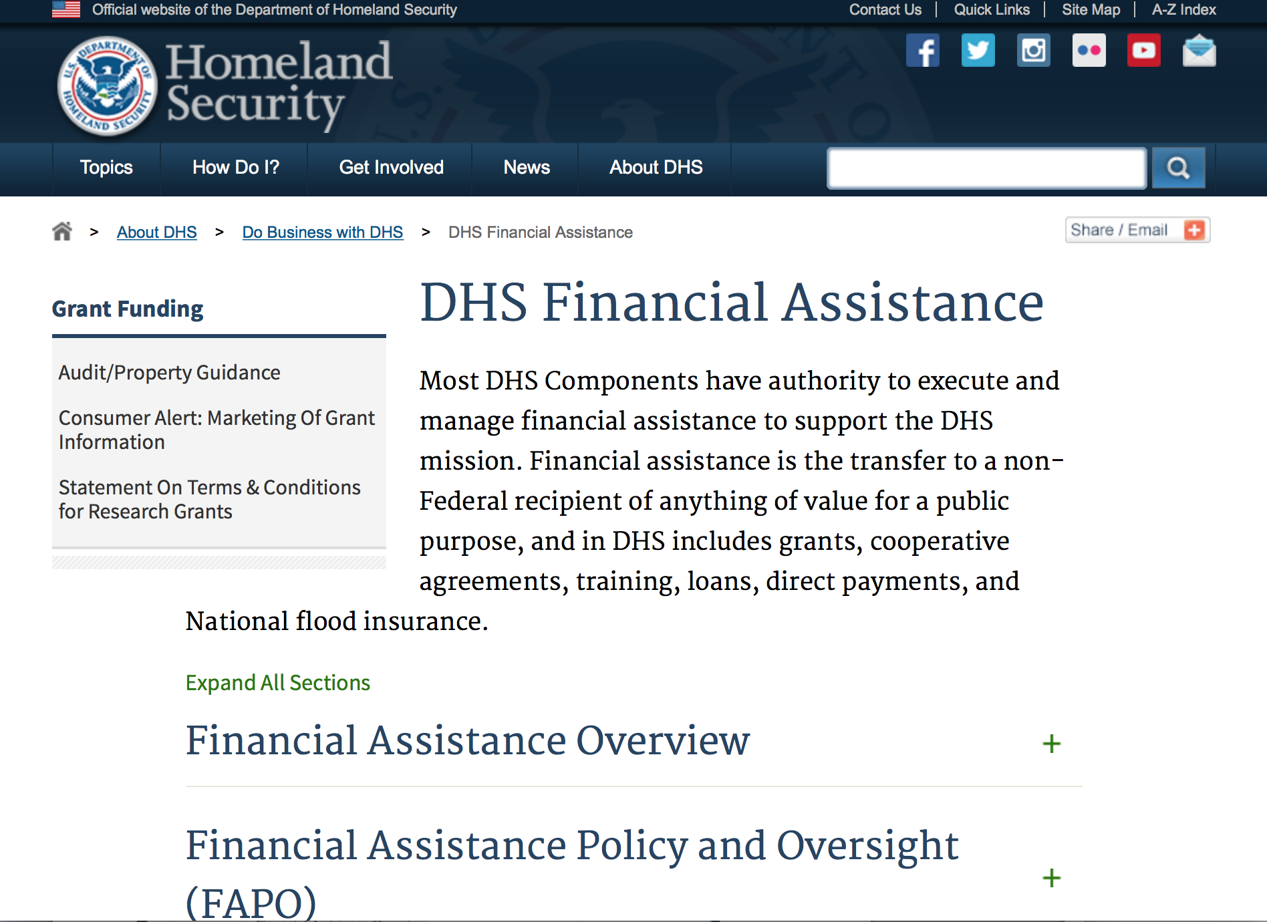
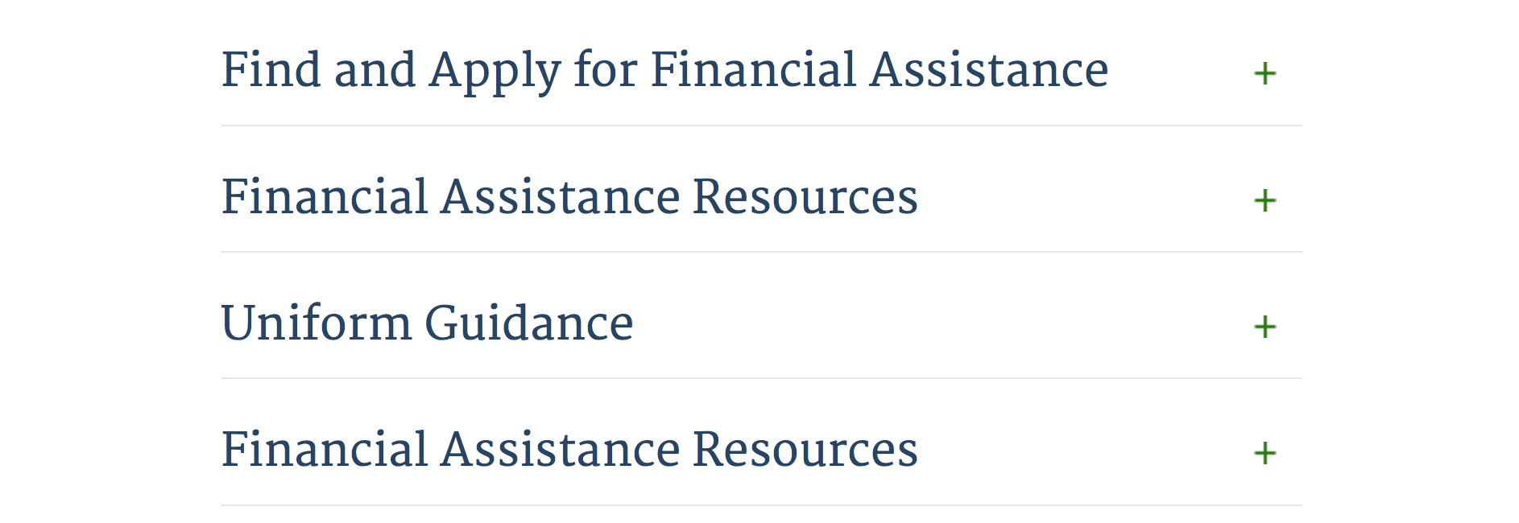

Webpage can be viewed at: http://www.dhs.gov/xopnbiz/grants/index.shtm#2

Information about 2016 for reference only
The FY 2016 Assistance to Firefighters Grants (AFG)
FY 2016 ASSISTANCE TO FIREFIGHTERS (AFG) GRANTS IS CLOSED AT THIS TIME
- FY 2016 Application Workshop Schedule
- FY 2016 AFG Application Guidance Materials The following documents are now available:
  - FY 2016 Notice of Funding Opportunity (NOFO) – Available Now
  - FY 2016 AFG Grant Application Get Ready Guide
  - FY 2016 AFG Narrative Get Ready Guide
  - FY 2016 AFG Self-Evaluation - Operations and Safety
  - FY 2016 AFG Self-Evaluation - Vehicle Acquisition
  - FY 2016 AFG Application Checklist
  - FY 2016 AFG Cost Share Calculator
FY 2016 AFG FAQs
For AFG program guidance materials, please visit our Documents page.

Resources

AFG Help Desk
Contact the AFG Program Help Desk toll-free at 866-274-0960, or email us at firegrants@dhs.gov.
The AFG Program has Fire Program Specialists in 10 federal regional centers. These Regional Fire Program Specialists respond to questions about the AFG program and carry out grant monitoring activities. View regional contacts

Popular AFG links
- AFG Workshop Schedule
- Assistance to Firefighters Grants (AFG)
- AFG Awards List
- AFG Success Stories
- Staffing for Adequate Fire & Emergency Response (SAFER) Grants (SAFER)
- SAFER Awards List
- SAFER Success Stories
- Fire Prevention & Safety (FP&S) Grants
- FP&S Awards List
- FP&S Success Stories
- Grant Closeout Tutorial
- Assistance to Firefighters Grant (AFG) Email Alert Archive
- Frequently Asked Questions
Contact Information For The Assistance to Firefighters Grant (AFG) Program and Help Desk

Federal Funding Alternative To AFG

State Administrative Agencies (SAA) apply for and administer Federal grants on behalf of their States, including FEMA Preparedness Grants. The SAA will work with eligible organizations to comply with the general requirements of grant programs or cooperative agreements. Contact your State’s SAA to find out what current Federal funding opportunities may be available to your organization. A listing of the SAAs and points of contact can be found at http://www.fema.gov/library/viewRecord.do?id=6363.

Programs:

Department of Homeland Security - FEMA
Fiscal Year (FY) 2017 Cooperating Technical Partners (CTP) Program - HQ
Synopsis 1
Document Type: | Grants Notice
Funding Opportunity Number: | DHS-17-MT-045-00-01
Funding Opportunity Title: | Fiscal Year (FY) 2017 Cooperating Technical Partners (CTP) Program - HQ
Opportunity Category: | Discretionary
Opportunity Category Explanation:
Funding Instrument Type: | Cooperative Agreement
Category of Funding Activity: | Science and Technology and other Research and Development
Category Explanation:
Expected Number of Awards: | 11
CFDA Number(s): | 97.045 -- Cooperating Technical Partners
Cost Sharing or Matching Requirement: | No
Version: | Synopsis 1
Posted Date: | Jun 01, 2017
Last Updated Date: | Jun 01, 2017
Original Closing Date for Applications: | Jul 01, 2017
Current Closing Date for Applications: | Jul 01, 2017
Archive Date: | Jul 31, 2017
Estimated Total Program Funding: | $2,000,000
Award Ceiling: | $0
Award Floor: | $0
Eligible Applicants: | Others (see text field entitled "Additional Information on Eligibility" for clarification)  County governments  State governments  Native American tribal governments (Federally recognized)  Nonprofits having a 501(c)(3) status with the IRS, other than institutions of higher education  Public and State controlled institutions of higher education  Special district governments  City or township governments
Additional Information on Eligibility: | As approved by FEMA HQ
Agency Name: | Department of Homeland Security - FEMA
Description: | "The Cooperating Technical Partners Program (CTP Program) exists to strengthen and increase the effectiveness of the National Flood Insurance Program (NFIP) through fostering strong Federal, State, Tribal, regional and local partnerships for the purposes of reducing flood losses and promoting community resiliency. The CTP Program may provide federal assistance, through a grant or cooperative agreement, to an eligible Cooperating Technical Partner (herein referred to as 'CTP', 'partner' or 'grantee') to perform various projects and activities that stimulate and support the ability of NFIP State Coordinating Agencies and NFIP-participating communities (as defined in 44 CFR Part 59.1) to continue their ongoing regulatory NFIP responsibilities as well as support the ability of States, communities and the public and private sector to mitigate flood risk. The CTP Program seeks to enhance the existing capabilities of CTPs to increase local involvement in, and ownership of, the development and maintenance of flood risk data and products, such as the Flood Insurance Rate Maps (FIRMs) and other risk related products, as well as other support to advance the goals and objectives of the Risk Mapping Assessment and Planning (Risk MAP) program. Partnerships developed through FEMA's CTP Program are in the best interest of State and local communities, the NFIP and the public. CTPs may be able to perform activities related to program management, technical risk analysis and mapping, and communication of flood risk hazard data and information. Only qualified partners of the CTP Program are eligible for federal assistance awards through the CTP Program. Recipients must: - be a CTP (i.e., have a signed Partnership Agreement with FEMA HQ or a FEMA Regional Office); - either be or represent a National Flood Insurance Program (NFIP) community in good-standing, or a FEMA-approved non-profit agency whose primary mission supports the goals and objectives of the NFIP; - have existing non-Federally funded processes and/or systems in place to support the collection, development, evaluation, dissemination and communication of flood hazard and risk assessment data and mapping; - have the capability to perform funded activities; - demonstrate the ability to achieve the CTP Program performance metrics and provide timely and accurate reports to FEMA documenting performance and achievements; and - when applicable, agree to perform work in the Mapping Information Platform (MIP) and update the activities within the MIP every 30 days in the Studies Workflow (and more frequently within the Revisions Workflow). CTPs need to work with FEMA in advance of the application to understand FEMA program priorities, objectives and measures, and to identify specific tasks to undertake. In support of program objectives, FEMA may provide technical assistance, training, and/or data to a CTP to enhance the activities within the project categories. Any funds FEMA provides through a grant or cooperative agreement to complete project activities are in addition to the leveraged resources and data which may be provided by the CTP to complete the tasks agreed upon. When awarded a grant or cooperative agreement through the CTP Program in support of program objectives and to advance program measures, the CTP must comply with the requirements outlined in the announcement, the terms and conditions of the award, as well as the Partnership Agreement and the associated Statement of Work or Mapping Activity Statement approved by FEMA. These templates may be obtained from your granting organization, either the FEMA Region or FEMA Headquarters."
Link to Additional Information: | http://www.fema.gov/cooperating-technical-partners-program/cooperating-technical-partners-program
Grantor Contact Information: | If you have difficulty accessing the full announcement electronically, please contact:  System Branch  GMD-Systems-Branch@fema.gov

http://www.grants.gov/web/grants/view-opportunity.html?oppId=294242

Modifications:

Reminders:

Office of Procurement Operations - Grants Division
DHS S&T Center of Excellence for Cross-Border Threat Screening and Supply Chain Defense - Partner
Synopsis 2

Document Type: | Grants Notice
Funding Opportunity Number: | DHS-ST-061-CBTS-PARTNER
Funding Opportunity Title: | DHS S&T Center of Excellence for Cross-Border Threat Screening and Supply Chain Defense - Partner
Opportunity Category: | Discretionary
Opportunity Category Explanation:
Funding Instrument Type: | Cooperative Agreement
Category of Funding Activity: | Science and Technology and other Research and Development
Category Explanation:
Expected Number of Awards: | 3
CFDA Number(s): | 97.061 -- Centers for Homeland Security
Cost Sharing or Matching Requirement: | No
Version: | Synopsis 2
Posted Date: | Mar 16, 2017
Last Updated Date: | Mar 24, 2017
Original Closing Date for Applications: | Aug 04, 2017
Current Closing Date for Applications: | Aug 04, 2017
Archive Date: | Sep 03, 2017
Estimated Total Program Funding: | $1,500,000
Award Ceiling: | $500,000
Award Floor: | $400,000
Eligible Applicants: | Public and State controlled institutions of higher education  Private institutions of higher education
Agency Name: | Office of Procurement Operations - Grants Division
Description: | Informational Webinar: March 29, 2017 3:00PM EDT The Department of Homeland Security (DHS) Science and Technology Directorate (S&T) Office of University Programs (OUP) is requesting applications from U.S. colleges and universities to serve as a partner institution for the Center for Cross-Border Threat Screening and Supply Chain Defense (CBTS). OUP is also posting a separate NOFO for eligible applicants to submit lead proposals for consideration. Please see NOFO Number DHS-16-ST-061-CBTS-Lead or 97.061 on http://www.grants.gov for directions on how to submit Lead proposal. DHS will select qualified individual projects from applications received for either the Center Lead NOFO or the Center Partner NOFO, regardless of the institution that is awarded as lead institution. Principal Investigators that are already Partners under a Center Lead application may not submit the same application under this Partner NOFO.
Link to Additional Information:
Grantor Contact Information: | If you have difficulty accessing the full announcement electronically, please contact:  Melanie Bales Lead Grants Officer Phone 202-447-5522  Grants Officer

http://www.grants.gov/web/grants/view-opportunity.html?oppId=292507

Department of Housing and Urban Development

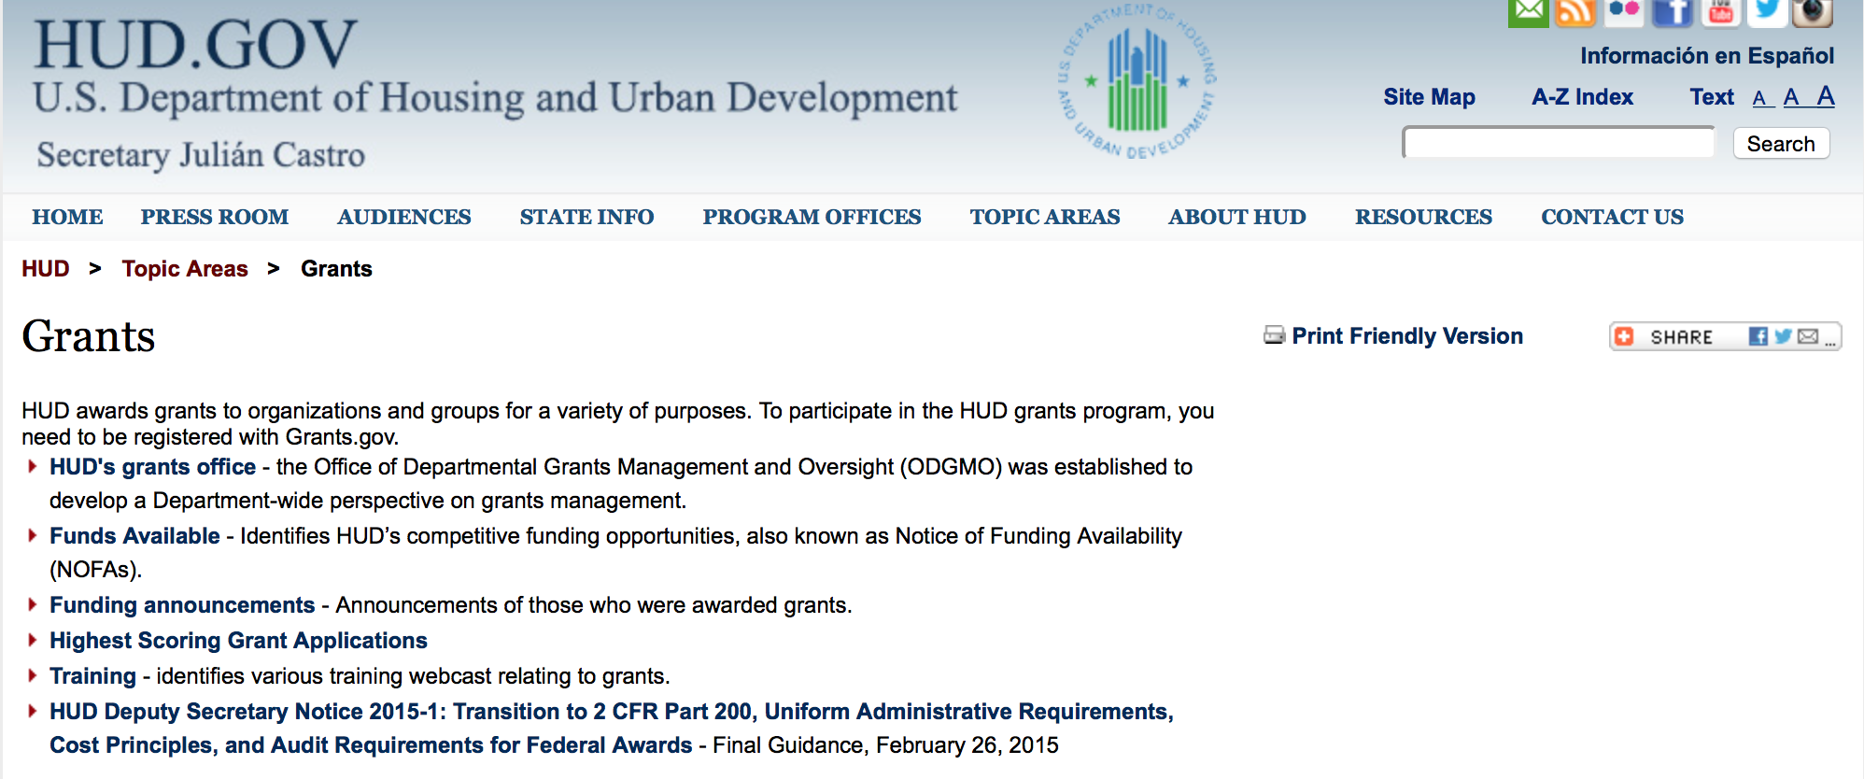

http://portal.hud.gov/hudportal/HUD?src=/topics/grants

HUD - Notice of Funds Available

For detailed information click here

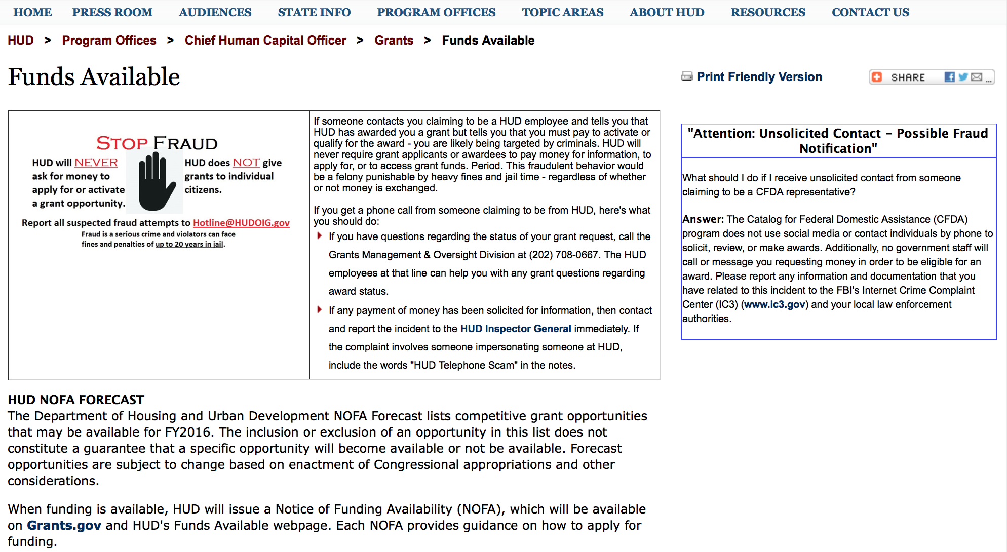

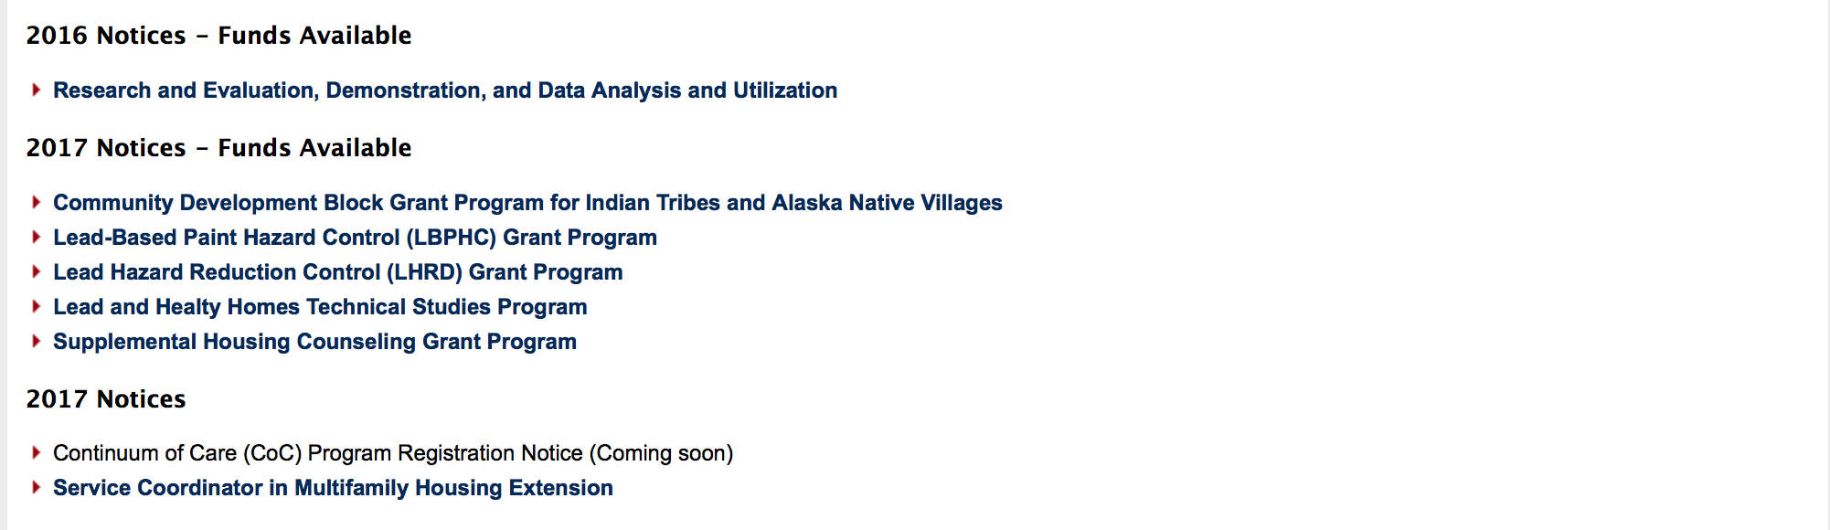
http://portal.hud.gov/hudportal/HUD?src=/program_offices/administration/grants/fundsavail

HUD NOFA FORECAST
The Department of Housing and Urban Development NOFA Forecast lists competitive grant opportunities that may be available for FY2016. The inclusion or exclusion of an opportunity in this list does not constitute a guarantee that a specific opportunity will become available or not be available. Forecast opportunities are subject to change based on enactment of Congressional appropriations and other considerations.
When funding is available, HUD will issue a Notice of Funding Availability (NOFA), which will be available on Grants.gov

Programs:

Modifications:

Deleted:

Reminders:

Resident Opportunity & Self-Sufficiency Program
Forecast 1

Document Type: | Grants Notice
Opportunity Number: | FR-6100-N-05
Opportunity Title: | Resident Opportunity & Self-Sufficiency Program
Opportunity Category: | Discretionary
Opportunity Category Explanation:
Funding Instrument Type: | Grant
Category of Funding Activity: | Housing
Category Explanation:
Expected Number of Awards: | 110
CFDA Number(s): | 14.870 -- Resident Opportunity and Supportive Services - Service Coordinators
Cost Sharing or Matching Requirement: | Yes
Posted Date: | Nov 21, 2016
Last Updated Date: | Nov 21, 2016
Estimated Synopsis Post Date: | May 01, 2017
Estimated Application Due Date: | Jun 20, 2017 Electronically submitted applications must be submitted no later than 11:59 p.m., ET, on the listed application due date.
Estimated Award Date: | Sep 25, 2017
Estimated Project Start Date: | Oct 16, 2017
Fiscal Year: | 2017
Archive Date:
Estimated Total Program Funding: | $35,000,000
Award Ceiling: | $738,000
Award Floor: | $0
Eligible Applicants: | Public housing authorities/Indian housing authorities  Nonprofits having a 501(c)(3) status with the IRS, other than institutions of higher education  Nonprofits that do not have a 501(c)(3) status with the IRS, other than institutions of higher education  Native American tribal governments (Federally recognized)
Additional Information on Eligibility: | For-profit entities are not eligible to apply. Resident associations of all kinds must have either locally-incorporated nonprofit status (usually designated by the state) or 501(c)(3) nonprofit status designated by the IRS. All applicants with nonprofit status must submit documentation attesting to their nonprofit status. Please see Section XXX for more information. Individuals, foreign entities, and sole proprietorship organizations are not eligible to compete for, or receive, awards made under this announcement.
Agency Name: | Department of Housing and Urban Development
Description: | Program Overview: The Resident Opportunity & Self Sufficiency (ROSS) Service Coordinator (SC) program funds eligible applicants to hire Service Coordinators to coordinate use of assistance under the Public Housing program with public and private resources, for supportive services and resident empowerment activities. Service Coordinators assess the needs of public and Indian housing residents and link them to supportive services that enable participants to increase earned income, reduce or eliminate the need for welfare assistance, and make progress toward achieving economic independence and housing self-sufficiency. In the case of elderly/disabled residents, the Service Coordinator links participants to supportive services which enable them to age/remain in-place thereby avoiding costlier forms of care. Funds awarded to applicants may be used for (1) service coordinator functions, (2) training and travel related to professional and/or program development, (3) and administration cost.
Link to Additional Information:
Grantor Contact Information: | Tremayne Youmans  (202) 402-6621  Tremayne.E.Youmans@hud.gov

http://www.grants.gov/web/grants/view-opportunity.html?oppId=290238

Institute of Museum and Library Services

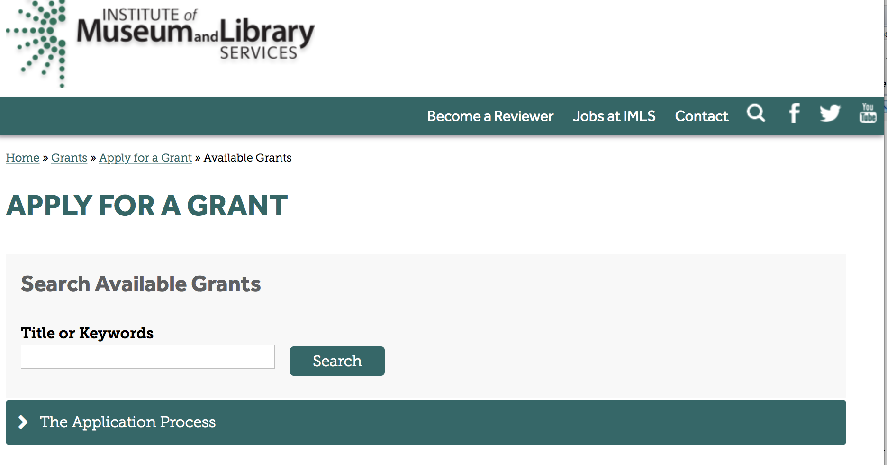

https://www.imls.gov/grants/apply-grant/available-grants

Each grant program has specific eligibility requirements. The links below provide general eligibility criteria for museums, libraries, and tribal organizations, but please note that additional organizations may be eligible for grants under certain programs. Additionally, ineligible organizations may still be able to participate in grant programs through partnerships with eligible organizations. Please click on the links below to see general criteria and review Applications and Guidelines for specific information.
Museums Libraries

Institutions: Archives, Federally Recognized Native American Tribe, Historical Society, Library, Nonprofits that serve Native Hawaiians, Professional Association, Public or Private Non-profit Institutions of Higher Education, Regional Organization, State Library Administrative Agency, State or Local Government

Check out IMLS's Facebook page at:
https://www.facebook.com/USIMLS/

Programs:

Modifications:

Reminders:

Deleted:

Department of the Interior
Working with Interior

The Interior Department provides assistance to the public, local governments and businesses through a number of programs. For a general overview see: http://www.doi.gov/index.cfm

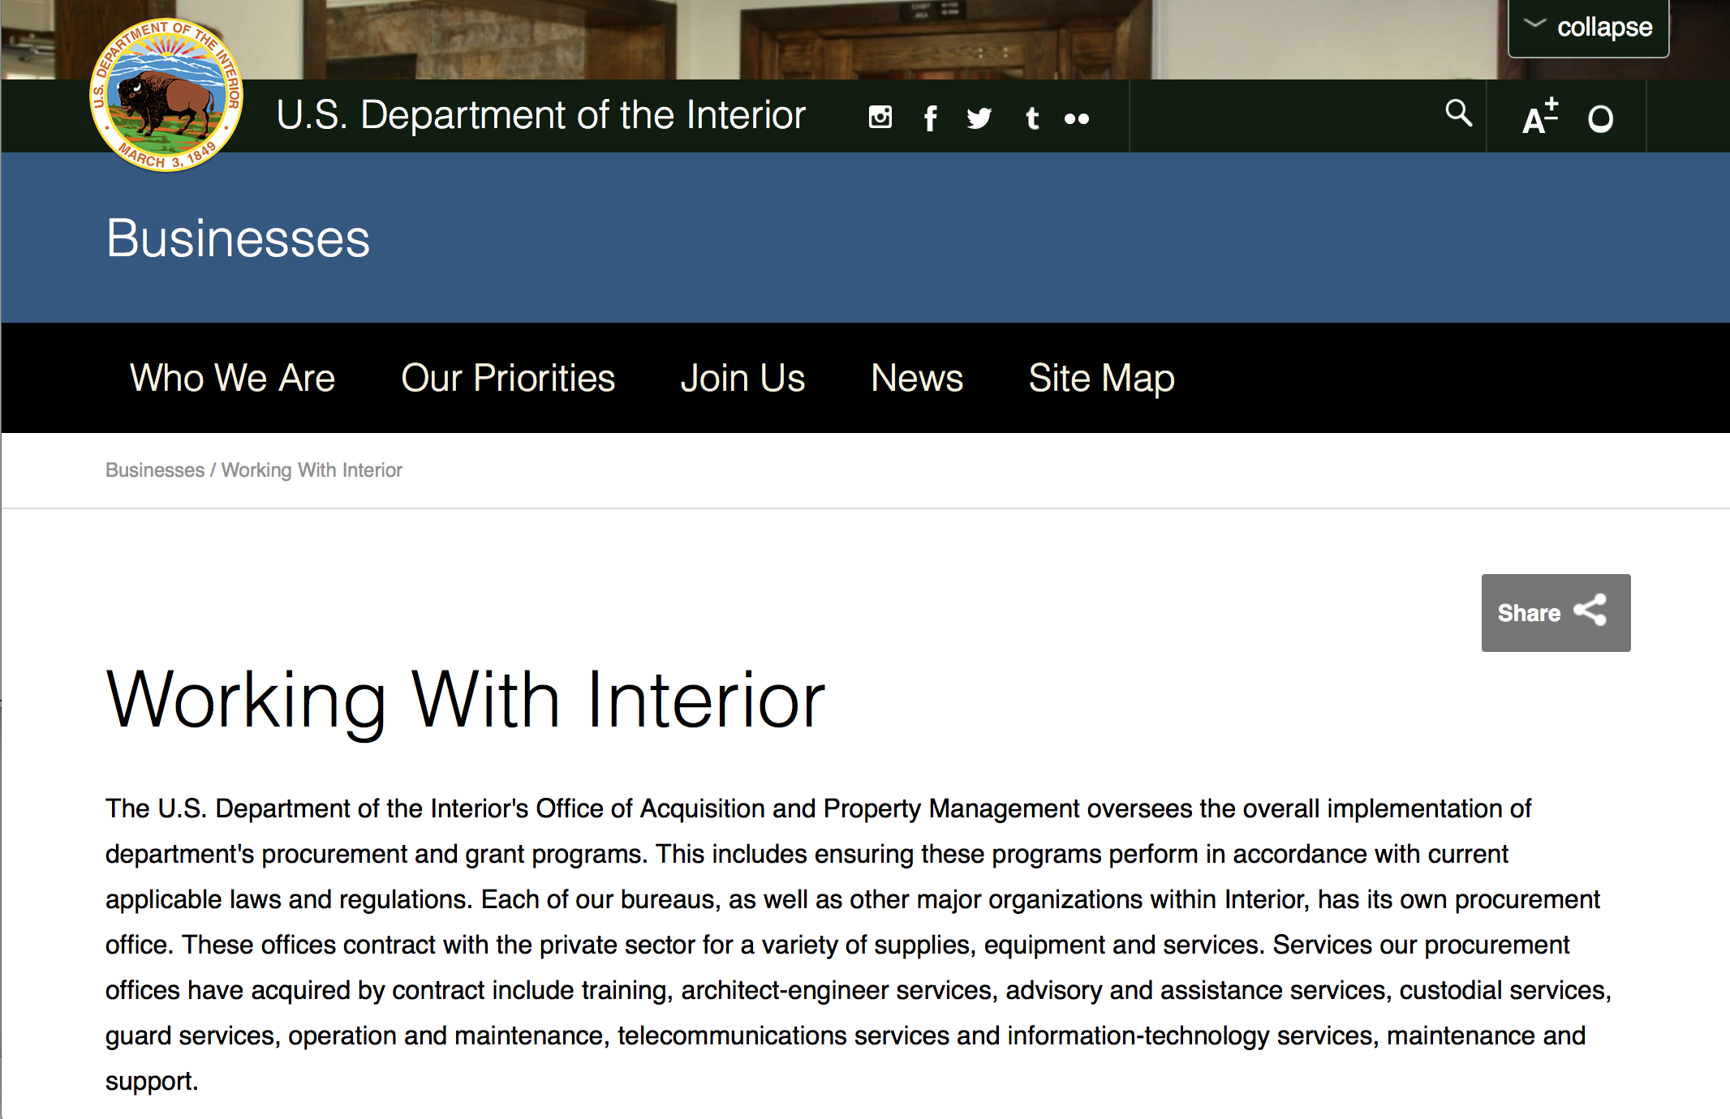

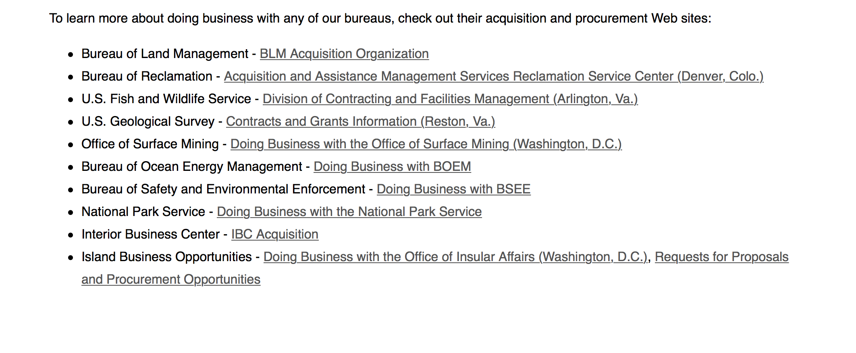
http://www.doi.gov/businesses/working-with-interior.cfm

Programs:

Modifications:

Reminders:

National Fish Passage Program
Synopsis 1

Document Type: | Grants Notice
Funding Opportunity Number: | F17AS00030
Funding Opportunity Title: | National Fish Passage Program
Opportunity Category: | Discretionary
Opportunity Category Explanation:
Funding Instrument Type: | Cooperative Agreement  Grant
Category of Funding Activity: | Natural Resources
Category Explanation:
Expected Number of Awards: | 0
CFDA Number(s): | 15.608 -- Fish and Wildlife Management Assistance
Cost Sharing or Matching Requirement: | Yes
Posted Date: | Nov 23, 2016
Last Updated Date: | Nov 23, 2016
Original Closing Date for Applications: | Sep 30, 2017
Current Closing Date for Applications: | Sep 30, 2017
Archive Date: | Oct 02, 2017
Estimated Total Program Funding: | $0
Award Ceiling: | $2,000,000
Award Floor: | $500
Eligible Applicants: | Unrestricted (i.e., open to any type of entity above), subject to any clarification in text field entitled "Additional Information on Eligibility"
Additional Information on Eligibility: | To receive funding, NFPP projects must be implemented in coordination with FAC staff. Applicants can be, but not limited to: state and federal agencies, private lands, tribes, local municipalities, and non-governmental organizations.
Agency Name: | Fish and Wildlife Service
Description: | The National Fish Passage Program (NFPP) is a voluntary program that provides direct technical assistance and financial assistance in the form of cooperative agreements and grants to partners to provide fish (and other aquatic organisms) passage and restore aquatic connectivity for the benefit of federal trust resources. The NFPP is delivered through more than 65 Fisheries and Aquatic Conservation (FAC) Field Offices across all States and territories. FAC staff coordinates with project partners, stakeholders and other Service programs to identify and collaboratively implement projects within Regional priority areas. Project work plans are developed strategically, in coordination with partners, and with substantial involvement from FAC staff. Projects must advance our mission, promote biological diversity, and be based upon sound scientific biological principles. FAC and Fish and Wildlife Service (FWS) strategic plans inform the types of projects funded under this opportunity. Applicants seeking funding under this program should review the program strategic plan and also contact the regional NFPP Coordinator for local FAC contacts prior to submitting an application for funding.
Link to Additional Information: | http://www.grants.gov
Grantor Contact Information: | If you have difficulty accessing the full announcement electronically, please contact:  Susan Wells 703-358-2523 Susan_Wells@fws.gov  Fish Passage Coordinator

http://www.grants.gov/web/grants/view-opportunity.html?oppId=290297

Fish and Wildlife Service
Fiscal Year

Document Type: | Grants Notice
Funding Opportunity Number: | F17AS00005
Funding Opportunity Title: | Fiscal Year 2017 Recovery Implementation Grants
Opportunity Category: | Discretionary
Opportunity Category Explanation:
Funding Instrument Type: | Cooperative Agreement  Grant  Procurement Contract
Category of Funding Activity: | Environment  Natural Resources
Category Explanation:
Expected Number of Awards: | 0
CFDA Number(s): | 15.657 -- Endangered Species Conservation - Recovery Implementation Funds
Cost Sharing or Matching Requirement: | No
Posted Date: | Oct 18, 2016
Last Updated Date: | Oct 18, 2016
Original Closing Date for Applications: | Applications are due by July 31, 2017. However, you may submit applications throughout the year. Consideration of applications ultimately will be based on the FWS budget cycle.
Current Closing Date for Applications: | Applications are due by July 31, 2017. However, you may submit applications throughout the year. Consideration of applications ultimately will be based on the FWS budget cycle.
Archive Date: | Aug 31, 2017
Estimated Total Program Funding: | $100,000
Award Ceiling: | $100,000
Award Floor: | $1
Eligible Applicants: | Unrestricted (i.e., open to any type of entity above), subject to any clarification in text field entitled "Additional Information on Eligibility"
Additional Information on Eligibility: | Applicants must have a demonstrated knowledge and understanding of the biology of the involved endangered or threatened species in the United States and their ecosystem, including preferably having worked with the species in the field and holding a currently valid Endangered Species Act permit, issued by the FWS, authorizing them to work with these species (or that have previously held a permit to do so). If funding is awarded, applicants that do not currently hold a valid permit for the proposed activity may need to apply for and obtain a permit (http://www.fws.gov/endangered/permits/index.html) before beginning the proposed activity. FWS Regional (or Field Office) contacts will discuss potential proposals with interested parties if needed, and review eligible applications. The FWS Regional Office will refer interested parties to the appropriate FWS Field Office for further consideration as appropriate. For potential proposals submitted directly to the Field Office, the Field Office will conduct the proposal review and selection process. A list of FWS Regional Office contacts is available in the Full Announcement under section VII. Agency Contacts.
Agency Name: | Fish and Wildlife Service
Description: | The FWS Ecological Services Program provides Federal financial assistance on a competitive basis to States, other Federal agencies, landowners, educators, non-profit organizations, researchers, and other partners to secure information about endangered, threatened or candidate species, to aid in the recovery of these species, to avert listing of species pursuant to the Endangered Species Act, and to help conserve the ecosystems upon which these species depend. The FWS and National Marine Fisheries Service (NMFS), which is part of the Department of Commerceï¿½s NOAA Fisheries office, share Endangered Species Act responsibilities for several species such as sea turtles. We have responsibility for sea turtles when they are on land, and NMFS has responsibility for sea turtles when they are in the water. Projects for NMFS-managed species are not included in this funding opportunity. This Recovery Implementation funding opportunity is intended for projects that will contribute to the recovery of FWS-managed endangered and threatened species in the United States, and is limited to projects carrying out actions described in a speciesï¿½ approved recovery plan, in the implementation schedule of a speciesï¿½ approved recovery plan, actions recommended in a completed 5-year status review of the species or in a spotlight species action plan, or projects documenting speciesï¿½ response to climate change. For example: securing scientific information about endangered or threatened species, implementing restoration actions that will lead to delisting of a species, help prevent extinction of a species, or aid in the recovery of a species. Projects that address species response to climate change will receive additional consideration.
Link to Additional Information: | http://www.grants.gov
Grantor Contact Information: | If you have difficulty accessing the full announcement electronically, please contact:  Kelly Niland 703-358-2492 Kelly_Niland@fws.gov  Kelly_Niland@fws.gov

http://www.grants.gov/web/grants/view-opportunity.html?oppId=289600

Fish and Wildlife Service
Partners for Fish and Wildlife
Synopsis 1

Document Type: | Grants Notice
Funding Opportunity Number: | F17AS00015
Funding Opportunity Title: | Partners for Fish and Wildlife
Opportunity Category: | Discretionary
Opportunity Category Explanation:
Funding Instrument Type: | Cooperative Agreement
Category of Funding Activity: | Community Development  Education  Environment  Natural Resources
Category Explanation:
Expected Number of Awards: | 5000
CFDA Number(s): | 15.631 -- Partners for Fish and Wildlife
Cost Sharing or Matching Requirement: | No
Posted Date: | Nov 03, 2016
Last Updated Date: | Nov 03, 2016
Original Closing Date for Applications: | Sep 30, 2017
Current Closing Date for Applications: | Sep 30, 2017
Archive Date: | Oct 07, 2017
Estimated Total Program Funding: | $52,000,000
Award Ceiling: | $500,000
Award Floor: | $1
Eligible Applicants: | For profit organizations other than small businesses  Nonprofits having a 501(c)(3) status with the IRS, other than institutions of higher education  City or township governments  Native American tribal organizations (other than Federally recognized tribal governments)  State governments  Individuals  Small businesses  Public and State controlled institutions of higher education  Nonprofits that do not have a 501(c)(3) status with the IRS, other than institutions of higher education  Native American tribal governments (Federally recognized)  County governments  Private institutions of higher education
Agency Name: | Fish and Wildlife Service
Description: | The Partners for Fish and Wildlife (PFW) Program is a voluntary, incentive-based program that provides direct technical assistance and financial assistance in the form of cooperative agreements to private landowners to restore and conserve fish and wildlife habitat for the benefit of federal trust resources. The PFW Program is delivered through more than 250 full-time staff, active in all 50 States and territories. Partners for Fish and Wildlife Program staff coordinate with project partners, stakeholders and other Service programs to identify geographic focus areas and develop habitat conservation priorities within these focus areas. Geographic focus areas are where the PFW Program directs resources to conserve habitat for federal trust species. Project work plans are developed strategically, in coordination with partners, and with substantial involvement from Service field staff. Projects must advance our mission, promote biological diversity, and be based upon sound scientific biological principles. Program strategic plans inform the types of projects funded under this opportunity. Applicants seeking funding under this program should review the program strategic plan and also contact the regional PFW Program office prior to submitting an application for funding. Authorizing statues include Partners for Fish and Wildlife Act of 2006, 16 U.S.C. 3771-3774; Fish and Wildlife Act of 1956; 16 U.S.C. 742a-c, 742e-j; Fish and Wildlife Coordination Act of 1958, 16 U.S.C. 661-667(e).
Link to Additional Information: | http://www.grants.gov
Grantor Contact Information: | If you have difficulty accessing the full announcement electronically, please contact:  Matthew Filsinger 703-358-2011 matthew_filsinger@fws.gov  Project Officer

http://www.grants.gov/web/grants/view-opportunity.html?oppId=289882

Fish and Wildlife Service
Coastal Program
Synopsis 1

Document Type: | Grants Notice
Funding Opportunity Number: | F17AS00014
Funding Opportunity Title: | Coastal Program
Opportunity Category: | Discretionary
Opportunity Category Explanation:
Funding Instrument Type: | Cooperative Agreement
Category of Funding Activity: | Community Development  Education  Environment  Natural Resources
Category Explanation:
Expected Number of Awards: | 500
CFDA Number(s): | 15.630 -- Coastal
Cost Sharing or Matching Requirement: | No
Posted Date: | Nov 03, 2016
Last Updated Date: | Nov 03, 2016
Original Closing Date for Applications: | Sep 30, 2017
Current Closing Date for Applications: | Sep 30, 2017
Archive Date: | Oct 07, 2017
Estimated Total Program Funding: | $14,000,000
Award Ceiling: | $500,000
Award Floor: | $1
Eligible Applicants: | County governments  Nonprofits having a 501(c)(3) status with the IRS, other than institutions of higher education  City or township governments  Special district governments  Native American tribal governments (Federally recognized)  Private institutions of higher education  Native American tribal organizations (other than Federally recognized tribal governments)  For profit organizations other than small businesses  State governments  Small businesses  Public and State controlled institutions of higher education  Individuals  Nonprofits that do not have a 501(c)(3) status with the IRS, other than institutions of higher education
Agency Name: | Fish and Wildlife Service
Description: | The Coastal Program is a voluntary, incentive-based program that provides direct technical assistance and financial assistance in the form of cooperative agreements to coastal communities and landowners to restore and protect fish and wildlife habitat on public and private lands. Coastal Program staff coordinate with project partners, stakeholders and other Service programs to identify geographic focus areas and develop habitat conservation priorities within these focus areas. Geographic focus areas are where the Coastal Program directs resources to conserve habitat for federal trust species. Project work plans are developed strategically, in coordination with partners, and with substantial involvement from Service field staff. Projects must advance our mission, promote biological diversity, and be based upon sound scientific biological principles. Program strategic plans inform the types of projects funded under this opportunity. Applicants seeking funding under this program should review the program strategic plan and also contact the regional Coastal Program office prior to submitting an application for funding. Authorizing statues include Fish and Wildlife Act of 1956, 16 U.S.C. 742a-c, 747e-742j; and Fish and Wildlife Coordination Act of 1958, 16 U.S.C. 661 667(e).
Link to Additional Information: | http://www.grants.gov
Grantor Contact Information: | If you have difficulty accessing the full announcement electronically, please contact:  Chris Darnell 703-358-2236 chris_darnell@fws.gov  Project Officer

http://www.grants.gov/web/grants/view-opportunity.html?oppId=289863

Geological Survey
Cooperative Research Units Program FY 2017
Synopsis 2

Document Type: | Grants Notice
Funding Opportunity Number: | G17AS00004
Funding Opportunity Title: | Cooperative Research Units Program FY 2017
Opportunity Category: | Discretionary
Opportunity Category Explanation:
Funding Instrument Type: | Cooperative Agreement
Category of Funding Activity: | Environment  Natural Resources  Science and Technology and other Research and Development
Category Explanation:
Expected Number of Awards: | 0
CFDA Number(s): | 15.812 -- Cooperative Research Units
Cost Sharing or Matching Requirement: | No
Version: | Synopsis 2
Posted Date: | Sep 23, 2016
Last Updated Date: | Sep 23, 2016
Original Closing Date for Applications: | June 20, 2017 (new or changes in scope of work or total estimated cost) August 9, 2017 (other changes not involving change to scope of work or total estimated cost)
Current Closing Date for Applications: | June 20, 2017 (new or changes in scope of work or total estimated cost) August 9, 2017 (other changes not involving change to scope of work or total estimated cost)
Archive Date: | Oct 31, 2017
Estimated Total Program Funding: | $0
Award Ceiling: | $0
Award Floor: | $0
Eligible Applicants: | Others (see text field entitled "Additional Information on Eligibility" for clarification)
Additional Information on Eligibility: | Only CRU Cooperating Universities are eligible to apply to the RWO component of the Cooperative Research Unit Program pursuant to the Cooperative Research Unit Act (Public Law 86-686).
Agency Name: | Geological Survey
Description: | The Cooperative Research Units Program is a unique collaborative relationship between States, Universities, the Federal government and a non-profit organization. The program is comprised of 40 Cooperative Fish and Wildlife Research Units on university campuses in 38 states. Since the original nine Units were established in the 1930s, additional Units were established by Congress at specified universities. The 40 units in the program are jointly supported by the US Geological Survey, Host Universities, State Natural Resource Agencies, Wildlife Management Institute, and the US Fish and Wildlife Service.
Link to Additional Information: | http://www.grants.gov/
Grantor Contact Information: | If you have difficulty accessing the full announcement electronically, please contact:  Melissa Thode (703) 648-4265  CRU Headquarters Office

http://www.grants.gov/web/grants/view-opportunity.html?oppId=289097

Deleted:

Bureau of Ocean Energy Management
M17AS00012 - BOEM FY 2017 Environmental Studies Program
Deletion Comments: Opportunity deleted

Department of Justice

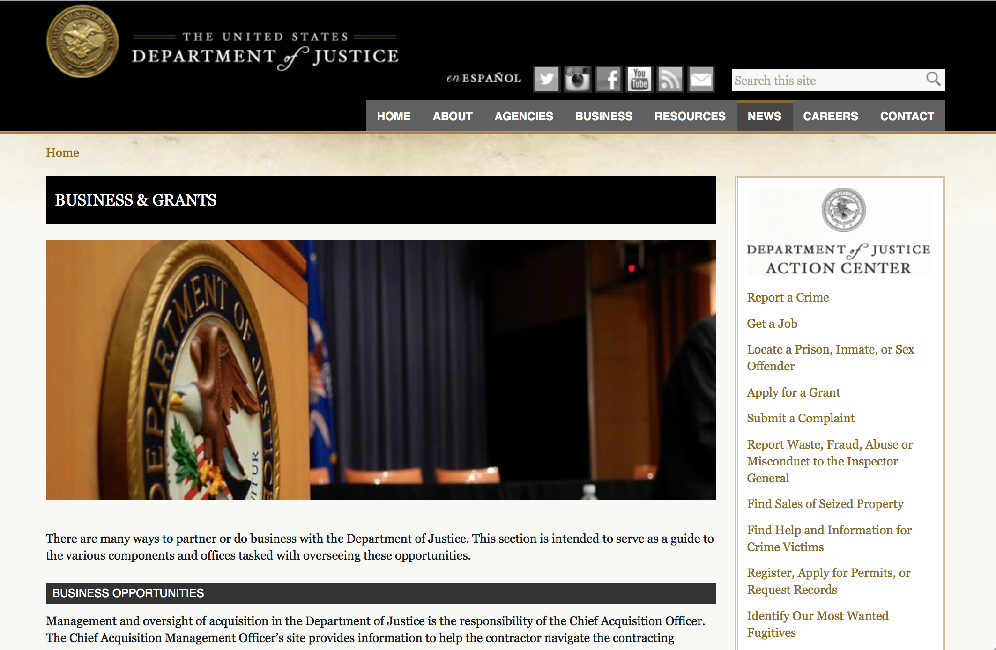

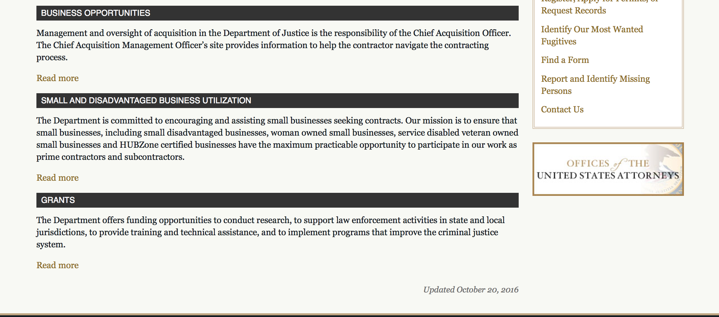

The DOJ agencies listed below also have sites that provide grant information specific to that agency. Examples of what can be found on these sites are programs, funding opportunities, application assistance, and other useful information.

Bureau of Justice Assistance (BJA)

Bureau of Justice Statistics (BJS)

National Criminal Justice Reference Service (NCJRS)

National Institute of Justice (NIJ)

Office of Sex Offender Sentencing, Monitoring, Apprehending, Registering, and Tracking (SMART)

http://www.justice.gov/business/

Programs:

Bureau of Justice Assistance
BJA FY 17 Second Chance Act Reentry and Mentoring Program
Synopsis 1

Eligible Applicants: | Nonprofits having a 501(c)(3) status with the IRS, other than institutions of higher education  Native American tribal governments (Federally recognized)
Document Type: | Grants Notice
Funding Opportunity Number: | BJA-2017-11540
Funding Opportunity Title: | BJA FY 17 Second Chance Act Reentry and Mentoring Program
Opportunity Category: | Discretionary
Opportunity Category Explanation:
Funding Instrument Type: | Grant
Category of Funding Activity: | Law, Justice and Legal Services
Category Explanation:
Expected Number of Awards: | 10
CFDA Number(s): | 16.812 -- Second Chance Act Reentry Initiative
Cost Sharing or Matching Requirement: | No
Version: | Synopsis 1
Posted Date: | May 17, 2017
Last Updated Date: | May 17, 2017
Original Closing Date for Applications: | Jul 05, 2017
Current Closing Date for Applications: | Jul 05, 2017
Archive Date:
Estimated Total Program Funding: | $9,000,000
Award Ceiling: | $1,000,000
Award Floor: | $0
Eligible Applicants: | Nonprofits having a 501(c)(3) status with the IRS, other than institutions of higher education  Native American tribal governments (Federally recognized)
Agency Name: | Bureau of Justice Assistance
Description: | The Second Chance Act of 2007 (Pub. L. 110-199) provides a comprehensive response to the increasing number of incarcerated adults and juveniles who are released from prison, jail, and juvenile residential facilities and returning to communities. There are currently over 2.2 million individuals serving time in our federal and state prisons, and millions of people cycling through tribal and local jails every year . Ninety-five percent of all people incarcerated today will eventually be released and will return to communities. The coordination of reentry of members of Native American tribes is even more complex given that they can return from federal, Bureau of Indian Affairs (BIA), state, local, and tribal facilities. The Second Chance Act helps to ensure that the transition individuals make from prison, jail, or juvenile residential facilities to the community is successful and promotes public safety.
Link to Additional Information: | See link
Grantor Contact Information: | If you have difficulty accessing the full announcement electronically, please contact:  For assistance with any unforeseen Grants.gov technical issues beyond an applicant’s control that prevent it from submitting its application by the deadline, or any other requirement of this solicitation, contact the National Criminal Justice Reference Service (NCJRS) Response Center: toll-free at 800-851-3420; via TTY at 301-240-6310 (hearing impaired only); email grants@ncjrs.gov; fax to 301-240-5830; or web chat at https://webcontact.ncjrs.gov/ncjchat/chat.jsp. The NCJRS Response Center hours of operation are 10:00 a.m. to 6:00 p.m. eastern time, Monday through Friday, and 10:00 a.m. to 8:00 p.m. eastern time on the solicitation close date. support@grants.gov  technical application support

http://www.grants.gov/web/grants/view-opportunity.html?oppId=293910

Office for Victims of Crime
OVC FY 17 Field-Generated Innovations in Addressing Elder Abuse and Financial Exploitation
Synopsis 1
Document Type: | Grants Notice
Funding Opportunity Number: | OVC-2017-12021
Funding Opportunity Title: | OVC FY 17 Field-Generated Innovations in Addressing Elder Abuse and Financial Exploitation
Opportunity Category: | Discretionary
Opportunity Category Explanation:
Funding Instrument Type: | Cooperative Agreement
Category of Funding Activity: | Income Security and Social Services  Law, Justice and Legal Services
Category Explanation:
Expected Number of Awards: | 5
CFDA Number(s): | 16.582 -- Crime Victim Assistance/Discretionary Grants
Cost Sharing or Matching Requirement: | No
Version: | Synopsis 1
Posted Date: | May 30, 2017
Last Updated Date: | May 30, 2017
Original Closing Date for Applications: | Jun 28, 2017
Current Closing Date for Applications: | Jun 28, 2017
Archive Date:
Estimated Total Program Funding: | $3,250,000
Award Ceiling: | $500,000
Award Floor: | $200,000
Eligible Applicants: | Others (see text field entitled "Additional Information on Eligibility" for clarification)
Additional Information on Eligibility: | Eligible applicants are limited to private nonprofit organizations (including tribal nonprofit organizations); for-profit organizations; colleges or universities (including tribal institutions of higher education); and public agencies, tribal governments, or tribal organizations that can demonstrate knowledge and understanding of the needs of victims of elder abuse (with particular emphasis on elder abuse victims of financial exploitation) and the capacity to partner with other organizations and key stakeholders to address the unique needs of this underserved population. Applicants must have the staff resources and capability to develop or enhance a model for delivery of these services. A private nonprofit organization does not need to have 501(c)(3) status to apply for grant funding under this solicitation. For-profit organizations (and other recipients) must forgo any profit or management fee. OVC welcomes applications under which two or more entities would carry out the federal award; however, only one entity may be the applicant. Any others must be proposed as subrecipients (“subgrantees"). The applicant must be the entity that would have primary responsibility for carrying out the award, including administering the funding and managing the entire project. Under this solicitation, only one application by any particular applicant entity will be considered. An entity may, however, be proposed as a subrecipient (“subgrantee”) in more than one application. OVC may elect to fund applications submitted under this FY 2017 solicitation in future fiscal years, dependent on, among other considerations, the merit of the applications and on the availability of appropriations.
Agency Name: | Office for Victims of Crime
Description: | The Field-Generated Innovations in Addressing Elder Abuse and Financial Exploitation Project solicitation seeks applications that are national in scope to develop or enhance promising practices, models, and programs that build the capacity of victim service and other ancillary providers in support of victims of elder abuse and financial exploitation. The ultimate aim is to enhance the provision of services and support to crime victims and ensure that victims are afforded the rights, services, and responses they are due. Innovation projects should focus on improving the capacity of the crime victims’ field to provide trauma-informed, culturally competent, comprehensive services to victims of elder abuse and financial exploitation. Applicants must propose to provide enhanced or improved victim services for these victims through implementation or continuation of a demonstration project developed from a promising practice, model, or program in three distinct areas (Combating Elder Abuse and Financial Exploitation Through Technology, Increasing Justice for Older Americans, and Focusing on Victims by Identifying and Remedying Elder Abuse and Financial Exploitation).
Link to Additional Information: | Funding Opportunity
Grantor Contact Information: | If you have difficulty accessing the full announcement electronically, please contact:  For assistance with any other requirements of this solicitation, contact Laura Ivkovich, Policy Analyst, by telephone at 202-616-3576. Laura.Ivkovich@usdoj.gov  For Programmatic Questions

http://www.grants.gov/web/grants/view-opportunity.html?oppId=294195

Research:

Modifications:

Office for Victims of Crime
OVC FY 17 Vision 21: Advancing the Use of Technology to Assist Victims of Crime
Synopsis 3
Document Type: | Grants Notice
Funding Opportunity Number: | OVC-2017-12281
Funding Opportunity Title: | OVC FY 17 Vision 21: Advancing the Use of Technology to Assist Victims of Crime
Opportunity Category: | Discretionary
Opportunity Category Explanation:
Funding Instrument Type: | Cooperative Agreement
Category of Funding Activity: | Income Security and Social Services  Law, Justice and Legal Services
Category Explanation:
Expected Number of Awards: | 5
CFDA Number(s): | 16.582 -- Crime Victim Assistance/Discretionary Grants
Cost Sharing or Matching Requirement: | No
Version: | Synopsis 2
Posted Date: | May 25, 2017
Last Updated Date: | May 25, 2017
Original Closing Date for Applications: | Jun 23, 2017
Current Closing Date for Applications: | Jun 23, 2017
Archive Date:
Estimated Total Program Funding: | $10,000,000
Award Ceiling: | $1,400,000
Award Floor: | $500,000
Eligible Applicants: | Others (see text field entitled "Additional Information on Eligibility" for clarification)
Additional Information on Eligibility: | Eligible applicants are limited to nonprofit organizations (including tribal nonprofits) with the financial and administrative capacity to manage a federal award funding for a national-scope project serving crime victims within the United States. Applicants must demonstrate a unique capability and strong desire to reach and serve victims of crime through a project that is national in scope. A private nonprofit organization does not have to have 501(c)(3) status to apply for grant funding under this solicitation. Applicants are permitted to submit proposals (each with a separate application) for multiple projects under this solicitation. OVC welcomes applications under which two or more entities would carry out the federal award; however, only one entity may be the applicant. Any others must be proposed as subrecipient(s) (“subgrantees"). The applicant must be the entity that would have primary responsibility for carrying out the award, including administering the funding and managing the entire program. OVC may elect to fund applications submitted under this FY 2017 solicitation in future fiscal years, dependent on, among other considerations, the merit of the applications and on the availability of appropriations.
Agency Name: | Office for Victims of Crime
Description: | This program will provide project funding to eligible nonprofit organizations (see Eligibility) that propose to develop, use, and strategize around the use of technology in innovative ways to interact directly with crime victims and provide information, referral, crisis assistance, and longer term help. Through this solicitation, OVC seeks to support organizations which demonstrate innovative strategies to create, expand, or enhance use of technology initiatives on a national scale to improve response, services, and access for victims of crime.  Please see attached corrected funding opportunity. Deleted from page 10 under Project Abstract "Please note that to be responsive to this solicitation, the project described must be national in scope and address gaps in responding to the needs related to post-conviction issues for children or adult victims of crime."
Link to Additional Information: | Funding Opportunity
Grantor Contact Information: | If you have difficulty accessing the full announcement electronically, please contact:  For assistance with any other requirements of this solicitation, contact Jasmine D’Addario-Fobian, Victim Justice Program Specialist, by telephone at 202-–305–-3332.  For Programmatic Questions

http://www.grants.gov/web/grants/view-opportunity.html?oppId=294125

Office for Victims of Crime
OVC FY 17 Action Partnerships for National Membership, Professional Affiliation, and Community Service Organizations: Post-Conviction Services to Victims of Crime
Synopsis 2
Document Type: | Grants Notice
Funding Opportunity Number: | OVC-2017-11967
Funding Opportunity Title: | OVC FY 17 Action Partnerships for National Membership, Professional Affiliation, and Community Service Organizations: Post-Conviction Services to Victims of Crime
Opportunity Category: | Discretionary
Opportunity Category Explanation:
Funding Instrument Type: | Cooperative Agreement
Category of Funding Activity: | Income Security and Social Services  Law, Justice and Legal Services
Category Explanation:
Expected Number of Awards: | 5
CFDA Number(s): | 16.582 -- Crime Victim Assistance/Discretionary Grants
Cost Sharing or Matching Requirement: | No
Version: | Synopsis 2
Posted Date: | May 24, 2017
Last Updated Date: | May 24, 2017
Original Closing Date for Applications: | Jun 22, 2017
Current Closing Date for Applications: | Jun 22, 2017
Archive Date:
Estimated Total Program Funding: | $2,500,000
Award Ceiling: | $350,000
Award Floor: | $0
Eligible Applicants: | Others (see text field entitled "Additional Information on Eligibility" for clarification)
Additional Information on Eligibility: | Eligible applicants are limited to national nonprofit (including tribal nonprofits) membership, professional affiliation, and community service organizations, and must demonstrate the financial and organizational capacity to manage this cooperative agreement. Applicants must demonstrate a capability and strong desire to reach and serve victims of crime through a project that is national in scope. The applicant organization must also be national, with the following exception: local or state chapters of groups based on professional membership or professional affiliation may apply, but must submit a memorandum of understanding (MOU) documenting a close partnership with their national office to achieve national capacity for the dissemination of this project. OVC welcomes applications under which two or more entities would carry out the federal award; however, only one entity may be the applicant. Any others must be proposed as subrecipients (“subgrantees"). The applicant must be the entity that would have primary responsibility for carrying out the award, including administering the funding and managing the entire program. Under this solicitation, only one application by any particular applicant entity will be considered. An entity may, however, be proposed as a subrecipient (“subgrantee”) in more than one application. OVC may elect to fund applications submitted under this FY 2017 solicitation in future fiscal years, dependent on, among other considerations, the merit of the applications and on the availability of appropriations.
Agency Name: | Office for Victims of Crime
Description: | Under the OVC FY 2017 Action Partnerships for National Membership, Professional Affiliation, and Community Service Organizations: Post-Conviction Services to Victims of Crime solicitation, applicants will be asked to address one or a combination of the following areas: Victim services throughout post-conviction involvement in criminal cases through appeal, parole, and psychiatric review hearings, etc. Unique issues in serving victims involved with cold cases (it is understood there may not be an actual conviction in these instances), capital cases, and/or wrongful conviction cases. Emerging issues such as retroactive legislation making necessary protocols for victim notification and other services and support. Provision of victim services through facilitated dialogue processes such as victim driven voluntary restorative justice programs and/or diversion programs or tribal peacemaking programs in lieu of conviction. Field-generated ideas or other issues related to post-conviction services not addressed above where applicants can effectively demonstrate a need or gap.
Link to Additional Information: | Funding Opportunity
Grantor Contact Information: | If you have difficulty accessing the full announcement electronically, please contact:  For assistance with any other requirements of this solicitation, contact Jasmine D'Addario-Fobian, Victim Justice Program Specialist, by telephone at 202-–305-–3332, or by email at Jasmine.D’Addario-Fobian@usdoj.gov.  For Programmatic Questions

http://www.grants.gov/web/grants/view-opportunity.html?oppId=294085

Office of Juvenile Justice Delinquency Prevention
OJJDP FY 2017 Second Chance Act: Implementing County and Statewide Plans To Improve Outcomes for Youth in the Juvenile Justice System
Synopsis 3
Document Type: | Grants Notice
Funding Opportunity Number: | OJJDP-2017-11025
Funding Opportunity Title: | OJJDP FY 2017 Second Chance Act: Implementing County and Statewide Plans To Improve Outcomes for Youth in the Juvenile Justice System
Opportunity Category: | Discretionary
Opportunity Category Explanation:
Funding Instrument Type: | Grant
Category of Funding Activity: | Law, Justice and Legal Services
Category Explanation:
Expected Number of Awards: | 4
CFDA Number(s): | 16.812 -- Second Chance Act Reentry Initiative
Cost Sharing or Matching Requirement: | No
Version: | Synopsis 3
Posted Date: | May 15, 2017
Last Updated Date: | May 15, 2017
Original Closing Date for Applications: | Jun 29, 2017
Current Closing Date for Applications: | Jun 29, 2017
Archive Date: | Jul 29, 2017
Estimated Total Program Funding: | $3,500,000
Award Ceiling: | $1,000,000
Award Floor: | $750,000
Eligible Applicants: | City or township governments  State governments  Others (see text field entitled "Additional Information on Eligibility" for clarification)  County governments
Additional Information on Eligibility: | Eligible applicants are limited to units of local government and states that have developed a countywide or statewide plan to reduce recidivism and improve outcomes for youth in contact with the juvenile justice system. Eligible applicants must have developed and attached a completed jurisdictionwide plan to the application. Refer to Section C for additional Eligibility requirements. OJJDP welcomes applications under which two or more entities would carry out the federal award; however, only one entity may be the applicant. Any others must be proposed as subrecipients (“subgrantees”). The applicant must be the entity that would have primary responsibility for carrying out the award, including administering the funding and managing the entire program. Under this solicitation, only one application by any particular applicant entity will be considered. An entity may, however, be proposed as a subrecipient (“subgrantee”) in more than one application. For information on eligibility, see “Section C. Eligibility Information.”
Agency Name: | Office of Juvenile Justice Delinquency Prevention
Description: | section 101 of the Second Chance Act authorizes the Department of Justice to award grants to counties and states to improve reentry outcomes for incarcerated youth. The Second Chance Act Program supports counties and states in refining and implementing improved collaborative strategies to address the challenges that reentry and recidivism reduction pose. Implementing a cooperative and wide-ranging plan for reducing recidivism is challenging for even the most sophisticated juvenile justice agencies and requires an intensive systemwide realignment to address gaps in programs and services to improve outcomes for youth in contact with the juvenile justice system. This program will provide grants to support counties and states that have developed a recidivism reduction plan to better align juvenile justice policy, practice, and resource allocation with what research shows works to reduce recidivism and improve outcomes for youth in contact with the juvenile justice system. OJJDP expects that a committee, task force, or working group will designate an agency to act as the legal applicant for this grant program. This solicitation will support counties and states that illustrate their readiness to implement a planning strategy developed and coordinated among multiple systems, to track implementation progress, and to show progress toward sustainable changes.
Link to Additional Information: | Full Announcement
Grantor Contact Information: | If you have difficulty accessing the full announcement electronically, please contact:  For technical assistance with submitting an application, contact the Grants.gov Customer Support Hotline at 800–518–4726 or 606–545–5035, or via email to support@grants.gov. The Grants.gov Support Hotline operates 24 hours a day, 7 days a week, except on federal holidays. An applicant that experiences unforeseen Grants.gov technical issues beyond its control that prevent it from submitting its application by the deadline must email the National Criminal Justice Reference Service Response Center (Response Center) at grants@ncjrs.gov within 24 hours after the application deadline in order to request approval to submit its application after the deadline. Additional information on reporting technical issues appears under “Experiencing Unforeseen Grants.gov Technical Issues” in the How to Apply section. For assistance with any other requirements of this solicitation, contact the Response Center by telephone at 800–851–3420 or TTY: 301–240–6310 (hearing impaired only), by email at grants@ncjrs.gov, or by web chat. Response Center hours of operation are 10 a.m. to 6 p.m. ET, Monday through Friday, and 10 a.m. to 8 p.m. ET on the solicitation close date. Answers to frequently asked questions that may assist applicants are posted at www.ojjdp.gov/grants/solicitations/FY2017/FAQ/SCAOutcomes.pdf.  email

http://www.grants.gov/web/grants/view-opportunity.html?oppId=293841

Office of Juvenile Justice Delinquency Prevention
OJJDP FY 2017 Smart on Juvenile Justice: Systemwide Reform and Reinvestment Initiative
Synopsis 4
http://www.grants.gov/web/grants/view-opportunity.html?oppId=293864

Office of Juvenile Justice Delinquency Prevention
OJJDP FY 17 Mentoring for Child Victims of Commercial Sexual Exploitation and Domestic Sex Trafficking Program and Training and Technical Assistance
Synopsis 3 and 4
http://www.grants.gov/web/grants/view-opportunity.html?oppId=293868

Deleted:

Reminders:



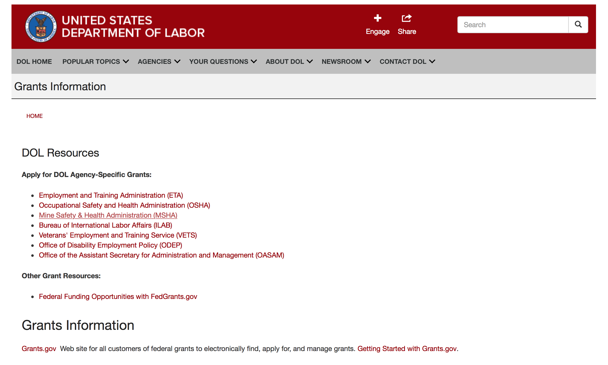

Agency Grants and Contract General Overview

DOL Resources
Apply for DOL Agency-Specific Grants:
- Employment and Training Administration (ETA)
- Occupational Safety and Health Administration (OSHA)
- Mine Safety & Health Administration (MSHA)
- Bureau of International Labor Affairs (ILAB)
- Veterans' Employment and Training Service (VETS)
- Office of Disability Employment Policy (ODEP)
- Office of the Assistant Secretary for Administration and Management (OASAM)

Other Grant Resources:
- Federal Funding Opportunities with FedGrants.gov
Grants Information
Grants.gov — Web site for all customers of federal grants to electronically find, apply for, and manage grants. Getting Started with Grants.gov.

DOL Resources and Instructions for Applying for a Grant
- DOL Guidance Clarifying the Effect of the Religious Freedom Restoration Act on Faith-Based Organizations
- Grant and Contract Information
- Contracting and Grant Program Overview
- Civil Rights Enforcement for Department of Labor Grant Recipients
- More Information About Grants
- Use of Contracts, Grants & Cooperative Agreements

Other Federal Government Grant Information
- Grant Opportunities (Catalog of Federal Domestic Assistance)

Department of Labor Grant Programs

- Bureau of International Labor Affairs (ILAB): provides grants (cooperative agreements) for the implementation of projects designed to assist developing countries combat the worse forms of child labor, forced labor, and human trafficking; and support worker rights and improve working conditions. http://www.dol.gov/general/business.
- Bureau of Labor Statistics (BLS): provides project grants (cooperative agreements) and the dissemination of technical statistical data and related information on labor force activities; provides data on prices (CPI) and cost of living; data on productivity and technology data; data on compensation and working conditions; data on employment projections.
- Employment and Training (ETA): ETA administers financial assistance programs pursuant to the Workforce Investment Act (WIA), administering State formula grant programs for youth, adults and dislocated workers, national emergency grants for workers affected by mass layoffs, plant closures, and disasters; grant programs for workers with disabilities, Indians and Native Americans, and for migrant and seasonal farmworkers. ETA also administers grant programs for older American workers, apprenticeship programs, Trade Adjustment Assistance (TAA) programs, and assistance for research and development of workforce programs. In addition, ETA is responsible for the operation and maintenance of a national system of public employment service offices and for the national unemployment insurance program.
- Mine Safety and Health (MSHA): provides grants for research, education and training programs to ensure an adequate and competent staff of trained inspectors; and assistance for establishing or improving State mine health and safety programs through technical assistance.
- Occupational Safety and Health (OSHA): provides grants to non-profit organizations to provide training, educational services, and technical assistance; assistance to states to administer and enforce state programs; assistance to states to provide occupational safety and health technical assistance and consultant services.
- Office of Disability Employment Policy (ODEP): The Office of Disability Employment Policy awards competitive grants establishing short-term pilot and technical assistance projects designed to identify, develop, test, evaluate, and disseminate policies to increase employment by expanding access to training, education, employment supports, assistive and systems technology, integrated employment, entrepreneurial development, and small business opportunities for adults and youth with disabilities. Current pilots projects focus on customized employment, Olmstead populations, and innovative demonstration youth grants, among others. Solicitations for grant applications are published in the Federal Register and announced at www.dol.gov/odep. ODEP grants are awarded by the OASAM grant office.
- Veterans' Employment and Training (VETS): provides special employment and training assistance for veterans through the Disabled Veterans' Outreach Program (DVOP) Solicitation for Grant Applications; the Local Veterans' Employment Representative Program (LVER); Veterans' Workforce Investment Program (VWIP); elaws Advisor on veterans' employment and reemployment rights; and the Homeless Veterans Reintegration Project (HVRP). VETS grants are awarded by the OASAM grant office.

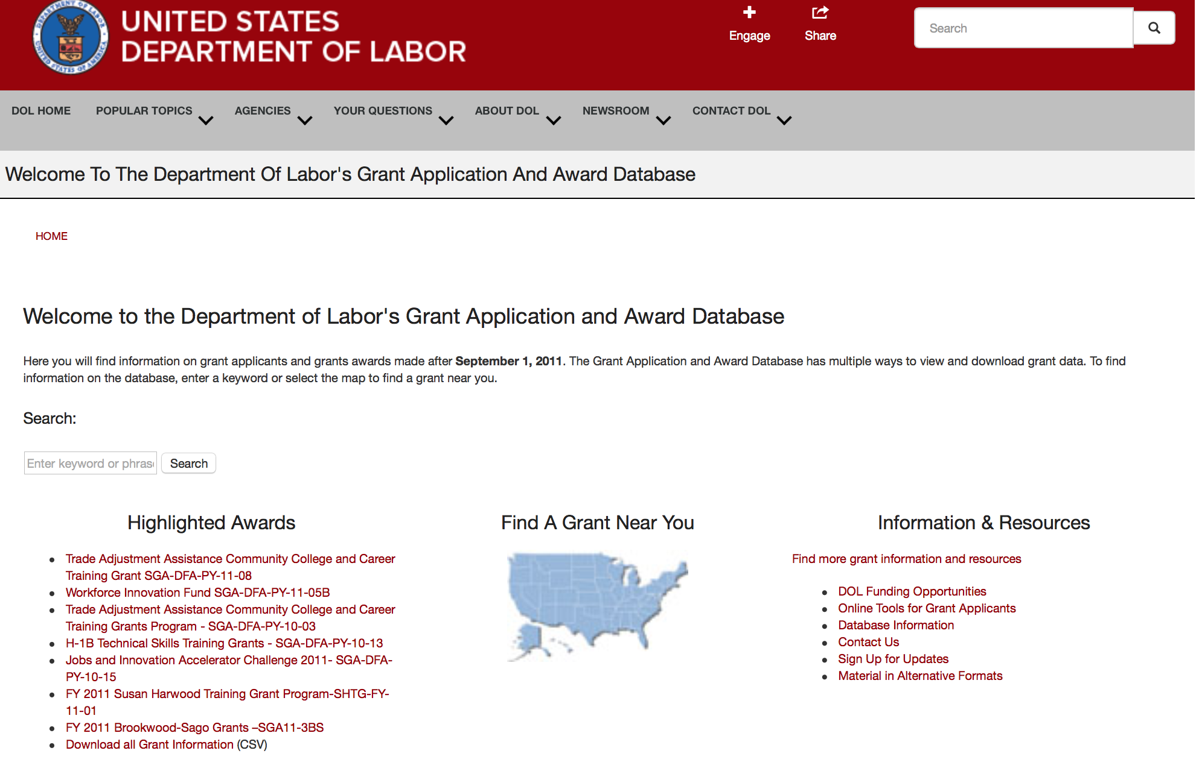

http://www.dol.gov/dol/grants/

Programs

Modifications

Reminders



National Aeronautics and Space Administration

Research and Contracting Opportunities

NASA Research Opportunities Online

- Various NASA offices publish their research announcements over the Internet, broadening the opportunity for researchers to apply for funding. This site provides access to current research announcements along with their specific due dates.

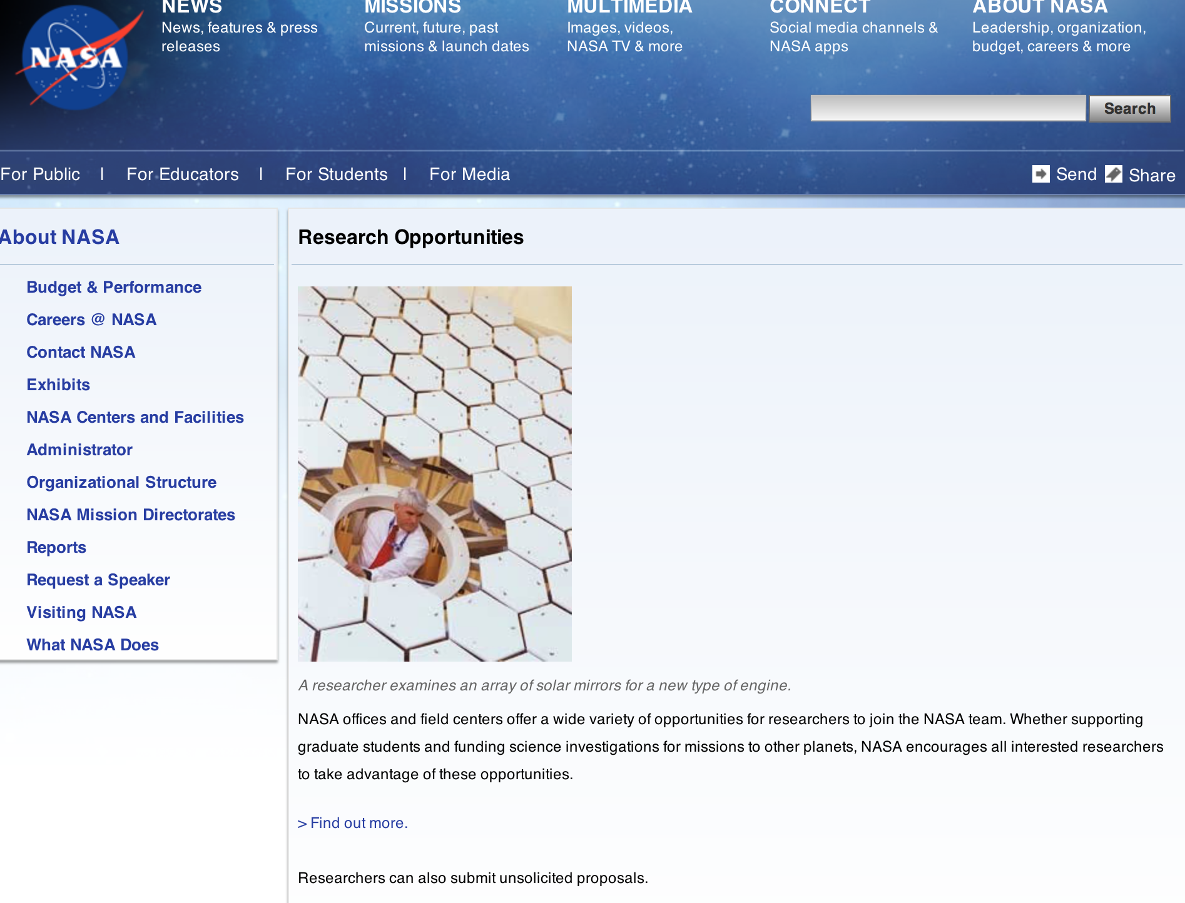

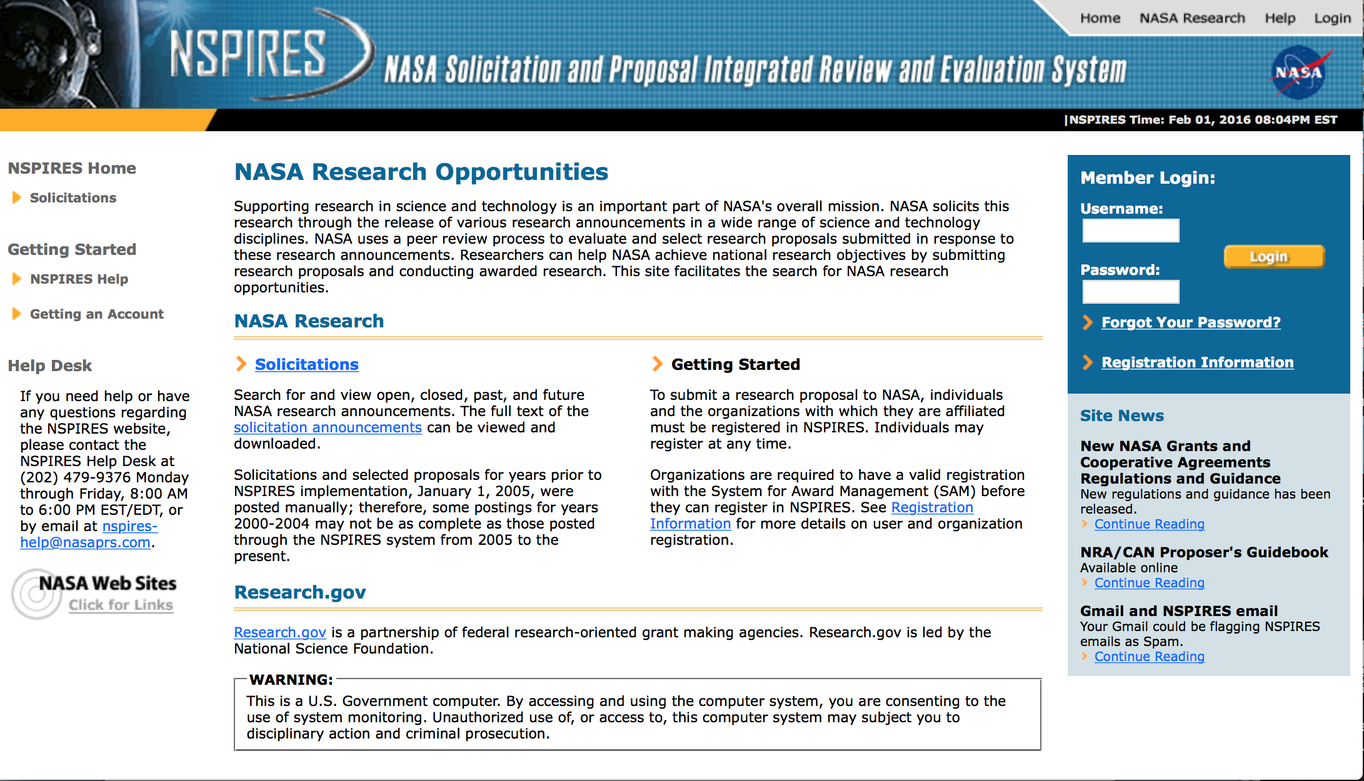
http://nspires.nasaprs.com/external/

Research Programs:

NASA Headquarters
ROSES 2017: Computational Modeling Algorithms and Cyberinfrastructure
Synopsis 1
http://www.grants.gov/web/grants/view-opportunity.html?oppId=293553

National Aeronautics and Space Administration
NASA Headquarters
ROSES 2017: Terrestrial Hydrology
Synopsis 1
http://www.grants.gov/web/grants/view-opportunity.html?oppId=293752

NASA Headquarters
ROSES 2017: Exobiology
Synopsis 1
http://www.grants.gov/web/grants/view-opportunity.html?oppId=293767

NASA Headquarters
ROSES 2017: Astrophysics Theory Program
Synopsis 1
http://www.grants.gov/web/grants/view-opportunity.html?oppId=293796

NASA Headquarters
ROSES 2017: New (Early Career) Investigator Program
Synopsis 1
http://www.grants.gov/web/grants/view-opportunity.html?oppId=293790

NASA Headquarters
ROSES 2017: Heliophysics Supporting Research
Synopsis 1
http://www.grants.gov/web/grants/view-opportunity.html?oppId=294198

Modifications:

NASA Headquarters
ROSES 2017: Planetary Data Archiving, Restoration, and Tools
Synopsis 2
http://www.grants.gov/web/grants/view-opportunity.html?oppId=293094

NASA Headquarters
ROSES 2017: OSIRIS-REx Participating Scientist Program
Synopsis 2
http://www.grants.gov/web/grants/view-opportunity.html?oppId=293024

NASA Headquarters
ROSES 2017: Heliophysics Guest Investigator - Open
Synopsis 4
http://www.grants.gov/web/grants/view-opportunity.html?oppId=291864

NASA Headquarters
ROSES 2017: Laboratory Analysis of Returned Samples
Synopsis 2
http://www.grants.gov/web/grants/view-opportunity.html?oppId=292791

NASA Headquarters
NASA Astrobiology Institute - Cycle 8
Synopsis 2
http://www.grants.gov/web/grants/view-opportunity.html?oppId=292102

National Archives and Records Administration

Grant Opportunities General Overview

To access the information below: click here

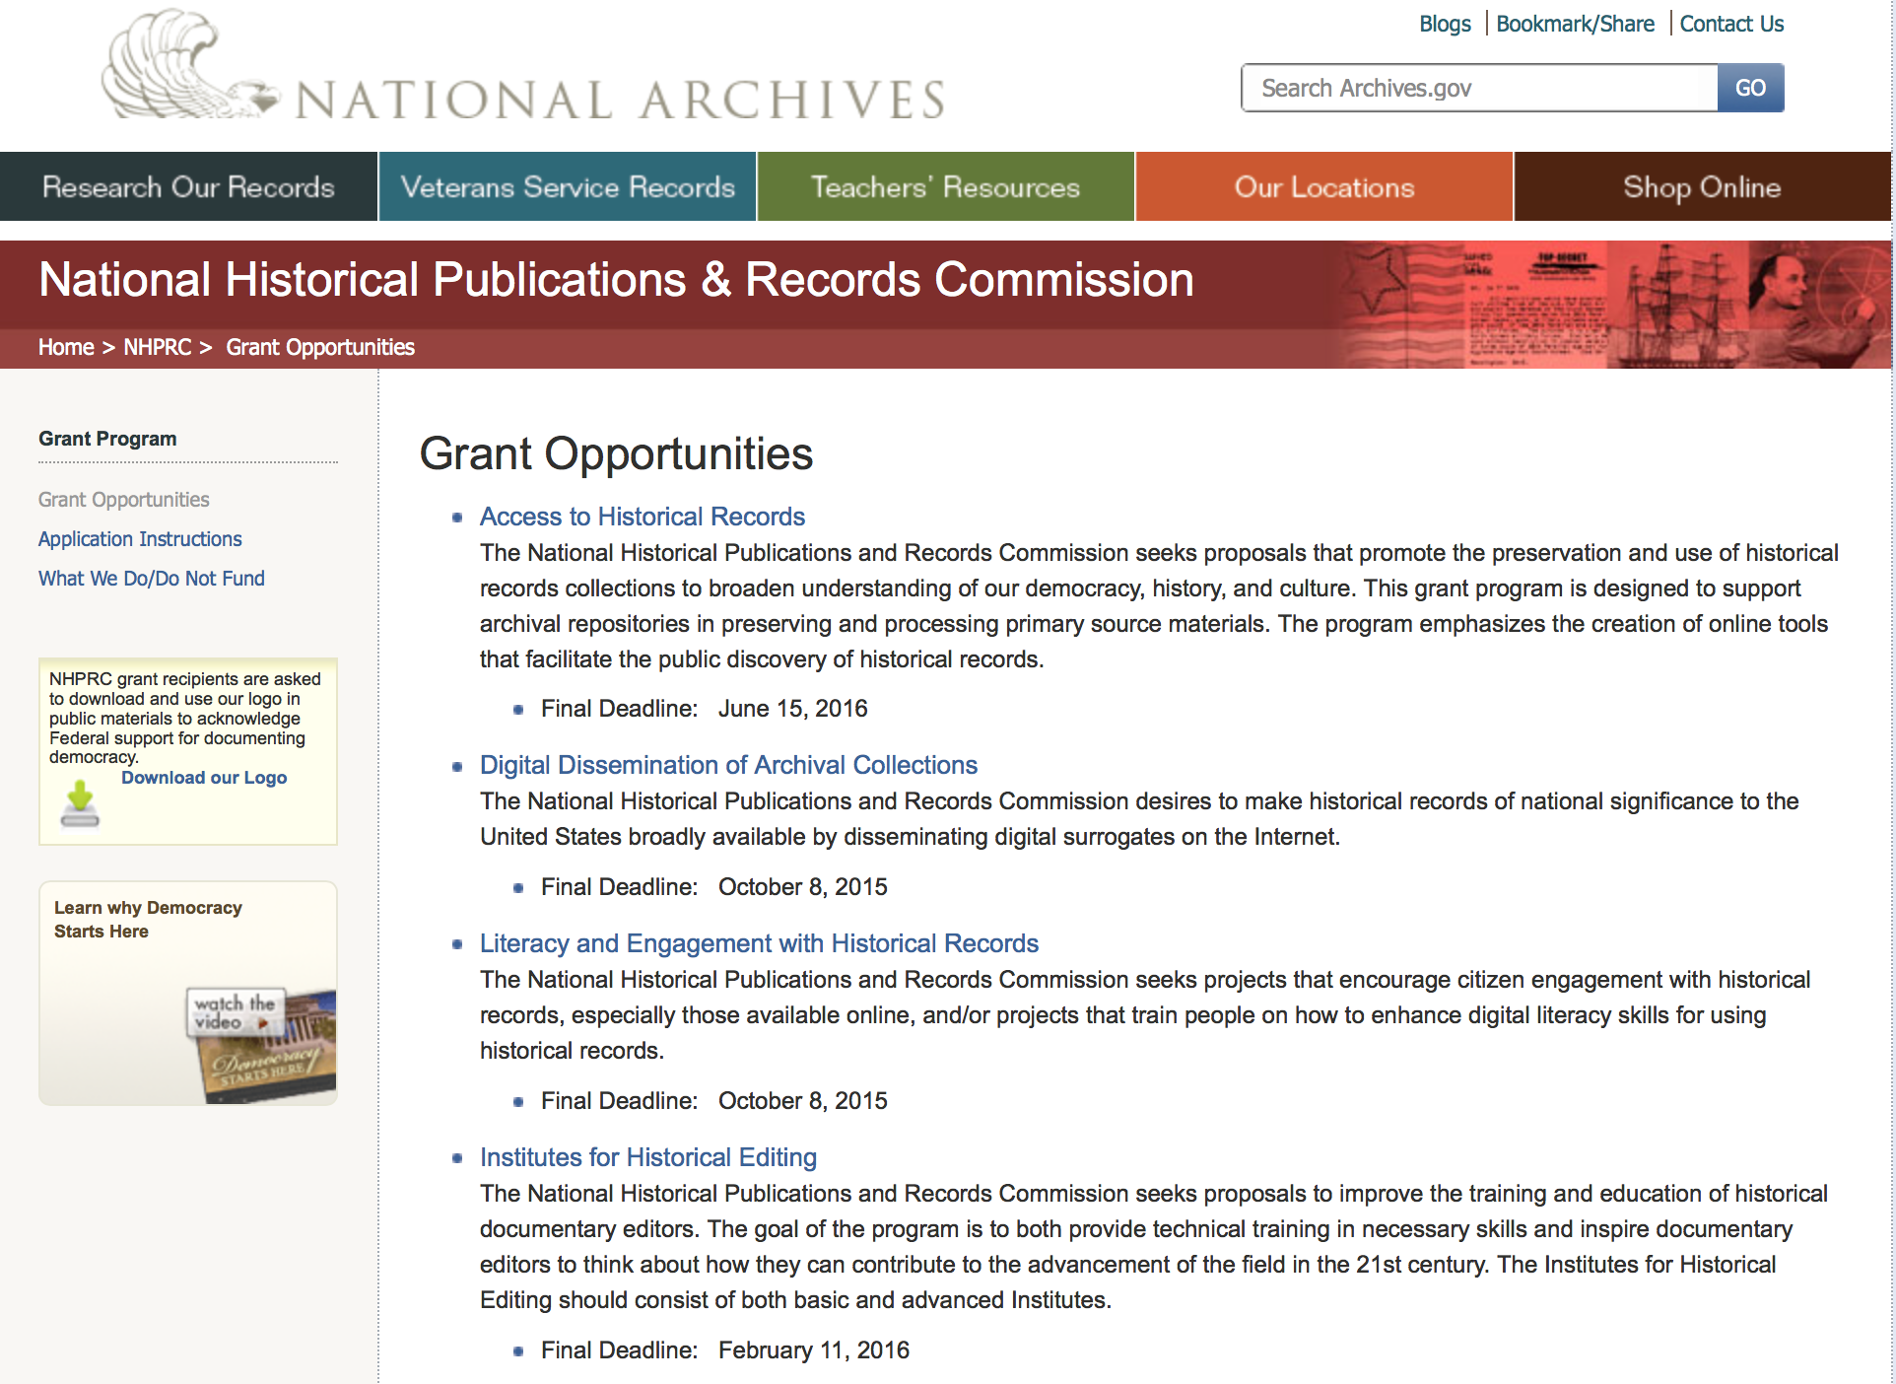

https://www.archives.gov/nhprc/announcement

Programs:

Reminders:

Publishing Historical Records in Documentary Editions
Synopsis 1

Document Type: | Grants Notice
Funding Opportunity Number: | EDITIONS-201706
Funding Opportunity Title: | Publishing Historical Records in Documentary Editions
Opportunity Category: | Discretionary
Opportunity Category Explanation:
Funding Instrument Type: | Grant
Category of Funding Activity: | Humanities (see "Cultural Affairs" in CFDA)
Category Explanation:
Expected Number of Awards: | 25
CFDA Number(s): | 89.003 -- National Historical Publications and Records Grants
Cost Sharing or Matching Requirement: | Yes
Version: | Synopsis 1
Posted Date: | Dec 09, 2016
Last Updated Date: | Dec 09, 2016
Original Closing Date for Applications: | Jun 14, 2017
Current Closing Date for Applications: | Jun 14, 2017
Archive Date:
Estimated Total Program Funding: | $2,500,000
Award Ceiling: | $200,000
Award Floor: | $1
Eligible Applicants: | Public and State controlled institutions of higher education  City or township governments  State governments  Private institutions of higher education  Nonprofits having a 501(c)(3) status with the IRS, other than institutions of higher education  Native American tribal governments (Federally recognized)  County governments
Agency Name: | National Archives and Records Administration
Description: | The National Historical Publications and Records Commission seeks proposals to publish documentary editions of historical records. Projects may focus on the papers of major figures from American history or cover broad historical movements in politics, military, business, social reform, the arts, and other aspects of the national experience. The historical value of the records and their expected usefulness to broad audiences must justify the costs of the project. The goal of this program is to provide access to, and editorial context for, the historical documents and records that tell the American story. The NHPRC encourages projects, whenever possible and appropriate, to provide free access to these materials in an open online environment, without precluding other forms of publication. Applicants should demonstrate familiarity with the best practices recommended by the Association for Documentary Editing or the Modern Language Association Committee on Scholarly Editions. Projects may also prepare print editions as part of their overall publishing plan. However, projects that do not have definitive plans for digital dissemination and preservation in place at the time of application will not be considered. It is also expected that the contents of any print volumes produced will be made available online within a reasonable period of time following print publication. Grants are awarded for collecting, describing, preserving, compiling, transcribing, annotating, editing, encoding, and publishing documentary source materials online and in print. Because of the focus on documentary sources, grants do not support preparation of critical editions of published works unless such works are just a small portion of the larger project. All applicants should be aware that the application process is highly competitive. For a comprehensive list of Commission's limitations on funding, please see What We Do and Do Not Fund. Applications that consist entirely of ineligible activities will not be considered. Ongoing projects: Applicants from ongoing projects must demonstrate that they have successfully achieved the performance objectives associated with previous NHPRC awards; provide updated, current information, including a description of the new activities; describe the content and historical significance of the specific materials to be edited during the proposed grant period; show progress towards completing the edition; and justify costs in a new budget. Award Information A grant is for one year and for up to $200,000. The Commission expects to make up to 25 grants in this category for a total of up to $2,500,000. Grants begin no earlier than January 1, 2018. The Commission requires that grant recipients acknowledge NHPRC grant assistance in all publications, publicity, and other products that result from its support. Eligibility • U.S. nonprofit organizations or institutions • U.S. colleges, universities, and other academic institutions • State or local government agencies • Federally-acknowledged or state-recognized Native American tribes or groups Cost Sharing The total costs of a project are shared between the NHPRC and the applicant organization. The Commission provides no more than 50 per cent of total direct project costs in the Publishing Historical Records in Documentary Editions category. NHPRC grant recipients are not permitted to use grant funds for indirect costs (as indicated in 2 CFR 2600.101). Cost sharing is required. The applicant’s financial contribution may include both direct and indirect expenses, in-kind contributions, non-Federal third-party contributions, and any income earned directly by the project. Indirect costs must be listed under the applicant’s cost sharing contribution. Other Requirements Applicant organizations must be registered in the System for Award Management (SAM) prior to submitting an application, maintain SAM registration throughout the application and award process, and include a valid DUNS number in their application. Details on SAM registration and requesting a DUNS number can be found at the System for Award Management website at https://sam.gov. Please refer to the User Guides section and the Grants Registrations PDF. A complete application includes the Application for Federal Assistance (Standard Form 424), Assurances -- Non-Construction Programs (Standard Form 424B), a Project Narrative, Summary, Supplementary Materials, and Budget. Applications lacking these items will not be considered. Ineligible applications will not be reviewed.
Link to Additional Information: | Link to full grant announcement, including additional requirements
Grantor Contact Information: | If you have difficulty accessing the full announcement electronically, please contact:  Jeff de la Concepcion Jeff.delaConcepcion@nara.gov  Grant Information Specialist

http://www.grants.gov/web/grants/view-opportunity.html?oppId=290563

EDITIONS-201710 for Publishing Historical Records in Documentary Editions
Synopsis 1

Document Type: | Grants Notice
Funding Opportunity Number: | EDITIONS-201710
Funding Opportunity Title: | For Publishing Historical Records in Documentary Editions
Opportunity Category: | Discretionary
Opportunity Category Explanation:
Funding Instrument Type: | Grant
Category of Funding Activity: | Humanities (see "Cultural Affairs" in CFDA)
Category Explanation:
Expected Number of Awards: | 25
CFDA Number(s): | 89.003 -- National Historical Publications and Records Grants
Cost Sharing or Matching Requirement: | Yes
Version: | Synopsis 1
Posted Date: | Dec 09, 2016
Last Updated Date: | Dec 09, 2016
Original Closing Date for Applications: | Oct 05, 2017
Current Closing Date for Applications: | Oct 05, 2017
Archive Date:
Estimated Total Program Funding: | $2,500,000
Award Ceiling: | $200,000
Award Floor: | $1
Eligible Applicants: | County governments  Nonprofits having a 501(c)(3) status with the IRS, other than institutions of higher education  Native American tribal governments (Federally recognized)  City or township governments  Public and State controlled institutions of higher education  State governments  Private institutions of higher education
Agency Name: | National Archives and Records Administration
Description: | The National Historical Publications and Records Commission seeks proposals to publish documentary editions of historical records. Projects may focus on the papers of major figures from American history or cover broad historical movements in politics, military, business, social reform, the arts, and other aspects of the national experience. The historical value of the records and their expected usefulness to broad audiences must justify the costs of the project. The goal of this program is to provide access to, and editorial context for, the historical documents and records that tell the American story. The NHPRC encourages projects, whenever possible and appropriate, to provide free access to these materials in an open online environment, without precluding other forms of publication. Applicants should demonstrate familiarity with the best practices recommended by the Association for Documentary Editing or the Modern Language Association Committee on Scholarly Editions. Projects may also prepare print editions as part of their overall publishing plan. However, projects that do not have definitive plans for digital dissemination and preservation in place at the time of application will not be considered. It is also expected that the contents of any print volumes produced will be made available online within a reasonable period of time following print publication. Grants are awarded for collecting, describing, preserving, compiling, transcribing, annotating, editing, encoding, and publishing documentary source materials online and in print. Because of the focus on documentary sources, grants do not support preparation of critical editions of published works unless such works are just a small portion of the larger project. All applicants should be aware that the application process is highly competitive. For a comprehensive list of Commission's limitations on funding, please see What We Do and Do Not Fund. Applications that consist entirely of ineligible activities will not be considered. Ongoing projects: Applicants from ongoing projects must demonstrate that they have successfully achieved the performance objectives associated with previous NHPRC awards; provide updated, current information, including a description of the new activities; describe the content and historical significance of the specific materials to be edited during the proposed grant period; show progress towards completing the edition; and justify costs in a new budget. Award Information A grant is for one year and for up to $200,000. The Commission expects to make up to 25 grants in this category for a total of up to $2,500,000. Grants begin no earlier than January 1, 2018. The Commission requires that grant recipients acknowledge NHPRC grant assistance in all publications, publicity, and other products that result from its support. Eligibility • U.S. nonprofit organizations or institutions • U.S. colleges, universities, and other academic institutions • State or local government agencies • Federally-acknowledged or state-recognized Native American tribes or groups Cost Sharing The total costs of a project are shared between the NHPRC and the applicant organization. The Commission provides no more than 50 per cent of total direct project costs in the Publishing Historical Records in Documentary Editions category. NHPRC grant recipients are not permitted to use grant funds for indirect costs (as indicated in 2 CFR 2600.101). Cost sharing is required. The applicant’s financial contribution may include both direct and indirect expenses, in-kind contributions, non-Federal third-party contributions, and any income earned directly by the project. Indirect costs must be listed under the applicant’s cost sharing contribution. Other Requirements Applicant organizations must be registered in the System for Award Management (SAM) prior to submitting an application, maintain SAM registration throughout the application and award process, and include a valid DUNS number in their application. Details on SAM registration and requesting a DUNS number can be found at the System for Award Management website at https://sam.gov. Please refer to the User Guides section and the Grants Registrations PDF. A complete application includes the Application for Federal Assistance (Standard Form 424), Assurances -- Non-Construction Programs (Standard Form 424B), a Project Narrative, Summary, Supplementary Materials, and Budget. Applications lacking these items will not be considered. Ineligible applications will not be reviewed.
Link to Additional Information: | Link to full grant announcement, including additional requirements
Grantor Contact Information: | If you have difficulty accessing the full announcement electronically, please contact:  Jeff de la Concepcion Jeff.delaConcepcion@nara.gov  Grant Information Specialist

http://www.grants.gov/web/grants/view-opportunity.html?oppId=290564

Access to Historical Records - Major Initiatives

Document Type: | Grants Notice
Funding Opportunity Number: | MAJOR-201707
Funding Opportunity Title: | Access to Historical Records - Major Initiatives
Opportunity Category: | Discretionary
Opportunity Category Explanation:
Funding Instrument Type: | Grant
Category of Funding Activity: | Humanities (see "Cultural Affairs" in CFDA)
Category Explanation:
Expected Number of Awards: | 5
CFDA Number(s): | 89.003 -- National Historical Publications and Records Grants
Cost Sharing or Matching Requirement: | Yes
Posted Date: | Jul 25, 2016
Last Updated Date: | Jul 25, 2016
Current Closing Date for Applications: | Jul 12, 2017
Archive Date: | Aug 11, 2017
Estimated Total Program Funding: | $1,000,000
Award Ceiling: | $350,000
Award Floor: | $1
Eligible Applicants: | Private institutions of higher education  County governments  Native American tribal governments (Federally recognized)  Public and State controlled institutions of higher education  City or township governments  Nonprofits having a 501(c)(3) status with the IRS, other than institutions of higher education  State governments
Agency Name: | National Archives and Records Administration
Description: | The National Historical Publications and Records Commission seeks projects that will significantly improve public discovery and use of major historical records collections. All types of historical records are eligible, including documents, photographs, born-digital records, and analog audio and moving images. Projects may: • Digitize historical records collections, or related collections, held by a single institution and make them freely available online • Provide access to born-digital records • Create new freely-available virtual collections drawn from historical records held by multiple institutions • Create new tools and methods for users to access records The NHPRC welcomes collaborative projects, particularly for bringing together related records from multiple institutions. Projects that address significant needs in the field and result in replicable and scalable approaches will be more competitive. We also encourage organizations to actively engage the public in the work of the project. For a comprehensive list of Commission limitations on funding, please see “What we do and do not fund” (http://www.archives.gov/nhprc/apply/eligibility.html). Applications that consist entirely of ineligible activities will not be considered. Award Information A grant is for one to three years and for up to $350,000. We expect to make up to five grants in this category for a total of up to $1,000,000. Grants begin no earlier than January 1, 2018. Eligible applicants: • Nonprofit organizations or institutions • Colleges, universities, and other academic institutions • State or local government agencies • Federally-acknowledged or state-recognized Native American tribes or groups Cost Sharing The total costs of a project are shared between the NHPRC and the applicant organization. The Commission provides no more than 50 per cent of total project costs in the Access to Historical Records: Major Initiatives category. NHPRC grant recipients are not permitted to use grant funds for indirect costs (as indicated in 2 CFR 2600.101). Cost sharing is required. The applicant’s financial contribution may include both direct and indirect expenses, in-kind contributions, non-Federal third-party contributions, and any income earned directly by the project. Indirect costs must be listed under the applicant’s cost sharing contribution. Other Requirements Applicant organizations must be registered in the System for Award Management (SAM) prior to submitting an application, maintain SAM registration throughout the application and award process, and include a valid DUNS number in their application. Details on SAM registration and requesting a DUNS number can be found at the System for Award Management website at http://sam.gov. Please refer to the User Guides section and the Grants Registrations PDF. APPLICATION AND SUBMISSION INFORMATION You must use Grants.gov to submit a Full Proposal. All information necessary to apply is included in this announcement, the Application Instructions, and the forms on Grants.gov. If you need the information supplied in an alternative format, please call the NHPRC at 202-357-5010. Applying for the Access to Historical Records: Major Initiatives program is a two-phase process. Phase One All applicants must have submitted a five-page preliminary proposal and Application for Federal Domestic Assistance – Short Organizational form SF424 and the Budget Information for Non-Construction Projects form SF424A by January 19, 2017 using the preliminary proposal Major Initiatives grant announcement (insert link). Only those applicants who have successfully completed Phase One and who have been invited by the Commission to submit a full proposal to the Access to Historical Records: Major Initiatives program are eligible to participate in the second phase of the process. Phase Two Using this announcement, invited applicants will prepare and submit a complete application via Grants.gov by July 12, 2017. A complete application includes the Application for Federal Assistance (Standard Form 424), Assurances -- Non-Construction Programs (Standard Form 424B), a Project Narrative, Supplementary Materials, and Budget. Applications lacking any of these items will not be considered. Applicants may consult with the Director of the Access Program, Alex Lorch (alexander.lorch@nara.gov) during both the preliminary and full proposal project phases. In order to ensure eligibility, applicants should first review the rules and regulations governing NHPRC grants under the Administering an NHPRC Grant section.
Link to Additional Information: | Link to full grant announcement, including additional requirements
Grantor Contact Information: | If you have difficulty accessing the full announcement electronically, please contact:  Jeff de la Concepcion Grant Program Specialist Phone 202-357-5022  Grant Information Specialist

http://www.grants.gov/web/grants/view-opportunity.html?oppId=286436

National Endowment for the Arts

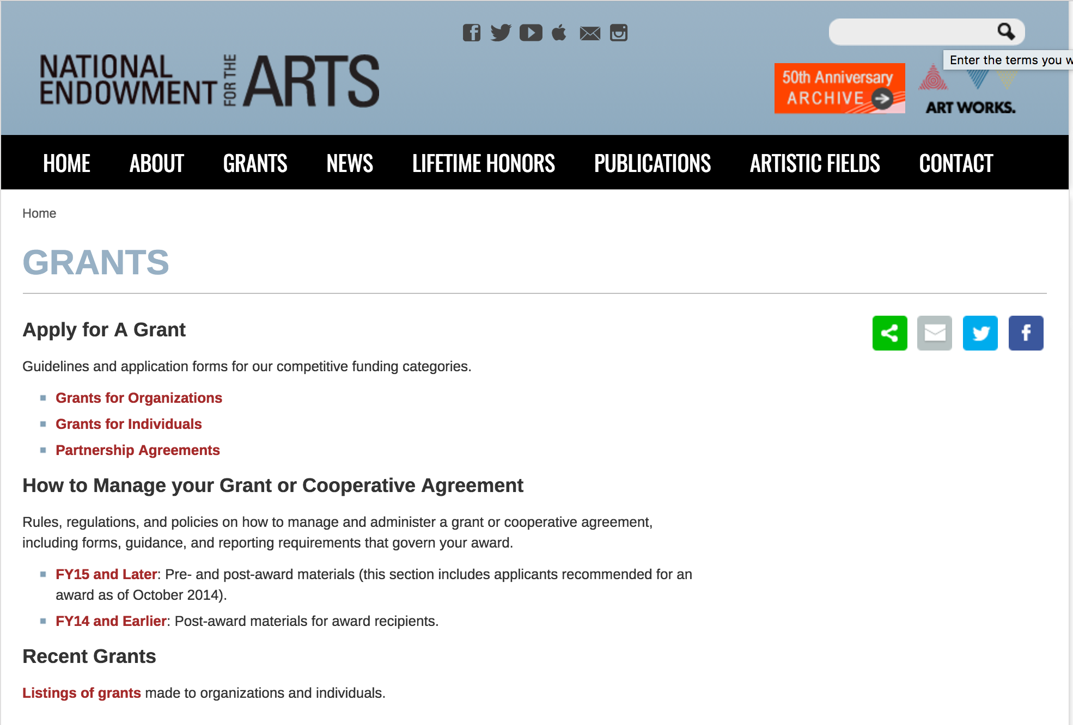

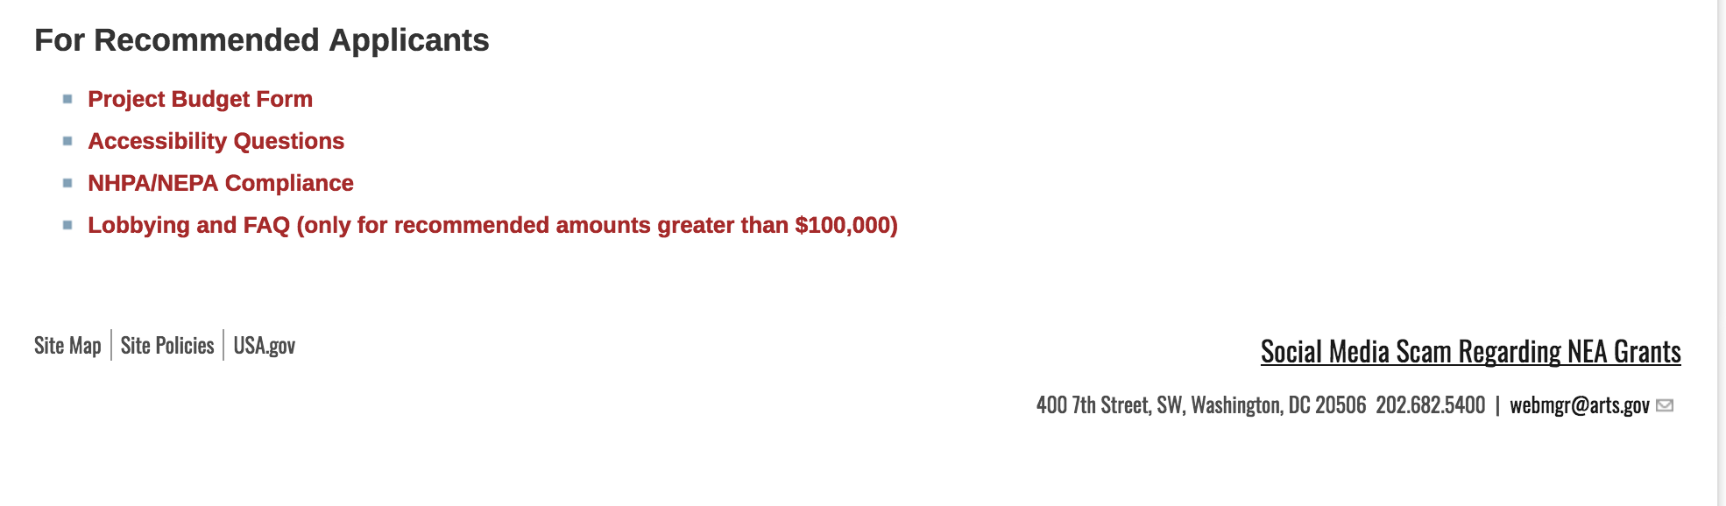
See more at: https://www.arts.gov/grants

Programs:

NEA Our Town Application, FY2018
Synopsis 1
Document Type: | Grants Notice
Funding Opportunity Number: | 2017NEA01OT
Funding Opportunity Title: | NEA Our Town Application, FY2018
Opportunity Category: | Discretionary
Opportunity Category Explanation:
Funding Instrument Type: | Grant
Category of Funding Activity: | Arts (see "Cultural Affairs" in CFDA)
Category Explanation:
Expected Number of Awards: | 500
CFDA Number(s): | 45.024 -- Promotion of the Arts Grants to Organizations and Individuals
Cost Sharing or Matching Requirement: | Yes
Version: | Synopsis 1
Posted Date: | May 18, 2017
Last Updated Date: | May 18, 2017
Original Closing Date for Applications: | Sep 11, 2017
Current Closing Date for Applications: | Sep 11, 2017
Archive Date:
Estimated Total Program Funding:
Award Ceiling: | $200,000
Award Floor: | $25,000
Eligible Applicants: | State governments  County governments  Private institutions of higher education  Independent school districts  Public and State controlled institutions of higher education  City or township governments  Special district governments  Nonprofits having a 501(c)(3) status with the IRS, other than institutions of higher education  Native American tribal governments (Federally recognized)
Agency Name: | National Endowment for the Arts
Description: | The Our Town grant program supports creative placemaking projects that help to transform communities into lively, beautiful, and resilient places – achieving these community goals through strategies that incorporate arts, culture, and/or design. Creative placemaking is when artists, arts organizations, and community development practitioners deliberately integrate arts and culture into community revitalization work - placing arts at the table with land-use, transportation, economic development, education, housing, infrastructure, and public safety strategies. This funding supports local efforts to enhance quality of life and opportunity for existing residents, increase creative activity, and create or preserve a distinct sense of place. Through Our Town, subject to the availability of funding, the National Endowment for the Arts will provide a limited number of grants for creative placemaking. Our Town requires partnerships between arts organizations and government, other nonprofit organizations, and private entities to achieve livability goals for communities. Our Town offers support for projects in two areas: • Arts Engagement, Cultural Planning, and Design Projects. These projects represent the distinct character and quality of their communities. These projects require a partnership between a nonprofit organization and a local government entity, with one of the partners being a cultural organization. Matching grants range from $25,000 to $200,000. • Projects that Build Knowledge About Creative Placemaking. These projects are available to arts and design service organizations, and industry, policy, or university organizations that provide technical assistance to those doing place-based work. Matching grants range from $25,000 to $100,000. • Through Our Town projects, the National Endowment for the Arts intends to achieve the following objective: Livability: American communities are strengthened through the arts.
Link to Additional Information: | NEA Website Announcement
Grantor Contact Information: | If you have difficulty accessing the full announcement electronically, please contact:  NEA Web Manager webmgr@arts.gov  NEA Web Manager

http://www.grants.gov/web/grants/view-opportunity.html?oppId=293915

NEA Arts Research Labs PS Application, FY2018
Synopsis 1

Document Type: | Grants Notice
Funding Opportunity Number: | NEAPS1704
Funding Opportunity Title: | NEA Arts Research Labs PS Application, FY2018
Opportunity Category: | Discretionary
Opportunity Category Explanation:
Funding Instrument Type: | Cooperative Agreement
Category of Funding Activity: | Arts (see "Cultural Affairs" in CFDA)
Category Explanation:
Expected Number of Awards:
CFDA Number(s): | 45.024 -- Promotion of the Arts Grants to Organizations and Individuals
Cost Sharing or Matching Requirement: | Yes
Version: | Synopsis 1
Posted Date: | May 23, 2017
Last Updated Date: | May 23, 2017
Original Closing Date for Applications: | Jul 18, 2017 The Grants.gov system must receive your validated and accepted application no later than 11:59 p.m., Eastern Time, on July 18, 2017. We strongly recommend that you submit your application by July 8, 2017 to give yourself ample time to resolve any problems that you might encounter.
Current Closing Date for Applications: | Jul 18, 2017 The Grants.gov system must receive your validated and accepted application no later than 11:59 p.m., Eastern Time, on July 18, 2017. We strongly recommend that you submit your application by July 8, 2017 to give yourself ample time to resolve any problems that you might encounter.
Archive Date: | Aug 17, 2017
Estimated Total Program Funding:
Award Ceiling: | $150,000
Award Floor: | $150,000
Eligible Applicants: | Native American tribal governments (Federally recognized)  Nonprofits having a 501(c)(3) status with the IRS, other than institutions of higher education  Independent school districts  Private institutions of higher education  State governments  Public and State controlled institutions of higher education  City or township governments  County governments  Special district governments
Agency Name: | National Endowment for the Arts
Description: | The National Endowment for the Arts’ support may begin no earlier than March 1, 2018 and extend for up to 24 months. An organization may submit only one proposal under this program solicitation. Program Description: In recent years, the National Endowment for the Arts’ research agenda has focused on yielding new knowledge about the value and impact of the arts. Through the National Endowment for the Arts Research Labs (NEA Research Labs), we seek to extend this agenda and its impact by cultivating a series of transdisciplinary research partnerships, grounded in the social and behavioral sciences, to produce and report empirical insights about the arts for the benefit of arts and non-arts sectors alike. Each NEA Research Lab will define its own research agenda, conduct a research program to implement that agenda, and prepare reports that will contribute substantively to a wider understanding of one of three areas of special interest to the National Endowment for the Arts: 1. The Arts, Health, and Social/Emotional Well-Being a. Therapeutic Approaches and Benefits b. Non-Therapeutic Approaches and Benefits 2. The Arts, Creativity, Cognition, and Learning 3. The Arts, Entrepreneurship, and Innovation We anticipate that a sustained engagement with these topic areas, and with the corresponding research questions we frame below, will have distinctive benefits not only for the arts community, but also for sectors such as healthcare, education, and business or management. We intend for the NEA Research Labs to serve as “hubs” or centers of excellence in the domain of interest. Each NEA Research Lab will develop a pipeline of projects or products, even while conducting at least one major study. In addition, NEA Research Labs will be positioned to fulfill ad hoc analyses or information requests concerning the research agenda being pursued, as may be required by the National Endowment for the Arts during the project period of performance. Such requests will not involve new data collection.
Link to Additional Information: | NEA Website Announcement
Grantor Contact Information: | If you have difficulty accessing the full announcement electronically, please contact:  NEA Web Manager  NEA Web Manager

http://www.grants.gov/web/grants/view-opportunity.html?oppId=294024

Modifications:

Reminders:

National Endowment for the Humanities

Grant Overview -

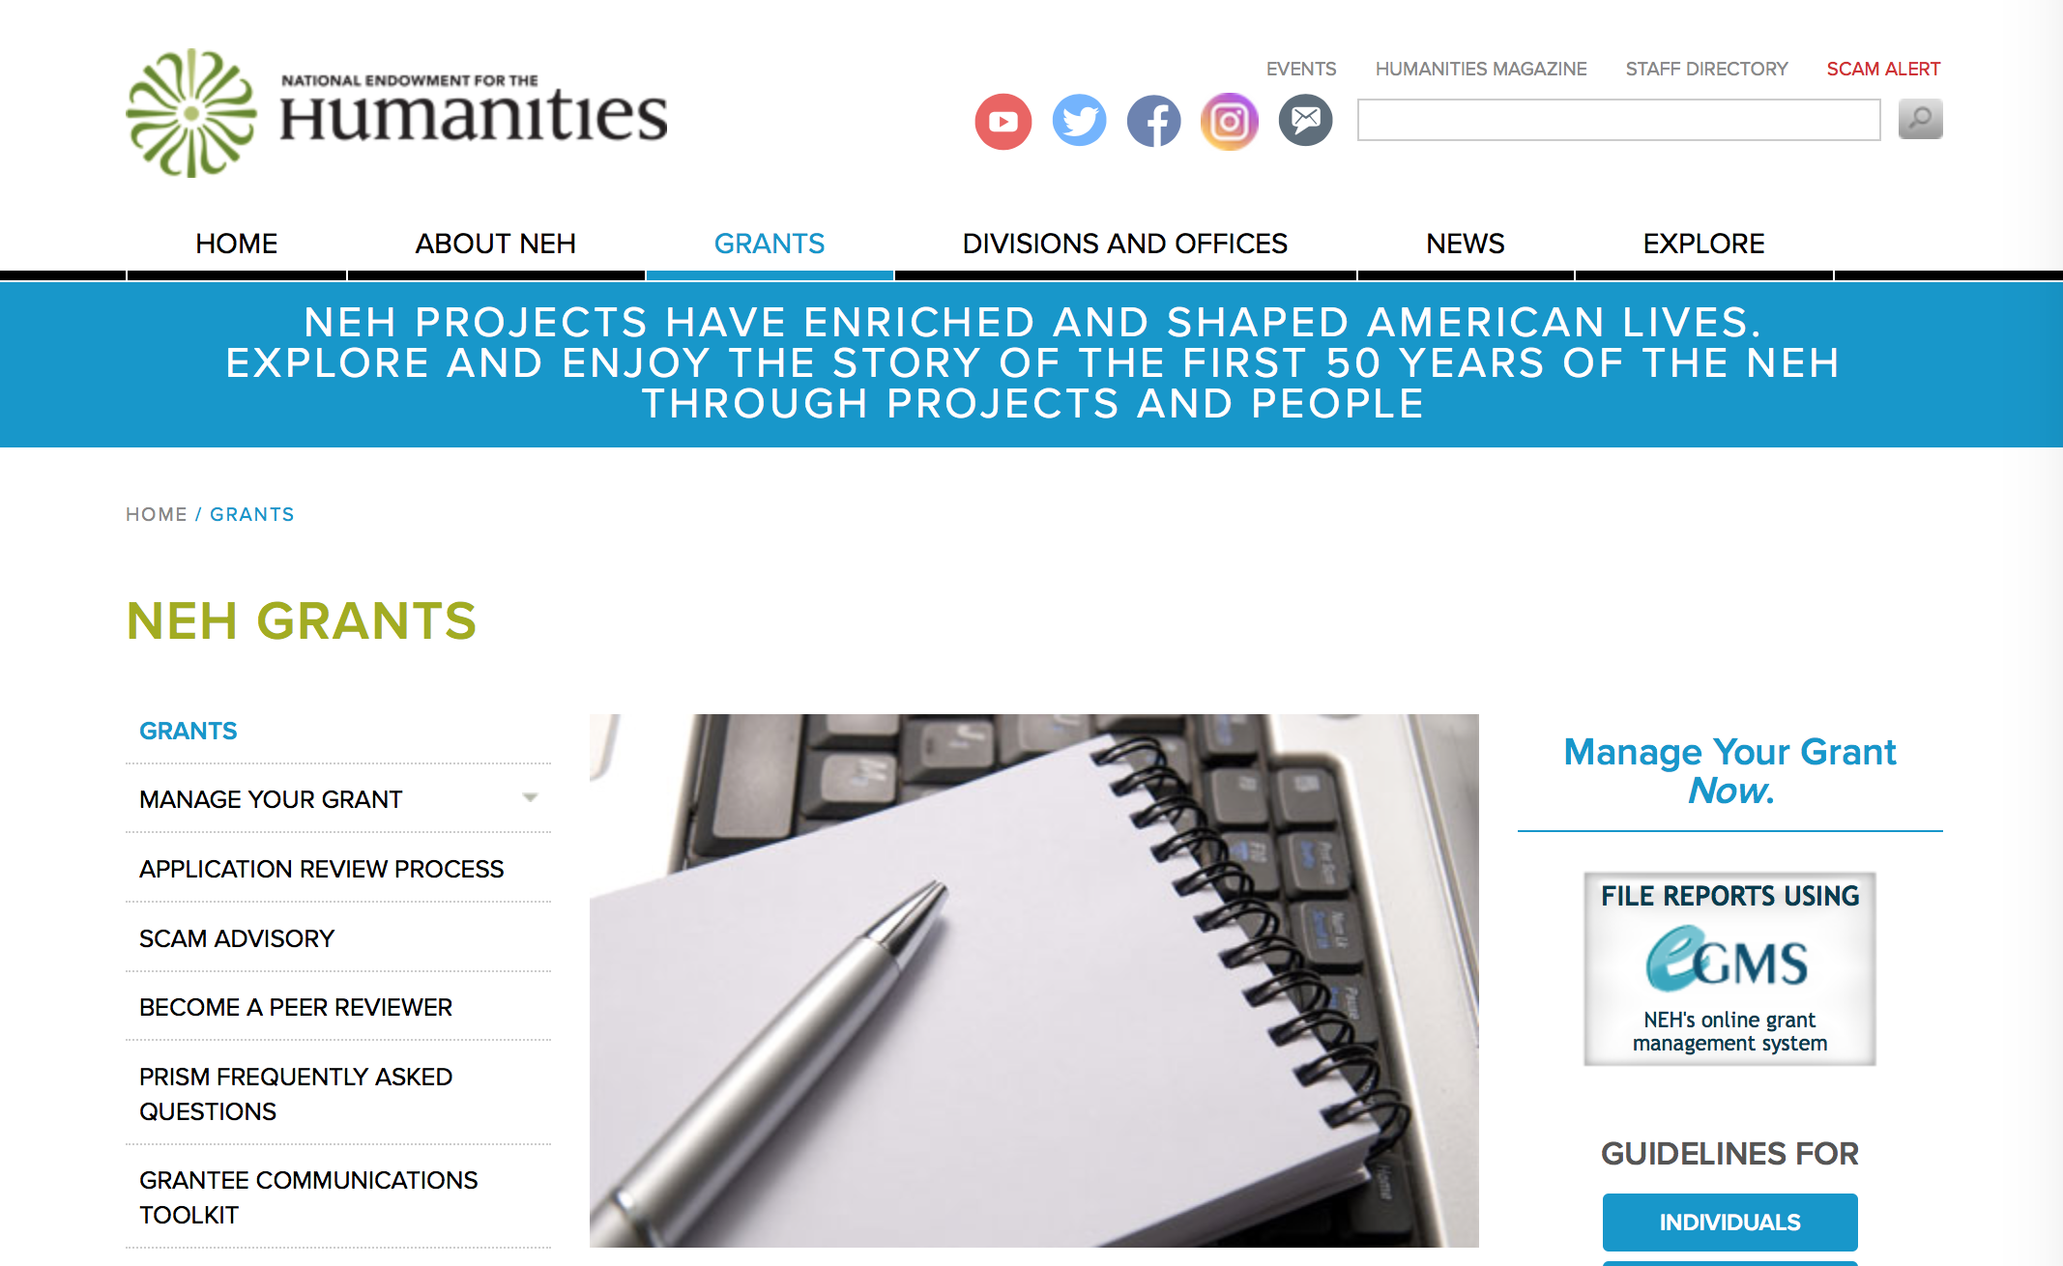

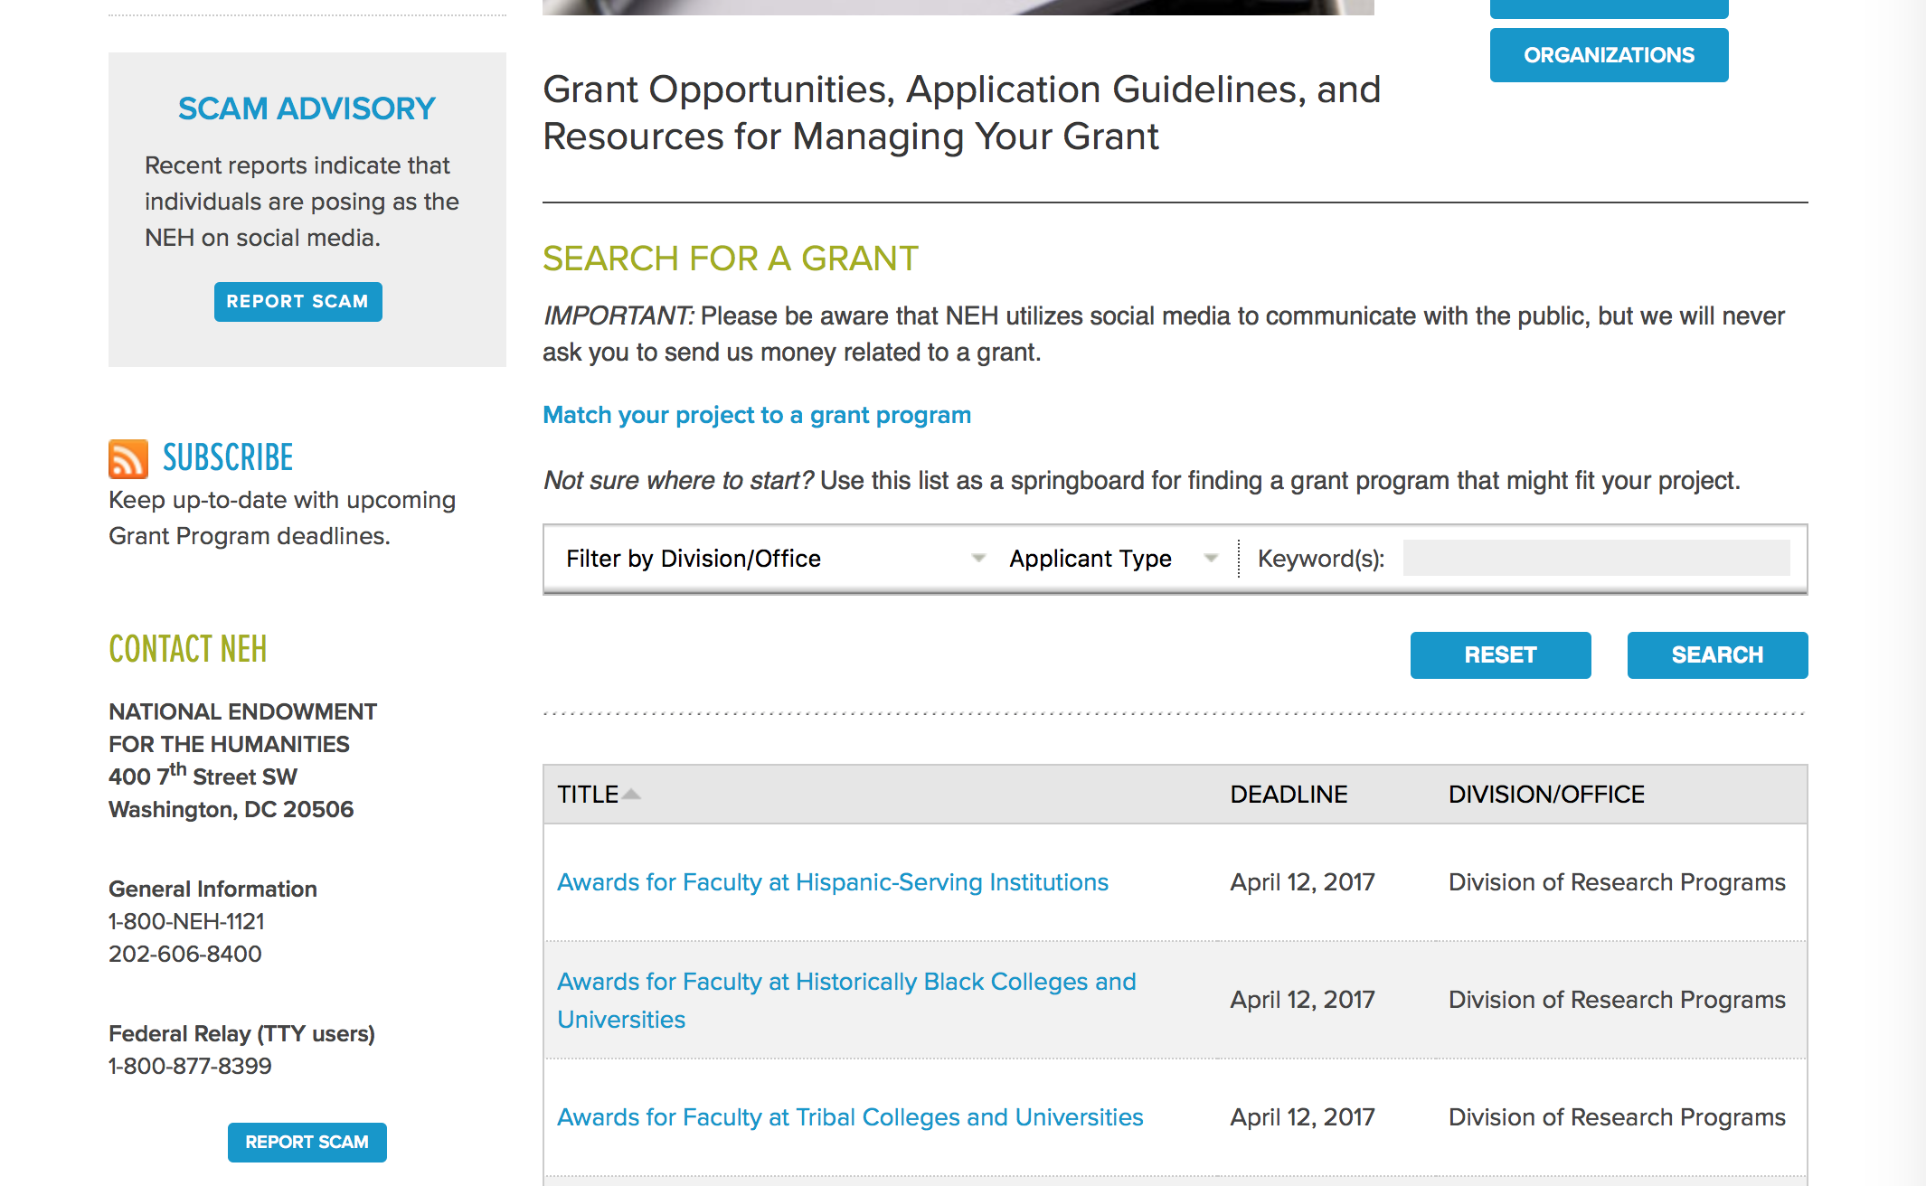

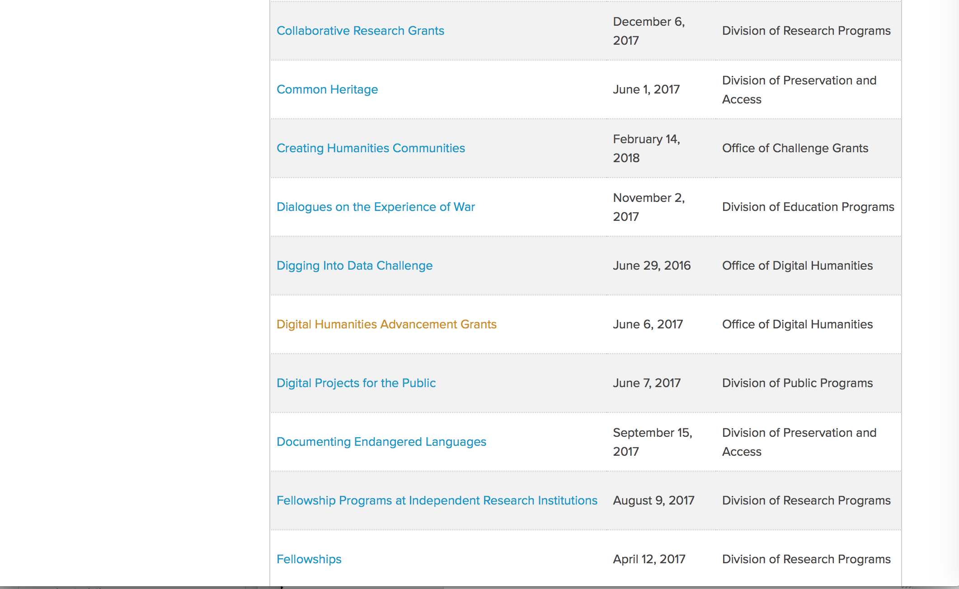

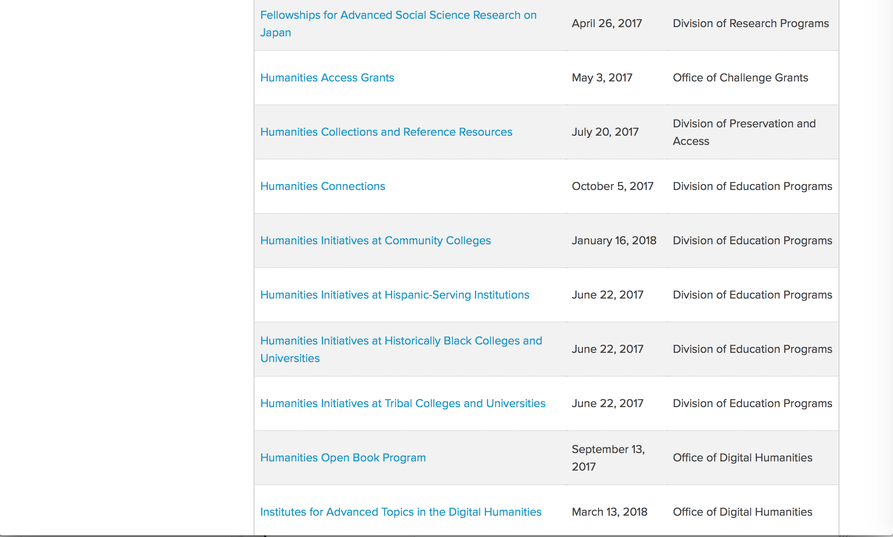

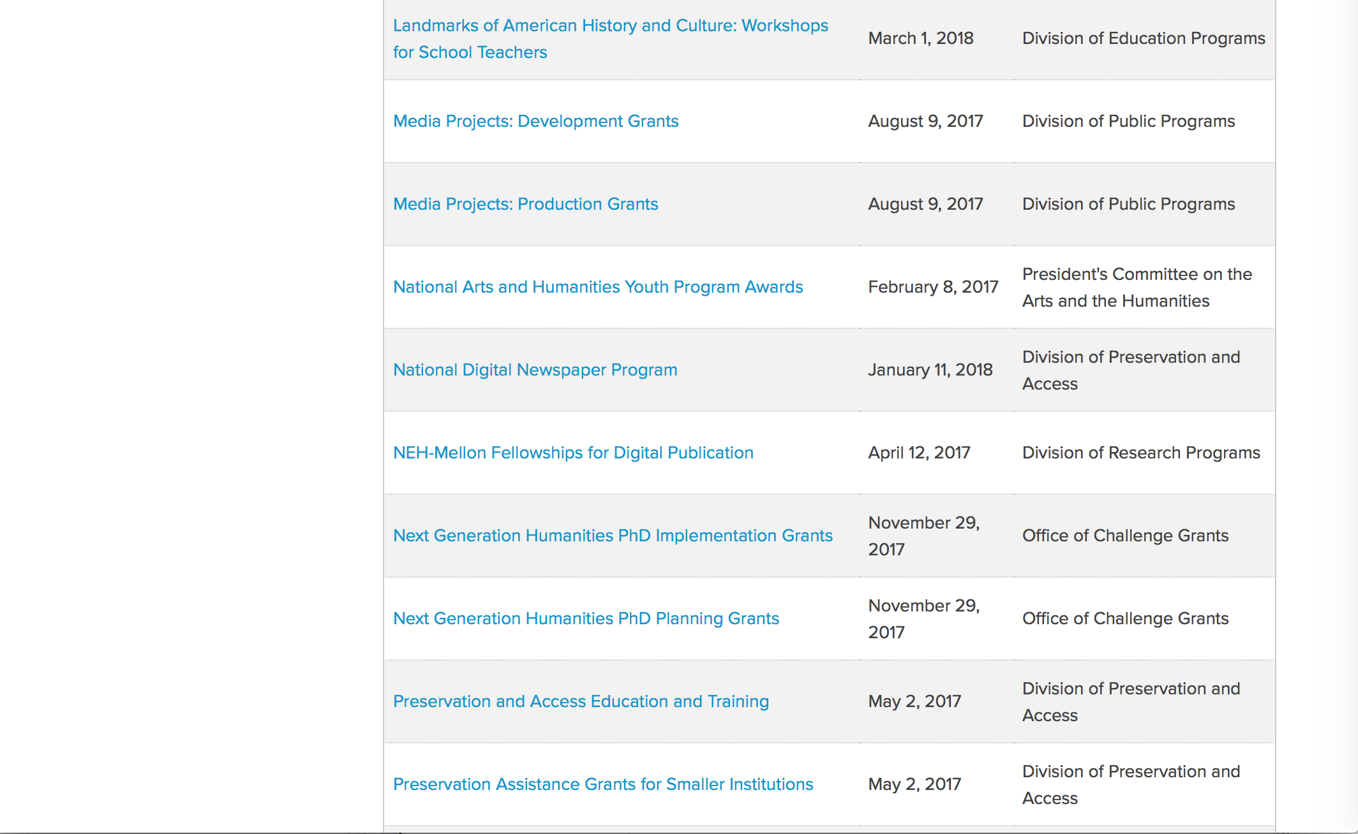
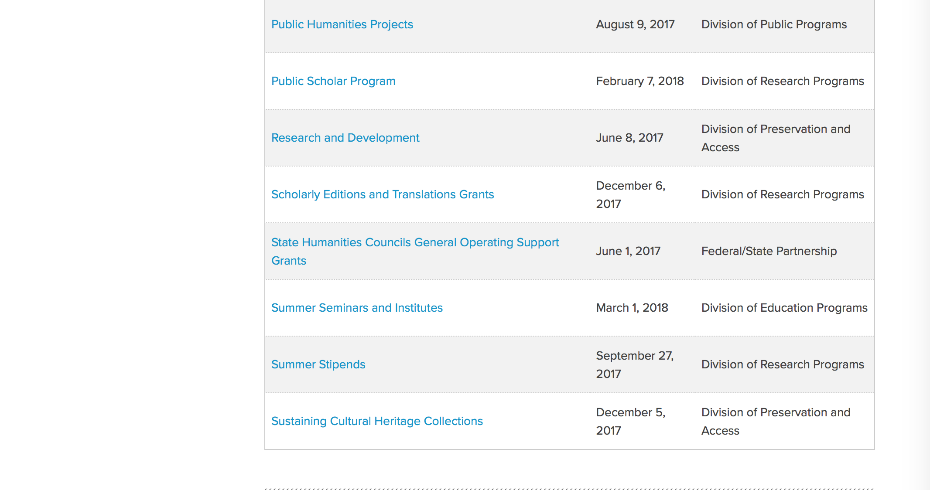
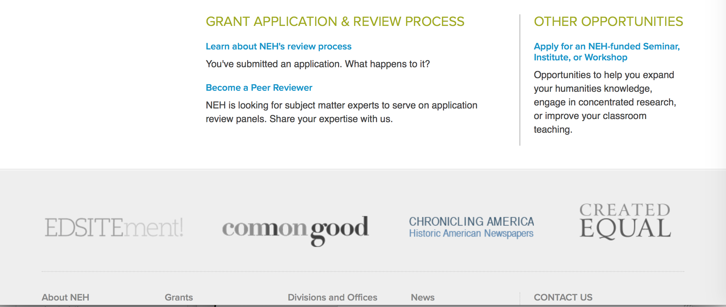

https://www.neh.gov/grants

Programs:

Humanities Collections and Reference Resources
Synopsis 1

Document Type: | Grants Notice
Funding Opportunity Number: | 20170720-PW
Funding Opportunity Title: | Humanities Collections and Reference Resources
Opportunity Category: | Discretionary
Opportunity Category Explanation:
Funding Instrument Type: | Grant
Category of Funding Activity: | Humanities (see "Cultural Affairs" in CFDA)
Category Explanation:
Expected Number of Awards:
CFDA Number(s): | 45.149 -- Promotion of the Humanities Division of Preservation and Access
Cost Sharing or Matching Requirement: | No
Version: | Synopsis 1
Posted Date: | May 16, 2017
Last Updated Date: | May 16, 2017
Original Closing Date for Applications: | Jul 20, 2017
Current Closing Date for Applications: | Jul 20, 2017
Archive Date:
Estimated Total Program Funding:
Award Ceiling: | $350,000
Award Floor: | $1
Eligible Applicants: | Native American tribal governments (Federally recognized)  Nonprofits having a 501(c)(3) status with the IRS, other than institutions of higher education  Special district governments  Private institutions of higher education  State governments  City or township governments  County governments  Public and State controlled institutions of higher education
Agency Name: | National Endowment for the Humanities
Description: | The Humanities Collections and Reference Resources (HCRR) program supports projects that provide an essential underpinning for scholarship, education, and public programming in the humanities. Thousands of libraries, archives, museums, and historical organizations across the country maintain important collections of books and manuscripts, photographs, sound recordings and moving images, archaeological and ethnographic artifacts, art and material culture, and digital objects. Funding from this program strengthens efforts to extend the life of such materials and make their intellectual content widely accessible, often through the use of digital technology. Awards are also made to create various reference resources that facilitate use of cultural materials, from works that provide basic information quickly to tools that synthesize and codify knowledge of a subject for in-depth investigation. HCRR offers two kinds of awards: 1) for implementation and 2) for planning, assessment, and pilot efforts (HCRR Foundations grants).
Link to Additional Information: | https://www.neh.gov/grants/preservation/humanities-collections-and-reference-resources
Grantor Contact Information: | If you have difficulty accessing the full announcement electronically, please contact:  Humanities Collections and Reference Resources Division of Preservation and Access National Endowment for the Humanities 400 Seventh Street, SW Washington, DC 20506 preservation@neh.gov preservation@neh.gov  preservation@neh.gov

http://www.grants.gov/web/grants/view-opportunity.html?oppId=293869

Summer Stipends
Synopsis 1

Document Type: | Grants Notice
Funding Opportunity Number: | 20170927-FT
Funding Opportunity Title: | Summer Stipends
Opportunity Category: | Discretionary
Opportunity Category Explanation:
Funding Instrument Type: | Grant
Category of Funding Activity: | Humanities (see "Cultural Affairs" in CFDA)
Category Explanation:
Expected Number of Awards:
CFDA Number(s): | 45.160 -- Promotion of the Humanities Fellowships and Stipends
Cost Sharing or Matching Requirement: | No
Version: | Synopsis 1
Posted Date: | May 19, 2017
Last Updated Date: | May 19, 2017
Original Closing Date for Applications: | Sep 27, 2017
Current Closing Date for Applications: | Sep 27, 2017
Archive Date:
Estimated Total Program Funding:
Award Ceiling: | $6,000
Award Floor: | $6,000
Eligible Applicants: | Others (see text field entitled "Additional Information on Eligibility" for clarification)
Additional Information on Eligibility: | The only eligible applicants are individuals. Individuals who teach full-time at colleges or universities must be nominated by their institutions to be eligible.
Agency Name: | National Endowment for the Humanities
Description: | Summer Stipends support individuals pursuing advanced research that is of value to humanities scholars, general audiences, or both. Eligible projects usually result in articles, monographs, books, digital materials and publications, archaeological site reports, translations, or editions. Projects must not result solely in the collection of data; instead they must also incorporate analysis and interpretation. Summer Stipends support continuous full-time work on a humanities project for a period of two consecutive months. Summer Stipends support projects at any stage of development.
Link to Additional Information: | https://www.neh.gov/grants/research/summer-stipends
Grantor Contact Information: | If you have difficulty accessing the full announcement electronically, please contact:  Division of Research Programs National Endowment for the Humanities 400 Seventh Street, SW Washington, D.C. 20506 202-606-8200 stipends@neh.gov stipends@neh.gov  stipends@neh.gov

http://www.grants.gov/web/grants/view-opportunity.html?oppId=293973

Modifications:

Reminders:

Digital Projects for the Public
Synopsis 1
Document Type: | Grants Notice
Funding Opportunity Number: | 20170607-MD
Funding Opportunity Title: | Digital Projects for the Public
Opportunity Category: | Discretionary
Opportunity Category Explanation:
Funding Instrument Type: | Grant
Category of Funding Activity: | Humanities (see "Cultural Affairs" in CFDA)
Category Explanation:
Expected Number of Awards:
CFDA Number(s): | 45.164 -- Promotion of the Humanities Public Programs
Cost Sharing or Matching Requirement: | No
Version: | Synopsis 1
Posted Date: | Apr 05, 2017
Last Updated Date: | Apr 05, 2017
Original Closing Date for Applications: | Jun 07, 2017
Current Closing Date for Applications: | Jun 07, 2017
Archive Date:
Estimated Total Program Funding:
Award Ceiling: | $400,000
Award Floor: | $1
Eligible Applicants: | State governments  Nonprofits having a 501(c)(3) status with the IRS, other than institutions of higher education  Private institutions of higher education  Native American tribal governments (Federally recognized)  County governments  Public and State controlled institutions of higher education  Special district governments  City or township governments
Agency Name: | National Endowment for the Humanities
Description: | Digital Projects for the Public grants support projects that cogently interpret and analyze humanities content in formats that will attract broad public audiences. Digital platforms—such as websites, mobile applications and tours, interactive touch screens and kiosks, games, and virtual environments—can reach diverse audiences and bring the humanities to life for the American people. The program offers three levels of support for digital projects: grants for Discovery projects (early-stage planning work), Prototyping projects (proof-of-concept development work), and Production projects (end-stage production and distribution work). While projects can take many forms, shapes, and sizes, your request should be for an exclusively digital project or for a digital component of a larger project. All Digital Projects for the Public projects should • present analysis that deepens public understanding of significant humanities stories and ideas; • incorporate sound humanities scholarship; • involve humanities scholars in all phases of development and production; • include appropriate digital media professionals; • reach a broad public through a realistic plan for development, marketing, and distribution; • create appealing digital formats for the general public; and • demonstrate the capacity to sustain themselves. All projects should demonstrate the potential to attract a broad, general, nonspecialist audience, either online or in person at venues such as museums, libraries, or other cultural institutions. Applicants may also choose to identify particular communities and groups, including students, to whom a project may have particular appeal. NEH also welcomes applications for non-promotional digital components of a larger project. For these projects, you should explain how the digital platform will enrich the users’ learning experience and engagement. For instance, if your request is for a mobile experience that would operate within a museum or would work in conjunction with a film, you should explain how this project element will substantially add to the audience’s learning experience.
Link to Additional Information: | https://www.neh.gov/grants/public/digital-projects-the-public
Grantor Contact Information: | If you have difficulty accessing the full announcement electronically, please contact:  Division of Public Programs National Endowment for the Humanities 400 Seventh Street, S.W. Washington, DC 20506 202-606-8269 publicpgms@neh.gov publicpgms@neh.gov  publicpgms@neh.gov

http://www.grants.gov/web/grants/view-opportunity.html?oppId=293003

Research and Development
Synopsis 1
Document Type: | Grants Notice
Funding Opportunity Number: | 20170608-PR
Funding Opportunity Title: | Research and Development
Opportunity Category: | Discretionary
Opportunity Category Explanation:
Funding Instrument Type: | Grant
Category of Funding Activity: | Humanities (see "Cultural Affairs" in CFDA)
Category Explanation:
Expected Number of Awards:
CFDA Number(s): | 45.149 -- Promotion of the Humanities Division of Preservation and Access
Cost Sharing or Matching Requirement: | No
Posted Date: | Mar 27, 2017
Last Updated Date: | Mar 27, 2017
Original Closing Date for Applications: | Jun 08, 2017
Current Closing Date for Applications: | Jun 08, 2017
Archive Date:
Estimated Total Program Funding:
Award Ceiling: | $350,000
Award Floor: | $1
Eligible Applicants: | Public and State controlled institutions of higher education  County governments  Nonprofits having a 501(c)(3) status with the IRS, other than institutions of higher education  Special district governments  City or township governments  Native American tribal governments (Federally recognized)  Private institutions of higher education  State governments
Agency Name: | National Endowment for the Humanities
Description: | The Research and Development program supports projects that address major challenges in preserving or providing access to humanities collections and resources. These challenges include the need to find better ways to preserve materials of critical importance to the nation’s cultural heritage—from fragile artifacts and manuscripts to analog recordings and digital assets subject to technological obsolescence—and to develop advanced modes of organizing, searching, discovering, and using such materials. This program recognizes that finding solutions to complex problems often requires forming interdisciplinary project teams, bringing together participants with expertise in the humanities; in preservation; and in information, computer, and natural science. All projects must demonstrate how advances in preservation and access would benefit the cultural heritage community in supporting humanities research, teaching, or public programming.
Link to Additional Information: | https://www.neh.gov/grants/preservation/research-and-development
Grantor Contact Information: | If you have difficulty accessing the full announcement electronically, please contact:  Research and Development National Endowment for the Humanities 400 Seventh Street, SW Washington, DC 20506 202-606-8570 preservation@neh.gov preservation@neh.gov  preservation@neh.gov

http://www.grants.gov/web/grants/view-opportunity.html?oppId=292772

Digital Humanities Advancement Grants
Synopsis 1

Document Type: | Grants Notice
Funding Opportunity Number: | 20170606-HAA
Funding Opportunity Title: | Digital Humanities Advancement Grants
Opportunity Category: | Discretionary
Opportunity Category Explanation:
Funding Instrument Type: | Grant
Category of Funding Activity: | Humanities (see "Cultural Affairs" in CFDA)
Category Explanation:
Expected Number of Awards:
CFDA Number(s): | 45.169 -- Promotion of the Humanities Office of Digital Humanities
Cost Sharing or Matching Requirement: | No
Version: | Synopsis 1
Posted Date: | Feb 17, 2017
Last Updated Date: | Feb 17, 2017
Original Closing Date for Applications: | Jun 06, 2017
Current Closing Date for Applications: | Jun 06, 2017
Archive Date:
Estimated Total Program Funding:
Award Ceiling: | $375,000
Award Floor: | $5,000
Eligible Applicants: | Special district governments  Native American tribal governments (Federally recognized)  Public and State controlled institutions of higher education  State governments  Private institutions of higher education  Nonprofits having a 501(c)(3) status with the IRS, other than institutions of higher education  City or township governments  County governments
Agency Name: | National Endowment for the Humanities
Description: | Digital Humanities Advancement Grants (DHAG) support digital projects throughout their lifecycles, from early start-up phases through implementation and long-term sustainability. Experimentation, reuse, and extensibility are hallmarks of this grant category, leading to innovative work that can scale to enhance research, teaching, and public programming in the humanities. You can find a discussion of the forms that experimentation can take in the Frequently Asked Questions document, which is available on the program resource page. This program combines the former Digital Humanities Start-Up Grants and Digital Humanities Implementation Grants programs; the combined program is offered twice per year. Proposals are welcome for digital initiatives in any area of the humanities. Through a special partnership, the Institute of Museum and Library Services (IMLS) anticipates providing additional funding to this program to encourage innovative collaborations between museum or library professionals and humanities professionals to advance preservation of, access to, use of, and engagement with digital collections and services. Through this partnership, IMLS and NEH may jointly fund some DHAG projects that involve collaborations with museums and/or libraries.
Link to Additional Information: | https://www.neh.gov/grants/odh/digital-humanities-advancement-grants
Grantor Contact Information: | If you have difficulty accessing the full announcement electronically, please contact:  If you have questions about the program, contact the ODH staff at odh@neh.gov. Applicants wishing to speak to a staff member by telephone should provide in an e-mail message a telephone number and a preferred time to call. odh@neh.gov  odh@neh.gov

http://www.grants.gov/web/grants/view-opportunity.html?oppId=291873



National Science Foundation

General Funding Overview

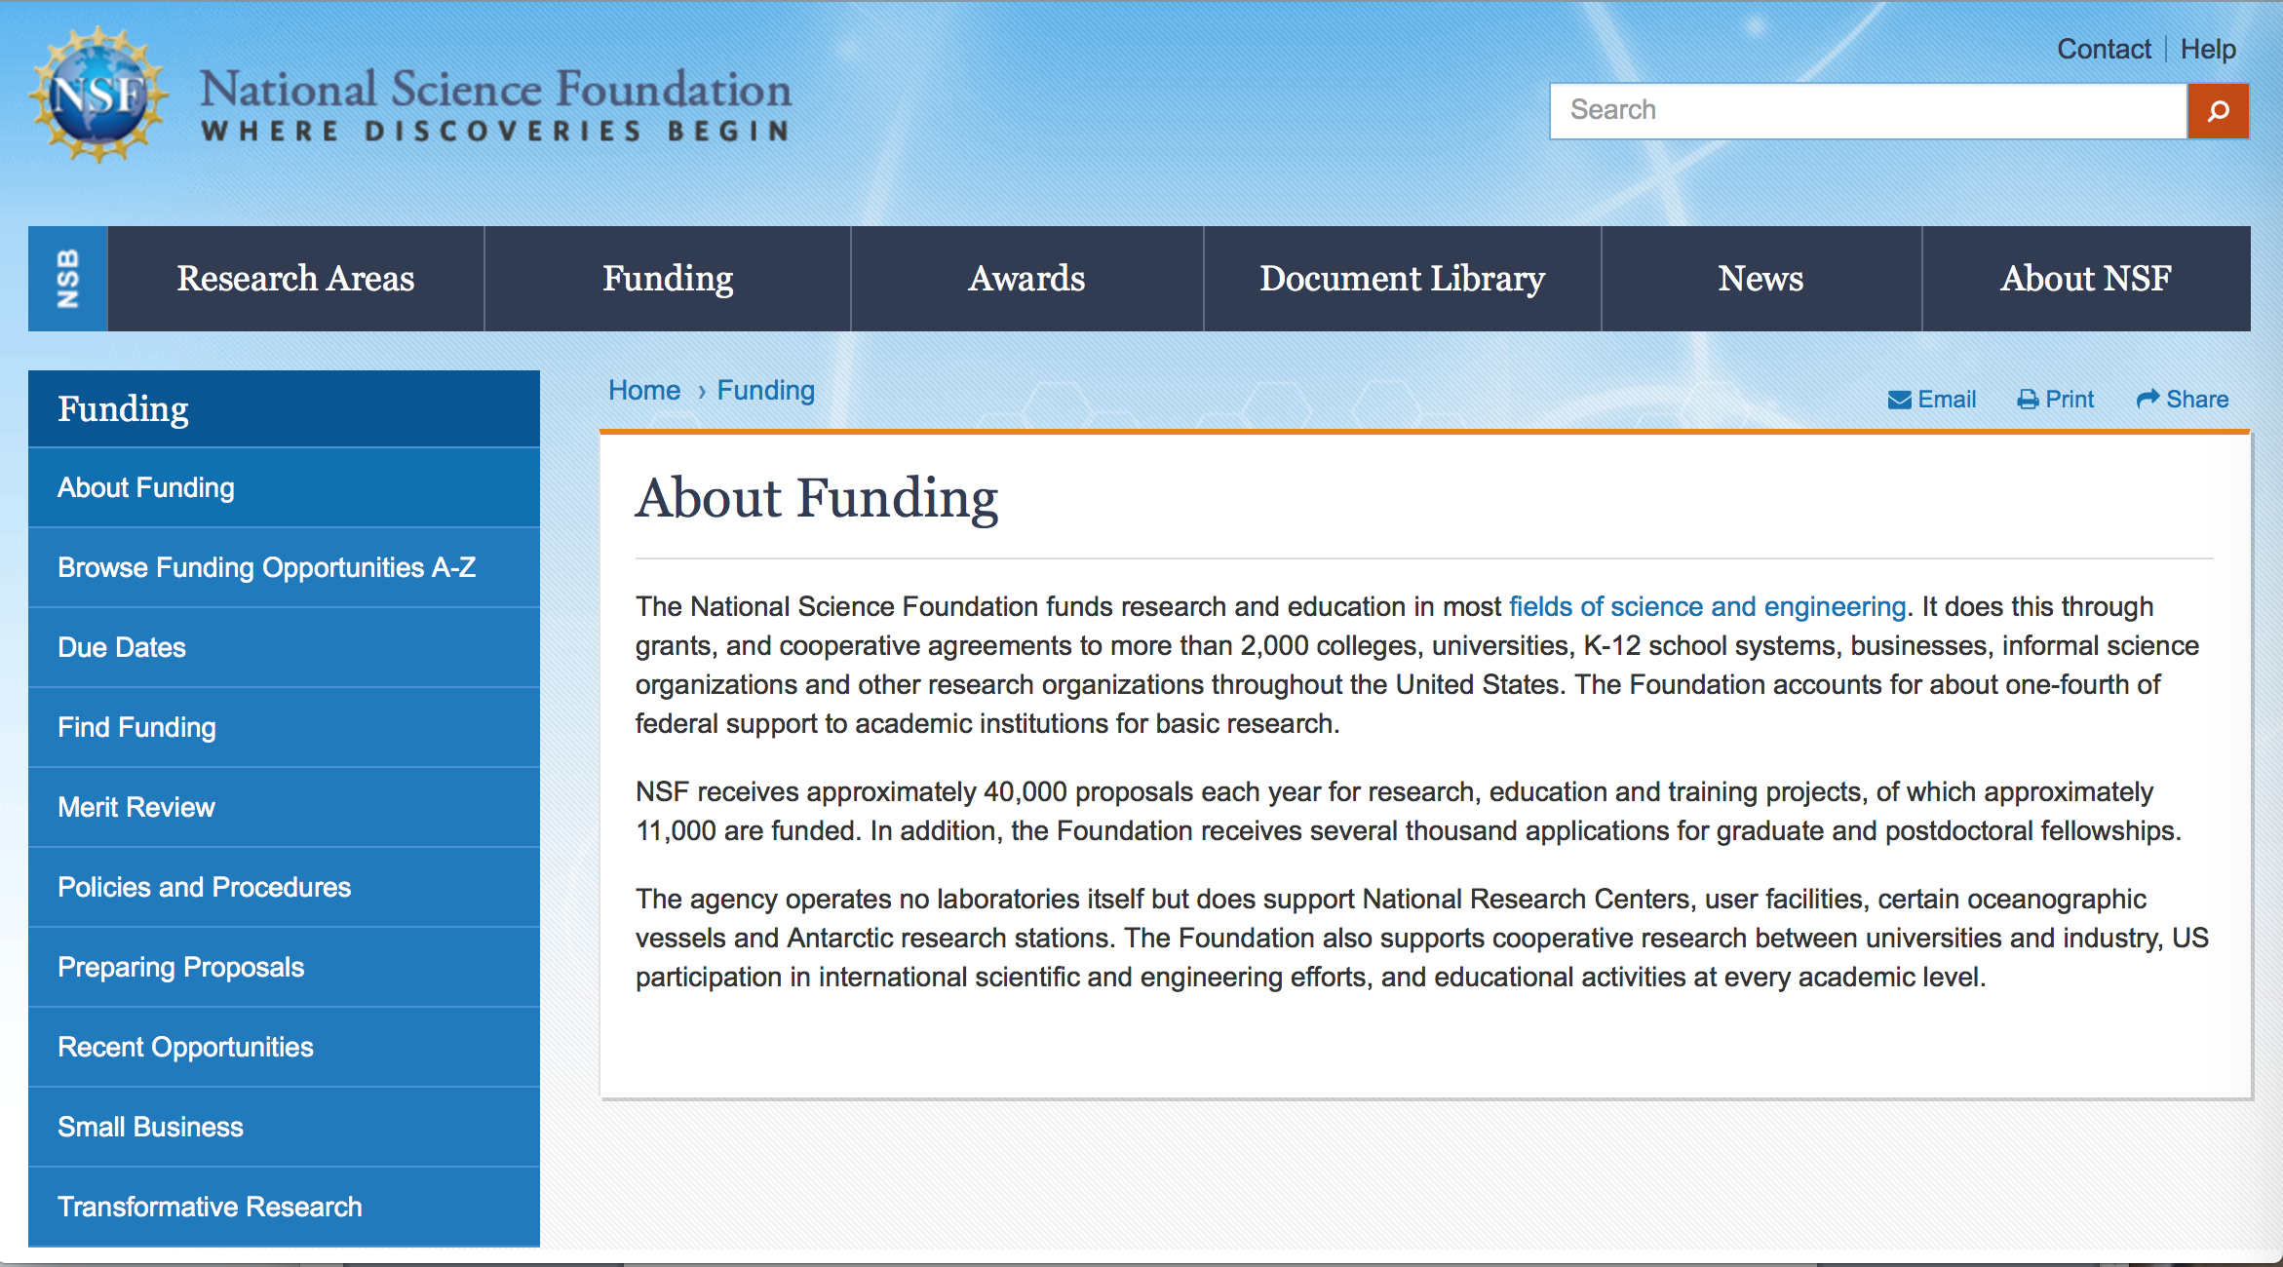

For assistance: https://nsf.gov/funding/aboutfunding.jsp

The National Science Foundation funds research and education in most fields of science and engineering. It does this through grants, and cooperative agreements to more than 2,000 colleges, universities, K-12 school systems, businesses, informal science organizations and other research organizations throughout the United States. The Foundation accounts for about one-fourth of federal support to academic institutions for basic research.
NSF receives approximately 40,000 proposals each year for research, education and training projects, of which approximately 11,000 are funded. In addition, the Foundation receives several thousand applications for graduate and postdoctoral fellowships.
The agency operates no laboratories itself but does support National Research Centers, user facilities, certain oceanographic vessels and Antarctic research stations. The Foundation also supports cooperative research between universities and industry, US participation in international scientific and engineering efforts, and educational activities at every academic level.

For details on active funding deadline dates: http://nsf.gov/funding/pgm_list.jsp?org=NSF&ord=date

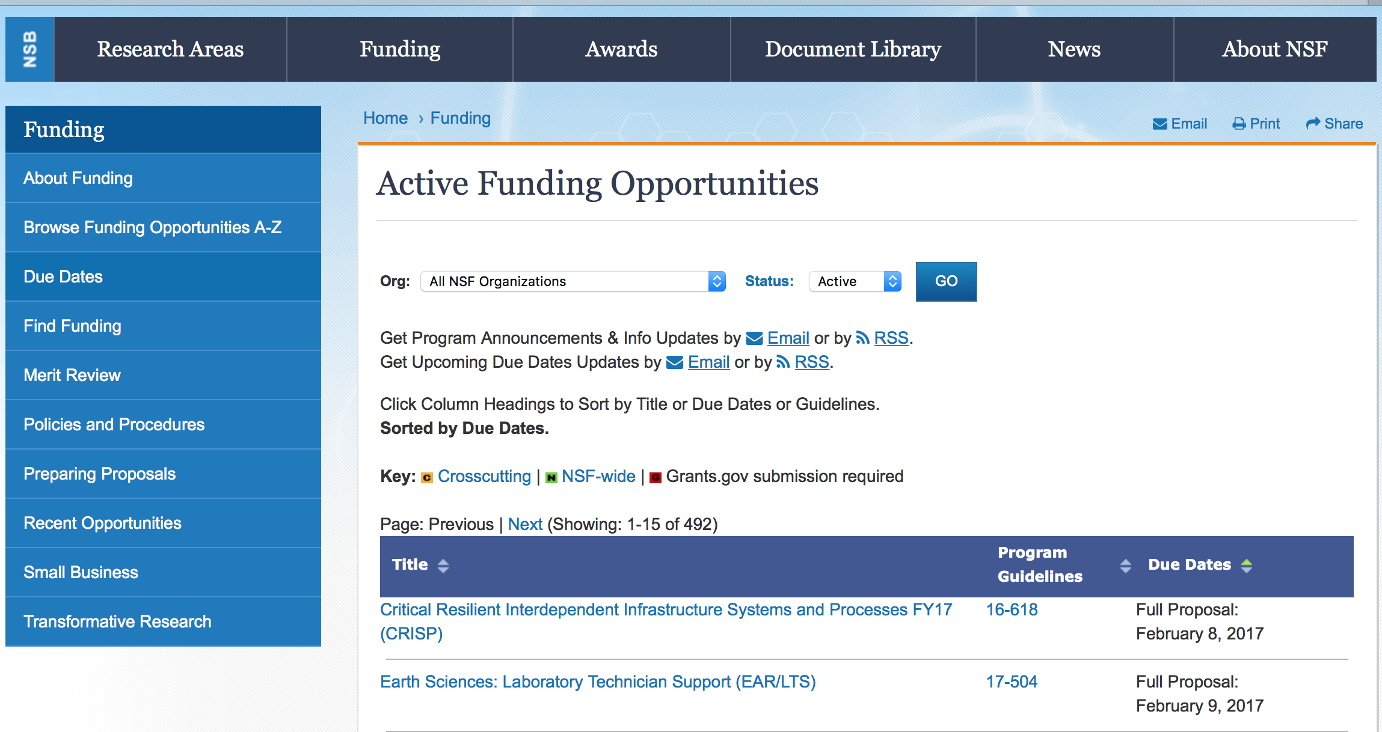

NSF Astronomy and Astrophysics Postdoctoral Fellowships
Synopsis 1
http://www.grants.gov/web/grants/view-opportunity.html?oppId=293972

Centers for Chemical Innovation
Synopsis 1
http://www.grants.gov/web/grants/view-opportunity.html?oppId=294185

CyberCorps(R) Scholarship for Service
Synopsis 1
http://www.grants.gov/web/grants/view-opportunity.html?oppId=293546

Division of Physics: Investigator-Initiated Research Projects
Synopsis 1
http://www.grants.gov/web/grants/view-opportunity.html?oppId=294065

EPSCoR Research Infrastructure Improvement Program Track-1:
Synopsis 1
http://www.grants.gov/web/grants/view-opportunity.html?oppId=294062

Innovation Corps - National Innovation Network Teams Program (I-CorpsTM Teams)
Synopsis 1
http://www.grants.gov/web/grants/view-opportunity.html?oppId=293748

NSF-Simons Research Centers for Mathematics of Complex Biological Systems
Synopsis 1
http://www.grants.gov/web/grants/view-opportunity.html?oppId=294064

Provision of Marine Seismic Capabilities to the U. S. Research Community
Synopsis 1
http://www.grants.gov/web/grants/view-opportunity.html?oppId=294063

Provision of Marine Seismic Capabilities to the U. S. Research Community
Synopsis 1
http://www.grants.gov/web/grants/view-opportunity.html?oppId=294063

Semiconductor Synthetic Biology for Information Processing and Storage Technologies
Synopsis 1
http://www.grants.gov/web/grants/view-opportunity.html?oppId=293588

Towards a Leadership-Class Computing Facility - Phase 1
Synopsis 1
http://www.grants.gov/web/grants/view-opportunity.html?oppId=293684

Modifications:

Reminders:

Deleted:

11-581 - Geoinformatics
Deletion Comments: Opportunity deleted

PD-13-1252 - LIGO Research Support
Deletion Comments: Opportunity deleted

PD-16-7244 - Computational Physics
Deletion Comments: Opportunity deleted

16-503 - National Science Foundation Research Traineeship Program (NRT)
Deletion Comments: Opportunity deleted

16-525 - Centers of Research Excellence in Science and Technology (CREST) and HBCU Research Infrastructure for Science and Engineering (HBCU-RISE)
Deletion Comments: Opportunity deleted

16-566 - Division of Physics: Investigator-Initiated Research Projects
Deletion Comments: Opportunity deleted

16-561 - Physics Frontiers Centers
Deletion Comments: Opportunity deleted

16-568 - Centers for Chemical Innovation
Deletion Comments: Opportunity deleted

16-573 - Joint NSF/NIH Initiative on Quantitative Approaches to Biomedical Big Data
Deletion Comments: Opportunity deleted

15-602 - Resource Implementations for Data Intensive Research in the Social Behavioral and Economic Sciences
Deletion Comments: Opportunity deleted

16-610 - Smart and Connected Communities
Deletion Comments: Opportunity deleted

16-618 - Critical Resilient Interdependent Infrastructure Systems and Processes
Deletion Comments: Opportunity deleted

PD-16-7244 - Computational Physics
Deletion Comments: Opportunity deleted

17-503 - EPSCoR Research Infrastructure Improvement Program: Track-2 Focused EPSCoR Collaborations (RII Track-2 FEC)
Deletion Comments: Opportunity deleted

17-505 - Thwaites: The Future of Thwaites Glacier and its Contribution to Sea-level Rise
Deletion Comments: Opportunity deleted

17-509 - EPSCoR Research Infrastructure Improvement Track 4: EPSCoR Research Fellows
Deletion Comments: Opportunity deleted

17-515 - United States-Israel Collaboration in Computer Science
Deletion Comments: Opportunity deleted

17-519 - Integrative Strategies for Understanding Neural and Cognitive Systems
Deletion Comments: Opportunity deleted

17-520 - Cyberlearning and Future Learning Technologies
Deletion Comments: Opportunity deleted

17-523 - Dimensions of Biodiversity
Deletion Comments: Opportunity deleted

17-525 - Computer Science for All
Deletion Comments: Opportunity deleted

17-528 - Cybersecurity Innovation for Cyberinfrastructure
Deletion Comments: Opportunity deleted

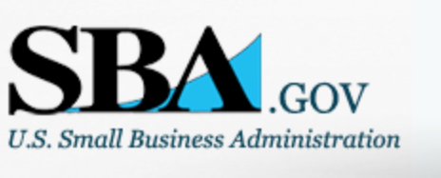

Small Business Administration

General Overview Finding Loans & Grants

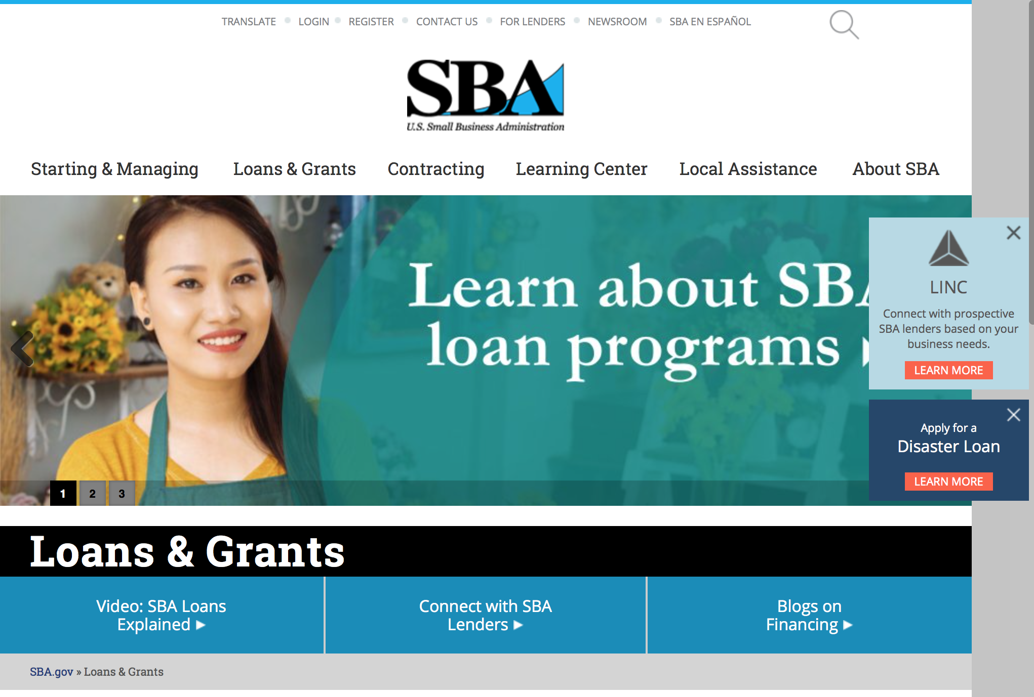
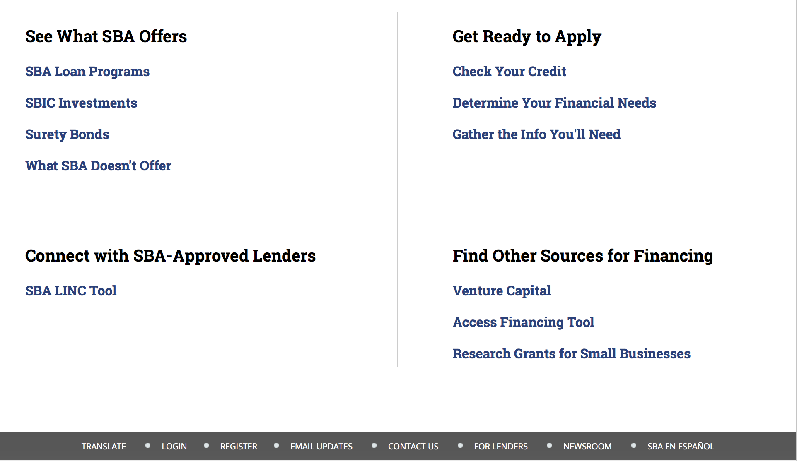

https://www.sba.gov/category/navigation-structure/loans-grants
Federal, state and local governments offer a wide range of financing programs to help small businesses start and grow their operations. These programs include low-interest loans, venture capital, and scientific and economic development grants.
Use SBA.gov's Loans and Grants Search Tool to get a list of financing programs for which you may qualify, or visit the resources below to learn more about small business financing programs.
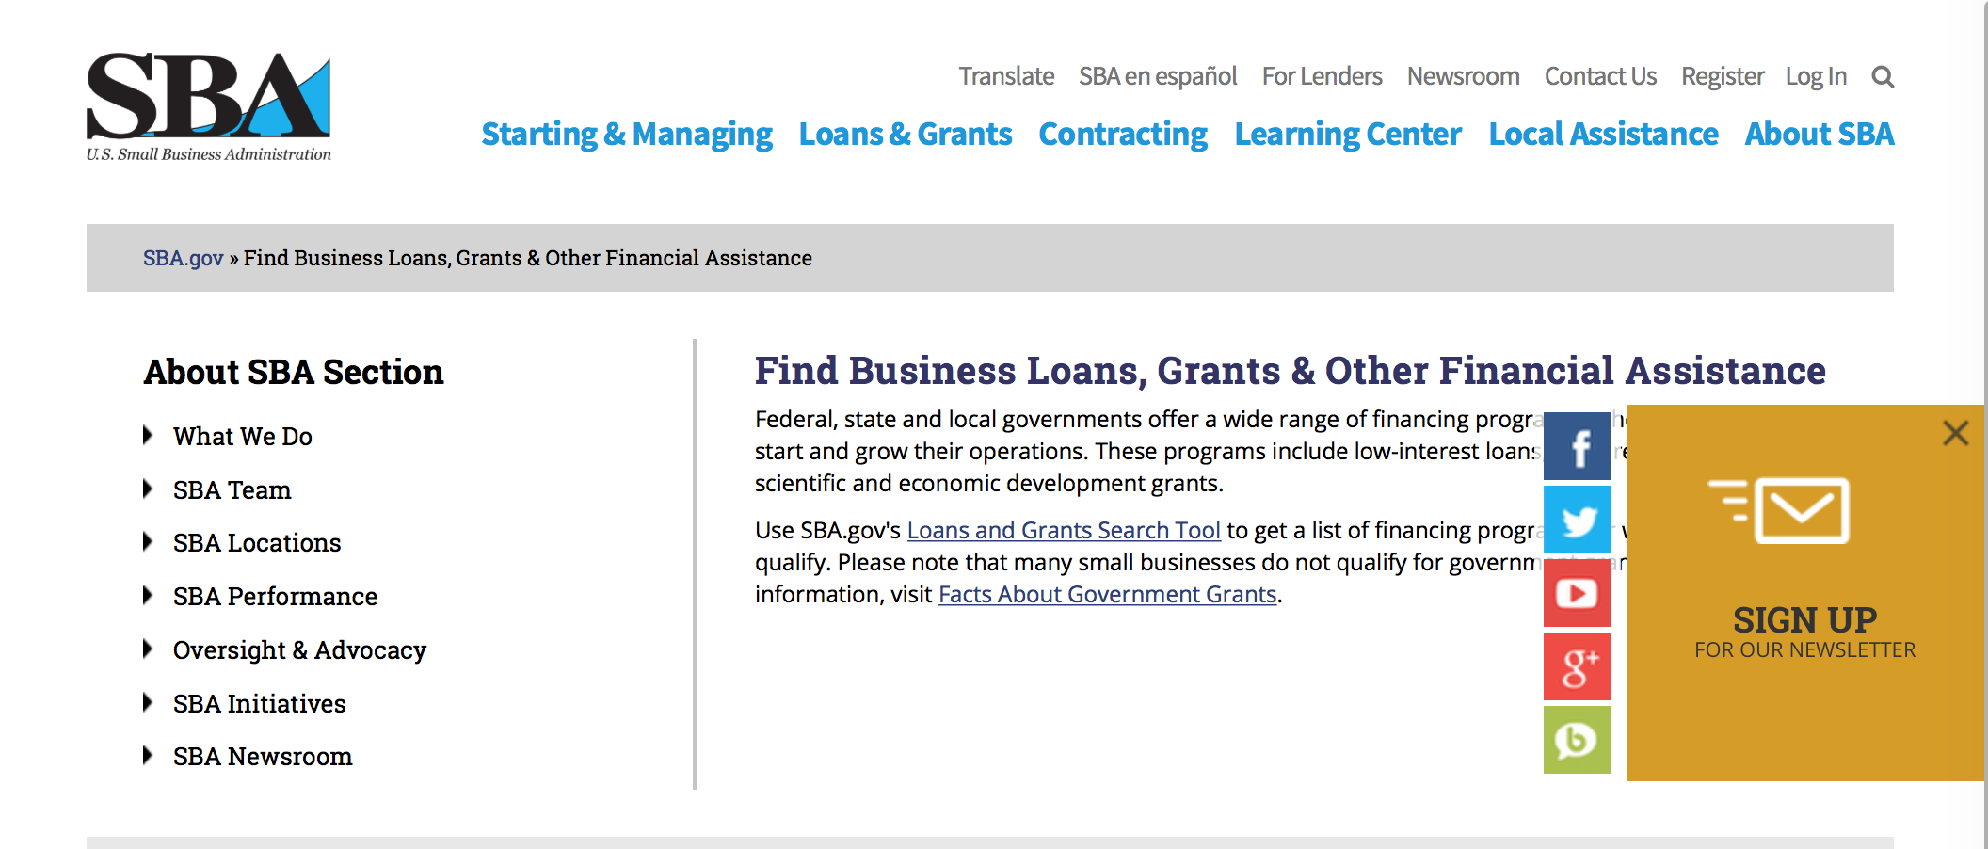
To get to the main SBA.gov funding page click here
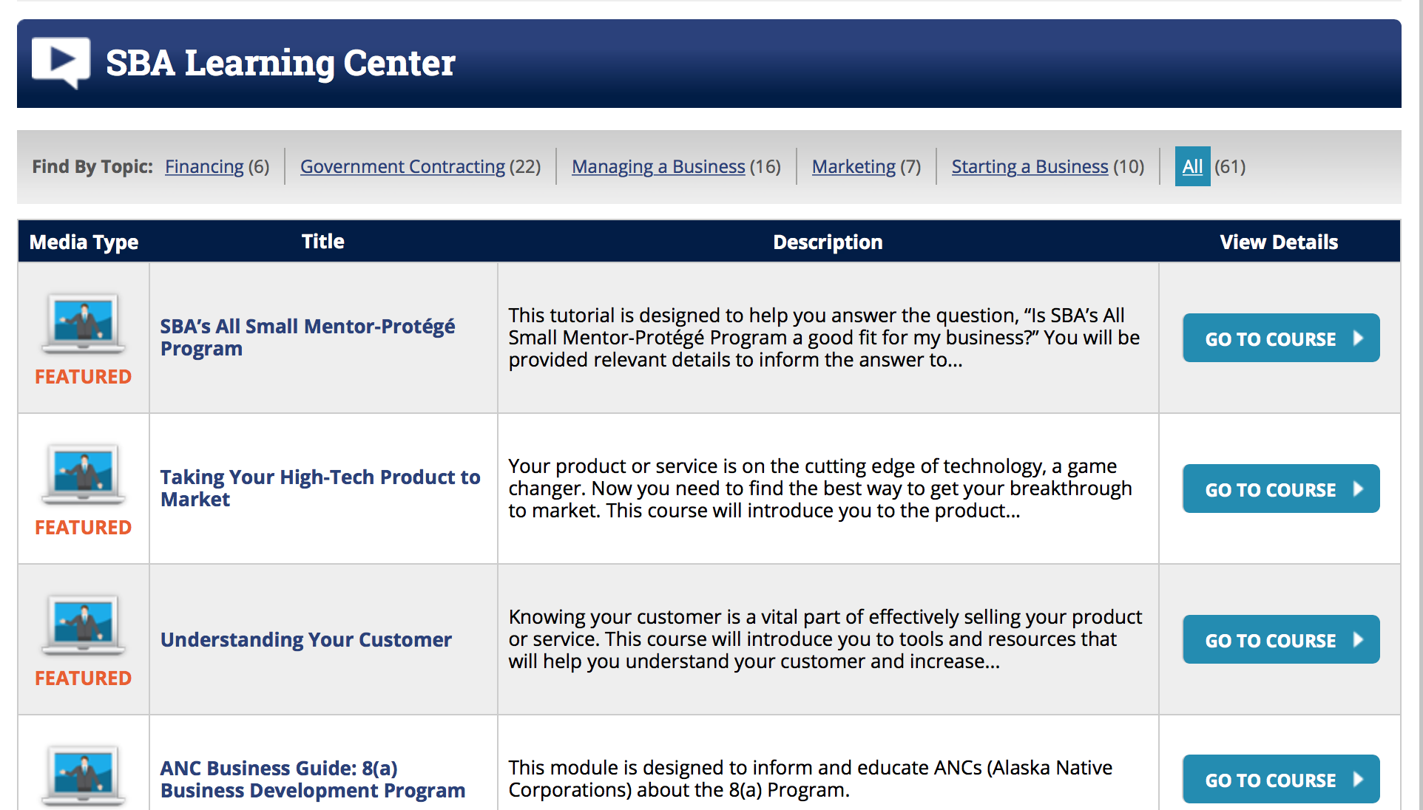
https://www.sba.gov/tools/sba-learning-center/search/training

Programs:

OSBDC
Synopsis 1 & 3
Document Type: | Grants Notice
Funding Opportunity Number: | OSBDC-2018-01
Funding Opportunity Title: | OSBDC
Opportunity Category: | Mandatory
Opportunity Category Explanation:
Funding Instrument Type: | Grant
Category of Funding Activity: | Business and Commerce
Category Explanation:
Expected Number of Awards: | 63
CFDA Number(s): | 59.037 -- Small Business Development Centers
Cost Sharing or Matching Requirement: | Yes
Version: | Synopsis 3
Posted Date: | May 22, 2017
Last Updated Date: | May 24, 2017
Original Closing Date for Applications: | Jul 21, 2017
Current Closing Date for Applications: | Jul 21, 2017
Archive Date:
Estimated Total Program Funding: | $115,000,000
Award Ceiling: | $7,300,000
Award Floor: | $199,999
Eligible Applicants: | Unrestricted (i.e., open to any type of entity above), subject to any clarification in text field entitled "Additional Information on Eligibility"
Additional Information on Eligibility: | Higher Institutions of Education
Agency Name: | Small Business Administration
Description: | SBDC organization
Link to Additional Information:
Grantor Contact Information: | If you have difficulty accessing the full announcement electronically, please contact:  Victoria Mundt Deputy Director/SBDC Phone 202-205-7176  victoria.mundt@sba.gov

http://www.grants.gov/web/grants/view-opportunity.html?oppId=294035

Program Announcement
Synopsis 2
Document Type: | Grants Notice
Funding Opportunity Number: | OSBDC-2018-02
Funding Opportunity Title: | Program Announcement
Opportunity Category: | Mandatory
Opportunity Category Explanation:
Funding Instrument Type: | Cooperative Agreement
Category of Funding Activity: | Business and Commerce
Category Explanation:
Expected Number of Awards: | 63
CFDA Number(s): | 59.037 -- Small Business Development Centers
Cost Sharing or Matching Requirement: | Yes
Version: | Synopsis 2
Posted Date: | May 22, 2017
Last Updated Date: | May 24, 2017
Original Closing Date for Applications: | Aug 25, 2017
Current Closing Date for Applications: | Aug 25, 2017
Archive Date:
Estimated Total Program Funding:
Award Ceiling: | $7,300,000
Award Floor: | $199,999
Eligible Applicants: | Unrestricted (i.e., open to any type of entity above), subject to any clarification in text field entitled "Additional Information on Eligibility"
Agency Name: | Small Business Administration
Description: | Higher Institutions are eligible
Link to Additional Information:
Grantor Contact Information: | If you have difficulty accessing the full announcement electronically, please contact:  Victoria Mundt Deputy Director/SBDC Phone 202-205-7176  victoria.mundt@sba.gov

http://www.grants.gov/web/grants/view-opportunity.html?oppId=294041

Modifications

Prime 2017
Synopsis 3, 6 & 7

Document Type: | Grants Notice
Funding Opportunity Number: | PRIME-2017-01
Funding Opportunity Title: | Prime 2017
Opportunity Category: | Discretionary
Opportunity Category Explanation:
Funding Instrument Type: | Grant
Category of Funding Activity: | Employment, Labor and Training
Category Explanation:
Expected Number of Awards: | 63
CFDA Number(s): | 59.050 -- Prime Technical Assistance
Cost Sharing or Matching Requirement: | Yes
Version: | Synopsis 7
Posted Date: | May 16, 2017
Last Updated Date: | May 23, 2017
Original Closing Date for Applications: | Jun 16, 2017
Current Closing Date for Applications: | Jun 16, 2017
Archive Date: | Jul 16, 2017
Estimated Total Program Funding:
Award Ceiling: | $250,000
Award Floor: | $50,000
Eligible Applicants: | Nonprofits having a 501(c)(3) status with the IRS, other than institutions of higher education
Additional Information on Eligibility: | * Higher Education Institutions are eligible
Description: | Opportunity Number: PRIME-2017-01Opportunity Title: Program for Investment in Microentrepreneurs Act Opportunity Category: Discretionary CFDA Numbers: 59.050Instrument Type: Grant Activity Category: Business and Commerce Posting Date: May 16, 2017Close Date: June 16, 2017Agency Contact: Office of Economic Opportunity E-Mail Address: prime@sba.gov Eligible Applicants: (See Eligibility Explanation)Eligibility Explanation:An applicant must clearly demonstrate that it is one of the following:•A microenterprise development organization or program (or group or Collaborative thereof) such as a non-profit Community Development Financial Institution or similar entity, that has a demonstrated record of delivering microenterprise services to disadvantaged entrepreneurs or•An Intermediary (as defined in Section 8.1) which has experience in delivering technical assistance to disadvantaged entrepreneurs; or•A microenterprise development organization or program (as defined in Section 8.1)that is accountable to a local community, working in conjunction with a State or local government or Indian Tribe; or•An Indian tribe acting on its own, if it can certify that no private organization or program referred to in paragraph in paragraphs (1) exists within its jurisdiction. Cost Sharing or Matching Requirement: Yes, 50%. Expected Number of Awards: SBA anticipates issuing approximately 35 awards under this Announcement. The period of performance for this grant will begin during FY 2017. Estimated Total Program Funding: Up to $5 Million Award Ceiling: $250,000 Award Floor: $50,000 Funding Opportunity Text Description: The U.S. Small Business Administration (SBA) has issued Program Announcement No. PRIME-2017-01 to provide training and capacity building grant programs to microenterprise development organizations (MDOs). The Program for Investment in Microentrepreneurs Act of 1999 (the PRIME Act) became law on November 12, 1999 with the passage of Pub. L. No. 106-102 (15 U.S.C. § 6901 note).The PRIME Act authorizes the SBA to provide funding to qualified organizations for the purposes of: (i) providing training and technical assistance to disadvantaged entrepreneurs; (ii) providing training and capacity building assistance to microenterprise development organizations (MDOs) and programs; (iii) aiding in Research and development of best practices for microenterprise and technical assistance programs for disadvantaged entrepreneurs; and (iv) for other activities as the SBA Administrator determines. In FY2016, PRIME has two tracks for which SBA will consider granting awards under this program announcement:• Track 1 (Technical Assistance) – seeks applications for funding to provide training and technical assistance programs to disadvantaged entrepreneurs. Examples include training specifically designed to: (1) strengthen the capacity of cooperatives serving economically disadvantaged entrepreneurs and areas; and/or(2) to support entrepreneurship among ex-offenders in the criminal justice system, especially those on parole, probation or incarcerated persons soon to be released.• Track 2 (Capacity Building) – seeks applications for funding to provide training and capacity building services to MDOs, microenterprise development programs, and groups of such organizations to assist them in developing micro enterprise training and services. Examples include services geared towards building MDO capacity to provide business training and technical assistance to: (1) cooperatives serving economically disadvantaged areas; and/or (2) to support entrepreneurship among ex-offenders in the criminal justice system, especially those on parole, probation or incarcerated individuals soon to be released. View Section 3.0 of the Program Announcement for full eligibility criteria. Please note that for-profit organizations and individual persons are ineligible for this grant. SBA will evaluate applications for funding in accordance with the purposes of the Act, including an application’s ability to demonstrate mission-oriented and culturally competent projects and/or services that reflect local community demographics. Section5.0 of the Program Announcement more fully defines the specific evaluation criteria. Questions about this Program Announcement should be directed to the Office of Economic Opportunity at prime@sba.gov.
Link to Additional Information:
Grantor Contact Information: | If you have difficulty accessing the full announcement electronically, please contact:  Office of Economic Opportunity James Webb 202-619-0628 PRIME@sba.gov  SBA email

http://www.grants.gov/web/grants/view-opportunity.html?oppId=293845

Reminders:

Deleted:

SBA Trainings

Contracting Opportunities for Veteran Entrepreneurs
This self-paced training exercise is an introduction to Federal contracting opportunities for Veterans.
Topics include basic information about Veteran-owned businesses and opportunities, services available to small Veteran-owned businesses, small business incentives, and government procurement methods.
Duration: 00:30:00

http://www.sba.gov/tools/sba-learning-center/training/contracting-opportunities-veteran-entrepreneurs

Interested in Exporting? These Four Resources Can Help
Did you know that two-thirds of the world’s purchasing power is in foreign countries? As the numbers show, the international marketplace is a big one. So if you’re interested in exploring the world of exporting – or have gotten started but could use some guidance – check out these resources to help.
- Read more

Upcoming Trainings: Check out SBA's Online Training!
- Financing Options for Small Businesses
How to Prepare Government Contract Proposals
Getting Started With Exporting: Training and Educational Resources
Exporting represents a big opportunity to tap in to new markets, expand your customer base and grow your business. But getting started with exporting can sometimes feel like a maze of regulations, policies, and other barriers. Here are some free training and educational resources to help.
- Read more

For Specific Information in Hawaii see the following links:
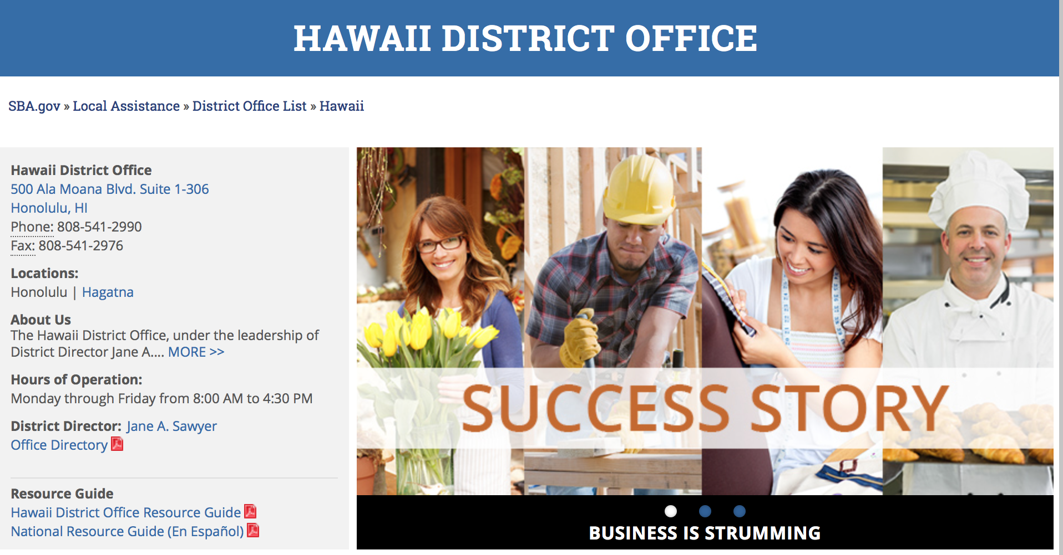

https://www.sba.gov/offices/district/hi/Honolulu

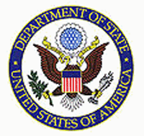

State Department General Overview and Resources for Program Administrators

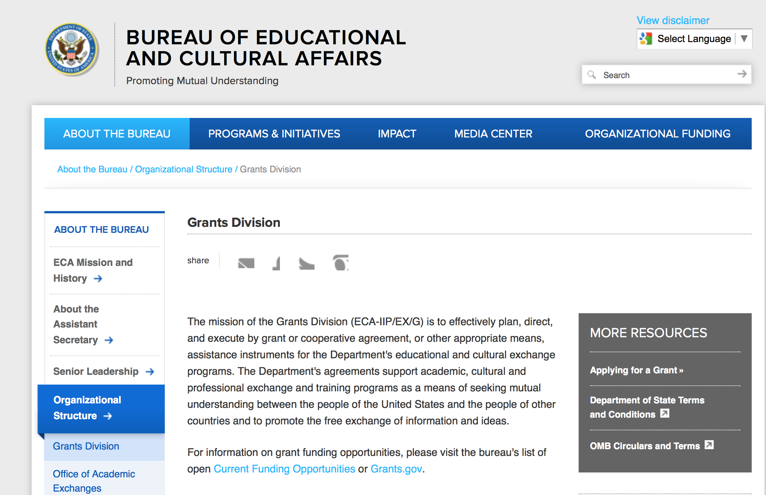

https://eca.state.gov/about-bureau/organizational-structure/grants-division

http://eca.state.gov/search/solr/grants?search_referrer=node/237

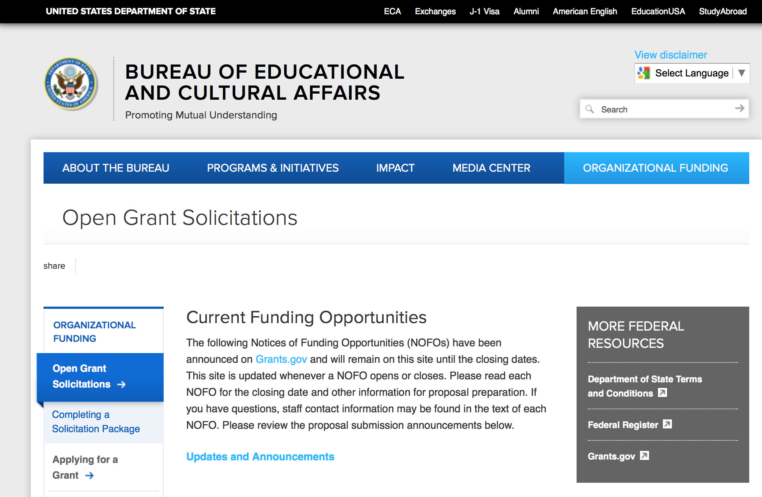
https://eca.state.gov/organizational-funding/open-grant-solicitations

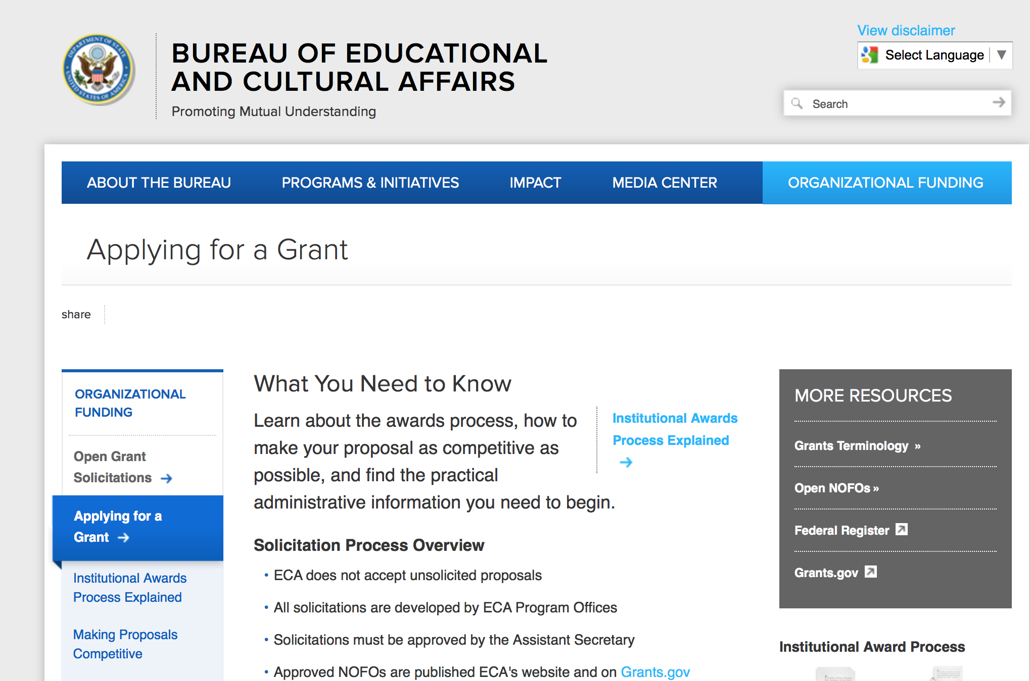
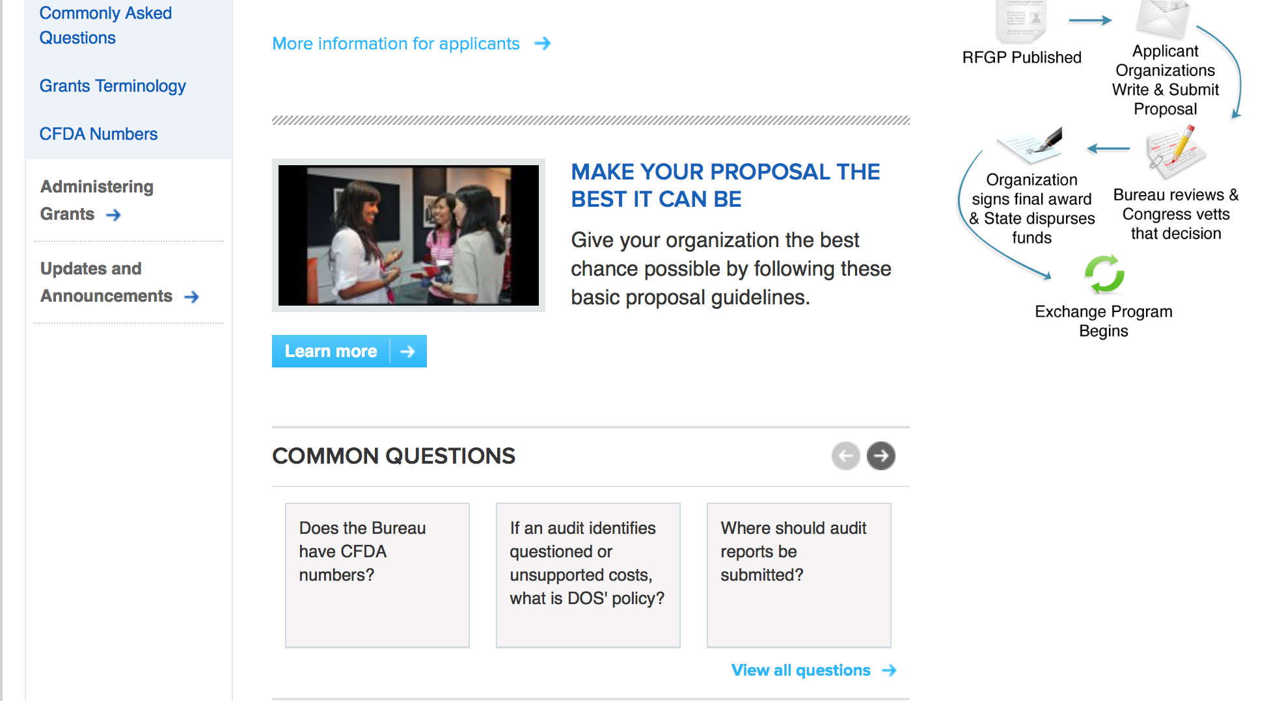
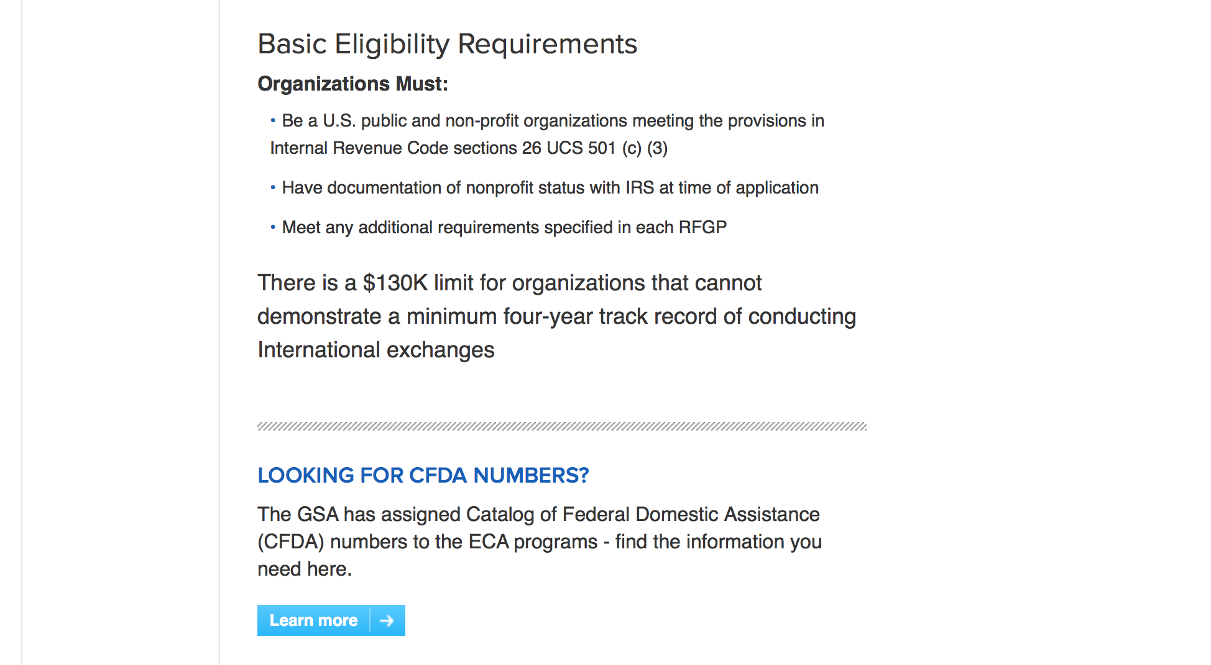
http://eca.state.gov/organizational-funding/applying-grant

General Information:
- Bureau of Educational and Cultural Affairs Grants Division
- Open Grant Opportunities (Requests for Grant Proposals)

For General Information click here

Program Grants:

Assistance Coordination
Supporting Job Creation for Young Tunisians from Marginalized Communities
Synopsis 1
http://www.grants.gov/web/grants/view-opportunity.html?oppId=294196

Bureau of Democracy Human Rights and Labor
DRL Internet Freedom Annual Program Statement
Synopsis 1
http://www.grants.gov/web/grants/view-opportunity.html?oppId=294247

Bureau Of Educational and Cultural Affairs
FY 2018 International Visitor Leadership Program
Synopsis 1
http://www.grants.gov/web/grants/view-opportunity.html?oppId=293771

Bureau of European and Eurasian Affairs
U.S-EU Relationship
Synopsis 1
http://www.grants.gov/web/grants/view-opportunity.html?oppId=294245

Bureau of International Narcotics-Law Enforcement
Advancing Justice Reform in Argentina
Synopsis 1
http://www.grants.gov/web/grants/view-opportunity.html?oppId=294051

Bureau of International Narcotics-Law Enforcement
Strengthening Law Enforcement’s Partnerships with Women’s Justice Centers
Synopsis 1
http://www.grants.gov/web/grants/view-opportunity.html?oppId=293569

PM Weapons Removal and Abatement
17.PMWRA.Global.SALWDiversionData
Synopsis 1
http://www.grants.gov/web/grants/view-opportunity.html?oppId=294056

U.S. Mission to India
U.S. Universities Alumni: The East and Northeast India Connect Program
Synopsis 1
http://www.grants.gov/web/grants/view-opportunity.html?oppId=293619

U.S. Mission to India
TIP Conclave 7: Engagement and Advocacy
Synopsis 1
http://www.grants.gov/web/grants/view-opportunity.html?oppId=293693

U.S. Mission to Vietnam
English Language Teaching Program.
Synopsis 1
http://www.grants.gov/web/grants/view-opportunity.html?oppId=293933

Guatemala USAID-Guatemala City
Stakeholder Consultative Workshop in Guatemala
Synopsis 1
http://www.grants.gov/web/grants/view-opportunity.html?oppId=293979

Peru USAID-Lima
Brazil Environment Program- Territorial and Environmental Management of Indigenous Lands
Synopsis 1
http://www.grants.gov/web/grants/view-opportunity.html?oppId=293957

Modifications:

Bureau of Counterterrorism
Kenya Counterterrorism Criminal Justice Sector Support
Synopsis 9 & 10
http://www.grants.gov/web/grants/view-opportunity.html?oppId=293031

Mali USAID -Bamako
Education for deaf and blind Children in Mali
Synopsis 11
http://www.grants.gov/web/grants/view-opportunity.html?oppId=286603

U.S. Mission to Belize
Strengthening Government Through Civil Society Engagement
Synopsis 2
http://www.grants.gov/web/grants/view-opportunity.html?oppId=293645

U.S. Mission to Fiji
Regional Environment, Science, Technology and Health (ESTH) Program for Select Pacific Island Countries (PICs)
Synopsis 2 & 3
http://www.grants.gov/web/grants/view-opportunity.html?oppId=294098

U.S. Mission to Panama
Promoting Sustainability and Accountability in Panama
Synopsis 2
http://www.grants.gov/web/grants/view-opportunity.html?oppId=293021

Zimbabwe USAID-Harare
REQUEST FOR COMMENTS - Request for Comments
Forecast 2
http://www.grants.gov/web/grants/view-opportunity.html?oppId=293953

Zimbabwe USAID-Harare
Advancing Accountability and Rights in Zimbabwe (AARZ)
Synopsis 2
http://www.grants.gov/web/grants/view-opportunity.html?oppId=293883

Reminders:

Deleted:

Kazakhstan USAID-Almaty
RFA-176-17-000004 - New Youth Development Activity
Deletion Comments: Opportunity deleted

Department of Transportation

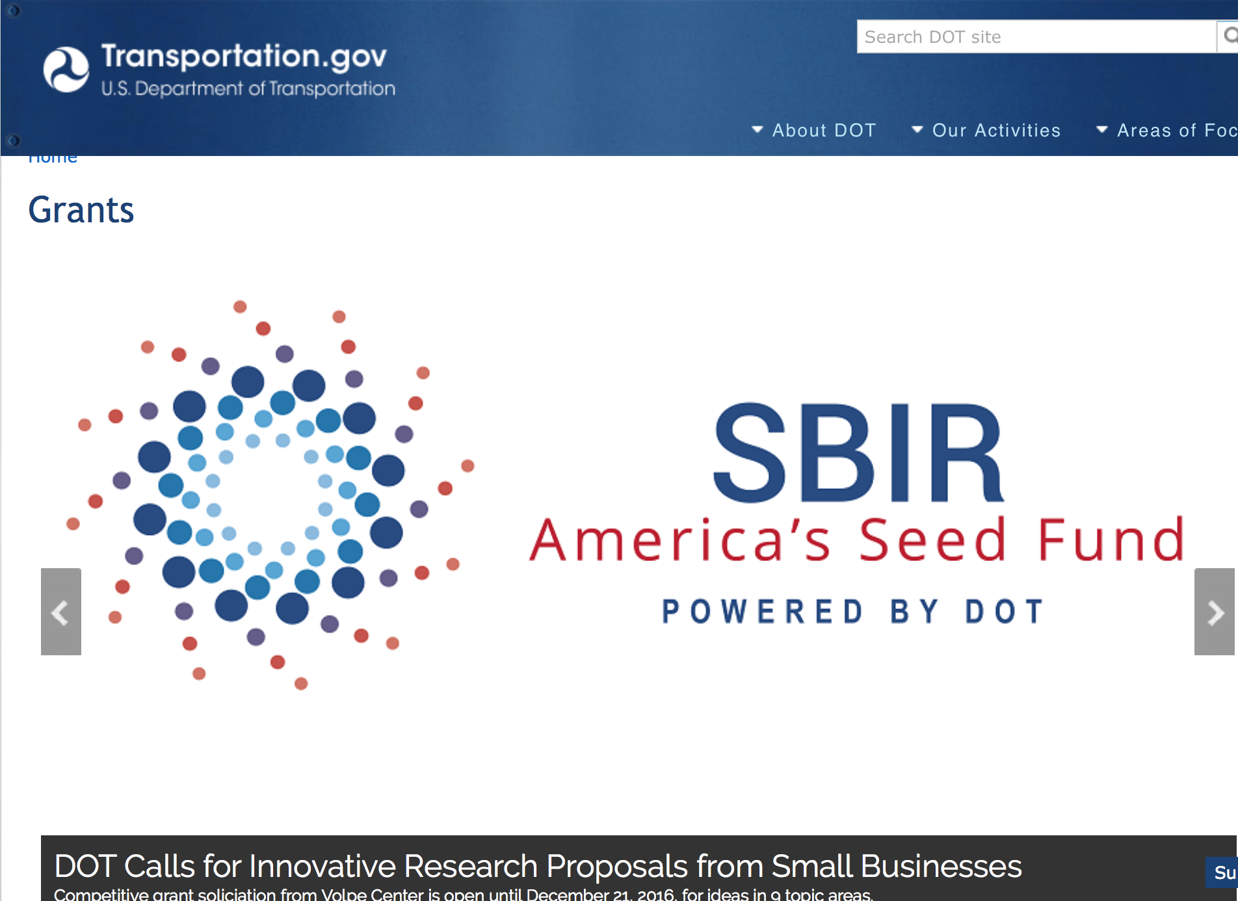

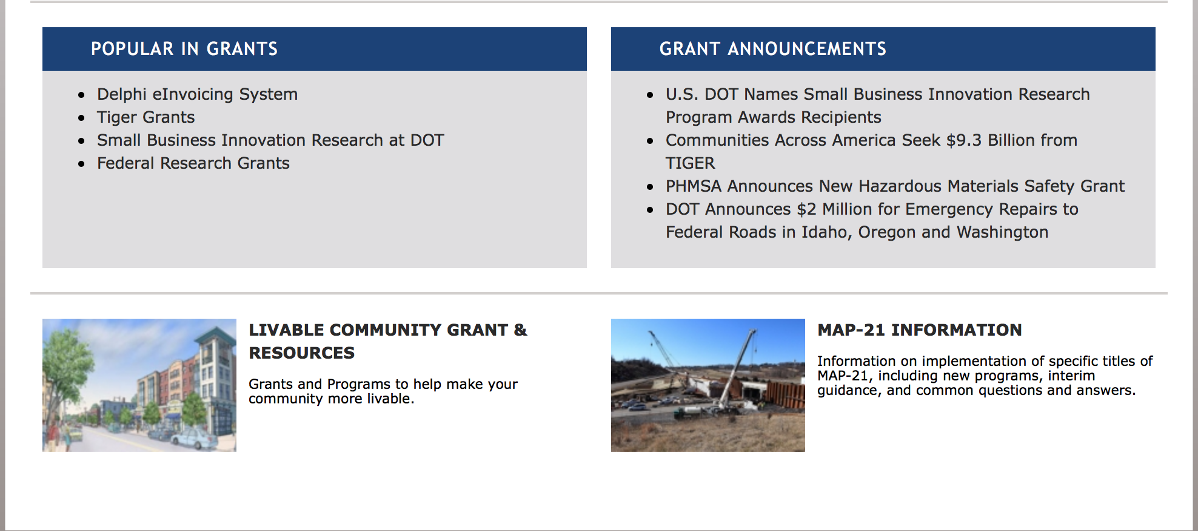
General Grant Program Overview https://www.transportation.gov/grants

Programs:

Modifications:

Research:

Reminders:

Federal Transport Administration
DOT Federal Highway Administration
Advanced Transportation and Congestion Management Technologies Deployment Initiative
Synopsis 1
Document Type: | Grants Notice
Funding Opportunity Number: | 693JJ317NF0001
Funding Opportunity Title: | Advanced Transportation and Congestion Management Technologies Deployment Initiative
Opportunity Category: | Discretionary
Opportunity Category Explanation:
Funding Instrument Type: | Cooperative Agreement
Category of Funding Activity: | Transportation
Category Explanation:
Expected Number of Awards: | 10
CFDA Number(s): | 20.200 -- Highway Research and Development Program
Cost Sharing or Matching Requirement: | Yes
Version: | Synopsis 1
Posted Date: | Apr 12, 2017
Last Updated Date: | Apr 12, 2017
Original Closing Date for Applications: | Jun 12, 2017 Applications Due by June 12, 2017 at 3:00 pm Eastern Time through www.Grants.gov
Current Closing Date for Applications: | Jun 12, 2017 Applications Due by June 12, 2017 at 3:00 pm Eastern Time through www.Grants.gov
Archive Date: | Oct 01, 2017
Estimated Total Program Funding: | $60,000,000
Award Ceiling: | $12,000,000
Award Floor: | $0
Eligible Applicants: | Others (see text field entitled "Additional Information on Eligibility" for clarification)
Additional Information on Eligibility: | Eligible applicants are State or local governments, transit agencies, metropolitan planning organizations (MPO) representing a population of over 200,000, or other political subdivisions of a State or local government (such as publicly owned toll or port authorities), or a multijurisdictional group or consortia of research institutions or academic institutions. Partnership with the private sector or public agencies, including multimodal and multijurisdictional entities, research institutions, organizations representing transportation and technology leaders, or other transportation stakeholders is encouraged. Typically, a consortium is a meaningful arrangement with all members involved in planning the overall direction of the group’s activities and participating in most aspects of the group; the consortium is a long-term relationship intended to last the full life of the grant. Any application submitted by a sole research or academic institution and that is not part of a consortium will not be considered for selection.
Agency Name: | DOT Federal Highway Administration
Description: | The DOT hereby requests applications to result in awards to eligible entities to develop model deployment sites for large-scale installation and operation of advanced transportation technologies to improve safety, efficiency, system performance, and infrastructure return on investment. These model deployments are expected to provide benefits in the form of: reduced traffic-related fatalities and injuries; reduced traffic congestion and improved travel time reliability; reduced transportation-related emissions; optimized multimodal system performance; improved access to transportation alternatives, including for underserved populations; public access to real time integrated traffic, transit, and multimodal transportation information to make informed travel decisions; cost savings to transportation agencies, businesses, and the traveling public; or other benefits to transportation users and the general public. This competitive advanced transportation and congestion management technologies deployment grant program will promote the use of innovative transportation solutions. The deployment of these technologies will provide Congress and DOT with valuable real life data and feedback to inform future decision-making. The United States Department of Transportation (DOT) will host an Informational Session regarding this Funding Opportunity focused on the Advanced Transportation and Congestion Management Technologies Deployment Initiative. This session will be conducted as a virtual forum and will focus on specific topics to help potential applicants gather additional information and ask specific questions. Participation in this session is not mandatory in order to submit an application under this solicitation. However, we encourage potential applicants to take advantage of this opportunity to gather information regarding this specific funding opportunity. WEBINAR DATE: April 25, 2017; TIME: 1:00 pm Eastern Time. WEBINAR INFORMATION AND REGISTRATION: https://connectdot.connectsolutions.com/e4x9x0mcr0a/event/registration.html
Link to Additional Information:
Grantor Contact Information: | If you have difficulty accessing the full announcement electronically, please contact:  Jeff Martin Agreement Specialist Phone 202-366-1323  jeffrey.d.martin@dot.gov

http://www.grants.gov/web/grants/view-opportunity.html?oppId=293139

DOT/Federal Transit Administration
FY 2017 Competitive Funding Opportunity: Low or No Emission Grant
Synopsis 1

Document Type: | Grants Notice
Funding Opportunity Number: | FTA-2017-003-TPM-LOWNO
Funding Opportunity Title: | FY 2017 Competitive Funding Opportunity: Low or No Emission Grant
Opportunity Category: | Discretionary
Opportunity Category Explanation:
Funding Instrument Type: | Grant
Category of Funding Activity: | Transportation
Category Explanation:
Expected Number of Awards: | 20
CFDA Number(s): | 20.526 -- Bus and Bus Facilities Formula Program
Cost Sharing or Matching Requirement: | Yes
Version: | Synopsis 1
Posted Date: | Apr 27, 2017
Last Updated Date: | Apr 27, 2017
Original Closing Date for Applications: | Jun 26, 2017
Current Closing Date for Applications: | Jun 26, 2017
Archive Date: | Jul 26, 2017
Estimated Total Program Funding: | $55,000,000
Eligible Applicants: | City or township governments  Others (see text field entitled "Additional Information on Eligibility" for clarification)  State governments  Native American tribal governments (Federally recognized)  County governments
Additional Information on Eligibility: | An Eligible Applicant is a designated recipient of FTA grants, States, local governmental authorities and Indian Tribes.
Agency Name: | DOT/Federal Transit Administration
Description: | Notice of Funding Opportunity (NOFO): Solicitation of Project Proposals for the Low or No Emission Program (Low-No) Program. The Federal Transit Administration (FTA) announces the availability of $55 million of Fiscal Year 2017 funds for the purchase or lease of low or no emission vehicles as well as related equipment or facilities. Only $31.5 million is available under the Continuing Resolution that expires on April 28, 2017. Synopses and full announcement are posted on Grants.gov site as opportunity FTA-2017-003-LowNo. Proposals must be submitted electronically through Grants.gov website by midnight EDT on 6/26/2017. Summary: The main purpose of the Low-No Program is to support the transition of the nation’s transit fleet to the lowest polluting and most energy efficient transit vehicles. The Low-No Program provides funding to State and local governmental authorities for the purchase or lease of zero-emission and low-emission transit buses, including acquisition, construction, and leasing of required supporting facilities.
Link to Additional Information: | FTA Notices of Funding Opportunity
Grantor Contact Information: | If you have difficulty accessing the full announcement electronically, please contact:  Tara Clark Office of Program Management 202-366-2623  FTA Office of Program Management

http://www.grants.gov/web/grants/view-opportunity.html?oppId=293467

DOT/Federal Motor Carrier Safety Administration
2017 Commercial Motor Vehicle Operator Safety Training Grant Program
Synopsis 1

Document Type: | Grants Notice
Funding Opportunity Number: | FM-DTG-17-001
Funding Opportunity Title: | 2017 Commercial Motor Vehicle Operator Safety Training Grant Program
Opportunity Category: | Discretionary
Opportunity Category Explanation:
Funding Instrument Type: | Grant
Category of Funding Activity: | Transportation
Category Explanation:
Expected Number of Awards:
CFDA Number(s): | 20.235 -- Commercial Motor Vehicle Operators Grants
Cost Sharing or Matching Requirement: | Yes
Version: | Synopsis 1
Posted Date: | Apr 28, 2017
Last Updated Date: | Apr 28, 2017
Original Closing Date for Applications: | Jun 23, 2017 No Explanation
Current Closing Date for Applications: | Jun 23, 2017 No Explanation
Archive Date: | Jul 23, 2017
Estimated Total Program Funding: | $1,000,000
Award Ceiling: | $100,000
Award Floor: | $20,000
Eligible Applicants: | Nonprofits having a 501(c)(3) status with the IRS, other than institutions of higher education  County governments  State governments  Public and State controlled institutions of higher education  City or township governments  Special district governments  Private institutions of higher education  Native American tribal governments (Federally recognized)  Others (see text field entitled "Additional Information on Eligibility" for clarification)  Small businesses  For profit organizations other than small businesses
Additional Information on Eligibility: | Vocational Technical Schools and Truck Training Schools
Agency Name: | DOT/Federal Motor Carrier Safety Administration
Description: | The Federal Motor Carrier Safety Administration (FMCSA) announces the Fiscal Year (FY) 2017 CMVOST grant program Notice of Funding Availability (NOFA) to solicit applications from organizations that provide CMV operator training, including accredited public or private colleges, universities, vocational-technical schools, post-secondary educational institutions, truck driver training schools, associations, and State and local governments, including Federally-recognized Native American Tribal governments that support CMVOST activities. The CMVOST grant is a nationwide Federal financial assistance program intended to reduce the severity and number of crashes on U.S. roads involving CMV by training operators and future operators in the safe use of such vehicles.
Link to Additional Information: | 2017 Commercial Motor Vehicle Operator Safety Training Grant Program
Grantor Contact Information: | If you have difficulty accessing the full announcement electronically, please contact:  Grants.gov Contact Center Phone Number: 1-800-518-4726 Hours of operation are 24 hours a day, 7 days a week. The contact center is closed on federal holidays. support@grants.gov  Grants.gov Customer Support

http://www.grants.gov/web/grants/view-opportunity.html?oppId=293500

DOT Federal Aviation Administration
DOT - FAA Aviation Research Grants
FAA Aviation Research and Development Grants
Modifications 3 & 4

Document Type: | Grants Notice
Funding Opportunity Number: | 12-01
Funding Opportunity Title: | FAA Aviation Research and Development Grants
Opportunity Category: | Discretionary
Opportunity Category Explanation:
Funding Instrument Type: | Grant
Category of Funding Activity: | Transportation
Category Explanation:
Expected Number of Awards:
CFDA Number(s): | 20.108 -- Aviation Research Grants
Cost Sharing or Matching Requirement: | No
Version: | Synopsis 5
Posted Date: | Jan 01, 2012
Last Updated Date: | Jun 09, 2016
Original Closing Date for Applications: | Dec 31, 2019
Current Closing Date for Applications: | Dec 31, 2019
Archive Date: | Jan 30, 2020
Estimated Total Program Funding:
Award Ceiling: | $5,000,000
Eligible Applicants: | Nonprofits having a 501(c)(3) status with the IRS, other than institutions of higher education  Private institutions of higher education  Public and State controlled institutions of higher education
Agency Name: | DOT - FAA Aviation Research Grants
Description: | The FAA is soliciting proposals for research grants and cooperative agreements to pursue the long-term growth and short-term technical needs of civil aviation. In order to streamline the application process, it is recommended that all prospective grantees submit a white paper (letter of intent) for agency technical review before complete proposal submission. Please be sure to identify the specific area of interest (Solicitation FAA-12-01 – Chapter I. FAA Research Grants Program, Technical Areas of Research #1-#9). The white paper shall be no longer than three (3) pages and shall detail overall research objectives.
Link to Additional Information:
Grantor Contact Information: | If you have difficulty accessing the full announcement electronically, please contact:  Debra Monzo Grants Officer Phone 609-485-4962  business

http://www.grants.gov/web/grants/view-opportunity.html?oppId=134953

Deleted:

Department of the Treasury

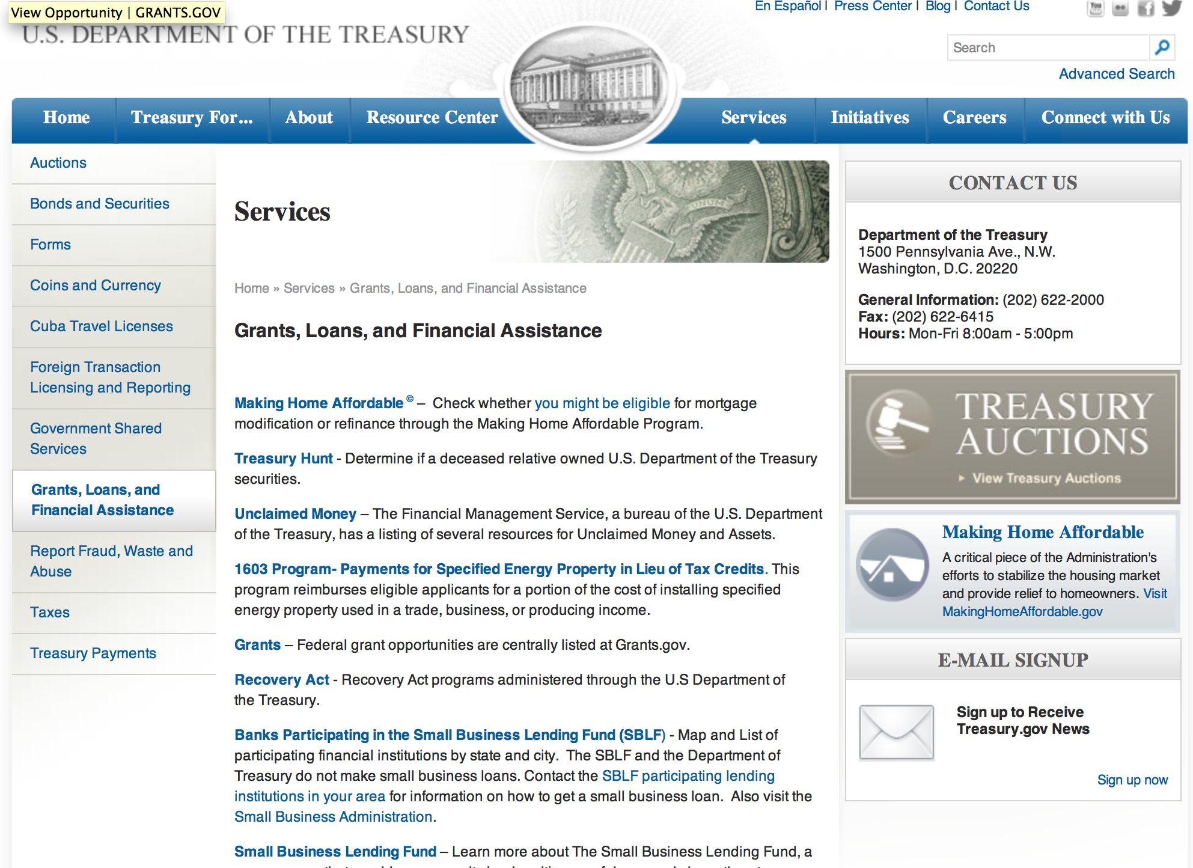

http://www.treasury.gov/services/Pages/Grants-Loans-and-Financial-Assistance.aspx

Programs:

Modifications:

Low Income Taxpayer Clinic
Synopsis 2

Document Type: | Grants Notice
Funding Opportunity Number: | TREAS-GRANTS-052018-001
Funding Opportunity Title: | Low Income Taxpayer Clinic
Opportunity Category: | Discretionary
Opportunity Category Explanation:
Funding Instrument Type: | Grant
Category of Funding Activity: | Law, Justice and Legal Services
Category Explanation:
Expected Number of Awards: | 150
CFDA Number(s): | 21.008 -- Low Income Taxpayer Clinics
Cost Sharing or Matching Requirement: | Yes
Version: | Synopsis 2
Posted Date: | May 03, 2017
Last Updated Date: | May 03, 2017
Original Closing Date for Applications: | Jun 20, 2017 No Explanation
Current Closing Date for Applications: | Jun 20, 2017 No Explanation
Archive Date: | Jul 20, 2017
Estimated Total Program Funding: | $12,000,000
Award Ceiling: | $100,000
Award Floor: | $0
Eligible Applicants: | Nonprofits having a 501(c)(3) status with the IRS, other than institutions of higher education  Public and State controlled institutions of higher education  Private institutions of higher education
Agency Name: | Low Income Taxpayer Clinic
Description: | Provide representation, education and advocacy for low income and ESL taxpayers.
Link to Additional Information: | Low Income Taxpayer Clinic
Grantor Contact Information: | If you have difficulty accessing the full announcement electronically, please contact:  Grants.gov Contact Center Phone Number: 1-800-518-4726 Hours of operation are 24 hours a day, 7 days a week. The contact center is closed on federal holidays. support@grants.gov  Grants.gov Customer Support

http://www.grants.gov/web/grants/view-opportunity.html?oppId=293578

Reminders:

U.S. Agency for International Development

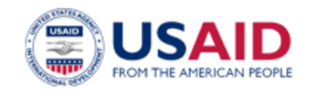

www.usaid.gov

General Overview Funding Opportunities

USAID has working relationships with thousands of American companies and hundreds of U.S.-based private voluntary organizations. For more information on our business and procurement opportunities, please visit our Business section.

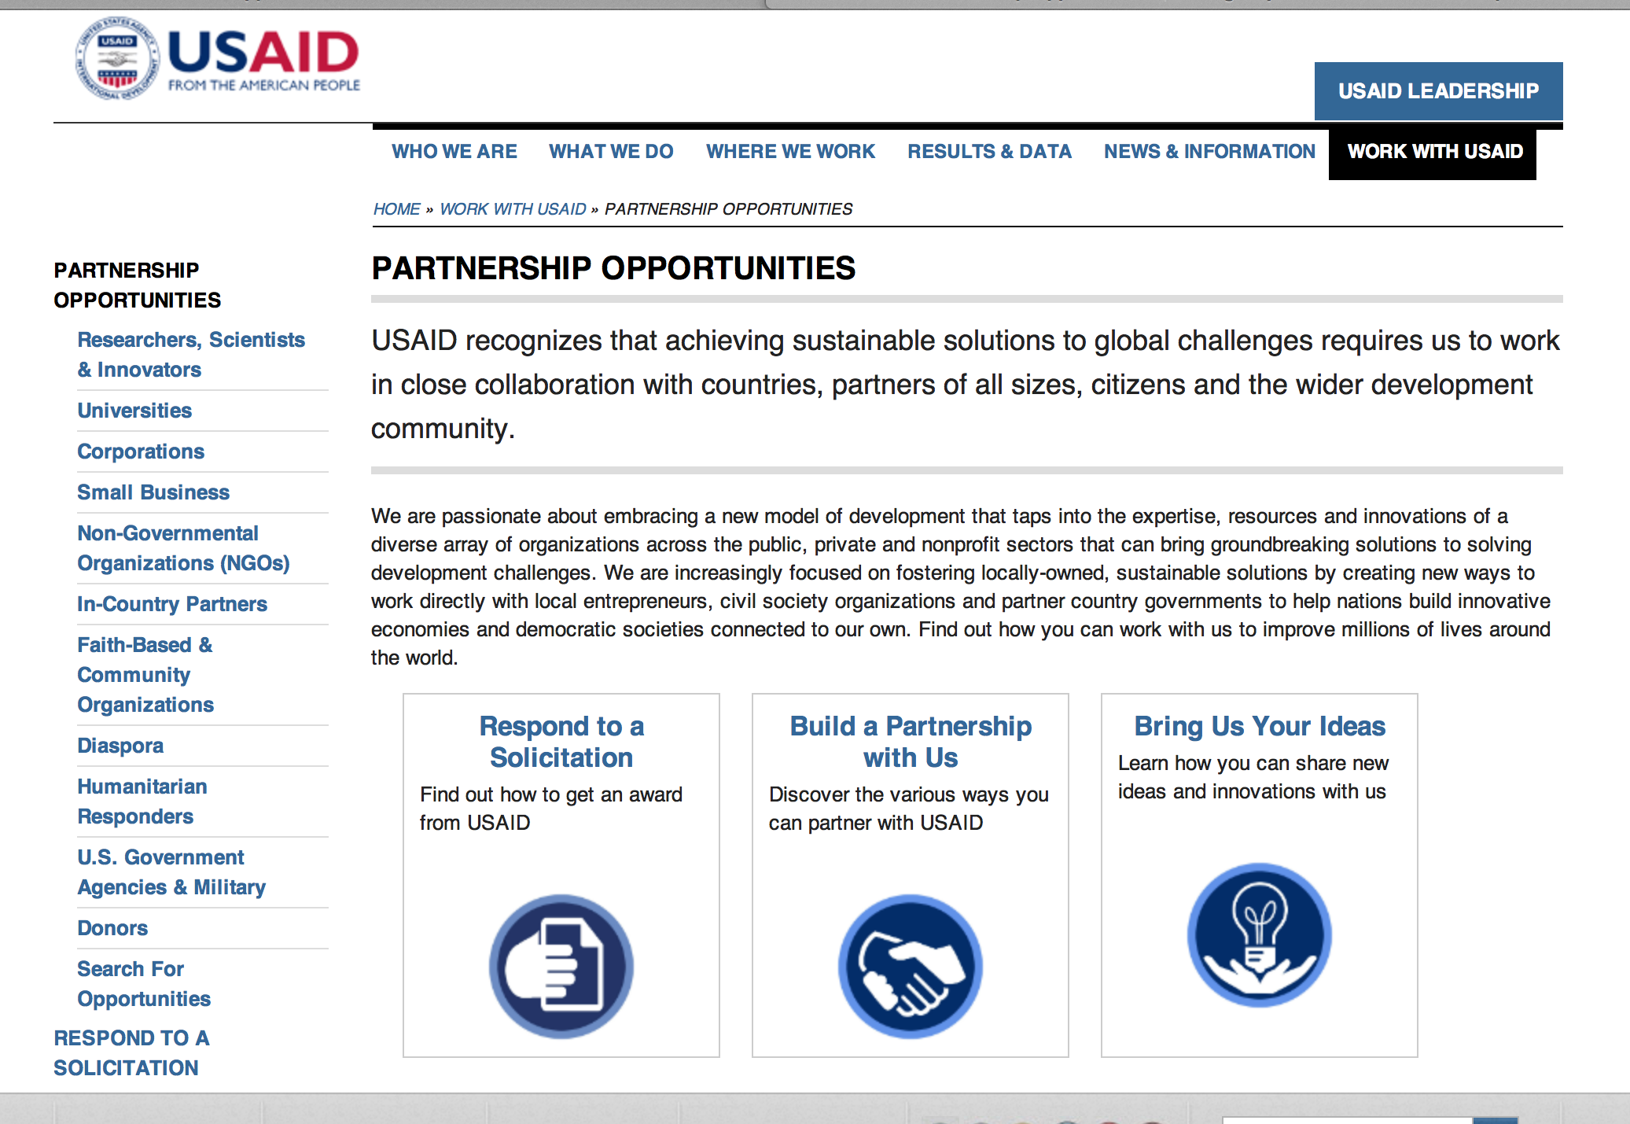
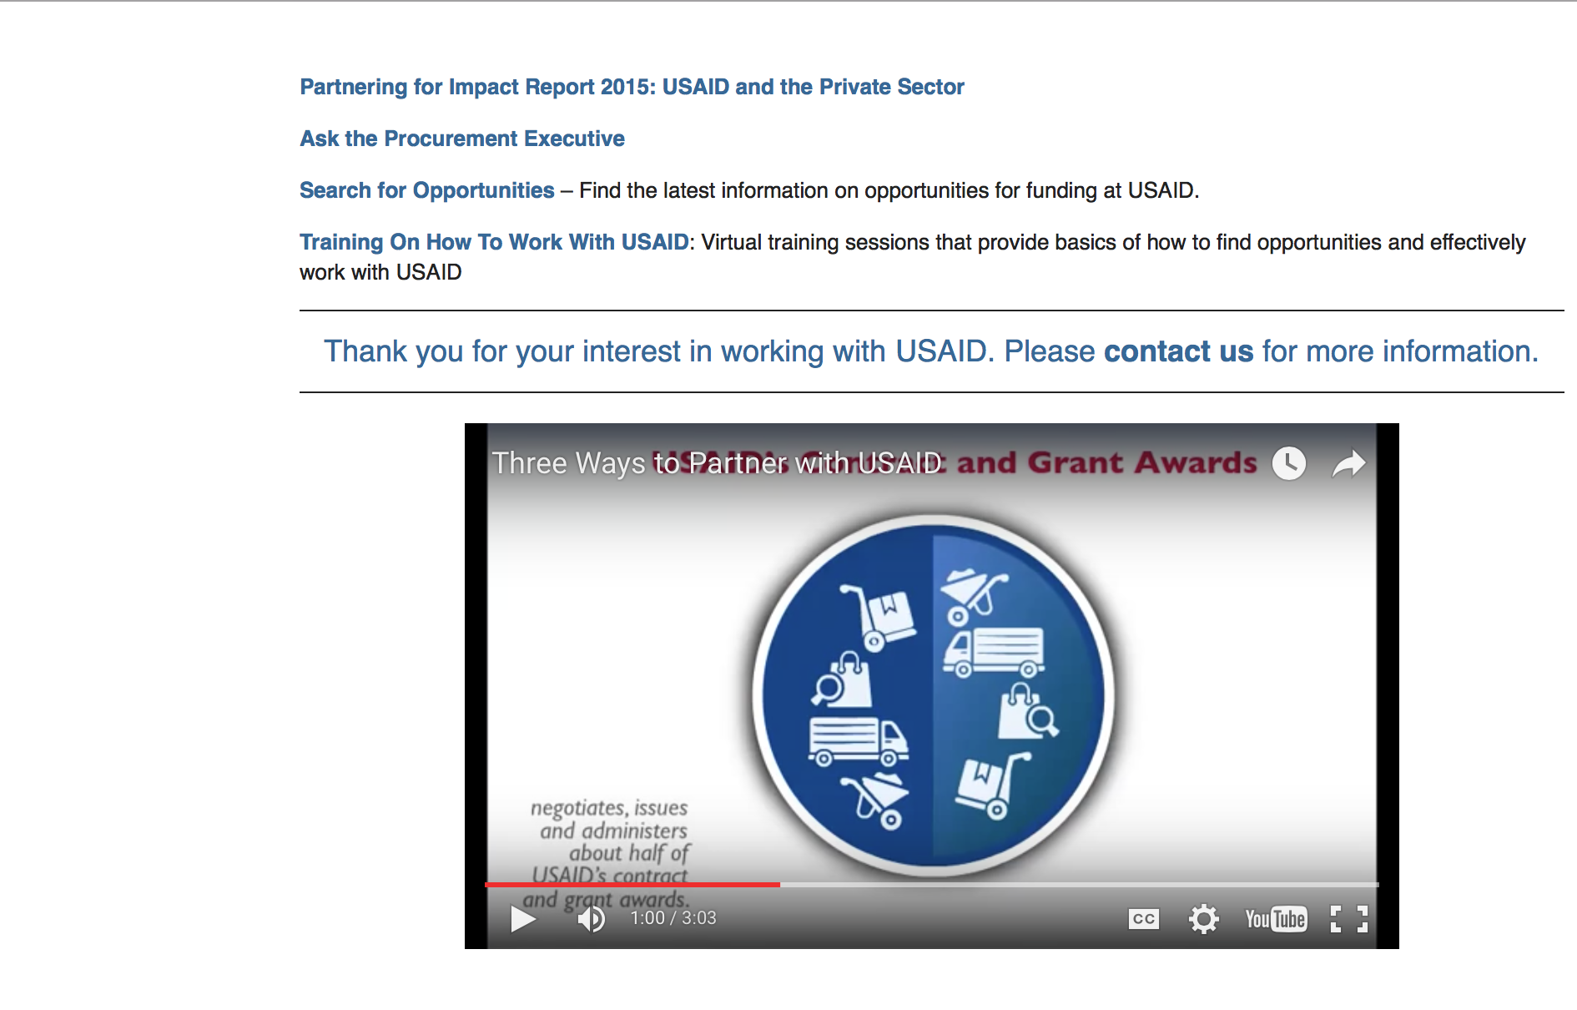

http://www.usaid.gov/partnerships

Programs:

Thailand USAID-Bangkok
Enhancing Worker-Management Relations in Vietnam
Synopsis 1
http://www.grants.gov/web/grants/view-opportunity.html?oppId=294072

Zimbabwe USAID-Harare
ZIMBABWE’S ENHANCING RESILIENCE OF OVC: Getting to ZERO
Synopsis 1
http://www.grants.gov/web/grants/view-opportunity.html?oppId=294050

Malawi USAID-Lilongwe
Malawi Agricultural Policy and Implementation Activity (MAPI)
Synopsis 1
http://www.grants.gov/web/grants/view-opportunity.html?oppId=294172

The USAID Global Health Challenge BAA
Synopsis 1
http://www.grants.gov/web/grants/view-opportunity.html?oppId=294194

Modifications:

Ocean Freight Reimbursement Program FY18 and FY19
Synopsis 2
http://www.grants.gov/web/grants/view-opportunity.html?oppId=293712

Zimbabwe USAID-Harare
Advancing Accountability and Rights in Zimbabwe (AARZ)
Synopsis 3
http://www.grants.gov/web/grants/view-opportunity.html?oppId=293883

Family Planning and Reproductive Health Methods APS
Synopsis 7
http://www.grants.gov/web/grants/view-opportunity.html?oppId=215873

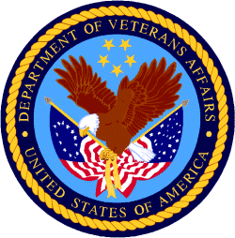

Department of Veterans Affairs

