Senator Mazie Hirono

Grants Assistance Information Newsletter

JUNE 2023

PART 1 – CURRENT FEDERAL AGENCY DISCRETIONARY GRANT OPPORTUNITIES

PART 2 – GENERAL FEDERAL AGENCY GRANTS INFORMATION

Current Federal Agency Grant and Cooperative Agreement Discretionary Program Summaries

Click on Index Links below to find summaries of the current announcements listed by agency in this document. Once you reach the item, if you cannot open the links for further information, copy the selected URL website address into your browser.

Notices is Teal are items with immediate deadline dates.

Notices in Yellow are of special interest.

Notices is Green are items of special interest with immediate deadline dates.

Several Agencies have research or program opportunities that are not individually listed because they are for very technical or specific audiences. Click on the Agency Index Research or Program designation to review those grant and contract notices.

If an Agency does not have listings, it is due to the lack of competitive open opportunities at that Agency this month. Please review Part 2 for general information not specific to a current deadline date for general funding cycle information.

Special Notice

President Biden’s Bipartisan Infrastructure Law’s Distribution of funding in Hawaii

Programs specific to Hawaii

Current Notices
Fiscal Year (FY) 2023 Regional Catastrophic Preparedness Grant Program (RCPGP) - Region 9
Synopsis 2
https://www.grants.gov/web/grants/view-opportunity.html?oppId=348325

Reminders

Office of Postsecondary Education (OPE): Higher Education Programs (HEP): Institutional Service: Native Hawaiian-Serving Institutions Program Part A, Assistance Listing Number 84.031W

U.S. Department of Agriculture

Programs

Agricultural Marketing Service
Organic Market Development Grants
Natural Resources Conservation Service
Community Agriculture Grants

Rural Housing Service
Rural Community Development Initiative
National Institute of Food and Agriculture
Agriculture in the K-12 Classroom
Research

Modifications

Natural Resources Conservation Service
Notice of Funding for NRCS’s Regional Conservation Partnership Program (RCPP) for Federal Fiscal Year (FY) 2023
Rural Housing Service
Consolidated Multifamily Housing Technical Assistance Grant Programs

Reminders

Rural Housing Service
Community Facilities Technical Assistance and Training Grant

Office of Partnerships and Public Engagements
Outreach and Assistance for Socially Disadvantaged Farmers and Ranchers and Veteran Farmers and Ranchers
National Institute of Food and Agriculture
Agriculture and Food Research Initiative Competitive Grants Program Education and Workforce Development
National Institute of Food and Agriculture
Enhancing Agricultural Opportunities for Military Veterans Competitive Grants Program
Foreign Agricultural Service
FY 2023 Food Assistance Proposal Instructions and Request for Applications Food For Progress Program Notice Of Funding Opportunity

Natural Resources Conservation Service
Composting and Food Waste Reduction (CFWR) Pilot Project

Rural Utilities Service
Community Connect Grant Program

National Institute of Food and Agriculture
Agriculture and Food Research Initiative Sustainable Agricultural Systems
National Institute of Food and Agriculture
Agriculture and Food Research Initiative Competitive Grants Program Foundational and Applied Science Program

Rural Business-Cooperative Service
Rural Microentrepreneur Assistance Program

Rural Business-Cooperative Service
Rural Economic Development Loan and Grant

Rural Business-Cooperative Service
Rural Cooperative Development Grant
Rural Utilities Service
Broadband Technical Assistance

Food and Nutrition Service
SNAP Process and Technology Improvement Grants 2023
Agricultural Marketing Service
Local Meat Capacity Grant

Department of Commerce

Programs
Economic Development Administration
FY2023 Build to Scale Program
National Institute of Standards and Technology
Regional Alliances and Multistakeholder Partnerships to Stimulate (RAMPS) Cybersecurity Education and Workforce Development
Research
Modifications

FY24 Saltonstall-Kennedy Competition

Economic Development Administration
Tech Hubs Phase 1 NOFO

Reminders

Market Development Cooperator Program 2023
National Institute of Standards and Technology
Measurement Science and Engineering (MSE) Research Grant Programs

National Institute of Standards and Technology
Training for Improving Plastics Circularity (TIPC) Grant Program
National Institute of Standards and Technology
CHIPS Incentives Program – Commercial Fabrication Facilities

FY2023 National Sea Grant College Program Special Projects
FY 2021 - 2023 Economic Development RNTA
National Institute of Standards and Technology
Measurement Science and Engineering (MSE) Research Grant Programs
National Institute of Standards and Technology
NIST Manufacturing USA National Emergency Assistance Program
Economic Development Administration
FY 2020 EDA Public Works and Economic Adjustment Assistance Programs

Consumer Product Safety Commission

Corporation for National and Community Service

Programs

Reminders

Department of Defense

Programs

Research Grants

Reminders

Dept of the Army -- Materiel Command
United States Army Research Institute For The Behavioral And Social Sciences (ARI) Broad Agency Announcement For Basic, Applied, And Advanced Scientific Research

Dept of the Army -- Materiel Command
U.S. Army Research Institute for the Behavioral and Social Sciences Broad Agency Announcement for Basic Research (Fiscal Year 2024)
Air Force Office of Scientific Research
Fiscal Year (FY) 2024 Department of Defense Multidisciplinary Research Program of the University Research Initiative (MURI)

Dept of the Army -- Materiel Command
Fiscal Year (FY) 2024 Department of Defense Multidisciplinary Research Program of the University Research Initiative (MURI)- Army Submission

Dept of the Army -- Materiel Command
DEVCOM Analysis Center Broad Agency Announcement For Applied Research

ACC-APG-Aberdeen Division A
APEX Accelerator- Option Period for Existing Award Recipients

Dept of the Army -- Materiel Command
DEVCOM Army Research Laboratory Broad Agency Announcement For Foundational Research

Department of Education

Programs
Office of Elementary and Secondary Education (OESE): Innovation and Early Learning Programs: Education Innovation and Research (EIR) Program—Mid-Phase Grants Assistance Listing Number (ALN) 84.411B

Institute of Education Sciences (IES): National Center for Education Research (NCER): Transformative Research in the Education Sciences Grant Program, Assistance Listing Number (ALN) 84.305T
Research
Modifications
Office of Elementary and Secondary Education (OESE): Charter School Program (CSP): Grants to Charter School Developers for the Opening of New Charter Schools, Assistance Listing Number 84.282B
Office of Elementary and Secondary Education (OESE): Charter School Program (CSP): Grants to Charter School Developers for The Replication and Expansion of High-Quality Charter Schools, Assistance Listing Number 84.282E
Office of Elementary and Secondary Education (OESE): School Choice & Improvement Program (SCIP)Full-Service Community Schools (FSCS) Program, Assistance Listing Number 84.215J
Office of Postsecondary Education (OPE): Higher Education Programs (HEP): Child Care Access Means Parents in School (CCAMPIS) Program, Assistance Listing Number 84.335A

Office of Elementary and Secondary Education (OESE): Innovation and Early Learning Programs: Education Innovation and Research (EIR) Program—Early-Phase Grants Assistance Listing Number (ALN) 84.411C
Office of Elementary and Secondary Education (OESE): Effective Educator Development (EED) Division: Teacher and School Leader Incentive Program, Assistance Listing Number 84.374A
Office of Elementary and Secondary Education (OESE): Safe & Supportive Schools: Fostering Diverse Schools Demonstration Grants, Assistance Listing Number (ALN) 84.424G

Office of Postsecondary Education (OPE): Higher Education Programs (HEP): Fund for the Improvement of Postsecondary Education (FIPSE): Transitioning Gang-Involved Youth to Higher Education Program, Assistance Listing Number 84.116Y
OSERS: OSEP: Personnel Development to Improve Services and Results for Children with Disabilities--Preparation of Related Services Personnel Serving Children with Disabilities who have High-Intensity Needs, Assistance Listing Number (ALN) 84.325R
OSERS-OSEP: Personnel Development to Improve Services and Results for Children with Disabilities--Preparation of Special Education, Early Intervention, and Related Services Leadership Personnel, Assistance Listing Number 84.325D
OSERS: Personnel Development to Improve Services and Results for Children with Disabilities--Personnel Preparation of Special Education, Early Intervention, and Related Services Personnel, ALN 84.325M

Reminders

Office of Elementary and Secondary Education (OESE): Effective Educator Development Programs: American History and Civics Education National Activities (AHC-NA) Program, Assistance Listing Number 84.422B
Office of Elementary and Secondary Education (OESE): Effective Educator Development Programs: American History and Civics Education: Presidential and Congressional Academies for American History and Civics Program, Assistance Listing Number (ALN) 84.422A
Office of Postsecondary Education (OPE): Higher Education Programs (HEP): Fund for the Improvement of Postsecondary Education (FIPSE): Rural Postsecondary and Economic Development (RPED) Grant Program, Assistance Listing Number 84.116W
Office of Postsecondary Education (OPE): Higher Education Programs (HEP): Modeling and Simulation Program (MSP), Assistance Listing Number 84.116S

US Department of Energy

Programs

Research

Modifications

Reminders

Office of Science
FY2023 Continuation of Solicitation for the Office of Science Financial Assistance Program

Environmental Protection Agency

Programs

FY24 Brownfields Job Training (JT) Grants
Modifications
Reminders

2023 Clean School Bus (CSB) Grant Program

FY 2023 – FY 2024 Pollution Prevention Grants: Environmental Justice Through Safer and More Sustainable Products

Department of Health and Human Services

Programs
Research Grants

Modifications

Reminders

Department of Homeland Security
Programs
Office of Procurement Operations - Grants Division
Terrorism and Targeted Violence Research and Evaluation
Reminders

Department of Homeland Security - FEMA
Fiscal Year (FY)2023 Cooperating Technical Partners (CTP) - HQ
Department of Homeland Security - FEMA
Fiscal Year (FY) 2023 Cooperating Technical Partners (CTP) Program - Regional

Department of Housing and Urban Development

Programs
Capital Fund At-Risk/Receivership/Substandard/Troubled Program
Green and Resilient Retrofit Program (GRRPC) Comprehensive

Green and Resilient Retrofit Program (GRRPE) Elements

Green and Resilient Retrofit Program (GRRP) Leading Edge
Housing Mobility-Related Services
FY 2023 Jobs Plus NOFO

Modifications

Reminders
Lead Hazard Reduction Capacity Building Grant Program
Lead Risk Assessment Demonstration (LRAD)

Veterans Housing Rehabilitation and Modification Pilot Program

Youth Homeless Demonstration Program
Authority to Accept Unsolicited Proposals for Research Partnerships

Institute of Museum and Library Services
Programs

Modifications
Reminders

Department of Interior

Programs
Fish and Wildlife Service
F23AS00395 National Fire Plan-Wildland Urban Interface Community Fire Assistance
Geological Survey
National Land Remote Sensing Education Outreach and Research Activity (NLRSEORA)

Modifications

Reminders

Bureau of Reclamation
Desalination and Water Purification Research Program Pitch to Pilot FY 23
Fish and Wildlife Service
F23AS00339 - White-nose Syndrome Research and Conservation Grants - 2023

National Park Service
FY2023 Historic Preservation Fund- History of Equal Rights- Preservation Grants

Fish and Wildlife Service
F23AS00249 National Fish Passage Program Base Funding Fiscal Year 2023
National Park Service
FY2023 ABPP - Battlefield Restoration Grants

Fish and Wildlife Service
F23AS00124 FY23 Recovery Implementation
Fish and Wildlife Service
F23AS00126 FY23 Candidate Species Conservation Fund
National Park Service
FY2023 ABPP - Battlefield Land Acquisition Grant

National Park Service
NPS Cooperative Ecosystems Studies Units (CESU) Master Cooperative Agreements
Fish and Wildlife Service
F23AS00078 National Fish Passage Program Bipartisan Infrastructure Law Fiscal Year 2023
Fish and Wildlife Service
F23AS00100 Refuges Enhancement/Infrastructure
Fish and Wildlife Service
F23AS00069 Youth Engagement, Education, and Employment

Fish and Wildlife Service
F23AS00032 - 2023 Coastal Program

Geological Survey
Cooperative Research Units Program Department of the Interior Geological Survey

Department of Justice

Programs
Bureau of Justice Assistance
BJA FY 23 Harold Rogers Prescription Drug Monitoring Program (PDMP)
Bureau of Justice Assistance
BJA FY 23 Virtual Reality De-escalation Site-Based Initiative
Bureau of Justice Assistance
BJA FY 23 Transforming Prison Cultures, Climates, and Spaces
Community Oriented Policing Services
FY 2023 COPS Technology and Equipment Program II Invitational Solicitation
OJJDP FY 2023 Juvenile Justice Emergency Planning Demonstration Program for Juvenile Justice Residential Facilities

Modifications

Office on Violence Against Women
OVW Fiscal Year 2023 Training and Technical Assistance Initiative Solicitation

Research

Reminders

Bureau of Justice Assistance
BJA FY 23 The Price of Justice: Rethinking the Consequences of Fines and Fees
Bureau of Justice Assistance
BJA FY 23 Visiting Fellows Program
Bureau of Justice Assistance
BJA FY 23 Rural and Small Department Violent Crime Reduction Program

Bureau of Justice Assistance
BJA FY 23 Reimagining Justice: Testing a New Model of Community Safety
Bureau of Justice Assistance
BJA FY 23 Second Chance Act Community-based Reentry Incubator Initiative
Office on Violence Against Women
OVW Fiscal Year 2023 Research and Evaluation Initiative Solicitation
________________________________________________________________________

Department of Labor

Programs
Employment and Training Administration
Critical Sector Job Quality Grants
Occupational Safety and Health Administration
Capacity Building Developmental & Capacity Building Pilot
Occupational Safety and Health Administration
Targeted Topic Training
Occupational Safety and Health Administration
Training and Educational Materials Development

Modifications

Reminders

Employment and Training Administration
Critical Sector Job Quality Grants

Employment and Training Administration
DOL Building Pathways to Infrastructure Jobs Grant Program
Employment and Training Administration
Pathway Home 4

Veterans Employment and Training Service
Announcement of Stand Down Grants

Employment and Training Administration
National Dislocated Worker Grants Program Guidance

Library of Congress

Lewis-Houghton Civics and Democracy Initiative

National Aeronautics and Space Administration

Research

_______________________________________________________________
National Archives and Records Administration

Programs

Archival Projects
Public Engagement with Historical Records
Reminders

Publishing Historical Records in Collaborative Digital Editions
_______________________________________________________________
National Endowment for the Arts

Programs
NEA Grants for Arts Projects 2, FY2024
Modifications

Reminders

___________________________________________________________

National Endowment for the Humanities

Programs

Climate Smart Humanities Organizations
Media Projects
Public Humanities Projects
Fellowship Programs at Independent Research Institutions

Dialogues on the Experiences of War
Modifications
Humanities Connections
Reminders

Public Impact Projects at Smaller Organizations
Humanities Collections and Reference Resources

Fellowships Open Book Program
_______________________________________________________________
National Science Foundation

Research and Program Grants

Modifications

Reminders

Nuclear Regulatory Commission

Programs

Small Business Administration

Programs
Modifications

Reminders

State Department

Programs

Reminders

U.S. Department of Transportation

Programs

Pipeline and Hazardous Materials Safety Admin
FY 2023 Natural Gas Distribution Infrastructure Safety and Modernization Grant
Modifications
DOT Federal Highway Administration
2023 Work Zone Safety Grants

Reminders

DOT Federal Highway Administration
Reduction of Truck Emissions at Port Facilities Grant Program

DOT Federal Highway Administration
Promoting Resilient Operations for Transformative, Efficient, and Cost-Saving Transportation (PROTECT) Program
DOT Federal Aviation Administration
FY 2023 Competitive Funding Opportunity: Airport Improvement Program Discretionary Grants

DOT Federal Highway Administration
Fiscal Years 2022-2023 Wildlife Crossings Pilot Program (WCPP)
69A345 Office of the Under Secretary for Policy
Safe Streets and Roads for All Funding Opportunity
69A345 Office of the Under Secretary for Policy
Small Community Air Service Development Program

Department of the Treasury

Programs

Low Income Taxpayer Clinic

Modifications

Reminders

US Agency for International Development

Programs

Department of Veterans Affairs

Programs
VHA Member Services-Veterans Transportation
Grants for Transportation in Highly Rural Areas

Reminders

Current Federal Agency Grant and Cooperative Agreement Discretionary Program Summaries

Special Programs:

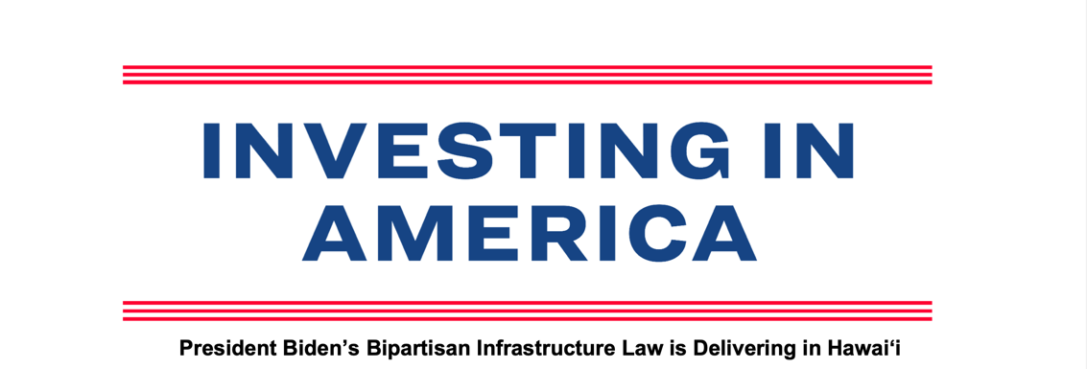
Most Recent Version - As of May 3, 2023
The Biden-Harris Administration has hit the ground running to implement the Bipartisan Infrastructure Law, and it is already delivering results for the people of Hawaiʻi. To date, $1.1 billion in Bipartisan Infrastructure Law funding has been announced and is headed to Hawaiʻi with over 42 specific projects identified for funding. Since the Bipartisan Infrastructure Law passed, approximately $885.9 million has been announced for transportation – to invest in roads, bridges, public transit, ports and airports – and roughly $106 million has been announced for clean water. And, as of today, more than 41,000 households across the state are receiving affordable high-speed internet due to the Bipartisan Infrastructure Law. Many more projects will be added in the coming months, as funding opportunities become grant awards and as formula funds become specific projects. By reaching communities all across Hawaiʻi – including rural communities and historically underserved populations – the law makes critical investments that will improve lives for the people of Hawaiʻi and position the state for success.
Roads and Bridges: In Hawaiʻi, there are 84 bridges and over 664 miles of highway in poor condition. The Bipartisan Infrastructure Law will rebuild our roads and includes the single largest dedicated bridge investment since the construction of the interstate highway system. Based on formula funding alone, Hawaiʻi is expected to receive approximately $1.5 billion over five years in federal funding for highways and bridges.
● Announced funding to date: To date, $598.3 million has been announced in Hawaiʻi for roads, bridges, roadway safety, and major projects. This includes:
o $452.6 million in highway formula funding and $145.7 million in dedicated formula funding for bridges in 2022 and 2023.
o $49.8 million through the RAISE program in 2022 and 2023.
Announced Bipartisan Infrastructure Law funding is as of March 17, 2023
Internet: High-speed internet is necessary for Americans to do their jobs, participate in school, access health care, and stay connected. Yet nearly 17% of people living in Hawaiʻi do not have an internet subscription. The Bipartisan Infrastructure Law invests $65 billion to provide affordable, high-speed internet to every American. Hawaiʻi will receive a minimum allocation of at least $100 million to help ensure high-speed internet coverage across the state. Additionally, experts estimate that as many as 163,000 households in Hawaiʻi are eligible for the Affordable Connectivity Program, which cuts internet bills by up to $30 per month, or $75 for households in Native Hawaiian communities, and provides a one-time $100 discount off a connected device. The Biden-Harris Administration is providing further cost savings by working with internet providers to offer high-speed internet plans that are fully covered by the Affordable Connectivity Program — meaning most eligible households can now get high-speed internet without paying a dime.
∉ Progress to date: To date, Hawaiʻi has received $5 million through the Broadband Equity, Access, and Deployment Program (BEAD) to help provide access to high-speed internet across the state. In addition, about 41,000 households in Hawaiʻi are enrolled in the Affordable Connectivity Program, with more signing up every day. Households can check their eligibility, sign up, and find fully covered internet plans at GetInternet.gov.
Water: The Bipartisan Infrastructure Law represents the largest investment in clean drinking water in American history, including the first-ever dedicated federal funding to replace lead service lines and address dangerous PFAS chemicals.
∉ Announced funding to date: To date, $105 million has been announced to Hawaiʻi to provide clean and safe water across the state and improve water infrastructure. This includes:
○ $105 million available in fiscal years 2022 and 2023 to provide clean and safe water across the state through the Environmental Protection Agency. Of this funding, $28.4 million is dedicated to lead pipe and service line replacement, with another $18 million for safe drinking water investments that can also support lead pipe replacement in fiscal year 2022 and 2023.
Public Transit: The Bipartisan Infrastructure Law makes the largest investment in public transit in U.S. history. Based on formula funding alone, Hawaiʻi would expect to receive approximately $316 million over five years under the Bipartisan Infrastructure Law to improve public transit across the state.1 This funding will expand healthy, sustainable transportation options in Hawaiʻi, where non-white households are 2.2 times more likely to commute via public transportation and 43% transit vehicles in the state are currently past useful life.
1 Transit formula funding amounts are subject to changes resulting from the 2020 census or from annual transit service data reported to FTA’s National Transit Database.
Announced Bipartisan Infrastructure Law funding is as of March 17, 2023
● Announced funding to date: To date, Hawaiʻi has been allocated $60.6 million to improve public transportation options across the state in fiscal year 2022 and 2023.
Clean Buses: The Bipartisan Infrastructure invests over $10 billion for clean public transit and school buses. This includes a $5 billion investment over the next five years to replace existing school buses with zero-emission and low-emission models. Use of clean school buses promotes cleaner air, reduced health risks, especially for children, and reduced greenhouse gas emissions. This year alone, funding from the Bipartisan Infrastructure Law will help double the number of clean public transit buses on America’s roads.
● Announced funding to date: To date, schools in Hawaiʻi have been awarded $5 million through the Environmental Protection Agency’s Clean School Bus Program. In addition, communities in Hawaiʻi were awarded $43.2 million for clean transit buses and improved bus service through DOT’s Low- and No- Emission Bus and Bus and Bus Facilities Program.
Electric Vehicle Charging: The Bipartisan Infrastructure Law invests $7.5 billion to build the first-ever national network of electric vehicle chargers in the United States and is a critical element of President Biden’s plan to address the climate crisis and support domestic manufacturing jobs. Through the National Electric Vehicle Infrastructure Program alone, Hawaiʻi should expect to receive roughly $18 million in formula funding over five years to support the expansion of electric vehicle charging in the state.
● Announced funding to date: Hawaiʻi has been allocated $6.4 million in 2022 and 2023 to build out a network of EV chargers across the state.
Clean Energy & Power: Power outages cost the U.S. economy more than $70 billion annually. The Bipartisan Infrastructure Law makes a historic investment to upgrade our power infrastructure by making the grid more resilient and building thousands of miles of new transmission lines to deliver clean, affordable electricity. The law also makes a historic investment in clean energy technologies like advanced nuclear, clean hydrogen, carbon capture, and batteries, as well as a historic $3.5 billion investment in weatherization to improve energy efficiency of homes and lower energy costs for impacted households by an average of $372 per year.
● Announced funding to date: To date, approximately $16.1 million has been allocated to Hawaiʻi for clean energy, energy efficiency, and power in 2022 and 2023. This includes:
o $3.6 million for weatherization;
Announced Bipartisan Infrastructure Law funding is as of March 17, 2023
o $3.5 million through the State Energy Program;
o $2.9 million through the Energy Efficiency and Conservation Block Grant
Program;
o $6.1 million to prevent outages and make the power grid more resilient. Additional grid funding will be made available in the coming months.
Airports: According to some rankings, no U.S. airports rank in the top 25 of airports worldwide. The Bipartisan Infrastructure Law invests $25 billion in airports to replace and modernize airport infrastructure, which helps the U.S. become more economically competitive globally, creates good jobs, and revitalizes and supports more efficient and enhanced traveler experience.
● Announced funding to date: To date, Hawaiʻi has received approximately $61.5 million in 2022 and 2023 for airports.
Ports and Waterways: Like airports, our ports and waterways are in need of repair and investment. The Bipartisan Infrastructure Law invests $17 billion in port infrastructure to strengthen our supply chains, address maintenance backlogs, and reduce congestion and emissions near ports– ultimately helping our country move goods more quickly and at lower cost.
● Announced funding to date: To date, Hawaiʻi has received roughly $57.4 million in 2022 and 2023 for ports and waterways. Hawaiʻi was awarded $47.3 million for a port project through the Port Infrastructure Development Program.
Resilience: Millions of Americans feel the effects of climate change and extreme weather every day. More frequent hurricanes, wildfires, heat waves, floods, unprecedented power outages, and persistent droughts devastate our communities and threaten our infrastructure. In the last decade, Hawaiʻi has experienced 145 extreme weather events, costing the state up to $921 billion in damages. The Bipartisan Infrastructure Law makes a historic investment to bolster our resilience against pressing challenges like impacts of climate change, extreme weather events, and other hazards like cyberattacks.
● Announced funding to date: To date, approximately $32.4 million has been allocated to Hawaiʻi for infrastructure resilience in 2022 and 2023 including $3.8 million through the Army Corps of Engineers for flood mitigation.
Legacy Pollution Cleanup: Across the country, thousands of former industrial, chemical, and energy sites emit harmful pollutants into surrounding communities. These sites pose harms to health, welfare, and economic prosperity — and disproportionately
Announced Bipartisan Infrastructure Law funding is as of March 17, 2023
impact communities of color. The Bipartisan Infrastructure Law will deliver the largest investment in tackling legacy pollution in American history by cleaning up Superfund and brownfield sites, reclaiming abandoned mines, and capping orphaned oil and gas wells.
● Announced funding to date: To date, approximately $1 million has been allocated to cleaning up brownfield sites.
For more information, click here to see a map of funding and announced projects in your community through the Bipartisan Infrastructure Law.
Hawaiʻi Project Spotlights
Roads and Bridges Project Spotlight
Waiʻale Road Extension Project
A $25 million Department of Transportation grant will help construct the Waiʻale Road Extension to connect Waiʻale Road southward to Honoapiʻilani Highway. The 8,600-foot extension will contain two travel lanes, bike lanes, sidewalks, grass swales, and a shared-use path. The project provides non-motorized facility improvements in an area where residents have a higher reliance on non-vehicle forms of transportation, increasing accessibility to new housing developments and connecting residential and commercial areas. The project also uses new broadband technology for smart signals and facilitates public WiFi access.
See here for more information on awarded grants through the RAISE program.
Airport Project Spotlight
Daniel K. Inouye International Airport Roadway Reconstruction
The Department of Transportation has awarded $10 million from DOT’s Airport Terminals Program (ATP) and $20.9 million through DOT’s Airport Infrastructure Grant Program to Daniel K. Inouye International. The ATP portion of the funding will go towards reconstructing a 1970s terminal roadway including approximately 142,000 square feet of pavement, select draining and lighting on terminal floors 2 and 3.
See here for a map and list of the 2022 Airport Terminal awards. Ports and Waterways Project Spotlight
Kapalama Container Terminal Project
Announced Bipartisan Infrastructure Law funding is as of March 17, 2023
The Federal Maritime Administration’s grant of $47 million will help upgrade electrified ship-to-shore cranes and allow for the installation of solar panels on terminal buildings, ultimately improving the reliability of port operations. Integration of smart gate and security technology will also improve safety and operational efficiency, while a new electrical micro-grid will improve resilience. Finally, collaboration with local stakeholders and residents will allow for the development of a Facility Resiliency Plan and a Terminal Electrification Plan to support additional environmental and resilience improvements in the future.
See here for more information on PIDP programs that have been announced.
Clean Bus Project Spotlight
Kauaʻi, Maui Clean Bus Program
The Federal Transit Authority is awarding $23 million to The Hawaiʻi Department of Transportation on behalf of Hawaiʻi, Kauaʻi, and Maui counties to buy a mix of zero- emission buses, battery electric buses, and fuel cell electric buses. The new vehicles will replace diesel buses and three retrofitted hydrogen fuel cell cutaways that have exceeded their useful life.
See here for more information on Low or No Emission Bus programs that have been announced.
Harbor Project Spotlight
Kaunakakai Harbor
The U.S. Army Corps of Engineers announced $3.3 million to complete operations and maintenance work at the Kaunakakai Harbor to support Molokaʻi’s local economy. Funding will go toward maintenance dredging and completing surveys at the harbor. The site was last maintenance dredged in 1973.
See here for a list of projects funded under the Army Civil Works Program.
Airport Project Spotlight
Lānaʻi Airport (LNY)
The Department of Transportation’s Federal Aviation Administration announced $1 million in funding through the Airport Infrastructure Grant Program to the Lānaʻi Airport (LNY).
See here for the full list of announced Airport Infrastructure Grant projects. Announced Bipartisan Infrastructure Law funding is as of March 17, 2023
Community Wildfire Prevention Spotlight
South Kona Community Wildfire Prevention Update
The Department of Agriculture’s Forest Service has awarded $84,700 to the Hawaiʻi Department of Land & Natural Resources to engage community and agency partners in order to collaboratively complete a revised hazard assessment. The project will also identify shared wildfire concerns and begin prioritizing risk-reducing actions for purposes of updating a Community Wildfire Protection Plan from 2015.
See here for more information on the Community Wildfire Defense Grants.
Transportation Project Spotlight
Poʻipū Road Safety and Mobility
The County of Kauaʻi will receive $24.8 million to improve approximately 3.3 miles of Poʻipū Road, from Kōloa Town to Poʻipū, Kauaʻi’s primary economic sector. The project includes three roundabouts, bicycle lanes, sidewalks, pedestrian crossings, bus stops, landscaped medians, resurfaced roadway, and drainage improvements. This project will improve safety for school children and commuters by making roadways improvements and adding pedestrian and bicycle infrastructure.
See here for more information on awarded grants through the RAISE program.
Announced Bipartisan Infrastructure Law funding is as of April 20, 2023

The entire fact sheet which is the most current available summary as of June 6, 2023 is available by clicking this link:

https://www.whitehouse.gov/wp-content/uploads/2023/05/Hawaiʻi-Fact-Sheet-May.pdf

https://d2d.gsa.gov/report/bipartisan-infrastructure-law-bil-maps-dashboard

To learn more about how the Bipartisan Infrastructure Law will rebuild our roads and bridges, replace lead pipes for clean water, and more, click here.

https://www.whitehouse.gov/build/guidebook/

HAWAII SPECIFIC APPLICANTS ENCOURAGED

Current Notices

Fiscal Year (FY) 2023 Regional Catastrophic Preparedness Grant Program (RCPGP) - Region 9
Synopsis 2
Document Type: Grants Notice  Funding Opportunity Number: DHS-23-GPD-111-09-01  Funding Opportunity Title: Fiscal Year (FY) 2023 Regional Catastrophic Preparedness Grant Program (RCPGP) - Region 9  Opportunity Category: Discretionary  Opportunity Category Explanation:  Funding Instrument Type: Grant  Category of Funding Activity: Disaster Prevention and Relief  Category Explanation:  Expected Number of Awards: 10  CFDA Number(s): 97.111 -- Regional Catastrophic Preparedness Grant Program (RCPGP)  Cost Sharing or Matching Requirement: No | Version: Synopsis 2  Posted Date: May 23, 2023  Last Updated Date: May 23, 2023  Original Closing Date for Applications: Jul 24, 2023  Current Closing Date for Applications: Jul 24, 2023  Archive Date: Aug 24, 2023  Estimated Total Program Funding: $12,000,000  Award Ceiling: $3,000,000  Award Floor: $0

Eligible Applicants: | County governments  City or township governments  State governments
Additional Information on Eligibility:

Agency Name: | Department of Homeland Security - FEMA
Description: | The FY 2023 Regional Catastrophic Preparedness Grant Program (RCPGP), as appropriated by the Department of Homeland Security Appropriations Act, 2023 (Pub. L. No. 117-328), provides funding to close known capability gaps, encourages innovative regional solutions to issues related to catastrophic incidents, and builds on existing regional preparedness efforts. The purpose of the RCPGP is to build regional capacity to manage catastrophic incidents by improving and expanding collaboration for catastrophic incident preparedness. The National Response Framework (4th edition or superseding edition) defines a catastrophic incident as any natural or human-caused incident, including terrorism, that results in extraordinary levels of mass casualties, damage, or disruption severely affecting the population, infrastructure, environment, economy, national morale, or government functions. Effective prevention, protection, mitigation, response, and recovery activities require a cohesive regional approach to catastrophic planning.  The FY 2023 RCPGP also complements the 2022-2026 FEMA Strategic Plan which outlines a bold vision and three ambitious goals designed to address key challenges the agency faces during a pivotal moment in the field of emergency management. Wide-ranging and long-term, the goals defined in the plan respond to the changing landscape in which we find ourselves. The goals to meet this challenge are:  · Goal 1 - Promote and Instill Equity as a Foundation of Emergency Management;  · Goal 2 - Lead Whole of Community in Climate Resilience; and  · Goal 3 - Promote and Sustain a Ready FEMA and Prepared Nation.  In support of the above goals, the strategic priorities for the FY 2023 RCPGP are equity, climate resilience, and readiness. The FY 2023 RCPGP will promote and instill the goal of equity by helping members of particularly disadvantaged groups who might be at special risk as a result of current hazards, including those associated with climate change. By addressing the needs of underserved, at-risk communities, the FY 2023 RCPGP aims to ensure consistent and systematic fair, just, and impartial treatment of all individuals before, during, and after a disaster.
Link to Additional Information: | https://www.grants.gov/
Grantor Contact Information: | If you have difficulty accessing the full announcement electronically, please contact:  ND Grants Service Desk Phone: 1-800-865-4076 E-mail: NDGrants@fema.dhs.gov  NDGrants@fema.dhs.gov
https://www.grants.gov/web/grants/view-opportunity.html?oppId=348325

Reminders:

Department of Education

Office of Postsecondary Education (OPE): Higher Education Programs (HEP): Institutional Service: Native Hawaiian-Serving Institutions Program Part A, Assistance Listing Number 84.031W
Synopsis 1
Document Type: Grants Notice  Funding Opportunity Number: ED-GRANTS-041823-002  Funding Opportunity Title: Office of Postsecondary Education (OPE): Higher Education Programs (HEP): Institutional Service: Native Hawaiian-Serving Institutions Program Part A, Assistance Listing Number 84.031W  Opportunity Category: Discretionary  Opportunity Category Explanation:  Funding Instrument Type: Grant  Category of Funding Activity: Education  Category Explanation:  Expected Number of Awards: 12  CFDA Number(s): 84.031 -- Higher Education Institutional Aid  Cost Sharing or Matching Requirement: No | Version: Synopsis 1  Posted Date: Apr 18, 2023  Last Updated Date: Apr 18, 2023  Current Closing Date for Applications: Jun 20, 2023 Applications Available: April 18, 2023. Deadline for Transmittal of Applications: June 20, 2023. Deadline for Intergovernmental Review: August 16, 2023. FOR FURTHER INFORMATION CONTACT: Robyn Wood, U.S. Department of Education, 400 Maryland Avenue, SW, room 2B203, Washington, DC 20202-4260. Telephone: (202) 987-1577. Email: Robyn.Wood@ed.gov.  Archive Date: Jul 20, 2023  Estimated Total Program Funding: $11,771,979  Award Ceiling: $1,000,000  Award Floor:

Eligible Applicants: | Others (see text field entitled "Additional Information on Eligibility" for clarification)
Additional Information on Eligibility: | 1. a. Eligible Applicants: This program is authorized by title III, part A, of the HEA. At the time of submission of their applications, applicants must certify that an Alaska Native-serving institution has an enrollment of undergraduate students that are at least 20 percent Alaska Native students or that a Native Hawaiian-serving institution has an enrollment of undergraduate students that is at least 10 percent Native Hawaiian students. An assurance form, which is included in the application materials for this competition, must be signed by an official for the applicant and submitted with this application. To qualify as an eligible institution under the ANNH Program, an institution also must-- (i) Be accredited or preaccredited by a nationally recognized accrediting agency or association that the Secretary has determined to be a reliable authority as to the quality of education or training offered; (ii) Be legally authorized by the State in which it is located to be a junior or community college or to provide an educational program for which it awards a bachelor’s degree; (iii) Demonstrate that it (1) has an enrollment of needy students as described in 34 CFR 607.3; and (2) has low average education and general expenditures per full-time equivalent (FTE) undergraduate student as described in 34 CFR 607.4. Note: The notice announcing the FY 2023 process for designation of eligible institutions, and inviting applications for waiver of eligibility requirements, was published in the Federal Register on January 17, 2023 (88 FR 2611). Only institutions that the Department determines are eligible, or which are granted a waiver under the process described in that notice, may apply for a grant in this program. b. Relationship between the Title III, Part A Programs and the Developing Hispanic-Serving Institutions (HSI) Program: A grantee under the HSI Program, which is authorized under title V of the HEA, may not receive a grant under any HEA, title III, part A program. 20 U.S.C. 1101d. The title III, part A programs are the Strengthening Institutions Program, the ANNH program, the Tribally Controlled Colleges and Universities Program, the Asian American and Native American Pacific Islander-Serving Institutions Program, the Predominantly Black Institutions Program, and the Native American-Serving Nontribal Institutions Program. Furthermore, a current title III, Part A or title V program grantee may not give up its grant to receive a grant under SIP, as described in 34 CFR 607.2(g)(1).An eligible IHE that is not a current grantee under the above-cited programs may apply for a FY 2023 grant under all title III, part A programs for which it is eligible, as well as receive consideration for a grant under the HSI program. However, a successful applicant may receive only one grant, as described in 34 CFR 607.2(g)(1).c. Individual Development and Cooperative Arrangement Grants: An eligible IHE that submits applications for an Individual Development Grant and a Cooperative Arrangement Development Grant in this competition may be awarded both in the same fiscal year. However, we will not award a second Cooperative Arrangement Development Grant as the lead institution to an otherwise eligible IHE for an award year for which the IHE already has a Cooperative Arrangement Development Grant as the lead institution under the ANNH Program. A grantee with an Individual Development Grant or a Cooperative Arrangement Development Grant may be a partner in one or more Cooperative Arrangement Development Grants. The lead institution in a Cooperative Arrangement Development Grant must be an eligible institution. Partners are not required to be eligible institutions.

Agency Name: | Department of Education
Description: | Note: Each funding opportunity description is a synopsis of information in the Federal Register application notice. For specific information about eligibility, please see the official application notice. The official version of this document is the document published in the Federal Register. Free Internet access to the official edition of the Federal Register and the Code of Federal Regulations is available on GPO Access at: http://www.access.gpo.gov/nara/index.html. Please review the official application notice for pre-application and application requirements, application submission information, performance measures, priorities and program contact information.  For the addresses for obtaining and submitting an application, please refer to our Revised Common Instructions for Applicants to Department of Education Discretionary Grant Programs, published in the Federal Register on December 7, 2022.  Purpose of Program: The ANNH Program provides grants to eligible institutions of higher education (IHEs) to enable them to improve and expand their capacity to serve Alaska Native and Native Hawaiian students. Institutions may use these grants to plan, develop, or implement activities that strengthen the institution.  Assistance Listing Number (ALN) 84.031W.
Link to Additional Information: | Office of Postsecondary Education (OPE): Higher Education Programs (HEP): Institutional Service: Native Hawaiian-Serving Institutions Program Part A, Assistance Listing Number 84.031W; Notice Inviting Applications for New Awards for Fiscal Year (FY)
Grantor Contact Information: | If you have difficulty accessing the full announcement electronically, please contact:  Julius C Cotton ED Grants.gov FIND Systems Admin. Phone 202-245-6288 julius.cotton@ed.gov Program Manager: Robyn Wood, U.S. Department of Education, 400 Maryland Avenue, SW, room 2B203, Washington, DC 20202-4260. Telephone: (202) 987-1577. Email: Robyn.Wood@ed.gov.  Program Manager
https://www.grants.gov/web/grants/view-opportunity.html?oppId=347502

U.S. Department of Agriculture

Programs:

Agricultural Marketing Service
Organic Market Development Grants
Synopsis 1
Document Type: Grants Notice  Funding Opportunity Number: USDA-AMS-TM-OMDG-G-23-0019  Funding Opportunity Title: Organic Market Development Grants  Opportunity Category: Discretionary  Opportunity Category Explanation:  Funding Instrument Type: Grant  Category of Funding Activity: Agriculture  Category Explanation:  Expected Number of Awards: 75  CFDA Number(s): 10.188 -- Organic Market Development Grant (OMDG) Program  Cost Sharing or Matching Requirement: Yes | Version: Synopsis 2  Posted Date: May 10, 2023  Last Updated Date: May 19, 2023  Original Closing Date for Applications: Jul 11, 2023 Only applications submitted and validated by 11:59 pm Eastern Time on  Current Closing Date for Applications: Aug 08, 2023 Only applications submitted and validated by 11:59 pm Eastern Time on  Archive Date: Sep 07, 2023  Estimated Total Program Funding: $75,000,000  Award Ceiling: $3,000,000  Award Floor: $100,000

Eligible Applicants: | Others (see text field entitled "Additional Information on Eligibility" for clarification)
Additional Information on Eligibility: | Eligible applicants for Organic Market Development grants include business entities (regardless of legal structure) who produce or handle organic foods. Producer and handler applicants must either be certified to the USDA organic standards or in transition to organic certification, consistent with 7 C.F.R. §205. Such applicants must be registered in the Organic INTEGRITY Database before the date of the Notice of Award. This requirement does not apply to non-profit or government entities. Eligible applicants also include non-profit or government entities. Eligible government entities include but are not limited to state, territory, and local government entities such as economic development authorities and regional conservation districts. Eligible non-profit entities may include trade associations. MS may prioritize funding to individual or groups of agricultural producers majority-controlled producer-based ventures, farmer or rancher-controlled cooperatives, or government entities. Separate entities who are at least 51 percent owned and operated by the same parent company may not submit multiple applications. Such entities may submit a single joint application. AMS may remove applications from consideration, if the applicants are found to be owned and operated by the same parent company and are applying separately. All applicants must be domestic entities owned, operated, and located within the 50 United States, the District of Columbia, the Commonwealth of Puerto Rico, the United States Virgin Islands, Guam, American Samoa, and the Commonwealth of the Northern Mariana Islands, or Tribal Governments. Producer or handler operations which are suspended or revoked at the time of application are ineligible for funding. Suspension and revocation are defined by 7 C.F.R. §205.662(e).

Agency Name: | Agricultural Marketing Service
Description: | This program will support the development of new and expanded organic markets by providing additional resources for businesses transitioning to organic or initiating new organic production and processing capacity. These investments in certified organic infrastructure, expanding capacity for aggregation, processing,[1] manufacturing, storing, transporting, wholesaling, distribution, or consumer markets, and supporting activities which develop new markets, are anticipated to increase demand for domestically produced organic agricultural products and provide additional market paths. Domestic organic producers and handlers have identified the development of new and expanded organic infrastructure, capacity, and markets as critical needs through public comments and listening sessions. Organic production and markets play a critical, expanding role in further diversifying food systems. Consumer demand for organically produced goods surpassed $63 million in 2021, and multi-year trends of strong growth in the sector provide market incentives for U.S. farmers across a broad range of products. Organic sales account for over 4 percent of total U.S. food sales and organic products are now available in nearly 20,000 natural food stores and nearly 3 out of 4 conventional grocery stores. However, stakeholders have conveyed that producers may be less willing to commit to the three-year transition to organic certification because of risks related to inadequate organic processing, storage, and handling capacity, cost barriers due to limited markets for rotational crops, a lack of certainty about market access, and insufficient supply of certain organic ingredients. The organic livestock and processed product markets depend heavily on imported agricultural products for feed grains and key ingredients. These longstanding market issues facing organic livestock feed stocks, rotational crops, dairy, fiber, and ingredients were brought into sharp focus due to the impacts of COVID and international conflicts in critical overseas organic supply areas, resulting in limitations on certain organic products in the face of rising demand. Further, existing organic producers lack market access because of bottlenecks in certified organic processing, storage, specialized equipment, and handling/shipping, which have not kept up with the growth in organic crops or the demand for organic products. Producers of organic commodities often lack the resources or the capacity to build processing infrastructure, which is also outside the business model for end-use consumer food manufacturers or animal feed buyers. Certain regions also lack certified organic processing capacity, meaning that local and regional organic producers must either pay increased shipping costs or sacrifice organic price premiums by processing their commodities at non-organic facilities, which removes the ability to sell the product as “organic” to the consumer. These middle-of-the-supply-chain bottlenecks limit markets for raw organic commodities and cause some producers to sell organic commodities at conventional prices, missing premium prices for organic animal feed and processed consumer products. Implementation of the Organic Market Development Grants program is intended to align with numerous policy goals and objectives across government, including, but not limited to: Ensure equitable access to USDA programs and benefits from USDA-funded projects and support the policies of Executive Order 13985 (Executive Order on Advancing Racial Equity and Support for Underserved Communities Through the Federal Government).Contribute to the resilience of the food and agricultural supply chains through support for diversified, value-added agriculture such as organic production and support the policies of Executive Order 14017 (Executive Order on America’s Supply Chains).Promote competition in the organic sector and support the policies of Executive Order 14036 (Promoting Competition in the American Economy).Implement the Build America, Buy America (BABA) Act. Guidance on BABA requirements for USDA award recipients is available here. [1] As defined in the USDA Organic Regulations at 7 C.F.R. § 205.2, processing includes cooking, baking, curing, heating, drying, mixing, grinding, churning, separating, extracting, slaughtering, cutting, fermenting, distilling, eviscerating, preserving, dehydrating, freezing, chilling, or otherwise manufacturing food and agricultural commodities. Processing also includes packaging, canning, and jarring food.
Link to Additional Information: | See Related Documents
Grantor Contact Information: | If you have difficulty accessing the full announcement electronically, please contact:  OMDG@usda.gov OMDG@usda.gov  OMDG@usda.gov
https://www.grants.gov/web/grants/view-opportunity.html?oppId=348047
Natural Resources Conservation Service
Community Agriculture Grants
Synopsis 1
Document Type: Grants Notice  Funding Opportunity Number: USDA-NRCS-WI-23-NOFO0001225  Funding Opportunity Title: Community Agriculture Grants  Opportunity Category: Discretionary  Opportunity Category Explanation:  Funding Instrument Type: Cooperative Agreement  Category of Funding Activity: Agriculture Environment Natural Resources  Category Explanation:  Expected Number of Awards: 10  CFDA Number(s): 10.902 -- Soil and Water Conservation  Cost Sharing or Matching Requirement: No | Version: Synopsis 1  Posted Date: May 22, 2023  Last Updated Date: May 22, 2023  Original Closing Date for Applications: Jul 07, 2023  Current Closing Date for Applications: Jul 07, 2023  Archive Date: Aug 06, 2023  Estimated Total Program Funding: $1,000,000  Award Ceiling: $250,000  Award Floor: $5,000

Eligible Applicants: | Special district governments  Independent school districts  Public and State controlled institutions of higher education  State governments  County governments  Nonprofits having a 501(c)(3) status with the IRS, other than institutions of higher education  Private institutions of higher education  Native American tribal governments (Federally recognized)  City or township governments  Native American tribal organizations (other than Federally recognized tribal governments)  Public housing authorities/Indian housing authorities  Nonprofits that do not have a 501(c)(3) status with the IRS, other than institutions of higher education
Additional Information on Eligibility:

Agency Name: | Natural Resources Conservation Service
Description: | Notice of Funding Opportunity Summary  The purpose of this NFO is to encourage and promote conservation planning and conservation practice demonstrations in urban, suburban, and other small-scale type agricultural operations. Emphasis will be placed on projects that establish new community gardens, or enhance and expand existing community agriculture projects. Proposals should seek to:  1. Provide conservation learning experiences to urban, suburban, and Tribal communities.  2. Address concerns regarding food deserts.  3. Advance Tribal food sovereignty.  4. Achieve positive and measurable natural resources conservation outcomes.  For new users of Grants.gov, see Section D. for information about steps required before submitting an application via Grants.gov.  Key Dates  Applicants must submit their applications via Grants.gov by 11:59 pm Eastern Time on July 07, 2023. For technical issues with Grants.gov, contact Grants.gov Applicant Support at 1-800-518-4726 or support@grants.gov. Awarding agency staff cannot support applicants regarding Grants.gov accounts.  For inquiries specific to the content of the NFO requirements, contact the federal awarding agency contact (section G of this NFO). Please limit questions to those regarding specific information contained in this NFO (such as dates, page numbers, clarification of discrepancies, etc.). Questions related to eligibility, or the merits of a specific proposal will not be addressed.  The agency anticipates making selections by September 01, 2023 and expects to execute awards by September 30, 2023. These dates are estimates and are subject to change.  Federal Funding Floor and Ceiling Amounts  The estimated funding floor for this opportunity is $5,000, and the estimated funding ceiling is $250,000. The funding floor means the minimum agreement funding amount for the Federal share per agreement awarded. The ceiling is the maximum agreement funding amount for the Federal share per agreement awarded. These numbers refer to the total agreement amount, not any specific budget period.  Federal Financial Assistance Training  The funding available through this NFO is Federal financial assistance. Grants 101 Training is highly recommended for those seeking knowledge about Federal financial assistance. The training is free and available to the public via https://www.cfo.gov/grants-training/. It consists of five modules covering each of the following topics: 1) laws, regulations, and guidance; 2) financial assistance mechanisms; 3) uniform guidance administrative requirements; 4) cost principles; and 5) risk management and single audit. FPAC agencies also apply Federal financial assistance regulations to certain non-assistance awards (e.g., non-assistance cooperative agreements).
Link to Additional Information: | See Related Documents
Grantor Contact Information: | If you have difficulty accessing the full announcement electronically, please contact:  Kaylie Alderman Grants Management Specialist  If you have any questions related to preparing application content.
https://www.grants.gov/web/grants/view-opportunity.html?oppId=348281

Rural Housing Service
Rural Community Development Initiative
Synopsis 1
Document Type: Grants Notice  Funding Opportunity Number: USDA-RD-HCFP-RCDI-2023  Funding Opportunity Title: Rural Community Development Initiative  Opportunity Category: Discretionary  Opportunity Category Explanation:  Funding Instrument Type: Grant  Category of Funding Activity: Agriculture Community Development  Category Explanation:  Expected Number of Awards: 30  CFDA Number(s): 10.446 -- Rural Community Development Initiative  Cost Sharing or Matching Requirement: Yes | Version: Synopsis 1  Posted Date: May 04, 2023  Last Updated Date: May 04, 2023  Original Closing Date for Applications: Jun 28, 2023  Current Closing Date for Applications: Jun 28, 2023  Archive Date: Jul 28, 2023  Estimated Total Program Funding: $6,000,000  Award Ceiling: $500,000  Award Floor: $50,000

Eligible Applicants: | State governments  Public and State controlled institutions of higher education  Native American tribal governments (Federally recognized)  Special district governments  Nonprofits having a 501(c)(3) status with the IRS, other than institutions of higher education  Nonprofits that do not have a 501(c)(3) status with the IRS, other than institutions of higher education  Small businesses  City or township governments  Public housing authorities/Indian housing authorities  Native American tribal organizations (other than Federally recognized tribal governments)  For profit organizations other than small businesses  County governments  Private institutions of higher education  Independent school districts
Additional Information on Eligibility: | The intermediary organization must have been legally organized for a minimum of 3 years and have at least 3 years prior experience working with private nonprofit community-based housing and development organizations, low-income rural communities, or tribal organizations in the areas of housing, community facilities, or community and economic development. The Intermediary will be required to provide matching funds in an amount at least equal to the RCDI grant. The respective minimum and maximum grant amount per Intermediary are $50,000 and $500,000. The Recipient and Beneficiary, but not the Intermediary, must be located in a city or town that has a population of 50,000 or less inhabitants.

Agency Name: | Rural Housing Service
Description: | Technical Assistance & Training Grant  Qualified private, nonprofit and public (including tribal) intermediary organizations proposing to carry out financial and technical assistance programs will be eligible to receive the funding. The RCDI structure requires the intermediary (grantee) to provide a program of financial and technical assistance to recipients to develop their capacity and ability to undertake projects related to housing, community facilities, or community and economic development. The recipients will, in turn, provide programs that will support their communities (beneficiaries). The Intermediary will be required to provide matching funds in an amount at least equal to the RCDI grant. The respective minimum and maximum grant amount per Intermediary are $50,000 and $500,000.
Link to Additional Information: | Notice of funding of availability for the RCDI grant
Grantor Contact Information: | If you have difficulty accessing the full announcement electronically, please contact:  Shirley J Stevenson Community Programs Specialist Phone 2022059685  email contact for Shirley Stevenson
https://www.grants.gov/web/grants/view-opportunity.html?oppId=347930

National Institute of Food and Agriculture
Agriculture in the K-12 Classroom
Synopsis 2
Document Type: Grants Notice  Funding Opportunity Number: USDA-NIFA-OP-009883  Funding Opportunity Title: Agriculture in the K-12 Classroom  Opportunity Category: Discretionary  Opportunity Category Explanation:  Funding Instrument Type: Cooperative Agreement  Category of Funding Activity: Agriculture  Category Explanation:  Expected Number of Awards:  CFDA Number(s): 10.500 -- Cooperative Extension Service  Cost Sharing or Matching Requirement: No | Version: Synopsis 2  Posted Date: May 26, 2023  Last Updated Date: May 26, 2023  Original Closing Date for Applications: Jul 06, 2023  Current Closing Date for Applications: Jul 06, 2023  Archive Date: Aug 05, 2023  Estimated Total Program Funding: $960,000  Award Ceiling: $960,000  Award Floor: $960,000

Eligible Applicants: | Others (see text field entitled "Additional Information on Eligibility" for clarification)
Additional Information on Eligibility: | Eligibility Requirements Applications may only be submitted by the following eligible applicants: (a) State agricultural experiment stations; (b) colleges and universities; (c) university research foundations; (d) other research institutions and organizations; (e) Federal agencies; (f) national laboratories; (g) private organizations or corporations; and (h) individuals or any group consisting of two or more of the entities described in subparagraphs (A) through (H).
Additional Information
Agency Name: | National Institute of Food and Agriculture
Description: | The disciplines of agriculture and education have been related for much of our nation's history. When most Americans lived on farms or in small towns, students often did farm chores before and after school. Old schoolbooks have numerous agricultural references. As the farming population began to decline, agricultural emphasis decreased in educational materials as well. NIFA's Agriculture in the Classroom Program (AITC) serves nearly 5 million students and 60,000 teachers annually through workshops, conferences, field trips, farm tours, and other educational activities. The AITC program works in partnership with state AITC organizations and support activities engaged in a variety of issues relating to agricultural literacy in rural and urban America.
Link to Additional Information: | Agriculture in the K-12 Classroom
Grantor Contact Information: | If you have difficulty accessing the full announcement electronically, please contact:  NIFA Support Key Information: Business hours: Monday thru Friday, 7a.m. – 5p.m. ET, except federal holidays  If you have any questions related to preparing application content.
https://www.grants.gov/web/grants/view-opportunity.html?oppId=348403
Research:

Modifications:

Natural Resources Conservation Service
Notice of Funding for NRCS’s Regional Conservation Partnership Program (RCPP) for Federal Fiscal Year (FY) 2023
Synopsis 8
Document Type: Grants Notice  Funding Opportunity Number: USDA-NRCS-NHQ-RCPP-23-NOFO0001304  Funding Opportunity Title: Notice of Funding for NRCS’s Regional Conservation Partnership Program (RCPP) for Federal Fiscal Year (FY) 2023  Opportunity Category: Discretionary  Opportunity Category Explanation:  Funding Instrument Type: Other  Category of Funding Activity: Agriculture Environment Natural Resources  Category Explanation:  Expected Number of Awards:  CFDA Number(s): 10.932 -- Regional Conservation Partnership Program  Cost Sharing or Matching Requirement: Yes | Version: Synopsis 8  Posted Date: May 19, 2023  Last Updated Date: May 19, 2023  Original Closing Date for Applications: Aug 17, 2023  Current Closing Date for Applications: Aug 17, 2023  Archive Date: Sep 16, 2023  Estimated Total Program Funding: $500,000,000  Award Ceiling: $25,000,000  Award Floor: $250,000

Eligible Applicants: | Others (see text field entitled "Additional Information on Eligibility" for clarification)
Additional Information on Eligibility: | Entities that are classified as one of the following organizational types can serve as an eligible RCPP partner:1. An agricultural or silvicultural producer association or other group of producers.2. A state or unit of local government.3. An Indian Tribe.4. A farmer cooperative.5. A water district, irrigation district, acequia, rural water district or association, or other organization with specific water delivery authority to agricultural producers.6. A municipal water or wastewater treatment entity.7. An institution of higher education.8. An organization, business or entity with an established history of working cooperatively with producers, as determined by NRCS, to address: a. local conservation priorities related to agricultural production, wildlife habitat development, or nonindustrial private forest land management; orb. critical watershed-scale soil erosion, water quality, sediment reduction, or other natural resource issues.9. An entity, such as an Indian Tribe, state government, local government, or a non-governmental organization, that has a farmland or grassland protection program that purchases agricultural land easements, as defined in 7 CFR 1468.3. 10. A conservation district.

Agency Name: | Natural Resources Conservation Service
Description: | EXECUTIVE SUMMARY  Federal Awarding Agency Name: U.S. Department of Agriculture (USDA) Natural Resources Conservation Service (NRCS), Commodity Credit Corporation (CCC)  Funding Opportunity Title: Notice of Funding for NRCS’s Regional Conservation Partnership Program (RCPP) for Federal Fiscal Year (FY) 2023.  Funding Opportunity Number: USDA-NRCS-NHQ-RCPP-23-NOFO0001304  Federal Assistance Listing (previously referred to as the Catalog of Federal Financial Assistance): 10.932, RCPP  Due Date: Proposals must be received by NRCS by 4:59 p.m. Eastern Time on August 18, 2023.  The RCPP promotes the coordination of NRCS conservation activities with partners that contribute a significant portion of the overall costs of a project. This coordination expands our ability to address resource concerns at farm, watershed, and regional scales. Through the RCPP, NRCS coinvests with partners to implement projects that address conservation challenges and provide measurable improvements and outcomes for resource concerns.  Using guidance contained in this notice, potential RCPP partners propose projects that generate conservation benefits by addressing specific natural resource objectives in a state or multistate area or address one or more priority resource concerns within an NRCS-designated critical conservation area (CCA). NRCS and partners collaborate to design, promote, and implement RCPP projects on agricultural and nonindustrial private forest land. Through the RCPP, NRCS may provide both financial and technical assistance funds to project partners and producers to carry out projects. RCPP proposals are evaluated through a competitive proposal process based on three criteria: quantifiable impact, partner contributions, and partnership and management.  NRCS is actively working on improving the delivery and administration of the RCPP. Some of the improvements will be directed at areas such as simplifying and reducing the number of agreements while still complying with statutory and regulatory requirements, streamlining and reducing evaluation criteria, reducing lengthy RCPP easement transactions, improving the RCPP Portal, consistent guidance and training for employees and partners, as well as simplifying the technical assistance structure.  In FY 2023, NRCS will make a total of $500 million available for both the “Classic” component and the alternative funding arrangements (AFA). The $500 million total is funded from two separate authorizations: the Agriculture Improvement Act of 2018 (2018 Farm Bill) and the Inflation Reduction Act of 2022 (IRA). Individual RCPP projects will only receive RCPP funds from a single source, either the 2018 Farm Bill funds or the IRA funds due to the specific, measurable climate-smart targeting required in the IRA. NRCS will prioritize using IRA funds for projects that will implement climate-smart agriculture conservation activities which are targeted to assist agricultural producers and nonindustrial private forestland owners in directly improving soil carbon, reducing nitrogen losses, or reducing, capturing, avoiding, or sequestering carbon dioxide, methane, or nitrous oxide emissions, associated with agricultural production, Where co-benefits exist with climate mitigation goals exist, IRA funds can support projects that address water resource concerns and associated risks.  Up to 15 AFAs may be awarded through 2018 Farm Bill funding, and additional AFAs or grants may be awarded through IRA funding. There is no cap on the number of AFAs/ Grants that can be funded utilizing the IRA funding. Proposals will be accepted for projects located in all 50 states, the Caribbean Area (Puerto Rico and U.S. Virgin Islands), and U.S. territories in the Pacific Island Areas (Guam, American Samoa, and the Commonwealth of the Northern Mariana Islands).  Up to $50 million is being made available specifically for NRCS to enter into AFAs with Indian Tribes. Any unused funds may be available to enter into other partnership agreements.  RCPP AFAs are intended to support projects and approaches that cannot be effectively carried out through RCPP Classic. RCPP AFA applications must describe the conservation approach they are proposing. The following are examples of project types that might be implemented through RCPP AFA:  - projects that use innovative approaches to leverage the Federal investment in conservation,  - projects that deploy a pay-for-performance conservation approach, and  - projects that seek large-scale infrastructure investments that generate conservation benefits for agricultural producers and nonindustrial private forest owners.  Submissions: Applicants must submit proposals through the RCPP portal, and partners must be registered with USDA’s eAuthentication system to access the portal. See section VIII of this notice for time sensitive information on registering for eAuthentication and for other details about on using the RCPP portal to submit proposals.  For More Information: Applicants are strongly encouraged to contact the appropriate RCPP coordinator for their state to discuss any questions. A list of state RCPP coordinators (as of the date of this notice’s posting) is on the RCPP website. Applicants can also email questions about this notice to the RCPP inbox at rcpp@usda.gov. The RCPP website also provides current information about the program.  Webinar: Interested applicants are encouraged to participate in webinars that provide general information about this funding announcement. Two webinars are scheduled for May 24, 2023, from 2 p.m. to 3:30 p.m. Eastern Time and June 7, 2023 from 2 p.m. to 3:30 p.m. Eastern Time. (you may join the conference 10 minutes prior). Additional webinars may be announced as needed.  Connection information is posted on the RCPP How to Apply website - https://www.nrcs.usda.gov/programs-initiatives/rcpp-regional-conservation-partnership-program/how-to-apply.
Link to Additional Information: | See Related Documents
Grantor Contact Information: | If you have difficulty accessing the full announcement electronically, please contact:  Applicants with questions are encouraged to contact the appropriate NRCS state RCPP coordinator with proposal-related questions. State coordinators are often the person best suited to answer applicant questions about proposals and RCPP in general. The RCPP website maintains a list of NRCS state conservationists, and RCPP coordinators are updated for each funding opportunity.  NRCS National RCPP Staff
https://www.grants.gov/web/grants/view-opportunity.html?oppId=348189

Rural Housing Service
Consolidated Multifamily Housing Technical Assistance Grant Programs
Synopsis 7
Document Type: Grants Notice  Funding Opportunity Number: USDA-RD-HCFP-NPTA-OFFFLHTA  Funding Opportunity Title: Consolidated Multifamily Housing Technical Assistance Grant Programs  Opportunity Category: Discretionary  Opportunity Category Explanation:  Funding Instrument Type: Grant  Category of Funding Activity: Agriculture  Category Explanation:  Expected Number of Awards: 20  CFDA Number(s): 10.494 -- Multi-Family Housing Non-Profit Transfer Technical Assistance Grants 10.495 -- Farm Labor Housing Technical Assistance Grants  Cost Sharing or Matching Requirement: No | Version: Synopsis 7  Posted Date: May 10, 2023  Last Updated Date: May 10, 2023  Original Closing Date for Applications: Jul 03, 2023  Current Closing Date for Applications: Jul 03, 2023  Archive Date: Jul 05, 2023  Estimated Total Program Funding: $7,900,000  Award Ceiling: $500,000  Award Floor: $50,000

Eligible Applicants: | Others (see text field entitled "Additional Information on Eligibility" for clarification)
Additional Information on Eligibility: | Eligibility for MFH Nonprofit Transfer Technical Assistance Grants is limited to qualified private and public nonprofit organizations and public housing authorities. Nonprofit organizations must meet the definition of nonprofit organization in 7 CFR part 3560. Qualified NPs and PHAs include tribally designated housing entities (TDHE) and tribal housing NPs. Eligibility for Off-FLH Technical Assistance Grants is limited to qualified nonprofit organizations. Nonprofit organizations must meet the definition of nonprofit organization in 7 CFR part 3560. Qualified nonprofit organizations include tribal housing nonprofits.

Agency Name: | Rural Housing Service
Description: | The Rural Housing Service (RHS) (Agency), a Rural Development (RD) agency of the United States Department of Agriculture, announces the availability of funding for Multifamily Housing Nonprofit Transfer Technical Assistance (MFH NP TA) Grants and Off-Farm Labor Housing Technical Assistance (Off-FLH TA) Grants. This funding is available for eligible technical assistance (TA) providers seeking grants to provide technical assistance services to qualified applicants.  Estimated Funding amounts:  10.494 – Nonprofit Transfer TA Grants - $6,900,000  10.495 – Off-FLH TA Grants - $1,000,000  Estimated Total Program Funding: $7,900,000  Award ceiling:  10.494 – Nonprofit Transfer TA Grants - $500,000  10.495 – Off-FLH TA Grants - $250,000  Award floor:  10.494 – Nonprofit Transfer TA Grants - $100,000  10.495 – Off-FLH TA Grants - $50,000
Link to Additional Information: | See Related Documents
Grantor Contact Information: | If you have difficulty accessing the full announcement electronically, please contact:  Timothy James Finance and Loan Analyst Phone 919-500-8878  email
https://www.grants.gov/web/grants/view-opportunity.html?oppId=344530

Reminders:

Rural Housing Service
Community Facilities Technical Assistance and Training Grant
Synopsis 1
Document Type: Grants Notice  Funding Opportunity Number: USDA-RD-CFTAT-2023  Funding Opportunity Title: Community Facilities Technical Assistance and Training Grant  Opportunity Category: Discretionary  Opportunity Category Explanation:  Funding Instrument Type: Grant  Category of Funding Activity: Agriculture Community Development  Category Explanation:  Expected Number of Awards: 15  CFDA Number(s): 10.766 -- Community Facilities Loans and Grants  Cost Sharing or Matching Requirement: No | Version: Synopsis 1  Posted Date: Apr 21, 2023  Last Updated Date: Apr 21, 2023  Original Closing Date for Applications: Jun 30, 2023  Current Closing Date for Applications: Jun 30, 2023  Archive Date: Jul 30, 2023  Estimated Total Program Funding: $1,265,000  Award Ceiling: $150,000  Award Floor: $0

Eligible Applicants: | Public and State controlled institutions of higher education  Native American tribal governments (Federally recognized)  Special district governments  State governments  County governments  Private institutions of higher education  Independent school districts  Public housing authorities/Indian housing authorities  Nonprofits having a 501(c)(3) status with the IRS, other than institutions of higher education  Native American tribal organizations (other than Federally recognized tribal governments)  City or township governments  Nonprofits that do not have a 501(c)(3) status with the IRS, other than institutions of higher education
Additional Information on Eligibility: | There are two types of applicants. They are Technical Assistance Providers and Ultimate Recipients. Generally speaking, both types of applicants must be a public body, nonprofit corporation, Federally Recognized Indian Tribe or Indian Tribe located on Federal and State reservations.

Agency Name: | Rural Housing Service
Description: | The Agency will make grants to public bodies and private nonprofit corporations, (such as States, counties, cities, townships, and incorporated towns and villages, boroughs, authorities, districts, and Indian tribes on Federal and State reservations) to provide associations Technical Assistance and/or training with respect to essential community facilities programs. The Technical Assistance and/or training will assist communities, Indian Tribes, and Nonprofit Corporations to identify and plan for community facility needs that exist in their area. Once those needs have been identified, the Grantee can assist in identifying public and private resources to finance those identified community facility needs.
Link to Additional Information: | Notice of Funding of Availability (NOFA) for the CF TAT Grant Program
Grantor Contact Information: | If you have difficulty accessing the full announcement electronically, please contact:  Nathan Chitwood Special Projects Coordinator, RHS Phone 573 876-0965  Email contact for Nathan Chitwood
https://www.grants.gov/web/grants/view-opportunity.html?oppId=347693

Office of Partnerships and Public Engagements
Outreach and Assistance for Socially Disadvantaged Farmers and Ranchers and Veteran Farmers and Ranchers
Synopsis 1
Document Type: Grants Notice  Funding Opportunity Number: OPPE-018  Funding Opportunity Title: Outreach and Assistance for Socially Disadvantaged Farmers and Ranchers and Veteran Farmers and Ranchers  Opportunity Category: Discretionary  Opportunity Category Explanation:  Funding Instrument Type: Grant  Category of Funding Activity: Agriculture  Category Explanation:  Expected Number of Awards: 60  CFDA Number(s): 10.443 -- Outreach and Assistance for Socially Disadvantaged and Veteran Farmers and Ranchers  Cost Sharing or Matching Requirement: No | Version: Synopsis 1  Posted Date: Apr 26, 2023  Last Updated Date: Apr 26, 2023  Original Closing Date for Applications: Jul 25, 2023  Current Closing Date for Applications: Jul 25, 2023  Archive Date: Aug 24, 2023  Estimated Total Program Funding: $45,000,000  Award Ceiling: $750,000  Award Floor:

Eligible Applicants: | Public and State controlled institutions of higher education  Nonprofits having a 501(c)(3) status with the IRS, other than institutions of higher education  Native American tribal governments (Federally recognized)  Native American tribal organizations (other than Federally recognized tribal governments)  Private institutions of higher education  Nonprofits that do not have a 501(c)(3) status with the IRS, other than institutions of higher education
Additional Information on Eligibility:

Agency Name: | Office of Partnerships and Public Engagements
Description: | The OPPE is committed to ensuring underserved communities can equitably participate in USDA programs. Differences in demographics, culture, economics, language, and other factors preclude a single approach to identifying solutions that can benefit underserved farmers and ranchers. Grants are provided to nonprofit community-based organizations, higher education institutions, and eligible Tribal entities with at least three (3) years of documented experience, preceding the submission date of an application. Eligible entities working with underserved farmers and ranchers, or military veteran farmers and ranchers can improve their ability to start and maintain successful forestry and/or agricultural-related operations. With 2501 Program funding, eligible entities can provide education, training, and technical assistance and extend outreach and education efforts to connect with and assist underserved and military veteran farmers and ranchers to provide them with information on available USDA resources.
Link to Additional Information: | See Related Documents
Grantor Contact Information: | If you have difficulty accessing the full announcement electronically, please contact:  Benjamin Chan 2501 Program Director United States Department of Agriculture Office of the Secretary Office of Partnerships and Public Engagement (202) 720-8877  2501grants@usda.gov
https://www.grants.gov/web/grants/view-opportunity.html?oppId=347769

National Institute of Food and Agriculture
Agriculture and Food Research Initiative Competitive Grants Program Education and Workforce Development
Synopsis 1
Document Type: Grants Notice  Funding Opportunity Number: USDA-NIFA-AFRI-009842  Funding Opportunity Title: Agriculture and Food Research Initiative Competitive Grants Program Education and Workforce Development  Opportunity Category: Discretionary  Opportunity Category Explanation:  Funding Instrument Type: Grant  Category of Funding Activity: Agriculture  Category Explanation:  Expected Number of Awards:  CFDA Number(s): 10.310 -- Agriculture and Food Research Initiative (AFRI)  Cost Sharing or Matching Requirement: Yes | Version: Synopsis 1  Posted Date: May 02, 2023  Last Updated Date: May 02, 2023  Original Closing Date for Applications: Dec 07, 2023  Current Closing Date for Applications: Dec 07, 2023  Archive Date: Jan 06, 2024  Estimated Total Program Funding: $49,000,000  Award Ceiling: $750,000  Award Floor: $20,000

Eligible Applicants: | Others (see text field entitled "Additional Information on Eligibility" for clarification)
Additional Information on Eligibility: | Eligibility Requirements Applicants for AFRI must meet all the requirements discussed in this RFA. Failure to meet the eligibility criteria by the application deadline may result in exclusion from consideration or, preclude NIFA from making an award. For those new to Federal financial assistance, NIFA’s Grants Overview provides highly recommended information about grants and other resources to help understand the Federal awards process. Eligibility is linked to the project type as specified below. 1. Research, Education, or Extension Projects Eligible applicants for single-function Research, Education or Extension Projects include: a) State Agricultural Experiment Station; b) colleges and universities (including junior colleges offering associate degrees or higher); c) university research foundations; d) other research institutions and organizations; e) Federal agencies; f) national laboratories; g) private organizations or corporations; h) individuals who are U.S. citizens, nationals, or permanent residents; and i) any group consisting of two or more entities identified in a) through h). Eligible institutions do not include foreign and international organizations. 2. Integrated Projects Eligible applicants for Integrated Projects include: a) colleges and universities; b) 1994 Land-Grant Institutions; and c) Hispanic-serving agricultural colleges and universities (see NIFA’s Hispanic-Serving Agricultural Colleges and Universities page). For item a) under Integrated Projects, the terms “college” and “university” mean an educational institution in any state which: a) admits as regular students only persons having a certificate of graduation from a school providing secondary education, or the recognized equivalent of such a certificate; b) is legally authorized within such state to provide a program of education beyond secondary education; c) provides an educational program for which a bachelor’s degree or any other higher degree is awarded; d) is a public or other nonprofit institution; and e) is accredited by a nationally recognized accrediting agency or association. A research foundation maintained by a college or university is eligible to receive an award under this program. 3. Food and Agricultural Science Enhancement Grants Part II C.2 contains the eligibility details for Food and Agricultural Science Enhancement (FASE) Grants. Note that under FASE program, New Investigator, Strengthening Standard, Strengthening Conference, Seed, Equipment and Sabbatical Grants are solicited in this RFA. Applicants must respond to the program area priorities and deadlines found in Part I C. Grant recipients may subcontract to organizations not eligible to apply provided such organizations are necessary for the conduct of the project. Failure to meet an eligibility criterion by the application deadline may result in the application being excluded from consideration or, even though an application may be reviewed, will preclude NIFA from making an award (see Part III B).

Agency Name: | National Institute of Food and Agriculture
Description: | The Agriculture and Food Research Initiative - Education and Workforce Development (EWD) focuses on developing the next generation of research, education, and extension professionals in the food and agricultural sciences. In 2023, the National Institute of Food and Agriculture (NIFA) requests applications for the AFRI’s Education and Workforce Development program areas to support:  1. professional development opportunities for K-14 educational professionals;  2. non-formal education that cultivates food and agricultural interest in youth;  3. workforce training at community, junior, and technical colleges;  4. training of undergraduate students in research and extension;  5. fellowships for predoctoral candidates and postdoctoral scholars.
Link to Additional Information: | Agriculture and Food Research Initiative Competitive Grants Program Education and Workforce Development
Grantor Contact Information: | If you have difficulty accessing the full announcement electronically, please contact:  NIFA Support Key Information: Business hours: Monday thru Friday, 7a.m. – 5p.m. ET, except federal holidays  If you have any questions related to preparing application content.
https://www.grants.gov/web/grants/view-opportunity.html?oppId=347879
National Institute of Food and Agriculture
Enhancing Agricultural Opportunities for Military Veterans Competitive Grants Program
Synopsis 1
Document Type: Grants Notice  Funding Opportunity Number: USDA-NIFA-OP-009766  Funding Opportunity Title: Enhancing Agricultural Opportunities for Military Veterans Competitive Grants Program  Opportunity Category: Discretionary  Opportunity Category Explanation:  Funding Instrument Type: Grant  Category of Funding Activity: Agriculture  Category Explanation:  Expected Number of Awards:  CFDA Number(s): 10.334 -- Enhancing Agricultural Opportunities for Military Veterans Competitive Grants Program  Cost Sharing or Matching Requirement: No | Version: Synopsis 1  Posted Date: May 02, 2023  Last Updated Date: May 02, 2023  Original Closing Date for Applications: Jun 19, 2023  Current Closing Date for Applications: Jun 19, 2023  Archive Date: Jul 19, 2023  Estimated Total Program Funding: $4,791,170  Award Ceiling: $250,000  Award Floor: $100,000

Eligible Applicants: | Others (see text field entitled "Additional Information on Eligibility" for clarification)
Additional Information on Eligibility: | Eligibility Requirements Applicants for the AgVets must meet all the requirements discussed in this RFA. Failure to meet the eligibility criteria by the application deadline may result in exclusion from consideration or, preclude NIFA from making an award. For those new to Federal financial assistance, NIFA’s Grants Overview provides highly recommended information about grants and other resources to help understand the Federal awards process. AgVets applicants must be nonprofit entities (see Definitions in Appendix III). A letter stating the non-profit status should be included as an attachment to Field 12, Other Attachments (Part IV.B.). Only the applicant must meet the eligibility requirement. Project partners and collaborators need not meet the eligibility requirement. Award recipients may subcontract to organizations not eligible to apply provided such organizations are necessary for the successful completion of the project. Applications submitted by individuals are not eligible for consideration under any category applicable to AgVets. Fiscal Agent: If an applicant cannot accept Federal funds directly, a letter must be included in the application stating that in the event the application results in an award, the award funds must be administered through a fiscal agent organization on their behalf. This agent must be identified in the letter from the applicant and the letter must be countersigned by an authorized representative of the fiscal agent organization. The letter should include the fiscal agent’s point of contact, address, telephone number, fax number and e-mail address. This letter is to be included as an attachment to Field 12, Other Attachments (Part IV, Section B). In the event an application is recommended for funding, NIFA will request that both the applicant or institution/organization and the fiscal agent organization submit complete management information (see Part V, Section D).

Agency Name: | National Institute of Food and Agriculture
Description: | The Enhancing Agricultural Opportunities for Military Veterans Program provides grants to non-profits to increase the number of military veterans gaining knowledge and skills through comprehensive, hands-on and immersive model farm and ranch programs offered regionally that lead to successful careers in the food and agricultural sector. The program encourages the development of training opportunities specifically designed for military veterans. AgVets projects will offer onsite, hands-on training and classroom education leading to a comprehensive understanding of successful farm and ranch operations and management practices. Projects may also offer workforce readiness and employment prospects for service-disabled veterans. Ensuring there are pathways for military veterans interested in pursuing careers in agriculture — regardless of age or production choice — strengthens agricultural production and rural economies across the United States. NIFA requests applications for the AgVets to provide grants to nonprofit organizations for training programs and services to establish and enhance farming and ranching opportunities for military veterans.
Link to Additional Information: | Enhancing Agricultural Opportunities for Military Veterans Competitive Grants Program
Grantor Contact Information: | If you have difficulty accessing the full announcement electronically, please contact:  NIFA Support Key Information: Business hours: Monday thru Friday, 7a.m. – 5p.m. ET, except federal holidays  If you have any questions related to preparing application content.
https://www.grants.gov/web/grants/view-opportunity.html?oppId=347893

Natural Resources Conservation Service
Composting and Food Waste Reduction (CFWR) Pilot Project
Synopsis 2
Document Type: Grants Notice  Funding Opportunity Number: USDA-NRCS-NHQ-CFWR-23-NOFO0001235  Funding Opportunity Title: Composting and Food Waste Reduction (CFWR) Pilot Project  Opportunity Category: Discretionary  Opportunity Category Explanation:  Funding Instrument Type: Cooperative Agreement  Category of Funding Activity: Agriculture Environment Natural Resources  Category Explanation:  Expected Number of Awards:  CFDA Number(s): 10.935 -- Urban Agriculture and Innovative Production  Cost Sharing or Matching Requirement: Yes | Version: Synopsis 3  Posted Date: Mar 16, 2023  Last Updated Date: Mar 20, 2023  Original Closing Date for Applications: Jun 15, 2023 Applicants must submit their proposals via Grants.gov by 11:59 pm Eastern Time on June 15, 2023. For technical issues with Grants.gov, contact Grants.gov Applicant Support at 1-800-518-4726 or support@grants.gov. Awarding agency staff cannot support applicants regarding Grants.gov accounts.  Current Closing Date for Applications: Jun 15, 2023 Applicants must submit their proposals via Grants.gov by 11:59 pm Eastern Time on June 15, 2023. For technical issues with Grants.gov, contact Grants.gov Applicant Support at 1-800-518-4726 or support@grants.gov. Awarding agency staff cannot support applicants regarding Grants.gov accounts.  Archive Date: Jul 15, 2023  Estimated Total Program Funding: $9,500,000  Award Ceiling: $400,000  Award Floor: $55,000

Eligible Applicants: | Native American tribal governments (Federally recognized)  City or township governments  Special district governments  Independent school districts  Native American tribal organizations (other than Federally recognized tribal governments)  County governments  Public housing authorities/Indian housing authorities
Additional Information on Eligibility:

Agency Name: | Natural Resources Conservation Service
Description: | The U.S. Department of Agriculture (USDA), Natural Resources Conservation Service (NRCS), under the Office of Urban Agriculture and Innovative Production (OUAIP), is soliciting proposals in fiscal year (FY) 2023 from eligible applicants to host a Composting and Food Waste Reduction (CFWR) pilot project.  The purpose of the CFWR program is to enter into cooperative agreements with eligible entities to develop and test strategies for planning and implementing municipal compost plans and food waste reduction plans. Proposed projects can be located in all community types including rural, urban and suburban.  For further details about this opportunity and information about how to prepare and submit an application, see the Notice of Funding Opportunity (NFO) located under the Related Documents tab near the top of this page.
Link to Additional Information: | See Related Documents
Grantor Contact Information: | If you have difficulty accessing the full announcement electronically, please contact:  Melanie Krizmanich Grantor  If you have any questions related to preparing application content.
https://www.grants.gov/web/grants/view-opportunity.html?oppId=346901

Rural Utilities Service
Community Connect Grant Program
Synopsis 3
Document Type: Grants Notice  Funding Opportunity Number: RDRUS-CC-2023  Funding Opportunity Title: Community Connect Grant Program  Opportunity Category: Discretionary  Opportunity Category Explanation:  Funding Instrument Type: Grant  Category of Funding Activity: Business and Commerce Community Development Regional Development  Category Explanation:  Expected Number of Awards: 50  CFDA Number(s): 10.863 -- Community Connect Grant Program  Cost Sharing or Matching Requirement: Yes | Version: Synopsis 3  Posted Date: Mar 20, 2023  Last Updated Date: Mar 20, 2023  Original Closing Date for Applications: Jun 20, 2023  Current Closing Date for Applications: Jun 20, 2023  Archive Date: Jul 20, 2023  Estimated Total Program Funding: $79,000,000  Award Ceiling: $5,000,000  Award Floor: $100,000

Eligible Applicants: | For profit organizations other than small businesses  City or township governments  Special district governments  Native American tribal organizations (other than Federally recognized tribal governments)  Nonprofits having a 501(c)(3) status with the IRS, other than institutions of higher education  County governments  Nonprofits that do not have a 501(c)(3) status with the IRS, other than institutions of higher education  State governments  Native American tribal governments (Federally recognized)  Small businesses
Additional Information on Eligibility:

Agency Name: | Rural Utilities Service
Description: | The Community Connect Grant Program provides financial assistance to eligible applicants that will provide service at or above the Broadband Grant Speed to all premises in rural, economically-challenged communities where broadband service does not exist. The deployment of broadband services on a “community-oriented connectivity” basis stimulates economic development and provides enhanced educational and health care opportunities in rural areas. RUS will give priority to rural areas that demonstrate the greatest need for broadband services, based on the criteria contained herein.  The regulation for the Community Connect Grant Program can be found at 7 CFR part 1739.  All applicants should carefully review and prepare their applications according to instructions in the FY 2023 Community Connect Grant Program Application Guide (Application Guide) and program resources. This Application Guide can be found at https://www.rd.usda.gov/community-connect. Expenses incurred in developing applications will be at the applicant’s own risk. Applications will be submitted through the Community Connect Portal application system available on the program web site.  The Agency encourages applications that will help improve life in rural America. See information on the Interagency Task Force on Agriculture and Rural Prosperity found at www.usda.gov/ruralprosperity. Applicants are encouraged to consider projects that provide measurable results in helping rural communities build robust and sustainable economies through strategic investments in infrastructure, partnerships and innovation. Key strategies include:  - Achieving e-Connectivity for Rural America  - Developing the Rural Economy  - Harnessing Technological Innovation  - Supporting a Rural Workforce  - Improving Quality of Life
Link to Additional Information: | USDA Community Connect Program Website
Grantor Contact Information: | If you have difficulty accessing the full announcement electronically, please contact:  Scott Steiner Engineering Branch Chief  Community Connect Help Desk Email
https://www.grants.gov/web/grants/view-opportunity.html?oppId=346989

National Institute of Food and Agriculture
Agriculture and Food Research Initiative Sustainable Agricultural Systems
Synopsis 1
Document Type: Grants Notice  Funding Opportunity Number: USDA-NIFA-AFRI-009802  Funding Opportunity Title: Agriculture and Food Research Initiative Sustainable Agricultural Systems  Opportunity Category: Discretionary  Opportunity Category Explanation:  Funding Instrument Type: Grant  Category of Funding Activity: Agriculture  Category Explanation:  Expected Number of Awards:  CFDA Number(s): 10.310 -- Agriculture and Food Research Initiative (AFRI)  Cost Sharing or Matching Requirement: Yes | Version: Synopsis 1  Posted Date: Feb 17, 2023  Last Updated Date: Feb 17, 2023  Original Closing Date for Applications: Jul 13, 2023  Current Closing Date for Applications: Jul 13, 2023  Archive Date: Aug 12, 2023  Estimated Total Program Funding: $80,000,000  Award Ceiling: $10,000,000  Award Floor: $0

Eligible Applicants: | Others (see text field entitled "Additional Information on Eligibility" for clarification)
Additional Information on Eligibility: | Eligibility Requirements Applicants for the Agriculture and Food Research Initiative (AFRI) Sustainable Agricultural Systems (SAS) RFA must meet all the requirements discussed in this RFA. Failure to meet the eligibility criteria by the application deadline may result in exclusion from consideration or, preclude NIFA from making an award. For those new to Federal financial assistance, NIFA’s Grants Overview provides highly recommended information about grants and other resources to help understand the Federal awards process. 1. Integrated Projects Eligible applicants for Integrated Projects include: a) colleges and universities; b) 1994 Land-Grant Institutions; and c) Hispanic-serving agricultural colleges and universities (see NIFA's Hispanic-Serving Agricultural Colleges and Universities page). For item a) under Integrated Projects, the terms "college" and "university" mean an educational institution in any state which i) admits as regular students only persons having a certificate of graduation from a school providing secondary education, or the recognized equivalent of such a certificate; ii) is legally authorized within such state to provide a program of education beyond secondary education; iii) provides an educational program for which a bachelor’s degree or any other higher degree is awarded; iv) is a public or other nonprofit institution; and v) is accredited by a nationally recognized accrediting agency or association. A research foundation maintained by a college or university is eligible to receive an award under this program. 2. Food and Agricultural Science Enhancement Grants Part II § C.2 of this RFA contains the eligibility details for Food and Agricultural Science Enhancement (FASE) Grants. Note that under FASE program, Strengthening Coordinated Agricultural Project and Strengthening Standard Grants are solicited in this RFA. Applicants must respond to the program area priorities and deadlines found in Part I § C of this RFA. Grant recipients may subcontract to organizations not eligible to apply provided such organizations are necessary for the conduct of the project. Failure to meet an eligibility criterion by the application deadline may result in the application being excluded from consideration or, even though an application may be reviewed, will preclude NIFA from making an award (see Part III § B). Duplicate or Multiple Submissions – submission of duplicate or predominantly overlapping applications is not allowed. NIFA will disqualify both applications if an applicant submits multiple applications that are duplicative or substantially overlapping to NIFA programs within the same fiscal year. For those new to Federal financial assistance, NIFA’s Grants Overview provides highly recommended information about grants and other resources to help understand the Federal awards process.

Agency Name: | National Institute of Food and Agriculture
Description: | Applications to the Agriculture and Food Research Initiative - Sustainable Agricultural Systems (SAS) Request for Applications (RFA) must focus on approaches that promote transformational changes in the U.S. food and agriculture system. NIFA seeks creative and visionary applications that take a systems approach for projects are expected to significantly improve the supply of affordable, safe, nutritious, and accessible agricultural products, while fostering economic development and rural prosperity in America. These approaches must demonstrate current needs and anticipate future social, cultural, behavioral, economic, health, and environmental impacts. Additionally, the outcomes of the work being proposed should result in societal benefits, including promotion of rural prosperity and enhancement of quality of life for all those involved in food and agricultural value chains from production to utilization and consumption. See AFRI SAS RFA for details.
Link to Additional Information: | Agriculture and Food Research Initiative Sustainable Agricultural Systems
Grantor Contact Information: | If you have difficulty accessing the full announcement electronically, please contact:  NIFA Support Key Information: Business hours: Monday thru Friday, 7a.m. – 5p.m. ET, except federal holidays  If you have any questions related to preparing application content.
https://www.grants.gov/web/grants/view-opportunity.html?oppId=346239

National Institute of Food and Agriculture
Agriculture and Food Research Initiative Competitive Grants Program Foundational and Applied Science Program
Synopsis 1
Document Type: Grants Notice  Funding Opportunity Number: USDA-NIFA-AFRI-009755  Funding Opportunity Title: Agriculture and Food Research Initiative Competitive Grants Program Foundational and Applied Science Program  Opportunity Category: Discretionary  Opportunity Category Explanation:  Funding Instrument Type: Grant  Category of Funding Activity: Agriculture  Category Explanation:  Expected Number of Awards:  CFDA Number(s): 10.310 -- Agriculture and Food Research Initiative (AFRI)  Cost Sharing or Matching Requirement: No | Version: Synopsis 1  Posted Date: Feb 03, 2023  Last Updated Date: Feb 03, 2023  Original Closing Date for Applications: Dec 29, 2023  Current Closing Date for Applications: Dec 29, 2023  Archive Date: Jan 28, 2024  Estimated Total Program Funding: $300,000,000  Award Ceiling: $15,000,000  Award Floor: $0

Eligible Applicants: | Others (see text field entitled "Additional Information on Eligibility" for clarification)
Additional Information on Eligibility: | A. Eligibility Requirements Applicants for AFRI must meet all the requirements discussed in this RFA. Failure to meet the eligibility criteria by the application deadline may result in exclusion from consideration or, preclude NIFA from making an award. For those new to Federal financial assistance, NIFA’s Grants Overview provides highly recommended information about grants and other resources to help understand the Federal awards process. Eligibility is linked to the project type as specified below. 1. Research, Education or Extension Projects Eligible applicants for single-function Research, Education or Extension Projects include: a) State Agricultural Experiment Station; b) colleges and universities (including junior colleges offering associate degrees or higher); c) university research foundations; d) other research institutions and organizations; e) Federal agencies; f) national laboratories; g) private organizations or corporations; h) individuals who are U.S. citizens, nationals, or permanent residents; and i) any group consisting of two or more entities identified in a) through h). Eligible institutions do not include foreign and international organizations. 2. Integrated Projects Eligible applicants for Integrated Projects include: a) colleges and universities; b) 1994 Land-Grant Institutions; and c) Hispanic-serving agricultural colleges and universities (see NIFA's Hispanic-Serving Agricultural Colleges and Universities page). For item a) under Integrated Projects, the terms "college" and "university" mean an educational institution in any state which a) admits as regular students only persons having a certificate of graduation from a school providing secondary education, or the recognized equivalent of such a certificate; b) is legally authorized within such state to provide a program of education beyond secondary education; c) provides an educational program for which a bachelor’s degree or any other higher degree is awarded; d) is a public or other nonprofit institution; and e) is accredited by a nationally recognized accrediting agency or association. A research foundation maintained by a college or university is eligible to receive an award under this program. 115 3. Food and Agricultural Science Enhancement Grants Part II § C.2 contains the eligibility details for Food and Agricultural Science Enhancement (FASE) Grants. Note that under FASE program, New Investigator, Strengthening Standard, Strengthening Conference, Seed, Equipment and Sabbatical Grants are solicited in this RFA. Applicants must respond to the program area priorities and deadlines found in Part I § C. Grant recipients may subcontract to organizations not eligible to apply provided such organizations are necessary for the conduct of the project. Failure to meet an eligibility criterion by the application deadline may result in the application being excluded from consideration or, even though an application may be reviewed, will preclude NIFA from making an award (see Part III § B).

Agency Name: | National Institute of Food and Agriculture
Description: | The AFRI Foundational and Applied Science Program supports grants in six AFRI priority areas to advance knowledge in both fundamental and applied sciences important to agriculture. The six priority areas are: Plant Health and Production and Plant Products; Animal Health and Production and Animal Products; Food Safety, Nutrition, and Health; Bioenergy, Natural Resources, and Environment; Agriculture Systems and Technology; and Agriculture Economics and Rural Communities. Research-only, extension-only, and integrated research, education and/or extension projects are solicited in this Request for Applications (RFA). See Foundational and Applied Science RFA for specific detail.
Link to Additional Information: | Agriculture and Food Research Initiative - Foundational and Applied Science Program
Grantor Contact Information: | If you have difficulty accessing the full announcement electronically, please contact:  NIFA Support Key Information: Business hours: Monday thru Friday, 7a.m. – 5p.m. ET, except federal holidays  If you have any questions related to preparing application content.
https://www.grants.gov/web/grants/view-opportunity.html?oppId=345796

Rural Business-Cooperative Service
Rural Microentrepreneur Assistance Program
Synopsis 1
Document Type: Grants Notice  Funding Opportunity Number: RD-RBCS-23-RMAP  Funding Opportunity Title: Rural Microentrepreneur Assistance Program  Opportunity Category: Discretionary  Opportunity Category Explanation:  Funding Instrument Type: Grant  Category of Funding Activity: Other (see text field entitled "Explanation of Other Category of Funding Activity" for clarification)  Category Explanation: The program provides loans and grants to Microenterprise Development Organizations (MDOs) to: To help microenterprises startup and growth through a Rural Microloan Revolving Fund. Provide training and technical assistance to microloan borrowers and micro entrepreneurs.  Expected Number of Awards: 20  CFDA Number(s): 10.870 -- Rural Microentrepreneur Assistance Program  Cost Sharing or Matching Requirement: Yes | Version: Synopsis 1  Posted Date: Aug 31, 2022  Last Updated Date: Aug 31, 2022  Original Closing Date for Applications: Jun 30, 2023 The deadlines for completed applications to be received in the USDA RD State Office for quarterly funding competitions are no later than 11:59 p.m. Eastern time on: First Quarter, September 30, 2022;Second Quarter, December 31, 2022;Third Quarter, March 31, 2023, and Fourth Quarter, June 30, 2023.  Current Closing Date for Applications: Jun 30, 2023 The deadlines for completed applications to be received in the USDA RD State Office for quarterly funding competitions are no later than 11:59 p.m. Eastern time on: First Quarter, September 30, 2022;Second Quarter, December 31, 2022;Third Quarter, March 31, 2023, and Fourth Quarter, June 30, 2023.  Archive Date: Jul 30, 2023  Estimated Total Program Funding:  Award Ceiling: $500,000  Award Floor:

Eligible Applicants: | Native American tribal governments (Federally recognized)  Nonprofits having a 501(c)(3) status with the IRS, other than institutions of higher education  Public and State controlled institutions of higher education
Additional Information on Eligibility: | The following are eligible to be a Microenterprise Development Organization: Nonprofits. Federally-recognized tribes. Institutions of higher education. The following are eligible to apply for a loan from the MDO as an ultimate recipient: Businesses located in an eligible area with 10 or fewer full-time employees.

Agency Name: | Rural Business-Cooperative Service
Description: | What does this program do?  It provides loans and grants to Microenterprise Development Organizations (MDOs) to:  - To help microenterprises startup and growth through a Rural Microloan Revolving Fund.  - Provide training and technical assistance to microloan borrowers and micro entrepreneurs.  Who may apply for this program?  The following are eligible to be a Microenterprise Development Organization:  - Nonprofits.  - Federally-recognized tribes.  - Institutions of higher education.  The following are eligible to apply for a loan from the MDO as an ultimate recipient:  - Businesses located in an eligible area with 10 or fewer full-time employees.  What is an eligible area?  - Rural areas outside a city or town with a population of fewer than 50,000 residents. Urbanized areas near a city of 50,000 or more may not be eligible.  - The borrower’s headquarters may be based within a larger city so long as the project service area is located in an eligible rural area.  - The lender may be located anywhere.
Link to Additional Information: | Program Information
Grantor Contact Information: | If you have difficulty accessing the full announcement electronically, please contact:  Shamika Johnson Program Manager  Program Manager
https://www.grants.gov/web/grants/view-opportunity.html?oppId=343324

Rural Business-Cooperative Service
Rural Economic Development Loan and Grant
Synopsis 2
Document Type: Grants Notice  Funding Opportunity Number: RD-RBCS-23-REDLG  Funding Opportunity Title: Rural Economic Development Loan and Grant  Opportunity Category: Discretionary  Opportunity Category Explanation:  Funding Instrument Type: Other  Category of Funding Activity: Agriculture Business and Commerce Community Development Education Health Regional Development  Category Explanation:  Expected Number of Awards: 40  CFDA Number(s): 10.854 -- Rural Economic Development Loans and Grants  Cost Sharing or Matching Requirement: Yes | Version: Synopsis 2  Posted Date: Aug 31, 2022  Last Updated Date: Aug 31, 2022  Original Closing Date for Applications: Jun 30, 2023 The deadlines for complete applications to be received in the USDA Rural Development State Office for quarterly funding competitions are no later than 4:30 p.m. (local time) on: First Quarter, September 30, 2022; Second Quarter, December 31, 2022; Third Quarter, March 31, 2023 and Fourth Quarter, June 30, 2023.  Current Closing Date for Applications: Jun 30, 2023 The deadlines for complete applications to be received in the USDA Rural Development State Office for quarterly funding competitions are no later than 4:30 p.m. (local time) on: First Quarter, September 30, 2022; Second Quarter, December 31, 2022; Third Quarter, March 31, 2023 and Fourth Quarter, June 30, 2023.  Archive Date:  Estimated Total Program Funding:  Award Ceiling: $2,000,000  Award Floor: $0

Eligible Applicants: | Others (see text field entitled "Additional Information on Eligibility" for clarification)
Additional Information on Eligibility: | To receive funding (which will be forwarded to selected eligible projects), an entity must be: A former Rural Utilities Service borrower who borrowed, repaid or pre-paid an insured, direct or guaranteed loan. Nonprofit utilities that are eligible to receive assistance from the Rural Development Electric or Telecommunication Programs. Current Rural Development Electric or Telecommunication Programs borrowers.

Agency Name: | Rural Business-Cooperative Service
Description: | The Rural Economic Development Loan and Grant program provides funding for rural projects through local utility organizations. USDA provides zero-interest loans to local utilities which they, in turn, pass through to local businesses (ultimate recipients) for projects that will create and retain employment in rural areas. The ultimate recipients repay the lending utility directly. The utility then is responsible for repayment to USDA.  USDA provides grants to local utility organizations which use the funding to establish Revolving Loan Funds (RLF). Loans are made from the revolving loan funds to projects that will create or retain rural jobs. When the revolving loan fund is terminated, the grant is repaid to USDA.  The Agency anticipates the following maximum amounts per award: Loans - $2,000,000; Grants - $300,000.
Link to Additional Information: | REDLG Program Web Site
Grantor Contact Information: | If you have difficulty accessing the full announcement electronically, please contact:  Cindy Mason Program Manager  Program Manager
https://www.grants.gov/web/grants/view-opportunity.html?oppId=343066

Rural Business-Cooperative Service
Rural Cooperative Development Grant
Synopsis 4
Document Type: Grants Notice  Funding Opportunity Number: RBCS-RCDG-2023  Funding Opportunity Title: Rural Cooperative Development Grant  Opportunity Category: Discretionary  Opportunity Category Explanation:  Funding Instrument Type: Grant  Category of Funding Activity: Business and Commerce  Category Explanation:  Expected Number of Awards: 29  CFDA Number(s): 10.771 -- Rural Cooperative Development Grants  Cost Sharing or Matching Requirement: Yes | Version: Synopsis 4  Posted Date: Apr 26, 2023  Last Updated Date: Apr 26, 2023  Original Closing Date for Applications: Jun 26, 2023  Current Closing Date for Applications: Jun 26, 2023  Archive Date: Jul 26, 2023  Estimated Total Program Funding: $5,800,000  Award Ceiling: $200,000  Award Floor: $0

Eligible Applicants: | Nonprofits having a 501(c)(3) status with the IRS, other than institutions of higher education  Public and State controlled institutions of higher education  Private institutions of higher education
Additional Information on Eligibility:

Agency Name: | Rural Business-Cooperative Service
Description: | The primary objective of the RCDG program is to improve the economic condition of rural areas by assisting individuals or entities in the startup, expansion or operational improvement of rural cooperatives and other business entities. Grants are awarded competitively on an annual basis to Rural Cooperative Development Centers who in turn provide technical assistance to individuals and entities.
Link to Additional Information: | RCDG Program Website
Grantor Contact Information: | If you have difficulty accessing the full announcement electronically, please contact:  Program Management Division (202) 720-1400  Program Management Division
https://www.grants.gov/web/grants/view-opportunity.html?oppId=347753

Rural Utilities Service
Broadband Technical Assistance
Synopsis 3
Document Type: Grants Notice  Funding Opportunity Number: RUS-BTA-2023  Funding Opportunity Title: Broadband Technical Assistance  Opportunity Category: Discretionary  Opportunity Category Explanation:  Funding Instrument Type: Cooperative Agreement  Category of Funding Activity: Business and Commerce Community Development Infrastructure Investment and Jobs Act (IIJA) Regional Development  Category Explanation:  Expected Number of Awards: 25  CFDA Number(s): 10.752 -- Rural eConnectivity Pilot Program  Cost Sharing or Matching Requirement: No | Version: Synopsis 3  Posted Date: Apr 19, 2023  Last Updated Date: Apr 19, 2023  Original Closing Date for Applications: Jun 20, 2023  Current Closing Date for Applications: Jun 20, 2023  Archive Date: Jul 20, 2023  Estimated Total Program Funding:  Award Ceiling: $1,000,000  Award Floor: $50,000

Eligible Applicants: | Special district governments  Public housing authorities/Indian housing authorities  State governments  Native American tribal organizations (other than Federally recognized tribal governments)  Public and State controlled institutions of higher education  Native American tribal governments (Federally recognized)  Private institutions of higher education  City or township governments  Small businesses  County governments  Independent school districts  For profit organizations other than small businesses  Nonprofits having a 501(c)(3) status with the IRS, other than institutions of higher education
Additional Information on Eligibility: | Cooperatives

Agency Name: | Rural Utilities Service
Description: | The Rural Utilities Service (RUS or the Agency), a Rural Development (RD) agency of the United States Department of Agriculture (USDA), announces the acceptance of applications for Broadband Technical Assistance (BTA) for Fiscal Year (FY) 2023. Broadband Technical Assistance provides competitive cooperative agreement funding to eligible entities to receive or deliver broadband technical assistance and training that promotes the expansion of broadband into rural areas. Examples of broadband technical assistance projects may include conducting feasibility studies, completing network designs, and developing broadband financial assistance applications.  The Agency encourages applicants to consider projects that will advance the following key priorities.  - Assisting rural communities recover economically through more and better market opportunities and through improved infrastructure;  - Ensuring all rural residents have equitable access to RD programs and benefits from RD funded projects; and  - Reducing climate pollution and increasing resilience to the impacts of climate change through economic support to rural communities.  In addition, the Agency encourages applicants to work with the Rural Partners Network. The Rural Partners Network is an all-of-government program that demonstrates to rural America that the federal government can work differently to serve their unique needs in a way this is community-centered and locally-driven. RPN is a recognition by the Biden Administration that it is time to do more for rural communities. Applicants to this funding opportunity are encouraged to include RPN Community Networks in their proposals by identifying Community Networks as collaborative partners or recipients of service. Please visit Community Networks
Link to Additional Information: | See Related Documents
Grantor Contact Information: | If you have difficulty accessing the full announcement electronically, please contact:  Contact Us https://www.usda.gov/reconnect/contact-us  Email
https://www.grants.gov/web/grants/view-opportunity.html?oppId=347579

Food and Nutrition Service
SNAP Process and Technology Improvement Grants 2023
Synopsis 2
Document Type: Grants Notice  Funding Opportunity Number: USDA-FNS-SNAP-PTI-2023  Funding Opportunity Title: SNAP Process and Technology Improvement Grants 2023  Opportunity Category: Discretionary  Opportunity Category Explanation:  Funding Instrument Type: Grant  Category of Funding Activity: Food and Nutrition  Category Explanation:  Expected Number of Awards: 10  CFDA Number(s): 10.580 -- Supplemental Nutrition Assistance Program, Process and Technology Improvement Grants  Cost Sharing or Matching Requirement: No | Version: Synopsis 2  Posted Date: Apr 14, 2023  Last Updated Date: Apr 14, 2023  Original Closing Date for Applications: Jun 15, 2023  Current Closing Date for Applications: Jun 15, 2023  Archive Date: Jul 15, 2023  Estimated Total Program Funding: $5,000,000  Award Ceiling: $2,000,000  Award Floor: $20,000

Eligible Applicants: | State governments  County governments  Others (see text field entitled "Additional Information on Eligibility" for clarification)  Private institutions of higher education  Public and State controlled institutions of higher education  Nonprofits having a 501(c)(3) status with the IRS, other than institutions of higher education  Native American tribal governments (Federally recognized)
Additional Information on Eligibility: | The entities eligible to receive grants under this competition are the 53 State agencies that administer SNAP; State or local governments; Agencies providing health or welfare services; Public health or educational entities; and private non-profit entities such as community-based or faith-based organizations, food banks, or other emergency feeding organizations. Unless the applicant is a State agency submitting an application on its own, a letter of commitment or letter of endorsement from the relevant State SNAP agency must be included in the application package to be considered for funding. State agencies should have the necessary approvals of State officials (such as councils or legislatures) of funding prior to submitting the application. Applicants should also acknowledge in their application that all necessary approvals for funding have been obtained. State and local governments should have the necessary approvals of State officials (such as councils or legislatures) of funding prior to submitting the application. Applicants should also acknowledge in their application that all necessary approvals for funding have been obtained. On-profit organizations are required to submit a copy of the IRS Determination Letter, form 501(c)(3) or proof of application for exempt status under section 501(c)(3) of the Internal Revenue Code, and a list of their Board of Directors, if applicable. All corporations, including nonprofit corporations are required to complete the attached representation regarding felony convictions and tax delinquency.

Agency Name: | Food and Nutrition Service
Description: | Objectives:  - Modernize SNAP customer service and client communication to improve accessibility, transparency, and responsiveness in processing applications and determining eligibility. Proposals will use technology-based tools to help improve the customer experience and access to SNAP.  - Improve administrative infrastructure and day-to-day SNAP operations in processing applications and determining eligibility. Proposals will employ technology to maintain or improve service levels, ease administrative burden, and incorporate lessons learned about effective use of technology and new ways of working from the COVID-19 pandemic.  - Invest in technology and systems to encourage cross collaboration and cross enrollment between SNAP and other Federal, State, and local assistance programs. Proposals will improve access to benefits for eligible populations and improve State administration between programs, as allowable by program requirements.
Link to Additional Information: | SNAP Process and Technology Improvement Grants Program
Grantor Contact Information: | If you have difficulty accessing the full announcement electronically, please contact:  Jeewon Chang Grantor USDA FNS  Jeewon Chang
https://www.grants.gov/web/grants/view-opportunity.html?oppId=347510

Agricultural Marketing Service
Local Meat Capacity Grant
Synopsis 2
Document Type: Grants Notice  Funding Opportunity Number: USDA-AMS-TM-LMCG-G-23-0017  Funding Opportunity Title: Local Meat Capacity Grant  Opportunity Category: Discretionary  Opportunity Category Explanation:  Funding Instrument Type: Grant  Category of Funding Activity: Agriculture  Category Explanation:  Expected Number of Awards: 100  CFDA Number(s): 10.189 -- Local Meat Capacity Grants  Cost Sharing or Matching Requirement: Yes | Version: Synopsis 2  Posted Date: Apr 19, 2023  Last Updated Date: Apr 19, 2023  Original Closing Date for Applications: Jul 19, 2023 Only applications submitted and validated by 11:59 pm Eastern Time on  Current Closing Date for Applications: Jul 19, 2023 Only applications submitted and validated by 11:59 pm Eastern Time on  Archive Date: Aug 18, 2023  Estimated Total Program Funding: $75,000,000  Award Ceiling: $5,000,000  Award Floor: $10,000

Eligible Applicants: | City or township governments  Small businesses  Nonprofits that do not have a 501(c)(3) status with the IRS, other than institutions of higher education  Native American tribal organizations (other than Federally recognized tribal governments)  County governments  Nonprofits having a 501(c)(3) status with the IRS, other than institutions of higher education  For profit organizations other than small businesses  State governments
Additional Information on Eligibility:

Agency Name: | Agricultural Marketing Service
Description: | The purpose of this program is to build resilience in the meat and poultry supply chain by increasing processing capacity and promoting more competition in the sector. This program is part of the broader Biden-Harris Administration $1 billion investment to expand processing capacity for small and midsized meat and poultry processors. Given that the meat and poultry processing sector is particularly vulnerable to disruption, increasing capacity and promoting competition is a high priority for USDA. Based on public input, USDA identified an urgent need to expand and diversify meat and poultry processing capacity; increase producer income; provide producers an opportunity to have ownership in processing facilities; create stable, well-paying jobs in rural regions; improve worker health, safety, training, and wages for meatpacking jobs; spur collaboration among producers and workers; prompt State, Tribal, and private co-investment; and provide consumers with more choices.
Link to Additional Information: | https://www.ams.usda.gov/localmcap
Grantor Contact Information: | If you have difficulty accessing the full announcement electronically, please contact:  The Local MCap Grant Team LocalMCap@usda.gov  LocalMCap@usda.gov
https://www.grants.gov/web/grants/view-opportunity.html?oppId=347620

Department of Commerce

Programs:

Economic Development Administration
FY2023 Build to Scale Program
Synopsis 7
Document Type: Grants Notice  Funding Opportunity Number: EDA-B2S-2023  Funding Opportunity Title: FY2023 Build to Scale Program  Opportunity Category: Discretionary  Opportunity Category Explanation:  Funding Instrument Type: Cooperative Agreement Grant  Category of Funding Activity: Other (see text field entitled "Explanation of Other Category of Funding Activity" for clarification)  Category Explanation: Economic Development Technology-Based Economic Development  Expected Number of Awards: 65  CFDA Number(s): 11.024 -- BUILD TO SCALE  Cost Sharing or Matching Requirement: Yes | Version: Synopsis 7  Posted Date: Jun 01, 2023  Last Updated Date: Jun 01, 2023  Original Closing Date for Applications: Jul 28, 2023  Current Closing Date for Applications: Jul 28, 2023  Archive Date:  Estimated Total Program Funding: $50,000,000  Award Ceiling: $2,000,000  Award Floor: $0

Eligible Applicants: | County governments  Native American tribal organizations (other than Federally recognized tribal governments)  State governments  Others (see text field entitled "Additional Information on Eligibility" for clarification)  Public and State controlled institutions of higher education  Nonprofits that do not have a 501(c)(3) status with the IRS, other than institutions of higher education  City or township governments  Native American tribal governments (Federally recognized)  Nonprofits having a 501(c)(3) status with the IRS, other than institutions of higher education  Private institutions of higher education
Additional Information on Eligibility: | Public-private partnership, Science or research park, Federal laboratory, Venture development organization, Economic development organization or similar entity that is focused primarily on improving science, technology, innovation, or entrepreneurship, Consortium of any of the aforementioned entities

Agency Name: | Economic Development Administration
Description: | EDA’s Office of Innovation & Entrepreneurship is committed to furthering tech-based economic development initiatives that accelerate high-skill and high-wage job growth, create economic opportunity, and support the future of the next generation of industry leading companies. Funding is available for organizations that aid companies in developing the next generation of technologies. Under the Build to Scale Program, EDA is soliciting applications for two competitions:  - 2023 Venture Challenge; and  - 2023 Capital Challenge.  EDA is excited to announce the launch of its new grants management platform: the Economic Development Grants Experience (EDGE). EDGE was developed to streamline the application and grants management process by implementing a single platform with increased transparency, improved user experience, higher data quality, and more efficiency throughout the entire grant lifecycle.  Starting April 6, 2023, applications will no longer be accepted on Grants.gov, and will ONLY be accepted through EDGE (sfgrants@eda.gov). To apply for the FY2023 STEM Talent Challenge NOFO, please access the NOFO here to apply. More information on how to apply is provided in the full NOFO.
Link to Additional Information: | https://www.eda.gov/funding/programs/build-to-scale?q=/oie/buildtoscale/
Grantor Contact Information: | If you have difficulty accessing the full announcement electronically, please contact:  oie@eda.gov  oie@eda.gov
https://www.grants.gov/web/grants/view-opportunity.html?oppId=347492

National Institute of Standards and Technology
Regional Alliances and Multistakeholder Partnerships to Stimulate (RAMPS) Cybersecurity Education and Workforce Development
Synopsis 1
Document Type: Grants Notice  Funding Opportunity Number: 2023-NIST-RAMPS-01  Funding Opportunity Title: Regional Alliances and Multistakeholder Partnerships to Stimulate (RAMPS) Cybersecurity Education and Workforce Development  Opportunity Category: Discretionary  Opportunity Category Explanation:  Funding Instrument Type: Cooperative Agreement  Category of Funding Activity: Science and Technology and other Research and Development  Category Explanation:  Expected Number of Awards: 18  CFDA Number(s): 11.620 -- Science, Technology, Business and/or Education Outreach  Cost Sharing or Matching Requirement: No | Version: Synopsis 1  Posted Date: Jun 06, 2023  Last Updated Date: Jun 06, 2023  Original Closing Date for Applications: Aug 07, 2023  Current Closing Date for Applications: Aug 07, 2023  Archive Date: Sep 06, 2023  Estimated Total Program Funding:  Award Ceiling:  Award Floor:

Eligible Applicants: | Others (see text field entitled "Additional Information on Eligibility" for clarification)
Additional Information on Eligibility: | Eligibility for the program listed in this NOFO is open to all non-Federal entities. Eligible applicants include accredited institutions of higher education; non-profit organizations; for-profit organizations incorporated in the United States; state, local, territorial, and Indian tribal governments; foreign public entities; and foreign organizations. Please note that individuals and unincorporated sole proprietors are not considered “non-Federal entities” and are not eligible to apply under this NOFO. Although Federal entities are not eligible to receive funding under this NOFO, they may participate as unfunded collaborators.

Agency Name: | National Institute of Standards and Technology
Description: | The NIST National Initiative for Cybersecurity Education (NICE) is seeking applications from eligible applicants for activities to establish community-based partnerships to develop cybersecurity career pathways that address local workforce needs.
Link to Additional Information: | See Related Documents
Grantor Contact Information: | If you have difficulty accessing the full announcement electronically, please contact:  Misty L Roosa Management Analyst  Agency Contact
https://www.grants.gov/web/grants/view-opportunity.html?oppId=348550
Research:

Modifications:

FY24 Saltonstall-Kennedy Competition
Synopsis 3

Document Type: Grants Notice  Funding Opportunity Number: NOAA-NMFS-FHQ-2024-2008000  Funding Opportunity Title: FY24 Saltonstall-Kennedy Competition  Opportunity Category: Discretionary  Opportunity Category Explanation:  Funding Instrument Type: Cooperative Agreement Grant  Category of Funding Activity: Other (see text field entitled "Explanation of Other Category of Funding Activity" for clarification)  Category Explanation: The Saltonstall-Kennedy Act established a fund (known as the S-K fund) used by the Secretary of Commerce to provide grants or cooperative agreements for fisheries research and development projects addressing aspects of U.S. fisheries, including, but not limited to, harvesting, processing, marketing, and associated business infrastructures (see section IV, F; Funding Restrictions). Under this authority, grants and cooperative agreements are made on a competitive basis (subject to availability of funding) to assist in carrying out projects to expand domestic and foreign markets related to U.S. commercial and recreational fisheries. The term “U.S. fisheries” refers to any marine fishery (including the Great Lakes) that encompasses commercial, recreational, charter, subsistence, wild capture, and aquaculture that is, or may be, engaged in by citizens or nationals of the United States or other eligible applicants. The objective of the S-K Research and Development Program, referred to throughout this document as the S-K Program, is to promote U.S. fisheries by assisting the fishing community to address marketing and research needs. Proposals submitted to this competition must address at least one of the following priorities: Promotion, and Marketing; Development, Infrastructure and Capacity Building; Science or Technology that Enhances Sustainable U.S. Fisheries. This Notice of Funding Opportunity (NOFO) includes information on application and criteria for proposals requesting a maximum of $500,000 in Federal funding for up to a two-year period. Matching funds are not required, nor will they be considered during the evaluation process. Awards are anticipated to start no earlier than September 1, 2024.  Expected Number of Awards: 40  CFDA Number(s): 11.427 -- Fisheries Development and Utilization Research and Development Grants and Cooperative Agreements Program  Cost Sharing or Matching Requirement: No | Version: Synopsis 3  Posted Date: May 25, 2023  Last Updated Date: May 25, 2023  Original Closing Date for Applications: Jul 24, 2023  Current Closing Date for Applications: Jul 24, 2023  Archive Date: Aug 23, 2023  Estimated Total Program Funding: $10,000,000  Award Ceiling: $500,000  Award Floor: $25,000

Eligible Applicants: | Others (see text field entitled "Additional Information on Eligibility" for clarification)
Additional Information on Eligibility: | You are eligible to apply for a grant or a cooperative agreement under the Saltonstall Kennedy Grant Competition if: 1. You are a citizen or national of the United States; 2. You represent an entity that is a corporation, partnership, association, or other non-Federal entity, non-profit or otherwise (including Indian tribes), if such entity is a citizen of the United States within the meaning of section 2 of the Shipping Act, 1916, as amended (46 U.S.C. app. 802); or 3. You are a citizen of the Republic of the Marshall Islands, Republic of Palau, or the States of Micronesia. We recognize the interest of the Secretaries of Commerce and Interior in defining appropriate fisheries policies and programs that meet the needs of the U.S. insular areas, so we encourage applications from individuals, government entities, and businesses in U.S. insular areas. We support cultural and gender diversity in our programs and encourage women and minority individuals and groups to submit applications. We are also committed to broadening the participation of Minority Serving Institutions (MSIs), which include Historically Black Colleges and Universities, Hispanic Serving Institutions, and Tribal Colleges and Universities, in our grant programs. To find out more about MSIs go to https://www.doi.gov/pmb/eeo/doi-minority-serving-institutions-program We encourage applications from members of fishing communities (including the Great Lakes) and applications that involve fishing community cooperation and participation. We will consider the extent of fishing community involvement when evaluating the potential benefit of funding a proposal. Eligible Applicants must submit a pre-proposal that meets the submission requirements listed in this NOFO by the established due date. Full proposals will not be reviewed or evaluated if a pre-proposal was not received on time and ranked. Non Eligible Applicants You are not eligible to submit an application under this program if you are an employee of any Federal agency; a member of the American Fisheries Advisory Committee; a Regional Fishery Management Council (Council); or an employee of a Council. However, Council members who are not Federal employees can submit an application to the S-K Grant Competition. Multiple full proposal submissions from the same entity or applicant are limited to three. NMFS will only accept three full proposals from the same entity or individual, if more than three full proposals are submitted from the same entity or applicant NMFS will accept the first three in the order they are received.
Additional Information
Agency Name: | Department of Commerce
Description: | NOTE: Submission requirements in this NOFO may change from previous year's announcements. The S-K Program recommends reading the full announcement carefully, paying close attention to Section IV Application and Submission Information, for changes to application submission requirements.  The objectives of the S-K Program and, therefore, the funding priorities for the S-K Grant Competition, have changed over the years since the program began in 1980. The program has evolved as Federal fishery management laws and policies and research needs have evolved in response to changing circumstances.  The Magnuson-Stevens Fishery Conservation and Management Act requires fishery managers to undertake efforts to prevent overfishing, rebuild overfished fisheries, ensure conservation, minimize by-catch, protect essential fish habitats, and realize the full potential of U.S. fishery resources. It further requires that the Federal government take into account the importance of fishery resources to fishing communities; provide for the sustained participation of such communities; and, to the extent possible, minimize the adverse economic impacts of conservation and management measures on such communities.  The objective of the S-K Research and Development Program, referred to throughout this document as the S-K Program, is to promote U.S. fisheries by assisting the fishing community to address marketing and research needs.  NMFS seeks applications that demonstrate direct benefits to U.S. fisheries and meaningful participation of fishing communities . The S-K Grant Competition is open to applicants from a variety of sectors, including individuals, industry, academia, and state and local governments.
Link to Additional Information: | See Related Documents
Grantor Contact Information: | If you have difficulty accessing the full announcement electronically, please contact:  Clifford Cosgrove, telephone (301) 427-8736 email: clifford.cosgrove@noaa.gov, Alaska Region: Kristin Cieciel, telephone: (907) 723-1305-; email: kristin.cieciel@noaa.gov; Greater Atlantic Region: Nicole MacDonald, telephone (978) 281-9299; email: Nicole.MacDonald@noaa.gov; Pacific Islands Region: Scott Bloom, telephone: (808) 725-5055; email: Scott.Bloom@noaa.gov, Southeast Region: Kim Raneses, telephone: (206) 669-4151; email: Kim.Raneses@noaa.gov; West Coast Region: Desmond Gelman, telephone: (503) 530-0274; email: Desmond.Gelman@noaa.gov.  Regional S-K Program point of contacts
https://www.grants.gov/web/grants/view-opportunity.html?oppId=348372

Economic Development Administration
Tech Hubs Phase 1 NOFO
Synopsis 2
Document Type: Grants Notice  Funding Opportunity Number: EDA-TECHHUBSPHASE1-2023  Funding Opportunity Title: Tech Hubs Phase 1 NOFO  Opportunity Category: Discretionary  Opportunity Category Explanation:  Funding Instrument Type: Cooperative Agreement Grant  Category of Funding Activity: Regional Development  Category Explanation:  Expected Number of Awards:  CFDA Number(s): 11.039 -- Regional Technology and Innovation Hubs  Cost Sharing or Matching Requirement: No | Version: Synopsis 2  Posted Date: May 15, 2023  Last Updated Date: May 15, 2023  Original Closing Date for Applications: Aug 15, 2023  Current Closing Date for Applications: Aug 15, 2023  Archive Date: Sep 14, 2023  Estimated Total Program Funding:  Award Ceiling: $500,000  Award Floor: $1

Eligible Applicants: | Others (see text field entitled "Additional Information on Eligibility" for clarification)
Additional Information on Eligibility: | Only consortia are eligible to apply for investment assistance under this NOFO. Each consortium must include at least one each of the following as a member, one of whom should serve as the lead institution to receive an award under this NOFO:(1) Institutions of higher education, which may include Historically Black Colleges and Universities, Tribal Colleges or Universities, and Minority-Serving Institutions;(2) State, territorial, local, or Tribal governments or other political subdivisions of a State, including State and local agencies, or a consortium thereof;(3) Industry or firms in relevant technology, innovation, or manufacturing sectors (see section A.1.b.iii. for additional information related to this member type, including that EDA encourages two or more firms in the consortium’s selected core technology area to be part of the consortium);(4) Economic development organizations or similar entities that are focused primarily on improving science, technology, innovation, entrepreneurship, or access to capital; and(5) Labor organizations or workforce training organizations, which may include State and local workforce development boards as established under 29 U.S.C. §§ 3111 and 3122 (see section A.1.b.iii. for additional information related to this member type, including that EDA encourages a labor organization to be part of the consortium).Consortia may also include one or more of:(1) Economic development entities with relevant expertise, including a district organization (as defined in section 300.3 of title 13, Code of Federal Regulations, or successor regulation);(2) Organizations that contribute to increasing the participation of underserved populations in science, technology, innovation, and entrepreneurship;(3) Venture development organizations (as defined in 15 U.S.C. § 3722(a));(4) Organizations that promote local economic stability, high-wage domestic jobs, and broad-based economic opportunities, such as employee ownership membership associations and State or local employee ownerships and cooperative development centers, financial institutions and investment funds, including community development financial institutions (see 12 U.S.C. § 4702(5)) and minority depository institutions (see 12 U.S.C. § 1463 note or considered a minority depository institution by the appropriate Federal banking agency or the National Credit Union Administration);(5) Elementary schools and secondary schools, including area career and technical education schools (as defined in section 3 of the Carl D. Perkins Career and Technical Education Act of 2006 (29 2 U.S.C. § 2302));(6) National Laboratories (as defined in 42 U.S.C. § 15801);(7) Federal laboratories;(8) Manufacturing Extension Partnership centers;(9) Manufacturing USA Institutes;(10) Transportation planning organizations;(11) A cooperative extension services (as defined in 7 U.S.C. § 3103(6));(12) Organizations that represent the perspectives of underserved communities in economic development initiatives; and(13) Institutions receiving an award under the National Science Foundation’s Regional Innovation Engines program (42 U.S.C. § 19108).
Additional Information
Agency Name: | Economic Development Administration
Description: | The Tech Hubs Program is an economic development initiative designed to drive regional technology- and innovation-centric growth by strengthening a region’s capacity to manufacture, commercialize, and deploy critical technologies. This program will invest directly in regions with the assets, resources, capacity, and potential to transform into globally competitive innovation centers in approximately 10 years while catalyzing the creation of good jobs for American workers at all skill levels, both equitably and inclusively.  The Tech Hubs Program is an investment in our future. This program will bring together a wide array of public, private, and academic partners into a collaborative consortium focused on regional economic development needs and unique growth opportunities. By growing these new centers of innovation throughout America, the Tech Hubs Program will help strengthen U.S. economic and national security.  The Tech Hubs Program was enacted as part of the CHIPS and Science Act of 2022 (as the Regional Technology and Innovation Hubs program). The statute authorized $10 billion for the program over five years. As part of the FY 2023 Consolidated Appropriations Act, Congress appropriated EDA $500 million to launch the program.  The Tech Hubs Program seeks to ensure that the industries of the future—and their good jobs—start, grow, and remain in the United States. This program will invest in U.S. regions that are focused on technologies within or across the key technology focus areas outlined in the statute.  As of April 6, 2023, EDA no longer accepts applications via Grants.gov, and ONLY accepts applications through its new grants and program management platform, the Economic Development Grants Experience (EDGE) (https://sfgrants.eda.gov). To submit an application to the Tech Hubs Phase 1 NOFO, please click here. More information on how to apply is provided in the full NOFO.
Link to Additional Information: | https://techhubs.gov
Grantor Contact Information: | If you have difficulty accessing the full announcement electronically, please contact:  Tech Hubs Program Office Phone 2024825081  Tech Hubs Program Office
https://www.grants.gov/web/grants/view-opportunity.html?oppId=348101

Reminders:

Market Development Cooperator Program 2023
Synopsis 1
Document Type: Grants Notice  Funding Opportunity Number: ITA-INA-OIE-2023-2007968  Funding Opportunity Title: Market Development Cooperator Program 2023  Opportunity Category: Discretionary  Opportunity Category Explanation:  Funding Instrument Type: Cooperative Agreement  Category of Funding Activity: Environment Natural Resources Science and Technology and other Research and Development  Category Explanation:  Expected Number of Awards: 10  CFDA Number(s): 11.112 -- Market Development Cooperator Program  Cost Sharing or Matching Requirement: Yes | Version: Synopsis 1  Posted Date: Apr 20, 2023  Last Updated Date: Apr 20, 2023  Original Closing Date for Applications: Jun 20, 2023  Current Closing Date for Applications: Jun 20, 2023  Archive Date: Jul 20, 2023  Estimated Total Program Funding: $1,500,000  Award Ceiling: $300,000  Award Floor: $50,000

Eligible Applicants: | Others (see text field entitled "Additional Information on Eligibility" for clarification)
Additional Information on Eligibility: | A prospective applicant for MDCP funding should submit an eligibility determination request prior to working on its application as described in III.C.2. Determination of Eligibility below. Entities that fall within the following categories are generally found to be eligible to apply for an MDCP award: trade associations; state departments of trade and their regional associations; and non-profit industry organizations, including organizations such as World Trade Centers, standards-developing organizations, centers for international trade development, and small business development centers. In cases where no entity described above represents the industry, private industry firms or groups of firms may be eligible to apply for an MDCP award. Such private industry firms or groups of firms must provide documentation in their eligibility determination request demonstrating that no entity in the first three categories listed below represents their industry.

Agency Name: | Department of Commerce
Description: | ITA requests that eligible organizations submit proposals (applications) for the fiscal year (FY) 2023 competition for MDCP awards. ITA creates economic opportunity for U.S. workers and firms by promoting international trade and investment, strengthening industry competitiveness, and ensuring fair trade.
Link to Additional Information: | See Related Documents
Grantor Contact Information: | If you have difficulty accessing the full announcement electronically, please contact:  Mr. Brad Hess 202-482-2969 1401 Constitution Ave., NW, Washington, DC 20230  Work
https://www.grants.gov/web/grants/view-opportunity.html?oppId=347645
National Institute of Standards and Technology
Measurement Science and Engineering (MSE) Research Grant Programs
Synopsis 1
Document Type: Grants Notice  Funding Opportunity Number: 2023-NIST-MSE-01  Funding Opportunity Title: Measurement Science and Engineering (MSE) Research Grant Programs  Opportunity Category: Discretionary  Opportunity Category Explanation:  Funding Instrument Type: Cooperative Agreement Grant  Category of Funding Activity: Science and Technology and other Research and Development  Category Explanation:  Expected Number of Awards: 300  CFDA Number(s): 11.609 -- Measurement and Engineering Research and Standards 11.619 -- Arrangements for Interdisciplinary Research Infrastructure 11.620 -- Science, Technology, Business and/or Education Outreach  Cost Sharing or Matching Requirement: No | Version: Synopsis 1  Posted Date: Apr 14, 2023  Last Updated Date: Apr 14, 2023  Original Closing Date for Applications: Apr 14, 2025 Rolling NOFO  Current Closing Date for Applications: Apr 14, 2025 Rolling NOFO  Archive Date: May 14, 2025  Estimated Total Program Funding:  Award Ceiling:  Award Floor:

Eligible Applicants: | Others (see text field entitled "Additional Information on Eligibility" for clarification)
Additional Information on Eligibility: | Eligibility for all programs listed in this NOFO is open to all non-Federal entities. Eligible applicants include institutions of higher education, non-profit organizations, for-profit organizations, state and local governments, Indian tribes, hospitals, foreign public entities, and foreign governments. NIST seeks to collaborate with a wide range of organizations and encourages minority-serving institutions of higher education to apply. Please note that individuals and unincorporated sole proprietors are not considered “non-Federal entities” and are not eligible to apply under this NOFO.

Agency Name: | National Institute of Standards and Technology
Description: | NIST’s mission is to drive innovation and industrial competitiveness through measurement science and standards by cultivating a culture of belonging that integrates diversity, equity, inclusion, and accessibility in all ways of working. One component of this mission is NIST’s ongoing effort to develop a diverse, world-class pool of scientists and engineers to engage in NIST's measurement science and standards research, and to support the development of a general population that understands and appreciates measurement science and standards. NIST also seeks to collaborate with a wide range of organizations, including but not limited to minority-serving institutions such as Historically Black colleges and universities, as well as community colleges, in support of NIST's mission.
Link to Additional Information: | See Related Documents
Grantor Contact Information: | If you have difficulty accessing the full announcement electronically, please contact:  Misty L Roosa Management Analyst  Agency Contact
https://www.grants.gov/web/grants/view-opportunity.html?oppId=347512

National Institute of Standards and Technology
Training for Improving Plastics Circularity (TIPC) Grant Program
Synopsis 1
Document Type: Grants Notice  Funding Opportunity Number: 2023-NIST-TIPC-01  Funding Opportunity Title: Training for Improving Plastics Circularity (TIPC) Grant Program  Opportunity Category: Discretionary  Opportunity Category Explanation:  Funding Instrument Type: Grant  Category of Funding Activity: Science and Technology and other Research and Development  Category Explanation:  Expected Number of Awards: 100  CFDA Number(s): 11.620 -- Science, Technology, Business and/or Education Outreach  Cost Sharing or Matching Requirement: No | Version: Synopsis 1  Posted Date: Mar 17, 2023  Last Updated Date: Mar 17, 2023  Original Closing Date for Applications: Jul 17, 2023  Current Closing Date for Applications: Jul 17, 2023  Archive Date: Aug 16, 2023  Estimated Total Program Funding:  Award Ceiling:  Award Floor:

Eligible Applicants: | Others (see text field entitled "Additional Information on Eligibility" for clarification)
Additional Information on Eligibility: | Accredited institutions of higher education (IHEs) or non-profit organizations located in the United States or its territories. An eligible IHE applicant may work individually or include proposed sub-awards or contracts with others, such as non-profits or commercial organizations, in a project application, effectively forming a team or consortium. Although Federal entities are not eligible to receive funding under this NOFO, they may participate as unfunded collaborators. NIST seeks to collaborate with a wide range of organizations and encourages minority-serving institutions of higher education to apply.

Agency Name: | National Institute of Standards and Technology
Description: | The NIST Training for Improving Plastics Circularity (TIPC) Grant Program seeks to advance the development of coursework and hands-on training resources in polymer measurement methods, manufacturing, and systems thinking that will promote a skilled workforce to support expansion and increased scale of circular domestic plastics industries. The Program will support academic coursework development and implementation at the associates or bachelors’ level or the development of a continuing education program for an existing workforce, related purchases and installation of equipment, and/or possible training experiences to help promote the development of a skilled and distributed workforce focused on the growing field of circular plastics.
Link to Additional Information: | See Related Documents
Grantor Contact Information: | If you have difficulty accessing the full announcement electronically, please contact:  Misty L Roosa Management Analyst  Agency Contact
https://www.grants.gov/web/grants/view-opportunity.html?oppId=346934

National Institute of Standards and Technology
CHIPS Incentives Program – Commercial Fabrication Facilities
Synopsis 14
Document Type: Grants Notice  Funding Opportunity Number: 2023-NIST-CHIPS-CFF-01  Funding Opportunity Title: CHIPS Incentives Program – Commercial Fabrication Facilities  Opportunity Category: Discretionary  Opportunity Category Explanation:  Funding Instrument Type: Other  Category of Funding Activity: Science and Technology and other Research and Development  Category Explanation:  Expected Number of Awards: 500  CFDA Number(s): 11.037 -- CHIPS Incentives Program  Cost Sharing or Matching Requirement: No | Version: Synopsis 14  Posted Date: Feb 28, 2023  Last Updated Date: Feb 28, 2023  Original Closing Date for Applications: Rolling NOFO  Current Closing Date for Applications: Rolling NOFO  Archive Date:  Estimated Total Program Funding:  Award Ceiling:  Award Floor:

Eligible Applicants: | Others (see text field entitled "Additional Information on Eligibility" for clarification)
Additional Information on Eligibility: | An applicant must be a “covered entity” to receive CHIPS Incentives. For purposes of this NOFO, a “covered entity” means a nonprofit entity; a private-sector entity; a consortium of private-sector entities; or a consortium of nonprofit, public, and private-sector entities with a demonstrated ability to substantially finance, construct, expand, or modernize a facility relating to fabrication, assembly, testing, advanced packaging, or production of semiconductors.

Agency Name: | National Institute of Standards and Technology
Description: | The CHIPS Incentives Program aims to catalyze long-term economically sustainable growth in the domestic semiconductor industry in support of U.S. economic and national security. This is the first Notice of Funding Opportunity under this program. It seeks applications for projects for the construction, expansion, or modernization of commercial facilities for the front- and back-end fabrication of leading-edge, current-generation, and mature-node semiconductors.  For more information, additional resources, and instructions on how to apply, please visit chips.gov. Note that all applications must be submitted through the CHIPS Incentives Portal at http://applications.chips.gov. If you have any questions on how to apply, please email apply@chips.gov.
Link to Additional Information: | CHIPS Application portal
Grantor Contact Information: | If you have difficulty accessing the full announcement electronically, please contact:  Misty Roosa Management Analyst  Agency Contact
https://www.grants.gov/web/grants/view-opportunity.html?oppId=346349

FY2023 National Sea Grant College Program Special Projects
Synopsis 1
Document Type: Grants Notice  Funding Opportunity Number: NOAA-OAR-SG-2023-2007550  Funding Opportunity Title: FY2023 National Sea Grant College Program Special Projects  Opportunity Category: Discretionary  Opportunity Category Explanation:  Funding Instrument Type: Cooperative Agreement Grant  Category of Funding Activity: Business and Commerce Education Environment Natural Resources Science and Technology and other Research and Development  Category Explanation:  Expected Number of Awards: 15  CFDA Number(s): 11.417 -- Sea Grant Support  Cost Sharing or Matching Requirement: No | Version: Synopsis 1  Posted Date: Sep 21, 2022  Last Updated Date: Sep 21, 2022  Original Closing Date for Applications: Sep 30, 2023  Current Closing Date for Applications: Sep 30, 2023  Archive Date: Oct 30, 2023  Estimated Total Program Funding: $30,000,000  Award Ceiling: $2,500,000  Award Floor: $100,000

Eligible Applicants: | Others (see text field entitled "Additional Information on Eligibility" for clarification)
Additional Information on Eligibility: | Eligible applicants are: Sea Grant Programs (Sea Grant Colleges, Institutions, or Coherent Area Programs). Individual competition announcements may restrict eligibility to a subset of these applicants. The National Sea Grant College Program champions diversity, equity, and inclusion (DEI) by recruiting, retaining, and preparing a diverse workforce, and proactively engaging and serving the diverse populations of coastal communities. Sea Grant is committed to building inclusive research, extension, communication, and education programs that serve people with unique backgrounds, circumstances, needs, perspectives, and ways of thinking. We encourage Sea Grant program applications to reflect diverse participation with regards to age, race, ethnicities, national origins, gender identities, sexual orientations, disabilities, cultures, religions, citizenship types, marital statuses, education levels, job classifications, veteran status types, income, and socioeconomic status.

Agency Name: | Department of Commerce
Description: | The National Sea Grant College Program was enacted by U.S. Congress in 1966 (amended in 2020, Public Law 116-221) to support leveraged federal and state partnerships that harness the intellectual capacity of the nation’s universities and research institutions to solve problems and generate opportunities in coastal communities. The purpose of this notice is to request proposals for special projects consistent with the focus areas outlined in the National Sea Grant College Program’s (Sea Grant) strategic plan, and to provide the general public with information and guidelines on how Sea Grant will select proposals and administer Federal assistance under this announcement. This announcement is a mechanism to encourage research or other projects that are not normally funded through Sea Grant national competitions. This opportunity is open only to: Sea Grant programs (Sea Grant Colleges, Institutions, or Coherent Area Programs). Section III of this announcement describes eligibility requirements in more detail. Funding has not yet been made available to support applications submitted to this Notice of Funding Opportunity (NOFO), but such funding may become available during the year. Section II.A. below describes individual competition announcements that will be used to announce when funding is available, any restrictions or requirements such as cost share, and other funding details. Awards will be made under this NOFO only to applications that are responsive to individual competition announcements. Unsolicited applications will not be reviewed. This document sets out requirements for submitting to NOAA-OAR-SG-2023-2007550.
Link to Additional Information: | See Related Documents
Grantor Contact Information: | If you have difficulty accessing the full announcement electronically, please contact:  NOAA Sea Grant 1315 East-West Highway Silver Spring, MD 20910  Work
https://www.grants.gov/web/grants/view-opportunity.html?oppId=343695

FY 2021 - 2023 Economic Development RNTA
Synopsis 1
Document Type: Grants Notice  Funding Opportunity Number: EDA-HDQ-RNTA-2021-2006892  Funding Opportunity Title: FY 2021 - 2023 Economic Development RNTA  Opportunity Category: Discretionary  Opportunity Category Explanation:  Funding Instrument Type: Cooperative Agreement Grant  Category of Funding Activity: Other (see text field entitled "Explanation of Other Category of Funding Activity" for clarification) Opportunity Zone Benefits  Category Explanation: EDA provides strategic investments on a competitive merit basis to support economic development, foster job creation, and attract private investment in economically distressed areas of the United States. Under this NOFO, EDA solicits applications from applicants in order to provide investments that support research and technical assistance projects under EDA’s R&E and NTA programs. Grants and cooperative agreements made under these programs are designed to leverage existing regional assets and support the implementation of economic development strategies that advance new ideas and creative approaches to advance economic prosperity in distressed communities. EDA reserves the right to determine if an award will be structured as a grant or a cooperative agreement. EDA may make changes or additions to this NOFO. All changes will be communicated on Grants.gov.  Expected Number of Awards: 15  CFDA Number(s): 11.303 -- Economic Development Technical Assistance 11.312 -- Research and Evaluation Program  Cost Sharing or Matching Requirement: No | Version: Synopsis 1  Posted Date: Apr 02, 2021  Last Updated Date: Apr 02, 2021  Original Closing Date for Applications: There are no submission deadlines under this NOFO. Applications will be accepted on an ongoing basis until the termination of this NOFO or publication of a superseding RNTA NOFO.  Current Closing Date for Applications: There are no submission deadlines under this NOFO. Applications will be accepted on an ongoing basis until the termination of this NOFO or publication of a superseding RNTA NOFO.  Archive Date:  Estimated Total Program Funding:  Award Ceiling: $1,500,000  Award Floor: $0

Eligible Applicants: | Others (see text field entitled "Additional Information on Eligibility" for clarification)
Additional Information on Eligibility: | Pursuant to Section 3(4) of PWEDA (42 U.S.C. § 3122(4)) and 13 C.F.R. § 300.3 (Eligible Recipient), eligible applicants for and recipients of EDA RNTA investment assistance include: a District Organization; an Indian Tribe or a consortium of Indian Tribes; a State; a city or other political subdivision of a State, including a special purpose unit of a State or local government engaged in economic or infrastructure development activities, or a consortium of political subdivisions; an institution of higher education or a consortium of institutions of higher education; a public or private non-profit organization or association acting in cooperation with officials of a political subdivision of a State; private individual; or a for-profit organization.

Agency Name: | Department of Commerce
Description: | EDA provides strategic investments on a competitive merit basis to support economic development, foster job creation, and attract private investment in economically distressed areas of the United States. Under this NOFO, EDA solicits applications from applicants in order to provide investments that support research and technical assistance projects under EDA’s R&E and NTA programs. Grants and cooperative agreements made under these programs are designed to leverage existing regional assets and support the implementation of economic development strategies that advance new ideas and creative approaches to advance economic prosperity in distressed communities.
Link to Additional Information: | See Related Documents
Grantor Contact Information: | If you have difficulty accessing the full announcement electronically, please contact:  rnta@eda.gov  rnta@eda.gov
https://www.grants.gov/web/grants/view-opportunity.html?oppId=332576

National Institute of Standards and Technology
Measurement Science and Engineering (MSE) Research Grant Programs
Synopsis 1
Document Type: Grants Notice  Funding Opportunity Number: 2021-NIST-MSE-01  Funding Opportunity Title: Measurement Science and Engineering (MSE) Research Grant Programs  Opportunity Category: Discretionary  Opportunity Category Explanation:  Funding Instrument Type: Cooperative Agreement Grant  Category of Funding Activity: Science and Technology and other Research and Development  Category Explanation:  Expected Number of Awards:  CFDA Number(s): 11.609 -- Measurement and Engineering Research and Standards 11.619 -- Arrangements for Interdisciplinary Research Infrastructure 11.620 -- Science, Technology, Business and/or Education Outreach  Cost Sharing or Matching Requirement: No | Version: Synopsis 1  Posted Date: Jan 26, 2021  Last Updated Date: Jan 26, 2021  Original Closing Date for Applications: Applications will be accepted and considered on a rolling basis as they are received. See Section IV.4. in the Full Announcement Text of this NOFO.  Current Closing Date for Applications: Applications will be accepted and considered on a rolling basis as they are received. See Section IV.4. in the Full Announcement Text of this NOFO.  Archive Date:  Estimated Total Program Funding:  Award Ceiling:  Award Floor:

Eligible Applicants: | Others (see text field entitled "Additional Information on Eligibility" for clarification)
Additional Information on Eligibility: | Eligibility for all programs listed in this NOFO is open to all non-Federal entities. Eligible applicants include institutions of higher education, non-profit organizations, for-profit organizations, state and local governments, Indian tribes, hospitals, foreign public entities, and foreign governments. Please note that individuals and unincorporated sole proprietors are not considered “non-Federal entities” and are not eligible to apply under this NOFO.

Agency Name: | National Institute of Standards and Technology
Description: | NIST is soliciting applications for financial assistance for Fiscal Year 2021 (FY21) within the following NIST grant programs:  - the Associate Director for Innovation and Industry Services (ADIIS);  - the Associate Director for Laboratory Programs (ADLP);  - the Communications Technology Laboratory (CTL);  - the Engineering Laboratory (EL);  - Fire Research (FR);  - the Information Technology Laboratory (ITL);  - the International and Academic Affairs Office (IAAO);  - the Material Measurement Laboratory (MML);  - the NIST Center for Neutron Research (NCNR);  - the Physical Measurement Laboratory (PML);  - the Special Programs Office (SPO); and  - the Standards Coordination Office (SCO).
Link to Additional Information: | See Related Documents
Grantor Contact Information: | If you have difficulty accessing the full announcement electronically, please contact:  Misty L Roosa Management Analyst Phone 301-975-3007  Agency Contact
https://www.grants.gov/web/grants/view-opportunity.html?oppId=331121

National Institute of Standards and Technology
NIST Public Safety Innovation Accelerator Program (PSIAP) – Follow-on Funding for Technical and Business Assistance and Demonstration Projects with Public Safety Agencies
Synopsis 1
Document Type: Grants Notice  Funding Opportunity Number: 2020-NIST-PSIAP-TABA-01  Funding Opportunity Title: NIST Public Safety Innovation Accelerator Program (PSIAP) – Follow-on Funding for Technical and Business Assistance and Demonstration Projects with Public Safety Agencies  Opportunity Category: Discretionary  Opportunity Category Explanation:  Funding Instrument Type: Cooperative Agreement Grant  Category of Funding Activity: Science and Technology and other Research and Development  Category Explanation:  Expected Number of Awards:  CFDA Number(s): 11.620 -- Science, Technology, Business and/or Education Outreach  Cost Sharing or Matching Requirement: No | Version: Synopsis 10  Posted Date: May 14, 2020  Last Updated Date: Oct 17, 2022  Original Closing Date for Applications: Applications will be accepted and considered on a rolling basis as they are received. This announcement will remain open until the next version is published. See Section IV.4 in the Full Announcement Text of this NOFO.  Current Closing Date for Applications: Jul 21, 2022  Archive Date:  Estimated Total Program Funding:  Award Ceiling:  Award Floor:

Eligible Applicants: | Others (see text field entitled "Additional Information on Eligibility" for clarification)
Additional Information on Eligibility: | This NOFO is open to entities that have been awarded a grant or cooperative agreement (including Small Business Innovation Research and Small Business Technology Transfer awards originally made in the form of a procurement contract), or received an award as part of a prize challenge, from a federal agency (“entities with a previous award”) for a public-safety focused communication technology innovation. NIST will only consider one application per applicant, for a single technology innovation, at a time. Applicants may only request funding for either (1) technical and business assistance or (2) a demonstration project, in a single application. Entities with multiple eligible technology innovation awards may submit multiple applications, but only one application per technology innovation will be considered at a time. After the applicant has completed their proposed technical and business assistance or demonstration project (or been notified that their initial application will not be funded), they may reapply to this NOFO for the other funding opportunity (i.e., the same technology innovation may not receive two technical and business assistance awards or two demonstration project awards, but may receive one of each type).

Agency Name: | National Institute of Standards and Technology
Description: | The NIST PSIAP is seeking applications from eligible organizations - entities that previously were awarded a grant, cooperative agreement, prize challenge, including a Small Business Innovation Research or Small Business Technology Transfer award originally made in the form of a procurement contract, or subaward by a federal entity (‘entities with a previous award”), such as NIST Public Safety Communications Research Division, National Telecommunications and Information Administration, Department of Homeland Security, etc., for a public-safety focused communication technology innovation - to propose activities that will either: (1) more rapidly advance their prototypes through needed technical and business assistance or (2) a demonstration project with a partnering public safety agency, to provide additional testing and research.
Link to Additional Information: | See Related Documents
Grantor Contact Information: | If you have difficulty accessing the full announcement electronically, please contact:  Ashley Smothers NOFO Coordinator  grants@nist.gov
https://www.grants.gov/web/grants/view-opportunity.html?oppId=327052

National Institute of Standards and Technology
NIST Manufacturing USA National Emergency Assistance Program
Synopsis 1
Document Type: Grants Notice  Funding Opportunity Number: 2020-NIST-MFGUSA-NEAP-01  Funding Opportunity Title: NIST Manufacturing USA National Emergency Assistance Program  Opportunity Category: Discretionary  Opportunity Category Explanation:  Funding Instrument Type: Cooperative Agreement Grant  Category of Funding Activity: Science and Technology and other Research and Development  Category Explanation:  Expected Number of Awards:  CFDA Number(s): 11.620 -- Science, Technology, Business and/or Education Outreach  Cost Sharing or Matching Requirement: No | Version: Synopsis 1  Posted Date: Mar 30, 2020  Last Updated Date: Mar 27, 2020  Original Closing Date for Applications: Applications for funding pursuant to this NOFO will be reviewed and considered on a rolling basis as they are received. Applications will be accepted until an amendment indicating 90 days to close this NOFO, subject to the publication of a superseding NOFO. Funding is subject to availability.  Current Closing Date for Applications: Applications for funding pursuant to this NOFO will be reviewed and considered on a rolling basis as they are received. Applications will be accepted until an amendment indicating 90 days to close this NOFO, subject to the publication of a superseding NOFO. Funding is subject to availability.  Archive Date:  Estimated Total Program Funding:  Award Ceiling:  Award Floor:

Eligible Applicants: | Others (see text field entitled "Additional Information on Eligibility" for clarification)
Additional Information on Eligibility: | NIST invites applications from current Manufacturing USA institutes not receiving financial assistance under Section 1741(e) of the National Defense Authorization Act for Fiscal Year 2020 ((Pub. L. 116-92, December 20, 2019), to be codified at 15 U.S.C. § 278s(e)) at the time of proposal submission. An institute may work individually or may include proposed subawards to other institutes and/or proposed contracts with other organizations as part of the applicant’s proposal.

Agency Name: | National Institute of Standards and Technology
Description: | NIST invites Manufacturing USA institutes to propose high-impact projects designed to respond to the COVID-19 pandemic.
Link to Additional Information: | See Related Documents
Grantor Contact Information: | If you have difficulty accessing the full announcement electronically, please contact:  Leon Sampson NOFO Coordinator Phone 301-975-3086  Agency Contact
https://www.grants.gov/web/grants/view-opportunity.html?oppId=325811

Economic Development Administration
FY 2020 EDA Public Works and Economic Adjustment Assistance Programs
Synopsis 10
Document Type: Grants Notice  Funding Opportunity Number: PWEAA2020  Funding Opportunity Title: FY 2020 EDA Public Works and Economic Adjustment Assistance Programs including CARES Act Funding  Opportunity Category: Discretionary  Opportunity Category Explanation:  Funding Instrument Type: Cooperative Agreement Grant  Category of Funding Activity: Other (see text field entitled "Explanation of Other Category of Funding Activity" for clarification) Opportunity Zone Benefits  Category Explanation: **This section reflects the availability of financial assistance for CARES Act Recovery Assistance Projects.** The Economic Development Administration's (EDA's) mission is to lead the Federal economic development agenda by promoting innovation and competitiveness, preparing American regions for economic growth and success in the worldwide economy. EDA fulfills this mission through strategic investments and partnerships that create the regional economic ecosystems required to foster globally competitive regions throughout the United States. EDA supports development in economically distressed areas of the United States by fostering job creation and attracting private investment. Under this NOFO, EDA solicits applications from applicants in order to provide investments that support construction, non-construction, planning, technical assistance, and revolving loan fund projects under EDA’s Public Works program and EAA program (which includes Assistance to Coal Communities and Nuclear Closure Communities). Grants and cooperative agreements made under these programs are designed to leverage existing regional assets and support the implementation of economic development strategies that advance new ideas and creative approaches to advance economic prosperity in distressed communities, including those negatively impacted by changes to the coal economy and nuclear power plant closures. Details about financial assistance for CARES Act Recovery Assistance Projects are located in the addendum released 05/07/2020.  Expected Number of Awards: 3000  CFDA Number(s): 11.300 -- Investments for Public Works and Economic Development Facilities 11.307 -- Economic Adjustment Assistance  Cost Sharing or Matching Requirement: Yes | Version: Synopsis 10  Posted Date: Oct 18, 2019  Last Updated Date: Apr 05, 2023  Original Closing Date for Applications: There are no submission deadlines under this opportunity. Applications will be accepted on an ongoing basis until the publication of a new PWEAA NOFO.  Current Closing Date for Applications: Apr 06, 2023  Archive Date:  Estimated Total Program Funding:  Award Ceiling: $30,000,000  Award Floor: $100,000

Eligible Applicants: | Nonprofits having a 501(c)(3) status with the IRS, other than institutions of higher education  State governments  Others (see text field entitled "Additional Information on Eligibility" for clarification)  Public and State controlled institutions of higher education  Special district governments  City or township governments  Nonprofits that do not have a 501(c)(3) status with the IRS, other than institutions of higher education  County governments  Native American tribal governments (Federally recognized)  Private institutions of higher education
Additional Information on Eligibility: | Eligible applicants for EDA financial assistance under the Public Works and EAA programs include a(n): (i) District Organization of a designated Economic Development District; (ii) Indian Tribe or a consortium of Indian Tribes; (iii) State, county, city, or other political subdivision of a State, including a special purpose unit of a State or local government engaged in economic or infrastructure development activities, or a consortium of political subdivisions; (iv) institution of higher education or a consortium of institutions of higher education; or (v) public or private non-profit organization or association acting in cooperation with officials of a political subdivision of a State. See Section 3 of the Public Works and Economic Development Act of 1965 (PWEDA) (42 U.S.C. § 3122) and 13 C.F.R. § 300.3. EDA is not authorized to provide grants or cooperative agreements to individuals or to for profit entities. Requests from such entities will not be considered for funding. For ACC funding, projects must be located within and targeted to communities or regions that have been impacted, or can reasonably demonstrate that they will be impacted, by coal mining or coal power plant employment loss, or employment loss in the supply chain industries of either. For NCC funding, eligible regions have been impacted, or can reasonably demonstrate that they will be impacted, by one or more nuclear power plant closures. For CARES Act funding, applicants must explain clearly in their application how the proposed project would “prevent, prepare for, and respond to coronavirus” or respond to “economic injury as a result of coronavirus.”

Agency Name: | Economic Development Administration
Description: | *NOTICE - PLEASE READ FOR UPDATE ON APPLICATION PROCESS*  EDA is excited to announce the launch of its new grants management platform: the Economic Development Grants Experience (EDGE). EDGE was developed to streamline the application and grants management process by implementing a single platform with increased transparency, improved user experience, higher data quality, and more efficiency throughout the entire grant lifecycle.  As of April 6th, 2023, this NOFO is closed and PWEAA applications can no longer be submitted on Grants.gov. To apply for the new PWEAA2023 NOFO, please go here to access the NOFO and go to: sfgrants.eda.gov to apply. More information on how to apply is provided in the full NOFO.  *PREVIOUS UPDATE ON CARES ACT FUNDING AVAILABILITY*  Due to the extraordinary level of interest in EDA’s CARES Act Recovery Assistance there has been an unusually high volume of applications received. Prospective applicants are strongly encouraged to contact their applicable EDA Regional Office representatives to discuss their needs and availability of funds. Prospective applicants can find current contact information for EDA Regional Office staff at https://www.eda.gov/contact/.  Under this NOFO, EDA solicits applications from applicants in rural and urban areas to provide investments that support construction, non-construction, technical assistance, and revolving loan fund projects under EDA’s Public Works and EAA programs. Grants and cooperative agreements made under these programs are designed to leverage existing regional assets and support the implementation of economic development strategies that advance new ideas and creative approaches to advance economic prosperity in distressed communities. EDA provides strategic investments on a competitive- merit-basis to support economic development, foster job creation, and attract private investment in economically distressed areas of the United States. If you are interested in applying for a project of national impact/scope under the CARES Act; please inquire at RNTA@eda.gov.  **Please note: While the published Notice of Funding Opportunity (available under "Related Documents") states that the ED900A form and the SF424B form are both required for a complete application in some cases, these forms are no longer required and have therefore been removed from the relevant package templates. The rest of the ED900 application forms have all been updated in the appropriate packages on April 1, 2022 and are expected to be used for all applications submitted after April 1, 2022.
Link to Additional Information: | EDA Website
Grantor Contact Information: | If you have difficulty accessing the full announcement electronically, please contact:  If you have difficulty accessing the full announcement electronically, please contact: the EDA representative for your state. A complete list of EDA representatives is available on EDA's website at http://www.eda.gov/contact/  http://www.eda.gov/contact/
https://www.grants.gov/web/grants/view-opportunity.html?oppId=321695

Consumer Product Safety Commission

Corporation for National and Community Service

Programs:

Research:

Reminders:

U.S. Department of Defense

Programs:

Research:

DARPA - Microsystems Technology Office
High Operational Temperature Sensors (HOTS)
Synopsis 1
https://www.grants.gov/web/grants/view-opportunity.html?oppId=348156
DARPA - Defense Sciences Office
Principles of Undersea Magnetohydrodynamic Pumps (PUMP)
Synopsis 1
https://www.grants.gov/web/grants/view-opportunity.html?oppId=348417

Dept. of the Army -- USAMRAA
DoD Melanoma Research Team Science Award
Synopsis 1
https://www.grants.gov/web/grants/view-opportunity.html?oppId=348202

Dept. of the Army -- USAMRAA
FY23 DoD Melanoma Idea Award
Synopsis 1
https://www.grants.gov/web/grants/view-opportunity.html?oppId=348198

Dept. of the Army -- USAMRAA
DoD Neurofibromatosis Exploration-Hypothesis Development
Synopsis 1
https://www.grants.gov/web/grants/view-opportunity.html?oppId=348283

Dept. of the Army -- USAMRAA
DoD Neurofibromatosis Investigator-Initiated Award
Synopsis 1
https://www.grants.gov/web/grants/view-opportunity.html?oppId=348285
Dept. of the Army -- USAMRAA
DoD Kidney Cancer, Concept Award
Synopsis 1
https://www.grants.gov/web/grants/view-opportunity.html?oppId=348504
Dept. of the Army -- USAMRAA
DoD Duchenne Muscular Dystrophy Idea Development Award
Synopsis 1
https://www.grants.gov/web/grants/view-opportunity.html?oppId=348570

Dept. of the Army -- USAMRAA
DoD Kidney Cancer, Idea Development Award
Synopsis 1
https://www.grants.gov/web/grants/view-opportunity.html?oppId=348547
Dept. of the Army -- USAMRAA
DoD Kidney Cancer, Translational Research Partnership Award
Synopsis 1
https://www.grants.gov/web/grants/view-opportunity.html?oppId=348545
Dept. of the Army -- USAMRAA
DOD Reconstructive Transplant, Idea Discovery Award
Synopsis 1
https://www.grants.gov/web/grants/view-opportunity.html?oppId=348524

Reminders:

Dept of the Army -- Materiel Command
United States Army Research Institute For The Behavioral And Social Sciences (ARI) Broad Agency Announcement For Basic, Applied, And Advanced Scientific Research
Synopsis 2
Document Type: Grants Notice  Funding Opportunity Number: W911NF-23-S-0010  Funding Opportunity Title: UNITED STATES ARMY RESEARCH INSTITUTE FOR THE BEHAVIORAL AND SOCIAL SCIENCES (ARI) BROAD AGENCY ANNOUNCEMENT FOR BASIC, APPLIED, AND ADVANCED SCIENTIFIC RESEARCH  Opportunity Category: Discretionary  Opportunity Category Explanation:  Funding Instrument Type: Cooperative Agreement Grant Other Procurement Contract  Category of Funding Activity: Science and Technology and other Research and Development  Category Explanation:  Expected Number of Awards: 1000  CFDA Number(s): 12.630 -- Basic, Applied, and Advanced Research in Science and Engineering  Cost Sharing or Matching Requirement: No | Version: Synopsis 2  Posted Date: May 01, 2023  Last Updated Date: May 01, 2023  Original Closing Date for Applications: Apr 30, 2028  Current Closing Date for Applications: Apr 30, 2028  Archive Date: May 30, 2028  Estimated Total Program Funding:  Award Ceiling:  Award Floor:

Eligible Applicants: | Others (see text field entitled "Additional Information on Eligibility" for clarification)
Additional Information on Eligibility: | Proposals are sought from institutions of higher education, non-profit organizations, and for- profit organizations, domestic or foreign, for research and development (R&D) in those areas specified in SECTION II. A of this BAA. Foreign organization and foreign public entities are advised that security restrictions may apply that could preclude their participation in these efforts. Countries included on the U.S. State Department List of Countries that Support Terrorism are excluded from participation in these efforts. Government Laboratories, Federal Funded Research and Development Centers (FFRDCs), and U.S. Service Academies are not eligible to participate as prime Contractors or Recipients under this BAA. If a proposal selected for award includes the involvement of a Government laboratory, Federally Funded Research and Development Center, or U.S. Service Academy, award funds allocated for the involvement of Government laboratories, FFRDCs, and/or U.S. Service Academies will be directly provided from ARI to the respective Government laboratory, FFRDC or U.S. Service Academy via a Military Interdepartmental Purchase Request (MIPR). No award funds will be channeled directly from a prime awardee (e.g., Contractor or Recipient) to a Government laboratory, FFRDC, or U.S. Service Academy.

Agency Name: | Dept of the Army -- Materiel Command
Description: | This Broad Agency Announcement (BAA), which sets forth research areas of interest to the United States Army Research Institute for the Behavioral and Social Sciences (ARI), is issued under the provisions of paragraph 6.102(d)(2) and 35.016 of the Federal Acquisition Regulation (FAR), which provides for the acquisition of basic and applied research and that part of development not related to the development of a specific system or hardware procurement through the competitive selection of proposals, and 10 U.S.C. 4001, 10 U.S.C. 4021, and 10 U.S.C. 4022, which provide the authorities for issuing awards under this announcement for basic and applied research. Proposals submitted in response to this BAA and selected for award are considered to be the result of full and open competition and in full compliance with the provisions of Public Law 98-369, "The Competition in Contracting Act of 1984" and subsequent amendments.  ARI is the Army’s lead agency for the conduct of research, development, and analyses for Army readiness and performance via research advances and applications of the behavioral and social sciences that address personnel, organization, and Soldier and leader development issues. Programs funded under this BAA include basic research, applied research, and advanced technology development that can improve human performance and Army readiness.  Funding of research and development (R&D) within ARI areas of interest will be determined by funding constraints and priorities set during each budget cycle. Those contemplating submission of a proposal are encouraged to contact the ARI Technical Point of Contact (TPOC) identified in Section G of this BAA or the responsible ARI Manager noted at the end of the technical area entry (Part II Section A of this BAA) to determine whether the proposed R&D warrants further inquiry. If the proposed R&D warrants further inquiry and funding is available, submission of a white paper or proposal will be entertained. The recommended three-step sequence is (1) initial contact with the ARI TPOC or responsible ARI Manager, (2) white paper submission, (3) proposal submission.  This sequence allows earliest determination of the potential for funding and minimizes the labor and cost associated with submission of proposals that have minimal probability of being selected for funding. Costs associated with white paper or proposal submissions in response to this BAA are not considered allowable direct charges to any resulting award. These costs may be allowable expenses to normal bid and proposal indirect costs specified in FAR 31.205-18.  Applicants submitting proposals are cautioned that only a Government Contracting or Grants Officer may obligate the Government to any agreement involving expenditure of Government funds.  To be eligible for an award under this announcement, a prospective awardee must meet certain minimum standards pertaining to financial resources and responsibility, ability to comply with the performance schedule, past performance, integrity, experience, technical capabilities, operational controls, and facilities. In accordance with Federal statutes, regulations, and Department of Defense (DoD) and Army policies, no person on grounds of race, color, age, sex, national origin, or disability shall be excluded from participation in, be denied the benefits of, or be subjected to discrimination under any program or activity receiving financial assistance from the Army.
Link to Additional Information: | See Related Documents
Grantor Contact Information: | If you have difficulty accessing the full announcement electronically, please contact:  Wilveria A Sanders Grantor  Point of Contact
https://www.grants.gov/web/grants/view-opportunity.html?oppId=347858

Dept of the Army -- Materiel Command
U.S. Army Research Institute for the Behavioral and Social Sciences Broad Agency Announcement for Basic Research (Fiscal Year 2024)
Synopsis 1
Document Type: Grants Notice  Funding Opportunity Number: W911NF-23-S-0009  Funding Opportunity Title: U.S. Army Research Institute for the Behavioral and Social Sciences Broad Agency Announcement for Basic Research (Fiscal Year 2024)  Opportunity Category: Discretionary  Opportunity Category Explanation:  Funding Instrument Type: Cooperative Agreement Grant Other Procurement Contract  Category of Funding Activity: Science and Technology and other Research and Development  Category Explanation:  Expected Number of Awards: 100  CFDA Number(s): 12.431 -- Basic Scientific Research  Cost Sharing or Matching Requirement: No | Version: Synopsis 1  Posted Date: Mar 01, 2023  Last Updated Date: Mar 01, 2023  Original Closing Date for Applications: Jul 15, 2023  Current Closing Date for Applications: Jul 15, 2023  Archive Date: Aug 14, 2023  Estimated Total Program Funding:  Award Ceiling:  Award Floor:

Eligible Applicants: | Others (see text field entitled "Additional Information on Eligibility" for clarification)
Additional Information on Eligibility: | Eligible Applicants: Proposals are sought from institutions of higher education, non-profit organizations, and commercial entities, domestic or foreign, for research and development (R&D) in those areas specified in SECTION II. A of this BAA. Foreign owned, controlled, or influenced organizations are advised that security restrictions may apply that could preclude their participation in these efforts. Countries included on the U.S. State Department List of Countries that Support Terrorism are excluded from participation in these efforts. Government Laboratories, Federal Funded Research and Development Centers (FFRDCs), and U.S. Service Academies are not eligible to participate as prime Contractors or Recipients under this BAA. If a proposal selected for award includes the involvement of a Government laboratory, Federally Funded Research and Development Center, or U.S. Service Academy, award funds allocated for the involvement of Government laboratories, FFRDCs, and/or U.S. Service Academies will be directly provided from ARI to the respective Government laboratory, FFRDC or U.S. Service Academy via a Military Interdepartmental Purchase Request (MIPR). No award funds will be channeled directly from a prime awardee (e.g., Contractor or Recipient) to a Government laboratory, FFRDC, or U.S. Service Academy.

Agency Name: | Dept of the Army -- Materiel Command
Description: | This Broad Agency Announcement (BAA) for the Foundational Science Research Unit (FSRU) of the U.S. Army Research Institute for the Behavioral and Social Sciences (ARI) solicits new proposals for its fiscal year 2024 program of basic research in behavioral science. It is issued under the provisions of paragraph 6.102(d) (2) and 35.016 of the Federal Acquisition Regulation (FAR), which provides for the acquisition of basic and applied research and that part of development not related to the development of a specific system or hardware procurement through the competitive selection of proposals and 10 U.S.C. 4001, 10 U.S.C. 4021, and 10 U.S.C. 4022  To meet the operational objectives of the U.S. Army over the next two decades, the Army must improve its capability to acquire, develop, employ, and retain Soldiers and leaders who can individually and as part of a group:  - Adapt quickly to dynamic missions, unpredictable operational environments, and a wide spectrum of cultures;  - Effectively function autonomously and as part of larger systems in complex, information rich environments;  - Perform in extended, hybrid, and continuous operations;  - Interact and collaborate effectively in joint-service and multi-national operations.  ARI requests proposals to conduct basic research that will provide a scientific foundation to support these broad capabilities.  The Basic Research program employs four strategic focus areas for advancing science.  - Science of Measurement of Individuals and Collectives: Advanced psychometric theory for deriving valid measurements from complex assessments and continuous streams of data  - Understanding Multilevel and Organizational Dynamics: Multilevel theory and methods for understanding dynamic restructuring, coordination, and composition processes in complex organizations  - Formal/Informal Learning and Development: Holistic models of individual and collective learning across work settings and contexts throughout the career span  - Context of Behavior in Military Environments: Integrative theory specifying the interactive relationships between individual characteristics and contextual drivers in predicting human behavior  To be eligible for an award under this announcement, a potential awardee must meet certain minimum standards pertaining to financial resources and responsibility, ability to comply with the performance schedule, past performance, integrity, experience, technical capabilities, operational controls, and facilities. In accordance with Federal statutes, regulations, and Department of Defense and Army policies, no person on grounds of race, color, age, sex, national origin, or disability shall be excluded from participation in, be denied the benefits of, or be subjected to discrimination under any program or activity receiving financial assistance from the Army.  Response Dates (Submissions):  White Paper submissions must be received by: 5:00 PM/1700 Eastern Daylight Time (EDT) on 31 March 2023  Proposal submissions must be received by: 5:00 PM/1700 Eastern Daylight Time (EDT) on 15 July 2023  2023 Response Dates (Questions):  Questions regarding White Papers must be submitted in writing to Alexander.P.Wind.civ@army.mil by: 5:00 PM/1700 Eastern Daylight Time (EDT) on 15 March 2023  Questions regarding Proposals must be submitted in writing to Alexander.P.Wind.civ@army.mil by: 5:00 PM/1700 Eastern Daylight Time (EDT) on 1 July 2023
Link to Additional Information: | See Related Documents
Grantor Contact Information: | If you have difficulty accessing the full announcement electronically, please contact:  Wilveria A Sanders Contracting Officer  Point of Contact
https://www.grants.gov/web/grants/view-opportunity.html?oppId=346503
Air Force Office of Scientific Research
Fiscal Year (FY) 2024 Department of Defense Multidisciplinary Research Program of the University Research Initiative (MURI)
Synopsis 4
Document Type: Grants Notice  Funding Opportunity Number: FOA-AFRL-AFOSR-2023-0004  Funding Opportunity Title: Fiscal Year (FY) 2024 Department of Defense Multidisciplinary Research Program of the University Research Initiative (MURI)  Opportunity Category: Discretionary  Opportunity Category Explanation:  Funding Instrument Type: Grant  Category of Funding Activity: Science and Technology and other Research and Development  Category Explanation:  Expected Number of Awards: 500  CFDA Number(s): 12.800 -- Air Force Defense Research Sciences Program  Cost Sharing or Matching Requirement: No | Version: Synopsis 4  Posted Date: Feb 22, 2023  Last Updated Date: Feb 22, 2023  Original Closing Date for Applications: Sep 08, 2023 09/08/2023 at 5:00 PM Eastern Time  Current Closing Date for Applications: Sep 08, 2023 09/08/2023 at 5:00 PM Eastern Time  Archive Date: Oct 08, 2023  Estimated Total Program Funding: $276,000,000  Award Ceiling: $7,500,000  Award Floor: $1,000,000

Eligible Applicants: | Others (see text field entitled "Additional Information on Eligibility" for clarification)
Additional Information on Eligibility: | This MURI competition is open only to, and proposals are to be submitted only by, U.S. institutions of higher education (universities) with degree-granting programs in science and/or engineering, including DoD institutions of higher education. To the extent that it is part of a U.S. institution of higher education and is not designated as a Federally Funded Research and Development Center (FFRDC), a University Affiliated Research Center (UARC) is eligible to submit a proposal to this MURI competition and/or receive MURI funds. Ineligible organizations (e.g., industry, DoD laboratories, FFRDCs, and foreign entities) may collaborate on the research but may not receive MURI funds directly or via subaward.

Agency Name: | Air Force Office of Scientific Research
Description: | Agency Name:  Air Force Office of Scientific Research  Description:  See full announcement in Related Documents folder for detailed descriptions of the SPECIFIC MURI TOPICS.  Grantor Contact Information:  If you have difficulty accessing the full announcement electronically, please contact  Katie Wisecarver  Program Coordinator  Phone 703-696-9544  Business Point of Contact
Link to Additional Information: | https://www.afrl.af.mil/About-Us/Fact-Sheets/Fact-Sheet-Display/Article/2282103/afosr-funding-opportunities/
Grantor Contact Information: | If you have difficulty accessing the full announcement electronically, please contact:  Katie Wisecarver Program Coordinator Katie.wisecarver@us.af.mil Phone 703-696-9544  Business Point of Contact
https://www.grants.gov/web/grants/view-opportunity.html?oppId=346285

Dept of the Army -- Materiel Command
Fiscal Year (FY) 2024 Department of Defense Multidisciplinary Research Program of the University Research Initiative (MURI)- Army Submission
Synopsis 1
Document Type: Grants Notice  Funding Opportunity Number: W911NF-23-S-0005  Funding Opportunity Title: Fiscal Year (FY) 2024 Department of Defense Multidisciplinary Research Program of the University Research Initiative (MURI)- Army Submission  Opportunity Category: Discretionary  Opportunity Category Explanation:  Funding Instrument Type: Cooperative Agreement Grant  Category of Funding Activity: Science and Technology and other Research and Development  Category Explanation:  Expected Number of Awards: 100  CFDA Number(s): 12.431 -- Basic Scientific Research  Cost Sharing or Matching Requirement: No | Version: Synopsis 1  Posted Date: Feb 22, 2023  Last Updated Date: Feb 22, 2023  Original Closing Date for Applications: Sep 08, 2023 White Paper Inquiries and Questions: 05 May 2023 White Papers must be received no later than: 19 May 2023 at 5:00 PM Eastern Time Application Inquiries and Questions: 25 August 2023 Applications must be received no later than: 08 September 2023 at 5:00 PM Eastern Time  Current Closing Date for Applications: Sep 08, 2023 White Paper Inquiries and Questions: 05 May 2023 White Papers must be received no later than: 19 May 2023 at 5:00 PM Eastern Time Application Inquiries and Questions: 25 August 2023 Applications must be received no later than: 08 September 2023 at 5:00 PM Eastern Time  Archive Date: Oct 08, 2023  Estimated Total Program Funding: $276,000,000  Award Ceiling: $1,500,000  Award Floor: $1,250,000

Eligible Applicants: | Others (see text field entitled "Additional Information on Eligibility" for clarification)
Additional Information on Eligibility: | This MURI competition is open only to, and proposals are to be submitted only by, U.S. institutions of higher education (universities) with degree-granting programs in science and/or engineering, including DoD institutions of higher education. To the extent that it is part of a U.S. institution of higher education and is not designated as a Federally Funded Research and Development Center (FFRDC), a University Affiliated Research Center (UARC) is eligible to submit a proposal to this MURI competition and/or receive MURI funds. Ineligible organizations (e.g., industry, DoD laboratories, FFRDCs, and foreign entities) may collaborate on the research but may not receive MURI funds directly or via subaward.

Agency Name: | Dept of the Army -- Materiel Command
Description: | The Department of Defense (DoD) Multidisciplinary University Research Initiative (MURI), one element of the University Research Initiative (URI), is sponsored by the DoD research offices. Those offices include the Office of Naval Research (ONR), the Army Research Office (ARO), and the Air Force Office of Scientific Research (AFOSR) (hereafter collectively referred to as "DoD agencies" or “DoD”). This publication constitutes a Funding Opportunity Announcement (FOA) as contemplated in the Department of Defense Grants and Agreements regulations (DoDGARS) 32 CFR 22.315(a). The DoD agencies reserve the right to fund all, some, or none of the proposals received under this FOA. The DoD agencies provide no funding for direct reimbursement of proposal development costs. Technical and budget proposals (or any other material) submitted in response to this FOA will not be returned. It is the policy of the DoD agencies to treat all white papers and proposals submitted under this FOA as sensitive competitive information and to disclose their contents only for the purposes of evaluation.  Hyperlinks have been embedded within this document and appear as underlined, blue-colored words. The reader may “jump” to the linked section by clicking the hyperlink. A formal Request for Proposals (RFP), solicitation, and/or additional information regarding this announcement will not be issued. DoD's MURI program addresses high-risk basic research and attempts to understand or achieve something that has never been done before. The program was initiated over 25 years ago, and it has regularly produced significant scientific breakthroughs with far reaching consequences to the fields of science, economic growth, and revolutionary new military technologies. Key to the program’s success is the close management of the MURI projects by Service program officers and their active role in providing research guidance. The DoD agencies involved in this program reserve the right to select for award all, some or none of the proposals submitted in response to this announcement. The DoD agencies provide no funding for direct reimbursement of proposal development costs. Technical and cost proposals (or any other material) submitted in response to this FOA will not be returned. It is the policy of the DoD agencies to treat all proposals as competition sensitive information and to disclose their contents only for the purposes of evaluation.  Awards will take the form of grants. FOR ARO SUBMISSIONS ONLY, awards will take the form of grants and/or cooperative agreements. Any assistance instrument awarded under this announcement will be governed by the award terms and conditions that conform to DoD’s implementation of the Office of Management and Budget (OMB) circulars applicable to financial assistance. Terms and conditions will reflect DoD implementation of OMB guidance in 2 CFR Part 200, “Uniform Administrative Requirements, Cost Principles, and Audit Requirements for Federal Awards.”
Link to Additional Information: | See Related Documents
Grantor Contact Information: | If you have difficulty accessing the full announcement electronically, please contact:  Kia S McCormick Procurement Analyst Phone 919-549-4281  Point of Contact
https://www.grants.gov/web/grants/view-opportunity.html?oppId=346282

Dept of the Army -- Materiel Command
DEVCOM Analysis Center Broad Agency Announcement For Applied Research
Synopsis 1
Document Type: Grants Notice  Funding Opportunity Number: W911NF-23-S-0003  Funding Opportunity Title: DEVCOM ANALYSIS CENTER BROAD AGENCY ANNOUNCEMENT FOR APPLIED RESEARCH  Opportunity Category: Discretionary  Opportunity Category Explanation:  Funding Instrument Type: Cooperative Agreement Grant Other Procurement Contract  Category of Funding Activity: Science and Technology and other Research and Development  Category Explanation:  Expected Number of Awards: 1000  CFDA Number(s): 12.431 -- Basic Scientific Research  Cost Sharing or Matching Requirement: No | Version: Synopsis 1  Posted Date: Jan 05, 2023  Last Updated Date: Jan 05, 2023  Original Closing Date for Applications: Jan 04, 2028  Current Closing Date for Applications: Jan 04, 2028  Archive Date: Feb 03, 2028  Estimated Total Program Funding:  Award Ceiling:  Award Floor:

Eligible Applicants: | Others (see text field entitled "Additional Information on Eligibility" for clarification)
Additional Information on Eligibility: | Unless dictated by the award instrument type, eligible applicants under this BAA include institutions of higher education, nonprofit organizations, state and local governments, foreign organizations, foreign public entities, and for-profit organizations (i.e. large and small businesses). For specific Other Transactions for Prototypes eligibility requirements, please see the “Other Transaction for Prototype or Production” section within the II.B. Federal Award Information section.

Agency Name: | Dept of the Army -- Materiel Command
Description: | The purpose of this Broad Agency Announcement (BAA) under Federal Acquisition Regulation (FAR) Part 35 and Funding Opportunity Announcement (FOA) under 2 Code of Federal Regulations (CFR) 200.204 (henceforth referred to as “BAA”) is to solicit research proposals for submission to the U.S. Army Combat Capabilities Development Command (DEVCOM) Analysis Center (DAC) for funding consideration.  The DAC is the Army's foundation for data-driven analytical decisions across the lifecycle to ensure overmatch for a lethal Army. DAC’s mission is to: Inform Army modernization and readiness decisions with objective Analysis enabled through Tool development and Data curation.  DAC partners across the national security enterprise to deliver fundamentally advantageous change that is rooted in the creation and exploitation of scientific knowledge. DAC accomplishes this mission by funding the areas of applied research (budget activity 6.2), as defined by 32 CFR 22.105, advanced technology development (budget activity 6.3), and advanced component development and prototypes (budget activity 6.4).  Whitepapers for initial concept reviews and full proposals are sought from institutions of higher education, nonprofit organizations, state and local governments, foreign organizations, foreign public entities, and for-profit organizations (i.e. large and small businesses) for scientific research that supports the DAC mission. The DAC BAA generally conforms to the portfolio structured around research area based mission execution. Whitepapers and full proposals are expected to be for cutting-edge innovative research that could produce discoveries with a significant impact to enable new and improved Army technologies and related operational capabilities and related technologies.  In an effort to provide DAC's research topics and related information in an easy to digest format, DAC has published the following public website listing all current DAC research topics: https://www.army.mil/article/261533, hereafter referenced as the DAC BAA topics website. DAC focuses on executing in-house research programs but supplements our efforts with support from the broader technology base and Academia. DAC funds a modest amount of extramural research in certain specific areas, and those areas are described on the DAC BAA topics website. Changes to these topics will be made using this website on an as needed basis. A change to the DAC BAA topics website is not an amendment to this BAA and will not be posted on https://www.grants.gov/ and https://sam.gov/. A change to this document, the BAA itself, is an amendment and will be posted on https://www.grants.gov/ and https://sam.gov/. DAC will maintain a daily static snapshot of the DAC BAA topics website to ensure submissions are aligned with listed research topics on the day of submission.  Interested parties are encouraged to continually browse the DAC BAA topics website for white paper and proposal topics that DAC desires to explore. These specific research topics should be viewed as suggestive, rather than limiting. DAC is always interested in considering other innovative research concepts of relevance to the Army if those concepts align with DAC's mission. Please see Section II, Detailed Information about the Funding Opportunity, for more information on the DAC research topics advertised through this BAA. Interested parties should also review https://www.grants.gov/ and https://sam.gov/ to obtain the latest version of the BAA for whitepaper and proposal submission requirements.
Link to Additional Information: | DAC Listing of Research Topics
Grantor Contact Information: | If you have difficulty accessing the full announcement electronically, please contact:  Kia S McCormick Procurement Analyst Phone 919-549-4281  Point of Contact
https://www.grants.gov/web/grants/view-opportunity.html?oppId=345241

ACC-APG-Aberdeen Division A
APEX Accelerator- Option Period for Existing Award Recipients
Synopsis 3
Document Type: Grants Notice  Funding Opportunity Number: DOD-202301B-APEX-ACCELERATOR  Funding Opportunity Title: APEX Accelerator- Option Period for Existing Award Recipients  Opportunity Category: Discretionary  Opportunity Category Explanation:  Funding Instrument Type: Cooperative Agreement  Category of Funding Activity: Business and Commerce  Category Explanation:  Expected Number of Awards: 96  CFDA Number(s): 12.002 -- Procurement Technical Assistance For Business Firms  Cost Sharing or Matching Requirement: Yes | Version: Synopsis 3  Posted Date: Dec 15, 2022  Last Updated Date: Dec 15, 2022  Original Closing Date for Applications: Aug 15, 2023  Current Closing Date for Applications: Aug 15, 2023  Archive Date: Sep 14, 2023  Estimated Total Program Funding: $50,000,000  Award Ceiling: $1,000,000  Award Floor: $50,000

Eligible Applicants: | State governments  County governments  Native American tribal governments (Federally recognized)  Special district governments  Nonprofits having a 501(c)(3) status with the IRS, other than institutions of higher education  City or township governments
Additional Information on Eligibility: | See Funding Opportunity for details

Agency Name: | ACC-APG-Aberdeen Division A
Description: | This funding opportunity is for option award periods for existing Procurement Technical Assistance Centers/ APEX Accelerators
Link to Additional Information: | https://www.apexaccelerators.us/#/
Grantor Contact Information: | If you have difficulty accessing the full announcement electronically, please contact:  Christopher M Fisher Grantor Phone 4438618374  Email
https://www.grants.gov/web/grants/view-opportunity.html?oppId=344937

Dept of the Army -- Materiel Command
DEVCOM Army Research Laboratory Broad Agency Announcement For Foundational Research
Synopsis 1

Document Type: Grants Notice  Funding Opportunity Number: W911NF-23-S-0001  Funding Opportunity Title: DEVCOM ARMY RESEARCH LABORATORY BROAD AGENCY ANNOUNCEMENT FOR FOUNDATIONAL RESEARCH  Opportunity Category: Discretionary  Opportunity Category Explanation:  Funding Instrument Type: Cooperative Agreement Grant Other Procurement Contract  Category of Funding Activity: Science and Technology and other Research and Development  Category Explanation:  Expected Number of Awards: 2000  CFDA Number(s): 12.431 -- Basic Scientific Research  Cost Sharing or Matching Requirement: No | Version: Synopsis 1  Posted Date: Nov 21, 2022  Last Updated Date: Nov 21, 2022  Original Closing Date for Applications: Nov 20, 2027  Current Closing Date for Applications: Nov 20, 2027  Archive Date: Dec 20, 2027  Estimated Total Program Funding:  Award Ceiling:  Award Floor:

Eligible Applicants: | Others (see text field entitled "Additional Information on Eligibility" for clarification)
Additional Information on Eligibility: | Eligible applicants under this BAA include institutions of higher education, nonprofit organizations, state and local governments, foreign organizations, foreign public entities, and for-profit organizations (i.e. large and small businesses). For ARO Targeted Opportunities, please see the specific eligibility requirements in the II.A.3 ARO Targeted Opportunities section above. For specific Other Transactions for Prototypes eligibility requirements, please see the “Other Transaction for Prototype or Production” section within the II.B. Federal Award Information section.

Agency Name: | Dept of the Army -- Materiel Command
Description: | The purpose of this combined Broad Agency Announcement (BAA) under Federal Acquisition Regulation (FAR) Part 35 and Funding Opportunity Announcement (FOA) under 2 Code of Federal Regulations (CFR) 200.204 (henceforth referred to as “BAA”) is to solicit research proposals for submission to the U.S. Army Combat Capabilities Development Command (DEVCOM) Army Research Laboratory (ARL) for funding consideration.  Prior to this announcement, ARL announced two separate BAAs to support the mission: 1) W911NF-17-S-0002 titled “Army Research Laboratory Army Research Office Broad Agency Announcement for Fundamental Research”; and 2) W911NF-17-S-0003 titled “Army Research Laboratory Broad Agency Announcement for Basic and Applied Scientific Research”. This announcement succeeds BAA W911NF-17-S-0002 and BAA W911NF-17-S-0003 combining the opportunities into a single announcement.  ARL’s mission as the Army’s foundational research laboratory is to Operationalize Science to ensure overmatch in any future conflict. ARL’s foundational research mission spans basic research (budget activity 6.1) and applied research (budget activity 6.2) as defined by 32 CFR 22.105 but may include advanced technology development (budget activity 6.3) and advanced component development and prototypes (budget activity 6.4) when opportunities arise to help directly or indirectly achieve ARL’s mission. ARL partners across the national security enterprise to deliver fundamentally advantageous change that is rooted in the creation and exploitation of scientific knowledge.  This publication constitutes a BAA for awards as contemplated in FAR 6.102(d)(2) and 35.016 as well as a merit-based, competitive procedure in accordance with the Department of Defense Grant and Agreement Regulations (DoDGARS) at 32 CFR 22.315(a) and the Office of the Under Secretary of Defense for Acquisition and Sustainment Other Transaction Guide version 1.0 dated November, 2018.  This BAA document, and the online list of research topics found on the ARL BAA topics website at https://www.arl.army.mil/opportunities/arl-baa/, sets forth ARL’s research topics of interest for whitepapers and proposals. This BAA is issued under FAR 6.102(d)(2), which provides for the competitive selection of basic and applied research proposals, and 10 U.S.C. 4001, 10 U.S.C. 4021, and 10 U.S.C. 4022, which provide the authorities for issuing awards under this announcement for basic and applied research. The definitions of basic and applied research may be found at 32 CFR 22.105.  Proposals submitted in response to this BAA and selected for award are considered to be the result of full and open competition and in full compliance with the provision of Public Law 98-369, “The Competition in Contracting Act of 1984” and subsequent amendments.
Link to Additional Information: | ARL BAA topics website
Grantor Contact Information: | If you have difficulty accessing the full announcement electronically, please contact:  U.S. Army Contracting Command Aberdeen Proving Ground Research Triangle Park Division P. O. Box 12211 Research Triangle Park, NC 27709-2211  Point of Contact
https://www.grants.gov/web/grants/view-opportunity.html?oppId=344592

Department of Education

Programs:

Office of Elementary and Secondary Education (OESE): Innovation and Early Learning Programs: Education Innovation and Research (EIR) Program—Mid-Phase Grants Assistance Listing Number (ALN) 84.411B
Synopsis 1
Document Type: Grants Notice  Funding Opportunity Number: ED-GRANTS-052323-003  Funding Opportunity Title: Office of Elementary and Secondary Education (OESE): Innovation and Early Learning Programs: Education Innovation and Research (EIR) Program—Mid-Phase Grants Assistance Listing Number (ALN) 84.411B  Opportunity Category: Discretionary  Opportunity Category Explanation:  Funding Instrument Type: Grant  Category of Funding Activity: Education  Category Explanation:  Expected Number of Awards: 8  CFDA Number(s): 84.411 -- Education Innovation and Research (formerly Investing in Innovation (i3) Fund)  Cost Sharing or Matching Requirement: Yes | Version: Synopsis 1  Posted Date: May 23, 2023  Last Updated Date: May 23, 2023  Original Closing Date for Applications: Jul 12, 2023 Applications Available: May 25, 2023. Deadline for Notice of Intent To Apply: June 22, 2023. Deadline for Transmittal of Applications: July 12, 2023. Deadline for Intergovernmental Review: September 11, 2023. Pre-Application Information: The Department will post additional competition information for prospective applicants on the EIR program website: https://oese.ed.gov/offices/office-of-discretionary-grants-support-services/innovation-early-learning/education-innovation-and-research-eir/fy-2023-competition/. FOR FURTHER INFORMATION CONTACT: Yvonne Crockett, U.S. Department of Education, 400 Maryland Avenue SW, Washington, DC 20202-5900. Telephone: 202-987-1753. Email: eir@ed.gov.  Current Closing Date for Applications: Jul 12, 2023 Applications Available: May 25, 2023. Deadline for Notice of Intent To Apply: June 22, 2023. Deadline for Transmittal of Applications: July 12, 2023. Deadline for Intergovernmental Review: September 11, 2023. Pre-Application Information: The Department will post additional competition information for prospective applicants on the EIR program website: https://oese.ed.gov/offices/office-of-discretionary-grants-support-services/innovation-early-learning/education-innovation-and-research-eir/fy-2023-competition/. FOR FURTHER INFORMATION CONTACT: Yvonne Crockett, U.S. Department of Education, 400 Maryland Avenue SW, Washington, DC 20202-5900. Telephone: 202-987-1753. Email: eir@ed.gov.  Archive Date: Aug 11, 2023  Estimated Total Program Funding: $273,000,000  Award Ceiling: $8,000,000  Award Floor:

Eligible Applicants: | Others (see text field entitled "Additional Information on Eligibility" for clarification)
Additional Information on Eligibility: | 1. Eligible Applicants: (a) An LEA; (b) An SEA; (c) The Bureau of Indian Education (BIE); (d) A consortium of SEAs or LEAs; (e) A nonprofit organization; and (f) An LEA, an SEA, the BIE, or a consortium described in clause (d), in partnership with-- (1) A nonprofit (as defined in this notice) organization; (2) A business; (3) An educational service agency; or (4) An IHE. To qualify as a rural applicant under the EIR program, an applicant must meet both of the following requirements: (a) The applicant is-- (1) An LEA with an urban-centric district locale code of 32, 33, 41, 42, or 43, as determined by the Secretary; (2) A consortium of such LEAs; (3) An educational service agency or a nonprofit organization in partnership with such an LEA; or (4) A grantee described in clause (1) or (2) in partnership with an SEA; and (b) A majority of the schools to be served by the program are designated with a locale code of 32, 33, 41, 42, or 43, or a combination of such codes, as determined by the Secretary. Applicants are encouraged to retrieve locale codes from the National Center for Education Statistics School District search tool (https://nces.ed.gov/ccd/districtsearch/), where districts can be looked up individually to retrieve locale codes, and the Public School search tool (https://nces.ed.gov/ccd/schoolsearch/), where individual schools can be looked up to retrieve locale codes. More information on rural applicant eligibility will be in the application package for this competition. Note: If you are a nonprofit organization, under 34 CFR 75.51, you may demonstrate your nonprofit status by providing: (1) proof that the Internal Revenue Service currently recognizes the applicant as an organization to which contributions are tax deductible under section 501(c)(3) of the Internal Revenue Code; (2) a statement from a State taxing body or the State attorney general certifying that the organization is a nonprofit organization operating within the State and that no part of its net earnings may lawfully benefit any private shareholder or individual; (3) a certified copy of the applicant's certificate of incorporation or similar document if it clearly establishes the nonprofit status of the applicant; or (4) any item described above if that item applies to a State or national parent organization, together with a statement by the State or parent organization that the applicant is a local nonprofit affiliate. In addition, with respect to IHEs and their affiliates, the following may apply for a grant under this competition: (1) As noted above, any IHE that is a partner in an application submitted by an LEA, SEA, BIE, consortium of SEAs or LEAs, or a nonprofit organization; (2) A private IHE that is a nonprofit organization; (3) A nonprofit organization, such as a development foundation, that is affiliated with a public IHE; and (4) A public IHE with 501(c)(3) status. A public IHE without 501(c)(3) status (even if that entity is tax exempt under Section 115 of the Internal Revenue Code or any other State or Federal provision), or that could not provide any other documentation of nonprofit status described above, however, would not qualify as a nonprofit organization, and therefore would not be eligible to apply for and receive an EIR grant.
Additional Information
Agency Name: | Department of Education
Description: | Note: Each funding opportunity description is a synopsis of information in the Federal Register application notice. For specific information about eligibility, please see the official application notice. The official version of this document is the document published in the Federal Register. Free Internet access to the official edition of the Federal Register and the Code of Federal Regulations is available on GPO Access at: http://www.access.gpo.gov/nara/index.html. Please review the official application notice for pre-application and application requirements, application submission information, performance measures, priorities and program contact information.  For the addresses for obtaining and submitting an application, please refer to our Revised Common Instructions for Applicants to Department of Education Discretionary Grant Programs, published in the Federal Register on December 7, 2022.  Purpose of Program: The EIR program, established under section 4611 of the Elementary and Secondary Education Act, as amended (ESEA), provides funding to create, develop, implement, replicate, or take to scale entrepreneurial, evidence-based (as defined in this notice), field-initiated innovations to improve student achievement and attainment for high-need students; and to rigorously evaluate such innovations. The EIR program is designed to generate and validate solutions to persistent education challenges and to support the expansion of those solutions to serve substantially more students. The central design element of the EIR program is its multi-tier structure that links the amount of funding an applicant may receive to the quality of the evidence supporting the efficacy of the proposed project. One of the program's goals is for projects to build evidence that will allow them advance through EIR's grant tiers: ``Early-phase,'' ``Mid-phase,'' and ``Expansion.'' Early-phase,'' ``Mid-phase,'' and ``Expansion'' grants differ in terms of the evidence of effectiveness required to be considered for funding, the expectations regarding the kind of evidence and information funded projects should produce, the scale of funded projects, and, consequently, the amount of funding available to support each type of project. Mid-phase grants are supported by moderate evidence (as defined in this notice). Mid-phase grants provide funding for the implementation and rigorous evaluation of a program, which has been successfully implemented under an Early-phase grant or other similar effort, such as developing and testing an innovative education practice at a local level, for the purpose of measuring the program's impact and cost-effectiveness. This notice invites applications for Mid-phase grants only. The notices inviting applications for Early-phase and Expansion grants are published elsewhere in this issue of the Federal Register.  Assistance Listing Number (ALN) 84.411B.
Link to Additional Information: | Office of Elementary and Secondary Education (OESE): Innovation and Early Learning Programs: Education Innovation and Research (EIR) Program—Mid-Phase Grants Assistance Listing Number (ALN) 84.411B; Notice Inviting Applications for New Awards
Grantor Contact Information: | If you have difficulty accessing the full announcement electronically, please contact:  Julius C Cotton ED Grants.gov FIND Systems Admin. Phone 202-245-6288 julius.cotton@ed.gov Program Manager: Yvonne Crockett, U.S. Department of Education, 400 Maryland Avenue SW, Washington, DC 20202-5900. Telephone: 202-987-1753. Email: eir@ed.gov.
https://www.grants.gov/web/grants/view-opportunity.html?oppId=348315

Institute of Education Sciences (IES): National Center for Education Research (NCER): Transformative Research in the Education Sciences Grant Program, Assistance Listing Number (ALN) 84.305T
Synopsis 1
Document Type: Grants Notice  Funding Opportunity Number: ED-GRANTS-060623-002  Funding Opportunity Title: Institute of Education Sciences (IES): National Center for Education Research (NCER): Transformative Research in the Education Sciences Grant Program, Assistance Listing Number (ALN) 84.305T  Opportunity Category: Discretionary  Opportunity Category Explanation:  Funding Instrument Type: Cooperative Agreement Grant  Category of Funding Activity: Education  Category Explanation:  Expected Number of Awards:  CFDA Number(s): 84.305 -- Education Research, Development and Dissemination  Cost Sharing or Matching Requirement: Yes | Version: Synopsis 1  Posted Date: Jun 06, 2023  Last Updated Date: Jun 06, 2023  Current Closing Date for Applications: Aug 17, 2023 Applications Available: June 8, 2023. Deadline for Transmittal of Applications: August 17, 2023. FOR FURTHER INFORMATION CONTACT: Dr. Erin Higgins for the Transformative Research in the Education Sciences grant program (EMAIL: Erin.Higgins@ed.gov), Institute of Education Sciences, U.S. Department of Education, Potomac Center Plaza, Room 4148, 550 12th Street SW, Washington, DC 20202.  Archive Date: Sep 16, 2023  Estimated Total Program Funding:  Award Ceiling: $1,250,000  Award Floor:

Eligible Applicants: | State governments  Nonprofits that do not have a 501(c)(3) status with the IRS, other than institutions of higher education  County governments  Others (see text field entitled "Additional Information on Eligibility" for clarification)  City or township governments  Private institutions of higher education  Nonprofits having a 501(c)(3) status with the IRS, other than institutions of higher education  For profit organizations other than small businesses  Special district governments  Public and State controlled institutions of higher education
Additional Information on Eligibility: | 1. Eligible Applicants: For the Transformative Research in the Education Sciences (ALN 84.305T) grant program, eligible applicants are organizations that have the demonstrated ability and capacity to conduct rigorous research and development. Eligible applicants include, but are not limited to, institutions of higher education and non-profit, for-profit, public, or private agencies.

Agency Name: | Department of Education
Description: | Note: Each funding opportunity description is a synopsis of information in the Federal Register application notice. For specific information about eligibility, please see the official application notice. The official version of this document is the document published in the Federal Register. Free Internet access to the official edition of the Federal Register and the Code of Federal Regulations is available on GPO Access at: http://www.access.gpo.gov/nara/index.html. Please review the official application notice for pre-application and application requirements, application submission information, performance measures, priorities and program contact information.  For the addresses for obtaining and submitting an application, please refer to our Revised Common Instructions for Applicants to Department of Education Discretionary Grant Programs, published in the Federal Register on December 7, 2022.  Purpose of Program: In awarding research grants, the Institute of Education Sciences (IES) intends to provide national leadership in expanding knowledge and understanding of (1) education outcomes for all learners from early childhood education through postsecondary and adult education, and (2) employment and wage outcomes when relevant (such as for those engaged in career and technical, postsecondary, or adult education). The IES research grant programs are designed to provide interested individuals and the general public with reliable and valid information about education practices that support learning and improve academic achievement and access to education opportunities for all learners. These interested individuals include parents, educators, learners, researchers, and policymakers. In carrying out its grant programs, IES provides support for programs of research in areas of demonstrated national need.  Competitions in This Notice:  The IES National Center for Education Research (NCER) is announcing two competitions--one competition in each of the following areas: using longitudinal data to support State education policymaking and transformative research in the education sciences.  Using Longitudinal Data to Support State Education Policymaking (ALN 84.305S). Under this competition, NCER will only consider applications that address State agencies’ use of their State’s education longitudinal data systems to identify and reduce opportunity and achievement gaps for learners from prekindergarten through adult education.  Transformative Research in the Education Sciences (ALN 84.305T). Through this program, IES seeks to support innovative and unconventional research that has the potential to make dramatic advances towards solving seemingly intractable problems and challenges in the education field and/or to accelerate the pace of conducting education research to facilitate major breakthroughs. For the FY 2024 competition, the Transformative Research in the Education Sciences grant program will have a special focus on accelerating learning and reducing persistent education inequities by leveraging evidence-based principles from the learning sciences with advanced technology to create high-reward, scalable solutions.  Assistance Listing Number (ALN) 84.305T.
Link to Additional Information: | Institute of Education Sciences (IES): National Center for Education Research (NCER): Transformative Research in the Education Sciences Grant Program, Assistance Listing Number (ALN) 84.305T; Notice Inviting Applications for New Awards
Grantor Contact Information: | If you have difficulty accessing the full announcement electronically, please contact:  Julius C Cotton ED Grants.gov FIND Systems Admin. Phone 202-245-6288 julius.cotton@ed.gov Program Manager: Dr. Erin Higgins for the Transformative Research in the Education Sciences grant program (EMAIL: Erin.Higgins@ed.gov), Institute of Education Sciences, U.S. Department of Education, Potomac Center Plaza, Room 4148, 550 12th Street SW, Washington, DC 20202.  Program Manager
https://www.grants.gov/web/grants/view-opportunity.html?oppId=348539

Research:

Modifications:

Office of Elementary and Secondary Education (OESE): Charter School Program (CSP): Grants to Charter School Developers for the Opening of New Charter Schools, Assistance Listing Number 84.282B
Synopsis 4
Document Type: Grants Notice  Funding Opportunity Number: ED-GRANTS-060523-001  Funding Opportunity Title: Office of Elementary and Secondary Education (OESE): Charter School Program (CSP): Grants to Charter School Developers for the Opening of New Charter Schools, Assistance Listing Number 84.282B  Opportunity Category: Discretionary  Opportunity Category Explanation:  Funding Instrument Type: Grant  Category of Funding Activity: Education  Category Explanation:  Expected Number of Awards: 10  CFDA Number(s): 84.282 -- Charter Schools  Cost Sharing or Matching Requirement: No | Version: Synopsis 4  Posted Date: Jun 05, 2023  Last Updated Date: Jun 05, 2023  Current Closing Date for Applications: Jul 07, 2023 Applications Available: June 5, 2023. Notice of Intent to Apply: Applicants are strongly encouraged but not required to submit a notice of intent to apply by June 30, 2023. Applicants who do not meet this deadline may still apply. . Notice of Intent to Apply: The Department will be able to review grant applications more efficiently if we know the approximate number of applicants that intend to apply. Therefore, we strongly encourage each potential applicant to notify us of their intent to submit an application. To do so, please email the program contact person listed under FOR FURTHER INFORMATION CONTACT with the subject line “Intent to Apply,” and include the applicant’s name, a contact person’s name and email address, and the Assistance Listing Number. Applicants that do not submit a notice of intent to apply may still apply for funding. Deadline for Transmittal of Applications: July 7, 2023. Deadline for Intergovernmental Review: September 5, 2023. Pre-Application Webinar Information: The Department will hold a pre-application meeting via webinar to provide technical assistance to prospective applicants. Detailed information regarding this webinar will be provided at https://oese.ed.gov/offices/office-of-discretionary-grants-support-services/charter-school-programs/charter-schools-program-non-state-educational-agencies-non-sea-planning-program-design-and-initial-implementation-grant/applicant-info-and-eligibility/. Note: For new potential grantees unfamiliar with grantmaking at the Department, please consult our grantmaking basics resource: https://www2.ed.gov/fund/grant/about/discretionary/index.html FOR FURTHER INFORMATION CONTACT: Porscheoy Brice, U.S. Department of Education, 400 Maryland Avenue, SW, Washington, DC 20202-5970. Telephone: 202-453-5563. Email: DeveloperCompetition2023@ed.gov.  Archive Date: Aug 06, 2023  Estimated Total Program Funding: $4,000,000  Award Ceiling: $2,000,000  Award Floor:

Eligible Applicants: | Others (see text field entitled "Additional Information on Eligibility" for clarification)
Additional Information on Eligibility: | 1. Eligible Applicants: Eligible applicants are developers that have--(a) Applied to an authorized public chartering authority to operate a charter school; and (b) Provided adequate and timely notice to that authority. (Section 4310(6) of the ESEA). Additionally, the charter school must be located in a State with a State statute specifically authorizing the establishment of charter schools (as defined in section 4310(2) of the ESEA) and in which a State entity currently does not have a CSP State Entity grant (Assistance Listing Number 84.282A) under section 4303 of the ESEA. (Section 4305(a)(2) of the ESEA). As a general matter, the Secretary considers charter schools that have been in operation for more than five years to be past the initial implementation phase and, therefore, ineligible to receive CSP funds under Assistance Listing Number 84.282B to support the opening of a new charter school or under Assistance Listing Number 84.282E for the replication of a high-quality charter school; however, such schools may receive CSP funds under Assistance Listing Number 84.282E for the expansion of a high-quality charter school. Note: If you are a nonprofit organization, under 34 CFR 75.51, you may demonstrate your nonprofit status by providing: (1) proof that the Internal Revenue Service currently recognizes the applicant as an organization to which contributions are tax deductible under section 501(c)(3) of the Internal Revenue Code; (2) a statement from a State taxing body or the State attorney general certifying that the organization is a nonprofit organization operating within the State and that no part of its net earnings may lawfully benefit any private shareholder or individual; (3) a certified copy of the applicant's certificate of incorporation or similar document if it clearly establishes the nonprofit status of the applicant; or (4) any item described above if that item applies to a State or national parent organization, together with a statement by the State or parent organization that the applicant is a local nonprofit affiliate; or (5) for an entity that holds a sincerely held religious belief that it cannot apply for a determination as an entity that is tax-exempt under section 501(c)(3) of the Internal Revenue Code, evidence sufficient to establish that the entity would otherwise qualify as a nonprofit organization under (1) through (4) above.

Agency Name: | Department of Education
Description: | Note: Each funding opportunity description is a synopsis of information in the Federal Register application notice. For specific information about eligibility, please see the official application notice. The official version of this document is the document published in the Federal Register. Free Internet access to the official edition of the Federal Register and the Code of Federal Regulations is available on GPO Access at: http://www.access.gpo.gov/nara/index.html. Please review the official application notice for pre-application and application requirements, application submission information, performance measures, priorities and program contact information.  For the addresses for obtaining and submitting an application, please refer to our Revised Common Instructions for Applicants to Department of Education Discretionary Grant Programs, published in the Federal Register on December 7, 2022.  Purpose of Program: The major purposes of the CSP are to expand opportunities for all students, particularly for children with disabilities,[1] English learners, and other traditionally underserved students, to attend charter schools and meet challenging State academic standards; provide financial assistance for the planning, program design, and initial implementation of charter schools; increase the number of high-quality charter schools available to students across the United States; evaluate the impact of charter schools on student achievement, families, and communities; share best practices between charter schools and other public schools; aid States in providing facilities support to charter schools; and support efforts to strengthen the charter school authorizing process (section 4301 of the Elementary and Secondary Education Act of 1965, as amended by the Every Student Succeeds Act (ESEA)).  The CSP Developer Grant program (Assistance Listing Numbers 84.282B and 84.282E) is authorized under Title IV, Part C of the ESEA (20 U.S.C. 7221-7221j). Through CSP Developer Grants, the Department provides financial assistance to charter school developers to enable them to open and prepare for the operation of new or replicated charter schools or to expand high-quality charter schools in States that do not currently have a CSP State Entity grant under the ESEA. Charter schools that receive financial assistance through CSP Developer Grants provide programs of elementary or secondary education, or both, and may also serve students in early childhood education programs or postsecondary students.  Assistance Listing Number (ALN) 84.282B.  [1] Terms defined in this notice are italicized the first time each term is used.
Link to Additional Information: | Office of Elementary and Secondary Education (OESE): Charter School Program (CSP): Grants to Charter School Developers for the Opening of New Charter Schools, Assistance Listing Number 84.282B ; Notice Inviting Applications for New Awards
Grantor Contact Information: | If you have difficulty accessing the full announcement electronically, please contact:  Julius C Cotton ED Grants.gov FIND Systems Admin. Phone 202-245-6288 julius.cotton@ed.gov Program Manager: Porscheoy Brice, U.S. Department of Education, 400 Maryland Avenue, SW, Washington, DC 20202-5970. Telephone: 202-453-5563. Email: DeveloperCompetition2023@ed.gov.  Program Mailbox
https://www.grants.gov/web/grants/view-opportunity.html?oppId=348479

Office of Elementary and Secondary Education (OESE): Charter School Program (CSP): Grants to Charter School Developers for The Replication and Expansion of High-Quality Charter Schools, Assistance Listing Number 84.282E
Synopsis 5
Document Type: Grants Notice  Funding Opportunity Number: ED-GRANTS- 060523-002  Funding Opportunity Title: Office of Elementary and Secondary Education (OESE): Charter School Program (CSP): Grants to Charter School Developers for The Replication and Expansion of High-Quality Charter Schools, Assistance Listing Number 84.282E  Opportunity Category: Discretionary  Opportunity Category Explanation:  Funding Instrument Type: Grant  Category of Funding Activity: Education  Category Explanation:  Expected Number of Awards: 8  CFDA Number(s): 84.282 -- Charter Schools  Cost Sharing or Matching Requirement: No | Version: Synopsis 5  Posted Date: Jun 05, 2023  Last Updated Date: Jun 05, 2023  Current Closing Date for Applications: Jul 07, 2023 Applications Available: June 5, 2023. Notice of Intent to Apply: Applicants are strongly encouraged but not required to submit a notice of intent to apply by June 30, 2023. Applicants who do not meet this deadline may still apply. Notice of Intent to Apply: The Department will be able to review grant applications more efficiently if we know the approximate number of applicants that intend to apply. Therefore, we strongly encourage each potential applicant to notify us of their intent to submit an application. To do so, please email the program contact person listed under FOR FURTHER INFORMATION CONTACT with the subject line “Intent to Apply,” and include the applicant’s name, a contact person’s name and email address, and the Assistance Listing Number. Applicants that do not submit a notice of intent to apply may still apply for funding. Deadline for Transmittal of Applications: July 7, 2023. Pre-Application Webinar Information: The Department will hold a pre-application meeting via webinar to provide technical assistance to prospective applicants. Detailed information regarding this webinar will be provided at https://oese.ed.gov/offices/office-of-discretionary-grants-support-services/charter-school-programs/charter-schools-program-non-state-educational-agencies-non-sea-planning-program-design-and-initial-implementation-grant/applicant-info-and-eligibility/.Note: For new potential grantees unfamiliar with grantmaking at the Department, please consult our grantmaking basics resource: https://www2.ed.gov/fund/grant/about/discretionary/index.html. Deadline for Intergovernmental Review: September 5, 2023. FOR FURTHER INFORMATION CONTACT: Porscheoy Brice, U.S. Department of Education, 400 Maryland Avenue, SW, Washington, DC 20202-5970. Telephone: 202-453-5563. Email: DeveloperCompetition2023@ed.gov.  Archive Date: Aug 06, 2023  Estimated Total Program Funding: $4,000,000  Award Ceiling: $2,000,000  Award Floor:

Eligible Applicants: | Others (see text field entitled "Additional Information on Eligibility" for clarification)
Additional Information on Eligibility: | 1. Eligible Applicants: Eligible applicants are developers that have--(a) Applied to an authorized public chartering authority to operate a charter school; and (b) Provided adequate and timely notice to that authority. (Section 4310(6) of the ESEA). Additionally, the charter school must be located in a State with a State statute specifically authorizing the establishment of charter schools (as defined in section 4310(2) of the ESEA) and in which a State entity currently does not have a CSP State Entity grant (Assistance Listing Number 84.282A) under section 4303 of the ESEA. (Section 4305(a)(2) of the ESEA). As a general matter, the Secretary considers charter schools that have been in operation for more than five years to be past the initial implementation phase and, therefore, ineligible to receive CSP funds under Assistance Listing Number 84.282B to support the opening of a new charter school or under Assistance Listing Number 84.282E for the replication of a high-quality charter school; however, such schools may receive CSP funds under Assistance Listing Number 84.282E for the expansion of a high-quality charter school. Note: If you are a nonprofit organization, under 34 CFR 75.51, you may demonstrate your nonprofit status by providing: (1) proof that the Internal Revenue Service currently recognizes the applicant as an organization to which contributions are tax deductible under section 501(c)(3) of the Internal Revenue Code; (2) a statement from a State taxing body or the State attorney general certifying that the organization is a nonprofit organization operating within the State and that no part of its net earnings may lawfully benefit any private shareholder or individual; (3) a certified copy of the applicant's certificate of incorporation or similar document if it clearly establishes the nonprofit status of the applicant; or (4) any item described above if that item applies to a State or national parent organization, together with a statement by the State or parent organization that the applicant is a local nonprofit affiliate; or (5) for an entity that holds a sincerely held religious belief that it cannot apply for a determination as an entity that is tax-exempt under section 501(c)(3) of the Internal Revenue Code, evidence sufficient to establish that the entity would otherwise qualify as a nonprofit organization under (1) through (4) above.

Agency Name: | Department of Education
Description: | Note: Each funding opportunity description is a synopsis of information in the Federal Register application notice. For specific information about eligibility, please see the official application notice. The official version of this document is the document published in the Federal Register. Free Internet access to the official edition of the Federal Register and the Code of Federal Regulations is available on GPO Access at: http://www.access.gpo.gov/nara/index.html. Please review the official application notice for pre-application and application requirements, application submission information, performance measures, priorities and program contact information.  For the addresses for obtaining and submitting an application, please refer to our Revised Common Instructions for Applicants to Department of Education Discretionary Grant Programs, published in the Federal Register on December 7, 2022.  Purpose of Program: The major purposes of the CSP are to expand opportunities for all students, particularly for children with disabilities,[1] English learners, and other traditionally underserved students, to attend charter schools and meet challenging State academic standards; provide financial assistance for the planning, program design, and initial implementation of charter schools; increase the number of high-quality charter schools available to students across the United States; evaluate the impact of charter schools on student achievement, families, and communities; share best practices between charter schools and other public schools; aid States in providing facilities support to charter schools; and support efforts to strengthen the charter school authorizing process (section 4301 of the Elementary and Secondary Education Act of 1965, as amended by the Every Student Succeeds Act (ESEA)).  The CSP Developer Grant program (Assistance Listing Numbers 84.282B and 84.282E) is authorized under Title IV, Part C of the ESEA (20 U.S.C. 7221-7221j). Through CSP Developer Grants, the Department provides financial assistance to charter school developers to enable them to open and prepare for the operation of new or replicated charter schools or to expand high-quality charter schools in States that do not currently have a CSP State Entity grant under the ESEA. Charter schools that receive financial assistance through CSP Developer Grants provide programs of elementary or secondary education, or both, and may also serve students in early childhood education programs or postsecondary students.  Assistance Listing Number (ALN) 84.282E..  [1] Terms defined in this notice are italicized the first time each term is used.
Link to Additional Information: | Office of Elementary and Secondary Education (OESE): Charter School Program (CSP): Grants to Charter School Developers for The Replication and Expansion of High-Quality Charter Schools, Assistance Listing Number 84.282E ; Notice Inviting Applications
Grantor Contact Information: | If you have difficulty accessing the full announcement electronically, please contact:  Julius C Cotton ED Grants.gov FIND Systems Admin. Phone 202-245-6288 julius.cotton@ed.gov Program Manager: Porscheoy Brice, U.S. Department of Education, 400 Maryland Avenue, SW, Washington, DC 20202-5970. Telephone: 202-453-5563. Email: DeveloperCompetition2023@ed.gov.  Program Mailbox
https://www.grants.gov/web/grants/view-opportunity.html?oppId=348484

Office of Elementary and Secondary Education (OESE): School Choice & Improvement Program (SCIP)Full-Service Community Schools (FSCS) Program, Assistance Listing Number 84.215J
Synopsis 4
Document Type: Grants Notice  Funding Opportunity Number: ED-GRANTS-060723-002  Funding Opportunity Title: Office of Elementary and Secondary Education (OESE): School Choice & Improvement Program (SCIP)Full-Service Community Schools (FSCS) Program, Assistance Listing Number 84.215J  Opportunity Category: Discretionary  Opportunity Category Explanation:  Funding Instrument Type: Grant  Category of Funding Activity: Education  Category Explanation:  Expected Number of Awards: | Version: Synopsis 4  Posted Date: Jun 07, 2023  Last Updated Date: Jun 07, 2023  Current Closing Date for Applications: Aug 08, 2023 Applications Available: June 7, 2023. Deadline for Notice of Intent to Apply: July 7, 2023. Date of Pre-Application Meetings: The Department will hold pre-application meetings via webinars for prospective applicants. Detailed information regarding these webinars will be provided on the FSCS website at https://oese.ed.gov/offices/office-of-discretionary-grants-support-services/school-choice-improvement-programs/full-service-community-schools-program-fscs/fy-2023-fscs-grant-competition/. Deadline for Transmittal of Applications: August 8, 2023. Deadline for Intergovernmental Review: October 8, 2023. FOR FURTHER INFORMATION CONTACT: Jane Hodgdon, U.S. Department of Education, 400 Maryland Avenue, SW, room 4E246, Washington, DC 20202. Telephone: 202-245-6057. Email: FSCS@ed.gov.  Archive Date: Sep 07, 2023  Estimated Total Program Funding: $74,000,000  Award Ceiling: $50,000,000  Award Floor: $75,000
Cost Sharing or Matching Requirement: | Yes

Eligible Applicants: | Nonprofits that do not have a 501(c)(3) status with the IRS, other than institutions of higher education  State governments  Special district governments  City or township governments  Nonprofits having a 501(c)(3) status with the IRS, other than institutions of higher education  County governments  Others (see text field entitled "Additional Information on Eligibility" for clarification)
Additional Information on Eligibility: | 1. Eligible Applicants: A consortium of--(a)(i) One or more LEAs; or(ii) The BIE; and (b) One or more community-based organizations, nonprofit organizations, or other public or private entities. A consortium must comply with the provisions governing group applications in 34 CFR 75.127 through 75.129.Note: If you are a nonprofit organization, under 34 CFR 75.51, you may demonstrate your nonprofit status by providing: (1) proof that the Internal Revenue Service currently recognizes the applicant as an organization to which contributions are tax deductible under section 501(c)(3) of the Internal Revenue Code; (2) a statement from a State taxing body or the State attorney general certifying that the organization is a nonprofit organization operating within the State and that no part of its net earnings may lawfully benefit any private shareholder or individual; (3) a certified copy of the applicant’s certificate of incorporation or similar document if it clearly establishes the nonprofit status of the applicant; or (4) any item described above if that item applies to a State or national parent organization, together with a statement by the State or parent organization that the applicant is a local nonprofit affiliate.

Agency Name: | Department of Education
Description: | Note: Each funding opportunity description is a synopsis of information in the Federal Register application notice. For specific information about eligibility, please see the official application notice. The official version of this document is the document published in the Federal Register. Free Internet access to the official edition of the Federal Register and the Code of Federal Regulations is available on GPO Access at: http://www.access.gpo.gov/nara/index.html. Please review the official application notice for pre-application and application requirements, application submission information, performance measures, priorities and program contact information.  For the addresses for obtaining and submitting an application, please refer to our Revised Common Instructions for Applicants to Department of Education Discretionary Grant Programs, published in the Federal Register on December 7, 2022.  Purpose of Program: The FSCS program is authorized by sections 4621-4623 and 4625 of the Elementary and Secondary Education Act of 1965, as amended (ESEA). This program provides support for the planning, implementation, and operation of full-service community schools that improve the coordination, integration, accessibility, and effectiveness of services for children and families, particularly for children attending high-poverty schools, including high-poverty rural schools.  Assistance Listing Number (ALN) 84.215J.
Link to Additional Information: | Office of Elementary and Secondary Education (OESE): School Choice & Improvement Program (SCIP)Full-Service Community Schools (FSCS) Program, Assistance Listing Number 84.215J
Grantor Contact Information: | If you have difficulty accessing the full announcement electronically, please contact:  Julius C Cotton ED Grants.gov FIND Systems Admin. Phone 202-245-6288 julius.cotton@ed.gov Program Manager: Jane Hodgdon, U.S. Department of Education, 400 Maryland Avenue, SW, room 4E246, Washington, DC 20202. Telephone: 202-245-6057. Email: FSCS@ed.gov.  Program Mailbox
https://www.grants.gov/web/grants/view-opportunity.html?oppId=348573

Office of Postsecondary Education (OPE): Higher Education Programs (HEP): Child Care Access Means Parents in School (CCAMPIS) Program, Assistance Listing Number 84.335A
Synopsis 4
Document Type: Grants Notice  Funding Opportunity Number: ED-GRANTS-053123-001  Funding Opportunity Title: Office of Postsecondary Education (OPE): Higher Education Programs (HEP): Child Care Access Means Parents in School (CCAMPIS) Program, Assistance Listing Number 84.335A  Opportunity Category: Discretionary  Opportunity Category Explanation:  Funding Instrument Type: Grant  Category of Funding Activity: Education  Category Explanation:  Expected Number of Awards: 27  CFDA Number(s): 84.335 -- Child Care Access Means Parents in School  Cost Sharing or Matching Requirement: No | Version: Synopsis 4  Posted Date: May 31, 2023  Last Updated Date: May 31, 2023  Current Closing Date for Applications: Jul 31, 2023 Applications Available: May 31, 2023. Deadline for Transmittal of Applications: July 31, 2023 Deadline for Intergovernmental Review: August 29, 2023. FOR FURTHER INFORMATION CONTACT: Harold Wells, U.S. Department of Education, 400 Maryland Avenue, SW, 5th Floor, Washington, DC 20202-4260. Telephone: (202) 453-6131. Email: Harold.Wells@ed.gov.  Archive Date: Aug 30, 2023  Estimated Total Program Funding: $13,600,000  Award Ceiling: $500,000  Award Floor:

Eligible Applicants: | Public and State controlled institutions of higher education  Private institutions of higher education  Others (see text field entitled "Additional Information on Eligibility" for clarification)
Additional Information on Eligibility: | 1. Eligible Applicants: Institutions of higher education that awarded a total of $250,000 or more of Federal Pell Grant funds during FY 2022 to students enrolled at the institution.

Agency Name: | Department of Education
Description: | Note: Each funding opportunity description is a synopsis of information in the Federal Register application notice. For specific information about eligibility, please see the official application notice. The official version of this document is the document published in the Federal Register. Free Internet access to the official edition of the Federal Register and the Code of Federal Regulations is available on GPO Access at: http://www.access.gpo.gov/nara/index.html. Please review the official application notice for pre-application and application requirements, application submission information, performance measures, priorities and program contact information.  For the addresses for obtaining and submitting an application, please refer to our Revised Common Instructions for Applicants to Department of Education Discretionary Grant Programs, published in the Federal Register on December 7, 2022.  Purpose of Program: The CCAMPIS Program supports the participation of low-income parents in postsecondary education by providing campus-based child care services.  Assistance Listing Number (ALN) 84.335A.
Link to Additional Information: | Office of Postsecondary Education (OPE): Higher Education Programs (HEP): Child Care Access Means Parents in School (CCAMPIS) Program, Assistance Listing Number 84.335A; Notice Inviting Applications for New Awards for Fiscal Year (FY) 2023 Document
Grantor Contact Information: | If you have difficulty accessing the full announcement electronically, please contact:  Julius C Cotton ED Grants.gov FIND Systems Admin. Phone 202-245-6288 julius.cotton@ed.gov Program Manager: Harold Wells, U.S. Department of Education, 400 Maryland Avenue, SW, 5th Floor, Washington, DC 20202-4260. Telephone: (202) 453-6131. Email: Harold.Wells@ed.gov.  Program Manager
https://www.grants.gov/web/grants/view-opportunity.html?oppId=348389

Office of Elementary and Secondary Education (OESE): Innovation and Early Learning Programs: Education Innovation and Research (EIR) Program—Early-Phase Grants Assistance Listing Number (ALN) 84.411C
Synopsis 2
Document Type: Grants Notice  Funding Opportunity Number: ED-GRANTS-052323-004  Funding Opportunity Title: Office of Elementary and Secondary Education (OESE): Innovation and Early Learning Programs: Education Innovation and Research (EIR) Program—Early-Phase Grants Assistance Listing Number (ALN) 84.411C  Opportunity Category: Discretionary  Opportunity Category Explanation:  Funding Instrument Type: Grant  Category of Funding Activity: Education  Category Explanation:  Expected Number of Awards: 17  CFDA Number(s): 84.411 -- Education Innovation and Research (formerly Investing in Innovation (i3) Fund)  Cost Sharing or Matching Requirement: No | Version: Synopsis 2  Posted Date: May 24, 2023  Last Updated Date: May 24, 2023  Current Closing Date for Applications: Aug 01, 2023 Applications Available: May 25, 2023. Deadline for Notice of Intent to Apply: June 22, 2023. Deadline for Transmittal of Applications: August 1, 2023. Deadline for Intergovernmental Review: October 2, 2023. Pre-Application Information: The Department will post additional competition information for prospective applicants on the EIR program website: https://oese.ed.gov/offices/office-of-discretionary-grants-support-services/innovation-early-learning/education-innovation-and-research-eir/fy-2023-competition/. FOR FURTHER INFORMATION CONTACT: Yvonne Crockett, U.S. Department of Education, 400 Maryland Avenue SW, Washington, DC 20202-5900. Telephone: (202) 987-1753. Email: eir@ed.gov.  Archive Date: Aug 31, 2023  Estimated Total Program Funding: $273,000,000  Award Ceiling: $4,000,000  Award Floor:

Eligible Applicants: | Others (see text field entitled "Additional Information on Eligibility" for clarification)
Additional Information on Eligibility: | 1. Eligible Applicants: (a) An LEA; (b) An SEA; (c) The Bureau of Indian Education (BIE); (d) A consortium of SEAs or LEAs; (e) A nonprofit (as defined in this notice) organization; and (f) An LEA, an SEA, the BIE, or a consortium described in clause (d), in partnership with-- (1) A nonprofit organization; (2) A business; (3) An educational service agency; or (4) An IHE. To qualify as a rural applicant under the EIR program, an applicant must meet both of the following requirements: (a) The applicant is-- (1) An LEA with an urban-centric district locale code of 32, 33, 41, 42, or 43, as determined by the Secretary; (2) A consortium of such LEAs; (3) An educational service agency or a nonprofit organization in partnership with such an LEA; or (4) A grantee described in clause (1) or (2) in partnership with an SEA; and (b) A majority of the schools to be served by the program are designated with a locale code of 32, 33, 41, 42, or 43, or a combination of such codes, as determined by the Secretary. Applicants are encouraged to retrieve locale codes from the National Center for Education Statistics School District search tool (https://nces.ed.gov/ccd/districtsearch/), where districts can be looked up individually to retrieve locale codes, and the Public School search tool https://nces.ed.gov/ccd/schoolsearch/), where individual schools can be looked up to retrieve locale codes. More information on rural applicant eligibility will be in the application package for this competition. Note: If you are a nonprofit organization, under 34 CFR 75.51, you may demonstrate your nonprofit status by providing: (1) proof that the Internal Revenue Service currently recognizes the applicant as an organization to which contributions are tax deductible under section 501(c)(3) of the Internal Revenue Code; (2) a statement from a State taxing body or the State attorney general certifying that the organization is a nonprofit organization operating within the State and that no part of its net earnings may lawfully benefit any private shareholder or individual; (3) a certified copy of the applicant's certificate of incorporation or similar document if it clearly establishes the nonprofit status of the applicant; or (4) any item described above if that item applies to a State or national parent organization, together with a statement by the State or parent organization that the applicant is a local nonprofit affiliate. In addition, with respect to IHEs and their affiliates, the following may apply for a grant in this competition: (1) As noted above, any IHE that is a partner in an application submitted by an LEA, SEA, BIE, consortium of SEAs or LEAs, or a nonprofit organization; (2) A private IHE that is a nonprofit organization may apply for an EIR grant; (3) A nonprofit organization, such as a development foundation, that is affiliated with a public IHE; and (4) A public IHE with 501(c)(3) status. A public IHE without 501(c)(3) status (even if that entity is tax exempt under Section 115 of the Internal Revenue Code or any other State or Federal provision), or that could not provide any other documentation of nonprofit status described above, however, would not qualify as a nonprofit organization, and therefore would not be eligible to apply for and receive an EIR grant.
Additional Information
Agency Name: | Department of Education
Description: | Note: Each funding opportunity description is a synopsis of information in the Federal Register application notice. For specific information about eligibility, please see the official application notice. The official version of this document is the document published in the Federal Register. Free Internet access to the official edition of the Federal Register and the Code of Federal Regulations is available on GPO Access at: http://www.access.gpo.gov/nara/index.html. Please review the official application notice for pre-application and application requirements, application submission information, performance measures, priorities and program contact information.  For the addresses for obtaining and submitting an application, please refer to our Revised Common Instructions for Applicants to Department of Education Discretionary Grant Programs, published in the Federal Register on December 7, 2022.  Purpose of Program: The EIR program, established under section 4611 of the Elementary and Secondary Education Act, as amended (ESEA), provides funding to create, develop, implement, replicate, or take to scale entrepreneurial, evidence-based (as defined in this notice), field-initiated innovations to improve student achievement and attainment for high-need students and to rigorously evaluate such innovations. The EIR program is designed to generate and validate solutions to persistent education challenges and to support the expansion of those solutions to serve substantially more students. The central design element of the EIR program is its multitier structure that links the amount of funding an applicant may receive to the quality of the evidence supporting the efficacy of the proposed project, with the expectation that projects that build this evidence will advance through EIR's grant tiers: ``Early-phase,'' ``Mid-phase,'' and ``Expansion.'' Early-phase,'' ``Mid-phase,'' and ``Expansion'' grants differ in terms of the level of prior evidence of effectiveness required for consideration for funding, the expectations regarding the kind of evidence and information funded projects should produce, the level of scale funded projects should reach, and, consequently, the amount of funding available to support each type of project. Early-phase grants must demonstrate a rationale (as defined in this notice). Early-phase grants provide funding for the development, implementation, and feasibility testing of a program, which prior research suggests has promise, for the purpose of determining whether the program can successfully improve student achievement and attainment for high-need students. Early-phase grants are not intended simply to expand established practices or address needs that are unique to one particular context. Rather, the goal is to determine whether and in what ways relatively new practices can improve student achievement and attainment for high-need students. This notice invites applications for Early-phase grants only. The notices inviting applications for Mid-phase and Expansion grants are published elsewhere in this issue of the Federal Register.  Assistance Listing Number (ALN) 84.411C.
Link to Additional Information: | Office of Elementary and Secondary Education (OESE): Innovation and Early Learning Programs: Education Innovation and Research (EIR) Program—Early-Phase Grants Assistance Listing Number (ALN) 84.411C; Notice Inviting Applications for New Awards
Grantor Contact Information: | If you have difficulty accessing the full announcement electronically, please contact:  Julius C Cotton ED Grants.gov FIND Systems Admin. Phone 202-245-6288 julius.cotton@ed.gov Program Manager: Yvonne Crockett, U.S. Department of Education, 400 Maryland Avenue SW, Washington, DC 20202-5900. Telephone: (202) 987-1753. Email: eir@ed.gov.  Program Mailbox
https://www.grants.gov/web/grants/view-opportunity.html?oppId=348328

Office of Elementary and Secondary Education (OESE): Effective Educator Development (EED) Division: Teacher and School Leader Incentive Program, Assistance Listing Number 84.374A
Synopsis 4
Document Type: Grants Notice  Funding Opportunity Number: ED-GRANTS-052423-001  Funding Opportunity Title: Office of Elementary and Secondary Education (OESE): Effective Educator Development (EED) Division: Teacher and School Leader Incentive Program, Assistance Listing Number 84.374A  Opportunity Category: Discretionary  Opportunity Category Explanation:  Funding Instrument Type: Grant  Category of Funding Activity: Education  Category Explanation:  Expected Number of Awards: 20  CFDA Number(s): 84.374 -- Teacher and School Leader Incentive Grants (formerly the Teacher Incentive Fund)  Cost Sharing or Matching Requirement: Yes | Version: Synopsis 4  Posted Date: May 24, 2023  Last Updated Date: May 24, 2023  Current Closing Date for Applications: Jun 28, 2023 Applications Available: May 24, 2023. Pre-Application Webinars: The Office of Elementary and Secondary Education intends to post pre-recorded informational webinars designed to provide technical assistance to interested applicants for TSL grants. These informational webinars will be available on the TSL webpage shortly after this notice is published in the Federal Register at oese.ed.gov/offices/office-of-discretionary-grants-support-services/effective-educator-development-programs/teacher-and-school-leader-incentive-program/applicant-info-eligibility/. A TSL Frequently Asked Questions document will also be published on the TSL program webpage as soon as it is available at https://oese.ed.gov/offices/office-of-discretionary-grants-support-services/effective-educator-development-programs/teacher-and-school-leader-incentive-program/. Deadline for Notice of Intent to Apply: June 7, 2023. Notice of Intent to Apply: The Department will be able to review grant applications more efficiently if we know the approximate number of applicants who intend to apply. Therefore, we strongly encourage each potential applicant to notify us of the applicant’s intent to submit an application. To do so, please email TSL@ed.gov with the subject line “Intent to Apply,” and include the applicant’s name and contact person’s name and email address by July 7, 2023. Applicants that do not submit a notice of intent to apply may still apply for funding; applicants that do submit a notice of intent to apply are not bound to apply or bound by the information provided. Deadline for Transmittal of Applications: June 28, 2023. Deadline for Intergovernmental Review: August 28, 2023. FOR FURTHER INFORMATION CONTACT: Cynthia Hunter, U.S. Department of Education, 400 Maryland Avenue, SW, Washington, DC 20202-5960. Telephone: 202-401-3584. Email: cynthia.hunter@ed.gov or TSL@ed.gov.  Archive Date: Jul 28, 2023  Estimated Total Program Funding: $95,452,236  Award Ceiling:  Award Floor:

Eligible Applicants: | Others (see text field entitled "Additional Information on Eligibility" for clarification)
Additional Information on Eligibility: | 1. Eligible Applicants: (a) An LEA, including a charter school that is an LEA, or a consortium of LEAs; (b) A State educational agency (SEA) or other State agency designated by the Chief Executive of a State to participate;(c) The Bureau of Indian Education; or(d) A partnership consisting of--(i) One or more agencies described in paragraph (a), (b), or (c); and(ii) At least one nonprofit or for-profit entity. Note: For the purpose of this program, the Secretary considers all schools funded by the Department of Interior's Bureau of Indian Education to be LEAs under section 8101(30)(C) of the ESEA. Note: Under section 2212(b)(3) of the ESEA, an LEA may receive (whether individually or as part of a consortium or partnership) a grant under the TSL program only twice.
Additional Information
Agency Name: | Department of Education
Description: | Note: Each funding opportunity description is a synopsis of information in the Federal Register application notice. For specific information about eligibility, please see the official application notice. The official version of this document is the document published in the Federal Register. Free Internet access to the official edition of the Federal Register and the Code of Federal Regulations is available on GPO Access at: http://www.access.gpo.gov/nara/index.html. Please review the official application notice for pre-application and application requirements, application submission information, performance measures, priorities and program contact information.  For the addresses for obtaining and submitting an application, please refer to our Revised Common Instructions for Applicants to Department of Education Discretionary Grant Programs, published in the Federal Register on December 7, 2022.  Purpose of Program: The purpose of TSL is to assist States, local educational agencies (LEAs), and nonprofit organizations to develop, implement, improve, or expand comprehensive performance-based compensation systems (PBCS) or human capital management systems (HCMS) for teachers, principals, or other school leaders (as defined in this notice) (especially for teachers, principals, or other school leaders in high-need schools who raise student growth and academic achievement and close the achievement gap between high- and low-performing students. In addition, a portion of TSL funds may be used to study the effectiveness, fairness, quality, consistency, and reliability of PBCS or HCMS for educators. Many of the terms used here are defined terms and can be found in the “Definitions” section of this notice.  Assistance Listing Number (ALN) 84.374A.
Link to Additional Information: | Office of Elementary and Secondary Education (OESE): Effective Educator Development (EED) Division: Teacher and School Leader Incentive Program, Assistance Listing Number 84.374A; Notice Inviting Applications for New Awards for Fiscal Year (FY) 2023
Grantor Contact Information: | If you have difficulty accessing the full announcement electronically, please contact:  Julius C Cotton ED Grants.gov FIND Systems Admin. Phone 202-245-6288 julius.cotton@ed.gov Program Manager: Cynthia Hunter, U.S. Department of Education, 400 Maryland Avenue, SW, Washington, DC 20202-5960. Telephone: 202-401-3584. Email: cynthia.hunter@ed.gov or TSL@ed.gov.  Program Mailbox
https://www.grants.gov/web/grants/view-opportunity.html?oppId=348335
Office of Elementary and Secondary Education (OESE): Safe & Supportive Schools: Fostering Diverse Schools Demonstration Grants, Assistance Listing Number (ALN) 84.424G
Synopsis 3
Document Type: Grants Notice  Funding Opportunity Number: ED-GRANTS-050823-001  Funding Opportunity Title: Office of Elementary and Secondary Education (OESE): Safe & Supportive Schools: Fostering Diverse Schools Demonstration Grants, Assistance Listing Number (ALN) 84.424G  Opportunity Category: Discretionary  Opportunity Category Explanation:  Funding Instrument Type: Grant  Category of Funding Activity: Education  Category Explanation:  Expected Number of Awards: 11  CFDA Number(s): 84.424 -- Student Support and Academic Enrichment Program  Cost Sharing or Matching Requirement: No | Version: Synopsis 4  Posted Date: May 08, 2023  Last Updated Date: May 09, 2023  Current Closing Date for Applications: Jul 07, 2023 Applications Available: May 8, 2023. Deadline for Transmittal of Applications: July 7, 2023. Deadline for Intergovernmental Review: September 5, 2023. Pre-Application Webinar Information: The Department will hold pre-application webinars on Tuesday, May 9, 2023, at 2:00 p.m. Eastern time and Thursday, May 18, 2023 at 2:00 p.m. Eastern time. Applicants can sign on at https://oese.ed.gov/offices/office-of-discretionary-grants-support-services/school-choice-improvement-programs/fostering-diverse-schools-program-fdsp/applicant-info-and-eligibility/. FOR FURTHER INFORMATION CONTACT: Richard Wilson, U.S. Department of Education, 400 Maryland Avenue SW, Room 3W101, Washington, DC 20202-5970. Telephone: (202) 453-6709. Email: FDS@ed.gov.  Archive Date: Aug 06, 2023  Estimated Total Program Funding: $10,000,000  Award Ceiling: $4,000,000  Award Floor:

Eligible Applicants: | Others (see text field entitled "Additional Information on Eligibility" for clarification)
Additional Information on Eligibility: | 1. Eligible Applicants: LEAs, consortia of LEAs, or one or more LEAs in partnership with an SEA.
Additional Information
Agency Name: | Department of Education
Description: | Note: Each funding opportunity description is a synopsis of information in the Federal Register application notice. For specific information about eligibility, please see the official application notice. The official version of this document is the document published in the Federal Register. Free Internet access to the official edition of the Federal Register and the Code of Federal Regulations is available on GPO Access at: http://www.access.gpo.gov/nara/index.html. Please review the official application notice for pre-application and application requirements, application submission information, performance measures, priorities and program contact information.  For the addresses for obtaining and submitting an application, please refer to our Revised Common Instructions for Applicants to Department of Education Discretionary Grant Programs, published in the Federal Register on December 7, 2022.  Purpose of Program: The Fostering Diverse Schools Demonstration Grants program provides competitive grants to local educational agencies (LEAs), consortia of LEAs, or one or more LEAs in partnership with a State educational agency (SEA) to provide students with access to a well-rounded education and to improve school conditions for student learning by developing or implementing, and making publicly available as a resource for other LEAs and SEAs, comprehensive plans for increasing school socioeconomic diversity in preschool through grade 12.  Assistance Listing Number (ALN) 84.424G.
Link to Additional Information: | Office of Elementary and Secondary Education (OESE): Safe & Supportive Schools: Fostering Diverse Schools Demonstration Grants, Assistance Listing Number (ALN) 84.424G; Notice Inviting Applications for New Awards for Fiscal Year (FY) 2023
Grantor Contact Information: | If you have difficulty accessing the full announcement electronically, please contact:  Julius C Cotton ED Grants.gov FIND Systems Admin. Phone 202-245-6288 julius.cotton@ed.gov Program Manager: Richard Wilson, U.S. Department of Education, 400 Maryland Avenue SW, Room 3W101, Washington, DC 20202-5970. Telephone: (202) 453-6709. Email: Richard.Wilson@ed.gov.  Program Manager
https://www.grants.gov/web/grants/view-opportunity.html?oppId=347992

Office of Postsecondary Education (OPE): Higher Education Programs (HEP): Fund for the Improvement of Postsecondary Education (FIPSE): Transitioning Gang-Involved Youth to Higher Education Program, Assistance Listing Number 84.116Y
Synopsis 3
Document Type: Grants Notice  Funding Opportunity Number: ED-GRANTS-051823-001  Funding Opportunity Title: Office of Postsecondary Education (OPE): Higher Education Programs (HEP): Fund for the Improvement of Postsecondary Education (FIPSE): Transitioning Gang-Involved Youth to Higher Education Program, Assistance Listing Number 84.116Y  Opportunity Category: Discretionary  Opportunity Category Explanation:  Funding Instrument Type: Grant  Category of Funding Activity: Education  Category Explanation:  Expected Number of Awards: 5  CFDA Number(s): 84.116 -- Fund for the Improvement of Postsecondary Education  Cost Sharing or Matching Requirement: No | Version: Synopsis 3  Posted Date: May 18, 2023  Last Updated Date: May 18, 2023  Current Closing Date for Applications: Jul 17, 2023 Applications Available: May 18, 2023. Deadline for Transmittal of Applications: July 17, 2023. Deadline for Intergovernmental Review: September 15, 2023. FOR FURTHER INFORMATION CONTACT: Jymece Seward, U.S. Department of Education, 400 Maryland Avenue, SW, 5th floor, Washington, DC 20202-4260. Telephone: 202-453-6138. Email: Jymece.Seward@ed.gov.  Archive Date: Aug 16, 2023  Estimated Total Program Funding: $4,950,000  Award Ceiling: $990,000  Award Floor:
Eligibility
Eligible Applicants: | State governments  Nonprofits that do not have a 501(c)(3) status with the IRS, other than institutions of higher education  City or township governments  Private institutions of higher education  Special district governments  County governments  Nonprofits having a 501(c)(3) status with the IRS, other than institutions of higher education  Public and State controlled institutions of higher education  Others (see text field entitled "Additional Information on Eligibility" for clarification)
Additional Information on Eligibility: | 1. Eligible Applicants: Eligible applicants are IHEs (as defined in section 101 of the Higher Education Act of 1965, as amended (20 U.S.C. 1001)) that are public or private nonprofit IHEs, and public and private nonprofit organizations and agencies that partner with institutions of higher education. Note: If you are a nonprofit organization, under 34 CFR 75.51, you may demonstrate your nonprofit status by providing: (1) proof that the Internal Revenue Service currently recognizes the applicant as an organization to which contributions are tax deductible under section 501(c)(3) of the Internal Revenue Code; (2) a statement from a State taxing body or the State attorney general certifying that the organization is a nonprofit organization operating within the State and that no part of its net earnings may lawfully benefit any private shareholder or individual; (3) a certified copy of the applicant's certificate of incorporation or similar document if it clearly establishes the nonprofit status of the applicant; or (4) any item described above if that item applies to a State or national parent organization, together with a statement by the State or parent organization that the applicant is a local nonprofit affiliate.
Additional Information
Agency Name: | Department of Education
Description: | Note: Each funding opportunity description is a synopsis of information in the Federal Register application notice. For specific information about eligibility, please see the official application notice. The official version of this document is the document published in the Federal Register. Free Internet access to the official edition of the Federal Register and the Code of Federal Regulations is available on GPO Access at: http://www.access.gpo.gov/nara/index.html. Please review the official application notice for pre-application and application requirements, application submission information, performance measures, priorities and program contact information.  For the addresses for obtaining and submitting an application, please refer to our Revised Common Instructions for Applicants to Department of Education Discretionary Grant Programs, published in the Federal Register on December 7, 2022.  Purpose of Program: The purpose of the Transitioning Gang-Involved Youth to Higher Education Program (TGIY) is to provide a funding opportunity for organizations that work directly with gang-involved youth to help such youth pursue higher education opportunities that will lead to certification or credentials. Such programs can include apprenticeships or other workforce preparation programs that promote job readiness upon completion of the program, while simultaneously providing essential wraparound services that include culturally competent social and emotional support.  Assistance Listing Number (ALN) 84.116Y.
Link to Additional Information: | Office of Postsecondary Education (OPE): Higher Education Programs (HEP): Fund for the Improvement of Postsecondary Education (FIPSE): Transitioning Gang-Involved Youth to Higher Education Program, Assistance Listing Number 84.116Y; Notice
Grantor Contact Information: | If you have difficulty accessing the full announcement electronically, please contact:  Julius C Cotton ED Grants.gov FIND Systems Admin. Phone 202-245-6288 julius.cotton@ed.gov Program Manager: Jymece Seward, U.S. Department of Education, 400 Maryland Avenue, SW, 5th floor, Washington, DC 20202-4260. Telephone: 202-453-6138. Email: Jymece.Seward@ed.gov.  Program Manager
https://www.grants.gov/web/grants/view-opportunity.html?oppId=348121

OSERS: OSEP: Personnel Development to Improve Services and Results for Children with Disabilities--Preparation of Related Services Personnel Serving Children with Disabilities who have High-Intensity Needs, Assistance Listing Number (ALN) 84.325R
Synopsis 3
Document Type: Grants Notice  Funding Opportunity Number: ED-GRANTS-051023-001  Funding Opportunity Title: OSERS: OSEP: Personnel Development to Improve Services and Results for Children with Disabilities--Preparation of Related Services Personnel Serving Children with Disabilities who have High-Intensity Needs, Assistance Listing Number (ALN) 84.325R  Opportunity Category: Discretionary  Opportunity Category Explanation:  Funding Instrument Type: Grant  Category of Funding Activity: Education  Category Explanation:  Expected Number of Awards: 27  CFDA Number(s): 84.325 -- Special Education - Personnel Development to Improve Services and Results for Children with Disabilities  Cost Sharing or Matching Requirement: No | Version: Synopsis 3  Posted Date: May 10, 2023  Last Updated Date: May 10, 2023  Current Closing Date for Applications: Jun 29, 2023 Applications Available: May 10, 2023. Deadline for Transmittal of Applications: June 29, 2023. Deadline for Intergovernmental Review: [INSERT DATE 110 DAYS AFTER DATE OF PUBLICATION IN THE FEDERAL REGISTER]. Pre-Application Webinar Information: No later than May 15, 2023, the Office of Special Education and Rehabilitative Services will post details on pre-recorded informational webinars designed to provide technical assistance to interested applicants. Links to the webinars may be found at https://www2.ed.gov/fund/grant/apply/osep/new-osep-grants.html. FOR FURTHER INFORMATION CONTACT: Louise Tripoli, U.S. Department of Education, 400 Maryland Avenue SW, room 5013, Potomac Center Plaza, Washington, DC 20202-5076. Telephone: (202) 245-7554. Email: Louise.Tripoli@ed.gov.  Archive Date: Jul 29, 2023  Estimated Total Program Funding: $6,750,000  Award Ceiling: $250,000  Award Floor:

Eligible Applicants: | Private institutions of higher education  Nonprofits having a 501(c)(3) status with the IRS, other than institutions of higher education  Nonprofits that do not have a 501(c)(3) status with the IRS, other than institutions of higher education  Others (see text field entitled "Additional Information on Eligibility" for clarification)  Public and State controlled institutions of higher education
Additional Information on Eligibility: | 1. Eligible Applicants: Eligible applicants are IHEs and private nonprofit organizations. Note: If you are a nonprofit organization, under 34 CFR 75.51, you may demonstrate your nonprofit status by providing: (1) proof that the Internal Revenue Service currently recognizes the applicant as an organization to which contributions are tax deductible under section 501(c)(3) of the Internal Revenue Code; (2) a statement from a State taxing body or the State attorney general certifying that the organization is a nonprofit organization operating within the State and that no part of its net earnings may lawfully benefit any private shareholder or individual; (3) a certified copy of the applicant’s certificate of incorporation or similar document if it clearly establishes the nonprofit status of the applicant; or (4) any item described above if that item applies to a State or national parent organization, together with a statement by the State or parent organization that the applicant is a local nonprofit affiliate.

Agency Name: | Department of Education
Description: | Note: Each funding opportunity description is a synopsis of information in the Federal Register application notice. For specific information about eligibility, please see the official application notice. The official version of this document is the document published in the Federal Register. Free Internet access to the official edition of the Federal Register and the Code of Federal Regulations is available on GPO Access at: http://www.access.gpo.gov/nara/index.html. Please review the official application notice for pre-application and application requirements, application submission information, performance measures, priorities and program contact information.  For the addresses for obtaining and submitting an application, please refer to our Revised Common Instructions for Applicants to Department of Education Discretionary Grant Programs, published in the Federal Register on December 7, 2022.  Purpose of Program: The purposes of this program are to (1) help address State-identified needs for personnel preparation in early intervention, special education, related services, and regular education to work with children, including infants, toddlers, and youth, with disabilities; and (2) ensure that those personnel have the necessary skills and knowledge, derived from practices that have been determined through scientifically based research, to be successful in serving those children.  Assistance Listing Number (ALN) 84.325R.
Link to Additional Information: | OSERS: OSEP: Personnel Development to Improve Services and Results for Children with Disabilities--Preparation of Related Services Personnel Serving Children with Disabilities who have High-Intensity Needs, Assistance Listing Number (ALN) 84.325R
Grantor Contact Information: | If you have difficulty accessing the full announcement electronically, please contact:  Julius C Cotton ED Grants.gov FIND Systems Admin. Phone 202-245-6288 julius.cotton@ed.gov Program Manager: Louise Tripoli, U.S. Department of Education, 400 Maryland Avenue SW, room 5013, Potomac Center Plaza, Washington, DC 20202-5076. Telephone: (202) 245-7554. Email: Louise.Tripoli@ed.gov.  Program Manager
https://www.grants.gov/web/grants/view-opportunity.html?oppId=348027

OSERS-OSEP: Personnel Development to Improve Services and Results for Children with Disabilities--Preparation of Special Education, Early Intervention, and Related Services Leadership Personnel, Assistance Listing Number 84.325D
Synopsis 3
Document Type: Grants Notice  Funding Opportunity Number: ED-GRANTS-050823-002  Funding Opportunity Title: OSERS-OSEP: Personnel Development to Improve Services and Results for Children with Disabilities--Preparation of Special Education, Early Intervention, and Related Services Leadership Personnel, Assistance Listing Number 84.325D  Opportunity Category: Discretionary  Opportunity Category Explanation:  Funding Instrument Type: Grant  Category of Funding Activity: Education  Category Explanation:  Expected Number of Awards: 39  CFDA Number(s): 84.325 -- Special Education - Personnel Development to Improve Services and Results for Children with Disabilities  Cost Sharing or Matching Requirement: No | Version: Synopsis 3  Posted Date: May 10, 2023  Last Updated Date: May 10, 2023  Current Closing Date for Applications: Jul 07, 2023 Applications Available: May 10, 2023. Deadline for Transmittal of Applications: July 7, 2023. Deadline for Intergovernmental Review: September 5, 2023. Pre-Application Webinar Information: No later than May 15, 2023, the Office of Special Education and Rehabilitative Services (OSERS) will post pre-recorded informational webinars designed to provide technical assistance to interested applicants. The webinars may be found at www2.ed.gov/fund/grant/apply/osep/new-osep-grants.html. FOR FURTHER INFORMATION CONTACT: Celia Rosenquist, U.S. Department of Education, 400 Maryland Avenue SW, Room 5076, Potomac Center Plaza, Washington, DC 20202-5076. Telephone: 202-245-7373. Email: Celia.Rosenquist@ed.gov.  Archive Date: Aug 06, 2023  Estimated Total Program Funding: $9,750,000  Award Ceiling: $750,000  Award Floor:
Eligibility
Eligible Applicants: | Nonprofits that do not have a 501(c)(3) status with the IRS, other than institutions of higher education  Nonprofits having a 501(c)(3) status with the IRS, other than institutions of higher education  Others (see text field entitled "Additional Information on Eligibility" for clarification)  Public and State controlled institutions of higher education  Private institutions of higher education
Additional Information on Eligibility: | 1. Eligible Applicants: IHEs and private nonprofit organizations. Note: If you are a nonprofit organization, under 34 CFR 75.51, you may demonstrate your nonprofit status by providing: (1) proof that the Internal Revenue Service currently recognizes the applicant as an organization to which contributions are tax deductible under section 501(c)(3) of the Internal Revenue Code; (2) a statement from a State taxing body or the State attorney general certifying that the organization is a nonprofit organization operating within the State and that no part of its net earnings may lawfully benefit any private shareholder or individual; (3) a certified copy of the applicant's certificate of incorporation or similar document if it clearly establishes the nonprofit status of the applicant; or (4) any item described above if that item applies to a State or national parent organization, together with a statement by the State or parent organization that the applicant is a local nonprofit affiliate.
Additional Information
Agency Name: | Department of Education
Description: | Note: Each funding opportunity description is a synopsis of information in the Federal Register application notice. For specific information about eligibility, please see the official application notice. The official version of this document is the document published in the Federal Register. Free Internet access to the official edition of the Federal Register and the Code of Federal Regulations is available on GPO Access at: http://www.access.gpo.gov/nara/index.html. Please review the official application notice for pre-application and application requirements, application submission information, performance measures, priorities and program contact information.  For the addresses for obtaining and submitting an application, please refer to our Revised Common Instructions for Applicants to Department of Education Discretionary Grant Programs, published in the Federal Register on December 7, 2022.  Purposes of Program: The purposes of this program are to (1) help address State-identified needs for personnel preparation in special education, early intervention, related services, and regular education to work with children, including infants and toddlers, with disabilities; and (2) ensure that those personnel have the necessary skills and knowledge, derived from practices that have been determined through scientifically based research and experience, to be successful in serving those children.  Assistance Listing Number (ALN) 84.325D.
Link to Additional Information: | OSERS-OSEP: Personnel Development to Improve Services and Results for Children with Disabilities--Preparation of Special Education, Early Intervention, and Related Services Leadership Personnel, Assistance Listing Number 84.325D; Notice
Grantor Contact Information: | If you have difficulty accessing the full announcement electronically, please contact:  Julius C Cotton ED Grants.gov FIND Systems Admin. Phone 202-245-6288 julius.cotton@ed.gov Program Manager: Celia Rosenquist, U.S. Department of Education, 400 Maryland Avenue SW, Room 5076, Potomac Center Plaza, Washington, DC 20202-5076. Telephone: 202-245-7373. Email: Celia.Rosenquist@ed.gov.  Program Manager
https://www.grants.gov/web/grants/view-opportunity.html?oppId=348002

OSERS: Personnel Development to Improve Services and Results for Children with Disabilities--Personnel Preparation of Special Education, Early Intervention, and Related Services Personnel, ALN 84.325M
Synopsis 2
Document Type: Grants Notice  Funding Opportunity Number: ED-GRANTS-050523-001  Funding Opportunity Title: OSERS: Personnel Development to Improve Services and Results for Children with Disabilities--Personnel Preparation of Special Education, Early Intervention, and Related Services Personnel, ALN 84.325M  Opportunity Category: Discretionary  Opportunity Category Explanation:  Funding Instrument Type: Grant  Category of Funding Activity: Education  Category Explanation:  Expected Number of Awards: 29  CFDA Number(s): 84.325 -- Special Education - Personnel Development to Improve Services and Results for Children with Disabilities  Cost Sharing or Matching Requirement: No | Version: Synopsis 2  Posted Date: May 05, 2023  Last Updated Date: May 05, 2023  Current Closing Date for Applications: Jul 14, 2023 Applications Available: May 5, 2023. Deadline for Transmittal of Applications: July 14, 2023. Deadline for Intergovernmental Review: September 12, 2023. Pre-Application Webinar Information: No later than May 10, 2023, the Office of Special Education and Rehabilitative Services will post details on pre-recorded informational webinars designed to provide technical assistance to interested applicants. Links to the webinars may be found at https://www2.ed.gov/​fund/​grant/​apply/​osep/​new-osep-grants.html. FOR FURTHER INFORMATION CONTACT: Tracie Dickson, U.S. Department of Education, 400 Maryland Avenue, SW, room 5013, Potomac Center Plaza, Washington, DC 20202-5076. Telephone: 202-245-7844. Email: Tracie.Dickson@ed.gov.  Archive Date:  Estimated Total Program Funding: $7,250,000  Award Ceiling: $250,000  Award Floor:

Eligible Applicants: | Others (see text field entitled "Additional Information on Eligibility" for clarification)
Additional Information on Eligibility: | Eligible Applicants: HBCUs, TCCUs, MSIs, and private nonprofit organizations. Note: If you are a nonprofit organization, under 34 CFR 75.51, you may demonstrate your nonprofit status by providing: (1) proof that the Internal Revenue Service currently recognizes the applicant as an organization to which contributions are tax deductible under section 501(c)(3) of the Internal Revenue Code; (2) a statement from a State taxing body or the State attorney general certifying that the organization is a nonprofit organization operating within the State and that no part of its net earnings may lawfully benefit any private shareholder or individual; (3) a certified copy of the applicant’s certificate of incorporation or similar document if it clearly establishes the nonprofit status of the applicant; or (4) any item described above if that item applies to a State or national parent organization, together with a statement by the State or parent organization that the applicant is a local nonprofit affiliate.
Additional Information
Agency Name: | Department of Education
Description: | Note: Each funding opportunity description is a synopsis of information in the Federal Register application notice. For specific information about eligibility, please see the official application notice. The official version of this document is the document published in the Federal Register. Free Internet access to the official edition of the Federal Register and the Code of Federal Regulations is available on GPO Access at: http://www.access.gpo.gov/nara/index.html. Please review the official application notice for pre-application and application requirements, application submission information, performance measures, priorities and program contact information.  For the addresses for obtaining and submitting an application, please refer to our Revised Common Instructions for Applicants to Department of Education Discretionary Grant Programs, published in the Federal Register on December 7, 2022.  Purpose of Program: The purposes of this program are to (1) help address State-identified needs for personnel preparation in special education, early intervention, related services, and regular education to work with children, including infants, toddlers, and youth with disabilities; and (2) ensure that those personnel have the necessary skills and knowledge, derived from practices that have been determined through scientifically based research, to be successful in serving those children.  ALN 84.325M
Link to Additional Information: | OSERS: Personnel Development to Improve Services and Results for Children with Disabilities--Personnel Preparation of Special Education, Early Intervention, and Related Services Personnel Department of Education, ALN 84.325M NIA
Grantor Contact Information: | If you have difficulty accessing the full announcement electronically, please contact:  Tracie Dickson Telephone: 202-245-7844. Email: Tracie.Dickson@ed.gov  Program Manager
https://www.grants.gov/web/grants/view-opportunity.html?oppId=347936
Reminders:

Office of Elementary and Secondary Education (OESE): Effective Educator Development Programs: American History and Civics Education National Activities (AHC-NA) Program, Assistance Listing Number 84.422B
Synopsis 6
Document Type: Grants Notice  Funding Opportunity Number: ED-GRANTS-042823-002  Funding Opportunity Title: Office of Elementary and Secondary Education (OESE): Effective Educator Development Programs: American History and Civics Education National Activities (AHC-NA) Program, Assistance Listing Number 84.422B  Opportunity Category: Discretionary  Opportunity Category Explanation:  Funding Instrument Type: Grant  Category of Funding Activity: Education  Category Explanation:  Expected Number of Awards: 30  CFDA Number(s): 84.422 -- American History and Civics Education  Cost Sharing or Matching Requirement: No | Version: Synopsis 6  Posted Date: Apr 28, 2023  Last Updated Date: Apr 28, 2023  Current Closing Date for Applications: Jul 12, 2023 Applications Available: April 14, 2023. Pre-Application Webinars: The Office of Elementary and Secondary Education intends to conduct informational webinars designed to provide technical assistance to interested applicants for grants under the AHC-NA program. These informational webinars will occur approximately 2 weeks after this notice is published in the Federal Register, with information available at https://oese.ed.gov/offices/office-of-discretionary-grants-support-services/effective-educator-development-programs/national-activities-grant/. Note: For potential grantees new or unfamiliar with grantmaking at the Department, please consult the resources on the Department’s Grants webpage: www2.ed.gov/fund/grant/about/discretionary/index.html. Deadline for Notice of Intent to Apply: May 30, 2023. Notice of Intent to Apply: The Department will be able to develop a more efficient process for reviewing grant applications if it has a better understanding of the number of entities that intend to apply for funding under this competition. Therefore, the Secretary strongly encourages each potential applicant to notify the Department of its intent to submit an application. To do so, please email the program contact person listed under FOR FURTHER INFORMATION CONTACT with the subject line “Intent to Apply,” and include the applicant’s name and a contact person’s name and email address. Deadline for Transmittal of Applications: July 12, 2023. Deadline for Intergovernmental Review: September 11, 2023. FOR FURTHER INFORMATION CONTACT: Orman Feres, U.S. Department of Education, 400 Maryland Avenue, SW, Washington, DC 20202-5960. Telephone: 202-453-6921. Email: Orman.Feres@ed.gov.  Archive Date: Jul 28, 2023  Estimated Total Program Funding: $18,975,000  Award Ceiling: $1,000,000  Award Floor:

Eligible Applicants: | Nonprofits having a 501(c)(3) status with the IRS, other than institutions of higher education  For profit organizations other than small businesses  Private institutions of higher education  Nonprofits that do not have a 501(c)(3) status with the IRS, other than institutions of higher education  Public and State controlled institutions of higher education  Others (see text field entitled "Additional Information on Eligibility" for clarification)
Additional Information on Eligibility: | 1. Eligible Applicants: An institution of higher education or other nonprofit or for-profit organization with demonstrated expertise in the development of evidence-based approaches with the potential to improve the quality of American history, civics and government, or geography learning and teaching. Note: If multiple eligible entities wish to form a consortium and jointly submit a single application, they must follow the procedures for group applications described in 34 CFR 75.127 through 34 CFR 75.129.
Additional Information
Agency Name: | Department of Education
Description: | Note: Each funding opportunity description is a synopsis of information in the Federal Register application notice. For specific information about eligibility, please see the official application notice. The official version of this document is the document published in the Federal Register. Free Internet access to the official edition of the Federal Register and the Code of Federal Regulations is available on GPO Access at: http://www.access.gpo.gov/nara/index.html. Please review the official application notice for pre-application and application requirements, application submission information, performance measures, priorities and program contact information.  For the addresses for obtaining and submitting an application, please refer to our Revised Common Instructions for Applicants to Department of Education Discretionary Grant Programs, published in the Federal Register on December 7, 2022.  Purpose of Program: The purpose of the AHC-NA program is to promote new and existing evidence-based strategies to encourage innovative American history, civics and government, and geography instruction, learning strategies, and professional development activities and programs for teachers, principals, or other school leaders, particularly such instruction, strategies, activities, and programs that benefit students from low-income backgrounds and other underserved populations.  Assistance Listing Number (ALN) 84.422B.
Link to Additional Information: | Office of Elementary and Secondary Education (OESE): Effective Educator Development Programs: American History and Civics Education National Activities (AHC-NA) Program, Assistance Listing Number 84.422B; Notice Inviting Applications for New Awards
Grantor Contact Information: | If you have difficulty accessing the full announcement electronically, please contact:  Julius C Cotton ED Grants.gov FIND Systems Admin. Phone 202-245-6288 julius.cotton@ed.gov Program Manager: Orman Feres, U.S. Department of Education, 400 Maryland Avenue, SW, Washington, DC 20202-5960. Telephone: 202-453-6921. Email: Orman.Feres@ed.gov.  Program Manager
https://www.grants.gov/web/grants/view-opportunity.html?oppId=347453

Office of Elementary and Secondary Education (OESE): Effective Educator Development Programs: American History and Civics Education: Presidential and Congressional Academies for American History and Civics Program, Assistance Listing Number (ALN) 84.422A
Synopsis 6
Document Type: Grants Notice  Funding Opportunity Number: ED-GRANTS-042823-001  Funding Opportunity Title: Office of Elementary and Secondary Education (OESE): Effective Educator Development Programs: American History and Civics Education: Presidential and Congressional Academies for American History and Civics Program, Assistance Listing Number (ALN) 84.422A  Opportunity Category: Discretionary  Opportunity Category Explanation:  Funding Instrument Type: Grant  Category of Funding Activity: Education  Category Explanation:  Expected Number of Awards: 5  CFDA Number(s): 84.422 -- American History and Civics Education  Cost Sharing or Matching Requirement: Yes | Version: Synopsis 6  Posted Date: Apr 28, 2023  Last Updated Date: Apr 28, 2023  Original Closing Date for Applications: Jun 28, 2023 Applications Available: April 28, 2023. Date of Pre-Application Webinars: The Office of Elementary and Secondary Education intends to conduct informational webinars designed to provide technical assistance to interested applicants for grants under the Academies Program. These informational webinars occur approximately 2 weeks after the publication of this notice in the Federal Register at https://oese.ed.gov/offices/office-of-discretionary-grants-support-services/effective-educator-development-programs/american-history-and-civics-academies. Note: For potential new grantees or for applicants unfamiliar with grantmaking at the Department, please consult the resources on the Department’s Grants webpage: www2.ed.gov/fund/grant/about/discretionary/index.html. Deadline for Notice of Intent to Apply: May 30, 2023. Deadline for Transmittal of Applications: July 12, 2023. Deadline for Intergovernmental Review: September 11, 2023. FOR FURTHER INFORMATION CONTACT: Orman Feres, U.S. Department of Education, 400 Maryland Avenue, SW, Washington, DC 20202-5960. Telephone: (202) 453-6921. Email: Orman.Feres@ed.gov.  Current Closing Date for Applications: Jul 12, 2023 Applications Available: April 28, 2023. Date of Pre-Application Webinars: The Office of Elementary and Secondary Education intends to conduct informational webinars designed to provide technical assistance to interested applicants for grants under the Academies Program. These informational webinars occur approximately 2 weeks after the publication of this notice in the Federal Register at https://oese.ed.gov/offices/office-of-discretionary-grants-support-services/effective-educator-development-programs/american-history-and-civics-academies. Note: For potential new grantees or for applicants unfamiliar with grantmaking at the Department, please consult the resources on the Department’s Grants webpage: www2.ed.gov/fund/grant/about/discretionary/index.html. Deadline for Notice of Intent to Apply: May 30, 2023. Deadline for Transmittal of Applications: July 12, 2023. Deadline for Intergovernmental Review: September 11, 2023. FOR FURTHER INFORMATION CONTACT: Orman Feres, U.S. Department of Education, 400 Maryland Avenue, SW, Washington, DC 20202-5960. Telephone: (202) 453-6921. Email: Orman.Feres@ed.gov.  Archive Date: Jul 28, 2023  Estimated Total Program Funding: $2,975,000  Award Ceiling: $1,000,000  Award Floor:

Eligible Applicants: | Nonprofits having a 501(c)(3) status with the IRS, other than institutions of higher education  Private institutions of higher education  Others (see text field entitled "Additional Information on Eligibility" for clarification)  Public and State controlled institutions of higher education  Nonprofits that do not have a 501(c)(3) status with the IRS, other than institutions of higher education
Additional Information on Eligibility: | 1. Eligible Applicants: An institution of higher education or nonprofit educational organization, museum, library, or research center with demonstrated expertise in historical methodology or the teaching of American history and civics; or a consortium of these entities. In its application, an applicant must submit documentation of its organization’s demonstrated expertise in historical methodology or the teaching of American history or civics. Note: Consortium applicants must follow the procedures for group applications described in 34 CFR 75.127 through 34 CFR 75.129.Note: If you are a nonprofit organization, under 34 CFR 75.51, you may demonstrate your nonprofit status by providing: (1) proof that the Internal Revenue Service currently recognizes the applicant as an organization to which contributions are tax deductible under section 501(c)(3) of the Internal Revenue Code; (2) a statement from a State taxing body or the State attorney general certifying that the organization is a nonprofit organization operating within the State and that no part of its net earnings may lawfully benefit any private shareholder or individual; (3) a certified copy of the applicant’s certificate of incorporation or similar document if it clearly establishes the nonprofit status of the applicant; or (4) any item described above if that item applies to a State or national parent organization, together with a statement by the State or parent organization that the applicant is a local nonprofit affiliate.

Agency Name: | Department of Education
Description: | Note: Each funding opportunity description is a synopsis of information in the Federal Register application notice. For specific information about eligibility, please see the official application notice. The official version of this document is the document published in the Federal Register. Free Internet access to the official edition of the Federal Register and the Code of Federal Regulations is available on GPO Access at: http://www.access.gpo.gov/nara/index.html. Please review the official application notice for pre-application and application requirements, application submission information, performance measures, priorities and program contact information.  For the addresses for obtaining and submitting an application, please refer to our Revised Common Instructions for Applicants to Department of Education Discretionary Grant Programs, published in the Federal Register on December 7, 2022.  Purpose of Program: The Academies Program supports the establishment of (1) Presidential Academies for the Teaching of American History and Civics that offer workshops for both veteran and new teachers to strengthen their knowledge of American history, civics, and government education (Presidential Academies); and (2) Congressional Academies for Students of American History and Civics that provide high school students opportunities to enrich their understanding of these subjects (Congressional Academies).  Assistance Listing Number (ALN) 84.422A.
Link to Additional Information: | Office of Elementary and Secondary Education (OESE): Effective Educator Development Programs: American History and Civics Education: Presidential and Congressional Academies for American History and Civics Program, Assistance Listing Number
Grantor Contact Information: | If you have difficulty accessing the full announcement electronically, please contact:  Julius C Cotton ED Grants.gov FIND Systems Admin. Phone 202-245-6288 julius.cotton@ed.gov Program Manager: Orman Feres, U.S. Department of Education, 400 Maryland Avenue, SW, Washington, DC 20202-5960. Telephone: (202) 453-6921. Email: Orman.Feres@ed.gov.  Program Manager
https://www.grants.gov/web/grants/view-opportunity.html?oppId=347443

Office of Postsecondary Education (OPE): Higher Education Programs (HEP): Fund for the Improvement of Postsecondary Education (FIPSE): Rural Postsecondary and Economic Development (RPED) Grant Program, Assistance Listing Number 84.116W
Synopsis 4
Document Type: Grants Notice  Funding Opportunity Number: ED-GRANTS-041823-003  Funding Opportunity Title: Office of Postsecondary Education (OPE): Higher Education Programs (HEP): Fund for the Improvement of Postsecondary Education (FIPSE): Rural Postsecondary and Economic Development (RPED) Grant Program, Assistance Listing Number 84.116W  Opportunity Category: Discretionary  Opportunity Category Explanation:  Funding Instrument Type: Grant  Category of Funding Activity: Education  Category Explanation:  Expected Number of Awards: 23  CFDA Number(s): 84.116 -- Fund for the Improvement of Postsecondary Education  Cost Sharing or Matching Requirement: No | Version: Synopsis 4  Posted Date: Apr 18, 2023  Last Updated Date: Apr 18, 2023  Current Closing Date for Applications: Jun 20, 2023 Applications Available: April 18, 2023. Deadline for Transmittal of Applications: June 20, 2023. Deadline for Intergovernmental Review: August 16, 2023. FOR FURTHER INFORMATION CONTACT: Kurrinn Abrams, U.S. Department of Education, 400 Maryland Avenue, SW, Washington, DC 20202-4260. Telephone: (202) 987-1920. Email: kurrinn.abrams2@ed.gov.  Archive Date: Jul 20, 2023  Estimated Total Program Funding: $44,550,000  Award Ceiling: $2,227,500  Award Floor:

Eligible Applicants: | State governments  Nonprofits that do not have a 501(c)(3) status with the IRS, other than institutions of higher education  Nonprofits having a 501(c)(3) status with the IRS, other than institutions of higher education  City or township governments  Others (see text field entitled "Additional Information on Eligibility" for clarification)  Public and State controlled institutions of higher education  County governments  Private institutions of higher education  Special district governments
Additional Information on Eligibility: | 1. Eligible Applicants: Eligible applicants are IHEs (as defined in section 101 of the HEA (20 U.S.C. 1001)) that are public or private nonprofit IHEs, and public and private nonprofit organizations and agencies that partner with IHEs.

Agency Name: | Department of Education
Description: | Note: Each funding opportunity description is a synopsis of information in the Federal Register application notice. For specific information about eligibility, please see the official application notice. The official version of this document is the document published in the Federal Register. Free Internet access to the official edition of the Federal Register and the Code of Federal Regulations is available on GPO Access at: http://www.access.gpo.gov/nara/index.html. Please review the official application notice for pre-application and application requirements, application submission information, performance measures, priorities and program contact information.  For the addresses for obtaining and submitting an application, please refer to our Revised Common Instructions for Applicants to Department of Education Discretionary Grant Programs, published in the Federal Register on December 7, 2022.  Purpose of Program: The purpose of the RPED Grant Program is to improve rates of postsecondary enrollment, persistence, and completion among rural students through development of career pathways aligned to high-skill, high-wage, and in-demand industry sectors and occupations in the region.  Assistance Listing Number (ALN) 84.116W.
Link to Additional Information: | Office of Postsecondary Education (OPE): Higher Education Programs (HEP): Fund for the Improvement of Postsecondary Education (FIPSE): Rural Postsecondary and Economic Development (RPED) Grant Program, Assistance Listing Number 84.116W; Notice
Grantor Contact Information: | If you have difficulty accessing the full announcement electronically, please contact:  Julius C Cotton ED Grants.gov FIND Systems Admin. Phone 202-245-6288 julius.cotton@ed.gov Program Manager: Kurrinn Abrams, U.S. Department of Education, 400 Maryland Avenue, SW, Washington, DC 20202-4260. Telephone: (202) 987-1920. Email: kurrinn.abrams2@ed.gov.  Program Manager
https://www.grants.gov/web/grants/view-opportunity.html?oppId=347515

Office of Postsecondary Education (OPE): Higher Education Programs (HEP): Modeling and Simulation Program (MSP), Assistance Listing Number 84.116S
Synopsis 6
Document Type: Grants Notice  Funding Opportunity Number: ED-GRANTS-042423-001  Funding Opportunity Title: Office of Postsecondary Education (OPE): Higher Education Programs (HEP): Modeling and Simulation Program (MSP), Assistance Listing Number 84.116S  Opportunity Category: Discretionary  Opportunity Category Explanation:  Funding Instrument Type: Grant  Category of Funding Activity: Education  Category Explanation:  Expected Number of Awards: 8  CFDA Number(s): 84.116 -- Fund for the Improvement of Postsecondary Education  Cost Sharing or Matching Requirement: Yes | Version: Synopsis 6  Posted Date: Apr 24, 2023  Last Updated Date: Apr 24, 2023  Current Closing Date for Applications: Jun 23, 2023 Applications Available: April 24, 2023. Deadline for Transmittal of Applications: June 23, 2023. Deadline for Intergovernmental Review: August 22, 2023. FOR FURTHER INFORMATION CONTACT: Robin M. Dabney, U.S. Department of Education, 400 Maryland Avenue, SW, room 2B117, Washington, DC 20202-4260. Telephone: (202) 453-7908. Email: Robin.Dabney@ed.gov.  Archive Date: Jul 23, 2023  Estimated Total Program Funding: $7,920,000  Award Ceiling: $1,155,000  Award Floor:

Eligible Applicants: | Others (see text field entitled "Additional Information on Eligibility" for clarification)  Public and State controlled institutions of higher education  Private institutions of higher education
Additional Information on Eligibility: | 1. Eligible Applicants: A public or private nonprofit institution of higher education as defined in section 101(a) of the HEA. Applicants must be eligible to apply under either Absolute Priority 1 or Absolute Priority 2 as outlined in the Absolute Priorities section. Applicants applying under Absolute Priority 1 must also be an institution of higher education that has—(a) An established modeling and simulation degree program, including a major, minor, or career-track program; or(b) An established modeling and simulation certificate or concentration program.

Agency Name: | Department of Education
Description: | Note: Each funding opportunity description is a synopsis of information in the Federal Register application notice. For specific information about eligibility, please see the official application notice. The official version of this document is the document published in the Federal Register. Free Internet access to the official edition of the Federal Register and the Code of Federal Regulations is available on GPO Access at: http://www.access.gpo.gov/nara/index.html. Please review the official application notice for pre-application and application requirements, application submission information, performance measures, priorities and program contact information.  For the addresses for obtaining and submitting an application, please refer to our Revised Common Instructions for Applicants to Department of Education Discretionary Grant Programs, published in the Federal Register on December 7, 2022.  Purpose of Program: The MSP is designed to promote the study of modeling and simulation at institutions of higher education (IHEs) through collaboration with new and existing programs, and specifically to promote the use of technology through the creation of accurate models that can simulate processes or recreate real life, by--  (a) Establishing a task force at the Department to raise awareness of and define the study of modeling and simulation;  (b) Providing grants to IHEs to develop new modeling and simulation degree programs; and  (c) Providing grants for IHEs to enhance existing modeling and simulation degree programs.  Assistance Listing Number (ALN) 84.116S.
Link to Additional Information: | Office of Postsecondary Education (OPE): Higher Education Programs (HEP): Modeling and Simulation Program (MSP), Assistance Listing Number 84.116S; Notice Inviting Applications for New Awards for Fiscal Year (FY) 2023
Grantor Contact Information: | If you have difficulty accessing the full announcement electronically, please contact:  Julius C Cotton ED Grants.gov FIND Systems Admin. Phone 202-245-6288 julius.cotton@ed.gov Program Manager: Robin M. Dabney, U.S. Department of Education, 400 Maryland Avenue, SW, room 2B117, Washington, DC 20202-4260. Telephone: (202) 453-7908. Email: Robin.Dabney@ed.gov.  Program Manager
https://www.grants.gov/web/grants/view-opportunity.html?oppId=347624

U.S. Department of Energy

Programs

Research:

Golden Field Office
2023 Funding Opportunity Announcement for Energy Improvements at Nonprofits - Bipartisan Infrastructure Law (BIL) – Renew America’s Nonprofits
Synopsis 1
https://www.grants.gov/web/grants/view-opportunity.html?oppId=348353
National Energy Technology Laboratory
Fiscal Year 2023 Vehicle Technologies Office Program Wide Funding Opportunity Announcement
Synopsis 1
https://www.grants.gov/web/grants/view-opportunity.html?oppId=348233
National Energy Technology Laboratory
Bipartisan Infrastructure Law (BIL) Joint Office of Energy and Transportation Ride and Drive Electric, Fiscal Year 2023 Funding Opportunity Announcement
Synopsis 2
https://www.grants.gov/web/grants/view-opportunity.html?oppId=348195
Office of Science
Inertial Fusion Energy Science & Technology Accelerated Research (IFE-STAR)
Synopsis 1
https://www.grants.gov/web/grants/view-opportunity.html?oppId=347926
Office of Science
Research, Development, and Training in Isotope Production
Synopsis 1
https://www.grants.gov/web/grants/view-opportunity.html?oppId=347946
Reminders:

Office of Science
FY2023 Continuation of Solicitation for the Office of Science Financial Assistance Program
Synopsis 1
Document Type: Grants Notice  Funding Opportunity Number: DE-FOA-0002844  Funding Opportunity Title: FY2023 Continuation of Solicitation for the Office of Science Financial Assistance Program  Opportunity Category: Discretionary  Opportunity Category Explanation:  Funding Instrument Type: Cooperative Agreement Grant Procurement Contract  Category of Funding Activity: Science and Technology and other Research and Development  Category Explanation:  Expected Number of Awards: 1000  CFDA Number(s): 81.049 -- Office of Science Financial Assistance Program  Cost Sharing or Matching Requirement: No | Version: Synopsis 1  Posted Date: Sep 30, 2022  Last Updated Date: Sep 30, 2022  Original Closing Date for Applications: Sep 30, 2023  Current Closing Date for Applications: Sep 30, 2023  Archive Date: Dec 31, 2023  Estimated Total Program Funding: $400,000,000  Award Ceiling: $100,000,000  Award Floor: $5,000

Eligible Applicants: | Unrestricted (i.e., open to any type of entity above), subject to any clarification in text field entitled "Additional Information on Eligibility"
Additional Information on Eligibility:

Agency Name: | Office of Science
Description: | The Office of Science (SC) of the Department of Energy (DOE) hereby announces its continuing interest in receiving grant applications for support of work in the following program areas: Advanced Scientific Computing Research, Basic Energy Sciences, Biological and Environmental Research, Fusion Energy Sciences, High Energy Physics, Nuclear Physics, Isotope R&D and Production, and Accelerator R&D and Production. On September 3, 1992, DOE published in the Federal Register the Office of Energy Research Financial Assistance Program (now called the Office of Science Financial Assistance Program), 10 CFR 605, as a Final Rule, which contained a solicitation for this program. Information about submission of applications, eligibility, limitations, evaluation and selection processes and other policies and procedures are specified in 10 CFR 605.  This FOA is our annual, broad, open solicitation that covers all research areas in SC and is open throughout the Fiscal Year. Any research within SC’s Congressionally-authorized mission may be proposed under this FOA.  This FOA will remain open until September 30, 2023, 11:59 PM Eastern Time, or until it is succeeded by another issuance, whichever occurs first. This FOA succeeds DE-FOA-0002562, which was published September 30, 2021.
Link to Additional Information: | Office of Science
Grantor Contact Information: | If you have difficulty accessing the full announcement electronically, please contact:  sc.grantsandcontracts@science.doe.gov  Office of Grants and Contracts Support
https://www.grants.gov/web/grants/view-opportunity.html?oppId=343866

Environmental Protection Agency

Programs:

FY24 Brownfields Job Training (JT) Grants
Synopsis 1
Document Type: Grants Notice  Funding Opportunity Number: EPA-I-OLEM-OBLR-23-08  Funding Opportunity Title: FY24 BROWNFIELDS JOB TRAINING (JT) GRANTS  Opportunity Category: Discretionary  Opportunity Category Explanation:  Funding Instrument Type: Cooperative Agreement  Category of Funding Activity: Infrastructure Investment and Jobs Act (IIJA)  Category Explanation:  Expected Number of Awards: 24  CFDA Number(s): 66.815 -- Brownfields Job Training Cooperative Agreements  Cost Sharing or Matching Requirement: No | Version: Synopsis 1  Posted Date: May 30, 2023  Last Updated Date: May 30, 2023  Original Closing Date for Applications: Aug 02, 2023 See Section IV of funding opportunity announcement for closing date information.  Current Closing Date for Applications: Aug 02, 2023 See Section IV of funding opportunity announcement for closing date information.  Archive Date: Sep 01, 2023  Estimated Total Program Funding: $12,000,000  Award Ceiling: $500,000  Award Floor: $0

Eligible Applicants: | Others (see text field entitled "Additional Information on Eligibility" for clarification)
Additional Information on Eligibility: | Please see Section III of the funding opportunity announcement for eligibility information.

Agency Name: | Environmental Protection Agency
Description: | This funding opportunity is made available through EPA’s Office of Brownfields and Land Revitalization (OBLR). This notice announces the availability of funds and solicits applications from eligible entities, including nonprofit organizations, to deliver Brownfields Job Training programs that recruit, train, and retain a local, skilled workforce by prioritizing unemployed and under-employed residents to obtain the skills and credentials needed for pathways into full-time employment in various aspects of hazardous and solid waste management and within the larger environmental field, including sustainable cleanup and reuse, and chemical safety. This program is being funded by the Infrastructure Investment and Jobs Act, Public Law 117-58 (the “Bipartisan Infrastructure Law”).
Link to Additional Information: | See Related Documents
Grantor Contact Information: | If you have difficulty accessing the full announcement electronically, please contact:  EPA Headquarters Contact: Matt Wosje 1200 Pennsylvania Ave. N.W. (Mail Code: 5105T) Washington, D.C. 20460 Phone: (202) 566-1060; E-mail: Wosje.Matthew@epa.gov  Matthew Wosje
https://www.grants.gov/web/grants/view-opportunity.html?oppId=348423

Modifications:

Reminders:

2023 Clean School Bus (CSB) Grant Program
Synopsis 1
Document Type: Grants Notice  Funding Opportunity Number: EPA-OAR-OTAQ-23-06  Funding Opportunity Title: 2023 Clean School Bus (CSB) Grant Program  Opportunity Category: Discretionary  Opportunity Category Explanation:  Funding Instrument Type: Cooperative Agreement Grant  Category of Funding Activity: Environment  Category Explanation:  Expected Number of Awards: 50  CFDA Number(s): 66.045 -- Clean School Bus Program  Cost Sharing or Matching Requirement: No | Version: Synopsis 1  Posted Date: Apr 24, 2023  Last Updated Date: Apr 24, 2023  Original Closing Date for Applications: Aug 22, 2023  Current Closing Date for Applications: Aug 22, 2023  Archive Date: Sep 21, 2023  Estimated Total Program Funding: $400,000,000  Award Ceiling: $400,000,000  Award Floor:

Eligible Applicants: | Others (see text field entitled "Additional Information on Eligibility" for clarification)
Additional Information on Eligibility: | See Section III of the funding opportunity announcement for eligibility information.

Agency Name: | Environmental Protection Agency
Description: | EPA anticipates awarding approximately $400 million in Clean School Bus (CSB) funding under this Notice of Funding Opportunity (NOFO), subject to the availability of funds, the quantity and quality of applications received, and other applicable considerations. To ensure a healthy grant competition, this NOFO includes two sub-programs, one for school district and Tribal applicants (School District Sub-program) and one for third-party applicants (Third-Party Sub-program) to serve at least four school district beneficiaries. EPA is providing two separate competitions under this single NOFO to address the unique needs and concerns of diverse recipients and encourage participation in the CSB grants program.
Link to Additional Information: | See Related Documents
Grantor Contact Information: | If you have difficulty accessing the full announcement electronically, please contact:  cleanschoolbus@epa.gov  cleanschoolbus@epa.gov
https://www.grants.gov/web/grants/view-opportunity.html?oppId=347715

FY 2023 – FY 2024 Pollution Prevention Grants: Environmental Justice Through Safer and More Sustainable Products
Synopsis 1
Document Type: Grants Notice  Funding Opportunity Number: EPA-I-OCSPP-OPPT-FY2023-002  Funding Opportunity Title: FY 2023 – FY 2024 Pollution Prevention Grants: Environmental Justice Through Safer and More Sustainable Products  Opportunity Category: Discretionary  Opportunity Category Explanation:  Funding Instrument Type: Cooperative Agreement Grant  Category of Funding Activity: Environment Infrastructure Investment and Jobs Act (IIJA)  Category Explanation:  Expected Number of Awards: 25  CFDA Number(s): 66.708 -- Pollution Prevention Grants Program  Cost Sharing or Matching Requirement: No | Version: Synopsis 1  Posted Date: Mar 08, 2023  Last Updated Date: Mar 08, 2023  Original Closing Date for Applications: Jun 20, 2023  Current Closing Date for Applications: Jun 20, 2023  Archive Date: Jul 20, 2023  Estimated Total Program Funding: $8,000,000  Award Ceiling: $1,200,000  Award Floor:

Eligible Applicants: | Others (see text field entitled "Additional Information on Eligibility" for clarification)
Additional Information on Eligibility: | See Section III of funding opportunity for eligibility information.

Agency Name: | Environmental Protection Agency
Description: | This grant opportunity is announced under the authority of the Pollution Prevention Act of 1990 and is funded by IIJA. EPA is announcing a two-year competitive funding opportunity for awards to eligible entities, including: the fifty states, the District of Columbia, the U.S. Virgin Islands, the Commonwealth of Puerto Rico, any territory or possession of the U.S., any agency or instrumentality of a state or tribe, including colleges and universities, and federally recognized tribes and intertribal consortia. Applicants are strongly encouraged, but not required, to develop partnerships where they can strengthen their ability to provide P2 technical assistance to businesses in disadvantaged communities, which are communities that are marginalized, underserved, and overburdened by pollution.  The goal of this grant opportunity is to address environmental justice by providing P2 technical assistance to businesses (e.g., information, training, expert advice) to improve human health and the environment in disadvantaged communities by increasing the supply, demand and use of safer and more sustainable products, such as those that are certified by EPA’s Safer Choice Program, or those that conform to EPA’s Recommendations for Specifications, Standards and Ecolabels for Federal Purchasing (EPA Recommendations). Greater availability and use of safer and sustainable products can decrease harmful chemical exposures and impacts on human health and the environment in disadvantaged communities. Therefore, EPA views these grants as a component of the Biden Administration Justice40 Initiative, which is designed to assure that 40 percent of the overall benefits of certain Federal investments flow to disadvantaged communities.  To allow a greater number of disadvantaged communities to benefit from the results and lessons learned from projects funded by these grants, EPA is requiring recipients to develop P2 case studies on approaches to make safer and sustainable products more available in disadvantaged communities where the approaches are new, not widely known or adopted, or where the recipient believes detailed information on the project could support more widespread project replication. Recipients must develop at least one case study during the grant period. Case studies submitted by recipients will be used to build and share a body of knowledge about P2 approaches to make safer and sustainable products more available in disadvantaged communities that could be implemented by other enterprises. In addition to case studies, EPA also encourages other means to document and widely share projects and lessons learned through the technical assistance provided through these grants (e.g., outreach, training, and videos). Guidance for developing these case studies can be found in Appendix B.
Link to Additional Information: | See Related Documents
Grantor Contact Information: | If you have difficulty accessing the full announcement electronically, please contact:  Bridget Kelly U.S. EPA 1200 Pennsylvania Ave, NW Mail code 7406M Washington, DC 20460 202-566-0718 Nicholas Bradford U.S. EPA 1200 Pennsylvania Ave, NW Mail code 7406M Washington, DC 20460 202-566-0813 bradford.nicholas@epa.gov  kelly.bridget@epa.gov
https://www.grants.gov/web/grants/view-opportunity.html?oppId=346670

Department of Health and Human Services

Programs:

Research:

Administration for Children and Families - OPRE
Prevention Services Evaluation Partnerships: Building Evidence for Mental Health, Substance Use, In-home Parent Skill-based, and Kinship Navigator Programs and Services
Synopsis 1
https://www.grants.gov/web/grants/view-opportunity.html?oppId=344096
Administration for Children and Families - ORR
Residential (Therapeutic Group Home) Services for Unaccompanied Children
Synopsis 1
https://www.grants.gov/web/grants/view-opportunity.html?oppId=348364

Administration for Children & Families - ACYF/FYSB
Sexual Risk Avoidance Education Program
Synopsis 1
https://www.grants.gov/web/grants/view-opportunity.html?oppId=343845

Administration for Children & Families - ACYF/FYSB
Title V Competitive Sexual Risk Avoidance Education
Synopsis 1
https://www.grants.gov/web/grants/view-opportunity.html?oppId=343693

Administration for Children & Families - ACYF/FYSB
FY 2023 Runaway and Homeless Youth-Prevention Demonstration Program (RHY-PDP)
Synopsis 1
https://www.grants.gov/web/grants/view-opportunity.html?oppId=345856

Administration for Children and Families - ACYF/CB
Field-Initiated Approach to Addressing Racial Bias and Inequity in Child Welfare
Synopsis 1
https://www.grants.gov/web/grants/view-opportunity.html?oppId=343853
Administration for Children and Families - ORR
Residential Treatment Center Services for Unaccompanied Children
Synopsis 1
https://www.grants.gov/web/grants/view-opportunity.html?oppId=348434

Centers for Disease Control - NCEZID
Epidemiology and Laboratory Capacity for Prevention and Control of Emerging Infectious Diseases (ELC)
Forecast 1
https://www.grants.gov/web/grants/view-opportunity.html?oppId=348437

Centers for Disease Control - NCHHSTP
Implementation of Community Health Worker-Mediated Services for Re-Engagement to Care and Outreach for Persons with HIV in Rural Communities (REACH: Rural Re-Engagement and Care using CHWs for Persons with HIV)
Forecast 1
https://www.grants.gov/web/grants/view-opportunity.html?oppId=348438

Centers for Disease Control and Prevention - ERA
Research Grants for Preventing Violence and Violence Related Injury (R01)
Forecast 1
https://www.grants.gov/web/grants/view-opportunity.html?oppId=348440
Centers for Disease Control - NCEH
Supporting Communities to Reduce Lead Poisoning
Synopsis 1
https://www.grants.gov/web/grants/view-opportunity.html?oppId=345157
Centers for Disease Control - NCHHSTP
Capacity Building Assistance (CBA) for HIV Prevention Programs to End the HIV Epidemic in the United States
Forecast 1
https://www.grants.gov/web/grants/view-opportunity.html?oppId=348092

Centers for Disease Control - NCCDPHP
Closing the Gap with Social Determinants of Health Accelerator Plans
Synopsis 1
https://www.grants.gov/web/grants/view-opportunity.html?oppId=347451
Centers for Disease Control - NCCDPHP
Outcomes Building Capacity to Reduce the Burden of Menthol and Other Flavored Commercial Tobacco Products in Communities that Experience Health Disparities
Synopsis 1
https://www.grants.gov/web/grants/view-opportunity.html?oppId=342806
Centers for Disease Control - CFA
Centers for Outbreak Analytics and Disease Modeling
Synopsis 1
https://www.grants.gov/web/grants/view-opportunity.html?oppId=345850

Food and Drug Administration
Vet-LIRN Capacity-Building Project and Equipment Grants (U18)
Forecast 1
https://www.grants.gov/web/grants/view-opportunity.html?oppId=347990
Health Resources and Services Administration
Healthy Start Initiative – Enhanced
Synopsis 1
https://www.grants.gov/web/grants/view-opportunity.html?oppId=346219

Health Resources and Services Administration
FY 2024 Service Area Competition (Round 2)
Forecast 1
https://www.grants.gov/web/grants/view-opportunity.html?oppId=348279
Health Resources and Services Administration
Nurse Education, Practice, Quality and Retention (NEPQR) Simulation Education Training (SET) Program
Synopsis 1
https://www.grants.gov/web/grants/view-opportunity.html?oppId=346097

Health Resources and Services Administration
Primary Care Training and Enhancement-Language and Disability Access (PCTE-LDA)
Synopsis 1
https://www.grants.gov/web/grants/view-opportunity.html?oppId=346093
Health Resources and Services Administration
Service Area Competition
Synopsis 1
https://www.grants.gov/web/grants/view-opportunity.html?oppId=348279

Health Resources and Services Administration
Children’s Hospitals Graduate Medical Education (CHGME) Payment Program
Synopsis 1
https://www.grants.gov/web/grants/view-opportunity.html?oppId=348490

National Institutes of Health
NIAID Clinical Trial Planning Grant (R34 Clinical Trial Not Allowed)
Synopsis 1
https://www.grants.gov/web/grants/view-opportunity.html?oppId=348508
National Institutes of Health
NIAID New Innovators Awards (DP2 Clinical Trial Not Allowed)
Synopsis 1
https://www.grants.gov/web/grants/view-opportunity.html?oppId=348507
National Institutes of Health
Precision Mental Health: Develop Tools to Inform Treatment Selection in Depression (UG3/UH3 Clinical Trial Optional)
Synopsis 1
https://www.grants.gov/web/grants/view-opportunity.html?oppId=348515
National Institutes of Health
Enhancing Use of Harmonized Cognitive Assessment Protocol Data?(R01 Clinical Trial Not Allowed)
Synopsis 1
https://www.grants.gov/web/grants/view-opportunity.html?oppId=348433

National Institutes of Health
Integration of Novel Measures for Improved Classification of Type 2 Diabetes (U01, Clinical Trials Not Allowed)
Synopsis 1
https://www.grants.gov/web/grants/view-opportunity.html?oppId=348457
National Institutes of Health
Integration of Novel Measures for Improved Classification of Type 2 Diabetes Biostatistics Research Center (U01 Clinical Trial Not Allowed)
Synopsis 1
https://www.grants.gov/web/grants/view-opportunity.html?oppId=348458

National Institutes of Health
Center for Inherited Disease Research (CIDR) High Throughput Sequencing and Genotyping Resource Access (X01 Clinical Trial Not Allowed)
Synopsis 1
https://www.grants.gov/web/grants/view-opportunity.html?oppId=348409
National Institutes of Health
Limited Competition: National Primate Research Centers (P51) (Clinical Trials Not Allowed)
Synopsis 1
https://www.grants.gov/web/grants/view-opportunity.html?oppId=348407
National Institutes of Health
NEI Collaborative Clinical Vision Research: Chair's Grant (UG1-Clinical Trial Required)
Synopsis 1
https://www.grants.gov/web/grants/view-opportunity.html?oppId=348386
National Institutes of Health
NEI Collaborative Clinical Vision Research Project: Coordinating Center Grant (UG1 Clinical Trial Required)
Synopsis 1
https://www.grants.gov/web/grants/view-opportunity.html?oppId=348406
National Institutes of Health
NEI Collaborative Clinical Vision Research Project: Resource Center Grant (UG1 Clinical Trial Required)
Synopsis 1
https://www.grants.gov/web/grants/view-opportunity.html?oppId=348404

National Institutes of Health
Accelerating Behavioral and Social Science through Ontology Development and Use: Dissemination and Coordination Center (U24) Clinical Trial Not Allowed
Synopsis 1
https://www.grants.gov/web/grants/view-opportunity.html?oppId=348355
National Institutes of Health
Accelerating Behavioral and Social Science through Ontology Development and Use: Research Network Projects (U01 Clinical Trial Not Allowed)
Synopsis 1
https://www.grants.gov/web/grants/view-opportunity.html?oppId=348356
National Institutes of Health
Assessment of TBI-related ADRD Pathology Related to Cognitive Impairment and Dementia Outcomes (U01 - Clinical Trial Not Allowed)
Synopsis 1
https://www.grants.gov/web/grants/view-opportunity.html?oppId=348250

National Institutes of Health
Chemical Screening and Optimization Facility (X01 Clinical Trial Not Allowed)
Synopsis 1
https://www.grants.gov/web/grants/view-opportunity.html?oppId=348234
National Institutes of Health
Comprehensive Alcohol Research Centers (P60 Clinical trial Optional)
Synopsis 1
https://www.grants.gov/web/grants/view-opportunity.html?oppId=348362
National Institutes of Health
Field-Deployable, Low-Cost Point-of-Need Approaches and Technologies to Lower the Barriers to Substance Use Disorders (SUD) Diagnosis and Treatment (R41/R42 Clinical Trial Optional)
Synopsis 1
https://www.grants.gov/web/grants/view-opportunity.html?oppId=348338
National Institutes of Health
Field-Deployable, Low-Cost Point-of-Need Approaches and Technologies to Lower the Barriers to Substance Use Disorders (SUD) Diagnosis and Treatment (R43/R44 Clinical Trial Optional)
Synopsis 1
https://www.grants.gov/web/grants/view-opportunity.html?oppId=348339
National Institutes of Health
Investigating Distinct and Overlapping Mechanisms in TDP-43 Proteinopathies, including in LATE, FTD and other ADRDs (R01 - Clinical Trial Not Allowed)
Synopsis 1
https://www.grants.gov/web/grants/view-opportunity.html?oppId=348314

National Institutes of Health
Limited Competition for the NIDDK Short-Term Research Experience Program to Unlock Potential (STEP-UP) (R25 Clinical Trial Not Allowed)
Synopsis 1
https://www.grants.gov/web/grants/view-opportunity.html?oppId=348336
National Institutes of Health
Mechanistic Investigations into ADRD Multiple Etiology Dementias (R01 - Clinical Trial Not Allowed)
Synopsis 1
https://www.grants.gov/web/grants/view-opportunity.html?oppId=348313

National Institutes of Health
NIMHD Centers of Excellence in Investigator Development and Community Engagement (P50 - Clinical Trial Optional)
Synopsis 1
https://www.grants.gov/web/grants/view-opportunity.html?oppId=348340
National Institutes of Health
Notice of Intent to Publish a Notice of Funding Opportunity for "Leveraging Social Networks to Promote Widespread Individual Behavior Change (R01 Clinical Trial Optional)"
Forecast 1
https://www.grants.gov/web/grants/view-opportunity.html?oppId=348269

National Institutes of Health
Notice of Intent to Publish a Notice of Funding Opportunity for "Leveraging Social Networks to Promote Widespread Individual Behavior Change (R34 Clinical Trial Optional)"
Forecast 1
https://www.grants.gov/web/grants/view-opportunity.html?oppId=348270

National Institutes of Health
Notice of Intent to Publish a Notice of Funding Opportunity for National Centers for Biomedical Imaging and Bioengineering (NCBIB) (P41 Clinical Trials Optional)
Forecast 1
https://www.grants.gov/web/grants/view-opportunity.html?oppId=348267

National Institutes of Health
"Notice of Intent to Publish a Funding Opportunity Announcement for NIH Blueprint and BRAIN Initiative Program for Enhancing Neuroscience Diversity through Undergraduate Research Education Experiences (BP BRAIN-ENDURE) (R25 Clinical Trial Not Allowed)"
Forecast 1
https://www.grants.gov/web/grants/view-opportunity.html?oppId=348273

National Institutes of Health
Notice of Intent to Publish a Notice of Funding Opportunity (NOFO) for the Rare Diseases Clinical Research Consortia (RDCRC) for the Rare Diseases Clinical Research Network (RDCRN)
Forecast 1
https://www.grants.gov/web/grants/view-opportunity.html?oppId=348274
National Institutes of Health
Specialized Alcohol Research Centers (P50 Clinical trial Optional)
Synopsis 1
https://www.grants.gov/web/grants/view-opportunity.html?oppId=348361
National Institutes of Health
Advancing Psychedelics Research for Treating Addiction (R61/R33 Clinical Trial Required)
Synopsis 1
https://www.grants.gov/web/grants/view-opportunity.html?oppId=348140
National Institutes of Health
Advancing Psychedelics Research for Treating Addiction (R01 Clinical Trial Not Allowed)
Synopsis 1
https://www.grants.gov/web/grants/view-opportunity.html?oppId=348141

National Institutes of Health
Advancing Psychedelics Research for Treating Addiction (R61/R33 Basic Experimental Study with Humans Required)
Synopsis 1
https://www.grants.gov/web/grants/view-opportunity.html?oppId=348142
National Institutes of Health
Alcohol Health Services Research (R01 Clinical Trial Optional)
Synopsis 1
https://www.grants.gov/web/grants/view-opportunity.html?oppId=348109

National Institutes of Health
Alcohol Health Services Research (R34 Clinical Trial Optional)
Synopsis 1
https://www.grants.gov/web/grants/view-opportunity.html?oppId=348111
National Institutes of Health
Alcohol Treatment and Recovery Research (R01 Clinical Trial Required)
Synopsis 1
https://www.grants.gov/web/grants/view-opportunity.html?oppId=348110

National Institutes of Health
Alcohol Treatment and Recovery Research (R34 Clinical Trial required)
Synopsis 1
https://www.grants.gov/web/grants/view-opportunity.html?oppId=348112
National Institutes of Health
Analyzing Early Events in TB and TB/HIV Infection for Interventional Targets (R01 Clinical Trial Not Allowed)
Synopsis 1
https://www.grants.gov/web/grants/view-opportunity.html?oppId=348115
National Institutes of Health
Collaborative Opportunities for Multidisciplinary, Bold, and Innovative Neuroscience (COMBINE) (RM1 Clinical Trial Optional)
Synopsis 1
https://www.grants.gov/web/grants/view-opportunity.html?oppId=348114
National Institutes of Health
Early-Stage Therapy Development for Alzheimer's Disease-Related Dementias (ADRD) (R61/R33 - Clinical Trial Not Allowed)
Synopsis 1
https://www.grants.gov/web/grants/view-opportunity.html?oppId=348113
National Institutes of Health
Emergency Medicine Research Career Development Program in the Neurological Sciences (EMRCDP-NS) (K12 - No Independent Clinical Trial Allowed)
Synopsis 1
https://www.grants.gov/web/grants/view-opportunity.html?oppId=348138

National Institutes of Health
Measuring Financial Hardship Among People and Families Living with AD/ADRD (R01 Clinical Trial Not Allowed)?
Synopsis 1
https://www.grants.gov/web/grants/view-opportunity.html?oppId=348176
National Institutes of Health
NLM Grants for Scholarly Works in Biomedicine and Health (G13 Clinical Trial Not Allowed)
Synopsis 1
https://www.grants.gov/web/grants/view-opportunity.html?oppId=348175
National Institutes of Health
Patient Engagement Resource Centers to Inform SUD Treatment Services Research (R24 Clinical Trial Optional)
Synopsis 1
https://www.grants.gov/web/grants/view-opportunity.html?oppId=348108

National Institutes of Health
Significance of Clonal Hematopoiesis (CH) in Aging Humans (R01 Clinical Trial Not Allowed)?
Synopsis 1
https://www.grants.gov/web/grants/view-opportunity.html?oppId=348177
National Institutes of Health
Aging Research Dissertation Awards to Promote Diversity (R36 Clinical Trial Not Allowed)
Synopsis 1
https://www.grants.gov/web/grants/view-opportunity.html?oppId=348065
National Institutes of Health
Awards Supporting Cutting-Edge Technologies for Translational Science (ASCETTS) (R21 Clinical Trials Not Allowed)
Synopsis 1
https://www.grants.gov/web/grants/view-opportunity.html?oppId=348066

National Institutes of Health
HIV Prevention and Alcohol (R34 Clinical Trials Optional)
Synopsis 1
https://www.grants.gov/web/grants/view-opportunity.html?oppId=348090

National Institutes of Health
HIV Prevention and Alcohol (R01 Clinical Trials Optional)
Synopsis 1
https://www.grants.gov/web/grants/view-opportunity.html?oppId=348094
National Institutes of Health
BRAIN Initiative: Development of Novel Tools to Probe Cell-Specific and Circuit-Specific Processes in Human and Non-Human Primate Brain (UG3/UH3 Clinical Trial Optional)
Synopsis 1
https://www.grants.gov/web/grants/view-opportunity.html?oppId=348003

National Institutes of Health
HEAL Initiative Partnerships to Advance Interdisciplinary (PAIN) Training in Clinical Pain Research: The HEAL PAIN Cohort Program (T90/R90 Independent Clinical Trial Not Allowed)
Synopsis 1
https://www.grants.gov/web/grants/view-opportunity.html?oppId=348028

National Institutes of Health
HIV-associated Non-Communicable Diseases Research at Low- and Middle-Income Country Institutions (R21 Clinical Trial Optional)
Synopsis 1
https://www.grants.gov/web/grants/view-opportunity.html?oppId=348053

National Institutes of Health
INCLUDE (Investigation of Co-occurring conditions across the Lifespan to Understand Down syndrome) Predoctoral to Postdoctoral Fellow Transition Award (F99/K00 Clinical Trial Not Allowed)
Synopsis 1
https://www.grants.gov/web/grants/view-opportunity.html?oppId=348005

National Institutes of Health
Interventions for Stigma Reduction to Improve HIV/AIDS Prevention, Treatment and Care in Low- and Middle- Income Countries (R01 - Clinical Trial Optional)
Synopsis 1
https://www.grants.gov/web/grants/view-opportunity.html?oppId=348051

National Institutes of Health
Limited Competition: Renewal of the Longevity Consortium (U19 Clinical Trial Not Allowed)
Synopsis 1
https://www.grants.gov/web/grants/view-opportunity.html?oppId=348042

National Institutes of Health
Next Generation Multipurpose Prevention Technologies (NGM) (R01 Clinical Trial Optional)
Synopsis 1
https://www.grants.gov/web/grants/view-opportunity.html?oppId=348026
National Institutes of Health
Sex Differences in Radiation Research: Models, Underlying Pathways, Biomarkers of Injury, and Medical Countermeasure Responses (U01 Clinical Trial Not Allowed)
Synopsis 1
https://www.grants.gov/web/grants/view-opportunity.html?oppId=347950

National Institutes of Health
ClinGen Genomic Curation Expert Panels (U24 Clinical Trial Not Allowed)
Synopsis 1
https://www.grants.gov/web/grants/view-opportunity.html?oppId=348563
National Institutes of Health
Human Islet Research Enhancement Center for the Human Islet Research Network (U24 Clinical Trial Not Allowed)
Synopsis 1
https://www.grants.gov/web/grants/view-opportunity.html?oppId=348565
National Institutes of Health
Investigator-Initiated Research in Genomics and Health Equity (R21 Clinical Trial Optional)
Synopsis 1
https://www.grants.gov/web/grants/view-opportunity.html?oppId=348533
National Institutes of Health
Investigator-Initiated Research in Genomics and Health Equity (R01 Clinical Trial Optional)
Synopsis 1
https://www.grants.gov/web/grants/view-opportunity.html?oppId=348534
National Institutes of Health
Limited Competition: Collaborative Partnership to Advance Global Health Research (U01 Clinical Trial Not Allowed)
Synopsis 1
https://www.grants.gov/web/grants/view-opportunity.html?oppId=348542
National Institutes of Health
Neuropathological Interactions Between COVID-19 and ADRD (R01 - Clinical Trial Not Allowed)
Synopsis 1
https://www.grants.gov/web/grants/view-opportunity.html?oppId=348572
Office of the Assistant Secretary for Health
Healthy Families Community-Based Perinatal Health Initiative
Synopsis 1
https://www.grants.gov/web/grants/view-opportunity.html?oppId=342764

Modifications:

Administration for Children and Families - ORR
Home Study and Post-Release Services for Unaccompanied Children
Synopsis 5
https://www.grants.gov/web/grants/view-opportunity.html?oppId=346130

Administration for Children and Families - ORR
Refugee Individual Development Accounts Program
Synopsis 2
https://www.grants.gov/web/grants/view-opportunity.html?oppId=344161

Food and Drug Administration
Vet-LIRN Capacity-Building Project and Equipment Grants (U18)
Synopsis 4
https://www.grants.gov/web/grants/view-opportunity.html?oppId=347990

Reminders:

Department of Homeland Security

Programs:

Office of Procurement Operations - Grants Division
Terrorism and Targeted Violence Research and Evaluation
Synopsis 1
Document Type: Grants Notice  Funding Opportunity Number: DHS-ST-23-108-FR01  Funding Opportunity Title: Terrorism and Targeted Violence Research and Evaluation  Opportunity Category: Discretionary  Opportunity Category Explanation:  Funding Instrument Type: Grant  Category of Funding Activity: Science and Technology and other Research and Development  Category Explanation:  Expected Number of Awards: 15  CFDA Number(s): 97.108 -- Homeland Security, Research, Testing, Evaluation, and Demonstration of Technologies  Cost Sharing or Matching Requirement: No | Version: Synopsis 2  Posted Date: May 04, 2023  Last Updated Date: May 09, 2023  Original Closing Date for Applications: Jun 23, 2023  Current Closing Date for Applications: Jun 21, 2023  Archive Date: Jul 23, 2023  Estimated Total Program Funding: $9,513,943  Award Ceiling: $0  Award Floor: $0

Eligible Applicants: | Nonprofits having a 501(c)(3) status with the IRS, other than institutions of higher education  Others (see text field entitled "Additional Information on Eligibility" for clarification)  Small businesses  For profit organizations other than small businesses  Public and State controlled institutions of higher education  Nonprofits that do not have a 501(c)(3) status with the IRS, other than institutions of higher education  Private institutions of higher education
Additional Information on Eligibility: | Hispanic-serving Institution Historically Black Colleges and Universities (HBCUs)Tribally Controlled Colleges and Universities (TCCUs) Alaska Native and Native Hawaiian Serving Institutions on-domestic (non-US) Entity
Additional Information
Agency Name: | Office of Procurement Operations - Grants Division
Description: | S&T seeks to support foundational research that contributes to advancing the state of the science through novel, nuanced, innovative and rigorous scientific inquiry using diverse and non-traditional strategies. This notice of funding opportunity (NOFO) aims to:  1. Conduct basic and applied research to improve our understanding of how and why individuals radicalize to violence, mobilize to violence, and disengage from violence using diverse and non-traditional research strategies from a multi-disciplinary perspective.  2. Understand the efficacy of non-government, online interventions to prevent, deter, or otherwise mitigate negative outcomes and harms related to online behaviors as they are related to Homeland Security missions. Please note that any activities conducted for research purposes must include an independent and objective evaluation component to understand outcomes and, if possible, impacts of interventions that are measurable and repeatable.  3. Ensure key stakeholders such as federal, state, local, tribal, and territorial partners, community-based organizations, violence prevention practitioners, and members of the public have the knowledge and tools required to support the implementation of effective prevention and intervention programming.  This NOFO will prioritize investigations of historical terrorist and targeted violence acts, events, and movements that occur within the United States and its territories, or that targets its citizens specifically. The focus of this NOFO is to advance the understanding of behaviors and motivations to engage in terrorist or targeted violence activities, to inform greater understanding and provide situational awareness regarding terrorist movements, and to inform the creation of prevention, diversion, and rehabilitation strategies for those involved. Proposals focused on traditional counter terrorism or state-sponsored adversarial behaviors will not be prioritized. Proposals that seek to predict future patterns of behavior or threats will not be prioritized.
Link to Additional Information: | See Related Documents
Grantor Contact Information: | If you have difficulty accessing the full announcement electronically, please contact:  Janet Bailey Grants Specialist Phone 202-447-0362
https://www.grants.gov/web/grants/view-opportunity.html?oppId=347924

Reminders:

Department of Homeland Security - FEMA
Fiscal Year (FY)2023 Cooperating Technical Partners (CTP) - HQ
Synopsis 1
Document Type: Grants Notice  Funding Opportunity Number: DHS-23-MT-045-00-99  Funding Opportunity Title: Fiscal Year (FY)2023 Cooperating Technical Partners (CTP) - HQ  Opportunity Category: Discretionary  Opportunity Category Explanation:  Funding Instrument Type: Cooperative Agreement  Category of Funding Activity: Disaster Prevention and Relief  Category Explanation:  Expected Number of Awards: 6  CFDA Number(s): 97.045 -- Cooperating Technical Partners  Cost Sharing or Matching Requirement: No | Version: Synopsis 1  Posted Date: Apr 26, 2023  Last Updated Date: Apr 26, 2023  Original Closing Date for Applications: Jun 19, 2023  Current Closing Date for Applications: Jun 19, 2023  Archive Date: Jul 19, 2023  Estimated Total Program Funding: $2,000,000  Award Ceiling: $0  Award Floor: $0

Eligible Applicants: | City or township governments  Private institutions of higher education  State governments  Native American tribal governments (Federally recognized)  County governments  Special district governments  Nonprofits having a 501(c)(3) status with the IRS, other than institutions of higher education
Additional Information on Eligibility:

Agency Name: | Department of Homeland Security - FEMA
Description: | The objectives of the CTP program are primarily to support the mission and objectives of the NFIP’s Flood Hazard Mapping Program through FEMA’s flood hazard identification and risk assessment programs, including the Risk Mapping, Assessment and Planning (Risk MAP) acquisition program. The vision for Risk MAP is to deliver quality data that increases public awareness of flood risk and leads to action that reduces flood risk to life and property. Through more precise flood mapping products, risk assessment tools, and planning and outreach support, Risk MAP strengthens the local ability to make informed decisions about reducing flood risk. The Risk MAP process was developed not only to introduce new and useful tools to help address these challenges, but also to create partnerships with communities affected by flooding and other hazards. By engaging local communities throughout the process and by sharing ownership of the products, Risk MAP results in tools that meet the needs of individual communities and stakeholders, and can be used to effectively communicate and reduce risk from flooding and other hazards for citizens across the United States. The CTP supports Risk MAP in developing flood hazard data and maps for communities that have never had identified risks, building on effective flood hazard data and flood insurance rate maps (FIRMS), and increasing public awareness of flood risk and potential mitigation options to reduce that risk and better inform planning. Over the course of FY22, CTPs processed over 200 Letters of Map Change, delivered Flood Insurance Rate Maps to 307 communities for review and initiated approximately 40,000 miles of stream studies to be updated.  Additional information about Risk MAP (including goals, strategies, progress, and success stories), can be found on FEMA’s website at Risk Mapping, Assessment and Planning (Risk MAP)
Link to Additional Information: | Cooperating Technical Partners Program
Grantor Contact Information: | If you have difficulty accessing the full announcement electronically, please contact:  FEMA GO Help Desk Phone: 1-877-585-3242 E-mail: femago@fema.dhs.gov  femago@fema.dhs.gov
https://www.grants.gov/web/grants/view-opportunity.html?oppId=347755
Department of Homeland Security - FEMA
Fiscal Year (FY) 2023 Cooperating Technical Partners (CTP) Program - Regional
Synopsis 1
Document Type: Grants Notice  Funding Opportunity Number: DHS-23-MT-045-01-99  Funding Opportunity Title: Fiscal Year (FY) 2023 Cooperating Technical Partners (CTP) Program - Regional  Opportunity Category: Discretionary  Opportunity Category Explanation:  Funding Instrument Type: Cooperative Agreement  Category of Funding Activity: Disaster Prevention and Relief Natural Resources  Category Explanation:  Expected Number of Awards: 130  CFDA Number(s): 97.045 -- Cooperating Technical Partners  Cost Sharing or Matching Requirement: No | Version: Synopsis 1  Posted Date: Apr 26, 2023  Last Updated Date: Apr 26, 2023  Original Closing Date for Applications: Jun 19, 2023  Current Closing Date for Applications: Jun 19, 2023  Archive Date: Jul 19, 2023  Estimated Total Program Funding: $93,000,000  Award Ceiling: $0  Award Floor: $0

Eligible Applicants: | Private institutions of higher education  State governments  Special district governments  County governments  City or township governments  Nonprofits having a 501(c)(3) status with the IRS, other than institutions of higher education  Native American tribal governments (Federally recognized)
Additional Information on Eligibility:

Agency Name: | Department of Homeland Security - FEMA
Description: | The objectives of the CTP program are primarily to support the mission and objectives of the NFIP’s Flood Hazard Mapping Program through FEMA’s flood hazard identification and risk assessment programs, including the Risk Mapping, Assessment and Planning (Risk MAP) acquisition program. The vision for Risk MAP is to deliver quality data that increases public awareness of flood risk and leads to action that reduces flood risk to life and property. Through more precise flood mapping products, risk assessment tools, and planning and outreach support, Risk MAP strengthens the local ability to make informed decisions about reducing flood risk. The Risk MAP process was developed not only to introduce new and useful tools to help address these challenges, but also to create partnerships with communities affected by flooding and other hazards. By engaging local communities throughout the process and by sharing ownership of the products, Risk MAP results in tools that meet the needs of individual communities and stakeholders, and can be used to effectively communicate and reduce risk from flooding and other hazards for citizens across the United States. The CTP supports Risk MAP in developing flood hazard data and maps for communities that have never had identified risks, building on effective flood hazard data and flood insurance rate maps (FIRMS), and increasing public awareness of flood risk and potential mitigation options to reduce that risk and better inform planning. Over the course of FY22, CTPs processed over 200 Letters of Map Change, delivered Flood Insurance Rate Maps to 307 communities for review and initiated approximately 40,000 miles of stream studies to be updated.  Additional information about Risk MAP (including goals, strategies, progress, and success stories), can be found on FEMA’s website at Risk Mapping, Assessment and Planning (Risk MAP)
Link to Additional Information: | Cooperating Technical Partners Program
Grantor Contact Information: | If you have difficulty accessing the full announcement electronically, please contact:  FEMA GO Help Desk Phone: 1-877-585-3242 E-mail: femago@fema.dhs.gov  femago@fema.dhs.gov
https://www.grants.gov/web/grants/view-opportunity.html?oppId=347754

Department of Housing and Urban Development

Programs:

Capital Fund At-Risk/Receivership/Substandard/Troubled Program
Synopsis 1
Document Type: Grants Notice  Funding Opportunity Number: FR-6700-N-81  Funding Opportunity Title: Capital Fund At-Risk/Receivership/Substandard/Troubled Program  Opportunity Category: Discretionary  Opportunity Category Explanation:  Funding Instrument Type: Grant  Category of Funding Activity: Housing  Category Explanation:  Expected Number of Awards: 5  CFDA Number(s): 14.888 -- Lead-Based Paint Capital Fund Program  Cost Sharing or Matching Requirement: No | Version: Synopsis 1  Posted Date: May 22, 2023  Last Updated Date: May 22, 2023  Current Closing Date for Applications: Aug 21, 2023 The application deadline is 11:59:59 PM Eastern time on  Archive Date:  Estimated Total Program Funding: $12,500,000  Award Ceiling: $3,000,000  Award Floor: $250,000

Eligible Applicants: | Public housing authorities/Indian housing authorities
Additional Information on Eligibility: | PHAs with the legal authority to develop, own, modernize, and operate a public housing project in accordance with the 1937 Act are eligible. Tribes and tribally designated housing entities (TDHEs), nonprofit organizations, resident management corporations, and resident associations are not eligible to apply. Eligible applicants under this NOFO are troubled, substandard, receivership or high risk PHAs, as defined in Section I.A.3, Definitions. Individuals, foreign entities, and sole proprietorship organizations are not eligible to compete for, or receive, awards made under this announcement.
Additional Information
Agency Name: | Department of Housing and Urban Development
Description: | $12,000,000 shall be to support the costs of administrative and judicial receiverships and for competitive grants to PHAs in receivership, designated troubled or substandard, or otherwise at risk, as determined by the Secretary, for costs associated with public housing asset improvement, in addition to other amounts for that purpose provided under any heading under this title.
Link to Additional Information: | https://www.hud.gov/program_offices/public_indian_housing/programs/ph/capfund
Grantor Contact Information: | If you have difficulty accessing the full announcement electronically, please contact:  United States Department of Housing and Urban Development NOFO_FY23@hud.gov  PIH Office of Field Operations
https://www.grants.gov/web/grants/view-opportunity.html?oppId=348296
Green and Resilient Retrofit Program (GRRPC) Comprehensive
Synopsis 2
Document Type: Grants Notice  Funding Opportunity Number: FR-6700-N-91A  Funding Opportunity Title: Green and Resilient Retrofit Program (GRRPC) Comprehensive  Opportunity Category: Discretionary  Opportunity Category Explanation:  Funding Instrument Type: Other  Category of Funding Activity: Housing  Category Explanation:  Expected Number of Awards: 300  CFDA Number(s): 14.021 -- Green and Resilient Retrofit Program  Cost Sharing or Matching Requirement: Yes | Version: Synopsis 2  Posted Date: May 11, 2023  Last Updated Date: May 11, 2023  Original Closing Date for Applications: May 30, 2024 The application deadline is 11:59:59 PM Eastern time on  Current Closing Date for Applications: May 30, 2024 The application deadline is 11:59:59 PM Eastern time on  Archive Date:  Estimated Total Program Funding: $1,470,000,000  Award Ceiling: $20,000,000  Award Floor: $1

Eligible Applicants: | Unrestricted (i.e., open to any type of entity above), subject to any clarification in text field entitled "Additional Information on Eligibility"
Additional Information on Eligibility: | An entity is an Eligible Applicant and may apply under this NOFO if it:1. Owns a property that is assisted under one of the following forms of assistance contract with HUD: Properties assisted by the following types of Project-Based Rental Assistance (PBRA) Housing Assistance Payments (HAP) Contracts: New Construction State Housing Agencies Program Substantial Rehabilitation Section 202/8Rural Housing Services Section 515/8 (including Section 8 Farmer Home Administration (FmHA))Loan Management Set-Aside (LMSA)Property Disposition Set-Aside (PDSA)Rental Assistance Demonstration (RAD) PBRA Contracts executed on or before September 30, 2021Pension Fund PBRA Contracts executed on or before September 30, 2021.Properties assisted under Section 202 of the Housing Act of 1959 (12 U.S.C. 1701q) and Section 202 of the Housing Act of 1959 (former 12 U.S.C. 1701q), as such section existed before the enactment of the Cranston-Gonzalez National Affordable Housing Act (“Section 202”), including: Section 202/162 Project Assistance Contract (PAC)Section 202 Capital Advance (commonly known as “Section 202 Project Rental Assistance Contract” (PRAC) properties)Section 202 Direct Loans (commonly known as “Pre-1974 Section 202 Direct Loan” properties)Properties assisted under Section 811 of the Cranston-Gonzalez National Affordable Housing Act (42 U.S.C. 8013) (“Section 811”), including: Section 811 Capital Advance (commonly known as “Section 811 Project Rental Assistance Contract” (PRAC) properties)Section 811 Project Rental Assistance (PRA)Properties assisted under Section 236 of the National Housing Act (12 U.S.C. 1715z-1) which are receiving Section 236 Interest Reduction Payments (IRP)2. Has a signed purchase agreement, purchase option, or an agreement or option to enter into a long-term ground leasehold interest (more than 50 years) for a property assisted under the programs listed above, provided that A) the applicant submits a consent to the application executed by the owner; B) at the time of any request by HUD for confirmation between the date of application and the financial closing, the purchase has either been consummated or the purchase agreement or purchase option remains valid; and C) the applicant or its assignee is the legal owner of the property at the point of Closing as defined in Housing Notice H 2023-05. Individuals, foreign entities, and sole proprietorship organizations are not eligible to compete for, or receive, awards made under this announcement.

Agency Name: | Department of Housing and Urban Development
Description: | The Green and Resilient Retrofit Program (GRRP) is authorized and funded by Section 30002 of the Inflation Reduction Act of 2022, (Public Law 117-169) (the “IRA”), titled “Improving Energy Efficiency or Water Efficiency or Climate Resilience of Affordable Housing.” The program seeks to amplify recent technological advancements in utility efficiency and energy generation, bring a new focus on preparing for climate hazards by reducing residents’ and properties’ exposure to hazards, and protecting life, livability, and property when disaster strikes. GRRP is the first HUD program to simultaneously invest in energy efficiency, energy generation, and climate resilience strategies specifically in HUD-assisted multifamily housing. All of the investments under the GRRP will be made in affordable housing communities serving low-income families in alignment with the Administration’s Justice 40 goals. HUD is offering GRRP funding through three separate cohorts designed to meet the different needs of HUD’s assisted multifamily portfolio. Round One of the GRRP consists of three cohorts of awards, implemented through three parallel Notices of Funding Opportunity (NOFOs):The Elements NOFO provides modest awards designed to add proven and highly impactful climate resilience and carbon reduction measures to the construction scopes of in-progress recapitalization transactions. The Leading Edge NOFO provides funding to Owners aiming to quickly meet ambitious carbon reduction and resilience goals without requiring extensive collaboration with HUD. The Comprehensive NOFO provides funding to initiate recapitalization investments designed from inception around deep retrofits, focused on innovative energy efficiency and greening measures, renewable energy generation, use of structural building materials with lower embodied carbon, and climate resilience investments. Comprehensive Awards are designed for the widest range of properties, including those that have not yet developed a recapitalization plan. To the greatest extent feasible, these approaches will: Substantially improve energy and water efficiency, including moving properties toward net zero, zero energy ready, or zero over time energy performance; Address climate resilience, including synergies that can be achieved between efficiency and resilience investments; Enhance indoor air quality and resident health; Implement the use of zero-emission electricity generation and energy storage; Minimize embodied carbon and incorporate low-emission building materials or processes; and Support building electrification.
Link to Additional Information: | For additional training and technical assistance materials for applicants, please click above.
Grantor Contact Information: | If you have difficulty accessing the full announcement electronically, please contact:  HUD GRRP Team GRRP@hud.gov  Questions related to this NOFO.
https://www.grants.gov/web/grants/view-opportunity.html?oppId=348061

Green and Resilient Retrofit Program (GRRPE) Elements
Synopsis 2
Document Type: Grants Notice  Funding Opportunity Number: FR-6700-N-91B  Funding Opportunity Title: Green and Resilient Retrofit Program (GRRPE) Elements  Opportunity Category: Discretionary  Opportunity Category Explanation:  Funding Instrument Type: Other  Category of Funding Activity: Housing  Category Explanation:  Expected Number of Awards: 200  CFDA Number(s): 14.021 -- Green and Resilient Retrofit Program  Cost Sharing or Matching Requirement: No | Version: Synopsis 2  Posted Date: May 11, 2023  Last Updated Date: May 11, 2023  Original Closing Date for Applications: Mar 28, 2024 The application deadline is 11:59:59 PM Eastern time on  Current Closing Date for Applications: Mar 28, 2024 The application deadline is 11:59:59 PM Eastern time on  Archive Date:  Estimated Total Program Funding: $140,000,000  Award Ceiling: $750,000  Award Floor: $1

Eligible Applicants: | Unrestricted (i.e., open to any type of entity above), subject to any clarification in text field entitled "Additional Information on Eligibility"
Additional Information on Eligibility: | An entity is an Eligible Applicant and may apply under this NOFO if it:1. Owns a property that is assisted under one of the following forms of assistance contract with HUD: Properties assisted by the following types of Project-Based Rental Assistance (PBRA) Housing Assistance Payments (HAP) Contracts: New Construction State Housing Agencies Program Substantial Rehabilitation Section 202/8Rural Housing Services Section 515/8 (including Section 8 Farmer Home Administration (FmHA))Loan Management Set-Aside (LMSA)Property Disposition Set-Aside (PDSA)Rental Assistance Demonstration (RAD) PBRA Contracts executed on or before September 30, 2021Pension Fund PBRA Contracts executed on or before September 30, 2021.Properties assisted under Section 202 of the Housing Act of 1959 (12 U.S.C. 1701q) and Section 202 of the Housing Act of 1959 (former 12 U.S.C. 1701q), as such section existed before the enactment of the Cranston-Gonzalez National Affordable Housing Act (“Section 202”), including: Section 202/162 Project Assistance Contract (PAC)Section 202 Capital Advance (commonly known as “Section 202 Project Rental Assistance Contract” (PRAC) properties)Section 202 Direct Loans (commonly known as “Pre-1974 Section 202 Direct Loan” properties)Properties assisted under Section 811 of the Cranston-Gonzalez National Affordable Housing Act (42 U.S.C. 8013) (“Section 811”), including: Section 811 Capital Advance (commonly known as “Section 811 Project Rental Assistance Contract” (PRAC) properties)Section 811 Project Rental Assistance (PRA)Properties assisted under Section 236 of the National Housing Act (12 U.S.C. 1715z-1) which are receiving Section 236 Interest Reduction Payments (IRP)2. Has a signed purchase agreement, purchase option, or an agreement or option to enter into a long-term ground leasehold interest (more than 50 years) for a property assisted under the programs listed above, provided that A) the applicant submits a consent to the application executed by the owner; B) at the time of any request by HUD for confirmation between the date of application and the financial closing, the purchase has either been consummated or the purchase agreement or purchase option remains valid; and C) the applicant or its assignee is the legal owner of the property at the point of Closing as defined in Housing Notice H 2023-05. Individuals, foreign entities, and sole proprietorship organizations are not eligible to compete for, or receive, awards made under this announcement.

Agency Name: | Department of Housing and Urban Development
Description: | The Green and Resilient Retrofit Program (GRRP) is authorized and funded by Section 30002 of the Inflation Reduction Act of 2022, (Public Law 117-169) (the “IRA”), titled “Improving Energy Efficiency or Water Efficiency or Climate Resilience of Affordable Housing.” The program seeks to amplify recent technological advancements in utility efficiency and energy generation, bring a new focus on preparing for climate hazards by reducing residents’ and properties’ exposure to hazards, and protecting life, livability, and property when disaster strikes. GRRP is the first HUD program to simultaneously invest in energy efficiency, energy generation, and climate resilience strategies specifically in HUD-assisted multifamily housing. All of the investments under the GRRP will be made in affordable housing communities serving low-income families in alignment with the Administration’s Justice 40 goals. HUD is offering GRRP funding through three separate cohorts designed to meet the different needs of HUD’s assisted multifamily portfolio. Round One of the GRRP consists of three cohorts of awards, implemented through three parallel Notices of Funding Opportunity (NOFOs):The Elements NOFO provides modest awards designed to add proven and highly impactful climate resilience and carbon reduction measures to the construction scopes of in-progress recapitalization transactions. The Leading Edge NOFO provides funding to Owners aiming to quickly meet ambitious carbon reduction and resilience goals without requiring extensive collaboration with HUD. The Comprehensive NOFO provides funding to initiate recapitalization investments designed from inception around deep retrofits, focused on innovative energy efficiency and greening measures, renewable energy generation, use of structural building materials with lower embodied carbon, and climate resilience investments. Comprehensive Awards are designed for the widest range of properties, including those that have not yet developed a recapitalization plan. To the greatest extent feasible, these approaches will: Substantially improve energy and water efficiency, including moving properties toward net zero, zero energy ready, or zero over time energy performance; /Address climate resilience, including synergies that can be achieved between efficiency and resilience investments; Enhance indoor air quality and resident health; Implement the use of zero-emission electricity generation and energy storage; Minimize embodied carbon and incorporate low-emission building materials or processes; and Support building electrification.
Link to Additional Information: | For additional training and technical assistance materials for applicants click the link above.
Grantor Contact Information: | If you have difficulty accessing the full announcement electronically, please contact:  HUD GRRP Team GRRP@hud.gov  n/a
https://www.grants.gov/web/grants/view-opportunity.html?oppId=348062

Green and Resilient Retrofit Program (GRRP) Leading Edge
Synopsis 2
Document Type: Grants Notice  Funding Opportunity Number: FR-6700-N-91C  Funding Opportunity Title: Green and Resilient Retrofit Program (GRRP) Leading Edge  Opportunity Category: Discretionary  Opportunity Category Explanation:  Funding Instrument Type: Other  Category of Funding Activity: Housing  Category Explanation:  Expected Number of Awards: 100  CFDA Number(s): 14.021 -- Green and Resilient Retrofit Program  Cost Sharing or Matching Requirement: No | Version: Synopsis 2  Posted Date: May 11, 2023  Last Updated Date: May 11, 2023  Original Closing Date for Applications: Apr 30, 2024 The application deadline is 11:59:59 PM Eastern time on  Current Closing Date for Applications: Apr 30, 2024 The application deadline is 11:59:59 PM Eastern time on  Archive Date:  Estimated Total Program Funding: $400,000,000  Award Ceiling: $10,000,000  Award Floor: $1

Eligible Applicants: | Unrestricted (i.e., open to any type of entity above), subject to any clarification in text field entitled "Additional Information on Eligibility"
Additional Information on Eligibility: | An entity is an Eligible Applicant and may apply under this NOFO if it:1. Owns a property that is assisted under one of the following forms of assistance contract with HUD: Properties assisted by the following types of Project-Based Rental Assistance (PBRA) Housing Assistance Payments (HAP) Contracts: New Construction State Housing Agencies Program Substantial Rehabilitation Section 202/8Rural Housing Services Section 515/8 (including Section 8 Farmer Home Administration (FmHA))Loan Management Set-Aside (LMSA)Property Disposition Set-Aside (PDSA)Rental Assistance Demonstration (RAD) PBRA Contracts executed on or before September 30, 2021Pension Fund PBRA Contracts executed on or before September 30, 2021.Properties assisted under Section 202 of the Housing Act of 1959 (12 U.S.C. 1701q) and Section 202 of the Housing Act of 1959 (former 12 U.S.C. 1701q), as such section existed before the enactment of the Cranston-Gonzalez National Affordable Housing Act (“Section 202”), including: Section 202/162 Project Assistance Contract (PAC)Section 202 Capital Advance (commonly known as “Section 202 Project Rental Assistance Contract” (PRAC) properties)Section 202 Direct Loans (commonly known as “Pre-1974 Section 202 Direct Loan” properties)Properties assisted under Section 811 of the Cranston-Gonzalez National Affordable Housing Act (42 U.S.C. 8013) (“Section 811”), including: Section 811 Capital Advance (commonly known as “Section 811 Project Rental Assistance Contract” (PRAC) properties)Section 811 Project Rental Assistance (PRA)Properties assisted under Section 236 of the National Housing Act (12 U.S.C. 1715z-1) which are receiving Section 236 Interest Reduction Payments (IRP)2. Has a signed purchase agreement, purchase option, or an agreement or option to enter into a long-term ground leasehold interest (more than 50 years) for a property assisted under the programs listed above, provided that A) the applicant submits a consent to the application executed by the owner; B) at the time of any request by HUD for confirmation between the date of application and the financial closing, the purchase has either been consummated or the purchase agreement or purchase option remains valid; and C) the applicant or its assignee is the legal owner of the property at the point of Closing as defined in Housing Notice H 2023-05. Individuals, foreign entities, and sole proprietorship organizations are not eligible to compete for, or receive, awards made under this announcement.
Additional Information
Agency Name: | Department of Housing and Urban Development
Description: | The Green and Resilient Retrofit Program (GRRP) is authorized and funded by Section 30002 of the Inflation Reduction Act of 2022, (Public Law 117-169) (the “IRA”), titled “Improving Energy Efficiency or Water Efficiency or Climate Resilience of Affordable Housing.” The program seeks to amplify recent technological advancements in utility efficiency and energy generation, bring a new focus on preparing for climate hazards by reducing residents’ and properties’ exposure to hazards, and protecting life, livability, and property when disaster strikes. GRRP is the first HUD program to simultaneously invest in energy efficiency, energy generation, and climate resilience strategies specifically in HUD-assisted multifamily housing. All of the investments under the GRRP will be made in affordable housing communities serving low-income families in alignment with the Administration’s Justice 40 goals. HUD is offering GRRP funding through three separate cohorts designed to meet the different needs of HUD’s assisted multifamily portfolio. Round One of the GRRP consists of three cohorts of awards, implemented through three parallel Notices of Funding Opportunity (NOFOs):The Elements NOFO provides modest awards designed to add proven and highly impactful climate resilience and carbon reduction measures to the construction scopes of in-progress recapitalization transactions. The Leading Edge NOFO provides funding to Owners aiming to quickly meet ambitious carbon reduction and resilience goals without requiring extensive collaboration with HUD. The Comprehensive NOFO provides funding to initiate recapitalization investments designed from inception around deep retrofits, focused on innovative energy efficiency and greening measures, renewable energy generation, use of structural building materials with lower embodied carbon, and climate resilience investments. Comprehensive Awards are designed for the widest range of properties, including those that have not yet developed a recapitalization plan. To the greatest extent feasible, these approaches will: Substantially improve energy and water efficiency, including moving properties toward net zero, zero energy ready, or zero over time energy performance; Address climate resilience, including synergies that can be achieved between efficiency and resilience investments; Enhance indoor air quality and resident health; Implement the use of zero-emission electricity generation and energy storage; Minimize embodied carbon and incorporate low-emission building materials or processes; and Support building electrification.
Link to Additional Information: | For additional training and technical assistance materials for applicants please click link above.
Grantor Contact Information: | If you have difficulty accessing the full announcement electronically, please contact:  HUD GRRP Team GRRP@hud.gov  n/a
https://www.grants.gov/web/grants/view-opportunity.html?oppId=348063

Housing Mobility-Related Services
Synopsis 1
Document Type: Grants Notice  Funding Opportunity Number: FR-6700-N-87  Funding Opportunity Title: Housing Mobility-Related Services  Opportunity Category: Discretionary  Opportunity Category Explanation:  Funding Instrument Type: Grant  Category of Funding Activity: Housing  Category Explanation:  Expected Number of Awards: 11  CFDA Number(s): 14.871 -- Section 8 Housing Choice Vouchers  Cost Sharing or Matching Requirement: No | Version: Synopsis 1  Posted Date: Jun 01, 2023  Last Updated Date: Jun 01, 2023  Original Closing Date for Applications: Aug 30, 2023 The application deadline is 11:59:59 PM Eastern time on  Current Closing Date for Applications: Aug 30, 2023 The application deadline is 11:59:59 PM Eastern time on  Archive Date:  Estimated Total Program Funding: $25,000,000  Award Ceiling: $5,000,000  Award Floor: $750,000

Eligible Applicants: | Public housing authorities/Indian housing authorities
Additional Information on Eligibility: | Only PHAs that have an existing Annual Contributions Contract (ACC) with HUD for HCVs are eligible to apply for funding under this announcement. Has wishing to share the administration of housing mobility-related services with another PHA may apply jointly. However, the grant will solely be with the lead PHA applicant. HUD will only consider funding one application per PHA. Individuals, foreign entities, and sole proprietorship organizations are not eligible to compete for, or receive, awards made under this announcement.

Agency Name: | Department of Housing and Urban Development
Description: | The Consolidated Appropriations Act, 2022 ((Pub. L., 117-103, approved March 15, 2022) (2022 Appropriations Act), made available $25,000,000 for mobility-related services (as defined by the Secretary) for voucher families with children modeled after services provided in connection with the mobility demonstration authorized under section 235 of division G of the Consolidated Appropriations Act, 2019 (42 U.S.C. 1437f note; Public Law 116–6). The overall purpose of these mobility-related services funds made available under the FY 2022 appropriations bill is to expand housing choices for Housing Choice Voucher families with children particularly by increasing access to opportunity neighborhoods with high-performing schools, access to jobs, low crime, parks and other amenities. The HCV program offers families with vouchers the opportunity to live in a neighborhood of their choice, including low-poverty, opportunity neighborhoods. Yet, HCV families may encounter barriers to using their vouchers in communities with expanded opportunities. Some barriers may be financial, such as saving enough money for a security deposit or maintaining a positive credit score. Other barriers may include inadequate time to find a unit, landlord unwillingness to rent to voucher holders, or limited awareness of neighborhood amenities, such as the location of high-performing schools. Congress previously made available $50 million for the Community Choice Demonstration (CCD), formerly known as the HCV mobility demonstration. The CCD is now underway at 8 Public Housing Agency (PHA) sites across the country. As required by the 2022 Appropriations Act, the funds awarded under this NOFO will be modeled after the services provided in the CCD. The CCD builds upon recent research that shows growing up in neighborhoods with lower levels of poverty improves children's academic achievement and long-term chances of success and reduces intergenerational poverty. Children who move to low-poverty neighborhoods have also been shown to experience lower rates of hospitalizations, lower hospital spending, and some positive changes in mental health over the long-term. Adults given the chance to move to low-poverty neighborhoods experience reductions in obesity and diabetes. The CCD supports selected PHAs in addressing barriers to accessing housing choices by offering mobility-related services to increase the number of voucher families with children living in opportunity areas. The CCD includes a rigorous, independent evaluation to determine what services are most effective at helping families move to opportunity areas. HUD also intends to make materials developed for the Demonstration available to all PHAs for use in their own communities. Under the CCD program, PHAs must offer comprehensive mobility-related services (CMRS), which includes pre- and post-move supports, family financial assistance (e.g. security deposits), landlord outreach, and housing search assistance. The mobility-related services funds made available under this NOFO will allow more PHAs to begin planning for, and implementing housing mobility programs, thus increasing the number of HCV families with children residing in lower-poverty neighborhoods. HUD will continue, to the extent possible, to share lessons learned and evidence from the CCD with grantees to implement successful evidence and practice-based programs.
Link to Additional Information: | https://
Grantor Contact Information: | If you have difficulty accessing the full announcement electronically, please contact:  Alison Bell housingmobility@hud.gov  housingmobility@hud.gov
https://www.grants.gov/web/grants/view-opportunity.html?oppId=348474

FY 2023 Jobs Plus NOFO
Synopsis 1
Document Type: Grants Notice  Funding Opportunity Number: FR-6700-N-14  Funding Opportunity Title: FY 2023 Jobs Plus NOFO  Opportunity Category: Discretionary  Opportunity Category Explanation:  Funding Instrument Type: Grant  Category of Funding Activity: Employment, Labor and Training  Category Explanation:  Expected Number of Awards: 12  CFDA Number(s): 14.895 -- Jobs-Plus Pilot Initiative  Cost Sharing or Matching Requirement: Yes | Version: Synopsis 1  Posted Date: Jun 06, 2023  Last Updated Date: Jun 06, 2023  Original Closing Date for Applications: Aug 21, 2023 The application deadline is 11:59:59 PM Eastern time on  Current Closing Date for Applications: Aug 21, 2023 The application deadline is 11:59:59 PM Eastern time on  Archive Date:  Estimated Total Program Funding: $22,500,000  Award Ceiling: $3,700,000  Award Floor: $1,600,000

Eligible Applicants: | Others (see text field entitled "Additional Information on Eligibility" for clarification)
Additional Information on Eligibility: | See Section III.A.1. Criteria for Eligible Applicants; paragraph a. Eligible applicants for additional criteria. Individuals, foreign entities, and sole proprietorship organizations are not eligible to compete for, or receive, awards made under this announcement.

Agency Name: | Department of Housing and Urban Development
Description: | The subject line of the email message should be "FY 2023Jobs Plus NOFO"
Link to Additional Information: | https://https://www.hud.gov/program_offices/public_indian_housing/jpi
Grantor Contact Information: | If you have difficulty accessing the full announcement electronically, please contact:  Jobs Plus Program Office jobsplus@hud.gov  Jobs Plus Program Office email
https://www.grants.gov/web/grants/view-opportunity.html?oppId=348561

Modifications:

Reminders:

Lead Hazard Reduction Capacity Building Grant Program
Synopsis 1
Document Type: Grants Notice  Funding Opportunity Number: FR-6600-N-31  Funding Opportunity Title: Lead Hazard Reduction Capacity Building Grant Program  Opportunity Category: Discretionary  Opportunity Category Explanation:  Funding Instrument Type: Cooperative Agreement  Category of Funding Activity: Housing  Category Explanation:  Expected Number of Awards: 20  CFDA Number(s): 14.912 -- Lead Hazard Control Capacity Building  Cost Sharing or Matching Requirement: Yes | Version: Synopsis 1  Posted Date: Apr 27, 2023  Last Updated Date: Apr 27, 2023  Original Closing Date for Applications: Jun 27, 2023 The application deadline is 11:59:59 PM Eastern time on  Current Closing Date for Applications: Jun 27, 2023 The application deadline is 11:59:59 PM Eastern time on  Archive Date:  Estimated Total Program Funding: $50,000,000  Award Ceiling: $2,500,000  Award Floor: $500,000

Eligible Applicants: | Special district governments  County governments  City or township governments  Others (see text field entitled "Additional Information on Eligibility" for clarification)  State governments  Native American tribal governments (Federally recognized)
Additional Information on Eligibility: | States, federally recognized Native American Tribes (that have an U.S. Environmental Protection Agency-authorized lead abatement certification program), cities, counties/parishes, or other units of local government that have not been a direct recipient or a subgrantee of a Lead-Based Paint Hazard Control or Lead Hazard Reduction Demonstration grant as of January 1, 2010.If your department or agency does not report directly or through a direct chain of command to your jurisdiction’s chief executive officer (governor, county executive, mayor, etc.), you must identify the specific statute(s) (e.g., 1 MyState Revised Code 2345) establishing it as a part of the government, and either attach the relevant wording, or include the specific freely accessible web address(es) in the application. Individuals, foreign entities, and sole proprietorship organizations are not eligible to compete for, or receive, awards made under this announcement.

Agency Name: | Department of Housing and Urban Development
Description: | The purpose of the Lead Hazard Control Capacity Building Grant Program is to assist states, Federally-recognized Native American Tribes (that have an U.S. Environmental Protection Agency-authorized lead abatement certification program), cities, counties/parishes, or other units of local government which have not received a HUD lead hazard control grant or been a sub-recipient of such a grant since January 1, 2010 in developing the infrastructure necessary to undertake comprehensive programs to identify and control lead-based paint hazards in eligible privately owned rental or owner-occupied housing. The necessity of adequate capacity to ensure the successful implementation of a lead hazard control grant program relies on the following implementation of several key program components listed below: Build local capacity to determine the prevalence of childhood lead poisoning among children under six years in the targeted community(ies);Build local capacity to safely and effectively address lead hazards during lead hazard control and renovation, remodeling, and maintenance activities by integrating lead-safe work practices; Developing and implementing procedures/guidelines for program activities that include program intake of potential program participants that establish a system, or process that will facilitate lead-safe units to be affirmatively marketed to families with young children, such as advertising available units to such families where lead-based paint hazards have been controlled; Hiring qualified staff with experienced organizational management and financial capacity to immediately execute the program upon receipt of a grant award; Promote collaboration, data sharing, and targeting between health and housing departments; Developing key partnerships/subgrantees such as: faith-based, health departments, coalitions, or other community-based organizations; Integrating strategies to incorporate lead hazard control into existing housing repair programs; (e.g. housing rehabilitation, local housing ordinance, property maintenance, weatherization, housing-related health hazard interventions, and energy conservation activities);Obtaining high quality data to target resources where need is greatest; and Developing systems for sustaining a lead hazard control program after successful completion of a capacity building grant program.
Link to Additional Information: | See Related Documents
Grantor Contact Information: | If you have difficulty accessing the full announcement electronically, please contact:  Victoria L Jackson victoria.l.jackson@hud.gov  Questions related to this NOFO can be sent via email
https://www.grants.gov/web/grants/view-opportunity.html?oppId=347808

Lead Risk Assessment Demonstration (LRAD)
Synopsis 1
Document Type: Grants Notice  Funding Opportunity Number: FR-6600-N-86  Funding Opportunity Title: Lead Risk Assessment Demonstration (LRAD)  Opportunity Category: Discretionary  Opportunity Category Explanation:  Funding Instrument Type: Grant  Category of Funding Activity: Housing  Category Explanation:  Expected Number of Awards: 50  CFDA Number(s): 14.920 -- Lead Hazard Control for High Risk Areas  Cost Sharing or Matching Requirement: No | Version: Synopsis 1  Posted Date: Apr 27, 2023  Last Updated Date: Apr 27, 2023  Original Closing Date for Applications: Jun 20, 2023 The application deadline is 11:59:59 PM Eastern time on  Current Closing Date for Applications: Jun 20, 2023 The application deadline is 11:59:59 PM Eastern time on  Archive Date:  Estimated Total Program Funding: $50,000,000  Award Ceiling: $3,000,000  Award Floor: $200,000

Eligible Applicants: | Public housing authorities/Indian housing authorities
Additional Information on Eligibility: | Only Public Housing Authorities administering Housing Choice Voucher Programs are eligible under this NOFO. Indian Housing Authorities are not eligible. Individuals, foreign entities, and sole proprietorship organizations are not eligible to compete for, or receive, awards made under this announcement.

Agency Name: | Department of Housing and Urban Development
Description: | The purpose of this NOFO is to develop a lead-based paint risk assessment demonstration grant program for public housing agencies to conduct lead hazard screens or lead-based paint risk assessments of units in which a family receiving assistance under section 8(o) of the U.S. Housing Act of 1937 (42 U.S.C. 1437f(o)) resides or expects to reside, and has or expects to have a child under age 6 residing in the unit, while preserving rental housing availability and affordability.
Link to Additional Information: | https://www.hud.gov/lead
Grantor Contact Information: | If you have difficulty accessing the full announcement electronically, please contact:  Bruce P. Haber bruce.p.haber@hud.gov  For programmatic questions on the Lead Risk Assessment Demonstration Grant Program
https://www.grants.gov/web/grants/view-opportunity.html?oppId=347809

Veterans Housing Rehabilitation and Modification Pilot Program
Synopsis 1
Document Type: Grants Notice  Funding Opportunity Number: FR-6700-N-39  Funding Opportunity Title: Veterans Housing Rehabilitation and Modification Pilot Program  Opportunity Category: Discretionary  Opportunity Category Explanation:  Funding Instrument Type: Grant  Category of Funding Activity: Housing  Category Explanation:  Expected Number of Awards: 6  CFDA Number(s): 14.278 -- Veterans Housing Rehabilitation and Modification Program  Cost Sharing or Matching Requirement: Yes | Version: Synopsis 1  Posted Date: Apr 26, 2023  Last Updated Date: Apr 26, 2023  Original Closing Date for Applications: Aug 31, 2023 The application deadline is 11:59:59 PM Eastern time on  Current Closing Date for Applications: Aug 31, 2023 The application deadline is 11:59:59 PM Eastern time on  Archive Date:  Estimated Total Program Funding: $6,445,980  Award Ceiling: $1,000,000  Award Floor: $700,000
Eligibility
Eligible Applicants: | Others (see text field entitled "Additional Information on Eligibility" for clarification)
Additional Information on Eligibility: | To be eligible for a VHRMP grant, each applicant must meet both of the following criteria: (1) The organization must be described in section 501(c)(3) or 501(c)(19) of the Internal Revenue Code of 1986 (26 U.S.C. 501(c)(3) or 501(c)(19)) and be exempt from tax under section 501(a) of such Code (26 U.S.C. 501(a)); and (2) The organization must provide nationwide or statewide programs that primarily serve veterans or low-income individuals. Individuals, foreign entities, and sole proprietorship organizations are not eligible to compete for, or receive, awards made under this announcement.
Additional Information
Agency Name: | Department of Housing and Urban Development
Description: | The purpose of the Veterans Housing Rehabilitation and Modification Pilot Program (VHRMP) is to explore the potential benefits of awarding grants to nonprofit organizations to rehabilitate and modify the primary residence of veterans who are low-income and have disabilities. The funds made available under this program will be awarded competitively. A number of America’s veterans who are low-income and have disabilities are in need of adaptive housing to help them regain or maintain their independence, are unable to fund significant home repairs, or are burdened by utility costs. In partnership with the U.S. Department of Veterans Affairs, HUD designed the VHRMP to test a new approach to address these challenges in accordance with section 1079 of the Carl Levin and Howard P. “Buck” McKeon National Defense Authorization Act for Fiscal Year 2015 (Public Law 113-291, §1079, enacted December 19, 2014, as amended by Public Law 114-92, §1081(b)(4), November 25, 2015). The VHRMP provides competitive grants of up to $1 million each to nonprofit organizations that provide nationwide or statewide programs that primarily serve veterans and/or low-income individuals. The grants may be used to modify or rehabilitate eligible veterans’ primary residences or to provide grantees’ affiliates with technical, administrative, and training support in connection with those services. The performance goals and required output and outcome measures for these grants are discussed in section VI.C.6 of this NOFO.
Link to Additional Information: | https://www.hud.gov/program_offices/spm/gmomgmt/grantsinfo/fundingopps
Grantor Contact Information: | If you have difficulty accessing the full announcement electronically, please contact:  Jovette G. Bryant RHED@hud.gov  Office of Rural Housing and Economic Development Email Account
https://www.grants.gov/web/grants/view-opportunity.html?oppId=347761

Youth Homeless Demonstration Program
Synopsis 1
Document Type: Grants Notice  Funding Opportunity Number: FR-6700-N-35  Funding Opportunity Title: Youth Homeless Demonstration Program  Opportunity Category: Discretionary  Opportunity Category Explanation:  Funding Instrument Type: Grant  Category of Funding Activity: Community Development  Category Explanation:  Expected Number of Awards: 25  CFDA Number(s): 14.276 -- Youth Homelessness Demonstration Program  Cost Sharing or Matching Requirement: Yes | Version: Synopsis 2  Posted Date: Apr 13, 2023  Last Updated Date: Apr 14, 2023  Original Closing Date for Applications: Jun 27, 2023 The application deadline is 11:59:59 PM Eastern time on  Current Closing Date for Applications: Jun 27, 2023 The application deadline is 11:59:59 PM Eastern time on  Archive Date:  Estimated Total Program Funding: $60,000,000  Award Ceiling: $15,000,000  Award Floor: $600,000

Eligible Applicants: | Special district governments  State governments  City or township governments  Others (see text field entitled "Additional Information on Eligibility" for clarification)  County governments
Additional Information on Eligibility: | (25) Other Indian Tribes and tribally designated housing entities as defined in Section 4 of the Native American Housing Assistance and Self-Determination Act of 1996 (25 U.S.C. 4103)Nonprofits, as demonstrated by criteria at 24 CFR 5.109(l)(1) through 24 CFR 5.109(l)(5).Community Selection application: Available to Collaborative Applicants designated by CoCs registered through the most recent CoC Program Registration process. The Collaborative Applicant can apply for any community located within its CoC’s geographic area. The Collaborative Applicant can also apply for multiple communities located within its CoC’s geographic area; however, HUD will not select more than one community within a CoC's geographic area. Project application: Project Applicants that are designated during the application process by the Collaborative Applicant or its designee are eligible to apply for grant funds. The Collaborative Applicant may apply for projects under this Demonstration as well. The Collaborative Applicants that are not Unified Funding Agencies (UFAs) may also designate an eligible applicant to be the recipient of the planning grant. UFAs must apply for and be recipient of all grants for their community. For-profit entities are not eligible to apply for grants or to be subrecipients of grant funds. For a dedicated HMIS grant, the project application must either be from the UFA (when there is a UFA for the community) or the HMIS Lead (when there is no UFA for the community) that will be the grant recipient. To be considered for funding, Project Applicants must provide completed information required by HUD, outlined in Appendix A of this NOFO Eligible Program Participants. Funds awarded under the YHDP must only be used to serve: a. Youth, as defined in I.A.4, who initially qualify as homeless under paragraph (1) or (2) of the homeless definition in 24 CFR 578.3 or section 103(b) of the McKinney-Vento Homeless Assistance Act, or; b. Youth who initially qualify to be served as stated in I.C.5 of Appendix A. Individuals, foreign entities, and sole proprietorship organizations are not eligible to compete for, or receive, awards made under this announcement.

Agency Name: | Department of Housing and Urban Development
Description: | 1. NOFO Highlights HUD will select up to 25 communities to participate in the Youth Homelessness Demonstration Program (YHDP) to develop and execute a coordinated community approach to preventing and ending youth homelessness. Only CoC Collaborative Applicants may apply for a community under this NOFO [Section III.A]Community selection applications are submitted through grants.gov, and are due by June 27, 2023.Communities represented by the CoC Collaborative Applicant must include a youth action board, the local or state public child welfare agency, and a broad array of other partners [V.A]The rating and ranking criteria included in this NOFO will be used to competitively select the communities; however, HUD has the right to select lower scoring community selection applications, as provided in section III.F. a [Section V.A]The selection of the selected communities will be announced in August 2023 Selected Communities will: Develop and implement a CCP to prevent and end youth homelessness [Section III.F. b] Apply for project funding up to an amount between $600,000 and $15 million per community, based on each community’s youth population size and poverty rate, for a total demonstration amount of approximately $60 million [Section II.C] Request funding for all project types allowed under the CoC Program to support homeless youth, as well as innovative project types that may require a waiver or exception of CoC Program or McKinney-Vento Act requirements [Appendix A ]Request funding for a 2-year grant term that may be eligible for renewal under the CoC Program. Have technical assistance available to them to advise the development and implementation of the CCP [Section I.A]NOFO Priority The purpose of the YHDP is to implement projects that demonstrate how a comprehensive approach to serving homeless youth age 24 and under can dramatically reduce youth homelessness. The population to be served by this demonstration program is youth experiencing homelessness, including unaccompanied and pregnant or parenting youth. In order to effectively implement a system that addresses the needs of youth experiencing homelessness, Continuums of Care (CoCs) must understand the subgroups of unaccompanied youth and incorporate those understandings into the YHDP CCP and awarded projects. This will require CoCs to use innovative practices to design better projects and strong comprehensive plans to prevent and end youth homelessness.
Link to Additional Information: | https://
Grantor Contact Information: | If you have difficulty accessing the full announcement electronically, please contact:  Sidhartha Nilakanta youthdemo@hud.gov  Government email
https://www.grants.gov/web/grants/view-opportunity.html?oppId=347488

Authority to Accept Unsolicited Proposals for Research Partnerships
Synopsis 1
Document Type: Grants Notice  Funding Opportunity Number: FR-6600-N-USP  Funding Opportunity Title: Authority to Accept Unsolicited Proposals for Research Partnerships  Opportunity Category: Discretionary  Opportunity Category Explanation:  Funding Instrument Type: Cooperative Agreement  Category of Funding Activity: Housing Science and Technology and other Research and Development  Category Explanation:  Expected Number of Awards: 12  CFDA Number(s): 14.506 -- General Research and Technology Activity  Cost Sharing or Matching Requirement: Yes | Version: Synopsis 4  Posted Date: Sep 07, 2022  Last Updated Date: Sep 08, 2022  Original Closing Date for Applications: Dec 30, 2022 Electronically submitted applications must be submitted no later than 11:59 `p.m., ET, on the Notice's expiration date. Daylight time on December 30, 2022.  Current Closing Date for Applications: Jun 30, 2023 Electronically submitted applications must be submitted no later than 11:59 `p.m., ET, on the Notice's expiration date. Daylight time on June 30, 2023.  Archive Date:  Estimated Total Program Funding: $3,000,000  Award Ceiling: $500,000  Award Floor: $10,000

Eligible Applicants: | Others (see text field entitled "Additional Information on Eligibility" for clarification)
Additional Information on Eligibility: | Eligible applicants under this Notice include philanthropic entities, other Federal agencies, State or local governments and their agencies, Indian Tribes, tribally designated housing entities, or colleges or universities located in the United States. Financial proposals may not include a line for profit because successful applicants may not earn profit under their financial arrangements with HUD. Individuals are not eligible. For the purposes of this Notice, HUD defines a philanthropic entity as one among the subset of 501(c)(3) organizations whose articles of incorporation or other organizational documents include the direct funding of research activities and other charitable purposes. These include private foundations, educational institutions that may have a separate foundation, public charities, and operating foundations. Individuals, foreign entities, and sole proprietorship organizations are not eligible to compete for, or receive, awards made under this announcement.

Agency Name: | Department of Housing and Urban Development
Description: | This Notice announces that HUD’s Office of Policy Development and Research (PD&R) has the authority to accept unsolicited research proposals that address current research priorities. In accordance with statutory requirements, the research proposals must be submitted by eligible applicants and provide cost sharing at least 50 percent of total project cost from philanthropic entities or Federal, state, or local government agencies. This Notice announces that HUD is accepting research proposals for such research partnerships and provides a general description of information that should be included in any research proposal.
Link to Additional Information: | https://https://www.hud.gov/program_offices/spm/gmomgmt/grantsinfo/fundingopps
Grantor Contact Information: | If you have difficulty accessing the full announcement electronically, please contact:  Leatha Blanks, Grant Specialist; or Katina Jordan, Grant Specialist Leatha.M.Blanks@hud.gov; or Katina.L.Jordan@hud.gov  Contact staff for this NOFO
https://www.grants.gov/web/grants/view-opportunity.html?oppId=343377

Institute of Museum and Library Services

Programs:

Modifications:

Reminders:

Department of the Interior
Programs:

Fish and Wildlife Service
F23AS00395 National Fire Plan-Wildland Urban Interface Community Fire Assistance
Synopsis 1

Document Type: Grants Notice  Funding Opportunity Number: F23AS00395  Funding Opportunity Title: F23AS00395 National Fire Plan-Wildland Urban Interface Community Fire Assistance  Opportunity Category: Discretionary  Opportunity Category Explanation:  Funding Instrument Type: Cooperative Agreement Grant Other  Category of Funding Activity: Natural Resources  Category Explanation:  Expected Number of Awards:  CFDA Number(s): 15.674 -- National Fire Plan-Wildland Urban Interface Community Fire Assistance  Cost Sharing or Matching Requirement: No | Version: Synopsis 1  Posted Date: Jun 05, 2023  Last Updated Date: Jun 05, 2023  Original Closing Date for Applications: Sep 01, 2023 Electronically submitted applications must be submitted no later than 11:59 PM., ET, on the listed application due date.  Current Closing Date for Applications: Sep 01, 2023 Electronically submitted applications must be submitted no later than 11:59 PM., ET, on the listed application due date.  Archive Date: Sep 10, 2023  Estimated Total Program Funding: $25,000,000  Award Ceiling: $10,000,000  Award Floor: $5,000

Eligible Applicants: | County governments  Special district governments  Native American tribal governments (Federally recognized)  For profit organizations other than small businesses  City or township governments  Nonprofits having a 501(c)(3) status with the IRS, other than institutions of higher education  Native American tribal organizations (other than Federally recognized tribal governments)  Small businesses  Others (see text field entitled "Additional Information on Eligibility" for clarification)  Private institutions of higher education  Nonprofits that do not have a 501(c)(3) status with the IRS, other than institutions of higher education  Public and State controlled institutions of higher education  State governments  Individuals
Additional Information on Eligibility: | Applicants seeking technical or financial assistance are requested to consult with local FWS HQ, program, of field station BEFORE developing or submitting an application. See Agency Contacts at the end of this announcement. Other Organizations such as 501(c) 4 or 501(c) 5 nonprofit organizations that are labor unions, neighborhood associations, or other types of eligible organizations, including those that reach or represent potentially underserved communities

Agency Name: | Fish and Wildlife Service
Description: | To implement the National Cohesive Wildland Fire Management Strategy and assist communities at risk from catastrophic wildland fires by providing assistance in the following areas: Implementation of community programs that develop and enhance local capability in the areas of risk assessment and planning, training, mitigation activities, and community and homeowner education and action; Planning and implementation of fuels management reduction activities aimed at mitigating the threat of catastrophic wildlife to communities and natural resources in high risk areas, including associated monitoring or maintenance, on federal land and/or on adjacent non-federal land; Enhancement of local and small business employment opportunities for rural communities; and providing education and training focused on increasing knowledge and fire protection capability of rural fire districts. Projects that include a cost-share or in-kind contribution will have priority for selection.
Link to Additional Information: | See Related Documents
Grantor Contact Information: | If you have difficulty accessing the full announcement electronically, please contact:  Patrick Schulze patrick_schulze@fws.gov  patrick_schulze@fws.gov
https://www.grants.gov/web/grants/view-opportunity.html?oppId=348531

Geological Survey
National Land Remote Sensing Education Outreach and Research Activity (NLRSEORA)
Synopsis 1
Document Type: Grants Notice  Funding Opportunity Number: G23AS00381  Funding Opportunity Title: National Land Remote Sensing Education Outreach and Research Activity (NLRSEORA)  Opportunity Category: Discretionary  Opportunity Category Explanation:  Funding Instrument Type: Grant  Category of Funding Activity: Education  Category Explanation:  Expected Number of Awards:  CFDA Number(s): 15.815 -- National Land Remote Sensing Education Outreach and Research  Cost Sharing or Matching Requirement: No | Version: Synopsis 1  Posted Date: May 17, 2023  Last Updated Date: May 17, 2023  Original Closing Date for Applications: Jul 19, 2023 Electronically submitted applications must be submitted no later than 5:00 p.m., ET, on the listed application due date.  Current Closing Date for Applications: Jul 19, 2023 Electronically submitted applications must be submitted no later than 5:00 p.m., ET, on the listed application due date.  Archive Date:  Estimated Total Program Funding: $12,000,000  Award Ceiling: $12,000,000  Award Floor: $1,465,000

Eligible Applicants: | City or township governments  Native American tribal governments (Federally recognized)  Special district governments  Public and State controlled institutions of higher education  Native American tribal organizations (other than Federally recognized tribal governments)  County governments  Private institutions of higher education  Independent school districts  Nonprofits having a 501(c)(3) status with the IRS, other than institutions of higher education  State governments
Additional Information on Eligibility:

Agency Name: | Geological Survey
Description: | The National Land Imaging (NLI) Program of the United States Geological Survey (USGS), Core Science Systems (CSS) Mission Area, is soliciting applications to develop and/or maintain a U.S. nationwide consortium to expand the science of remote sensing through education, outreach and research/applications development.
Link to Additional Information: | See Related Documents
Grantor Contact Information: | If you have difficulty accessing the full announcement electronically, please contact:  Jeff Caravelli jcaravelli@usgs.gov  jcaravelli@usgs.gov
https://www.grants.gov/web/grants/view-opportunity.html?oppId=348193

Modifications:

Reminders:

Bureau of Reclamation
Desalination and Water Purification Research Program Pitch to Pilot FY 23
Synopsis 1
Document Type: Grants Notice  Funding Opportunity Number: R23AS00282  Funding Opportunity Title: Desalination and Water Purification Research Program Pitch to Pilot FY 23  Opportunity Category: Discretionary  Opportunity Category Explanation:  Funding Instrument Type: Cooperative Agreement Grant  Category of Funding Activity: Natural Resources  Category Explanation:  Expected Number of Awards:  CFDA Number(s): 15.506 -- Water Desalination Research and Development 15.560 -- SECURE Water Act ��� Research Agreements  Cost Sharing or Matching Requirement: No | Version: Synopsis 1  Posted Date: Apr 19, 2023  Last Updated Date: Apr 19, 2023  Original Closing Date for Applications: Jun 20, 2023 Electronically submitted applications must be submitted no later than June 20, 2023, 4:00 p.m., Mountain Daylight Time.  Current Closing Date for Applications: Jun 20, 2023 Electronically submitted applications must be submitted no later than June 20, 2023, 4:00 p.m., Mountain Daylight Time.  Archive Date:  Estimated Total Program Funding: $2,000,000  Award Ceiling: $300,000  Award Floor: $0

Eligible Applicants: | State governments  Nonprofits having a 501(c)(3) status with the IRS, other than institutions of higher education  Nonprofits that do not have a 501(c)(3) status with the IRS, other than institutions of higher education  Native American tribal governments (Federally recognized)  Individuals  Others (see text field entitled "Additional Information on Eligibility" for clarification)  County governments  City or township governments  Small businesses  Native American tribal organizations (other than Federally recognized tribal governments)  Private institutions of higher education  Special district governments  For profit organizations other than small businesses
Additional Information on Eligibility: | Foreign entities are not eligible for funding under the authorizing legislation for this program. Federal agencies are not eligible to apply.

Agency Name: | Bureau of Reclamation
Description: | The United States Department of the Interior (Department), Bureau of Reclamation’s (Reclamation) Desalination and Water Purification Research Program (DWPR) works with Reclamation researchers and partners to develop innovative, cost-effective, and technologically efficient ways to desalinate and treat water. DWPR funding plays a critical role in iterating an idea from the lab to a real-world demonstration, yielding products that serve the water treatment community and attract commercialization interest. Reclamation is interested in research where the benefits are widespread but where private-sector entities are not able to make the full investment and assume all the risks. Reclamation is also interested in research that has a national significance—where the issues are of large-scale concern and the benefits accrue to a large sector of the public. The goal of the DWPR program is to address the need to reduce the costs, energy requirements, and environmental impacts of treating impaired and unusable water. DWPR program activities further support multiple related initiatives related to the Water Subcabinet such as the Water Reuse Action Plan and Water Security Grand Challenge. The program also aligns with Executive Order 14008, “Tackling the Climate Crisis at Home and Abroad,” by investing in development and application of advanced water treatment technologies that expand access to otherwise unusable water resources, thereby increasing water supply flexibility under the risks of long-term climate change and shorter-term drought. For further information on the DWPR Program, see www.usbr.gov/research/dwpr.
Link to Additional Information: | See Related Documents
Grantor Contact Information: | If you have difficulty accessing the full announcement electronically, please contact:  Christina Munoz bor-sha-fafoa@usbr.gov  bor-sha-fafoa@usbr.gov
https://www.grants.gov/web/grants/view-opportunity.html?oppId=347623
Fish and Wildlife Service
F23AS00339 - White-nose Syndrome Research and Conservation Grants - 2023
Synopsis 1
Document Type: Grants Notice  Funding Opportunity Number: F23AS00339  Funding Opportunity Title: F23AS00339 - White-nose Syndrome Research and Conservation Grants - 2023  Opportunity Category: Discretionary  Opportunity Category Explanation:  Funding Instrument Type: Cooperative Agreement Grant Other Procurement Contract  Category of Funding Activity: Recovery Act  Category Explanation:  Expected Number of Awards:  CFDA Number(s): 15.684 -- White-nose Syndrome National Response Implementation  Cost Sharing or Matching Requirement: Yes | Version: Synopsis 1  Posted Date: Apr 27, 2023  Last Updated Date: Apr 27, 2023  Original Closing Date for Applications: Jun 30, 2023 Electronically submitted applications must be submitted no later than 11:59 p.m., ET, on the listed application due date.  Current Closing Date for Applications: Jun 30, 2023 Electronically submitted applications must be submitted no later than 11:59 p.m., ET, on the listed application due date.  Archive Date:  Estimated Total Program Funding: $1,500,000  Award Ceiling: $250,000  Award Floor: $20,000

Eligible Applicants: | Special district governments  Private institutions of higher education  For profit organizations other than small businesses  Small businesses  County governments  City or township governments  Nonprofits having a 501(c)(3) status with the IRS, other than institutions of higher education  Public and State controlled institutions of higher education  Native American tribal governments (Federally recognized)  State governments  Independent school districts  Native American tribal organizations (other than Federally recognized tribal governments)
Additional Information on Eligibility: | This funding opportunity is open to domestic and foreign applicants. Additional information for foreign entities is included below. To be eligible, the following conditions must be met:1. Proposed projects must clearly address one or more priorities identified by the WNS program, as identified above.2. Applicants must be in good standing on previously awarded Federal grant agreements, with no outstanding reports or obligations, and a record of successful use of funds from previous WNS grants (if applicable).When an applicant is carrying two or more active WNS awards while applying for another, the Service has an administrative obligation to verify that there are no correctable problems in implementing the existing awards. The Service will review the reasons why those grants are still open before proceeding with further consideration. Previous recipients that demonstrate their effective use of WNS funds will not be affected. Previous recipients that have taken no significant action on any one of their two or more preexisting awards will not be considered eligible to apply for new funds from the WNS program until the issue is resolved.

Agency Name: | Fish and Wildlife Service
Description: | The U.S. Fish and Wildlife Service (Service) is pleased to announce the availability of funding in 2023 for research and conservation action to support the management of white-nose syndrome (WNS) and susceptible bat species. The Service provides financial and technical assistance to nongovernmental, university, and private researchers, as well as state and local governments, Native American tribes, and federal agencies, for the management of WNS and conservation of bats. Funded projects will investigate priority questions to improve our ability to manage the disease and implement management actions that will help to conserve affected bat species. As of April 2023, WNS is confirmed or suspected in bats in 39 states and eight Canadian provinces, and evidence of the causative fungus, Pseudogymnoascus destructans (Pd), has been detected in at least four additional states and two provinces without additional signs of the disease. Numerous North American and Eurasian species of bats have been confirmed with WNS or detected carrying Pd. For information on WNS and previously funded projects, please see: http://www.whitenosesyndrome.org/Funding through WNS Research and Conservation Grants provides critical resources for maximizing the benefits of conservation efforts for bats. These actions are focused on minimizing the impacts of WNS and compounding stressors on federally listed species, prioritizing actions to conserve species that are susceptible to the disease, including those that may be assessed for listing due to the impacts of WNS, and understanding how different species are likely to respond when exposed to the pathogen. Projects submitted to this opportunity should concentrate on efforts where there is the greatest need and benefit. Priorities for this funding opportunity are designed to develop and apply tools that maximize persistence of WNS-affected bat populations, minimize impacts from Pd, and support recovery of impacted species. Competitive projects will also support collaborative actions of the WNS National Response and inform management decisions for WNS and bats. Scientific research conducted in collaboration with management authorities is encouraged. Due to the urgency of this threat to bats and the rapid progress of related science, we seek to fund projects that are likely to produce impactful results within a two year project period. A. Objective: Assess disease dynamics and population impacts in areas on the leading edge of WNS Priorities: Understand Pd invasion dynamics and effects of WNS on northern long-eared bat and tricolored bat in coastal and southeastern regions. Investigate mechanisms affecting rates of spread and severity of WNS in western bat populations recently or imminently exposed to Pd, including apparent regional differences. Objective: Improve critical knowledge relevant to WNS risk and management decisions for hibernating bats. Priorities: Test hypothesize related to evolutionary or behavioral resistance or tolerance to WNS in WNS-affected species of bats. Understand mechanisms affecting variability in severity of WNS among species, regions, and localities. Understand effects of non-disease factors that introduce additive or compounding impacts to WNS-affected bat species (e.g. contaminants, wind energy, etc.).C. Objective: Conduct management activities aimed at building resiliency and promoting population growth in hibernating bat populations. Priorities Implement adaptive management programs to improve survival and persistence of bat populations currently being or soon to be impacted by WNS. (Management tools with ability to reach and benefit a large number of bats in at risk populations are a high priority.)Develop and implement strategies to support biological and ecological needs of hibernating bat populations, including management actions to promote resilience to climate change, invasive species and other future stressors. White-nose Syndrome Research and Conservation Grants complement three additional funding opportunities from the Service in support of the WNS National Response in 2023: 1) WNS Grants to States and Tribes 2023 (www.Grants.gov, F23AS00330); 2) Bats for the Future Fund (National Fish and Wildlife Foundation (www.nfwf.org/bats); and 3) Biotechnological Tools WNS Research for Conservation Grants-Biotechnology (www.Grants.gov, F23AS00037). Contact the Service’s WNS national assistant coordinator for more information about these funding opportunities. The use of grant funds requires adherence to established protocols and methodologies developed or espoused by the national WNS working groups for surveillance, diagnostics, population monitoring, conservation and recovery, and disease management (for more information contact the appropriate Service WNS coordinator), as well as the Endangered Species Act, National Historic Preservation Act, National Environmental Policy Act. All proposed actions must be in line with the most current guidance, policies, and information related to the COVID-19 pandemic and SARS-CoV-2.The Service’s WNS program is coordinated and funded through the branches of Ecological Services and Science Applications and grants will be administered through the Wildlife and Sport Fish Restoration program (WSFR). Grants will be competitively awarded based on merit review of proposed projects for their applicability and feasibility to address priorities identified in this notice and for their overall contribution to meeting the objectives of the WNS national plan (White-Nose Syndrome Response Plans).
Link to Additional Information: | See Related Documents
Grantor Contact Information: | If you have difficulty accessing the full announcement electronically, please contact:  Kyle Welsh Kyle_Welsh@fws.gov  Kyle_Welsh@fws.gov
https://www.grants.gov/web/grants/view-opportunity.html?oppId=347789

National Park Service
FY2023 Historic Preservation Fund- History of Equal Rights- Preservation Grants
Synopsis 1
Document Type: Grants Notice  Funding Opportunity Number: P23AS00474  Funding Opportunity Title: FY2023 Historic Preservation Fund- History of Equal Rights- Preservation Grants  Opportunity Category: Discretionary  Opportunity Category Explanation:  Funding Instrument Type: Grant  Category of Funding Activity: Other (see text field entitled "Explanation of Other Category of Funding Activity" for clarification)  Category Explanation: Historic Preservation  Expected Number of Awards:  CFDA Number(s): 15.904 -- Historic Preservation Fund Grants-In-Aid  Cost Sharing or Matching Requirement: No | Version: Synopsis 1  Posted Date: Apr 14, 2023  Last Updated Date: Apr 14, 2023  Current Closing Date for Applications: Jul 11, 2023 Electronically submitted applications must be submitted no later than 11:59 PM, ET on the listed application due date. Applicants are held responsible for their proposals being submitted to the National Park Service. Applications must be received by the date above. Applicants are encouraged to submit the application well before the deadline. Application preparation time may take several weeks. Start the application process as soon as possible. Applications received after the deadline will not be reviewed or considered for award. If it is determined that a proposal was not considered due to lateness, the applicant will be notified after the selection process.  Archive Date: Sep 30, 2023  Estimated Total Program Funding: $5,000,000  Award Ceiling: $750,000  Award Floor: $15,000

Eligible Applicants: | Special district governments  Native American tribal governments (Federally recognized)  County governments  Nonprofits that do not have a 501(c)(3) status with the IRS, other than institutions of higher education  City or township governments  Private institutions of higher education  State governments  Native American tribal organizations (other than Federally recognized tribal governments)  Nonprofits having a 501(c)(3) status with the IRS, other than institutions of higher education  Public and State controlled institutions of higher education  Independent school districts
Additional Information on Eligibility: | Eligible applicants are State governments, local governments, nonprofits, educational institutions, and Federally Recognized Indian Tribes, Alaskan Natives, and Native Hawaiian Organizations as defined by 54 USC 300300. Grants are not available for sites or collections owned by the NPS.

Agency Name: | National Park Service
Description: | The National Park Service’s (NPS) History of Equal Rights Grant Program (HER) will preserve sites related to the struggle of all Americans to achieve equal rights. HER grants are funded by the Historic Preservation Fund (HPF), administered by the NPS, and will fund a broad range of preservation projects for historic sites including: architectural services, historic structure reports, preservation plans, and physical preservation to structures. Grants are awarded through a competitive process and do not require non-Federal match. The HER opportunity number is P23AS00474.
Link to Additional Information: | http://go.nps.gov/HER
Grantor Contact Information: | If you have difficulty accessing the full announcement electronically, please contact:  STLPG Staff STLPG@nps.gov  STLPG@nps.gov
https://www.grants.gov/web/grants/view-opportunity.html?oppId=347518

Fish and Wildlife Service
F23AS00249 National Fish Passage Program Base Funding Fiscal Year 2023
Synopsis 1
Document Type: Grants Notice  Funding Opportunity Number: F23AS00249  Funding Opportunity Title: F23AS00249 National Fish Passage Program Base Funding Fiscal Year 2023  Opportunity Category: Discretionary  Opportunity Category Explanation:  Funding Instrument Type: Cooperative Agreement Grant  Category of Funding Activity: Environment  Category Explanation:  Expected Number of Awards:  CFDA Number(s): 15.685 -- National Fish Passage  Cost Sharing or Matching Requirement: No | Version: Synopsis 2  Posted Date: Feb 10, 2023  Last Updated Date: Mar 03, 2023  Current Closing Date for Applications: Dec 31, 2023 Due Date for applications December 31, 2023 in Grant Solutions. Applications accepted on a rolling basis. Electronically submitted applications must be submitted no later than 11:59 p.m., ET, on the listed application due date. Applications should only be submitted in GrantSolutions following invitation by appropriate Regional staff. Regional staff should be contacted to determine appropriate deadlines and application process. Applications may be submitted continuously between date Funding Opportunity Announcement is posted, and December 31, 2023. Electronically submitted applications must be submitted no later than 5:00 p.m., ET, on December 31, 2023.  Archive Date: Dec 31, 2024  Estimated Total Program Funding: $9,200,000  Award Ceiling: $2,000,000  Award Floor: $500

Eligible Applicants: | Nonprofits having a 501(c)(3) status with the IRS, other than institutions of higher education  Others (see text field entitled "Additional Information on Eligibility" for clarification)  Native American tribal organizations (other than Federally recognized tribal governments)  Native American tribal governments (Federally recognized)  For profit organizations other than small businesses  Nonprofits that do not have a 501(c)(3) status with the IRS, other than institutions of higher education  Special district governments  Independent school districts  Small businesses  Public housing authorities/Indian housing authorities  Individuals  Public and State controlled institutions of higher education  State governments  Private institutions of higher education
Additional Information on Eligibility: | For eligible applicants to receive funding, NFPP projects must be implemented in coordination with FAC staff. FAC Program staff work collaboratively with potential applicants to identify common conservation priorities. We strongly suggest that all potential applicants work with the local FAC Program staff to ensure that their project meets conservation needs of the Service. Projects are considered for funding throughout the year, depending on the availability of funds. Applicants must ensure that activities occurring outside the United States, or its territories are coordinated as necessary with appropriate U.S. and foreign government authorities and that any necessary licenses, permits, or approvals are obtained prior to undertaking proposed activities. The Service does not assume responsibility for recipient compliance with the laws and regulations of the country in which the work is to be conducted.

Agency Name: | Fish and Wildlife Service
Description: | The National Fish Passage Program (NFPP) is a voluntary program that provides direct technical and financial assistance to partners to remove instream barriers and restore aquatic organism passage and aquatic connectivity for the benefit of Federal trust resources. In doing so, NFPP aims to maintain or increase fish populations to improve ecosystem resiliency and provide quality fishing experiences for the American people. Activities that restore fish passage also support the modernization of the country’s infrastructure such as road culverts, bridges, and water diversions contributing to enhanced community resilience to the impacts from climate change and other public safety hazards. NFPP funds a variety of project types including, but not limited to, dam removals, culvert replacements, floodplain restoration, and the installation of fishways. This funding is available through annual appropriations to the NFPP and is separate from NFPP funding provided through the Infrastructure Investment and Jobs Act (also known as the Bipartisan Infrastructure Law). The NFPP is delivered through the Fish and Aquatic Conservation Program (FAC) across all States and territories. FAC staff coordinate with project partners, stakeholders, and other Service programs to identify and collaboratively implement projects within regional priority areas. Project work plans are developed strategically, in coordination with partners, and with substantial involvement from FAC staff. Projects must be based upon sound scientific principles, advance the Service mission, and promote biological diversity. Applicants seeking funding under this program should contact the regional NFPP Coordinator that corresponds to the location of the project for additional information on regional priorities and coordination with FAC staff prior to applying for funding. Contacts are listed at end of this announcement. We use our staff and cooperative partnerships to provide: (1) information on habitat needs of fish and other aquatic species; (2) methods for fish to bypass barriers; (3) technical engineering support to develop or review project designs and recommend the most cost-effective techniques; (4) assistance to partners in planning and prioritizing fish passage projects; and (5) assistance in fulfilling environmental compliance requirements. Activities proposed under this award may include project planning and feasibility studies, engineering and design, permitting, on-the-ground fish passage restoration, near-term implementation monitoring, project outreach, and capacity to manage these project-related activities.
Link to Additional Information: | See Related Documents
Grantor Contact Information: | If you have difficulty accessing the full announcement electronically, please contact:  Shannon Boyle shannon_boyle@fws.gov  shannon_boyle@fws.gov
https://www.grants.gov/web/grants/view-opportunity.html?oppId=345976

National Park Service
FY2023 ABPP - Battlefield Restoration Grants
Synopsis 1
Document Type: Grants Notice  Funding Opportunity Number: P23AS00479  Funding Opportunity Title: FY2023 ABPP - Battlefield Restoration Grants  Opportunity Category: Discretionary  Opportunity Category Explanation:  Funding Instrument Type: Grant  Category of Funding Activity: Other (see text field entitled "Explanation of Other Category of Funding Activity" for clarification)  Category Explanation: ABPP Battlefield Restoration Grants  Expected Number of Awards:  CFDA Number(s): 15.926 -- American Battlefield Protection  Cost Sharing or Matching Requirement: Yes | Version: Synopsis 1  Posted Date: Mar 08, 2023  Last Updated Date: Mar 08, 2023  Original Closing Date for Applications: Jul 06, 2023 Electronically submitted applications must be submitted no later than 11:59 PM, ET, on the listed application due date.  Current Closing Date for Applications: Jul 06, 2023 Electronically submitted applications must be submitted no later than 11:59 PM, ET, on the listed application due date.  Archive Date:  Estimated Total Program Funding: $2,000,000  Award Ceiling: $500,000  Award Floor: $30,000

Eligible Applicants: | City or township governments  Nonprofits that do not have a 501(c)(3) status with the IRS, other than institutions of higher education  County governments  Public and State controlled institutions of higher education  Nonprofits having a 501(c)(3) status with the IRS, other than institutions of higher education  Native American tribal governments (Federally recognized)  Private institutions of higher education  State governments  Native American tribal organizations (other than Federally recognized tribal governments)
Additional Information on Eligibility:

Agency Name: | National Park Service
Description: | FY2022 Battlefield Restoration Grants
Link to Additional Information: | https://www.nps.gov/orgs/2287/index.htm
Grantor Contact Information: | If you have difficulty accessing the full announcement electronically, please contact:  James Modrick james_modrick@nps.gov  james_modrick@nps.gov
https://www.grants.gov/web/grants/view-opportunity.html?oppId=346699

Fish and Wildlife Service
F23AS00124 FY23 Recovery Implementation
Synopsis 1
Document Type: Grants Notice  Funding Opportunity Number: F23AS00124  Funding Opportunity Title: F23AS00124 FY23 Recovery Implementation  Opportunity Category: Discretionary  Opportunity Category Explanation:  Funding Instrument Type: Cooperative Agreement Grant  Category of Funding Activity: Natural Resources  Category Explanation:  Expected Number of Awards:  CFDA Number(s): 15.657 -- Endangered Species Recovery Implementation  Cost Sharing or Matching Requirement: No | Version: Synopsis 2  Posted Date: Dec 21, 2022  Last Updated Date: Jan 05, 2023  Original Closing Date for Applications: Sep 30, 2023 Electronically submitted applications must be submitted no later than 11:59 p.m., ET, on the listed application due date.  Current Closing Date for Applications: Sep 30, 2023 Electronically submitted applications must be submitted no later than 11:59 p.m., ET, on the listed application due date.  Archive Date: Oct 30, 2023  Estimated Total Program Funding: $14,000,000  Award Ceiling: $2,000,000  Award Floor: $1,000

Eligible Applicants: | Nonprofits having a 501(c)(3) status with the IRS, other than institutions of higher education  Unrestricted (i.e., open to any type of entity above), subject to any clarification in text field entitled "Additional Information on Eligibility"  State governments  Nonprofits that do not have a 501(c)(3) status with the IRS, other than institutions of higher education  Others (see text field entitled "Additional Information on Eligibility" for clarification)  For profit organizations other than small businesses  Public and State controlled institutions of higher education  Native American tribal organizations (other than Federally recognized tribal governments)  Small businesses  City or township governments  Public housing authorities/Indian housing authorities  Individuals  County governments  Independent school districts  Special district governments  Native American tribal governments (Federally recognized)  Private institutions of higher education
Additional Information on Eligibility: | Applicants are expected to have demonstrated knowledge and understanding of the biology of the involved endangered or threatened species and their ecosystem, including preferably having worked with the species and holding a currently valid Endangered Species Act permit, issued by the Service, authorizing them to work with these species (or that have previously held a permit to do so). If funding is awarded, applicants that do not currently hold a valid permit for the proposed activity may need to apply for and obtain a Service permit before beginning the proposed activity. For more information about the permit requirements, please visit our Ecological Services Program’s permit website at https://fws.gov/service/permits

Agency Name: | Fish and Wildlife Service
Description: | The principal objective of this Recovery Implementation funding opportunity is to support the implementation of priority recovery actions for federally endangered and threatened species. The ESA conveys the importance of recovery plans as a central organizing tool for guiding each species’ recovery process by requiring their development for every listed species. Recovery plans establish an overall recovery vision that, among other things: • Defines the point at which protections under the Endangered Species Act (ESA) are no longer needed, • Identifies and prioritizes the most effective and feasible suite of recovery actions that will promote species survival and recovery, • Provides the public and policy makers with an overall estimate of the time and cost to recover species, and the ability to measure success and resources needs, and • Aids the Service in working with others to improve the status for imperiled species.
Link to Additional Information: | See Related Documents
Grantor Contact Information: | If you have difficulty accessing the full announcement electronically, please contact:  Patrick G. McKenney FWS_ES_GRANTS@fws.gov  FWS_ES_GRANTS@fws.gov
https://www.grants.gov/web/grants/view-opportunity.html?oppId=345057

Fish and Wildlife Service
F23AS00126 FY23 Candidate Species Conservation Fund
Synopsis 1
Document Type: Grants Notice  Funding Opportunity Number: F23AS00126  Funding Opportunity Title: F23AS00126 FY23 Candidate Species Conservation Fund  Opportunity Category: Discretionary  Opportunity Category Explanation:  Funding Instrument Type: Cooperative Agreement Grant  Category of Funding Activity: Natural Resources  Category Explanation:  Expected Number of Awards:  CFDA Number(s): 15.660 -- Candidate Species Conservation  Cost Sharing or Matching Requirement: No | Version: Synopsis 1  Posted Date: Dec 21, 2022  Last Updated Date: Dec 21, 2022  Original Closing Date for Applications: Sep 30, 2023 Electronically submitted applications must be submitted no later than 11:59 p.m., ET, on the listed application due date.  Current Closing Date for Applications: Sep 30, 2023 Electronically submitted applications must be submitted no later than 11:59 p.m., ET, on the listed application due date.  Archive Date: Dec 30, 2023  Estimated Total Program Funding: $500,000  Award Ceiling: $500,000  Award Floor: $1,000
Eligibility
Eligible Applicants: | Native American tribal governments (Federally recognized)  Individuals  State governments  Nonprofits having a 501(c)(3) status with the IRS, other than institutions of higher education  City or township governments  Native American tribal organizations (other than Federally recognized tribal governments)  Small businesses  Public and State controlled institutions of higher education  Public housing authorities/Indian housing authorities  Others (see text field entitled "Additional Information on Eligibility" for clarification)  Independent school districts  For profit organizations other than small businesses  Unrestricted (i.e., open to any type of entity above), subject to any clarification in text field entitled "Additional Information on Eligibility"  County governments  Private institutions of higher education  Nonprofits that do not have a 501(c)(3) status with the IRS, other than institutions of higher education  Special district governments
Additional Information on Eligibility: | Applicants are expected to have demonstrated knowledge and understanding of the biology of the involved candidate or at-risk species and its ecosystem, including preferably having worked with the species in the field.

Agency Name: | Fish and Wildlife Service
Description: | The purpose of the Endangered Species Act (ESA) is to provide a means by which the ecosystems upon which endangered and threatened species depend may be conserved, to provide a program for the conservation of such endangered species and threatened species, and to take appropriate steps to achieve the purposes of treaties and conventions set forth in the ESA. Section 2(a)(5) of the ESA authorizes the use of Federal financial assistance to encourage the states and other interested parties to develop and maintain conservation programs to safeguard the Nation’s heritage in fish, wildlife and plants for the benefit of all citizens. The U.S. Fish and Wildlife Service (Service) Ecological Services Program provides Federal financial assistance on a competitive basis to states, landowners, educators, non-profit organizations, researchers and other potential partners to secure information about candidate and other at-risk species to avert listing of species pursuant to the ESA, and to help conserve the ecosystems upon which these species depend. II. Program Objective The principal objective of this Candidate Species Conservation funding opportunity is to accomplish conservation tasks for high priority candidate species (based on our annual Candidate Species Assessments) or other at-risk species in the United States, such that identified threats to the species may be reduced or eliminated. These efforts are based on cooperative relationships with states, non-governmental organizations, private landowners and those interested in habitat restoration or undertaking candidate and at-risk species research, surveys and monitoring, or educational outreach efforts. III. Program Priorities This opportunity will help to support the Administration’s priorities of Build Back Better framework, integrate climate change mitigation, and advance racial justice, equity, diversity and inclusion, as well as supports America the Beautiful initiative. Projects should show a clear conservation benefit that will help prevent listing of a candidate or at-risk species, remove identified threats and improve status, or contribute information on the species’ response to changes in the environment. Priority will be given to proposals that (1) enhance partnerships with states, non-governmental organizations, private landowners, Federal agencies, and others, and (2) leverage our resources and authorities with those of our partners. Priority will be given to projects that aid in improving the conservation status of a species so as to preclude the need to list. These projects could include, but are not limited to, activities that will secure scientific information about candidate or at-risk species and their habitat, implement restoration actions that will lead to removing threats to the species, or help prevent extinction of a species. This opportunity addresses the Presidential priority articulated in Executive Order 14008: Tackling the Climate Crisis at Home and Abroad by supporting biodiversity efforts. Species eligible for this funding opportunity include both candidate and at-risk species. A full list of candidate species is available through the Service’s ECOS website: https://ecos.fws.gov/ecp/report/candidate-species. Candidate species with a Listing Priority Number of 1-6 are especially important to focus on. Projects must include the purpose of conserving species that are candidates for ESA listing status (50 CFR 424.15), included in the Service National Listing work plan, or otherwise identified as priority at-risk species. At-risk species are those that have a reasonable potential to be considered for listing. Listing of at-risk species can be found on the National listing workplan, state endangered species list, and/or have a state heritage rank of G1 or G2, as a few examples. The Service has prioritized at-risk species in their national listing work plan by assigning a priority number. The at-risk species with a priority number of 3 or 4 are especially important to work on – see https://www.fws.gov/endangered/what- we-do/listing-workplan.html for a list of species on the work plan, and see https://www.fws.gov/endangered/what-we-do/listing-workplan-prioritization.html for a description of the prioritization methodology. Funds may be provided via cooperative agreements or project grants. Land acquisition or easement purchase is not allowed under this Notice of Funding Opportunity. Projects for NMFS-managed species are not included in this funding opportunity.
Link to Additional Information: | See Related Documents
Grantor Contact Information: | If you have difficulty accessing the full announcement electronically, please contact:  Patrick McKenney FWS_ES_GRANTS@fws.gov  FWS_ES_GRANTS@fws.gov
https://www.grants.gov/web/grants/view-opportunity.html?oppId=345058
National Park Service
FY2023 ABPP - Battlefield Land Acquisition Grant
Synopsis 1
Document Type: Grants Notice  Funding Opportunity Number: P23AS00469  Funding Opportunity Title: FY2023 ABPP - Battlefield Land Acquisition Grant  Opportunity Category: Discretionary  Opportunity Category Explanation:  Funding Instrument Type: Grant  Category of Funding Activity: Other (see text field entitled "Explanation of Other Category of Funding Activity" for clarification)  Category Explanation: Non-Federal acquisition of property or interest in property.  Expected Number of Awards:  CFDA Number(s): 15.928 -- Battlefield Land Acquisition Grants  Cost Sharing or Matching Requirement: Yes | Version: Synopsis 1  Posted Date: Dec 30, 2022  Last Updated Date: Dec 30, 2022  Current Closing Date for Applications: Dec 31, 2023 This Notice of Funding Opportunity will remain open until December 31, 2023, or until it is succeeded by another issuance. Electronically submitted applications and associated required documents will be accepted throughout the calendar year, but must be submitted no later than 11:59 PM, ET, on December 31, 2023.  Archive Date:  Estimated Total Program Funding: $17,400,000  Award Ceiling: $0  Award Floor: $0

Eligible Applicants: | State governments  City or township governments  County governments
Additional Information on Eligibility: | In accordance with 54 U.S.C. § 308103(b), Battlefield Acquisition Grant Program, this funding opportunity is limited to state or local governments. Nonprofit organizations may acquire an interest in an eligible site by partnering in an application from a state or local government which has jurisdiction over the property interest to be acquired. The government agency will be the grant recipient and serve as a pass-through entity for Federal funds to the nonprofit organization (2 C.F.R. § 200.74 and 2 C.F.R. § 200.86).

Agency Name: | National Park Service
Description: | Battlefields and sites of armed conflict are powerful reminders of the shared heritage of all Americans. To learn and heal from the past, the National Park Service’s American Battlefield Protection Program (NPS ABPP) promotes the preservation and interpretation of these important places. NPS ABPP supports community-driven stewardship of historic resources through four grant programs: Preservation Planning, Battlefield Restoration, Battlefield Interpretation, and Battlefield Land Acquisition. NPS ABPP offers Battlefield Land Acquisition Grants (BLAGs) to assist state and local governments and, when applicable, their nonprofit partners acquire and preserve eligible Revolutionary War, War of 1812, and Civil War battlefield lands. Funding for the BLAG program is made available from the Land and Water Conservation Fund (LWCF) and is awarded competitively. Each grant requires a dollar-for-dollar non-Federal match. Grants are available to purchase 1) land in fee simple or 2) permanent, protective interests in land (easements) at Civil War battlefields listed in the Civil War sites Advisory Commission's (CWSAC) Report on the Nation's Civil War Battlefields (1993) and the principal battlefields and associated sites of the Revolutionary War and War of 1812 identified in NPS ABPP’s Report to Congress on the Historic Preservation of Revolutionary War and War of 1812 Sites in the United States (2007) (Survey Reports). Applications are accepted and evaluated on a rolling basis. Applications for acquisition of lands at eligible battlefield and associated sites rated as Preservation Priority I and II properties will be given precedence in processing, evaluation, and award recommendations. Eligible battlefields and associated sites (“eligible sites”) have been assigned a battlefield or “survey” code in the Survey Reports. Boundaries for most eligible battlefields are defined in NPS survey data. Eligible acquisitions should lie within the boundaries of eligible sites. If the land to be acquired overlaps the battlefield boundary, a majority (more than 50%) of the land must be within the boundary for the proposal to be eligible for funding.
Link to Additional Information: | https://www.nps.gov/orgs/2287/index.htm
Grantor Contact Information: | If you have difficulty accessing the full announcement electronically, please contact:  James E. Modrick james_modrick@nps.gov  james_modrick@nps.gov
https://www.grants.gov/web/grants/view-opportunity.html?oppId=345162

National Park Service
NPS Cooperative Ecosystems Studies Units (CESU) Master Cooperative Agreements
Synopsis 1
Document Type: Grants Notice  Funding Opportunity Number: P23AS00132  Funding Opportunity Title: NPS Cooperative Ecosystems Studies Units (CESU) Master Cooperative Agreements  Opportunity Category: Discretionary  Opportunity Category Explanation:  Funding Instrument Type: Cooperative Agreement  Category of Funding Activity: Environment  Category Explanation:  Expected Number of Awards:  CFDA Number(s): 15.945 -- Cooperative Research and Training Programs ��� Resources of the National Park System  Cost Sharing or Matching Requirement: No | Version: Synopsis 1  Posted Date: Dec 22, 2022  Last Updated Date: Dec 22, 2022  Original Closing Date for Applications: Dec 31, 2027 Electronically submitted applications must be submitted no later than 05:00 PM, ET, on the listed application due date.  Current Closing Date for Applications: Dec 31, 2027 Electronically submitted applications must be submitted no later than 05:00 PM, ET, on the listed application due date.  Archive Date: Jan 01, 2028  Estimated Total Program Funding:  Award Ceiling: $0  Award Floor: $0

Eligible Applicants: | Others (see text field entitled "Additional Information on Eligibility" for clarification)
Additional Information on Eligibility: | All applicants must be a partner of the CESU network prior to being considered for an award of a master cooperative agreement under this announcement. Information on how to join the CESU network can be found at: www.cesu.org.

Agency Name: | National Park Service
Description: | The National Park Service (NPS) are seeking applications for Master Cooperative Agreements from CESU network participants in the following CESU network regions: North and West Alaska Californian Chesapeake Watershed Colorado Plateau Desert Southwest Great Basin Great Lakes Northern Forest Great Plains Great Rivers Gulf Coast Hawaii/Pacific Islands North Atlantic Coast Pacific Northwest Piedmont-South Atlantic Coast Rocky Mountains South Florida Caribbean Southern Appalachian Cooperative agreements to CESU network participants residing in CESU network regions other than those listed above will be pursued separate from this notice of funding opportunity; however, those CESU network participants may still apply for a Master Cooperative Agreement under this announcement. Application instructions are found in Section D. Application and Submission Information. Applications will be reviewed and evaluated as they are received and may be submitted at any time up until the closing date of this announcement. The Cooperative Ecosystem Studies Units network is a national consortium of Federal agencies, tribes, academic institutions, state and local governments, nongovernmental conservation organizations, and other partners working together to support informed public trust resource stewardship. The CESU network includes 390 non-Federal partners and 15 Federal Agencies in seventeen (17) CESUs representing biogeographic regions encompassing all 50 states and U.S. territories. The CESU network is well positioned as a platform to support research, technical assistance, education and capacity building that is responsive to long-standing and contemporary science and resource management priorities. The seventeen (17) CESUs bring together scientists, resource managers, students, and other conservation professionals, drawing upon expertise from across the biological, physical, social, cultural, and engineering disciplines (from Anthropology to Zoology) to conduct collaborative and interdisciplinary applied projects that address natural and cultural heritage resource issues at multiple scales and in an ecosystem context. Each CESU is structured as a working collaborative with participation from numerous Federal and non-Federal institutional partners. CESUs are based at host universities and focused on a particular biogeographic region of the country. The NPS is required under “Research Mandate” 54 USC 100702 to ensure the management of NPS units are “enhanced by the availability and utilization of a broad program of the highest quality science and information.” To help answer this mandate, the NPS works cooperatively with approved CESU cooperators. Annually the NPS obligates between $30M and $40M in CESU cooperative agreements agency wide. Individual projects are up to five (5) years in duration with an average of approximately $60,000 per agreement. The NPS plans to create Master Cooperative Agreements with CESU partners to carry out the CFDA program 15.945, Cooperative Research and Training Programs – Resources of the National Park System. The NPS is announcing the intent to solicit proposals from organizations within the CESU network. The objectives of the CESU program are: a. Provide usable knowledge to support informed decision making. b. Ensure the independence and objectivity of research. c. Create and maintain effective partnerships among the Federal agencies and universities to share resources and expertise. d. Take full advantage of university resources while benefiting faculty and students. e. Encourage professional development of current and future Federal scientists, resource managers, and environmental leaders. f. Manage Federal resources effectively.
Link to Additional Information: | See Related Documents
Grantor Contact Information: | If you have difficulty accessing the full announcement electronically, please contact:  Melissa Jacobi melissa_a_jacobi@nps.gov  Email
https://www.grants.gov/web/grants/view-opportunity.html?oppId=345083

Fish and Wildlife Service
F23AS00078 National Fish Passage Program Bipartisan Infrastructure Law Fiscal Year 2023
Synopsis 1
Document Type: Grants Notice  Funding Opportunity Number: F23AS00078  Funding Opportunity Title: F23AS00078 National Fish Passage Program Bipartisan Infrastructure Law Fiscal Year 2023  Opportunity Category: Discretionary  Opportunity Category Explanation:  Funding Instrument Type: Cooperative Agreement Grant Other Procurement Contract  Category of Funding Activity: Natural Resources  Category Explanation:  Expected Number of Awards:  CFDA Number(s): 15.685 -- National Fish Passage  Cost Sharing or Matching Requirement: No | Version: Synopsis 2  Posted Date: Nov 17, 2022  Last Updated Date: Nov 22, 2022  Current Closing Date for Applications: Dec 31, 2023 Letters of Intent must be received via email to the appropriate NFPP Regional Coordinator by 11:59 p.m. Eastern Time on December 16, 2022 (see Section G1 for contact information). Full proposals (by invitation only) are due in GrantSolutions by 11:59 p.m. Eastern Time on December 31, 2023. See Section D2 Content and Form of Application Submission for more information.  Archive Date: May 01, 2024  Estimated Total Program Funding: $38,000,000  Award Ceiling: $2,000,000  Award Floor: $100,000

Eligible Applicants: | Others (see text field entitled "Additional Information on Eligibility" for clarification)  Native American tribal governments (Federally recognized)  Public and State controlled institutions of higher education  Private institutions of higher education  Small businesses  Individuals  City or township governments  Special district governments  Public housing authorities/Indian housing authorities  State governments  Nonprofits that do not have a 501(c)(3) status with the IRS, other than institutions of higher education  Independent school districts  County governments  Unrestricted (i.e., open to any type of entity above), subject to any clarification in text field entitled "Additional Information on Eligibility"  Nonprofits having a 501(c)(3) status with the IRS, other than institutions of higher education  For profit organizations other than small businesses  Native American tribal organizations (other than Federally recognized tribal governments)
Additional Information on Eligibility: | For eligible applicants to receive funding, NFPP BIL projects must be developed and implemented in coordination with FAC staff. FAC Program staff work collaboratively with potential applicants to identify common conservation priorities and provide technical assistance to applicants in the generation and development of projects. To be eligible for this funding, potential applicants must work with their local FAC Program staff to ensure the eligibility of their project (see Section D2 for application submission process and Section E2 for project review and selection process). Applicants must ensure that activities occurring outside the United States, or its territories are coordinated as necessary with appropriate U.S. and foreign government authorities and that any necessary licenses, permits, or approvals are obtained prior to undertaking proposed activities. The Service does not assume responsibility for recipient compliance with the laws and regulations of the country in which the work is to be conducted.

Agency Name: | Fish and Wildlife Service
Description: | The Infrastructure Investment and Jobs Act of 2021 (Pub. L. 117-58, November 15, 2021, “Bipartisan Infrastructure Law,” or “BIL”) provided $200 million for Federal Fiscal Years (FY) 2022 to 2026 to the U.S. Fish and Wildlife Service’s (Service) National Fish Passage Program (NFPP). This funding opportunity announcement outlines the criteria and process to select projects for NFPP BIL FY2023 funding. The NFPP is a voluntary program that provides direct technical and financial assistance to partners to remove instream barriers and restore aquatic organism passage and aquatic connectivity for the benefit of Federal trust resources. In doing so, NFPP aims to maintain or increase fish populations to improve ecosystem resiliency and provide quality fishing experiences for the American people. Activities that restore fish passage also support the modernization of the country’s infrastructure such as road culverts, bridges, and water diversions contributing to enhanced community resilience to the impacts from climate change and other public safety hazards. NFPP funds a variety of project types including, but not limited to, dam removals, culvert replacements, floodplain restoration, and the installation of fishways. The NFPP is delivered through the Fish and Aquatic Conservation Program (FAC) across all States and territories. FAC staff coordinate with project partners, stakeholders, and other Service programs to identify and collaboratively implement projects within regional priority areas. Project work plans are developed strategically, in coordination with partners, and with substantial involvement from FAC staff. Projects must be based upon sound scientific principles, advance the Service mission, and promote biological diversity. Applicants seeking funding under this program should contact the regional NFPP Coordinator that corresponds to the location of the project for additional information on regional priorities and coordination with FAC staff prior to applying for funding. Contact is listed at the end of the announcement.
Link to Additional Information: | See Related Documents
Grantor Contact Information: | If you have difficulty accessing the full announcement electronically, please contact:  Sara Nicole Williams sara_n_williams@fws.gov  sara_n_williams@fws.gov
https://www.grants.gov/web/grants/view-opportunity.html?oppId=344533

Fish and Wildlife Service
F23AS00100 Refuges Enhancement/Infrastructure
Synopsis 1
Document Type: Grants Notice  Funding Opportunity Number: F23AS00100  Funding Opportunity Title: F23AS00100 Refuges Enhancement/Infrastructure  Opportunity Category: Discretionary  Opportunity Category Explanation:  Funding Instrument Type: Cooperative Agreement  Category of Funding Activity: Natural Resources  Category Explanation:  Expected Number of Awards:  CFDA Number(s): 15.654 -- National Wildlife Refuge System Enhancements  Cost Sharing or Matching Requirement: Yes | Version: Synopsis 1  Posted Date: Nov 23, 2022  Last Updated Date: Nov 23, 2022  Current Closing Date for Applications: Sep 10, 2023 Electronically submitted applications must be submitted no later than 11:59 PM., ET, on the listed application due date.  Archive Date: Sep 15, 2023  Estimated Total Program Funding: $5,000,000  Award Ceiling: $5,000,000  Award Floor: $5,000

Eligible Applicants: | For profit organizations other than small businesses  City or township governments  Native American tribal organizations (other than Federally recognized tribal governments)  Private institutions of higher education  County governments  Small businesses  Others (see text field entitled "Additional Information on Eligibility" for clarification)  Special district governments  Public and State controlled institutions of higher education  Nonprofits that do not have a 501(c)(3) status with the IRS, other than institutions of higher education  Native American tribal governments (Federally recognized)  Nonprofits having a 501(c)(3) status with the IRS, other than institutions of higher education  Independent school districts  State governments
Additional Information on Eligibility: | Be a state or local government entity, the governing body of any Indian tribe, a nonprofit organization, or an accredited institution of higher education. Have financial policies and procedures that reflect generally accepted accounting principles. Have risk management policies that reflect industry standards and are proactive and thorough in mitigating and managing risk. Have a current Memorandum of Understanding (MOU) with FWS (national, regional office, or field station) that clearly identifies both organization’s roles and responsibilities for implementing the type of project the Partner Organization is proposing (i.e. an organization will not need a new MOU for every individual project if the current MOU includes the type of project being proposed). For example, a national nonprofit organization with a general national MOU with FWS to conduct trail maintenance will not need a new MOU for every refuge where it performs trail maintenance. A copy of the MOU must be included in the application. Please contact your local U.S. Fish and Wildlife Service National Wildlife Refuge or Robert L. Williams for more information on developing an MOU. Contribute a minimum of 50% of the total costs of the project, either as cash or qualified third-party in-kind contributions which can include donations of items considered a reasonable expense of the project such as labor, materials, supplies, or equipment loans. Other Organizations that have an established Memorandum of Understanding (MOU) with FWS such as 501(c) 4 or 501(c) 5 nonprofit organizations that are labor unions, neighborhood associations, or other types of eligible organizations, including those that reach or represent potentially underserved communities.

Agency Name: | Fish and Wildlife Service
Description: | The U.S. Fish and Wildlife Service (FWS) is the premier government agency dedicated to the conservation, protection, and enhancement of fish, wildlife and plants, and their habitats. We are the only agency in the federal government whose primary responsibility is the conservation and management of these important natural resources for the American public. FWS origins date back to 1871 when Congress established the U.S. Fish Commission to study the decrease in the nation’s food fishes and recommend ways to reverse that decline. Today, we are a diverse and largely decentralized organization, employing about 8,000 dedicated professionals working out of facilities across the country, including a headquarters office in Falls Church, Virginia, and eight regional offices representing the 12 Unified Interior Regions. The National Infrastructure Partnerships initiative of the US Fish and Wildlife Service (FWS) encourages National Wildlife Refuge System field stations to partner with local, regional, and national nonprofit organizations, other land management groups, state and tribal partners, and others to accomplish projects that: promote the stewardship of resources of the refuge through habitat maintenance, restoration, and improvement, and support the operation and maintenance of the refuge through constructing, operating, maintaining, or improving the facilities and services of the refuge. The goals of the initiative are to enable local communities to play a more active role in increasing outdoor recreation opportunities on refuge lands and waters, to be more focused and deliberate in using partnerships to help FWS address infrastructure repair and improvement needs such as proactive maintenance and the maintenance backlog, and to enhance wildlife habitat. Additionally, this initiative can help address multiple FWS priorities as a catalyst for: Economic and Conservation Enhancement Career Training and Mentoring Opportunities for Youth and Adults Equity and Inclusion in Conservation and Recreation Climate and Wildlife Resilience Community Health Successful projects will be related to identified FWS priorities or infrastructure projects at national wildlife refuges that enhance the visitor experience, promote wildlife-dependent outdoor recreation, provide sustainable wildlife habitat, provide career training and mentoring opportunities, and engage the community in opportunities to participate in wildlife-dependent outdoor recreation on FWS lands and waters. Fish and Wildlife Act – Community Partnership Enhancement Authority Overview Notwithstanding the Federal Grants and Cooperative Agreements Act, the Fish and Wildlife Act—Community partnership enhancement (16 U.S.C. 742f(d)) authorizes FWS to enter into cooperative agreements with non-Federal partner entities to implement projects or programs for a refuge or complex of geographically related refuges , including carrying out certain construction projects on refuge property. For the purposes of this Act, construction projects include “constructing, operating, maintaining, or improving the facilities”. However, there are several restrictions that apply to the special authority when used for construction, including restrictions on partner administrative and operational costs and property ownership. This authority is only available to the National Wildlife Refuge System. Improvements become the property of the US Fish and Wildlife Service. Federal funds may not exceed non-Federal matching funds. Per the Fish and Wildlife Act – Community Partnership Enhancement Authority, FWS cannot provide funding under this program for non-Federal entity operation or administration costs (i.e. indirect costs): “(ii) Use of Federal funds - Any Federal funds used to fund a project or program under a cooperative agreement may be used only for expenses directly related to the project or program and may not be used for operation or administration of any non-Federal entity.”
Link to Additional Information: | See Related Documents
Grantor Contact Information: | If you have difficulty accessing the full announcement electronically, please contact:  Robert L. Williams robert_l_williams@fws.gov  robert_l_williams@fws.gov
https://www.grants.gov/web/grants/view-opportunity.html?oppId=344640

Fish and Wildlife Service
F23AS00069 Youth Engagement, Education, and Employment
Synopsis 1
Document Type: Grants Notice  Funding Opportunity Number: F23AS00069  Funding Opportunity Title: F23AS00069 Youth Engagement, Education, and Employment  Opportunity Category: Discretionary  Opportunity Category Explanation:  Funding Instrument Type: Cooperative Agreement  Category of Funding Activity: Natural Resources  Category Explanation:  Expected Number of Awards:  CFDA Number(s): 15.676 -- Youth Engagement, Education, and Employment  Cost Sharing or Matching Requirement: Yes | Version: Synopsis 1  Posted Date: Nov 07, 2022  Last Updated Date: Nov 07, 2022  Original Closing Date for Applications: Sep 10, 2023 Electronically submitted applications must be submitted no later than 11:59 PM., ET, on the listed application due date. Awards are issued on a rolling-basis throughout the year.  Current Closing Date for Applications: Sep 10, 2023 Electronically submitted applications must be submitted no later than 11:59 PM., ET, on the listed application due date. Awards are issued on a rolling-basis throughout the year.  Archive Date: Sep 15, 2023  Estimated Total Program Funding: $18,000,000  Award Ceiling: $2,000,000  Award Floor: $5,000
Eligibility
Eligible Applicants: | County governments  Nonprofits having a 501(c)(3) status with the IRS, other than institutions of higher education  Native American tribal governments (Federally recognized)  Others (see text field entitled "Additional Information on Eligibility" for clarification)  City or township governments  Public and State controlled institutions of higher education  State governments  Special district governments  Native American tribal organizations (other than Federally recognized tribal governments)  Nonprofits that do not have a 501(c)(3) status with the IRS, other than institutions of higher education  Private institutions of higher education
Additional Information on Eligibility: | Other Organizations that have established Public Lands Corps Act eligibility as FWS Youth Corps member organizations such as 501(c) 4 or 501(c) 5 nonprofit organizations that are labor unions, neighborhood associations, or other types of eligible organizations, including those that reach or represent potentially underserved communities. FWS Youth Corps eligibility information is included in the attachments to this NOFO.
Additional Information
Agency Name: | Fish and Wildlife Service
Description: | The U.S. Fish and Wildlife Service (FWS, Service) is committed to building and retaining a diverse and inclusive workforce that reflects the ethic, age, socioeconomic and cultural backgrounds, and language diversity of contemporary America. The Service operates a variety of programs that promote wildlife conservation and public land management under the Public Lands Corps Act (PLC, FWS Youth Corps) through engagement, employment, and education of our nation’s diverse youth and veterans. Service programs operating under the Public Lands Corps Act have been designated as covered programs under Justice40 (Executive Order 14008). The Service strives to meet the Federal Government’s goal that 40 percent of the overall benefits of certain Federal Investments flow to disadvantaged communities that are marginalized, underserved, and overburdened by pollution. The categories of investment are: climate change, clean energy and energy efficiency, clean transit, affordable and sustainable housing, training and workforce development, remediation of reduction of legacy pollution, and the development of critical clean water and wastewater infrastructure. The Service is the premier government agency dedicated to the conservation, protection, and enhancement of fish, wildlife and plants, and their habitats. We are the only agency in the federal government whose primary responsibility is the conservation and management of these important natural resources for the American public. The Service's origins date back to 1871 when Congress established the U.S. Fish Commission to study the decrease in the nation’s food fishes and recommend ways to reverse that decline. ***Applicants seeking technical or financial assistance from a Service PLC Program are requested to consult with a local Service office BEFORE developing or submitting an application (see Agency Contacts at the end of this announcement or visit U.S. Fish and Wildlife Service (fws.gov) The Public Lands Corps (PLC) Program is authorized by Congress under Title 16 USC Sec. 1721-1726; Public Law 109-154, Public Lands Corps Healthy Forests Restoration Act of 2005 (amends the Public Lands Corps Act of 1993)1, and all subsequent amendments. Guidance authorizes U.S. Fish and Wildlife Service (Service) HQ, Regional, and field offices to (1) establish PLC Programs (2) certify participants who meet the PLC eligibility requirements for the PLC non- competitive hiring authority status, and (3) ensure consistent program standards throughout the Service. The purpose of Service PLC Programs is to provide work and education opportunities for youth (defined as ages 16-30 inclusive, and up to age 35 for veterans) participants in the areas of natural and cultural resource conservation, development, and scientific research. Participants perform work on our nation’s public lands by providing additional, unique capacity designed to boost the impact of the Service for the conservation and management of fish, wildlife, plants and their habitats for the American people. The PLC Program allows the Service to establish partnerships with Partner organizations (Partners), generally defined as “qualified youth or conservation corps,” using financial assistance/cooperative agreements or MOUs, to employ the next generation of conservationists in paid PLC projects and internships. Partners must be designated as an official member of the FWS Youth Corps (formerly 21CSC Youth Corps) in order to certify Participants. FWS Youth Corps application information is available in the attachments to this Notice of Funding Opportunity (NOFO). The purpose of this NOFO is not to establish new partnerships. Unsolicited partnership applications or projects that are not collaboratively developed between an existing FWS Youth Corps member and the U.S. Fish and Wildlife Service will be returned as ineligible. ***Applicants seeking technical or financial assistance from a Service PLC Program are requested to consult with a local Service office BEFORE developing or submitting an application (see Agency Contacts at the end of this announcement or visit U.S. Fish and Wildlife Service (fws.gov) The PLC Program’s goals are to: Perform, in a cost-effective manner, appropriate conservation projects on eligible lands where such projects will not be performed by existing government employees. Assist governments and Indian tribes in performing research and public education tasks associated with natural and cultural resources on eligible lands. Expose young people to public service while furthering their understanding and appreciation of the Nation’s natural and cultural resources. Stimulate interest among the Nation’s youth in the Service and conservation careers by exposing them to conservation, scientific research, and other professionals in the Service, and offering them non-competitive hiring eligibility for Federal positions for which they qualify upon meeting program requirements. Allow PLC participants the opportunity to seek forbearance on Stafford loans2. Qualifying PLC participants, who have met program requirements, may become eligible for PLC non-competitive hiring authority status that is valid for up to for two (2) years and can be used to apply for permanent, temporary and term federal positions for which they qualify. The Service operates many PLC programs under the FWS Youth Corps that offer the possibility of non-competitive hiring authority status. Programs such as: Public Lands Transportation Fellows Program (PLTFP) The Public Lands Transportation Fellows program (PLTF) provides fellowships to outstanding graduates in a transportation-related field to work directly with staff of Federal Land Management Agencies on key visitor transportation issues. The PLTF program began in 2012 and was modeled after the very successful Transportation Scholars program managed by the National Park Foundation (NPF) that serves the National Park Service (NPS). The PLTF program gives recent graduates (sometimes current students) in a transportation related engineering, planning, or resource management program a unique opportunity for career development and public service. Successful applicants are placed at a federal land unit facing a transportation issue to facilitate a transportation planning or implementation project. A fellow is assigned to work directly with staff at a unit or headquarters/region/field office. The assigned projects help the land units develop transportation solutions that preserve valuable resources and enhance the visitor experience. The program has three goals, which are to: Encourage emerging transportation professionals to pursue their career serving federal lands. Provide much needed transportation expertise to FMLA units and regions to help them address critical transportation issues. Support the development, implementation, and evaluation of viable alternative transportation for visitors to FLMA’s. Youth Conservation Corps The Youth Conservation Corps (YCC) is summer youth employment program that engages young people in meaningful work experiences on public lands while developing an ethic of environmental stewardship and civic responsibility. YCC programs are generally 8 to 10 weeks long. Participants are paid the minimum wage for a 40-hour work week. Most YCC opportunities are non-residential programs that provide paid daytime work. The Service anticipates entering into cooperative agreements with multiple organizations to accomplish crew-based YCC projects in fiscal year 2022. For Service Regions that operate YCC programs through financial assistance, collaborative projects must be submitted through GrantSolutions prior to the Application Due Date of this Notice of Funding Opportunity. Youth Conservation Corps Career Discovery Internship Program Founded in 2008, the Career Discovery Internship Program (CDIP) was created in partnership with the Student Conservation Association (SCA) to help prepare the next generation of wildlife professionals and managers by: Introducing culturally and ethnically diverse college freshman and sophomores to conservation careers in the U.S. Fish and Wildlife Service (Service); Giving field staff the experience of working with culturally and ethnically diverse employee; and Increasing the diversity of the applicant pool for conservation-based jobs. These internships provide a diverse group of youth with the opportunity to gain hands-on experience in the field. Interns are paid a living wage and, in some cases, are also provided with room and board for the duration of their service. CDIP interns are assigned to Service field stations for a summer of hard work and experiential education. Before beginning their assignment, interns attend a week-long training and orientation program. During this time, interns receive a variety of training units including an introduction to the Service and SCA, cultural and intergenerational awareness training, mentor/mentee training to name a few. The interns also engage in simulations and Service challenges designed and facilitated by Service and SCA staff. Interns also meet their designated mentor for the summer, who is a Service employee. Service challenges are usually management issues common to daily life on a Service field station, with topics considering public relations, invasive species, and resource conservation. The interns close their week with a presentation on their solutions to these challenges. New and emerging Programs The Indian Youth Service Corps Program The IYSC Program is a program established within the Public Lands Corps Act that offers Tribes and other partner organizations the opportunity to enter into agreements with the Secretary of the Interior, Agriculture, or Commerce to do one or more of the following, for the benefit of Tribal members: Establish conservation crews to carry out appropriate conservation projects on eligible service lands; or Place individuals in resource assistant positions; or Place individuals in apprenticeships. The purpose of the IYSC is to: Perform, in a cost-effective manner, appropriate conservation projects on eligible service lands where such projects will not be performed by existing employees; Assist governments and Indian tribes in performing research and public education tasks associated with natural and cultural resources on eligible service lands. Expose Indian young men and women to public service while furthering their understanding and appreciation of our Nation’s natural and cultural resources. Expand educational opportunities by rewarding individuals who participate in national service with an increased ability to pursue higher education or job training; and Stimulate interest among our nation’s Indian young men and women in conservation careers by exposing them to conservation professionals in land-managing agencies. U.S. Fish and Wildlife Service Fire Management Program The U.S. Fish and Wildlife Service Fire Management Program’s goals include: Provide enough fuels work to employ a module of 6 or more for 3 or more months. Provide project leadership to introduce each treatment, present goals, objectives, ensure a safe work environment, quality control monitoring, and ensure FWS policies are being followed. Provide a short project description for each treatment including the scope of the project, objectives, required equipment, required qualifications, etc., to allow the FWS Youth Corps program to develop a cost estimate and bid, and ensure qualification compliance. Provide logistical support when logistical options are limited. Provide educational opportunities to FWS Youth Corps staff about the FWS, our refuges, ecology, wildland fire management, etc. Resource Assistant Programs In addition to PLC non-competitive hiring authority programs, the Service operates Direct Hire programs such as the Directorate Fellows Program (DFP). Under the authorization of the Public Land Corp Act, Resources Assistant Program, the Department of the Interior established policy for bureaus to implement the Direct Hire Authority, Resources Assistant Internship Program (DHA/RAIP) in 2012. The key requirements of the program are: (1) students must be enrolled in undergraduate and graduate degree programs; and (2) mandated targeted recruitment to ensure the full representation of women and participants from historically Black, Hispanic, Asian Pacific Islander and Native American schools or other schools with diverse student populations; and (3) design a rigorous project for a minimum of least 11-weeks for candidates selected to participate in the program. The DFP program is designed with the intent of creating a pipeline of diverse talented individuals who would qualify and be eligible for hiring into permanent entry level science positions. The FWS, DFP was implemented in 2014 with a focus on recruiting diverse students pursuing biological science, natural resources management or related degrees that support FWS conservation mission. The FWS, DFP has provided a cohort of well-qualified, motivated folks who are eligible for direct hiring authority. Since its inception, the DFP has provided 11-week rigorous fellowships for hundreds of students with exemplary talent, approximately 200 of whom have joined our workforce.
Link to Additional Information: | See Related Documents
Grantor Contact Information: | If you have difficulty accessing the full announcement electronically, please contact:  Patrick K. Schulze patrick_schulze@fws.gov  Service e-mail
https://www.grants.gov/web/grants/view-opportunity.html?oppId=344392

Fish and Wildlife Service
F23AS00032 - 2023 Coastal Program
Synopsis 1

Document Type: Grants Notice  Funding Opportunity Number: F23AS00032  Funding Opportunity Title: F23AS00032 - 2023 Coastal Program  Opportunity Category: Discretionary  Opportunity Category Explanation:  Funding Instrument Type: Cooperative Agreement Grant  Category of Funding Activity: Natural Resources  Category Explanation:  Expected Number of Awards:  CFDA Number(s): 15.630 -- Coastal  Cost Sharing or Matching Requirement: No | Version: Synopsis 1  Posted Date: Sep 21, 2022  Last Updated Date: Sep 21, 2022  Current Closing Date for Applications: Sep 30, 2023 Electronically submitted applications must be submitted no later than 11:59 PM, ET, on the listed application due date. Applications are accepted on a rolling basis between October 1, 2022 and September 29, 2023. In order for applications to be considered for funding in FY23, they must be submitted by June 30, 2023. Applications received after June 30, 2023, may not be awarded until the following fiscal year.  Archive Date:  Estimated Total Program Funding: $6,000,000  Award Ceiling: $200,000  Award Floor: $1

Eligible Applicants: | Nonprofits having a 501(c)(3) status with the IRS, other than institutions of higher education  Public and State controlled institutions of higher education  Private institutions of higher education  Special district governments  Native American tribal governments (Federally recognized)  State governments  Small businesses  Public housing authorities/Indian housing authorities  Individuals  Independent school districts  Native American tribal organizations (other than Federally recognized tribal governments)  City or township governments  For profit organizations other than small businesses  County governments  Nonprofits that do not have a 501(c)(3) status with the IRS, other than institutions of higher education
Additional Information on Eligibility:

Agency Name: | Fish and Wildlife Service
Description: | The U.S. Fish and Wildlife Service (Service) Coastal Program is a voluntary, community-based program that provides technical and financial assistance through cooperative agreements to coastal communities, conservation partners, and landowners to restore and protect fish and wildlife habitat on public and private lands. The Coastal Program staff coordinates with partners, stakeholders and other Service programs to identify geographic focus areas and develop habitat conservation goals and priorities within these focus areas. Geographic focus areas are where the Coastal Program directs resources to conserve habitat for Federal trust species. Projects are developed in collaboration with partners, and with substantial involvement from Service field staff. Coastal Program projects must support the missions of the U.S. Department of the Interior (DOI), U.S. Fish and Wildlife Service (Service), and the Coastal Program, and be based on biological principles and the best available science. The Coastal Program takes an adaptive approach to designing and implementing coastal habitat protection and restoration strategies that anticipate and ameliorate the impacts of climate change and other environmental stressors. Coastal Program habitat improvement projects strive to increase coastal resiliency by improving the ability of coastal ecosystems to adapt to environmental changes and supporting natural and nature-based infrastructure projects to protect and enhance coastal habitats. Applicants seeking technical or financial assistance from the Coastal Program are requested to consult with the regional or local Coastal Program office BEFORE developing or submitting an application (Visit https://www.fws.gov/program/coastal/contact-us for regional Coastal Program contacts).
Link to Additional Information: | See Related Documents
Grantor Contact Information: | If you have difficulty accessing the full announcement electronically, please contact:  John Huffman john_huffman@fws.gov  john_huffman@fws.gov

https://www.grants.gov/web/grants/view-opportunity.html?oppId=343706

Geological Survey
Cooperative Research Units Program Department of the Interior Geological Survey
Synopsis 1

Document Type: Grants Notice  Funding Opportunity Number: G23AS00034  Funding Opportunity Title: Cooperative Research Units Program Department of the Interior Geological Survey  Opportunity Category: Discretionary  Opportunity Category Explanation:  Funding Instrument Type: Cooperative Agreement  Category of Funding Activity: Science and Technology and other Research and Development  Category Explanation:  Expected Number of Awards:  CFDA Number(s): 15.812 -- Cooperative Research Units  Cost Sharing or Matching Requirement: No | Version: Synopsis 1  Posted Date: Oct 12, 2022  Last Updated Date: Oct 12, 2022  Current Closing Date for Applications: Jul 28, 2023 Electronically submitted The announcement shall open each year for new Research Work Orders and modifications to be submitted from October 3 through the due date stipulated by the USGS. For FY 2023, due dates are as follows: June 19, 2023, (new or changes in scope of work or total estimated cost) July 24, 2023 (other changes not involving change to scope of work or total estimated cost) applications must be submitted no later than 5:00 p.m., ET, on the listed application due date.  Archive Date:  Estimated Total Program Funding:  Award Ceiling: $100,000  Award Floor: $0

Eligible Applicants: | Others (see text field entitled "Additional Information on Eligibility" for clarification)
Additional Information on Eligibility: | Only CRU Cooperating Universities are eligible to apply to the RWO component of the Cooperative Research Unit Program pursuant to the Cooperative Research Unit Act (Public Law 86-686).

Agency Name: | Geological Survey
Description: | The Cooperative Research Units (CRU) Program is a unique collaborative relationship between States, Universities, the Federal government and a non-profit organization. The program is comprised of 440 states. Since the original nine Units were established in the 1930s, additional Units were established by Congress at specified universities. The 41 units in the program are jointly supported by the US Geological Survey, Host Universities, State Natural Resource Agencies, Wildlife Management Institute, and the US Fish and Wildlife Service.
Link to Additional Information: | See Related Documents
Grantor Contact Information: | If you have difficulty accessing the full announcement electronically, please contact:  FAITH GRAVES fgraves@usgs.gov  fgraves@usgs.gov

https://www.grants.gov/web/grants/view-opportunity.html?oppId=344029

Department of Justice

Programs:

Bureau of Justice Assistance
BJA FY 23 Harold Rogers Prescription Drug Monitoring Program (PDMP)
Synopsis 1
Document Type: Grants Notice  Funding Opportunity Number: O-BJA-2023-171768  Funding Opportunity Title: BJA FY 23 Harold Rogers Prescription Drug Monitoring Program (PDMP)  Opportunity Category: Discretionary  Opportunity Category Explanation:  Funding Instrument Type: Cooperative Agreement  Category of Funding Activity: Law, Justice and Legal Services  Category Explanation:  Expected Number of Awards:  CFDA Number(s): 16.754 -- Harold Rogers Prescription Drug Monitoring Program  Cost Sharing or Matching Requirement: No | Version: Synopsis 1  Posted Date: May 18, 2023  Last Updated Date: May 18, 2023  Original Closing Date for Applications: Jun 29, 2023  Current Closing Date for Applications: Jun 29, 2023  Archive Date:  Estimated Total Program Funding:  Award Ceiling: $2,000,000  Award Floor: $0

Eligible Applicants: | Private institutions of higher education  Public and State controlled institutions of higher education  Native American tribal governments (Federally recognized)  Nonprofits having a 501(c)(3) status with the IRS, other than institutions of higher education  Native American tribal organizations (other than Federally recognized tribal governments)  Nonprofits that do not have a 501(c)(3) status with the IRS, other than institutions of higher education  State governments
Additional Information on Eligibility:

Agency Name: | Bureau of Justice Assistance
Description: | OJP is committed to advancing work that promotes civil rights and racial equity, increases access to justice, supports crime victims and individuals impacted by the justice system, strengthens community safety and protects the public from crime and evolving threats, and builds trust between law enforcement and the community. The Harold Rogers Prescription Drug Monitoring Program (PDMP) enhances the capacity of regulatory and law enforcement agencies and public health officials to collect and analyze controlled substance prescription data and other scheduled chemical products through a centralized database administered by an authorized agency.
Link to Additional Information: | https://bja.ojp.gov/funding/opportunities/o-bja-2023-171768
Grantor Contact Information: | If you have difficulty accessing the full announcement electronically, please contact:  For assistance with the requirements of this solicitation, contact the OJP Response Center at 800-851-3420, 301-240-6310 (TTY for hearing-impaired callers only), or grants@ncjrs.gov. The OJP Response Center operates from 10:00 a.m. to 6:00 p.m. eastern time (ET) Monday-Friday, and 10:00 a.m. to 8:00 p.m. ET on the solicitation close date. grants@ncjrs.gov  Technical Assistance
https://www.grants.gov/web/grants/view-opportunity.html?oppId=348212

Bureau of Justice Assistance
BJA FY 23 Virtual Reality De-escalation Site-Based Initiative
Synopsis 1
Document Type: Grants Notice  Funding Opportunity Number: O-BJA-2023-171767  Funding Opportunity Title: BJA FY 23 Virtual Reality De-escalation Site-Based Initiative  Opportunity Category: Discretionary  Opportunity Category Explanation:  Funding Instrument Type: Grant  Category of Funding Activity: Law, Justice and Legal Services  Category Explanation:  Expected Number of Awards:  CFDA Number(s): 16.054 -- Virtual Reality De-escalation Training  Cost Sharing or Matching Requirement: No | Version: Synopsis 1  Posted Date: May 16, 2023  Last Updated Date: May 16, 2023  Original Closing Date for Applications: Jun 29, 2023  Current Closing Date for Applications: Jun 29, 2023  Archive Date:  Estimated Total Program Funding:  Award Ceiling: $800,000  Award Floor: $0

Eligible Applicants: | City or township governments  State governments  Native American tribal governments (Federally recognized)  Public and State controlled institutions of higher education  County governments
Additional Information on Eligibility:

Agency Name: | Bureau of Justice Assistance
Description: | OJP is committed to advancing work that promotes civil rights and racial equity, increases access to justice, supports crime victims and individuals impacted by the justice system, strengthens community safety and protects the public from crime and evolving threats, and builds trust between law enforcement and the community. BJA seeks to support law enforcement agencies through the adoption of innovative, immersive virtual reality technology designed for training law enforcement. New technologies—including virtual reality systems that are designed for use by police, allow for multiparticipant engagement, and can be integrated into training programs focused on improving responses to encounters with individuals in crisis—should be the basis of proposals for this program. New technologies, such as those designed for law enforcement trainings to model reality virtually, should enable police to prepare for the intense situations they may face in communities. Such technologies allow law enforcement to share their world in a virtual setting with critical partners interested in public safety. Adequately and effectively preparing law enforcement to engage with every member of the community, including individuals with intellectual and/or development disabilities and people with mental health disorders, results in greater public safety outcomes for all and increased community trust.
Link to Additional Information: | https://bja.ojp.gov/funding/opportunities/o-bja-2023-171767
Grantor Contact Information: | If you have difficulty accessing the full announcement electronically, please contact:  For assistance with the requirements of this solicitation, contact the OJP Response Center at 800-851-3420, 301-240-6310 (TTY for hearing-impaired callers only), or grants@ncjrs.gov. The OJP Response Center operates from 10:00 a.m. to 6:00 p.m. eastern time (ET) Monday-Friday, and 10:00 a.m. to 8:00 p.m. ET on the solicitation close date. grants@ncjrs.gov  Technical Assistance
https://www.grants.gov/web/grants/view-opportunity.html?oppId=348150

Bureau of Justice Assistance
BJA FY 23 Transforming Prison Cultures, Climates, and Spaces
Synopsis 1
Document Type: Grants Notice  Funding Opportunity Number: O-BJA-2023-171771  Funding Opportunity Title: BJA FY 23 Transforming Prison Cultures, Climates, and Spaces  Opportunity Category: Discretionary  Opportunity Category Explanation:  Funding Instrument Type: Cooperative Agreement  Category of Funding Activity: Law, Justice and Legal Services  Category Explanation:  Expected Number of Awards:  CFDA Number(s): 16.738 -- Edward Byrne Memorial Justice Assistance Grant Program 16.812 -- Second Chance Act Reentry Initiative 16.827 -- Justice Reinvestment Initiative  Cost Sharing or Matching Requirement: No | Version: Synopsis 1  Posted Date: May 23, 2023  Last Updated Date: May 23, 2023  Original Closing Date for Applications: Jul 18, 2023  Current Closing Date for Applications: Jul 18, 2023  Archive Date:  Estimated Total Program Funding:  Award Ceiling: $3,000,000  Award Floor: $0

Eligible Applicants: | Public and State controlled institutions of higher education  For profit organizations other than small businesses  Private institutions of higher education  Nonprofits having a 501(c)(3) status with the IRS, other than institutions of higher education  Nonprofits that do not have a 501(c)(3) status with the IRS, other than institutions of higher education
Additional Information on Eligibility:

Agency Name: | Bureau of Justice Assistance
Description: | OJP is committed to advancing work that promotes civil rights and racial equity, increases access to justice, supports crime victims and individuals impacted by the justice system, strengthens community safety and protects the public from crime and evolving threats, and builds trust between law enforcement and the community. With this solicitation, BJA seeks to support prisons and state correctional agencies that are working to transform their cultures, climates, and spaces to create safe, humane, and effective environments for people who work, visit, and are incarcerated in them; to recruit and retain qualified staff; and to make and sustain needed changes to better promote the successful reintegration of individuals returning from incarceration to their communities. In Category 1, BJA seeks to fund a training and technical assistance (TTA) provider to help prisons and state correctional agencies assess and transform their culture, climate, and spaces to improve outcomes including staff recruitment, training, retention, and wellness; the design of spaces and the structure of people’s time to prepare them for reintegration into their communities; and strategies that will promote and sustain these changes. In Category 2, BJA seeks to fund a provider who will develop, manage, and promote a website with curated resources that will advance knowledge around prison operations. This website will be a landing space for resources developed under Category 1 as well as other BJA-supported work including Officer Safety and Wellness, Corrections Data Analysis, and Restrictive Housing Reform Implementation Assistance.
Link to Additional Information: | https://bja.ojp.gov/funding/opportunities/o-bja-2023-171771
Grantor Contact Information: | If you have difficulty accessing the full announcement electronically, please contact:  For assistance with the requirements of this solicitation, contact the OJP Response Center at 800-851-3420, 301-240-6310 (TTY for hearing-impaired callers only), or grants@ncjrs.gov. The OJP Response Center operates from 10:00 a.m. to 6:00 p.m. eastern time (ET) Monday-Friday, and 10:00 a.m. to 8:00 p.m. ET on the solicitation close date. grants@ncjrs.gov  Technical Assistance
https://www.grants.gov/web/grants/view-opportunity.html?oppId=348327
Community Oriented Policing Services
FY 2023 COPS Technology and Equipment Program II Invitational Solicitation
Synopsis 1
Document Type: Grants Notice  Funding Opportunity Number: O-COPS-2023-171766  Funding Opportunity Title: FY 2023 COPS Technology and Equipment Program II Invitational Solicitation  Opportunity Category: Discretionary  Opportunity Category Explanation:  Funding Instrument Type: Grant  Category of Funding Activity: Law, Justice and Legal Services  Category Explanation:  Expected Number of Awards: 196  CFDA Number(s): 16.710 -- Public Safety Partnership and Community Policing Grants  Cost Sharing or Matching Requirement: No | Version: Synopsis 1  Posted Date: May 23, 2023  Last Updated Date: May 23, 2023  Original Closing Date for Applications: Jul 18, 2023  Current Closing Date for Applications: Jul 18, 2023  Archive Date:  Estimated Total Program Funding: $177,880,000  Award Ceiling: $9,000,000  Award Floor: $0

Eligible Applicants: | Others (see text field entitled "Additional Information on Eligibility" for clarification)
Additional Information on Eligibility: | This is an invitational program. Eligible applicants are limited to those identified in the Congressional Joint Explanatory Statement (JES) for the projects designated for funding. The list of eligible applicants can be found under "COPS Other Information". The legal name (or "doing business as" name) associated with the applicant’s unique entity identifier (UEI) as registered in the System of Award Management (SAM) must coincide with the agency name listed in the JES.
Additional Information
Agency Name: | Community Oriented Policing Services
Description: | Overview of COPS Office The Office of Community Oriented Policing Services (COPS Office) is the component of the U.S. Department of Justice responsible for advancing the practice of community policing by the nation’s state, local, territorial, and tribal law enforcement agencies through information and grant resources. The COPS Office has been appropriated more than $20 billion to advance community policing, including grants awarded to more than 13,000 state, local and tribal law enforcement agencies to fund the hiring and redeployment of more than 136,000 officers. COPS Office information resources, covering a wide range of community policing topics such as school and campus safety, violent crime, and officer safety and wellness, can be downloaded via the COPS Office’s home page, https://cops.usdoj.gov. Statutory Authority: The Omnibus Crime Control and Safe Streets Act of 1968, as amended, and the Violent Crime Control and Law Enforcement Act of 1994, Title I, Part Q, Public Law 103-322, 34 U.S.C. § 10381 et seq. Consolidated Appropriations Act, 2023 (Pub. L. No. 117-328) The Explanatory Statement of the Consolidated Appropriations Act, 2022 (Public Law 117-328) lists the designated projects, which the Act incorporates by reference, as stated in relevant part, below— $177,880,000 is for a law enforcement technologies and interoperable communications program, and related law enforcement and public safety equipment, which shall be used for the projects, and in the amounts, specified under the heading, ‘‘Community Oriented Policing Services, Technology and Equipment Community Projects/ COPS Law Enforcement Technology and Equipment’’, in the explanatory statement described in section 4 (in the matter preceding division A of this consolidated Act) Pub. L. No. 117-328, div. B, title II (2023). Program Description This funding is for grants to State, local, Tribal, territorial, and other entities to develop and acquire effective equipment, technologies, and interoperable communications that assist in responding to and preventing crime. The goal of the program is to increase the community policing capacity and crime prevention efforts of law enforcement agencies. The objective is to provide funding for projects which improve police effectiveness and the flow of information among law enforcement agencies, local government service providers, and the communities they serve. Funding shall be used for the projects, and in the amounts, specified under the heading "Community Oriented Policing Services, Technology and Equipment Community Projects/ COPS Law Enforcement Technology and Equipment" in the Joint Explanatory Statement - Division B, which is incorporated by reference into Public Law 117-328. Equipment funded under this program should meet any applicable requirements of the National Institute of Standards and Technology's Office of Law Enforcement Standards. This is an invitational program. The list of eligible applicants is available in the COPS Other Information section below. The COPS Office is committed to advancing work that promotes civil rights and racial equity, increases access to justice, supports crime victims and individuals impacted by the justice system, strengthens community safety and protects the public from crime and evolving threats, and builds trust between law enforcement and the community. The COPS Office will issue awards with a period of performance beginning date of December 29, 2022, the enactment date of the Consolidated Appropriations Act, 2023. Costs incurred on/after December 29, 2022, but prior to issuance of an award and approval of the project budget by the COPS Office may be reimbursed, but are incurred at the applicant’s own risk, as authorized costs will be limited to those approved by the COPS Office. Note: Funding will only be provided for the specific projects designated for funding in the Consolidated Appropriations Act, 2023 (Public Law 117-328). Further, the COPS Office is not in a position to approve any changes to project scope as identified in the Explanatory Statement of the Consolidated Appropriations Act, 2023 (Public Law 117-328). This solicitation incorporates the FY23 COPS Technology and Equipment Program Reference Guide by reference. The reference guide describes the award terms and conditions and other requirements that applicants should be aware of before applying to this COPS Office program.
Link to Additional Information: | COPS Grants
Grantor Contact Information: | If you have difficulty accessing the full announcement electronically, please contact:  Applications must be submitted through both Grants.gov and the JustGrants system. For technical assistance with submitting the Application for Federal Assistance standard form (SF)-424 and a Disclosure of Lobbying Activities form (SF-LLL) in Grants.gov, contact the Grants.gov Customer Support Hotline at 800-518-4726, 606-5455035, Grants.gov Customer Support, or support@grants.gov. The Grants.gov Support Hotline operates 24 hours a day, 7 days a week, except on federal holidays. For technical assistance with submitting the full application in DOJ’s Justice Grants System (JustGrants), contact the JustGrants Service Desk at 833-872-5175 or JustGrants.Support@usdoj.gov. The JustGrants Service Desk operates 5 a.m. to 9 p.m. eastern time (ET) Monday-Friday and 9 a.m. to 5 p.m. Saturday, Sunday, and federal holidays. For programmatic assistance with the requirements of this program please call the COPS Office Response Center at 800-4216770 or send questions via email to AskCopsRC@usdoj.gov. askCopsRC@usdoj.gov  COPS Office Response Center
https://www.grants.gov/web/grants/view-opportunity.html?oppId=348332

OJJDP FY 2023 Juvenile Justice Emergency Planning Demonstration Program for Juvenile Justice Residential Facilities
Synopsis 1
Document Type: Grants Notice  Funding Opportunity Number: O-OJJDP-2023-171783  Funding Opportunity Title: OJJDP FY 2023 Juvenile Justice Emergency Planning Demonstration Program for Juvenile Justice Residential Facilities  Opportunity Category: Discretionary  Opportunity Category Explanation:  Funding Instrument Type: Grant  Category of Funding Activity: Law, Justice and Legal Services  Category Explanation:  Expected Number of Awards:  CFDA Number(s): 16.823 -- Emergency Planning for Juvenile Justice Facilities  Cost Sharing or Matching Requirement: No | Version: Synopsis 1  Posted Date: Jun 06, 2023  Last Updated Date: Jun 06, 2023  Original Closing Date for Applications: Jul 24, 2023  Current Closing Date for Applications: Jul 24, 2023  Archive Date:  Estimated Total Program Funding:  Award Ceiling: $250,000  Award Floor: $0

Eligible Applicants: | Special district governments  Nonprofits having a 501(c)(3) status with the IRS, other than institutions of higher education  Public and State controlled institutions of higher education  State governments  For profit organizations other than small businesses  Native American tribal governments (Federally recognized)  Native American tribal organizations (other than Federally recognized tribal governments)  Others (see text field entitled "Additional Information on Eligibility" for clarification)  Private institutions of higher education  City or township governments  Nonprofits that do not have a 501(c)(3) status with the IRS, other than institutions of higher education  County governments
Additional Information on Eligibility: | Tribal institutions of higher education are also eligible to apply.

Agency Name: | Office of Juvenile Justice Delinquency Prevention
Description: | OJP is committed to advancing work that promotes civil rights and racial equity, increases access to justice, supports crime victims and individuals impacted by the justice system, strengthens community safety and protects the public from crime and evolving threats, and builds trust between law enforcement and the community. OJJDP's guiding philosophy is to enhance the welfare of America’s youth and broaden their opportunities for a better future. To bring these goals to fruition, OJJDP is leading efforts to transform the juvenile justice system into one that will Treat Children as Children; Serve Children at Home, With Their Families, in their Communities; and Open Up Opportunities for System-Involved Youth. OJJDP encourages all proposed applications that work with youth to highlight how the proposed program aligns with these priorities. OJJDP envisions a juvenile justice system centered on the strengths, needs, and voices of youth and families. Young people and family members with lived experience are vital resources for understanding and reaching persons involved or at risk of involvement with youth-serving systems. OJJDP asks stakeholders to join us in sustainably integrating bold, transformative youth and family partnership strategies into our daily work. OJJDP believes in achieving positive outcomes for youth, families, and communities through meaningful engagement and active partnerships, ensuring they play a central role in collaboratively developing solutions. Applicants must describe how their proposed project/program will integrate and sustain meaningful youth and family partnerships into their project plan and budget. Depending on the nature of an applicant’s proposed project, youth and family partnership could consist of one or more of the following: Individual-level partnership in case planning and direct service delivery (before, during, and after contact with youth-serving systems). Agency-level partnership (e.g., in policy, practice, and program development, implementation, and evaluation; staffing; advisory bodies; budget development). System-level partnership (e.g., in strategic planning activities, system improvement initiatives, advocacy strategies, reform efforts). With this solicitation, OJJDP seeks to support emergency planning for state, local, and Tribal juvenile justice residential facilities. For youth that reside in residential facilities it is crucial that applicants plan for and facilitate continued meaningful engagement with family and other supportive members of their community. Applicants are encouraged to ensure that these activities and strategies are prioritized in any emergency planning effort. Examples of ways that applicants could partner with youth and families includes establishing or utilizing an existing advisory group that includes family members of and/or youth that are currently or have previously been housed in the facility. These members could be involved in the drafting and reviewing of existing and new emergency planning procedures, to include evacuation strategies, and plans to ensure ongoing notification and communication procedures.
Link to Additional Information: | Full Announcement
Grantor Contact Information: | If you have difficulty accessing the full announcement electronically, please contact:  For assistance with the requirements of this solicitation, contact the OJP Response Center at 800-851-3420, 301-240-6310 (TTY for hearing-impaired callers only), or grants@ncjrs.gov. The OJP Response Center operates from 10 a.m. to 6 p.m. eastern time (ET) Monday-Friday, and 10 a.m. to 8 p.m. ET on the solicitation close date. For information related to unforeseen technical issues beyond the control of the applicant and that impact submission, see the "How to Apply" section, Experiencing Unforeseen Technical Issues. grants@ncjrs.gov  Email
https://www.grants.gov/web/grants/view-opportunity.html?oppId=348562

Modifications:

Office on Violence Against Women
OVW Fiscal Year 2023 Training and Technical Assistance Initiative Solicitation
Synopsis 2
Document Type: Grants Notice  Funding Opportunity Number: O-OVW-2023-171530  Funding Opportunity Title: OVW Fiscal Year 2023 Training and Technical Assistance Initiative Solicitation  Opportunity Category: Discretionary  Opportunity Category Explanation:  Funding Instrument Type: Cooperative Agreement  Category of Funding Activity: Law, Justice and Legal Services  Category Explanation:  Expected Number of Awards: 65  CFDA Number(s): 16.526 -- OVW Technical Assistance Initiative  Cost Sharing or Matching Requirement: No | Version: Synopsis 2  Posted Date: Jun 01, 2023  Last Updated Date: Jun 01, 2023  Original Closing Date for Applications: Jul 11, 2023  Current Closing Date for Applications: Jul 11, 2023  Archive Date:  Estimated Total Program Funding:  Award Ceiling: $3,000,000  Award Floor: $100,000

Eligible Applicants: | Native American tribal organizations (other than Federally recognized tribal governments)  Public and State controlled institutions of higher education  City or township governments  Native American tribal governments (Federally recognized)  Nonprofits that do not have a 501(c)(3) status with the IRS, other than institutions of higher education  Nonprofits having a 501(c)(3) status with the IRS, other than institutions of higher education  Others (see text field entitled "Additional Information on Eligibility" for clarification)  Private institutions of higher education  County governments
Additional Information on Eligibility: | Eligible applicants for the Training and Technical Assistance Initiative are national, tribal, statewide, or other nonprofit organizations. Eligible applicants must have the capacity to provide training and technical assistance (TTA) on a national level and: in the United States or U.S. territories; In rare circumstances, OVW may support institutions of higher education; state, local, or tribal governments or governmental agencies (e.g., police departments, prosecutor’s offices, or probation departments); or local non-profit organizations. However, in such circumstances, those entities must describe in detail their demonstrated history of providing TTA and include justification in the application that they have delivered TTA to a national audience. For more information, see the Eligibility Information section of this solicitation.

Agency Name: | Office on Violence Against Women
Description: | This program is authorized by 34 U.S.C. 12291(b)(11). The primary purpose of the OVW Training and Technical Assistance Initiative (TA Initiative) (CFDA 16.526) is to provide direct training and technical assistance to existing and potential OVW recipients and subrecipients to enhance their efforts to successfully implement projects supported by OVW grant funds. OVW's TA Initiative is designed to strengthen and build the capacity of civil and criminal justice system professionals and victim service providers across the nation to respond effectively to domestic violence, dating violence, sexual assault, and stalking and foster partnerships among organizations that have not traditionally worked together to address these crimes. For additional information about this program and related performance measures, including how awards contribute to the achievement of program goals and objectives, see: OVW grant program information: OVW Grants and Programs Webpage. Program performance measures under the Measuring Effectiveness Initiative: VAWA Measuring Effectiveness Initiative webpage. Program-specific sections in OVW's most recent report to Congress on the effectiveness of VAWA grant programs.
Link to Additional Information: | Full Announcement
Grantor Contact Information: | If you have difficulty accessing the full announcement electronically, please contact:  For assistance with the requirements of this solicitation, email OVW at OVW.TechAssistance@usdoj.gov. Alternatively, interested parties may call OVW at 202-307-6026. OVW.TechAssistance@usdoj.gov  OVW.TechAssistance@usdoj.gov
https://www.grants.gov/web/grants/view-opportunity.html?oppId=348472

Research:

Reminders:

Bureau of Justice Assistance
BJA FY 23 The Price of Justice: Rethinking the Consequences of Fines and Fees
Synopsis 1
Document Type: Grants Notice  Funding Opportunity Number: O-BJA-2023-171758  Funding Opportunity Title: BJA FY 23 The Price of Justice: Rethinking the Consequences of Fines and Fees  Opportunity Category: Discretionary  Opportunity Category Explanation:  Funding Instrument Type: Cooperative Agreement  Category of Funding Activity: Law, Justice and Legal Services  Category Explanation:  Expected Number of Awards:  CFDA Number(s): 16.827 -- Justice Reinvestment Initiative  Cost Sharing or Matching Requirement: No | Version: Synopsis 1  Posted Date: May 01, 2023  Last Updated Date: May 01, 2023  Original Closing Date for Applications: Jul 06, 2023  Current Closing Date for Applications: Jul 06, 2023  Archive Date:  Estimated Total Program Funding:  Award Ceiling: $2,500,000  Award Floor: $0
Eligibility
Eligible Applicants: | For profit organizations other than small businesses  Public and State controlled institutions of higher education  Native American tribal organizations (other than Federally recognized tribal governments)  Nonprofits having a 501(c)(3) status with the IRS, other than institutions of higher education  Nonprofits that do not have a 501(c)(3) status with the IRS, other than institutions of higher education  Private institutions of higher education
Additional Information on Eligibility:
Additional Information
Agency Name: | Bureau of Justice Assistance
Description: | OJP is committed to advancing work that promotes civil rights and racial equity, increases access to justice, supports crime victims and individuals impacted by the justice system, strengthens community safety and protects the public from crime and evolving threats, and builds trust between law enforcement and the community. With this solicitation, BJA seeks to fund a training and technical assistance provider (TTA), to work in partnership with five states, local, and/or tribal criminal justice agencies or systems ("jurisdictions") to address the use of fines and fees and ensure they are being imposed in a constitutional and nondiscriminatory way. The provider will work with sites to address common barriers to creating a more equitable justice system by addressing how sites use and apply fines and fees.
Link to Additional Information: | https://bja.ojp.gov/funding/opportunities/o-bja-2023-171758
Grantor Contact Information: | If you have difficulty accessing the full announcement electronically, please contact:  For assistance with the requirements of this solicitation, contact the OJP Response Center at 800-851-3420, 301-240-6310 (TTY for hearing-impaired callers only), or grants@ncjrs.gov. The OJP Response Center operates from 10:00 a.m. to 6:00 p.m. eastern time (ET) Monday-Friday, and 10:00 a.m. to 8:00 p.m. ET on the solicitation close date. grants@ncjrs.gov  Technical Assistance
https://www.grants.gov/web/grants/view-opportunity.html?oppId=347867

Bureau of Justice Assistance
BJA FY 23 Visiting Fellows Program
Synopsis 1
Document Type: Grants Notice  Funding Opportunity Number: O-BJA-2023-171742  Funding Opportunity Title: BJA FY 23 Visiting Fellows Program  Opportunity Category: Discretionary  Opportunity Category Explanation:  Funding Instrument Type: Cooperative Agreement  Category of Funding Activity: Employment, Labor and Training  Category Explanation:  Expected Number of Awards:  CFDA Number(s): 16.031 -- Emmett Till Cold Case Investigations Program 16.040 -- Matthew Shepard and James Byrd, Jr. Hate Crimes Education, Investigation and Prosecution Program 16.585 -- Drug Court Discretionary Grant Program 16.608 -- Tribal Justice Systems 16.746 -- Capital Case Litigation Initiative 16.812 -- Second Chance Act Reentry Initiative 16.838 -- Comprehensive Opioid, Stimulant, and Substance Abuse Program  Cost Sharing or Matching Requirement: No | Version: Synopsis 1  Posted Date: Apr 20, 2023  Last Updated Date: Apr 20, 2023  Original Closing Date for Applications: Jun 13, 2023  Current Closing Date for Applications: Jun 13, 2023  Archive Date:  Estimated Total Program Funding:  Award Ceiling: $350,000  Award Floor: $0

Eligible Applicants: | Nonprofits having a 501(c)(3) status with the IRS, other than institutions of higher education  County governments  Public and State controlled institutions of higher education  Nonprofits that do not have a 501(c)(3) status with the IRS, other than institutions of higher education  Private institutions of higher education  Native American tribal organizations (other than Federally recognized tribal governments)  City or township governments  Native American tribal governments (Federally recognized)  Public housing authorities/Indian housing authorities  For profit organizations other than small businesses  State governments
Additional Information on Eligibility:

Agency Name: | Bureau of Justice Assistance
Description: | OJP is committed to advancing work that promotes civil rights and racial equity, increases access to justice, supports crime victims and individuals impacted by the justice system, strengthens community safety and protects the public from crime and evolving threats, and builds trust between law enforcement and the community. This solicitation will prioritize people with lived experience who bring knowledge and critical perspectives to help BJA reach and resonate with those impacted by the criminal justice system. With this solicitation, BJA seeks to invest in current and future leaders in the criminal justice field to advance priority national policy issues and offer cross-developmental opportunities for DOJ staff and criminal justice practitioners and researchers. Awards made under the BJA Visiting Fellows Program will fund fellowships for a period of 24 months, including a "residency" period of 9 to 12 months when the fellow will be expected to commit a significant portion of their time to the fellowship and have an opportunity to work closely with BJA staff members both virtually and with some portion of their time working onsite at BJA in Washington, D.C. The purpose of each fellowship is to make important policy and programmatic contributions in a criminal justice focus area. Fellows will collaborate with BJA and DOJ staff members to provide critical outreach, data, research, and subject matter expertise to inform the development of new BJA strategies, policies, and programs to benefit the field.
Link to Additional Information: | https://bja.ojp.gov/funding/opportunities/o-bja-2023-171742
Grantor Contact Information: | If you have difficulty accessing the full announcement electronically, please contact:  For assistance with the requirements of this solicitation, contact the OJP Response Center at 800-851-3420, 301-240-6310 (TTY for hearing-impaired callers only), or grants@ncjrs.gov. The OJP Response Center operates from 10:00 a.m. to 6:00 p.m. eastern time (ET) Monday-Friday, and 10:00 a.m. to 8:00 p.m. ET on the solicitation close date. grants@ncjrs.gov  Technical Assistance
https://www.grants.gov/web/grants/view-opportunity.html?oppId=347661

Bureau of Justice Assistance
BJA FY 23 Rural and Small Department Violent Crime Reduction Program
Synopsis 1
Document Type: Grants Notice  Funding Opportunity Number: O-BJA-2023-171729  Funding Opportunity Title: BJA FY 23 Rural and Small Department Violent Crime Reduction Program  Opportunity Category: Discretionary  Opportunity Category Explanation:  Funding Instrument Type: Cooperative Agreement  Category of Funding Activity: Law, Justice and Legal Services  Category Explanation:  Expected Number of Awards:  CFDA Number(s): 16.039 -- Rural Violent Crime Initiative 16.738 -- Edward Byrne Memorial Justice Assistance Grant Program  Cost Sharing or Matching Requirement: No | Version: Synopsis 1  Posted Date: Apr 17, 2023  Last Updated Date: Apr 17, 2023  Original Closing Date for Applications: Jun 13, 2023  Current Closing Date for Applications: Jun 13, 2023  Archive Date:  Estimated Total Program Funding:  Award Ceiling: $300,000  Award Floor: $0

Eligible Applicants: | City or township governments  County governments  Native American tribal governments (Federally recognized)
Additional Information on Eligibility:

Agency Name: | Bureau of Justice Assistance
Description: | OJP is committed to advancing work that promotes civil rights and racial equity, increases access to justice, supports crime victims and individuals impacted by the justice system, strengthens community safety and protects the public from crime and evolving threats, and builds trust between law enforcement and the community. With this solicitation, BJA seeks to support small and rural agencies in their efforts to combat violent crime.
Link to Additional Information: | https://bja.ojp.gov/funding/opportunities/o-bja-2023-171729
Grantor Contact Information: | If you have difficulty accessing the full announcement electronically, please contact:  For assistance with the requirements of this solicitation, contact the OJP Response Center at 800-851-3420, 301-240-6310 (TTY for hearing-impaired callers only), or grants@ncjrs.gov. The OJP Response Center operates from 10:00 a.m. to 6:00 p.m. eastern time (ET) Monday-Friday, and 10:00 a.m. to 8:00 p.m. ET on the solicitation close date. grants@ncjrs.gov  Technical Assistance
https://www.grants.gov/web/grants/view-opportunity.html?oppId=347557

Bureau of Justice Assistance
BJA FY 23 Reimagining Justice: Testing a New Model of Community Safety
Synopsis 1
Document Type: Grants Notice  Funding Opportunity Number: O-BJA-2023-171745  Funding Opportunity Title: BJA FY 23 Reimagining Justice: Testing a New Model of Community Safety  Opportunity Category: Discretionary  Opportunity Category Explanation:  Funding Instrument Type: Cooperative Agreement  Category of Funding Activity: Law, Justice and Legal Services  Category Explanation:  Expected Number of Awards:  CFDA Number(s): 16.738 -- Edward Byrne Memorial Justice Assistance Grant Program  Cost Sharing or Matching Requirement: Yes | Version: Synopsis 1  Posted Date: Apr 24, 2023  Last Updated Date: Apr 24, 2023  Original Closing Date for Applications: Jun 20, 2023  Current Closing Date for Applications: Jun 20, 2023  Archive Date:  Estimated Total Program Funding:  Award Ceiling: $2,000,000  Award Floor: $0

Eligible Applicants: | Others (see text field entitled "Additional Information on Eligibility" for clarification)  Native American tribal organizations (other than Federally recognized tribal governments)  Public and State controlled institutions of higher education  Nonprofits having a 501(c)(3) status with the IRS, other than institutions of higher education  Native American tribal governments (Federally recognized)  Nonprofits that do not have a 501(c)(3) status with the IRS, other than institutions of higher education  Private institutions of higher education
Additional Information on Eligibility: | ​​​​​Local non-law enforcement government agencies

Agency Name: | Bureau of Justice Assistance
Description: | OJP is committed to advancing work that promotes civil rights and racial equity, increases access to justice, supports crime victims and individuals impacted by the justice system, strengthens community safety and protects the public from crime and evolving threats, and builds trust between law enforcement and the community. With this solicitation, BJA seeks to fill a gap within OJP’s current funding plan by seeding the development, implementation, and testing of new or innovative approaches to achieving community safety that are alternatives to a traditional enforcement model for communities experiencing a precipitous increase in less serious and lower-level crimes. This solicitation will fund applications proposing an innovative strategy or model to improve community safety, build trust, limit unnecessary involvement in the criminal justice system, and improve residents’ perceptions of law enforcement and procedural fairness and legitimacy. BJA’s Reimagining Justice: Testing a New Model of Community Safety Program will invest in a collaborative network of community-based organizations and institutions as well as local non-law enforcement government agencies. This collaboration will address these increases in less serious/lower-level crimes through the delivery of coordinated programs and services in order to avoid any unnecessary criminal justice system involvement. This new community safety model will support the development of community-led responses to the needs and objectives of community leaders, residents, and other stakeholders through a community engagement process. This approach can include coordination with law enforcement entities, where appropriate, in order to focus on a locality or one or more neighborhoods experiencing a precipitous increase in less serious crime.
Link to Additional Information: | https://bja.ojp.gov/funding/opportunities/o-bja-2023-171745
Grantor Contact Information: | If you have difficulty accessing the full announcement electronically, please contact:  For assistance with the requirements of this solicitation, contact the OJP Response Center at 800-851-3420, 301-240-6310 (TTY for hearing-impaired callers only), or grants@ncjrs.gov. The OJP Response Center operates from 10:00 a.m. to 6:00 p.m. eastern time (ET) Monday-Friday, and 10:00 a.m. to 8:00 p.m. ET on the solicitation close date. grants@ncjrs.gov  Technical Assistance
https://www.grants.gov/web/grants/view-opportunity.html?oppId=347719

Bureau of Justice Assistance
BJA FY 23 Second Chance Act Community-based Reentry Incubator Initiative
Synopsis 1
Document Type: Grants Notice  Funding Opportunity Number: O-BJA-2023-171692  Funding Opportunity Title: BJA FY 23 Second Chance Act Community-based Reentry Incubator Initiative  Opportunity Category: Discretionary  Opportunity Category Explanation:  Funding Instrument Type: Cooperative Agreement  Category of Funding Activity: Humanities (see "Cultural Affairs" in CFDA)  Category Explanation:  Expected Number of Awards:  CFDA Number(s): 16.812 -- Second Chance Act Reentry Initiative  Cost Sharing or Matching Requirement: No | Version: Synopsis 1  Posted Date: Mar 28, 2023  Last Updated Date: Mar 28, 2023  Original Closing Date for Applications: Jun 20, 2023  Current Closing Date for Applications: Jun 20, 2023  Archive Date:  Estimated Total Program Funding:  Award Ceiling: $4,000,000  Award Floor: $0

Eligible Applicants: | Nonprofits having a 501(c)(3) status with the IRS, other than institutions of higher education  Nonprofits that do not have a 501(c)(3) status with the IRS, other than institutions of higher education
Additional Information on Eligibility:
Additional Information
Agency Name: | Bureau of Justice Assistance
Description: | OJP is committed to advancing work that promotes civil rights and racial equity, increases access to justice, supports crime victims and individuals impacted by the justice system, strengthens community safety and protects the public from crime and evolving threats, and builds trust between law enforcement and the community. Community- and faith-based organizations (CBOs) provide critical reentry services for people returning from incarceration to their communities. However, many CBOs face significant barriers directly accessing and managing federal grants. With this solicitation, BJA seeks to fund two intermediary organizations that will design and administer a competitive incubator initiative for community- and faith-based reentry providers. These intermediary organizations will provide subawards, oversight, and comprehensive training and technical assistance (TTA) services to help build capability, capacity, and sustainability among CBO subawardees to meet the needs of people returning home from incarceration and to apply for and manage private and public grant funding in the future.
Link to Additional Information: | https://bja.ojp.gov/funding/opportunities/o-bja-2023-171692
Grantor Contact Information: | If you have difficulty accessing the full announcement electronically, please contact:  For assistance with the requirements of this solicitation, contact the OJP Response Center at 800-851-3420, 301-240-6310 (TTY for hearing-impaired callers only), or grants@ncjrs.gov. The OJP Response Center operates from 10:00 a.m. to 6:00 p.m. eastern time (ET) Monday-Friday, and 10:00 a.m. to 8:00 p.m. ET on the solicitation close date. grants@ncjrs.gov  Technical Assistance
https://www.grants.gov/web/grants/view-opportunity.html?oppId=347180

Office on Violence Against Women
OVW Fiscal Year 2023 Research and Evaluation Initiative Solicitation
Synopsis 1
Document Type: Grants Notice  Funding Opportunity Number: O-OVW-2023-171728  Funding Opportunity Title: OVW Fiscal Year 2023 Research and Evaluation Initiative Solicitation  Opportunity Category: Discretionary  Opportunity Category Explanation:  Funding Instrument Type: Grant  Category of Funding Activity: Law, Justice and Legal Services  Category Explanation:  Expected Number of Awards: 12  CFDA Number(s): 16.026 -- OVW Research and Evaluation Program  Cost Sharing or Matching Requirement: No | Version: Synopsis 1  Posted Date: May 01, 2023  Last Updated Date: May 01, 2023  Original Closing Date for Applications: Jun 29, 2023  Current Closing Date for Applications: Jun 29, 2023  Archive Date:  Estimated Total Program Funding:  Award Ceiling: $450,000  Award Floor: $150,000

Eligible Applicants: | City or township governments  County governments  Native American tribal governments (Federally recognized)  Native American tribal organizations (other than Federally recognized tribal governments)  Private institutions of higher education  Public and State controlled institutions of higher education  Nonprofits having a 501(c)(3) status with the IRS, other than institutions of higher education  Nonprofits that do not have a 501(c)(3) status with the IRS, other than institutions of higher education  State governments
Additional Information on Eligibility:

Agency Name: | Office on Violence Against Women
Description: | This program is authorized by 34 U.S.C. 12291(b)(7). The purpose of the Research and Evaluation (R&E) Initiative is to research and evaluate approaches to combatting domestic violence, dating violence, sexual assault, and stalking (hereafter referred to as "VAWA crimes"). By generating more knowledge about strategies for serving victims and holding offenders accountable, communities that benefit from VAWA funding will be better equipped to align their work with practices that are known to be effective, and they will be more capable of generating empirical knowledge on the efficacy of new and promising ways of doing things. The initiative is designed to support researcher-practitioner partnerships and a broad range of research and evaluation methods, including qualitative, mixed-method, quasi-experimental, and experimental designs. Because OVW has very limited funds to support research and evaluation, this initiative prioritizes topics for which a stronger evidence base would help OVW grantees use federal funds most effectively. What’s new about the R&E Initiative this year: Topics under which OVW is inviting proposals have been updated since last year's solicitation.
Link to Additional Information: | Full Announcement
Grantor Contact Information: | If you have difficulty accessing the full announcement electronically, please contact:  For assistance with the requirements of this solicitation, email OVW.Research@usdoj.gov. Alternatively, applicants may call OVW at 202-307-6026. OVW.Research@usdoj.gov  OVW.Research@usdoj.gov
https://www.grants.gov/web/grants/view-opportunity.html?oppId=347870

Department of Labor

Programs:

Employment and Training Administration
Critical Sector Job Quality Grants
Synopsis 1
Document Type: Grants Notice  Funding Opportunity Number: FOA-ETA-23-13  Funding Opportunity Title: Critical Sector Job Quality Grants  Opportunity Category: Discretionary  Opportunity Category Explanation:  Funding Instrument Type: Grant  Category of Funding Activity: Employment, Labor and Training  Category Explanation:  Expected Number of Awards: 10  CFDA Number(s): 17.280 -- WIOA Dislocated Worker National Reserve Demonstration Grants  Cost Sharing or Matching Requirement: No | Version: Synopsis 1  Posted Date: May 17, 2023  Last Updated Date: May 17, 2023  Current Closing Date for Applications: Jul 17, 2023 This FOA has two closing dates. We must receive your application by 07/17/2023 for the first open period; and, based on the availability of funds, by 07/01/2024 to be considered for the second open period.  Archive Date: Aug 01, 2024  Estimated Total Program Funding: $15,000,000  Award Ceiling: $3,000,000  Award Floor: $0

Eligible Applicants: | Others (see text field entitled "Additional Information on Eligibility" for clarification)
Additional Information on Eligibility: | Labor Unions and Organizations, Labor-Management Partnerships, and Worker Centers and Organizations Workforce Intermediaries State and Local Workforce Development Boards Native American Tribal governments and Native American Training Program entities Education/Training Provider(s)Industry-based Intermediaries and Industry Associations National or Community-based Nonprofit Organizations State, County, and Local Governments State Registered Apprenticeship Agencies (if the geographic scope includes part of a state that is a State Apprenticeship Agency (SAA) state)
Additional Information
Agency Name: | Employment and Training Administration
Description: | The purpose of this demonstration program is to support transformative efforts to improve job quality and availability of good jobs, particularly for the benefit of historically marginalized populations and communities that have experienced barriers to employment in good jobs. The primary focus of these demonstration grants is expanding job quality in the care, climate resiliency and clean energy transition, and hospitality sectors. These demonstration grants will support industry-led, worker-centered sector strategies built through labor-management partnerships aimed at improving job quality in key sectors. These partnerships will address equity, job quality, and worker voice as they design training models and train workers for family-supporting jobs. High-quality jobs, for the purposes of this grant program, include those that offer family-sustaining wages and benefits, have predictable hours and schedules, are filled through transparent and nondiscriminatory hiring and promotion practices, offer clear paths for advancement, always prioritize worker health and safety, and include workers’ voices in the workplace. Projects under this announcement will fund both short-term capacity-building planning grants and longer-term implementation grants. This funding is authorized by the Workforce Innovation and Opportunity Act (WIOA) sec. 169(c) and appropriated under the Consolidated Appropriations Act, 2022 (Pub. L. 117-103, Div. H) for carrying out Demonstration and Pilot projects related to the employment and training needs of dislocated workers, other adults, or youth. Questions regarding this Funding Opportunity Announcement (FOA) may be emailed to DOL-ETA-DWG@dol.gov. We encourage prospective applicants and interested parties to use the Grants.gov subscription option to register for future updates provided for this particular FOA.
Link to Additional Information: | See Related Documents
Grantor Contact Information: | If you have difficulty accessing the full announcement electronically, please contact:  Anu Mathew DOL-ETA-DWG@dol.gov  DOL-ETA-DWG@dol.gov
https://www.grants.gov/web/grants/view-opportunity.html?oppId=347671

Occupational Safety and Health Administration
Capacity Building Developmental & Capacity Building Pilot
Synopsis 1
Document Type: Grants Notice  Funding Opportunity Number: SHTG-FY-23-03  Funding Opportunity Title: Capacity Building Developmental & Capacity Building Pilot  Opportunity Category: Discretionary  Opportunity Category Explanation:  Funding Instrument Type: Grant  Category of Funding Activity: Employment, Labor and Training  Category Explanation:  Expected Number of Awards: 90  CFDA Number(s): 17.502 -- Occupational Safety and Health Susan Harwood Training Grants  Cost Sharing or Matching Requirement: No | Version: Synopsis 1  Posted Date: May 23, 2023  Last Updated Date: May 23, 2023  Original Closing Date for Applications: Jul 07, 2023 This FOA closes on July 7, 2023, at 11:59 p.m. eastern time. Applications not validated by Grants.gov, or submitted after this deadline, are ineligible for consideration.  Current Closing Date for Applications: Jul 07, 2023 This FOA closes on July 7, 2023, at 11:59 p.m. eastern time. Applications not validated by Grants.gov, or submitted after this deadline, are ineligible for consideration.  Archive Date: Aug 06, 2023  Estimated Total Program Funding: $6,500,000  Award Ceiling: $180,000  Award Floor: $0

Eligible Applicants: | Others (see text field entitled "Additional Information on Eligibility" for clarification)
Additional Information on Eligibility: | Eligible nonprofit applicants include qualifying labor unions, community-based, faith-based, grassroots organizations, and employer associations that are not an agency of a state or local government. Public/state-controlled institutions of higher education are eligible to apply in accordance with OMB 2 CFR 200 and DOL exceptions in 2 CFR 2900. Native American tribes, tribal organizations, Alaska Native entities, Native Hawaiian organizations, and native-controlled organizations that are not an agency of a state or local government are eligible to apply in accordance with Executive Order 13175. Ineligible applicants are individuals, for profit organizations, federal, state, and local agencies, 501(c)(4) nonprofit organizations, and FY 2022 Susan Harwood Targeted Topic Training grant or Training and Educational Materials Development grantees with more than a 90-day time extension to their grant. Note: Capacity Building grantees are not eligible for a 90-day time extension.

Agency Name: | Occupational Safety and Health Administration
Description: | Under the authority of Section 21 of the Occupational Safety and Health Act of 1970 (OSH Act), the U.S. Department of Labor (DOL) Occupational Safety and Health Administration (OSHA) established its discretionary grant program in 1978. In 1997, OSHA renamed the program in honor of the late Susan Harwood, former director of the OSHA Office of Risk Assessment. The grant program offers opportunities for nonprofit organizations to compete annually for funding so they may develop and conduct training and educational programs for small business employers and workers.  The Susan Harwood Training Grant Program helps to expand Good Jobs for American workers by providing disadvantaged, underserved, low-income, or other hard-to-reach, at-risk workers hazard awareness, avoidance, and control training to protect them from on-the-job hazards, and to inform workers of their rights and employers of their responsibilities under the OSH Act.  (For more information on the Good Jobs Initiative visit: https://www.dol.gov/general/good-jobs/workers/good-jobs.)  The program and this funding opportunity announcement prioritizes investment and funding to train workers and employers impacted by working in in high-hazard industries, industries with high fatality rates, or whose workforce has historically had disadvantaged access to occupational safety and health training, including young workers, temporary, minority, low literacy, limited English speaking, and other disadvantaged and hard-to-reach workers and worker communities. The Susan Harwood Training Grant Program seeks to increase access to life-saving training by encouraging grantees to provide the training in other languages. Technical assistance, guidance, and support for this funding opportunity is presented in OSHA’s FY 2023 Susan Harwood Training Grant Funding Opportunity Overview available at: https://www.osha.gov/harwoodgrants/applicant-information.  The program is designed to support and enable nonprofit organizations to serve in providing this important occupational safety and health training to disadvantaged workers. These nonprofit organizations include qualifying labor unions, community-based, faith-based, grassroots organizations, employer associations, Native American tribes, tribal organizations, Alaska Native entities, Native Hawaiian organizations, and native-controlled organizations that are not an agency of a state or local government, and public/state-controlled institutions of higher education. The program provides education and training on advancement of workers’ workplace rights and protections against discrimination and reprisal.  The Susan Harwood Training Grant Program seeks applications based on proven strategies to reach the target training populations while also developing innovative solutions to expand access. Grantees agree to participate in the data collection and training impact evaluations described in this funding opportunity announcement.  The Susan Harwood Grant Program awards funds to qualifying organizations who have demonstrated capabilities to achieve the program’s performance expectations outlined in this FOA. This includes experience in becoming subject matter experts, delivering and administering adult training programs, recruiting students, and managing grants. Following the grant awards. OSHA monitors each organization’s progress in achieving their performance goals and training targets. OSHA accomplishes this by conducting orientation meetings, training material reviews, training observations, program and financial monitoring visits, and quarterly and year-end report reviews.  For FY 2023, OSHA announces the availability of not more than $6,500,000 to fund Susan Harwood Training Program Capacity Building grants. Susan Harwood Training Program grants are contingent on the availability of federal funding and appropriations. OSHA expects to award multiple grants to eligible nonprofit organizations under this competitive Funding Opportunity Announcement (FOA). This FOA does not itself obligate any federal funds. The obligation of funds occurs when grant recipients acknowledge receipt and acceptance of award documents.  Program funding is for a 12-month period beginning no later than September 30, 2023, and ending on September 30, 2024. Two types of capacity building grant opportunities are available. Applicant may apply for either a Capacity Building Developmental grant or a Capacity Building Pilot grant. The maximum award for a Capacity Building Developmental grant is $180,000 and for a Capacity Building Pilot grant is $80,000. Applicants are encouraged to carefully read this opportunity, so their application supports the type of grant they are requesting funding for. Capacity Building Developmental applications must provide a four-year plan describing the training capacity they plan to build. This is not a requirement for the Capacity Building Pilot application, but Pilot applicants must describe the training program they wish to build. Pilot grantees are required to test their plan, by attempting a small part of the program activities to see if they will be successful in building new capacity. Pilot grantee must provide one pilot training on their chosen topic, where a Developmental grantee must have the ability to conduct multiple trainings. By the end of the Pilot year, pilot grantees must have developed a four-year plan so they are prepared to apply for a new Developmental grant.  Organizations are restricted to one Susan Harwood Targeted Topic Training grant, Training and Educational Materials Development grant, Capacity Building Developmental or Capacity Building Pilot grant award in a fiscal year. If an organization submits multiple applications for any of these Susan Harwood funding opportunities, OSHA will review the last complete and viable application package submitted.  Once submitted, applications are not available for additions, corrections, or revisions. To make changes to a submitted application, the organization must submit a new application package. This FOA closes on July 7, 2023, at 11:59 p.m. eastern time. Applications not validated by Grants.gov, or submitted after this deadline, are ineligible for consideration.
Link to Additional Information: | OSHA Susan Harwood Training Grant Program
Grantor Contact Information: | If you have difficulty accessing the full announcement electronically, please contact:  Email your FOA questions to HarwoodGrants@dol.gov, or call 847-725-7805, weekdays between 8:00 a.m. and 4:30 p.m. eastern time.  Susan Harwood Training Grant Program
https://www.grants.gov/web/grants/view-opportunity.html?oppId=348309
Occupational Safety and Health Administration
Targeted Topic Training
Synopsis 1
Document Type: Grants Notice  Funding Opportunity Number: SHTG-FY-23-01  Funding Opportunity Title: Targeted Topic Training  Opportunity Category: Discretionary  Opportunity Category Explanation:  Funding Instrument Type: Grant  Category of Funding Activity: Employment, Labor and Training  Category Explanation:  Expected Number of Awards: 90  CFDA Number(s): 17.502 -- Occupational Safety and Health Susan Harwood Training Grants  Cost Sharing or Matching Requirement: No | Version: Synopsis 1  Posted Date: May 23, 2023  Last Updated Date: May 23, 2023  Original Closing Date for Applications: Jul 07, 2023 This FOA closes on July 7, 2023, at 11:59 p.m. eastern time. Applications not validated by Grants.gov, or submitted after this deadline, are ineligible for consideration.  Current Closing Date for Applications: Jul 07, 2023 This FOA closes on July 7, 2023, at 11:59 p.m. eastern time. Applications not validated by Grants.gov, or submitted after this deadline, are ineligible for consideration.  Archive Date: Aug 06, 2023  Estimated Total Program Funding: $12,787,000  Award Ceiling: $160,000  Award Floor: $0

Eligible Applicants: | Others (see text field entitled "Additional Information on Eligibility" for clarification)
Additional Information on Eligibility: | Eligible nonprofit applicants include qualifying labor unions, community-based, faith-based, grassroots organizations, and employer associations that are not an agency of a state or local government. Public/state-controlled institutions of higher education are eligible to apply in accordance with OMB 2 CFR 200 and DOL exceptions in 2 CFR 2900. Native American tribes, tribal organizations, Alaska Native entities, Native Hawaiian organizations, and native-controlled organizations that are not an agency of a state or local government are eligible to apply in accordance with Executive Order 13175. Ineligible applicants are individuals, for profit organizations, 501(c)(4) nonprofit organizations, federal, state, and local agencies, and FY 2022 Susan Harwood grantees with more than a 90-day time extension to their grant.
Additional Information
Agency Name: | Occupational Safety and Health Administration
Description: | Under the authority of Section 21 of the Occupational Safety and Health Act of 1970 (OSH Act), the U.S. Department of Labor (DOL) Occupational Safety and Health Administration (OSHA) established its discretionary grant program in 1978. In 1997, OSHA renamed the program in honor of the late Susan Harwood, former director of the OSHA Office of Risk Assessment. The grant program offers opportunities for nonprofit organizations to compete annually for funding so they may develop and conduct training and educational programs for small business employers and workers.  The Susan Harwood Training Grant Program helps expand Good Jobs for American workers by providing disadvantaged, underserved, low-income, or other hard-to-reach, at-risk workers hazard awareness, avoidance, and control training to protect them from on-the-job hazards, and to inform workers of their rights and employers of their responsibilities under the OSH Act.  The program and this funding opportunity announcement prioritizes investment and funding to train workers and employers impacted by working in high-hazard industries, industries with high fatality rates, or whose workforce has historically had disadvantaged access to occupational safety and health training, including young workers, temporary, minority, low literacy, limited-English speaking, and other disadvantaged and hard-to-reach workers and worker communities. The Susan Harwood Training Grant Program seeks to increase access to life-saving training by encouraging grantees to provide the training in other languages. Technical assistance, guidance, and support for this funding opportunity is presented in OSHA’s FY 2023 Susan Harwood Training Grant Funding Opportunity Overview available at: https://www.osha.gov/harwoodgrants/applicant-information.  The program is designed to support and enable nonprofit organizations to serve in providing this important occupational safety and health training to disadvantaged workers. These nonprofit organizations include qualifying labor unions, community-based, faith-based, grassroots organizations, employer associations, Native American tribes, tribal organizations, Alaska Native entities, Native Hawaiian organizations, and native-controlled organizations that are not an agency of a state or local government, and public/state-controlled institutions of higher education. The program provides education and training on advancement of workers’ workplace rights and protections against discrimination and reprisal.  The Susan Harwood Training Grant Program seeks applications based on proven strategies to reach the target training populations while also developing innovative solutions to expand access. Grantees agree to participate in the data collection and training impact evaluations described in this funding opportunity announcement.  The Susan Harwood Grant Program awards funds to qualifying organizations who have demonstrated capabilities to achieve the program’s performance expectations outlined in this FOA. This includes experience in employing subject matter experts, delivering and administering adult training programs, recruiting students, and managing grants. Following the grant awards, OSHA monitors each organization’s progress in achieving their performance goals and training targets. OSHA accomplishes this by conducting orientation meetings, training material reviews, training observations, program and financial monitoring visits, and quarterly and year-end report reviews.  For FY 2023, OSHA announces the availability of $12,787,000 to fund new Susan Harwood Training Program grants. Susan Harwood Training grants are contingent on the availability of federal funding and appropriations. OSHA expects to award multiple grants to eligible nonprofit organizations under this competitive Funding Opportunity Announcement (FOA). Program funding is for a 12-month period beginning no later than September 30, 2023, and ending on September 30, 2024. The maximum award for a Targeted Topic Training grant is $160,000.  Applications submitted under this FOA are competing for a Targeted Topic Training grant. Targeted Topic Training grant applicants must propose to develop and conduct instructor-led training addressing one of the OSHA-specified training topics for an audience identified in this funding opportunity. This FOA does not itself obligate any federal funds. The obligation of funds occurs when grant recipients acknowledge receipt and acceptance of award documents.  Organizations are restricted to one Susan Harwood Targeted Topic Training grant, Training and Educational Materials Development grant, or Capacity Building grant award in a fiscal year. If an organization submits multiple applications for any of these Susan Harwood funding opportunities, OSHA will review the last complete and viable application package submitted.  Once submitted, applications are not available for additions, corrections, or revisions. To make changes to a submitted application, the organization must submit a new application package. This FOA closes on July 7, 2023, at 11:59 p.m. eastern time. Applications not validated by Grants.gov, or submitted after this deadline, are ineligible for consideration.
Link to Additional Information: | OSHA Susan Harwood Training Grant Program
Grantor Contact Information: | If you have difficulty accessing the full announcement electronically, please contact:  Send an email to HarwoodGrants@dol.gov, or call the Susan Harwood Grants Coordinator at 847-725-7805, weekdays between 8:00 a.m. and 4:30 p.m. eastern time excluding federal holidays.  Susan Harwood Training Grant Program
https://www.grants.gov/web/grants/view-opportunity.html?oppId=348305

Occupational Safety and Health Administration
Training and Educational Materials Development
Synopsis 1
Document Type: Grants Notice  Funding Opportunity Number: SHTG-FY-23-02  Funding Opportunity Title: Training and Educational Materials Development  Opportunity Category: Discretionary  Opportunity Category Explanation:  Funding Instrument Type: Grant  Category of Funding Activity: Employment, Labor and Training  Category Explanation:  Expected Number of Awards: 90  CFDA Number(s): 17.502 -- Occupational Safety and Health Susan Harwood Training Grants  Cost Sharing or Matching Requirement: No | Version: Synopsis 1  Posted Date: May 23, 2023  Last Updated Date: May 23, 2023  Original Closing Date for Applications: Jul 07, 2023 This FOA closes on July 7, 2023, at 11:59 p.m. eastern time. Applications not validated by Grants.gov, or submitted after this deadline, are ineligible for consideration.  Current Closing Date for Applications: Jul 07, 2023 This FOA closes on July 7, 2023, at 11:59 p.m. eastern time. Applications not validated by Grants.gov, or submitted after this deadline, are ineligible for consideration.  Archive Date: Aug 06, 2023  Estimated Total Program Funding: $12,787,000  Award Ceiling: $75,000  Award Floor: $0

Eligible Applicants: | Others (see text field entitled "Additional Information on Eligibility" for clarification)
Additional Information on Eligibility: | Eligible nonprofit applicants include qualifying labor unions, community-based, faith-based, grassroots organizations, and employer associations that are not an agency of a state or local government. Public/state-controlled institutions of higher education are eligible to apply in accordance with OMB 2 CFR 200 and DOL exceptions in 2 CFR 2900. Native American tribes, tribal organizations, Alaska Native entities, Native Hawaiian organizations, and native-controlled organizations that are not an agency of a state or local government are eligible to apply in accordance with Executive Order 13175. Ineligible applicants are individuals, for profit organizations, 501(c)(4) nonprofit organizations, federal, state, and local agencies, and FY 2022 Susan Harwood Targeted Topic Training grant or Training and Educational Materials Development grant grantees with more than a 90-day time extension to their grant.
Additional Information
Agency Name: | Occupational Safety and Health Administration
Description: | Under the authority of Section 21 of the Occupational Safety and Health Act of 1970 (OSH Act), the U.S. Department of Labor (DOL) Occupational Safety and Health Administration (OSHA) established its discretionary grant program in 1978. In 1997, OSHA renamed the program in honor of the late Susan Harwood, former director of the OSHA Office of Risk Assessment. The grant program offers opportunities for nonprofit organizations to compete annually for funding so they may develop and conduct training and educational programs for small business employers and workers.  The Susan Harwood Training Grant Program helps expand Good Jobs for American workers by providing disadvantaged, underserved, low-income, or other hard-to-reach, at-risk workers hazard awareness, avoidance, and control training to protect them from on-the-job hazards, and to inform workers of their rights and employers of their responsibilities under the OSH Act. (For more information on the Good Jobs Initiative visit:  https://www.dol.gov/general/goodjobs/workers/good-jobs.)  The program and this funding opportunity announcement prioritizes investment and funding to train workers and employers impacted by working in high-hazard industries, industries with high fatality rates, or whose workforce has historically had disadvantaged access to occupational safety and health training, including young workers, temporary, minority, low literacy, limited English speaking, and other disadvantaged and hard-to-reach workers and worker communities. The Susan Harwood Training Grant Program seeks to increase access to life-saving training by encouraging grantees to provide the training in other languages. Technical assistance, guidance, and support for this funding opportunity is presented in OSHA’s FY 2023 Susan Harwood Training Grant Funding Opportunity Overview available at: https://www.osha.gov/harwoodgrants/applicant-information.  The program is designed to support and enable nonprofit organizations to serve in providing this important occupational safety and health training to disadvantaged workers. These nonprofit organizations include qualifying labor unions, community-based, faith-based, grassroots organizations, employer associations, Native American tribes, tribal organizations, Alaska Native entities, Native Hawaiian organizations, and native-controlled organizations that are not an agency of a state or local government, and public/state-controlled institutions of higher education. The program provides education and training on advancement of workers’ workplace rights and protections against discrimination and reprisal.  The Susan Harwood Training Grant Program seeks applications based on proven strategies to reach the target training populations while also developing innovative solutions to expand access. Grantees agree to participate in the data collection and training impact evaluations described in this funding opportunity announcement.  The Susan Harwood Grant Program awards funds to qualifying organizations who have demonstrated capabilities to achieve the program’s performance expectations outlined in this FOA. This includes experience in employing subject matter experts, delivering and administering adult training programs, recruiting students, and managing grants. Following the grant awards, OSHA monitors each organization’s progress in achieving their performance goals and training targets. OSHA accomplishes this by conducting orientation meetings, training material reviews, training observations, program and financial monitoring visits, and quarterly and year-end report reviews.  For FY 2023, OSHA announces the availability of $12,787,000 to fund new Susan Harwood Training Program grants. Susan Harwood Training Program grants are contingent on the availability of federal funding and appropriations. OSHA expects to award multiple grants to eligible nonprofit organizations under this competitive Funding Opportunity Announcement (FOA). Program funding is for a 12-month period beginning no later than September 30, 2023, and ending on September 30, 2024. The maximum award for a Training and Educational Materials Development grant is $75,000.  Applications submitted under this FOA are competing for a Training and Educational Materials Development grant. This FOA does not itself obligate any federal funds. The obligation of funds occurs when grant recipients acknowledge receipt and acceptance of award documents.  Applicants must propose to develop new training materials addressing one of the OSHA specified training topics. The materials must include learning objectives, course matrices, presentation/training materials including videos, instructor and participant guides, student handouts, training evaluations, and learning assessments. Grantees must validate the training materials by conducting a pilot instructor-led classroom training session.  Organizations are restricted to one Susan Harwood Targeted Topic Training grant, Training and Educational Materials Development grant, or Capacity Building grant award in a fiscal year. If an organization submits multiple applications for any of these Susan Harwood funding opportunities, OSHA will review the last complete and viable application package submitted. Organizations may have a Susan Harwood Workplace Safety and Health Training on Infectious Diseases, Including COVID-19 grant award in addition to one of the grants awards listed above.  Once submitted, applications are not available for additions, corrections, or revisions. To make changes to a submitted application, the organization must submit a new application package. This FOA closes on July 7, 2023, at 11:59 p.m. eastern time. Applications not validated by Grants.gov, or submitted after this deadline, are ineligible for consideration
Link to Additional Information: | OSHA Susan Harwood Training Grant Program
Grantor Contact Information: | If you have difficulty accessing the full announcement electronically, please contact:  Email your FOA questions to HarwoodGrants@dol.gov, or call 847-725-7805, weekdays between 8:00 a.m. and 4:30 p.m. eastern time.  Susan Harwood Training Grant Program
https://www.grants.gov/web/grants/view-opportunity.html?oppId=348307

Modifications:

Reminders:

Employment and Training Administration
Critical Sector Job Quality Grants
Forecast 1
Document Type: Grants Notice  Opportunity Number: FOA-ETA-23-13  Opportunity Title: Critical Sector Job Quality Grants  Opportunity Category: Discretionary  Opportunity Category Explanation:  Funding Instrument Type: Grant  Category of Funding Activity: Employment, Labor and Training  Category Explanation:  Expected Number of Awards: 10  CFDA Number(s): 17.280 -- WIOA Dislocated Worker National Reserve Demonstration Grants  Cost Sharing or Matching Requirement: No | Version: Forecast 3  Forecasted Date: Apr 20, 2023  Last Updated Date: Apr 21, 2023  Estimated Post Date: May 10, 2023  Estimated Application Due Date: Jul 10, 2023 Applications must be submitted electronically no later than 11:59 pm Eastern Time.  Estimated Award Date:  Estimated Project Start Date:  Fiscal Year: 2023  Archive Date: Aug 10, 2023  Estimated Total Program Funding: $15,000,000  Award Ceiling: $3,000,000  Award Floor: $0

Eligible Applicants: | Others (see text field entitled "Additional Information on Eligibility" for clarification)
Additional Information on Eligibility: | Labor Unions and Organizations, Labor-Management Partnerships, and Worker Centers and Organizations Workforce Intermediaries State and Local Workforce Development Boards Native American Tribal governments and Native American Training Program entities Education/Training Provider(s)Industry-based Intermediaries and Industry Associations National or Community-based Nonprofit Organizations State, County, and Local Governments State Registered Apprenticeship Agencies (if the geographic scope includes part of a state that is a State Apprenticeship Agency (SAA) state)

Agency Name: | Employment and Training Administration
Description: | The purpose of this demonstration program is to support transformative efforts to improve job quality and availability of good jobs, particularly for the benefit of historically marginalized populations and communities that have experienced barriers to employment in good jobs. The primary focus of these demonstration grants is expanding job quality in the care, climate resiliency and clean energy transition, and hospitality sectors. These demonstration grants will support industry-led, worker-centered sector strategies built through labor-management partnerships aimed at improving job quality in key sectors. These partnerships will address equity, job quality, and worker voice as they design training models and train workers for family-supporting jobs. High-quality jobs, for the purposes of this grant program, include those that offer family-sustaining wages and benefits, have predictable hours and schedules, are filled through transparent and nondiscriminatory hiring and promotion practices, offer clear paths for advancement, always prioritize worker health and safety, and include workers’ voices in the workplace. Projects under this announcement will fund both short-term capacity-building planning grants and longer-term implementation grants. This funding is authorized by the Workforce Innovation and Opportunity Act (WIOA) sec. 169(c) and appropriated under the Consolidated Appropriations Act, 2022 (Pub. L. 117-103, Div. H) for carrying out Demonstration and Pilot projects related to the employment and training needs of dislocated workers, other adults, or youth. Questions regarding this Funding Opportunity Announcement (FOA) Forecast may be emailed to DOL-ETA-DWG@dol.gov; however, please note there is limited information that may be shared with the public, as this FOA is currently under development. We encourage prospective applicants and interested parties to use the Grants.gov subscription option to register for future updates provided for this particular FOA.
Link to Additional Information:
Grantor Contact Information: | Anu Mathew  DOL-ETA-DWG@dol.gov  DOL-ETA-DWG@dol.gov
https://www.grants.gov/web/grants/view-opportunity.html?oppId=347671

Employment and Training Administration
DOL Building Pathways to Infrastructure Jobs Grant Program
Synopsis 3
Document Type: Grants Notice  Funding Opportunity Number: FOA-ETA-23-31  Funding Opportunity Title: DOL Building Pathways to Infrastructure Jobs Grant Program  Opportunity Category: Discretionary  Opportunity Category Explanation:  Funding Instrument Type: Grant  Category of Funding Activity: Employment, Labor and Training  Category Explanation:  Expected Number of Awards: 25  CFDA Number(s): 17.268 -- H-1B Job Training Grants  Cost Sharing or Matching Requirement: Yes | Version: Synopsis 3  Posted Date: Apr 05, 2023  Last Updated Date: Apr 05, 2023  Original Closing Date for Applications: Jul 07, 2023 Applications must be submitted electronically no later than 11:59 pm Eastern Time.  Current Closing Date for Applications: Jul 07, 2023 Applications must be submitted electronically no later than 11:59 pm Eastern Time.  Archive Date:  Estimated Total Program Funding: $80,000,000  Award Ceiling: $5,000,000  Award Floor: $500,000

Eligible Applicants: | City or township governments  Nonprofits having a 501(c)(3) status with the IRS, other than institutions of higher education  State governments  Public and State controlled institutions of higher education  Nonprofits that do not have a 501(c)(3) status with the IRS, other than institutions of higher education  County governments  Private institutions of higher education  Others (see text field entitled "Additional Information on Eligibility" for clarification)  Native American tribal governments (Federally recognized)
Additional Information on Eligibility: | See Section III. Eligibility Information for more information on Eligible Applicants.

Agency Name: | Employment and Training Administration
Description: | The purpose of the DOL Building Pathways to Infrastructure Jobs Grant Program is to fund public-private partnerships to develop, strengthen, and scale promising and evidence-based training models in H-1B industries and occupations critical to meeting the goals of the Bipartisan Infrastructure Law (BIL) and to maximize the impact of these investments. The United States (U.S.) will need a proficient workforce to fill the good-paying jobs created by this historic investment, and this grant program will train job seekers in advanced manufacturing; information technology; and professional, scientific, and technical services occupations that support renewable energy, transportation, and broadband infrastructure sectors. The DOL Building Pathways to Infrastructure Jobs Grant Program represents a down payment for the future skilled workforce needs that are being developed through the BIL investments by investing in the development and expansion of the workforce partnerships that will be needed to build equitable pathways to good infrastructure jobs. The Infrastructure Investment and Jobs Grant Program serves dual purposes by implementing and scaling worker-centered sector strategies to support the workforce necessary for successful implementation of the BIL. Applicants must choose one of the following tracks for this grant program: 1) Development Track: Developing and Implementing Local/Regional Worker-Centered Sector Strategy Programs; or 2) Scaling Track: Scaling Effective Worker-Centered Sector Strategy Programs. The goal of the Development Track is to use promising training models to invest in and establish local/regional partnerships that will implement sector-based training programs across one or multiple infrastructure-related sectors. This track will support equitable participation and growth of worker-centered sector-based training programs, particularly those serving rural and smaller communities and historically marginalized, underrepresented, and underserved populations. The goal of the Scaling Track is to scale an existing training model to the statewide or national level, that has shown demonstrated success in one infrastructure-related sector. This track will invest in statewide and national partnerships that will set the stage to enable support and growth in evidence-based worker-centered sector strategies. Both tracks require public-private partnerships to develop workforce training programs which incorporate the following core principles into their grant project design to ensure equitable access to quality jobs: 1) strategies for ensuring diversity, equity, inclusion, and accessibility; 2) career pathways that lead to middle- to high-skilled employment; and 3) worker-centered sector strategies. To embed strong worker voice into these grant projects, applicants should engage workers during the initial grant proposal development phase to ensure that worker needs and priorities and job quality are incorporated into the project design. Questions regarding this Funding Opportunity Announcement (FOA) may be emailed to IN_FOA-ETA-23-31@dol.gov. We encourage prospective applicants and interested parties to use the Grants.gov subscription option to register for future updates provided for this particular FOA.
Link to Additional Information: | See Related Documents
Grantor Contact Information: | If you have difficulty accessing the full announcement electronically, please contact:  Ariam Ferro IN_FOA-ETA-23-31@dol.gov  IN_FOA-ETA-23-31@dol.gov
https://www.grants.gov/web/grants/view-opportunity.html?oppId=343871

Veterans Employment and Training Service
Announcement of Stand Down Grants
Synopsis 1
Document Type: Grants Notice  Funding Opportunity Number: VPL-01-23  Funding Opportunity Title: Announcement of Stand Down Grants  Opportunity Category: Discretionary  Opportunity Category Explanation:  Funding Instrument Type: Grant  Category of Funding Activity: Employment, Labor and Training  Category Explanation:  Expected Number of Awards:  CFDA Number(s): 17.805 -- Homeless Veterans’ Reintegration Program  Cost Sharing or Matching Requirement: No | Version: Synopsis 2  Posted Date: Jan 10, 2023  Last Updated Date: Jan 11, 2023  Original Closing Date for Applications: Sep 30, 2025  Current Closing Date for Applications: Sep 30, 2025  Archive Date: Oct 30, 2025  Estimated Total Program Funding:  Award Ceiling: $10,000  Award Floor: $0

Eligible Applicants: | Others (see text field entitled "Additional Information on Eligibility" for clarification)
Additional Information on Eligibility: | See VPL 01-23 Section IV for the list of eligible applicants. Note: Organizations registered with the Internal Revenue Service as 501(c)(4) entities are ineligible to apply for this funding opportunity.

Agency Name: | Veterans Employment and Training Service
Description: | The U.S. Department of Labor’s (DOL) Veterans’ Employment and Training Service (VETS) supports local Stand Down events that assist veterans experiencing homelessness by providing a wide range of employment, social, and health services.  Stand Down is a military term referring to an opportunity to achieve a brief respite from combat. Troops assemble in a base camp to receive new clothing, hot food, support services, and a relative degree of safety before returning to combat action. A DOL VETS-funded Stand Down event serves a similar purpose; however, it is intended for veterans experiencing or at-risk of homelessness. The critical services provided at these events are often the catalyst that enables those individuals to reenter the workforce.  VETS awards these noncompetitive grants on a first-come, first-served basis to support one-day or multi-day events at up to $7,000 or $10,000, respectively. They are collaborative events coordinated between VA, DOL, other federal, state, and local government agencies and community-based organizations providing services and supplies to veterans experiencing and at risk of homelessness. In the event of a federal disaster declaration, VETS will accept applications up to $50,000 to conduct Stand Down events in the impacted areas.  State, Territory, and Possession, county, city, local, special district, and Native American tribal governments and agencies, non-profit and for-profit entities, state and local workforce boards, institutions of higher education, public and tribal housing authorities and faith-based organizations are eligible to apply.
Link to Additional Information: | DVET State Contact Information
Grantor Contact Information: | If you have difficulty accessing the full announcement electronically, please contact:  Questions regarding a SD grant application should be sent to the DVET in the state in which the event will take place. Contact information for the DVET is available at: https://www.dol.gov/vets/aboutvets/regionaloffices/map.htm.  N/A

https://www.grants.gov/web/grants/view-opportunity.html?oppId=345327

Employment and Training Administration
National Dislocated Worker Grants Program Guidance
Synopsis 1

Document Type: Grants Notice  Funding Opportunity Number: ETA-TEGL-12-19  Funding Opportunity Title: National Dislocated Worker Grants Program Guidance  Opportunity Category: Discretionary  Opportunity Category Explanation:  Funding Instrument Type: Grant  Category of Funding Activity: Employment, Labor and Training  Category Explanation:  Expected Number of Awards: 150  CFDA Number(s): 17.277 -- WIOA National Dislocated Worker Grants / WIA National Emergency Grants  Cost Sharing or Matching Requirement: No | Version: Synopsis 2  Posted Date: Mar 19, 2020  Last Updated Date: Apr 10, 2020  Original Closing Date for Applications: ETA-TEGL-12-19 is a rolling grant solicitation. Currently, there is no closing date for this opportunity.  Current Closing Date for Applications: ETA-TEGL-12-19 is a rolling grant solicitation. Currently, there is no closing date for this opportunity.  Archive Date:  Estimated Total Program Funding: $300,000,000  Award Ceiling: $100,000,000  Award Floor: $150,000

Eligible Applicants: | Others (see text field entitled "Additional Information on Eligibility" for clarification)
Additional Information on Eligibility: | Eligibility varies depending upon the type of National Dislocated Worker Grant requested, as noted below. Please reference the text of TEGL 12-19 for additional requirements. Disaster Recovery DWGs: 1. States, as defined by the Workforce Innovation and Opportunity Act (WIOA) in Section 3(56);2. Outlying areas as defined by WIOA, Section 3(45); and,3. Indian tribal governments as defined by the Stafford Act, 42 U.S.C. 5122(6) Employment Recovery DWGs: 1. a state or outlying area (as defined by WIOA, Section 3), or a consortium of states;2. a local Workforce Development Board (WDB) or a consortium of WDBs;3. an entity eligible for funding through the Indian and Native American program in WIOA Section 166(c);4. entities determined to be appropriate by the governor of the state or outlying area involved; and,5. entities that demonstrate to the Secretary of Labor their capability to effectively respond to circumstances related to particular dislocations.

Agency Name: | Employment and Training Administration
Description: | National Dislocated Worker Grants (DWGs) are discretionary grants awarded by the Secretary of Labor under Section 170 of the Workforce Innovation and Opportunity Act (WIOA) to provide employment-related services for dislocated workers. The Department funds two types of DWGs: Disaster Recovery and Employment Recovery.  Disaster Recovery DWGs provide funding to create temporary employment opportunities to assist with clean-up and recovery efforts when an area impacted by an emergency or major disaster is declared eligible for public assistance by the Federal Emergency Management Agency (FEMA), or is declared, or otherwise recognized, as an emergency or disaster of national significance by a Federal agency with authority or jurisdiction over Federal response to the disaster or emergency.  Employment Recovery DWGs temporarily expand capacity to serve dislocated workers and to meet the increased demand for employment and training services following a qualifying event. Qualifying events include major economic dislocations, such as plant closures, mass layoffs, or higher-than-average demand for employment and training activities for dislocated members of the Armed Forces and their spouses. Under 20 CFR 687.110(a)(5), the Secretary of Labor may determine other major dislocations eligible for Employment Recovery DWGs.
Link to Additional Information: | See Related Documents
Grantor Contact Information: | If you have difficulty accessing the full announcement electronically, please contact:  Jenifer McEnery Grants Management Specialist McEnery.Jenifer@dol.gov  McEnery.Jenifer@dol.gov
https://www.grants.gov/web/grants/view-opportunity.html?oppId=325616

Library of Congress

Lewis-Houghton Civics and Democracy Initiative
Synopsis 2
Document Type: Grants Notice  Funding Opportunity Number: 030ADV23R0047  Funding Opportunity Title: Lewis-Houghton Civics and Democracy Initiative  Opportunity Category: Discretionary  Opportunity Category Explanation:  Funding Instrument Type: Cooperative Agreement  Category of Funding Activity: Education  Category Explanation:  Expected Number of Awards: 6  CFDA Number(s): 42.015 -- Lewis-Houghton Civics and Democracy Initiative  Cost Sharing or Matching Requirement: No | Version: Synopsis 3  Posted Date: May 22, 2023  Last Updated Date: May 25, 2023  Original Closing Date for Applications: Jun 30, 2023 at 2:00PM Eastern Time  Current Closing Date for Applications: Jun 30, 2023 at 2:00PM Eastern Time  Archive Date: Jul 30, 2023  Estimated Total Program Funding:  Award Ceiling: $100,000  Award Floor:

Eligible Applicants: | Nonprofits having a 501(c)(3) status with the IRS, other than institutions of higher education  For profit organizations other than small businesses  Public and State controlled institutions of higher education  Private institutions of higher education  City or township governments  Nonprofits that do not have a 501(c)(3) status with the IRS, other than institutions of higher education  State governments  County governments  Native American tribal governments (Federally recognized)  Native American tribal organizations (other than Federally recognized tribal governments)  Independent school districts  Small businesses
Additional Information on Eligibility: | Eligible Applicants must • Be education-focused organizations knowledgeable about teaching about and/or creating music and other creative arts-based materials, public or private organizations, both not-for profit and for-profit organizations including institutions of higher education, K-12 school districts, professional associations, library systems, museums, cultural institutions, state agencies, Indian tribes and tribal organizations, and other educational entities; • Be based in any of the 50 U.S. states, the District of Columbia, territories, and commonwealths (Puerto Rico, Northern Mariana Islands, Guam, American Samoa, U.S. Virgin Islands); and • Propose a project that must be conducted within the United States or U.S. commonwealth or territory.
Additional Information
Agency Name: | Library of Congress
Description: | In the joint explanatory statement for the Legislative Branch Appropriations Act, 2023, Congress established the Lewis-Houghton Civics and Democracy Initiative and appropriated funds to the Library of Congress “to develop and administer a pilot educational program as a part of the Initiative, which funds eligible organizations within the United States and its territories to develop digitally-enabled comprehensive, assessable teaching project-based creative arts driven curricula programs focused on using the digitized primary sources of the Library of Congress related to history, civics and democracy.”  The purpose of this notice is to identify awardee organizations that will design and implement digitally-enabled educational products in which the Library’s music or creative arts-focused primary sources and other online materials are central to teaching and learning.  Awards made under Lewis-Houghton Civics and Democracy Initiative must include rights-free materials from the Library’s vast collections of music and creative arts-related resources to develop curriculum, teaching materials, and tools for history, civic and democracy instruction targeted toward high school students.  Funded projects will support the Library’s mission to use its collections to connect with all Americans, including those representing diverse communities, beliefs and endeavors to engage, inspire and inform Congress and the American people with a universal and enduring source of knowledge and creativity.  See attached Notice of Funding Opportunity (NOFO)* for additional information.  *Please note the Notice has been amended as of May 25, 2023. The amended notice is available for download from the Related Documents section of this opportunity posting.
Link to Additional Information: | See Related Documents
Grantor Contact Information: | If you have difficulty accessing the full announcement electronically, please contact:  Miriam Grinberg Grants Management Specialist  Miriam Grinberg
https://www.grants.gov/web/grants/view-opportunity.html?oppId=348276

National Aeronautics and Space Administration

Research Programs:
NASA Headquarters
ROSES 2023: F.12 Artemis III Deployed Instruments Program
Synopsis 1
https://www.grants.gov/web/grants/view-opportunity.html?oppId=348420

NASA Headquarters
D.5 University Student Research Challenge (USRC)
Synopsis 1
https://www.grants.gov/web/grants/view-opportunity.html?oppId=347871
NASA Headquarters
ROSES 2023: A.60 Global Ecosystem Dynamics Investigation Science Team
Synopsis 1
https://www.grants.gov/web/grants/view-opportunity.html?oppId=347878
NASA Headquarters
ROSES 2023: A.32 Earth Surface Mineral Dust Source Investigation (EMIT) Science and Applications Team
Synopsis 1
https://www.grants.gov/web/grants/view-opportunity.html?oppId=347520

NASA Headquarters
ROSES 2023: F.22 Research Initiation Awards
Synopsis 1
https://www.grants.gov/web/grants/view-opportunity.html?oppId=347587

NASA Headquarters
ROSES 2023: F.23 SMD Bridge Program Seed Funding
Synopsis 1
https://www.grants.gov/web/grants/view-opportunity.html?oppId=347589
NASA Headquarters
University Smallsat Technology Partnerships (USTP)
Synopsis 1
https://www.grants.gov/web/grants/view-opportunity.html?oppId=347738

NASA Headquarters
ROSES 2023: B.5 Living with a Star Science
Synopsis 1
https://www.grants.gov/web/grants/view-opportunity.html?oppId=347781
NASA Headquarters
University Leadership Initiative (ULI)
Synopsis 6
https://www.grants.gov/web/grants/view-opportunity.html?oppId=347740

NASA Headquarters
EARLY STAGE INNOVATIONS
Synopsis 1
https://www.grants.gov/web/grants/view-opportunity.html?oppId=347920

NASA Headquarters
ROSES 2023: A.39 Early Career Investigator Program in Earth Science
Synopsis 1
https://www.grants.gov/web/grants/view-opportunity.html?oppId=347944
NASA Headquarters
Support for Planetary Sample Science (SPSS) Cooperative Agreement Notice (CAN)
Synopsis 1
https://www.grants.gov/web/grants/view-opportunity.html?oppId=348067
NASA Headquarters
ROSES 2023: A.11 Surface Water and Ocean Topography (SWOT) Science Team
Synopsis 1
https://www.grants.gov/web/grants/view-opportunity.html?oppId=348277
NASA Headquarters
NASA Innovative Advanced Concepts (NIAC) Phase I
Synopsis 1
https://www.grants.gov/web/grants/view-opportunity.html?oppId=348486

National Archives and Records Administration

Programs:
Archival Projects
Synopsis 2
Document Type: Grants Notice  Funding Opportunity Number: ARCHIVAL-202311  Funding Opportunity Title: Archival Projects  Opportunity Category: Discretionary  Opportunity Category Explanation:  Funding Instrument Type: Grant  Category of Funding Activity: Humanities (see "Cultural Affairs" in CFDA)  Category Explanation:  Expected Number of Awards: 12  CFDA Number(s): 89.003 -- National Historical Publications and Records Grants  Cost Sharing or Matching Requirement: Yes | Version: Synopsis 2  Posted Date: May 18, 2023  Last Updated Date: May 18, 2023  Original Closing Date for Applications: Nov 02, 2023  Current Closing Date for Applications: Nov 02, 2023  Archive Date:  Estimated Total Program Funding: $1,200,000  Award Ceiling: $150,000  Award Floor: $1

Eligible Applicants: | Native American tribal governments (Federally recognized)  Nonprofits having a 501(c)(3) status with the IRS, other than institutions of higher education  City or township governments  Native American tribal organizations (other than Federally recognized tribal governments)  County governments  Public and State controlled institutions of higher education  Private institutions of higher education  State governments
Additional Information on Eligibility:

Agency Name: | National Archives and Records Administration
Description: | The NHPRC seeks archival projects that will significantly improve online public discovery and use of historical records collections. We welcome projects that engage the public, expand civic education, and promote understanding of the nation’s history, democracy, and culture from the founding era to the present day. The Commission encourages projects focused on collections of America’s early legal records, such as the records of colonial, territorial, county, and early statehood and tribal proceedings that document the evolution of the nation’s legal history. Collections that center the voices and document the history of Black, Indigenous, and People of Color are especially welcome. In addition, with the 250th anniversary of the Declaration of Independence approaching, the Commission is particularly interested in projects that promote discovery and access to collections that explore the ideals behind our nation’s founding and the continuous debate over those ideals to the present day. Projects, to preserve and process historical records, may:? Convert existing description for online access? Create new online finding aids to collections? Digitize historical records collections and make them freely available online All types of historical records are eligible, including documents, photographs, born-digital records, and analog audio and moving images. The successful application will:? demonstrate the value of the collections to the understanding of United States democracy, history, and culture;? outline a work plan that uses archival best practices,? be appropriately staffed with archivists;? propose a cost-effective budget; and outline activities that connect researchers to the project’s collections, as well as the rest of the repository’s holdings. For a comprehensive list of Commission limitations on funding, please see: "What we do and do not fund”. Award Information A grant is for one to two years and for up to $150,000. The Commission expects to make up to 12 grants in this category for a total of up to $1,200,000. The Commission requires that grant recipients acknowledge NHPRC grant assistance in all publicity, publications, and other products that result from its support. Eligibility Eligible applicants:? Nonprofit organizations or institutions? Colleges, universities, and other academic institutions? State or local government agencies? Federally-recognized or -acknowledged or state-recognized Native American tribes or groups Projects must include at least one of the eligible activities described for this program. Applications must include all required elements (SF424, Narrative, NHPRC Budget form, and Supplemental Materials). Applications that do not meet both of these criteria will not be considered. In order to ensure eligibility, applicants should first review the rules and regulations governing NHPRC grants under the Administering an NHPRC Grant section. Cost Sharing The total costs of a project are shared between the NHPRC and the applicant organization. Cost sharing is required. The applicant's financial contribution may include both direct and indirect expenses, in-kind contributions, non-Federal third-party contributions, and any income earned directly by the project. NHPRC grant recipients are not permitted to use grant funds for indirect costs (as indicated in 2 CFR 2600.101). Indirect costs must be listed under the applicant's cost sharing contribution if they are included in the budget. The Commission provides no more than 75 percent of total project costs in the Archival Projects program. For example, a total project cost of $100,000 means the applicant institution can request up to $75,000 in NHPRC grant funds and must provide at least $25,000 in cost share. Other Requirements Applicant organizations must be registered in the System for Award Management (SAM) prior to submitting an application, maintain SAM registration throughout the application and award process, and include a valid Unique Entity Identifier (UEI) in their application. Details on SAM registration and requesting a UEI can be found at the System for Award Management website at https://sam.gov. Please refer to the User Guides section and the Grants Registrations PDF. Ensure your SAM.gov and Grants.gov registrations and passwords are current. It may take up to one month to register or reactivate your registration with SAM.gov and Grants.gov. NHPRC will not grant deadline extensions for lack of registration.
Link to Additional Information: | Link to full grant announcement, including additional requirements
Grantor Contact Information: | If you have difficulty accessing the full announcement electronically, please contact:  Nancy Melley nancy.melley@nara.gov  Director for Access Programs
https://www.grants.gov/web/grants/view-opportunity.html?oppId=348207

Public Engagement with Historical Records
Synopsis 3
Document Type: Grants Notice  Funding Opportunity Number: ENGAGEMENT-202311  Funding Opportunity Title: Public Engagement with Historical Records  Opportunity Category: Discretionary  Opportunity Category Explanation:  Funding Instrument Type: Grant  Category of Funding Activity: Humanities (see "Cultural Affairs" in CFDA)  Category Explanation:  Expected Number of Awards: 5  CFDA Number(s): 89.003 -- National Historical Publications and Records Grants  Cost Sharing or Matching Requirement: Yes | Version: Synopsis 3  Posted Date: May 18, 2023  Last Updated Date: May 18, 2023  Original Closing Date for Applications: Nov 02, 2023  Current Closing Date for Applications: Nov 02, 2023  Archive Date:  Estimated Total Program Funding: $600,000  Award Ceiling: $150,000  Award Floor: $50,000

Eligible Applicants: | Native American tribal governments (Federally recognized)  City or township governments  Private institutions of higher education  Public and State controlled institutions of higher education  Nonprofits having a 501(c)(3) status with the IRS, other than institutions of higher education  State governments  County governments  Native American tribal organizations (other than Federally recognized tribal governments)
Additional Information on Eligibility:
Additional Information
Agency Name: | National Archives and Records Administration
Description: | The National Historical Publications and Records Commission seeks projects that encourage public engagement with historical records. The idea behind this program is to form collaborations among archivists, educators, historians (including documentary editors) and people working in community- based archives to involve the public in discovering and using historical records. The NHPRC is looking for collaborative projects that create models, tools, and technologies that other institutions can freely adopt to serve other communities. Projects that center the voices and document the history of Black, Indigenous, and People of Color are especially welcome. In addition, with the 250th anniversary of the Declaration of Independence approaching, the Commission is interested in projects that promote discovery and access to collections that explore the ideals behind our nation’s founding and the continuous debate over those ideals to the present day. We are seeking programs that will engage people in the study and use of historical records for institutional, educational or personal reasons. For example, an applicant can:? Enlist volunteer “citizen archivists” in projects to accelerate access to historical records, especially those online. This may include, but is not limited to, efforts to identify, tag, transcribe, annotate, or otherwise enhance digitized historical records.? Develop educational or creative programs for K-12 students, undergraduate classes, or community members that encourage them to discover and use historical records already in repositories or that are collected as part of the project.? Collect primary source material from people through public gatherings and sponsor discussions or websites about the results.? Use historical records for artistic endeavors in educational settings. This could include K-12 students, undergraduate classes, or community members. Examples include projects that encourage researching and writing life stories for performance; using record facsimiles in painting, sculpture, or audiovisual collages; or using text as lyrics for music or as music. For a comprehensive list of the Commission’s limitations on funding, please see “What we do and do not fund”. Applications that consist entirely of ineligible activities will not be considered. A grant normally is for one to three years. The Commission expects to make up to five grants of between $50,000 and $150,000. The total amount allocated for this program is up to $600,000. Grants begin no earlier than July 1, 2024.The Commission requires that grant recipients acknowledge NHPRC grant assistance in all publications and other products that result from its support. Eligibility: Eligible applicants:? Nonprofit organizations or institutions? Colleges, universities, and other academic institutions? State or local government agencies ? Federally-recognized or -acknowledged or state-recognized Native American tribes or groups Projects must include at least one of the eligible activities described for this program. Applications must include all required elements (SF424, Narrative, NHPRC Budget form, and Supplemental Materials). Applications that do not meet both of these criteria will not be considered. In order to ensure eligibility, applicants should first review the rules and regulations governing NHPRC grants under the Administering an NHPRC Grant section. Cost Sharing The total costs of a project are shared between the NHPRC and the applicant organization. Cost sharing is required. The applicant's financial contribution may include both direct and indirect expenses, in-kind contributions, non-Federal third-party contributions, and any income earned directly by the project. NHPRC grant recipients are not permitted to use grant funds for indirect costs (as indicated in 2 CFR 2600.101). Indirect costs must be listed under the applicant's cost sharing contribution if they are included in the budget. The Commission provides no more than 75 percent of total project costs in the Public Engagement with Historical Records category. For example, a total project cost of $100,000 means the applicant institution can request up to $75,000 in NHPRC grant funds and must provide at least $25,000 in cost share. Applicant organizations must be registered in the System for Award Management (SAM) prior to submitting an application, maintain SAM registration throughout the application and award process, and include a valid Unique Entity Identifier (UEI) in their application. Details on SAM registration and requesting a UEI can be found at the System for Award Management website at www.sam.gov. Please refer to the User Guides section and the Grants Registrations PDF. Ensure your SAM.gov and Grants.gov registrations and passwords are current. It may take up to one month to register or reactivate your registration with SAM.gov and Grants.gov. NHPRC will not grant deadline extensions for lack of registration.
Link to Additional Information: | Link to full grant announcement, including additional requirements
Grantor Contact Information: | If you have difficulty accessing the full announcement electronically, please contact:  Nancy Melley Nancy.Melley@nara.gov  Director for Access Programs
https://www.grants.gov/web/grants/view-opportunity.html?oppId=348208

Reminders:

Publishing Historical Records in Collaborative Digital Editions
Synopsis 1
Document Type: Grants Notice  Funding Opportunity Number: EDITIONS-202311  Funding Opportunity Title: Publishing Historical Records in Collaborative Digital Editions  Opportunity Category: Discretionary  Opportunity Category Explanation:  Funding Instrument Type: Grant  Category of Funding Activity: Humanities (see "Cultural Affairs" in CFDA)  Category Explanation:  Expected Number of Awards: 35  CFDA Number(s): 89.003 -- National Historical Publications and Records Grants  Cost Sharing or Matching Requirement: Yes | Version: Synopsis 1  Posted Date: Nov 29, 2022  Last Updated Date: Nov 29, 2022  Original Closing Date for Applications: Nov 02, 2023  Current Closing Date for Applications: Nov 02, 2023  Archive Date:  Estimated Total Program Funding: $4,000,000  Award Ceiling: $125,000  Award Floor: $1

Eligible Applicants: | Private institutions of higher education  County governments  Nonprofits having a 501(c)(3) status with the IRS, other than institutions of higher education  State governments  Public and State controlled institutions of higher education  City or township governments  Native American tribal governments (Federally recognized)
Additional Information on Eligibility:

Agency Name: | National Archives and Records Administration
Description: | The National Historical Publications and Records Commission seeks proposals to publish online editions of historical records. All types of historical records are eligible, including documents, photographs, born-digital records, and analog audio. Projects may focus on broad historical movements in U.S. history, including any aspect of African American, Asian American, Hispanic American, and Native American history, such as law (including the social and cultural history of the law), politics, social reform, business, military, the arts, and other aspects of the national experience. Projects that center the voices and document the history of Black, Indigenous, and People of Color are especially welcome. With the 250th anniversary of the Declaration of Independence approaching, the Commission also invites projects that promote discovery and access to collections that explore the ideals behind our nation’s founding and the continuous debate over those ideals to the present day. The goal of this program is to provide access to, and editorial context for, the historical documents and records that tell the American story. Applicants should demonstrate familiarity with the best practices recommended by the Association for Documentary Editing (ADE) or the Modern Language Association (MLA) Committee on Scholarly Editions. This grant program does not support the production of film or video documentaries. For a comprehensive list of the Commission's limitations on funding, please see What We Do and Do Not Fund. Applications that consist entirely of ineligible activities will not be considered. New Projects All new projects (those which have never received NHPRC funding) must have definitive plans for publishing and preserving a digital edition which provides online access to a searchable, fully-transcribed and annotated collection of documents. New projects may also prepare print editions as part of their overall publishing plan, but the contents of those volumes must be published in a fully-searchable digital edition within a reasonable period of time following print publication. The NHPRC encourages projects to provide free public access to online editions. Projects that do not have suitable plans for digital dissemination and preservation in place at the time of application will not be considered. Collaboration Grants are awarded to collaborative teams (including at least two scholar-editors, in addition to one or more archivists, digital scholars, data curators, and/or other support and technical staff, as necessary) for collecting, describing, preserving, compiling, transcribing, annotating, editing, encoding, and publishing documentary source materials online. We strongly encourage applications from collaborative teams that include diverse faculty and staff in key positions, and that include editorial, archival, and technical staff at Historically Black Colleges and Universities, Hispanic- and Minority-Serving Institutions, Tribal Colleges, and/or other Indigenous and Native American tribal scholars and community members, and institutions serving Asian American communities. We also encourage projects to seek out community members as well as undergraduate and graduate students to contribute to (and benefit from) participation in all phases of the project. **Notice of Funding Renewal Limitation: The NHPRC now limits the number of years it will support projects in this grant category. All projects seeking renewed funding are limited to a maximum of up to 10 years total funding support, beginning with and including any funds awarded for the FY 2022 funding year. (Funding years need not be consecutive.) Applicants seeking renewed funding in this grant category must demonstrate that they have successfully achieved the performance objectives associated with previous NHPRC awards; provide updated, current information, including a description of the new activities; describe the content and historical significance of the specific materials to be edited during the proposed grant period; show progress towards completing the edition; and justify costs in a new budget. Award Information A grant is for one year and for up to $125,000 per year. The Commission expects to make up to 35 grants in this category for a total of up to $4,000,000, contingent on the availability of appropriated funds. Grants begin no earlier than January 1, 2024. The Commission requires that grant recipients acknowledge NHPRC grant assistance in all publications, publicity, and other products that result from its support. Eligibility ? U.S. nonprofit organizations or institutions ? U.S. colleges, universities, and other academic institutions ? State or local government agencies ? Federally-acknowledged or state-recognized Native American tribes or groups In order to ensure eligibility, applicants should first review the rules and regulations governing NHPRC grants under the Administering an NHPRC Grant section. Cost Sharing The total costs of a project are shared between the NHPRC and the applicant organization. Cost sharing is required. The applicant's financial contribution may include both direct and indirect expenses, in-kind contributions, non-Federal third-party contributions, and any income earned directly by the project. NHPRC grant recipients are not permitted to use grant funds for indirect costs (as indicated in 2 CFR 2600.101). Indirect costs must be listed under the applicant's cost sharing contribution if they are included in the budget. The Commission provides no more than 75 percent of total project costs in the Publishing Historical Records in Collaborative Digital Editions category. For example, a request of $75,000 in NHPRC grant funds means the applicant institution must provide at least $25,000 in cost share. Other Requirements Applicant organizations must be registered in the System for Award Management (SAM) prior to submitting an application, maintain SAM registration throughout the application and award process, and include a valid Unique Entity ID in their application. To register or request a Unique Entity ID, go to https://sam.gov. Already manage an entity that does business with the federal government? You may want to consult this article on the transition from DUNS to the Unique Entity ID. Ensure your SAM.gov and Grants.gov registrations and passwords are current. It may take up to one month to register or reactivate your registration with SAM.gov and Grants.gov. NHPRC will not grant deadline extensions for lack of registration.
Link to Additional Information: | Link to full grant announcement, including additional requirements
Grantor Contact Information: | If you have difficulty accessing the full announcement electronically, please contact:  Darrell Meadows Darrell.Meadows@nara.gov  NHPRC Acting Deputy Director
https://www.grants.gov/web/grants/view-opportunity.html?oppId=344692

National Endowment for the Arts

Programs:

NEA Grants for Arts Projects 2, FY2024
Synopsis 1
Document Type: Grants Notice  Funding Opportunity Number: 2023NEA01GAP2  Funding Opportunity Title: NEA Grants for Arts Projects 2, FY2024  Opportunity Category: Discretionary  Opportunity Category Explanation:  Funding Instrument Type: Grant  Category of Funding Activity: Arts (see "Cultural Affairs" in CFDA)  Category Explanation:  Expected Number of Awards:  CFDA Number(s): 45.024 -- Promotion of the Arts Grants to Organizations and Individuals  Cost Sharing or Matching Requirement: Yes | Version: Synopsis 1  Posted Date: May 15, 2023  Last Updated Date: May 15, 2023  Original Closing Date for Applications: Jul 06, 2023  Current Closing Date for Applications: Jul 06, 2023  Archive Date:  Estimated Total Program Funding:  Award Ceiling: $150,000  Award Floor: $10,000

Eligible Applicants: | Special district governments  Native American tribal governments (Federally recognized)  Public and State controlled institutions of higher education  Nonprofits having a 501(c)(3) status with the IRS, other than institutions of higher education  City or township governments  Independent school districts  State governments  County governments  Private institutions of higher education
Additional Information on Eligibility:

Agency Name: | National Endowment for the Arts
Description: | The National Endowment for the Arts (NEA) is proud to support the nation’s arts sector with grant opportunities so that together we can help everyone live more artful lives. The arts contribute to our individual well-being, the well-being of our communities, and to our local economies. The arts are also crucial to helping us make sense of our circumstances from different perspectives as we emerge from the pandemic and plan for the future. Grants for Arts Projects is our largest grants program for organizations, providing comprehensive and expansive funding opportunities for communities. Through project-based funding, the program supports opportunities for public engagement with the arts and arts education, for the integration of the arts with strategies promoting the health and well-being of people and communities, and for the improvement of overall capacity and capabilities within the arts sector. We welcome applications from a variety of eligible organizations, including first-time applicants; from organizations serving communities of all sizes, including rural and urban areas; and from organizations with small, medium, or large operating budgets. An organization may submit only one application under these FY2024 Grants for Arts Projects guidelines. The National Endowment for the Arts’ support of a project may start on or after January 1, 2024. Generally, a period of performance of up to two years is allowed. If an organization applies to the Challenge America category, it may not also apply to the Grants for Arts Projects category.
Link to Additional Information: | Guidelines and Application Instructions
Grantor Contact Information: | If you have difficulty accessing the full announcement electronically, please contact:  NEA Web Manager webmgr@arts.gov  NEA Web Manager
https://www.grants.gov/web/grants/view-opportunity.html?oppId=348103

Modifications:

Reminders:

National Endowment for the Humanities

Programs:

Climate Smart Humanities Organizations
Synopsis 1
Document Type: Grants Notice  Funding Opportunity Number: 20230914-CLI  Funding Opportunity Title: Climate Smart Humanities Organizations  Opportunity Category: Discretionary  Opportunity Category Explanation:  Funding Instrument Type: Grant  Category of Funding Activity: Humanities (see "Cultural Affairs" in CFDA)  Category Explanation:  Expected Number of Awards: 25  CFDA Number(s): 45.130 -- Promotion of the Humanities Challenge Grants  Cost Sharing or Matching Requirement: Yes | Version: Synopsis 1  Posted Date: May 05, 2023  Last Updated Date: May 05, 2023  Original Closing Date for Applications: Sep 14, 2023  Current Closing Date for Applications: Sep 14, 2023  Archive Date:  Estimated Total Program Funding: $6,000,000  Award Ceiling: $300,000  Award Floor: $1

Eligible Applicants: | State governments  Native American tribal governments (Federally recognized)  Nonprofits having a 501(c)(3) status with the IRS, other than institutions of higher education  Public and State controlled institutions of higher education  Special district governments  Private institutions of higher education  City or township governments  County governments
Additional Information on Eligibility: | See C. Eligibility Information in the Notice of Funding Opportunity for more information.
Additional Information
Agency Name: | National Endowment for the Humanities
Description: | The National Endowment for the Humanities (NEH) Office of Challenge Programs is accepting applications for the Climate Smart Humanities Organizations program. This program supports comprehensive assessment and strategic planning efforts by humanities organizations to mitigate physical and operational environmental impacts and adapt to a changing climate. Projects will result in climate action and adaptation planning documents or similar detailed assessments including prioritized, measurable actions and their expected outcomes. Proposals must address how strategic planning for climate change will increase the organization’s resilience and support its work in the humanities over the long term. Projects are financed through a combination of federal matching funds and gifts raised from third-party non-federal sources.
Link to Additional Information: | https://www.neh.gov/program/climate-smart-humanities-organizations-0
Grantor Contact Information: | If you have difficulty accessing the full announcement electronically, please contact:  Office of Challenge Programs National Endowment for the Humanities 400 Seventh Street, SW Washington, DC 20506 202-606-8309 challenge@neh.gov  challenge@neh.gov
https://www.grants.gov/web/grants/view-opportunity.html?oppId=347961

Media Projects
Synopsis 1
Document Type: Grants Notice  Funding Opportunity Number: 20230809-TD-TR  Funding Opportunity Title: Media Projects  Opportunity Category: Discretionary  Opportunity Category Explanation:  Funding Instrument Type: Grant  Category of Funding Activity: Humanities (see "Cultural Affairs" in CFDA)  Category Explanation:  Expected Number of Awards: 11  CFDA Number(s): 45.164 -- Promotion of the Humanities Public Programs  Cost Sharing or Matching Requirement: No | Version: Synopsis 2  Posted Date: May 04, 2023  Last Updated Date: May 09, 2023  Original Closing Date for Applications: Aug 09, 2023  Current Closing Date for Applications: Aug 09, 2023  Archive Date:  Estimated Total Program Funding: $3,500,000  Award Ceiling: $1,000,000  Award Floor: $1

Eligible Applicants: | State governments  Private institutions of higher education  County governments  Special district governments  City or township governments  Nonprofits having a 501(c)(3) status with the IRS, other than institutions of higher education  Native American tribal governments (Federally recognized)  Public and State controlled institutions of higher education
Additional Information on Eligibility: | See C. Eligibility in the Notice of Funding Opportunity for more information.
Additional Information
Agency Name: | National Endowment for the Humanities
Description: | The National Endowment for the Humanities (NEH) Division of Public Programs is accepting applications for the Media Projects program. This program supports collaboration between media producers and scholars to develop content grounded in humanities scholarship and prepare documentary films, radio, and podcasts that engage public audiences with humanities ideas in creative and appealing ways. NEH makes Media Projects awards at two levels: Development and Production.
Link to Additional Information: | https://www.neh.gov/program/media-projects
Grantor Contact Information: | If you have difficulty accessing the full announcement electronically, please contact:  Division of Public Programs National Endowment for the Humanities 400 Seventh Street, SW Washington, DC 20506 publicpgms@neh.gov  publicpgms@neh.gov
https://www.grants.gov/web/grants/view-opportunity.html?oppId=347939
Public Humanities Projects
Synopsis 1
Document Type: Grants Notice  Funding Opportunity Number: 20230809-BP-BR-GE-GG-GI  Funding Opportunity Title: Public Humanities Projects  Opportunity Category: Discretionary  Opportunity Category Explanation:  Funding Instrument Type: Grant  Category of Funding Activity: Humanities (see "Cultural Affairs" in CFDA)  Category Explanation:  Expected Number of Awards: 20  CFDA Number(s): 45.164 -- Promotion of the Humanities Public Programs  Cost Sharing or Matching Requirement: No | Version: Synopsis 1  Posted Date: May 10, 2023  Last Updated Date: May 10, 2023  Original Closing Date for Applications: Aug 09, 2023  Current Closing Date for Applications: Aug 09, 2023  Archive Date:  Estimated Total Program Funding: $2,735,000  Award Ceiling: $1,000,000  Award Floor: $1

Eligible Applicants: | Native American tribal governments (Federally recognized)  City or township governments  State governments  Nonprofits having a 501(c)(3) status with the IRS, other than institutions of higher education  Public and State controlled institutions of higher education  County governments  Special district governments  Private institutions of higher education
Additional Information on Eligibility: | For more eligibility information see section C. Eligibility of the NOFO.
Additional Information
Agency Name: | National Endowment for the Humanities
Description: | The National Endowment for the Humanities (NEH) Division of Public Programs is accepting applications for the Public Humanities Projects program. This program supports projects that bring the ideas and insights of the humanities to life for general audiences through in-person, hybrid, or virtual programming. Projects must engage humanities scholarship to analyze significant themes in disciplines such as history, literature, ethics, and art history.
Link to Additional Information: | https://www.neh.gov/grants/public/public-humanities-projects
Grantor Contact Information: | If you have difficulty accessing the full announcement electronically, please contact:  Division of Public Programs National Endowment for the Humanities 400 Seventh Street, SW Washington, DC 20506 202-606-8269 publicpgms@neh.gov  publicpgms@neh.gov
https://www.grants.gov/web/grants/view-opportunity.html?oppId=348045

Fellowship Programs at Independent Research Institutions
Synopsis 1

Document Type: Grants Notice  Funding Opportunity Number: 20230809-RA  Funding Opportunity Title: Fellowship Programs at Independent Research Institutions  Opportunity Category: Discretionary  Opportunity Category Explanation:  Funding Instrument Type: Grant  Category of Funding Activity: Humanities (see "Cultural Affairs" in CFDA)  Category Explanation:  Expected Number of Awards: 10  CFDA Number(s): 45.161 -- Promotion of the Humanities Research  Cost Sharing or Matching Requirement: No | Version: Synopsis 2  Posted Date: May 30, 2023  Last Updated Date: Jun 01, 2023  Original Closing Date for Applications: Aug 09, 2023  Current Closing Date for Applications: Aug 09, 2023  Archive Date:  Estimated Total Program Funding: $1,900,000  Award Ceiling: $565,000  Award Floor: $1

Eligible Applicants: | County governments  Nonprofits having a 501(c)(3) status with the IRS, other than institutions of higher education  City or township governments  Special district governments  State governments  Native American tribal governments (Federally recognized)
Additional Information on Eligibility:

Agency Name: | National Endowment for the Humanities
Description: | The National Endowment for the Humanities (NEH) Division of Research Programs is accepting applications for the Fellowship Programs at Independent Research Institutions program. 42TThis program 42Tsupports institutions that provide fellowships devoted to advanced study and research in the humanities in the United States and abroad, foster communities of intellectual exchange among participating scholars, and provide access to resources that might otherwise not be available to fellows.
Link to Additional Information: | https://www.neh.gov/grants/research/fellowship-programs-independent-research-institutions
Grantor Contact Information: | If you have difficulty accessing the full announcement electronically, please contact:  Fellowship Programs at Independent Research Institutions fpiri@neh.gov  fpiri@neh.gov
https://www.grants.gov/web/grants/view-opportunity.html?oppId=348421

Dialogues on the Experiences of War
Synopsis 1
Document Type: Grants Notice  Funding Opportunity Number: 20230907-AV  Funding Opportunity Title: Dialogues on the Experiences of War  Opportunity Category: Discretionary  Opportunity Category Explanation:  Funding Instrument Type: Grant  Category of Funding Activity: Humanities (see "Cultural Affairs" in CFDA)  Category Explanation:  Expected Number of Awards: 10  CFDA Number(s): 45.163 -- Promotion of the Humanities Professional Development  Cost Sharing or Matching Requirement: No | Version: Synopsis 1  Posted Date: Jun 06, 2023  Last Updated Date: Jun 06, 2023  Original Closing Date for Applications: Sep 07, 2023  Current Closing Date for Applications: Sep 07, 2023  Archive Date:  Estimated Total Program Funding: $1,000,000  Award Ceiling: $100,000  Award Floor: $1

Eligible Applicants: | Nonprofits having a 501(c)(3) status with the IRS, other than institutions of higher education  Public and State controlled institutions of higher education  City or township governments  Native American tribal governments (Federally recognized)  State governments  County governments  Private institutions of higher education  Special district governments
Additional Information on Eligibility: | See C. Eligibility Information in the Notice of Funding Opportunity.

Agency Name: | National Endowment for the Humanities
Description: | The National Endowment for the Humanities (NEH) Division of Education Programs is accepting applications for the Dialogues on the Experience of War program. This program supports the study and discussion of important humanities sources about war and military service, in the belief that these sources can help U.S. military veterans and others think more deeply about the issues that they raise. Dialogues discussion groups may include exclusively veterans (including a subset of veterans such as students or residents of a group facility); civilians; military-affiliated persons; or any mix of these groups.
Link to Additional Information: | https://www.neh.gov/grants/education/dialogues-the-experience-war
Grantor Contact Information: | If you have difficulty accessing the full announcement electronically, please contact:  Division of Education Programs National Endowment for the Humanities 400 Seventh Street, SW Washington, DC 20506 dew@neh.gov  dew@neh.gov
https://www.grants.gov/web/grants/view-opportunity.html?oppId=348553
Modifications:

Humanities Connections
Synopsis 2
Document Type: Grants Notice  Funding Opportunity Number: 20230907-AKA-AKB  Funding Opportunity Title: Humanities Connections  Opportunity Category: Discretionary  Opportunity Category Explanation:  Funding Instrument Type: Grant  Category of Funding Activity: Humanities (see "Cultural Affairs" in CFDA)  Category Explanation:  Expected Number of Awards: 20  CFDA Number(s): 45.162 -- Promotion of the Humanities Teaching and Learning Resources and Curriculum Development  Cost Sharing or Matching Requirement: No | Version: Synopsis 2  Posted Date: May 22, 2023  Last Updated Date: May 22, 2023  Original Closing Date for Applications: Sep 07, 2023  Current Closing Date for Applications: Sep 07, 2023  Archive Date:  Estimated Total Program Funding: $1,500,000  Award Ceiling: $150,000  Award Floor: $1

Eligible Applicants: | Private institutions of higher education  Public and State controlled institutions of higher education
Additional Information on Eligibility:
Additional Information
Agency Name: | National Endowment for the Humanities
Description: | The National Endowment for the Humanities (NEH) Division of Education Programs is accepting applications for the Humanities Connections program. This program seeks to expand the role of the humanities in undergraduate education at two- and four-year institutions by encouraging partnerships between humanities faculty and their counterparts in other areas of study. Awards support the planning or implementation of curricular projects connecting the humanities to the physical and natural sciences; pre-service or professional programs, including law and business; computer science, data science, and other technology-driven fields; or other non-humanities departments or schools. Projects must incorporate the approaches and learning activities of both the humanities and the non-humanities disciplines involved.
Link to Additional Information: | https://www.neh.gov/grants/education/humanities-connections
Grantor Contact Information: | If you have difficulty accessing the full announcement electronically, please contact:  Division of Education Programs National Endowment for the Humanities 400 Seventh Street, SW Washington, DC 20506 202-606-8337 hc@neh.gov  hc@neh.gov
https://www.grants.gov/web/grants/view-opportunity.html?oppId=348280

Reminders:

Public Impact Projects at Smaller Organizations
Synopsis 1
Document Type: Grants Notice  Funding Opportunity Number: 20230628-TA  Funding Opportunity Title: Public Impact Projects at Smaller Organizations  Opportunity Category: Discretionary  Opportunity Category Explanation:  Funding Instrument Type: Grant  Category of Funding Activity: Humanities (see "Cultural Affairs" in CFDA)  Category Explanation:  Expected Number of Awards: 50  CFDA Number(s): 45.164 -- Promotion of the Humanities Public Programs  Cost Sharing or Matching Requirement: No | Version: Synopsis 1  Posted Date: Apr 14, 2023  Last Updated Date: Apr 14, 2023  Original Closing Date for Applications: Jun 28, 2023  Current Closing Date for Applications: Jun 28, 2023  Archive Date:  Estimated Total Program Funding: $1,250,000  Award Ceiling: $25,000  Award Floor: $1

Eligible Applicants: | Public and State controlled institutions of higher education  Private institutions of higher education  Native American tribal governments (Federally recognized)  Special district governments  County governments  Nonprofits having a 501(c)(3) status with the IRS, other than institutions of higher education  State governments  City or township governments
Additional Information on Eligibility: | See C. Eligibility Information in the Notice of Funding Opportunity for additional information.

Agency Name: | National Endowment for the Humanities
Description: | The National Endowment for the Humanities (NEH) Division of Public Programs is accepting applications for the Public Impact Projects at Smaller Organizations program. This program supports small and mid-sized museums and cultural organizations in the creation of public humanities programming and strengthens their capacity to develop such programming.
Link to Additional Information: | https://www.neh.gov/program/public-impact-projects-smaller-organizations
Grantor Contact Information: | If you have difficulty accessing the full announcement electronically, please contact:  Division of Public Programs National Endowment for the Humanities 400 Seventh Street, SW Washington, DC 20506 publicpgms@neh.gov  publicpgms@neh.gov
https://www.grants.gov/web/grants/view-opportunity.html?oppId=347533

Humanities Collections and Reference Resources
Synopsis 1
Document Type: Grants Notice  Funding Opportunity Number: 20230718-PW  Funding Opportunity Title: Humanities Collections and Reference Resources  Opportunity Category: Discretionary  Opportunity Category Explanation:  Funding Instrument Type: Grant  Category of Funding Activity: Humanities (see "Cultural Affairs" in CFDA)  Category Explanation:  Expected Number of Awards: 35  CFDA Number(s): 45.149 -- Promotion of the Humanities Division of Preservation and Access  Cost Sharing or Matching Requirement: No | Version: Synopsis 1  Posted Date: Mar 21, 2023  Last Updated Date: Mar 21, 2023  Original Closing Date for Applications: Jul 18, 2023  Current Closing Date for Applications: Jul 18, 2023  Archive Date:  Estimated Total Program Funding: $7,500,000  Award Ceiling: $350,000  Award Floor: $1

Eligible Applicants: | Nonprofits having a 501(c)(3) status with the IRS, other than institutions of higher education  County governments  City or township governments  Special district governments  Private institutions of higher education  Native American tribal governments (Federally recognized)  Public and State controlled institutions of higher education  State governments
Additional Information on Eligibility:

Agency Name: | National Endowment for the Humanities
Description: | The National Endowment for the Humanities (NEH) Division of Preservation and Access is accepting applications for the Humanities Collections and Reference Resources program. This program supports projects that provide an essential underpinning for scholarship, education, and public engagement in the humanities. It strengthens efforts to extend the reach of humanities collections and make their intellectual content widely accessible. Awards also support the creation of reference resources that facilitate the use of cultural materials, from works that provide basic information quickly to tools that synthesize and codify knowledge of a subject for in-depth investigation.
Link to Additional Information: | https://www.neh.gov/grants/preservation/humanities-collections-and-reference-resources
Grantor Contact Information: | If you have difficulty accessing the full announcement electronically, please contact:  Division of Preservation and Access National Endowment for the Humanities 400 Seventh Street, SW Washington, DC 20506 202-606-8570 preservation@neh.gov  preservation@neh.gov
https://www.grants.gov/web/grants/view-opportunity.html?oppId=347019

Fellowships Open Book Program
Synopsis 1
Document Type: Grants Notice  Funding Opportunity Number: 20230315-DR  Funding Opportunity Title: Fellowships Open Book Program  Opportunity Category: Discretionary  Opportunity Category Explanation:  Funding Instrument Type: Grant  Category of Funding Activity: Humanities (see "Cultural Affairs" in CFDA)  Category Explanation:  Expected Number of Awards: 45  CFDA Number(s): 45.169 -- Promotion of the Humanities Office of Digital Humanities  Cost Sharing or Matching Requirement: No | Version: Synopsis 1  Posted Date: Nov 21, 2022  Last Updated Date: Nov 21, 2022  Original Closing Date for Applications: Nov 15, 2023  Current Closing Date for Applications: Nov 15, 2023  Archive Date:  Estimated Total Program Funding: $450,000  Award Ceiling: $5,500  Award Floor: $5,500

Eligible Applicants: | Public and State controlled institutions of higher education  Private institutions of higher education  Nonprofits having a 501(c)(3) status with the IRS, other than institutions of higher education
Additional Information on Eligibility: | Eligibility is limited to publishers who have published during or after 2016 (or will publish within the period of performance) a book whose research was supported by an NEH fellowship or grant program, including books that were reissued or published in new editions during this period. See A. Program Description in the Notice of Funding Opportunity for additional information.

Agency Name: | National Endowment for the Humanities
Description: | The National Endowment for the Humanities (NEH) Office of Digital Humanities, in partnership with the NEH Division of Research Programs, is accepting applications for the Fellowships Open Book Program. This limited competition awards publishers a $5,500 grant to release open access digital editions of books whose underlying research was funded by an eligible NEH fellowship or grant. (See A. Program Description for a complete list of eligible programs.) Publishers must release e-books under a Creative Commons license, making those books free for anyone to download. The book could be a forthcoming title (to be open access upon first release) or it could be a book that was published, reissued, or printed in a new edition during or after calendar year 2016.
Link to Additional Information: | https://www.neh.gov/grants/odh/FOBP
Grantor Contact Information: | If you have difficulty accessing the full announcement electronically, please contact:  Office of Digital Humanities National Endowment for the Humanities 400 Seventh Street, SW Washington, DC 20506 odh@neh.gov  odh@neh.gov
https://www.grants.gov/web/grants/view-opportunity.html?oppId=344601

National Science Foundation

Programs:

Centers of Research Excellence in Science and Technology
Synopsis 1
https://www.grants.gov/web/grants/view-opportunity.html?oppId=348375
Community Infrastructure for Research in Computer and Information Science and Engineering
Synopsis 1
https://www.grants.gov/web/grants/view-opportunity.html?oppId=348095

Cyberinfrastructure Technology Acceleration Pathway
Synopsis 1
https://www.grants.gov/web/grants/view-opportunity.html?oppId=348598

Decision, Risk and Management Sciences
Synopsis 1
https://www.grants.gov/web/grants/view-opportunity.html?oppId=348058
Discovery Research PreK-12
Synopsis 1
https://www.grants.gov/web/grants/view-opportunity.html?oppId=348414
Energy, Power, Control, and Networks
Synopsis 1
https://www.grants.gov/web/grants/view-opportunity.html?oppId=348258

EPSCoR Collaborations for Optimizing Research Ecosystems Research Infrastructure Improvement Program
Synopsis 1
https://www.grants.gov/web/grants/view-opportunity.html?oppId=348096
EPSCoR Research Incubators for STEM Excellence Research Infrastructure Improvement
Synopsis 1
https://www.grants.gov/web/grants/view-opportunity.html?oppId=348097

EPSCoR Research Infrastructure Improvement Program Track-1
Synopsis 1
https://www.grants.gov/web/grants/view-opportunity.html?oppId=348089

Economics
Synopsis 1
https://www.grants.gov/web/grants/view-opportunity.html?oppId=348164
Expanding TRIPODS through Partnerships
Synopsis 1
https://www.grants.gov/web/grants/view-opportunity.html?oppId=348163
Geoinformatics
Synopsis 1
https://www.grants.gov/web/grants/view-opportunity.html?oppId=348347

IUSE: Innovation in Two-Year College STEM Education
Synopsis 1
https://www.grants.gov/web/grants/view-opportunity.html?oppId=347967

NSF Boosting Research Ideas for Transformative and Equitable Advances in Engineering
Synopsis 1
https://www.grants.gov/web/grants/view-opportunity.html?oppId=348225

NSF Convergence Accelerator Phases 1 and 2 for the 2023 Cohort - Tracks K, L, M
Synopsis 1
https://www.grants.gov/web/grants/view-opportunity.html?oppId=348098

NSF-DFG Lead Agency Activity in Measurements of Interfacial Systems at Scale with In-situ and Operando analysis
Synopsis 1
https://www.grants.gov/web/grants/view-opportunity.html?oppId=347942
NSF Small Business Innovation Research / Small Business Technology Transfer Programs Phase II
Synopsis 1
https://www.grants.gov/web/grants/view-opportunity.html?oppId=348497
Small Business Innovation Research/ Small Business Technology Transfer Program Phase I
Synopsis 1
https://www.grants.gov/web/grants/view-opportunity.html?oppId=348498

Robert Noyce Teacher Scholarship Program
Synopsis 1
https://www.grants.gov/web/grants/view-opportunity.html?oppId=348012

Workplace Equity for Persons with Disabilities in STEM and STEM Education
Synopsis 1
https://www.grants.gov/web/grants/view-opportunity.html?oppId=348261

Modifications:

Reminders:

Nuclear Regulatory Commission

Programs:

Small Business Administration

Programs:

Modifications:

Reminders:

State Department

Program Grants:
U.S. Mission to the European Union
U.S. Mission to the EU PAS Annual Program Statement
Synopsis 2
https://www.grants.gov/web/grants/view-opportunity.html?oppId=347898

U.S. Mission to Guinea
U.S. Embassy Conakry PDS Strategy to Prevent Conflict and Promote Stability Request for Statements of Interest
Synopsis 1
https://www.grants.gov/web/grants/view-opportunity.html?oppId=348453

U.S. Mission to India
Be Cybersmart
Synopsis 1
https://www.grants.gov/web/grants/view-opportunity.html?oppId=348416

U.S. Mission to Mozambique
U.S. Ambassador's Special Self-Help Fund
Synopsis 2
https://www.grants.gov/web/grants/view-opportunity.html?oppId=348376

U.S. Mission to Ukraine
Entrepreneurship in Arts and Creative Industries
Synopsis 1
https://www.grants.gov/web/grants/view-opportunity.html?oppId=348471

U.S. Mission to Ukraine
Improving English Language Education in Ukrainian Schools
Synopsis 1
https://www.grants.gov/web/grants/view-opportunity.html?oppId=348503
U.S. Mission to Ukraine
Supporting English Language Training for Ukrainian Professionals and Civil Servants
Synopsis 1
https://www.grants.gov/web/grants/view-opportunity.html?oppId=348502

Reminders:

Department of Transportation
Programs:
Pipeline and Hazardous Materials Safety Admin
FY 2023 Natural Gas Distribution Infrastructure Safety and Modernization Grant
Synopsis 4
Document Type: Grants Notice  Funding Opportunity Number: 693JK323NF0014  Funding Opportunity Title: FY 2023 Natural Gas Distribution Infrastructure and Safety Modernization Grant  Opportunity Category: Discretionary  Opportunity Category Explanation:  Funding Instrument Type: Grant  Category of Funding Activity: Employment, Labor and Training Energy Environment Opportunity Zone Benefits Transportation  Category Explanation:  Expected Number of Awards: 60  CFDA Number(s): 20.708 -- Natural Gas Distribution Infrastructure Safety and Modernization Grant Program  Cost Sharing or Matching Requirement: No | Version: Synopsis 8  Posted Date: May 23, 2023  Last Updated Date: May 30, 2023  Original Closing Date for Applications: Jul 24, 2023 Do not mail applications. Applications received after this deadline may not be considered. PHMSA will only accept one application from each applicant.  Current Closing Date for Applications: Jul 24, 2023 Do not mail applications. Applications received after this deadline may not be considered. PHMSA will only accept one application from each applicant.  Archive Date: Aug 23, 2023  Estimated Total Program Funding: $392,000,000  Award Ceiling: $125,000,000  Award Floor: $0

Eligible Applicants: | County governments  Others (see text field entitled "Additional Information on Eligibility" for clarification)  Native American tribal governments (Federally recognized)  City or township governments
Additional Information on Eligibility: | Municipality or community owned utilities (not including for-profit entities)

Agency Name: | Pipeline and Hazardous Materials Safety Admin
Description: | FY 2023 Natural Gas Distribution Infrastructure Safety and Modernization Grant
Link to Additional Information: | See Related Documents
Grantor Contact Information: | If you have difficulty accessing the full announcement electronically, please contact:  DAMOND SMITH damond.smith@dot.gov  Click to email contact

https://www.grants.gov/web/grants/view-opportunity.html?oppId=348316

Modifications:

DOT Federal Highway Administration
2023 Work Zone Safety Grants
Synopsis 2
Document Type: Grants Notice  Funding Opportunity Number: 693JJ323NF00007  Funding Opportunity Title: 2023 Work Zone Safety Grants  Opportunity Category: Discretionary  Opportunity Category Explanation:  Funding Instrument Type: Cooperative Agreement  Category of Funding Activity: Transportation  Category Explanation:  Expected Number of Awards: 10  CFDA Number(s): 20.215 -- Highway Training and Education  Cost Sharing or Matching Requirement: Yes | Version: Synopsis 3  Posted Date: Jun 01, 2023  Last Updated Date: Jun 06, 2023  Original Closing Date for Applications: Jul 14, 2023  Current Closing Date for Applications: Jul 14, 2023  Archive Date: Aug 13, 2023  Estimated Total Program Funding: $10,000,000  Award Ceiling: $2,500,000  Award Floor: $250,000

Eligible Applicants: | Others (see text field entitled "Additional Information on Eligibility" for clarification)
Additional Information on Eligibility: | In accordance with the enabling legislation for this program, beginning with section 1409 of SAFETEA-LU, Pub. L. 109-59, and continued through section 11124 of The Infrastructure Investment and Jobs Act of 2021, Pub. L. 117-58, competition is restricted to nonprofit and not-for-profit organizations (e.g., trade associations, universities, etc.) for the prime recipient(s). State and local Governments are not eligible for this award as primary recipients but are eligible as sub-awardees/sub-contractors. Applicants must demonstrate that they are a nonprofit or a not-for-profit organization. There is no limitation on the number of contractors or subrecipients that each applicant may propose. Note: Applications not containing verification that they are either a nonprofit or a not-for-profit organization will not be evaluated or considered for award. Suitable verification can include submitting a copy of the organization’s IRS certificate. Note: Proposed sub-recipients/contractors are not subject to this eligibility requirement to be nonprofit or not–for–profit.

Agency Name: | DOT Federal Highway Administration
Description: | BASE NOFO (Posted 6/1/2023)  The FHWA hereby requests applications for assistance to result in the award of new Cooperative Agreements, entitled, “2023 Work Zone Safety Grant Program.”  STATEMENT OF PURPOSE  The purpose of this Notice of Funding Opportunity (NOFO) is to solicit applications for the 2023 Work Zone Safety Grant Program and is expected to result in the distribution of up to $10 million in Federal funding to award up to 10 grants or cooperative agreements. The actual amount available to be awarded under this notice will be subject to the availability of funds.  The purpose of these proposed awards is to provide funding to qualified, eligible applicants to conduct training nationally for a wide range of workers on the prevention of injuries and fatalities in highway and roadway work zones, develop guidelines on work zone safety and operational issues and best practices that will assist State and local government transportation agencies and other entities in improving work zone safety, and to provide training based on these guidelines.  PROGRAM GOALS, WORK AREAS, & SUGGESTED TOPICS  The goals of the Work Zone Safety Grant Program are to support the development of guidelines and the provision of training to enhance highway work zone safety. Areas of emphasis for this program expansion include:  - Implementation of products already completed under the program;  - Strategic extension on provision of existing training; and  - Continued identification of gaps in available training and guidance and provisions to address these gaps.  Work Zone Safety Grant Recipients shall perform tasks within the following work areas (hereafter referred to as “AREAS”), making use of, and building on, the products already developed under this program as appropriate:  AREA 1. Highway Work Zone Worker Safety Training;  AREA 2. Highway Work Zone Safety Guidelines Development; and  AREA 3. Highway Work Zone Safety Guidelines Training.  IMPORTANT NOTE: Please refer to the "Related Documents" tab for the full text of this NOFO.
Link to Additional Information: | Work Zone Safety Grants Website
Grantor Contact Information: | If you have difficulty accessing the full announcement electronically, please contact:  Ryan J Buck  Agreement Officer

https://www.grants.gov/web/grants/view-opportunity.html?oppId=348493
Reminders:

DOT Federal Highway Administration
Reduction of Truck Emissions at Port Facilities Grant Program
Synopsis 2
Document Type: Grants Notice  Funding Opportunity Number: 693JJ323NF00005  Funding Opportunity Title: Reduction of Truck Emissions at Port Facilities Grant Program  Opportunity Category: Discretionary  Opportunity Category Explanation:  Funding Instrument Type: Grant  Category of Funding Activity: Transportation  Category Explanation:  Expected Number of Awards: 35  CFDA Number(s): 20.205 -- Highway Planning and Construction  Cost Sharing or Matching Requirement: Yes | Version: Synopsis 2  Posted Date: Apr 27, 2023  Last Updated Date: Apr 27, 2023  Original Closing Date for Applications: Jun 26, 2023  Current Closing Date for Applications: Jun 26, 2023  Archive Date: Jul 26, 2023  Estimated Total Program Funding: $160,000,000  Award Ceiling: $160,000,000  Award Floor: $0

Eligible Applicants: | Others (see text field entitled "Additional Information on Eligibility" for clarification)
Additional Information on Eligibility: | Eligible applicants for RTEPF Grant Program funds are entities that 1) have authority over, operate, or utilize port facilities and/or intermodal port transfer facilities, 2) have authority over areas within or adjacent to ports and intermodal port transfer facilities, or 3) will test and/or evaluate technologies that reduce truck emissions at port facilities and/or intermodal port transfer facilities. Multiple eligible entities that submit a joint application should identify a lead applicant as the primary point of contact and recipient for purposes of financial administration of the project. Joint applications should include a description of the roles and responsibilities of each applicant and should be signed by each applicant. For both individual applications and joint applications, it is strongly encouraged that the applicant responsible for financial administration of the project be familiar with the requirements associated with managing Federal assistance projects.

Agency Name: | DOT Federal Highway Administration
Description: | GENERAL  The FHWA is hereby accepting applications to result in the award of new grants, under the “Reduction of Truck Emissions at Port Facilities Grant Program.” This NOFO will result in the distribution of up to $160 million, which represents the combined amounts authorized for this program for fiscal years 2022 and 2023. The actual amount available to be awarded under this notice will be subject to the availability of funds. The assistance listing number for this funding opportunity is 20.205, Highway Planning and Construction.  PURPOSE  The RTEPF Grant Program is a new discretionary grants program aimed at funding projects that reduce port-related emissions from idling trucks, including the advancement of port electrification and improvements in port operations efficiency.  ELIGIBLE PROJECT LOCATIONS  Eligible project locations for deployment projects using RTEPF Grant Program funds include areas within or adjacent to ports and intermodal port transfer facilities. Testing and evaluation projects can be conducted anywhere but must be focused on reducing truck emissions within or adjacent to ports and/or intermodal port transfer facilities. Intermodal port transfer facilities are facilities that handle the transfer of freight shipments between two or more modes of transportation. The goods are transported via shipping containers, truck trailers, or as bulk cargo, and are transferred between marine vessels and trucks, marine vessels and rail cars, or rail cars and trucks.  NOTE: Please refer to the "Related Documents" tab for the full text of the NOFO.  Additional information on this and other programs made available under the Bipartisan Infrastructure Law (BIL) can be found at the following link:  Bipartisan Infrastructure Law Key Programs under the Federal Highway Administration Office of Operations - FHWA Operations (dot.gov)
Link to Additional Information: | See Related Documents
Grantor Contact Information: | If you have difficulty accessing the full announcement electronically, please contact:  Ryan J Buck Agreement Officer  Program Inbox
https://www.grants.gov/web/grants/view-opportunity.html?oppId=347783

DOT Federal Highway Administration
Promoting Resilient Operations for Transformative, Efficient, and Cost-Saving Transportation (PROTECT) Program
Synopsis 9
Document Type: Grants Notice  Funding Opportunity Number: 693JJ323NF00013  Funding Opportunity Title: Promoting Resilient Operations for Transformative, Efficient, and Cost-Saving Transportation (PROTECT) Program  Opportunity Category: Discretionary  Opportunity Category Explanation:  Funding Instrument Type: Grant  Category of Funding Activity: Transportation  Category Explanation:  Expected Number of Awards:  CFDA Number(s): 20.205 -- Highway Planning and Construction  Cost Sharing or Matching Requirement: Yes | Version: Synopsis 9  Posted Date: Apr 21, 2023  Last Updated Date: Apr 21, 2023  Original Closing Date for Applications: Aug 18, 2023  Current Closing Date for Applications: Aug 18, 2023  Archive Date: Sep 18, 2023  Estimated Total Program Funding: $848,000,000  Award Ceiling:  Award Floor: $100,000

Eligible Applicants: | Others (see text field entitled "Additional Information on Eligibility" for clarification)
Additional Information on Eligibility: | The PROTECT Discretionary Grant Program provides broad applicant eligibility for all levels of government to be direct recipients of funds. States, MPOs, local governments, and Indian Tribes can apply directly to FHWA. A Federal land management agency may be eligible if the agency applies jointly with a State or group of States. (See Section C for a complete list of eligible entities). FHWA encourages all eligible entities regardless of size, location, and experience administering Federal funding awards to apply for Federal assistance for Planning Grants and Resilience Grants under this NOFO.

Agency Name: | DOT Federal Highway Administration
Description: | Section 11405 of the Bipartisan Infrastructure Law (BIL), enacted as the Infrastructure Investment and Jobs Act (Pub. L. 117-58, Nov. 15, 2021), established the PROTECT Formula and Discretionary Grant programs, which are codified at 23 U.S.C. § 176. The purpose of the PROTECT Formula and Discretionary Grant programs is to plan for and strengthen surface transportation to be more resilient to natural hazards, including climate change, sea level rise, flooding, extreme weather events, and other natural disasters through formula and competitive discretionary grants. FHWA issued guidance for the formula portion of PROTECT in July 2022. This NOFO is for the discretionary portion of PROTECT. It will result in the distribution of up to $848 million for the PROTECT Discretionary Grant Program through a competitive discretionary grant process.[1] FHWA intends to hold future solicitations for funding available in FY 2024-2026.  The vision of the PROTECT Discretionary Grant Program is to fund projects that address the climate crisis by improving the resilience of the surface transportation system, including highways, public transportation, ports, and intercity passenger rail. Projects selected under this program should be grounded in the best available scientific understanding of climate change risks, impacts, and vulnerabilities. They should support the continued operation or rapid recovery of crucial local, regional, or national surface transportation facilities. Furthermore, selected projects should utilize innovative and collaborative approaches to risk reduction, including the use of natural infrastructure, which is explicitly eligible under the program. Also called nature-based solutions, these strategies include conservation, restoration, or construction of riparian and streambed treatments, marshes, wetlands, native vegetation, stormwater bioswales, breakwaters, reefs, dunes, and shade trees. They reduce flood risks, erosion, wave damage, and heat impacts while also creating habitat, filtering pollutants, and providing recreational benefits. Projects in the PROTECT Discretionary Grant Program have the potential to demonstrate innovation and best practices that State and local governments in other parts of the country can consider replicating.  By funding projects that improve resilience to natural hazards and climate change impacts, the PROTECT Discretionary Grant Program aims to reduce damage and disruption to the transportation system, improve the safety of the traveling public, and improve equity by addressing the needs of disadvantaged populations that are often the most vulnerable to hazards. FHWA will seek to award projects to communities that demonstrate a strong need for the funding; the program includes set asides for rural communities and Indian Tribes.  [1] Funding for the PROTECT Discretionary Grants Program comes from two sources: 1) funding authorized as contract authority from the Highway Trust Fund, and 2) funding appropriated from the General Fund in annual appropriations acts. Funding authorized from the Highway Trust Fund is reduced based on the imposition of the obligation limitation contained in the annual appropriations acts. The BIL authorized $250 million annually from the Highway Trust Fund for FY 2022 and FY 2023. An additional $400 million was appropriated in FY 2022 and FY 2023 as shown in detail in Section B. Currently, $300 million is authorized annually for FYs 2024, 2025, and 2026.  See related documents tab for the full text of the NOFO.
Link to Additional Information: | PROTECT Program Website
Grantor Contact Information: | If you have difficulty accessing the full announcement electronically, please contact:  Robert S Miller Agreement Specialist  PROTECT Program Inbox
https://www.grants.gov/web/grants/view-opportunity.html?oppId=347585

DOT Federal Aviation Administration
FY 2023 Competitive Funding Opportunity: Airport Improvement Program Discretionary Grants
Synopsis 9
Document Type: Grants Notice  Funding Opportunity Number: FAA-ARP-AIP-G-23-002  Funding Opportunity Title: FY 2023 Competitive Funding Opportunity: Airport Improvement Program Discretionary Grants  Opportunity Category: Discretionary  Opportunity Category Explanation:  Funding Instrument Type: Grant  Category of Funding Activity: Transportation  Category Explanation:  Expected Number of Awards:  CFDA Number(s): 20.106 -- Airport Improvement Program, COVID-19 Airports Programs, and Infrastructure Investment and Jobs Act Programs  Cost Sharing or Matching Requirement: Yes | Version: Synopsis 9  Posted Date: Apr 17, 2023  Last Updated Date: Apr 17, 2023  Current Closing Date for Applications: Jul 14, 2023 FAA will consider applications on a rolling basis, with the final deadline to submit discretionary grant applications Friday, July 14, 2023 11:59 pm Eastern Daylight Time to FAA Regional or Airport District Offices per instructions in the Notice of Funding Availability (NOFO). Dates are subject to possible adjustment based on future legislation. Under 49 U.S.C. 47115, the Secretary of Transportation, through the FAA, will consider projects that are the most appropriate to carry out the statute at any time prior to September 30, 2023.  Archive Date:  Estimated Total Program Funding: $1,500,000,000  Award Ceiling: $50,000,000  Award Floor: $25,000

Eligible Applicants: | County governments  Special district governments  City or township governments  State governments  Others (see text field entitled "Additional Information on Eligibility" for clarification)
Additional Information on Eligibility: | See the link to the FY 2023 NOFO for eligibility information. For AIP purposes, sponsors are broken down into the specific types show in Table 2-1 of the AIP Handbook. Eligible applicant categories include: a public agency owning (or leasing from another government entity) a public-use airport, a private entity owning a public use airport, and an Indian tribe or pueblo owning or leasing a public-use airport. This is not an all-inclusive list – for additional eligibility categories and further details on each eligible applicant category, see AIP Handbook Table 2-1 in the following weblink: https://www.faa.gov/airports/aip/aip_handbook/media/AIP-Handbook-Order-5100-38D-Chg1.pdf Per 49 USC § 47105(b)(2), a sponsor must be proposing a project for a public-use airport included in the current National Plan of Integrated Airport Systems (NPIAS). See this website for further information on NPIAS: https://www.faa.gov/airports/planning_capacity/npias/

Agency Name: | DOT Federal Aviation Administration
Description: | The U.S. Department of Transportation’s Federal Aviation Administration (FAA) announces the opportunity to apply for an estimated $1.5 billion in Fiscal Year (FY) 2023 discretionary grants under the Airport Improvement Program (AIP), per 49 U.S.C. § 47115. The FAA awards these annually appropriated discretionary funds through the FAA’s long-standing iterative, competitive grant process. Prior to the publication of this Notice of Funding Opportunity (NOFO), the FAA identified eligible applicants in its National Plan of Integrated Airport Systems (NPIAS) and compiled potentially eligible projects through the 3-year Airports Capital Improvement Plan (ACIP). Both of these processes are described in FAA Order 5090.5, “Formulation of NPIAS and ACIP,” adhering to 49 U.S.C. § 47115, which authorizes discretionary funds. The AIP funds airport capital improvements and rehabilitation projects. All discretionary grant funding is subject to appropriations, statutory requirements, and related program funding availability.
Link to Additional Information: | NOFO for FY 2023 Competitive Funding Opportunity: Airport Improvement Program Discretionary Grants
Grantor Contact Information: | If you have difficulty accessing the full announcement electronically, please contact:  Grant applicant communications for the FAA AIP grant program are handled by FAA ARP Regional Offices and Airport District Offices. Refer to the link below to locate the grantor contact information for your geographic location. Please contact your regional office or Airports District Office per this link: https://www.faa.gov/airports/regions/  The FAA website cited lists contacts by Regional Offices and Airports District Offices
https://www.grants.gov/web/grants/view-opportunity.html?oppId=347480

DOT Federal Highway Administration
Fiscal Years 2022-2023 Wildlife Crossings Pilot Program (WCPP)
Synopsis 4
Grants Notice  Funding Opportunity Number: 693JJ323NF00011  Funding Opportunity Title: Fiscal Years 2022-2023 Wildlife Crossings Pilot Program (WCPP)  Opportunity Category: Discretionary  Opportunity Category Explanation:  Funding Instrument Type: Grant  Category of Funding Activity: Transportation  Category Explanation:  Expected Number of Awards:  CFDA Number(s): 20.205 -- Highway Planning and Construction  Cost Sharing or Matching Requirement: Yes | Version: Synopsis 5  Posted Date: Apr 04, 2023  Last Updated Date: Apr 06, 2023  Original Closing Date for Applications: Aug 01, 2023  Current Closing Date for Applications: Aug 01, 2023  Archive Date: Aug 31, 2023  Estimated Total Program Funding:  Award Ceiling:  Award Floor:

Eligible Applicants: | Others (see text field entitled "Additional Information on Eligibility" for clarification)
Additional Information on Eligibility: | Eligible Applicants for the WCPP are the following individual entities or a group of such eligible entities (23 U.S.C. 171(c)):1) A State DOT;2) An MPO;3) A unit of local government;4) A regional transportation authority;5) A special purpose district or public authority with a transportation function;6) An Indian Tribe; or7) An FLMA.

Agency Name: | DOT Federal Highway Administration
Description: | The primary goals of the WCPP are to save lives, prevent serious injuries, and protect motorists and wildlife by reducing WVCs, and improve habitat connectivity for terrestrial and aquatic species. Reduction of wildlife vehicle collisions and improvement of terrestrial and aquatic habitat connectivity are the primary merit criteria that will be used in reviewing applications, and each of the primary merit criteria are of equal importance.
Link to Additional Information: | https://highways.dot.gov/federal-lands/programs/wildlife-crossings
Grantor Contact Information: | If you have difficulty accessing the full announcement electronically, please contact:  Freida Byrd Agreement Specialist E-mail wildlifecrossings@dot.gov Phone 202-366-6547  Point of Contact
https://www.grants.gov/web/grants/view-opportunity.html?oppId=347288

69A345 Office of the Under Secretary for Policy
Safe Streets and Roads for All Funding Opportunity
Synopsis 2
Document Type: Grants Notice  Funding Opportunity Number: DOT-SS4A-FY23-01  Funding Opportunity Title: Safe Streets and Roads for All Funding Opportunity  Opportunity Category: Discretionary  Opportunity Category Explanation:  Funding Instrument Type: Grant  Category of Funding Activity: Infrastructure Investment and Jobs Act (IIJA)  Category Explanation:  Expected Number of Awards: 400  CFDA Number(s): 20.939 -- Safe Streets and Roads for All  Cost Sharing or Matching Requirement: Yes | Version: Synopsis 2  Posted Date: Mar 30, 2023  Last Updated Date: Mar 30, 2023  Original Closing Date for Applications: Jul 10, 2023 Applications must be submitted by 5:00 PM Eastern Time on Monday, July 10, 2023. Late applications will not be accepted.  Current Closing Date for Applications: Jul 10, 2023 Applications must be submitted by 5:00 PM Eastern Time on Monday, July 10, 2023. Late applications will not be accepted.  Archive Date: Aug 09, 2023  Estimated Total Program Funding: $1,177,213,000  Award Ceiling: $25,000,000  Award Floor: $100,000

Eligible Applicants: | Native American tribal governments (Federally recognized)  Others (see text field entitled "Additional Information on Eligibility" for clarification)  County governments  City or township governments
Additional Information on Eligibility: | Eligible applicants include a metropolitan planning organization (MPO); a political subdivision of a State or territory; a federally recognized Tribal government; and a multijurisdictional group of entities described in any of the aforementioned three types of entities.

Agency Name: | 69A345 Office of the Under Secretary for Policy
Description: | The purpose of this notice is to solicit applications for Safe Streets and Roads for All (SS4A) grants. Funds for the fiscal year (FY) 2023 SS4A grant program are to be awarded on a competitive basis to support planning and demonstration activities, as well as projects and strategies to prevent death and serious injury on roads and streets involving all roadway users, including pedestrians; bicyclists; public transportation, personal conveyance, and micromobility users; motorists; and commercial vehicle operators.  Applicants must submit their applications via Valid Eval at https://usg.valideval.com/teams/usdot_ss4a_2023_implementation/signup for Implementation Grant applicants, and https://usg.valideval.com/teams/usdot_ss4a_2023_planning_demo/signup for Planning and Demonstration Grants. Do not submit your applications through Grants.Gov. Applications must be submitted by 5:00 PM Eastern Time on Monday, July 10, 2023. Late applications will not be accepted.
Link to Additional Information: | Safe Streets and Roads for All Website
Grantor Contact Information: | If you have difficulty accessing the full announcement electronically, please contact:  Paul D Teicher Grantor Phone 202-366-4114  SS4A applicant email address
https://www.grants.gov/web/grants/view-opportunity.html?oppId=347207

69A345 Office of the Under Secretary for Policy
Small Community Air Service Development Program
Synopsis 1
Document Type: Grants Notice  Funding Opportunity Number: DOT-OST-2023-0037  Funding Opportunity Title: Small Community Air Service Development Program  Opportunity Category: Discretionary  Opportunity Category Explanation:  Funding Instrument Type: Grant  Category of Funding Activity: Transportation  Category Explanation:  Expected Number of Awards: 40  CFDA Number(s): 20.930 -- Payments for Small Community Air Service Development  Cost Sharing or Matching Requirement: No | Version: Synopsis 1  Posted Date: Mar 15, 2023  Last Updated Date: Mar 15, 2023  Current Closing Date for Applications: May 17, 2023 To participate in this proceeding, interested communities, or consortia of communities, must submit applications of no more than 20 one-sided pages each (excluding the completed Application for Federal Domestic Assistance (SF424), Summary Information schedule, and any letters from the community or an air carrier showing support for the application). These applications, including all required information, must be submitted to www.grants.gov no later than 4:00 PM EDT on May 17, 2023. Applicants are strongly encouraged to submit applications in advance of the deadline. Please be aware that applicants must complete the grants.gov registration process before submitting an application, and that this process usually takes two to four weeks to complete. The Department will not accept late-filed applications except under limited circumstances related to technical difficulties. Additional information on applying through grants.gov is in Appendix A, including a notice regarding late-filed applications.  Archive Date: Jun 16, 2023  Estimated Total Program Funding: $15,000,000  Award Ceiling: $15,000,000  Award Floor: $0

Eligible Applicants: | Others (see text field entitled "Additional Information on Eligibility" for clarification)
Additional Information on Eligibility: | ELIGIBILITY INFORMATION 1. Eligible Applicants The Department determines application eligibility as part of the Eligibility Review stage. Applicants and applications deemed ineligible at this stage will be disqualified. The Department will apply the criteria under Section C.1 as part of the Eligibility Review stage. Only public entities may apply for and serve as the legal sponsor of a grant under the Small Community Program. Private organizations cannot be the lead applicant. A community may file only one application for a grant, either individually or as part of a consortium. Consortium Applications: Both individual communities and consortia of communities are eligible for SCASDP funds. An application from a consortium of communities must be one that seeks to facilitate the efforts of the communities working together toward one joint grant project, with one joint objective, including the establishment of one entity to ensure that the joint objective is accomplished. Communities Without Existing Air Service: Communities that do not currently have commercial air service are eligible for SCASDP funds. Eligible Projects: The Department is authorized to award grants under 49 U.S.C. § 41743(d) to communities that seek to provide assistance to: • A U.S. air carrier to subsidize service to and from an underserved airport for a period not to exceed 3 years; • An underserved airport to obtain service to and from the underserved airport; and/or • An underserved airport to implement such other measures as the Secretary, in consultation with such airport, considers appropriate to improve air service both in terms of the cost of such service to consumers and the availability of such service, including improving air service through marketing and promotion of air service and enhanced utilization of airport facilities. Eligibility Limitations: Hub Size: In order to satisfy the hub size requirement set forth in 49 U.S.C. § 41743(c)(1)(A), the airport serving the community or consortium may not be larger than a small hub airport, as determined using the FAA’s most recently published classification effective on the Department’s set application deadline (due date). Same Project Limitation: Under 49 U.S.C. § 41743(c)(4)(B), a community or consortium may not receive a new grant to support the same project more than once in a ten-year period. In assessing whether a previous recipient’s current application represents a new project, the Department will compare the goals and objectives of the previous grant, including the key components of the means by which those goals and objectives were to be achieved, to the current application. For example, if a community received an earlier grant to support a revenue guarantee for service to a particular destination or direction, a new application by that community for another revenue guarantee for service to the same destination or in the same direction would be subject to the ten-year restriction, even if the revenue guarantee were structured differently or the type of carrier were different. However, a new application by such a previous recipient for service to a new destination or direction using a revenue guarantee, or for general marketing and promotion (including advertising and public relations) of the airport and the various services it offers, would be eligible. The Department recognizes that not all revenue guarantees, marketing agreements, studies, or other activities are of the same nature, and that if a subsequent application incorporates different goals or significantly different components, it may be sufficiently different to constitute a new project under 49 U.S.C. § 41743(c). In FAA 2018, Congress authorized limited waivers of the Ten-Year Same Project Limitation. Under Section 41743(c)(4)(C), the Secretary may waive the limitation, and thus make additional grants to a community or consortium of communities to participate in support of the same project within a 10-year period, if the Secretary determines that communities “spent little or no money on [their] previous project or encountered industry or environmental challenges, due to circumstances that were reasonably beyond [their] control….” The Department will consider such waivers as part of complete and timely applications submitted in response to this Order. Communities seeking a waiver are asked to include in their application a discussion of the facts and circumstances that the Secretary should consider in applying the statutory test to their request, e.g., a full history of the previous grant and a documented and well-supported description of any industry or environmental challenges encountered in the communities. Concurrent Grant Limitation: A community or consortium may have only one SCASDP grant at any time. If a community or consortium applies for a subsequent SCASDP grant when its current grant has not yet expired, that community/consortium must notify the Department of its intent to terminate the current SCASDP grant, and if the community/consortium is selected for a new grant, such termination must take place prior to entering into the new grant agreement. Each beneficiary of a grant agreement under SCASDP is subject to this limitation; in other words, each airport or other government entity, including a State department of transportation, that receives a benefit from an active SCASDP grant, whether individually or part of a consortium, may not receive another SCASDP grant until the active grant is terminated. In addition, for consortium member applicants, permission must be granted from both the grant sponsor and the Department to withdraw from the current SCASDP grant before that consortium member will be deemed eligible to receive a subsequent SCASDP grant. No Direct Benefits to Air Carriers: SCASDP provides financial assistance to eligible communities and is not intended to benefit any specific air carrier (other than through a revenue guarantee agreement or carrier-implemented marketing program). To that end, projects seeking funds to support the purchase of aircraft, the establishment of a new air carrier, or other similar direct benefits to an air carrier or a company seeking to become an air carrier are not eligible under the Small Community Program. Airport Capital Improvement Projects: Airport capital improvement projects, including, but not limited to, runway expansions and enhancements, the construction of additional aircraft gates, and other airport terminal expansions and reconfigurations are ineligible for funding under the Small Community Program. Airports seeking funding for airport capital improvement projects may want to consult with their local FAA Regional Office to discuss potential eligibility for grants under the Airport Improvement Program. Essential Air Service Communities: Small communities that currently receive subsidized air service under the Essential Air Service (EAS) or Alternate Essential Air Service (AEAS) program will not be considered eligible for SCASDP funds. Specifically, the Department will not deem eligible for consideration a project that includes service to a subsidized EAS point (or a point receiving AEAS funding), whether it is a point of origin, an intermediate point (for example, on a one-stop service), or a destination point on the proposed service. Finally, the EAS statute (49 U.S.C. § 41733(c)(1)(E)) requires that the Department consider whether an air carrier has included a marketing plan in its proposal to provide subsidized EAS as part of the carrier selection criteria. In light of this and the scarcity of SCASDP funds, the Department will not consider awarding additional Federal support under SCASDP for the marketing of subsidized EAS air service. 2. Cost Sharing or Matching Cost sharing or matching is not required for applications. However, applications that provide multiple levels of contributions (State, local, cash, and in-kind contributions) will be viewed more favorably. See Section D.9 (“Local Contributions”).

Agency Name: | 69A345 Office of the Under Secretary for Policy
Description: | The Small Community Program was established by the Wendell H. Ford Aviation Investment and Reform Act for the 21st Century (Pub. L. No. 106-181), reauthorized by the Vision 100-Century of Aviation Reauthorization Act (Pub. L. No. 108-176), and subsequently reauthorized by the FAA Modernization and Reform Act of 2012 (Pub. L. No. 112-95) as amended, the Disaster Tax Relief and Airport and Airway Extension Act of 2017 (Pub. L. No. 115-63), and the FAA Reauthorization Act of 2018 (Pub. L. No. 115-254) (FAA 2018). The program is codified at 49 U.S.C. § 41743. The program is designed to provide financial assistance to small communities to help them enhance their air service. The Department provides this assistance in the form of grants that are disbursed on a reimbursable basis.  The Small Community Program is authorized to receive appropriations under 49 U.S.C. § 41743(e)(2). Appropriations are provided for this program for award selection in FY 2022 pursuant to the Consolidated Appropriations Act, 2022 (Pub. L. No. 117-103).
Link to Additional Information: | SCASDP Website
Grantor Contact Information: | If you have difficulty accessing the full announcement electronically, please contact:  Vince Corsaro Transportation Analyst Phone 202-366-1842  vince.corsaro@dot.gov
https://www.grants.gov/web/grants/view-opportunity.html?oppId=346840

Department of the Treasury

Programs:

Low Income Taxpayer Clinic
Low Income Taxpayer Clinic
Synopsis 2
Document Type: Grants Notice  Funding Opportunity Number: TREAS-GRANTS-052024-001  Funding Opportunity Title: Low Income Taxpayer Clinic  Opportunity Category: Discretionary  Opportunity Category Explanation:  Funding Instrument Type: Grant  Category of Funding Activity: Law, Justice and Legal Services  Category Explanation:  Expected Number of Awards: 150  CFDA Number(s): 21.008 -- Low Income Taxpayer Clinics  Cost Sharing or Matching Requirement: Yes | Version: Synopsis 2  Posted Date: May 08, 2023  Last Updated Date: May 05, 2023  Original Closing Date for Applications: Jun 26, 2023 No Explanation  Current Closing Date for Applications: Jun 26, 2023 No Explanation  Archive Date: Jul 26, 2023  Estimated Total Program Funding:  Award Ceiling: $200,000  Award Floor: $0

Eligible Applicants: | Nonprofits having a 501(c)(3) status with the IRS, other than institutions of higher education  Private institutions of higher education  Public and State controlled institutions of higher education
Additional Information on Eligibility:

Agency Name: | Low Income Taxpayer Clinic
Description: | Provide representation, education and advocacy for low income and English as a second language taxpayer.
Link to Additional Information: | Low Income Taxpayer Clinic
Grantor Contact Information: | If you have difficulty accessing the full announcement electronically, please contact:  Grants.gov Contact Center Phone Number: 1-800-518-4726 Hours of operation are 24 hours a day, 7 days a week. The contact center is closed on federal holidays. support@grants.gov  Grants.gov Customer Support
https://www.grants.gov/web/grants/view-opportunity.html?oppId=347948

Modifications:

Reminders:

U.S. Agency for International Development
Programs:

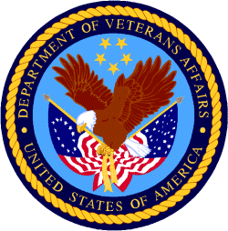

Department of Veterans Affairs

Programs:
VHA Member Services-Veterans Transportation
Grants for Transportation in Highly Rural Areas
Synopsis 1 & 2
Document Type: Grants Notice  Funding Opportunity Number: VA-HRTG-2023  Funding Opportunity Title: Grants for Transportation in Highly Rural Areas  Opportunity Category: Discretionary  Opportunity Category Explanation:  Funding Instrument Type: Grant  Category of Funding Activity: Transportation  Category Explanation:  Expected Number of Awards: 15  CFDA Number(s): 64.035 -- Veterans Transportation Program  Cost Sharing or Matching Requirement: No | Version: Synopsis 1  Posted Date: May 18, 2023  Last Updated Date: May 18, 2023  Original Closing Date for Applications: Jun 30, 2023  Current Closing Date for Applications: Jun 30, 2023  Archive Date: Jul 30, 2023  Estimated Total Program Funding: $4,000,000  Award Ceiling: $50,000  Award Floor: $0

Eligible Applicants: | Others (see text field entitled "Additional Information on Eligibility" for clarification)
Additional Information on Eligibility: | Only a VA accredited Veterans Service Organization (VSO) or a State Veterans Service Agency is eligible to apply.
Additional Information
Agency Name: | VHA Member Services-Veterans Transportation
Description: | This Notice of Funding Availability (NOFA) is for current grantees under the Grants for Transportation of Veterans in Highly Rural Areas for the fiscal year 2023. Approximately $4.0 million is authorized to be appropriated for this fiscal year.***This notice only applies to current HRTG recipients.***
Link to Additional Information: | See Related Documents
Grantor Contact Information: | If you have difficulty accessing the full announcement electronically, please contact:  Mindy S LaCrone Grantor HRTG@va.gov  HRTG@va.gov
https://www.grants.gov/web/grants/view-opportunity.html?oppId=348218

Reminders:

VA accesses resources to increase housing assistance for vulnerable Veterans
The Department of Veterans Affairs updated regulations Nov. 10 governing the Supportive Services for Veteran Families grant program to provide a more effective subsidy to Veterans in high-cost rental markets and to increase the cap in general housing assistance available to the most vulnerable Veteran families.
Under the new regulations, in certain communities, the SSVF grant will cover up to 50%, an increase from 35% of eligible Veterans’ reasonable rent for two years without need for recertification.
“We know Veterans are increasingly vulnerable to homelessness and housing insecurity,” said VA Secretary Denis McDonough. “The updated regulations give Supportive Services for Veteran Families grantees more flexibility and tools to keep Veterans housed while also helping them increase their income and access permanent affordable housing solutions.”
The new rule also expands the maximum stay in emergency housing for unsheltered Veterans.
The original rule authorized placement for a Veteran and his or her spouse with dependents in emergency housing for up to 45 days, which proved often not enough time to locate stable and affordable permanent housing in highly competitive rental markets.
A Veteran and his or her spouse with dependents can now stay in emergency housing for a maximum of 60 days. The 15-day increase in length-of-stay is expected to have the most significant benefit to Veteran families in rental markets with few vacancies, as well as unsheltered homeless Veterans families.
Ending Veteran homelessness is a top priority for VA, aligned with the White House’s priority to promote housing stability by supporting vulnerable tenants.
Learn more about VA’s mission to end homelessness among Veterans and how you can help.

PART 2 – GENERAL FEDERAL AGENCY GRANTS INFORMATION
JUNE 2023

Please review each department’s General Grant and Funding Overview. These overviews are the key web pages on each departmental website dedicated to the agency’s funding opportunities. Check back often to note the department updates.

(See Part 1 for current grant opportunity notices)

Federal Agencies Discretionary Grants and Contract Website Links

Native Hawaiian Programs

U.S. Department of Agriculture

Grants and Loans Overview

Department of Commerce

Grants at Commerce

Economic Development Administration Hawaii Contacts

Corporation for National and Community Service

General Program Overview

National Service in Hawaii

Department of Defense

Doing Business with the Department of Defense

Department of Education

Grant Programs Overview

US Department of Energy

Grants Overview

Environmental Protection Agency

Grants and Contracts Overview

Federal Mediation and Conciliation Service

Grants Overview

Department of Health and Human Services

Grants Overview

Department of Homeland Security
Grants Overview

Department of Housing and Urban Development

HUD - Notice of Funds Available

Institute of Museum and Library Services
Grants Overview

IMLS is on Facebook!

Department of Interior

Grants and Contract Overview

Department of Justice

Grants and Contract Overview

Hawaii State Administrative Agency Contacts
________________________________________________________________________

Department of Labor

Grants and Contract General Overview

National Aeronautics and Space Administration

Research Grant and Contract General Overview
_______________________________________________________________
National Archives and Records Administration

Grant Opportunities General Overview
_______________________________________________________________
National Endowment for the Arts

Grant Opportunities General Overview
_______________________________________________________________

National Endowment for the Humanities

Grant Opportunities General Overview
_______________________________________________________________
National Science Foundation

Grant Opportunities General Overview

Small Business Administration

General Overview Finding Loans & Grants

Links Specific to Hawaii

State Department

General Overview and Resources for Program Administrators

_________________________________________________________________________________

U.S. Department of Transportation

General Grant Program Overview

Department of the Treasury

Overview

US Agency for International Development

General Funding Opportunity Overview

Department of Veterans Affairs

Programs

Grants.Gov Links

Grant Writing Resources

SBIR – Small Business Innovation Research

Federal Agency Discretionary Grant and Contract Websites and Overviews

Federal Offices of Likely Interest to Native Hawaiians
- U.S. Department of Education
Office of Elementary and Secondary Education
Native Hawaiian Education Programs
White House Initiative on Asian Americans and Pacific Islanders
- U.S. Department of Health and Human Services
Health Resources & Services Administration
Native Hawaiian Health Care Systems
Office of Regional Operations Region 9 Office
Administration for Native Americans
ANA Pacific Region Training and Technical Assistance Center
- U.S. Department of Housing and Urban Development
Federal Housing Administration
Insured Mortgages on Hawaiian Home Lands, FHA Section 247
Office of Native American Programs
Native Hawaiian Housing
Hawai‘i State Home Page
- U.S. Department of the Interior
National Park Service
Hawai‘i Parks
National NAGPRA Program
U.S. Fish and Wildlife Service
Pacific Islands Fish and Wildlife Office
Office of the Region One Tribal Liaison
U.S. Geological Survey
Pacific Region - Hawai‘i
- U.S. Department of Agriculture
Cooperative Research and Extension Services
Farm Service Agency - Hawai‘i and Pacific Basin
Natural Resources Conservation Services - Pacific Islands Area
Rural Development - Hawai‘i
- U.S. Department of Defense
Office of the Deputy Under Secretary of Defense (Installations & Environment)
Senior Advisor and Liaison for Native American Affairs
Native Hawaiian Affairs
- Advisory Council on Historic Preservation
Office of Native American Affairs
- U.S. Department of Commerce
U.S. Economic Development Administration
University Center Economic Development Program
Representative covering the State of Hawaii
National Oceanic and Atmospheric Administration
NOAA in Your State - Hawai‘i
- U.S. Small Business Administration
Hawai‘i District Office
8(a) Business Development Program (open to qualified Native Hawaiian businesses)
- U.S. Department of the Treasury
Community Development Financial Institution Fund (CDFI Fund)
- U.S. Department of Veteran Affairs
Center for Minority Veterans
Office of Diversity and Inclusion

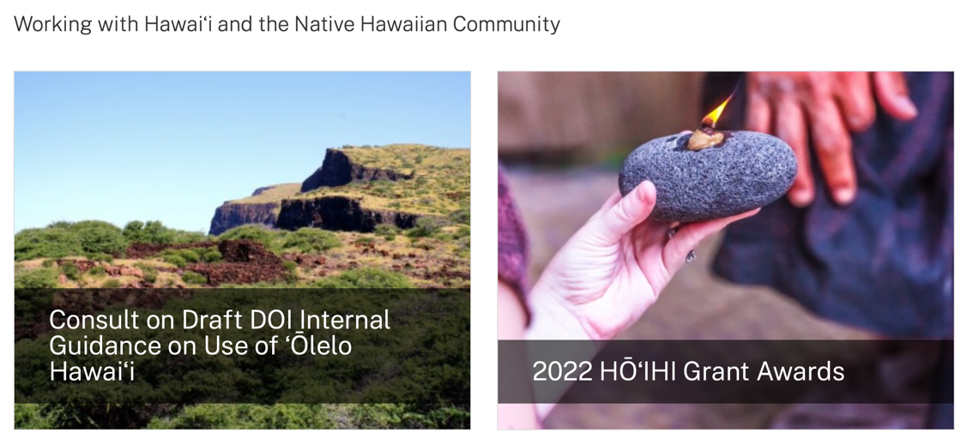
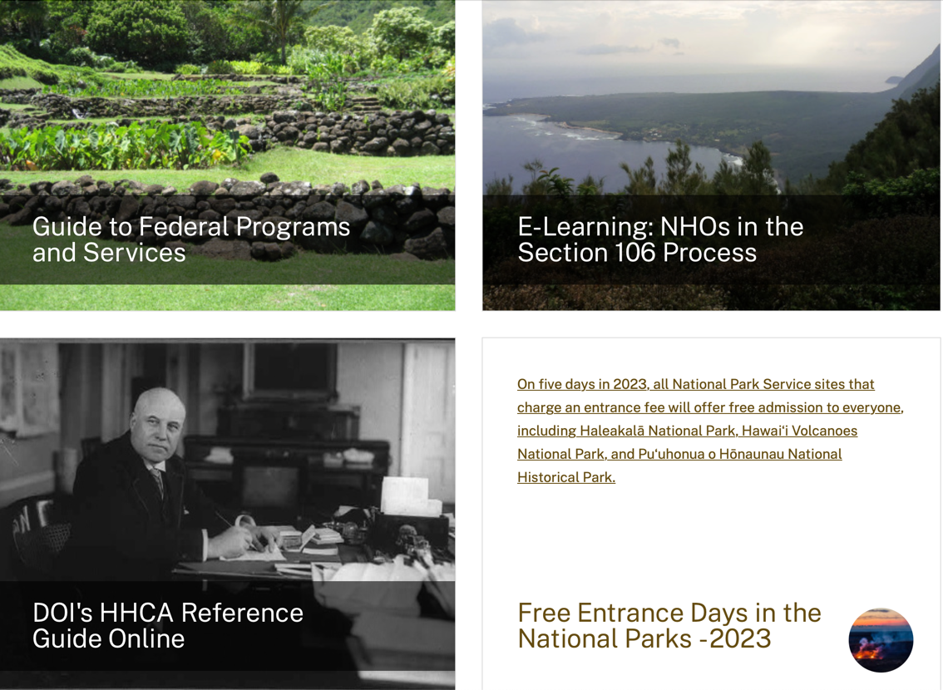
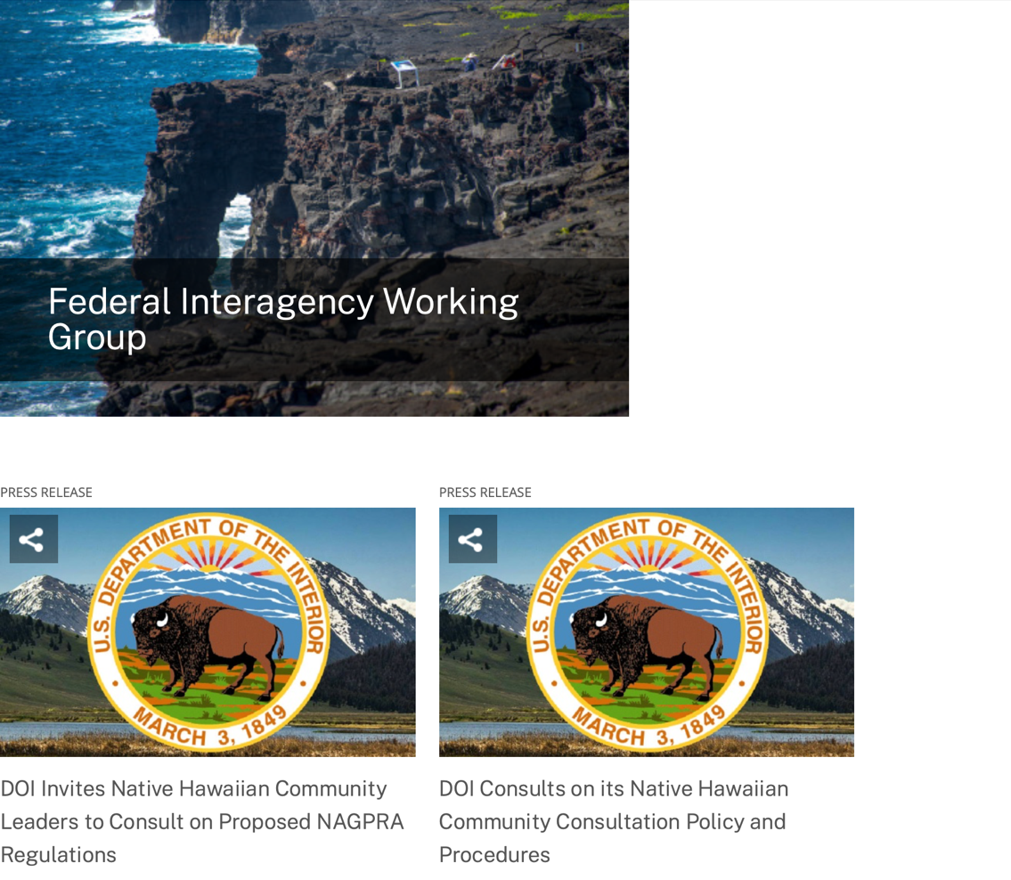
https://www.doi.gov/hawaiian

Office of Hawaiian Affairs Community Grants Program
Grants – The purpose of the Office of Hawaiian Affairs Grants Program is to support Hawaiʻi based nonprofit organizations that have projects, programs, and initiatives to serve our Lāhui in alignment with OHA’s Strategic Foundations, Directions & Outcomes.
Reminder, to be eligible for funding consideration, an applicant shall:
- Be registered to do business in the State of Hawaiʻi
- Provide services to Native Hawaiians and/or Native Hawaiian community(ies) in the State of Hawaiʻi
- Have an IRS letter of Determination
- Compliant with Hawaiʻi Compliance Express

https://www.oha.org/resources/

Resources
Providing resources is among the key ways that the Office of Hawaiian Affairs fulfills its purpose.
The best possible Native Hawaiian historical and cultural information has been just a click away since the launch in April 2013 of the Kipuka Database. It is a searchable online geographic information system that makes data that once would have taken long to compile, now available within seconds. The database helps complement our other key research tools, such as the Native Hawaiian Data Book and the Papakilo Database, which is a digital library for Native Hawaiian historical and cultural information.
In addition, we launched Kamakako’i, an issues-based digital media tool that has been years in the making. The cutting-edge website provides a platform to quickly engage key audiences and inspire action on policy matters important to the Native Hawaiian community.

Resources
- Grants – The purpose of the Office of Hawaiian Affairs Community Grants Program is to support projects, programs and initiatives that address OHA’s six Strategic Priorities and accompanying Strategic Results contained in OHA’s 2010-2018 Strategic Plan.
- Kamakakoʻi – A cutting edge tool that leverages technology to engage, inform, activate and rally the Hawaiʻi community around voices on the cutting edge of community issues. It is produced and maintained by the Office of Hawaiian Affairs.
- Ka Wai Ola – Ka Wai Ola is a monthly newspaper published by OHA. The Ka Wai Ola operates under the Communications division of Community Engagement. The Ka Wai Ola has about 60,000 subscribers and strives to create rich content geared toward captivating the Hawaiian community.
- Kīpuka Database – A geographical information system (GIS) that utilizes the latest mapping technologies to provide a window into native Hawaiian land, culture and history.
- Loans – The Office of Hawaiians Affairs is committed to ensuring Native Hawaiians and their ‘ohana have access to resources to assist them in pursuing their financial goals.
- OHA Native Hawaiian Data Book – A compilation of basic demographic data on Hawaiians and data to identify gaps and important issues to ensure OHA’s actions and initiatives are based on the best information available.
- Papakilo Data Base – A comprehensive “Database of Databases” consisting of varied collections of data pertaining to historically and culturally significant places, events, and documents in Hawai’i’s history.
- Reports and Research – A collection of reports and surveys intended to help guide strategic direction and policy decisions.
- Scholarships – Each year OHA provides funding for scholarships through its Higher Education Scholarship Programs.

U.S. Department of Agriculture

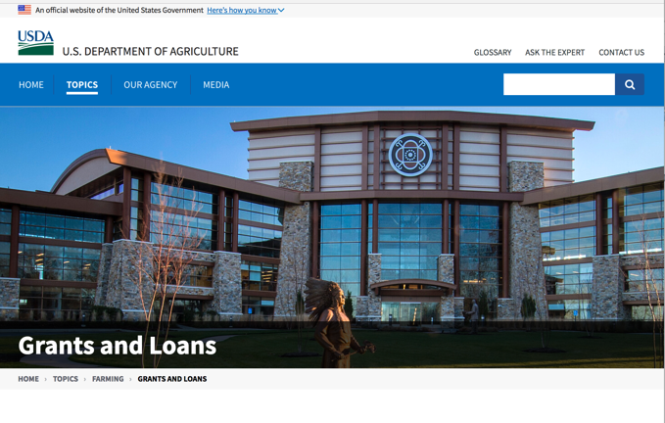

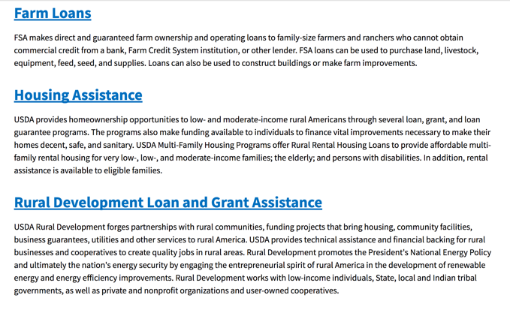

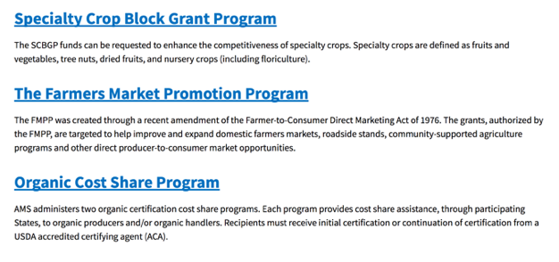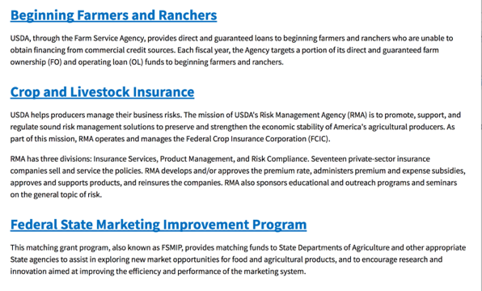
https://www.usda.gov/topics/farming/grants-and-loans
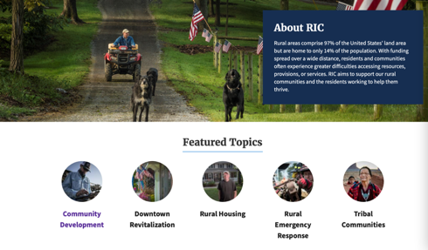https://www.nal.usda.gov/ric/community-development-resources

Department of Commerce

Grants, Contracting, and Trade Opportunities at Commerce
Learn more information about grants, contracting and trade opportunities at the Department of Commerce using the information below
https://www.commerce.gov/work-with-us/grants-and-contract-opportunities
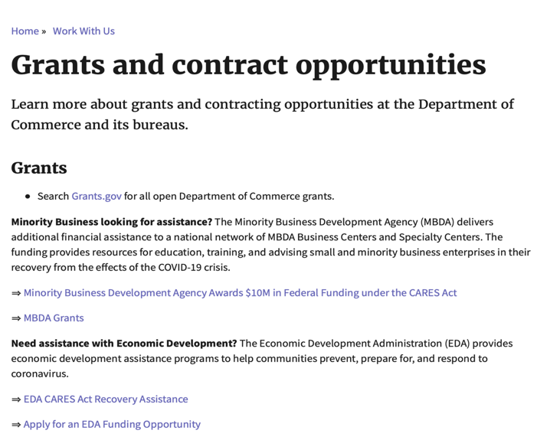

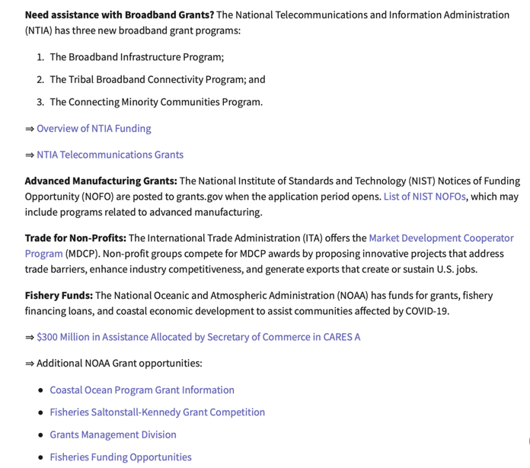
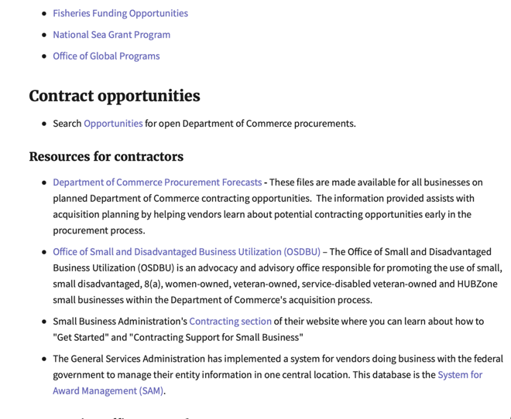
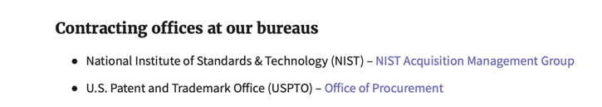
DOC Grant Making Bureaus
Economic Development Administration (EDA)
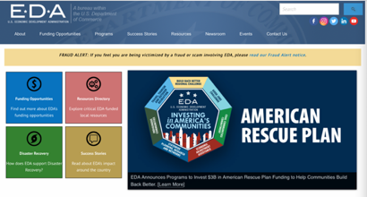
International Trade Administration (ITA)
- Market Development Cooperator Program
- Special American Business Internship Training Program (SABIT). A technical assistance initiative of the International Trade Administration of the U.S. Department of Commerce, SABIT offers organizations competitive grants and an opportunity to host industry-specific delegations. SABIT serves as an initial entry point for U.S. businesses seeking funding to establish long-term relationships with potential customers, distributors, or partners in the former Soviet Union. The program trains Eurasian managers and scientists in commonly accepted business practices as a means of facilitating cross border relationships. In turn, these personal relationships serve as a basis for business development and reduce market access barriers for U.S. businesses.
National Institute of Standards & Technology (NIST)
- Funding Opportunities
National Telecommunications & Information Administration (NTIA)
- Telecommunications Grants
National Oceanic & Atmospheric Administration (NOAA)
- Coastal Ocean Program Grant Information
- Fisheries Saltonstall Kennedy Grant Program
- National Undersea Research Program Funding Opportunities
- Grants Management Division
- Fisheries Grants Program
- National Sea Grant
- Office of Global Programs
Contracting Resources for Contractors
- Office of Small and Disadvantaged Business Utilization (OSDBU) - the Office of Small and Disadvantaged Business Utilization (OSDBU) is an advocacy and advisory office responsible for promoting the use of small, small disadvantaged, 8(a), women-owned, veteran-owned, service-disabled veteran-owned, and HUBZone small businesses within the U.S. Department of Commerce's (DOC) acquisition process.
- Business.USA.gov's Find Opportunities Wizard where in a few quick steps, it will guide you towards federal government contracting programs and opportunities for your business!
- Planned Acquisitions: the Department of Commerce's search tool for our planned acquisitions over $100,000. As requirements change, these acquisition plans are updated by department personnel and this search tool is automatically updated.
- Small Business Administration's Contracting section of their web site where you can learn about how to "Get Started" and "Contracting Support for Small Business."
- The General Services Administration (GSA) has implemented a system for vendors doing business with the Federal Government to manage their entity information in one central location. This new database is the System for Award Management (SAM).
DOC Contracting Offices
- Patent and Trademark Office (PTO)
  - Office of Procurement

- National Institute of Standards & Technology (NIST)
Trade Opportunities through Commerce
http://www.commerce.gov

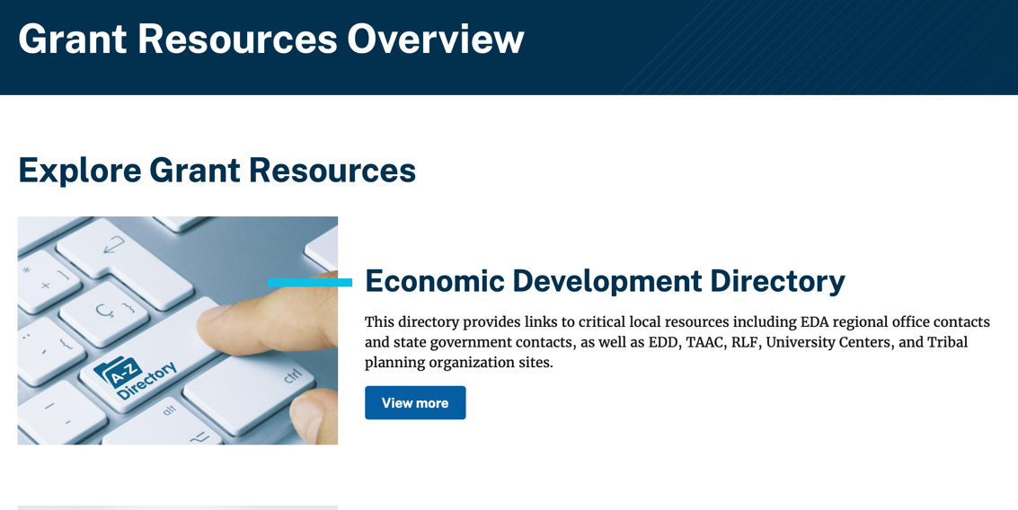
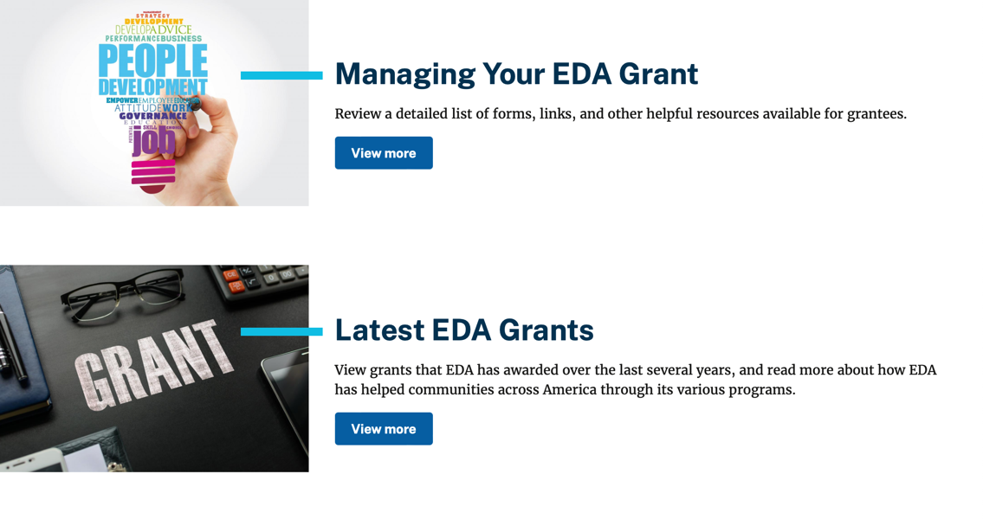

https://www.eda.gov/grant-resources

Economic Development Administration Hawaii Contacts

Corporation for National and Community Service

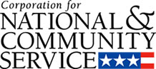

General Program Overview

AmeriCorps provides resources, both human and financial, to organizations that engage Americans in intensive service to meet our country’s critical needs.
Grantees use the funding to support AmeriCorps members for intensive service in their community. AmeriCorps grants partially cover the expense of operating an AmeriCorps program and do not cover general organizational expenses. A cash and in-kind match are required.

The main website can be accessed here: http://www.nationalservice.gov

For access to further funding information: https://americorps.gov/partner/funding-opportunities

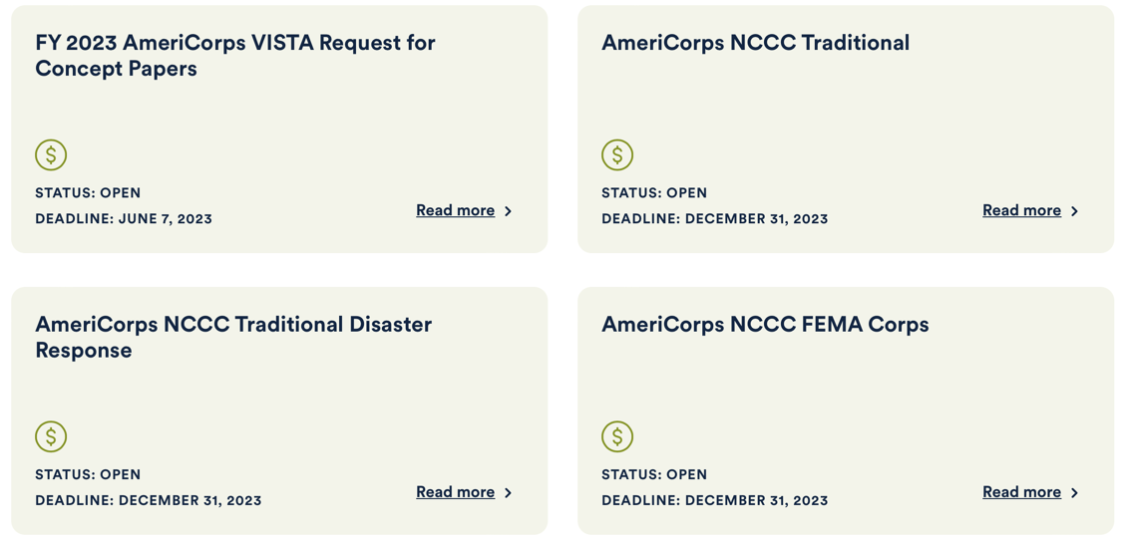

https://www.americorps.gov/partner/funding-opportunities

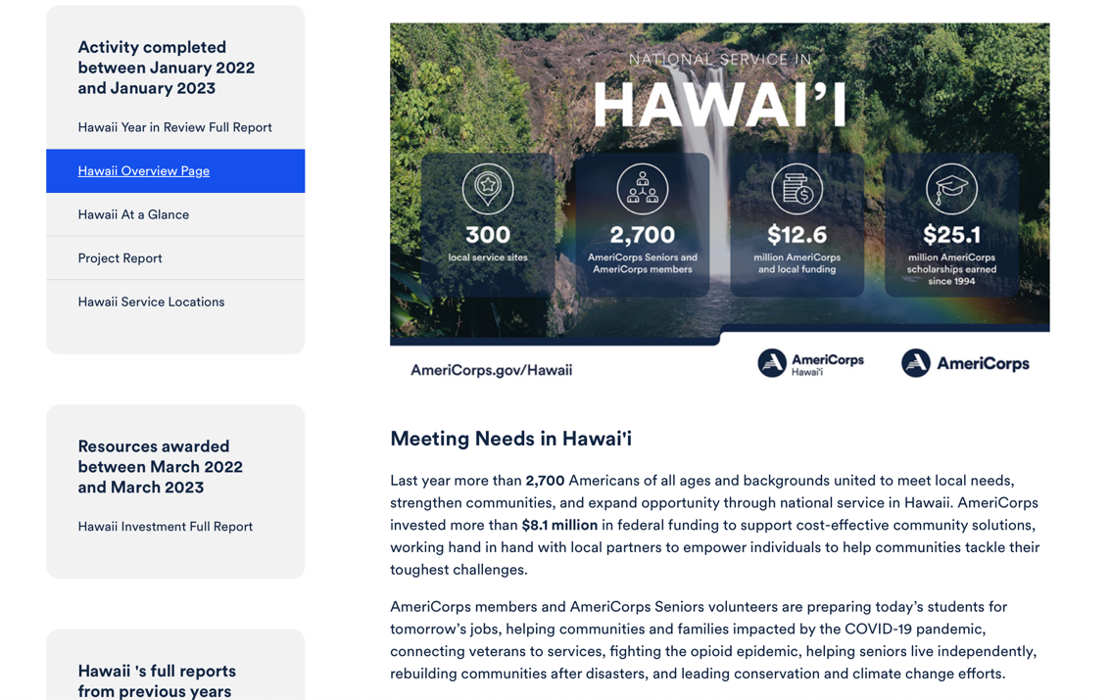
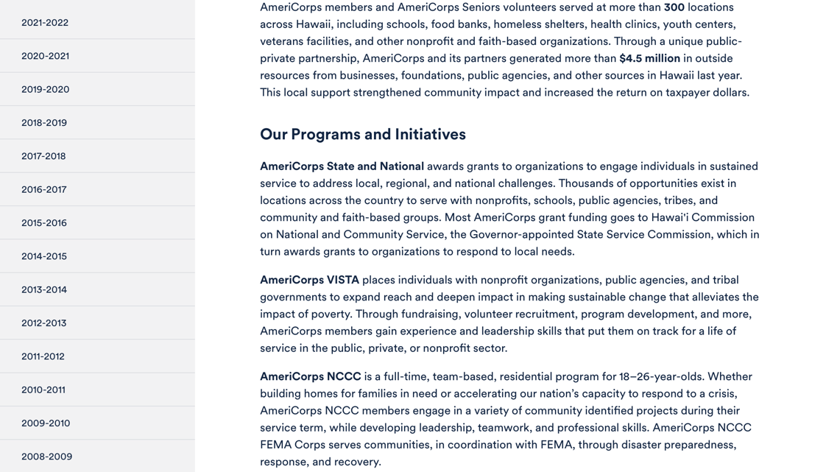
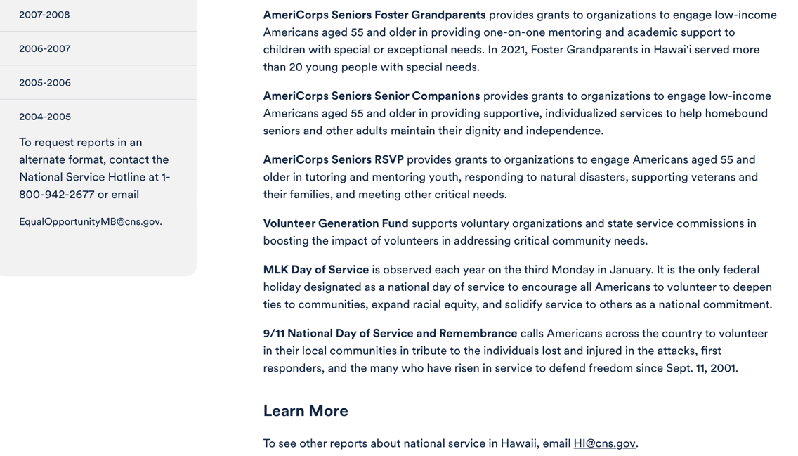

Learn More https://americorps.gov/national-service-report/hi
To see other reports about national service in Hawaii, please contact HI@cns.gov.
The Corporation for National and Community Service is a federal agency that improves lives, strengthens communities, and fosters civic engagement through service and volunteering. To learn more, visit www.NationalService.gov or call 202-606-5000 or TTY 1-800-833-3722.

U.S. Department of Defense

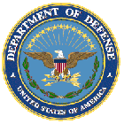

Doing Business with the Department of Defense

http://business.defense.gov

Corona Virus Response -- https://business.defense.gov/COVID-19-SMALL-BUSINESS-RESOURCES/

Department of Education


Grant Programs Overview at the Department of Education

The general information page for Education Grant funding is an excellent resource describing the three types of grants awarded by the Department of Education. See the screen shot of the Department of Education web page below:

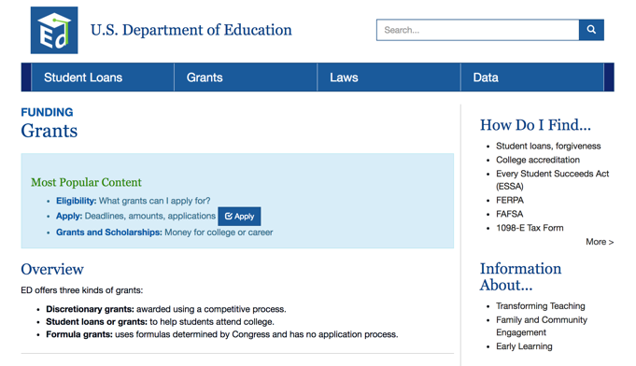
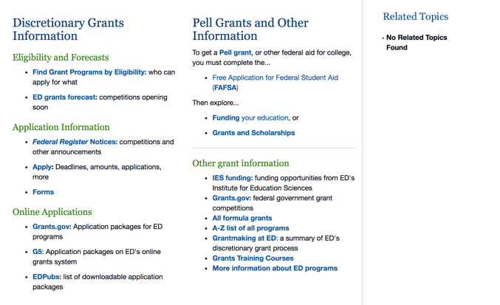

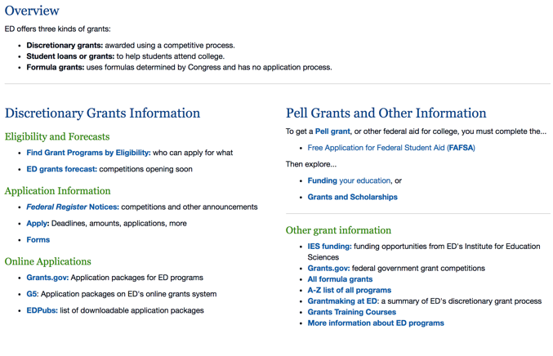

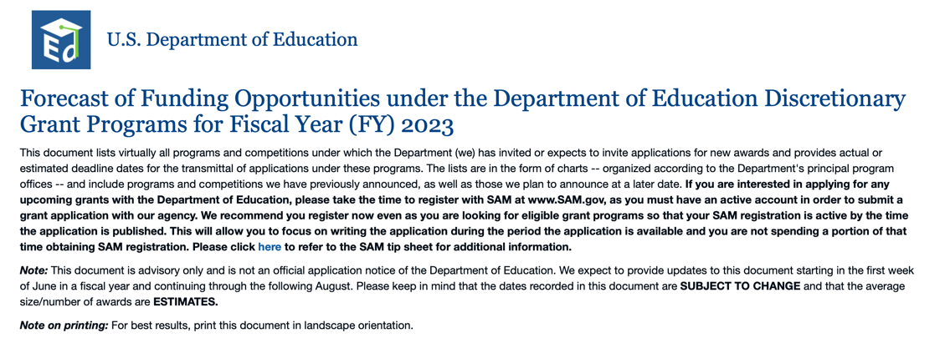

https://www2.ed.gov/fund/grant/find/edlite-forecast.html

U.S. Department of Energy

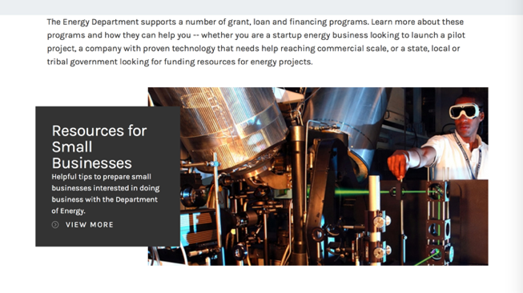
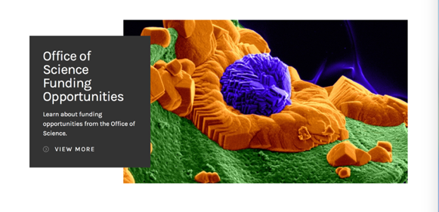

https://www.energy.gov/energy-economy/funding-financing

Environmental Protection Agency

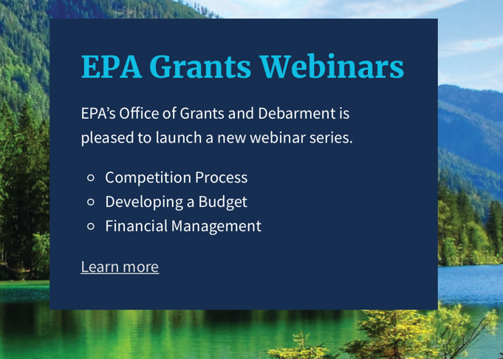

https://www.epa.gov/grants/epa-grants-webinars

https://www.epa.gov/grants

Federal Mediation and Conciliation Service

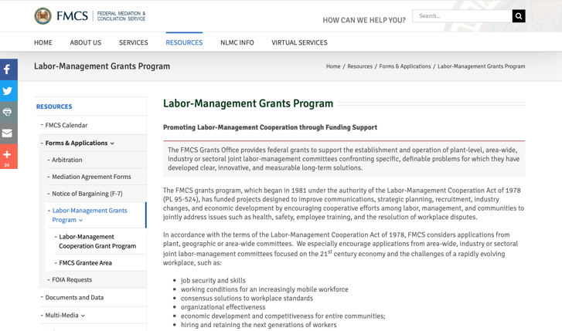
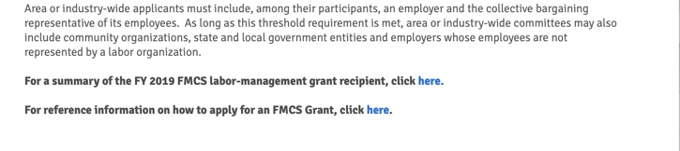

https://www.fmcs.gov/resources/forms-applications/labor-management-grants-program/

Department of Health and Human Services

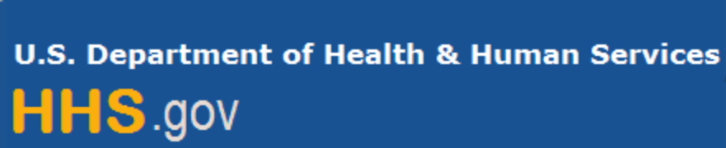

Grants Forecast and Overview

The Department of Health and Human Services’ Grants Forecast is a database of planned grant opportunities proposed by its agencies. Each Forecast record contains actual or estimated dates and funding levels for grants that the agency intends to award during the fiscal year. Forecast opportunities are subject to change based on enactment of congressional appropriations.

For more general information about HHS Grants and Funding go to the website below at:

https://www.hhs.gov/grants/grants/index.html

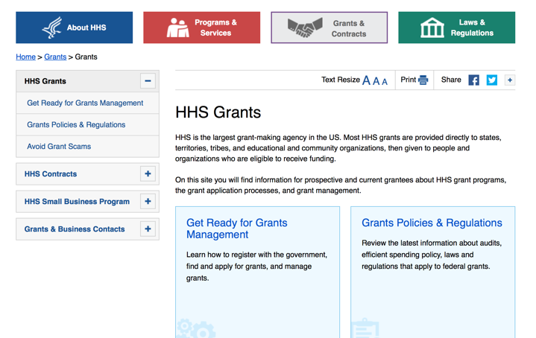

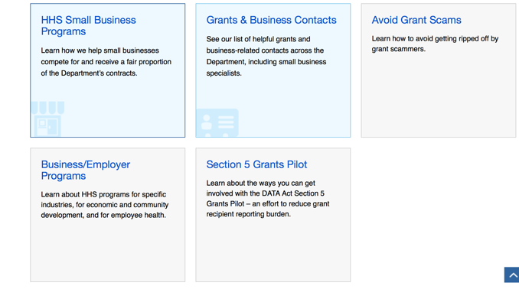

Department of Homeland Security



The Department of Homeland Security enhances the ability of states, local and tribal jurisdictions, and other regional authorities in the preparation, prevention, and response to terrorist attacks and other disasters, by distributing grant funds. Localities can use grants for planning, equipment, training and exercise needs.

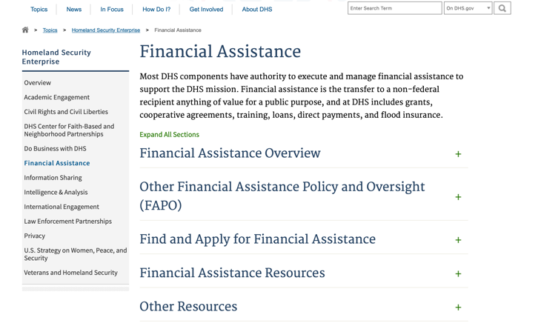

Webpage can be viewed at: https://www.dhs.gov/dhs-financial-assistance#2

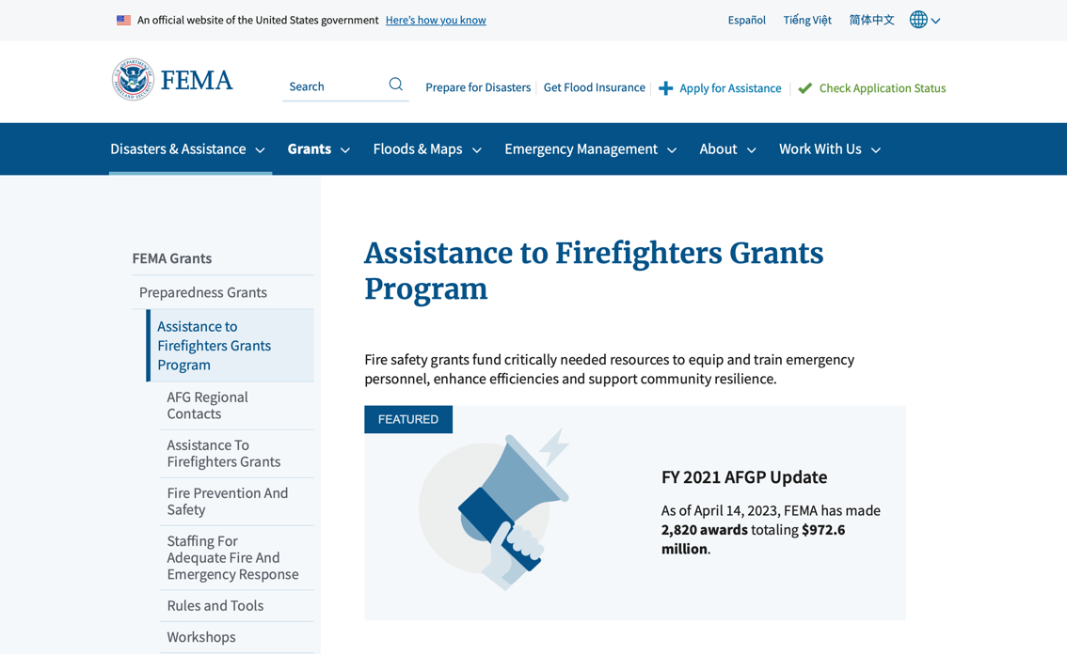
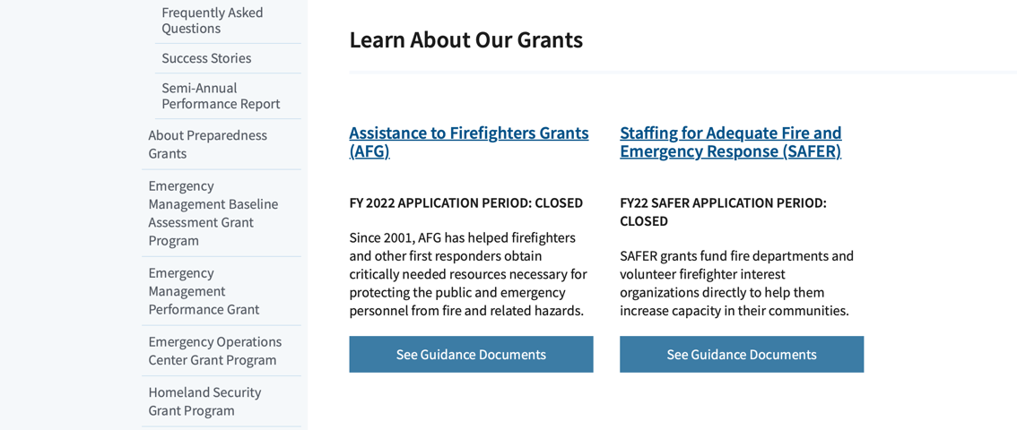
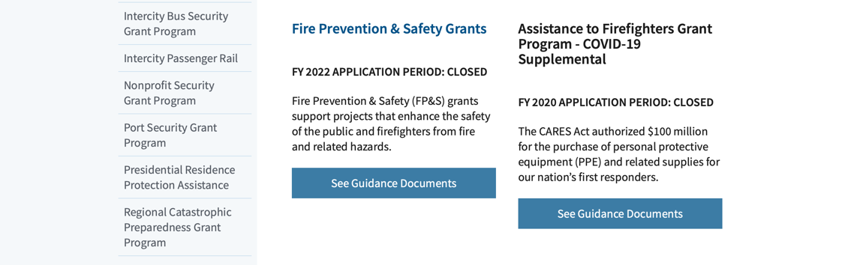

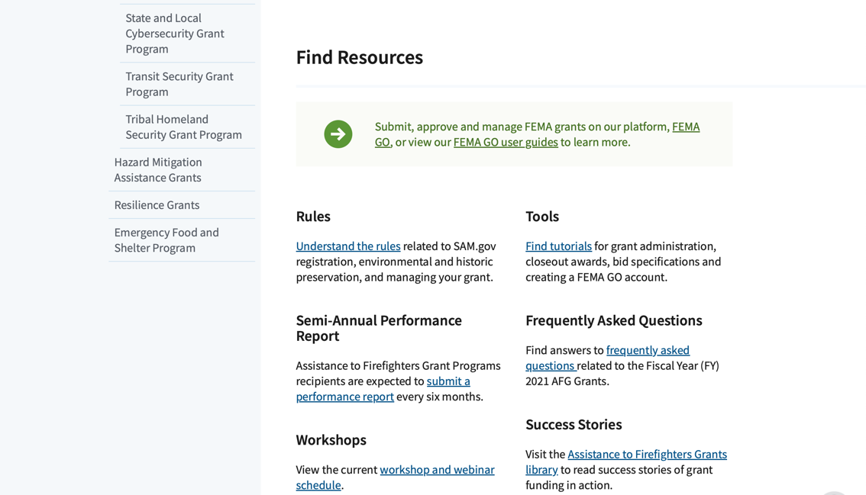
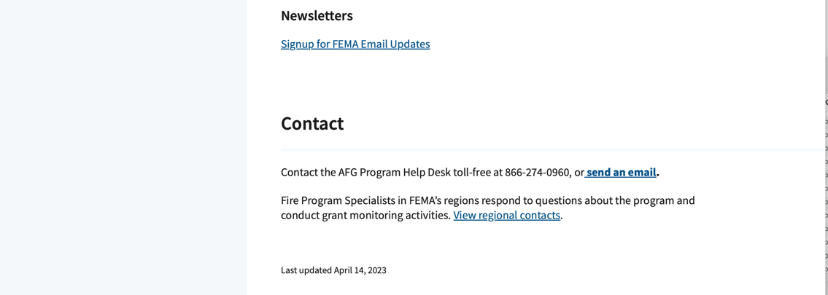
(Most recent update as of 6/7/2023)

https://www.fema.gov/welcome-assistance-firefighters-grant-program

For AFG program guidance materials, please visit our Documents page.

Resources

AFG Help Desk
Contact the AFG Program Help Desk toll-free at 866-274-0960, or email us at firegrants@dhs.gov.
The AFG Program has Fire Program Specialists in 10 federal regional centers. These Regional Fire Program Specialists respond to questions about the AFG program and carry out grant monitoring activities. View regional contacts

Popular AFG links
- Assistance to Firefighters Grants (AFG)
- AFG Awards List
- Staffing for Adequate Fire & Emergency Response (SAFER) Grants (SAFER)
- SAFER Awards List
- SAFER Success Stories
- Fire Prevention & Safety (FP&S) Grants
- FP&S Awards List
- FP&S Success Stories
- Grant Closeout Tutorial
- Assistance to Firefighters Grant (AFG) Email Alert Archive
- Frequently Asked Questions
Contact Information For The Assistance to Firefighters Grant (AFG) Program and Help Desk

Federal Funding Alternative To AFG

https://www.fema.gov

Department of Housing and Urban Development

https://www.hud.gov/program_offices/spm/gmomgmt/grantsinfo

HUD - Notice of Funds Available
For detailed information click here

Fiscal Year 2023 Funding Opportunities
HUD awards discretionary funding through over 20 Grant programs that support HUD initiatives, including Affordable Housing Development and Preservation, Community and Economic Development, Environment and Energy, Fair Housing, Homelessness, Homeownership, Rental Assistance, Supportive Housing and Services.
Notice of Funding Opportunity (NOFO) – The Notice of Funding Opportunities (NOFO) is a published each year on Grants.gov for HUD’s Discretionary Funding Programs. These NOFOs describe the type of funding available on a competitive basis and provides information on submission of an application, typically up to 30 to 90 days from the date of the NOFO publication on grants.gov.

Additional Information Related to HUD's Funding Opportunities
- 2 CFR Crosswalk - On August 13, 2020, the Office of Management and Budget (OMB) revised Federal Guidance for Grants and Agreements, to include 2 CFR 25, 2 CFR 170, 2 CFR 183, and 2 CFR 200. An index of those changes was consolidated in a document for reference. Here is the link to the document: https://www.cfo.gov/wp-content/uploads/2020/12/2-CFR-Crosswalk_20201106.xlsx
- Part 200 of Title 2 of the Code of Federal Regulations (2 CFR Part 200)
- Eligibility Requirements for Applicants of HUD's Grants Programs - 2023
- Eligibility Requirements for Applicants of HUD's Grants Programs - 2022
- Administrative, National & Departmental Policy Requirements and Terms for HUDs Financial Assistance - 2023
- Administrative, National & Departmental Policy Requirements and Terms for HUDs Financial Assistance - 2022
- Build American, Buy America Act (BABA)
  - This site provides a comprehensive collection of proposed, currently effective, and expired waivers (as they become available) of the Build America, Buy America Act (BABA) domestic content procurement preference as applied to HUD’s Federal Financial Assistance programs
- Environmental Requirements
  - E.O. 12898 Federal Actions to Address Environmental Justice
  - E.O. 14008 Tackling the Climate Crisis
- Code of Conducts Page
Fiscal Year 2023 Funding Opportunities
FY 2023 University-Nonprofit Partnerships Engaged in Community-Based Research Designed to Address Homelessness NOFO | FY 2023 Youth Homeless Demonstration Program (YHDP)
FY 2023 Choice Neighborhoods Planning Grant | Fair Housing Initiatives Program - Education and Outreach Initiative for the American Rescue Plan
FY 2022 Veterans Housing Rehabilitation and Modification Pilot Program (VHRMP) | FY 2023 Green and Resilient Retrofit Program (GRRP) Leading Edge
FY 2023 Green and Resilient Retrofit Program (GRRP) Elements | FY 2023 Green and Resilient Retrofit Program (GRRP) Comprehensive
FY 2023 Capital Fund at Risk/Receivership/Substandard/Troubled Program | FY 2023 HUDRD - Closing the Homeownership Gap and Preserving Homeownership During Economic Decline
FY 2023 Housing Mobility-Related Services | FY 2023 Jobs Plus NOFO
Forecast for Expected Fiscal Year 2023 Funding Opportunities
The Department of Housing and Urban Development NOFO Forecast list below identifies competitive grant opportunities that may be available for Fiscal Year (FY) 2023. The inclusion or exclusion of an opportunity in the listing below does not constitute a guarantee that a specific opportunity will become available or not be available. Forecast opportunities are subject to change based on enactment of Congressional appropriations and other considerations.
When funding is available, HUD will issue a Notice of Funding Opportunity (NOFO), which will be published on Grants.gov and the Funds Available webpage will be updated to indicate the NOFO has been published. Each NOFA provides guidance on how to apply for funding.
Office of Community Planning and Development (CPD)
- Self-Help Homeownership Opportunity Program (SHOP)
- Section 4 Capacity Building for Community Development and Affordable Housing (RCB)
- The Youth Homelessness Systems Improvement Program
- Continuum of Care Competition and Renewal or Replacement of Youth Homeless Demonstration Program
- Housing Opportunities for Persons with AIDS (HOPWA) Competitive Grant: Housing Interventions HINT) to End the HIV Epidemic
- Community Development Block Grant (CDBG) Pro – Housing
- Community Development Block Grant (CDBG) Price
Office of Fair Housing and Equal Opportunity (FHEO)
- Fair Housing Initiatives Program – Education Outreach Initiative
- Fair Housing Initiatives Program – Fair Housing Organization Initiative
- Fair Housing Initiatives Program – Private Enforcement Initiative

Office of Healthy Homes Lead Hazard Control (OHHLHC)
- FY2023 and FY2024 Radon Testing and Mitigation Demonstration for Public Housing
- Lead and Healthy Homes Technical Studies (LHHTS) Grant Program Pre- and Full Application
- Healthy Homes Production Grant Program
- Older Adult Modification Grant Program
- Healthy Homes Weatherization Cooperative Demonstration
Office of Housing (HSNG)
- Green and Resilient Retrofit Program Comprehensive
- Green and Resilient Retrofit Program Elements
- Green and Resilient Retrofit Program Leading Edge
- Section 811 Supportive Housing for Persons with Disabilities - Capitol Advance
- Section 811 Supportive Housing for Persons with Disabilities – Project Rental Assistance
- Fiscal Years 2022 and 2023 Homeownership Initiative Grant
- Comprehensive Housing Counseling Grant Program
- Service Coordinators in Multifamily Housing (SCMF) Discretionary
- Tenant Education and Outreach
Office of Policy Development and Research (PD&R)
- FY23 HUDRD - FHA’s Role in Closing the Homeownership Gap and Preserving Homeownership During Economic Decline
- FY2023 and FY2024 Authority to Accept Unsolicited Proposals for Research Partnerships
- Increasing the Supply of Affordable Housing through Off-Site Construction and Pro-Housing Reforms Research Grant Program Pre and Full Application
- Eviction Protection Grant Program

Office of Public and Indian Housing (PIH)
- Community Development Block Grant Program for Indian Tribes and Alaska Native Villages
- Housing Mobility-Related Services
- Indian Community Development Block Grant
- Capital Fund at Risk/Receivership/ Substandard/ Troubled Program
- Foster Youth to Independence (FYI) Competitive
- Resident Opportunity and Self-Sufficiency (ROSS) Service Coordinator Program
- Jobs Plus NOFO
- FY2023 HOPE VI Main Street Grant Program
- Choice Neighborhoods Implementation Grants

Updated 6/7/2023

http://portal.hud.gov/hudportal/HUD?src=/program_offices/Administration/grants/fundsavail

Institute of Museum and Library Services

https://www.imls.gov/grants/apply-grant/available-grants

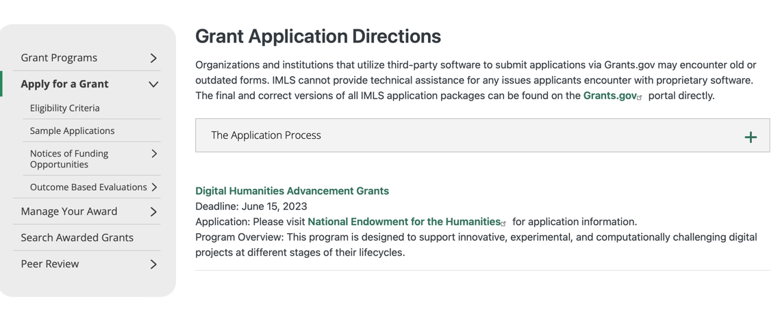

Each grant program has specific eligibility requirements. The links below provide general eligibility criteria for museums, libraries, and tribal organizations, but please note that additional organizations may be eligible for grants under certain programs. Additionally, ineligible organizations may still be able to participate in grant programs through partnerships with eligible organizations. Please click on the links below to see general criteria and review Applications and Guidelines for specific information.
Museums Libraries

Institutions: Archives, Federally Recognized Native American Tribe, Historical Society, Library, Nonprofits that serve Native Hawaiians, Professional Association, Public or Private Non-profit Institutions of Higher Education, Regional Organization, State Library Administrative Agency, State or Local Government

Check out IMLS's Facebook page at:
https://www.facebook.com/USIMLS/

Department of the Interior
The Interior Department provides assistance to the public, local governments and businesses through a number of programs. For a general overview see: http://www.doi.gov/index.cfm

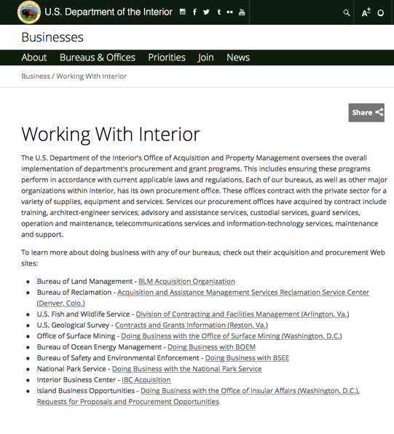

http://www.doi.gov/businesses/working-with-interior.cfm

Department of Justice

http://www.justice.gov/business/

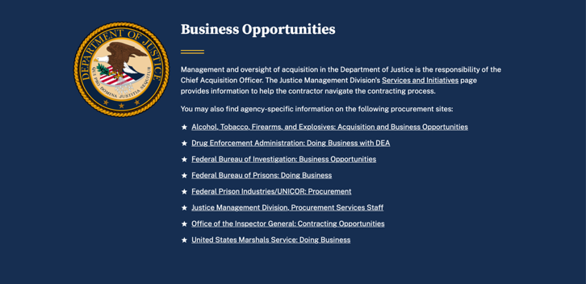

The DOJ agencies listed below also have sites that provide grant information specific to that agency. Examples of what can be found on these sites are programs, funding opportunities, application assistance, and other useful information.

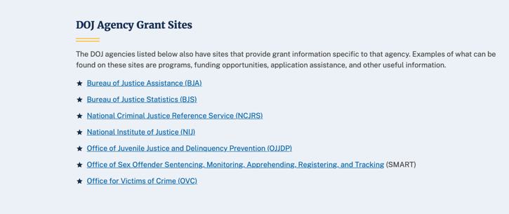

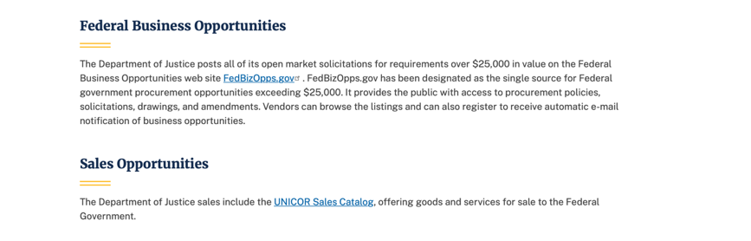

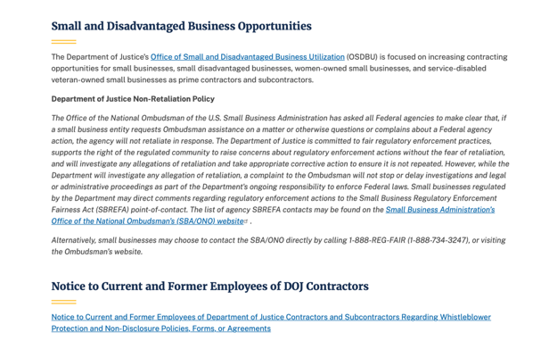

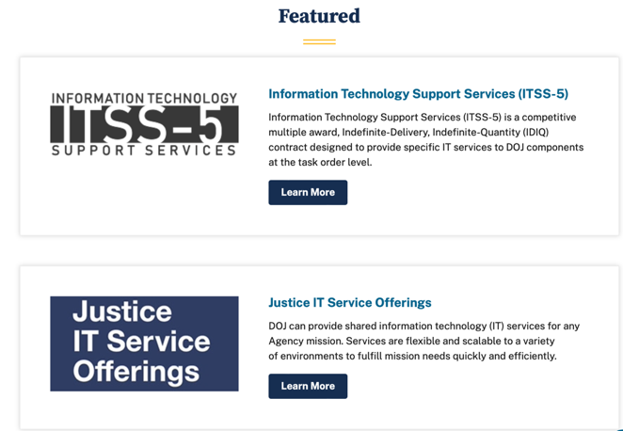

Bureau of Justice Assistance (BJA)

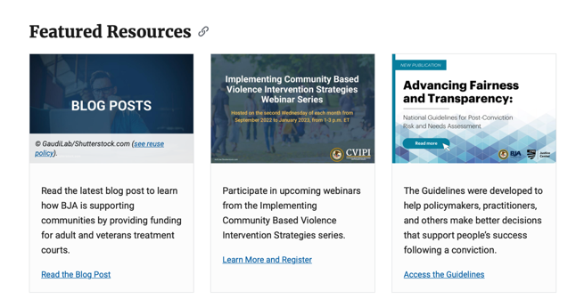

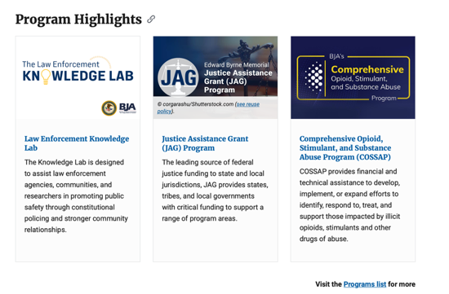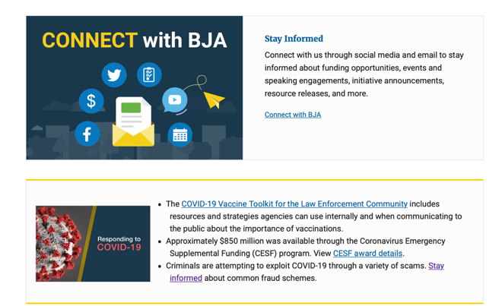

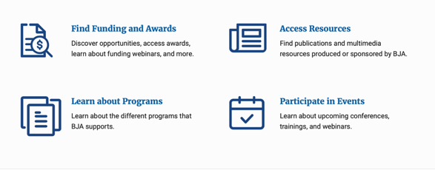

Bureau of Justice Statistics (BJS)

National Criminal Justice Reference Service (NCJRS)

National Institute of Justice (NIJ)

Office of Sex Offender Sentencing, Monitoring, Apprehending, Registering, and Tracking (SMART)

Hawaii State Administrative Agency Contacts

HAWAII DEPARTMENT OF THE ATTORNEY GENERAL, CRIME PREVENTION & JUSTICE ASSISTANCE DIVISION
235 S Beretania Street, Suite 401
Honolulu, HI 96813
(808) 586-1150
Agency Head: Julie Ebato, Administrator
JAG Contact: Shaleigh Tice, Grants & Planning Branch Chief
SAC Director: Paul Perrone, Chief of Research and Statistics

https://ag.hawaii.gov/cpja/gp/

Department of Labor

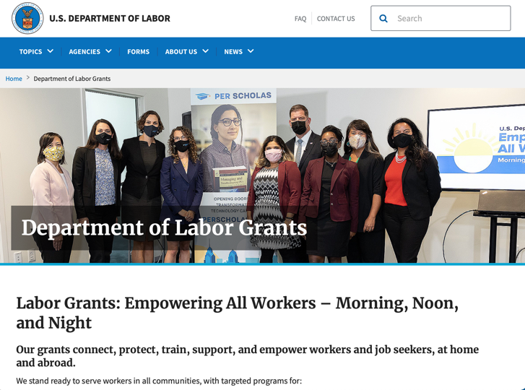
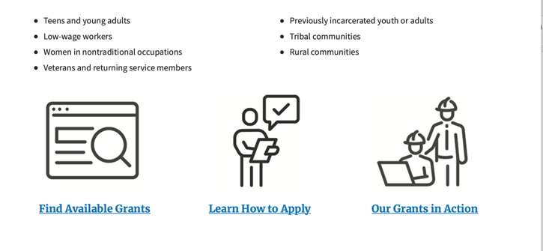

https://www.dol.gov/general/grants/howto

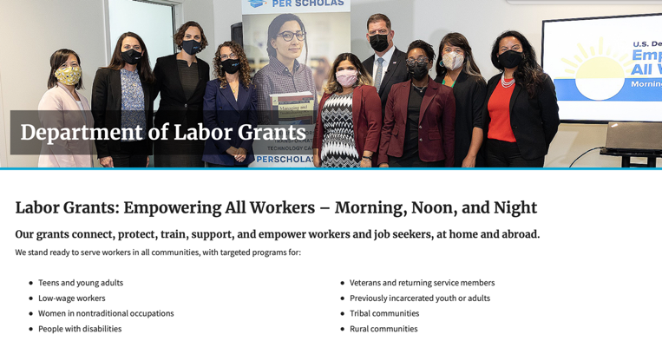

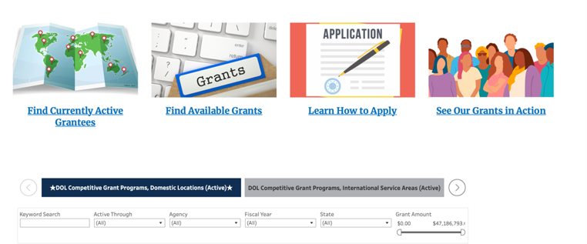

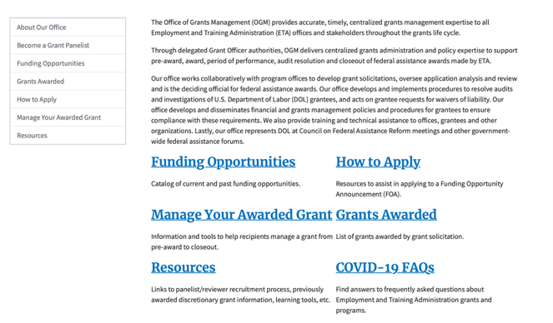

https://www.doleta.gov/grants/

Agency Grants and Contract General Overview

DOL Resources
Apply for DOL Agency-Specific Grants:
- Employment and Training Administration (ETA)
- Occupational Safety and Health Administration (OSHA)
- Bureau of International Labor Affairs (ILAB)
- Veterans' Employment and Training Service (VETS)
- Office of Disability Employment Policy (ODEP)
- Office of the Assistant Secretary for Administration and Management (OASAM)

Other Grant Resources:

DOL Resources and Instructions for Applying for a Grant
- DOL Guidance Clarifying the Effect of the Religious Freedom Restoration Act on Faith-Based Organizations
- Grant and Contract Information
- More Information About Grants

Other Federal Government Grant Information
- Grant Opportunities (Catalog of Federal Domestic Assistance)

Department of Labor Grant Programs

- Bureau of International Labor Affairs (ILAB): provides grants (cooperative agreements) for the implementation of projects designed to assist developing countries combat the worse forms of child labor, forced labor, and human trafficking; and support worker rights and improve working conditions. http://www.dol.gov/general/business.
- Bureau of Labor Statistics (BLS): provides project grants (cooperative agreements) and the dissemination of technical statistical data and related information on labor force activities; provides data on prices (CPI) and cost of living; data on productivity and technology data; data on compensation and working conditions; data on employment projections.
- Employment and Training (ETA): ETA Administers financial assistance programs pursuant to the Workforce Investment Act (WIA), administering State formula grant programs for youth, adults and dislocated workers, national emergency grants for workers affected by mass layoffs, plant closures, and disasters; grant programs for workers with disabilities, Indians and Native Americans, and for migrant and seasonal farmworkers. ETA also administers grant programs for older American workers, apprenticeship programs, Trade Adjustment Assistance (TAA) programs, and assistance for research and development of workforce programs. In addition, ETA is responsible for the operation and maintenance of a national system of public employment service offices and for the national unemployment insurance program.
- Mine Safety and Health (MSHA): provides grants for research, education and training programs to ensure an adequate and competent staff of trained inspectors; and assistance for establishing or improving State mine health and safety programs through technical assistance.
- Occupational Safety and Health (OSHA): provides grants to non-profit organizations to provide training, educational services, and technical assistance; assistance to states to administer and enforce state programs; assistance to states to provide occupational safety and health technical assistance and consultant services.
- Office of Disability Employment Policy (ODEP): The Office of Disability Employment Policy awards competitive grants establishing short-term pilot and technical assistance projects designed to identify, develop, test, evaluate, and disseminate policies to increase employment by expanding access to training, education, employment supports, assistive and systems technology, integrated employment, entrepreneurial development, and small business opportunities for adults and youth with disabilities. Current pilots projects focus on customized employment, Olmstead populations, and innovative demonstration youth grants, among others. Solicitations for grant applications are published in the Federal Register and announced at www.dol.gov/odep. ODEP grants are awarded by the OASAM grant office.
- Veterans' Employment and Training (VETS): provides special employment and training assistance for veterans through the Disabled Veterans' Outreach Program (DVOP) Solicitation for Grant Applications; the Local Veterans' Employment Representative Program (LVER); Veterans' Workforce Investment Program (VWIP); elaws Advisor on veterans' employment and reemployment rights; and the Homeless Veterans Reintegration Project (HVRP). VETS grants are awarded by the OASAM grant office.

https://www.dol.gov/general/grants/howto

National Aeronautics and Space Administration

 NASA Research Opportunities Online

- Various NASA offices publish their research announcements over the Internet, broadening the opportunity for researchers to apply for funding. This site provides access to current research announcements along with their specific due dates.

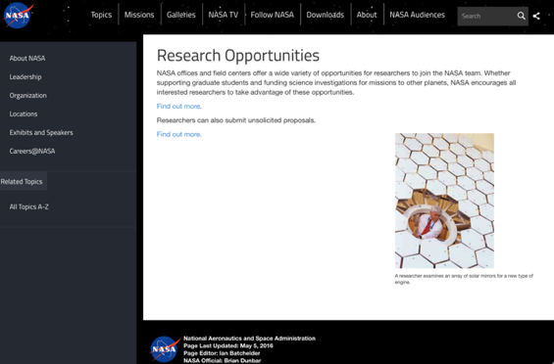
http://nspires.nasaprs.com/external/

National Archives and Records Administration

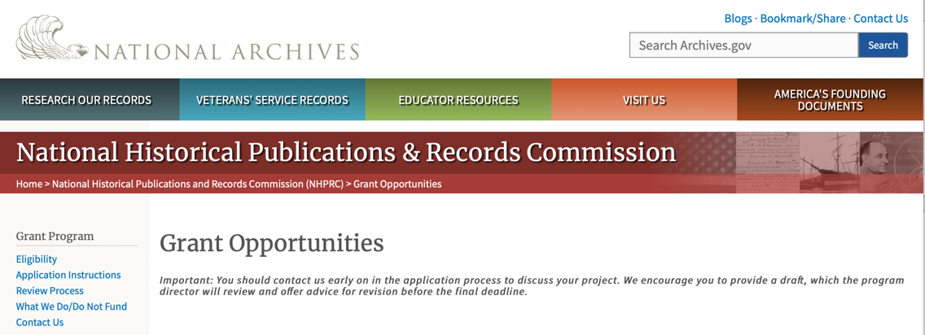

Archival Projects
For projects that ensure online public discovery and use of historical records collections.
- Draft Deadline (optional): August 15, 2023
- Final Deadline: November 2, 2023

Public Engagement with Historical Records
For projects that encourage public engagement with historical records.
- Draft Deadline (optional): August 15, 2023
- Final Deadline: November 2, 2023

Publishing Historical Records in Collaborative Digital Editions
For projects to publish documentary editions of historical records. This program has two application cycles.
First cycle:
- Draft Deadline: February 15, 2023
- Final Deadline: May 3, 2023
Second Cycle:
- Draft Deadline: August 15, 2023
- Final Deadline: November 2, 2023

NHPRC-Mellon Planning Grants for Collaborative Digital Editions in African American, Asian American, Hispanic American, and Native American History and Ethnic Studies
For projects to publish collaborative digital editions in African American, Asian American, Hispanic American, and Native American History and Ethnic Studies.
- Draft Deadline: April 1, 2023
- Final Deadline: June 7, 2023

The deadline for the opportunities listed below has passed. These guidelines may be used for reference, but should NOT be used to prepare an application. New announcements will be published in November 2023.

Major Collaborative Archival Initiatives
For collaborative projects that will significantly improve public discovery and use of major historical records collections.
- Draft Deadline: February 15, 2023
- Final Deadline: May 3, 2023

Archives Collaboratives
For projects to plan and develop a working collaborative designed to enhance the capacity of small and diverse organizations with historical records collections.
- Draft Deadline: February 15, 2023
- Final Deadline: May 3, 2023

State Board Programming Grants
For projects that strengthen the nation’s archival network through activities undertaken by state historical records advisory boards.
- Draft Deadline: February 15, 2023
- Final Deadline: May 3, 2023
This page was last reviewed on June 6, 2023
To access the information above: click here

https://www.archives.gov/nhprc/announcement

National Endowment for the Arts

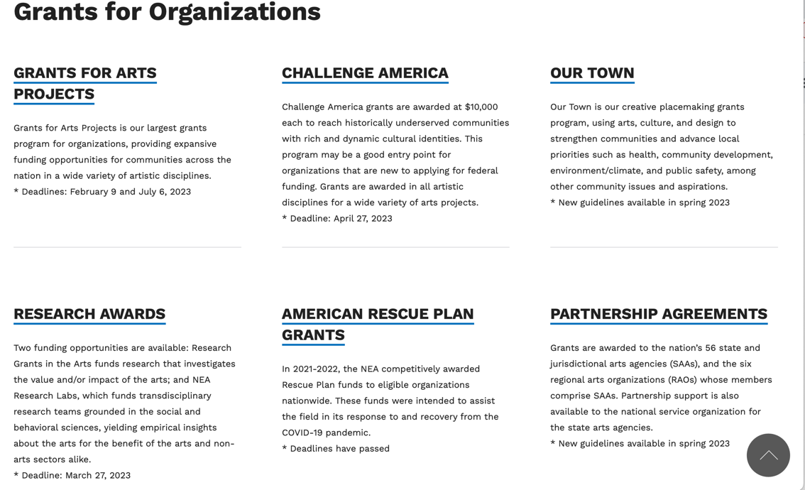

See more at: https://www.arts.gov/grants

National Endowment for the Humanities

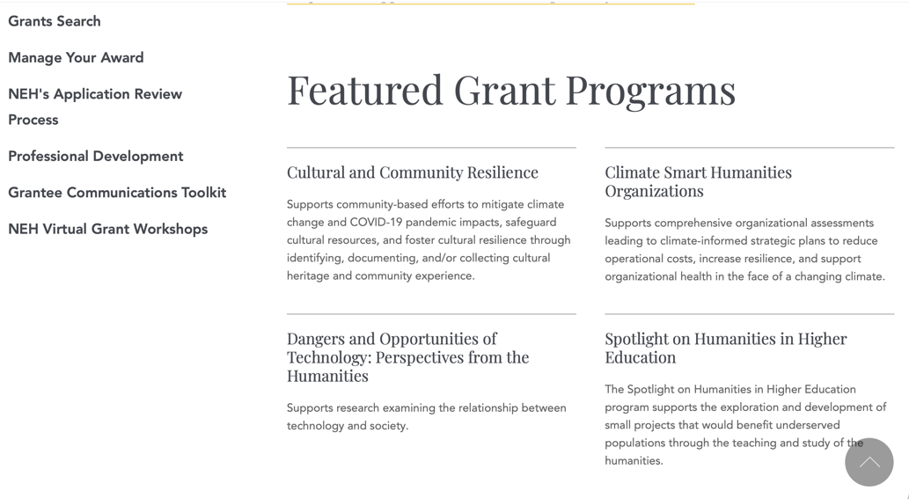

https://www.neh.gov/grants

National Science Foundation



For assistance: https://nsf.gov/funding/aboutfunding.jsp

The National Science Foundation funds research and education in most fields of science and engineering. It does this through grants, and cooperative agreements to more than 2,000 colleges, universities, K-12 school systems, businesses, informal science organizations and other research organizations throughout the United States. The Foundation accounts for about one-fourth of federal support to academic institutions for basic research.
NSF receives approximately 40,000 proposals each year for research, education and training projects, of which approximately 11,000 are funded. In addition, the Foundation receives several thousand applications for graduate and postdoctoral fellowships.
The agency operates no laboratories itself but does support National Research Centers, user facilities, certain oceanographic vessels and Antarctic research stations. The Foundation also supports cooperative research between universities and industry, US participation in international scientific and engineering efforts, and educational activities at every academic level.

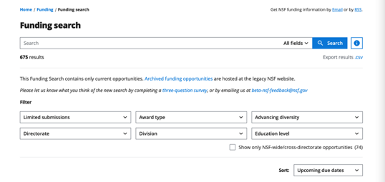

For details on active funding deadline dates: http://nsf.gov/funding/pgm_list.jsp?org=NSF&ord=date

Small Business Administration

https://www.sba.gov/funding-programs/loans
Federal, state and local governments offer a wide range of financing programs to help small businesses start and grow their operations. These programs include low-interest loans, venture capital, and scientific and economic development grants.
Use SBA.gov's Loans and Grants Search Tool to get a list of financing programs for which you may qualify, or visit the resources below to learn more about small business financing programs.

To get to the main SBA.gov funding page click here
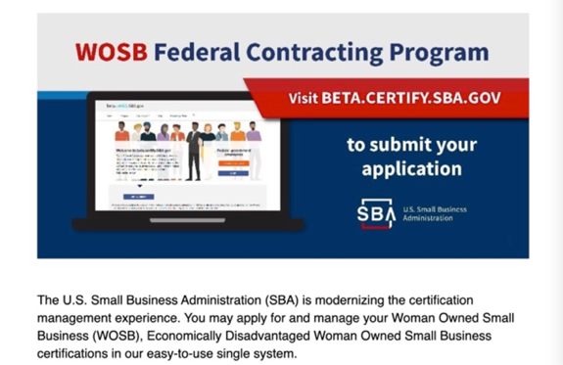
Learn more
https://www.sba.gov/learning-center

SBA Trainings

https://www.sba.gov/learning-center
Upcoming Trainings: Check out SBA's Online Training!
- Financing Options for Small Businesses
For Specific Information in Hawaii see the following links:

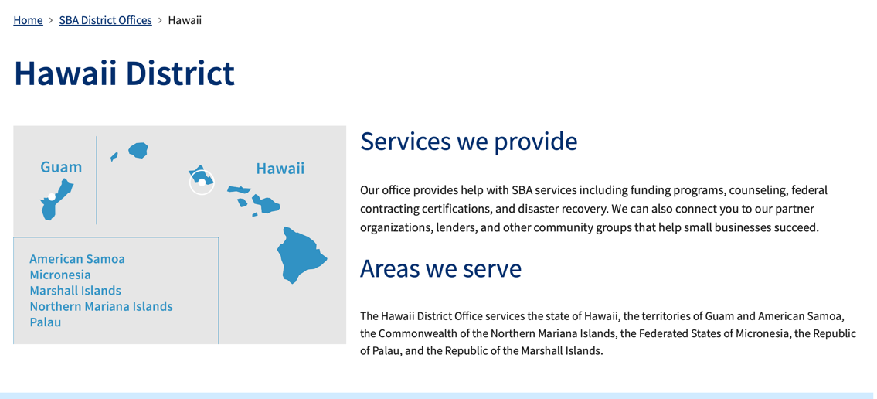
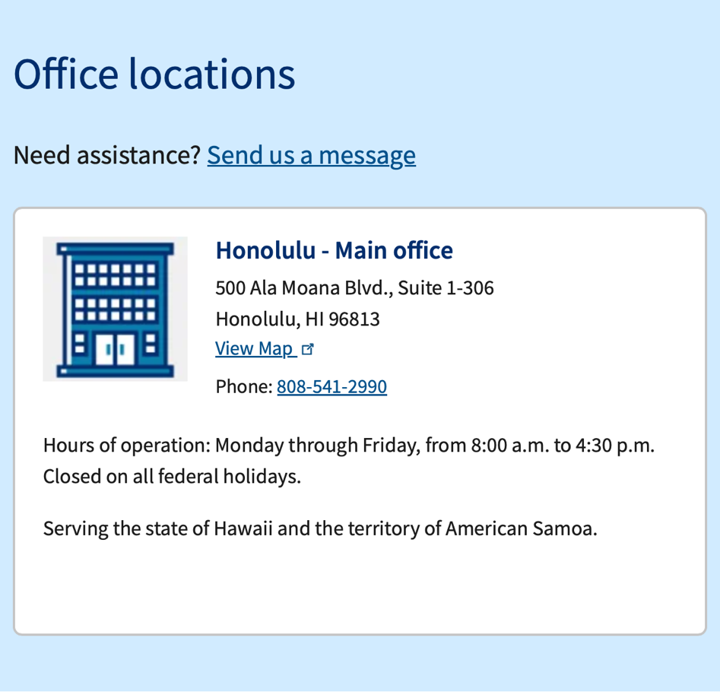

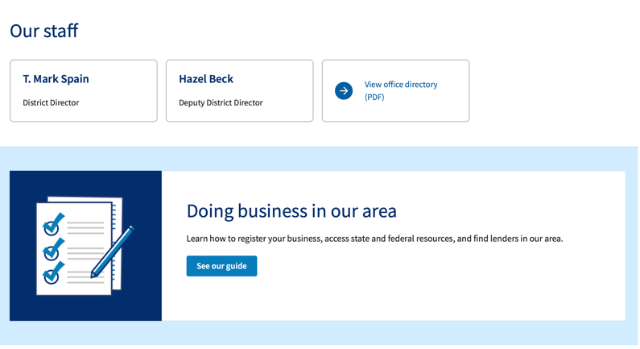

https://www.sba.gov/offices/district/hi/Honolulu

State Department

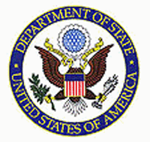

https://eca.state.gov/about-bureau/organizational-structure/grants-division

http://eca.state.gov/search/solr/grants?search_referrer=node/237

https://eca.state.gov/organizational-funding/open-grant-solicitations

http://eca.state.gov/organizational-funding/applying-grant

General Information:
- Bureau of Educational and Cultural Affairs Grants Division
- Open Grant Opportunities (Requests for Grant Proposals)

For General Information click here

Department of Transportation

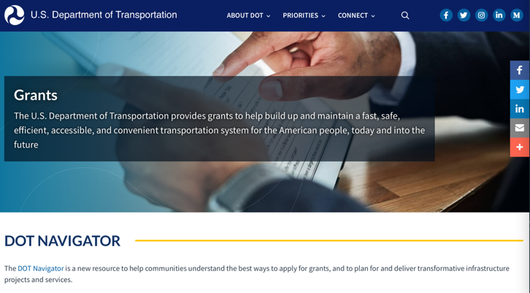

General Grant Program Overview https://www.transportation.gov/grants

Department of the Treasury

https://home.treasury.gov/services/grant-programs

U.S. Agency for International Development
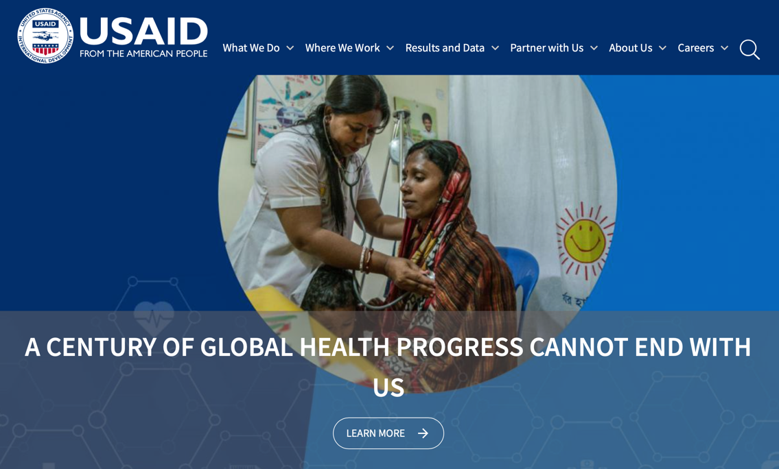

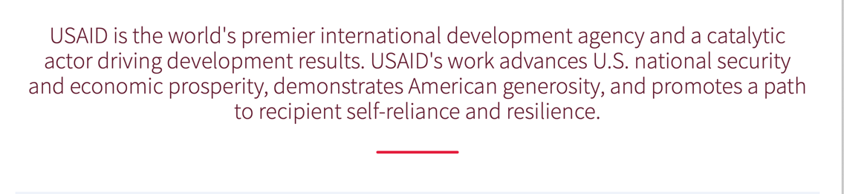

www.usaid.gov

General Overview Funding Opportunities

USAID has working relationships with thousands of American companies and hundreds of U.S.-based private voluntary organizations. For more information on our business and procurement opportunities, \

Department of Veterans Affairs

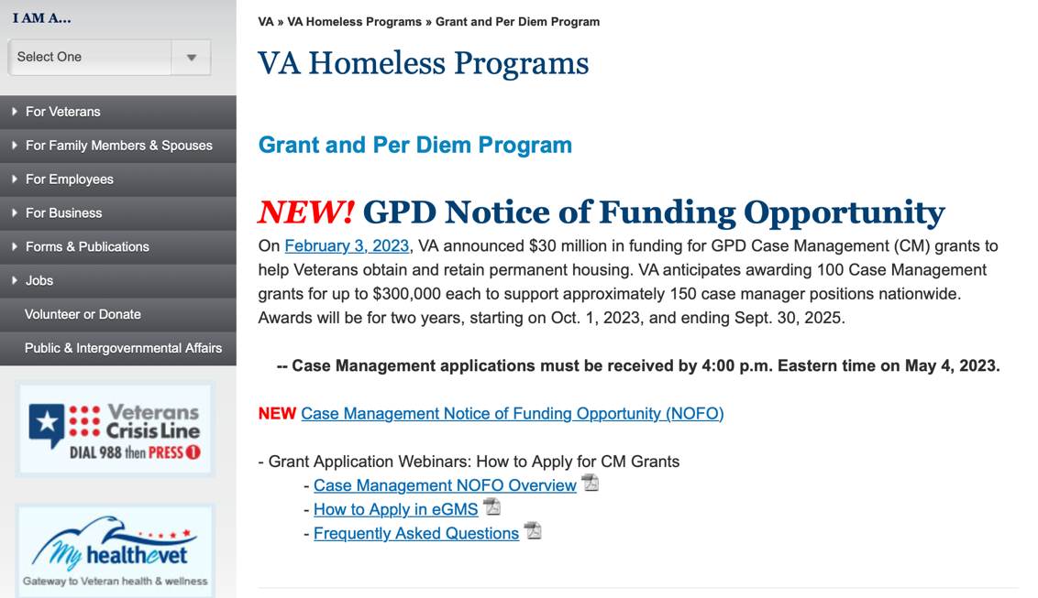

Page reviewed on May 3, 2023

https://www.va.gov/homeless/gpd.asp

https://www.va.gov/pacific-islands-health-care/

GRANTS.GOV

Provides a Grants Learning Center as a gateway to the federal grants world. Bookmark the following link and participate at blog.grants.gov or on twitter @grantsdotgov

Topics include: Grants 101, Grant Policies, Grant Eligibility, Grant Terms, Grant Agencies , Grant Systems, Grant Programs, Grant Careers, Grant Reporting, Grant Fraud and Grant Events

https://www.grants.gov/web/grants/learn-grants.html

Grants.gov maintains a blog. This reprinted article provides some helpful tips:

Grant Writing: 3 Tips for Crafting Need Statements in Federal Grant Proposals
Posted on March 27, 2019 by Grants.gov
In this space, we have previously shared tips about the pre-writing phase of completing a federal grant application – for example, the importance of reading (and re-reading) the grant announcement, and the importance of understanding the criteria by which your application will be evaluated.
In this post, we dip our toes into the grant writing process itself and share some tips about crafting a need statement. These tips are adapted from the U.S. Department of Health and Human Services Health Resources & Services Administration’s grant writing guide, titled “Tips for Writing and Submitting Good Grant Proposals”. Along with each tip, we also include an excerpt from an award-winning federal grant proposal that can be viewed in full on the website of the Institute of Museum and Library Services. (IMLS has an excellent collection of proposals that are worthy of review – especially for new federal grant applicants.)

https://grantsgovprod.wordpress.com/2019/03/27/3-tips-for-crafting-need-statements-in-federal-grant-proposals/?utm_source=newsletter&utm_medium=email&utm_campaign=noprofile&utm_content=june2020

Grant Writing Resources

The following links are a great resource for Faith-Based Non-profits and other community organizations:

U.S. Department of Justice
Task Force for Faith-Based and Community Initiatives

Foundation Center
Proposal Writing Short Course

USDA Rural Information Center
A Guide to Funding Resources

The Small Business Innovative Research Program - SBIR Program

The Small Business Innovation Research (SBIR) program is a highly competitive program that encourages domestic small businesses to engage in Federal Research/Research and Development (R/R&D) that has the potential for commercialization. Through a competitive awards-based program, SBIR enables small businesses to explore their technological potential and provides the incentive to profit from its commercialization. By including qualified small businesses in the nation's R&D arena, high-tech innovation is stimulated, and the United States gains entrepreneurial spirit as it meets its specific research and development needs.

SBIR Mission and Program Goals
The mission of the SBIR program is to support scientific excellence and technological innovation through the investment of Federal research funds in critical American priorities to build a strong national economy.
The program’s goals are four-fold:
- Stimulate technological innovation
- Meet Federal research and development needs.
- Foster and encourage participation in innovation and entrepreneurship by socially and economically disadvantaged persons.
- Increase private-sector commercialization of innovations derived from Federal research and development funding.

SBIR-Participating Agencies
Each year, Federal agencies with extramural research and development (R&D) budgets that exceed $100 million are required to allocate 2.5 percent of their R&D budget to these programs. Currently,
- eDepartment of Commerce - National Institute of Standards and Technology
- Department of Energy
- Department of Health and Human Services
- Department of Transportation
- National Aeronautics and Space Administration
- National Science Foundation
Each agency administers its own individual program within guidelines established by Congress. These agencies designate R&D topics in their solicitations and accept proposals from small businesses. Awards are made on a competitive basis after proposal evaluation.

Three-Phase Program
The SBIR Program is structured in three phases:
Phase I. The objective of Phase I is to establish the technical merit, feasibility, and commercial potential of the proposed R/R&D efforts and to determine the quality of performance of the small business awardee organization prior to providing further Federal support in Phase II. SBIR Phase I awards normally do not exceed $150,000 total costs for 6 months.
Phase II. The objective of Phase II is to continue the R/R&D efforts initiated in Phase I. Funding is based on the results achieved in Phase I and the scientific and technical merit and commercial potential of the project proposed in Phase II. Only Phase I awardees are eligible for a Phase II award. SBIR Phase II awards normally do not exceed $1,000,000 total costs for 2 years.
Phase III. The objective of Phase III, where appropriate, is for the small business to pursue commercialization objectives resulting from the Phase I/II R/R&D activities. The SBIR program does not fund Phase III. Some Federal agencies, Phase III may involve follow-on non-SBIR funded R&D or production contracts for products, processes or services intended for use by the U.S. Government

