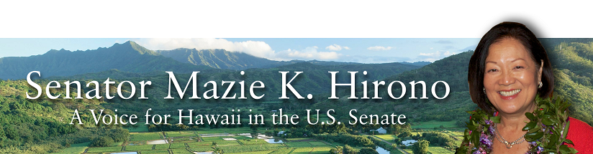

Grants Assistance Information
Newsletter
March 2016

G.A.I.N. INDEX

Click on Index Links below to read summaries of the announcements by agency in this document.
Once you reach the item, if you cannot open the links for further information, copy the selected
URL website address into your browser.

Modified sections from previous listings are shown in a GREY background

Notices is Teal are items with immediate deadline dates.

Notices in Yellow are of special interest.

Notices is Green are items of special interest with immediate deadline dates.

Items in this type color are aimed at Small Businesses

Items in this type color have a Faith-Based Organization component

Special Federal Program Notices

SBIR – Small Business Innovation Research

Programs specific to Hawaii

Current Notices

Department of Education

Office of Postsecondary Education (OPE): Asian American and Native American Pacific Islander-Serving Institutions Program CFDA Number 84.382B Grant

Office of Postsecondary Education (OPE): Native Hawaiian-Serving Institutions Program CFDA Number 84.031V Grant

Department of Health and Human Services

Health Resources and Services Administration
Service Area Competition – Additional Areas (SAC-AA) – California, Hawaii, New York, Oregon, and Washington Grant

Small Business Administration

Veterans Business Outreach Center Program (VBOC) Grant

Reminders

Department of Interior

National Park Service
NAGPRA Consultation/Documentation Grants FY16
Modification 2

Department of the Interior
National Park Service
FY 2016 Historic Preservation Fund Tribal Heritage Grants
Modification 1

See Individual Departments for information and webpages representing the best and most accessible information on the agency funding opportunities

Federal Grant and Cooperative Agreement Program Summaries

U.S. Department of Agriculture

Grants and Loans Overview

Programs

National Institute of Food and Agriculture
Supplemental and Alternative Crops Competitive Grants Program

National Institute of Food and Agriculture
Higher Education Challenge Grants Program

Forest Service
2017 National Urban and Community Forestry Grant Program

Modifications

Farm Service Agency
Outreach and Education, Technical Assistance, and Financial Education for FSA Programs, Functions, and Activities
Modification 2

Natural Resources Conservation Service
Wetlands Mitigation Banking Program
Modification 4

National Institute of Food and Agriculture
Secondary Education, Two-Year Postsecondary Education, and Agriculture in the K-12 Classroom (SPECA) Challenge Grant Program
Modification 1

National Institute of Food and Agriculture
Agriculture and Food Research Initiative - Food, Agriculture, Natural Resources and Human Sciences Education and Literacy Initiative
Modifications 1 & 2

Reminders

Utilities Programs
Distance Learning and Telemedicine Grant Program

National Institute of Food and Agriculture
Agriculture and Food Research Initiative - Food, Agriculture, Natural Resources and Human Sciences Education and Literacy Initiative Grant

National Institute of Food and Agriculture
Capacity Building Grants for Non Land Grant Colleges of Agriculture (NLGCA) Grant

National Institute of Food and Agriculture
FY '16 Farm Business Management and Benchmarking (FBMB) Competitive Grants Program RFA Grant

National Institute of Food and Agriculture
Organic Agriculture Research and Extension Initiative Grant

Farm Service Agency
Outreach and Education, Technical Assistance, and Financial Education for FSA Programs, Functions, and Activities Grant

Business and Cooperative Programs
Renewable Energy Systems and Energy Efficiency Improvements Program Grant

National Institute of Food and Agriculture
Biotechnology Risk Assessment Grants Program

Department of Commerce

Programs

National Institute of Standards and Technology
Graduate Student Measurement Science and Engineering (GMSE) Fellowship Program Grant

National Institute of Standards and Technology
NIST Standards Services Curricula Development (SSCD) Cooperative Agreement Program Grant

National Institute of Standards and Technology
FY 2016 Small Business Innovation Research (SBIR) Program Grant

National Institute of Standards and Technology
FY 2016 Small Business Innovation Research (SBIR) Program – Phase II Grant

National Institute of Standards and Technology
Replicable Smart City Technologies Cooperative Agreement Program Grant

FY 2016 Joint Technology Transfer Initiative Grant

National Institute of Standards and Technology
Measurement Science and Engineering (MSE) Research Grant Programs

National Institute of Standards and Technology
National Network for Manufacturing Innovation (NNMI) Institute Awards Grant

Modifications

Fiscal Year 2017 National Sea Grant College Program Dean John A. Knauss Marine Policy Fellowship
Modification 1

Reminders

Market Development Cooperator Program 2016 Grant

National Sea Grant College Program 2016-17 Special Projects Grant

FY 2016 – FY 2019 EDA Planning Program and Local Technical Assistance Program Grant

Fisheries International Cooperation and Assistance Program Grant

FY 2016 Economic Development Assistance Programs ­ Application submission and program requirements for EDA’s Public Works and Economic Adjustment Assistance Programs

Economic Development Administration
Planning Program and Local Technical Assistance Program Grant

Corporation for National and Community Service

General Program Overview

Reminders

National Service in Hawaii

Department of Defense

Doing Business with the Department of Defense

DoD Small Business Opportunities and Forecasting

Research Grants

Modifications

Reminders

Dept. of the Army -- Materiel Command
Army Research Office Broad Agency Announcement for Basic and Applied Scientific Research
Modification 8

Department of Education

Grant Programs Overview

Programs

Under the Small, Rural School Achievement (SRSA) Program CFDA 84.358A Grant

Office of Postsecondary Education (OPE): Training Program for Federal TRIO Programs CFDA Number 84.103A Grant

Office of Postsecondary Education (OPE): Educational Opportunity Centers (EOC) Program CFDA Number 84.066A Grant

Office of Special Education and Rehabilitative Services (OSERS): Office of Special Programs (OSEP): Training and Information for Parents of Children with Disabilities: Community Parent Resource Centers CFDA Number 84.328C Grant

Office of Special Education and Rehabilitative Services (OSERS): Office of Special Education Programs (OSEP): Educational Technology, Media, and Materials for Individuals with Disabilities: Stepping-up Technology Implementation CFDA Number 84.327S Grant

Modifications

Reminders

Office of Elementary and Secondary Education (OESE): College Assistance Migrant Program (CAMP) CFDA Number 84.149A
Modification 1

Office of Elementary and Secondary Education (OESE): High School Equivalency Program (HEP) CFDA Number 84.141A
Modification 1

US Department of Energy

Grants Overview

Programs

Modifications

Reminders

Environmental Protection Agency

Grants and Contracts Overview

Programs

Clean Diesel Funding Assistance Program FY 2016 Grant

Environmental Education Local Grants Program -- Solicitation Notice for 2016 Grant

Early Career Awards: Integrating Human Health and Well-Being with Ecosystem Services Grant

Integrating Human Health and Well-Being with Ecosystem Services Grant

Modifications

Reminders

Department of Health and Human Services

Grants Overview

Program

Research Grants

Modifications

Reminders

Office of the Assistant Secretary for Health
Announcement Availability of Funds for the College Sexual Assault Policy and Prevention Initiative
Modification 2

Substance Abuse & Mental Health Services Administration
Drug-Free Communities (DFC) Support Program Grant

National Institutes of Health
PHS 2015-02 Omnibus Solicitation of the NIH, CDC, FDA and ACF for Small Business Innovation Research Grant Applications (Parent SBIR [R43/R44]) Grant

Department of Homeland Security
Grants Overview

Programs

Department of Homeland Security - FEMA
Fiscal Year (FY) 2015 Staffing for Adequate Fire and Emergency Response (SAFER) Grant

Department of Homeland Security - FEMA
FY16 Pre-Disaster Mitigation Grant

Department of Homeland Security - FEMA
FY16 Flood Mitigation Assistance Grant

Modifications

Department of Homeland Security - FEMA
Fiscal Year 2016 Port Security Grant Program (PSGP)
Modification 2

Department of Homeland Security - FEMA
Fiscal Year (FY) 2016 Intercity Bus Security Grant Program (IBSGP)
Modification 2

Department of Homeland Security - FEMA
Fiscal Year 2016 Transit Security Grant Program (TSGP)
Modification 2

Reminders

United States Coast Guard
National Non-Profit Organization Grant Program

Department of Housing and Urban Development

HUD - Notice of Funds Available

Programs

Notice of Funding Availability (NOFA) for the Department's Fiscal Years 2016 and 2017 Comprehensive Housing Counseling Grant Program

NOFA for HUD's FY16-17 Housing Counseling Training Grant Program

Modifications

Reminders

Housing Opportunities for Persons With AIDS (HOPWA) Project Demonstration and Violence Against Women Act (VAWA) Grant

Supportive Services Demonstration for Elderly Households in HUD-Assisted Multifamily Housing
Grant

General Section to HUD's Fiscal Year 2016 Notice[s] of Funding Availability for Discretionary Programs (General Section)
Modification 1

Institute of Museum and Library Services

Grants Overview

IMLS is on Facebook!

Modifications

Reminders

STEM Expert Facilitation of Family Learning in Libraries and Museums

National Leadership Grants for Libraries Grant

Laura Bush 21st Century Librarian Program Grant

Department of Interior

Grants and Contract Overview

Programs

Fish and Wildlife Service
Combating Wildlife Trafficking Grant

Fish and Wildlife Service
Fiscal Year 2016 Recovery Implementation Fund Grant

Fish and Wildlife Service
Natural Resources Damage Assessment, Restoration and Implementation Grant

Fish and Wildlife Service
Fiscal Year 2016 Candidate Conservation Action Funds Grant

Modifications

Reminders

Request for Pre-Proposals to develop and or improve climate change actions' affect on linkages between ecological and human resources
Modification 1

Fish and Wildlife Service
National Fish Passage Program Grant

Department of the Interior
Fish and Wildlife Service
2016 National Fish Habitat Action Plan
Modification 1

Department of Justice

Grants and Contract Overview

Programs

Office of Justice Programs
National Institute of Justice
Research and Evaluation on Drugs and Crime Grant
And Modifications 1, 2 &3

Office of Justice Programs
Bureau of Justice Assistance
Smart Supervision: Reducing Prison Populations, Saving Money, and Creating Safer Communities
Grant

Office of Justice Programs
Bureau of Justice Assistance
Justice Reinvestment Initiative: Maximizing State Reforms Grant

Office of Justice Programs
Bureau of Justice Assistance
Second Chance Act Reentry Program for Adults with Co-Occurring Substance Abuse and Mental Disorders
And Modification 1

Office of Justice Programs
National Institute of Justice
NIJ FY16 Visiting Fellows Program Grant

Office of Justice Programs
Bureau of Justice Statistics
FY 2016 NICS Act Record Improvement Program (NARIP) Grant
And Modification 1

Office of Justice Programs
National Institute of Justice
Research and Evaluation on Institutional Corrections Grant

Office of Justice Programs
National Institute of Justice
Research and Evaluation in Support of the Recommendations of the President's Task Force on 21st Century Policing Grant

Office of Justice Programs
Bureau of Justice Assistance
National Initiatives: Officer Safety and Wellness
And Modification 1

National Institute of Justice
W.E.B. DuBois Program of Research on Race and Crime Grant

Modifications

Office of Justice Programs
Bureau of Justice Assistance
Swift, Certain, and Fair Sanctions (SCF)/ Replicating the Concepts Behind Project HOPE
Modification 2

Office of Justice Programs
Bureau of Justice Assistance
Intellectual Property Enforcement Program
Modification 2

Office of Justice Programs
Bureau of Justice Assistance
Wrongful Conviction Review Program
Modification 1

Office of Justice Programs
Bureau of Justice Assistance
Smart Prosecution Initiative
Modification 1

Office of Justice Programs
Bureau of Justice Assistance
Encouraging Innovation: Field-Initiated Programs Concept Paper
Modification 1

Office of Justice Programs
Bureau of Justice Assistance
Violent Gang And Gun Crime Reduction Program (PSN)
Modification 1

Office of Justice Programs
Bureau of Justice Assistance
Smart Policing Initiative
Modification 2

Office of Justice Programs
Bureau of Justice Assistance
Second Chance Act Comprehensive Community-Based Adult Reentry Program Utilizing Mentors
Modification 1

Office of Justice Programs
Bureau of Justice Assistance
Adult Drug Court Discretionary Grant Program
Modification 1

Office of Justice Programs
Bureau of Justice Assistance
Second Chance Act Technology-Based Career Training Program for Incarcerated Adults and Juveniles
Modification 1

Reminders

Office of Justice Programs
National Institute of Justice
Developing Improved Means to Collect Digital Evidence Grant

Office of Justice Programs
National Institute of Justice
Postconviction Testing of DNA Evidence to Exonerate the Innocent Grant

Office of Justice Programs
National Institute of Justice
Research and Evaluation for the Testing and Interpretation of Physical Evidence in Publicly Funded Forensic Laboratories Grant

Office of Justice Programs
Office on Violence Against Women
OVW FY 2016 Training and Services to End Violence Against Women with Disabilities Grant Program

Office of Justice Programs
Office of Juvenile Justice Delinquency Prevention
OJJDP FY 16 VOCA Regional Children Advocacy Center Program Grant

Office of Justice Programs
Office of Juvenile Justice Delinquency Prevention
OJJDP FY 16 Mentoring for Child Victims of Commercial Sexual Exploitation and Domestic Sex Trafficking Initiative
Modification 1

Office of Justice Programs
Office of Juvenile Justice Delinquency Prevention
OJJDP FY 16 Mentoring for Child Victims of Commercial Sexual Exploitation and Domestic Sex Trafficking Initiative
Modifications 2 & 3

Department of Labor

Grants and Contract General Overview

Programs

Employment and Training Administration
Summer Jobs and Beyond: Career Pathways for Youth (CPY)
And Modification 1

Employment and Training Administration
Veterans Employment and Training Service
Urban and Non-Urban Homeless Veterans’ Reintegration Program (HVRP) and Incarcerated Veterans Transition Program (IVTP) (referred together throughout this funding opportunity announcement as HVRP) Grant

Modifications

Employment and Training Administration
Tech Hire Partnership Grants
Modification 2

Reminders

Employment and Training Administration
Strengthening Working Families Initiative Grant

Employment and Training Administration
Tech Hire Partnership Grants

National Aeronautics and Space Administration

Research Grant and Contract General Overview

Programs

Modifications

_______________________________________________________________
National Archives and Records Administration

Grant Opportunities General Overview

Reminders

State Board Programming Grants

Publishing Historical Records in Documentary Editions Grant

Access to Historical Records Grant

_______________________________________________________________
National Endowment for the Arts

Grant Opportunities General Overview

Programs

Modifications

Reminders

2017 National Heritage Fellowships Awards Program Grant

2017 Mayor's Institute on City Design (MICD) Grant

NEA Challenge America Application, FY2017 Grant

NEA Literature (Poetry) Fellowships, FY2017 Grant

_______________________________________________________________

National Endowment for the Humanities

Grant Opportunities General Overview

Programs

Fellowships Grant

Fellowships for Advanced Social Science Research on Japan Grant

Institutes for Advanced Topics in the Digital Humanities Grant

Modifications

Reminders

National Science Foundation

Grant Opportunities General Overview

Research and Program Grants

Modifications

Reminders

Nuclear Regulatory Commission

Reminders

Small Business Administration

General Overview Finding Loans & Grants

Reminders

Upcoming Trainings

Links Specific to Hawaii

State Department

General Overview and Resources for Program Administrators

Programs

Modifications

Reminders

U.S. Department of Transportation

General Grant Program Overview

FY 2016 National Infrastructure Investments Grant

DOT/National Highway Traffic Safety Administration
Statewide Pedestrian and Bicyclist Focus Education and Enforcement Effort Grant

Modifications

Reminders

DOT Federal Highway Administration
National Summer Transportation Institute Grant

DOT/Federal Motor Carrier Safety Administration
FY2016 Commercial Motor Vehicle Operator Safety Training Grant Program

DOT/Federal Motor Carrier Safety Administration
FY 2016 Commercial Drivers License Program Implementation Notice of Funding Availability
And Modifications 1 & 4

DOT Federal Aviation Administration
DOT - FAA Aviation Research Grants
FAA Aviation Research and Development Grants
Modification 3

Department of the Treasury

Community Development Financial Institutions
Fiscal Year 2016 Capital Magnet Fund Program
And Modification 1

Modifications

Reminders

US Agency for International Development

General Funding Opportunity Overview

Programs
Modifications

Reminders

Department of Veterans Affairs

National Veterans Sports Programs
Grants for Adaptive Sports Programs for Disabled Veterans and Disabled Members of the Armed Forces Grant

Special Federal Program Notices

The Small Business Innovative Research Program - SBIR Program
The Small Business Innovation Research (SBIR) program is a highly competitive program that encourages domestic small businesses to engage in Federal Research/Research and Development (R/R&D) that has the potential for commercialization. Through a competitive awards-based program, SBIR enables small businesses to explore their technological potential and provides the incentive to profit from its commercialization. By including qualified small businesses in the nation's R&D arena, high-tech innovation is stimulated and the United States gains entrepreneurial spirit as it meets its specific research and development needs.

SBIR Mission and Program Goals
The mission of the SBIR program is to support scientific excellence and technological innovation through the investment of Federal research funds in critical American priorities to build a strong national economy.
The program’s goals are four-fold:
- Stimulate technological innovation
- Meet Federal research and development needs.
- Foster and encourage participation in innovation and entrepreneurship by socially and economically disadvantaged persons.
- Increase private-sector commercialization of innovations derived from Federal research and development funding.

SBIR-Participating Agencies
Each year, Federal agencies with extramural research and development (R&D) budgets that exceed $100 million are required to allocate 2.5 percent of their R&D budget to these programs. Currently, eleven Federal agencies participate in the program:
- Department of Agriculture
- Department of Commerce - National Institute of Standards and Technology
- Department of Commerce - National Oceanic and Atmospheric Administration
- Department of Defense
- Department of Education
- Department of Energy
- Department of Health and Human Services
- Department of Homeland Security
- Department of Transportation
- Environmental Protection Agency
- National Aeronautics and Space Administration
- National Science Foundation
Each agency administers its own individual program within guidelines established by Congress. These agencies designate R&D topics in their solicitations and accept proposals from small businesses. Awards are made on a competitive basis after proposal evaluation.

Three-Phase Program
The SBIR Program is structured in three phases:
Phase I. The objective of Phase I is to establish the technical merit, feasibility, and commercial potential of the proposed R/R&D efforts and to determine the quality of performance of the small business awardee organization prior to providing further Federal support in Phase II. SBIR Phase I awards normally do not exceed $150,000 total costs for 6 months.
Phase II. The objective of Phase II is to continue the R/R&D efforts initiated in Phase I. Funding is based on the results achieved in Phase I and the scientific and technical merit and commercial potential of the project proposed in Phase II. Only Phase I awardees are eligible for a Phase II award. SBIR Phase II awards normally do not exceed $1,000,000 total costs for 2 years.
Phase III. The objective of Phase III, where appropriate, is for the small business to pursue commercialization objectives resulting from the Phase I/II R/R&D activities. The SBIR program does not fund Phase III. Some Federal agencies, Phase III may involve follow-on non-SBIR funded R&D or production contracts for products, processes or services intended for use by the U.S. Government
SBIR NewsLetter

- SBIR Newsletter
Sign up for e-mail updates

HAWAII APPLICANTS ENCOURAGED

Current Notices:

Department of Education
Office of Postsecondary Education (OPE): Asian American and Native American Pacific Islander-Serving Institutions Program CFDA Number 84.382B Grant

Document Type: | Grants Notice
Funding Opportunity Number: | ED-GRANTS-022216-001
Funding Opportunity Title: | Office of Postsecondary Education (OPE): Asian American and Native American Pacific Islander-Serving Institutions Program CFDA Number 84.382B
Opportunity Category: | Discretionary
Opportunity Category Explanation:
Funding Instrument Type: | Grant
Category of Funding Activity: | Education
Category Explanation:
Expected Number of Awards: | 14
CFDA Number(s): | 84.382 -- Strengthening Minority-Serving Institutions
Cost Sharing or Matching Requirement: | No
Posted Date: | Feb 22, 2016
Last Updated Date: | Feb 22, 2016
Original Closing Date for Applications: | Apr 22, 2016 Applications Available: February 22, 2016. Deadline for Transmittal of Applications: April 22, 2016.
Current Closing Date for Applications: | Apr 22, 2016 Applications Available: February 22, 2016. Deadline for Transmittal of Applications: April 22, 2016.
Archive Date: | May 22, 2016
Estimated Total Program Funding: | $4,635,000
Award Ceiling: | $350,000
Eligible Applicants: | Public and State controlled institutions of higher education  Others (see text field entitled "Additional Information on Eligibility" for clarification)  Private institutions of higher education
Additional Information on Eligibility: | Eligible Applicants: An IHE is eligible to receive funds under the AANAPISI Program if it qualifies as an Asian American and Native American Pacific Islander-Serving Institution. At the time of application, IHEs applying for funds under the AANAPISI Program must have an enrollment of undergraduate students that is at least 10 percent Asian American or Native American Pacific Islander, as defined as follows: Asian American means a person having origins in any of the original peoples of the Far East, Southeast Asia, or the Indian subcontinent (including, for example, Cambodia, China, India, Japan, Korea, Malaysia, Pakistan, the Philippine Islands, Thailand, and Vietnam), as defined in OMB's Standards for Maintaining, Collecting, and Presenting Federal Data on Race and Ethnicity as published in the Federal Register on October 30, 1997 (62 FR 58789). Native American Pacific Islander means any descendant of the aboriginal people of any island in the Pacific Ocean that is a territory or possession of the United States. At the time of submission of their applications, applicants must certify their total undergraduate headcount enrollment and that 10 percent of the IHE's enrollment is Asian American or Native American Pacific Islander. An assurance form, which is included in the application materials for this competition, must be signed by an official for the applicant and submitted. To qualify as an eligible institution under the AANAPISI Program, an institution must also be-- (i) Accredited or pre-accredited by a nationally recognized accrediting agency or association that the Secretary has determined to be a reliable authority as to the quality of education or training offered; (ii) Legally authorized by the State in which it is located to be a community college or to provide an educational program for which it awards a bachelor's degree; and (iii) Designated as an ``eligible institution'' by demonstrating that it has: (A) An enrollment of needy students as described in 34 CFR 607.3; and (B) low average educational and general expenditures per full-time equivalent (FTE) undergraduate student as described in 34 CFR 607.4. Note: The notice announcing the FY 2016 process for designation of eligible institutions, and inviting applications for waiver of eligibility requirements, was published in the Federal Register on November 19, 2015 (80 FR 72422). Only institutions that the Department determines are eligible, or are granted a waiver, may apply for a grant in this program.
Agency Name: | Department of Education
Description: | Note: Each funding opportunity description is a synopsis of information in the Federal Register application notice. For specific information about eligibility, please see the official application notice. The official version of this document is the document published in the Federal Register. Free Internet access to the official edition of the Federal Register and the Code of Federal Regulations is available on GPO Access at: http://www.access.gpo.gov/nara/index.html. Please review the official application notice for pre-application and application requirements, application submission information, performance measures, priorities and program contact information. Purpose of Program: The AANAPISI Program provides grants to eligible institutions of higher education (IHEs) that have an undergraduate enrollment of at least 10 percent Asian American or Native American Pacific Islander students to allow such institutions to plan, develop, undertake, and carry out activities to improve and expand their capacity to serve Asian Americans and Native American Pacific Islanders and low-income individuals. Examples of authorized activities for the AANAPISI Program are in section 311(c) of the Higher Education Act of 1965, as amended (HEA). Catalog of Federal Domestic Assistance (CFDA) Number: 84.382B. Applications for grants under the AANAPISI Program, CFDA number 84.382B, must be submitted electronically using the Governmentwide Grants.gov Apply site at www.Grants.gov. Through this site, you will be able to download a copy of the application package, complete it offline, and then upload and submit your application. You may not email an electronic copy of a grant application to us. You may access the electronic grant application for the AANAPISI Program at www.Grants.gov. You must search for the downloadable application package for this program by the CFDA number. Do not include the CFDA number's alpha suffix in your search (e.g., search for 84.382, not 84.382B).
Link to Additional Information: | Office of Postsecondary Education (OPE): Asian American and Native American Pacific Islander-Serving Institutions Program CFDA Number 84.382B; Notice inviting applications for new awards for fiscal year (FY) 2016
Contact Information: | If you have difficulty accessing the full announcement electronically, please contact:  Julius Cotton ED Grants.gov FIND Systems Admin. Phone 202-245-6288 EducationGrantInquiries@ed.gov Program Managers: Pearson Owens or Don Crews, Office of Postsecondary Education, U.S. Department of Education, 400 Maryland Avenue SW., Room 7E311, Washington, DC 20202. You may contact these individuals at the following email addresses or telephone numbers: Pearson.Owens@ed.gov; (202) 502-7804 Don.Crews@ed.gov; (202) 502-7574  e-Mail: Program Manager

http://www.grants.gov/web/grants/view-opportunity.html?oppId=281701

Office of Postsecondary Education (OPE): Native Hawaiian-Serving Institutions Program CFDA Number 84.031V Grant
Document Type: | Grants Notice
Funding Opportunity Number: | ED-GRANTS-022616-004
Funding Opportunity Title: | Office of Postsecondary Education (OPE): Native Hawaiian-Serving Institutions Program CFDA Number 84.031V
Opportunity Category: | Discretionary
Opportunity Category Explanation: | Category Explanation
Funding Instrument Type: | Grant
Category of Funding Activity: | Education
Category Explanation:
Expected Number of Awards: | 3
CFDA Number(s): | 84.031 -- Higher Education Institutional Aid
Cost Sharing or Matching Requirement:
Posted Date: | Feb 26, 2016
Last Updated Date: | Feb 26, 2016
Original Closing Date for Applications: | Apr 26, 2016 Applications Available: February 26, 2016. Deadline for Transmittal of Applications: April 26, 2016.
Current Closing Date for Applications: | Apr 26, 2016 Applications Available: February 26, 2016. Deadline for Transmittal of Applications: April 26, 2016.
Archive Date: | May 26, 2016
Estimated Total Program Funding: | $1,500,000
Award Ceiling: | $500,000
Eligible Applicants: | Others (see text field entitled "Additional Information on Eligibility" for clarification)
Additional Information on Eligibility: | 1. Eligible Applicants: (a) An IHE is eligible to receive funds under the ANNH Program if it qualifies as an Alaska Native or Native Hawaiian-Serving Institution. At the time of application, an Alaska Native-Serving Institution must have an enrollment of undergraduate students that is at least 20 percent Alaska Native (34 CFR 607.2(e)); and a Native Hawaiian-Serving Institution must have an enrollment of undergraduate students that is at least 10 percent Native Hawaiian (34 CFR 607.2(f)). At the time of submission of their applications, applicants must certify their total undergraduate headcount enrollment and that either 20 percent of the IHE's enrollment is Alaska Native or 10 percent is Native Hawaiian. An assurance form, which is included in the application materials for this competition, must be signed by an official for the applicant and submitted. To qualify as an eligible institution under the ANNH Program, an institution must also be-- (i) Accredited or preaccredited by a nationally recognized accrediting agency or association that the Secretary has determined to be a reliable authority as to the quality of education or training offered; (ii) Legally authorized by the State in which it is located to be a junior college or to provide an educational program for which it awards a bachelor's degree; and (iii) Designated as an ``eligible institution'' by demonstrating that it: (1) Has an enrollment of needy students as described in 34 CFR 607.3; and (2) has low average educational and general expenditures per full-time equivalent (FTE) undergraduate student, as described in 34 CFR 607.4. Note: The notice announcing the FY 2016 process for designation of eligible institutions, and inviting applications for waiver of eligibility requirements, was published in the Federal Register on November 19, 2015 (80 FR 72422). Only institutions that the Department determines are eligible, or are granted a waiver, may apply for a grant in this program.
Agency Name: | Department of Education
Description: | Note: Each funding opportunity description is a synopsis of information in the Federal Register application notice. For specific information about eligibility, please see the official application notice. The official version of this document is the document published in the Federal Register. Free Internet access to the official edition of the Federal Register and the Code of Federal Regulations is available on GPO Access at: http://www.access.gpo.gov/nara/index.html. Please review the official application notice for pre-application and application requirements, application submission information, performance measures, priorities and program contact information. Purpose of Program: The ANNH Program provides grants to eligible institutions of higher education (IHEs) that have an undergraduate enrollment of at least 20 percent Alaska Native or 10 percent Native Hawaiian students to allow such institutions to plan, develop, undertake, and carry out activities to improve and expand their capacity to serve Alaska Native and Native Hawaiians. Examples of authorized activities for the ANNH Program are in section 317(c) of the Higher Education Act of 1965, as amended (HEA). Catalog of Federal Domestic Assistance (CFDA) Number: 84.031V. Applications for grants under the Alaska Native-Serving Institutions Program (CFDA number 84.031N) and the Native Hawaiian-Serving Institutions Program (CFDA number 84.031W) must be submitted electronically using the Governmentwide Grants.gov Apply site at www.Grants.gov. Through this site, you will be able to download a copy of the application package, complete it offline, and then upload and submit your application. You may not email an electronic copy of a grant application to us. You may access the electronic grant application for the ANNH Program at www.Grants.gov. You must search for the downloadable application package for this program by the CFDA number. Do not include the CFDA number's alpha suffix in your search (e.g., search for 84.031, not 84.031R or 84.031V).
Link to Additional Information: | Office of Postsecondary Education (OPE): Native Hawaiian-Serving Institutions Program CFDA Number 84.031V; Notice inviting applications for new awards for fiscal year (FY) 2016
Contact Information: | If you have difficulty accessing the full announcement electronically, please contact:  Julius Cotton ED Grants.gov FIND Systems Admin. Phone 202-245-6288 EducationGrantInquiries@ed.gov Program Managers: Robyn Wood or Don Crews, Office of Postsecondary Education, U.S. Department of Education, 400 Maryland Avenue SW., Room 7E311, Washington, DC 20202. You may contact these individuals at the following email addresses or telephone numbers: Robyn.Wood@ed.gov; (202) 502-7437 Don.Crews@ed.gov; (202) 502-7574  e-Mail: Program Manager

http://www.grants.gov/web/grants/view-opportunity.html?oppId=281796

Department of Health and Human Services
Health Resources and Services Administration
Service Area Competition – Additional Areas (SAC-AA) – California, Hawaii, New York, Oregon, and Washington Grant

Document Type: | Grants Notice
Funding Opportunity Number: | HRSA-16-181
Funding Opportunity Title: | Service Area Competition – Additional Areas (SAC-AA)  – California, Hawaii, New York, Oregon, and Washington
Opportunity Category: | Discretionary
Opportunity Category Explanation:
Funding Instrument Type: | Grant
Category of Funding Activity: | Health
Expected Number of Awards: | 5
CFDA Number(s): | 93.224 -- Consolidated Health Centers (Community Health Centers,  Migrant Health Centers, Health Care for the Homeless, and Public
Cost Sharing or Matching Requirement: | No
Eligible Applicants: | City or township governments  Nonprofits having a 501(c)(3) status with the IRS, other than institutions  of higher education  Native American tribal organizations (other than Federally recognized  tribal governments)  Public and State controlled institutions of higher education  Others (see text field entitled "Additional Information on Eligibility" f  or clarification)  Private institutions of higher education  State governments  Native American tribal governments (Federally recognized)  Independent school districts  Special district governments  Public housing authorities/Indian housing authorities  County governments
Additional Information on Eligibility: | Applicants must meet all of the eligibility requirements listed on  pages 5 - 7 of the FOA.
Agency Name: | Health Resources and Services Administration
Description: | This funding opportunity announcement (FOA) solicits applications for the  Health Center Program’s Service Area Competition – Additional Areas  (SAC-AA). The Health Center Program supports patient-directed public  and private nonprofit organizations that provide primary and preventive  health care services to the Nation’s medically underserved. The purpose of  the SAC-AA funding opportunity is to ensure continued access to  comprehensive, culturally competent, quality primary health care services  for communities and vulnerable populations served by the Health Center  Program. This FOA details the SAC-AA eligibility requirements, review  criteria, and awarding factors for organizations seeking funding for  operational support to provide primary and preventive health care services  to an announced service area under the Health Center Program, including  Community Health Center (CHC – section 330(e)), Migrant Health  Center (MHC – section 330(g)), Health Care for the Homeless  (HCH – section 330(h)), and/or Public Housing Primary Care  (PHPC – section 330(i)). For the purposes of this document,  the term “health center” encompasses these types of funding  (i.e., CHC, MHC, HCH, and PHPC).
Link to Additional Information:
Contact Information: | If you have difficulty accessing the full announcement electronically,  please contact:  Department of Health and Human Services, Health Resources and  Services Administration bphcsac@hrsa.gov  Contact Beth Hartmayer at (301)594-4300 or email bphcsac@hrsa.gov

http://www.grants.gov/web/grants/view-opportunity.html?oppId=281302

Small Business Administration

Veterans Business Outreach Center Program (VBOC) Grant

Office of Veterans Business Development | Resources

The U.S. Small Business Administration (SBA) is expanding the network of Veterans Business Outreach Centers (VBOC) through cooperative agreement funding to establish up to seven new VBOCs.
VBOCs are directed by Public Laws 110-186 and 106-50 to participate in transition assistance for service members separating or retiring from U.S. military service and serve as Boots to Business (B2B) instructors, follow-on providers and integrators of business assistance.

The SBA is inviting organizations—including educational institutions, private businesses, veterans nonprofit community organizations, as well as federal, state and local agencies to apply for a cooperative agreement to establish and operate a VBOC.

The focus areas for the development of the new VBOCs include Georgia, North/Central Texas, Alaska, Arizona, Colorado, Southern California, Hawaii, and New England.

Beginning Feb. 23, 2016, eligible organizations in the above states may apply for a cooperative agreement to establish and operate a VBOC by visiting www.grants.gov. The application deadline is 11:59 p.m. ET on March 29, 2016. All applications must be uploaded in the grants.gov portal; applications sent through any other media will not be accepted or evaluated.

Applicants who have questions about the cooperative agreement may submit those questions to janet.moorman@sba.gov (link sends e-mail)
. Questions received by 12:00 p.m. EST on 26 February will be answered during a conference call at 3:00 p.m. EST on March 2, 2016. The questions and answers addressed in the conference call will be posted as an attachment to this website following the calls conclusion. A second conference call to address any remaining questions will be held at 3 p.m. EST on March 16, 2016. Questions for the second conference call must be submitted via email to janet.moorman@sba.gov
(link sends e-mail)
by 12:00 p.m. EST March 11, 2016. To join either conference call, please use the dial in and access code provided below.
Dial In: 888-858-2144 Access Code: 5817583
Currently, 14 VBOCs exist as an SBA resource partner providing counseling, training, and mentoring services to the veteran, active duty, National Guard, Reserve and military spouse communities interested in starting or expanding their small businesses.
In 2015, VBOCs counseled more than 15,000 clients, provided training to 46,000 entrepreneurs and conducted 700 Boots to Business training courses. Within a year, the VBOCs supported the creation of more than 300 businesses and helped business owners receive up to $24 million in capital.
The high demand for entrepreneurship training by the service member community made it necessary to establish more VBOCs, and hire additional counselors.
Each year SBA assists more than 200,000 veterans, reservists and service-disabled veterans to start and grow their small businesses. To learn more about additional opportunities for veterans available through the SBA, visit www.sba.gov/vets.

Document Type: | Grants Notice
Funding Opportunity Number: | VBOC-2016-02
Funding Opportunity Title: | Veterans Business Outreach Center Program (VBOC)
Opportunity Category: | Discretionary
Opportunity Category Explanation:
Funding Instrument Type: | Cooperative Agreement
Category of Funding Activity: | Business and Commerce
Category Explanation:
Expected Number of Awards: | 8
CFDA Number(s): | 59.044 -- Veterans Outreach Program
Cost Sharing or Matching Requirement: | No
Posted Date: | Feb 02, 2016
Last Updated Date: | Feb 02, 2016
Original Closing Date for Applications: | Apr 04, 2016
Current Closing Date for Applications: | Apr 04, 2016
Archive Date: | Jun 03, 2016
Estimated Total Program Funding: | $10,602,055
Award Ceiling: | $0
Award Floor: | $0
Eligible Applicants: | City or township governments  Nonprofits having a 501(c)(3) status with the IRS, other than institutions of higher education  Native American tribal organizations (other than Federally recognized tribal governments)  Public and State controlled institutions of higher education  Others (see text field entitled "Additional Information on Eligibility" for clarification)  Private institutions of higher education  State governments  Native American tribal governments (Federally recognized)  Independent school districts  Special district governments  Public housing authorities/Indian housing authorities  County governments
Additional Information on Eligibility: | Applicants must meet all of the eligibility requirements listed on pages 5 - 7 of the FOA.
Agency Name: | Small Business Administration
Description: | The purpose of this Program Announcement is to provide funding for no fewer than five (5) and no more than eight (8) eligible organizations that will provide the services to Georgia, North/Central Texas, Alaska, Arizona, Colorado, Southern California, Hawaii and New England. In accordance with Public Law 110-186, the organizations will provide information on small business ownership to service members and military spouses by facilitating and instructing the U.S. Small Business Administration’s “Introduction to Entrepreneurship” known as “Boots to Business” which is a course offered within the Department of Defense Transition Assistance Program (TAP). Additionally, these organizations will provide counseling, training, technical and financial skill development, comprehensive business assessments and mentoring to veteran, service disabled veteran, active duty, Reserve, Guard, and military spouse/survivor entrepreneurs and small business owners interested in starting new or expanding/diversifying established small businesses. This Program Announcement is subject to the availability of funding.
Link to Additional Information: | https://www.sba.gov/offices/headquarters/ovbd/resources/1515402
Contact Information: | If you have difficulty accessing the full announcement electronically, please contact:  U.S. Small Business Administration Office of Veterans Business Development Tel: (202) 205-7419. Email: janet.moorman@sba.gov  janet.moorman@sba.gov

http://www.grants.gov/web/grants/view-opportunity.html?oppId=281736

Reminders:

National Park Service
NAGPRA Consultation/Documentation Grants FY16
Modification 2

Document Type: | Grants Notice
Funding Opportunity Number: | P16AS00002
Funding Opportunity Title: | NAGPRA Consultation/Documentation Grants FY16
Opportunity Category: | Discretionary
Funding Instrument Type: | Grant
Category of Funding Activity: | Other (see text field entitled "Explanation of Other Category of Funding Activity" for clarification)
Category Explanation: | Cultural Resources
Expected Number of Awards: | 20
CFDA Number(s): | 15.922 -- Native American Graves Protection and Repatriation Act
Cost Sharing or Matching Requirement: | No
Posted Date: | Dec 15, 2015
Creation Date: | Jan 6, 2016
Original Closing Date for Applications: | Mar 11, 2016
Current Closing Date for Applications: | Mar 11, 2016
Archive Date: | Apr 11, 2016
Estimated Total Program Funding: | $1,750,000
Award Ceiling: | $0
Award Floor: | $0
Eligible Applicants: | Private institutions of higher education  Nonprofits having a 501(c)(3) status with the IRS, other than institutions of higher education  Native American tribal organizations (other than Federally recognized tribal governments)  Native American tribal governments (Federally recognized)  Public and State controlled institutions of higher education
Agency Name: | National Park Service
Description: | Consultation. Museums and Federal agencies must consult with known Indian tribes and Native Hawaiian organizations in compiling a NAGPRA inventory and when responding to claims and interests of potential claimants to items in the NAGPRA summary. Consultation should lead to determining control, treatment and disposition of NAGPRA-related human remains and objects. The consultation process is outlined in 43 CFR 10.5, 10.8 (a),10.9 (b) and 10.11.Documentation. The term documentation refers to data that will lead to determining the geographical origin, cultural affiliation, and basic facts surrounding the acquisition of Native American human remains and cultural items to further the NAGPRA process.
Link to Additional Information: | http://www.nps.gov/nagpra/GRANTS/INDEX.HTM
Contact Information: | If you have difficulty accessing the full announcement electronically, please contact:  Melanie O'Brien, 202-354-2201 Nagpra_Grants@nps.gov  Nagpra_Grants@nps.gov

http://www.grants.gov/web/grants/view-opportunity.html?oppId=279655

Department of the Interior
National Park Service
FY 2016 Historic Preservation Fund Tribal Heritage Grants
Modification 1

Document Type: | Grants Notice
Funding Opportunity Number: | P16AS00042
Funding Opportunity Title: | FY 2016 Historic Preservation Fund Tribal Heritage Grants
Opportunity Category: | Discretionary
Funding Instrument Type: | Grant
Category of Funding Activity: | Other (see text field entitled "Explanation of Other Category of Funding Activity" for clarification)
Category Explanation: | Cultural Heritage and Historic Preservation
Expected Number of Awards: | 13
CFDA Number(s): | 15.904 -- Historic Preservation Fund Grants-In-Aid
Cost Sharing or Matching Requirement: | No
Posted Date: | Jan 29, 2016
Creation Date: | Feb 1, 2016
Original Closing Date for Applications: | Mar 31, 2016
Current Closing Date for Applications: | Mar 31, 2016
Archive Date: | Apr 1, 2016
Estimated Total Program Funding: | $450,000
Award Ceiling: | $55,000
Award Floor: | $5,000
Eligible Applicants: | Others (see text field entitled "Additional Information on Eligibility" for clarification)  Native American tribal governments (Federally recognized)
Additional Information on Eligibility: | Federally recognized Indian Tribes, Alaskan Natives, and Native Hawaiian Organizations as defined by 54 U.S.C. 300314.
Agency Name: | National Park Service
Description: | The National Historic Preservation Act of 1966 authorizes grants to Federally recognized Indian tribes for cultural and historic preservation projects. These grants assist Indian Tribes, Alaskan Natives, and Native Hawaiian Organizations in protecting and promoting their unique cultural heritage and traditions.
Link to Additional Information: | http://www.nps.gov/thpo/tribal-heritage/
Contact Information: | If you have difficulty accessing the full announcement electronically, please contact:  Madeline Konz 202-354-2064 Madeline_Konz@nps.gov  madeline_konz@nps.gov

http://www.grants.gov/web/grants/view-opportunity.html?oppId=281184

Reminders:

Please review each department’s General Grant and Funding Overview. These overviews are the key web pages on each departmental website dedicated to the agency’s funding opportunities. Check back often to note the department updates and use these sources to assist you in your planning.

Federal Grant and Cooperative Agreement Program Summaries

U.S. Department of Agriculture



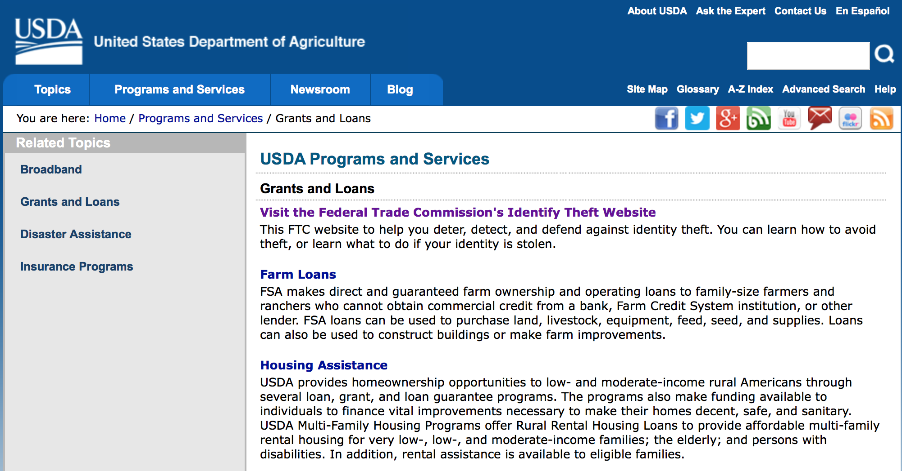
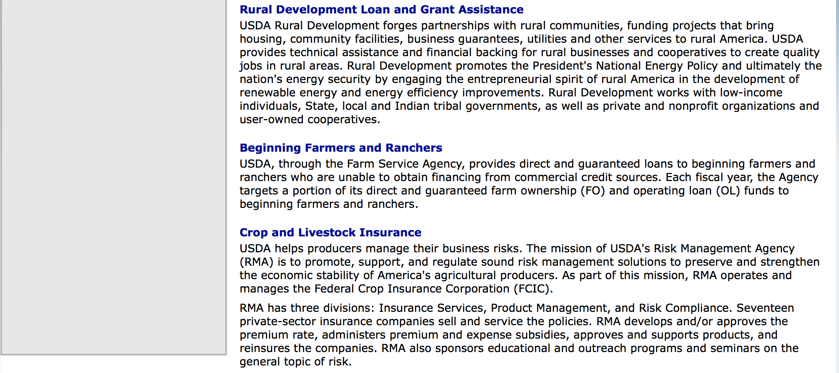

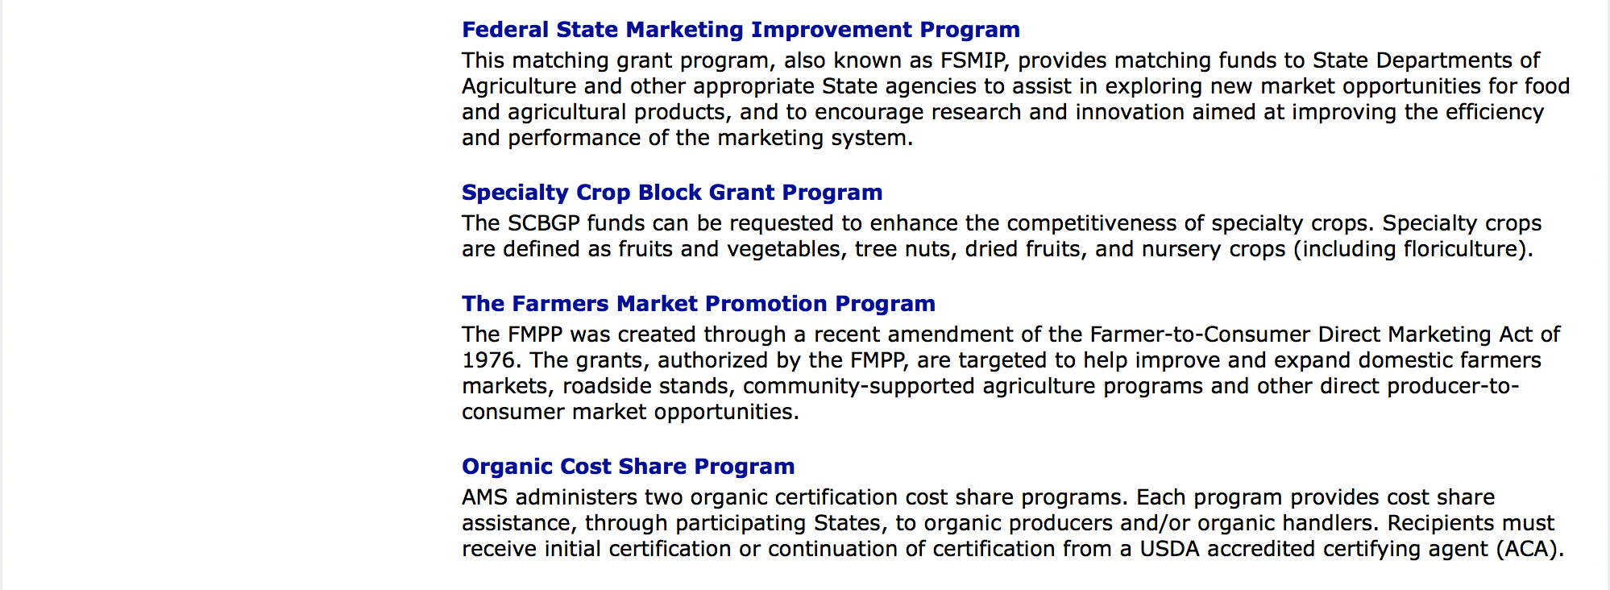

http://usda.gov/wps/portal/usda/usdahome?navid=GRANTS_LOANS

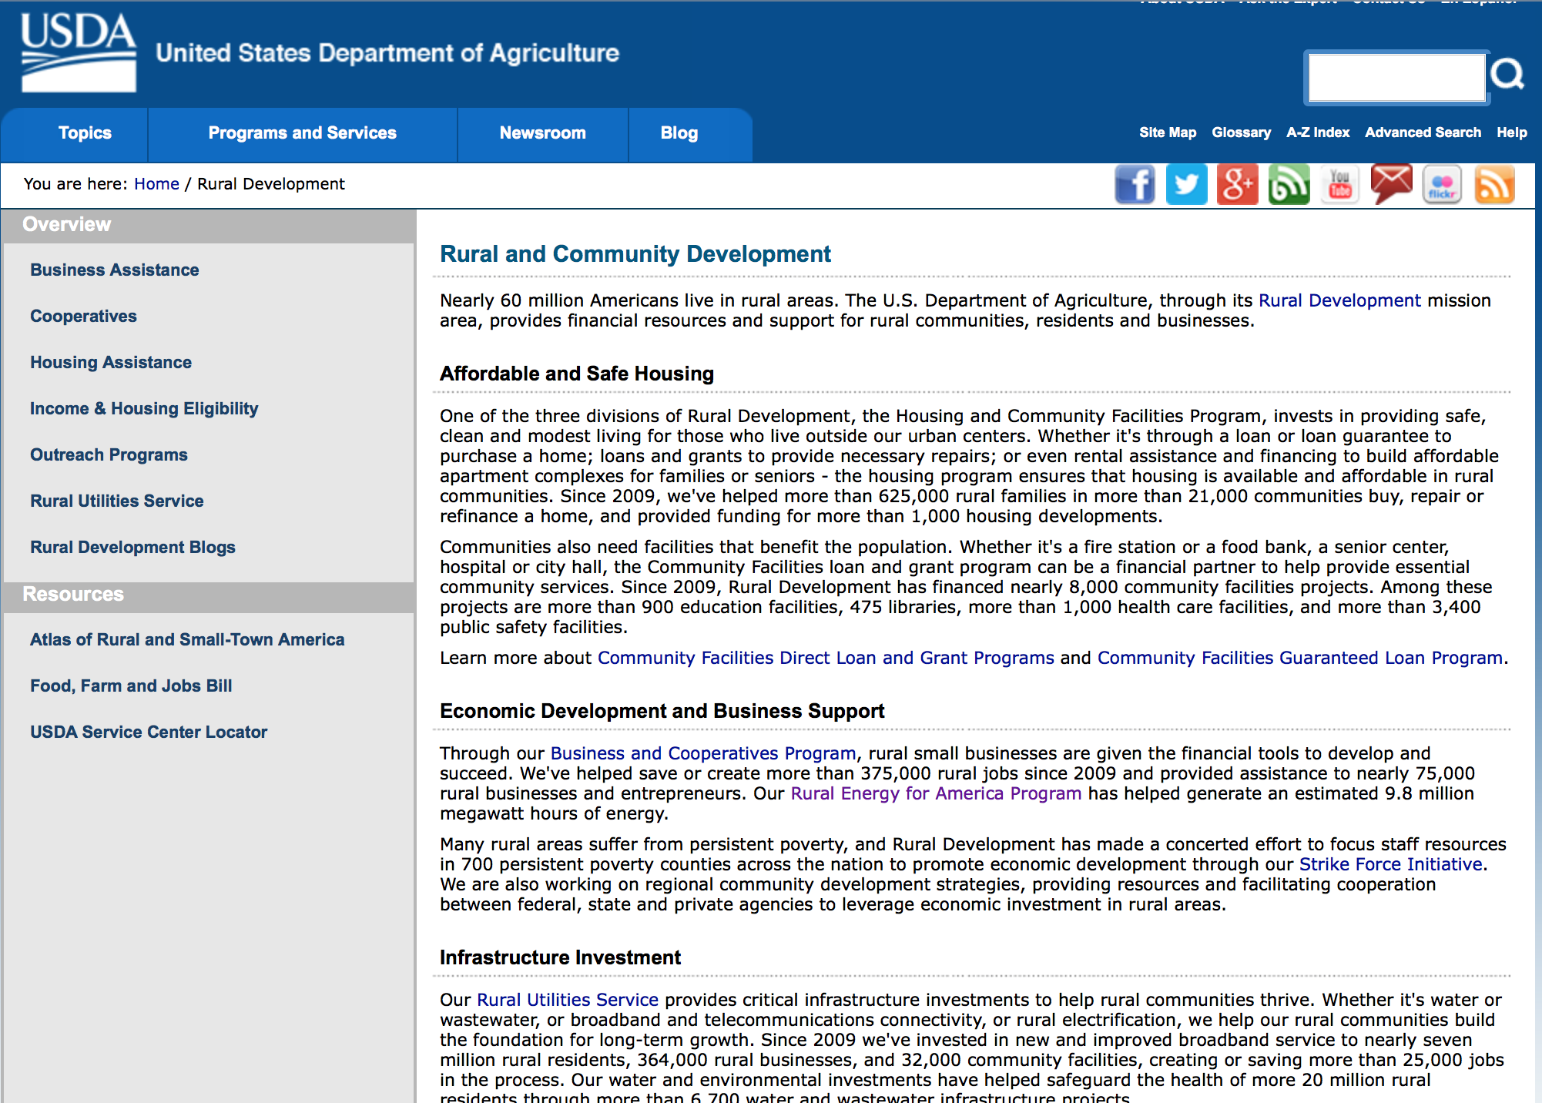

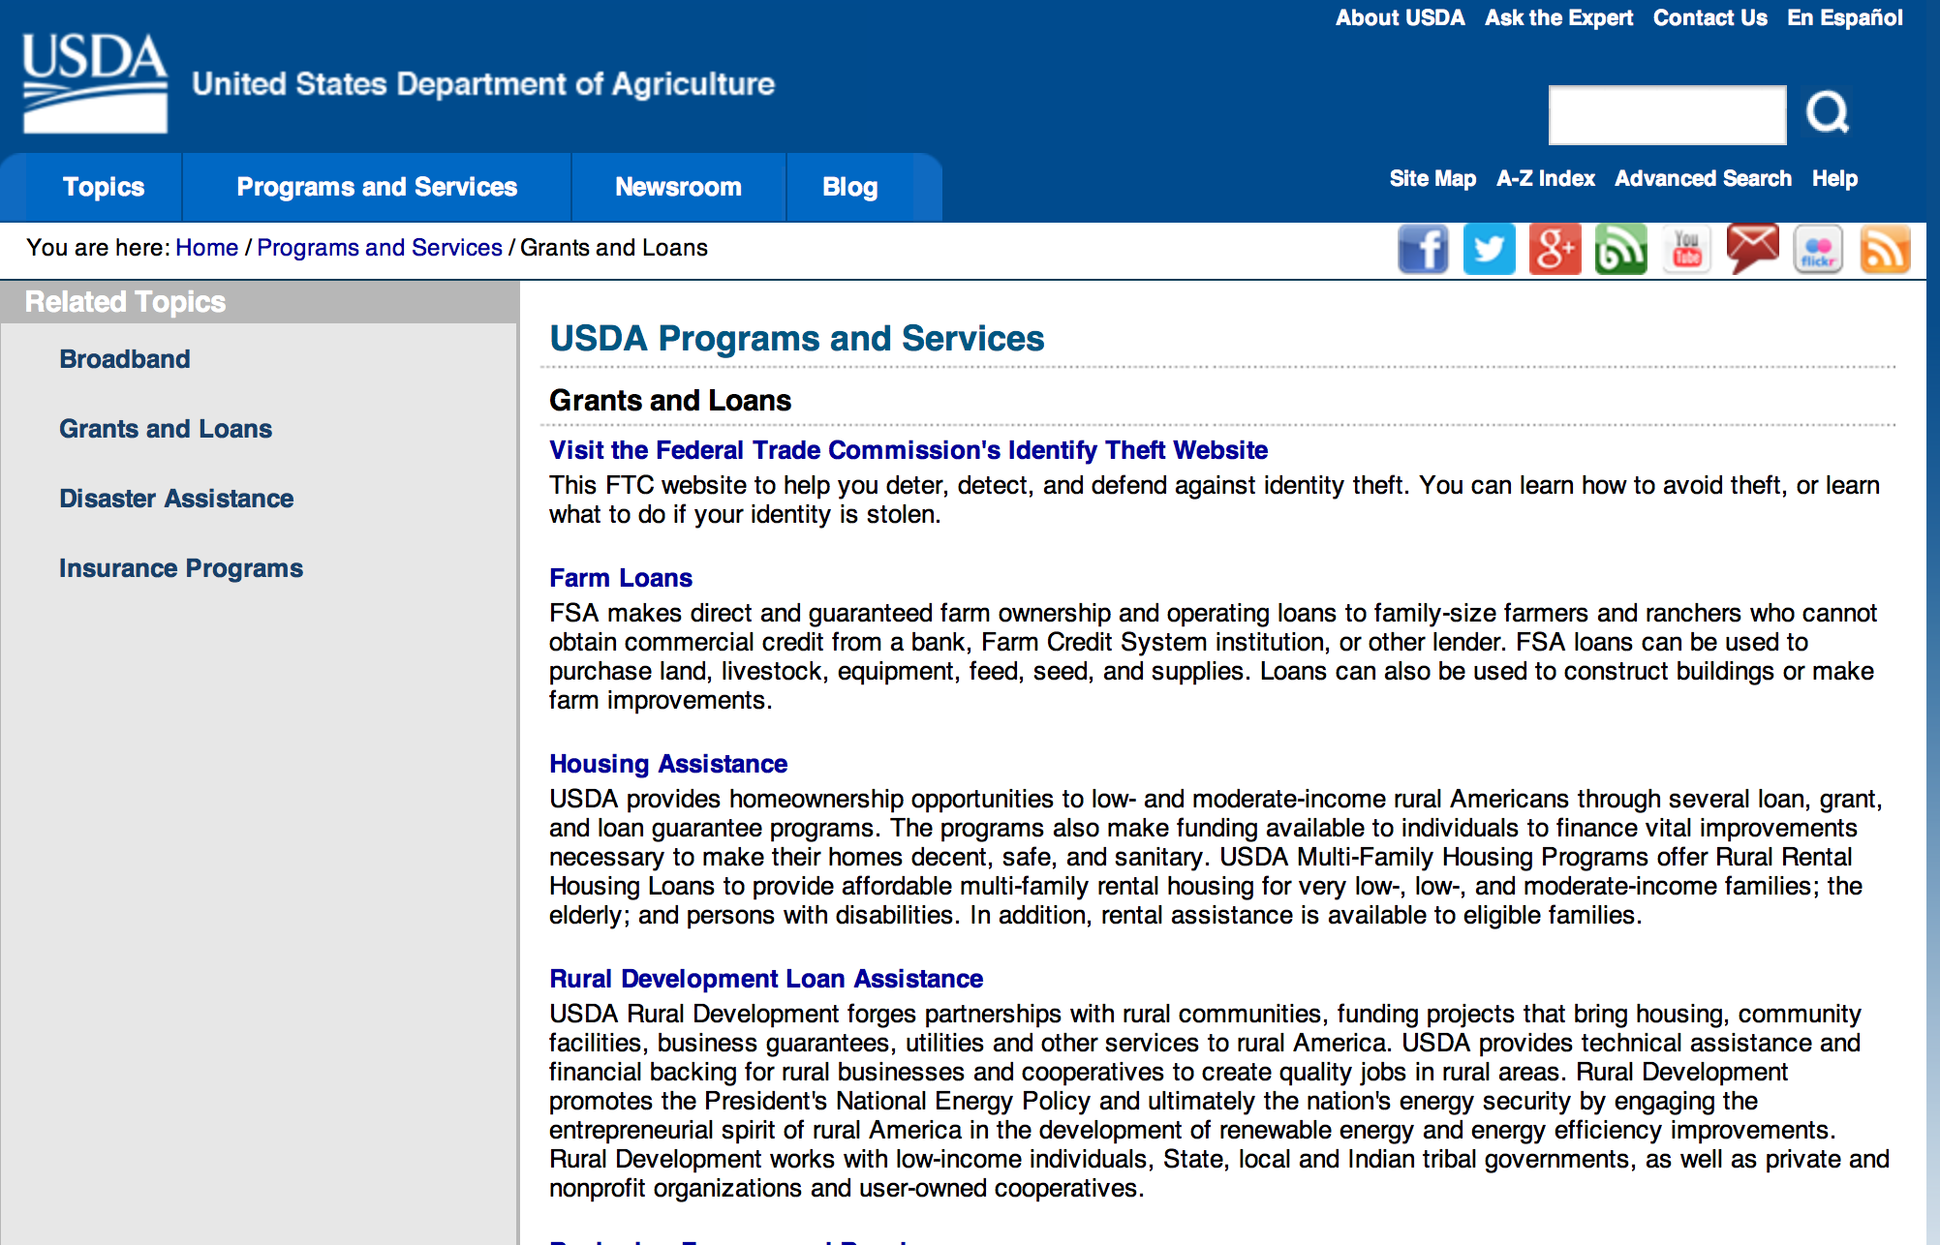

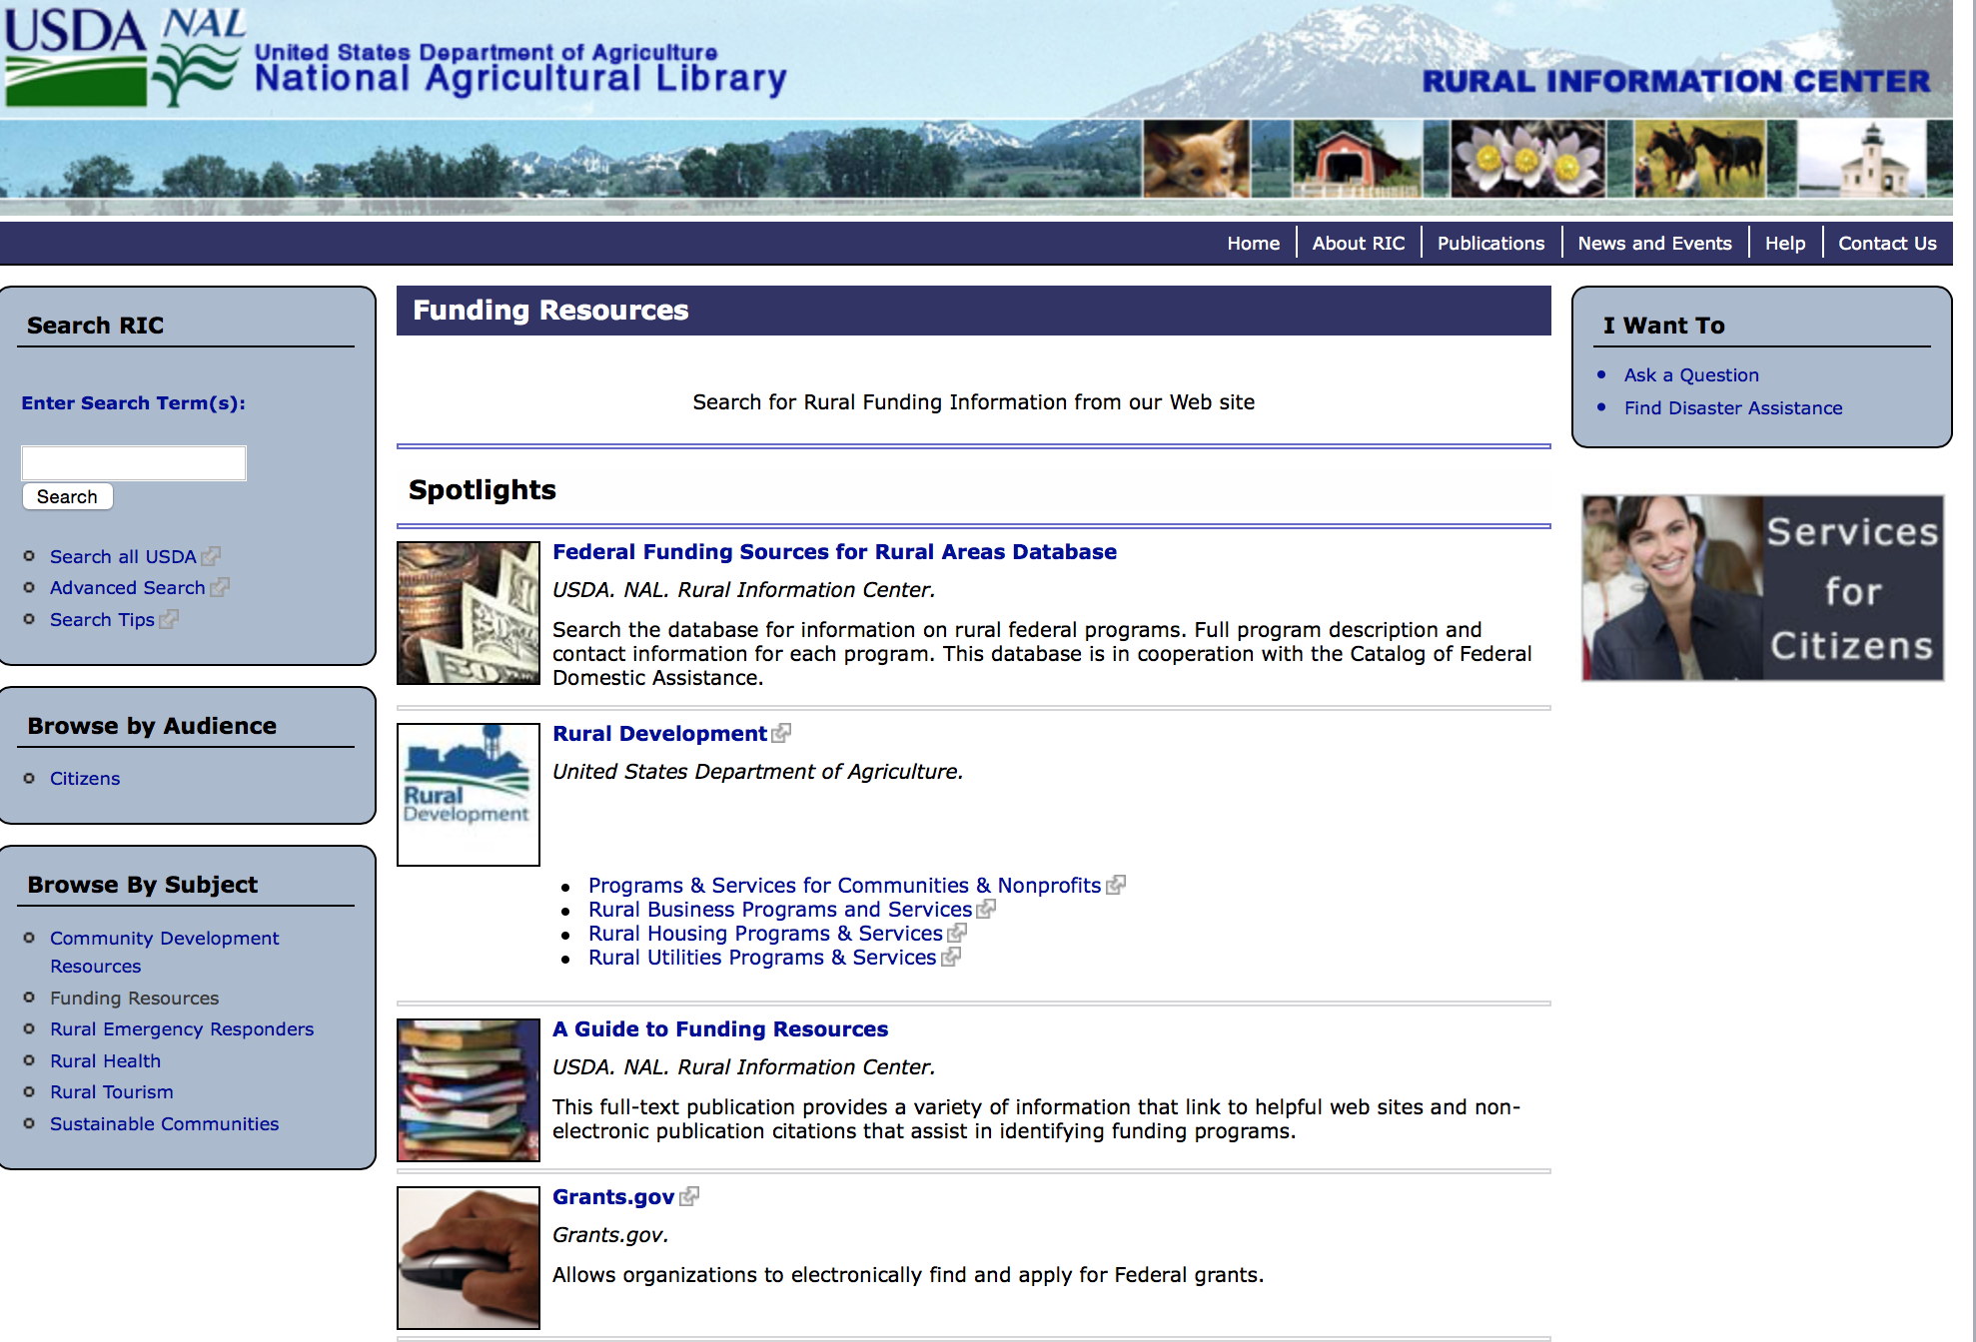

Federal Faith-Based Centers and Community Initiatives
USDA. NAL. Rural Information Center.
- Center for Faith-Based and Community Initiatives (link is external) , U.S. Department of Education
- Center for Faith-Based and Community Initiatives (link is external) , U.S. Department of Health and Human Services
- Center for Faith-Based and Community Initiatives (link is external) , U.S. Department of Labor
- Faith-Based and Community Initiatives (link is external) , U.S. Agency for International Development
- Faith-Based and Community Initiatives (link is external) , U.S. Department of Agriculture
- Faith-Based and Community Initiatives (link is external) , U.S. Department of Housing and Urban Development
- Faith-Based and Other Community Initiatives (link is external) , Corporation for National Community Service
- Task Force for Faith-Based and Community Initiatives (link is external) , U.S. Department of Justice

Grant Writing Resources
- Proposal Writing Short Course (link is external) Foundation Center.
- Data Universal Numbering System Fact sheet (link is external) [PDF | 302.2KB] USDA Rural Development.
- General Tips on Writing a Competitive Grant Proposal (link is external) U.S. Environmental Protection Agency.
- How to Write a Grant Proposal (link is external) Appalachian Regional Commission.<.li>

A Guide to Funding Resources USDA Rural Information Center.

http://ric.nal.usda.gov/funding-resources

http://usda.gov/wps/portal/usda/usdahome?navid=GRANTS_LOANS

Programs:

National Institute of Food and Agriculture
Supplemental and Alternative Crops Competitive Grants Program

Document Type: | Grants Notice
Funding Opportunity Number: | USDA-NIFA-OP-005676
Funding Opportunity Title: | Supplemental and Alternative Crops Competitive Grants Program
Opportunity Category: | Discretionary
Opportunity Category Explanation:
Funding Instrument Type: | Grant
Category of Funding Activity: | Agriculture
Category Explanation:
Expected Number of Awards:
CFDA Number(s): | 10.200 -- Grants for Agricultural Research, Special Research Grants
Cost Sharing or Matching Requirement: | Yes
Posted Date: | Feb 09, 2016
Last Updated Date: | Feb 09, 2016
Original Closing Date for Applications: | Apr 11, 2016
Current Closing Date for Applications: | Apr 11, 2016
Archive Date: | May 11, 2016
Estimated Total Program Funding: | $767,340
Award Ceiling: | $210,000
Eligible Applicants: | Others (see text field entitled "Additional Information on Eligibility" for clarification)
Additional Information on Eligibility: | Applications may only be submitted by colleges and universities (as defined in section 1404 of NARETPA, 7 U.S.C. 3103), other Federal agencies and private sector entities. Award recipients may subcontract to organizations not eligible to apply provided such organizations are necessary for the conduct of the project. Failure to meet an eligibility criterion by the time of application deadline may result in the application being excluded from consideration or, even though an application may be reviewed, will preclude NIFA from making an award.
Agency Name: | National Institute of Food and Agriculture
Description: | The Supplemental and Alternative Crops Competitive (SACC) Grants Program will support the development of canola as a viable supplemental and alternative crop in the United States. The goal of the SACC program is to significantly increase crop production and/or acreage by developing and testing of superior germplasm, improving methods of planting, cultivation, and harvesting, and transferring new knowledge to producers (via Extension) as soon as practicable. Extension, education, and communication activities related to the research areas above must be addressed in the proposal.
Link to Additional Information: | Supplemental and Alternative Crops (SACC)
Contact Information: | If you have difficulty accessing the full announcement electronically, please contact:  NIFA Help Desk Phone: 202-401-5048 Business hours are M-F, 7:00 am -5:00 pm ET, excluding Federal holidays  If you have any questions related to preparing application content

http://www.grants.gov/web/grants/view-opportunity.html?oppId=281444

National Institute of Food and Agriculture
Higher Education Challenge Grants Program

Document Type: | Grants Notice
Funding Opportunity Number: | USDA-NIFA-CGP-005716
Funding Opportunity Title: | Higher Education Challenge Grants Program
Opportunity Category: | Discretionary
Opportunity Category Explanation:
Funding Instrument Type: | Grant
Category of Funding Activity: | Agriculture
Category Explanation:
Expected Number of Awards:
CFDA Number(s): | 10.217 -- Higher Education - Institution Challenge Grants Program
Cost Sharing or Matching Requirement: | Yes
Posted Date: | Feb 23, 2016
Last Updated Date: | Feb 23, 2016
Original Closing Date for Applications: | Apr 22, 2016
Current Closing Date for Applications: | Apr 22, 2016
Archive Date: | May 22, 2016
Estimated Total Program Funding: | $4,500,000
Eligible Applicants: | Others (see text field entitled "Additional Information on Eligibility" for clarification)
Additional Information on Eligibility: | Applications may be submitted by: (a) U.S. public or private nonprofit colleges and universities offering a baccalaureate or first professional degree in at least one discipline or area of the food and agricultural sciences; (b) land-grant colleges and universities, (including land grant institutions in the Insular Areas); (c) colleges and universities having significant minority enrollments and a demonstrable capacity to carry out the teaching of food and agricultural sciences; and (d) other colleges and universities having a demonstrable capacity to carry out the teaching of food and agricultural sciences.
Agency Name: | National Institute of Food and Agriculture
Description: | Projects supported by the Higher Education Challenge Grants Program will: (1) address a State, regional, national, or international educational need; (2) involve a creative or non-traditional approach toward addressing that need that can serve as a model to others; (3) encourage and facilitate better working relationships in the university science and education community, as well as between universities and the private sector, to enhance program quality and supplement available resources; and (4) result in benefits that will likely transcend the project duration and USDA support.
Link to Additional Information: | Higher Education Challenge (HEC) Grants Program
Contact Information: | If you have difficulty accessing the full announcement electronically, please contact:  NIFA Help Desk Phone: 202-401-5048 Business hours are M-F, 7:00 am -5:00 pm ET, excluding Federal holidays  If you have any questions related to preparing application content

http://www.grants.gov/web/grants/view-opportunity.html?oppId=281746

Forest Service
2017 National Urban and Community Forestry Grant Program

Document Type: |  | Grants Notice
Funding Opportunity Number: |  | USDA-FS-UCF-01-2017
Funding Opportunity Title: |  | 2017 National Urban and Community Forestry Grant Program
Opportunity Category: |  | Discretionary
Opportunity Category Explanation:
Funding Instrument Type: |  | Grant
Category of Funding Activity: |  | Community Development  Disaster Prevention and Relief  Education  Environment  Health  Natural Resources  Science and Technology and other Research and Development
Category Explanation: |  | The National Urban and Community Forestry Advisory Council seeks innovative (new, cutting-edge or builds upon existing studies) grant proposals for program development, study, and collaboration that will address strategies in the National Ten Year Urban Forestry Action Plan (2016-2026). This Request for Proposals is to address the following priority issues: • Developing a National Urban Forestry Funding Assessment and Methodology • Understand Urban Forest Ecosystem/Ecological Services Detailed information about each category follows this section. Proposals are to meet the request and intent of each applicable category. Organizations, local governments, tribal agencies, and partnerships are encouraged to submit proposals that will demonstrate the reach, resources, and expertise needed to address the three priority issues in ways that will lead to meaningful, replicable results across the country. Potential Innovation grantees are should work collaboratively with other organizations and entities not traditionally involved in urban and community forestry. Applicants should consider multi-year projects and other sources of funds, which may include other Federal cooperative conservation sources. While other Federal dollars or technical support may contribute to the project, they may not be used to match these Federal grant program dollars. The grant review process takes about a year to review pre and full proposals once they are received. Applicants should state their start and end date accordingly on their SF424. Each category is separate. Please do not merge more than one category content or intent into one proposal, which can result in disqualification of the proposal. Applicants may submit separate pre-proposals for more than one category.
Expected Number of Awards: |  | 5
CFDA Number(s): |  | 10.675 -- Urban and Community Forestry Program
Cost Sharing or Matching Requirement: |  | Yes
Posted Date: |  | Feb 29, 2016
Last Updated Date: |  | Mar 01, 2016
Original Closing Date for Applications: |  | Jun 17, 2016
Current Closing Date for Applications: |  | Jun 17, 2016
Archive Date: |  | Jul 17, 2016
Estimated Total Program Funding: |  | $900,000
Award Ceiling: |  | $300,000
Award Floor: |  | $75,000
Eligible Applicants: |  | State governments  Public and State controlled institutions of higher education  Special district governments  Public housing authorities/Indian housing authorities  Independent school districts  City or township governments  Private institutions of higher education  County governments  Nonprofits that do not have a 501(c)(3) status with the IRS, other than institutions of higher education  Nonprofits having a 501(c)(3) status with the IRS, other than institutions of higher education  Native American tribal governments (Federally recognized)
Agency Name: | Forest Service
Description: | Available Funding: The U.S. Forest Service anticipates that the statutory authority (Sub Title 9 of the Cooperative Forestry Assistance Act) for the Fiscal Year 2017 Urban and Community Forestry (U&CF) Program may provide, approximately $900,000 in grant funds to be awarded through the 2017 National Urban and Community Forestry Challenge Cost-Share Grant Program. Funds are to support national urban and community forestry projects on nonfederal public land that have a national or multi-state impact and application. All awards are based on the availability of funding, which may be subject to change. Eligible Applicants: Any U.S. non-Federal organization and Tribal agencies, operating within the United States or its territories, may apply for the Challenge Cost-Share grant. While collaboration with Federal agencies is encouraged, a Federal agency may not receive funding or be used as match to the Federal funds being requested. Individuals and private land are not eligible. Proposals are required to address National or multi-state, multi-tribal land urban forestry issues. The Forest Service will address any conflicts of interest. Not Eligible: If an entity has a local/State tree-planting projects, capital improvements to property of any ownership, and/or projects that have only a local impact and applicability are not eligible and they should contact their State Urban and Community Forestry Coordinator for assistance in identifying funding alternatives at the local level. The list of State Coordinators may be found at the following website: State Urban Foresters' Contact List
Link to Additional Information: | National Urban and Community Forestry Advisory Council Website
Contact Information: | If you have difficulty accessing the full announcement electronically, please contact:  Nancy Stremple Urban Forestry Program Specialist Phone 202-309-9873  Forest Service Email address

http://www.grants.gov/web/grants/view-opportunity.html?oppId=281798

Modifications:

Farm Service Agency
Outreach and Education, Technical Assistance, and Financial Education for FSA Programs, Functions, and Activities
Modification 2

Document Type: | Grants Notice
Funding Opportunity Number: | USDA-FSA-CA-2016-001
Funding Opportunity Title: | Outreach and Education, Technical Assistance, and Financial Education for FSA Programs, Functions, and Activities
Opportunity Category: | Discretionary
Opportunity Category Explanation:
Funding Instrument Type: | Cooperative Agreement
Category of Funding Activity: | Agriculture
Category Explanation:
Expected Number of Awards: | 125
CFDA Number(s):
Cost Sharing or Matching Requirement: | No
Posted Date: | Oct 20, 2015
Last Updated Date: | Feb 26, 2016
Original Closing Date for Applications: | May 27, 2016
Current Closing Date for Applications: | Jul 11, 2016
Archive Date: | Aug 10, 2016
Estimated Total Program Funding: | $2,500,000
Award Ceiling: | $99,999
Award Floor: | $20,000
Eligible Applicants: | Public and State controlled institutions of higher education  Nonprofits having a 501(c)(3) status with the IRS, other than institutions of higher education
Agency Name: | Farm Service Agency
Description: | As part of our mission supporting farmers and ranchers, the Farm Service Agency (FSA) provides extensive education and outreach for producers. This typically involves public meetings, mailings, news releases, and interactions with individual producers seeking additional information or to enroll in a program. However, there remains a need for additional outreach and education that could benefit potential participants in FSA’s portfolio of programs. This RFA seeks proposals to further support and expand FSA’s existing outreach and education efforts. The additional outreach and education could, for example, be public meetings, training sessions, and/or workshops for producers including new and beginning farmers, veterans, underserved communities, and/or established producers. Emphasis will be afforded to proposals that propose to address producers who are ethnic minorities, women, new and beginning, veterans, urban, or who grow non-commodity crops (e.g., fruits and vegetables or specialty crops). Proposals may include innovative outreach approaches that ease the learning curve for farmers and ranchers through training on best practices, common challenges and solutions, and local networking opportunities. The subject matter should include an introduction to FSA, its programs, and common provisions that generally apply. FSA’s common provisions include maintenance of producer-level records regarding payment eligibility and limitations, conservation compliance, and name and address, payments, and farm and tract information. Additional information regarding FSA is available at www.fsa.usda.gov.
Link to Additional Information: | FSA Outreach Staff
Contact Information: | If you have difficulty accessing the full announcement electronically, please contact:  Robert Stephenson Director, Office of Business and Program Integration Phone: 202-720-4019  Help Desk

http://www.grants.gov/web/grants/view-opportunity.html?oppId=279761

Natural Resources Conservation Service
Wetlands Mitigation Banking Program
Modification 4
Document Type: | Grants Notice
Funding Opportunity Number: | USDA-NRCS-NHQ-WMBP-16-01
Funding Opportunity Title: | Wetlands Mitigation Banking Program
Opportunity Category: | Discretionary
Opportunity Category Explanation:
Funding Instrument Type: | Grant
Category of Funding Activity: | Agriculture  Environment  Natural Resources
Category Explanation:
Expected Number of Awards: | 20
CFDA Number(s): | 10.933 -- Wetlands Mitigation Banking Program
Cost Sharing or Matching Requirement: | No
Posted Date: | Jan 28, 2016
Last Updated Date: | Feb 18, 2016
Original Closing Date for Applications: | Mar 18, 2016 Applications must be received by 5pm, EST.
Current Closing Date for Applications: | Mar 28, 2016 Applications must be received by 5pm, EST.
Archive Date: | Apr 17, 2016
Estimated Total Program Funding: | $9,000,000
Award Ceiling: | $1,000,000
Award Floor: | $0
Eligible Applicants: | Nonprofits having a 501(c)(3) status with the IRS, other than institutions of higher education  For profit organizations other than small businesses  Special district governments  Native American tribal governments (Federally recognized)  County governments  State governments  City or township governments  Small businesses
Agency Name: | Natural Resources Conservation Service
Description: | EXECUTIVE SUMMARY: The Natural Resources Conservation Service (NRCS), an agency under the United States Department of Agriculture (USDA), works with farmers, ranchers, and private forest landowners nationwide to identify and address natural resource objectives in balance with operational goals to benefit soil, water, wildlife, and related natural resources locally, regionally, and nationally. The purpose of this notice is to announce the availability of Wetland Mitigation Banking Program grant funds for the development and establishment of mitigation banks and banking opportunities solely for agricultural producers with wetlands subject to the Wetland Conservation Compliance provisions of the 1985 Food Security Act (as amended). NRCS has up to $9 million available for obligation through a nationwide competitive process. The maximum grant award is $1 million. Agreements governing the establishment of mitigation banks will last for up to 5 years in duration. NRCS will accept proposals from eligible entities that include federally recognized Indian Tribes, State and local units of government, for-profit entities, and nongovernmental organizations. Proposals will be accepted from applicants in any of the 50 States, the District of Columbia, the Caribbean Area (Puerto Rico and the U.S. Virgin Islands), and the Pacific Islands Area (Guam, American Samoa, and the Commonwealth of the Northern Mariana Islands). NRCS will give priority to proposals from geographic areas with significant numbers of cropped agricultural wetlands. This notice identifies the objectives, eligibility criteria, and application instructions for mitigation bank proposals. Proposals will be screened for completeness and compliance with the provisions of this notice. Incomplete and noncompliant proposals will be eliminated from the competitive ranking process, and notification of elimination will be sent to the applicant. Selected applicants will work directly with NRCS to develop a mitigation banking instrument that will establish an operational bank, and offer mitigation credits to interested USDA program participants for the purposes of addressing wetland conservation compliance. Program funds cannot be used to acquire any interest in land, including an interest acquired through an easement.
Link to Additional Information: | NRCS Homepage
Contact Information: | If you have difficulty accessing the full announcement electronically, please contact:  Frankie Comfort Grants & Agreements Specialist Phone 202-720-0242  Administrative Contact

http://www.grants.gov/web/grants/view-opportunity.html?oppId=281191

National Institute of Food and Agriculture
Secondary Education, Two-Year Postsecondary Education, and Agriculture in the K-12 Classroom (SPECA) Challenge Grant Program
Modification 1

Document Type: | Grants Notice
Funding Opportunity Number: | USDA-NIFA-SAECP-005616
Funding Opportunity Title: | Secondary Education, Two-Year Postsecondary Education, and Agriculture in the K-12 Classroom (SPECA) Challenge Grant Program
Opportunity Category: | Discretionary
Opportunity Category Explanation:
Funding Instrument Type: | Grant
Category of Funding Activity: | Agriculture
Category Explanation:
Expected Number of Awards:
CFDA Number(s): | 10.226 -- Secondary and Two-Year Postsecondary Agriculture Education Challenge Grants
Cost Sharing or Matching Requirement: | Yes
Posted Date: | Jan 19, 2016
Last Updated Date: | Feb 10, 2016
Original Closing Date for Applications: | Mar 18, 2016
Current Closing Date for Applications: | Mar 18, 2016
Archive Date: | Apr 17, 2016
Estimated Total Program Funding: | $858,500
Eligible Applicants: | Others (see text field entitled "Additional Information on Eligibility" for clarification)
Additional Information on Eligibility: | Applications may only be submitted b: (1) public secondary schools, (2) public or private nonprofit junior and community colleges, (3) institutions of higher education, or (4) nonprofit organizations (Attach IRS 501(c)(3) status under R&R ‘Other Project Information’ Field 12 Other Attachments).
Agency Name: | National Institute of Food and Agriculture
Description: | The Secondary Education, Two-Year Postsecondary Education, and Agriculture in the K-12 Classroom Challenge Grants (SPECA) program seeks to: (a) promote and strengthen secondary education and two-year postsecondary education in agriscience and agribusiness in order to help ensure the existence in the United States of a qualified workforce to serve the food and agricultural sciences system; and (b) promote complementary and synergistic linkages among secondary, two-year postsecondary, and higher education programs in the food and agricultural sciences in order to advance excellence in education and encourage more young Americans to pursue and complete a baccalaureate or higher degree in the food and agricultural sciences.
Link to Additional Information: | Secondary Education, Two-Year Postsecondary Education, and Agriculture in the K-12 Classroom (SPECA) Challenge Grant Program
Contact Information: | If you have difficulty accessing the full announcement electronically, please contact:  NIFA Help Desk Phone: 202-401-5048 Business hours are M-F, 7:00 am -5:00 pm ET, excluding Federal holidays  If you have any questions related to preparing application content

http://www.grants.gov/web/grants/view-opportunity.html?oppId=281049

National Institute of Food and Agriculture
Agriculture and Food Research Initiative - Food, Agriculture, Natural Resources and Human Sciences Education and Literacy Initiative
Modifications 1 & 2

Document Type: | Grants Notice
Funding Opportunity Number: | USDA-NIFA-AFRI-005576
Funding Opportunity Title: | Agriculture and Food Research Initiative - Food, Agriculture, Natural Resources and Human Sciences Education and Literacy Initiative
Opportunity Category: | Discretionary
Opportunity Category Explanation:
Funding Instrument Type: | Grant
Category of Funding Activity: | Agriculture  Education
Category Explanation:
Expected Number of Awards:
CFDA Number(s): | 10.310 -- Agriculture and Food Research Initiative (AFRI)
Cost Sharing or Matching Requirement: | Yes
Posted Date: | Jan 07, 2016
Last Updated Date: | Feb 12, 2016
Original Closing Date for Applications: | Mar 24, 2016 February 11, 2016 (for the Predoctoral and Postdoctoral Fellowships Programs), March 18, 2016 (for the Professional Development Opportunities for Secondary School Teachers Programs) and March 24, 2016 (for the Research and Extension Experiential Learning for Undergraduate Fellowships)
Current Closing Date for Applications: | Mar 24, 2016 March 3, 2016 (for the Predoctoral and Postdoctoral Fellowships Programs), March 18, 2016 (for the Professional Development Opportunities for Secondary School Teachers Programs) and March 24, 2016 (for the Research and Extension Experiential Learning for Undergraduate Fellowships)
Archive Date: | Apr 23, 2016
Estimated Total Program Funding: | $18,900,000
Award Ceiling: | $0
Award Floor: | $0
Eligible Applicants: | Others (see text field entitled "Additional Information on Eligibility" for clarification)
Additional Information on Eligibility: | See Part III, A., Eligible Applicants. Eligibility is linked to the project type. All project types are described beginning in Part II, C.
Agency Name: | National Institute of Food and Agriculture
Description: | The AFRI Food, Agriculture, Natural Resources, and Human Sciences Education and Literacy Initiative (ELI) provides fellowships to undergraduate, predoctoral, and postdoctoral students in the agricultural sciences.
Link to Additional Information: | Agriculture and Food Research Initiative - Food, Agriculture, Natural Resources and Human Sciences Education and Literacy Initiative
Contact Information: | If you have difficulty accessing the full announcement electronically, please contact:  NIFA Help Desk Phone: 202-401-5048 Business hours are M-F, 7:00 am -5:00 pm ET, excluding Federal holidays  If you have any questions related to preparing application content

http://www.grants.gov/web/grants/view-opportunity.html?oppId=280861

Reminders:

Utilities Programs
Distance Learning and Telemedicine Grant Program

Document Type: | Grants Notice
Funding Opportunity Number: | RUS-16-01-DLT
Funding Opportunity Title: | Distance Learning and Telemedicine Grant Program
Opportunity Category: | Discretionary
Funding Instrument Type: | Grant
Category of Funding Activity: | Community Development  Education  Health
Category Explanation:
Expected Number of Awards: | 65
CFDA Number(s): | 10.855 -- Distance Learning and Telemedicine Loans and Grants
Cost Sharing or Matching Requirement: | Yes
Posted Date: | Jan 14, 2016
Creation Date: | Jan 14, 2016
Original Closing Date for Applications: | Mar 14, 2016
Current Closing Date for Applications: | Mar 14, 2016
Archive Date: | Apr 13, 2016
Estimated Total Program Funding: | $19,000,000
Award Ceiling: | $500,000
Award Floor: | $50,000
Eligible Applicants: | Native American tribal organizations (other than Federally recognized tribal governments)  Small businesses  Independent school districts  Nonprofits having a 501(c)(3) status with the IRS, other than institutions of higher education  Public and State controlled institutions of higher education  Native American tribal governments (Federally recognized)  State governments  Private institutions of higher education  County governments  City or township governments  For profit organizations other than small businesses  Special district governments  Nonprofits that do not have a 501(c)(3) status with the IRS, other than institutions of higher education
Agency Name: | Utilities Programs
Description: | Distance Learning and Telemedicine Grant Program
Link to Additional Information: | Program Web Site
Contact Information: | If you have difficulty accessing the full announcement electronically, please contact:  Randall Millhiser DLT Coordinator Phone 2027200800  Agency Contact

http://www.grants.gov/web/grants/view-opportunity.html?oppId=280973

National Institute of Food and Agriculture
Agriculture and Food Research Initiative - Food, Agriculture, Natural Resources and Human Sciences Education and Literacy Initiative Grant

Document Type: | Grants Notice
Funding Opportunity Number: | USDA-NIFA-AFRI-005576
Funding Opportunity Title: | Agriculture and Food Research Initiative - Food, Agriculture, Natural Resources and Human Sciences Education and Literacy Initiative
Opportunity Category: | Discretionary
Funding Instrument Type: | Grant
Category of Funding Activity: | Agriculture  Education
Category Explanation:
Expected Number of Awards:
CFDA Number(s): | 10.310 -- Agriculture and Food Research Initiative (AFRI)
Cost Sharing or Matching Requirement: | Yes
Posted Date: | Jan 7, 2016
Creation Date: | Jan 7, 2016
Original Closing Date for Applications: | Mar 24, 2016 February 11, 2016 (for the Predoctoral and Postdoctoral Fellowships Programs), March 18, 2016 (for the Professional Development Opportunities for Secondary School Teachers Programs) and March 24, 2016 (for the Research and Extension Experiential Learning for Undergraduate Fellowships)
Current Closing Date for Applications: | Mar 24, 2016 February 11, 2016 (for the Predoctoral and Postdoctoral Fellowships Programs), March 18, 2016 (for the Professional Development Opportunities for Secondary School Teachers Programs) and March 24, 2016 (for the Research and Extension Experiential Learning for Undergraduate Fellowships)
Archive Date: | Apr 23, 2016
Estimated Total Program Funding: | $18,900,000
Eligible Applicants: | Others (see text field entitled "Additional Information on Eligibility" for clarification)
Additional Information on Eligibility: | See Part III, A., Eligible Applicants. Eligibility is linked to the project type. All project types are described beginning in Part II, C.
Agency Name: | National Institute of Food and Agriculture
Description: | The AFRI Food, Agriculture, Natural Resources, and Human Sciences Education and Literacy Initiative (ELI) provides fellowships to undergraduate, predoctoral, and postdoctoral students in the agricultural sciences.
Link to Additional Information: | Agriculture and Food Research Initiative - Food, Agriculture, Natural Resources and Human Sciences Education and Literacy Initiative
Contact Information: | If you have difficulty accessing the full announcement electronically, please contact:  NIFA Help Desk Phone: 202-401-5048 Business hours are M-F, 7:00 am -5:00 pm ET, excluding Federal holidays  If you have any questions related to preparing application content

http://www.grants.gov/web/grants/view-opportunity.html?oppId=280861

National Institute of Food and Agriculture
Capacity Building Grants for Non Land Grant Colleges of Agriculture (NLGCA) Grant

Document Type: | Grants Notice
Funding Opportunity Number: | USDA-NIFA-NLGCA-005637
Funding Opportunity Title: | Capacity Building Grants for Non Land Grant Colleges of Agriculture (NLGCA)
Opportunity Category: | Discretionary
Funding Instrument Type: | Grant
Category of Funding Activity: | Agriculture
Category Explanation:
Expected Number of Awards:
CFDA Number(s): | 10.326 -- Capacity Building for Non-Land Grant Colleges of Agriculture (NLGCA)
Cost Sharing or Matching Requirement: | No
Posted Date: | Jan 27, 2016
Creation Date: | Jan 27, 2016
Original Closing Date for Applications: | Apr 22, 2016
Current Closing Date for Applications: | Apr 22, 2016
Archive Date: | May 22, 2016
Estimated Total Program Funding: | $4,650,000
Award Ceiling: | $750,000
Award Floor: | $30,000
Eligible Applicants: | Others (see text field entitled "Additional Information on Eligibility" for clarification)
Additional Information on Eligibility: | Applications may only be submitted by a Non-Land Grant College of Agriculture (NLGCAs) certified as such by the National Institute of Food and Agriculture. In order for an institution to qualify as a NLGCA, it must be a public college or university offering a baccalaureate or higher degree in the study of food and agricultural sciences, as defined in 7 U.S.C. 3103(9). A list of NLGCA’s certified by NIFA can be found on the NIFA website.
Agency Name: | National Institute of Food and Agriculture
Description: | NLGCA Institutions may use the funds: (a) to successfully compete for funds from Federal grants and other sources to carry out educational, research, and outreach activities that address priority concerns of national, regional, State, and local interest; (b) to disseminate information relating to priority concerns to interested members of the agriculture, renewable resources, and other relevant communities, the public, and any other interested entity; (c) to encourage members of the agriculture, renewable resources, and other relevant communities to participate in priority education, research, and outreach activities by providing matching funding to leverage grant funds; and (d) through: (1) the purchase or other acquisition of equipment and other infrastructure (not including alteration, repair, renovation, or construction of buildings); (2) the professional growth and development of the faculty of the NLGCA Institution; and (3) the development of graduate assistantships.
Link to Additional Information: | Capacity Building Grants for Non Land Grant Colleges of Agriculture (NLGCA)
Contact Information: | If you have difficulty accessing the full announcement electronically, please contact:  NIFA Help Desk Phone: 202-401-5048 Business hours are M-F, 7:00 am -5:00 pm ET, excluding Federal holidays  If you have any questions related to preparing application content

http://www.grants.gov/web/grants/view-opportunity.html?oppId=281187

National Institute of Food and Agriculture
FY '16 Farm Business Management and Benchmarking (FBMB) Competitive Grants Program RFA Grant

Document Type: | Grants Notice
Funding Opportunity Number: | USDA-NIFA-FBMB-005638
Funding Opportunity Title: | FY '16 Farm Business Management and Benchmarking (FBMB) Competitive Grants Program RFA
Opportunity Category: | Discretionary
Funding Instrument Type: | Grant
Category of Funding Activity: | Agriculture
Category Explanation:
Expected Number of Awards:
CFDA Number(s): | 10.319 -- Farm Business Management and Benchmarking Competitive Grants Program
Cost Sharing or Matching Requirement: | Yes
Posted Date: | Feb 1, 2016
Creation Date: | Feb 1, 2016
Original Closing Date for Applications: | Apr 11, 2016
Current Closing Date for Applications: | Apr 11, 2016
Archive Date: | May 11, 2016
Estimated Total Program Funding: | $1,350,000
Eligible Applicants: | Others (see text field entitled "Additional Information on Eligibility" for clarification)
Additional Information on Eligibility: | Applications may be submitted by numerous entities. Pursuant to 7 U.S.C. 450i(b)(7), eligible applicants means: (A) State agricultural experiment stations; (B) Colleges and universities; (C) University research foundations; (D) Other research institutions and organizations; (E) Federal agencies; (F) National laboratories; (G) Private organizations or corporations: (H) Individuals; or (I) Any group consisting of two (2) or more of the entities described in subparagraphs (A) through (H).
Agency Name: | National Institute of Food and Agriculture
Description: | The Farm Business Management and Benchmarking (FBMB) Competitive Grants Program provides funds to (1) improve the farm management knowledge and skills of agricultural producers; and (2) establish and maintain a national, publicly available farm financial management database to support improved farm management
Link to Additional Information: | FY '16 Farm Business Management and Benchmarking Competitive Grants Program RFA
Contact Information: | If you have difficulty accessing the full announcement electronically, please contact:  NIFA Help Desk Phone: 202-401-5048 Business hours are M-F, 7:00 am -5:00 pm ET, excluding Federal holidays  If you have any questions related to preparing application content

http://www.grants.gov/web/grants/view-opportunity.html?oppId=281273

National Institute of Food and Agriculture
Organic Agriculture Research and Extension Initiative Grant

Document Type: | Grants Notice
Funding Opportunity Number: | USDA-NIFA-ICGP-005517
Funding Opportunity Title: | Organic Agriculture Research and Extension Initiative
Opportunity Category: | Mandatory
Funding Instrument Type: | Grant
Category of Funding Activity: | Agriculture
Category Explanation:
Expected Number of Awards:
CFDA Number(s): | 10.307 -- Organic Agriculture Research and Extension Initiative
Cost Sharing or Matching Requirement: | Yes
Posted Date: | Dec 10, 2015
Creation Date: | Dec 10, 2015
Original Closing Date for Applications: | Mar 10, 2016
Current Closing Date for Applications: | Mar 10, 2016
Archive Date: | Apr 9, 2016
Estimated Total Program Funding: | $18,000,000
Award Ceiling: | $2,000,000
Award Floor: | $50,000
Eligible Applicants: | Others (see text field entitled "Additional Information on Eligibility" for clarification)
Additional Information on Eligibility: | The following entities are eligible to apply for and receive a grant under this program. 1. State agricultural experiment stations; 2. Colleges and universities; 3. University research foundations; 4. Other research institutions and organizations; 5. Federal agencies; 6. National laboratories; 7. Private organizations, foundations, or corporations; 8. Individuals who are United States citizens or nationals; or 9. A group consisting of two or more of the entities described in subparagraphs (1) through (8).
Agency Name: | National Institute of Food and Agriculture
Description: | The OREI seeks to solve critical organic agriculture issues, priorities, or problems through the integration of research, education, and extension activities. The purpose of this program is to fund projects that will enhance the ability of producers and processors who have already adopted organic standards to grow and market high quality organic agricultural products. Priority concerns include biological, physical, and social sciences, including economics. The OREI is particularly interested in projects that emphasize research, education and outreach that assist farmers and ranchers with whole farm planning by delivering practical research-based information. Projects should plan to deliver applied production information to producers. Fieldwork must be done on certified organic land or on land in transition to organic certification, as appropriate to project goals and objectives. Refer to the USDA National Organic Program (http://www.ams.usda.gov/nop) for organic production standards. Visit the NIFA website to access a factsheet on the Center of Excellence (COE) designation process, including COE criteria, and a list of programs offering COE opportunities in fiscal year 2016. You can also review a recording of COE outreach webinars held in February and March of 2015 from the site. The COE webpages will be updated throughout FY 2016 with additional information, such as a summary of comments received from stakeholders.
Link to Additional Information: | Organic Agriculture Research and Extension Initiative
Contact Information: | If you have difficulty accessing the full announcement electronically, please contact:  NIFA Help Desk Phone: 202-401-5048 Business hours are M-F, 7:00 am -5:00 pm ET, excluding Federal holidays  If you have any questions related to preparing application content

http://www.grants.gov/web/grants/view-opportunity.html?oppId=280448

Business and Cooperative Programs
Renewable Energy Systems and Energy Efficiency Improvements Program Grant

Document Type: | Grants Notice
Funding Opportunity Number: | RDBCP-REAP-RES-EEI-2016
Funding Opportunity Title: | Renewable Energy Systems and Energy Efficiency Improvements Program
Opportunity Category: | Mandatory
Funding Instrument Type: | Grant
Category of Funding Activity: | Agriculture  Business and Commerce  Energy
Category Explanation:
Expected Number of Awards: | 1000
CFDA Number(s): | 10.868 -- Rural Energy for America Program
Cost Sharing or Matching Requirement: | Yes
Posted Date: | Oct 13, 2015
Creation Date: | Oct 13, 2015
Original Closing Date for Applications: | REAP Applications are accepted year-round. For applicants requesting grants of $20,000 or less, that wish to have their application compete for the "Grants of $20,000 or less set aside", complete applications must be received no later than 4:30pm local time on: November 2, 2015, or May 2, 2016. For applicants requesting grant funds of over $20,000 or funding for a combination grant and guaranteed loan, complete applications must be received no later than 4:30pm local time on May 2, 2016.
Current Closing Date for Applications: | REAP Applications are accepted year-round. For applicants requesting grants of $20,000 or less, that wish to have their application compete for the "Grants of $20,000 or less set aside", complete applications must be received no later than 4:30pm local time on: November 2, 2015, or May 2, 2016. For applicants requesting grant funds of over $20,000 or funding for a combination grant and guaranteed loan, complete applications must be received no later than 4:30pm local time on May 2, 2016.
Archive Date:
Estimated Total Program Funding: | $35,400,000
Award Ceiling: | $500,000
Award Floor: | $1,500
Eligible Applicants: | Native American tribal organizations (other than Federally recognized tribal governments)  Small businesses  Others (see text field entitled "Additional Information on Eligibility" for clarification)
Additional Information on Eligibility: | Agricultural Producers
Agency Name: | Business and Cooperative Programs
Description: | REAP Renewable Energy Systems and Energy Efficiency Improvement Program. Refer to Application Package AND Application Instruction links to obtain all necessary forms for a complete application. Contact State Energy Coordinators with questions: http://www.rd.usda.gov/files/RBS_StateEnergyCoordinators.pdf
Link to Additional Information: | REAP Renewable Energy Systems and Energy Efficiency Improvements Program
Contact Information: | If you have difficulty accessing the full announcement electronically, please contact:  State Energy Coordinator http://www.rd.usda.gov/files/RBS_StateEnergyCoordinators.pdf  Refer to energy coordinator list via link posted above.

http://www.grants.gov/web/grants/view-opportunity.html?oppId=279638

National Institute of Food and Agriculture
Biotechnology Risk Assessment Grants Program

Document Type: | Grants Notice
Funding Opportunity Number: | USDA-NIFA-BRAP-005435
Funding Opportunity Title: | Biotechnology Risk Assessment Grants Program
Opportunity Category: | Discretionary
Funding Instrument Type: | Grant
Category of Funding Activity: | Agriculture
Category Explanation:
Expected Number of Awards:
CFDA Number(s): | 10.219 -- Biotechnology Risk Assessment Research
Cost Sharing or Matching Requirement: | Yes
Posted Date: | Oct 29, 2015
Creation Date: | Oct 29, 2015
Original Closing Date for Applications: | Apr 15, 2016 Letter of Intent (LOI) should be received by 5:00 p.m., Eastern Time on February 12, 2016.
Current Closing Date for Applications: | Apr 15, 2016 Letter of Intent (LOI) should be received by 5:00 p.m., Eastern Time on February 12, 2016.
Archive Date: | May 15, 2016
Estimated Total Program Funding: | $4,000,000
Eligible Applicants: | Others (see text field entitled "Additional Information on Eligibility" for clarification)
Additional Information on Eligibility: | Applications may only be submitted by United States public or private research or educational institution or organization.
Agency Name: | National Institute of Food and Agriculture
Description: | The purpose of the BRAG program is to support the generation of new information that will assist Federal regulatory agencies in making science-based decisions about the effects of introducing into the environment genetically engineered organisms (GE), including plants, microorganisms (including fungi, bacteria, and viruses), arthropods, fish, birds, mammals and other animals excluding humans. Investigations of effects on both managed and natural environments are relevant. The BRAG program accomplishes its purpose by providing Federal regulatory agencies with scientific information relevant to regulatory issues. See RFA for details.
Link to Additional Information: | Biotechnology Risk Assessment Grants Program
Contact Information: | If you have difficulty accessing the full announcement electronically, please contact:  NIFA Help Desk Phone: 202-401-5048 Business hours are M-F, 7:00 am -5:00 pm ET, excluding Federal holidays  If you have any questions related to preparing application content

http://www.grants.gov/web/grants/view-opportunity.html?oppId=279885

Farm Service Agency
Outreach and Education, Technical Assistance, and Financial Education for FSA Programs, Functions, and Activities Grant

Document Type: | Grants Notice
Funding Opportunity Number: | USDA-FSA-CA-2016-001
Funding Opportunity Title: | Outreach and Education, Technical Assistance, and Financial Education for FSA Programs, Functions, and Activities
Opportunity Category: | Discretionary
Funding Instrument Type: | Cooperative Agreement
Category of Funding Activity: | Agriculture
Category Explanation:
Expected Number of Awards: | 125
CFDA Number(s):
Cost Sharing or Matching Requirement: | No
Posted Date: | Sep 22, 2015
Creation Date: | Sep 22, 2015
Original Closing Date for Applications: | May 27, 2016
Current Closing Date for Applications: | May 27, 2016
Archive Date: | Jun 26, 2016
Estimated Total Program Funding: | $2,500,000
Award Ceiling: | $99,999
Award Floor: | $20,000
Eligible Applicants: | Nonprofits having a 501(c)(3) status with the IRS, other than institutions of higher education  Public and State controlled institutions of higher education
Additional Information on Eligibility:
Agency Name: | Farm Service Agency
Description: | As part of our mission supporting farmers and ranchers, the Farm Service Agency (FSA) provides extensive education and outreach for producers. This typically involves public meetings, mailings, news releases, and interactions with individual producers seeking additional information or to enroll in a program. However, there remains a need for additional outreach and education that could benefit potential participants in FSA’s portfolio of programs. This RFA seeks proposals to further support and expand FSA’s existing outreach and education efforts. The additional outreach and education could, for example, be public meetings, training sessions, and/or workshops for producers including new and beginning farmers, veterans, underserved communities, and/or established producers. Emphasis will be afforded to proposals that propose to address producers who are ethnic minorities, women, new and beginning, veterans, urban, or who grow non-commodity crops (e.g., fruits and vegetables or specialty crops). Proposals may include innovative outreach approaches that ease the learning curve for farmers and ranchers through training on best practices, common challenges and solutions, and local networking opportunities. The subject matter should include an introduction to FSA, its programs, and common provisions that generally apply. FSA’s common provisions include maintenance of producer-level records regarding payment eligibility and limitations, conservation compliance, and name and address, payments, and farm and tract information. Additional information regarding FSA is available at www.fsa.usda.gov.
Link to Additional Information: | FSA RFA Announcement 2016-001
Contact Information: | If you have difficulty accessing the full announcement electronically, please contact:  Robert Stephenson; Director, Office of Business and Program Integration; Phone 202-720-4019  Help Desk

http://www.grants.gov/web/grants/view-opportunity.html?oppId=279153

Department of Commerce

Grants, Contracting, and Trade Opportunities at Commerce
Learn more information about grants, contracting and trade opportunities at the Department of Commerce using the information below.

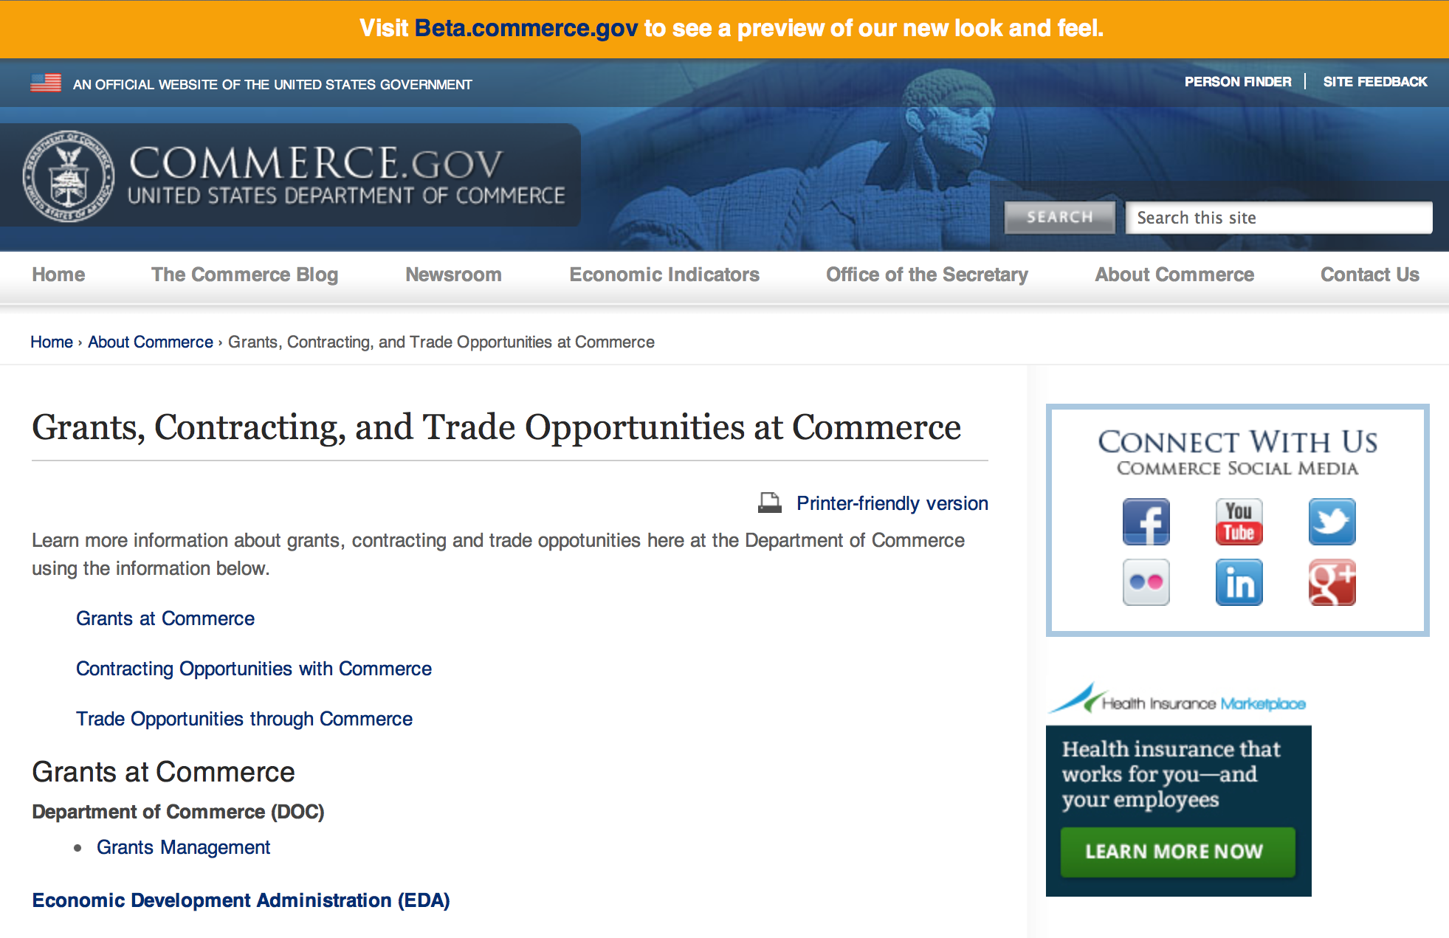
Grants at Commerce
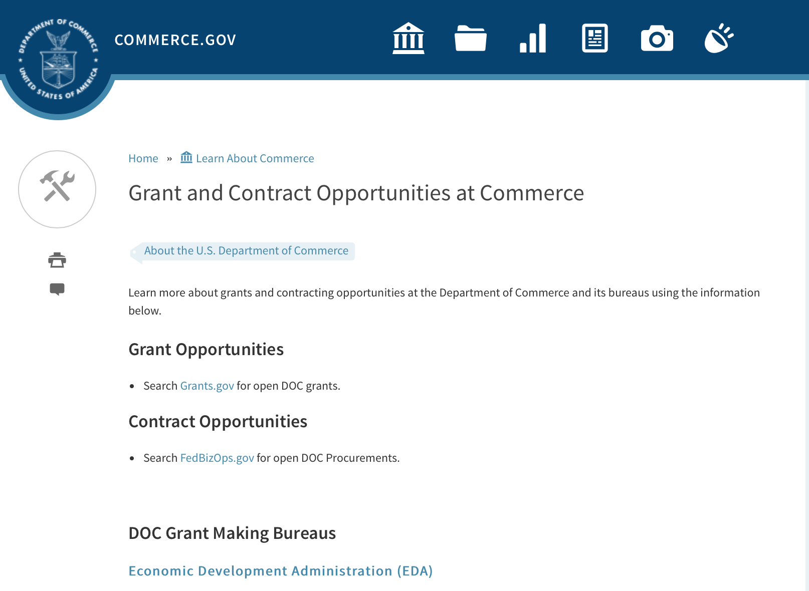

DOC Grant Making Bureaus
Economic Development Administration (EDA)
International Trade Administration (ITA)
- Market Development Cooperator Program
- Special American Business Internship Training Program (SABIT). A technical assistance initiative of the International Trade Administration of the U.S. Department of Commerce, SABIT offers organizations competitive grants and an opportunity to host industry-specific delegations. SABIT serves as an initial entry point for U.S. businesses seeking funding to establish long-term relationships with potential customers, distributors, or partners in the former Soviet Union. The program trains Eurasian managers and scientists in commonly accepted business practices as a means of facilitating cross border relationships. In turn, these personal relationships serve as a basis for business development and reduce market access barriers for U.S. businesses
National Institute of Standards & Technology (NIST)
- Funding Opportunities
National Telecommunications & Information Administration (NTIA)
- Telecommunications Grants
National Oceanic & Atmospheric Administration (NOAA)
- Coastal Ocean Program Grant Information
- Fisheries Saltonstall Kennedy Grant Program
- National Undersea Research Program Funding Opportunities
- Grants Management Division
- Fisheries Grants Program
- National Sea Grant
- Office of Global Programs
Contracting Resources for Contractors
- Office of Small and Disadvantaged Business Utilization (OSDBU) - he Office of Small and Disadvantaged Business Utilization (OSDBU) is an advocacy and advisory office responsible for promoting the use of small, small disadvantaged, 8(a), women-owned, veteran-owned, service-disabled veteran-owned, and HUBZone small businesses within the U.S. Department of Commerce's (DOC) acquisition process.
- Business.USA.gov's Find Opportunities Wizard where in a few quick steps, it will guide you towards federal government contracting programs and opportunities for your business!
- Planned Acquisitions: the Department of Commerce's search tool for our planned acquisitions over $100,000. As requirements change, these acquisition plans are updated by department personnel and this search tool is automatically updated.
- Small Business Administration's Contracting section of their web site where you can learn about how to "Get Started" and "Contracting Support for Small Business"
- The General Services Administration (GSA) has implemented a system for vendors doing business with the Federal Government to manage their entity information in one central location. This new database is the System for Award Management (SAM).

DOC Contracting Offices
- Patent and Trademark Office (PTO)
  - Office of Procurement
- National Institute of Standards & Technology (NIST)
NIST Acquisition Management Group
Contracting Opportunities with Commerce
Trade Opportunities through Commerce
http://www.commerce.gov/about-commerce/grants-contracting-trade-opportunities

Programs:

National Institute of Standards and Technology
Graduate Student Measurement Science and Engineering (GMSE) Fellowship Program

Document Type: | Grants Notice
Funding Opportunity Number: | 2016-NIST-GMSE-01
Funding Opportunity Title: | Graduate Student Measurement Science and Engineering (GMSE) Fellowship Program
Opportunity Category: | Discretionary
Opportunity Category Explanation:
Funding Instrument Type: | Cooperative Agreement
Category of Funding Activity: | Other (see text field entitled "Explanation of Other Category of Funding Activity" for clarification)
Category Explanation: | Science, Technology, Business and/or Education Outreach
Expected Number of Awards:
CFDA Number(s): | 11.620 -- Science, Technology, Business and/or Education Outreach
Cost Sharing or Matching Requirement: | No
Posted Date: | Feb 08, 2016
Last Updated Date: | Feb 08, 2016
Original Closing Date for Applications: | Apr 07, 2016
Current Closing Date for Applications: | Apr 07, 2016
Archive Date: | May 07, 2016
Eligible Applicants: | Others (see text field entitled "Additional Information on Eligibility" for clarification)
Additional Information on Eligibility: | Accredited institutions of higher education; non-profit organizations; commercial organizations; and state, local and Indian tribal governments. The applicant organization must be located in the United States and its territories. An eligible organization may work individually or include proposed sub-awards or contracts with others in a project proposal, effectively forming a team or consortium. Applicants are encouraged, but not required, to select underrepresented minorities for participation in the GMSE Fellowship Program. NIST is not accepting applications from individual graduate-level researchers to conduct work within the NIST laboratories on any NIST campus. This FFO seeks only applications from institutions with the knowledge, skills, and abilities to develop and manage a GMSE Fellowship Program that will provide doctoral-level graduate students with opportunities and financial assistance to obtain laboratory experiences within the NIST laboratories.
Agency Name: | National Institute of Standards and Technology
Description: | NIST is soliciting proposals from eligible applicants for a Graduate Student Measurement Science and Engineering (GMSE) Fellowship Program that will provide doctoral-level graduate students with opportunities and financial assistance to obtain laboratory experiences within the NIST laboratories in the science, technology, engineering and mathematics (STEM) disciplines. The recipient will work with NIST to foster collaborative STEM research relationships among NIST, doctoral-level graduate students, and the students’ academic institutions.
Link to Additional Information: | 2016-NIST-GMSE-01 Full Announcement/FFO document
Contact Information: | If you have difficulty accessing the full announcement electronically, please contact:  Christopher Hunton Management and Program Analyst Phone 301-975-5718  Agency Contact

http://www.grants.gov/web/grants/view-opportunity.html?oppId=281394

National Institute of Standards and Technology
NIST Standards Services Curricula Development (SSCD) Cooperative Agreement Program Grant
Document Type: | Grants Notice
Funding Opportunity Number: | 2016-NIST-SSCD-01
Funding Opportunity Title: | NIST Standards Services Curricula Development (SSCD) Cooperative Agreement Program
Opportunity Category: | Discretionary
Opportunity Category Explanation:
Funding Instrument Type: | Cooperative Agreement
Category of Funding Activity: | Other (see text field entitled "Explanation of Other Category of Funding Activity" for clarification)
Category Explanation: | Science, Technology, Business and/or Education Outreach
Expected Number of Awards:
CFDA Number(s): | 11.620 -- Science, Technology, Business and/or Education Outreach
Cost Sharing or Matching Requirement: | No
Posted Date: | Feb 05, 2016
Last Updated Date: | Feb 05, 2016
Original Closing Date for Applications: | Apr 05, 2016 Applications must be received electronically through Grants.gov no later than 11:59 p.m. Eastern Time, Tuesday, April 5, 2016. Applications received after this deadline will not be reviewed or considered. The anticipated start date for awards under this FFO is expected to be no later than September 2016.
Current Closing Date for Applications: | Apr 05, 2016 Applications must be received electronically through Grants.gov no later than 11:59 p.m. Eastern Time, Tuesday, April 5, 2016. Applications received after this deadline will not be reviewed or considered. The anticipated start date for awards under this FFO is expected to be no later than September 2016.
Archive Date: | May 05, 2016
Eligible Applicants: | Others (see text field entitled "Additional Information on Eligibility" for clarification)
Additional Information on Eligibility: | Accredited institutions of higher education located in the United States and its territories. In addition, non-profit organizations, commercial organizations, and state, local, and Indian tribal governments located in the United States and its territories are eligible so long as they describe and demonstrate their proposed or existing relationship with an accredited institution of higher education that will incorporate the applicant’s project through a pilot or other program in the institution’s educational programs. Any eligible applicant may work individually or include proposed sub-awards or contracts with others in a project application, effectively forming a team or consortium.
Agency Name: | National Institute of Standards and Technology
Description: | The NIST SSCD Cooperative Agreement Program provides financial assistance to support curriculum development for the undergraduate and/or graduate level. These cooperative agreements support the integration of standards and standardization information and content into seminars, courses, and learning resources for U.S. colleges and universities. The recipients will work with NIST to strengthen education and learning about standards and standardization.
Link to Additional Information: | 2016-NIST-SSCD-01 Full Announcement/FFO document
Contact Information: | If you have difficulty accessing the full announcement electronically, please contact:  Christopher Hunton Management and Program Analyst Phone 301-975-5718  Agency Contact

http://www.grants.gov/web/grants/view-opportunity.html?oppId=281409

National Institute of Standards and Technology
FY 2016 Small Business Innovation Research (SBIR) Program Grant

Document Type: | Grants Notice
Funding Opportunity Number: | 2016-NIST-SBIR-01
Funding Opportunity Title: | FY 2016 Small Business Innovation Research (SBIR) Program
Opportunity Category: | Discretionary
Opportunity Category Explanation: | Category Explanation
Funding Instrument Type: | Cooperative Agreement
Category of Funding Activity: | Other (see text field entitled "Explanation of Other Category of Funding Activity" for clarification)
Category Explanation: | Science, Technology, Business and/or Education Outreach
Expected Number of Awards:
CFDA Number(s): | 11.620 -- Science, Technology, Business and/or Education Outreach
Cost Sharing or Matching Requirement: | No
Posted Date: | Feb 02, 2016
Last Updated Date: | Feb 02, 2016
Original Closing Date for Applications: | Apr 14, 2016 Phase I electronic applications must be received no later than 11:59 p.m. Eastern Time, April 14, 2016. Paper applications must be received by NIST by 5:00 p.m. Eastern Time, April 14, 2016.
Current Closing Date for Applications: | Apr 14, 2016 Phase I electronic applications must be received no later than 11:59 p.m. Eastern Time, April 14, 2016. Paper applications must be received by NIST by 5:00 p.m. Eastern Time, April 14, 2016.
Archive Date: | May 14, 2016
Eligible Applicants: | Others (see text field entitled "Additional Information on Eligibility" for clarification)
Additional Information on Eligibility: | Each applicant for both Phase I and Phase II must qualify as a small business concern for R/R&D purposes, as defined in Section 1.06 of this FFO, at the time of award. In addition, the primary employment of the principal investigator must be with the small business at the time of the award and during the conduct of the proposed research. Primary employment means that more than one-half of the principal investigator's time is spent working with the small business. Primary employment with a small business precludes full-time employment with another organization. Occasionally, deviations from this requirement may occur, which must be approved in writing by the NIST Grants Officer after consultation with the SBIR Program Manager. Further, a small business may only replace the principal investigator on an SBIR Phase I or Phase II award if the NIST Grants Officer provides prior written approval. Personnel obtained through a Professional Employer Organization or other similar personnel leasing company may be considered employees of the awardee.
Agency Name: | National Institute of Standards and Technology
Description: | The National Institute of Standards and Technology (NIST) invites small businesses to submit Phase I research applications under this Federal Funding Opportunity (FFO). Firms with strong research capabilities in any of the areas listed in Section 9 of this FFO are encouraged to participate. Applications not addressing one of the subtopics in Section 9 are not responsive to this FFO. The NIST FY 2016 SBIR program identifies and solicits applications in topics that fall within NIST’s mission and allow collaboration between NIST scientists and the SBIR awardees whenever possible. In order to ensure a greater strategic alignment between the SBIR program and NIST’s laboratory research program, the SBIR topics are the priority areas identified in the NIST Programmatic Plan FY 2016-2018 available at: http://www.nist.gov/director/planning/planning.cfm.
Link to Additional Information: | 2016-NIST-SBIR-01 Full Announcement/FFO document
Contact Information: | If you have difficulty accessing the full announcement electronically, please contact:  Christopher Hunton Management and Program Analyst Phone 301-975-5718  Agency Contact

http://www.grants.gov/web/grants/view-opportunity.html?oppId=281304

National Institute of Standards and Technology
FY 2016 Small Business Innovation Research (SBIR) Program – Phase II Grant

Document Type: | Grants Notice
Funding Opportunity Number: | 2016-NIST-SBIR-02
Funding Opportunity Title: | FY 2016 Small Business Innovation Research (SBIR) Program – Phase II
Opportunity Category: | Discretionary
Opportunity Category Explanation:
Funding Instrument Type: | Cooperative Agreement
Category of Funding Activity: | Other (see text field entitled "Explanation of Other Category of Funding Activity" for clarification)
Category Explanation: | Science, Technology, Business and/or Education Outreach
Expected Number of Awards:
CFDA Number(s): | 11.620 -- Science, Technology, Business and/or Education Outreach
Cost Sharing or Matching Requirement: | No
Posted Date: | Feb 18, 2016
Last Updated Date: | Feb 18, 2016
Original Closing Date for Applications: | May 05, 2016 Phase II electronic applications must be received no later than 11:59 p.m. Eastern Time, May 5, 2016. Paper applications must be received by NIST by 5:00 p.m. Eastern Time, May 5, 2016.
Current Closing Date for Applications: | May 05, 2016 Phase II electronic applications must be received no later than 11:59 p.m. Eastern Time, May 5, 2016. Paper applications must be received by NIST by 5:00 p.m. Eastern Time, May 5, 2016.
Archive Date: | Jun 04, 2016
Eligible Applicants: | Others (see text field entitled "Additional Information on Eligibility" for clarification)
Additional Information on Eligibility: | Under this FFO, only FY 2015 NIST SBIR Phase I awardees are eligible to submit applications. Applicants must qualify as a small business concern for R/R&D purposes, as defined in Section 1.06 of this FFO, at the time of award. In addition, the primary employment of the principal investigator must be with the small business at the time of the award and during the conduct of the proposed research. Primary employment means that more than one-half of the principal investigator's time is spent working with the small business. Primary employment with a small business precludes full-time employment with another organization. Occasionally, deviations from this requirement may occur, which must be approved in writing by the NIST Grants Officer after consultation with the SBIR Program Manager. Consult the Full Announcement/FFO document for more details on eligibility.
Agency Name: | National Institute of Standards and Technology
Description: | The National Institute of Standards and Technology (NIST) invites FY 2015 NIST SBIR Phase I awardees to submit Phase II research applications under this Federal Funding Opportunity (FFO). Only NIST SBIR FY 2015 Phase I awardees are eligible to submit applications for Phase II of their projects. In Phase II, work from Phase I that exhibits potential for commercial application is further developed. Phase II is the R&D or prototype development phase. To apply for a Phase II award, each Phase I awardee is required to submit a comprehensive application outlining the research. Each NIST Phase II award is for up to $300,000 and up to a 24 month period of performance. One year after completing Phase II R&D activity, the awardee shall be required to report on its commercialization activities.
Link to Additional Information: | 2016-NIST-SBIR-02 Full Announcement/FFO document
Contact Information: | If you have difficulty accessing the full announcement electronically, please contact:  Christopher Hunton Management and Program Analyst Phone 301-975-5718  Agency Contact

http://www.grants.gov/web/grants/view-opportunity.html?oppId=281629

National Institute of Standards and Technology
Replicable Smart City Technologies Cooperative Agreement Program Grant

Document Type: | Grants Notice
Funding Opportunity Number: | 2016-NIST-RSCT-01
Funding Opportunity Title: | Replicable Smart City Technologies Cooperative Agreement Program
Opportunity Category: | Discretionary
Opportunity Category Explanation:
Funding Instrument Type: | Cooperative Agreement
Category of Funding Activity: | Other (see text field entitled "Explanation of Other Category of Funding Activity" for clarification)
Category Explanation: | Arrangements for Interdisciplinary Research Infrastructure
Expected Number of Awards:
CFDA Number(s): | 11.619 -- Arrangements for Interdisciplinary Research Infrastructure
Cost Sharing or Matching Requirement: | No
Posted Date: | Feb 19, 2016
Last Updated Date: | Feb 19, 2016
Original Closing Date for Applications: | May 12, 2016
Current Closing Date for Applications: | May 12, 2016
Archive Date: | Jun 11, 2016
Eligible Applicants: | Others (see text field entitled "Additional Information on Eligibility" for clarification)
Additional Information on Eligibility: | Local governments located in the United States and its territories and participating as a Team member in NIST’s 2016 GCTC. For purposes of this program, a local government is defined as any incorporated political subdivision of a state that is composed of the citizens of a designated geographic area and which performs certain government functions on a local level; local governments include counties and municipalities such as cities, towns, villages, and boroughs. An eligible organization may work individually or propose subawards or contracts with others effectively forming a team or consortium. Only one application will be considered per GCTC Team. A GCTC Team that includes more than one eligible local government member must designate one of the eligible local government team member as the lead responsible for submitting the application and, if selected, for receiving and administering the award, with the other members participating through subawards or contracts. More information about the 2016 GCTC, including how to register to participate, can be found at http://www.nist.gov/cps/sagc.cfm.
Agency Name: | National Institute of Standards and Technology
Description: | NIST invites applications from eligible applicants (referred to below as City/Community Partners) for a program that will support cities and communities in team-based efforts under the 2016 Global City Teams Challenge (GCTC). The purpose of this funding opportunity is to enable cities and communities to take a lead role in the team-based GCTC efforts to advance the measurement science of replicable, standards-based smart city technologies that provide measurable performance metrics, meet the needs of cities and communities of all types and sizes, and provide platforms for entrepreneurship and innovation.
Link to Additional Information: | 2016-NIST-RSCT-01 Full Announcement/FFO document
Contact Information: | If you have difficulty accessing the full announcement electronically, please contact:  Christopher Hunton Management and Program Analyst Phone 301-975-5718  Agency Contact

http://www.grants.gov/web/grants/view-opportunity.html?oppId=281680

FY 2016 Joint Technology Transfer Initiative Grant
Document Type: | Grants Notice
Funding Opportunity Number: | NOAA-OAR-OWAQ-2016-2004824
Funding Opportunity Title: | FY 2016 Joint Technology Transfer Initiative
Opportunity Category: | Discretionary
Opportunity Category Explanation:
Funding Instrument Type: | Cooperative Agreement
Category of Funding Activity: | Environment  Natural Resources  Science and Technology and other Research and Development
Category Explanation:
Expected Number of Awards: | 10
CFDA Number(s): | 11.459 -- Weather and Air Quality Research
Cost Sharing or Matching Requirement: | No
Posted Date: | Feb 19, 2016
Last Updated Date: | Feb 19, 2016
Original Closing Date for Applications: | Apr 29, 2016
Current Closing Date for Applications: | Apr 29, 2016
Archive Date: | May 29, 2016
Estimated Total Program Funding: | $1,800,000
Award Ceiling: | $300,000
Award Floor: | $150,000
Eligible Applicants: | Others (see text field entitled "Additional Information on Eligibility" for clarification)
Additional Information on Eligibility: | Eligible applicants are institutions of higher education; other nonprofit organizations; commercial organizations.
Agency Name: | Department of Commerce
Description: | Through the U.S. Weather Research Program (USWRP), OAR’s Office of Weather and Air Quality (OWAQ) is soliciting proposals to conduct research and development activities related to advancing the storm-scale modeling and Integrated Water Prediction over the coming 1 to 2 years.
Link to Additional Information:
Contact Information: | If you have difficulty accessing the full announcement electronically, please contact:  Chandra.Kondragunta, R/WA; Office of Weather and Air Quality/OAR/NOAA; R.No. 10321, SSMC-3; 1315 East West Highway; Silver Spring; MD 20910; 301-734-1034  Work

http://www.grants.gov/web/grants/view-opportunity.html?oppId=281686

National Institute of Standards and Technology
Measurement Science and Engineering (MSE) Research Grant Programs

Document Type: | Grants Notice
Funding Opportunity Number: | 2016-NIST-MSE-01
Funding Opportunity Title: | Measurement Science and Engineering (MSE) Research Grant Programs
Opportunity Category: | Discretionary
Opportunity Category Explanation:
Funding Instrument Type: | Cooperative Agreement  Grant
Category of Funding Activity: | Science and Technology and other Research and Development
Category Explanation:
Expected Number of Awards:
CFDA Number(s):
Cost Sharing or Matching Requirement: | No
Posted Date: | Feb 19, 2016
Last Updated Date: | Feb 19, 2016
Original Closing Date for Applications: | Applications will be accepted and considered on a rolling basis as they are received. See Section IV.4. in the text of the Full Announcement/FFO document. Applications may be submitted by paper or electronically through Grants.gov. Carefully read Section IV. of the Full Announcement/FFO document for details applying to electronic submissions and to paper submissions.
Current Closing Date for Applications: | Applications will be accepted and considered on a rolling basis as they are received. See Section IV.4. in the text of the Full Announcement/FFO document. Applications may be submitted by paper or electronically through Grants.gov. Carefully read Section IV. of the Full Announcement/FFO document for details applying to electronic submissions and to paper submissions.
Eligible Applicants: | Others (see text field entitled "Additional Information on Eligibility" for clarification)
Additional Information on Eligibility: | Eligibility for all programs listed in this FFO is open to all non-Federal entities. Eligible applicants include institutions of higher education, non-profit organizations, for-profit organizations, state and local governments, Indian tribes, hospitals, foreign public entities, and foreign governments. Applicants selected for awards under 15 U.S.C. § 278g-1 are encouraged, but not required, to select underrepresented minorities for participation. In addition, NIST is not able to accept an application from an individual unaffiliated with a sponsoring applicant organization.
Agency Name: | National Institute of Standards and Technology
Description: | NIST is soliciting applications for financial assistance for Fiscal Year 2016 (FY16) within the following NIST Laboratory grant programs: (1) the Material Measurement Laboratory (MML) Grant Program; (2) the Physical Measurement Laboratory (PML) Grant Program; (3) the Engineering Laboratory (EL) Grant Program; (4) the Fire Research (FR) Grant Program; (5) the Information Technology Laboratory (ITL) Grant Program; (6) the Communications Technology Laboratory (CTL) Grant Program; (7) the NIST Center for Neutron Research (NCNR) Grant Program; (8) the Center for Nanoscale Science and Technology (CNST) Grant Program; (9) the Special Programs Office (SPO) Grant Program; (10) the Standards Coordination Office (SCO) Grant Program; (11) the International and Academic Affairs Office (IAAO) Grant Program; and (12) the Associate Director for Laboratory Programs (ADLP) Grant Program.
Link to Additional Information: | 2016-NIST-MSE-01 Full Announcement/FFO document
Contact Information: | If you have difficulty accessing the full announcement electronically, please contact:  Christopher Hunton Management and Program Analyst Phone 301-975-5718  Agency Contact

http://www.grants.gov/web/grants/view-opportunity.html?oppId=281689

National Institute of Standards and Technology
National Network for Manufacturing Innovation (NNMI) Institute Awards Grant

Document Type: | Grants Notice
Funding Opportunity Number: | 2016-NIST-NNMI-01
Funding Opportunity Title: | National Network for Manufacturing Innovation (NNMI) Institute Awards
Opportunity Category: | Discretionary
Opportunity Category Explanation: | Category Explanation
Funding Instrument Type: | Cooperative Agreement
Category of Funding Activity: | Other (see text field entitled "Explanation of Other Category of Funding Activity" for clarification)
Category Explanation: | Arrangements for Interdisciplinary Research Infrastructure
Expected Number of Awards:
CFDA Number(s): | 11.619 -- Arrangements for Interdisciplinary Research Infrastructure
Cost Sharing or Matching Requirement:
Current Closing Date for Applications: | Apr 20, 2016 Required Pre-Applications must be received electronically through Grants.gov no later than 11:59 p.m. Eastern Time, April 20, 2016. Pre-Applications received after this deadline will not be reviewed or considered. Paper Pre-Applications will not be accepted. Review of Pre-Applications, selection, and notification to applicants is expected to be complete on or about May 23, 2016. Selected Pre-applicants will then be invited to submit a Full Application. Full Applications must be received electronically through Grants.gov no later than 11:59 p.m. Eastern Time, July 22, 2016. Full Applications received after this deadline will not be reviewed or considered. Paper Full Applications will not be accepted.
Eligible Applicants: | Others (see text field entitled "Additional Information on Eligibility" for clarification)
Additional Information on Eligibility: | Eligible applicants are non-profit organizations; accredited institutions of higher education; State, local, and Tribal governments; and for-profit organizations that are organized and operated in the United States (including U.S. territories) with majority domestic ownership or control. Federal agencies and Federally Funded Research and Development Centers (FFRDCs) are not eligible to apply for this funding opportunity. Please refer to the Full Announcement/FFO document for further details on eligibility.
Agency Name: | National Institute of Standards and Technology
Description: | NIST is soliciting applications for National Network for Manufacturing Innovation (NNMI) Institute Awards from eligible applicants to establish and operate a Manufacturing Innovation Institute in an area of U.S. advanced manufacturing national need. Proposed Institutes in any area of advanced manufacturing will be considered so long as they do not duplicate the technical scope and programs of both existing programs of federally funded Institutes within the National Network for Manufacturing Innovation (NNMI), and technical focus area(s) that are identified within any in-progress Institute funding opportunity announced by a federal agency. Please consult the Full Announcement/FFO document for further details on the NNMI Institute Awards, the program’s public web site, FAQs, and informational webinars.
Link to Additional Information: | 2016-NIST-NNMI-01 Full Announcement/FFO document
Contact Information: | If you have difficulty accessing the full announcement electronically, please contact:  Christopher Hunton Management and Program Analyst Phone 301-975-0404  Agency Contact

http://www.grants.gov/web/grants/view-opportunity.html?oppId=281622

Modifications:

Fiscal Year 2017 National Sea Grant College Program Dean John A. Knauss Marine Policy Fellowship
Modification 1

Document Type: | Grants Notice
Funding Opportunity Number: | NOAA-OAR-SG-2017-2004620
Funding Opportunity Title: | Fiscal Year 2017 National Sea Grant College Program Dean John A. Knauss Marine Policy Fellowship
Opportunity Category: | Discretionary
Opportunity Category Explanation:
Funding Instrument Type: | Cooperative Agreement
Category of Funding Activity: | Environment  Natural Resources  Science and Technology and other Research and Development
Category Explanation:
Expected Number of Awards: | 30
CFDA Number(s): | 11.417 -- Sea Grant Support
Cost Sharing or Matching Requirement: | No
Posted Date: | Oct 28, 2015
Last Updated Date: | Feb 04, 2016
Original Closing Date for Applications: | Feb 12, 2016
Current Closing Date for Applications: | Mar 31, 2016
Archive Date: | Apr 30, 2016
Estimated Total Program Funding: | $1,695,000
Award Ceiling: | $66,500
Award Floor: | $56,500
Eligible Applicants: | Others (see text field entitled "Additional Information on Eligibility" for clarification)
Additional Information on Eligibility: | An eligible applicant is any student, regardless of citizenship, who, on February 12, 2016, is enrolled towards a degree in a graduate program, that have an interest in ocean, coastal and Great Lakes resources and in the national policy decisions affecting those resources. The graduate degree needs to be awarded through a United States accredited institution of higher education in the United States or U.S. Territories.
Agency Name: | Department of Commerce
Description: | This notice announces that applications may be submitted for the 2017 National Sea Grant College Program Dean John A. Knauss Marine Policy Fellowship (Sea Grant Knauss Fellowship Program). Sea Grant anticipates funding not less than 30 selected applicants, of which those assigned to the Legislative branch may be limited to 12. Each award will be funded at a total of $56,500 in federal funding, with the option by the host office to add no more than $10,000 for fellow travel related to host office duties, for a maximum of $66,500.
Link to Additional Information:
Contact Information: | If you have difficulty accessing the full announcement electronically, please contact:  Julia Galkiewcz Sea Grant Knauss Fellowship Program Manager National Sea Grant College Program 1315 East-West Highway, R/SG, Room 11861 Silver Spring, MD 20910 (301) 734-1067  work

http://www.grants.gov/web/grants/view-opportunity.html?oppId=278911

Reminders:

Market Development Cooperator Program 2016 Grant

Document Type: | Grants Notice
Funding Opportunity Number: | ITA-INA-OPCM-2016-2004724
Funding Opportunity Title: | Market Development Cooperator Program 2016
Opportunity Category: | Discretionary
Funding Instrument Type: | Cooperative Agreement
Category of Funding Activity: | Environment  Natural Resources  Science and Technology and other Research and Development
Category Explanation:
Expected Number of Awards: | 10
CFDA Number(s): | 11.112 -- Market Development Cooperator Program
Cost Sharing or Matching Requirement: | Yes
Posted Date: | Jan 15, 2016
Creation Date: | Jan 15, 2016
Original Closing Date for Applications: | Mar 15, 2016
Current Closing Date for Applications: | Mar 15, 2016
Archive Date: | Apr 14, 2016
Estimated Total Program Funding: | $2,000,000
Award Ceiling: | $300,000
Award Floor: | $50,000
Eligible Applicants: | Others (see text field entitled "Additional Information on Eligibility" for clarification)
Additional Information on Eligibility: | Entities that fall within the following categories are generally found to be eligible to apply for an MDCP award: trade associations; state departments of trade and their regional associations; and non-profit industry organizations, including organizations such as World Trade Centers, centers for international trade development, and small business development centers. In cases where no entity described above represents the industry, private industry firms or groups of firms may be eligible to apply for an MDCP award. Such private industry firms or groups of firms must provide documentation in their eligibility determination request demonstrating that no entity in the first three categories listed below represents their industry
Agency Name: | Department of Commerce
Description: | ITA requests that eligible organizations submit proposals (applications) for the fiscal year (FY) 2016 competition for MDCP awards. ITA creates economic opportunity for U.S. workers and firms by promoting international trade and investment, strengthening industry competitiveness, and ensuring fair trade.
Link to Additional Information:
Contact Information: | If you have difficulty accessing the full announcement electronically, please contact:  Mr. Brad Hess Director, Market Development Cooperator Program Industry & Analysis, ITA U.S. Department of Commerce 1401 Constitution Avenue, N.W., Room 20023 Washington, D.C. 20230 202-482-2969  work

http://www.grants.gov/web/grants/view-opportunity.html?oppId=281029

National Sea Grant College Program 2016-17 Special Projects Grant

Document Type: | Grants Notice
Funding Opportunity Number: | NOAA-OAR-SG-2016-2004772
Funding Opportunity Title: | National Sea Grant College Program 2016-17 Special Projects
Opportunity Category: | Discretionary
Funding Instrument Type: | Cooperative Agreement  Grant
Category of Funding Activity: | Environment  Natural Resources  Science and Technology and other Research and Development
Category Explanation:
Expected Number of Awards: | 30
CFDA Number(s): | 11.417 -- Sea Grant Support
Cost Sharing or Matching Requirement: | Yes
Posted Date: | Jan 7, 2016
Creation Date: | Jan 7, 2016
Original Closing Date for Applications: | Sep 30, 2017
Current Closing Date for Applications: | Sep 30, 2017
Archive Date: | Oct 30, 2017
Estimated Total Program Funding: | $4,000,000
Award Ceiling: | $1,000,000
Award Floor: | $1
Eligible Applicants: | Others (see text field entitled "Additional Information on Eligibility" for clarification)
Additional Information on Eligibility: | Sea Grant Programs (Sea Grant Colleges, Institutions, or Coherent Area Programs), the National Sea Grant Law Center, and the National Sea Grant Library.
Agency Name: | Department of Commerce
Description: | The purpose of this notice is to request proposals for special projects associated with the National Sea Grant College Program’s (Sea Grant) strategic focus areas, and to provide the general public with information and guidelines on how Sea Grant will select proposals and administer Federal assistance under this announcement. This announcement is a mechanism to encourage research or other projects that are not normally funded through Sea Grant national competitions. This opportunity is open only to Sea Grant Programs. Section III of this announcement describes eligibility requirements in more detail. Funding has not yet been made available to support applications submitted to this Federal Funding Opportunity (FFO), but such funding may become available during the year. Section II.A. below describes individual competition announcements that will be used to announce when funding is available; any restrictions or requirements on such funding, such as matching funds; and other funding details. Awards will be made under this FFO only if funds have been announced as provided in this FFO.
Link to Additional Information:
Contact Information: | If you have difficulty accessing the full announcement electronically, please contact:  Special Projects Competition Manager, NOAA R/SG National Sea Grant Office 1315 East-West Highway, Rm 11839 Silver Spring, MD 20910 301-734-1066  work

http://www.grants.gov/web/grants/view-opportunity.html?oppId=280846

FY 2016 – FY 2019 EDA Planning Program and Local Technical Assistance Program Grant

Document Type: | Grants Notice
Funding Opportunity Number: | EDA-HDQ-TA-HDQ-2016-2004759
Funding Opportunity Title: | FY 2016 – FY 2019 EDA Planning Program and Local Technical Assistance Program
Opportunity Category: | Discretionary
Funding Instrument Type: | Cooperative Agreement  Grant
Category of Funding Activity: | Other (see text field entitled "Explanation of Other Category of Funding Activity" for clarification)  Regional Development
Category Explanation: | Regional planning and local technical assistance
Expected Number of Awards:
CFDA Number(s): | 11.302 -- Economic Development Support for Planning Organizations  11.303 -- Economic Development Technical Assistance
Cost Sharing or Matching Requirement: | No
Posted Date: | Dec 10, 2015
Creation Date: | Dec 10, 2015
Original Closing Date for Applications: | Applications are accepted on a continuing basis and processed as received. This Planning and Local Technical Assistance opportunity will remain in effect until superseded by a future announcement.
Current Closing Date for Applications: | Applications are accepted on a continuing basis and processed as received. This Planning and Local Technical Assistance opportunity will remain in effect until superseded by a future announcement.
Archive Date:
Estimated Total Program Funding:
Award Ceiling: | $300,000
Award Floor: | $0
Eligible Applicants: | Nonprofits having a 501(c)(3) status with the IRS, other than institutions of higher education  City or township governments  Nonprofits that do not have a 501(c)(3) status with the IRS, other than institutions of higher education  Others (see text field entitled "Additional Information on Eligibility" for clarification)  Private institutions of higher education  Native American tribal governments (Federally recognized)  Public and State controlled institutions of higher education  State governments  Special district governments  County governments
Additional Information on Eligibility: | Pursuant to section 3 of the Public Works and Economic Development Act of 1965 (42 U.S.C. § 3122) (PWEDA) and EDA’s regulation at 13 C.F.R. § 300.3, the following types of entities are eligible to receive funding assistance from EDA: 1. District Organizations (as defined in 13 C.F.R. § 300.3); 2. Indian Tribes or a consortium of Indian Tribes; 3. States, cities, or other political subdivisions of a State, including a special purpose unit of a State or local government engaged in economic or infrastructure development activities, or a consortium of political subdivisions; 4. Institutions of higher education or a consortium of institutions of higher education; or 5. Public or private non-profit organizations or associations acting in cooperation with officials of a political subdivision of a State.
Agency Name: | Department of Commerce
Description: | Pursuant to PWEDA, EDA announces general policies and application procedures for grant-based investments under the Planning and Local Technical Assistance programs. Under the Planning program EDA assists eligible recipients in creating regional economic development plans designed to build capacity and guide the economic prosperity and resiliency of an area or region. As part of this program, EDA supports Partnership Planning investments to facilitate the development, implementation, revision, or replacement of Comprehensive Economic Development Strategies (CEDS), which articulate and prioritize the strategic economic goals of recipients’ respective regions. In general, EDA provides Partnership Planning grants to the designated planning organization (e.g., District Organization) serving EDA designated Economic Development Districts to enable these organizations to develop and implement relevant CEDS. In addition, EDA provides Partnership Planning grants to Indian Tribes to help develop and implement CEDS and associated economic development activities. The Planning program also helps support organizations, including District Organizations, Indian Tribes, and other eligible recipients, with Short Term and State Planning investments designed to guide the eventual creation and retention of high-quality jobs, particularly for the unemployed and underemployed in the Nation’s most economically distressed regions. The Local Technical Assistance program strengthens the capacity of local or State organizations, institutions of higher education, and other eligible recipients to undertake and promote effective economic development programs through projects such as feasibility analyses and impact studies.
Link to Additional Information: | www.eda.gov
Contact Information: | If you have difficulty accessing the full announcement electronically, please contact:  The EDA representative for your state. A complete list of EDA representatives is available on EDA's website at http://www.eda.gov/contact/

http://www.grants.gov/web/grants/view-opportunity.html?oppId=280447

Fisheries International Cooperation and Assistance Program Grant

Document Type: | Grants Notice
Funding Opportunity Number: | NOAA-NMFS-FHQ-2016-2004689
Funding Opportunity Title: | Fisheries International Cooperation and Assistance Program
Opportunity Category: | Discretionary
Funding Instrument Type: | Cooperative Agreement  Grant
Category of Funding Activity: | Environment  Natural Resources  Science and Technology and other Research and Development
Category Explanation:
Expected Number of Awards: | 20
CFDA Number(s): | 11.463 -- Habitat Conservation
Cost Sharing or Matching Requirement: | No
Posted Date: | Dec 7, 2015
Creation Date: | Dec 7, 2015
Original Closing Date for Applications: | Mar 31, 2016
Current Closing Date for Applications: | Mar 31, 2016
Archive Date: | Apr 30, 2016
Estimated Total Program Funding: | $1,500,000
Award Ceiling: | $100,000
Award Floor: | $25,000
Eligible Applicants: | Others (see text field entitled "Additional Information on Eligibility" for clarification)
Additional Information on Eligibility: | Eligible applicants are institutions of higher education, nonprofits, for-profit commercial organizations, international or foreign organizations or foreign public entities, organizations under the jurisdiction of foreign governments, individuals, and state, local and Indian Tribal governments. If the applicant is a university that has a NOAA Joint or Cooperative Institute (CI), the institution is encouraged to submit an application that will be associated with the CI. The application must specify the name of the CI, its most recent award number, and the NOAA- approved research theme applicable to the work to be performed in the project narrative. The application must use the facilities and administrative rate (F&A or Indirect Cost Rate) associated with most recent CI award. If the application is selected for funding, NMFS will notify the university that a separate competitive award will be issued with its own award number. However, the competitive award will include a Special Award Condition (SAC) that evidences the link between it and the CI award. The SAC will provide (1) that the university has submitted the proposal to be associated with the CI; (2) that any existing University/NOAA Memorandum Of Agreement will be incorporated by reference into the terms of the competitive award, and (3) that any progress report(s) for the competitive award must follow the timetable of and be submitted by the CI directly to the funding program. Copies of these progress reports will be attached to the CI's performance report as an appendix.
Agency Name: | Department of Commerce
Description: | The purpose of this notice is to request applications for special projects and programs associated with NMFS Office of International Affairs and Seafood Inspection (IASI) strategic plan and mission goals (http://www.nmfs.noaa.gov/ia/), as well as to provide the general public with information and guidelines on how IASI will select proposals and administer discretionary Federal assistance under this National Marine Fisheries Service Fisheries International Cooperation and Assistance Program (FICAP) - FY 2016 Announcement. This program is a mechanism to encourage research, policy, and outreach, innovative projects, or sponsorship that are not addressed through our other competitive discretionary programs. Funding for potential projects in this notice is contingent upon the availability of Fiscal Year 2016 appropriations. Applicants are hereby given notice that funds have not yet been appropriated for any potential activities in this notice. Publication of this announcement does not oblige IASI to review an application, or to award any specific project, or to obligate any available funds.
Link to Additional Information:
Contact Information: | If you have difficulty accessing the full announcement electronically, please contact:  For further information about IASI, please visit NOAA Fisheries Office of International Affairs and Seafood Inspection website at: http://www.nmfs.noaa.gov/ia/ Or contact: National Marine Fisheries Service (NMFS) Christopher Rogers Phone Number: 301-427-8375 Email: Christopher.Rogers@noaa.gov 1315 East-West Hwy Suite 10648 Silver Spring, MD 20910-3282  Work

http://www.grants.gov/web/grants/view-opportunity.html?oppId=280408

FY 2016 Economic Development Assistance Programs ­ Application submission and program requirements for EDA’s Public Works and Economic Adjustment Assistance Programs Grant

Document Type: | Grants Notice
Funding Opportunity Number: | EDAP2016
Funding Opportunity Title: | FY 2016 Economic Development Assistance Programs ­ Application submission and program requirements for EDA’s Public Works and Economic Adjustment Assistance programs.
Opportunity Category: | Discretionary
Funding Instrument Type: | Cooperative Agreement  Grant
Category of Funding Activity: | Other (see text field entitled "Explanation of Other Category of Funding Activity" for clarification)
Category Explanation: | The Economic Development Administration's (EDA's) mission is to lead the Federal economic development agenda by promoting innovation and competitiveness, preparing American regions for economic growth and success in the worldwide economy. EDA fulfills this mission through strategic investments and partnerships that create the regional economic ecosystems required to foster globally competitive regions throughout the United States. EDA supports development in economically distressed areas of the United States by fostering job creation and attracting private investment. Specifically, under the Economic Development Assistance programs (EDAP) Federal Funding Opportunity (FFO) announcement, EDA will make construction, non-construction, and revolving loan fund investments under the Public Works and Economic Adjustment Assistance (EAA) Programs. Grants made under these programs will leverage regional assets to support the implementation of regional economic development strategies designed to create jobs, leverage private capital, encourage economic development, and strengthen America's ability to compete in the global marketplace. Through the EDAP FFO, EDA solicits applications from rural and urban communities to develop initiatives that advance new ideas and creative approaches to address rapidly evolving economic conditions.
Expected Number of Awards:
CFDA Number(s): | 11.300 -- Investments for Public Works and Economic Development Facilities  11.307 -- Economic Adjustment Assistance
Cost Sharing or Matching Requirement: | Yes
Posted Date: | Oct 26, 2015
Creation Date: | Oct 26, 2015
Original Closing Date for Applications: | There are no submission deadlines under this opportunity. Proposals and applications will be accepted on an ongoing basis until the publication of a new EDAP FFO.
Current Closing Date for Applications: | There are no submission deadlines under this opportunity. Proposals and applications will be accepted on an ongoing basis until the publication of a new EDAP FFO.
Archive Date:
Estimated Total Program Funding:
Award Ceiling: | $3,000,000
Award Floor: | $100,000
Eligible Applicants: | Others (see text field entitled "Additional Information on Eligibility" for clarification)  State governments  City or township governments  Native American tribal organizations (other than Federally recognized tribal governments)  Native American tribal governments (Federally recognized)  Private institutions of higher education  Special district governments  Nonprofits having a 501(c)(3) status with the IRS, other than institutions of higher education  County governments  Nonprofits that do not have a 501(c)(3) status with the IRS, other than institutions of higher education  Public and State controlled institutions of higher education
Additional Information on Eligibility: | Eligible applicants for EDA financial assistance under the Public Works and EAA programs include a(n): (i) District Organization of a designated Economic Development District; (ii) Indian Tribe or a consortium of Indian Tribes; (iii) State, county, city, or other political subdivision of a State, including a special purpose unit of a State or local government engaged in economic or infrastructure development activities, or a consortium of political subdivisions; (iv) institution of higher education or a consortium of institutions of higher education; or (v) public or private non-profit organization or association acting in cooperation with officials of a political subdivision of a State. See Section 3 of the Public Works and Economic Development Act of 1965 (PWEDA) (42 U.S.C. § 3122) and 13 C.F.R. § 300.3. EDA is not authorized to provide grants or cooperative agreements to individuals or to for profit entities. Requests from such entities will not be considered for funding.
Agency Name: | Economic Development Administration
Description: | Under this FFO, EDA solicits applications from applicants in rural and urban areas to provide investments that support construction, non-construction, technical assistance, and revolving loan fund projects under EDA’s Public Works and EAA programs. Grants and cooperative agreements made under these programs are designed to leverage existing regional assets and support the implementation of economic development strategies that advance new ideas and creative approaches to advance economic prosperity in distressed communities. EDA provides strategic investments on a competitive- merit-basis to support economic development, foster job creation, and attract private investment in economically distressed areas of the United States.
Link to Additional Information: | www.eda.gov
Contact Information: | If you have difficulty accessing the full announcement electronically, please contact:  the EDA representative for your state. A complete list of EDA representatives is available on EDA's website at http://www.eda.gov/contact/

http://www.grants.gov/web/grants/view-opportunity.html?oppId=279842

Economic Development Administration
Planning Program and Local Technical Assistance Program Grant

Document Type: | Grants Notice
Funding Opportunity Number: | EDAPLANNING2012
Opportunity Category: | Discretionary
Posted Date: | Aug 03, 2012
Creation Date: | Aug 03, 2012
Original Closing Date for Applications: | Applications are accepted on a continuing basis and processed as received. This Planning and Local Technical Assistance opportunity will remain in effect until superseded by a future announcement.
Current Closing Date for Applications: | Applications are accepted on a continuing basis and processed as received. This Planning and Local Technical Assistance opportunity will remain in effect until superseded by a future announcement.
Archive Date:
Funding Instrument Type: | Cooperative Agreement  Grant
Category of Funding Activity: | Other (see text field entitled "Explanation of Other Category of Funding Activity" for clarification)  Regional Development
Category Explanation: | Regional planning and local technical assistance
Expected Number of Awards: | 425
Estimated Total Program Funding:
Award Ceiling: | $100,000
Award Floor:
CFDA Number(s): | 11.302 -- Economic Development Support for Planning Organizations
 | 11.303 -- Economic Development Technical Assistance
Cost Sharing or Matching Requirement: | Yes

Eligible Applicants
State governments
County governments
City or township governments
Public and State controlled institutions of higher education
Native American tribal governments (Federally recognized)
Nonprofits having a 501(c)(3) status with the IRS, other than institutions of higher education
Nonprofits that do not have a 501(c)(3) status with the IRS, other than institutions of higher education
Private institutions of higher education
Others (see text field entitled "Additional Information on Eligibility" for clarification)

Additional Information on Eligibility:
Pursuant to section 3 of the Public Works and Economic Development Act of 1965 (42 U.S.C. § 3122) (PWEDA) and EDA’s regulation at 13 C.F.R. § 300.3, the following types of entities are eligible to receive funding assistance from EDA: 1. District Organizations (as defined in 13 C.F.R. § 300.3); 2. Indian Tribes or a consortium of Indian Tribes; 3. States, cities, or other political subdivisions of a State, including a special purpose unit of a State or local government engaged in economic or infrastructure development activities, or a consortium of political subdivisions; 4. Institutions of higher education or a consortium of institutions of higher education; or 5. Public or private non-profit organizations or associations acting in cooperation with officials of a political subdivision of a State.

Agency Name
Economic Development Administration

Description
Pursuant to PWEDA, EDA announces general policies and application procedures for grant-based investments under the Planning and Local Technical Assistance programs. Under the Planning program EDA assists eligible recipients in creating regional economic development plans designed to stimulate and guide the economic development efforts of a community or region. As part of this program, EDA supports Partnership Planning investments to facilitate the development, implementation, revision, or replacement of Comprehensive Economic Development Strategies (CEDS), which articulate and prioritize the strategic economic goals of recipients' respective regions. In general, EDA provides Partnership Planning grants to the designated planning organization (e.g., District Organization) serving EDA-designated Economic Development Districts to enable these organizations to develop and implement relevant CEDS. In addition, EDA provides Partnership Planning grants to Indian Tribes to help develop and implement CEDS and associated economic development activities. The Planning program also helps support planning organizations, including District Organizations, Indian Tribes, and other eligible Recipients, with Short Term and State Planning investments designed to guide the eventual creation and retention of higher-skill, higher-wage jobs, particularly for the unemployed and underemployed in the Nation’s most economically distressed regions. The Local Technical Assistance program strengthens the capacity of local or State organizations, institutions of higher education, and other eligible recipients to undertake and promote effective economic development programs through projects such as feasibility analyses and impact studies.

Link to Additional Information

If you have difficulty accessing the full announcement electronically, please contact:
David Ives Planning and Local TA email

http://www.grants.gov/web/grants/view-opportunity.html?oppId=189193

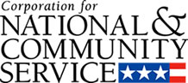

Corporation for National and Community Service

General Program Overview
AmeriCorps provides resources, both human and financial, to organizations that engage Americans in intensive service to meet our country’s critical needs.
Grantees use the funding to support AmeriCorps members for intensive service in their community. AmeriCorps grants partially cover the expense of operating an AmeriCorps program and do not cover general organizational expenses. A cash and in-kind match is required.

The main website can be accessed here: http://www.nationalservice.gov

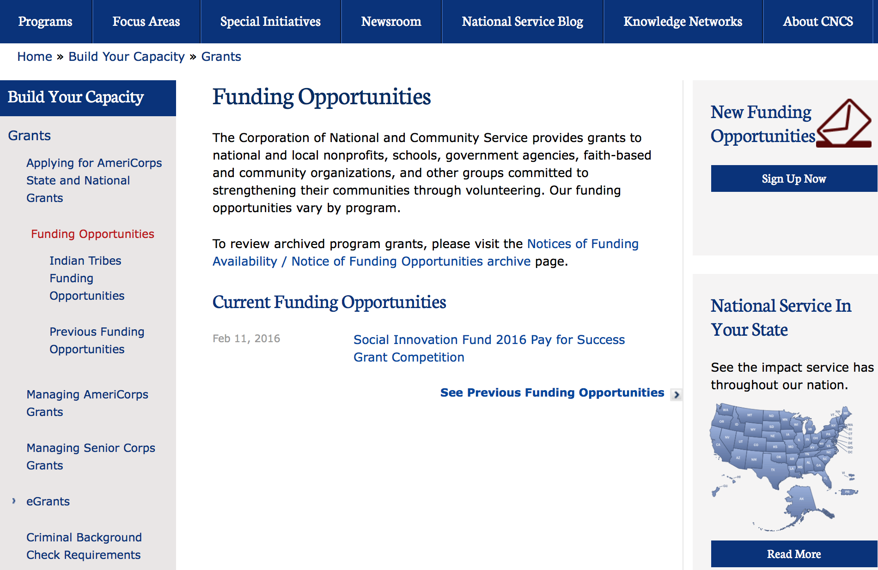

For access to further funding information: click here

http://www.nationalservice.gov/build-your-capacity/grants/funding-opportunities

Reminders:

National Service In Hawaii
National Service in Your State - Hawaii
2014-2015
Meeting Community Needs in Hawaii: More than 3,800 people of all ages and backgrounds are helping to meet local needs, strengthen communities, and increase civic engagement through national service in Hawaii. Serving at more than 350 locations throughout the state, these citizens tutor and mentor children, support veterans and military families, provide health services, restore the environment, respond to disasters, increase economic opportunity, and recruit and manage volunteers. This year, the Corporation for National and Community Service (CNCS) will commit more than $6,260,000 to support Hawaii communities through national service initiatives. Through a unique public-private partnership, this federal investment will leverage an additional $3,640,000 in other resources to strengthen community impact, build local support, and increase return on taxpayer dollars.

AmeriCorps
This year, AmeriCorps will provide more than 540 individuals the opportunity to provide intensive, results-driven service to meet education, environmental, health, economic, and other pressing needs in communities across Hawaii. Most AmeriCorps grant funding goes to the Hawaii Commission on National & Community Service, which in turn awards grants to nonprofit groups to respond to local needs. Most of the remainder of the grant funding is distributed by CNCS directly to multi-state and national organizations through a competitive grants process. Other individuals serve through AmeriCorps VISTA, whose members help bring individuals and communities out of poverty by serving full-time to fight illiteracy, improve health services, create businesses, and increase housing opportunities, and AmeriCorps NCCC (National Civilian Community Corps), a 10-month, full time residential program for men and women between the ages of 18 and 24. In exchange for their service, AmeriCorps members earn an education award that can be used to pay for college or to pay back qualified student loans. Since 1994, more than 5,600 Hawaii residents have served more than 5.8 million hours and have qualified for Segal AmeriCorps Education Awards totaling more than $13,510,000.

Senior Corps
More than 3,200 seniors in Hawaii contribute their time and talents in one of three Senior Corps programs. Foster Grandparents serve one-on-one as tutors and mentors to more than 340 young people who have special needs. Senior Companions help more than 200 homebound seniors and other adults maintain independence in their own homes. RSVP volunteers conduct safety patrols, renovate homes, protect the environment, tutor and mentor youth, respond to natural disasters, and provide other services through more than 170 groups across Hawaii.

The Corporation for National and Community Service is a federal agency that improves lives, strengthens communities, and fosters civic engagement through service and volunteering. CNCS annually engages more than five million Americans in service to meet local needs through Senior Corps, AmeriCorps, and national days of service; improves communities through the Social Innovation Fund, and leads President Obama's national call to service initiative, United We Serve. To learn more visit NationalService.gov or Serve.gov or call 202-606-5000 or TTY 1-800-833-3722.

http://www.nationalservice.gov/impact-our-nation/state-profiles/hi

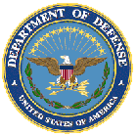

U.S. Department of Defense

Doing Business with the Department of Defense

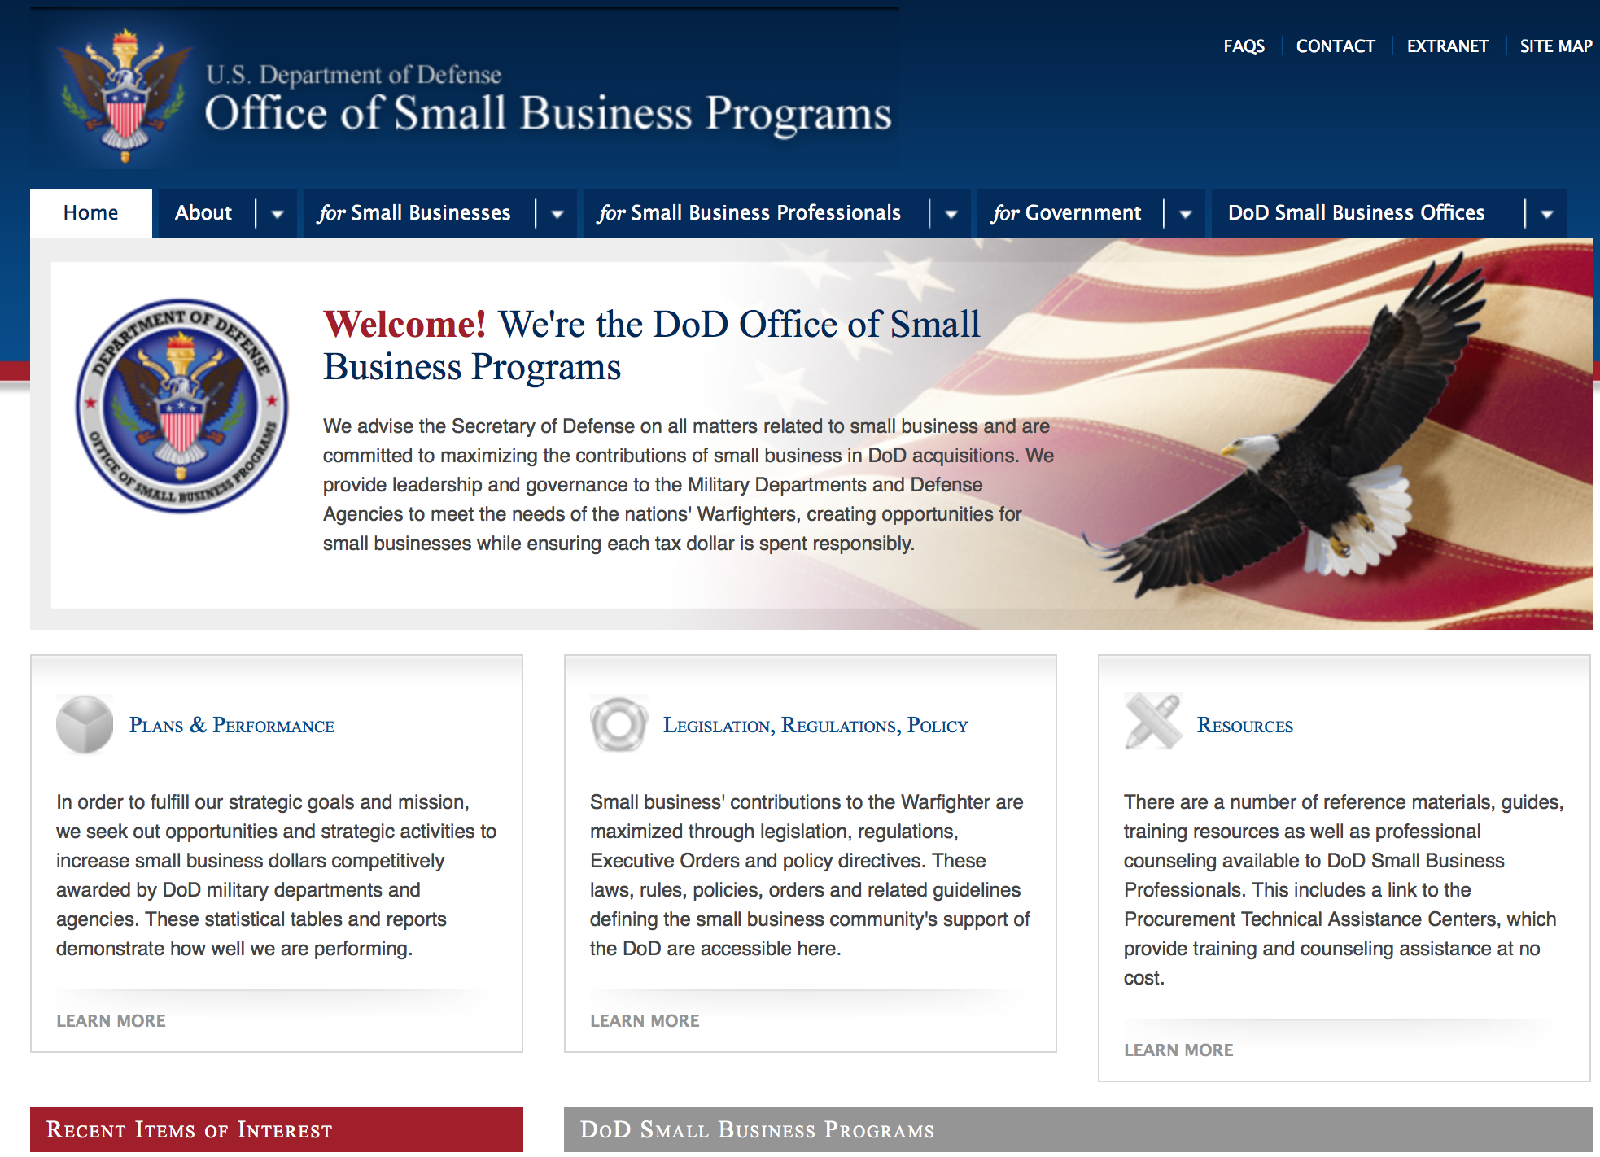

http://www.acq.osd.mil/osbp/

Doing Business with the DoD

Resources

Procurement Technical Assistance Centers (PTACs)

Procurement Technical Assistance Centers (PTACs), are charged with assisting businesses in learning how to do business with federal, state, and local governments. PTACs are a local resource available at no or nominal cost that can provide assistance to business firms in marketing their products and services. They offer training to businesses on how to research and bid on contracts, assist with registration requirements, provide bid-matching services, and assist with pre and post contracting issues.

Prime Contractors with Subcontracting Plans [xlsx]

Directory updated 4/19/11

This FY 2014 directory is intended for small business concerns seeking opportunities with DoD prime contractors. The directory is a listing of large business prime contractors who are required to establish subcontracting plans with goals. The report is generated from data contained in the Individual Subcontract Reports (ISRs) submitted in the Electronic Subcontracting Reporting System (eSRS) by contractors and from data contained in the Federal Procurement Data System (FPDS). The directory includes the name of the prime contractor; the major product/service code (PSC) provided to DoD; the major NAICS of the company; name, telephone number and email address of the company’s point of contact; contract number with the effective date and completion date, ultimate contract value and obligated dollars. In addition, many companies have websites with additional information which may be useful in your search for subcontracting opportunities or teaming arrangements.

Locate a Small Business Professional

Small Business Professionals serve as the primary liaison between private-sector small businesses seeking to do business with government agencies. Specialists advise small businesses regarding current acquisitions contracts available from the federal government.

Procurement Forecasts & the Department of Defense

The Department of Defense, due to its size and scope, does not have a single, comprehensive source for future procurements. Procurements are made locally and within the various services and agencies.

Business Intelligence, relative to future procurement planning, would be gathered at the local level.

For the purposes of forecasting, knowledge of past behavior is useful. Click here for a table of DoD acquisitions in FY10 summarized by NAICS code. The FY10 data has been validated but FPDS data is dynamic and changes continuously.

Non-Appropriated Fund Customers

Non-appropriated fund customers operate similar to non-profit organizations and include commissaries, exchanges, recreation and fitness centers, dining at officer/enlisted/civilian clubs, and barber/beauty services, just to name a few. For more information click here.

Research:

Air Force Office of Scientific Research
Military Medical Photonics Program Grant
http://www.grants.gov/web/grants/view-opportunity.html?oppId=281703

Dept. of the Army -- USAMRAA
Bone Marrow Failure Idea Development Award Grant
http://www.grants.gov/web/grants/view-opportunity.html?oppId=281487

Grants to Military-Connected Local Educational Agencies for Academic and Support Programs (MCASP) Grant
http://www.grants.gov/web/grants/view-opportunity.html?oppId=281730

Defense Advanced Research Projects Agency
DARPA - MTO - BAA0718
Signal Processing at RF (SPAR) Grant
http://www.grants.gov/web/grants/view-opportunity.html?oppId=281657

Defense Advanced Research Projects Agency
DARPA - Biological Technologies Office
Young Faculty Award Grant
http://www.grants.gov/web/grants/view-opportunity.html?oppId=281551

Defense Advanced Research Projects Agency
DARPA - Biological Technologies Office
Biological Control Grant
http://www.grants.gov/web/grants/view-opportunity.html?oppId=281618

Office of Naval Research
Naval Research Laboratory
NRL Wide Broad Agency Announcement Grant
http://www.grants.gov/web/grants/view-opportunity.html?oppId=281554

Office of Naval Research
Communications and Interoperability for Integrated Fires Grant
http://www.grants.gov/web/grants/view-opportunity.html?oppId=281384

Modifications:

Dept. of the Army -- Materiel Command
Army Contracting Command Rock Island
Industrial Base Analysis and Sustainment Program
Modification 1
http://www.grants.gov/web/grants/view-opportunity.html?oppId=280784

Defense Advanced Research Projects Agency
DARPA - Biological Technologies Office
Young Faculty Award
Modification 1
http://www.grants.gov/web/grants/view-opportunity.html?oppId=281551

Reminders:

Dept. of the Army -- Materiel Command
Army Research Office Broad Agency Announcement for Basic and Applied Scientific Research
Modification 8

Document Type: | Grants Notice
Funding Opportunity Number: | W911NF-12-R-0012
Funding Opportunity Title: | Army Research Office Broad Agency Announcement for Basic and Applied Scientific Research
Opportunity Category: | Discretionary
Funding Instrument Type: | Cooperative Agreement  Grant  Other  Procurement Contract
Category of Funding Activity: | Science and Technology and other Research and Development
Category Explanation:
Expected Number of Awards: | 1000
CFDA Number(s): | 12.431 -- Basic Scientific Research
Cost Sharing or Matching Requirement: | No
Posted Date: | Mar 27, 2015
Creation Date: | Mar 27, 2015
Original Closing Date for Applications: | Mar 31, 2017
Current Closing Date for Applications: | Mar 31, 2017
Archive Date: | Apr 30, 2017
Eligible Applicants: | Unrestricted (i.e., open to any type of entity above), subject to any clarification in text field entitled "Additional Information on Eligibility"
Agency Name: | Dept. of the Army -- Materiel Command
Description: | The purpose of this Broad Agency Announcement (BAA) is to solicit research proposals in the engineering, physical, life, and information sciences for submission to the Army Research Office (ARO) for consideration for possible funding. For ease of reference, this BAA is an extraction of the ARO sections of the Army Research Laboratory BAA. (www.arl.army.mil/www/default.cfm?page=8).
Link to Additional Information: | ARO CORE BAA-W911NF-12-R-0012-Mod 03
Contact Information: | If you have difficulty accessing the full announcement electronically, please contact:  ANDREW L. FISKE Procurement Analyst Army Contracting Command Aberdeen Proving Ground Research Triangle Park Division Phone: (919) 549-4338 FAX: (919) 549-4388 andrew.l.fiske.civ@mail.mil  Administrative POC

http://www.grants.gov/web/grants/view-opportunity.html?oppId=173593



Department of Education

Grant Programs Overview at the Department of Education

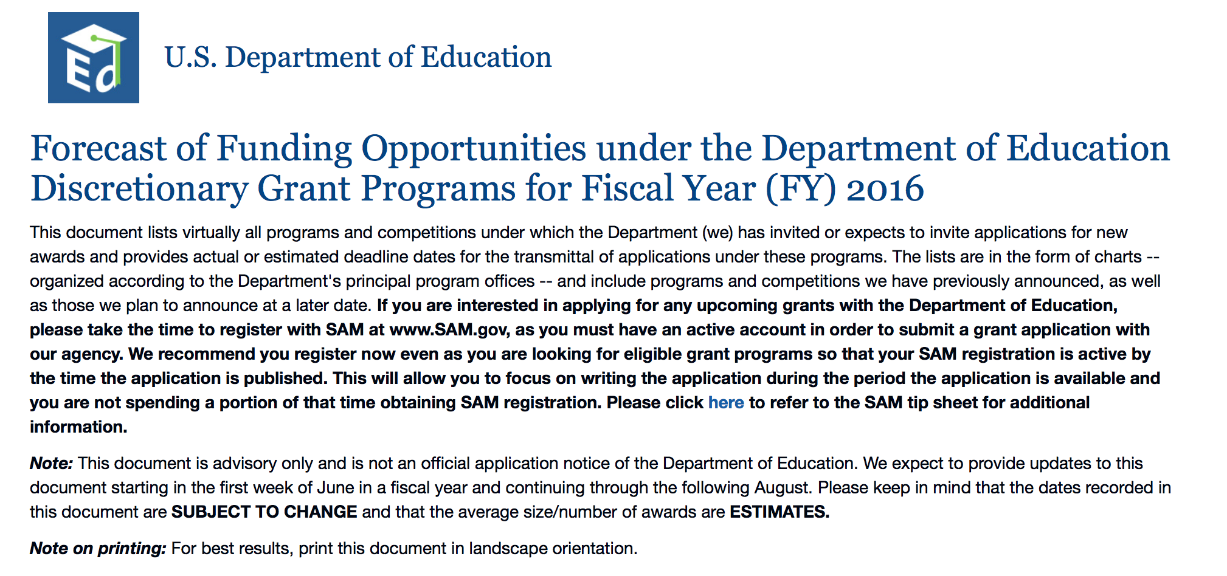To see the complete document click here: http://www2.ed.gov/fund/grant/find/edlite-forecast.html

The general information page for Education Grant funding is an excellent resource describing the three types of grants awarded by the Department of Education. See the screen shot of the Department of Education web page below:

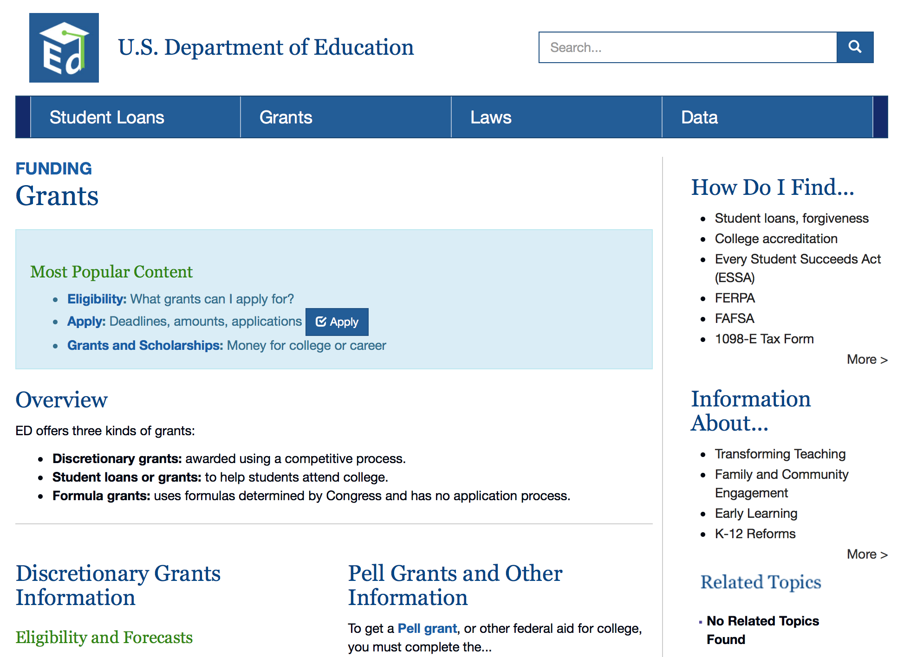

http://www.ed.gov/fund/grants-apply.html

Programs:

Under the Small, Rural School Achievement (SRSA) Program CFDA 84.358A Grant
And Modification 2  Document Type: | Grants Notice
Funding Opportunity Number: | ED-GRANTS-020516-001
Funding Opportunity Title: | Office of Elementary and Secondary Education (OESE): Small, Rural School Achievement (SRSA) Program CFDA 84.358A
Opportunity Category: | Mandatory
Opportunity Category Explanation:
Funding Instrument Type: | Grant
Category of Funding Activity: | Education
Category Explanation:
Expected Number of Awards:
CFDA Number(s): | 84.358 -- Rural Education
Cost Sharing or Matching Requirement: | No
Posted Date: | Feb 05, 2016
Last Updated Date: | Feb 08, 2016
Original Closing Date for Applications: | May 02, 2016
Current Closing Date for Applications: | May 02, 2016
Archive Date: | Jun 01, 2016
Eligible Applicants: | Others (see text field entitled "Additional Information on Eligibility" for clarification)
Additional Information on Eligibility: | Which LEAs are eligible for an award under the SRSA program? For FY 2016, an LEA (including a public charter school that is considered an LEA under State law) is eligible for an award under the SRSA program if--(a) The total number of students in average daily attendance at all of the schools served by the LEA is fewer than 600, or each county in which a school served by the LEA is located has a total population density of fewer than 10 persons per square mile; and (b)(1) All of the schools served by the LEA are designated with a school locale code of 7 or 8 by the Department's National Center for Education Statistics (NCES); or (2) The Secretary has determined, based on a demonstration by the LEA and concurrence of the State educational agency, that the LEA is located in an area defined as rural by a governmental agency of the State.
Agency Name: | Department of Education
Description: | Note: Each funding opportunity description is a synopsis of information in the Federal Register application notice. For specific information about eligibility, please see the official application notice. The official version of this document is the document published in the Federal Register. Free Internet access to the official edition of the Federal Register and the Code of Federal Regulations is available on GPO Access at: http://www.access.gpo.gov/nara/index.html. Please review the official application notice for pre-application and application requirements, application submission information, performance measures, priorities and program contact information. Under the Small, Rural School Achievement (SRSA) program, the U.S. Department of Education (Department) awards grants on a formula basis to eligible local educational agencies (LEAs) to address the unique needs of rural school districts. In this notice, we establish the deadline for submission of fiscal year (FY) 2016 SRSA grant applications. Catalog of Federal Domestic Assistance (CFDA) Number: 84.358A. An eligible LEA that is required to submit an application to receive FY 2016 SRSA funds must submit an electronic application by May 2, 2016, 4:30:00 p.m., Washington, DC time. Any application received from an eligible LEA after this deadline will be funded only to the extent that funds are available after the Department awards grants to other eligible LEAs under the program. Submission of an electronic application involves the use of the Department's G5 System. Prospective applicants can access the electronic application for the SRSA Program at: www.g5.gov. When applicants access this site, they will receive specific instructions regarding the information to include in the SRSA application.
Link to Additional Information: | Office of Elementary and Secondary Education (OESE): Small, Rural School Achievement (SRSA) Program CFDA 84.358A; Application Deadline for Fiscal Year 2016
Contact Information: | If you have difficulty accessing the full announcement electronically, please contact:  Joyce Mays Management Analyst Phone 202-245-6122 joyce.mays@ed.gov Program Manager: David Cantrell U.S. Department of Education 400 Maryland Avenue SW., room 3E303, Washington, DC 20202 Telephone: (202) 453-5990 or by email:  Program Manager: email

http://www.grants.gov/web/grants/view-opportunity.html?oppId=281373

Office of Postsecondary Education (OPE): Training Program for Federal TRIO Programs CFDA Number 84.103A Grant

Document Type: | Grants Notice
Funding Opportunity Number: | ED-GRANTS-021616-001
Funding Opportunity Title: | Office of Postsecondary Education (OPE): Training Program for Federal TRIO Programs CFDA Number 84.103A
Opportunity Category: | Discretionary
Opportunity Category Explanation:
Funding Instrument Type: | Grant
Category of Funding Activity: | Education
Category Explanation:
Expected Number of Awards: | 9
CFDA Number(s): | 84.103 -- TRIO Staff Training Program
Cost Sharing or Matching Requirement: | No
Posted Date: | Feb 16, 2016
Last Updated Date: | Feb 16, 2016
Original Closing Date for Applications: | Apr 15, 2016 Applications Available: February 16, 2016. Deadline for Transmittal of Applications: April 15, 2016.
Current Closing Date for Applications: | Apr 15, 2016 Applications Available: February 16, 2016. Deadline for Transmittal of Applications: April 15, 2016.
Archive Date: | May 15, 2016
Estimated Total Program Funding: | $2,500,000
Award Ceiling: | $334,750
Eligible Applicants: | Others (see text field entitled "Additional Information on Eligibility" for clarification)  State governments  Nonprofits that do not have a 501(c)(3) status with the IRS, other than institutions of higher education  Private institutions of higher education  Nonprofits having a 501(c)(3) status with the IRS, other than institutions of higher education  Public and State controlled institutions of higher education  County governments  Special district governments  Independent school districts  City or township governments
Additional Information on Eligibility: | Eligible Applicants: IHEs and other public and private nonprofit institutions and organizations.
Agency Name: | Department of Education
Description: | Note: Each funding opportunity description is a synopsis of information in the Federal Register application notice. For specific information about eligibility, please see the official application notice. The official version of this document is the document published in the Federal Register. Free Internet access to the official edition of the Federal Register and the Code of Federal Regulations is available on GPO Access at: http://www.access.gpo.gov/nara/index.html. Please review the official application notice for pre-application and application requirements, application submission information, performance measures, priorities and program contact information. Purpose of Program: The Training Program provides grants to train the staff and leadership personnel employed in, participating in, or preparing for employment in, projects funded under the Federal TRIO Programs to improve the operation of these projects. Catalog of Federal Domestic Assistance (CFDA) Number: 84.103A. Applications for grants under the Training Program, CFDA number 84.103A, must be submitted electronically using the Governmentwide Grants.gov Apply site at www.Grants.gov. Through this site, you will be able to download a copy of the application package, complete it offline, and then upload and submit your application. You may not email an electronic copy of a grant application to us. You may access the electronic grant application for the Training Program at www.Grants.gov. You must search for the downloadable application package for this program by the CFDA number. Do not include the CFDA number's alpha suffix in your search (e.g., search for 84.103, not 84.103A).
Link to Additional Information: | Office of Postsecondary Education (OPE): Training Program for Federal TRIO Programs CFDA Number 84.103A; Notice inviting applications for new awards for fiscal year (FY) 2016
Contact Information: | If you have difficulty accessing the full announcement electronically, please contact:  Julius Cotton ED Grants.gov FIND Systems Admin. Phone 202-245-6288 EducationGrantInquiries@ed.gov Program Managers: Suzanne Ulmer or, if unavailable, Dr. Katie Blanding, OPE, U.S. Department of Education, 400 Maryland Avenue SW., Room 7E311, Washington, DC 20202. Telephone: (202) 502-7600 or by email: TRIO@ed.gov.  e-Mail: Program Mailbox

http://www.grants.gov/web/grants/view-opportunity.html?oppId=281540

Office of Postsecondary Education (OPE): Educational Opportunity Centers (EOC) Program CFDA Number 84.066A Grant

Document Type: | Grants Notice
Funding Opportunity Number: | ED-GRANTS-020216-001
Funding Opportunity Title: | Office of Postsecondary Education (OPE): Educational Opportunity Centers (EOC) Program CFDA Number 84.066A
Opportunity Category: | Discretionary
Opportunity Category Explanation:
Funding Instrument Type: | Grant
Category of Funding Activity: | Education
Category Explanation:
Expected Number of Awards: | 151
CFDA Number(s): | 84.066 -- TRIO_Educational Opportunity Centers
Cost Sharing or Matching Requirement: | No
Posted Date: | Feb 02, 2016
Last Updated Date: | Feb 02, 2016
Original Closing Date for Applications: | Apr 04, 2016 Applications Available: February 2, 2016. Deadline for Transmittal of Applications: April 4, 2016.
Current Closing Date for Applications: | Apr 04, 2016 Applications Available: February 2, 2016. Deadline for Transmittal of Applications: April 4, 2016.
Archive Date: | May 04, 2016
Estimated Total Program Funding: | $54,296,053
Award Ceiling: | $236,000
Eligible Applicants: | Special district governments  Nonprofits having a 501(c)(3) status with the IRS, other than institutions of higher education  Public and State controlled institutions of higher education  Others (see text field entitled "Additional Information on Eligibility" for clarification)  County governments  Private institutions of higher education  City or township governments  Nonprofits that do not have a 501(c)(3) status with the IRS, other than institutions of higher education  Independent school districts  State governments
Additional Information on Eligibility: | Eligible Applicants: IHEs, public and private agencies and organizations including community-based organizations with experience in serving disadvantaged youth; combinations of such institutions, agencies, and organizations; and secondary schools.
Agency Name: | Department of Education
Description: | Note: Each funding opportunity description is a synopsis of information in the Federal Register application notice. For specific information about eligibility, please see the official application notice. The official version of this document is the document published in the Federal Register. Free Internet access to the official edition of the Federal Register and the Code of Federal Regulations is available on GPO Access at: http://www.access.gpo.gov/nara/index.html. Please review the official application notice for pre-application and application requirements, application submission information, performance measures, priorities and program contact information. Purpose of Program: The purposes of the EOC Program are to: provide information regarding financial and academic assistance available for qualified adults who want to enter or continue to pursue a program of postsecondary education; provide assistance to those individuals in applying for admission to institutions at which a program of postsecondary education is offered, including preparing necessary applications for use by admissions and financial aid officers; and assist in improving the financial and economic literacy of program participants. An Educational Opportunity Centers project may provide the following services: (1) Public information campaigns designed to inform the community regarding opportunities for postsecondary education and training; (2) Academic advice and assistance in course selection; (3) Assistance in completing college admission and financial aid applications; (4) Assistance in preparing for college entrance examinations; (5) Education or counseling services designed to improve the financial literacy and economic literacy of students; (6) Guidance on secondary school reentry or entry to a general educational development (GED) program or other alternative education program for secondary school dropouts; (7) Individualized personal, career, and academic counseling; (8) Tutorial services; (9) Career workshops and counseling; (10) Mentoring programs involving elementary or secondary school teachers, faculty members at institutions of higher education (IHEs), students, or any combination of these persons; and (11) Programs and activities as described in items (1) through (10) that are specially designed for students who are limited English proficient, students from groups that are traditionally underrepresented in postsecondary education, students with disabilities, students who are homeless children and youths, students who are in foster care or are aging out of the foster care system, or other disconnected students. (12) Other activities designed to meet the purposes of the EOC Program. Catalog of Federal Domestic Assistance (CFDA) Number: 84.066A. Applications for grants under the EOC Program, CFDA number 84.066A, must be submitted electronically using the Governmentwide Grants.gov Apply site at www.Grants.gov. Through this site, you will be able to download a copy of the application package, complete it offline, and then upload and submit your application. You may not email an electronic copy of a grant application to us. You may access the electronic grant application for the EOC Program at www.Grants.gov. You must search for the downloadable application package for this program by the CFDA number. Do not include the CFDA number's alpha suffix in your search (e.g., search for 84.066, not 84.066A).
Link to Additional Information: | Office of Postsecondary Education (OPE): Educational Opportunity Centers (EOC) Program CFDA Number 84.066A; Notice Inviting Applications for New Awards for Fiscal Year (FY) 2016
Contact Information: | If you have difficulty accessing the full announcement electronically, please contact:  Julius Cotton ED Grants.gov FIND Systems Admin. Phone 202-245-6288 EducationGrantInquiries@ed.gov Program Manager: Rachael Couch, Ed.D., U.S. Department of Education, 400 Maryland Avenue SW., room 7E311, Washington, DC 20202. Telephone: (202) 502-7655 or by email: Rachael.Couch@ed.gov.  e-Mail: Program Manager

http://www.grants.gov/web/grants/view-opportunity.html?oppId=281276

Office of Special Education and Rehabilitative Services (OSERS): Office of Special Programs (OSEP): Training and Information for Parents of Children with Disabilities: Community Parent Resource Centers CFDA Number 84.328C Grant

Document Type: | Grants Notice
Funding Opportunity Number: | ED-GRANTS-022616-001
Funding Opportunity Title: | Office of Special Education and Rehabilitative Services (OSERS): Office of Special Programs (OSEP): Training and Information for Parents of Children with Disabilities: Community Parent Resource Centers CFDA Number 84.328C
Opportunity Category: | Discretionary
Opportunity Category Explanation:
Funding Instrument Type: | Grant
Category of Funding Activity: | Education
Category Explanation:
Expected Number of Awards: | 30
CFDA Number(s): | 84.328 -- Special Education Parent Information Centers
Cost Sharing or Matching Requirement: | No
Posted Date: | Feb 26, 2016
Last Updated Date: | Feb 26, 2016
Original Closing Date for Applications: | Apr 11, 2016 Applications Available: February 26, 2016. Deadline for Transmittal of Applications: April 11, 2016.
Current Closing Date for Applications: | Apr 11, 2016 Applications Available: February 26, 2016. Deadline for Transmittal of Applications: April 11, 2016.
Archive Date: | May 11, 2016
Estimated Total Program Funding: | $3,000,000
Award Ceiling: | $100,000
Eligible Applicants: | Others (see text field entitled "Additional Information on Eligibility" for clarification)
Additional Information on Eligibility: | 1. Eligible Applicants: Local parent organizations. Note: Section 671(a)(2) of IDEA defines a ``parent organization'' as a private nonprofit organization (other than an institution of higher education) that-- (a) Has a board of directors-- (1) The majority of whom are parents of children with disabilities ages birth through 26; (2) That includes-- (i) Individuals working in the fields of special education, related services, and early intervention; and (ii) Individuals with disabilities; and (3) The parent and professional members of which are broadly representative of the population to be served, including low-income parents and parents of limited English proficient children; and (b) Has as its mission serving families of children with disabilities who are ages birth through 26, and have the full range of disabilities described in section 602(3) of IDEA.
Agency Name: | Department of Education
Description: | Note: Each funding opportunity description is a synopsis of information in the Federal Register application notice. For specific information about eligibility, please see the official application notice. The official version of this document is the document published in the Federal Register. Free Internet access to the official edition of the Federal Register and the Code of Federal Regulations is available on GPO Access at: http://www.access.gpo.gov/nara/index.html. Please review the official application notice for pre-application and application requirements, application submission information, performance measures, priorities and program contact information. Purpose of Program: The purpose of this program is to ensure that parents of children with disabilities receive training and information to help improve results for their children. Priority: In accordance with 34 CFR 75.105(b)(2)(iv) and (v), this priority is from allowable activities specified in the statute, or otherwise authorized in the statute (see sections 671 and 681(d) of the Individuals with Disabilities Education Act (IDEA)). Absolute Priority: For FY 2016 and any subsequent year in which we make awards from the list of unfunded applications from this competition, this priority is an absolute priority. Under 34 CFR 75.105(c)(3), we consider only applications that meet this priority. This priority is: Community Parent Resource Centers. Background: The purpose of this priority is to fund 30 Community Parent Resource Centers (CPRCs) designed to meet the specific needs of parents of children with disabilities, and youth with disabilities, who experience significant isolation from available sources of information and support in the geographically defined communities served by the centers. These parents can include, for example, low-income parents, parents with limited English proficiency, and parents with disabilities. Youth can include, for example, youth living in low-income households and youth with limited English proficiency. More than 35 years of research and experience has demonstrated that the education of children with disabilities can be made more effective by strengthening the ability of parents to participate fully in the education of their children at school and at home (see section 601(c)(5)(B) of IDEA). Since the Department first funded CPRCs over 20 years ago, the CPRC program has helped parents in their communities set high expectations for children with disabilities and has provided parents with the information and training they need to help their children meet those expectations. Information about the Office of Special Education's parent training and information program can be found at: www.parentcenterhub.org. Catalog of Federal Domestic Assistance (CFDA) Number: 84.328C. Applications for grants under the Community Parent Resource Centers competition, CFDA number 84.328C, must be submitted electronically using the Governmentwide Grants.gov Apply site at www.Grants.gov. Through this site, you will be able to download a copy of the application package, complete it offline, and then upload and submit your application. You may not email an electronic copy of a grant application to us. You may access the electronic grant application for the Community Parent Resource Centers competition at www.Grants.gov. You must search for the downloadable application package for this competition by the CFDA number. Do not include the CFDA number's alpha suffix in your search (e.g., search for 84.328, not 84.328C).
Link to Additional Information: | Office of Special Education and Rehabilitative Services (OSERS): Office of Special Programs (OSEP): Training and Information for Parents of Children with Disabilities: Community Parent Resource Centers CFDA Number 84.328C; Notice
Contact Information: | If you have difficulty accessing the full announcement electronically, please contact:  Julius Cotton ED Grants.gov FIND Systems Admin. Phone 202-245-6288 EducationGrantInquiries@ed.gov Program Manager: Carmen Sanchez, U.S. Department of Education, 400 Maryland Avenue SW., Room 5175, Potomac Center Plaza (PCP), Washington, DC 20202-5076. Telephone: (202) 245-6595 or e-Mail: Carmen.Sanchez@ed.gov.  e-Mail: Program Manager

http://www.grants.gov/web/grants/view-opportunity.html?oppId=281791

Office of Special Education and Rehabilitative Services (OSERS): Office of Special Education Programs (OSEP): Educational Technology, Media, and Materials for Individuals with Disabilities: Stepping-up Technology Implementation CFDA Number 84.327S Grant

Document Type: | Grants Notice
Funding Opportunity Number: | ED-GRANTS-022916-001
Funding Opportunity Title: | Office of Special Education and Rehabilitative Services (OSERS): Office of Special Education Programs (OSEP): Educational Technology, Media, and Materials for Individuals with Disabilities: Stepping-up Technology Implementation CFDA Number 84.327S
Opportunity Category: | Discretionary
Opportunity Category Explanation:
Funding Instrument Type: | Cooperative Agreement
Category of Funding Activity: | Education
Category Explanation:
Expected Number of Awards: | 3
CFDA Number(s): | 84.327 -- Special Education Educational Technology Media, and Materials for Individuals with Disabilities
Cost Sharing or Matching Requirement: | No
Posted Date: | Feb 29, 2016
Last Updated Date: | Feb 29, 2016
Original Closing Date for Applications: | Apr 14, 2016 Applications Available: February 29, 2016. Deadline for Transmittal of Applications: April 14, 2016.
Current Closing Date for Applications: | Apr 14, 2016 Applications Available: February 29, 2016. Deadline for Transmittal of Applications: April 14, 2016.
Archive Date: | May 14, 2016
Estimated Total Program Funding: | $1,414,056
Award Ceiling: | $500,000
Eligible Applicants: | Nonprofits that do not have a 501(c)(3) status with the IRS, other than institutions of higher education  Public and State controlled institutions of higher education  State governments  Native American tribal governments (Federally recognized)  Nonprofits having a 501(c)(3) status with the IRS, other than institutions of higher education  Private institutions of higher education  Special district governments  Independent school districts  Others (see text field entitled "Additional Information on Eligibility" for clarification)  Native American tribal organizations (other than Federally recognized tribal governments)  City or township governments  County governments
Additional Information on Eligibility: | Eligible Applicants: SEAs; LEAs, including public charter schools that are considered LEAs under State law; IHEs; other public agencies; private nonprofit organizations; outlying areas; freely associated States; Indian tribes or tribal organizations; and for-profit organizations.
Agency Name: | Department of Education
Description: | Note: Each funding opportunity description is a synopsis of information in the Federal Register application notice. For specific information about eligibility, please see the official application notice. The official version of this document is the document published in the Federal Register. Free Internet access to the official edition of the Federal Register and the Code of Federal Regulations is available on GPO Access at: http://www.access.gpo.gov/nara/index.html. Please review the official application notice for pre-application and application requirements, application submission information, performance measures, priorities and program contact information. Purpose of Program: The purposes of the Educational Technology, Media, and Materials for Individuals with Disabilities Program are to: (1) improve results for students with disabilities by promoting the development, demonstration, and use of technology; (2) support educational activities designed to be of educational value in the classroom for students with disabilities; (3) provide support for captioning and video description that is appropriate for use in the classroom; and (4) provide accessible educational materials to students with disabilities in a timely manner. Catalog of Federal Domestic Assistance (CFDA) Number: 84.327S. Applications for grants under the Stepping-up Technology Implementation competition, CFDA number 84.327S, must be submitted electronically using the Governmentwide Grants.gov Apply site at www.Grants.gov. Through this site, you will be able to download a copy of the application package, complete it offline, and then upload and submit your application. You may not email an electronic copy of a grant application to us. You may access the electronic grant application for the Stepping-up Technology Implementation competition at www.Grants.gov. You must search for the downloadable application package for this competition by the CFDA number. Do not include the CFDA number's alpha suffix in your search (e.g., search for 84.327, not 84.327S).
Link to Additional Information: | Office of Special Education and Rehabilitative Services (OSERS): Office of Special Education Programs (OSEP): Educational Technology, Media, and Materials for Individuals with Disabilities: Stepping-up Technology Implementation CFDA Number 84.327S
Contact Information: | If you have difficulty accessing the full announcement electronically, please contact:  Julius Cotton ED Grants.gov FIND Systems Admin. Phone 202-245-6288 EducationGrantInquiries@ed.gov Program Manager: Terry Jackson, U.S. Department of Education, 400 Maryland Avenue SW., Room 5158, Potomac Center Plaza (PCP), Washington, DC 20202-5076. Telephone: (202) 245-6039 or e-Mail: Terry.Jackson@ed.gov.  e-Mail: Program Manager

http://www.grants.gov/web/grants/view-opportunity.html?oppId=281829

Modifications:

Reminders:

Office of Elementary and Secondary Education (OESE): College Assistance Migrant Program (CAMP) CFDA Number 84.149A
Modification 1

Document Type: | Grants Notice
Funding Opportunity Number: | ED-GRANTS-010716-001
Funding Opportunity Title: | Office of Elementary and Secondary Education (OESE): College Assistance Migrant Program (CAMP) CFDA Number 84.149A
Opportunity Category: | Discretionary
Funding Instrument Type: | Grant
Category of Funding Activity: | Education
Category Explanation:
Expected Number of Awards: | 5
CFDA Number(s): | 84.149 -- Migrant Education College Assistance Migrant Program
Cost Sharing or Matching Requirement: | No
Posted Date: | Jan 7, 2016
Creation Date: | Jan 7, 2016
Original Closing Date for Applications: | Mar 7, 2016 Applications Available: January 7, 2016. Deadline for Transmittal of Applications: March 7, 2016.
Current Closing Date for Applications: | Mar 7, 2016 Applications Available: January 7, 2016. Deadline for Transmittal of Applications: March 7, 2016.
Archive Date: | Apr 6, 2016
Estimated Total Program Funding: | $5,407,472
Award Ceiling: | $425,000
Award Floor: | $180,000
Eligible Applicants: | Nonprofits that do not have a 501(c)(3) status with the IRS, other than institutions of higher education  Private institutions of higher education  Public and State controlled institutions of higher education  Others (see text field entitled "Additional Information on Eligibility" for clarification)  Nonprofits having a 501(c)(3) status with the IRS, other than institutions of higher education
Additional Information on Eligibility: | Eligible Applicants: IHEs or private non-profit organizations (including faith-based organizations) that plan their projects in cooperation with an IHE and propose to operate the project with the facilities of the IHE.
Agency Name: | Department of Education
Description: | Note: Each funding opportunity description is a synopsis of information in the Federal Register application notice. For specific information about eligibility, please see the official application notice. The official version of this document is the document published in the Federal Register. Free Internet access to the official edition of the Federal Register and the Code of Federal Regulations is available on GPO Access at: http://www.access.gpo.gov/nara/index.html. Please review the official application notice for pre-application and application requirements, application submission information, performance measures, priorities and program contact information. Purpose of Program: The purpose of CAMP is to provide academic and financial support to help migrant and seasonal farmworkers and members of their immediate family complete their first year of college and continue in postsecondary education. Catalog of Federal Domestic Assistance (CFDA) Number: 84.149A.Applications for grants under CAMP, CFDA number 84.149A, must be submitted electronically using the Governmentwide Grants.gov Apply site at www.Grants.gov. Through this site, you will be able to download a copy of the application package, complete it offline, and then upload and submit your application. You may not email an electronic copy of a grant application to us. You may access the electronic grant application for CAMP at www.Grants.gov. You must search for the downloadable application package for this competition by the CFDA number. Do not include the CFDA number's alpha suffix in your search (e.g., search for 84.149, not 84.149A).
Link to Additional Information: | Office of Elementary and Secondary Education (OESE): College Assistance Migrant Program (CAMP) CFDA Number 84.149A; Notice inviting applications for new awards for fiscal year (FY) 2016
Contact Information: | If you have difficulty accessing the full announcement electronically, please contact:  Julius Cotton ED Grants.gov FIND Systems Admin. Phone 202-245-6288 EducationGrantInquiries@ed.gov Program Manager: Emily Bank, U.S. Department of Education, 400 Maryland Avenue SW., Room 3E338, Washington, DC 20202-6135. Telephone: (202) 453-6389 or by email: emily.bank@ed.gov.  e-Mail: Program Manager

http://www.grants.gov/web/grants/view-opportunity.html?oppId=280845

Office of Elementary and Secondary Education (OESE): High School Equivalency Program (HEP) CFDA Number 84.141A
Modification 1

Document Type: | Grants Notice
Funding Opportunity Number: | ED-GRANTS-010716-002
Funding Opportunity Title: | Office of Elementary and Secondary Education (OESE): High School Equivalency Program (HEP) CFDA Number 84.141A
Opportunity Category: | Discretionary
Funding Instrument Type: | Grant
Category of Funding Activity: | Education
Category Explanation:
Expected Number of Awards: | 9
CFDA Number(s): | 84.141 -- Migrant Education High School Equivalency Program
Cost Sharing or Matching Requirement: | No
Posted Date: | Jan 7, 2016
Creation Date: | Jan 7, 2016
Original Closing Date for Applications: | Mar 7, 2016 Applications Available: January 7, 2016. Deadline for Transmittal of Applications: March 7, 2016.
Current Closing Date for Applications: | Mar 7, 2016 Applications Available: January 7, 2016. Deadline for Transmittal of Applications: March 7, 2016.
Archive Date: | Apr 6, 2016
Estimated Total Program Funding: | $4,082,415
Award Ceiling: | $475,000
Award Floor: | $180,000
Eligible Applicants: | Nonprofits having a 501(c)(3) status with the IRS, other than institutions of higher education  Private institutions of higher education  Nonprofits that do not have a 501(c)(3) status with the IRS, other than institutions of higher education  Others (see text field entitled "Additional Information on Eligibility" for clarification)  Public and State controlled institutions of higher education
Additional Information on Eligibility: | Eligible Applicants: IHEs or private non-profit organizations (including faith-based organizations) that plan their projects in cooperation with an IHE and propose to operate some aspects of the project with the facilities of the IHE.
Agency Name: | Department of Education
Description: | Note: Each funding opportunity description is a synopsis of information in the Federal Register application notice. For specific information about eligibility, please see the official application notice. The official version of this document is the document published in the Federal Register. Free Internet access to the official edition of the Federal Register and the Code of Federal Regulations is available on GPO Access at: http://www.access.gpo.gov/nara/index.html. Please review the official application notice for pre-application and application requirements, application submission information, performance measures, priorities and program contact information. Purpose of Program: The purposes of HEP are to help migrant and seasonal farmworkers and members of their immediate family: (1) Obtain a general education diploma that meets the guidelines for high school equivalency (HSE) established by the State in which the HEP project is conducted; and (2) gain employment or be placed in an institution of higher education (IHE) or other postsecondary education or training. Catalog of Federal Domestic Assistance (CFDA) Number: 84.141A. Applications for grants under HEP, CFDA number 84.141A, must be submitted electronically using the Governmentwide Grants.gov Apply site at www.Grants.gov. Through this site, you will be able to download a copy of the application package, complete it offline, and then upload and submit your application. You may not email an electronic copy of a grant application to us. You may access the electronic grant application for HEP at www.Grants.gov. You must search for the downloadable application package for this competition by the CFDA number. Do not include the CFDA number's alpha suffix in your search (e.g., search for 84.141, not 84.141A).
Link to Additional Information: | Office of Elementary and Secondary Education (OESE): High School Equivalency Program (HEP) CFDA Number 84.141A; Notice inviting applications for new awards for fiscal year (FY) 2016
Contact Information: | If you have difficulty accessing the full announcement electronically, please contact:  Julius Cotton ED Grants.gov FIND Systems Admin. Phone 202-245-6288 EducationGrantInquiries@ed.gov Program Manager: Emily Bank, U.S. Department of Education, 400 Maryland Avenue SW., Room 3E338, Washington, DC 20202-6135. Telephone: (202) 453-6389 or by email: emily.bank@ed.gov.  e-Mail: Program Manager

http://www.grants.gov/web/grants/view-opportunity.html?oppId=280857



U.S. Department of Energy
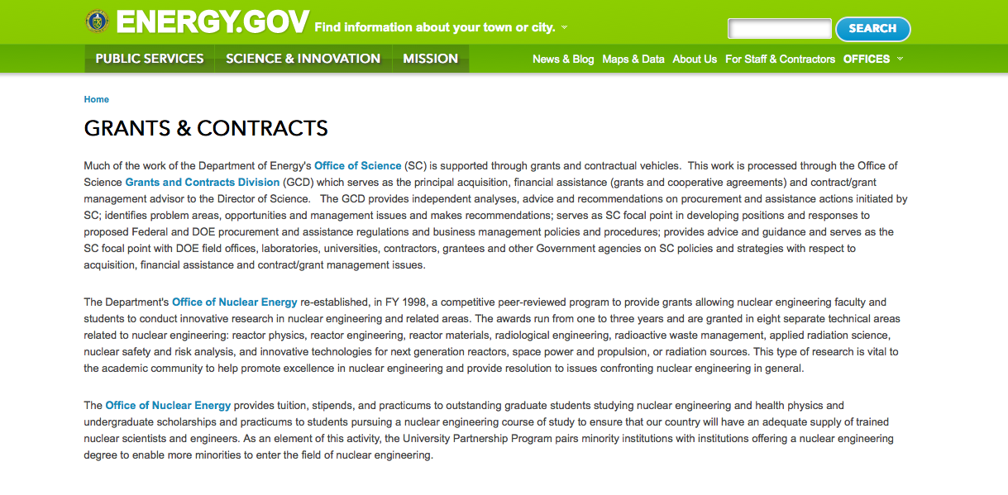
http://www.doe.gov/grants-contracts

Programs:

Golden Field Office
Request for Information (RFI) DE-FOA-0001512: Accounting Conventions for Non-Combustible Renewable Energy Grant
http://www.grants.gov/web/grants/view-opportunity.html?oppId=281279

Advanced Research Projects Agency Energy
Integration and Optimization of Novel Ion Conducting Solids (IONICS) Grant
http://www.grants.gov/web/grants/view-opportunity.html?oppId=281814

Golden Field Office
STATE ENERGY EVOLUTION AND DIFFUSION STUDIES II - STATE ENERGY STRATEGIES (SEEDSII-SES) Grant
http://www.grants.gov/web/grants/view-opportunity.html?oppId=281385

PAMS
Department of Energy - Office of Science
Office of Science
Regional and Global Climate Modeling and Integrated Assessment Research: An Integration Framework for Multi-Model, U.S. Regional Climate Evaluation that Incorporates Local Human Influences for Research at the Energy-Water-Land Nexus Grant
http://www.grants.gov/web/grants/view-opportunity.html?oppId=281367

Department of Energy - Office of Science
Office of Science
Collaborative Research in Magnetic Fusion Energy Sciences on International Long-Pulse Superconducting Tokamaks Grant
http://www.grants.gov/web/grants/view-opportunity.html?oppId=281649

Golden Field Office
Notice of Intent: Commercial Buildings and Energy Code Field Studies Grant
http://www.grants.gov/web/grants/view-opportunity.html?oppId=281515

Golden Field Office
Notice of Intent: Next Generation of Electric Machines: Enabling Technologies Grant
http://www.grants.gov/web/grants/view-opportunity.html?oppId=281619

Golden Field Office
'Marine and Hydrokinetic Energy Conversion and Environmental Monitoring Technology Advancement' Grant
http://www.grants.gov/web/grants/view-opportunity.html?oppId=281640

Golden Field Office
DE-FOA-0001545 Request for Information: Challenges and Opportunities for Non-Powered Dam and Pumped Storage Hydropower Development in the U.S. Grant
http://www.grants.gov/web/grants/view-opportunity.html?oppId=281754

Golden Field Office
RFI: Eagle Impact Minimization Technologies and Field Testing Opportunities Grant
http://www.grants.gov/web/grants/view-opportunity.html?oppId=281756

Modifications:

Advanced Research Projects Agency Energy
Innovative Development in Energy-Related Applied Science (IDEAS) 2015
Modification 1
http://www.grants.gov/web/grants/view-opportunity.html?oppId=279527

National Energy Technology Laboratory
Solid Oxide Fuel Cell Innovative Concepts and Core Technology
Modification 1
http://www.grants.gov/web/grants/view-opportunity.html?oppId=281030

Golden Field Office
MEGA-BIO: Bioproducts to Enable Biofuels
Modification 1
http://www.grants.gov/web/grants/view-opportunity.html?oppId=281419

National Energy Technology Laboratory
Fiscal Year 2016 Vehicle Technologies Program Wide Funding Opportunity Announcement
Modifications 3 & 4
http://www.grants.gov/web/grants/view-opportunity.html?oppId=281101

Golden Field Office
SOLAR ENERGY EVOLUTION AND DIFFUSION STUDIES II - STATE ENERGY STRATEGIES (SEEDSII-SES)
Modification 2
http://www.grants.gov/web/grants/view-opportunity.html?oppId=281385

Reminders:

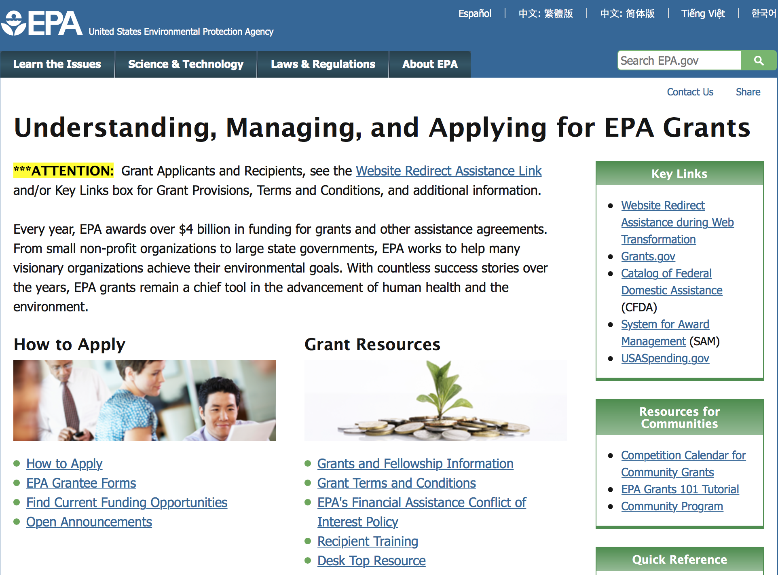

http://www.epa.gov/epahome/grants.htm

Programs:

Clean Diesel Funding Assistance Program FY 2016 Grant

Document Type: | Grants Notice
Funding Opportunity Number: | EPA-OAR-OTAQ-16-02
Funding Opportunity Title: | Clean Diesel Funding Assistance Program FY 2016
Opportunity Category: | Discretionary
Opportunity Category Explanation:
Funding Instrument Type: | Cooperative Agreement
Category of Funding Activity: | Environment
Category Explanation:
Expected Number of Awards: | 40
CFDA Number(s): | 66.039 -- National Clean Diesel Emissions Reduction Program
Cost Sharing or Matching Requirement: | Yes
Posted Date: | Feb 25, 2016
Last Updated Date: | Feb 25, 2016
Original Closing Date for Applications: | Apr 26, 2016 Please see the announcement including Section IV for additional submission information.
Current Closing Date for Applications: | Apr 26, 2016 Please see the announcement including Section IV for additional submission information.
Archive Date: | May 26, 2016
Estimated Total Program Funding: | $26,000,000
Award Ceiling: | $4,400,000
Award Floor: | $100,000
Eligible Applicants: | Others (see text field entitled "Additional Information on Eligibility" for clarification)
Additional Information on Eligibility: | Please see the announcement including Section III for additional eligibility information.
Agency Name: | Environmental Protection Agency
Description: | EPA’s Office of Transportation and Air Quality is soliciting proposals nationwide for projects that achieve significant reductions in diesel emissions in terms of tons of pollution produced by diesel engines and diesel emissions exposure, particularly from fleets operating at or servicing goods movement facilities located in areas designated as having poor air quality. Further, priority for funding may be given to projects which result in outcomes that benefit affected communities, those that engage local communities with respect to the design and performance of the project, and those which can demonstrate the ability to promote and continue efforts to reduce emissions after the project has ended.
Link to Additional Information: | Clean Diesel Funding Assistance Program FY 2016
Contact Information: | If you have difficulty accessing the full announcement electronically, please contact:  Faye Swift, 202-343-9147  Faye Swift

http://www.grants.gov/web/grants/view-opportunity.html?oppId=281782

Environmental Education Local Grants Program -- Solicitation Notice for 2016 Grant

Document Type: | Grants Notice
Funding Opportunity Number: | EPA-EE-16-01
Funding Opportunity Title: | Environmental Education Local Grants Program -- Solicitation Notice for 2016
Opportunity Category: | Discretionary
Opportunity Category Explanation:
Funding Instrument Type: | Grant
Category of Funding Activity: | Environment
Category Explanation:
Expected Number of Awards: | 30
CFDA Number(s): | 66.951 -- Environmental Education Grants
Cost Sharing or Matching Requirement: | Yes
Posted Date: | Feb 10, 2016
Last Updated Date: | Feb 10, 2016
Original Closing Date for Applications: | Apr 08, 2016 See Section IV of the announcement for additional information.
Current Closing Date for Applications: | Apr 08, 2016 See Section IV of the announcement for additional information.
Archive Date: | May 08, 2016
Estimated Total Program Funding: | $2,730,000
Award Ceiling: | $91,000
Eligible Applicants: | Others (see text field entitled "Additional Information on Eligibility" for clarification)
Additional Information on Eligibility: | See Section III of the announcement for eligibility information.
Agency Name: | Environmental Protection Agency
Description: | The purpose of the Environmental Education Local Grants Program is to support locally-focused environmental education projects that increase public awareness and knowledge about environmental issues and provide the skills that participants in its funded projects need to make informed environmental decisions and take responsible actions toward the environment.
Link to Additional Information: | Environmental Education (EE) Grant Solicitation Notice
Contact Information: | If you have difficulty accessing the full announcement electronically, please contact:  Karen Scott  EEgrants@epa.gov

http://www.grants.gov/web/grants/view-opportunity.html?oppId=281449

Early Career Awards: Integrating Human Health and Well-Being with Ecosystem Services Grant
Document Type: | Grants Notice
Funding Opportunity Number: | EPA-G2016-STAR-A2
Funding Opportunity Title: | Early Career Awards: Integrating Human Health and Well-Being with Ecosystem Services
Opportunity Category: | Discretionary
Opportunity Category Explanation:
Funding Instrument Type: | Grant
Category of Funding Activity: | Environment
Category Explanation:
Expected Number of Awards: | 3
CFDA Number(s): | 66.509 -- Science To Achieve Results (STAR) Research Program
Cost Sharing or Matching Requirement: | No
Posted Date: | Feb 22, 2016
Last Updated Date: | Feb 22, 2016
Original Closing Date for Applications: | Apr 21, 2016 See Section IV of the announcement for due dates and additional information.
Current Closing Date for Applications: | Apr 21, 2016 See Section IV of the announcement for due dates and additional information.
Archive Date: | May 21, 2016
Estimated Total Program Funding: | $3,000,000
Award Ceiling: | $400,000
Award Floor: | $0
Eligible Applicants: | Others (see text field entitled "Additional Information on Eligibility" for clarification)
Additional Information on Eligibility: | See Section III for eligibility information.
Agency Name: | Environmental Protection Agency
Description: | The U.S. Environmental Protection Agency (U.S. EPA or EPA), through its Science to Achieve Results (STAR) program, seeks applications for collaborative, community-based research that will foster better understanding of how ecosystems support human health and well-being. Specifically, this research should examine how communities can integrate ecosystem services with human health and well-being to inform their decision making and management practices. It should also develop information that allows communities to integrate environmental, societal and economic information and to better manage multiple stressors and their cumulative impacts on humans and ecosystems. The ultimate goal is to help communities achieve their own objectives.
Link to Additional Information: | Early Career Awards: Integrating Human Health and Well-Being with Ecosystem Services
Contact Information: | If you have difficulty accessing the full announcement electronically, please contact:  Debra M. Jones, Phone: 703-347-8081  Debra M. Jones

http://www.grants.gov/web/grants/view-opportunity.html?oppId=281713

Integrating Human Health and Well-Being with Ecosystem Services Grant

Document Type: | Grants Notice
Funding Opportunity Number: | EPA-G2016-STAR-A1
Funding Opportunity Title: | Integrating Human Health and Well-Being with Ecosystem Services
Opportunity Category: | Discretionary
Opportunity Category Explanation:
Funding Instrument Type: | Grant
Category of Funding Activity: | Environment
Category Explanation:
Expected Number of Awards: | 3
CFDA Number(s): | 66.509 -- Science To Achieve Results (STAR) Research Program
Cost Sharing or Matching Requirement: | No
Posted Date: | Feb 22, 2016
Last Updated Date: | Feb 22, 2016
Original Closing Date for Applications: | Apr 21, 2016 See Section IV of the announcement for due dates and additional information.
Current Closing Date for Applications: | Apr 21, 2016 See Section IV of the announcement for due dates and additional information.
Archive Date: | May 21, 2016
Estimated Total Program Funding: | $3,000,000
Award Ceiling: | $600,000
Award Floor: | $0
Eligible Applicants: | Others (see text field entitled "Additional Information on Eligibility" for clarification)
Additional Information on Eligibility: | See Section III of the announcement for eligibility information.
Agency Name: | Environmental Protection Agency
Description: | The U.S. Environmental Protection Agency (U.S. EPA or EPA), through its Science to Achieve Results (STAR) program, seeks applications for collaborative, community-based research that will foster better understanding of how ecosystems support human health and well-being. Specifically, this research should examine how communities can integrate ecosystem services with human health and well-being to inform their decision making and management practices. It should also develop information that allows communities to integrate environmental, societal and economic information and to better manage multiple stressors and their cumulative impacts on humans and ecosystems. The ultimate goal is to help communities achieve their own objectives.
Link to Additional Information: | Integrating Human Health and Well-Being with Ecosystem Services
Contact Information: | If you have difficulty accessing the full announcement electronically, please contact:  Debra M. Jones, Phone: 703-347-8081  Debra M. Jones

http://www.grants.gov/web/grants/view-opportunity.html?oppId=281731

Modifications:

Reminders:

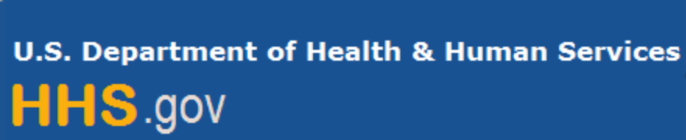

Department of Health and Human Services

Grants Forecast and Overview

The Department of Health and Human Services’ Grants Forecast is a database of planned grant opportunities proposed by its agencies. Each Forecast record contains actual or estimated dates and funding levels for grants that the agency intends to award during the fiscal year. Forecast opportunities are subject to change based on enactment of congressional appropriations. Go to the webpage below for more information.

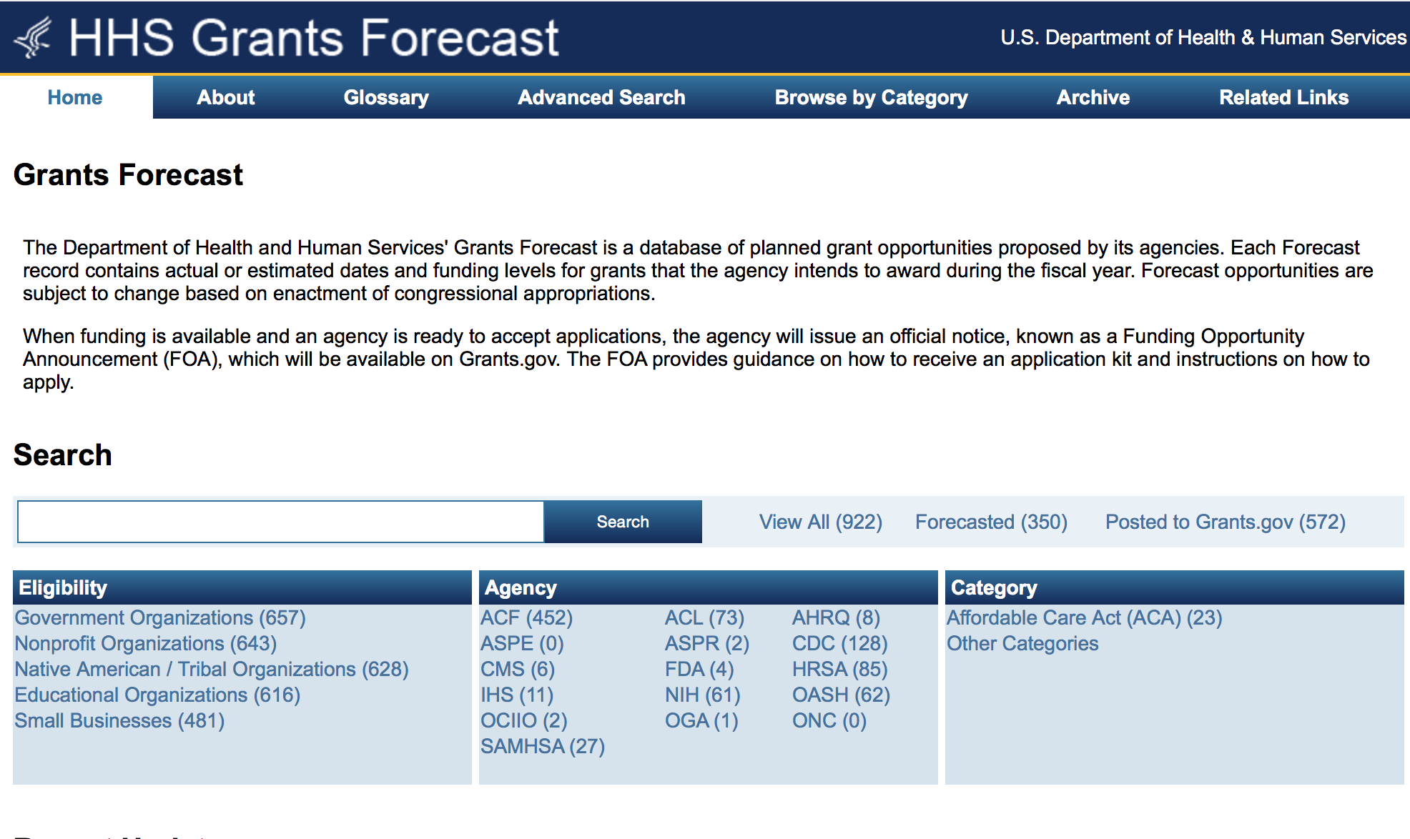
For more general information about HHS Grants and Funding go to the website below at: http://www.hhs.gov/grants/ .

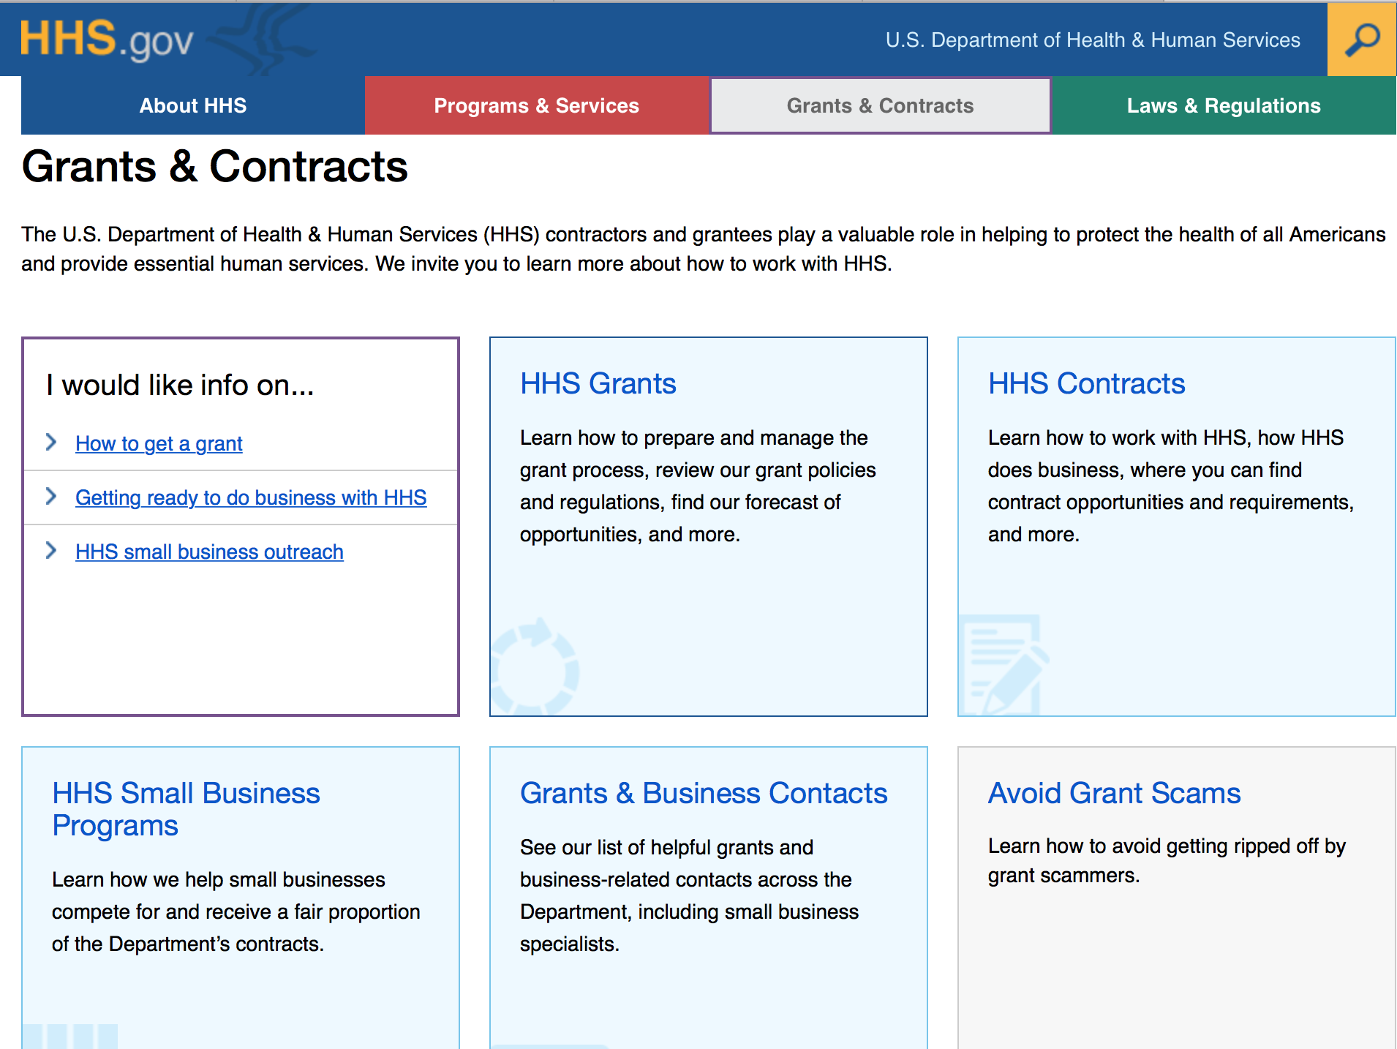

Programs:

Substance Abuse and Mental Health Services Administration
Targeted Capacity Expansion HIV: Substance Use Disorder Treatment for Racial/Ethnic Minority Women at High Risk for HIV/AIDS (Short Title: TCE-HIV: Minority Women) Grant
http://www.grants.gov/web/grants/view-opportunity.html?oppId=281848

Research:

Administration for Community Living
Disability and Rehabilitation Research Projects (DRRP) Program: Americans with Disabilities Act (ADA) National Network Grant
http://www.grants.gov/web/grants/view-opportunity.html?oppId=281683

Administration for Community Living
HHS/ACL/NIDILRR: Small Business Innovation Research Program (SBIR) Phase I
Grant
http://www.grants.gov/web/grants/view-opportunity.html?oppId=281752

Administration for Community Living
National Chronic Disease Self-Management Education (CDSME) Resource Center Financed Solely by 2016 Prevention and Public Health Funds (PPHF-2016) Grant
http://www.grants.gov/web/grants/view-opportunity.html?oppId=281456

Administration for Community Living
Evidence-Based Falls Prevention Programs Financed Solely by 2016 Prevention and Health Funds (PPHF-2016) Grant
http://www.grants.gov/web/grants/view-opportunity.html?oppId=281349

Administration for Community Living
Empowering Older Adults and Adults with Disabilities through Chronic Disease Self-Management Education Programs Financed Solely by 2016 Prevention and Public Health Funds (PPHF-2016) Grant
http://www.grants.gov/web/grants/view-opportunity.html?oppId=281361

Centers for Disease Control and Prevention
Centers for Disease Control - NCHHSTP
Expanding Partnerships and Disseminating HIV Prevention Materials to Reduce HIV and other STDs among Adolescents through National Non-Governmental Organizations
Grant
http://www.grants.gov/web/grants/view-opportunity.html?oppId=281558

Centers for Disease Control and Prevention
Centers for Disease Control - NCTP
National Center for HIV/AIDS, Viral Hepatitis, Sexually Transmitted Diseases and Tuberculosis Prevention (NCTP) Public Health Conference Support Grant
http://www.grants.gov/web/grants/view-opportunity.html?oppId=281348

Centers for Disease Control and Prevention
Centers for Disease Control - NCTP
Community-Based Organization Outcome Monitoring Projects for PS15-1502 HIV-Positive and High-Risk HIV-Negative Clients Grant
http://www.grants.gov/web/grants/view-opportunity.html?oppId=281406

Centers for Disease Control and Prevention
Centers for Disease Control - NCCDPHP
Advancing Arthritis Public Health Approaches through National Organizations
Grant
http://www.grants.gov/web/grants/view-opportunity.html?oppId=281507

Centers for Disease Control and Prevention
Cooperative Agreement for the Supporting and Building Capacity of Core Public Health Functions Related to Injury Prevention and Control Grant
http://www.grants.gov/web/grants/view-opportunity.html?oppId=281495

Centers for Disease Control and Prevention
Ebola Containment and Prevention Equipment Grant
http://www.grants.gov/web/grants/view-opportunity.html?oppId=281439

Centers for Disease Control and Prevention
Public Health Leader Fellowship Program (PHLFP) Grant
http://www.grants.gov/web/grants/view-opportunity.html?oppId=281440

Centers for Disease Control and Prevention
Centers for Disease Control - NCCDPHP
Advancing Arthritis Public Health Approaches through National Organizations
Grant
http://www.grants.gov/web/grants/view-opportunity.html?oppId=281507

Food & Drug Administration
NARMS Cooperative Agreement Program to Enhance and Strengthen Antibiotic Resistance Surveillance in Retail Food Specimens (U01) Grant
http://www.grants.gov/web/grants/view-opportunity.html?oppId=281542

Health Resources and Services Administration
Telehealth Network Grant Program Grant
http://www.grants.gov/web/grants/view-opportunity.html?oppId=281424

Health Resources and Services Administration
Strategic Approaches to Improving Access to Quality Health Care for Children and Youth with Epilepsy Grant
http://www.grants.gov/web/grants/view-opportunity.html?oppId=281815

National Institutes of Health
Small Vessel Vascular Contributions to Cognitive Impairment and Dementia (VCID) Biomarkers Development Projects (UH2/UH3) Grant
http://www.grants.gov/web/grants/view-opportunity.html?oppId=281840

National Institutes of Health
Pragmatic Strategies for Assessing Psychotherapy Quality in Practice (R01) Grant
http://www.grants.gov/web/grants/view-opportunity.html?oppId=281797National Institutes of Health
Mechanistic Ancillary Studies to Ongoing Interventional Clinical Trials (R01) Grant
http://www.grants.gov/web/grants/view-opportunity.html?oppId=281369

National Institutes of Health
Mechanistic Ancillary Studies to Ongoing Interventional Clinical Trials (R21)
Grant
http://www.grants.gov/web/grants/view-opportunity.html?oppId=281370

National Institutes of Health
Improvement of Animal Models for Stem Cell-Based Regenerative Medicine (R01)
Grant
http://www.grants.gov/web/grants/view-opportunity.html?oppId=281434

National Institutes of Health
NARMS Cooperative Agreement Program to Enhance and Strengthen Antibiotic Resistance Surveillance in Retail Food Specimens (U01) Grant
http://www.grants.gov/web/grants/view-opportunity.html?oppId=281509

National Institutes of Health
Improvement of Animal Models for Stem Cell-Based Regenerative Medicine (R21) Grant
http://www.grants.gov/web/grants/view-opportunity.html?oppId=281435

National Institutes of Health
Assessing Human Placental Development and Function Using Existing Data (R01) Grant
http://www.grants.gov/web/grants/view-opportunity.html?oppId=281436

National Institutes of Health
Assessing Human Placental Development and Function Using Existing Data (R21) Grant
http://www.grants.gov/web/grants/view-opportunity.html?oppId=281443

National Institutes of Health
Pre-application: Stimulating Peripheral Activity to Relieve Conditions (SPARC): Technologies to Understand the Control of Organ Function by the Peripheral Nervous System (OT1) Grant
http://www.grants.gov/web/grants/view-opportunity.html?oppId=281414

National Institutes of Health
Limited Competition - Stimulating Peripheral Activity to Relieve Conditions (SPARC): Technologies to Understand the Control of Organ Function by the Peripheral Nervous System (OT2) Grant
http://www.grants.gov/web/grants/view-opportunity.html?oppId=281416

National Institutes of Health
NARMS Cooperative Agreement Program to Enhance and Strengthen Antibiotic Resistance Surveillance in Retail Food Specimens (U01) Grant
http://www.grants.gov/web/grants/view-opportunity.html?oppId=281509

National Institutes of Health
Cooperative Research Agreements Related to the World Trade Center Health Program (U01) Grant
http://www.grants.gov/web/grants/view-opportunity.html?oppId=281520

National Institutes of Health
T4 Translation Research Capacity Building Initiative in Low Income Countries (TREIN) (U24) Grant
http://www.grants.gov/web/grants/view-opportunity.html?oppId=281521

National Institutes of Health
Cooperative Research Agreements Related to the World Trade Center Health Program (U01) Grant
http://www.grants.gov/web/grants/view-opportunity.html?oppId=281520

National Institutes of Health
T4 Translation Research Capacity Building Initiative in Low Income Countries (TREIN) (U24) Grant
http://www.grants.gov/web/grants/view-opportunity.html?oppId=281521

National Institutes of Health
Basic Biopsychosocial Mechanisms and Processes in the Management of Chronic Conditions (R21) Grant
http://www.grants.gov/web/grants/view-opportunity.html?oppId=281477

National Institutes of Health
Accelerating Research on Intervertebral Disc (ARID) (R21) Grant
http://www.grants.gov/web/grants/view-opportunity.html?oppId=281478

National Institutes of Health
Accelerating Research on Intervertebral Disc (ARID) (R01) Grant
http://www.grants.gov/web/grants/view-opportunity.html?oppId=281479

National Institutes of Health
Rapid Assessment of Zika Virus (ZIKV) Complications (R21) Grant
http://www.grants.gov/web/grants/view-opportunity.html?oppId=281682

National Institutes of Health
Biomarkers Discovery In Parkinsonism (U01) Grant
http://www.grants.gov/web/grants/view-opportunity.html?oppId=281751

National Institutes of Health
Cooperative Agreement to Develop Targeted Agents for Use with Systemic Agents Plus Radiotherapy (U01) Grant
http://www.grants.gov/web/grants/view-opportunity.html?oppId=281719

National Institutes of Health
Center without Walls for the Identification and Validation of Molecular Mechanisms Contributing to Tau Pathogenesis and Associated Neurodegeneration in Frontotemporal Degeneration (FTD) (U54) Grant
http://www.grants.gov/web/grants/view-opportunity.html?oppId=281757

National Institutes of Health
Maximizing Access to Research Careers Undergraduate - Student Training in Academic Research (MARC U-STAR) (T34) Grant
http://www.grants.gov/web/grants/view-opportunity.html?oppId=281759

National Institutes of Health
Characterization of Circulating Pro- and Anti-Geronic Proteins and Peptides (R01)
Grant
http://www.grants.gov/web/grants/view-opportunity.html?oppId=281781

National Institutes of Health
Cancer Tissue Engineering Collaborative: Enabling Biomimetic Tissue-Engineered Technologies for Cancer Research (U01) Grant
http://www.grants.gov/web/grants/view-opportunity.html?oppId=281661

National Institutes of Health
Multidisciplinary Research in Vulvodynia (R01) Grant
http://www.grants.gov/web/grants/view-opportunity.html?oppId=281604

National Institutes of Health
Multidisciplinary Research in Vulvodynia (R21) Grant
http://www.grants.gov/web/grants/view-opportunity.html?oppId=281605

National Institutes of Health
SBIR Phase II Bridge Awards to Accelerate the Development of Cancer Therapeutics, Imaging Technologies, Interventional Devices, Diagnostics, and Prognostics toward Commercialization (R44) Grant
http://www.grants.gov/web/grants/view-opportunity.html?oppId=281606

National Institutes of Health
Multidisciplinary Research in Vulvodynia (R03) Grant
http://www.grants.gov/web/grants/view-opportunity.html?oppId=281589

National Institutes of Health
NIAID SBIR-Technology Transfer Direct Phase II (R44) Grant
http://www.grants.gov/web/grants/view-opportunity.html?oppId=281590

National Institutes of Health
NLM Institutional Grants for Research Training in Biomedical Informatics and Data Science (T15) Grant
http://www.grants.gov/web/grants/view-opportunity.html?oppId=281591

Limited Competition: NIGMS Legacy Community-Wide Scientific Resources (R24)
Grant
http://www.grants.gov/web/grants/view-opportunity.html?oppId=281650

National Institutes of Health
Institutional Research and Academic Career Development Awards (IRACDA) (K12)
Grant
http://www.grants.gov/web/grants/view-opportunity.html?oppId=281651

National Institutes of Health
Team-Based Design in Biomedical Engineering Education (R25) Grant
http://www.grants.gov/web/grants/view-opportunity.html?oppId=281720

National Institutes of Health
Modeling of Infectious Disease Agent Study Research Projects (R01) Grant
http://www.grants.gov/web/grants/view-opportunity.html?oppId=281721

National Institutes of Health
Bridges to the Baccalaureate (R25) Grant
http://www.grants.gov/web/grants/view-opportunity.html?oppId=281722

National Institutes of Health
Bridges to the Doctorate (R25) Grant
http://www.grants.gov/web/grants/view-opportunity.html?oppId=281705

National Institutes of Health
Biomarkers for the Lewy Body Dementias (U01) Grant
http://www.grants.gov/web/grants/view-opportunity.html?oppId=281679

National Institutes of Health
Cooperative Study Group for Autoimmune Disease Prevention (U01) Grant
http://www.grants.gov/web/grants/view-opportunity.html?oppId=281802

National Institutes of Health
Optimization of Monoclonal Antibodies for Eliminating the HIV Reservoir (R01) Grant
http://www.grants.gov/web/grants/view-opportunity.html?oppId=281805

National Institutes of Health
Silvio O. Conte Digestive Diseases Research Core Centers (P30) Grant
http://www.grants.gov/web/grants/view-opportunity.html?oppId=281775

National Institutes of Health
Spermatogenic Stem Cell Culture Systems to Preserve and Restore Reproductive Capacity in Males (R01) Grant
http://www.grants.gov/web/grants/view-opportunity.html?oppId=281776

National Institutes of Health
Stimulating Peripheral Activity to Relieve Conditions (SPARC): Pre-clinical Development of Existing Market-approved Devices to Support New Market Indications (U18) Grant
http://www.grants.gov/web/grants/view-opportunity.html?oppId=281777

Substance Abuse and Mental Health Services Admin
2016 Cooperative Agreements for the Expansion and Sustainability of the Comprehensive Community Mental Health Services for Children with Serious Emotional Disturbances (Short title: System of Care (SOC) Expansion and Sustainability Cooperative Agreements) Grant
http://www.grants.gov/web/grants/view-opportunity.html?oppId=281522

Modifications:

Administration for Community Living
Empowering Older Adults and Adults with Disabilities through Chronic Disease Self-Management Education Programs Financed Solely by 2016 Prevention and Public Health Funds (PPHF-2016)
Modification 1
http://www.grants.gov/web/grants/view-opportunity.html?oppId=281361

Administration for Community Living
Senior Medicare Patrol Projects - Empowering Seniors to Prevent Health Care Fraud
Modification 1
http://www.grants.gov/web/grants/view-opportunity.html?oppId=281363

Administration for Children and Families - OCS
Community Economic Development Projects
Modification 2
http://www.grants.gov/web/grants/view-opportunity.html?oppId=255896

Administration for Children and Families - OCS
Community Economic Development Healthy Food Financing Initiative Projects
Modification 2
http://www.grants.gov/web/grants/view-opportunity.html?oppId=255897

Centers for Disease Control and Prevention
Centers for Disease Control - NCCDPHP
Sodium Reduction in Communities
Modification 5
http://www.grants.gov/web/grants/view-opportunity.html?oppId=280919

Centers for Disease Control and Prevention
Centers for Disease Control - NCCDPHP
Advancing Arthritis Public Health Approaches through National Organizations
Modification 2
http://www.grants.gov/web/grants/view-opportunity.html?oppId=281507

Centers for Disease Control and Prevention
Centers for Disease Control - NCBDDD
Improving the Health of People with Mobility Limitations and Intellectual Disabilities through State-based Public Health Programs
Modification 1
http://www.grants.gov/web/grants/view-opportunity.html?oppId=281617

Centers for Disease Control and Prevention
Centers for Disease Control and Prevention
Operations Research (Implementation Science) for Strengthening Program Implementation through the Presidents Emergency Plan for AIDS Relief (PEPFAR)
Modification 1
http://www.grants.gov/web/grants/view-opportunity.html?oppId=280844

Centers for Disease Control and Prevention
Centers for Disease Control - NCCDPHP
Sodium Reduction in Communities
Modification 10
http://www.grants.gov/web/grants/view-opportunity.html?oppId=280919

Centers for Disease Control - NCTP
National Center for HIV/AIDS, Viral Hepatitis, Sexually Transmitted Diseases and Tuberculosis Prevention (NCTP) Public Health Conference Support
Modification 1
http://www.grants.gov/web/grants/view-opportunity.html?oppId=281348

Centers for Disease Control and Prevention
NIOSH Exploratory/Developmental Grant Program (R21)
Modification 7
http://www.grants.gov/web/grants/view-opportunity.html?oppId=188173

Centers for Disease Control and Prevention
Centers for Disease Control and Prevention
Michigan Lupus Epidemiology and Surveillance (MILES) Program Longitudinal Cohort Study
Modification 2
http://www.grants.gov/web/grants/view-opportunity.html?oppId=280386

Centers for Disease Control and Prevention
Centers for Disease Control - NCCDPHP
Sodium Reduction in Communities
Modification 7
http://www.grants.gov/web/grants/view-opportunity.html?oppId=280919

Centers for Disease Control and Prevention
Conducting Public Health Research in Kenya
Modification 7
http://www.grants.gov/web/grants/view-opportunity.html?oppId=281000

Centers for Disease Control and Prevention
Operations Research (Implementation Science) for Strengthening Program Implementation through the Presidents Emergency Plan for AIDS Relief (PEPFAR)
Modification 3
http://www.grants.gov/web/grants/view-opportunity.html?oppId=280844

Health Resources and Services Administration
Early Childhood Comprehensive Systems Impact (ECCS Impact)
Modification 1
http://www.grants.gov/web/grants/view-opportunity.html?oppId=281007

National Institutes of Health
Investigator Initiated Multi-Site Clinical Trials (Collaborative R01)
Modification 1
http://www.grants.gov/web/grants/view-opportunity.html?oppId=223856

Office of the Assistant Secretary for Health
Announcement of Availability of Funds for the Female Genital Cutting (FGC) Community-Centered Health Care and Prevention Project
Modification 2
http://www.grants.gov/web/grants/view-opportunity.html?oppId=281078

Office of the Assistant Secretary for Health
Announcement Availability of Funds for the College Sexual Assault Policy and Prevention Initiative
Modification 3
http://www.grants.gov/web/grants/view-opportunity.html?oppId=281052

Office of the Assistant Secretary for Health
Re-Entry Community Linkages (RE-LINK)
Modification 1
http://www.grants.gov/web/grants/view-opportunity.html?oppId=281609

Substance Abuse and Mental Health Services Admin
Capacity Building Initiative for Substance Abuse (SA) and HIV Prevention Services for At-Risk Racial/Ethnic Minority Youth and Young Adults (HIV CBI)
Modification 1
http://www.grants.gov/web/grants/view-opportunity.html?oppId=281663

Reminders:

Office of the Assistant Secretary for Health
Announcement Availability of Funds for the College Sexual Assault Policy and Prevention Initiative
Modification 2

Document Type: | Grants Notice
Funding Opportunity Number: | WH-AST-16-001
Funding Opportunity Title: | Announcement Availability of Funds for the College Sexual Assault Policy and Prevention Initiative
Opportunity Category: | Discretionary
Funding Instrument Type: | Cooperative Agreement
Category of Funding Activity: | Health
Category Explanation:
Expected Number of Awards: | 10
CFDA Number(s): | 93.088 -- Advancing System Improvements for Key Issues in Women's Health
Cost Sharing or Matching Requirement: | No
Posted Date: | Jan 19, 2016
Creation Date: | Jan 20, 2016
Original Closing Date for Applications: | Apr 8, 2016 No Explanation
Current Closing Date for Applications: | Apr 8, 2016 No Explanation
Archive Date: | May 8, 2016
Estimated Total Program Funding:
Award Ceiling: | $250,000
Award Floor: | $100,000
Eligible Applicants: | Others (see text field entitled "Additional Information on Eligibility" for clarification)
Additional Information on Eligibility: | Any public or private entity is eligible to apply.
Agency Name: | Office of the Assistant Secretary for Health
Description: | The Centers for Disease Control and Prevention (CDC) defines sexual violence as a sexual act committed against someone without that persons freely given consent. Sexual violence can include sexual harassment, sexual assault, and rape. Sexual violence is divided into the following types: Completed or attempted forced penetration of a victim Completed or attempted alcohol/drug-facilitated penetration of a victim Completed or attempted forced acts in which a victim is made to penetrate a perpetrator or someone else Completed or attempted alcohol/drug-facilitated acts in which a victim is made to penetrate a perpetrator or someone else Non-physically forced penetration which occurs after a person is pressured verbally or through intimidation or misuse of authority to consent or acquiesce Unwanted sexual contact Non-contact unwanted sexual experiences The CDC estimates 23 million women have experienced completed or attempted rape in their lifetimes. Nearly 80% of female victims of completed rape or sexual assault reported the episode occurred before their 25th birthday, with 40% having experienced their first rape between the ages 18 and 24. Currently, one in five female college students report having been sexually assaulted. Further, the Association of American Universities (AAU) published results in September 2015 from a new survey finding 23% of female undergraduate students have reported experiencing sexual assault since enrolling in college. AAU surveyed over 150,000 students across 27 colleges and universities. More than 20 percent of female undergraduates at an array of prominent universities said they were victims of sexual assault and misconduct this year. Most often it happens her freshman or sophomore year by someone she knows, but it is not reported. In most cases, the perpetrator is an acquaintance, classmate, friend or (ex) boyfriend of the victim, and she was drugged, drunk, passed out, or otherwise incapacitated. There are approximately 3,000 four-year and 2,000 two-year colleges and universities in the U.S. Yet many post-secondary schools have no or limited policies and procedures in place to prevent sexual assault. For this initiative, each grantee will: Partner with organizations in position to influence policies and practices at post- secondary schools to disseminate sexual assault policy information and prevention strategies; and Partner with a cadre of post-secondary schools to institute policies and practices, and prevention strategies that prevent sexual assaults from occurring. Technical assistance for policy advancement should focus on 1) identifying the campus climate; 2) implementing bystander education and other prevention programs; and 3) effectively responding when a student is sexually assaulted. Grantees will achieve their objectives for this funding opportunity with substantial involvement from OWH. Specifically, OWH will: Actively participate in the development of prevention strategies and policies to ensure the inclusion of steps recommended by the White House Task Force on Campus Sexual Assault to: 1. Identify the scope of the problem on college campuses; 2. Help prevent sexual assault on campus; 3. Help schools respond effectively when a student is sexually assaulted; and 4. Improve the federal governments enforcement efforts, and make them more transparent. Facilitate collaboration among grantees to share best practices and lessons learned. Partner in identifying platforms for dissemination of evidence-based results.
Link to Additional Information: | Announcement Availability of Funds for the College Sexual Assault Policy and Prevention Initiative
Contact Information: | If you have difficulty accessing the full announcement electronically, please contact:  Grants.gov Contact Center Phone Number: 1-800-518-4726 Hours of operation are 24 hours a day, 7 days a week. The contact center is closed on federal holidays. support@grants.gov  Grants.gov Customer Support

http://www.grants.gov/web/grants/view-opportunity.html?oppId=281052

Substance Abuse & Mental Health Services Administration
Drug-Free Communities (DFC) Support Program Grant

Document Type: | Grants Notice
Funding Opportunity Number: | SP-16-001
Funding Opportunity Title: | Drug-Free Communities (DFC) Support Program
Opportunity Category: | Discretionary
Funding Instrument Type: | Grant
Category of Funding Activity: | Health
Category Explanation:
Expected Number of Awards: | 70
CFDA Number(s): | 93.276 -- Drug-Free Communities Support Program Grants
Cost Sharing or Matching Requirement: | Yes
Posted Date: | Dec 16, 2015
Creation Date: | Dec 16, 2015
Original Closing Date for Applications: | Mar 18, 2016
Current Closing Date for Applications: | Mar 18, 2016
Archive Date: | Apr 17, 2016
Estimated Total Program Funding: | $8,750,000
Award Ceiling: | $125,000
Award Floor: | $0
Eligible Applicants: | Others (see text field entitled "Additional Information on Eligibility" for clarification)
Additional Information on Eligibility: | Eligible applicants are community-based coalitions addressing youth substance use that have never received a DFC grant; or have previously received a DFC grant, but experienced a lapse in funding; or have concluded the first five-year funding cycle and are applying for a second five-year funding cycle. Applicants must meet all Statutory Eligibility Requirements. See Section III-1 of this FOA for complete eligibility information.
Agency Name: | Substance Abuse & Mental Health Services Adminis.
Description: | The DFC Program was created by the Drug-Free Communities Act of 1997 (Public Law 105-20). The DFC Support Program has two goals: 1. Establish and strengthen collaboration among communities, public and private non-profit agencies; as well as federal, state, local, and tribal governments to support the efforts of community coalitions working to prevent and reduce substance use among youth*. 2. Reduce substance use among youth and, over time, reduce substance abuse among adults by addressing the factors in a community that increase the risk of substance abuse and promoting the factors that minimize the risk of substance abuse. *For the purposes of this FOA, “youth” is defined as individuals 18 years of age and younger.
Link to Additional Information: | Drug-Free Communities (DFC) Support Program
Contact Information: | If you have difficulty accessing the full announcement electronically, please contact:  Jennifer Cramer, Division of Grants Management, SAMHSA, 7-1109, 1 Choke Cherry Road, Rockville, MD 20857 Phone: (240) 276-1422  DGMSAMHSA@samhsa. .gov

http://www.grants.gov/web/grants/view-opportunity.html?oppId=280572

National Institutes of Health
PHS 2015-02 Omnibus Solicitation of the NIH, CDC, FDA and ACF for Small Business Innovation Research Grant Applications (Parent SBIR [R43/R44]) Grant

Document Type: | Grants Notice
Funding Opportunity Number: | PA-15-269
Funding Opportunity Title: | PHS 2015-02 Omnibus Solicitation of the NIH, CDC, FDA and ACF for Small Business Innovation Research Grant Applications (Parent SBIR [R43/R44])
Opportunity Category: | Discretionary
Funding Instrument Type: | Grant
Category of Funding Activity: | Education  Environment  Food and Nutrition  Health  Income Security and Social Services
Category Explanation:
Expected Number of Awards:
CFDA Number(s): | 93.061 -- Innovations in Applied Public Health Research  93.103 -- Food and Drug Administration Research  93.113 -- Environmental Health  93.121 -- Oral Diseases and Disorders Research  93.136 -- Injury Prevention and Control Research and State and Community Based Programs  93.172 -- Human Genome Research  93.173 -- Research Related to Deafness and Communication Disorders  93.213 -- Research and Training in Complementary and Integrative Health  93.233 -- National Center on Sleep Disorders Research  93.242 -- Mental Health Research Grants  93.262 -- Occupational Safety and Health Program  93.273 -- Alcohol Research Programs  93.279 -- Drug Abuse and Addiction Research Programs  93.282 -- Mental Health National Research Service Awards for Research Training  93.283 -- Centers for Disease Control and Prevention Investigations and Technical Assistance  93.286 -- Discovery and Applied Research for Technological Innovations to Improve Human Health  93.307 -- Minority Health and Health Disparities Research  93.350 -- National Center for Advancing Translational Sciences  93.351 -- Research Infrastructure Programs  93.361 -- Nursing Research  93.393 -- Cancer Cause and Prevention Research  93.394 -- Cancer Detection and Diagnosis Research  93.395 -- Cancer Treatment Research  93.396 -- Cancer Biology Research  93.399 -- Cancer Control  93.595 -- Welfare Reform Research, Evaluations and National Studies  93.647 -- Social Services Research and Demonstration  93.823 -- Ebola Support: Transmission and Prevention Control, Public Health Preparedness, Vaccine Development  93.837 -- Cardiovascular Diseases Research  93.838 -- Lung Diseases Research  93.839 -- Blood Diseases and Resources Research  93.846 -- Arthritis, Musculoskeletal and Skin Diseases Research  93.847 -- Diabetes, Digestive, and Kidney Diseases Extramural Research  93.853 -- Extramural Research Programs in the Neurosciences and Neurological Disorders  93.855 -- Allergy, Immunology and Transplantation Research  93.856 -- Microbiology and Infectious Diseases Research  93.859 -- Biomedical Research and Research Training  93.865 -- Child Health and Human Development Extramural Research  93.866 -- Aging Research  93.867 -- Vision Research  93.879 -- Medical Library Assistance
Cost Sharing or Matching Requirement: | No
Posted Date: | Jun 4, 2015
Creation Date: | Jun 4, 2015
Original Closing Date for Applications: | Apr 5, 2016
Current Closing Date for Applications: | Apr 5, 2016
Archive Date: | May 6, 2016
Eligible Applicants: | Small businesses
Additional Information on Eligibility: | Other Eligible Applicants include the following: Non-domestic (non-U.S.) Entities (Foreign Institutions) are not eligible to apply. Non-domestic (non-U.S.) components of U.S. Organizations are not eligible to apply. Foreign components, as defined in the NIH Grants Policy Statement, may be allowed.
Agency Name: | National Institutes of Health
Description: | This Funding Opportunity Announcement (FOA) issued by the National Institutes of Health (NIH), the Centers for Disease Control and Prevention (CDC), the Food and Drug Administration (FDA) and the Administration for Children and Families (ACF) invites eligible United States small business concerns (SBCs) to submit Small Business Innovation Research (SBIR) grant applications. United States SBCs that have the research capabilities and technological expertise to contribute to the R and D mission(s) of the NIH, CDC, FDA or ACF awarding components identified in this FOA are encouraged to submit SBIR grant applications in response to identified topics (see PHS 2015-2 SBIR/STTR Program Descriptions and Research Topics for NIH, CDC, FDA and ACF.
Link to Additional Information: | http://grants.nih.gov/grants/guide/pa-files/PA-15-269.html
Contact Information: | If you have difficulty accessing the full announcement electronically, please contact:  NIH OER Webmaster FBOWebmaster@OD.NIH.GOV  If you have any problems linking to this funding announcement, please contact the NIH OER Webmaster

http://www.grants.gov/web/grants/view-opportunity.html?oppId=276977

Department of Homeland Security

The Department of Homeland Security enhances the ability of states, local and tribal jurisdictions, and other regional authorities in the preparation, prevention, and response to terrorist attacks and other disasters, by distributing grant funds. Localities can use grants for planning, equipment, training and exercise needs.

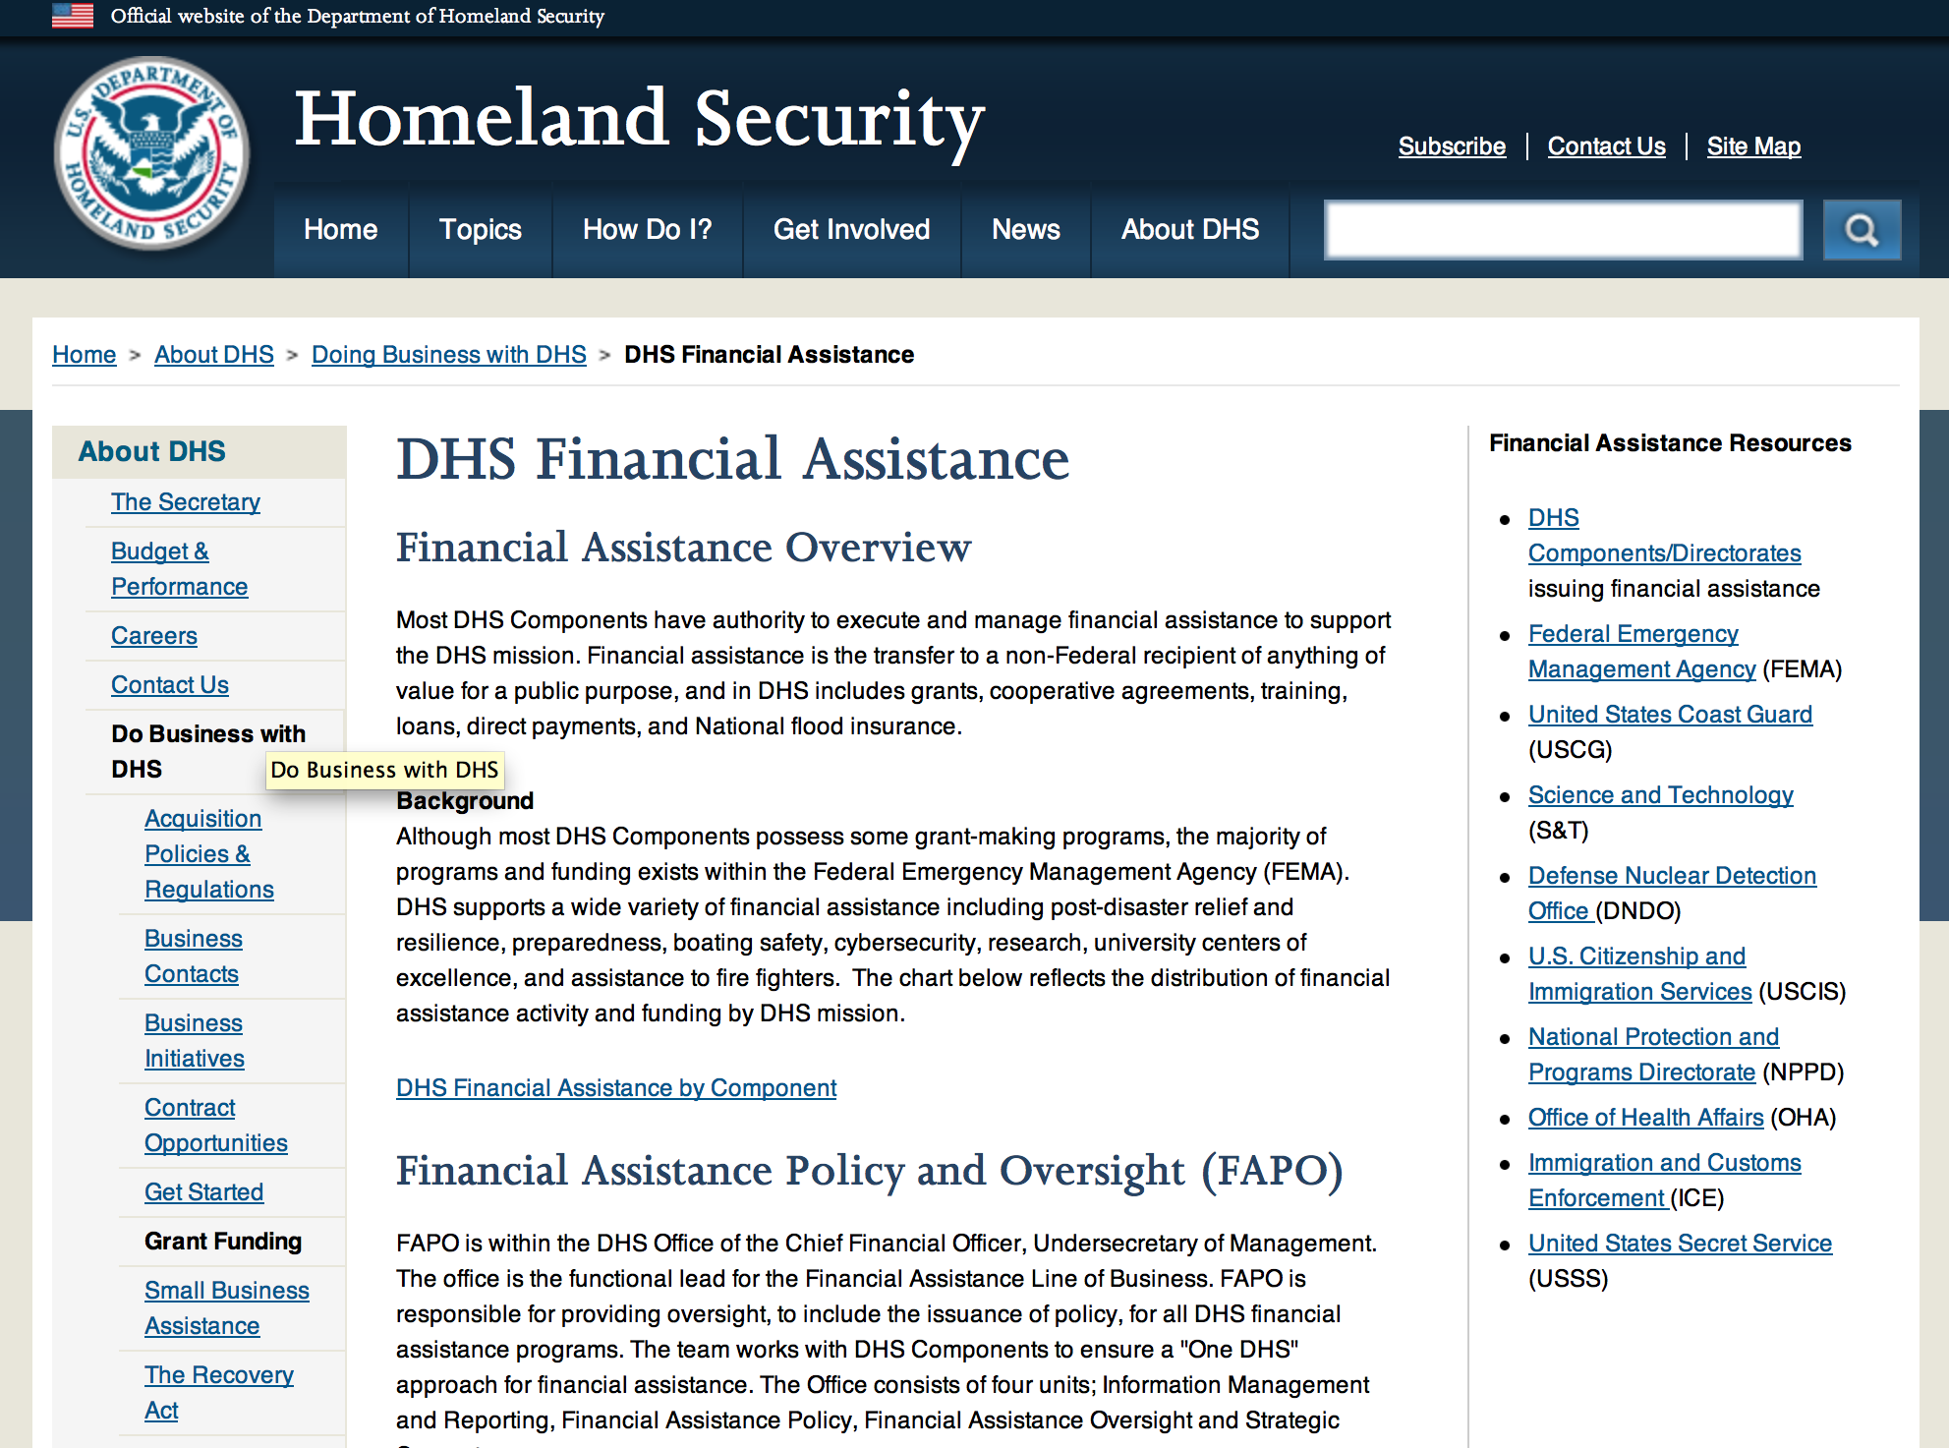

Webpage can be viewed at: http://www.dhs.gov/xopnbiz/grants/index.shtm#2

The FY 2015 Assistance to Firefighters Grants (AFG) Application Period Has Closed.
For AFG program guidance materials, please visit our Documents page.
FY 2015 FIRE PREVENTION & SAFETY (FP&S) Grants
- FY 2015 Application Information Coming Soon
- FP&S Success Stories
FY 2014 FIRE PREVENTION & SAFETY (FP&S) Grants
- FY 2014 FP&S Award Announcements - View Awards List
FY 2015 STAFFING FOR ADEQUATE FIRE and EMERGENCY RESPONSE (SAFER) Grants
- FY 2015 Application Information Coming Soon
- SAFER Success Stories
FY 2014 STAFFING FOR ADEQUATE FIRE and EMERGENCY RESPONSE (SAFER) Grants
- FY 2014 FP&S Award Announcements - View Awards List
FP&S Success Stories

Resources

AFG Help Desk
Contact the AFG Program Help Desk toll-free at 866-274-0960, or email us at firegrants@dhs.gov.
The AFG Program has Fire Program Specialists in 10 federal regional centers. These Regional Fire Program Specialists respond to questions about the AFG program and carry out grant monitoring activities. View regional contacts

Popular AFG links
- AFG Workshop Schedule
- Assistance to Firefighters Grants (AFG)
- AFG Awards List
- AFG Success Stories
- Staffing for Adequate Fire & Emergency Response (SAFER) Grants (SAFER)
- SAFER Awards List
- SAFER Success Stories
- Fire Prevention & Safety (FP&S) Grants
- FP&S Awards List
- FP&S Success Stories
- Grant Closeout Tutorial
- Assistance to Firefighters Grant (AFG) Email Alert Archive
- Frequently Asked Questions
Contact Information For The Assistance to Firefighters Grant (AFG) Program and Help Desk

Federal Funding Alternative To AFG

State Administrative Agencies (SAA) apply for and administer Federal grants on behalf of their States, including FEMA Preparedness Grants. The SAA will work with eligible organizations to comply with the general requirements of grant programs or cooperative agreements. Contact your State’s SAA to find out what current Federal funding opportunities may be available to your organization. A listing of the SAAs and points of contact can be found at http://www.fema.gov/library/viewRecord.do?id=6363.

Programs:

Department of Homeland Security - FEMA
Fiscal Year (FY) 2015 Staffing for Adequate Fire and Emergency Response (SAFER) Grant
Document Type: | Grants Notice
Funding Opportunity Number: | DHS-15-GPD-083-000-99
Funding Opportunity Title: | Fiscal Year (FY) 2015 Staffing for Adequate Fire and Emergency Response (SAFER)
Opportunity Category: | Discretionary
Opportunity Category Explanation:
Funding Instrument Type: | Grant
Category of Funding Activity: | Employment, Labor and Training
Category Explanation:
Expected Number of Awards: | 300
CFDA Number(s): | 97.083 -- Staffing for Adequate Fire and Emergency Response (SAFER)
Cost Sharing or Matching Requirement: | No
Posted Date: | Feb 16, 2016
Last Updated Date: | Feb 16, 2016
Original Closing Date for Applications: | Mar 25, 2016
Current Closing Date for Applications: | Mar 25, 2016
Archive Date: | Apr 24, 2016
Estimated Total Program Funding: | $340,000,000
Award Ceiling: | $0
Award Floor: | $0
Eligible Applicants: | Others (see text field entitled "Additional Information on Eligibility" for clarification)  County governments  City or township governments
Additional Information on Eligibility: | Fire Departments National, state, local, or tribal organizations representing the interests of volunteer firefighters
Agency Name: | Department of Homeland Security - FEMA
Description: | The Department of Homeland Security (DHS) Federal Emergency Management Agency’s (FEMA) Grant Programs Directorate implements and administers the Staffing for Adequate Fire and Emergency Response (SAFER) Grants. SAFER grants provide financial assistance to help fire departments increase frontline firefighters, rehire firefighters that have been laid off, retain firefighters facing imminent layoffs, or filling of positions that were vacated through attrition. SAFER offers grants to support activities in two categories: 1. Hiring of Firefighters 2. Recruitment and Retention of Volunteer Firefighters The authority for SAFER is derived from the Federal Fire Prevention and Control Act of 1974, as amended (15 U.S.C. §2229a et seq.). The notice of funding opportunity document provides potential applicants with the details of the requirements, processing, and evaluation of an application for financial assistance for both of these activity areas.
Link to Additional Information: | www.fema.gov/firegrants
Contact Information: | If you have difficulty accessing the full announcement electronically, please contact:  SAFER Help Desk FireGrants@fema.dhs.gov (866) 274-0960  FireGrants@fema.dhs.gov

http://www.grants.gov/web/grants/view-opportunity.html?oppId=281571

Department of Homeland Security - FEMA
FY16 Pre-Disaster Mitigation Grant

Document Type: | Grants Notice
Funding Opportunity Number: | DHS-16-MT-047-000-99
Funding Opportunity Title: | FY16 Pre-Disaster Mitigation
Opportunity Category: | Discretionary
Opportunity Category Explanation:
Funding Instrument Type: | Grant
Category of Funding Activity: | Other (see text field entitled "Explanation of Other Category of Funding Activity" for clarification)
Category Explanation: | The Robert T. Stafford Disaster Relief and Emergency Assistance Act, Public Law 93-288, as amended, (42 U.S.C. 5133), Section 203 authorizes FEMA to make grants for the purpose of implementing a sustained pre-disaster natural hazard mitigation program to reduce overall risk to the population and structures from future hazard events, while also reducing reliance on Federal funding from future disasters.
Expected Number of Awards: | 200
CFDA Number(s): | 97.047 -- Pre-Disaster Mitigation
Cost Sharing or Matching Requirement: | Yes
Posted Date: | Feb 10, 2016
Last Updated Date: | Feb 10, 2016
Original Closing Date for Applications: | Jun 15, 2016
Current Closing Date for Applications: | Jun 15, 2016
Archive Date: | Jul 15, 2016
Estimated Total Program Funding: | $90,000,000
Award Ceiling: | $15,000,000
Eligible Applicants: | State governments  Others (see text field entitled "Additional Information on Eligibility" for clarification)  Native American tribal governments (Federally recognized)
Additional Information on Eligibility: | District of Columbia; U.S. Territories. Local governments must apply through their state.
Agency Name: | Department of Homeland Security - FEMA
Description: | The Pre-Disaster Mitigation (PDM) program makes available Federal funds to State, Local and Tribal Governments to implement and sustain cost-effective measures designed to reduce the risk to individuals and property from natural hazards, while also reducing reliance on Federal funding from future disasters. FEMA will provide allocations of $575,000 as required by the Stafford Act to states and territories; and a tribal set aside of $10 million for allocations up to $575,000 for Native American Indian tribal governments to support overall mitigation planning and projects. The remaining PDM funds will be awarded on a competitive basis with a focus on Climate Resilient Mitigation Activities. Applicants must submit applications via the Mitigation eGrants system on the FEMA Grants Portal: https://portal.fema.gov. Applicants may submit a maximum of 19 sub-applications, including 1 management cost sub-application for Applicant management costs. Of the 18 sub-applications for mitigation activities, a maximum of 8 projects may be included.
Link to Additional Information: | Program Guidance
Contact Information: | If you have difficulty accessing the full announcement electronically, please contact:  Mitigation eGrants System Helpdesk Phone: 1-855-228-3362  MTeGrants@fema.dhs.gov

http://www.grants.gov/web/grants/view-opportunity.html?oppId=281453

Department of Homeland Security - FEMA
FY16 Flood Mitigation Assistance Grant

Document Type: | Grants Notice
Funding Opportunity Number: | DHS-16-MT-029-000-99
Funding Opportunity Title: | FY16 Flood Mitigation Assistance
Opportunity Category: | Discretionary
Opportunity Category Explanation:
Funding Instrument Type: | Grant
Category of Funding Activity: | Other (see text field entitled "Explanation of Other Category of Funding Activity" for clarification)
Category Explanation: | The Flood Mitigation Assistance (FMA) program is authorized by the National Flood Insurance Reform Act (NFIRA) of 1994 with the goal of reducing or eliminating claims under the NFIP.
Expected Number of Awards: | 200
CFDA Number(s): | 97.029 -- Flood Mitigation Assistance
Cost Sharing or Matching Requirement: | Yes
Posted Date: | Feb 10, 2016
Last Updated Date: | Feb 10, 2016
Original Closing Date for Applications: | Jun 15, 2016
Current Closing Date for Applications: | Jun 15, 2016
Archive Date: | Jul 15, 2016
Estimated Total Program Funding: | $199,000,000
Award Ceiling: | $0
Award Floor: | $0
Eligible Applicants: | Native American tribal governments (Federally recognized)  Others (see text field entitled "Additional Information on Eligibility" for clarification)  State governments
Additional Information on Eligibility: | District of Columbia; U.S. Territories. Local governments must apply through their state.
Agency Name: | Department of Homeland Security - FEMA
Description: | The Flood Mitigation Assistance (FMA) Program makes available federal funds to State, Local and Tribal Governments to implement and sustain cost-effective measures that reduce or eliminate risk of flood damage to buildings insured under the National Flood Insurance Program (NFIP). FEMA will fund planning up to $100,000 per applicant with a maximum of $50,000 for state plans and $25,000 for local plans. FEMA will fund technical assistance up to $50,000 for states who were awarded FMA Grant Program funds totaling at least $1 million in FY 2015. The remaining FMA funds will be awarded on a competitive basis for projects that will reduce or eliminate claims under the NFIP with a focus on mitigation of severe repetitive loss and repetitive loss properties as well as projects that will reduce the risk profile in communities through mitigation of the largest number of NFIP-insured properties on a neighborhood level. Applicants must apply for FMA funding through the Mitigation eGrants system on the FEMA Grants Portal accessible on the Internet at https:/portal.fema.gov
Link to Additional Information: | Program Guidance
Contact Information: | If you have difficulty accessing the full announcement electronically, please contact:  Mitigation eGrants System Helpdesk Phone: 1-855-228-3362  MTeGrants@fema.dhs.gov

http://www.grants.gov/web/grants/view-opportunity.html?oppId=281474

Modifications:

Department of Homeland Security - FEMA
Fiscal Year 2016 Port Security Grant Program (PSGP)
Modification 2

Document Type: | Grants Notice
Funding Opportunity Number: | DHS-16-GPD-056-00-01
Funding Opportunity Title: | Fiscal Year 2016 Port Security Grant Program (PSGP)
Opportunity Category: | Discretionary
Opportunity Category Explanation:
Funding Instrument Type: | Grant
Category of Funding Activity: | Other (see text field entitled "Explanation of Other Category of Funding Activity" for clarification)
Category Explanation: | Homeland Security Preparedness Grant
Expected Number of Awards: | 210
CFDA Number(s): | 97.056 -- Port Security Grant Program
Cost Sharing or Matching Requirement: | Yes
Posted Date: | Feb 16, 2016
Last Updated Date: | Feb 16, 2016
Original Closing Date for Applications: | Apr 25, 2016
Current Closing Date for Applications: | Apr 25, 2016
Archive Date: | May 25, 2016
Estimated Total Program Funding: | $100,000,000
Award Ceiling: | $0
Award Floor: | $0
Eligible Applicants: | Others (see text field entitled "Additional Information on Eligibility" for clarification)
Additional Information on Eligibility: | All entities subject to an Area Maritime Transportation Security Plan (AMSP), as defined by 46 U.S.S Section 7013(b), may apply for PSGP funding. Eligible applicants include, but are not limited to: port authorities, facility operators, and state and local government agencies.
Agency Name: | Department of Homeland Security - FEMA
Description: | The Department of Homeland Security Fiscal Year (FY) 2016 Port Security Grant Program (PSGP) plays an important role in the implementation of the National Preparedness System by supporting the building, sustainment, and delivery of core capabilities essential to achieving the National Preparedness Goal (the Goal) of a secure and resilient Nation. Delivering core capabilities requires the combined effort of the whole community, rather than the exclusive effort of any single organization or level of government. The FY 2016 PSGP's allowable costs support efforts to build and sustain core capabilities across Prevention, Protection, Mitigation, Response, and Recovery mission areas, with specific focus on addressing the security needs of our Nation's maritime ports. The PSGP supports the Quadrennial Homeland Security Review Mission to Strengthen National Preparedness and Resilience.
Link to Additional Information: | http://www.grants.gov
Contact Information: | If you have difficulty accessing the full announcement electronically, please contact:  GPD Systems Branch (800) 865-4076 GMD-Systems-Branch@fema.gov  GMD-Systems-Branch@fema.gov

http://www.grants.gov/web/grants/view-opportunity.html?oppId=281568

Department of Homeland Security - FEMA
Fiscal Year (FY) 2016 Intercity Bus Security Grant Program (IBSGP)
Modification 2
Document Type: | Grants Notice
Funding Opportunity Number: | DHS-16-GPD-057-00-01
Funding Opportunity Title: | Fiscal Year (FY) 2016 Intercity Bus Security Grant Program (IBSGP)
Opportunity Category: | Discretionary
Opportunity Category Explanation:
Funding Instrument Type: | Grant
Category of Funding Activity: | Other (see text field entitled "Explanation of Other Category of Funding Activity" for clarification)
Category Explanation: | Homeland Security - Preparedness
Expected Number of Awards: | 100
CFDA Number(s): | 97.057 -- Intercity Bus Security Grants
Cost Sharing or Matching Requirement: | No
Posted Date: | Feb 16, 2016
Last Updated Date: | Feb 16, 2016
Original Closing Date for Applications: | Apr 25, 2016
Current Closing Date for Applications: | Apr 25, 2016
Archive Date: | May 25, 2016
Estimated Total Program Funding: | $3,000,000
Eligible Applicants: | Others (see text field entitled "Additional Information on Eligibility" for clarification)
Additional Information on Eligibility: | Owners and operators of fixed route intercity and charter buses. See Notice of Funding Opportunity for details.
Agency Name: | Department of Homeland Security - FEMA
Description: | The FY 2016 Intercity Bus Security Grant Program (IBSGP) is one of DHS's FY 2016 grant programs that directly support transportation infrastructure security activities. IBSGP is one tool in the comprehensive set of measures authorized by Congress and implemented by the Administration to strengthen the Nation's critical infrastructure against risks associated with potential terrorist attacks. IBSGP provides funding support for critical infrastructure hardening and other physical security enhancements to operators serving the Nation's highest-risk metropolitan areas. The IBSGP supports the Quadrennial Homeland Security Review Mission to Strengthen National Preparedness and Resilience.
Link to Additional Information: | http://www.grants.gov
Contact Information: | If you have difficulty accessing the full announcement electronically, please contact:  GPD Systems Branch (800) 865-4076 GMD-Systems-Branch@fema.gov  GMD-Systems-Branch@fema.gov

http://www.grants.gov/web/grants/view-opportunity.html?oppId=281549

Department of Homeland Security - FEMA
Fiscal Year 2016 Transit Security Grant Program (TSGP)
Modification 2

Document Type: | Grants Notice
Funding Opportunity Number: | DHS-16-GPD-075-00-02
Funding Opportunity Title: | Fiscal Year 2016 Transit Security Grant Program (TSGP)
Opportunity Category: | Discretionary
Opportunity Category Explanation:
Funding Instrument Type: | Grant
Category of Funding Activity: | Other (see text field entitled "Explanation of Other Category of Funding Activity" for clarification)
Category Explanation: | Homeland Security Preparedness Grant
Expected Number of Awards: | 45
CFDA Number(s): | 97.075 -- Rail and Transit Security Grant Program
Cost Sharing or Matching Requirement: | No
Posted Date: | Feb 16, 2016
Last Updated Date: | Feb 16, 2016
Original Closing Date for Applications: | Apr 25, 2016
Current Closing Date for Applications: | Apr 25, 2016
Archive Date: | May 25, 2016
Estimated Total Program Funding: | $87,000,000
Eligible Applicants: | Others (see text field entitled "Additional Information on Eligibility" for clarification)
Additional Information on Eligibility: | Transportation Agencies
Agency Name: | Department of Homeland Security - FEMA
Description: | The FY 2016 TSGP is one of DHS/FEMA's FY 2016 grant programs that directly support transportation infrastructure security activities. TSGP is one tool in the comprehensive set of measures authorized by Congress and implemented by the Administration to strengthen the Nation's critical infrastructure against risks associated with potential terrorist attacks. The TSGP provides funds to eligible publicly owned operators of public transportation systems (which include intra-city bus, commuter bus, ferries, and all forms of passenger rail) to protect critical surface transportation infrastructure and the traveling public from acts of terrorism and to increase the resilience of transit infrastructure. The TSGP supports the Quadrennial Homeland Security Review Mission to Strengthen National Preparedness and Resilience.
Link to Additional Information: | https://www.grants.gov
Contact Information: | If you have difficulty accessing the full announcement electronically, please contact:  GPD Systems Branch (800) 865-4076 GMD-Systems-Branch@fema.gov  GMD-Systems-Branch@fema.gov

http://www.grants.gov/web/grants/view-opportunity.html?oppId=281550

Reminders:

United States Coast Guard
National Non-Profit Organization Grant Program

Document Type: | Grants Notice
Funding Opportunity Number: | DHS-USCG-2016-001
Funding Opportunity Title: | National Non-Profit Organization Grant Program
Opportunity Category: | Discretionary
Funding Instrument Type: | Grant
Category of Funding Activity: | Other (see text field entitled "Explanation of Other Category of Funding Activity" for clarification)
Category Explanation: | Recreational Boating Safety
Expected Number of Awards: | 30
CFDA Number(s): | 97.012 -- Boating Safety Financial Assistance
Cost Sharing or Matching Requirement: | No
Posted Date: | Dec 23, 2015
Creation Date: | Dec 23, 2015
Original Closing Date for Applications: | Mar 25, 2016
Current Closing Date for Applications: | Mar 25, 2016
Archive Date: | Apr 24, 2016
Estimated Total Program Funding: | $5,200,000
Eligible Applicants: | Nonprofits having a 501(c)(3) status with the IRS, other than institutions of higher education
Agency Name: | United States Coast Guard
Description: | The purpose of the National Recreational Boating Safety Program is to reduce the number of accidents, injuries and deaths on America's waterways and provide a safe enjoyable experience for the boating public. The program also encourages greater non-profit organizations participation and uniformity in boating safety efforts.
Link to Additional Information: | United States Coast Guard Boating Safety
Contact Information: | If you have difficulty accessing the full announcement electronically, please contact:  Carlin Hertz Grant Coordinator Phone 202-372-1060  Non Profit Grants Coordinator

http://www.grants.gov/web/grants/view-opportunity.html?oppId=280672

Department of Housing and Urban Development

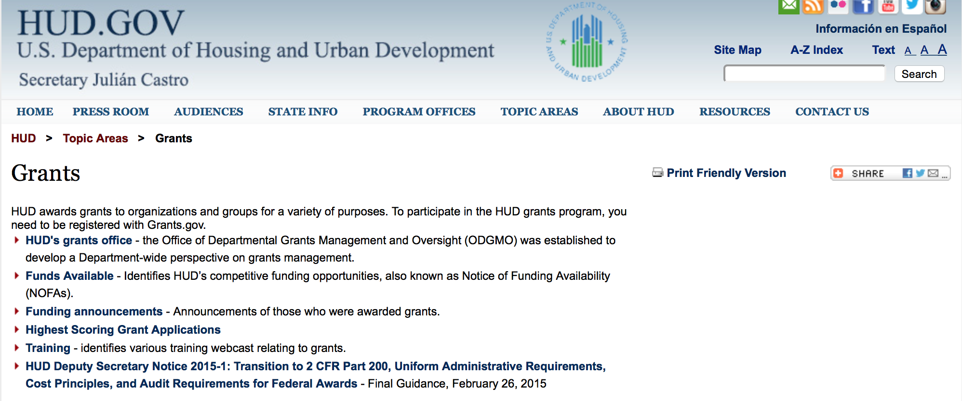

http://portal.hud.gov/hudportal/HUD?src=/topics/grants

HUD - Notice of Funds Available

For detailed information click here

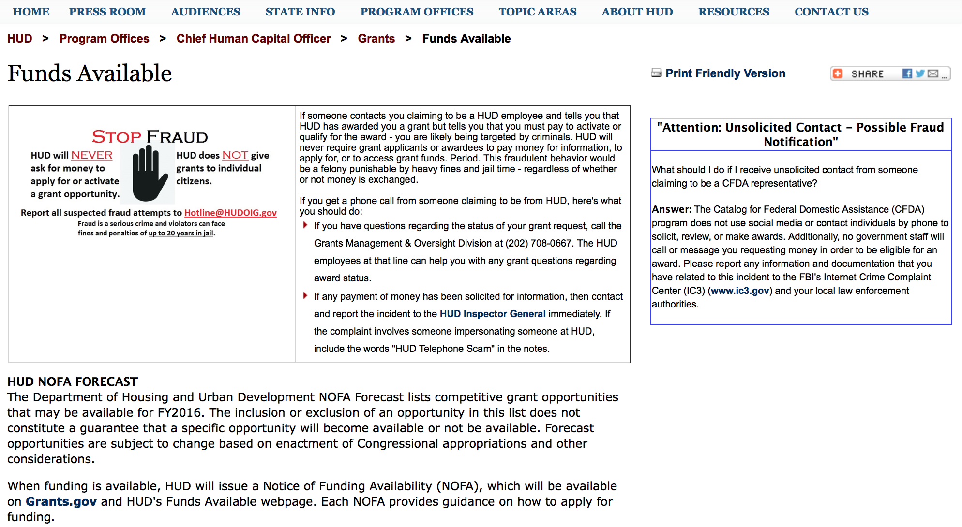

http://portal.hud.gov/hudportal/HUD?src=/program_offices/administration/grants/fundsavail

FY 2013 Notice of Funding Availability (NOFA) Policy Requirements and General Section to HUD’s FY2013 NOFAs for Discretionary Programs
This Notice provides prospective applicants for HUD's competitive funding with the opportunity to become familiar with the General Section to HUD's FY2013 Notices of Funding Availability (NOFAs) for Discretionary Funding (program NOFA), in advance of publication of any individual FY2013 program NOFAs. This General Section and the individual FY2013 program NOFA Sections comprise the entirety of the FY2013 NOFA instructions.
- General Section
- FONSI
- New Application Attachment Filename Requirement

Programs

Notice of Funding Availability (NOFA) for the Department's Fiscal Years 2016 and 2017 Comprehensive Housing Counseling Grant Program

Document Type: | Grants Notice
Funding Opportunity Number: | FR-6000-N-33
Funding Opportunity Title: | Notice of Funding Availability (NOFA) for the Department's Fiscal Years 2016 and 2017 Comprehensive Housing Counseling Grant Program
Opportunity Category: | Discretionary
Opportunity Category Explanation:
Funding Instrument Type: | Grant
Category of Funding Activity: | Housing
Category Explanation:
Expected Number of Awards: | 300
CFDA Number(s): | 14.169 -- Housing Counseling Assistance Program
Cost Sharing or Matching Requirement: | No
Posted Date: | Feb 18, 2016
Last Updated Date: | Feb 18, 2016
Original Closing Date for Applications: | Apr 04, 2016 Electronically submitted applications must be submitted no later than 11:59:59 p.m., ET, on the listed application due date.
Current Closing Date for Applications: | Apr 04, 2016 Electronically submitted applications must be submitted no later than 11:59:59 p.m., ET, on the listed application due date.
Archive Date: | May 04, 2016
Estimated Total Program Funding: | $40,000,000
Eligible Applicants: | Others (see text field entitled "Additional Information on Eligibility" for clarification)
Additional Information on Eligibility: | a. All housing counseling agencies (including LHCAs, Intermediaries and MSOs) that are directly approved by HUD to participate in the HUD Housing Counseling Program prior to the NOFA issue date and SHFAs are eligible for this NOFA. Housing Counseling agencies that have not received HUD approval but meet the Housing Counseling Program approval criteria at 24 C.F.R. &sect; 214.103 are encouraged to affiliate with a HUD-approved Intermediary or SHFA. Individuals, foreign entities, and sole proprietorship organizations are not eligible to compete for, or receive, awards made under this announcement.
Agency Name: | Department of Housing and Urban Development
Description: | This NOFA provides information and instructions for the FY 2016 Comprehensive Housing Counseling Grant Program. This NOFA is comprised of both the General Section to the Department's FY 2016 NOFAs for Discretionary Programs (General Section) published September 24, 2015, and this program section to the NOFA. In addition to the application requirements set forth in this document, Applicants must also comply with the requirements established in the General Section, and all Housing Counseling Program requirements. HUD reserves the right to award both FY 2016 and FY 2017 funds on the basis of this single NOFA competition. FY 2017 grant awards under this NOFA are contingent upon the availability of appropriations.
Link to Additional Information: | http://portal.hud.gov/hudportal/HUD?src=/program_offices/administration/grants/fundsavail
Contact Information: | If you have difficulty accessing the full announcement electronically, please contact:  Jamie Spakow Jamie.A.Spakow@hud.gov  Grants Policy

http://www.grants.gov/web/grants/view-opportunity.html?oppId=281614

NOFA for HUD's FY16-17 Housing Counseling Training Grant Program

Document Type: | Grants Notice
Funding Opportunity Number: | FR-6000-N-30
Funding Opportunity Title: | NOFA for HUD's FY16-17 Housing Counseling Training Grant Program
Opportunity Category: | Discretionary
Opportunity Category Explanation:
Funding Instrument Type: | Cooperative Agreement
Category of Funding Activity: | Housing
Category Explanation:
Expected Number of Awards: | 4
CFDA Number(s): | 14.316 -- Housing Counseling Training Program
Cost Sharing or Matching Requirement: | No
Posted Date: | Feb 18, 2016
Last Updated Date: | Feb 18, 2016
Original Closing Date for Applications: | Apr 04, 2016 Electronically submitted applications must be submitted no later than 11:59:59 p.m., ET, on the listed application due date.
Current Closing Date for Applications: | Apr 04, 2016 Electronically submitted applications must be submitted no later than 11:59:59 p.m., ET, on the listed application due date.
Archive Date: | May 04, 2016
Estimated Total Program Funding: | $2,000,000
Award Ceiling: | $2,000,000
Eligible Applicants: | City or township governments  County governments  Nonprofits having a 501(c)(3) status with the IRS, other than institutions of higher education  State governments
Additional Information on Eligibility: | Applicants must be a public or private non-profit organization and must submit evidence of tax exempt; status under section 501(a) pursuant to section 501(c)(3) of the Internal Revenue Code (26 USC 501(a) and (c)(3)). Applicants may also be SHFAs and other units of local, county or state government. Applicants must have at least two years of experience providing housing counseling training services nationwide to housing counselors employed by housing counseling agencies participating in HUD's Housing Counseling Program. Applicants may utilize in-house staff, sub-grant recipients, Training Partners, qualified third-party trainers, and consultants, with requisite experience and capacity. HUD strongly encourages the partnering by Grantees with SHFAs and other Training Partners. However, one organization must be designated as the primary applicant. This NOFA is structured to encourage agencies to sub-allocate funding to sub-grantees and/or Training Partners. Sub-grantees and Training Partners may include SHFAs; units of local, county or state government; and local or state housing coalitions/networks that are public or private non-profit organizations. sub-grantees and/or Training Partners must have tax exempt; status under section 501(a) pursuant to section 501(c)(3) of the Internal Revenue Code [26 USC 501(a) and (c)(3)] or be an established SHFA. The funding methodology of this NOFA will incentivize such Training Partnerships. Individuals, foreign entities, and sole proprietorship organizations are not eligible to compete for, or receive, awards made under this announcement.
Agency Name: | Department of Housing and Urban Development
Description: | This NOFA provides notice of a grant program that supports the provision of both basic housing counseling training and specialized topics of training to help meet these perceived needs. This financial support will assist housing counseling agencies to increase the use of partnerships with local and state-wide organizations to provide additional place based training on state and local issues.
Link to Additional Information: | http://portal.hud.gov/hudportal/HUD?src=/program_offices/administration/grants/fundsavail
Contact Information: | If you have difficulty accessing the full announcement electronically, please contact:  Virginia F. Holman virginia.f.holman@hud.gov  Grants Policy

http://www.grants.gov/web/grants/view-opportunity.html?oppId=281648

Modifications:

Reminders

Housing Opportunities for Persons With AIDS (HOPWA) Project Demonstration and Violence Against Women Act (VAWA) Grant

Document Type: | Grants Notice
Funding Opportunity Number: | FR-5900-N-11B
Funding Opportunity Title: | Housing Opportunities for Persons With AIDS (HOPWA) Project Demonstration and Violence Against Women Act (VAWA)
Opportunity Category: | Discretionary
Funding Instrument Type: | Grant
Category of Funding Activity: | Housing
Category Explanation:
Expected Number of Awards: | 9
CFDA Number(s): | 14.241 -- Housing Opportunities for Persons with AIDS
Cost Sharing or Matching Requirement: | No
Posted Date: | Jan 5, 2016
Creation Date: | Jan 5, 2016
Original Closing Date for Applications: | Mar 8, 2016 Electronically submitted applications must be submitted no later than 11:59:59 p.m., ET, on the listed application due date.
Current Closing Date for Applications: | Mar 8, 2016 Electronically submitted applications must be submitted no later than 11:59:59 p.m., ET, on the listed application due date.
Archive Date: | Apr 7, 2016
Estimated Total Program Funding: | $9,109,000
Award Ceiling: | $1,300,000
Award Floor: | $625,000
Eligible Applicants: | Others (see text field entitled "Additional Information on Eligibility" for clarification)
Additional Information on Eligibility: | Eligible applicants for funding under this NOFA are States, units of local government, and nonprofit organizations. Because selected applicants will receive a HOPWA grant and a Transitional Housing Assistance Program grant, eligibility under this demonstration will be limited to entities that are eligible to receive grant funding under both programs. Individuals, foreign entities, and sole proprietorship organizations are not eligible to compete for, or receive, awards made under this announcement.
Agency Name: | Department of Housing and Urban Development
Description: | Grants funded under this initiative will implement one of the recommendations of the Interagency Federal Working Group on the Intersection of HIV/AIDS, Violence against Women and Girls, and Gender-Related Health Disparities: to enhance federal efforts to address HIV and intimate partner violence (IPV) among homeless and marginally housed women and girls. These grants will also help further the goals and objectives of the National HIV/AIDS Strategy (NHAS), which calls for enhanced collaboration at the Federal, State and community level, among diverse agencies and partners to maximize efficient use of resources to achieve its goals. The activities funded under this NOFA will support the NHAS goals; to reduce HIV infection; to increase access to care and improve health outcomes for person living with HIV/AIDS; and to reduce HIV-related disparities. These goals will be accomplished through improved cross-agency coordination, resource utilization and service integration among HIV/AIDS housing providers and domestic violence service providers. This NOFA announces funds available for projects that provide housing assistance and supportive services to low-income persons living with HIV/AIDS who are also victims of domestic violence, dating violence, sexual assault, or stalking, including any minors and dependents living with such persons. Each successful applicant under this initiative will receive two separate one-time only, non-renewable grants from HUD: (1) a HOPWA grant, and (2) a Transitional Housing Assistance Program grant. HOPWA grant funds will be used for housing assistance for program participants, coordination and planning activities, and grant management and administration. Transitional Housing Assistance grant funds will be used to provide supportive services for program participants. As a result of project efforts, communities will be assisted in the development of a Housing and Services (HAS) Model to be issued at the end of the third year of operation. This HAS Model document will be an administrative function and should provide clear lessons learned and best practices for providing housing assistance and appropriate supportive services for persons living with HIV/AIDS who are victims of domestic violence, dating violence, sexual assault, or stalking. Each HAS Model will be shared with the public, and lessons learned through these grantee efforts will help inform national and community policy and actions.
Link to Additional Information: | http://www.grants.gov/web/grants/applicants/apply-for-grants.html
Contact Information: | If you have difficulty accessing the full announcement electronically, please contact:  Lisa Steinhauer Lisa.A.Steinhauer@hud.gov  Grants Policy

http://www.grants.gov/web/grants/view-opportunity.html?oppId=280825

Supportive Services Demonstration for Elderly Households in HUD-Assisted Multifamily Housing
Grant

Document Type: | Grants Notice
Funding Opportunity Number: | FR-5900-N-22
Funding Opportunity Title: | Supportive Services Demonstration for Elderly Households in HUD-Assisted Multifamily Housing
Opportunity Category: | Discretionary
Funding Instrument Type: | Cooperative Agreement
Category of Funding Activity: | Housing
Category Explanation:
Expected Number of Awards: | 80
CFDA Number(s): | 14.191 -- Multifamily Housing Service Coordinators
Cost Sharing or Matching Requirement: | No
Posted Date: | Jan 20, 2016
Creation Date: | Jan 20, 2016
Original Closing Date for Applications: | Apr 18, 2016 Electronically submitted applications must be submitted no later than 11:59:59 p.m., ET, on the listed application due date.
Current Closing Date for Applications: | Apr 18, 2016 Electronically submitted applications must be submitted no later than 11:59:59 p.m., ET, on the listed application due date.
Archive Date: | May 18, 2016
Estimated Total Program Funding: | $15,000,000
Eligible Applicants: | Others (see text field entitled "Additional Information on Eligibility" for clarification)
Additional Information on Eligibility: | Applicants must be owners of existing eligible federally assisted multifamily properties. 1. Eligible Multifamily Property: a. Must be a HUD-assisted development with at least 50 assisted housing units - Unit count may be a combined count of total number in a campus setting. The development must be occupied by Eligible Tenants as defined below. b. HUD-Assisted housing types are limited to: (1) Housing that is assisted under section 202 of the Housing Act of 1959 (12 U.S.C. 1701q), including housing that is assisted under section 202 as such section existed before the enactment of the National Affordable Housing Act (Public Law 101-625); (2) Housing for which project-based assistance is provided under section 8 of the United States Housing Act of 1937 (42 U.S.C. 1437f), including Section 515 rural housing projects, as authorized under section 515 of the Housing Act of 1949 (42 U.S.C. 1485), receiving Section 8 rental assistance; (3) Housing financed by a loan or mortgage insured under section 221(d)(3) of the National Housing Act (12 U.S.C. 1715) that bears interest at a rate determined under section 221(d)(5) of such Act; or (4) Housing insured, assisted, or held by the Secretary, a State, or a state agency under section 236 of the National Housing Act (12 U.S.C. 1715z&ndash;1); c. Properties meeting the requirements of 1.a. and 1.b. of this subsection with an existing service coordinator on staff may apply for funding under this NOFA in order to hire the Wellness Nurse and implement this enhanced supportive service model. Acceptance of funding under this NOFA will require the Owner to comply with the requirements as detailed in this NOFA. Individuals, foreign entities, and sole proprietorship organizations are not eligible to compete for, or receive, awards made under this announcement.
Agency Name: | Department of Housing and Urban Development
Description: | HUD’s investment under this Demonstration program is intended to facilitate aging in place by providing a supportive services subsidy to certain elderly restricted HUD assisted independent housing developments. The supportive service subsidy will (1) cover all reasonable cost related to the provision of a full-time enhanced service coordinator and part-time preventive health nurse as well as (2) allocate a nominal amount towards eligible services expenses for our aging residents. Elderly persons who have access to affordable, safe and accessible housing, who practice healthy behaviors, take advantage of wellness, preventive and long-term care services and supports, and those who continue to engage with family and friends are more likely to achieve better health outcomes, live independently, age in place and incur fewer health-related costs. Under this NOFA, HUD will evaluate the extent to which the selected housing plus supportive service models allow elderly persons to live independently and age in place, including improving general well being, improving health outcomes and health-care utilization, and preventing or delaying institutionalization. Funding priority will be given to those sponsors that evidence the ability to accomplish the following three goals: Strengthen the Availability of Supportive Services by effectively using the Service Coordinator to create and support partnerships between housing and supportive service providers to support aging in place; Support Aging-in-Place by fostering an environment that allows for elderly persons to live independently by accessing home and community-based supportive services that are designed to promote general well being, improved health outcomes; and Improve the evidence base on the effectiveness of Section 202 housing as a platform to improve health outcomes by participating in an effort led by HUD (or its contractors and/or grantees) to develop standard procedures to be implemented by all sponsors/owners for (1) measurement of outcomes related to general well being; health and health-care utilization; and costs to the health care system; (2) implementation of the enhanced service coordinator model in the same way in all sites; and (3) enrollment of eligible applicants into a random assignment study. To achieve these goals, Sponsors/Owners must have a comprehensive approach to strategically implement a supportive services model that can support the needs of all residents. As a condition of the receipt of financial assistance under this program NOFA, all Sponsors/Owners will be required to cooperate with HUD staff, contractors, or grantees who perform HUD-funded evaluation of the 202 housing program. HUD envisions the study will be undertaken by independent researchers in collaboration with Sponsors/Owners.
Link to Additional Information: | http://portal.hud.gov/hudportal/HUD?src=/program_offices/administration/grants/fundsavail
Contact Information: | If you have difficulty accessing the full announcement electronically, please contact:  Alicia Anderson Alicia.Anderson@hud.gov  Grants Policy

http://www.grants.gov/web/grants/view-opportunity.html?oppId=281074

General Section to HUD's Fiscal Year 2016 Notice[s] of Funding Availability for Discretionary Programs (General Section)
Modification 1

Document Type: | Grants Notice
Funding Opportunity Number: | FR-6000-N-01
Funding Opportunity Title: | General Section to HUD's Fiscal Year 2016 Notice[s] of Funding Availability for Discretionary Programs (General Section)
Opportunity Category: | Discretionary
Funding Instrument Type: | Grant
Category of Funding Activity: | Community Development
Category Explanation:
Expected Number of Awards: | 0
CFDA Number(s):
Cost Sharing or Matching Requirement: | No
Posted Date: | Sep 24, 2015
Creation Date: | Sep 24, 2015
Original Closing Date for Applications: | Dec 30, 2016 Electronically submitted applications must be submitted no later than 11:59:59 p.m., ET, on the listed application due date published in the individual program NOFA.
Current Closing Date for Applications: | Dec 30, 2016 Electronically submitted applications must be submitted no later than 11:59:59 p.m., ET, on the listed application due date published in the individual program NOFA.
Archive Date: | Jan 29, 2017
Eligible Applicants: | Others (see text field entitled "Additional Information on Eligibility" for clarification)
Additional Information on Eligibility: | This Document is a policy document only. The individual program Notices of Funds Available (NOFA) will identify eligible applicants for each competition. Each Program NOFA will describe additional eligibility requirements for applicants. All applicants must have valid, active Registration in the System for Award Management (SAM) prior to submission of applications for financial assistance. HUD does not provide direct services or products to individuals through its formula-based programs or its competitive Program NOFA process. Individuals seeking financial assistance should refer to www.GovBenefits.gov. Individuals, foreign entities, and sole proprietorship organizations are not eligible to compete for, or receive, awards made under this announcement.
Agency Name: | Department of Housing and Urban Development
Description: | The General Section describes the requirements that are applicable to all HUD FY 2015 Program NOFAs. The General Section also provides information on HUD’s priorities and strategic goals. Each Program NOFA will describe additional applicable procedures and requirements, including a description of the eligible applicants, eligible activities, threshold requirements, cross-program requirements such as nondiscrimination, environmental protection, and any additional program requirements or limitations. To adequately address all of the application requirements for any program, please carefully read and respond to both this General Section and any applicable Program NOFA.
Link to Additional Information: | http://portal.hud.gov/hudportal/HUD?src=/program_offices/administration/grants/fundsavail
Contact Information: | If you have difficulty accessing the full announcement electronically, please contact:  Loyd LaMois loyd.lamois@hud.gov  Grants Policy

http://www.grants.gov/web/grants/view-opportunity.html?oppId=279206



Institute of Museum and Library Services

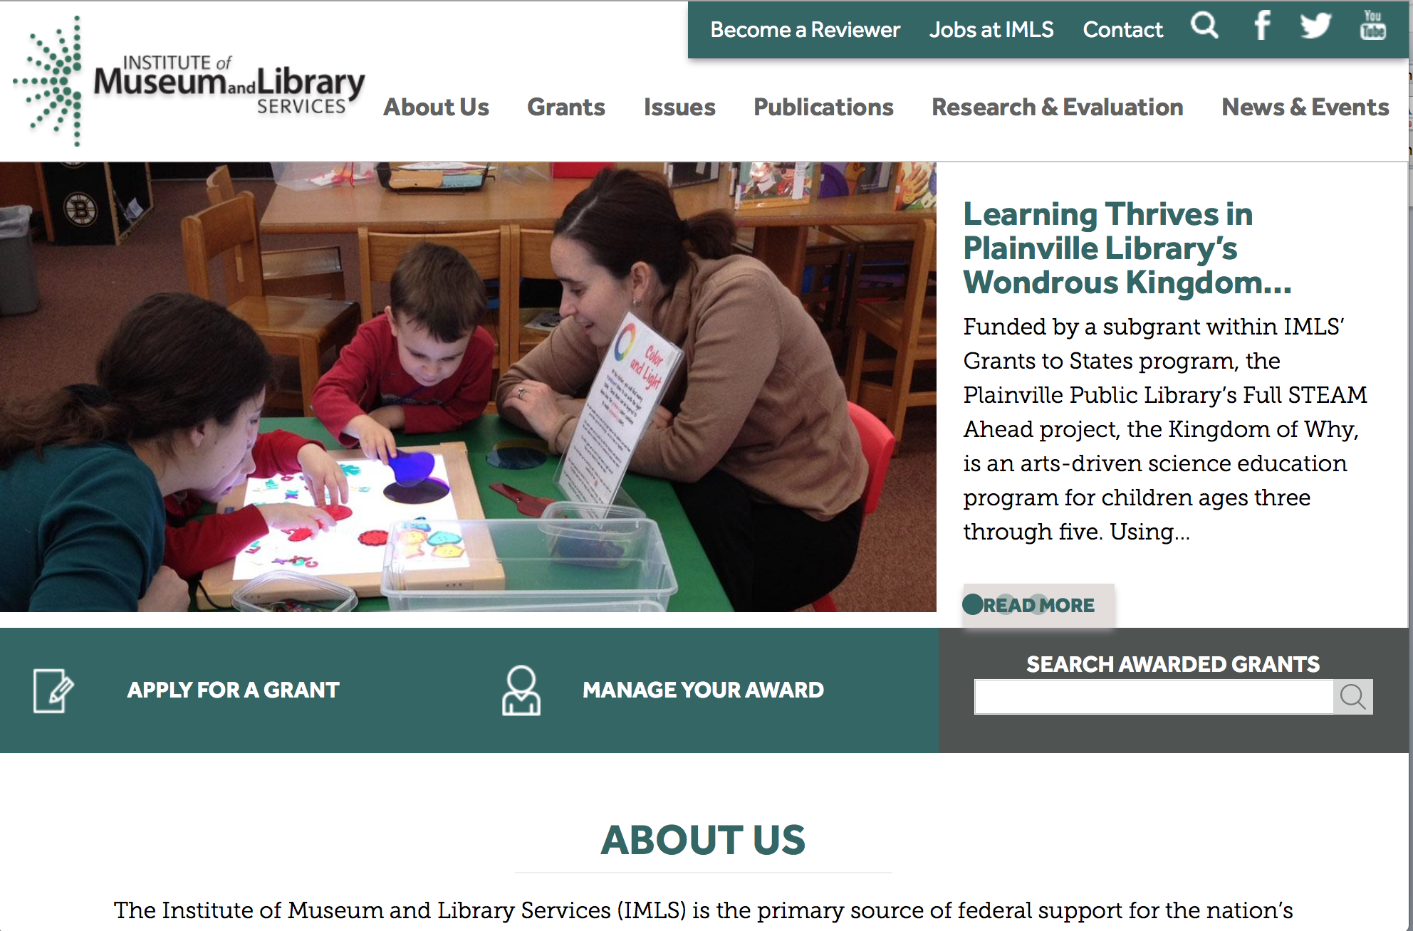

www.imls.gov

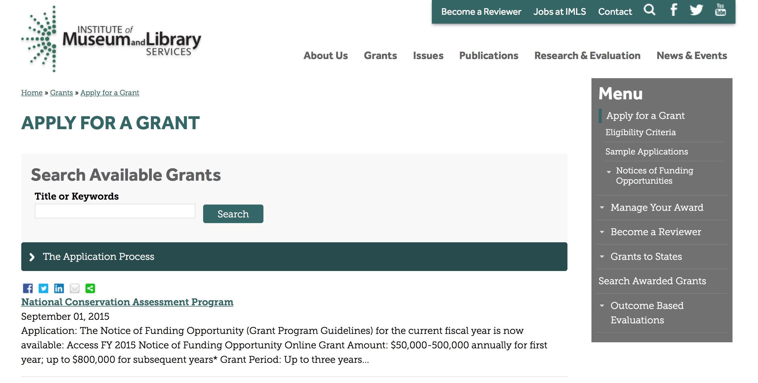
http://www.imls.gov/applicants/available_grants.aspx

Each grant program has specific eligibility requirements. The links below provide general eligibility criteria for museums, libraries, and tribal organizations, but please note that additional organizations may be eligible for grants under certain programs. Additionally, ineligible organizations may still be able to participate in grant programs through partnerships with eligible organizations. Please click on the links below to see general criteria and review Applications and Guidelines for specific information.
Museums Libraries

Institutions: Archives, Federally Recognized Native American Tribe, Historical Society, Library, Nonprofits that serve Native Hawaiians, Professional Association, Public or Private Non-profit Institutions of Higher Education, Regional Organization, State Library Administrative Agency, State or Local Government

Check out IMLS's Facebook page at:
https://www.facebook.com/USIMLS/

Modifications:

Reminders:

STEM Expert Facilitation of Family Learning in Libraries and Museums (STEMeX) – A National Leadership Grants Special Initiative – FY16 Notice of Funding Opportunity Grant

Document Type: | Grants Notice
Funding Opportunity Number: | NLGSPECIALINITIATIVE-STEMEX-FY16
Funding Opportunity Title: | STEM Expert Facilitation of Family Learning in Libraries and Museums (STEMeX) – A National Leadership Grants Special Initiative – FY16 Notice of Funding Opportunity
Opportunity Category: | Discretionary
Funding Instrument Type: | Grant
Category of Funding Activity: | Arts (see "Cultural Affairs" in CFDA)  Humanities (see "Cultural Affairs" in CFDA)
Category Explanation:
Expected Number of Awards: | 3
CFDA Number(s): | 45.312 -- National Leadership Grants
Cost Sharing or Matching Requirement: | No
Posted Date: | Feb 1, 2016
Creation Date: | Feb 1, 2016
Original Closing Date for Applications: | May 1, 2016
Current Closing Date for Applications: | May 1, 2016
Archive Date: | May 31, 2016
Estimated Total Program Funding: | $2,500,000
Award Ceiling: | $1,000,000
Award Floor: | $500,000
Eligible Applicants: | Others (see text field entitled "Additional Information on Eligibility" for clarification)
Additional Information on Eligibility: | The information below outlines eligibility requirements for a museum entity or library entity, and some institutions may be eligible as both. An institution will not be asked to identify as a museum or library, but will be asked to identify the organization type on the SF424S and the organization unit type on the Program Information Sheet (Section f). To be eligible as library entity, you must: be either a unit of State or local government or be a private nonprofit organization that has tax-exempt status under the Internal Revenue Code; be located in one of the 50 States of the United States of America, the District of Columbia, the Commonwealth of Puerto Rico, the U.S. Virgin Islands, Guam, American Samoa, the Commonwealth of the Northern Mariana Islands, the Republic of the Marshall Islands, the Federated States of Micronesia, or the Republic of Palau; and qualify as one of the following: a library or a parent organization, such as a school district, a municipality, a State agency, or an academic institution, that is responsible for the administration of a library. Eligible libraries include public libraries, public elementary and secondary school libraries, college and university libraries, research libraries and archives that are not an integral part of an institution of higher education and that make publicly available library services and materials that are suitable for scholarly research and not otherwise available. Research libraries must be under the supervision of at least one permanent professional staff librarian and be either generally recognized as possessing unique, scholarly research materials and services that are made available to the public, or able to demonstrate that such is the case when submitting an application to IMLS a private library or other special library, but only if the State in which it is located determines that the library should be considered a library for purposes of Library Services and Technology (see 20 U.S.C. 9121-9165) an academic or administrative unit, such as a graduate school of library and information science that is part of an institution of higher education through which it would make application a digital library, if it makes library materials publicly available and provides library services, including selection, organization, description, reference, and preservation, under the supervision of at least one permanent professional staff librarian a library agency that is an official agency of a State or other unit of government and is charged by the law governing it with the extension and development of public library services within its jurisdiction a library consortium that is a local, statewide, regional, interstate, or international cooperative association of library entities that provides for the systematic and effective coordination of the resources of eligible libraries, as defined above, and information centers that work to improve the services delivered to the clientele of these libraries or a library association that exists on a permanent basis; serves libraries or library professionals on a national, regional, State, or local level; and engages in activities designed to advance the well-being of libraries and the library profession To be eligible as a museum entity, you must meet all three of the following criteria: You must be either a unit of State or local government or be a private nonprofit organization that has tax-exempt status under the Internal Revenue Code; You must be located in one of the 50 States of the United States of America, the District of Columbia, the Commonwealth of Puerto Rico, the U.S. Virgin Islands, Guam, American Samoa, the Commonwealth of the Northern Mariana Islands, the Republic of the Marshall Islands, the Federated States of Micronesia, or the Republic of Palau; and You must qualify as one of the following: (a) A museum that, using a professional staff,
Agency Name: | Institute of Museum and Library Services
Description: | This special joint NLG-Libraries and NLG-Museums initiative invites proposals for research on informal educational approaches that leverage community Science, Technology, Engineering, and Math (STEM) professionals in the broadest sense. Funded research projects will create a foundation for reaching children and families from diverse economic, social, and cultural backgrounds, with different levels of knowledge about STEM. We are interested in proposals for design-based research projects that develop and explore models for inquiry-based STEM programs delivered by scientists, engineers, and related technical practitioners (STEM experts) to children ages 6-10 and their families. In particular, proposals should address the role of expert oral narratives (e.g., storytelling, personal histories, and analogies) as part of object-based science inquiry. Proposals should include information about how findings from this research will be applicable in both museum and library settings.
Link to Additional Information: | https://www.imls.gov/grants/available/stem-expert-facilitation-family-learning-libraries-and-museums-stemex
Contact Information: | If you have difficulty accessing the full announcement electronically, please contact:  Libraries: Sandra Toro Senior Library Program Officer 202-653-4662 storo@imls.gov Trevor Owens Senior Library Program Officer 202-653-4654 tjowens@imls.gov Museums: Helen Wechsler Supervisory Grants Management Specialist 202-653-4779 hwechsler@imls.gov Sandra Narva Senior Program Officer 202-653-4634 snarva@imls.gov  storo@imls.gov

STEM Expert Facilitation of Family Learning in Libraries and Museums

IMLS is inviting proposals for special grants for research on informal educational approaches that leverage Science, Technology, Engineering, and Math (STEM) expertise within communities in the broadest sense. The STEM Expert Facilitation of Family Learning in Libraries and Museums, or STEMeX, initiative will provide grants up to $1,000,000 for projects of up to two years. The deadline for applications is May 1, 2016.

Through STEMeX, IMLS seeks design-based research projects that develop and explore models for inquiry-based STEM programs delivered by scientists, engineers, and related technical practitioners (STEM experts) to children ages 6-10 and their families. In particular, proposals should address the role of experts’ oral narratives (e.g., storytelling, personal histories, and analogies) as part of object-based science inquiry. Proposals should include information about how findings from this research will be applicable in both museum and library settings. Funded research projects will create a foundation for reaching children and families from diverse geographic, economic, social, and cultural backgrounds, who have different levels of knowledge about STEM.

This special initiative falls jointly under the National Leadership Grants for Libraries (NLG-Libraries) and National Leadership Grants for Museums (NLG-Museums) programs. National Leadership grants support projects that address challenges faced by the library and museum fields and that have the potential to advance practice in those fields with new tools, research findings, models, services, practices, or alliances that can be widely used, adapted, scaled, or replicated.

“There is an opportunity to further define best practice models about how scientific and technical experts--whether medical researchers and road engineers or art conservators and dental hygienists--can successfully engage young children and their families in STEM activities and inspire interest in STEM-based careers. Every community has those experts to draw upon to enhance their informal educational STEM efforts. That is why I am particularly excited to announce this special funding initiative,” said IMLS Director Dr. Kathryn K. Matthew. “There has already been fruitful and substantive work in this area, enabled by IMLS and others, and this effort will build on those prior investments. The research from this initiative will focus on maximizing the stories and narratives provided by STEM experts as part of programs offered by museums and libraries."

Eligibility: Museums; libraries; public or private nonprofit agencies, organizations, or associations that engage in activities designed to advance libraries and museums may apply. In addition, institutions of higher education, including public and non-profit universities, are eligible.
See the Notice of Funding Opportunity (NOFO) for FY 2016 for full details.

Webinars: To learn more, participate on one of these upcoming webinars:
- Wednesday, February 17, 2016, 4:00 – 5:00 p.m. EST
- Thursday, February 18, 2016, 3:00 – 4:00 p.m. EST

See the IMLS website for information about joining the webinars.

Program Contacts:
You may also contact any of the staff listed under the category that best fits your project.

Office of Library Services
Dr. Sandra Toro, Senior Program Officer, storo@imls.gov
202-653-4662
Dr. Trevor Owens, Senior Program Officer, towens@imls.gov
(link sends e-mail)
202-653-4654

Office of Museum Services
Helen Wechsler, Supervisory Grants Management Specialist, hwechsler@imls.gov
202-653-4779
Sandra Narva, Senior Program Officer, snarva@imls.gov
202-653-4634

Issues:
STEM (Science, Technology, Engineering, Math)

21st Century Skills

National Leadership Grants for Libraries
National Leadership Grants for Museums

http://www.grants.gov/web/grants/view-opportunity.html?oppId=281271

National Leadership Grants for Libraries Grant

Document Type: | Grants Notice
Funding Opportunity Number: | NLG-LIBRARIES-FY16-2
Funding Opportunity Title: | National Leadership Grants for Libraries
Opportunity Category: | Discretionary
Funding Instrument Type: | Grant
Category of Funding Activity: | Arts (see "Cultural Affairs" in CFDA)  Humanities (see "Cultural Affairs" in CFDA)
Category Explanation:
Expected Number of Awards: | 20
CFDA Number(s): | 45.312 -- National Leadership Grants
Cost Sharing or Matching Requirement: | Yes
Posted Date: | Dec 21, 2015
Creation Date: | Dec 21, 2015
Original Closing Date for Applications: | Jun 1, 2016
Current Closing Date for Applications: | Jun 1, 2016
Archive Date: | Jul 1, 2016
Estimated Total Program Funding: | $12,000,000
Award Ceiling: | $2,000,000
Award Floor: | $10,000
Eligible Applicants: | Others (see text field entitled "Additional Information on Eligibility" for clarification)
Additional Information on Eligibility: | To be eligible as an applicant for this National Leadership Grants for Libraries Program, you must: be either a unit of State or local government or be a private nonprofit organization that has tax-exempt status under the Internal Revenue Code; be located in one of the 50 States of the United States of America, the District of Columbia, the Commonwealth of Puerto Rico, the U.S. Virgin Islands, Guam, American Samoa, the Commonwealth of the Northern Mariana Islands, the Republic of the Marshall Islands, the Federated States of Micronesia, or the Republic of Palau; and qualify as one of the following: a library or a parent organization, such as a school district, a municipality, a State agency, or an academic institution, that is responsible for the administration of a library. Eligible libraries include public libraries, public elementary and secondary school libraries, college and university libraries, research libraries and archives that are not an integral part of an institution of higher education and that make publicly available library services and materials that are suitable for scholarly research and not otherwise available. Research libraries must be under the supervision of at least one permanent professional staff librarian and be either generally recognized as possessing unique, scholarly research materials and services that are made available to the public, or able to demonstrate that such is the case when submitting an application to IMLS a private library or other special library, but only if the State in which it is located determines that the library should be considered a library for purposes of Library Services and Technology (see 20 U.S.C. 9121-9165) an academic or administrative unit, such as a graduate school of library and information science that is part of an institution of higher education through which it would make application a digital library, if it makes library materials publicly available and provides library services, including selection, organization, description, reference, and preservation, under the supervision of at least one permanent professional staff librarian a library agency that is an official agency of a State or other unit of government and is charged by the law governing it with the extension and development of public library services within its jurisdiction a library consortium that is a local, statewide, regional, interstate, or international cooperative association of library entities that provides for the systematic and effective coordination of the resources of eligible libraries, as defined above, and information centers that work to improve the services delivered to the clientele of these libraries or a library association that exists on a permanent basis; serves libraries or library professionals on a national, regional, State, or local level; and engages in activities designed to advance the well-being of libraries and the library profession Note to applicants: In order to receive an IMLS award, you must be in compliance with applicable requirements and be in good standing on all active IMLS awards.
Agency Name: | Institute of Museum and Library Services
Description: | National Leadership Grants for Libraries (NLG) support projects that address challenges faced by the library and archive fields and that have the potential to advance practice in those fields. Successful proposals will generate results such as new tools, research findings, models, services, practices, or alliances that can be widely used, adapted, scaled, or replicated to extend the benefits of federal investment. For FY16, there are two National Leadership Grants for Libraries funding opportunities with two separate deadlines. In addition to the opportunity described in this Notice of Funding Opportunity, an additional NLG funding opportunity was announced in September 2015 with an application submission due date in October 2015.
Link to Additional Information: | https://www.imls.gov/grants/available/national-leadership-grants-libraries
Contact Information: | If you have difficulty accessing the full announcement electronically, please contact:  Tim Carrigan Senior Library Program Officer 202-653-4639 tcarrigan@imls.gov Trevor Owens Senior Library Program Officer 202-653-4654 tjowens@imls.gov Sandra Toro Senior Library Program Officer 202-653-4662 storo@imls.gov Sarah Fuller Library Program Officer 202-653-4783 sfuller@imls.gov  tcarrigan@imls.gov

http://www.grants.gov/web/grants/view-opportunity.html?oppId=280677

Laura Bush 21st Century Librarian Program Grant

Document Type: | Grants Notice
Funding Opportunity Number: | LB21-FY16-2
Funding Opportunity Title: | Laura Bush 21st Century Librarian Program
Opportunity Category: | Discretionary
Funding Instrument Type: | Grant
Category of Funding Activity: | Arts (see "Cultural Affairs" in CFDA)  Humanities (see "Cultural Affairs" in CFDA)
Category Explanation:
Expected Number of Awards: | 22
CFDA Number(s): | 45.313 -- Laura Bush 21st Century Librarian Program
Cost Sharing or Matching Requirement: | Yes
Posted Date: | Dec 21, 2015
Creation Date: | Dec 21, 2015
Original Closing Date for Applications: | Jun 1, 2016
Current Closing Date for Applications: | Jun 1, 2016
Archive Date: | Jul 1, 2016
Estimated Total Program Funding: | $10,000,000
Award Ceiling: | $1,000,000
Award Floor: | $50,000
Eligible Applicants: | Others (see text field entitled "Additional Information on Eligibility" for clarification)
Additional Information on Eligibility: | To be eligible for LB21, you must be either a unit of State or local government or a private nonprofit organization that has tax-exempt status under the Internal Revenue Code and be located in one of the 50 States of the United States of America, the District of Columbia, the Commonwealth of Puerto Rico, Guam, American Samoa, the U.S. Virgin Islands, the Commonwealth of the Northern Mariana Islands, the Republic of the Marshall Islands, the Federated States of Micronesia, or the Republic of Palau. In addition, you must be one of the following six types of organizations: A library or a parent organization, such as a school district, a municipality, a State agency, or an academic institution, that is responsible for the administration of a library. Eligible libraries include the following: Public libraries Public elementary and secondary school libraries College and university libraries Research libraries and archives that are not an integral part of an institution of higher education and that make publicly available library services and materials that are suitable for scholarly research and not otherwise available (Research libraries must be under the supervision of at least one permanent professional staff person and must be either generally recognized as possessing unique scholarly research materials and services that are made available to the public, or able to demonstrate that such is the case when submitting an application to IMLS.) Private or special libraries that have been deemed eligible to participate in this program by the State in which the library is located An academic or administrative unit, such as a graduate school of library and information science that is part of an institution of higher education through which it would make application (See below for additional conditions of eligibility that might apply to such applicants) A digital library, if it makes library materials publicly available and provides library services, including selection, organization, description, reference, and preservation, under the supervision of at least one permanent professional staff person A library agency that is an official agency of a State or other unit of government and is charged by the law governing it with the extension and development of public library services within its jurisdiction A library consortium that is a local, statewide, regional, interstate, or international cooperative association of library entities that provides for the systematic and effective coordination of the resources of eligible libraries, as defined above, and information centers that work to improve the services delivered to the clientele of these libraries A library association that exists on a permanent basis; serves libraries or library professionals on a national, regional, state, or local level; and engages in activities designed to advance the well-being of libraries and the library profession We recognize the potential for valuable contributions to the overall goals of the LB21 program by entities that do not meet the eligibility requirements above. Although such entities may not serve as the official applicants, they are encouraged to participate in projects. Federally operated libraries and museums may not apply for LB21 grants, but they may participate with applicants. Contact us before submitting a proposal involving a federal agency or federal collection. Non-Federal entities may serve as subrecipients or contractors and may receive IMLS grant funds as a result of the project. Consult with us about any eligibility questions before submitting an application.
Agency Name: | Institute of Museum and Library Services
Description: | The Laura Bush 21st Century Librarian Program (LB21) supports professional development, graduate education and continuing education to help libraries and archives develop the human capital capacity they need to meet the changing learning and information needs of the American public. For FY16, there are two Laura Bush 21st Century Librarian Program funding opportunities with two separate deadlines. In addition to the opportunity described in this Notice of Funding Opportunity, an additional LB21 funding opportunity was announced in September 2015 with an application submission due date in October 2015.
Link to Additional Information: | https://www.imls.gov/grants/available/laura-bush-21st-century-librarian-program
Contact Information: | If you have difficulty accessing the full announcement electronically, please contact:  Mary Alice Ball Senior Library Program Officer 202-653-4730 mball@imls.gov Tim Carrigan Senior Library Program Officer 202-653-4639 tcarrigan@imls.gov Trevor Owens Senior Library Program Officer 202-653-4654 tjowens@imls.gov Sandra Toro Senior Library Program Officer 202-653-4662 storo@imls.gov Emily Reynolds Library Program Officer 202-653-4665 ereynolds@imls.gov  mball@imls.gov

http://www.grants.gov/web/grants/view-opportunity.html?oppId=280678

Department of the Interior
Working with Interior

The Interior Department provides assistance to the public, local governments and businesses through a number of programs. For a general overview see: http://www.doi.gov/index.cfm

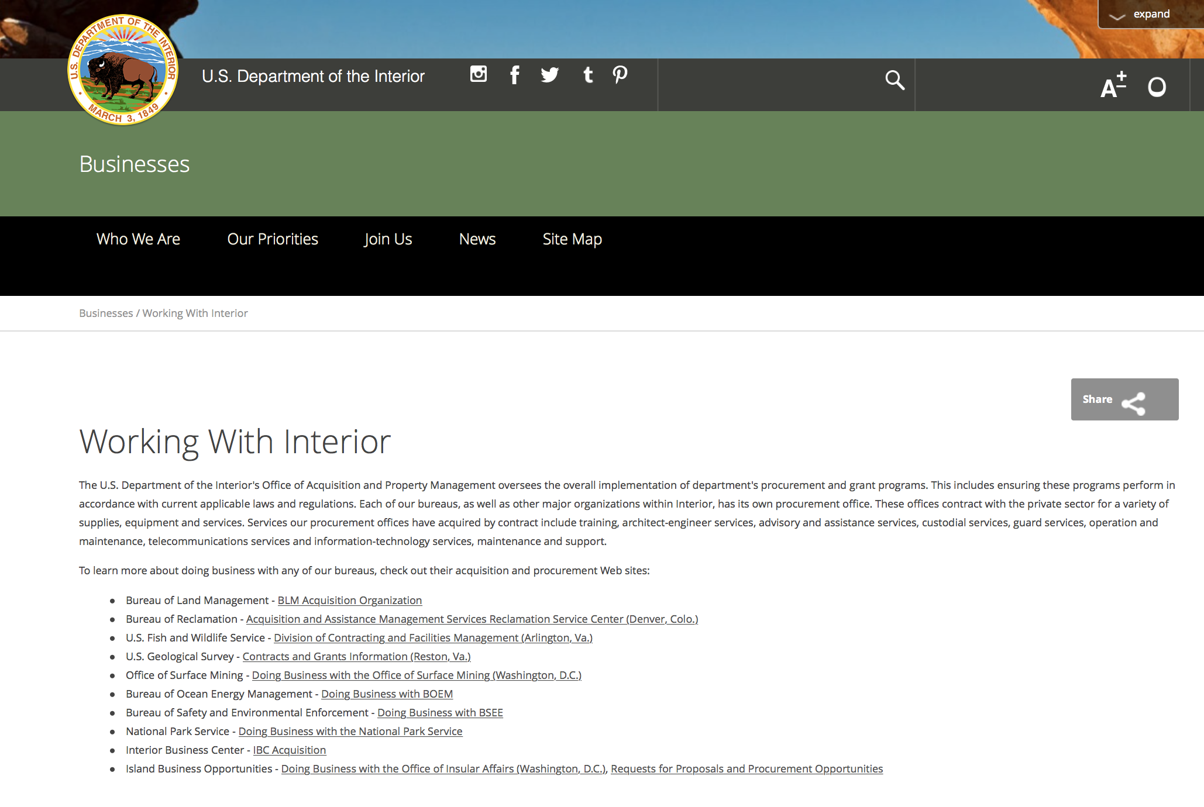

http://www.doi.gov/businesses/working-with-interior.cfm

Programs:

Fish and Wildlife Service
Combating Wildlife Trafficking Grant

Document Type: | Grants Notice
Funding Opportunity Number: | F16AS00106
Funding Opportunity Title: | Combating Wildlife Trafficking
Opportunity Category: | Discretionary
Opportunity Category Explanation:
Funding Instrument Type: | Cooperative Agreement  Grant
Category of Funding Activity: | Agriculture  Community Development  Environment  Natural Resources
Category Explanation:
Expected Number of Awards: | 10
CFDA Number(s): | 15.649 -- Service Training and Technical Assistance (Generic Training)
Cost Sharing or Matching Requirement: | No
Posted Date: | Feb 22, 2016
Last Updated Date: | Feb 19, 2016
Original Closing Date for Applications: | Apr 22, 2016 This announcement is for pre-applications only. Applicants will be notified of the opportunity to submit a full application by May 13, 2016 (by invitation only).
Current Closing Date for Applications: | Apr 22, 2016 This announcement is for pre-applications only. Applicants will be notified of the opportunity to submit a full application by May 13, 2016 (by invitation only).
Archive Date: | May 23, 2016
Estimated Total Program Funding: | $1,000,000
Award Ceiling: | $100,000
Award Floor: | $25,000
Eligible Applicants: | Unrestricted (i.e., open to any type of entity above), subject to any clarification in text field entitled "Additional Information on Eligibility"
Additional Information on Eligibility: | Applicants under this program can be: individuals; multi-national secretariats; foreign governments; US and foreign non-profit, non-governmental organizations, community and indigenous organizations; and US and foreign public and private institutions of higher education.
Agency Name: | Fish and Wildlife Service
Description: | On February 11, 2014, President Obama issued the National Strategy for Combating Wildlife Trafficking. Incorporating recommendations from the Advisory Council on Wildlife Trafficking, the Implementation Plan was released on February 11, 2015 to guide and direct the efforts of Federal agencies in executing the Strategy. The Plan followed the structure and objectives of the three Strategic Priorities identified in the Strategy: Strengthen Enforcement (including both U.S. Domestic Enforcement and Global Enforcement), Reduce Demand for Illegally Traded Wildlife, and Expand International Cooperation and Commitment. Twenty-four objectives fall under these three Strategic Priorities, each including a number of Next Steps that identify discrete actions. The U.S. Fish and Wildlife Service (USFWS) is identified as a lead or participating agency in all 24 Implementation Plan Objectives, reflecting the commitment and history of USFWS International Affairs and Office of Law Enforcement in the fight against the illegal wildlife trade. To complement and facilitate existing efforts, USFWS has developed this Notice of Funding Opportunity to provide financial assistance to projects that advance counter-wildlife trafficking activities (wildlife defined to include terrestrial and aquatic species and timber) as outlined in the Next Steps of the National Strategys Implementation Plan. Applicants may submit pre-proposals to support any of the Implementation Plans Objectives. Priority will be given, however, to proposals related to the Objectives identified below, which have been identified as appropriate activities for awards. 1. Strengthen Enforcement: Global Enforcement a. Support Governments in Building Capacity Description: The USFWS will support efforts to assist foreign governments in range, transit, and consumer countries affected by wildlife trafficking in building their capacity to address the wildlife trafficking chain at any critical stage of enforcement. These efforts may focus on building the capacity to fight wildlife trafficking through: crafting strong laws, stopping poachers, protecting borders, investigating traffickers, fighting trafficking-related corruption, improving professionalism, strengthening judicial and prosecutorial effectiveness, building and bringing strong cases, and obtaining penalties adequate to deter others. b. Support Community-Based Wildlife Conservation Description: The USFWS will support efforts to work with local communities in foreign countries to protect wildlife and prevent wildlife trafficking. For example, USFWS will support efforts to strengthen reporting of poaching and other trafficking activities by local communities working with authorities, as well as efforts that create local support for conserving wildlife, including through work to strengthen or create economic incentives for communities to protect wildlife. USFWS will also support efforts to work with communities to develop secure methods of sharing information with enforcement officials and efforts to further develop community based conservation initiatives in key wildlife areas where poaching occurs or is likely. c. Support Development and Use of Effective Technologies and Analytical Tools Description: The USFWS will support efforts to develop and broadly disseminate cost effective analytic tools and technological solutions to support wildlife trafficking investigations and prosecutions. For example, USFWS will support efforts to improve methods and capacity for customs, border and investigative personnel to detect and identify illegally traded wildlife and wildlife products, and for programs to build international forensic capacity. 2. Reduce Demand for Illegally Traded Wildlife a. Raise Public Awareness and Change Behavior Description: The USFWS will support efforts to raise public awareness and recognition of wildlife trafficking and its negative impacts, and associated risks of prosecution, as a means to change harmful consumption patterns and eliminate the demand for illegally traded wildlife and wildlife products. For example, where a lack of public awareness has been demonstrated to be the primary barrier to reducing demand, the USFWS will support activities such as social media campaigns, public service announcements, and the use of public spaces at home and abroad, which target specific consumer groups to raise public awareness of the illegal wildlife trade. USFWS will also support efforts to work with the private sector to raise awareness within organizations and among their respective consumer bases and audiences on the broader impacts and risks of buying or selling illegal wildlife products. b. Promote Demand Reduction Efforts Globally Description: The USFWS will support efforts to eliminate the market for illegally traded wildlife in key consumer countries and regions. For example, the USFWS will support efforts to develop, assess and implement best practices, effective approaches and robust methodologies in demand reduction in key consumer countries and range states. 3. Expand International Cooperation and Commitment a. Strengthen International Agreements and Arrangements that Protect Wildlife Description: The USFWS will support efforts to strengthen and ensure effective implementation and enforcement of the Convention on International Trade in Endangered Species of Wild Fauna and Flora (CITES), and other existing international agreements and arrangements, pursuing the adoption of appropriate measures to respond to the current crisis of poaching and trafficking. b. Cooperate with Other Governments (Bilateral and regional) Description: The USFWS will support efforts to catalyze political will and actions to address wildlife trafficking at all levels of government in foreign countries. These efforts may include government commitments to combat wildlife trafficking through multilateral, bilateral and/or regional agreements, and prioritizing wildlife trafficking in environmental and trade agreements. Outcomes may include securing key wildlife populations and habitats; providing information on the status of targeted species and of groups involved in poaching and trafficking; enhancing governance for the conservation and sustainable use of wildlife and other natural resources; and leveraging wildlife trafficking with efforts in other areas to develop synergies.
Link to Additional Information: | How to Apply
Contact Information: | If you have difficulty accessing the full announcement electronically, please contact:  Nikole Tucker 703 358-2379 CWT@fws.gov Daphne Carlson Bremer, DVM, PhD 703-358-2098 CWT@fws.gov  Program Email

http://www.grants.gov/web/grants/view-opportunity.html?oppId=281688

Fish and Wildlife Service
Fiscal Year 2016 Recovery Implementation Fund Grant

Document Type: | Grants Notice
Funding Opportunity Number: | F16AS00099
Funding Opportunity Title: | Fiscal Year 2016 Recovery Implementation Fund
Opportunity Category: | Discretionary
Opportunity Category Explanation:
Funding Instrument Type: | Cooperative Agreement  Grant  Procurement Contract
Category of Funding Activity: | Environment  Natural Resources
Category Explanation:
Expected Number of Awards: | 0
CFDA Number(s): | 15.657 -- Endangered Species Conservation - Recovery Implementation Funds
Cost Sharing or Matching Requirement: | No
Posted Date: | Feb 04, 2016
Last Updated Date: | Feb 04, 2016
Original Closing Date for Applications: | Jul 31, 2016 Applications are due by July 31, 2016. However, you may submit applications throughout the year. Consideration of applications ultimately will be based on the FWS budget cycle.
Current Closing Date for Applications: | Jul 31, 2016 Applications are due by July 31, 2016. However, you may submit applications throughout the year. Consideration of applications ultimately will be based on the FWS budget cycle.
Archive Date: | Aug 31, 2016
Estimated Total Program Funding: | $0
Award Ceiling: | $1,000,000
Award Floor: | $1
Eligible Applicants: | Unrestricted (i.e., open to any type of entity above), subject to any clarification in text field entitled "Additional Information on Eligibility"
Additional Information on Eligibility: | Applicants must have a demonstrated knowledge and understanding of the biology of the involved endangered or threatened species in the United States and their ecosystem, including preferably having worked with the species in the field and holding a currently valid Endangered Species Act permit, issued by the FWS, authorizing them to work with these species (or that have previously held a permit to do so). If funding is awarded, applicants that do not currently hold a valid permit for the proposed activity may need to apply for and obtain a permit (http://www.fws.gov/endangered/permits/index.html) before beginning the proposed activity. FWS Regional (or Field Office) contacts will discuss potential proposals with interested parties if needed, and review eligible applications. The FWS Regional Office will refer interested parties to the appropriate FWS Field Office for further consideration as appropriate. For potential proposals submitted directly to the Field Office, the Field Office will conduct the proposal review and selection process. A list of FWS Regional Office contacts is available in the Full Announcement under section VII. Agency Contacts.
Agency Name: | Fish and Wildlife Service
Description: | The FWS Ecological Services Program provides Federal financial assistance on a competitive basis to States, other Federal agencies, landowners, educators, non-profit organizations, researchers, and other partners to secure information about endangered, threatened or candidate species, to aid in the recovery of these species, to avert listing of species pursuant to the Endangered Species Act, and to help conserve the ecosystems upon which these species depend. The FWS and National Marine Fisheries Service (NMFS), which is part of the Department of Commerces NOAA Fisheries office, share Endangered Species Act responsibilities for several species such as sea turtles. We have responsibility for sea turtles when they are on land, and NMFS has responsibility for sea turtles when they are in the water. Projects for NMFS-managed species are not included in this funding opportunity. This Recovery Implementation funding opportunity is intended for projects that will contribute to the recovery of FWS-managed endangered and threatened species in the United States, and is limited to projects carrying out actions described in a species approved recovery plan, in the implementation schedule of a species approved recovery plan, actions recommended in a completed 5-year status review of the species or in a spotlight species action plan, or projects documenting species response to climate change. For example: securing scientific information about endangered or threatened species, implementing restoration actions that will lead to delisting of a species, help prevent extinction of a species, or aid in the recovery of a species. Projects that address species response to climate change will receive additional consideration.
Link to Additional Information: | http://www.grants.gov
Contact Information: | If you have difficulty accessing the full announcement electronically, please contact:  Kelly Niland 703-358-2492 Kelly_Niland@fws.gov  Grant Specialist

http://www.grants.gov/web/grants/view-opportunity.html?oppId=281338

Fish and Wildlife Service
Natural Resources Damage Assessment, Restoration and Implementation Grant

Document Type: | Grants Notice
Funding Opportunity Number: | F16AS00098
Funding Opportunity Title: | Natural Resources Damage Assessment, Restoration and Implementation
Opportunity Category: | Discretionary
Opportunity Category Explanation:
Funding Instrument Type: | Grant
Category of Funding Activity: | Natural Resources
Category Explanation:
Expected Number of Awards: | 5
CFDA Number(s): | 15.658 -- Natural Resource Damage Assessment, Restoration and Implementation
Cost Sharing or Matching Requirement: | No
Posted Date: | Feb 04, 2016
Last Updated Date: | Feb 04, 2016
Original Closing Date for Applications: | Apr 04, 2016
Current Closing Date for Applications: | Apr 04, 2016
Archive Date: | Feb 04, 2017
Estimated Total Program Funding: | $1,750,000
Award Ceiling: | $1,750,000
Award Floor: | $1,000
Eligible Applicants: | Unrestricted (i.e., open to any type of entity above), subject to any clarification in text field entitled "Additional Information on Eligibility"
Additional Information on Eligibility: | NONE
Agency Name: | Fish and Wildlife Service
Description: | To restore natural resources injured by oil spills or hazardous substance releases. This is done by Natural Resource Trustees; seeking and identifying natural resources injured, determining the extent of the injuries, recovering damages from responsible parties, and planning and carrying out natural resource restoration activities. Authorities for these actions are as follows: Comprehensive Environmental Response, Compensation and Liability Act, 42 U.S.C 9601, et seq.; Federal Water Pollution Control Act, 33 U.S.C 1251-1387; Fish and Wildlife Act of 1956, 16 U.S.C 742a-742j; Oil Pollution Act of 1990, Public Law 101-380.
Link to Additional Information: | http://www.grants.gov
Contact Information: | If you have difficulty accessing the full announcement electronically, please contact:  Grants Management Specialist Janet Huff 505 248-6477 janet_huff@fws.gov  janet_huff@fws.gov

http://www.grants.gov/web/grants/view-opportunity.html?oppId=281339

Fish and Wildlife Service
Fiscal Year 2016 Candidate Conservation Action Funds Grant

Document Type: | Grants Notice
Funding Opportunity Number: | F16AS00100
Funding Opportunity Title: | Fiscal Year 2016 Candidate Conservation Action Funds
Opportunity Category: | Discretionary
Funding Instrument Type: | Cooperative Agreement  Grant  Procurement Contract
Category of Funding Activity: | Environment  Natural Resources
Category Explanation:
Expected Number of Awards: | 0
CFDA Number(s): | 15.660 -- Endangered Species - Candidate Conservation Action Funds
Cost Sharing or Matching Requirement: | No
Posted Date: | Feb 4, 2016
Creation Date: | Feb 4, 2016
Original Closing Date for Applications: | Jul 31, 2016 Applications are due by July 31, 2016. However, you may submit applications throughout the year. Consideration of applications ultimately will be based on the FWS budget cycle.
Current Closing Date for Applications: | Jul 31, 2016 Applications are due by July 31, 2016. However, you may submit applications throughout the year. Consideration of applications ultimately will be based on the FWS budget cycle.
Archive Date: | Aug 31, 2016
Estimated Total Program Funding: | $0
Award Ceiling: | $1,000,000
Award Floor: | $1
Eligible Applicants: | Unrestricted (i.e., open to any type of entity above), subject to any clarification in text field entitled "Additional Information on Eligibility"
Additional Information on Eligibility: | Applicants must have a demonstrated knowledge and understanding of the biology of the involved candidate or at-risk species in the United States and their ecosystem, including preferably having worked with the species in the field. FWS Regional (or Field Office) contacts will discuss potential proposals with interested parties if needed, and review eligible applications. The FWS Regional Office will refer interested parties to the appropriate FWS Field Office for further consideration as appropriate. For potential proposals submitted directly to the Field Office, the Field Office will conduct the proposal review and selection process. A list of FWS Regional and Field Office contacts is available in the Full Announcement under section VII. Agency Contacts.
Agency Name: | Fish and Wildlife Service
Description: | Financial assistance is available to secure candidate and other at-risk species information or undertake restoration actions that will help avert federal listing of species. The purpose is to provide a means by which the ecosystems upon which candidate and at-risk species depend may be conserved, to provide a program for the conservation of these species.
Link to Additional Information: | http://www.grants.gov
Contact Information: | If you have difficulty accessing the full announcement electronically, please contact:  Grant Specialist Kelly Niland 703-358-2492 Kelly_Niland@fws.gov  Grant Specialist

http://www.grants.gov/web/grants/view-opportunity.html?oppId=281344

Modifications:

Reminders:

Fish and Wildlife Service
Request for Pre-Proposals to develop and or improve climate change actions' affect on linkages between ecological and human resources
Modification 1

Document Type: | Grants Notice
Funding Opportunity Number: | F16AS00086
Funding Opportunity Title: | Request for PreProposals to develop and or improve climate change actions' affect on linkages between ecological and human resources.
Opportunity Category: | Discretionary
Funding Instrument Type: | Cooperative Agreement
Category of Funding Activity: | Environment  Information and Statistics  Natural Resources  Science and Technology and other Research and Development
Category Explanation:
Expected Number of Awards: | 5
CFDA Number(s): | 15.669 -- Cooperative Landscape Conservation
Cost Sharing or Matching Requirement: | No
Posted Date: | Jan 19, 2016
Creation Date: | Feb 1, 2016
Original Closing Date for Applications: | Mar 18, 2016
Current Closing Date for Applications: | Mar 18, 2016
Archive Date: | Mar 19, 2016
Estimated Total Program Funding: | $200,000
Award Ceiling: | $50,000
Award Floor: | $10,000
Eligible Applicants: | Unrestricted (i.e., open to any type of entity above), subject to any clarification in text field entitled "Additional Information on Eligibility"
Agency Name: | Fish and Wildlife Service
Description: | Seeking proposals addressing this activity area that will directly benefit natural and cultural resource managers by informing policy, conservation and sustainable resource management decisions and actions. Project proposals must address natural and cultural resource managers¿¿ needs as they work to understand and adapt to our regions changing climate and/or other landscape-scale stressors. Project proposals should be developed in coordination with end-users and decision-relevant needs/outcomes must be clearly identified.
Link to Additional Information: | http://www.grants.gov
Contact Information: | If you have difficulty accessing the full announcement electronically, please contact:  Connie Sauer 503-872-2826 Mary_Mahaffy@fws.gov  MAHAFFY DU PBHJV

http://www.grants.gov/web/grants/view-opportunity.html?oppId=281069

Fish and Wildlife Service
National Fish Passage Program Grant

Document Type: | Grants Notice
Funding Opportunity Number: | F16AS00041
Funding Opportunity Title: | National Fish Passage Program
Opportunity Category: | Discretionary
Funding Instrument Type: | Cooperative Agreement
Category of Funding Activity: | Natural Resources
Category Explanation:
Expected Number of Awards:
CFDA Number(s): | 15.608 -- Fish and Wildlife Management Assistance
Cost Sharing or Matching Requirement: | Yes
Posted Date: | Dec 1, 2015
Creation Date: | Nov 30, 2015
Original Closing Date for Applications: | Sep 1, 2016
Current Closing Date for Applications: | Sep 1, 2016
Archive Date: | Sep 20, 2016
Eligible Applicants: | Unrestricted (i.e., open to any type of entity above), subject to any clarification in text field entitled "Additional Information on Eligibility"
Additional Information on Eligibility: | To receive funding, NFPP projects must be implemented in coordination with FAC staff. Applicants can be, but not limited to: state and federal agencies, private lands, tribes, local municipalities, and non-governmental organizations.
Agency Name: | Fish and Wildlife Service
Description: | The National Fish Passage Program (NFPP) is a voluntary program that provides direct technical assistance and financial assistance in the form of cooperative agreements to partners to provide fish (and other aquatic organisms) passage and restore aquatic connectivity for the benefit of federal trust resources. The NFPP is delivered through more than 65 Fisheries and Aquatic Conservation (FAC) Field Offices across all States and territories. FAC staff coordinates with project partners, stakeholders and other Service programs to identify and collaboratively implement projects within Regional priority areas. Project work plans are developed strategically, in coordination with partners, and with substantial involvement from FAC staff. Projects must advance our mission, promote biological diversity, and be based upon sound scientific biological principles. FAC and Fish and Wildlife Service (FWS) strategic plans inform the types of projects funded under this opportunity. Applicants seeking funding under this program should review the program strategic plan and also contact the regional NFPP Coordinator for local FAC contacts prior to submitting an application for funding.
Link to Additional Information: | http://www.grants.gov
Contact Information: | If you have difficulty accessing the full announcement electronically, please contact:  Stephanie Long, 703-358-1749 Stephanie_A_Long@fws.gov  Stephanie_A_Long@fws.gov

http://www.grants.gov/web/grants/view-opportunity.html?oppId=280260

Fish and Wildlife Service
2016 National Fish Habitat Action Plan
Modification 1

Document Type: | Grants Notice
Funding Opportunity Number: | F16AS00029
Funding Opportunity Title: | 2016 National Fish Habitat Action Plan
Opportunity Category: | Discretionary
Funding Instrument Type: | Cooperative Agreement  Grant
Category of Funding Activity: | Natural Resources
Category Explanation:
Expected Number of Awards: | 70
CFDA Number(s): | 15.608 -- Fish and Wildlife Management Assistance
Cost Sharing or Matching Requirement: | No
Posted Date: | Nov 16, 2015
Creation Date: | Nov 17, 2015
Original Closing Date for Applications: | Applications are accepted on a rolling basis.
Current Closing Date for Applications: | Applications are accepted on a rolling basis.
Archive Date: | Sep 30, 2016
Estimated Total Program Funding: | $0
Award Ceiling: | $300,000
Award Floor: | $1,000
Eligible Applicants: | Unrestricted (i.e., open to any type of entity above), subject to any clarification in text field entitled "Additional Information on Eligibility"
Agency Name: | Fish and Wildlife Service
Description: | The National Fish Habitat Action Plan is a national investment strategy to leverage federal and privately raised funds to protect, restore, and enhance the nation's fish and aquatic habitats through partnerships that foster fish habitat conservation. Funds appropriated to the U.S. Fish and Wildlife Service's (Service) Fish and Aquatic Conservation (FAC) Program specifically to implement the Action Plan will be utilized in collaboration with the National Fish Habitat Board and Fish Habitat Partnerships. Fish Habitat Partnerships are the primary work units of the Action Plan, formed around distinct geographic areas, "keystone" fish species, or system types (e.g. large lakes, impoundments, estuaries). Funds will support national and regional science and coordination activities to protect, restore, or enhance fish habitats. All or a portion or project funds may be transferred to partner organizations if the Service lacks the capability to implement a project. Projects must protect, restore, or enhance fish and aquatic habitats or otherwise directly support habitat-related priorities of Fish Habitat Partnerships or the National Fish Habitat Board. Every project must be identified in the Fisheries Operational Needs System (FONS), a database that identifies the operational needs of FAC field stations, including fish habitat project needs. FAC field offices will work with Fish Habitat Partnerships to identify fish habitat projects, and enter them into the FONS. Entities that seek to propose a fish habitat conservation project for consideration should contact a local or regional office of the Service FAC Program.
Link to Additional Information: | http://www.grants.gov
Contact Information: | If you have difficulty accessing the full announcement electronically, please contact:  Cecilia M. Lewis, National Coordinator National Fish Habitat Partnership Fish and Aquatic Conservation Program 703-358-2102  cecilia_lewis@fws.gov
http://www.grants.gov/web/grants/view-opportunity.html?oppId=280034

Department of Justice

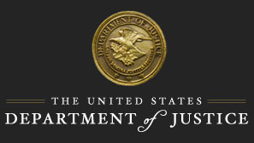

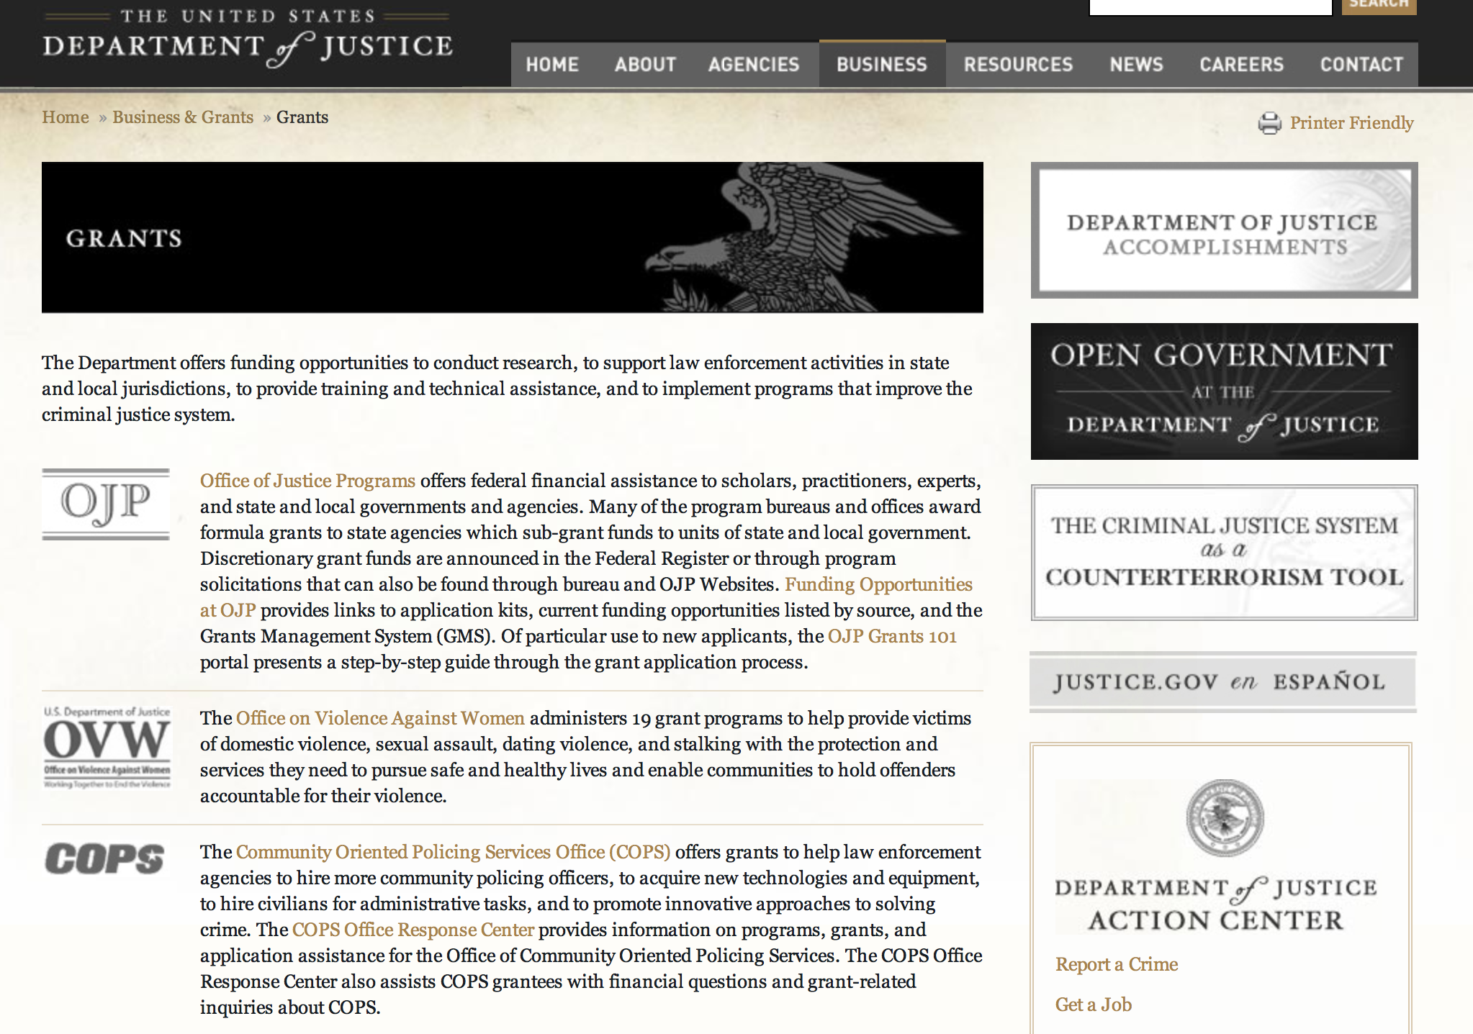

The DOJ agencies listed below also have sites that provide grant information specific to that agency. Examples of what can be found on these sites are programs, funding opportunities, application assistance, and other useful information.

Bureau of Justice Assistance (BJA)

Bureau of Justice Statistics (BJS)

National Criminal Justice Reference Service (NCJRS)

National Institute of Justice (NIJ)

Office of Juvenile Justice and Delinquency Prevention (OJJDP)

Office of Sex Offender Sentencing, Monitoring, Apprehending, Registering, and Tracking (SMART)

Office for Victims of Crime (OVC)

http://www.justice.gov/business/

Programs:

Office of Justice Programs
National Institute of Justice
Research and Evaluation on Drugs and Crime Grant
And Modifications 1, 2 &3

Document Type: | Grants Notice
Funding Opportunity Number: | NIJ-2016-9090
Funding Opportunity Title: | Research and Evaluation on Drugs and Crime
Opportunity Category: | Discretionary
Opportunity Category Explanation:
Funding Instrument Type: | Grant
Category of Funding Activity: | Law, Justice and Legal Services
Category Explanation:
Expected Number of Awards: | 5
CFDA Number(s): | 16.560 -- National Institute of Justice Research, Evaluation, and Development Project Grants
Cost Sharing or Matching Requirement: | No
Posted Date: | Feb 05, 2016
Last Updated Date: | Feb 23, 2016
Original Closing Date for Applications: | Apr 20, 2016
Current Closing Date for Applications: | Apr 20, 2016
Archive Date: | May 20, 2016
Estimated Total Program Funding: | $3,000,000
Award Ceiling: | $3,000,000
Eligible Applicants: | Nonprofits having a 501(c)(3) status with the IRS, other than institutions of higher education  For profit organizations other than small businesses  Small businesses  Native American tribal governments (Federally recognized)  State governments  Private institutions of higher education  Individuals  Nonprofits that do not have a 501(c)(3) status with the IRS, other than institutions of higher education  County governments  Public and State controlled institutions of higher education  City or township governments
Agency Name: | National Institute of Justice
Description: | NIJ is seeking investigator-initiated proposals to conduct research that examines criminal justice tools, protocols, and policies concerning drug trafficking, markets and use, and the effects of drug legalization and decriminalization on law enforcement, applicable to State, tribal and local jurisdictions. Proposals must address one of two criminal justice activities: drug intelligence and community surveillance, or criminal investigation and prosecution. In addition, NIJ has identified three drug research priorities: Marijuana and cannabis products; Heroin and other opioids (including diverted prescription drugs); and Novel psychoactive substances (also known as synthetic drugs).
Link to Additional Information: | http://nij.gov/funding/Documents/solicitations/NIJ-2016-9090.pdf
Contact Information: | If you have difficulty accessing the full announcement electronically, please contact:  NCJRS Call Center grants@ncjrs.gov  Technical Support

http://www.grants.gov/web/grants/view-opportunity.html?oppId=281358

Office of Justice Programs
Bureau of Justice Assistance
Smart Supervision: Reducing Prison Populations, Saving Money, and Creating Safer Communities
Grant

Document Type: | Grants Notice
Funding Opportunity Number: | BJA-2016-8992
Funding Opportunity Title: | Smart Supervision: Reducing Prison Populations, Saving Money, and Creating Safer Communities
Opportunity Category: | Discretionary
Opportunity Category Explanation:
Funding Instrument Type: | Grant
Category of Funding Activity: | Law, Justice and Legal Services
Category Explanation:
Expected Number of Awards: | 7
CFDA Number(s): | 16.812 -- Second Chance Act Reentry Initiative
Cost Sharing or Matching Requirement: | No
Posted Date: | Feb 09, 2016
Last Updated Date: | Feb 09, 2016
Original Closing Date for Applications: | Apr 11, 2016
Current Closing Date for Applications: | Apr 11, 2016
Archive Date:
Estimated Total Program Funding: | $5,250,000
Award Ceiling: | $750,000
Award Floor: | $0
Eligible Applicants: | City or township governments  Native American tribal governments (Federally recognized)  State governments  County governments
Agency Name: | Bureau of Justice Assistance
Description: | The FY 2015 Smart Supervision Program seeks to improve supervision success rates and reduce crime, which would in turn reduce admissions to prisons and jails and save taxpayer dollars. Funds can be used to implement evidence-based supervision strategies and to develop innovative strategies to improve outcomes for probationers.
Link to Additional Information: | Full Announcement
Contact Information: | If you have difficulty accessing the full announcement electronically, please contact:  For technical assistance with submitting an application, contact the Grants.gov Customer Support Hotline at 800-518-4726 or 606-545-5035, or via email to support@grants.gov. The Grants.gov Support Hotline hours of operation are 24 hours a day, 7 days a week, except federal holidays. support@grants.gov  Technical Application Support

http://www.grants.gov/web/grants/view-opportunity.html?oppId=281427

Office of Justice Programs
Bureau of Justice Assistance
Justice Reinvestment Initiative: Maximizing State Reforms Grant

Document Type: | Grants Notice
Funding Opportunity Number: | BJA-2016-8975
Funding Opportunity Title: | Justice Reinvestment Initiative: Maximizing State Reforms
Opportunity Category: | Discretionary
Opportunity Category Explanation:
Funding Instrument Type: | Grant
Category of Funding Activity: | Law, Justice and Legal Services
Category Explanation:
Expected Number of Awards: | 5
CFDA Number(s): | 16.827 -- Justice Reinvestment Initiative
Cost Sharing or Matching Requirement: | No
Posted Date: | Feb 09, 2016
Last Updated Date: | Feb 09, 2016
Original Closing Date for Applications: | Apr 11, 2016
Current Closing Date for Applications: | Apr 11, 2016
Archive Date:
Estimated Total Program Funding: | $0
Award Ceiling: | $1,750,000
Award Floor: | $0
Eligible Applicants: | For profit organizations other than small businesses  Private institutions of higher education  Native American tribal governments (Federally recognized)  State governments  Public and State controlled institutions of higher education
Agency Name: | Bureau of Justice Assistance
Description: | Approximately 2.2 million people were incarcerated in federal, state, and local prisons and jails in 2014, a rate of 1 out of every 110 adults. Many prison populations remain near all-time high levels and face crowding or resource challenges, and state spending on corrections has remained high. Over the last 25 years, state corrections expenditures have increased exponentially from $12 billion in 1988 to more than $55 billion estimated for 2014, a significant increase even accounting for inflation. Justice reinvestment emerged as a way to address these issues through a targeted, data-driven policymaking process. BJA, in a public/private partnership with The Pew Charitable Trusts, launched the Justice Reinvestment Initiative (JRI) in 2010 as a multistaged process in which a jurisdiction reduces unnecessary incarceration, increases the cost-effectiveness of its criminal justice system and reinvests savings into high-performing public safety strategies. Under the JRI model, a governmental working group with bipartisan and interbranch representation analyzes the correctional population and its cost drivers, develops cost-effective policy options, and implements reforms to manage correctional populations while enhancing public safety. JRI jurisdictions reinvest these cost savings into high-performing initiatives that make communities safer. In addition to reducing prison populations, justice reinvestment encourages states to embrace a culture of greater collaboration, data-driven decisionmaking, and increased use of evidence-based practices. The JRI State Assessment Report, funded by BJA and authored by the Urban Institute, showed that the 17 assessed JRI states are making steady progress toward achieving the goals of JRI: reducing correctional spending and reinvesting in recidivism-reduction strategies. Of the 17 states, 8 had JRI policies in effect for at least one year. All eight have experienced meaningful reductions in their prison populations, and five of them have met or exceeded their population reduction goals. While the full impact of justice reinvestment reforms is not yet known, the policies enacted in JRI states hold great promise to reduce prison populations, achieve substantial cost savings, and avert future growth. The Urban Institute continues to track outcomes in these 17 states and in the additional 7 states that have undertaken justice reinvestment efforts under JRI since the JRI State Assessment Report. The report revealed that many JRI states have issues in common and have focused on similar priorities. Each states criminal justice system is unique, requiring detailed analysis to determine factors behind prison growth and corrections spending. However, many of the states found similar factors driving populations and costs for example, parole and probation revocation rates; sentencing policies and practices that favored incarceration of low-risk offenders over alternatives and that resulted in long lengths of stay; insufficient or inefficient community supervision, services, and support; and parole system processing delays and denials. The policy responses to these issues also overlapped, sharing themes of evidence-based practices and data-driven decisionmaking, including risk and needs assessments; accountability measures such as performance and outcome measure reporting; earned credits to encourage compliance with conditions of community supervision; sentencing changes; swift, certain and fair responses to technical probation and parole violations, mandatory post-incarceration supervision requirements; problem-solving courts; streamlined parole processes and expanded parole eligibility; and re-entry programs to reduce recidivism.
Link to Additional Information: | Full Announcement
Contact Information: | If you have difficulty accessing the full announcement electronically, please contact:  For technical assistance with submitting an application, contact the Grants.gov Customer Support Hotline at 800-518-4726 or 606-545-5035, or via e-mail to support@grants.gov. The Grants.gov Support Hotline hours of operation are 24 hours a day, 7 days a week, except federal holidays. support@grants.gov  Technical Application Support

http://www.grants.gov/web/grants/view-opportunity.html?oppId=281428

Office of Justice Programs
Bureau of Justice Assistance
Second Chance Act Reentry Program for Adults with Co-Occurring Substance Abuse and Mental Disorders
And Modification 1

Document Type: | Grants Notice
Funding Opportunity Number: | BJA-2016-9094
Funding Opportunity Title: | Second Chance Act Reentry Program for Adults with Co-Occurring Substance Abuse and Mental Disorders
Opportunity Category: | Discretionary
Opportunity Category Explanation:
Funding Instrument Type: | Grant
Category of Funding Activity: | Law, Justice and Legal Services
Category Explanation:
Expected Number of Awards: | 8
CFDA Number(s): | 16.812 -- Second Chance Act Reentry Initiative
Cost Sharing or Matching Requirement: | No
Posted Date: | Feb 10, 2016
Last Updated Date: | Feb 11, 2016
Original Closing Date for Applications: | Mar 30, 2016
Current Closing Date for Applications: | Mar 30, 2016
Archive Date:
Estimated Total Program Funding: | $7,000,000
Award Ceiling: | $650,000
Award Floor: | $0
Eligible Applicants: | State governments  Native American tribal governments (Federally recognized)  City or township governments  County governments
Agency Name: | Bureau of Justice Assistance
Description: | The Second Chance Act of 2007 (Pub. L. 110-199) provides a comprehensive response to the increasing number of incarcerated adults and juveniles who are released from prison, jail, and juvenile residential facilities and returning to communities. There are currently over 2.2 million individuals serving time in our federal and state prisons, and millions of people cycling through tribal and local jails every year . Ninety-five percent of all people incarcerated today will eventually be released and will return to communities. The coordination of reentry of members of Native American tribes is even more complex given that they can return from federal, Bureau of Indian Affairs (BIA), state, local, and tribal facilities. The Second Chance Act helps to ensure that the transition individuals make from prison, jail, or juvenile residential facilities to the community is successful and promotes public safety. The Second Chance Act Programs are designed to help communities develop and implement comprehensive and collaborative strategies that address the challenges posed by reentry and recidivism reduction. is not a specific program, but rather a process that starts when an individual is initially incarcerated and ends when he or she has been successfully reintegrated in the community as a law-abiding citizen. The reentry process includes screening and assessment in a pre-release setting, the delivery of evidence-based programming in a pre-release setting, and the delivery of a variety of evidence-based programming for every program participant in a post-release setting designed to ensure that the transition from prison or jail to the community is safe and successful.
Link to Additional Information: | Full Announcement
Contact Information: | If you have difficulty accessing the full announcement electronically, please contact:  For technical assistance with submitting an application, contact the Grants.gov Customer Support Hotline at 800-518-4726 or 606-545-5035, or via e-mail to support@grants.gov. The Grants.gov Support Hotline hours of operation are 24 hours a day, 7 days a week, except federal holidays. support@grants.gov  Technical Application Support

http://www.grants.gov/web/grants/view-opportunity.html?oppId=281473

Office of Justice Programs
National Institute of Justice
NIJ FY16 Visiting Fellows Program Grant

Document Type: | Grants Notice
Funding Opportunity Number: | NIJ-2016-8890
Funding Opportunity Title: | NIJ FY16 Visiting Fellows Program
Opportunity Category: | Discretionary
Opportunity Category Explanation:
Funding Instrument Type: | Grant
Category of Funding Activity: | Law, Justice and Legal Services
Category Explanation:
Expected Number of Awards: | 6
CFDA Number(s): | 16.560 -- National Institute of Justice Research, Evaluation, and Development Project Grants
Cost Sharing or Matching Requirement: | No
Posted Date: | Feb 12, 2016
Last Updated Date: | Feb 12, 2016
Original Closing Date for Applications: | May 11, 2016
Current Closing Date for Applications: | May 11, 2016
Archive Date: | Jun 10, 2016
Estimated Total Program Funding: | $1,000,000
Award Ceiling: | $1,000,000
Award Floor: | $0
Eligible Applicants: | City or township governments  State governments  County governments  Native American tribal governments (Federally recognized)  Nonprofits that do not have a 501(c)(3) status with the IRS, other than institutions of higher education  Individuals  Small businesses  For profit organizations other than small businesses  Public and State controlled institutions of higher education  Nonprofits having a 501(c)(3) status with the IRS, other than institutions of higher education  Private institutions of higher education
Agency Name: | National Institute of Justice
Description: | With this solicitation, subject to available funding, NIJ seeks proposals for important research work and scholarship as part of the 2016 NIJ Visiting Fellows Program. Awards made under the NIJ Visiting Fellows Program will bring leading researchers and others into residency at NIJ to make important scholarly contributions in their chosen fields of criminology or criminal justice research, and to work with the NIJ Director and staff to help shape the direction of NIJ's research programs. NIJ will recruit research fellows, who have backgrounds primarily in academic or research settings, and policy fellows, who have backgrounds working primarily in a criminal justice policy or practice setting. NIJ will also recruit partnership fellows, a research fellow and a policy fellow who will work together on a joint-research project. During their fellowship at NIJ, visiting fellows will work on a significant piece of scholarship that has the potential to advance significantly criminology or criminal justice research, such as a major capstone effort culminating a line of research or some work in a new area that has significant potential to transform our understanding of crime and justice in the United States.
Link to Additional Information: | Full Announcement
Contact Information: | If you have difficulty accessing the full announcement electronically, please contact:  NCJRS Call Center  Technical Support

http://www.grants.gov/web/grants/view-opportunity.html?oppId=281510

Office of Justice Programs
Office of Justice Programs
Bureau of Justice Statistics
FY 2016 NICS Act Record Improvement Program (NARIP) Grant
And Modification 1

Document Type: | Grants Notice
Funding Opportunity Number: | BJS-2016-9017
Funding Opportunity Title: | FY 2016 NICS Act Record Improvement Program (NARIP)
Opportunity Category: | Discretionary
Opportunity Category Explanation:
Funding Instrument Type: | Cooperative Agreement
Category of Funding Activity: | Information and Statistics
Category Explanation:
Expected Number of Awards: | 28
CFDA Number(s): | 16.813 -- NICS Act Record Improvement Program
Cost Sharing or Matching Requirement: | No
Posted Date: | Feb 12, 2016
Last Updated Date: | Feb 17, 2016
Original Closing Date for Applications: | May 10, 2016
Current Closing Date for Applications: | May 10, 2016
Archive Date:
Estimated Total Program Funding: | $25,000,000
Award Ceiling: | $500,000
Award Floor: | $0
Eligible Applicants: | Others (see text field entitled "Additional Information on Eligibility" for clarification)
Additional Information on Eligibility: | Eligible applicants are limited to (a) the agency designated by the Governor to administer the NARIP, (b) the state or territory central administrative office or similar entity designated by statute or regulation to administer federal grant funds on behalf of the jurisdiction’s court system, or (c) federally recognized Indian tribal governments as determined by the Secretary of the Interior. Additionally, there are two specific conditions associated with eligibility for grants under this program (see “Eligibility” on page 10).
Agency Name: | Bureau of Justice Statistics
Description: | This program was authorized by the NICS Improvement Amendments Act of 2007 (NIAA). The NIAA was enacted in the wake of the April 2007 shooting tragedy at Virginia Tech. The Virginia Tech shooter was able to purchase firearms from a Federal Firearms License (FFL) because information about his prohibiting mental health history was not available to the NICS, and the system was therefore unable to deny the transfer of the firearms used in the shootings. The NIAA seeks to address the gap in information available to NICS about such prohibiting mental health adjudications and commitments and other prohibiting factors. Filling these information gaps will better enable the system to operate as intended to keep guns out of the hands of persons prohibited by federal or state law from receiving or possessing firearms. The automation of records will also reduce delays for law-abiding gun purchasers. The NIAA authorized this grant program to assist states in providing certain information to the NICS.
Link to Additional Information: | Full Announcement available at www.bjs.gov.
Contact Information: | If you have difficulty accessing the full announcement electronically, please contact:  askbjs@usdoj.gov askbjs@usdoj.gov  General Information

http://www.grants.gov/web/grants/view-opportunity.html?oppId=281498

Office of Justice Programs
National Institute of Justice
Research and Evaluation on Institutional Corrections Grant

Document Type: | Grants Notice
Funding Opportunity Number: | NIJ-2016-9086
Funding Opportunity Title: | Research and Evaluation on Institutional Corrections
Opportunity Category: | Discretionary
Opportunity Category Explanation:
Funding Instrument Type: | Grant
Category of Funding Activity: | Law, Justice and Legal Services
Category Explanation:
Expected Number of Awards: | 12
CFDA Number(s): | 16.560 -- National Institute of Justice Research, Evaluation, and Development Project Grants
Cost Sharing or Matching Requirement: | No
Posted Date: | Feb 17, 2016
Last Updated Date: | Feb 17, 2016
Original Closing Date for Applications: | May 17, 2016
Current Closing Date for Applications: | May 17, 2016
Archive Date:
Estimated Total Program Funding: | $8,000,000
Award Ceiling: | $8,000,000
Eligible Applicants: | Nonprofits that do not have a 501(c)(3) status with the IRS, other than institutions of higher education  Native American tribal governments (Federally recognized)  Public and State controlled institutions of higher education  County governments  Small businesses  City or township governments  For profit organizations other than small businesses  Individuals  Private institutions of higher education  Nonprofits having a 501(c)(3) status with the IRS, other than institutions of higher education  State governments
Agency Name: | National Institute of Justice
Description: | The National Institute of Justice (NIJ) seeks innovative research proposals to empirically assess pressing issues in institutional corrections. Interested applicants should submit proposals that address any of the three categories below. NIJ anticipates that up to $8 million may become available for awards under this solicitation. 1. Advancing science: Responding to the National Academy of Sciences (NAS) Report, The Growth of Incarceration in the United States: Exploring Causes and Consequences.  2. Understanding the use of restrictive housing. a. An examination of the use of restrictive housing in state and/or federal prisons. b. Assessing the use of restrictive housing in jails. c. Understanding the impact of restrictive housing on the mental health of inmates and staff in prison and how working in restrictive housing varies from working in the general population. d. A review of step down programs available in restrictive housing environments in U.S. prisons and jails. 3. An examination of correctional officer safety and wellness: The impact of fatal and non-fatal work-related injuries on the corrections institution.
Link to Additional Information: | http://nij.gov/funding/Documents/solicitations/NIJ-2016-9086.pdf
Contact Information: | If you have difficulty accessing the full announcement electronically, please contact:  NCJRS Call Center grants@ncjrs.gov  Technical Support

http://www.grants.gov/web/grants/view-opportunity.html?oppId=281600

Office of Justice Programs
National Institute of Justice
Research and Evaluation in Support of the Recommendations of the President's Task Force on 21st Century Policing Grant

Document Type: | Grants Notice
Funding Opportunity Number: | NIJ-2016-9095
Funding Opportunity Title: | Research and Evaluation in Support of the Recommendations of the President's Task Force on 21st Century Policing
Opportunity Category: | Discretionary
Opportunity Category Explanation:
Funding Instrument Type: | Grant
Category of Funding Activity: | Law, Justice and Legal Services
Category Explanation:
Expected Number of Awards: | 10
CFDA Number(s): | 16.560 -- National Institute of Justice Research, Evaluation, and Development Project Grants
Cost Sharing or Matching Requirement: | No
Posted Date: | Feb 17, 2016
Last Updated Date: | Feb 17, 2016
Original Closing Date for Applications: | May 17, 2016
Current Closing Date for Applications: | May 17, 2016
Archive Date:
Estimated Total Program Funding: | $6,500,000
Award Ceiling: | $6,500,000
Award Floor: | $0
Eligible Applicants: | Small businesses  Nonprofits having a 501(c)(3) status with the IRS, other than institutions of higher education  Individuals  Private institutions of higher education  City or township governments  County governments  Nonprofits that do not have a 501(c)(3) status with the IRS, other than institutions of higher education  State governments  For profit organizations other than small businesses  Native American tribal governments (Federally recognized)  Public and State controlled institutions of higher education
Agency Name: | National Institute of Justice
Description: | NIJ seeks proposals to conduct research on policing to improve policing practices and public safety at the State, local, and tribal levels. In 2015, a task force was created by President Barack Obama to examine the current state of policing in the United States. In response to a number of high profile events across the nation involving the police, the panel provided recommendations on promising policing practices that police could adopt as effective crime fighting strategies that would also strengthen trust and confidence in the police among community residents that they serve. The panel identified a number of reforms or pillars that were viewed as vital to improving current police practices. In response to the recommendations and action items proposed by the task force, NIJ is interested in research in the following topical areas: 1. Research and Evaluation of Strategies to Build and Strengthen Police-Community Relationships 2. Research and Evaluation of Police Training 3. Research and Evaluation on Officer Wellness and Safety 4. Research and Evaluation on Police Technology 5. Research on Crime Scene Investigations: Triaging Evidence
Link to Additional Information: | http://nij.gov/funding/Documents/solicitations/NIJ-2016-9095.pdf
Contact Information: | If you have difficulty accessing the full announcement electronically, please contact:  NCJRS Call Center grants@ncjrs.gov  Technical Support

http://www.grants.gov/web/grants/view-opportunity.html?oppId=281601

Office of Justice Programs
Bureau of Justice Assistance
National Initiatives: Officer Safety and Wellness
And Modification 1

Document Type: | Grants Notice
Funding Opportunity Number: | BJA-2016-9112
Funding Opportunity Title: | National Initiatives: Officer Safety and Wellness
Opportunity Category: | Discretionary
Opportunity Category Explanation:
Funding Instrument Type: | Grant
Category of Funding Activity: | Law, Justice and Legal Services
Category Explanation:
Expected Number of Awards: | 5
CFDA Number(s): | 16.738 -- Edward Byrne Memorial Justice Assistance Grant Program
Cost Sharing or Matching Requirement: | No
Posted Date: | Feb 23, 2016
Last Updated Date: | Feb 24, 2016
Original Closing Date for Applications: | Apr 21, 2016
Current Closing Date for Applications: | Apr 21, 2016
Archive Date:
Estimated Total Program Funding: | $13,431,507
Award Ceiling: | $4,850,000
Eligible Applicants: | Private institutions of higher education  State governments  Public and State controlled institutions of higher education  For profit organizations other than small businesses  Nonprofits having a 501(c)(3) status with the IRS, other than institutions of higher education  County governments  Native American tribal governments (Federally recognized)  Others (see text field entitled "Additional Information on Eligibility" for clarification)  City or township governments
Additional Information on Eligibility: | Eligible applicants are not-for-profit and for-profit organizations (including tribal nonprofit and for-profit organizations); state and local governments; federally recognized Indian tribal governments (as determined by the Secretary of the Interior); and institutions of higher learning (including tribal institutions of higher education). Applicants must have extensive experience in providing national training and technical assistance as well as extensive experience and knowledge of the officer safety and wellness field. For-profit organizations must agree to forgo any profit or management fee.
Agency Name: | Bureau of Justice Assistance
Description: | In 2010, the Bureau of Justice Assistance (BJA) VALOR Officer Safety Initiative was created in response to the startling increase in felonious assaults that have taken the lives of many law enforcement officers. VALOR provides all levels of law enforcement with tools to help prevent violence against law enforcement officers and enhance officer resilience, wellness, and survivability. VALOR is a comprehensive effort that includes classroom and Web-based training, research, and resources for sworn state, local and tribal law enforcement officers. VALOR Training provides critical nationwide, no-cost officer safety training to all levels of law enforcement. Training modules are developed using the latest expertise, analysis, tactics, interdiction techniques, and response methods to address alarming trends. The program also includes active shooter response training for first responders.
Link to Additional Information: | Full Announcement
Contact Information: | If you have difficulty accessing the full announcement electronically, please contact:  For technical assistance with submitting an application, contact the Grants.gov Customer Support Hotline at 800-518-4726 or 606-545-5035, or via email to support@grants.gov. The Grants.gov Support Hotline hours of operation are 24 hours a day, 7 days a week, except federal holidays. support@grants.gov  Technical Application Support

http://www.grants.gov/web/grants/view-opportunity.html?oppId=281744

National Institute of Justice
W.E.B. DuBois Program of Research on Race and Crime Grant

Document Type: | Grants Notice
Funding Opportunity Number: | NIJ-2016-9108
Funding Opportunity Title: | W.E.B. DuBois Program of Research on Race and Crime
Opportunity Category: | Discretionary
Opportunity Category Explanation:
Funding Instrument Type: | Grant
Category of Funding Activity: | Law, Justice and Legal Services
Category Explanation:
Expected Number of Awards: | 7
CFDA Number(s): | 16.566 -- National Institute of Justice W.E.B. DuBois Fellowship Program
Cost Sharing or Matching Requirement: | No
Posted Date: | Feb 26, 2016
Last Updated Date: | Feb 26, 2016
Original Closing Date for Applications: | May 16, 2016
Current Closing Date for Applications: | May 16, 2016
Archive Date:
Estimated Total Program Funding: | $2,300,000
Award Ceiling: | $2,300,000
Eligible Applicants: | Nonprofits having a 501(c)(3) status with the IRS, other than institutions of higher education  Individuals  Private institutions of higher education  Public and State controlled institutions of higher education  City or township governments  State governments  Nonprofits that do not have a 501(c)(3) status with the IRS, other than institutions of higher education  Small businesses  For profit organizations other than small businesses  County governments  Native American tribal governments (Federally recognized)
Agency Name: | National Institute of Justice
Description: | With this solicitation, NIJ seeks applications for the W.E.B. Du Bois Program of Research on Race and Crime. The program seeks to advance knowledge regarding the confluence of crime, justice, and culture in various societal contexts. This year, NIJ seeks applicants for two funding categories: 1) W.E.B. Du Bois Scholars- those who are advanced in their careers and seek to conduct research that advances the study of race and crime and 2) W.E.B. Du Bois Fellows- those who are early in their careers and seek the opportunity to elevate their research ideas to the level of national discussion.
Link to Additional Information: | http://nij.gov/funding/Documents/solicitations/NIJ-2016-9108.pdf
Contact Information: | If you have difficulty accessing the full announcement electronically, please contact:  NCJRS Call Center grants@ncjrs.gov  Technical Support

http://www.grants.gov/web/grants/view-opportunity.html?oppId=281799

Modifications:

Office of Justice Programs
Bureau of Justice Assistance
Swift, Certain, and Fair Sanctions (SCF)/ Replicating the Concepts Behind Project HOPE
Modification 2

Document Type: | Grants Notice
Funding Opportunity Number: | BJA-2016-8993
Funding Opportunity Title: | Swift, Certain, and Fair Sanctions (SCF)/ Replicating the Concepts Behind Project HOPE
Opportunity Category: | Discretionary
Opportunity Category Explanation:
Funding Instrument Type: | Grant
Category of Funding Activity: | Law, Justice and Legal Services
Category Explanation:
Expected Number of Awards: | 7
CFDA Number(s): | 16.828 -- Swift, Certain, and Fair (SCF) Sanctions program: Replicating the Concepts behind Project HOPE
Cost Sharing or Matching Requirement: | No
Posted Date: | Feb 09, 2016
Last Updated Date: | Feb 09, 2016
Original Closing Date for Applications: | Apr 11, 2016
Current Closing Date for Applications: | Apr 11, 2016
Archive Date: | May 11, 2016
Estimated Total Program Funding: | $2,800,000
Award Ceiling: | $400,000
Award Floor: | $0
Eligible Applicants: | State governments  Native American tribal governments (Federally recognized)  County governments  City or township governments
Agency Name: | Bureau of Justice Assistance
Description: | There are a multiple states, counties, cities, and tribes that are interested in implementing Swift, Certain, and Fair (SCF) models of supervision with offenders in the community. This interest has grown out of the potential promise that these SCF models have shown in effectively reducing recidivism and preventing crime. In particular, Hawaii's Opportunity Probation with Enforcement (HOPE) program has been shown to have promise, and as a result there is significant interest and activity in implementing models of supervision, and other versions of the HOPE model which rely on swift and certain sanctions. SCF approaches are intended to: (a) improve supervision strategies that reduce recidivism; (b) promote and increase collaboration among agencies and officials who work in community corrections and related fields; (c) enhance the offenders perception that the supervision decisions are fair, consistently applied and consequences are transparent; and (d) improve the outcomes of individuals participating in these initiatives. Through this FY 2015 grant announcement, BJA will select multiple applicants to implement or enhance a HOPE model using SCF. Applicants selected under this announcement will work with BJA and its training and technical assistance (TTA) partner to implement the model with fidelity.
Link to Additional Information: | Full Announcement
Contact Information: | If you have difficulty accessing the full announcement electronically, please contact:  For technical assistance with submitting an application, contact the Grants.gov Customer Support Hotline at 800-518-4726 or 606-545-5035, or via e-mail to support@grants.gov. The Grants.gov Support Hotline hours of operation are 24 hours a day, 7 days a week, except federal holidays support@grants.gov  Technical Application Support

http://www.grants.gov/web/grants/view-opportunity.html?oppId=281426

Office of Justice Programs
Bureau of Justice Assistance
Intellectual Property Enforcement Program
Modification 2

Document Type: | Grants Notice
Funding Opportunity Number: | BJA-2016-9111
Funding Opportunity Title: | Intellectual Property Enforcement Program
Opportunity Category: | Discretionary
Opportunity Category Explanation:
Funding Instrument Type: | Grant
Category of Funding Activity: | Law, Justice and Legal Services
Category Explanation:
Expected Number of Awards: | 6
CFDA Number(s): | 16.752 -- Economic High-Tech and Cyber Crime Prevention
Cost Sharing or Matching Requirement: | No
Posted Date: | Feb 10, 2016
Last Updated Date: | Feb 10, 2016
Original Closing Date for Applications: | Mar 28, 2016
Current Closing Date for Applications: | Mar 28, 2016
Archive Date: | Apr 27, 2016
Estimated Total Program Funding: | $2,600,000
Award Ceiling: | $400,000
Eligible Applicants: | Native American tribal organizations (other than Federally recognized tribal governments)  City or township governments  State governments  County governments
Agency Name: | Bureau of Justice Assistance
Description: | The Intellectual Property Enforcement Program (IPEP), administered by BJA, is designed to provide national support and improve the capacity of state, local, and tribal criminal justice systems to address IP criminal enforcement, including prosecution, prevention, training, and technical assistance.
Link to Additional Information: | Full Announcement
Contact Information: | If you have difficulty accessing the full announcement electronically, please contact:  For technical assistance with submitting an application, contact the Grants.gov Customer Support Hotline at 800-518-4726 or 606-545-5035, or via e-mail to support@grants.gov. The Grants.gov Support Hotline hours of operation are 24 hours a day, 7 days a week, except federal holidays. support@grants.gov  Technical Application Support

http://www.grants.gov/web/grants/view-opportunity.html?oppId=281450

Office of Justice Programs
Bureau of Justice Assistance
Wrongful Conviction Review Program
Modification 1

Document Type: | Grants Notice
Funding Opportunity Number: | BJA-2016-9076
Funding Opportunity Title: | Wrongful Conviction Review Program
Opportunity Category: | Discretionary
Opportunity Category Explanation:
Funding Instrument Type: | Grant
Category of Funding Activity: | Law, Justice and Legal Services
Category Explanation:
Expected Number of Awards: | 5
CFDA Number(s): | 16.746 -- Capital Case Litigation Initiative
Cost Sharing or Matching Requirement: | No
Posted Date: | Feb 11, 2016
Last Updated Date: | Feb 11, 2016
Original Closing Date for Applications: | Mar 28, 2016
Current Closing Date for Applications: | Mar 28, 2016
Archive Date:
Estimated Total Program Funding: | $1,250,000
Award Ceiling: | $250,000
Award Floor: | $0
Eligible Applicants: | Others (see text field entitled "Additional Information on Eligibility" for clarification)  Nonprofits having a 501(c)(3) status with the IRS, other than institutions of higher education  For profit organizations other than small businesses
Additional Information on Eligibility: | Eligible applicants for this solicitation are limited to public and nonprofit organizations (including tribal nonprofit and for-profit organizations) dedicated to exonerating the innocent, institutions of higher learning (including tribal institutions of higher education), and state or local public defender offices. For-profit organizations must agree to forgo any profit or management fee.
Agency Name: | Bureau of Justice Assistance
Description: | One of BJA's guiding principles is to promote a fair criminal justice system. For the past two decades, the American justice system has been confronted with a steady stream of post-conviction exonerations, and the issue of wrongful conviction has emerged as a critical area for examination. BJA is committed to assisting the state and local law enforcement entities in adopting evidence-based practices and assessing the necessary technologies to reduce the likelihood of a wrongful conviction (to include wrongful arrests and prosecutions) occurring from the outset of each criminal investigation. BJA is also committed to ensuring that wrongful convictions are expeditiously detected and addressed when they occur. On support of the latter goal, BJA established the Wrongful Conviction Review Program, the funding for which is anticipated through the FY 2015 appropriation. The purpose of the Wrongful Conviction Review Program is to provide high-quality and efficient representation for defendants in post-conviction claims of innocence.
Link to Additional Information: | Full Announcement
Contact Information: | If you have difficulty accessing the full announcement electronically, please contact:  For technical assistance with submitting an application, contact the Grants.gov Customer Support Hotline at 800-518-4726 or 606-545-5035, or via email to support@grants.gov. The Grants.gov Support Hotline hours of operation are 24 hours a day, 7 days a week, except federal holidays. support@grants.gov  Technical Application Support

http://www.grants.gov/web/grants/view-opportunity.html?oppId=281486

Office of Justice Programs
Bureau of Justice Assistance
Smart Prosecution Initiative
Modification 1

Document Type: | Grants Notice
Funding Opportunity Number: | BJA-2016-8991
Funding Opportunity Title: | Smart Prosecution Initiative
Opportunity Category: | Discretionary
Opportunity Category Explanation:
Funding Instrument Type: | Grant
Category of Funding Activity: | Law, Justice and Legal Services
Category Explanation:
Expected Number of Awards: | 9
CFDA Number(s): | 16.825 -- Smart Prosecution Initiative
Cost Sharing or Matching Requirement: | No
Posted Date: | Feb 11, 2016
Last Updated Date: | Feb 11, 2016
Original Closing Date for Applications: | Mar 28, 2016
Current Closing Date for Applications: | Mar 28, 2016
Archive Date:
Estimated Total Program Funding: | $5,000,000
Award Ceiling: | $400,000
Eligible Applicants: | Others (see text field entitled "Additional Information on Eligibility" for clarification)
Additional Information on Eligibility: | Eligible applicants are limited to state, local, and tribal prosecutor agencies or a government agency or nonprofit organization as fiscal agent for the applicant.
Agency Name: | Bureau of Justice Assistance
Description: | BJA's Smart Prosecution Initiative is designed to promote effective data-driven, research-based approaches to prosecution and prosecutor-led justice systems innovations and reforms. The Smart Prosecution model builds off of the lessons learned from BJA's Smart Suite of crime fighting programs. Smart Prosecution will seek to pair an operational, results focused researcher with a prosecutor's office to develop data-driven solutions which create effective, efficient, and just prosecution strategies which will ultimately improve public safety. It will provide other valuable resources to equip a prosecutor's office to access data across various criminal justice and non-criminal justice information systems to improve results for communities. BJA will use the lessons learned to develop a rich body of evidence for use by prosecutors nationally as they seek to work with communities to solve chronic problems and fight violent crime.
Link to Additional Information: | Full Announcement
Contact Information: | If you have difficulty accessing the full announcement electronically, please contact:  For technical assistance with submitting an application, contact the Grants.gov Customer Support Hotline at 800-518-4726 or 606-545-5035, or via e-mail to support@grants.gov. The Grants.gov Support Hotline hours of operation are 24 hours a day, 7 days a week, except federal holidays. support@grants.gov  Technical Application Support

http://www.grants.gov/web/grants/view-opportunity.html?oppId=281501

Office of Justice Programs
Bureau of Justice Assistance
Encouraging Innovation: Field-Initiated Programs Concept Paper
Modification 1
Document Type: | Grants Notice
Funding Opportunity Number: | BJA-2016-8986
Funding Opportunity Title: | Encouraging Innovation: Field-Initiated Programs Concept Paper
Opportunity Category: | Discretionary
Opportunity Category Explanation:
Funding Instrument Type: | Grant
Category of Funding Activity: | Law, Justice and Legal Services
Category Explanation:
Expected Number of Awards: | 0
CFDA Number(s): | 16.817 -- Byrne Criminal Justice Innovation Program
Cost Sharing or Matching Requirement: | No
Posted Date: | Feb 12, 2016
Last Updated Date: | Feb 12, 2016
Original Closing Date for Applications: | Mar 29, 2016
Current Closing Date for Applications: | Mar 29, 2016
Archive Date:
Estimated Total Program Funding: | $4,000,000
Award Ceiling: | $400,000
Eligible Applicants: | Others (see text field entitled "Additional Information on Eligibility" for clarification)
Additional Information on Eligibility: | Category 1: Eligible applicants are limited to public agencies that perform criminal justice functions, including states, units of local government, and Indian tribes that perform law enforcement functions as determined by the Secretary of the Interior (including the departments, agencies, or instrumentality of the foregoing); or public or private entities, including but not limited to for-profit (commercial) and nonprofit organizations (including tribal for-profit and nonprofit organizations), faith-based and community organizations, and institutions of higher education (including tribal institutions of higher education). For-profit organizations must agree to forgo any profit or management fee. Category 2: Eligible applicants are limited to public or private entities, including institutions of higher education (including tribal institutions of higher education) or national for-profit (commercial) and nonprofit organizations (including tribal for-profit and nonprofit organizations). For-profit organizations must agree to forgo any profit or management fee.
Agency Name: | Bureau of Justice Assistance
Description: | The program is targeted to receive application from organizations to develop and implement new and innovative strategies that better enable local criminal justice systems to prevent and respond to emerging and chronic crime problems that affect many communities in the United States. Proposals will be aimed at addressing a gap in the current base of knowledge about responding to and or preventing crime and be developed or implemented in a way that allows other communities or organizations to learn from and potentially replicate the approach. Applications must be either innovative and or strategic in nature.
Link to Additional Information: | Full Announcement
Contact Information: | If you have difficulty accessing the full announcement electronically, please contact:  For technical assistance with submitting a concept paper, contact the Grants.gov Customer Support Hotline at 800-518-4726 or 606-545-5035, or via email to support@grants.gov. The Grants.gov Support Hotline hours of operation are 24 hours a day, 7 days a week, except federal holidays. support@grants.gov  Technical Application Support

http://www.grants.gov/web/grants/view-opportunity.html?oppId=281525

Office of Justice Programs
Bureau of Justice Assistance
Violent Gang And Gun Crime Reduction Program (PSN)
Modification 1

Document Type: | Grants Notice
Funding Opportunity Number: | BJA-2016-9202
Funding Opportunity Title: | Violent Gang And Gun Crime Reduction Program (PSN)
Opportunity Category: | Discretionary
Opportunity Category Explanation:
Funding Instrument Type: | Grant
Category of Funding Activity: | Law, Justice and Legal Services
Category Explanation:
Expected Number of Awards: | 12
CFDA Number(s): | 16.609 -- Project Safe Neighborhoods
Cost Sharing or Matching Requirement: | No
Posted Date: | Feb 16, 2016
Last Updated Date: | Feb 16, 2016
Original Closing Date for Applications: | May 17, 2016
Current Closing Date for Applications: | May 17, 2016
Archive Date:
Estimated Total Program Funding: | $8,500,000
Award Ceiling: | $500,000
Eligible Applicants: | Others (see text field entitled "Additional Information on Eligibility" for clarification)
Additional Information on Eligibility: | Eligible applicants are PSN Task Force fiscal agents for the U.S. Attorney districts and federally recognized Indian tribal governments (as determined by the Secretary of the Interior). All fiscal agents must be certified by the relevant U.S. Attorney’s Office (USAO). Eligible USAO-certified fiscal agents include states, units of local government, educational institutions, faith-based and other community organizations, private nonprofit organizations, and federally recognized Indian tribal governments (as determined by the Secretary of the Interior). For details on the fiscal agent certification process, see www.bja.gov/programs/psn/cert_process.html.
Agency Name: | Bureau of Justice Assistance
Description: | Project Safe Neighborhoods (PSN) is designed to create safer neighborhoods through a sustained reduction in crime associated with gang and gun violence, and violent offenders. The program's effectiveness is based on the cooperation of local, state, and federal agencies engaged in a unified approach led by the U.S. Attorney (USA) in each district. The USA is responsible for establishing a collaborative PSN task force of federal, state, and local law enforcement and other community members to implement gang and gun crime enforcement, intervention and prevention initiatives within the district. Through the PSN task force, the USA will implement the five design features of PSN partnerships, strategic planning, training, outreach, and accountability to address specific gun and gang crime, and violent offenders, in the most violent neighborhoods.
Link to Additional Information: | Full Announcement
Contact Information: | If you have difficulty accessing the full announcement electronically, please contact:  For technical assistance with submitting an application, contact the Grants.gov Customer Support Hotline at 800-518-4726 or 606-545-5035, or via email to support@grants.gov. The Grants.gov Support Hotline hours of operation are 24 hours a day, 7 days a week, except federal holidays. support@grants.gov  Technical Application Support

http://www.grants.gov/web/grants/view-opportunity.html?oppId=281544

Office of Justice Programs
Bureau of Justice Assistance
Smart Policing Initiative
Modification 2

Document Type: | Grants Notice
Funding Opportunity Number: | BJA-2016-9208
Funding Opportunity Title: | Smart Policing Initiative
Opportunity Category: | Discretionary
Opportunity Category Explanation:
Funding Instrument Type: | Grant
Category of Funding Activity: | Law, Justice and Legal Services
Category Explanation:
Expected Number of Awards: | 8
CFDA Number(s): | 16.738 -- Edward Byrne Memorial Justice Assistance Grant Program
Cost Sharing or Matching Requirement: | No
Posted Date: | Feb 17, 2016
Last Updated Date: | Feb 17, 2016
Original Closing Date for Applications: | Apr 12, 2016
Current Closing Date for Applications: | Apr 12, 2016
Archive Date:
Estimated Total Program Funding: | $5,000,000
Award Ceiling: | $700,000
Eligible Applicants: | Native American tribal governments (Federally recognized)  County governments  State governments  City or township governments
Agency Name: | Bureau of Justice Assistance
Description: | This FY 2015 Smart Policing Initiative (SPI) grant program seeks to build upon analysis-driven, evidence-based policing by encouraging state, local, and tribal law enforcement agencies to develop effective, economical, and innovative responses to crime within their jurisdictions.
Link to Additional Information: | Full Announcement
Contact Information: | If you have difficulty accessing the full announcement electronically, please contact:  For technical assistance with submitting an application, contact the Grants.gov Customer Support Hotline at 800-518-4726 or 606-545-5035, or via email to support@grants.gov. The Grants.gov Support Hotline hours of operation are 24 hours a day, 7 days a week, except federal holidays. support@grants.gov  Technical Application Support

http://www.grants.gov/web/grants/view-opportunity.html?oppId=281577

Office of Justice Programs
Bureau of Justice Assistance
Second Chance Act Comprehensive Community-Based Adult Reentry Program Utilizing Mentors
Modification 1

Document Type: | Grants Notice
Funding Opportunity Number: | BJA-2016-8990
Funding Opportunity Title: | Second Chance Act Comprehensive Community-Based Adult Reentry Program Utilizing Mentors
Opportunity Category: | Discretionary
Opportunity Category Explanation:
Funding Instrument Type: | Grant
Category of Funding Activity: | Law, Justice and Legal Services
Category Explanation:
Expected Number of Awards: | 10
CFDA Number(s): | 16.812 -- Second Chance Act Reentry Initiative
Cost Sharing or Matching Requirement: | No
Posted Date: | Feb 18, 2016
Last Updated Date: | Feb 18, 2016
Original Closing Date for Applications: | Apr 12, 2016
Current Closing Date for Applications: | Apr 12, 2016
Archive Date:
Estimated Total Program Funding: | $10,000,000
Award Ceiling: | $1,000,000
Award Floor: | $0
Eligible Applicants: | Others (see text field entitled "Additional Information on Eligibility" for clarification)
Additional Information on Eligibility: | Applicants are limited to nonprofit organizations (including tribal nonprofit organizations) with a documented history of providing comprehensive, evidence-based reentry services, and federally recognized Indian tribal governments (as determined by the Secretary of the Interior).
Agency Name: | Bureau of Justice Assistance
Description: | The Community-Based Reentry Program Utilizing Mentors will provide $1, 000, 0000 awards for a three year grant period to private non-profits to provide comprehensive, community-based reentry services to formerly incarcerated individuals with moderate to high risk of recidivating. These reentry programs will include a mentoring component.
Link to Additional Information: | Full Announcement
Contact Information: | If you have difficulty accessing the full announcement electronically, please contact:  For technical assistance with submitting an application, contact the Grants.gov Customer Support Hotline at 800-518-4726 or 606-545-5035, or via email to support@grants.gov. The Grants.gov Support Hotline hours of operation are 24 hours a day, 7 days a week, except federal holidays. support@grants.gov  Technical Application Support

http://www.grants.gov/web/grants/view-opportunity.html?oppId=281593

Office of Justice Programs
Bureau of Justice Assistance
Adult Drug Court Discretionary Grant Program
Modification 1

Document Type: | Grants Notice
Funding Opportunity Number: | BJA-2016-9197
Funding Opportunity Title: | Adult Drug Court Discretionary Grant Program
Opportunity Category: | Discretionary
Opportunity Category Explanation:
Funding Instrument Type: | Grant
Category of Funding Activity: | Law, Justice and Legal Services
Category Explanation:
Expected Number of Awards: | 40
CFDA Number(s): | 16.585 -- Drug Court Discretionary Grant Program
Cost Sharing or Matching Requirement: | No
Posted Date: | Feb 23, 2016
Last Updated Date: | Feb 23, 2016
Original Closing Date for Applications: | Apr 19, 2016
Current Closing Date for Applications: | Apr 19, 2016
Archive Date:
Estimated Total Program Funding: | $45,000,000
Award Ceiling: | $1,500,000
Award Floor: | $0
Eligible Applicants: | State governments  Others (see text field entitled "Additional Information on Eligibility" for clarification)  City or township governments  County governments
Additional Information on Eligibility: | For Category 1: Implementation and Category 2: Enhancement, applications will be accepted to support states, state and local courts, counties, units of local government, and federally recognized Indian tribal governments (as determined by the Secretary of the Interior) on behalf of a single jurisdiction drug court. For Category 3: Statewide, applicants are limited to state agencies. State agencies include the state court administrative offices, state criminal justice agencies, and other state agencies involved with the provision of substance abuse, mental health, or related services to criminal substance abusers such as the State Administering Agency (SAA), the Administrative Office of the Courts, and the State Alcohol and Substance Abuse Agency.
Agency Name: | Bureau of Justice Assistance
Description: | BJA is accepting applications to establish new drug courts or enhance existing drug court services, coordination, and offender management and recovery support services. The purpose of the Adult Drug Court Discretionary Grant Program (42 U.S.C. 3797u et seq.) is to provide financial and technical assistance to states, state courts, local courts, units of local government, and Indian tribal governments to develop and implement drug courts that effectively integrate evidenced-based substance abuse treatment, mandatory drug testing, sanctions and incentives, and transitional services in a judicially supervised court setting with jurisdiction over substance-abusing offenders.
Link to Additional Information: | Full Announcement
Contact Information: | If you have difficulty accessing the full announcement electronically, please contact:  For technical assistance with submitting an application, contact the Grants.gov Customer Support Hotline at 800-518-4726 or 606-545-5035, or via email to support@grants.gov. The Grants.gov Support Hotline hours of operation are 24 hours a day, 7 days a week, except federal holidays. support@grants.gov  Technical Application Support

http://www.grants.gov/web/grants/view-opportunity.html?oppId=281717

Office of Justice Programs
Bureau of Justice Assistance
Second Chance Act Technology-Based Career Training Program for Incarcerated Adults and Juveniles
Modification 1
Document Type: | Grants Notice
Funding Opportunity Number: | BJA-2016-9074
Funding Opportunity Title: | Second Chance Act Technology-Based Career Training Program for Incarcerated Adults and Juveniles
Opportunity Category: | Discretionary
Opportunity Category Explanation:
Funding Instrument Type: | Grant
Category of Funding Activity: | Law, Justice and Legal Services
Category Explanation:
Expected Number of Awards: | 6
CFDA Number(s): | 16.812 -- Second Chance Act Reentry Initiative
Cost Sharing or Matching Requirement: | No
Posted Date: | Feb 23, 2016
Last Updated Date: | Feb 23, 2016
Original Closing Date for Applications: | Apr 12, 2016
Current Closing Date for Applications: | Apr 12, 2016
Archive Date: | May 12, 2016
Estimated Total Program Funding: | $6,000,000
Award Ceiling: | $750,000
Eligible Applicants: | State governments  City or township governments  Native American tribal governments (Federally recognized)  County governments
Agency Name: | Bureau of Justice Assistance
Description: | The Second Chance Act of 2007 (Pub. L. 110-199) provides a comprehensive response to the increasing number of incarcerated adults and juveniles who are released from prison, jail, and juvenile residential facilities and returning to communities. Section 115 of the Second Chance Act authorizes federal awards to states, units of local government, territories, and federally recognized Indian tribes to provide technology career training to persons confined in state prisons, local jails, and juvenile residential facilities. This program supports the education, training, mentoring, support services, and job placement for incarcerated/detained adults and juveniles in a technology field.
Link to Additional Information: | Full Announcement
Contact Information: | If you have difficulty accessing the full announcement electronically, please contact:  For technical assistance with submitting an application, contact the Grants.gov Customer Support Hotline at 800-518-4726 or 606-545-5035, or via email to support@grants.gov. The Grants.gov Support Hotline hours of operation are 24 hours a day, 7 days a week, except federal holidays. support@grants.gov  Technical Application Support

http://www.grants.gov/web/grants/view-opportunity.html?oppId=281742

Reminders:

Office of Justice Programs
National Institute of Justice
Developing Improved Means to Collect Digital Evidence Grant

Document Type: | Grants Notice
Funding Opportunity Number: | NIJ-2016-8976
Funding Opportunity Title: | Developing Improved Means to Collect Digital Evidence
Opportunity Category: | Discretionary
Funding Instrument Type: | Cooperative Agreement
Category of Funding Activity: | Law, Justice and Legal Services
Category Explanation:
Expected Number of Awards: | 3
CFDA Number(s): | 16.560 -- National Institute of Justice Research, Evaluation, and Development Project Grants
Cost Sharing or Matching Requirement: | No
Posted Date: | Jan 15, 2016
Creation Date: | Jan 15, 2016
Original Closing Date for Applications: | Apr 14, 2016
Current Closing Date for Applications: | Apr 14, 2016
Archive Date:
Estimated Total Program Funding: | $1,500,000
Award Ceiling: | $1,500,000
Eligible Applicants: | Private institutions of higher education  Native American tribal governments (Federally recognized)  Individuals  Nonprofits that do not have a 501(c)(3) status with the IRS, other than institutions of higher education  Nonprofits having a 501(c)(3) status with the IRS, other than institutions of higher education  City or township governments  County governments  State governments  For profit organizations other than small businesses  Small businesses  Public and State controlled institutions of higher education
Agency Name: | National Institute of Justice
Description: | With this solicitation, NIJ seeks proposals for funding to conduct research and technology development leading to the introduction into practice of new and innovative tools to: -Process large-scale computer networks for digital evidence in a forensically sound manner that preserves the probative value of the evidence that the computer network may contain; or -Process mobile devices voluntarily surrendered to law enforcement by witnesses or victims of an alleged crime, which will discriminate between data that is germane to that crime and that which is not, and which will only collect data that is germane; or -Automatically detect children in pornographic videos of varying quality. Individual applicants may propose to address one or more of these topics, but most do so in separate, discrete applications. Single applications proposing to address more than one topic will not be accepted.
Link to Additional Information: | http://nij.gov/funding/Documents/solicitations/NIJ-2016-8976.pdf
Contact Information: | If you have difficulty accessing the full announcement electronically, please contact:  NCJRS Call Center grants@ncjrs.gov  Technical Support

http://www.grants.gov/web/grants/view-opportunity.html?oppId=281004

Office of Justice Programs
National Institute of Justice
Postconviction Testing of DNA Evidence to Exonerate the Innocent Grant

Document Type: | Grants Notice
Funding Opportunity Number: | NIJ-2016-8998
Funding Opportunity Title: | Postconviction Testing of DNA Evidence to Exonerate the Innocent
Opportunity Category: | Discretionary
Funding Instrument Type: | Cooperative Agreement
Category of Funding Activity: | Law, Justice and Legal Services
Category Explanation:
Expected Number of Awards: | 8
CFDA Number(s): | 16.820 -- Postconviction Testing of DNA Evidence to Exonerate the Innocent
Cost Sharing or Matching Requirement: | No
Posted Date: | Jan 8, 2016
Creation Date: | Jan 8, 2016
Original Closing Date for Applications: | Apr 7, 2016
Current Closing Date for Applications: | Apr 7, 2016
Archive Date:
Estimated Total Program Funding: | $3,600,000
Award Ceiling: | $3,600,000
Eligible Applicants: | County governments  Public and State controlled institutions of higher education  City or township governments  State governments
Agency Name: | National Institute of Justice
Description: | NIJ seeks proposals for funding to assist in defraying the costs associated with postconviction DNA testing in cases of violent felony offenses (as defined by State law) in which actual innocence might be demonstrated. Funds may be used to identify and review such postconviction cases and to locate and analyze associated biological evidence.
Link to Additional Information: | http://nij.gov/funding/Documents/solicitations/NIJ-2016-8998.pdf
Contact Information: | If you have difficulty accessing the full announcement electronically, please contact:  NCJRS Call Center grants@ncjrs.gov  Technical Support

http://www.grants.gov/web/grants/view-opportunity.html?oppId=280881

Office of Justice Programs
National Institute of Justice
Research and Evaluation for the Testing and Interpretation of Physical Evidence in Publicly Funded Forensic Laboratories Grant

Document Type: | Grants Notice
Funding Opportunity Number: | NIJ-2016-9011
Funding Opportunity Title: | Research and Evaluation for the Testing and Interpretation of Physical Evidence in Publicly Funded Forensic Laboratories
Opportunity Category: | Discretionary
Funding Instrument Type: | Grant
Category of Funding Activity: | Law, Justice and Legal Services
Category Explanation:
Expected Number of Awards: | 12
CFDA Number(s): | 16.560 -- National Institute of Justice Research, Evaluation, and Development Project Grants
Cost Sharing or Matching Requirement: | No
Posted Date: | Jan 7, 2016
Creation Date: | Jan 7, 2016
Original Closing Date for Applications: | Apr 6, 2016
Current Closing Date for Applications: | Apr 6, 2016
Archive Date:
Estimated Total Program Funding: | $3,000,000
Award Ceiling: | $3,000,000
Eligible Applicants: | State governments  County governments  City or township governments  Native American tribal governments (Federally recognized)
Agency Name: | National Institute of Justice
Description: | With this solicitation, NIJ seeks proposals for research and evaluation projects that will: 1. Identify and inform the forensic community of best practices through the evaluation of existing laboratory protocols; and 2. Have a direct and immediate impact on laboratory efficiency and assist in making laboratory policy decisions. The intent of this program is to direct the findings of the research and evaluation toward the identification of the most efficient, accurate, reliable, and cost-effective methods for the identification, analysis, and interpretation of physical evidence for criminal justice purposes.
Link to Additional Information: | http://nij.gov/funding/Documents/solicitations/NIJ-2016-9011.pdf
Contact Information: | If you have difficulty accessing the full announcement electronically, please contact:  NCJRS Call Center grants@ncjrs.gov  Technical Support

http://www.grants.gov/web/grants/view-opportunity.html?oppId=280868

Office of Justice Programs
Office on Violence Against Women
OVW FY 2016 Training and Services to End Violence Against Women with Disabilities Grant Program

Document Type: | Grants Notice
Funding Opportunity Number: | OVW-2016-9147
Funding Opportunity Title: | OVW FY 2016 Training and Services to End Violence Against Women with Disabilities Grant Program
Opportunity Category: | Discretionary
Funding Instrument Type: | Cooperative Agreement
Category of Funding Activity: | Other (see text field entitled "Explanation of Other Category of Funding Activity" for clarification)
Category Explanation: | Training; disability; Deaf; domestic violence, dating violence, sexual violence and stalking;
Expected Number of Awards: | 15
CFDA Number(s): | 16.529 -- Education, Training, and Enhanced Services to End Violence Against and Abuse of Women with Disabilities
Cost Sharing or Matching Requirement: | No
Posted Date: | Jan 27, 2016
Creation Date: | Jan 27, 2016
Original Closing Date for Applications: | Mar 10, 2016
Current Closing Date for Applications: | Mar 10, 2016
Archive Date: | Apr 9, 2016
Estimated Total Program Funding: | $6,000,000
Award Ceiling: | $425,000
Award Floor: | $300,000
Eligible Applicants: | Nonprofits having a 501(c)(3) status with the IRS, other than institutions of higher education  Native American tribal organizations (other than Federally recognized tribal governments)  State governments  City or township governments  Native American tribal governments (Federally recognized)  County governments
Agency Name: | Office on Violence Against Women
Description: | This program is authorized by 42 U.S.C. 3796gg-7. The goal of the Disability Grant Program is to create sustainable change within and between organizations that results in increased capacity to respond to individuals with disabilities and Deaf individuals who are victims of sexual assault, domestic violence, dating violence, and stalking and to hold perpetrators of such crimes accountable. Disability Grant Program funds will be used to establish and strengthen multidisciplinary collaborative relationships; increase organizational capacity to provide accessible, safe, and effective services to individuals with disabilities and Deaf individuals who are victims of violence and abuse; and identify needs within the grantee’s organization and/or service area, and develop a plan to address those identified needs that builds a strong foundation for future work.
Link to Additional Information: | OVW FY 2016 Training and Services to End Violence Against Women with Disabilities Grant Program
Contact Information: | If you have difficulty accessing the full announcement electronically, please contact:  Amy Loder Associate Director Phone 202.305.2971  Amy.Loder@usdoj.gov

http://www.grants.gov/web/grants/view-opportunity.html?oppId=281165

Office of Justice Programs
Office of Juvenile Justice Delinquency Prevention
OJJDP FY 16 VOCA Regional Children Advocacy Center Program Grant

Document Type: | Grants Notice
Funding Opportunity Number: | OJJDP-2016-9155
Funding Opportunity Title: | OJJDP FY 16 VOCA Regional Children Advocacy Center Program
Opportunity Category: | Discretionary
Funding Instrument Type: | Cooperative Agreement
Category of Funding Activity: | Law, Justice and Legal Services
Category Explanation:
Expected Number of Awards: | 4
CFDA Number(s): | 16.758 -- Improving the Investigation and Prosecution of Child Abuse and the Regional and Local Children's Advocacy Centers
Cost Sharing or Matching Requirement: | No
Posted Date: | Dec 30, 2015
Creation Date: | Dec 30, 2015
Original Closing Date for Applications: | Mar 7, 2016
Current Closing Date for Applications: | Mar 7, 2016
Archive Date:
Estimated Total Program Funding: | $5,000,000
Award Ceiling: | $1,250,000
Eligible Applicants: | Small businesses  Nonprofits having a 501(c)(3) status with the IRS, other than institutions of higher education  Others (see text field entitled "Additional Information on Eligibility" for clarification)  For profit organizations other than small businesses
Additional Information on Eligibility: | Eligible applicants are limited to local public and private nonprofit children’s advocacy center agencies and organizations that can demonstrate a minimum of 5 years of experience providing regional or national training and technical assistance to a wide range of multidisciplinary professionals and others (including children’s advocacy center staff) with respect to the judicial handling and investigative response to child abuse and neglect cases. For-profit organizations must agree to forgo any profit or management fee. Nonprofit organizations that hold money in offshore accounts for the purpose of avoiding paying the tax described in 26 U.S.C. 511(a) are not eligible to apply. OJJDP welcomes applications from two or more entities; however, one eligible entity must be the applicant and the others must be proposed as subrecipients. The applicant must be the entity with primary responsibility for administering the funding and managing the entire program. Only one application per lead applicant will be considered; however, subrecipients may be part of multiple proposals. OJJDP may elect to make awards for applications submitted under this solicitation in future fiscal years, dependent on the merit of the applications and on the availability of appropriations. For additional eligibility information, see Section C. Eligibility Information.
Agency Name: | Office of Juvenile Justice Delinquency Prevention
Description: | Children's advocacy centers provide a coordinated response to victims of child abuse through multidisciplinary teams composed of representatives from community agencies and professionals involved with intervention, prevention, prosecution, and investigation systems that respond to child abuse cases. The program objectives of a CAC are to: Assist communities in developing child-focused, community-oriented, facility-based programs to improve the resources available to child victims and families. Provide support for nonoffending family members. Enhance coordination among community agencies and professionals involved in the intervention, prevention, prosecution, and investigation systems that respond to child abuse cases. Train physicians and other healthcare and mental healthcare professionals in the multidisciplinary approach to child abuse.
Link to Additional Information: | The Victims of Child Abuse Regional Children’s Advocacy Centers program supports four regional centers, one situated within each of the four U.S. Census regions.
Contact Information: | If you have difficulty accessing the full announcement electronically, please contact:  For technical assistance with submitting an application, contact the Grants.gov Customer Support Hotline at 800–518–4726 or 606–545–5035, or via e-mail to support@grants.gov. Hotline hours of operation are 24 hours a day, 7 days a week, except federal holidays. For assistance with any other requirements of this solicitation, contact the Response Center by telephone at 800-851-3420 or TTY: 301-240-6310 (Hearing impaired only), by e-mail at grants@ncjrs.gov, or by web chat. Response Center hours of operation are 10 a.m. to 6 p.m. ET, Monday through Friday. grants@ncjrs.gov  Email

http://www.grants.gov/web/grants/view-opportunity.html?oppId=280754

Office of Justice Programs
Office of Juvenile Justice Delinquency Prevention
OJJDP FY 16 Mentoring for Child Victims of Commercial Sexual Exploitation and Domestic Sex Trafficking Initiative
Modification 1

Document Type: | Grants Notice
Funding Opportunity Number: | OJJDP-2016-9143
Funding Opportunity Title: | OJJDP FY 16 Mentoring for Child Victims of Commercial Sexual Exploitation and Domestic Sex Trafficking Initiative
Opportunity Category: | Discretionary
Funding Instrument Type: | Grant
Category of Funding Activity: | Law, Justice and Legal Services
Category Explanation:
Expected Number of Awards: | 10
CFDA Number(s): | 16.726 -- Juvenile Mentoring Program
Cost Sharing or Matching Requirement: | No
Posted Date: | Dec 30, 2015
Creation Date: | Dec 30, 2015
Original Closing Date for Applications: | Mar 7, 2016
Current Closing Date for Applications: | Mar 7, 2016
Archive Date:
Estimated Total Program Funding: | $1,350,000
Award Ceiling: | $450,000
Eligible Applicants: | Others (see text field entitled "Additional Information on Eligibility" for clarification)  City or township governments  Private institutions of higher education  Public and State controlled institutions of higher education  County governments  State governments  For profit organizations other than small businesses  Native American tribal governments (Federally recognized)  Small businesses  Nonprofits having a 501(c)(3) status with the IRS, other than institutions of higher education
Additional Information on Eligibility: | Eligible applicants are limited to states (including territories), units of local government (including federally recognized tribal governments, as determined by the Secretary of the Interior), nonprofit and for-profit organizations (including tribal nonprofit and for-profit organizations), and institutions of higher education (including tribal institutions of higher education). Eligible applicants must initiate mentoring services to youth who are 17 years old or younger. Recipient organizations, including for-profit organizations, must agree to forgo any profit or management fee. OJJDP welcomes applications that involve two or more eligible entities; however, one eligible entity must be the lead applicant and the others must be proposed as subrecipients. The lead applicant must be the entity with primary responsibility for administering the funding and managing the entire project. OJJDP will consider only one application per lead applicant; however, subrecipients may be part of multiple proposals.
Agency Name: | Office of Juvenile Justice Delinquency Prevention
Description: | This program supports efforts of eligible applicant organizations to develop or enhance their mentoring capacity, facilitate outreach efforts, and increase the availability of direct services for child victims (17 years old or younger) of commercial sexual exploitation (CSE) and domestic sex trafficking (DST). Under this initiative, OJJDP expects successful applicants to join current and previously funded grantees and to work with OJJDP's training and technical assistance provider to develop or enhance mentoring service models and mentor training based on best practices to focus on the needs of girls and boys, including lesbian, gay, bisexual, transgender, and questioning (LGBTQ) youth who are at risk or are victims of CSE/DST; develop or update strategies to recruit and maintain mentors to serve this target population; begin or enhance efforts to identify and enroll girls and boys, including LGBTQ youth, who are in need of services; and provide needed services to these youth.
Link to Additional Information: | This program supports the development or enhancement of mentoring programs and increases the availability of direct services for child victims (17 years old or younger) of commercial sexual exploitation and domestic sex trafficking.
Contact Information: | If you have difficulty accessing the full announcement electronically, please contact:  For technical assistance with submitting an application, contact the Grants.gov Customer Support Hotline at 800-518-4726 or 606-545-5035, or via e-mail to support@grants.gov. Hotline hours of operation are 24 hours a day, 7 days a week, except federal holidays. For assistance with any other requirements of this solicitation, contact the Response Center by telephone at 800-851-3420 or TTY: 301-240-6310 (Hearing impaired only), by e-mail at grants@ncjrs.gov, or by web chat. Response Center hours of operation are 10 a.m. to 6 p.m. ET, Monday through Friday. Answers to frequently asked questions that may assist applicants are posted at www.ojjdp.gov/grants/solicitations/FY2016/FAQ/MentoringCSEDSTFAQ.pdf. grants@ncjrs.gov  Email

http://www.grants.gov/web/grants/view-opportunity.html?oppId=280766



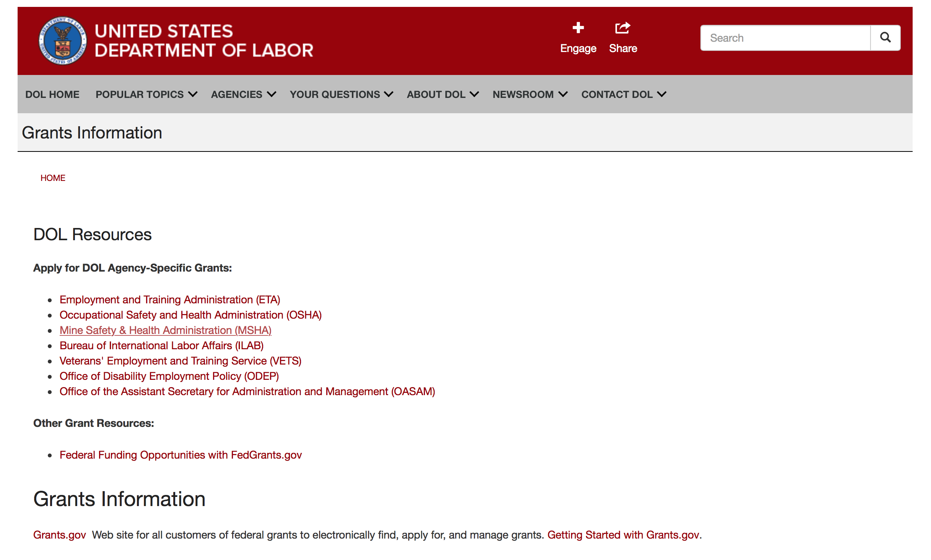

Agency Grants and Contract General Overview

DOL Resources
Apply for DOL Agency-Specific Grants:
- Employment and Training Administration (ETA)
- Occupational Safety and Health Administration (OSHA)
- Mine Safety & Health Administration (MSHA)
- Bureau of International Labor Affairs (ILAB)
- Veterans' Employment and Training Service (VETS)
- Office of Disability Employment Policy (ODEP)
- Office of the Assistant Secretary for Administration and Management (OASAM)

Other Grant Resources:
- Federal Funding Opportunities with FedGrants.gov
Grants Information
Grants.gov — Web site for all customers of federal grants to electronically find, apply for, and manage grants. Getting Started with Grants.gov.

DOL Resources and Instructions for Applying for a Grant
- DOL Guidance Clarifying the Effect of the Religious Freedom Restoration Act on Faith-Based Organizations
- Grant and Contract Information
- Contracting and Grant Program Overview
- Annual Acquisition Plan & Procurement Forecast
- Civil Rights Enforcement for Department of Labor Grant Recipients
- More Information About Grants
- Use of Contracts, Grants & Cooperative Agreements

Other Federal Government Grant Information
- List of Parties Excluded From Federal Procurement and Nonprocurement Programs (as created and maintained by GSA)
- Grant Opportunities (Catalog of Federal Domestic Assistance)

Department of Labor Grant Programs

- Bureau of International Labor Affairs (ILAB): provides grants (cooperative agreements) for the implementation of projects designed to assist developing countries combat the worse forms of child labor, forced labor, and human trafficking; and support worker rights and improve working conditions. http://www.dol.gov/general/business.
- Bureau of Labor Statistics (BLS): provides project grants (cooperative agreements) and the dissemination of technical statistical data and related information on labor force activities; provides data on prices (CPI) and cost of living; data on productivity and technology data; data on compensation and working conditions; data on employment projections.
- Employment and Training (ETA): ETA administers financial assistance programs pursuant to the Workforce Investment Act (WIA), administering State formula grant programs for youth, adults and dislocated workers, national emergency grants for workers affected by mass layoffs, plant closures, and disasters; grant programs for workers with disabilities, Indians and Native Americans, and for migrant and seasonal farmworkers. ETA also administers grant programs for older American workers, apprenticeship programs, Trade Adjustment Assistance (TAA) programs, and assistance for research and development of workforce programs. In addition, ETA is responsible for the operation and maintenance of a national system of public employment service offices and for the national unemployment insurance program.
- Mine Safety and Health (MSHA): provides grants for research, education and training programs to ensure an adequate and competent staff of trained inspectors; and assistance for establishing or improving State mine health and safety programs through technical assistance.
- Occupational Safety and Health (OSHA): provides grants to non-profit organizations to provide training, educational services, and technical assistance; assistance to states to administer and enforce state programs; assistance to states to provide occupational safety and health technical assistance and consultant services.
- Office of Disability Employment Policy (ODEP): The Office of Disability Employment Policy awards competitive grants establishing short-term pilot and technical assistance projects designed to identify, develop, test, evaluate, and disseminate policies to increase employment by expanding access to training, education, employment supports, assistive and systems technology, integrated employment, entrepreneurial development, and small business opportunities for adults and youth with disabilities. Current pilots projects focus on customized employment, Olmstead populations, and innovative demonstration youth grants, among others. Solicitations for grant applications are published in the Federal Register and announced at www.dol.gov/odep. ODEP grants are awarded by the OASAM grant office.
- Veterans' Employment and Training (VETS): provides special employment and training assistance for veterans through the Disabled Veterans' Outreach Program (DVOP) Solicitation for Grant Applications; the Local Veterans' Employment Representative Program (LVER); Veterans' Workforce Investment Program (VWIP); elaws Advisor on veterans' employment and reemployment rights; and the Homeless Veterans Reintegration Project (HVRP). VETS grants are awarded by the OASAM grant office.

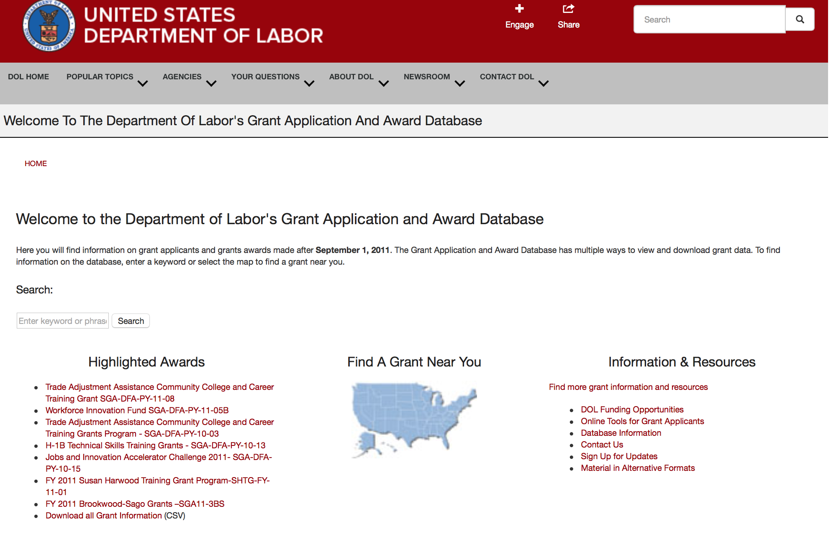

http://www.dol.gov/dol/grants/

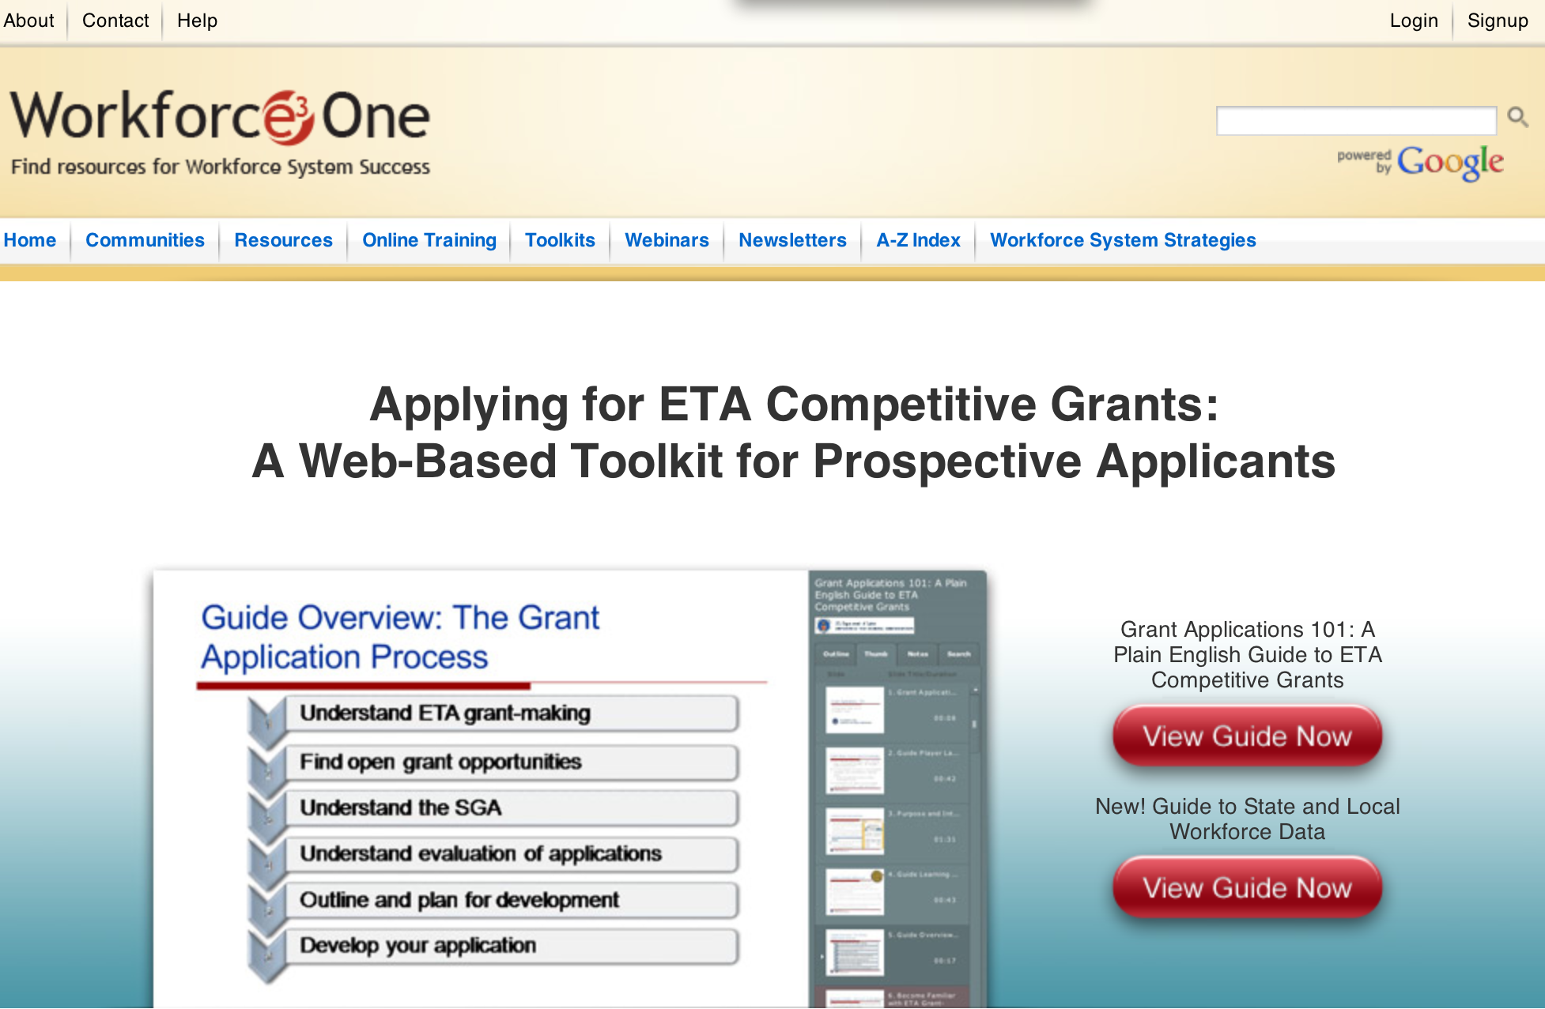

https://www.workforce3one.org/ws/www/pages/grants_toolkit.aspx?pparams=/

Programs

Employment and Training Administration
Summer Jobs and Beyond: Career Pathways for Youth (CPY) Grant

Document Type: | Grants Notice
Funding Opportunity Number: | FOA-ETA-16-08
Funding Opportunity Title: | Summer Jobs and Beyond: Career Pathways for Youth (CPY)
Opportunity Category: | Discretionary
Opportunity Category Explanation: | Category Explanation
Funding Instrument Type: | Grant
Category of Funding Activity: | Employment, Labor and Training
Category Explanation:
Expected Number of Awards: | 10
CFDA Number(s): | 17.280 -- WIA/WIOA Dislocated Worker National Reserve Demonstration Grants
Cost Sharing or Matching Requirement: | No
Posted Date: | Feb 04, 2016
Last Updated Date: | Feb 25, 2016
Original Closing Date for Applications: | Mar 25, 2016 Applications must be received no later than 4:00:00 p.m. Eastern Time.
Current Closing Date for Applications: | Mar 25, 2016 Applications must be received no later than 4:00:00 p.m. Eastern Time.
Archive Date: | Apr 24, 2016
Estimated Total Program Funding: | $20,000,000
Award Ceiling: | $2,000,000
Eligible Applicants: | Others (see text field entitled "Additional Information on Eligibility" for clarification)
Additional Information on Eligibility: | Eligible applicants are LWDBs. In states with a single state local area or where the State Workforce Development Board (SWDB) carries out the functions of a LWDB pursuant to a waiver, the SWDB is an eligible applicant. To be eligible for a CPY grant, applicants must administer an existing summer employment program or, if an LWDB-administered summer employment program does not exist, they must partner with an existing summer employment program that is not administered by a LWDB. Where multiple summer employment programs exist (including a LWDB-administered summer employment program), these grant funds may be used to align these programs.
Agency Name: | Employment and Training Administration
Description: | The Employment and Training Administration (ETA), U.S. Department of Labor (DOL, or the Department, or we), announces the availability of up to $20,000,000 in grant funds authorized by section 169(c) of the Workforce Innovation and Opportunity Act (WIOA), Public Law 113‐128, Dislocated Worker Demonstration Projects, and the Consolidated Appropriation Act of 2016, Public Law 114‐113 for the pilot grant program, Summer Jobs and Beyond: Career Pathways for Youth (CPY).The purpose of this program is to provide employment‐related services to eligible youth who are new entrants to the workforce, including those with limited current or past work experience. The program will provide youth with work experience opportunities, including summer and year‐round part‐time job opportunities for ISY and employment and work experience opportunities throughout the year for OSY, and exposure to career pathways in in‐demand job sectors. This program will fund projects designed to link existing summer employment programs, including the LWDB‐administered local summer employment programs and non‐LWDB programs run by cities/counties (where they exist), with LEAs, re‐engagement centers (where they exist), employers, and other community partners to streamline service delivery, align resources, and assist youth in preparing for successful entry into the workforce. To be eligible for a CPY grant, applicants must administer an existing summer employment program or partner with an existing summer employment program that is not administered by the LWDB. The Department expects that most LWDB‐administered programs will be WIOA‐funded.
Link to Additional Information:
Contact Information: | If you have difficulty accessing the full announcement electronically, please contact:  Janice Sheelor Grants Management Specialist  sheelor.janice@dol.gov

http://www.grants.gov/web/grants/view-opportunity.html?oppId=281342

Employment and Training Administration
Veterans Employment and Training Service
Urban and Non-Urban Homeless Veterans’ Reintegration Program (HVRP) and Incarcerated Veterans Transition Program (IVTP) (referred together throughout this funding opportunity announcement as HVRP) Grant
Document Type: | Grants Notice
Funding Opportunity Number: | FOA-VETS-16-01
Funding Opportunity Title: | Urban and Non-Urban Homeless Veterans’ Reintegration Program (HVRP) and Incarcerated Veterans Transition Program (IVTP) (referred together throughout this funding opportunity announcement as HVRP)
Opportunity Category: | Discretionary
Opportunity Category Explanation:
Funding Instrument Type: | Grant
Category of Funding Activity: | Other (see text field entitled "Explanation of Other Category of Funding Activity" for clarification)
Category Explanation: | Veterans’ Employment and Training Service
Expected Number of Awards: | 32
CFDA Number(s): | 17.805 -- Homeless Veterans Reintegration Project
Cost Sharing or Matching Requirement: | No
Posted Date: | Feb 22, 2016
Last Updated Date: | Feb 22, 2016
Original Closing Date for Applications: | Mar 23, 2016 The application must be received no later than 4:00:00 p.m. Eastern Time.
Current Closing Date for Applications: | Mar 23, 2016 The application must be received no later than 4:00:00 p.m. Eastern Time.
Archive Date: | Apr 22, 2016
Estimated Total Program Funding: | $13,000,000
Award Ceiling: | $300,000
Award Floor: | $100,000
Eligible Applicants: | Others (see text field entitled "Additional Information on Eligibility" for clarification)
Additional Information on Eligibility: | • State and Local Workforce Development Boards (SWDBs/LWDBs) established under the Workforce Innovation and Opportunity Act (WIOA) • States or general purpose political subdivisions of a State that have the power to levy taxes and spend funds, such as a city or a county. Additionally, public agencies of such States or general purpose political subdivisions. • Federally-recognized Indian and Native American tribes; tribal organizations, as defined in 25 U.S.C. 450b; Alaskan Native-controlled organizations; and Native Hawaiian controlled organizations. • For-profit/commercial entities. • Non-profit organizations, including community and faith-based organizations. Non-profit entities incorporated under Internal Revenue Service Code Section 501(c)(4) are ineligible.
Agency Name: | Veterans Employment and Training Service
Description: | The U.S. Department of Labor (USDOL), Veterans’ Employment and Training Service (VETS), announces the availability of approximately $13 million in grant funds authorized under Title 38 of United States Code (U.S.C.), Sections 2021 and 2023. Consistent with the Opening Doors national campaign directed by the U.S. Interagency Council on Homelessness (USICH), the purpose of these funds is to conduct programs to provide job training, counseling, placement, and related services to expedite the reintegration of homeless and incarcerated veterans (eligible veterans) into the labor force. As the applicant, you are encouraged to design programs that address the employment challenges faced by eligible veterans in consultation with industry, employers and employer associations to identify the skills needed for in-demand jobs and careers. Applications selected for funding will demonstrate the following: • Ability to develop and execute strategies with attainable goals for job-driven training based on Labor Market Information and evidence-based successful practices. • Ability to collaborate and coordinate with community-based organizations to ensure that local, state, and federal resources are used effectively and efficiently to expedite the reintegration of eligible veterans into the labor force. • Ability to deliver or connect participants to effective job training, counseling, and other related services, such as the provision of housing and needed health services as means for expediting the reintegration of eligible veterans into the labor force. • Ability to provide effective services to female homeless veterans and homeless veterans with families. • Ability to provide effective services to incarcerated or recently incarcerated veterans who are at risk of homelessness.
Link to Additional Information:
Contact Information: | If you have difficulty accessing the full announcement electronically, please contact:  Ashley Hoek Grants Management Specialist  Hoek.Ashley.A@dol.gov

http://www.grants.gov/web/grants/view-opportunity.html?oppId=281708

Modifications

Employment and Training Administration
Tech Hire Partnership Grants
Modification 2

Document Type: | Grants Notice
Funding Opportunity Number: | FOA-ETA-16-01
Funding Opportunity Title: | Tech Hire Partnership Grants
Opportunity Category: | Discretionary
Opportunity Category Explanation:
Funding Instrument Type: | Grant
Category of Funding Activity: | Employment, Labor and Training
Category Explanation:
Expected Number of Awards: | 35
CFDA Number(s): | 17.268 -- H-1B Job Training Grants
Cost Sharing or Matching Requirement: | No
Posted Date: | Nov 17, 2015
Last Updated Date: | Feb 24, 2016
Original Closing Date for Applications: | Mar 11, 2016 Applications must be received no later than 4:00:00 p.m. Eastern Time.
Current Closing Date for Applications: | Mar 11, 2016 Applications must be received no later than 4:00:00 p.m. Eastern Time.
Archive Date: | Apr 10, 2016
Estimated Total Program Funding: | $100,000,000
Award Ceiling: | $5,000,000
Award Floor: | $2,000,000
Eligible Applicants: | Others (see text field entitled "Additional Information on Eligibility" for clarification)
Additional Information on Eligibility: | Grants will be awarded to the lead applicant, which will serve as the grantee and have overall fiscal and administrative responsibility for the grant. Eligible lead applicants must be public or non-profit organizations that: 1) meet the definition of one of the three types of eligible entities described below; and 2) apply in partnership with at least one representative of each of the three types of eligible entities (including the lead applicant), which collectively form the “primary partnership.” An eligible entity cannot serve as more than one type of entity for the purpose of meeting the requirements to include three types of entities in the primary partnership. To be eligible for consideration, applications must include at least one representative of each of the following three types of entities: a) the workforce investment system; b) education and training providers; and c) business-related nonprofit organizations, an organization functioning as a workforce intermediary for the express purpose of serving the needs of businesses, or a consortium of three or more businesses, or at least three independent businesses. Applications that do not include all three entities mentioned above will be considered non-responsive and will not be reviewed. Detailed eligibility requirements for each type of entity are provided in Section III of the announcement.
Agency Name: | Employment and Training Administration
Description: | The Employment and Training Administration (ETA), U.S. Department of Labor (DOL, or the Department, or we), announces the availability of approximately $100,000,000 in grant funds for the TechHire partnership grant program. This grant program is designed to equip individuals with the skills they need through innovative approaches that can rapidly train workers for and connect them to well-paying, middle- and high-skilled, and high-growth jobs across a diversity of H-1B industries such as Information Technology (IT), healthcare, advanced manufacturing, financial services, and broadband. Projects funded by this grant program will help participants begin careers in H-1B occupations and industries which are in-demand and/or high growth in the area applicants are proposing to serve. On a limited basis, this grant program will also enable applicants to work with companies on increasing the skills of existing workers in lower-skilled jobs to move into more highly skilled positions requiring technology-related skills. These grants will pilot and scale public-private partnerships among the workforce investment system, education and training providers, and business-related nonprofit organizations to address the following goals for the target populations: 1) Expand access to accelerated learning options that provide the fastest paths to good jobs, such as “bootcamp” style programs, online options, and competency-based programs to give people the skills required for employment in three months to two years among people with historic barriers to accessing employment and training;2) Improve the likelihood that those populations complete training and enter employment, through specialized training strategies, supportive services and other focused participant services that assist targeted populations to overcome barriers, including networking and job search, active job development, transportation, mentoring, and financial counseling; 3) Connect those who have received training or who already have the skills required for employment, but are being overlooked, to employment, paid internships, or Registered Apprenticeship opportunities that allow them to get work experience and prove themselves to hiring employers; 4) Demonstrate strong commitment to customer-centered design and excellence in customer experience, so that the programs and services reflect real need of employers and participants, through human centered design methodology and other methods of design thinking; and 5) Ensure that innovations form the basis for broader change and sustainability over time and that a clear strategy exists for adapting to rapidly changing market needs after the initial period of the grant.
Link to Additional Information:
Contact Information: | If you have difficulty accessing the full announcement electronically, please contact:  Aiyana Pucci Grants Management Specialist  pucci.aiyana@dol.gov

http://www.grants.gov/web/grants/view-opportunity.html?oppId=280094

Reminders

Employment and Training Administration
Strengthening Working Families Initiative Grant
And Modification 1

Document Type: | Grants Notice
Funding Opportunity Number: | FOA-ETA-16-05
Funding Opportunity Title: | Strengthening Working Families Initiative
Opportunity Category: | Discretionary
Funding Instrument Type: | Grant
Category of Funding Activity: | Employment, Labor and Training
Category Explanation:
Expected Number of Awards: | 10
CFDA Number(s): | 17.268 -- H-1B Job Training Grants
Cost Sharing or Matching Requirement: | No
Posted Date: | Dec 17, 2015
Creation Date: | Dec 17, 2015
Original Closing Date for Applications: | Mar 16, 2016 Applications must be received no later than 4:00:00 p.m. Eastern Time.
Current Closing Date for Applications: | Mar 16, 2016 Applications must be received no later than 4:00:00 p.m. Eastern Time.
Archive Date: | Apr 15, 2016
Estimated Total Program Funding: | $25,000,000
Award Ceiling: | $4,000,000
Award Floor: | $0
Eligible Applicants: | Others (see text field entitled "Additional Information on Eligibility" for clarification)
Additional Information on Eligibility: | In keeping with the authority provided by Congress under Section 414 (c) of ACWIA, grants will be awarded to the lead applicant of a public and private partnership of entities that includes: • The public workforce investment system; • Education and training providers, such as community colleges, community-based and faith-based organizations, and “bootcamp” style tech programs; and • Business entities. Applications must include significant employer engagement, including a minimum of at least three employer partners, or an employer or regional industry association consisting of at least three employers, with demonstrated engagement in the project. Additional partners that reflect the character and resources of the local or regional economy and the community are strongly encouraged.
Agency Name: | Employment and Training Administration
Description: | This announcement solicits applications for the Strengthening Working Families Initiative (SWFI) grant program. On June 23, 2014, President Obama convened the White House Summit on Working Families, which was jointly hosted by the Department of Labor, Center for American Progress and the White House Council on Women and Girls. During the Summit, participants (including businesses, economists, labor leaders, legislators, advocates, the media and ordinary citizens) discussed issues that working families face. The Summit was the beginning of a larger conversation about the changes necessary in society, business policies, and in our laws to ensure that all Americans have the opportunity to have a job and a family. Working parents, particularly those with low incomes and low skills, face significant barriers to employment. Six out of ten households with children have all parents working (married working or single working parents), increasing the need for affordable and quality child care. With more parents working, greater access to affordable, high-quality child care is needed but is difficult to find due to steadily increasing child care costs and relatively stagnant funding to cover the costs of child care. Even where affordable child care exists, parents have to deal with unpredictable situations where child care may be unavailable, such as when their child is sick, the child care provider is closed, they are attending professional development sessions, and other emergencies that may result in parents needing alternative solutions. Additionally, an increasing number of families have employers who shift the family member’s work schedule with minimal notice, making stable child care harder to find. It can be difficult to handle these unexpected situations, particularly for low-wage workers who cannot afford to take unpaid leave and are less likely to have flexibility in the workplace. While training and education can help move parents into better paying jobs, some of the barriers to employment also serve as barriers to training and education. The lack of access to affordable and consistent child care can keep parents from attending training and educational programs. Of the 21 million low-income parents, only 1 in 10 participates in education and training. For those low-income parents participating in education and training, almost half were working at the same time, resulting in the additional burden of arranging for and paying the cost of child care while at work, while in training, and while commuting. As education and earnings are strongly linked, this FOA supports providing access to education and training to help move parents along a career pathway that will lead to better paying jobs. This FOA also encourages applicants to develop an approach that provides skills training leading to family-supporting jobs for low- to middle-skilled parents while simultaneously developing and implementing a plan for the applicant’s community or region that helps families better navigate the existing complex systems of supportive services, including increased access to child care. To help meet these objectives, the Department is interested in supporting evidence-based strategies or innovations based on these models that remove a range of barriers to training, including child care and other needs that working families face, by investing in education and skills training in combination with customized participant supportive services. Of particular interest are new promising ideas developed through human centered design methodology and behavioral insight research. Program strategies must include moving lower- to middle-skilled individuals into middle- to high-skilled jobs, with the goals of increasing family-supporting wages and enabling the success of the parent. In particular, the Department is interested in supporting parents – defined as custodial parent, legal guardian, foster parent, or other person standing in loco parentis – who face a barrier to training, including child care and other participant supportive service needs, and are in need of increasing skills and competencies that will either prepare them for entry into an H-1B-aligned career pathway or advancement along an H-1B-aligned career pathway and into middle- or high-skilled jobs. Through this FOA, the Department aims to address education and training barriers for low- to middle-skilled parents by prioritizing the needs of this targeted population; addressing child care needs for parents seeking education and training; increasing access to child care resources; and bridging the gap between the workforce development and child care systems. As applicants design their training strategies to meet the needs of working parents, they should consider the delivery methods and scheduling of training as important factors in providing the flexibility that working parents may require for participation in training. This may include adjusting curriculum design to provide flexible course offerings, expanding asynchronous learning options, or providing online courses. It could also include delivering training through banded schedules to enable parents to accommodate their work schedules and make it easier for working parents to make child care arrangements. Another possibility is the inclusion of training onsite at the workplace, particularly if child care is provided in the same location. An important element of this FOA is the need for communities to address how local areas will help parents navigate complex systems and access the child care services they need. The SWFI grants will provide the platform for strengthening partnerships between systems (workforce training providers and child care providers) to ensure consistency in care and flexibility in services. To support these efforts, applicants are required to leverage cash or in-kind resources amounting to at least 25 percent of the total award.
Link to Additional Information:
Contact Information: | If you have difficulty accessing the full announcement electronically, please contact:  Elizabeth DeHart Grants Management Specialist  dehart.elizabeth@dol.gov

http://www.grants.gov/web/grants/view-opportunity.html?oppId=280609

Employment and Training Administration
Tech Hire Partnership Grants

Document Type: | Grants Notice
Funding Opportunity Number: | FOA-ETA-16-01
Funding Opportunity Title: | Tech Hire Partnership Grants
Opportunity Category: | Discretionary
Funding Instrument Type: | Grant
Category of Funding Activity: | Employment, Labor and Training
Category Explanation:
Expected Number of Awards: | 35
CFDA Number(s): | 17.268 -- H-1B Job Training Grants
Cost Sharing or Matching Requirement: | No
Posted Date: | Nov 17, 2015
Creation Date: | Nov 17, 2015
Original Closing Date for Applications: | Mar 11, 2016 Applications must be received no later than 4:00:00 p.m. Eastern Time.
Current Closing Date for Applications: | Mar 11, 2016 Applications must be received no later than 4:00:00 p.m. Eastern Time.
Archive Date: | Apr 10, 2016
Estimated Total Program Funding: | $100,000,000
Award Ceiling: | $5,000,000
Award Floor: | $2,000,000
Eligible Applicants: | Others (see text field entitled "Additional Information on Eligibility" for clarification)
Additional Information on Eligibility: | Grants will be awarded to the lead applicant, which will serve as the grantee and have overall fiscal and administrative responsibility for the grant. Eligible lead applicants must be public or non-profit organizations that: 1) meet the definition of one of the three types of eligible entities described below; and 2) apply in partnership with at least one representative of each of the three types of eligible entities (including the lead applicant), which collectively form the “primary partnership.” An eligible entity cannot serve as more than one type of entity for the purpose of meeting the requirements to include three types of entities in the primary partnership. To be eligible for consideration, applications must include at least one representative of each of the following three types of entities: a) the workforce investment system; b) education and training providers; and c) business-related nonprofit organizations, an organization functioning as a workforce intermediary for the express purpose of serving the needs of businesses, or a consortium of three or more businesses, or at least three independent businesses. Applications that do not include all three entities mentioned above will be considered non-responsive and will not be reviewed. Detailed eligibility requirements for each type of entity are provided in Section III of the announcement.
Agency Name: | Employment and Training Administration
Description: | The Employment and Training Administration (ETA), U.S. Department of Labor (DOL, or the Department, or we), announces the availability of approximately $100,000,000 in grant funds for the TechHire partnership grant program. This grant program is designed to equip individuals with the skills they need through innovative approaches that can rapidly train workers for and connect them to well-paying, middle- and high-skilled, and high-growth jobs across a diversity of H-1B industries such as Information Technology (IT), healthcare, advanced manufacturing, financial services, and broadband. Projects funded by this grant program will help participants begin careers in H-1B occupations and industries, which are in-demand, and/or high growth in the area applicants are proposing to serve. On a limited basis, this grant program will also enable applicants to work with companies on increasing the skills of existing workers in lower-skilled jobs to move into more highly skilled positions requiring technology-related skills. These grants will pilot and scale public-private partnerships among the workforce investment system, education and training providers, and business-related nonprofit organizations to address the following goals for the target populations: 1) Expand access to accelerated learning options that provide the fastest paths to good jobs, such as “bootcamp” style programs, online options, and competency-based programs to give people the skills required for employment in three months to two years among people with historic barriers to accessing employment and training; 2) Improve the likelihood that those populations complete training and enter employment, through specialized training strategies, supportive services and other focused participant services that assist targeted populations to overcome barriers, including networking and job search, active job development, transportation, mentoring, and financial counseling; 3) Connect those who have received training or who already have the skills required for employment, but are being overlooked, to employment, paid internships, or Registered Apprenticeship opportunities that allow them to get work experience and prove themselves to hiring employers; 4) Demonstrate strong commitment to customer-centered design and excellence in customer experience, so that the programs and services reflect real need of employers and participants, through human centered design methodology and other methods of design thinking; and 5) Ensure that innovations form the basis for broader change and sustainability over time and that a clear strategy exists for adapting to rapidly changing market needs after the initial period of the grant.
Link to Additional Information:
Contact Information: | If you have difficulty accessing the full announcement electronically, please contact:  Aiyana Pucci Grants Management Specialist  pucci.aiyana@dol.gov

This amendment provides a link to the prospective applicant webinar, clarifies language in Section IV.B.3., and clarifies language in Sections IV.E. and IV.E.7.

http://www.grants.gov/web/grants/view-opportunity.html?oppId=280094



National Aeronautics and Space Administration

Research and Contracting Opportunities

NASA Research Opportunities Online

- Various NASA offices publish their research announcements over the Internet, broadening the opportunity for researchers to apply for funding. This site provides access to current research announcements along with their specific due dates.

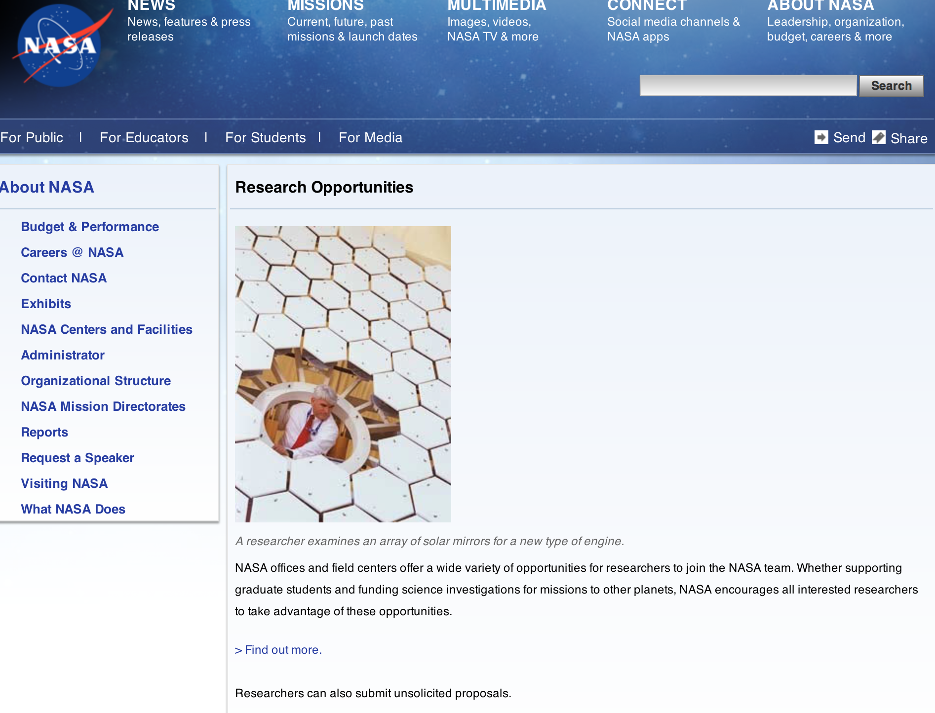

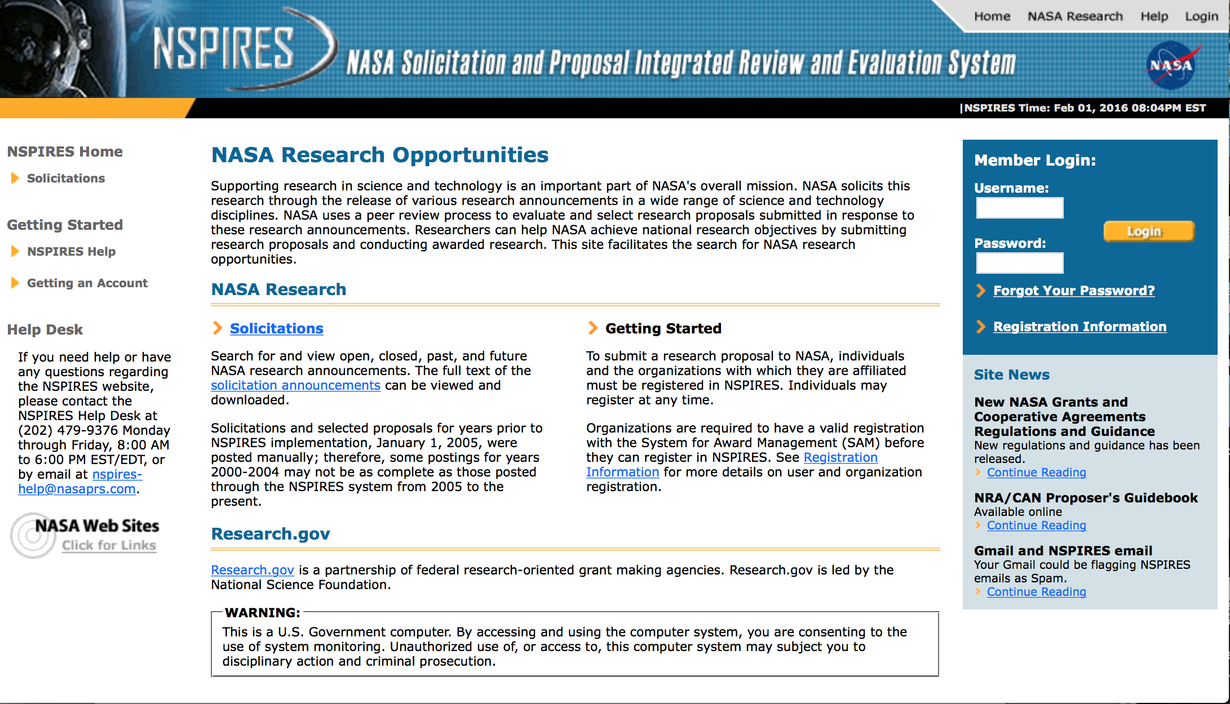

http://nspires.nasaprs.com/external/

Programs

NASA Headquarters
EARLY CAREER FACULTY (ECF) Grant
http://www.grants.gov/web/grants/view-opportunity.html?oppId=281506

NASA Headquarters
RESEARCH OPPORTUNITIES IN SPACE AND EARTH SCIENCES – 2016 (ROSES-2016) Grant
http://www.grants.gov/web/grants/view-opportunity.html?oppId=281709

NASA Headquarters
ROSES 2015: Understanding Changes in High Mountain Asia Grant
http://www.grants.gov/web/grants/view-opportunity.html?oppId=281734

NASA Headquarters
ROSES 2016: Solar System Observations Grant
http://www.grants.gov/web/grants/view-opportunity.html?oppId=281849

Modifications:

NASA Headquarters
ROSES 2016: Heliophysics Guest Investigators - Open
Modification 1
http://www.grants.gov/web/grants/view-opportunity.html?oppId=281740

National Archives and Records Administration

Grant Opportunities General Overview

To access the information below: click here

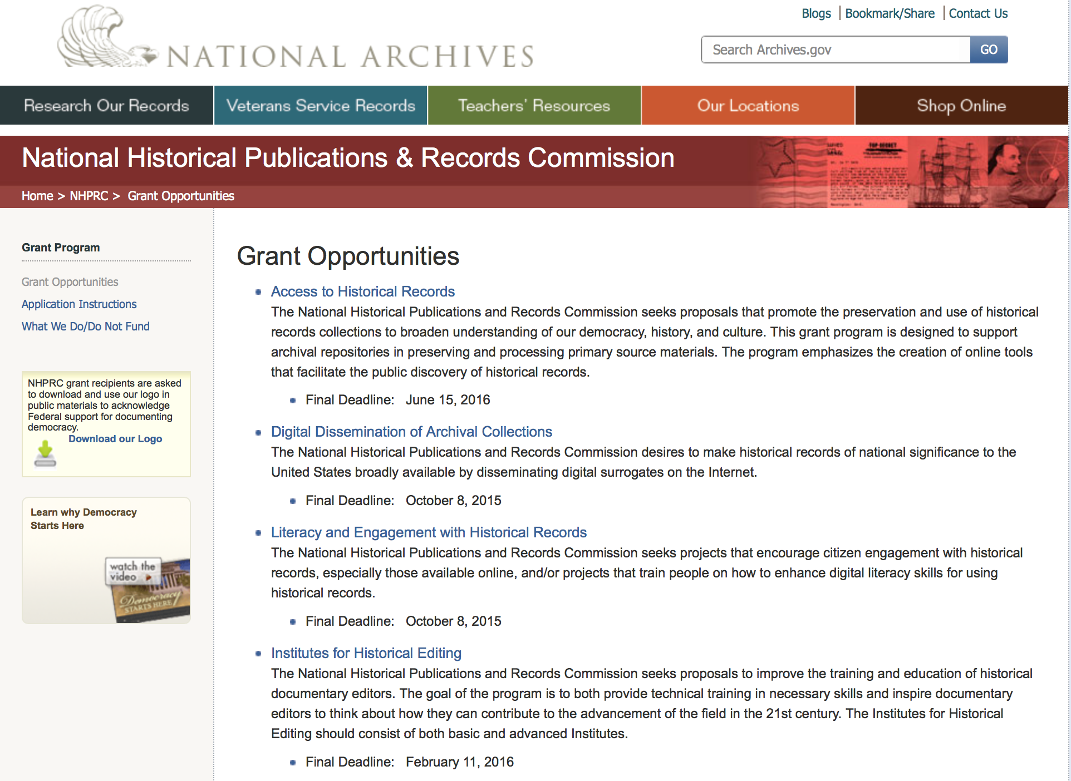

Reminders:

State Board Programming Grants

Document Type: | Grants Notice
Funding Opportunity Number: | STATE-201606
Funding Opportunity Title: | State Board Programming Grants
Opportunity Category: | Discretionary
Funding Instrument Type: | Grant
Category of Funding Activity: | Humanities (see "Cultural Affairs" in CFDA)
Category Explanation:
Expected Number of Awards: | 25
CFDA Number(s): | 89.003 -- National Historical Publications and Records Grants
Cost Sharing or Matching Requirement: | Yes
Posted Date: | Nov 24, 2015
Creation Date: | Nov 23, 2015
Original Closing Date for Applications: | Jun 15, 2016
Current Closing Date for Applications: | Jun 15, 2016
Archive Date: | Jul 15, 2016
Estimated Total Program Funding: | $650,000
Award Ceiling: | $80,000
Award Floor: | $0
Eligible Applicants: | State governments  Public and State controlled institutions of higher education  Others (see text field entitled "Additional Information on Eligibility" for clarification)  Nonprofits having a 501(c)(3) status with the IRS, other than institutions of higher education
Additional Information on Eligibility: | These grants are awarded only to SHRABs in each state, or to the state agency responsible for the SHRAB, ordinarily the state archives. Another state agency, or a non-profit organization, such as a foundation or university, acting on behalf of the designated state agency may apply. States also include the District of Columbia, the Commonwealth of Puerto Rico, and United States territories.
Agency Name: | National Archives and Records Administration
Description: | The National Historical Publications and Records Commission seeks proposals that strengthen the nation’s archival network through activities undertaken by state historical records advisory boards (SHRABs). The purpose of this grant program is to assist state boards to enhance access to historical records, increase citizen engagement with records, and provide learning and development opportunities for students, citizens and professional archivists. The Commission will award grants to State Historical Records Advisory Boards to: • Provide educational and outreach programs, workshops, and other activities that enhance citizen and student engagement with historical records • Operate state-based regrant and scholarship programs that advance access to historical records • Collaborate on projects with other organizations to address common problems or shared opportunities within a state or among a consortium of state archives • Hold or participate in meetings and public forums on statewide or national archival issues. For a comprehensive list of Commission limitations on funding, please see What We Do and Do Not Fund. Applications that consist entirely of ineligible activities will not be considered. Award Information A grant is for one year and for up to $40,000 or for two years and for up to $80,000. The NHPRC expects to award approximately 25 grants in this program. The total amount allocated for this program is up to $650,000. Grants begin no earlier than January 1, 2017. The Commission requires that grant recipients acknowledge NHPRC grant assistance in all publicity, publications, and other products that result from its support. Eligibility These grants are awarded only to SHRABs in each state, or to the state agency responsible for the SHRAB, ordinarily the state archives. Another state agency, or a non-profit organization, such as a foundation or university, acting on behalf of the designated state agency may apply. States also include the District of Columbia, the Commonwealth of Puerto Rico, and United States territories. Cost Sharing The total costs of a project are shared between the NHPRC and the applicant organization. The Commission provides no more than 75 per cent of total direct project costs in the State Board Programming Grants category. NHPRC grant recipients are not permitted to use grant funds for indirect costs (as indicated in 2 CFR 2600.101). Cost sharing is required. The applicant’s financial contribution may include both direct and indirect expenses, in-kind contributions, non-Federal third-party contributions, and any income earned directly by the project. Indirect costs must be listed under the applicant’s cost sharing contribution. Other Requirements Applicant organizations must be registered in System for Award Management (SAM) prior to submitting an application, maintain SAM registration throughout the application and award process, and include a valid DUNS number in their application. Details on SAM registration and requesting a DUNS number can be found at the System for Award Management website at https://sam.gov. Please refer to the User Guides section and the Grants Registrations PDF. A complete application includes the Application for Federal Assistance (Standard Form 424), Assurances - Non-Construction Programs (Standard Form 424B), a Project Narrative, Summary, Supplementary Materials, and Budget. Applications lacking these items will not be considered. Ineligible applications will not be reviewed.
Link to Additional Information: | Link to full grant announcement, including additional requirements
Contact Information: | If you have difficulty accessing the full announcement electronically, please contact:  Jeff de la Concepcion Grant Program Specialist Phone 202-357-5022  Grant Program Specialist

http://www.grants.gov/web/grants/view-opportunity.html?oppId=280200

Publishing Historical Records in Documentary Editions Grant

Document Type: | Grants Notice
Funding Opportunity Number: | EDITIONS-201606
Funding Opportunity Title: | Publishing Historical Records in Documentary Editions
Opportunity Category: | Discretionary
Funding Instrument Type: | Grant
Category of Funding Activity: | Humanities (see "Cultural Affairs" in CFDA)
Category Explanation:
Expected Number of Awards: | 25
CFDA Number(s): | 89.003 -- National Historical Publications and Records Grants
Cost Sharing or Matching Requirement: | Yes
Posted Date: | Nov 24, 2015
Creation Date: | Nov 23, 2015
Original Closing Date for Applications: | Jun 15, 2016
Current Closing Date for Applications: | Jun 15, 2016
Archive Date: | Jul 15, 2016
Estimated Total Program Funding: | $2,500,000
Award Ceiling: | $200,000
Award Floor: | $0
Eligible Applicants: | County governments  Native American tribal governments (Federally recognized)  City or township governments  Private institutions of higher education  Nonprofits having a 501(c)(3) status with the IRS, other than institutions of higher education  State governments  Public and State controlled institutions of higher education
Agency Name: | National Archives and Records Administration
Description: | The National Historical Publications and Records Commission seeks proposals to publish documentary editions of historical records. Projects may focus on the papers of major figures from American history or cover broad historical movements in politics, military, business, social reform, the arts, and other aspects of the national experience. The historical value of the records and their expected usefulness to broad audiences must justify the costs of the project. The goal of this program is to provide access to, and editorial context for, the historical documents and records that tell the American story. The NHPRC encourages projects, whenever possible and appropriate, to provide access to these materials in a free and open online environment, without precluding other forms of publication. Applicants should demonstrate familiarity with the best practices recommended by the Association for Documentary Editing or the Modern Language Association Committee on Scholarly Editions. Projects may also prepare print editions as part of their overall publishing plan. However, projects that do not have definitive plans for digital dissemination and preservation in place at the time of application will not be considered. It is also expected that the contents of any print volumes produced will be made available online within a reasonable period of time following print publication. Grants are awarded for collecting, describing, preserving, compiling, transcribing, annotating, editing, encoding, and publishing documentary source materials in print and online. Because of the focus on documentary sources, grants do not support preparation of critical editions of published works unless such works are just a small portion of the larger project. All applicants should be aware that the application process is highly competitive. Ongoing projects: Applicants from ongoing projects must demonstrate that they have successfully achieved the performance objectives associated with previous NHPRC awards; provide updated, current information, including a description of the new activities as well as description and significance of the specific materials to be edited during the proposed grant period; show progress towards completing the edition; and justify costs in a new budget. For a comprehensive list of Commission's limitations on funding, please see What We Do and Do Not Fund. Applications that consist entirely of ineligible activities will not be considered. Award Information A grant is for one year and for up to $200,000. The Commission expects to make up to 25 grants in this category for a total of up to $2,500,000. Grants begin no earlier than January 1, 2017. The Commission requires that grant recipients acknowledge NHPRC grant assistance in all publications and other products that result from its support. Eligibility U.S. nonprofit organizations or institutions U.S. colleges, universities, and other academic institutions State or local government agencies Federally-acknowledged or state-recognized Native American tribes or groups Cost Sharing The total costs of a project are shared between the NHPRC and the applicant organization. The Commission provides no more than 50 per cent of total direct project costs in the Publishing Historical Records in Documentary Editions category. NHPRC grant recipients are not permitted to use grant funds for indirect costs (as indicated in 2 CFR 2600.101). Cost sharing is required. The applicant’s financial contribution may include both direct and indirect expenses, in-kind contributions, non-Federal third-party contributions, and any income earned directly by the project. Indirect costs must be listed under the applicant’s cost sharing contribution. Other Requirements Applicant organizations must be registered in the System for Award Management (SAM) prior to submitting an application, maintain SAM registration throughout the application and award process, and include a valid DUNS number in their application. Details on SAM registration and requesting a DUNS number can be found at the System for Award Management website at https://sam.gov. Please refer to the User Guides section and the Grants Registrations PDF. A complete application includes the Application for Federal Assistance (Standard Form 424), Assurances -- Non-Construction Programs (Standard Form 424B), a Project Narrative, Summary, Supplementary Materials, and Budget. Applications lacking these items will not be considered. Ineligible applications will not be reviewed.
Link to Additional Information: | Link to full grant announcement, including additional requirements
Contact Information: | If you have difficulty accessing the full announcement electronically, please contact:  Jeff de la Concepcion Grant Program Specialist Phone 202-357-5022  Grant Program Specialist

http://www.grants.gov/web/grants/view-opportunity.html?oppId=280201

Publishing Historical Records in Documentary Editions Grant

Document Type: | Grants Notice
Funding Opportunity Number: | EDITIONS-201610
Funding Opportunity Title: | Publishing Historical Records in Documentary Editions
Opportunity Category: | Discretionary
Funding Instrument Type: | Grant
Category of Funding Activity: | Humanities (see "Cultural Affairs" in CFDA)
Category Explanation:
Expected Number of Awards: | 25
CFDA Number(s): | 89.003 -- National Historical Publications and Records Grants
Cost Sharing or Matching Requirement: | Yes
Posted Date: | Nov 24, 2015
Creation Date: | Nov 23, 2015
Original Closing Date for Applications: | Oct 6, 2016
Current Closing Date for Applications: | Oct 6, 2016
Archive Date: | Nov 4, 2016
Estimated Total Program Funding: | $2,500,000
Award Ceiling: | $200,000
Award Floor: | $0
Eligible Applicants: | Private institutions of higher education  County governments  City or township governments  Public and State controlled institutions of higher education  Native American tribal governments (Federally recognized)  Nonprofits having a 501(c)(3) status with the IRS, other than institutions of higher education  State governments
Agency Name: | National Archives and Records Administration
Description: | The National Historical Publications and Records Commission seeks proposals to publish documentary editions of historical records. Projects may focus on the papers of major figures from American history or cover broad historical movements in politics, military, business, social reform, the arts, and other aspects of the national experience. The historical value of the records and their expected usefulness to broad audiences must justify the costs of the project. The goal of this program is to provide access to, and editorial context for, the historical documents and records that tell the American story. The NHPRC encourages projects, whenever possible and appropriate, to provide access to these materials in a free and open online environment, without precluding other forms of publication. Applicants should demonstrate familiarity with the best practices recommended by the Association for Documentary Editing or the Modern Language Association Committee on Scholarly Editions. Projects may also prepare print editions as part of their overall publishing plan. However, projects that do not have definitive plans for digital dissemination and preservation in place at the time of application will not be considered. It is also expected that the contents of any print volumes produced will be made available online within a reasonable period of time following print publication. Grants are awarded for collecting, describing, preserving, compiling, transcribing, annotating, editing, encoding, and publishing documentary source materials in print and online. Because of the focus on documentary sources, grants do not support preparation of critical editions of published works unless such works are just a small portion of the larger project. All applicants should be aware that the application process is highly competitive. Ongoing projects: Applicants from ongoing projects must demonstrate that they have successfully achieved the performance objectives associated with previous NHPRC awards; provide updated, current information, including a description of the new activities as well as description and significance of the specific materials to be edited during the proposed grant period; show progress towards completing the edition; and justify costs in a new budget. For a comprehensive list of Commission's limitations on funding, please see What We Do and Do Not Fund. Applications that consist entirely of ineligible activities will not be considered. Award Information A grant is for one year and for up to $200,000. The Commission expects to make up to 25 grants in this category for a total of up to $2,500,000. Grants begin no earlier than January 1, 2017. The Commission requires that grant recipients acknowledge NHPRC grant assistance in all publications and other products that result from its support. Eligibility U.S. nonprofit organizations or institutions U.S. colleges, universities, and other academic institutions State or local government agencies Federally-acknowledged or state-recognized Native American tribes or groups Cost Sharing The total costs of a project are shared between the NHPRC and the applicant organization. The Commission provides no more than 50 per cent of total direct project costs in the Publishing Historical Records in Documentary Editions category. NHPRC grant recipients are not permitted to use grant funds for indirect costs (as indicated in 2 CFR 2600.101). Cost sharing is required. The applicant’s financial contribution may include both direct and indirect expenses, in-kind contributions, non-Federal third-party contributions, and any income earned directly by the project. Indirect costs must be listed under the applicant’s cost sharing contribution. Other Requirements Applicant organizations must be registered in the System for Award Management (SAM) prior to submitting an application, maintain SAM registration throughout the application and award process, and include a valid DUNS number in their application. Details on SAM registration and requesting a DUNS number can be found at the System for Award Management website at https://sam.gov. Please refer to the User Guides section and the Grants Registrations PDF. A complete application includes the Application for Federal Assistance (Standard Form 424), Assurances -- Non-Construction Programs (Standard Form 424B), a Project Narrative, Summary, Supplementary Materials, and Budget. Applications lacking these items will not be considered. Ineligible applications will not be reviewed.
Link to Additional Information: | Link to full grant announcement, including additional requirements
Contact Information: | If you have difficulty accessing the full announcement electronically, please contact:  Jeff de la Concepcion Grant Program Specialist Phone 202-357-5022  Grant Program Specialist

http://www.grants.gov/web/grants/view-opportunity.html?oppId=280202

Access to Historical Records Grant

Document Type: | Grants Notice
Funding Opportunity Number: | ACCESS-201606
Funding Opportunity Title: | Access to Historical Records
Opportunity Category: | Discretionary
Funding Instrument Type: | Grant
Category of Funding Activity: | Humanities (see "Cultural Affairs" in CFDA)
Category Explanation:
Expected Number of Awards: | 14
CFDA Number(s): | 89.003 -- National Historical Publications and Records Grants
Cost Sharing or Matching Requirement: | Yes
Posted Date: | Nov 24, 2015
Creation Date: | Nov 23, 2015
Original Closing Date for Applications: | Jun 15, 2016
Current Closing Date for Applications: | Jun 15, 2016
Archive Date: | Jul 15, 2016
Estimated Total Program Funding: | $1,000,000
Award Ceiling: | $200,000
Eligible Applicants: | Public and State controlled institutions of higher education  State governments  City or township governments  Nonprofits having a 501(c)(3) status with the IRS, other than institutions of higher education  Private institutions of higher education  Native American tribal governments (Federally recognized)  County governments
Agency Name: | National Archives and Records Administration
Description: | The National Historical Publications and Records Commission seeks proposals that promote the preservation and use of historical records collections to broaden understanding of our democracy, history, and culture. This grant program is designed to support archival repositories in preserving and processing primary source materials. The program emphasizes the creation of online tools that facilitate the public discovery of historical records. The Commission looks to fund projects that undertake one or more of the following activities: • Preservation, arrangement, and online description of historical records in all formats • Digital preservation of electronic records and unstable audio or moving image formats After completing arrangement and description activities, applicants may also propose to digitize materials to provide online access to collections. For a comprehensive list of Commission limitations on funding, please see “What we do and do not fund” (http://www.archives.gov/nhprc/apply/eligibility.html). Applications that consist entirely of ineligible activities will not be considered. Award Information A grant is for one to two years and for up to $200,000. The Commission expects to make up to 14 grants in this category for a total of up to $1,000,000. Grants begin no earlier than January 1, 2017. The Commission requires that grant recipients acknowledge NHPRC grant assistance in all publicity, publications, and other products that result from its support. Eligibility Information Eligible applicants: • Nonprofit organizations or institutions • Colleges, universities, and other academic institutions • State or local government agencies • Federally-acknowledged or state-recognized Native American tribes or groups Cost Sharing - The total costs of a project are shared between the NHPRC and the applicant organization. The Commission provides no more than 50 per cent of total direct project costs in the Access to Historical Records category. NHPRC grant recipients are not permitted to use grant funds for indirect costs (as indicated in 2 CFR 2600.101). Cost sharing is required. The applicant’s financial contribution may include both direct and indirect expenses, in-kind contributions, non-Federal third-party contributions, and any income earned directly by the project. Indirect costs must be listed under the applicant’s cost sharing contribution. Other Requirements - Applicant organizations must be registered in the System for Award Management (SAM) prior to submitting an application, maintain SAM registration throughout the application and award process, and include a valid DUNS number in their application. Details on SAM registration and requesting a DUNS number can be found at the System for Award Management website at http://sam.gov. Please refer to the User Guides section and the Grants Registrations PDF. A complete application includes the Application for Federal Assistance (Standard Form 424), Assurances -- Non-Construction Programs (Standard Form 424B), a Project Narrative, Summary, Supplementary Materials, and Budget. Applications lacking these items will not be considered. Ineligible applications will not be reviewed.
Link to Additional Information: | Link to full grant announcement, including additional requirements
Contact Information: | If you have difficulty accessing the full announcement electronically, please contact:  Jeff de la Concepcion Grant Program Specialist Phone 202-357-5022  Grant Program Specialist

http://www.grants.gov/web/grants/view-opportunity.html?oppId=280217

National Endowment for the Arts

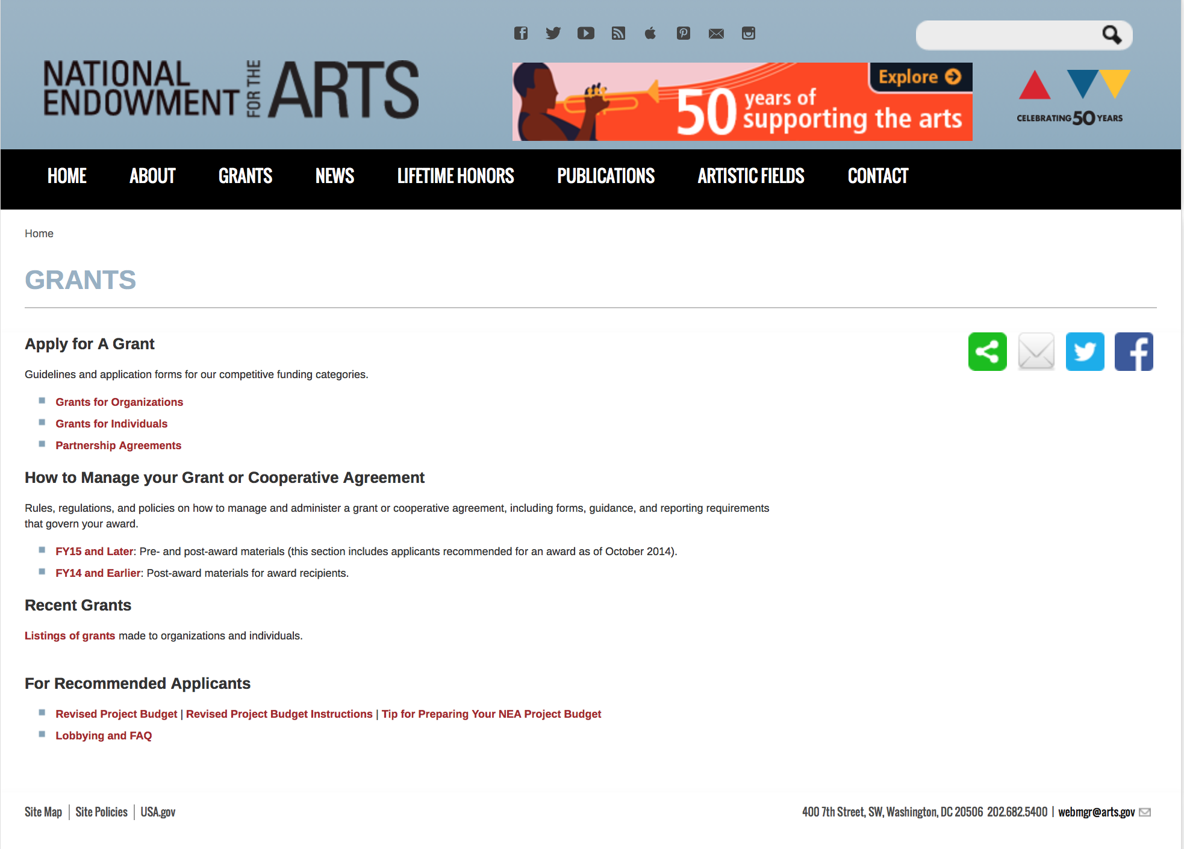

http://arts.gov/grants

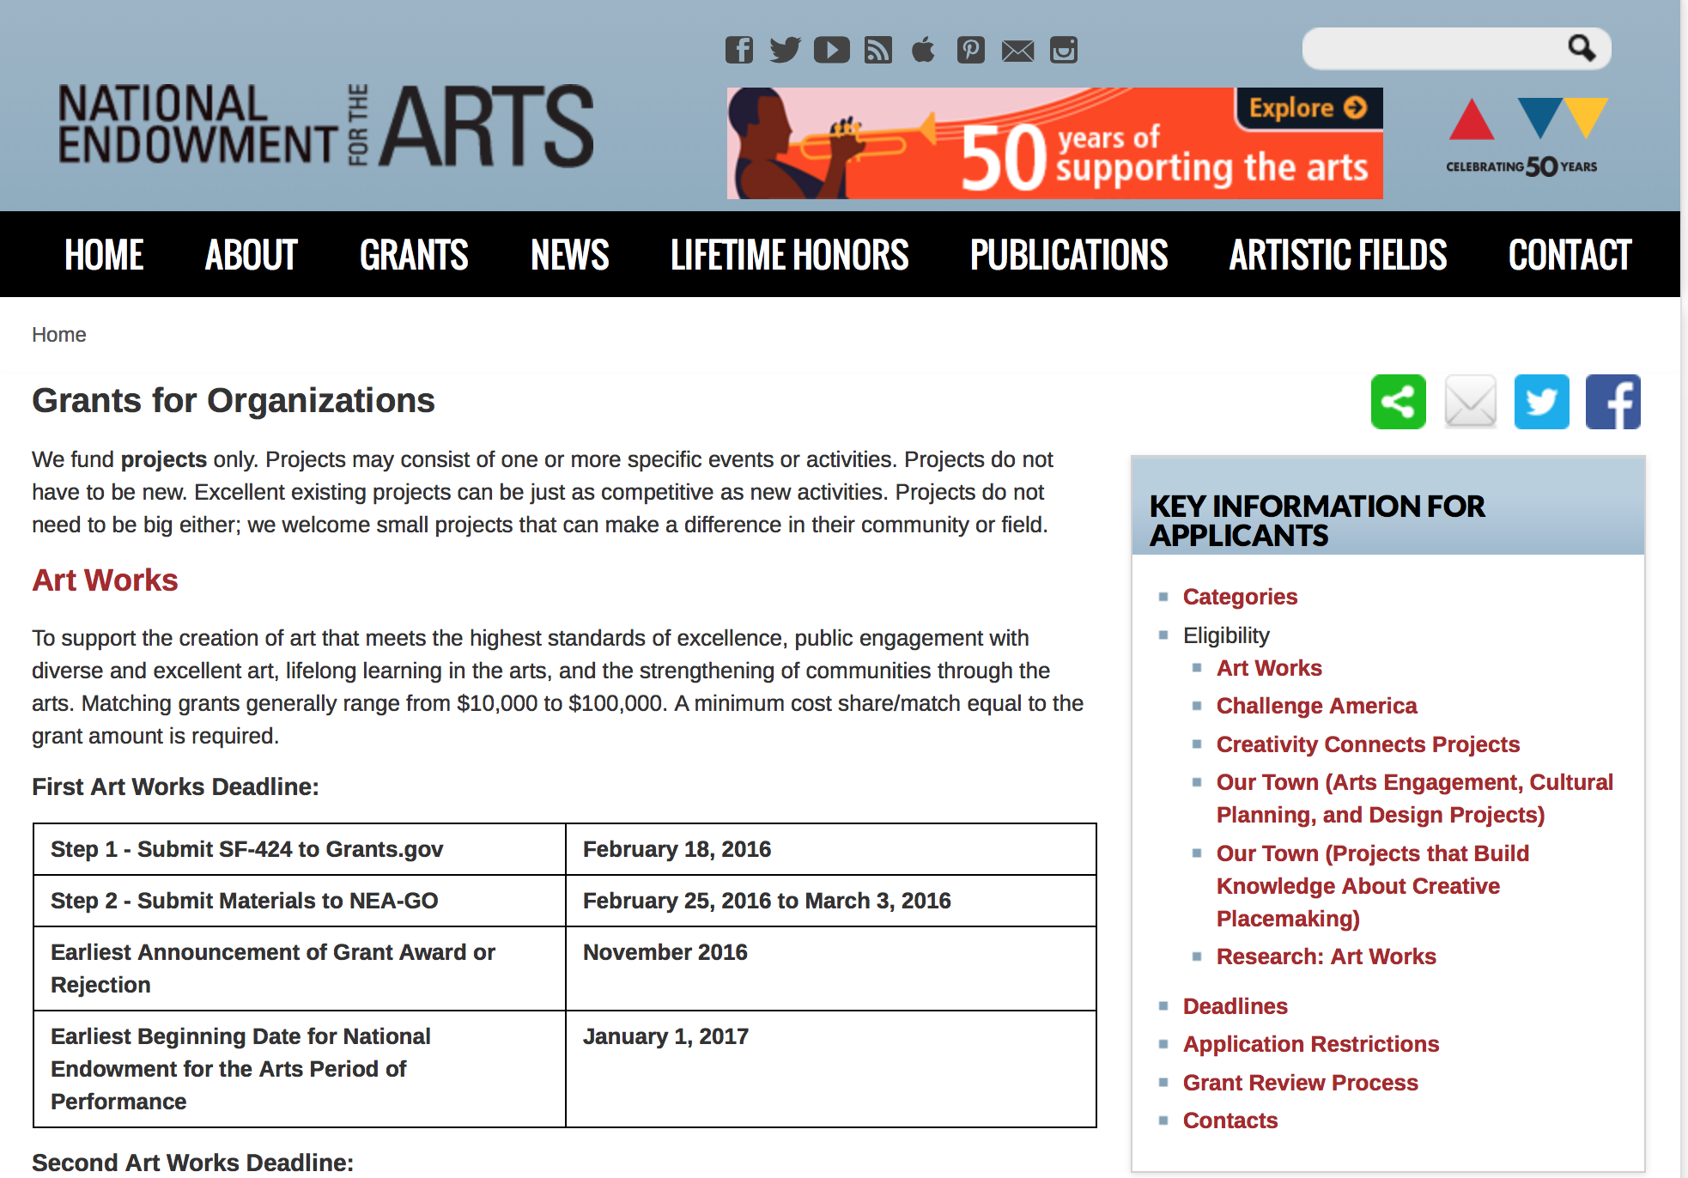
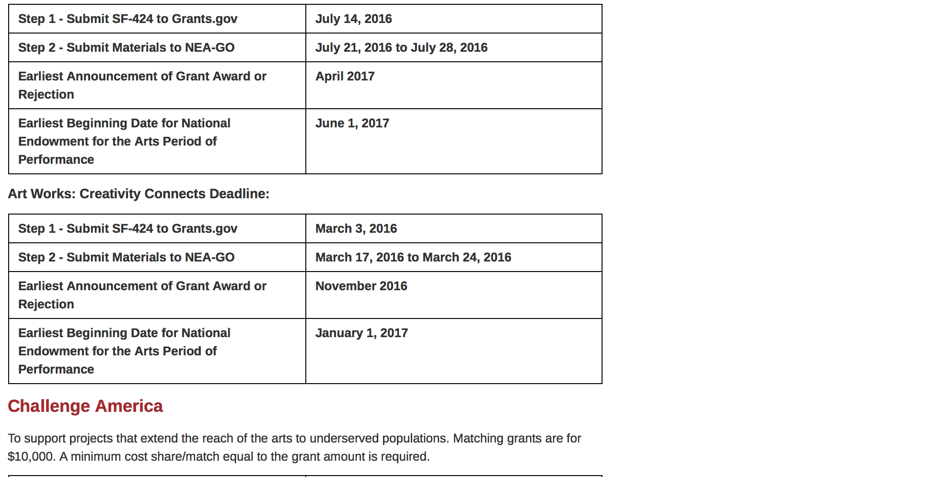
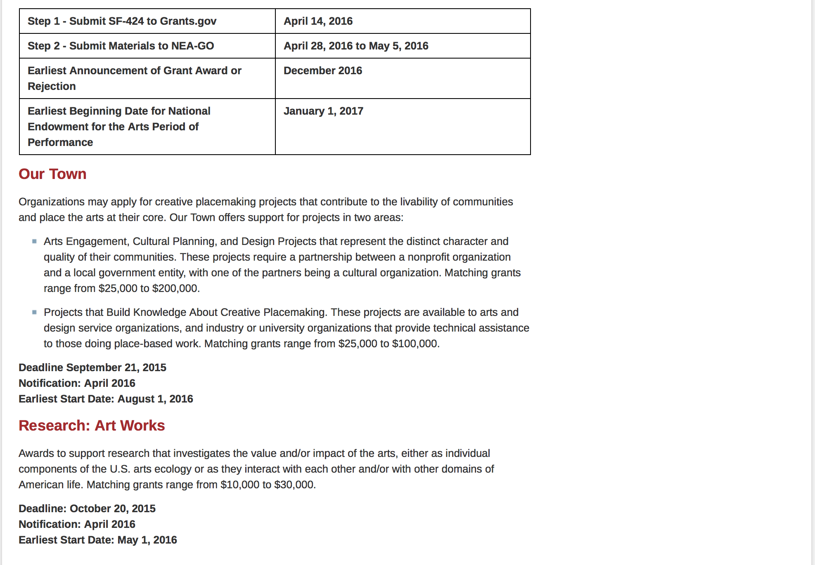
See more at: https://www.arts.gov/grants/apply-grant/grants-organizations

Programs:

Modifications:

Reminders:

2017 National Heritage Fellowships Awards Program Grant

Document Type: | Grants Notice
Funding Opportunity Number: | NEAPS1504
Funding Opportunity Title: | 2017 National Heritage Fellowships Awards Program
Opportunity Category: | Discretionary
Funding Instrument Type: | Grant
Category of Funding Activity: | Arts (see "Cultural Affairs" in CFDA)
Category Explanation:
Expected Number of Awards:
CFDA Number(s): | 45.024 -- Promotion of the Arts Grants to Organizations and Individuals
Cost Sharing or Matching Requirement: | No
Posted Date: | Jan 28, 2016
Creation Date: | Jan 28, 2016
Original Closing Date for Applications: | Apr 5, 2016 The Grants.gov system must receive your proposal no later than 11:59 p.m., Eastern Time, on April 5, 2016. We strongly recommend that you submit your application by March 25, 2016 to give yourself ample time to resolve any problems that you might encounter.
Current Closing Date for Applications: | Apr 5, 2016 The Grants.gov system must receive your proposal no later than 11:59 p.m., Eastern Time, on April 5, 2016. We strongly recommend that you submit your application by March 25, 2016 to give yourself ample time to resolve any problems that you might encounter.
Archive Date: | May 5, 2016
Estimated Total Program Funding:
Award Ceiling: | $310,000
Award Floor: | $310,000
Eligible Applicants: | Special district governments  Nonprofits having a 501(c)(3) status with the IRS, other than institutions of higher education  County governments  Independent school districts  Private institutions of higher education  Native American tribal governments (Federally recognized)  State governments  City or township governments  Public and State controlled institutions of higher education
Additional Information on Eligibility: | Applicant Eligibility Nonprofit, tax-exempt 501(c)(3), U.S. organizations; units of state or local government; or federally recognized tribal communities or tribes may apply. To be eligible, the applicant organization must: • Meet the Arts Endowment's "Legal Requirements" at the time of application. • Have submitted acceptable Final Report packages by the due date(s) for all Arts Endowment award(s) previously received. An organization may submit only one proposal under this program solicitation. You may apply to other National Endowment for the Arts funding opportunities, including Art Works and Our Town, in addition to this program solicitation. In each case, the request must be for a distinctly different project.
Agency Name: | National Endowment for the Arts
Description: | An organization may submit only one proposal under this program solicitation. This Cooperative Agreement may begin no earlier than December 1, 2016, and may extend for up to 12 months. Description The purpose of this Program Solicitation is to select an organization to assist the National Endowment for the Arts with the 2017 National Heritage Fellowships Awards program by coordinating a concert, ceremony and reception, awardee dinner, and associated events. Each year, the National Endowment for the Arts awards a limited number of lifetime honors to individuals in recognition of their outstanding contributions to our nation’s artistic heritage. One of these programs, the NEA National Heritage Fellowship Awards, pays tribute and draws public attention to the excellence and diversity of our nation’s folk and traditional arts. The one-time-only awards go to significant traditional artists from across the country in recognition of their contributions to a particular traditional art form and to the American public through their artistic work. Since 1982, new awardees have travelled to Washington, DC to receive our nation’s highest honor in this field in a public ceremony and perform in a concert. Through this Program Solicitation, the National Endowment for the Arts seeks a Cooperator to assist in the production and execution of the award program’s public events including bringing the recipients to Washington, DC and coordinating the various events surrounding the official presentation of the 2017 National Heritage Fellowship awards.
Link to Additional Information: | Complete NEA Website Announcement
Contact Information: | If you have difficulty accessing the full announcement electronically, please contact:  NEA Web Manager  NEA Web Manager

http://www.grants.gov/web/grants/view-opportunity.html?oppId=281176

2017 Mayor's Institute on City Design (MICD) Grant

Document Type: | Grants Notice
Funding Opportunity Number: | NEAPS1505
Funding Opportunity Title: | 2017 Mayor's Institute on City Design (MICD)
Opportunity Category: | Discretionary
Funding Instrument Type: | Grant
Category of Funding Activity: | Arts (see "Cultural Affairs" in CFDA)
Category Explanation:
Expected Number of Awards:
CFDA Number(s): | 45.024 -- Promotion of the Arts Grants to Organizations and Individuals
Cost Sharing or Matching Requirement: | Yes
Posted Date: | Jan 28, 2016
Creation Date: | Jan 28, 2016
Original Closing Date for Applications: | Mar 29, 2016 The Grants.gov system must receive your proposal no later than 11:59 p.m., Eastern Time, on March 29, 2016. We strongly recommend that you submit your application by March 19, 2016 to give yourself ample time to resolve any problems that you might encounter.
Current Closing Date for Applications: | Mar 29, 2016 The Grants.gov system must receive your proposal no later than 11:59 p.m., Eastern Time, on March 29, 2016. We strongly recommend that you submit your application by March 19, 2016 to give yourself ample time to resolve any problems that you might encounter.
Archive Date: | Apr 28, 2016
Estimated Total Program Funding:
Award Ceiling: | $450,000
Award Floor: | $450,000
Eligible Applicants: | Special district governments  County governments  City or township governments  Independent school districts  Native American tribal governments (Federally recognized)  Private institutions of higher education  Nonprofits having a 501(c)(3) status with the IRS, other than institutions of higher education  State governments  Public and State controlled institutions of higher education
Additional Information on Eligibility: | Applicant Eligibility Nonprofit, tax-exempt 501(c)(3), U.S. organizations; units of state or local government; or federally recognized tribal communities or tribes may apply. To be eligible, the applicant organization must: • Meet the National Endowment for the Arts’ "Legal Requirements" including nonprofit, tax-exempt status at the time of application. • Have submitted acceptable Final Report packages by the due date(s) for all NEA award(s) previously received. • Have, at the time of application, at least a three-year history with education and advocacy regarding policies and practices affecting the design of American cities. An organization may submit only one proposal under this program solicitation.
Agency Name: | National Endowment for the Arts
Description: | An organization may submit only one proposal under this program solicitation. This Cooperative Agreement may begin no earlier than October 1, 2016, and may extend for up to 12 months. Description The purpose of this Program Solicitation is to select an organization (Cooperator) to administer the Mayors’ Institute on City Design (MICD), a program of the National Endowment for the Arts (NEA). MICD brings U.S. mayors together with design professionals in workshops to assist mayors with urban design challenges, to promote design excellence, and to enhance the livability of communities across the country. Since 1986, the MICD has helped transform communities through design by training more than 1,000 mayors to be the chief urban designers of their cities. MICD achieves its mission by organizing sessions where mayors engage with leading design experts to find solutions to the most critical urban design challenges facing their cities. Institutes are organized around case-study problems in closed-door sessions. Each mayor presents a problem from his or her city and receives feedback from other mayors and design experts. Every year, the MICD hosts at least six institutes held throughout the country. Each 2½-day institute is limited to fewer than twenty participants consisting of two equal cohorts: mayors and a resource team of city design and development professionals. Mayors present a case study that might include a range of challenges, such as waterfront redevelopment, downtown revitalization, transportation planning, and the design of new public buildings such as libraries and arts centers. Following each presentation, mayors and the resource team identify important issues, offer suggestions, and discuss potential solutions. This interchange generates creative solutions to urban design challenges. MICD’s success stories are well documented on the program’s website. The program has also been recognized with a number of awards, including a Presidential Award for Design Excellence in 2000. The National Endowment for the Arts will provide general guidance and financial support for the MICD through this Cooperative Agreement. As a federal agency, we regularly issue Program Solicitations for organizations to manage collaborative projects.
Link to Additional Information: | Complete NEA Website Announcement
Contact Information: | If you have difficulty accessing the full announcement electronically, please contact:  NEA Web Manager  NEA Web Manager

http://www.grants.gov/web/grants/view-opportunity.html?oppId=281199

NEA Challenge America Application, FY2017 Grant

Document Type: | Grants Notice
Funding Opportunity Number: | 2016NEA01CA
Funding Opportunity Title: | NEA Challenge America Application, FY2017
Opportunity Category: | Discretionary
Funding Instrument Type: | Grant
Category of Funding Activity: | Arts (see "Cultural Affairs" in CFDA)
Category Explanation:
Expected Number of Awards:
CFDA Number(s): | 45.024 -- Promotion of the Arts Grants to Organizations and Individuals
Cost Sharing or Matching Requirement: | Yes
Posted Date: | Dec 15, 2015
Creation Date: | Dec 15, 2015
Original Closing Date for Applications: | Apr 14, 2016 “The Grants.gov system must receive your validated and accepted application no later than 11:59 p.m., Eastern Time, on April 14, 2016.”
Current Closing Date for Applications: | Apr 14, 2016 “The Grants.gov system must receive your validated and accepted application no later than 11:59 p.m., Eastern Time, on April 14, 2016.”
Archive Date: | May 14, 2016
Estimated Total Program Funding:
Award Ceiling: | $10,000
Award Floor: | $10,000
Eligible Applicants: | County governments  Private institutions of higher education  Native American tribal governments (Federally recognized)  State governments  Public and State controlled institutions of higher education  Independent school districts  Special district governments  Nonprofits having a 501(c)(3) status with the IRS, other than institutions of higher education  City or township governments
Additional Information on Eligibility: | The Arts Endowment's support of a project may start on or after January 1, 2017. Grants awarded under these guidelines generally may cover a period of performance of up to two years. An organization that has received Challenge America grants in FY 2014, 2015, and 2016 may not apply for a Challenge America grant under these FY 2017 guidelines. Applicant Eligibility Nonprofit, tax-exempt 501(c)(3), U.S. organizations; units of state or local government; or federally recognized tribal communities or tribes may apply. Applicants may be arts organizations, local arts agencies, arts service organizations, local education agencies (school districts), and other organizations that can help advance the goals of the National Endowment for the Arts.
Agency Name: | National Endowment for the Arts
Description: | The Arts Endowment's support of a project may start on or after January 1, 2017. Grants awarded under these guidelines generally may cover a period of performance of up to two years. An organization that has received Challenge America grants in FY 2014, 2015, and 2016 may not apply for a Challenge America grant under these FY 2017 guidelines. Grant Program Description The Challenge America category offers support primarily to small and mid-sized organizations for projects that extend the reach of the arts to underserved populations -- those whose opportunities to experience the arts are limited by geography, ethnicity, economics, or disability. Age alone (e.g., youth, seniors) does not qualify a group as underserved; at least one of the underserved characteristics noted above also must be present. Grants are available for professional arts programming and for projects that emphasize the potential of the arts in community development. This category encourages and supports the following objective: • Engagement: Engaging the public with diverse and excellent art.
Link to Additional Information: | NEA Complete Website Announcement
Contact Information: | If you have difficulty accessing the full announcement electronically, please contact:  NEA Web Manager  NEA Web Manager

http://www.grants.gov/web/grants/view-opportunity.html?oppId=280532

NEA Literature (Poetry) Fellowships, FY2017 Grant

Document Type: | Grants Notice
Funding Opportunity Number: | 2016NEA03LFCW
Funding Opportunity Title: | NEA Literature (Poetry) Fellowships, FY2017
Opportunity Category: | Discretionary
Funding Instrument Type: | Grant
Category of Funding Activity: | Arts (see "Cultural Affairs" in CFDA)
Category Explanation:
Expected Number of Awards:
CFDA Number(s): | 45.024 -- Promotion of the Arts Grants to Organizations and Individuals
Cost Sharing or Matching Requirement: | No
Posted Date: | Dec 15, 2015
Creation Date: | Dec 15, 2015
Original Closing Date for Applications: | Mar 9, 2016 The Grants.gov system must receive your validated and accepted application no later than 11:59 p.m., Eastern Time, on March 9, 2016.
Current Closing Date for Applications: | Mar 9, 2016 The Grants.gov system must receive your validated and accepted application no later than 11:59 p.m., Eastern Time, on March 9, 2016.
Archive Date: | Apr 8, 2016
Estimated Total Program Funding:
Award Ceiling: | $25,000
Award Floor: | $25,000
Eligible Applicants: | Individuals
Additional Information on Eligibility: | The Arts Endowment’s support of a project may begin any time between January 1, 2017, and January 1, 2018, and extend for up to two years. You may submit only one application per year. You may not apply for a Literature Fellowship (in poetry or prose) and a Translation Fellowship in the same year. Applicant Eligibility Creative writers who meet the publication requirements are eligible to apply. Applicants must be citizens or permanent residents of the United States.
Agency Name: | National Endowment for the Arts
Description: | The Arts Endowment’s support of a project may begin any time between January 1, 2017, and January 1, 2018, and extend for up to two years. You may submit only one application per year. You may not apply for a Literature Fellowship (in poetry or prose) and a Translation Fellowship in the same year. Grant Program Description The National Endowment for the Arts’ Literature Fellowships program offers $25,000 grants in prose (fiction and creative nonfiction) and poetry to published creative writers that enable recipients to set aside time for writing, research, travel, and general career advancement. Applications are reviewed through an anonymous process in which the only criteria for review are artistic excellence and artistic merit. To review the applications, we assemble a different advisory panel every year, each diverse with regard to geography, race and ethnicity, and artistic points of view. The Literature Fellowships program operates on a two-year cycle with fellowships in prose and poetry available in alternating years. For FY 2017, which is covered by these guidelines, fellowships in poetry are available. Fellowships in prose (fiction and creative nonfiction) will be offered in FY 2018 and guidelines will be available in the winter of 2017. You may apply only once each year. Competition for fellowships is extremely rigorous. We typically receive more than 1,200 applications each year in this category and award fellowships to fewer than 5% of applicants. You should consider carefully whether your work will be competitive at the national level.
Link to Additional Information: | NEA Complete Website Announcement
Contact Information: | If you have difficulty accessing the full announcement electronically, please contact:  NEA Web Manager  NEA Web Manager

http://www.grants.gov/web/grants/view-opportunity.html?oppId=280533

National Endowment for the Humanities

Grant Overview -

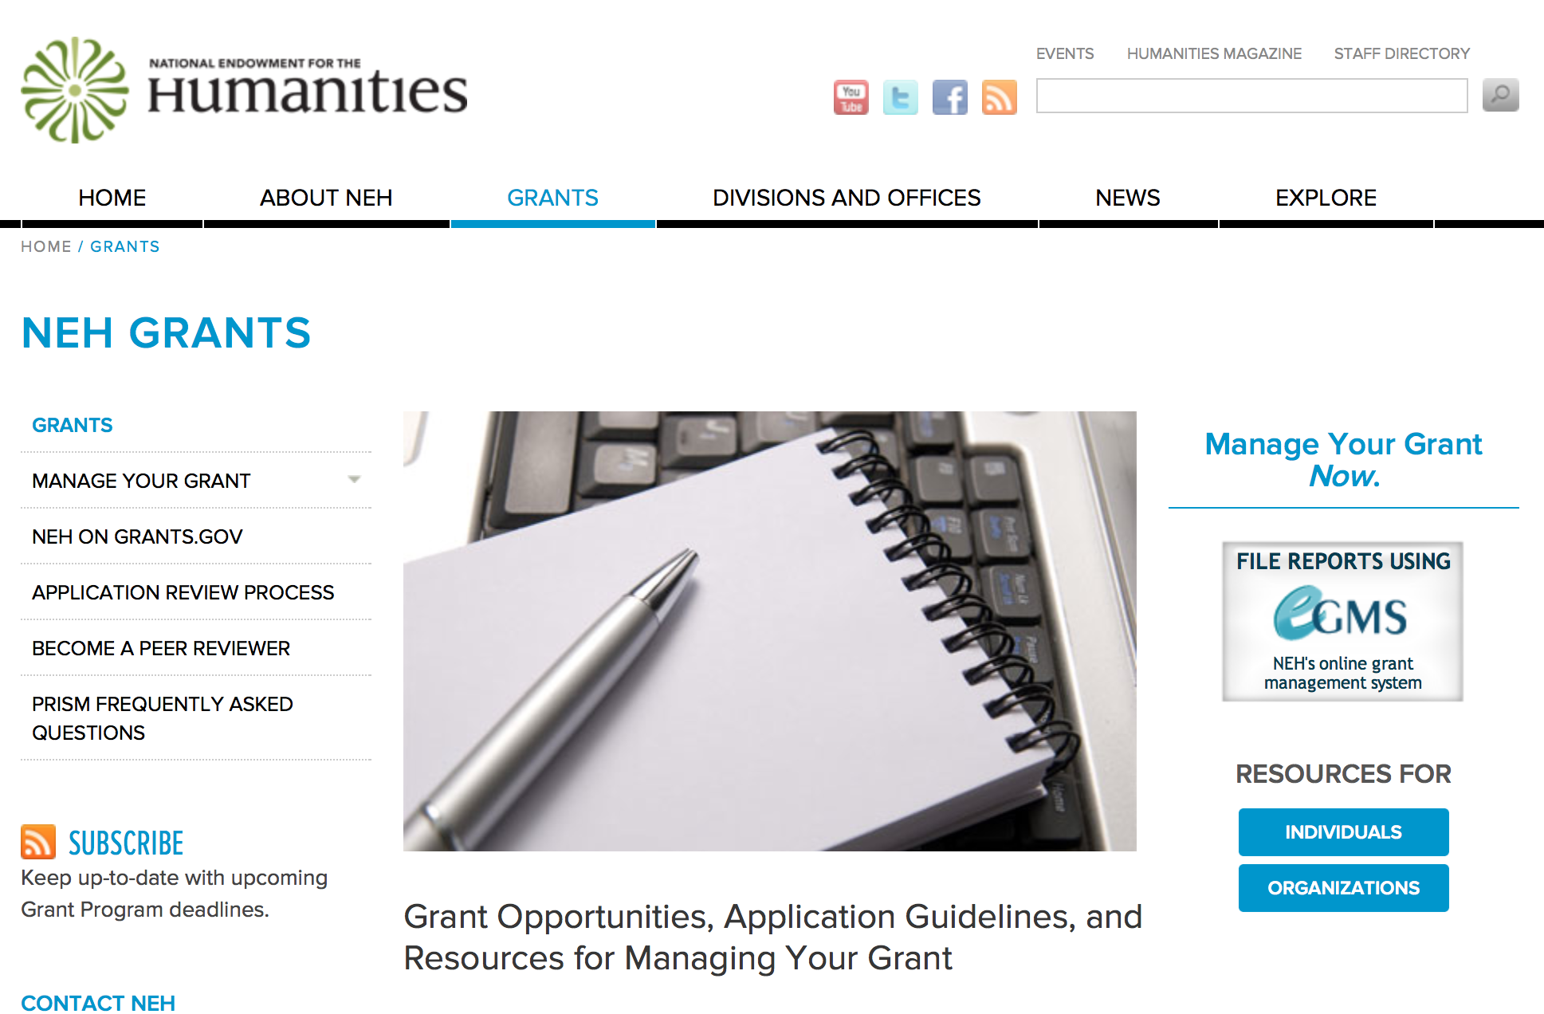

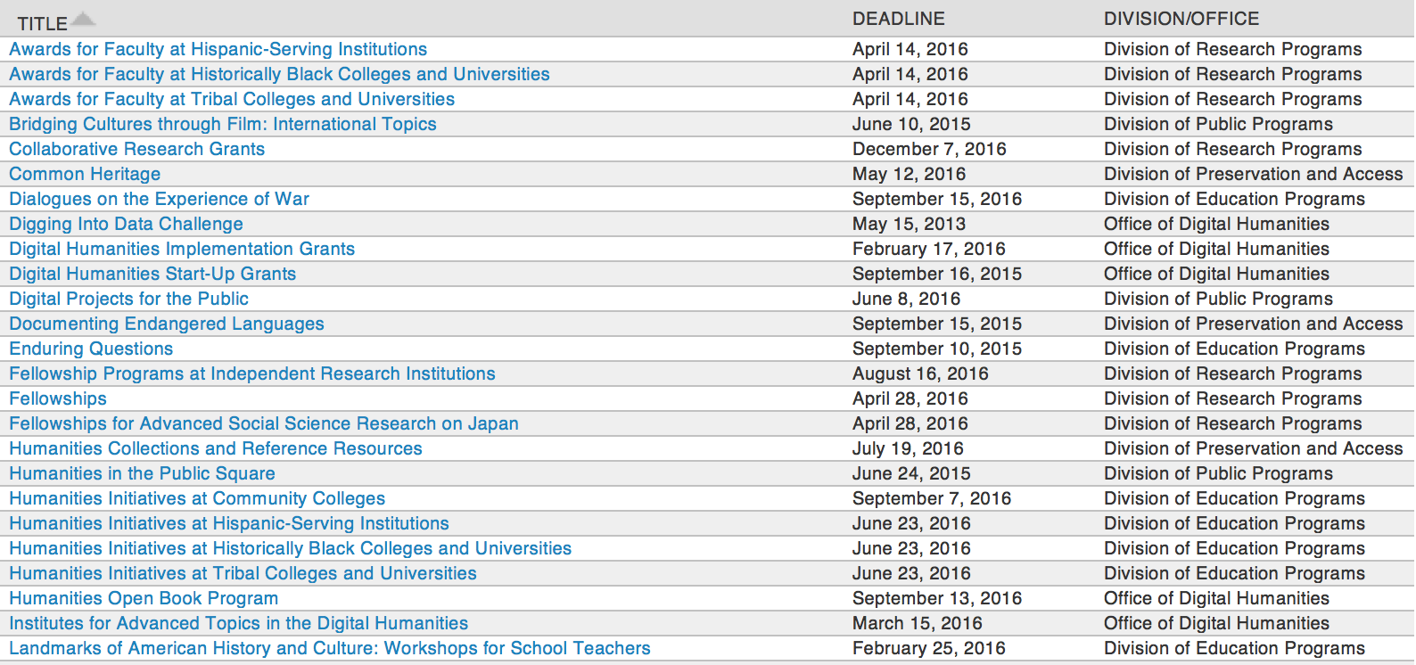

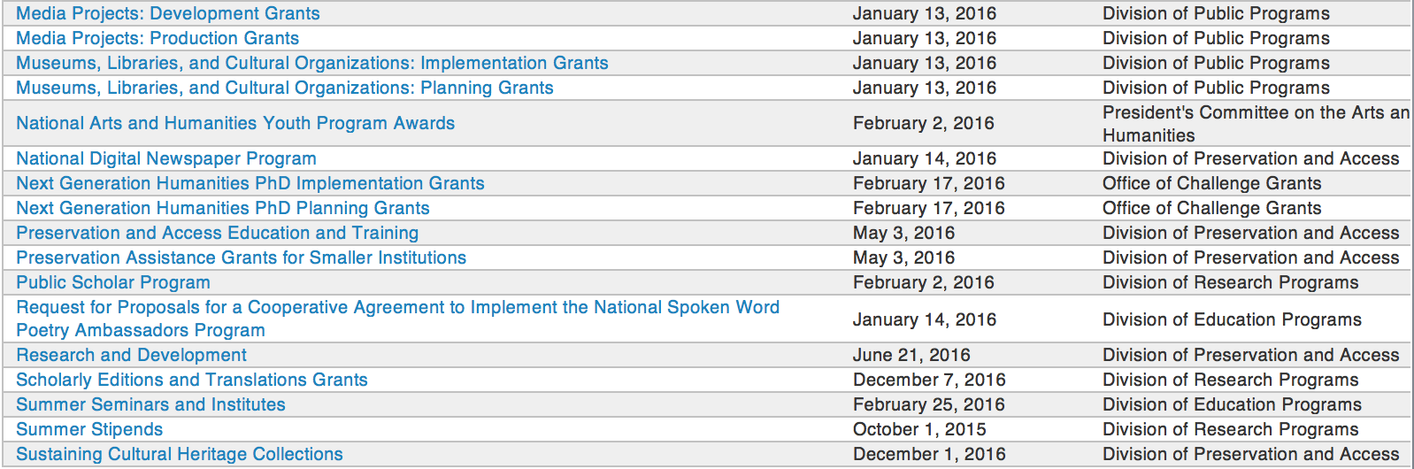

http://www.neh.gov/grants/grantsbydivision.html

Programs:

Fellowships Grant

Document Type: | Grants Notice
Funding Opportunity Number: | 20160428-FA
Funding Opportunity Title: | Fellowships
Opportunity Category: | Discretionary
Opportunity Category Explanation:
Funding Instrument Type: | Grant
Category of Funding Activity: | Humanities (see "Cultural Affairs" in CFDA)
Category Explanation:
Expected Number of Awards:
CFDA Number(s): | 45.160 -- Promotion of the Humanities Fellowships and Stipends
Cost Sharing or Matching Requirement: | No
Posted Date: | Feb 26, 2016
Last Updated Date: | Feb 26, 2016
Original Closing Date for Applications: | Apr 28, 2016
Current Closing Date for Applications: | Apr 28, 2016
Archive Date:
Estimated Total Program Funding:
Award Ceiling: | $50,400
Award Floor: | $25,200
Eligible Applicants: | Individuals
Agency Name: | National Endowment for the Humanities
Description: | Fellowships support individuals pursuing advanced research that is of value to humanities scholars, general audiences, or both. Recipients usually produce articles, monographs, books, digital materials, archaeological site reports, translations, editions, or other scholarly resources in the humanities. Projects may be at any stage of development. Applicants interested in research projects that require digital expression and digital publication are encouraged to apply for NEH-Mellon Fellowships for Digital Publication. Through NEH-Mellon Fellowships for Digital Publication, the National Endowment for the Humanities and The Andrew W. Mellon Foundation jointly support individual scholars pursuing research projects that require digital expression and digital publication. To be eligible for this special opportunity, an applicant’s plans for digital publication must be essential to the project’s research goals. That is, the project must be conceived as digital because the nature of the research and the topics being addressed demand presentation beyond traditional print publication. Successful projects will likely incorporate visual, audio, and/or other multimedia materials or flexible reading pathways that could not be included in traditionally published books.
Link to Additional Information: | http://www.neh.gov/grants/fellowships
Contact Information: | If you have difficulty accessing the full announcement electronically, please contact:  Division of Research Programs National Endowment for the Humanities 400 Seventh Street, SW Washington, DC 20506 202-606-8200 fellowships@neh.gov fellowships@neh.gov  fellowships@neh.gov

http://www.grants.gov/web/grants/view-opportunity.html?oppId=281792

Fellowships for Advanced Social Science Research on Japan Grant

Document Type: | Grants Notice
Funding Opportunity Number: | 20160428-FO
Funding Opportunity Title: | Fellowships for Advanced Social Science Research on Japan
Opportunity Category: | Discretionary
Opportunity Category Explanation:
Funding Instrument Type: | Grant
Category of Funding Activity: | Humanities (see "Cultural Affairs" in CFDA)
Category Explanation:
Expected Number of Awards:
CFDA Number(s): | 45.160 -- Promotion of the Humanities Fellowships and Stipends
Cost Sharing or Matching Requirement: | No
Posted Date: | Feb 26, 2016
Last Updated Date: | Feb 26, 2016
Original Closing Date for Applications: | Apr 28, 2016
Current Closing Date for Applications: | Apr 28, 2016
Archive Date:
Estimated Total Program Funding:
Award Ceiling: | $50,400
Award Floor: | $25,200
Eligible Applicants: | Individuals
Agency Name: | National Endowment for the Humanities
Description: | The Fellowships for Advanced Social Science Research on Japan program is a joint activity of the Japan-U.S. Friendship Commission (JUSFC) and the National Endowment for the Humanities. Awards support research on modern Japanese society and political economy, Japan's international relations, and U.S.-Japan relations. The program encourages innovative research that puts these subjects in wider regional and global contexts and is comparative and contemporary in nature. Research should contribute to scholarly knowledge or to the general public’s understanding of issues of concern to Japan and the United States. Appropriate disciplines for the research include anthropology, economics, geography, history, international relations, linguistics, political science, psychology, public administration, and sociology. Awards usually result in articles, monographs, books, digital materials, archaeological site reports, translations, editions, or other scholarly resources. The fellowships are designed for researchers with advanced language skills whose research will require use of data, sources, and documents in their original languages or whose research requires interviews onsite in direct one-on-one contact. Fellows may undertake their projects in Japan, the United States, or both, and may include work in other countries for comparative purposes. Projects may be at any stage of development.
Link to Additional Information: | http://www.neh.gov/grants/research/fellowships-advanced-social-science-research-japan
Contact Information: | If you have difficulty accessing the full announcement electronically, please contact:  Division of Research Programs National Endowment for the Humanities 400 Seventh Street, SW Washington, DC 20506 202-606-8200 fellowships@neh.gov fellowships@neh.gov  fellowships@neh.gov

http://www.grants.gov/web/grants/view-opportunity.html?oppId=281794

Humanities Access Grants

Document Type: | Grants Notice
Funding Opportunity Number: | 20160504-ZH
Funding Opportunity Title: | Humanities Access Grants
Opportunity Category: | Discretionary
Opportunity Category Explanation:
Funding Instrument Type: | Grant
Category of Funding Activity: | Humanities (see "Cultural Affairs" in CFDA)
Category Explanation:
Expected Number of Awards:
CFDA Number(s): | 45.130 -- Promotion of the Humanities Challenge Grants
Cost Sharing or Matching Requirement: | Yes
Posted Date: | Feb 23, 2016
Last Updated Date: | Feb 23, 2016
Original Closing Date for Applications: | May 04, 2016
Current Closing Date for Applications: | May 04, 2016
Archive Date:
Estimated Total Program Funding:
Award Ceiling: | $200,000
Award Floor: | $100,000
Eligible Applicants: | City or township governments  County governments  Native American tribal governments (Federally recognized)  Public and State controlled institutions of higher education  Special district governments  Private institutions of higher education  Nonprofits that do not have a 501(c)(3) status with the IRS, other than institutions of higher education  State governments  Nonprofits having a 501(c)(3) status with the IRS, other than institutions of higher education
Agency Name: | National Endowment for the Humanities
Description: | Humanities Access grants help support capacity building for humanities programs that benefit one or more of the following groups: youth, communities of color, and economically disadvantaged populations. Humanities Access grants establish or augment term endowments (that is, endowments whose funds are entirely expended over the course of a set time period) to provide funding for existing programs at institutions such as public libraries, local and regional museums, historical societies, community colleges, HBCUs and tribal colleges, Hispanic-serving institutions, archival repositories, and other cultural organizations. Humanities Access grants are intended to seed longer-term endowment-building efforts. Programs supported by Humanities Access grants might include, for example • a summer project for teens at a local historical society; • internships for Native American students at a tribal museum; or • a Clemente course at a homeless shelter organized by a community college. Humanities Access Grants offer two years of match-based funding to be expended through a term endowment over the final three years of the five-year grant period. Humanities Access grant funds should not be used to replace existing program funds. Instead, the grant should expand or enhance an existing exemplary humanities program. Institutions that have never received an NEH grant and small to mid-sized institutions are especially encouraged to apply.
Link to Additional Information: | http://www.neh.gov/grants/challenge/humanities-access-grants
Contact Information: | If you have difficulty accessing the full announcement electronically, please contact:  Office of Challenge Grants National Endowment for the Humanities 400 Seventh Street, SW Washington, DC 20506 202-606-8309 challenge@neh.gov challenge@neh.gov  challenge@neh.gov

http://www.grants.gov/web/grants/view-opportunity.html?oppId=281718

Institutes for Advanced Topics in the Digital Humanities Grant

Document Type: | Grants Notice
Funding Opportunity Number: | 20160315-HT
Funding Opportunity Title: | Institutes for Advanced Topics in the Digital Humanities
Opportunity Category: | Discretionary
Opportunity Category Explanation:
Funding Instrument Type: | Grant
Category of Funding Activity: | Humanities (see "Cultural Affairs" in CFDA)
Category Explanation:
Expected Number of Awards:
CFDA Number(s): | 45.169 -- Promotion of the Humanities Office of Digital Humanities
Cost Sharing or Matching Requirement: | No
Posted Date: | Feb 05, 2016
Last Updated Date: | Feb 05, 2016
Original Closing Date for Applications: | Mar 15, 2016
Current Closing Date for Applications: | Mar 15, 2016
Archive Date:
Estimated Total Program Funding:
Award Ceiling: | $250,000
Award Floor: | $50,000
Eligible Applicants: | State governments  Private institutions of higher education  City or township governments  County governments  Nonprofits having a 501(c)(3) status with the IRS, other than institutions of higher education  Public and State controlled institutions of higher education  Special district governments  Nonprofits that do not have a 501(c)(3) status with the IRS, other than institutions of higher education  Native American tribal governments (Federally recognized)
Agency Name: | National Endowment for the Humanities
Description: | These NEH grants support national or regional (multistate) training programs for scholars and advanced graduate students to broaden and extend their knowledge of digital humanities. Through these programs, NEH seeks to increase the number of humanities scholars using digital technology in their research and to broadly disseminate knowledge about advanced technology tools and methodologies relevant to the humanities. The projects may be a single opportunity or offered multiple times to different audiences. Institutes may be as short as a few days and held at multiple locations or as long as six weeks at a single site. For example, training opportunities could be offered before or after regularly occurring scholarly meetings, during the summer months, or during appropriate times of the academic year. The duration of a program should allow for full and thorough treatment of the topic. Today, complex data—its form, manipulation, and interpretation—are as important to humanities study as more traditional research materials. Datasets, for example, may represent digitized historical records, high-quality image data, or even multimedia collections, all of which are increasing in number due to the availability and affordability of mass data storage devices and international initiatives to create digital content. Moreover, extensive networking capabilities, sophisticated analytical tools, and new collaboration platforms are simultaneously providing and improving interactive access to and analysis of these data as well as a multitude of other resources. The Institutes for Advanced Topics in the Digital Humanities program seeks to enable humanities scholars in the United States to incorporate advances like these into their scholarship and teaching.
Link to Additional Information: | http://www.neh.gov/grants/odh/institutes-advanced-topics-in-the-digital-humanities
Contact Information: | If you have difficulty accessing the full announcement electronically, please contact:  If you have questions about the program, contact the ODH staff at odh@neh.gov. Applicants wishing to speak to a staff member by telephone should provide in an e-mail message a telephone number and a preferred time to call. odh@neh.gov  odh@neh.gov

http://www.grants.gov/web/grants/view-opportunity.html?oppId=281355

Modifications:

Reminders:



National Science Foundation

General Funding Overview

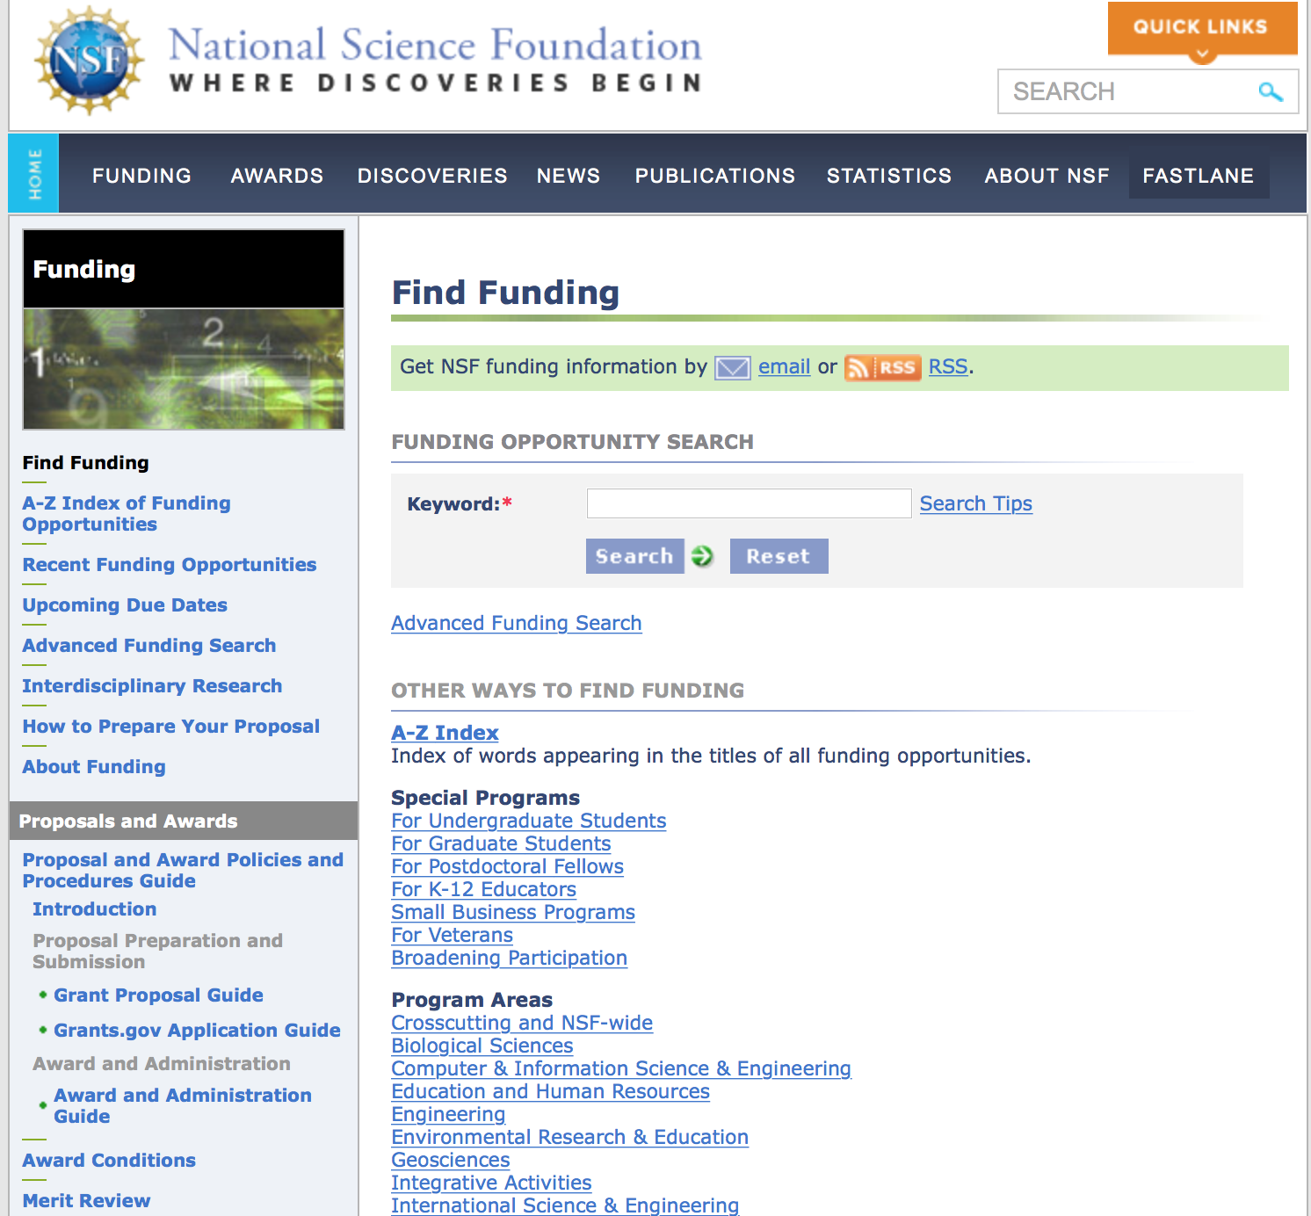
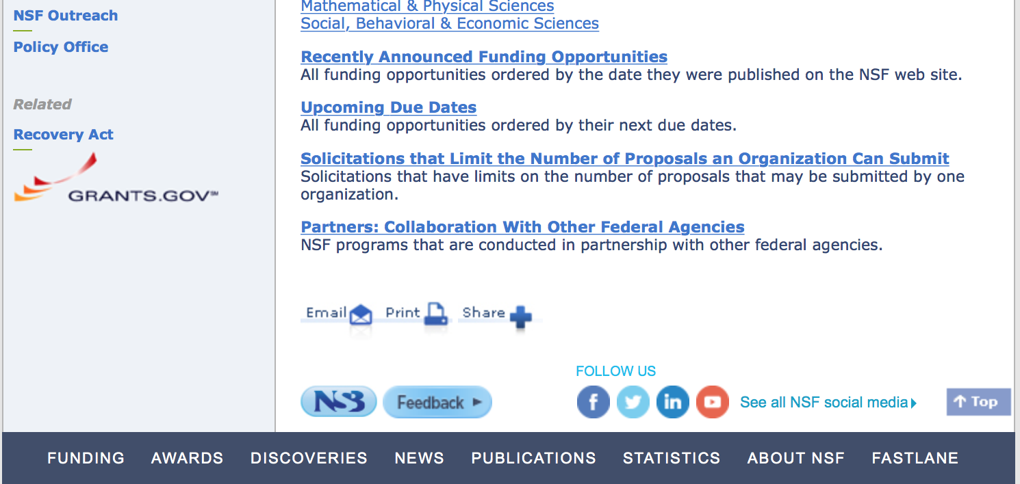

For assistance in finding funding: http://nsf.gov/funding/index.jsp - areas

The National Science Foundation funds research and education in most fields of science and engineering. It does this through grants, and cooperative agreements to more than 2,000 colleges, universities, K-12 school systems, businesses, informal science organizations and other research organizations throughout the United States. The Foundation accounts for about one-fourth of federal support to academic institutions for basic research.
NSF receives approximately 40,000 proposals each year for research, education and training projects, of which approximately 11,000 are funded. In addition, the Foundation receives several thousand applications for graduate and postdoctoral fellowships.
The agency operates no laboratories itself but does support National Research Centers, user facilities, certain oceanographic vessels and Antarctic research stations. The Foundation also supports cooperative research between universities and industry, US participation in international scientific and engineering efforts, and educational activities at every academic level.

For details on active funding deadline dates: http://nsf.gov/funding/pgm_list.jsp?org=NSF&ord=date

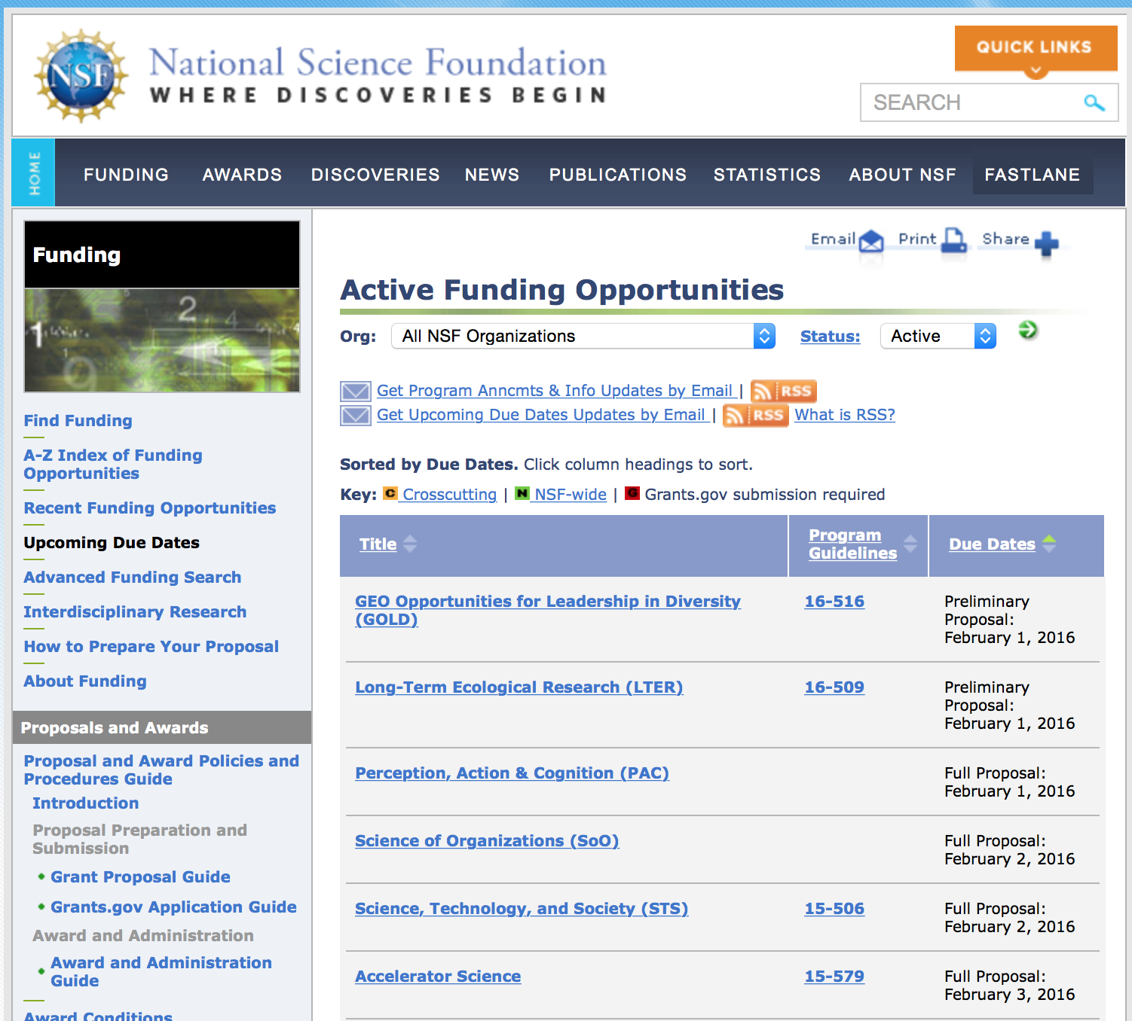

Research and Program Grants:

Antarctic Artists and Writers Program Grant
http://www.grants.gov/web/grants/view-opportunity.html?oppId=281575

Antarctic Research Grant
http://www.grants.gov/web/grants/view-opportunity.html?oppId=281576

Enhancing Access to the Radio Spectrum Grant
http://www.grants.gov/web/grants/view-opportunity.html?oppId=281351

Inclusion across the Nation of Communities of Learners of Underrepresented Discoverers in Engineering and Science Grant
http://www.grants.gov/web/grants/view-opportunity.html?oppId=281715

Innovation Corps - National Innovation Network Sites Program Grant
http://www.grants.gov/web/grants/view-opportunity.html?oppId=281826

Innovation Corps - Nodes Program Grant
http://www.grants.gov/web/grants/view-opportunity.html?oppId=281491

Joint DMS/NIGMS Initiative to Support Research at the Interface of the Biological and Mathematical Sciences Grant
http://www.grants.gov/web/grants/view-opportunity.html?oppId=281716

Management and Operation of the National Geophysical Observatory for Geoscience Grant
http://www.grants.gov/web/grants/view-opportunity.html?oppId=281808

Materials Research Science and Engineering Center Grant
http://www.grants.gov/web/grants/view-opportunity.html?oppId=281809

NSF Scholarships in Science, Technology, Engineering, and Mathematics Program
Grant
http://www.grants.gov/web/grants/view-opportunity.html?oppId=281574

Science Learning+ Partnership Grants
http://www.grants.gov/web/grants/view-opportunity.html?oppId=281827

Modifications:

Reminders:

Nuclear Regulatory Commission

Reminders:

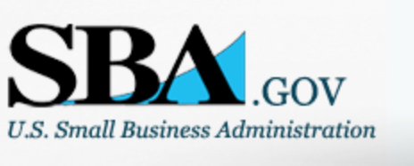

Small Business Administration

General Overview Finding Loans & Grants

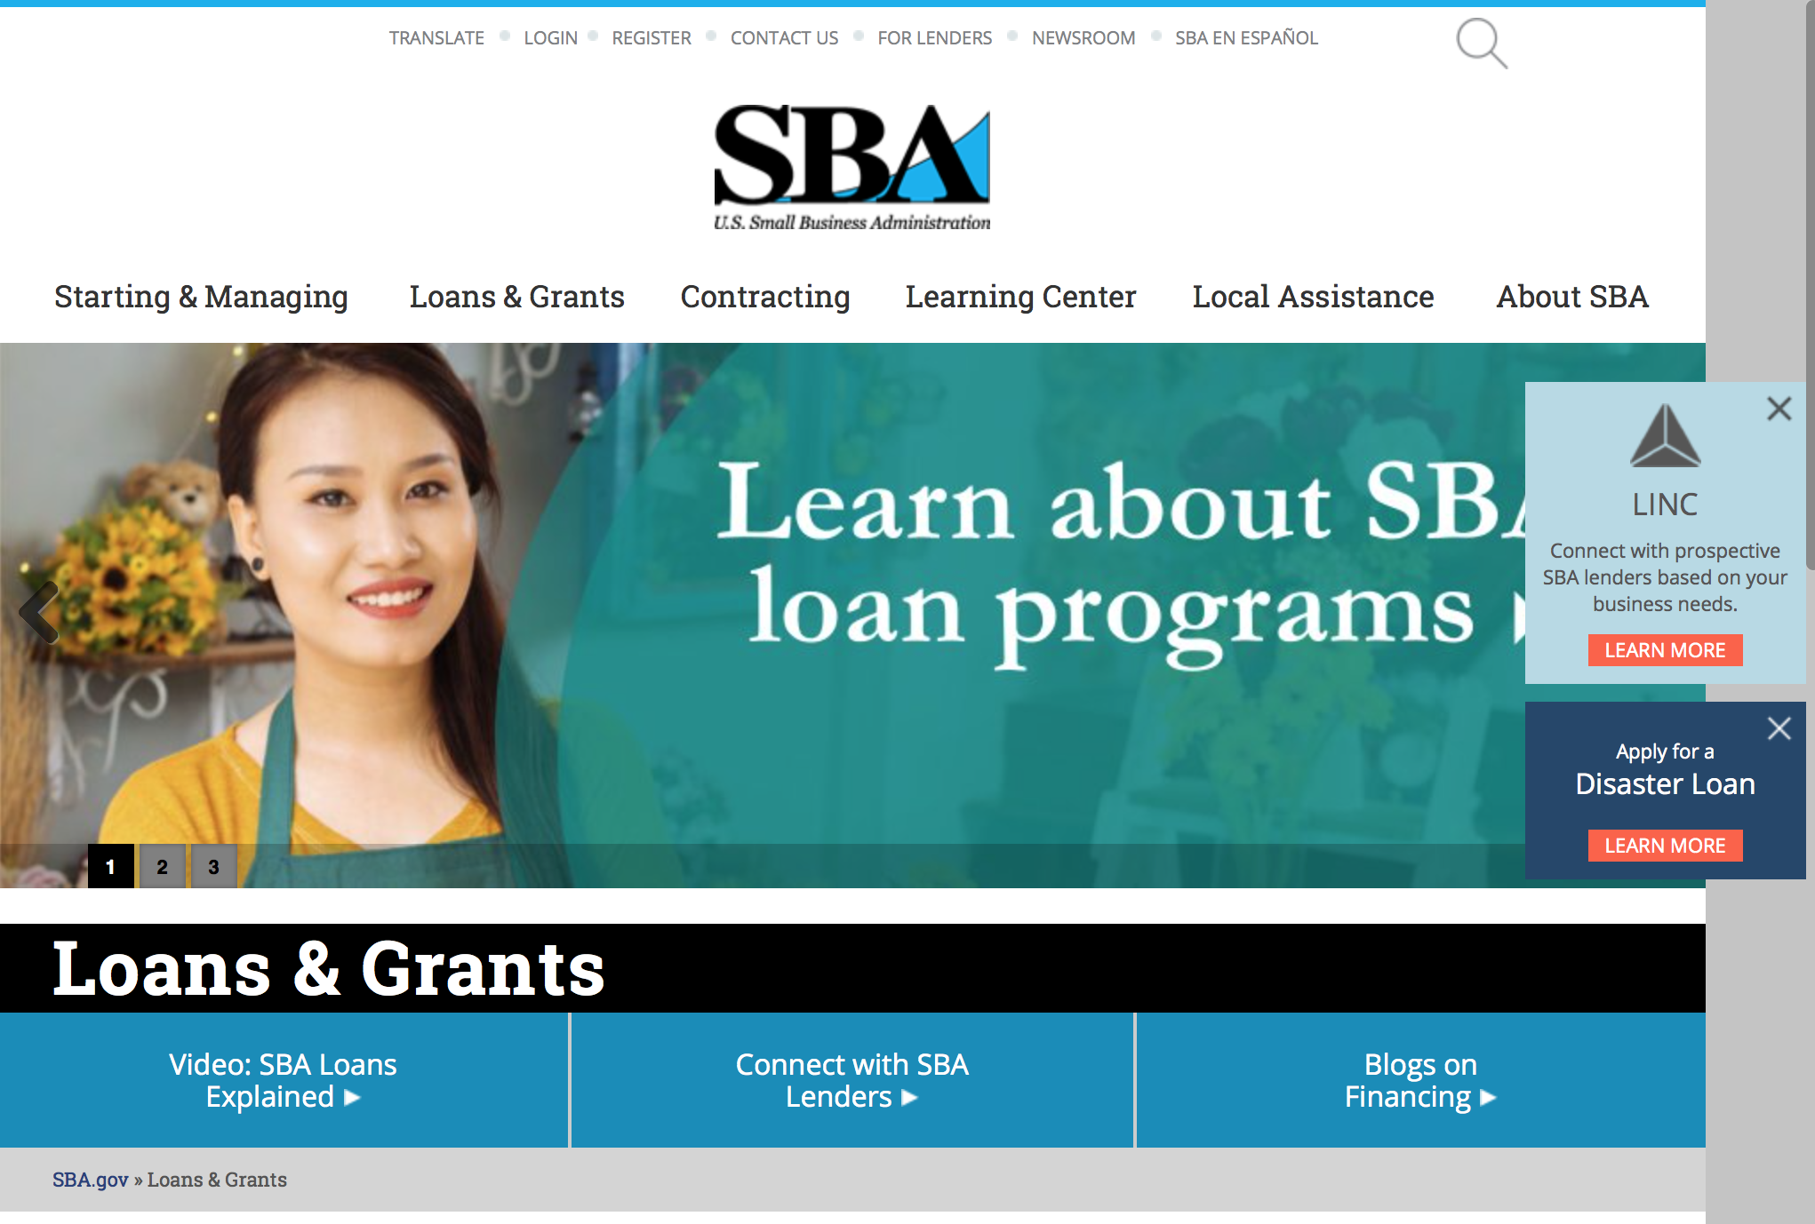
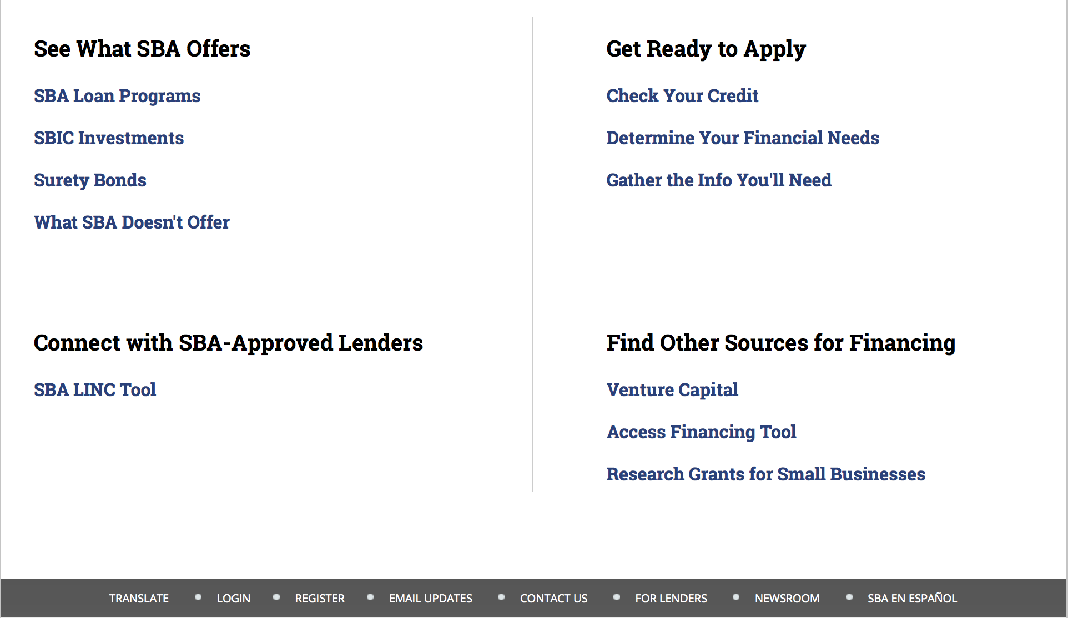

https://www.sba.gov/category/navigation-structure/loans-grants
Federal, state and local governments offer a wide range of financing programs to help small businesses start and grow their operations. These programs include low-interest loans, venture capital, and scientific and economic development grants.

Use SBA.gov's Loans and Grants Search Tool to get a list of financing programs for which you may qualify, or visit the resources below to learn more about small business financing programs. 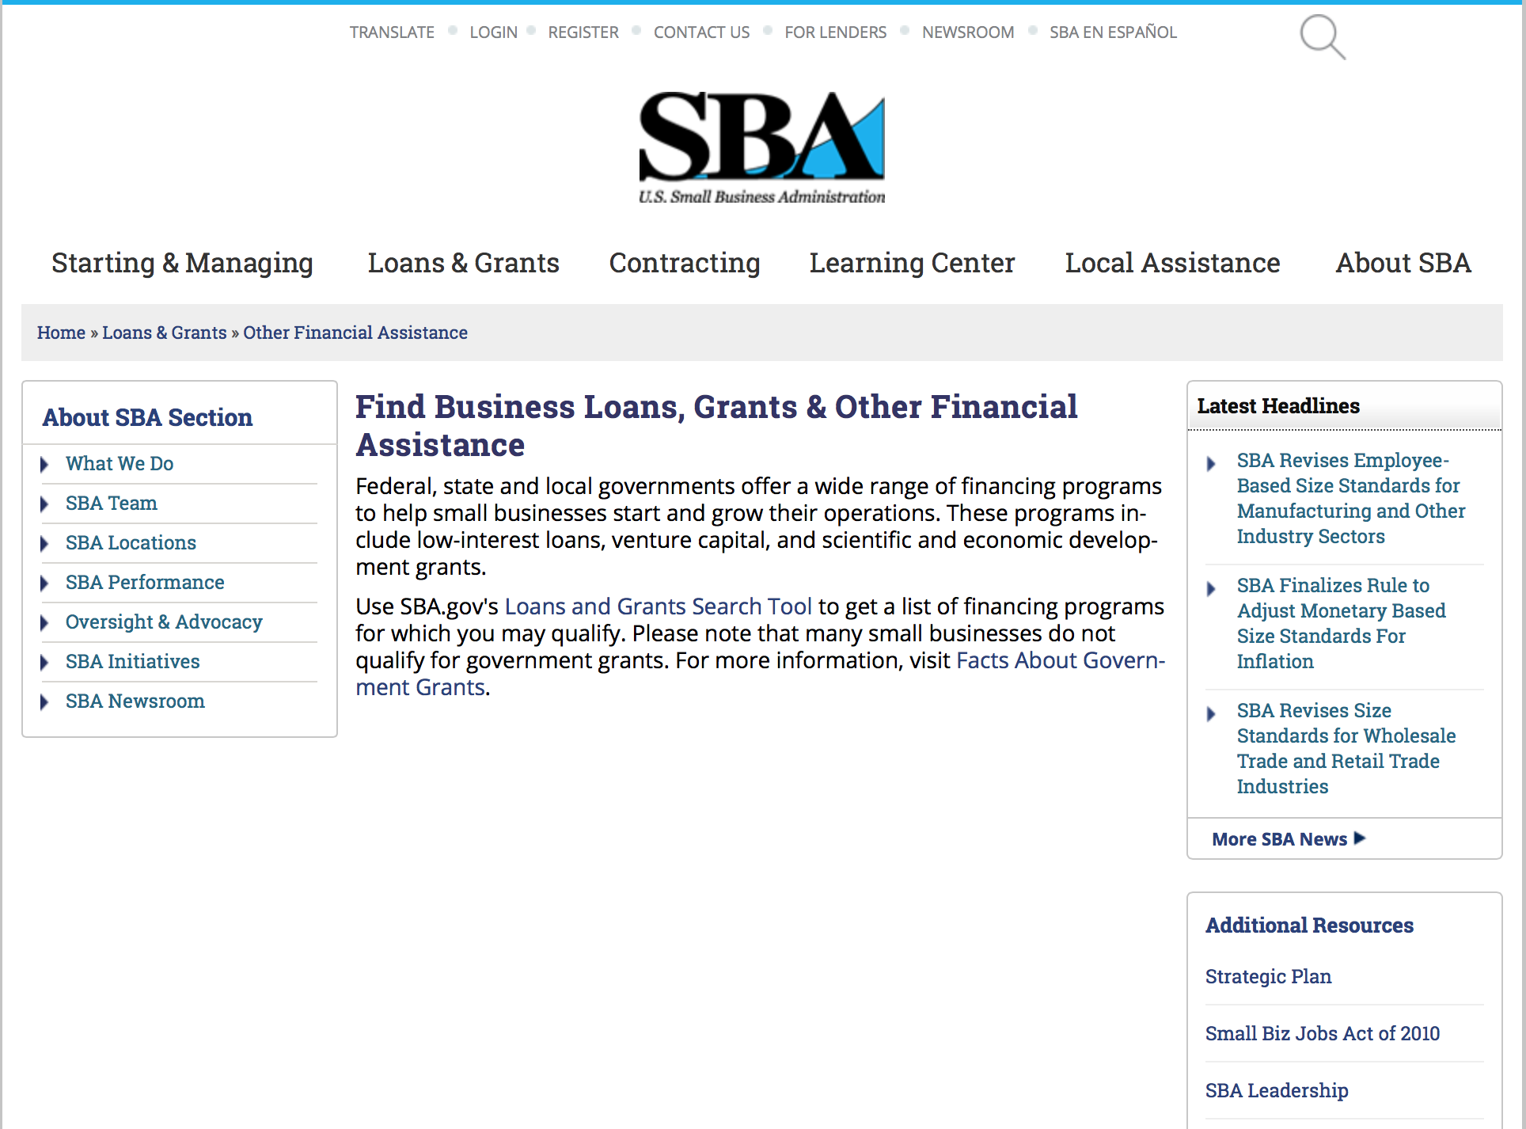
To get to the main SBA.gov funding page click here
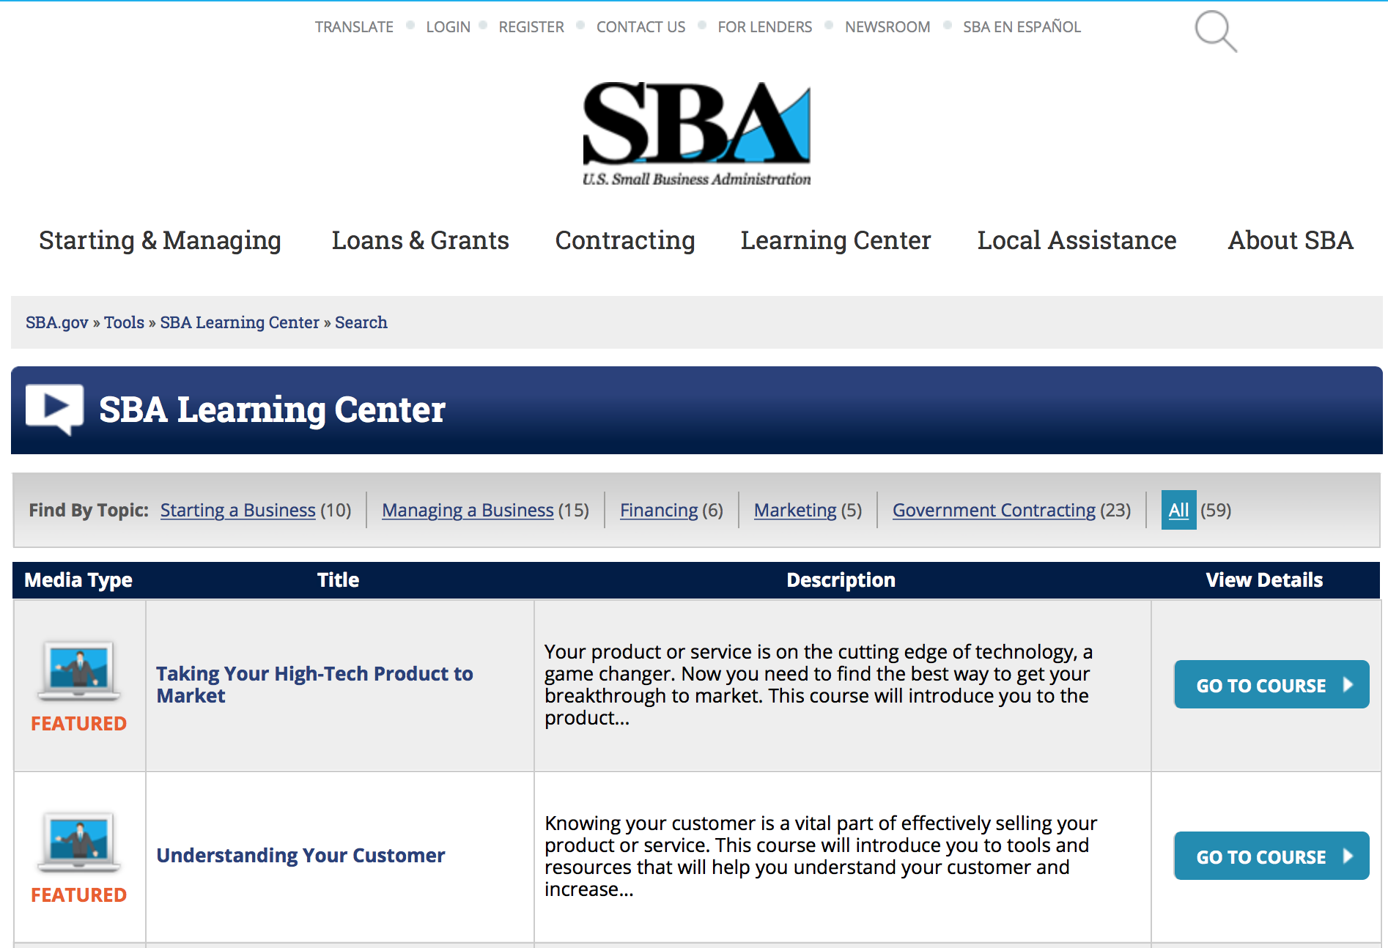
https://www.sba.gov/tools/sba-learning-center/search/training

Reminders:

SBA Trainings

Contracting Opportunities for Veteran Entrepreneurs
This self-paced training exercise is an introduction to Federal contracting opportunities for Veterans.
Topics include basic information about Veteran-owned businesses and opportunities, services available to small Veteran-owned businesses, small business incentives, and government procurement methods.
Duration: 00:30:00

http://www.sba.gov/tools/sba-learning-center/training/contracting-opportunities-veteran-entrepreneurs

Interested in Exporting? These Four Resources Can Help
Did you know that two-thirds of the world’s purchasing power is in foreign countries? As the numbers show, the international marketplace is a big one. So if you’re interested in exploring the world of exporting – or have gotten started but could use some guidance – check out these resources to help.
- Read more

Upcoming Trainings: Check out SBA's Online Training!
- Financing Options for Small Businesses
How to Prepare Government Contract Proposals
Getting Started With Exporting: Training and Educational Resources
Exporting represents a big opportunity to tap in to new markets, expand your customer base and grow your business. But getting started with exporting can sometimes feel like a maze of regulations, policies, and other barriers. Here are some free training and educational resources to help.
- Read more

For Specific Information in Hawaii see the following links:
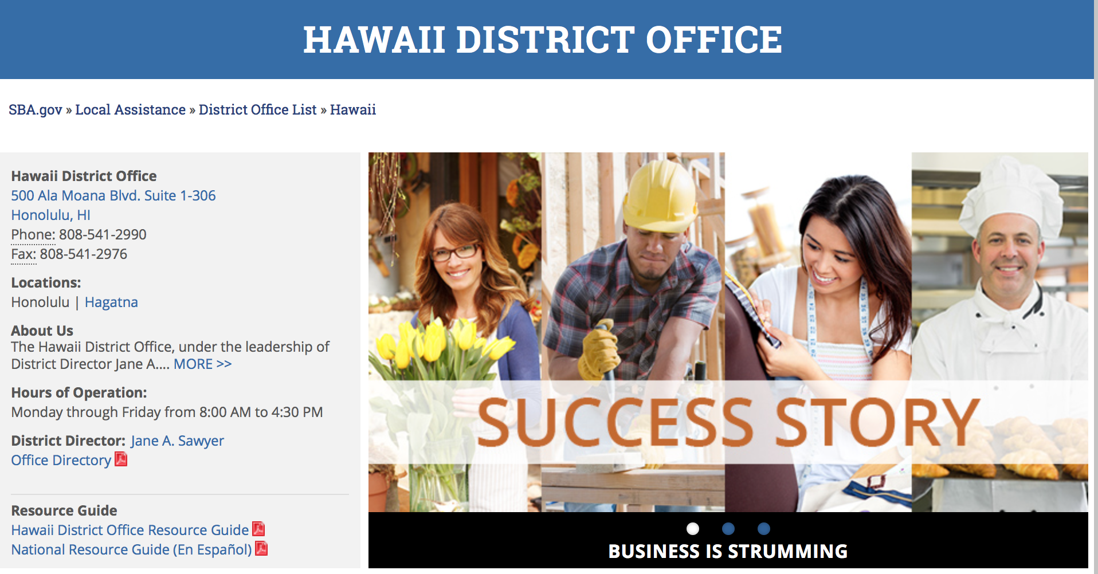

https://www.sba.gov/offices/district/hi/Honolulu

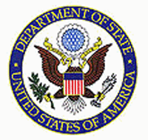

State Department General Overview and Resources for Program Administrators

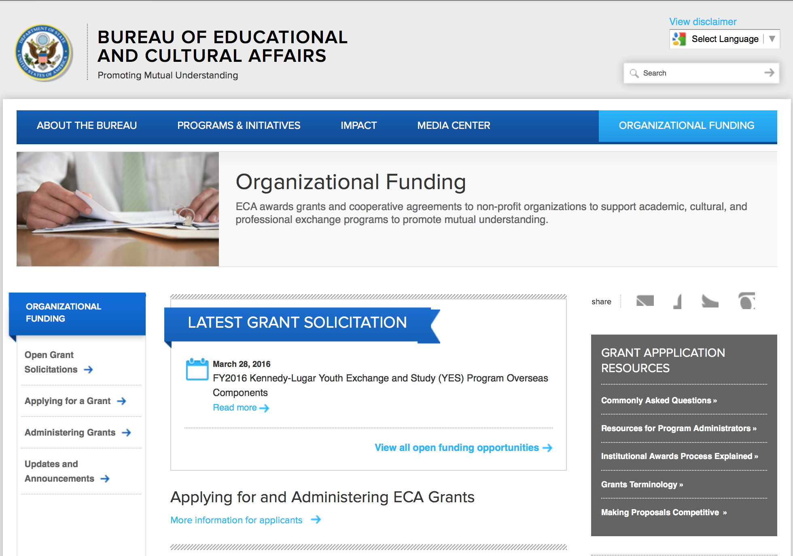
http://eca.state.gov/search/solr/grants?search_referrer=node/237
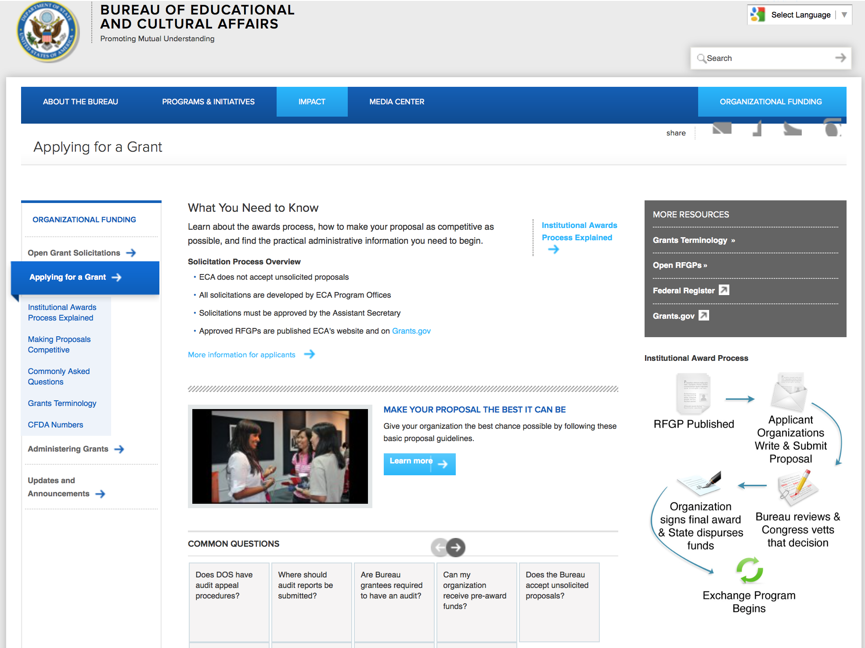

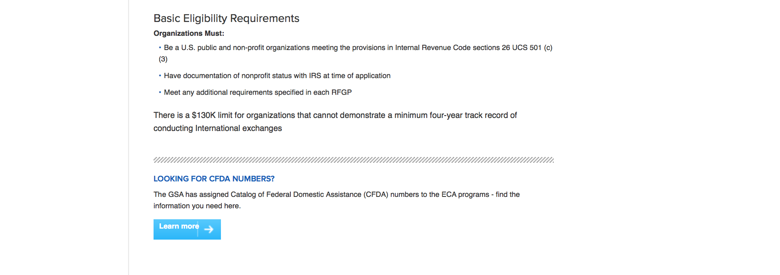
http://eca.state.gov/organizational-funding/applying-grant

General Information:
- Bureau of Educational and Cultural Affairs Grants Division
- Open Grant Opportunities (Requests for Grant Proposals)

For General Information click here

Program Grants:

Bureau of International Security and Nonproliferation
Advancing Industry Outreach in Ukraine Grant
http://www.grants.gov/web/grants/view-opportunity.html?oppId=281824

Bureau of South and Central Asian Affairs
Book Translation Grant
http://www.grants.gov/web/grants/view-opportunity.html?oppId=281677

Bureau of Democracy, Human Rights and Labor
Combatting Slavery in Mauritania, Mali, and Senegal Grant
http://www.grants.gov/web/grants/view-opportunity.html?oppId=281769

Bureau of Near Eastern Affairs
Near East Affairs - Assistance Coordination
Trans-Sahara Counterterrorism Partnership Programming in the Greater Maghreb Grant
http://www.grants.gov/web/grants/view-opportunity.html?oppId=281354

PM Weapons Removal and Abatement
16.PMWRA.COLOMBIA.IM.NOFO Grant
http://www.grants.gov/web/grants/view-opportunity.html?oppId=281741

U.S. Mission to Pakistan
Annual Program Statement—Punjab Grant
http://www.grants.gov/web/grants/view-opportunity.html?oppId=281451

PM Weapons Removal and Abatement
16.PMWRA.Somalia.NOFO Grant
http://www.grants.gov/web/grants/view-opportunity.html?oppId=281598

Ocean and International Environmental Scientific
CAFTA-DR: Public Participation in Environmental Protection Grant
http://www.grants.gov/web/grants/view-opportunity.html?oppId=281632

U.S. Mission to Bosnia and Herzegovina
Comprehensive in-School Civic Education Program Grant
http://www.grants.gov/web/grants/view-opportunity.html?oppId=281368

Modifications:

Bureau of Population, Refugees and Migration
FY 2016 Notice of Funding Opportunity for NGO programs benefiting refugees and other vulnerable populations in Afghanistan, Pakistan, and Central Asia
Modification 1
http://www.grants.gov/web/grants/view-opportunity.html?oppId=281623

Bureau of Near Eastern Affairs
Near East Affairs - Assistance Coordination
Supporting Libya through Political Transition
Modifications 1 & 2
http://www.grants.gov/web/grants/view-opportunity.html?oppId=281780

S Bureau Grants Offices
Funds Manager for DREAMS Innovation Challenge
Modification 3
http://www.grants.gov/web/grants/view-opportunity.html?oppId=281397

Bureau of Population, Refugees and Migration
FY 2016 Notice of Funding Opportunity for NGO programs benefiting refugees in Rwanda, Tanzania, Uganda, and the Democratic Republic of Congo
Modification 1
http://www.grants.gov/web/grants/view-opportunity.html?oppId=281828

International Narcotics and Law Enforcement Affair
Alternatives to Drugs and Violence Annual Program Statement (ADVAPS)
Modification 9
http://www.grants.gov/web/grants/view-opportunity.html?oppId=272431

Bureau of International Security and Nonproliferation
Global Chemical Security Activities
Modification 1
http://www.grants.gov/web/grants/view-opportunity.html?oppId=280140

Reminders:

Department of Transportation

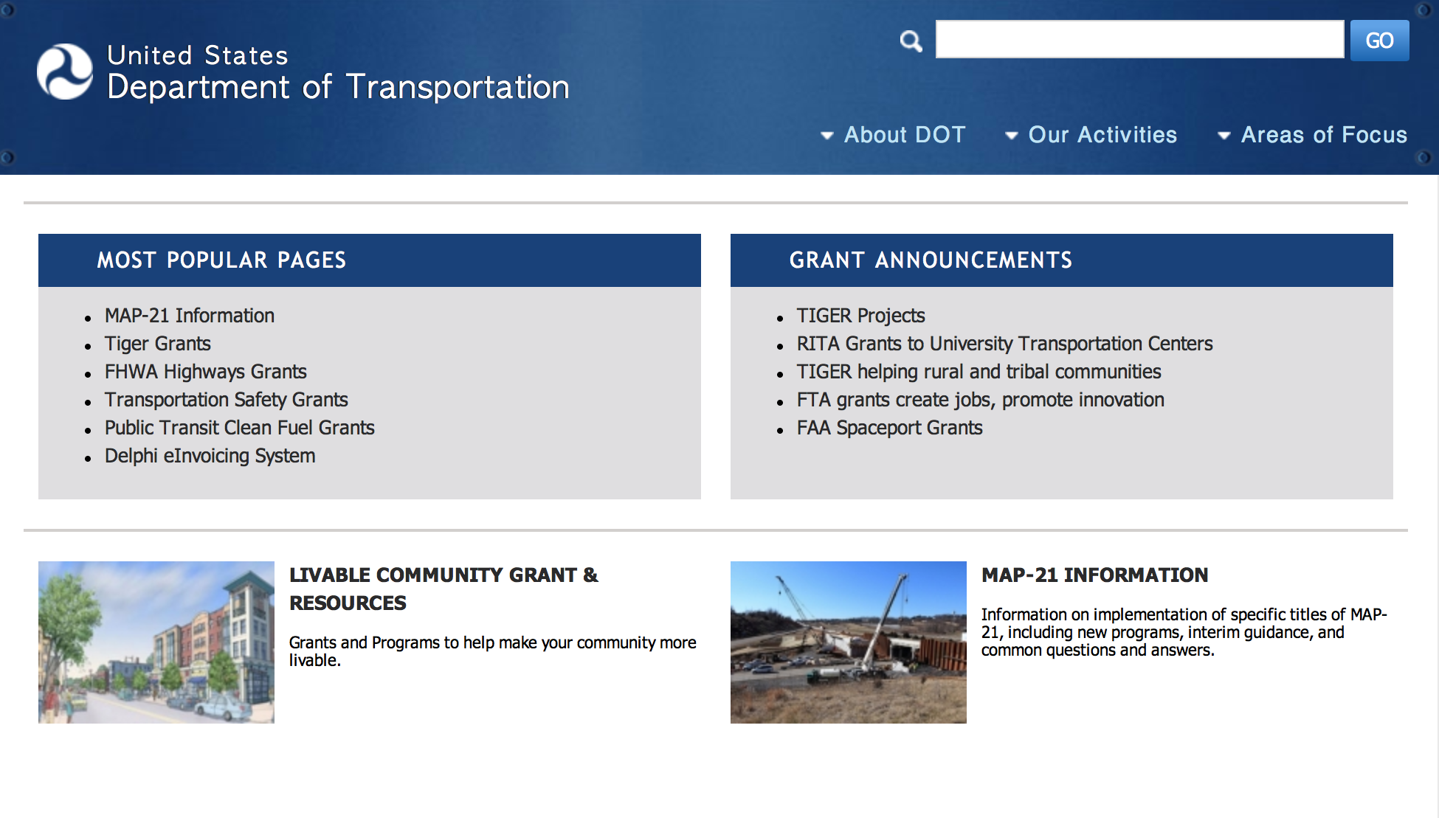
General Grant Program Overview https://www.transportation.gov/grants

Programs:

FY 2016 National Infrastructure Investments Grant
Document Type: | Grants Notice
Funding Opportunity Number: | DTOS59-16-RA-TIGER8
Funding Opportunity Title: | FY 2016 National Infrastructure Investments
Opportunity Category: | Discretionary
Opportunity Category Explanation:
Funding Instrument Type: | Grant
Category of Funding Activity: | Transportation
Category Explanation:
Expected Number of Awards:
CFDA Number(s): | 20.933 -- National Infrastructure Investments
Cost Sharing or Matching Requirement: | Yes
Current Closing Date for Applications: | Apr 29, 2016 NOTE: Detailed Instructions on "How to Apply" for TIGER Discretionary Grants can be found on the TIGER Website (www.transportation.gov/tiger). Application Instructions: Applications must be submitted through Grants.gov. The Grants.gov “Apply” function opens on Feb 26, 2016. Please be aware that you must complete the Grants.gov registration process before submitting the Application, and that this process usually takes 2-4 weeks to complete. Applications must be submitted by 8:00 PM E.D.T. on April 29, 2016. Applicants are strongly encouraged to make submissions in advance of the deadline. *Late Applications: Applications received after the deadline will not be considered except in the case of unforeseen technical difficulties outlined below. Late applications that are the result of failure to register or comply with Grants.gov applicant requirements in a timely manner will not be considered. Applicants experiencing technical issues with Grants.gov that are beyond the applicant’s control must contact TIGERGrants@dot.gov or Howard Hill at 202-366-0301 prior to the deadline with the user name of the registrant and details of the technical issue experienced. The applicant must provide 1: Details of the technical issue experienced 2: Screen capture(s) of the technical issue experienced along corresponding “Grant tracking number” (Grants.gov) 3: The "Legal Business Name" for the applicant that was provided in the SF-424. 4: The AOR name submitted in the SF-424 (Grants.gov). 5: The DUNS number associated with the Application. 6: The Grants.gov Help Desk Tracking Number. To ensure a fair competition for limited discretionary funds, the following conditions are not valid reasons to permit late submissions: (1) failure to complete the registration process before the deadline date; (2) failure to follow Grants.gov instructions on how to register and apply as posted on its website; (3) failure to follow all of the instructions in this notice of funding availability; and (4) technical issues experienced with the applicant’s computer or information technology (IT) environment. After DOT staff review all of the information submitted and contact the Grants.gov Help Desk to validate the technical issues you reported, DOT staff will contact you to either approve or deny your request to submit a late application through Grants.gov. If the technical issues you reported cannot be validated, your application will be rejected as untimely.
Archive Date: | Dec 31, 2016
Estimated Total Program Funding: | $500,000,000
Award Ceiling: | $100,000,000
Award Floor: | $1,000,000
Eligible Applicants: | Others (see text field entitled "Additional Information on Eligibility" for clarification)
Additional Information on Eligibility: | Eligible Applicants for TIGER Discretionary Grants are State, local and tribal governments, including U.S. territories, transit agencies, port authorities, metropolitan planning organizations (MPOs), and other political subdivisions of State or local governments. Multiple States or jurisdictions may submit a joint application and must identify a lead applicant as the primary point of contact. Each project party in a joint application must be an Eligible Applicant. Joint applications must include a description of the roles and responsibilities of each project party and must be signed by each project party.
Agency Name: | Department of Transportation
Description: | The FY 2016 Appropriations Act appropriated $500 million to be awarded by DOT for the TIGER Discretionary Grants program. The FY 2016 TIGER Discretionary Grants are for capital investments in surface transportation infrastructure and are to be awarded on a competitive basis for projects that will have a significant impact on the Nation, a metropolitan area, or a region. The Act also allows DOT to use a small portion of the $500 million for oversight and administration of grants. If this solicitation does not result in the award and obligation of all available funds, DOT may publish additional solicitations. The FY 2016 Appropriations Act specifies that TIGER Discretionary Grants may not be less than $5 million and not greater than $100 million, except that for projects located in rural areas the minimum TIGER Discretionary Grant size is $1 million. Pursuant to the FY 2016 Appropriations Act, no more than 20 percent of the funds made available for TIGER Discretionary Grants (or $100 million) may be awarded to projects in a single State. The FY 2016 Appropriations Act directs that not less than 20 percent of the funds provided for TIGER Discretionary Grants (or $100 million) shall be used for projects located in rural areas. Further, pursuant to the FY 2016 Appropriations Act, DOT must take measures to ensure an equitable geographic distribution of grant funds, an appropriate balance in addressing the needs of urban and rural areas, and investment in a variety of transportation modes. The FY 2016 Appropriations Act requires that FY 2016 TIGER funds are only available for obligation through September 30, 2019. No FY 2016 TIGER funds may be expended after September 30, 2024. As part of the review and selection process described in the Notice of Funding Opportunity, DOT will consider whether a project is ready to proceed with an obligation of grant funds from DOT within the statutory time provided. Under the FY 2016 Appropriations Act, no waiver is possible for these deadlines. The FY 2016 Appropriations Act allows for up to 20 percent of available funds (or $100 million) to be used by the Department to pay the subsidy and administrative costs for a project receiving credit assistance under the Transportation Infrastructure Finance and Innovation Act of 1998 (“TIFIA”) program, if it would further the purposes of the TIGER Discretionary Grant program. Recipients of prior TIGER Discretionary Grants may apply for funding to support additional phases of a project awarded funds in earlier rounds of this program. However, to be competitive, the applicant should demonstrate the extent to which the previously funded project phase has been able to meet estimated project schedules and budget, as well as the ability to realize the benefits expected for the project. DOT expects that each TIGER Discretionary Grant will be administered by one of the relevant modal administrations, pursuant to a grant agreement between the TIGER Discretionary Grant recipient and the relevant modal administration.
Link to Additional Information: | TIGER Discretionary Grant Program
Contact Information: | If you have difficulty accessing the full announcement electronically, please contact:  Robert Mariner Senior Policy Analyst Phone 202-366-8914  TIGER Program Manager

http://www.grants.gov/web/grants/view-opportunity.html?oppId=281810

DOT/National Highway Traffic Safety Administration
Statewide Pedestrian and Bicyclist Focus Education and Enforcement Effort Grant
Document Type: | Grants Notice
Funding Opportunity Number: | DTNH2216R00004
Funding Opportunity Title: | Statewide Pedestrian and Bicyclist Focus Education and Enforcement Effort
Opportunity Category: | Discretionary
Opportunity Category Explanation:
Funding Instrument Type: | Cooperative Agreement
Category of Funding Activity: | Transportation
Category Explanation:
Expected Number of Awards: | 3
CFDA Number(s): | 20.614 -- National Highway Traffic Safety Administration (NHTSA) Discretionary Safety Grants
Cost Sharing or Matching Requirement: | No
Posted Date: | Feb 18, 2016
Last Updated Date: | Feb 18, 2016
Original Closing Date for Applications: | Mar 21, 2016
Current Closing Date for Applications: | Mar 21, 2016
Archive Date: | Apr 20, 2016
Estimated Total Program Funding: | $1,500,000
Award Ceiling: | $1,500,000
Eligible Applicants: | Others (see text field entitled "Additional Information on Eligibility" for clarification)
Additional Information on Eligibility: | The successful organization must demonstrate that they have the infrastructure in place, as well as the necessary staff and support to carry out the responsibilities in developing, administering/coordinating and implementing this agreement. Only organizations capable of fulfilling the criteria listed below will be considered. The criteria require that: Applicant must have the existence of an organizational infra-structure that will allow staff time necessary to handle the day-to-day logistical needs for this project. Interested applicants are advised that no fee or profit will be allowed under this Cooperative Agreement. Applicants (focus states) shall have a pedestrian and bicycle safety action plan (PBSAP) that has been adopted by the governing body of the jurisdiction. To be eligible to participate in this cooperative agreement, applicants shall meet the following requirements: a. Demonstrate high involvement in the development and/or implementation of the jurisdiction’s Pedestrian and Bicycle Safety Action Plan; b. Provide an approved version of the Pedestrian and Bicycle Safety Action Plan (as an appendix to the application); c. Provide data defining the State’s or States’ pedestrian and bicycle high-risk group(s), high-crash locations/intersections and most common pedestrian crash types; d. Considering the extent of the problem and the current needs of the State’s pedestrian and bicycle safety programs, show how the requested funding will enable the applicant to make significant progress toward improving or enhancing their pedestrian safety efforts in the focus State; e. Provide a list of related training(s) the State has received for improving pedestrian and bicycle safety; f. Demonstrate leadership or point of contact in the Focus State to champion such a program; g. Demonstrate partnerships with education and enforcement professionals, pedestrian advocacy organizations and others who will be involved in the implementation of the program; h. Demonstrate willingness to accept Federal involvement in proposed effort. NHTSA plans to award three (3) cooperative agreements, via limited competition, to continue the focused city comprehensive approach to pedestrian safety. This Request for Application broadens the scope to include bicycle safety as well as pedestrian safety and will support the implementation of the education and enforcement elements of the localities’ pedestrian/bicycle safety plans. This broadened approach reflects the direction taken by FHWA. Only those localities currently designated as Pedestrian/Bicycle Focus States with an approved city pedestrian and bicycle safety action plan that have not previously received NHTSA focus State funded awards will be eligible to apply . This funding supplements active infrastructure improvement projects already proposed or in progress as outlined in their existing State action plan.
Agency Name: | DOT/National Highway Traffic Safety Administration
Description: | Announcement of a Request for Applications (RFA) to provide assistance to eligible designated pedestrian/bicycle focus States to support focus cities implement education and enforcement components of their local Pedestrian/Bicycle Safety Action Plans.
Link to Additional Information:
Contact Information: | If you have difficulty accessing the full announcement electronically, please contact:  Seth Moody Contract Specialist Phone 2023669557  Work

http://www.grants.gov/web/grants/view-opportunity.html?oppId=281258

Modifications:

Reminders:

DOT Federal Highway Administration
National Summer Transportation Institute Grant

Document Type: | Grants Notice
Funding Opportunity Number: | FY16
Funding Opportunity Title: | National Summer Transportation Institute
Opportunity Category: | Discretionary
Funding Instrument Type: | Grant
Category of Funding Activity: | Education
Category Explanation:
Expected Number of Awards: | 100
CFDA Number(s): | 20.215 -- Highway Training and Education
Cost Sharing or Matching Requirement: | No
Posted Date: | Jan 29, 2016
Creation Date: | Jan 29, 2016
Current Closing Date for Applications: | Mar 31, 2016 Applications must be submitted to your State DOT by Close Date.
Archive Date: | Apr 30, 2016
Estimated Total Program Funding: | $2,000,000
Award Ceiling: | $100,000
Award Floor: | $20,000
Eligible Applicants: | Public and State controlled institutions of higher education
Agency Name: | DOT Federal Highway Administration
Description: | The Federal Highway Administration (FHWA) Headquarters' Civil Rights (HCR) Office requests Statements of Work (SOWs) for the Fiscal Year (FY) 2016 NSTI Program. The NSTI program is a Science, Technology and Math (STEM) focused program for high school and junior high school students. It is administered by accredited colleges, community colleges and universities, accredited Tribal colleges, Historically Black Colleges and Universities (HBCUs), Minority Serving Institutions (MSIs), Hispanic Serving Institutions (HSIs) and Asian-American Native American Pacific Island Serving Institutions (ANAPISI) throughout the United States, the District of Columbia, the Commonwealth of Puerto Rico, Pacific Island territories and the U.S. Virgin Islands. These institutions make application to the State DOT (State DOTs) to serve as NSTI Host sites. State DOTs provide NSTI program oversight to the host sites. The FHWA Division Offices Civil Rights Specialists provide program guidance to the State DOTs in their oversight of the NSTI program. Academic institutions interested in serving as host sites must complete and submit their application package to the State DOT. The NSTI program objectives are to improve STEM skills, provide awareness to middle and high school students - particularly minority, female and disadvantaged youth - about transportation careers, and encourage them to consider transportation-related courses of study in their higher education pursuits. Host sites are required to commit significant program time to classroom participation. The length of the program is typically 2-4 consecutive weeks. Host sites may choose to be student day programs or residential programs in which room and board are provided by the Host Sites to the students. For more information including the application packet and deadline for submission, please contact your State DOT Representative.
Link to Additional Information:
Contact Information: | If you have difficulty accessing the full announcement electronically, please contact:  Joyce Gottlieb Program Analyst Phone 202-366-3664  FHWA-Headquarters Office of Civil Rights

http://www.grants.gov/web/grants/view-opportunity.html?oppId=281260

DOT/Federal Motor Carrier Safety Administration
FY2016 Commercial Motor Vehicle Operator Safety Training Grant Program

Document Type: | Grants Notice
Funding Opportunity Number: | FM-DTG-16-001
Funding Opportunity Title: | FY2016 Commercial Motor Vehicle Operator Safety Training Grant Program
Opportunity Category: | Discretionary
Funding Instrument Type: | Grant
Category of Funding Activity: | Transportation
Category Explanation:
Expected Number of Awards: | 10
CFDA Number(s): | 20.235 -- Commercial Motor Vehicle Operator Training Grants
Cost Sharing or Matching Requirement: | Yes
Posted Date: | Jan 5, 2016
Creation Date: | Jan 13, 2016
Original Closing Date for Applications: | Apr 5, 2016 No Explanation
Current Closing Date for Applications: | Apr 5, 2016 No Explanation
Archive Date: | May 5, 2016
Eligible Applicants: | Native American tribal governments (Federally recognized)  Others (see text field entitled "Additional Information on Eligibility" for clarification)  Nonprofits having a 501(c)(3) status with the IRS, other than institutions of higher education  Small businesses  County governments  Private institutions of higher education  Public and State controlled institutions of higher education  For profit organizations other than small businesses  Special district governments  City or township governments  State governments
Additional Information on Eligibility: | Vocational Technical Schools and Truck Training Schools
Agency Name: | DOT/Federal Motor Carrier Safety Administration
Description: | The Federal Motor Carrier Safety Administration (FMCSA) announces the Fiscal Year (FY) 2016 CMVOST grant program Notice of Funding Availability (NOFA) to solicit applications from organizations that provide CMV operator training, including accredited public or private colleges, universities, vocational-technical schools, post-secondary educational institutions, truck driver training schools, associations, and State and local governments, including Federally-recognized Native American Tribal governments that support CMVOST activities. The CMVOST grant is a nationwide Federal financial assistance program intended to reduce the severity and number of crashes on U.S. roads involving CMV by training operators and future operators in the safe use of such vehicles.
Link to Additional Information: | FY2016 Commercial Motor Vehicle Operator Safety Training Grant Program
Contact Information: | If you have difficulty accessing the full announcement electronically, please contact:  Grants.gov Contact Center Phone Number: 1-800-518-4726 Hours of operation are 24 hours a day, 7 days a week. The contact center is closed on federal holidays. support@grants.gov  Grants.gov Customer Support

http://www.grants.gov/web/grants/view-opportunity.html?oppId=280837

DOT/Federal Motor Carrier Safety Administration
FY 2016 Commercial Drivers License Program Implementation Notice of Funding Availability
And Modifications 1 & 4

Document Type: | Grants Notice
Funding Opportunity Number: | FM-CDL-16-002
Funding Opportunity Title: | FY 2016 Commercial Drivers License Program Implementation Notice of Funding Availability
Opportunity Category: | Discretionary
Funding Instrument Type: | Cooperative Agreement  Grant
Category of Funding Activity: | Transportation
Category Explanation:
Expected Number of Awards: | 45
CFDA Number(s): | 20.232 -- Commercial Driver's License Program Improvement Grant
Cost Sharing or Matching Requirement: | No
Posted Date: | Jan 5, 2016
Creation Date: | Jan 14, 2016
Original Closing Date for Applications: | Apr 5, 2016 No Explanation
Current Closing Date for Applications: | Apr 5, 2016 No Explanation
Archive Date: | May 5, 2016
Estimated Total Program Funding: | $30,000,000
Eligible Applicants: | Private institutions of higher education  Others (see text field entitled "Additional Information on Eligibility" for clarification)  City or township governments  Nonprofits having a 501(c)(3) status with the IRS, other than institutions of higher education  Special district governments  Public and State controlled institutions of higher education  County governments  State governments  Individuals
Additional Information on Eligibility: | Applications will be accepted from applications from State agencies, local governments, as well as other persons and organizations representing government agencies that support CDLPI activities. Note that applications must support the public purpose of the program.
Agency Name: | DOT/Federal Motor Carrier Safety Administration
Description: | The Federal Motor Carrier Safety Administration (FMCSA) announces the Fiscal Year (FY) 2016 Commercial Driver's License Program Implementation (CDLPI) grant program Notice of Funding Availability (NOFA) to solicit applications from State agencies, local governments, as well as other persons and organizations representing government agencies that support CDLPI activities. The goal of the national Commercial Drivers License (CDL) program is to reduce the number and severity of commercial motor vehicle crashes in the United States by ensuring that only qualified drivers are eligible to receive and retain a CDL. This goal focuses on maintaining the concept that for every driver, there is only one driving record and only one licensing document, commonly referred to as "One Driver One License One Record". States are required to conduct knowledge and skills testing before issuing a CDL; to maintain a complete and accurate driver history record for anyone who obtains a CDL; and to impose driver disqualifications as appropriate.
Link to Additional Information: | FY 2016 Commercial Drivers License Program Implementation Notice of Funding Availability
Contact Information: | If you have difficulty accessing the full announcement electronically, please contact:  Grants.gov Contact Center Phone Number: 1-800-518-4726 Hours of operation are 24 hours a day, 7 days a week. The contact center is closed on federal holidays. support@grants.gov  Grants.gov Customer Support

http://www.grants.gov/web/grants/view-opportunity.html?oppId=280835

DOT Federal Aviation Administration
DOT - FAA Aviation Research Grants
FAA Aviation Research and Development Grants
Modification 3

Document Type: | Grants Notice
Funding Opportunity Number: | 12-01
Funding Opportunity Title: | FAA Aviation Research and Development Grants
Opportunity Category: | Discretionary
Funding Instrument Type: | Grant
Category of Funding Activity: | Transportation
Category Explanation:
Expected Number of Awards:
CFDA Number(s): | 20.108 -- Aviation Research Grants
Cost Sharing or Matching Requirement: | No
Posted Date: | Jan 1, 2012
Creation Date: | Dec 9, 2015
Original Closing Date for Applications: | Dec 31, 2019
Current Closing Date for Applications: | Dec 31, 2019
Archive Date: | Jan 30, 2020
Estimated Total Program Funding:
Award Ceiling: | $5,000,000
Eligible Applicants: | Private institutions of higher education  Nonprofits having a 501(c)(3) status with the IRS, other than institutions of higher education  Public and State controlled institutions of higher education
Agency Name: | DOT - FAA Aviation Research Grants
Description: | The FAA is soliciting proposals for research grants and cooperative agreements to pursue the long-term growth and short-term technical needs of civil aviation. In order to streamline the application process, it is recommended that all prospective grantees submit a white paper (letter of intent) for agency technical review before complete proposal submission. Please be sure to identify the specific area of interest (Solicitation FAA-12-01 – Chapter I. FAA Research Grants Program, Technical Areas of Research #1-#9). The white paper shall be no longer than three (3) pages and shall detail overall research objectives.
Link to Additional Information:
Contact Information: | If you have difficulty accessing the full announcement electronically, please contact:  Robert Boggi Grants Specialist Phone 609-485-6911  business

http://www.grants.gov/web/grants/view-opportunity.html?oppId=134953

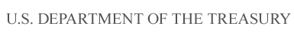

Department of the Treasury

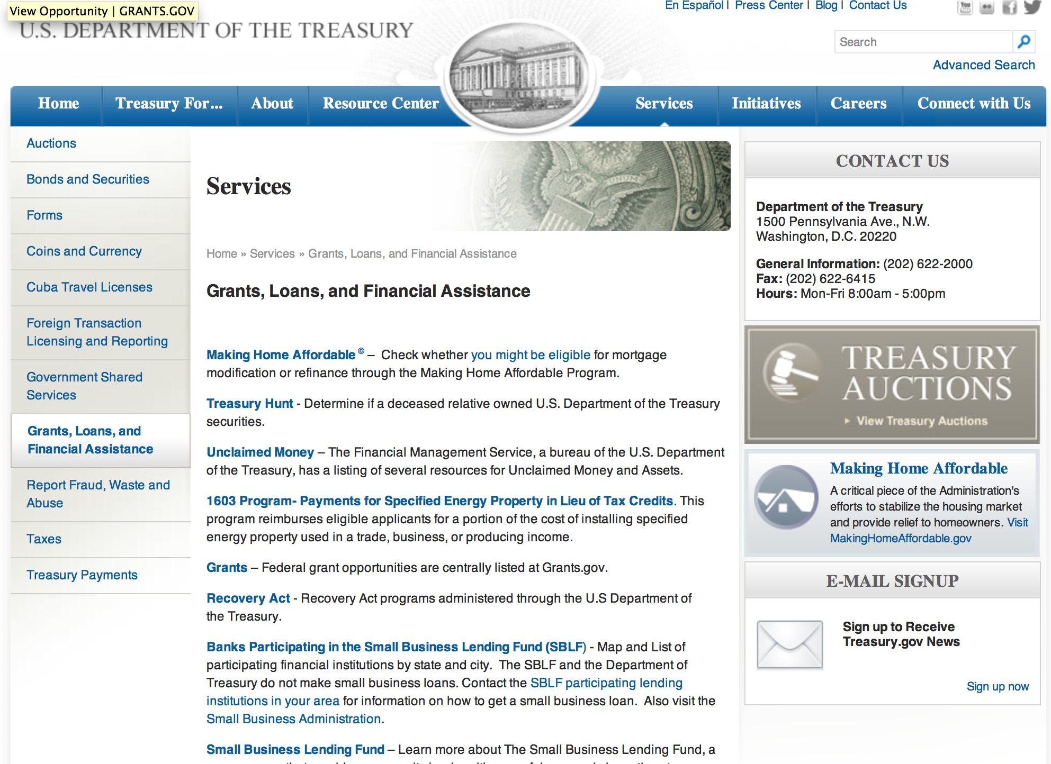

http://www.treasury.gov/services/Pages/Grants-Loans-and-Financial-Assistance.aspx

Programs:

Community Development Financial Institutions
Fiscal Year 2016 Capital Magnet Fund Program
And Modification 1

Document Type: | Grants Notice
Funding Opportunity Number: | CDFI-2016-CMF
Funding Opportunity Title: | Fiscal Year 2016 Capital Magnet Fund Program
Opportunity Category: | Discretionary
Opportunity Category Explanation: | Category Explanation
Funding Instrument Type: | Grant  Other
Category of Funding Activity: | Community Development
Category Explanation:
Expected Number of Awards: | 25
CFDA Number(s): | 21.011 -- Capital Magnet Fund
Cost Sharing or Matching Requirement: | No
Posted Date: | Feb 05, 2016
Last Updated Date: | Feb 19, 2016
Original Closing Date for Applications: | Mar 30, 2016
Current Closing Date for Applications: | Mar 16, 2016
Archive Date: | Mar 17, 2016
Estimated Total Program Funding: | $80,000,000
Award Ceiling: | $12,000,000
Eligible Applicants: | Others (see text field entitled "Additional Information on Eligibility" for clarification)
Additional Information on Eligibility: | Applicants must be (1) a Treasury certified CDFI; or (2) a nonprofit organization having as one of its principal purposes the development or management of affordable housing. An applicant must provide information necessary to establish that it is an eligible organization in order to apply for assistance. This information is included as part of the application materials. This program is excluded from coverage under OMB Circular No. A-87.
Agency Name: | Community Development Financial Institutions
Description: | The CDFI Fund awards Capital Magnet Fund grants to certified Community Development Financial Institutions (CDFIs) and certain nonprofit organizations to finance: (1) the development, preservation, rehabilitation, or purchase of affordable housing for primarily extremely low-, very low-, and low-income families; and (2) economic development activities or community service facilities, such as day care centers, workforce development centers, and health care clinics, which in conjunction with affordable housing activities implement a concerted strategy to stabilize or revitalize a low-income area or underserved rural area. CMF's award ceiling is 15% of Total Program Funding. This field will be updated when the Total Program Funding amount is released.
Link to Additional Information: | A webpage on the CDFI Fund's website with all the relevant details regarding the Capital Magnet Fund Program.
Contact Information: | If you have difficulty accessing the full announcement electronically, please contact:  CDFI IT Help Desk 202-653-0422  CDFI Fund IT Help Desk

http://www.grants.gov/web/grants/view-opportunity.html?oppId=281343

Modifications:

Reminders:

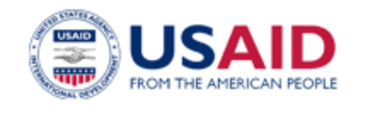

U.S. Agency for International Development

www.usaid.gov

General Overview Funding Opportunities

USAID has working relationships with thousands of American companies and hundreds of U.S.-based private voluntary organizations. For more information on our business and procurement opportunities, please visit our Business section.

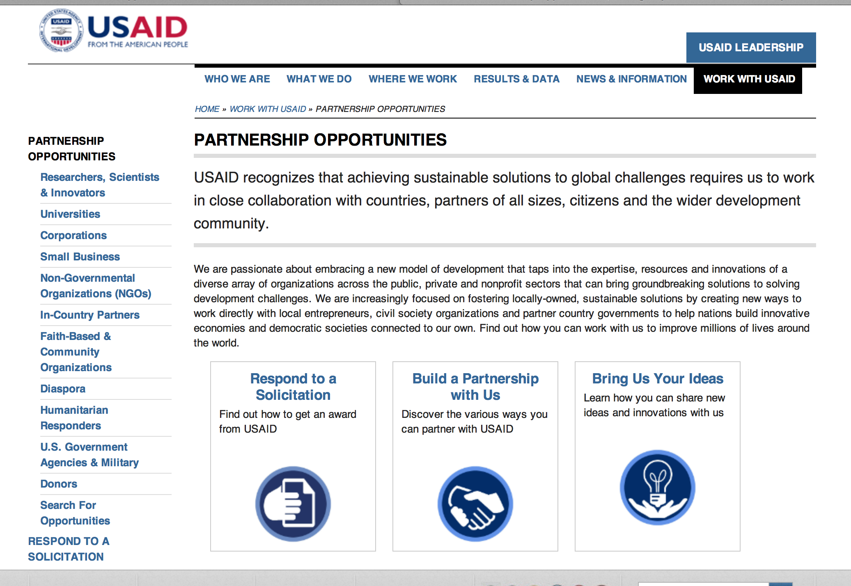
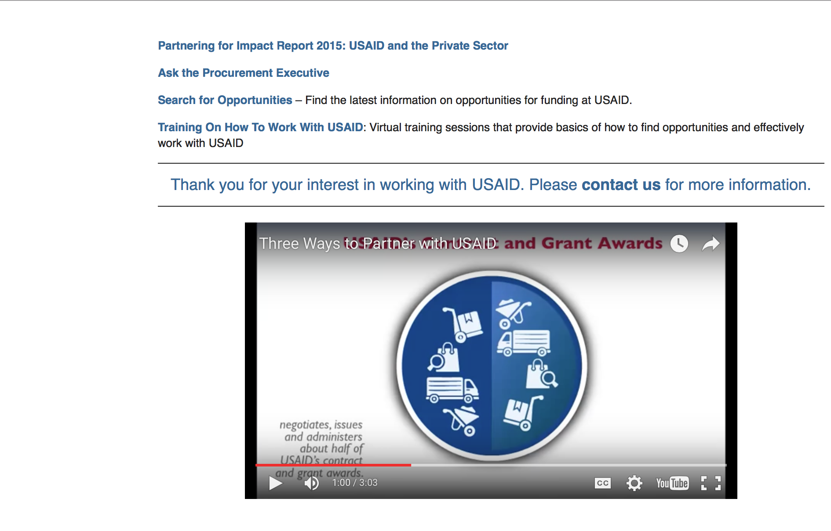

http://www.usaid.gov/partnerships

Programs:

Agency for International Development
The USAID BAA for Sustainable Development in Sub-Saharan Africa Grant
http://www.grants.gov/web/grants/view-opportunity.html?oppId=281432

Pre-Solicitation Notice: FY 2016 Conflict Mitigation and Reconciliation Programs and Activities Grant
http://www.grants.gov/web/grants/view-opportunity.html?oppId=281613

Modifications:

Reminders:

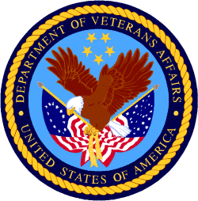

Department of Veterans Affairs

National Veterans Sports Programs
Grants for Adaptive Sports Programs for Disabled Veterans and Disabled Members of the Armed Forces Grant
http://www.grants.gov/web/grants/view-opportunity.html?oppId=281763

