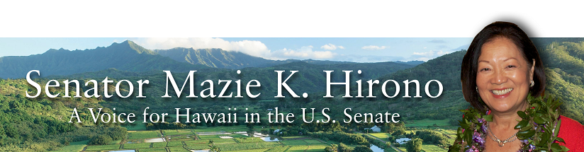

Grants Assistance Information
Newsletter
May 2016

G.A.I.N. INDEX

Click on Index Links below to read summaries of the announcements by agency in this document.
Once you reach the item, if you cannot open the links for further information, copy the selected
URL website address into your browser.

Modified sections from previous listings are shown in a GREY background

Notices is Teal are items with immediate deadline dates.

Notices in Yellow are of special interest.

Notices is Green are items of special interest with immediate deadline dates.

Items in this type color are aimed at Small Businesses

Items in this type color have a Faith-Based Organization component

Special Federal Program Notices

SBIR – Small Business Innovation Research

Programs specific to Hawaii

Current Notices

Reminders

Department of Homeland Security

Department of Homeland Security - FEMA
Fiscal Year (FY) 2016 Cooperating Technical Partners (CTP) Program - Region 9
Modifications 2 & 4

See Individual Departments for information and webpages representing the best and most accessible information on the agency funding opportunities

Federal Grant and Cooperative Agreement Program Summaries

U.S. Department of Agriculture

Grants and Loans Overview

Programs

Utilities Programs
Community Connect Grant Program Grant

Business and Cooperative Programs
Value Added Producer Grant

National Institute of Food and Agriculture
AFRI Food Safety Challenge Area Grant

National Institute of Food and Agriculture
Food Safety Outreach Program
And Modification 1

Modifications

Reminders

Utilities Programs
Household Water Well Grant Program

National Institute of Food and Agriculture
Rural Health & Safety Education Grant

Business and Cooperative Programs
Rural Cooperative Development Grant

Agricultural Marketing Service
Farmers Market Promotion Program Grant

Agricultural Marketing Service
Local Food Promotion Program Grant

Natural Resources Conservation Service
Conservation Innovation Grants

Natural Resources Conservation Service
Regional Conservation Partnership Program
And Modification 1

National Institute of Food and Agriculture
Special Research Grants Program - Aquaculture Research Grant

Forest Service
2017 National Urban and Community Forestry Grant Program

Farm Service Agency
Outreach and Education, Technical Assistance, and Financial Education for FSA Programs, Functions, and Activities Grant

Farm Service Agency
Outreach and Education, Technical Assistance, and Financial Education for FSA Programs, Functions, and Activities
Modification 2

Department of Commerce

Programs

FY2016 Regional Innovation Strategies Program Grant

Capital Project Grant

Research

National Institute of Standards and Technology
Embedding MEP in NNMI Institutes Pilot Projects
Modification 1

Modifications

Reminders

National Institute of Standards and Technology
National Strategy for Trusted Identities in Cyberspace (NSTIC) Federated Identity in Healthcare Pilot Program Grant

National Institute of Standards and Technology
Replicable Smart City Technologies Cooperative Agreement Program Grant

National Institute of Standards and Technology
Measurement Science and Engineering (MSE) Research Grant Programs

National Sea Grant College Program 2016-17 Special Projects Grant

FY 2016 – FY 2019 EDA Planning Program and Local Technical Assistance Program Grant

FY 2016 Economic Development Assistance Programs ­ Application submission and program requirements for EDA’s Public Works and Economic Adjustment Assistance Programs

Economic Development Administration
Planning Program and Local Technical Assistance Program Grant

Corporation for National and Community Service

General Program Overview

FY 2016 Social Innovation Fund Classic Cooperative Agreements Grant

Reminders

National Service in Hawaii

Department of Defense

Doing Business with the Department of Defense

DoD Small Business Opportunities and Forecasting

Research Grants

Modifications

Reminders

Dept. of the Army -- Materiel Command
Army Research Office Broad Agency Announcement for Basic and Applied Scientific Research
Modification 8

Department of Education

Grant Programs Overview

Programs

Office of Innovation and Improvement (OII): Magnet Schools Assistance Program CFDA Number 84.165A Grant
Office of Innovation and Improvement (OII): Investing in Innovation Fund: Development Grants Pre-Application CFDA Number 84.411P Grant

Research

Modifications

Office of Career, Technical, and Adult Education (OCTAE): Performance Partnership Pilots (P3) CFDA Number 84.420A
Modification 1

Reminders

Institute of Education Sciences (IES CFDA Number 84.305

Office of Elementary and Secondary Education (OESE): Carol M. White Physical Education Program CFDA Number 84.215F
Modification 1

US Department of Energy

Grants Overview

Programs

Modifications

Reminders

Cities Leading through Energy Analysis and Planning (Cities-LEAP) Grant

Environmental Protection Agency

Grants and Contracts Overview

Programs

Modifications

Reminders

FY 2016 and FY 2017 Pollution Prevention Grant Program

FY 2016 and FY 2017 Pollution Prevention Information Network (PPIN) Grants Program

Department of Health and Human Services

Grants Overview

Program

Research Grants

Modifications

Reminders

Department of Homeland Security
Grants Overview

Programs

Fiscal Year (FY) 2016 National Urban Search & Rescue (US&R) Response System Readiness Cooperation Agreement Grant
And Modifications 1 & 2

Modifications

Reminders

Department of Homeland Security - FEMA
Fiscal Year (FY) 2016 Cooperating Technical Partners (CTP) Program
Modification 3

Department of Homeland Security - FEMA
FY16 Pre-Disaster Mitigation Grant

Department of Homeland Security - FEMA
FY16 Flood Mitigation Assistance Grant

Department of Housing and Urban Development

HUD - Notice of Funds Available

Programs

Fair Housing Initiative Program - Education and Outreach Initiative Grant

Jobs Plus Initiative Grant

Healthy Homes Technical Studies Grant Program Pre and Full Application Grant

Fair Housing Initiatives Program - Private Enforcement Initiative Grant

Modifications

Reminders

Resident Opportunity & Self-Sufficiency Program Grant

Choice Neighborhoods Implementation Grant Program
Modification 1

General Section to HUD's Fiscal Year 2016 Notice[s] of Funding Availability for Discretionary Programs (General Section)
Modification 1

Institute of Museum and Library Services

Grants Overview

IMLS is on Facebook!

Modifications

Reminders

National Leadership Grants for Libraries Grant

Laura Bush 21st Century Librarian Program Grant

Department of Interior

Grants and Contract Overview

Programs

Modifications

Reminders

Geological Survey
2017 Earthquake Hazards External Grants Program

National Park Service
Land and Water Conservation Fund Outdoor Recreation Legacy Partnership Program Grant

Fish and Wildlife Service
Youth Engagement, Education, and Employment Programs Grant

Fish and Wildlife Service
Fiscal Year 2016 Recovery Implementation Fund Grant

Fish and Wildlife Service
Fiscal Year 2016 Candidate Conservation Action Funds Grant

Fish and Wildlife Service
National Fish Passage Program Grant

Department of the Interior
Fish and Wildlife Service
2016 National Fish Habitat Action Plan
Modification 1

Department of Justice

Grants and Contract Overview

Programs

Office of Justice Programs
Office of Juvenile Justice Delinquency Prevention
OJJDP FY 16 Safe and Thriving Communities: Uniting Community Based Violence Prevention, Defending Childhood and National Forum Approaches to Prevent and Heal Violence Grant

Office of Justice Programs
Office of Juvenile Justice Delinquency Prevention
OJJDP FY 2016 Juvenile Justice Emergency Planning Demonstration Program Grant

Office of Justice Programs
Bureau of Justice Assistance
Smart Reentry: Focus on Evidence-Based Strategies for Successful Reentry from Incarceration to Community Grant

Modifications

Reminders

Bureau of Justice Assistance
Justice and Mental Health Collaboration Program Grant

Office of Justice Programs
Bureau of Justice Assistance
Justice and Mental Health Collaboration Training and Technical Assistance Program Grant

Office of Justice Programs
National Institute of Justice
Investigator-Initiated Research and Evaluation on Firearms Violence Grant

Office of Juvenile Justice Delinquency Prevention
OJJDP FY 16 Smart on Juvenile Justice: Statewide Juvenile Justice Reform Planning Training & Technical Assistance Grant

Office of Justice Programs
Office of Juvenile Justice Delinquency Prevention
OJJDP FY 16 Assessing the Impact of Juvenile Justice Reforms Program Grant

Office of Justice Programs
Office of Juvenile Justice Delinquency Prevention
OJJDP FY 16 Comprehensive Anti-Gang Strategies and Programs Grant

Office of Justice Programs
Office for Victims of Crime
OVC FY 16 Specialized Services for Victims of Human Trafficking Grant

Office of Justice Programs
Office of Juvenile Justice Delinquency Prevention
OJJDP FY 2016 Family Drug Court Implementation and Enhancement Program Grant

Office of Justice Programs
National Institute of Justice
Research on "Sentinel Events" and Criminal Justice System Errors Grant

Federal Bureau of Prisons
National Institute of Corrections
Diversion Symposium Grant

Office of Justice Programs
National Institute of Justice
Comprehensive School Safety Initiative Grant

Office of Justice Programs
National Institute of Justice
Research and Evaluation on Domestic Radicalization to Violent Extremism: Prevention and Intervention Demonstration Programs Grant
Office of Justice Programs
National Institute of Justice
Research and Evaluation on Identity Theft and Services to Victims of Identity Theft Grant

Office of Justice Programs
National Institute of Justice
Sexual Assault Forensic Evidence - Inventory, Tracking, and Reporting Grant

Office of Justice Programs
National Institute of Justice
NIJ FY16 Visiting Fellows Program Grant

Office of Justice Programs
Bureau of Justice Statistics
FY 2016 NICS Act Record Improvement Program (NARIP) Grant
And Modification 1

Office of Justice Programs
National Institute of Justice
Research and Evaluation on Institutional Corrections Grant

Office of Justice Programs
National Institute of Justice
Research and Evaluation in Support of the Recommendations of the President's Task Force on 21st Century Policing Grant

National Institute of Justice
W.E.B. DuBois Program of Research on Race and Crime Grant

Office of Justice Programs
Bureau of Justice Assistance
Violent Gang And Gun Crime Reduction Program (PSN)
Modification 1

Department of Labor

Grants and Contract General Overview

Programs

Modifications

Reminders

National Aeronautics and Space Administration

Research Grant and Contract General Overview

Programs

Modifications

_______________________________________________________________
National Archives and Records Administration

Grant Opportunities General Overview

Reminders

State Board Programming Grants

Publishing Historical Records in Documentary Editions Grant

Access to Historical Records Grant

_______________________________________________________________
National Endowment for the Arts

Grant Opportunities General Overview

Programs

Modifications

Reminders

_______________________________________________________________

National Endowment for the Humanities

Grant Opportunities General Overview

Programs

Humanities Connections Grant

Research and Development Grant

Modifications

Reminders

Common Heritage Grant

Humanities Open Book Program Grant

Digital Projects for the Public Grant

National Science Foundation

Grant Opportunities General Overview

Research and Program Grants

Modifications

Reminders

Nuclear Regulatory Commission

Reminders

Small Business Administration

General Overview Finding Loans & Grants

Programs

Program for Investment in Microentrepreneurs (PRIME)
Modifications 6, 8, 10, 15 & 17

Reminders

Portable Assistance Program Grant

Federal And State Technology Partnership Program
Modifications 2, 4 & 6

Federal And State Technology Partnership Program – SBTDC States
Modifications 2, 4, 6 & 8

Upcoming Trainings

Links Specific to Hawaii

State Department

General Overview and Resources for Program Administrators

Programs

Modifications

Reminders

U.S. Department of Transportation

General Grant Program Overview

Programs

Pipeline &Hazardous Material Safety Administration
Pipeline Safety Research Competitive Academic Agreement Program (CAAP) 2016 Grant

Modifications

Reminders

DOT/Federal Transit Administration
Solicitation of Project Proposals for the 5339(b) Grants for Buses and Bus Facilities (Bus) Program Grant

DOT/Federal Transit Administration
Low or No Emission Program (Low-No Program) - 2016 NOFO Grant

DOT/Federal Transit Administration
Innovative Coordinated Access and Mobility Grants Program - 2016 NOFO Grant

University Transportation Centers Open Competition 2016 Grant

DOT Federal Highway Administration
Advanced Transportation and Congestion Management Technologies Deployment Initiative Grant

DOT Federal Aviation Administration
DOT - FAA Aviation Research Grants
FAA Aviation Research and Development Grants
Modification 3

Department of the Treasury

Programs

Internal Revenue Service
Volunteer Income Tax Assistance VITA Grant

Internal Revenue Service
Tax Counseling for the Elderly
And Modification 1

Modifications

Low Income Taxpayer Clinic (LITC)
Modification 2

Reminders

US Agency for International Development

General Funding Opportunity Overview

Programs
Modifications

Department of Veterans Affairs

Special Federal Program Notices

The Small Business Innovative Research Program - SBIR Program
The Small Business Innovation Research (SBIR) program is a highly competitive program that encourages domestic small businesses to engage in Federal Research/Research and Development (R/R&D) that has the potential for commercialization. Through a competitive awards-based program, SBIR enables small businesses to explore their technological potential and provides the incentive to profit from its commercialization. By including qualified small businesses in the nation's R&D arena, high-tech innovation is stimulated and the United States gains entrepreneurial spirit as it meets its specific research and development needs.

SBIR Mission and Program Goals
The mission of the SBIR program is to support scientific excellence and technological innovation through the investment of Federal research funds in critical American priorities to build a strong national economy.
The program’s goals are four-fold:
- Stimulate technological innovation
- Meet Federal research and development needs.
- Foster and encourage participation in innovation and entrepreneurship by socially and economically disadvantaged persons.
- Increase private-sector commercialization of innovations derived from Federal research and development funding.

SBIR-Participating Agencies
Each year, Federal agencies with extramural research and development (R&D) budgets that exceed $100 million are required to allocate 2.5 percent of their R&D budget to these programs. Currently, eleven Federal agencies participate in the program:
- Department of Agriculture
- Department of Commerce - National Institute of Standards and Technology
- Department of Commerce - National Oceanic and Atmospheric Administration
- Department of Defense
- Department of Education
- Department of Energy
- Department of Health and Human Services
- Department of Homeland Security
- Department of Transportation
- Environmental Protection Agency
- National Aeronautics and Space Administration
- National Science Foundation
Each agency administers its own individual program within guidelines established by Congress. These agencies designate R&D topics in their solicitations and accept proposals from small businesses. Awards are made on a competitive basis after proposal evaluation.

Three-Phase Program
The SBIR Program is structured in three phases:
Phase I. The objective of Phase I is to establish the technical merit, feasibility, and commercial potential of the proposed R/R&D efforts and to determine the quality of performance of the small business awardee organization prior to providing further Federal support in Phase II. SBIR Phase I awards normally do not exceed $150,000 total costs for 6 months.
Phase II. The objective of Phase II is to continue the R/R&D efforts initiated in Phase I. Funding is based on the results achieved in Phase I and the scientific and technical merit and commercial potential of the project proposed in Phase II. Only Phase I awardees are eligible for a Phase II award. SBIR Phase II awards normally do not exceed $1,000,000 total costs for 2 years.
Phase III. The objective of Phase III, where appropriate, is for the small business to pursue commercialization objectives resulting from the Phase I/II R/R&D activities. The SBIR program does not fund Phase III. Some Federal agencies, Phase III may involve follow-on non-SBIR funded R&D or production contracts for products, processes or services intended for use by the U.S. Government
SBIR NewsLetter

- SBIR Newsletter
Sign up for e-mail updates

HAWAII APPLICANTS ENCOURAGED

Current Notices:

Reminders:

Department of Homeland Security

Department of Homeland Security - FEMA
Fiscal Year (FY) 2016 Cooperating Technical Partners (CTP) Program - Region 9
Modifications 2 & 4

Document Type: | Grants Notice
Funding Opportunity Number: | DHS-16-MT-045-09-01
Funding Opportunity Title: | Fiscal Year (FY) 2016 Cooperating Technical Partners (CTP) Program - Region 9
Opportunity Category: | Discretionary
Opportunity Category Explanation:
Funding Instrument Type: | Cooperative Agreement
Category of Funding Activity: | Science and Technology and other Research and Development
Category Explanation:
Expected Number of Awards: | 14
CFDA Number(s): | 97.045 -- Cooperating Technical Partners
Cost Sharing or Matching Requirement: | No
Posted Date: | Mar 25, 2016
Last Updated Date: | Mar 31, 2016
Original Closing Date for Applications: | Jun 10, 2016
Current Closing Date for Applications: | Jun 10, 2016
Archive Date: | Jul 10, 2016
Estimated Total Program Funding: | $5,100,000
Eligible Applicants: | Special district governments  Nonprofits having a 501(c)(3) status with the IRS, other than institutions of higher education  County governments  Native American tribal governments (Federally recognized)  City or township governments  Public and State controlled institutions of higher education  State governments  Others (see text field entitled "Additional Information on Eligibility" for clarification)
Additional Information on Eligibility: | As approved by FEMA HQ
Agency Name: | Department of Homeland Security - FEMA
Description: | "The Cooperating Technical Partners Program (CTP Program) exists to strengthen and increase the effectiveness of the National Flood Insurance Program (NFIP) through fostering strong Federal, State, Tribal, regional and local partnerships for the purposes of reducing flood losses and promoting community resiliency. The CTP Program may provide federal assistance, through a grant or cooperative agreement, to an eligible Cooperating Technical Partner (herein referred to as CTP, partner, or grantee) to perform various projects and activities that stimulate and support the ability of NFIP State Coordinating Agencies and NFIP-participating communities (as defined in 44 CFR Part 59.1) to continue their ongoing regulatory NFIP responsibilities as well as support the ability of States, communities and the public and private sector to mitigate flood risk. The CTP Program seeks to enhance the existing capabilities of CTPs to increase local involvement in, and ownership of, the development and maintenance of flood risk data and products, such as the Flood Insurance Rate Maps (FIRMs) and other risk related products, as well as other support to advance the goals and objectives of the Risk Mapping Assessment and Planning (Risk MAP) program. Partnerships developed through FEMA¿s CTP Program are in the best interest of State and local communities, the NFIP and the public. CTPs may be able to perform activities related to program management, technical risk analysis and mapping, and communication of flood risk hazard data and information. Only qualified partners of the CTP Program are eligible for federal assistance awards through the CTP Program. Recipients must: be a CTP (i.e., have a signed Partnership Agreement with FEMA HQ or a FEMA Regional Office); ¿ either be or represent a National Flood Insurance Program (NFIP) community in good-standing, or a FEMA-approved non-profit agency whose primary mission supports the goals and objectives of the NFIP; ¿ have existing non-Federally funded processes and/or systems in place to support the collection, development, evaluation, dissemination and communication of flood hazard and risk assessment data and mapping;¿ have the capability to perform funded activities; demonstrate the ability to achieve the CTP Program performance metrics and provide timely and accurate reports to FEMA documenting performance and achievements; and¿ when applicable, agree to perform work in the Mapping Information Platform (MIP) and update the activities within the MIP every 30 days in the Studies Workflow (and more frequently within the Revisions Workflow).CTPs need to work with FEMA in advance of the application to understand FEMA program priorities, objectives and measures, and to identify specific tasks to undertake. In support of program objectives, FEMA may provide technical assistance, training, and/or data to a CTP to enhance the activities within the project categories. Any funds FEMA provides through a grant or cooperative agreement to complete project activities are in addition to the leveraged resources and data which may be provided by the CTP to complete the tasks agreed upon. When awarded a grant or cooperative agreement through the CTP Program in support of program objectives and to advance program measures, the CTP must comply with the requirements outlined in the announcement, the terms and conditions of the award, as well as the Partnership Agreement and the associated Statement of Work or Mapping Activity Statement approved by FEMA. These templates may be obtained from your granting organization, either the FEMA Region or FEMA Headquarters."
Link to Additional Information:
Contact Information: | If you have difficulty accessing the full announcement electronically, please contact:  System Branch  GMD-Systems-Branch@fema.gov

http://www.grants.gov/web/grants/view-opportunity.html?oppId=282551

Reminders:

Please review each department’s General Grant and Funding Overview. These overviews are the key web pages on each departmental website dedicated to the agency’s funding opportunities. Check back often to note the department updates and use these sources to assist you in your planning.

Federal Grant and Cooperative Agreement Program Summaries

U.S. Department of Agriculture



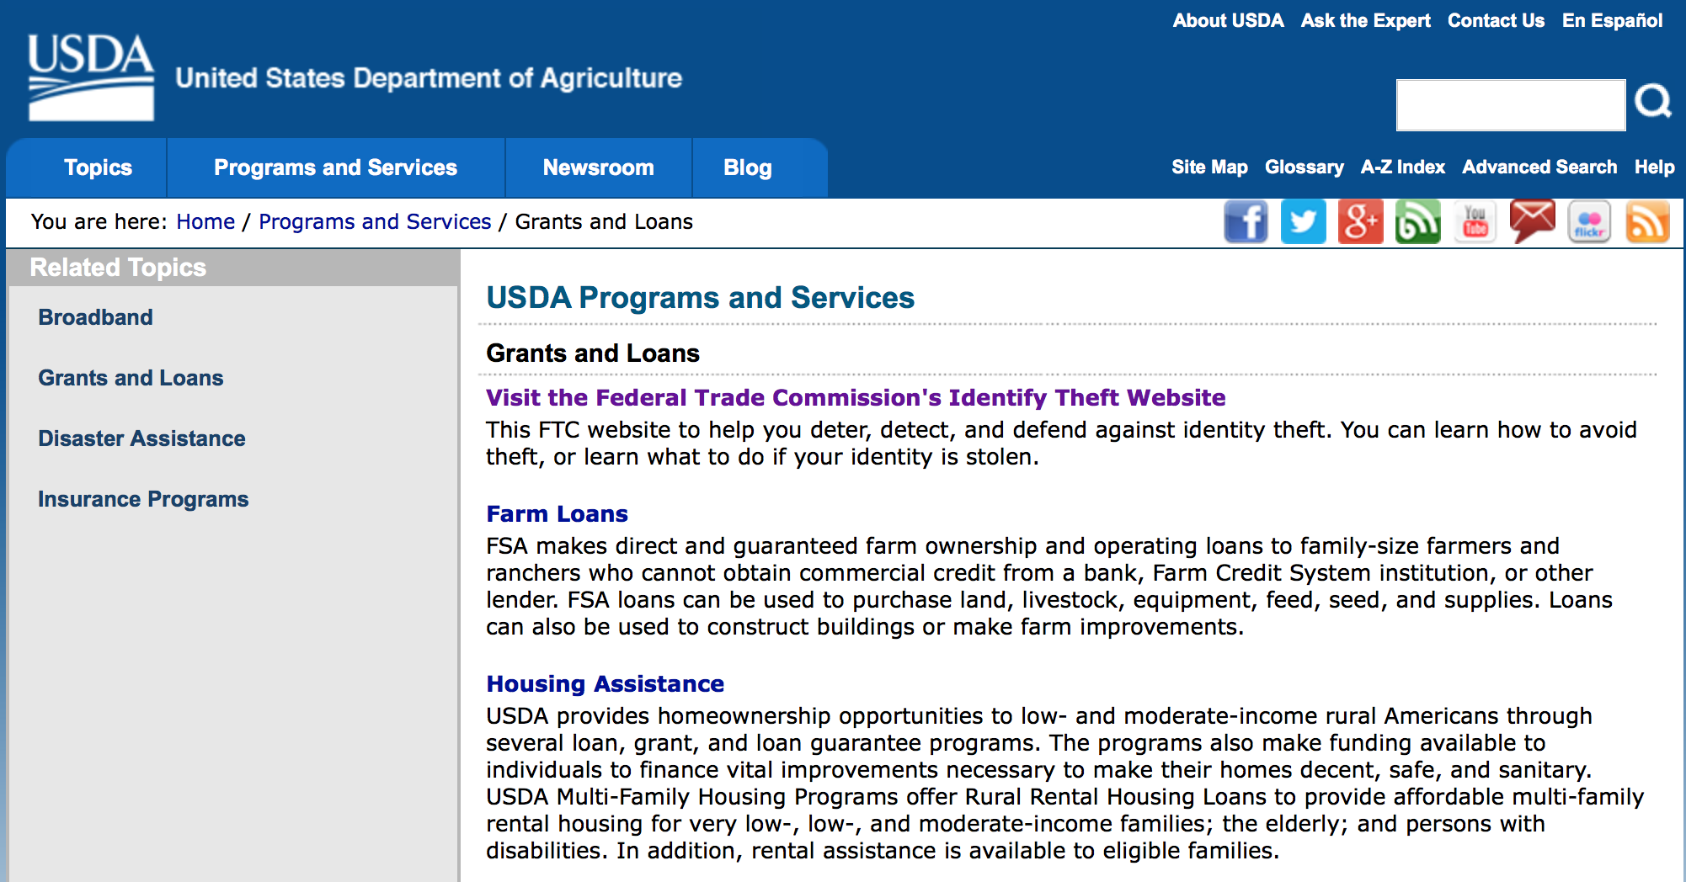
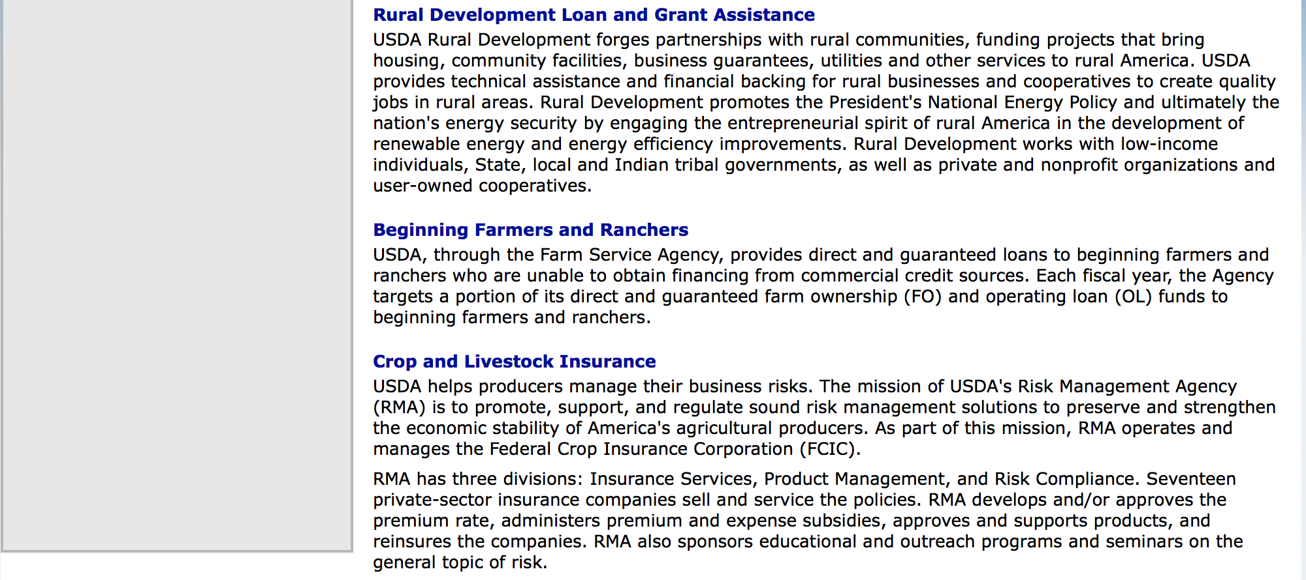

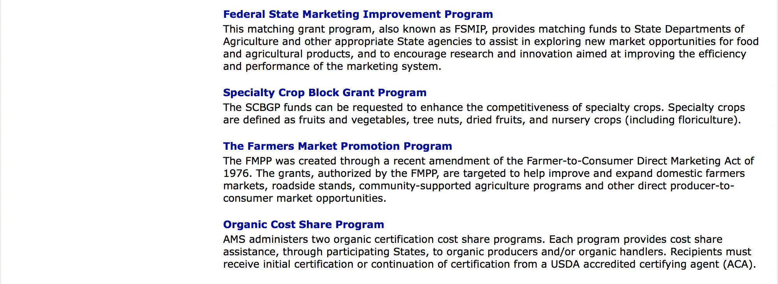

http://usda.gov/wps/portal/usda/usdahome?navid=GRANTS_LOANS

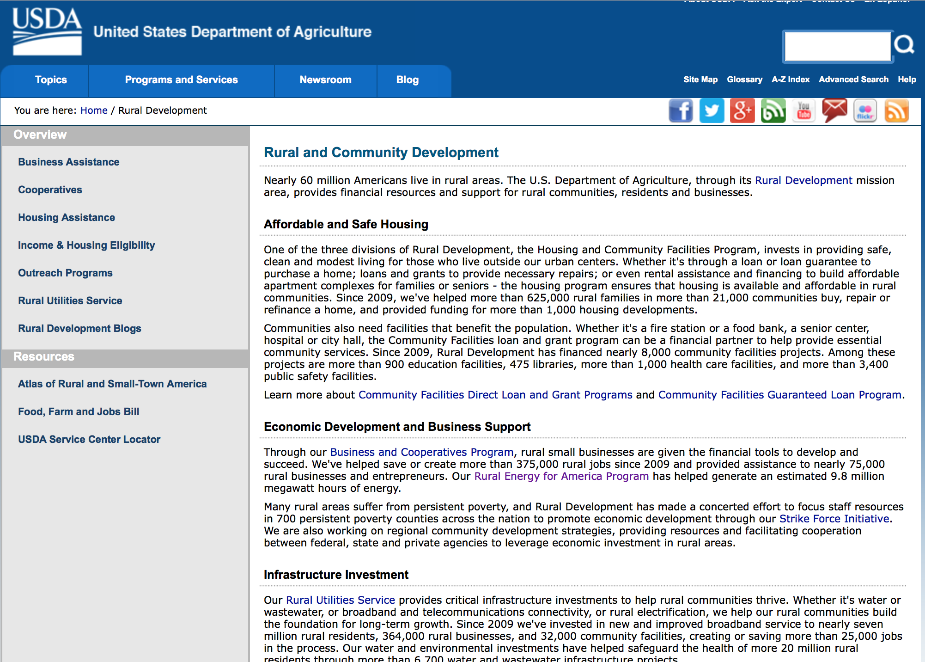

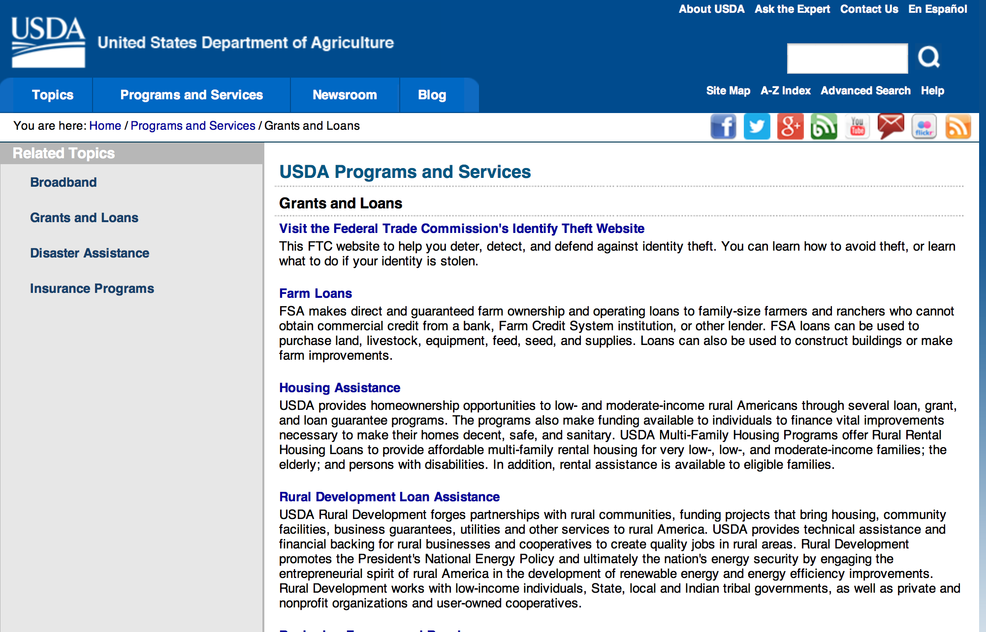

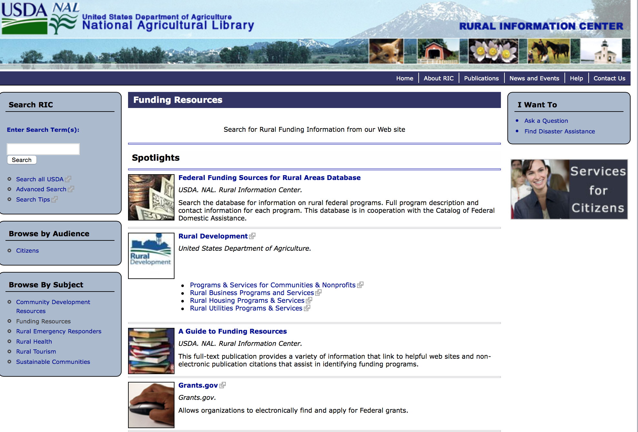

Federal Faith-Based Centers and Community Initiatives
USDA. NAL. Rural Information Center.
- Center for Faith-Based and Community Initiatives (link is external) , U.S. Department of Education
- Center for Faith-Based and Community Initiatives (link is external) , U.S. Department of Health and Human Services
- Center for Faith-Based and Community Initiatives (link is external) , U.S. Department of Labor
- Faith-Based and Community Initiatives (link is external) , U.S. Agency for International Development
- Faith-Based and Community Initiatives (link is external) , U.S. Department of Agriculture
- Faith-Based and Community Initiatives (link is external) , U.S. Department of Housing and Urban Development
- Faith-Based and Other Community Initiatives (link is external) , Corporation for National Community Service
- Task Force for Faith-Based and Community Initiatives (link is external) , U.S. Department of Justice

Grant Writing Resources
- Proposal Writing Short Course (link is external) Foundation Center.
- Data Universal Numbering System Fact sheet (link is external) [PDF | 302.2KB] USDA Rural Development.
- General Tips on Writing a Competitive Grant Proposal (link is external) U.S. Environmental Protection Agency.
- How to Write a Grant Proposal (link is external) Appalachian Regional Commission. <. li>

A Guide to Funding Resources USDA Rural Information Center.

http://ric.nal.usda.gov/funding-resources

http://usda.gov/wps/portal/usda/usdahome?navid=GRANTS_LOANS

Programs:

Utilities Programs
Community Connect Grant Program Grant

Document Type: | Grants Notice
Funding Opportunity Number: | RDRUS-CC-2016
Funding Opportunity Title: | Community Connect Grant Program
Opportunity Category: | Discretionary
Opportunity Category Explanation:
Funding Instrument Type: | Grant
Category of Funding Activity: | Community Development  Regional Development
Category Explanation:
Expected Number of Awards: | 10
CFDA Number(s): | 10.863 -- Community Connect Grant Program
Cost Sharing or Matching Requirement: | Yes
Posted Date: | Apr 19, 2016
Last Updated Date: | Apr 19, 2016
Original Closing Date for Applications: | Jun 17, 2016
Current Closing Date for Applications: | Jun 17, 2016
Archive Date: | Jul 17, 2016
Estimated Total Program Funding: | $11,740,000
Award Ceiling: | $3,000,000
Award Floor: | $100,000
Eligible Applicants: | For profit organizations other than small businesses  Public housing authorities/Indian housing authorities  Native American tribal organizations (other than Federally recognized tribal governments)  Nonprofits that do not have a 501(c)(3) status with the IRS, other than institutions of higher education  City or township governments  State governments  Native American tribal governments (Federally recognized)  Small businesses  Special district governments  Public and State controlled institutions of higher education  Independent school districts  County governments  Private institutions of higher education  Nonprofits having a 501(c)(3) status with the IRS, other than institutions of higher education
Agency Name: | Utilities Programs
Description: | The Community-Oriented Connectivity Broadband Grant Program (Community Connect Grant Program) is designed to provide financial assistance to provide service at the Broadband Grant Speed in rural, economically-challenged communities where broadband service does not currently exist. Grant funds may be used to: (1) deploy service at the Broadband Grant Speed to critical community facilities, rural residents, and rural businesses, (2) construct, acquire, or expand a community center, and (3) equip a community center that provides free access to service at the Broadband Grant Speed to community residents for at least two years. Grants will be awarded on a competitive basis for entities to serve all premises in eligible rural areas at the Broadband Grant Speed to ensure rural consumers enjoy the same quality and range of broadband services as are available in urban and suburban communities.
Link to Additional Information: | Community Connect Program Website
Contact Information: | If you have difficulty accessing the full announcement electronically, please contact:  Scott Steiner Engineering Branch Chief Phone 2027200800  Agency Contact

http://www.grants.gov/web/grants/view-opportunity.html?oppId=283149

Business and Cooperative Programs
Value Added Producer Grant

Document Type: | Grants Notice
Funding Opportunity Number: | RDBCP-VAPG-2016
Funding Opportunity Title: | Value Added Producer Grant
Opportunity Category: | Mandatory
Opportunity Category Explanation: | Category Explanation
Funding Instrument Type: | Grant
Category of Funding Activity: | Business and Commerce
Category Explanation:
Expected Number of Awards: | 400
CFDA Number(s): | 10.352 -- Value-Added Producer Grants
Cost Sharing or Matching Requirement: | Yes
Posted Date: | Apr 08, 2016
Last Updated Date: | Apr 08, 2016
Original Closing Date for Applications: | Jun 24, 2016 Electronic Submissions must be submitted by midnight on 6/24/2016
Current Closing Date for Applications: | Jun 24, 2016 Electronic Submissions must be submitted by midnight on 6/24/2016.
Archive Date: | Sep 30, 2016
Estimated Total Program Funding: | $44,000,000
Award Ceiling: | $250,000
Award Floor: | $0
Eligible Applicants: | Others (see text field entitled "Additional Information on Eligibility" for clarification)
Additional Information on Eligibility: | Independent Producers, Agriculture Producer Groups, Majority Controlled Business Ventures, and Farmer or Rancher Cooperatives.
Agency Name: | Business and Cooperative Programs
Description: | This Notice announces that the Rural Business-Cooperative Service (Agency) is accepting fiscal year (FY) 2016 applications for the Value-Added Producer Grant (VAPG) program. Approximately $44 Million in funding is available to help agricultural producers enter into value-added activities for FY 2016.
Link to Additional Information: | VAPG 2016 Federal Notice
Contact Information: | If you have difficulty accessing the full announcement electronically, please contact:  Shantelle Gordon or Tracey Kennedy Phone 202-720-1374  Contact email

http://www.grants.gov/web/grants/view-opportunity.html?oppId=282855

National Institute of Food and Agriculture
AFRI Food Safety Challenge Area Grant

Document Type: | Grants Notice
Funding Opportunity Number: | USDA-NIFA-AFRI-005802
Funding Opportunity Title: | AFRI Food Safety Challenge Area
Opportunity Category: | Discretionary
Opportunity Category Explanation:
Funding Instrument Type: | Grant
Category of Funding Activity: | Agriculture
Category Explanation:
Expected Number of Awards:
CFDA Number(s): | 10.310 -- Agriculture and Food Research Initiative (AFRI)
Cost Sharing or Matching Requirement: | No
Posted Date: | Apr 28, 2016
Last Updated Date: | Apr 28, 2016
Original Closing Date for Applications: | Aug 03, 2016
Current Closing Date for Applications: | Aug 03, 2016
Archive Date: | Sep 02, 2016
Estimated Total Program Funding: | $6,000,000
Eligible Applicants: | Others (see text field entitled "Additional Information on Eligibility" for clarification)
Additional Information on Eligibility: | See Part III, A., Eligible Applicants. Eligibility is linked to the project type. All project types are described beginning in Part II, C.
Agency Name: | National Institute of Food and Agriculture
Description: | This AFRI Challenge Area promotes and enhances the scientific discipline of food safety, with an overall aim of protecting consumers from microbial and chemical contaminants that may occur during all stages of the food chain, from production to consumption. This requires an understanding of the interdependencies of human, animal, and ecosystem health as it pertains to foodborne pathogens. The long-term outcome for this program is to reduce foodborne illnesses and deaths by improving the safety of the food supply, which will result in reduced impacts on public health and on our economy. In order to achieve this outcome, this program will support single-function Research Projects and multi-function Integrated Research, Education, and/or Extension Projects, and Food and Agricultural Science Enhancement (FASE) Grants that address one of the Program Area Priorities (see Food Safety RFA for details).
Link to Additional Information: | AFRI Food Safety Challenge Area
Contact Information: | If you have difficulty accessing the full announcement electronically, please contact:  NIFA Help Desk Phone: 202-401-5048 Business hours are M-F, 7:00 am -5:00 pm ET, excluding Federal holidays  If you have any questions related to preparing application content

http://www.grants.gov/web/grants/view-opportunity.html?oppId=283339

National Institute of Food and Agriculture
Food Safety Outreach Program
And Modification 1

Document Type: | Grants Notice
Funding Opportunity Number: | USDA-NIFA-FSMA-005777
Funding Opportunity Title: | Food Safety Outreach Program
Opportunity Category: | Discretionary
Opportunity Category Explanation:
Funding Instrument Type: | Grant
Category of Funding Activity: | Agriculture  Education  Food and Nutrition
Category Explanation:
Expected Number of Awards:
CFDA Number(s): | 10.328 -- National Food Safety Training, Education, Extension, Outreach, and Technical Assistance Competitive Grants Program
Cost Sharing or Matching Requirement: | Yes
Posted Date: | Apr 13, 2016
Last Updated Date: | Apr 14, 2016
Original Closing Date for Applications: | Jun 02, 2016
Current Closing Date for Applications: | Jun 02, 2016
Archive Date: | Jul 02, 2016
Estimated Total Program Funding: | $4,700,000
Award Ceiling: | $400,000
Award Floor: | $0
Eligible Applicants: | Others (see text field entitled "Additional Information on Eligibility" for clarification)
Additional Information on Eligibility: | See Part III "Eligibility" of the RFA for details.
Agency Name: | National Institute of Food and Agriculture
Description: | Under the National Food Safety Training, Education, Extension, Outreach, and Technical Assistance Competitive Grants Program, NIFA and the U.S. Food and Drug Administration (FDA) began jointly funding an infrastructure of national and regional centers to extend food safety education, training, education, and technical assistance to those affected by Food Safety Modernization Act (FSMA). In FY 2016, the Food Safety Outreach Program will build upon that national infrastructure, with a sustained focus on delivery of customized training to members of the target audiences. Grant applications will be solicited directly from those in local communities - to include those from community-based organizations, non-governmental organizations, food hubs, farm cooperatives, extension, and other local groups. Successful awardees will be required to interact with Regional Centers by reporting project outcomes to the Centers.
Link to Additional Information: | Food Safety Outreach Program
Contact Information: | If you have difficulty accessing the full announcement electronically, please contact:  NIFA Help Desk Phone: 202-401-5048 Business hours are M-F, 7:00 am -5:00 pm ET, excluding Federal holidays  If you have any questions related to preparing application content

http://www.grants.gov/web/grants/view-opportunity.html?oppId=282966

Modifications:

Reminders:

Utilities Programs
Household Water Well Grant Program

Document Type: | Grants Notice
Funding Opportunity Number: | RDRUS-16-01-HWWS
Funding Opportunity Title: | Household Water Well Grant Program
Opportunity Category: | Discretionary
Opportunity Category Explanation:
Funding Instrument Type: | Grant
Category of Funding Activity: | Agriculture  Environment  Health
Category Explanation:
Expected Number of Awards: | 10
CFDA Number(s): | 10.862 -- Household Water Well System Grant Program
Cost Sharing or Matching Requirement: | Yes
Posted Date: | Mar 11, 2016
Last Updated Date: | Mar 11, 2016
Original Closing Date for Applications: | May 09, 2016
Current Closing Date for Applications: | May 09, 2016
Archive Date: | Jun 08, 2016
Estimated Total Program Funding: | $1,192,081
Award Ceiling: | $0
Award Floor: | $0
Eligible Applicants: | Others (see text field entitled "Additional Information on Eligibility" for clarification)
Additional Information on Eligibility: | 1. An organization is eligible to receive a HWWS grant if it: a. Has an active registration with current information in the System for Award Management (SAM) and has a Dun and Bradstreet (D&B) Data Universal Numbering System (DUNS) number. b. Is a private, non-profit organization. c. Is legally established and located within one of the following: (1) A state within the United States (2) The District of Columbia (3) The Commonwealth of Puerto Rico (4) A United States territory. d. Has the legal capacity and authority to carry out the grant purpose. e. Has sufficient expertise and experience in lending activities. f. Has sufficient expertise and experience in promoting the safe and productive use of individually-owned HWWS and ground water. g. Has no delinquent debt to the federal government or no outstanding judgments to repay a Federal debt. h. Demonstrates that it possesses the financial, technical, and managerial capability to comply with Federal and State laws and requirements, and i. Is not a corporation that has been convicted of a felony (or had an officer or agent acting on behalf of the corporation convicted of a felony) within the past 24 months. Any Corporation that has any unpaid Federal tax liability that has been assessed, for which all judicial and administrative remedies have been exhausted or have lapsed, and that is not being paid in a timely manner pursuant to an agreement with the authority responsible for collecting the tax liability is not eligible. 2. An individual is ineligible to receive a Household Water Well grant. An individual may receive a loan from an organization receiving a grant award.
Agency Name: | Utilities Programs
Description: | The HWWS Grant Program has been established to help individuals with low to moderate incomes finance the costs of household water wells that they own or will own. Eligible Grant Purposes a. Grant funds must be used to establish and maintain a revolving loan fund to provide loans to eligible individuals for household water well systems. b. Individuals may use the loans to construct, refurbish, rehabilitate, or replace household water well systems up to the point of entry of a home. Point of entry for the well system is the junction where water enters into a home water delivery system after being pumped from a well. c. Grant funds may be used to pay administrative expenses associated with providing Household Water Well loans.
Link to Additional Information: | Website Address
Contact Information: | If you have difficulty accessing the full announcement electronically, please contact:  Derek Jones Community Program Specialist Phone 202-720-9640  Email Address

http://www.grants.gov/web/grants/view-opportunity.html?oppId=282162

National Institute of Food and Agriculture
Rural Health & Safety Education Grant

Document Type: | Grants Notice
Funding Opportunity Number: | USDA-NIFA-RHSE-005756
Funding Opportunity Title: | Rural Health & Safety Education
Opportunity Category: | Discretionary
Opportunity Category Explanation:
Funding Instrument Type: | Grant
Category of Funding Activity: | Agriculture  Education  Health
Category Explanation:
Expected Number of Awards:
CFDA Number(s): | 10.500 -- Cooperative Extension Service
Cost Sharing or Matching Requirement: | No
Posted Date: | Mar 23, 2016
Last Updated Date: | Mar 23, 2016
Original Closing Date for Applications: | Jun 01, 2016
Current Closing Date for Applications: | Jun 01, 2016
Archive Date: | Jul 01, 2016
Estimated Total Program Funding: | $1,400,000
Award Ceiling: | $350,000
Award Floor: | $250,000
Eligible Applicants: | Private institutions of higher education  Public and State controlled institutions of higher education  Others (see text field entitled "Additional Information on Eligibility" for clarification)
Additional Information on Eligibility: | See Part III of the RFA, "Eligibility Information" for details.
Agency Name: | National Institute of Food and Agriculture
Description: | The RHSE program proposals are expected to be community-based, outreach education programs, such as those conducted through Human Science extension outreach, that provides individuals and families with: Information as to the value of good health at any age; Information to increase individual or family’s motivation to take more responsibility for their own health; Information regarding rural environmental health issues that directly impact on human health; Information about and access to health promotion and educational activities; and Training for volunteers and health services providers concerning health promotion and health care services for individuals and families in cooperation with state, local and community partners.
Link to Additional Information: | Rural Health and Safety Education
Contact Information: | If you have difficulty accessing the full announcement electronically, please contact:  NIFA Help Desk Phone: 202-401-5048 Business hours are M-F, 7:00 am -5:00 pm ET, excluding Federal holidays  If you have any questions related to preparing application content

http://www.grants.gov/web/grants/view-opportunity.html?oppId=282423

Business and Cooperative Programs
Rural Cooperative Development Grant

Document Type: | Grants Notice
Funding Opportunity Number: | RDBCP-RCDG-2016
Funding Opportunity Title: | Rural Cooperative Development Grant
Opportunity Category: | Discretionary
Opportunity Category Explanation:
Funding Instrument Type: | Grant
Category of Funding Activity: | Agriculture  Business and Commerce
Category Explanation:
Expected Number of Awards: | 39
CFDA Number(s): | 10.771 -- Rural Cooperative Development Grants
Cost Sharing or Matching Requirement: | Yes
Posted Date: | Mar 29, 2016
Last Updated Date: | Mar 29, 2016
Original Closing Date for Applications: | Jun 20, 2016
Current Closing Date for Applications: | Jun 20, 2016
Archive Date: | Jul 20, 2016
Estimated Total Program Funding: | $5,800,000
Award Ceiling: | $200,000
Award Floor: | $0
Eligible Applicants: | Public and State controlled institutions of higher education  Private institutions of higher education  Nonprofits having a 501(c)(3) status with the IRS, other than institutions of higher education
Agency Name: | Business and Cooperative Programs
Description: | The primary objective of the RCDG program is to improve the economic condition of rural areas by assisting individuals or entities in the startup, expansion or operational improvement of rural cooperatives and other business entities. Grants are awarded competitively on an annual basis to Rural Cooperative Development Centers who in turn provide technical assistance to individuals and entities.
Link to Additional Information: | RCDG Program Website
Contact Information: | If you have difficulty accessing the full announcement electronically, please contact:  Grants Division Phone 2026901374  Grants Division

http://www.grants.gov/web/grants/view-opportunity.html?oppId=282595

Agricultural Marketing Service
Farmers Market Promotion Program Grant

Document Type: | Grants Notice
Funding Opportunity Number: | USDA-AMS-TM-FMPP-G-16-0002
Funding Opportunity Title: | Farmers Market Promotion Program
Opportunity Category: | Discretionary
Opportunity Category Explanation: | Category Explanation
Funding Instrument Type: | Grant
Category of Funding Activity: | Agriculture
Category Explanation:
Expected Number of Awards: | 160
CFDA Number(s): | 10.168 -- Farmers' Market and Local Food Promotion Program
Cost Sharing or Matching Requirement: | No
Posted Date: | Mar 08, 2016
Last Updated Date: | Mar 08, 2016
Original Closing Date for Applications: | May 12, 2016
Current Closing Date for Applications: | May 12, 2016
Archive Date: | Jun 11, 2016
Estimated Total Program Funding: | $13,000,000
Award Ceiling: | $500,000
Award Floor: | $50,000
Eligible Applicants: | Others (see text field entitled "Additional Information on Eligibility" for clarification)
Additional Information on Eligibility: | 1. Agricultural Business. A business entity that provides, holds, delivers, transports, offers, or sells agricultural products or services.2. Agricultural Cooperative. A group-owned or member-owned entity or business that provides, offers, or sells agricultural products or services for the mutual benefit of their members. 3. Producer Network. A producer group- or member-owned organization or business that provides, offers, or sells agricultural products or services through a common distribution system for the mutual benefit of their members.4. Producer Associations. An organization or other business that assists, represents, or serves producers or a producer network. 5. Community Supported Agriculture (CSA) Network. A formal group of farms that work collectively to offer consumers regular (usually weekly) deliveries of locally-grown farm products during one or more harvest season(s), often on a subscription or membership basis. Customers have access to a selected share or range of farm products offered by the group of farmers based on partial or total advance payment of a subscription or membership fee.6. CSA Associations. An organization or other business that assists or serves, represents, or services CSAs or CSA networks.7. Local Government. Any unit of government within a state, including a county; borough; municipality; city; town; township; parish; local public authority, including any public housing agency under the United States Housing Act of 1937; special district; school district; intrastate district; council of governments, whether or not incorporated as a nonprofit corporation under state law; and any other agency or instrumentality of a multi-, regional, or intra-state or local government.8. Nonprofit Corporations: Any organization or institution, including nonprofits with State or IRS 501 (c) status and accredited institutions of higher education, where no part of the net earnings of which inure to the benefit of any private shareholder or individual. 9.Public Benefit Corporation. A corporation organized to construct or operate a public improvement, the profits from which inure to the benefit of a State(s) or to the people thereof. 10. Economic Development Corporation. An organization whose mission is the improvement, maintenance, development and/or marketing or promotion of a specific geographic area. 11. Regional Famers Market Authority. An entity that establishes and enforces regional, State, or county policies and jurisdiction over State, regional, or county farmers markets.12. Tribal Government. A governing body or a governmental agency of any Indian tribe, band, nation, or other organized group or community (including any native village as defined in section 3 of the Alaska Native Claims Settlement Act, 85 Stat. 688 (43 U.S.C. § 1602)) certified by the Secretary of the Interior as eligible for the special programs and services provided through the Bureau of Indian Affairs.
Agency Name: | Agricultural Marketing Service
Description: | Approximately $13 million in competitive grant funds in fiscal year (FY) 2016 is available to be awarded through the Farmers Market Promotion Program (FMPP). The Farmers Market Promotion Program (FMPP) is a component of the Farmers Marketing and Local Food Promotion Program (FMLFPP), which is authorized by the Farmer-to-Consumer Direct Marketing Act of 1946, as amended (7 U.S.C. 3005). The goals of FMPP grants are to increase domestic consumption of and access to locally and regionally produced agricultural products, and to develop new market opportunities for farm and ranch operations serving local markets by developing, improving, expanding, and providing outreach, training, and technical assistance to, or assisting in the development, improvement, and expansion of domestic farmers’ markets, roadside stands, community-supported agriculture programs, agritourism activities, and other direct producer-to-consumer market opportunities. Eligible entities include agricultural businesses, agricultural cooperatives, producer networks, producer associations, community supported agriculture networks, community supported agriculture associations, and other agricultural business entities (for-profit groups); nonprofit corporations; public benefit corporations; economic development corporations; regional farmers’ market authorities; and local and tribal governments. FMPP offers both Capacity Building (CB) and Community Development, Training, and Technical Assistance (CTA) projects. For CB projects, the minimum grant award is $50,000 and maximum award is $250,000. For CTA projects, the minimum grant award is $250,000 and maximum award $500,000. The official performance period must begin on September 30, 2016. Both CB and CTA FMPP projects are awarded for up to 36 months (3 years) and are expected to be completed by September 29, 2019. Matching funds are not required. FMLFPP will host a webinar on March 24, 2016, at 2 p.m. (Eastern Time) for FMPP applicants (registration link). In addition, FMLFPP will host www.Grants.gov webinars on March 22 (registration link) and March 29 (registration link), both at 2 p.m. (Eastern Time), to explain how to submit grant applications via www.Grants.gov.
Link to Additional Information: | Grant program website
Contact Information: | If you have difficulty accessing the full announcement electronically, please contact:  Camia Lane Management Analyst Phone 202-720-0933  Application Questions

http://www.grants.gov/web/grants/view-opportunity.html?oppId=282046

Agricultural Marketing Service
Local Food Promotion Program Grant

Document Type: | Grants Notice
Funding Opportunity Number: | USDA-AMS-TM-LFPP-G-16-0001
Funding Opportunity Title: | Local Food Promotion Program
Opportunity Category: | Discretionary
Opportunity Category Explanation:
Funding Instrument Type: | Grant
Category of Funding Activity: | Agriculture
Category Explanation:
Expected Number of Awards: | 160
CFDA Number(s): | 10.172 -- Local Food Promotion Program
Cost Sharing or Matching Requirement: | Yes
Posted Date: | Mar 08, 2016
Last Updated Date: | Mar 08, 2016
Original Closing Date for Applications: | May 12, 2016
Current Closing Date for Applications: | May 12, 2016
Archive Date: | Jun 11, 2016
Estimated Total Program Funding: | $13,000,000
Award Ceiling: | $500,000
Award Floor: | $25,000
Eligible Applicants: | Others (see text field entitled "Additional Information on Eligibility" for clarification)
Additional Information on Eligibility: | 1. Agricultural Business. A business entity that provides, holds, delivers, transports, offers, or sells agricultural products or services.2. Agricultural Cooperative. A group-owned or member-owned entity or business that provides, offers, or sells agricultural products or services for the mutual benefit of their members. 3. Producer Network. A producer group- or member-owned organization or business that provides, offers, or sells agricultural products or services through a common distribution system for the mutual benefit of their members.4. Producer Associations. An organization or other business that assists, represents, or serves producers or a producer network. 5. Community Supported Agriculture (CSA) Network. A formal group of farms that work collectively to offer consumers regular (usually weekly) deliveries of locally-grown farm products during one or more harvest season(s), often on a subscription or membership basis. Customers have access to a selected share or range of farm products offered by the group of farmers based on partial or total advance payment of a subscription or membership fee.6. CSA Associations. An organization or other business that assists or serves, represents, or services CSAs or CSA networks.7. Local Government. Any unit of government within a state, including a county; borough; municipality; city; town; township; parish; local public authority, including any public housing agency under the United States Housing Act of 1937; special district; school district; intrastate district; council of governments, whether or not incorporated as a nonprofit corporation under state law; and any other agency or instrumentality of a multi-, regional, or intra-state or local government.8. Nonprofit Corporations: Any organization or institution, including nonprofits with State or IRS 501 (c) status and accredited institutions of higher education, where no part of the net earnings of which inure to the benefit of any private shareholder or individual. 9.Public Benefit Corporation. A corporation organized to construct or operate a public improvement, the profits from which inure to the benefit of a State(s) or to the people thereof. 10. Economic Development Corporation. An organization whose mission is the improvement, maintenance, development and/or marketing or promotion of a specific geographic area. 11. Regional Famers Market Authority. An entity that establishes and enforces regional, State, or county policies and jurisdiction over State, regional, or county farmers markets.12. Tribal Government. A governing body or a governmental agency of any Indian tribe, band, nation, or other organized group or community (including any native village as defined in section 3 of the Alaska Native Claims Settlement Act, 85 Stat. 688 (43 U.S.C. § 1602)) certified by the Secretary of the Interior as eligible for the special programs and services provided through the Bureau of Indian Affairs.
Agency Name: | Agricultural Marketing Service
Description: | Approximately $13 million in competitive grant funds in fiscal year (FY) 2016 is available for award through the Local Food Promotion Program (LFPP). LFPP is a component of the Farmers Marketing and Local Food Promotion Program (FMLFPP), which is authorized by the Farmer-to-Consumer Direct Marketing Act of 1946, as amended (7 U.S.C. 3005). LFPP offers grant funds with a 25% match to increase domestic consumption of and access to locally and regionally produced agricultural products, and to develop new market opportunities for farm and ranch operations serving local markets, by: developing, improving, expanding, and providing outreach, training, and technical assistance to Local and Regional Food Business Enterprises, or assisting in the development, improvement, and expansion of Local and Regional Food Business Enterprises. Eligible entities may apply if they support local and regional food business enterprises that process, distribute, aggregate, or store locally or regionally produced food products. Such entities may include agricultural businesses, agricultural cooperatives, producer networks, producer associations, community supported agriculture networks, community supported agriculture associations, and other agricultural business entities (for-profit groups); nonprofit corporations; public benefit corporations; economic development corporations; regional farmers’ market authorities; and local and tribal governments. Two types of project applications are accepted under LFPP—planning grants and implementation grants. Applicants can apply for either but will receive only one type of grant in the same grant cycle. LFPP Planning Grants are used in the planning stages of establishing or expanding a local and regional food business enterprise. Activities can include but are not limited to market research, feasibility studies, and business planning. A minimum of $25,000 and a maximum of $100,000 will be awarded for any one proposal, and the grants must be completed within a 18 month period. LFPP Implementation Grants are used to establish a new local and regional food business enterprise, or to improve or expand an existing local or regional food business enterprise. Activities can include but are not limited to training and technical assistance for the business enterprise and/or for producers working with the business enterprise; outreach and marketing to buyers and consumers; and non-construction infrastructure improvements to business enterprise facilities or information technology systems. A minimum of $100,000 and a maximum of $500,000 will be awarded for any one proposal, and the grants must be completed within a 36 month (3 years) grant period. FMLFPP will host a webinar on March 24, 2016, at 2 p.m. (Eastern Time) for FMPP applicants (registration link). In addition, FMLFPP will host www.Grants.gov webinars on March 22 (registration link) and March 29 (registration link), both at 2 p.m. (Eastern Time), to explain how to submit grant applications via www.Grants.gov.
Link to Additional Information: | Grant program website
Contact Information: | If you have difficulty accessing the full announcement electronically, please contact:  Camia Lane Management Analyst Phone 202-720-0933  Application Questions

http://www.grants.gov/web/grants/view-opportunity.html?oppId=282075

Natural Resources Conservation Service
Conservation Innovation Grants

Document Type: | Grants Notice
Funding Opportunity Number: | USDA-NRCS-NHQ-CIG-16-01
Funding Opportunity Title: | Conservation Innovation Grants
Opportunity Category: | Discretionary
Opportunity Category Explanation:
Funding Instrument Type: | Grant
Category of Funding Activity: | Agriculture  Environment  Natural Resources
Category Explanation:
Expected Number of Awards: | 75
CFDA Number(s): | 10.912 -- Environmental Quality Incentives Program
Cost Sharing or Matching Requirement: | Yes
Posted Date: | Mar 07, 2016
Last Updated Date: | Mar 07, 2016
Original Closing Date for Applications: | May 10, 2016
Current Closing Date for Applications: | May 10, 2016
Archive Date: | May 31, 2016
Estimated Total Program Funding: | $20,000,000
Award Ceiling: | $2,000,000
Award Floor: | $0
Eligible Applicants: | City or township governments  Private institutions of higher education  State governments  Special district governments  Individuals  Public and State controlled institutions of higher education  Small businesses  For profit organizations other than small businesses  Native American tribal governments (Federally recognized)  Nonprofits having a 501(c)(3) status with the IRS, other than institutions of higher education  County governments
Agency Name: | Natural Resources Conservation Service
Description: | Overview: The purpose of CIG is to stimulate the development and adoption of innovative conservation approaches and technologies, while leveraging the Federal investment in environmental enhancement and protection in conjunction with agricultural production. CIG projects are expected to lead to the transfer of conservation technologies, management systems, and innovative approaches (such as market-based systems) into NRCS technical manuals and guides or to the private sector. CIG is used to apply or demonstrate previously proven technology in order to increase adoption with an emphasis on opportunities to scale proven, emerging conservation strategies. CIG promotes sharing of skills, knowledge, technologies, and facilities among communities, governments, and other institutions to ensure that scientific and technological developments are accessible to a wider range of users. CIG funds projects targeting innovative on-the-ground conservation, including pilot projects, field demonstrations, and on-farm conservation research. On-farm conservation research is defined as an investigation conducted to answer a specific conservation-related question using a statistically valid design, while employing farm-scale equipment on farm fields. Specifically, a valid study design will use an appropriate number of replications and statistical analysis of results. To the extent NRCS funds research projects through CIG, the agency will only fund on-farm research projects that stimulate innovative approaches to natural resource management in conjunction with agricultural production. NRCS will accept proposals under this notice for single or multiyear projects, not to exceed three years, submitted by eligible entities from any of the 50 States, the District of Columbia, the Caribbean Area (Puerto Rico and the U.S. Virgin Islands), or the Pacific Islands Area (Guam, American Samoa, and the Commonwealth of the Northern Mariana Islands). Eligible entities include Indian Tribes, State and local units of government, non-governmental organizations, and individuals. Complete proposals received by the deadline will be evaluated through a two-tier review process. The first-tier review will be by a technical peer review panel based on the Proposal Evaluation Criteria identified in the instructions in section V.B. For the second-tier review, full proposals, along with their evaluations from the technical peer review and State Conservationist, will be forwarded to the Grants Review Board. The Grants Review Board will make its recommendations for project approval to the NRCS Chief who will make the final selections.
Link to Additional Information: | NRCS CIG Homepage
Contact Information: | If you have difficulty accessing the full announcement electronically, please contact:  Frankie Comfort Grants & Agreements Specialist Phone 202-720-0242  Administrative Contact

http://www.grants.gov/web/grants/view-opportunity.html?oppId=282011

Natural Resources Conservation Service
Regional Conservation Partnership Program
And Modification 1

Document Type: | Grants Notice
Funding Opportunity Number: | USDA-NRCS-NHQ-RCPP-17-01
Funding Opportunity Title: | Regional Conservation Partnership Program
Opportunity Category: | Discretionary
Opportunity Category Explanation:
Funding Instrument Type: | Other
Category of Funding Activity: | Agriculture  Environment  Natural Resources
Category Explanation: | This announcement will use Partnership Agreements and/or Cooperative Agreements for its competitive process.
Expected Number of Awards: | 85
CFDA Number(s): | 10.932 -- Regional Conservation Partnership Program
Cost Sharing or Matching Requirement: | Yes
Posted Date: | Mar 14, 2016
Last Updated Date: | Mar 24, 2016
Original Closing Date for Applications: | May 10, 2016 Closing date is for submission of "Pre-applications" only. Selected applications will be notified to submit "Full" applications.
Current Closing Date for Applications: | May 10, 2016 Closing date is for submission of "Pre-applications" only. Selected applications will be notified to submit "Full" applications.
Archive Date: | Oct 21, 2016
Estimated Total Program Funding: | $263,100,000
Award Ceiling: | $10,000,000
Award Floor: | $0
Eligible Applicants: | Native American tribal governments (Federally recognized)  Others (see text field entitled "Additional Information on Eligibility" for clarification)  Private institutions of higher education  Public and State controlled institutions of higher education
Additional Information on Eligibility: | For "Others" please see Section II.A Partners Eligibility for a more descriptive explanation.
Agency Name: | Natural Resources Conservation Service
Description: | EXECUTIVE SUMMARY: NRCS is the Department of Agriculture’s (USDA) conservation agency working with farmers, ranchers, and private forest landowners nationwide to identify and address natural resource objectives in balance with operational goals in order to benefit soil, water, wildlife, and related natural resources locally, regionally, and nationally. NRCS works in partnership with other entities to accelerate getting conservation on the ground. Through the Regional Conservation Partnership Program (RCPP), NRCS seeks to co-invest with partners in innovative, workable, and cost-effective approaches to benefit farming, ranching, and forest operations, local economies, and the communities and resources in a watershed or other geographic area. RCPP partners develop project applications, as described in this notice, to address specific natural resource objectives in a proposed area or region. Partnering organizations design, promote, implement, and evaluate the project outcomes. NRCS will select final RCPP projects following a two-phase application process that includes: (1) a pre- proposal application and (2) a full-proposal application. NRCS will assess and evaluate RCPP project applications against four criteria: solutions, contributions, innovation, and participation. The full-proposal process is only open to applicants whose pre-proposal applications are selected by the agency to go forward from the pre-proposal stage. All RCPP applications become the property of NRCS for use in the administration of the program and will not be returned to the applicant. RCPP Federal assistance is delivered in accordance with the authorities of the Environmental Quality Incentives Program (EQIP), Conservation Stewardship Program (CSP), Agricultural Conservation Easement Program (ACEP), Healthy Forests Reserve Program (HFRP), and in certain geographic areas, the Watershed Protection and Flood Prevention program. NRCS and partners implement RCPP projects by working with agricultural producers and owners of agricultural and forest land. The purpose of this notice is to announce the availability of CCC funding for RCPP and to solicit applications from potential partners. Subject to fiscal year (FY) 2017 appropriations action, NRCS anticipates the availability of up to $263 million in funding for RCPP. Applications will be accepted from all 50 States, the Caribbean Area (Puerto Rico and U.S. Virgin Islands), and U.S. territories in the Pacific Island Areas (Guam, American Samoa, and the Commonwealth of the Northern Mariana Islands).
Link to Additional Information: | NRCS RCPP Homepage
Contact Information: | If you have difficulty accessing the full announcement electronically, please contact:  Angella Greaves Grants & Agreements Specialist Phone 202-720-2307  Administrative Contact

http://www.grants.gov/web/grants/view-opportunity.html?oppId=282185

National Institute of Food and Agriculture
Special Research Grants Program - Aquaculture Research Grant

Document Type: | Grants Notice
Funding Opportunity Number: | USDA-NIFA-SRGP-005776
Funding Opportunity Title: | Special Research Grants Program - Aquaculture Research
Opportunity Category: | Discretionary
Opportunity Category Explanation:
Funding Instrument Type: | Grant
Category of Funding Activity: | Agriculture  Natural Resources
Category Explanation:
Expected Number of Awards:
CFDA Number(s): | 10.200 -- Grants for Agricultural Research, Special Research Grants
Cost Sharing or Matching Requirement: | Yes
Posted Date: | Apr 04, 2016
Last Updated Date: | Apr 04, 2016
Original Closing Date for Applications: | May 17, 2016
Current Closing Date for Applications: | May 17, 2016
Archive Date: | Jun 16, 2016
Estimated Total Program Funding: | $1,200,000
Award Ceiling: | $300,000
Eligible Applicants: | Others (see text field entitled "Additional Information on Eligibility" for clarification)
Additional Information on Eligibility: | See Part III of the RFA "Eligibility" for details
Agency Name: | National Institute of Food and Agriculture
Description: | The purpose of the Aquaculture Research program is to support the development of an environmentally and economically sustainable aquaculture industry in the U.S. and generate new science-based information and innovation to address industry constraints. Over the long term, results of projects supported by this program may help improve the profitability of the U.S. aquaculture industry, reduce the U.S. trade deficit, increase domestic food security, provide markets for U.S.-produced grain products, increase domestic aquaculture business investment opportunities, and provide more jobs for rural and coastal America. The Aquaculture Research program will fund projects that directly address major constraints to the U.S. aquaculture industry and focus on one or more of the following program priorities: (1) Genetics of commercial aquaculture species. (2) Critical disease issues impacting aquaculture species. (3) Design of environmentally and economically sustainable aquaculture production systems. (4) Economic research for increasing aquaculture profitability.
Link to Additional Information: | Special Research Grants Program Aquaculture Research
Contact Information: | If you have difficulty accessing the full announcement electronically, please contact:  NIFA Help Desk Phone: 202-401-5048 Business hours are M-F, 7:00 am -5:00 pm ET, excluding Federal holidays  If you have any questions related to preparing application content

http://www.grants.gov/web/grants/view-opportunity.html?oppId=282728

Forest Service
2017 National Urban and Community Forestry Grant Program

Document Type: |  | Grants Notice
Funding Opportunity Number: |  | USDA-FS-UCF-01-2017
Funding Opportunity Title: |  | 2017 National Urban and Community Forestry Grant Program
Opportunity Category: |  | Discretionary
Opportunity Category Explanation:
Funding Instrument Type: |  | Grant
Category of Funding Activity: |  | Community Development  Disaster Prevention and Relief  Education  Environment  Health  Natural Resources  Science and Technology and other Research and Development
Category Explanation: |  | The National Urban and Community Forestry Advisory Council seeks innovative (new, cutting-edge or builds upon existing studies) grant proposals for program development, study, and collaboration that will address strategies in the National Ten Year Urban Forestry Action Plan (2016-2026). This Request for Proposals is to address the following priority issues: • Developing a National Urban Forestry Funding Assessment and Methodology • Understand Urban Forest Ecosystem/Ecological Services Detailed information about each category follows this section. Proposals are to meet the request and intent of each applicable category. Organizations, local governments, tribal agencies, and partnerships are encouraged to submit proposals that will demonstrate the reach, resources, and expertise needed to address the three priority issues in ways that will lead to meaningful, replicable results across the country. Potential Innovation grantees are should work collaboratively with other organizations and entities not traditionally involved in urban and community forestry. Applicants should consider multi-year projects and other sources of funds, which may include other Federal cooperative conservation sources. While other Federal dollars or technical support may contribute to the project, they may not be used to match these Federal grant program dollars. The grant review process takes about a year to review pre and full proposals once they are received. Applicants should state their start and end date accordingly on their SF424. Each category is separate. Please do not merge more than one category content or intent into one proposal, which can result in disqualification of the proposal. Applicants may submit separate pre-proposals for more than one category.
Expected Number of Awards: |  | 5
CFDA Number(s): |  | 10.675 -- Urban and Community Forestry Program
Cost Sharing or Matching Requirement: |  | Yes
Posted Date: |  | Feb 29, 2016
Last Updated Date: |  | Mar 01, 2016
Original Closing Date for Applications: |  | Jun 17, 2016
Current Closing Date for Applications: |  | Jun 17, 2016
Archive Date: |  | Jul 17, 2016
Estimated Total Program Funding: |  | $900,000
Award Ceiling: |  | $300,000
Award Floor: |  | $75,000
Eligible Applicants: |  | State governments  Public and State controlled institutions of higher education  Special district governments  Public housing authorities/Indian housing authorities  Independent school districts  City or township governments  Private institutions of higher education  County governments  Nonprofits that do not have a 501(c)(3) status with the IRS, other than institutions of higher education  Nonprofits having a 501(c)(3) status with the IRS, other than institutions of higher education  Native American tribal governments (Federally recognized)
Agency Name: | Forest Service
Description: | Available Funding: The U.S. Forest Service anticipates that the statutory authority (Sub Title 9 of the Cooperative Forestry Assistance Act) for the Fiscal Year 2017 Urban and Community Forestry (U&CF) Program may provide, approximately $900,000 in grant funds to be awarded through the 2017 National Urban and Community Forestry Challenge Cost-Share Grant Program. Funds are to support national urban and community forestry projects on nonfederal public land that have a national or multi-state impact and application. All awards are based on the availability of funding, which may be subject to change. Eligible Applicants: Any U.S. non-Federal organization and Tribal agencies, operating within the United States or its territories, may apply for the Challenge Cost-Share grant. While collaboration with Federal agencies is encouraged, a Federal agency may not receive funding or be used as match to the Federal funds being requested. Individuals and private land are not eligible. Proposals are required to address National or multi-state, multi-tribal land urban forestry issues. The Forest Service will address any conflicts of interest. Not Eligible: If an entity has a local/State tree-planting projects, capital improvements to property of any ownership, and/or projects that have only a local impact and applicability are not eligible and they should contact their State Urban and Community Forestry Coordinator for assistance in identifying funding alternatives at the local level. The list of State Coordinators may be found at the following website: State Urban Foresters' Contact List
Link to Additional Information: | National Urban and Community Forestry Advisory Council Website
Contact Information: | If you have difficulty accessing the full announcement electronically, please contact:  Nancy Stremple Urban Forestry Program Specialist Phone 202-309-9873  Forest Service Email address

http://www.grants.gov/web/grants/view-opportunity.html?oppId=281798

Farm Service Agency
Outreach and Education, Technical Assistance, and Financial Education for FSA Programs, Functions, and Activities Grant

Document Type: | Grants Notice
Funding Opportunity Number: | USDA-FSA-CA-2016-001
Funding Opportunity Title: | Outreach and Education, Technical Assistance, and Financial Education for FSA Programs, Functions, and Activities
Opportunity Category: | Discretionary
Funding Instrument Type: | Cooperative Agreement
Category of Funding Activity: | Agriculture
Category Explanation:
Expected Number of Awards: | 125
CFDA Number(s):
Cost Sharing or Matching Requirement: | No
Posted Date: | Sep 22, 2015
Creation Date: | Sep 22, 2015
Original Closing Date for Applications: | May 27, 2016
Current Closing Date for Applications: | May 27, 2016
Archive Date: | Jun 26, 2016
Estimated Total Program Funding: | $2,500,000
Award Ceiling: | $99,999
Award Floor: | $20,000
Eligible Applicants: | Nonprofits having a 501(c)(3) status with the IRS, other than institutions of higher education  Public and State controlled institutions of higher education
Additional Information on Eligibility:
Agency Name: | Farm Service Agency
Description: | As part of our mission supporting farmers and ranchers, the Farm Service Agency (FSA) provides extensive education and outreach for producers. This typically involves public meetings, mailings, news releases, and interactions with individual producers seeking additional information or to enroll in a program. However, there remains a need for additional outreach and education that could benefit potential participants in FSA’s portfolio of programs. This RFA seeks proposals to further support and expand FSA’s existing outreach and education efforts. The additional outreach and education could, for example, be public meetings, training sessions, and/or workshops for producers including new and beginning farmers, veterans, underserved communities, and/or established producers. Emphasis will be afforded to proposals that propose to address producers who are ethnic minorities, women, new and beginning, veterans, urban, or who grow non-commodity crops (e.g., fruits and vegetables or specialty crops). Proposals may include innovative outreach approaches that ease the learning curve for farmers and ranchers through training on best practices, common challenges and solutions, and local networking opportunities. The subject matter should include an introduction to FSA, its programs, and common provisions that generally apply. FSA’s common provisions include maintenance of producer-level records regarding payment eligibility and limitations, conservation compliance, and name and address, payments, and farm and tract information. Additional information regarding FSA is available at www.fsa.usda.gov.
Link to Additional Information: | FSA RFA Announcement 2016-001
Contact Information: | If you have difficulty accessing the full announcement electronically, please contact:  Robert Stephenson; Director, Office of Business and Program Integration; Phone 202-720-4019  Help Desk

http://www.grants.gov/web/grants/view-opportunity.html?oppId=279153

Farm Service Agency
Outreach and Education, Technical Assistance, and Financial Education for FSA Programs, Functions, and Activities
Modification 2

Document Type: | Grants Notice
Funding Opportunity Number: | USDA-FSA-CA-2016-001
Funding Opportunity Title: | Outreach and Education, Technical Assistance, and Financial Education for FSA Programs, Functions, and Activities
Opportunity Category: | Discretionary
Opportunity Category Explanation:
Funding Instrument Type: | Cooperative Agreement
Category of Funding Activity: | Agriculture
Category Explanation:
Expected Number of Awards: | 125
CFDA Number(s):
Cost Sharing or Matching Requirement: | No
Posted Date: | Oct 20, 2015
Last Updated Date: | Feb 26, 2016
Original Closing Date for Applications: | May 27, 2016
Current Closing Date for Applications: | Jul 11, 2016
Archive Date: | Aug 10, 2016
Estimated Total Program Funding: | $2,500,000
Award Ceiling: | $99,999
Award Floor: | $20,000
Eligible Applicants: | Public and State controlled institutions of higher education  Nonprofits having a 501(c)(3) status with the IRS, other than institutions of higher education
Agency Name: | Farm Service Agency
Description: | As part of our mission supporting farmers and ranchers, the Farm Service Agency (FSA) provides extensive education and outreach for producers. This typically involves public meetings, mailings, news releases, and interactions with individual producers seeking additional information or to enroll in a program. However, there remains a need for additional outreach and education that could benefit potential participants in FSA’s portfolio of programs. This RFA seeks proposals to further support and expand FSA’s existing outreach and education efforts. The additional outreach and education could, for example, be public meetings, training sessions, and/or workshops for producers including new and beginning farmers, veterans, underserved communities, and/or established producers. Emphasis will be afforded to proposals that propose to address producers who are ethnic minorities, women, new and beginning, veterans, urban, or who grow non-commodity crops (e.g., fruits and vegetables or specialty crops). Proposals may include innovative outreach approaches that ease the learning curve for farmers and ranchers through training on best practices, common challenges and solutions, and local networking opportunities. The subject matter should include an introduction to FSA, its programs, and common provisions that generally apply. FSA’s common provisions include maintenance of producer-level records regarding payment eligibility and limitations, conservation compliance, and name and address, payments, and farm and tract information. Additional information regarding FSA is available at www.fsa.usda.gov.
Link to Additional Information: | FSA Outreach Staff
Contact Information: | If you have difficulty accessing the full announcement electronically, please contact:  Robert Stephenson Director, Office of Business and Program Integration Phone: 202-720-4019  Help Desk

http://www.grants.gov/web/grants/view-opportunity.html?oppId=279761

Department of Commerce

Grants, Contracting, and Trade Opportunities at Commerce
Learn more information about grants, contracting and trade opportunities at the Department of Commerce using the information below.

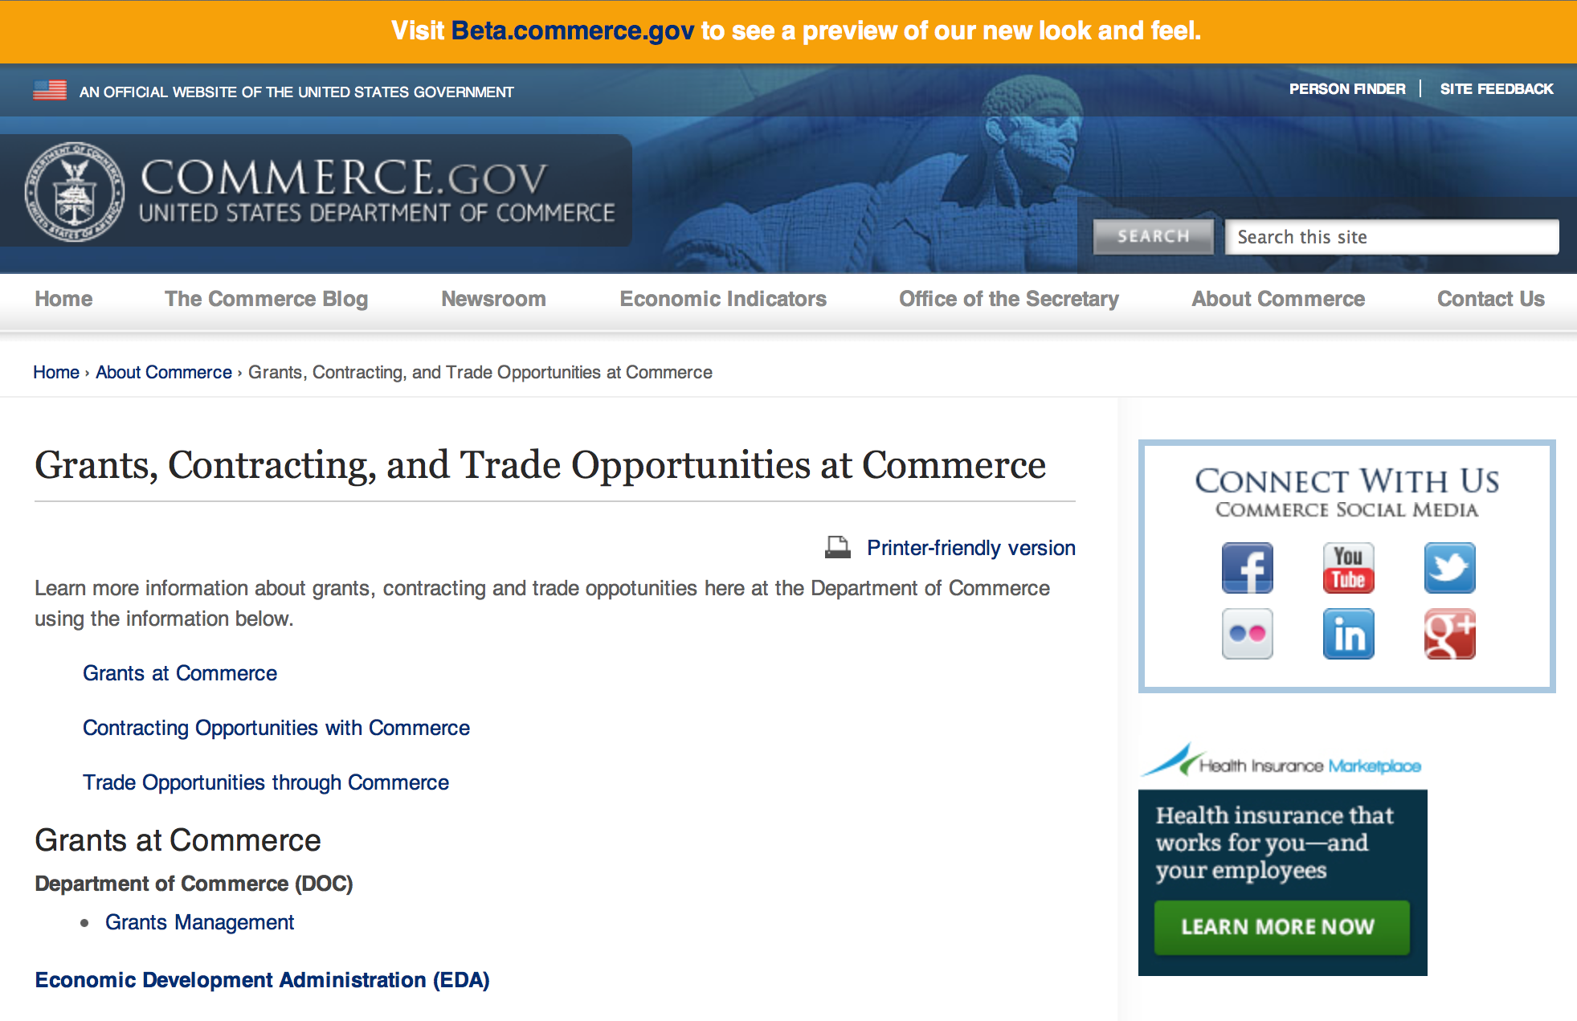
Grants at Commerce
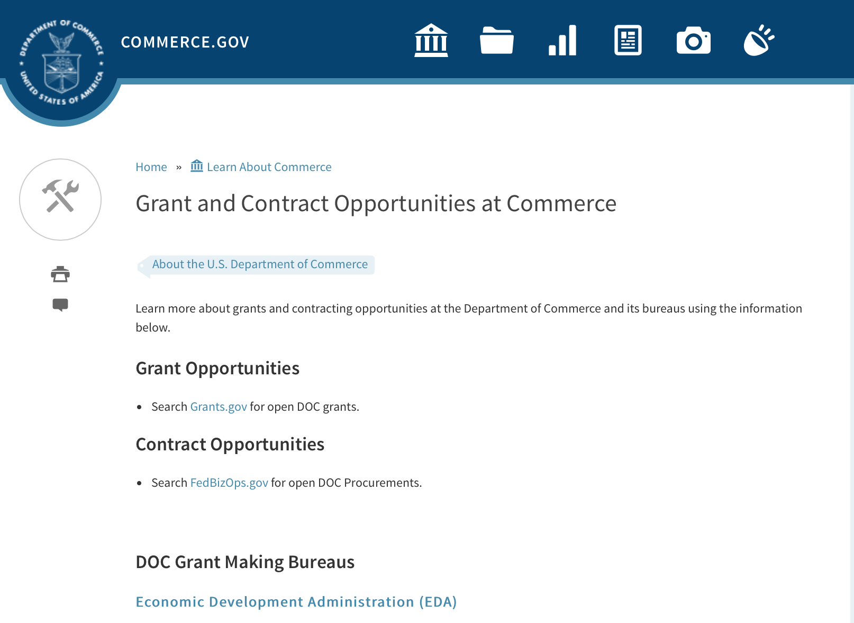

DOC Grant Making Bureaus
Economic Development Administration (EDA)
International Trade Administration (ITA)
- Market Development Cooperator Program
- Special American Business Internship Training Program (SABIT). A technical assistance initiative of the International Trade Administration of the U.S. Department of Commerce, SABIT offers organizations competitive grants and an opportunity to host industry-specific delegations. SABIT serves as an initial entry point for U.S. businesses seeking funding to establish long-term relationships with potential customers, distributors, or partners in the former Soviet Union. The program trains Eurasian managers and scientists in commonly accepted business practices as a means of facilitating cross border relationships. In turn, these personal relationships serve as a basis for business development and reduce market access barriers for U.S. businesses
National Institute of Standards & Technology (NIST)
- Funding Opportunities
National Telecommunications & Information Administration (NTIA)
- Telecommunications Grants
National Oceanic & Atmospheric Administration (NOAA)
- Coastal Ocean Program Grant Information
- Fisheries Saltonstall Kennedy Grant Program
- National Undersea Research Program Funding Opportunities
- Grants Management Division
- Fisheries Grants Program
- National Sea Grant
- Office of Global Programs
Contracting Resources for Contractors
- Office of Small and Disadvantaged Business Utilization (OSDBU) - he Office of Small and Disadvantaged Business Utilization (OSDBU) is an advocacy and advisory office responsible for promoting the use of small, small disadvantaged, 8(a), women-owned, veteran-owned, service-disabled veteran-owned, and HUBZone small businesses within the U.S. Department of Commerce's (DOC) acquisition process.
- Business.USA.gov's Find Opportunities Wizard where in a few quick steps, it will guide you towards federal government contracting programs and opportunities for your business!
- Planned Acquisitions: the Department of Commerce's search tool for our planned acquisitions over $100,000. As requirements change, these acquisition plans are updated by department personnel and this search tool is automatically updated.
- Small Business Administration's Contracting section of their web site where you can learn about how to "Get Started" and "Contracting Support for Small Business"
- The General Services Administration (GSA) has implemented a system for vendors doing business with the Federal Government to manage their entity information in one central location. This new database is the System for Award Management (SAM).

DOC Contracting Offices
- Patent and Trademark Office (PTO)
  - Office of Procurement
- National Institute of Standards & Technology (NIST)
NIST Acquisition Management Group
Contracting Opportunities with Commerce
Trade Opportunities through Commerce
http://www.commerce.gov/about-commerce/grants-contracting-trade-opportunities

Programs:

FY2016 Regional Innovation Strategies Program Grant

Document Type: | Grants Notice
Funding Opportunity Number: | EDA-HDQ-OIE-2016-2004868
Funding Opportunity Title: | FY2016 Regional Innovation Strategies Program
Opportunity Category: | Discretionary
Opportunity Category Explanation:
Funding Instrument Type: | Grant
Category of Funding Activity: | Other (see text field entitled "Explanation of Other Category of Funding Activity" for clarification)  Regional Development
Category Explanation: | Economic Development Innovation and Entrepreneurship
Expected Number of Awards: | 40
CFDA Number(s): | 11.020 -- Cluster Grants
Cost Sharing or Matching Requirement: | Yes
Posted Date: | Apr 25, 2016
Last Updated Date: | Apr 11, 2016
Original Closing Date for Applications: | Jun 24, 2016
Current Closing Date for Applications: | Jun 24, 2016
Archive Date: | Jul 24, 2016
Estimated Total Program Funding: | $15,000,000
Award Ceiling: | $500,000
Award Floor: | $1
Eligible Applicants: | State governments  Private institutions of higher education  City or township governments  County governments  Others (see text field entitled "Additional Information on Eligibility" for clarification)  Nonprofits that do not have a 501(c)(3) status with the IRS, other than institutions of higher education  Native American tribal governments (Federally recognized)  Nonprofits having a 501(c)(3) status with the IRS, other than institutions of higher education  Public and State controlled institutions of higher education  Special district governments
Additional Information on Eligibility: | A State; An Indian tribe; A city or other political subdivision of a State; An entity that— (a) is a nonprofit organization, an institution of higher education, a public-private partnership, a science or research park, a Federal laboratory, or an economic development organization or similar entity, and (b) has an application that is supported by a State or a political subdivision of a State; or A consortium of any of the entities described above.
Agency Name: | Department of Commerce
Description: | EDA is committed to fostering connected, innovation-centric economic sectors which support the conversion of research into products and services, businesses, and ultimately jobs through entrepreneurship. See SWTIA § 27. The DOC FY 2014-2018 Strategic Plan sets forth the strategic goal of working within and across ecosystems throughout the country to develop regional innovation strategies, including regional innovation clusters. Regional innovation strategies are a keystone of the Secretary of Commerce’s commitment to building globally competitive regions. As part of this strategy, funding is available for capacity-building programs that provide proof-of-concept and commercialization assistance to innovators and entrepreneurs and for operational support for organizations that provide essential early-stage funding to startups. Under the RIS Program, EDA is soliciting applications for two separate competitions: the 2016 i6 Challenge, and the Seed Fund Support (SFS) Grant competition. Applicants may, but are not required to, submit proposals for more than one competition under the RIS Program. Note that the 2016 RIS Program is authorized under SWTIA § 27, which does not restrict the focus of grantees’ projects to economically distressed communities.
Link to Additional Information: | http://www.eda.gov/oie/ris/
Contact Information: | If you have difficulty accessing the full announcement electronically, please contact:  EDA Office of Innovation and Entrepreneurship  oie@eda.gov

http://www.grants.gov/web/grants/view-opportunity.html?oppId=282919

Capital Project Grant

Document Type: | Grants Notice
Funding Opportunity Number: | MBDA-OBD-2016-2004600
Funding Opportunity Title: | Capital Project
Opportunity Category: | Discretionary
Opportunity Category Explanation:
Funding Instrument Type: | Cooperative Agreement
Category of Funding Activity: | Environment  Natural Resources  Science and Technology and other Research and Development
Category Explanation:
Expected Number of Awards: | 10
CFDA Number(s): | 11.802 -- Minority Business Resource Development
Cost Sharing or Matching Requirement: | No
Posted Date: | Apr 30, 2016
Last Updated Date: | Apr 30, 2016
Original Closing Date for Applications: | Jun 15, 2016
Current Closing Date for Applications: | Jun 15, 2016
Archive Date: | Jul 15, 2016
Estimated Total Program Funding: | $2,500,000
Award Ceiling: | $500,000
Award Floor: | $100
Eligible Applicants: | Others (see text field entitled "Additional Information on Eligibility" for clarification)
Additional Information on Eligibility: | For-profit entities (including but not limited to sole-proprietorships, partnerships, limited liability companies and corporations), non-profit organizations, state and local government entities, Native American Tribes and educational institutions are eligible to apply to operate the Project.
Agency Name: | Department of Commerce
Description: | This Federal Funding Opportunity (FFO or Announcement) announces the anticipated availability of funding for the MBDA Capital Project (Project or CAP), and solicits competitive applications for an operator of this Project in one (1) area. The Project is established to provide technical assistance and business development services that result in awarded financial transactions to Minority Business Enterprises (MBEs). The technical assistance and business development services for this Project are provided through a federal financial assistance award to generate increased financing opportunities for MBEs. In addition, the services provided will assist these firms in creating and retaining jobs.
Link to Additional Information:
Contact Information: | If you have difficulty accessing the full announcement electronically, please contact:  Ms. Joann J. Hill, Chief MBDA Office of Business Development U.S. Department of Commerce 1401 Constitution Ave., N.W. Room 5079 Washington, DC 20230 Tel: 202-482-1940  work

http://www.grants.gov/web/grants/view-opportunity.html?oppId=283411

Research:

National Institute of Standards and Technology
Embedding MEP in NNMI Institutes Pilot Projects
Modification 1

Document Type: | Grants Notice
Funding Opportunity Number: | 2016-NIST-MEP-ENNMI-01
Funding Opportunity Title: | Embedding MEP in NNMI Institutes Pilot Projects
Opportunity Category: | Discretionary
Opportunity Category Explanation: | Category Explanation
Funding Instrument Type: | Cooperative Agreement
Category of Funding Activity: | Other (see text field entitled "Explanation of Other Category of Funding Activity" for clarification)
Category Explanation: | Manufacturing Extension Partnership
Expected Number of Awards: | 7
CFDA Number(s): | 11.611 -- Manufacturing Extension Partnership
Cost Sharing or Matching Requirement: | No
Posted Date: | Apr 19, 2016
Last Updated Date: | Apr 19, 2016
Original Closing Date for Applications: | Jun 17, 2016 Electronic applications in response to this FFO must be received no later than 11:59 p.m. Eastern Time on Friday, June 17, 2016. Applications received after the deadline will not be reviewed or considered.
Current Closing Date for Applications: | Jun 17, 2016 Electronic applications in response to this FFO must be received no later than 11:59 p.m. Eastern Time on Friday, June 17, 2016. Applications received after the deadline will not be reviewed or considered.
Archive Date: | Jul 17, 2016
Eligible Applicants: | Others (see text field entitled "Additional Information on Eligibility" for clarification)
Additional Information on Eligibility: | Eligible applicants for this program are MEP Centers receiving current cooperative agreement funding from NIST. An applicant MEP Center must form a collaboration, teaming arrangement, or other appropriate relationship with one or more of the current NNMI Institutes. NIST encourages project proposals involving participation from multiple MEP Centers and multiple NNMI Institutes, as well as other collaborating entities such as local economic development organizations, universities, community colleges, technology incubator programs, and other organizations.
Agency Name: | National Institute of Standards and Technology
Description: | NIST invites proposals from current MEP Centers to pilot test approaches to provide needed technology acceleration assistance to small and mid-sized U.S. manufacturers (referred to hereinafter as small U.S. manufacturers) through the establishment of meaningful and results oriented collaborations between the nationwide system of Centers operating as part of the NIST Hollings Manufacturing Extension Partnership (MEP) Program (hereinafter referred to as NIST MEP), and the Institutes participating in the National Network for Manufacturing Innovation (NNMI). The emphasis of these Pilot Projects will be to demonstrate ways to more fully leverage the assets and resources of the national MEP Program to provide assistance to small U.S. manufacturers in technology areas that are the focus of the NNMI Institutes. These Pilots will embed personnel from MEP Centers in residence at NNMI Institutes, targeting the cultivation of enduring collaborations among small U.S. manufacturers, NNMI Institutes, and MEP Centers for the benefit of all these entities. The Pilots will accelerate the processes by which small U.S. manufacturers transition the latest and most compelling technological innovations into the manufactured goods needed by our Nation.
Link to Additional Information: | 2016-NIST-MEP-ENNMI-01 Full Announcement/FFO document
Contact Information: | If you have difficulty accessing the full announcement electronically, please contact:  Christopher Hunton Management and Program Analyst Phone 301-975-5718  Agency Contact

http://www.grants.gov/web/grants/view-opportunity.html?oppId=283127

Modifications:

Reminders:

National Institute of Standards and Technology
National Strategy for Trusted Identities in Cyberspace (NSTIC) Federated Identity in Healthcare Pilot Program Grant

Document Type: | Grants Notice
Funding Opportunity Number: | 2016-NIST-NSTIC-02
Funding Opportunity Title: | National Strategy for Trusted Identities in Cyberspace (NSTIC) Federated Identity in Healthcare Pilot Program
Opportunity Category: | Discretionary
Opportunity Category Explanation:
Funding Instrument Type: | Cooperative Agreement
Category of Funding Activity: | Other (see text field entitled "Explanation of Other Category of Funding Activity" for clarification)
Category Explanation: | Arrangements for Interdisciplinary Research Infrastructure
Expected Number of Awards:
CFDA Number(s): | 11.619 -- Arrangements for Interdisciplinary Research Infrastructure
Cost Sharing or Matching Requirement: | No
Posted Date: | Mar 31, 2016
Last Updated Date: | Mar 31, 2016
Original Closing Date for Applications: | Jun 01, 2016
Current Closing Date for Applications: | Jun 01, 2016
Eligible Applicants: | Others (see text field entitled "Additional Information on Eligibility" for clarification)
Additional Information on Eligibility: | All applicants must meet all of the following requirements: • Applicants must be hospitals or healthcare systems consisting of multiple hospitals, ambulatory sites, clinics or similar healthcare facilities. • Applicants may be for-profit, not-for-profit or governmental (other than Federal government) entities located in the United States or its territories. • Applicants must partner with at least one other healthcare organization in their locality/region. The partner organization should have anticipated overlap with the applicant organization of patients, physicians and other clinical staff (such as a physician practice group(s), clinic(s) and hospital(s)). • The partner organization must be organizationally independent of the applicant and maintain a separate health information system from the applicant. Health information systems refer to any system that captures, stores, manages or transmits information related to the health of individuals or the activities of organizations that work within the health sector. NIST will not assist in matching organizations. Federal agencies (including facilities and components of the Veteran’s Integrated Service Network of the Veteran’s Health Administration) may participate in projects but may not receive NIST funding.
Agency Name: | National Institute of Standards and Technology
Description: | NIST is soliciting applications from eligible applicants to demonstrate the usage of federated online identity solutions for patients and providers across multiple healthcare providers (e.g., provider groups, regional healthcare systems, hospital systems).
Link to Additional Information: | 2016-NIST-NSTIC-02 Full Announcement/FFO document
Contact Information: | If you have difficulty accessing the full announcement electronically, please contact:  Christopher Hunton Management and Program Analyst Phone 301-975-5718  Agency Contact

http://www.grants.gov/web/grants/view-opportunity.html?oppId=282655

National Institute of Standards and Technology
Replicable Smart City Technologies Cooperative Agreement Program Grant

Document Type: | Grants Notice
Funding Opportunity Number: | 2016-NIST-RSCT-01
Funding Opportunity Title: | Replicable Smart City Technologies Cooperative Agreement Program
Opportunity Category: | Discretionary
Opportunity Category Explanation:
Funding Instrument Type: | Cooperative Agreement
Category of Funding Activity: | Other (see text field entitled "Explanation of Other Category of Funding Activity" for clarification)
Category Explanation: | Arrangements for Interdisciplinary Research Infrastructure
Expected Number of Awards:
CFDA Number(s): | 11.619 -- Arrangements for Interdisciplinary Research Infrastructure
Cost Sharing or Matching Requirement: | No
Posted Date: | Feb 19, 2016
Last Updated Date: | Feb 19, 2016
Original Closing Date for Applications: | May 12, 2016
Current Closing Date for Applications: | May 12, 2016
Archive Date: | Jun 11, 2016
Eligible Applicants: | Others (see text field entitled "Additional Information on Eligibility" for clarification)
Additional Information on Eligibility: | Local governments located in the United States and its territories and participating as a Team member in NIST’s 2016 GCTC. For purposes of this program, a local government is defined as any incorporated political subdivision of a state that is composed of the citizens of a designated geographic area and which performs certain government functions on a local level; local governments include counties and municipalities such as cities, towns, villages, and boroughs. An eligible organization may work individually or propose subawards or contracts with others effectively forming a team or consortium. Only one application will be considered per GCTC Team. A GCTC Team that includes more than one eligible local government member must designate one of the eligible local government team member as the lead responsible for submitting the application and, if selected, for receiving and administering the award, with the other members participating through subawards or contracts. More information about the 2016 GCTC, including how to register to participate, can be found at http://www.nist.gov/cps/sagc.cfm.
Agency Name: | National Institute of Standards and Technology
Description: | NIST invites applications from eligible applicants (referred to below as City/Community Partners) for a program that will support cities and communities in team-based efforts under the 2016 Global City Teams Challenge (GCTC). The purpose of this funding opportunity is to enable cities and communities to take a lead role in the team-based GCTC efforts to advance the measurement science of replicable, standards-based smart city technologies that provide measurable performance metrics, meet the needs of cities and communities of all types and sizes, and provide platforms for entrepreneurship and innovation.
Link to Additional Information: | 2016-NIST-RSCT-01 Full Announcement/FFO document
Contact Information: | If you have difficulty accessing the full announcement electronically, please contact:  Christopher Hunton Management and Program Analyst Phone 301-975-5718  Agency Contact

http://www.grants.gov/web/grants/view-opportunity.html?oppId=281680

National Institute of Standards and Technology
Measurement Science and Engineering (MSE) Research Grant Programs

Document Type: | Grants Notice
Funding Opportunity Number: | 2016-NIST-MSE-01
Funding Opportunity Title: | Measurement Science and Engineering (MSE) Research Grant Programs
Opportunity Category: | Discretionary
Opportunity Category Explanation:
Funding Instrument Type: | Cooperative Agreement  Grant
Category of Funding Activity: | Science and Technology and other Research and Development
Category Explanation:
Expected Number of Awards:
CFDA Number(s):
Cost Sharing or Matching Requirement: | No
Posted Date: | Feb 19, 2016
Last Updated Date: | Feb 19, 2016
Original Closing Date for Applications: | Applications will be accepted and considered on a rolling basis as they are received. See Section IV.4. in the text of the Full Announcement/FFO document. Applications may be submitted by paper or electronically through Grants.gov. Carefully read Section IV. of the Full Announcement/FFO document for details applying to electronic submissions and to paper submissions.
Current Closing Date for Applications: | Applications will be accepted and considered on a rolling basis as they are received. See Section IV.4. in the text of the Full Announcement/FFO document. Applications may be submitted by paper or electronically through Grants.gov. Carefully read Section IV. of the Full Announcement/FFO document for details applying to electronic submissions and to paper submissions.
Eligible Applicants: | Others (see text field entitled "Additional Information on Eligibility" for clarification)
Additional Information on Eligibility: | Eligibility for all programs listed in this FFO is open to all non-Federal entities. Eligible applicants include institutions of higher education, non-profit organizations, for-profit organizations, state and local governments, Indian tribes, hospitals, foreign public entities, and foreign governments. Applicants selected for awards under 15 U.S.C. § 278g-1 are encouraged, but not required, to select underrepresented minorities for participation. In addition, NIST is not able to accept an application from an individual unaffiliated with a sponsoring applicant organization.
Agency Name: | National Institute of Standards and Technology
Description: | NIST is soliciting applications for financial assistance for Fiscal Year 2016 (FY16) within the following NIST Laboratory grant programs: (1) the Material Measurement Laboratory (MML) Grant Program; (2) the Physical Measurement Laboratory (PML) Grant Program; (3) the Engineering Laboratory (EL) Grant Program; (4) the Fire Research (FR) Grant Program; (5) the Information Technology Laboratory (ITL) Grant Program; (6) the Communications Technology Laboratory (CTL) Grant Program; (7) the NIST Center for Neutron Research (NCNR) Grant Program; (8) the Center for Nanoscale Science and Technology (CNST) Grant Program; (9) the Special Programs Office (SPO) Grant Program; (10) the Standards Coordination Office (SCO) Grant Program; (11) the International and Academic Affairs Office (IAAO) Grant Program; and (12) the Associate Director for Laboratory Programs (ADLP) Grant Program.
Link to Additional Information: | 2016-NIST-MSE-01 Full Announcement/FFO document
Contact Information: | If you have difficulty accessing the full announcement electronically, please contact:  Christopher Hunton Management and Program Analyst Phone 301-975-5718  Agency Contact

http://www.grants.gov/web/grants/view-opportunity.html?oppId=281689

National Sea Grant College Program 2016-17 Special Projects Grant

Document Type: | Grants Notice
Funding Opportunity Number: | NOAA-OAR-SG-2016-2004772
Funding Opportunity Title: | National Sea Grant College Program 2016-17 Special Projects
Opportunity Category: | Discretionary
Funding Instrument Type: | Cooperative Agreement  Grant
Category of Funding Activity: | Environment  Natural Resources  Science and Technology and other Research and Development
Category Explanation:
Expected Number of Awards: | 30
CFDA Number(s): | 11.417 -- Sea Grant Support
Cost Sharing or Matching Requirement: | Yes
Posted Date: | Jan 7, 2016
Creation Date: | Jan 7, 2016
Original Closing Date for Applications: | Sep 30, 2017
Current Closing Date for Applications: | Sep 30, 2017
Archive Date: | Oct 30, 2017
Estimated Total Program Funding: | $4,000,000
Award Ceiling: | $1,000,000
Award Floor: | $1
Eligible Applicants: | Others (see text field entitled "Additional Information on Eligibility" for clarification)
Additional Information on Eligibility: | Sea Grant Programs (Sea Grant Colleges, Institutions, or Coherent Area Programs), the National Sea Grant Law Center, and the National Sea Grant Library.
Agency Name: | Department of Commerce
Description: | The purpose of this notice is to request proposals for special projects associated with the National Sea Grant College Program’s (Sea Grant) strategic focus areas, and to provide the general public with information and guidelines on how Sea Grant will select proposals and administer Federal assistance under this announcement. This announcement is a mechanism to encourage research or other projects that are not normally funded through Sea Grant national competitions. This opportunity is open only to Sea Grant Programs. Section III of this announcement describes eligibility requirements in more detail. Funding has not yet been made available to support applications submitted to this Federal Funding Opportunity (FFO), but such funding may become available during the year. Section II.A. below describes individual competition announcements that will be used to announce when funding is available; any restrictions or requirements on such funding, such as matching funds; and other funding details. Awards will be made under this FFO only if funds have been announced as provided in this FFO.
Link to Additional Information:
Contact Information: | If you have difficulty accessing the full announcement electronically, please contact:  Special Projects Competition Manager, NOAA R/SG National Sea Grant Office 1315 East-West Highway, Rm 11839 Silver Spring, MD 20910 301-734-1066  work

http://www.grants.gov/web/grants/view-opportunity.html?oppId=280846

FY 2016 – FY 2019 EDA Planning Program and Local Technical Assistance Program Grant

Document Type: | Grants Notice
Funding Opportunity Number: | EDA-HDQ-TA-HDQ-2016-2004759
Funding Opportunity Title: | FY 2016 – FY 2019 EDA Planning Program and Local Technical Assistance Program
Opportunity Category: | Discretionary
Funding Instrument Type: | Cooperative Agreement  Grant
Category of Funding Activity: | Other (see text field entitled "Explanation of Other Category of Funding Activity" for clarification)  Regional Development
Category Explanation: | Regional planning and local technical assistance
Expected Number of Awards:
CFDA Number(s): | 11.302 -- Economic Development Support for Planning Organizations  11.303 -- Economic Development Technical Assistance
Cost Sharing or Matching Requirement: | No
Posted Date: | Dec 10, 2015
Creation Date: | Dec 10, 2015
Original Closing Date for Applications: | Applications are accepted on a continuing basis and processed as received. This Planning and Local Technical Assistance opportunity will remain in effect until superseded by a future announcement.
Current Closing Date for Applications: | Applications are accepted on a continuing basis and processed as received. This Planning and Local Technical Assistance opportunity will remain in effect until superseded by a future announcement.
Archive Date:
Estimated Total Program Funding:
Award Ceiling: | $300,000
Award Floor: | $0
Eligible Applicants: | Nonprofits having a 501(c)(3) status with the IRS, other than institutions of higher education  City or township governments  Nonprofits that do not have a 501(c)(3) status with the IRS, other than institutions of higher education  Others (see text field entitled "Additional Information on Eligibility" for clarification)  Private institutions of higher education  Native American tribal governments (Federally recognized)  Public and State controlled institutions of higher education  State governments  Special district governments  County governments
Additional Information on Eligibility: | Pursuant to section 3 of the Public Works and Economic Development Act of 1965 (42 U.S.C. § 3122) (PWEDA) and EDA’s regulation at 13 C.F.R. § 300.3, the following types of entities are eligible to receive funding assistance from EDA: 1. District Organizations (as defined in 13 C.F.R. § 300.3); 2. Indian Tribes or a consortium of Indian Tribes; 3. States, cities, or other political subdivisions of a State, including a special purpose unit of a State or local government engaged in economic or infrastructure development activities, or a consortium of political subdivisions; 4. Institutions of higher education or a consortium of institutions of higher education; or 5. Public or private non-profit organizations or associations acting in cooperation with officials of a political subdivision of a State.
Agency Name: | Department of Commerce
Description: | Pursuant to PWEDA, EDA announces general policies and application procedures for grant-based investments under the Planning and Local Technical Assistance programs. Under the Planning program EDA assists eligible recipients in creating regional economic development plans designed to build capacity and guide the economic prosperity and resiliency of an area or region. As part of this program, EDA supports Partnership Planning investments to facilitate the development, implementation, revision, or replacement of Comprehensive Economic Development Strategies (CEDS), which articulate and prioritize the strategic economic goals of recipients’ respective regions. In general, EDA provides Partnership Planning grants to the designated planning organization (e.g., District Organization) serving EDA designated Economic Development Districts to enable these organizations to develop and implement relevant CEDS. In addition, EDA provides Partnership Planning grants to Indian Tribes to help develop and implement CEDS and associated economic development activities. The Planning program also helps support organizations, including District Organizations, Indian Tribes, and other eligible recipients, with Short Term and State Planning investments designed to guide the eventual creation and retention of high-quality jobs, particularly for the unemployed and underemployed in the Nation’s most economically distressed regions. The Local Technical Assistance program strengthens the capacity of local or State organizations, institutions of higher education, and other eligible recipients to undertake and promote effective economic development programs through projects such as feasibility analyses and impact studies.
Link to Additional Information: | www.eda.gov
Contact Information: | If you have difficulty accessing the full announcement electronically, please contact:  The EDA representative for your state. A complete list of EDA representatives is available on EDA's website at http://www.eda.gov/contact/

http://www.grants.gov/web/grants/view-opportunity.html?oppId=280447

FY 2016 Economic Development Assistance Programs ­ Application submission and program requirements for EDA’s Public Works and Economic Adjustment Assistance Programs Grant

Document Type: | Grants Notice
Funding Opportunity Number: | EDAP2016
Funding Opportunity Title: | FY 2016 Economic Development Assistance Programs ­ Application submission and program requirements for EDA’s Public Works and Economic Adjustment Assistance programs.
Opportunity Category: | Discretionary
Funding Instrument Type: | Cooperative Agreement  Grant
Category of Funding Activity: | Other (see text field entitled "Explanation of Other Category of Funding Activity" for clarification)
Category Explanation: | The Economic Development Administration's (EDA's) mission is to lead the Federal economic development agenda by promoting innovation and competitiveness, preparing American regions for economic growth and success in the worldwide economy. EDA fulfills this mission through strategic investments and partnerships that create the regional economic ecosystems required to foster globally competitive regions throughout the United States. EDA supports development in economically distressed areas of the United States by fostering job creation and attracting private investment. Specifically, under the Economic Development Assistance programs (EDAP) Federal Funding Opportunity (FFO) announcement, EDA will make construction, non-construction, and revolving loan fund investments under the Public Works and Economic Adjustment Assistance (EAA) Programs. Grants made under these programs will leverage regional assets to support the implementation of regional economic development strategies designed to create jobs, leverage private capital, encourage economic development, and strengthen America's ability to compete in the global marketplace. Through the EDAP FFO, EDA solicits applications from rural and urban communities to develop initiatives that advance new ideas and creative approaches to address rapidly evolving economic conditions.
Expected Number of Awards:
CFDA Number(s): | 11.300 -- Investments for Public Works and Economic Development Facilities  11.307 -- Economic Adjustment Assistance
Cost Sharing or Matching Requirement: | Yes
Posted Date: | Oct 26, 2015
Creation Date: | Oct 26, 2015
Original Closing Date for Applications: | There are no submission deadlines under this opportunity. Proposals and applications will be accepted on an ongoing basis until the publication of a new EDAP FFO.
Current Closing Date for Applications: | There are no submission deadlines under this opportunity. Proposals and applications will be accepted on an ongoing basis until the publication of a new EDAP FFO.
Archive Date:
Estimated Total Program Funding:
Award Ceiling: | $3,000,000
Award Floor: | $100,000
Eligible Applicants: | Others (see text field entitled "Additional Information on Eligibility" for clarification)  State governments  City or township governments  Native American tribal organizations (other than Federally recognized tribal governments)  Native American tribal governments (Federally recognized)  Private institutions of higher education  Special district governments  Nonprofits having a 501(c)(3) status with the IRS, other than institutions of higher education  County governments  Nonprofits that do not have a 501(c)(3) status with the IRS, other than institutions of higher education  Public and State controlled institutions of higher education
Additional Information on Eligibility: | Eligible applicants for EDA financial assistance under the Public Works and EAA programs include a(n): (i) District Organization of a designated Economic Development District; (ii) Indian Tribe or a consortium of Indian Tribes; (iii) State, county, city, or other political subdivision of a State, including a special purpose unit of a State or local government engaged in economic or infrastructure development activities, or a consortium of political subdivisions; (iv) institution of higher education or a consortium of institutions of higher education; or (v) public or private non-profit organization or association acting in cooperation with officials of a political subdivision of a State. See Section 3 of the Public Works and Economic Development Act of 1965 (PWEDA) (42 U.S.C. § 3122) and 13 C.F.R. § 300.3. EDA is not authorized to provide grants or cooperative agreements to individuals or to for profit entities. Requests from such entities will not be considered for funding.
Agency Name: | Economic Development Administration
Description: | Under this FFO, EDA solicits applications from applicants in rural and urban areas to provide investments that support construction, non-construction, technical assistance, and revolving loan fund projects under EDA’s Public Works and EAA programs. Grants and cooperative agreements made under these programs are designed to leverage existing regional assets and support the implementation of economic development strategies that advance new ideas and creative approaches to advance economic prosperity in distressed communities. EDA provides strategic investments on a competitive- merit-basis to support economic development, foster job creation, and attract private investment in economically distressed areas of the United States.
Link to Additional Information: | www.eda.gov
Contact Information: | If you have difficulty accessing the full announcement electronically, please contact:  the EDA representative for your state. A complete list of EDA representatives is available on EDA's website at http://www.eda.gov/contact/

http://www.grants.gov/web/grants/view-opportunity.html?oppId=279842

Economic Development Administration
Planning Program and Local Technical Assistance Program Grant

Document Type: | Grants Notice
Funding Opportunity Number: | EDAPLANNING2012
Opportunity Category: | Discretionary
Posted Date: | Aug 03, 2012
Creation Date: | Aug 03, 2012
Original Closing Date for Applications: | Applications are accepted on a continuing basis and processed as received. This Planning and Local Technical Assistance opportunity will remain in effect until superseded by a future announcement.
Current Closing Date for Applications: | Applications are accepted on a continuing basis and processed as received. This Planning and Local Technical Assistance opportunity will remain in effect until superseded by a future announcement.
Archive Date:
Funding Instrument Type: | Cooperative Agreement  Grant
Category of Funding Activity: | Other (see text field entitled "Explanation of Other Category of Funding Activity" for clarification)  Regional Development
Category Explanation: | Regional planning and local technical assistance
Expected Number of Awards: | 425
Estimated Total Program Funding:
Award Ceiling: | $100,000
Award Floor:
CFDA Number(s): | 11.302 -- Economic Development Support for Planning Organizations
 | 11.303 -- Economic Development Technical Assistance
Cost Sharing or Matching Requirement: | Yes

Eligible Applicants
State governments
County governments
City or township governments
Public and State controlled institutions of higher education
Native American tribal governments (Federally recognized)
Nonprofits having a 501(c)(3) status with the IRS, other than institutions of higher education
Nonprofits that do not have a 501(c)(3) status with the IRS, other than institutions of higher education
Private institutions of higher education
Others (see text field entitled "Additional Information on Eligibility" for clarification)

Additional Information on Eligibility:
Pursuant to section 3 of the Public Works and Economic Development Act of 1965 (42 U.S.C. § 3122) (PWEDA) and EDA’s regulation at 13 C.F.R. § 300.3, the following types of entities are eligible to receive funding assistance from EDA: 1. District Organizations (as defined in 13 C.F.R. § 300.3); 2. Indian Tribes or a consortium of Indian Tribes; 3. States, cities, or other political subdivisions of a State, including a special purpose unit of a State or local government engaged in economic or infrastructure development activities, or a consortium of political subdivisions; 4. Institutions of higher education or a consortium of institutions of higher education; or 5. Public or private non-profit organizations or associations acting in cooperation with officials of a political subdivision of a State.

Agency Name
Economic Development Administration

Description
Pursuant to PWEDA, EDA announces general policies and application procedures for grant-based investments under the Planning and Local Technical Assistance programs. Under the Planning program EDA assists eligible recipients in creating regional economic development plans designed to stimulate and guide the economic development efforts of a community or region. As part of this program, EDA supports Partnership Planning investments to facilitate the development, implementation, revision, or replacement of Comprehensive Economic Development Strategies (CEDS), which articulate and prioritize the strategic economic goals of recipients' respective regions. In general, EDA provides Partnership Planning grants to the designated planning organization (e.g., District Organization) serving EDA-designated Economic Development Districts to enable these organizations to develop and implement relevant CEDS. In addition, EDA provides Partnership Planning grants to Indian Tribes to help develop and implement CEDS and associated economic development activities. The Planning program also helps support planning organizations, including District Organizations, Indian Tribes, and other eligible Recipients, with Short Term and State Planning investments designed to guide the eventual creation and retention of higher-skill, higher-wage jobs, particularly for the unemployed and underemployed in the Nation’s most economically distressed regions. The Local Technical Assistance program strengthens the capacity of local or State organizations, institutions of higher education, and other eligible recipients to undertake and promote effective economic development programs through projects such as feasibility analyses and impact studies.

Link to Additional Information

If you have difficulty accessing the full announcement electronically, please contact:
David Ives Planning and Local TA email

http://www.grants.gov/web/grants/view-opportunity.html?oppId=189193

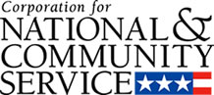

Corporation for National and Community Service

General Program Overview
AmeriCorps provides resources, both human and financial, to organizations that engage Americans in intensive service to meet our country’s critical needs.
Grantees use the funding to support AmeriCorps members for intensive service in their community. AmeriCorps grants partially cover the expense of operating an AmeriCorps program and do not cover general organizational expenses. A cash and in-kind match is required.

The main website can be accessed here: http://www.nationalservice.gov

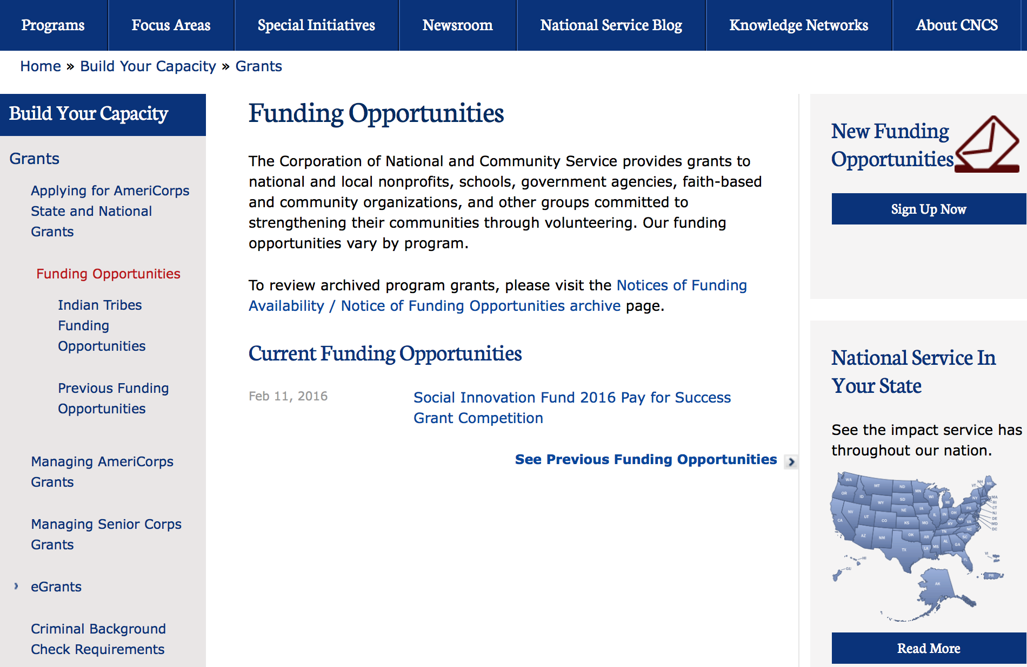

For access to further funding information: click here

http://www.nationalservice.gov/build-your-capacity/grants/funding-opportunities

FY 2016 Social Innovation Fund Classic Cooperative Agreements Grant

Document Type: | Grants Notice
Funding Opportunity Number: | CNCS-03-18-16
Funding Opportunity Title: | FY 2016 Social Innovation Fund Classic Cooperative Agreements
Opportunity Category: | Discretionary
Opportunity Category Explanation:
Funding Instrument Type: | Cooperative Agreement
Category of Funding Activity: | Education  Employment, Labor and Training  Food and Nutrition  Health  Housing  Income Security and Social Services  Law, Justice and Legal Services
Category Explanation:
Expected Number of Awards: | 10
CFDA Number(s): | 94.019 -- Social Innovation Fund
Cost Sharing or Matching Requirement: | Yes
Posted Date: | Mar 18, 2016
Last Updated Date: | Mar 18, 2016
Original Closing Date for Applications: | May 10, 2016
Current Closing Date for Applications: | May 10, 2016
Archive Date: | Jun 09, 2016
Estimated Total Program Funding: | $31,000,000
Award Ceiling: | $10,000,000
Award Floor: | $1,000,000
Eligible Applicants: | Private institutions of higher education  Nonprofits having a 501(c)(3) status with the IRS, other than institutions of higher education  Native American tribal governments (Federally recognized)  Native American tribal organizations (other than Federally recognized tribal governments)
Agency Name: | Corporation for National and Community Service
Description: | The Social Innovation awards grants to grantmaking institutions, referred to as “intermediaries.” These intermediaries in turn competitively select, provide grants to, and otherwise support high-performing community-based nonprofit organizations to implement evidence-based programs in the areas of healthy futures, economic opportunity and youth development. The intermediaries and the nonprofits must match the grant funds they receive one-to-one in cash from with non-federal sources.
Link to Additional Information: | Full notice of funding
Contact Information: | If you have difficulty accessing the full announcement electronically, please contact:  Social Innovation Fund (202) 606-3223  Competition mailbox

http://www.grants.gov/web/grants/view-opportunity.html?oppId=282317

Reminders:

National Service In Hawaii
National Service in Your State - Hawaii
2014-2015
Meeting Community Needs in Hawaii: More than 3,800 people of all ages and backgrounds are helping to meet local needs, strengthen communities, and increase civic engagement through national service in Hawaii. Serving at more than 350 locations throughout the state, these citizens tutor and mentor children, support veterans and military families, provide health services, restore the environment, respond to disasters, increase economic opportunity, and recruit and manage volunteers. This year, the Corporation for National and Community Service (CNCS) will commit more than $6,260,000 to support Hawaii communities through national service initiatives. Through a unique public-private partnership, this federal investment will leverage an additional $3,640,000 in other resources to strengthen community impact, build local support, and increase return on taxpayer dollars.

AmeriCorps
This year, AmeriCorps will provide more than 540 individuals the opportunity to provide intensive, results-driven service to meet education, environmental, health, economic, and other pressing needs in communities across Hawaii. Most AmeriCorps grant funding goes to the Hawaii Commission on National & Community Service, which in turn awards grants to nonprofit groups to respond to local needs. Most of the remainder of the grant funding is distributed by CNCS directly to multi-state and national organizations through a competitive grants process. Other individuals serve through AmeriCorps VISTA, whose members help bring individuals and communities out of poverty by serving full-time to fight illiteracy, improve health services, create businesses, and increase housing opportunities, and AmeriCorps NCCC (National Civilian Community Corps), a 10-month, full time residential program for men and women between the ages of 18 and 24. In exchange for their service, AmeriCorps members earn an education award that can be used to pay for college or to pay back qualified student loans. Since 1994, more than 5,600 Hawaii residents have served more than 5.8 million hours and have qualified for Segal AmeriCorps Education Awards totaling more than $13,510,000.

Senior Corps
More than 3,200 seniors in Hawaii contribute their time and talents in one of three Senior Corps programs. Foster Grandparents serve one-on-one as tutors and mentors to more than 340 young people who have special needs. Senior Companions help more than 200 homebound seniors and other adults maintain independence in their own homes. RSVP volunteers conduct safety patrols, renovate homes, protect the environment, tutor and mentor youth, respond to natural disasters, and provide other services through more than 170 groups across Hawaii.

The Corporation for National and Community Service is a federal agency that improves lives, strengthens communities, and fosters civic engagement through service and volunteering. CNCS annually engages more than five million Americans in service to meet local needs through Senior Corps, AmeriCorps, and national days of service; improves communities through the Social Innovation Fund, and leads President Obama's national call to service initiative, United We Serve. To learn more visit NationalService.gov or Serve.gov or call 202-606-5000 or TTY 1-800-833-3722.

http://www.nationalservice.gov/impact-our-nation/state-profiles/hi

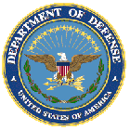

U.S. Department of Defense

Doing Business with the Department of Defense

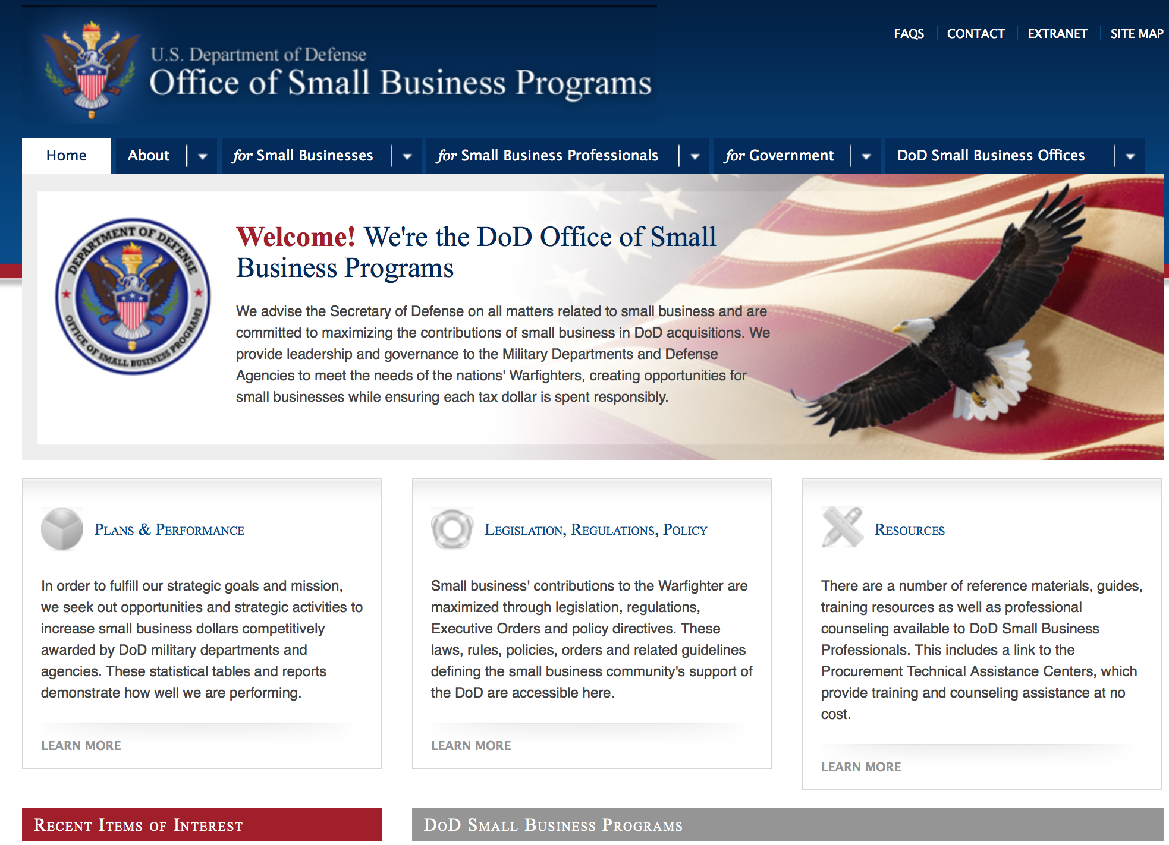

http://www.acq.osd.mil/osbp/

Doing Business with the DoD

Resources

Procurement Technical Assistance Centers (PTACs)

Procurement Technical Assistance Centers (PTACs) are charged with assisting businesses in learning how to do business with federal, state, and local governments. PTACs are a local resource available at no or nominal cost that can provide assistance to business firms in marketing their products and services. They offer training to businesses on how to research and bid on contracts, assist with registration requirements, provide bid-matching services, and assist with pre and post contracting issues.

Prime Contractors with Subcontracting Plans [xlsx]

Directory updated 4/19/11

This FY 2014 directory is intended for small business concerns seeking opportunities with DoD prime contractors. The directory is a listing of large business prime contractors who are required to establish subcontracting plans with goals. The report is generated from data contained in the Individual Subcontract Reports (ISRs) submitted in the Electronic Subcontracting Reporting System (eSRS) by contractors and from data contained in the Federal Procurement Data System (FPDS). The directory includes the name of the prime contractor; the major product/service code (PSC) provided to DoD; the major NAICS of the company; name, telephone number and email address of the company’s point of contact; contract number with the effective date and completion date, ultimate contract value and obligated dollars. In addition, many companies have websites with additional information which may be useful in your search for subcontracting opportunities or teaming arrangements.

Locate a Small Business Professional

Small Business Professionals serve as the primary liaison between private-sector small businesses seeking to do business with government agencies. Specialists advise small businesses regarding current acquisitions contracts available from the federal government.

Procurement Forecasts & the Department of Defense

The Department of Defense, due to its size and scope, does not have a single, comprehensive source for future procurements. Procurements are made locally and within the various services and agencies.

Business Intelligence, relative to future procurement planning, would be gathered at the local level.

For the purposes of forecasting, knowledge of past behavior is useful. Click here for a table of DoD acquisitions in FY10 summarized by NAICS code. The FY10 data has been validated but FPDS data is dynamic and changes continuously.

Non-Appropriated Fund Customers

Non-appropriated fund customers operate similar to non-profit organizations and include commissaries, exchanges, recreation and fitness centers, dining at officer/enlisted/civilian clubs, and barber/beauty services, just to name a few. For more information click here.

Research:

Air Force Office of Scientific Research
Multidisciplinary Research Program of the University Research Initiative (FY17 AF SUBMISSION)
Grant
http://www.grants.gov/web/grants/view-opportunity.html?oppId=283045

Air Force -- Research Lab
Air Force Research Laboratory, Materials & Manufacturing Directorate, Functional Materials and Applications (AFRL/RXA) Two-Step Open BAA Grant
http://www.grants.gov/web/grants/view-opportunity.html?oppId=283134

Dept. of the Army -- USAMRAA
Peer Reviewed Cancer Translational Team Science Award Grant
http://www.grants.gov/web/grants/view-opportunity.html?oppId=283062

Dept. of the Army -- USAMRAA
Peer Reviewed Cancer Career Development Award Grant
http://www.grants.gov/web/grants/view-opportunity.html?oppId=283063

Dept. of the Army -- USAMRAA
US Special Operations Command Broad Agency Announcement Grant
http://www.grants.gov/web/grants/view-opportunity.html?oppId=283046

Dept. of the Army -- USAMRAA
Lung Cancer Research Program Idea Development Award Grant
http://www.grants.gov/web/grants/view-opportunity.html?oppId=282895

Dept. of the Army -- USAMRAA
Lung Cancer Research Program Investigator-Initiated Translational Research Award Grant
http://www.grants.gov/web/grants/view-opportunity.html?oppId=282897

Dept. of the Army -- USAMRAA
Lung Cancer Research Program Career Development Award Grant
http://www.grants.gov/web/grants/view-opportunity.html?oppId=282905

Dept. of the Army -- USAMRAA
Autism Clinical Trial Award Grant
http://www.grants.gov/web/grants/view-opportunity.html?oppId=283352

Dept. of the Army -- USAMRAA
Autism Idea Development Award Grant
http://www.grants.gov/web/grants/view-opportunity.html?oppId=283335

Dept. of the Army -- Materiel Command
Multidisciplinary Research Program of the University Research Initiative (FY17 ARMY SUBMISSION) Grant
http://www.grants.gov/web/grants/view-opportunity.html?oppId=283011

Defense Advanced Research Projects Agency
DARPA - Biological Technologies Office
INTERfering and Co-Evolving Prevention and Therapy Grant
http://www.grants.gov/web/grants/view-opportunity.html?oppId=283354

Defense Advanced Research Projects Agency
DARPA - Defense Sciences Office
Intense and Compact Neutron Sources Phase Two (ICONS2) Grant
http://www.grants.gov/web/grants/view-opportunity.html?oppId=283360

Defense Advanced Research Projects Agency
DARPA - Biological Technologies Office
Biological Technologies Grant
http://www.grants.gov/web/grants/view-opportunity.html?oppId=283365

Office of Naval Research
Broad Agency Announcement for the Office of Naval Research (ONR) Navy and Marine Corps FY2017 Basic Research Challenge (BRC) Program Grant
http://www.grants.gov/web/grants/view-opportunity.html?oppId=283194

Office of Naval Research
Naval Supply Systems Command
FY16 Acquisition Research Program Grant
http://www.grants.gov/web/grants/view-opportunity.html?oppId=282922

Office of Naval Research
Multidisciplinary Research Program of the University Research Initiative Grant
http://www.grants.gov/web/grants/view-opportunity.html?oppId=282951

Modifications:

Air Force Office of Scientific Research
Center Of Excellence: Multi-Fidelity Modeling of Combustion Instabilities
Modification 2
http://www.grants.gov/web/grants/view-opportunity.html?oppId=282087

Air Force Office of Scientific Research
Air Force Fiscal Year 2017 Young Investigator Research Program (YIP)
Modification 3
http://www.grants.gov/web/grants/view-opportunity.html?oppId=282395

Dept. of the Army -- Materiel Command
ACC-APG-Detrick
Medical Countermeasure Systems Broad Agency Announcement
Modification 1
http://www.grants.gov/web/grants/view-opportunity.html?oppId=279996

Dept. of the Army -- Materiel Command
Army Contracting Command Rock Island
Industrial Base Analysis and Sustainment Program
Modification 3
http://www.grants.gov/web/grants/view-opportunity.html?oppId=280784

Dept. of the Army -- USAMRAA
Peer Reviewed Cancer Idea Award with Special Focus
Modification 1
http://www.grants.gov/web/grants/view-opportunity.html?oppId=283060

Missile Defense Agency STEM Outreach BEST Robotics Grant
Modification 2
http://www.grants.gov/web/grants/view-opportunity.html?oppId=282796

Missile Defense Agency STEM Outreach BEST Robotics Grant
Modification 2
http://www.grants.gov/web/grants/view-opportunity.html?oppId=282798

Missile Defense Agency STEM Outreach BEST Robotics Grant
Modification 1
http://www.grants.gov/web/grants/view-opportunity.html?oppId=282801

Office of Naval Research
Multidisciplinary Research Program of the University Research Initiative
Modification 1
http://www.grants.gov/web/grants/view-opportunity.html?oppId=282951

Reminders:

Dept. of the Army -- Materiel Command
Army Research Office Broad Agency Announcement for Basic and Applied Scientific Research
Modification 8

Document Type: | Grants Notice
Funding Opportunity Number: | W911NF-12-R-0012
Funding Opportunity Title: | Army Research Office Broad Agency Announcement for Basic and Applied Scientific Research
Opportunity Category: | Discretionary
Funding Instrument Type: | Cooperative Agreement  Grant  Other  Procurement Contract
Category of Funding Activity: | Science and Technology and other Research and Development
Category Explanation:
Expected Number of Awards: | 1000
CFDA Number(s): | 12.431 -- Basic Scientific Research
Cost Sharing or Matching Requirement: | No
Posted Date: | Mar 27, 2015
Creation Date: | Mar 27, 2015
Original Closing Date for Applications: | Mar 31, 2017
Current Closing Date for Applications: | Mar 31, 2017
Archive Date: | Apr 30, 2017
Eligible Applicants: | Unrestricted (i.e., open to any type of entity above), subject to any clarification in text field entitled "Additional Information on Eligibility"
Agency Name: | Dept. of the Army -- Materiel Command
Description: | The purpose of this Broad Agency Announcement (BAA) is to solicit research proposals in the engineering, physical, life, and information sciences for submission to the Army Research Office (ARO) for consideration for possible funding. For ease of reference, this BAA is an extraction of the ARO sections of the Army Research Laboratory BAA. (www.arl.army.mil/www/default.cfm?page=8).
Link to Additional Information: | ARO CORE BAA-W911NF-12-R-0012-Mod 03
Contact Information: | If you have difficulty accessing the full announcement electronically, please contact:  ANDREW L. FISKE Procurement Analyst Army Contracting Command Aberdeen Proving Ground Research Triangle Park Division Phone: (919) 549-4338 FAX: (919) 549-4388 andrew.l.fiske.civ@mail.mil  Administrative POC

http://www.grants.gov/web/grants/view-opportunity.html?oppId=173593



Department of Education

Grant Programs Overview at the Department of Education

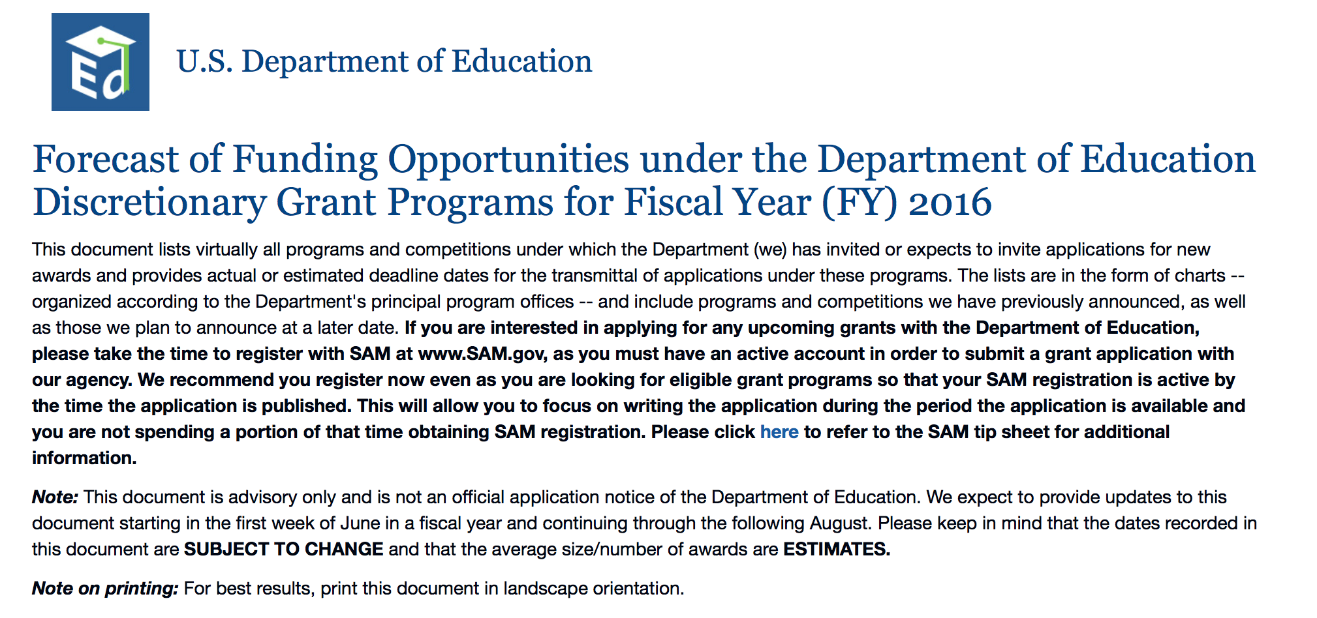To see the complete document click here: http://www2.ed.gov/fund/grant/find/edlite-forecast.html

The general information page for Education Grant funding is an excellent resource describing the three types of grants awarded by the Department of Education. See the screen shot of the Department of Education web page below:

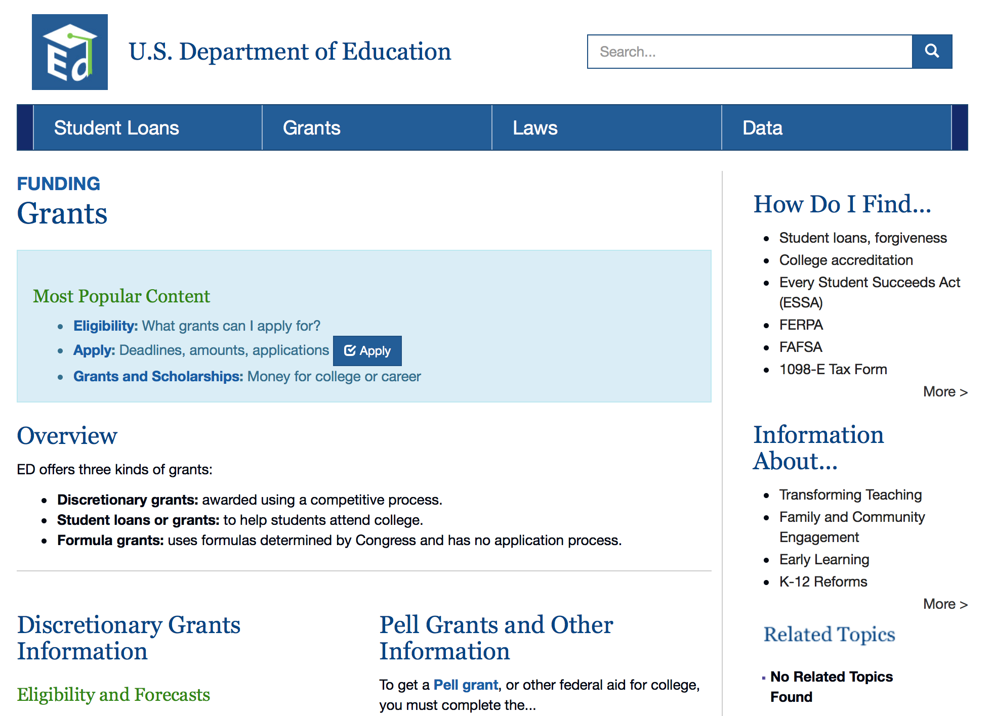

http://www.ed.gov/fund/grants-apply.html

Programs:

Office of Innovation and Improvement (OII): Magnet Schools Assistance Program CFDA Number 84.165A Grant

Document Type: | Grants Notice
Funding Opportunity Number: | ED-GRANTS-042216-001
Funding Opportunity Title: | Office of Innovation and Improvement (OII): Magnet Schools Assistance Program CFDA Number 84.165A
Opportunity Category: | Discretionary
Opportunity Category Explanation: | Category Explanation
Funding Instrument Type: | Grant
Category of Funding Activity: | Education
Category Explanation:
Expected Number of Awards: | 8
CFDA Number(s): | 84.165 -- Magnet Schools Assistance
Cost Sharing or Matching Requirement: | No
Posted Date: | Apr 22, 2016
Last Updated Date: | Apr 22, 2016
Current Closing Date for Applications: | Jun 01, 2016 Applications Available: April 22, 2016. Deadline for Notice of Intent to Apply: May 9, 2016. Notice of Intent to Apply: The Department will be able to develop a more efficient process for reviewing grant applications if it has a better understanding of the number of entities that intend to apply for funding under this competition. Therefore, the Secretary strongly encourages each potential applicant to notify the Department of the applicant's intent to submit an application for funding by completing a Web-based form. When completing this form, applicants will provide (1) the applicant organization's name and address, (2) the number of and proposed theme(s) of school(s) that will be served through the MSAP grant, and (3) information on the priority or priorities (if any) under which the applicant intends to apply. Applicants may access this form online at http://innovation.ed.gov/what-we-do/parental-options/magnet-school-assistance-program-msap/. Applicants that do not complete this form may still apply for funding. Deadline for Transmittal of Applications: June 1, 2016.
Archive Date: | Jul 01, 2016
Estimated Total Program Funding: | $91,322,994
Award Ceiling: | $12,000,000
Eligible Applicants: | Others (see text field entitled "Additional Information on Eligibility" for clarification)
Additional Information on Eligibility: | 1. Eligible Applicants: LEAs or consortia of LEAs implementing a desegregation plan as specified in section III. 3 of this notice. 2. Cost Sharing or Matching: This program does not require cost sharing or matching. 3. Other: Applicants must submit with their applications one of the following types of desegregation plans to establish eligibility to receive MSAP assistance: (a) A desegregation plan required by a court order; (b) a desegregation plan required by a State agency or an official of competent jurisdiction; (c) a desegregation plan required by the Office for Civil Rights (OCR), United States Department of Education (Department), under Title VI of the Civil Rights Act of 1964 (Title VI); or (d) a voluntary desegregation plan adopted by the applicant and submitted to the Department for approval as part of the application. Under the MSAP regulations, applicants are required to provide all of the information required in 34 CFR 280.20(a) through (g) in order to satisfy the civil rights eligibility requirements found in 34 CFR 280.2(a)(2) and (b). In addition to the particular data and other items for required and voluntary desegregation plans described in the application package, an application must include-- Projected enrollment by race and ethnicity for magnet and feeder schools; Signed civil rights assurances (included in the application package); and An assurance that the desegregation plan is being implemented or will be implemented if the application is funded
Agency Name: | Department of Education
Description: | Note: Each funding opportunity description is a synopsis of information in the Federal Register application notice. For specific information about eligibility, please see the official application notice. The official version of this document is the document published in the Federal Register. Free Internet access to the official edition of the Federal Register and the Code of Federal Regulations is available on GPO Access at: http://www.access.gpo.gov/nara/index.html. Please review the official application notice for pre-application and application requirements, application submission information, performance measures, priorities and program contact information. Purpose of Program: The MSAP provides grants to eligible local educational agencies (LEAs) and consortia of LEAs to support magnet schools under an approved, required or voluntary, desegregation plan. By supporting the development and implementation of magnet schools that reduce, eliminate, or prevent minority group isolation, these program resources can be used in pursuit of the objectives of the Elementary and Secondary Education Act of 1965, as amended (ESEA), which supports State and local efforts to enable all elementary and secondary school students to achieve high standards. In particular, the MSAP provides an opportunity for eligible entities to provide students from varied backgrounds with the educational benefits of diversity and equitable access to a high-quality education that will enable all students to succeed academically. Catalog of Federal Domestic Assistance (CFDA) Number: 84.165A. Applications for grants under MSAP, CFDA number 84.165A, must be submitted electronically using the Governmentwide Grants.gov Apply site at www.Grants.gov. Through this site, you will be able to download a copy of the application package, complete it offline, and then upload and submit your application. You may not email an electronic copy of a grant application to us. You may access the electronic grant application for the Magnet Schools Assistance Program at www.Grants.gov. You must search for the downloadable application package for this program by the CFDA number. Do not include the CFDA number's alpha suffix in your search (e.g., search for 84.165, not 84.165A).
Link to Additional Information: | Office of Innovation and Improvement (OII): Magnet Schools Assistance Program CFDA Number 84.165A; Notice inviting applications for new awards for fiscal year (FY) 2016
Contact Information: | If you have difficulty accessing the full announcement electronically, please contact:  Julius Cotton ED Grants.gov FIND Systems Admin. Phone 202-245-6288 EducationGrantInquiries@ed.gov Program Manager: Tiffany McClain, U.S. Department of Education, 400 Maryland Avenue SW., Room 4W250, Washington, DC 20202-5970. Telephone: (202) 453-7200 or by email: msap.team@ed.gov.

http://www.grants.gov/web/grants/view-opportunity.html?oppId=283228

Office of Innovation and Improvement (OII): Investing in Innovation Fund: Development Grants Pre-Application CFDA Number 84.411P Grant

Document Type: | Grants Notice
Funding Opportunity Number: | ED-GRANTS-042516-001
Funding Opportunity Title: | Office of Innovation and Improvement (OII): Investing in Innovation Fund: Development Grants Pre-Application CFDA Number 84.411P
Opportunity Category: | Discretionary
Opportunity Category Explanation:
Funding Instrument Type: | Cooperative Agreement  Grant
Category of Funding Activity: | Education
Category Explanation:
Expected Number of Awards: | 11
CFDA Number(s): | 84.411 -- Investing in Innovation (i3) Fund
Cost Sharing or Matching Requirement: | No
Posted Date: | Apr 25, 2016
Last Updated Date: | Apr 25, 2016
Current Closing Date for Applications: | May 25, 2016 Pre-Applications Available: April 27, 2016. Deadline for Notice of Intent to Submit Pre-Application: May 10, 2016. Deadline for Transmittal of Pre-applications: May 25, 2016. Full Applications Available: If you are invited to submit a full application for a Development grant, we will transmit the full application package and instructions using the contact information you provide to us in your pre-application. Other pre-applicants that choose to submit a full application may access these items on the i3 Web site at http://innovation.ed.gov/what-we-do/innovation/investing-in-innovation-i3/. Deadline for Transmittal of Full Applications: Entities that submit a highly rated pre-application, as scored by peer reviewers and as identified by the Department, will be invited to submit a full application for a Development grant. Other pre-applicants may choose to submit a full application. The Department will announce on its Web site the deadline date for transmission of full applications and will also communicate this deadline to applicants in the full application package and instructions.
Archive Date: | Jun 24, 2016
Estimated Total Program Funding: | $103,100,000
Award Ceiling: | $19,000,000
Eligible Applicants: | Others (see text field entitled "Additional Information on Eligibility" for clarification)
Additional Information on Eligibility: | 1. Innovations that Improve Achievement for High-Need Students: All grantees must implement practices that are designed to improve student achievement (as defined in this notice) or student growth (as defined in this notice), close achievement gaps, decrease dropout rates, increase high school graduation rates (as defined in this notice), or increase college enrollment and completion rates for high-need students (as defined in this notice). 2. Innovations that Serve Kindergarten-through-Grade-12 (K-12) Students: All grantees must implement practices that serve students who are in grades K-12 at some point during the funding period. To meet this requirement, projects that serve early learners (i.e., infants, toddlers, or preschoolers) must provide services or supports that extend into kindergarten or later years, and projects that serve postsecondary students must provide services or supports during the secondary grades or earlier. 3. Eligible Applicants: Entities eligible to apply for i3 grants include either of the following: (a) An LEA. (b) A partnership between a nonprofit organization and-- (1) One or more LEAs; or (2) A consortium of schools. Statutory Eligibility Requirements: Except as specifically set forth in the Note about Eligibility for an Eligible Applicant that Includes a Nonprofit Organization that follows, to be eligible for an award, an eligible applicant must-- (a)(1) Have significantly closed the achievement gaps between groups of students described in section 1111(b)(2) of the ESEA (economically disadvantaged students, students from major racial and ethnic groups, students with limited English proficiency, students with disabilities); or (2) Have demonstrated success in significantly increasing student academic achievement for all groups of students described in that section; (b) Have made significant improvements in other areas, such as high school graduation rates (as defined in this notice) or increased recruitment and placement of high-quality teachers and principals, as demonstrated with meaningful data; (c) Demonstrate that it has established one or more partnerships with the private sector, which may include philanthropic organizations, and that organizations in the private sector will provide matching funds in order to help bring results to scale; and (d) In the case of an eligible applicant that includes a nonprofit organization, provide in the application the names of the LEAs with which the nonprofit organization will partner, or the names of the schools in the consortium with which it will partner. If an eligible applicant that includes a nonprofit organization intends to partner with additional LEAs or schools that are not named in the application, it must describe in the application the demographic and other characteristics of these LEAs and schools and the process it will use to select them.
Agency Name: | Department of Education
Description: | Note: Each funding opportunity description is a synopsis of information in the Federal Register application notice. For specific information about eligibility, please see the official application notice. The official version of this document is the document published in the Federal Register. Free Internet access to the official edition of the Federal Register and the Code of Federal Regulations is available on GPO Access at: http://www.access.gpo.gov/nara/index.html. Please review the official application notice for pre-application and application requirements, application submission information, performance measures, priorities and program contact information. Purpose of Program: The Investing in Innovation Fund (i3), established under section 14007 of the American Recovery and Reinvestment Act of 2009 (ARRA), provides funding to support (1) local educational agencies (LEAs), and (2) nonprofit organizations in partnership with (a) one or more LEAs or (b) a consortium of schools. The i3 program is designed to generate and validate solutions to persistent educational challenges and to support the expansion of effective solutions to serve substantially larger numbers of students. The central design element of the i3 program is its multi-tier structure that links the amount of funding that an applicant may receive to the quality of the evidence supporting the efficacy of the proposed project. Applicants proposing practices supported by limited evidence can receive relatively small grants that support the development and initial evaluation of promising practices and help to identify new solutions to pressing challenges; applicants proposing practices supported by evidence from rigorous evaluations, such as large randomized controlled trials, can receive sizable grants to support expansion across the country. This structure provides incentives for applicants to build evidence of effectiveness of their proposed projects and to address the barriers to serving more students across schools, districts, and States. As importantly, all i3 projects are required to generate additional evidence of effectiveness. All i3 grantees must use part of their budgets to conduct independent evaluations (as defined in this notice) of their projects. This requirement ensures that projects funded under the i3 program contribute significantly to improving the information available to practitioners and policymakers about which practices work, for which types of students, and in what contexts. The Department awards three types of grants under this program: ``Development'' grants, ``Validation'' grants, and ``Scale-up'' grants. These grants differ in terms of the level of prior evidence of effectiveness required for consideration of funding, the level of scale the funded project should reach, and, consequently, the amount of funding available to support the project. Development grants provide funding to support the development or testing of practices that are supported by evidence of promise (as defined in this notice) or a strong theory (as defined in this notice) and whose efficacy should be systematically studied. Development grants will support new or substantially more effective practices for addressing widely shared challenges. Development projects are novel and significant nationally, not projects that simply implement existing practices in additional locations or support needs that are primarily local in nature. All Development grantees must evaluate the effectiveness of the project at the level of scale proposed in the application. This notice invites applications for Development grants only. The Department anticipates publishing notices inviting applications for the other types of i3 grants (Validation and Scale-up grants) in the spring of 2016. We remind LEAs of the continuing applicability of the provisions of the Individuals with Disabilities Education Act (IDEA) for students who may be served under i3 grants. Any grants in which LEAs participate must be consistent with the rights, protections, and processes established under IDEA for students who are receiving special education and related services or who are in the process of being evaluated to determine their eligibility for such services. Catalog of Federal Domestic Assistance (CFDA) Number: 84.411P (Development grants Pre-Application) and 84.411C (Development grants Full Application). Note: To receive an Investing in Innovation Fund (i3) Development grant, an entity must submit a pre-application. The pre-application is intended to reduce the burden of submitting a full application for an i3 Development grant. Pre-applications will be reviewed and scored by peer reviewers using the selection criteria designated in this notice. Entities that submit a highly rated pre-application will be invited to submit a full application for a Development grant; however, any entity that successfully submits a pre-application may choose to submit a full application.
Link to Additional Information: | Office of Innovation and Improvement (OII): Investing in Innovation Fund: Development Grants Pre-Application CFDA Number 84.411P; Notice inviting applications for new awards for fiscal year (FY) 2016
Contact Information: | If you have difficulty accessing the full announcement electronically, please contact:  Julius Cotton ED Grants.gov FIND Systems Admin. Phone 202-245-6288 EducationGrantInquiries@ed.gov Program Manager: Kelly Terpak, U.S. Department of Education, 400 Maryland Avenue SW., Room 4CW312, Washington, DC 20202. Telephone: (202) 453-7122. FAX: (202) 401-4123 or by email: i3@ed.gov.  e-Mail: Program Mailbox

http://www.grants.gov/web/grants/view-opportunity.html?oppId=283266

Research:

Modifications:

Office of Career, Technical, and Adult Education (OCTAE): Performance Partnership Pilots (P3) CFDA Number 84.420A
Modification 1
Document Type: | Grants Notice
Funding Opportunity Number: | ED-GRANTS-042616-001
Funding Opportunity Title: | Office of Career, Technical, and Adult Education (OCTAE): Performance Partnership Pilots (P3) CFDA Number 84.420A
Opportunity Category: | Discretionary
Opportunity Category Explanation:
Funding Instrument Type: | Cooperative Agreement
Category of Funding Activity: | Education
Category Explanation:
Expected Number of Awards: | 10
CFDA Number(s): | 84.420 -- Performance Partnership Pilots for Disconnected Youth
Cost Sharing or Matching Requirement: | No
Posted Date: | Apr 26, 2016
Last Updated Date: | Apr 26, 2016
Current Closing Date for Applications: | Jun 27, 2016 Applications Available: April 26, 2016. Deadline for Notice of Intent to Apply: May 26, 2016. Note: Submission of a notice of intent to apply is optional. We will be able to develop a more efficient process for reviewing applications if we know the approximate number of applicants that intend to apply under this competition. Therefore, we strongly encourage each potential applicant to notify us of the applicant's intent to apply by emailing to disconnectedyouth@ed.gov the following information: (1) The applicant organization's name and address and (2) the absolute priority the applicant intends to address. Applicants that do not submit a notice of intent to apply may still submit an application. Note: Submission of a notice of intent to apply is optional. Deadline for Transmittal of Applications: June 27, 2016.
Archive Date: | Jul 27, 2016
Estimated Total Program Funding: | $3,050,000
Eligible Applicants: | State governments  Others (see text field entitled "Additional Information on Eligibility" for clarification)  County governments  Special district governments  Native American tribal governments (Federally recognized)  City or township governments
Additional Information on Eligibility: | Eligible Applicants: The lead applicant must be a State, local, or tribal government entity, represented by a Chief Executive, such as a governor, mayor, or other elected leader, or the head of a State, local, or tribal agency.
Agency Name: | Department of Education
Description: | Note: Each funding opportunity description is a synopsis of information in the Federal Register application notice. For specific information about eligibility, please see the official application notice. The official version of this document is the document published in the Federal Register. Free Internet access to the official edition of the Federal Register and the Code of Federal Regulations is available on GPO Access at: http://www.access.gpo.gov/nara/index.html. Please review the official application notice for pre-application and application requirements, application submission information, performance measures, priorities and program contact information. Purpose of Program: Performance Partnership Pilots (P3), first authorized by Congress for FY 2014 by the Consolidated Appropriations Act, 2014 (2014 Appropriations Act) and reauthorized for FY 2015 by the Consolidated and Further Continuing Appropriations Act, 2015 (2015 Appropriations Act) and for FY 2016 by the Consolidated Appropriations Act, 2016 (2016 Appropriations Act) (together, the Acts), enable pilot sites to test innovative, outcome-focused strategies to achieve significant improvements in educational, employment, and other key outcomes for disconnected youth using new flexibility to blend existing Federal funds and to seek waivers of associated program requirements. Background: The Acts authorize the Departments of Education (ED), Labor (DOL), Health and Human Services (HHS), Housing and Urban Development (HUD),\1\ and Justice (DOJ),\2\ the Corporation for National and Community Service (CNCS), and the Institute of Museum and Library Services (IMLS) (collectively, the Agencies), to enter into Performance Partnership Agreements (performance agreements) with State, local, or tribal governments to provide additional flexibility in using certain of the Agencies' discretionary funds,\3\ including competitive and formula grant funds, across multiple Federal programs. Entities that seek to participate in these pilots will be required to commit to achieving significant improvements in outcomes for disconnected youth in exchange for this new flexibility. The authorizing statute states that `` `[t]o improve outcomes for disconnected youth' means to increase the rate at which individuals between the ages of 14 and 24 (who are low-income and either homeless, in foster care, involved in the juvenile justice system, unemployed, or not enrolled in or at risk of dropping out of an educational institution) achieve success in meeting educational, employment, or other key goals.'' Catalog of Federal Domestic Assistance (CFDA) Number: 84.420A. Applications for grants under the P3 program, CFDA number 84.420A, must be submitted electronically using the Governmentwide Grants.gov Apply site at www.Grants.gov. Through this site, you will be able to download a copy of the application package, complete it offline, and then upload and submit your application. You may not email and you may access the electronic grant application for P3 at www.Grants.gov. You must search for the downloadable application package for this competition by the CFDA number. Do not include the CFDA number's alpha suffix in your search (e.g., search for 84.420, not 84.420A).
Link to Additional Information: | Office of Career, Technical, and Adult Education (OCTAE): Performance Partnership Pilots (P3) CFDA NUmber 84.420A; Notice inviting applications for new awards for fiscal year (FY) 2015
Contact Information: | If you have difficulty accessing the full announcement electronically, please contact:  Julius Cotton ED Grants.gov FIND Systems Admin. Phone 202-245-6288 EducationGrantInquiries@ed.gov Program Managers: Marilyn Fountain, U.S. Department of Education, 400 Maryland Avenue SW., Room 11026, Potomac Center Plaza (PCP), Washington, DC 20202. Telephone: (202)245-7346 or by email: disconnectedyouth@ed.gov or Rosanne Andre, U.S. Department of Education, 400 Maryland Avenue SW., Room 11070, Potomac Center Plaza (PCP), Washington, DC 20202. Telephone: (202) 245-7789. Email address: Disconnectedyouth@ed.gov.  e-Mail: Program Mailbox

http://www.grants.gov/web/grants/view-opportunity.html?oppId=283281

Reminders:

Institute of Education Sciences (IES CFDA Number 84.305

Original Closing Date for Applications: | Aug 04, 2016 Application Package Available: May 5, 2016 Deadline for Transmittal of Applications: August 4, 2016.
Current Closing Date for Applications: | Aug 04, 2016 Application Package Available: May 5, 2016 Deadline for Transmittal of Applications: August 4, 2016.
Eligible Applicants: | Others (see text field entitled "Additional Information on Eligibility" for clarification)  County governments  Nonprofits having a 501(c)(3) status with the IRS, other than institutions of higher education  City or township governments  State governments  Special district governments  Nonprofits that do not have a 501(c)(3) status with the IRS, other than institutions of higher education  Public and State controlled institutions of higher education  Independent school districts  For profit organizations other than small businesses  Private institutions of higher education
Additional Information on Eligibility: | Eligible Applicants: Applicants that have the ability and capacity to conduct scientifically valid research are eligible to apply. Eligible applicants include, but are not limited to, nonprofit and for-profit organizations and public and private agencies and institutions of higher education, such as colleges and universities.
Agency Name: | Department of Education
Description: | Note: Each funding opportunity description is a synopsis of information in the Federal Register application notice. For specific information about eligibility, please see the official application notice. The official version of this document is the document published in the Federal Register. Free Internet access to the official edition of the Federal Register and the Code of Federal Regulations is available on GPO Access at: http://www.access.gpo.gov/nara/index.html. Please review the official application notice for pre-application and application requirements, application submission information, performance measures, priorities and program contact information. Purpose of Program: The central purpose of the Institute's research grant programs is to provide interested individuals and the general public with reliable and valid information about education practices that support learning and improve academic achievement and access to education opportunities for all students. These interested individuals include parents, educators, students, researchers, and policymakers. In carrying out its grant programs, the Institute provides support for programs of research in areas of demonstrated national need. Competitions in This Notice: The Institute will conduct nine research competitions in FY 2017 through two of its centers: Catalog of Federal Domestic Assistance (CFDA) Numbers: 84.305A, 84.305B, 84.305D, 84.305H, 84.305L, 84.305N, 84.324A, 84.324B, and 84.324L. The Deputy Director for Policy and Research, Delegated the Duties of the Director, of the Institute of Education Sciences (Institute) announces the Institute's FY 2017 competitions for grants to support education research and special education research. The Delegated Director takes this action under the Education Sciences Reform Act of 2002. The Institute's purpose in awarding these grants is to provide national leadership in expanding fundamental knowledge and understanding of (1) developmental and school readiness outcomes for infants and toddlers with or at risk for disability, and (2) education outcomes for all students from early childhood education through postsecondary and adult education. Applications for grants under the Education Research, Research Training Programs in the Education Sciences, Statistical and Research Methodology in Education, Partnerships and Collaborations Focused on Problems of Practice or Policy, Low-Cost, Short-Duration Evaluation of Education Interventions, Research Networks Focused on Critical Problems of Education Policy and Practice, Special Education Research, Research Training Programs in Special Education, and Low-Cost, Short-Duration Evaluation of Special Education Interventions competitions, CFDA numbers 84.305A, 84.305B, 84.305D, 84.305H, 84.305L, 84.305N, 84.324A, 84.324B, and 84.324L must be submitted electronically using the Governmentwide Grants.gov Apply site at www.Grants.gov. Through this site, you will be able to download a copy of the application package, complete it offline, and then upload and submit your application. You may not email an electronic copy of a grant application to us. You may access the electronic grant applications for the Education Research, Research Training Programs in the Education Sciences, Statistical and Research Methodology in Education, Partnerships and Collaborations Focused on Problems of Practice or Policy, Low-Cost, Short-Duration Evaluation of Education Interventions, Research Networks Focused on Critical Problems of Education Policy and Practice, Special Education Research, Research Training Programs in Special Education, and Low-Cost, Short-Duration Evaluation of Special Education Interventions competitions at www.Grants.gov. You must search for the downloadable application package for each competition by the CFDA number. Do not include the CFDA number's alpha suffix in your search (e.g., search for 84.305, not 84.305A).
Link to Additional Information: | Institute of Education Sciences (IES): Statistical and Research Methodology in Education CFDA Number 84.305D; Notice inviting applications for new awards for fiscal year (FY) 2017
Contact Information: | If you have difficulty accessing the full announcement electronically, please contact:  Julius Cotton ED Grants.gov FIND Systems Admin. Phone 202-245-6288 EducationGrantInquiries@ed.gov Program Manager: Phill Gagne, Phill.Gagne@ed.gov.  e-Mail: Program Manager

Office of Elementary and Secondary Education (OESE): Carol M. White Physical Education Program CFDA Number 84.215F

Modification 1
Document Type: | Grants Notice
Funding Opportunity Number: | ED-GRANTS-032116-001
Funding Opportunity Title: | Office of Elementary and Secondary Education (OESE): Carol M. White Physical Education Program CFDA Number 84.215F
Opportunity Category: | Discretionary
Opportunity Category Explanation:
Funding Instrument Type: | Grant
Category of Funding Activity: | Education
Category Explanation:
Expected Number of Awards: | 15
CFDA Number(s): | 84.215 -- Fund for the Improvement of Education
Cost Sharing or Matching Requirement: | Yes
Posted Date: | Mar 21, 2016
Last Updated Date: | Mar 21, 2016
Original Closing Date for Applications: | May 20, 2016 Applications Available: March 21, 2016. Deadline for Transmittal of Applications: May 20, 2016.
Current Closing Date for Applications: | May 20, 2016 Applications Available: March 21, 2016. Deadline for Transmittal of Applications: May 20, 2016.
Archive Date: | Jun 19, 2016
Estimated Total Program Funding: | $23,000,000
Eligible Applicants: | Others (see text field entitled "Additional Information on Eligibility" for clarification)
Additional Information on Eligibility: | 1. Eligible Applicants: (a) LEAs, including charter schools that are considered LEAs under State law, and CBOs, including faith-based organizations provided that they meet the applicable statutory and regulatory requirements. (b) The Secretary limits eligibility under this discretionary grant competition to LEAs or CBOs that do not currently have an active grant under PEP. For the purpose of this eligibility requirement, a grant is considered active until the end of the grant's project or funding period, including any extensions of those periods that extend the grantee's authority to obligate funds. (See the notice of final eligibility requirements for the Office of Safe and Drug-Free Schools discretionary grant programs published in the Federal Register on December 4, 2006 (71 FR 70369)).
Agency Name: | Department of Education
Description: | Note: Each funding opportunity description is a synopsis of information in the Federal Register application notice. For specific information about eligibility, please see the official application notice. The official version of this document is the document published in the Federal Register. Free Internet access to the official edition of the Federal Register and the Code of Federal Regulations is available on GPO Access at: http://www.access.gpo.gov/nara/index.html. Please review the official application notice for pre-application and application requirements, application submission information, performance measures, priorities and program contact information. Purpose of Program: The Carol M. White Physical Education Program (PEP) provides grants to local educational agencies (LEAs) and community-based organizations (CBOs) to initiate, expand, and improve physical education for students in grades K-12. Grant recipients must implement programs that help students make progress toward meeting State physical education standards. Catalog of Federal Domestic Assistance (CFDA) Number: 84.215F. Applications for grants under the Carol M. White Physical Education Program, CFDA number 84.215F, must be submitted electronically using the Governmentwide Grants.gov Apply site at www.Grants.gov. Through this site, you will be able to download a copy of the application package, complete it offline, and then upload and submit your application. You may not email an electronic copy of a grant application to us. You may access the electronic grant application for the Carol M. White Physical Education Program at www.Grants.gov. You must search for the downloadable application package for this program by the CFDA number. Do not include the CFDA number's alpha suffix in your search (e.g., search for 84.215, not 84.215F).
Link to Additional Information: | Office of Elementary and Secondary Education (OESE): Carol M. White Physical Education Program CFDA NUmber 84.215F; Notice inviting applications for new awards for fiscal year (FY) 2016
Contact Information: | If you have difficulty accessing the full announcement electronically, please contact:  Julius Cotton ED Grants.gov FIND Systems Admin. Phone 202-245-6288 EducationGrantInquiries@ed.gov Program Manager: Carlette Kyser Pegram, U.S. Department of Education, 400 Maryland Avenue SW., Room 3E256, Washington, DC 20202-6450. Telephone: 202-453-6732 or by email: Carlette.KyserPegram@ed.gov.  e-Mail: Program Manager

http://www.grants.gov/web/grants/view-opportunity.html?oppId=282386



U.S. Department of Energy
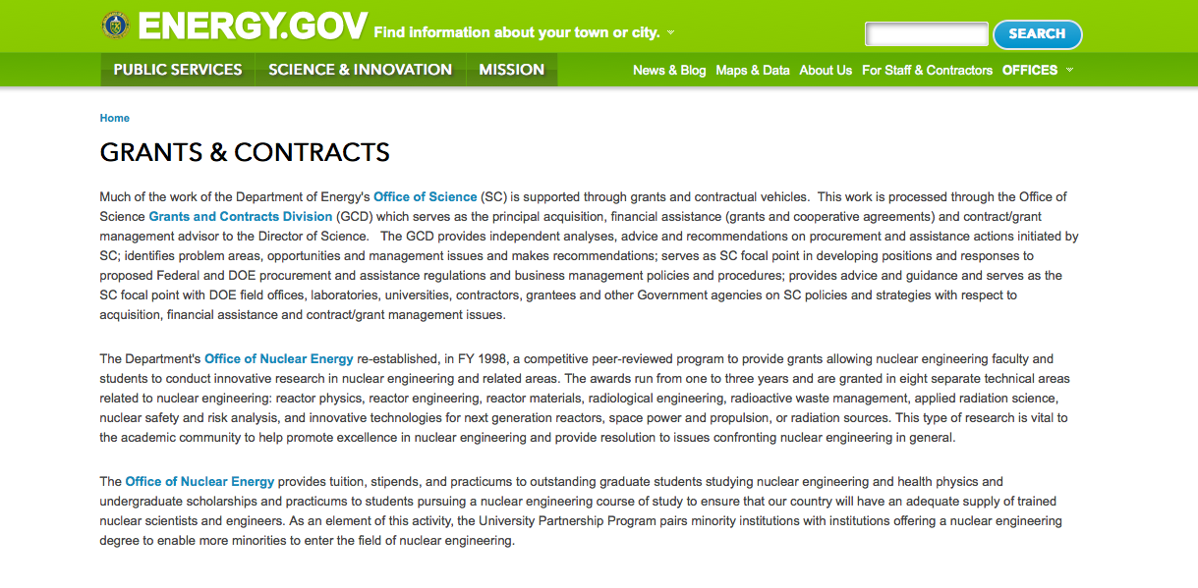
http://www.doe.gov/grants-contracts

Programs:

Advanced Research Projects Agency Energy
Rhizosphere Observations Optimizing Terrestrial Sequestration (ROOTS) Grant
http://www.grants.gov/web/grants/view-opportunity.html?oppId=282948

Advanced Research Projects Agency Energy
Next Generation Energy Technologies for Connected and Automated On-Road Vehicles (NEXTCAR) Grant
http://www.grants.gov/web/grants/view-opportunity.html?oppId=282945

Advanced Research Projects Agency Energy
REFUEL (SBIR/STTR) Grant
http://www.grants.gov/web/grants/view-opportunity.html?oppId=283291

Advanced Research Projects Agency Energy
REFUEL FOA Grant
http://www.grants.gov/web/grants/view-opportunity.html?oppId=283314

Golden Field Office
Notice of Intent (NOI) DE-FOA-0001581 to Issue Funding Opportunity Announcement DE-FOA-0001232 Grant
http://www.grants.gov/web/grants/view-opportunity.html?oppId=283078

National Energy Technology Laboratory
Lighting Alternatives Maximizing Performance & Suitability (LAMPS) Grant
http://www.grants.gov/web/grants/view-opportunity.html?oppId=283183

National Energy Technology Laboratory
Notice of Intent to Issue Funding Opportunity Announcement entitled FY 2016 Vehicle Technologies Multi-Topic Funding Opportunity Announcement Grant
http://www.grants.gov/web/grants/view-opportunity.html?oppId=283276

National Energy Technology Laboratory
FY2016 Methane Hydrates Grant
http://www.grants.gov/web/grants/view-opportunity.html?oppId=282993

Office of Science
Research, Development and Training in Isotope Production
Grant
http://www.grants.gov/web/grants/view-opportunity.html?oppId=283293

Golden Field Office
ENabling Extreme Real-time Grid Integration of Solar Energy (ENERGISE)
Grant
http://www.grants.gov/web/grants/view-opportunity.html?oppId=283450

Modifications:

National Energy Technology Laboratory
Methane Emissions Mitigation and Quantification from Natural Gas Infrastructure
Modification 1
http://www.grants.gov/web/grants/view-opportunity.html?oppId=283010

Reminders:

Cities Leading through Energy Analysis and Planning (Cities-LEAP) Grant

Document Type: | Grants Notice
Funding Opportunity Number: | DE-FOA-0001403
Funding Opportunity Title: | Cities Leading through Energy Analysis and Planning (Cities-LEAP)
Opportunity Category: | Discretionary
Opportunity Category Explanation:
Funding Instrument Type: | Cooperative Agreement
Category of Funding Activity: | Energy
Category Explanation:
Expected Number of Awards: | 0
CFDA Number(s): | 81.117 -- Energy Efficiency and Renewable Energy Information Dissemination, Outreach, Training and Technical Analysis/Assistance
Cost Sharing or Matching Requirement: | Yes
Posted Date: | Mar 23, 2016
Last Updated Date: | Mar 23, 2016
Original Closing Date for Applications: | Jun 17, 2016
Current Closing Date for Applications: | Jun 23, 2016
Archive Date: | Sep 30, 2016
Estimated Total Program Funding: | $0
Award Ceiling: | $500,000
Award Floor: | $100,000
Eligible Applicants: | County governments  City or township governments  Native American tribal governments (Federally recognized)  Native American tribal organizations (other than Federally recognized tribal governments)  Independent school districts  Special district governments
Agency Name: | Golden Field Office
Description: | The intent of this Funding Opportunity Announcement (FOA) is to support the development and piloting of data-driven decision frameworks by local and tribal governments. These frameworks should advance model practices and processes that improve the ability of local and tribal governments to integrate, analyze, and understand varied datasets, in order to pursue opportunities across all clean energy sectors such as sustainable transportation, energy efficiency, and renewable power. To develop and pilot such data-driven efforts, this FOA strongly encourages partnerships between local or tribal governments and entities such as academic institutions, technology companies, utilities, regional planning bodies, and non-governmental organizations. The full Funding Opportunity Announcement is posted on the EERE eXCHANGE website at https://eere-exchange.energy.gov. Applications must be submitted through the EERE eXCHANGE website to be considered for award. The applicant must first register and create an account on the EERE eXCHANGE website. A User Guide for the EERE eXCHANGE can be found on the EERE website https://eere-exchange.energy.gov/Manuals.aspx after logging in to the system. Information on where to submit questions regarding the content of the announcement and where to submit questions regarding submission of applications is found in the full FOA posted on the EERE eXCHANGE website.
Link to Additional Information: | https://eere-exchange.energy.gov
Contact Information: | If you have difficulty accessing the full announcement electronically, please contact:  Grants Management Specialist Brenda L. Dias Cities.LEAP@ee.doe.gov  Submit all questions to Cities.LEAP@ee.doe.gov

http://www.grants.gov/web/grants/view-opportunity.html?oppId=282452

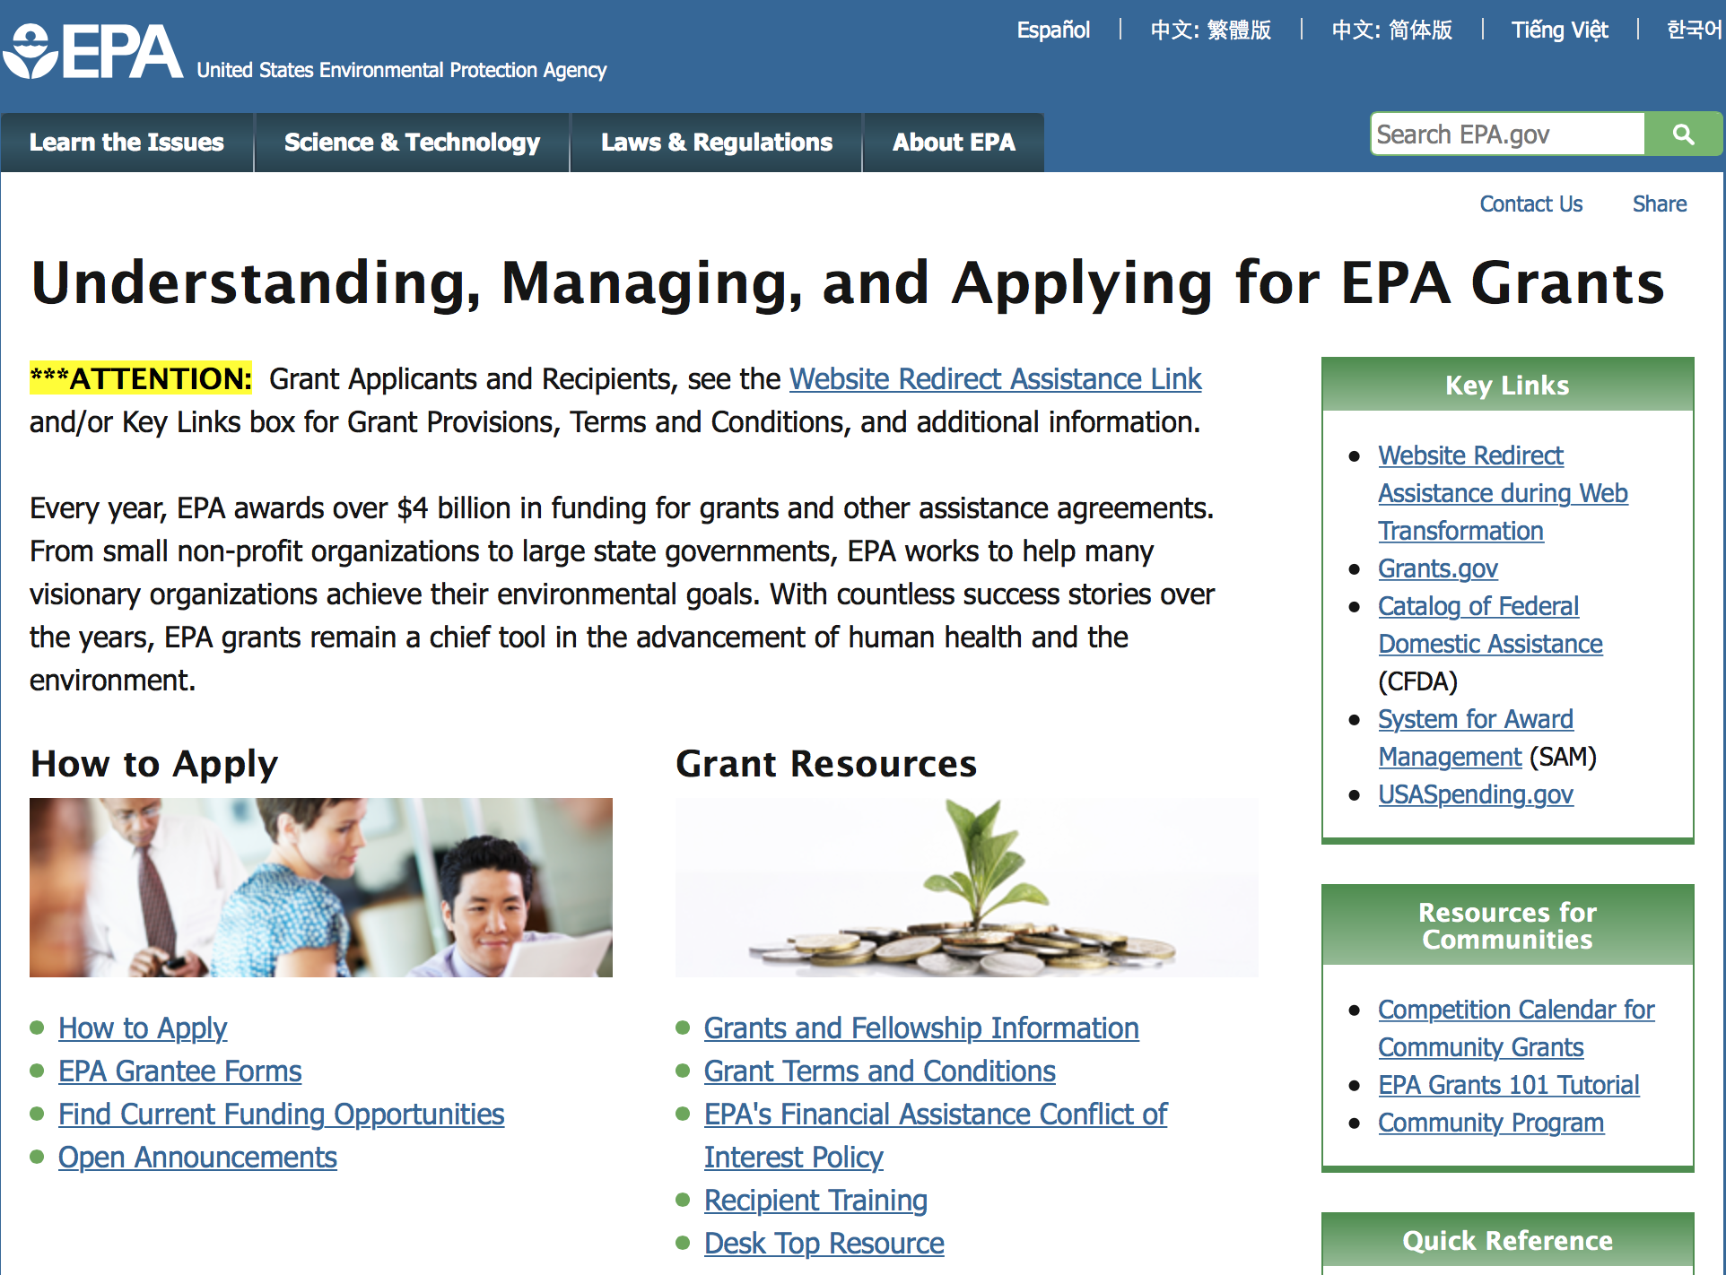

http://www.epa.gov/epahome/grants.htm

Programs:

Modifications:

Reminders:

Environmental Protection Agency
FY 2016 and FY 2017 Pollution Prevention Grant Program

Document Type: | Grants Notice
Funding Opportunity Number: | EPA-HQ-OPPT-2016-002
Funding Opportunity Title: | FY 2016 and FY 2017 Pollution Prevention Grant Program
Opportunity Category: | Discretionary
Opportunity Category Explanation:
Funding Instrument Type: | Cooperative Agreement  Grant
Category of Funding Activity: | Environment
Category Explanation:
Expected Number of Awards: | 60
CFDA Number(s): | 66.708 -- Pollution Prevention Grants Program
Cost Sharing or Matching Requirement: | Yes
Posted Date: | Mar 11, 2016
Last Updated Date: | Mar 11, 2016
Original Closing Date for Applications: | May 09, 2016 Please refer to the announcement, including Section IV, for additional information on submission methods and due dates.
Current Closing Date for Applications: | May 09, 2016 Please refer to the announcement, including Section IV, for additional information on submission methods and due dates.
Archive Date: | Jun 08, 2016
Estimated Total Program Funding: | $7,940,000
Award Ceiling: | $360,000
Award Floor: | $40,000
Eligible Applicants: | Others (see text field entitled "Additional Information on Eligibility" for clarification)
Additional Information on Eligibility: | See Section III of the announcement for eligibility information.
Agency Name: | Environmental Protection Agency
Description: | EPA’s Office of Pollution Prevention and Toxics, Chemistry, Economic and Sustainable Strategies Division oversees the Pollution Prevention (P2) Grant Program to support State and Tribal P2 Programs administer P2 projects that will help businesses identify better environmental strategies and solutions for reducing or eliminating waste at the source. EPA anticipates it will award approximately $7.94 million in federal P2 grant funding ($3.97 million in FY 2016 and $3.97 million in FY 2017) to support two-year grant agreements. Grants will be awarded and managed by EPA's ten Regional P2 Program Offices. P2 grants are dependent on Congressional appropriation and the quality of proposals received.
Link to Additional Information: | FY 2016 and FY 2017 Pollution Prevention Grant Program
Contact Information: | If you have difficulty accessing the full announcement electronically, please contact:  Michele Amhaz, Phone: (202) 564 -8857  Michele Amhaz

http://www.grants.gov/web/grants/view-opportunity.html?oppId=282166

FY 2016 and FY 2017 Pollution Prevention Information Network (PPIN) Grants Program
And Modification 1

Document Type: | Grants Notice
Funding Opportunity Number: | EPA-HQ-OPPT-2016-001
Funding Opportunity Title: | FY 2016 and FY 2017 Pollution Prevention Information Network (PPIN) Grants Program
Opportunity Category: | Discretionary
Opportunity Category Explanation:
Funding Instrument Type: | Cooperative Agreement
Category of Funding Activity: | Environment
Category Explanation:
Expected Number of Awards: | 8
CFDA Number(s): | 66.708 -- Pollution Prevention Grants Program
Cost Sharing or Matching Requirement: | Yes
Posted Date: | Mar 18, 2016
Last Updated Date: | Mar 24, 2016
Original Closing Date for Applications: | May 17, 2016 Please refer to the announcement, including Section IV, for additional information on submission methods and due dates.
Current Closing Date for Applications: | May 17, 2016 Please refer to the announcement, including Section IV, for additional information on submission methods and due dates.
Archive Date: | Jun 16, 2016
Estimated Total Program Funding: | $1,600,000
Award Ceiling: | $220,000
Award Floor: | $0
Eligible Applicants: | Others (see text field entitled "Additional Information on Eligibility" for clarification)
Additional Information on Eligibility: | See Section III of the announcement for eligibility information.
Agency Name: | Environmental Protection Agency
Description: | EPA is announcing a two-year grant competition cycle to support two-year PPIN grant or cooperative agreements. EPA anticipates awarding approximately $1.6 million in federal P2 grant funding (about $800,000 in FY 2016 and $800,000 in FY 2017) to state entities. The grants will support the development and delivery of pollution prevention (P2) information resources, tools, training and related services to meet the needs of businesses and technical assistance providers working in one or more of the three P2 national emphasis areas (NEAs). The three areas referred to as the NEAs are: 1) climate change mitigation/prevention of greenhouse gas emissions, 2) pollution prevention practices in the food manufacturing and processing sector, and 3) state or community approaches to hazardous materials source reduction. Applicants must demonstrate how their activities increase the adoption of pollution prevention practices by reporting outcome measures. Pollution prevention refers to practices that: 1) reduce or eliminate the creation of pollutants through increased efficiency in the use of raw materials, energy, water, or other resources; or 2) reduce the amount of hazardous substance, pollutant or contaminate entering any waste stream or released to the environment. The cooperative agreements will be issued and managed through EPA’s regional P2 programs. The amount of grant funding released each year is dependent upon Congressional appropriation and the quality of proposals received.
Link to Additional Information: | FY 2016 and FY 2017 Pollution Prevention Information Network (PPIN) Grants Program
Contact Information: | If you have difficulty accessing the full announcement electronically, please contact:  Beth Anderson, (202) 564-8833  Beth Anderson

http://www.grants.gov/web/grants/view-opportunity.html?oppId=282347

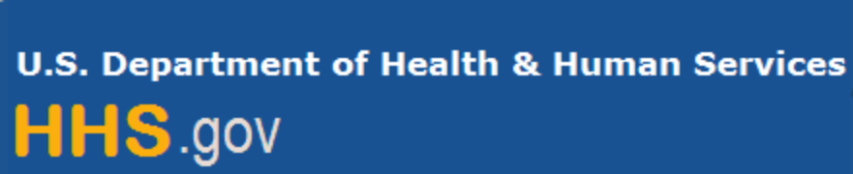

Department of Health and Human Services

Grants Forecast and Overview

The Department of Health and Human Services’ Grants Forecast is a database of planned grant opportunities proposed by its agencies. Each Forecast record contains actual or estimated dates and funding levels for grants that the agency intends to award during the fiscal year. Forecast opportunities are subject to change based on enactment of congressional appropriations. Go to the webpage below for more information.

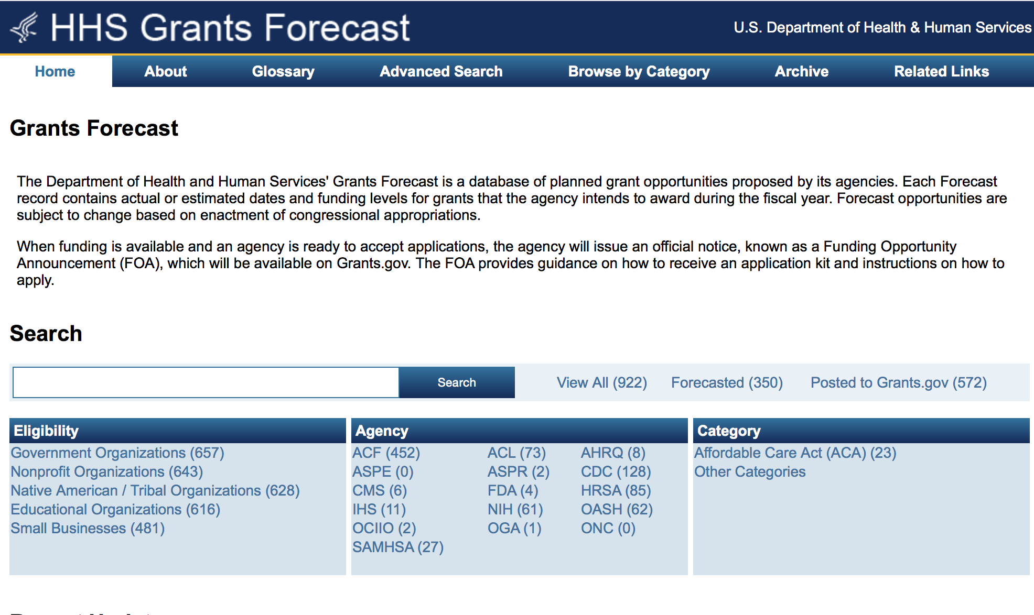
For more general information about HHS Grants and Funding go to the website below at: http://www.hhs.gov/grants/ .

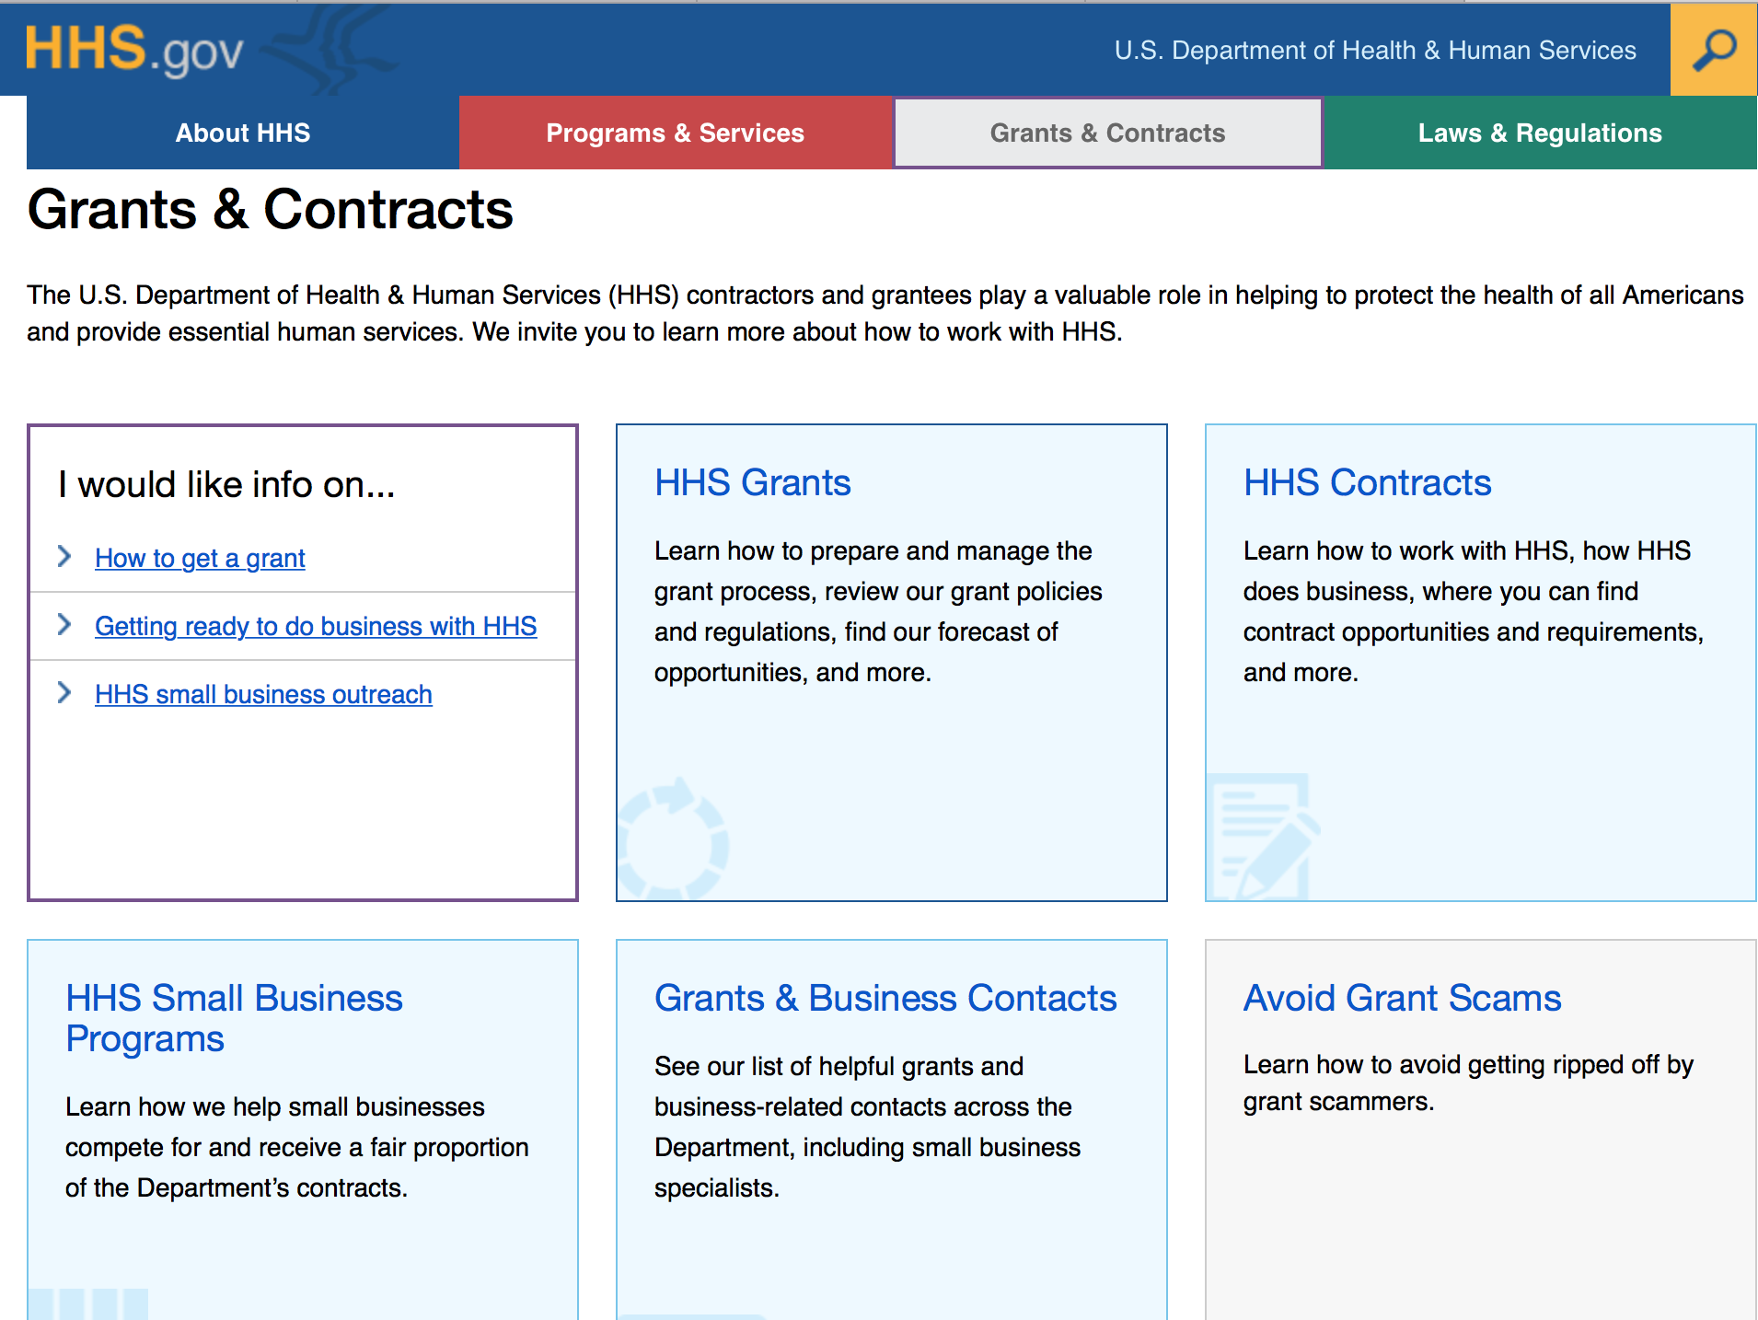

Programs:

Research:

Administration for Children and Families
Personal Responsibility Education Program Innovative Strategies Grant
http://www.grants.gov/web/grants/view-opportunity.html?oppId=283367

Administration for Children and Families
Family Violence Prevention and Services Discretionary Grants: Specialized Services for Abused Parents and Their Children (Demonstration Projects) Grant
http://www.grants.gov/web/grants/view-opportunity.html?oppId=283286

Administration for Children and Families
Family Violence Prevention and Services Discretionary Grants: National and Special Issue Resource Centers - Special Issue Resource Center (SIRC) Grant
http://www.grants.gov/web/grants/view-opportunity.html?oppId=283054

Administration for Children and Families
Administration for Children and Families - ORR
Refugee Individual Development Accounts (IDA) Program Grant
http://www.grants.gov/web/grants/view-opportunity.html?oppId=283195

Administration for Children and Families
Administration for Children and Families - ORR
Refugee Microenterprise Development (MED) Program Grant
http://www.grants.gov/web/grants/view-opportunity.html?oppId=283196

Administration for Community Living
Elder Justice Innovation Grants
http://www.grants.gov/web/grants/view-opportunity.html?oppId=283115

Agency for Health Care Research and Quality
Pediatric Quality Measures Program (PQMP): Dissemination and Implementation of Child Health Quality Measures Cooperative Research Grants (U18) Grant
http://www.grants.gov/web/grants/view-opportunity.html?oppId=283217

Centers for Disease Control and Prevention
Centers for Disease Control - NCCDPHP
Promoting CDC's Cancer Surveillance Data Through Workforce Development and Education
Grant
http://www.grants.gov/web/grants/view-opportunity.html?oppId=283436

Centers for Disease Control and Prevention
Centers for Disease Control - NCIRD
PPHF 2016: Increasing HPV Vaccine Coverage by Strengthening Adolescent AFIX Activities, Financed in Part by 2016 Prevention and Public Health Funds Grant
http://www.grants.gov/web/grants/view-opportunity.html?oppId=283447

Food and Drug Administration
Food Protection Task Force (FPTF) and Integrated Food Safety System (IFSS) Project Grant Program (R18) Grant
http://www.grants.gov/web/grants/view-opportunity.html?oppId=283029

Food and Drug Administration
Natural History Studies for Rare Disease Product Development: Orphan Products Research Project Grant (R01) Grant
http://www.grants.gov/web/grants/view-opportunity.html?oppId=283041

Health Resources and Services Administration
New Access Points Grant
http://www.grants.gov/web/grants/view-opportunity.html?oppId=283105

National Institutes of Health
Limited Competition: Caenorhabditis Intervention Testing Program Data Coordinating Center (U24) Grant
http://www.grants.gov/web/grants/view-opportunity.html?oppId=283427

National Institutes of Health
Limited Competition: Renewal of the Caenorhabditis Intervention Testing Program (U01) Grant
http://www.grants.gov/web/grants/view-opportunity.html?oppId=283433

National Institutes of Health
Improving Smoking Cessation in Socioeconomically Disadvantaged Populations via Scalable Interventions (R01) Grant
http://www.grants.gov/web/grants/view-opportunity.html?oppId=283106

National Institutes of Health
Improving Physical Infrastructure to Enhance Animal Model Research: Revisions of Center Grants (P51) Grant
http://www.grants.gov/web/grants/view-opportunity.html?oppId=283269

National Institutes of Health
Improving Physical Infrastructure to Enhance Animal Model Research: Revisions of Research Project Grants (R24)
http://www.grants.gov/web/grants/view-opportunity.html?oppId=283270

National Institutes of Health
Outcome Measures for Use in Treatment Trials of Individuals with Intellectual and Developmental Disabilities (R01) Grant
http://www.grants.gov/web/grants/view-opportunity.html?oppId=283312

National Institutes of Health
Paul Calabresi Career Development Award for Clinical Oncology (K12) Grant
http://www.grants.gov/web/grants/view-opportunity.html?oppId=282999

National Institutes of Health
Research Partnerships for Scaling Up Mental Health Interventions in Low-and Middle-Income Countries (U19) Grant
http://www.grants.gov/web/grants/view-opportunity.html?oppId=282870

National Institutes of Health
Preclinical Research on Model Organisms to Predict Treatment Outcomes for Disorders Associated with Intellectual and Developmental Disabilities (R01) Grant
http://www.grants.gov/web/grants/view-opportunity.html?oppId=283313

National Institutes of Health
Research Answers to NCIs Pediatric Provocative Questions (R01) Grant
http://www.grants.gov/web/grants/view-opportunity.html?oppId=283318

National Institutes of Health
Pilot and Feasibility Studies Evaluating the Role of RNA Modifications (the 'epitranscriptome') in Cancer Biology (R21) Grant
http://www.grants.gov/web/grants/view-opportunity.html?oppId=282886

National Institutes of Health
Development and Commercialization of Technologies to Create, Characterize or Improve Animal Models of Human Disease (R43/R44) Grant
http://www.grants.gov/web/grants/view-opportunity.html?oppId=282898

National Institutes of Health
Development and Commercialization of Technologies to Create, Characterize or Improve Animal Models of Human Disease (R41/R42) Grant
http://www.grants.gov/web/grants/view-opportunity.html?oppId=282908

National Institutes of Health
Short-term Mentored Career Enhancement Award in Dental, Oral and Craniofacial Research for Mid-Career and Senior Investigators (K18) Grant
http://www.grants.gov/web/grants/view-opportunity.html?oppId=282906

National Institutes of Health
Exploratory Grants in Cancer Epidemiology and Genomics Research (R21) Grant
http://www.grants.gov/web/grants/view-opportunity.html?oppId=282887

National Institutes of Health
Research Answers to NCIs Pediatric Provocative Questions (R21) Grant
http://www.grants.gov/web/grants/view-opportunity.html?oppId=283321

National Institutes of Health
Nutrition Obesity Research Centers (NORCs) (P30) Grant
http://www.grants.gov/web/grants/view-opportunity.html?oppId=283322

National Institutes of Health
Small Market Awards: SBIR Phase IIB Competing Renewals for Heart, Lung, Blood, and Sleep Technologies with Small Commercial Markets (R44) Grant
http://www.grants.gov/web/grants/view-opportunity.html?oppId=283107

National Institutes of Health
Research to Advance the Understanding and Management of the Multiple Organ Dysfunction Syndrome in Children (R01) Grant
http://www.grants.gov/web/grants/view-opportunity.html?oppId=283044

National Institutes of Health
NIH Pathway to Independence Award (Parent K99/R00) Grant
http://www.grants.gov/web/grants/view-opportunity.html?oppId=283042

National Institutes of Health
Mechanisms, Models, Measurement, and Management in Pain Research (R01) Grant
http://www.grants.gov/web/grants/view-opportunity.html?oppId=283012

National Institutes of Health
Mentored Clinical Scientist Research Career Development Award (Parent K08) Grant
http://www.grants.gov/web/grants/view-opportunity.html?oppId=283068

National Institutes of Health
Laboratory and Diagnostic Tools to Advance Microbiome-Brain Research (R41) Grant
http://www.grants.gov/web/grants/view-opportunity.html?oppId=283070

National Institutes of Health
Mentored Patient-Oriented Research Career Development Award (Parent K23) Grant
http://www.grants.gov/web/grants/view-opportunity.html?oppId=283049

National Institutes of Health
Laboratory and Diagnostic Tools to Advance Microbiome-Brain Research (R43/R44) Grant
http://www.grants.gov/web/grants/view-opportunity.html?oppId=283050

National Institutes of Health
Independent Scientist Award (Parent K02) Grant
http://www.grants.gov/web/grants/view-opportunity.html?oppId=283047

National Institutes of Health
Lasker Clinical Research Scholars Program (Si2/R00) Grant
http://www.grants.gov/web/grants/view-opportunity.html?oppId=283108

National Institutes of Health
HIV Pre-exposure Prophylaxis (PrEP) Implementation Science in CDC-funded Public Health Demonstration Projects (Admin Supp) Grant
http://www.grants.gov/web/grants/view-opportunity.html?oppId=283109

National Institutes of Health
Program for Extramural/Intramural Alcohol Research Collaborations (U01) Grant
http://www.grants.gov/web/grants/view-opportunity.html?oppId=283236

National Institutes of Health
The Use of mRNA for an HIV Envelope Vaccine (R43/R44) Grant
http://www.grants.gov/web/grants/view-opportunity.html?oppId=283150

National Institutes of Health
Understanding HIV Rebound (P01) Grant
http://www.grants.gov/web/grants/view-opportunity.html?oppId=283152

National Institutes of Health
Tools for Cell Line Identification (R43/R44) Grant
http://www.grants.gov/web/grants/view-opportunity.html?oppId=283035

National Institutes of Health
Mentored Research Scientist Development Award (Parent K01) Grant
http://www.grants.gov/web/grants/view-opportunity.html?oppId=283038

National Institutes of Health
Research to Advance the Understanding and Management of the Multiple Organ Dysfunction Syndrome in Children (R03) Grant
http://www.grants.gov/web/grants/view-opportunity.html?oppId=283032

National Institutes of Health
Research to Advance the Understanding and Management of the Multiple Organ Dysfunction Syndrome in Children (R21) Grant
http://www.grants.gov/web/grants/view-opportunity.html?oppId=283033

National Institutes of Health
Investigator-Initiated Clinical Sequencing Research (R01) Grant
http://www.grants.gov/web/grants/view-opportunity.html?oppId=283165

National Institutes of Health
The Use of mRNA for an HIV Envelope Vaccine (R41/R42) Grant
http://www.grants.gov/web/grants/view-opportunity.html?oppId=283151

National Institutes of Health
Improving Physical Infrastructure Revisions of Center Grants (P40) Grant
http://www.grants.gov/web/grants/view-opportunity.html?oppId=283223

National Institutes of Health
Extracellular Vesicle Tools, Technologies, and Products for Neuroscience Research (R41/R42)
Grant
http://www.grants.gov/web/grants/view-opportunity.html?oppId=283216

National Institutes of Health
Extracellular Vesicle Tools, Technologies, and Products for Neuroscience Research (R43/R44)
Grant
http://www.grants.gov/web/grants/view-opportunity.html?oppId=283227

National Institutes of Health
NIDCD Research Dissertation Fellowship for Au.D. Audiologists (F32) Grant
http://www.grants.gov/web/grants/view-opportunity.html?oppId=283190

National Institutes of Health
Leveraging Cognitive Neuroscience Research to Improve Assessment of Cancer Treatment Related Cognitive Impairment (R01) Grant
http://www.grants.gov/web/grants/view-opportunity.html?oppId=283191

National Institutes of Health
Leveraging Cognitive Neuroscience to Improve Assessment of Cancer Treatment-Related Cognitive Impairment (R21) Grant
http://www.grants.gov/web/grants/view-opportunity.html?oppId=283192

National Institutes of Health
NIDDK Mentored Research Scientist Development Award (K01) Grant
http://www.grants.gov/web/grants/view-opportunity.html?oppId=283205

National Institutes of Health
NLM Career Development Award in Biomedical Informatics and Data Science (K01) Grant
http://www.grants.gov/web/grants/view-opportunity.html?oppId=283117

National Institutes of Health
Products to Support Applied Research Towards Zero Suicide Healthcare Systems (R43/R44) Grant
http://www.grants.gov/web/grants/view-opportunity.html?oppId=282946

National Institutes of Health
Limited Competition: Rare Diseases Clinical Research Network (RDCRN) Project Supplements for Clinical Trials to Repurpose Drugs in Collaboration with E-Rare Awardees (Admin Supp) Grant
http://www.grants.gov/web/grants/view-opportunity.html?oppId=282952

National Institutes of Health
Improved Technologies and Ligands for Non-invasive Brain Imaging (R41/R42) Grant
http://www.grants.gov/web/grants/view-opportunity.html?oppId=282953

National Institutes of Health
Midcareer Investigator Award in Patient-Oriented Research (Parent K24) Grant
http://www.grants.gov/web/grants/view-opportunity.html?oppId=283136

National Institutes of Health
Nonhuman Primate Transplantation Tolerance (U01) Grant
http://www.grants.gov/web/grants/view-opportunity.html?oppId=283137

National Institutes of Health
Nonhuman Primate Transplantation Tolerance (U19) Grant
http://www.grants.gov/web/grants/view-opportunity.html?oppId=283139

National Institutes of Health
Mentored Quantitative Research Development Award (Parent K25) Grant
http://www.grants.gov/web/grants/view-opportunity.html?oppId=283141

National Institutes of Health
NIDDK Short-Term Research Experience Program for Underrepresented Persons (STEP-UP) (R25)
Grant
http://www.grants.gov/web/grants/view-opportunity.html?oppId=283143

National Institutes of Health
Academic Research Enhancement Award (Parent R15) Grant
http://www.grants.gov/web/grants/view-opportunity.html?oppId=283084

National Institutes of Health
NHLBI TOPMed Program: Integrative Omics Approaches for Analysis of TOPMed Data (U01) Grant
http://www.grants.gov/web/grants/view-opportunity.html?oppId=283082

National Institutes of Health
Improving Smoking Cessation in Socioeconomically Disadvantaged Populations via Scalable Interventions (R21) Grant
http://www.grants.gov/web/grants/view-opportunity.html?oppId=283088

National Institutes of Health
Animal-Assisted Interventions for Special Populations (R21) Grant
http://www.grants.gov/web/grants/view-opportunity.html?oppId=282861

National Institutes of Health
Animal-Assisted Interventions for Special Populations (R03) Grant
http://www.grants.gov/web/grants/view-opportunity.html?oppId=282858

National Institutes of Health
Strategies for the Improvement of HIV Envelope Protein Expression and Yield (R41/R42)
Grant
http://www.grants.gov/web/grants/view-opportunity.html?oppId=282931

National Institutes of Health
Strategies for the Improvement of HIV Envelope Protein Expression and Yield (R43/R44)
Grant
http://www.grants.gov/web/grants/view-opportunity.html?oppId=282932

National Institutes of Health
Improved Technologies and Ligands for Non-invasive Brain Imaging (R43/R44) Grant
http://www.grants.gov/web/grants/view-opportunity.html?oppId=282933

National Institutes of Health
NCI Clinical and Translational Exploratory/Developmental Studies (R21) Grant
http://www.grants.gov/web/grants/view-opportunity.html?oppId=282878

Substance Abuse and Mental Health Services Admin
Assisted Outpatient Treatment Grant Program for Individuals with Serious Mental Illness, (Short Title: Assisted Outpatient Treatment [AOT]) Grant
http://www.grants.gov/web/grants/view-opportunity.html?oppId=283059

Substance Abuse and Mental Health Services Admin
Resiliency in Communities After Stress and Trauma (Short Title: ReCAST Program)
Grant
http://www.grants.gov/web/grants/view-opportunity.html?oppId=282880

Modifications:

Administration for Community Living
Assistive Technology Alternative Financing Program
Modification 1

http://www.grants.gov/web/grants/view-opportunity.html?oppId=282802

Centers for Disease Control and Prevention
Evaluating Practice-based Sexual Violence Primary Prevention Approaches from CDC's Rape Prevention and Education (RPE) Program
Modification 10
http://www.grants.gov/web/grants/view-opportunity.html?oppId=282468

Centers for Disease Control and Prevention
NIOSH Exploratory/Developmental Grant Program (R21)
Modification 11
http://www.grants.gov/web/grants/view-opportunity.html?oppId=188173

Centers for Disease Control and Prevention
NIOSH Small Research Program (R03)
Modification 13
http://www.grants.gov/web/grants/view-opportunity.html?oppId=188233

Centers for Disease Control and Prevention
Workers Compensation Surveillance
Modification 5
http://www.grants.gov/web/grants/view-opportunity.html?oppId=256009

Centers for Disease Control and Prevention
NIOSH Support for Conferences and Scientific Meetings (R13)
Modification 3
http://www.grants.gov/web/grants/view-opportunity.html?oppId=257213

Centers for Disease Control and Prevention
Occupational Safety and Health Training Project Grants (T03)
Modification 6
http://www.grants.gov/web/grants/view-opportunity.html?oppId=279237

Centers for Disease Control and Prevention
Centers for Disease Control - NCIRD
HPV Roundtable: Creating a National Network of Partners to Promote Cancer Prevention through Human
Modification 2
http://www.grants.gov/web/grants/view-opportunity.html?oppId=282935

Centers for Disease Control and Prevention
Evaluating Practice-based Sexual Violence Primary Prevention Approaches from CDC's Rape Prevention and Education (RPE) Program
Modification 3
http://www.grants.gov/web/grants/view-opportunity.html?oppId=282468

Centers for Disease Control and Prevention
Centers for Disease Control - NCEH
Building Resilience Against Climate Effects: Enhancing Community Resilience by Implementing Health Adaptations
Modification 1
http://www.grants.gov/web/grants/view-opportunity.html?oppId=283036

Centers for Disease Control and Prevention
Operations Research (Implementation Science) for Strengthening Global Health Protection Implementation
Modification 1
http://www.grants.gov/web/grants/view-opportunity.html?oppId=283023

Centers for Disease Control and Prevention
Occupational Safety and Health Research (R01)
Modification 5
http://www.grants.gov/web/grants/view-opportunity.html?oppId=229513

Centers for Disease Control and Prevention
Mentored Research Scientist Development Award (K01)
Modification 17
http://www.grants.gov/web/grants/view-opportunity.html?oppId=237453

Centers for Disease Control and Prevention
Centers for Disease Control - NCIRD
PPHF 2016: Immunization Grants-HPV Roundtable: Creating a National Network of Partners to Promote Cancer Prevention through Human
Modification 3
http://www.grants.gov/web/grants/view-opportunity.html?oppId=282935

Food and Drug Administration
Collaborating Centers of Excellence in Regulatory Science and Innovation (U01)
Modification 1
http://www.grants.gov/web/grants/view-opportunity.html?oppId=283275

Food and Drug Administration
Advancing Medical Device Postmarket Surveillance Infrastructure and Epidemiologic Methodologies through Multi-stakeholder Partnership (U01)
Modification 4
http://www.grants.gov/web/grants/view-opportunity.html?oppId=235342

National Institutes of Health
NCI Clinical and Translational Exploratory/Developmental Studies (R21)
Modification 1
http://www.grants.gov/web/grants/view-opportunity.html?oppId=282878

National Institutes of Health
Research on Autism Spectrum Disorders (R01)
Modification 1
http://www.grants.gov/web/grants/view-opportunity.html?oppId=232615

National Institutes of Health
Research on Autism Spectrum Disorders (R03)
Modification 1
http://www.grants.gov/web/grants/view-opportunity.html?oppId=232617

National Institutes of Health
Integrating Biospecimen Science into Clinical Assay Development (U01)
Modification 1
http://www.grants.gov/web/grants/view-opportunity.html?oppId=282768

National Institutes of Health
Midcareer Investigator Award in Patient-Oriented Research (Parent K24)
Modification 1
http://www.grants.gov/web/grants/view-opportunity.html?oppId=283136

National Institutes of Health
Addressing Health Disparities in NIDDK Diseases (R01)
Modification 1
http://www.grants.gov/web/grants/view-opportunity.html?oppId=229473

National Institutes of Health
Mechanisms, Models, Measurement, and Management in Pain Research (R21)
Modification 1
http://www.grants.gov/web/grants/view-opportunity.html?oppId=283024

Reminders:

Department of Homeland Security

The Department of Homeland Security enhances the ability of states, local and tribal jurisdictions, and other regional authorities in the preparation, prevention, and response to terrorist attacks and other disasters, by distributing grant funds. Localities can use grants for planning, equipment, training and exercise needs.

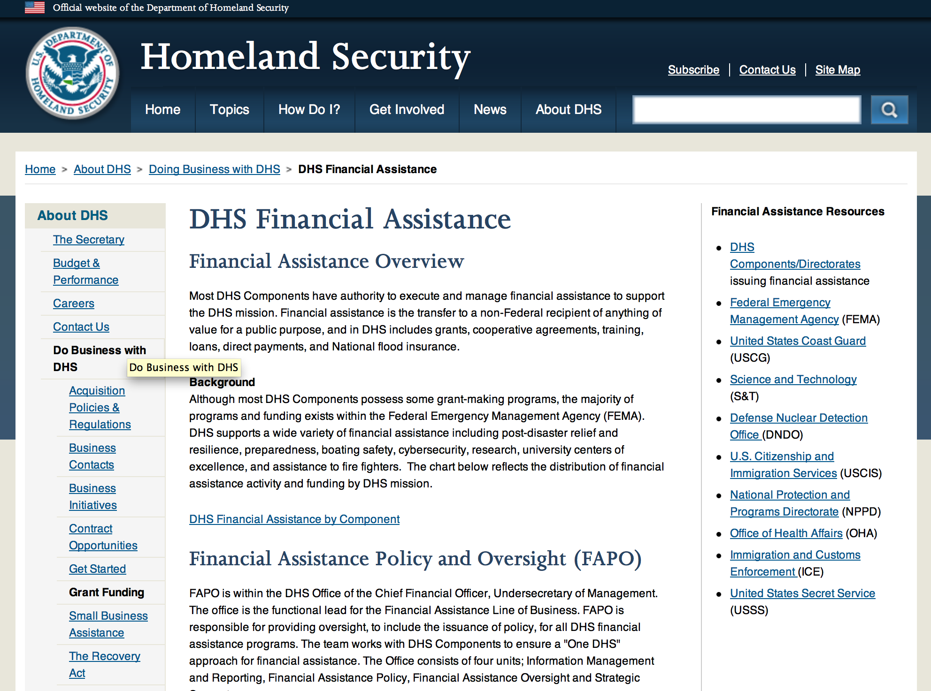

Webpage can be viewed at: http://www.dhs.gov/xopnbiz/grants/index.shtm#2

The FY 2015 Assistance to Firefighters Grants (AFG) Application Period Has Closed.
For AFG program guidance materials, please visit our Documents page.
FY 2015 FIRE PREVENTION & SAFETY (FP&S) Grants
- FY 2015 Application Information Coming Soon
- FP&S Success Stories
FY 2014 FIRE PREVENTION & SAFETY (FP&S) Grants
- FY 2014 FP&S Award Announcements - View Awards List
FY 2015 STAFFING FOR ADEQUATE FIRE and EMERGENCY RESPONSE (SAFER) Grants
- FY 2015 Application Information Coming Soon
- SAFER Success Stories
FY 2014 STAFFING FOR ADEQUATE FIRE and EMERGENCY RESPONSE (SAFER) Grants
- FY 2014 FP&S Award Announcements - View Awards List
FP&S Success Stories

Resources

AFG Help Desk
Contact the AFG Program Help Desk toll-free at 866-274-0960, or email us at firegrants@dhs.gov.
The AFG Program has Fire Program Specialists in 10 federal regional centers. These Regional Fire Program Specialists respond to questions about the AFG program and carry out grant monitoring activities. View regional contacts

Popular AFG links
- AFG Workshop Schedule
- Assistance to Firefighters Grants (AFG)
- AFG Awards List
- AFG Success Stories
- Staffing for Adequate Fire & Emergency Response (SAFER) Grants (SAFER)
- SAFER Awards List
- SAFER Success Stories
- Fire Prevention & Safety (FP&S) Grants
- FP&S Awards List
- FP&S Success Stories
- Grant Closeout Tutorial
- Assistance to Firefighters Grant (AFG) Email Alert Archive
- Frequently Asked Questions
Contact Information For The Assistance to Firefighters Grant (AFG) Program and Help Desk

Federal Funding Alternative To AFG

State Administrative Agencies (SAA) apply for and administer Federal grants on behalf of their States, including FEMA Preparedness Grants. The SAA will work with eligible organizations to comply with the general requirements of grant programs or cooperative agreements. Contact your State’s SAA to find out what current Federal funding opportunities may be available to your organization. A listing of the SAAs and points of contact can be found at http://www.fema.gov/library/viewRecord.do?id=6363.

Programs:

Fiscal Year (FY) 2016 National Urban Search & Rescue (US&R) Response System Readiness Cooperation Agreement Grant
And Modifications 1 & 2

Document Type: | Grants Notice
Funding Opportunity Number: | DHS-16-DOD-025-00-01
Funding Opportunity Title: | Fiscal Year (FY) 2016 National Urban Search & Rescue (US&R) Response System Readiness Cooperative Agreement
Opportunity Category: | Discretionary
Opportunity Category Explanation:
Funding Instrument Type: | Cooperative Agreement
Category of Funding Activity: | Other (see text field entitled "Explanation of Other Category of Funding Activity" for clarification)
Category Explanation: | Disaster Readiness/Response
Expected Number of Awards: | 28
CFDA Number(s): | 97.025 -- National Urban Search and Rescue (US&R) Response System
Cost Sharing or Matching Requirement: | No
Posted Date: | Apr 26, 2016
Last Updated Date: | Apr 28, 2016
Original Closing Date for Applications: | Jun 01, 2016
Current Closing Date for Applications: | Jun 01, 2016
Archive Date: | Jul 01, 2016
Estimated Total Program Funding: | $34,132,296
Award Ceiling: | $1,361,582
Award Floor: | $1,158,582
Eligible Applicants: | State governments  Others (see text field entitled "Additional Information on Eligibility" for clarification)  County governments  City or township governments
Additional Information on Eligibility: | One of the 28 Sponsoring Agencies of the National US&R Response System Task Forces
Agency Name: | Department of Homeland Security - FEMA
Description: | The National Urban Search and Rescue (US&R) Response System (the System) provides funding for 28 national task forces staffed and equipped to conduct around-the-clock search-and-rescue operations following earthquakes, tornadoes, floods, hurricanes, aircraft accidents, hazardous materials spills and catastrophic structure collapses. When deployed, these task forces, support state and local emergency responders' efforts to locate survivors and manage recovery operations. This program supports Mission 5, Goal 5.1: "Enhance National Readiness", as provided in the Quadrennial Homeland Security Review. To provide for the sustainment and readiness of the System and their local jurisdictions, through the funding of: administration and management, training, equipment and storage and maintenance.
Link to Additional Information: | http://www.grants.gov
Contact Information: | If you have difficulty accessing the full announcement electronically, please contact:  User, System ndgrants@fema.dhs.gov  ndgrants@fema.dhs.gov

http://www.grants.gov/web/grants/view-opportunity.html?oppId=283257

Modifications:

Reminders:

Department of Homeland Security - FEMA
Fiscal Year (FY) 2016 Cooperating Technical Partners (CTP) Program
Modifications 3 & 5

Document Type: | Grants Notice
Funding Opportunity Number: | DHS-16-MT-045-00-01
Funding Opportunity Title: | Fiscal Year (FY) 2016 Cooperating Technical Partners (CTP) Program
Opportunity Category: | Discretionary
Opportunity Category Explanation:
Funding Instrument Type: | Cooperative Agreement
Category of Funding Activity: | Science and Technology and other Research and Development
Category Explanation:
Expected Number of Awards: | 11
CFDA Number(s): | 97.045 -- Cooperating Technical Partners
Cost Sharing or Matching Requirement: | No
Posted Date: | Mar 25, 2016
Last Updated Date: | Mar 31, 2016
Original Closing Date for Applications: | Jun 10, 2016
Current Closing Date for Applications: | Jun 10, 2016
Archive Date: | Jul 10, 2016
Estimated Total Program Funding: | $2,450,000
Eligible Applicants: | Native American tribal governments (Federally recognized)  Others (see text field entitled "Additional Information on Eligibility" for clarification)  Special district governments  State governments  City or township governments  Nonprofits having a 501(c)(3) status with the IRS, other than institutions of higher education  Public and State controlled institutions of higher education  County governments
Additional Information on Eligibility: | As approved by FEMA HQ
Agency Name: | Department of Homeland Security - FEMA
Description: | "The Cooperating Technical Partners Program (CTP Program) exists to strengthen and increase the effectiveness of the National Flood Insurance Program (NFIP) through fostering strong Federal, State, Tribal, regional and local partnerships for the purposes of reducing flood losses and promoting community resiliency. The CTP Program may provide federal assistance, through a grant or cooperative agreement, to an eligible Cooperating Technical Partner (herein referred to as ¿CTP¿, ¿partner¿ or ¿grantee¿) to perform various projects and activities that stimulate and support the ability of NFIP State Coordinating Agencies and NFIP-participating communities (as defined in 44 CFR Part 59.1) to continue their ongoing regulatory NFIP responsibilities as well as support the ability of States, communities and the public and private sector to mitigate flood risk. The CTP Program seeks to enhance the existing capabilities of CTPs to increase local involvement in, and ownership of, the development and maintenance of flood risk data and products, such as the Flood Insurance Rate Maps (FIRMs) and other risk related products, as well as other support to advance the goals and objectives of the Risk Mapping Assessment and Planning (Risk MAP) program. Partnerships developed through FEMA¿s CTP Program are in the best interest of State and local communities, the NFIP and the public. CTPs may be able to perform activities related to program management, technical risk analysis and mapping, and communication of flood risk hazard data and information. Only qualified partners of the CTP Program are eligible for federal assistance awards through the CTP Program. Recipients must:¿ be a CTP (i.e., have a signed Partnership Agreement with FEMA HQ or a FEMA Regional Office);¿ either be or represent a National Flood Insurance Program (NFIP) community in good-standing, or a FEMA-approved non-profit agency whose primary mission supports the goals and objectives of the NFIP;¿ have existing non-Federally funded processes and/or systems in place to support the collection, development, evaluation, dissemination and communication of flood hazard and risk assessment data and mapping;¿ have the capability to perform funded activities; demonstrate the ability to achieve the CTP Program performance metrics and provide timely and accurate reports to FEMA documenting performance and achievements; and¿ when applicable, agree to perform work in the Mapping Information Platform (MIP) and update the activities within the MIP every 30 days in the Studies Workflow (and more frequently within the Revisions Workflow).CTPs need to work with FEMA in advance of the application to understand FEMA program priorities, objectives and measures, and to identify specific tasks to undertake. In support of program objectives, FEMA may provide technical assistance, training, and/or data to a CTP to enhance the activities within the project categories. Any funds FEMA provides through a grant or cooperative agreement to complete project activities are in addition to the leveraged resources and data which may be provided by the CTP to complete the tasks agreed upon. When awarded a grant or cooperative agreement through the CTP Program in support of program objectives and to advance program measures, the CTP must comply with the requirements outlined in the announcement, the terms and conditions of the award, as well as the Partnership Agreement and the associated Statement of Work or Mapping Activity Statement approved by FEMA. These templates may be obtained from your granting organization, either the FEMA Region or FEMA Headquarters."
Link to Additional Information:
Contact Information: | If you have difficulty accessing the full announcement electronically, please contact:  System Branch  GMD-Systems-Branch@fema.gov

http://www.grants.gov/web/grants/view-opportunity.html?oppId=282549

Department of Homeland Security - FEMA
FY16 Pre-Disaster Mitigation Grant

Document Type: | Grants Notice
Funding Opportunity Number: | DHS-16-MT-047-000-99
Funding Opportunity Title: | FY16 Pre-Disaster Mitigation
Opportunity Category: | Discretionary
Opportunity Category Explanation:
Funding Instrument Type: | Grant
Category of Funding Activity: | Other (see text field entitled "Explanation of Other Category of Funding Activity" for clarification)
Category Explanation: | The Robert T. Stafford Disaster Relief and Emergency Assistance Act, Public Law 93-288, as amended, (42 U.S.C. 5133), Section 203 authorizes FEMA to make grants for the purpose of implementing a sustained pre-disaster natural hazard mitigation program to reduce overall risk to the population and structures from future hazard events, while also reducing reliance on Federal funding from future disasters.
Expected Number of Awards: | 200
CFDA Number(s): | 97.047 -- Pre-Disaster Mitigation
Cost Sharing or Matching Requirement: | Yes
Posted Date: | Feb 10, 2016
Last Updated Date: | Feb 10, 2016
Original Closing Date for Applications: | Jun 15, 2016
Current Closing Date for Applications: | Jun 15, 2016
Archive Date: | Jul 15, 2016
Estimated Total Program Funding: | $90,000,000
Award Ceiling: | $15,000,000
Eligible Applicants: | State governments  Others (see text field entitled "Additional Information on Eligibility" for clarification)  Native American tribal governments (Federally recognized)
Additional Information on Eligibility: | District of Columbia; U.S. Territories. Local governments must apply through their state.
Agency Name: | Department of Homeland Security - FEMA
Description: | The Pre-Disaster Mitigation (PDM) program makes available Federal funds to State, Local and Tribal Governments to implement and sustain cost-effective measures designed to reduce the risk to individuals and property from natural hazards, while also reducing reliance on Federal funding from future disasters. FEMA will provide allocations of $575,000 as required by the Stafford Act to states and territories; and a tribal set aside of $10 million for allocations up to $575,000 for Native American Indian tribal governments to support overall mitigation planning and projects. The remaining PDM funds will be awarded on a competitive basis with a focus on Climate Resilient Mitigation Activities. Applicants must submit applications via the Mitigation eGrants system on the FEMA Grants Portal: https://portal.fema.gov. Applicants may submit a maximum of 19 sub-applications, including 1 management cost sub-application for Applicant management costs. Of the 18 sub-applications for mitigation activities, a maximum of 8 projects may be included.
Link to Additional Information: | Program Guidance
Contact Information: | If you have difficulty accessing the full announcement electronically, please contact:  Mitigation eGrants System Helpdesk Phone: 1-855-228-3362  MTeGrants@fema.dhs.gov

http://www.grants.gov/web/grants/view-opportunity.html?oppId=281453

Department of Homeland Security - FEMA
FY16 Flood Mitigation Assistance Grant

Document Type: | Grants Notice
Funding Opportunity Number: | DHS-16-MT-029-000-99
Funding Opportunity Title: | FY16 Flood Mitigation Assistance
Opportunity Category: | Discretionary
Opportunity Category Explanation:
Funding Instrument Type: | Grant
Category of Funding Activity: | Other (see text field entitled "Explanation of Other Category of Funding Activity" for clarification)
Category Explanation: | The Flood Mitigation Assistance (FMA) program is authorized by the National Flood Insurance Reform Act (NFIRA) of 1994 with the goal of reducing or eliminating claims under the NFIP.
Expected Number of Awards: | 200
CFDA Number(s): | 97.029 -- Flood Mitigation Assistance
Cost Sharing or Matching Requirement: | Yes
Posted Date: | Feb 10, 2016
Last Updated Date: | Feb 10, 2016
Original Closing Date for Applications: | Jun 15, 2016
Current Closing Date for Applications: | Jun 15, 2016
Archive Date: | Jul 15, 2016
Estimated Total Program Funding: | $199,000,000
Award Ceiling: | $0
Award Floor: | $0
Eligible Applicants: | Native American tribal governments (Federally recognized)  Others (see text field entitled "Additional Information on Eligibility" for clarification)  State governments
Additional Information on Eligibility: | District of Columbia; U.S. Territories. Local governments must apply through their state.
Agency Name: | Department of Homeland Security - FEMA
Description: | The Flood Mitigation Assistance (FMA) Program makes available federal funds to State, Local and Tribal Governments to implement and sustain cost-effective measures that reduce or eliminate risk of flood damage to buildings insured under the National Flood Insurance Program (NFIP). FEMA will fund planning up to $100,000 per applicant with a maximum of $50,000 for state plans and $25,000 for local plans. FEMA will fund technical assistance up to $50,000 for states who were awarded FMA Grant Program funds totaling at least $1 million in FY 2015. The remaining FMA funds will be awarded on a competitive basis for projects that will reduce or eliminate claims under the NFIP with a focus on mitigation of severe repetitive loss and repetitive loss properties as well as projects that will reduce the risk profile in communities through mitigation of the largest number of NFIP-insured properties on a neighborhood level. Applicants must apply for FMA funding through the Mitigation eGrants system on the FEMA Grants Portal accessible on the Internet at https:/portal.fema.gov
Link to Additional Information: | Program Guidance
Contact Information: | If you have difficulty accessing the full announcement electronically, please contact:  Mitigation eGrants System Helpdesk Phone: 1-855-228-3362  MTeGrants@fema.dhs.gov

http://www.grants.gov/web/grants/view-opportunity.html?oppId=281474

Department of Housing and Urban Development

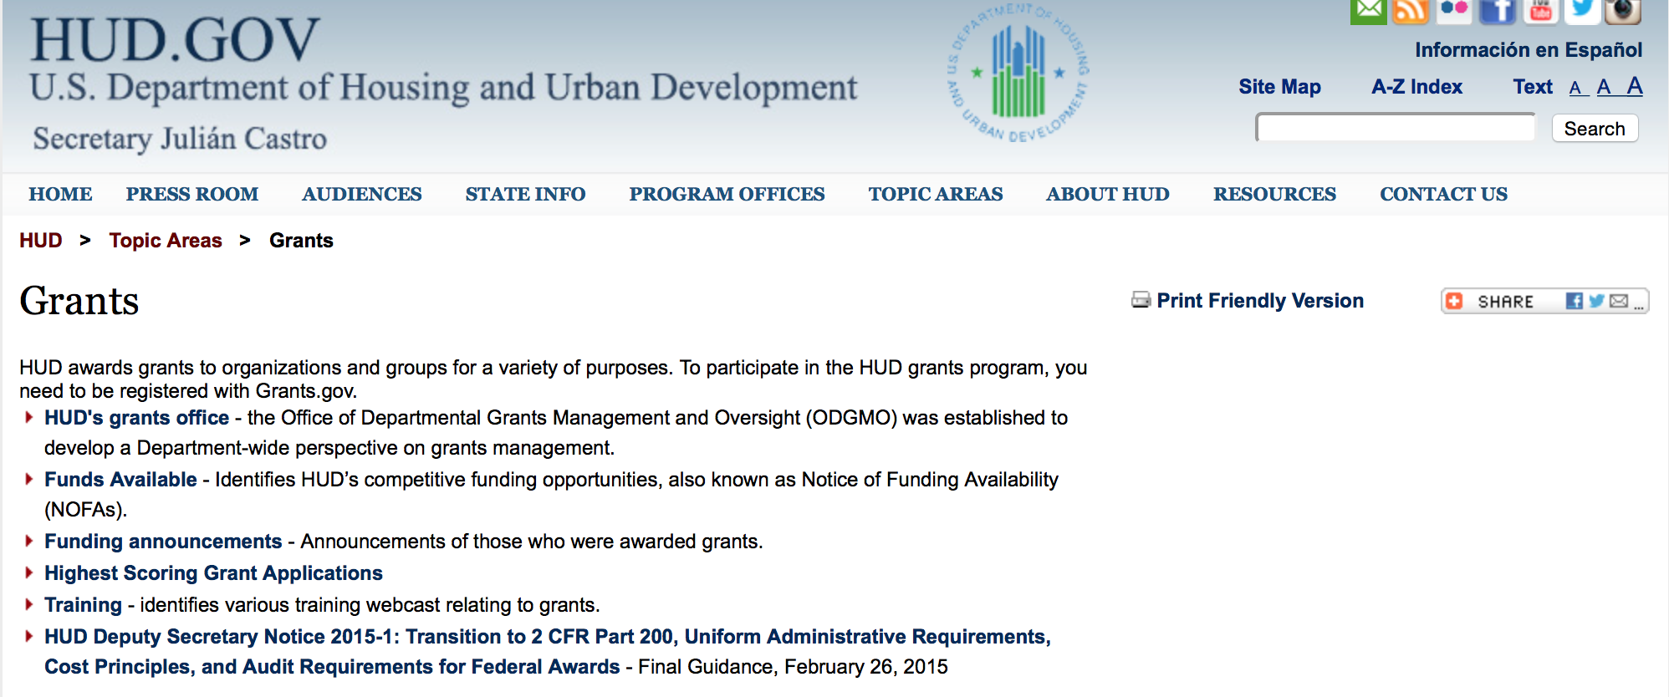

http://portal.hud.gov/hudportal/HUD?src=/topics/grants

HUD - Notice of Funds Available

For detailed information click here

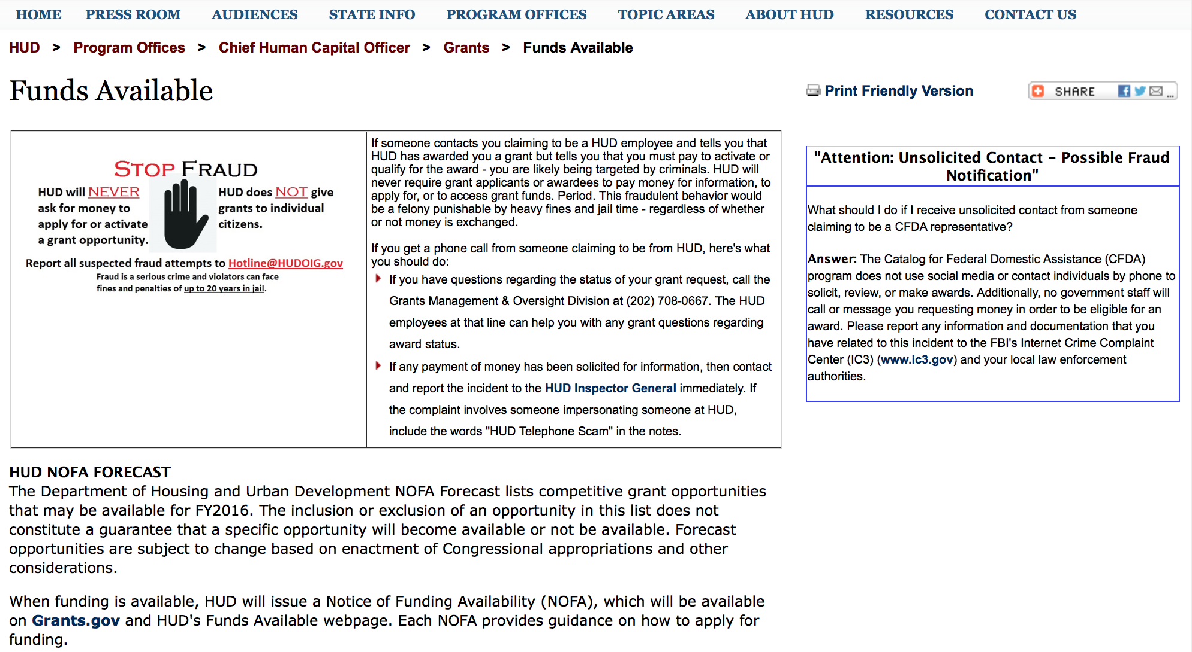

http://portal.hud.gov/hudportal/HUD?src=/program_offices/administration/grants/fundsavail

FY 2013 Notice of Funding Availability (NOFA) Policy Requirements and General Section to HUD’s FY2013 NOFAs for Discretionary Programs
This Notice provides prospective applicants for HUD's competitive funding with the opportunity to become familiar with the General Section to HUD's FY2013 Notices of Funding Availability (NOFAs) for Discretionary Funding (program NOFA), in advance of publication of any individual FY2013 program NOFAs. This General Section and the individual FY2013 program NOFA Sections comprise the entirety of the FY2013 NOFA instructions.
- General Section
- FONSI
- New Application Attachment Filename Requirement

Programs

Fair Housing Initiative Program - Education and Outreach Initiative Grant

Document Type: | Grants Notice
Funding Opportunity Number: | FR-6000-N-21A
Funding Opportunity Title: | Fair Housing Initiative Program - Education and Outreach Initiative
Opportunity Category: | Discretionary
Opportunity Category Explanation:
Funding Instrument Type: | Grant
Category of Funding Activity: | Housing
Category Explanation:
Expected Number of Awards: | 49
CFDA Number(s): | 14.416 -- Education and Outreach Initiatives
Cost Sharing or Matching Requirement: | No
Posted Date: | Apr 26, 2016
Last Updated Date: | Apr 26, 2016
Original Closing Date for Applications: | Jun 23, 2016 Electronically submitted applications must be submitted no later than 11:59:59 p.m., ET, on the listed application due date.
Current Closing Date for Applications: | Jun 23, 2016 Electronically submitted applications must be submitted no later than 11:59:59 p.m., ET, on the listed application due date.
Archive Date: | Jul 23, 2016
Estimated Total Program Funding: | $7,450,000
Award Ceiling: | $1,250,000
Award Floor: | $125,000
Eligible Applicants: | Others (see text field entitled "Additional Information on Eligibility" for clarification)
Additional Information on Eligibility: | Eligible Applicants. Depending on the specific component as outlined in the eligibility chart, eligible applicants may be Qualified Fair Housing Enforcement Organizations (QFHOs) and Fair Housing Enforcement Organizations (FHOs), public or private not-for-profit organizations or institutions, and other public or private entities that are formulating or carrying out programs to prevent or eliminate discriminatory housing practices; agencies of State or local governments; and agencies that participate in the Fair Housing Assistance Program (FHAP). Individuals, foreign entities, and sole proprietorship organizations are not eligible to compete for, or receive, awards made under this announcement.
Agency Name: | Department of Housing and Urban Development
Description: | HUD is making available through this Education and Outreach Initiative (EOI) NOFA $7,450,000 for The Fair Housing Initiatives Program. Additional funds may become available for award under this NOFA as a result of HUD's efforts to recapture unused funds, use carryover funds, or because of the availability of additional appropriated funds. Use of these funds will be subject to statutory constraints. All awards are subject to the applicable funding restrictions described in the General Section and to those contained in this NOFA. FHIP funds are used to increase compliance with the Fair Housing Act. This year, funding is available under three Initiatives: Private Enforcement (PEI), Fair Housing Organization (FHOI) and Education and Outreach (EOI) Initiatives. Multi-year awards beyond FY2016 funding are subject to appropriations and the availability of funds. For FY2016, funding for each initiative is listed under a separate NOFA. Applicants must apply under the correct NOFA to be considered for funding. Additionally, if an applicant is eligible and applying for funding under separate initiatives and/or components, the applicant must submit a separate application under the correct NOFA for each component the applicant applies. This NOFA will consider applicants applying under EOI only. The following is a general description of the Education and Outreach Initiative (see chart in section III. A. for all eligibility requirements and a listing of related components): Education and Outreach Initiative (EOI). This Initiative provides funding for the purpose of developing, implementing, carrying out, or coordinating education and outreach programs designed to inform members of the public concerning their rights and obligations under the provisions of the Fair Housing Act. EOI applicants may be funded under the following components based on eligibility: Education and Outreach Initiative (EOI) - $7,450,000 (1) National-Based Programs (a) National Media Campaign Component (EOI-NMCC) - $1,250,000 (2) Regional/Local/Community Based Program (a) General Component (EOI-G) - $5,950,000 (b) Tester Coordinator Training (EOI-TC) - $250,000 Applicants may apply for funding under multiple EOI Components as long as the applicant meets the specific eligibility requirements for each Component (see eligibility chart in Section III.A.1, and applies under the correct NOFA. Applicants will be funded in accordance with the funding restrictions listed under Section IV.F.5.
Link to Additional Information: | http://portal.hud.gov/hudportal/HUD?src=/program_offices/administration/grants/fundsavail
Contact Information: | If you have difficulty accessing the full announcement electronically, please contact:  Myron Newry Myron.P.Newry@hud.gov  Grants Policy

http://www.grants.gov/web/grants/view-opportunity.html?oppId=283306

Jobs Plus Initiative Grant

Document Type: | Grants Notice
Funding Opportunity Number: | FR-6000-N-14
Funding Opportunity Title: | Jobs Plus Initiative
Opportunity Category: | Discretionary
Opportunity Category Explanation:
Funding Instrument Type: | Grant
Category of Funding Activity: | Housing
Category Explanation:
Expected Number of Awards: | 5
CFDA Number(s): | 14.895 -- Jobs-Plus Pilot Initiative
Cost Sharing or Matching Requirement: | Yes
Posted Date: | Apr 11, 2016
Last Updated Date: | Apr 11, 2016
Original Closing Date for Applications: | Jun 13, 2016 Electronically submitted applications must be submitted no later than 11:59:59 p.m., ET, on the listed application due date.
Current Closing Date for Applications: | Jun 13, 2016 Electronically submitted applications must be submitted no later than 11:59:59 p.m., ET, on the listed application due date.
Archive Date: | Jul 13, 2016
Estimated Total Program Funding: | $15,000,000
Award Ceiling: | $3,000,000
Award Floor: | $1,000,000
Eligible Applicants: | Others (see text field entitled "Additional Information on Eligibility" for clarification)
Additional Information on Eligibility: | Conditions for Eligibility of Public Housing Authorities Eligible applicants are PHAs that operate one or more public housing developments (as designated for asset management purposes) that meet the criteria outlined in this NOFA. A list of developments that meet the criteria is provided in Appendix B however, the mere appearance of a development on this list does not necessarily mean that the development is appropriate for a Jobs Plus program. Federally designated tribes and tribally designated housing entities (TDHEs) are not eligible entities under this award. PHAs that received a Jobs Plus program grant in 2014 or 2015 are not eligible for 2016 grant funds. If a PHA is a successful applicant for Jobs Plus funds, the PHA will be required to implement the full 48 month term of the grant at the public housing site(s) for which funds were awarded and commit to not engaging in any significant redevelopment that would result in resident relocation during the 48-month Jobs Plus implementation timeframe. Notwithstanding the above, conversion of public housing assistance to a project-based section 8 contract under the Rental Assistance Demonstration (RAD) will not itself cause the termination of Jobs Plus funds. Grantees that convert the Jobs Plus target projects(s) under RAD will be able to finish out their Jobs Plus period of performance at the subject site as long as the conversion does not entail significant relocation or result in a substantial change in building occupancy. Criteria for Eligible Developments Size: Minimum development size of 200 non-elderly-only households. Non-elderly-only means households where at least one resident is under age 62. Unemployment: At least 50 percent of the households (excluding elderly-only households) contain no member showing earned income in PIC. Place: Because Jobs Plus is a place-based program, units to be served must be contiguous unless good cause can be shown that the program will be successful in non-contiguous developments. A detailed description as to how the program will be run from one central location and remain accessible to all residents of non-contiguous developments will be required in the rating factors. This requirement may disqualify developments on the Eligible Development list if the Asset Management Project (AMP) is for scattered sites. Only public housing development PHA residents are eligible to be served by the funding. Performance: Developments that belong to a non-performing PHA may be eligible to participate provided HUD has determined the PHA has the capacity to implement and oversee the grant successfully. A non-performing PHA is defined as a PHA that is designated as a troubled performer under the Public Housing Assessment System (PHAS) as listed on HUD’s most recent official Troubled List or is designated a substandard performer based on its most recent published PHAS score. See Threshold requirements in Section III.C.3 for more information. PHAs that have more than one development already listed as eligible in Appendix B may apply to serve more than one of the eligible developments as long as they are contiguous or show in the application that they meet the required criteria for place (see above). No Request for Review of Eligibility is required prior to submitting the application. PHAs that have developments not listed on Appendix B that they believe, when combined, meet the criteria, may submit a request for review of eligibility. Individuals, foreign entities, and sole proprietorship organizations are not eligible to compete for, or receive, awards made under this announcement.
Agency Name: | Department of Housing and Urban Development
Description: | This Notice of Funding Availability (NOFA) announces the availability of funding of approximately $15 million for the Jobs Plus program for Public Housing Agencies (PHAs) to develop locally-based approaches to increase earnings and advance employment outcomes for Public Housing residents. The NOFA will fund initiatives to improve employment and earnings outcomes for Public Housing residents through supports such as work readiness, employer linkages, job placement and financial literacy. To help applicants with the electronic application registration and submission process, the Department advises applicants to use the checklists, user guides, and other help features located at SAM.gov and Grants.gov websites. Both websites provide access to instructions and answers to frequently asked questions which are updated periodically.
Link to Additional Information: | http://portal.hud.gov/hudportal/HUD?src=/program_offices/administration/grants/fundsavail
Contact Information: | If you have difficulty accessing the full announcement electronically, please contact:  Jayme Brown Jayme.A.Brown@hud.gov  Grants Policy

http://www.grants.gov/web/grants/view-opportunity.html?oppId=282902

Healthy Homes Technical Studies Grant Program Pre and Full Application Grant

Document Type: | Grants Notice
Funding Opportunity Number: | FR-6000-N-15
Funding Opportunity Title: | Healthy Homes Technical Studies Grant Program Pre and Full Application
Opportunity Category: | Discretionary
Opportunity Category Explanation:
Funding Instrument Type: | Cooperative Agreement
Category of Funding Activity: | Housing
Category Explanation:
Expected Number of Awards: | 3
CFDA Number(s): | 14.906 -- Healthy Homes Technical Studies Grants
Cost Sharing or Matching Requirement: | No
Posted Date: | Apr 28, 2016
Last Updated Date: | Apr 28, 2016
Original Closing Date for Applications: | Jun 01, 2016 Electronically submitted applications must be submitted no later than 11:59:59 p.m., ET, on the listed application due date.
Current Closing Date for Applications: | Jun 01, 2016 Electronically submitted applications must be submitted no later than 11:59:59 p.m., ET, on the listed application due date.
Archive Date: | Jul 01, 2016
Estimated Total Program Funding: | $2,000,000
Award Ceiling: | $700,000
Award Floor: | $300,000
Eligible Applicants: | Small businesses  Independent school districts  For profit organizations other than small businesses  Native American tribal governments (Federally recognized)  City or township governments  Nonprofits having a 501(c)(3) status with the IRS, other than institutions of higher education  Public housing authorities/Indian housing authorities  Native American tribal organizations (other than Federally recognized tribal governments)  Private institutions of higher education  Nonprofits that do not have a 501(c)(3) status with the IRS, other than institutions of higher education  County governments  Public and State controlled institutions of higher education  State governments  Special district governments
Additional Information on Eligibility: | Applications to supplement existing projects are eligible to compete with applications for new awards. Federal agencies are not eligible to submit applications. The 2016 General Section identifies threshold requirements that must be met for an organization to receive an award. If your organization received an award under the FY2014 or FY 2015 Healthy Homes Technical Studies Grant Program cycle, your application must identify a principal investigator that is different from the principal investigator identified in the application that received an award in either of these fiscal years. Full Application NOFA Based on the scoring of pre-applications, only the pre-applicants that are subsequently invited through direct contact will be eligible to submit a full application. Individuals, foreign entities, and sole proprietorship organizations are not eligible to compete for, or receive, awards made under this announcement.
Agency Name: | Department of Housing and Urban Development
Description: | To fund technical studies to improve existing methods for detecting and controlling key housing-related health and safety hazards; to develop new methods to detect and control these hazards; and to improve our knowledge of key housing-related health and safety hazards. This notice of funding availability is requesting preliminary applications only. Following the scoring of preliminary applications applicants that submitted the highest scoring preliminary applications will be invited to submit full applications. Full applications will not be reviewed if they are submitted in response to this NOFA.
Link to Additional Information: | http://portal.hud.gov/hudportal/HUD?src=/program_offices/administration/grants/fundsavail
Contact Information: | If you have difficulty accessing the full announcement electronically, please contact:  Peter Ashley peter.j.ashley@hud.gov  Grants Policy

http://www.grants.gov/web/grants/view-opportunity.html?oppId=283358

Fair Housing Initiatives Program - Private Enforcement Initiative Grant

Document Type: | Grants Notice
Funding Opportunity Number: | FR-6000-N-21C
Funding Opportunity Title: | Fair Housing Initiatives Program - Private Enforcement Initiative
Opportunity Category: | Discretionary
Opportunity Category Explanation:
Funding Instrument Type: | Grant
Category of Funding Activity: | Housing
Category Explanation:
Expected Number of Awards: | 24
CFDA Number(s): | 14.418 -- Private Enforcement Initiatives
Cost Sharing or Matching Requirement: | No
Posted Date: | Apr 26, 2016
Last Updated Date: | Apr 26, 2016
Original Closing Date for Applications: | Jun 23, 2016 Electronically submitted applications must be submitted no later than 11:59:59 p.m., ET, on the listed application due date.
Current Closing Date for Applications: | Jun 23, 2016 Electronically submitted applications must be submitted no later than 11:59:59 p.m., ET, on the listed application due date.
Archive Date: | Jul 23, 2016
Estimated Total Program Funding: | $7,897,458
Award Ceiling: | $325,000
Award Floor: | $325,000
Eligible Applicants: | Others (see text field entitled "Additional Information on Eligibility" for clarification)
Additional Information on Eligibility: | Under the PEI NOFA, eligible applicants must be Qualified Fair Housing Enforcement Organizations (QFHOs) or Fair Housing Enforcement Organizations (FHOs). If an organization does not meet the eligibility requirements for the PEI (current QFHO or FHO), the organization may be an eligible to apply under the Education and Outreach Initiative (FR-6000-N-21A) or Fair Housing Organizations Initiative (FR-6000-N-21B) NOFAs. Please see those NOFAs for specific eligibility requirements. Individuals, foreign entities, and sole proprietorship organizations are not eligible to compete for, or receive, awards made under this announcement.
Agency Name: | Department of Housing and Urban Development
Description: | HUD is making available through this Private Enforcement Initiative (PEI) NOFA $7,897,458 for Fair Housing Initiative Programs. Additional funds may become available for award under this NOFA as a result of HUD's efforts to recapture unused funds, use carryover funds, or because of the availability of additional appropriated funds. Use of these funds will be subject to statutory constraints. All awards are subject to the applicable funding restrictions described in the General Section and to those contained in this NOFA. Funding for additional years beyond FY2016 is subject to the availability of appropriations. FHIP funds are used to increase compliance with the Fair Housing Act. This year, funding is available under three Initiatives: Private Enforcement (PEI), Fair Housing Organization (FHOI) and Education and Outreach (EOI) Initiatives. However, for FY2016, funding for each initiative is listed under a separate NOFA. Applicants must apply under the correct NOFA to be considered for funding. Additionally, if an applicant is eligible and applying for funding under separate initiatives and/or components, the applicant must submit a separate application under the correct NOFA for each component the applicant applies. This NOFA will consider applicants applying under PEI only. The following is a general description of the Private Enforcement Initiative (PEI) and each PEI component (see chart in section III. A. for all PEI eligibility requirements): Private Enforcement Initiative (PEI). This Initiative provides funding to private, non-profit fair housing enforcement organizations that meet statutory requirements to investigate violations and obtain enforcement of the rights granted under the Fair Housing Act or State or local laws that provide rights and remedies for discriminatory housing practices that are substantially equivalent to the rights and remedies provided in the Fair Housing Act. PEI applicants may be funded under the following component based on eligibility: Private Enforcement Initiative (PEI) - $7,897,458 (1) Multi-Year Funding Component (PEI-MYFC) Total PEI Multi-Year Funding (PEI-MYFC) is $29,375,000 minus $22,452,542 already reserved for FY 2014 and FY 2015 Multi-year grantees), therefore making $6,922,458 available for FY2016 new awardees. (2) Lending Component (PEI-L) - $975,000 Applicants may apply for funding under each FHIP NOFA as long as the applicant meets the specific eligibility requirements for each Initiative/Component, and in accordance with the funding restrictions listed in each NOFA.
Link to Additional Information: | http://portal.hud.gov/hudportal/HUD?src=/program_offices/administration/grants/fundsavail
Contact Information: | If you have difficulty accessing the full announcement electronically, please contact:  Myron Newry Myron.P.Newry@hud.gov  Grants Policy

http://www.grants.gov/web/grants/view-opportunity.html?oppId=283288

Modifications:

Reminders

Resident Opportunity & Self-Sufficiency Program Grant

Document Type: | Grants Notice
Funding Opportunity Number: | FR-6000-N-05
Funding Opportunity Title: | Resident Opportunity & Self-Sufficiency Program
Opportunity Category: | Discretionary
Opportunity Category Explanation:
Funding Instrument Type: | Grant
Category of Funding Activity: | Housing
Category Explanation:
Expected Number of Awards: | 110
CFDA Number(s): | 14.870 -- Resident Opportunity and Supportive Services - Service Coordinators
Cost Sharing or Matching Requirement: | Yes
Posted Date: | Mar 31, 2016
Last Updated Date: | Mar 31, 2016
Original Closing Date for Applications: | May 16, 2016 Electronically submitted applications must be submitted no later than 11:59:59 p.m., ET, on the listed application due date.
Current Closing Date for Applications: | May 16, 2016 Electronically submitted applications must be submitted no later than 11:59:59 p.m., ET, on the listed application due date.
Archive Date: | Jun 15, 2016
Estimated Total Program Funding: | $35,000,000
Award Ceiling: | $738,000
Award Floor: | $0
Eligible Applicants: | Public housing authorities/Indian housing authorities  Nonprofits having a 501(c)(3) status with the IRS, other than institutions of higher education  Nonprofits that do not have a 501(c)(3) status with the IRS, other than institutions of higher education
Additional Information on Eligibility: | Native American tribes as defined at 4(13) of NAHASDA, Tribally Designated Housing Entities (TDHEs) as defined at 4(22) of NAHASDA. Resident associations of all kinds must have either locally-incorporated nonprofit status (usually designated by the state or tribal government) or 501(c)(3) nonprofit status designated by the IRS. Applicants must provide documentation with their application attesting to their designation as a locally-incorporated non-profit organization or a federally designated 501(c)(3) nonprofit. Such documentation must include a copy of the 2015 federal annual information return submitted to the IRS (for 501(c)(3) applicants) or the state or tribal equivalent for locally-incorporated nonprofits. If this information is not submitted as part of the application, it will be requested during the deficiency period. Please see Section IV.B. "Content and Form of Application Submission" for more information. EDSC Provision. PHA applicants that are currently eligible to receive annual renewal funding under the Elderly/Disabled Service Coordinator (EDSC) program from the Public Housing Operating Fund that apply to serve elderly/disabled residents through this NOFA will forgo all future eligibility for EDSC funding through the Operating Fund. These applicants may apply and receive funding to serve families only without risking their EDSC funding. To confirm if your PHA is affected by this EDSC provision. When completing your ROSS-SC application, please pay special attention to the EDSC section on the HUD form 52768;ROSS Service Coordinators Funding Request; For-profit entities are not eligible to apply. Individuals, foreign entities, and sole proprietorship organizations are not eligible to compete for, or receive, awards made under this announcement.
Agency Name: | Department of Housing and Urban Development
Description: | The purpose of the Resident Opportunity & Self Sufficiency (ROSS) Service Coordinator (SC) program is to assist residents of public and Indian housing in making progress towards economic and housing self-sufficiency. To accomplish this goal, ROSS provides grant funding to eligible applicants to hire Service Coordinators to assess the needs of public and Indian housing residents and link them to supportive services that enable participants to increase earned income, reduce or eliminate the need for welfare assistance, and make progress toward achieving economic independence and housing self-sufficiency. In the case of elderly/disabled residents, the Service Coordinator links participants to supportive services which enable them to age/remain in place thereby avoiding more costly forms of care.
Link to Additional Information: | http://portal.hud.gov/hudportal/HUD?src=/program_offices/administration/grants/fundsavail
Contact Information: | If you have difficulty accessing the full announcement electronically, please contact:  Dina Lehmann-Kim Dina.Lehmann-Kim@hud.gov  Grants Policy

http://www.grants.gov/web/grants/view-opportunity.html?oppId=282668

Choice Neighborhoods Implementation Grant Program
Modification 1

Document Type: | Grants Notice
Funding Opportunity Number: | FR-6000-N-34
Funding Opportunity Title: | Choice Neighborhoods Implementation Grant Program
Opportunity Category: | Discretionary
Opportunity Category Explanation:
Funding Instrument Type: | Grant
Category of Funding Activity: | Housing
Category Explanation:
Expected Number of Awards: | 4
CFDA Number(s): | 14.889 -- Choice Neighborhoods Implementation Grants
Cost Sharing or Matching Requirement: | Yes
Posted Date: | Mar 31, 2016
Last Updated Date: | Mar 31, 2016
Original Closing Date for Applications: | Jun 28, 2016 Electronically submitted applications must be submitted no later than 11:59:59 p.m., ET, on the listed application due date.
Current Closing Date for Applications: | Jun 28, 2016 Electronically submitted applications must be submitted no later than 11:59:59 p.m., ET, on the listed application due date.
Archive Date: | Jul 28, 2016
Estimated Total Program Funding: | $120,000,000
Award Ceiling: | $30,000,000
Award Floor: | $0
Eligible Applicants: | Others (see text field entitled "Additional Information on Eligibility" for clarification)
Additional Information on Eligibility: | Eligible applicants are Public Housing Authorities (PHAs), local governments, tribal entities, nonprofits, and for-profit developers that apply jointly with a public entity. Refer to section I.A.4 for definitions of these terms as applicable to this program. Individuals, foreign entities, and sole proprietorship organizations are not eligible to compete for, or receive, awards made under this announcement.
Agency Name: | Department of Housing and Urban Development
Description: | Choice Neighborhoods Implementation Grants support the implementation of comprehensive neighborhood revitalization plans that are expected to achieve the following three core goals: 1. Housing: Replace distressed public and assisted housing with high-quality mixed-income housing that is well-managed and responsive to the needs of the surrounding neighborhood; 2. People: Improve educational outcomes and intergenerational mobility for youth with services and supports delivered directly to youth and their families; and 3. Neighborhood: Create the conditions necessary for public and private reinvestment in distressed neighborhoods to offer the kinds of amenities and assets, including safety, good schools, and commercial activity, that are important to families; choices about their community.
Link to Additional Information: | http://portal.hud.gov/hudportal/HUD?src=/program_offices/administration/grants/fundsavail
Contact Information: | If you have difficulty accessing the full announcement electronically, please contact:  Please send inquiries to email below  Grants Policy

http://www.grants.gov/web/grants/view-opportunity.html?oppId=282659

General Section to HUD's Fiscal Year 2016 Notice[s] of Funding Availability for Discretionary Programs (General Section)
Modification 1

Document Type: | Grants Notice
Funding Opportunity Number: | FR-6000-N-01
Funding Opportunity Title: | General Section to HUD's Fiscal Year 2016 Notice[s] of Funding Availability for Discretionary Programs (General Section)
Opportunity Category: | Discretionary
Funding Instrument Type: | Grant
Category of Funding Activity: | Community Development
Category Explanation:
Expected Number of Awards: | 0
CFDA Number(s):
Cost Sharing or Matching Requirement: | No
Posted Date: | Sep 24, 2015
Creation Date: | Sep 24, 2015
Original Closing Date for Applications: | Dec 30, 2016 Electronically submitted applications must be submitted no later than 11:59:59 p.m., ET, on the listed application due date published in the individual program NOFA.
Current Closing Date for Applications: | Dec 30, 2016 Electronically submitted applications must be submitted no later than 11:59:59 p.m., ET, on the listed application due date published in the individual program NOFA.
Archive Date: | Jan 29, 2017
Eligible Applicants: | Others (see text field entitled "Additional Information on Eligibility" for clarification)
Additional Information on Eligibility: | This Document is a policy document only. The individual program Notices of Funds Available (NOFA) will identify eligible applicants for each competition. Each Program NOFA will describe additional eligibility requirements for applicants. All applicants must have valid, active Registration in the System for Award Management (SAM) prior to submission of applications for financial assistance. HUD does not provide direct services or products to individuals through its formula-based programs or its competitive Program NOFA process. Individuals seeking financial assistance should refer to www.GovBenefits.gov. Individuals, foreign entities, and sole proprietorship organizations are not eligible to compete for, or receive, awards made under this announcement.
Agency Name: | Department of Housing and Urban Development
Description: | The General Section describes the requirements that are applicable to all HUD FY 2015 Program NOFAs. The General Section also provides information on HUD’s priorities and strategic goals. Each Program NOFA will describe additional applicable procedures and requirements, including a description of the eligible applicants, eligible activities, threshold requirements, cross-program requirements such as nondiscrimination, environmental protection, and any additional program requirements or limitations. To adequately address all of the application requirements for any program, please carefully read and respond to both this General Section and any applicable Program NOFA.
Link to Additional Information: | http://portal.hud.gov/hudportal/HUD?src=/program_offices/administration/grants/fundsavail
Contact Information: | If you have difficulty accessing the full announcement electronically, please contact:  Loyd LaMois loyd.lamois@hud.gov  Grants Policy

http://www.grants.gov/web/grants/view-opportunity.html?oppId=279206



Institute of Museum and Library Services

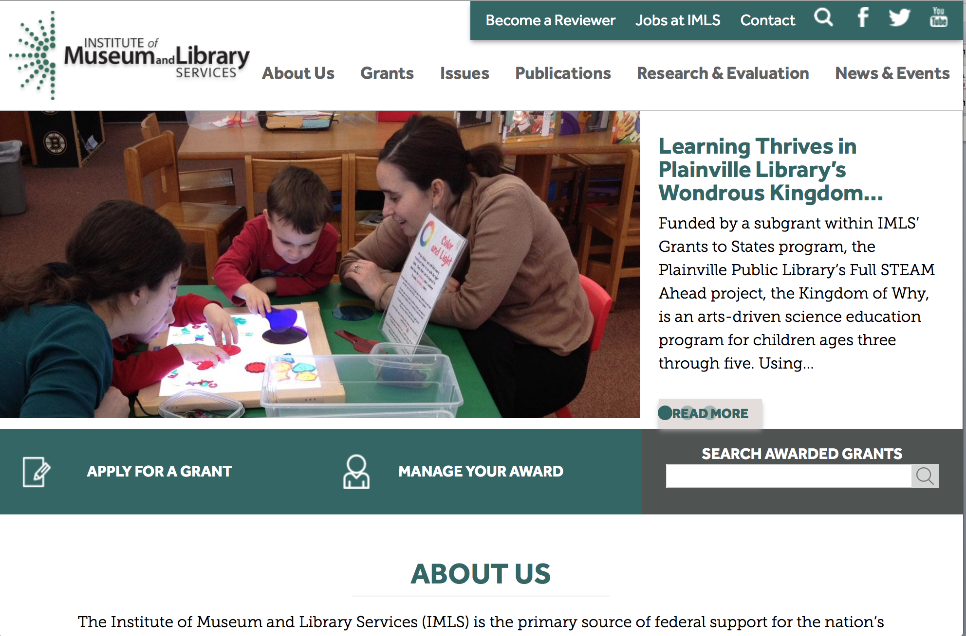

www.imls.gov

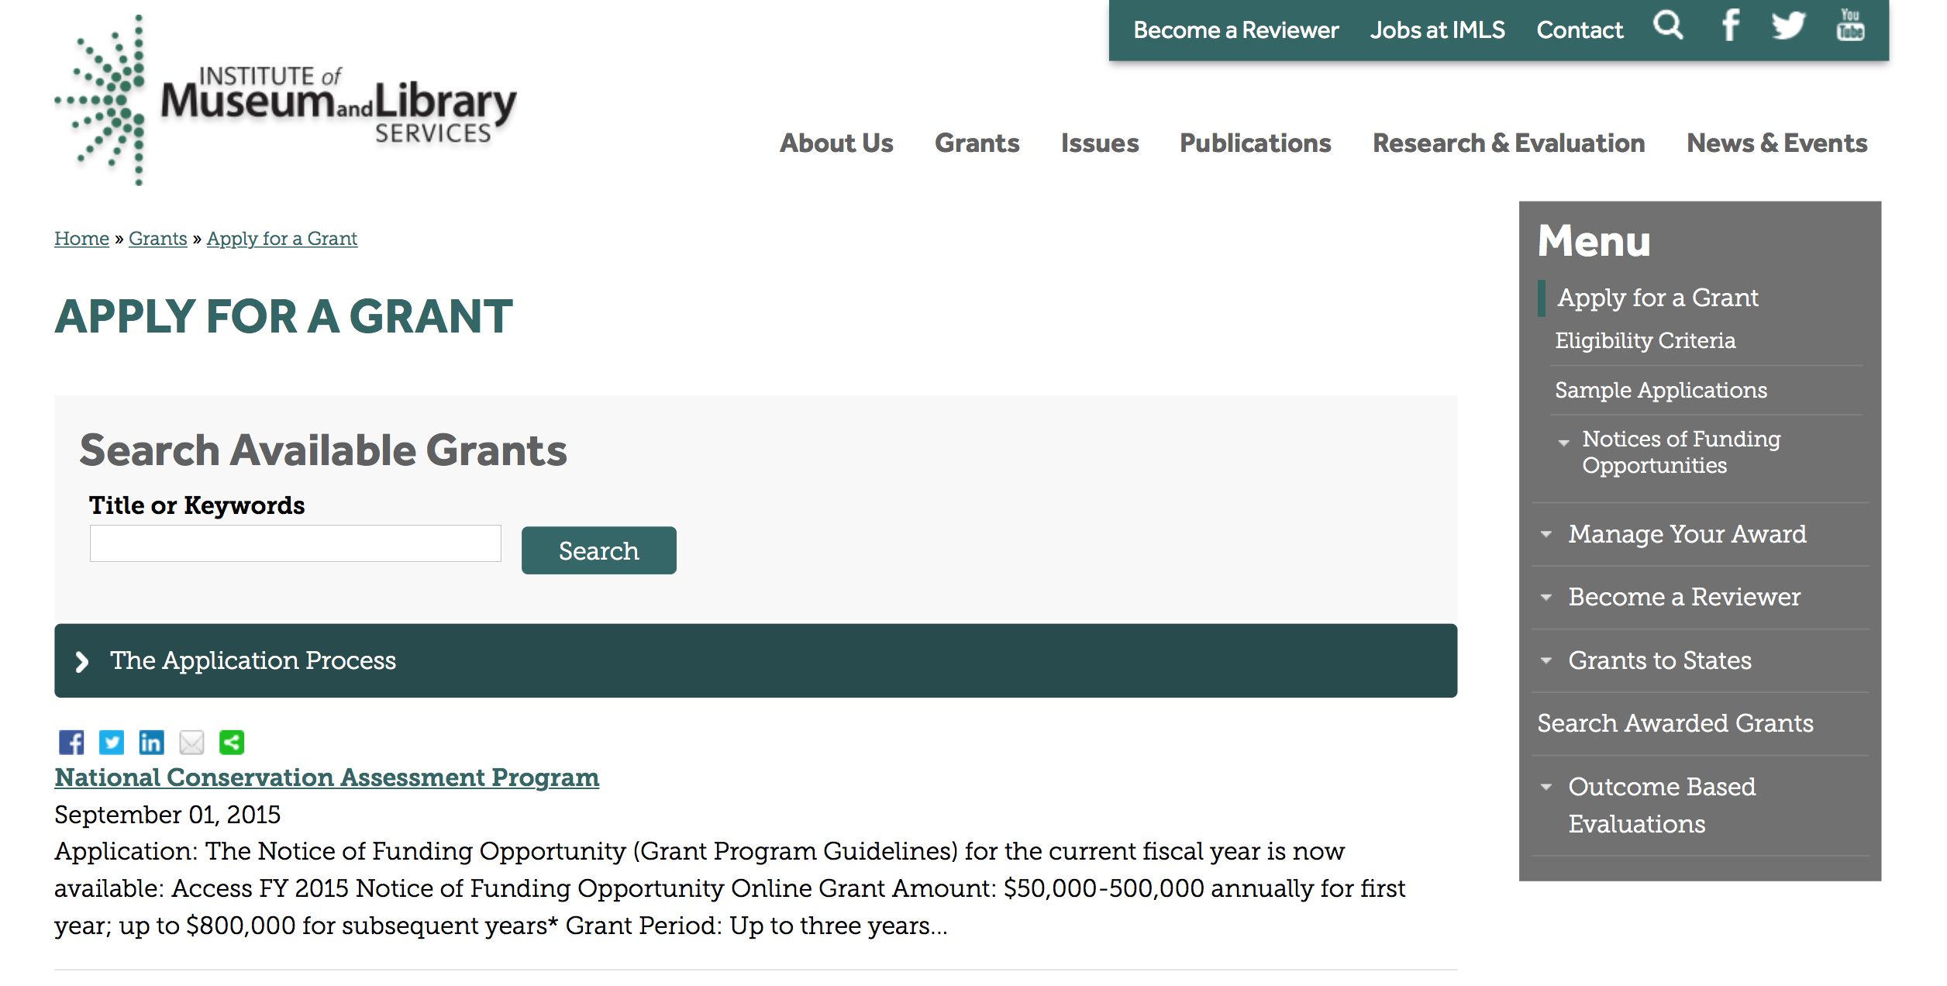
http://www.imls.gov/applicants/available_grants.aspx

Each grant program has specific eligibility requirements. The links below provide general eligibility criteria for museums, libraries, and tribal organizations, but please note that additional organizations may be eligible for grants under certain programs. Additionally, ineligible organizations may still be able to participate in grant programs through partnerships with eligible organizations. Please click on the links below to see general criteria and review Applications and Guidelines for specific information.
Museums Libraries

Institutions: Archives, Federally Recognized Native American Tribe, Historical Society, Library, Nonprofits that serve Native Hawaiians, Professional Association, Public or Private Non-profit Institutions of Higher Education, Regional Organization, State Library Administrative Agency, State or Local Government

Check out IMLS's Facebook page at:
https://www.facebook.com/USIMLS/

Modifications:

Reminders:

National Leadership Grants for Libraries Grant

Document Type: | Grants Notice
Funding Opportunity Number: | NLG-LIBRARIES-FY16-2
Funding Opportunity Title: | National Leadership Grants for Libraries
Opportunity Category: | Discretionary
Funding Instrument Type: | Grant
Category of Funding Activity: | Arts (see "Cultural Affairs" in CFDA)  Humanities (see "Cultural Affairs" in CFDA)
Category Explanation:
Expected Number of Awards: | 20
CFDA Number(s): | 45.312 -- National Leadership Grants
Cost Sharing or Matching Requirement: | Yes
Posted Date: | Dec 21, 2015
Creation Date: | Dec 21, 2015
Original Closing Date for Applications: | Jun 1, 2016
Current Closing Date for Applications: | Jun 1, 2016
Archive Date: | Jul 1, 2016
Estimated Total Program Funding: | $12,000,000
Award Ceiling: | $2,000,000
Award Floor: | $10,000
Eligible Applicants: | Others (see text field entitled "Additional Information on Eligibility" for clarification)
Additional Information on Eligibility: | To be eligible as an applicant for this National Leadership Grants for Libraries Program, you must: be either a unit of State or local government or be a private nonprofit organization that has tax-exempt status under the Internal Revenue Code; be located in one of the 50 States of the United States of America, the District of Columbia, the Commonwealth of Puerto Rico, the U.S. Virgin Islands, Guam, American Samoa, the Commonwealth of the Northern Mariana Islands, the Republic of the Marshall Islands, the Federated States of Micronesia, or the Republic of Palau; and qualify as one of the following: a library or a parent organization, such as a school district, a municipality, a State agency, or an academic institution, that is responsible for the administration of a library. Eligible libraries include public libraries, public elementary and secondary school libraries, college and university libraries, research libraries and archives that are not an integral part of an institution of higher education and that make publicly available library services and materials that are suitable for scholarly research and not otherwise available. Research libraries must be under the supervision of at least one permanent professional staff librarian and be either generally recognized as possessing unique, scholarly research materials and services that are made available to the public, or able to demonstrate that such is the case when submitting an application to IMLS a private library or other special library, but only if the State in which it is located determines that the library should be considered a library for purposes of Library Services and Technology (see 20 U.S.C. 9121-9165) an academic or administrative unit, such as a graduate school of library and information science that is part of an institution of higher education through which it would make application a digital library, if it makes library materials publicly available and provides library services, including selection, organization, description, reference, and preservation, under the supervision of at least one permanent professional staff librarian a library agency that is an official agency of a State or other unit of government and is charged by the law governing it with the extension and development of public library services within its jurisdiction a library consortium that is a local, statewide, regional, interstate, or international cooperative association of library entities that provides for the systematic and effective coordination of the resources of eligible libraries, as defined above, and information centers that work to improve the services delivered to the clientele of these libraries or a library association that exists on a permanent basis; serves libraries or library professionals on a national, regional, State, or local level; and engages in activities designed to advance the well-being of libraries and the library profession Note to applicants: In order to receive an IMLS award, you must be in compliance with applicable requirements and be in good standing on all active IMLS awards.
Agency Name: | Institute of Museum and Library Services
Description: | National Leadership Grants for Libraries (NLG) support projects that address challenges faced by the library and archive fields and that have the potential to advance practice in those fields. Successful proposals will generate results such as new tools, research findings, models, services, practices, or alliances that can be widely used, adapted, scaled, or replicated to extend the benefits of federal investment. For FY16, there are two National Leadership Grants for Libraries funding opportunities with two separate deadlines. In addition to the opportunity described in this Notice of Funding Opportunity, an additional NLG funding opportunity was announced in September 2015 with an application submission due date in October 2015.
Link to Additional Information: | https://www.imls.gov/grants/available/national-leadership-grants-libraries
Contact Information: | If you have difficulty accessing the full announcement electronically, please contact:  Tim Carrigan Senior Library Program Officer 202-653-4639 tcarrigan@imls.gov Trevor Owens Senior Library Program Officer 202-653-4654 tjowens@imls.gov Sandra Toro Senior Library Program Officer 202-653-4662 storo@imls.gov Sarah Fuller Library Program Officer 202-653-4783 sfuller@imls.gov  tcarrigan@imls.gov

http://www.grants.gov/web/grants/view-opportunity.html?oppId=280677

Laura Bush 21st Century Librarian Program Grant

Document Type: | Grants Notice
Funding Opportunity Number: | LB21-FY16-2
Funding Opportunity Title: | Laura Bush 21st Century Librarian Program
Opportunity Category: | Discretionary
Funding Instrument Type: | Grant
Category of Funding Activity: | Arts (see "Cultural Affairs" in CFDA)  Humanities (see "Cultural Affairs" in CFDA)
Category Explanation:
Expected Number of Awards: | 22
CFDA Number(s): | 45.313 -- Laura Bush 21st Century Librarian Program
Cost Sharing or Matching Requirement: | Yes
Posted Date: | Dec 21, 2015
Creation Date: | Dec 21, 2015
Original Closing Date for Applications: | Jun 1, 2016
Current Closing Date for Applications: | Jun 1, 2016
Archive Date: | Jul 1, 2016
Estimated Total Program Funding: | $10,000,000
Award Ceiling: | $1,000,000
Award Floor: | $50,000
Eligible Applicants: | Others (see text field entitled "Additional Information on Eligibility" for clarification)
Additional Information on Eligibility: | To be eligible for LB21, you must be either a unit of State or local government or a private nonprofit organization that has tax-exempt status under the Internal Revenue Code and be located in one of the 50 States of the United States of America, the District of Columbia, the Commonwealth of Puerto Rico, Guam, American Samoa, the U.S. Virgin Islands, the Commonwealth of the Northern Mariana Islands, the Republic of the Marshall Islands, the Federated States of Micronesia, or the Republic of Palau. In addition, you must be one of the following six types of organizations: A library or a parent organization, such as a school district, a municipality, a State agency, or an academic institution, that is responsible for the administration of a library. Eligible libraries include the following: Public libraries Public elementary and secondary school libraries College and university libraries Research libraries and archives that are not an integral part of an institution of higher education and that make publicly available library services and materials that are suitable for scholarly research and not otherwise available (Research libraries must be under the supervision of at least one permanent professional staff person and must be either generally recognized as possessing unique scholarly research materials and services that are made available to the public, or able to demonstrate that such is the case when submitting an application to IMLS.) Private or special libraries that have been deemed eligible to participate in this program by the State in which the library is located An academic or administrative unit, such as a graduate school of library and information science that is part of an institution of higher education through which it would make application (See below for additional conditions of eligibility that might apply to such applicants) A digital library, if it makes library materials publicly available and provides library services, including selection, organization, description, reference, and preservation, under the supervision of at least one permanent professional staff person A library agency that is an official agency of a State or other unit of government and is charged by the law governing it with the extension and development of public library services within its jurisdiction A library consortium that is a local, statewide, regional, interstate, or international cooperative association of library entities that provides for the systematic and effective coordination of the resources of eligible libraries, as defined above, and information centers that work to improve the services delivered to the clientele of these libraries A library association that exists on a permanent basis; serves libraries or library professionals on a national, regional, state, or local level; and engages in activities designed to advance the well-being of libraries and the library profession We recognize the potential for valuable contributions to the overall goals of the LB21 program by entities that do not meet the eligibility requirements above. Although such entities may not serve as the official applicants, they are encouraged to participate in projects. Federally operated libraries and museums may not apply for LB21 grants, but they may participate with applicants. Contact us before submitting a proposal involving a federal agency or federal collection. Non-Federal entities may serve as subrecipients or contractors and may receive IMLS grant funds as a result of the project. Consult with us about any eligibility questions before submitting an application.
Agency Name: | Institute of Museum and Library Services
Description: | The Laura Bush 21st Century Librarian Program (LB21) supports professional development, graduate education and continuing education to help libraries and archives develop the human capital capacity they need to meet the changing learning and information needs of the American public. For FY16, there are two Laura Bush 21st Century Librarian Program funding opportunities with two separate deadlines. In addition to the opportunity described in this Notice of Funding Opportunity, an additional LB21 funding opportunity was announced in September 2015 with an application submission due date in October 2015.
Link to Additional Information: | https://www.imls.gov/grants/available/laura-bush-21st-century-librarian-program
Contact Information: | If you have difficulty accessing the full announcement electronically, please contact:  Mary Alice Ball Senior Library Program Officer 202-653-4730 mball@imls.gov Tim Carrigan Senior Library Program Officer 202-653-4639 tcarrigan@imls.gov Trevor Owens Senior Library Program Officer 202-653-4654 tjowens@imls.gov Sandra Toro Senior Library Program Officer 202-653-4662 storo@imls.gov Emily Reynolds Library Program Officer 202-653-4665 ereynolds@imls.gov  mball@imls.gov

http://www.grants.gov/web/grants/view-opportunity.html?oppId=280678

Department of the Interior
Working with Interior

The Interior Department provides assistance to the public, local governments and businesses through a number of programs. For a general overview see: http://www.doi.gov/index.cfm

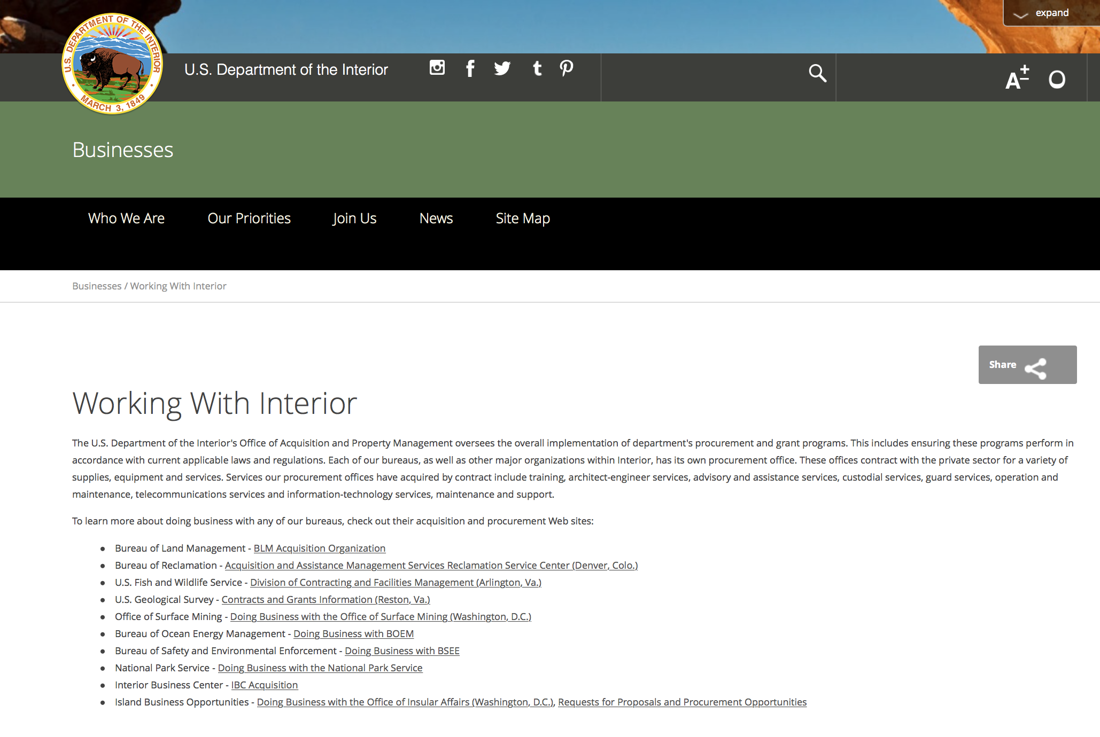

http://www.doi.gov/businesses/working-with-interior.cfm

Programs:

Modifications:

Reminders:

Geological Survey
2017 Earthquake Hazards External Grants Program

Document Type: | Grants Notice
Funding Opportunity Number: | G16AS00024
Funding Opportunity Title: | 2017 Earthquake Hazards External Grants Program
Opportunity Category: | Discretionary
Opportunity Category Explanation:
Funding Instrument Type: | Grant
Category of Funding Activity: | Natural Resources
Category Explanation:
Expected Number of Awards:
CFDA Number(s): | 15.807 -- Earthquake Hazards Research and Monitoring Assistance
Cost Sharing or Matching Requirement: | No
Posted Date: | Mar 11, 2016
Last Updated Date: | Mar 11, 2016
Original Closing Date for Applications: | May 25, 2016
Current Closing Date for Applications: | May 25, 2016
Archive Date: | Jun 24, 2016
Eligible Applicants: | Unrestricted (i.e., open to any type of entity above), subject to any clarification in text field entitled "Additional Information on Eligibility"
Agency Name: | Geological Survey
Description: | USGS Earthquake Hazards Program (EHP) annual Announcement for assistance to support research in earthquake hazards, the physics of earthquakes, earthquake occurrence, and earthquake safety policy. This activity is authorized by the Earthquake Hazards Reduction Act of 1977.
Link to Additional Information:
Contact Information: | If you have difficulty accessing the full announcement electronically, please contact:  Margaret Eastman Contract Specialist Phone 703-648-7366  Contracting Officer

http://www.grants.gov/web/grants/view-opportunity.html?oppId=282164

National Park Service
Land and Water Conservation Fund Outdoor Recreation Legacy Partnership Program Grant

Document Type: | Grants Notice
Funding Opportunity Number: | P16AS00065
Funding Opportunity Title: | Land and Water Conservation Fund Outdoor Recreation Legacy Partnership Program
Opportunity Category: | Discretionary
Opportunity Category Explanation:
Funding Instrument Type: | Grant
Category of Funding Activity: | Environment  Natural Resources  Other (see text field entitled "Explanation of Other Category of Funding Activity" for clarification)
Category Explanation: | Outdoor recreation
Expected Number of Awards: | 30
CFDA Number(s): | 15.916 -- Outdoor Recreation Acquisition, Development and Planning
Cost Sharing or Matching Requirement: | Yes
Posted Date: | Mar 09, 2016
Last Updated Date: | Mar 09, 2016
Original Closing Date for Applications: | May 20, 2016
Current Closing Date for Applications: | May 20, 2016
Archive Date: | Jun 01, 2016
Estimated Total Program Funding: | $15,000,000
Award Ceiling: | $750,000
Award Floor: | $250,000
Eligible Applicants: | Special district governments  State governments  City or township governments  County governments  Native American tribal governments (Federally recognized)
Agency Name: | National Park Service
Description: | The National Park Service State and Local Assistance Division announces the availability of $15 million (total) set aside in FY 2015 and FY 2016 appropriations for Land and Water Conservation Fund State Assistance grants for a nationally competitive grant program. Eligible U.S. state and local government agencies and federally recognized Indian tribes are invited to submit proposals for matching grants to support projects that would acquire or develop public land for outdoor recreation purposes located within or serving Census-delineated "urbanized areas": places with a population of 50,000 or more people that are densely settled.
Link to Additional Information: | www.grants.gov
Contact Information: | If you have difficulty accessing the full announcement electronically, please contact:  Branch Chief for Recreation Grants Programs Elisabeth Fondriest 202 354-6916 Elisabeth_Fondriest@nps.gov  Elisabeth_Fondriest@nps.gov

http://www.grants.gov/web/grants/view-opportunity.html?oppId=282085

Fish and Wildlife Service
Youth Engagement, Education, and Employment Programs Grant

Document Type: | Grants Notice
Funding Opportunity Number: | F16AS00108
Funding Opportunity Title: | Youth Engagement, Education, and Employment Programs
Opportunity Category: | Discretionary
Opportunity Category Explanation:
Funding Instrument Type: | Cooperative Agreement
Category of Funding Activity: | Community Development  Education  Employment, Labor and Training  Environment  Natural Resources
Category Explanation:
Expected Number of Awards: | 0
CFDA Number(s): | 15.676 -- Youth Engagement, Education, and Employment Programs
Cost Sharing or Matching Requirement: | Yes
Posted Date: | Apr 06, 2016
Last Updated Date: | Apr 06, 2016
Original Closing Date for Applications: | May 21, 2016
Current Closing Date for Applications: | May 21, 2016
Archive Date: | Jun 21, 2016
Estimated Total Program Funding: | $10,000,000
Award Ceiling: | $500,000
Award Floor: | $5,000
Eligible Applicants: | Nonprofits that do not have a 501(c)(3) status with the IRS, other than institutions of higher education  City or township governments  Special district governments  State governments  County governments  Nonprofits having a 501(c)(3) status with the IRS, other than institutions of higher education
Agency Name: | Fish and Wildlife Service
Description: | I. Description of Funding Opportunity The U.S. Fish and Wildlife Service's (USFWS or Service) National Youth Development Program is accepting proposals from non-profit, state, and local government youth-serving organizations with the interest and capacity to work cooperatively with the USFWS to develop and administer projects focused on providing employment, educational, and public-service opportunities for U.S. citizens and legal residents between 15 and 25 years of age and for military veterans up to the age of 35. Projects funded under this program will be carried out at USFWS regional and field offices and on non-Federal lands in adjacent communities. Projects are developed based on needs identified by USFWS offices at the national, regional and local levels that will lead to the development of project scopes of work in consultation with the youth-serving organizations selected as program partners under this Notice of Funding Opportunity (NOFO). The National Youth Development Program is focused on providing the following types of opportunities: 1. Employment: Projects that provide participants with job skills training, education and professional development. These projects will engage youth crews, small teams and individuals. Crews will work collectively and intensely together under the supervision of trained and experienced crew leaders or conservation professionals. Teams and individuals will work under the direction of conservation professionals on initiatives that require specific skills or dedicated attention. Most projects require significant outdoor-based activity, but may also involve indoor work related to visitor services, administration, and research that contribute directly to the Service's mission. Examples of employment projects include: visitor communications and support; historic and archaeological site data collection and research; inventory and monitoring of fish and wildlife habitat; facility preservation, restoration, rehabilitation, and maintenance; trail building and maintenance; invasive species removal; habitat restoration; wilderness stewardship; leading and conducting educational and informational outreach events; research; and endangered species monitoring and recovery work. 2. Education and Public Service: Projects that provide participants an opportunity to be exposed to civic engagement and collaborative, community-based stewardship of natural and cultural resources. These projects will employ a variety of educational techniques to convey the USFWS mission to â¿¿work with others to conserve, protect, and enhance fish, wildlife and plants and their habitats for the continuing benefit of the American people. Examples of education projects include: place-based learning opportunities; training seminars; and projects that engage and train young people as mentors and educational leaders for younger students and children. The purpose of this NOFO is to identify non-profit youth-serving organizations with the interest and capacity to work cooperatively with the USFWS to develop and administer projects under this program. The USFWS seeks to partner with organizations focused on providing youth with educational, technical, life and leadership skills and helping them to develop a sense of community and purpose from their work on projects conducted under this program. As a result of this NOFO, the USFWS will establish a list of approved partner organizations. The USFWS will send written notice to all applicants confirming if they have or have not been selected as potential project partners under this program. Selection as a potential project partner does not guarantee the entity will receive funding under this program. The list of selected potential partners will be shared with USFWS national, regional and field station program points of contact, who will then notify the partner organizations on the list who perform work within particular regions or states about upcoming projects that they may be qualified to undertake. USFWS regional program points of contact and field station managers will be responsible for selecting and working with partners to develop project-specific work plans, timelines, and budgets to carry out priority projects. Each project developed will be funded under a unique cooperative agreement award with funding and a period of performance specific to that project. Selected project partners will be required to submit to the USFWS, in advance of award, the documentation listed in Section VII. Award Notices below. Contingent upon the availability of funds, the USFWS estimates having available a maximum of $10,000,000 this fiscal year nationwide for projects under this program. The number of projects to be funded each year will vary based on USFWS national, regional and field station management priorities, needs, and available funding to perform the work. This program supports the goals of the 21st Century Conservation Service Corps (21CSC). The 21CSC is a national collaborative effort to put America's youth and veterans to work protecting, restoring and enhancing America’s natural and cultural resources. This inter-agency effort is a central component of the President’s America’s Great Outdoors Initiative, which is helping to protect some of the places that Americans love most and to connect people from all backgrounds with the recreational, economic and health benefits of our nation’s lands and waters. For more information, visit the Department of the Interior’s Youth in the Great Outdoors webpage at http://www.doi.gov/youth/index.cfm and the 21CSC website at http://21csc.org/. The USFWS is committed to engaging young people with diverse cultural, ethnic and economic backgrounds under this program. Potential partners engaging young people from diverse backgrounds are strongly encouraged to apply. This program is authorized under the Public Lands Corp Act of 1993, as amended (16 U.S.C 1723). Refer to the attached PDF for the full version of this NOFO.
Link to Additional Information: | http
Contact Information: | If you have difficulty accessing the full announcement electronically, please contact:  Devon Larson 703-358-2052 devon_larson@fws.gov  Administrative Officer

http://www.grants.gov/web/grants/view-opportunity.html?oppId=282830

Fish and Wildlife Service
Fiscal Year 2016 Recovery Implementation Fund Grant

Document Type: | Grants Notice
Funding Opportunity Number: | F16AS00099
Funding Opportunity Title: | Fiscal Year 2016 Recovery Implementation Fund
Opportunity Category: | Discretionary
Opportunity Category Explanation:
Funding Instrument Type: | Cooperative Agreement  Grant  Procurement Contract
Category of Funding Activity: | Environment  Natural Resources
Category Explanation:
Expected Number of Awards: | 0
CFDA Number(s): | 15.657 -- Endangered Species Conservation - Recovery Implementation Funds
Cost Sharing or Matching Requirement: | No
Posted Date: | Feb 04, 2016
Last Updated Date: | Feb 04, 2016
Original Closing Date for Applications: | Jul 31, 2016 Applications are due by July 31, 2016. However, you may submit applications throughout the year. Consideration of applications ultimately will be based on the FWS budget cycle.
Current Closing Date for Applications: | Jul 31, 2016 Applications are due by July 31, 2016. However, you may submit applications throughout the year. Consideration of applications ultimately will be based on the FWS budget cycle.
Archive Date: | Aug 31, 2016
Estimated Total Program Funding: | $0
Award Ceiling: | $1,000,000
Award Floor: | $1
Eligible Applicants: | Unrestricted (i.e., open to any type of entity above), subject to any clarification in text field entitled "Additional Information on Eligibility"
Additional Information on Eligibility: | Applicants must have a demonstrated knowledge and understanding of the biology of the involved endangered or threatened species in the United States and their ecosystem, including preferably having worked with the species in the field and holding a currently valid Endangered Species Act permit, issued by the FWS, authorizing them to work with these species (or that have previously held a permit to do so). If funding is awarded, applicants that do not currently hold a valid permit for the proposed activity may need to apply for and obtain a permit (http://www.fws.gov/endangered/permits/index.html) before beginning the proposed activity. FWS Regional (or Field Office) contacts will discuss potential proposals with interested parties if needed, and review eligible applications. The FWS Regional Office will refer interested parties to the appropriate FWS Field Office for further consideration as appropriate. For potential proposals submitted directly to the Field Office, the Field Office will conduct the proposal review and selection process. A list of FWS Regional Office contacts is available in the Full Announcement under section VII. Agency Contacts.
Agency Name: | Fish and Wildlife Service
Description: | The FWS Ecological Services Program provides Federal financial assistance on a competitive basis to States, other Federal agencies, landowners, educators, non-profit organizations, researchers, and other partners to secure information about endangered, threatened or candidate species, to aid in the recovery of these species, to avert listing of species pursuant to the Endangered Species Act, and to help conserve the ecosystems upon which these species depend. The FWS and National Marine Fisheries Service (NMFS), which is part of the Department of Commerce’s NOAA Fisheries office, share Endangered Species Act responsibilities for several species such as sea turtles. We have responsibility for sea turtles when they are on land, and NMFS has responsibility for sea turtles when they are in the water. Projects for NMFS-managed species are not included in this funding opportunity. This Recovery Implementation funding opportunity is intended for projects that will contribute to the recovery of FWS-managed endangered and threatened species in the United States, and is limited to projects carrying out actions described in a species approved recovery plan, in the implementation schedule of a species approved recovery plan, actions recommended in a completed 5-year status review of the species or in a spotlight species action plan, or projects documenting species response to climate change. For example: securing scientific information about endangered or threatened species, implementing restoration actions that will lead to delisting of a species, help prevent extinction of a species, or aid in the recovery of a species. Projects that address species response to climate change will receive additional consideration.
Link to Additional Information: | http://www.grants.gov
Contact Information: | If you have difficulty accessing the full announcement electronically, please contact:  Kelly Niland 703-358-2492 Kelly_Niland@fws.gov  Grant Specialist

http://www.grants.gov/web/grants/view-opportunity.html?oppId=281338

Fish and Wildlife Service
National Fish Passage Program Grant

Document Type: | Grants Notice
Funding Opportunity Number: | F16AS00041
Funding Opportunity Title: | National Fish Passage Program
Opportunity Category: | Discretionary
Funding Instrument Type: | Cooperative Agreement
Category of Funding Activity: | Natural Resources
Category Explanation:
Expected Number of Awards:
CFDA Number(s): | 15.608 -- Fish and Wildlife Management Assistance
Cost Sharing or Matching Requirement: | Yes
Posted Date: | Dec 1, 2015
Creation Date: | Nov 30, 2015
Original Closing Date for Applications: | Sep 1, 2016
Current Closing Date for Applications: | Sep 1, 2016
Archive Date: | Sep 20, 2016
Eligible Applicants: | Unrestricted (i.e., open to any type of entity above), subject to any clarification in text field entitled "Additional Information on Eligibility"
Additional Information on Eligibility: | To receive funding, NFPP projects must be implemented in coordination with FAC staff. Applicants can be, but not limited to: state and federal agencies, private lands, tribes, local municipalities, and non-governmental organizations.
Agency Name: | Fish and Wildlife Service
Description: | The National Fish Passage Program (NFPP) is a voluntary program that provides direct technical assistance and financial assistance in the form of cooperative agreements to partners to provide fish (and other aquatic organisms) passage and restore aquatic connectivity for the benefit of federal trust resources. The NFPP is delivered through more than 65 Fisheries and Aquatic Conservation (FAC) Field Offices across all States and territories. FAC staff coordinates with project partners, stakeholders and other Service programs to identify and collaboratively implement projects within Regional priority areas. Project work plans are developed strategically, in coordination with partners, and with substantial involvement from FAC staff. Projects must advance our mission, promote biological diversity, and be based upon sound scientific biological principles. FAC and Fish and Wildlife Service (FWS) strategic plans inform the types of projects funded under this opportunity. Applicants seeking funding under this program should review the program strategic plan and also contact the regional NFPP Coordinator for local FAC contacts prior to submitting an application for funding.
Link to Additional Information: | http://www.grants.gov
Contact Information: | If you have difficulty accessing the full announcement electronically, please contact:  Stephanie Long, 703-358-1749 Stephanie_A_Long@fws.gov  Stephanie_A_Long@fws.gov

http://www.grants.gov/web/grants/view-opportunity.html?oppId=280260

Fish and Wildlife Service
Fiscal Year 2016 Candidate Conservation Action Funds Grant

Document Type: | Grants Notice
Funding Opportunity Number: | F16AS00100
Funding Opportunity Title: | Fiscal Year 2016 Candidate Conservation Action Funds
Opportunity Category: | Discretionary
Funding Instrument Type: | Cooperative Agreement  Grant  Procurement Contract
Category of Funding Activity: | Environment  Natural Resources
Category Explanation:
Expected Number of Awards: | 0
CFDA Number(s): | 15.660 -- Endangered Species - Candidate Conservation Action Funds
Cost Sharing or Matching Requirement: | No
Posted Date: | Feb 4, 2016
Creation Date: | Feb 4, 2016
Original Closing Date for Applications: | Jul 31, 2016 Applications are due by July 31, 2016. However, you may submit applications throughout the year. Consideration of applications ultimately will be based on the FWS budget cycle.
Current Closing Date for Applications: | Jul 31, 2016 Applications are due by July 31, 2016. However, you may submit applications throughout the year. Consideration of applications ultimately will be based on the FWS budget cycle.
Archive Date: | Aug 31, 2016
Estimated Total Program Funding: | $0
Award Ceiling: | $1,000,000
Award Floor: | $1
Eligible Applicants: | Unrestricted (i.e., open to any type of entity above), subject to any clarification in text field entitled "Additional Information on Eligibility"
Additional Information on Eligibility: | Applicants must have a demonstrated knowledge and understanding of the biology of the involved candidate or at-risk species in the United States and their ecosystem, including preferably having worked with the species in the field. FWS Regional (or Field Office) contacts will discuss potential proposals with interested parties if needed, and review eligible applications. The FWS Regional Office will refer interested parties to the appropriate FWS Field Office for further consideration as appropriate. For potential proposals submitted directly to the Field Office, the Field Office will conduct the proposal review and selection process. A list of FWS Regional and Field Office contacts is available in the Full Announcement under section VII. Agency Contacts.
Agency Name: | Fish and Wildlife Service
Description: | Financial assistance is available to secure candidate and other at-risk species information or undertake restoration actions that will help avert federal listing of species. The purpose is to provide a means by which the ecosystems upon which candidate and at-risk species depend may be conserved, to provide a program for the conservation of these species.
Link to Additional Information: | http://www.grants.gov
Contact Information: | If you have difficulty accessing the full announcement electronically, please contact:  Grant Specialist Kelly Niland 703-358-2492 Kelly_Niland@fws.gov  Grant Specialist

http://www.grants.gov/web/grants/view-opportunity.html?oppId=281344

Department of Justice

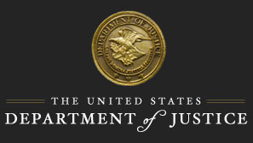

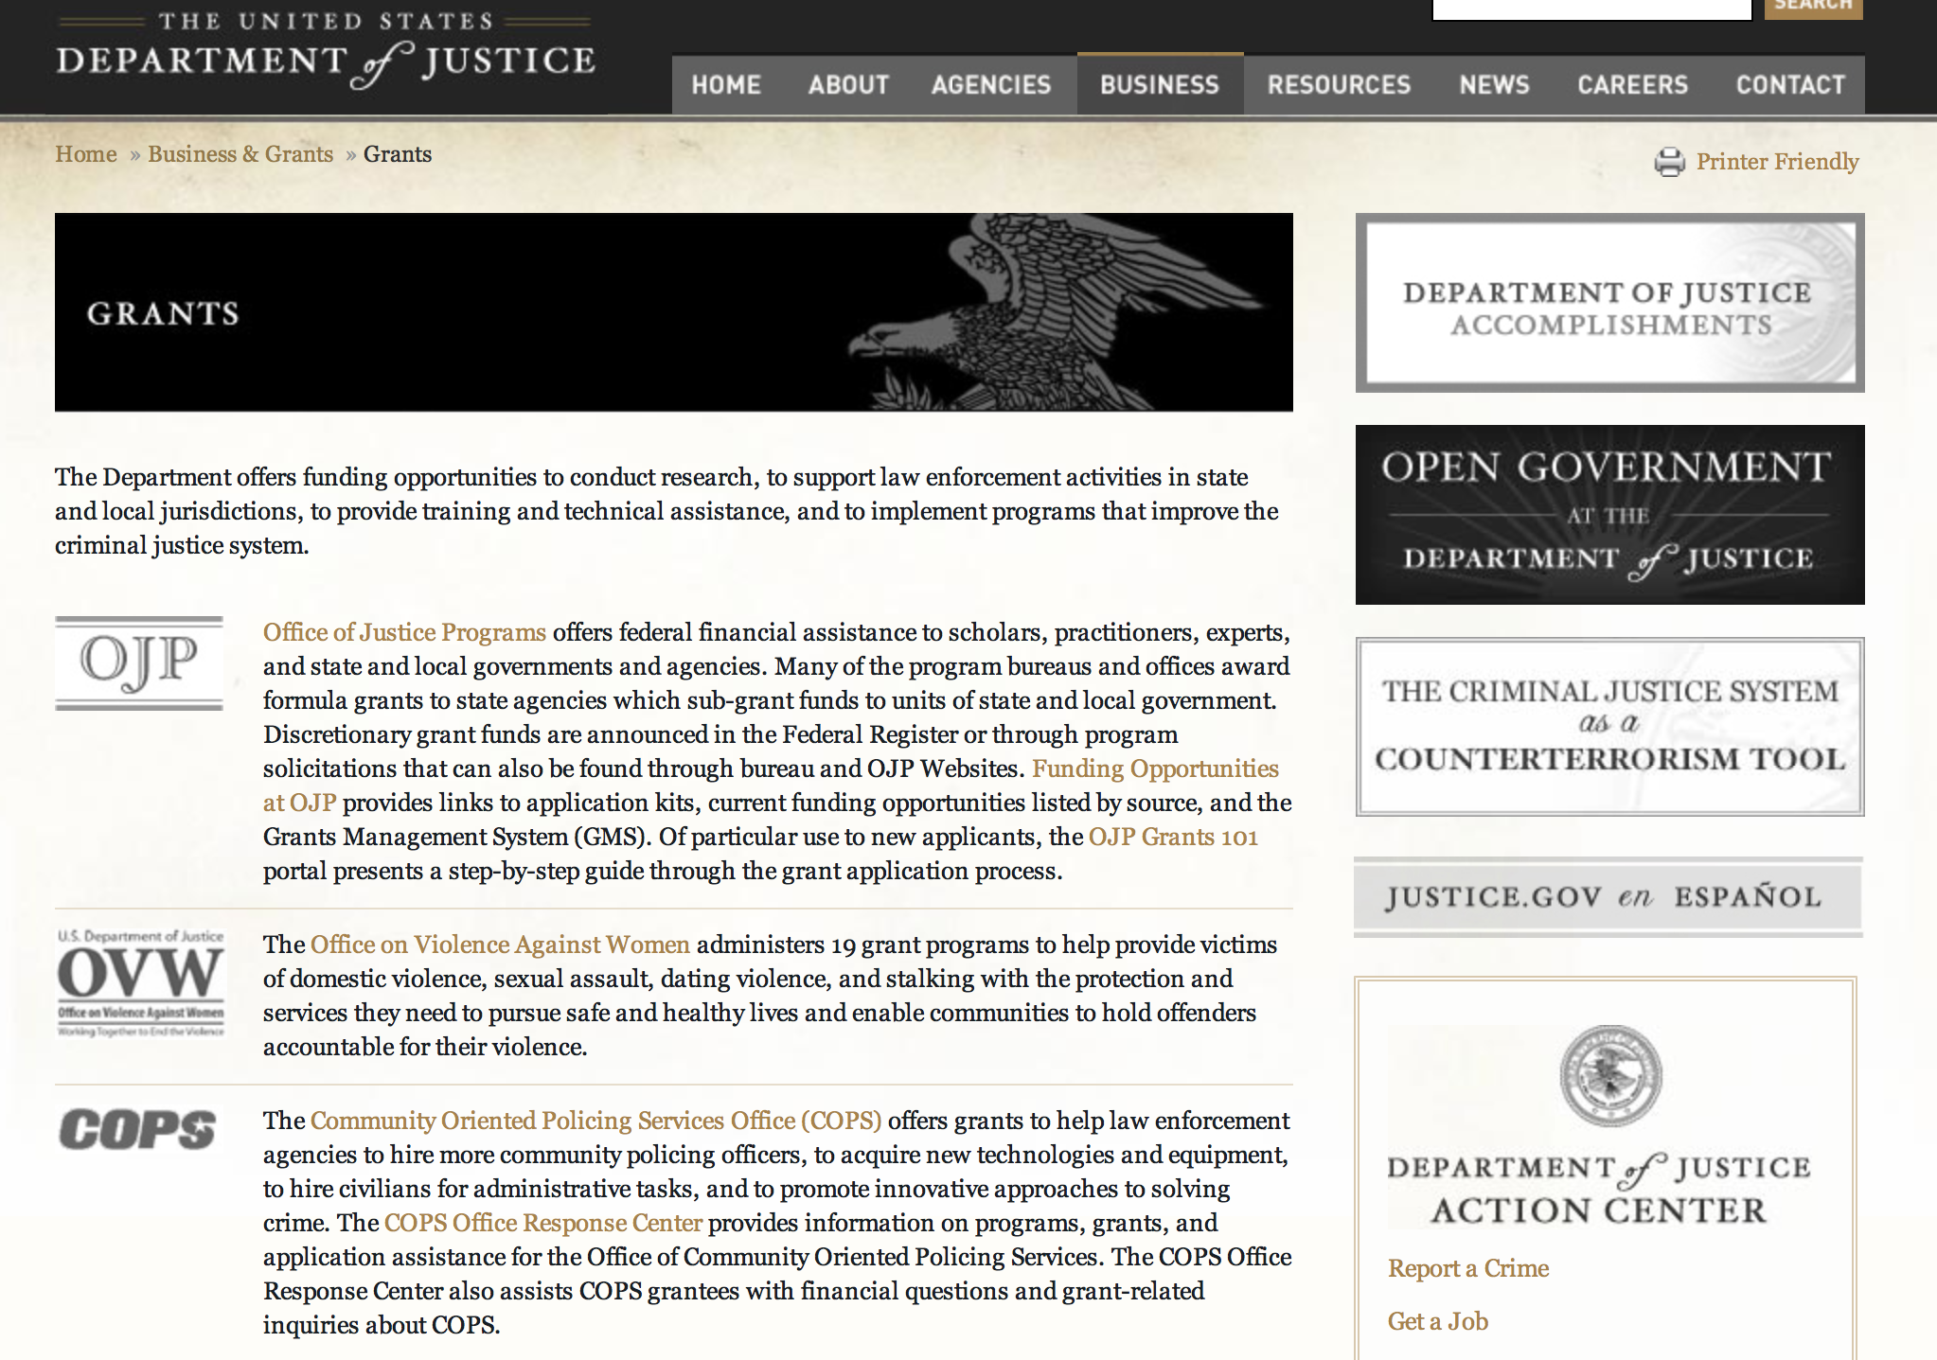

The DOJ agencies listed below also have sites that provide grant information specific to that agency. Examples of what can be found on these sites are programs, funding opportunities, application assistance, and other useful information.

Bureau of Justice Assistance (BJA)

Bureau of Justice Statistics (BJS)

National Criminal Justice Reference Service (NCJRS)

National Institute of Justice (NIJ)

Office of Juvenile Justice and Delinquency Prevention (OJJDP)

Office of Sex Offender Sentencing, Monitoring, Apprehending, Registering, and Tracking (SMART)

Office for Victims of Crime (OVC)

http://www.justice.gov/business/

Programs:

Office of Justice Programs
Office of Juvenile Justice Delinquency Prevention
OJJDP FY 16 Safe and Thriving Communities: Uniting Community Based Violence Prevention, Defending Childhood and National Forum Approaches to Prevent and Heal Violence Grant

Document Type: | Grants Notice
Funding Opportunity Number: | OJJDP-2016-9157
Funding Opportunity Title: | OJJDP FY 16 Safe and Thriving Communities: Uniting Community Based Violence Prevention, Defending Childhood and National Forum Approaches to Prevent and Heal Violence
Opportunity Category: | Discretionary
Opportunity Category Explanation:
Funding Instrument Type: | Cooperative Agreement
Category of Funding Activity: | Law, Justice and Legal Services
Category Explanation:
Expected Number of Awards: | 14
CFDA Number(s): | 16.818 -- Children Exposed to Violence
Cost Sharing or Matching Requirement: | No
Posted Date: | Apr 22, 2016
Last Updated Date: | Apr 22, 2016
Original Closing Date for Applications: | Jun 21, 2016
Current Closing Date for Applications: | Jun 21, 2016
Archive Date:
Estimated Total Program Funding: | $3,000,000
Award Ceiling: | $1,000,000
Award Floor: | $500,000
Eligible Applicants: | County governments  Native American tribal governments (Federally recognized)  Others (see text field entitled "Additional Information on Eligibility" for clarification)  City or township governments  State governments
Additional Information on Eligibility: | Category 1: New Applicants. Eligible applicants are limited to units of local government, state agencies proposing local initiatives in collaboration with community-based organizations, and federally recognized tribal governments (as determined by the Secretary of the Interior). Existing grantees funded under OJJDP’s National Forum on Youth Violence Prevention, Defending Childhood, and Community-Based Violence Prevention initiatives are eligible only under Category 2. Category 2: Existing Grantees. Eligible applicants are existing grantee sites of OJJDP’s National Forum on Youth Violence Prevention, Defending Childhood, and Community-Based Violence Prevention initiatives that did not receive funding under the FY 2015 Youth Violence Prevention Enhancement solicitation. (Refer to the matrix, Appendix B, page 52.) All Applicants: To be eligible for consideration for funding under this solicitation, applicants must provide letters of commitment/memoranda of understanding that the chief executive officer (e.g., mayor, county executive, tribal chair), chief of police, superintendent of schools within the locality, and directors of public health, housing, workforce development, economic development, and child welfare (or the equivalent positions) have signed. Letters of commitment/memoranda must indicate an understanding of the goals of the proposal, describe the roles and responsibilities of the signer and/or represented agency, and specify the fiscal and staffing resource commitments made to the collaboration. OJJDP welcomes applications that involve two or more entities that will carry out the funded federal award activities; however, one eligible entity must be the applicant and the other(s) must be proposed as subrecipient(s). The applicant must be the entity with primary responsibility for administering the funding and managing the entire project. Only one application per lead applicant will be considered; however, a subrecipient may be part of multiple proposals. OJJDP may elect to make awards for applications submitted under this solicitation in future fiscal years, dependent on, among other considerations, the merit of the applications and on the availability of appropriations.
Agency Name: | Office of Juvenile Justice Delinquency Prevention
Description: | This solicitation seeks to help catalyze and further advance the prevention and intervention of youth victimization and violence, especially youth gun and gang violence, by focusing efforts in partnership with a limited number of localities and Tribes. The funds are intended to help initiate or strengthen work to end youth violence and improve the wellbeing of children, youth, families and communities through comprehensive approaches that unify the central tenets of OJJDP’s existing youth violence initiatives through a single, shared framework for collective action.
Link to Additional Information: | Full Announcement
Contact Information: | If you have difficulty accessing the full announcement electronically, please contact:  For technical assistance with submitting an application, contact the Grants.gov Customer Support Hotline at 800-518-4726or 606-545-5035, or via e-mail to support@grants.gov. Hotline hours of operation are 24 hours a day, 7 days a week, except federal holidays. Applicants who experience unforeseen Grants.gov technical issues beyond their control that prevent them from submitting their application by the deadline must e-mail the OJJDP contact identified below within 24 hours after the application deadline and request approval to submit their application. Additional information on reporting technical issues is found under “Experiencing Unforeseen Grants.gov Technical Issues” in the How To Apply section. For assistance with any other requirements of this solicitation, contact the Response Center by telephone at 800-851-3420 or TTY: 301-240-6310 (Hearing impaired only), by e-mail at grants@ncjrs.gov, or by web chat. Response Center hours of operation are 10 a.m. to 6 p.m. ET, Monday through Friday, and 10 a.m. to 8 p.m. ET on the solicitation close date. Answers to frequently asked questions that may assist applicants are posted at www.ojjdp.gov/grants/solicitations/FY2016/FAQ/Safe&ThrivingFAQ.pdf. grants@ncjrs.gov  Email

http://www.grants.gov/web/grants/view-opportunity.html?oppId=283239

Office of Justice Programs
Office of Juvenile Justice Delinquency Prevention
OJJDP FY 2016 Juvenile Justice Emergency Planning Demonstration Program Grant

Document Type: | Grants Notice
Funding Opportunity Number: | OJJDP-2016-9720
Funding Opportunity Title: | OJJDP FY 2016 Juvenile Justice Emergency Planning Demonstration Program
Opportunity Category: | Discretionary
Opportunity Category Explanation:
Funding Instrument Type: | Grant
Category of Funding Activity: | Law, Justice and Legal Services
Category Explanation:
Expected Number of Awards: | 6
CFDA Number(s): | 16.823 -- Emergency Planning for Juvenile Justice Facilities
Cost Sharing or Matching Requirement: | No
Posted Date: | Apr 12, 2016
Last Updated Date: | Apr 12, 2016
Original Closing Date for Applications: | May 31, 2016
Current Closing Date for Applications: | May 31, 2016
Archive Date:
Estimated Total Program Funding: | $350,000
Award Ceiling: | $150,000
Award Floor: | $50,000
Eligible Applicants: | Small businesses  Private institutions of higher education  For profit organizations other than small businesses  Others (see text field entitled "Additional Information on Eligibility" for clarification)  State governments  City or township governments  County governments  Native American tribal governments (Federally recognized)  Public and State controlled institutions of higher education  Nonprofits having a 501(c)(3) status with the IRS, other than institutions of higher education
Additional Information on Eligibility: | Eligible applicants are limited to states (including territories), units of local government, federally recognized tribal governments (as determined by the Secretary of the Interior), nonprofit and for-profit organizations (including tribal nonprofit and for-profit organizations), and institutions of higher education (including tribal institutions of higher education). For-profit organizations must agree to forgo any profit or management fee. OJJDP welcomes applications that involve two or more entities that will carry out the funded federal award activities; however, one eligible entity must be the applicant and the other(s) must be proposed as subrecipient(s). The applicant must be the entity with primary responsibility for administering the funding and managing the entire project. Only one application per lead applicant will be considered; however, a subrecipient may be part of multiple proposals.
Agency Name: | Office of Juvenile Justice Delinquency Prevention
Description: | The OJJDP FY 2016 Juvenile Justice Emergency Planning Demonstration Program will provide resources for state, tribal, local, municipal and community organizations to develop, strengthen and implement emergency preparedness plans for juvenile justice facilities. These plans should be based upon the principles outlined in Emergency Planning for Juvenile Justice Residential Facilities, and should address the specific needs of children, youth, and families involved in the justice system, during an emergency.
Link to Additional Information: | Full Announcement
Contact Information: | If you have difficulty accessing the full announcement electronically, please contact:  For technical assistance with submitting an application, contact the Grants.gov Customer Support Hotline at 800-518-4726 or 606-545-5035, or via email to support@grants.gov. Hotline hours of operation are 24 hours a day, 7 days a week, except federal holidays. For assistance with any other requirements of this solicitation, contact the Response Center by telephone at 800-851-3420 or TTY: 301-240-6310 (Hearing impaired only), by e-mail at grants@ncjrs.gov, or by web chat. Response Center hours of operation are 10 a.m. to 6 p.m. ET, Monday through Friday, and 10 a.m. to 8 p.m. ET on the solicitation close date. Answers to frequently asked questions that may assist applicants are posted at www.ojjdp.gov/grants/solicitations/FY2016/FAQ/EmergencyPlanningFAQ.pdf. grants@ncjrs.gov  Email

http://www.grants.gov/web/grants/view-opportunity.html?oppId=282923

Office of Justice Programs
Bureau of Justice Assistance
Smart Reentry: Focus on Evidence-Based Strategies for Successful Reentry from Incarceration to Community Grant

Document Type: | Grants Notice
Funding Opportunity Number: | BJA-2016-9207
Funding Opportunity Title: | Smart Reentry: Focus on Evidence-Based Strategies for Successful Reentry from Incarceration to Community
Opportunity Category: | Discretionary
Opportunity Category Explanation:
Funding Instrument Type: | Grant
Category of Funding Activity: | Law, Justice and Legal Services
Category Explanation:
Expected Number of Awards: | 6
CFDA Number(s): | 16.812 -- Second Chance Act Reentry Initiative
Cost Sharing or Matching Requirement: | N
Posted Date: | Apr 10, 2016
Last Updated Date: | Apr 11, 2016
Original Closing Date for Applications: | Jun 09, 2016
Current Closing Date for Applications: | Jun 09, 2016
Archive Date:
Estimated Total Program Funding: | $6,000,000
Award Ceiling: | $1,000,000
Eligible Applicants: | Native American tribal governments (Federally recognized)  State governments  County governments  City or township governments
Agency Name: | Bureau of Justice Assistance
Description: | The goal of this program is to support jurisdictions to develop and implement comprehensive and collaborative strategies that address the challenges posed by reentry to increase public safety and reduce recidivism for individuals reentering communities from incarceration who are at medium to risk for recidivating. Within the context of this initiative, reentry is not envisioned to be a specific program, but rather a process that begins when the individual is first incarcerated (pre-release) and ends with his or her successful reduction in risk of recidivism and community reintegration (post-release). This process should provide the individual with appropriate evidence-based services including reentry planning that addresses individual criminogenic needs identified through information obtained from an empirically validated risk/needs assessment that also reflects the risk of recidivism for each individual. The reentry plan should reflect both specific and ongoing pre-release and post-release needs, and a strategy for ensuring that these needs are met throughout the duration of the reentry process.
Link to Additional Information: | Full Announcement
Contact Information: | If you have difficulty accessing the full announcement electronically, please contact:  For technical assistance with submitting an application, contact the Grants.gov Customer Support Hotline at 800-518-4726 or 606-545-5035, or via e-mail to support@grants.gov. The Grants.gov Support Hotline hours of operation are 24 hours a day, 7 days a week, except federal holidays. support@grants.gov  Technical Application Support

http://www.grants.gov/web/grants/view-opportunity.html?oppId=282907

Modifications:

Reminders:

Bureau of Justice Assistance
Justice and Mental Health Collaboration Program Grant

Document Type: | Grants Notice
Funding Opportunity Number: | BJA-2016-9205
Funding Opportunity Title: | Justice and Mental Health Collaboration Program
Opportunity Category: | Discretionary
Opportunity Category Explanation:
Funding Instrument Type: | Grant
Category of Funding Activity: | Law, Justice and Legal Services
Category Explanation:
Expected Number of Awards: | 30
CFDA Number(s): | 16.745 -- Criminal and Juvenile Justice and Mental Health Collaboration Program
Cost Sharing or Matching Requirement: | No
Posted Date: | Mar 22, 2016
Last Updated Date: | Mar 22, 2016
Original Closing Date for Applications: | May 17, 2016
Current Closing Date for Applications: | May 17, 2016
Archive Date:
Estimated Total Program Funding: | $9,000,000
Award Ceiling: | $250,000
Eligible Applicants: | City or township governments  County governments  State governments  Native American tribal governments (Federally recognized)  Others (see text field entitled "Additional Information on Eligibility" for clarification)
Additional Information on Eligibility: | Eligible applicants are limited to states, units of local government, federally recognized Indian tribes (as determined by the Secretary of the Interior), and tribal organizations. BJA will only accept applications that demonstrate that the proposed project will be administered jointly by an agency with responsibility for criminal or juvenile justice activities and a mental health agency. Only one agency is responsible for the submission of the application in Grants.gov. This lead agency must be a state agency, unit of local government, federally recognized Indian tribe, or tribal organization.
Agency Name: | Bureau of Justice Assistance
Description: | The Justice and Mental Health Collaboration Program (JMHCP) supports innovative cross-system collaboration for individuals with mental illnesses or co-occurring mental health and substance abuse disorders who come into contact with the justice system. BJA is seeking applications that demonstrate a collaborative project between criminal justice and mental health partners from eligible applicants to plan, implement or expand a justice and mental health collaboration program. The program is authorized by the Mentally Ill Offender Treatment and Crime Reduction Act of 2004 (MIOTCRA) (Pub.L. 108-414) and the Mentally Ill Offender Treatment and Crime Reduction Reauthorization and Improvement Act of 2008 (Pub.L. 110-416).
Link to Additional Information: | Full Announcement
Contact Information: | If you have difficulty accessing the full announcement electronically, please contact:  For technical assistance with submitting an application, contact the Grants.gov Customer Support Hotline at 800-518-4726 or 606-545-5035, or via email to support@grants.gov. The Grants.gov Support Hotline hours of operation are 24 hours a day, 7 days a week, except federal holidays. support@grants.gov  Technical Application Support

http://www.grants.gov/web/grants/view-opportunity.html?oppId=282382

Office of Justice Programs
Bureau of Justice Assistance
Justice and Mental Health Collaboration Training and Technical Assistance Program Grant

Document Type: | Grants Notice
Funding Opportunity Number: | BJA-2016-9214
Funding Opportunity Title: | Justice and Mental Health Collaboration Training and Technical Assistance Program
Opportunity Category: | Discretionary
Opportunity Category Explanation:
Funding Instrument Type: | Grant
Category of Funding Activity: | Information and Statistics
Category Explanation:
Expected Number of Awards: | 3
CFDA Number(s): | 16.745 -- Criminal and Juvenile Justice and Mental Health Collaboration Program
Cost Sharing or Matching Requirement: | No
Posted Date: | Mar 16, 2016
Last Updated Date: | Mar 16, 2016
Original Closing Date for Applications: | May 17, 2016
Current Closing Date for Applications: | May 17, 2016
Archive Date:
Estimated Total Program Funding: | $600,000
Award Ceiling: | $600,000
Award Floor: | $0
Eligible Applicants: | Nonprofits having a 501(c)(3) status with the IRS, other than institutions of higher education  For profit organizations other than small businesses  Public and State controlled institutions of higher education  Others (see text field entitled "Additional Information on Eligibility" for clarification)  Private institutions of higher education
Additional Information on Eligibility: | Eligible applicants are for-profit (commercial) organizations, nonprofit organizations (including tribal nonprofit and for-profit organizations), faith-based and community organizations, and institutions of higher education (including tribal institutions of higher education). BJA welcomes applicants to partner with other technical assistance providers who have in-depth knowledge in policing. Competitive applications will identify significant law enforcement expertise or be submitted in partnership with a police organization or association that has the capacity to consult and engage communities on issues of improved police and public health responses to people with mental health disorders (MDs) and co-occurring mental health and substance use disorders (CODs). For-profit organizations must agree to forgo any profit or management fee.
Agency Name: | Bureau of Justice Assistance
Description: | To Serve as the primary TTA Provider for approximately 35 Justice and Mental Health grantees to include providing TTA through teleconferencing, peer to peer consultations, web-based assistance and onsite assistance, which utilizes staff and consultants whose expertise and experience best fit the needs of the grantees. TTA will include assistance with the planning process and program design via a five-point planning and implementation guide and targeted support by a team of expert consultants. Continue TTA provision to active JMHCP grantees from former funding years. TTA will also include targeted assistance for grantees on the Affordable Care Act and how it may be leveraged to increase service linkages and improve outcomes for people with mental illness who are involved, or at risk of involvement, in the criminal justice system. This program is funded through the Mentally Ill Offender Treatment and Crime Reduction Act of 2004 (MIOTCRA) (Pub. L. 108-414) and the Mentally Ill Offender Treatment and Crime Reduction Reauthorization and Improvement Act of 2008 (Pub. L. 110-416).
Link to Additional Information: | Full Announcement
Contact Information: | If you have difficulty accessing the full announcement electronically, please contact:  For technical assistance with submitting an application, contact the Grants.gov Customer Support Hotline at 800-518-4726 or 606-545-5035, or via email to support@grants.gov. The Grants.gov Support Hotline hours of operation are 24 hours a day, 7 days a week, except federal holidays. support@grants.gov  Technical Application Support

http://www.grants.gov/web/grants/view-opportunity.html?oppId=282269

Office of Justice Programs
Bureau of Justice Statistics
2016 Visiting Fellows: Criminal Justice Statistics Programs Grant

Document Type: | Grants Notice
Funding Opportunity Number: | BJS-2016-9005
Funding Opportunity Title: | 2016 Visiting Fellows: Criminal Justice Statistics Programs
Opportunity Category: | Discretionary
Opportunity Category Explanation:
Funding Instrument Type: | Cooperative Agreement
Category of Funding Activity: | Information and Statistics
Category Explanation:
Expected Number of Awards: | 3
CFDA Number(s): | 16.734 -- Special Data Collections and Statistical Studies
Cost Sharing or Matching Requirement: | No
Posted Date: | Mar 25, 2016
Last Updated Date: | Mar 25, 2016
Original Closing Date for Applications: | May 23, 2016
Current Closing Date for Applications: | May 23, 2016
Archive Date:
Estimated Total Program Funding: | $600,000
Award Ceiling: | $600,000
Award Floor: | $200,000
Eligible Applicants: | Others (see text field entitled "Additional Information on Eligibility" for clarification)
Additional Information on Eligibility: | Eligible applicants are individuals who have a nationally recognized research portfolio and considerable expertise in their area of proposed research. They should be willing to commit a substantial portion of their time over at least a 12-month period to undertake analyses of BJS data or statistical programs and produce at least one publishable-quality report summarizing their analysis.
Agency Name: | Bureau of Justice Statistics
Description: | The Bureau of Justice Statistics (BJS) Visiting Fellowship Program intended to facilitate collaboration between academic scholars and government researchers in survey methodology, statistics, economics, and social science. BJS Visiting Fellows are provided the unique opportunity to address substantive, methodological, and analytic issues relevant to BJS programs and to further knowledge about and understanding of the operation of the criminal justice system. BJS Visiting Fellows conduct projects that aim to enhance understanding of the operation of the criminal justice system and contribute to improving BJSÃ¢Â€Â™s statistical programs. The BJS Visiting Fellow program offers researchers, survey methodologists, and statisticians an opportunity to conduct statistical research in a particular area of mutual interest to them and BJS, to examine innovative approaches to the analysis and dissemination of BJS data, and to interact with BJS staff and gain first-hand knowledge of developments in BJS statistical programs.
Link to Additional Information: | Program Announcement
Contact Information: | If you have difficulty accessing the full announcement electronically, please contact:  askbjs@usdoj.gov Gerard.Ramker@usdoj.gov  Deputy Director

http://www.grants.gov/web/grants/view-opportunity.html?oppId=282521

Office of Justice Programs
National Institute of Justice
Investigator-Initiated Research and Evaluation on Firearms Violence Grant

Document Type: | Grants Notice
Funding Opportunity Number: | NIJ-2016-9091
Funding Opportunity Title: | Investigator-Initiated Research and Evaluation on Firearms Violence
Opportunity Category: | Discretionary
Opportunity Category Explanation:
Funding Instrument Type: | Grant
Category of Funding Activity: | Law, Justice and Legal Services
Category Explanation:
Expected Number of Awards: | 5
CFDA Number(s): | 16.560 -- National Institute of Justice Research, Evaluation, and Development Project Grants
Cost Sharing or Matching Requirement: | No
Posted Date: | Mar 14, 2016
Last Updated Date: | Mar 14, 2016
Original Closing Date for Applications: | May 13, 2016
Current Closing Date for Applications: | May 13, 2016
Archive Date:
Estimated Total Program Funding: | $3,000,000
Award Ceiling: | $3,000,000
Award Floor: | $0
Eligible Applicants: | Native American tribal governments (Federally recognized)  Public and State controlled institutions of higher education  Nonprofits having a 501(c)(3) status with the IRS, other than institutions of higher education  Private institutions of higher education  County governments  State governments  For profit organizations other than small businesses  Small businesses  Nonprofits that do not have a 501(c)(3) status with the IRS, other than institutions of higher education  Individuals  City or township governments
Agency Name: | National Institute of Justice
Description: | NIJ seeks investigator-initiated applications for funding for research and evaluation related to reducing firearms violence and understanding the causes and effects of firearms violence. This solicitation aims to strengthen our knowledge base and improve public safety by producing findings with practical implications for reducing firearms violence. This solicitation is focused specifically on producing research related to intentional, interpersonal firearms violence. NIJ is particularly interested in supporting research related to the following three areas identified in the 2013 report by the Institute of Medicine and National Research Council titled Priorities for Research to Reduce the Threat of Firearm-Related Violence: (1) the characteristics of firearm violence; (2) risk and protective factors; and (3) interventions and strategies.
Link to Additional Information: | http://nij.gov/funding/Documents/solicitations/NIJ-2016-9091.pdf
Contact Information: | If you have difficulty accessing the full announcement electronically, please contact:  NCJRS Call Center grants@ncjrs.gov  Technical Support

http://www.grants.gov/web/grants/view-opportunity.html?oppId=282208

Office of Juvenile Justice Delinquency Prevention
OJJDP FY 16 Smart on Juvenile Justice: Statewide Juvenile Justice Reform Planning Training & Technical Assistance Grant
And Modification 1

Document Type: | Grants Notice
Funding Opportunity Number: | OJJDP-2016-9284
Funding Opportunity Title: | OJJDP FY 16 Smart on Juvenile Justice: Statewide Juvenile Justice Reform Planning Training & Technical Assistance
Opportunity Category: | Discretionary
Opportunity Category Explanation:
Funding Instrument Type: | Cooperative Agreement
Category of Funding Activity: | Law, Justice and Legal Services
Category Explanation:
Expected Number of Awards: | 5
CFDA Number(s): | 16.827 -- Justice Reinvestment Initiative
Cost Sharing or Matching Requirement: | No
Posted Date: | Mar 29, 2016
Last Updated Date: | Mar 31, 2016
Original Closing Date for Applications: | May 31, 2016
Current Closing Date for Applications: | May 31, 2016
Archive Date:
Estimated Total Program Funding: | $1,600,000
Award Ceiling: | $800,000
Award Floor: | $200,000
Eligible Applicants: | Private institutions of higher education  Public and State controlled institutions of higher education  Small businesses  Others (see text field entitled "Additional Information on Eligibility" for clarification)  Nonprofits having a 501(c)(3) status with the IRS, other than institutions of higher education  State governments  For profit organizations other than small businesses
Additional Information on Eligibility: | This initiative is composed of two categories. Eligibility differs by category: • Category 1: Statewide Juvenile Justice Reform Planning Grants. Eligible applicants are limited to states (including territories and the District of Columbia). • Category 2: Statewide Juvenile Justice Reform Training and Technical Assistance. Eligible applicants are limited to nonprofit and for-profit organizations (including tribal nonprofit and for-profit organizations) and institutions of higher education (including tribal institutions of higher education). For-profit organizations must agree to forgo any profit or management fee. OJJDP welcomes applications that involve two or more entities that will carry out the funded federal award activities; however, one eligible entity must be the applicant and the others must be proposed as subrecipients. The applicant must be the entity with primary responsibility for administering the funding and managing the entire program. OJJDP will consider only one application per lead applicant; however, subrecipients may be part of multiple proposals. OJJDP may elect to make awards for applications submitted under this solicitation in future fiscal years, dependent on, among other considerations, the merit of the applications and on the availability of appropriations.
Agency Name: | Office of Juvenile Justice Delinquency Prevention
Description: | OJJDP will select a TTA provider to deliver direct training and technical assistance and to provide pass-through funding to selected states to assess their current juvenile justice systems and to develop system-wide juvenile justice reform strategic plans. OJJDP will work with the successful applicant to develop a selection process for eligible states to apply for the TTA and pass-through funding available through this program.
Link to Additional Information: | Full Announcement
Contact Information: | If you have difficulty accessing the full announcement electronically, please contact:  For technical assistance with submitting an application, contact the Grants.gov Customer Support Hotline at 800-518-4726 or 606-545-5035, or via email to support@grants.gov. Hotline hours of operation are 24 hours a day, 7 days a week, except federal holidays. Applicants that experience unforeseen Grants.gov technical issues beyond their control that prevent them from submitting their application by the deadline must email the Response Center at grants@ncjrs.gov within 24 hours after the deadline and request approval to submit their application. Find additional information on reporting technical issues under “Experiencing Unforeseen Grants.gov Technical Issues” in the How To Apply section. For assistance with any other requirements of this solicitation, contact the Response Center by telephone at 800-851-3420 or TTY: 301-240-6310 (Hearing impaired only), by e-mail at grants@ncjrs.gov, or by web chat. Response Center hours of operation are 10 a.m. to 6 p.m. ET, Monday through Friday, and 10 a.m. to 8 p.m. ET on the solicitation close date. Answers to frequently asked questions that may assist applicants are posted at www.ojjdp.gov/grants/solicitations/FY2016/FAQ/JJReformFAQ.pdf. grants@ncjrs.gov  Email

http://www.grants.gov/web/grants/view-opportunity.html?oppId=282578

Office of Justice Programs
Office of Juvenile Justice Delinquency Prevention
OJJDP FY 16 Assessing the Impact of Juvenile Justice Reforms Program Grant

Document Type: | Grants Notice
Funding Opportunity Number: | OJJDP-2016-8999
Funding Opportunity Title: | OJJDP FY 16 Assessing the Impact of Juvenile Justice Reforms Program
Opportunity Category: | Discretionary
Opportunity Category Explanation:
Funding Instrument Type: | Grant
Category of Funding Activity: | Law, Justice and Legal Services
Category Explanation:
Expected Number of Awards: | 3
CFDA Number(s): | 16.540 -- Juvenile Justice and Delinquency Prevention Allocation to States
Cost Sharing or Matching Requirement: | No
Posted Date: | Mar 23, 2016
Last Updated Date: | Mar 23, 2016
Original Closing Date for Applications: | May 23, 2016
Current Closing Date for Applications: | May 23, 2016
Archive Date:
Estimated Total Program Funding: | $150,000
Award Ceiling: | $500,000
Award Floor: | $0
Eligible Applicants: | Native American tribal governments (Federally recognized)  City or township governments  Others (see text field entitled "Additional Information on Eligibility" for clarification)  State governments  Public housing authorities/Indian housing authorities  Small businesses  County governments  Nonprofits having a 501(c)(3) status with the IRS, other than institutions of higher education  Public and State controlled institutions of higher education
Additional Information on Eligibility: | States (including territories), units of local government, federally recognized tribal governments (as determined by the Secretary of the Interior), nonprofit and for-profit organizations (including tribal nonprofit or for-profit organizations), and institutions of higher education (including tribal institutions of higher education) are eligible. Recipient organizations must agree to forgo any profit or management fee. Foreign governments, foreign organizations, and foreign institutions of higher education are not eligible to apply. This solicitation has two categories. Applicants may submit more than one unique application under this solicitation, but they may not submit the same application under both categories. Applicants must clearly indicate under which category they are applying in the project abstract. • Category 1: Smart on Juvenile Justice Initiative State Policy Evaluations • Category 2: State and Local Juvenile Justice Reform Policy Evaluations OJJDP welcomes applications that involve two or more entities that will carry out the funded federal award activities; however, one eligible entity must be the applicant and the other(s) must be proposed as subrecipient(s). The applicant must be the entity with primary responsibility for conducting and leading the project. If successful, the applicant will be responsible for monitoring and appropriately managing any subrecipients or, as applicable, for administering any procurement subcontracts that would receive federal program funds from the applicant under the award. (Applicants should also review and consider the “Duplicate Applications” note under How To Apply in Section D. Application and Submission Information.)
Agency Name: | Office of Juvenile Justice Delinquency Prevention
Description: | OJJDP seeks to award funding for assessing the effectiveness and/or cost efficiency of juvenile justice system reforms defined as systemic policy or practice changes within a locality or state that impact one or more segments of the juvenile justice system.
Link to Additional Information: | Full Announcement
Contact Information: | If you have difficulty accessing the full announcement electronically, please contact:  For technical assistance with submitting an application, contact the Grants.gov Customer Support Hotline at 800-518-4726 or 606-545-5035, or via e-mail to support@grants.gov. Hotline hours of operation are 24 hours a day, 7 days a week, except federal holidays. Applicants that experience unforeseen Grants.gov technical issues beyond their control that prevent them from submitting their application by the deadline must e-mail the OJJDP contact identified below within 24 hours after the application deadline and request approval to submit their application. Additional information on reporting technical issues is found under “Experiencing Unforeseen Grants.gov Technical Issues” in the How To Apply section. For assistance with any other requirements of this solicitation, contact the Response Center by telephone at 800-851-3420 or TTY: 301-240-6310 (Hearing impaired only), by e-mail at grants@ncjrs.gov, or by web chat. Response Center hours of operation are 10 a.m. to 6 p.m. ET, Monday through Friday, and 10 a.m. to 8 p.m. ET on the solicitation close date. Answers to frequently asked questions that may assist applicants are posted at www.ojjdp.gov/grants/solicitations/FY2016/FAQ/AssessingJJReformFAQ.pdf. support@grants.gov  Email

http://www.grants.gov/web/grants/view-opportunity.html?oppId=282472

Office of Justice Programs
Office of Juvenile Justice Delinquency Prevention
OJJDP FY 16 Comprehensive Anti-Gang Strategies and Programs Grant

Document Type: | Grants Notice
Funding Opportunity Number: | OJJDP-2016-9332
Funding Opportunity Title: | OJJDP FY 16 Comprehensive Anti-Gang Strategies and Programs
Opportunity Category: | Discretionary
Opportunity Category Explanation:
Funding Instrument Type: | Grant
Category of Funding Activity: | Law, Justice and Legal Services
Category Explanation:
Expected Number of Awards: | 8
CFDA Number(s): | 16.544 -- Youth Gang Prevention
Cost Sharing or Matching Requirement: | No
Posted Date: | Mar 23, 2016
Last Updated Date: | Mar 23, 2016
Original Closing Date for Applications: | May 23, 2016
Current Closing Date for Applications: | May 23, 2016
Archive Date:
Estimated Total Program Funding: | $2,400,000
Award Ceiling: | $300,000
Award Floor: | $0
Eligible Applicants: | State governments  Native American tribal governments (Federally recognized)  County governments  Nonprofits having a 501(c)(3) status with the IRS, other than institutions of higher education  City or township governments  Others (see text field entitled "Additional Information on Eligibility" for clarification)
Additional Information on Eligibility: | Eligible applicants are limited to states (including territories), units of local government, federally recognized tribal governments (as determined by the Secretary of the Interior), and nonprofit organizations (including tribal nonprofit organizations). OJJDP welcomes applications that involve two or more entities that will carry out the funded federal award activities; however, one eligible entity must be the applicant and the other(s) must be proposed as subrecipient(s). The applicant must be the entity with primary responsibility for administering the funding and managing the entire project. Only one application per lead applicant will be considered; however, a subrecipient may be part of multiple proposals. OJJDP may elect to make awards for applications submitted under this solicitation in future fiscal years, dependent on, among other considerations, the merit of the applications and the availability of appropriations.
Agency Name: | Office of Juvenile Justice Delinquency Prevention
Description: | Youth gangs continue to have a significant adverse impact on youth, families, and communities across America. A growing number of communities have adopted OJJDP's Comprehensive Gang Model, a multistrategy, multidisciplinary approach that has proven to be effective in reducing gang activity. The fiscal year 2016 Comprehensive Antigang Strategies and Programs solicitation provides funding for localities to enhance coordination of federal, state, and local resources in support of community partnerships implementing the following antigang programs: primary prevention, secondary prevention, gang intervention, and targeted gang enforcement.
Link to Additional Information: | Full Announcement
Contact Information: | If you have difficulty accessing the full announcement electronically, please contact:  For technical assistance with submitting an application, contact the Grants.gov Customer Support Hotline at 800-518-4726 or 606-545-5035, or via e-mail to support@grants.gov. Hotline hours of operation are 24 hours a day, 7 days a week, except federal holidays. Applicants who experience unforeseen Grants.gov technical issues beyond their control that prevent them from submitting their applications by the deadline must e-mail JIC@telesishq.com within 24 hours after the application deadline and request approval to submit their application. For assistance with any other requirements of this solicitation, contact the contact the Response Center by telephone at 800-851-3420 or TTY: 301-240-6310 (Hearing impaired only), by e-mail at grants@ncjrs.gov, or by web chat. Response Center hours of operation are 10 a.m. to 6 p.m. ET, Monday through Friday, and 10 a.m. to 8 p.m. ET on the solicitation close date. Answers to frequently asked questions that may assist applicants are posted at www.ojjdp.gov/grants/solicitations/FY2016/FAQ/AntigangFAQ.pdf. grants@ncjrs.gov  Email

http://www.grants.gov/web/grants/view-opportunity.html?oppId=282447

Office of Justice Programs
Office for Victims of Crime
OVC FY 16 Specialized Services for Victims of Human Trafficking Grant

Document Type: | Grants Notice
Funding Opportunity Number: | OVC-2016-9290
Funding Opportunity Title: | OVC FY 16 Specialized Services for Victims of Human Trafficking
Opportunity Category: | Discretionary
Opportunity Category Explanation:
Funding Instrument Type: | Cooperative Agreement
Category of Funding Activity: | Income Security and Social Services  Law, Justice and Legal Services
Category Explanation:
Expected Number of Awards: | 13
CFDA Number(s): | 16.320 -- Services for Trafficking Victims
Cost Sharing or Matching Requirement: | Yes
Posted Date: | Mar 28, 2016
Last Updated Date: | Mar 28, 2016
Original Closing Date for Applications: | May 12, 2016
Current Closing Date for Applications: | May 12, 2016
Archive Date:
Estimated Total Program Funding: | $7,800,000
Award Ceiling: | $600,000
Eligible Applicants: | Others (see text field entitled "Additional Information on Eligibility" for clarification)
Additional Information on Eligibility: | By statute, grants under this program may be awarded to states, units of local government, federally recognized Indian tribal governments (as determined by the Secretary of the Interior), and nonprofit, nongovernmental organizations (including tribal nonprofits). For the purposes of this program, a unit of local government is any city, county, township, town, borough, parish, village, or other general purpose political subdivision of a state, territory, or federally recognized Indian tribal government. Organizations with a demonstrated history of providing victim assistance, social services, legal services, shelter, or mental health services for victims of human trafficking are eligible to apply. Tribal governments, tribal nonprofits, and organizations that specialize in serving American Indian/Alaska Native victims of human trafficking are also eligible to apply. OVC may elect to make awards for applications submitted under this solicitation in future fiscal years, dependent on the merit of the applications and the availability of appropriations. OVC welcomes applications that involve two or more entities that will carry out the funded federal award activities; however, one eligible entity must be the applicant and the others must be proposed as subrecipients. The applicant must be the entity with primary responsibility for administering the funding and managing the entire project. Only one application per lead applicant will be considered; however, subrecipients may be part of multiple proposals. FY 2015 Specialized Services, FY 2015 Comprehensive Services, and FY 2015 Enhanced Collaborative Model to Combat Human Trafficking grantees are not eligible to apply for funding under this solicitation, unless the new proposal outlines new services and cost items that were not included in the FY 2015 application. Nonprofit organizations that hold money in offshore accounts for the purpose of avoiding paying the tax described in 26 U.S.C. 511(a) are not eligible to apply.
Agency Name: | Office for Victims of Crime
Description: | The primary goal of this FY16 program is to enhance the quality and quantity of services available to assist victims of human trafficking, as defined by the Trafficking Victims Protection Act (TVPA) of 2000, as amended, by enhancing interagency collaboration and the coordinated community response to victims of human trafficking, and through the provision of high-quality services that address the individual needs of trafficking victims. This solicitation will provide funding to victim service organizations with a demonstrated history of providing services for victims of human trafficking. Funding under this program will support the provision of a specific type of service or intervention for victims of human trafficking, services provided in specialized settings, or services targeted at specific subgroups of trafficking victims. Funding will also support efforts to increase the capacity of communities to respond to human trafficking victims through the development of interagency partnerships, professional training, and public awareness activities.
Link to Additional Information: | Funding Opportunity
Contact Information: | If you have difficulty accessing the full announcement electronically, please contact:  For assistance with any other requirements of this solicitation, contact Ivette Estrada, Victim Justice Program Specialist, by telephone at 202-307-0932 or by email at ivette.estrada@usdoj.gov. Ivette.Estrada@usdoj.gov  For Programmatic Questions

http://www.grants.gov/web/grants/view-opportunity.html?oppId=282567

Office of Justice Programs
Office of Juvenile Justice Delinquency Prevention
OJJDP FY 2016 Family Drug Court Implementation and Enhancement Program Grant
And Modification 1

Document Type: | Grants Notice
Funding Opportunity Number: | OJJDP-2016-9171
Funding Opportunity Title: | OJJDP FY 2016 Family Drug Court Implementation and Enhancement Program
Opportunity Category: | Discretionary
Opportunity Category Explanation:
Funding Instrument Type: | Grant
Category of Funding Activity: | Law, Justice and Legal Services
Category Explanation:
Expected Number of Awards: | 3
CFDA Number(s): | 16.585 -- Drug Court Discretionary Grant Program
Cost Sharing or Matching Requirement: | Yes
Posted Date: | Mar 28, 2016
Last Updated Date: | Mar 31, 2016
Original Closing Date for Applications: | May 31, 2016
Current Closing Date for Applications: | May 31, 2016
Archive Date:
Estimated Total Program Funding: | $1,000,000
Award Ceiling: | $600,000
Award Floor: | $0
Eligible Applicants: | Others (see text field entitled "Additional Information on Eligibility" for clarification)  State governments  City or township governments  County governments  Native American tribal governments (Federally recognized)
Additional Information on Eligibility: | Eligible applicants under both categories are limited to states (including territories), state and local courts, units of local government, and federally recognized tribal governments (as determined by the Secretary of the Interior). Faith- and community-based, nonprofit, and for-profit organizations are ineligible as applicants, but OJJDP encourages them to partner with eligible applicants as a community provider of services, if applicable and appropriate. Eligible applicants must provide direct services to youth who are younger than 18 years of age and to their parents. An eligible applicant may designate a subunit of government (for example, county probation department, district attorney’s office, or pretrial services agency) as the authorized representative. Another example, the county executive may designate the county probation or district attorney’s office as its representative when applying for this grant. In such cases, the applicant must submit an authorization letter from the eligible agency or organization. OJJDP welcomes applications that involve two or more entities that will carry out the funded federal award activities; however, one eligible entity must be the applicant and the others must be proposed as subrecipients. The applicant must be the entity that will administer the funding and manage the entire project. OJJDP will consider only one application per lead applicant; however, subrecipients may be part of multiple proposals. This solicitation is composed of two grant categories. Applicants must clearly designate under which category they are applying. Category 1: Implementation. Implementation grants are available to jurisdictions that are ready to implement a family drug court. These are for jurisdictions where either no family drug court currently exists or a family drug court has been operational for less than 1 year. Jurisdictions may already have other types of drug or treatment courts (such as adult drug or mental health courts). Category 2: Enhancement. Enhancement grants are available to jurisdictions with a fully operational (for at least 1 year) family drug court that wish to enhance the operation of the court.
Agency Name: | Office of Juvenile Justice Delinquency Prevention
Description: | The Family Drug Courts program builds the capacity of states, state and local courts, units of local government, and federally recognized tribal governments to either implement new drug courts or enhance pre-existing drug courts for individuals with substance abuse disorders or substance use and co-occurring mental health disorders, including histories of trauma, who are involved with the family dependency court as a result of child abuse, neglect, and other parenting issues. Applicants must provide services to the parents in the program and their children. This program provides seed money, not long-term support. OJJDP expects successful applicants to develop and implement a sustainability plan during the grant period to continue operation of the family drug court when the grant ends.
Link to Additional Information: | Full Announcement
Contact Information: | If you have difficulty accessing the full announcement electronically, please contact:  For technical assistance with submitting an application, contact the Grants.gov Customer Support Hotline at 800-518-4726 or 606-545-5035, or via e-mail to support@grants.gov. Hotline hours of operation are 24 hours a day, 7 days a week, except federal holidays. Applicants who experience unforeseen Grants.gov technical issues beyond their control that prevent them from submitting their application by the deadline must e-mail the OJJDP contact identified below within 24 hours after the application deadline and request approval to submit their application. Additional information on reporting technical issues is found under “Experiencing Unforeseen Grants.gov Technical Issues” in the How To Apply section. For assistance with any other requirements of this solicitation, contact the Response Center by telephone at 800-851-3420 or TTY: 301-240-6310 (Hearing impaired only), by e-mail at grants@ncjrs.gov, or by web chat. Response Center hours of operation are 10 a.m. to 6 p.m. ET, Monday through Friday, and 10 a.m. to 8 p.m. ET on the solicitation close date. Answers to frequently asked questions that may assist applicants are posted at www.ojjdp.gov/grants/solicitations/FY2016/FAQ/FamilyDrugCourtFAQ.pdf. grants@ncjrs.gov

http://www.grants.gov/web/grants/view-opportunity.html?oppId=282585

Office of Justice Programs
National Institute of Justice
Research on "Sentinel Events" and Criminal Justice System Errors Grant

Document Type: | Grants Notice
Funding Opportunity Number: | NIJ-2016-9235
Funding Opportunity Title: | Research on "Sentinel Events" and Criminal Justice System Errors
Opportunity Category: | Discretionary
Opportunity Category Explanation:
Funding Instrument Type: | Grant
Category of Funding Activity: | Law, Justice and Legal Services
Category Explanation:
Expected Number of Awards: | 3
CFDA Number(s): | 16.560 -- National Institute of Justice Research, Evaluation, and Development Project Grants
Cost Sharing or Matching Requirement: | No
Posted Date: | Mar 18, 2016
Last Updated Date: | Mar 18, 2016
Original Closing Date for Applications: | May 17, 2016
Current Closing Date for Applications: | May 17, 2016
Archive Date:
Estimated Total Program Funding: | $1,000,000
Award Ceiling: | $1,000,000
Award Floor: | $0
Eligible Applicants: | State governments  For profit organizations other than small businesses  Private institutions of higher education  Public and State controlled institutions of higher education  Nonprofits that do not have a 501(c)(3) status with the IRS, other than institutions of higher education  County governments  Small businesses  Individuals  Native American tribal governments (Federally recognized)  Nonprofits having a 501(c)(3) status with the IRS, other than institutions of higher education  City or township governments
Agency Name: | National Institute of Justice
Description: | The purpose of the National Institute of Justice Research, Evaluation, and Development Projects grants program (CFDA 16.560) is to encourage and support research, development, and evaluation to improve criminal justice policy and practice in the United States. NIJ is interested in encouraging further research on a relatively new area of study in criminal justice research- an exploration of the use of sentinel event reviews to improve justice systems overall. Mistakes, or negative outcomes, in the criminal justice system are rarely caused by one single act or actor. Often, mistakes signal multiple weaknesses in the criminal justice system or process. Thus, corrections to such errors need to go beyond traditional remedies that focus on removing the "bad apple" responsible for the event to those that address the underlying system level problems that contributed to the event. Sentinel event review processes have been used in other fields, notably aviation and medicine, and NIJ would like to sponsor research projects that explore the use of these reviews in the criminal justice system.
Link to Additional Information: | http://nij.gov/funding/Documents/solicitations/NIJ-2016-9235.pdf
Contact Information: | If you have difficulty accessing the full announcement electronically, please contact:  NCJRS Call Center grants@ncjrs.gov  Technical Support

http://www.grants.gov/web/grants/view-opportunity.html?oppId=282362

Federal Bureau of Prisons
National Institute of Corrections
Diversion Symposium Grant

Document Type: | Grants Notice
Funding Opportunity Number: | 16CS13
Funding Opportunity Title: | Diversion Symposium
Opportunity Category: | Discretionary
Opportunity Category Explanation:
Funding Instrument Type: | Cooperative Agreement
Category of Funding Activity: | Other (see text field entitled "Explanation of Other Category of Funding Activity" for clarification)
Category Explanation: | Symposium
Expected Number of Awards: | 5
CFDA Number(s): | 16.601 -- Corrections Training and Staff Development
Cost Sharing or Matching Requirement: | No
Posted Date: | Mar 23, 2016
Last Updated Date: | Mar 23, 2016
Original Closing Date for Applications: | May 23, 2016
Current Closing Date for Applications: | May 23, 2016
Archive Date: | Jun 22, 2016
Estimated Total Program Funding:
Award Ceiling: | $107,000
Award Floor: | $0
Eligible Applicants: | Others (see text field entitled "Additional Information on Eligibility" for clarification)
Additional Information on Eligibility: | NIC invites applications from nonprofit organizations (including faith-based, community, and tribal organizations), for-profit organizations (including tribal for-profit organizations), and institutions of higher education (including tribal institutions of higher education). Recipients, including for-profit organizations, must agree to waive any profit or fee for services. NIC welcomes applications that involve two or more entities; however, one eligible entity must be the applicant and the others must be proposed as subrecipients. The applicant must be the entity with primary responsibility for administering the funding and managing the entire program. NIC may elect to make awards for applications submitted under this solicitation in future fiscal years, dependent on the merit of the applications and on the availability of appropriations.
Agency Name: | National Institute of Corrections
Description: | The National Institute of Corrections (NIC) is seeking applications for funding under the Fiscal Year (FY) 2016. The purpose of the Diversion Symposium is to educate and inform criminal justice stakeholders and policymakers about pretrial diversion decision making. The Symposium will expose participants to a wide range of diversion related topics incorporating proven and research based criminal justice practices on diversion criteria, interventions and programming.
Link to Additional Information:
Contact Information: | If you have difficulty accessing the full announcement electronically, please contact:  Melanie Simms Administrative Officer Phone 202-353-0484  Technical and application questions

http://www.grants.gov/web/grants/view-opportunity.html?oppId=282459

Office of Justice Programs
National Institute of Justice
Comprehensive School Safety Initiative Grant

Document Type: | Grants Notice
Funding Opportunity Number: | NIJ-2016-9093
Funding Opportunity Title: | Comprehensive School Safety Initiative
Opportunity Category: | Discretionary
Opportunity Category Explanation:
Funding Instrument Type: | Grant
Category of Funding Activity: | Law, Justice and Legal Services
Category Explanation:
Expected Number of Awards: | 21
CFDA Number(s): | 16.560 -- National Institute of Justice Research, Evaluation, and Development Project Grants
Cost Sharing or Matching Requirement: | No
Posted Date: | Mar 17, 2016
Last Updated Date: | Mar 17, 2016
Original Closing Date for Applications: | May 27, 2016
Current Closing Date for Applications: | May 27, 2016
Archive Date:
Estimated Total Program Funding: | $65,000,000
Award Ceiling: | $65,000,000
Eligible Applicants: | Others (see text field entitled "Additional Information on Eligibility" for clarification)  Private institutions of higher education  County governments  For profit organizations other than small businesses  Native American tribal governments (Federally recognized)  State governments  Public and State controlled institutions of higher education  Nonprofits that do not have a 501(c)(3) status with the IRS, other than institutions of higher education  Individuals  Nonprofits having a 501(c)(3) status with the IRS, other than institutions of higher education  Independent school districts  Small businesses  City or township governments
Additional Information on Eligibility: | Local education agencies (LEA), public charter schools that are recognized as LEA, and State education agencies
Agency Name: | National Institute of Justice
Description: | The Comprehensive School Safety Initiative (CSSI) funds rigorous research to produce practical knowledge that can improve the safety of schools and students. The initiative is carried out through partnerships between researchers, educators and other stakeholders, including law enforcement and mental health professionals. Projects funded under the CSSI are designed to produce knowledge that can be applied to schools and school districts across the nation for years to come. This solicitation includes multiple funding categories with different expectations and requirements to accomplish the purposes of the CSSI.
Link to Additional Information: | http://nij.gov/funding/Documents/solicitations/NIJ-2016-9093.pdf
Contact Information: | If you have difficulty accessing the full announcement electronically, please contact:  NCJRS Call Center grants@ncjrs.gov  Technical Support

http://www.grants.gov/web/grants/view-opportunity.html?oppId=282321

Office of Justice Programs
National Institute of Justice
Research and Evaluation on Domestic Radicalization to Violent Extremism: Prevention and Intervention Demonstration Programs Grant

Document Type: | Grants Notice
Funding Opportunity Number: | NIJ-2016-9103
Funding Opportunity Title: | Research and Evaluation on Domestic Radicalization to Violent Extremism: Prevention and Intervention Demonstration Programs
Opportunity Category: | Discretionary
Opportunity Category Explanation:
Funding Instrument Type: | Cooperative Agreement
Category of Funding Activity: | Law, Justice and Legal Services
Category Explanation:
Expected Number of Awards: | 5
CFDA Number(s): | 16.560 -- National Institute of Justice Research, Evaluation, and Development Project Grants
Cost Sharing or Matching Requirement: | No
Posted Date: | Mar 08, 2016
Last Updated Date: | Mar 08, 2016
Original Closing Date for Applications: | May 09, 2016
Current Closing Date for Applications: | May 09, 2016
Archive Date:
Estimated Total Program Funding: | $3,500,000
Award Ceiling: | $3,500,000
Eligible Applicants: | City or township governments  For profit organizations other than small businesses  Native American tribal governments (Federally recognized)  Private institutions of higher education  County governments  Nonprofits having a 501(c)(3) status with the IRS, other than institutions of higher education  State governments  Individuals  Small businesses  Nonprofits that do not have a 501(c)(3) status with the IRS, other than institutions of higher education  Public and State controlled institutions of higher education
Agency Name: | National Institute of Justice
Description: | The goal of this research program is to provide a more comprehensive and extensive understanding of domestic radicalization as it occurs in the United States, and to provide State, local and tribal criminal justice agencies evidence-based tools to address it. The primary objective of this solicitation is to produce research studies that improve this understanding by filling gaps in the existing research or expanding on existing work to provide insights for criminal justice agencies. The secondary objective of this solicitation is to provide the empirical basis upon which to formulate and implement policies and programs designed to address domestic radicalization in the United States. The deliverables from this solicitation will consist of research studies and published works that speak to these objectives.
Link to Additional Information: | http://nij.gov/funding/Documents/solicitations/NIJ-2016-9103.pdf
Contact Information: | If you have difficulty accessing the full announcement electronically, please contact:  NCJRS Call Center grants@ncjrs.gov  Technical Support

http://www.grants.gov/web/grants/view-opportunity.html?oppId=282076

Office of Justice Programs
National Institute of Justice
Research and Evaluation on Identity Theft and Services to Victims of Identity Theft Grant

Document Type: | Grants Notice
Funding Opportunity Number: | NIJ-2016-9880
Funding Opportunity Title: | Research and Evaluation on Identity Theft and Services to Victims of Identity Theft
Opportunity Category: | Discretionary
Opportunity Category Explanation:
Funding Instrument Type: | Cooperative Agreement
Category of Funding Activity: | Law, Justice and Legal Services
Category Explanation:
Expected Number of Awards: | 3
CFDA Number(s): | 16.560 -- National Institute of Justice Research, Evaluation, and Development Project Grants
Cost Sharing or Matching Requirement: | No
Posted Date: | Apr 01, 2016
Last Updated Date: | Apr 01, 2016
Original Closing Date for Applications: | Jun 01, 2016
Current Closing Date for Applications: | Jun 01, 2016
Archive Date:
Estimated Total Program Funding: | $1,500,000
Award Ceiling: | $1,500,000
Award Floor: | $0
Eligible Applicants: | Small businesses  Individuals  Public and State controlled institutions of higher education  County governments  Native American tribal governments (Federally recognized)  Nonprofits having a 501(c)(3) status with the IRS, other than institutions of higher education  Nonprofits that do not have a 501(c)(3) status with the IRS, other than institutions of higher education  State governments  City or township governments  Private institutions of higher education  For profit organizations other than small businesses
Agency Name: | National Institute of Justice
Description: | This solicitation seeks to build knowledge and evidence related to strategies, practices, and programs that serve victims of identity theft. The overall purpose of these services is to help victims minimize the damage, restore the security of their accounts and personal information, and recover from the experience. This funding will support research and evaluation projects that build knowledge about the consequences of identity theft and improve the quality of services to victims of identity theft.
Link to Additional Information: | http://nij.gov/funding/Documents/solicitations/NIJ-2016-9880.pdf
Contact Information: | If you have difficulty accessing the full announcement electronically, please contact:  NCJRS Call Center grants@ncjrs.gov  Technical Support

http://www.grants.gov/web/grants/view-opportunity.html?oppId=282681

Office of Justice Programs
National Institute of Justice
Sexual Assault Forensic Evidence - Inventory, Tracking, and Reporting Grant

Document Type: | Grants Notice
Funding Opportunity Number: | NIJ-2016-9088
Funding Opportunity Title: | Sexual Assault Forensic Evidence - Inventory, Tracking, and Reporting
Opportunity Category: | Discretionary
Opportunity Category Explanation:
Funding Instrument Type: | Cooperative Agreement
Category of Funding Activity: | Law, Justice and Legal Services
Category Explanation:
Expected Number of Awards: | 10
CFDA Number(s): | 16.741 -- DNA Backlog Reduction Program
Cost Sharing or Matching Requirement: | No
Posted Date: | Mar 15, 2016
Last Updated Date: | Mar 15, 2016
Original Closing Date for Applications: | May 31, 2016
Current Closing Date for Applications: | May 31, 2016
Archive Date:
Estimated Total Program Funding: | $5,000,000
Award Ceiling: | $5,000,000
Eligible Applicants: | County governments  City or township governments  State governments  Native American tribal governments (Federally recognized)
Agency Name: | National Institute of Justice
Description: | It is not known how many unanalyzed sexual assault kits (SAKs) there are nationwide . Evidence from sexual assaults like weapons, bedding, clothing, and SAKs can be used to corroborate that a crime occurred, identify or eliminate a possible perpetrator, and ascertain whether a suspect may have been involved in other crimes. SAKs contain biological and trace evidence, along with other physical evidence collected from a victim. While all evidence from sexual assaults is important, this program focuses on SAKs. SAKs may be stored in a number of places such as, crime laboratories, police department evidence storage units, hospitals and clinics. Many law enforcement agencies do not have computerized systems to track the processing of a SAK. This program will allow agencies to inventory, track and report all untested and unsubmitted SAKs ensuring accountability and transparency for the collection, processing and testing of SAKs.
Link to Additional Information: | http://nij.gov/funding/Documents/solicitations/NIJ-2016-9088.pdf
Contact Information: | If you have difficulty accessing the full announcement electronically, please contact:  NCJRS Call Center grants@ncjrs.gov  Technical Support

http://www.grants.gov/web/grants/view-opportunity.html?oppId=282228

Office of Justice Programs
National Institute of Justice
NIJ FY16 Visiting Fellows Program Grant

Document Type: | Grants Notice
Funding Opportunity Number: | NIJ-2016-8890
Funding Opportunity Title: | NIJ FY16 Visiting Fellows Program
Opportunity Category: | Discretionary
Opportunity Category Explanation:
Funding Instrument Type: | Grant
Category of Funding Activity: | Law, Justice and Legal Services
Category Explanation:
Expected Number of Awards: | 6
CFDA Number(s): | 16.560 -- National Institute of Justice Research, Evaluation, and Development Project Grants
Cost Sharing or Matching Requirement: | No
Posted Date: | Feb 12, 2016
Last Updated Date: | Feb 12, 2016
Original Closing Date for Applications: | May 11, 2016
Current Closing Date for Applications: | May 11, 2016
Archive Date: | Jun 10, 2016
Estimated Total Program Funding: | $1,000,000
Award Ceiling: | $1,000,000
Award Floor: | $0
Eligible Applicants: | City or township governments  State governments  County governments  Native American tribal governments (Federally recognized)  Nonprofits that do not have a 501(c)(3) status with the IRS, other than institutions of higher education  Individuals  Small businesses  For profit organizations other than small businesses  Public and State controlled institutions of higher education  Nonprofits having a 501(c)(3) status with the IRS, other than institutions of higher education  Private institutions of higher education
Agency Name: | National Institute of Justice
Description: | With this solicitation, subject to available funding, NIJ seeks proposals for important research work and scholarship as part of the 2016 NIJ Visiting Fellows Program. Awards made under the NIJ Visiting Fellows Program will bring leading researchers and others into residency at NIJ to make important scholarly contributions in their chosen fields of criminology or criminal justice research, and to work with the NIJ Director and staff to help shape the direction of NIJ's research programs. NIJ will recruit research fellows, who have backgrounds primarily in academic or research settings, and policy fellows, who have backgrounds working primarily in a criminal justice policy or practice setting. NIJ will also recruit partnership fellows, a research fellow and a policy fellow who will work together on a joint-research project. During their fellowship at NIJ, visiting fellows will work on a significant piece of scholarship that has the potential to advance significantly criminology or criminal justice research, such as a major capstone effort culminating a line of research or some work in a new area that has significant potential to transform our understanding of crime and justice in the United States.
Link to Additional Information: | Full Announcement
Contact Information: | If you have difficulty accessing the full announcement electronically, please contact:  NCJRS Call Center  Technical Support

http://www.grants.gov/web/grants/view-opportunity.html?oppId=281510

Office of Justice Programs
Office of Justice Programs
Bureau of Justice Statistics
FY 2016 NICS Act Record Improvement Program (NARIP) Grant
And Modification 1

Document Type: | Grants Notice
Funding Opportunity Number: | BJS-2016-9017
Funding Opportunity Title: | FY 2016 NICS Act Record Improvement Program (NARIP)
Opportunity Category: | Discretionary
Opportunity Category Explanation:
Funding Instrument Type: | Cooperative Agreement
Category of Funding Activity: | Information and Statistics
Category Explanation:
Expected Number of Awards: | 28
CFDA Number(s): | 16.813 -- NICS Act Record Improvement Program
Cost Sharing or Matching Requirement: | No
Posted Date: | Feb 12, 2016
Last Updated Date: | Feb 17, 2016
Original Closing Date for Applications: | May 10, 2016
Current Closing Date for Applications: | May 10, 2016
Archive Date:
Estimated Total Program Funding: | $25,000,000
Award Ceiling: | $500,000
Award Floor: | $0
Eligible Applicants: | Others (see text field entitled "Additional Information on Eligibility" for clarification)
Additional Information on Eligibility: | Eligible applicants are limited to (a) the agency designated by the Governor to administer the NARIP, (b) the state or territory central administrative office or similar entity designated by statute or regulation to administer federal grant funds on behalf of the jurisdiction’s court system, or (c) federally recognized Indian tribal governments as determined by the Secretary of the Interior. Additionally, there are two specific conditions associated with eligibility for grants under this program (see “Eligibility” on page 10).
Agency Name: | Bureau of Justice Statistics
Description: | This program was authorized by the NICS Improvement Amendments Act of 2007 (NIAA). The NIAA was enacted in the wake of the April 2007 shooting tragedy at Virginia Tech. The Virginia Tech shooter was able to purchase firearms from a Federal Firearms License (FFL) because information about his prohibiting mental health history was not available to the NICS, and the system was therefore unable to deny the transfer of the firearms used in the shootings. The NIAA seeks to address the gap in information available to NICS about such prohibiting mental health adjudications and commitments and other prohibiting factors. Filling these information gaps will better enable the system to operate as intended to keep guns out of the hands of persons prohibited by federal or state law from receiving or possessing firearms. The automation of records will also reduce delays for law-abiding gun purchasers. The NIAA authorized this grant program to assist states in providing certain information to the NICS.
Link to Additional Information: | Full Announcement available at www.bjs.gov.
Contact Information: | If you have difficulty accessing the full announcement electronically, please contact:  askbjs@usdoj.gov askbjs@usdoj.gov  General Information

http://www.grants.gov/web/grants/view-opportunity.html?oppId=281498

Office of Justice Programs
National Institute of Justice
Research and Evaluation on Institutional Corrections Grant

Document Type: | Grants Notice
Funding Opportunity Number: | NIJ-2016-9086
Funding Opportunity Title: | Research and Evaluation on Institutional Corrections
Opportunity Category: | Discretionary
Opportunity Category Explanation:
Funding Instrument Type: | Grant
Category of Funding Activity: | Law, Justice and Legal Services
Category Explanation:
Expected Number of Awards: | 12
CFDA Number(s): | 16.560 -- National Institute of Justice Research, Evaluation, and Development Project Grants
Cost Sharing or Matching Requirement: | No
Posted Date: | Feb 17, 2016
Last Updated Date: | Feb 17, 2016
Original Closing Date for Applications: | May 17, 2016
Current Closing Date for Applications: | May 17, 2016
Archive Date:
Estimated Total Program Funding: | $8,000,000
Award Ceiling: | $8,000,000
Eligible Applicants: | Nonprofits that do not have a 501(c)(3) status with the IRS, other than institutions of higher education  Native American tribal governments (Federally recognized)  Public and State controlled institutions of higher education  County governments  Small businesses  City or township governments  For profit organizations other than small businesses  Individuals  Private institutions of higher education  Nonprofits having a 501(c)(3) status with the IRS, other than institutions of higher education  State governments
Agency Name: | National Institute of Justice
Description: | The National Institute of Justice (NIJ) seeks innovative research proposals to empirically assess pressing issues in institutional corrections. Interested applicants should submit proposals that address any of the three categories below. NIJ anticipates that up to $8 million may become available for awards under this solicitation. 1. Advancing science: Responding to the National Academy of Sciences (NAS) Report, The Growth of Incarceration in the United States: Exploring Causes and Consequences.  2. Understanding the use of restrictive housing. a. An examination of the use of restrictive housing in state and/or federal prisons. b. Assessing the use of restrictive housing in jails. c. Understanding the impact of restrictive housing on the mental health of inmates and staff in prison and how working in restrictive housing varies from working in the general population. d. A review of step down programs available in restrictive housing environments in U.S. prisons and jails. 3. An examination of correctional officer safety and wellness: The impact of fatal and non-fatal work-related injuries on the corrections institution.
Link to Additional Information: | http://nij.gov/funding/Documents/solicitations/NIJ-2016-9086.pdf
Contact Information: | If you have difficulty accessing the full announcement electronically, please contact:  NCJRS Call Center grants@ncjrs.gov  Technical Support

http://www.grants.gov/web/grants/view-opportunity.html?oppId=281600

Office of Justice Programs
National Institute of Justice
Research and Evaluation in Support of the Recommendations of the President's Task Force on 21st Century Policing Grant

Document Type: | Grants Notice
Funding Opportunity Number: | NIJ-2016-9095
Funding Opportunity Title: | Research and Evaluation in Support of the Recommendations of the President's Task Force on 21st Century Policing
Opportunity Category: | Discretionary
Opportunity Category Explanation:
Funding Instrument Type: | Grant
Category of Funding Activity: | Law, Justice and Legal Services
Category Explanation:
Expected Number of Awards: | 10
CFDA Number(s): | 16.560 -- National Institute of Justice Research, Evaluation, and Development Project Grants
Cost Sharing or Matching Requirement: | No
Posted Date: | Feb 17, 2016
Last Updated Date: | Feb 17, 2016
Original Closing Date for Applications: | May 17, 2016
Current Closing Date for Applications: | May 17, 2016
Archive Date:
Estimated Total Program Funding: | $6,500,000
Award Ceiling: | $6,500,000
Award Floor: | $0
Eligible Applicants: | Small businesses  Nonprofits having a 501(c)(3) status with the IRS, other than institutions of higher education  Individuals  Private institutions of higher education  City or township governments  County governments  Nonprofits that do not have a 501(c)(3) status with the IRS, other than institutions of higher education  State governments  For profit organizations other than small businesses  Native American tribal governments (Federally recognized)  Public and State controlled institutions of higher education
Agency Name: | National Institute of Justice
Description: | NIJ seeks proposals to conduct research on policing to improve policing practices and public safety at the State, local, and tribal levels. In 2015, a task force was created by President Barack Obama to examine the current state of policing in the United States. In response to a number of high profile events across the nation involving the police, the panel provided recommendations on promising policing practices that police could adopt as effective crime fighting strategies that would also strengthen trust and confidence in the police among community residents that they serve. The panel identified a number of reforms or pillars that were viewed as vital to improving current police practices. In response to the recommendations and action items proposed by the task force, NIJ is interested in research in the following topical areas: 1. Research and Evaluation of Strategies to Build and Strengthen Police-Community Relationships 2. Research and Evaluation of Police Training 3. Research and Evaluation on Officer Wellness and Safety 4. Research and Evaluation on Police Technology 5. Research on Crime Scene Investigations: Triaging Evidence
Link to Additional Information: | http://nij.gov/funding/Documents/solicitations/NIJ-2016-9095.pdf
Contact Information: | If you have difficulty accessing the full announcement electronically, please contact:  NCJRS Call Center grants@ncjrs.gov  Technical Support

http://www.grants.gov/web/grants/view-opportunity.html?oppId=281601

National Institute of Justice
W.E.B. DuBois Program of Research on Race and Crime Grant

Document Type: | Grants Notice
Funding Opportunity Number: | NIJ-2016-9108
Funding Opportunity Title: | W.E.B. DuBois Program of Research on Race and Crime
Opportunity Category: | Discretionary
Opportunity Category Explanation:
Funding Instrument Type: | Grant
Category of Funding Activity: | Law, Justice and Legal Services
Category Explanation:
Expected Number of Awards: | 7
CFDA Number(s): | 16.566 -- National Institute of Justice W.E.B. DuBois Fellowship Program
Cost Sharing or Matching Requirement: | No
Posted Date: | Feb 26, 2016
Last Updated Date: | Feb 26, 2016
Original Closing Date for Applications: | May 16, 2016
Current Closing Date for Applications: | May 16, 2016
Archive Date:
Estimated Total Program Funding: | $2,300,000
Award Ceiling: | $2,300,000
Eligible Applicants: | Nonprofits having a 501(c)(3) status with the IRS, other than institutions of higher education  Individuals  Private institutions of higher education  Public and State controlled institutions of higher education  City or township governments  State governments  Nonprofits that do not have a 501(c)(3) status with the IRS, other than institutions of higher education  Small businesses  For profit organizations other than small businesses  County governments  Native American tribal governments (Federally recognized)
Agency Name: | National Institute of Justice
Description: | With this solicitation, NIJ seeks applications for the W.E.B. Du Bois Program of Research on Race and Crime. The program seeks to advance knowledge regarding the confluence of crime, justice, and culture in various societal contexts. This year, NIJ seeks applicants for two funding categories: 1) W.E.B. Du Bois Scholars- those who are advanced in their careers and seek to conduct research that advances the study of race and crime and 2) W.E.B. Du Bois Fellows- those who are early in their careers and seek the opportunity to elevate their research ideas to the level of national discussion.
Link to Additional Information: | http://nij.gov/funding/Documents/solicitations/NIJ-2016-9108.pdf
Contact Information: | If you have difficulty accessing the full announcement electronically, please contact:  NCJRS Call Center grants@ncjrs.gov  Technical Support

http://www.grants.gov/web/grants/view-opportunity.html?oppId=281799

Office of Justice Programs
Bureau of Justice Assistance
Violent Gang And Gun Crime Reduction Program (PSN)
Modification 1

Document Type: | Grants Notice
Funding Opportunity Number: | BJA-2016-9202
Funding Opportunity Title: | Violent Gang And Gun Crime Reduction Program (PSN)
Opportunity Category: | Discretionary
Opportunity Category Explanation:
Funding Instrument Type: | Grant
Category of Funding Activity: | Law, Justice and Legal Services
Category Explanation:
Expected Number of Awards: | 12
CFDA Number(s): | 16.609 -- Project Safe Neighborhoods
Cost Sharing or Matching Requirement: | No
Posted Date: | Feb 16, 2016
Last Updated Date: | Feb 16, 2016
Original Closing Date for Applications: | May 17, 2016
Current Closing Date for Applications: | May 17, 2016
Archive Date:
Estimated Total Program Funding: | $8,500,000
Award Ceiling: | $500,000
Eligible Applicants: | Others (see text field entitled "Additional Information on Eligibility" for clarification)
Additional Information on Eligibility: | Eligible applicants are PSN Task Force fiscal agents for the U.S. Attorney districts and federally recognized Indian tribal governments (as determined by the Secretary of the Interior). All fiscal agents must be certified by the relevant U.S. Attorney’s Office (USAO). Eligible USAO-certified fiscal agents include states, units of local government, educational institutions, faith-based and other community organizations, private nonprofit organizations, and federally recognized Indian tribal governments (as determined by the Secretary of the Interior). For details on the fiscal agent certification process, see www.bja.gov/programs/psn/cert_process.html.
Agency Name: | Bureau of Justice Assistance
Description: | Project Safe Neighborhoods (PSN) is designed to create safer neighborhoods through a sustained reduction in crime associated with gang and gun violence, and violent offenders. The program's effectiveness is based on the cooperation of local, state, and federal agencies engaged in a unified approach led by the U.S. Attorney (USA) in each district. The USA is responsible for establishing a collaborative PSN task force of federal, state, and local law enforcement and other community members to implement gang and gun crime enforcement, intervention and prevention initiatives within the district. Through the PSN task force, the USA will implement the five design features of PSN partnerships, strategic planning, training, outreach, and accountability to address specific gun and gang crime, and violent offenders, in the most violent neighborhoods.
Link to Additional Information: | Full Announcement
Contact Information: | If you have difficulty accessing the full announcement electronically, please contact:  For technical assistance with submitting an application, contact the Grants.gov Customer Support Hotline at 800-518-4726 or 606-545-5035, or via email to support@grants.gov. The Grants.gov Support Hotline hours of operation are 24 hours a day, 7 days a week, except federal holidays. support@grants.gov  Technical Application Support

http://www.grants.gov/web/grants/view-opportunity.html?oppId=281544



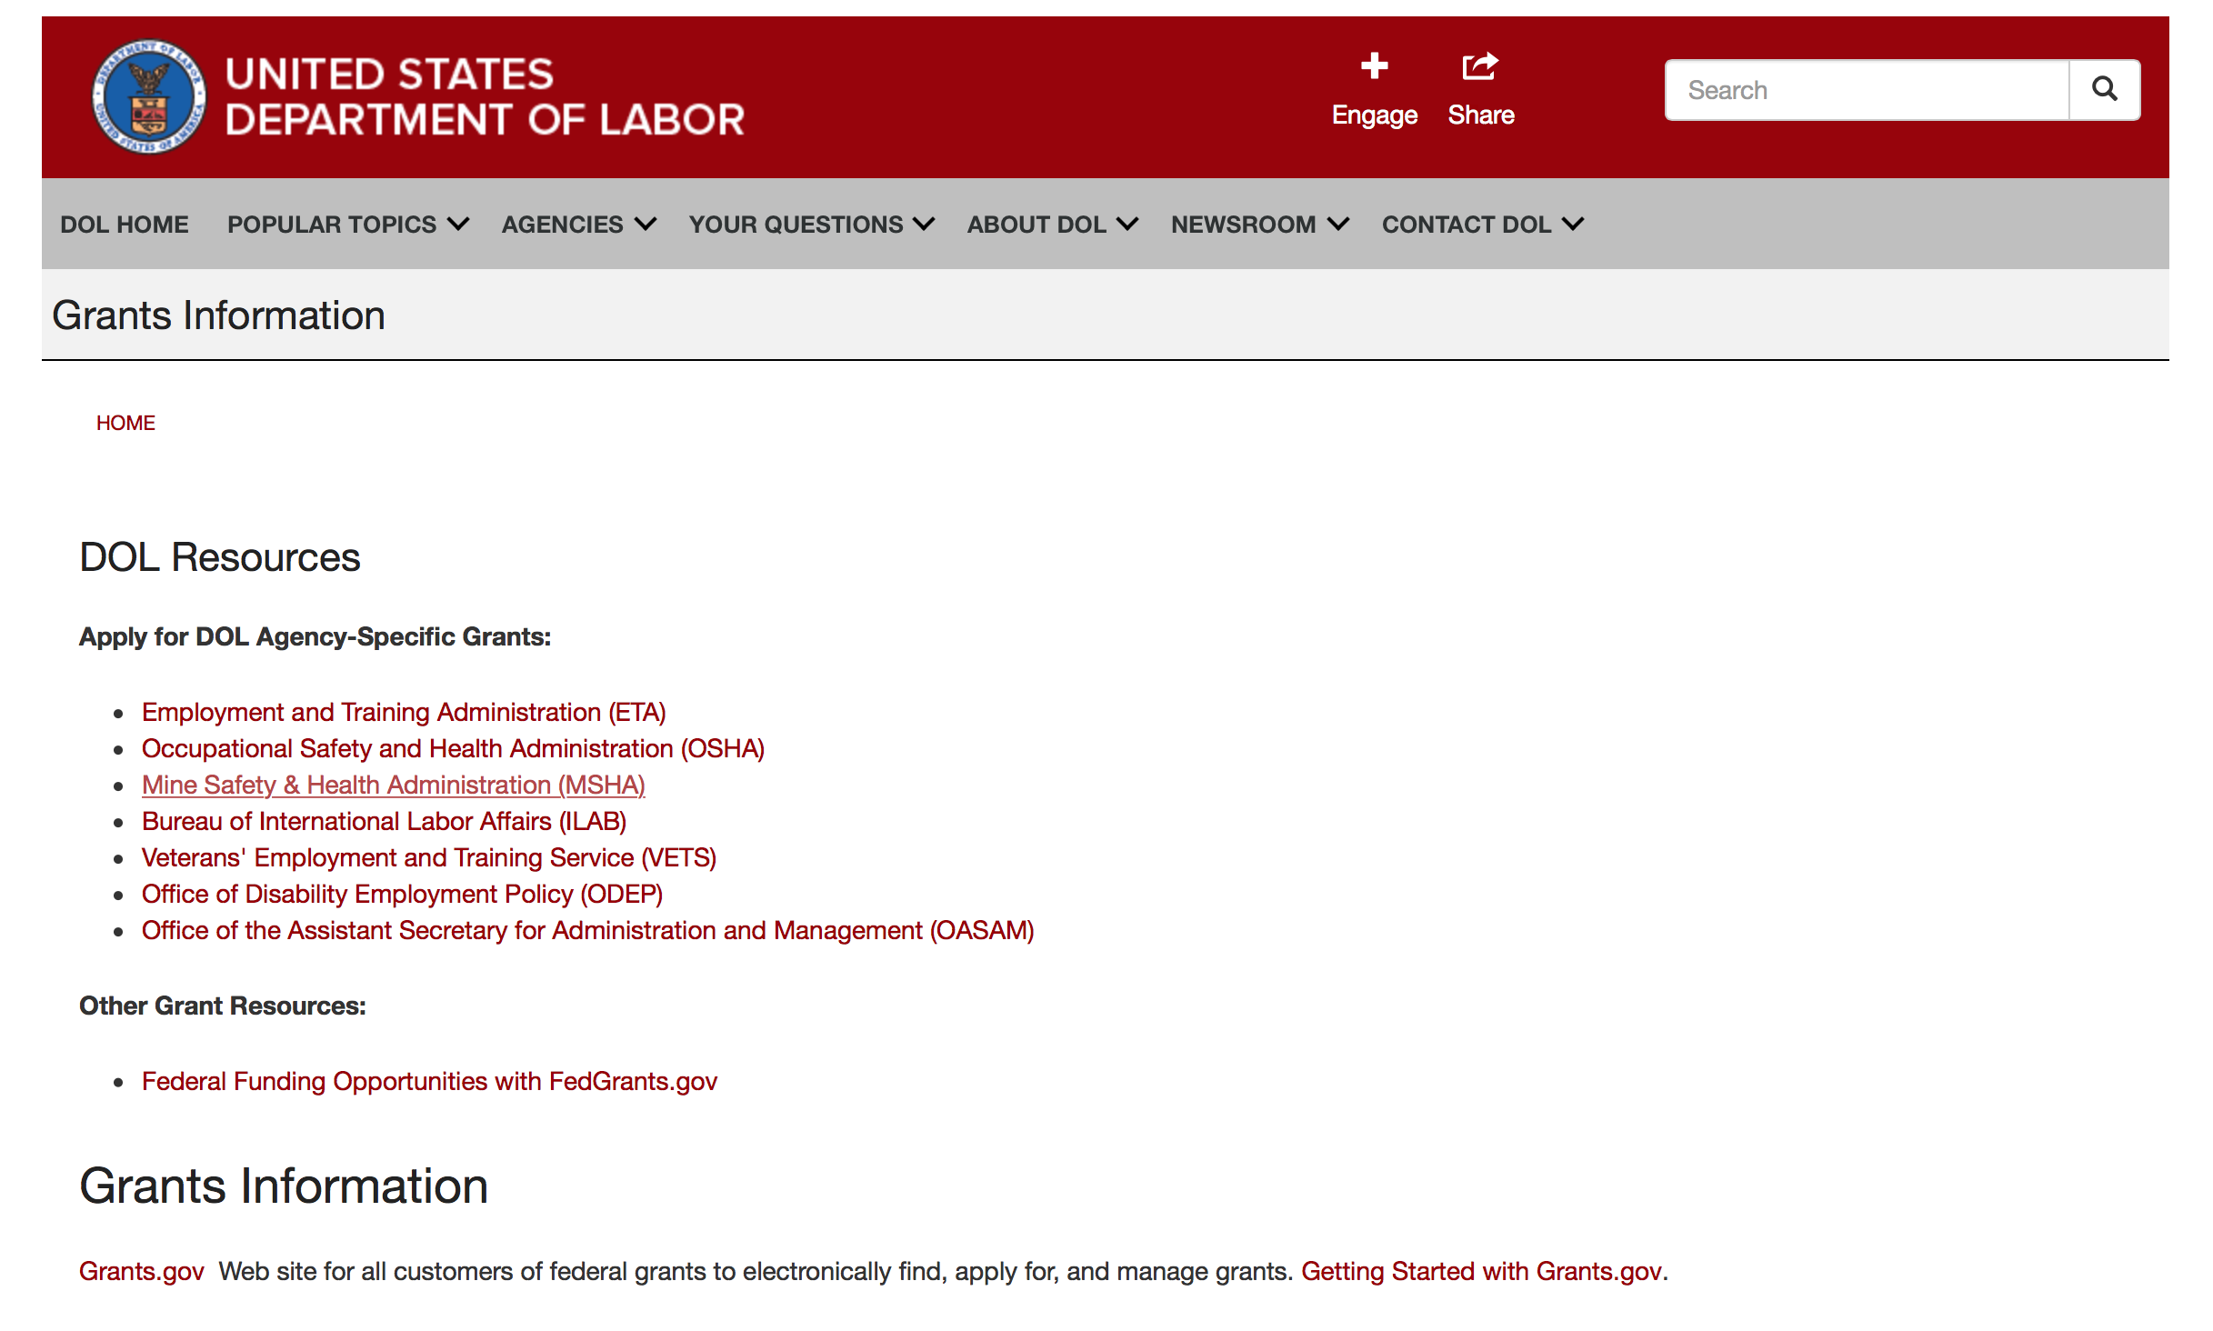

Agency Grants and Contract General Overview

DOL Resources
Apply for DOL Agency-Specific Grants:
- Employment and Training Administration (ETA)
- Occupational Safety and Health Administration (OSHA)
- Mine Safety & Health Administration (MSHA)
- Bureau of International Labor Affairs (ILAB)
- Veterans' Employment and Training Service (VETS)
- Office of Disability Employment Policy (ODEP)
- Office of the Assistant Secretary for Administration and Management (OASAM)

Other Grant Resources:
- Federal Funding Opportunities with FedGrants.gov
Grants Information
Grants.gov — Web site for all customers of federal grants to electronically find, apply for, and manage grants. Getting Started with Grants.gov.

DOL Resources and Instructions for Applying for a Grant
- DOL Guidance Clarifying the Effect of the Religious Freedom Restoration Act on Faith-Based Organizations
- Grant and Contract Information
- Contracting and Grant Program Overview
- Annual Acquisition Plan & Procurement Forecast
- Civil Rights Enforcement for Department of Labor Grant Recipients
- More Information About Grants
- Use of Contracts, Grants & Cooperative Agreements

Other Federal Government Grant Information
- List of Parties Excluded From Federal Procurement and Nonprocurement Programs (as created and maintained by GSA)
- Grant Opportunities (Catalog of Federal Domestic Assistance)

Department of Labor Grant Programs

- Bureau of International Labor Affairs (ILAB): provides grants (cooperative agreements) for the implementation of projects designed to assist developing countries combat the worse forms of child labor, forced labor, and human trafficking; and support worker rights and improve working conditions. http://www.dol.gov/general/business.
- Bureau of Labor Statistics (BLS): provides project grants (cooperative agreements) and the dissemination of technical statistical data and related information on labor force activities; provides data on prices (CPI) and cost of living; data on productivity and technology data; data on compensation and working conditions; data on employment projections.
- Employment and Training (ETA): ETA administers financial assistance programs pursuant to the Workforce Investment Act (WIA), administering State formula grant programs for youth, adults and dislocated workers, national emergency grants for workers affected by mass layoffs, plant closures, and disasters; grant programs for workers with disabilities, Indians and Native Americans, and for migrant and seasonal farmworkers. ETA also administers grant programs for older American workers, apprenticeship programs, Trade Adjustment Assistance (TAA) programs, and assistance for research and development of workforce programs. In addition, ETA is responsible for the operation and maintenance of a national system of public employment service offices and for the national unemployment insurance program.
- Mine Safety and Health (MSHA): provides grants for research, education and training programs to ensure an adequate and competent staff of trained inspectors; and assistance for establishing or improving State mine health and safety programs through technical assistance.
- Occupational Safety and Health (OSHA): provides grants to non-profit organizations to provide training, educational services, and technical assistance; assistance to states to administer and enforce state programs; assistance to states to provide occupational safety and health technical assistance and consultant services.
- Office of Disability Employment Policy (ODEP): The Office of Disability Employment Policy awards competitive grants establishing short-term pilot and technical assistance projects designed to identify, develop, test, evaluate, and disseminate policies to increase employment by expanding access to training, education, employment supports, assistive and systems technology, integrated employment, entrepreneurial development, and small business opportunities for adults and youth with disabilities. Current pilots projects focus on customized employment, Olmstead populations, and innovative demonstration youth grants, among others. Solicitations for grant applications are published in the Federal Register and announced at www.dol.gov/odep. ODEP grants are awarded by the OASAM grant office.
- Veterans' Employment and Training (VETS): provides special employment and training assistance for veterans through the Disabled Veterans' Outreach Program (DVOP) Solicitation for Grant Applications; the Local Veterans' Employment Representative Program (LVER); Veterans' Workforce Investment Program (VWIP); elaws Advisor on veterans' employment and reemployment rights; and the Homeless Veterans Reintegration Project (HVRP). VETS grants are awarded by the OASAM grant office.

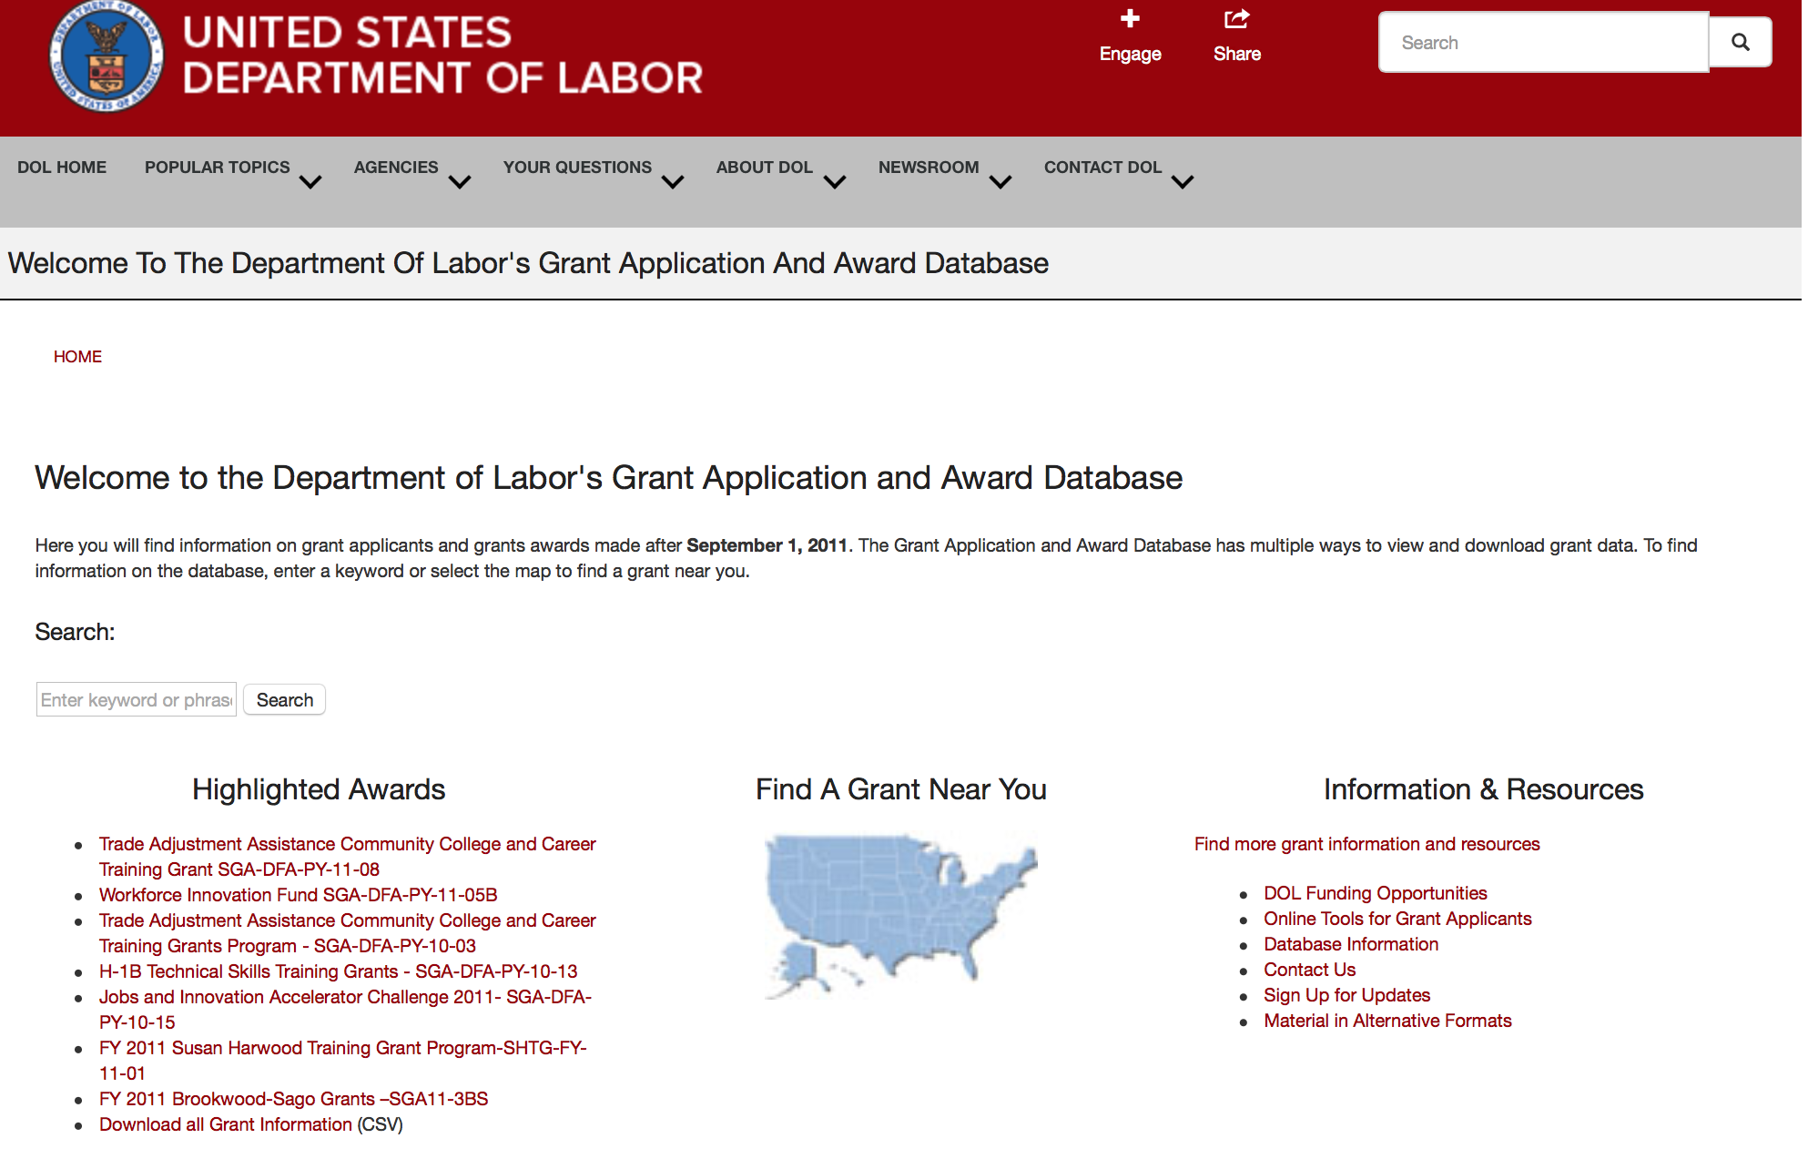

http://www.dol.gov/dol/grants/

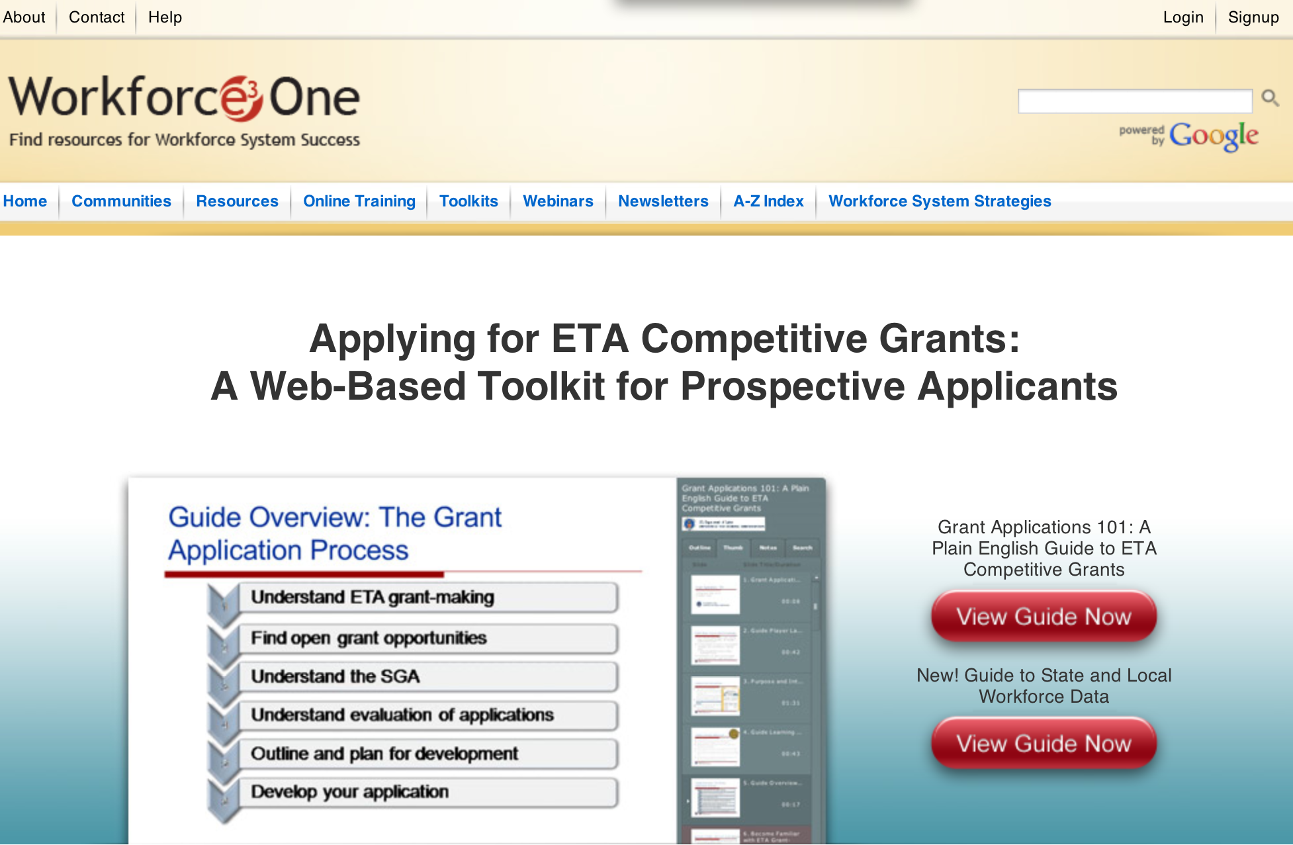

https://www.workforce3one.org/ws/www/pages/grants_toolkit.aspx?pparams=/

Programs

Modifications

Reminders



National Aeronautics and Space Administration

Research and Contracting Opportunities

NASA Research Opportunities Online

- Various NASA offices publish their research announcements over the Internet, broadening the opportunity for researchers to apply for funding. This site provides access to current research announcements along with their specific due dates.

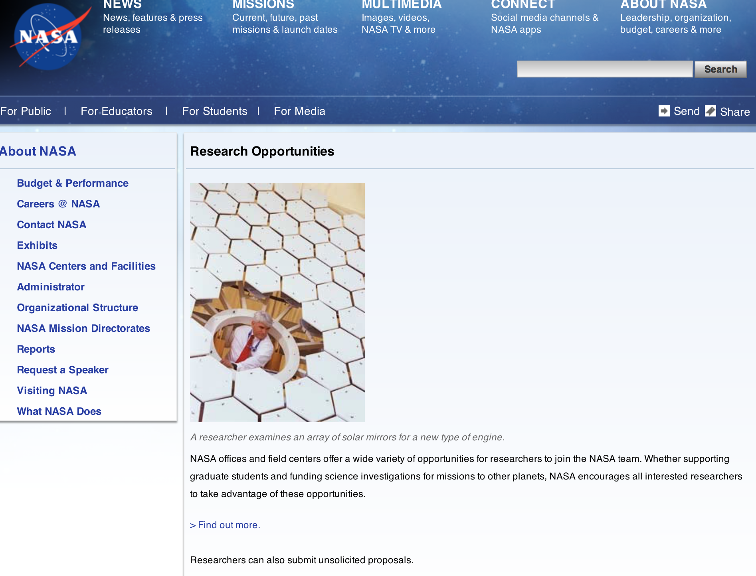

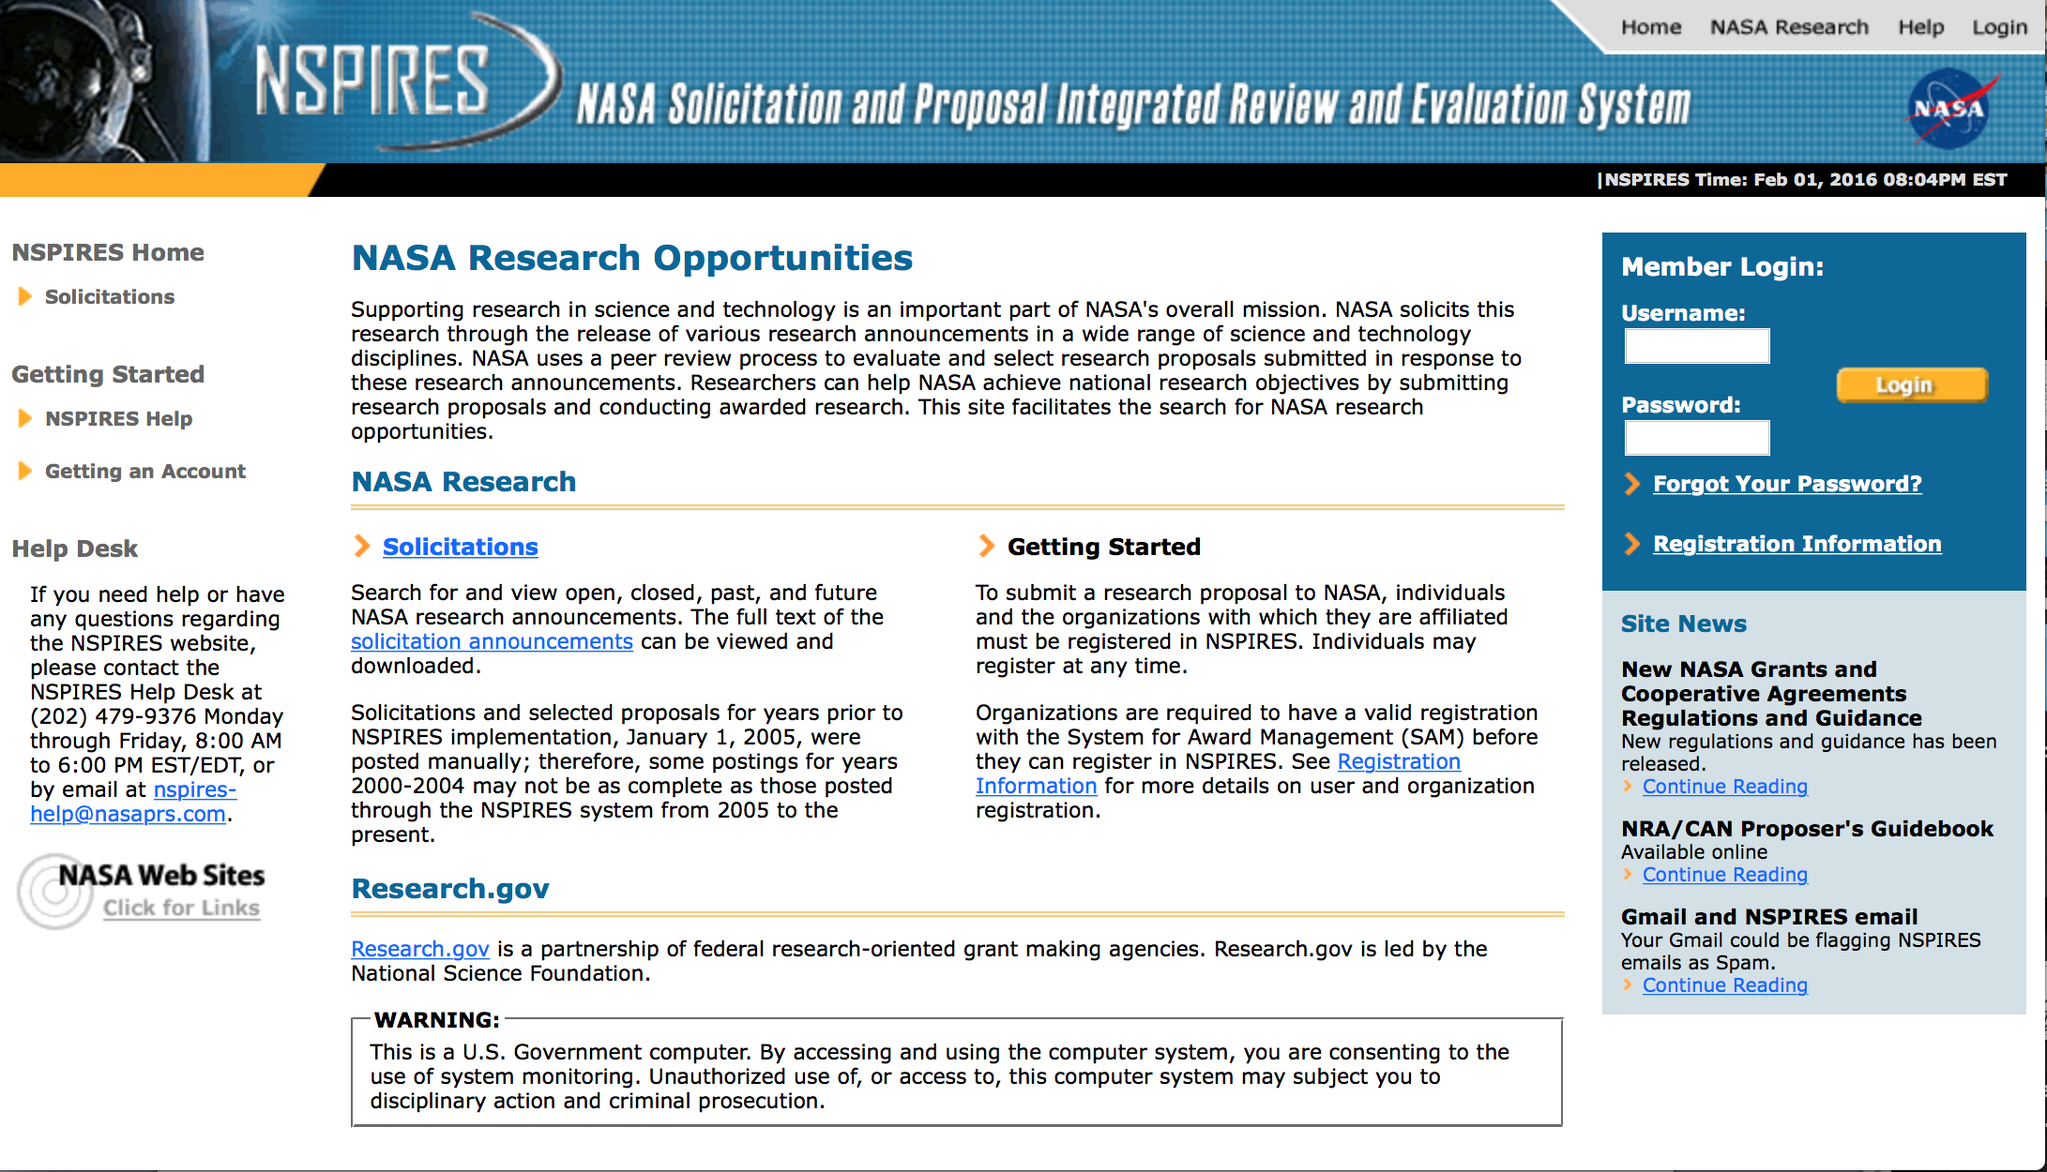

http://nspires.nasaprs.com/external/

Research Programs:

NASA Headquarters
ROSES 2016: Terrestrial Ecology: An Airborne Campaign for the Arctic-Boreal Vulnerability Experiment (ABoVE) Grant
http://www.grants.gov/web/grants/view-opportunity.html?oppId=282911

NASA Headquarters
ROSES 2016: Terrestrial Hydrology Program Grant
http://www.grants.gov/web/grants/view-opportunity.html?oppId=283210

NASA Headquarters
D.5 University Leadership Initiative Grant
http://www.grants.gov/web/grants/view-opportunity.html?oppId=283279

NASA Headquarters
Research Opportunities In Aeronautics – 2016 Grant
http://www.grants.gov/web/grants/view-opportunity.html?oppId=283110

NASA Headquarters
A.2: Advanced Air Transport Technology (AATT) Project Grant
http://www.grants.gov/web/grants/view-opportunity.html?oppId=283111

NASA Headquarters
ROSES 2016: Exobiology Grant
http://www.grants.gov/web/grants/view-opportunity.html?oppId=283000

NASA Headquarters
ROSES 2016: Heliophysics Technology and Instrument Development for Science Grant
http://www.grants.gov/web/grants/view-opportunity.html?oppId=283001

NASA Headquarters
ROSES 2016: Heliophysics Data Environment Enhancements Grant
http://www.grants.gov/web/grants/view-opportunity.html?oppId=283002

NASA Headquarters
ROSES 2016: Instrument Incubator Program Grant
http://www.grants.gov/web/grants/view-opportunity.html?oppId=282874

NASA Headquarters
ROSES 2016: Physical Oceanography Grant
http://www.grants.gov/web/grants/view-opportunity.html?oppId=283424

NASA Headquarters
ROSES 2016: Maturation of Instruments for Solar System Exploration
Modification 1
http://www.grants.gov/web/grants/view-opportunity.html?oppId=282380

NASA Headquarters
ROSES 2016: Emerging Worlds
Modification 2
http://www.grants.gov/web/grants/view-opportunity.html?oppId=281873

NASA Headquarters
ROSES 2016: Solar System Observations
Modification 2
http://www.grants.gov/web/grants/view-opportunity.html?oppId=281849

NASA Headquarters
ROSES 2016: Cassini Data Analysis Program
Modification 2
http://www.grants.gov/web/grants/view-opportunity.html?oppId=281886

NASA Headquarters
ROSES 2016: Exoplanets Research Program
Modification 2
http://www.grants.gov/web/grants/view-opportunity.html?oppId=281888

National Archives and Records Administration

Grant Opportunities General Overview

To access the information below: click here

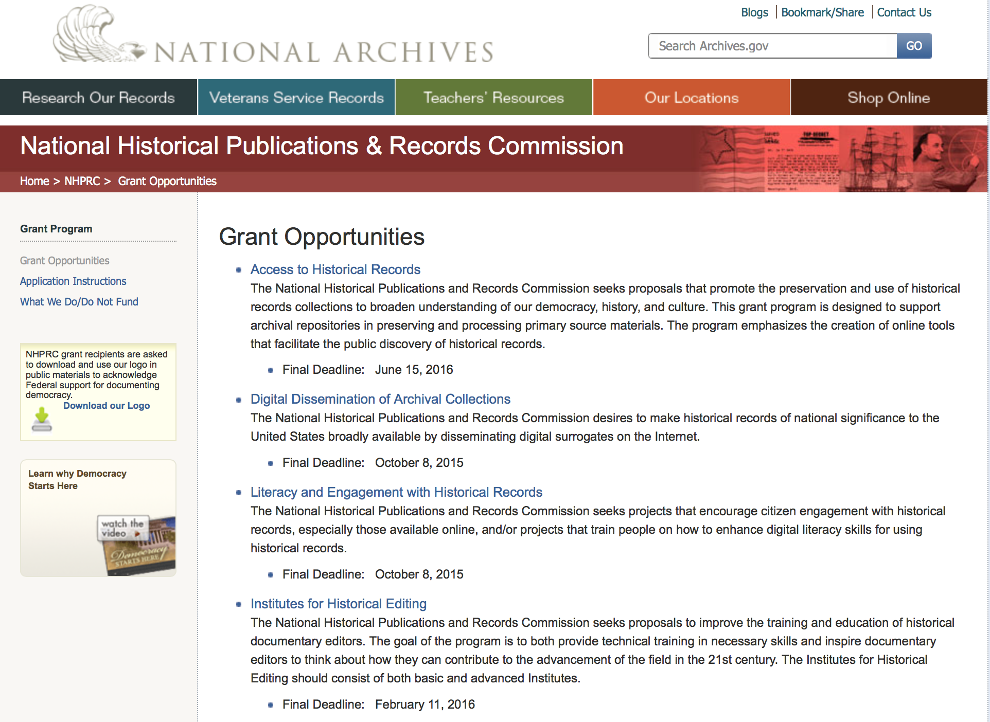

Reminders:

State Board Programming Grants

Document Type: | Grants Notice
Funding Opportunity Number: | STATE-201606
Funding Opportunity Title: | State Board Programming Grants
Opportunity Category: | Discretionary
Funding Instrument Type: | Grant
Category of Funding Activity: | Humanities (see "Cultural Affairs" in CFDA)
Category Explanation:
Expected Number of Awards: | 25
CFDA Number(s): | 89.003 -- National Historical Publications and Records Grants
Cost Sharing or Matching Requirement: | Yes
Posted Date: | Nov 24, 2015
Creation Date: | Nov 23, 2015
Original Closing Date for Applications: | Jun 15, 2016
Current Closing Date for Applications: | Jun 15, 2016
Archive Date: | Jul 15, 2016
Estimated Total Program Funding: | $650,000
Award Ceiling: | $80,000
Award Floor: | $0
Eligible Applicants: | State governments  Public and State controlled institutions of higher education  Others (see text field entitled "Additional Information on Eligibility" for clarification)  Nonprofits having a 501(c)(3) status with the IRS, other than institutions of higher education
Additional Information on Eligibility: | These grants are awarded only to SHRABs in each state, or to the state agency responsible for the SHRAB, ordinarily the state archives. Another state agency, or a non-profit organization, such as a foundation or university, acting on behalf of the designated state agency may apply. States also include the District of Columbia, the Commonwealth of Puerto Rico, and United States territories.
Agency Name: | National Archives and Records Administration
Description: | The National Historical Publications and Records Commission seeks proposals that strengthen the nation’s archival network through activities undertaken by state historical records advisory boards (SHRABs). The purpose of this grant program is to assist state boards to enhance access to historical records, increase citizen engagement with records, and provide learning and development opportunities for students, citizens and professional archivists. The Commission will award grants to State Historical Records Advisory Boards to: • Provide educational and outreach programs, workshops, and other activities that enhance citizen and student engagement with historical records • Operate state-based regrant and scholarship programs that advance access to historical records • Collaborate on projects with other organizations to address common problems or shared opportunities within a state or among a consortium of state archives • Hold or participate in meetings and public forums on statewide or national archival issues. For a comprehensive list of Commission limitations on funding, please see What We Do and Do Not Fund. Applications that consist entirely of ineligible activities will not be considered. Award Information A grant is for one year and for up to $40,000 or for two years and for up to $80,000. The NHPRC expects to award approximately 25 grants in this program. The total amount allocated for this program is up to $650,000. Grants begin no earlier than January 1, 2017. The Commission requires that grant recipients acknowledge NHPRC grant assistance in all publicity, publications, and other products that result from its support. Eligibility These grants are awarded only to SHRABs in each state, or to the state agency responsible for the SHRAB, ordinarily the state archives. Another state agency, or a non-profit organization, such as a foundation or university, acting on behalf of the designated state agency may apply. States also include the District of Columbia, the Commonwealth of Puerto Rico, and United States territories. Cost Sharing The total costs of a project are shared between the NHPRC and the applicant organization. The Commission provides no more than 75 per cent of total direct project costs in the State Board Programming Grants category. NHPRC grant recipients are not permitted to use grant funds for indirect costs (as indicated in 2 CFR 2600.101). Cost sharing is required. The applicant’s financial contribution may include both direct and indirect expenses, in-kind contributions, non-Federal third-party contributions, and any income earned directly by the project. Indirect costs must be listed under the applicant’s cost sharing contribution. Other Requirements Applicant organizations must be registered in System for Award Management (SAM) prior to submitting an application, maintain SAM registration throughout the application and award process, and include a valid DUNS number in their application. Details on SAM registration and requesting a DUNS number can be found at the System for Award Management website at https://sam.gov. Please refer to the User Guides section and the Grants Registrations PDF. A complete application includes the Application for Federal Assistance (Standard Form 424), Assurances - Non-Construction Programs (Standard Form 424B), a Project Narrative, Summary, Supplementary Materials, and Budget. Applications lacking these items will not be considered. Ineligible applications will not be reviewed.
Link to Additional Information: | Link to full grant announcement, including additional requirements
Contact Information: | If you have difficulty accessing the full announcement electronically, please contact:  Jeff de la Concepcion Grant Program Specialist Phone 202-357-5022  Grant Program Specialist

http://www.grants.gov/web/grants/view-opportunity.html?oppId=280200

Publishing Historical Records in Documentary Editions Grant

Document Type: | Grants Notice
Funding Opportunity Number: | EDITIONS-201606
Funding Opportunity Title: | Publishing Historical Records in Documentary Editions
Opportunity Category: | Discretionary
Funding Instrument Type: | Grant
Category of Funding Activity: | Humanities (see "Cultural Affairs" in CFDA)
Category Explanation:
Expected Number of Awards: | 25
CFDA Number(s): | 89.003 -- National Historical Publications and Records Grants
Cost Sharing or Matching Requirement: | Yes
Posted Date: | Nov 24, 2015
Creation Date: | Nov 23, 2015
Original Closing Date for Applications: | Jun 15, 2016
Current Closing Date for Applications: | Jun 15, 2016
Archive Date: | Jul 15, 2016
Estimated Total Program Funding: | $2,500,000
Award Ceiling: | $200,000
Award Floor: | $0
Eligible Applicants: | County governments  Native American tribal governments (Federally recognized)  City or township governments  Private institutions of higher education  Nonprofits having a 501(c)(3) status with the IRS, other than institutions of higher education  State governments  Public and State controlled institutions of higher education
Agency Name: | National Archives and Records Administration
Description: | The National Historical Publications and Records Commission seeks proposals to publish documentary editions of historical records. Projects may focus on the papers of major figures from American history or cover broad historical movements in politics, military, business, social reform, the arts, and other aspects of the national experience. The historical value of the records and their expected usefulness to broad audiences must justify the costs of the project. The goal of this program is to provide access to, and editorial context for, the historical documents and records that tell the American story. The NHPRC encourages projects, whenever possible and appropriate, to provide access to these materials in a free and open online environment, without precluding other forms of publication. Applicants should demonstrate familiarity with the best practices recommended by the Association for Documentary Editing or the Modern Language Association Committee on Scholarly Editions. Projects may also prepare print editions as part of their overall publishing plan. However, projects that do not have definitive plans for digital dissemination and preservation in place at the time of application will not be considered. It is also expected that the contents of any print volumes produced will be made available online within a reasonable period of time following print publication. Grants are awarded for collecting, describing, preserving, compiling, transcribing, annotating, editing, encoding, and publishing documentary source materials in print and online. Because of the focus on documentary sources, grants do not support preparation of critical editions of published works unless such works are just a small portion of the larger project. All applicants should be aware that the application process is highly competitive. Ongoing projects: Applicants from ongoing projects must demonstrate that they have successfully achieved the performance objectives associated with previous NHPRC awards; provide updated, current information, including a description of the new activities as well as description and significance of the specific materials to be edited during the proposed grant period; show progress towards completing the edition; and justify costs in a new budget. For a comprehensive list of Commission's limitations on funding, please see What We Do and Do Not Fund. Applications that consist entirely of ineligible activities will not be considered. Award Information A grant is for one year and for up to $200,000. The Commission expects to make up to 25 grants in this category for a total of up to $2,500,000. Grants begin no earlier than January 1, 2017. The Commission requires that grant recipients acknowledge NHPRC grant assistance in all publications and other products that result from its support. Eligibility U.S. nonprofit organizations or institutions U.S. colleges, universities, and other academic institutions State or local government agencies Federally-acknowledged or state-recognized Native American tribes or groups Cost Sharing The total costs of a project are shared between the NHPRC and the applicant organization. The Commission provides no more than 50 per cent of total direct project costs in the Publishing Historical Records in Documentary Editions category. NHPRC grant recipients are not permitted to use grant funds for indirect costs (as indicated in 2 CFR 2600.101). Cost sharing is required. The applicant’s financial contribution may include both direct and indirect expenses, in-kind contributions, non-Federal third-party contributions, and any income earned directly by the project. Indirect costs must be listed under the applicant’s cost sharing contribution. Other Requirements Applicant organizations must be registered in the System for Award Management (SAM) prior to submitting an application, maintain SAM registration throughout the application and award process, and include a valid DUNS number in their application. Details on SAM registration and requesting a DUNS number can be found at the System for Award Management website at https://sam.gov. Please refer to the User Guides section and the Grants Registrations PDF. A complete application includes the Application for Federal Assistance (Standard Form 424), Assurances -- Non-Construction Programs (Standard Form 424B), a Project Narrative, Summary, Supplementary Materials, and Budget. Applications lacking these items will not be considered. Ineligible applications will not be reviewed.
Link to Additional Information: | Link to full grant announcement, including additional requirements
Contact Information: | If you have difficulty accessing the full announcement electronically, please contact:  Jeff de la Concepcion Grant Program Specialist Phone 202-357-5022  Grant Program Specialist

http://www.grants.gov/web/grants/view-opportunity.html?oppId=280201

Publishing Historical Records in Documentary Editions Grant

Document Type: | Grants Notice
Funding Opportunity Number: | EDITIONS-201610
Funding Opportunity Title: | Publishing Historical Records in Documentary Editions
Opportunity Category: | Discretionary
Funding Instrument Type: | Grant
Category of Funding Activity: | Humanities (see "Cultural Affairs" in CFDA)
Category Explanation:
Expected Number of Awards: | 25
CFDA Number(s): | 89.003 -- National Historical Publications and Records Grants
Cost Sharing or Matching Requirement: | Yes
Posted Date: | Nov 24, 2015
Creation Date: | Nov 23, 2015
Original Closing Date for Applications: | Oct 6, 2016
Current Closing Date for Applications: | Oct 6, 2016
Archive Date: | Nov 4, 2016
Estimated Total Program Funding: | $2,500,000
Award Ceiling: | $200,000
Award Floor: | $0
Eligible Applicants: | Private institutions of higher education  County governments  City or township governments  Public and State controlled institutions of higher education  Native American tribal governments (Federally recognized)  Nonprofits having a 501(c)(3) status with the IRS, other than institutions of higher education  State governments
Agency Name: | National Archives and Records Administration
Description: | The National Historical Publications and Records Commission seeks proposals to publish documentary editions of historical records. Projects may focus on the papers of major figures from American history or cover broad historical movements in politics, military, business, social reform, the arts, and other aspects of the national experience. The historical value of the records and their expected usefulness to broad audiences must justify the costs of the project. The goal of this program is to provide access to, and editorial context for, the historical documents and records that tell the American story. The NHPRC encourages projects, whenever possible and appropriate, to provide access to these materials in a free and open online environment, without precluding other forms of publication. Applicants should demonstrate familiarity with the best practices recommended by the Association for Documentary Editing or the Modern Language Association Committee on Scholarly Editions. Projects may also prepare print editions as part of their overall publishing plan. However, projects that do not have definitive plans for digital dissemination and preservation in place at the time of application will not be considered. It is also expected that the contents of any print volumes produced will be made available online within a reasonable period of time following print publication. Grants are awarded for collecting, describing, preserving, compiling, transcribing, annotating, editing, encoding, and publishing documentary source materials in print and online. Because of the focus on documentary sources, grants do not support preparation of critical editions of published works unless such works are just a small portion of the larger project. All applicants should be aware that the application process is highly competitive. Ongoing projects: Applicants from ongoing projects must demonstrate that they have successfully achieved the performance objectives associated with previous NHPRC awards; provide updated, current information, including a description of the new activities as well as description and significance of the specific materials to be edited during the proposed grant period; show progress towards completing the edition; and justify costs in a new budget. For a comprehensive list of Commission's limitations on funding, please see What We Do and Do Not Fund. Applications that consist entirely of ineligible activities will not be considered. Award Information A grant is for one year and for up to $200,000. The Commission expects to make up to 25 grants in this category for a total of up to $2,500,000. Grants begin no earlier than January 1, 2017. The Commission requires that grant recipients acknowledge NHPRC grant assistance in all publications and other products that result from its support. Eligibility U.S. nonprofit organizations or institutions U.S. colleges, universities, and other academic institutions State or local government agencies Federally-acknowledged or state-recognized Native American tribes or groups Cost Sharing The total costs of a project are shared between the NHPRC and the applicant organization. The Commission provides no more than 50 per cent of total direct project costs in the Publishing Historical Records in Documentary Editions category. NHPRC grant recipients are not permitted to use grant funds for indirect costs (as indicated in 2 CFR 2600.101). Cost sharing is required. The applicant’s financial contribution may include both direct and indirect expenses, in-kind contributions, non-Federal third-party contributions, and any income earned directly by the project. Indirect costs must be listed under the applicant’s cost sharing contribution. Other Requirements Applicant organizations must be registered in the System for Award Management (SAM) prior to submitting an application, maintain SAM registration throughout the application and award process, and include a valid DUNS number in their application. Details on SAM registration and requesting a DUNS number can be found at the System for Award Management website at https://sam.gov. Please refer to the User Guides section and the Grants Registrations PDF. A complete application includes the Application for Federal Assistance (Standard Form 424), Assurances -- Non-Construction Programs (Standard Form 424B), a Project Narrative, Summary, Supplementary Materials, and Budget. Applications lacking these items will not be considered. Ineligible applications will not be reviewed.
Link to Additional Information: | Link to full grant announcement, including additional requirements
Contact Information: | If you have difficulty accessing the full announcement electronically, please contact:  Jeff de la Concepcion Grant Program Specialist Phone 202-357-5022  Grant Program Specialist

http://www.grants.gov/web/grants/view-opportunity.html?oppId=280202

Access to Historical Records Grant

Document Type: | Grants Notice
Funding Opportunity Number: | ACCESS-201606
Funding Opportunity Title: | Access to Historical Records
Opportunity Category: | Discretionary
Funding Instrument Type: | Grant
Category of Funding Activity: | Humanities (see "Cultural Affairs" in CFDA)
Category Explanation:
Expected Number of Awards: | 14
CFDA Number(s): | 89.003 -- National Historical Publications and Records Grants
Cost Sharing or Matching Requirement: | Yes
Posted Date: | Nov 24, 2015
Creation Date: | Nov 23, 2015
Original Closing Date for Applications: | Jun 15, 2016
Current Closing Date for Applications: | Jun 15, 2016
Archive Date: | Jul 15, 2016
Estimated Total Program Funding: | $1,000,000
Award Ceiling: | $200,000
Eligible Applicants: | Public and State controlled institutions of higher education  State governments  City or township governments  Nonprofits having a 501(c)(3) status with the IRS, other than institutions of higher education  Private institutions of higher education  Native American tribal governments (Federally recognized)  County governments
Agency Name: | National Archives and Records Administration
Description: | The National Historical Publications and Records Commission seeks proposals that promote the preservation and use of historical records collections to broaden understanding of our democracy, history, and culture. This grant program is designed to support archival repositories in preserving and processing primary source materials. The program emphasizes the creation of online tools that facilitate the public discovery of historical records. The Commission looks to fund projects that undertake one or more of the following activities: • Preservation, arrangement, and online description of historical records in all formats • Digital preservation of electronic records and unstable audio or moving image formats After completing arrangement and description activities, applicants may also propose to digitize materials to provide online access to collections. For a comprehensive list of Commission limitations on funding, please see “What we do and do not fund” (http://www.archives.gov/nhprc/apply/eligibility.html). Applications that consist entirely of ineligible activities will not be considered. Award Information A grant is for one to two years and for up to $200,000. The Commission expects to make up to 14 grants in this category for a total of up to $1,000,000. Grants begin no earlier than January 1, 2017. The Commission requires that grant recipients acknowledge NHPRC grant assistance in all publicity, publications, and other products that result from its support. Eligibility Information Eligible applicants: • Nonprofit organizations or institutions • Colleges, universities, and other academic institutions • State or local government agencies • Federally-acknowledged or state-recognized Native American tribes or groups Cost Sharing - The total costs of a project are shared between the NHPRC and the applicant organization. The Commission provides no more than 50 per cent of total direct project costs in the Access to Historical Records category. NHPRC grant recipients are not permitted to use grant funds for indirect costs (as indicated in 2 CFR 2600.101). Cost sharing is required. The applicant’s financial contribution may include both direct and indirect expenses, in-kind contributions, non-Federal third-party contributions, and any income earned directly by the project. Indirect costs must be listed under the applicant’s cost sharing contribution. Other Requirements - Applicant organizations must be registered in the System for Award Management (SAM) prior to submitting an application, maintain SAM registration throughout the application and award process, and include a valid DUNS number in their application. Details on SAM registration and requesting a DUNS number can be found at the System for Award Management website at http://sam.gov. Please refer to the User Guides section and the Grants Registrations PDF. A complete application includes the Application for Federal Assistance (Standard Form 424), Assurances -- Non-Construction Programs (Standard Form 424B), a Project Narrative, Summary, Supplementary Materials, and Budget. Applications lacking these items will not be considered. Ineligible applications will not be reviewed.
Link to Additional Information: | Link to full grant announcement, including additional requirements
Contact Information: | If you have difficulty accessing the full announcement electronically, please contact:  Jeff de la Concepcion Grant Program Specialist Phone 202-357-5022  Grant Program Specialist

http://www.grants.gov/web/grants/view-opportunity.html?oppId=280217

National Endowment for the Arts

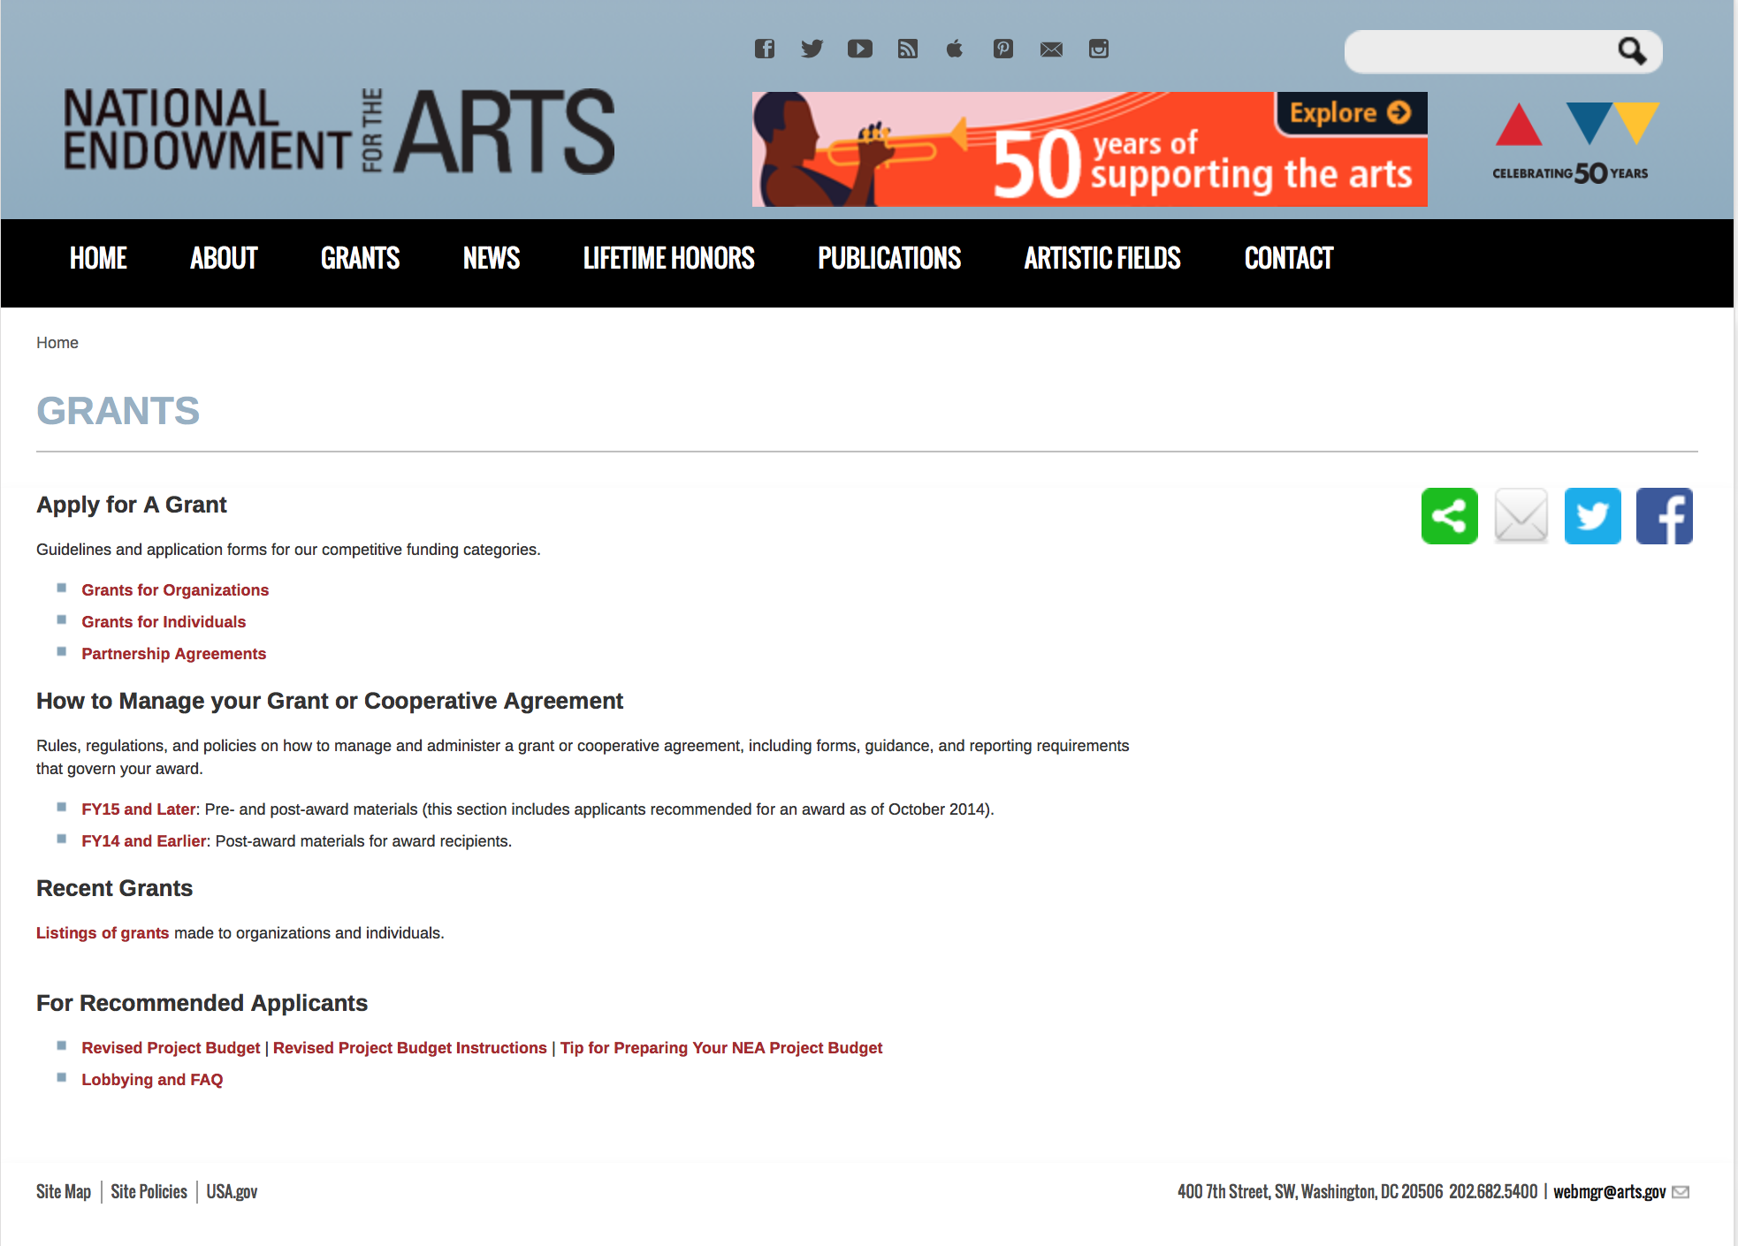

http://arts.gov/grants

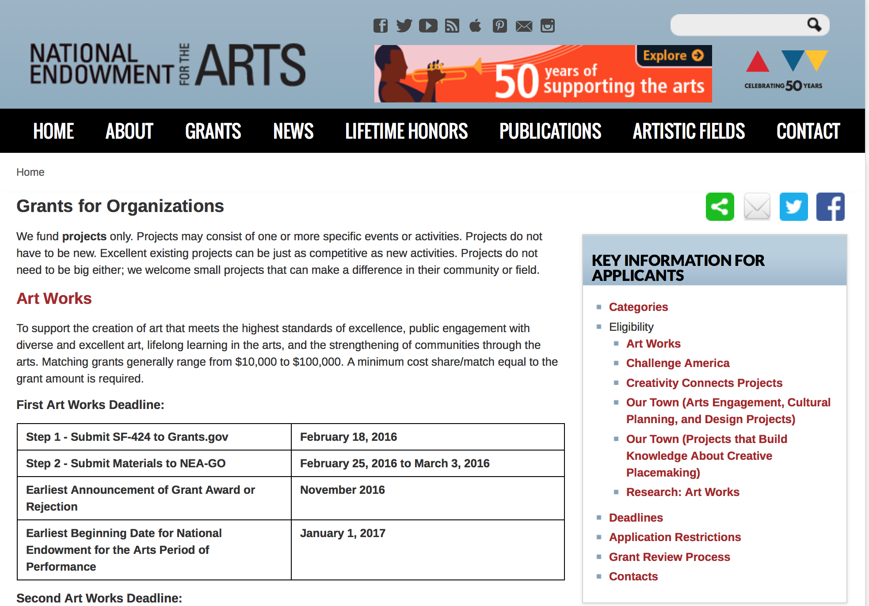
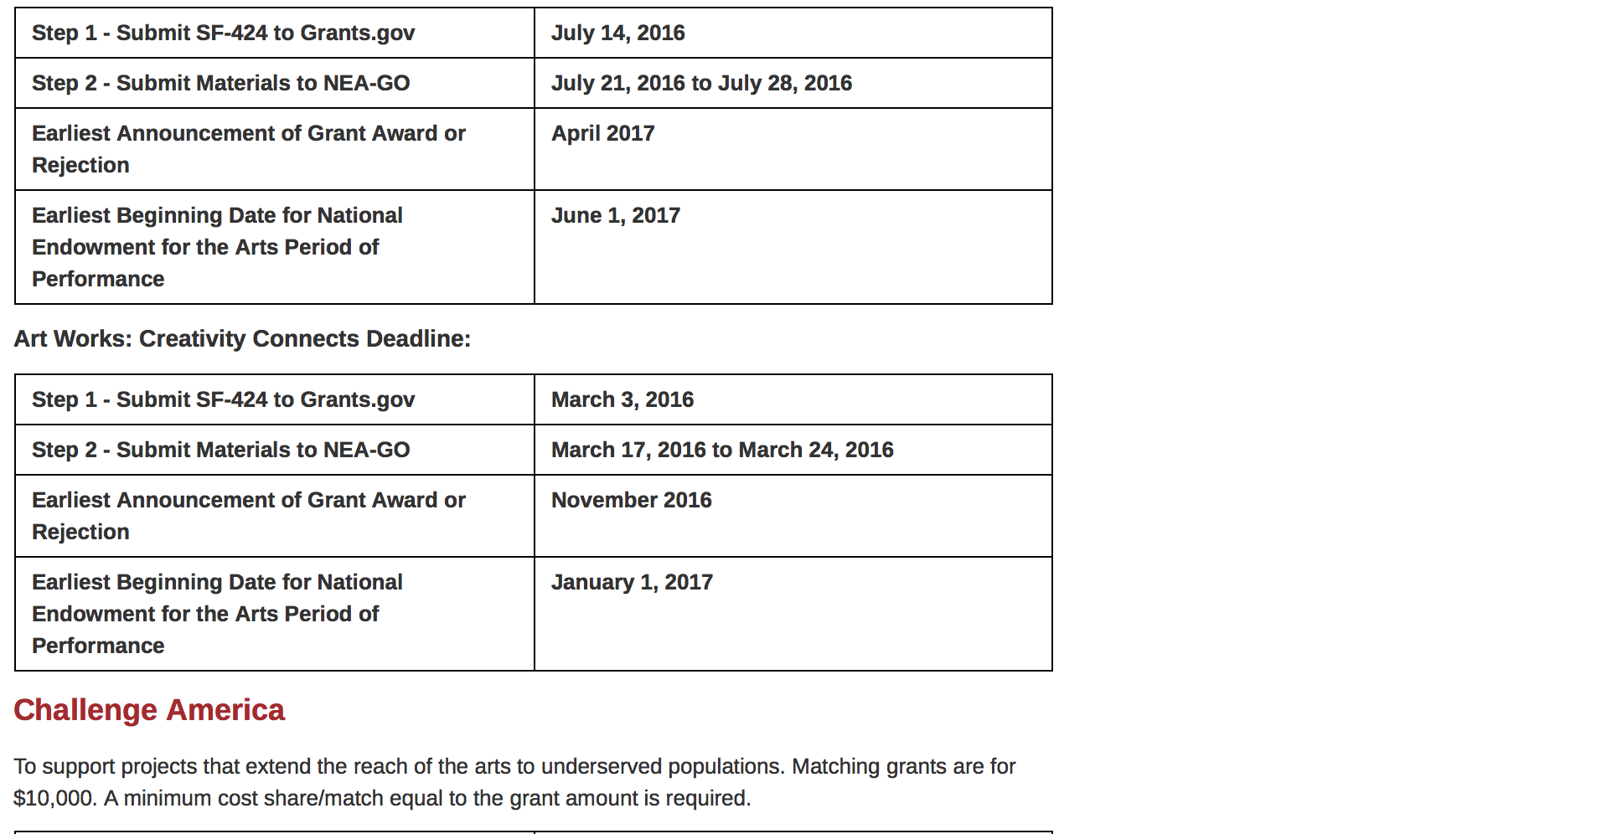
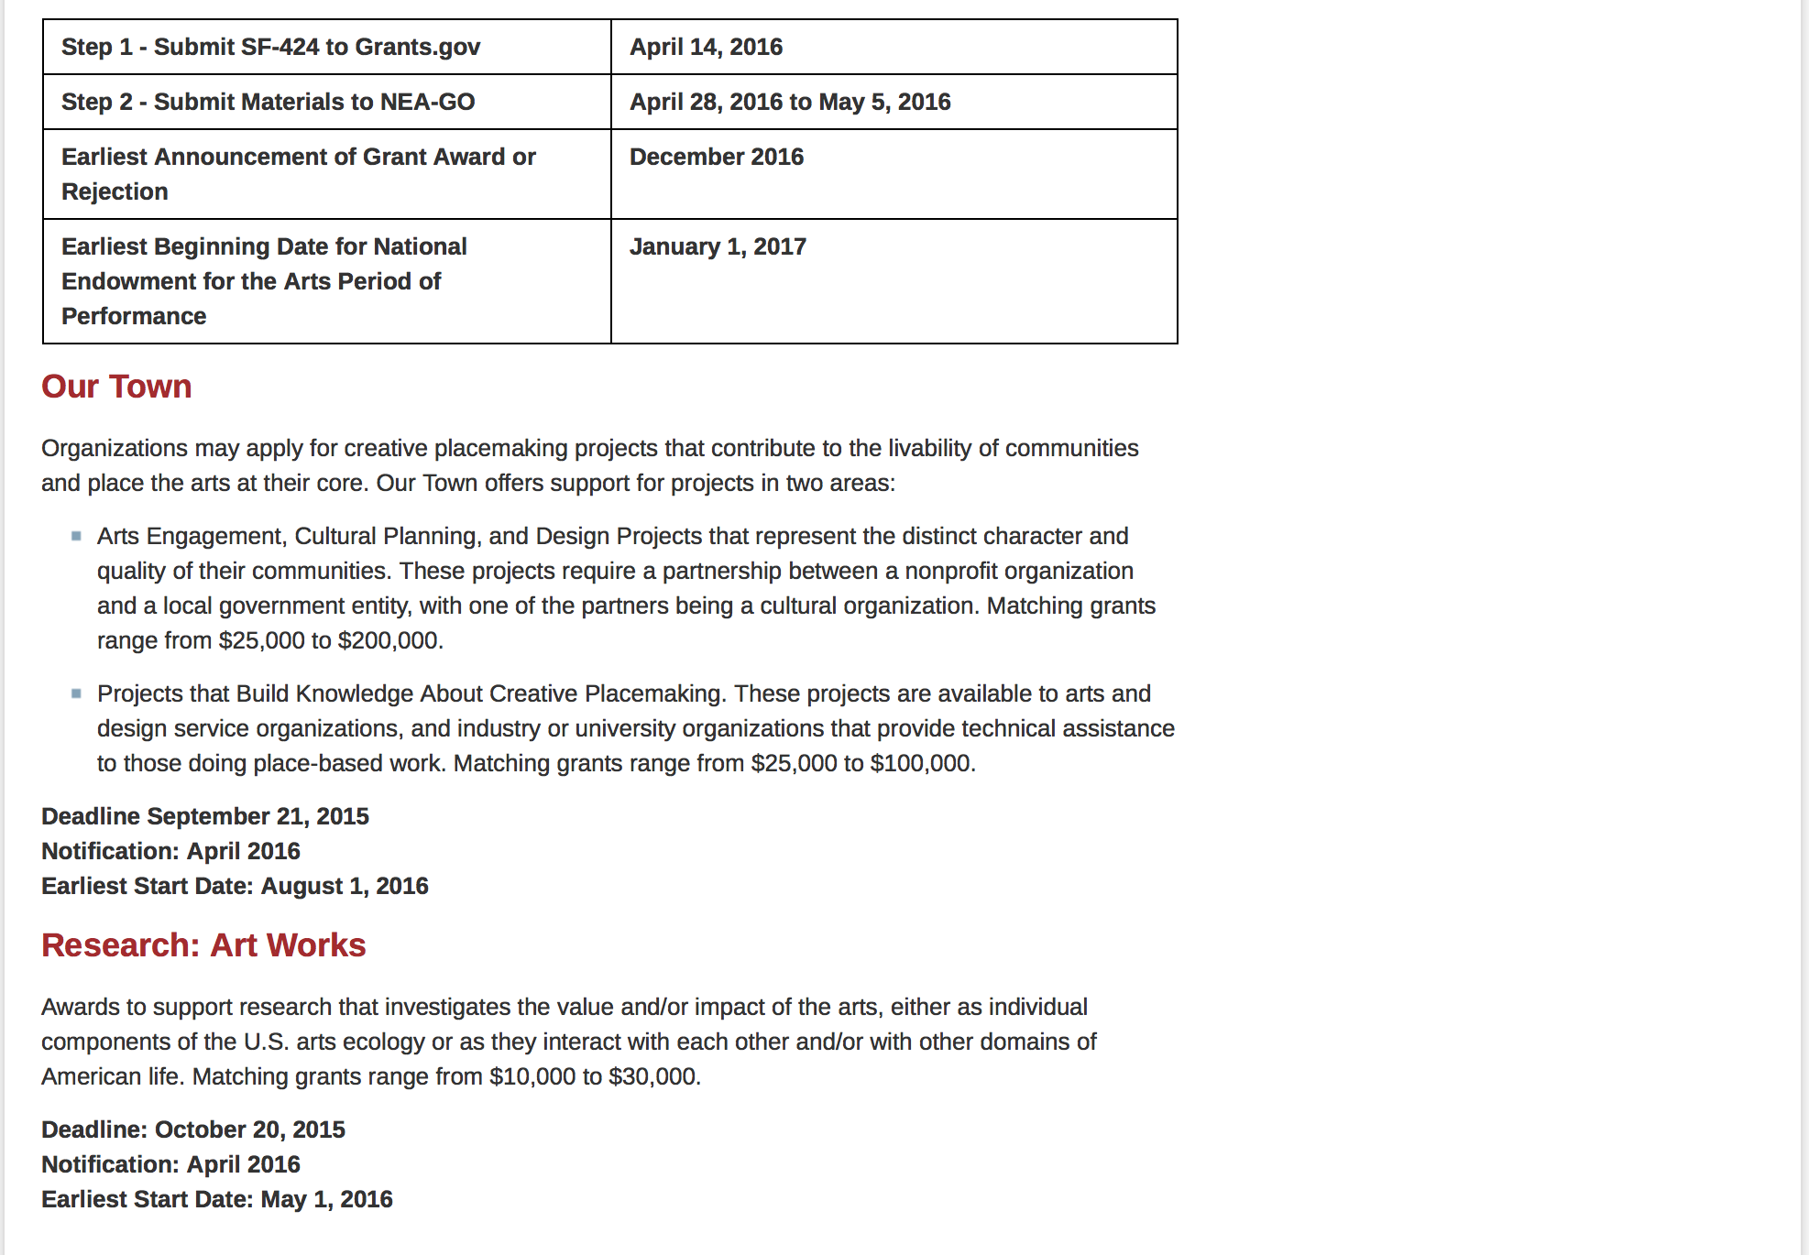
See more at: https://www.arts.gov/grants/apply-grant/grants-organizations

Programs:

Modifications:

Reminders:

National Endowment for the Humanities

Grant Overview -

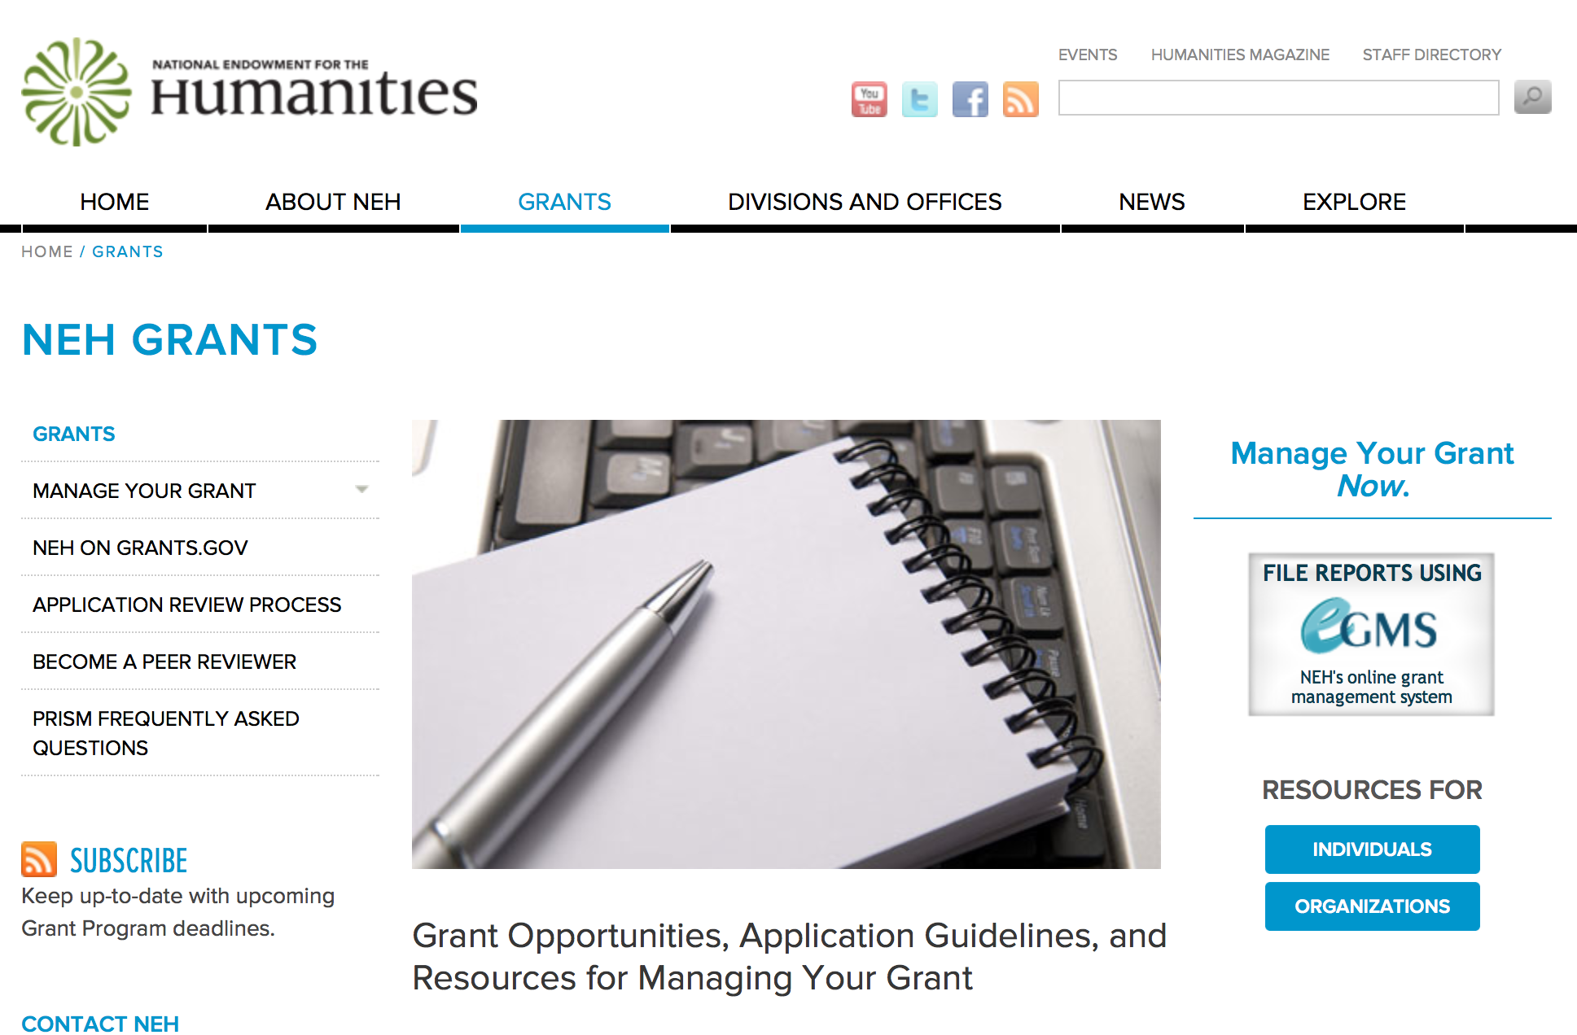

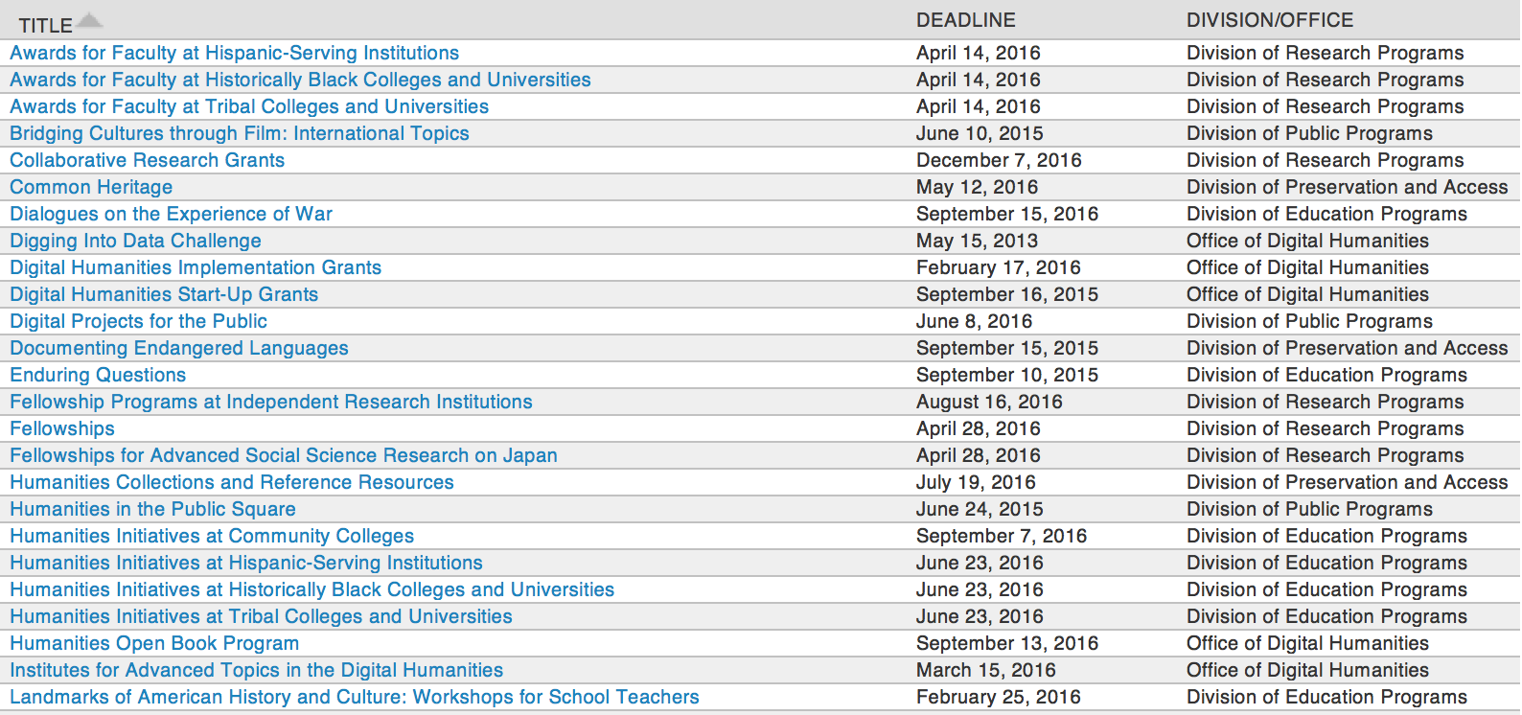

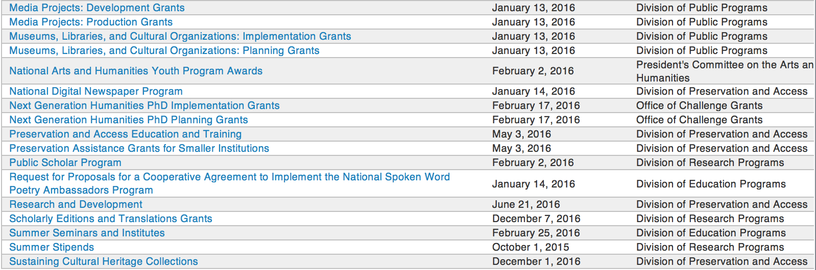

http://www.neh.gov/grants/grantsbydivision.html

Programs:

Humanities Connections Grant

Document Type: | Grants Notice
Funding Opportunity Number: | 20161005-AK
Funding Opportunity Title: | Humanities Connections
Opportunity Category: | Discretionary
Opportunity Category Explanation:
Funding Instrument Type: | Grant
Category of Funding Activity: | Humanities (see "Cultural Affairs" in CFDA)
Category Explanation:
Expected Number of Awards:
CFDA Number(s): | 45.162 -- Promotion of the Humanities Teaching and Learning Resources and Curriculum Development
Cost Sharing or Matching Requirement: | No
Posted Date: | Apr 19, 2016
Last Updated Date: | Apr 19, 2016
Original Closing Date for Applications: | Oct 05, 2016
Current Closing Date for Applications: | Oct 05, 2016
Archive Date:
Estimated Total Program Funding:
Award Ceiling: | $100,000
Award Floor: | $1
Eligible Applicants: | Public and State controlled institutions of higher education  Private institutions of higher education
Agency Name: | National Endowment for the Humanities
Description: | Humanities Connections grants seek to expand the role of the humanities in the undergraduate curriculum at two- and four-year institutions, offering students in all academic fields new opportunities to develop the intellectual skills and habits of mind that the humanities cultivate. Grant projects focus on connecting the resources and perspectives of the humanities to students’ broader educational and professional goals, regardless of their path of study. Through this new grant program, NEH invites proposals that reflect innovative and imaginative approaches to preparing students for their roles as engaged citizens and productive professionals in a rapidly changing and interdependent world. Grants support the development and implementation of an integrated set of courses and student engagement activities focusing on significant humanities content. A common topic, theme, or compelling issue or question must link the courses and activities. The linked courses (a minimum of three) may fulfill general education or core curriculum requirements but could also be designed primarily for students in a particular major or course of study. The Humanities Connections program gives special encouragement to projects that foster collaboration between humanities faculty and their counterparts in the social and natural sciences and pre-service or professional programs in business, engineering, health sciences, law, computer science, and other non-humanities fields. Humanities Connections projects have two core features: 1. faculty from at least two separate departments or schools at a single institution must collaborate to devise new curricular arrangements; and 2. projects must include provisions for high-impact student engagement activities that relate directly to the topic(s) of the linked courses. These activities could include individual or collaborative undergraduate research projects; opportunities for civic engagement; or a structured experience with community-based, project-based, or site-based learning. Community organizations and cultural institutions can play key roles in this regard.
Link to Additional Information: | http://www.neh.gov/grants/education/humanities-connections
Contact Information: | If you have difficulty accessing the full announcement electronically, please contact:  Humanities Connections Division of Education Programs National Endowment for the Humanities 400 Seventh Street, SW Washington, DC 20506 202-606-8500  humanitiesconnections@neh.gov

http://www.grants.gov/web/grants/view-opportunity.html?oppId=283098

Research and Development Grant

Document Type: | Grants Notice
Funding Opportunity Number: | 20160621-PR
Funding Opportunity Title: | Research and Development
Opportunity Category: | Discretionary
Opportunity Category Explanation:
Funding Instrument Type: | Grant
Category of Funding Activity: | Humanities (see "Cultural Affairs" in CFDA)
Category Explanation:
Expected Number of Awards:
CFDA Number(s): | 45.149 -- Promotion of the Humanities Division of Preservation and Access
Cost Sharing or Matching Requirement: | No
Posted Date: | Apr 18, 2016
Last Updated Date: | Apr 18, 2016
Original Closing Date for Applications: | Jun 21, 2016
Current Closing Date for Applications: | Jun 21, 2016
Archive Date:
Estimated Total Program Funding:
Award Ceiling: | $350,000
Award Floor: | $1
Eligible Applicants: | Private institutions of higher education  Nonprofits that do not have a 501(c)(3) status with the IRS, other than institutions of higher education  Public and State controlled institutions of higher education  Native American tribal governments (Federally recognized)  Nonprofits having a 501(c)(3) status with the IRS, other than institutions of higher education  City or township governments  State governments  County governments  Special district governments
Agency Name: | National Endowment for the Humanities
Description: | The Research and Development program supports projects that address major challenges in preserving or providing access to humanities collections and resources. These challenges include the need to find better ways to preserve materials of critical importance to the nation’s cultural heritage—from fragile artifacts and manuscripts to analog recordings and digital assets subject to technological obsolescence—and to develop advanced modes of organizing, searching, discovering, and using such materials. This program recognizes that finding solutions to complex problems often requires forming interdisciplinary project teams, bringing together participants with expertise in the humanities; in preservation; and in information, computer, and natural science. All projects must demonstrate how advances in preservation and access would benefit the cultural heritage community in supporting humanities research, teaching, or public programming.
Link to Additional Information: | http://www.neh.gov/grants/preservation/research-and-development
Contact Information: | If you have difficulty accessing the full announcement electronically, please contact:  Research and Development National Endowment for the Humanities 400 Seventh Street, SW Washington, DC 20506 202-606-8570 preservation@neh.gov preservation@neh.gov  preservation@neh.gov

http://www.grants.gov/web/grants/view-opportunity.html?oppId=283061

Modifications:

Reminders:

Common Heritage Grant

Document Type: | Grants Notice
Funding Opportunity Number: | 20160512-PY
Funding Opportunity Title: | Common Heritage
Opportunity Category: | Discretionary
Opportunity Category Explanation:
Funding Instrument Type: | Grant
Category of Funding Activity: | Humanities (see "Cultural Affairs" in CFDA)
Category Explanation:
Expected Number of Awards:
CFDA Number(s): | 45.149 -- Promotion of the Humanities Division of Preservation and Access
Cost Sharing or Matching Requirement: | No
Posted Date: | Mar 11, 2016
Last Updated Date: | Mar 11, 2016
Original Closing Date for Applications: | May 12, 2016
Current Closing Date for Applications: | May 12, 2016
Archive Date:
Estimated Total Program Funding:
Award Ceiling: | $12,000
Award Floor: | $1
Eligible Applicants: | Native American tribal governments (Federally recognized)  State governments  Public and State controlled institutions of higher education  Private institutions of higher education  County governments  Nonprofits that do not have a 501(c)(3) status with the IRS, other than institutions of higher education  City or township governments  Nonprofits having a 501(c)(3) status with the IRS, other than institutions of higher education  Special district governments
Agency Name: | National Endowment for the Humanities
Description: | America’s cultural heritage is preserved not only in libraries, museums, archives, and other community organizations, but also in all of our homes, family histories, and life stories. The Common Heritage program aims to capture this vitally important part of our country’s heritage and preserve it for future generations. Common Heritage will support both the digitization of cultural heritage materials and the organization of public programming at community events that explore these materials as a window on a community’s history and culture. The Common Heritage program recognizes that members of the public—in partnership with libraries, museums, archives, and historical organizations—have much to contribute to the understanding of our cultural mosaic. Together, such institutions and the public can be effective partners in the appreciation and stewardship of our common heritage. The program supports day-long events organized by community cultural institutions, which members of the public will be invited to attend. At these events experienced staff will digitize the community historical materials brought in by the public. Project staff will also record descriptive information—provided by community attendees—about the historical materials. Contributors will be given a free digital copy of their items to take home, along with the original materials. With the owner’s permission, digital copies of these materials would be included in the institutions’ collections. Historical photographs, artifacts, documents, family letters, art works, and audiovisual recordings are among the many items eligible for digitization and public commemoration. Projects must also present public programming that would expand knowledge of the community’s heritage. Public programs could include lectures, panels, reading and discussion, special gallery tours, screening and discussion of relevant films, presentations by a historian, special initiatives for families and children, or comments by curators about items brought in by the public, workshops on preserving heritage materials, or other activities that bring humanities perspectives on heritage materials to wide public audiences. These public programs should provide a framework for a deeper understanding of the community members’ shared or divergent heritage. The programs may take place before, during, and/or after the day of the digitization event. Applicants may but need not include in their proposals a topic around which the event and the public programming would be organized. Topics proposed for the public programming may also be proposed for the digitization event. The applicant institution must plan, promote, and organize the event and ensure that a wide range of historical materials can be digitized and also contextualized through public programming. Since the help of additional institutions and organizations in the community may be needed to accomplish this work, the applicant must take responsibility for enlisting appropriate organizations or institutions, such as local libraries and museums, to contribute to the project, as needed. NEH especially welcomes applications from small and medium-sized institutions that have not previously received NEH support.
Link to Additional Information: | http://www.neh.gov/grants/preservation/common-heritage
Contact Information: | If you have difficulty accessing the full announcement electronically, please contact:  Common Heritage National Endowment for the Humanities 400 Seventh Street, SW Washington, DC 20506 202-606-8570 or preservation@neh.gov preservation@neh.gov  preservation@neh.gov

http://www.grants.gov/web/grants/view-opportunity.html?oppId=282148

Humanities Open Book Program Grant

Document Type: | Grants Notice
Funding Opportunity Number: | 20160913-HZ
Funding Opportunity Title: | Humanities Open Book Program
Opportunity Category: | Discretionary
Opportunity Category Explanation:
Funding Instrument Type: | Grant
Category of Funding Activity: | Humanities (see "Cultural Affairs" in CFDA)
Category Explanation:
Expected Number of Awards:
CFDA Number(s): | 45.169 -- Promotion of the Humanities Office of Digital Humanities
Cost Sharing or Matching Requirement: | No
Posted Date: | Mar 22, 2016
Last Updated Date: | Mar 22, 2016
Original Closing Date for Applications: | Sep 13, 2016
Current Closing Date for Applications: | Sep 13, 2016
Archive Date:
Estimated Total Program Funding:
Award Ceiling: | $100,000
Award Floor: | $50,000
Eligible Applicants: | Native American tribal governments (Federally recognized)  Special district governments  Public and State controlled institutions of higher education  City or township governments  Private institutions of higher education  County governments  Nonprofits having a 501(c)(3) status with the IRS, other than institutions of higher education  Nonprofits that do not have a 501(c)(3) status with the IRS, other than institutions of higher education  State governments
Agency Name: | National Endowment for the Humanities
Description: | The Humanities Open Book Program is designed to make outstanding out-of-print humanities books available to a wide audience. By taking advantage of low-cost “ebook” technology, the program will allow teachers, students, scholars, and the public to read humanities books that have long been out of print. Humanities Open Book is jointly sponsored by NEH and the Andrew W. Mellon Foundation. Traditionally, printed books have been the primary medium for expressing, communicating, and debating humanistic ideas. However, the vast majority of humanities books sell a small number of copies and then quickly go out of print. Most scholarly books printed since 1923 are not in the public domain and are not easily available to the general public. As a result, there is a huge, mostly untapped resource of remarkable scholarship going back decades that is largely unused by today’s scholars, teachers, students, and members of the public, many of whom turn first to the Internet when looking for information. Modern ebook technology can make these books far more accessible than they are today. NEH and Mellon are soliciting proposals from academic presses, scholarly societies, museums, and other institutions that publish books in the humanities to participate in the Humanities Open Book Program. Applicants will provide a list of previously published humanities books along with brief descriptions of the books and their intellectual significance. Depending on the length and topics of the books, the number to be digitized may vary. However, NEH and Mellon anticipate that applicants may propose to digitize a total that ranges from less than fifty to more than one hundred books. Awards will be given to digitize these books and make them available as Creative Commons-licensed “ebooks” that can be read by the public at no charge on computers, mobile devices, and ebook readers. The final ebook files must be in EPUB version 3.0.1 (or later) format, to ensure that the text is fully searchable and reflowable and that fonts are resizable on any e-reading device.
Link to Additional Information: | http://www.neh.gov/grants/odh/humanities-open-book-program
Contact Information: | If you have difficulty accessing the full announcement electronically, please contact:  If you have questions about the program, contact the ODH staff at odh@neh.gov. Applicants wishing to speak to a staff member by telephone should provide in an e-mail message a telephone number and a preferred time to call. odh@neh.gov  odh@neh.gov

http://www.grants.gov/web/grants/view-opportunity.html?oppId=282404

Digital Projects for the Public Grant

Document Type: | Grants Notice
Funding Opportunity Number: | 20160608-MD
Funding Opportunity Title: | Digital Projects for the Public
Opportunity Category: | Discretionary
Opportunity Category Explanation:
Funding Instrument Type: | Grant
Category of Funding Activity: | Humanities (see "Cultural Affairs" in CFDA)
Category Explanation:
Expected Number of Awards:
CFDA Number(s): | 45.164 -- Promotion of the Humanities Public Programs
Cost Sharing or Matching Requirement: | No
Posted Date: | Apr 05, 2016
Last Updated Date: | Apr 05, 2016
Original Closing Date for Applications: | Jun 08, 2016
Current Closing Date for Applications: | Jun 08, 2016
Archive Date:
Estimated Total Program Funding:
Award Ceiling: | $400,000
Award Floor: | $1
Eligible Applicants: | Private institutions of higher education  Nonprofits that do not have a 501(c)(3) status with the IRS, other than institutions of higher education  State governments  City or township governments  County governments  Special district governments  Nonprofits having a 501(c)(3) status with the IRS, other than institutions of higher education  Native American tribal governments (Federally recognized)  Public and State controlled institutions of higher education
Agency Name: | National Endowment for the Humanities
Description: | Digital Projects for the Public grants support projects that significantly contribute to the public’s engagement with the humanities. Digital platforms—such as websites, mobile applications and tours, interactive touch screens and kiosks, games, and virtual environments—can reach diverse audiences and bring the humanities to life for the American people. The program offers three levels of support for digital projects: grants for Discovery projects (early-stage planning work), Prototyping projects (proof-of-concept development work), and Production projects (end-stage production and distribution work). While projects can take many forms, shapes, and sizes, your request should be for an exclusively digital project or for a digital component of a larger project. All Digital Projects for the Public projects should • deepen public understanding of significant humanities stories and ideas; • incorporate sound humanities scholarship; • involve humanities scholars in all phases of development and production; • include appropriate digital media professionals; • reach a broad public through a realistic plan for development, marketing, and distribution; • create appealing digital formats for the general public; and • demonstrate the capacity to sustain themselves. All projects should demonstrate the potential to attract a broad, general, nonspecialist audience, either online or in person at venues such as museums, libraries or other cultural institutions. Applicants may also choose to identify particular communities and groups, including students, to whom a project may have particular appeal.
Link to Additional Information: | http://www.neh.gov/grants/public/digital-projects-the-public
Contact Information: | If you have difficulty accessing the full announcement electronically, please contact:  Division of Public Programs National Endowment for the Humanities 400 Seventh Street, S.W. Washington, DC 20506 202-606-8269 publicpgms@neh.gov publicpgms@neh.gov  publicpgms@neh.gov

http://www.grants.gov/web/grants/view-opportunity.html?oppId=282754



National Science Foundation

General Funding Overview

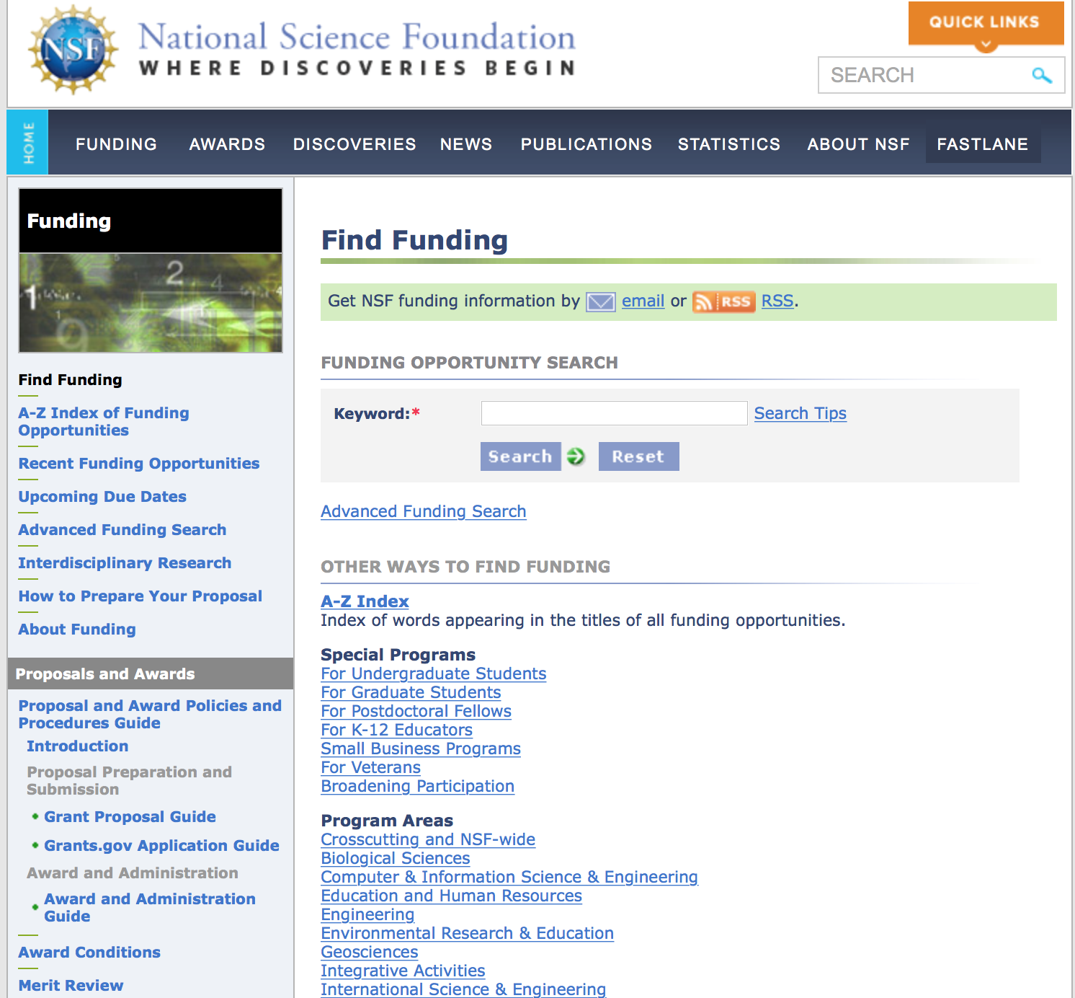
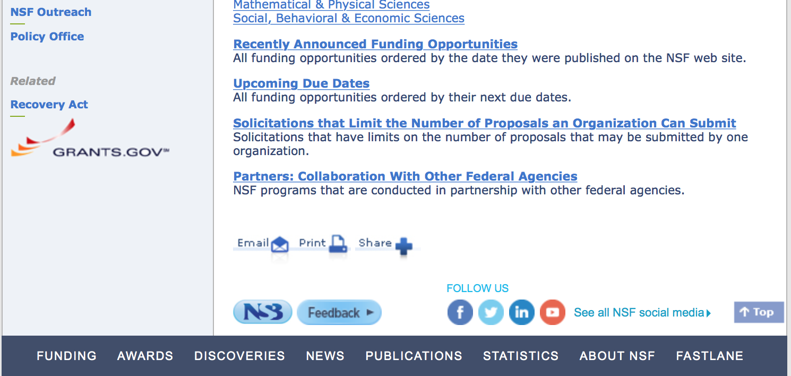

For assistance in finding funding: http://nsf.gov/funding/index.jsp - areas

The National Science Foundation funds research and education in most fields of science and engineering. It does this through grants, and cooperative agreements to more than 2,000 colleges, universities, K-12 school systems, businesses, informal science organizations and other research organizations throughout the United States. The Foundation accounts for about one-fourth of federal support to academic institutions for basic research.
NSF receives approximately 40,000 proposals each year for research, education and training projects, of which approximately 11,000 are funded. In addition, the Foundation receives several thousand applications for graduate and postdoctoral fellowships.
The agency operates no laboratories itself but does support National Research Centers, user facilities, certain oceanographic vessels and Antarctic research stations. The Foundation also supports cooperative research between universities and industry, US participation in international scientific and engineering efforts, and educational activities at every academic level.

For details on active funding deadline dates: http://nsf.gov/funding/pgm_list.jsp?org=NSF&ord=date

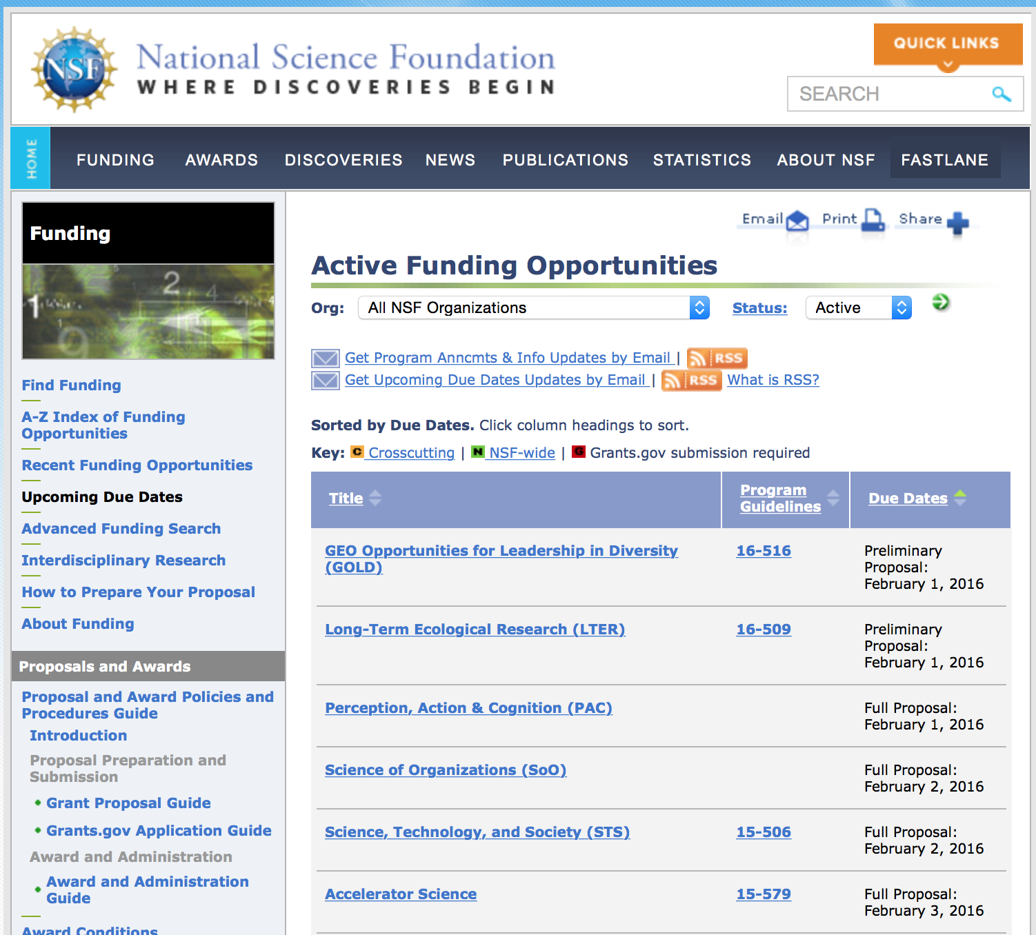

Research and Program Grants:

Communications, Circuits, and Sensing-Systems Grant
http://www.grants.gov/web/grants/view-opportunity.html?oppId=283299

Electronics, Photonics and Magnetic Devices Grant
http://www.grants.gov/web/grants/view-opportunity.html?oppId=283242

Energy, Power, Control, and Networks Grant
http://www.grants.gov/web/grants/view-opportunity.html?oppId=283243

GeoPRISMS Program Grant
http://www.grants.gov/web/grants/view-opportunity.html?oppId=283261

Robert Noyce Teacher Scholarship Program Grant
http://www.grants.gov/web/grants/view-opportunity.html?oppId=283186

Modifications:

Reminders:

Nuclear Regulatory Commission

Reminders:

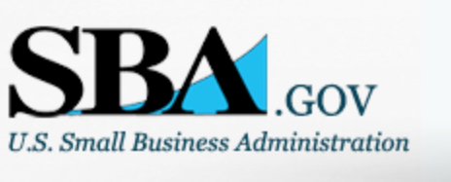

Small Business Administration

General Overview Finding Loans & Grants

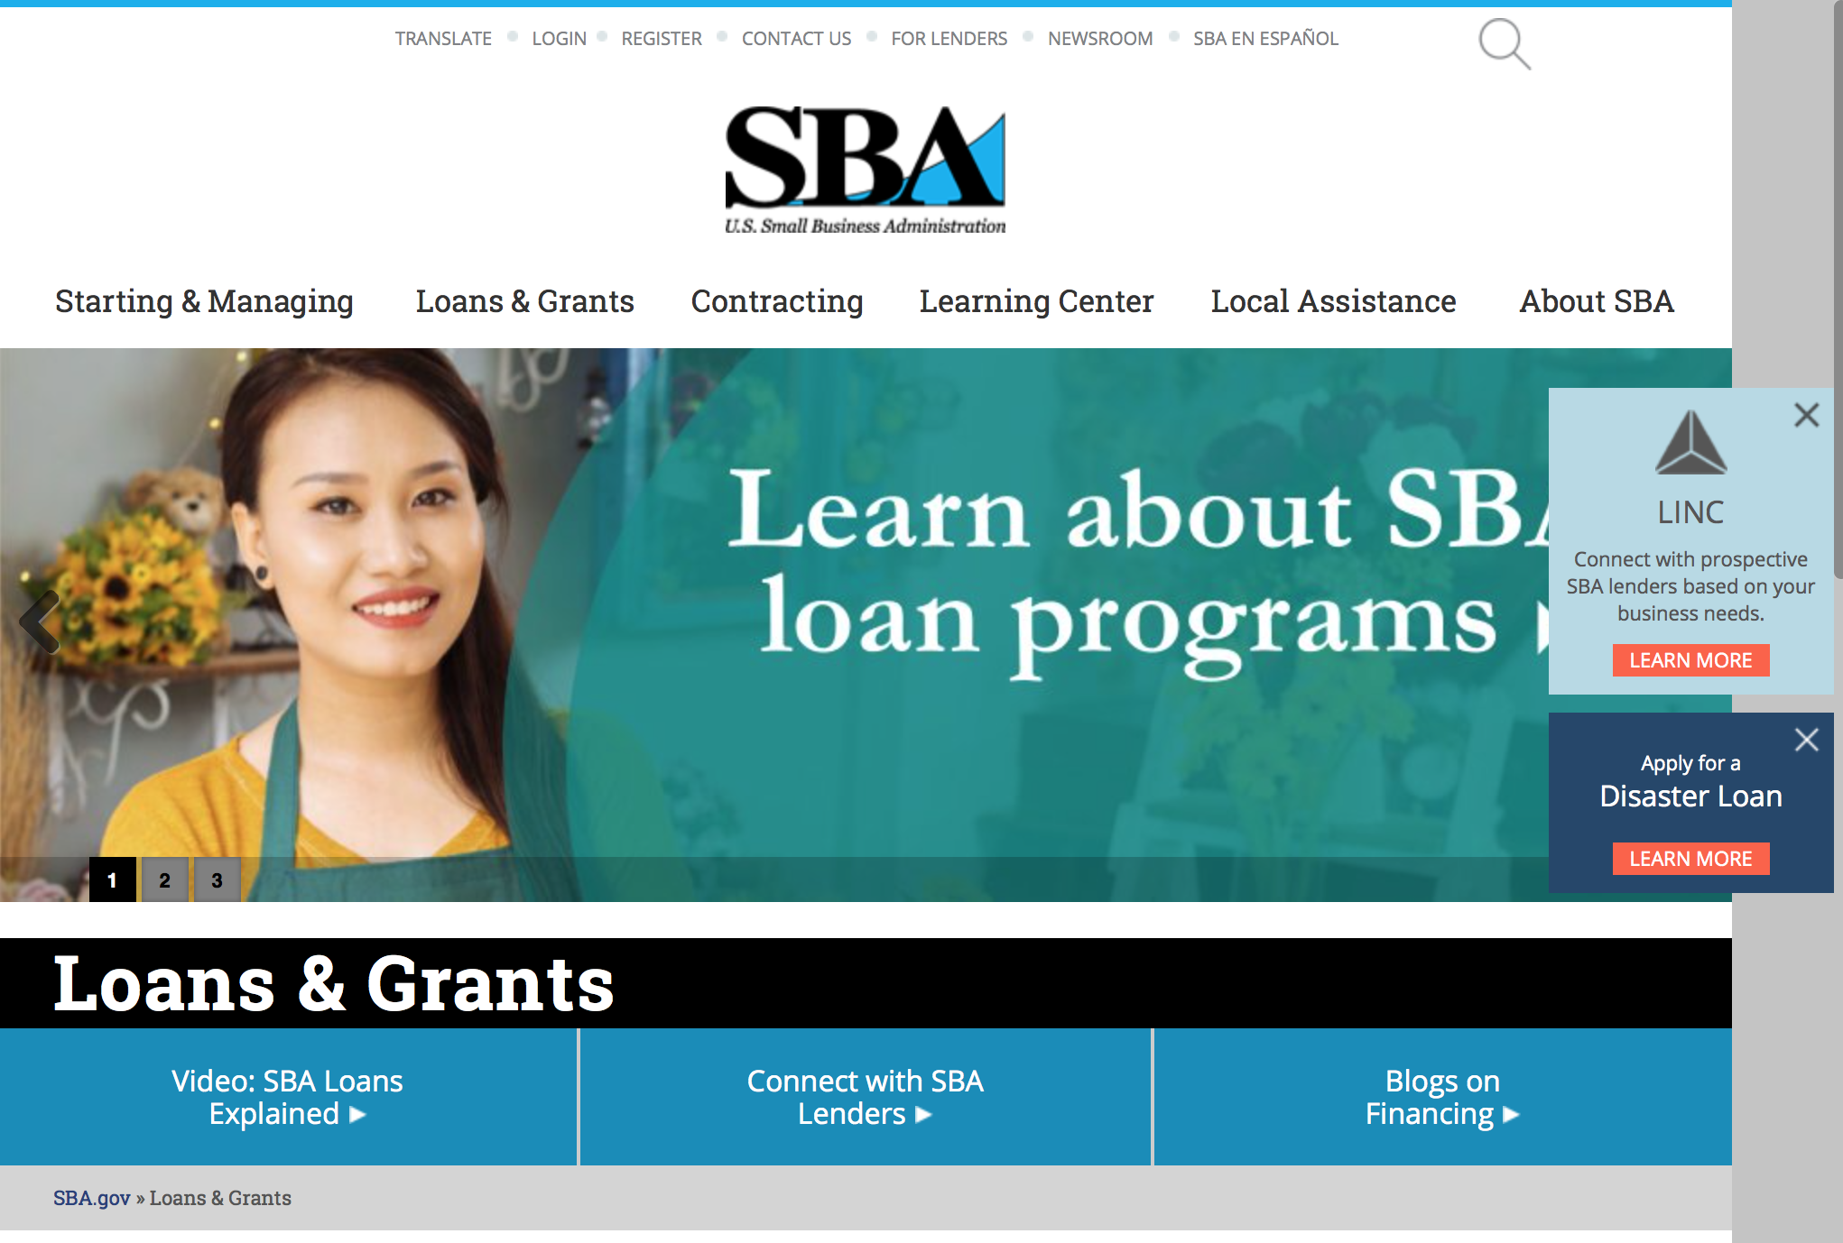
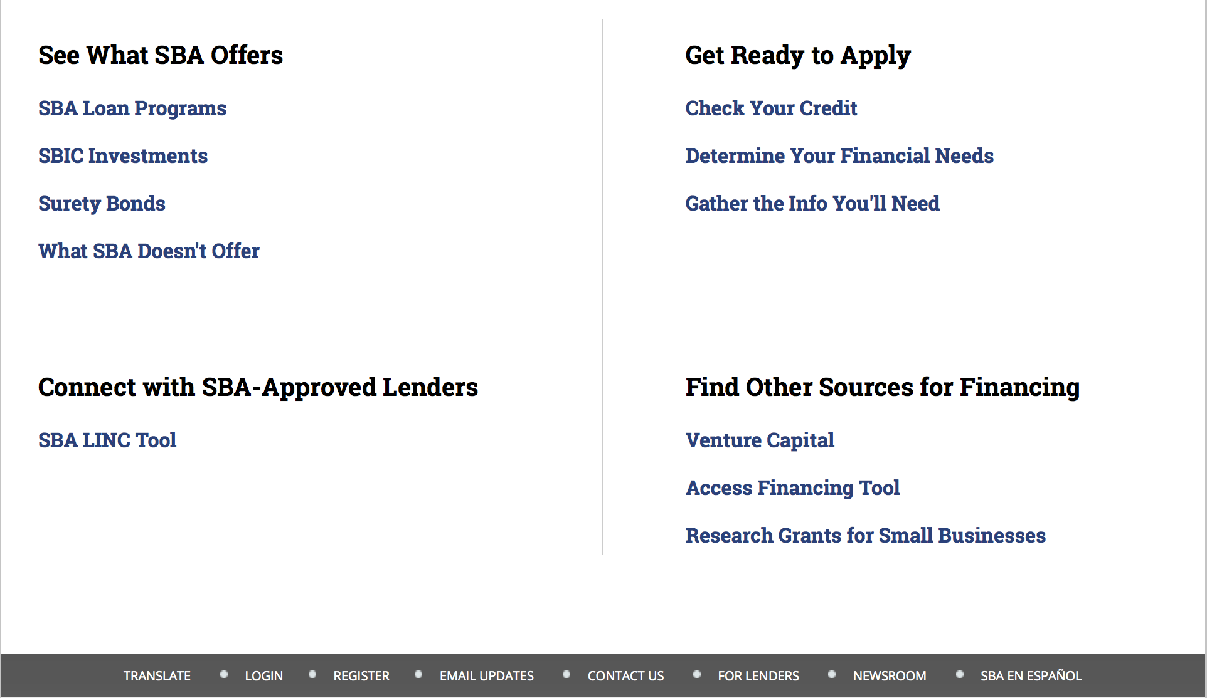

https://www.sba.gov/category/navigation-structure/loans-grants
Federal, state and local governments offer a wide range of financing programs to help small businesses start and grow their operations. These programs include low-interest loans, venture capital, and scientific and economic development grants.

Use SBA.gov's Loans and Grants Search Tool to get a list of financing programs for which you may qualify, or visit the resources below to learn more about small business financing programs. 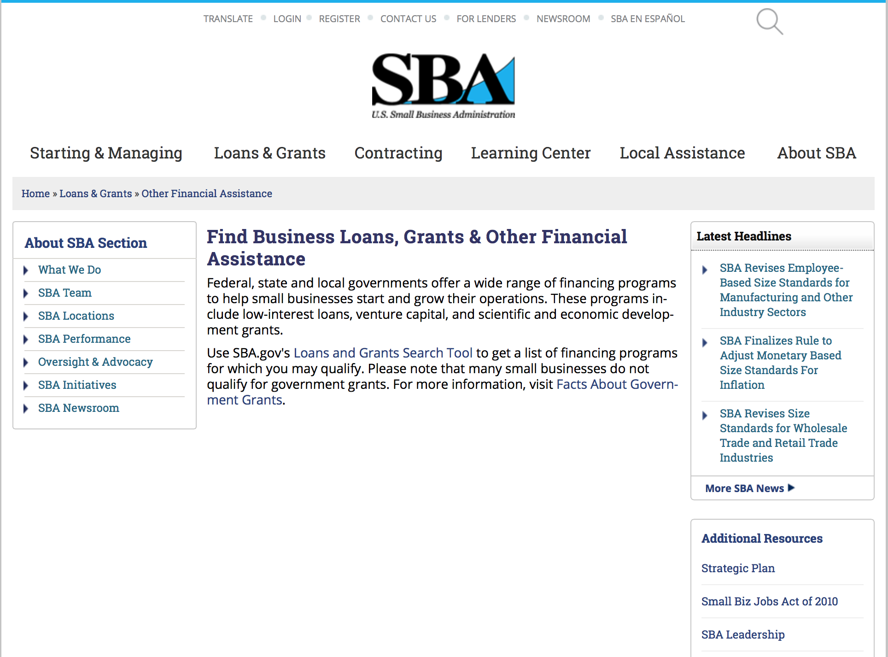
To get to the main SBA.gov funding page click here
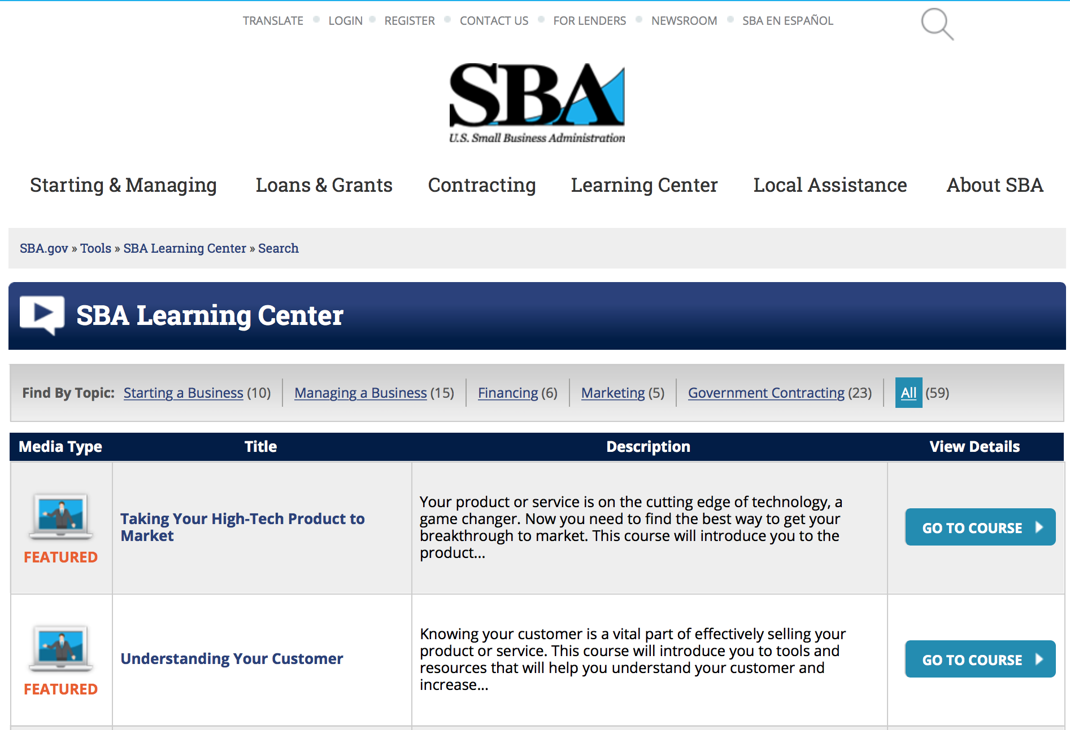
https://www.sba.gov/tools/sba-learning-center/search/training
Programs:

Program for Investment in Microentrepreneurs (PRIME)
Modifications 6, 8, 10, 15 & 17

Document Type: | Grants Notice
Funding Opportunity Number: | PRIME-2016-02
Funding Opportunity Title: | Program for Investment in Microentrepreneurs (PRIME)
Opportunity Category: | Discretionary
Opportunity Category Explanation:
Funding Instrument Type: | Cooperative Agreement
Category of Funding Activity: | Business and Commerce
Category Explanation:
Expected Number of Awards: | 35
CFDA Number(s): | 59.050 -- Prime Technical Assistance
Cost Sharing or Matching Requirement: | Yes
Posted Date: | Mar 29, 2016
Last Updated Date: | Apr 30, 2016
Original Closing Date for Applications: | Apr 29, 2016 The closing date is 04/29/2016 at 11:59 EST
Current Closing Date for Applications: | May 18, 2016 The closing date is 05/18/2016 at 11:59 EST
Archive Date: | May 23, 2016
Estimated Total Program Funding: | $5,000,000
Award Ceiling: | $250,000
Award Floor: | $50,000
Eligible Applicants: | Others (see text field entitled "Additional Information on Eligibility" for clarification)
Additional Information on Eligibility: | See Synopsis
Agency Name: | Small Business Administration
Description: | The Program for Investment in Microentrepreneurs Act of 1999 (the PRIME Act) became law on November 12, 1999 with the passage of Pub. L. No. 106-102 (15 U.S.C. § 6901 note). The PRIME Act authorizes the SBA Administrator to establish a program for the purposes of: (i) providing training and technical assistance to disadvantaged entrepreneurs; (ii) providing training and capacity building assistance to microenterprise development organizations (MDOs) and programs; (iii) aiding in Research and development of best practices for microenterprise and technical assistance programs for disadvantaged entrepreneurs; and (iv) for other activities as the SBA Administrator determines. This year, SBA will concentrate resources in the use of (1) training and technical assistance to strengthen cooperatives serving economically disadvantaged entrepreneurs and areas; and (2) training and technical assistance to support entrepreneurship among ex-offenders in the criminal justice system, especially those on parole, probation or incarcerated persons soon to be released.
Link to Additional Information:
Contact Information: | If you have difficulty accessing the full announcement electronically, please contact:  Jamie Davenport, Chief Community Advantage Division  PRIME@SBA.gov

http://www.grants.gov/web/grants/view-opportunity.html?oppId=282625

Reminders:

Portable Assistance Program Grant

Document Type: | Grants Notice
Funding Opportunity Number: | OSBDC-2016-05
Funding Opportunity Title: | Portable Assistance Program
Opportunity Category: | Discretionary
Opportunity Category Explanation:
Funding Instrument Type: | Cooperative Agreement
Category of Funding Activity: | Business and Commerce
Category Explanation:
Expected Number of Awards: | 11
CFDA Number(s): | 59.037 -- Small Business Development Centers
Cost Sharing or Matching Requirement: | No
Posted Date: | Mar 25, 2016
Last Updated Date: | Mar 25, 2016
Original Closing Date for Applications: | May 16, 2016 The closing date is May 16, 2016 at 11:59pm EST.
Current Closing Date for Applications: | May 16, 2016 The closing date is May 16, 2016 at 11:59pm EST.
Archive Date: | Jun 15, 2016
Estimated Total Program Funding: | $1,109,769
Award Ceiling: | $100,000
Eligible Applicants: | Others (see text field entitled "Additional Information on Eligibility" for clarification)
Additional Information on Eligibility: | See Synopsis
Agency Name: | Small Business Administration
Description: | The purpose of this Program Announcement is to invite proposals for funding from entities currently funded by SBA as a Small Business Development Center (SBDC) Lead Center. Each proposal must describe recent, serious economic conditions resulting from diminished business or government operations within a discrete area served by an SBDC network. Proposals must include detailed plans to deliver technical assistance to the affected area with corresponding objectives and milestones to be accomplished. Only applications from SBDC Lead Centers will be considered for funding.
Link to Additional Information: | https://www.sba.gov/offices/headquarters/osbdc/resources/20351
Contact Information: | If you have difficulty accessing the full announcement electronically, please contact:  Small Business Administration Office of Small Business Development Centers Tel: (202) 205-6766 Email: OSBDC@sba.gov  OSBDC@sba.gov

http://www.grants.gov/web/grants/view-opportunity.html?oppId=282525

Federal And State Technology Partnership Program
Modifications 2, 4, 6 & 8

Document Type: | Grants Notice
Funding Opportunity Number: | FAST-2016-R-0010
Funding Opportunity Title: | FEDERAL AND STATE TECHNOLOGY PARTNERSHIP PROGRAM
Opportunity Category: | Discretionary
Opportunity Category Explanation:
Funding Instrument Type: | Cooperative Agreement
Category of Funding Activity: | Business and Commerce
Category Explanation:
Expected Number of Awards: | 16
CFDA Number(s): | 59.058 -- Federal and State Technology Partnership Program
Cost Sharing or Matching Requirement: | Yes
Posted Date: | Mar 18, 2016
Last Updated Date: | Mar 30, 2016
Original Closing Date for Applications: | May 20, 2016 The closing date is May 20,2016 at 11:59pm EST.
Current Closing Date for Applications: | May 20, 2016 The closing date is May 20,2016 at 11:59pm EST.
Archive Date: | Jun 19, 2016
Estimated Total Program Funding: | $2,000,000
Award Ceiling: | $125,000
Eligible Applicants: | Others (see text field entitled "Additional Information on Eligibility" for clarification)
Additional Information on Eligibility: | See Synopsis
Agency Name: | Small Business Administration
Description: | The purpose of this Program Announcement is to invite proposals for funding from any public or private organization, entity or individual interested in providing assistance and guidance to small technology business concerns.
Link to Additional Information: | http://www.sbir.gov
Contact Information: | If you have difficulty accessing the full announcement electronically, please contact:  Lisa Younger Small Business Administration Office of Technology Tel: 202 619-0359 Email: FAST@sba.gov  FAST@sba.gov

http://www.grants.gov/web/grants/view-opportunity.html?oppId=282341

Federal And State Technology Partnership Program – SBTDC States
Modifications 2, 4, 6 , 8 & 12

Document Type: | Grants Notice
Funding Opportunity Number: | FAST-2016-R-0010A
Funding Opportunity Title: | FEDERAL AND STATE TECHNOLOGY PARTNERSHIP PROGRAM – SBTDC STATES
Opportunity Category: | Discretionary
Opportunity Category Explanation:
Funding Instrument Type: | Cooperative Agreement
Category of Funding Activity: | Business and Commerce
Category Explanation:
Expected Number of Awards: | 5
CFDA Number(s): | 59.058 -- Federal and State Technology Partnership Program
Cost Sharing or Matching Requirement: | Yes
Posted Date: | Mar 18, 2016
Last Updated Date: | Mar 30, 2016
Original Closing Date for Applications: | May 20, 2016 The closing date is May 20, 2016 at 11:59pm EST.
Current Closing Date for Applications: | May 20, 2016 The closing date is May 20, 2016 at 11:59pm EST.
Archive Date: | Jun 19, 2016
Estimated Total Program Funding: | $1,000,000
Award Ceiling: | $200,000
Award Floor: | $0
Eligible Applicants: | Others (see text field entitled "Additional Information on Eligibility" for clarification)
Additional Information on Eligibility: | See Synopsis
Agency Name: | Small Business Administration
Description: | The purpose of this Program Announcement is to invite proposals for funding from any public or private organization, entity or individual interested in providing assistance and guidance to small technology business concerns.
Link to Additional Information: | http://www.sbir.gov
Contact Information: | If you have difficulty accessing the full announcement electronically, please contact:  Lisa Younger Small Business Administration Office of Technology Tel: 202 619-0359 Email: FAST@sba.gov  FAST@sba.gov

http://www.grants.gov/web/grants/view-opportunity.html?oppId=282343

SBA Trainings

Contracting Opportunities for Veteran Entrepreneurs
This self-paced training exercise is an introduction to Federal contracting opportunities for Veterans.
Topics include basic information about Veteran-owned businesses and opportunities, services available to small Veteran-owned businesses, small business incentives, and government procurement methods.
Duration: 00:30:00

http://www.sba.gov/tools/sba-learning-center/training/contracting-opportunities-veteran-entrepreneurs

Interested in Exporting? These Four Resources Can Help
Did you know that two-thirds of the world’s purchasing power is in foreign countries? As the numbers show, the international marketplace is a big one. So if you’re interested in exploring the world of exporting – or have gotten started but could use some guidance – check out these resources to help.
- Read more

Upcoming Trainings: Check out SBA's Online Training!
- Financing Options for Small Businesses
How to Prepare Government Contract Proposals
Getting Started With Exporting: Training and Educational Resources
Exporting represents a big opportunity to tap in to new markets, expand your customer base and grow your business. But getting started with exporting can sometimes feel like a maze of regulations, policies, and other barriers. Here are some free training and educational resources to help.
- Read more

For Specific Information in Hawaii see the following links:
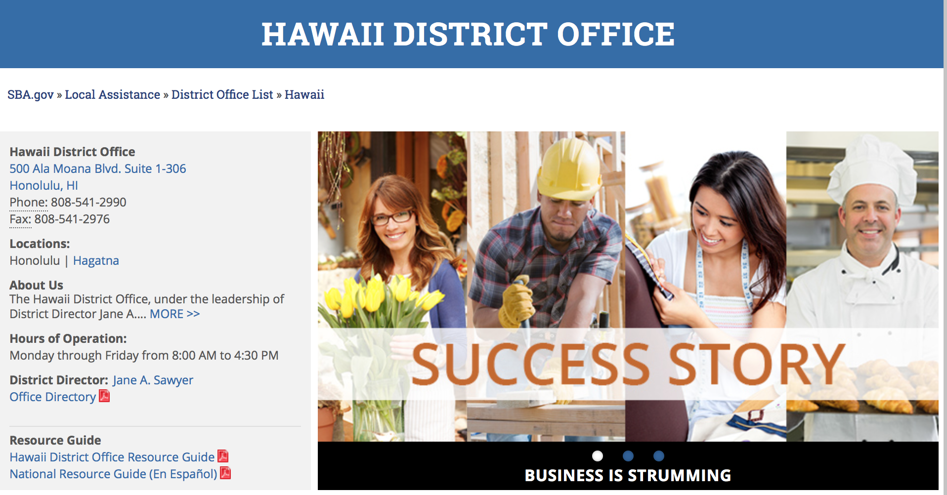

https://www.sba.gov/offices/district/hi/Honolulu

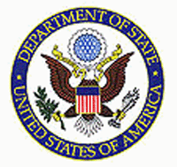

State Department General Overview and Resources for Program Administrators

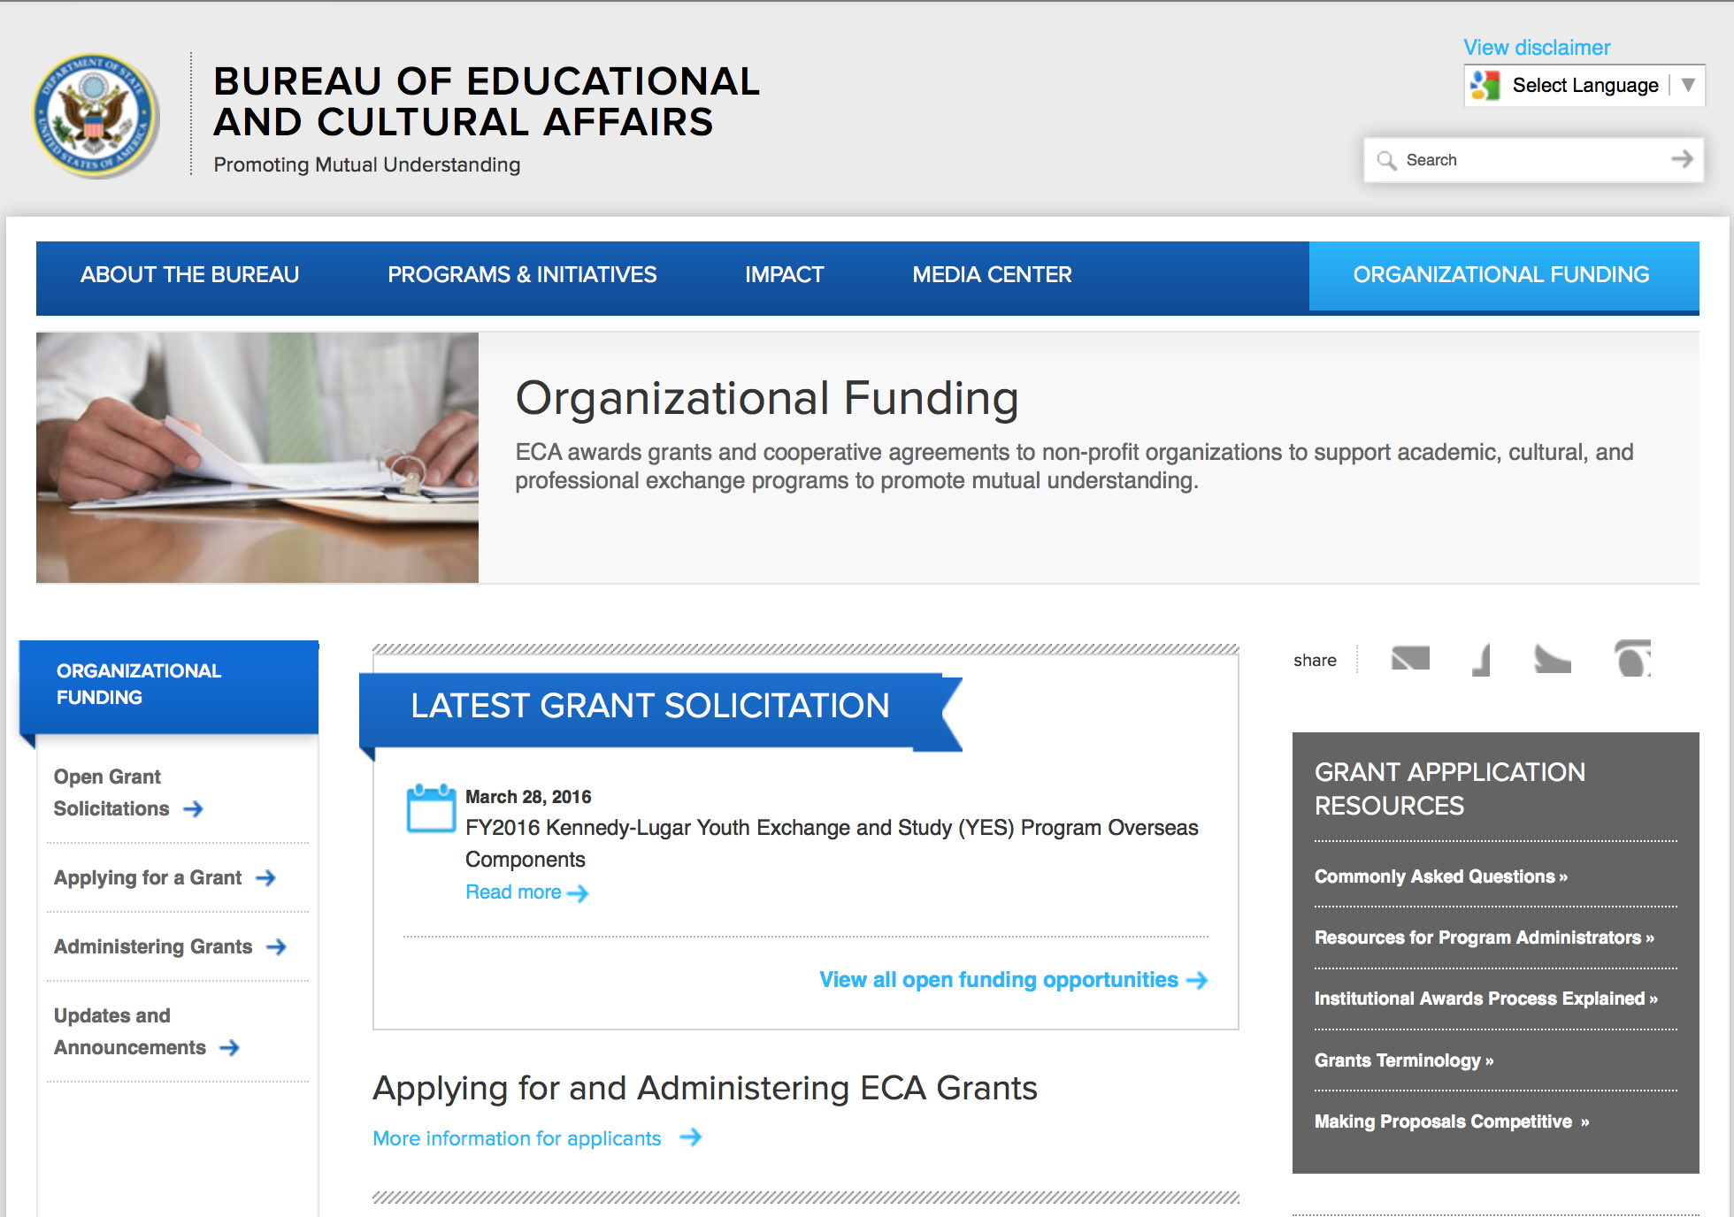
http://eca.state.gov/search/solr/grants?search_referrer=node/237
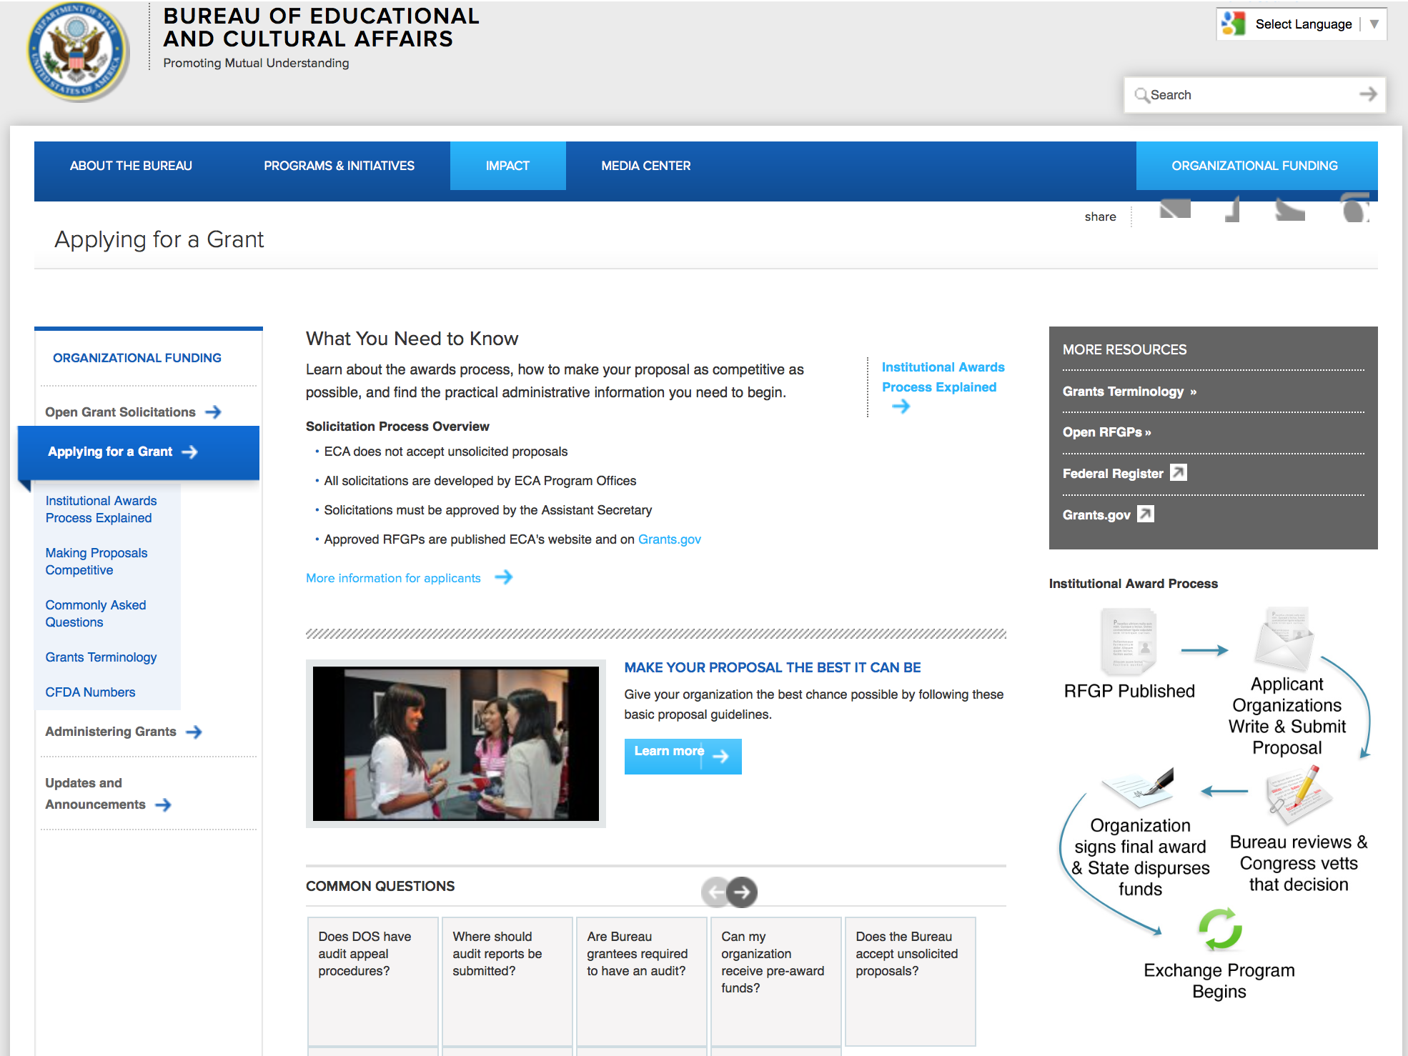

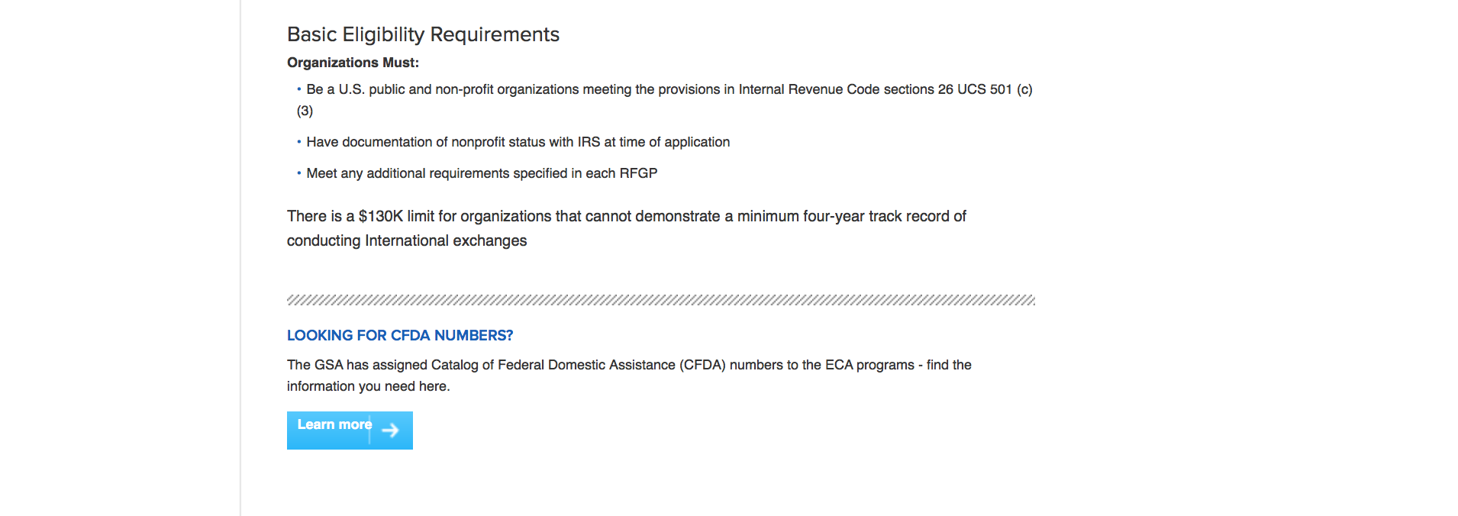
http://eca.state.gov/organizational-funding/applying-grant

General Information:
- Bureau of Educational and Cultural Affairs Grants Division
- Open Grant Opportunities (Requests for Grant Proposals)

For General Information click here

Program Grants:

Bureau of Counterterrorism
Building Civilian Criminal Justice Capacity to Address Terrorism Grant
http://www.grants.gov/web/grants/view-opportunity.html?oppId=282985

Bureau of Conflict Stabilization Operations
Peace Processes Statement of Interest and Capacity (SOIC) Grant
http://www.grants.gov/web/grants/view-opportunity.html?oppId=283444

Bureau of Democracy, Human Rights and Labor
DRL FY15 Democracy, Human Rights, and Rule of Law in Pakistan Grant
http://www.grants.gov/web/grants/view-opportunity.html?oppId=283034

Bureau Of Educational and Cultural Affairs
FY 2016 Arts Envoy Program Grant
http://www.grants.gov/web/grants/view-opportunity.html?oppId=283013

Bureau Of Educational and Cultural Affairs
FY 2016 Youth Leadership Program with Burma Grant
http://www.grants.gov/web/grants/view-opportunity.html?oppId=283014

Bureau Of Educational and Cultural Affairs
FY 2016 Pan Africa Youth Leadership Program Grant
http://www.grants.gov/web/grants/view-opportunity.html?oppId=283015

Bureau Of Educational and Cultural Affairs
FY2017 Hubert H. Humphrey Fellowship Program Grant
http://www.grants.gov/web/grants/view-opportunity.html?oppId=283189

Bureau Of Educational and Cultural Affairs
FY 2016 Creative Arts Exchange Grant
http://www.grants.gov/web/grants/view-opportunity.html?oppId=283022

Bureau Of Educational and Cultural Affairs
FY 2016 Communities Connecting Heritage Program Grant

http://www.grants.gov/web/grants/view-opportunity.html?oppId=283226

Bureau of Intelligence and Research
FY 2015 Program for Research and Training on Eastern Europe and the Independent States of the Former Soviet Union (Title VIII) Grant
http://www.grants.gov/web/grants/view-opportunity.html?oppId=283204

Havana Small Grants Opportunity Grant
http://www.grants.gov/web/grants/view-opportunity.html?oppId=282981

Havana Large Grants Opportunity Grant
http://www.grants.gov/web/grants/view-opportunity.html?oppId=282982

International Narcotics and Law Enforcement Affair
Management of Model Precinct/Smart Policing Program in El Salvador Grant
http://www.grants.gov/web/grants/view-opportunity.html?oppId=282928

Lower Mekong Initiative Grant Opportunity Grant
http://www.grants.gov/web/grants/view-opportunity.html?oppId=282853

Ocean and International Environmental Scientific
CAFTA-DR: Public Participation in the Enforcement of Wildlife Laws Grant
http://www.grants.gov/web/grants/view-opportunity.html?oppId=282986

PM Weapons Removal and Abatement
16.PMWRA.Project 9.Laghman.Afghanistan.NOFO Grant
http://www.grants.gov/web/grants/view-opportunity.html?oppId=283005

PM Weapons Removal and Abatement
16.PMWRA.Project 6.Kabul.Afghanistan.NOFO Grant
http://www.grants.gov/web/grants/view-opportunity.html?oppId=282979

PM Weapons Removal and Abatement
16.PMWRA.Project12.Kapisa.Afghanistan.NOFO Grant
http://www.grants.gov/web/grants/view-opportunity.html?oppId=282996

PM Weapons Removal and Abatement
16.PMWRA.Project 8.Parwan.Afghanistan.NOFO Grant
http://www.grants.gov/web/grants/view-opportunity.html?oppId=283004

PM Weapons Removal and Abatement
16.PMWRA.Project 11.Baghlan.Afghanistan.NOFO Grant
http://www.grants.gov/web/grants/view-opportunity.html?oppId=282995

Public Affairs
Unwrapping the Warsaw Summit: NATO and the New Euro-Atlantic Security Environment
Grant
http://www.grants.gov/web/grants/view-opportunity.html?oppId=283336

Modifications:

Bureau of Counterterrorism
Establish, Develop, and Operationalize the East Africa Countering Violent Extremism (CVE) Center of Excellence and Counter-messaging Hub in East Africa
Modification 1
http://www.grants.gov/web/grants/view-opportunity.html?oppId=282211

Bureau Of Educational and Cultural Affairs
FY 2016 Youth Leadership Program with Burma
Modification 1
http://www.grants.gov/web/grants/view-opportunity.html?oppId=283014

Bureau Of Educational and Cultural Affairs
FY 2016 Emerging Young Leaders Award
Modification 1
http://www.grants.gov/web/grants/view-opportunity.html?oppId=283256

Bureau Of Educational and Cultural Affairs
FY 2016 Ngwang Choephel Fellows Program
Modification 2
http://www.grants.gov/web/grants/view-opportunity.html?oppId=283273

Bureau of Population, Refugees and Migration
FY 2016 Notice of Funding Opportunity for NGO programs benefiting urban refugees in South Africa.
Modification 1
http://www.grants.gov/web/grants/view-opportunity.html?oppId=283171

Bureau of Population, Refugees and Migration
FY 2016 Notice of Funding Opportunity for NGO programs benefiting refugees and other vulnerable populations in Central Asia
Modification 1
http://www.grants.gov/web/grants/view-opportunity.html?oppId=283274

Bureau of Population, Refugees and Migration
FY 2016 Notice of Funding Opportunity for Global Innovation Programs to promote the Call to Action on Protection from Gender-based Violence (GBV) in Emergencies
Modification 2
http://www.grants.gov/web/grants/view-opportunity.html?oppId=283126

Ocean and International Environmental Scientific
A Program on International Water Cooperation
Modification 2
http://www.grants.gov/web/grants/view-opportunity.html?oppId=283155

Ocean and International Environmental Scientific
The Partnership on Women's Entrepreneurship in Renewables (wPOWER)
Modification 1
http://www.grants.gov/web/grants/view-opportunity.html?oppId=282978

Bureau of Population, Refugees and Migration
FY 2016 Notice of Funding Opportunity for Global Innovation Programs to promote the Call to Action on Protection from Gender-based Violence (GBV) in Emergencies
Modification 2
http://www.grants.gov/web/grants/view-opportunity.html?oppId=283126

PM Weapons Removal and Abatement
16.PMWRA.Project 11.Baghlan.Afghanistan.NOFO
Modification 1
http://www.grants.gov/web/grants/view-opportunity.html?oppId=282995

PM Weapons Removal and Abatement
16.PMWRA.Project12.Kapisa.Afghanistan.NOFO
Modification 1
http://www.grants.gov/web/grants/view-opportunity.html?oppId=282996

PM Weapons Removal and Abatement
16.PMWRA.Project 8.Parwan.Afghanistan.NOFO
Modification 1
http://www.grants.gov/web/grants/view-opportunity.html?oppId=283004

PM Weapons Removal and Abatement
16.PMWRA.Project 9.Laghman.Afghanistan.NOFO
Modification 1
http://www.grants.gov/web/grants/view-opportunity.html?oppId=283005

PM Weapons Removal and Abatement
16.PMWRA.Project 6.Kabul.Afghanistan.NOFO
Modification 1
http://www.grants.gov/web/grants/view-opportunity.html?oppId=282979

Reminders:

Department of Transportation

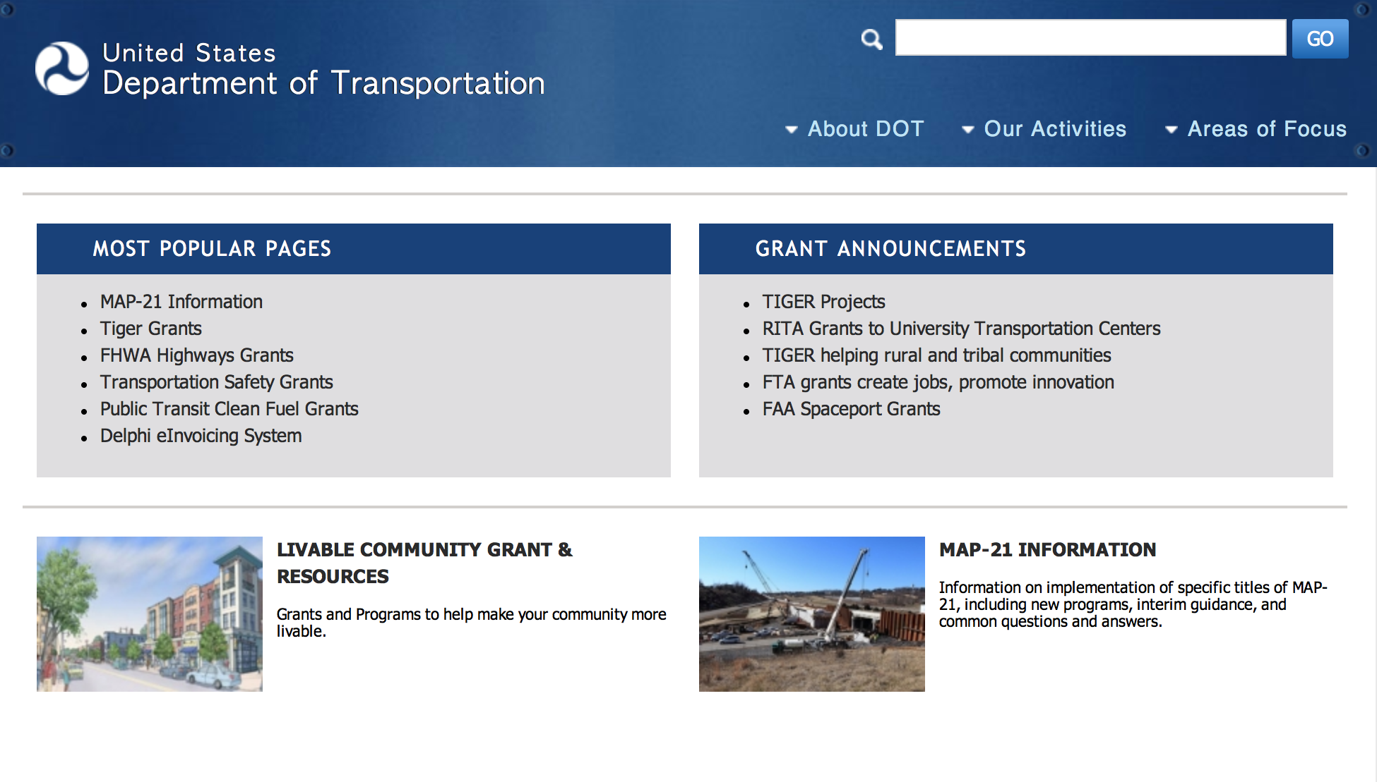
General Grant Program Overview https://www.transportation.gov/grants

Programs:

Pipeline &Hazardous Material Safety Administration
Pipeline Safety Research Competitive Academic Agreement Program (CAAP) 2016 Grant
And Modification 1

Document Type: | Grants Notice
Funding Opportunity Number: | DTPH5616SN000002
Funding Opportunity Title: | Pipeline Safety Research Competitive Academic Agreement Program (CAAP) 2016
Opportunity Category: | Discretionary
Opportunity Category Explanation:
Funding Instrument Type: | Cooperative Agreement
Category of Funding Activity: | Other (see text field entitled "Explanation of Other Category of Funding Activity" for clarification)
Category Explanation: | Pipeline Safety Research Competitive Academic Agreement Program (CAAP) – FY 2016
Expected Number of Awards: | 20
CFDA Number(s): | 20.724 -- Pipeline Safety Research Competitive Academic Agreement Program (CAAP)
Cost Sharing or Matching Requirement: | Yes
Posted Date: | Apr 25, 2016
Last Updated Date: | Apr 27, 2016
Original Closing Date for Applications: | Jun 09, 2016
Current Closing Date for Applications: | Jun 09, 2016
Archive Date: | Jul 09, 2016
Estimated Total Program Funding:
Award Ceiling: | $300,000
Eligible Applicants: | Others (see text field entitled "Additional Information on Eligibility" for clarification)
Additional Information on Eligibility: | Applicants must be non-profit institutions of higher education located in the United States or a U.S. territory or possession.
Agency Name: | Pipeline &Hazardous Material Safety Administration
Description: | Article I. Funding Opportunity Description Section 1.01 Statement of Purpose The Pipeline and Hazardous Materials Safety Administration (PHMSA), through the U.S. DOT, hereby requests applications from non-profit institutions of higher education to obtain funding to research innovative solutions to pipeline corrosion and other known pipeline integrity challenges. Section 1.02 Program Authority The authority for PHMSA’s Pipeline Safety Research and Development Program comes from the Pipeline Safety Improvement Act of 2002 (P. L. 107-355). Further, the authority to enter into cooperative agreements under the CAAP initiative is codified at 49 U.S.C. 60117(k).Section 1.03 Background Section 1.03-1 Background on Pipelines and PHMSA’s Pipeline R&D Program The intent of the CAAP program is to award approximately five (5) research agreements per year to non-profit institutions of higher education in the U.S. or U.S. territories or possessions with a total federal amount not to exceed $300,000 per award. The research to be conducted under the agreements will seek a wide set of solutions for corrosion and other pipeline integrity challenges. PHMSA anticipates the period of performance of each award to be no less than 24 months, while not exceeding 36 months. The pipeline infrastructure in the United States (U.S.) is the primary means of transporting natural gas and the majority of hazardous liquids from production basins and ports to areas of consumption. The importance of energy pipelines to the U.S. economy, our standard of living, and potential for safety and environmental impacts requires that these assets be safely maintained and appropriately expanded to sustain demand. Research must play a larger role in finding the solutions to national, regional and local pipeline operational safety and environmental challenges. Some of these challenges involve operators having the best technology to efficiently and effectively meet or exceed federal and state regulatory requirements on the safety and integrity of pipelines. Other challenges include keeping critical industry consensus standards fresh with the latest knowledge so that people, property and the environment are protected. PHMSA’s core pipeline research program involves all stakeholders in a time-tested process for generating success. Since 2002, this program has been focused on the near-term with demonstrating and deploying technology development and commercialization. Additional information on the existing Pipeline Safety Research and Development (R&D) Program is available at: https://primis.phmsa.dot.gov/rd/index.htm.This research enterprise continues to have a tangible impact toward developing technology, strengthening consensus standards and creating and promoting general knowledge to decision makers. More performance details are available at PHMSA's Pipeline Safety Research website http://primis.phmsa.dot.gov/rd/performance.htm. Section 1.03-2 Background on the CAAP InitiativePHMSA’s Pipeline Safety R&D Program was congressionally mandated by the Pipeline Safety Improvement act of 2002, which tasked DOT and other designated federal agencies to “carry out a program of research, development, demonstration and standardization to ensure the integrity of pipeline facilities.” Specifically, the program’s mission is to sponsor research and development projects focused on providing near-term solutions that will improve the safety, reduce the environmental impact, and enhance the reliability of the Nation’s pipeline transportation system. The goals and objectives of the CAAP initiative, as discussed below, directly support both the mission and the congressional mandate of PHMSA’s Pipeline Safety R&D Program. The CAAP initiative is intended to spur innovation by enabling academic research focused on high-risk and high pay-off solutions for the many pipeline safety challenges. It will potentially deliver solutions that can be “handed-off” to PHMSA’s core research program for demonstration and deployment. The goal is to validate proof of concept of a thesis or theory all the way to commercial implementation into the market. The pipeline industry and federal/state regulators are experiencing low numbers of applicants to entry level positions that are technically focused. Consequently, another goal of the CAAP program is to expose and engage graduate and PhD research students to participate in subject matter task(s) that are common to pipeline safety challenges and to illustrate how their engineering or technical disciplines are highly needed in the field. The ultimate benefit would be to cultivate new talent in all aspects of the pipeline industry, similar to how programs at other Federal Agencies and non-profit organizations have encouraged talent to consider a career in a certain field. The CAAP program intends to award approximately five (5) research agreements per year to non-profit institutions of higher education in the U.S. or U.S. territories or possessions with a total federal amount not to exceed $300,000 per award. The research to be conducted under the agreements will include a wide set of solutions for corrosion and other pipeline integrity challenges. PHMSA anticipates the period of performance of each award to be at least 24 months, while not exceeding 36 months See FOA for full details.
Link to Additional Information:
Contact Information: | If you have difficulty accessing the full announcement electronically, please contact:  Saurabh Vasudeva Agreement Specialist Phone 2025274195  saurabh.vasudeva@dot.gov

http://www.grants.gov/web/grants/view-opportunity.html?oppId=283272

Modifications:

Reminders:

DOT/Federal Transit Administration
Solicitation of Project Proposals for the 5339(b) Grants for Buses and Bus Facilities (Bus) Program Grant

Document Type: | Grants Notice
Funding Opportunity Number: | FTA-2016-002-TPM
Funding Opportunity Title: | Solicitation of Project Proposals for the 5339(b) Grants for Buses and Bus Facilities (Bus) Program
Opportunity Category: | Discretionary
Opportunity Category Explanation:
Funding Instrument Type: | Grant
Category of Funding Activity: | Transportation
Category Explanation:
Expected Number of Awards: | 100
CFDA Number(s): | 20.526 -- Bus and Bus Facilities Formula Program
Cost Sharing or Matching Requirement: | Yes
Posted Date: | Mar 29, 2016
Last Updated Date: | Mar 29, 2016
Original Closing Date for Applications: | May 13, 2016
Current Closing Date for Applications: | May 13, 2016
Archive Date: | Jun 12, 2016
Estimated Total Program Funding: | $211,000,000
Eligible Applicants: | City or township governments  County governments  Native American tribal governments (Federally recognized)  State governments  Others (see text field entitled "Additional Information on Eligibility" for clarification)
Additional Information on Eligibility: | Eligible applicants include direct recipients of FTA grants under the Section 5307 Urbanized Area Formula program, States, and Indian Tribes. Except for projects proposed by Indian Tribes, proposals for projects in rural (non-urbanized) areas must be submitted as part of a consolidated State proposal. States and other eligible applicants may also submit consolidated proposals for projects in urbanized areas. Proposals may contain projects to be implemented by the recipient or its subrecipients. Eligible subrecipients include public agencies, private nonprofit organizations, and private providers engaged in public transportation. If a single project proposal involves multiple public transportation providers, such as when an agency acquires vehicles that will be operated by another agency, the proposal must include a detailed statement regarding the role of each public transportation provider in the implementation of the project.
Agency Name: | DOT/Federal Transit Administration
Description: | The purpose of the Bus Program is to improve the condition of the nation’s public transportation bus fleets, expand transportation access to employment, educational, and healthcare facilities, and to improve mobility options in rural and urban areas throughout the country. In accordance with the statutory requirement that FTA must “consider the age and condition of buses, bus fleets, related equipment, and bus-related facilities”, FTA will prioritize projects that demonstrate how they will address significant repair and maintenance needs, improve the safety of transit systems, deploy connective projects that include advanced technologies to connect bus systems with other networks, and support the creation of ladders of opportunity.
Link to Additional Information: | Notices of Funding Opportunity
Contact Information: | If you have difficulty accessing the full announcement electronically, please contact:  Samuel Snead Office of Program Management  Samuel Snead
http://www.grants.gov/web/grants/view-opportunity.html?oppId=282624

DOT/Federal Transit Administration
Low or No Emission Program (Low-No Program) - 2016 NOFO Grant
Document Type: | Grants Notice
Funding Opportunity Number: | FTA-2016-003-TPM
Funding Opportunity Title: | Low or No Emission Program (Low-No Program) - 2016 NOFO
Opportunity Category: | Discretionary
Opportunity Category Explanation:
Funding Instrument Type: | Grant
Category of Funding Activity: | Transportation
Category Explanation:
Expected Number of Awards: | 100
CFDA Number(s): | 20.526 -- Bus and Bus Facilities Formula Program
Cost Sharing or Matching Requirement: | Yes
Posted Date: | Mar 29, 2016
Last Updated Date: | Mar 29, 2016
Original Closing Date for Applications: | May 13, 2016
Current Closing Date for Applications: | May 13, 2016
Archive Date: | Jun 12, 2016
Estimated Total Program Funding: | $55,000,000
Eligible Applicants: | City or township governments  Others (see text field entitled "Additional Information on Eligibility" for clarification)  County governments  State governments  Native American tribal governments (Federally recognized)
Additional Information on Eligibility: | An Eligible Applicant is a direct recipient of FTA grants under the Section 5307 Urbanized Area Formula program, States and Indian Tribes.
Agency Name: | DOT/Federal Transit Administration
Description: | The main purpose of the Low-No Program is to support the transition of the nation’s transit fleet to the lowest polluting and most energy efficient transit vehicles. The Low-No Program provides funding to State and local governmental authorities for the purchase or lease of zero-emission and low-emission transit buses, including acquisition, construction, and leasing of required supporting facilities.
Link to Additional Information: | Low or No Emission Program (Low-No Program) - 2016 NOFO
Contact Information: | If you have difficulty accessing the full announcement electronically, please contact:  Tara Clark Office of Program Management 202-366-2623  Tara Clark

http://www.grants.gov/web/grants/view-opportunity.html?oppId=282627

DOT/Federal Transit Administration
Innovative Coordinated Access and Mobility Grants Program - 2016 NOFO Grant

Document Type: | Grants Notice
Funding Opportunity Number: | FTA-2015-012-TPM-RTW
Funding Opportunity Title: | Innovative Coordinated Access and Mobility Grants Program - 2016 NOFO
Opportunity Category: | Discretionary
Opportunity Category Explanation:
Funding Instrument Type: | Grant
Category of Funding Activity: | Transportation
Category Explanation:
Expected Number of Awards:
CFDA Number(s): | 20.514 -- Public Transportation Research, Technical Assistance, and Training
Cost Sharing or Matching Requirement: | Yes
Posted Date: | Mar 29, 2016
Last Updated Date: | Mar 29, 2016
Original Closing Date for Applications: | May 31, 2016
Current Closing Date for Applications: | May 31, 2016
Archive Date: | Jun 30, 2016
Estimated Total Program Funding: | $5,300,000
Eligible Applicants: | Native American tribal governments (Federally recognized)  Others (see text field entitled "Additional Information on Eligibility" for clarification)  State governments  County governments  City or township governments
Additional Information on Eligibility: | Eligible proposers and eventual grant applicants under this initiative must be States, Tribes, and Designated or Direct Recipients for funds under 49 U.S.C. 5307, 5310 or 5311. Applicants must serve as the lead agency of a local consortium that includes stakeholders from the transportation, healthcare, human service or other sectors. Members of this consortium are eligible as subrecipients. Applicants must demonstrate that the proposed project was planned through an inclusive process with the involvement of the transportation, healthcare and human service industries.
Agency Name: | DOT/Federal Transit Administration
Description: | The goal of the competitive R2W Demonstration Grants is to find and test promising, replicable public transportation healthcare access solutions that support the following Rides to Wellness goals: increased access to care, improved health outcomes and reduced healthcare costs. To support these goals, the R2W Demonstration Grants will: 1. Develop replicable, innovative, sustainable solutions to healthcare access challenges; 2. Foster local partnerships between health, transportation, home and community-based services and other sectors to collaboratively develop and support solutions that increase healthcare access; and 3. Demonstrate the impacts of transportation solutions on improved access to healthcare and health outcomes and reduced costs to the healthcare and transportation sectors.
Link to Additional Information: | Rides to Wellness Demonstration and Innovative Coordinated Access and Mobility Grants program - 2016 NOFO
Contact Information: | If you have difficulty accessing the full announcement electronically, please contact:  Danielle Nelson Office of Program Management 202-366-2160  Danielle Nelson

http://www.grants.gov/web/grants/view-opportunity.html?oppId=282628

University Transportation Centers Open Competition 2016 Grant

Document Type: | Grants Notice
Funding Opportunity Number: | UTCOPENCOMP2016
Funding Opportunity Title: | University Transportation Centers Open Competition 2016
Opportunity Category: | Discretionary
Opportunity Category Explanation:
Funding Instrument Type: | Grant
Category of Funding Activity: | Transportation
Category Explanation:
Expected Number of Awards: | 35
CFDA Number(s): | 20.701 -- University Transportation Centers Program
Cost Sharing or Matching Requirement: | Yes
Posted Date: | Mar 01, 2016
Last Updated Date: | Feb 29, 2016
Original Closing Date for Applications: | May 13, 2016 NOTE ALSO: Required Letter of Intent Due 04/01/2016.
Current Closing Date for Applications: | May 13, 2016 NOTE ALSO: Required Letter of Intent Due 04/01/2016.
Archive Date: | Jun 12, 2016
Estimated Total Program Funding: | $72,500,000
Award Ceiling: | $3,000,000
Award Floor: | $1,500,000
Eligible Applicants: | Private institutions of higher education  Public and State controlled institutions of higher education
Agency Name: | Department of Transportation
Description: | See attached solicitation for details.
Link to Additional Information: | http://utc.dot.gov
Contact Information: | If you have difficulty accessing the full announcement electronically, please contact:  Amy Stearns University Program Specialist Phone 202-366-4957  Amy Stearns

http://www.grants.gov/web/grants/view-opportunity.html?oppId=281834

DOT Federal Highway Administration
Advanced Transportation and Congestion Management Technologies Deployment Initiative Grant

Document Type: | Grants Notice
Funding Opportunity Number: | DTFH6116RA00012
Funding Opportunity Title: | Advanced Transportation and Congestion Management Technologies Deployment Initiative
Opportunity Category: | Discretionary
Opportunity Category Explanation: | Category Explanation
Funding Instrument Type: | Other
Category of Funding Activity: | Transportation
Category Explanation:
Expected Number of Awards: | 10
CFDA Number(s): | 20.200 -- Highway Research and Development Program
Cost Sharing or Matching Requirement: | Yes
Posted Date: | Mar 22, 2016
Last Updated Date: | Mar 22, 2016
Original Closing Date for Applications: | Jun 03, 2016 Applications Due by 06/03/2016 at 3:00 pm Eastern Time through www.Grants.gov
Current Closing Date for Applications: | Jun 03, 2016 Applications Due by 06/03/2016 at 3:00 pm Eastern Time through www.Grants.gov
Archive Date: | Oct 01, 2016
Estimated Total Program Funding: | $60,000,000
Award Ceiling: | $12,000,000
Eligible Applicants: | Others (see text field entitled "Additional Information on Eligibility" for clarification)
Additional Information on Eligibility: | Eligible applicants are State or local governments, transit agencies, metropolitan planning organizations (MPO) representing a population of over 200,000, or other political subdivisions of a State or local government (such as publicly owned toll or port authorities), or a multijurisdictional group or consortia of research institutions or academic institutions. Partnership with the private sector or public agencies, including multimodal and multijurisdictional entities, research institutions, organizations representing transportation and technology leaders, or other transportation stakeholders is encouraged. Typically, a consortium is a meaningful arrangement with all members involved in planning the overall direction of the group’s activities and participating in most aspects of the group; the consortium is a long-term relationship intended to last the full life of the grant. Any application submitted by a sole research or academic institution and that is not part of a consortium will not be considered for selection. Awards will be either Cooperative Agreements or Allocations to State Departments of Transportations.
Agency Name: | DOT Federal Highway Administration
Description: | The DOT hereby requests applications to result in awards to eligible entities to develop model deployment sites for large scale installation and operation of advanced transportation technologies to improve safety, efficiency, system performance, and infrastructure return on investment. These model deployments are expected to provide benefits in the form of: •reduced traffic-related fatalities and injuries; •reduced traffic congestion and improved travel time reliability; •reduced transportation-related emissions; •optimized multimodal system performance; •improved access to transportation alternatives, including for underserved populations; •public access to real time integrated traffic, transit, and multimodal transportation information to make informed travel decisions; •cost savings to transportation agencies, businesses, and the traveling public; or •other benefits to transportation users and the general public. This competitive advanced transportation and congestion management technologies deployment grant program will promote the use of innovative transportation solutions. The deployment of these technologies will provide Congress and DOT with valuable real life data and feedback to inform future decision making. The United States Department of Transportation (DOT) will host an Informational Session regarding this Funding Opportunity focused on the Advanced Transportation and Congestion Management Technologies Deployment Initiative. This session will be conducted as a virtual forum and will focus on specific topics to help potential applicants gather additional information and ask specific questions. Participation in this session is not mandatory in order to submit an application under this solicitation. Potential applicants are encouraged to take advantage of this opportunity to gather information regarding this specific funding opportunity. DATE: 3/29/2016 TIME: 1:00 pm Eastern Time INFORMATION AND REGISTRATION: https://connectdot.connectsolutions.com/e4x9x0mcr0a/event/registration.html
Link to Additional Information:
Contact Information: | If you have difficulty accessing the full announcement electronically, please contact:  Rick Murray Agreement Officer Phone 202-366-4250  Rick Murray (rick.murray@dot.gov)

http://www.grants.gov/web/grants/view-opportunity.html?oppId=282433

DOT Federal Aviation Administration
DOT - FAA Aviation Research Grants
FAA Aviation Research and Development Grants
Modification 3

Document Type: | Grants Notice
Funding Opportunity Number: | 12-01
Funding Opportunity Title: | FAA Aviation Research and Development Grants
Opportunity Category: | Discretionary
Funding Instrument Type: | Grant
Category of Funding Activity: | Transportation
Category Explanation:
Expected Number of Awards:
CFDA Number(s): | 20.108 -- Aviation Research Grants
Cost Sharing or Matching Requirement: | No
Posted Date: | Jan 1, 2012
Creation Date: | Dec 9, 2015
Original Closing Date for Applications: | Dec 31, 2019
Current Closing Date for Applications: | Dec 31, 2019
Archive Date: | Jan 30, 2020
Estimated Total Program Funding:
Award Ceiling: | $5,000,000
Eligible Applicants: | Private institutions of higher education  Nonprofits having a 501(c)(3) status with the IRS, other than institutions of higher education  Public and State controlled institutions of higher education
Agency Name: | DOT - FAA Aviation Research Grants
Description: | The FAA is soliciting proposals for research grants and cooperative agreements to pursue the long-term growth and short-term technical needs of civil aviation. In order to streamline the application process, it is recommended that all prospective grantees submit a white paper (letter of intent) for agency technical review before complete proposal submission. Please be sure to identify the specific area of interest (Solicitation FAA-12-01 – Chapter I. FAA Research Grants Program, Technical Areas of Research #1-#9). The white paper shall be no longer than three (3) pages and shall detail overall research objectives.
Link to Additional Information:
Contact Information: | If you have difficulty accessing the full announcement electronically, please contact:  Robert Boggi Grants Specialist Phone 609-485-6911  business

http://www.grants.gov/web/grants/view-opportunity.html?oppId=134953

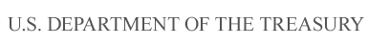

Department of the Treasury

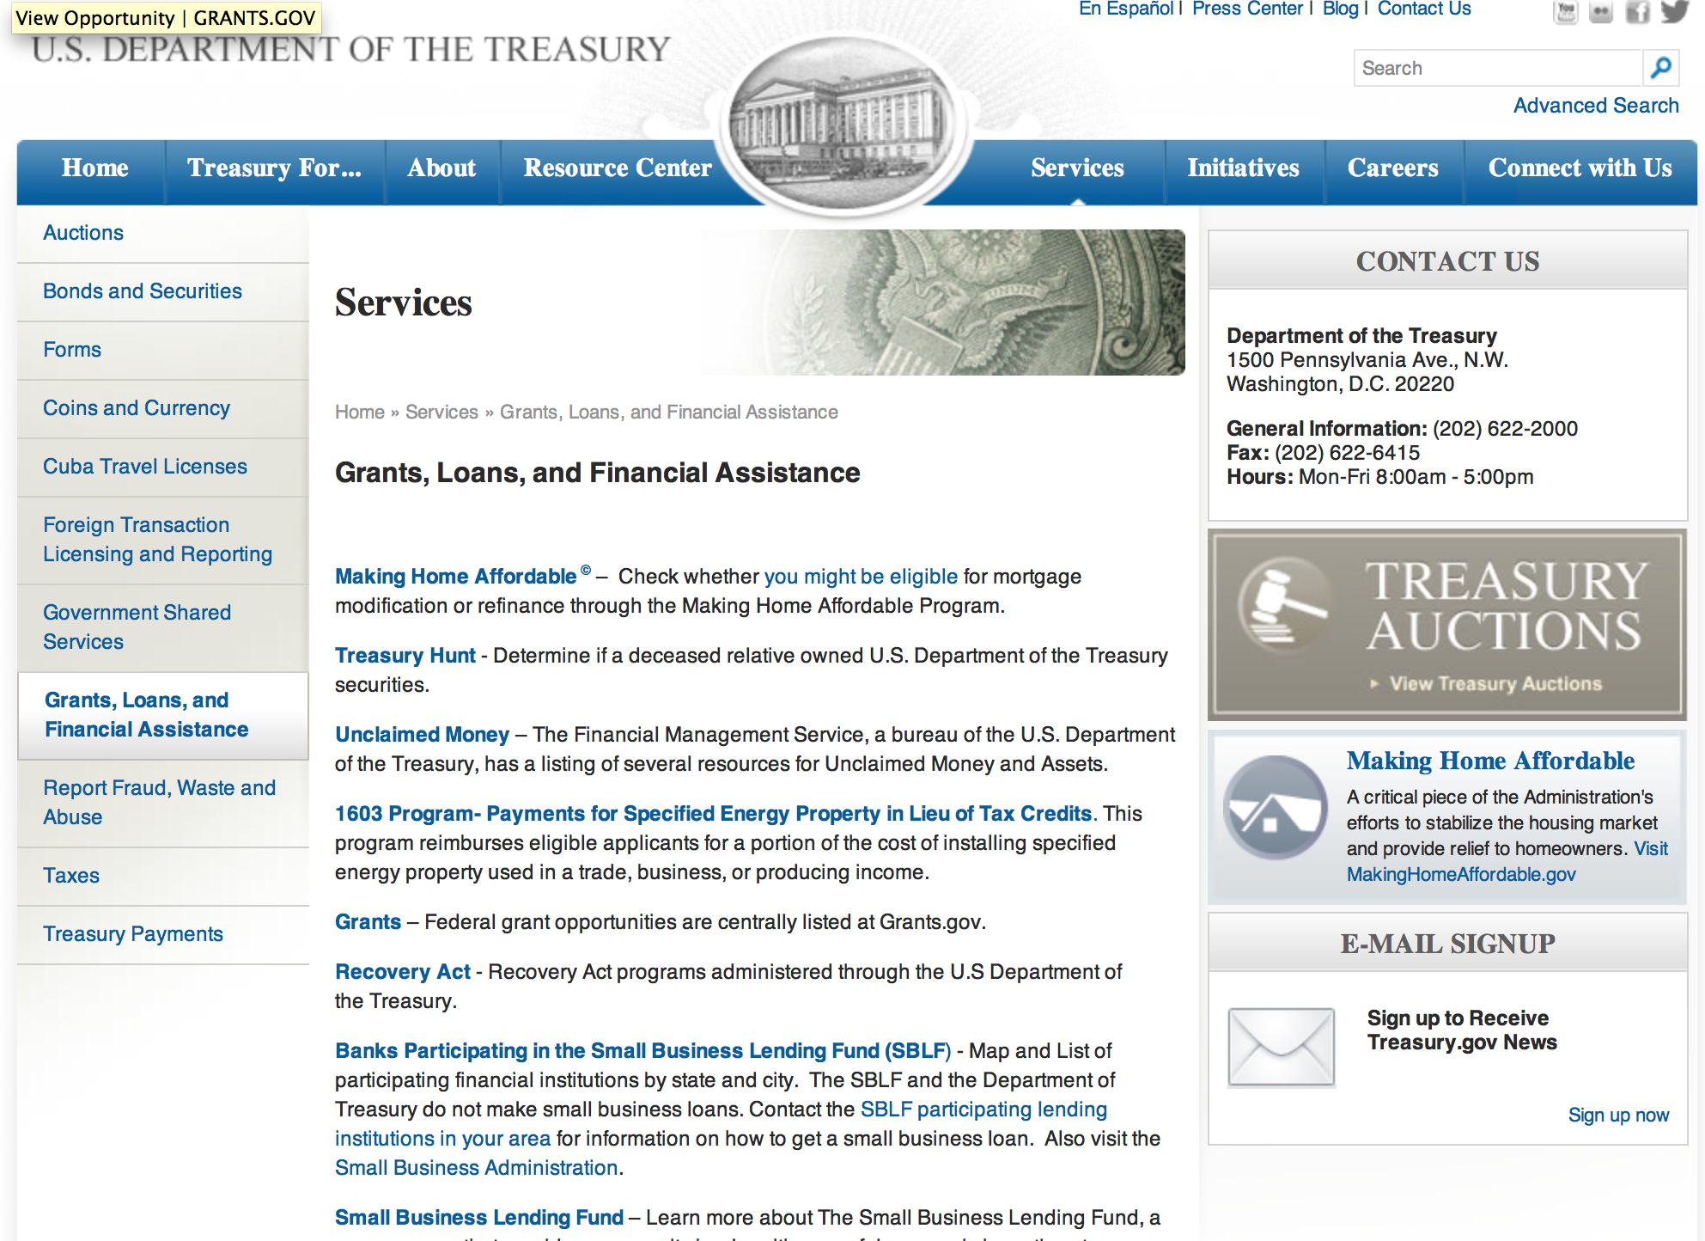

http://www.treasury.gov/services/Pages/Grants-Loans-and-Financial-Assistance.aspx

Programs:

Internal Revenue Service
Volunteer Income Tax Assistance VITA Grant

Document Type: | Grants Notice
Funding Opportunity Number: | VITA-2017
Funding Opportunity Title: | VITA
Opportunity Category: | Discretionary
Opportunity Category Explanation:
Funding Instrument Type: | Grant
Category of Funding Activity: | Other (see text field entitled "Explanation of Other Category of Funding Activity" for clarification)
Category Explanation: | Federal tax return preparation and electronic e-filing of returns
Expected Number of Awards: | 240
CFDA Number(s): | 21.009 -- Volunteer Income Tax Assistance (VITA) Matching Grant Program
Cost Sharing or Matching Requirement: | Yes
Posted Date: | May 01, 2016
Last Updated Date: | Apr 28, 2016
Original Closing Date for Applications: | Jun 01, 2016
Current Closing Date for Applications: | Jun 01, 2016
Archive Date: | Oct 31, 2016
Estimated Total Program Funding: | $15,000,000
Eligible Applicants: | City or township governments  Native American tribal governments (Federally recognized)  Private institutions of higher education  State governments  Public and State controlled institutions of higher education  Nonprofits having a 501(c)(3) status with the IRS, other than institutions of higher education  County governments
Agency Name: | Volunteer Income Tax Assistance
Description: | This funding allows the Stakeholder Partnerships, Education and Communication (SPEC)organization within the IRS to provide grants to partner organizations to achieve the following program objectives:• Enable the Volunteer Income Tax Assistance (VITA) Program to extend services to underserved populations in hardest-to-reach areas, both urban and non-urban;• Increase the capacity to file returns electronically;• Heighten quality control;• Enhance training of volunteers; and• Improve significantly the accuracy rate of returns prepared at VITA sites. The VITA Grant program supplements the work already being done in the VITA Program by providing support to help organizations grow their existing programs for free federal tax return preparation.
Link to Additional Information: | VITA Grant Program Overview and Application Instructions
Contact Information: | If you have difficulty accessing the full announcement electronically, please contact:  IRS Grant Program Office  Grant Program Office

http://www.grants.gov/web/grants/view-opportunity.html?oppId=283351

Internal Revenue Service
Tax Counseling for the Elderly
Tax Counseling for the Elderly
And Modification 1

Document Type: | Grants Notice
Funding Opportunity Number: | TCE-2017-001
Funding Opportunity Title: | Tax Counseling for the Elderly
Opportunity Category: | Discretionary
Opportunity Category Explanation:
Funding Instrument Type: | Cooperative Agreement
Category of Funding Activity: | Other (see text field entitled "Explanation of Other Category of Funding Activity" for clarification)
Category Explanation: | Tax preparation and counseling services for the elderly
Expected Number of Awards: | 100
CFDA Number(s): | 21.006 -- Tax Counseling for the Elderly
Cost Sharing or Matching Requirement: | No
Posted Date: | May 01, 2016
Last Updated Date: | May 02, 2016
Original Closing Date for Applications: | May 31, 2016
Current Closing Date for Applications: | Jun 01, 2016
Archive Date: | Jun 30, 2016
Estimated Total Program Funding: | $6,500,000
Eligible Applicants: | Native American tribal governments (Federally recognized)  Nonprofits having a 501(c)(3) status with the IRS, other than institutions of higher education
Agency Name: | Tax Counseling for the Elderly
Description: | IRS is authorized to enter into agreements with private or non-governmental public non profit agencies or organizations, exempt under Section 501 of the Internal Revenue Code, that will provide training and technical assistance to volunteers who in turn provide free tax counseling and assistance to elderly individuals in the preparation of their Federal income tax returns. Grant funds are used to reimburse volunteers for out-of-pocket expenses including transportation, meals and other expenses incurred by them in providing tax counseling assistance at locations convenient to the taxpayers.
Link to Additional Information: | Publication 1101 - TCE
Contact Information: | If you have difficulty accessing the full announcement electronically, please contact:  TCE Grant Office Phone 404-338-7894  TCE Email Address

http://www.grants.gov/web/grants/view-opportunity.html?oppId=283262

Modifications:

Low Income Taxpayer Clinic (LITC)
Modification 2

Document Type: | Grants Notice
Funding Opportunity Number: | TREAS-GRANTS-052017-001
Funding Opportunity Title: | Low Income Taxpayer Clinic
Opportunity Category: | Discretionary
Opportunity Category Explanation:
Funding Instrument Type: | Grant
Category of Funding Activity: | Law, Justice and Legal Services
Category Explanation:
Expected Number of Awards: | 150
CFDA Number(s): | 21.008 -- Low Income Taxpayer Clinics
Cost Sharing or Matching Requirement: | Yes
Posted Date: | May 02, 2016
Last Updated Date: | May 02, 2016
Original Closing Date for Applications: | Jun 20, 2016 No Explanation
Current Closing Date for Applications: | Jun 20, 2016
Archive Date: | Jul 20, 2016
Estimated Total Program Funding: | $12,000,000
Award Ceiling: | $100,000
Award Floor: | $0
Eligible Applicants: | Private institutions of higher education  Nonprofits having a 501(c)(3) status with the IRS, other than institutions of higher education  Public and State controlled institutions of higher education
Agency Name: | Low Income Taxpayer Clinic (LITC)
Description: | The Low Income Taxpayer Clinic (LITC) program is a matching grant program that provides Federal funds to organizations so they in turn can provide LITC services to taxpayers who are low income or who speak English as a second language (ESL). Clinics participating in the LITC program provide: Representation for individuals in disputes with the Internal Revenue Service (IRS), including audits, appeals, collection matters, and federal tax litigation. LITCs can also help taxpayers respond to IRS notices and correct account problems; Education about taxpayer rights and responsibilities; and Advocacy on behalf of low income and ESL taxpayers. LITC services are free or low cost for eligible taxpayers. LITCs are independent from the IRS but receive some of their funding from the IRS through the LITC grant program. Each clinic determines whether prospective clients meet income guidelines and other criteria before agreeing to represent them.
Link to Additional Information: | Publication 3319
Contact Information: | If you have difficulty accessing the full announcement electronically, please contact:  Grants.gov Contact Center Phone Number: 1-800-518-4726 Hours of operation are 24 hours a day, 7 days a week. The contact center is closed on federal holidays. support@grants.gov  Grants.gov Customer Support

http://www.grants.gov/web/grants/view-opportunity.html?oppId=283393

Reminders:

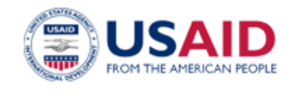

U.S. Agency for International Development

www.usaid.gov

General Overview Funding Opportunities

USAID has working relationships with thousands of American companies and hundreds of U.S.-based private voluntary organizations. For more information on our business and procurement opportunities, please visit our Business section.

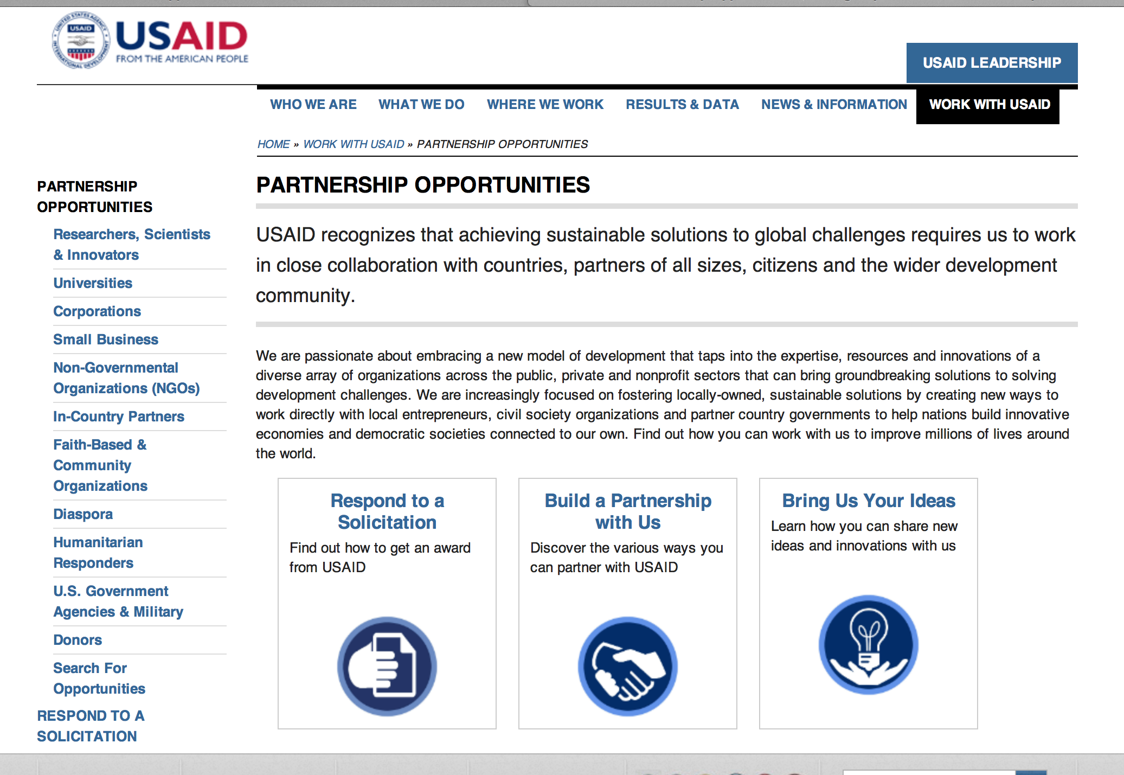
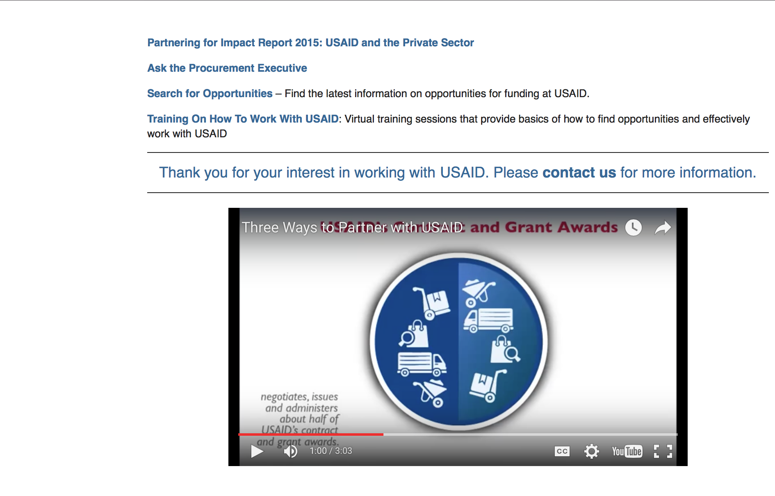

http://www.usaid.gov/partnerships

Programs:

The Global Health Challenge BAA Grant
http://www.grants.gov/web/grants/view-opportunity.html?oppId=282988

Fiscal Year 2016 Title II Development Food Assistance Projects for Democratic Republic of Congo, Ethiopia, and Liberia Grant
http://www.grants.gov/web/grants/view-opportunity.html?oppId=282920

Modifications:

West Africa -Ghana
Human Rights for All
Modification 1
http://www.grants.gov/web/grants/view-opportunity.html?oppId=279889

Afghanistan -Kabul
Promoting Afghanistan’s Commercial Agricultural Production and Exports
Modifications 1 & 2
http://www.grants.gov/web/grants/view-opportunity.html?oppId=283154

Annual Program Statement - Integrating Community Health
Modification 4
http://www.grants.gov/web/grants/view-opportunity.html?oppId=276749

Senegal -Dakar
Call for Partnership Concept Papers for Sahel Senegal (-Dakar)
Modification 5
http://www.grants.gov/web/grants/view-opportunity.html?oppId=280487

Tanzania -Dar es Salaam
Comprehensive Health Services Delivery (CHSD)
Modification 3
http://www.grants.gov/web/grants/view-opportunity.html?oppId=282679

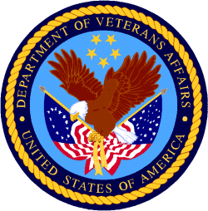

Department of Veterans Affairs

