Senator Mazie Hirono

Grants Assistance Information Newsletter

NOVEMBER 2017

G.A.I.N. INDEX

Click on Index Links below to read summaries of the announcements by agency in this document. Once you reach the item, if you cannot open the links for further information, copy the selected URL website address into your browser.

Modified sections from previous listings are shown in a GREY background

Notices is Teal are items with immediate deadline dates.

Notices in Yellow are of special interest.

Notices is Green are items of special interest with immediate deadline dates.

Items in this type color are aimed at Small Businesses

Items in this type color have a Faith-Based Organization component

Special Federal Program Notices

Grant Writing Resources

SAM and Grants.Gov Information

SBIR – Small Business Innovation Research

Programs specific to Hawaii

Current Notices

Institute of Museum and Library Services
Native American/Native Hawaiian Museum Services Program

Reminders

See Individual Departments for information and webpages representing the best and most accessible information on the agency funding opportunities

Federal Grant and Cooperative Agreement Program Summaries

U.S. Department of Agriculture

Grants and Loans Overview

Programs

Utilities Programs
Assistance to High Energy Cost Communities

Food and Nutrition Service
FY 18 Farm to school Grant

Forest Service
2018 Wood Innovations Funding Opportunity

Research

National Institute of Food and Agriculture
Specialty Crop Research Initiative Request for Pre-Applications

Modifications

National Institute of Food and Agriculture
Higher Education Multicultural Scholars Program (MSP)

Reminders

Utilities Programs
TAT Grant Program FY18

Utilities Programs
Solid Waste Management Grant Program

National Institute of Food and Agriculture
Food Insecurity Nutrition Incentive Competitive Grant Program

National Institute of Food and Agriculture
Community Food Projects Competitive Grant Program

Business and Cooperative Programs
VALUE ADDED PRODUCER GRANT

Deleted:

Department of Commerce

Grants at Commerce

Programs

Modifications

FY18 Saltonstall Kennedy Competition

Research

National Institute of Standards and Technology
NIST Public Safety Innovation Accelerator Program – User Interface

Reminders

FY2018 Marine Debris Prevention

National Telecommunications and Information Admin
State and Local Implementation Grant Program (SLIGP) 2.0

FY18-19 CRCP International Coral Reef Conservation Cooperative Agreements

FY18 Marine Debris Removal

Ocean Exploration FY 2018 Funding Opportunity

Economic Development Administration
FY 2017 Economic Development Assistance Programs ­ Application submission and program requirements for EDA’s Public Works and Economic Adjustment Assistance programs.

National Institute of Standards and Technology
Embedding MEP in Manufacturing USA Institutes Pilot Projects – Round 3

National Institute of Standards and Technology
Measurement Science and Engineering (MSE) Research Grant Programs

FY 2016 – FY 2019 EDA Planning Program and Local Technical Assistance Program Grant

Economic Development Administration
Planning Program and Local Technical Assistance Program Grant

Deleted

Corporation for National and Community Service

General Program Overview

Programs

Reminders

AmeriCorps State and National Grants FY2018

National Service in Hawaii

Department of Defense

Doing Business with the Department of Defense

DoD Small Business Opportunities and Forecasting

Research Grants

Modifications

Deleted

Reminders

Department of Education

Grant Programs Overview

Programs

Research

Modifications

Reminders

Deleted

US Department of Energy

Grants Overview

Research

Modifications

Reminders

Environmental Protection Agency

Grants and Contracts Overview

Programs

FY 2017 and FY 2018 Training and Technical Assistance to Improve Water Quality and Enable Small Public Water Systems to Provide Safe Drinking Water

FY18 Environmental Workforce Development And Job Training (EWDJT) Grants

Modifications

Research

Reminders

FY18 Guidelines For Brownfields Cleanup Grants

FY18 Guidelines For Brownfields Revolving Loan Fund Grants

FY18 Guidelines For Brownfields Assessment Grants

2017 Targeted Air Shed Grant Program

Department of Health and Human Services

Grants Overview

Program

Research Grants

Modifications

Deleted

Reminders

Department of Homeland Security
Grants Overview

Programs

Modifications

Reminders

Department of Homeland Security - FEMA
FY17 Flood Mitigation Assistance

Department of Homeland Security - FEMA
FY17 Pre-Disaster Mitigation

Department of Housing and Urban Development

HUD - Notice of Funds Available

Programs

Self-Help Homeownership Opportunity Program (SHOP)

Modifications

Deleted

Reminders

Choice Neighborhoods Implementation Grant Program

Rural Capacity Building for Community Development and Affordable Housing Grants (RCB)

Choice Neighborhoods Implementation Grant Program

Jobs Plus Initiative

Institute of Museum and Library Services

Grants Overview

IMLS is on Facebook!

Programs

Modifications

Reminders

Institute of Museum and Library Services
National Leadership Grants for Museums

Museums for America

Deleted

Department of Interior

Grants and Contract Overview

Programs

National Park Service
2018 Preservation Technology and Training Grants

National Park Service
FY 18 American Battlefield Protection Program Battlefield Preservation Planning Project Grants

Modifications

Fish and Wildlife Service
Partners for Fish and Wildlife

Fish and Wildlife Service
Coastal

Fish and Wildlife Service
National Outreach and Communication Program

Cooperative Agriculture

Reminders

Deleted

Department of Justice

Grants and Contract Overview

Programs

Research

Modifications

Deleted

Reminders

Office on Violence Against Women
Supplemental OVW Fiscal Year 2017 Enhanced Training And Services To End Abuse In Later Life Program Solicitation

________________________________________________________________________

Department of Labor

Grants and Contract General Overview

Programs

Modifications

Reminders

National Aeronautics and Space Administration

Research Grant and Contract General Overview

Programs

Modifications

_______________________________________________________________
National Archives and Records Administration

Grant Opportunities General Overview

Programs

Reminders

Access to Historical Records: Major Initiatives (Preliminary)

Access to Historical Records: Major Initiatives

_______________________________________________________________
National Endowment for the Arts

Grant Opportunities General Overview

Programs

Modifications

Reminders

NEA Literature Fellowships: Translation Projects, FY2019
_______________________________________________________________

National Endowment for the Humanities

Grant Opportunities General Overview

Programs

Collaborative Research Grants

Scholarly Editions and Translations Grants

Sustaining Cultural Heritage Collections

Reminders

Next Generation Humanities PhD Planning Grants

_______________________________________________________________
National Science Foundation

Grant Opportunities General Overview

Research and Program Grants

Modifications

Reminders

Deleted

Nuclear Regulatory Commission

Reminders

Small Business Administration

General Overview Finding Loans & Grants

Programs

Modifications

Reminders

Deleted

Upcoming Trainings

Links Specific to Hawaii

State Department

General Overview and Resources for Program Administrators

Programs

Modifications

Reminders

U.S. Department of Transportation

General Grant Program Overview

Programs

DOT - Office of Aviation Analysis
Small Community Air Service Development Program

Research

Modifications

Reminders

DOT Federal Aviation Administration
DOT - FAA Aviation Research Grants
FAA Aviation Research and Development Grants
Modifications 3,4& 6

Deleted

Department of the Treasury

Programs

Modifications

Reminders

Community Development Financial Institutions
FY 2017 Bank Enterprise Award Program Application

US Agency for International Development

General Funding Opportunity Overview

Programs
Modifications

Deleted

Department of Veterans Affairs

Special Federal Program Notices

Grant Writing Resources

The following links are a great resource for faith-based non-profits and other community organizations :

- Center for Faith-Based and Community Initiatives (link is external) , U.S. Department of Labor

- http://www.usaid.gov/partnership-opportunities/fbci. U.S. Agency for International Development

- Faith-Based and Other Community Initiatives (link is external) , Corporation for National Community Service

- Task Force for Faith-Based and Community Initiatives (link is external) , U.S. Department of Justice

- Proposal Writing Short Course (link is external) Foundation Center.
- General Tips on Writing a Competitive Grant Proposal (link is external) U.S. Environmental Protection Agency.
- How to Write a Grant Proposal (link is external) Appalachian Regional Commission.
- A Guide to Funding Resources USDA Rural Information Center.

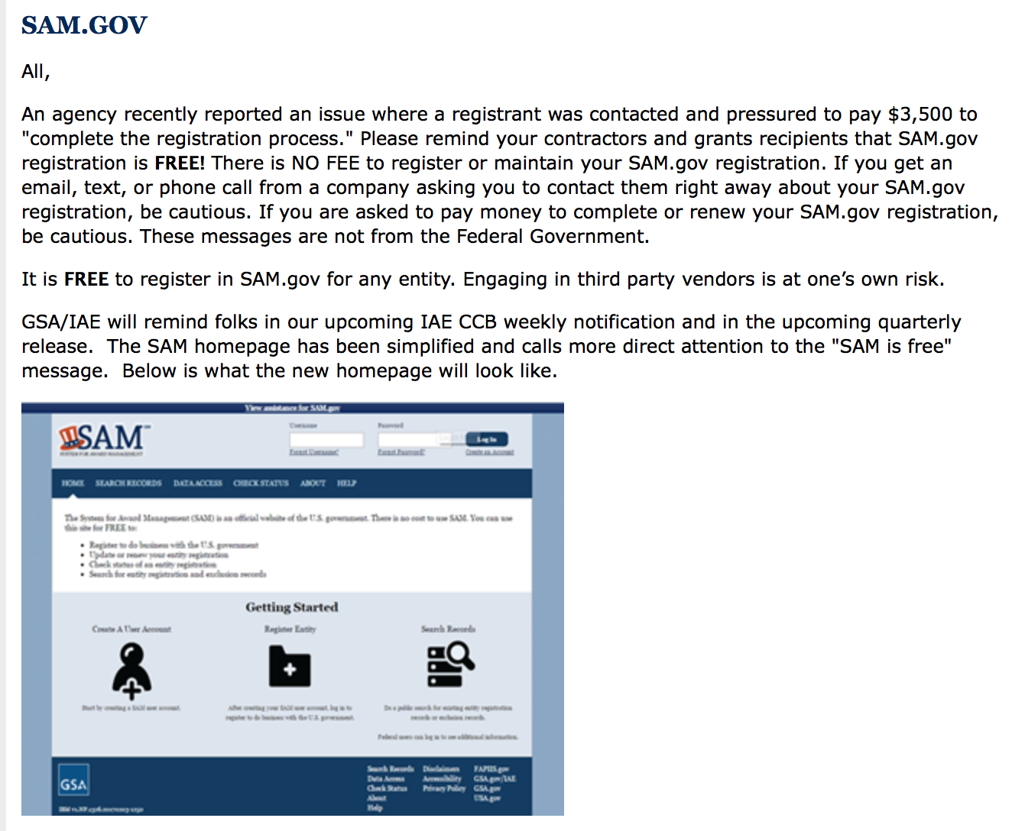

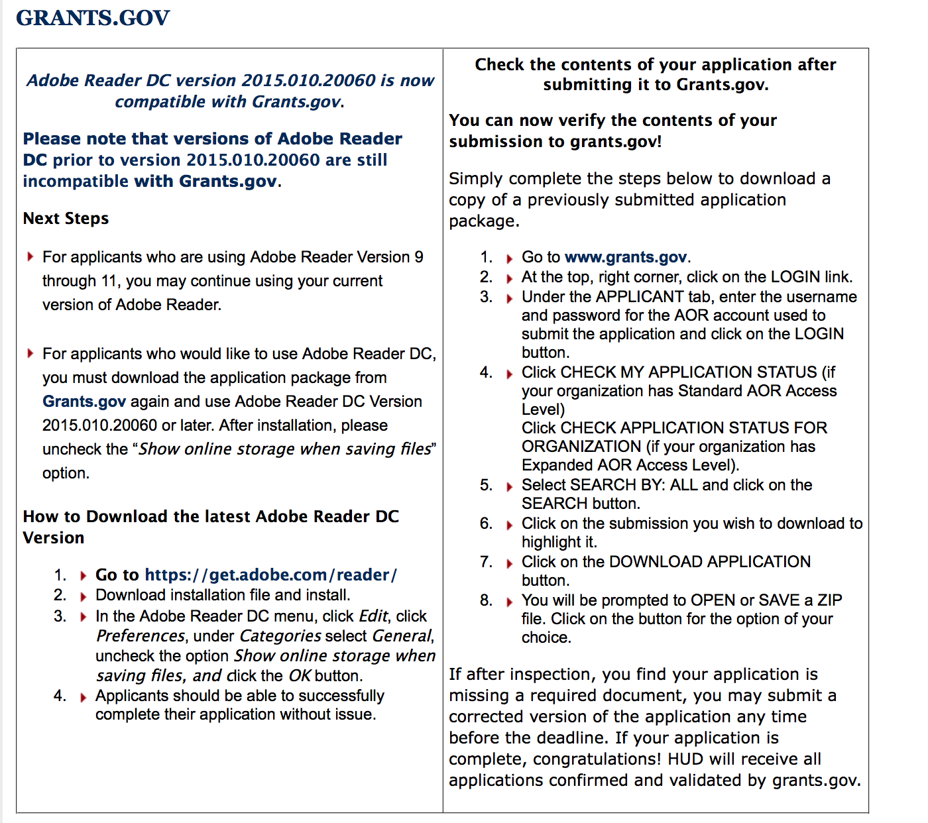

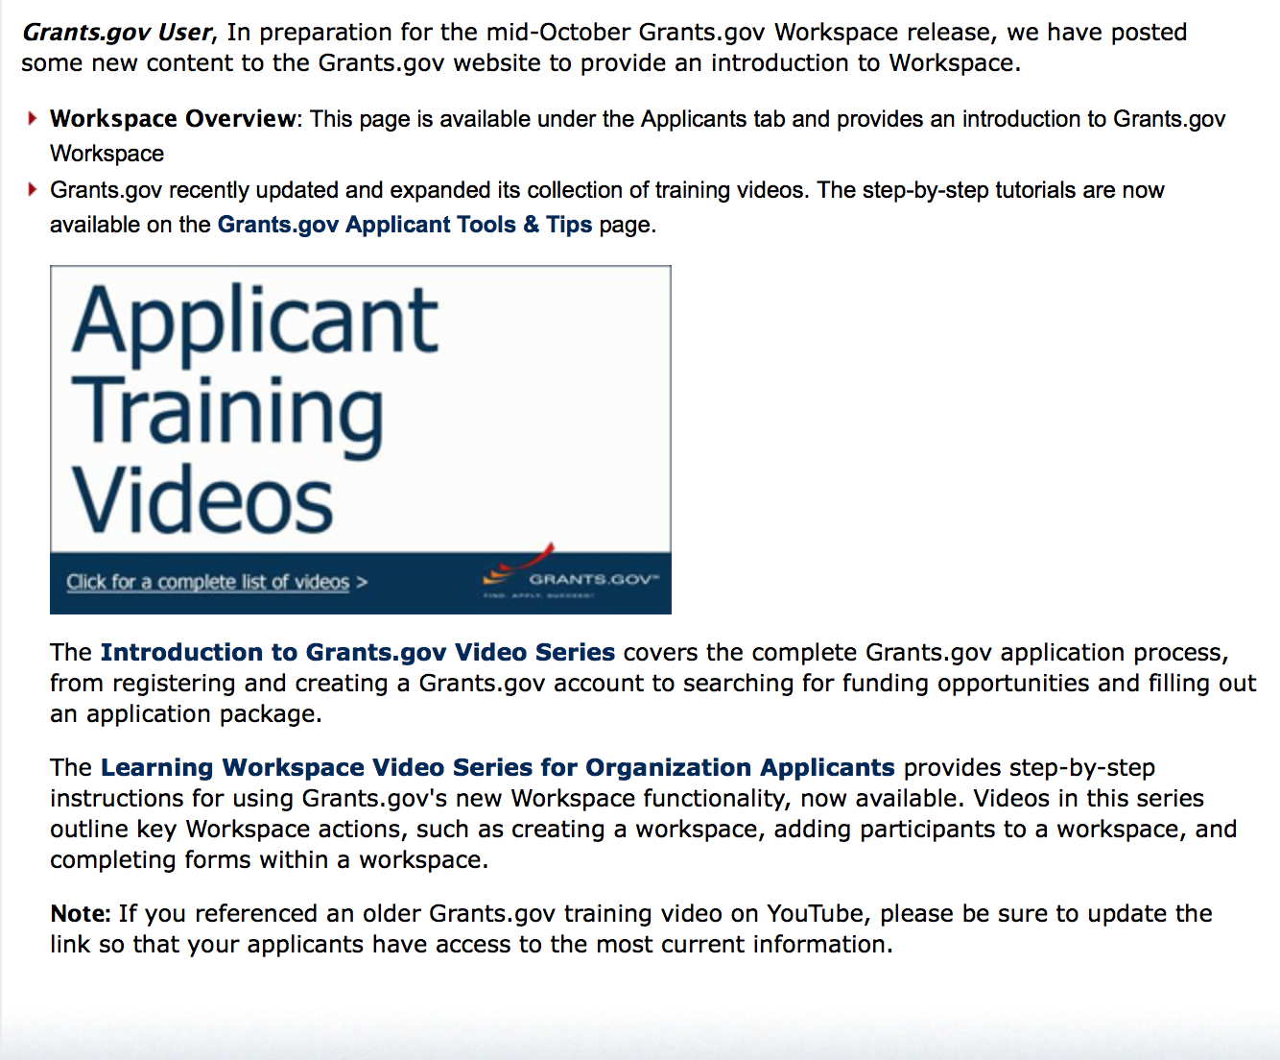
https://portal.hud.gov/hudportal/HUD?src=/program_offices/administration/grants/fundsavail

The Small Business Innovative Research Program - SBIR Program

The Small Business Innovation Research (SBIR) program is a highly competitive program that encourages domestic small businesses to engage in Federal Research/Research and Development (R/R&D) that has the potential for commercialization. Through a competitive awards-based program, SBIR enables small businesses to explore their technological potential and provides the incentive to profit from its commercialization. By including qualified small businesses in the nation's R&D arena, high-tech innovation is stimulated and the United States gains entrepreneurial spirit as it meets its specific research and development needs.

SBIR Mission and Program Goals
The mission of the SBIR program is to support scientific excellence and technological innovation through the investment of Federal research funds in critical American priorities to build a strong national economy.
The program’s goals are four-fold:
- Stimulate technological innovation
- Meet Federal research and development needs.
- Foster and encourage participation in innovation and entrepreneurship by socially and economically disadvantaged persons.
- Increase private-sector commercialization of innovations derived from Federal research and development funding.

SBIR-Participating Agencies
Each year, Federal agencies with extramural research and development (R&D) budgets that exceed $100 million are required to allocate 2.5 percent of their R&D budget to these programs. Currently, eleven Federal agencies participate in the program:
- Department of Agriculture
- Department of Commerce - National Institute of Standards and Technology
- Department of Commerce - National Oceanic and Atmospheric Administration
- Department of Defense
- Department of Education
- Department of Energy
- Department of Health and Human Services
- Department of Homeland Security
- Department of Transportation
- Environmental Protection Agency
- National Aeronautics and Space Administration
- National Science Foundation
Each agency administers its own individual program within guidelines established by Congress. These agencies designate R&D topics in their solicitations and accept proposals from small businesses. Awards are made on a competitive basis after proposal evaluation.

Three-Phase Program
The SBIR Program is structured in three phases:
Phase I. The objective of Phase I is to establish the technical merit, feasibility, and commercial potential of the proposed R/R&D efforts and to determine the quality of performance of the small business awardee organization prior to providing further Federal support in Phase II. SBIR Phase I awards normally do not exceed $150,000 total costs for 6 months.
Phase II. The objective of Phase II is to continue the R/R&D efforts initiated in Phase I. Funding is based on the results achieved in Phase I and the scientific and technical merit and commercial potential of the project proposed in Phase II. Only Phase I awardees are eligible for a Phase II award. SBIR Phase II awards normally do not exceed $1,000,000 total costs for 2 years.
Phase III. The objective of Phase III, where appropriate, is for the small business to pursue commercialization objectives resulting from the Phase I/II R/R&D activities. The SBIR program does not fund Phase III. Some Federal agencies, Phase III may involve follow-on non-SBIR funded R&D or production contracts for products, processes or services intended for use by the U.S. Government
SBIR NewsLetter

- SBIR Newsletter
Sign up for e-mail updates

HAWAII APPLICANTS ENCOURAGED

Current Notices:

Institute of Museum and Library Services
Native American/Native Hawaiian Museum Services Program
Synopsis 1

Document Type: | Grants Notice
Funding Opportunity Number: | NANH-FY18
Funding Opportunity Title: | Native American/Native Hawaiian Museum Services Program
Opportunity Category: | Discretionary
Opportunity Category Explanation:
Funding Instrument Type: | Grant
Category of Funding Activity: | Arts (see "Cultural Affairs" in CFDA)  Humanities (see "Cultural Affairs" in CFDA)
Category Explanation:
Expected Number of Awards: | 14
CFDA Number(s): | 45.308 -- Native American/Native Hawaiian Museum Services Program
Cost Sharing or Matching Requirement: | No
Version: | Synopsis 1
Posted Date: | Oct 04, 2017
Last Updated Date: | Oct 04, 2017
Original Closing Date for Applications: | Dec 01, 2017
Current Closing Date for Applications: | Dec 01, 2017
Archive Date: | Dec 31, 2017
Estimated Total Program Funding: | $924,000
Award Ceiling: | $75,000
Award Floor: | $5,000
Eligible Applicants: | Others (see text field entitled "Additional Information on Eligibility" for clarification)
Additional Information on Eligibility: | Please see the Notice of Funding Opportunity for eligibility information.
Agency Name: | Institute of Museum and Library Services
Description: | Native American/Native Hawaiian Museum Services (NANH) grants support Indian tribes and organizations that primarily serve and represent Native Hawaiians. They are intended to provide opportunities to sustain heritage, culture, and knowledge through strengthened activities in areas such as exhibitions, educational services and programming, professional development, and collections stewardship.
Link to Additional Information: | https://www.imls.gov/grants/available/native-americannative-hawaiian-museum-services-program
Grantor Contact Information: | If you have difficulty accessing the full announcement electronically, please contact:  Sandra Narva, Senior Program Officer, 202-653-4791, snarva@imls.gov; Kelsey Monahan, Museum Program Specialist, 202-653-4753, kmonahan@imls.gov  snarva@imls.gov

http://www.grants.gov/web/grants/view-opportunity.html?oppId=297852

Reminders:

Please review each department’s General Grant and Funding Overview. These overviews are the key web pages on each departmental website dedicated to the agency’s funding opportunities. Check back often to note the department updates and use these sources to assist you in your planning.

Federal Grant and Cooperative Agreement Program Summaries

U.S. Department of Agriculture

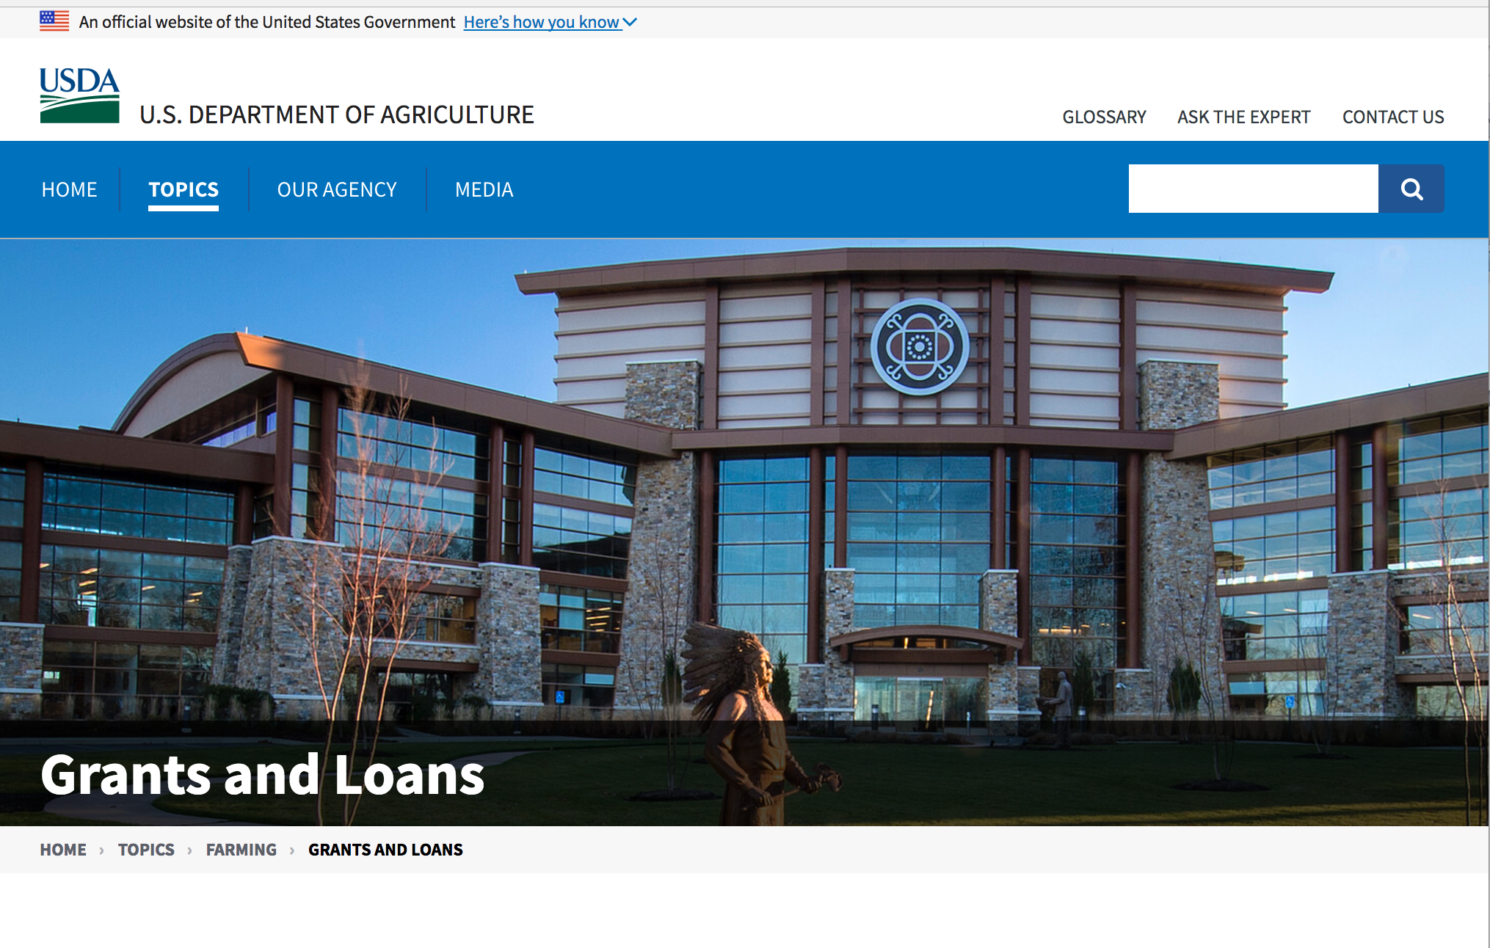

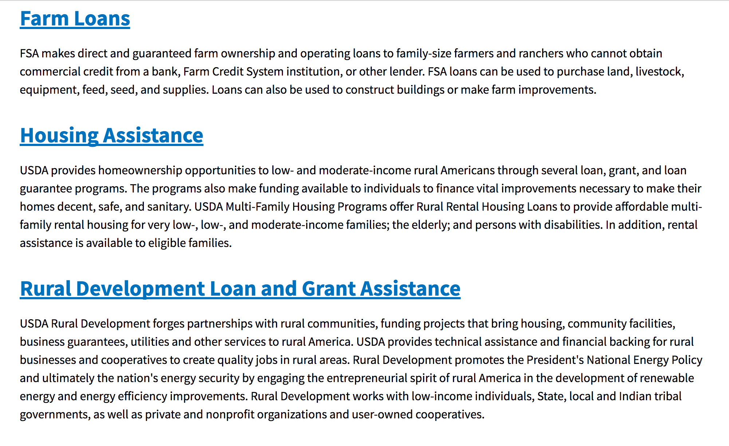

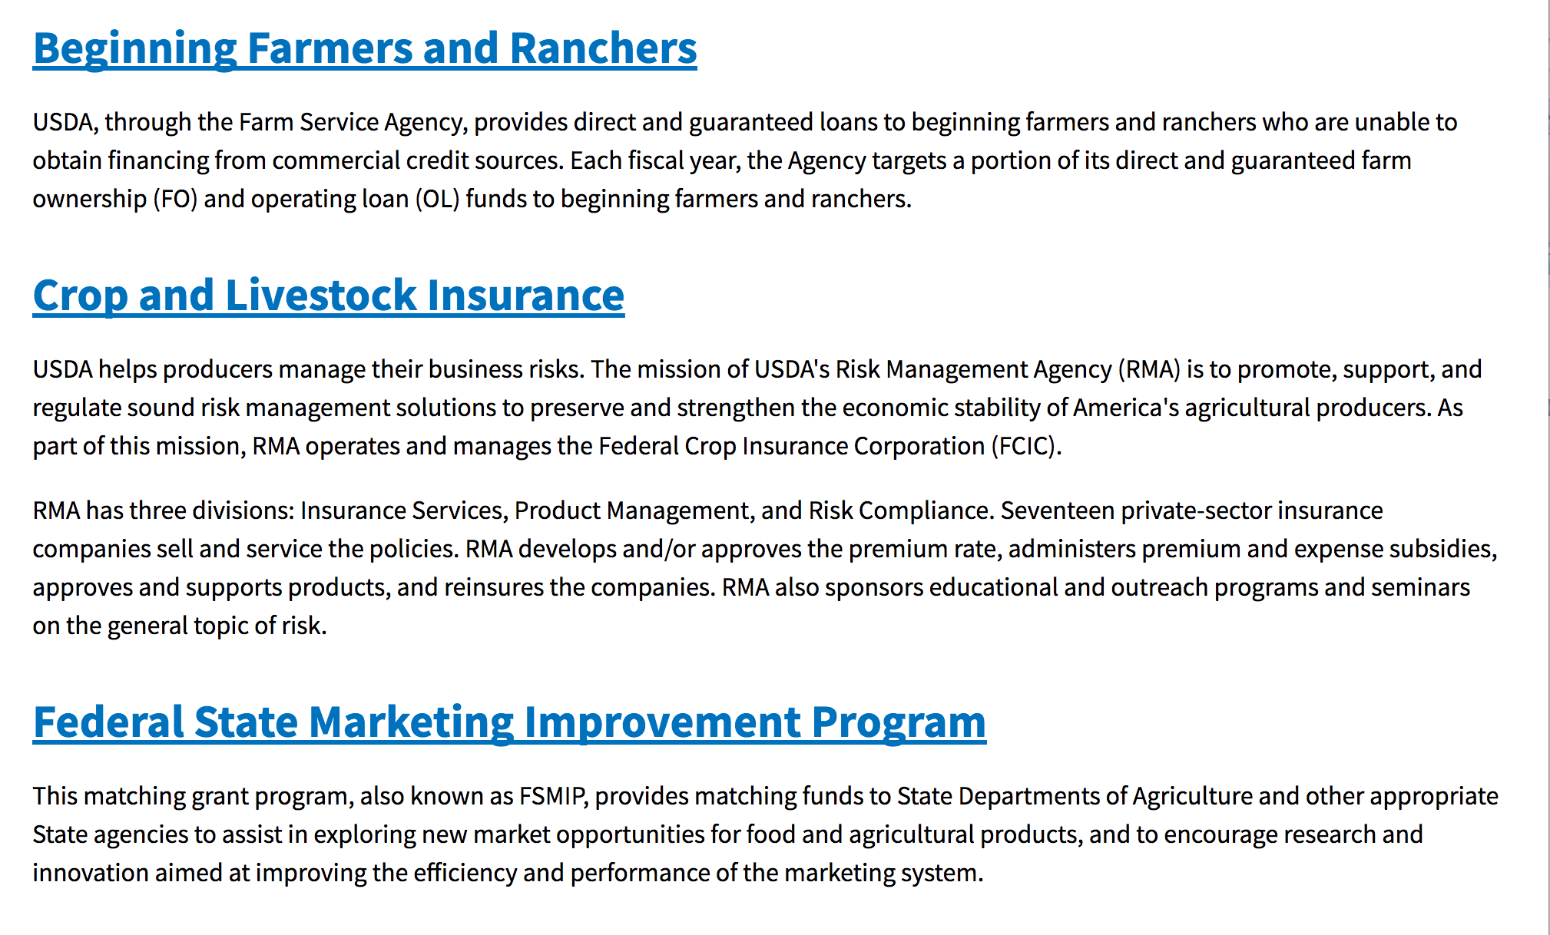
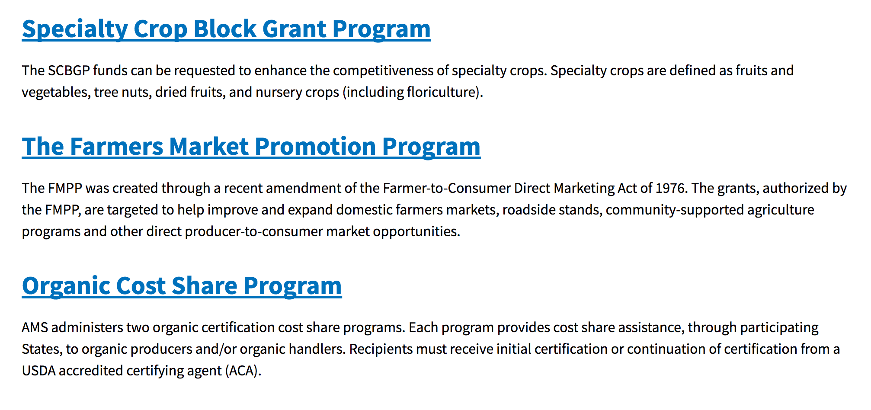
https://www.usda.gov/topics/farming/grants-and-loans

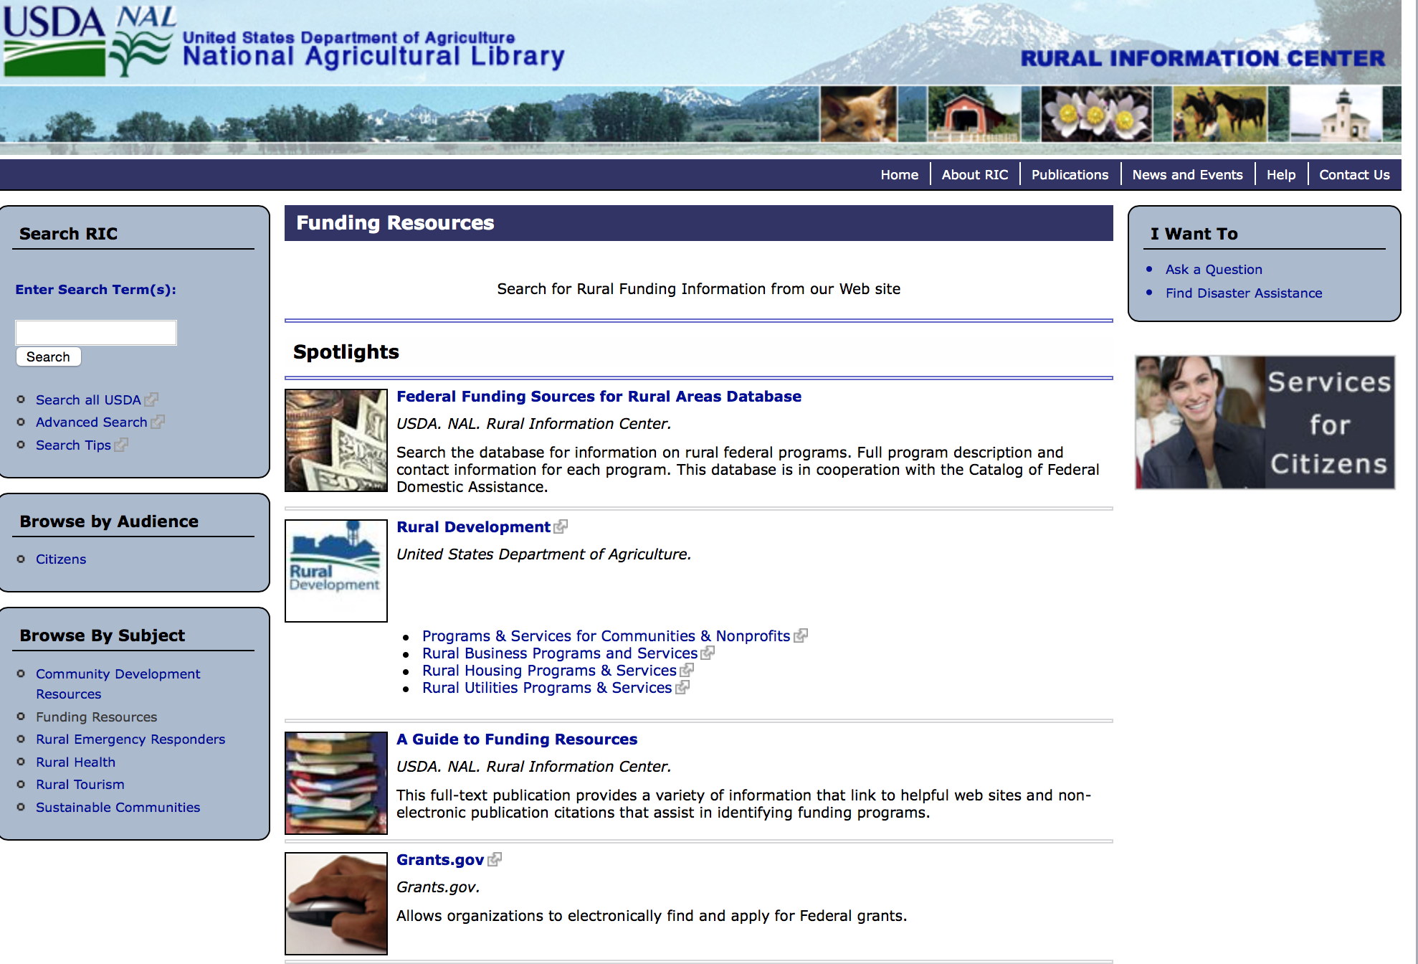

http://ric.nal.usda.gov/funding-resources

Programs:

Utilities Programs
Assistance to High Energy Cost Communities
Synopsis 1 & 2
Document Type: | Grants Notice
Funding Opportunity Number: | RD-RUS-HECG17
Funding Opportunity Title: | Assistance to High Energy Cost Communities
Opportunity Category: | Discretionary
Opportunity Category Explanation:
Funding Instrument Type: | Grant
Category of Funding Activity: | Business and Commerce  Community Development  Energy
Category Explanation:
Expected Number of Awards: | 10
CFDA Number(s): | 10.859 -- Assistance to High Energy Cost Rural Communities
Cost Sharing or Matching Requirement: | No
Version: | Synopsis 2
Posted Date: | Oct 20, 2017
Last Updated Date: | Oct 23, 2017
Original Closing Date for Applications: | Dec 13, 2017
Current Closing Date for Applications: | Dec 11, 2017
Archive Date: | Jan 12, 2018
Estimated Total Program Funding: | $10,000,000
Award Ceiling: | $3,000,000
Award Floor: | $100,000
Eligible Applicants: | Special district governments  Public and State controlled institutions of higher education  Native American tribal organizations (other than Federally recognized tribal governments)  Native American tribal governments (Federally recognized)  Individuals  City or township governments  State governments  Nonprofits having a 501(c)(3) status with the IRS, other than institutions of higher education  Independent school districts  Others (see text field entitled "Additional Information on Eligibility" for clarification)  County governments  Public housing authorities/Indian housing authorities  Private institutions of higher education  Small businesses  Nonprofits that do not have a 501(c)(3) status with the IRS, other than institutions of higher education  For profit organizations other than small businesses
Additional Information on Eligibility: | Individuals may apply on behalf of unincorporated community organizations. Awards will not be made directly to individuals. Eligible applicants also include sole proprietorships, legally organized for-profit or nonprofit organizations such as, but not limited to, a corporation, association, partnership (including a limited liability partnership), cooperative or trust. Applicant must be located in the United States, a U.S. Territory or other area authorized by law to participate in programs of the Rural Utilities Service or under the Rural Electrification Act.
Agency Name: | Utilities Programs
Description: | The Rural Utilities Service (RUS), an agency of the United States Department of Agriculture (USDA), announces the availability of up to $10 million in competitive grants to assist communities with extremely high-energy costs. The grant funds may be used to acquire, construct, or improve energy generation, transmission, or distribution facilities serving communities where the average annual residential expenditure for home energy exceeds 275% of the national average. Eligible projects also include on-grid and off-grid renewable energy projects and the implementation of energy efficiency and energy conservation projects for eligible communities. Projects cannot be for the primary benefit of a single household or business. Grant funds may not be used for the preparation of the grant application, payment of utility bills, fuel purchases, routine maintenance or other routine operating costs, or for the purchase of any equipment, structures, or real estate not directly associated with the provision of community energy services. See the Notice of Solicitation of Applications published October 12, 2017 at 82 FR 47446.
Link to Additional Information: | Homepage for the USDA High Energy Cost Grant Program
Grantor Contact Information: | If you have difficulty accessing the full announcement electronically, please contact:  Robin Meigel Finance Specialist Phone 202 720 9452  USDA Washington, DC

http://www.grants.gov/web/grants/view-opportunity.html?oppId=298063

Food and Nutrition Service
FY 18 Farm to school Grant
Synopsis 1
Document Type: | Grants Notice
Funding Opportunity Number: | USDA-FNS-F2S-2018
Funding Opportunity Title: | FY 18 Farm to school Grant
Opportunity Category: | Discretionary
Opportunity Category Explanation:
Funding Instrument Type: | Grant
Category of Funding Activity: | Food and Nutrition
Category Explanation:
Expected Number of Awards: | 70
CFDA Number(s): | 10.575 -- Farm to School Grant Program
Cost Sharing or Matching Requirement: | Yes
Version: | Synopsis 1
Posted Date: | Oct 04, 2017
Last Updated Date: | Oct 04, 2017
Original Closing Date for Applications: | Dec 08, 2017
Current Closing Date for Applications: | Dec 08, 2017
Archive Date: | Jan 07, 2018
Estimated Total Program Funding: | $5,000,000
Award Ceiling: | $100,000
Award Floor: | $20,000
Eligible Applicants: | Others (see text field entitled "Additional Information on Eligibility" for clarification)
Additional Information on Eligibility: | Planning and Implementation Grant Eligibility: Eligible schools, state and local agencies, Indian tribal organizations, small- and medium-sized agricultural producers or groups of small- and medium-sized agricultural producers, and non-profit entities are eligible to receive planning and implementation grants. Eligible schools are defined as pre-K-12 School Food Authorities (SFAs), non-profit private schools, charter schools, Indian tribal schools, and others that participate in the National School Lunch or Breakfast Programs. Eligible SFAs may apply for funding that spans the entire SFA, for a specific group of schools (e.g. only K-5 schools within an SFA), or for an individual school. In the case where an SFA exists, the application must come from the SFA, and only one application per SFA is allowed. Funding is available to support school-based programs only. If a proposal seeks to increase local foods in the Child and Adult Care Program or the Summer Food Service Program, target sites must be located at a school. Training Grant Eligibility: Only state and local agencies, Indian Tribal Organizations, small- and medium-sized agricultural producers or groups of small- and medium-sized agricultural producers, and non-profit entities are eligible to receive training grant funds. Training grants may support projects that impact CACFP and SFSP operators that have sites beyond schools.
Agency Name: | Food and Nutrition Service
Description: | The Healthy, Hunger-Free Kids Act of 2010 (HHFKA) amended Section 18 of the Richard B. Russell National School Lunch Act (NSLA) to establish a Farm to School Program in order to assist eligible entities, through grants and technical assistance, in implementing farm to school programs that improve access to local foods in eligible schools. To fulfill the farm to school mandate in the HHFKA, $5 million is provided to the United States Department of Agriculture (USDA) on an annual basis to support grants, technical assistance, and the Federal administrative costs related to USDA’s Farm to School Program. The USDA Farm to School Program is housed within the Food and Nutrition Services’ (FNS) Office of Community Food Systems (OCFS). This request for applications (RFA) provides additional details regarding the grants component of the USDA Farm to School Program. Authorizing language in the HHFKA directed the Secretary of Agriculture to award competitive grants for: (i) Training; (ii) Supporting operations; (iii) Planning; (iv) Purchasing equipment; (v) Developing school gardens; (vi) Developing partnerships; and, (vii) Implementing farm to school programs. The Secretary of Agriculture was also directed through the HHFKA to ensure geographical diversity and equitable treatment of urban, rural, and tribal communities, as well as give the highest priority to funding projects that, as determined by the Secretary – (a) Make local food products available on the menu of the eligible school; (b) Serve a high proportion of children who are eligible for free or reduced price lunches; (c) Incorporate experiential nutrition education activities in curriculum planning that encourage the participation of school children in farm and garden-based activities; (d) Demonstrate collaboration between eligible schools, nongovernmental and community-based organizations, agricultural producer groups, and other community partners; (e) Include adequate and participatory evaluation plans; (f) Demonstrate the potential for long-term program sustainability; and, (g) Meet any other criteria that the Secretary determines appropriate. Authorizing language also states that as a condition of receiving a USDA Farm to School Program Grant, each grant recipient shall provide matching support in the form of cash or in-kind contributions, and agree to cooperate in an evaluation of the program carried out using grant funds. Grant Tracks: Grant funds will be made available on a competitive basis, subject to availability of Federal funds, using three grants tracks: Implementation grants are intended to help schools, school districts, state and local agencies, Indian tribal organizations, small- and medium-sized agricultural producers or groups of small- and medium-sized agricultural producers, and non-profit entities working with schools or school districts to scale or further develop existing farm to school initiatives. Implementation awards range from $50,000 - $100,000. Planning grants are for schools or school districts, state and local agencies, Indian tribal organizations, small- and medium-sized agricultural producers or groups of small- and medium-sized agricultural producers, and non-profit entities working with schools or school districts that are just getting started on farm to school activities. These funds are intended to help these entities organize and structure their efforts for maximum impact by embedding known best practices into early design considerations. Planning awards range from $20,000 - $50,000. Training grants are intended for state and local agencies, Indian tribal organizations, small- and medium-sized agricultural producers or groups of small- and medium-sized agricultural producers, and non-profit entities to support trainings that strengthen farm to school supply chains, or trainings that provide technical assistance in the area of local procurement, food safety, culinary education, and/or integration of agriculture‐based curriculum. Training awards range from $20,000 - $50,000.
Link to Additional Information: | Farm to School Grants - FY 2018
Grantor Contact Information: | If you have difficulty accessing the full announcement electronically, please contact:  Anna Arrowsmith Grants Officer Phone 703-305-2998  anna.arrowsmith@fns.usda.gov

http://www.grants.gov/web/grants/view-opportunity.html?oppId=297858

Forest Service
2018 Wood Innovations Funding Opportunity
Synopsis 1

Document Type: | Grants Notice
Funding Opportunity Number: | USDA-FS-WERC-2018
Funding Opportunity Title: | 2018 Wood Innovations Funding Opportunity
Opportunity Category: | Discretionary
Opportunity Category Explanation:
Funding Instrument Type: | Grant
Category of Funding Activity: | Natural Resources
Category Explanation:
Expected Number of Awards: | 28
CFDA Number(s): | 10.674 -- Wood Utilization Assistance
Cost Sharing or Matching Requirement: | Yes
Version: | Synopsis 1
Posted Date: | Oct 18, 2017
Last Updated Date: | Oct 18, 2017
Original Closing Date for Applications: | Jan 22, 2018
Current Closing Date for Applications: | Jan 22, 2018
Archive Date: | Feb 21, 2018
Estimated Total Program Funding: | $7,000,000
Award Ceiling: | $250,000
Award Floor: | $10,000
Eligible Applicants: | Others (see text field entitled "Additional Information on Eligibility" for clarification)
Additional Information on Eligibility: | Eligible applicants are for-profit entities; State, local, and Tribal governments; school districts; communities; not-for-profit organizations; institutions of higher education; and special purpose districts (e.g., public utilities districts, fire districts, conservation districts, and ports).
Agency Name: | Forest Service
Description: | Important Dates: October 18, 2017 - Issuance of Request for Proposals. January 22, 2018 - Proposal submission deadline. May 1, 2018 - Approximate date to notify applicants of results. July 1, 2018 - Approximate date of award. Synopsis of Funding Opportunity: The U.S. Forest Service requests proposals to substantially expand and accelerate wood energy and wood products markets throughout the United States to support forest management needs on National Forest System and other forest lands. This Request for Proposals focuses on the following priorities to: • Reduce hazardous fuels and improve forest health on National Forest System and other forest lands. • Reduce costs of forest management on all land types. • Promote economic and environmental health of communities. Funding will be awarded in two separate categories. Grant Category 1: Expansion of Wood Energy Markets - The intent of this category is to: 1. Stimulate, expand, or support wood energy markets that depend on forest residues or forest byproducts generated from all land types. Projects can include, but are not limited to: a. Develop a cluster of wood energy projects in a geographic area or specific sector (e.g., prisons, hospitals, universities, manufacturing sector, or industrial sector). b. Overcome market barriers and stimulate expansion of wood energy in the commercial sector. 2. Complete requirements, such as engineering designs, cost analyses, and permitting, necessary in the later stages of wood energy project development to secure financing. Grant Category 2: Expansion of Wood Products Markets - The intent of this category is to promote markets that create or expand the demand for non-energy based wood products. Preference will be given to projects that support commercial building markets or other markets that use innovative wood products. Wood energy projects will not be considered under this category because those projects can apply for funding under Grant Category 1. Demonstration projects and applied research will be considered, but applicants are strongly encouraged to first consult with their designed Forest Service Regional Biomass Coordinator to determine whether such projects will be competitive. Specific details, including the application and instructions, can be viewed and downloaded at the website listed below.
Link to Additional Information: | U.S. Forest Service web site
Grantor Contact Information: | If you have difficulty accessing the full announcement electronically, please contact:  Edward Cesa Deputy Director - WERC Phone 304-285-1530  U.S. Forest Service email address

http://www.grants.gov/web/grants/view-opportunity.html?oppId=298037

Research:

Modifications:

Reminders:

Utilities Programs
TAT Grant Program FY18
Synopsis 1
Document Type: | Grants Notice
Funding Opportunity Number: | TATFY18
Funding Opportunity Title: | TAT Grant Program FY18
Opportunity Category: | Discretionary
Opportunity Category Explanation:
Funding Instrument Type: | Grant
Category of Funding Activity: | Other (see text field entitled "Explanation of Other Category of Funding Activity" for clarification)
Category Explanation: | The Technical Assistance and Training (TAT) Grant Program has been established to communities with water or wastewater systems through free technical assistance and/or training provided by the grant recipients. Qualified private non-profit organizations will receive TAT grant funds to identify and evaluate solutions to water and waste disposal problems in rural areas, assist applicants in preparing applications for water and waste grants made at the State level offices, and improve operation and maintenance of existing water and waste disposal facilities in rural areas.
Expected Number of Awards: | 17
CFDA Number(s): | 10.761 -- Technical Assistance and Training Grants
Cost Sharing or Matching Requirement: | No
Version: | Synopsis 1
Posted Date: | Oct 02, 2017
Last Updated Date: | Oct 02, 2017
Original Closing Date for Applications: | Jan 02, 2018 Close date has been changed to 1/1/2018 since 12/31/17 deadline falls on a Sunday and next available day is a federal holiday.
Current Closing Date for Applications: | Jan 02, 2018 Close date has been changed to 1/1/2018 since 12/31/17 deadline falls on a Sunday and next available day is a federal holiday.
Archive Date: | Feb 01, 2018
Estimated Total Program Funding: | $20,000,000
Eligible Applicants: | Others (see text field entitled "Additional Information on Eligibility" for clarification)
Additional Information on Eligibility: | Eligibility criteria for TAT grants is as follows: (a) Entities eligible for grants must be private nonprofit organizations with tax exempt status, designated by the Internal Revenue Service. A nonprofit organization is defined as any corporation, trust, association, cooperative, or other organization that: (1) Is operated primarily for scientific, education, service, charitable, or similar purposes in the public interest. (2) Is not organized primarily for profit. (3) Uses its net proceeds to maintain, improve, and/or expand its operations. (b) Entities must be legally established and located within a state as defined inï¿½ 1775.2. (c) Organizations must be incorporated by December 31 of the year the application period occurs to be eligible for funds. (d)Private businesses, Federal agencies, public bodies, and individuals are ineligible for these grants.(e) Applicants must also have the proven ability, background, experience (as evidenced by the organization's satisfactory completion of project(s)similar to those proposed), legal authority, and actual capacity to provide technical assistance and/or training on a regional basis to associations as provided in 7 CFR 1775.33. To meet the requirement of actual capacity, an applicant must either:(1) Have the necessary resources to provide technical assistance and/or training to associations in rural areas through its staff, or (2) Be assisted by an affiliate or member organization which has such background and experience and which agrees, in writing, that it will provide the assistance, or (3) Contract with a non-affiliated organization for not more than 49 percent of the grant to provide the proposed assistance.
Agency Name: | Utilities Programs
Description: | Funds may be used to pay expenses associated with providing technical assistance and/or training (TAT) to identify and evaluate solutions to water problems relating to source, storage, treatment, and distribution, and to waste disposal problems relating to collection, treatment, and disposal; assist applicants that have filed an preapplication with RUS in the preparation of water and/or waste disposal loan and/or grant applications; and to provide training that will improve the management, operation and maintenance of water and waste disposal facilities. Grant funds may not be used to recruit applications, duplicate current services such as those performed by a consultant in developing a project, fund political activities, pay for capital assets, purchase real estate or vehicles, improve and renovate office space or repair and maintain privately owned property, pay construction or O&M costs, and pay costs incurred prior to the effective date of grants made.
Link to Additional Information:
Grantor Contact Information: | If you have difficulty accessing the full announcement electronically, please contact:  Anita OBrien Loan Specialist Phone 202-690-3789  Government Email Address

http://www.grants.gov/web/grants/view-opportunity.html?oppId=297811

Utilities Programs
Solid Waste Management Grant Program
Synopsis 1

Document Type: | Grants Notice
Funding Opportunity Number: | SWMFY2018
Funding Opportunity Title: | Solid Waste Management Grant Program
Opportunity Category: | Discretionary
Opportunity Category Explanation:
Funding Instrument Type: | Grant
Category of Funding Activity: | Community Development  Environment
Category Explanation: | The Solid Waste Management (SWM) Grant Program has been established to assist communities through free technical assistance and/or training provided by the grant recipients. Qualified organizations will receive SWM grant funds to reduce or eliminate pollution of water resources in rural areas, and improve planning and management of solid waste sites in rural areas.
Expected Number of Awards: | 33
CFDA Number(s): | 10.762 -- Solid Waste Management Grants
Cost Sharing or Matching Requirement: | No
Version: | Synopsis 1
Posted Date: | Oct 02, 2017
Last Updated Date: | Oct 02, 2017
Original Closing Date for Applications: | Jan 02, 2018 Close date for FY 2018 has been changed to January 2, 2018 due to normal close date (12/31) falling on Sunday. Applications must be submitted by 11:59pm (Eastern Time) on Jan, 2, 2018
Current Closing Date for Applications: | Jan 02, 2018 Close date for FY 2018 has been changed to January 2, 2018 due to normal close date (12/31) falling on Sunday. Applications must be submitted by 11:59pm (Eastern Time) on Jan, 2, 2018
Archive Date: | Feb 01, 2018
Estimated Total Program Funding: | $4,000,000
Award Ceiling: | $1,000,000
Eligible Applicants: | Others (see text field entitled "Additional Information on Eligibility" for clarification)
Additional Information on Eligibility: | An organization is eligible to receive a SWM grant if it: a. Is a private, non-profit organization that has tax-exempt status from the United States Internal Revenue Service (IRS);b. Is a Public body; c. Is a federally acknowledged or State-recognized Native American tribe or group; d. Is an Academic institution; e. Is legally established and located within one of the following: a state within the United States; the District of Columbia; the Commonwealth of Puerto Rico; a United States territory. Has the legal capacity and authority to carry out the grant purpose; g. Has a proven record of successfully providing technical assistance and/or training to rural areas; h. Has capitalization acceptable to the Agency, and is composed of at least 51 percent of the outstanding interest or membership being citizens of the United States or individuals who reside in the United States after being legally admitted for permanent residence; i. Has no delinquent debt to the Federal Government or no outstanding judgments to repay a Federal debt; j. Demonstrates that it possesses the financial, technical, and managerial capability to comply with Federal and State laws and requirements. k. Contracts with a nonaffiliated organization for not more than 49 percent of the grant to provide the proposed assistance.
Agency Name: | Utilities Programs
Description: | Funds may be used to: Evaluate current landfill conditions to determine threats to water resources in rural areas; provide technical assistance and/or training to enhance operator skills in the maintenance and operation of active landfills in rural areas; provide technical assistance and/or training to help associations reduce the solid waste stream; and provide technical assistance and/or training for operators of landfills in rural areas which are closed or will be closed in the near future with the development/implementation of closure plans, future land use plans, safety and maintenance planning, and closure scheduling within permit requirements. Grant funds may not be used to: Recruit pre-applications/applications for any loan and/or grant program including RUS Water and Waste Disposal Loan and/or Grant Program; duplication of current services, replacement or substitution of support previously provided such as those performed by an association's consultant in developing a project; fund political activities; pay for capital assets, the purchase of real estate or vehicles, improve and renovate office space, or repair and maintain privately-owned property; pay for construction or operation and maintenance costs of water and waste facilities; and pay costs incurred prior to the effective date of grants made under 7 CFR 1775.
Link to Additional Information: | government website
Grantor Contact Information: | If you have difficulty accessing the full announcement electronically, please contact:  LAVONDA PERNELL Community Programs Specialist Phone 202-720-9635  Grant Manager

http://www.grants.gov/web/grants/view-opportunity.html?oppId=297812

National Institute of Food and Agriculture
Food Insecurity Nutrition Incentive Competitive Grant Program
Synopsis 1

 | Document Type: | Grants Notice
 | Funding Opportunity Number: | USDA-NIFA-FINI-006393
 | Funding Opportunity Title: | Food Insecurity Nutrition Incentive Competitive Grant Program
 | Opportunity Category: | Mandatory
 | Opportunity Category Explanation:
 | Funding Instrument Type: | Grant
 | Category of Funding Activity: | Agriculture
 | Category Explanation:
 | Expected Number of Awards:
 | CFDA Number(s): | 10.331 -- Food Insecurity Nutrition Incentive Grants Program
 | Cost Sharing or Matching Requirement: | Yes
 | Version: | Synopsis 1
 | Posted Date: | Sep 22, 2017
 | Last Updated Date: | Sep 22, 2017
 | Original Closing Date for Applications: | Dec 13, 2017
 | Current Closing Date for Applications: | Dec 13, 2017
 | Archive Date: | Jan 12, 2018
 | Estimated Total Program Funding: | $21,000,000
 | Award Ceiling: | $500,000
 | Award Floor: | $100,000
 | Eligible Applicants: | Others (see text field entitled "Additional Information on Eligibility" for clarification)
 | Additional Information on Eligibility: | Applications may only be submitted by government agencies and non-profit organizations.
Agency Name: |  | National Institute of Food and Agriculture
Description: |  | The Food Insecurity Nutrition Incentive (FINI) Grant Program for fiscal year (FY) 2018 to support projects to increase the purchase of fruits and vegetables among low-income consumers participating in the Supplemental Nutrition Assistance Program (SNAP) by providing incentives at the point of purchase.
Link to Additional Information: |  | Error! Hyperlink reference not valid.
Grantor Contact Information: |  | If you have difficulty accessing the full announcement electronically, please contact:  NIFA Help Desk Phone: 202-401-5048 Business hours are M-F, 7:00 am -5:00 pm ET, excluding Federal holidays  If you have any questions related to preparing application content

http://www.grants.gov/web/grants/view-opportunity.html?oppId=297637

National Institute of Food and Agriculture
Community Food Projects Competitive Grant Program
Synopsis 1

Document Type: | Grants Notice
Funding Opportunity Number: | USDA-NIFA-CFP-006392
Funding Opportunity Title: | Community Food Projects Competitive Grant Program
Opportunity Category: | Mandatory
Opportunity Category Explanation:
Funding Instrument Type: | Grant
Category of Funding Activity: | Agriculture
Category Explanation:
Expected Number of Awards:
CFDA Number(s): | 10.225 -- Community Food Projects
Cost Sharing or Matching Requirement: | Yes
Version: | Synopsis 1
Posted Date: | Sep 12, 2017
Last Updated Date: | Sep 12, 2017
Original Closing Date for Applications: | Dec 04, 2017
Current Closing Date for Applications: | Dec 04, 2017
Archive Date: | Jan 03, 2018
Estimated Total Program Funding: | $8,640,000
Eligible Applicants: | Others (see text field entitled "Additional Information on Eligibility" for clarification)
Additional Information on Eligibility: | Public food program service providers, tribal organizations, or private nonprofit entities, including gleaners (see Definition in Part VIII, E.). Please refer to Part III, Eligibility in the RFA.
Agency Name: | National Institute of Food and Agriculture
Description: | In FY 2018, NIFA's CFP intends to solicit applications and fund two types of grants. The types are entitled (1) Community Food Projects (CFP) and (2) Planning Projects (PP). The primary goals of the CFP are to: Meet the food needs of low-income individuals through food distribution, community outreach to assist in participation in Federally assisted nutrition programs, or improving access to food as part of a comprehensive service; Increase the self-reliance of communities in providing for the food needs of the communities; Promote comprehensive responses to local food access, farm, and nutrition issues; and Meet specific state, local or neighborhood food and agricultural needs including needs relating to: Equipment necessary for the efficient operation of a project; Planning for long-term solutions; or The creation of innovative marketing activities that mutually benefit agricultural producers and low-income consumers.
Link to Additional Information: | Community Food Projects Competitive Grant Program
Grantor Contact Information: | If you have difficulty accessing the full announcement electronically, please contact:  NIFA Help Desk Phone: 202-401-5048 Business hours are M-F, 7:00 am -5:00 pm ET, excluding Federal holidays  If you have any questions related to preparing application content

http://www.grants.gov/web/grants/view-opportunity.html?oppId=297333

Business and Cooperative Programs
VALUE ADDED PRODUCER GRANT
Synopsis 3
Document Type: | Grants Notice
Funding Opportunity Number: | RDBCP-VAPG-2017
Funding Opportunity Title: | VALUE ADDED PRODUCER GRANT
Opportunity Category: | Discretionary
Opportunity Category Explanation:
Funding Instrument Type: | Grant
Category of Funding Activity: | Agriculture
Category Explanation:
Expected Number of Awards: | 200
CFDA Number(s): | 10.352 -- Value-Added Producer Grants
Cost Sharing or Matching Requirement: | Yes
Version: | Synopsis 3
Posted Date: | Aug 29, 2017
Last Updated Date: | Aug 29, 2017
Original Closing Date for Applications: | Jan 31, 2018
Current Closing Date for Applications: | Jan 24, 2018
Archive Date: | Mar 02, 2018
Estimated Total Program Funding:
Award Ceiling: | $250,000
Eligible Applicants: | Others (see text field entitled "Additional Information on Eligibility" for clarification)
Additional Information on Eligibility: | Independent Producers, Agricultural Producer Groups, Farmer or Rancher Cooperatives, or Majority-Controlled Producer-Based Business
Agency Name: | Business and Cooperative Programs
Description: | This Notice announces that the Rural Business-Cooperative Service (Agency) is accepting applications for the Value-Added Producer Grant (VAPG) program. Approximately $18 million is currently available. The Agency may also utilize any funding that become available after publishing this notice. Enactment of a continuing resolution or an appropriations act may affect the availability or level of funding for this program. The Agency will publish the program funding level on the Rural Development website (https://www.rd.usda.gov/programs-services/value-added-producer-grants ). Section VII also announces solicitation of non-Federal independent grant reviewers to evaluate and score applications submitted under this Notice.
Link to Additional Information: | Link to Federal Register
Grantor Contact Information: | If you have difficulty accessing the full announcement electronically, please contact:  Shantelle Gordon Management Analyst Phone 2026901374  CPGrants@wdc.usda.gov

http://www.grants.gov/web/grants/view-opportunity.html?oppId=296903

Deleted:

Department of Commerce

Grants, Contracting, and Trade Opportunities at Commerce
Learn more information about grants, contracting and trade opportunities at the Department of Commerce using the information below.

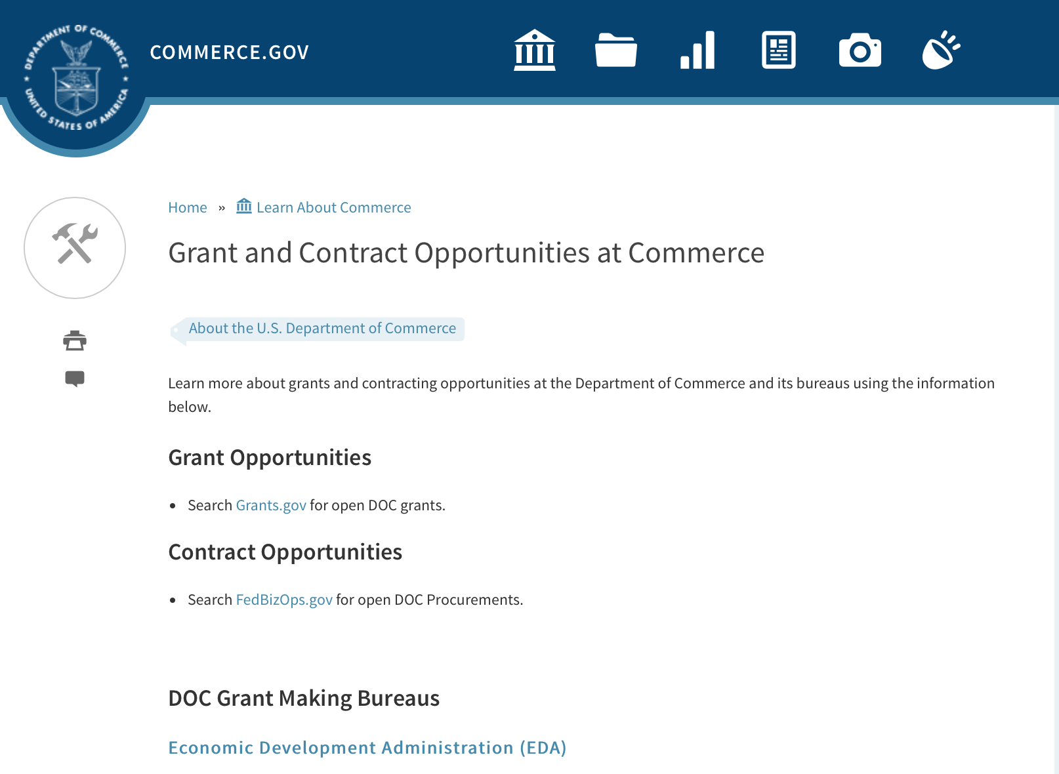
Grants at Commerce
DOC Grant Making Bureaus
Economic Development Administration (EDA)
International Trade Administration (ITA)
- Market Development Cooperator Program
- Special American Business Internship Training Program (SABIT). A technical assistance initiative of the International Trade Administration of the U.S. Department of Commerce, SABIT offers organizations competitive grants and an opportunity to host industry-specific delegations. SABIT serves as an initial entry point for U.S. businesses seeking funding to establish long-term relationships with potential customers, distributors, or partners in the former Soviet Union. The program trains Eurasian managers and scientists in commonly accepted business practices as a means of facilitating cross border relationships. In turn, these personal relationships serve as a basis for business development and reduce market access barriers for U.S. businesses
National Institute of Standards & Technology (NIST)
- Funding Opportunities
National Telecommunications & Information Administration (NTIA)
- Telecommunications Grants
National Oceanic & Atmospheric Administration (NOAA)
- Coastal Ocean Program Grant Information
- Fisheries Saltonstall Kennedy Grant Program
- National Undersea Research Program Funding Opportunities
- Grants Management Division
- Fisheries Grants Program
- National Sea Grant
- Office of Global Programs
Contracting Resources for Contractors
- Office of Small and Disadvantaged Business Utilization (OSDBU) - he Office of Small and Disadvantaged Business Utilization (OSDBU) is an advocacy and advisory office responsible for promoting the use of small, small disadvantaged, 8(a), women-owned, veteran-owned, service-disabled veteran-owned, and HUBZone small businesses within the U.S. Department of Commerce's (DOC) acquisition process.
- Business.USA.gov's Find Opportunities Wizard where in a few quick steps, it will guide you towards federal government contracting programs and opportunities for your business!
- Planned Acquisitions: the Department of Commerce's search tool for our planned acquisitions over $100,000. As requirements change, these acquisition plans are updated by department personnel and this search tool is automatically updated.
- Small Business Administration's Contracting section of their web site where you can learn about how to "Get Started" and "Contracting Support for Small Business"
- The General Services Administration (GSA) has implemented a system for vendors doing business with the Federal Government to manage their entity information in one central location. This new database is the System for Award Management (SAM).

DOC Contracting Offices
- Patent and Trademark Office (PTO)
  - Office of Procurement
- National Institute of Standards & Technology (NIST)
NIST Acquisition Management Group
Contracting Opportunities with Commerce
Trade Opportunities through Commerce
http://www.commerce.gov/about-commerce/grants-contracting-trade-opportunities

Programs:

Modifications:

FY18 Saltonstall Kennedy Competition
Synopsis 2
Document Type: | Grants Notice
Funding Opportunity Number: | NOAA-NMFS-FHQ-2018-2005332
Funding Opportunity Title: | FY18 Saltonstall Kennedy Competition
Opportunity Category: | Discretionary
Opportunity Category Explanation:
Funding Instrument Type: | Cooperative Agreement  Grant
Category of Funding Activity: | Environment  Natural Resources  Science and Technology and other Research and Development
Category Explanation:
Expected Number of Awards: | 50
CFDA Number(s): | 11.427 -- Fisheries Development and Utilization Research and Development Grants and Cooperative Agreements Program
Cost Sharing or Matching Requirement: | No
Version: | Synopsis 2
Posted Date: | Aug 11, 2017
Last Updated Date: | Oct 12, 2017
Original Closing Date for Applications: | Oct 10, 2017
Current Closing Date for Applications: | Jan 08, 2018
Archive Date: | Feb 07, 2018
Estimated Total Program Funding: | $10,000,000
Award Ceiling: | $300,000
Award Floor: | $25,000
Eligible Applicants: | Others (see text field entitled "Additional Information on Eligibility" for clarification)
Additional Information on Eligibility: | You are eligible to apply for a grant or a cooperative agreement under the Saltonstall-Kennedy Grant Program if:1. You are a citizen or national of the United States;2. You represent an entity that is a corporation, partnership, association, or other non-Federal entity, non-profit or otherwise (including Indian tribes), if such entity is a citizen of the United States within the meaning of section 2 of the Shipping Act, 1916, as amended (46 U.S.C. app. 802); or3. You are a citizen of the Republic of the Marshall Islands, Republic of Palau, or the Federated States of Micronesia. We recognize the interest of the Secretaries of Commerce and Interior in defining appropriate fisheries policies and programs that meet the needs of the U.S. insular areas, so we encourage applications from individuals, government entities, and businesses in U.S. insular areas. We support cultural and gender diversity in our programs and encourage women and minority individuals and groups to submit applications. We are also committed to broadening the participation of Minority Serving Institutions (MSIs), which include Historically Black Colleges and Universities, Hispanic Serving Institutions, and Tribal Colleges and Universities, in our grant programs. To find out more about MSIs go to http://www2.ed.gov/about/offices/list/ocr/edlite-minorityinst.html.We encourage applications from members of the fishing community and applications that involve fishing community cooperation and participation. We will consider the extent of fishing community involvement when evaluating the potential benefit of funding a proposal. Eligible Applicants must submit a pre-proposal that meets the submission requirements listing in this FFO by the established due date. Full proposals will not be reviewed or evaluated if a pre-proposal was not received on time and ranked. Non Eligible Applicants You are not eligible to submit an application under this program if you are an employee of any Federal agency; a Regional Fishery Management Council (Council); or an employee of a Council. However, Council members who are not Federal employees can submit an application to the S-K Program.
Agency Name: | Department of Commerce
Description: | The Saltonstall-Kennedy Act established a fund (known as the S-K fund) used by the Secretary of Commerce to provide grants or cooperative agreements for fisheries research and development projects addressing aspects of U.S. fisheries, including, but not limited to, harvesting, processing, marketing, and associated business infrastructures. Under this authority, grants and cooperative agreements are made on a competitive basis (subject to availability of funding) to assist in carrying out projects related to U.S. commercial and recreational fisheries. The term “fisheries” encompasses wild capture, marine aquaculture and recreational fishing. The objective of the S-K Grant Program is to address the needs of the fisheries and fishing communities in optimizing economic benefits by building and maintaining sustainable fisheries and practices, dealing with the impacts of conservation and management measures, and increasing other opportunities to use existing infrastructure to support keeping working waterfronts viable. U.S. fisheries include any fishery, commercial or recreational, that is, or may be, engaged in by citizens or nationals of the United States. Proposals submitted to this competition must address at least one of the following priorities: Marine Aquaculture; Adapting to Environmental Change and Other Long Term Ecosystem Change; Promotion, Development and Marketing; or Territorial Science. This Federal Funding Opportunity includes information on application and criteria for research proposals requesting a maximum of $300,000 in Federal funding for up to a two-year period. Matching funds are not required, nor will they be considered during the evaluation process. Awards are anticipated to start no earlier than September 1, 2018.Grant awards are dependent on the availability of Federal funding as provided in enacted Appropriations Acts. This FFO is being released prior to final appropriations due to award process time frames. While the FY 2018 President's budget proposed $0 for this program, final Congressional direction has not been determined. Applicants are not guaranteed any level of funding. Should funds not be available in FY2018 submitted applications may be carried over to subsequent fiscal year for review and obligation should funds be available and the Agency deems this the most appropriate administrative process.
Link to Additional Information:
Grantor Contact Information: | If you have difficulty accessing the full announcement electronically, please contact:  Daniel Namur, telephone (301) 427-8730 email: Dan.Namur@noaa.gov  Work

http://www.grants.gov/web/grants/view-opportunity.html?oppId=296392

Research:

National Institute of Standards and Technology
NIST Public Safety Innovation Accelerator Program – User Interface
Synopsis 1 & 2
http://www.grants.gov/web/grants/view-opportunity.html?oppId=298236

Reminders:

FY2018 Marine Debris Prevention
Synopsis 4

Document Type: | Grants Notice
Funding Opportunity Number: | NOAA-NOS-ORR-2018-2005333
Funding Opportunity Title: | FY2018 Marine Debris Prevention
Opportunity Category: | Discretionary
Opportunity Category Explanation:
Funding Instrument Type: | Cooperative Agreement
Category of Funding Activity: | Environment  Natural Resources  Science and Technology and other Research and Development
Category Explanation:
Expected Number of Awards: | 10
CFDA Number(s): | 11.999 -- Marine Debris Program
Cost Sharing or Matching Requirement: | Yes
Version: | Synopsis 4
Posted Date: | Aug 23, 2017
Last Updated Date: | Sep 26, 2017
Original Closing Date for Applications: | Dec 16, 2017
Current Closing Date for Applications: | Dec 16, 2017
Archive Date: | Jan 15, 2018
Estimated Total Program Funding: | $1,500,000
Award Ceiling: | $250,000
Award Floor: | $50,000
Eligible Applicants: | Others (see text field entitled "Additional Information on Eligibility" for clarification)
Additional Information on Eligibility: | NOTICE: The Letter of Intent (LOI) due date has been changed to October 5, 2017. Please note: to apply for marine debris prevention funding through this opportunity, applicants must first submit a Letter of Intent (LOI), via email, to grants.marinedebris@noaa.gov, in accordance with the guidelines described in Section IV.B. of the funding opportunity announcement. The deadline for LOI submission is October 5, 2017. After NOAA reviews all submitted LOIs, only those invited to submit a full proposal will be considered for funding. Applicants will be notified by November 1, 2017 if they have been invited to submit a full proposal. In accordance with the Marine Debris Act, eligible applicants are state, local, and tribal governments whose activities affect research or regulation of marine debris and any institution of higher education, nonprofit organization, or commercial (for-profit) organization with expertise in a field related to marine debris. Applications from federal agencies or employees of federal agencies will not be considered. Interested federal agencies may collaborate with eligible applicants but may not receive funds through this competition. All projects must take place within the United States or territories or their respective waterways. Foreign organizations and foreign public entities are not eligible to apply as the primary applicant but can be listed as a sub-awardee or contractor. NOAA is strongly committed to broadening the participation of veterans, minority-serving institutions, and entities that work in underserved areas. The NOAA MDP encourages proposals from, or involving any of the above types of institutions. Applications that have been submitted to other NOAA grant programs or as part of another NOAA grant may be considered under this solicitation.
Agency Name: | Department of Commerce
Description: | The NOAA Marine Debris Program, authorized in the Marine Debris Act (33 U.S.C. 1951-1958), provides funding to prevent the introduction of marine debris into the marine and coastal environment. Projects awarded through this grant competition will encourage changes in behavior of a target audience (such as students, teachers, industries, or the public) to address a specific marine debris issue, and will actively engage these groups in hands-on personal participation. Successful proposals through this solicitation will be funded through cooperative agreements. Funding of up to $1,500,000 is expected to be available for Marine Debris Prevention grants in FY2018. Typical awards will range from $50,000 - $150,000. Funding for this purpose comes through the NOAA Marine Debris Program as appropriations to the Office of Response and Restoration, National Ocean Service. This solicitation is focused on efforts to prevent marine debris from entering the environment through targeted behavior change. It is not intended for large-scale debris removal projects, deployment of catchment basins, or scientific research.
Link to Additional Information:
Grantor Contact Information: | If you have difficulty accessing the full announcement electronically, please contact:  Tom Barry (tom.barry@noaa.gov, 240-533-0425).  Work

http://www.grants.gov/web/grants/view-opportunity.html?oppId=296756

National Telecommunications and Information Admin
State and Local Implementation Grant Program (SLIGP) 2.0
Synopsis 1

Document Type: | Grants Notice
Funding Opportunity Number: | 2018-NTIA-SLIGP-2
Funding Opportunity Title: | State and Local Implementation Grant Program (SLIGP) 2.0
Opportunity Category: | Discretionary
Opportunity Category Explanation:
Funding Instrument Type: | Grant
Category of Funding Activity: | Other (see text field entitled "Explanation of Other Category of Funding Activity" for clarification)
Category Explanation: | State and Local Implementation Grant Program
Expected Number of Awards:
CFDA Number(s): | 11.549 -- State and Local Implementation Grant Program
Cost Sharing or Matching Requirement: | Yes
Version: | Synopsis 2
Posted Date: | Sep 27, 2017
Last Updated Date: | Sep 29, 2017
Original Closing Date for Applications: | Applications will be accepted from September 27, 2017 until December 28, 2017 at 11:59 p.m. Eastern Time; or from September 27, 2017 until 11:59 p.m. Eastern Time on the 91st calendar day from the date that the Governor of an applicant State receives notice from FirstNet of its final State Plan, whichever is later.
Current Closing Date for Applications: | Applications will be accepted from September 27, 2017 until December 28, 2017 at 11:59 p.m. Eastern Time; or from September 27, 2017 until 11:59 p.m. Eastern Time on the 91st calendar day from the date that the Governor of an applicant State receives notice from FirstNet of its final State Plan, whichever is later.
Archive Date: | Jan 31, 2018
Eligible Applicants: | Others (see text field entitled "Additional Information on Eligibility" for clarification)
Additional Information on Eligibility: | Any State, territory, or the District of Columbia is eligible for a grant under the SLIGP 2.0
Agency Name: | National Telecommunications and Information Admin
Description: | The National Telecommunications and Information Administration (NTIA) issues this NOFO to describe the requirements under which NTIA will award grants for the State and Local Implementation Grant Program 2.0 (SLIGP 2.0), authorized by section 6302 of the Middle Class Tax Relief and Job Creation Act of 2012 (Act), to assist state, local and tribal governments with planning activities for the nationwide interoperable public safety broadband network.
Link to Additional Information: | 2018-NTIA-SLIGP-2 NOFO
Grantor Contact Information: | If you have difficulty accessing the full announcement electronically, please contact:  Michael Dame Program Director Phone 202 482-1181  Agency Contact

http://www.grants.gov/web/grants/view-opportunity.html?oppId=297692

FY18-19 CRCP International Coral Reef Conservation Cooperative Agreements
Synopsis 1

Document Type: | Grants Notice
Funding Opportunity Number: | NOAA-NOS-OCM-2018-2005319
Funding Opportunity Title: | FY18-19 CRCP International Coral Reef Conservation Cooperative Agreements
Opportunity Category: | Discretionary
Opportunity Category Explanation:
Funding Instrument Type: | Cooperative Agreement
Category of Funding Activity: | Environment  Natural Resources  Science and Technology and other Research and Development
Category Explanation:
Expected Number of Awards: | 10
CFDA Number(s): | 11.482 -- Coral Reef Conservation Program
Cost Sharing or Matching Requirement: | Yes
Version: | Synopsis 1
Posted Date: | Aug 30, 2017
Last Updated Date: | Aug 30, 2017
Original Closing Date for Applications: | Feb 15, 2018
Current Closing Date for Applications: | Feb 15, 2018
Archive Date: | Mar 17, 2018
Estimated Total Program Funding: | $600,000
Award Ceiling: | $300,000
Award Floor: | $75,000
Eligible Applicants: | Others (see text field entitled "Additional Information on Eligibility" for clarification)
Additional Information on Eligibility: | Eligible applicants are institutions of higher education, non-profit organizations, non-U.S. government natural resource management agencies, foreign public entities and foreign organizations, and for-profit organizations. An eligible organization may include proposed sub-recipients, contractors, or other collaborators, which may include governmental authorities, effectively forming a team. Federal agencies and employees may participate in projects as collaborative project partners at the agency’s expense, as this announcement does not cover their funding. Federal agencies’ and employees’ in-kind services and equipment are generally not allowed as part of an applicant’s match on shared costs. If an applicant proposes federal agency collaborators, applicants should provide detail on the expected level of federal engagement in the application. Examples might include, but are not limited to partnership services; serving in a review capacity; or participating in priority task teams, working groups, or leadership teams. Proposals are expected to target the following specific countries: 1) For proposals that address the NOAA-GCFI Assessment, projects must be conducted in at least two of the following Non-US countries and territories of the Wider Caribbean: Bahamas, Belize, British Virgin Islands, Grenada, Honduras, Mexico, Saba and St. Eustatius, St. Lucia, St. Vincent and the Grenadines, and Turks and Caicos Islands. For eligible MPA sites in each country please refer to the above Section B., Program Priorities. 2) Proposals for the South East Asia and South Pacific regions must be conducted in one or more of the following countries: Cook Islands, Federated States of Micronesia, Fiji, Indonesia, Kiribati, Malaysia, Nauru, Niue, Palau, Papua New Guinea, Philippines, Republic of the Marshall Islands, Samoa, Solomon Islands, Timor-Leste, Tonga, Tuvalu, and Vanuatu. 3) For Micronesia proposals, the project must only be conducted in all of the following independent countries under compacts of free association with the United States: the Republic of the Marshall Islands; the Republic of Palau; and the Federated States of Micronesia.
Agency Name: | Department of Commerce
Description: | The NOAA Coral Reef Conservation Program (CRCP) provides matching grants for international coral reef conservation projects. CRCP solicits proposals that will support the NOAA Coral Reef Conservation Program’s International Strategy 2010-2015 (International Strategy). The International Strategy focuses on supporting existing regional efforts in four priority regions based on their interconnections with U.S. reef ecosystems and existing initiatives and partnerships. The following three priority regions will be considered under this Federal Funding Opportunity: the Wider Caribbean, South East Asia and South Pacific, and Micronesia. Funding for the Fiscal Year 2018 competition is subject to the availability of Congressional appropriations and is expected to be approximately $600,000. NOAA expects each applicant will request between $75,000 and $300,000 annually for an award with a project period up to two years. Funding after the first year generally depends on future Congressional appropriations, NOAA/CRCP priorities, and recipient performance in the first year(s) of the award.
Link to Additional Information:
Grantor Contact Information: | If you have difficulty accessing the full announcement electronically, please contact:  Scot Frew NOAA/OCM Corel Reef Program 1305 East West Highway 10th Floor, N/OCM6 Silver Spring, MD 20910 (240) 533-0774  Work email

http://www.grants.gov/web/grants/view-opportunity.html?oppId=296927

FY2018 Marine Debris Prevention
Synopsis 2 & 3

Document Type: | Grants Notice
Funding Opportunity Number: | NOAA-NOS-ORR-2018-2005333
Funding Opportunity Title: | FY2018 Marine Debris Prevention
Opportunity Category: | Discretionary
Opportunity Category Explanation:
Funding Instrument Type: | Cooperative Agreement
Category of Funding Activity: | Environment  Natural Resources  Science and Technology and other Research and Development
Category Explanation:
Expected Number of Awards: | 10
CFDA Number(s): | 11.999 -- Marine Debris Program
Cost Sharing or Matching Requirement: | Yes
Version: | Synopsis 3
Posted Date: | Aug 23, 2017
Last Updated Date: | Aug 29, 2017
Original Closing Date for Applications: | Dec 16, 2017
Current Closing Date for Applications: | Dec 16, 2017
Archive Date: | Jan 15, 2018
Estimated Total Program Funding: | $1,500,000
Award Ceiling: | $250,000
Award Floor: | $50,000
Eligible Applicants: | Others (see text field entitled "Additional Information on Eligibility" for clarification)
Additional Information on Eligibility: | Please note: to apply for marine debris prevention funding through this opportunity, applicants must first submit a Letter of Intent (LOI), via email, to grants.marinedebris@noaa.gov, in accordance with the guidelines described in Section IV.B. of the funding opportunity announcement. The deadline for LOI submission is September 28, 2017. After NOAA reviews all submitted LOIs, only those invited to submit a full proposal will be considered for funding. Applicants will be notified by November 1, 2017 if they have been invited to submit a full proposal. In accordance with the Marine Debris Act, eligible applicants are state, local, and tribal governments whose activities affect research or regulation of marine debris and any institution of higher education, nonprofit organization, or commercial (for-profit) organization with expertise in a field related to marine debris. Applications from federal agencies or employees of federal agencies will not be considered. Interested federal agencies may collaborate with eligible applicants but may not receive funds through this competition. All projects must take place within the United States or territories or their respective waterways. Foreign organizations and foreign public entities are not eligible to apply as the primary applicant but can be listed as a sub-awardee or contractor. NOAA is strongly committed to broadening the participation of veterans, minority-serving institutions, and entities that work in underserved areas. The NOAA MDP encourages proposals from, or involving any of the above types of institutions Applications that have been submitted to other NOAA grant programs or as part of another NOAA grant may be considered under this solicitation.
Agency Name: | Department of Commerce
Description: | The NOAA Marine Debris Program, authorized in the Marine Debris Act (33 U.S.C. 1951-1958), provides funding to prevent the introduction of marine debris into the marine and coastal environment. Projects awarded through this grant competition will encourage changes in behavior of a target audience (such as students, teachers, industries, or the public) to address a specific marine debris issue, and will actively engage these groups in hands-on personal participation. Successful proposals through this solicitation will be funded through cooperative agreements. Funding of up to $1,500,000 is expected to be available for Marine Debris Prevention grants in FY2018. Typical awards will range from $50,000 - $150,000. Funding for this purpose comes through the NOAA Marine Debris Program as appropriations to the Office of Response and Restoration, National Ocean Service. This solicitation is focused on efforts to prevent marine debris from entering the environment through targeted behavior change. It is not intended for large-scale debris removal projects, deployment of catchment basins, or scientific research.
Link to Additional Information:
Grantor Contact Information: | If you have difficulty accessing the full announcement electronically, please contact:  Tom Barry (tom.barry@noaa.gov, 240-533-0425).  Work

http://www.grants.gov/web/grants/view-opportunity.html?oppId=296756

Ocean Exploration FY 2018 Funding Opportunity
Synopsis 1 & 2
Document Type: | Grants Notice
Funding Opportunity Number: | NOAA-OAR-OER-2018-2005296
Funding Opportunity Title: | Ocean Exploration FY 2018 Funding Opportunity
Opportunity Category: | Discretionary
Opportunity Category Explanation:
Funding Instrument Type: | Cooperative Agreement  Grant
Category of Funding Activity: | Environment  Natural Resources  Science and Technology and other Research and Development
Category Explanation:
Expected Number of Awards: | 10
CFDA Number(s): | 11.011 -- Ocean Exploration
Cost Sharing or Matching Requirement: | No
Version: | Synopsis 2
Posted Date: | Jul 12, 2017
Last Updated Date: | Jul 14, 2017
Original Closing Date for Applications: | Dec 08, 2017
Current Closing Date for Applications: | Dec 08, 2017
Archive Date: | Jan 07, 2018
Estimated Total Program Funding: | $3,000,000
Award Ceiling: | $750,000
Award Floor: | $10,000
Eligible Applicants: | Others (see text field entitled "Additional Information on Eligibility" for clarification)
Additional Information on Eligibility: | Eligible applicants are institutions of higher education; non-profit institutions; state, local, and tribal governments; for-profit organizations; and U.S. territories that possess the statutory authority to accept funding for this type of work.
Agency Name: | Department of Commerce
Description: | NOAA’s Office of Ocean Exploration & Research (OER) seeks to enhance ocean exploration and scientific knowledge of the unknown or poorly known areas of the ocean. This entails identifying, describing and creating baseline characterizations of new ocean habitats, marine resources and/or processes. In this Announcement, OER is seeking proposals focused on three topics including: 1. Exploration of the deep marine environments in the US EEZ and US Outer Continental Shelf (OCS) of the Gulf of Mexico; 2. Discovery and exploration of prehistorically and historically significant submerged marine heritage sites in the Gulf of Mexico within the US EEZ and the US Outer Continental Shelf (OCS); and 3. Novel or innovative technologies and methodologies that could increase the pace and scope of ocean exploration, especially exploration of deep environments including the water column and archaeological sites. For themes 1 and 2, OER will not entertain proposals outside the US EEZ and the US Outer Continental Shelf (OCS) in the Gulf of Mexico. Proposals that combine more than one of these exploration topics are encouraged. All correspondence regarding this FFO must be sent to the email: oer.ffo2018@noaa.gov Applicants are required to submit pre-proposals and, ultimately, full proposals that support OER’s exploration mission. OER’s overarching objective is to investigate and document poorly known and unknown ocean areas through interdisciplinary exploration, and to advance and disseminate knowledge of the ocean’s physical, geological, chemical, biological, and archaeological environments. OER’s mission is compliant with NOAA’s Next Generation Strategic Plan (http://www.performance.noaa.gov/ngsp/) which outlines NOAA goals of Science, Service and Stewardship. Findings from projects and expeditions are anticipated to result in new baseline characterizations; provide better scientific understanding of the processes on US continental margins; offer new insights into climate variability and marine ecosystems; reveal new or unconventional energy, mineral, biological, and/or archaeological resources; help identify hazards resulting from extreme events such as submarine volcanic eruptions, earthquakes and tsunamis; and deliver technology advancements (platforms, sensors, methodologies, etc.) that will increase observational capabilities of the ocean. In FY18, OER anticipates availability of approximately $3,000,000 for this Funding Opportunity (this amount includes of costs for any required ship and/or submersible assets). Note: Ship time on the NOAA Ship Okeanos Explorer will not be funded through this announcement. Background information on how to apply and other informational documents are accessible through the OER Office Website: http://oceanexplorer.noaa.gov/about/what-we-do/funding-opportunities.html. Eligible applicants are institutions of higher education; non-profit institutions; for-profit organizations; state, local, and tribal governments, as well as U.S. territories that possess the statutory authority to accept funding for this type of work. Federal agencies that possess the statutory authority to accept funding for this type of work may also apply and must agree to take FY2018 funding for proposed projects. Federal and state agencies are strongly encouraged to collaborate with partners from a non-federal/non-state eligible entity. For the purpose of this opportunity, the buying of ship time and/or other ocean data collection platform support (remotely operated vehicles, autonomous underwater vehicles, etc.) is considered a rental cost and therefore not included in Modified Total Direct Cost (MTDC). OER funding will not be provided to hire and/or fund the salaries and associated overhead costs of any permanent federal or state government employee. OER will not pay Facilities and Administrative (F&A or "overhead") fees to federal and state agencies for subawards such as ship time or other ocean data collection platform support. Federal and state award recipients may use funding to cover travel, equipment, supplies, and contractual personnel costs associated with the proposed work. Foreign researchers may participate by submitting a subaward through collaboration with an eligible U.S. entity. The DOC and NOAA support cultural and gender diversity and encourage women and minority individuals and groups to submit applications to this Announcement of Federal Funding Opportunity. In addition, DOC/NOAA is strongly committed to broadening the participation of historically black colleges and universities, Hispanic serving institutions, tribal colleges and universities, and institutions that work in underserved areas. DOC/NOAA encourages applications involving any of the above institutions to apply.
Link to Additional Information:
Grantor Contact Information: | If you have difficulty accessing the full announcement electronically, please contact:  NOAA Office of Ocean Exploration and Research OER FFO 2018, SSMC3, Rm 10316, 1315 East West Highway, Silver Spring, Maryland 20910 (301) 734-1014  OER Group email

http://www.grants.gov/web/grants/view-opportunity.html?oppId=295442

Economic Development Administration
FY 2017 Economic Development Assistance Programs ­ Application submission and program requirements for EDA’s Public Works and Economic Adjustment Assistance programs.
Synopsis 1
Document Type: | Grants Notice
Funding Opportunity Number: | EDAP-2017
Funding Opportunity Title: | FY 2017 Economic Development Assistance Programs Application submission and program requirements for EDA’s Public Works and Economic Adjustment Assistance programs.
Opportunity Category: | Discretionary
Opportunity Category Explanation:
Funding Instrument Type: | Cooperative Agreement  Grant
Category of Funding Activity: | Other (see text field entitled "Explanation of Other Category of Funding Activity" for clarification)
Category Explanation: | The Economic Development Administration's (EDA's) mission is to lead the Federal economic development agenda by promoting innovation and competitiveness, preparing American regions for economic growth and success in the worldwide economy. EDA fulfills this mission through strategic investments and partnerships that create the regional economic ecosystems required to foster globally competitive regions throughout the United States. EDA supports development in economically distressed areas of the United States by fostering job creation and attracting private investment. Specifically, under the Economic Development Assistance programs (EDAP) Notice of Funding Availability (NOFA), EDA will make construction, non-construction, and revolving loan fund investments under the Public Works and Economic Adjustment Assistance (EAA) Programs. Through this NOFA, EDA will also designate a portion of its EAA funding to support communities and regions that have been negatively impacted by changes in the coal economy (Assistance to Coal Communities, or ACC 2017). Grants made under these programs will leverage regional assets to support the implementation of regional economic development strategies designed to create jobs, leverage private capital, encourage economic development, and strengthen America's ability to compete in the global marketplace. Through the EDAP NOFA, EDA solicits applications from rural and urban communities to develop initiatives that advance new ideas and creative approaches to address rapidly evolving economic conditions.
Expected Number of Awards:
CFDA Number(s): | 11.300 -- Investments for Public Works and Economic Development Facilities  11.307 -- Economic Adjustment Assistance
Cost Sharing or Matching Requirement: | Yes
Version: | Synopsis 1
Posted Date: | Jun 19, 2017
Last Updated Date: | Jun 19, 2017
Original Closing Date for Applications: | There are no submission deadlines under this opportunity. Proposals and applications will be accepted on an ongoing basis until the publication of a new EDAP NOFA.
Current Closing Date for Applications: | There are no submission deadlines under this opportunity. Proposals and applications will be accepted on an ongoing basis until the publication of a new EDAP NOFA.
Archive Date:
Estimated Total Program Funding:
Award Ceiling: | $3,000,000
Award Floor: | $100,000
Eligible Applicants: | Native American tribal organizations (other than Federally recognized tribal governments)  Special district governments  Others (see text field entitled "Additional Information on Eligibility" for clarification)  Private institutions of higher education  County governments  Native American tribal governments (Federally recognized)  City or township governments  Nonprofits that do not have a 501(c)(3) status with the IRS, other than institutions of higher education  State governments  Nonprofits having a 501(c)(3) status with the IRS, other than institutions of higher education  Public and State controlled institutions of higher education
Additional Information on Eligibility: | Eligible applicants for EDA financial assistance under the Public Works and EAA programs (including ACC 2017 funding) include a(n): (i) District Organization of a designated Economic Development District; (ii) Indian Tribe or a consortium of Indian Tribes; (iii) State, county, city, or other political subdivision of a State, including a special purpose unit of a State or local government engaged in economic or infrastructure development activities, or a consortium of political subdivisions; (iv) institution of higher education or a consortium of institutions of higher education; or (v) public or private non-profit organization or association acting in cooperation with officials of a political subdivision of a State. See Section 3 of the Public Works and Economic Development Act of 1965 (PWEDA) (42 U.S.C. § 3122) and 13 C.F.R. § 300.3. EDA is not authorized to provide grants or cooperative agreements to individuals or to for profit entities. Requests from such entities will not be considered for funding. For ACC 2017 funding, projects must be located within and targeted to communities or regions that have been impacted, or can reasonably demonstrate that they will be impacted, by coal mining or coal power plant employment loss, or employment loss in the supply chain industries of either.
Agency Name: | Economic Development Administration
Description: | Under this NOFA, EDA solicits applications from applicants in rural and urban areas to provide investments that support construction, non-construction, technical assistance, and revolving loan fund projects under EDA’s Public Works and EAA programs. Grants and cooperative agreements made under these programs are designed to leverage existing regional assets and support the implementation of economic development strategies that advance new ideas and creative approaches to advance economic prosperity in distressed communities, including communities and regions that have been impacted, or can reasonably demonstrate that they will be impacted, by coal mining or coal power plant employment loss, or employment loss in the supply chain industries of either. EDA provides strategic investments on a competitive- merit-basis to support economic development, foster job creation, and attract private investment in economically distressed areas of the United States. This EDAP NOFA supersedes the EDAP Federal Funding Opportunity dated December 23, 2016.
Link to Additional Information: | Economic Development Administration
Grantor Contact Information: | If you have difficulty accessing the full announcement electronically, please contact:  If you have difficulty accessing the full announcement electronically, please contact: the EDA representative for your state. A complete list of EDA representatives is available on EDA's website at http://www.eda.gov/contact/  http://www.eda.gov/contact/

http://www.grants.gov/web/grants/view-opportunity.html?oppId=294771

National Institute of Standards and Technology
Measurement Science and Engineering (MSE) Research Grant Programs

Document Type: | Grants Notice
Funding Opportunity Number: | 2016-NIST-MSE-01
Funding Opportunity Title: | Measurement Science and Engineering (MSE) Research Grant Programs
Opportunity Category: | Discretionary
Opportunity Category Explanation:
Funding Instrument Type: | Cooperative Agreement  Grant
Category of Funding Activity: | Science and Technology and other Research and Development
Category Explanation:
Expected Number of Awards:
CFDA Number(s):
Cost Sharing or Matching Requirement: | No
Posted Date: | Feb 19, 2016
Last Updated Date: | Feb 19, 2016
Original Closing Date for Applications: | Applications will be accepted and considered on a rolling basis as they are received. See Section IV.4. in the text of the Full Announcement/FFO document. Applications may be submitted by paper or electronically through Grants.gov. Carefully read Section IV. of the Full Announcement/FFO document for details applying to electronic submissions and to paper submissions.
Current Closing Date for Applications: | Applications will be accepted and considered on a rolling basis as they are received. See Section IV.4. in the text of the Full Announcement/FFO document. Applications may be submitted by paper or electronically through Grants.gov. Carefully read Section IV. of the Full Announcement/FFO document for details applying to electronic submissions and to paper submissions.
Eligible Applicants: | Others (see text field entitled "Additional Information on Eligibility" for clarification)
Additional Information on Eligibility: | Eligibility for all programs listed in this FFO is open to all non-Federal entities. Eligible applicants include institutions of higher education, non-profit organizations, for-profit organizations, state and local governments, Indian tribes, hospitals, foreign public entities, and foreign governments. Applicants selected for awards under 15 U.S.C. § 278g-1 are encouraged, but not required, to select underrepresented minorities for participation. In addition, NIST is not able to accept an application from an individual unaffiliated with a sponsoring applicant organization.
Agency Name: | National Institute of Standards and Technology
Description: | NIST is soliciting applications for financial assistance for Fiscal Year 2016 (FY16) within the following NIST Laboratory grant programs: (1) the Material Measurement Laboratory (MML) Grant Program; (2) the Physical Measurement Laboratory (PML) Grant Program; (3) the Engineering Laboratory (EL) Grant Program; (4) the Fire Research (FR) Grant Program; (5) the Information Technology Laboratory (ITL) Grant Program; (6) the Communications Technology Laboratory (CTL) Grant Program; (7) the NIST Center for Neutron Research (NCNR) Grant Program; (8) the Center for Nanoscale Science and Technology (CNST) Grant Program; (9) the Special Programs Office (SPO) Grant Program; (10) the Standards Coordination Office (SCO) Grant Program; (11) the International and Academic Affairs Office (IAAO) Grant Program; and (12) the Associate Director for Laboratory Programs (ADLP) Grant Program.
Link to Additional Information: | 2016-NIST-MSE-01 Full Announcement/FFO document
Contact Information: | If you have difficulty accessing the full announcement electronically, please contact:  Christopher Hunton Management and Program Analyst Phone 301-975-5718  Agency Contact

http://www.grants.gov/web/grants/view-opportunity.html?oppId=281689

FY 2016 – FY 2019 EDA Planning Program and Local Technical Assistance Program Grant

Document Type: | Grants Notice
Funding Opportunity Number: | EDA-HDQ-TA-HDQ-2016-2004759
Funding Opportunity Title: | FY 2016 – FY 2019 EDA Planning Program and Local Technical Assistance Program
Opportunity Category: | Discretionary
Funding Instrument Type: | Cooperative Agreement  Grant
Category of Funding Activity: | Other (see text field entitled "Explanation of Other Category of Funding Activity" for clarification)  Regional Development
Category Explanation: | Regional planning and local technical assistance
Expected Number of Awards:
CFDA Number(s): | 11.302 -- Economic Development Support for Planning Organizations  11.303 -- Economic Development Technical Assistance
Cost Sharing or Matching Requirement: | No
Posted Date: | Dec 10, 2015
Creation Date: | Dec 10, 2015
Original Closing Date for Applications: | Applications are accepted on a continuing basis and processed as received. This Planning and Local Technical Assistance opportunity will remain in effect until superseded by a future announcement.
Current Closing Date for Applications: | Applications are accepted on a continuing basis and processed as received. This Planning and Local Technical Assistance opportunity will remain in effect until superseded by a future announcement.
Archive Date:
Estimated Total Program Funding:
Award Ceiling: | $300,000
Award Floor: | $0
Eligible Applicants: | Nonprofits having a 501(c)(3) status with the IRS, other than institutions of higher education  City or township governments  Nonprofits that do not have a 501(c)(3) status with the IRS, other than institutions of higher education  Others (see text field entitled "Additional Information on Eligibility" for clarification)  Private institutions of higher education  Native American tribal governments (Federally recognized)  Public and State controlled institutions of higher education  State governments  Special district governments  County governments
Additional Information on Eligibility: | Pursuant to section 3 of the Public Works and Economic Development Act of 1965 (42 U.S.C. § 3122) (PWEDA) and EDA’s regulation at 13 C.F.R. § 300.3, the following types of entities are eligible to receive funding assistance from EDA: 1. District Organizations (as defined in 13 C.F.R. § 300.3); 2. Indian Tribes or a consortium of Indian Tribes; 3. States, cities, or other political subdivisions of a State, including a special purpose unit of a State or local government engaged in economic or infrastructure development activities, or a consortium of political subdivisions; 4. Institutions of higher education or a consortium of institutions of higher education; or 5. Public or private non-profit organizations or associations acting in cooperation with officials of a political subdivision of a State.
Agency Name: | Department of Commerce
Description: | Pursuant to PWEDA, EDA announces general policies and application procedures for grant-based investments under the Planning and Local Technical Assistance programs. Under the Planning program EDA assists eligible recipients in creating regional economic development plans designed to build capacity and guide the economic prosperity and resiliency of an area or region. As part of this program, EDA supports Partnership Planning investments to facilitate the development, implementation, revision, or replacement of Comprehensive Economic Development Strategies (CEDS), which articulate and prioritize the strategic economic goals of recipients’ respective regions. In general, EDA provides Partnership Planning grants to the designated planning organization (e.g., District Organization) serving EDA designated Economic Development Districts to enable these organizations to develop and implement relevant CEDS. In addition, EDA provides Partnership Planning grants to Indian Tribes to help develop and implement CEDS and associated economic development activities. The Planning program also helps support organizations, including District Organizations, Indian Tribes, and other eligible recipients, with Short Term and State Planning investments designed to guide the eventual creation and retention of high-quality jobs, particularly for the unemployed and underemployed in the Nation’s most economically distressed regions. The Local Technical Assistance program strengthens the capacity of local or State organizations, institutions of higher education, and other eligible recipients to undertake and promote effective economic development programs through projects such as feasibility analyses and impact studies.
Link to Additional Information: | www.eda.gov
Contact Information: | If you have difficulty accessing the full announcement electronically, please contact:  The EDA representative for your state. A complete list of EDA representatives is available on EDA's website at http://www.eda.gov/contact/

http://www.grants.gov/web/grants/view-opportunity.html?oppId=280447

Economic Development Administration
Planning Program and Local Technical Assistance Program Grant

Document Type: | Grants Notice
Funding Opportunity Number: | EDAPLANNING2012
Opportunity Category: | Discretionary
Posted Date: | Aug 03, 2012
Creation Date: | Aug 03, 2012
Original Closing Date for Applications: | Applications are accepted on a continuing basis and processed as received. This Planning and Local Technical Assistance opportunity will remain in effect until superseded by a future announcement.
Current Closing Date for Applications: | Applications are accepted on a continuing basis and processed as received. This Planning and Local Technical Assistance opportunity will remain in effect until superseded by a future announcement.
Archive Date:
Funding Instrument Type: | Cooperative Agreement  Grant
Category of Funding Activity: | Other (see text field entitled "Explanation of Other Category of Funding Activity" for clarification)  Regional Development
Category Explanation: | Regional planning and local technical assistance
Expected Number of Awards: | 425
Estimated Total Program Funding:
Award Ceiling: | $100,000
Award Floor:
CFDA Number(s): | 11.302 -- Economic Development Support for Planning Organizations
 | 11.303 -- Economic Development Technical Assistance
Cost Sharing or Matching Requirement: | Yes

Eligible Applicants
State governments
County governments
City or township governments
Public and State controlled institutions of higher education
Native American tribal governments (Federally recognized)
Nonprofits having a 501(c)(3) status with the IRS, other than institutions of higher education
Nonprofits that do not have a 501(c)(3) status with the IRS, other than institutions of higher education
Private institutions of higher education
Others (see text field entitled "Additional Information on Eligibility" for clarification)

Additional Information on Eligibility:
Pursuant to section 3 of the Public Works and Economic Development Act of 1965 (42 U.S.C. § 3122) (PWEDA) and EDA’s regulation at 13 C.F.R. § 300.3, the following types of entities are eligible to receive funding assistance from EDA: 1. District Organizations (as defined in 13 C.F.R. § 300.3); 2. Indian Tribes or a consortium of Indian Tribes; 3. States, cities, or other political subdivisions of a State, including a special purpose unit of a State or local government engaged in economic or infrastructure development activities, or a consortium of political subdivisions; 4. Institutions of higher education or a consortium of institutions of higher education; or 5. Public or private non-profit organizations or associations acting in cooperation with officials of a political subdivision of a State.

Agency Name
Economic Development Administration

Description
Pursuant to PWEDA, EDA announces general policies and application procedures for grant-based investments under the Planning and Local Technical Assistance programs. Under the Planning program EDA assists eligible recipients in creating regional economic development plans designed to stimulate and guide the economic development efforts of a community or region. As part of this program, EDA supports Partnership Planning investments to facilitate the development, implementation, revision, or replacement of Comprehensive Economic Development Strategies (CEDS), which articulate and prioritize the strategic economic goals of recipients' respective regions. In general, EDA provides Partnership Planning grants to the designated planning organization (e.g., District Organization) serving EDA-designated Economic Development Districts to enable these organizations to develop and implement relevant CEDS. In addition, EDA provides Partnership Planning grants to Indian Tribes to help develop and implement CEDS and associated economic development activities. The Planning program also helps support planning organizations, including District Organizations, Indian Tribes, and other eligible Recipients, with Short Term and State Planning investments designed to guide the eventual creation and retention of higher-skill, higher-wage jobs, particularly for the unemployed and underemployed in the Nation’s most economically distressed regions. The Local Technical Assistance program strengthens the capacity of local or State organizations, institutions of higher education, and other eligible recipients to undertake and promote effective economic development programs through projects such as feasibility analyses and impact studies.

Link to Additional Information

If you have difficulty accessing the full announcement electronically, please contact:
David Ives Planning and Local TA email

http://www.grants.gov/web/grants/view-opportunity.html?oppId=189193

Deleted:

ITA-INA-OPCM-2017-2004912 - Market Development Cooperator Program 2017
Deletion Comments: Opportunity deleted. Per the Program Officer email dated 3/22/17 this FFO is being deleted.

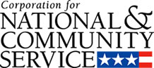

Corporation for National and Community Service

General Program Overview
AmeriCorps provides resources, both human and financial, to organizations that engage Americans in intensive service to meet our country’s critical needs.
Grantees use the funding to support AmeriCorps members for intensive service in their community. AmeriCorps grants partially cover the expense of operating an AmeriCorps program and do not cover general organizational expenses. A cash and in-kind match is required.

The main website can be accessed here: http://www.nationalservice.gov

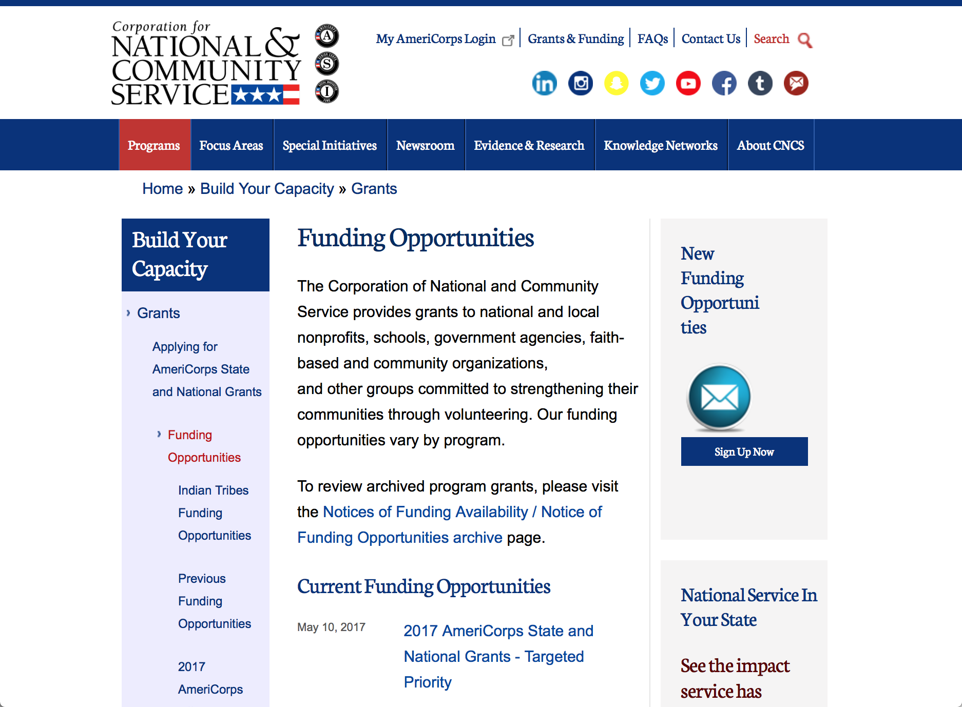

Current Funding Opportunities
There are no current funding opportunities.

For access to further funding information: click here

http://www.nationalservice.gov/build-your-capacity/grants/funding-opportunities

Programs:

Research:

Reminders:

AmeriCorps State and National Grants FY2018
Synopsis 1
Document Type: | Grants Notice
Funding Opportunity Number: | CNCS-08-24-17
Funding Opportunity Title: | AmeriCorps State and National Grants FY2018
Opportunity Category: | Discretionary
Opportunity Category Explanation:
Funding Instrument Type: | Grant
Category of Funding Activity: | Community Development  Disaster Prevention and Relief  Education  Employment, Labor and Training  Environment  Food and Nutrition  Health  Housing  Natural Resources
Category Explanation:
Expected Number of Awards:
CFDA Number(s): | 94.006 -- AmeriCorps
Cost Sharing or Matching Requirement: | Yes
Version: | Synopsis 1
Posted Date: | Aug 24, 2017
Last Updated Date: | Aug 24, 2017
Original Closing Date for Applications: | Jan 17, 2018
Current Closing Date for Applications: | Jan 17, 2018
Archive Date: | Jan 18, 2018
Eligible Applicants: | Private institutions of higher education  City or township governments  State governments  Nonprofits that do not have a 501(c)(3) status with the IRS, other than institutions of higher education  Nonprofits having a 501(c)(3) status with the IRS, other than institutions of higher education  Native American tribal organizations (other than Federally recognized tribal governments)  Public housing authorities/Indian housing authorities  Public and State controlled institutions of higher education  Native American tribal governments (Federally recognized)  County governments  Special district governments  Independent school districts
Additional Information on Eligibility:
Agency Name: | Corporation for National and Community Service
Description: | AmeriCorps grants are awarded to eligible organizations proposing to engage AmeriCorps members in evidence-based or evidence-informed interventions to strengthen communities. An AmeriCorps member is an individual who engages in community service through an approved national service position. Members may receive a living allowance and other benefits while serving. Upon successful completion of their service, members earn a Segal AmeriCorps Education Award from the National Service Trust that members can use to pay for higher education expenses or apply to qualified student loans.
Link to Additional Information: | Full competition information and resources.
Grantor Contact Information: | If you have difficulty accessing the full announcement electronically, please contact:  (202) 606-7508  Competition inbox

http://www.grants.gov/web/grants/view-opportunity.html?oppId=296773

National Service In Hawaii
National Service in Your State - Hawaii
2015-2016

Meeting Community Needs in Hawaii: More than 3,100 people of all ages and backgrounds are helping to meet local needs, strengthen communities, and increase civic engagement through national service in Hawaii. Serving at more than 450 locations throughout the state, these citizens tutor and mentor children, support veterans and military families, provide health services, restore the environment, respond to disasters, increase economic opportunity, and recruit and manage volunteers. This year, the Corporation for National and Community Service (CNCS) will commit more than $6,260,000 to support Hawaii communities through national service initiatives. Through a unique public-private partnership, this federal investment will leverage an additional $9,060,000 in other resources to strengthen community impact, build local support, and increase return on taxpayer dollars. Nationwide, CNCS, its grantees, and project sponsors generated more than $1.25 billion in outside resources from businesses, foundations, public agencies, and other sources in FY 2015.

AmeriCorps
This year, AmeriCorps will provide more than 560 individuals the opportunity to provide intensive, results-driven service to meet education, environmental, health, economic, and other pressing needs in communities across Hawaii. Most AmeriCorps grant funding goes to the Hawaii Commission on National & Community Service, which in turn awards grants to nonprofit groups to respond to local needs. Most of the remainder of the grant funding is distributed by CNCS directly to multi-state and national organizations through a competitive grants process. Other individuals serve through AmeriCorps VISTA, whose members help bring individuals and communities out of poverty by serving full-time to fight illiteracy, improve health services, create businesses, and increase housing opportunities, and AmeriCorps NCCC (National Civilian Community Corps), a 10-month, full time residential program for men and women between the ages of 18 and 24. In exchange for their service, AmeriCorps members earn an education award that can be used to pay for college or to pay back qualified student loans. Since 1994, more than 5,900 Hawaii residents have served more than 6.4 million hours and have qualified for Segal AmeriCorps Education Awards totaling more than $14,980,000.
Download: AmeriCorps in Hawaii (PDF)
Senior Corps
More than 2,500 seniors in Hawaii contribute their time and talents in one of three Senior Corps programs. Foster Grandparents serve one-on-one as tutors and mentors to more than 310 young people who have special needs. Senior Companions help more than 220 homebound seniors and other adults maintain independence in their own homes. RSVP volunteers conduct safety patrols, renovate homes, protect the environment, tutor and mentor youth, respond to natural disasters, and provide other services through more than 250 groups across Hawaii.
Download: Senior Corps in Hawaii (PDF)

The Corporation for National and Community Service is a federal agency that improves lives, strengthens communities, and fosters civic engagement through service and volunteering. CNCS annually engages more than five million Americans in service to meet local needs through Senior Corps, AmeriCorps, and national days of service; improves communities through the Social Innovation Fund, and leads President Obama's national call to service initiative, United We Serve. To learn more visit NationalService.gov or Serve.gov or call 202-606-5000 or TTY 1-800-833-3722.

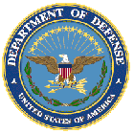

U.S. Department of Defense

Doing Business with the Department of Defense

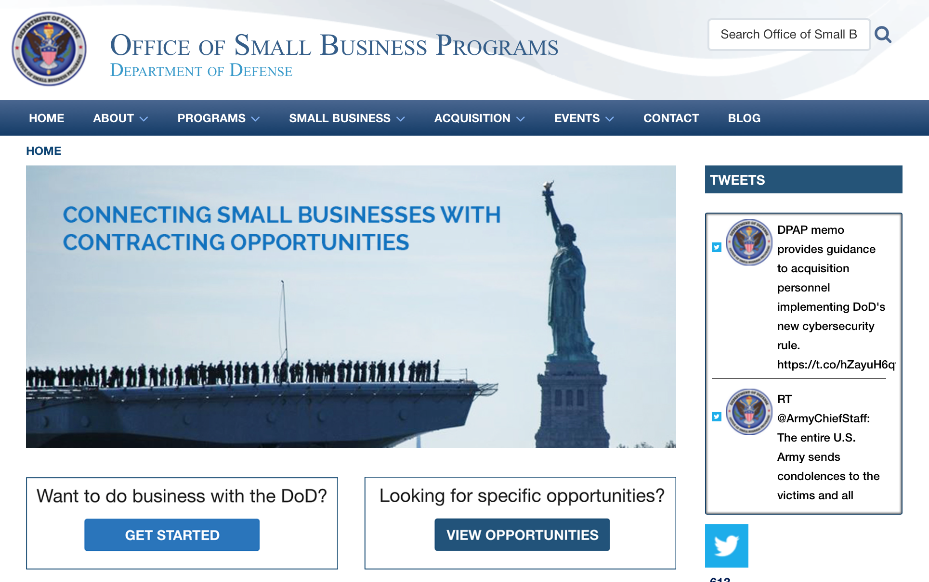

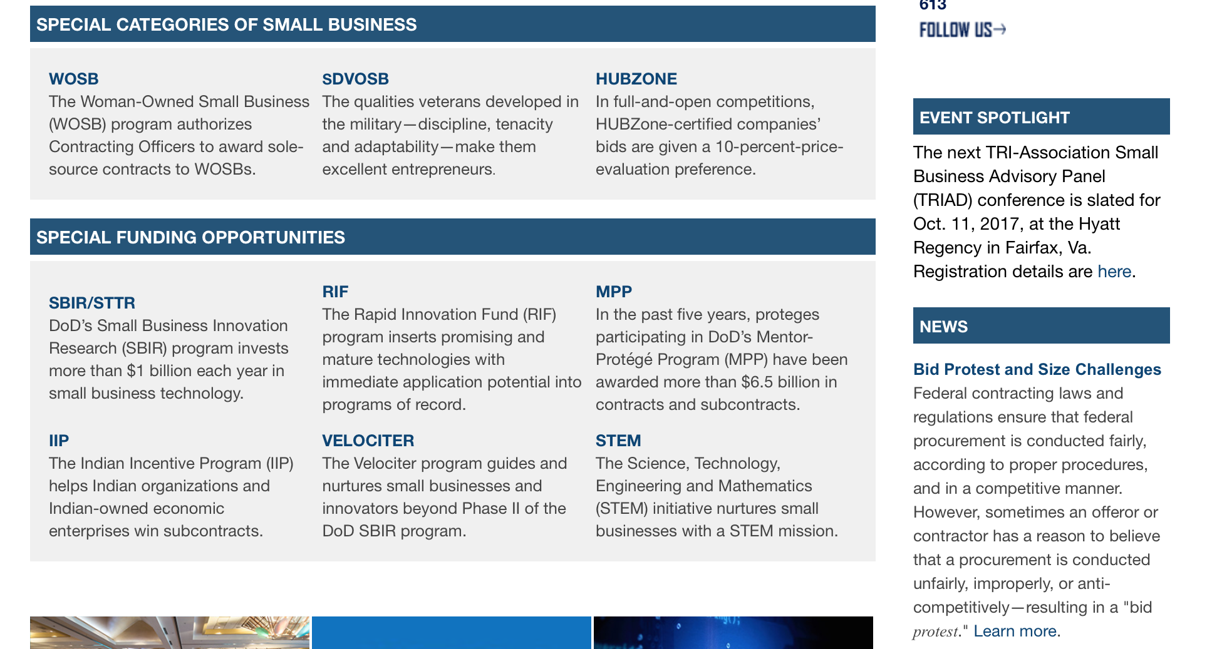

http://business.defense.gov

http://www.acq.osd.mil/osbp/

Doing Business with the DoD

Resources

Procurement Technical Assistance Centers (PTACs)

Procurement Technical Assistance Centers (PTACs) are charged with assisting businesses in learning how to do business with federal, state, and local governments. PTACs are a local resource available at no or nominal cost that can provide assistance to business firms in marketing their products and services. They offer training to businesses on how to research and bid on contracts, assist with registration requirements, provide bid-matching services, and assist with pre and post contracting issues.

Prime Contractors with Subcontracting Plans [xlsx]

Directory last updated 6/2017

This FY 2014 directory is intended for small business concerns seeking opportunities with DoD prime contractors. The directory is a listing of large business prime contractors who are required to establish subcontracting plans with goals. The report is generated from data contained in the Individual Subcontract Reports (ISRs) submitted in the Electronic Subcontracting Reporting System (eSRS) by contractors and from data contained in the Federal Procurement Data System (FPDS). The directory includes the name of the prime contractor; the major product/service code (PSC) provided to DoD; the major NAICS of the company; name, telephone number and email address of the company’s point of contact; contract number with the effective date and completion date, ultimate contract value and obligated dollars. In addition, many companies have websites with additional information which may be useful in your search for subcontracting opportunities or teaming arrangements.

Locate a Small Business Professional

Non-Appropriated Fund Customers

Non-appropriated fund customers operate similar to non-profit organizations and include commissaries, exchanges, recreation and fitness centers, dining at officer/enlisted/civilian clubs, and barber/beauty services, just to name a few.

For more information click here.

Research:

Dept. of the Army -- USAMRAA
DoD Kidney Cancer, Concept Award
Synopsis 1
http://www.grants.gov/web/grants/view-opportunity.html?oppId=298121

Dept. of the Army -- USAMRAA
DoD Kidney Cancer, Idea Development Award
Synopsis 1
http://www.grants.gov/web/grants/view-opportunity.html?oppId=298143

Dept. of the Army -- USAMRAA
DoD Lupus, Concept Award
Synopsis 1
http://www.grants.gov/web/grants/view-opportunity.html?oppId=298036

Dept. of the Army -- USAMRAA
DoD Lupus, Impact Award
Synopsis 1
http://www.grants.gov/web/grants/view-opportunity.html?oppId=298023

Uniformed Services Univ. of the Health Sciences
"Open Call" Funding Opportunity Announcement
Synopsis 1
http://www.grants.gov/web/grants/view-opportunity.html?oppId=297841

Modifications:

Air Force Office of Scientific Research
Research Interests of the Air Force Office of Scientific Research
Synopsis 5
http://www.grants.gov/web/grants/view-opportunity.html?oppId=285269

Army Research Laboratory Broad Agency Announcement for Basic and Applied Scientific Research
Synopsis 2 & 3
http://www.grants.gov/web/grants/view-opportunity.html?oppId=292896

Dept. of the Army -- USAMRAA
US Special Operations Command Broad Agency Announcement
Synopsis 2
http://www.grants.gov/web/grants/view-opportunity.html?oppId=293654

DARPA - Information Innovation Office
Active Social Engineering Defense (ASED)
Synopsis 2
http://www.grants.gov/web/grants/view-opportunity.html?oppId=297238

DARPA - Microsystems Technology Office
Electronics Resurgence Initiative: Page 3 Investments Architectures Thrust
Synopsis 3
http://www.grants.gov/web/grants/view-opportunity.html?oppId=297375

Dept. of the Army -- USAMRAA
DoD Psychological Health/ Traumatic Brain Injury Research Program, Complex Traumatic Brain Injury Rehabilitation Research Clinical Research Award
Synopsis 3
http://www.grants.gov/web/grants/view-opportunity.html?oppId=297121

Dept. of the Army -- USAMRAA
DoD Spinal Cord Injury Research Program, Clinical Trial Award
Synopsis 3
http://www.grants.gov/web/grants/view-opportunity.html?oppId=294432

Naval Supply Systems Command
Funding Opportunity Announcement (FOA) for Research Initiatives at The Naval Postgraduate School
Synopsis 4
http://www.grants.gov/web/grants/view-opportunity.html?oppId=288093

Naval Supply Systems Command
FY17 - FY18 Department of Defense HIV/AIDS Prevention Program: Military Specific HIV/AIDS Prevention, Care, and Treatment Program for PEPFAR (President's Emergency Plan for AID Relief) Funded Countries
Synopsis 6
http://www.grants.gov/web/grants/view-opportunity.html?oppId=290111

Deleted:

Reminders:



Department of Education
Grant Programs Overview at the Department of Education

The general information page for Education Grant funding is an excellent resource describing the three types of grants awarded by the Department of Education. See the screen shot of the Department of Education web page below:

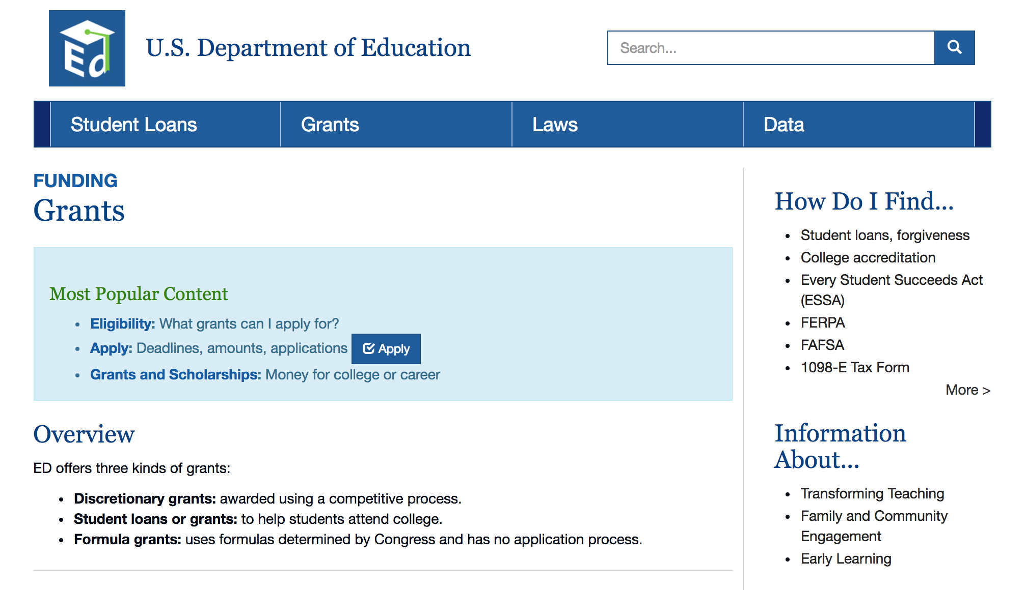
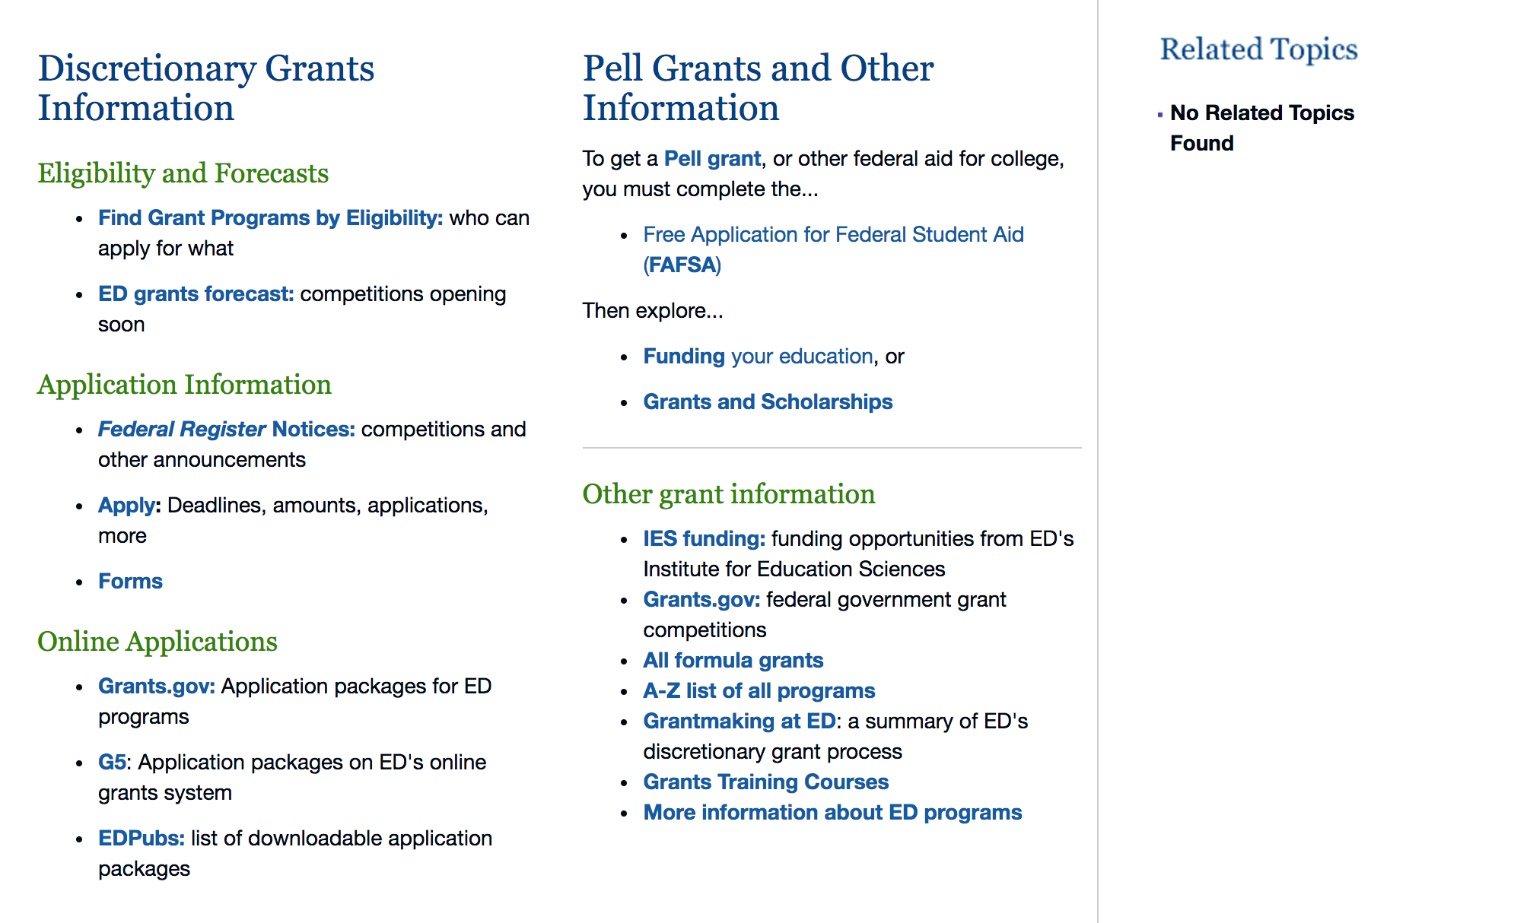

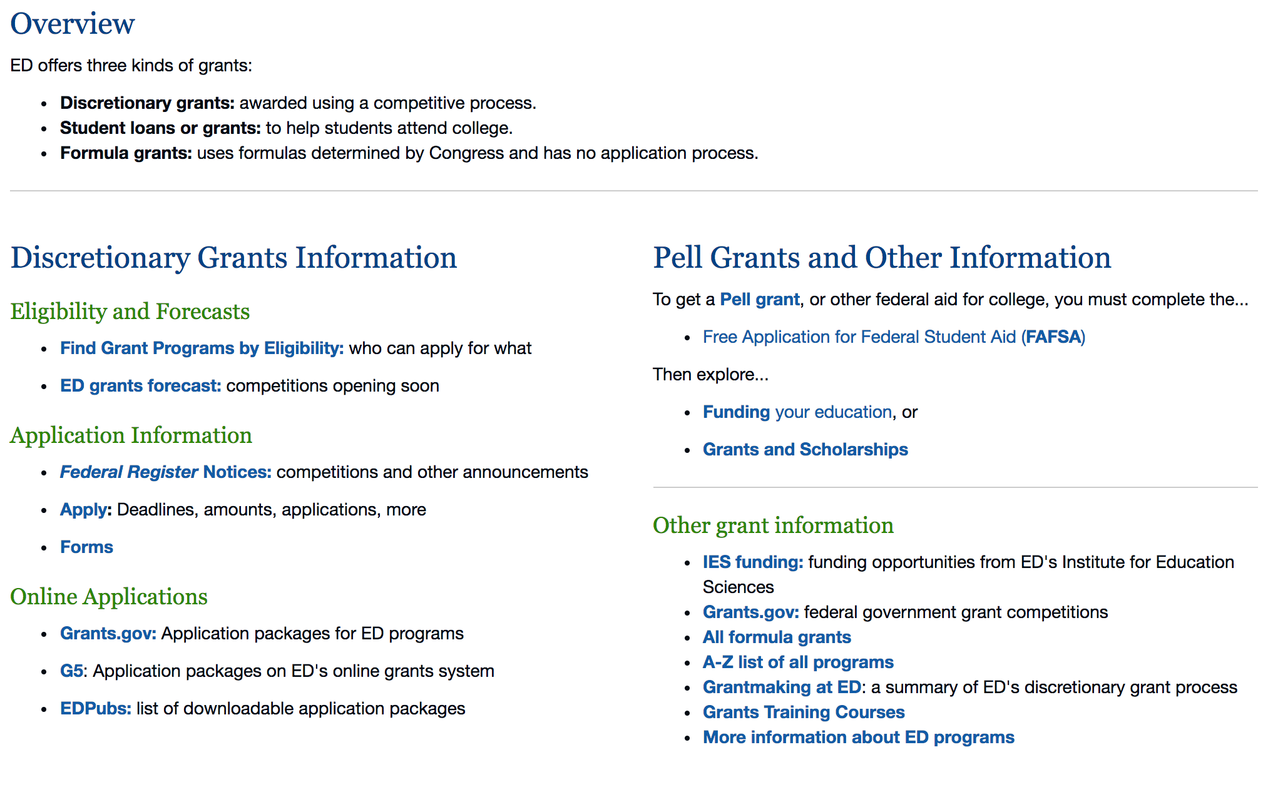

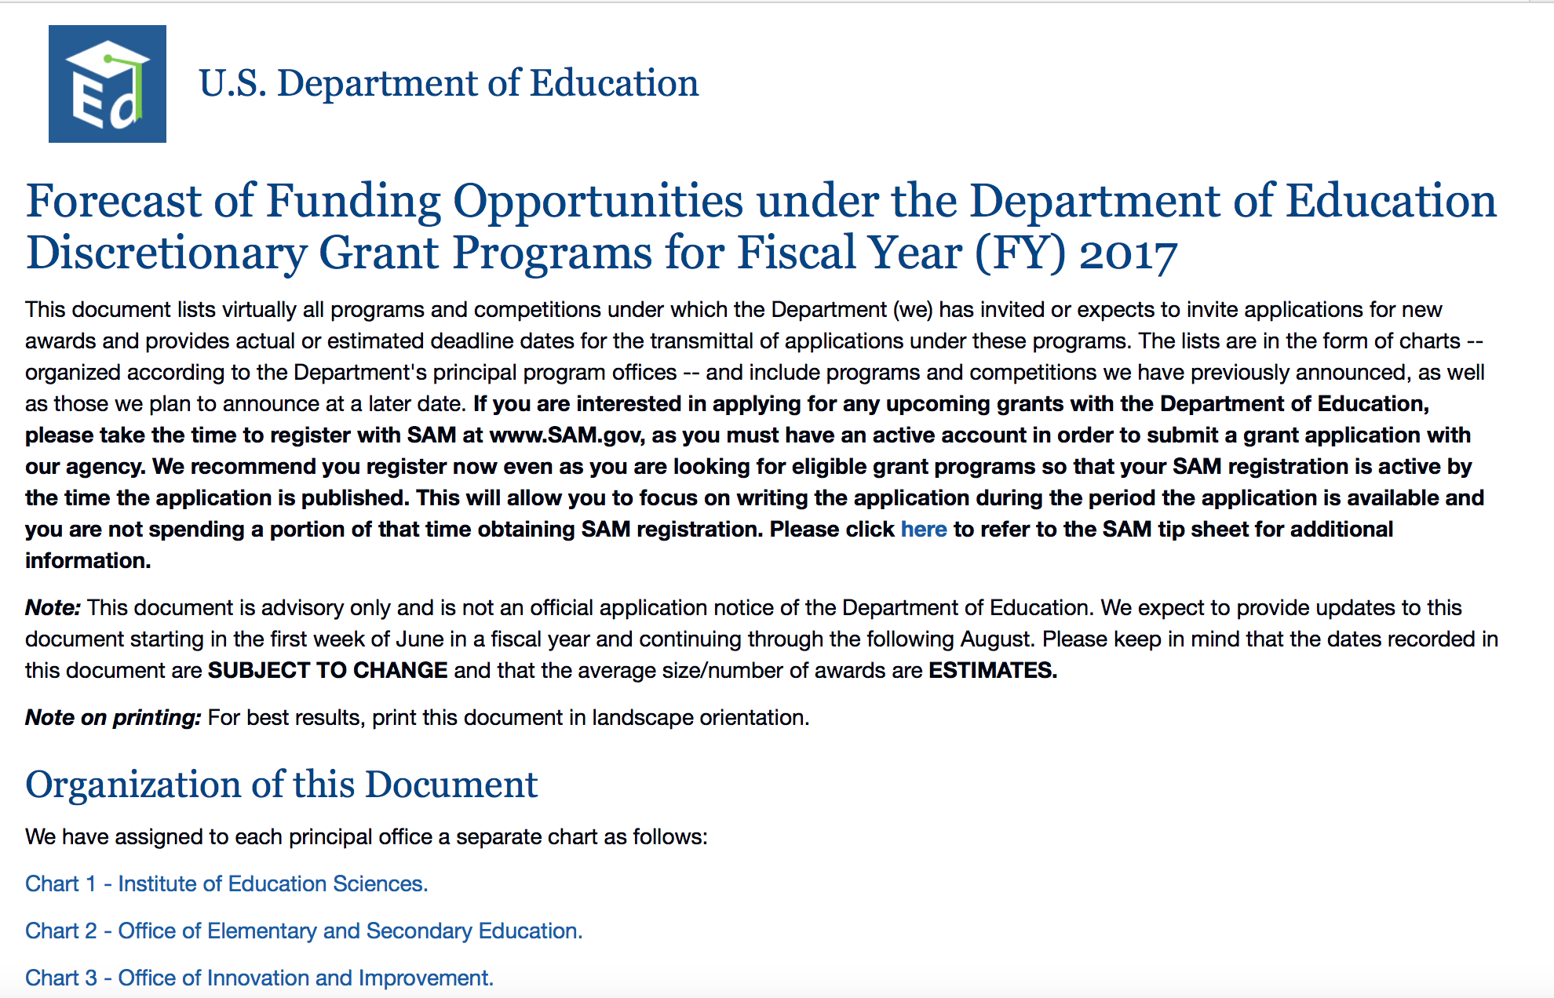
https://www2.ed.gov/fund/grants-apply.html?src=pn

https://www2.ed.gov/fund/grant/find/edlite-forecast.html

Programs:

Research:

Modifications:

Reminders:

Deleted:

U.S. Department of Energy

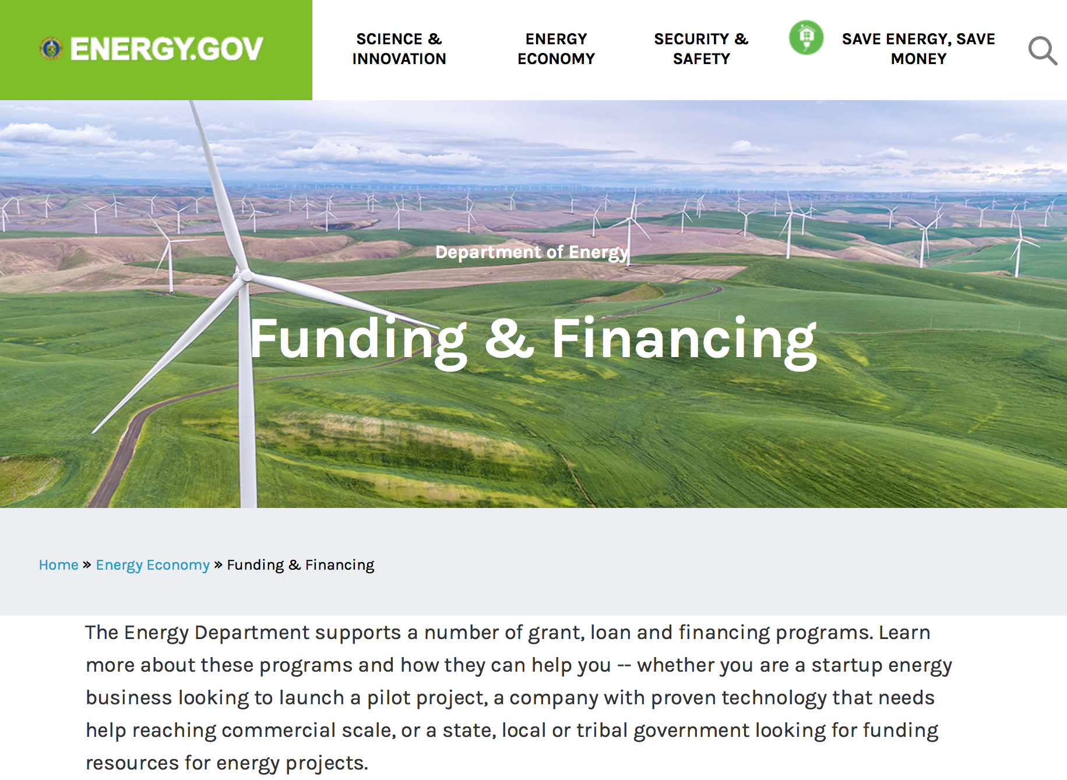

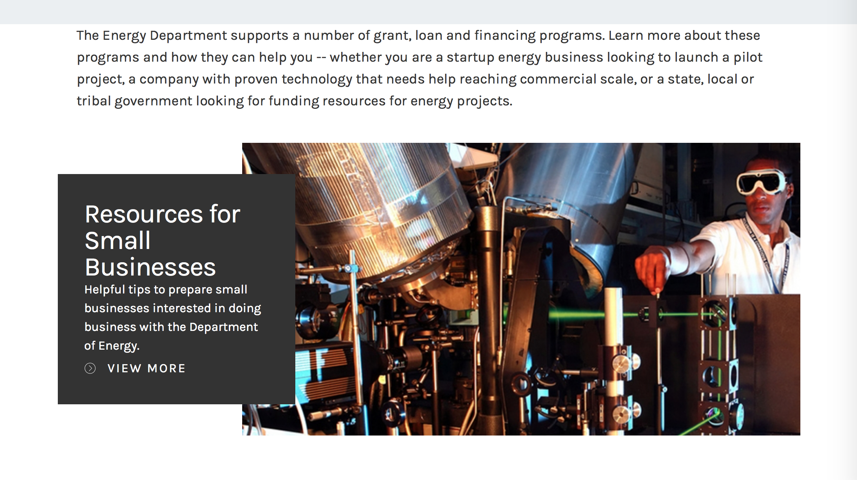

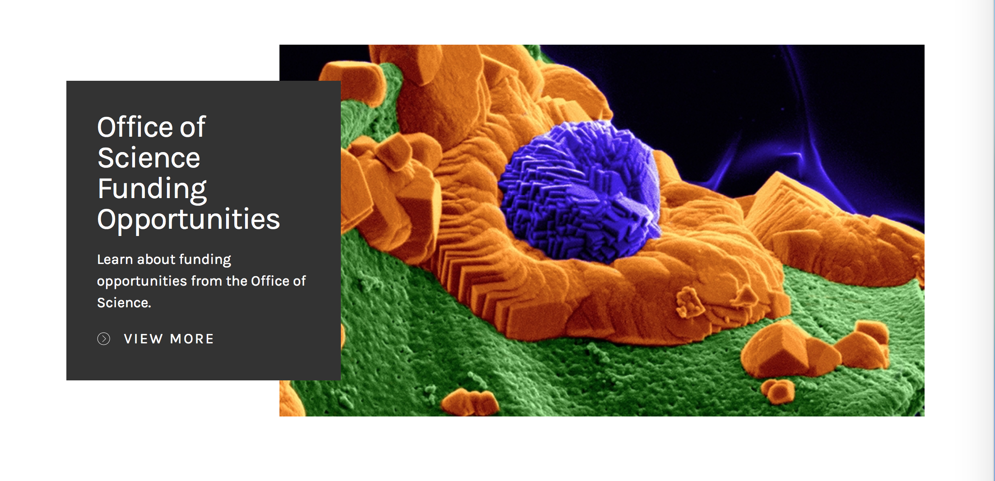

https://www.energy.gov/energy-economy/funding-financing

Research:

Advanced Research Projects Agency Energy
MEITNER FOA
Synopsis 1
http://www.grants.gov/web/grants/view-opportunity.html?oppId=298044

Idaho Field Office
FY2018 Scientific Infrastructure Support for CINR Funding Opportunity Announcement
Synopsis 1
http://www.grants.gov/web/grants/view-opportunity.html?oppId=298026

Idaho Field Office
FY2018 Consolidated Innovative Nuclear Research Funding Opportunity Announcement
Synopsis 1
http://www.grants.gov/web/grants/view-opportunity.html?oppId=298027

National Energy Technology Laboratory
Novel and Enabling Carbon Capture Transformational Technologies
Synopsis 1
http://www.grants.gov/web/grants/view-opportunity.html?oppId=297893

National Energy Technology Laboratory
FY2017 Vehicle Technologies Office Batteries and Electrification to Enable Extreme Fast Charging Funding Opportunity Announcement
Synopsis 1
http://www.grants.gov/web/grants/view-opportunity.html?oppId=298059

Modifications:

Reminders:

Environmental Protection Agency

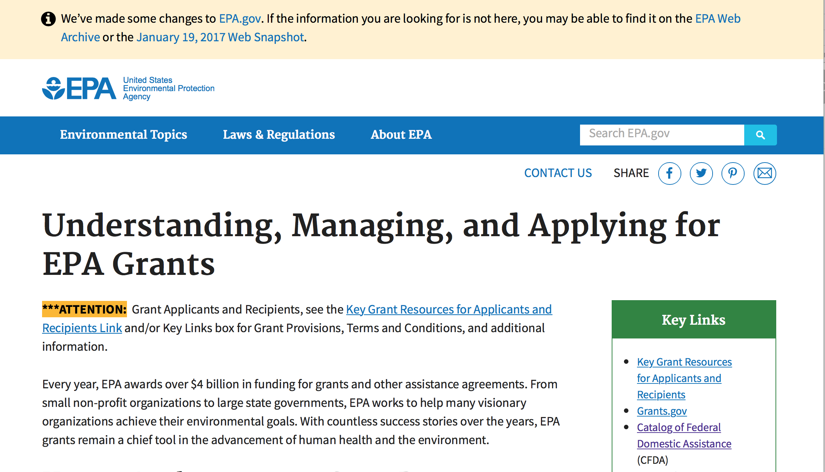
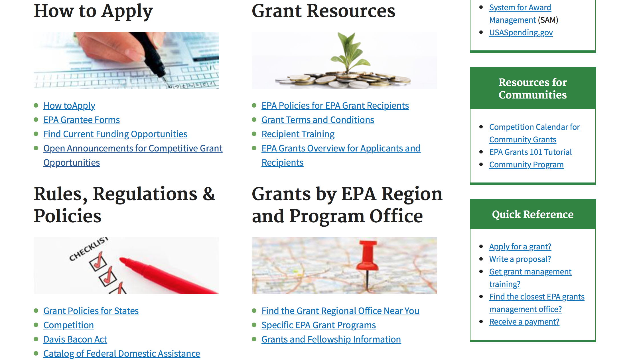

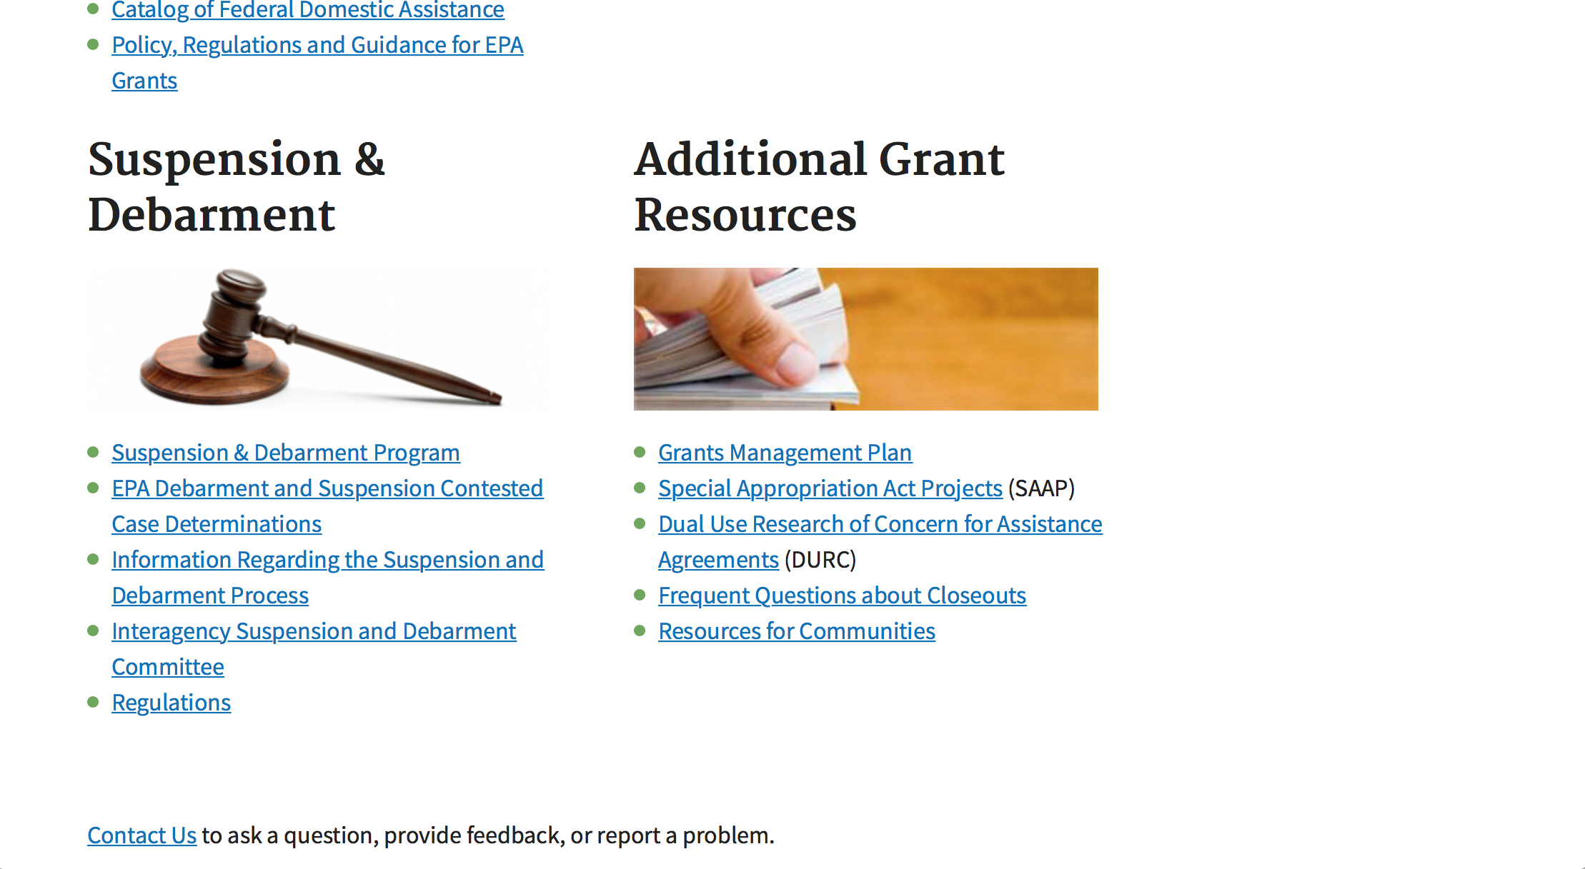

http://www.epa.gov/epahome/grants.htm

Programs:

FY 2017 and FY 2018 Training and Technical Assistance to Improve Water Quality and Enable Small Public Water Systems to Provide Safe Drinking Water
Synopsis 1
Document Type: | Grants Notice
Funding Opportunity Number: | EPA-OW-OGWDW-17-01
Funding Opportunity Title: | FY 2017 and FY 2018 Training and Technical Assistance to Improve Water Quality and Enable Small Public Water Systems to Provide Safe Drinking Water
Opportunity Category: | Discretionary
Opportunity Category Explanation:
Funding Instrument Type: | Cooperative Agreement
Category of Funding Activity: | Environment
Category Explanation:
Expected Number of Awards: | 9
CFDA Number(s): | 66.424 -- Surveys, Studies, Investigations, Demonstrations, and Training Grants - Section 1442 of the Safe Drinking Water Act  66.436 -- Surveys, Studies, Investigations, Demonstrations, and Training Grants and Cooperative Agreements - Section 104(b)(3) of
Cost Sharing or Matching Requirement: | Yes
Version: | Synopsis 1
Posted Date: | Oct 19, 2017
Last Updated Date: | Oct 19, 2017
Original Closing Date for Applications: | Dec 04, 2017 Please see the announcement including Section IV for additional submission information.
Current Closing Date for Applications: | Dec 04, 2017 Please see the announcement including Section IV for additional submission information.
Archive Date: | Jan 03, 2018
Estimated Total Program Funding: | $25,400,000
Award Ceiling: | $16,000,000
Award Floor: | $0
Eligible Applicants: | Others (see text field entitled "Additional Information on Eligibility" for clarification)
Additional Information on Eligibility: | Please see Section III of the announcement for eligibility information.
Agency Name: | Environmental Protection Agency
Description: | The U.S. Environmental Protection Agency (EPA) is soliciting applications from eligible applicants as described in Section III.A to provide training and technical assistance for small public water systems to help such systems achieve and maintain compliance with the Safe Drinking Water Act (SDWA), and to provide training and technical assistance for small publicly owned wastewater systems, communities served by onsite/decentralized wastewater systems, and private well owners to improve water quality under the Clean Water Act (CWA). Training and technical assistance activities provided to these systems, communities and private well owners should be made available nationally in rural and urban communities and to personnel of tribally- owned and operated systems.
Link to Additional Information: | FY 2017 and FY 2018 Training and Technical Assistance to Improve Water Quality and Enable Small Public Water Systems to Provide Safe Drinking Water
Grantor Contact Information: | If you have difficulty accessing the full announcement electronically, please contact:  Leslie Temple,(202) 564-4734  Leslie Temple

http://www.grants.gov/web/grants/view-opportunity.html?oppId=298028

FY18 ENVIRONMENTAL WORKFORCE DEVELOPMENT AND JOB TRAINING (EWDJT) GRANTS
Synopsis 1

Document Type: | Grants Notice
Funding Opportunity Number: | EPA-OLEM-OBLR-17-10
Funding Opportunity Title: | FY18 ENVIRONMENTAL WORKFORCE DEVELOPMENT AND JOB TRAINING (EWDJT) GRANTS
Opportunity Category: | Discretionary
Opportunity Category Explanation:
Funding Instrument Type: | Cooperative Agreement
Category of Funding Activity: | Environment
Category Explanation:
Expected Number of Awards: | 16
CFDA Number(s): | 66.815 -- Environmental Workforce Development and Job Training Cooperative Agreements
Cost Sharing or Matching Requirement: | No
Version: | Synopsis 1
Posted Date: | Oct 17, 2017
Last Updated Date: | Oct 17, 2017
Original Closing Date for Applications: | Dec 15, 2017 See Section IV of the solicitation for additional close date information.
Current Closing Date for Applications: | Dec 15, 2017 See Section IV of the solicitation for additional close date information.
Archive Date: | Jan 14, 2018
Estimated Total Program Funding: | $3,000,000
Award Ceiling: | $200,000
Eligible Applicants: | Others (see text field entitled "Additional Information on Eligibility" for clarification)
Additional Information on Eligibility: | See Section III of the solicitation for eligibility information.
Agency Name: | Environmental Protection Agency
Description: | This notice announces the availability of funds and solicits proposals from eligible entities, including nonprofit organizations, to deliver Environmental Workforce Development and Job Training programs that recruit, train, and place local, unemployed and under-employed residents with the skills needed to secure full-time employment in the environmental field. Please note that eligible entities who received an EWDJT grant in Fiscal Year 2017 (FY17) are not eligible to apply for funding in FY18.
Link to Additional Information: | FY 2018 Environmental Workforce Development and Job Training (EWDJT) Grants
Grantor Contact Information: | If you have difficulty accessing the full announcement electronically, please contact:  Rachel Congdon 1200 Pennsylvania Ave. N.W. Mail Code: 5105T Washington, D.C. 20460 Phone: (202) 566-1564  congdon.rachel@epa.gov

http://www.grants.gov/web/grants/view-opportunity.html?oppId=298017

Research:

Modifications:

Reminders:

FY18 GUIDELINES FOR BROWNFIELDS CLEANUP GRANTS
Synopsis 1
Document Type: | Grants Notice
Funding Opportunity Number: | EPA-OLEM-OBLR-17-09
Funding Opportunity Title: | FY18 GUIDELINES FOR BROWNFIELDS CLEANUP GRANTS
Opportunity Category: | Discretionary
Opportunity Category Explanation:
Funding Instrument Type: | Cooperative Agreement
Category of Funding Activity: | Environment
Category Explanation:
Expected Number of Awards: | 38
CFDA Number(s): | 66.818 -- Brownfields Assessment and Cleanup Cooperative Agreements
Cost Sharing or Matching Requirement: | Yes
Version: | Synopsis 1
Posted Date: | Sep 19, 2017
Last Updated Date: | Sep 19, 2017
Original Closing Date for Applications: | Nov 16, 2017 See Section IV of solicitation for additional close date information.
Current Closing Date for Applications: | Nov 16, 2017 See Section IV of solicitation for additional close date information.
Archive Date: | Dec 16, 2017
Estimated Total Program Funding: | $7,500,000
Award Ceiling: | $200,000
Eligible Applicants: | Others (see text field entitled "Additional Information on Eligibility" for clarification)
Additional Information on Eligibility: | See Section III of the solicitation for additional information about eligibility.
Agency Name: | Environmental Protection Agency
Description: | The Small Business Liability Relief and Brownfields Revitalization Act (“Brownfields Law,” P.L. 107-118) requires the U.S. Environmental Protection Agency (EPA) to publish guidance to assist applicants in preparing proposals for grants to assess and clean up brownfield sites. EPA’s Brownfields Program provides funds to empower states, communities, tribes, and nonprofits to prevent, inventory, assess, clean up, and reuse brownfield sites. EPA provides brownfields funding for three types of grants: Brownfields Assessment Grants, Brownfields Revolving Loan Fund (RLF) Grants, and Brownfields Cleanup Grants. Under this RFP, EPA is seeking proposals for Cleanup Grants, only, to provide funds to carry out cleanup activities at a specific brownfield site owned by the applicant.
Link to Additional Information: | FY 2018 Guidelines for Brownfields Cleanup Grants
Grantor Contact Information: | If you have difficulty accessing the full announcement electronically, please contact:  M. Jerry Minor-Gordon Phone: (202) 566-1817  Minor-Gordon.Jerry@epa.gov

http://www.grants.gov/web/grants/view-opportunity.html?oppId=297578

FY18 GUIDELINES FOR BROWNFIELDS REVOLVING LOAN FUND GRANTS
Synopsis 1
Document Type: | Grants Notice
Funding Opportunity Number: | EPA-OLEM-OBLR-17-08
Funding Opportunity Title: | FY18 GUIDELINES FOR BROWNFIELDS REVOLVING LOAN FUND GRANTS
Opportunity Category: | Discretionary
Opportunity Category Explanation:
Funding Instrument Type: | Cooperative Agreement
Category of Funding Activity: | Environment
Category Explanation:
Expected Number of Awards: | 15
CFDA Number(s): | 66.818 -- Brownfields Assessment and Cleanup Cooperative Agreements
Cost Sharing or Matching Requirement: | Yes
Version: | Synopsis 1
Posted Date: | Sep 18, 2017
Last Updated Date: | Sep 18, 2017
Original Closing Date for Applications: | Nov 16, 2017 Please see the announcement for additional submission information.
Current Closing Date for Applications: | Nov 16, 2017 Please see the announcement for additional submission information.
Archive Date: | Dec 16, 2017
Estimated Total Program Funding: | $9,000,000
Award Ceiling: | $1,000,000
Version: | Synopsis 1
Posted Date: | Sep 18, 2017
Last Updated Date: | Sep 18, 2017
Original Closing Date for Applications: | Nov 16, 2017 Please see the announcement for additional submission information.
Current Closing Date for Applications: | Nov 16, 2017 Please see the announcement for additional submission information.
Archive Date: | Dec 16, 2017
Estimated Total Program Funding: | $9,000,000
Award Ceiling: | $1,000,000
Eligible Applicants: | Others (see text field entitled "Additional Information on Eligibility" for clarification)
Additional Information on Eligibility: | Please see the announcement including Section III for additional eligibility information.
Agency Name: | Environmental Protection Agency
Description: | The Small Business Liability Relief and Brownfields Revitalization Act (“Brownfields Law”, P.L. 107-118) requires the U.S. Environmental Protection Agency (EPA) to publish guidance for grants to assess and clean up brownfield sites. EPA’s Brownfields Program provides funds to empower states, communities, tribes, and nonprofits to prevent, inventory, assess, clean up, and reuse brownfield sites. Under these guidelines, EPA is seeking proposals for Revolving Loan Fund Grants only. If you are interested in requesting funding for Assessment Grants and/or Cleanup Grants, please refer to announcement EPA-OLEM-OBLR-17-07 (Assessment Grant Guidelines) or EPA-OLEM-OBLR-17-09 (Cleanup Grant Guidelines) posted separately on www.grants.gov and www.epa.gov/brownfields/apply-brownfields-grant-funding.
Link to Additional Information: | FY18 GUIDELINES FOR BROWNFIELDS REVOLVING LOAN FUND GRANTS
Grantor Contact Information: | If you have difficulty accessing the full announcement electronically, please contact:  See Section VII of solicitation  See Section VII of solicitation

http://www.grants.gov/web/grants/view-opportunity.html?oppId=297557

FY18 GUIDELINES FOR BROWNFIELDS ASSESSMENT GRANTS
Synopsis 1
Document Type: | Grants Notice
Funding Opportunity Number: | EPA-OLEM-OBLR-17-07
Funding Opportunity Title: | FY18 GUIDELINES FOR BROWNFIELDS ASSESSMENT GRANTS
Opportunity Category: | Discretionary
Opportunity Category Explanation:
Funding Instrument Type: | Cooperative Agreement
Category of Funding Activity: | Environment
Category Explanation:
Expected Number of Awards: | 145
CFDA Number(s): | 66.818 -- Brownfields Assessment and Cleanup Cooperative Agreements
Cost Sharing or Matching Requirement: | No
Version: | Synopsis 1
Posted Date: | Sep 18, 2017
Last Updated Date: | Sep 18, 2017
Original Closing Date for Applications: | Nov 16, 2017 Please see the announcement for additional submission information.
Current Closing Date for Applications: | Nov 16, 2017 Please see the announcement for additional submission information.
Archive Date: | Dec 16, 2017
Estimated Total Program Funding: | $33,500,000
Award Ceiling: | $600,000
Eligible Applicants: | Others (see text field entitled "Additional Information on Eligibility" for clarification)
Additional Information on Eligibility: | Please see the announcement for additional eligibility information.
Agency Name: | Environmental Protection Agency
Description: | The Small Business Liability Relief and Brownfields Revitalization Act (“Brownfields Law”, P.L. 107-118) requires the U.S. Environmental Protection Agency (EPA) to publish guidance for grants to assess and clean up brownfield sites. EPA’s Brownfields Program provides funds to empower states, communities, tribes, and nonprofits to prevent, inventory, assess, clean up, and reuse brownfield sites. Under these guidelines, EPA is seeking proposals for Assessment Grants only. If you are interested in requesting funding for Cleanup Grants and/or Revolving Loan Fund Grants, please refer to announcement EPA-OLEM-OBLR-17-08 (Revolving Loan Fund Grant Guidelines) or EPA-OLEM-OBLR-17-09 (Cleanup Grant Guidelines) posted separately on www.grants.gov and www.epa.gov/brownfields/apply-brownfields-grant-funding.
Link to Additional Information: | FY18 GUIDELINES FOR BROWNFIELDS ASSESSMENT GRANTS
Grantor Contact Information: | If you have difficulty accessing the full announcement electronically, please contact:  See Section VII of solicitation  See Section VII of solicitation

http://www.grants.gov/web/grants/view-opportunity.html?oppId=297558

2017 Targeted Air Shed Grant Program
Synopsis 1
Document Type: | Grants Notice
Funding Opportunity Number: | EPA-OAR-OAQPS-17-06
Funding Opportunity Title: | 2017 Targeted Air Shed Grant Program
Opportunity Category: | Discretionary
Opportunity Category Explanation:
Funding Instrument Type: | Cooperative Agreement  Grant
Category of Funding Activity: | Environment
Category Explanation:
Expected Number of Awards: | 7
CFDA Number(s): | 66.202 -- Congressionally Mandated Projects
Cost Sharing or Matching Requirement: | No
Version: | Synopsis 1
Posted Date: | Jul 19, 2017
Last Updated Date: | Jul 19, 2017
Original Closing Date for Applications: | Oct 18, 2017 Please see the announcement including Section IV for additional submission information.
Current Closing Date for Applications: | Oct 18, 2017 Please see the announcement including Section IV for additional submission information.
Archive Date: | Nov 17, 2017
Estimated Total Program Funding: | $30,000,000
Award Ceiling: | $4,000,000
Award Floor: | $0
Eligible Applicants: | Others (see text field entitled "Additional Information on Eligibility" for clarification)
Additional Information on Eligibility: | Please see the announcement including Section III for additional eligibility information.
Agency Name: | Environmental Protection Agency
Description: | This notice announces the availability of funds and solicits applications from eligible entities to compete for financial assistance through the Targeted Air Shed Grant Program. This program will assist local, state and/or tribal air pollution control agencies in developing plans, conducting demonstrations, and implementing projects to reduce air pollution in nonattainment areas that EPA determines are the top five most polluted areas relative to ozone (O3), annual average fine particulate matter (PM2.5), or 24-hour PM2.5 National Ambient Air Quality Standards (NAAQS). The overall goal of the Targeted Air Shed Grant program is to reduce air pollution in the Nation’s areas with the highest levels of ozone and PM2.5 ambient air concentrations.
Link to Additional Information: | 2017 Targeted Air Shed Grant Program
Grantor Contact Information: | If you have difficulty accessing the full announcement electronically, please contact:  Gary Blais, 919-541-3223  Gary Blais

http://www.grants.gov/web/grants/view-opportunity.html?oppId=295677

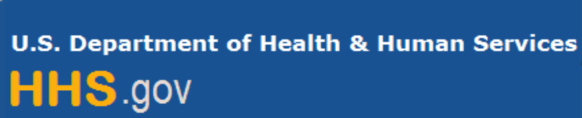

Department of Health and Human Services

Grants Forecast and Overview

The Department of Health and Human Services’ Grants Forecast is a database of planned grant opportunities proposed by its agencies. Each Forecast record contains actual or estimated dates and funding levels for grants that the agency intends to award during the fiscal year. Forecast opportunities are subject to change based on enactment of congressional appropriations.

For more general information about HHS Grants and Funding go to the website below at:

https://www.hhs.gov/grants/grants/index.html

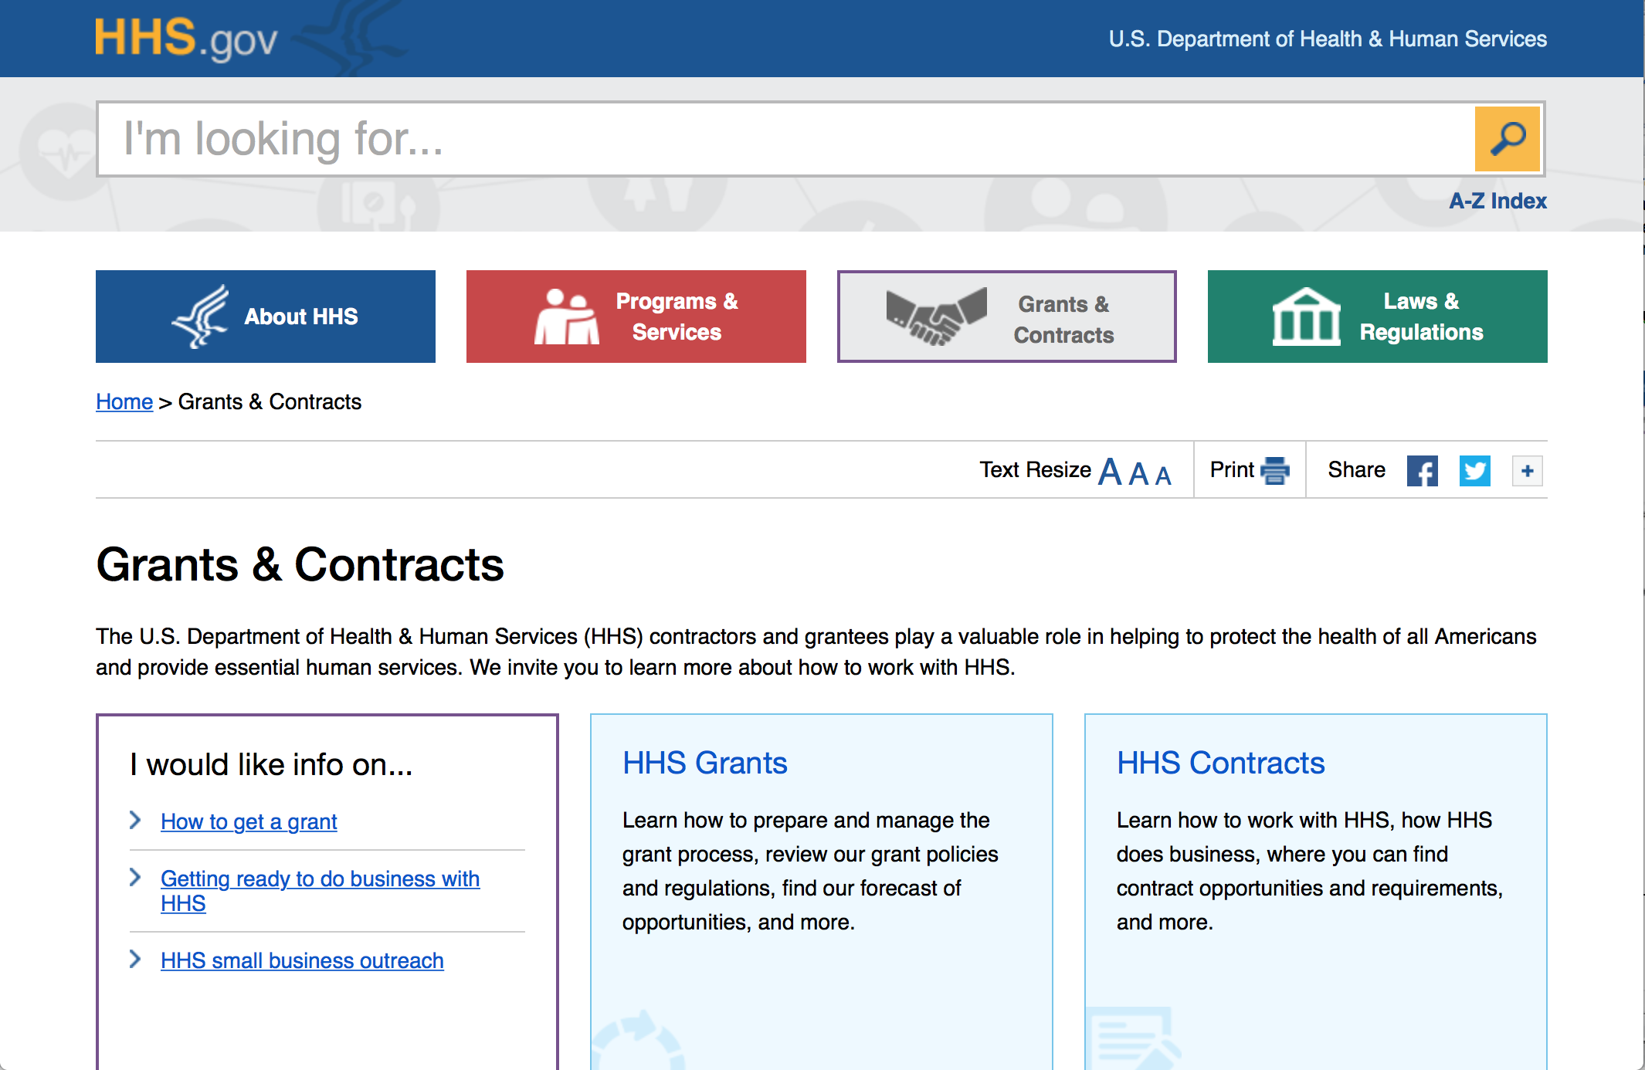

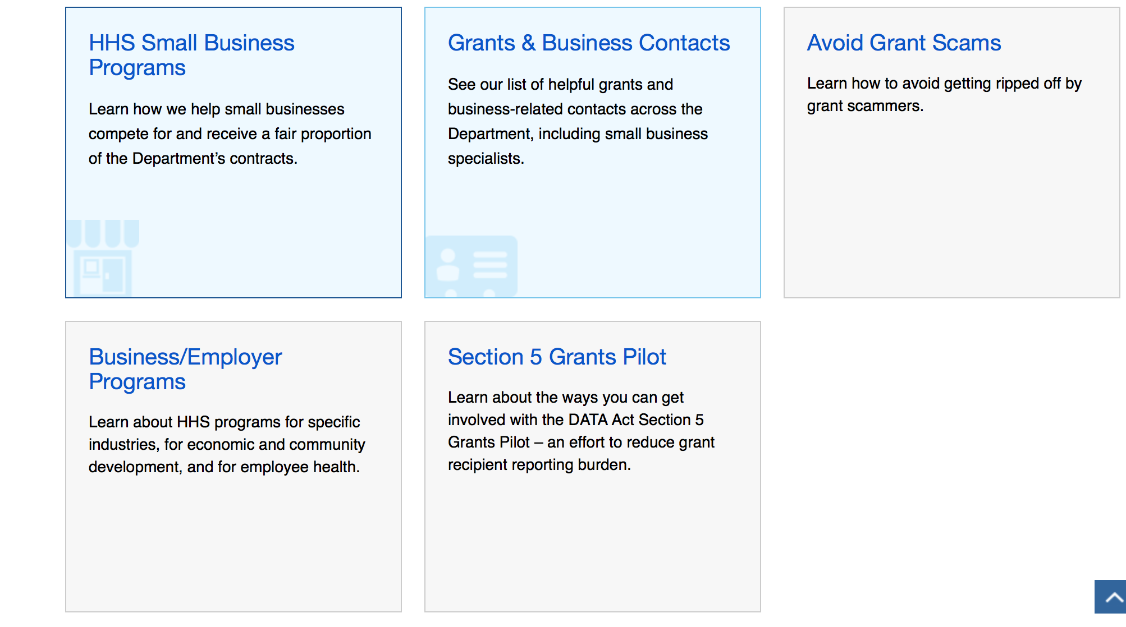

Programs:

Research:

Administration for Children and Families - ANA
Environmental Regulatory Enhancement
Forecast 1
http://www.grants.gov/web/grants/view-opportunity.html?oppId=298045

Administration for Children & Families - ACYF/FYSB
Sexual Risk Avoidance Education Program
Forecast 1
http://www.grants.gov/web/grants/view-opportunity.html?oppId=298222

Administration for Children and Families - ANA
Social and Economic Development Strategies -SEDS
Forecast 1
http://www.grants.gov/web/grants/view-opportunity.html?oppId=298007

Administration for Children and Families - ANA
Native Youth Initiative for Leadership, Empowerment, and Development (I-LEAD)
Forecast 1
http://www.grants.gov/web/grants/view-opportunity.html?oppId=298009
Administration for Children and Families - ANA
Native American Language Preservation and Maintenance
Forecast 1
http://www.grants.gov/web/grants/view-opportunity.html?oppId=298010

Administration for Children and Families - ORR
Refugee Family Child Care Microenterprise Development Program
Forecast 1
http://www.grants.gov/web/grants/view-opportunity.html?oppId=298031

Administration for Children and Families - ORR
Refugee Individual Development Accounts (IDA) Program
Forecast 1
http://www.grants.gov/web/grants/view-opportunity.html?oppId=298032

Administration for Children & Families - ACYF/FYSB
Transitional Living Program and Maternity Group Homes
Forecast 1
http://www.grants.gov/web/grants/view-opportunity.html?oppId=298156

Administration for Children & Families - ACYF/FYSB
Street Outreach Program
Forecast 1
http://www.grants.gov/web/grants/view-opportunity.html?oppId=298175

Administration for Children & Families - ACYF/FYSB
Basic Center Program
Forecast 1
http://www.grants.gov/web/grants/view-opportunity.html?oppId=298176

Administration for Children and Families - ORR
Direct Services for Survivors of Torture
Forecast 1
http://www.grants.gov/web/grants/view-opportunity.html?oppId=298162

Centers for Disease Control and Prevention - ERA
Birth Defects Study To Evaluate Pregnancy exposures (BD-STEPS) II
Forecast 1
http://www.grants.gov/web/grants/view-opportunity.html?oppId=297928

Centers for Disease Control - NCIRD
PPHF 2018; Immunization Information Systems Sentinel Site Project Financed in Part by 2018 Prevention and Public Health Funds
Forecast 1
http://www.grants.gov/web/grants/view-opportunity.html?oppId=298003

Centers for Disease Control - OPHPR
Cooperative Agreement for Emergency Response: Public Health Crisis Response
Synopsis 1
http://www.grants.gov/web/grants/view-opportunity.html?oppId=297939

Health Resources and Services Administration
Ryan White HIV/AIDS Program Part C HIV Early Intervention Services Program: New Geographic Service Areas
Synopsis 1
http://www.grants.gov/web/grants/view-opportunity.html?oppId=295231

Health Resources and Services Administration
Rural Health Care Services Outreach Program
Synopsis 1
http://www.grants.gov/web/grants/view-opportunity.html?oppId=295218

National Institutes of Health
BRAIN Initiative: Theories, Models and Methods for Analysis of Complex Data from the Brain (R01 Clinical Trial Not Allowed)
Synopsis 1
http://www.grants.gov/web/grants/view-opportunity.html?oppId=297947

National Institutes of Health
Assay Validation of High Quality Markers for Clinical Studies in Cancer (UH2/UH3 - Clinical Trials Not Allowed)
Synopsis 1
http://www.grants.gov/web/grants/view-opportunity.html?oppId=297948

National Institutes of Health
Innovation Corps (I-Corps) at NIH Program for NIH and CDC Translational Research (Admin Supp)
Synopsis 1
http://www.grants.gov/web/grants/view-opportunity.html?oppId=297945

National Institutes of Health
Assay Validation of High Quality Markers for Clinical Studies in Cancer (UH3 - Clinical Trials Not Allowed
Synopsis 1
http://www.grants.gov/web/grants/view-opportunity.html?oppId=297926

National Institutes of Health
Specialized Programs of Research Excellence (SPOREs) in Human Cancers for years 2018, 2019 and 2020 (P50)
Synopsis 1
http://www.grants.gov/web/grants/view-opportunity.html?oppId=297924

National Institutes of Health
Fundamental Science Research on Mind and Body Approaches (R01 - Clinical Trial Optional)
Synopsis 1
http://www.grants.gov/web/grants/view-opportunity.html?oppId=297951

National Institutes of Health
Feasibility and Planning Studies for Development of Specialized Programs of Research Excellence (SPOREs) to Investigate Cancer Health Disparities (P20)
Synopsis 1
http://www.grants.gov/web/grants/view-opportunity.html?oppId=297953

National Institutes of Health
HIV Vaccine Research and Design (HIVRAD) Program (P01 Clinical Trial Not Allowed)
Synopsis 1
http://www.grants.gov/web/grants/view-opportunity.html?oppId=297927

National Institutes of Health
Fundamental Science Research on Mind and Body Approaches (R21 - Clinical Trial Optional)
Synopsis 1
http://www.grants.gov/web/grants/view-opportunity.html?oppId=297930

National Institutes of Health
Testing Interventions for Health-Enhancing Physical Activity (R01 - Clinical Trial Optional)
Synopsis 1
http://www.grants.gov/web/grants/view-opportunity.html?oppId=298004

National Institutes of Health
Interactive Digital Media STEM Resources for Pre-College and Informal Science Education Audiences (STTR) (R41/R42 - Clinical Trial Not Allowed)
Synopsis 1
http://www.grants.gov/web/grants/view-opportunity.html?oppId=297835

National Institutes of Health
Interactive Digital Media STEM Resources for Pre-College and Informal Science Education Audiences (SBIR) (R43/R44 - Clinical Trial Not Allowed)
Synopsis 1
http://www.grants.gov/web/grants/view-opportunity.html?oppId=297836

National Institutes of Health
BRAIN Initiative: Targeted BRAIN Circuits Projects- TargetedBCP (R01 - Clinical Trial Not Allowed)
Synopsis 1
http://www.grants.gov/web/grants/view-opportunity.html?oppId=297855

National Institutes of Health
Notice of Intent to Publish a Funding Opportunity Announcement for Countermeasures Against Chemical Threats (CounterACT) Research Centers of Excellence (U54)
Forecast 1
http://www.grants.gov/web/grants/view-opportunity.html?oppId=297846

National Institutes of Health
Notice of Intent to Publish a Funding Opportunity Announcement for Regional Tech Transfer Accelerator Hubs for IDeA States (STTR) (UT2)
Forecast 1
http://www.grants.gov/web/grants/view-opportunity.html?oppId=297847

National Institutes of Health
Notice of Intent to Publish a Funding Opportunity Announcement for Alzheimer's Disease Centers (P30)
Forecast 1
http://www.grants.gov/web/grants/view-opportunity.html?oppId=297848

National Institutes of Health
BRAIN Initiative: Exploratory Research Opportunities Using Invasive Neural Recording and Stimulating Technologies in the Human Brain (U01)
Synopsis 1
http://www.grants.gov/web/grants/view-opportunity.html?oppId=297861

National Institutes of Health
BRAIN Initiative: Proof of Concept Development of Early Stage Next Generation Human Brain Imaging (R01 Clinical Trials Not Allowed)
Synopsis 1
http://www.grants.gov/web/grants/view-opportunity.html?oppId=297862

National Institutes of Health
BRAIN Initiative: Development of Next Generation Human Brain Imaging Tools and Technologies (U01) (Clinical Trials Not Allowed)
Synopsis 1
http://www.grants.gov/web/grants/view-opportunity.html?oppId=297863

National Institutes of Health
Developmental Centers for Interdisciplinary Research in Benign Urology (P20 - Clinical Trials Not Allowed)
Synopsis 1
http://www.grants.gov/web/grants/view-opportunity.html?oppId=297873

National Institutes of Health
National Institute of General Medical Sciences Ruth L. Kirschstein National Research Service Award (NRSA) Predoctoral Institutional Research Training Grant (T32)
Synopsis 1
http://www.grants.gov/web/grants/view-opportunity.html?oppId=297875

National Institutes of Health
Limited Competition: Small Grant Program for NHLBI K01/K08/K23 Recipients (R03) - (Clinical Trial Optional)
Synopsis 1
http://www.grants.gov/web/grants/view-opportunity.html?oppId=297892

National Institutes of Health
Limited Competition: Brain Tissue Resource Center for Alcohol Research (R28)
Synopsis 1
http://www.grants.gov/web/grants/view-opportunity.html?oppId=297912

National Institutes of Health
Testing Interventions for Health-Enhancing Physical Activity (R01 - Clinical Trial Optional)
Synopsis 1
http://www.grants.gov/web/grants/view-opportunity.html?oppId=297913

National Institutes of Health
Immuno-Oncology Translation Network (IOTN): Cellular Immunotherapy Data Resource (CIDR) (U24)
Synopsis 1
http://www.grants.gov/web/grants/view-opportunity.html?oppId=297914

National Institutes of Health
Immuno-Oncology Translational Network (IOTN): Cancer Immunotherapy Research Projects (U01)
Synopsis 1
http://www.grants.gov/web/grants/view-opportunity.html?oppId=297915

National Institutes of Health
Developing Interventions for Health-Enhancing Physical Activity (R21/R33 - Clinical Trial Optional)
Synopsis 1
http://www.grants.gov/web/grants/view-opportunity.html?oppId=297931

National Institutes of Health
Immuno-Oncology Translation Network (IOTN): Data Management and Resource-Sharing Center (DMRC) (U24)
Synopsis 1
http://www.grants.gov/web/grants/view-opportunity.html?oppId=297933

National Institutes of Health
Prevention and Treatment through a Comprehensive Care Continuum for HIV-affected Adolescents in Resource Constrained Settings (PATC3H) (UG3/UH3)
Synopsis 1
http://www.grants.gov/web/grants/view-opportunity.html?oppId=298019

National Institutes of Health
Research Centers for Improving Management of Symptoms Across Cancer Treatments (IMPACT) (UM1)
Synopsis 1
http://www.grants.gov/web/grants/view-opportunity.html?oppId=298020

National Institutes of Health
Coordinating Center for Improving Management of Symptoms Across Cancer Treatments (IMPACT) (U24)
Synopsis 1
http://www.grants.gov/web/grants/view-opportunity.html?oppId=298021

National Institutes of Health
Mechanisms of Cancer Drug Resistance and Sensitivity: Coordinating Center (U24)
Synopsis 1
http://www.grants.gov/web/grants/view-opportunity.html?oppId=298052

National Institutes of Health
Accelerating Colorectal Cancer Screening and follow-up through Implementation Science (ACCSIS)(UG3/UH3)
Synopsis 1
http://www.grants.gov/web/grants/view-opportunity.html?oppId=298046

National Institutes of Health
Accelerating Colorectal Cancer Screening and follow-up through Implementation Science (ACCSIS): Coordinating Center (U24)
Synopsis 1
http://www.grants.gov/web/grants/view-opportunity.html?oppId=298047

National Institutes of Health
Limited Competition: NCI National Clinical Trials Network - Network Group Statistics and Data Management Centers (U10)
Synopsis 1
http://www.grants.gov/web/grants/view-opportunity.html?oppId=298048

National Institutes of Health
Limited Competition: NCI National Clinical Trials Network - Network Group Operations Centers (U10)
Synopsis 1
http://www.grants.gov/web/grants/view-opportunity.html?oppId=298049

National Institutes of Health
Limited Competition: NCI National Clinical Trials Network - Canadian Collaborating Clinical Trials Network (U10)
Synopsis 1
http://www.grants.gov/web/grants/view-opportunity.html?oppId=298050

National Institutes of Health
Typical and Atypical Patterns of Language and Literacy in Dual Language Learners (R01-Clinical Trial Optional)
Synopsis 1
http://www.grants.gov/web/grants/view-opportunity.html?oppId=298051

National Institutes of Health
Typical and Atypical Patterns of Language and Literacy in Dual Language Learners (R21-Clinical Trial Optional)
Synopsis 1
http://www.grants.gov/web/grants/view-opportunity.html?oppId=298030

National Institutes of Health
Limited Competition: NCI National Clinical Trials Network - Network Radiotherapy and Imaging Core Services Center (U24)
Synopsis 1
http://www.grants.gov/web/grants/view-opportunity.html?oppId=298054

National Institutes of Health
NCI National Clinical Trials Network - Network Group Integrated Translational Science Centers (UG1)
Synopsis 1
http://www.grants.gov/web/grants/view-opportunity.html?oppId=298055

National Institutes of Health
Human Tumor Atlases (HTA) Precancer Atlas Research Centers (U2C)
Synopsis 1
http://www.grants.gov/web/grants/view-opportunity.html?oppId=298056

National Institutes of Health
Clinic Testing Therapeutic/Indication Pairing Strategies (U01 Clinical Trial Required)
Synopsis 1
http://www.grants.gov/web/grants/view-opportunity.html?oppId=298057

National Institutes of Health
Human Tumor Atlases (HTA) Research Centers (U2C)
Synopsis 1
http://www.grants.gov/web/grants/view-opportunity.html?oppId=298058

National Institutes of Health
Human Tumor Atlas Network: Data Coordinating Center (U24)
Synopsis 1
http://www.grants.gov/web/grants/view-opportunity.html?oppId=298060

National Institutes of Health
Regional Technology Transfer Accelerator Hubs for IDeA States (STTR) (UT2 - Clinical Trial Not Allowed)
Synopsis 1
http://www.grants.gov/web/grants/view-opportunity.html?oppId=298061

National Institutes of Health
NHLBI Program Project Applications (P01 - Clinical Trials Optional)
Synopsis 1
http://www.grants.gov/web/grants/view-opportunity.html?oppId=298062

National Institutes of Health
Maintaining Immunity After Immunization (U01 - Clinical Trial Optional)
Synopsis 1
http://www.grants.gov/web/grants/view-opportunity.html?oppId=298071

National Institutes of Health
NCI National Clinical Trials Network (NCTN)--Network Lead Academic Participating Sites (UG1)
Synopsis 1
http://www.grants.gov/web/grants/view-opportunity.html?oppId=298072

National Institutes of Health
Investigator-Initiated Clinical Trials Targeting Diseases within the Mission of NIDDK (R01-Clinical Trial Required)
Synopsis 1
http://www.grants.gov/web/grants/view-opportunity.html?oppId=298073

National Institutes of Health
Simulation Modeling and Systems Science to Address Health Disparities (R01-Clinical Trial Not Allowed)
Synopsis 1
http://www.grants.gov/web/grants/view-opportunity.html?oppId=298074

National Institutes of Health
Research Grants Using the Resources from the Osteoarthritis Initiative (OAI) (R21) - Clinical Trial Not Allowed
Synopsis 1
http://www.grants.gov/web/grants/view-opportunity.html?oppId=298145

National Institutes of Health
Research Grants Using the Resources from the Osteoarthritis Initiative (OAI) (R01) - Clinical Trial Not Allowed
Synopsis 1
http://www.grants.gov/web/grants/view-opportunity.html?oppId=298146

National Institutes of Health
Mentored Career Development Award to Promote Faculty Diversity in Biomedical Research (K01) - (Clinical Trials Not Allowed)
Synopsis 1
http://www.grants.gov/web/grants/view-opportunity.html?oppId=298147

National Institutes of Health
Clinical Coordinating Center for Multi-Site Investigator-Initiated Clinical Trials (Collaborative UG3/UH3) - Clinical Trial Required
Synopsis 1
http://www.grants.gov/web/grants/view-opportunity.html?oppId=298149

National Institutes of Health
Data Coordinating Center for Multi-Site Investigator-Initiated Clinical Trials (Collaborative U24 Clinical Trial Required)
Synopsis 1
http://www.grants.gov/web/grants/view-opportunity.html?oppId=298151

National Institutes of Health
Technology to Detect, Monitor and Assess Daily Functions in Individuals with Cognitive Decline, Alzheimer's Disease and/or Alzheimer's Disease Related Dementias (AD/ADRD) (R43/R44 Clinical Trial Not Allowed)
Synopsis 1
http://www.grants.gov/web/grants/view-opportunity.html?oppId=298116

National Institutes of Health
Role of Peripheral Proteostasis on Brain Aging and Alzheimer's Disease (R01 Clinical Trial Not Allowed)
Synopsis 1
http://www.grants.gov/web/grants/view-opportunity.html?oppId=298139

National Institutes of Health
Enhancing Central Neural Control of Mobility in Aging (U01 Clinical Trial Optional)
Synopsis 1
http://www.grants.gov/web/grants/view-opportunity.html?oppId=298140

National Institutes of Health
Single-Site Investigator-Initiated Clinical Trials (R61/R33 Clinical Trial Required)
Synopsis 1
http://www.grants.gov/web/grants/view-opportunity.html?oppId=298142

National Institutes of Health
Immunity in the Elderly (R01) Clinical Trial Optional
Synopsis 1
http://www.grants.gov/web/grants/view-opportunity.html?oppId=298118

National Institutes of Health
Outstanding New Environmental Scientist (ONES) Award (R01 Clinical Trial Optional)
Synopsis 1
http://www.grants.gov/web/grants/view-opportunity.html?oppId=298119

National Institutes of Health
Technology to Detect, Monitor and Assess Daily Functions in Individuals with Cognitive Decline, Alzheimer's Disease and/or Alzheimer's Disease Related Dementias (AD/ADRD) (R41/R42 Clinical Trial Not Allowed)
Synopsis 1
http://www.grants.gov/web/grants/view-opportunity.html?oppId=298117

National Institutes of Health
NCI Mentored Clinical Scientist Research Career Development Award to Promote Diversity (K08 - No Independent Clinical Trials)
Synopsis 1
http://www.grants.gov/web/grants/view-opportunity.html?oppId=298225

National Institutes of Health
NCI Mentored Clinical Scientist Research Career Development Award to Promote Diversity (K08 - Clinical Trials Required)
Synopsis 1
http://www.grants.gov/web/grants/view-opportunity.html?oppId=298226

National Institutes of Health
Global Infectious Disease Research Administration Development Award for Low-and Middle-Income Country Institutions (G11-Clinical Trial Not Allowed)
Synopsis 1
http://www.grants.gov/web/grants/view-opportunity.html?oppId=298242

National Institutes of Health
NIA Revision and Resubmission Program Project Applications (P01 Clinical Trial Optional)
Synopsis 1
http://www.grants.gov/web/grants/view-opportunity.html?oppId=298231

National Institutes of Health
Phase III Clinical Trials for the Spectrum of Alzheimer's Disease and Age-related Cognitive Decline (R01 Clinical Trial Required)
Synopsis 1
http://www.grants.gov/web/grants/view-opportunity.html?oppId=298211

National Institutes of Health
Clarifying the Relationship between Delirium and Alzheimers Disease and Related Dementias (R01 Clinical Trial Optional)
Synopsis 1
http://www.grants.gov/web/grants/view-opportunity.html?oppId=298212

National Institutes of Health
NIBIB Biomedical Technology Resource Centers (P41 Clinical Trials Optional)
Synopsis 1
http://www.grants.gov/web/grants/view-opportunity.html?oppId=298213

National Institutes of Health
NIDDK Program Projects (P01 Clinical Trial Optional)
Synopsis 1
http://www.grants.gov/web/grants/view-opportunity.html?oppId=298215

National Institutes of Health
National Cancer Institute Program Project Applications (P01 Clinical Trial Optional)
Synopsis 1
http://www.grants.gov/web/grants/view-opportunity.html?oppId=298216

Office of the Assistant Secretary for Health
Announcement of the Anticipated Availability of Funds for “Research Integrity Conferences”
Forecast 1
http://www.grants.gov/web/grants/view-opportunity.html?oppId=297922

Office of the Assistant Secretary for Health
Health Education Lupus Program (HELP)
Forecast 1
http://www.grants.gov/web/grants/view-opportunity.html?oppId=297940

Office of the Assistant Secretary for Health
Communities Building Healthier Environments for a Stronger Nation Initiative (‘Communities Initiative’)
Forecast 1 & 3
http://www.grants.gov/web/grants/view-opportunity.html?oppId=297941

Office of the Assistant Secretary for Health
Announcement of the Anticipated Availability of Funds for “Phase I: Research on Research Integrity”
Forecast 1 & 2
http://www.grants.gov/web/grants/view-opportunity.html?oppId=297942

Office of the Assistant Secretary for Health
Availability of funds for Title X Family Planning Grants
Forecast 1 & 4
http://www.grants.gov/web/grants/view-opportunity.html?oppId=297943

Office of the Assistant Secretary for Health
Announcement of Anticipated Availability of Funds for Support for Expectant and Parenting Teens, Women, Fathers and their Families
Forecast 1 & 2
http://www.grants.gov/web/grants/view-opportunity.html?oppId=297944

Modifications:

Administration for Children and Families - ANA
Social and Economic Development Strategies -SEDS
Forecast 2
http://www.grants.gov/web/grants/view-opportunity.html?oppId=298007

Centers for Disease Control - NCIPC
DELTA (Domestic Violence Prevention Enhancement and Leadership Through Alliances) Impact
Synopsis 3
http://www.grants.gov/web/grants/view-opportunity.html?oppId=297628

Centers for Disease Control and Prevention - ERA
Injury Control Research Centers
Forecast 3
http://www.grants.gov/web/grants/view-opportunity.html?oppId=297572

Centers for Disease Control - NCIPC
DELTA (Domestic Violence Prevention Enhancement and Leadership Through Alliances) Impact
Synopsis 2
http://www.grants.gov/web/grants/view-opportunity.html?oppId=297628

Centers for Disease Control - OPHPR
Cooperative Agreement for Emergency Response: Public Health Crisis Response
Synopsis 5
http://www.grants.gov/web/grants/view-opportunity.html?oppId=297939

Health Resources and Services Administration
Service Area Competition
Synopsis 4
http://www.grants.gov/web/grants/view-opportunity.html?oppId=295217

National Institutes of Health
Mentored Career Development Award to Promote Faculty Diversity in Biomedical Research (K01)
Synopsis 3
http://www.grants.gov/web/grants/view-opportunity.html?oppId=269855

National Institutes of Health
NIMH Research Education Mentoring Programs for HIV/AIDS Researchers (R25)
Synopsis 2
http://www.grants.gov/web/grants/view-opportunity.html?oppId=297431

National Institutes of Health
Early-Stage Development of Informatics Technologies for Cancer Research and Management (U01)
Synopsis 2
http://www.grants.gov/web/grants/view-opportunity.html?oppId=278548

National Institutes of Health
Advanced Development of Informatics Technologies for Cancer Research and Management (U24)
Synopsis 3
http://www.grants.gov/web/grants/view-opportunity.html?oppId=278549

National Institutes of Health
Sustained Support for Informatics Resources for Cancer Research and Management (U24)
Synopsis 3
http://www.grants.gov/web/grants/view-opportunity.html?oppId=278550

National Institutes of Health
Development of Innovative Informatics Methods and Algorithms for Cancer Research and Management (R21)
Synopsis 2
http://www.grants.gov/web/grants/view-opportunity.html?oppId=278558

National Institutes of Health
Typical and Atypical Patterns of Language and Literacy in Dual Language Learners (R01)
Synopsis 2
http://www.grants.gov/web/grants/view-opportunity.html?oppId=296036

National Institutes of Health
Typical and Atypical Patterns of Language and Literacy in Dual Language Learners (R21)
Synopsis 2
http://www.grants.gov/web/grants/view-opportunity.html?oppId=296051

National Institutes of Health
Population Assessment of Tobacco and Health (PATH) Biospecimen Access (X01)
Synopsis 2
http://www.grants.gov/web/grants/view-opportunity.html?oppId=296506

Office of the Assistant Secretary for Health
Announcement of the Anticipated Availability of Funds for “Research Integrity Conferences”
Forecast 2
http://www.grants.gov/web/grants/view-opportunity.html?oppId=297922

Office of the Assistant Secretary for Health
Health Education Lupus Program (HELP)
Forecast 2
http://www.grants.gov/web/grants/view-opportunity.html?oppId=297940

Deleted:

Centers for Disease Control - NCIRD
CDC-RFA-IP18-1803 - Improving Standard Immunization Practices Among Pharmacists and Other Healthcare Providers
Deletion Comments: Opportunity deleted

Reminders:

Department of Homeland Security

The Department of Homeland Security enhances the ability of states, local and tribal jurisdictions, and other regional authorities in the preparation, prevention, and response to terrorist attacks and other disasters, by distributing grant funds. Localities can use grants for planning, equipment, training and exercise needs.

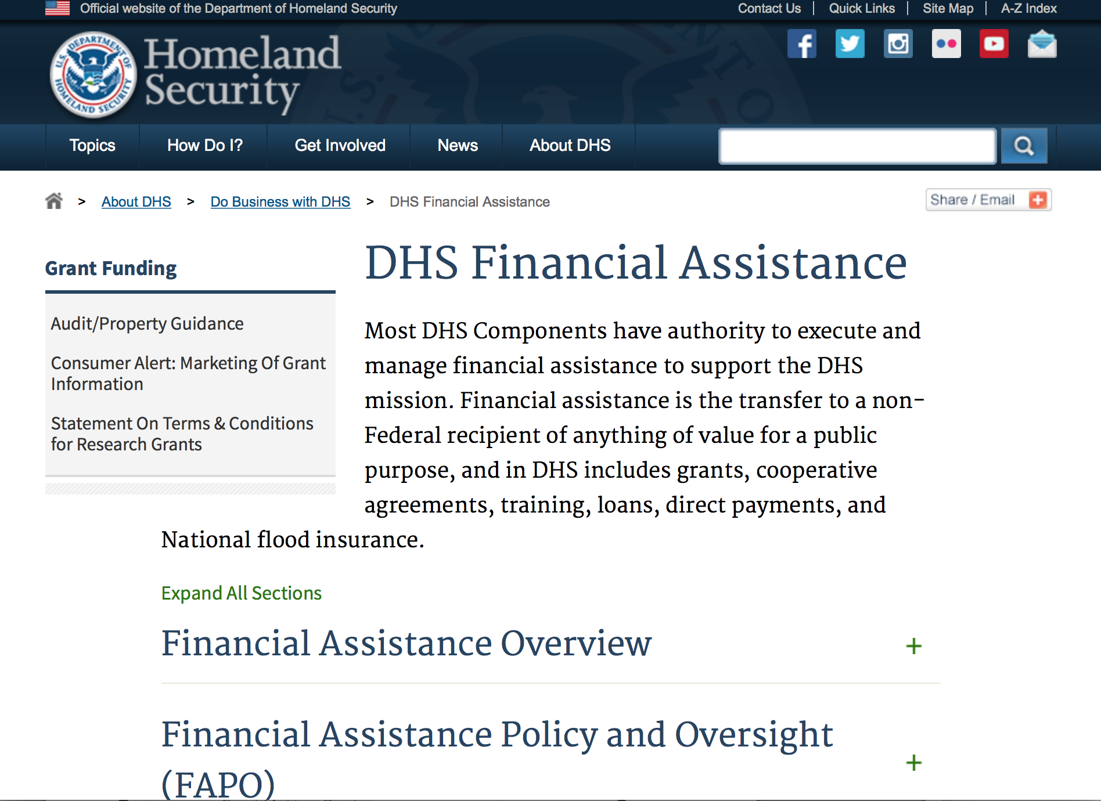
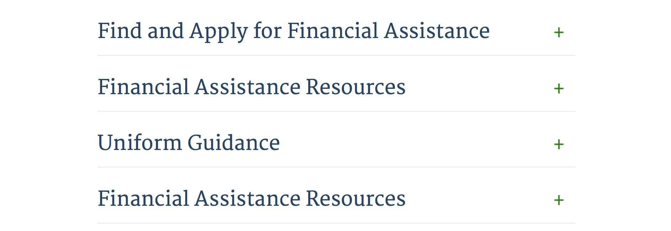

Webpage can be viewed at: http://www.dhs.gov/xopnbiz/grants/index.shtm#2

Information about 2016 for reference only
The FY 2016 Assistance to Firefighters Grants (AFG)
FY 2016 ASSISTANCE TO FIREFIGHTERS (AFG) GRANTS IS CLOSED AT THIS TIME
- FY 2016 Application Workshop Schedule
- FY 2016 AFG Application Guidance Materials The following documents are now available:
  - FY 2016 Notice of Funding Opportunity (NOFO) – Available Now
  - FY 2016 AFG Grant Application Get Ready Guide
  - FY 2016 AFG Narrative Get Ready Guide
  - FY 2016 AFG Self-Evaluation - Operations and Safety
  - FY 2016 AFG Self-Evaluation - Vehicle Acquisition
  - FY 2016 AFG Application Checklist
  - FY 2016 AFG Cost Share Calculator
FY 2016 AFG FAQs
For AFG program guidance materials, please visit our Documents page.

Resources

AFG Help Desk
Contact the AFG Program Help Desk toll-free at 866-274-0960, or email us at firegrants@dhs.gov.
The AFG Program has Fire Program Specialists in 10 federal regional centers. These Regional Fire Program Specialists respond to questions about the AFG program and carry out grant monitoring activities. View regional contacts

Popular AFG links
- AFG Workshop Schedule
- Assistance to Firefighters Grants (AFG)
- AFG Awards List
- AFG Success Stories
- Staffing for Adequate Fire & Emergency Response (SAFER) Grants (SAFER)
- SAFER Awards List
- SAFER Success Stories
- Fire Prevention & Safety (FP&S) Grants
- FP&S Awards List
- FP&S Success Stories
- Grant Closeout Tutorial
- Assistance to Firefighters Grant (AFG) Email Alert Archive
- Frequently Asked Questions
Contact Information For The Assistance to Firefighters Grant (AFG) Program and Help Desk

Federal Funding Alternative To AFG

State Administrative Agencies (SAA) apply for and administer Federal grants on behalf of their States, including FEMA Preparedness Grants. The SAA will work with eligible organizations to comply with the general requirements of grant programs or cooperative agreements. Contact your State’s SAA to find out what current Federal funding opportunities may be available to your organization. A listing of the SAAs and points of contact can be found at http://www.fema.gov/library/viewRecord.do?id=6363.

Programs:

Modifications:

Reminders:

Department of Homeland Security - FEMA
FY17 Flood Mitigation Assistance
Synopsis 1
Document Type: | Grants Notice
Funding Opportunity Number: | DHS-17-MT-029-000-99
Funding Opportunity Title: | FY17 Flood Mitigation Assistance
Opportunity Category: | Discretionary
Opportunity Category Explanation:
Funding Instrument Type: | Grant
Category of Funding Activity: | Other (see text field entitled "Explanation of Other Category of Funding Activity" for clarification)
Category Explanation: | The Flood Mitigation Assistance (FMA) Program makes available Federal funds to State, Local and Tribal Governments to reduce or eliminate the risk of repetitive flood damage to buildings and structures insured under the National Flood Insurance Program (NFIP).
Expected Number of Awards: | 200
CFDA Number(s): | 97.029 -- Flood Mitigation Assistance
Cost Sharing or Matching Requirement:

Version: | Synopsis 1
Posted Date: | Jul 10, 2017
Last Updated Date: | Jul 10, 2017
Original Closing Date for Applications: | Nov 14, 2017
Current Closing Date for Applications: | Nov 14, 2017
Archive Date: | Dec 14, 2017
Estimated Total Program Funding: | $160,000,000
Eligible Applicants: | State governments  Others (see text field entitled "Additional Information on Eligibility" for clarification)  Native American tribal governments (Federally recognized)
Additional Information on Eligibility: | District of Columbia; U.S. Territories. Local governments must apply through their state.
Agency Name: | Department of Homeland Security - FEMA
Description: | The Flood Mitigation Assistance (FMA) Program makes available Federal funds to State, Local and Tribal Governments to reduce or eliminate the risk of repetitive flood damage to buildings and structures insured under the National Flood Insurance Program (NFIP). In FY17, the FMA Program will prioritize proposals that address community flood risk by setting aside $70 million for this purpose. FEMA will seek to fund two types of community flood mitigation activities: Advance Assistance for flood mitigation design and development of community flood mitigation projects and mitigation projects that address community flood risk for the purpose of reducing NFIP flood claim payments. The remaining funding, at least $90,000,000, will be used for FMA technical assistance, mitigation planning, and mitigation projects reducing risk to severe repetitive loss (SRL) and repetitive loss (RL) properties. Applicants must submit applications via the Mitigation eGrants system on the FEMA Grants Portal: https://portal.fema.gov. Applicants may submit a maximum of 1 advanced assistance and 1 community mitigation project sub-application.
Link to Additional Information:
Grantor Contact Information: | If you have difficulty accessing the full announcement electronically, please contact:  Mitigation eGrants System Helpdesk Phone: 1-855-228-3362  MTeGrants@fema.dhs.gov

http://www.grants.gov/web/grants/view-opportunity.html?oppId=295313

Department of Homeland Security - FEMA
FY17 Pre-Disaster Mitigation
Synopsis 1

Document Type: | Grants Notice
Funding Opportunity Number: | DHS-17-MT-047-000-99
Funding Opportunity Title: | FY17 Pre-Disaster Mitigation
Opportunity Category: | Discretionary
Opportunity Category Explanation:
Funding Instrument Type: | Grant
Category of Funding Activity: | Other (see text field entitled "Explanation of Other Category of Funding Activity" for clarification)
Category Explanation: | The Robert T. Stafford Disaster Relief and Emergency Assistance Act, Public Law 93-288, as amended, (42 U.S.C. 5133), Section 203 authorizes FEMA to make grants for the purpose of implementing a sustained pre-disaster natural hazard mitigation program to reduce overall risk to the population and structures from future hazard events, while also reducing reliance on Federal funding from future disasters.
Expected Number of Awards: | 250
CFDA Number(s): | 97.047 -- Pre-Disaster Mitigation
Cost Sharing or Matching Requirement: | No
Version: | Synopsis 1
Posted Date: | Jul 10, 2017
Last Updated Date: | Jul 10, 2017
Original Closing Date for Applications: | Nov 14, 2017
Current Closing Date for Applications: | Nov 14, 2017
Archive Date: | Dec 14, 2017
Estimated Total Program Funding: | $90,000,000
Award Ceiling: | $15,000,000
Eligible Applicants: | State governments  Native American tribal governments (Federally recognized)  Others (see text field entitled "Additional Information on Eligibility" for clarification)
Additional Information on Eligibility: | District of Columbia; U.S. Territories. Local governments must apply through their state.
Agency Name: | Department of Homeland Security - FEMA
Description: | The Pre-Disaster Mitigation (PDM) program makes available Federal funds to State, Local and Tribal Governments to implement and sustain cost-effective measures designed to reduce the risk to individuals and property from natural hazards, while also reducing reliance on Federal funding from future disasters. FEMA will provide allocations of $575,000 as required by the Stafford Act to states and territories; and a tribal set aside of $10 million for allocations up to $575,000 for Native American Indian tribal governments to support overall mitigation planning and projects. The remaining PDM funds will be awarded on a competitive basis with a focus on multi-state/tribal mitigation initiatives. Applicants must submit applications via the Mitigation eGrants system on the FEMA Grants Portal: https://portal.fema.gov. Applicants may submit a maximum of 9 project sub-applications notwithstanding any project(s) submitted for the state/territory allocation or tribal set aside. In addition, any state or tribe willing to serve as the applicant for a multi-state or tribal activity may submit one additional plan or project subapplication.
Link to Additional Information:
Grantor Contact Information: | If you have difficulty accessing the full announcement electronically, please contact:  Mitigation eGrants System Helpdesk Phone: 1-855-228-3362  MTeGrants@fema.dhs.gov

http://www.grants.gov/web/grants/view-opportunity.html?oppId=295314

Department of Housing and Urban Development

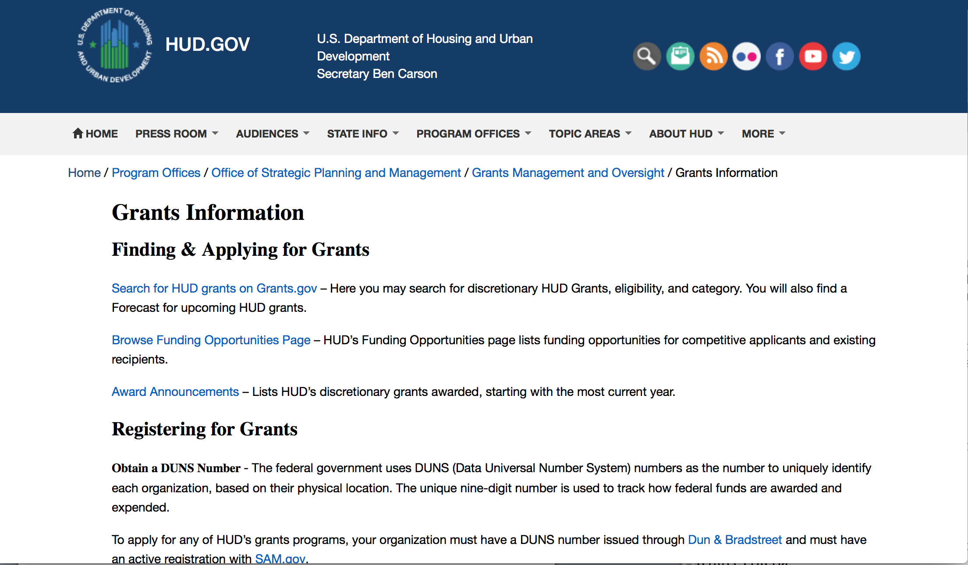
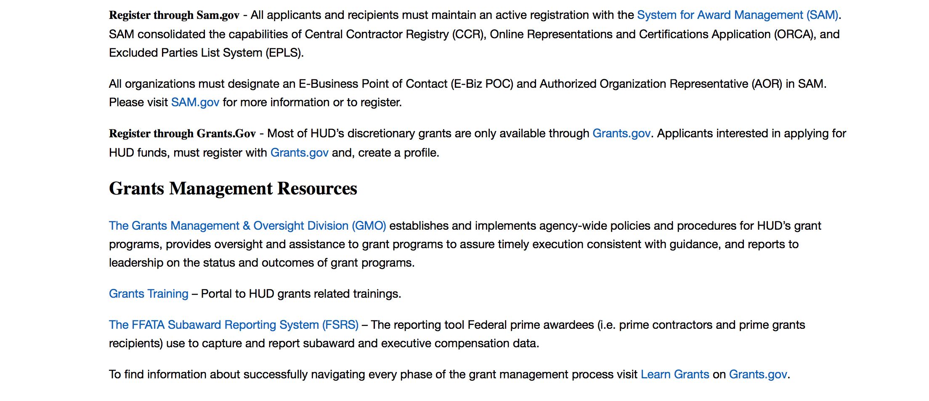
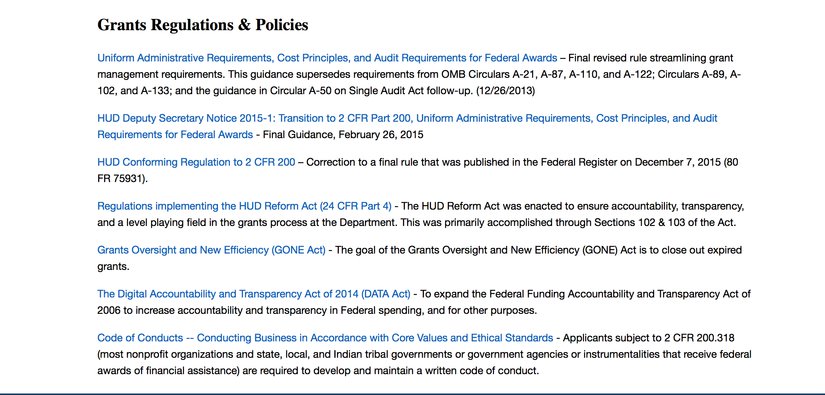

http://portal.hud.gov/hudportal/HUD?src=/topics/grants

HUD - Notice of Funds Available
For detailed information click here

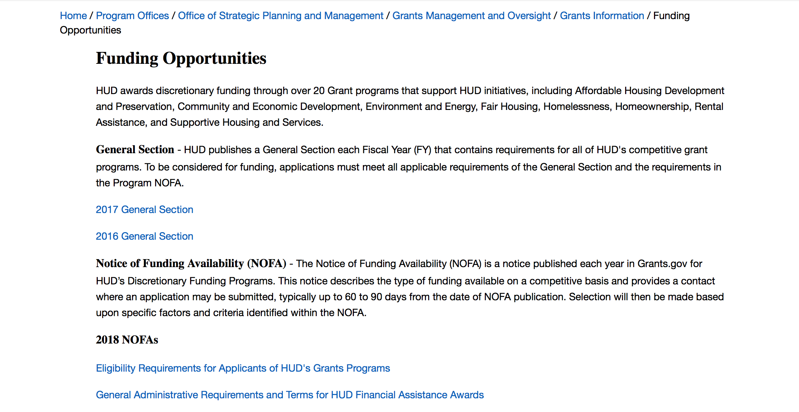

http://portal.hud.gov/hudportal/HUD?src=/program_offices/administration/grants/fundsavail

HUD NOFA FORECAST
The Department of Housing and Urban Development NOFA Forecast lists competitive grant opportunities that may be available for FY2016. The inclusion or exclusion of an opportunity in this list does not constitute a guarantee that a specific opportunity will become available or not be available. Forecast opportunities are subject to change based on enactment of Congressional appropriations and other considerations.
When funding is available, HUD will issue a Notice of Funding Availability (NOFA), which will be available on Grants.gov

Programs:

Self-Help Homeownership Opportunity Program (SHOP)
Synopsis 1

Document Type: | Grants Notice
Funding Opportunity Number: | FR-6100-N-19
Funding Opportunity Title: | Self-Help Homeownership Opportunity Program (SHOP)
Opportunity Category: | Discretionary
Opportunity Category Explanation:
Funding Instrument Type: | Grant
Category of Funding Activity: | Housing
Category Explanation:
Expected Number of Awards: | 4
CFDA Number(s): | 14.247 -- Self-Help Homeownership Opportunity Program
Cost Sharing or Matching Requirement: | Yes
Version: | Synopsis 1
Posted Date: | Oct 25, 2017
Last Updated Date: | Oct 25, 2017
Original Closing Date for Applications: | Jan 25, 2018 Electronically submitted applications must be submitted no later than 11:59 p.m., ET, on the listed application due date.
Current Closing Date for Applications: | Jan 25, 2018 Electronically submitted applications must be submitted no later than 11:59 p.m., ET, on the listed application due date.
Archive Date: | Feb 24, 2018
Estimated Total Program Funding: | $10,000,000
Award Ceiling: | $10,000,000
Award Floor: | $450,000
Eligible Applicants: | Nonprofits having a 501(c)(3) status with the IRS, other than institutions of higher education
Additional Information on Eligibility: | Eligible applicants include public or private non-profit organizations, or a consortium of public or private non-profit organizations, that have the capacity and experience to provide or facilitate self-help homeownership opportunities on a national or regional basis. Grantees must directly undertake eligible SHOP activities and/or enter into a written agreement with one or more non-profit affiliate organizations to carry out eligible SHOP activities. Individuals, foreign entities, and sole proprietorship organizations are not eligible to compete for, or receive, awards made under this announcement.
Agency Name: | Department of Housing and Urban Development
Description: | This SHOP NOFA announces the availability of $10,000,000 in FY2017 SHOP Grant funds to be awarded to national and regional non-profit organizations and consortia to facilitate and encourage innovative homeownership opportunities on a national, geographically diverse basis through the provision of self-help homeownership housing programs. Applicants must propose to use a significant amount of SHOP Grant funds in at least two states. Individuals are not eligible to apply for SHOP Grant funds. SHOP Grant funds must be used for land acquisition, infrastructure improvements, and for reasonable and necessary planning, administration and management costs (not to exceed 20 percent). The construction or rehabilitation costs of each SHOP unit must be funded with other leveraged public and private funds. The average SHOP Grant expenditure for the combined costs of land acquisition and infrastructure improvements must not exceed $15,000 per SHOP unit. SHOP units must be decent, safe, and sanitary non-luxury dwellings that comply with state and local codes, ordinances, and zoning requirements, and with all other SHOP requirements, including but not limited to, the requirements for energy-efficiency, water conservation and accessibility). The SHOP units must be sold to homebuyers at prices below the prevailing market price. Homebuyers must be low-income and must contribute a significant amount of sweat equity towards the development of the SHOP units. A homebuyer's sweat equity contribution must not be mortgaged or otherwise restricted upon future sale of the SHOP unit. Volunteer labor is also required SHOP Grantees may award SHOP Grant funds to local non-profit affiliate organizations to carry out the Grantee's SHOP program. These affiliate organizations must be located within the Grantee's service area.
Link to Additional Information: | https://hud.gov/program_offices/spm/gmomgmt/grantsinfo/fundingopps
Grantor Contact Information: | If you have difficulty accessing the full announcement electronically, please contact:  Thann Young Thann.Young@hud.gov  Grants Policy

http://www.grants.gov/web/grants/view-opportunity.html?oppId=298120

Modifications:

Deleted:

Reminders:

Rural Capacity Building for Community Development and Affordable Housing Grants (RCB)
Synopsis 1
Document Type: | Grants Notice
Funding Opportunity Number: | FR-6100-N-08
Funding Opportunity Title: | Rural Capacity Building for Community Development and Affordable Housing Grants (RCB)
Opportunity Category: | Discretionary
Opportunity Category Explanation:
Funding Instrument Type: | Grant
Category of Funding Activity: | Community Development
Category Explanation:
Expected Number of Awards: | 4
CFDA Number(s): | 14.265 -- Rural Capacity Building for Community Development and Affordable Housing Grants
Cost Sharing or Matching Requirement: | No
Version: | Synopsis 1
Posted Date: | Sep 28, 2017
Last Updated Date: | Sep 28, 2017
Original Closing Date for Applications: | Dec 07, 2017 Electronically submitted applications must be submitted no later than 11:59 p.m., ET, on the listed application due date.
Current Closing Date for Applications: | Dec 07, 2017 Electronically submitted applications must be submitted no later than 11:59 p.m., ET, on the listed application due date.
Archive Date: | Jan 06, 2018
Estimated Total Program Funding: | $5,000,000
Award Ceiling: | $2,500,000
Award Floor: | $1,000,000
Eligible Applicants: | Nonprofits having a 501(c)(3) status with the IRS, other than institutions of higher education
Additional Information on Eligibility: | Only National Organizations that are 501(c)(3) nonprofits can apply for HUD funding. For the purpose of determining eligibility for the RCB program, a national organization must be a single organization that meets all of these criteria: Has experience conducting activities from the first and/or the second RCB NOFA eligible activities in rural areas. Has experience working in rural areas with rural housing development organizations, Community Development Corporations (CDCs), Community Housing Development Organizations (CHDOs), local governments, and/or Indian tribes, and Has experience working, within the last ten years, in one or more states in at least seven Federal regions described on HUD's website at http://portal.hud.gov/hudportal/HUD?src=/localoffices/regions. Individuals, foreign entities, and sole proprietorship organizations are not eligible to compete for, or receive, awards made under this announcement.
Agency Name: | Department of Housing and Urban Development
Description: | Purpose: Through funding of national organizations with expertise in rural housing and community development, the Rural Capacity Building (RCB) program enhances the capacity and ability of rural housing development organizations, Community Development Corporations (CDCs), Community Housing Development Organizations (CHDOs), local governments, and Indian tribes to carry out community development and affordable housing activities that benefit low- and moderate-income families and persons in rural areas. a. Eligible Program Activities. Funds may be used to provide the following services: Training, education, support, and advice to enhance the technical and administrative capabilities of rural housing development organizations, CDCs, CHDOs, local governments, and Indian tribes, including the capacity to participate in consolidated planning, as well as in fair housing planning and Continuum of Care homeless assistance efforts that help ensure community-wide participation in assessing area needs; consulting broadly within the community; cooperatively planning for the use of available resources in a comprehensive and holistic manner; and assisting in evaluating performance under these community efforts and in linking plans with neighboring communities in order to foster regional planning; Loans, pass-through grants or other financial assistance to rural housing organizations, CDCs, CHDOs, local governments, and Indian tribes to carry-out community development and affordable housing activities that benefit low-income or low- and moderate-income families and persons by building the capacity of those eligible beneficiaries to serve rural communities over time. Such other activities as may be determined by the grantees in consultation with the Secretary or his or her designee. Program Priorities. Activities undertaken as part of, or as a result of, capacity building efforts described in this section shall support the implementation of other HUD programs in rural areas, including, but not limited to, the Community Development Block Grant Program (CDBG), HOME Investment Partnerships, Housing Opportunities for Persons With AIDS (HOPWA), Emergency Solutions Grant Program (ESG), and the Continuum of Care program, in addition to issues related to sustainability and comprehensive neighborhood revitalization activities. Through the eligible activities of this NOFA, grantees are encouraged to build the capacity of entities in rural areas that lack designated rural housing development organizations, CDCs or CHDOs and to ensure that those entities gain new access or expand existing access to federal funding. Grantees are encouraged to align with and support projects that create opportunities for transformative revitalization and investments focused on job growth, economic recovery, and neighborhood revitalization. Grantees are encouraged to consider how eligible beneficiaries may align investments with regional planning for sustainable economic development if such efforts are underway in a given jurisdiction.
Link to Additional Information: | https://hud.gov/program_offices/spm/gmomgmt/grantsinfo/fundingopps
Grantor Contact Information: | If you have difficulty accessing the full announcement electronically, please contact:  Diane Schmutzler Diane.M.Schmutzler@hud.gov  Grants Policy

http://www.grants.gov/web/grants/view-opportunity.html?oppId=297733

Choice Neighborhoods Implementation Grant Program
Synopsis 1
Document Type: | Grants Notice
Funding Opportunity Number: | FR-6100-N-34
Funding Opportunity Title: | Choice Neighborhoods Implementation Grant Program
Opportunity Category: | Discretionary
Opportunity Category Explanation:
Funding Instrument Type: | Grant
Category of Funding Activity: | Housing
Category Explanation:
Expected Number of Awards: | 5
CFDA Number(s): | 14.889 -- Choice Neighborhoods Implementation Grants
Cost Sharing or Matching Requirement: | Yes
Version: | Synopsis 1
Posted Date: | Aug 24, 2017
Last Updated Date: | Aug 24, 2017
Original Closing Date for Applications: | Nov 22, 2017 Electronically submitted applications must be submitted no later than 11:59 p.m., ET, on the listed application due date.
Current Closing Date for Applications: | Nov 22, 2017 Electronically submitted applications must be submitted no later than 11:59 p.m., ET, on the listed application due date.
Archive Date: | Dec 22, 2017
Estimated Total Program Funding: | $132,000,000
Award Ceiling: | $30,000,000
Award Floor: | $1
Eligible Applicants: | Others (see text field entitled "Additional Information on Eligibility" for clarification)
Additional Information on Eligibility: | The Lead Applicant must be a Public Housing Agency (PHA), a local government, or a tribal entity. If there is also a Co-Applicant, it must be a PHA, a local government, a tribal entity, a nonprofit, or a for-profit developer. Individuals, foreign entities, and sole proprietorship organizations are not eligible to compete for, or receive, awards made under this announcement.
Agency Name: | Department of Housing and Urban Development
Description: | Choice Neighborhoods Implementation Grants support the implementation of comprehensive neighborhood revitalization plans that are expected to achieve the following three core goals: 1. Housing: Replace distressed public and assisted housing with high-quality mixed-income housing that is well-managed and responsive to the needs of the surrounding neighborhood; 2. People: Improve intergenerational mobility with a focus on children and families'; employment, health, and education outcomes; and 3. Neighborhood: Create the conditions necessary for public and private reinvestment in distressed neighborhoods to offer the kinds of amenities and assets, including safety, good schools, and commercial activity, that are important to families'; choices about their community.
Link to Additional Information: | http://portal.hud.gov/hudportal/HUD?src=/program_offices/spm/gmomgmt/grantsinfo/fundingopps
Grantor Contact Information: | If you have difficulty accessing the full announcement electronically, please contact:  Choice Neighborhoods office ChoiceNeighborhoods@hud.gov  Grants Policy

http://www.grants.gov/web/grants/view-opportunity.html?oppId=296794

Choice Neighborhoods Implementation Grant Program
Synopsis 2
Document Type: | Grants Notice
Funding Opportunity Number: | FR-6100-N-34
Funding Opportunity Title: | Choice Neighborhoods Implementation Grant Program
Opportunity Category: | Discretionary
Opportunity Category Explanation:
Funding Instrument Type: | Grant
Category of Funding Activity: | Housing
Category Explanation:
Expected Number of Awards: | 5
CFDA Number(s): | 14.889 -- Choice Neighborhoods Implementation Grants
Cost Sharing or Matching Requirement: | Yes
Version: | Synopsis 2
Posted Date: | Aug 24, 2017
Last Updated Date: | Sep 14, 2017
Original Closing Date for Applications: | Nov 22, 2017 Electronically submitted applications must be submitted no later than 11:59 p.m., ET, on the listed application due date.
Current Closing Date for Applications: | Nov 22, 2017 Electronically submitted applications must be submitted no later than 11:59 p.m., ET, on the listed application due date.
Archive Date: | Dec 22, 2017
Estimated Total Program Funding: | $132,000,000
Award Ceiling: | $30,000,000
Award Floor: | $1
Eligible Applicants: | Others (see text field entitled "Additional Information on Eligibility" for clarification)
Additional Information on Eligibility: | The Lead Applicant must be a Public Housing Agency (PHA), a local government, or a tribal entity. If there is also a Co-Applicant, it must be a PHA, a local government, a tribal entity, a nonprofit, or a for-profit developer. Individuals, foreign entities, and sole proprietorship organizations are not eligible to compete for, or receive, awards made under this announcement.
Agency Name: | Department of Housing and Urban Development
Description: | Choice Neighborhoods Implementation Grants support the implementation of comprehensive neighborhood revitalization plans that are expected to achieve the following three core goals: 1. Housing: Replace distressed public and assisted housing with high-quality mixed-income housing that is well-managed and responsive to the needs of the surrounding neighborhood; 2. People: Improve intergenerational mobility with a focus on children and families; employment, health, and education outcomes; and 3. Neighborhood: Create the conditions necessary for public and private reinvestment in distressed neighborhoods to offer the kinds of amenities and assets, including safety, good schools, and commercial activity, that are important to families'; choices about their community.
Link to Additional Information: | http://portal.hud.gov/hudportal/HUD?src=/program_offices/spm/gmomgmt/grantsinfo/fundingopps
Grantor Contact Information: | If you have difficulty accessing the full announcement electronically, please contact:  Choice Neighborhoods office ChoiceNeighborhoods@hud.gov  Grants Policy

http://www.grants.gov/web/grants/view-opportunity.html?oppId=296794

Jobs Plus Initiative
Synopsis 3
Document Type: | Grants Notice
Funding Opportunity Number: | FR-6100-N-14
Funding Opportunity Title: | Jobs Plus Initiative
Opportunity Category: | Discretionary
Opportunity Category Explanation:
Funding Instrument Type: | Grant
Category of Funding Activity: | Housing
Category Explanation:
Expected Number of Awards: | 5
CFDA Number(s): | 14.895 -- Jobs-Plus Pilot Initiative
Cost Sharing or Matching Requirement: | Yes
Version: | Synopsis 2
Posted Date: | Oct 4, 2017
Last Updated Date: | Oct 4, 2017
Original Closing Date for Applications: | Nov 17, 2017 Electronically submitted applications must be submitted no later than 11:59 p.m., ET, on the listed application due date.
Current Closing Date for Applications: | Nov 17, 2017 Electronically submitted applications must be submitted no later than 11:59 p.m., ET, on the listed application due date.
Archive Date: | Dec 17, 2017
Estimated Total Program Funding: | $15,000,000
Award Ceiling: | $3,700,000
Award Floor: | $1,000,000
Eligible Applicants: | Others (see text field entitled "Additional Information on Eligibility" for clarification)
Additional Information on Eligibility: | Conditions for Eligibility of Public Housing Authorities Eligible applicants are PHAs that operate one or more public housing developments that meet the criteria outlined in this NOFA. A list of developments that meet the criteria is provided in Appendix B, however, the mere appearance of a development on this list does not mean that the development is appropriate for a Jobs Plus program. PHAs that received a Jobs Plus program grant in 2014, 2015 or 2016 are not eligible for 2017 grant funds. Federally designated tribes and tribally designated housing entities are not eligible entities under this award. Successful applicants will be required to implement the full 48-month term of the grant at the public housing site(s) for which funds were awarded. Successful applicants will be required to inform HUD of any planned Rental Assistance Demonstration (RAD) conversions at the Jobs Plus site. RAD Conversion of Jobs Plus sites will be permitted if the planned conversion will take place post award. Pursuant to the RAD Notice (Rental Assistance Demonstration &; Final Implementation, PIH-2012-32 (HA), as amended from time to time), Jobs Plus grantees that convert Jobs Plus target project(s) to PBV or PBRA through RAD will be able to finish out their Jobs Plus period of performance unless significant relocation and/or change in building occupancy is planned. If either is planned at the Jobs Plus target project(s), HUD may allow for a modification of the Jobs Plus work plan or may, at the Secretary's discretion, choose to end the Jobs Plus program at that project. Individuals, foreign entities, and sole proprietorship organizations are not eligible to compete for, or receive, awards made under this announcement.
Agency Name: | Department of Housing and Urban Development
Description: | 1. Purpose. The purpose of the Jobs Plus Pilot program is to develop locally-based, job-driven approaches to increase earnings and advance employment outcomes through work readiness, employer linkages, job placement, educational advancement, technology skills, and financial literacy for residents of public housing. The place-based Jobs Plus Pilot program addresses poverty among public housing residents by incentivizing and enabling employment through earned income disregards for working families, and a set of services designed to support work including employer linkages, job placement and counseling, educational advancement, and financial counseling. Ideally, these incentives will saturate the target developments, building a culture of work and making working families the norm. The Jobs Plus Pilot program consists of the following three core components: Employment-Related Services Financial Incentives &; Jobs Plus Earned Income Disregard (JPEID) Community Supports for Work Applicants are encouraged to develop key partnerships to connect participants with any other needed services to remove barriers to work. An Individualized Training and Services Plan (ITSP) should be developed for each participant to establish goals and service strategies, and to track progress. Background HUD, the Rockefeller Foundation, and the MDRC, through a public-private partnership, designed and supported the Jobs Plus program model between 1998 and 2003. HUD has issued two separate evaluation reports on the demonstration, in an effort to identify and document the most promising approaches to increasing employment among families in public housing. Each evaluation showed ongoing positive effects for residents when the program was well-implemented and included the three core elements. More information on the findings can be found at http://www.mdrc.org/project/jobs-plus-community-revitalization-initiative-public-housing-families#overview. Employment-Related Services Successful applicants must partner with the Department of Labor Workforce Investment Board (WIB) and American Job Center (AJC)/One-Stop in their area to offer multiple employment-related services for residents with a range of employment needs. Local Labor Market Information (LMI) should be used both for initial planning and analysis of which employment opportunities are most available locally, as well as for monitoring ongoing trends. Program services provided on-site should include, but need not be limited to, the following: Career exploration/job readiness workshops Job search and job placement assistance Work experience including on-the-job training, internships, pre-apprenticeships and Registered Apprenticeships (HUD encourages opportunities for residents to be paid while training whenever possible) Facilitated connections to education and training opportunities Rapid re-employment assistance in the event of job loss Proactive post-placement job retention support and career advancement coaching Access to computers, phones, fax, and copy machines and other supplies, for participants'; employment-related uses as well as adequate training on how to use these technologies To facilitate these employment services, applicants may consider having dedicated, on-site, workforce system staff to perform job developer and case manager functions. Job developers work directly with the business community to identify and create employment opportunities and act as liaisons with local employment agencies. Case managers work one-on-one with participants to guide them through the employment process and help them achieve employment-related goals. Financial Incentives &; Jobs Plus Earned Income Disregard (JPEID) Successful applicants must also implement a financial incentive to program participants, known as the Jobs Plus Earned Income Disregard (JPEID). This component will neutralize any rent increase due to rising income for Jobs Plus participants, removing a major disincentive to employment. Rent incentives offered through JPEID will be reimbursed to the PHA via Jobs Plus appropriations, and should be included in the program budget. Any other compensation to the PHA for lost rent revenues, such as by the standard EID calculation in the Operating Fund, will be offset manually to prevent overpayment of HUD funds to grant recipients. Further guidance will be available at the time of the award. All residents in a Jobs Plus development are eligible to receive the JPEID benefit, but in order to access JPEID they must sign up for the Jobs Plus program even if they do not actively participate in other Jobs Plus Activities. Residents who previously used up some or all of their lifetime EID eligibility are eligible to receive the full JPEID benefit. Disregarded Amount. The JPEID excludes from the Family Rent calculation 100 percent of incremental earned income for the entire period of the Jobs Plus program. Calculation of the JPEID. Once the JPEID is triggered for a family, their baseline income will not change for the duration of the term of the grant (so participants who enroll early may benefit from the JPEID longer than residents who enroll later.) To facilitate reimbursements for rent revenue losses due to the JPEID, grantees must calculate and document each participant's Family Rent both before and after the inclusion of any incremental earned income. The difference between these two rents is the amount to be reimbursed to the PHA through JPEID. These calculations must be provided to HUD when drawing reimbursement funds. As with any government benefit, an increase in earned income may result in the reduction or loss of other benefits that an individual was previously receiving. Grantees, through case management or other means, must be prepared to help residents understand the overall financial impact of an increase in earned income and the JPEID. It is also expected that grantees will encourage participants to take advantage of other financial work incentives they may be entitled to, such as the Earned Income Tax Credit (EITC). Community Supports for Work Successful applicants will incorporate a robust engagement strategy for involving the residents in the targeted development and creating a working community. Engagement is more than signing up; sustained involvement in the program leading to residents' ownership of their own growth and experiences, as well as that of peers, will yield continued benefits for both participants and future residents of the development beyond the grant period. Program outreach should be directed towards residents at all points along the employment spectrum; from unemployed individuals with no work history to working underemployed families with substantial work history. Unless an application specifies that the applicant will target a limited sub-group, the application narrative should include strategies to target this wide range of potential participants, as well as strategies for retention. One key strategy for retention should include the use of residents as Community Coaches. Community Coaches can market the various aspects of the Jobs Plus program, disseminate information about job opportunities and programs via resident social networks in the development, mentor specific individuals or groups who enroll in Jobs Plus, and help shape program offerings and outreach efforts based on their intimate knowledge of the needs and strengths of the community. Partnerships with Local Agencies The comprehensive nature of the Jobs Plus Pilot model requires that PHAs establish partnerships with American Job Centers and other key social service agencies within the community. HUD and DOL have developed a toolkit and webinar which describes effective strategies for establishing partnerships between PHAs and WIBs/AJCs (see; From the Ground Up: Creating Partnerships between Public Housing Authorities and Workforce Investment Boards; at (http://portal.hud.gov/hudportal/documents/huddoc?id=14_dol_publication.pdf) The toolkit provides several models for partnership that prospective applicants may want to consider. These partnerships will serve to strengthen program planning and implementation, as well as streamline access to services for participants. For each partner identified, applicants must describe the role of the partner agency and a description of the services to be provided by the partner agency, as well as the amount of grant funding (if any) that partners will receive. Applicants should demonstrate their ability to build collaboration among all partners, regardless of whether a partner will be receiving grant funding for their services, or if the services will be provided in-kind. Partners should include: Workforce Investment Boards/American Job Centers Local welfare agencies Employment and training organizations Vocational training providers Community colleges and four-year educational institutions Other supportive service agencies providing either direct services or referrals to services that are critical for supporting successful employment In addition to employment, training and educational supports, grantees will have the flexibility to provide other supportive services based on resident needs and local capacity. HUD expects that all services that are generally available to residents of the community will be leveraged in-kind from partners. Grant funds should only be used to procure services that are not already available (either by service type or amount). Examples of the types of services that may be provided by grant funds, formal partners or the program's referral network include but are not limited to the following: Child care services and/or after school programs Transportation assistance Financial literacy workshops Legal services (e.g. expungement) Domestic violence prevention services Services for formerly incarcerated/returning citizens Life Skills Other applicable local business support
Link to Additional Information: | http://portal.hud.gov/hudportal/HUD?src=/program_offices/administration/grants/fundsavail
Grantor Contact Information: | If you have difficulty accessing the full announcement electronically, please contact:  Jobs Plus jobsplus@hud.gov  Grants Policy

http://www.grants.gov/web/grants/view-opportunity.html?oppId=297406

Institute of Museum and Library Services

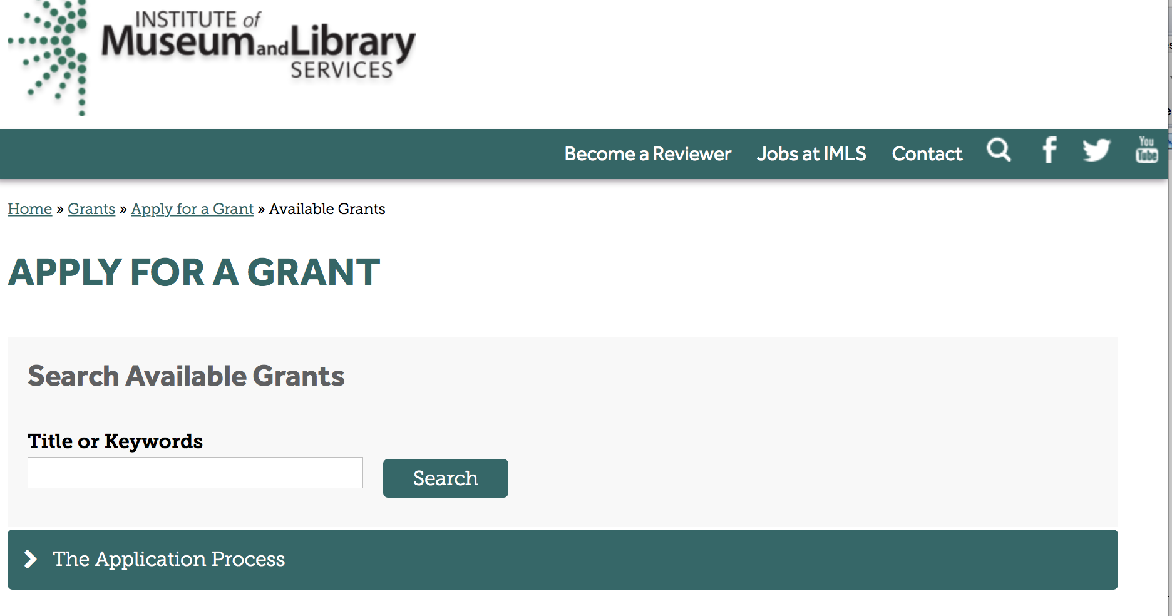

https://www.imls.gov/grants/apply-grant/available-grants

Each grant program has specific eligibility requirements. The links below provide general eligibility criteria for museums, libraries, and tribal organizations, but please note that additional organizations may be eligible for grants under certain programs. Additionally, ineligible organizations may still be able to participate in grant programs through partnerships with eligible organizations. Please click on the links below to see general criteria and review Applications and Guidelines for specific information.
Museums Libraries

Institutions: Archives, Federally Recognized Native American Tribe, Historical Society, Library, Nonprofits that serve Native Hawaiians, Professional Association, Public or Private Non-profit Institutions of Higher Education, Regional Organization, State Library Administrative Agency, State or Local Government

Check out IMLS's Facebook page at:
https://www.facebook.com/USIMLS/

Programs:

Modifications:

Reminders:

Institute of Museum and Library Services
National Leadership Grants for Museums
Synopsis 1

Document Type: | Grants Notice
Funding Opportunity Number: | NLG-M-FY18
Funding Opportunity Title: | National Leadership Grants for Museums
Opportunity Category: | Discretionary
Opportunity Category Explanation:
Funding Instrument Type: | Grant
Category of Funding Activity: | Arts (see "Cultural Affairs" in CFDA)  Humanities (see "Cultural Affairs" in CFDA)
Category Explanation:
Expected Number of Awards: | 11
CFDA Number(s): | 45.312 -- National Leadership Grants
Cost Sharing or Matching Requirement: | Yes
Version: | Synopsis 1
Posted Date: | Sep 29, 2017
Last Updated Date: | Sep 29, 2017
Original Closing Date for Applications: | Dec 01, 2017
Current Closing Date for Applications: | Dec 01, 2017
Archive Date: | Dec 31, 2017
Estimated Total Program Funding: | $6,500,000
Award Ceiling: | $1,000,000
Award Floor: | $5,000
Eligible Applicants: | Others (see text field entitled "Additional Information on Eligibility" for clarification)
Additional Information on Eligibility: | Please see the Notice of Funding Opportunity for eligibility information.
Agency Name: | Institute of Museum and Library Services
Description: | National Leadership Grants for Museums support projects that address critical needs of the museum field and that have the potential to advance practice in the profession so that museums can improve services for the American public.
Link to Additional Information: | https://www.imls.gov/grants/available/national-leadership-grants-museums
Grantor Contact Information: | If you have difficulty accessing the full announcement electronically, please contact:  Helen Wechsler, Supervisory Grants Management Specialist, 202-653-4779, hwechsler@imls.gov; Sandra Narva, Senior Program Officer, 202-653-4791, snarva@imls.gov; Connie Bodner, Supervisory Grants Management Specialist, 202-653-4636, cbodner@imls.gov; Steve Shwartzman, Senior Program Officer, 202-653-4641, sshwartzman@imls.gov; Jill Connors-Joyner, Museum Program Specialist, 202-653-4791, jconnors-joyner@imls.gov; Reagan Moore, Museum Program Specialist, 202-653-4637, rmoore@imls.gov; Mark Feitl, Museum Program Specialist, 202-653-4635, mfeitl@imls.gov  imls-museumgrants@imls.gov

http://www.grants.gov/web/grants/view-opportunity.html?oppId=297756

Museums for America
Synopsis 1
Document Type: | Grants Notice
Funding Opportunity Number: | MFA-FY18
Funding Opportunity Title: | Museums for America
Opportunity Category: | Discretionary
Opportunity Category Explanation:
Funding Instrument Type: | Grant
Category of Funding Activity: | Arts (see "Cultural Affairs" in CFDA)  Humanities (see "Cultural Affairs" in CFDA)
Category Explanation:
Expected Number of Awards: | 130
CFDA Number(s): | 45.301 -- Museums for America
Cost Sharing or Matching Requirement: | Yes
Version: | Synopsis 1
Posted Date: | Sep 29, 2017
Last Updated Date: | Sep 29, 2017
Original Closing Date for Applications: | Dec 01, 2017
Current Closing Date for Applications: | Dec 01, 2017
Archive Date: | Dec 31, 2017
Estimated Total Program Funding: | $19,150,000
Award Ceiling: | $250,000
Award Floor: | $5,000
Eligible Applicants: | Others (see text field entitled "Additional Information on Eligibility" for clarification)
Additional Information on Eligibility: | Please see the Notice of Funding Opportunity for eligibility information.
Agency Name: | Institute of Museum and Library Services
Description: | The Museums for America (MFA) program supports projects that strengthen the ability of an individual museum to serve its public.
Link to Additional Information: | https://www.imls.gov/grants/available/museums-america
Grantor Contact Information: | If you have difficulty accessing the full announcement electronically, please contact:  Sandra Narva, Senior Program Officer, 202-653-4791, snarva@imls.gov; Connie Bodner, Supervisory Grants Management Specialist, 202-653-4636, cbodner@imls.gov; Helen Wechsler, Supervisory Grants Management Specialist, 202-653-4779, hwechsler@imls.gov; Steve Shwartzman, Senior Program Officer, 202-653-4641, sshwartzman@imls.gov; Jill Connors-Joyner, Museum Program Specialist, 202-653-4791, jconnors-joyner@imls.gov; Reagan Moore, Museum Program Specialist, 202-653-4637, rmoore@imls.gov; Mark Feitl, Museum Program Specialist, 202-653-4635, mfeitl@imls.gov  imls-museumgrants@imls.gov

http://www.grants.gov/web/grants/view-opportunity.html?oppId=297772

Deleted:

Department of the Interior
Working with Interior

The Interior Department provides assistance to the public, local governments and businesses through a number of programs. For a general overview see: http://www.doi.gov/index.cfm

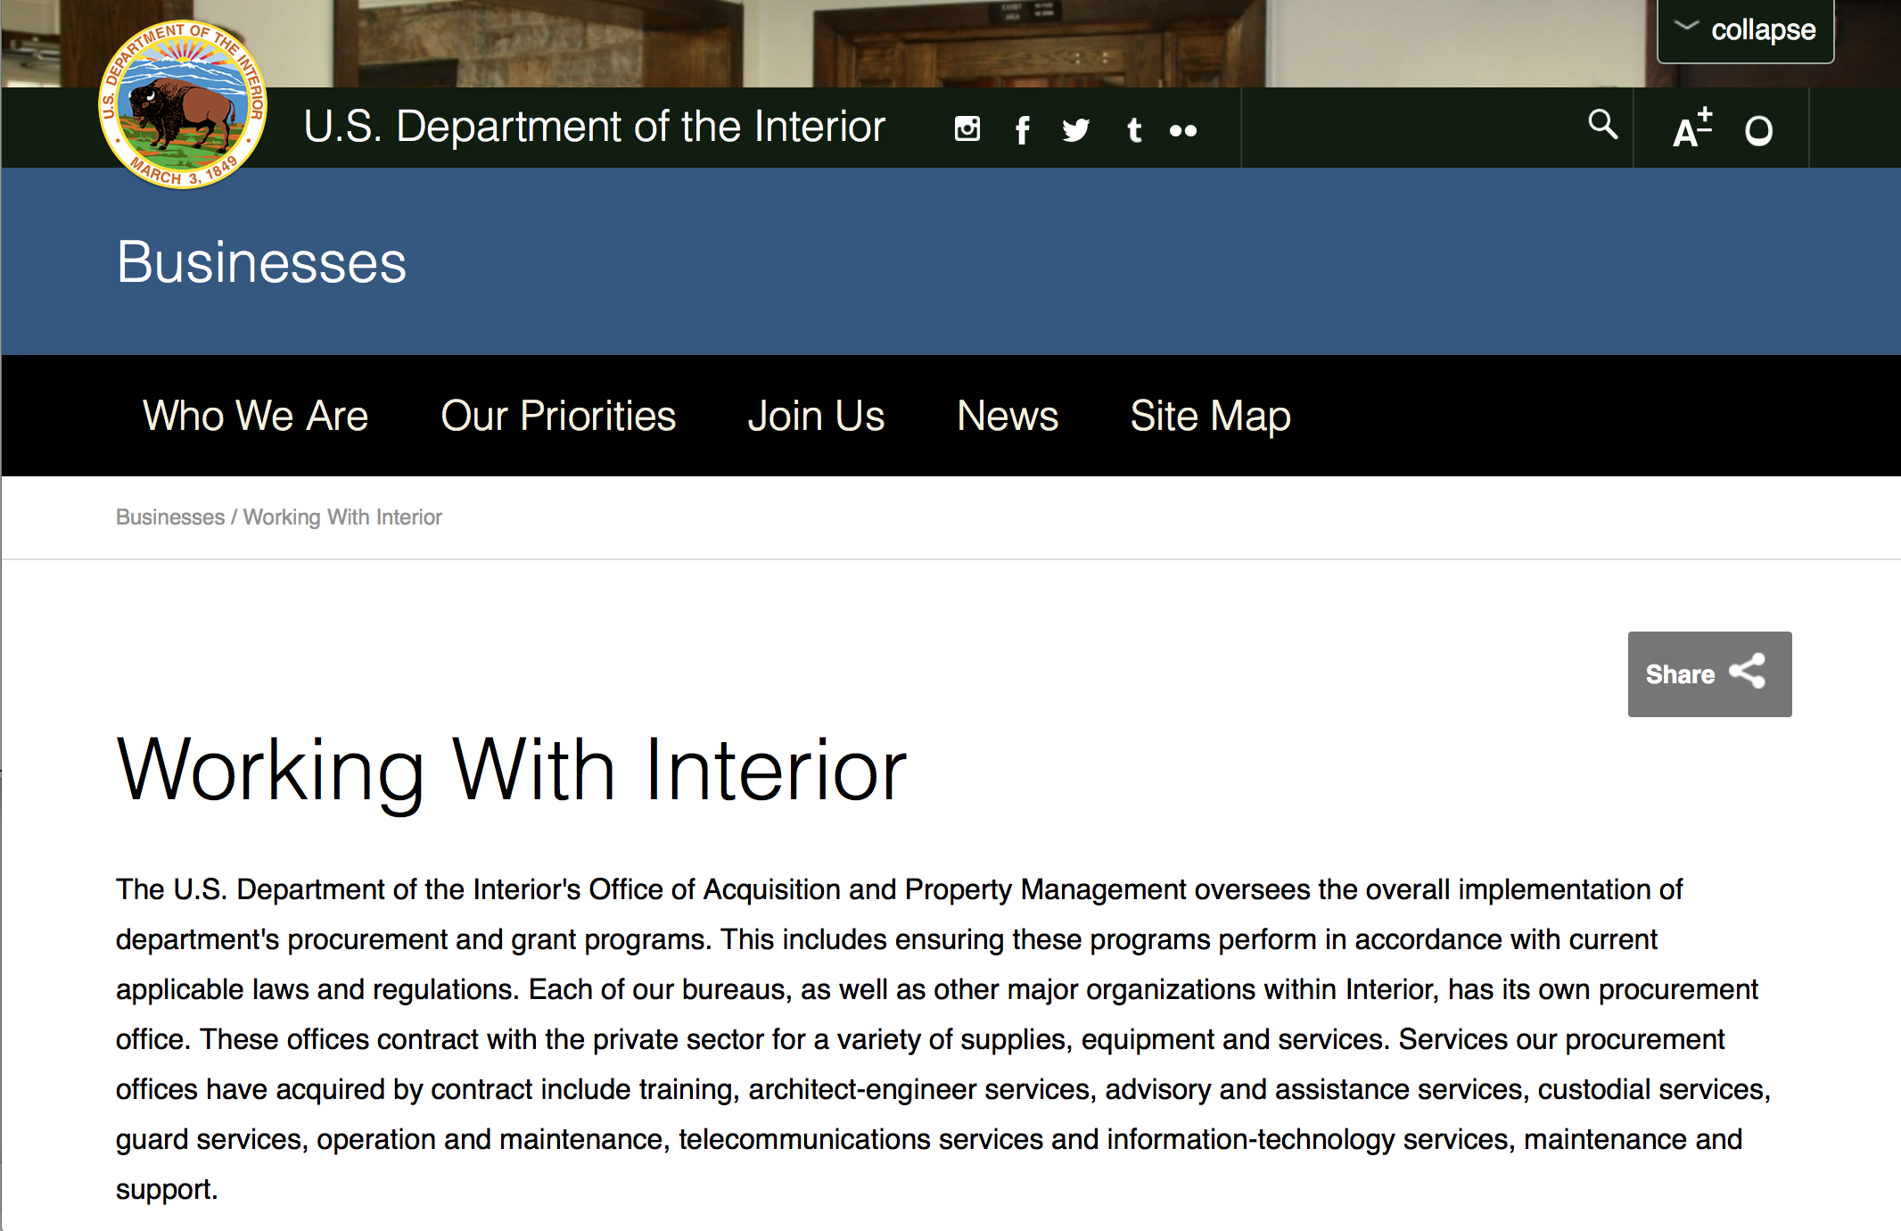

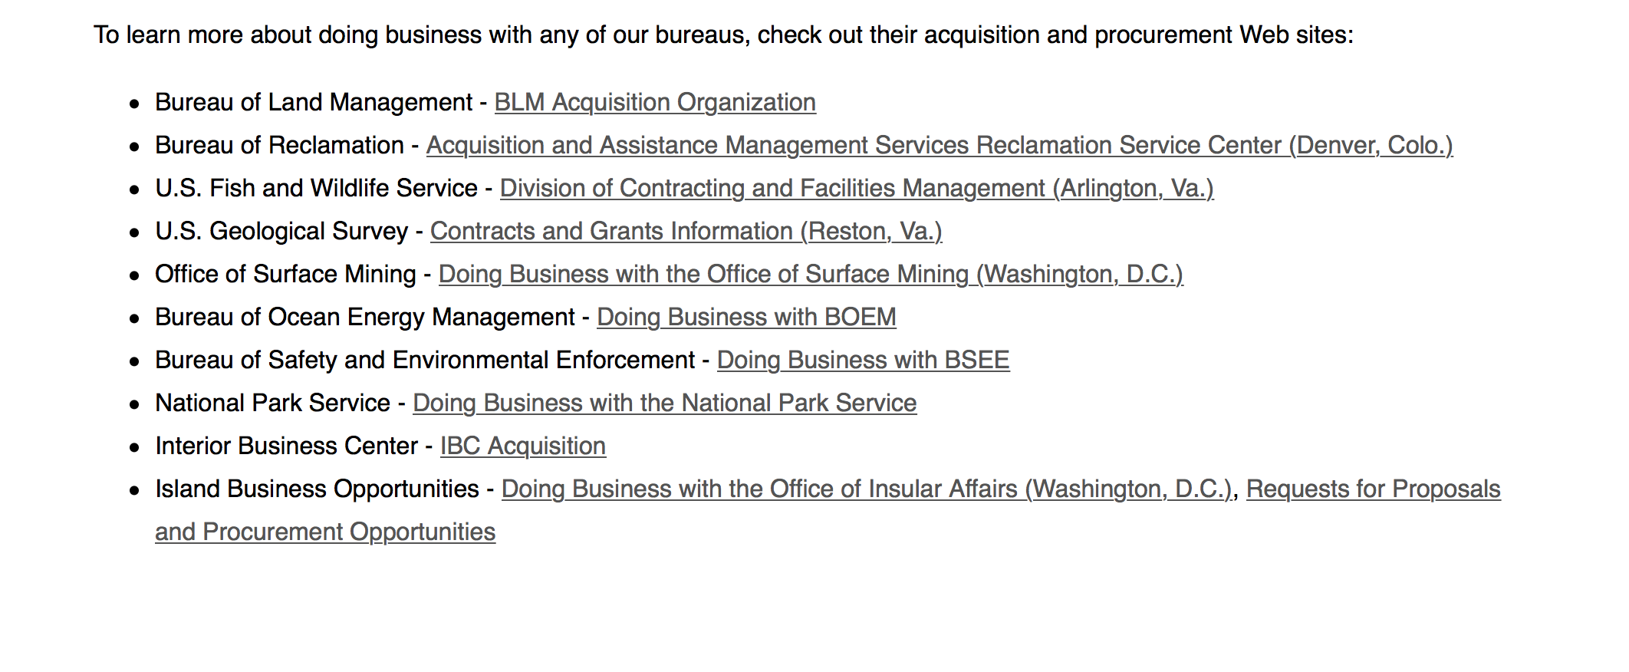
http://www.doi.gov/businesses/working-with-interior.cfm

Programs:

National Park Service
2018 Preservation Technology and Training Grants
Synopsis 1
Document Type: | Grants Notice
Funding Opportunity Number: | P18AS00006
Funding Opportunity Title: | 2018 Preservation Technology and Training Grants
Opportunity Category: | Discretionary
Opportunity Category Explanation:
Funding Instrument Type: | Grant
Category of Funding Activity: | Other (see text field entitled "Explanation of Other Category of Funding Activity" for clarification)
Category Explanation: | National Park Service
Expected Number of Awards: | 10
CFDA Number(s): | 15.923 -- National Center for Preservation Technology and Training
Cost Sharing or Matching Requirement: | No
Version: | Synopsis 1
Posted Date: | Oct 31, 2017
Last Updated Date: | Oct 31, 2017
Original Closing Date for Applications: | Jan 04, 2018
Current Closing Date for Applications: | Jan 04, 2018
Archive Date: | Jan 11, 2018
Estimated Total Program Funding: | $300,000
Award Ceiling: | $40,000
Award Floor: | $5,000
Eligible Applicants: | Others (see text field entitled "Additional Information on Eligibility" for clarification)
Additional Information on Eligibility: | In accordance with 54 U.S.C.305304(c). Preservation grants, eligible applicants may include (1) Federal and non-Federal laboratories (2) accredited museums (3) universities (4) nonprofit organizations (5) System units and offices and Cooperative Park Study Units of the System (6) State Historic Preservation Offices (7) tribal preservation offices (8) Native Hawaiian organizations
Agency Name: | National Park Service
Description: | 2018 Preservation Technology and Training Grants (PTT Grants) are intended to create better tools, better materials, and better approaches to conserving buildings, landscapes, sites, and collections. The PTT Grants are administered by the National Center for Preservation Technology and Training (NCPTT), the National Park Service innovation center for the preservation community. The competitive grants program will provide funding to federal agencies, states, tribes, local governments, and non-profit organizations. PTT Grants will support the following activities: â¿¢ Innovative research that develops new technologies or adapts existing technologies to preserve cultural resources (typically $25,000 to $40,000) â¿¢ Specialized workshops or symposia that identify and address national preservation needs (typically $15,000 to $25,000) â¿¢ How-to videos, mobile applications, podcasts, best practices publications, or webinars that disseminate practical preservation methods or provide better tools for preservation practice (typically $5,000 to $15,000) The maximum grant award is $40,000. The actual grant award amount is dependent on the scope of the proposed activity. NCPTT does not fund "bricks and mortar" grants.
Link to Additional Information: | http://www.grants.gov
Grantor Contact Information: | If you have difficulty accessing the full announcement electronically, please contact:  Todd Wilson Todd_Wilson@nps.gov  Email

http://www.grants.gov/web/grants/view-opportunity.html?oppId=298228

National Park Service
FY 18 American Battlefield Protection Program Battlefield Preservation Planning Project Grants
Synopsis 1
Document Type: | Grants Notice
Funding Opportunity Number: | P18AS00003
Funding Opportunity Title: | FY 18 American Battlefield Protection Program Battlefield Preservation Planning Project Grants
Opportunity Category: | Discretionary
Opportunity Category Explanation:
Funding Instrument Type: | Grant
Category of Funding Activity: | Other (see text field entitled "Explanation of Other Category of Funding Activity" for clarification)
Category Explanation: | Battlefield Planning Grant
Expected Number of Awards: | 25
CFDA Number(s): | 15.926 -- American Battlefield Protection
Cost Sharing or Matching Requirement: | No
Version: | Synopsis 1
Posted Date: | Oct 18, 2017
Last Updated Date: | Oct 18, 2017
Original Closing Date for Applications: | Jan 18, 2018 Applications can be submitted through Grants.gov, by mail, or by hand. All applications must be submitted to Grants.gov or be received in the ABPP office by 3:00PM EST on January 18, 2018. Late applications will be discarded without notification.
Current Closing Date for Applications: | Jan 18, 2018 Applications can be submitted through Grants.gov, by mail, or by hand. All applications must be submitted to Grants.gov or be received in the ABPP office by 3:00PM EST on January 18, 2018. Late applications will be discarded without notification.
Archive Date: | Oct 10, 2020
Estimated Total Program Funding: | $0
Award Ceiling: | $100,000
Award Floor: | $5,000
Eligible Applicants: | Nonprofits that do not have a 501(c)(3) status with the IRS, other than institutions of higher education  Public and State controlled institutions of higher education  County governments  State governments  Native American tribal governments (Federally recognized)  City or township governments
Agency Name: | National Park Service
Description: | A. Program Background Information The purpose of this grant program is to provide seed money for projects that lead directly to the identification, preservation, and interpretation of battlefield land or historic sites associated with battlefields. B. Program Objectives The ABPP encourages an interdisciplinary, holistic approach to battlefield preservation. Grant proposals for projects that fit into a larger vision for the site are favored. To maximize effectiveness of battlefield protection efforts, applicant organizations are encouraged to work with partner organizations and Federal, State and local government agencies as early as possible to integrate their efforts into a larger battle site protection strategy. C. Term of the Agreement Agreement terms for funded projects are estimated to range between one and two years, depending on the negotiated project scope. Agreements are not effective until fully executed with signature from the NPS Awarding Officer. In most cases an agreement will expire after five years from the effective date, unless terminated earlier in accordance with 2 CFR, Part 200, Sections 200.338 and 200.339.
Link to Additional Information:
Grantor Contact Information: | If you have difficulty accessing the full announcement electronically, please contact:  Historian Philip Bailey (202) 513-7126 Philip_Bailey@nps.gov  Philip_Bailey@nps.gov

http://www.grants.gov/web/grants/view-opportunity.html?oppId=298024

Modifications:

Fish and Wildlife Service
Partners for Fish and Wildlife
Synopsis 2 & 6

Document Type: | Grants Notice
Funding Opportunity Number: | F18AS00011
Funding Opportunity Title: | Partners for Fish and Wildlife
Opportunity Category: | Discretionary
Opportunity Category Explanation:
Funding Instrument Type: | Cooperative Agreement
Category of Funding Activity: | Environment  Natural Resources
Category Explanation:
Expected Number of Awards: | 3000
CFDA Number(s): | 15.631 -- Partners for Fish and Wildlife
Cost Sharing or Matching Requirement: | No
Version: | Synopsis 6
Posted Date: | Oct 30, 2017
Last Updated Date: | Oct 31, 2017
Original Closing Date for Applications: | Sep 30, 2018 For the full program announcement and applications, please click the "Full Announcement" link above.
Current Closing Date for Applications: | Sep 30, 2018 Please click on "Related Documents" for full program announcement.
Archive Date: | Oct 07, 2018
Estimated Total Program Funding: | $52,000,000
Award Ceiling: | $750,000
Award Floor: | $1
Eligible Applicants: | Unrestricted (i.e., open to any type of entity above), subject to any clarification in text field entitled "Additional Information on Eligibility"
Agency Name: | Fish and Wildlife Service
Description: | The Partners for Fish and Wildlife (PFW) Program is a voluntary, incentive-based program that provides direct technical assistance and financial assistance in the form of cooperative agreements to private landowners to restore and conserve fish and wildlife habitat for the benefit of federal trust resources. The PFW Program is delivered through more than 250 full-time staff, active in all 50 States and territories. Partners for Fish and Wildlife Program staff coordinate with project partners, stakeholders and other Service programs to identify geographic focus areas and develop habitat conservation priorities within these focus areas. Geographic focus areas define where the program directs resources to conserve habitat for federal trust species. Project work plans are developed strategically, in coordination with partners, and with substantial involvement from Service field staff. Projects must advance the Department of the Interior's mission, U.S. Fish and Wildlife Service's mission, and PFW's mission, promote biological diversity, and based upon sound scientific biological principles. Program strategic plans inform the types of projects funded under this opportunity. Applicants seeking funding under this program should contact the appropriate PFW Regional Program office prior to submitting an application for funding. ***Applicants seeking technical or financial assistance from the PFW Program are requested to consult with the Regional PFW Program office BEFORE developing or submitting an application (see Section VIII. Agency Contacts).***Legal authorities: Partners for Fish and Wildlife Act of 2006, S.260 Public Law 109-294; Fish and Wildlife Act of 1956, 16 U.S.C. 742a-c, 747e-742j; and Fish and Wildlife Coordination Act of 1958, 16 U.S.C. 661 667(e).
Link to Additional Information: | http://www.grants.gov
Grantor Contact Information: | If you have difficulty accessing the full announcement electronically, please contact:  Grants Management Specialist Patrick Schulze 703 358 2567 patrick_schulze@fws.gov  Service e-mail

http://www.grants.gov/web/grants/view-opportunity.html?oppId=298219

Fish and Wildlife Service
Coastal
Synopsis 2
Document Type: | Grants Notice
Funding Opportunity Number: | F18AS00013
Funding Opportunity Title: | Coastal
Opportunity Category: | Discretionary
Opportunity Category Explanation:
Funding Instrument Type: | Cooperative Agreement
Category of Funding Activity: | Environment  Natural Resources
Category Explanation:
Expected Number of Awards: | 100
CFDA Number(s): | 15.630 -- Coastal
Cost Sharing or Matching Requirement: | No
Version: | Synopsis 2
Posted Date: | Oct 31, 2017
Last Updated Date: | Oct 31, 2017
Original Closing Date for Applications: | Sep 30, 2018 Please click on "Related Documents" for full program announcement.
Current Closing Date for Applications: | Sep 30, 2018 Please click on "Related Documents" for full program announcement.
Archive Date: | Oct 07, 2018
Estimated Total Program Funding: | $13,000,000
Award Ceiling: | $500,000
Award Floor: | $1
Eligible Applicants: | Unrestricted (i.e., open to any type of entity above), subject to any clarification in text field entitled "Additional Information on Eligibility"
Agency Name: | Fish and Wildlife Service
Description: | The Coastal Program is a voluntary, community-based program that provides technical and financial assistance in the form of cooperative agreements to coastal communities and landowners to restore and protect fish and wildlife habitat on public and private lands. Coastal Program staff coordinates with project partners, stakeholders and other Service programs to identify geographic focus areas and develop habitat conservation priorities within these focus areas. Geographic focus areas are where the Coastal Program directs resources to conserve habitat for federal trust species. Projects are developed in collaboration with partners, and with substantial involvement from Service field staff. Projects must advance the mission and priorities of the Department of the Interior, U.S. Fish and Wildlife Service (Service), and the Coastal Program, and be based on sound scientific biological principles. Regional strategic plans describe the types of projects funded under this opportunity.***Applicants seeking technical or financial assistance from the Coastal Program are requested to consult with the regional Coastal Program office and review the appropriate strategic plan BEFORE developing or submitting an application (see Section VIII. Agency Contacts).***Legal authorities: Fish and Wildlife Act of 1956, 16 U.S.C. 742a-c, 747e-742j; and Fish and Wildlife Coordination Act of 1958, 16 U.S.C. 661 667(e).
Link to Additional Information: | http://www.grants.gov
Grantor Contact Information: | If you have difficulty accessing the full announcement electronically, please contact:  Grants Management Specialist Patrick Schulze 703 358 2567 patrick_schulze@fws.gov  Service e-mail

http://www.grants.gov/web/grants/view-opportunity.html?oppId=298240

Fish and Wildlife Service
National Outreach and Communication Program
Synopsis 2
Document Type: | Grants Notice
Funding Opportunity Number: | F18AS00004
Funding Opportunity Title: | National Outreach and Communication Program
Opportunity Category: | Discretionary
Opportunity Category Explanation:
Funding Instrument Type: | Cooperative Agreement
Category of Funding Activity: | Education  Environment  Natural Resources
Category Explanation:
Expected Number of Awards: | 5
CFDA Number(s): | 15.653 -- National Outreach and Communication
Cost Sharing or Matching Requirement: | Yes
Version: | Synopsis 2
Posted Date: | Oct 23, 2017
Last Updated Date: | Oct 23, 2017
Original Closing Date for Applications: | Nov 23, 2017
Current Closing Date for Applications: | Nov 23, 2017
Archive Date: | Nov 24, 2017
Estimated Total Program Funding: | $0
Award Ceiling: | $59,000,000
Award Floor: | $1,000,000
Eligible Applicants: | Unrestricted (i.e., open to any type of entity above), subject to any clarification in text field entitled "Additional Information on Eligibility"
Agency Name: | Fish and Wildlife Service
Description: | The U.S. Fish and Wildlife Service (Service) is seeking proposals from applicants to implement the National Outreach and Communication Program (NOCP) for sportfishing and boating. This program was established by the Sportfishing and Boating Safety Act of 1998 (Public Law 105 178) in an attempt to reverse declining trends in participation rates in angling and boating. The primary purposes of the NOCP are to: 1)improve communications with anglers, boaters, and the general public regarding angling and boating opportunities; 2)reduce barriers to access and participation in angling and boating activities; 3) advance the adoption of sound angling and boating practices in the U.S.' 4)promote conservation and the responsible use of the nation's aquatic resources; and 5)further safety in angling and boating. The law requires the Secretary of the Interior to develop and implement a national plan for the NOCP in cooperation and consultation with the Sport Fishing and Boating Partnership Council(Council). The Council develop the National Outreach and Communication Program Strategic Plan (Strategic Plan).
Link to Additional Information: | http://www.grants.gov
Grantor Contact Information: | If you have difficulty accessing the full announcement electronically, please contact:  Brian Bohnsack 703-358-2435 brian_bohnsack@fws.gov  Project Officer

http://www.grants.gov/web/grants/view-opportunity.html?oppId=298111

Cooperative Agriculture
Synopsis 5

Document Type: | Grants Notice
Funding Opportunity Number: | F18AS00003
Funding Opportunity Title: | Cooperative Agriculture
Opportunity Category: | Discretionary
Opportunity Category Explanation:
Funding Instrument Type: | Cooperative Agreement
Category of Funding Activity: | Agriculture  Natural Resources
Category Explanation:
Expected Number of Awards: | 50
CFDA Number(s): | 15.681 -- Cooperative Agriculture
Cost Sharing or Matching Requirement: | No
Version: | Synopsis 5
Posted Date: | Oct 20, 2017
Last Updated Date: | Oct 20, 2017
Original Closing Date for Applications: | Sep 30, 2023
Current Closing Date for Applications: | Sep 30, 2023
Archive Date: | Oct 01, 2023
Estimated Total Program Funding: | $0
Award Ceiling: | $0
Award Floor: | $0
Eligible Applicants: | Small businesses  Individuals
Additional Information on Eligibility: | Applicants must be private individuals or small business entities. Pre-application coordination is required. Environmental impact information is not required for this program. This program is eligible for coverage under E.O. 12372, "Intergovernmental Review of Federal Programs." An applicant should consult the office or official designated as the single point of contact in his or her State for more information on the process the State requires to be followed in applying for assistance, if the State has selected the program for review.
Agency Name: | Fish and Wildlife Service
Description: | The objectives for the use of cooperative agriculture in the National Wildlife Refuge System (NWRS) are: production or modification of specific cover types or growing methods that meet the life history requirements of species for which we have established objectives (e.g., waterfowl production); production of foods for wildlife species for which we have established objectives; and/or maintenance, rehabilitation, or reestablishment of natural habitat. Cooperative agriculture is when a person or entity conducts agricultural practices on NWRS lands in support of the Service conservation and resource management objectives and there is substantial involvement between the Service and that person or entity. The NWRS uses cooperative agreements, known as Cooperative Agriculture Agreements (CAAs), as the legal instruments to formalize the agreement between the Service and the program participant. The cost-sharing of a person or entity in cooperative agricultural on NWRS lands can vary depending on the needs and objectives of the particular NWRS land. For example, the Service may provide the cooperator with the right to perform agricultural practices on NWRS land and a percentage of any resulting crop yield, as well as the ability to use Service water, equipment, and/or refuge staff. In exchange, the cooperator may provide the Service with labor, equipment, and materials; a percentage of any resulting crop yield; and/or maintenance, rehabilitation, or reestablishment of specific habitat conditions on NWRS lands. In addition to or instead of cost-sharing, the Service may accept bids for payment for the person or entity agriculture use (e.g. haying or grazing) on NWRS lands in compliance with the Refuge Revenue Sharing Act. This is a nonfinancial assistance program. No Federal funds are obligated or awarded to program participants. This program is excluded from coverage under 2 CFR 200, Uniform Administrative Requirements, Cost Principles, and Audit Requirements for Federal Awards. The program will post an annual Notice of Participation Opportunity on Grants.gov. The annual notice will provide a link to the NWRS website where individual cooperative agricultural opportunities will be posted as they become available (https://www.fws.gov/refuges/whm/cooperativeAgriculture.html/). Individual cooperative agriculture opportunities will also be advertised through other national, regional, and local outreach channels as determined by the Service to be appropriate. The notice for each new opportunity will include a general description of the opportunity, the objective criteria the Service will use to evaluate applicants, the application due date, and application instructions. Individual cooperative agriculture agreements can be approved for a period of a few months or up to a period of 5 years. Once that period ends, the Service will determine if those same cooperative agriculture activities should continue. If the Service will continue those same cooperative agriculture activities, a new individual cooperative agriculture opportunity will be posted on the NWRS website and made available for eligible entities to apply. Because a CAA is not a financial assistance award, it is not subject to the regulations at 2 CFR 200 or policy in parts 515 and 516 of the Fish and Wildlife Service Manual. CAA's issued under this Notice of Opportunity are entered into under the U.S. Fish and Wildlife Service's (Service)'s CFDA (15.681) under the authority of the Fish and Wildlife Coordination Act (16 U.S.C. 661-667e); Migratory Bird Conservation Act (16 U.S.C. 715); National Wildlife Refuge System Administration Act, as amended by the National Wildlife Refuge System Improvement Act (16 U.S.C. 668dd); Refuge Revenue Sharing Act (16 U.S.C. 715s); National Wildlife Refuge System Regulations, Economic Uses and Cooperative Land Management (50 CFR 29.1-2); and Department of Interior Policy, 505 Departmental Manual (DM) 2, Procurement Contracts, Grant and Cooperative Agreements.
Link to Additional Information: | http://www.grants.gov
Grantor Contact Information: | If you have difficulty accessing the full announcement electronically, please contact:  Grants Management Specialist Patrick Schulze 703 358 2567 patrick_schulze@fws.gov  Service e-mail

http://www.grants.gov/web/grants/view-opportunity.html?oppId=298029

Reminders:

Deleted:

Department of Justice

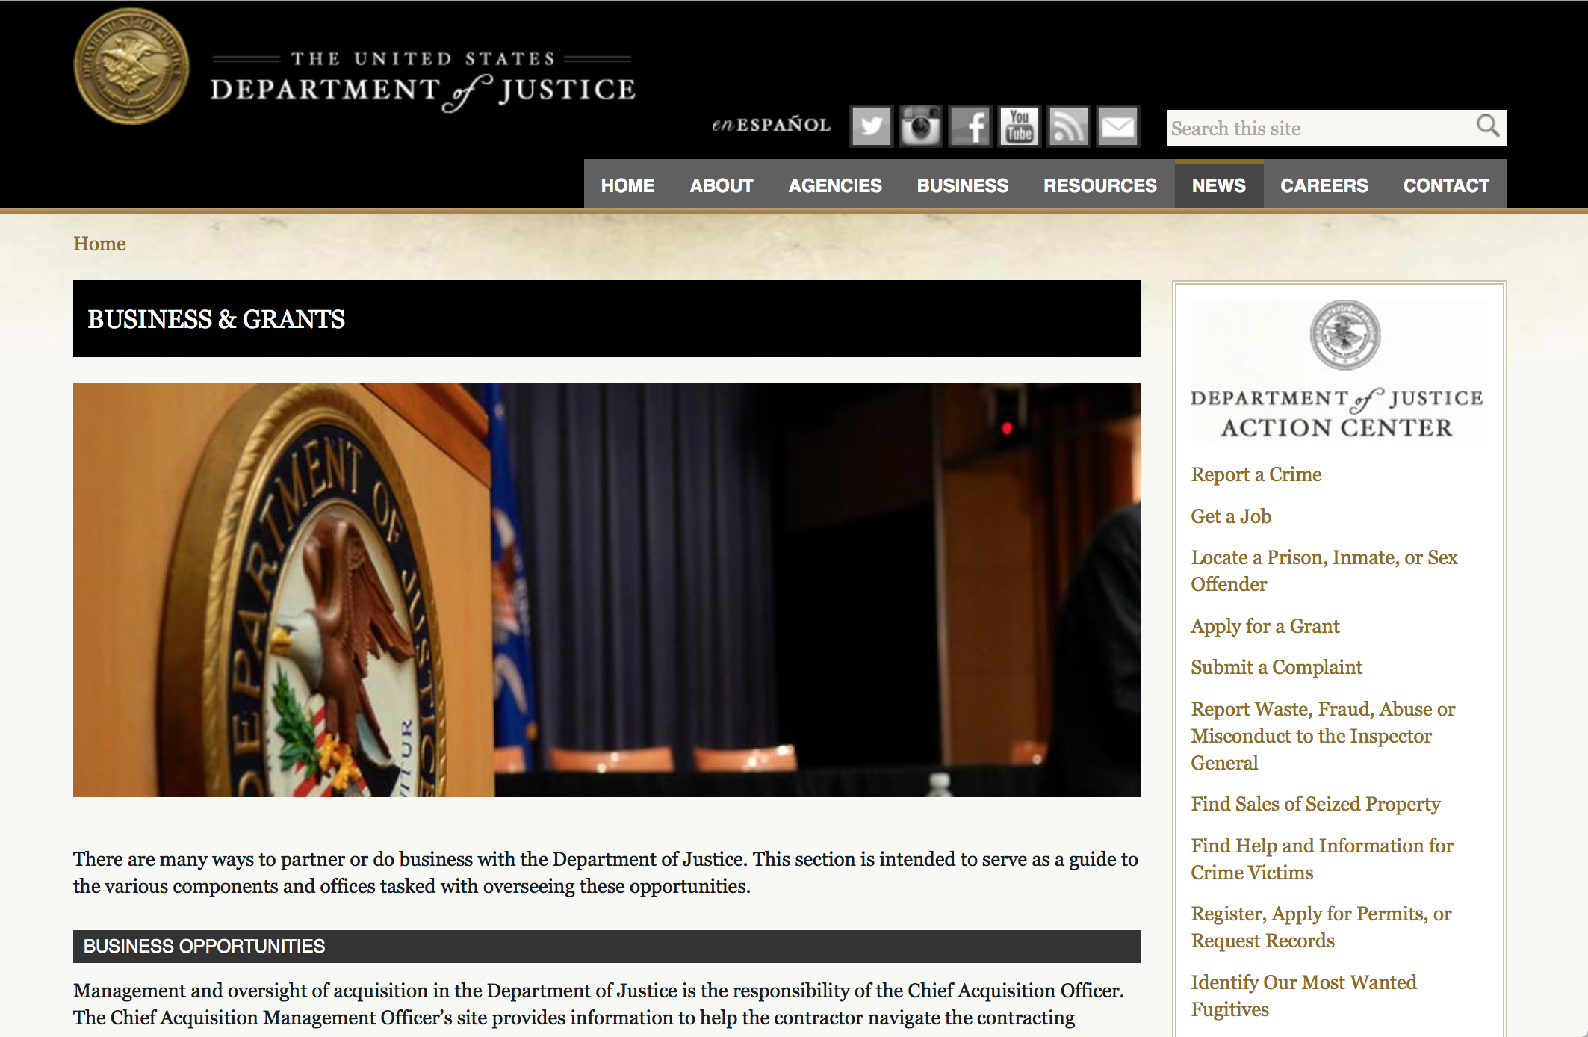

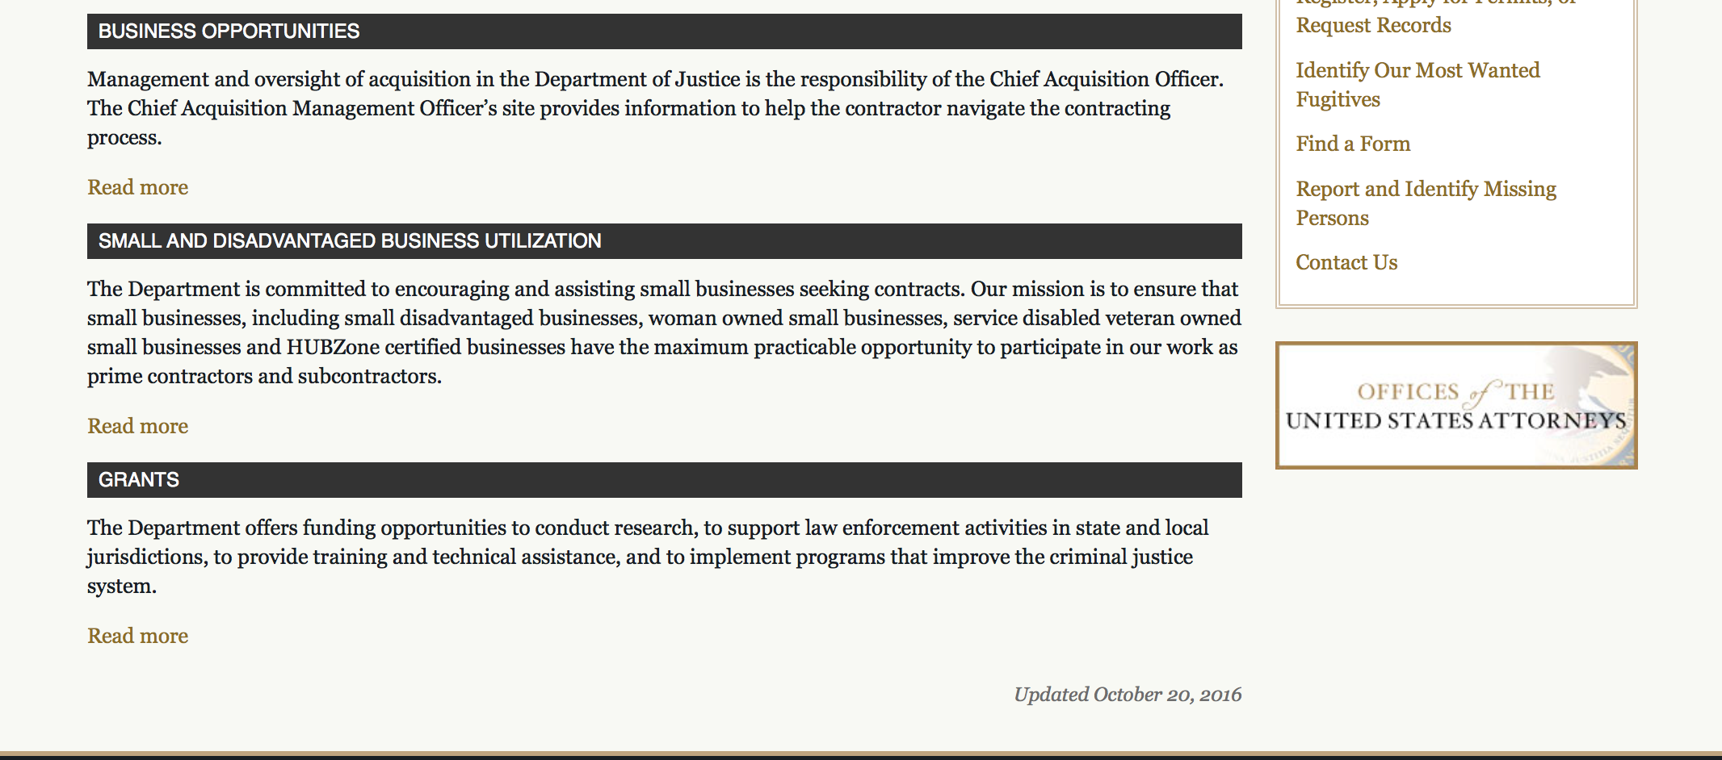

The DOJ agencies listed below also have sites that provide grant information specific to that agency. Examples of what can be found on these sites are programs, funding opportunities, application assistance, and other useful information.

Bureau of Justice Assistance (BJA)

Bureau of Justice Statistics (BJS)

National Criminal Justice Reference Service (NCJRS)

National Institute of Justice (NIJ)

Office of Sex Offender Sentencing, Monitoring, Apprehending, Registering, and Tracking (SMART)

http://www.justice.gov/business/

Programs:

Research:

Modifications:

Deleted:

Reminders:

Office on Violence Against Women
Supplemental OVW Fiscal Year 2017 Enhanced Training And Services To End Abuse In Later Life Program Solicitation
Synopsis 1

Document Type: | Grants Notice
Funding Opportunity Number: | OVW-2017-13480
Funding Opportunity Title: | Supplemental OVW Fiscal Year 2017 Enhanced Training And Services To End Abuse In Later Life Program Solicitation
Opportunity Category: | Discretionary
Opportunity Category Explanation:
Funding Instrument Type: | Cooperative Agreement
Category of Funding Activity: | Law, Justice and Legal Services
Category Explanation:
Expected Number of Awards: | 8
CFDA Number(s): | 16.528 -- Enhanced Training and Services to End Violence and Abuse of Women Later in Life
Cost Sharing or Matching Requirement: | No
Version: | Synopsis 1
Posted Date: | Sep 13, 2017
Last Updated Date: | Sep 13, 2017
Original Closing Date for Applications: | Nov 08, 2017
Current Closing Date for Applications: | Nov 08, 2017
Archive Date:
Estimated Total Program Funding: | $2,300,000
Award Ceiling: | $400,000
Award Floor: | $0
Eligible Applicants: | State governments  Native American tribal organizations (other than Federally recognized tribal governments)  Native American tribal governments (Federally recognized)  Nonprofits having a 501(c)(3) status with the IRS, other than institutions of higher education  County governments  Others (see text field entitled "Additional Information on Eligibility" for clarification)  City or township governments
Additional Information on Eligibility: | • Population specific organizations with demonstrated experience in assisting individuals over 50 years of age; • Victim service providers with demonstrated experience in addressing domestic violence, dating violence, sexual assault, and stalking; and • State, tribal, or territorial domestic violence or sexual assault coalitions
Agency Name: | Office on Violence Against Women
Description: | Enhanced Training And Services To End Abuse In Later Life Program (Abuse in Later Life) provides or enhances training and services to address elder abuse, neglect, and exploitation, including domestic violence, dating violence, sexual assault, or stalking, involving victims who are 50 years of age or older. In FY 2017, OVW will fund projects that will focus on providing training to assist criminal justice and other professionals in recognizing and addressing instances of elder abuse; providing services for older victims of abuse in later life; and supporting multidisciplinary collaborative community responses to victims of abuse in later life.
Link to Additional Information: | Full Solicitation
Grantor Contact Information: | If you have difficulty accessing the full announcement electronically, please contact:  Janice A. Green Sr. Program Specialist 202-616-6728 janice.a.green@usdoj.gov  janice.a.green@usdoj.gov

http://www.grants.gov/web/grants/view-opportunity.html?oppId=297344



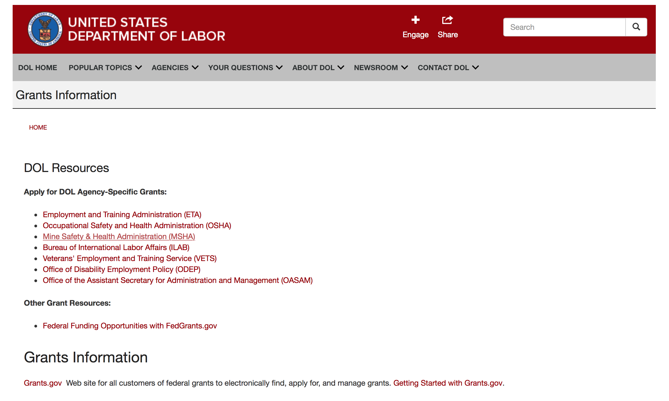

Agency Grants and Contract General Overview

DOL Resources
Apply for DOL Agency-Specific Grants:
- Employment and Training Administration (ETA)
- Occupational Safety and Health Administration (OSHA)
- Mine Safety & Health Administration (MSHA)
- Bureau of International Labor Affairs (ILAB)
- Veterans' Employment and Training Service (VETS)
- Office of Disability Employment Policy (ODEP)
- Office of the Assistant Secretary for Administration and Management (OASAM)

Other Grant Resources:
- Federal Funding Opportunities with FedGrants.gov
Grants Information
Grants.gov — Web site for all customers of federal grants to electronically find, apply for, and manage grants. Getting Started with Grants.gov.

DOL Resources and Instructions for Applying for a Grant
- DOL Guidance Clarifying the Effect of the Religious Freedom Restoration Act on Faith-Based Organizations
- Grant and Contract Information
- Contracting and Grant Program Overview
- Civil Rights Enforcement for Department of Labor Grant Recipients
- More Information About Grants
- Use of Contracts, Grants & Cooperative Agreements

Other Federal Government Grant Information
- Grant Opportunities (Catalog of Federal Domestic Assistance)

Department of Labor Grant Programs

- Bureau of International Labor Affairs (ILAB): provides grants (cooperative agreements) for the implementation of projects designed to assist developing countries combat the worse forms of child labor, forced labor, and human trafficking; and support worker rights and improve working conditions. http://www.dol.gov/general/business.
- Bureau of Labor Statistics (BLS): provides project grants (cooperative agreements) and the dissemination of technical statistical data and related information on labor force activities; provides data on prices (CPI) and cost of living; data on productivity and technology data; data on compensation and working conditions; data on employment projections.
- Employment and Training (ETA): ETA administers financial assistance programs pursuant to the Workforce Investment Act (WIA), administering State formula grant programs for youth, adults and dislocated workers, national emergency grants for workers affected by mass layoffs, plant closures, and disasters; grant programs for workers with disabilities, Indians and Native Americans, and for migrant and seasonal farmworkers. ETA also administers grant programs for older American workers, apprenticeship programs, Trade Adjustment Assistance (TAA) programs, and assistance for research and development of workforce programs. In addition, ETA is responsible for the operation and maintenance of a national system of public employment service offices and for the national unemployment insurance program.
- Mine Safety and Health (MSHA): provides grants for research, education and training programs to ensure an adequate and competent staff of trained inspectors; and assistance for establishing or improving State mine health and safety programs through technical assistance.
- Occupational Safety and Health (OSHA): provides grants to non-profit organizations to provide training, educational services, and technical assistance; assistance to states to administer and enforce state programs; assistance to states to provide occupational safety and health technical assistance and consultant services.
- Office of Disability Employment Policy (ODEP): The Office of Disability Employment Policy awards competitive grants establishing short-term pilot and technical assistance projects designed to identify, develop, test, evaluate, and disseminate policies to increase employment by expanding access to training, education, employment supports, assistive and systems technology, integrated employment, entrepreneurial development, and small business opportunities for adults and youth with disabilities. Current pilots projects focus on customized employment, Olmstead populations, and innovative demonstration youth grants, among others. Solicitations for grant applications are published in the Federal Register and announced at www.dol.gov/odep. ODEP grants are awarded by the OASAM grant office.
- Veterans' Employment and Training (VETS): provides special employment and training assistance for veterans through the Disabled Veterans' Outreach Program (DVOP) Solicitation for Grant Applications; the Local Veterans' Employment Representative Program (LVER); Veterans' Workforce Investment Program (VWIP); elaws Advisor on veterans' employment and reemployment rights; and the Homeless Veterans Reintegration Project (HVRP). VETS grants are awarded by the OASAM grant office.

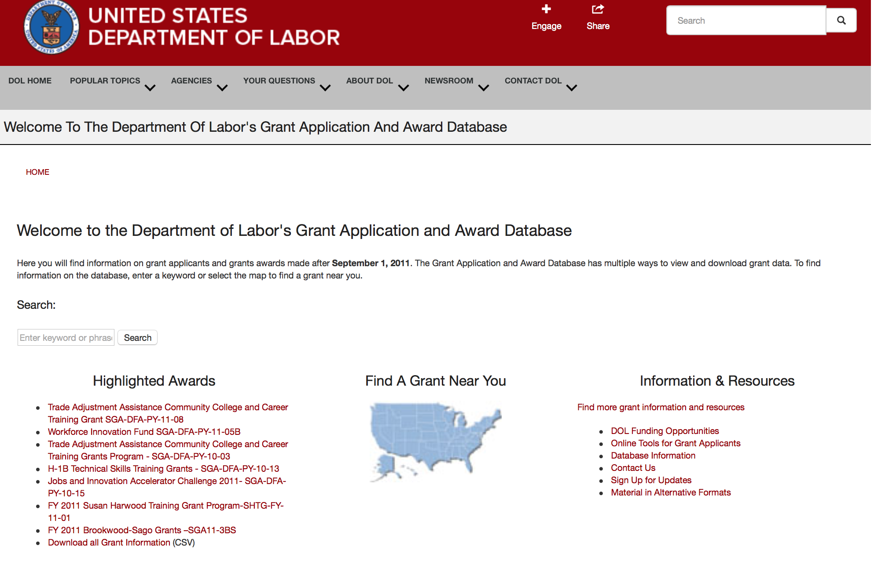

http://www.dol.gov/dol/grants/

Programs

Modifications

Reminders



National Aeronautics and Space Administration

Research and Contracting Opportunities

NASA Research Opportunities Online

- Various NASA offices publish their research announcements over the Internet, broadening the opportunity for researchers to apply for funding. This site provides access to current research announcements along with their specific due dates.

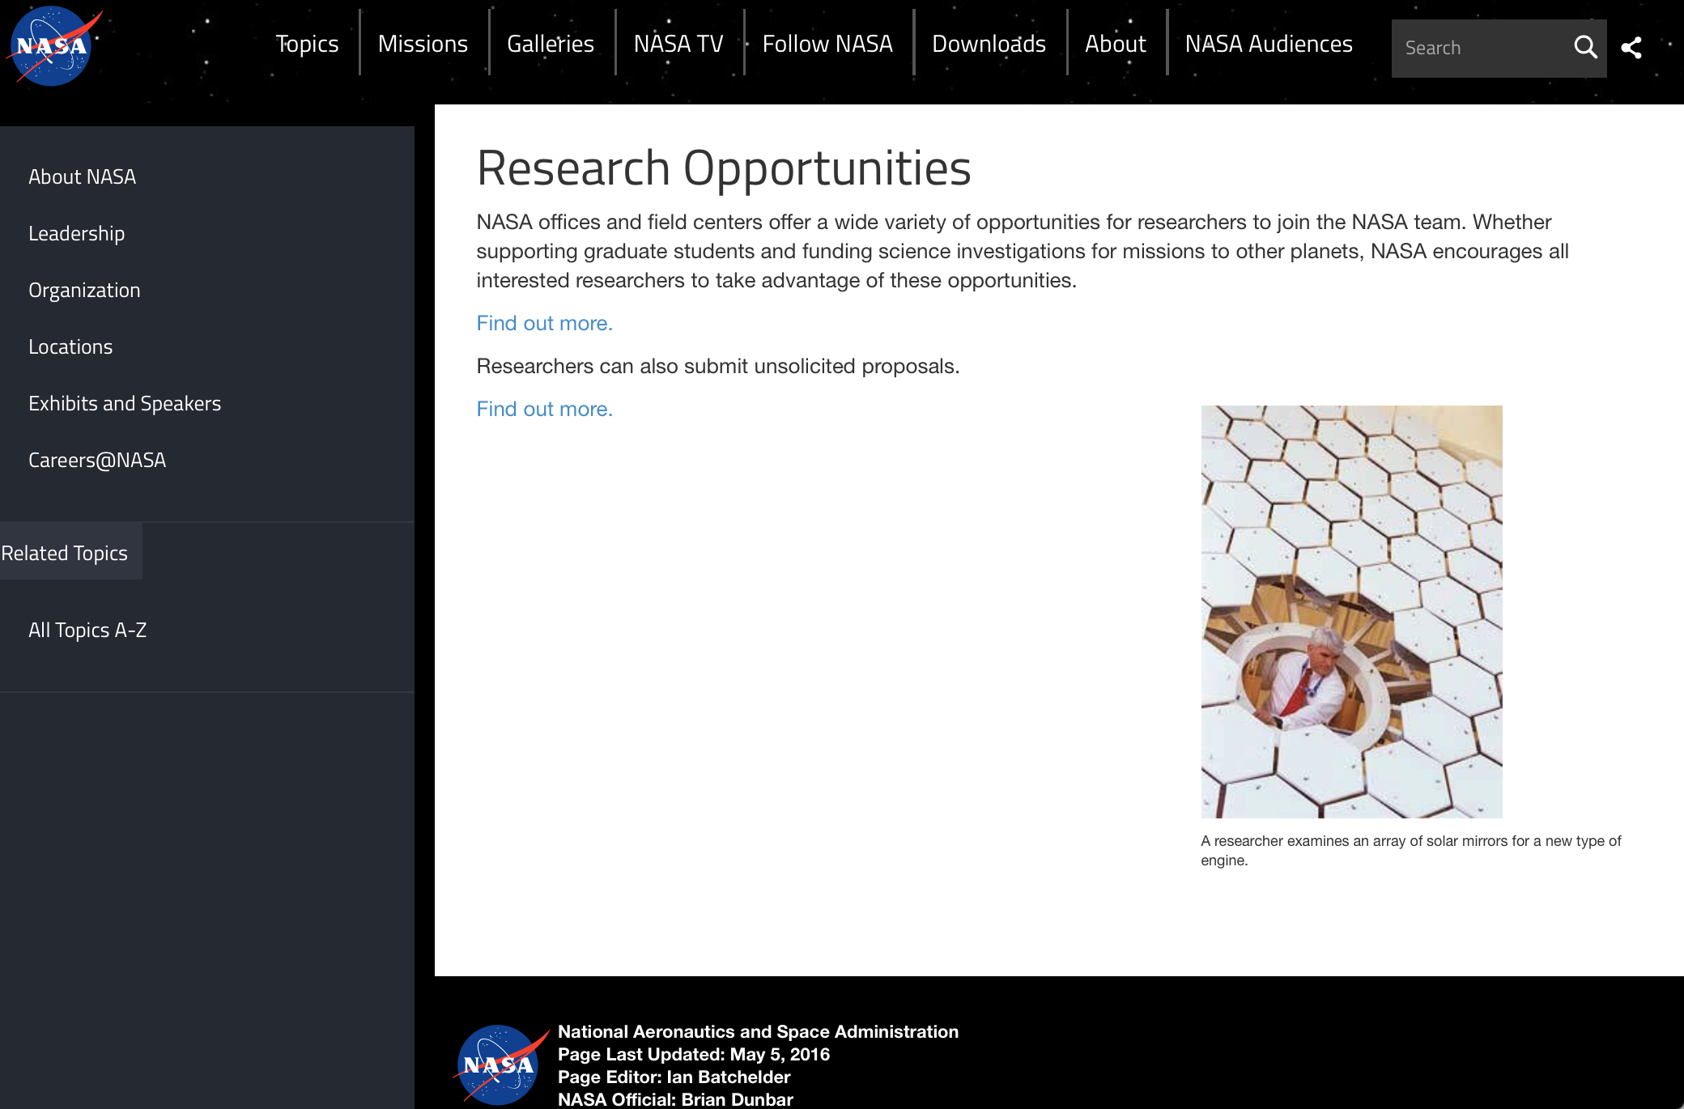

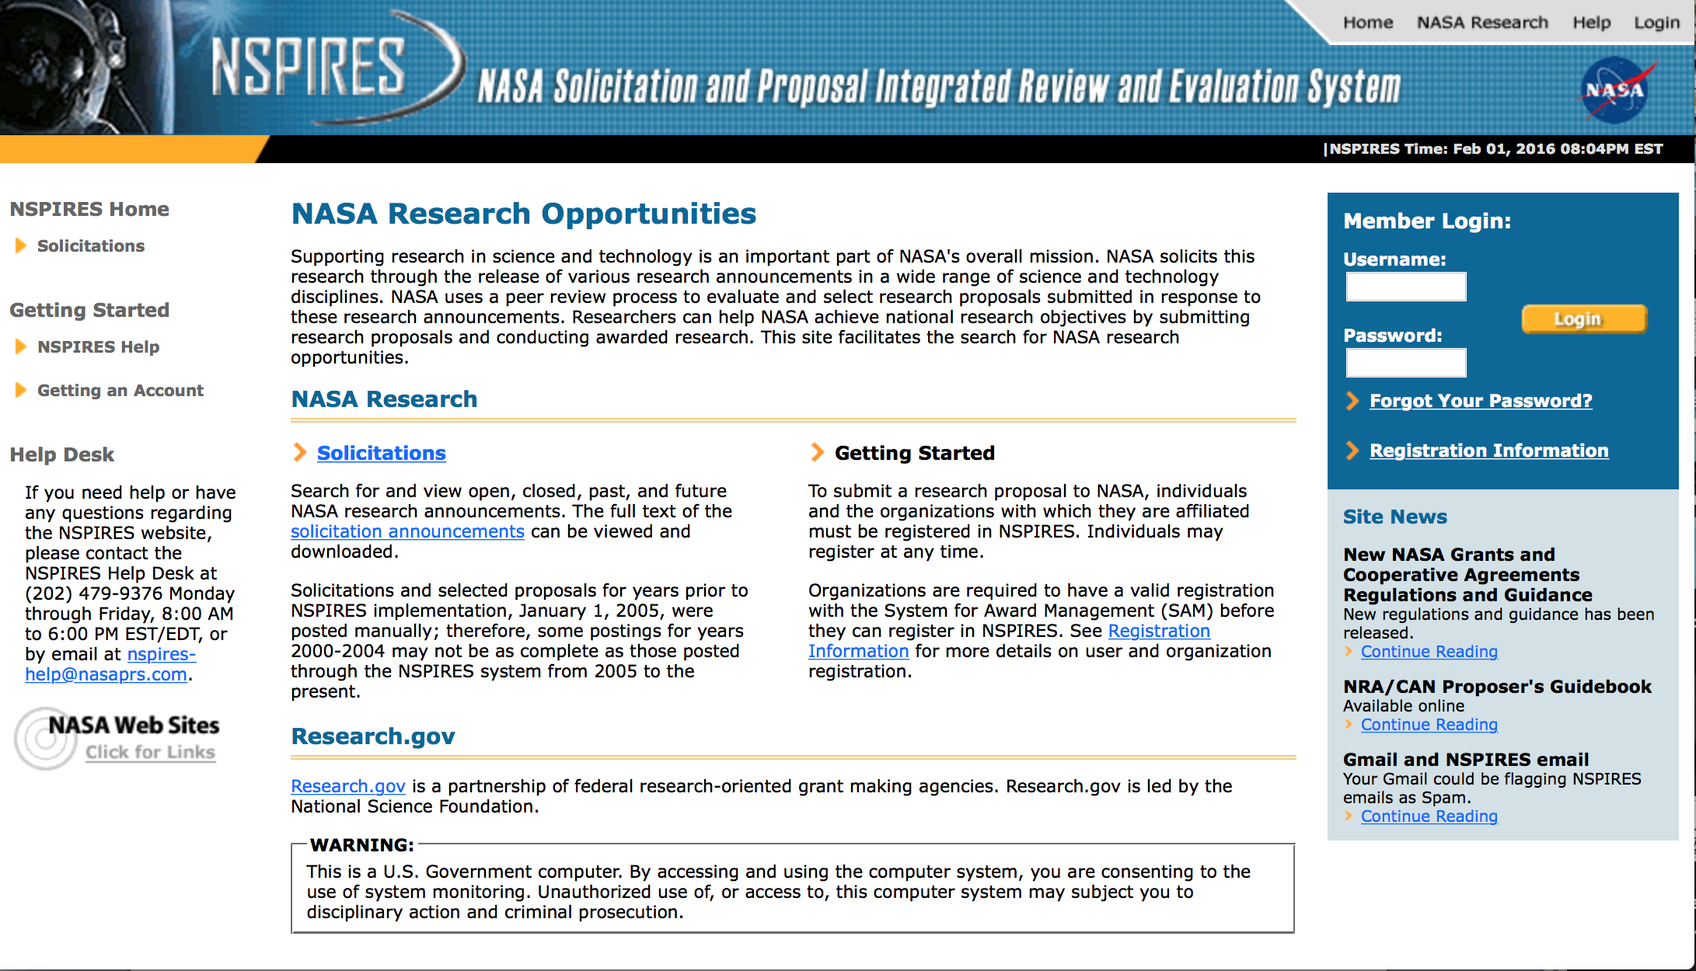
http://nspires.nasaprs.com/external/

Research Programs:

NASA Headquarters
ROSES 2017: Magnetospheric Multiscale Guest Investigators
Synopsis 1
http://www.grants.gov/web/grants/view-opportunity.html?oppId=297993

NASA Headquarters
ROSES 2017: Habitable Worlds
Synopsis 1
http://www.grants.gov/web/grants/view-opportunity.html?oppId=297994

Modifications:

NASA Headquarters
ROSES 2017: Ocean Vector Winds Science Team
Synopsis 2
http://www.grants.gov/web/grants/view-opportunity.html?oppId=296984

NASA Headquarters
ROSES 2017: Heliophysics Living With a Star Science
Synopsis 2
http://www.grants.gov/web/grants/view-opportunity.html?oppId=293759

NASA Headquarters
ROSES 2017: Discovery Data Analysis Program
Synopsis 3
http://www.grants.gov/web/grants/view-opportunity.html?oppId=296349

NASA Headquarters
ROSES 2017: Rosetta Data Analysis Program
Synopsis 3
http://www.grants.gov/web/grants/view-opportunity.html?oppId=296371

NASA Headquarters
ROSES 2017: X-ray Astronomy Recovery Mission (XARM) Participating Scientists
Synopsis 2
http://www.grants.gov/web/grants/view-opportunity.html?oppId=297335

National Archives and Records Administration

Grant Opportunities General Overview

To access the information below: click here

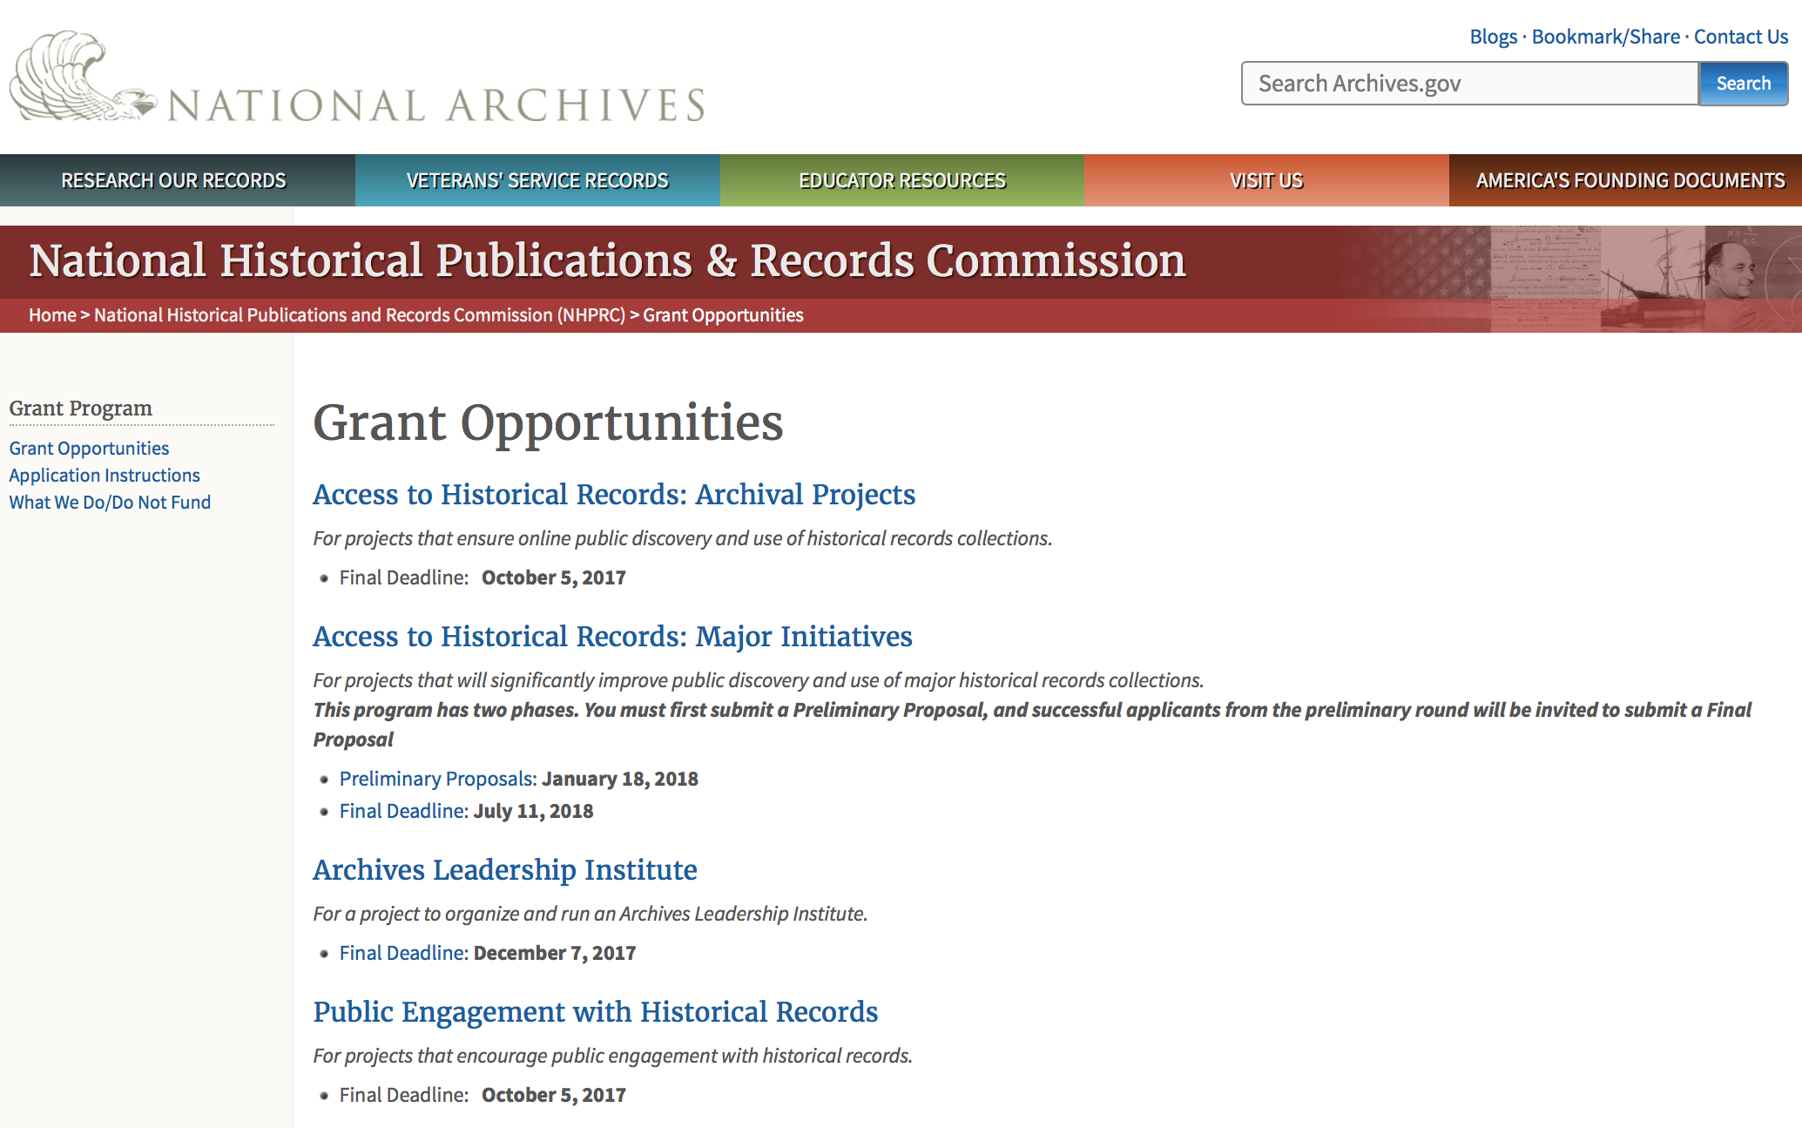

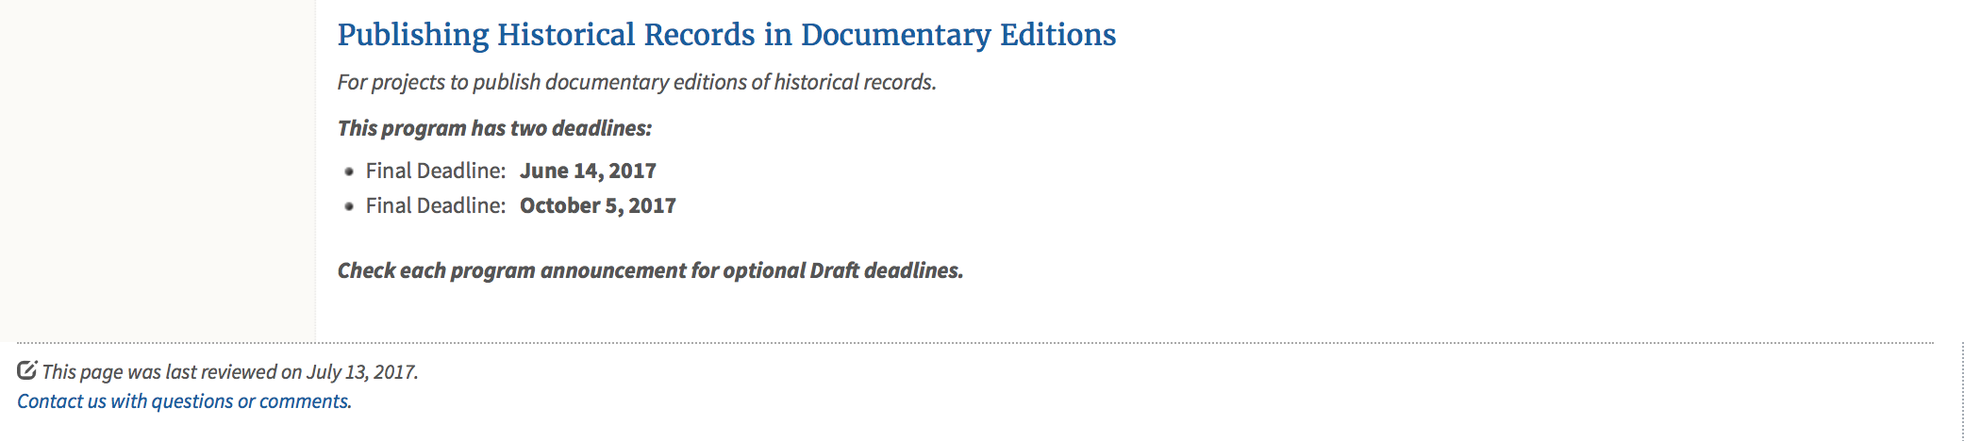
https://www.archives.gov/nhprc/announcement

Programs:

Reminders:

Access to Historical Records: Major Initiatives (Preliminary)
Synopsis 1

Document Type: | Grants Notice
Funding Opportunity Number: | PRELIM-201801
Funding Opportunity Title: | Access to Historical Records: Major Initiatives (Preliminary)
Opportunity Category: | Discretionary
Opportunity Category Explanation:
Funding Instrument Type: | Grant
Category of Funding Activity: | Humanities (see "Cultural Affairs" in CFDA)
Category Explanation:
Expected Number of Awards: | 5
CFDA Number(s): | 89.003 -- National Historical Publications and Records Grants
Cost Sharing or Matching Requirement: | Yes
Version: | Synopsis 3
Posted Date: | Jul 14, 2017
Last Updated Date: | Jul 24, 2017
Original Closing Date for Applications: | Jan 18, 2018
Current Closing Date for Applications: | Jan 18, 2018
Archive Date:
Estimated Total Program Funding: | $1,000,000
Award Ceiling: | $350,000
Award Floor: | $100,000
Eligible Applicants: | State governments  County governments  Nonprofits having a 501(c)(3) status with the IRS, other than institutions of higher education  Private institutions of higher education  Native American tribal governments (Federally recognized)  Public and State controlled institutions of higher education  City or township governments
Agency Name: | National Archives and Records Administration
Description: | The National Historical Publications and Records Commission seeks projects that will significantly improve public discovery and use of major historical records collections. All types of historical records are eligible, including documents, photographs, born-digital records, and analog audio and moving images. Projects may: • Digitize historical records collections, or related collections, held by a single institution and make them freely available online• Provide access to born-digital records• Create new freely-available virtual collections drawn from historical records held by multiple institutions• Create new tools and methods for users to access records The NHPRC welcomes collaborative projects, particularly for bringing together related records from multiple institutions. Projects that address significant needs in the field and result in replicable and scalable approaches will be more competitive. We also encourage organizations to actively engage the public in the work of the project. Applicants should also consult Access to Historical Records: Archival Projects program, which has different requirements and award amounts. For a comprehensive list of Commission limitations on funding, please see: "What we do and do not fund" (http://www.archives.gov/nhprc/apply/eligibility.html). Applications that consist entirely of ineligible activities will not be considered. Award Information A grant is for one to three years and for between $100,000 and $350,000. We expect to make up to five grants in this category for a total of up to $1,000,000. Grants begin no earlier than January 1, 2019.The Commission requires that grant recipients acknowledge NHPRC grant assistance in all publications and other products that result from its support. Eligibility Eligible applicants:• Nonprofit organizations or institutions• Colleges, universities, and other academic institutions• State or local government agencies• Federally-acknowledged or state-recognized Native American tribes or groups Cost Sharing The total costs of a project are shared between the NHPRC and the applicant organization. The Commission provides no more than 50 per cent of total project costs in the Access to Historical Records: Major Initiatives category. NHPRC grant recipients are not permitted to use grant funds for indirect costs (as indicated in 2 CFR 2600.101).Cost sharing is required. The applicant's financial contribution may include both direct and indirect expenses, in-kind contributions, non-Federal third-party contributions, and any income earned directly by the project. Indirect costs must be listed under the applicant's cost sharing contribution. Other Requirements Applicant organizations must be registered in the System for Award Management (SAM) prior to submitting an application, maintain SAM registration throughout the application and award process, and include a valid DUNS number in their application. Details on SAM registration and requesting a DUNS number can be found at the System for Award Management website at https://sam.gov. Please refer to the User Guides section and the Grants Registrations PDF. Application Information You must use Grants.gov to submit a Preliminary Proposal. All information necessary to apply is included in this announcement, the Application Instructions, and the forms on Grants.gov. If you need the information supplied in an alternative format, please call the NHPRC at 202-357-5010.In order to ensure eligibility, applicants should first review the rules and regulations governing NHPRC grants under the Administering an NHPRC Grant section. Applying to the Access to Historical Records: Major Initiatives program is a two-phase process. Phase One• Using this announcement, all applicants must submit an Application Package that includes the Application for Federal Domestic Assistance Form SF424, a completed NHPRC Budget, and five-page Project Narrative via Grants.gov by January 18, 2018.• Preliminary proposals will then undergo peer and staff review. Based on those reviews, a selection of promising applicants will be invited by April 16, 2018 to participate in the second phase of the process. Phase Two• Invited applicants will then prepare and submit a complete application to the full Major Initiatives grant announcement via Grants.gov by July 11, 2018. • Applicants may consult with the Director of the Access Program, Alex Lorch (alexander.lorch@nara.gov), or with the Director for Technology Initiatives, Nancy Melley (nancy.melley@nara.gov), during both the preliminary and full proposal project phases. • In order to ensure eligibility, applicants should first review the rules and regulations governing NHPRC grants under the Administering an NHPRC Grant section.
Link to Additional Information: | Link to full grant announcement, including additional requirements
Grantor Contact Information: | If you have difficulty accessing the full announcement electronically, please contact:  Jeff de la Concepcion Jeff.delaconcepcion@Nara.gov  Grant Information Specialist

http://www.grants.gov/web/grants/view-opportunity.html?oppId=295495

Access to Historical Records: Major Initiatives
Synopsis 1

Document Type: | Grants Notice
Funding Opportunity Number: | MAJOR-201807
Funding Opportunity Title: | Access to Historical Records: Major Initiatives
Opportunity Category: | Discretionary
Opportunity Category Explanation:
Funding Instrument Type: | Grant
Category of Funding Activity: | Humanities (see "Cultural Affairs" in CFDA)
Category Explanation:
Expected Number of Awards: | 5
CFDA Number(s): | 89.003 -- National Historical Publications and Records Grants
Cost Sharing or Matching Requirement: | Yes
Version: | Synopsis 1
Posted Date: | Jul 14, 2017
Last Updated Date: | Jul 14, 2017
Original Closing Date for Applications: | Jul 11, 2018
Current Closing Date for Applications: | Jul 11, 2018
Archive Date:
Estimated Total Program Funding: | $1,000,000
Award Ceiling: | $350,000
Award Floor: | $100,000
Eligible Applicants: | Public and State controlled institutions of higher education  County governments  Nonprofits having a 501(c)(3) status with the IRS, other than institutions of higher education  State governments  City or township governments  Private institutions of higher education  Native American tribal governments (Federally recognized)
Agency Name: | National Archives and Records Administration
Description: | The National Historical Publications and Records Commission seeks projects that will significantly improve public discovery and use of major historical records collections. All types of historical records are eligible, including documents, photographs, born-digital records, and analog audio and moving images. Projects may: • Digitize historical records collections, or related collections, held by a single institution and make them freely available online • Provide access to born-digital records • Create new freely-available virtual collections drawn from historical records held by multiple institutions • Create new tools and methods for users to access records The NHPRC welcomes collaborative projects, particularly for bringing together related records from multiple institutions. Projects that address significant needs in the field and result in replicable and scalable approaches will be more competitive. We also encourage organizations to actively engage the public in the work of the project. Applicants should also consult Access to Historical Records: Archival Projects program, which has different requirements and award amounts. For a comprehensive list of Commission limitations on funding, please see: "What we do and do not fund" (http://www.archives.gov/nhprc/apply/eligibility.html). Applications that consist entirely of ineligible activities will not be considered. Award Information A grant is for one to three years and between $100,000 and $350,000. We expect to make up to five grants in this category for a total of up to $1,000,000. Grants begin no earlier than January 1, 2019. The Commission requires that grant recipients acknowledge NHPRC grant assistance in all publicity, publications, and other products that result from its support. Eligibility Eligible applicants: • U.S. nonprofit organizations or institutions • U.S. colleges, universities, and other academic institutions • State or local government agencies • Federally-acknowledged or state-recognized Native American tribes or groups Cost Sharing The total costs of a project are shared between the NHPRC and the applicant organization. The Commission provides no more than 50 per cent of total project costs in the Access to Historical Records: Major Initiatives category. NHPRC grant recipients are not permitted to use grant funds for indirect costs (as indicated in 2 CFR 2600.101). Cost sharing is required. The applicant's financial contribution may include both direct and indirect expenses, in-kind contributions, non-Federal third-party contributions, and any income earned directly by the project. Indirect costs must be listed under the applicant's cost sharing contribution. Other Requirements Applicant organizations must be registered in the System for Award Management (SAM) prior to submitting an application, maintain SAM registration throughout the application and award process, and include a valid DUNS number in their application. Details on SAM registration and requesting a DUNS number can be found at the System for Award Management website at https://sam.gov. Please refer to the User Guides section and the Grants Registrations PDF. Application Information You must use Grants.gov to submit your Full Proposal. All information necessary to apply is included in this announcement, the Application Instructions, and the forms on Grants.gov. If you need the information supplied in an alternative format, please call the NHPRC at 202-357-5010. In order to ensure eligibility, applicants should first review the rules and regulations governing NHPRC grants under the Administering an NHPRC Grant section. Applying to the Access to Historical Records: Major Initiatives program is a two-phase process. Phase One • All applicants must have submitted a Preliminary Proposal by January 18, 2018. • Only those applicants who have successfully completed Phase One and who have been invited by the Commission to submit a full proposal to the Access to Historical Records: Major Initiatives program are eligible to participate in the second phase of the process. Phase Two • If you have been invited, prepare and submit a complete application to the full Major Initiatives grant announcement via Grants.gov by July 11, 2018. • Applicants may consult with the Director of the Access Program, Alex Lorch (alexander.lorch@nara.gov), or with the Director for Technology Initiatives, Nancy Melley (nancy.melley@nara.gov), during both the preliminary and full proposal project phases.
Link to Additional Information: | Link to full grant announcement, including additional requirements
Grantor Contact Information: | If you have difficulty accessing the full announcement electronically, please contact:  Jeff de la Concepcion Jeff.delaconcepcion@nara.gov  Grant Information Specialist

http://www.grants.gov/web/grants/view-opportunity.html?oppId=295496

National Endowment for the Arts

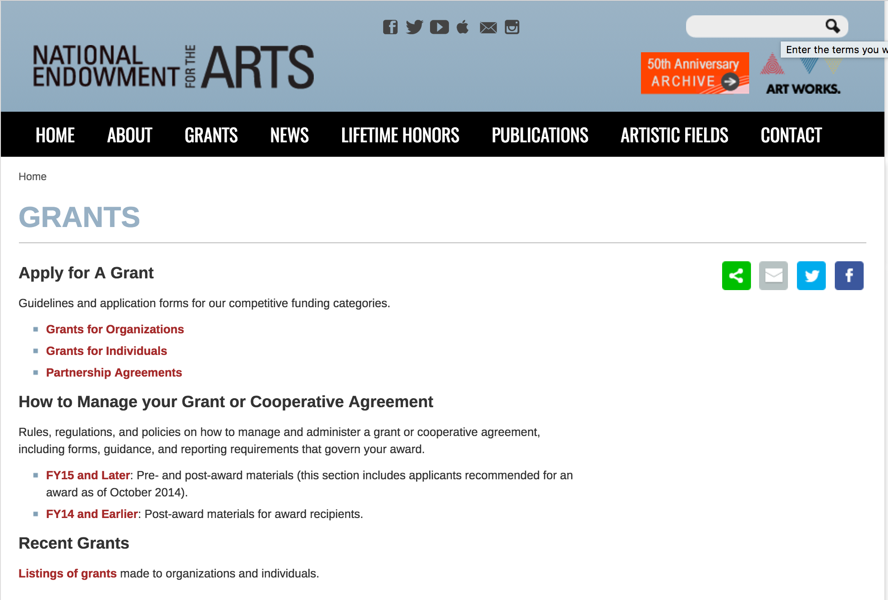

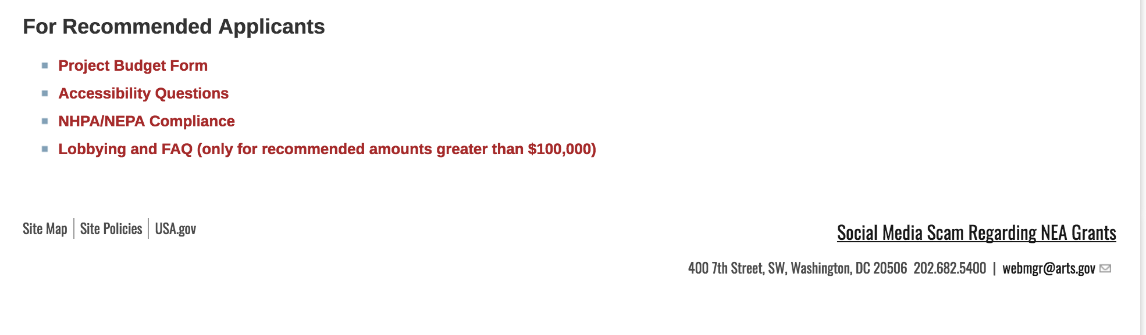
See more at: https://www.arts.gov/grants

Programs:

Modifications:

Reminders:

NEA Literature Fellowships: Translation Projects, FY2019
Synopsis 1
Document Type: | Grants Notice
Funding Opportunity Number: | 2018NEA03LFTP
Funding Opportunity Title: | NEA Literature Fellowships: Translation Projects, FY2019
Opportunity Category: | Discretionary
Opportunity Category Explanation:
Funding Instrument Type: | Grant
Category of Funding Activity: | Arts (see "Cultural Affairs" in CFDA)
Category Explanation:
Expected Number of Awards:
CFDA Number(s): | 45.024 -- Promotion of the Arts Grants to Organizations and Individuals
Cost Sharing or Matching Requirement: | No
Version: | Synopsis 1
Posted Date: | Jul 25, 2017
Last Updated Date: | Jul 25, 2017
Original Closing Date for Applications: | Dec 05, 2017
Current Closing Date for Applications: | Dec 05, 2017
Archive Date:
Estimated Total Program Funding:
Award Ceiling: | $25,000
Award Floor: | $12,500
Eligible Applicants: | Individuals
Agency Name: | National Endowment for the Arts
Description: | An individual may submit only one application for FY 2019 funding. You may not apply for both a Translation Project under this deadline (December 5, 2017) and a Literature Fellowship (in prose or poetry) under the 2018 deadline (when fellowships in prose are offered). The Arts Endowment’s support of a project may begin any time between November 1, 2018, and November 1, 2019, and extend for up to two years. Program Description Through fellowships to published translators, the National Endowment for the Arts supports projects for the translation of specific works of prose, poetry, or drama from other languages into English. We encourage translations of writers and of work that are not well represented in English translation. All proposed projects must be for creative translations of literary material into English. The work to be translated should be of interest for its literary excellence and value. Priority will be given to projects that involve work that has not previously been translated into English. Competition for fellowships is rigorous. Potential applicants should consider carefully whether their work will be competitive at the national level.
Link to Additional Information: | NEA Website Announcement
Grantor Contact Information: | If you have difficulty accessing the full announcement electronically, please contact:  NEA Web Manager webmgr@arts.gov  NEA Web Manager

http://www.grants.gov/web/grants/view-opportunity.html?oppId=295826

National Endowment for the Humanities

Grant Overview -

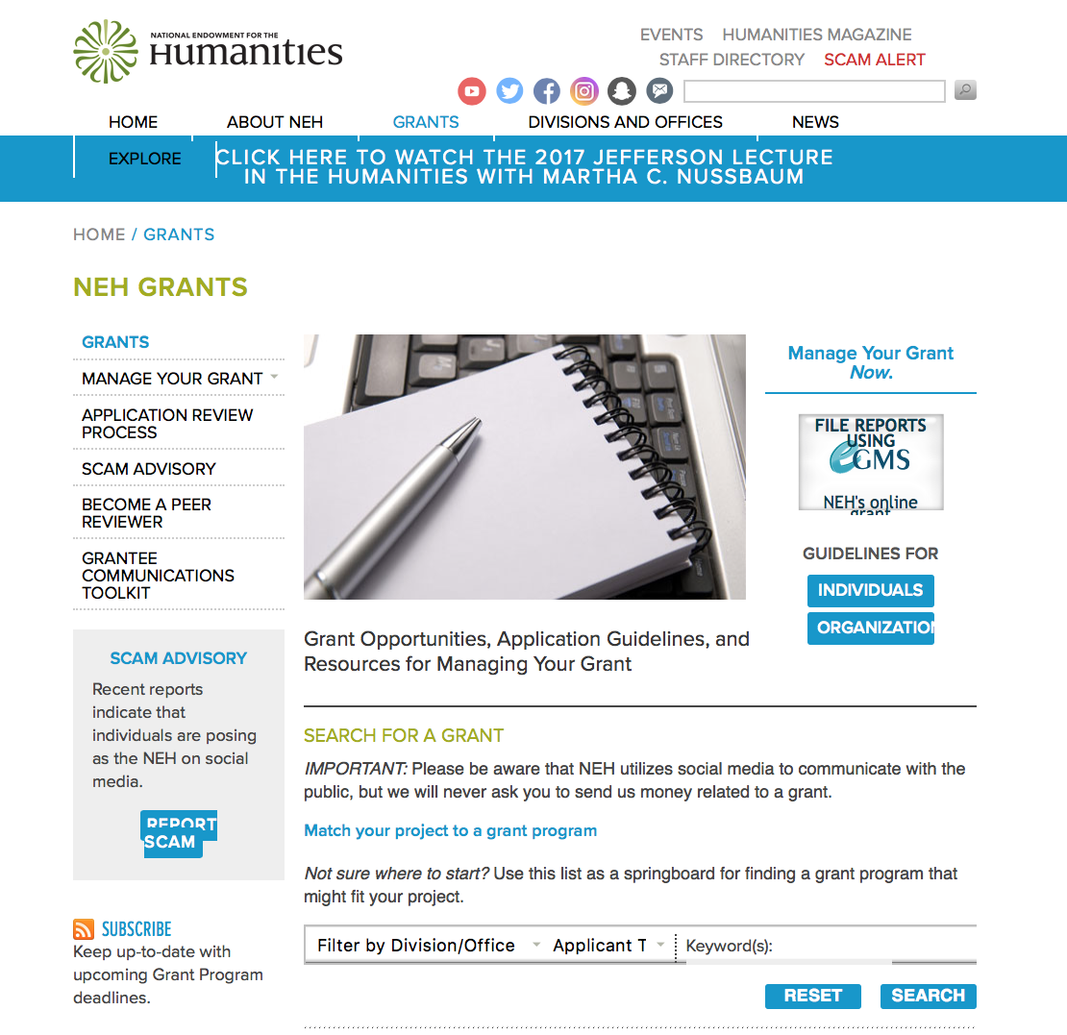

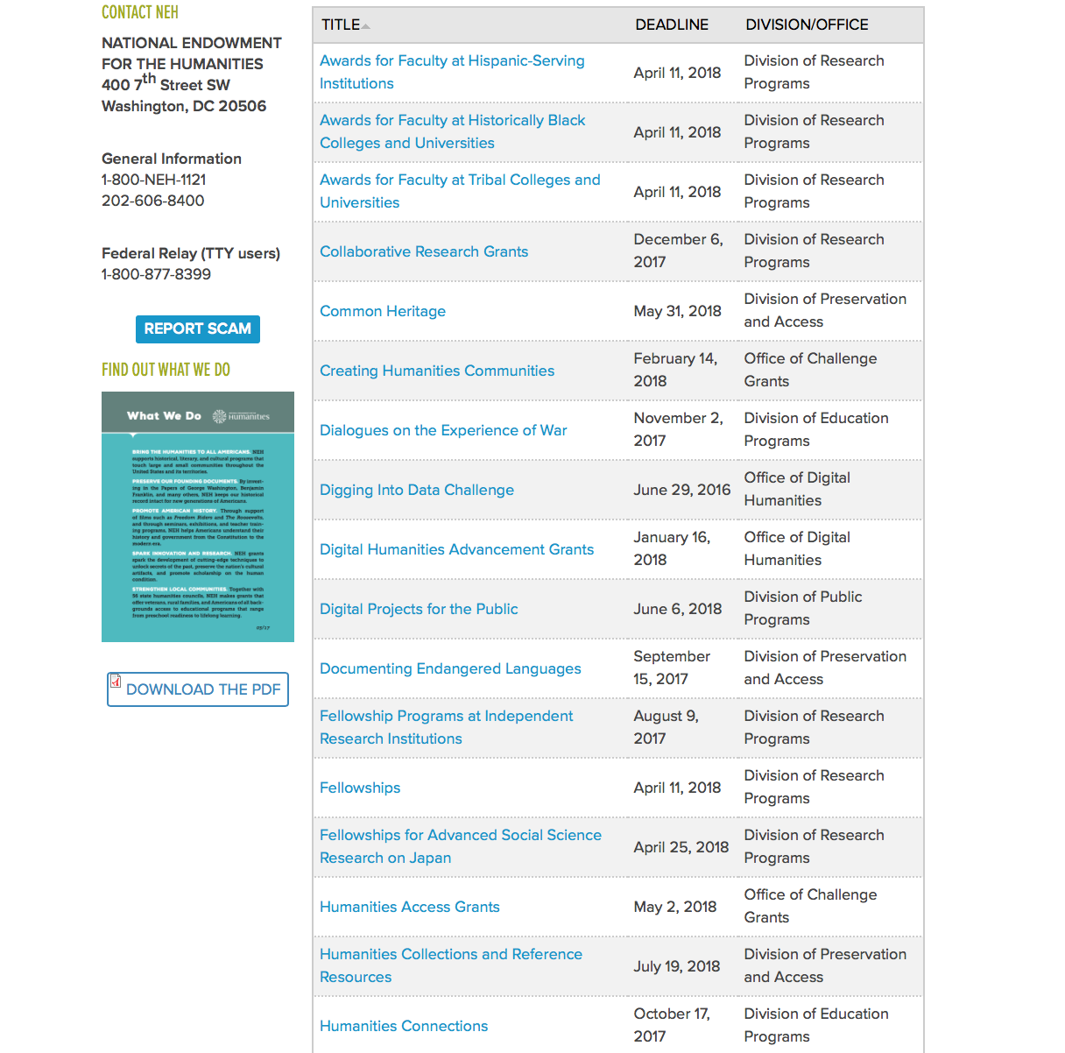

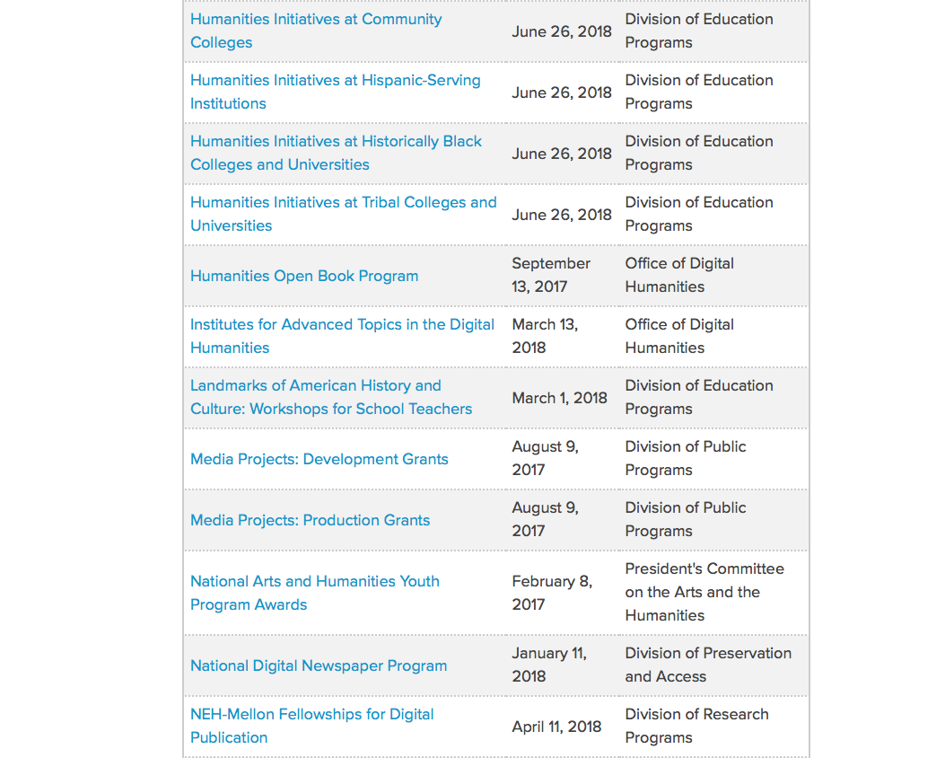

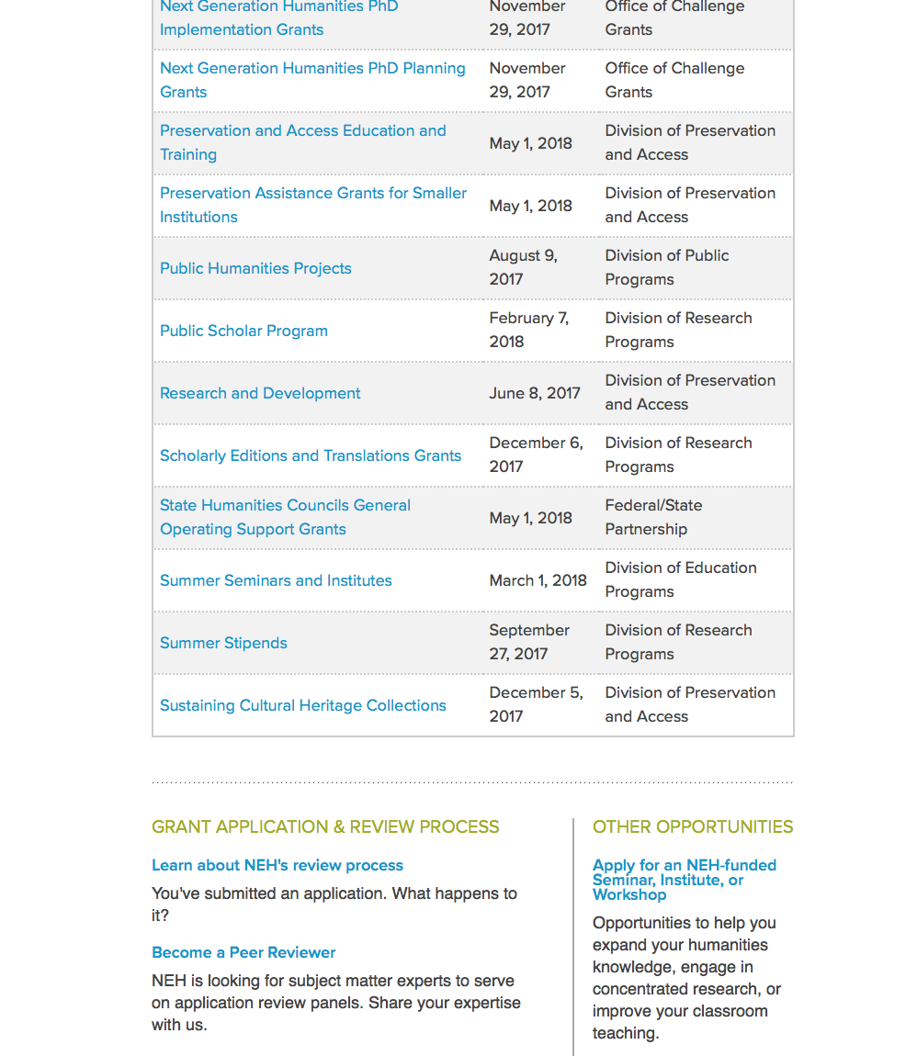

https://www.neh.gov/grants

Programs:

Collaborative Research Grants
Synopsis 1
Document Type: | Grants Notice
Funding Opportunity Number: | 20171206-RZ
Funding Opportunity Title: | Collaborative Research Grants
Opportunity Category: | Discretionary
Opportunity Category Explanation:
Funding Instrument Type: | Grant
Category of Funding Activity: | Humanities (see "Cultural Affairs" in CFDA)
Category Explanation:
Expected Number of Awards:
CFDA Number(s): | 45.161 -- Promotion of the Humanities Research
Cost Sharing or Matching Requirement: | No
Version: | Synopsis 1
Posted Date: | Oct 04, 2017
Last Updated Date: | Oct 04, 2017
Original Closing Date for Applications: | Dec 06, 2017
Current Closing Date for Applications: | Dec 06, 2017
Archive Date:
Estimated Total Program Funding:
Award Ceiling: | $250,000
Award Floor: | $1
Eligible Applicants: | Nonprofits having a 501(c)(3) status with the IRS, other than institutions of higher education  Private institutions of higher education  City or township governments  Special district governments  State governments  Native American tribal governments (Federally recognized)  Public and State controlled institutions of higher education  County governments  Individuals
Agency Name: | National Endowment for the Humanities
Description: | Debate, exchange of ideas, and working together—all are basic activities that advance humanities knowledge and foster rich scholarship that would not be possible by researchers working on their own. The Collaborative Research grant program encourages collaboration that proposes diverse approaches to topics, incorporates multiple points of view, and explores new avenues of inquiry that lead to publications and other resources for scholarly audiences and/or general audiences. Collaborative Research grants support groups of two or more scholars engaging in significant and sustained research in the humanities. The program seeks to encourage interdisciplinary work, both within the humanities and beyond. Projects that include partnerships with researchers from the natural and social sciences are encouraged, but they must remain firmly rooted in the humanities and must employ humanistic methods. Eligible projects must propose tangible and sustainable outcomes such as co-authored or multi-authored books; born-digital publications; themed issues of peer-reviewed journals; and content-rich, open-access digital resources (for example, websites, databases, or tools). All project outcomes must be based on and must convey interpretive humanities research. All grantees are expected to disseminate the results of their work to scholarly audiences and/or general audiences. Collaborative Research offers three types of awards to address different sorts of projects and stages of development. Type 1: Convening Grants – up to $50,000 Convening grants last one year and typically fund conferences and working group meetings to sharpen the chosen research topic and discuss and plan subsequent publication. Type 2: Publication Grants – up to $250,000 (no more than $100,000 per year) Publication grants last one to three years and support the project toward completion of its publication goals. Publications can appear in traditional print or in digital form. Note that costs paid to publishers and subventions are not supported. Type 3: Archaeology Grants – up to $250,000 (no more than $100,000 per year) Archaeology grants last one to three years and support projects that lead to publication.
Link to Additional Information: | https://www.neh.gov/grants/research/collaborative-research-grants
Grantor Contact Information: | If you have difficulty accessing the full announcement electronically, please contact:  If you have questions about the program, contact NEH's Division of Research Programs at 202-606-8200 and collaborative@neh.gov. collaborative@neh.gov  collaborative@neh.gov

http://www.grants.gov/web/grants/view-opportunity.html?oppId=297854

Scholarly Editions and Translations Grants
Synopsis 1
Document Type: | Grants Notice
Funding Opportunity Number: | 20171206-RQ
Funding Opportunity Title: | Scholarly Editions and Translations Grants
Opportunity Category: | Discretionary
Opportunity Category Explanation:
Funding Instrument Type: | Grant
Category of Funding Activity: | Humanities (see "Cultural Affairs" in CFDA)
Category Explanation:
Expected Number of Awards:
CFDA Number(s): | 45.161 -- Promotion of the Humanities Research
Cost Sharing or Matching Requirement: | No
Version: | Synopsis 1
Posted Date: | Oct 04, 2017
Last Updated Date: | Oct 04, 2017
Original Closing Date for Applications: | Dec 06, 2017
Current Closing Date for Applications: | Dec 06, 2017
Archive Date:
Estimated Total Program Funding:
Award Ceiling: | $300,000
Award Floor: | $1
Eligible Applicants: | State governments  Private institutions of higher education  Individuals  Nonprofits having a 501(c)(3) status with the IRS, other than institutions of higher education  Special district governments  Native American tribal governments (Federally recognized)  Public and State controlled institutions of higher education  City or township governments  County governments
Agency Name: | National Endowment for the Humanities
Description: | Scholarly Editions and Translations grants support the preparation of editions and translations of pre-existing texts of value to the humanities that are currently inaccessible or available only in inadequate editions or transcriptions. Typically, the texts and documents are significant literary, philosophical, and historical materials; but other types of work, such as musical notation, are also eligible. Projects must be undertaken by at least one editor or translator and one other collaborating scholar. These grants support full-time or part-time activities for periods of one to three years. Applicants should demonstrate familiarity with the best practices recommended by the Association for Documentary Editing or the Modern Language Association Committee on Scholarly Editions. Translation projects should also explain the theory and method adopted for the particular work to be translated. Editions and translations produced with NEH support contain scholarly and critical apparatus appropriate to their subject matter and format. This usually means introductions and annotations that provide essential information about a text’s form, transmission, and historical and intellectual context. Proposals for editions of foreign language materials in the original language are eligible for funding, as well as proposals for editions of translated materials.
Link to Additional Information: | https://www.neh.gov/grants/research/scholarly-editions-and-translations-grants
Grantor Contact Information: | If you have difficulty accessing the full announcement electronically, please contact:  If you have questions about the program, contact NEH's Division of Research Programs at 202-606-8200 and editions@neh.gov. editions@neh.gov  editions@neh.gov

http://www.grants.gov/web/grants/view-opportunity.html?oppId=297856

Sustaining Cultural Heritage Collections
Synopsis 1
Document Type: | Grants Notice
Funding Opportunity Number: | 20171205-PF
Funding Opportunity Title: | Sustaining Cultural Heritage Collections
Opportunity Category: | Discretionary
Opportunity Category Explanation:
Funding Instrument Type: | Grant
Category of Funding Activity: | Humanities (see "Cultural Affairs" in CFDA)
Category Explanation:
Expected Number of Awards:
CFDA Number(s): | 45.149 -- Promotion of the Humanities Division of Preservation and Access
Cost Sharing or Matching Requirement: | No
Version: | Synopsis 1
Posted Date: | Oct 04, 2017
Last Updated Date: | Oct 04, 2017
Original Closing Date for Applications: | Dec 05, 2017
Current Closing Date for Applications: | Dec 05, 2017
Archive Date:
Estimated Total Program Funding:
Award Ceiling: | $350,000
Award Floor: | $1
Eligible Applicants: | Special district governments  Native American tribal governments (Federally recognized)  Private institutions of higher education  City or township governments  Nonprofits having a 501(c)(3) status with the IRS, other than institutions of higher education  County governments  Public and State controlled institutions of higher education  State governments
Agency Name: | National Endowment for the Humanities
Description: | The Sustaining Cultural Heritage Collections (SCHC) program helps cultural institutions meet the complex challenge of preserving large and diverse holdings of humanities materials for future generations by supporting sustainable conservation measures that mitigate deterioration, prolong the useful life of collections, and support institutional resilience: the ability to anticipate and respond to natural and man-made disasters. Cultural institutions, including libraries, archives, museums, and historical organizations, face an enormous challenge: to preserve humanities collections that facilitate research, strengthen teaching, and provide opportunities for life-long learning. To ensure the preservation of books and manuscripts, photographs, sound recordings and moving images, archaeological and ethnographic artifacts, art, and historical objects, cultural institutions must implement measures that slow deterioration and prevent catastrophic loss from natural or man-made emergencies. They can accomplish this work most effectively through preventive conservation. Preventive conservation encompasses managing relative humidity, temperature, light, and pollutants in collection spaces; providing protective storage enclosures and systems for collections; and safeguarding collections from theft, fire, floods, and other disasters. As museums, libraries, archives, and other collecting institutions strive to be effective stewards of humanities collections, they must find ways to implement preventive conservation measures that are sustainable. This program therefore helps cultural repositories plan and implement preservation strategies that pragmatically balance effectiveness, cost, and environmental impact. Sustainable approaches to preservation can contribute to an institution’s financial health, reduce its use of fossil fuels, and benefit its green initiatives, while ensuring that collections are well cared for and available for use in humanities programming, education, and research. Sustainable preventive conservation measures may also aim to prepare and plan for, absorb, respond to, recover from, and more successfully protect collections in the event of natural or man-made disasters. Effective and sustainable preservation strategies must be informed by the nature of an institution and its collections. All applicants, whether at the planning or the implementation level, should have completed the process of basic preservation planning; they should also clearly state how sustainable strategies will address priorities established in existing preservation or collection management plans. Sustainable preservation strategies can take many forms, depending on collection materials, the building envelope, and the local climate. However, interdisciplinary collaboration during planning and implementation of these strategies is essential. In SCHC projects, such teams typically consist of consultants and members of the institution’s staff and can include architects, building engineers, conservation scientists, conservators, curators, archivists, and facilities managers, among others.
Link to Additional Information: | https://www.neh.gov/grants/preservation/sustaining-cultural-heritage-collections
Grantor Contact Information: | If you have difficulty accessing the full announcement electronically, please contact:  Sustaining Cultural Heritage Collections Division of Preservation and Access National Endowment for the Humanities 400 Seventh Street, SW Washington, DC 20506 202-606-8570 or preservation@neh.gov preservation@neh.gov  preservation@neh.gov

http://www.grants.gov/web/grants/view-opportunity.html?oppId=297837

Modifications:

Reminders:

Next Generation Humanities PhD Planning Grants
Synopsis 1
Document Type: | Grants Notice
Funding Opportunity Number: | 20171129-ZA
Funding Opportunity Title: | Next Generation Humanities PhD Planning Grants
Opportunity Category: | Discretionary
Opportunity Category Explanation:
Funding Instrument Type: | Grant
Category of Funding Activity: | Humanities (see "Cultural Affairs" in CFDA)
Category Explanation:
Expected Number of Awards:
CFDA Number(s): | 45.162 -- Promotion of the Humanities Teaching and Learning Resources and Curriculum Development
Cost Sharing or Matching Requirement: | Yes
Version: | Synopsis 1
Posted Date: | Sep 14, 2017
Last Updated Date: | Sep 14, 2017
Original Closing Date for Applications: | Nov 29, 2017
Current Closing Date for Applications: | Nov 29, 2017
Archive Date:
Estimated Total Program Funding:
Award Ceiling: | $50,000
Award Floor: | $2
Eligible Applicants: | Others (see text field entitled "Additional Information on Eligibility" for clarification)
Additional Information on Eligibility: | The only eligible applicants are U.S. nonprofit institutions of higher education with PhD programs in the humanities.
Agency Name: | National Endowment for the Humanities
Description: | In recent years, research published by Humanities Indicators, among others, has revealed that humanities PhDs pursue careers in many different professions—both inside and outside academia. Yet most humanities PhD programs in the United States still prepare students primarily for tenure-track professor positions at colleges and universities. The increasing shortage of such positions has changed students’ expected career outcomes. NEH therefore hopes to assist universities in devising a new model of doctoral education, which can both transform the understanding of what it means to be a humanities scholar and promote the integration of the humanities in the public sphere. Next Generation Humanities PhD Planning Grants support universities in preparing to institute wide-ranging changes in humanities doctoral programs. Humanities knowledge and methods can make an even more substantial impact on society if students are able to translate what they learn in doctoral programs into a multitude of careers. Next Generation Humanities PhD Planning Grants are designed to bring together various important constituencies to discuss and strategize, and then to produce plans that will transform scholarly preparation in the humanities at the doctoral level. Students will be prepared to undertake various kinds of careers, and humanities PhD programs will increase their relevance for the twenty-first century. Grantee institutions must provide funds raised from nonfederal third parties equal to the grant funds released by NEH.
Link to Additional Information: | https://www.neh.gov/grants/education/next-generation-humanities-phd-planning-grants
Grantor Contact Information: | If you have difficulty accessing the full announcement electronically, please contact:  nextgen@neh.gov 202-606-8500 nextgen@neh.gov  nextgen@neh.gov

http://www.grants.gov/web/grants/view-opportunity.html?oppId=297393



National Science Foundation

General Funding Overview

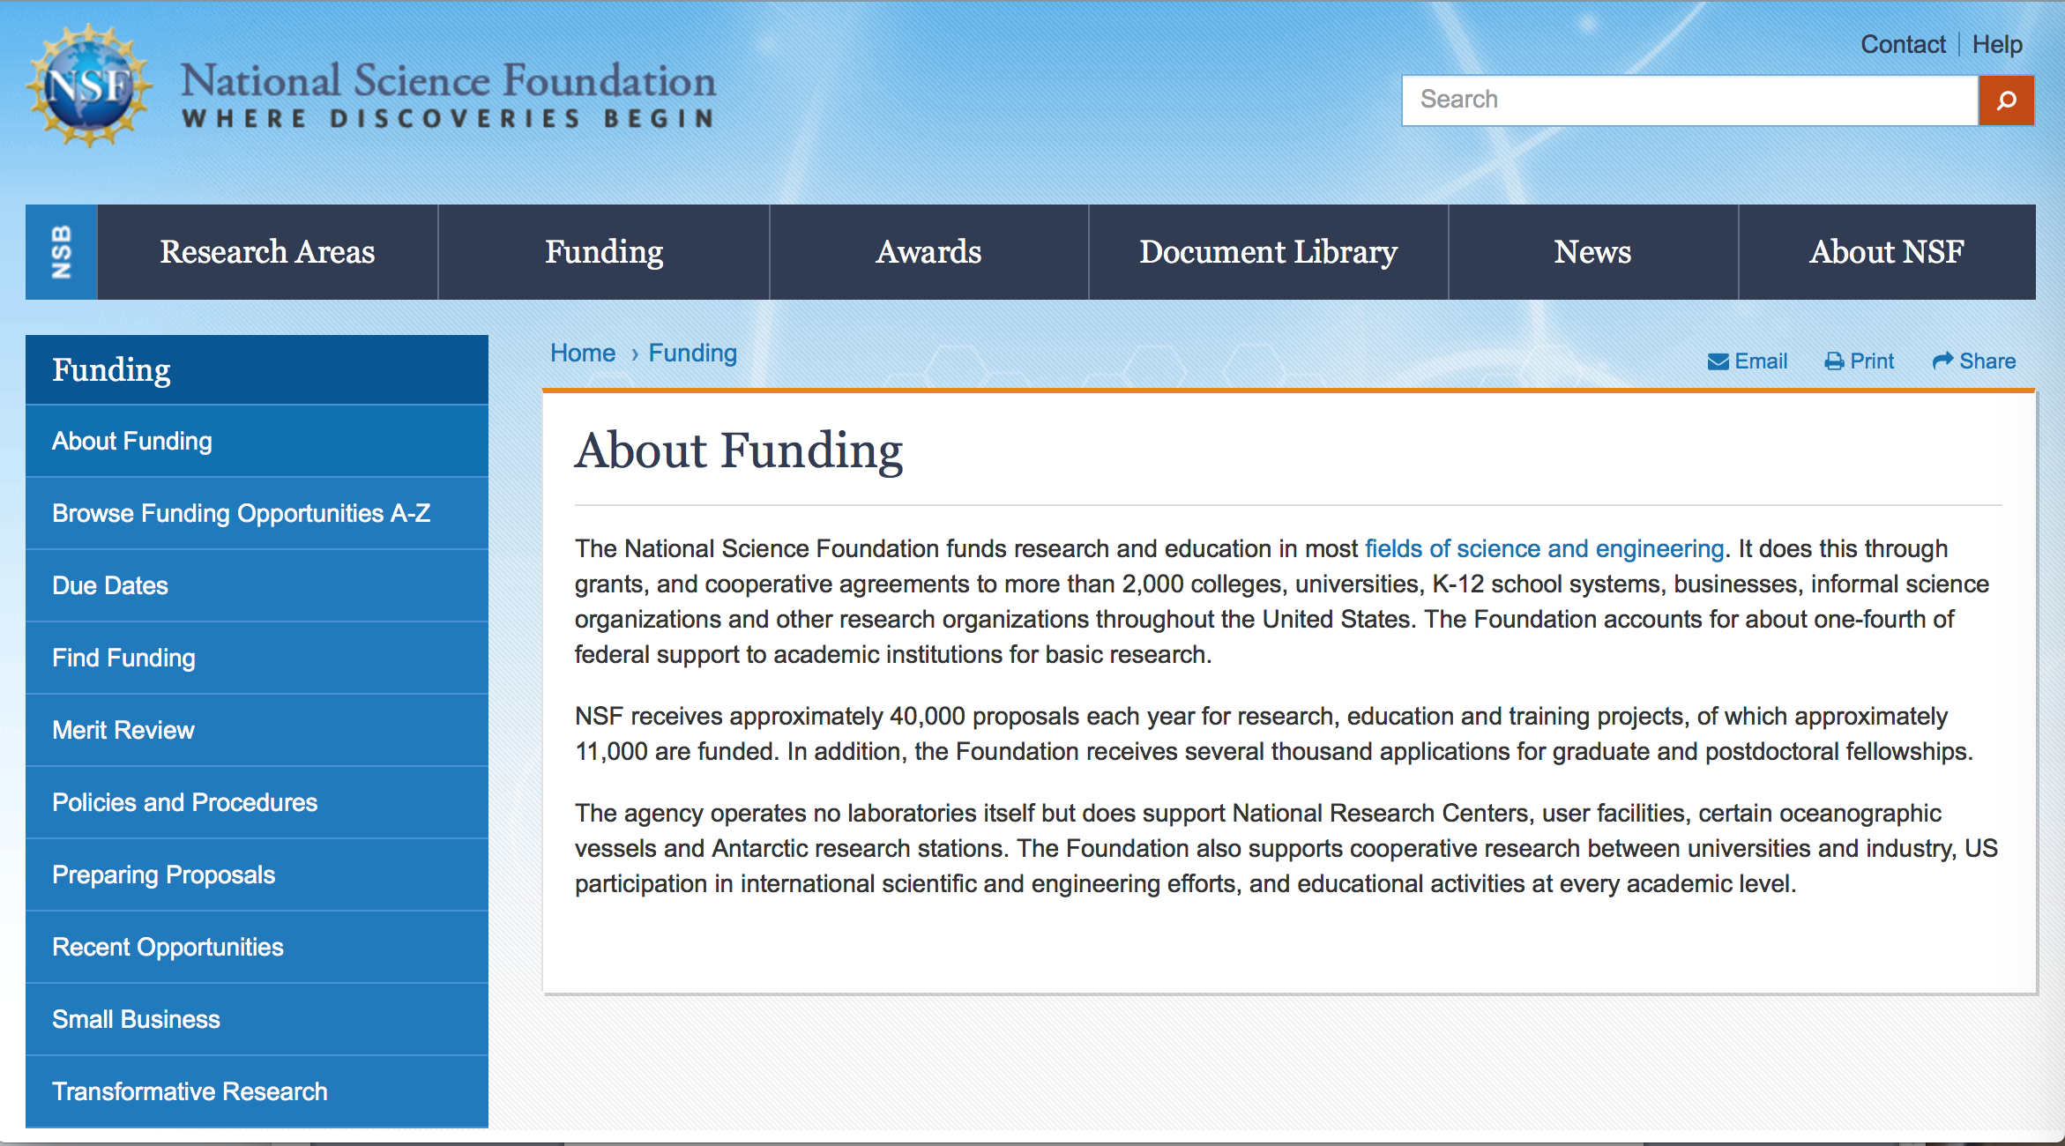

For assistance: https://nsf.gov/funding/aboutfunding.jsp

The National Science Foundation funds research and education in most fields of science and engineering. It does this through grants, and cooperative agreements to more than 2,000 colleges, universities, K-12 school systems, businesses, informal science organizations and other research organizations throughout the United States. The Foundation accounts for about one-fourth of federal support to academic institutions for basic research.
NSF receives approximately 40,000 proposals each year for research, education and training projects, of which approximately 11,000 are funded. In addition, the Foundation receives several thousand applications for graduate and postdoctoral fellowships.
The agency operates no laboratories itself but does support National Research Centers, user facilities, certain oceanographic vessels and Antarctic research stations. The Foundation also supports cooperative research between universities and industry, US participation in international scientific and engineering efforts, and educational activities at every academic level.

For details on active funding deadline dates: http://nsf.gov/funding/pgm_list.jsp?org=NSF&ord=date

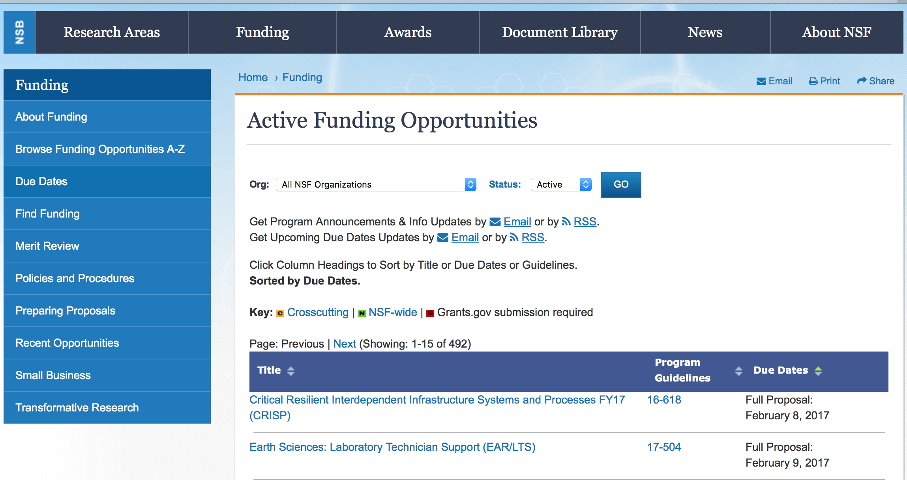

Biological Anthropology Program - Doctoral Dissertation Research Improvement Grants
Synopsis 1
http://www.grants.gov/web/grants/view-opportunity.html?oppId=298158

Campus Cyberinfrastructure
Synopsis 1
http://www.grants.gov/web/grants/view-opportunity.html?oppId=298221

Centers of Research Excellence in Science and Technology (CREST) and HBCU Research Infrastructure for Science and Engineering (HBCU-RISE)
Synopsis 1
http://www.grants.gov/web/grants/view-opportunity.html?oppId=298220

Collaborative Research in Computational Neuroscience
Synopsis 1
http://www.grants.gov/web/grants/view-opportunity.html?oppId=297871

Condensed Matter and Materials Theory
Synopsis 1
http://www.grants.gov/web/grants/view-opportunity.html?oppId=297843

Dynamics of Coupled Natural and Human Systems
Synopsis 1
http://www.grants.gov/web/grants/view-opportunity.html?oppId=298133

Enabling Discovery through Genomic Tools
Synopsis 1
http://www.grants.gov/web/grants/view-opportunity.html?oppId=298130

Enabling Discovery through Genomic Tools
Synopsis 1
http://www.grants.gov/web/grants/view-opportunity.html?oppId=298130

EPSCoR Research Infrastructure Improvement Program: Track-2 Focused EPSCoR Collaborations (RII Track-2 FEC)
Synopsis 1
http://www.grants.gov/web/grants/view-opportunity.html?oppId=298038

International Research Experiences for Students
Synopsis 1
http://www.grants.gov/web/grants/view-opportunity.html?oppId=298171

National Science Foundation Research Traineeship (NRT) Program
Synopsis 1
http://www.grants.gov/web/grants/view-opportunity.html?oppId=298129

Partnerships for Innovation
Synopsis 1
http://www.grants.gov/web/grants/view-opportunity.html?oppId=298272

Research Coordination Networks in Undergraduate Biology Education
Synopsis 1
http://www.grants.gov/web/grants/view-opportunity.html?oppId=298271

Solar, Heliospheric, and INterplanetary Environment
Synopsis 1
http://www.grants.gov/web/grants/view-opportunity.html?oppId=297842

Modifications:

12-551 - International Research Experiences for Students
Deletion Comments: Opportunity deleted

14-601 - Dynamics of Coupled Natural and Human Systems
Deletion Comments: Opportunity deleted

16-596 - Condensed Matter and Materials Theory
Deletion Comments: Opportunity deleted

14-601 - Dynamics of Coupled Natural and Human Systems
Deletion Comments: Opportunity deleted

17-506 - Biological Anthropology Program - Doctoral Dissertation Research Improvement Grants
Deletion Comments: Opportunity deleted

17-549 - GeoPRISMS Program
Deletion Comments: Opportunity deleted

17-563 - Provision of Marine Seismic Capabilities to the U. S. Research Community
Deletion Comments: Opportunity deleted

Reminders:

Deleted:

Nuclear Regulatory Commission

Reminders:

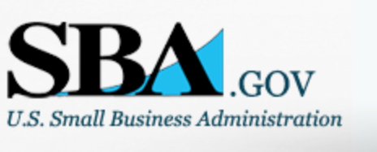

Small Business Administration

General Overview Finding Loans & Grants

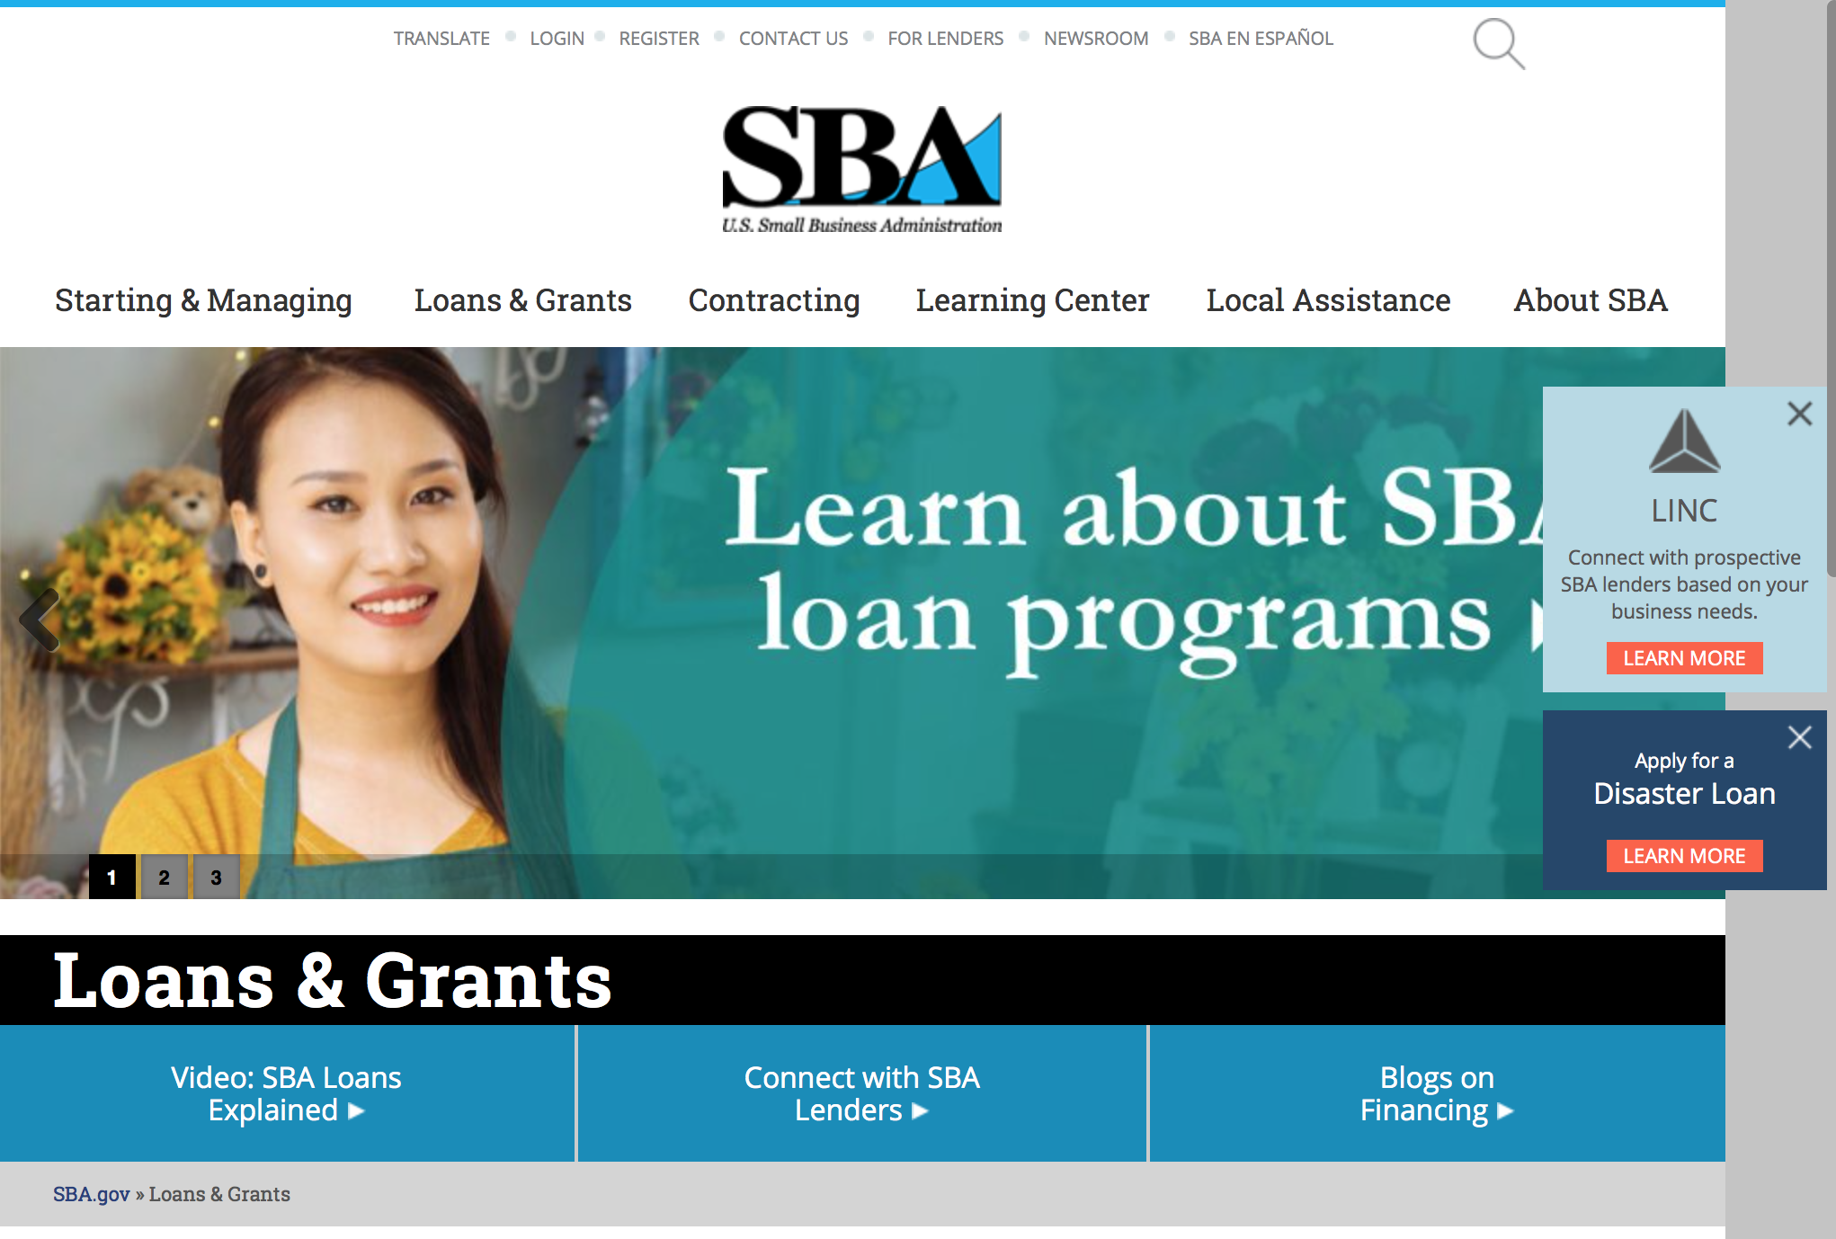
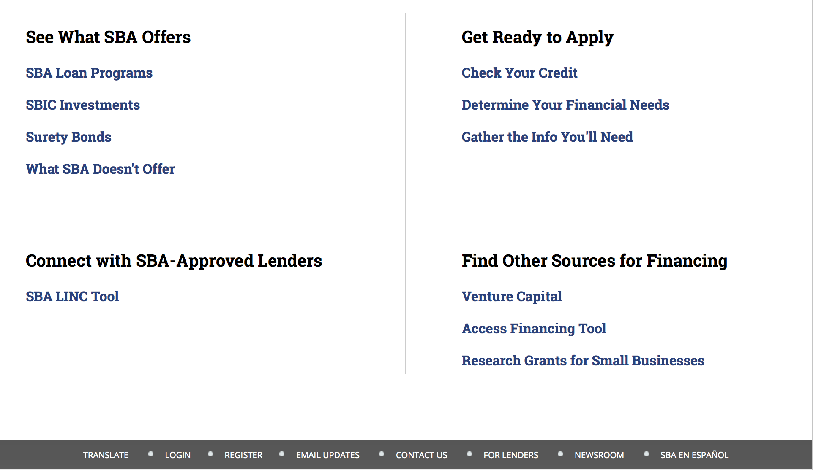

https://www.sba.gov/category/navigation-structure/loans-grants
Federal, state and local governments offer a wide range of financing programs to help small businesses start and grow their operations. These programs include low-interest loans, venture capital, and scientific and economic development grants.
Use SBA.gov's Loans and Grants Search Tool to get a list of financing programs for which you may qualify, or visit the resources below to learn more about small business financing programs.
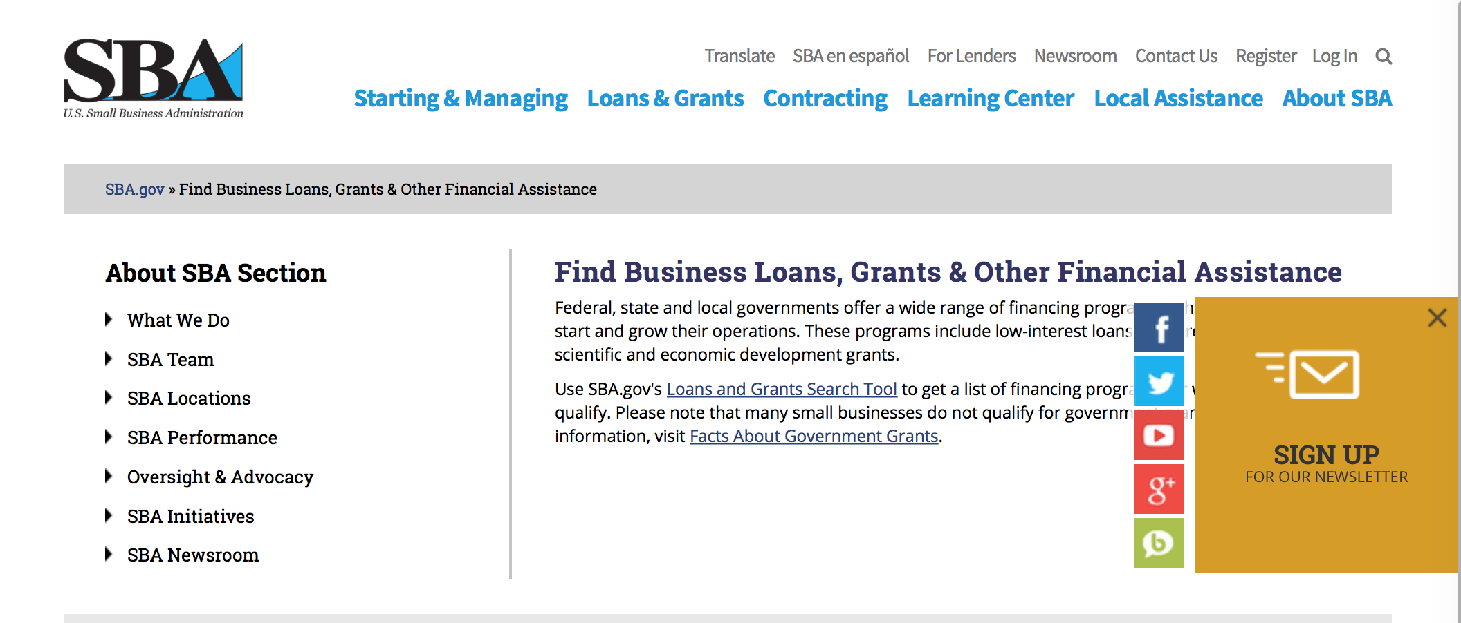
To get to the main SBA.gov funding page click here
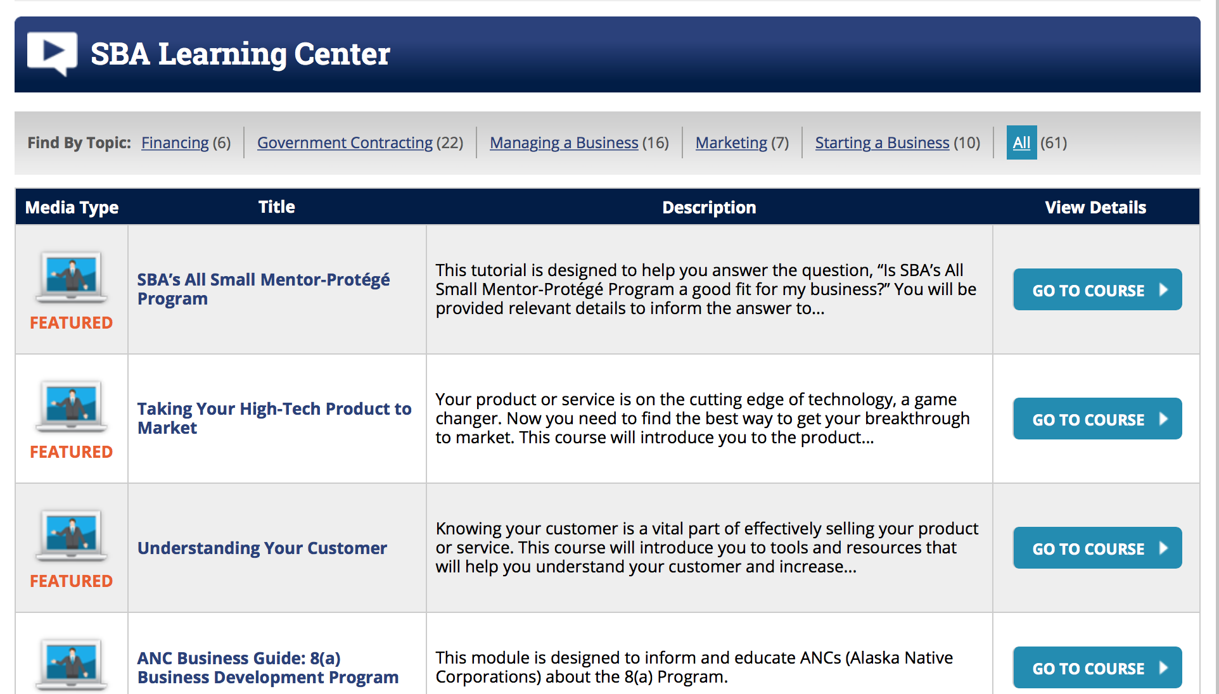
https://www.sba.gov/tools/sba-learning-center/search/training

Programs:

Modifications

Reminders:

Deleted:

SBA Trainings

Contracting Opportunities for Veteran Entrepreneurs
This self-paced training exercise is an introduction to Federal contracting opportunities for Veterans.
Topics include basic information about Veteran-owned businesses and opportunities, services available to small Veteran-owned businesses, small business incentives, and government procurement methods.
Duration: 00:30:00

http://www.sba.gov/tools/sba-learning-center/training/contracting-opportunities-veteran-entrepreneurs

Interested in Exporting? These Four Resources Can Help
Did you know that two-thirds of the world’s purchasing power is in foreign countries? As the numbers show, the international marketplace is a big one. So if you’re interested in exploring the world of exporting – or have gotten started but could use some guidance – check out these resources to help.
- Read more

Upcoming Trainings: Check out SBA's Online Training!
- Financing Options for Small Businesses
How to Prepare Government Contract Proposals
Getting Started With Exporting: Training and Educational Resources
Exporting represents a big opportunity to tap in to new markets, expand your customer base and grow your business. But getting started with exporting can sometimes feel like a maze of regulations, policies, and other barriers. Here are some free training and educational resources to help.
- Read more

For Specific Information in Hawaii see the following links:
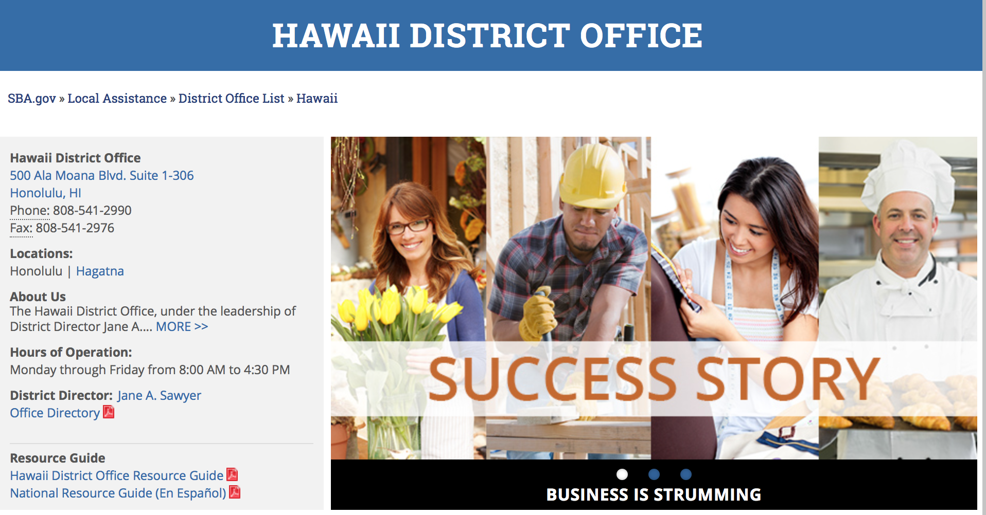

https://www.sba.gov/offices/district/hi/Honolulu

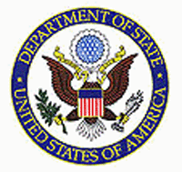

State Department General Overview and Resources for Program Administrators

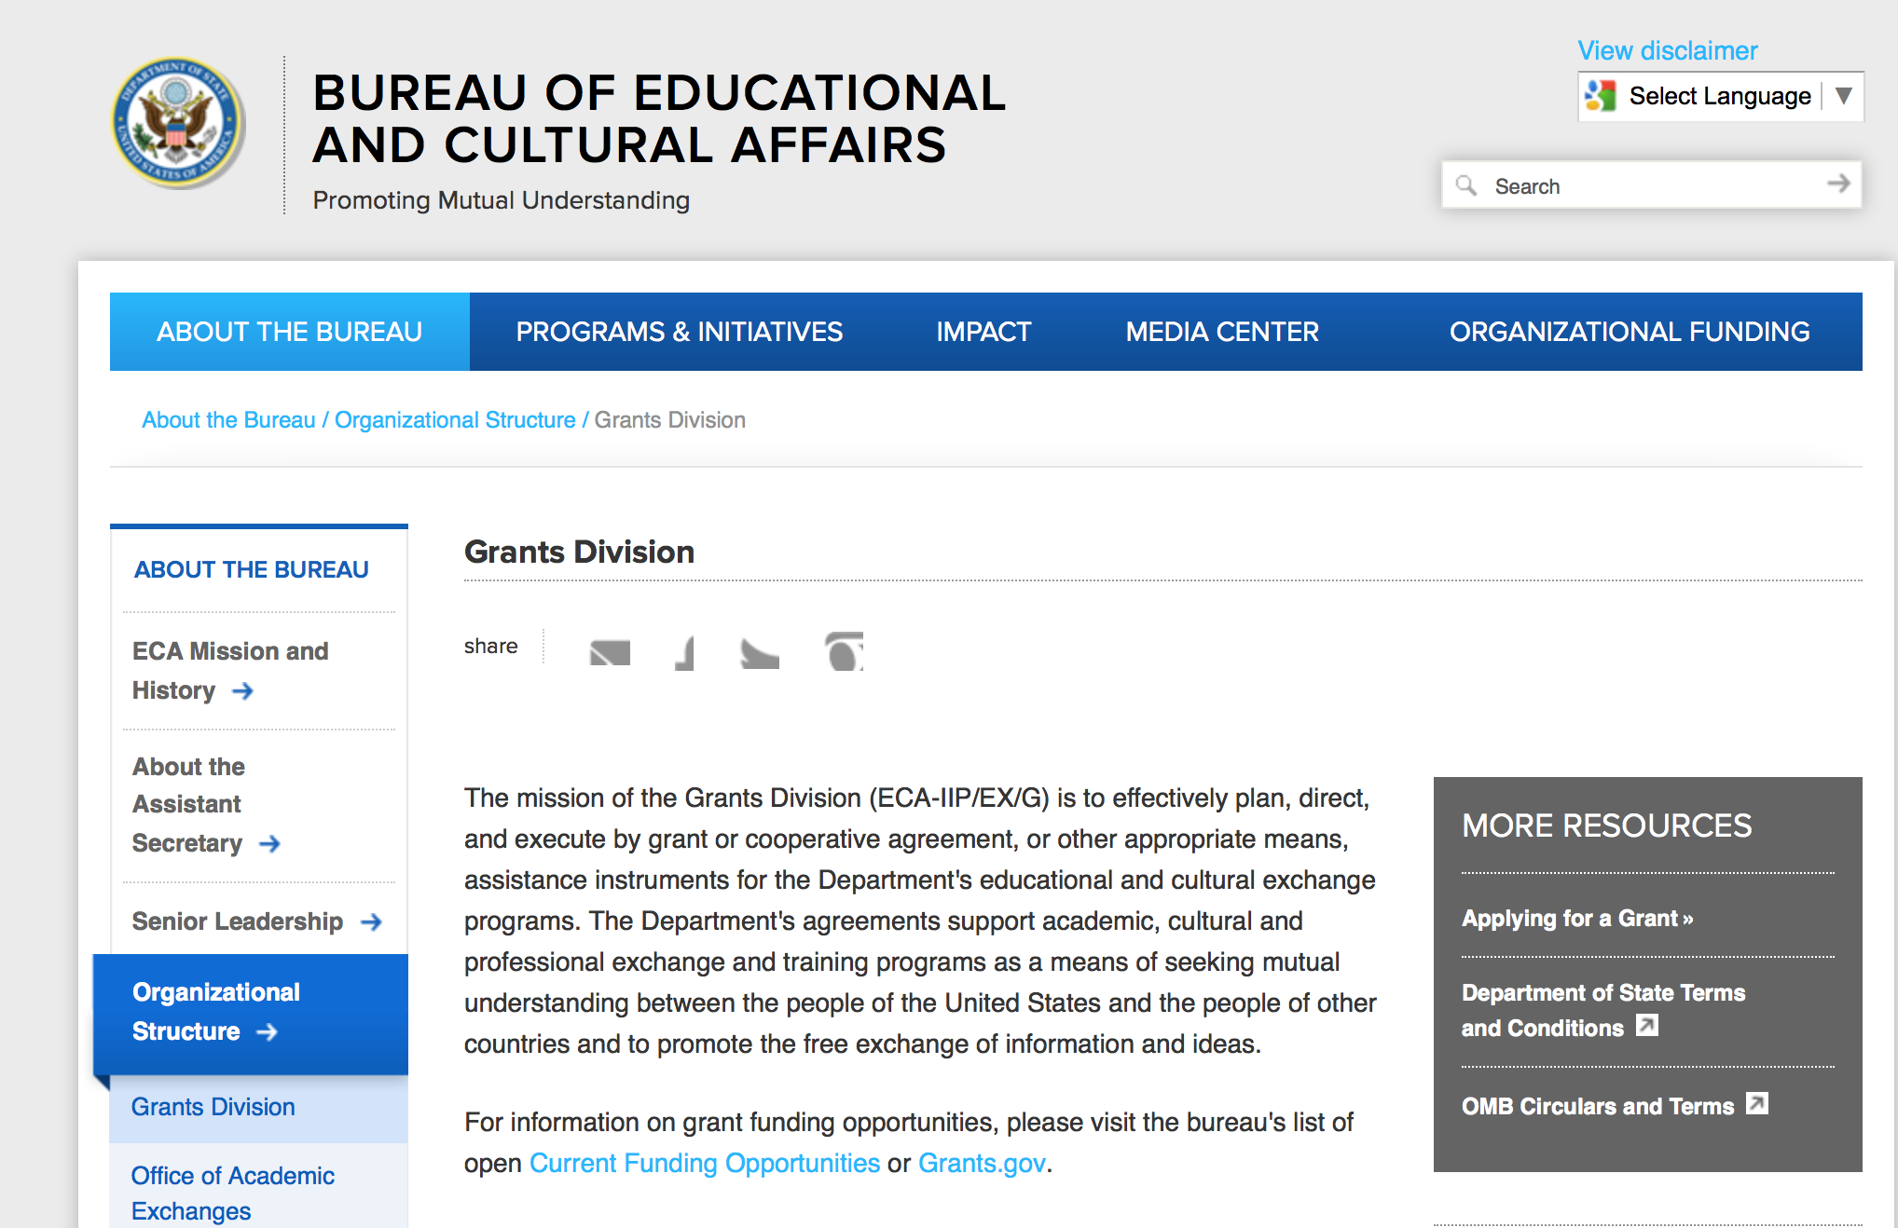

https://eca.state.gov/about-bureau/organizational-structure/grants-division

http://eca.state.gov/search/solr/grants?search_referrer=node/237

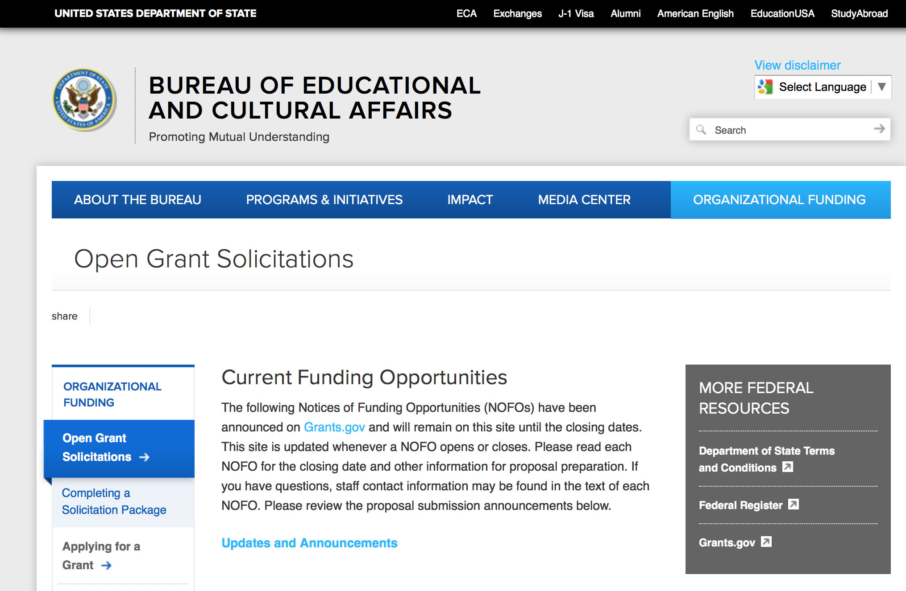
https://eca.state.gov/organizational-funding/open-grant-solicitations

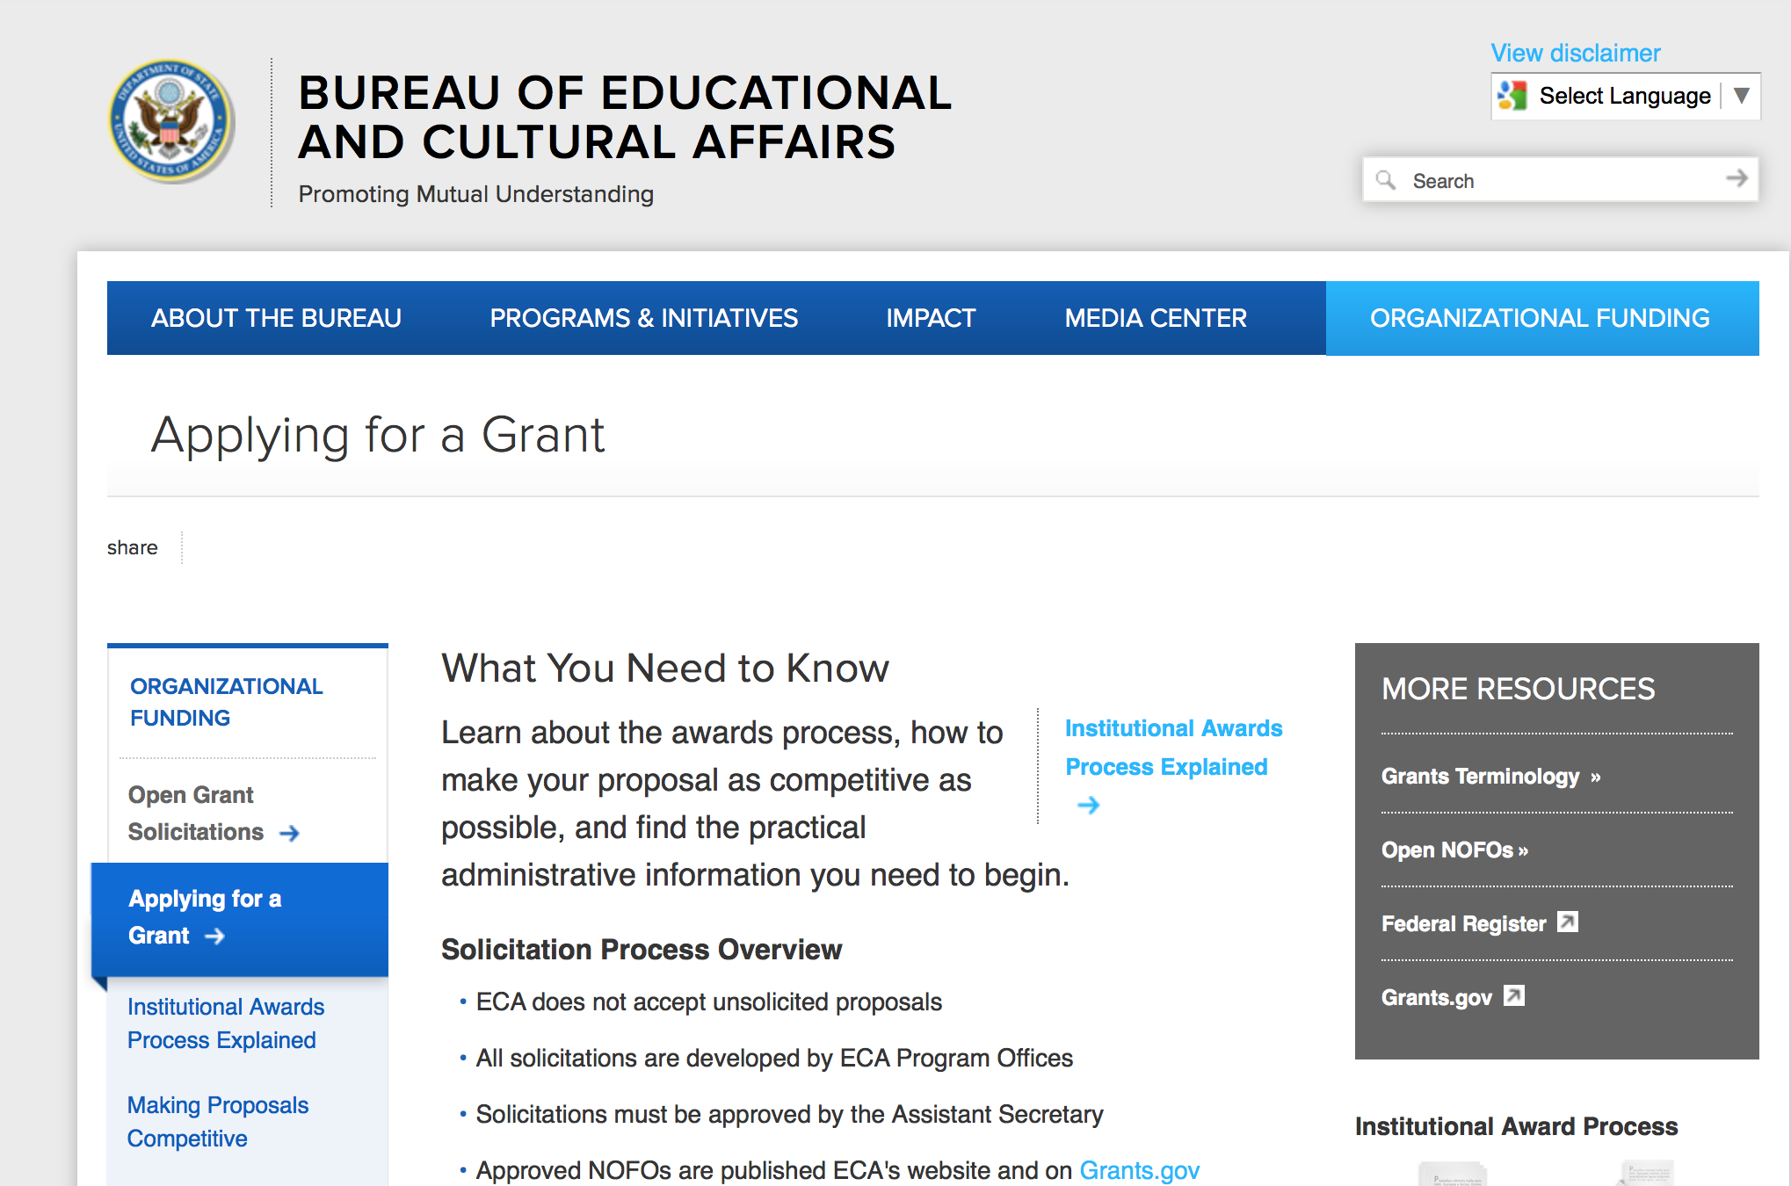
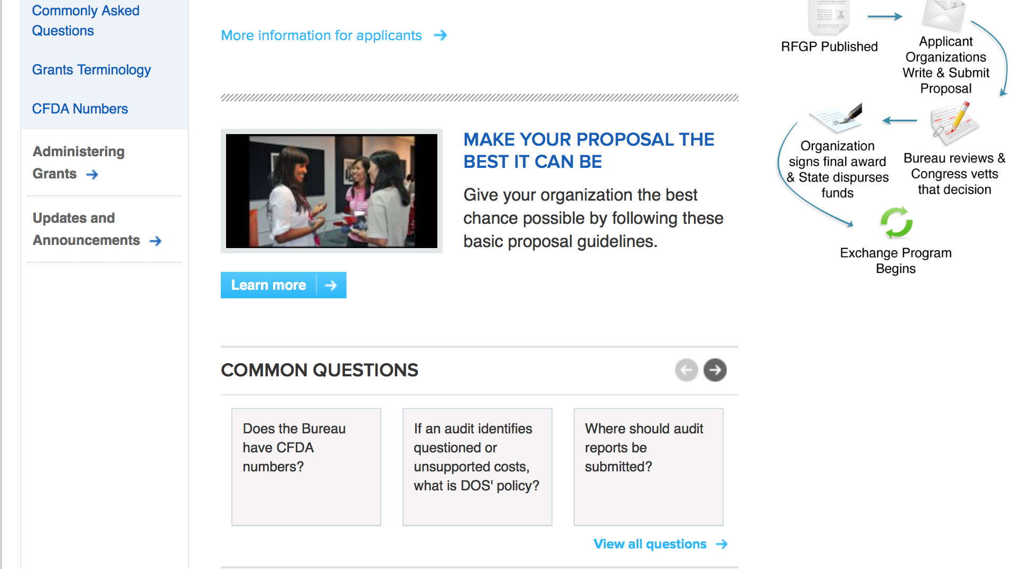
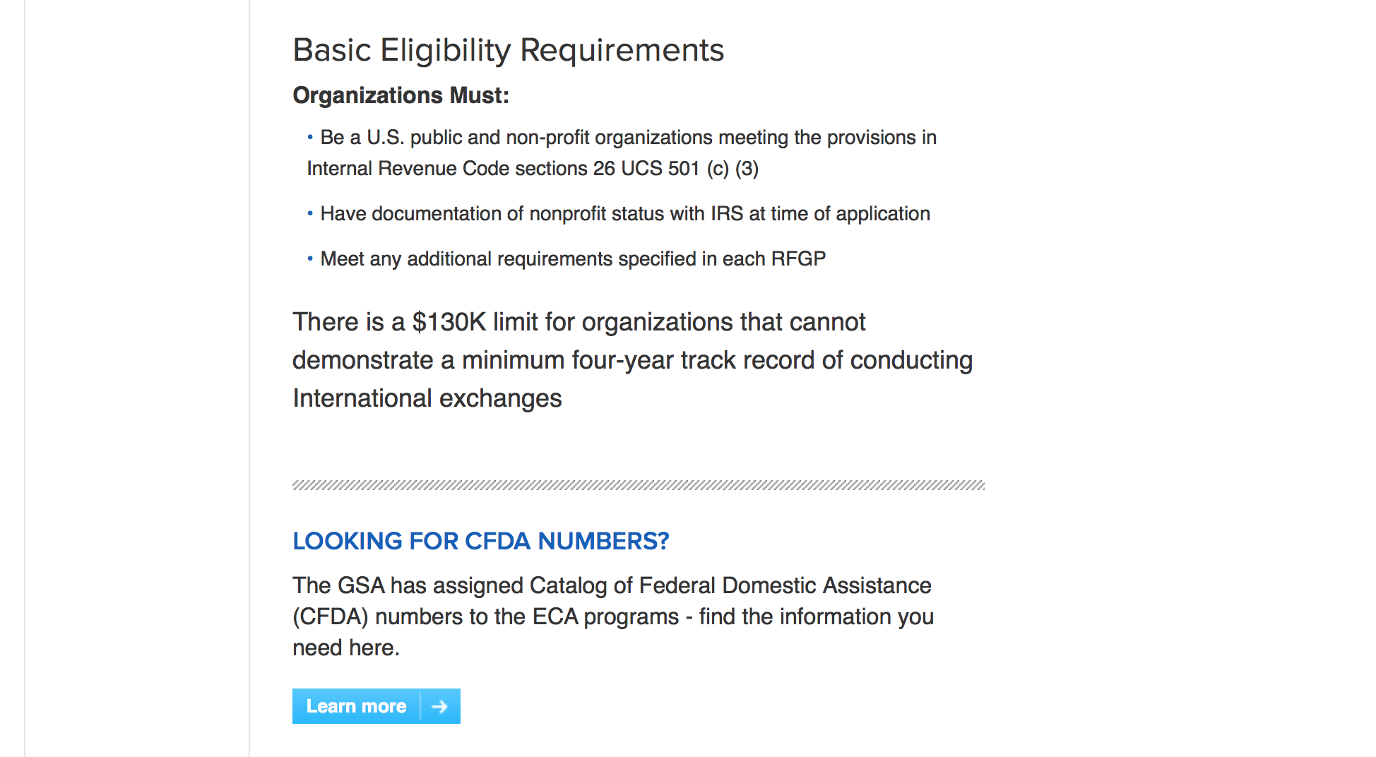
http://eca.state.gov/organizational-funding/applying-grant

General Information:
- Bureau of Educational and Cultural Affairs Grants Division
- Open Grant Opportunities (Requests for Grant Proposals)

For General Information click here

Program Grants:

Bureau Of Educational and Cultural Affairs
FY 2018 Jovenes en Accion Program
Synopsis 1
http://www.grants.gov/web/grants/view-opportunity.html?oppId=298218

Bureau Of Educational and Cultural Affairs
FY 2018 Study of the U.S. Institutes for Secondary Educators
Synopsis 1
http://www.grants.gov/web/grants/view-opportunity.html?oppId=298152

Bureau Of Educational and Cultural Affairs
FY 2018 Study of the U.S. Institutes for Student Leaders on Women's Leadership
Synopsis 1
http://www.grants.gov/web/grants/view-opportunity.html?oppId=298153

Bureau Of Educational and Cultural Affairs
FY 2018 TechGirls Program
Synopsis 1
http://www.grants.gov/web/grants/view-opportunity.html?oppId=298154

Public Affairs
FY18 International Media Reporting Program
Synopsis 1
http://www.grants.gov/web/grants/view-opportunity.html?oppId=297834

Office to Monitor-Combat Trafficking in Persons
FY 2018 TIP Office International Programs to Combat Human Trafficking Funding Opportunity - SOIs
Synopsis 1
http://www.grants.gov/web/grants/view-opportunity.html?oppId=297971

PM Weapons Removal and Abatement
18.PMWRA.Iraq.ThirdPartyMonitoring.NOFO
Synopsis 1 & 2
http://www.grants.gov/web/grants/view-opportunity.html?oppId=297934

Modifications:

Bureau of Democracy Human Rights and Labor
Promotion and Protection of the Human Rights of LGBTI Persons
Synopsis 2
http://www.grants.gov/web/grants/view-opportunity.html?oppId=297674

U.S. Mission to Nicaragua
Managua Annual Program Statement - PAS Small Grants Program
Synopsis 13
http://www.grants.gov/web/grants/view-opportunity.html?oppId=297148

Public Affairs
FY18 International Media Reporting Program
Synopsis 2
http://www.grants.gov/web/grants/view-opportunity.html?oppId=297834

Reminders:

Deleted:

Bureau of Democracy Human Rights and Labor
DRLA-DRLAQM-17-089 - Promote and Protect the Human Rights of Persons with Disabilities, Women and Girls, LGBTI persons and other Marginalized Individuals
Deletion Comments: Opportunity deleted

U.S. Mission to India
ND-NOFO-17-109 - Engaging Youth and Political Leaders from North India (REPOST)
Deletion Comments: Opportunity deleted

Department of Transportation

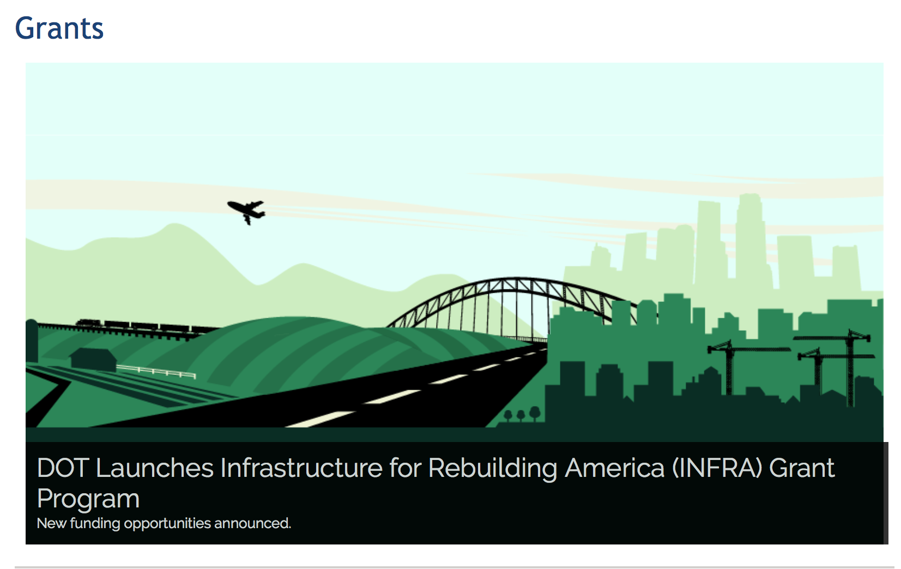

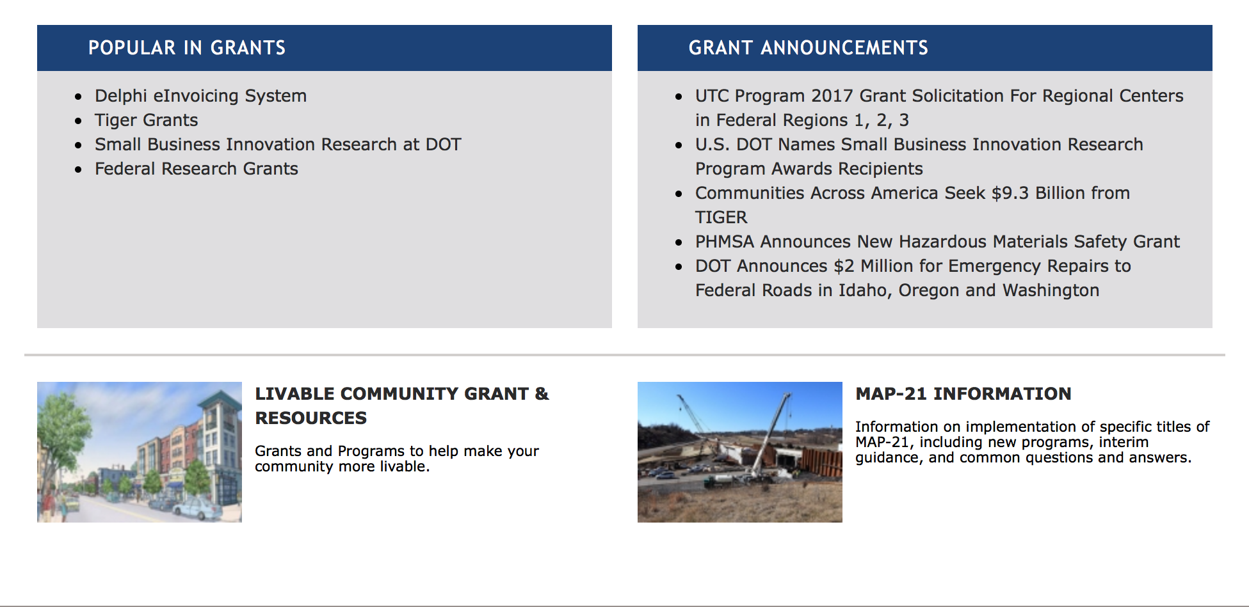

General Grant Program Overview https://www.transportation.gov/grants

Programs:

DOT - Office of Aviation Analysis
Small Community Air Service Development Program
Synopsis 1

Document Type: | Grants Notice
Funding Opportunity Number: | DOT-OST-2017-0155
Funding Opportunity Title: | Small Community Air Service Development Program
Opportunity Category: | Discretionary
Opportunity Category Explanation:
Funding Instrument Type: | Grant
Category of Funding Activity: | Transportation
Category Explanation:
Expected Number of Awards: | 40
CFDA Number(s): | 20.930 -- Payments for Small Community Air Service Development
Cost Sharing or Matching Requirement: | No
Version: | Synopsis 1
Posted Date: | Oct 18, 2017
Last Updated Date: | Oct 17, 2017
Original Closing Date for Applications: | Dec 15, 2017 Applications of no more than 20 one-sided pages each (excluding the completed Application for Federal Domestic Assistance (SF424), Summary Information schedule, and any letters from the community or an air carrier showing support for the application), including all required information, must be submitted to www.grants.gov no later than 4:00 PM EST on December 15, 2017.
Current Closing Date for Applications: | Dec 15, 2017 Applications of no more than 20 one-sided pages each (excluding the completed Application for Federal Domestic Assistance (SF424), Summary Information schedule, and any letters from the community or an air carrier showing support for the application), including all required information, must be submitted to www.grants.gov no later than 4:00 PM EST on December 15, 2017.
Archive Date: | Jan 14, 2018
Estimated Total Program Funding: | $10,000,000
Award Ceiling: | $10,000,000
Award Floor: | $0
Eligible Applicants: | Others (see text field entitled "Additional Information on Eligibility" for clarification)
Additional Information on Eligibility: | Eligible applicants are small communities that meet the following statutory criteria under 49 U.S.C. § 41743, as amended by Pub. L. No. 114-113: 1. (a) The airport serving the community or consortium is not larger than a small hub airport, according to FAA hub classifications effective on the date of service of this Order, or (b) As of calendar year 1997, the airport serving the community or consortium was not larger than a small hub airport, and 2. It has insufficient air carrier service or unreasonably high air fares; and 3. The airport serving the community presents characteristics, such as geographic diversity or unique circumstances that demonstrate the need for, and feasibility of, grant assistance from the Small Community Program. No more than four communities or consortia of communities, or a combination thereof, from the same State may be selected to participate in the program in any fiscal year. No more than 40 communities or consortia of communities, or a combination thereof, may be selected to participate in the program in each year for which the funds are appropriated. Consortium Applications: Both individual communities and consortia of communities are eligible for SCASDP funds. An application from a consortium of communities must be one that seeks to facilitate the efforts of the communities working together toward one joint grant project, with one joint objective, including the establishment of one entity to ensure that the joint objective is accomplished. Communities Without Existing Air Service: Communities that do not currently have commercial air service are eligible for SCASDP funds. Essential Air Service Communities: Small communities that currently receive subsidized air service under the Essential Air Service (“EAS”) or Alternate Essential Air Service (“AEAS”) program will not be considered for SCASDP funds. The EAS statute (49 U.S.C. § 41733(c)(E)) now includes a provision requiring that the Department consider whether an air carrier has included a marketing proposal in its proposal to provide subsidized EAS as part of the carrier selection criteria. In light of this and the scarcity of SCASDP funds, the Department will not consider awarding additional Federal support under SCASDP for the marketing of subsidized EAS air service. Applicants should also keep in mind the following statutory restrictions on eligible projects: • An applicant may not receive an additional grant to support the same project from a previous grant. • An applicant may not receive an additional grant, prior to the completion of its previous grant. See the full Order for more information on these 2 conditions.
Agency Name: | DOT - Office of Aviation Analysis
Description: | The Small Community Program was established by the Wendell H. Ford Aviation Investment and Reform Act for the 21st Century (Pub. L. No. 106-181), reauthorized by the Vision 100-Century of Aviation Reauthorization Act (Pub. L. No. 108-176), and subsequently reauthorized by the FAA Modernization and Reform Act of 2012 (Pub. L. No. 112-95) (FAA 2012), as amended. The program is designed to provide financial assistance to small communities in order to help them enhance their air service. The Department provides this assistance in the form of monetary grants that are disbursed on a reimbursable basis. Authorization for this program is codified at 49 U.S.C. § 41743. The Small Community Program is authorized to receive appropriations under 49 U.S.C. § 41743(e)(2), as amended. Appropriations are provided for this program for award selection in FY 2016 pursuant to FAA 2012, the Consolidated Appropriations Act, 2016 (Pub. L. No. 114-113), as extended through FY 2017 by the Continuing Appropriations and Military Construction, Veterans Affairs, and Related Agencies Appropriations Act, 2017, and Zika Response and Preparedness Act (Pub. L. No. 114-223). In addition, the FAA Extension, Safety, and Security Act of 2016 (Pub. L. No. 114-190) amended 49 U.S.C. § 41743(e)(2) to authorize the program to receive an additional $6 million in appropriations through FY 2017. The FY17 Continuing Appropriations Act (Pub. L. No. 115-31 (May 5, 2017)) then provided additional appropriations for the program.
Link to Additional Information: | SCASDP website
Grantor Contact Information: | If you have difficulty accessing the full announcement electronically, please contact:  Vince Corsaro Transportation Industry Analyst Phone 202-366-1842  vince.corsaro@dot.gov

http://www.grants.gov/web/grants/view-opportunity.html?oppId=298018

Modifications:

Research:

Reminders:

DOT - FAA Aviation Research Grants
FAA Aviation Research and Development Grants
Synopsis 3, 4 & 6

Document Type: | Grants Notice
Funding Opportunity Number: | 12-01
Funding Opportunity Title: | FAA Aviation Research and Development Grants
Opportunity Category: | Discretionary
Opportunity Category Explanation:
Funding Instrument Type: | Grant
Category of Funding Activity: | Transportation
Category Explanation:
Expected Number of Awards:
CFDA Number(s): | 20.108 -- Aviation Research Grants
Cost Sharing or Matching Requirement: | No
Version: | Synopsis 6
Posted Date: | Jan 01, 2012
Last Updated Date: | Oct 18, 2017
Original Closing Date for Applications: | Dec 31, 2019
Current Closing Date for Applications: | Dec 31, 2019
Archive Date: | Jan 30, 2020
Estimated Total Program Funding:
Award Ceiling: | $5,000,000
Eligible Applicants: | Private institutions of higher education  Nonprofits having a 501(c)(3) status with the IRS, other than institutions of higher education  Public and State controlled institutions of higher education
Agency Name: | DOT - FAA Aviation Research Grants
Description: | The FAA is soliciting proposals for research grants and cooperative agreements to pursue the long-term growth and short-term technical needs of civil aviation. In order to streamline the application process, it is recommended that all prospective grantees submit a white paper (letter of intent) for agency technical review before complete proposal submission. Please be sure to identify the specific area of interest (Solicitation FAA-12-01 – Chapter I. FAA Research Grants Program, Technical Areas of Research #1-#9). The white paper shall be no longer than three (3) pages and shall detail overall research objectives.
Link to Additional Information:
Grantor Contact Information: | If you have difficulty accessing the full announcement electronically, please contact:  Nicole Saiauskie Grants Officer Phone 609-485-4781  business

http://www.grants.gov/web/grants/view-opportunity.html?oppId=134953

Deleted:

Department of the Treasury

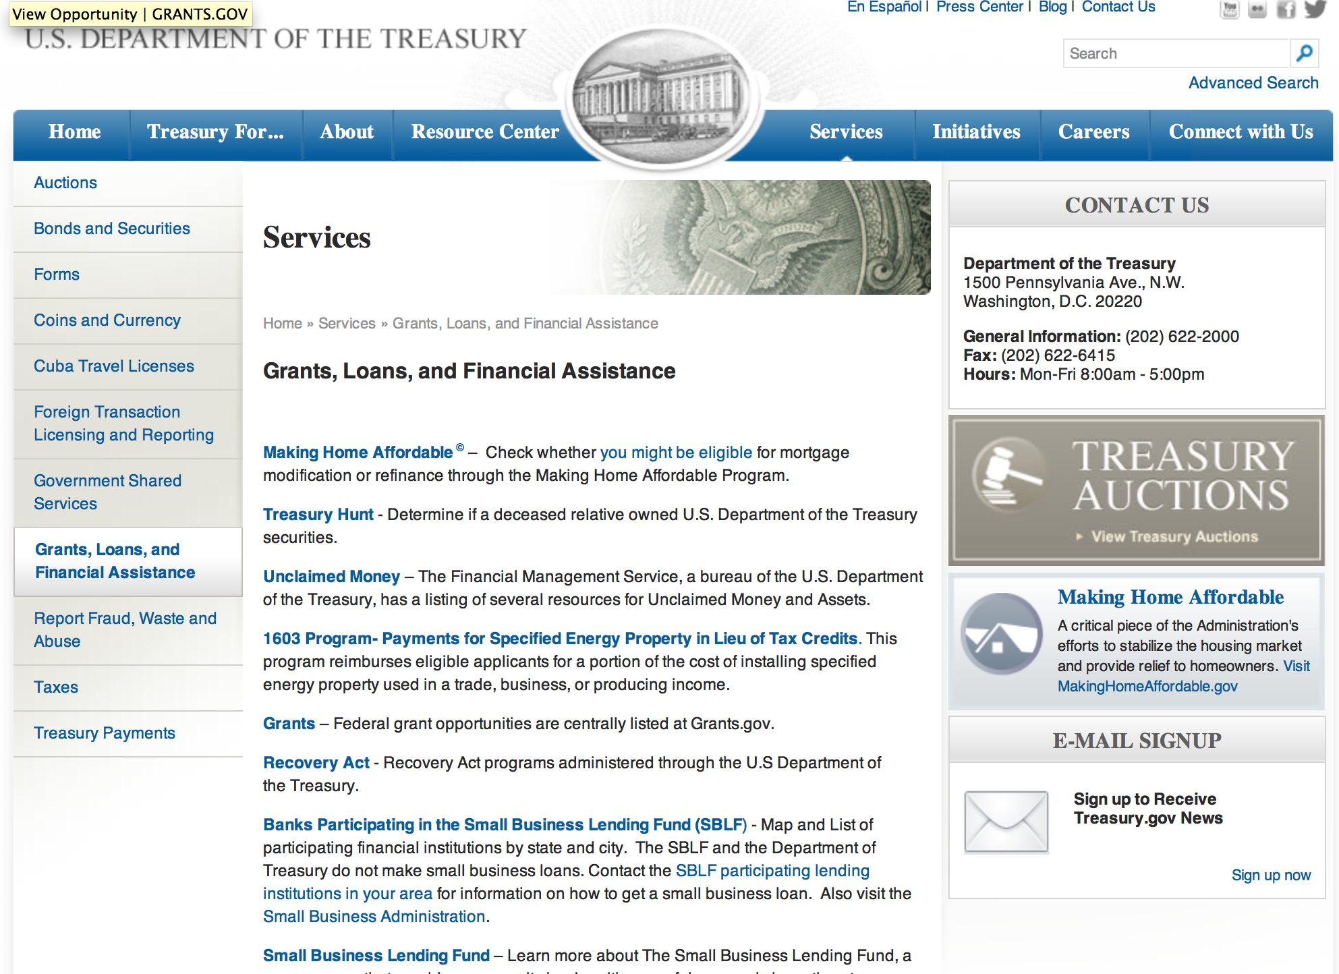

http://www.treasury.gov/services/Pages/Grants-Loans-and-Financial-Assistance.aspx

Programs:

Modifications:

Reminders:

Community Development Financial Institutions
FY 2017 Bank Enterprise Award Program Application
Synopsis 1

Document Type: | Grants Notice
Funding Opportunity Number: | CDFI-2017-BEA
Funding Opportunity Title: | FY 2017 Bank Enterprise Award Program Application
Opportunity Category: | Discretionary
Opportunity Category Explanation:
Funding Instrument Type: | Grant
Category of Funding Activity: | Community Development
Category Explanation:
Expected Number of Awards: | 90
CFDA Number(s): | 21.021 -- Bank Enterprise Award Program
Cost Sharing or Matching Requirement: | No
Version: | Synopsis 1
Posted Date: | Sep 29, 2017
Last Updated Date: | Sep 28, 2017
Original Closing Date for Applications: | Nov 16, 2017
Current Closing Date for Applications: | Nov 16, 2017
Archive Date: | Dec 16, 2017
Estimated Total Program Funding: | $23,000,000
Award Ceiling: | $1,000,000
Award Floor: | $1,500
Eligible Applicants: | Others (see text field entitled "Additional Information on Eligibility" for clarification)
Additional Information on Eligibility: | Applicants must be FDIC-Insured Depository Institutions (banks and thrifts).
Agency Name: | Community Development Financial Institutions
Description: | Through the Bank Enterprise Award Program (BEA Program), the U.S. Department of the Treasury’s Community Development Financial Institutions Fund (CDFI Fund) supports FDIC-insured financial institutions around the country that are dedicated to financing and supporting community and economic development activities. The BEA Program complements the community development activities of insured depository institutions (i.e., banks and thrifts) by providing monetary awards for increasing investments in CDFIs and for increasing qualified lending, investment, and service activities within economically distressed communities. Providing BEA Program awards for increasing community development activities leverages the CDFI Fund’s dollars and puts more capital to work in distressed communities throughout the nation.
Link to Additional Information: | A webpage on the CDFI Fund's website with all the relevant details regarding the Bank Enterprise Award Program.
Grantor Contact Information: | If you have difficulty accessing the full announcement electronically, please contact:  CDFI Fund Help Desk (202) 653-0421  CDFI Fund Help Desk

http://www.grants.gov/web/grants/view-opportunity.html?oppId=297731

U.S. Agency for International Development

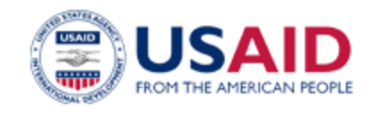

www.usaid.gov

General Overview Funding Opportunities

USAID has working relationships with thousands of American companies and hundreds of U.S.-based private voluntary organizations. For more information on our business and procurement opportunities, please visit our Business section.

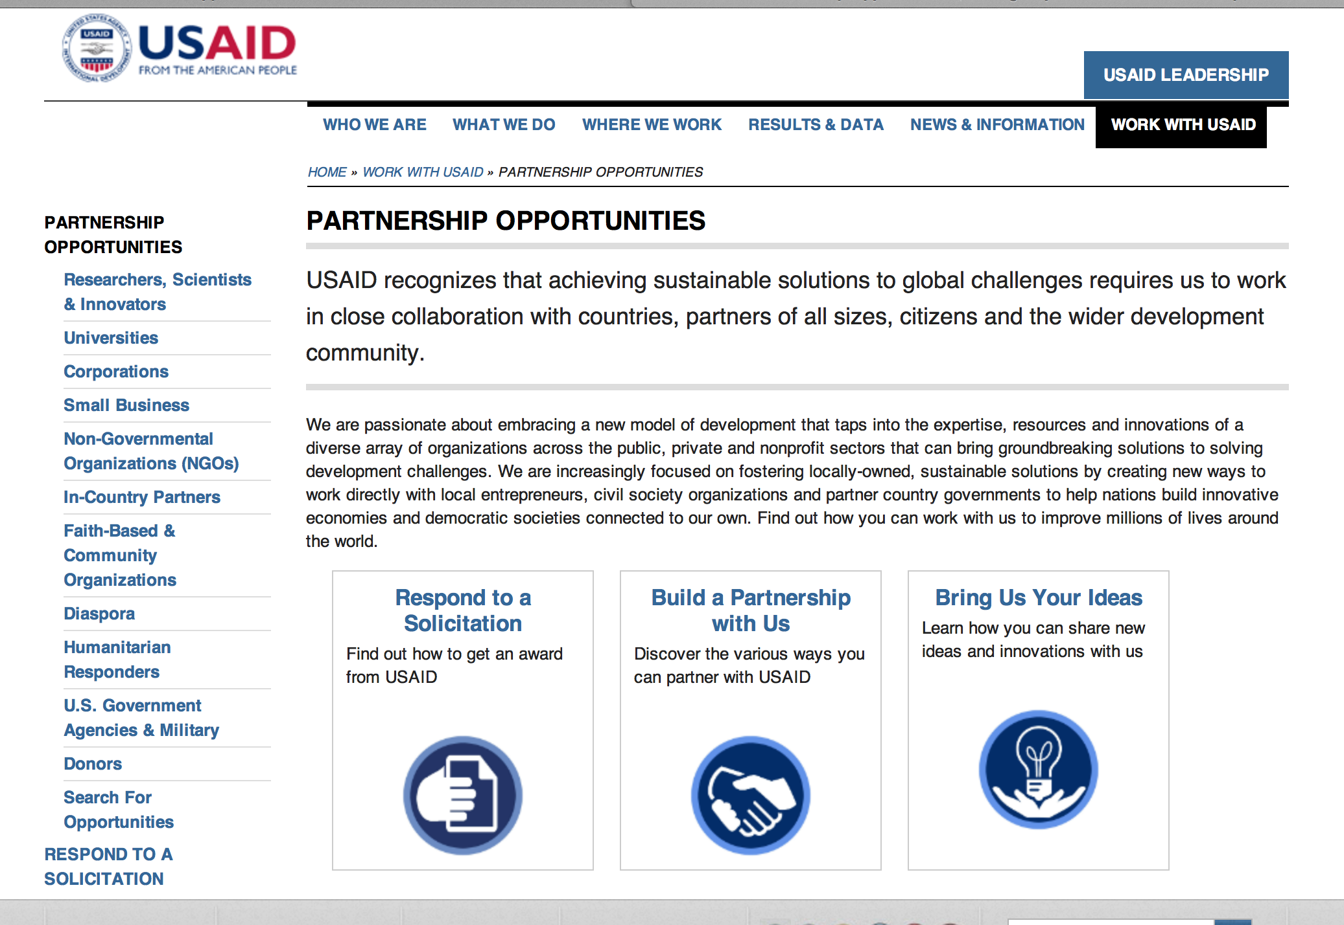
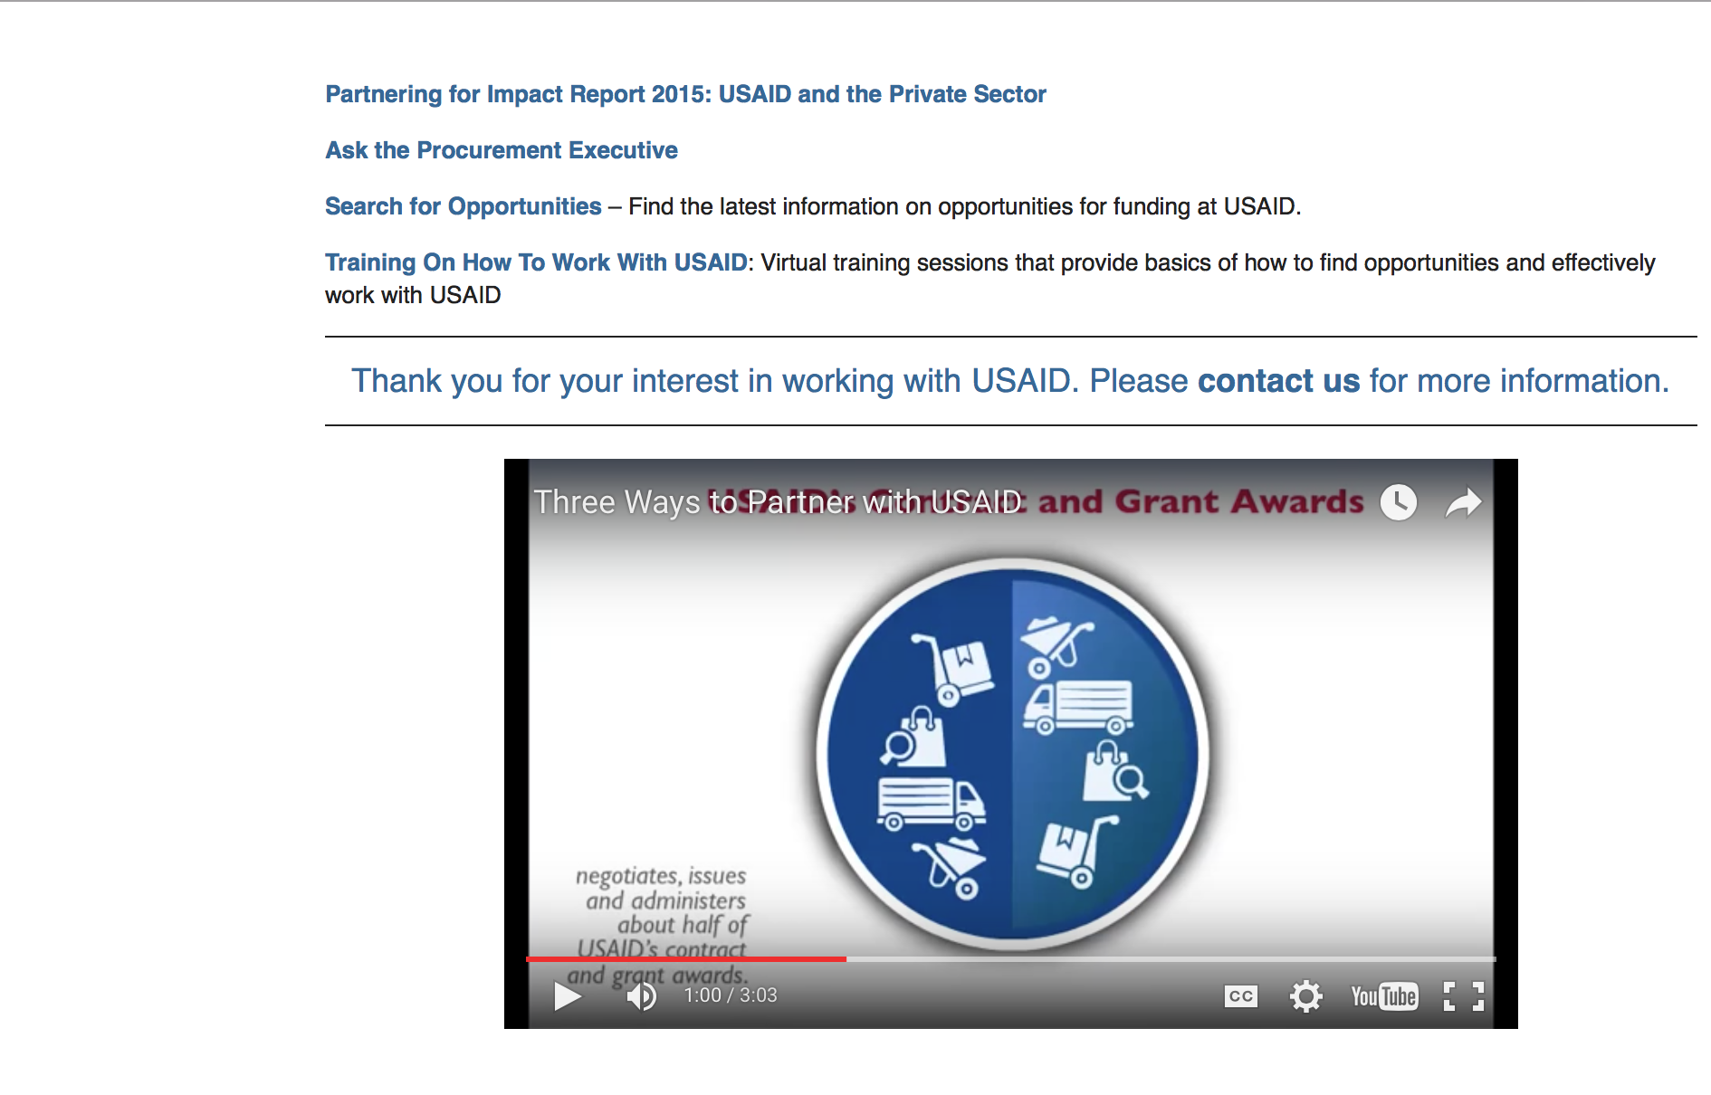

http://www.usaid.gov/partnerships

Programs:

Agency for International Development
American Schools and Hospitals Abroad Program Worldwide
Synopsis 1
http://www.grants.gov/web/grants/view-opportunity.html?oppId=298112

Egypt USAID-Cairo
Request for Information (RFI) for the Centers of Excellence Activity
Synopsis 1
http://www.grants.gov/web/grants/view-opportunity.html?oppId=298144

Innovations in Feed the Future Monitoring and Evaluation
Synopsis 1
http://www.grants.gov/web/grants/view-opportunity.html?oppId=297972

Serbia USAID-Belgrade
Overview of Anticipated Civil Society Programming
Synopsis 1
http://www.grants.gov/web/grants/view-opportunity.html?oppId=298135

Iraq USAID-Baghdad
USAID BAA for Building Resilience in the Ninewa Plains and Western Ninewa
Synopsis 1
http://www.grants.gov/web/grants/view-opportunity.html?oppId=298232

Indonesia USAID-Jakarta
USAID/Indonesia Harmoni: Towards Inclusion and Resilience Activity
Synopsis 1
http://www.grants.gov/web/grants/view-opportunity.html?oppId=298191

South Africa USAID-Pretoria
Preventing HIV/AIDS in Vulnerable Populations
Synopsis 1
http://www.grants.gov/web/grants/view-opportunity.html?oppId=298160

Modifications:

The USAID Global Health Challenge BAA
Synopsis 3
http://www.grants.gov/web/grants/view-opportunity.html?oppId=294194

Innovations in Feed the Future Monitoring and Evaluation
Synopsis 3
http://www.grants.gov/web/grants/view-opportunity.html?oppId=297972

Philippines USAID-Manila
Patient-Centered TB Care
Synopsis 2
http://www.grants.gov/web/grants/view-opportunity.html?oppId=293547

Reading for All
Synopsis 3
http://www.grants.gov/web/grants/view-opportunity.html?oppId=297679

Control and Elimination Program for NTD
Synopsis 2
http://www.grants.gov/web/grants/view-opportunity.html?oppId=296373

South Africa USAID-Pretoria
AID-17-O-00004 - Test Test
Deletion Comments: Opportunity deleted

South Africa USAID-Pretoria
72067418FYI00002 - Preventing HIV/AIDS in Vulnerable Populations
Deletion Comments: Opportunity deleted

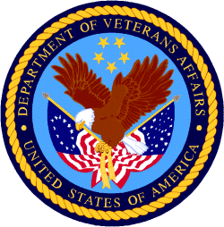

Department of Veterans Affairs

