Senator Mazie Hirono

Grants Assistance Information Newsletter

NOVEMBER 2018

G.A.I.N. INDEX

Click on Index Links below to read summaries of the announcements by agency in this document. Once you reach the item, if you cannot open the links for further information, copy the selected URL website address into your browser.

Modified sections from previous listings are shown in a GREY background

Notices is Teal are items with immediate deadline dates.

Notices in Yellow are of special interest.

Notices is Green are items of special interest with immediate deadline dates.

Items in this type color are aimed at Small Businesses

Items in this type color have a Faith-Based Organization component

Special Federal Program Notices

Highlighted

Reminders

Programs specific to Hawaii

Current Notices

2019 Partnerships for Hawaiian Monk Seal Recovery and Conservation
FY2019 NOAA Bay Watershed Education and Training (B-WET) Hawaii Program

Reminders

Grant Writing Resources

SAM and Grants.Gov Information

SBIR – Small Business Innovation Research

See Individual Departments for information and webpages representing the best and most accessible information on the agency funding opportunities

Federal Grant and Cooperative Agreement Program Summaries

U.S. Department of Agriculture

Grants and Loans Overview

Programs

Business and Cooperative Programs
Renewable Energy Systems and Energy Efficiency Improvements Program
Forest Service
Forest Service -Wildfire Risk Reduction / Wildfire Response RFA 2019

Research

National Institute of Food and Agriculture
Specialty Crop Research Initiative (SCRI) Pre-applications

Modifications

Reminders

Food and Nutrition Service
FY_19_Farm to School Grant
Utilities Programs
Solid Waste Management Grant Program
Utilities Programs
TAT Grant Program
Office of Trade Programs
PL–480 Market Development and Technical Assistance

Deleted:

Department of Commerce

Grants at Commerce

Programs

National Estuarine Research Reserve System (NERRS) Land Acquisition and Construction Program for Fiscal Year 2019

Research

Modifications

Reminders

Climate Program Office FY 2019
FY2019 Marine Debris Removal
Ocean Exploration Fiscal Year 2019 Funding Opportunity

Economic Development Administration
FY 2017 Economic Development Assistance Programs ­ Application submission and program requirements for EDA’s Public Works and Economic Adjustment Assistance programs.

FY 2016 – FY 2019 EDA Planning Program and Local Technical Assistance Program Grant

Economic Development Administration
Planning Program and Local Technical Assistance Program Grant

Deleted

Corporation for National and Community Service

General Program Overview

Programs

Reminders

AmeriCorps State and National Grants FY2019
National Service in Hawaii

Department of Defense

Doing Business with the Department of Defense

DoD Small Business Opportunities and Forecasting

Research Grants

Modifications

Deleted

Reminders

Department of Education

Grant Programs Overview

Programs

Research

Modifications

Reminders

Institute of Education Sciences (IES): Low-Cost, Short-Duration Evaluation of Education Interventions CFDA Number 84.305L
Institute of Education Sciences (IES): Low-Cost, Short-Duration Evaluation of Special Education Interventions CFDA Number 84.324L
Deleted

US Department of Energy

Grants Overview

Research

Modifications

Reminders

Environmental Protection Agency

Grants and Contracts Overview

Programs

2018 Targeted Airshed Grant Program
16th Annual P3 Awards: A National Student Design Competition Focusing on People, Prosperity and the Planet - Air Quality

16th Annual P3 Awards: A National Student Design Competition Focusing on People, Prosperity and the Planet - Chemical Safety

16th Annual P3 Awards: A National Student Design Competition Focusing on People, Prosperity and the Planet - Sustainable and Healthy Communities

Modifications

16th Annual P3 Awards: A National Student Design Competition Focusing on People, Prosperity and the Planet - Safe and Sustainable Water Resources
Research

Reminders

Federal Mediation and Conciliation Service

Programs

Reminders

Department of Health and Human Services

Grants Overview

Program

Research Grants

Modifications

Deleted

Reminders

Department of Homeland Security
Grants Overview

Programs
Modifications

Reminders

Department of Housing and Urban Development

HUD - Notice of Funds Available

Programs

Fair Housing Initiative Program - Education and Outreach Initiative
Fair Housing Initiatives Program - Private Enforcement Initiative

Modifications

Deleted

Reminders

Institute of Museum and Library Services

Grants Overview

IMLS is on Facebook!

Programs

Modifications

Reminders

Museums for America

National Leadership Grants for Museums

Deleted

Department of Interior

Grants and Contract Overview

Programs
National Park Service
2019 Preservation Technology and Training Grants

Modifications

Fish and Wildlife Service
Partners for Fish and Wildlife
Fish and Wildlife Service
Coastal

Reminders

Fish and Wildlife Service
Marine Turtle Conservation Fund

National Park Service
Save America’s Treasures - Collections

National Park Service
Save America's Treasures - Preservation

Bureau of Reclamation
Desalination and Water Purification Research Program for Fiscal Year 2019

U. S. Geological Survey
2019 National Ground-Water Monitoring Network
Deleted

Department of Justice

Grants and Contract Overview

Programs
Office on Violence Against Women
OVW FY 2019 Justice for Families Program Solicitation

Research

Modifications

Deleted

Reminders

________________________________________________________________________

Department of Labor

Grants and Contract General Overview

Programs

Modifications

Reminders

Veterans Employment and Training Service
Announcement of Stand Down Grants

National Aeronautics and Space Administration

Research Grant and Contract General Overview

Programs

Modifications

_______________________________________________________________
National Archives and Records Administration

Grant Opportunities General Overview

Programs

Reminders

Access to Historical Records: Major Initiatives (Preliminary)
_______________________________________________________________
National Endowment for the Arts

Grant Opportunities General Overview

Programs

NEA Performing Arts Discovery, FY2019

NEA Performing Arts Global Exchange, FY2019
NEA Shakespeare in American Communities, FY2019
NEA USArtists International, FY2019
Modifications

Reminders

NEA Literature Fellowships: Translation Projects, FY2020
_______________________________________________________________

National Endowment for the Humanities

Grant Opportunities General Overview

Programs

Digital Humanities Advancement Grants

Media Projects

Reminders

Collaborative Research Grants
Scholarly Editions and Translations Grants
Dialogues on the Experience of War

_______________________________________________________________
National Science Foundation

Grant Opportunities General Overview

Research and Program Grants

Modifications

Reminders

Deleted

Nuclear Regulatory Commission

U.S. Nuclear Regulatory Commission Funding Opportunity Announcement (FOA), Scholarship and Fellowship Education Grant, Faculty Development Grant, and Trade School and Community College Scholarship Grant, Fiscal Year (FY) 2019.
Reminders

Small Business Administration

General Overview Finding Loans & Grants

Programs
Option Year Workplan and Budget
Women’s Business Center Renewal Grant

Modifications

Reminders

Deleted

Upcoming Trainings

Links Specific to Hawaii

State Department

General Overview and Resources for Program Administrators

Programs

Modifications

Reminders

U.S. Department of Transportation

General Grant Program Overview

Programs

Research

Modifications

Reminders

DOT/Federal Transit Administration
Access and Mobility Partnership Grants; Human Services Coordination Research (HSCR)
DOT Federal Aviation Administration
DOT - FAA Aviation Research Grants
FAA Aviation Research and Development Grants
Modifications 3,4& 6

Deleted

Department of the Treasury

Programs

Modifications

Reminders

US Agency for International Development

General Funding Opportunity Overview

Programs
Modifications

Deleted

Department of Veterans Affairs

Special Federal Program Notices

Highlighted Programs

Reminders:

HAWAII APPLICANTS ENCOURAGED

Current Notices:

2019 Partnerships for Hawaiian Monk Seal Recovery and Conservation
Synopsis 1

Document Type: | Grants Notice
Funding Opportunity Number: | NOAA-NMFS-PIRO-2019-2005826
Funding Opportunity Title: | 2019 Partnerships for Hawaiian Monk Seal Recovery and Conservation
Opportunity Category: | Discretionary
Opportunity Category Explanation:
Funding Instrument Type: | Cooperative Agreement  Grant
Category of Funding Activity: | Environment  Natural Resources  Science and Technology and other Research and Development
Category Explanation:
Expected Number of Awards: | 6
CFDA Number(s): | 11.454 -- Unallied Management Projects
Cost Sharing or Matching Requirement: | No
Version: | Synopsis 1
Posted Date: | Oct 23, 2018
Last Updated Date: | Oct 23, 2018
Original Closing Date for Applications: | Dec 21, 2018
Current Closing Date for Applications: | Dec 21, 2018
Archive Date: | Jan 20, 2019
Estimated Total Program Funding: | $310,000
Award Ceiling: | $125,000
Award Floor: | $5,000
Eligible Applicants: | Others (see text field entitled "Additional Information on Eligibility" for clarification)
Additional Information on Eligibility: | Eligible applicants are individuals, institutions of higher education, nonprofits, commercial organizations, state, local, and Indian tribal governments. Federal agencies and their employees, as well as, Federal instrumentalities (including employees and members)are not eligible to apply.

Agency Name: | Department of Commerce
Description: | The National Marine Fisheries Service (hereinafter, "NMFS") is soliciting competitive applications for the fiscal year 2019 Partnerships for Hawaiian Monk Seal Recovery and Conservation. Projects are being solicited to support specific programmatic activities related to the following two priorities:  Priority 1: Conducting outreach and monitoring efforts at seal haul-out locations and providing support for monk seal health and safety responses. Priority 1 projects can occur within Maui, Lanai, Molokai, Hawaii Island or Oahu.  Priority 2: Addressing management strategies outlined in the Main Hawaiian Islands Monk Seal Management Plan. Priority 2 projects can occur within the entire Main Hawaiian Islands (Maui, Lanai, Molokai, Hawaii Island, Kauai, or Oahu).
Link to Additional Information:
Grantor Contact Information: | If you have difficulty accessing the full announcement electronically, please contact:  Penny Larin (808) 725-5057 NOAA Inouye Regional Center 1845 Wasp Blvd., Building 176 Honolulu, HI 96818  Work
https://www.grants.gov/web/grants/view-opportunity.html?oppId=309788

FY2019 NOAA Bay Watershed Education and Training (B-WET) Hawaii Program
Synopsis 1

Document Type: | Grants Notice
Funding Opportunity Number: | NOAA-NOS-OCM-2019-2005858
Funding Opportunity Title: | FY2019 NOAA Bay Watershed Education and Training (B-WET) Hawaii Program
Opportunity Category: | Discretionary
Opportunity Category Explanation:
Funding Instrument Type: | Cooperative Agreement  Grant
Category of Funding Activity: | Environment  Natural Resources  Science and Technology and other Research and Development
Category Explanation:
Expected Number of Awards: | 10
CFDA Number(s): | 11.473 -- Office for Coastal Management
Cost Sharing or Matching Requirement: | No
Version: | Synopsis 1
Posted Date: | Nov 05, 2018
Last Updated Date: | Nov 05, 2018
Original Closing Date for Applications: | Feb 05, 2019
Current Closing Date for Applications: | Feb 05, 2019
Archive Date: | Mar 07, 2019
Estimated Total Program Funding: | $1,000,000
Award Ceiling: | $150,000
Award Floor: | $25,000
Eligible Applicants: | Others (see text field entitled "Additional Information on Eligibility" for clarification)
Additional Information on Eligibility: | Eligible funding applicants are K-12 public and independent schools and school systems, institutions of higher education, commercial and nonprofit organizations, state or local government agencies, and Indian tribal governments conducting projects in Hawaii (Islands of Hawaii, Maui, Lanai, Molokai, Oahu, Kauai, Kahoolawe, Niihau, and/or the Northwestern Hawaiian Islands). Individual applicants and Federal agencies are not eligible. Existing recipients selected during the FY 2017 (NOAA-NOS-OCM-2017-2004984) and FY 2018 (NOAA-NOS-OCM-2018-2005344) Hawaii B-WET competitions are eligible to apply as competitive renewal projects and are required to re-apply to receive consideration for further funding. Federal agencies and employees are not allowed to receive funds under this announcement but may serve as collaborative project partners and may contribute services in kind. Federal agencies and employees’ ‘in-kind services’ cannot be considered as part of an applicant’s match on shared costs. If federal agencies are collaborators, applicants must provide detail on the expected level of federal engagement in the application. Examples might include, but are not limited to partnership services; serving in a review capacity; or participating in priority task teams, working groups, or leadership teams.
Additional Information
Agency Name: | Department of Commerce
Description: | The NOAA Bay Watershed Education and Training (B-WET) Hawaii Program is a federal funding opportunity which meets NOAA's mission of science, service and stewardship. The B-WET Hawaii Program supports a vision of a future where societies and ecosystems are healthy and resilient in the face of sudden or prolonged change. The purpose for this financial assistance is to support our communities by developing a well-informed citizenry involved in decision-making that positively impacts our coastal, marine and watershed ecosystems in the State of Hawaii. This is a competitive opportunity for grants to assist in the development of new programs, encourage innovative partnerships among environmental education programs, and support geographically targeted programs to advance environmental education efforts that complement national and state school requirements. The-WET Hawaii Program plays a foundational role as an environmental education program that promotes locally relevant, experiential learning in the K-12 environment on priority topics such understanding ocean, earth and atmospheric sciences, community resilience to hazards, and place-based environmental management. Funded projects provide meaningful watershed educational experiences for students, professional development for teachers, service-learning opportunities for students, and support regional education and environmental priorities. More information about the B-WET program is online athttp://www.noaa.gov/office-education/bwet.
Link to Additional Information:
Grantor Contact Information: | If you have difficulty accessing the full announcement electronically, please contact:  For administrative and technical questions regarding this announcement, contact Jim Foley, B-WET Hawaii Coordinator, at NOAA/NOS Office for Coastal Management - Pacific Islands, 1845 Wasp Blvd., Bldg. 176, Honolulu, Hawaii 96818, ATTN: Jim Foley, or by phone at (808) 725-5284, or via email at jim.foley@noaa.gov. Questions may also be addressed to Stephanie Bennett by phone at (808) 725-5254 or via email at stephanie.bennett@noaa.gov.  Work email address
https://www.grants.gov/web/grants/view-opportunity.html?oppId=310157

Reminders:

Grant Writing Resources

The following links are a great resource for faith-based non-profits and other community organizations :

- Center for Faith-Based and Community Initiatives (link is external) , U.S. Department of Labor

- http://www.usaid.gov/partnership-opportunities/fbci. U.S. Agency for International Development

- Faith-Based and Other Community Initiatives (link is external) , Corporation for National Community Service

- Task Force for Faith-Based and Community Initiatives (link is external) , U.S. Department of Justice

- Proposal Writing Short Course (link is external) Foundation Center.
- General Tips on Writing a Competitive Grant Proposal (link is external) U.S. Environmental Protection Agency.
- How to Write a Grant Proposal (link is external) Appalachian Regional Commission.
- A Guide to Funding Resources USDA Rural Information Center.

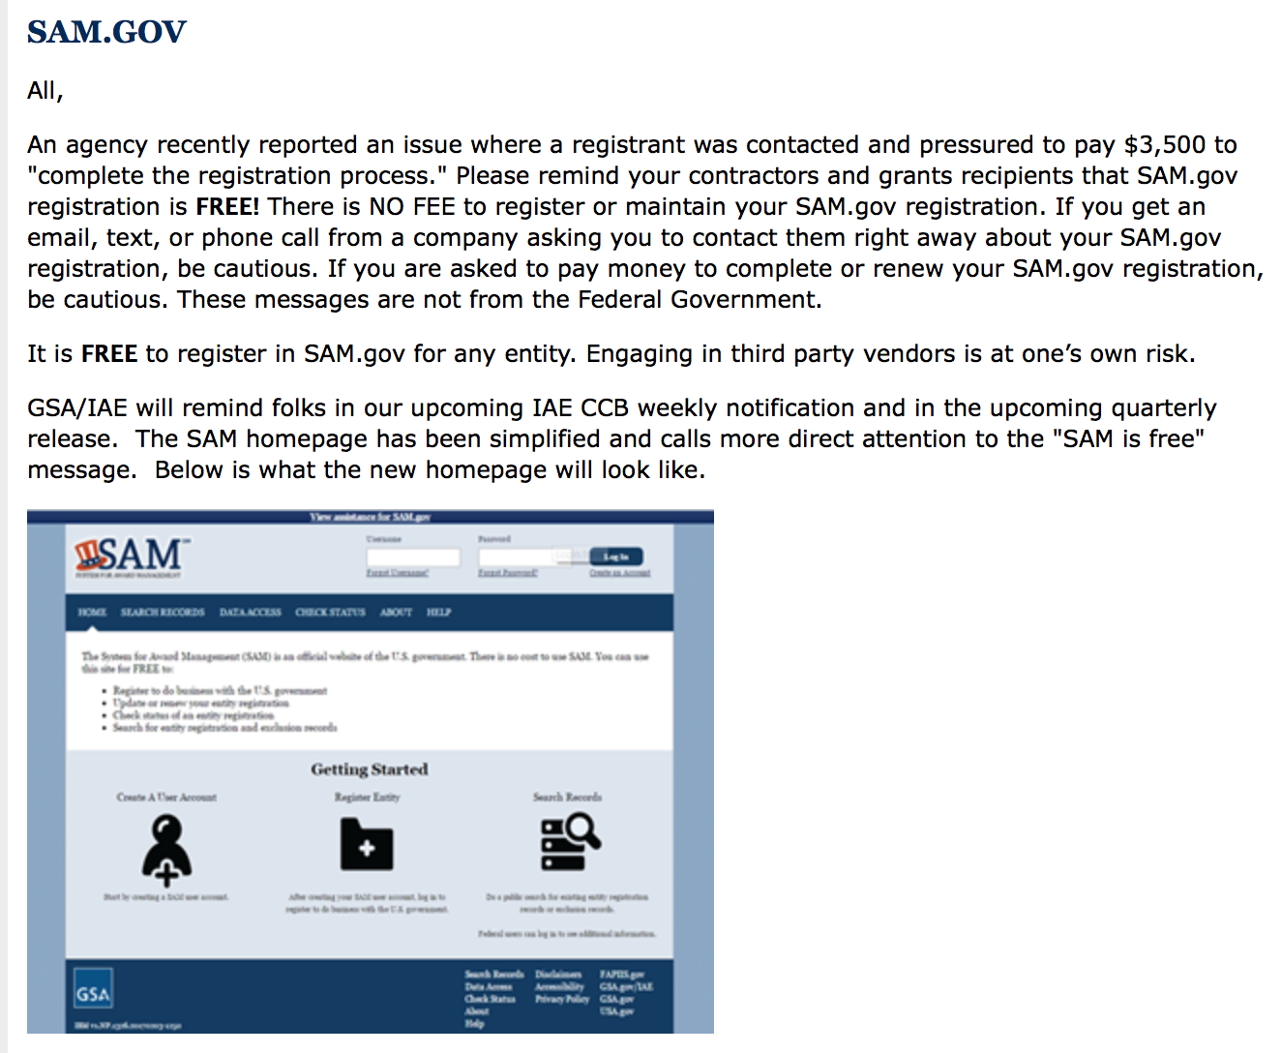

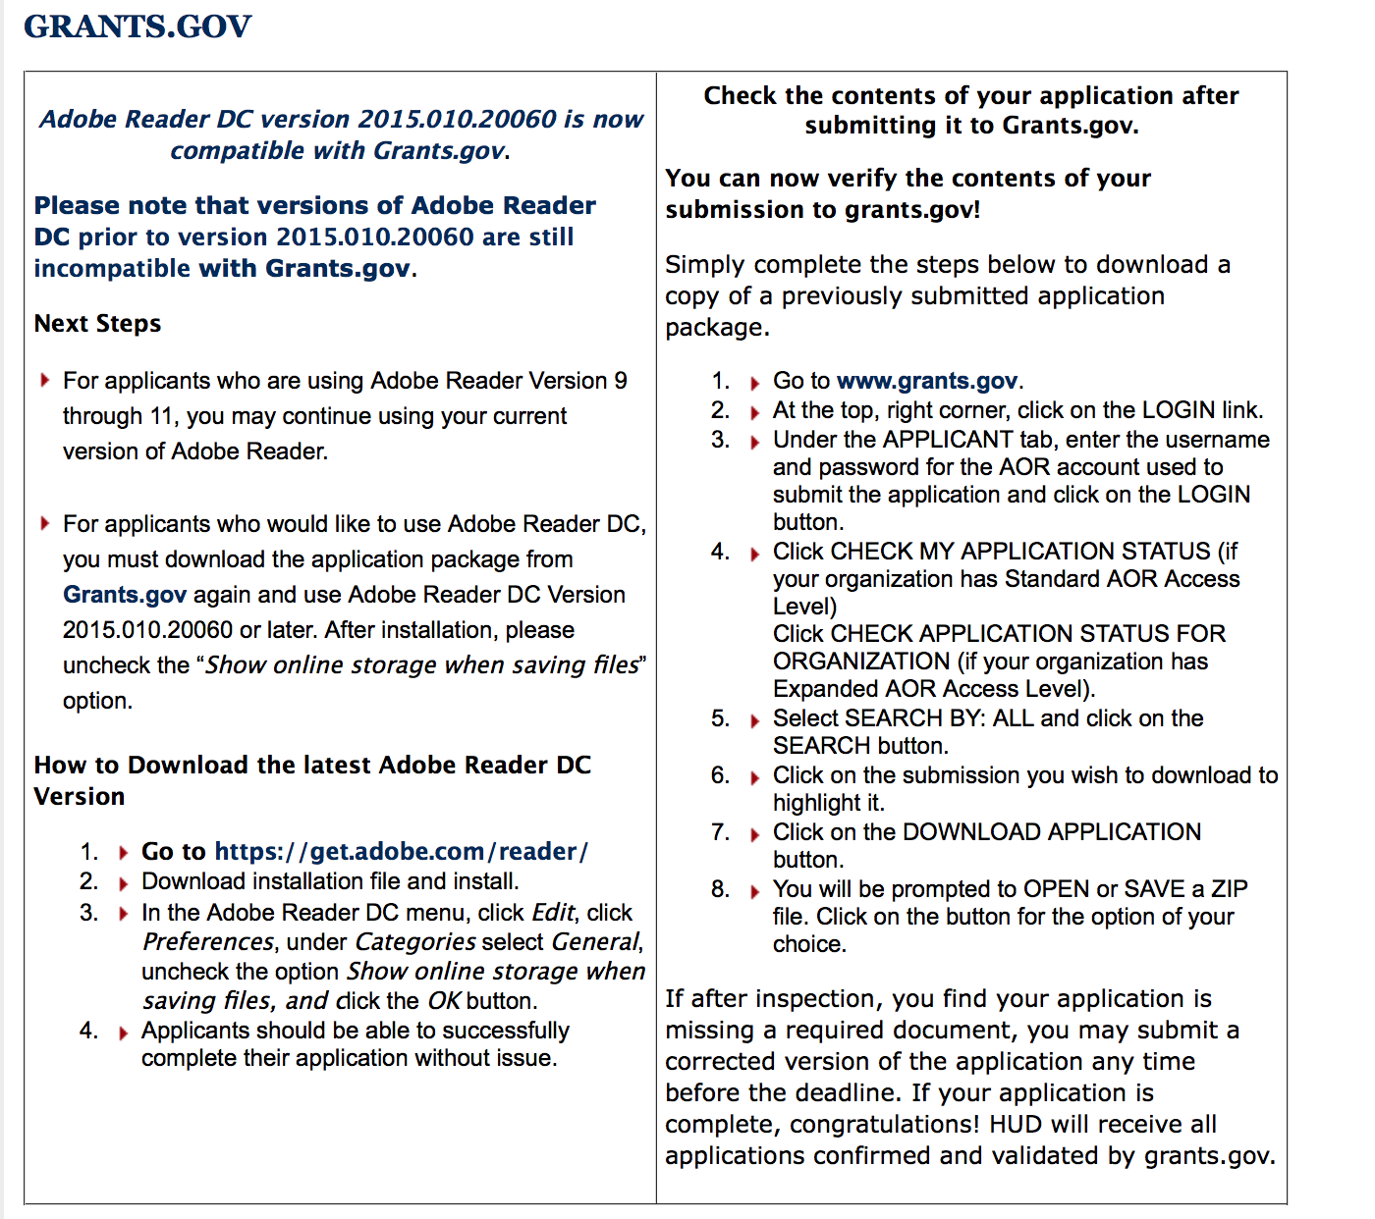

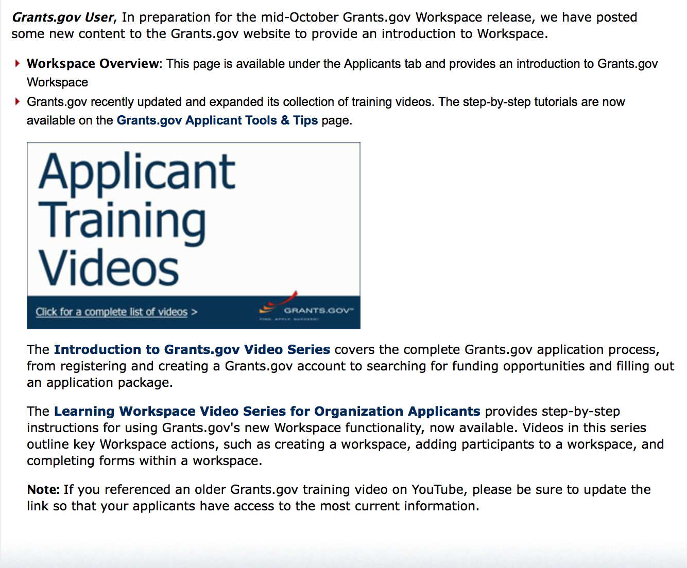
https://portal.hud.gov/hudportal/HUD?src=/program_offices/administration/grants/fundsavail

The Small Business Innovative Research Program - SBIR Program

The Small Business Innovation Research (SBIR) program is a highly competitive program that encourages domestic small businesses to engage in Federal Research/Research and Development (R/R&D) that has the potential for commercialization. Through a competitive awards-based program, SBIR enables small businesses to explore their technological potential and provides the incentive to profit from its commercialization. By including qualified small businesses in the nation's R&D arena, high-tech innovation is stimulated, and the United States gains entrepreneurial spirit as it meets its specific research and development needs.

SBIR Mission and Program Goals
The mission of the SBIR program is to support scientific excellence and technological innovation through the investment of Federal research funds in critical American priorities to build a strong national economy.
The program’s goals are four-fold:
- Stimulate technological innovation
- Meet Federal research and development needs.
- Foster and encourage participation in innovation and entrepreneurship by socially and economically disadvantaged persons.
- Increase private-sector commercialization of innovations derived from Federal research and development funding.

SBIR-Participating Agencies
Each year, Federal agencies with extramural research and development (R&D) budgets that exceed $100 million are required to allocate 2.5 percent of their R&D budget to these programs. Currently, eleven Federal agencies participate in the program:
- Department of Agriculture
- Department of Commerce - National Institute of Standards and Technology
- Department of Commerce - National Oceanic and Atmospheric Administration
- Department of Defense
- Department of Education
- Department of Energy
- Department of Health and Human Services
- Department of Homeland Security
- Department of Transportation
- Environmental Protection Agency
- National Aeronautics and Space Administration
- National Science Foundation
Each agency administers its own individual program within guidelines established by Congress. These agencies designate R&D topics in their solicitations and accept proposals from small businesses. Awards are made on a competitive basis after proposal evaluation.

Three-Phase Program
The SBIR Program is structured in three phases:
Phase I. The objective of Phase I is to establish the technical merit, feasibility, and commercial potential of the proposed R/R&D efforts and to determine the quality of performance of the small business awardee organization prior to providing further Federal support in Phase II. SBIR Phase I awards normally do not exceed $150,000 total costs for 6 months.
Phase II. The objective of Phase II is to continue the R/R&D efforts initiated in Phase I. Funding is based on the results achieved in Phase I and the scientific and technical merit and commercial potential of the project proposed in Phase II. Only Phase I awardees are eligible for a Phase II award. SBIR Phase II awards normally do not exceed $1,000,000 total costs for 2 years.
Phase III. The objective of Phase III, where appropriate, is for the small business to pursue commercialization objectives resulting from the Phase I/II R/R&D activities. The SBIR program does not fund Phase III. Some Federal agencies, Phase III may involve follow-on non-SBIR funded R&D or production contracts for products, processes or services intended for use by the U.S. Government
SBIR NewsLetter

- SBIR Newsletter
Sign up for e-mail updates

Please review each department’s General Grant and Funding Overview. These overviews are the key web pages on each departmental website dedicated to the agency’s funding opportunities. Check back often to note the department updates and use these sources to assist you in your planning.

Federal Grant and Cooperative Agreement Program Summaries

U.S. Department of Agriculture

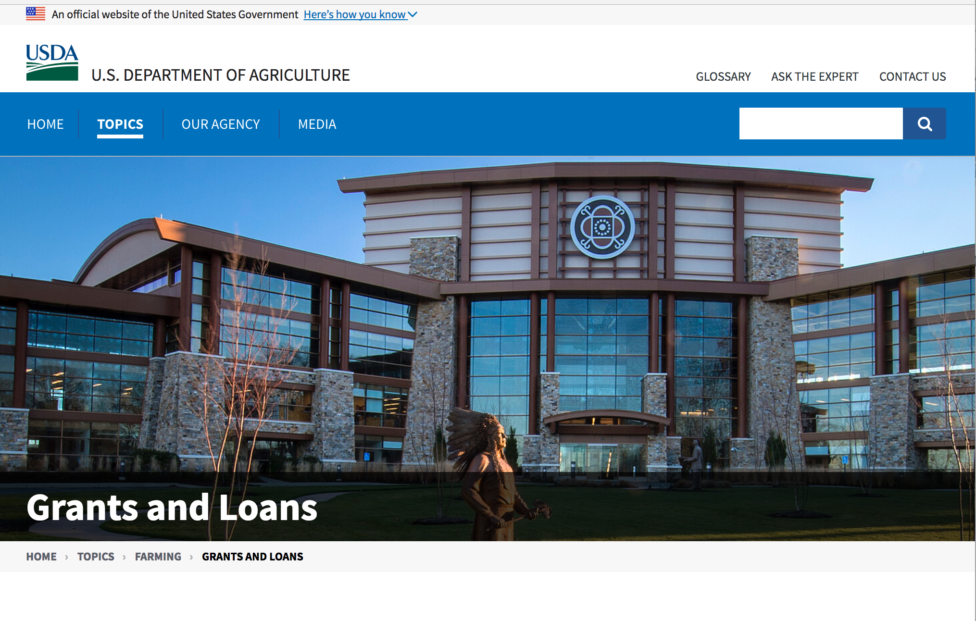

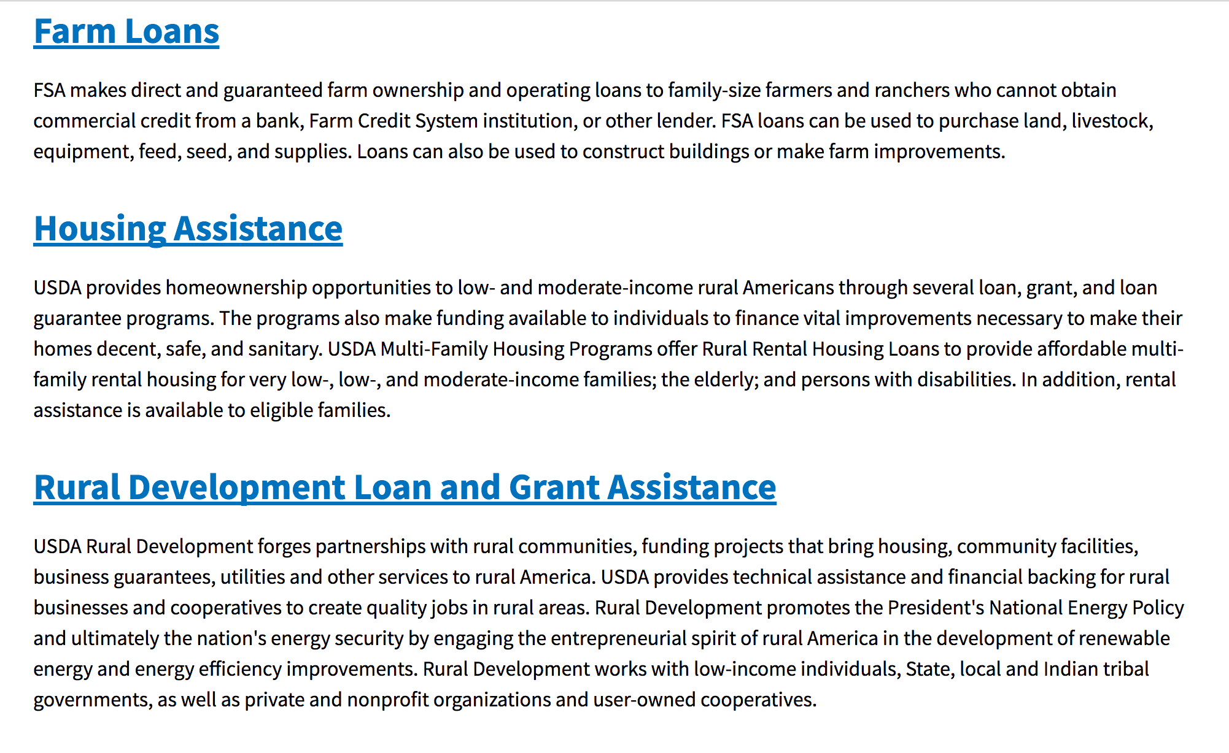

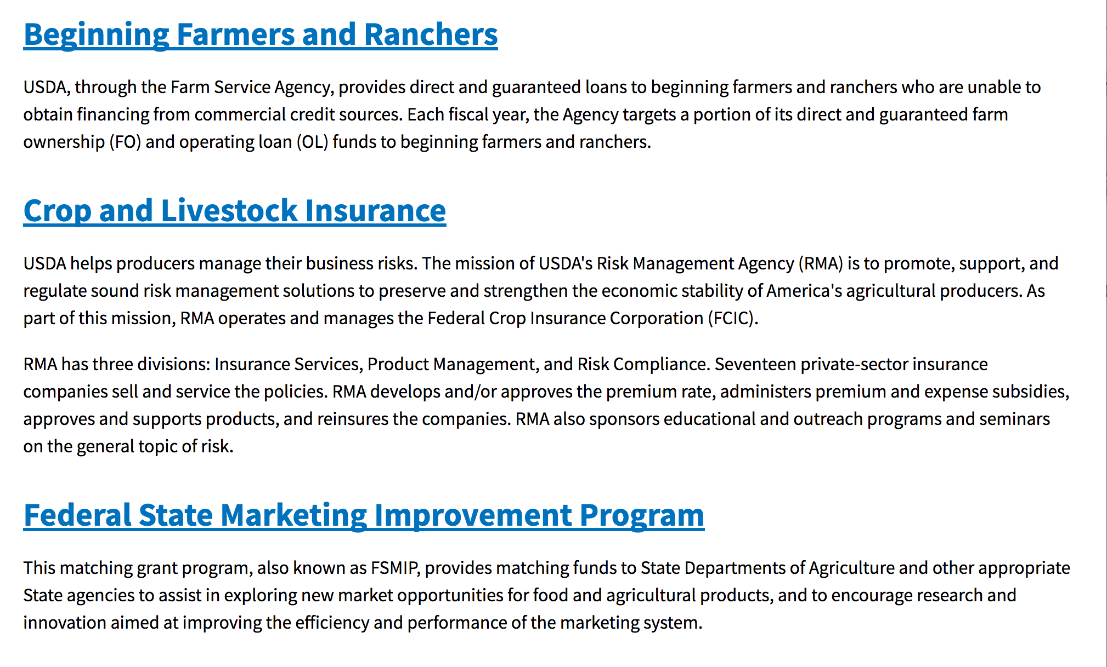
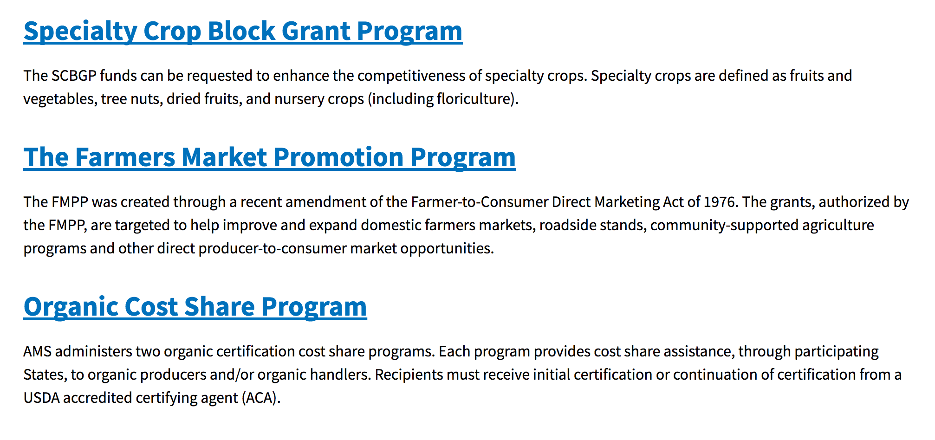
https://www.usda.gov/topics/farming/grants-and-loans

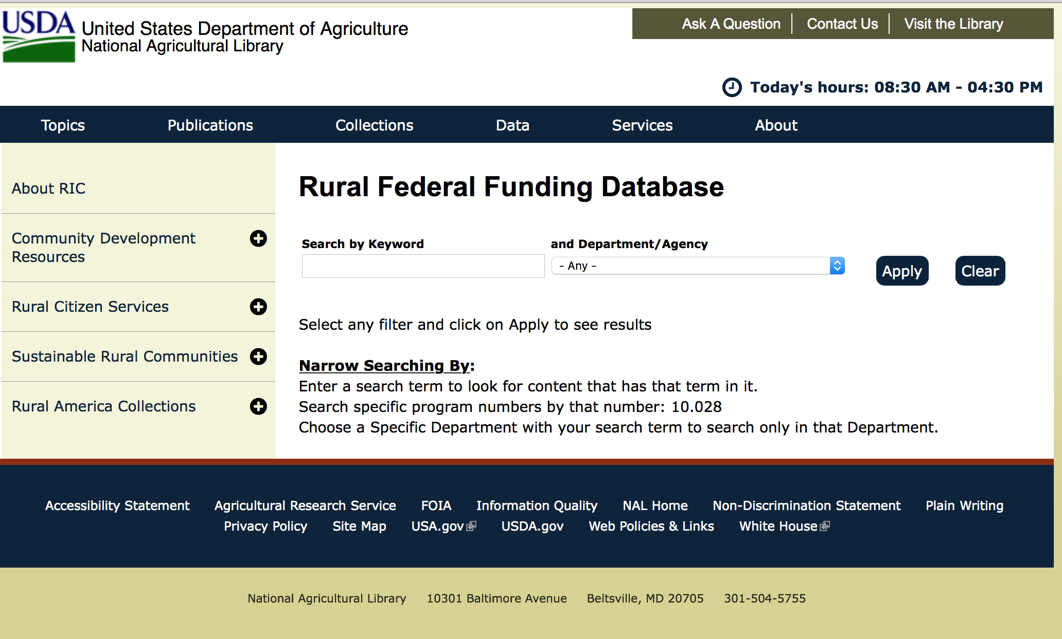

https://www.nal.usda.gov/ric/rural-federal-funding-database

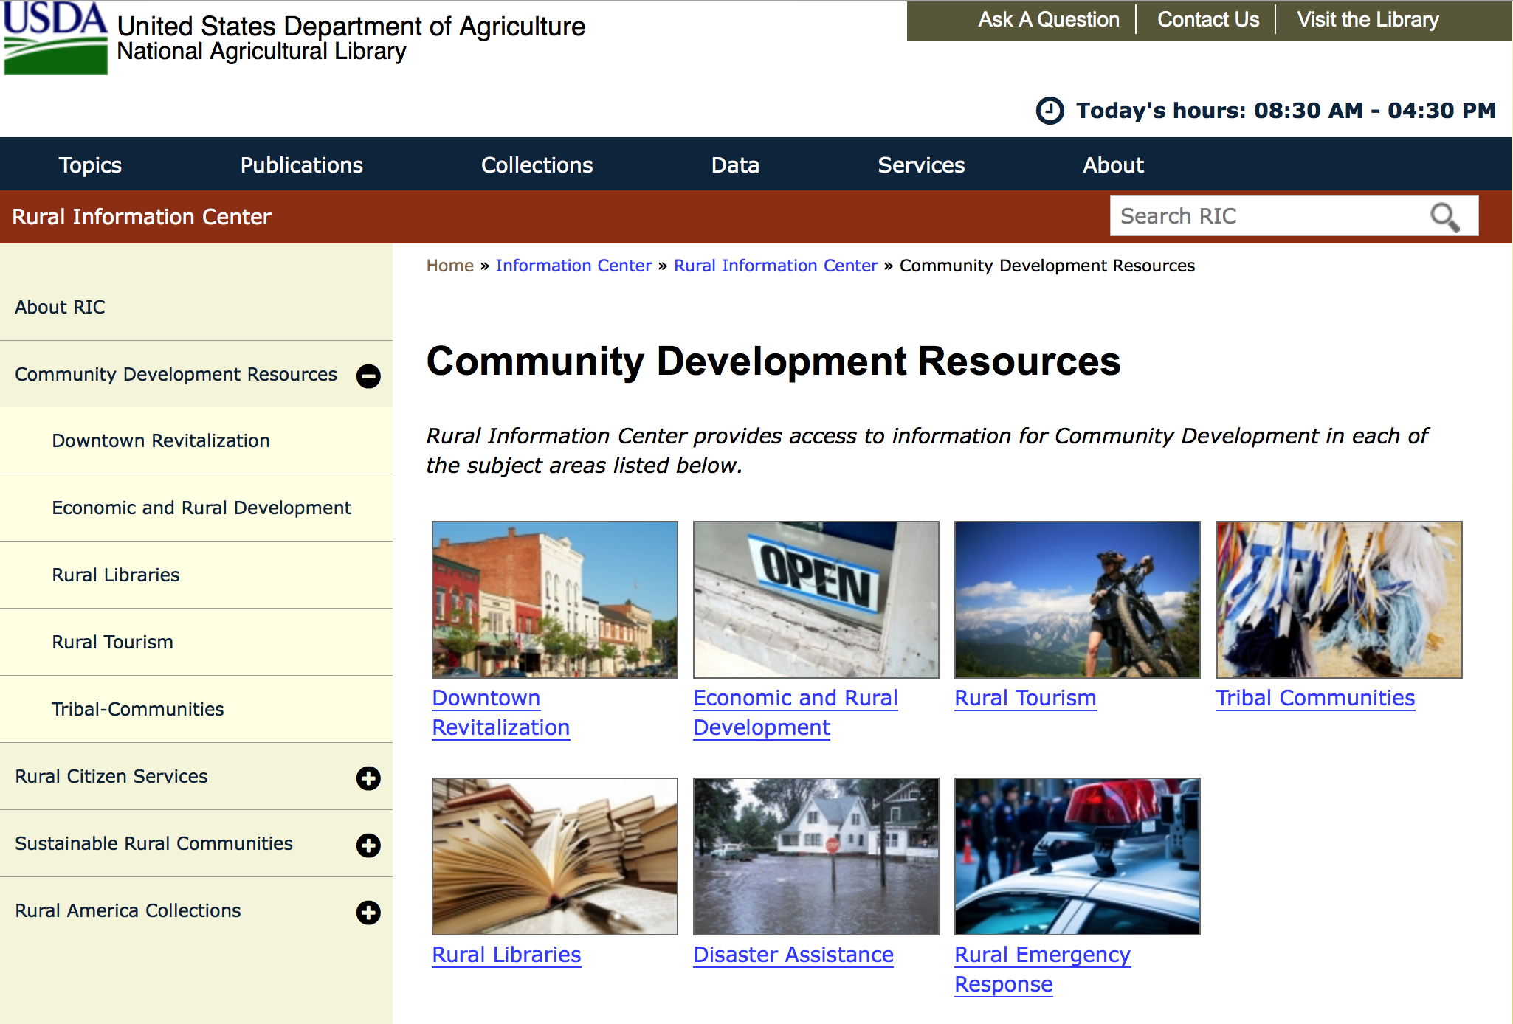

https://www.nal.usda.gov/ric/community-development-resources

Programs:

Business and Cooperative Programs
Renewable Energy Systems and Energy Efficiency Improvements Program
Synopsis 1

Document Type: | Grants Notice
Funding Opportunity Number: | RDBCP-REAP-RES-EEI-2019
Funding Opportunity Title: | Renewable Energy Systems and Energy Efficiency Improvements Program
Opportunity Category: | Mandatory
Opportunity Category Explanation:
Funding Instrument Type: | Grant
Category of Funding Activity: | Agriculture  Business and Commerce  Energy
Category Explanation:
Expected Number of Awards: | 1000
CFDA Number(s): | 10.868 -- Rural Energy for America Program
Cost Sharing or Matching Requirement: | Yes
Version: | Synopsis 1
Posted Date: | Oct 30, 2018
Last Updated Date: | Oct 30, 2018
Original Closing Date for Applications: | REAP Applications are accepted year-round. For applicants requesting grants of $20,000 or less, that wish to have their application compete for the "Grants of $20,000 or less set aside", complete applications must be received no later than 4:30pm local time on: October 31, 2018, or April 1, 2019. For applicants requesting grant funds of over $20,000, complete applications must be received no later than 4:30pm local time on April 1, 2019.
Current Closing Date for Applications: | REAP Applications are accepted year-round. For applicants requesting grants of $20,000 or less, that wish to have their application compete for the "Grants of $20,000 or less set aside", complete applications must be received no later than 4:30pm local time on: October 31, 2018, or April 1, 2019. For applicants requesting grant funds of over $20,000, complete applications must be received no later than 4:30pm local time on April 1, 2019.
Archive Date:
Estimated Total Program Funding: | $35,400,000
Award Ceiling: | $500,000
Award Floor: | $1,500
Eligible Applicants: | Others (see text field entitled "Additional Information on Eligibility" for clarification)  Small businesses  Native American tribal organizations (other than Federally recognized tribal governments)
Additional Information on Eligibility: | Agricultural Producers
Additional Information
Agency Name: | Business and Cooperative Programs
Description: | REAP Renewable Energy Systems and Energy Efficiency Improvement Program. Refer to Application Package AND Application Instruction links to obtain all necessary forms for a complete application. Contact State Energy Coordinators with questions: http://www.rd.usda.gov/files/RBS_StateEnergyCoordinators.pdf
Link to Additional Information: | REAP Renewable Energy Systems and Energy Efficiency Improvements Program
Grantor Contact Information: | If you have difficulty accessing the full announcement electronically, please contact:  Maureen Hessel Business Loan and Grant Analyst Phone 2024010142  Refer to energy coordinator list via link posted above.
https://www.grants.gov/web/grants/view-opportunity.html?oppId=310029

Forest Service
Forest Service -Wildfire Risk Reduction / Wildfire Response RFA 2019
Synopsis 1

Document Type: | Grants Notice
Funding Opportunity Number: | USDA-FS-2019-WRR-WR
Funding Opportunity Title: | Forest Service -Wildfire Risk Reduction / Wildfire Response RFA 2019
Opportunity Category: | Discretionary
Opportunity Category Explanation:
Funding Instrument Type: | Grant
Category of Funding Activity: | Environment  Natural Resources
Category Explanation:
Expected Number of Awards: | 15
CFDA Number(s): | 10.664 -- Cooperative Forestry Assistance
Cost Sharing or Matching Requirement: | Yes
Version: | Synopsis 1
Posted Date: | Nov 05, 2018
Last Updated Date: | Nov 05, 2018
Original Closing Date for Applications: | Dec 21, 2018
Current Closing Date for Applications: | Dec 21, 2018
Archive Date: | Jan 20, 2019
Estimated Total Program Funding: | $2,100,000
Award Ceiling: | $150,000
Award Floor: | $25,000
Eligible Applicants: | County governments  Special district governments  Nonprofits having a 501(c)(3) status with the IRS, other than institutions of higher education  Independent school districts  Nonprofits that do not have a 501(c)(3) status with the IRS, other than institutions of higher education  City or township governments  Public and State controlled institutions of higher education  State governments  Others (see text field entitled "Additional Information on Eligibility" for clarification)  Native American tribal governments (Federally recognized)
Additional Information on Eligibility: | Forest Fire Compacts
Additional Information
Agency Name: | Forest Service
Description: | The U.S. Forest Service supports Moving Toward Shared Stewardship Across Landscapes as part of a conceptual framework for making strategic investments across landscapes to co-manage wildfire risk and achieve positive outcomes at the most appropriate scale. Within this framework, The Northeastern Area Cohesive Fire Strategy Competitive Request for Applications is designed to support and carry out the goals of the National Cohesive Wildland Fire Management Strategy (NCS) across the Midwestern and Northeastern States as well as meet the intent of the current year budget direction. These national goals are:  - Restore and Maintain Landscapes: Landscapes across all jurisdictions are resilient to fire-related disturbances in accordance with management objectives.  - Create Fire Adapted Communities: Human populations and infrastructure can withstand a wildfire without loss of life and property.  - Improve Wildfire Response: All jurisdictions participate in making and implementing safe, effective, efficient risk-based wildfire management decisions.
Link to Additional Information: | USFS Wildfire Risk Reduction - Wildfire Response grants web page
Grantor Contact Information: | If you have difficulty accessing the full announcement electronically, please contact:  Thomas Brady Grantor Phone 603-868-7656 Maris Gabliks Grantor mggabliks@fs.fed.us  thomasbrady@fs.fed.us
https://www.grants.gov/web/grants/view-opportunity.html?oppId=309785

Research:

National Institute of Food and Agriculture
Specialty Crop Research Initiative (SCRI) Pre-applications
Synopsis 1

Document Type: | Grants Notice
Funding Opportunity Number: | USDA-NIFA-SCRI-006671
Funding Opportunity Title: | Specialty Crop Research Initiative (SCRI) Pre-applications
Opportunity Category: | Mandatory
Opportunity Category Explanation:
Funding Instrument Type: | Grant
Category of Funding Activity: | Agriculture
Category Explanation:
Expected Number of Awards:
CFDA Number(s): | 10.309 -- Specialty Crop Research Initiative
Cost Sharing or Matching Requirement: | Yes
Version: | Synopsis 1
Posted Date: | Nov 07, 2018
Last Updated Date: | Nov 07, 2018
Original Closing Date for Applications: | Dec 10, 2018
Current Closing Date for Applications: | Dec 10, 2018
Archive Date: | Jan 09, 2019
Estimated Total Program Funding: | $80,000,000
Eligible Applicants: | Others (see text field entitled "Additional Information on Eligibility" for clarification)
Additional Information on Eligibility: | Pre-Applications may only be submitted by Federal agencies, national laboratories, colleges and universities, research institutions and organizations, private organizations or corporations, State Agricultural Experiment Stations, Cooperative Extension Services, individuals, or groups consisting of two or more of these entities.
Additional Information
Agency Name: | National Institute of Food and Agriculture
Description: | The purpose of the SCRI program is to address the critical needs of the specialty crop industry (as defined in Part VIII, D of the RFA) by awarding grants to support research and extension that address key challenges of national, regional, and multi-state importance in sustaining all components of food and agriculture, including conventional and organic food production systems.
Link to Additional Information: | Specialty Crop Research Initiative (SCRI)
Grantor Contact Information: | If you have difficulty accessing the full announcement electronically, please contact:  NIFA Help Desk Phone: 202-401-5048 Business hours are M-F, 7:00 am -5:00 pm ET, excluding Federal holidays  If you have any questions related to preparing application content
https://www.grants.gov/web/grants/view-opportunity.html?oppId=310171

Modifications:

Reminders:

Food and Nutrition Service
FY_19_Farm to School Grant
Synopsis 1

Document Type: | Grants Notice
Funding Opportunity Number: | USDA-FNS-F2S-2019
Funding Opportunity Title: | FY_19_Farm to School Grant_
Opportunity Category: | Discretionary
Opportunity Category Explanation:
Funding Instrument Type: | Grant
Category of Funding Activity: | Food and Nutrition
Category Explanation:
Expected Number of Awards: | 105
CFDA Number(s): | 10.575 -- Farm to School Grant Program
Cost Sharing or Matching Requirement: | Yes
Version: | Synopsis 1
Posted Date: | Oct 02, 2018
Last Updated Date: | Oct 02, 2018
Original Closing Date for Applications: | Dec 04, 2018
Current Closing Date for Applications: | Dec 04, 2018
Archive Date: | Aug 30, 2019
Estimated Total Program Funding: | $7,500,000
Award Ceiling: | $100,000
Award Floor: | $20,000
Eligible Applicants: | Others (see text field entitled "Additional Information on Eligibility" for clarification)
Additional Information on Eligibility: | The authorizing language specifies the following eligible entities: • Eligible schools; • State and local agencies; • Indian tribal organizations; • Agricultural producers or groups of agricultural producers; and • Non-profit entities. Eligible schools are defined as pre-K-12 School Food Authorities (SFAs), non-profit private schools, charter schools, Indian tribal schools, and others that participate in the National School Lunch or Breakfast Programs. Eligible SFAs may apply for funding that spans the entire SFA, for a specific group of schools (e.g. only K-5 schools within an SFA), or for an individual school. In the case where an SFA exists, the application must come from the SFA, and only one application per SFA is allowed. F2S Planning & Training: Eligible schools, state and local agencies, Indian tribal organizations, agricultural producers or groups of agricultural producers, and non-profit entities are eligible to receive planning and implementation grants. Funding is available to support school-based programs only. If a proposal seeks to increase local foods in the Child and Adult Care Program or the Summer Food Service Program, target sites must be located at an eligible school. If a proposal seeks to target school(s), schools discussed in the project proposal as benefiting from the project must be eligible as defined in section 3.0. Training Grant Eligibility: Only state and local agencies, Indian Tribal Organizations, agricultural producers or groups of agricultural producers, and non-profit entities are eligible to receive training grant funds. Unlike planning and implementation grants, training grants may support projects that impact CACFP and SFSP operators that have sites beyond schools. Please review section 3.0 for additional eligibility requirements before proceeding with preparing an application
Additional Information
Agency Name: | Food and Nutrition Service
Description: | Section 18 of the Richard B. Russell National School Lunch Act (NSLA) established a Farm to Schoolprogram in order to assist eligible entities, (schools, school districts, agricultural producers, Indian tribal organizations, nonprofit organizations, state agencies and local agencies), through grants and technicalassistance, in implementing farm to school programs that improve access to local foods in eligible schools.  Additional funding for the Farm to School Grant Program was made available through the FY 18 Omnibus bill, and as a result, approximately $7.5 million will be released under this solicitation in FY 2019. In the FY 2018application cycle, FNS received 290 eligible applications and was able to fund 73 (25%) of the applications.To be competitive, applications must be complete and of high quality.  Planning and training grant awards range from $20,000 to $50,000, and implementation grant awardsrange from $50,000 to $100,000. Organizations that have received implementation, support service, ortraining grants through the Farm to School Grant Program in the last two funding cycles (FY 2017 or FY2018) are ineligible to apply for FY 2019 funding.  A 25 percent cash or in-kind funding match is required.
Link to Additional Information: | Farm to School Resource
Grantor Contact Information: | If you have difficulty accessing the full announcement electronically, please contact:  Grantor Contact: Grant Officer Carla.Garcia@usda.gov (If you have difficulty accessing the full announcement electronically, please contact the Grant Officer.) For all other inquires please contact the Farm to School team at: email address: farmtoschool@usda.gov  Farm to School
https://www.grants.gov/web/grants/view-opportunity.html?oppId=309362

Utilities Programs
Solid Waste Management Grant Program
Synopsis 1
Document Type: | Grants Notice
Funding Opportunity Number: | SWMFY2019
Funding Opportunity Title: | Solid Waste Management Grant Program
Opportunity Category: | Discretionary
Opportunity Category Explanation:
Funding Instrument Type: | Grant
Category of Funding Activity: | Community Development  Environment
Category Explanation: | The Solid Waste Management (SWM) Grant Program has been established to assist communities through free technical assistance and/or training provided by the grant recipients. Qualified organizations will receive SWM grant funds to reduce or eliminate pollution of water resources in rural areas, and improve planning and management of solid waste sites in rural areas.
Expected Number of Awards: | 30
CFDA Number(s): | 10.762 -- Solid Waste Management Grants
Cost Sharing or Matching Requirement: | No
Version: | Synopsis 1
Posted Date: | Oct 01, 2018
Last Updated Date: | Sep 28, 2018
Original Closing Date for Applications: | Dec 31, 2018
Current Closing Date for Applications: | Dec 31, 2018
Archive Date: | Jan 30, 2019
Estimated Total Program Funding: | $4,000,000
Award Ceiling: | $1,000,000
Award Floor: | $0
Eligible Applicants: | Others (see text field entitled "Additional Information on Eligibility" for clarification)
Additional Information on Eligibility: | An organization is eligible to receive a SWM grant if it: a. Is a private, non-profit organization that has tax-exempt status from the United States Internal Revenue Service (IRS);b. Is a Public body; c. Is a federally acknowledged or State-recognized Native American tribe or group; d. Is an Academic institution; e. Is legally established and located within one of the following: a state within the United States; the District of Columbia; the Commonwealth of Puerto Rico; a United States territory. Has the legal capacity and authority to carry out the grant purpose; g. Has a proven record of successfully providing technical assistance and/or training to rural areas; h. Has capitalization acceptable to the Agency, and is composed of at least 51 percent of the outstanding interest or membership being citizens of the United States or individuals who reside in the United States after being legally admitted for permanent residence; i. Has no delinquent debt to the Federal Government or no outstanding judgments to repay a Federal debt; j. Demonstrates that it possesses the financial, technical, and managerial capability to comply with Federal and State laws and requirements. k. Contracts with a nonaffiliated organization for not more than 49 percent of the grant to provide the proposed assistance.
Additional Information
Agency Name: | Utilities Programs
Description: | Funds may be used to: Evaluate current landfill conditions to determine threats to water resources in rural areas; provide technical assistance and/or training to enhance operator skills in the maintenance and operation of active landfills in rural areas; provide technical assistance and/or training to help associations reduce the solid waste stream; and provide technical assistance and/or training for operators of landfills in rural areas which are closed or will be closed in the near future with the development/implementation of closure plans, future land use plans, safety and maintenance planning, and closure scheduling within permit requirements. Grant funds may not be used to: Recruit pre-applications/applications for any loan and/or grant program including RUS Water and Waste Disposal Loan and/or Grant Program; duplication of current services, replacement or substitution of support previously provided such as those performed by an association's consultant in developing a project; fund political activities; pay for capital assets, the purchase of real estate or vehicles, improve and renovate office space, or repair and maintain privately-owned property; pay for construction or operation and maintenance costs of water and waste facilities; and pay costs incurred prior to the effective date of grants made under 7 CFR 1775.
Link to Additional Information: | government website
Grantor Contact Information: | If you have difficulty accessing the full announcement electronically, please contact:  LAVONDA PERNELL Community Programs Specialist Phone 202-720-9635  Grant Manager
https://www.grants.gov/web/grants/view-opportunity.html?oppId=309321

Utilities Programs
TAT Grant Program
Synopsis 1
Document Type: | Grants Notice
Funding Opportunity Number: | TATFY19
Funding Opportunity Title: | TAT Grant Program
Opportunity Category: | Discretionary
Opportunity Category Explanation:
Funding Instrument Type: | Grant
Category of Funding Activity: | Other (see text field entitled "Explanation of Other Category of Funding Activity" for clarification)
Category Explanation: | The Technical Assistance and Training (TAT) Grant Program has been established to communities with water or wastewater systems through free technical assistance and/or training provided by the grant recipients. Qualified private non-profit organizations will receive TAT grant funds to identify and evaluate solutions to water and waste disposal problems in rural areas, assist applicants in preparing applications for water and waste grants made at the State level offices, and improve operation and maintenance of existing water and waste disposal facilities in rural areas.
Expected Number of Awards: | 17
CFDA Number(s): | 10.761 -- Technical Assistance and Training Grants
Cost Sharing or Matching Requirement: | No

Version: | Synopsis 1
Posted Date: | Oct 01, 2018
Last Updated Date: | Sep 28, 2018
Original Closing Date for Applications: | Dec 31, 2018
Current Closing Date for Applications: | Dec 31, 2018
Archive Date: | Jan 30, 2019
Estimated Total Program Funding: | $20,000,000
Award Ceiling: | $0
Award Floor: | $0
Eligible Applicants: | Others (see text field entitled "Additional Information on Eligibility" for clarification)
Additional Information on Eligibility: | Eligibility criteria for TAT grants is as follows: (a) Entities eligible for grants must be private nonprofit organizations with tax exempt status, designated by the Internal Revenue Service. A nonprofit organization is defined as any corporation, trust, association, cooperative, or other organization that: (1) Is operated primarily for scientific, education, service, charitable, or similar purposes in the public interest. (2) Is not organized primarily for profit. (3) Uses its net proceeds to maintain, improve, and/or expand its operations. (b) Entities must be legally established and located within a state as defined inï¿½ 1775.2. (c) Organizations must be incorporated by December 31 of the year the application period occurs to be eligible for funds. (d)Private businesses, Federal agencies, public bodies, and individuals are ineligible for these grants.(e) Applicants must also have the proven ability, background, experience (as evidenced by the organization's satisfactory completion of project(s)similar to those proposed), legal authority, and actual capacity to provide technical assistance and/or training on a regional basis to associations as provided in 7 CFR 1775.33. To meet the requirement of actual capacity, an applicant must either:(1) Have the necessary resources to provide technical assistance and/or training to associations in rural areas through its staff, or (2) Be assisted by an affiliate or member organization which has such background and experience and which agrees, in writing, that it will provide the assistance, or (3) Contract with a non-affiliated organization for not more than 49 percent of the grant to provide the proposed assistance.
Additional Information
Agency Name: | Utilities Programs
Description: | Funds may be used to pay expenses associated with providing technical assistance and/or training (TAT) to identify and evaluate solutions to water problems relating to source, storage, treatment, or distribution; to identify and evaluate solutions to waste problems relating to collection, treatment, or disposal; assist applicants that have filed a pre-application with RUS in the preparation of water and/or waste loan and/or grant applications; and to provide training that will improve the management, operation, and maintenance of water and waste disposal facilities. Grant funds may not be used to recruit applications, duplicate current services such as those performed by a consultant in developing a project, fund political activities, pay for capital assets, purchase real estate or vehicles, improve or renovate office space or repair and maintain privately owned property, pay for construction or O&M costs, and pay costs incurred prior to the effective date of grants made.
Link to Additional Information: | government website
Grantor Contact Information: | If you have difficulty accessing the full announcement electronically, please contact:  LAVONDA PERNELL Community Programs Specialist Phone 202-720-9635  Grant Manager
https://www.grants.gov/web/grants/view-opportunity.html?oppId=309338

Deleted:

Department of Commerce

Grants, Contracting, and Trade Opportunities at Commerce
Learn more information about grants, contracting and trade opportunities at the Department of Commerce using the information below.
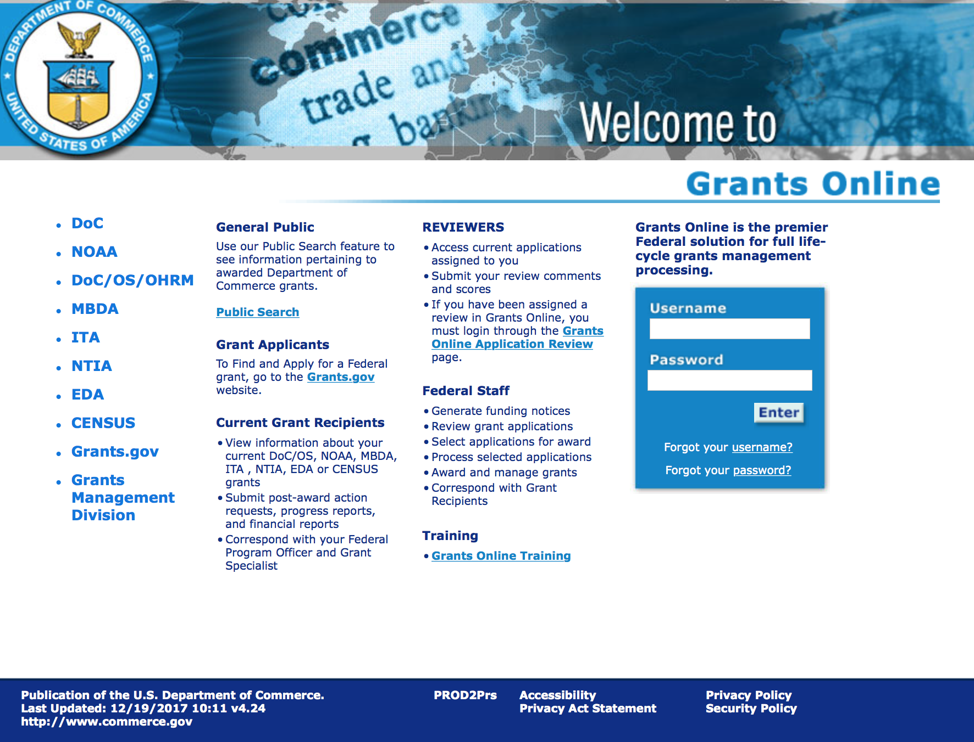
https://grantsonline.rdc.noaa.gov/flows/home/Login/LoginController.jpf

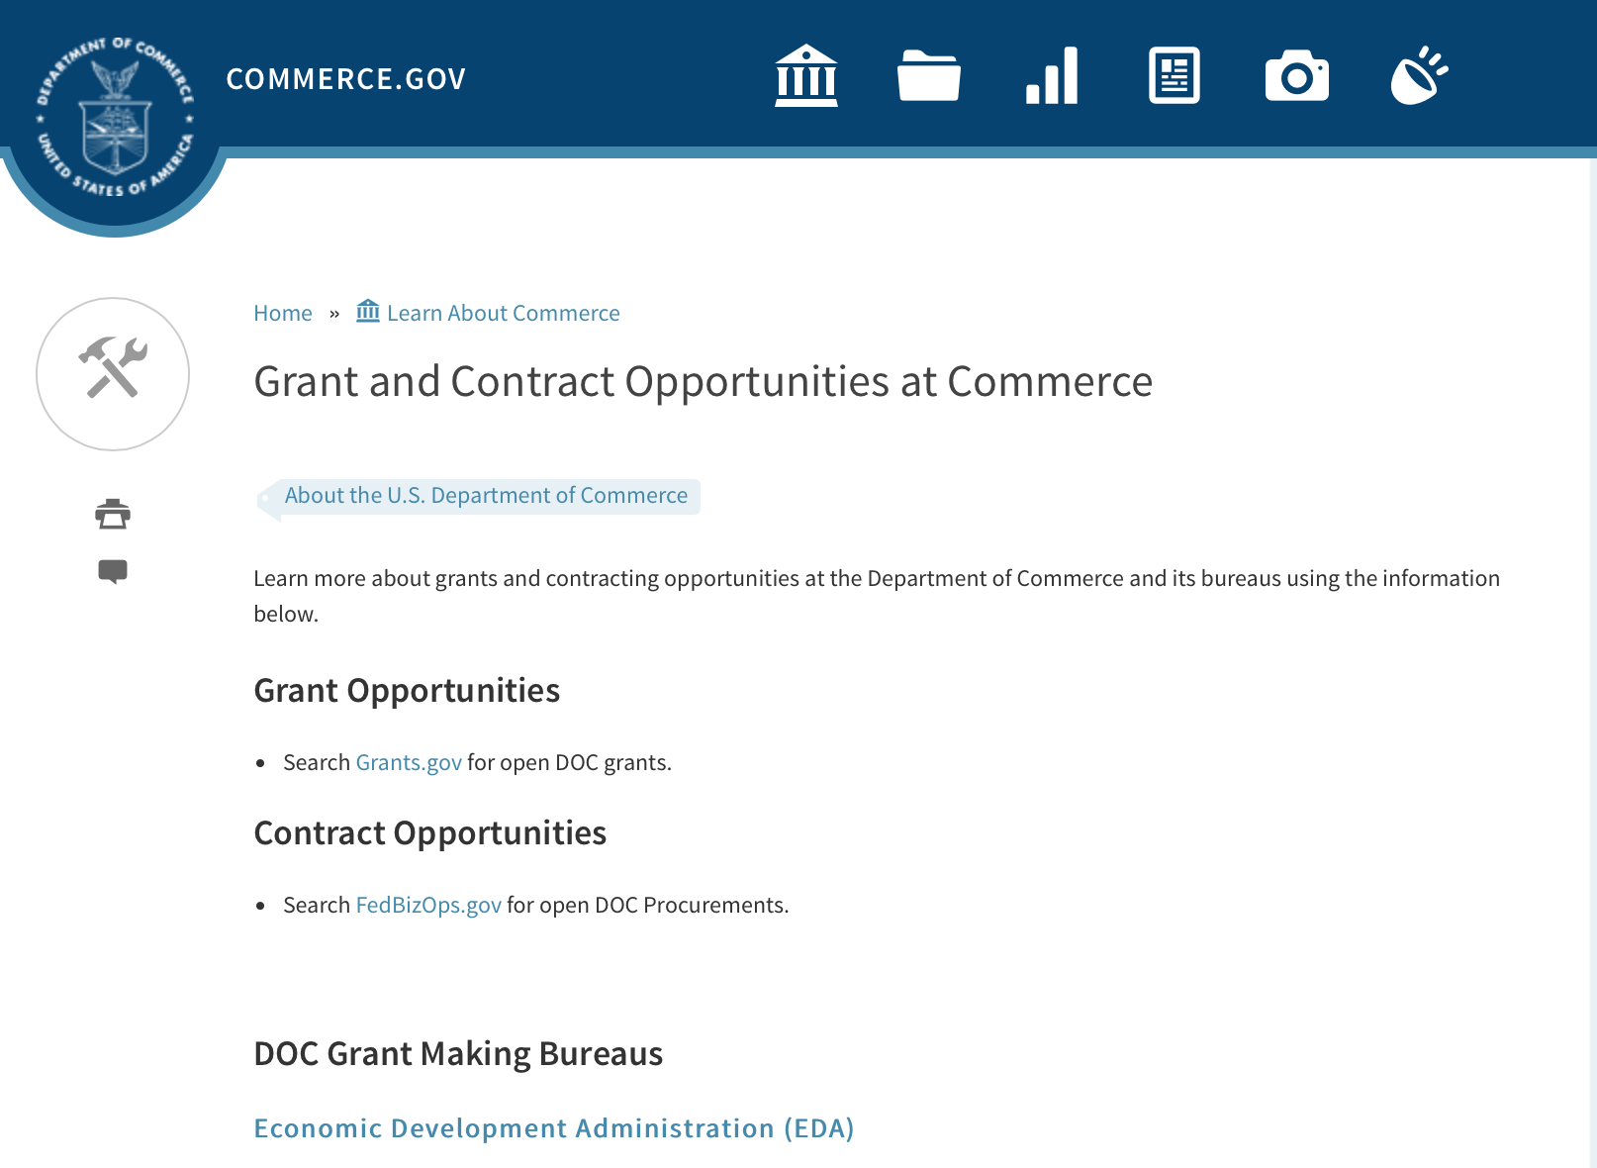
Grant and Contract Opportunities Department of Commerce

DOC Grant Making Bureaus
Economic Development Administration (EDA)
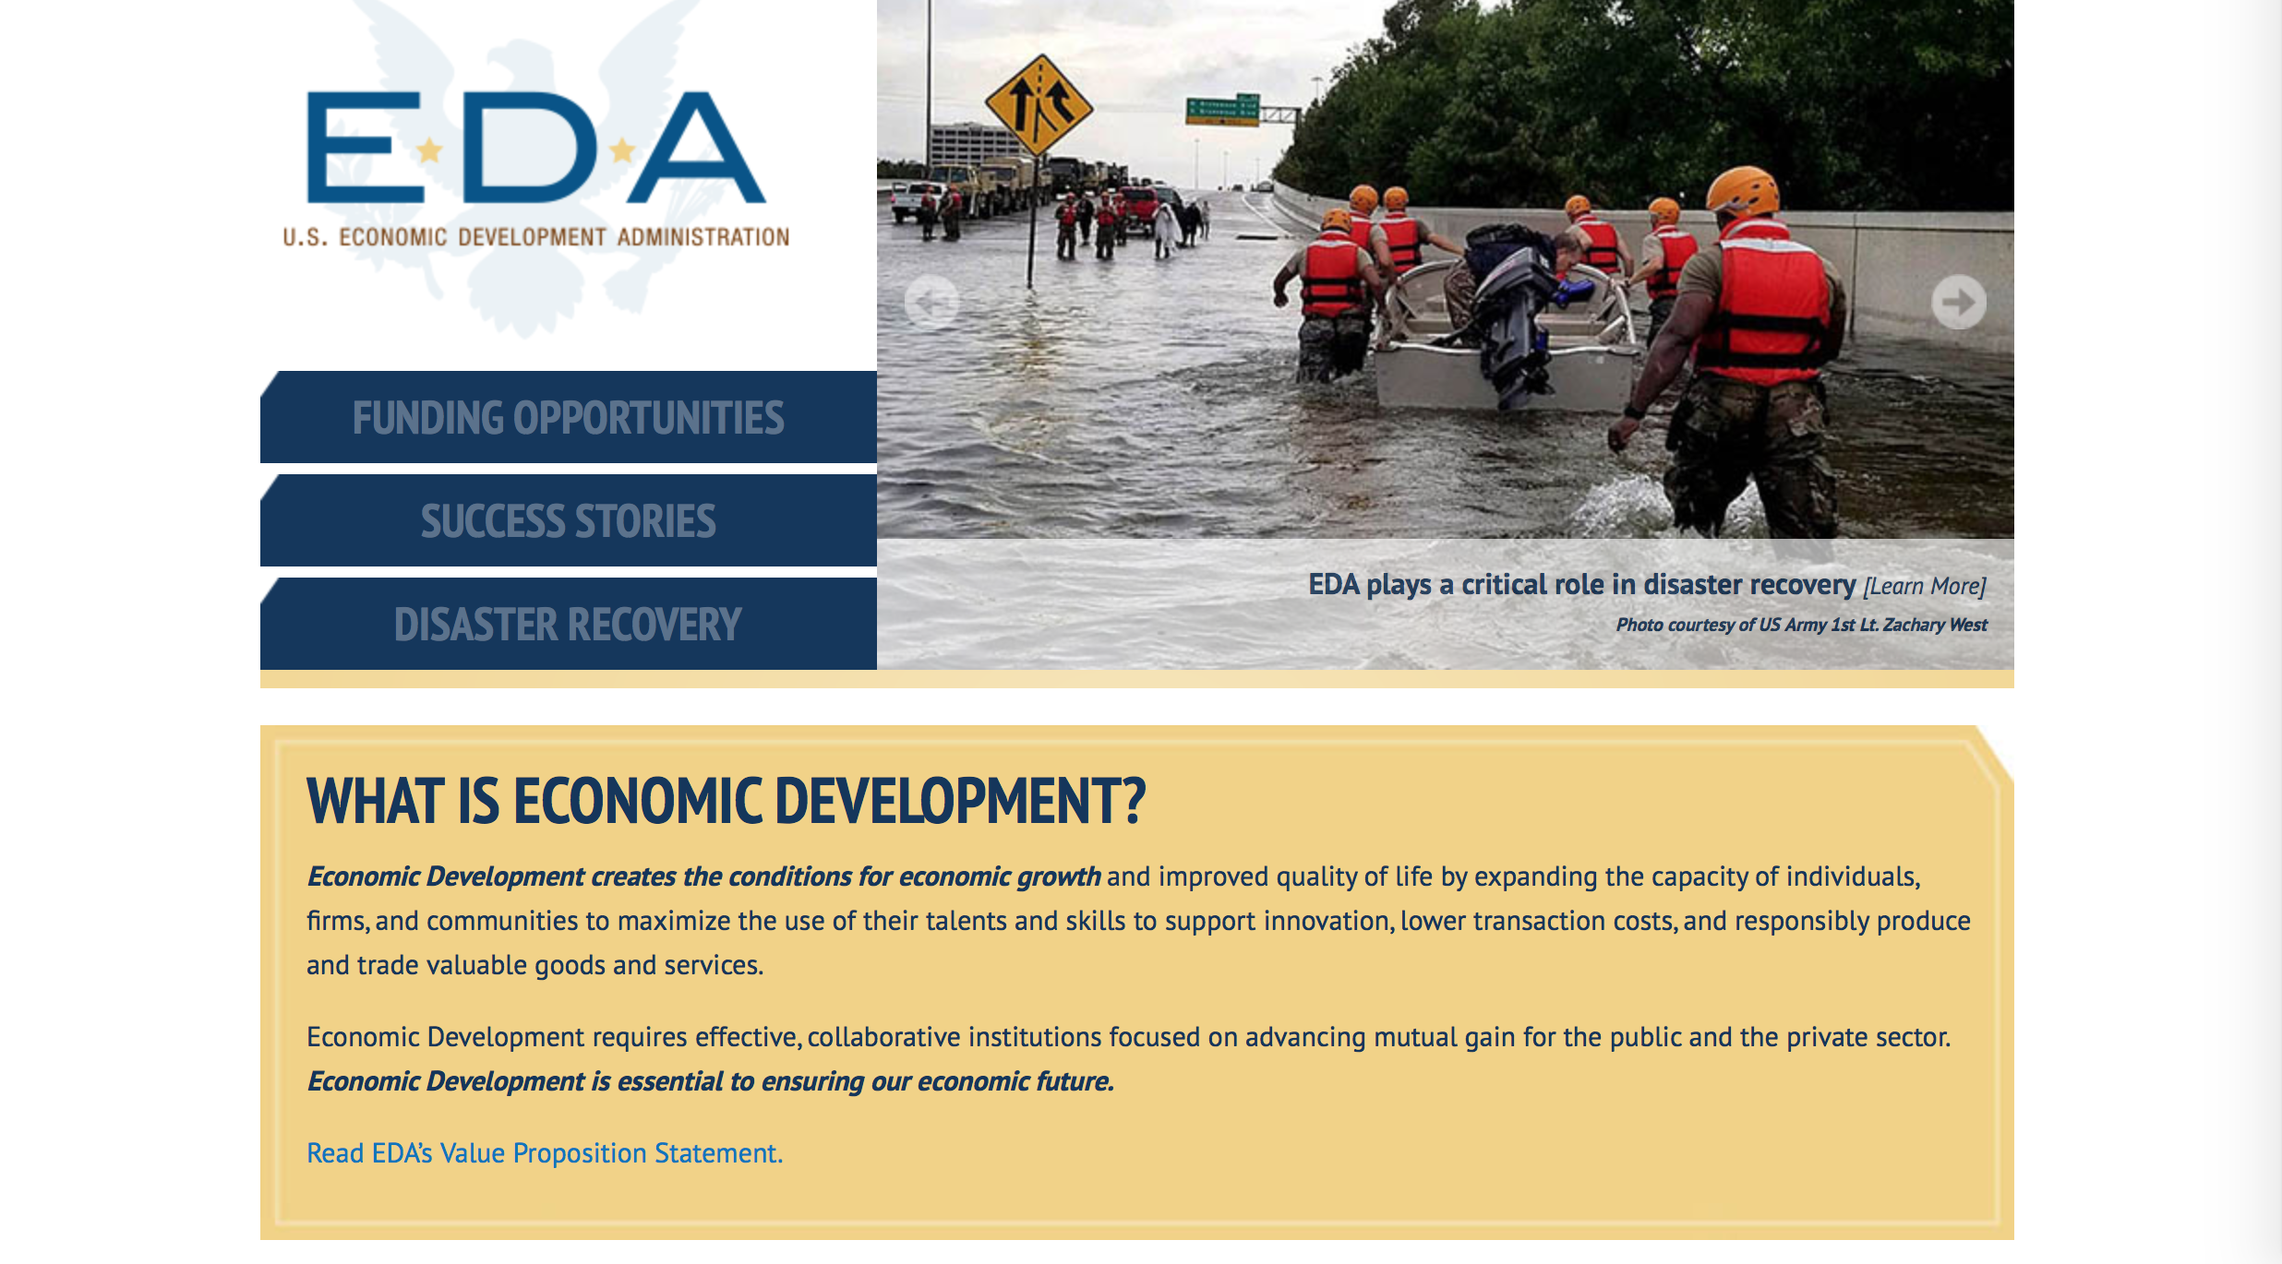
International Trade Administration (ITA)
- Market Development Cooperator Program
- Special American Business Internship Training Program (SABIT). A technical assistance initiative of the International Trade Administration of the U.S. Department of Commerce, SABIT offers organizations competitive grants and an opportunity to host industry-specific delegations. SABIT serves as an initial entry point for U.S. businesses seeking funding to establish long-term relationships with potential customers, distributors, or partners in the former Soviet Union. The program trains Eurasian managers and scientists in commonly accepted business practices as a means of facilitating cross border relationships. In turn, these personal relationships serve as a basis for business development and reduce market access barriers for U.S. businesses
National Institute of Standards & Technology (NIST)
- Funding Opportunities
National Telecommunications & Information Administration (NTIA)
- Telecommunications Grants
National Oceanic & Atmospheric Administration (NOAA)
- Coastal Ocean Program Grant Information
- Fisheries Saltonstall Kennedy Grant Program
- National Undersea Research Program Funding Opportunities
- Grants Management Division
- Fisheries Grants Program
- National Sea Grant
- Office of Global Programs
Contracting Resources for Contractors
- Office of Small and Disadvantaged Business Utilization (OSDBU) - the Office of Small and Disadvantaged Business Utilization (OSDBU) is an advocacy and advisory office responsible for promoting the use of small, small disadvantaged, 8(a), women-owned, veteran-owned, service-disabled veteran-owned, and HUBZone small businesses within the U.S. Department of Commerce's (DOC) acquisition process.
- Business.USA.gov's Find Opportunities Wizard where in a few quick steps, it will guide you towards federal government contracting programs and opportunities for your business!
- Planned Acquisitions: the Department of Commerce's search tool for our planned acquisitions over $100,000. As requirements change, these acquisition plans are updated by department personnel and this search tool is automatically updated.
- Small Business Administration's Contracting section of their web site where you can learn about how to "Get Started" and "Contracting Support for Small Business"
- The General Services Administration (GSA) has implemented a system for vendors doing business with the Federal Government to manage their entity information in one central location. This new database is the System for Award Management (SAM).

DOC Contracting Offices
- Patent and Trademark Office (PTO)
  - Office of Procurement
- National Institute of Standards & Technology (NIST)
NIST Acquisition Management Group
Contracting Opportunities with Commerce
Trade Opportunities through Commerce
http://www.commerce.gov/about-commerce/grants-contracting-trade-opportunities

Programs:

National Estuarine Research Reserve System (NERRS) Land Acquisition and Construction Program for Fiscal Year 2019
Synopsis 1

Document Type: | Grants Notice
Funding Opportunity Number: | NOAA-NOS-OCM-2019-2005800
Funding Opportunity Title: | National Estuarine Research Reserve System (NERRS) Land Acquisition and Construction Program for Fiscal Year 2019
Opportunity Category: | Discretionary
Opportunity Category Explanation:
Funding Instrument Type: | Grant
Category of Funding Activity: | Environment  Natural Resources  Science and Technology and other Research and Development
Category Explanation:
Expected Number of Awards: | 20
CFDA Number(s): | 11.420 -- Coastal Zone Management Estuarine Research Reserves
Cost Sharing or Matching Requirement: | Yes
Version: | Synopsis 1
Posted Date: | Oct 18, 2018
Last Updated Date: | Oct 18, 2018
Original Closing Date for Applications: | Feb 08, 2019
Current Closing Date for Applications: | Feb 08, 2019
Archive Date: | Mar 10, 2019
Estimated Total Program Funding: | $1,900,000
Award Ceiling: | $800,000
Award Floor: | $20,000
Eligible Applicants: | Others (see text field entitled "Additional Information on Eligibility" for clarification)
Additional Information on Eligibility: | Eligible applicants are NERRS lead state agencies or universities designated to receive NERRS operations funding through a Memorandum of Understanding with NOAA in coastal states including the Pacific, Gulf, Atlantic Coast and Great Lakes. Eligible applicants should meet requirements as stated in the NERRS regulations codified at 15 CFR 921.32 which are available online at http://go.usa.gov/xkGEf. Federal agencies and employees are not allowed to receive funds under this announcement but may serve as collaborative project partners. Federal agencies and employees’ ‘in-kind’ services cannot be considered as part of an applicant’s match on shared costs. If federal agencies are collaborators, applicants are expected to provide detail on the planned level of federal engagement in the application. Examples might include, but are not limited to partnership services; serving in a review capacity; or participating in priority task teams, working groups, or leadership teams.
Additional Information
Agency Name: | Department of Commerce
Description: | The National Estuarine Research Reserve System (NERRS or System) consists of estuarine areas of the United States and its territories designated and managed for research and educational purposes. Each Reserve within the system is chosen to represent a different bio-geographic region and to include a variety of ecosystem types in accordance with the classification scheme of the national program as specified in 15 CFR Part 921. By funding Reserve lead agencies and universities to conduct land acquisition and construction projects that support the NERRS mission, NOAA will strengthen protection of key land and water areas, enhance long-term protection of Reserve areas for research and education, and provide for facility and exhibit construction that meet the highest sustainable design standards possible.  NOAA anticipates approximately $1.9 million in Fiscal Year 2019 will be available to designated lead Reserve agencies or universities in coastal states for approximately 5-10 construction and  acquisition projects, and expected to range from approximately $20,000 to $800,000 per project and with project periods typically covering 12-36 months, depending on the availability of funds.
Link to Additional Information:
Grantor Contact Information: | If you have difficulty accessing the full announcement electronically, please contact:  Mr. Matthew Chasse 301-713-3155 1325 East West Highway, Silver Spring, MD 20910  work
https://www.grants.gov/web/grants/view-opportunity.html?oppId=309682

Research:

Modifications:

Reminders:

Climate Program Office FY 2019
Synopsis 1

Document Type: | Grants Notice
Funding Opportunity Number: | NOAA-OAR-CPO-2019-2005530
Funding Opportunity Title: | Climate Program Office FY 2019
Opportunity Category: | Discretionary
Opportunity Category Explanation:
Funding Instrument Type: | Cooperative Agreement  Grant
Category of Funding Activity: | Environment  Natural Resources  Science and Technology and other Research and Development
Category Explanation:
Expected Number of Awards: | 90
CFDA Number(s): | 11.431 -- Climate and Atmospheric Research
Cost Sharing or Matching Requirement: | No

Version: | Synopsis 1
Posted Date: | Aug 08, 2018
Last Updated Date: | Aug 08, 2018
Original Closing Date for Applications: | Nov 20, 2018
Current Closing Date for Applications: | Nov 20, 2018
Archive Date: | Dec 20, 2018
Estimated Total Program Funding: | $11,250,000
Award Ceiling: | $300,000
Award Floor: | $50,000
Eligible Applicants: | Others (see text field entitled "Additional Information on Eligibility" for clarification)
Additional Information on Eligibility: | Eligible applicants are institutions of higher education, other nonprofits, commercial organizations, international organizations, and state, local and Indian tribal governments. Federal agencies interested in receiving financial support for projects should contact the appropriate competition manager.
Additional Information
Agency Name: | Department of Commerce
Description: | The National Oceanic and Atmospheric Administration (NOAA) is focused on providing the essential and highest quality environmental information vital to our Nation’s safety, prosperity and resilience. Toward this goal, the agency conducts and supports weather and climate research, oceanic and atmospheric observations, modeling, information management, assessments, interdisciplinary decision-support research, outreach, education, and partnership development.  Climate variability and change present society with significant economic, health, safety, and security challenges and opportunities. In meeting these challenges, and as part of NOAA’s climate portfolio within the Office of Oceanic and Atmospheric Research (OAR), the Climate Program Office (CPO) advances scientific understanding, monitoring, and prediction of climate and its impacts, to enable effective decisions through investments at NOAA labs, service lines and Cooperative Institutes, as well as non-governmental organizations, the private sector and the university community. These investments are key to NOAA’s mission of "Science, Service, and Stewardship" and are guided by the agency’s vision to create and sustain enhanced resilience in ecosystems, communities, and economies.  Within this context, CPO manages competitive research programs through which NOAA funds high-priority climate science, assessments, decision support research, outreach, education, and  capacity-building activities designed to advance our understanding of the Earth’s climate system, and to foster the application and use of this knowledge to improve the resilience of our Nation and its partners. CPO supports research that is conducted across the United States and internationally. CPO also provides strategic guidance for the agency’s broader climate science and services programs and supports NOAA’s mandated responsibilities under the National Climate Program Act, Global Change Research Act and its National Climate Assessment, the National Integrated Drought Information System Act, and similar international endeavors such as the Global Framework for Climate Services. CPO’s climate research portfolio is designed to achieve a fully integrated research and applications program.  CPO’s strategy addresses challenges in the areas of: (1) Weather and climate extremes, (2) Climate impacts on water resources, (3) Coasts and climate resilience, (4) Sustainability of marine ecosystems, and (5) Changing atmospheric composition and its impacts. Making progress in addressing climate-related societal challenges, and realizing benefits for NOAA’s public and private partners, requires that these mission-focused capabilities be integrated across CPO to align research, applications, transitions, and operations, and to meet the information needs for a resilient society. We work towards this objective of integration through a focus on climate intelligence and climate resilience, in support of NOAA’s goals.  CPO defines climate intelligence as the capabilities regarding: (1) Observations and monitoring, (2) Earth system science and modeling, (3) Climate and societal interactions, and (4) Communication, education, and engagement. Climate resilience leverages climate intelligence to advance capabilities for responding to the urgent and growing demand for reliable, trusted, transparent, and timely climate information needed to protect and sustain all sectors of our economy and environment.  A hallmark of CPO’s success in linking climate intelligence to resilience is the development and deployment of end-to-end research-based integrated information systems that address needs of high societal relevance. Key components of this effort are annual Federal Funding Opportunities, competitive grants programs and other types of support that advance and extend NOAA’s foundational capabilities and applications research. Proficiency in these core areas ensures that CPO’s infrastructure is always in place to meet the intelligence and resilience challenges of our changing climate.  NOAA, OAR, and CPO encourage applicants and awardees to support the principles of diversity and inclusion when writing their proposals and performing their work. Diversity is defined as a collection of individual attributes that together help organizations achieve objectives. Inclusion is defined as a culture that connects each employee to the organization. Promoting diversity and inclusion improves creativity, productivity, and the vitality of the climate research community in which CPO engages.
Link to Additional Information:
Grantor Contact Information: | If you have difficulty accessing the full announcement electronically, please contact:  Diane Brown CPO Grants Manager diane.brown@noaa.gov  Work
https://www.grants.gov/web/grants/view-opportunity.html?oppId=308094

FY2019 Marine Debris Removal
Synopsis 1
Document Type: | Grants Notice
Funding Opportunity Number: | NOAA-NOS-ORR-2019-2005796
Funding Opportunity Title: | FY2019 Marine Debris Removal
Opportunity Category: | Discretionary
Opportunity Category Explanation:
Funding Instrument Type: | Cooperative Agreement
Category of Funding Activity: | Environment  Natural Resources  Science and Technology and other Research and Development
Category Explanation:
Expected Number of Awards: | 15
CFDA Number(s): | 11.999 -- Marine Debris Program
Cost Sharing or Matching Requirement: | Yes
Version: | Synopsis 2
Posted Date: | Aug 20, 2018
Last Updated Date: | Aug 22, 2018
Original Closing Date for Applications: | Oct 29, 2018
Current Closing Date for Applications: | Oct 29, 2018
Archive Date: | Nov 28, 2018
Estimated Total Program Funding: | $2,000,000
Award Ceiling: | $250,000
Award Floor: | $50,000
Eligible Applicants: | Others (see text field entitled "Additional Information on Eligibility" for clarification)
Additional Information on Eligibility: | In accordance with the Marine Debris Act, eligible applicants are state, local, tribal, and territory governments whose activities affect research or regulation of marine debris and any institution of higher education, nonprofit organization, or commercial (for-profit) organization with expertise in a field related to marine debris. Applications from federal agencies or employees of federal agencies will not be considered. Interested federal agencies may collaborate with eligible applicants but may not receive funds through this competition. All projects must take place within the United States or territories or their respective waterways. Foreign organizations and foreign public entities are not eligible to apply as the primary applicant but can be involved as a sub-awardee or sub-contractor. NOAA is strongly committed to broadening the participation of veterans, minority-serving institutions, and entities that work in underserved areas. The NOAA MDP encourages proposals from, or involving any of the above types of institutions. Applications that have been submitted to other NOAA grant programs or as part of another NOAA grant may be considered under this solicitation.
Additional Information
Agency Name: | Department of Commerce
Description: | The NOAA Marine Debris Program, authorized in the Marine Debris Act, codified at 33 U.S.C. 1951-1958, supports the development and implementation of locally-driven, marine debris prevention, assessment, and removal projects that benefit coastal habitat, waterways, and NOAA trust resources. Projects awarded through this grant competition will create long-term, quantifiable ecological habitat improvements for NOAA trust resources through on-the-ground marine debris removal activities, with priority for those targeting derelict fishing gear and other medium- and large-scale debris. Projects should also foster awareness of the effects of marine debris to further the conservation of living marine resource habitats, and contribute to the understanding of marine debris composition, distribution and impacts. Successful proposals through this solicitation will be funded through cooperative agreements. Funding of up to $2,000,000 is expected to be available for Marine Debris Removal grants in Fiscal Year 2019. Typical awards will range from $50,000 to $150,000. Funding for this grant competition comes through the NOAA Marine Debris Program as appropriations to the Office of Response and Restoration, National Ocean Service.
Link to Additional Information:
Grantor Contact Information: | If you have difficulty accessing the full announcement electronically, please contact:  Tom Barry tom.barry@noaa.gov 240-533-0425  Work
https://www.grants.gov/web/grants/view-opportunity.html?oppId=308384

Ocean Exploration Fiscal Year 2019 Funding Opportunity
Synopsis 1
Document Type: Grants Notice  Funding Opportunity Number: NOAA-OAR-OER-2019-2005679  Funding Opportunity Title: Ocean Exploration Fiscal Year 2019 Funding Opportunity  Opportunity Category: Discretionary  Opportunity Category Explanation:  Funding Instrument Type: Cooperative Agreement Grant  Category of Funding Activity: Environment Natural Resources Science and Technology and other Research and Development  Category Explanation:  Expected Number of Awards: 6  CFDA Number(s): 11.011 -- Ocean Exploration  Cost Sharing or Matching Requirement: No | Version: Synopsis 1  Posted Date: Jun 19, 2018  Last Updated Date: Jun 19, 2018  Original Closing Date for Applications: Nov 15, 2018  Current Closing Date for Applications: Nov 15, 2018  Archive Date: Dec 15, 2018  Estimated Total Program Funding: $3,000,000  Award Ceiling: $750,000  Award Floor: $10,000
Eligibility
Eligible Applicants: | Others (see text field entitled "Additional Information on Eligibility" for clarification)
Additional Information on Eligibility: | Eligible applicants are U.S.-based institutions of higher education; non-profit institutions; state, local, and tribal governments; Federal agencies; for-profit organizations; and U.S. territories that possess the statutory authority to accept funding for this type of work. PLEASE NOTE: Before non-NOAA federal applicants may be funded, they must demonstrate that they have legal authority to receive funds from another federal agency in excess of their appropriation. NOAA and other Federal agencies that possess the statutory authority to accept funding for this type of work must agree to take FY 2019 funding for proposed projects and allocate them in FY2019. Federal and state agencies are strongly encouraged to collaborate with partners from a non- federal eligible entity. Foreign researchers may participate by submitting a sub-award through collaboration with an eligible U.S. entity. The DOC and NOAA support cultural and gender diversity and encourage women and minority individuals and groups to submit applications to this Announcement of Notice of Funding Opportunity (NOFO). In addition, DOC/NOAA is strongly committed to broadening the participation of historically black colleges and universities, Hispanic serving institutions, tribal colleges and universities, and institutions that work in underserved areas. DOC/NOAA encourages applications involving any of the above institutions to apply.
Additional Information
Agency Name: | Department of Commerce
Description: | NOAA’s Office of Ocean Exploration & Research (OER) is soliciting proposals for ocean exploration in waters under U.S. jurisdiction, including the U.S. Exclusive Economic Zone (EEZ), and areas mapped by, or of interest to, the U.S. Extended Continental Shelf (ECS) Project. Presently, important marine habitats and living and non-living resources are neither fully explored nor characterized. OER's intent is to address these knowledge gaps and support growth in the Nation's Blue Economy by soliciting ocean exploration proposals that focus on:  1. Discovering microorganisms, sponges, corals, and other organisms with biopharmaceutical or biotechnical potential;  2. Acquiring baseline ocean environmental information to better inform decision-making where future ocean energy development or critical mineral extraction may occur;  3. Finding and characterizing shipwrecks and submerged cultural resources that played a role in America’s past ocean-based economy (e.g., transport, trade, warfare, etc.) and could inform decisions on future seabed activities and potential environmental impacts.  OER seeks to enhance ocean exploration and scientific knowledge of unknown or poorly known areas of the ocean through interdisciplinary exploration, and to advance and disseminate knowledge of the ocean’s physical, geological, chemical, biological, and archaeological environments. This entails identifying, describing and creating baseline characterizations of new ocean habitats, marine resources and/or processes. OER’s mission is compliant with NOAA’s Next Generation Strategic Plan (http://www.performance.noaa.gov/ngsp/) which outlines NOAA goals of Science, Service and Stewardship.  Applicants are required to submit pre-proposals and, ultimately, full proposals that support OER’s exploration mission.  Note: Ship time on the NOAA Ship Okeanos Explorer will not be funded through this announcement.  Informational documents on this funding opportunity are accessible through the OER Website: https://oceanexplorer.noaa.gov/about/funding-opps/welcome.html.  For the purpose of this opportunity, ship time costs and/or other ocean data collection platform support (remotely operated vehicles, autonomous underwater vehicles, etc.) are considered rental costs and therefore are not included in Modified Total Direct Cost (MTDC).
Link to Additional Information:
Grantor Contact Information: | If you have difficulty accessing the full announcement electronically, please contact:  For further information, contact the NOAA Office of Ocean Exploration and Research at (301)734-1014 or oer.ffo2019@noaa.gov. Email inquiries should include the Principal Investigator's name in the subject heading. Inquiries can also be mailed to: NOAA Office of Ocean Exploration and Research, ATTN: OER NOFO 2019, SSMC3, Rm 10316, 1315 East West Highway, Silver Spring, Maryland 20910.  OER Work email
https://www.grants.gov/web/grants/view-opportunity.html?oppId=306381

Economic Development Administration
FY 2017 Economic Development Assistance Programs ­ Application submission and program requirements for EDA’s Public Works and Economic Adjustment Assistance programs.
Synopsis 1
Document Type: | Grants Notice
Funding Opportunity Number: | EDAP-2017
Funding Opportunity Title: | FY 2017 Economic Development Assistance Programs Application submission and program requirements for EDA’s Public Works and Economic Adjustment Assistance programs.
Opportunity Category: | Discretionary
Opportunity Category Explanation:
Funding Instrument Type: | Cooperative Agreement  Grant
Category of Funding Activity: | Other (see text field entitled "Explanation of Other Category of Funding Activity" for clarification)
Category Explanation: | The Economic Development Administration's (EDA's) mission is to lead the Federal economic development agenda by promoting innovation and competitiveness, preparing American regions for economic growth and success in the worldwide economy. EDA fulfills this mission through strategic investments and partnerships that create the regional economic ecosystems required to foster globally competitive regions throughout the United States. EDA supports development in economically distressed areas of the United States by fostering job creation and attracting private investment. Specifically, under the Economic Development Assistance programs (EDAP) Notice of Funding Availability (NOFA), EDA will make construction, non-construction, and revolving loan fund investments under the Public Works and Economic Adjustment Assistance (EAA) Programs. Through this NOFA, EDA will also designate a portion of its EAA funding to support communities and regions that have been negatively impacted by changes in the coal economy (Assistance to Coal Communities, or ACC 2017). Grants made under these programs will leverage regional assets to support the implementation of regional economic development strategies designed to create jobs, leverage private capital, encourage economic development, and strengthen America's ability to compete in the global marketplace. Through the EDAP NOFA, EDA solicits applications from rural and urban communities to develop initiatives that advance new ideas and creative approaches to address rapidly evolving economic conditions.
Expected Number of Awards:
CFDA Number(s): | 11.300 -- Investments for Public Works and Economic Development Facilities  11.307 -- Economic Adjustment Assistance
Cost Sharing or Matching Requirement: | Yes
Version: | Synopsis 1
Posted Date: | Jun 19, 2017
Last Updated Date: | Jun 19, 2017
Original Closing Date for Applications: | There are no submission deadlines under this opportunity. Proposals and applications will be accepted on an ongoing basis until the publication of a new EDAP NOFA.
Current Closing Date for Applications: | There are no submission deadlines under this opportunity. Proposals and applications will be accepted on an ongoing basis until the publication of a new EDAP NOFA.
Archive Date:
Estimated Total Program Funding:
Award Ceiling: | $3,000,000
Award Floor: | $100,000
Eligible Applicants: | Native American tribal organizations (other than Federally recognized tribal governments)  Special district governments  Others (see text field entitled "Additional Information on Eligibility" for clarification)  Private institutions of higher education  County governments  Native American tribal governments (Federally recognized)  City or township governments  Nonprofits that do not have a 501(c)(3) status with the IRS, other than institutions of higher education  State governments  Nonprofits having a 501(c)(3) status with the IRS, other than institutions of higher education  Public and State controlled institutions of higher education
Additional Information on Eligibility: | Eligible applicants for EDA financial assistance under the Public Works and EAA programs (including ACC 2017 funding) include a(n): (i) District Organization of a designated Economic Development District; (ii) Indian Tribe or a consortium of Indian Tribes; (iii) State, county, city, or other political subdivision of a State, including a special purpose unit of a State or local government engaged in economic or infrastructure development activities, or a consortium of political subdivisions; (iv) institution of higher education or a consortium of institutions of higher education; or (v) public or private non-profit organization or association acting in cooperation with officials of a political subdivision of a State. See Section 3 of the Public Works and Economic Development Act of 1965 (PWEDA) (42 U.S.C. § 3122) and 13 C.F.R. § 300.3. EDA is not authorized to provide grants or cooperative agreements to individuals or to for profit entities. Requests from such entities will not be considered for funding. For ACC 2017 funding, projects must be located within and targeted to communities or regions that have been impacted, or can reasonably demonstrate that they will be impacted, by coal mining or coal power plant employment loss, or employment loss in the supply chain industries of either.
Agency Name: | Economic Development Administration
Description: | Under this NOFA, EDA solicits applications from applicants in rural and urban areas to provide investments that support construction, non-construction, technical assistance, and revolving loan fund projects under EDA’s Public Works and EAA programs. Grants and cooperative agreements made under these programs are designed to leverage existing regional assets and support the implementation of economic development strategies that advance new ideas and creative approaches to advance economic prosperity in distressed communities, including communities and regions that have been impacted, or can reasonably demonstrate that they will be impacted, by coal mining or coal power plant employment loss, or employment loss in the supply chain industries of either. EDA provides strategic investments on a competitive- merit-basis to support economic development, foster job creation, and attract private investment in economically distressed areas of the United States. This EDAP NOFA supersedes the EDAP Federal Funding Opportunity dated December 23, 2016.
Link to Additional Information: | Economic Development Administration
Grantor Contact Information: | If you have difficulty accessing the full announcement electronically, please contact:  If you have difficulty accessing the full announcement electronically, please contact: the EDA representative for your state. A complete list of EDA representatives is available on EDA's website at http://www.eda.gov/contact/  http://www.eda.gov/contact/

http://www.grants.gov/web/grants/view-opportunity.html?oppId=294771

FY 2016 – FY 2019 EDA Planning Program and Local Technical Assistance Program Grant

Document Type: | Grants Notice
Funding Opportunity Number: | EDA-HDQ-TA-HDQ-2016-2004759
Funding Opportunity Title: | FY 2016 – FY 2019 EDA Planning Program and Local Technical Assistance Program
Opportunity Category: | Discretionary
Funding Instrument Type: | Cooperative Agreement  Grant
Category of Funding Activity: | Other (see text field entitled "Explanation of Other Category of Funding Activity" for clarification)  Regional Development
Category Explanation: | Regional planning and local technical assistance
Expected Number of Awards:
CFDA Number(s): | 11.302 -- Economic Development Support for Planning Organizations  11.303 -- Economic Development Technical Assistance
Cost Sharing or Matching Requirement: | No
Posted Date: | Dec 10, 2015
Creation Date: | Dec 10, 2015
Original Closing Date for Applications: | Applications are accepted on a continuing basis and processed as received. This Planning and Local Technical Assistance opportunity will remain in effect until superseded by a future announcement.
Current Closing Date for Applications: | Applications are accepted on a continuing basis and processed as received. This Planning and Local Technical Assistance opportunity will remain in effect until superseded by a future announcement.
Archive Date:
Estimated Total Program Funding:
Award Ceiling: | $300,000
Award Floor: | $0
Eligible Applicants: | Nonprofits having a 501(c)(3) status with the IRS, other than institutions of higher education  City or township governments  Nonprofits that do not have a 501(c)(3) status with the IRS, other than institutions of higher education  Others (see text field entitled "Additional Information on Eligibility" for clarification)  Private institutions of higher education  Native American tribal governments (Federally recognized)  Public and State controlled institutions of higher education  State governments  Special district governments  County governments
Additional Information on Eligibility: | Pursuant to section 3 of the Public Works and Economic Development Act of 1965 (42 U.S.C. § 3122) (PWEDA) and EDA’s regulation at 13 C.F.R. § 300.3, the following types of entities are eligible to receive funding assistance from EDA: 1. District Organizations (as defined in 13 C.F.R. § 300.3); 2. Indian Tribes or a consortium of Indian Tribes; 3. States, cities, or other political subdivisions of a State, including a special purpose unit of a State or local government engaged in economic or infrastructure development activities, or a consortium of political subdivisions; 4. Institutions of higher education or a consortium of institutions of higher education; or 5. Public or private non-profit organizations or associations acting in cooperation with officials of a political subdivision of a State.
Agency Name: | Department of Commerce
Description: | Pursuant to PWEDA, EDA announces general policies and application procedures for grant-based investments under the Planning and Local Technical Assistance programs. Under the Planning program EDA assists eligible recipients in creating regional economic development plans designed to build capacity and guide the economic prosperity and resiliency of an area or region. As part of this program, EDA supports Partnership Planning investments to facilitate the development, implementation, revision, or replacement of Comprehensive Economic Development Strategies (CEDS), which articulate and prioritize the strategic economic goals of recipients’ respective regions. In general, EDA provides Partnership Planning grants to the designated planning organization (e.g., District Organization) serving EDA designated Economic Development Districts to enable these organizations to develop and implement relevant CEDS. In addition, EDA provides Partnership Planning grants to Indian Tribes to help develop and implement CEDS and associated economic development activities. The Planning program also helps support organizations, including District Organizations, Indian Tribes, and other eligible recipients, with Short Term and State Planning investments designed to guide the eventual creation and retention of high-quality jobs, particularly for the unemployed and underemployed in the Nation’s most economically distressed regions. The Local Technical Assistance program strengthens the capacity of local or State organizations, institutions of higher education, and other eligible recipients to undertake and promote effective economic development programs through projects such as feasibility analyses and impact studies.
Link to Additional Information: | www.eda.gov
Contact Information: | If you have difficulty accessing the full announcement electronically, please contact:  The EDA representative for your state. A complete list of EDA representatives is available on EDA's website at http://www.eda.gov/contact/

http://www.grants.gov/web/grants/view-opportunity.html?oppId=280447

Economic Development Administration
Planning Program and Local Technical Assistance Program Grant

Document Type: | Grants Notice
Funding Opportunity Number: | EDAPLANNING2012
Opportunity Category: | Discretionary
Posted Date: | Aug 03, 2012
Creation Date: | Aug 03, 2012
Original Closing Date for Applications: | Applications are accepted on a continuing basis and processed as received. This Planning and Local Technical Assistance opportunity will remain in effect until superseded by a future announcement.
Current Closing Date for Applications: | Applications are accepted on a continuing basis and processed as received. This Planning and Local Technical Assistance opportunity will remain in effect until superseded by a future announcement.
Archive Date:
Funding Instrument Type: | Cooperative Agreement  Grant
Category of Funding Activity: | Other (see text field entitled "Explanation of Other Category of Funding Activity" for clarification)  Regional Development
Category Explanation: | Regional planning and local technical assistance
Expected Number of Awards: | 425
Estimated Total Program Funding:
Award Ceiling: | $100,000
Award Floor:
CFDA Number(s): | 11.302 -- Economic Development Support for Planning Organizations
 | 11.303 -- Economic Development Technical Assistance
Cost Sharing or Matching Requirement: | Yes

Eligible Applicants
State governments
County governments
City or township governments
Public and State controlled institutions of higher education
Native American tribal governments (Federally recognized)
Nonprofits having a 501(c)(3) status with the IRS, other than institutions of higher education
Nonprofits that do not have a 501(c)(3) status with the IRS, other than institutions of higher education
Private institutions of higher education
Others (see text field entitled "Additional Information on Eligibility" for clarification)

Additional Information on Eligibility:
Pursuant to section 3 of the Public Works and Economic Development Act of 1965 (42 U.S.C. § 3122) (PWEDA) and EDA’s regulation at 13 C.F.R. § 300.3, the following types of entities are eligible to receive funding assistance from EDA: 1. District Organizations (as defined in 13 C.F.R. § 300.3); 2. Indian Tribes or a consortium of Indian Tribes; 3. States, cities, or other political subdivisions of a State, including a special purpose unit of a State or local government engaged in economic or infrastructure development activities, or a consortium of political subdivisions; 4. Institutions of higher education or a consortium of institutions of higher education; or 5. Public or private non-profit organizations or associations acting in cooperation with officials of a political subdivision of a State.

Agency Name
Economic Development Administration

Description
Pursuant to PWEDA, EDA announces general policies and application procedures for grant-based investments under the Planning and Local Technical Assistance programs. Under the Planning program EDA assists eligible recipients in creating regional economic development plans designed to stimulate and guide the economic development efforts of a community or region. As part of this program, EDA supports Partnership Planning investments to facilitate the development, implementation, revision, or replacement of Comprehensive Economic Development Strategies (CEDS), which articulate and prioritize the strategic economic goals of recipients' respective regions. In general, EDA provides Partnership Planning grants to the designated planning organization (e.g., District Organization) serving EDA-designated Economic Development Districts to enable these organizations to develop and implement relevant CEDS. In addition, EDA provides Partnership Planning grants to Indian Tribes to help develop and implement CEDS and associated economic development activities. The Planning program also helps support planning organizations, including District Organizations, Indian Tribes, and other eligible Recipients, with Short Term and State Planning investments designed to guide the eventual creation and retention of higher-skill, higher-wage jobs, particularly for the unemployed and underemployed in the Nation’s most economically distressed regions. The Local Technical Assistance program strengthens the capacity of local or State organizations, institutions of higher education, and other eligible recipients to undertake and promote effective economic development programs through projects such as feasibility analyses and impact studies.

Link to Additional Information

If you have difficulty accessing the full announcement electronically, please contact:
David Ives Planning and Local TA email

http://www.grants.gov/web/grants/view-opportunity.html?oppId=189193

Deleted:
ITA-INA-OPCM-2017-2004912 - Market Development Cooperator Program 2017
Deletion Comments: Opportunity deleted. Per the Program Officer email dated 3/22/17 this FFO is being deleted.

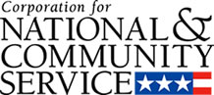

Corporation for National and Community Service

General Program Overview
AmeriCorps provides resources, both human and financial, to organizations that engage Americans in intensive service to meet our country’s critical needs.
Grantees use the funding to support AmeriCorps members for intensive service in their community. AmeriCorps grants partially cover the expense of operating an AmeriCorps program and do not cover general organizational expenses. A cash and in-kind match is required.

The main website can be accessed here: http://www.nationalservice.gov

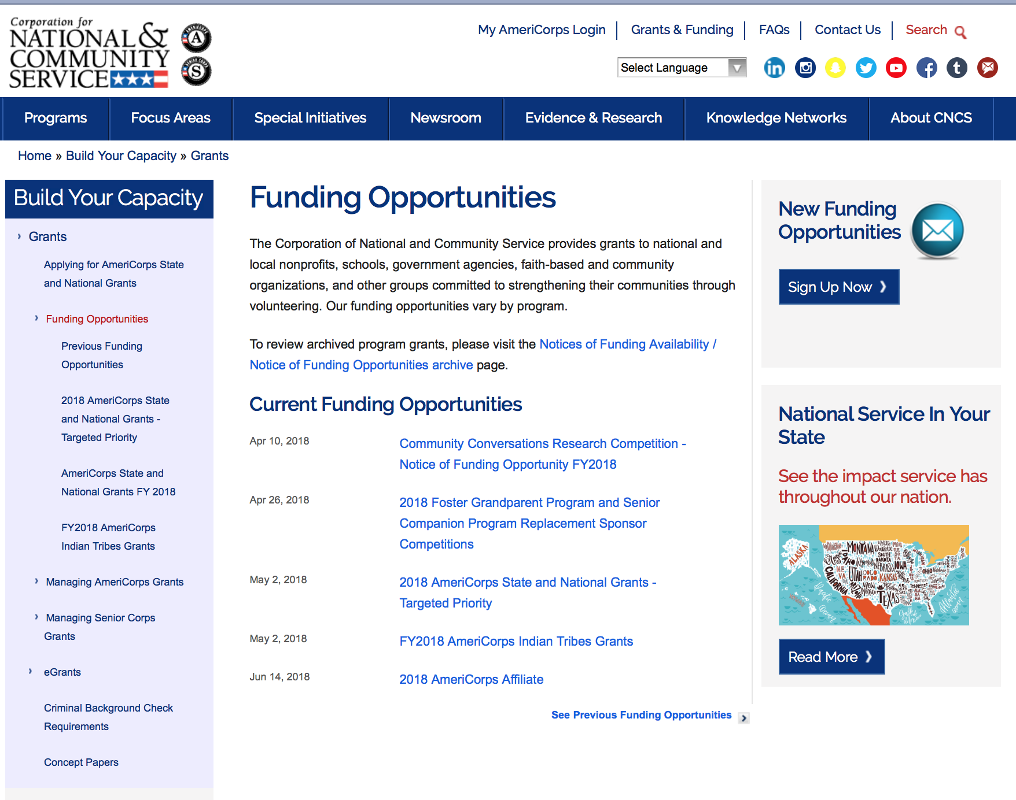

For access to further funding information: click here

http://www.nationalservice.gov/build-your-capacity/grants/funding-opportunities

Programs:

Research:

Reminders:

AmeriCorps State and National Grants FY2019
Synopsis 1

Document Type: | Grants Notice
Funding Opportunity Number: | CNCS-09-25-18
Funding Opportunity Title: | AmeriCorps State and National Grants FY2019
Opportunity Category: | Discretionary
Opportunity Category Explanation:
Funding Instrument Type: | Grant
Category of Funding Activity: | Community Development  Disaster Prevention and Relief  Education  Employment, Labor and Training  Environment  Food and Nutrition  Health  Housing  Natural Resources
Category Explanation:
Expected Number of Awards:
CFDA Number(s): | 94.006 -- AmeriCorps
Cost Sharing or Matching Requirement: | Yes
Version: | Synopsis 1
Posted Date: | Sep 25, 2018
Last Updated Date: | Sep 25, 2018
Original Closing Date for Applications: | Jan 30, 2019
Current Closing Date for Applications: | Jan 30, 2019
Archive Date: | Jan 31, 2019
Eligible Applicants: | Independent school districts  Native American tribal organizations (other than Federally recognized tribal governments)  State governments  Special district governments  City or township governments  Private institutions of higher education  Native American tribal governments (Federally recognized)  Nonprofits that do not have a 501(c)(3) status with the IRS, other than institutions of higher education  Public and State controlled institutions of higher education  County governments  Nonprofits having a 501(c)(3) status with the IRS, other than institutions of higher education  Public housing authorities/Indian housing authorities
Additional Information on Eligibility:
Additional Information
Agency Name: | Corporation for National and Community Service
Description: | AmeriCorps grants are awarded to eligible organizations proposing to engage AmeriCorps members in evidence-based or evidence-informed interventions to strengthen communities. An AmeriCorps member is an individual who engages in community service through an approved national service position. Members may receive a living allowance and other benefits while serving. Upon successful completion of their service, members earn a Segal AmeriCorps Education Award from the National Service Trust that members can use to pay for higher education expenses or apply to qualified student loans.
Link to Additional Information: | Full competition information and resources
Grantor Contact Information: | If you have difficulty accessing the full announcement electronically, please contact:  202-606-6659  Competition inbox
https://www.grants.gov/web/grants/view-opportunity.html?oppId=309257

National Service In Hawaii
National Service in Your State - Hawaii
2015-2016

Meeting Community Needs in Hawaii: More than 3,100 people of all ages and backgrounds are helping to meet local needs, strengthen communities, and increase civic engagement through national service in Hawaii. Serving at more than 450 locations throughout the state, these citizens tutor and mentor children, support veterans and military families, provide health services, restore the environment, respond to disasters, increase economic opportunity, and recruit and manage volunteers. This year, the Corporation for National and Community Service (CNCS) will commit more than $6,260,000 to support Hawaii communities through national service initiatives. Through a unique public-private partnership, this federal investment will leverage an additional $9,060,000 in other resources to strengthen community impact, build local support, and increase return on taxpayer dollars. Nationwide, CNCS, its grantees, and project sponsors generated more than $1.25 billion in outside resources from businesses, foundations, public agencies, and other sources in FY 2015.

AmeriCorps
This year, AmeriCorps will provide more than 560 individuals the opportunity to provide intensive, results-driven service to meet education, environmental, health, economic, and other pressing needs in communities across Hawaii. Most AmeriCorps grant funding goes to the Hawaii Commission on National & Community Service, which in turn awards grants to nonprofit groups to respond to local needs. Most of the remainder of the grant funding is distributed by CNCS directly to multi-state and national organizations through a competitive grants process. Other individuals serve through AmeriCorps VISTA, whose members help bring individuals and communities out of poverty by serving full-time to fight illiteracy, improve health services, create businesses, and increase housing opportunities, and AmeriCorps NCCC (National Civilian Community Corps), a 10-month, full time residential program for men and women between the ages of 18 and 24. In exchange for their service, AmeriCorps members earn an education award that can be used to pay for college or to pay back qualified student loans. Since 1994, more than 5,900 Hawaii residents have served more than 6.4 million hours and have qualified for Segal AmeriCorps Education Awards totaling more than $14,980,000.
Download: AmeriCorps in Hawaii (PDF)
Senior Corps
More than 2,500 seniors in Hawaii contribute their time and talents in one of three Senior Corps programs. Foster Grandparents serve one-on-one as tutors and mentors to more than 310 young people who have special needs. Senior Companions help more than 220 homebound seniors and other adults maintain independence in their own homes. RSVP volunteers conduct safety patrols, renovate homes, protect the environment, tutor and mentor youth, respond to natural disasters, and provide other services through more than 250 groups across Hawaii.
Download: Senior Corps in Hawaii (PDF)

The Corporation for National and Community Service is a federal agency that improves lives, strengthens communities, and fosters civic engagement through service and volunteering. CNCS annually engages more than five million Americans in service to meet local needs through Senior Corps, AmeriCorps, and national days of service; improves communities through the Social Innovation Fund, and leads President Obama's national call to service initiative, United We Serve. To learn more visit NationalService.gov or Serve.gov or call 202-606-5000 or TTY 1-800-833-3722.

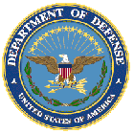

U.S. Department of Defense

Doing Business with the Department of Defense

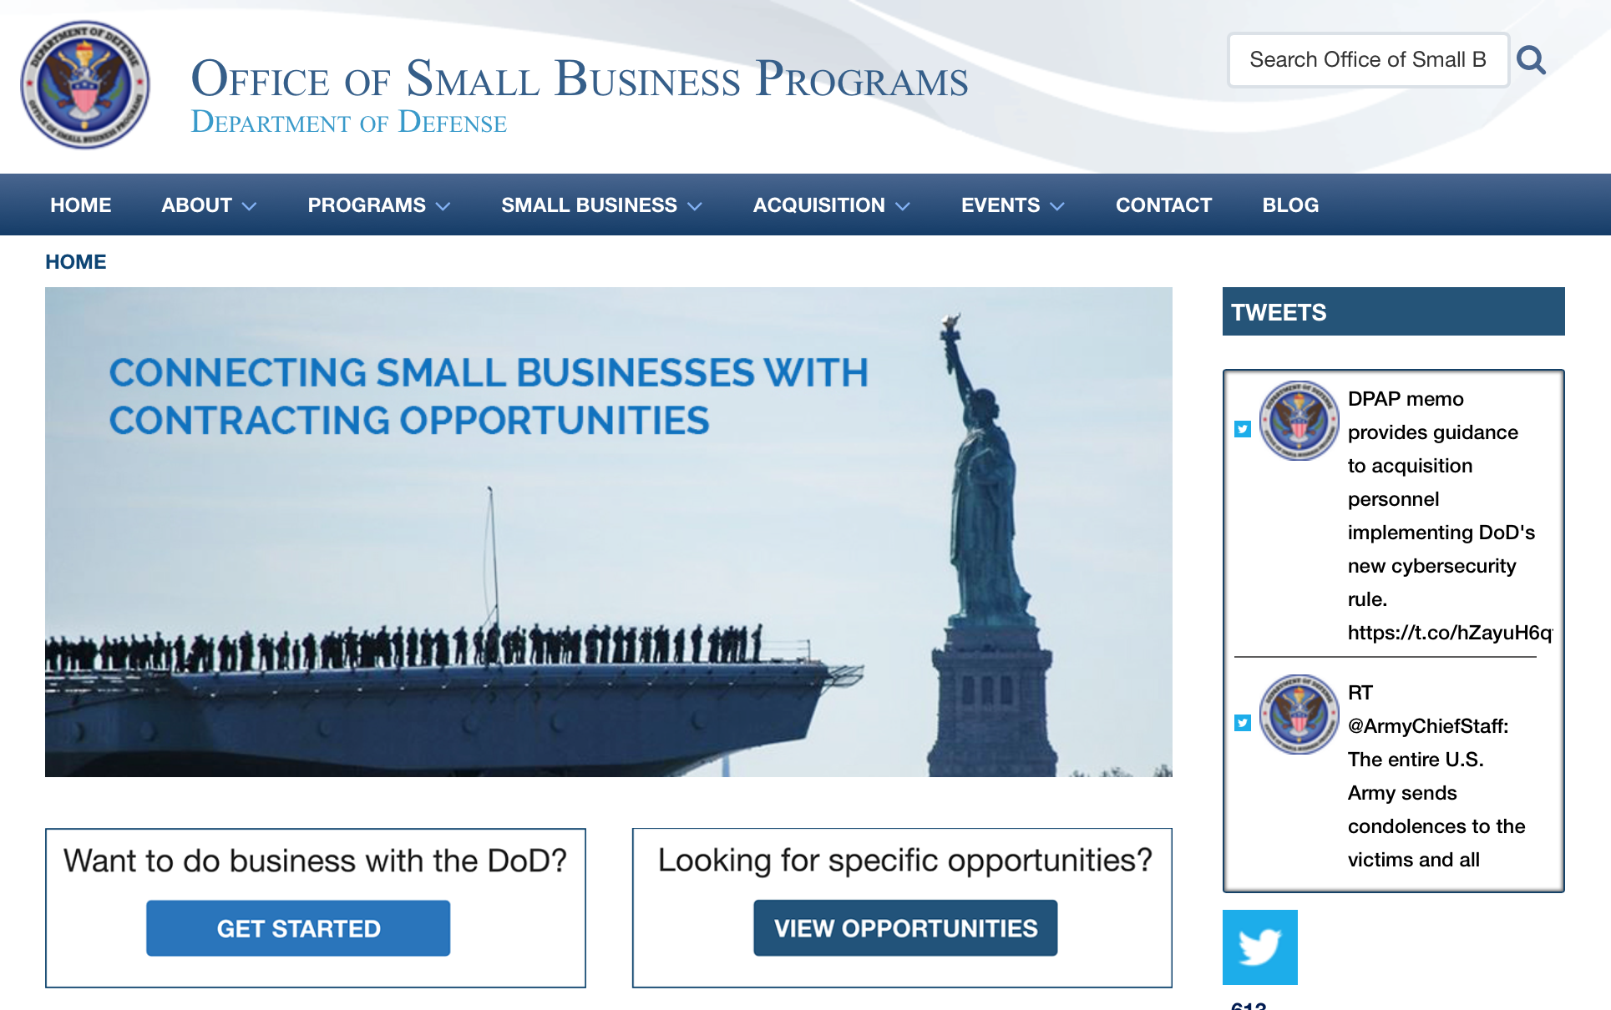

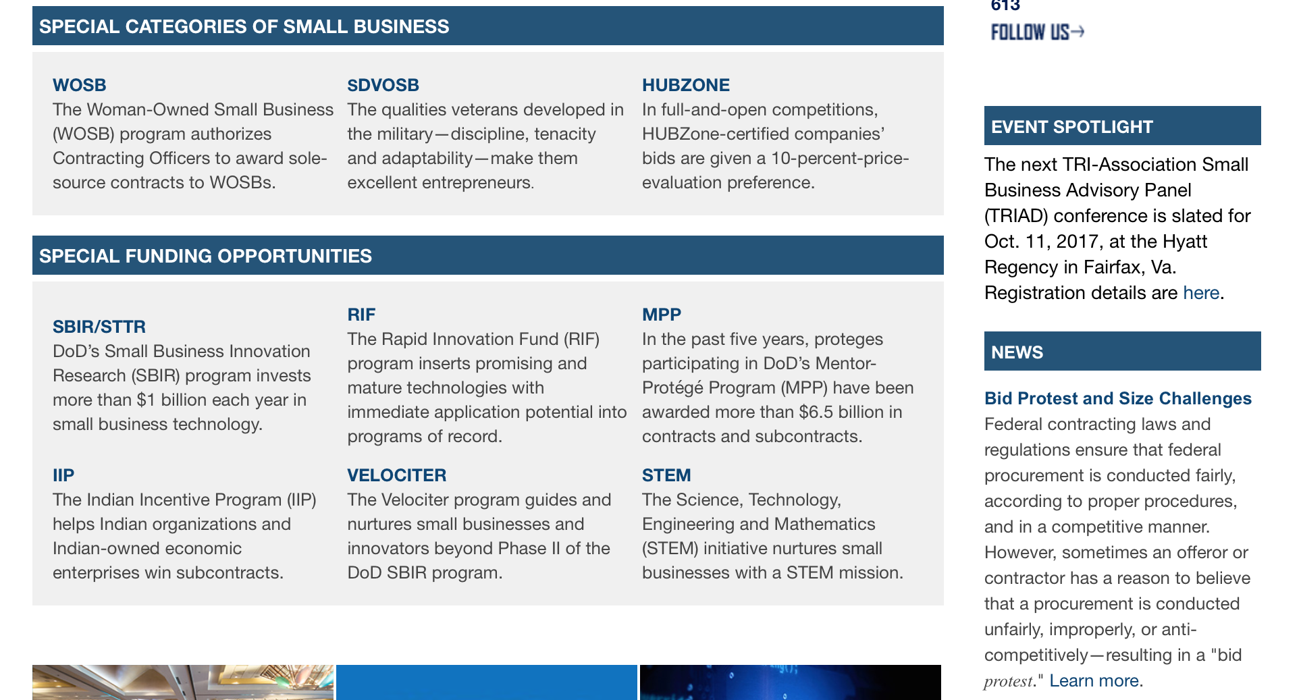

http://business.defense.gov

http://www.acq.osd.mil/osbp/

Doing Business with the DoD

Resources

Procurement Technical Assistance Centers (PTACs)

Procurement Technical Assistance Centers (PTACs) are charged with assisting businesses in learning how to do business with federal, state, and local governments. PTACs are a local resource available at no or nominal cost that can provide assistance to business firms in marketing their products and services. They offer training to businesses on how to research and bid on contracts, assist with registration requirements, provide bid-matching services, and assist with pre and post contracting issues.

Prime Contractors with Subcontracting Plans [xlsx]

Directory last updated 6/2017

This FY 2014 directory is intended for small business concerns seeking opportunities with DoD prime contractors. The directory is a listing of large business prime contractors who are required to establish subcontracting plans with goals. The report is generated from data contained in the Individual Subcontract Reports (ISRs) submitted in the Electronic Subcontracting Reporting System (eSRS) by contractors and from data contained in the Federal Procurement Data System (FPDS). The directory includes the name of the prime contractor; the major product/service code (PSC) provided to DoD; the major NAICS of the company; name, telephone number and email address of the company’s point of contact; contract number with the effective date and completion date, ultimate contract value and obligated dollars. In addition, many companies have websites with additional information which may be useful in your search for subcontracting opportunities or teaming arrangements.

Locate a Small Business Professional

Non-Appropriated Fund Customers

Non-appropriated fund customers operate similar to non-profit organizations and include commissaries, exchanges, recreation and fitness centers, dining at officer/enlisted/civilian clubs, and barber/beauty services, just to name a few.

For more information click here.

Research:

ACC-APG-Detrick
Armed Forces Pest Management Board Broad Agency Announcement
Synopsis 1
https://www.grants.gov/web/grants/view-opportunity.html?oppId=309840

Air Force -- Research Lab
Structural Integrity Research Collaborations for Aircraft (SIRCA)
Synopsis 1
https://www.grants.gov/web/grants/view-opportunity.html?oppId=309814

DARPA - Defense Sciences Office
Accelerated Molecular Discovery (AMD)
Synopsis 1
https://www.grants.gov/web/grants/view-opportunity.html?oppId=309695
DARPA - Information Innovation Office
Machine Common Sense (MCS)
Synopsis 1
https://www.grants.gov/web/grants/view-opportunity.html?oppId=309716

Office of Naval Research
Electronic Warfare Technology
Synopsis 1
https://www.grants.gov/web/grants/view-opportunity.html?oppId=309702

Modifications:

Dept of the Army -- Materiel Command
Strengthening Teamwork for Robust Operations in Novel Groups (STRONG)
Synopsis 2
https://www.grants.gov/web/grants/view-opportunity.html?oppId=310010

Deleted:

Reminders:



Department of Education
Grant Programs Overview at the Department of Education

The general information page for Education Grant funding is an excellent resource describing the three types of grants awarded by the Department of Education. See the screen shot of the Department of Education web page below:

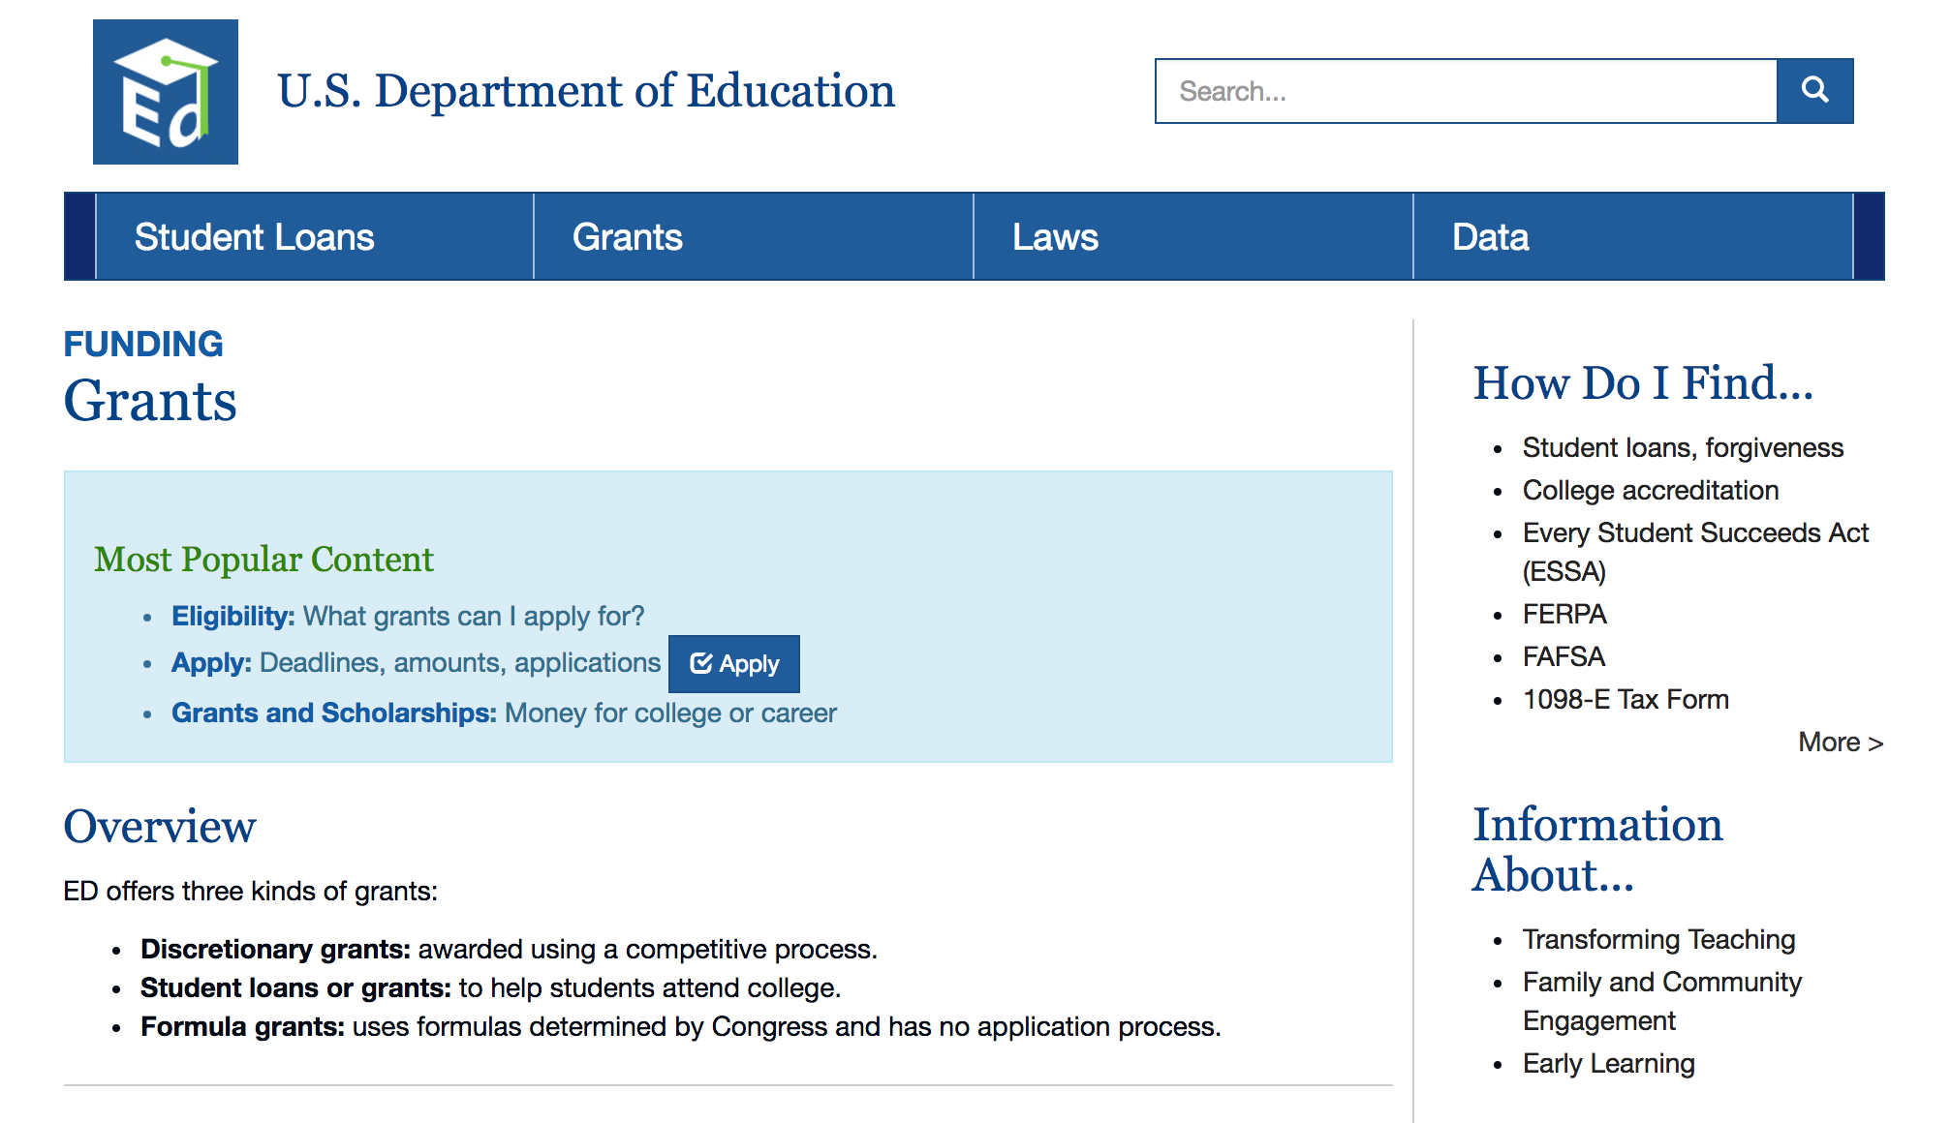
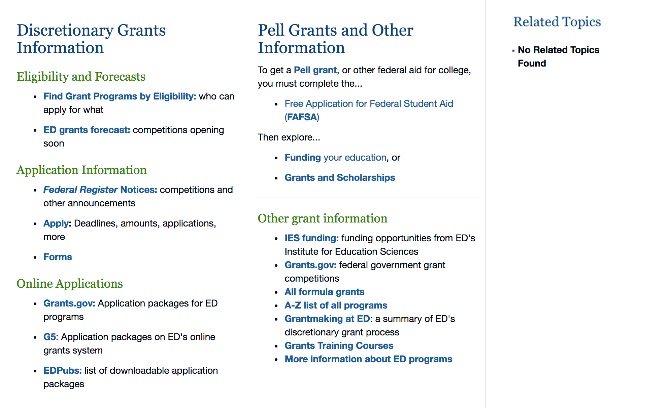

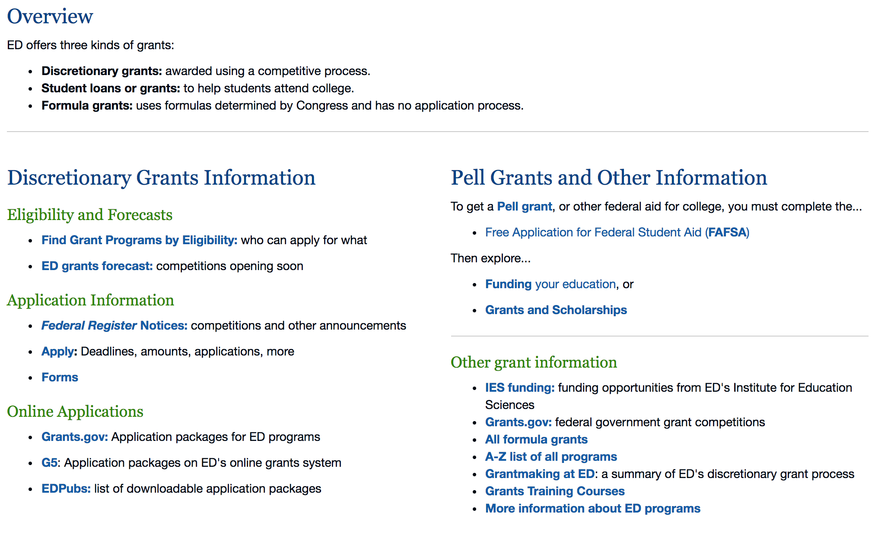

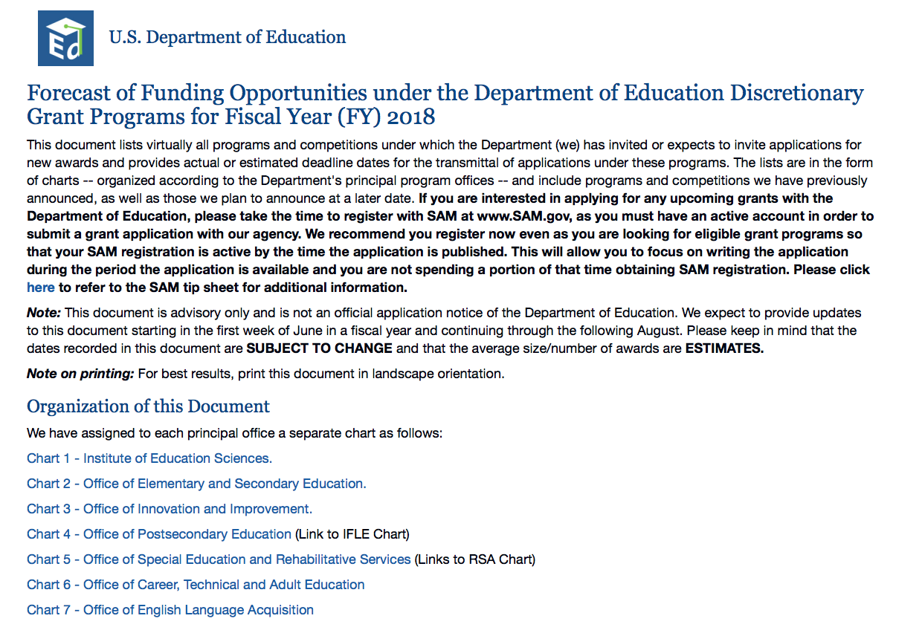

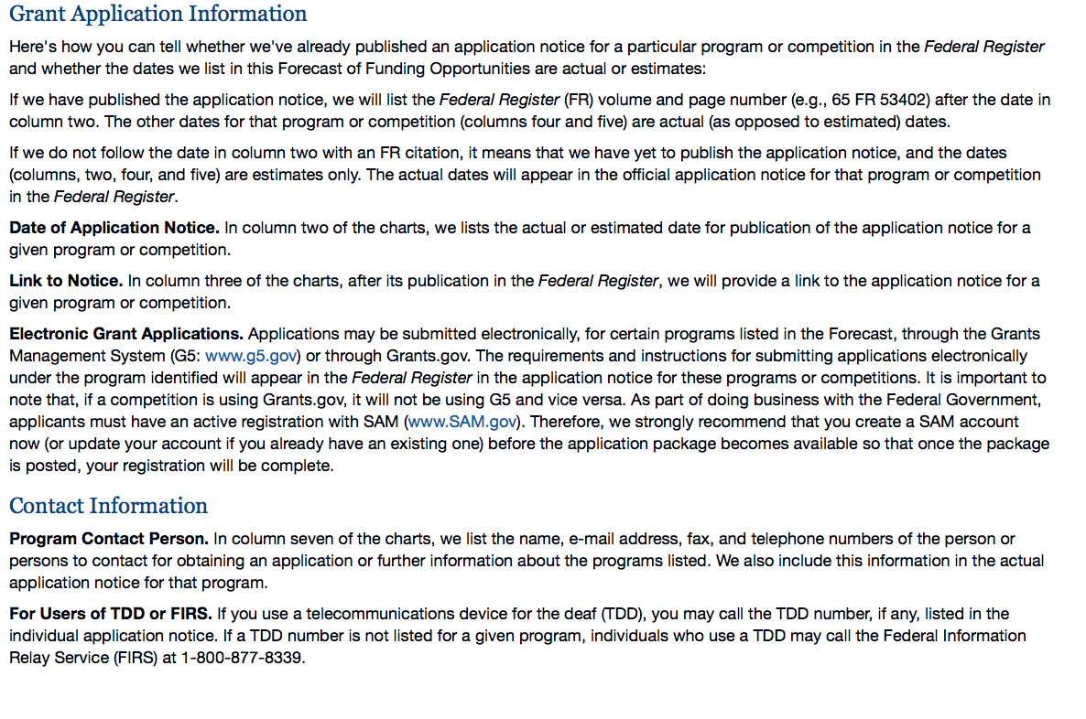

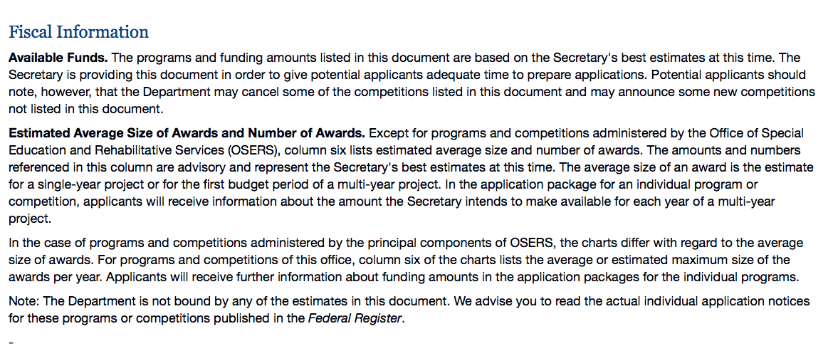

https://www2.ed.gov/fund/grant/find/edlite-forecast.html

Programs:

Research:

Modifications:

Reminders:

Institute of Education Sciences (IES): Low-Cost, Short-Duration Evaluation of Education Interventions CFDA Number 84.305L
Synopsis 1
Document Type: Grants Notice  Funding Opportunity Number: ED-GRANTS-052118-005  Funding Opportunity Title: Institute of Education Sciences (IES): Low-Cost, Short-Duration Evaluation of Education Interventions CFDA Number 84.305L  Opportunity Category: Discretionary  Opportunity Category Explanation:  Funding Instrument Type: Cooperative Agreement Grant  Category of Funding Activity: Education  Category Explanation:  Expected Number of Awards:  CFDA Number(s): 84.305 -- Education Research, Development and Dissemination  Cost Sharing or Matching Requirement: No | Version: Synopsis 1  Posted Date: May 21, 2018  Last Updated Date: May 21, 2018  Original Closing Date for Applications: Mar 07, 2019 Applications Available: January 10, 2019. Deadline for Transmittal of Applications: March 7, 2019.  Current Closing Date for Applications: Mar 07, 2019 Applications Available: January 10, 2019. Deadline for Transmittal of Applications: March 7, 2019.  Archive Date: Apr 06, 2019  Estimated Total Program Funding:  Award Ceiling:  Award Floor:
Eligibility
Eligible Applicants: | Others (see text field entitled "Additional Information on Eligibility" for clarification)  Independent school districts  County governments  City or township governments  Special district governments  Public and State controlled institutions of higher education  State governments  Nonprofits that do not have a 501(c)(3) status with the IRS, other than institutions of higher education  For profit organizations other than small businesses  Nonprofits having a 501(c)(3) status with the IRS, other than institutions of higher education  Private institutions of higher education
Additional Information on Eligibility: | Eligible Applicants: Applicants that have the ability and capacity to conduct scientifically valid research are eligible to apply. Eligible applicants include, but are not limited to, nonprofit and for-profit organizations and public and private agencies and institutions of higher education, such as colleges and universities.
Additional Information
Agency Name: | Department of Education
Description: | Note: Each funding opportunity description is a synopsis of information in the Federal Register application notice. For specific information about eligibility, please see the official application notice. The official version of this document is the document published in the Federal Register. Free Internet access to the official edition of the Federal Register and the Code of Federal Regulations is available on GPO Access at: http://www.access.gpo.gov/nara/index.html. Please review the official application notice for pre-application and application requirements, application submission information, performance measures, priorities and program contact information.  For the addresses for obtaining and submitting an application, please refer to our Common Instructions for Applicants to Department of Education Discretionary Grant Programs, published in the Federal Register on February 12, 2018 (83 FR 6003) and available atwww.gpo.gov/fdsys/pkg/FR-2018-02-12/pdf/2018-02558.pdf.  The dates when applications are available and the deadlines for transmittal of applications invited under this notice are indicated in the chart at the end of this notice and in the Requests for Applications (RFAs) that are posted at the following websites: https://ies.ed.gov/funding,https://www.ed.gov/programs/edresearch/index.html,and https://www.ed.gov/programs/specialedresearch/index.html.  FOR FURTHER INFORMATION CONTACT: The contact person associated with a particular research competition is listed in the chart at the end of this notice, as well as in the relevant RFA and application package.  Purpose of Program: In awarding these grants, the Institute of Education Sciences (Institute) intends to provide national leadership in expanding fundamental knowledge and understanding of (1) developmental and school readiness outcomes for infants and toddlers with or at risk for a disability, (2) education outcomes for all students from early childhood education through postsecondary and adult education, and (3) employment and wage outcomes when relevant (such as for students who engaged in career and technical, postsecondary, or adult education). The Institute's research grant programs are designed to provide interested individuals and the general public with reliable and valid information about education practices that support learning and improve academic achievement and access to education opportunities for all students. These interested individuals include parents, educators, students, researchers, and policymakers. In carrying out its grant programs, the Institute provides support for programs of research in areas of demonstrated national need.  Competitions in This Notice: The Institute will conduct nine research competitions in FY 2019 through two of its centers: The Institute's National Center for Education Research (NCER) will hold a total of five competitions--one competition in each of the following areas: Education research; education research and development centers; statistical and research methodology in education; partnerships and collaborations focused on problems of practice or policy; and low-cost, short-duration evaluation of education interventions.  Catalog of Federal Domestic Assistance (CFDA) numbers 84.305A, 84.305C, 84.305D, 84.305H, 84.305L, 84.324A, 84.324B, 84.324L, and 84.324N.
Link to Additional Information: | Institute of Education Sciences (IES): Low-Cost, Short-Duration Evaluation of Education Interventions CFDA Number 84.305L; Notice Inviting Applications for New Awards for Fiscal Year (FY) 2019
Grantor Contact Information: | If you have difficulty accessing the full announcement electronically, please contact:  Julius Cotton ED Grants.gov FIND Systems Admin. Phone 202-245-6288 educationgrantinquiries@ed.gov Program Manager: Phill Gagne e-Mail: Phill Gagne@ed.gov  e-Mail: Program Manager
https://www.grants.gov/web/grants/view-opportunity.html?oppId=305419

Institute of Education Sciences (IES): Low-Cost, Short-Duration Evaluation of Special Education Interventions CFDA Number 84.324L
Synopsis 1
Document Type: Grants Notice  Funding Opportunity Number: ED-GRANTS-052118-008  Funding Opportunity Title: Institute of Education Sciences (IES): Low-Cost, Short-Duration Evaluation of Special Education Interventions CFDA Number 84.324L  Opportunity Category: Discretionary  Opportunity Category Explanation:  Funding Instrument Type: Cooperative Agreement Grant  Category of Funding Activity: Education  Category Explanation:  Expected Number of Awards:  CFDA Number(s): 84.324 -- Research in Special Education  Cost Sharing or Matching Requirement: No | Version: Synopsis 1  Posted Date: May 21, 2018  Last Updated Date: May 21, 2018  Original Closing Date for Applications: Mar 07, 2019 Applications Available: January 10, 2019. Deadline for Transmittal of Applications: March 7, 2019.  Current Closing Date for Applications: Mar 07, 2019 Applications Available: January 10, 2019. Deadline for Transmittal of Applications: March 7, 2019.  Archive Date: Apr 06, 2019  Estimated Total Program Funding:  Award Ceiling:  Award Floor:
Eligibility
Eligible Applicants: | Special district governments  City or township governments  Public and State controlled institutions of higher education  Nonprofits having a 501(c)(3) status with the IRS, other than institutions of higher education  Nonprofits that do not have a 501(c)(3) status with the IRS, other than institutions of higher education  Private institutions of higher education  Independent school districts  State governments  Others (see text field entitled "Additional Information on Eligibility" for clarification)  County governments  For profit organizations other than small businesses
Additional Information on Eligibility: | Eligible Applicants: Applicants that have the ability and capacity to conduct scientifically valid research are eligible to apply. Eligible applicants include, but are not limited to, nonprofit and for-profit organizations and public and private agencies and institutions of higher education, such as colleges and universities.
Additional Information
Agency Name: | Department of Education
Description: | Note: Each funding opportunity description is a synopsis of information in the Federal Register application notice. For specific information about eligibility, please see the official application notice. The official version of this document is the document published in the Federal Register. Free Internet access to the official edition of the Federal Register and the Code of Federal Regulations is available on GPO Access at: http://www.access.gpo.gov/nara/index.html. Please review the official application notice for pre-application and application requirements, application submission information, performance measures, priorities and program contact information.  For the addresses for obtaining and submitting an application, please refer to our Common Instructions for Applicants to Department of Education Discretionary Grant Programs, published in the Federal Register on February 12, 2018 (83 FR 6003) and available atwww.gpo.gov/fdsys/pkg/FR-2018-02-12/pdf/2018-02558.pdf.  The dates when applications are available and the deadlines for transmittal of applications invited under this notice are indicated in the chart at the end of this notice and in the Requests for Applications (RFAs) that are posted at the following websites: https://ies.ed.gov/funding,https://www.ed.gov/programs/edresearch/index.html,and https://www.ed.gov/programs/specialedresearch/index.html.  FOR FURTHER INFORMATION CONTACT: The contact person associated with a particular research competition is listed in the chart at the end of this notice, as well as in the relevant RFA and application package.  Purpose of Program: In awarding these grants, the Institute of Education Sciences (Institute) intends to provide national leadership in expanding fundamental knowledge and understanding of (1) developmental and school readiness outcomes for infants and toddlers with or at risk for a disability, (2) education outcomes for all students from early childhood education through postsecondary and adult education, and (3) employment and wage outcomes when relevant (such as for students who engaged in career and technical, postsecondary, or adult education). The Institute's research grant programs are designed to provide interested individuals and the general public with reliable and valid information about education practices that support learning and improve academic achievement and access to education opportunities for all students. These interested individuals include parents, educators, students, researchers, and policymakers. In carrying out its grant programs, the Institute provides support for programs of research in areas of demonstrated national need.  Competitions in This Notice: The Institute will conduct nine research competitions in FY 2019 through two of its centers: The Institute's National Center for Education Research (NCER) will hold a total of five competitions--one competition in each of the following areas: Education research; education research and development centers; statistical and research methodology in education; partnerships and collaborations focused on problems of practice or policy; and low-cost, short-duration evaluation of education interventions.  Catalog of Federal Domestic Assistance (CFDA) numbers 84.305A, 84.305C, 84.305D, 84.305H, 84.305L, 84.324A, 84.324B, 84.324L, and 84.324N.
Link to Additional Information: | Institute of Education Sciences (IES): Low-Cost, Short-Duration Evaluation of Special Education Interventions CFDA Number 84.324L;
Grantor Contact Information: | If you have difficulty accessing the full announcement electronically, please contact:  Julius Cotton ED Grants.gov FIND Systems Admin. Phone 202-245-6288 educationgrantinquiries@ed.gov Program Manager: Sarah Brasiel e-Mail: Sarah.Brasiel@ed.gov  e-Mail: Program Manager
https://www.grants.gov/web/grants/view-opportunity.html?oppId=305447

Deleted:

U.S. Department of Energy

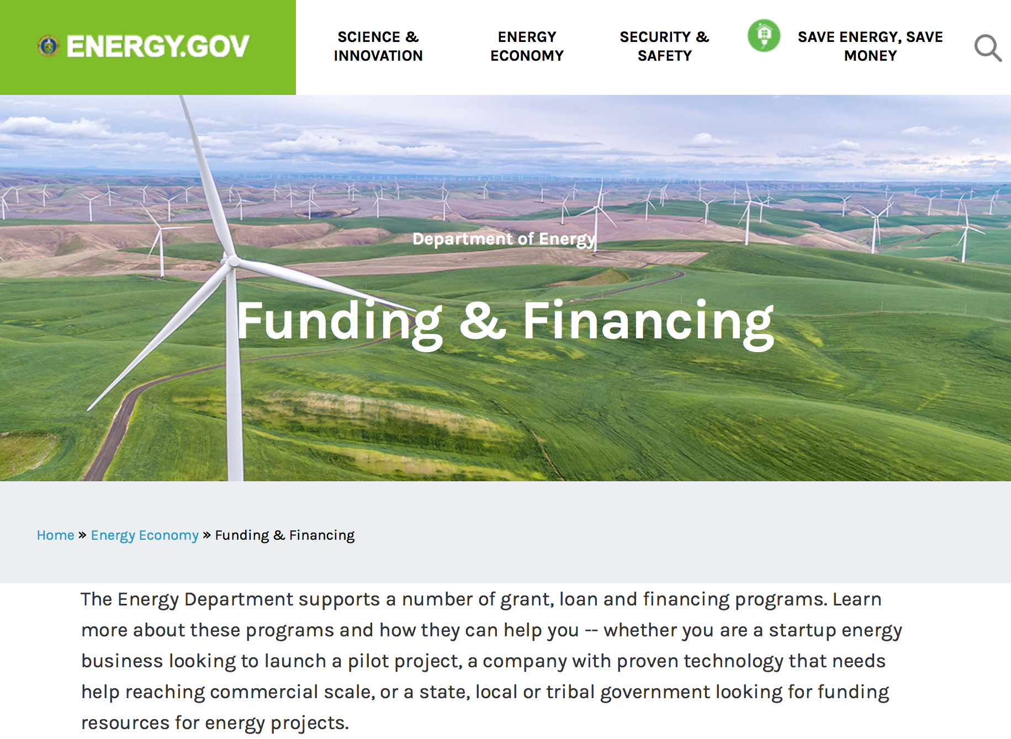

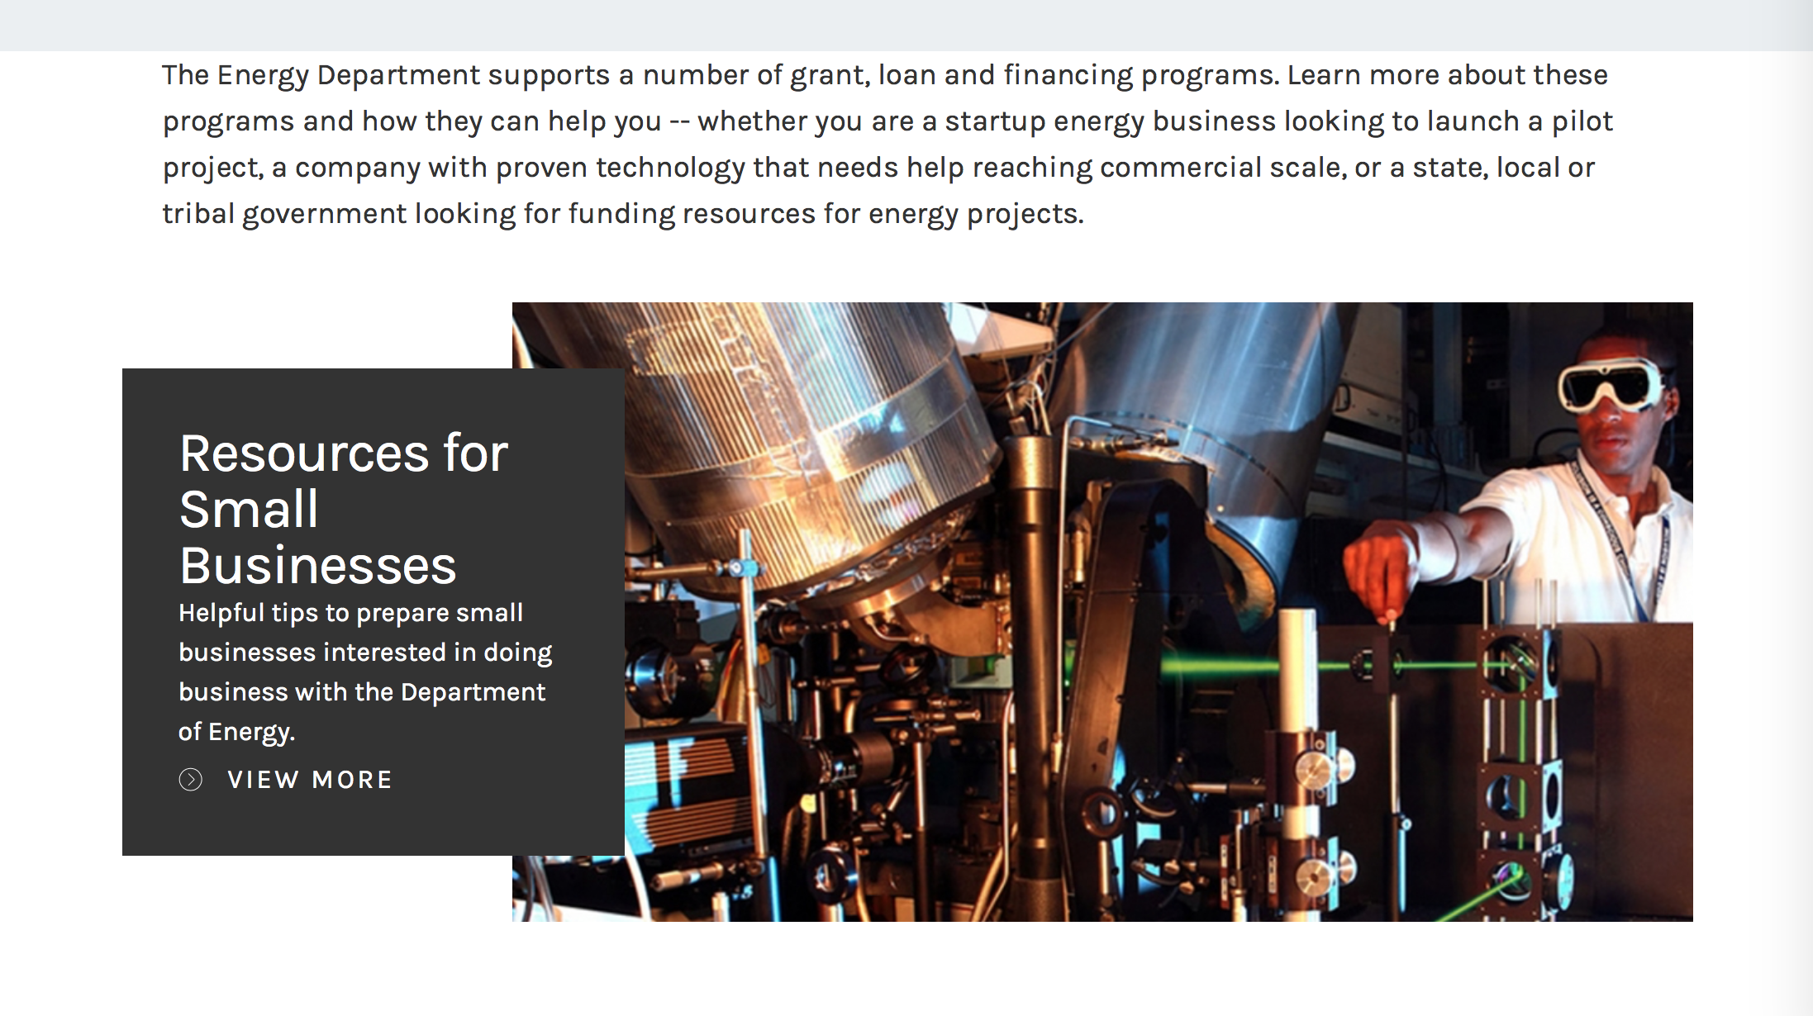

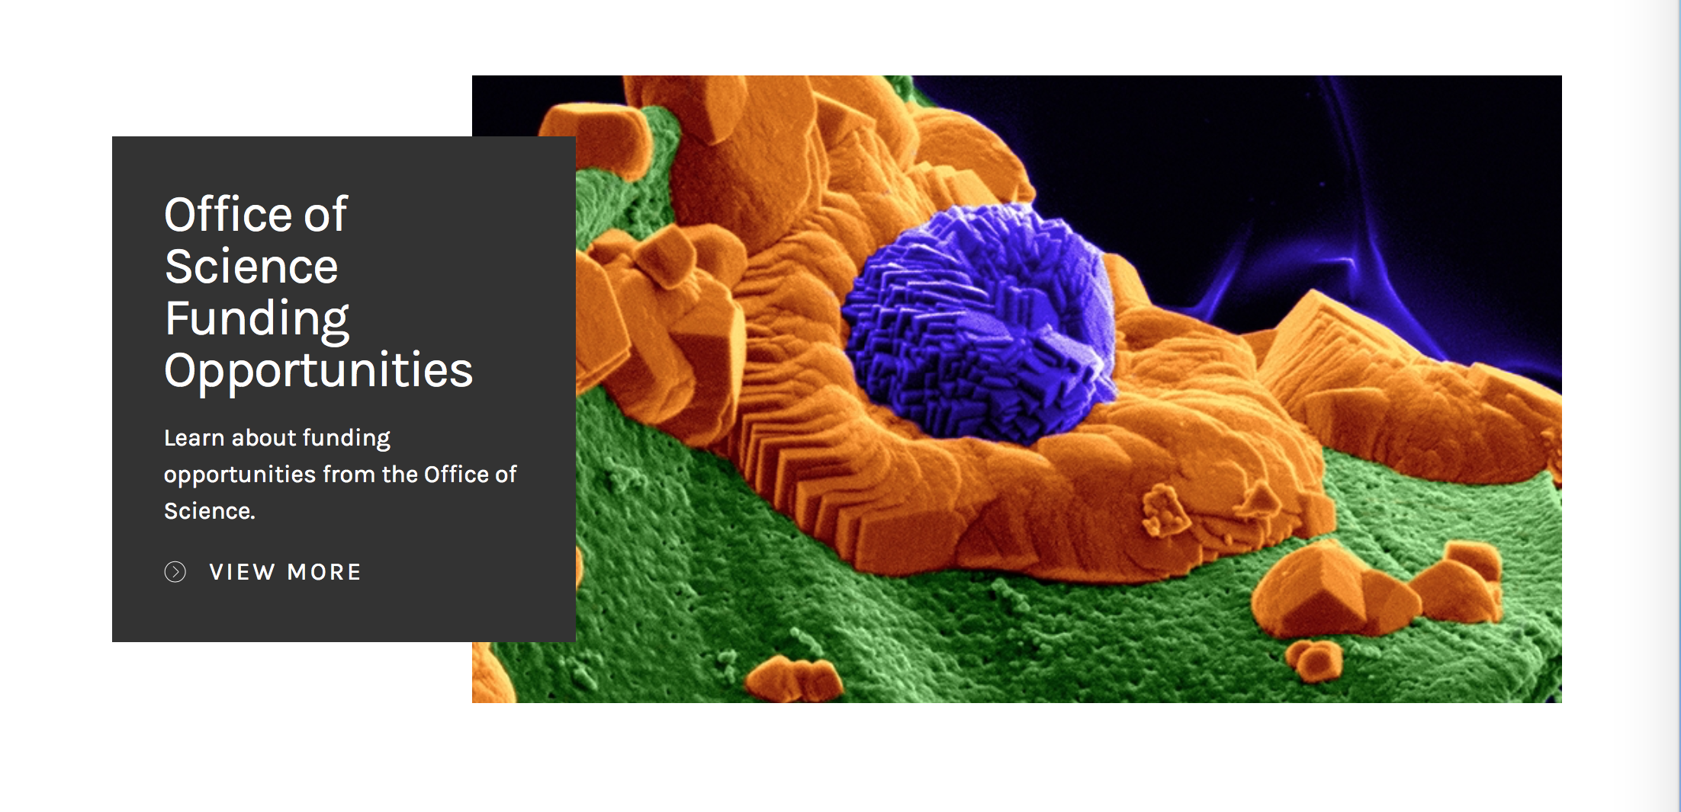

https://www.energy.gov/energy-economy/funding-financing

Research:

Office of Science
FY2019 Research Opportunities in High Energy Physics
Synopsis 1
https://www.grants.gov/web/grants/view-opportunity.html?oppId=310137

Modifications:

Reminders:

Environmental Protection Agency

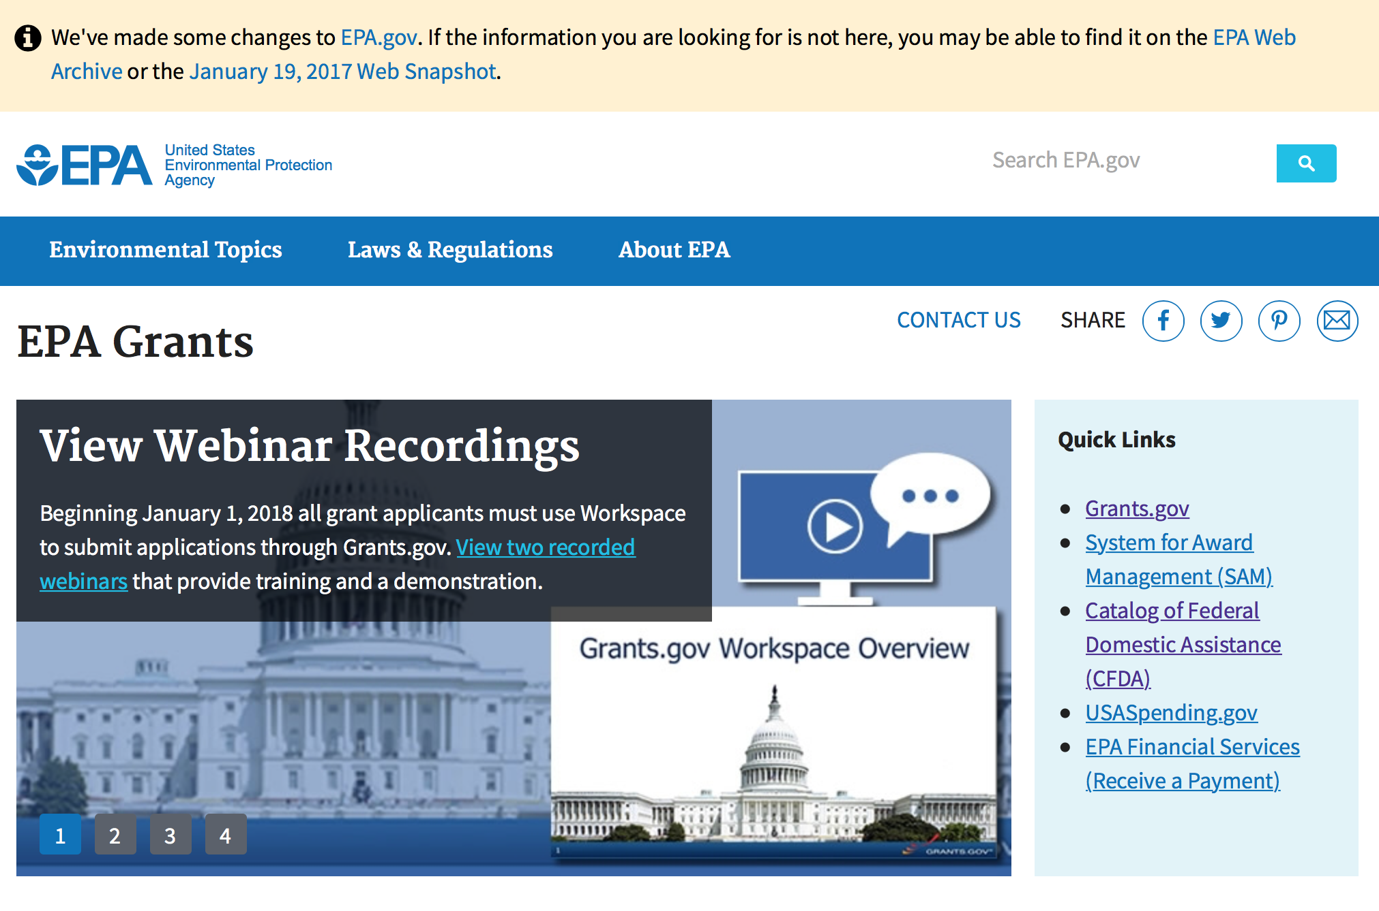
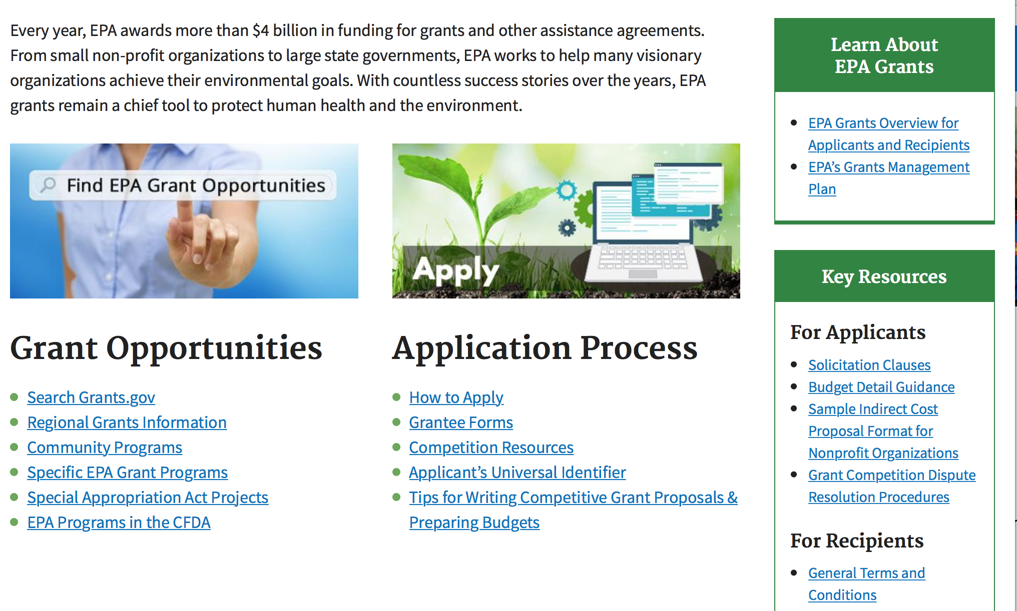

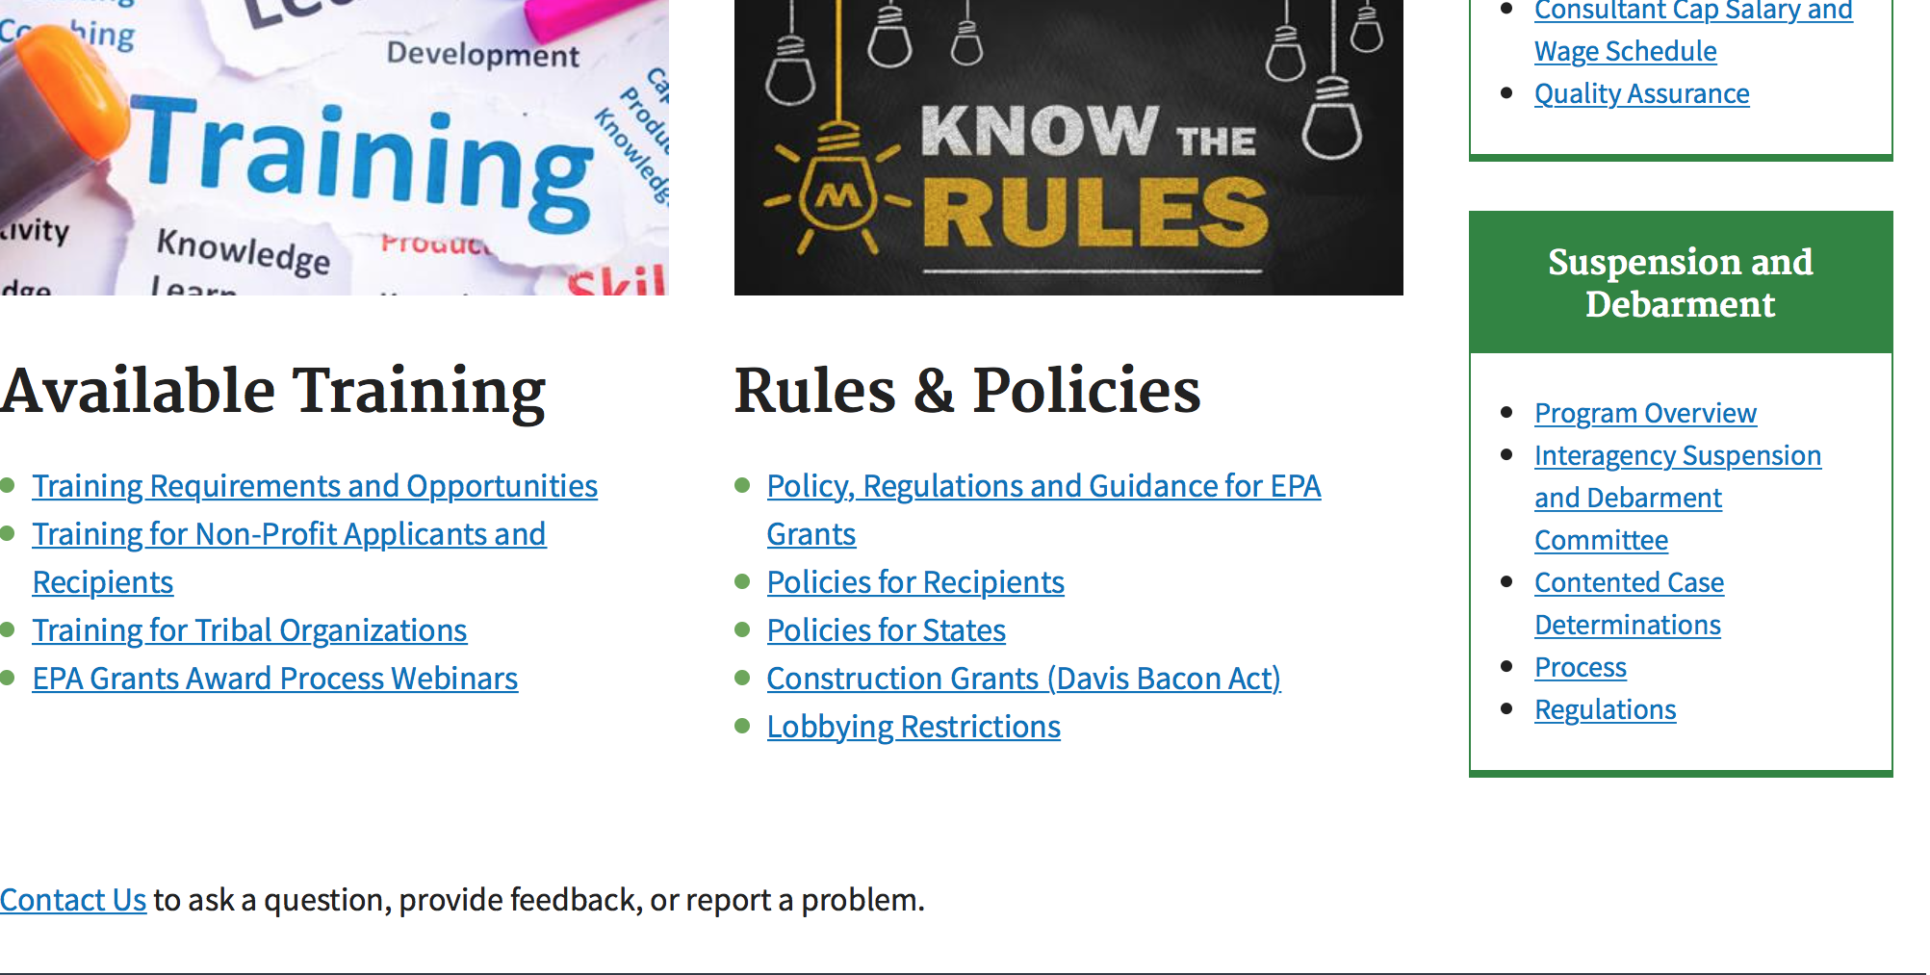

http://www.epa.gov/epahome/grants.htm

Programs:

2018 Targeted Airshed Grant Program
Synopsis 1

Document Type: | Grants Notice
Funding Opportunity Number: | EPA-OAR-OAQPS-18-08
Funding Opportunity Title: | 2018 Targeted Airshed Grant Program
Opportunity Category: | Discretionary
Opportunity Category Explanation:
Funding Instrument Type: | Cooperative Agreement  Grant
Category of Funding Activity: | Environment
Category Explanation:
Expected Number of Awards: | 12
CFDA Number(s): | 66.956 -- Targeted Air Sheds Grant Program
Cost Sharing or Matching Requirement: | No
Version: | Synopsis 1
Posted Date: | Oct 16, 2018
Last Updated Date: | Oct 16, 2018
Original Closing Date for Applications: | Jan 04, 2019 Please see the announcement including Section IV for additional submission information
Current Closing Date for Applications: | Jan 04, 2019 Please see the announcement including Section IV for additional submission information
Archive Date: | Feb 03, 2019
Estimated Total Program Funding: | $40,000,000
Award Ceiling: | $5,000,000
Award Floor: | $0
Eligible Applicants: | Others (see text field entitled "Additional Information on Eligibility" for clarification)
Additional Information on Eligibility: | Please see the announcement including Section III for additional eligibility information.
Additional Information
Agency Name: | Environmental Protection Agency
Description: | This notice announces the availability of funds and solicits applications from eligible entities to compete for financial assistance through the Targeted Airshed Grant Program. This program will assist local, state and/or tribal air pollution control agencies to develop plans and conduct projects to reduce air pollution in nonattainment areas that EPA determines are the top five most polluted areas relative to ozone (O3), annual average fine particulate matter (PM2.5), or 24-hour PM2.5 National Ambient Air Quality Standards (NAAQS). The overall goal of the Targeted Airshed Grant Program is to reduce air pollution in the nation’s areas with the highest levels of ozone and PM2.5 ambient air concentrations.
Link to Additional Information: | 2018 Targeted Airshed Grant Program
Grantor Contact Information: | If you have difficulty accessing the full announcement electronically, please contact:  Deborah Elmore, 919-541-5437  Deborah Elmore
https://www.grants.gov/web/grants/view-opportunity.html?oppId=309633

16th Annual P3 Awards: A National Student Design Competition Focusing on People, Prosperity and the Planet - Air Quality
Synopsis 1

Document Type: | Grants Notice
Funding Opportunity Number: | EPA-G2019-P3-Q1
Funding Opportunity Title: | 16th Annual P3 Awards: A National Student Design Competitiion Focusing on People, Prosperity and the Planet - Air Quality
Opportunity Category: | Discretionary
Opportunity Category Explanation:
Funding Instrument Type: | Grant
Category of Funding Activity: | Environment
Category Explanation:
Expected Number of Awards: | 20
CFDA Number(s): | 66.516 -- P3 Award: National Student Design Competition for Sustainability
Cost Sharing or Matching Requirement: | No
Version: | Synopsis 2
Posted Date: | Oct 24, 2018
Last Updated Date: | Oct 25, 2018
Original Closing Date for Applications: | Dec 11, 2018 Please refer to the announcement, including Section IV, for additional information on submission methods and due dates.
Current Closing Date for Applications: | Dec 11, 2018 Please refer to the announcement, including Section IV, for additional information on submission methods and due dates.
Archive Date: | Jan 10, 2019
Estimated Total Program Funding: | $800,000
Award Ceiling: | $25,000
Award Floor: | $0
Eligible Applicants: | Others (see text field entitled "Additional Information on Eligibility" for clarification)
Additional Information on Eligibility: | Please see Section III of the announcement for eligibility information.
Additional Information
Agency Name: | Environmental Protection Agency
Description: | The U.S. Environmental Protection Agency (EPA) – as part of its People, Prosperity and the Planet (P3) Award Program – is seeking applications proposing to research, develop, design, and demonstrate solutions to real world challenges. The P3 competition highlights the use of scientific principles in creating innovative technology-based projects that achieve the mutual goals of improved quality of life, economic prosperity, and protection of the planet – people, prosperity, and the planet. The EPA offers the P3 competition to respond to the needs of people in the United States (U.S.)—e.g., those in small, rural, tribal, and disadvantaged communities. Please see the People, Prosperity and the Planet (P3) Student Design Competition website for more details about this program. Proposed projects must embody the P3 approach, which is that they have the intention and capability to simultaneously improve the quality of people’s lives, provide economic benefits, and protect the environment.
Link to Additional Information: | 16th Annual P3 Awards: A National Student Design Competition Focusing on People, Prosperity and the Planet - Air Quality
Grantor Contact Information: | If you have difficulty accessing the full announcement electronically, please contact:  Technical Contact: Angela Page (page.angelad@epa.gov), Phone: 202-564-7957; Eligibility Contact: Ron Josephson (josephson.ron@epa.gov), Phone: 202-564-7823; Electronic Submissions: Debra M. Jones (jones.debram@epa.gov), Phone: 202-564-7839  Debra M. Jones
https://www.grants.gov/web/grants/view-opportunity.html?oppId=309873

16th Annual P3 Awards: A National Student Design Competition Focusing on People, Prosperity and the Planet - Chemical Safety
Synopsis 1

Document Type: | Grants Notice
Funding Opportunity Number: | EPA-G2019-P3-Q4
Funding Opportunity Title: | 16th Annual P3 Awards: A National Student Design Competition Focusing on People, Prosperity and the Planet - Chemical Safety
Opportunity Category: | Discretionary
Opportunity Category Explanation:
Funding Instrument Type: | Grant
Category of Funding Activity: | Environment
Category Explanation:
Expected Number of Awards: | 20
CFDA Number(s): | 66.516 -- P3 Award: National Student Design Competition for Sustainability
Cost Sharing or Matching Requirement: | No

Version: | Synopsis 2
Posted Date: | Oct 24, 2018
Last Updated Date: | Oct 25, 2018
Original Closing Date for Applications: | Dec 11, 2018 Please refer to the announcement, including Section IV, for additional information on submission methods and due dates.
Current Closing Date for Applications: | Dec 11, 2018 Please refer to the announcement, including Section IV, for additional information on submission methods and due dates.
Archive Date: | Jan 10, 2019
Estimated Total Program Funding: | $800,000
Award Ceiling: | $25,000
Award Floor: | $0
Eligible Applicants: | Others (see text field entitled "Additional Information on Eligibility" for clarification)
Additional Information on Eligibility: | Please see Section III of the announcement for eligibility information.
Additional Information
Agency Name: | Environmental Protection Agency
Description: | The U.S. Environmental Protection Agency (EPA) – as part of its People, Prosperity and the Planet (P3)Award Program – is seeking applications proposing to research, develop, design, and demonstrate solutions to real world challenges. The P3 competition highlights the use of scientific principles in creating innovative technology-based projects that achieve the mutual goals of improved quality of life, economic prosperity, and protection of the planet – people, prosperity, and the planet. The EPA offers the P3 competition to respond to the needs of people in the United States (U.S.)—e.g., those in small, rural, tribal, and disadvantaged communities. Please see the People, Prosperity and the Planet(P3) Student Design Competition website for more details about this program. Proposed projects must embody the P3 approach, which is that they have the intention and capability to simultaneously improve the quality of people’s lives, provide economic benefits, and protect the environment.
Link to Additional Information: | 16th Annual P3 Awards: A National Student Design Competition Focusing on People, Prosperity and the Planet - Chemical Safety
Grantor Contact Information: | If you have difficulty accessing the full announcement electronically, please contact:  Technical Contact: Angela Page (page.angelad@epa.gov), Phone: 202-564-7957; Eligibility Contact: Ron Josephson (josephson.ron@epa.gov), Phone: 202-564-7823; Electronic Submissions: Debra M. Jones (jones.debram@epa.gov), Phone: 202-564-7839  Debra M. Jones
https://www.grants.gov/web/grants/view-opportunity.html?oppId=309864

16th Annual P3 Awards: A National Student Design Competition Focusing on People, Prosperity and the Planet - Sustainable and Healthy Communities
Synopsis 1
Document Type: | Grants Notice
Funding Opportunity Number: | EPA-G2019-P3-Q3
Funding Opportunity Title: | 16th Annual P3 Awards: A National Student Design Competition Focusing on People, Prosperity and the Planet - Sustainable and Healthy Communities
Opportunity Category: | Discretionary
Opportunity Category Explanation:
Funding Instrument Type: | Grant
Category of Funding Activity: | Environment
Category Explanation:
Expected Number of Awards: | 20
CFDA Number(s): | 66.516 -- P3 Award: National Student Design Competition for Sustainability
Cost Sharing or Matching Requirement: | No
Version: | Synopsis 2
Posted Date: | Oct 24, 2018
Last Updated Date: | Oct 25, 2018
Original Closing Date for Applications: | Dec 11, 2018 Please refer to the announcement, including Section IV, for additional information on submission methods and due dates.
Current Closing Date for Applications: | Dec 11, 2018 Please refer to the announcement, including Section IV, for additional information on submission methods and due dates.
Archive Date: | Jan 10, 2019
Estimated Total Program Funding: | $800,000
Award Ceiling: | $25,000
Award Floor: | $0
Eligible Applicants: | Others (see text field entitled "Additional Information on Eligibility" for clarification)
Additional Information on Eligibility: | Please see Section III of the announcement for eligibility information.
Additional Information
Agency Name: | Environmental Protection Agency
Description: | The U.S. Environmental Protection Agency (EPA) – as part of its People, Prosperity and the Planet (P3)Award Program – is seeking applications proposing to research, develop, design, and demonstrate solutions to real world challenges. The P3 competition highlights the use of scientific principles in creating innovative technology-based projects that achieve the mutual goals of improved quality of life, economic prosperity, and protection of the planet – people, prosperity,and the planet. The EPA offers the P3 competition to respond to the needs of people in the United States (U.S.)—e.g., those in small, rural, tribal, and disadvantaged communities. Please see the People, Prosperity and the Planet(P3) Student Design Competition website for more details about this program. Proposed projects must embody the P3 approach, which is that they have the intention and capability to simultaneously improve the quality of people’s lives, provide economic benefits, and protect the environment.
Link to Additional Information: | 16th Annual P3 Awards: A National Student Design Competition Focusing on People, Prosperity and the Planet - Sustainable and Healthy Communities
Grantor Contact Information: | If you have difficulty accessing the full announcement electronically, please contact:  Technical Contact: Angela Page (page.angelad@epa.gov), Phone: 202-564-7957; Eligibility Contact: Ron Josephson (josephson.ron@epa.gov), Phone: 202-564-7823; Electronic Submissions: Debra M. Jones (jones.debram@epa.gov), Phone: 202-564-7839  Debra M. Jones
https://www.grants.gov/web/grants/view-opportunity.html?oppId=309863

Research:

Modifications:

16th Annual P3 Awards: A National Student Design Competition Focusing on People, Prosperity and the Planet - Safe and Sustainable Water Resources
Synopsis 2

Document Type: | Grants Notice
Funding Opportunity Number: | EPA-G2019-P3-Q2
Funding Opportunity Title: | 16th Annual P3 Awards: A National Student Design Competition Focusing on People, Prosperity and the Planet - Safe and Sustainable Water Resources
Opportunity Category: | Discretionary
Opportunity Category Explanation:
Funding Instrument Type: | Grant
Category of Funding Activity: | Environment
Category Explanation:
Expected Number of Awards: | 20
CFDA Number(s): | 66.516 -- P3 Award: National Student Design Competition for Sustainability
Cost Sharing or Matching Requirement: | No
Version: | Synopsis 3
Posted Date: | Oct 24, 2018
Last Updated Date: | Oct 25, 2018
Original Closing Date for Applications: | Dec 11, 2018 Please refer to the announcement, including Section IV, for additional information on submission methods and due dates.
Current Closing Date for Applications: | Dec 11, 2018 Please refer to the announcement, including Section IV, for additional information on submission methods and due dates.
Archive Date: | Jan 10, 2019
Estimated Total Program Funding: | $800,000
Award Ceiling: | $25,000
Award Floor: | $0
Eligible Applicants: | Others (see text field entitled "Additional Information on Eligibility" for clarification)
Additional Information on Eligibility: | Please see Section III of the announcement for eligibility information.
Additional Information
Agency Name: | Environmental Protection Agency
Description: | The U.S. Environmental Protection Agency (EPA) – as part of its People, Prosperity and the Planet (P3) Award Program – is seeking applications proposing to research, develop, design, and demonstrate solutions to real world challenges. The P3 competition highlights the use of scientific principles in creating innovative technology-based projects that achieve the mutual goals of improved quality of life, economic prosperity, and protection of the planet – people, prosperity, and the planet. The EPA offers the P3 competition to respond to the needs of people in the United States (U.S.)—e.g., those in small, rural, tribal, and disadvantaged communities. Please see the People, Prosperity and the Planet (P3) Student Design Competition website for more details about this program. Proposed projects must embody the P3 approach, which is that they have the intention and capability to simultaneously improve the quality of people’s lives, provide economic benefits, and protect the environment.
Link to Additional Information: | 16th Annual P3 Awards: A National Student Design Competition Focusing on People, Prosperity and the Planet - Safe and Sustainable Water Resources
Grantor Contact Information: | If you have difficulty accessing the full announcement electronically, please contact:  Technical Contact: Angela Page (page.angelad@epa.gov), Phone: 202-564-7957; Eligibility Contact: Ron Josephson (josephson.ron@epa.gov), Phone: 202-564-7823; Electronic Submissions: Debra M. Jones (jones.debram@epa.gov), Phone: 202-564-7839  Debra M. Jones
https://www.grants.gov/web/grants/view-opportunity.html?oppId=309862

Reminders:

Federal Mediation and Conciliation Service

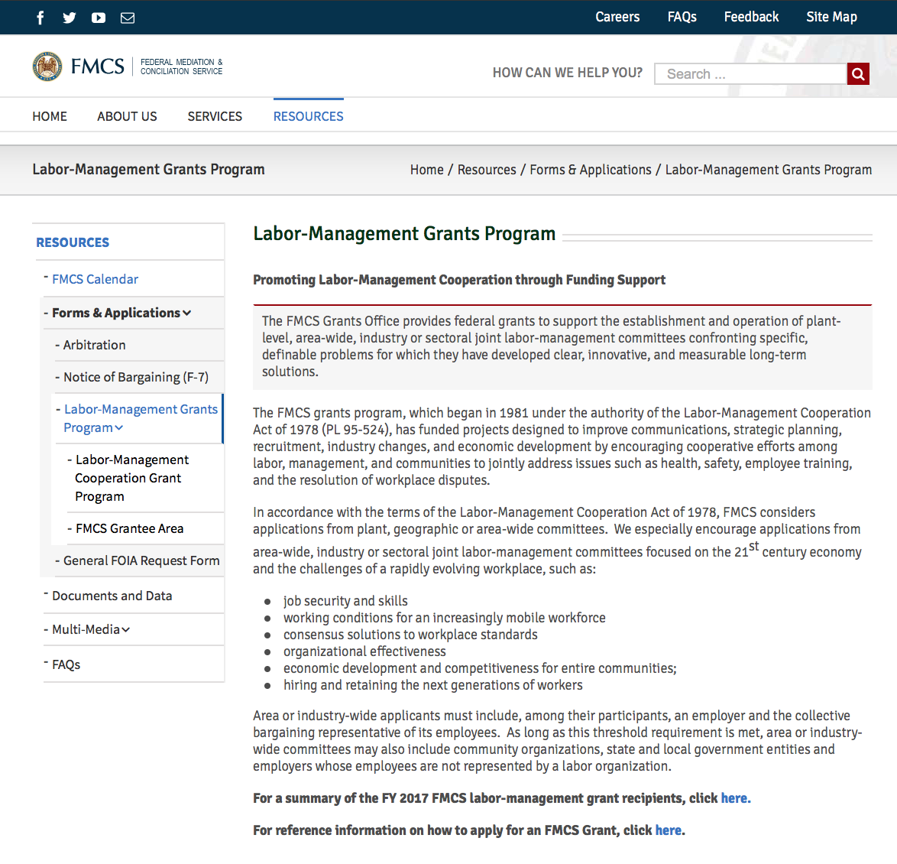

Programs:

Reminders:

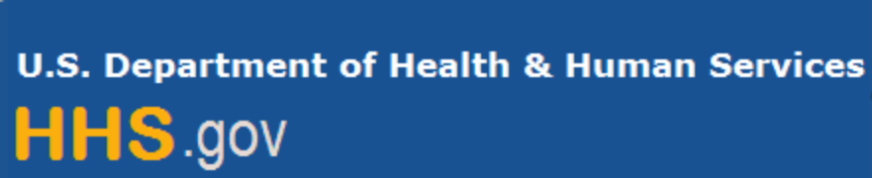

Department of Health and Human Services

Grants Forecast and Overview

The Department of Health and Human Services’ Grants Forecast is a database of planned grant opportunities proposed by its agencies. Each Forecast record contains actual or estimated dates and funding levels for grants that the agency intends to award during the fiscal year. Forecast opportunities are subject to change based on enactment of congressional appropriations.

For more general information about HHS Grants and Funding go to the website below at:

https://www.hhs.gov/grants/grants/index.html

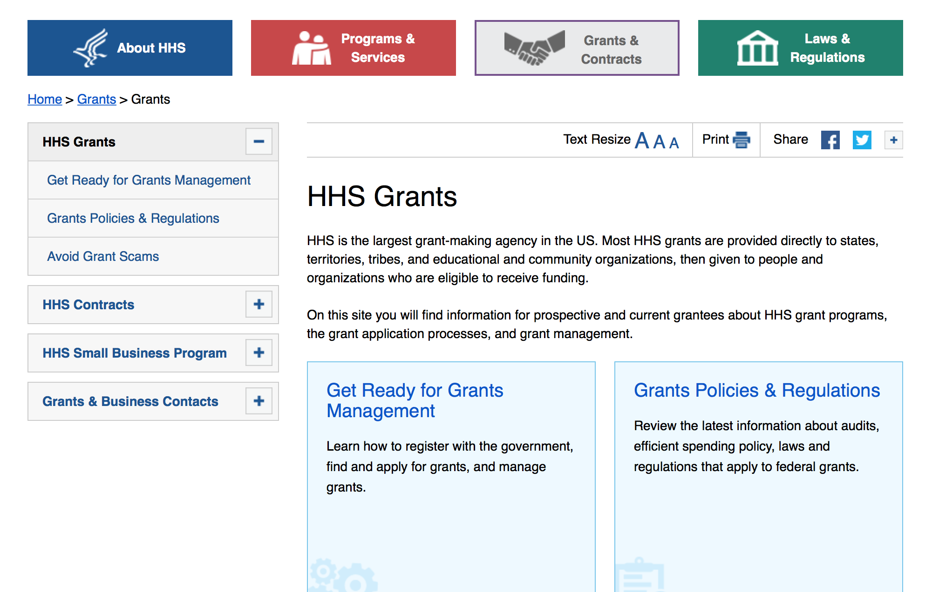

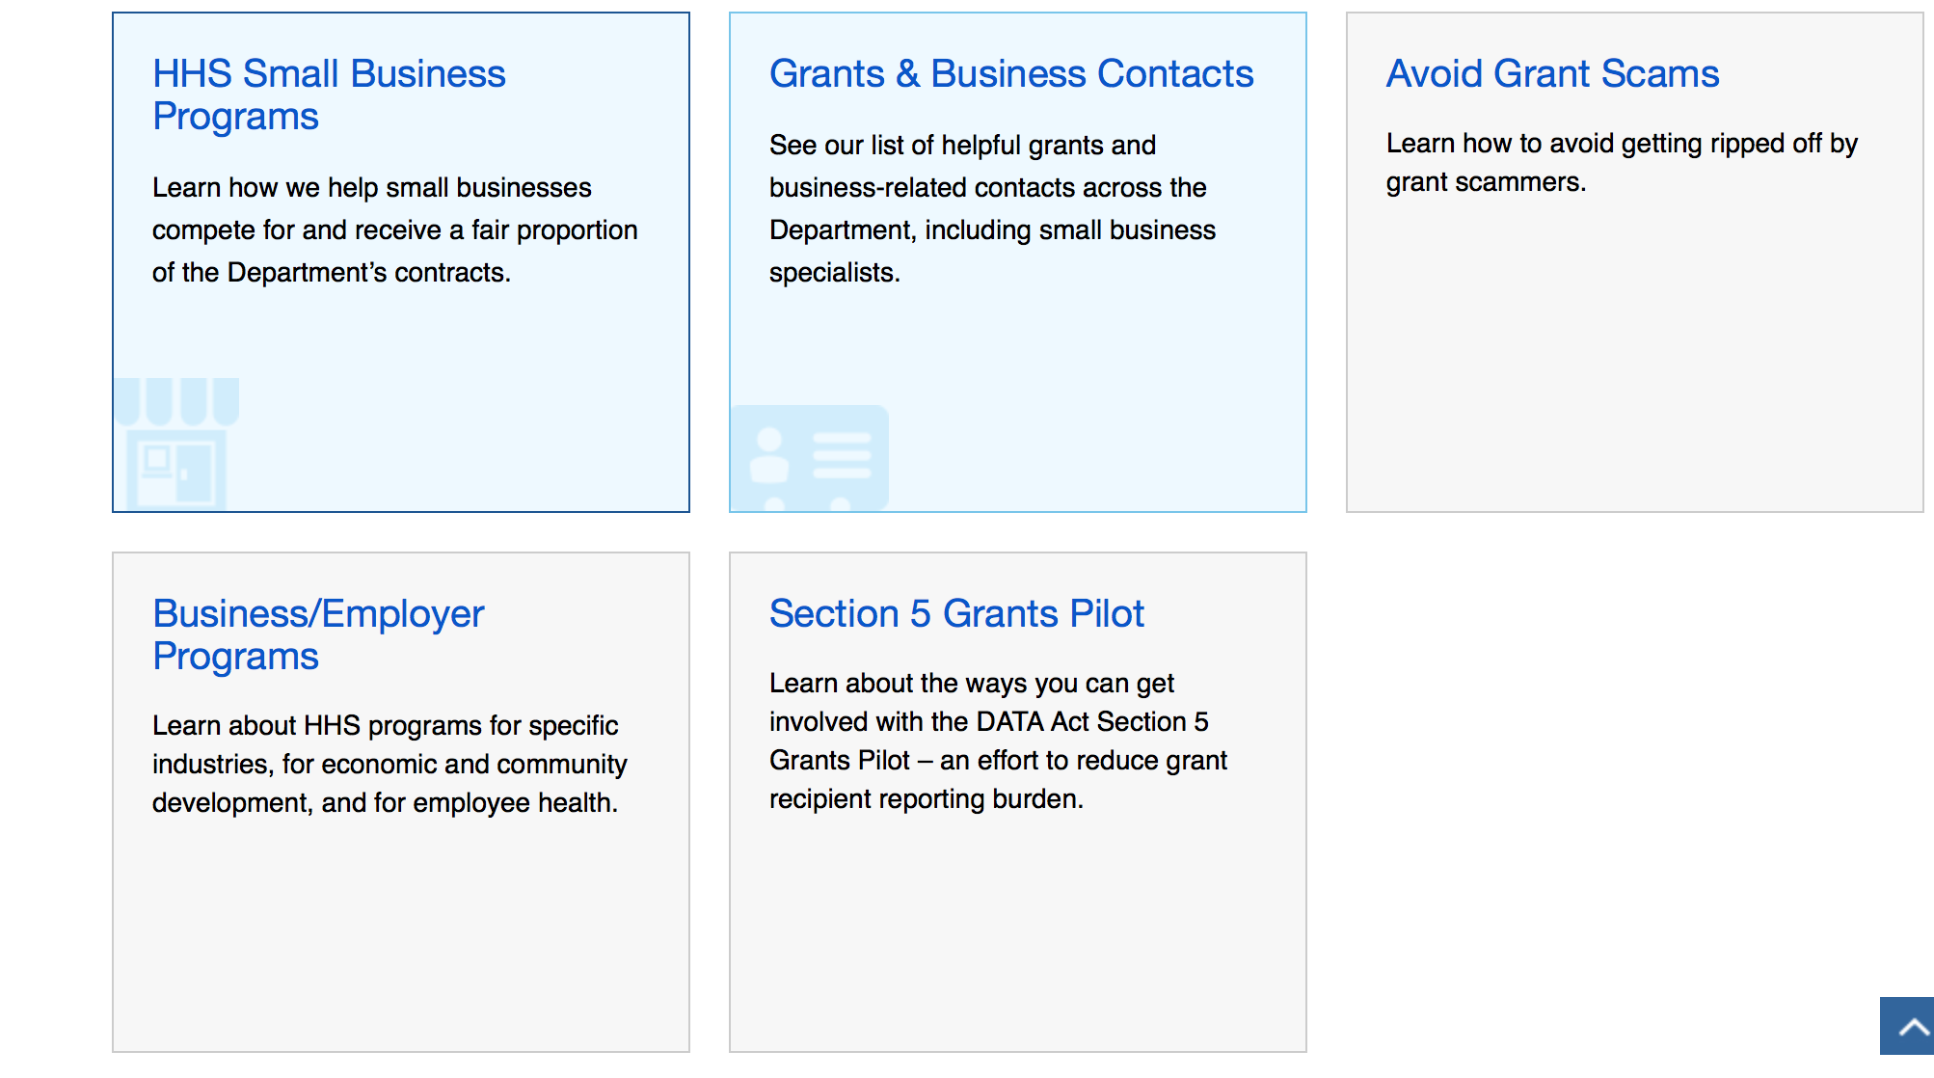

Programs:

Research:

Administration for Children & Families - ACYF/FYSB
Basic Center Program
Forecast 1
https://www.grants.gov/web/grants/view-opportunity.html?oppId=309860

Administration for Children and Families - ACYF/CB
Community Collaborations to Strengthen and Preserve Families
Forecast 1
https://www.grants.gov/web/grants/view-opportunity.html?oppId=309872

Administration for Children & Families - ACYF/FYSB
Street Outreach Program
Forecast 1
https://www.grants.gov/web/grants/view-opportunity.html?oppId=309781

Administration for Children and Families - ACYF/CB
Supporting Interstate Placement through Electronic Systems
Forecast 1
https://www.grants.gov/web/grants/view-opportunity.html?oppId=309893
Administration for Children and Families - OHS
Early Head Start Expansion and Early Head Start-Child Care Partnership Grants
Forecast 1
https://www.grants.gov/web/grants/view-opportunity.html?oppId=309869
Administration for Children and Families - OHS
Migrant and Seasonal Early Head Start Expansion and Early Head Start-Child Care Partnership Grants
Forecast 1
https://www.grants.gov/web/grants/view-opportunity.html?oppId=309870

Administration for Children and Families - ORR
Refugee Agricultural Partnership Program
Forecast 1
https://www.grants.gov/web/grants/view-opportunity.html?oppId=309777

Administration for Children and Families - ORR
Refugee Agricultural Partnership Program
Forecast 1
https://www.grants.gov/web/grants/view-opportunity.html?oppId=309614

Administration for Children and Families - ORR
Refugee Individual Development Accounts (IDA) Program
Forecast 1
https://www.grants.gov/web/grants/view-opportunity.html?oppId=309859

Administration for Children and Families - ORR
Ethnic Community Self Help Program
Forecast 1
https://www.grants.gov/web/grants/view-opportunity.html?oppId=309697
Administration for Children & Families - ACYF/FYSB
Sexual Risk Avoidance Education Program
Forecast 1
https://www.grants.gov/web/grants/view-opportunity.html?oppId=309665

Administration for Children & Families - ACYF/FYSB
Title V Competitive Sexual Risk Avoidance Education
Forecast 1
https://www.grants.gov/web/grants/view-opportunity.html?oppId=309660
Administration for Children and Families - ACYF/CB
Regional Partnership Grants to Improve Well-Being and Permanency Outcomes for Children and Families Affected by Opioids and Other Substance Abuse
Forecast 1
https://www.grants.gov/web/grants/view-opportunity.html?oppId=310247
Administration for Community Living
Small Business Innovation Research Program (SBIR) Phase I
Forecast 1
https://www.grants.gov/web/grants/view-opportunity.html?oppId=310217

Administration for Community Living
Switzer Research Fellowships Program
Forecast 1
https://www.grants.gov/web/grants/view-opportunity.html?oppId=310255
Administration for Community Living
2019 Empowering Older Adults and Adults with Disabilities through Chronic Disease Self-Management Education Programs Financed by the Prevention and Public Health Fund
Forecast 1
https://www.grants.gov/web/grants/view-opportunity.html?oppId=309656

Administration for Community Living
2019 Evidence-Based Falls Prevention Program
Forecast 1
https://www.grants.gov/web/grants/view-opportunity.html?oppId=309713
Centers for Disease Control and Prevention - ERA
Commercial Fishing Occupational Safety Training Project Grants
Forecast 1
https://www.grants.gov/web/grants/view-opportunity.html?oppId=309674

Centers for Disease Control and Prevention - ERA
TREST
Synopsis 1
https://www.grants.gov/web/grants/view-opportunity.html?oppId=309474

Centers for Disease Control and Prevention - ERA
Advancing Infectious Disease Detection and Response in Liberia
Forecast 1
https://www.grants.gov/web/grants/view-opportunity.html?oppId=310244

Centers for Disease Control - NCCDPHP
Multiple Approaches to Support Young Breast Cancer Survivors and Metastatic Breast Cancer Patients
Forecast 1
https://www.grants.gov/web/grants/view-opportunity.html?oppId=310243
Centers for Disease Control - NCCDPHP
Prevention and Control of Chronic Disease and Associated Risk Factors in the U.S. Affiliated Pacific Islands, U.S. Virgin Islands, and Puerto Rico
Synopsis 1
https://www.grants.gov/web/grants/view-opportunity.html?oppId=310165

Centers for Disease Control - NCCDPHP
The CDC Cancer Genomics Program: Translating Research into Public Health Practice
Forecast 1
https://www.grants.gov/web/grants/view-opportunity.html?oppId=310242

Centers for Disease Control - NCEZID
2019 Epidemiology and Laboratory Capacity for Prevention and Control of Emerging Infectious Diseases (ELC)
Forecast 1
https://www.grants.gov/web/grants/view-opportunity.html?oppId=310241

Food and Drug Administration
State and Territory Produce Safety Implementation Program Expansion for Entrance into Competition B of PAR-16-137 (U18)
Synopsis 1
https://www.grants.gov/web/grants/view-opportunity.html?oppId=309473

Food and Drug Administration
Clinical Studies of Orphan Products Addressing Unmet Needs of Rare Diseases (R01)
Synopsis 1
https://www.grants.gov/web/grants/view-opportunity.html?oppId=309783

Health Resources and Services Administration
Health Center Controlled Networks
Synopsis 1
https://www.grants.gov/web/grants/view-opportunity.html?oppId=307871

Health Resources and Services Administration
Regional AIDS Education and Training Centers
Synopsis 1
https://www.grants.gov/web/grants/view-opportunity.html?oppId=307891

Health Resources and Services Administration
Advanced Nursing Education Workforce (ANEW)
Synopsis 1
https://www.grants.gov/web/grants/view-opportunity.html?oppId=309694
Health Resources and Services Administration
Ryan White HIV/AIDS Program Part D -- Women, Infants, Children, and Youth (WICY) Grants Supplemental Funding
Synopsis 1
https://www.grants.gov/web/grants/view-opportunity.html?oppId=307888

Health Resources and Services Administration
Building Capacity for HIV Elimination in Ryan White HIV/AIDS Program Part A Jurisdictions
Synopsis 1
https://www.grants.gov/web/grants/view-opportunity.html?oppId=307890

National Institutes of Health
Building in vivo Preclinical Assays of Circuit Engagement for Application in Therapeutic Development (R01 Clinical Trial Not Allowed)
Synopsis 1
https://www.grants.gov/web/grants/view-opportunity.html?oppId=310020
National Institutes of Health
Centers on the Demography and Economics of Aging (P30 Clinical Trial Optional)
Synopsis 1
https://www.grants.gov/web/grants/view-opportunity.html?oppId=310025
National Institutes of Health
Centers on the Demography and Economics of Alzheimer's Disease and Alzheimer's Related Dementias (P30 Clinical Trial Optional)
Synopsis 1
https://www.grants.gov/web/grants/view-opportunity.html?oppId=310026

National Institutes of Health
Demography and Economics of Aging and AD-ADRD Coordinating Center (R24 Clinical Trial Not Allowed)
Synopsis 1
https://www.grants.gov/web/grants/view-opportunity.html?oppId=310024

National Institutes of Health
Lewy Body Dementia Center Without Walls (CWOW) (U54 Clinical Trial Not Allowed)
Synopsis 1
https://www.grants.gov/web/grants/view-opportunity.html?oppId=310015
National Institutes of Health
Limited Competition: Restoring Research Resources Lost or Damaged Due to Hurricanes Harvey, Irma, and Maria (R24 Clinical Trial Optional)
Synopsis 1
https://www.grants.gov/web/grants/view-opportunity.html?oppId=310001

National Institutes of Health
Promoting Research on Music and Health: Fundamentals and Applications (R21 Clinical Trials Optional)
Synopsis 1
https://www.grants.gov/web/grants/view-opportunity.html?oppId=310021
National Institutes of Health
Promoting Research on Music and Health: Fundamentals and Applications (R01 Clinical Trials Optional)
Synopsis 1
https://www.grants.gov/web/grants/view-opportunity.html?oppId=310022
National Institutes of Health
Promoting Research on Music and Health: Phased Innovation Award for Music Interventions (R61/R33 Clinical Trial Optional)
Synopsis 1
https://www.grants.gov/web/grants/view-opportunity.html?oppId=310023
National Institutes of Health
Administrative Supplements for Complementary Health Practitioner Research Experience (Admin Supp Clinical Trial Optional)
Synopsis 1
https://www.grants.gov/web/grants/view-opportunity.html?oppId=309677

National Institutes of Health
Basic Neurodevelopmental Biology of Brain Circuits and Behavior (R21 Clinical Trial Not Allowed)
Synopsis 1
https://www.grants.gov/web/grants/view-opportunity.html?oppId=309612

National Institutes of Health
Basic Neurodevelopmental Biology of Circuits and Behavior (R01 Clinical Trial Not Allowed)
Synopsis 1
https://www.grants.gov/web/grants/view-opportunity.html?oppId=309638

National Institutes of Health
BRAIN Initiative: Research on the Ethical Implications of Advancements in Neurotechnology and Brain Science (R01 Clinical Trial Optional)
Synopsis 1
https://www.grants.gov/web/grants/view-opportunity.html?oppId=309676
National Institutes of Health
Innovation Corps (I-Corps) at NIH Program for NIH and CDC Translational Research (Admin Supp Clinical Trial Not Allowed)
Synopsis 1
https://www.grants.gov/web/grants/view-opportunity.html?oppId=309655

National Institutes of Health
NIDDK Education Program Grants (R25 Clinical Trial Not Allowed)
Synopsis 1
https://www.grants.gov/web/grants/view-opportunity.html?oppId=309675
National Institutes of Health
Addressing Caregiver Symptoms through Technological Tools (R01 Clinical Trial Optional)
Synopsis 1
https://www.grants.gov/web/grants/view-opportunity.html?oppId=309573

National Institutes of Health
Addressing Caregiver Symptoms through Technological Tools (R21 Clinical Trial Optional)
Synopsis 1
https://www.grants.gov/web/grants/view-opportunity.html?oppId=309575
National Institutes of Health
Diabetes Research Centers (P30)
Synopsis 1
https://www.grants.gov/web/grants/view-opportunity.html?oppId=309576

National Institutes of Health
Enhancing Data Management and Sharing in NIEHS-Funded Research Grants (Admin Supp Clinical Trial Not Allowed)
Synopsis 1
https://www.grants.gov/web/grants/view-opportunity.html?oppId=309555

National Institutes of Health
Health-professional Education Partnership Initiative (HEPI) (R25 Clinical Trial Not Allowed)
Synopsis 1
https://www.grants.gov/web/grants/view-opportunity.html?oppId=309514
National Institutes of Health
Specialized Alcohol Research Centers Clinical Trial Optional (P50 Clinical Trial Optional)
Synopsis 1
https://www.grants.gov/web/grants/view-opportunity.html?oppId=309501
National Institutes of Health
Understanding the Glycemic Profile of Pregnancy - Biostatistics Research Center (U01 Clinical Trial Not Allowed)
Synopsis 1
https://www.grants.gov/web/grants/view-opportunity.html?oppId=309535

National Institutes of Health
Understanding the Glycemic Profile of Pregnancy - Clinical Centers (U01 Clinical Trial Not Allowed)
Synopsis 1
https://www.grants.gov/web/grants/view-opportunity.html?oppId=309500
National Institutes of Health
A Census of Cells and Circuits in the Aging Brain (R01 Clinical Trial Not Allowed)
Synopsis 1
https://www.grants.gov/web/grants/view-opportunity.html?oppId=309837

National Institutes of Health
Administrative Supplements to Cancer Center Support Grants to Strengthen NCI-Supported Community Outreach Capacity through Community Health Educators of the National Outreach Network (Admin Suppl Clinical Trial Not Allowed)
Synopsis 1
https://www.grants.gov/web/grants/view-opportunity.html?oppId=309791
National Institutes of Health
BRAIN Initiative: Research Resource Grants for Technology Integration and Dissemination (U24 Clinical Trial Not Allowed)
Synopsis 1
https://www.grants.gov/web/grants/view-opportunity.html?oppId=309776

National Institutes of Health
Commercializing Understudied Proteins from the Illuminating the Druggable Genome Project (IDG) (R43/R44 Clinical Trial Not Allowed)
Synopsis 1
https://www.grants.gov/web/grants/view-opportunity.html?oppId=309853
National Institutes of Health
Commercializing Understudied Proteins from the Illuminating the Druggable Genome Project (IDG) (R41/R42 Clinical Trial Not Allowed)
Synopsis 1
https://www.grants.gov/web/grants/view-opportunity.html?oppId=309854

National Institutes of Health
Countermeasures Against Chemical Threats (CounterACT): Identification of Therapeutic Lead Compounds (U01 Clinical Trial Not Allowed)
Synopsis 1
https://www.grants.gov/web/grants/view-opportunity.html?oppId=309956
National Institutes of Health
Countermeasures Against Chemical Threats (CounterACT): Optimization of Therapeutic Lead Compounds (U01 Clinical Trial Optional)
Synopsis 1
https://www.grants.gov/web/grants/view-opportunity.html?oppId=309957
National Institutes of Health
Early Screening for Autism Spectrum Disorder (R01 Clinical Trial Not Allowed)
Synopsis 1
https://www.grants.gov/web/grants/view-opportunity.html?oppId=309882

National Institutes of Health
Early Screening for Autism Spectrum Disorder (R21 Clinical Trial Not Allowed)
Synopsis 1
https://www.grants.gov/web/grants/view-opportunity.html?oppId=309896

National Institutes of Health
Emerging Global Leader Award (K43 Independent Clinical Trial Required)
Synopsis 1
https://www.grants.gov/web/grants/view-opportunity.html?oppId=309895
National Institutes of Health
Initiative for Maximizing Student Development (IMSD) (T32)
Synopsis 1
https://www.grants.gov/web/grants/view-opportunity.html?oppId=309881

National Institutes of Health
Limited Competition: Extramural Research Facilities Restoration Program: Hurricanes Harvey, Irma, and Maria Disaster Relief (C06 Clinical Trial Not Allowed)
Synopsis 1
https://www.grants.gov/web/grants/view-opportunity.html?oppId=309939

National Institutes of Health
Medical Scientist Training Program (T32)
Synopsis 1
https://www.grants.gov/web/grants/view-opportunity.html?oppId=309880

National Institutes of Health
NINDS Morris K. Udall Center without Walls for Parkinson’s Disease Research (P20 Clinical Trial Optional)
Synopsis 1
https://www.grants.gov/web/grants/view-opportunity.html?oppId=309879
National Institutes of Health
Reproductive Medicine Collaborative Clinical Trials Program (Collaborative R01 Clinical Trial Required)
Synopsis 1
https://www.grants.gov/web/grants/view-opportunity.html?oppId=309857

National Institutes of Health
Global Noncommunicable Diseases and Injury Across the Lifespan: Exploratory Research (R21 Clinical Trials Optional)
Synopsis 1
https://www.grants.gov/web/grants/view-opportunity.html?oppId=310246
National Institutes of Health
NIH Exploratory/Developmental Research Grant Program (Parent R21 Clinical Trial Not Allowed)
Synopsis 1
https://www.grants.gov/web/grants/view-opportunity.html?oppId=310138

National Institutes of Health
NIH Exploratory/Developmental Research Grant Program (Parent R21 Clinical Trial Required)
Synopsis 1
https://www.grants.gov/web/grants/view-opportunity.html?oppId=310139

National Institutes of Health
NIH Small Research Grant Program (Parent R03 Clinical Trial Not Allowed)
Synopsis 1
https://www.grants.gov/web/grants/view-opportunity.html?oppId=310158

National Institutes of Health
NINR Clinical Trial Planning Grant (R34 Clinical Trial Required)
Synopsis 1
https://www.grants.gov/web/grants/view-opportunity.html?oppId=310258

National Institutes of Health
Notice of Intent to Publish a Funding Opportunity Announcement for Back Pain Consortium (BACPAC) Research Program: Mechanistic Research Centers (U19) (Clinical Trial Optional)
Forecast 1
https://www.grants.gov/web/grants/view-opportunity.html?oppId=310191
National Institutes of Health
Notice of Intent to Publish a Funding Opportunity Announcement for Behavioral Research to Improve MAT: Behavioral and Social Interventions to Improve Adherence to Medication Assisted Treatment for Opioid Use Disorders (R61/R33, Clinical Trials Optional)
Forecast 1
https://www.grants.gov/web/grants/view-opportunity.html?oppId=310187

National Institutes of Health
Notice of Intent to Issue the Funding Opportunity Announcement for Bioengineering Research Grants (BRG) (R01 Clinical Trial Required)
Forecast 1
https://www.grants.gov/web/grants/view-opportunity.html?oppId=310182

National Institutes of Health
Notice of Intent to Issue the Funding Opportunity Announcement for Bioengineering Research Grants (BRG) (R01 Clinical Trial Not Allowed)
Forecast 1
https://www.grants.gov/web/grants/view-opportunity.html?oppId=310188

National Institutes of Health
Notice of Intent to Issue the Funding Opportunity Announcement for Bioengineering Research Partnerships (U01 Clinical Trial Required)
Forecast 1
https://www.grants.gov/web/grants/view-opportunity.html?oppId=310193

National Institutes of Health
Notice of Intent to Issue the Funding Opportunity Announcement for Bioengineering Research Partnerships (U01 Clinical Trial Not Allowed)
Forecast 1
https://www.grants.gov/web/grants/view-opportunity.html?oppId=310200
National Institutes of Health
Notice of Intent to Publish a Funding Opportunity Announcement for Development of Translational Devices to Treat Pain (U18 Clinical Trial Not Allowed)
Forecast 1
https://www.grants.gov/web/grants/view-opportunity.html?oppId=310181

National Institutes of Health
Notice of Intent to Publish a Funding Opportunity Announcement for Integrated Approach to Pain and Opioid Use in Hemodialysis Patients Clinical Sites (U01 Clinical Trial Required)
Forecast 1
https://www.grants.gov/web/grants/view-opportunity.html?oppId=310195
National Institutes of Health
Notice of Intent to Publish a Funding Opportunity Announcement for Limited Competition for Adolescent Brain Cognitive Development (ABCD) Study Funding Opportunity Announcement - Coordinating Center (U24 - Clinical Trial Not Allowed)
Forecast 1
https://www.grants.gov/web/grants/view-opportunity.html?oppId=310176

National Institutes of Health
Notice of Intent to Publish a Funding Opportunity Announcement for Limited Competition Adolescent Brain Cognitive Development (ABCD) Study Funding Opportunity Announcement - Data Analysis, Informatics, and Resource Center (U24)
Forecast 1
https://www.grants.gov/web/grants/view-opportunity.html?oppId=310150

National Institutes of Health
Notice of Intent to Publish a Funding Opportunity Announcement for Limited Competition Adolescent Brain Cognitive Development (ABCD) Study Funding Opportunity Announcement - Research Project Sites (U01 - Clinical Trial Not Allowed)
Forecast 1
https://www.grants.gov/web/grants/view-opportunity.html?oppId=310177
National Institutes of Health
Notice of Intent to Publish a Funding Opportunity Announcement for Limited Competition: Behavioral Research to Improve MAT: Ancillary Studies to Enhance Behavioral or Social Interventions to Improve Adherence to Medication Assisted Treatment for OUD (R01)
Forecast 1
https://www.grants.gov/web/grants/view-opportunity.html?oppId=310151

National Institutes of Health
Notice of Intent to Publish a Funding Opportunity Announcement for Physical Sciences-Oncology Network (PS-ON): Physical Sciences-Oncology Projects (PS-OP) (U01 Clinical Trial Optional)
Forecast 1
https://www.grants.gov/web/grants/view-opportunity.html?oppId=310192

National Institutes of Health
Notice of Intent to Publish a Funding Opportunity Announcement for Pragmatic and Implementation Studies for the Management of Pain to Reduce Opioid Prescribing (PRISM) (UG3/UH3, Clinical Trials Optional)
Forecast 1
https://www.grants.gov/web/grants/view-opportunity.html?oppId=310190
National Institutes of Health
Notice of Intent to Publish a Funding Opportunity Announcement for Translational Devices to Treat Pain (UG3/UH3 Clinical Trial Optional)
Forecast 1
https://www.grants.gov/web/grants/view-opportunity.html?oppId=310199
National Institutes of Health
Notice of Intent to Publish Parent Funding Opportunity Announcements for Basic Experimental Studies with Humans
Forecast 1
https://www.grants.gov/web/grants/view-opportunity.html?oppId=310173

National Institutes of Health
Optimization of Non-addictive Therapies [Small Molecules and Biologics] to Treat Pain (UG3/UH3 Clinical Trial Not Allowed)
Synopsis 1
https://www.grants.gov/web/grants/view-opportunity.html?oppId=310135

National Institutes of Health
Research Project Grant (Parent R01 Clinical Trial Required)
Synopsis 1
https://www.grants.gov/web/grants/view-opportunity.html?oppId=310141

National Institutes of Health
Research Project Grant (Parent R01 Clinical Trial Not Allowed)
Synopsis 1
https://www.grants.gov/web/grants/view-opportunity.html?oppId=310156

National Institutes of Health
Strategies to Provide Culturally Tailored Palliative and End-of-Life Care for Seriously Ill American Indian and Alaska Native Individuals (R21 Clinical Trial Optional)
Synopsis 1
https://www.grants.gov/web/grants/view-opportunity.html?oppId=310238
National Institutes of Health
Strategies to Provide Culturally Tailored Palliative and End-of-Life Care for Seriously Ill American Indian and Alaska Native Individuals (R01 Clinical Trial Optional)
Synopsis 1
https://www.grants.gov/web/grants/view-opportunity.html?oppId=310239

Office of the Assistant Secretary for Health
Announcement of Availability of Funds for Title X Family Planning Services Grants
Synopsis 1
https://www.grants.gov/web/grants/view-opportunity.html?oppId=308947
Substance Abuse and Mental Health Services Administration
Grants to Expand Substance Abuse Treatment Capacity in Family Treatment Drug Courts
Synopsis 1
https://www.grants.gov/web/grants/view-opportunity.html?oppId=310147

Substance Abuse and Mental Health Services Administration
Project AWARE (Advancing Wellness and Resiliency in Education) State Education Agency Grants
Synopsis 1
https://www.grants.gov/web/grants/view-opportunity.html?oppId=309861

Substance Abuse and Mental Health Services Administration
Statewide Consumer Network Program
Synopsis 1
https://www.grants.gov/web/grants/view-opportunity.html?oppId=309858

Modifications:
Food and Drug Administration
Natural History Studies Addressing Unmet Needs of Rare Diseases: Orphan Products Research Project Grant (R01)
Synopsis 2
https://www.grants.gov/web/grants/view-opportunity.html?oppId=309556
Substance Abuse and Mental Health Services Administration
Healthy Transitions: Improving Life Trajectories for Youth and Young Adults with Serious Mental Disorders Program
Synopsis 2
https://www.grants.gov/web/grants/view-opportunity.html?oppId=309779
Substance Abuse and Mental Health Services Administration
Statewide Family Network
Synopsis 2
https://www.grants.gov/web/grants/view-opportunity.html?oppId=310143

Reminders:

Department of Homeland Security

The Department of Homeland Security enhances the ability of states, local and tribal jurisdictions, and other regional authorities in the preparation, prevention, and response to terrorist attacks and other disasters, by distributing grant funds. Localities can use grants for planning, equipment, training and exercise needs.

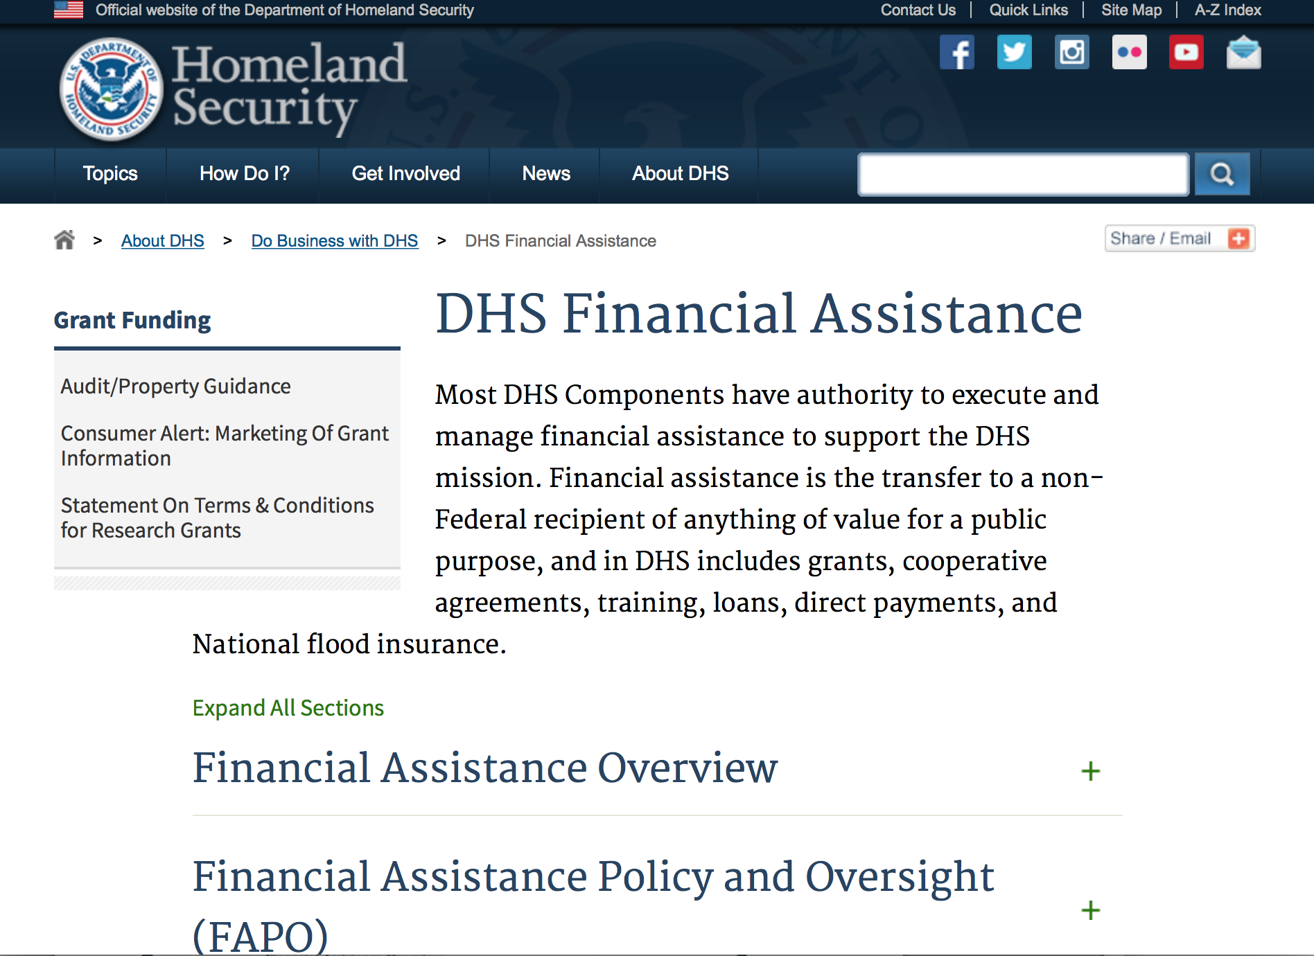
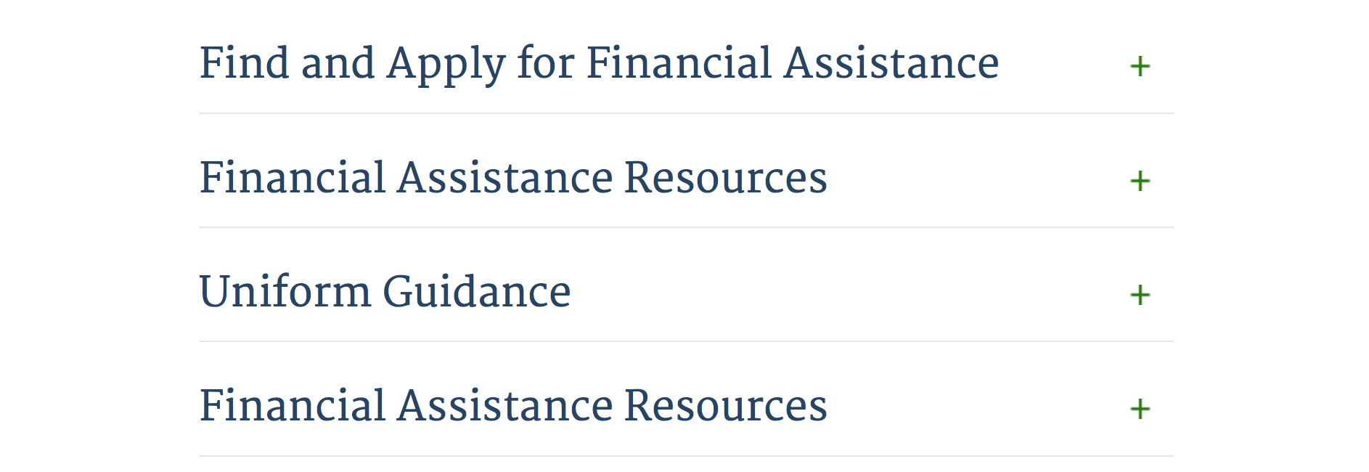

Webpage can be viewed at: http://www.dhs.gov/xopnbiz/grants/index.shtm#2

Information about 2016 for reference only
The FY 2016 Assistance to Firefighters Grants (AFG)

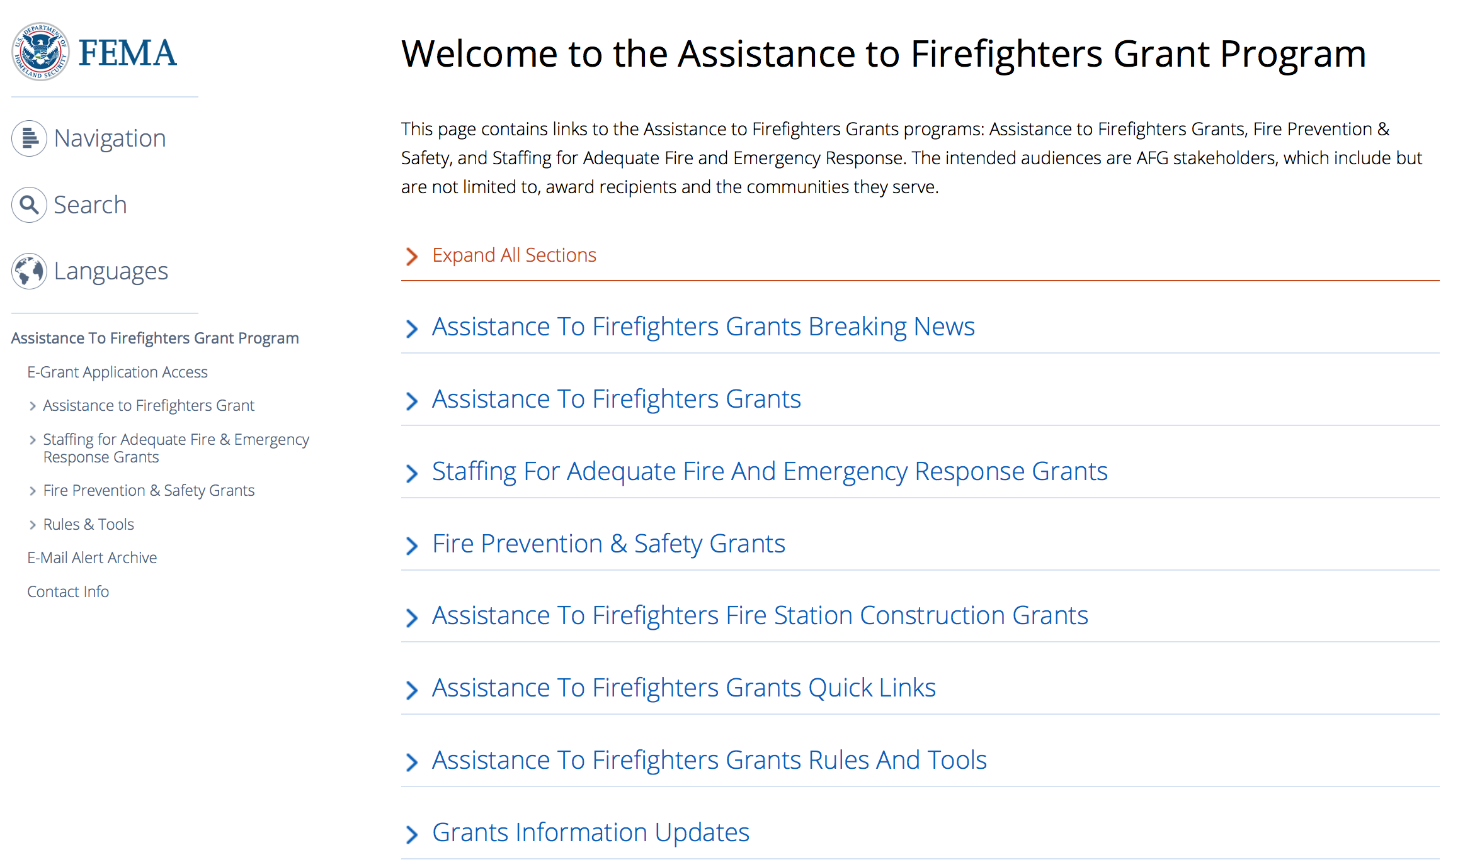

https://www.fema.gov/welcome-assistance-firefighters-grant-program

For AFG program guidance materials, please visit our Documents page.

Resources

AFG Help Desk
Contact the AFG Program Help Desk toll-free at 866-274-0960, or email us at firegrants@dhs.gov.
The AFG Program has Fire Program Specialists in 10 federal regional centers. These Regional Fire Program Specialists respond to questions about the AFG program and carry out grant monitoring activities. View regional contacts

Popular AFG links
- Assistance to Firefighters Grants (AFG)
- AFG Awards List
- AFG Success Stories
- Staffing for Adequate Fire & Emergency Response (SAFER) Grants (SAFER)
- SAFER Awards List
- SAFER Success Stories
- Fire Prevention & Safety (FP&S) Grants
- FP&S Awards List
- FP&S Success Stories
- Grant Closeout Tutorial
- Assistance to Firefighters Grant (AFG) Email Alert Archive
- Frequently Asked Questions
Contact Information For The Assistance to Firefighters Grant (AFG) Program and Help Desk

Federal Funding Alternative To AFG

State Administrative Agencies (SAA) apply for and administer Federal grants on behalf of their States, including FEMA Preparedness Grants. The SAA will work with eligible organizations to comply with the general requirements of grant programs or cooperative agreements. Contact your State’s SAA to find out what current Federal funding opportunities may be available to your organization. A listing of the SAAs and points of contact can be found at http://www.fema.gov/library/viewRecord.do?id=6363.

Programs:

Modifications:

Reminders:

Department of Housing and Urban Development

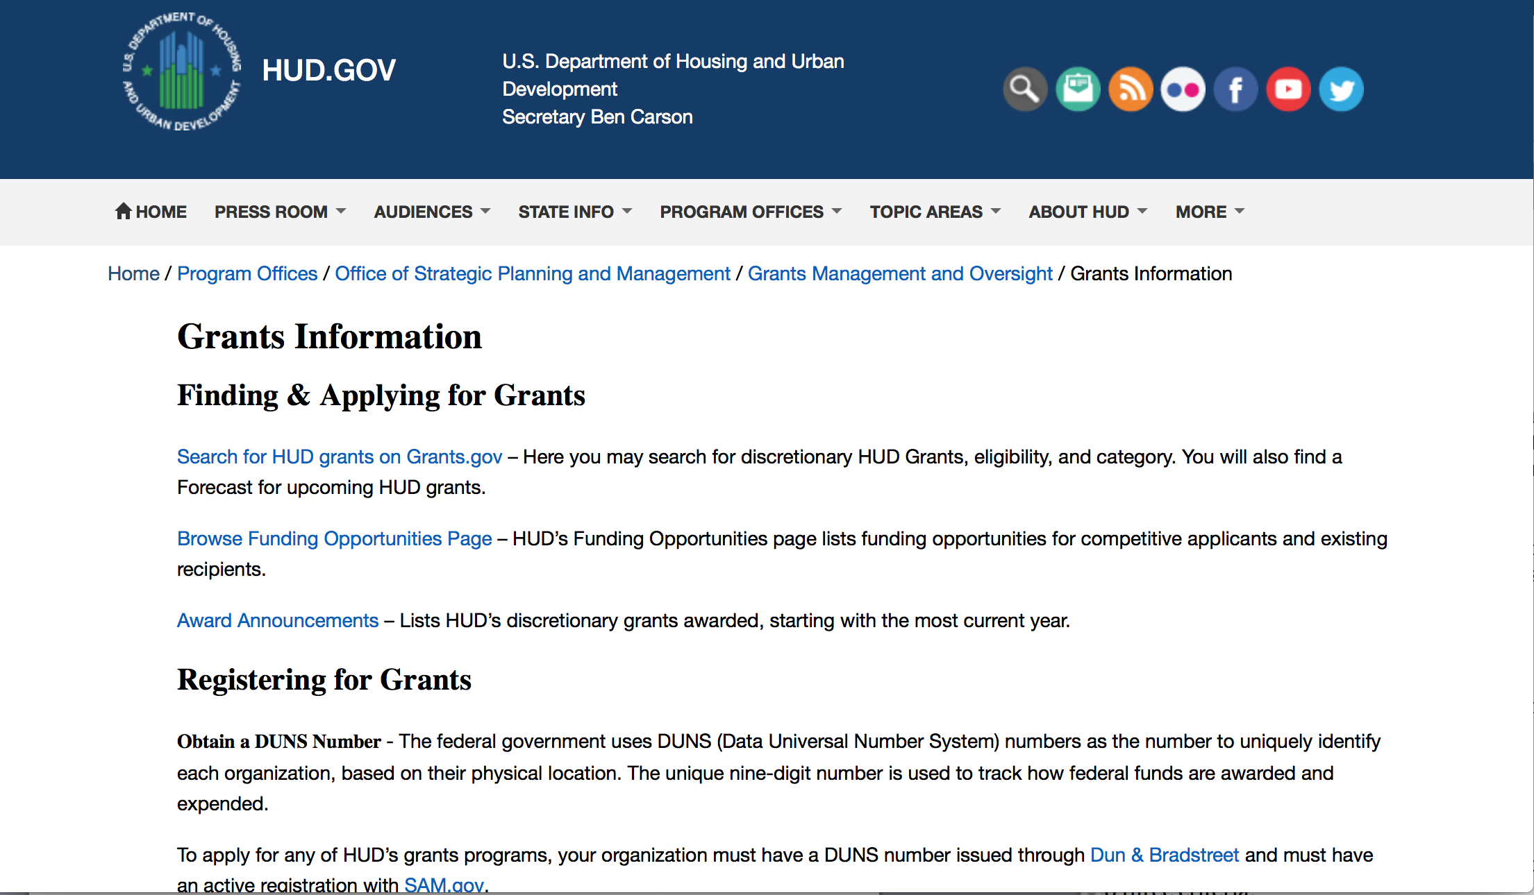
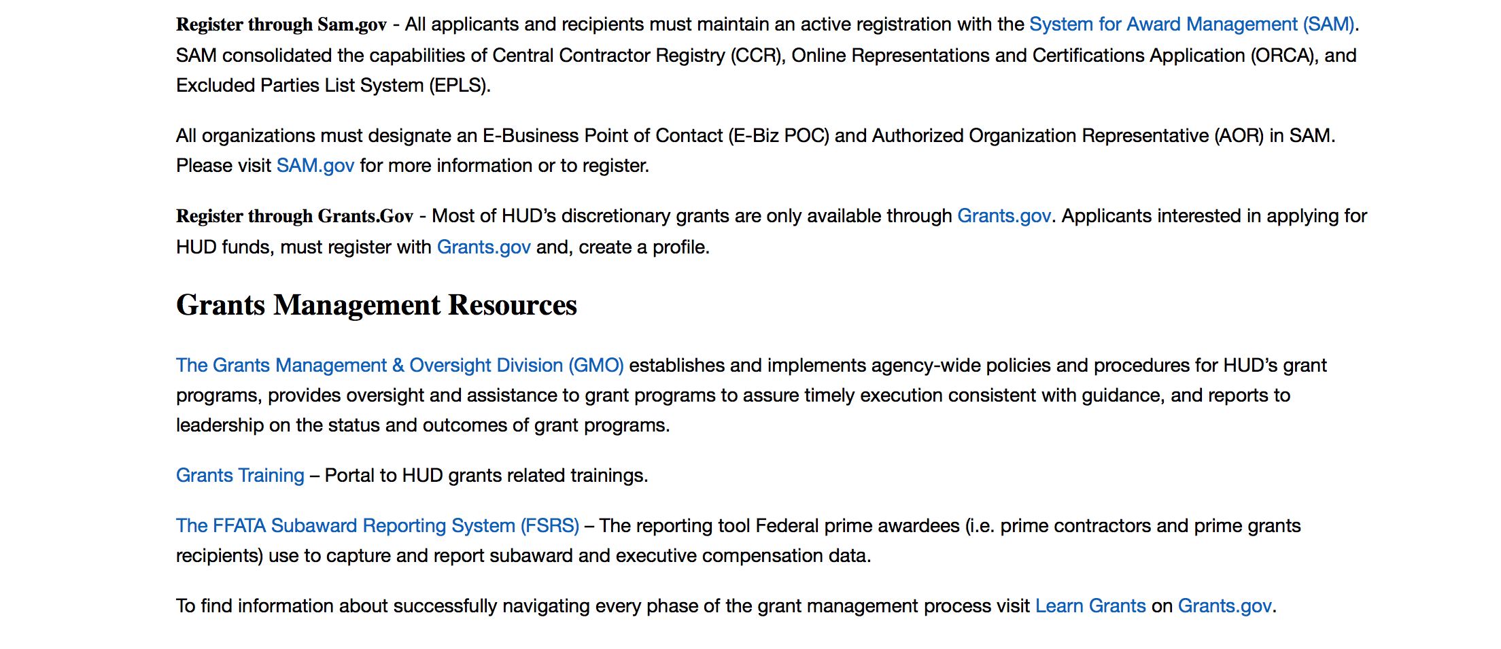
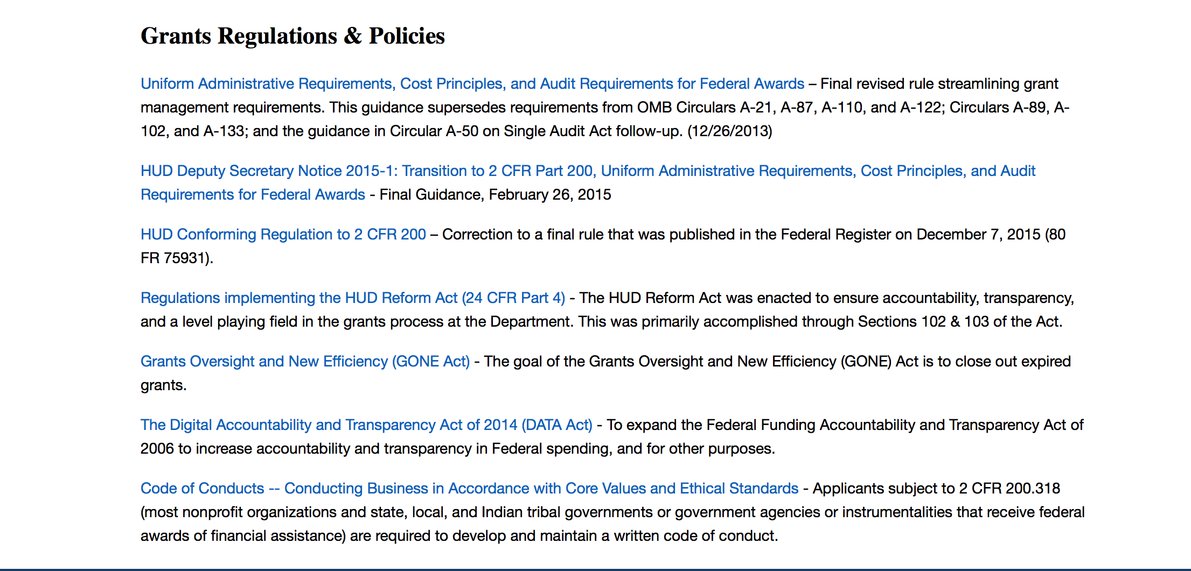

http://portal.hud.gov/hudportal/HUD?src=/topics/grants

HUD - Notice of Funds Available
For detailed information click here

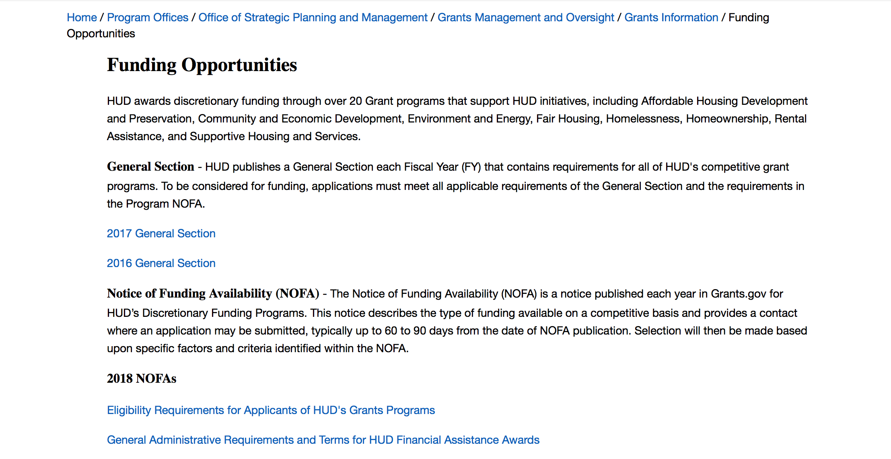

http://portal.hud.gov/hudportal/HUD?src=/program_offices/administration/grants/fundsavail

HUD NOFA FORECAST
The Department of Housing and Urban Development NOFA Forecast lists competitive grant opportunities that may be available for FY2016. The inclusion or exclusion of an opportunity in this list does not constitute a guarantee that a specific opportunity will become available or not be available. Forecast opportunities are subject to change based on enactment of Congressional appropriations and other considerations.
When funding is available, HUD will issue a Notice of Funding Availability (NOFA), which will be available on Grants.gov

Programs:

Fair Housing Initiative Program - Education and Outreach Initiative
Synopsis 1

Document Type: | Grants Notice
Funding Opportunity Number: | FR-6200-N-21A
Funding Opportunity Title: | Fair Housing Initiative Program - Education and Outreach Initiative
Opportunity Category: | Discretionary
Opportunity Category Explanation:
Funding Instrument Type: | Grant
Category of Funding Activity: | Housing
Category Explanation:
Expected Number of Awards: | 56
CFDA Number(s): | 14.416 -- Education and Outreach Initiatives
Cost Sharing or Matching Requirement: | No
Version: | Synopsis 2
Posted Date: | Oct 29, 2018
Last Updated Date: | Oct 30, 2018
Original Closing Date for Applications: | Dec 19, 2018 Electronically submitted applications must be submitted no later than 11:59 p.m., ET, on the listed application due date.
Current Closing Date for Applications: | Dec 19, 2018 Electronically submitted applications must be submitted no later than 11:59 p.m., ET, on the listed application due date.
Archive Date: | Jan 18, 2019
Estimated Total Program Funding: | $7,450,000
Award Ceiling: | $1,000,000
Award Floor: | $125,000
Eligible Applicants: | Others (see text field entitled "Additional Information on Eligibility" for clarification)
Additional Information on Eligibility: | Eligible applicants may be Qualified Fair Housing Enforcement Organizations (QFHOs) and Fair Housing Enforcement Organizations (FHOs), public or private not-for-profit organizations or institutions, and other public or private entities that are formulating or carrying out programs to prevent or eliminate discriminatory housing practices; agencies of State or local governments; and agencies that participate in the Fair Housing Assistance Program (FHAP). All applicants are required to complete Appendix B, EOI Eligibility Certification and submit as a part of your application. All EOI project periods are 12-18 months. HUD does not award grants to individuals. HUD will not evaluate applications from ineligible applicants. Individuals, foreign entities, and sole proprietorship organizations are not eligible to compete for, or receive, awards made under this announcement.
Additional Information
Agency Name: | Department of Housing and Urban Development
Description: | HUD is making available through this NOFA $ 7,450,000for Fair Housing Initiatives Program Education and Outreach Initiative. Additional funds may become available for award under this NOFA as a result of HUD's efforts to recapture unused funds, use carryover funds, or because of the availability of additional appropriated funds. Use of these funds will be subject to statutory constraints. All awards are subject to the applicable funding restrictions described in this NOFA. FHIP funds are used to increase compliance with the Fair Housing Act. This year, funding is available under three Initiatives: Private Enforcement (PEI), Fair Housing Organization (FHOI) and Education and Outreach (EOI) Initiatives. Multi-year awards beyond FY2018 funding are subject to appropriations and the availability of funds. For FY2018, funding for each initiative is listed under a separate NOFA, therefore, applicants must apply under the correct NOFA to be considered for funding. Additionally, if an applicant is eligible and applies for funding under separate initiatives and/or components, the applicant must submit a separate application under the correct NOFA for each component the applicant applies. This NOFA will consider applicants applying under EOI only. The following is a general description of the Education and Outreach Initiative (see chart in section III. A. for all eligibility requirements and a listing of related components): Education and Outreach Initiative (EOI). This Initiative provides funding to organizations that inform the general public about their rights and obligations under the Fair Housing Act. EOI applicants may be funded under the following components based on eligibility: Education and Outreach Initiative (EOI) - $7,450,000 National-Based Programs - National Media Campaign Component (EOI-NMCC) - $1,000,000 Regional/Local/Community Based Program - General Component (EOI-G) - $6,200,000 Regional/Local/Community Based Program – Tester Training Component (EOI-TTC) - $250,000 Under the EOI NOFA, applicants may apply for funding under each FHIP NOFA and for multiple components as long as the applicant applies under the correct NOFA, and meets the specific eligibility requirements and funding restrictions for each component (see eligibility chart in Section III.A.1). Applicants will be funded in accordance with the funding restrictions listed under Section IV.F.5.
Link to Additional Information: | https://hud.gov/program_offices/spm/gmomgmt/grantsinfo/fundingopps
Grantor Contact Information: | If you have difficulty accessing the full announcement electronically, please contact:  Myron Newry Myron.P.Newry@hud.gov  Grants Policy
https://www.grants.gov/web/grants/view-opportunity.html?oppId=310016

Fair Housing Initiatives Program - Private Enforcement Initiative
Synopsis 1
Document Type: | Grants Notice
Funding Opportunity Number: | FR-6200-N-21-C
Funding Opportunity Title: | Fair Housing Initiatives Program - Private Enforcement Initiative
Opportunity Category: | Discretionary
Opportunity Category Explanation:
Funding Instrument Type: | Grant
Category of Funding Activity: | Housing
Category Explanation:
Expected Number of Awards: | 20
CFDA Number(s): | 14.418 -- Private Enforcement Initiatives
Cost Sharing or Matching Requirement: | No
Version: | Synopsis 2
Posted Date: | Oct 29, 2018
Last Updated Date: | Oct 30, 2018
Original Closing Date for Applications: | Dec 19, 2018 Electronically submitted applications must be submitted no later than 11:59 p.m., ET, on the listed application due date.
Current Closing Date for Applications: | Dec 19, 2018 Electronically submitted applications must be submitted no later than 11:59 p.m., ET, on the listed application due date.
Archive Date: | Jan 18, 2019
Estimated Total Program Funding: | $6,130,337
Award Ceiling: | $300,000
Award Floor: | $100,000
Eligible Applicants: | Others (see text field entitled "Additional Information on Eligibility" for clarification)
Additional Information on Eligibility: | Under this NOFA, eligible applicants must be Qualified Fair Housing Enforcement Organizations (QFHOs) with at least two years of experience in complaint intake, complaint investigation, testing for fair housing violations and enforcement related experience and meritorious claims in the three years prior to filing this application, or Fair Housing Enforcement Organizations (FHOs) with at least one year of experience in the enforcement-related activities listed above in the two years prior to the filing of the application, or the organization is ineligible. Both FHOs and QFHOs must currently conduct these enforcement activities and operate a full- service program. Applicants must complete the Appendix B, "Certification for PEI Applicants" to confirm QFHO or FHO status. If an organization does not currently have sufficient experience to qualify as a FHO or QFHO (see 24 CFR part 125.103 and 125.401), the organization may be eligible to apply under FHIP's Education and Outreach Initiative (FR-6200-21A) and/or Fair Housing Organizations Initiative (FR-6200-21B) NOFAs. Please see the correct NOFA for specific eligibility requirements. Eligible Activities. Eligible activities include, but are not limited to: (1) Intake of allegations of violations of the Fair Housing Act, testing, evaluating testing results, and providing other investigative work to provide a just resolution for violations of the Fair Housing Act that may violate federal, state or substantially equivalent local fair housing laws; (2) investigation of violations of the Fair Housing Act, through testing and other investigative methods including systemic investigations; (3) mediation or other voluntary resolution of allegations of violations of the Fair Housing Act; (4) litigation of fair housing cases, including procuring expert witnesses, and (5) fair housing education activities. Activities are eligible only in cases involving conduct prohibited by, or rights protected under, the Fair Housing Act. HUD will allow applicants under the PEI-MY funding component to modify their activities in the second or third year with the approval of the General Technical Representative (GTR) based upon changing demographics and/or need. All applicants must review Appendix A for guidance on the format that should be used to list the applicant's proposed tasks/activities. Individuals, foreign entities, and sole proprietorship organizations are not eligible to compete for, or receive, awards made under this announcement.
Additional Information
Agency Name: | Department of Housing and Urban Development
Description: | HUD is making available through this PEI NOFA $30,750,000 for Fair Housing Initiative Programs. While the total PEI Multi-Year (PEI-MY) Funding is $30,750,000, approximately $24,619,663 is set aside based upon appropriations for FY 2016 and FY 2017 current Multi-year grantees. The remaining funding of $6,130,337 will fund new FY 2018 grantees. Additional funds may become available for award under this NOFA under HUD's efforts to recapture unused funds, use carryover funds, or because of the availability of additional appropriated funds. Use of these funds will be subject to statutory constraints. All awards are subject to the applicable funding restrictions contained in this NOFA. Funding for additional years beyond FY 2018 is subject to the availability of appropriations. FHIP funds are used to increase compliance with the Fair Housing Act. This year, funding is available under three Initiatives: Private Enforcement (PEI), Fair Housing Organization (FHOI) and Education and Outreach (EOI) Initiatives. However, for FY2018, funding for each initiative is listed under a separate NOFA. Applicants must apply under the correct NOFA to be considered for funding. Additionally, if an applicant is eligible and applying for funding under separate NOFAs and initiatives and/or components, the applicant must submit a separate application under the correct NOFA for each component the applicant applies. This NOFA will consider applicants applying under PEI only. The following is a general description of PEI (see chart in section III. A. for all eligibility requirements): Private Enforcement Initiative (PEI). This Initiative provides funding to private, non-profit fair housing enforcement organizations that meet statutory requirements to conduct investigation and enforcement of alleged violations of the Fair Housing Act. PEI applicants may be funded under the following Initiative based on eligibility: Private Enforcement Initiative (PEI) - $30,750,000 - Multi-Year Funding Component (PEI-MY) Applicants may apply for funding under each FHIP NOFA and apply under multiple components as long as the applicant applies under the correct NOFA, and meets the specific eligibility requirements and funding restrictions.
Link to Additional Information: | https://hud.gov/program_offices/spm/gmomgmt/grantsinfo/fundingopps
Grantor Contact Information: | If you have difficulty accessing the full announcement electronically, please contact:  Myron Newry Myron.P.Newry@hud.gov  Grants Policy
https://www.grants.gov/web/grants/view-opportunity.html?oppId=310017

Modifications:

Deleted:

Reminders:

Institute of Museum and Library Services

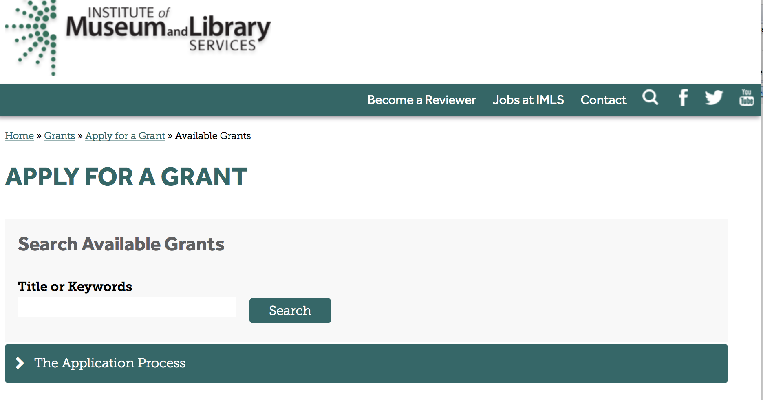

https://www.imls.gov/grants/apply-grant/available-grants

Each grant program has specific eligibility requirements. The links below provide general eligibility criteria for museums, libraries, and tribal organizations, but please note that additional organizations may be eligible for grants under certain programs. Additionally, ineligible organizations may still be able to participate in grant programs through partnerships with eligible organizations. Please click on the links below to see general criteria and review Applications and Guidelines for specific information.
Museums Libraries

Institutions: Archives, Federally Recognized Native American Tribe, Historical Society, Library, Nonprofits that serve Native Hawaiians, Professional Association, Public or Private Non-profit Institutions of Higher Education, Regional Organization, State Library Administrative Agency, State or Local Government

Check out IMLS's Facebook page at:
https://www.facebook.com/USIMLS/

Programs:

Modifications:

Reminders:

Museums for America
Synopsis 1

Document Type: | Grants Notice
Funding Opportunity Number: | MFA-FY19
Funding Opportunity Title: | Museums for America
Opportunity Category: | Discretionary
Opportunity Category Explanation:
Funding Instrument Type: | Grant
Category of Funding Activity: | Arts (see "Cultural Affairs" in CFDA)  Humanities (see "Cultural Affairs" in CFDA)
Category Explanation:
Expected Number of Awards: | 120
CFDA Number(s): | 45.301 -- Museums for America
Cost Sharing or Matching Requirement: | Yes
Version: | Synopsis 1
Posted Date: | Aug 16, 2018
Last Updated Date: | Aug 16, 2018
Original Closing Date for Applications: | Dec 14, 2018
Current Closing Date for Applications: | Dec 14, 2018
Archive Date: | Jan 13, 2019
Estimated Total Program Funding: | $19,900,000
Award Ceiling: | $250,000
Award Floor: | $5,000
Eligible Applicants: | Others (see text field entitled "Additional Information on Eligibility" for clarification)
Additional Information on Eligibility: | Please see Notice of Funding Opportunity for eligibility information.
Additional Information
Agency Name: | Institute of Museum and Library Services
Description: | The goal of the Museums for America (MFA) grant program is to support projects that strengthen the ability of an individual museum to serve its public. Projects may be structured at any of several stages of maturity: exploratory, piloting, scaling, or mainstreaming. A proposed project’s activities may be brand new to the institution, or they may implement learnings, perspectives, or competencies acquired during a previous project. A project may be an effort to intensify the impact of an approach that has been tested and found to be effective, or it may be structured as an opportunity to expand a function or activity that has been deemed successful.
Link to Additional Information: | https://www.imls.gov/grants/available/museums-america
Grantor Contact Information: | If you have difficulty accessing the full announcement electronically, please contact:  Sandra Narva, Senior Program Officer, 202-653-4791, snarva@imls.gov; Connie Bodner, Supervisory Grants Management Specialist, 202-653-4636, cbodner@imls.gov; Steve Shwartzman, Senior Program Officer, 202-653-4641, sshwartzman@imls.gov; Reagan Moore, Museum Program Officer, 202-653-4637, rmoore@imls.gov; Kelsey Monahan, Museum Program Specialist, 202-653-4753, kmonahan@imls.gov; Ashley Jones, Museum Program Specialist, 202-653-4782, ajones@imls.gov  imls-museumgrants@imls.gov

https://www.grants.gov/web/grants/view-opportunity.html?oppId=308273

National Leadership Grants for Museums
Synopsis 1
Document Type: | Grants Notice
Funding Opportunity Number: | NLG-M-FY19
Funding Opportunity Title: | National Leadership Grants for Museums
Opportunity Category: | Discretionary
Opportunity Category Explanation:
Funding Instrument Type: | Grant
Category of Funding Activity: | Arts (see "Cultural Affairs" in CFDA)  Humanities (see "Cultural Affairs" in CFDA)
Category Explanation:
Expected Number of Awards: | 11
CFDA Number(s): | 45.312 -- National Leadership Grants
Cost Sharing or Matching Requirement: | Yes
Version: | Synopsis 1
Posted Date: | Aug 16, 2018
Last Updated Date: | Aug 16, 2018
Original Closing Date for Applications: | Dec 14, 2018
Current Closing Date for Applications: | Dec 14, 2018
Archive Date: | Jan 13, 2019
Estimated Total Program Funding: | $6,500,000
Award Ceiling: | $1,000,000
Award Floor: | $5,000
Eligible Applicants: | Others (see text field entitled "Additional Information on Eligibility" for clarification)
Additional Information on Eligibility: | Please see Notice of Funding Opportunity for eligibility information.
Additional Information
Agency Name: | Institute of Museum and Library Services
Description: | The goals of National Leadership Grants (NLG) for Museums are to support projects that address critical needs of the museum field and that have the potential to advance practice in the profession so that museums can strengthen services for the American public. This work may be achieved through projects at various stages of maturity (exploring, piloting, scaling, or mainstreaming).
Link to Additional Information: | https://www.imls.gov/grants/available/national-leadership-grants-museums
Grantor Contact Information: | If you have difficulty accessing the full announcement electronically, please contact:  Helen Wechsler, Supervisory Grants Management Specialist, 202-653-4779, hwechsler@imls.gov; Connie Bodner, Supervisory Grants Management Specialist, 202-653-4636, cbodner@imls.gov; Mark Isaksen, Senior Program Officer, 202-653-4667, misaksen@imls.gov  imls-museumgrants@imls.gov
https://www.grants.gov/web/grants/view-opportunity.html?oppId=308275

Deleted:

Department of the Interior
Working with Interior

The Interior Department provides assistance to the public, local governments and businesses through a number of programs. For a general overview see: http://www.doi.gov/index.cfm

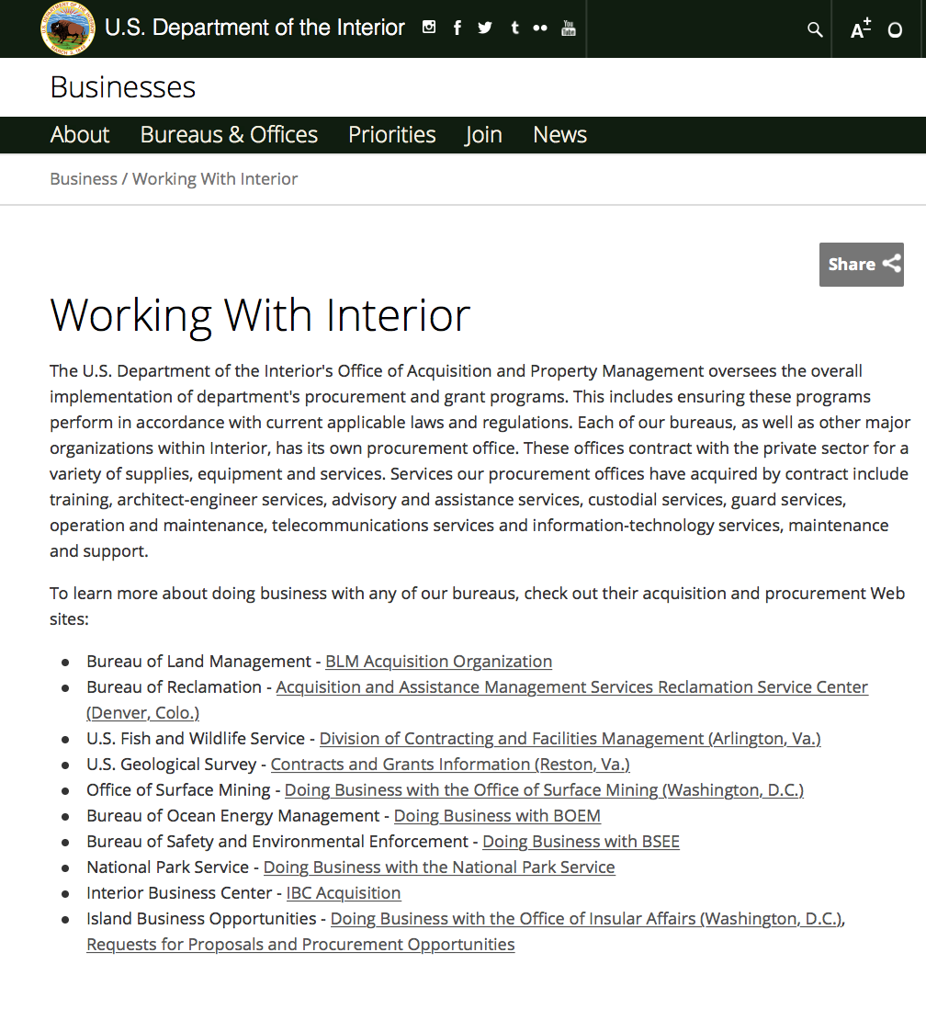

http://www.doi.gov/businesses/working-with-interior.cfm

Programs:

National Park Service
2019 Preservation Technology and Training Grants
Synopsis 1

Document Type: | Grants Notice
Funding Opportunity Number: | P19AS00001
Funding Opportunity Title: | 2019 Preservation Technology and Training Grants
Opportunity Category: | Discretionary
Opportunity Category Explanation:
Funding Instrument Type: | Grant
Category of Funding Activity: | Natural Resources
Category Explanation:
Expected Number of Awards: | 10
CFDA Number(s): | 15.923 -- National Center for Preservation Technology and Training
Cost Sharing or Matching Requirement: | No
Version: | Synopsis 1
Posted Date: | Oct 04, 2018
Last Updated Date: | Oct 04, 2018
Original Closing Date for Applications: | Jan 03, 2019
Current Closing Date for Applications: | Jan 03, 2019
Archive Date: | Jan 05, 2019
Estimated Total Program Funding: | $300,000
Award Ceiling: | $30,000
Award Floor: | $5,000
Eligible Applicants: | Others (see text field entitled "Additional Information on Eligibility" for clarification)
Additional Information on Eligibility: | Eligible applicants include Federal and non-Federal laboratories, accredited museums, universities, nonprofit organizations, system units and offices and cooperative park study units of the system, state historic preservation offices, tribal preservation offices, and native Hawaiian organizations.
Additional Information
Agency Name: | National Park Service
Description: | 2019 Preservation Technology and Training Grants (PTT Grants) are intended to create better tools, better materials, and better approaches to conserving buildings, landscapes, sites, and collections. The PTT Grants are administered by the National Center for Preservation Technology and Training (NCPTT), the National Park Services innovation center for the preservation community. The competitive grants program will provide funding to federal agencies, states, tribes, local governments, and non-profit organizations. PTT Grants will support the following activities: 1. Innovative research that develops new technologies or adapts existing technologies to preserve cultural resources (typically $25,000 to $30,000) 2. Specialized workshops or symposia that identify and address national preservation needs (typically $15,000 to $25,000) 3. How-to videos, mobile applications, podcasts, best practices publications, or webinars that disseminate practical preservation methods or provide better tools for preservation practice (typically $5,000 to $15,000) The maximum grant award is $30,000. The actual grant award amount is dependent on the scope of the proposed activity. NCPTT does not fund bricks and mortar grants.
Link to Additional Information: | https://www.ncptt.nps.gov/grants/preservation-technology-and-training-grants/
Grantor Contact Information: | If you have difficulty accessing the full announcement electronically, please contact:  Todd Wilson Todd_Wilson@nps.gov  Email
https://www.grants.gov/web/grants/view-opportunity.html?oppId=309405

Modifications:

Fish and Wildlife Service
Partners for Fish and Wildlife
Synopsis 2

Document Type: | Grants Notice
Funding Opportunity Number: | F19AS00024
Funding Opportunity Title: | Partners for Fish and Wildlife
Opportunity Category: | Discretionary
Opportunity Category Explanation:
Funding Instrument Type: | Cooperative Agreement
Category of Funding Activity: | Natural Resources
Category Explanation:
Expected Number of Awards: | 2500
CFDA Number(s): | 15.631 -- Partners for Fish and Wildlife
Cost Sharing or Matching Requirement: | No
Version: | Synopsis 2
Posted Date: | Oct 19, 2018
Last Updated Date: | Oct 19, 2018
Original Closing Date for Applications: | Sep 30, 2019
Current Closing Date for Applications: | Sep 30, 2019
Archive Date: | Oct 01, 2019
Estimated Total Program Funding: | $52,000,000
Award Ceiling: | $750,000
Award Floor: | $1
Eligible Applicants: | Unrestricted (i.e., open to any type of entity above), subject to any clarification in text field entitled "Additional Information on Eligibility"
Additional Information on Eligibility: | To receive funding, PFW projects must be implemented on private lands, with the exception for efforts that support projects on private lands. IN GENERAL, the term private lands is any property not state or federally owned. Private lands include, but are not limited to; tribal, Hawaiian homeland, city, municipality, non-governmental, and private fee-title properties. 501(c)(3) applicants should be prepared to prove status as determined by the Internal Revenue Service and tribal applicants may be required to provide an authorizing tribal resolution.
Additional Information
Agency Name: | Fish and Wildlife Service
Description: | Federal Program: Department of the Interior, United States (U.S.) Fish and Wildlife Service, Division of Natural Resources and Conservation Planning  Catalog of Federal Domestic Assistance (CFDA) Number: 15.631Authorizing Legislation: Partners for Fish and Wildlife Act of 2006, S.260 Public Law 109-294; Fish and Wildlife Act of 1956, 16 U.S.C. 742a-c, 747e-742j; and Fish and Wildlife Coordination Act of 1958, 16 U.S.C. 661 667(e).  The Partners for Fish and Wildlife (PFW) Program is a voluntary, incentive-based program that provides direct technical assistance and financial assistance in the form of cooperative and grant agreements to private landowners to restore and conserve fish and wildlife habitat for the benefit of federal trust resources. The PFW Program is delivered through more than 250 full-time staff, active in all 50 States and territories. Partners for Fish and Wildlife Program staff coordinate with project partners, stakeholders and other Service programs to identify geographic focus areas and develop habitat conservation priorities within these focus areas. Geographic focus areas define where the program directs resources to conserve habitat for federal trust species. Project work plans are developed strategically, in coordination with partners, and with substantial involvement from Service field staff. The program has been in existence since 1987 and has over 30 years of successful delivery. Project selection will seek to align or support the Secretary's priorities. It also advance the Department of the Interior's mission, U.S. Fish and Wildlife Service's mission, and PFW's mission, promote biological diversity, and based upon sound scientific biological principles. Program strategic plans inform the types of projects funded under this opportunity.  ***Applicants seeking technical or financial assistance from the PFW Program are requested to consult with the Regional PFW Program office BEFORE developing or submitting an application (see Section VIII. Agency Contacts at the end of this announcement).  ***Project selection will seek to align or support the Secretary's priorities. Program funding will enhance the missions of DOI, FWS, and PFW.  1. Restoring trust with local communities: The PFW program has local field biologists across all 50 states stationed and living in the communities they serve which enhances trust and allows sustainable relationship building. Projects which support and build trust with local communities will receive high prioritization. 2. Modernizing our infrastructure: The PFW program will assist with modernizing fish passage structures to allow safe travel by aquatic resources and at the same time, allow for structural stability by designing units to avoid flood damage. Additionally, wetland levees, water control structures, and fencing projects are a few examples of modernizing infrastructure to support American conservation.3. Ensuring sovereignty means something: Many PFW projects support tribal operations and PFW staff will continue to recognize opportunities to enhance those relationships.4. Hunt/Fish: The PFW Program will continue to deliver on-the-ground habitat to support robust populations of wildlife for recreational use by the American public. These will support Secretarial Orders 3347, 3356, and 3362.5. National Wildlife Refuge System. PFW Program staff will favor conservation activities and projects that are on private lands near National Wildlife Refuge (Refuges) lands. Activities or projects that complement conservation practices on Refuges or resolve problems on Refuges that are caused by off-refuge land use practices will be given higher priority.6. Expand priority habitats, reduce habitat fragmentation, establish conservation buffers, and provide wildlife movement corridors that result in self-sustaining systems. Our staff will give preference to habitat improvement projects near protected land, including land owned or controlled by the National Wildlife Refuge System, National Forests, National Park Service, U.S. Department of Agriculture, other federal agencies, tribal, state agencies, or nongovernment entities.7. Regional strategic plans and priorities. PFW Program regional and field staff work with conservation partners to identify habitat conservation priorities and delineate geographic focus areas in our Regional strategic plans. The geographic focus areas represent an integration of shared habitat conservation priorities among the Service, conservation partners, and stakeholders. We will concentrate our technical and financial resources in these focus areas to conserve priority habitat. Habitat improvement projects that meet region-specific priorities and are located within geographic focus areas will receive higher priority. However, field staff are not prohibited from implementing high-value habitat improvement projects outside of these geographic focus areas.  ***If you have a potential project that meets the VI. APPLICATION REVIEW criteria, we request that you consult with your Regional PFW Program office below BEFORE developing or submitting an application.  Pacific Region (ID, OR, WA, HI, the Commonwealth of the Northern Mariana Islands, and the territories of American Samoa and Guam,): 503-231-6156  Southwest Region (AZ, NM, OK, TX): 817-277-1100 X2110  Midwest Region (IA, IL, IN, MI, MN, MO, OH, WI): 612-713-5475  Southeast Region (AL, AR, FL, GA, KY, LA, MO, NC, SC, TN, Puerto Rico, U.S. Virgin Islands): 404-679-7138  Northeast Region (CT, DE, MA, MD, ME, NH, NJ, NY, PA, RI, VA, VT, WV): 413-253-8657  Mountain Prairie Region (CO, KS, MT, ND, NE, SD, UT, WY): 303-236-4316  Alaska Region (AK): 907-786-3523  Pacific Southwest Region (CA, NV): 916-335-7054  Or, visit our website to find the nearest Partners for Fish and Wildlife Program office: http://www.fws.gov/partners/contactUs.html
Link to Additional Information: | https://www.grants.gov/
Grantor Contact Information: | If you have difficulty accessing the full announcement electronically, please contact:  Grants Management Specialist Patrick Schulze 703 358 2567 patrick_schulze@fws.gov  Service e-mail
https://www.grants.gov/web/grants/view-opportunity.html?oppId=309699

Fish and Wildlife Service
Coastal
Synopsis 2

Document Type: | Grants Notice
Funding Opportunity Number: | F19AS00027
Funding Opportunity Title: | Coastal
Opportunity Category: | Discretionary
Opportunity Category Explanation:
Funding Instrument Type: | Cooperative Agreement
Category of Funding Activity: | Natural Resources
Category Explanation:
Expected Number of Awards: | 100
CFDA Number(s): | 15.630 -- Coastal
Cost Sharing or Matching Requirement: | No
Version: | Synopsis 2
Posted Date: | Oct 22, 2018
Last Updated Date: | Oct 22, 2018
Original Closing Date for Applications: | Sep 30, 2019
Current Closing Date for Applications: | Sep 30, 2019
Archive Date: | Oct 01, 2019
Estimated Total Program Funding: | $13,000,000
Award Ceiling: | $500,000
Award Floor: | $1
Eligible Applicants: | Unrestricted (i.e., open to any type of entity above), subject to any clarification in text field entitled "Additional Information on Eligibility"
Additional Information on Eligibility:
Additional Information
Agency Name: | Fish and Wildlife Service
Description: | Federal Program: Department of the Interior, Unite States (U.S.) Fish and Wildlife Service, National Wildlife Refuge System, Division of Natural Resources and Conservation Planning,  Coastal Program Catalog of Federal Domestic Assistance (CFDA) Number: 15.630 Authorizing Legislation: Fish and Wildlife Coordination Act (16 U.S.C. 661-667e), Fish and Wildlife Act of 1956 (16 U.S.C. 742a-742j, not including 742 d-I), National Wildlife Refuge System Improvement Act of 1997 (Public Law 105-57)  The Coastal Program is a voluntary, community-based program that provides technical and financial assistance through cooperative agreements to coastal communities, conservation partners, and landowners to restore and protect fish and wildlife habitat on public and private lands. Coastal Program staff coordinates with project partners, stakeholders and other Service programs to identify geographic focus areas and develop habitat conservation priorities within these focus areas. Geographic focus areas are where the Coastal Program directs resources to conserve habitat for Federal trust species. Regional staff develop five-year strategic work plans based on the conservation priorities and the geographic focus areas that guides the work of the program. Projects are developed in collaboration with partners, and with substantial involvement from Service field staff. Projects must advance the missions of the U.S. Department of the Interior (DOI), U.S. Fish and Wildlife Service (Service), and the Coastal Program, and be based on sound scientific biological principles. Projects must also support the financial assistance priorities of Department of the Interior, specifically Priorities 1, 3, 8.  DOI Priority Coastal Program Support  1. Creating a conservation stewardship legacy second only to Teddy Roosevelt The Coastal Program mission is to achieve voluntary habitat conservation by providing technical and financial assistance, in collaboration with partners, for the benefit of Federal trust species. Working with partners, we deliver strategic habitat conservation by conducting landscape-scale planning and design and implementing habitat improvement and protection projects.  3. Restoring trust with local communities The Coastal Program partners with local communities to plan and deliver priority habitat conservation projects that benefit recovery and management of Federal trust species, and address other community priorities;  8. Modernizing our infrastructure Some Coastal Program projects are designed to: (1) improve habitat connectivity (e.g., fish passage structures, culvert retrofits, stream channel improvements, and removal of tidal restrictions and low head dams and levees); (2) attenuate coastal erosion (e.g., wetland restoration, living shorelines, streambank stabilizations, dune restorations, revegetation, and fencing); and (3) maintain habitat for migratory birds and waterfowl (e.g., construction of berms and installation of water control structures).  ***If you have a potential project that meets the VI. APPLICATION REVIEW criteria, we request that you consult with your regional Coastal Program office below BEFORE developing or submitting an application.  Pacific Region (HI, ID, OR minus the Klamath River Basin, WA, the Commonwealth of the Northern Mariana Islands, American Samoa, Guam, Palmyra Atoll, Midway Atoll, the Republic of Palau, the Federated States of Micronesia, and the Republic of the Marshall Islands): 503-213-2198, https://www.fws.gov/pacific/ecoservices/habcon/coastal/index.html  Southwest Region (AZ, NM, OK, TX): 361-225-7320, https://www.fws.gov/southeast/our-services/coastal-conservation/  Midwest Region (IA, IL, IN, MI, MN, MO, OH, WI): 906-226-1240  Southeast Region (AL, AR, FL, GA, KY, LA, MS, NC, SC, TN, Puerto Rico, U.S. Virgin Islands): 404-679-7122  Northeast Region (CT, DE, MA, MD, ME, NH, NJ, NY, PA, RI, VA, VT, WV): 413-253-8657, https://www.fws.gov/northeast/ecologicalservices/coastal.html  Alaska Region (AK): 907-786-3523, https://www.fws.gov/alaska/fisheries/restoration/pdf/coastal%20program_Webversion.pdf  Pacific Southwest Region (CA, NV, Klamath River Basin): 831-460-7553, https://www.fws.gov/cno/conservation/Coastal.html  Headquarters (Washington, DC): 703-358-1829Or, please visit our website to find the nearest Coastal Program office: HTTPs://www.fws.gov/coastal/contact.html
Link to Additional Information: | https://www.grants.gov
Grantor Contact Information: | If you have difficulty accessing the full announcement electronically, please contact:  Grants Management Specialist Patrick Schulze 703 358 2567 patrick_schulze@fws.gov  Service e-mail
https://www.grants.gov/web/grants/view-opportunity.html?oppId=309815

Reminders:

Fish and Wildlife Service
Marine Turtle Conservation Fund
Synopsis 1
Document Type: | Grants Notice
Funding Opportunity Number: | F18AS00378
Funding Opportunity Title: | Marine Turtle Conservation Fund
Opportunity Category: | Discretionary
Opportunity Category Explanation:
Funding Instrument Type: | Cooperative Agreement  Grant
Category of Funding Activity: | Agriculture  Business and Commerce  Community Development  Education  Employment, Labor and Training  Environment  Information and Statistics  Natural Resources  Regional Development  Science and Technology and other Research and Development
Category Explanation:
Expected Number of Awards: | 30
CFDA Number(s): | 15.645 -- Marine Turtle Conservation Fund
Cost Sharing or Matching Requirement: | No
Version: | Synopsis 1
Posted Date: | Sep 26, 2018
Last Updated Date: | Sep 26, 2018
Original Closing Date for Applications: | Nov 26, 2018
Current Closing Date for Applications: | Nov 26, 2018
Archive Date: | Nov 28, 2018
Estimated Total Program Funding: | $1,500,000
Award Ceiling: | $80,000
Award Floor: | $10,000
Eligible Applicants: | Unrestricted (i.e., open to any type of entity above), subject to any clarification in text field entitled "Additional Information on Eligibility"
Additional Information on Eligibility:
Additional Information
Agency Name: | Fish and Wildlife Service
Description: | The Marine Turtle Conservation Fund (MTCA) is soliciting proposals for the conservation of marine turtles (Chelonia mydas, Caretta caretta, Dermochelys coriacea, Eretmochelys imbricata, Lepidochelys olivacea, Lepidochelys kempii) throughout their range outside of the United States and its territories. The U.S. Government enacted the Marine Turtle Conservation Act of 2004 in response to the decline of many marine turtle populations worldwide and the serious threats to their long-term survival. The primary purpose of the Act is to provide financial support for projects that conserve nesting populations and habitat and address other threats to the survival of marine turtles in foreign countries.
Link to Additional Information: | https://www.fws.gov/international/grants-and-reporting/how-to-apply.html
Grantor Contact Information: | If you have difficulty accessing the full announcement electronically, please contact:  Forrest Miller 703-358-2259 forrest_miller@fws.gov  forrest_miller@fws.gov
https://www.grants.gov/web/grants/view-opportunity.html?oppId=309266

National Park Service
Save America's Treasures - Collections
Synopsis 1
Document Type: | Grants Notice
Funding Opportunity Number: | P18AS00727
Funding Opportunity Title: | Save America's Treasures - Collections
Opportunity Category: | Discretionary
Opportunity Category Explanation:
Funding Instrument Type: | Grant
Category of Funding Activity: | Arts (see "Cultural Affairs" in CFDA)  Community Development  Humanities (see "Cultural Affairs" in CFDA)  Other (see text field entitled "Explanation of Other Category of Funding Activity" for clarification)
Category Explanation: | Cultural Heritage and Historic Preservation
Expected Number of Awards: | 25
CFDA Number(s): | 15.929 -- Save America's Treasures
Cost Sharing or Matching Requirement: | Yes
Version: | Synopsis 1
Posted Date: | Sep 25, 2018
Last Updated Date: | Sep 25, 2018
Original Closing Date for Applications: | Dec 03, 2018 Complete applications must be received by 11:59 pm Eastern.
Current Closing Date for Applications: | Dec 03, 2018 Complete applications must be received by 11:59 pm Eastern.
Archive Date: | Dec 27, 2018
Estimated Total Program Funding: | $13,000,000
Award Ceiling: | $500,000
Award Floor: | $25,000
Eligible Applicants: | County governments  Public and State controlled institutions of higher education  Private institutions of higher education  City or township governments  State governments  Others (see text field entitled "Additional Information on Eligibility" for clarification)  Independent school districts  Native American tribal governments (Federally recognized)  Nonprofits having a 501(c)(3) status with the IRS, other than institutions of higher education
Additional Information on Eligibility: | Federal agencies funded by the Department of the Interior and Related Agencies Appropriations Act, with the exception of the National Park Service (NPS). Grants will not be available for work on sites or collections owned by the NPS. Other federal agencies collaborating with a partner to preserve the historic properties or collections owned by the federal agency may submit applications through a nonprofit partner. Federally recognized tribal governments are those Indian Tribes, Alaska Natives, and Native Hawaiian Organizations as defined by 54 USC 300300.
Additional Information
Agency Name: | National Park Service
Description: | Save America's Treasures grants from the Historic Preservation Fund provide preservation and/or conservation assistance to nationally significant historic properties and collections. Grants are awarded through a competitive process and require a dollar-for-dollar, non-Federal match, which can be cash or documented in-kind. These grants are administered by the National Park Service in partnership with the National Endowment for the Arts, the National Endowment for the Humanities, and the Institute of Museum and Library Services.
Link to Additional Information: | Complete announcement information is available on grants.gov, but general program information is available at the link above.
Grantor Contact Information: | If you have difficulty accessing the full announcement electronically, please contact:  Grants Management Specialist Seth Tinkham 202-354-2020 preservation_grants_info@nps.gov  Email preferred.
https://www.grants.gov/web/grants/view-opportunity.html?oppId=309243

National Park Service
Save America's Treasures - Preservation
Synopsis 1
Document Type: | Grants Notice
Funding Opportunity Number: | P18AS00728
Funding Opportunity Title: | Save America's Treasures - Preservation
Opportunity Category: | Discretionary
Opportunity Category Explanation:
Funding Instrument Type: | Grant
Category of Funding Activity: | Arts (see "Cultural Affairs" in CFDA)  Community Development  Humanities (see "Cultural Affairs" in CFDA)  Other (see text field entitled "Explanation of Other Category of Funding Activity" for clarification)
Category Explanation: | Cultural Heritage and Historic Preservation
Expected Number of Awards: | 25
CFDA Number(s): | 15.929 -- Save America's Treasures
Cost Sharing or Matching Requirement: | Yes
Version: | Synopsis 1
Posted Date: | Sep 25, 2018
Last Updated Date: | Sep 25, 2018
Original Closing Date for Applications: | Dec 03, 2018 Complete applications must be received by 11:59 pm Eastern.
Current Closing Date for Applications: | Dec 03, 2018 Complete applications must be received by 11:59 pm Eastern.
Archive Date: | Dec 27, 2018
Estimated Total Program Funding: | $13,000,000
Award Ceiling: | $500,000
Award Floor: | $125,000
Eligible Applicants: | Public and State controlled institutions of higher education  Others (see text field entitled "Additional Information on Eligibility" for clarification)  City or township governments  Native American tribal governments (Federally recognized)  Private institutions of higher education  County governments  Independent school districts  Nonprofits having a 501(c)(3) status with the IRS, other than institutions of higher education  State governments
Additional Information on Eligibility: | Federal agencies funded by the Department of the Interior and Related Agencies Appropriations Act, with the exception of the National Park Service (NPS). Grants will not be available for work on sites or collections owned by the NPS. Other federal agencies collaborating with a partner to preserve the historic properties or collections owned by the federal agency may submit applications through a nonprofit partner. Federally recognized tribal governments are those Indian Tribes, Alaska Natives, and Native Hawaiian Organizations as defined by 54 USC 300300.
Additional Information
Agency Name: | National Park Service
Description: | Save America's Treasures grants from the Historic Preservation Fund provide preservation and/or conservation assistance to nationally significant historic properties and collections. Grants are awarded through a competitive process and require a dollar-for-dollar, non-Federal match, which can be cash or documented in-kind. These grants are administered by the National Park Service in partnership with the National Endowment for the Arts, the National Endowment for the Humanities, and the Institute of Museum and Library Services.
Link to Additional Information: | Complete announcement information is available on grants.gov, but general program information is available by following this link.
Grantor Contact Information: | If you have difficulty accessing the full announcement electronically, please contact:  Grants Management Specialist Seth Tinkham 202-354-2020 preservation_grants_info@nps.gov  Email preferred.
https://www.grants.gov/web/grants/view-opportunity.html?oppId=309244

Bureau of Reclamation
Desalination and Water Purification Research Program for Fiscal Year 2019
Synopsis 1

Document Type: | Grants Notice
Funding Opportunity Number: | BOR-DO-19-F001
Funding Opportunity Title: | Desalination and Water Purification Research Program for Fiscal Year 2019
Opportunity Category: | Discretionary
Opportunity Category Explanation:
Funding Instrument Type: | Cooperative Agreement
Category of Funding Activity: | Science and Technology and other Research and Development
Category Explanation:
Expected Number of Awards: | 15
CFDA Number(s): | 15.506 -- Water Desalination Research and Development
Cost Sharing or Matching Requirement: | Yes
Version: | Synopsis 1
Posted Date: | Sep 12, 2018
Last Updated Date: | Sep 12, 2018
Original Closing Date for Applications: | Dec 13, 2018
Current Closing Date for Applications: | Dec 13, 2018
Archive Date: | Dec 14, 2018
Estimated Total Program Funding:
Award Ceiling: | $400,000
Award Floor: | $150,000
Eligible Applicants: | Others (see text field entitled "Additional Information on Eligibility" for clarification)  Public and State controlled institutions of higher education  Private institutions of higher education
Additional Information on Eligibility: | Individuals, institutions of higher education, profit organizations, State and local governmental entities, non-profit organizations, Federally-funded Research and Development Centers, United States-Mexico binational research foundations and interuniversity research programs, and Indian tribal governments and organizations. Foreign entities are not eligible for funding under the authorizing legislation for this program, except for the United States-Mexico binational entities as mentioned above.
Additional Information
Agency Name: | Bureau of Reclamation
Description: | This Funding Opportunity Announcement’s (FOA) objective is to invite private industry, universities, water utilities, and other research sponsors to submit proposals to cost share laboratory scale and pilot scale projects that address DWPR program goals and objectives.  Funding Group I: Laboratory scale projects are typically bench scale studies involving small flow rates (less than 2 gallons per minute). They are used to determine the viability of a novel process, new materials, or process modifications. Research at this stage often involves a high degree of risk and uncertainty.  Funding Group II: Pilot scale projects test a novel process at a sufficiently large scale to determine the technical, practical, and economic viability of the process and are generally preceded by laboratory studies (funded previously by DWPR or others) that demonstrate that the technology works.
Link to Additional Information:
Grantor Contact Information: | If you have difficulty accessing the full announcement electronically, please contact:  Janeen Koza Grants Management Specialist Phone 303-445-3446  Grants Management Specialist

https://www.grants.gov/web/grants/view-opportunity.html?oppId=308923

U. S. Geological Survey
2019 National Ground-Water Monitoring Network
Synopsis 1

Document Type: | Grants Notice
Funding Opportunity Number: | G18AS00121
Funding Opportunity Title: | 2019 National Ground-Water Monitoring Network
Opportunity Category: | Discretionary
Opportunity Category Explanation:
Funding Instrument Type: | Cooperative Agreement
Category of Funding Activity: | Natural Resources
Category Explanation:
Expected Number of Awards:
CFDA Number(s): | 15.980 -- National Ground-Water Monitoring Network
Cost Sharing or Matching Requirement: | No
Version: | Synopsis 1
Posted Date: | Sep 04, 2018
Last Updated Date: | Sep 04, 2018
Original Closing Date for Applications: | Nov 30, 2018
Current Closing Date for Applications: | Nov 30, 2018
Archive Date: | Dec 30, 2018
Estimated Total Program Funding: | $1,800,000
Award Ceiling: | $300,000
Award Floor: | $0
Agency Name: | Geological Survey
Description: | The Groundwater and Streamflow Information Program of the USGS is  offering a two-year cooperative agreement opportunity to state or local  water-resources agencies that collect groundwater data to participate in the  National Ground-Water Monitoring Network. The USGS is working with the  Federal Advisory Committee on Water Information (ACWI) and its  Subcommittee on Ground Water (SOGW) to develop and administer a  National Ground-Water Monitoring Network (NGWMN). This funding  opportunity is to support data providers for the National Ground-Water  Monitoring Network.
Link to Additional Information:
Grantor Contact Information: | If you have difficulty accessing the full announcement electronically, please contact:  Sara Roser Grants Specialist Phone 703-648-7357  sroser@usgs.gov
https://www.grants.gov/web/grants/view-opportunity.html?oppId=308735

Deleted:

Department of Justice

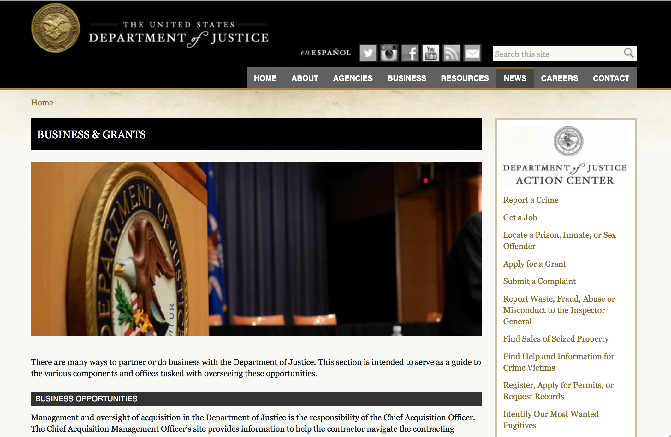

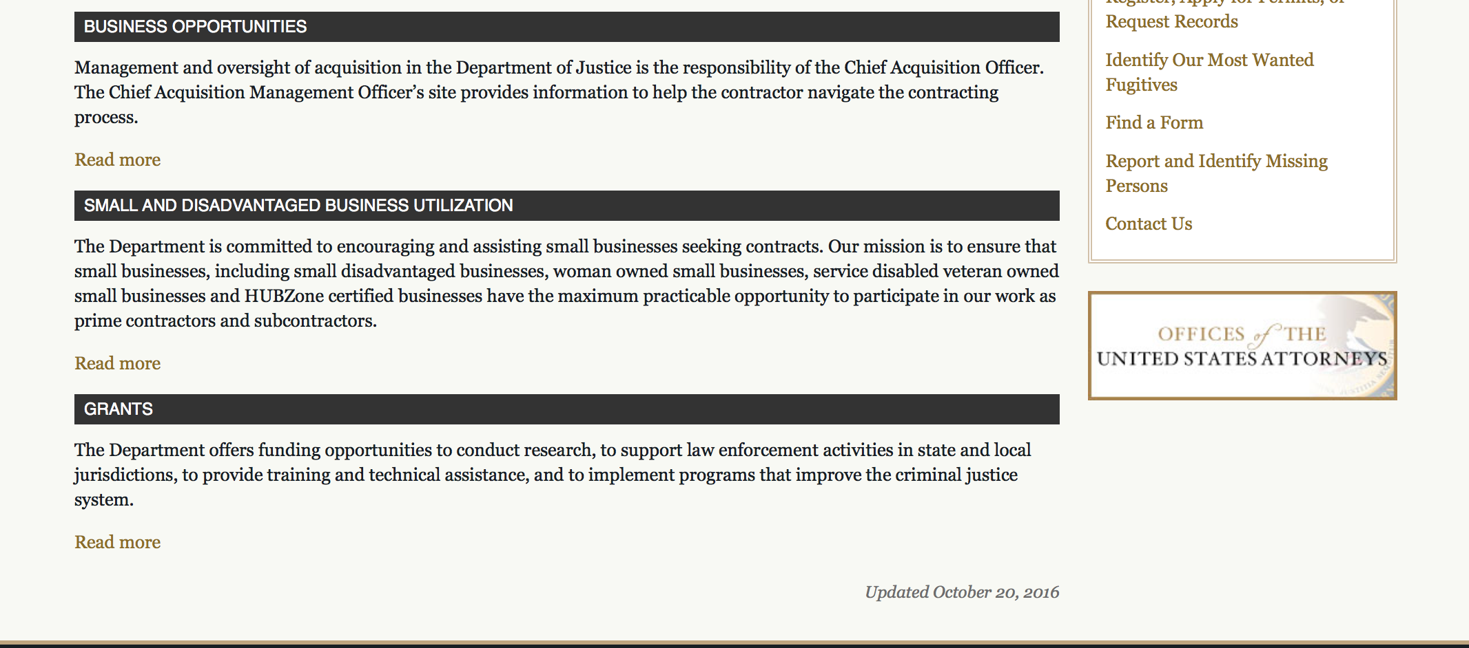

The DOJ agencies listed below also have sites that provide grant information specific to that agency. Examples of what can be found on these sites are programs, funding opportunities, application assistance, and other useful information.

Bureau of Justice Assistance (BJA)

Bureau of Justice Statistics (BJS)

National Criminal Justice Reference Service (NCJRS)

National Institute of Justice (NIJ)

Office of Sex Offender Sentencing, Monitoring, Apprehending, Registering, and Tracking (SMART)

http://www.justice.gov/business/

Programs:

Office on Violence Against Women
OVW FY 2019 Justice for Families Program Solicitation
Synopsis 1

Document Type: | Grants Notice
Funding Opportunity Number: | OVW-2019-15529
Funding Opportunity Title: | OVW FY 2019 Justice for Families Program Solicitation
Opportunity Category: | Discretionary
Opportunity Category Explanation:
Funding Instrument Type: | Grant
Category of Funding Activity: | Law, Justice and Legal Services  Other (see text field entitled "Explanation of Other Category of Funding Activity" for clarification)
Category Explanation: | The Justice for Families Program supports projects to improve the response of the civil and criminal justice system to families with a history of sexual assault, domestic violence, dating violence, and stalking, or in cases involving allegations of child sexual abuse.
Expected Number of Awards: | 20
CFDA Number(s): | 16.021 -- Justice Systems Response to Families
Cost Sharing or Matching Requirement: | No
Version: | Synopsis 1
Posted Date: | Nov 06, 2018
Last Updated Date: | Nov 06, 2018
Original Closing Date for Applications: | Jan 08, 2019
Current Closing Date for Applications: | Jan 08, 2019
Archive Date:
Estimated Total Program Funding: | $11,000,000
Award Ceiling: | $650,000
Award Floor: | $550,000
Eligible Applicants: | City or township governments  Native American tribal governments (Federally recognized)  County governments  Nonprofits having a 501(c)(3) status with the IRS, other than institutions of higher education  Others (see text field entitled "Additional Information on Eligibility" for clarification)  State governments
Additional Information on Eligibility: | States, units of local government, courts (including juvenile courts), Indian tribal governments, nonprofit organizations, legal services providers, and victim service providers
Agency Name: | Office on Violence Against Women
Description: | The Grants to Support Families in the Justice System program (referred to as the Justice for Families Program) was authorized in the Violence Against Women Reauthorization Act (VAWA) of 2013 to improve the response of the civil and criminal justice system to families with a history of sexual assault, domestic violence, dating violence, and stalking, or in cases involving allegations of child sexual abuse. The program supports the following activities for improving the capacity of courts and communities to respond to families affected by the targeted crimes: court-based and court-related programs; supervised visitation and safe exchange by and between parents; training for people who work with families in the court system; civil legal services; and the provision of resources in juvenile court matters.
Link to Additional Information: | Full Solicitation
Grantor Contact Information: | If you have difficulty accessing the full announcement electronically, please contact:  Carrie Mitchell Grant Program Specialist 202-307-6026 OVW.JFF@usdoj.gov  OVW.JFF@usdoj.gov
https://www.grants.gov/web/grants/view-opportunity.html?oppId=310226

Research:

Modifications:

Deleted:

Reminders:



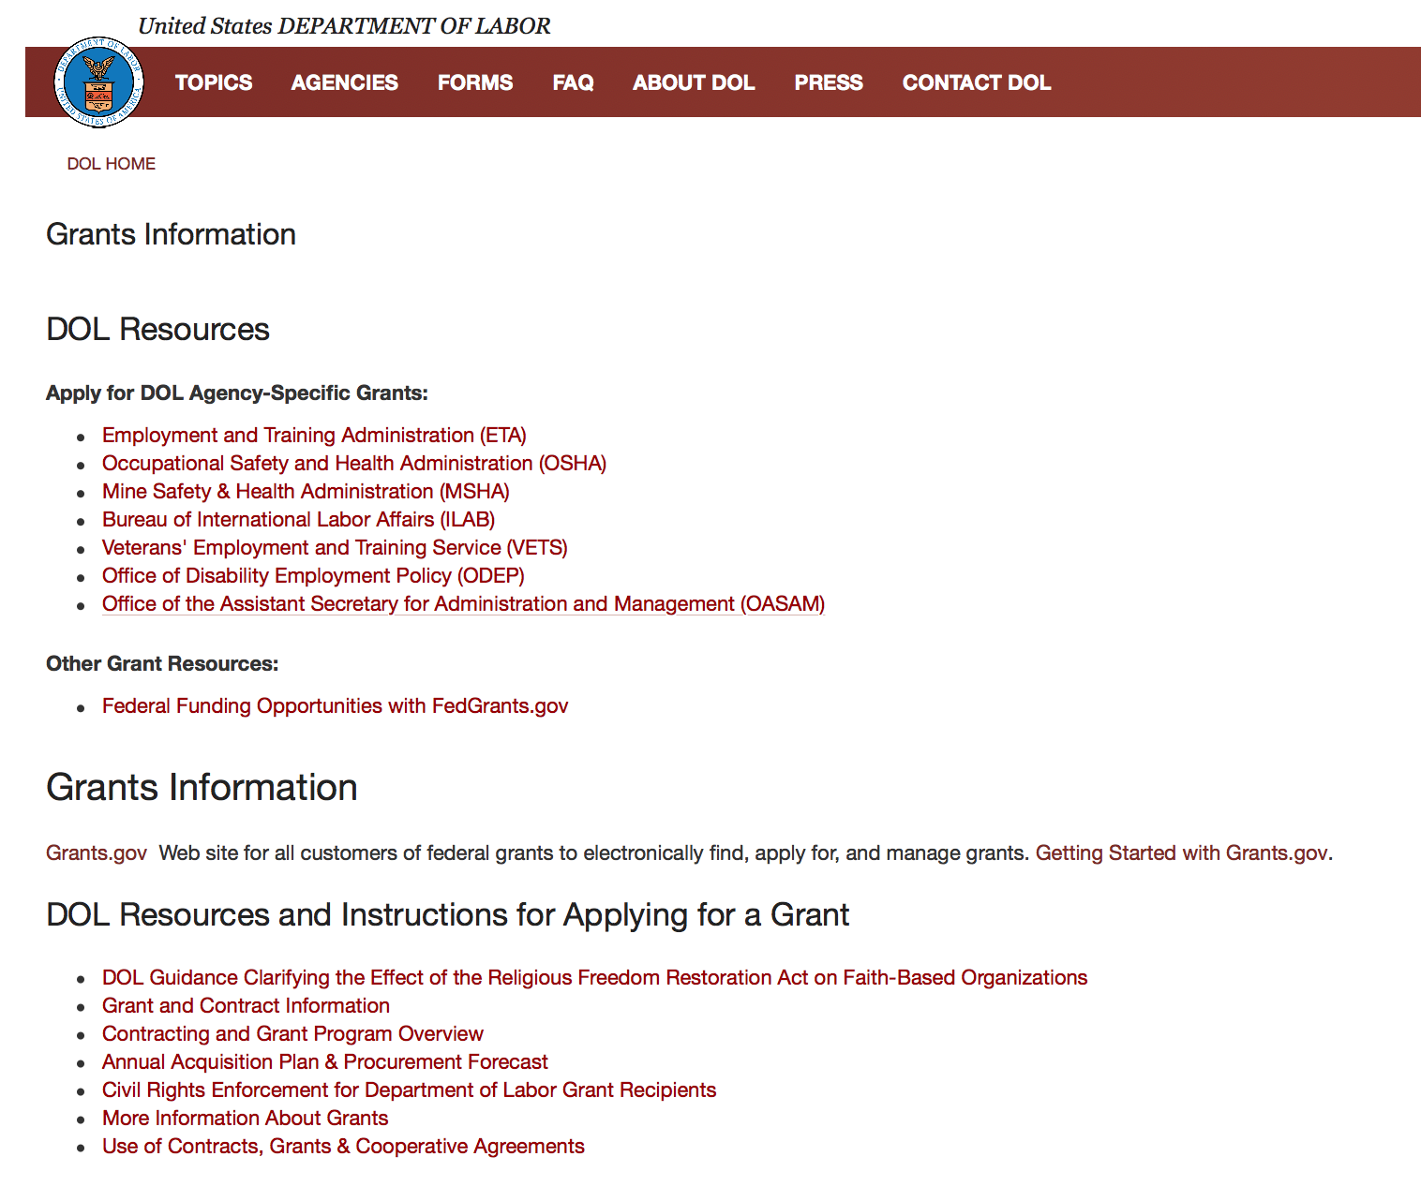

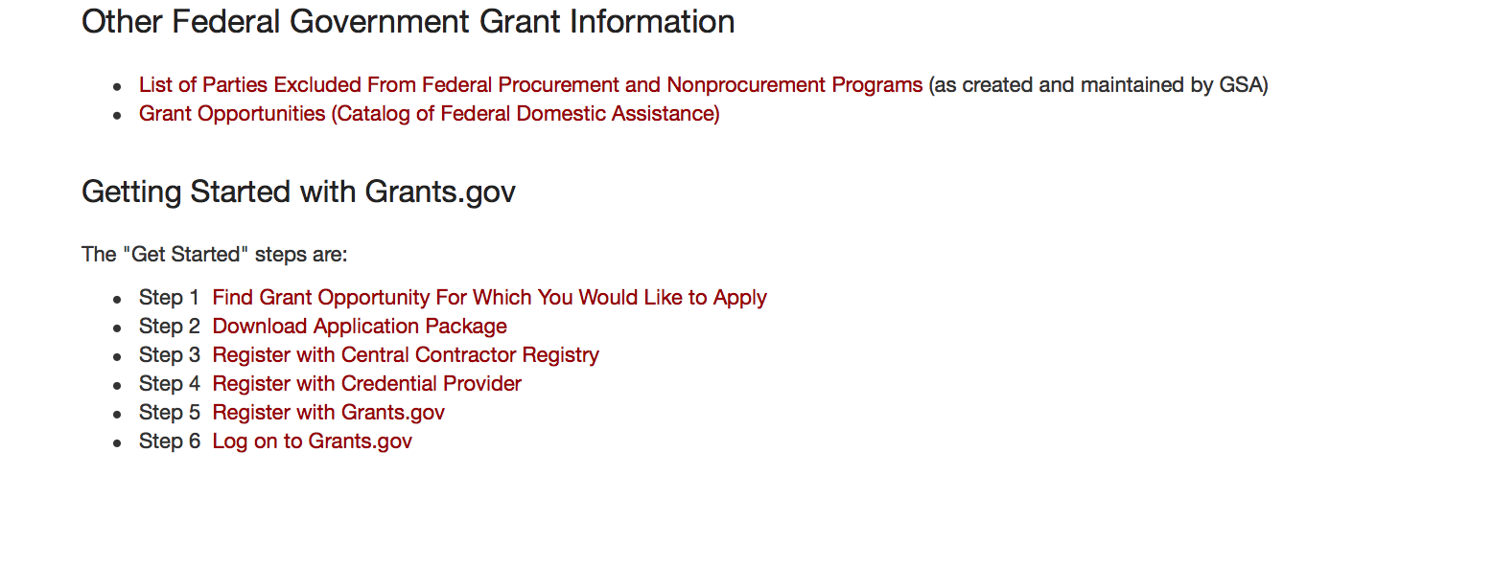
https://www.dol.gov/general/grants2

Agency Grants and Contract General Overview

DOL Resources
Apply for DOL Agency-Specific Grants:
- Employment and Training Administration (ETA)
- Occupational Safety and Health Administration (OSHA)
- Mine Safety & Health Administration (MSHA)
- Bureau of International Labor Affairs (ILAB)
- Veterans' Employment and Training Service (VETS)
- Office of Disability Employment Policy (ODEP)
- Office of the Assistant Secretary for Administration and Management (OASAM)

Other Grant Resources:
- Federal Funding Opportunities with FedGrants.gov
Grants Information
Grants.gov — Web site for all customers of federal grants to electronically find, apply for, and manage grants. Getting Started with Grants.gov.

DOL Resources and Instructions for Applying for a Grant
- DOL Guidance Clarifying the Effect of the Religious Freedom Restoration Act on Faith-Based Organizations
- Grant and Contract Information
- Contracting and Grant Program Overview
- Civil Rights Enforcement for Department of Labor Grant Recipients
- More Information About Grants
- Use of Contracts, Grants & Cooperative Agreements

Other Federal Government Grant Information
- Grant Opportunities (Catalog of Federal Domestic Assistance)

Department of Labor Grant Programs

- Bureau of International Labor Affairs (ILAB): provides grants (cooperative agreements) for the implementation of projects designed to assist developing countries combat the worse forms of child labor, forced labor, and human trafficking; and support worker rights and improve working conditions. http://www.dol.gov/general/business.
- Bureau of Labor Statistics (BLS): provides project grants (cooperative agreements) and the dissemination of technical statistical data and related information on labor force activities; provides data on prices (CPI) and cost of living; data on productivity and technology data; data on compensation and working conditions; data on employment projections.
- Employment and Training (ETA): ETA administers financial assistance programs pursuant to the Workforce Investment Act (WIA), administering State formula grant programs for youth, adults and dislocated workers, national emergency grants for workers affected by mass layoffs, plant closures, and disasters; grant programs for workers with disabilities, Indians and Native Americans, and for migrant and seasonal farmworkers. ETA also administers grant programs for older American workers, apprenticeship programs, Trade Adjustment Assistance (TAA) programs, and assistance for research and development of workforce programs. In addition, ETA is responsible for the operation and maintenance of a national system of public employment service offices and for the national unemployment insurance program.
- Mine Safety and Health (MSHA): provides grants for research, education and training programs to ensure an adequate and competent staff of trained inspectors; and assistance for establishing or improving State mine health and safety programs through technical assistance.
- Occupational Safety and Health (OSHA): provides grants to non-profit organizations to provide training, educational services, and technical assistance; assistance to states to administer and enforce state programs; assistance to states to provide occupational safety and health technical assistance and consultant services.
- Office of Disability Employment Policy (ODEP): The Office of Disability Employment Policy awards competitive grants establishing short-term pilot and technical assistance projects designed to identify, develop, test, evaluate, and disseminate policies to increase employment by expanding access to training, education, employment supports, assistive and systems technology, integrated employment, entrepreneurial development, and small business opportunities for adults and youth with disabilities. Current pilots projects focus on customized employment, Olmstead populations, and innovative demonstration youth grants, among others. Solicitations for grant applications are published in the Federal Register and announced at www.dol.gov/odep. ODEP grants are awarded by the OASAM grant office.
- Veterans' Employment and Training (VETS): provides special employment and training assistance for veterans through the Disabled Veterans' Outreach Program (DVOP) Solicitation for Grant Applications; the Local Veterans' Employment Representative Program (LVER); Veterans' Workforce Investment Program (VWIP); elaws Advisor on veterans' employment and reemployment rights; and the Homeless Veterans Reintegration Project (HVRP). VETS grants are awarded by the OASAM grant office.

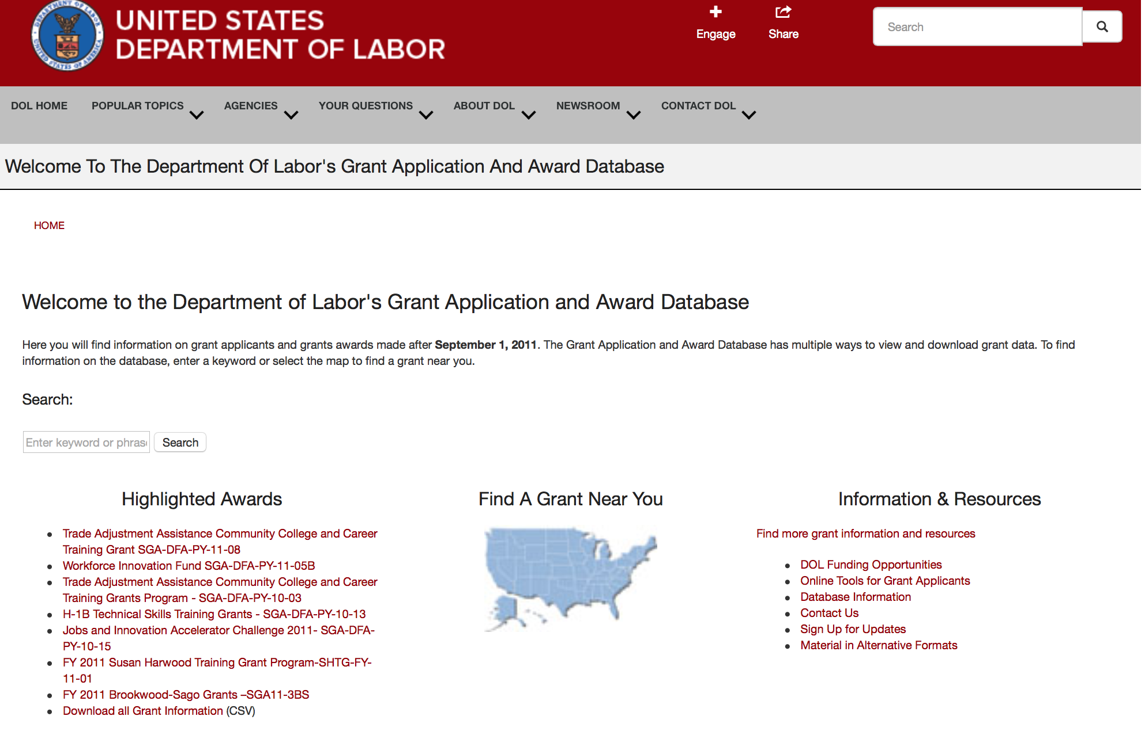

http://www.dol.gov/dol/grants/

Programs

Modifications

Reminders

Veterans Employment and Training Service
Announcement of Stand Down Grants
Synopsis 2

Document Type: | Grants Notice
Funding Opportunity Number: | VPL-02-18
Funding Opportunity Title: | Announcement of Stand Down Grants
Opportunity Category: | Discretionary
Opportunity Category Explanation:
Funding Instrument Type: | Grant
Category of Funding Activity: | Other (see text field entitled "Explanation of Other Category of Funding Activity" for clarification)
Category Explanation: | Veterans' Employment and Training Service
Expected Number of Awards:
CFDA Number(s): | 17.805 -- Homeless Veterans Reintegration Program
Cost Sharing or Matching Requirement: | No
Version: | Synopsis 2
Posted Date: | Jan 02, 2018
Last Updated Date: | Jan 02, 2018
Original Closing Date for Applications: | Dec 31, 2020
Current Closing Date for Applications: | Dec 31, 2020
Archive Date: | Jan 30, 2021
Estimated Total Program Funding:
Award Ceiling: | $10,000
Award Floor: | $7,000
Eligible Applicants: | Others (see text field entitled "Additional Information on Eligibility" for clarification)
Additional Information on Eligibility: | The following organizations and entities may apply for grant funds for Stand Down events: State and Local Workforce Development Boards, Veteran Service Organizations, local public agencies, tribal governments, and non-profit organizations including community and faith-based organizations. Organizations registered with the Internal Revenue Service as 501(c)(4) entities are not eligible to apply for this funding opportunity.
Additional Information
Agency Name: | Veterans Employment and Training Service
Description: | DOL VETS supports local Stand Down (SD) events that assist homeless veterans by providing a wide variety of employment, social, and health services. A homeless veteran is a veteran, as defined in 38 U.S.C. 101(2), who is “homeless” as that term is defined at 42 U.S.C. 11302(a)-(b), as amended by the Homeless Emergency Assistance and Rapid Transition to Housing Act of 2009 (Public Law 111-22).Stand Down grant funds must be used to enhance employment and training opportunities or to promote the self-sufficiency of homeless veterans through paid work. Veterans experiencing homelessness do not always have access to basic hygiene supplies necessary to maintain their health and appearance. Lack of shelter limits their ability to prepare for and present themselves at job interviews or be contacted for follow-up. Basic services such as showers, haircuts, attention to health concerns, and other collaborative services provided at SD events can give participants a greater sense of self and an opportunity to improve their chances of securing and maintaining employment. Each year, VETS sets funds aside from the Homeless Veterans’ Reintegration Program (HVRP) budget activity to award SD grants. Stand Down funding is a non-competitive grant awarded on a first-come, first-served basis until available annual funding is exhausted. VETS will continue to accept applications and process when additional funds become available. The maximum amount that can be awarded, per applicant for a geographic area, in a fiscal year (October 1 – September 30) is $7,000 for a one-day event and $10,000 for a multi-day event. Grants may be awarded to multiple organizations that conduct SD events in the same general area so long as there is no commingling of federal funds. In the event of a significant natural or man-made disaster, VETS may elect to accept and award grants for SD events in excess of the $10,000 limit. VETS recognizes the following as circumstances that may justify awarding SD grants in higher amounts: emergencies or major disasters, as defined in the Stafford Act, which have been declared eligible for public assistance by the Federal Emergency Management Agency (FEMA). In addition, emergencies or disaster situations of national significance, natural or man-made, that could result in a potentially large loss of employment, as declared or otherwise recognized in writing by the chief official of the Federal Agency with jurisdiction over the Federal response to the emergency or disaster. If the VETS Assistant Secretary determines it is appropriate to award increased grants for SD events due to a disaster, the VETS Assistant Secretary will announce such a determination in writing, including the maximum amount that can be awarded on account of such an identified disaster, in order to provide notice to entities proposing to conduct SD events in those geographic areas where a disaster has been declared or to which a substantial number of veterans have relocated or been relocated. Acceptable uses of Stand Down grant funds do not change in such circumstances. All applications should be emailed to the appropriate DVET of the state in which the SD event is planned.
Link to Additional Information:
Grantor Contact Information: | If you have difficulty accessing the full announcement electronically, please contact:  Questions regarding a SD grant application should be referred to the DVET in the state in which the event will take place. DVET contact information is available at: https://www.dol.gov/vets/aboutvets/regionaloffices/map.htm.  https://www.dol.gov/vets/aboutvets/regionaloffices/map.htm
https://www.grants.gov/web/grants/view-opportunity.html?oppId=299798

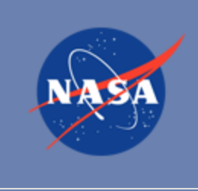

National Aeronautics and Space Administration

Research and Contracting Opportunities

NASA Research Opportunities Online

- Various NASA offices publish their research announcements over the Internet, broadening the opportunity for researchers to apply for funding. This site provides access to current research announcements along with their specific due dates.

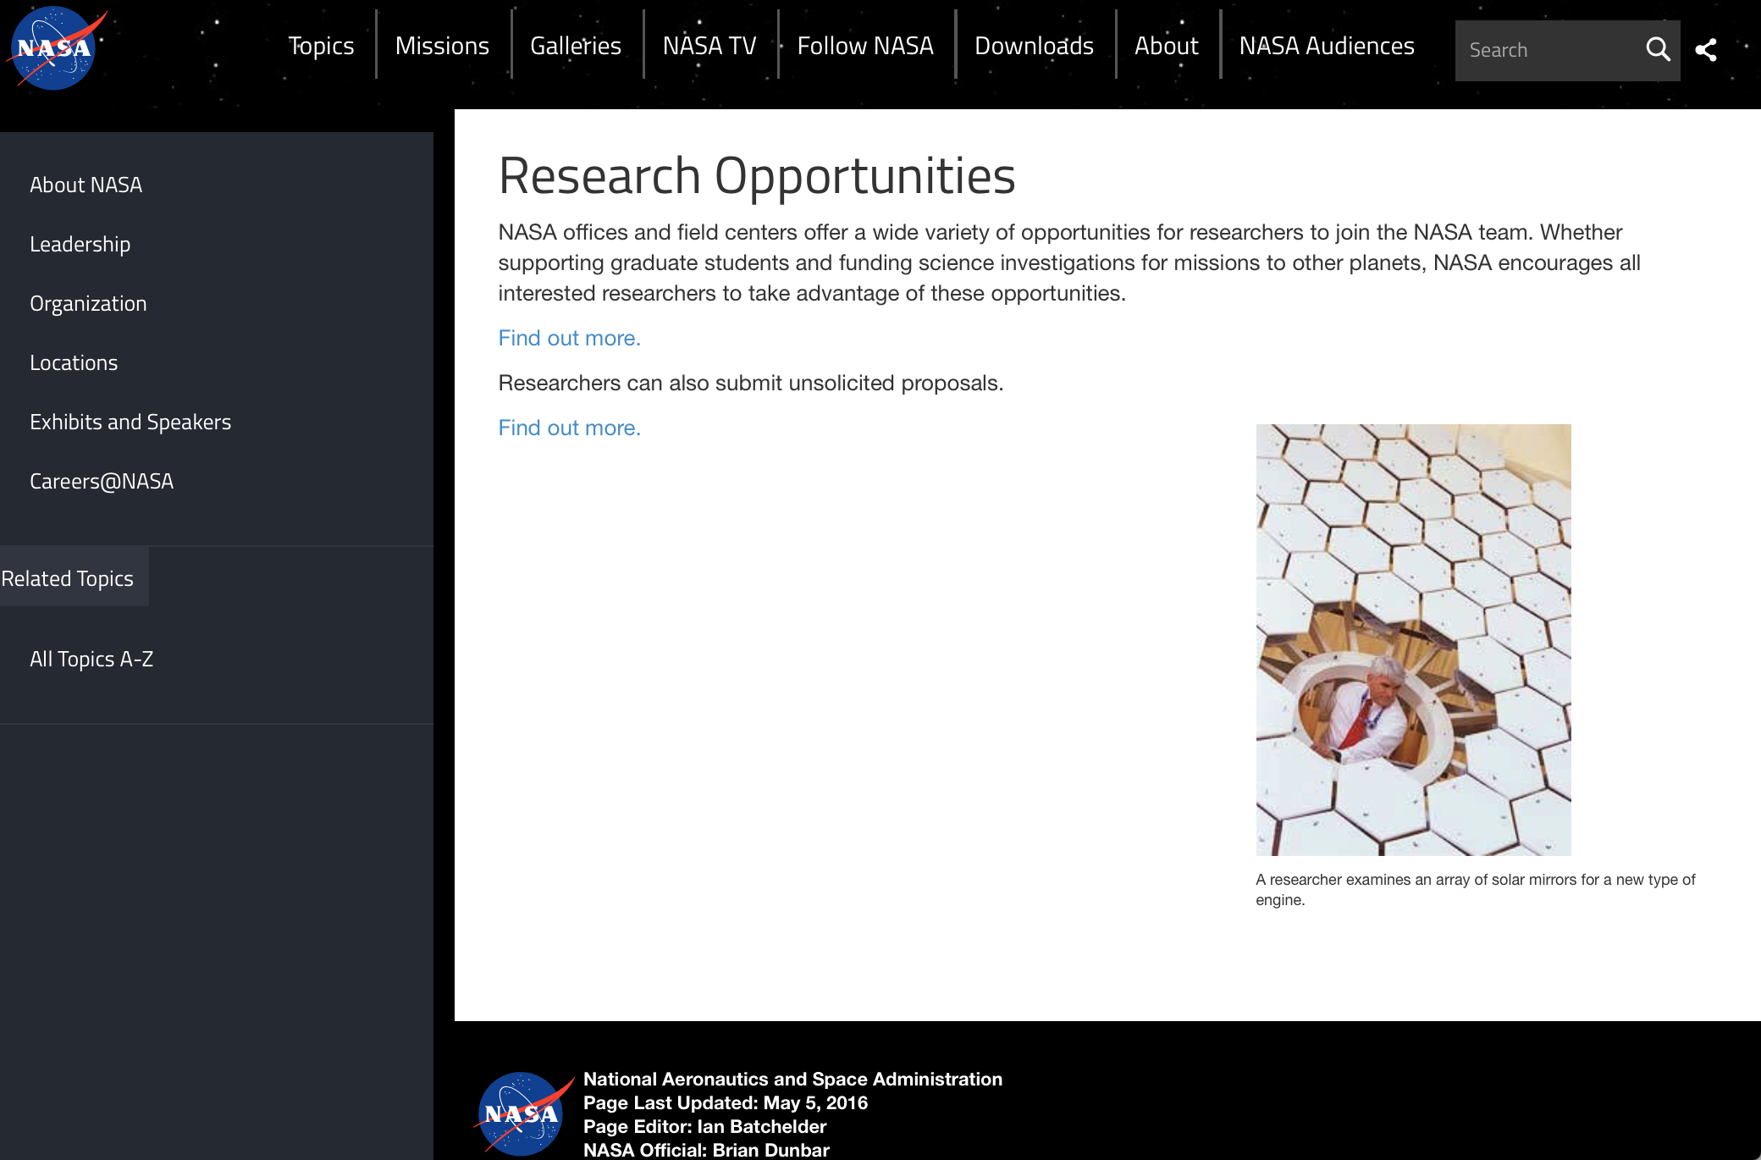

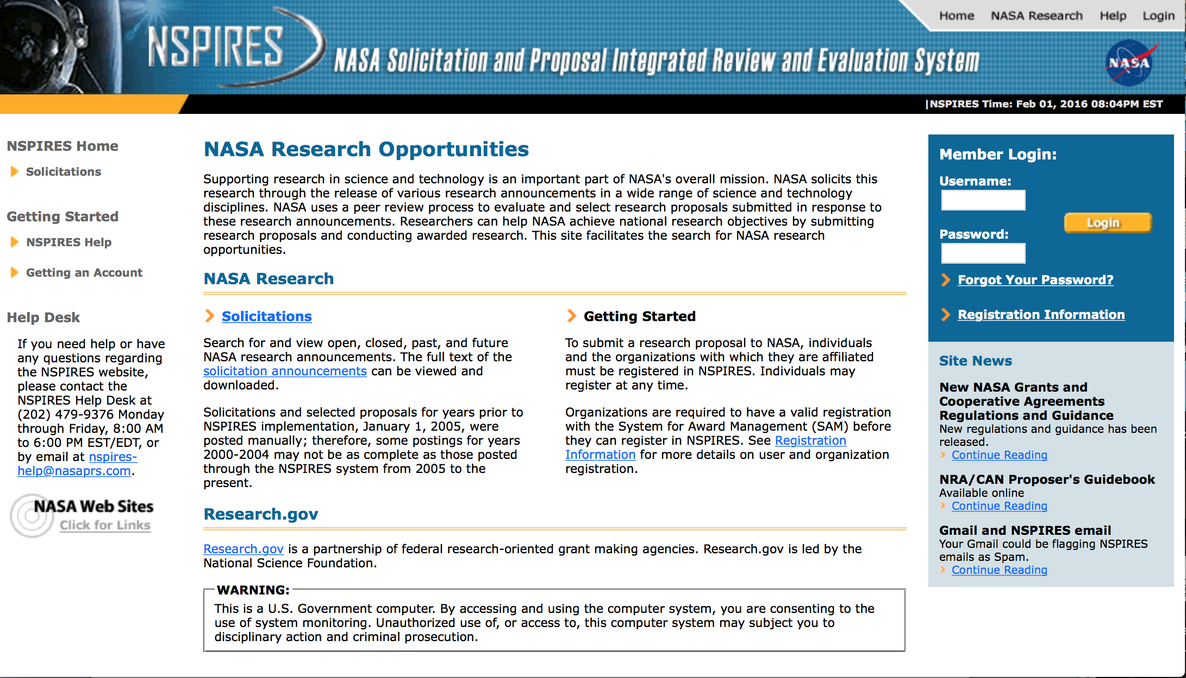
http://nspires.nasaprs.com/external/

Research Programs:

Modifications:

National Archives and Records Administration

Grant Opportunities General Overview

To access the information below: click here

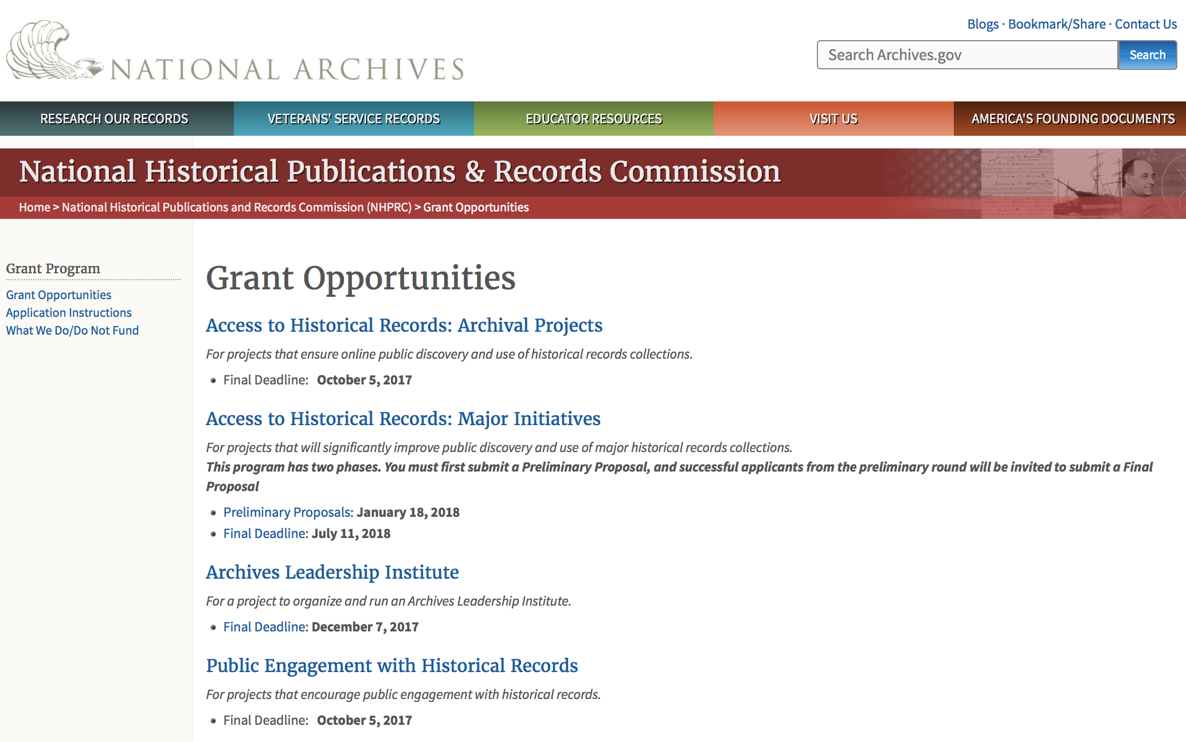

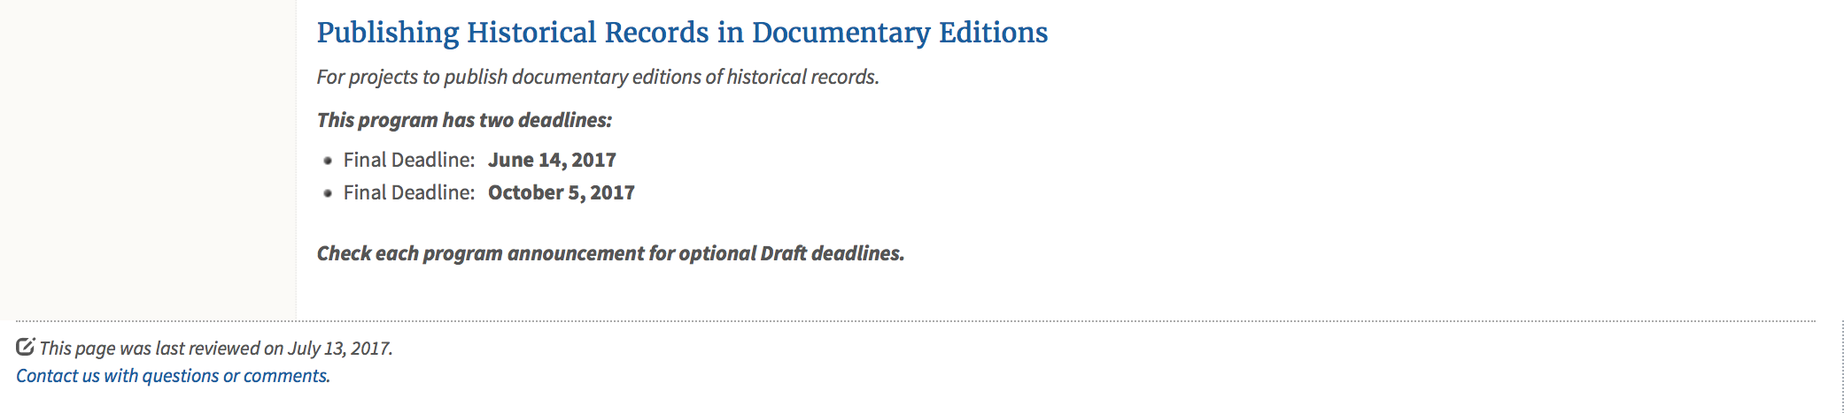
https://www.archives.gov/nhprc/announcement

Programs:

Reminders:

Access to Historical Records: Major Initiatives (Preliminary)
Synopsis 1
Document Type: | Grants Notice
Funding Opportunity Number: | PRELIM-201901
Funding Opportunity Title: | Access to Historical Records: Major Initiatives (Preliminary)
Opportunity Category: | Discretionary
Opportunity Category Explanation:
Funding Instrument Type: | Grant
Category of Funding Activity: | Humanities (see "Cultural Affairs" in CFDA)
Category Explanation:
Expected Number of Awards: | 5
CFDA Number(s): | 89.003 -- National Historical Publications and Records Grants
Cost Sharing or Matching Requirement: | Yes
Version: | Synopsis 1
Posted Date: | Jun 18, 2018
Last Updated Date: | Jun 18, 2018
Original Closing Date for Applications: | Jan 17, 2019
Current Closing Date for Applications: | Jan 17, 2019
Archive Date:
Estimated Total Program Funding: | $1,000,000
Award Ceiling: | $350,000
Award Floor: | $100,000
Eligible Applicants: | Private institutions of higher education  Nonprofits having a 501(c)(3) status with the IRS, other than institutions of higher education  County governments  Native American tribal governments (Federally recognized)  City or township governments  State governments  Public and State controlled institutions of higher education
Additional Information on Eligibility:

Agency Name: | National Archives and Records Administration
Description: | Grant Program Description The National Historical Publications and Records Commission seeks projects that will significantly improve public discovery and use of major historical records collections. The Commission is especially interested in collections of America’s early legal records, such as the records of colonial, territorial, county, and early statehood and tribal proceedings that document the evolution of the nation’s legal history. All types of historical records are eligible, including documents, photographs, born-digital records, and analog audio and moving images. Projects may: • Digitize historical records collections, or related collections, held by a single institution and make them freely available online • Provide access to born-digital records • Create new freely-available virtual collections drawn from historical records held by multiple institutions • Create new tools and methods for users to access records The NHPRC welcomes collaborative projects, particularly for bringing together related records from multiple institutions. Projects that address significant needs in the field and result in replicable and scalable approaches will be more competitive. We also encourage organizations to actively engage the public in the work of the project. Applicants should also consult Access to Historical Records: Archival Projects program, which has different requirements and award amounts. For a comprehensive list of Commission limitations on funding, please see: "What we do and do not fund" (http://www.archives.gov/nhprc/apply/eligibility.html). Applications that consist entirely of ineligible activities will not be considered. Award Information A grant is for one to three years and for between $100,000 and $350,000. We expect to make up to five grants in this category for a total of up to $1,000,000. Grants begin no earlier than January 1, 2020. The Commission requires that grant recipients acknowledge NHPRC grant assistance in all publications and other products that result from its support. Eligibility Eligible applicants: • Nonprofit organizations or institutions • Colleges, universities, and other academic institutions • State or local government agencies • Federally-acknowledged or state-recognized Native American tribes or groups Cost Sharing The total costs of a project are shared between the NHPRC and the applicant organization. The Commission provides no more than 50 per cent of total project costs in the Access to Historical Records: Major Initiatives category. NHPRC grant recipients are not permitted to use grant funds for indirect costs (as indicated in 2 CFR 2600.101). Cost sharing is required. The applicant's financial contribution may include both direct and indirect expenses, in-kind contributions, non-Federal third-party contributions, and any income earned directly by the project. Indirect costs must be listed under the applicant's cost sharing contribution. Other Requirements Applicant organizations must be registered in the System for Award Management (SAM) prior to submitting an application, maintain SAM registration throughout the application and award process, and include a valid DUNS number in their application. Details on SAM registration and requesting a DUNS number can be found at the System for Award Management website at https://sam.gov. Please refer to the User Guides section and the Grants Registrations PDF. A complete preliminary application includes the Application for Federal Assistance (Standard Form 424), a Project Narrative, and Budget. Applications lacking these items will not be considered. Ineligible applications will not be reviewed.
Link to Additional Information: | Link to full grant announcement, including additional requirements
Grantor Contact Information: | If you have difficulty accessing the full announcement electronically, please contact:  Jeff de la Concepcion Jeff.delaconcepcion@nara.gov  Grant Information Specialist
https://www.grants.gov/web/grants/view-opportunity.html?oppId=306357

National Endowment for the Arts

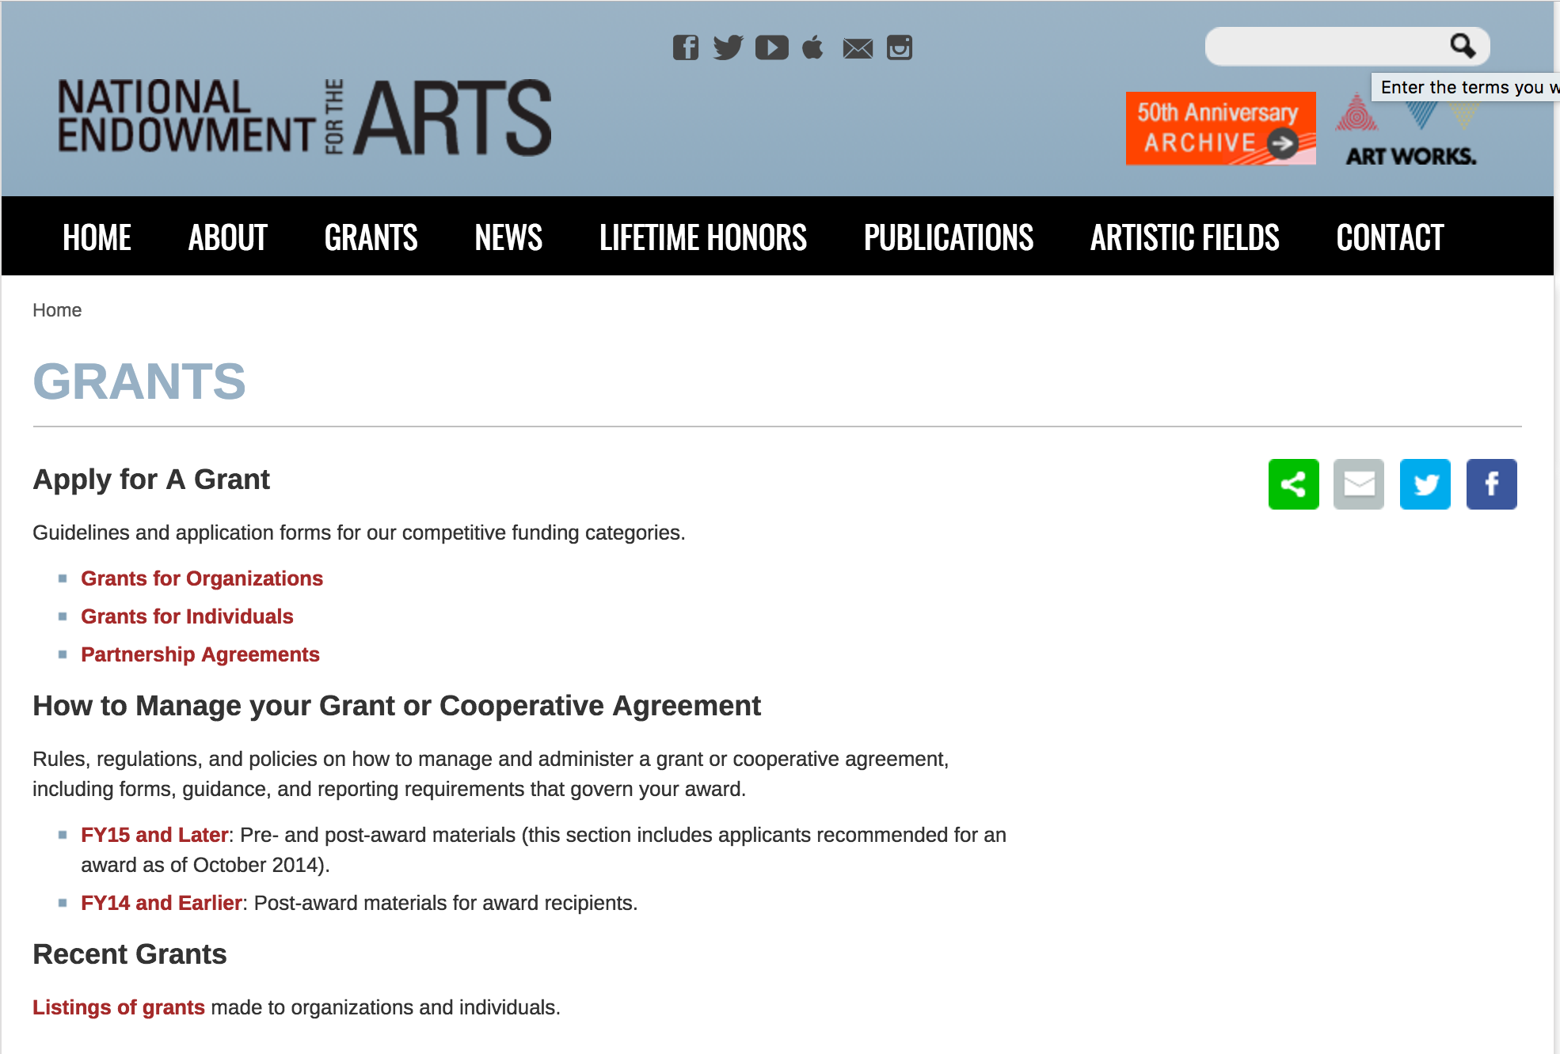

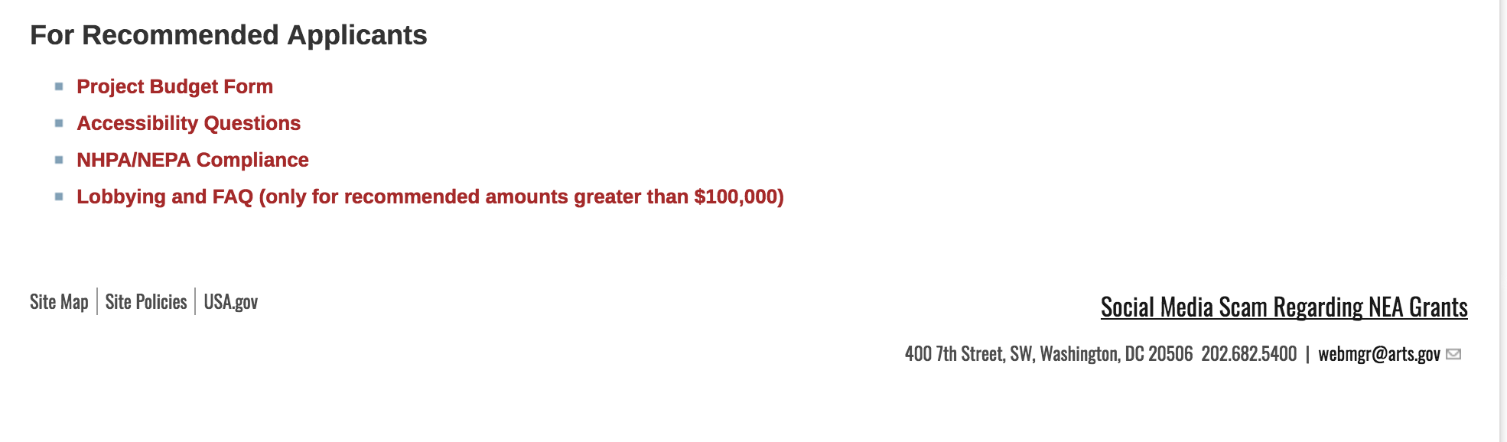
See more at: https://www.arts.gov/grants

Programs:

NEA Performing Arts Discovery, FY2019
Synopsis 1

Document Type: | Grants Notice
Funding Opportunity Number: | NEAPS1807
Funding Opportunity Title: | NEA Performing Arts Discovery, FY2019
Opportunity Category: | Discretionary
Opportunity Category Explanation:
Funding Instrument Type: | Grant
Category of Funding Activity: | Arts (see "Cultural Affairs" in CFDA)
Category Explanation:
Expected Number of Awards:
CFDA Number(s): | 45.024 -- Promotion of the Arts Grants to Organizations and Individuals
Cost Sharing or Matching Requirement: | Yes
Version: | Synopsis 1
Posted Date: | Nov 06, 2018
Last Updated Date: | Nov 06, 2018
Original Closing Date for Applications: | Jan 15, 2019 The Grants.gov system must receive your validated and accepted application no later than 11:59 p.m., Eastern Time, on January 15, 2019. We strongly recommend that you submit your application by January 5, 2019 to give yourself ample time to resolve any problems that you might encounter.
Current Closing Date for Applications: | Jan 15, 2019 The Grants.gov system must receive your validated and accepted application no later than 11:59 p.m., Eastern Time, on January 15, 2019. We strongly recommend that you submit your application by January 5, 2019 to give yourself ample time to resolve any problems that you might encounter.
Archive Date: | Feb 14, 2019
Estimated Total Program Funding:
Award Ceiling: | $100,000
Award Floor: | $100,000
Eligible Applicants: | Nonprofits having a 501(c)(3) status with the IRS, other than institutions of higher education
Additional Information on Eligibility: | U.S. Regional Arts Organizations
Additional Information
Agency Name: | National Endowment for the Arts
Description: | An organization may submit only one proposal under this program solicitation.  The NEA’s support may begin no earlier than June 1, 2019, and may extend for up to 30 months.  Program Description  Through grants with other funders, the National Endowment for the Arts (NEA) has a long history of bringing the benefits of international exchange to audiences, artists, and arts organizations nationwide. For many years, however, there have been limited opportunities for foreign arts presenters to come to the U.S. and see artists at events in geographically diverse areas of our country. Programs such as these are important because they create new markets for working artists, expand mutual understanding, and raise the profile of each participating U.S. region and country.  To address this ongoing gap, the NEA’s Performing Arts Discovery program supports U.S. Regional Arts Organizations (RAOs) to undertake performing arts platforms in their region that will showcase the work of U.S. performing artists for presenters1 based outside of this country.
Link to Additional Information: | https://www.arts.gov/program-solicitation-performing-arts-discovery-2019
Grantor Contact Information: | If you have difficulty accessing the full announcement electronically, please contact:  If you have questions about programmatic requirements, contact: Michael Orlove, NEA Director of Presenting & Multidisciplinary Works, Artist Communities, and International Activities 202-682-5469 or orlovem@arts.gov If you have questions about award administration, contact: Nicki Jacobs NEA Director of Grants Management 202/682-5403 jacobsn@arts.gov  NEA Web Manager
https://www.grants.gov/web/grants/view-opportunity.html?oppId=310221

NEA Performing Arts Global Exchange, FY2019
Synopsis 1
Document Type: | Grants Notice
Funding Opportunity Number: | NEAPS1805
Funding Opportunity Title: | NEA Performing Arts Global Exchange, FY2019
Opportunity Category: | Discretionary
Opportunity Category Explanation:
Funding Instrument Type: | Cooperative Agreement
Category of Funding Activity: | Arts (see "Cultural Affairs" in CFDA)
Category Explanation:
Expected Number of Awards:
CFDA Number(s): | 45.024 -- Promotion of the Arts Grants to Organizations and Individuals
Cost Sharing or Matching Requirement: | Yes
Version: | Synopsis 1
Posted Date: | Nov 06, 2018
Last Updated Date: | Nov 06, 2018
Original Closing Date for Applications: | Jan 15, 2019 The Grants.gov system must receive your validated and accepted application no later than 11:59 p.m., Eastern Time, on January 15, 2019. We strongly recommend that you submit your application by January 5, 2019 to give yourself ample time to resolve any problems that you might encounter.
Current Closing Date for Applications: | Jan 15, 2019 The Grants.gov system must receive your validated and accepted application no later than 11:59 p.m., Eastern Time, on January 15, 2019. We strongly recommend that you submit your application by January 5, 2019 to give yourself ample time to resolve any problems that you might encounter.
Archive Date: | Feb 14, 2019
Estimated Total Program Funding:
Award Ceiling: | $300,000
Award Floor: | $300,000
Eligible Applicants: | Nonprofits having a 501(c)(3) status with the IRS, other than institutions of higher education
Additional Information on Eligibility:
Additional Information
Agency Name: | National Endowment for the Arts
Description: | The National Endowment for the Arts (NEA) aims to increase access to quality international arts programming throughout the U.S and to promote a greater understanding of other cultures through the arts.  Through the Performing Arts Global Exchange (PAGE) program, a Cooperator will award subgrants to nonprofit presenting organizations that book artists from an NEA-approved roster of international performing artists or ensembles for performances in the U.S. An emphasis will be placed on funding engagements in underserved communities that have limited access to this type of artistic work. All funded engagements will be required to include public performances and activities that provide audiences with direct interaction with the visiting artists.  Award support for initiatives and programs such as PAGE are competed by the NEA on a regular basis. Through this Program Solicitation, the NEA is seeking to enter into a Cooperative Agreement with a U.S. Regional Arts Organization (RAO) to administer the 2020-21 cycle of PAGE. Together with the Cooperator, the NEA will identify eligible countries of a chosen region of the world (e.g., North Africa, Southeast Asia, Nordic countries) to highlight biennially.
Link to Additional Information: | https://www.arts.gov/program-solicitation-performing-arts-global-exchange
Grantor Contact Information: | If you have difficulty accessing the full announcement electronically, please contact:  If you have questions about programmatic requirements, contact: Michael Orlove, NEA Director of Presenting & Multidisciplinary Works, Artist Communities, and International Activities 202-682-5469 or orlovem@arts.gov If you have questions about award administration, contact: Nicki Jacobs NEA Director of Grants Management 202/682-5403 jacobsn@arts.gov  NEA Web Manager
https://www.grants.gov/web/grants/view-opportunity.html?oppId=310219

NEA Shakespeare in American Communities, FY2019
Synopsis 1
Document Type: | Grants Notice
Funding Opportunity Number: | NEAPS1808
Funding Opportunity Title: | NEA Shakespeare in American Communities, FY2019
Opportunity Category: | Discretionary
Opportunity Category Explanation:
Funding Instrument Type: | Grant
Category of Funding Activity: | Arts (see "Cultural Affairs" in CFDA)
Category Explanation:
Expected Number of Awards: | 30
CFDA Number(s): | 45.024 -- Promotion of the Arts Grants to Organizations and Individuals
Cost Sharing or Matching Requirement: | Yes
Version: | Synopsis 1
Posted Date: | Nov 06, 2018
Last Updated Date: | Nov 06, 2018
Original Closing Date for Applications: | Jan 15, 2019 The Grants.gov system must receive your validated and accepted application no later than 11:59 p.m., Eastern Time, on January 15, 2019. We strongly recommend that you submit your application by January 5, 2019 to give yourself ample time to resolve any problems that you might encounter.
Current Closing Date for Applications: | Jan 15, 2019 The Grants.gov system must receive your validated and accepted application no later than 11:59 p.m., Eastern Time, on January 15, 2019. We strongly recommend that you submit your application by January 5, 2019 to give yourself ample time to resolve any problems that you might encounter.
Archive Date: | Feb 14, 2019
Estimated Total Program Funding:
Award Ceiling: | $1,482,000
Award Floor: | $1,482,000
Eligible Applicants: | Nonprofits having a 501(c)(3) status with the IRS, other than institutions of higher education
Additional Information on Eligibility: | U.S. Regional Arts Organizations
Additional Information
Agency Name: | National Endowment for the Arts
Description: | An organization may submit only one proposal under this program.  The NEA’s support may begin no earlier than June 1, 2019, and may extend for up to 30 months.  Program Description  A program of the National Endowment for the Arts (NEA), Shakespeare in American Communities (SIAC) brings professional performances of Shakespeare’s plays and related educational activities to middle and high school students in communities across the United States. For many students, these performances may be their first experience with live, professional theater—as well as their first interaction with the works of Shakespeare. Since SIAC’s inception in 2003, approximately 2.5 million students have participated in the program.  The NEA seeks to award a grant to a U.S. Regional Arts Organization (RAO) to administer the SIAC program for the 2020-2021 school year. NEA funds will support program management expenses as well as subgrants to participating theater companies.
Link to Additional Information: | https://www.arts.gov/national-initiatives/shakespeare-american-communities-administration
Grantor Contact Information: | If you have difficulty accessing the full announcement electronically, please contact:  If you have questions about programmatic requirements, contact: Greg Reiner, NEA Director of Theater and Musical Theater 202-682-5482 or reinerg@arts.gov If you have questions about award administration, contact: Nicki Jacobs NEA Director of Grants Management 202/682-5403 jacobsn@arts.gov  NEA Web Manager
https://www.grants.gov/web/grants/view-opportunity.html?oppId=310164

NEA USArtists International, FY2019
Synopsis 1
Document Type: | Grants Notice
Funding Opportunity Number: | NEAPS1806
Funding Opportunity Title: | NEA USArtists International, FY2019
Opportunity Category: | Discretionary
Opportunity Category Explanation:
Funding Instrument Type: | Cooperative Agreement
Category of Funding Activity: | Arts (see "Cultural Affairs" in CFDA)
Category Explanation:
Expected Number of Awards:
CFDA Number(s): | 45.024 -- Promotion of the Arts Grants to Organizations and Individuals
Cost Sharing or Matching Requirement: | Yes
Version: | Synopsis 1
Posted Date: | Nov 06, 2018
Last Updated Date: | Nov 06, 2018
Original Closing Date for Applications: | Jan 15, 2019 The Grants.gov system must receive your validated and accepted application no later than 11:59 p.m., Eastern Time, on January 15, 2019. We strongly recommend that you submit your application by January 5, 2019 to give yourself ample time to resolve any problems that you might encounter.
Current Closing Date for Applications: | Jan 15, 2019 The Grants.gov system must receive your validated and accepted application no later than 11:59 p.m., Eastern Time, on January 15, 2019. We strongly recommend that you submit your application by January 5, 2019 to give yourself ample time to resolve any problems that you might encounter.
Archive Date: | Feb 14, 2019
Estimated Total Program Funding:
Award Ceiling: | $435,000
Award Floor: | $435,000
Eligible Applicants: | Nonprofits having a 501(c)(3) status with the IRS, other than institutions of higher education
Additional Information on Eligibility: | U.S. Regional Arts Organizations
Additional Information
Agency Name: | National Endowment for the Arts
Description: | An organization may submit only one proposal under this program solicitation.  Project activities may begin on or after June 1, 2019, and may extend for up to 24 months.  Program Description  The National Endowment for the Arts (NEA) has a long history of supporting the participation of artists from the U.S. at international festivals abroad. Since 2004, this commitment has been carried out through USArtists International (USAI), a NEA program undertaken in partnership with a U.S. Regional Arts Organization (RAO).  USAI supports performances by U.S. artists at important cultural festivals and arts marketplaces outside of the U.S. and its jurisdictions. The program aims to extend the reach and impact of performing artists and their accomplishments globally. USAI subgrants may support costs such as artist fees, travel, housing, per diem, shipping, and visa preparation.  Award support for initiatives and programs such as USAI are competed by the NEA on a regular basis. Through this Program Solicitation, the NEA is seeking to enter into a Cooperative Agreement with a RAO to administer the 2020-2021 cycle of the USAI program.
Link to Additional Information: | https://www.arts.gov/program-solicitation-usartists-international
Grantor Contact Information: | If you have difficulty accessing the full announcement electronically, please contact:  If you have questions about programmatic requirements, contact: Michael Orlove, NEA Director of Presenting & Multidisciplinary Works, Artist Communities, and International Activities 202-682-5469 or orlovem@arts.gov If you have questions about award administration, contact: Nicki Jacobs NEA Director of Grants Management 202/682-5403 jacobsn@arts.gov  NEA Web Manager
https://www.grants.gov/web/grants/view-opportunity.html?oppId=310220

Modifications:

Reminders:

NEA Literature Fellowships: Translation Projects, FY2020
Synopsis 1
Document Type: | Grants Notice
Funding Opportunity Number: | 2019NEA03LFTP
Funding Opportunity Title: | NEA Literature Fellowships: Translation Projects, FY2020
Opportunity Category: | Discretionary
Opportunity Category Explanation:
Funding Instrument Type: | Grant
Category of Funding Activity: | Arts (see "Cultural Affairs" in CFDA)
Category Explanation:
Expected Number of Awards:
CFDA Number(s): | 45.024 -- Promotion of the Arts Grants to Organizations and Individuals
Cost Sharing or Matching Requirement: | No
Version: | Synopsis 1
Posted Date: | Aug 14, 2018
Last Updated Date: | Aug 14, 2018
Original Closing Date for Applications: | Dec 05, 2018
Current Closing Date for Applications: | Dec 05, 2018
Archive Date:
Estimated Total Program Funding:
Award Ceiling: | $25,000
Award Floor: | $12,500
Eligible Applicants: | Individuals
Additional Information on Eligibility:
Additional Information
Agency Name: | National Endowment for the Arts
Description: | An individual may submit only one application for FY 2020 funding. You may not apply for both a Translation Project under this deadline (December 5, 2018) and a Literature Fellowship (in prose or poetry) under the 2019 deadline (when fellowships in prose are offered). The Arts Endowment’s support of a project may begin any time between November 1, 2019, and November 1, 2020, and extend for up to two years. Grant Program Description Through fellowships to published translators, the National Endowment for the Arts (NEA) supports projects for the translation of specific works of prose, poetry, or drama from other languages into English. We encourage translations of writers and of work that are not well represented in English translation. All proposed projects must be for creative translations of literary material into English. The work to be translated should be of interest for its literary excellence and value. Priority will be given to projects that involve work that has not previously been translated into English.
Link to Additional Information: | NEA Website Announcement
Grantor Contact Information: | If you have difficulty accessing the full announcement electronically, please contact:  NEA Web Manager webmgr@arts.gov  NEA Web Manager
https://www.grants.gov/web/grants/view-opportunity.html?oppId=308183

National Endowment for the Humanities

Grant Overview -

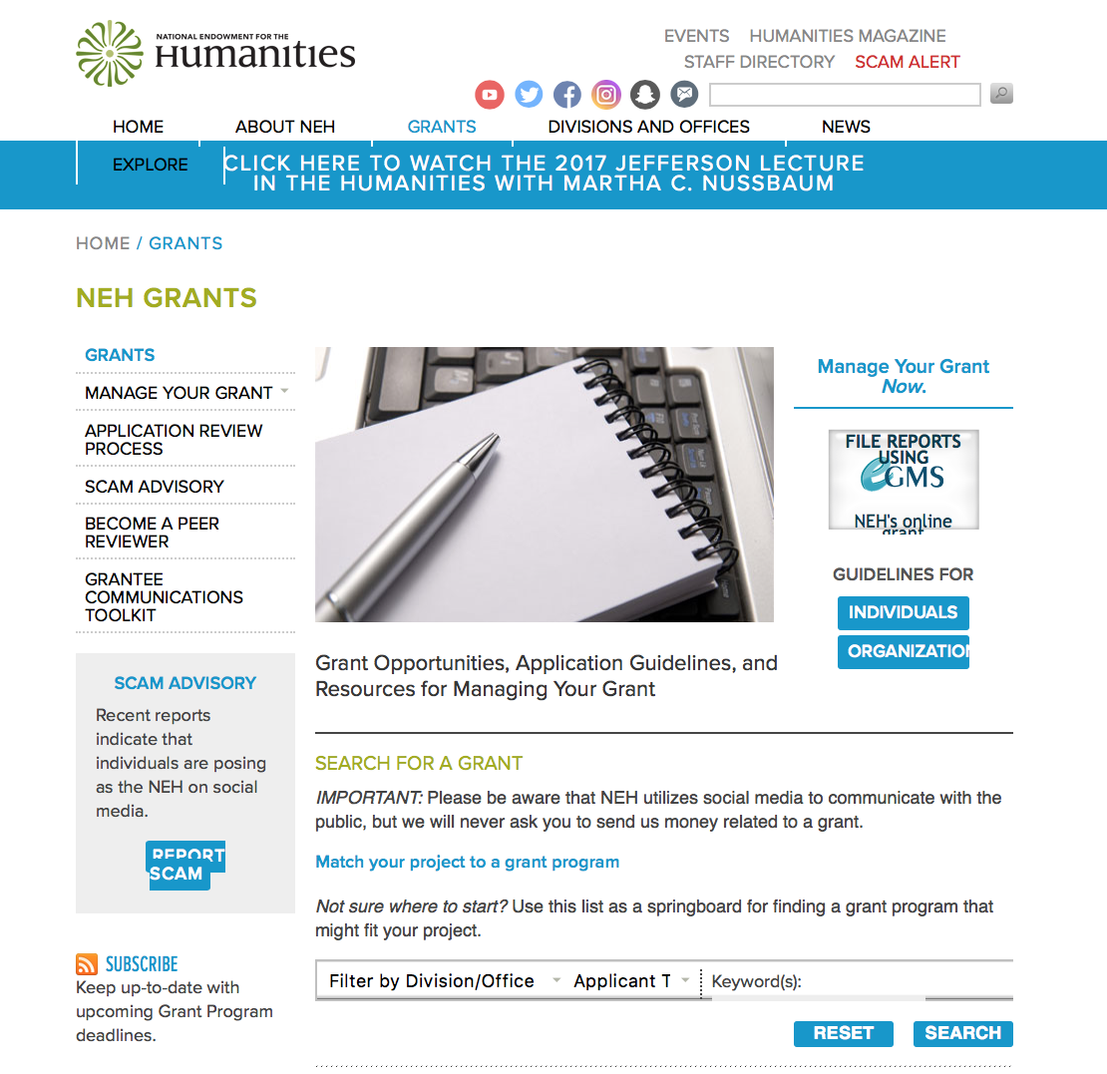

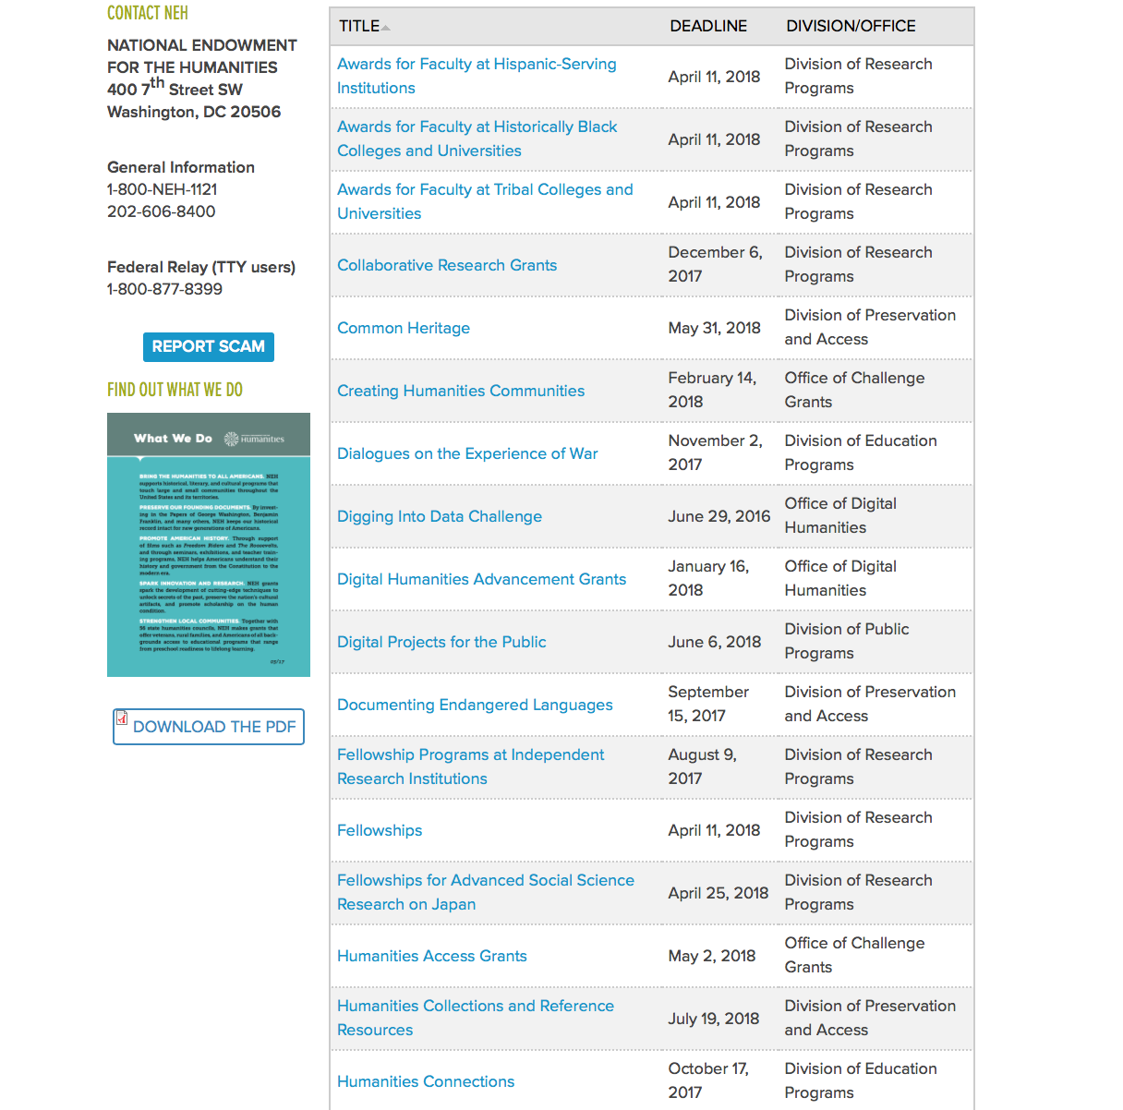

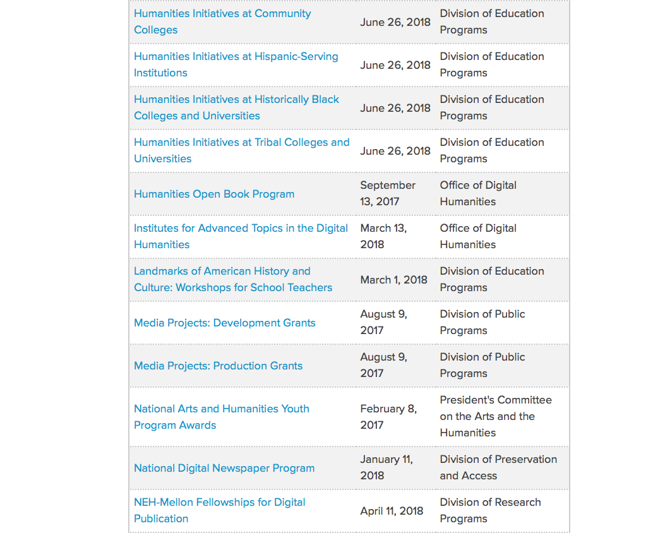

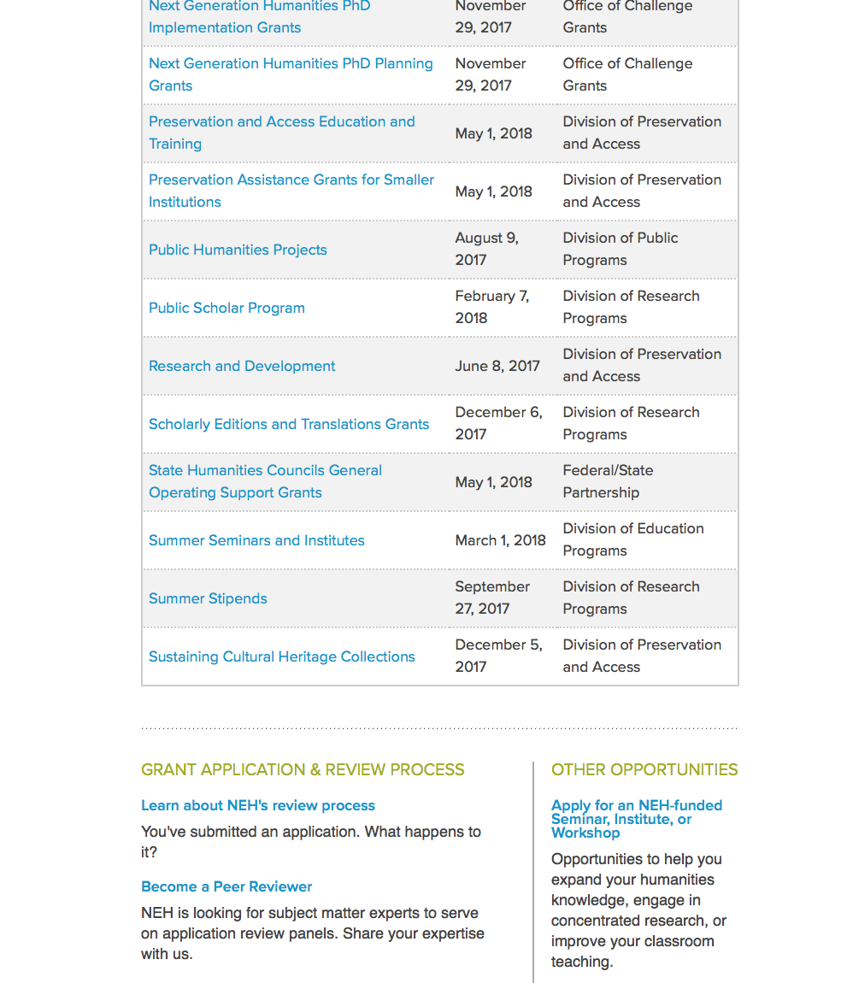

https://www.neh.gov/grants

Programs:

Digital Humanities Advancement Grants
Synopsis 1

Document Type: | Grants Notice
Funding Opportunity Number: | 20190115-HAA
Funding Opportunity Title: | Digital Humanities Advancement Grants
Opportunity Category: | Discretionary
Opportunity Category Explanation:
Funding Instrument Type: | Grant
Category of Funding Activity: | Humanities (see "Cultural Affairs" in CFDA)
Category Explanation:
Expected Number of Awards:
CFDA Number(s): | 45.169 -- Promotion of the Humanities Office of Digital Humanities
Cost Sharing or Matching Requirement: | No
Version: | Synopsis 1
Posted Date: | Oct 23, 2018
Last Updated Date: | Oct 23, 2018
Original Closing Date for Applications: | Jan 15, 2019
Current Closing Date for Applications: | Jan 15, 2019
Archive Date:
Estimated Total Program Funding:
Award Ceiling: | $375,000
Award Floor: | $10,000
Eligible Applicants: | County governments  Private institutions of higher education  City or township governments  Nonprofits having a 501(c)(3) status with the IRS, other than institutions of higher education  Native American tribal governments (Federally recognized)  Public and State controlled institutions of higher education  State governments  Special district governments
Additional Information on Eligibility:
Additional Information
Agency Name: | National Endowment for the Humanities
Description: | Digital Humanities Advancement Grants (DHAG) support digital projects at different stages throughout their lifecycles, from early start-up phases through implementation and sustainability. Experimentation, reuse, and extensibility are hallmarks of this program, leading to innovative work that can scale to enhance scholarly research, teaching, and public programming in the humanities. This program is offered twice per year. Proposals are welcome for digital initiatives in any area of the humanities. Through a special partnership with NEH and pending the availability of appropriated funds, the Institute of Museum and Library Services (IMLS) anticipates providing additional funding to this program to encourage innovative collaborations between museum or library professionals and humanities professionals to advance preservation of, access to, use of, and engagement with digital collections and services. IMLS and NEH may jointly fund some DHAG projects that involve collaborations with museums and/or libraries. Digital Humanities Advancement Grants may involve • creating or enhancing experimental, computationally-based methods, techniques, or infrastructure that contribute to the humanities; • pursuing scholarship that examines the history, criticism, and philosophy of digital culture and its impact on society; or • conducting evaluative studies that investigate the practices and the impact of digital scholarship on research, pedagogy, scholarly communication, and public engagement.
Link to Additional Information: | https://www.neh.gov/grants/listing
Grantor Contact Information: | If you have difficulty accessing the full announcement electronically, please contact:  If you have questions about the program, contact the ODH staff at odh@neh.gov. Applicants wishing to speak to a staff member by telephone should provide in an e-mail message a telephone number and a preferred time to call. odh@neh.gov  odh@neh.gov
https://www.grants.gov/web/grants/view-opportunity.html?oppId=309839

Media Projects
Synopsis 1
Document Type: | Grants Notice
Funding Opportunity Number: | 20190109-TD
Funding Opportunity Title: | Media Projects
Opportunity Category: | Discretionary
Opportunity Category Explanation:
Funding Instrument Type: | Grant
Category of Funding Activity: | Humanities (see "Cultural Affairs" in CFDA)
Category Explanation:
Expected Number of Awards:
CFDA Number(s): | 45.164 -- Promotion of the Humanities Public Programs
Cost Sharing or Matching Requirement: | No
Version: | Synopsis 1
Posted Date: | Oct 26, 2018
Last Updated Date: | Oct 26, 2018
Original Closing Date for Applications: | Jan 09, 2019
Current Closing Date for Applications: | Jan 09, 2019
Archive Date:
Estimated Total Program Funding:
Award Ceiling: | $1,000,000
Award Floor: | $1
Eligible Applicants: | Native American tribal governments (Federally recognized)  City or township governments  Private institutions of higher education  Public and State controlled institutions of higher education  State governments  Special district governments  Nonprofits having a 501(c)(3) status with the IRS, other than institutions of higher education  County governments
Additional Information on Eligibility:
Additional Information
Agency Name: | National Endowment for the Humanities
Description: | The Media Projects program supports documentary film, television, radio, and podcast projects that engage public audiences with humanities ideas in creative and appealing ways. All projects must be grounded in humanities scholarship in disciplines such as history, art history, film studies, literature, religious studies, philosophy, or anthropology. Projects must also demonstrate an approach that is thoughtful, balanced, and analytical. The approach to the subject matter must go beyond the mere presentation of factual information to explore its larger significance and stimulate reflection. NEH is a national funding agency, so the projects that we support must demonstrate the potential to attract a broad general audience. The Division of Public Programs encourages media projects that promote a deeper understanding of American history and culture and advance civic education. The Division of Public Programs also supports media projects that examine international themes and subjects in the humanities. Film and television projects may be single films or a series addressing significant figures, events, or ideas. Programs may be intended for regional or national distribution, via traditional carriage or online distribution. The Division of Public Programs welcomes projects that range in length from short-form to broadcast-length video. Radio and podcast projects may involve single programs, limited series, or segments within an ongoing series. They may be intended for regional or national distribution. NEH encourages projects that engage public audiences through multiple formats. Proposed projects might include supplementary components to a film, television, radio, or podcast project: for example, book/film discussion programs, supplementary educational websites, or museum exhibitions. Applicants must have clear central ideas and a solid command of the major humanities scholarship on their subject, and they must have consulted with a team of scholarly advisers to work out the intellectual issues that the program will explore. The scholars must represent major fields relevant to the subject matter, have a strong record of research and scholarship in the humanities, and offer diverse perspectives and approaches. Development awards enable media producers to collaborate with scholars to develop humanities content and to prepare programs for production. Awards should result in a script (for documentary film or television programs) or a detailed treatment (for radio programs or podcasts) and may also yield a plan for outreach and public engagement. Production awards support the production and distribution of films, television programs, radio programs, or podcasts that promise to engage a broad public audience.
Link to Additional Information: | https://www.neh.gov/grants/listing?f%5B0%5D=division_office%3A2516&f%5B1%5D=output%3A3341&keywords=media%20projects
Grantor Contact Information: | If you have difficulty accessing the full announcement electronically, please contact:  Division of Public Programs National Endowment for the Humanities 400 Seventh Street, SW Washington, DC 20506 202-606-8269 publicpgms@neh.gov publicpgms@neh.gov  Publicpgms@neh.gov
https://www.grants.gov/web/grants/view-opportunity.html?oppId=309936

Modifications:

Reminders:

Collaborative Research Grants
Synopsis 1
Document Type: | Grants Notice
Funding Opportunity Number: | 20181205-RZ
Funding Opportunity Title: | Collaborative Research Grants
Opportunity Category: | Discretionary
Opportunity Category Explanation:
Funding Instrument Type: | Grant
Category of Funding Activity: | Humanities (see "Cultural Affairs" in CFDA)
Category Explanation:
Expected Number of Awards:
CFDA Number(s): | 45.161 -- Promotion of the Humanities Research
Cost Sharing or Matching Requirement: | No
Version: | Synopsis 1
Posted Date: | Oct 05, 2018
Last Updated Date: | Oct 05, 2018
Original Closing Date for Applications: | Dec 05, 2018
Current Closing Date for Applications: | Dec 05, 2018
Archive Date:
Estimated Total Program Funding:
Award Ceiling: | $250,000
Award Floor: | $1
Eligible Applicants: | City or township governments  Special district governments  Nonprofits having a 501(c)(3) status with the IRS, other than institutions of higher education  County governments  Native American tribal governments (Federally recognized)  Public and State controlled institutions of higher education  Private institutions of higher education  State governments  Individuals
Additional Information on Eligibility:
Additional Information
Agency Name: | National Endowment for the Humanities
Description: | Debate, exchange of ideas, and working together—all are basic activities that advance humanities knowledge and foster rich scholarship that would not be possible by researchers working on their own. The Collaborative Research grant program encourages collaboration that proposes diverse approaches to topics, incorporates multiple points of view, and explores new avenues of inquiry that lead to publications and other resources for humanities scholars, general audiences, or both. Collaborative Research grants support groups of two or more scholars engaging in significant and sustained research in the humanities. The program seeks to encourage projects in a single field of study, as well as interdisciplinary work, both within the humanities and beyond. Projects that include partnerships with researchers from the natural and social sciences are encouraged, but they must remain firmly rooted in the humanities and must employ humanistic methods. Collaborators may be drawn from a single institution or several institutions across the United States; up to half of the collaborators may be based outside of the U.S. Partnerships among different sorts of institutions are welcome: for example, research universities might partner with teaching colleges, libraries, museums, or independent research institutions. Eligible projects must propose tangible and sustainable outcomes such as co-authored or multi-authored books; born-digital publications; themed issues of peer-reviewed journals; and open-access digital resources. All project outcomes must be based on and must convey interpretive humanities research. All award recipients are expected to disseminate the results of their work to scholarly audiences and/or general audiences. Funding is available for sustained full-time or part-time activities during the period of performance to facilitate collaboration. Funds may be requested to cover, where appropriate, salary replacement; compensation of collaborators, consultants, and research assistants; fringe benefits; and travel, lodging, and per diem costs. Indirect costs can be included. NEH is rarely able to cover the full cost of a project. For that reason, funding from other sources and cost sharing are expected but not required. (See the budget instructions below for additional information.) Collaborative Research offers three types of awards to address different sorts of projects and stages of development. Type 1: Convening Grants – up to $50,000 Convening grants last one year and typically fund conferences and working group meetings to sharpen the chosen research topic and discuss and plan subsequent publication. Type 2: Publication Grants – up to $250,000 (no more than $100,000 per year) Publication grants last one to three years and support the project toward completion of its publication goals. Publications can appear in traditional print or in digital form. Note that costs paid to publishers and subventions are not supported. A Type 1 Convening Grant can be used to plan and prepare for a Type 2 Publication Grant in a subsequent year. A Type 1 grant is not, however, a prerequisite for a Type 2 grant. Collaborators who have done their planning and are ready to work toward completion and publication can apply directly for a Type 2 Publication grant. Type 3: Archaeology Grants – up to $250,000 (no more than $100,000 per year) Archaeology grants last one to three years and support projects that lead to publication. Excavation is not required.
Link to Additional Information: | https://www.neh.gov/grants/research/collaborative-research-grants
Grantor Contact Information: | If you have difficulty accessing the full announcement electronically, please contact:  If you have questions about the program, contact NEH's Division of Research Programs at 202-606-8200 and collaborative@neh.gov. collaborative@neh.gov  collaborative@neh.gov
https://www.grants.gov/web/grants/view-opportunity.html?oppId=309439

Scholarly Editions and Translations Grants
Synopsis 1
Document Type: | Grants Notice
Funding Opportunity Number: | 20181205-RQ
Funding Opportunity Title: | Scholarly Editions and Translations Grants
Opportunity Category: | Discretionary
Opportunity Category Explanation:
Funding Instrument Type: | Grant
Category of Funding Activity: | Humanities (see "Cultural Affairs" in CFDA)
Category Explanation:
Expected Number of Awards:
CFDA Number(s): | 45.161 -- Promotion of the Humanities Research
Cost Sharing or Matching Requirement: | No
Version: | Synopsis 1
Posted Date: | Oct 05, 2018
Last Updated Date: | Oct 05, 2018
Original Closing Date for Applications: | Dec 05, 2018
Current Closing Date for Applications: | Dec 05, 2018
Archive Date:
Estimated Total Program Funding:
Award Ceiling: | $300,000
Award Floor: | $1
Agency Name: | National Endowment for the Humanities
Description: | Scholarly Editions and Translations grants support the preparation of editions and translations of pre-existing texts of value to the humanities that are currently inaccessible or available only in inadequate editions or transcriptions. Typically, the texts and documents are significant literary, philosophical, and historical materials; but other types of work, such as musical notation, are also eligible. Projects must be undertaken by at least two scholars working collaboratively. These grants support sustained full-time or part-time activities during the periods of performance of one to three years. Projects should embody the best practices recommended by the Association for Documentary Editing (ADE) or the Modern Language Association (MLA) Committee on Scholarly Editions. Translation projects must also explain the theory and method adopted for the particular work to be translated. Editions and translations produced with NEH support contain scholarly and critical apparatus appropriate to their subject matter and format. This usually means introductions and annotations that provide essential information about a text’s form, transmission, and historical and intellectual context. Proposals for editions of foreign language materials in the original language are eligible for funding, as well as proposals for editions of materials translated into English.
Link to Additional Information: | https://www.neh.gov/grants/research/scholarly-editions-and-translations-grants
Grantor Contact Information: | If you have difficulty accessing the full announcement electronically, please contact:  If you have questions about the program, contact NEH's Division of Research Programs at 202-606-8200 and editions@neh.gov. editions@neh.gov  editions@neh.gov
https://www.grants.gov/web/grants/view-opportunity.html?oppId=309429

Dialogues on the Experience of War
Synopsis 1

Document Type: | Grants Notice
Funding Opportunity Number: | 20181115-AV
Funding Opportunity Title: | Dialogues on the Experience of War
Opportunity Category: | Discretionary
Opportunity Category Explanation:
Funding Instrument Type: | Grant
Category of Funding Activity: | Humanities (see "Cultural Affairs" in CFDA)
Category Explanation:
Expected Number of Awards:
CFDA Number(s): | 45.163 -- Promotion of the Humanities Professional Development
Cost Sharing or Matching Requirement: | No
Version: | Synopsis 1
Posted Date: | Sep 26, 2018
Last Updated Date: | Sep 26, 2018
Original Closing Date for Applications: | Nov 15, 2018
Current Closing Date for Applications: | Nov 15, 2018
Archive Date:
Estimated Total Program Funding:
Award Ceiling: | $100,000
Award Floor: | $1
Eligible Applicants: | Nonprofits having a 501(c)(3) status with the IRS, other than institutions of higher education  Private institutions of higher education  Special district governments  State governments  Public and State controlled institutions of higher education  Native American tribal governments (Federally recognized)  County governments  City or township governments
Additional Information on Eligibility:

Agency Name: | National Endowment for the Humanities
Description: | The National Endowment for the Humanities offers the Dialogues on the Experience of War (Dialogues) program as part of its current initiative, Standing Together: The Humanities and the Experience of War. The program supports the study and discussion of important humanities sources about war, in the belief that these sources can help U.S. military veterans and others think more deeply about the issues raised by war and military service. Dialogues is primarily designed to reach military veterans; however, men and women in active service, military families, and interested members of the public may also participate. The program makes awards of up to $100,000 to support • the convening of at least two sustained discussion programs for no fewer than fifteen participants; and • the creation of a preparatory program to recruit and train program discussion leaders (NEH Discussion Leaders). Preparatory training and discussion programs may take place in veterans’ centers, at public libraries or cultural centers, on college and university campuses, and at other community venues. The discussion programs should comprise multiple meetings that are long enough to allow participants to engage in deep and inclusive discussion.
Link to Additional Information: | https://www.neh.gov/grants/education/dialogues-the-experience-war
Grantor Contact Information: | If you have difficulty accessing the full announcement electronically, please contact:  Division of Education Programs National Endowment for the Humanities 400 Seventh Street, SW Washington, DC 20506 202-606-8337 dew@neh.gov dew@neh.gov  dew@neh.gov
https://www.grants.gov/web/grants/view-opportunity.html?oppId=309248



National Science Foundation

General Funding Overview

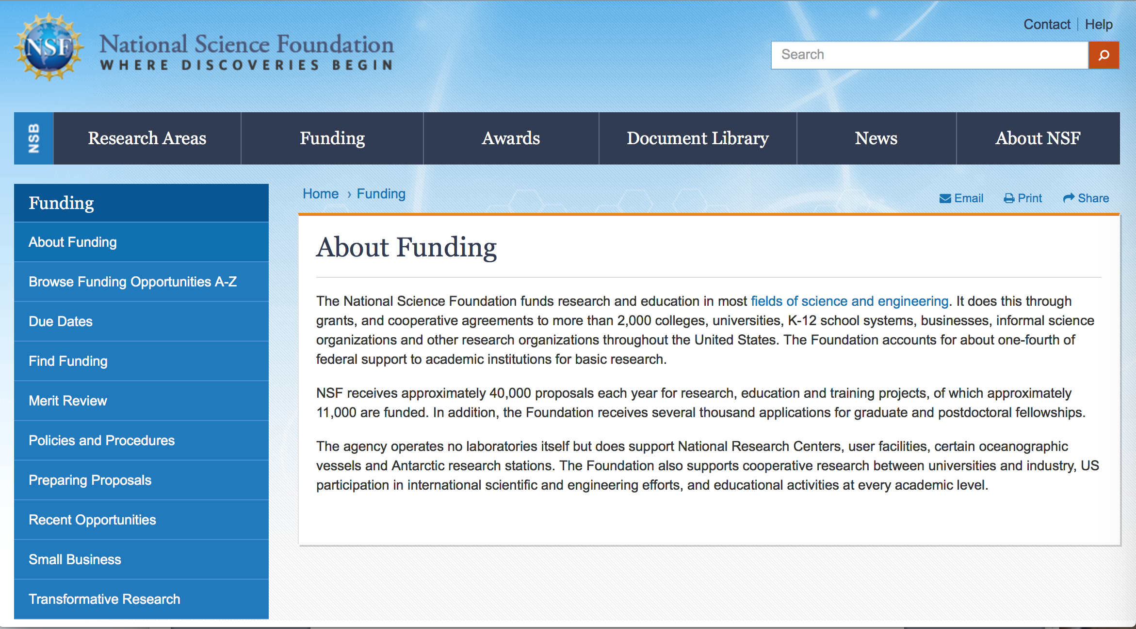

For assistance: https://nsf.gov/funding/aboutfunding.jsp

The National Science Foundation funds research and education in most fields of science and engineering. It does this through grants, and cooperative agreements to more than 2,000 colleges, universities, K-12 school systems, businesses, informal science organizations and other research organizations throughout the United States. The Foundation accounts for about one-fourth of federal support to academic institutions for basic research.
NSF receives approximately 40,000 proposals each year for research, education and training projects, of which approximately 11,000 are funded. In addition, the Foundation receives several thousand applications for graduate and postdoctoral fellowships.
The agency operates no laboratories itself but does support National Research Centers, user facilities, certain oceanographic vessels and Antarctic research stations. The Foundation also supports cooperative research between universities and industry, US participation in international scientific and engineering efforts, and educational activities at every academic level.

For details on active funding deadline dates: http://nsf.gov/funding/pgm_list.jsp?org=NSF&ord=date

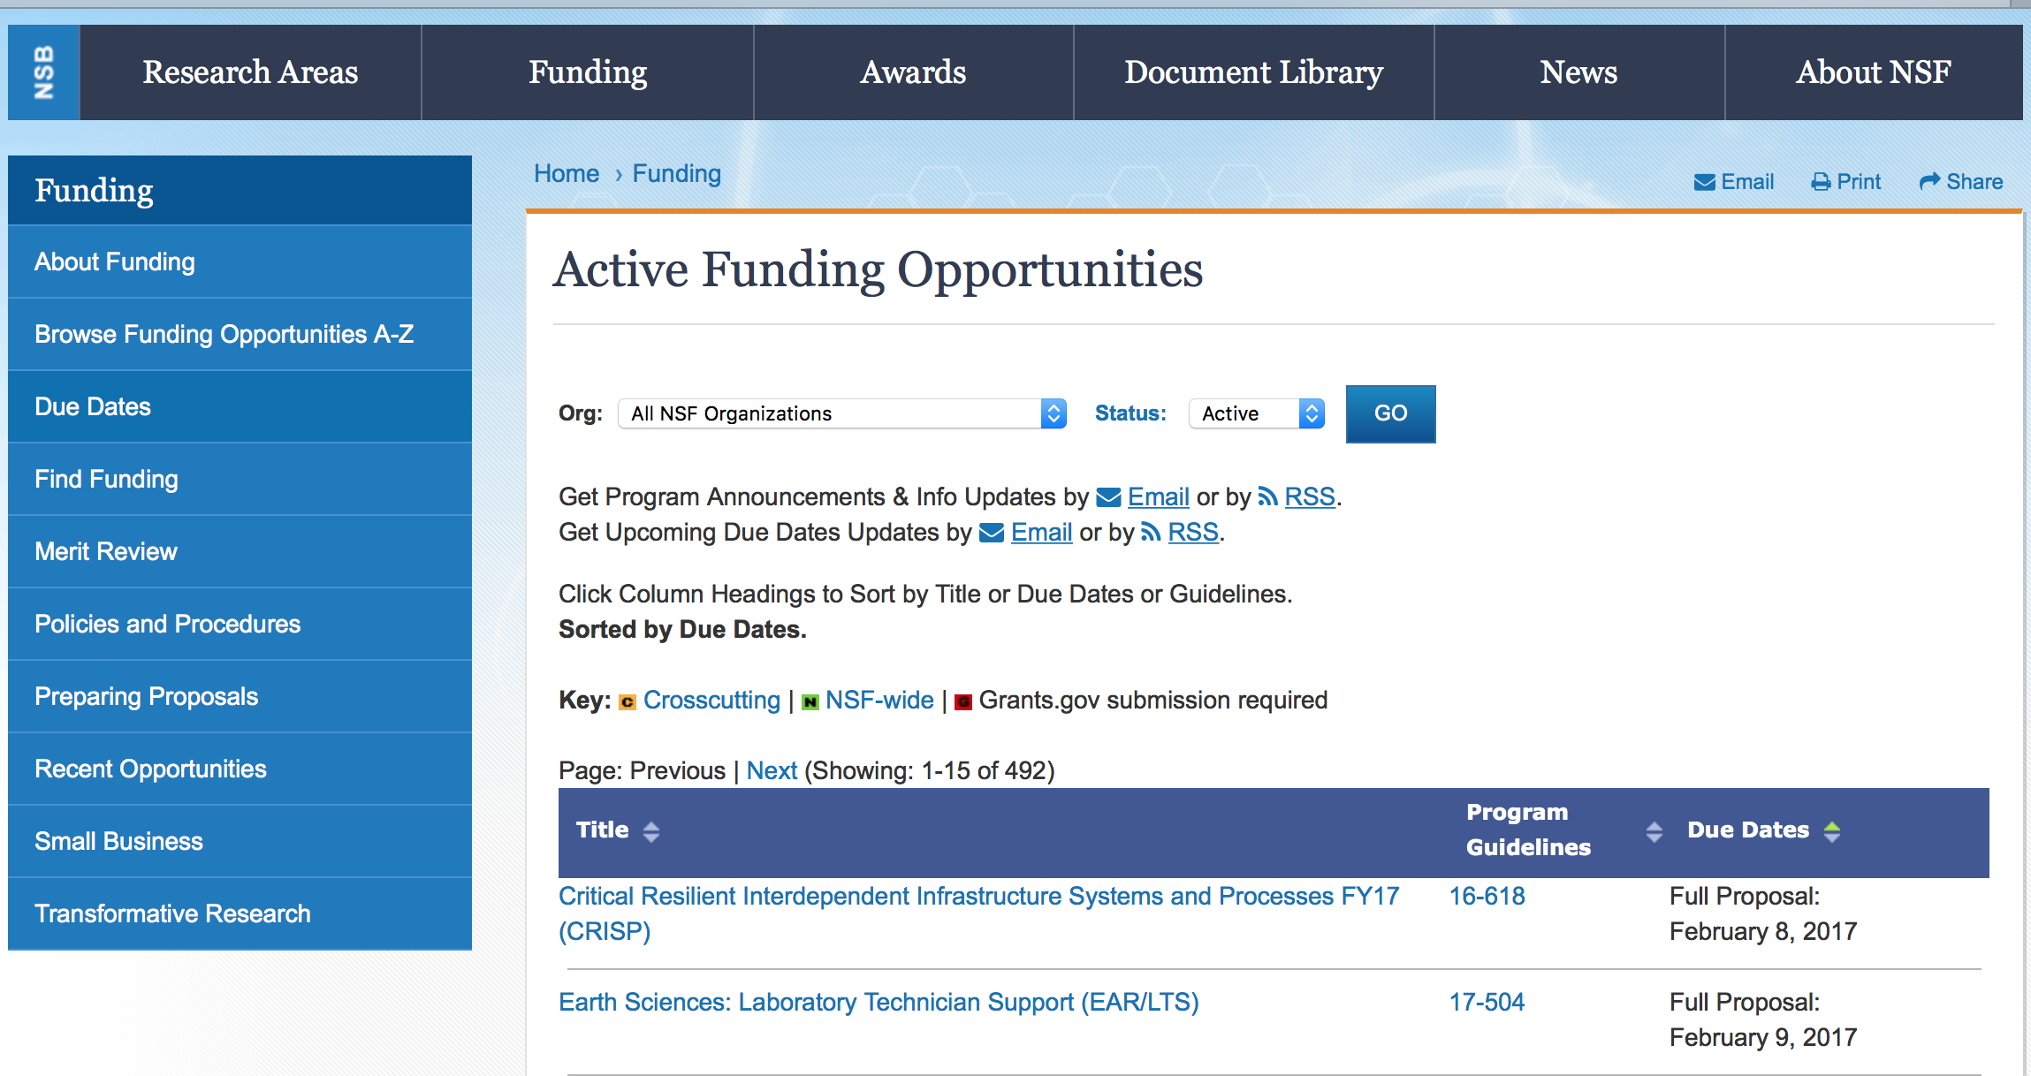

Algorithms for Threat Detection
Synopsis 1
https://www.grants.gov/web/grants/view-opportunity.html?oppId=309664
Ceramics
Synopsis 1
https://www.grants.gov/web/grants/view-opportunity.html?oppId=310004

CISE Community Research Infrastructure
Synopsis 1
https://www.grants.gov/web/grants/view-opportunity.html?oppId=309899

Cybersecurity Innovation for Cyberinfrastructure
Synopsis 1
https://www.grants.gov/web/grants/view-opportunity.html?oppId=309941

CyberCorps(R) Scholarship for Service
Synopsis 1
https://www.grants.gov/web/grants/view-opportunity.html?oppId=310232
EarthCube
Synopsis 1
https://www.grants.gov/web/grants/view-opportunity.html?oppId=310234
EarthCube
Synopsis 1
https://www.grants.gov/web/grants/view-opportunity.html?oppId=310237

Enabling Access to Cloud Computing Resources for CISE Research and Education
Synopsis 1
https://www.grants.gov/web/grants/view-opportunity.html?oppId=309833

EHR Core Research
Synopsis 1
https://www.grants.gov/web/grants/view-opportunity.html?oppId=309754

EMERGING FRONTIERS IN RESEARCH AND INNOVATION (EFRI): Chromatin and Epigenetic Engineering (CEE) and Continuum, Compliant, and Configurable Soft Robotics Engineering (C3 SoRo)
Synopsis 1
https://www.grants.gov/web/grants/view-opportunity.html?oppId=309662

Gen-4 Engineering Research Centers
Synopsis 1
https://www.grants.gov/web/grants/view-opportunity.html?oppId=309663
Geoinformatics
Synopsis 1
https://www.grants.gov/web/grants/view-opportunity.html?oppId=309661

IUSE/Professional Formation of Engineers: Revolutionizing Engineering Departments
Synopsis 1
https://www.grants.gov/web/grants/view-opportunity.html?oppId=309942

National Science Foundation Research Traineeship (NRT) Program
Synopsis 1
https://www.grants.gov/web/grants/view-opportunity.html?oppId=310233

Navigating the New Arctic
Synopsis 1
https://www.grants.gov/web/grants/view-opportunity.html?oppId=309866

NSF/CASIS Collaboration on Tissue Engineering and Mechanobiology on the International Space Station (ISS) to Benefit Life on Earth
Synopsis 1
https://www.grants.gov/web/grants/view-opportunity.html?oppId=309755

NSF Quantum Computing & Information Science Faculty Fellows
Synopsis 1
https://www.grants.gov/web/grants/view-opportunity.html?oppId=309753

Partnerships for Innovation
Synopsis 1
https://www.grants.gov/web/grants/view-opportunity.html?oppId=309683

Scalable Parallelism in the Extreme
Synopsis 1
https://www.grants.gov/web/grants/view-opportunity.html?oppId=309684

Training-based Workforce Development for Advanced Cyberinfrastructure
Synopsis 1
https://www.grants.gov/web/grants/view-opportunity.html?oppId=310235

Transport Phenomena Research at the International Space Station to Benefit Life on Earth
Synopsis 1
https://www.grants.gov/web/grants/view-opportunity.html?oppId=310236

Modifications:

Reminders:

Deleted:

Nuclear Regulatory Commission

U.S. Nuclear Regulatory Commission Funding Opportunity Announcement (FOA), Scholarship and Fellowship Education Grant, Faculty Development Grant, and Trade School and Community College Scholarship Grant, Fiscal Year (FY) 2019.
Synopsis 1

Document Type: | Grants Notice
Funding Opportunity Number: | 31310018K0002
Funding Opportunity Title: | U.S. Nuclear Regulatory Commission Funding Opportunity Announcement (FOA), Scholarship and Fellowship Education Grant, Faculty Development Grant, and Trade School and Community College Scholarship Grant, Fiscal Year (FY) 2019.
Opportunity Category: | Discretionary
Opportunity Category Explanation:
Funding Instrument Type: | Grant
Category of Funding Activity: | Education
Category Explanation:
Expected Number of Awards: | 50
CFDA Number(s): | 77.008 -- U.S. Nuclear Regulatory Commission Scholarship and Fellowship Program
Cost Sharing or Matching Requirement: | No
Version: | Synopsis 1
Posted Date: | Sep 30, 2018
Last Updated Date: | Sep 28, 2018
Original Closing Date for Applications: | Nov 30, 2018
Current Closing Date for Applications: | Nov 30, 2018
Archive Date: | Dec 30, 2018
Estimated Total Program Funding: | $15,000,000
Award Ceiling: | $450,000
Award Floor: | $100,000
Eligible Applicants: | Private institutions of higher education  Public and State controlled institutions of higher education  Others (see text field entitled "Additional Information on Eligibility" for clarification)
Additional Information on Eligibility: | Public/State Controlled Institutions of Higher Education • Private Institutions of Higher Education • Hispanic-Serving Institutions (HSIs) • Historically Black Colleges and Universities (HBCUs) • Tribally Controlled Colleges and Universities (TCCUs) • Alaska Native and Native Hawaiian Serving Institutions • Predominately Black Institutions (PBIs) • Asian American and Native American Pacific Islander Serving Institutions (AAPIs)
Additional Information
Agency Name: | Nuclear Regulatory Commission
Description: | U.S. Nuclear Regulatory Commission Funding Opportunity Announcement (FOA), Scholarship and Fellowship Education Grant, Faculty Development Grant, and Trade School and Community College Scholarship Grant, Fiscal Year (FY) 2019
Link to Additional Information:
Grantor Contact Information: | If you have difficulty accessing the full announcement electronically, please contact:  MLita Carr Contracts Specialist Phone 301-415-6869  Office

https://www.grants.gov/web/grants/view-opportunity.html?oppId=309334

Reminders:

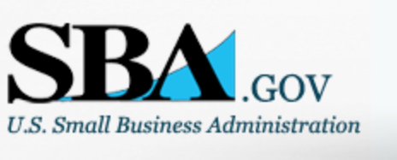

Small Business Administration

General Overview Finding Loans & Grants



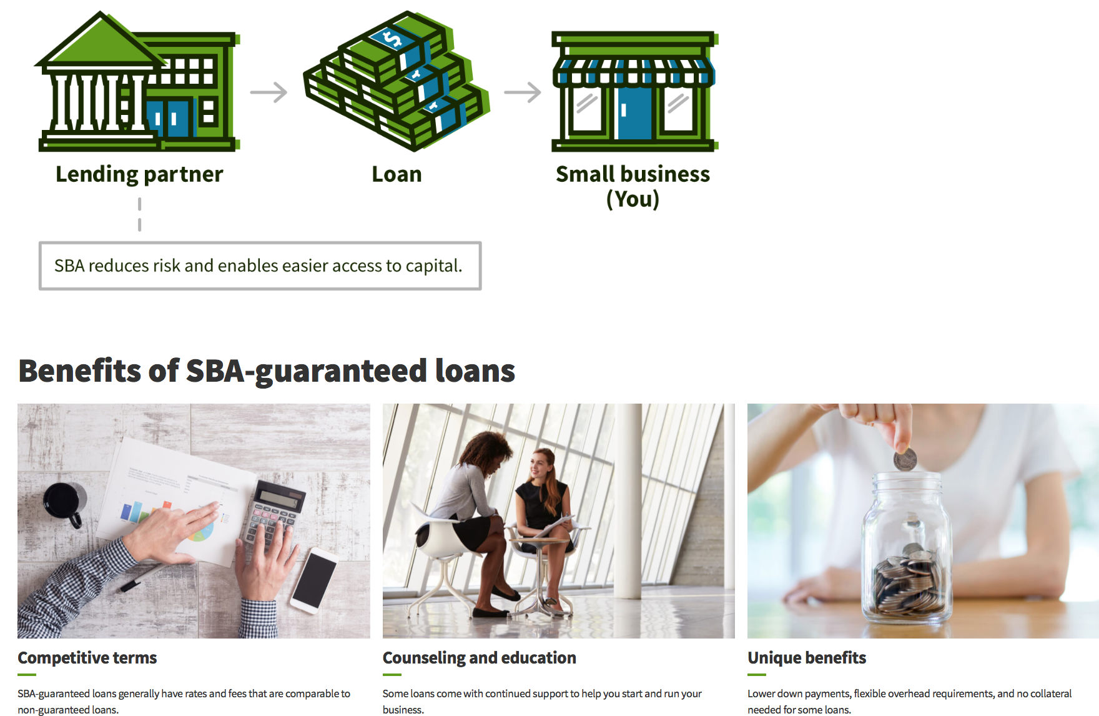

https://www.sba.gov/funding-programs/loans
Federal, state and local governments offer a wide range of financing programs to help small businesses start and grow their operations. These programs include low-interest loans, venture capital, and scientific and economic development grants.
Use SBA.gov's Loans and Grants Search Tool to get a list of financing programs for which you may qualify, or visit the resources below to learn more about small business financing programs.

To get to the main SBA.gov funding page click here
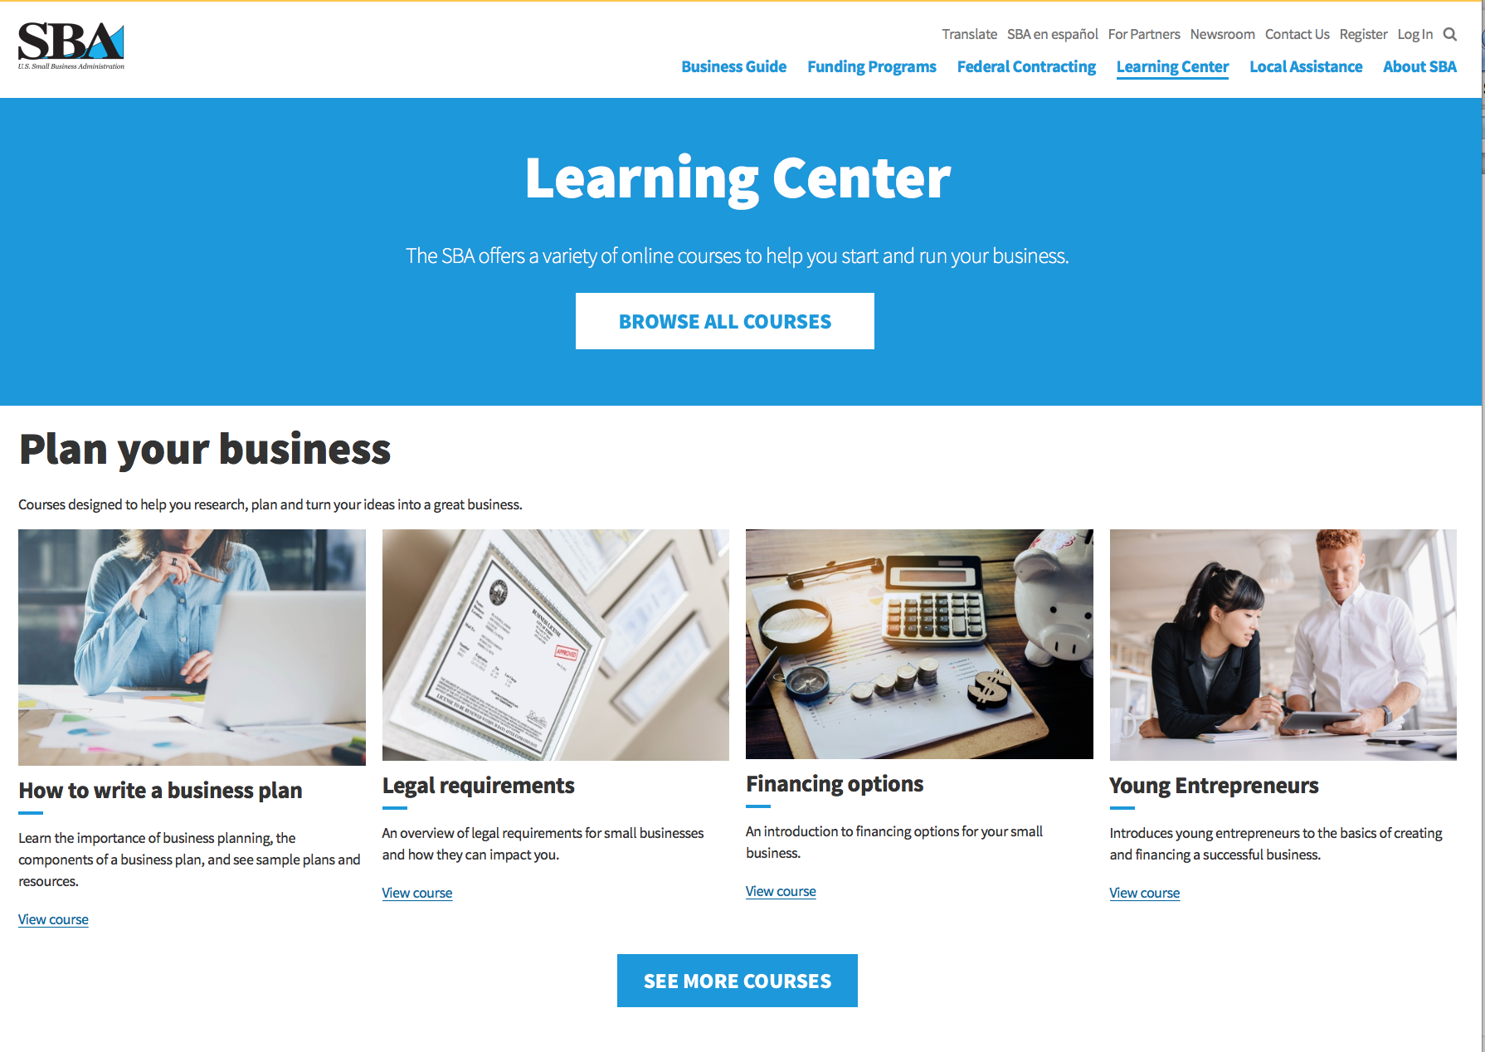
https://www.sba.gov/learning-center

Programs:

Modifications:

Reminders:

Deleted:

SBA Trainings

Contracting Opportunities for Veteran Entrepreneurs
This self-paced training exercise is an introduction to Federal contracting opportunities for Veterans.
Topics include basic information about Veteran-owned businesses and opportunities, services available to small Veteran-owned businesses, small business incentives, and government procurement methods.
Duration: 00:30:00

http://www.sba.gov/tools/sba-learning-center/training/contracting-opportunities-veteran-entrepreneurs

Interested in Exporting? These Four Resources Can Help
Did you know that two-thirds of the world’s purchasing power is in foreign countries? As the numbers show, the international marketplace is a big one. So if you’re interested in exploring the world of exporting – or have gotten started but could use some guidance – check out these resources to help.
- Read more

Upcoming Trainings: Check out SBA's Online Training!
- Financing Options for Small Businesses
How to Prepare Government Contract Proposals
Getting Started With Exporting: Training and Educational Resources
Exporting represents a big opportunity to tap in to new markets, expand your customer base and grow your business. But getting started with exporting can sometimes feel like a maze of regulations, policies, and other barriers. Here are some free training and educational resources to help.
- Read more

For Specific Information in Hawaii see the following links:
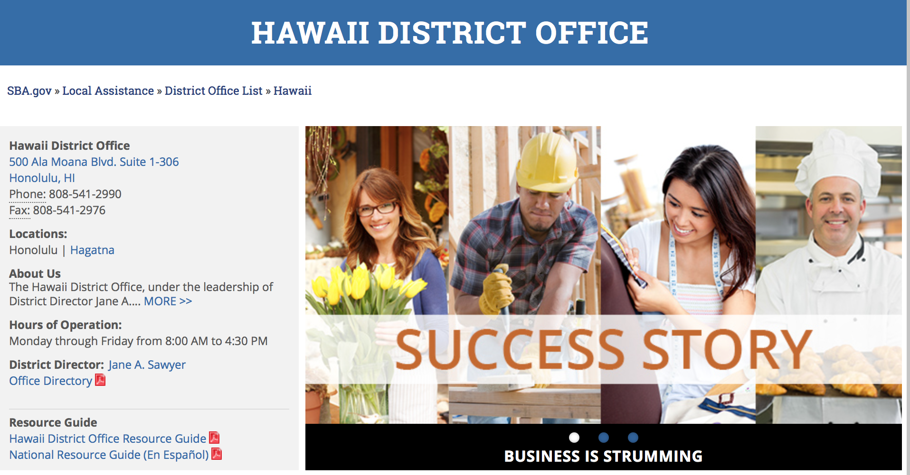

https://www.sba.gov/offices/district/hi/Honolulu

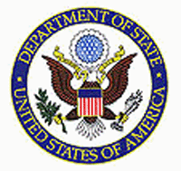

State Department General Overview and Resources for Program Administrators

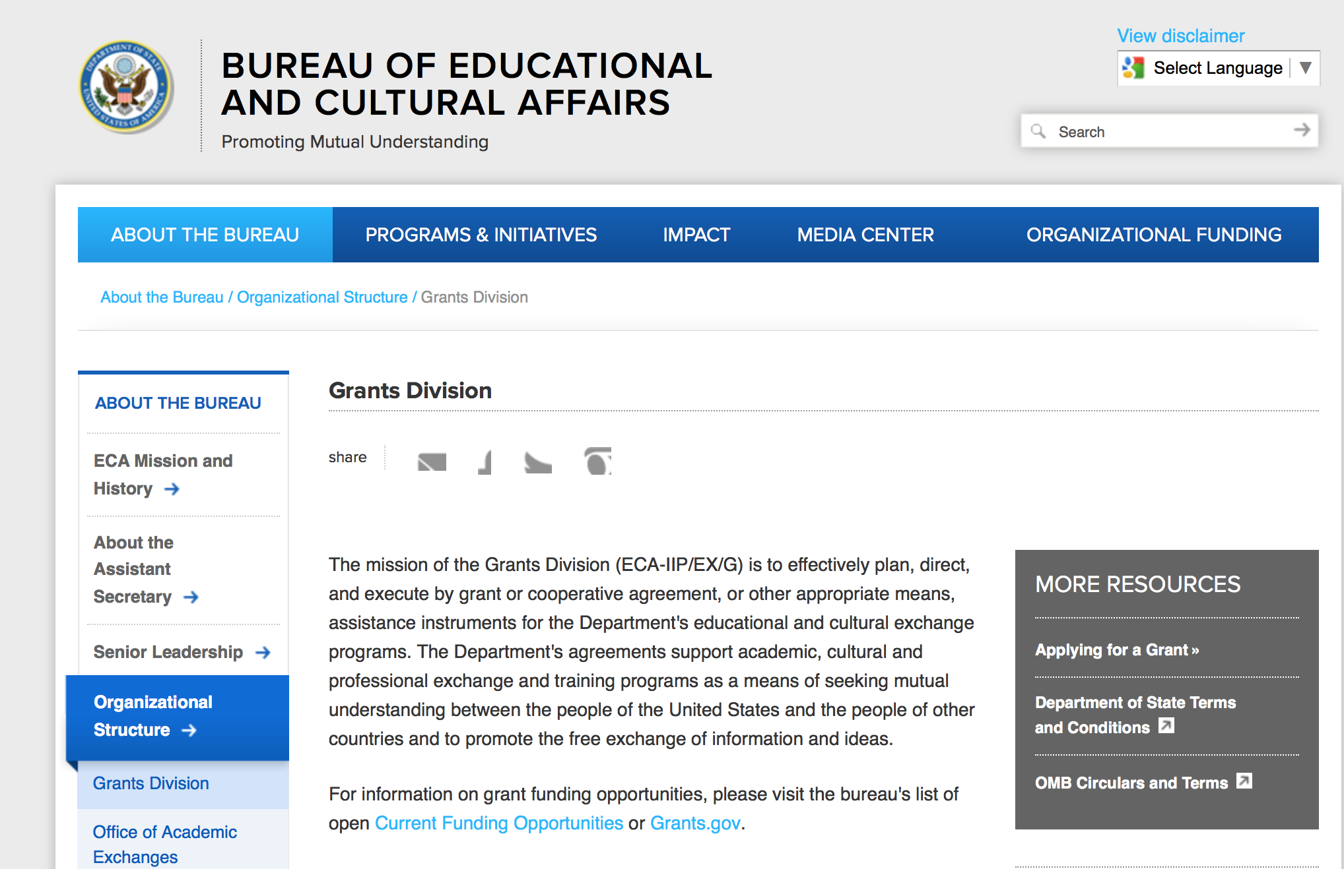

https://eca.state.gov/about-bureau/organizational-structure/grants-division

http://eca.state.gov/search/solr/grants?search_referrer=node/237

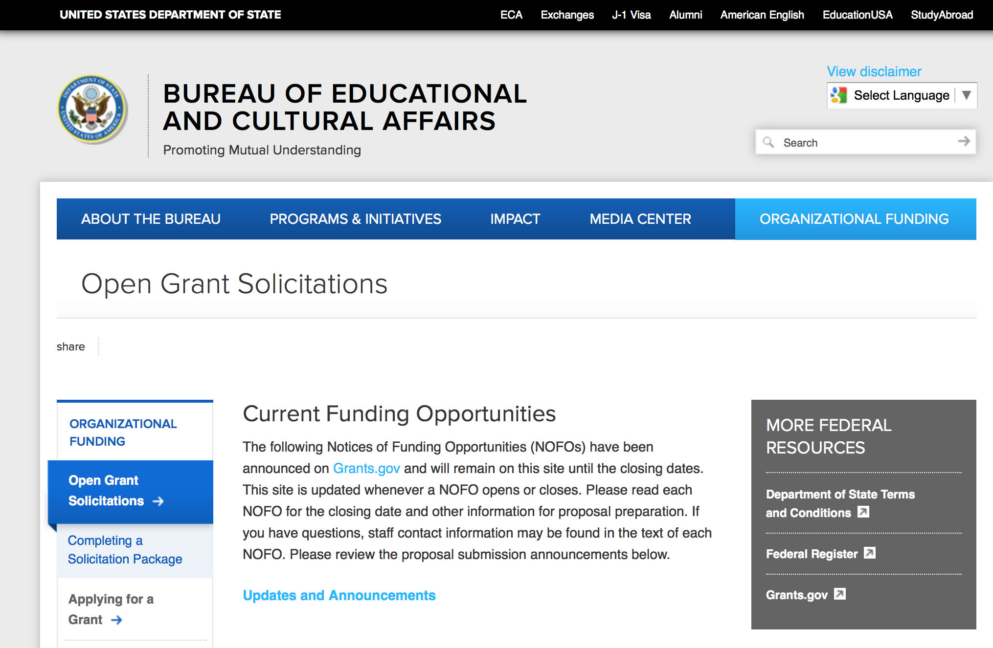
https://eca.state.gov/organizational-funding/open-grant-solicitations

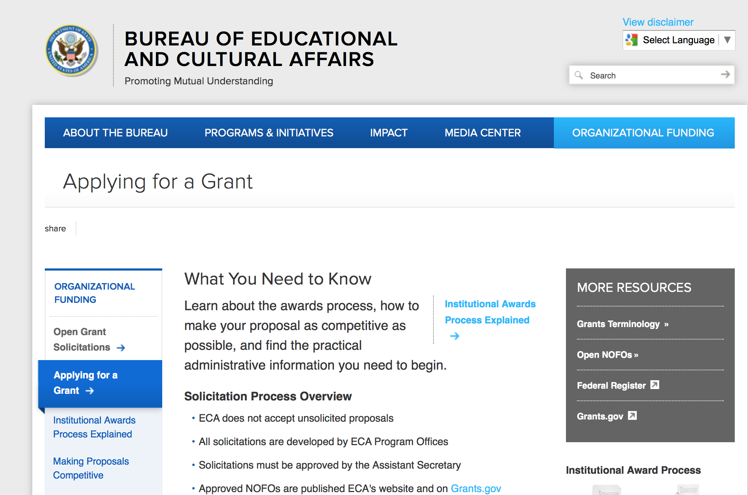
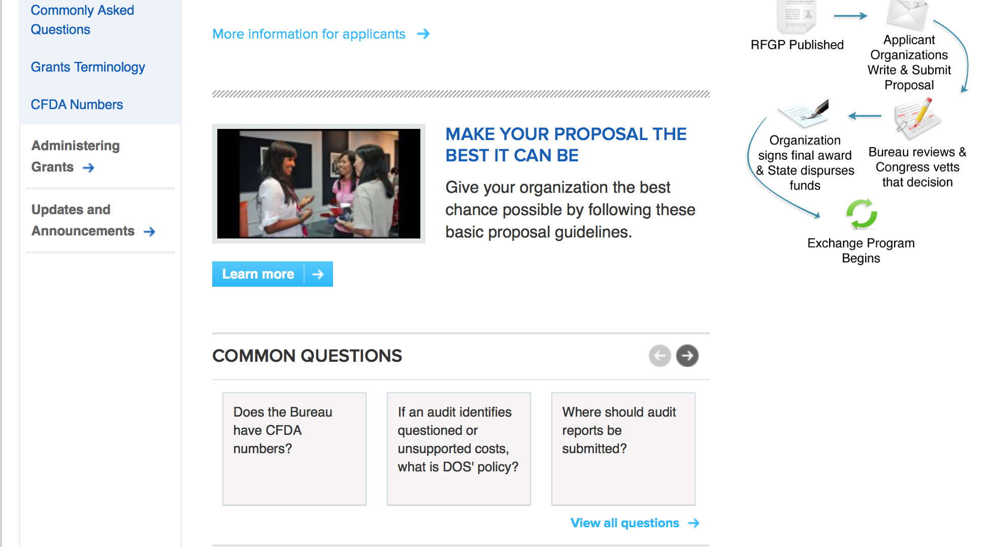
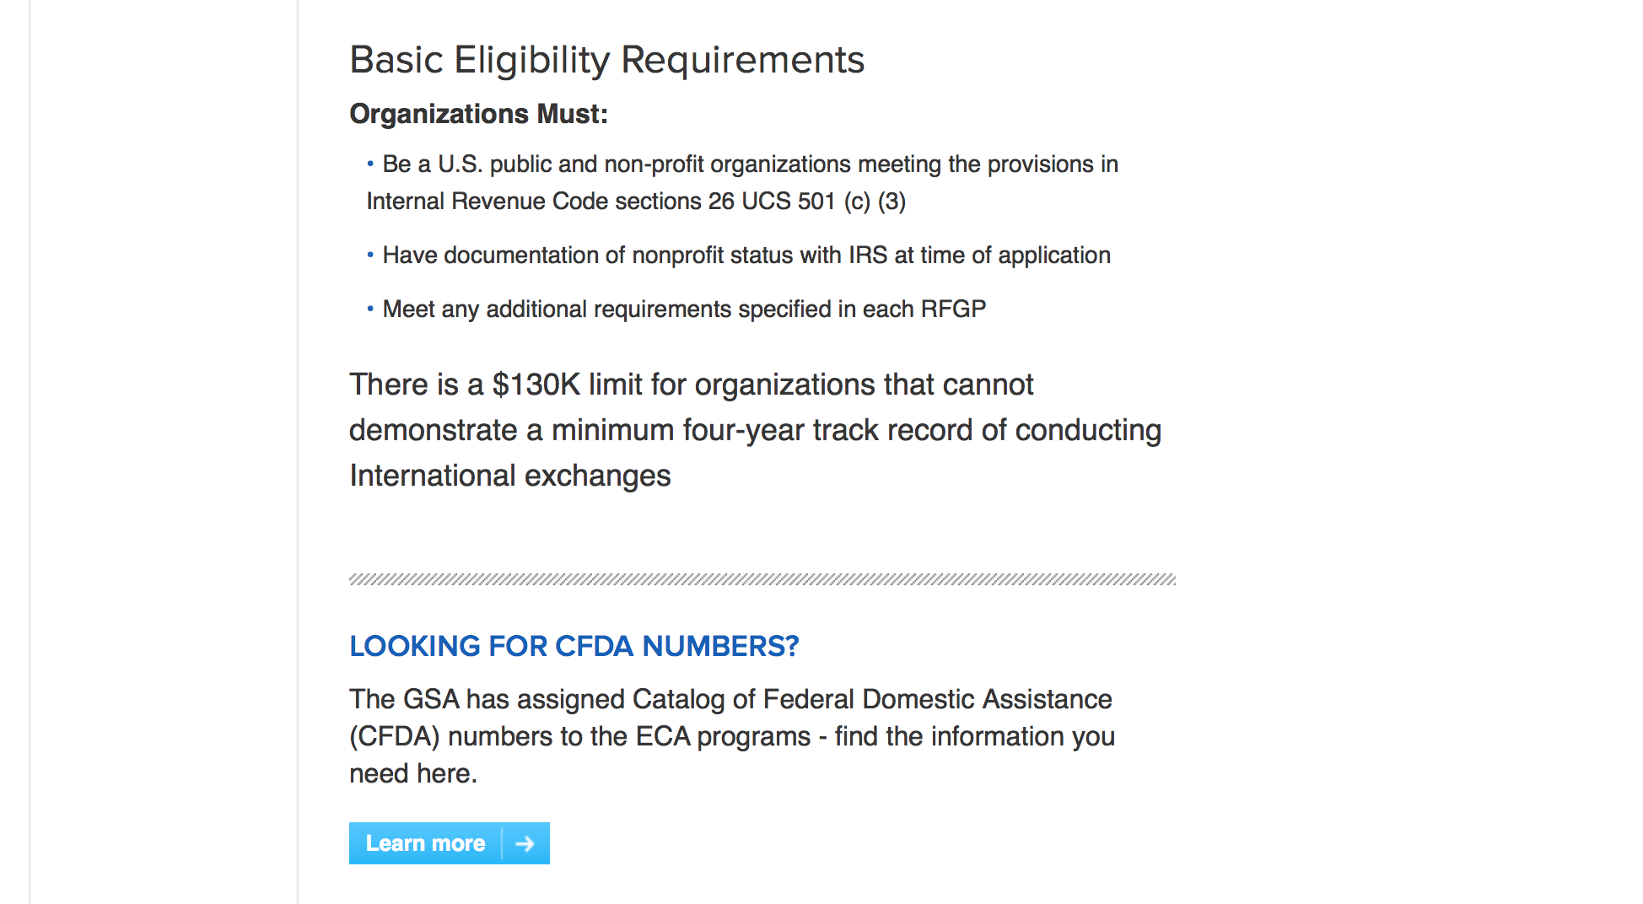
http://eca.state.gov/organizational-funding/applying-grant

General Information:
- Bureau of Educational and Cultural Affairs Grants Division
- Open Grant Opportunities (Requests for Grant Proposals)

For General Information click here

Program Grants:
Bureau of European and Eurasian Affairs
U.S. Embassy Ankara, Public Affairs Grant Program
Synopsis 1
https://www.grants.gov/web/grants/view-opportunity.html?oppId=310153

U.S. Mission to Belgium
U.S. Embassy Brussels FY2019 Annual Program Statement - Individuals
Synopsis 1
https://www.grants.gov/web/grants/view-opportunity.html?oppId=309595

U.S. Mission to Bolivia
U.S. Embassy La Paz - PAS Annual Program Statement
Forecast 1
https://www.grants.gov/web/grants/view-opportunity.html?oppId=309494

U.S. Mission to China
Hong Kong Small Grant Program
Synopsis 1
https://www.grants.gov/web/grants/view-opportunity.html?oppId=309475

U.S. Mission to Guinea
U.S. Embassy Conakry, Annual Program Statement: Ambassadors Fund for Cultural Preservation
Synopsis 1
https://www.grants.gov/web/grants/view-opportunity.html?oppId=309793

U.S. Mission to Moldova
AFCP 2019 Small Grants Competition
Synopsis 1
https://www.grants.gov/web/grants/view-opportunity.html?oppId=309597

U.S. Mission to Nigeria
U.S. Mission to Nigeria: Ambassadors Fund for Cultural Preservation
Synopsis 1
https://www.grants.gov/web/grants/view-opportunity.html?oppId=309554

U.S. Mission to Nigeria
U.S. Mission to Nigeria: Ambassadors Fund for Cultural Preservation
Synopsis 1
https://www.grants.gov/web/grants/view-opportunity.html?oppId=309574

Modifications:
U.S. Mission to Belgium
U.S. Embassy Brussels FY2019 Annual Program Statement - Organizations
Synopsis 4
https://www.grants.gov/web/grants/view-opportunity.html?oppId=309613

U.S. Mission to Mexico
Ambassadors Fund for Cultural Preservation Large Grants Program
Synopsis 2
https://www.grants.gov/web/grants/view-opportunity.html?oppId=309789
U.S. Mission to Mexico
Ambassadors Fund for Cultural Preservation Small Grants Program
Synopsis 5
https://www.grants.gov/web/grants/view-opportunity.html?oppId=309841

U.S. Mission to South Africa
U.S. Mission to South Africa: Ambassadors Fund for Cultural Preservation
Synopsis 3 and 4
https://www.grants.gov/web/grants/view-opportunity.html?oppId=309593
U.S. Mission to Vietnam
US Mission to Vietnam/Consulate General in HCMC: Annual Program Statement of Public Diplomacy Programs
Synopsis 2
https://www.grants.gov/web/grants/view-opportunity.html?oppId=309604

Reminders:

Deleted:

Department of Transportation

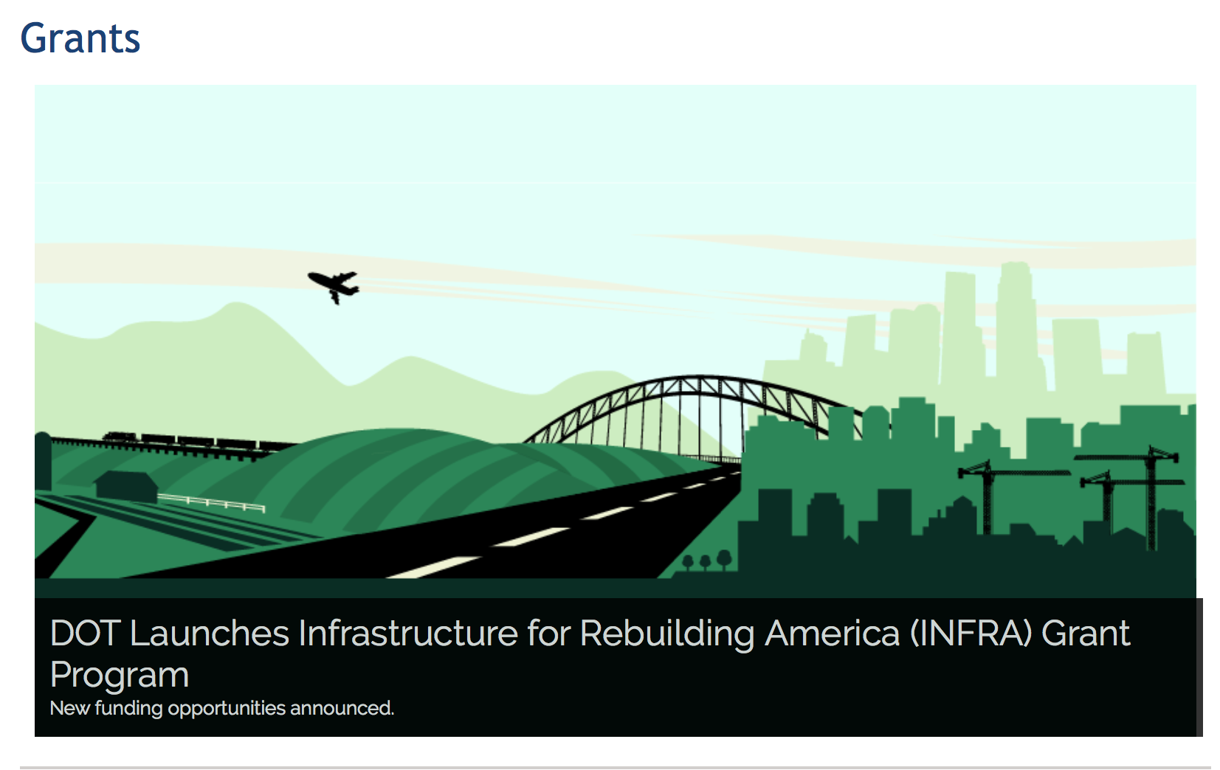

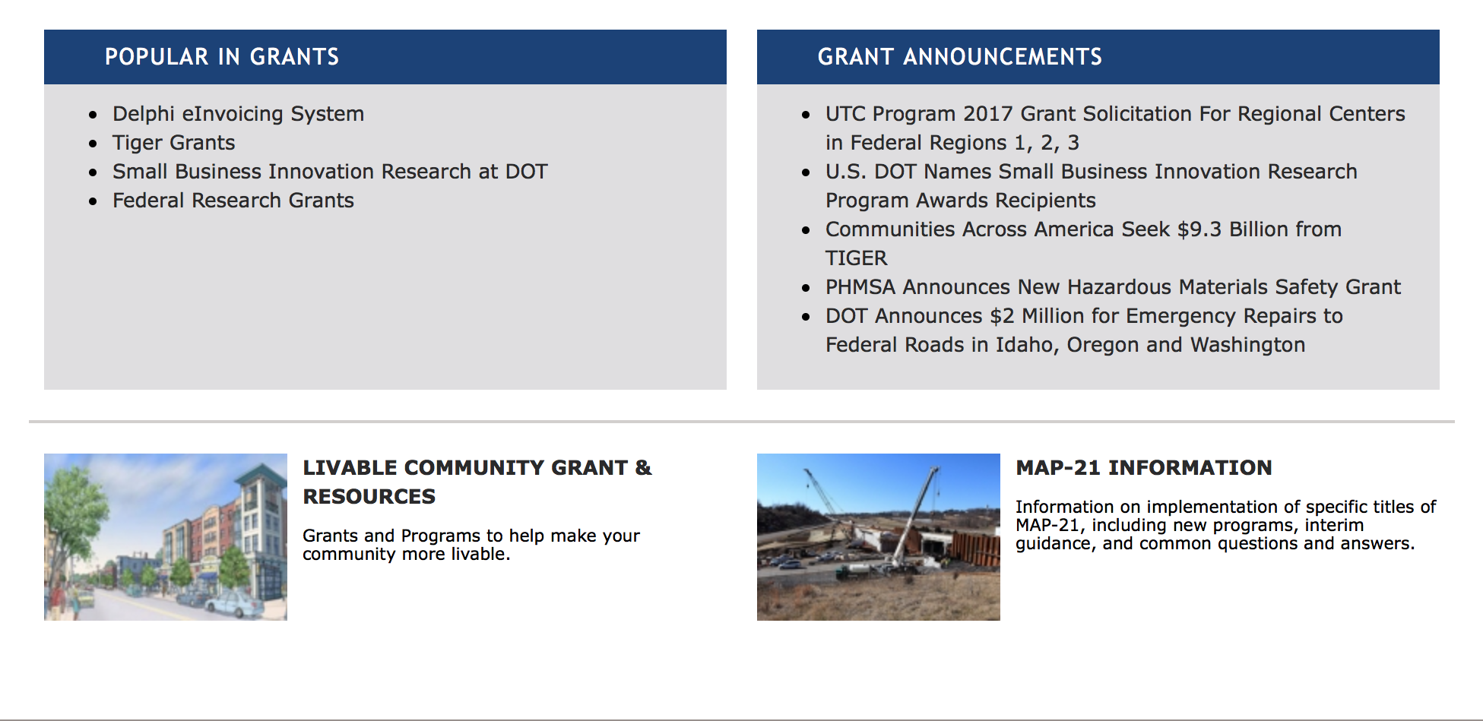

General Grant Program Overview https://www.transportation.gov/grants

Programs:

Modifications:

Research:

Reminders:

DOT/Federal Transit Administration
Access and Mobility Partnership Grants; Human Services Coordination Research (HSCR)
Synopsis 1

Document Type: | Grants Notice
Funding Opportunity Number: | FTA-2018-006-HSCR
Funding Opportunity Title: | Access and Mobility Partnership Grants; Human Services Coordination Research (HSCR)
Opportunity Category: | Discretionary
Opportunity Category Explanation:
Funding Instrument Type: | Grant
Category of Funding Activity: | Transportation
Category Explanation:
Expected Number of Awards: | 10
CFDA Number(s): | 20.514 -- Public Transportation Research, Technical Assistance, and Training
Cost Sharing or Matching Requirement: | Yes
Version: | Synopsis 1
Posted Date: | Sep 13, 2018
Last Updated Date: | Sep 13, 2018
Original Closing Date for Applications: | Nov 13, 2018
Current Closing Date for Applications: | Nov 13, 2018
Archive Date: | Dec 13, 2018
Estimated Total Program Funding: | $2,434,767
Eligible Applicants: | Others (see text field entitled "Additional Information on Eligibility" for clarification)
Additional Information on Eligibility: | Eligible applicants for awards are State and local governmental entities, providers of public transportation, private or non-profit organizations. Proposals may contain projects the recipient or its subrecipients will implement. Eligible subrecipients include public agencies, private nonprofit organizations, and private providers engaged in public transportation.
Additional Information
Agency Name: | DOT/Federal Transit Administration
Description: | FTA makes available $2,434,767 in funding for a Human Services Coordination Research (HSCR) Program (FTA-2018-006-HSCR ) with funds available under the Public Transportation Innovation Program (Catalog of Federal Domestic Assistance (CFDA) number: 20.514). Research activities awarded under this competitive program will support the implementation of innovative strategies in the coordination of human services transportation to provide more effective and efficient public transportation services to seniors, individuals with disabilities, and low-income individuals. Proposed research projects should address gaps identified in the locally developed Coordinated Public Transit-Human Services Transportation Plan. The HSCR funds will finance operating and capital project expenditures to develop and deploy projects that improve transportation services for targeted populations as noted above through methods that effectively and efficiently coordinate human services transportation.
Link to Additional Information: | FTA website
Grantor Contact Information: | If you have difficulty accessing the full announcement electronically, please contact:  Kelly Tyler Program Manager Office of Program Management 202-366-3102  Kelly Tyler
https://www.grants.gov/web/grants/view-opportunity.html?oppId=308944

DOT - FAA Aviation Research Grants
FAA Aviation Research and Development Grants
Synopsis 3, 4 & 6

Document Type: | Grants Notice
Funding Opportunity Number: | 12-01
Funding Opportunity Title: | FAA Aviation Research and Development Grants
Opportunity Category: | Discretionary
Opportunity Category Explanation:
Funding Instrument Type: | Grant
Category of Funding Activity: | Transportation
Category Explanation:
Expected Number of Awards:
CFDA Number(s): | 20.108 -- Aviation Research Grants
Cost Sharing or Matching Requirement: | No
Version: | Synopsis 6
Posted Date: | Jan 01, 2012
Last Updated Date: | Oct 18, 2017
Original Closing Date for Applications: | Dec 31, 2019
Current Closing Date for Applications: | Dec 31, 2019
Archive Date: | Jan 30, 2020
Estimated Total Program Funding:
Award Ceiling: | $5,000,000
Eligible Applicants: | Private institutions of higher education  Nonprofits having a 501(c)(3) status with the IRS, other than institutions of higher education  Public and State controlled institutions of higher education
Agency Name: | DOT - FAA Aviation Research Grants
Description: | The FAA is soliciting proposals for research grants and cooperative agreements to pursue the long-term growth and short-term technical needs of civil aviation. In order to streamline the application process, it is recommended that all prospective grantees submit a white paper (letter of intent) for agency technical review before complete proposal submission. Please be sure to identify the specific area of interest (Solicitation FAA-12-01 – Chapter I. FAA Research Grants Program, Technical Areas of Research #1-#9). The white paper shall be no longer than three (3) pages and shall detail overall research objectives.
Link to Additional Information:
Grantor Contact Information: | If you have difficulty accessing the full announcement electronically, please contact:  Nicole Saiauskie Grants Officer Phone 609-485-4781  business

http://www.grants.gov/web/grants/view-opportunity.html?oppId=134953

Deleted:

Department of the Treasury

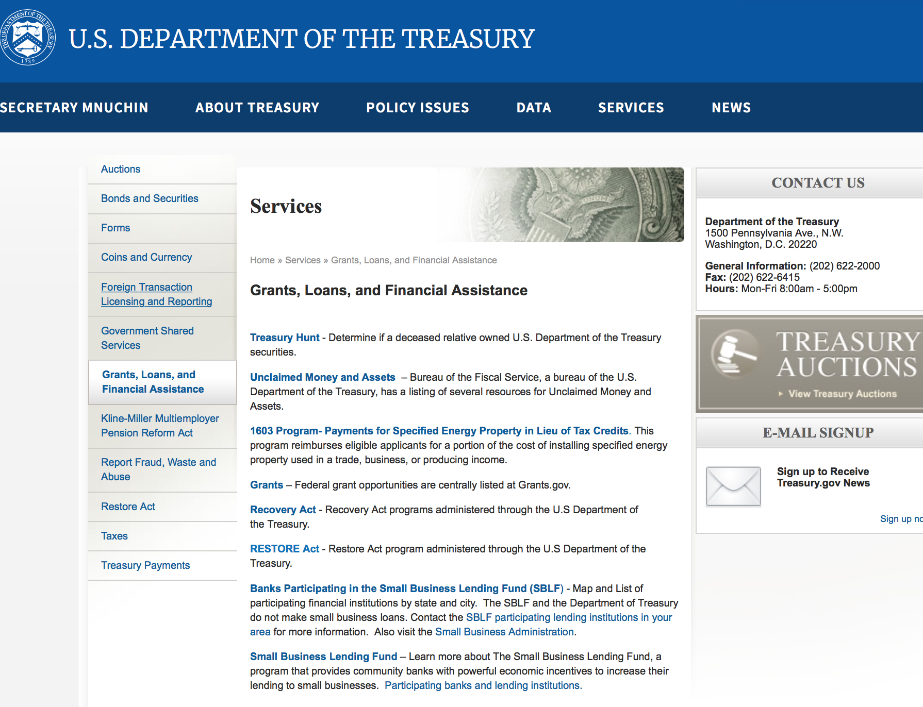

https://www.treasury.gov/services/Pages/Grants-Loans-and-Financial-Assistance.aspx

Programs:

DOT Federal Highway Administration
National Summer Transportation Institute
Synopsis 1
https://www.grants.gov/web/grants/view-opportunity.html?oppId=308558
DOT/Federal Railroad Administration
FY18 Rail Safety Innovations Deserving Exploratory Analysis (Rail Safety IDEA)
Synopsis 1
https://www.grants.gov/web/grants/view-opportunity.html?oppId=308622

DOT/Federal Railroad Administration
FY18 South Lander Grade Separation and Railroad Safety Project
Synopsis 1
https://www.grants.gov/web/grants/view-opportunity.html?oppId=308565

DOT/Federal Transit Administration
Solicitation of Project Proposals for the National Center for Mobility Management
Synopsis 1
https://www.grants.gov/web/grants/view-opportunity.html?oppId=308576

Modifications:

Reminders:

U.S. Agency for International Development

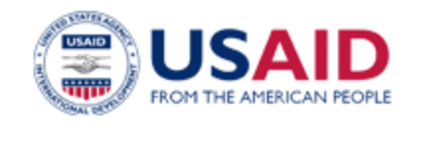

www.usaid.gov

General Overview Funding Opportunities

USAID has working relationships with thousands of American companies and hundreds of U.S.-based private voluntary organizations. For more information on our business and procurement opportunities, please visit our Business section.

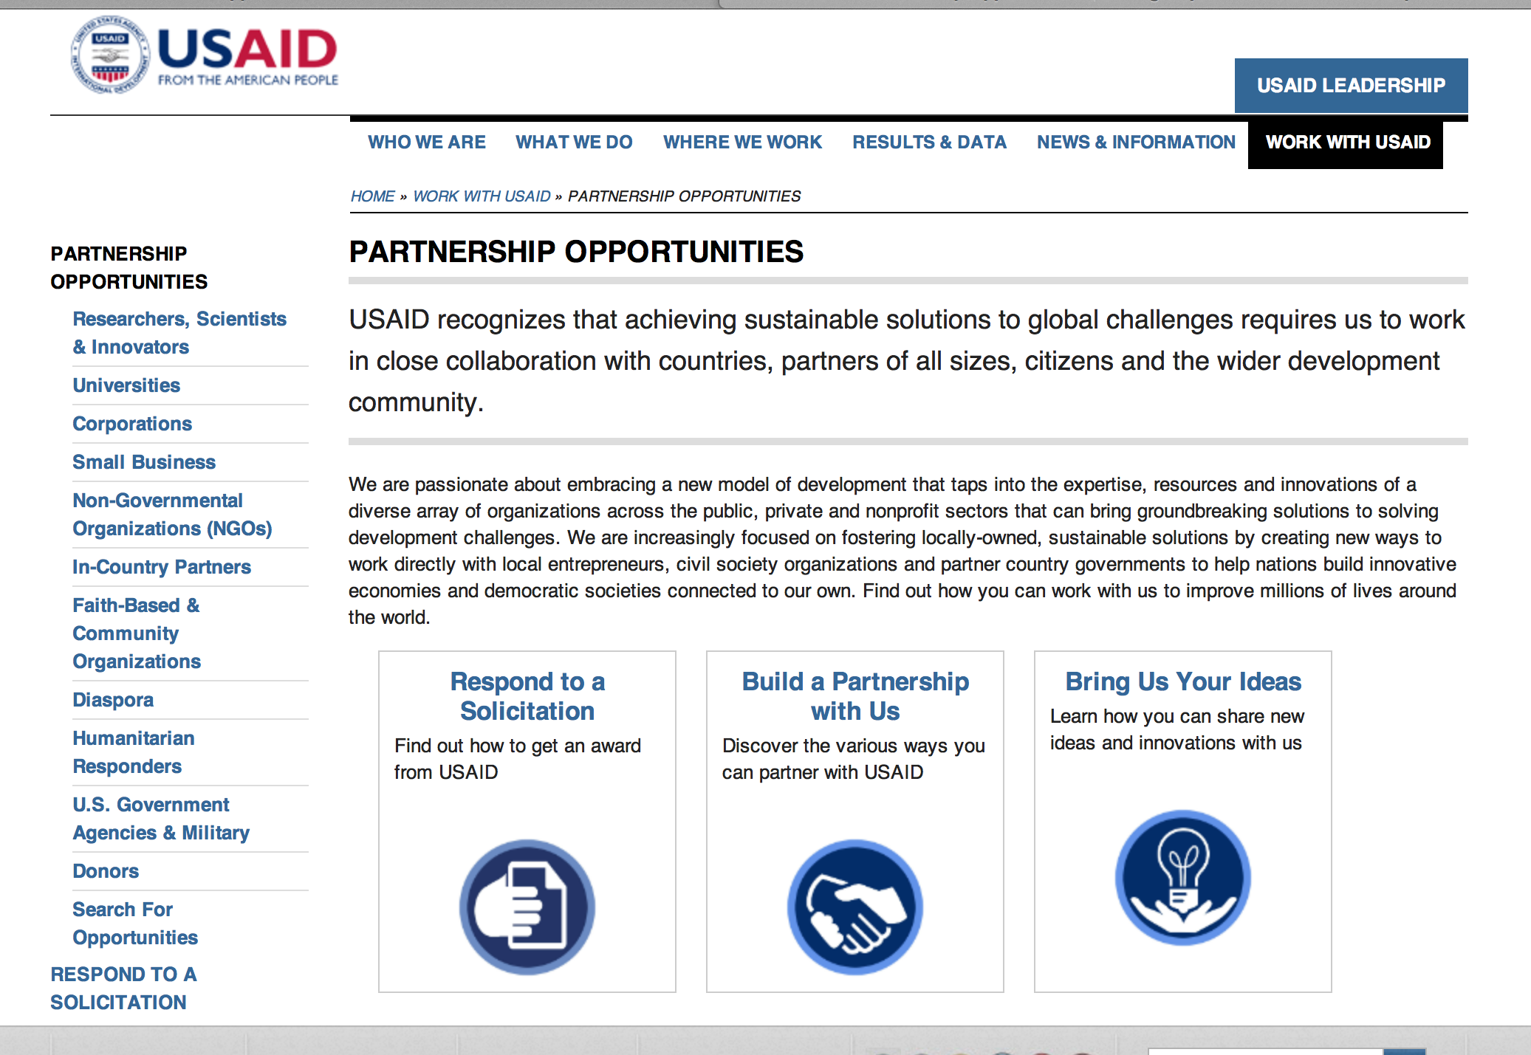
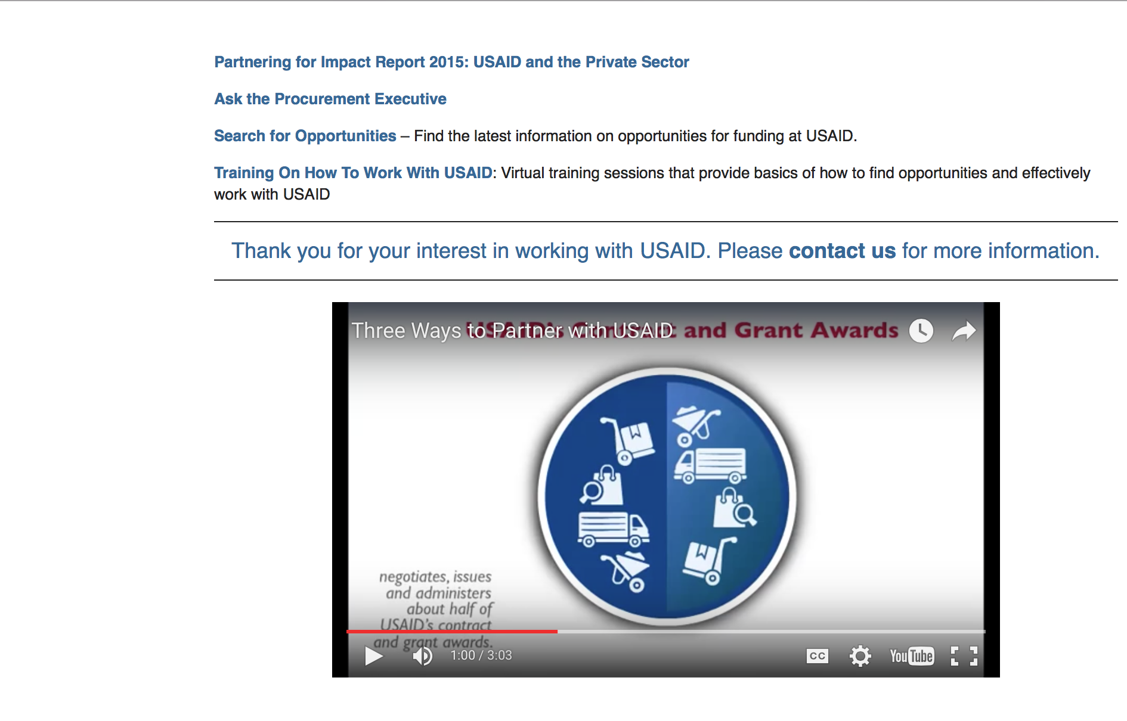

http://www.usaid.gov/partnerships

Programs:

Ukraine USAID-Kiev
APS-OAA-16-000001 Addendum Ukraine Health
Synopsis 1
https://www.grants.gov/web/grants/view-opportunity.html?oppId=309495
American Schools and Hospitals Abroad Program Worldwide
Synopsis 1
https://www.grants.gov/web/grants/view-opportunity.html?oppId=309603
Egypt USAID-Cairo
Cultural Tourism Development in Egypt
Synopsis 1
https://www.grants.gov/web/grants/view-opportunity.html?oppId=309780

Modifications:

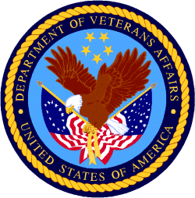

Department of Veterans Affairs

