Senator Mazie Hirono

Grants Assistance Information
Newsletter
October 2016

G.A.I.N. INDEX

Click on Index Links below to read summaries of the announcements by agency in this document.
Once you reach the item, if you cannot open the links for further information, copy the selected
URL website address into your browser.

Modified sections from previous listings are shown in a GREY background

Notices is Teal are items with immediate deadline dates.

Notices in Yellow are of special interest.

Notices is Green are items of special interest with immediate deadline dates.

Items in this type color are aimed at Small Businesses

Items in this type color have a Faith-Based Organization component

Special Federal Program Notices

SBIR – Small Business Innovation Research

Programs specific to Hawaii

Current Notices

FY17 Coral Reef Conservation Program, Domestic Coral Reef Conservation Grants
Synopsis 1

Reminders

Department of Commerce
FY2017 NOAA Bay Watershed Education and Training (B-WET) Hawaii Program

See Individual Departments for information and webpages representing the best and most accessible information on the agency funding opportunities

Federal Grant and Cooperative Agreement Program Summaries

U.S. Department of Agriculture

Grants and Loans Overview

Programs

Food and Nutrition Service
FY 17 Farm to School Grant Program

National Institute of Food and Agriculture
Specialty Crop Research Initiative Request for Pre-applications

National Institute of Food and Agriculture
Beginning Farmer and Rancher Development Program

Utilities Programs
RUS SWM Grant FY 2017
Synopsis 1

Modifications

Reminders

National Institute of Food and Agriculture
Food and Agricultural Sciences National Needs Graduate and Postgraduate Fellowship (NNF) Grants Program

National Institute of Food and Agriculture
Agriculture and Food Research Initiative - Agriculture and Natural Resources Science for Climate Variability and Change Challenge Area

Department of Commerce

Programs

Research

FY2017 Marine Debris Research

FY 2017 Joint Hurricane Testbed (JHT), Hazardous Weather Testbed (HWT), and Hydrometeorology Testbed (HMT)

Collaborative Science, Technology, and Applied Research (CSTAR) Program

Regional Vulnerability Assessments for Ocean Acidification (RVA-OA17)

Collaborative Science, Technology, and Applied Research (CSTAR) Program
Synopsis 2

Modifications

Reminders

Fiscal Year 2018 National Sea Grant College Program Dean John A. Knauss Marine Policy Fellowship

FY2017 Community-based Marine Debris Removal

Ocean Exploration FY 2017 Funding Opportunity

National Competitive Harmful Algal Bloom Programs: The Ecology and Oceanography of Harmful Algal Blooms (ECOHAB) and Prevention, Control and Mitigation of Harmful Algal Blooms Program (PCMHAB)

2017 Saltonstall-Kennedy Competitive Research Program

National Institute of Standards and Technology
Disaster Resilience (DR) Research Grants Program

FY 2017 Climate Program Office

National Institute of Standards and Technology
Project to Develop, Produce, and Distribute a Documentary Film about Rebooting the International Measurement System

National Institute of Standards and Technology
Measurement Science and Engineering (MSE) Research Grant Programs

National Sea Grant College Program 2016-17 Special Projects Grant

FY 2016 – FY 2019 EDA Planning Program and Local Technical Assistance Program Grant

FY 2016 Economic Development Assistance Programs ­ Application submission and program requirements for EDA’s Public Works and Economic Adjustment Assistance Programs

Economic Development Administration
Planning Program and Local Technical Assistance Program Grant

Deleted

Corporation for National and Community Service

General Program Overview

Programs

Reminders

2017 AmeriCorps State and National Grants

National Service in Hawaii

Department of Defense

Doing Business with the Department of Defense

DoD Small Business Opportunities and Forecasting

Research Grants

Modifications

Reminders

Dept. of the Army -- Materiel Command
Army Research Office Broad Agency Announcement for Basic and Applied Scientific Research
Modification 8

Department of Education

Grant Programs Overview

Programs

Research

Modifications

Reminders

Office of Career, Technical, and Adult Education (OCTAE): Performance Partnership Pilots (P3) CFDA Number 84.420A

Deleted

US Department of Energy

Grants Overview

Research

Office of Science
FY 2017 Continuation of Solicitation for the Office of Science Financial Assistance Program
Synopsis 1

Modifications

Reminders

Environmental Protection Agency

Grants and Contracts Overview

Programs

Modifications

Reminders

Modeling of Climate Change Mitigation, Impacts and Adaptation

Department of Health and Human Services

Grants Overview

Program

Administration for Children & Families - ACYF/FYSB
Transitional Living Program and Maternity Group Homes
Forecast 1

Administration for Children and Families - ORR
Ethnic Community Self Help Program
Forecast 1

Research Grants

Modifications

Reminders

Administration for Children and Families - ORR
Standing Announcement for Residential (Shelter) Services for Unaccompanied Children
Forecast 5

Deleted

Department of Homeland Security
Grants Overview

Programs

Modifications

Reminders

Department of Homeland Security - FEMA
Assistance to Firefighters Grant (AFG)

Office of Procurement Operations - Grants Division
DHS S&T Center of Excellence for Homeland Security Quantitative Analysis – Center Partner

Department of Housing and Urban Development

HUD - Notice of Funds Available

Programs

Modifications

Reminders

Self-Help Homeownership Opportunity Program (SHOP)

Youth Homelessness Demonstration Program

Technical Correction to the General Section to HUD's Fiscal Year 2016 Notice[s] of Funding Availability for Discretionary Programs
Modification 1

General Section to HUD's Fiscal Year 2016 Notice[s] of Funding Availability for Discretionary Programs (General Section)
Modification 1

Institute of Museum and Library Services

Grants Overview

IMLS is on Facebook!

Programs

National Leadership Grants for Museums

Museums for America

Modifications

Reminders

Deleted

Department of Interior

Grants and Contract Overview

Programs

Bureau of Land Management
Joint Fire Science Program (JFSP) Primary Announcement (6 Task Statements)

Bureau of Land Management
Joint Fire Science Program (JFSP) Graduate Research Innovation (GRIN) Announcement (1 Task Statement)

Geological Survey
The Educational Component of the National Cooperative Geologic Mapping Program

Modifications

Fish and Wildlife Service
NAWCA U.S. Small Grants
Synopsis 3

Fish and Wildlife Service
Neotropical Migratory Bird Conservation Act grants
Synopsis 4 & 5

Geological Survey
Cooperative Research Units Program FY 2017
Synopsis 2

Reminders

National Park Service
2017 Preservation Technology and Training Grants
Synopsis 3

Fish and Wildlife Service
NAWCA U.S. Small Grants
Synopsis 2

Deleted

Department of Justice

Grants and Contract Overview

Programs

Research

National Institute of Justice
FY17 Graduate Research Fellowship Program in the Social and Behavioral Sciences
Synopsis 1, 2 & 3

National Institute of Justice
Graduate Research Fellowship Program in Science, Technology, Engineering and Mathematics
Synopsis 1 & 2

Modifications

Reminders

Department of Labor

Grants and Contract General Overview

Programs

Employment and Training Administration
DEPARTMENT OF LABOR RESEARCH AND EVALUATION GRANTS
Synopsis 2

Modifications

Reminders

National Aeronautics and Space Administration

Research Grant and Contract General Overview

Programs

Modifications

_______________________________________________________________
National Archives and Records Administration

Grant Opportunities General Overview

Reminders

Access to Historical Records - Major Initiatives

Access to Historical Records – Archival Projects

_______________________________________________________________
National Endowment for the Arts

Grant Opportunities General Overview

Programs

NEA Poetry Out Loud: 2018 National Finals Competition

Modifications

Reminders

NEA Literature Fellowships: Translation Projects, FY 2018

NEA Research: Art Works Application, FY 2017

_______________________________________________________________

National Endowment for the Humanities

Grant Opportunities General Overview

Programs

Digital Humanities Advancement Grants

Collaborative Research Grants

Scholarly Editions and Translations Grants

Modifications

Reminders

Dialogues on the Experience of War
Synopsis 1

_______________________________________________________________
National Science Foundation

Grant Opportunities General Overview

Research and Program Grants

Modifications

Reminders

Deleted

Nuclear Regulatory Commission

Reminders

U.S. Nuclear Regulatory Commission Funding Opportunity Announcement (FOA), Scholarship and Fellowship Education Grant, Faculty Development Grant, and Trade School and Community College Scholarship Grant, Fiscal Year (FY) 2017

Small Business Administration

General Overview Finding Loans & Grants

Programs

Reminders

Upcoming Trainings

Links Specific to Hawaii

State Department

General Overview and Resources for Program Administrators

Programs

Modifications

Reminders

U.S. Department of Transportation

General Grant Program Overview

Programs

Reminders

DOT Federal Aviation Administration
DOT - FAA Aviation Research Grants
FAA Aviation Research and Development Grants
Modifications 3 & 4

Deleted

Department of the Treasury

Programs

Modifications

Reminders

US Agency for International Development

General Funding Opportunity Overview

Programs
Modifications

Deleted

Department of Veterans Affairs

Special Federal Program Notices

The Small Business Innovative Research Program - SBIR Program
The Small Business Innovation Research (SBIR) program is a highly competitive program that encourages domestic small businesses to engage in Federal Research/Research and Development (R/R&D) that has the potential for commercialization. Through a competitive awards-based program, SBIR enables small businesses to explore their technological potential and provides the incentive to profit from its commercialization. By including qualified small businesses in the nation's R&D arena, high-tech innovation is stimulated and the United States gains entrepreneurial spirit as it meets its specific research and development needs.

SBIR Mission and Program Goals
The mission of the SBIR program is to support scientific excellence and technological innovation through the investment of Federal research funds in critical American priorities to build a strong national economy.
The program’s goals are four-fold:
- Stimulate technological innovation
- Meet Federal research and development needs.
- Foster and encourage participation in innovation and entrepreneurship by socially and economically disadvantaged persons.
- Increase private-sector commercialization of innovations derived from Federal research and development funding.

SBIR-Participating Agencies
Each year, Federal agencies with extramural research and development (R&D) budgets that exceed $100 million are required to allocate 2.5 percent of their R&D budget to these programs. Currently, eleven Federal agencies participate in the program:
- Department of Agriculture
- Department of Commerce - National Institute of Standards and Technology
- Department of Commerce - National Oceanic and Atmospheric Administration
- Department of Defense
- Department of Education
- Department of Energy
- Department of Health and Human Services
- Department of Homeland Security
- Department of Transportation
- Environmental Protection Agency
- National Aeronautics and Space Administration
- National Science Foundation
Each agency administers its own individual program within guidelines established by Congress. These agencies designate R&D topics in their solicitations and accept proposals from small businesses. Awards are made on a competitive basis after proposal evaluation.

Three-Phase Program
The SBIR Program is structured in three phases:
Phase I. The objective of Phase I is to establish the technical merit, feasibility, and commercial potential of the proposed R/R&D efforts and to determine the quality of performance of the small business awardee organization prior to providing further Federal support in Phase II. SBIR Phase I awards normally do not exceed $150,000 total costs for 6 months.
Phase II. The objective of Phase II is to continue the R/R&D efforts initiated in Phase I. Funding is based on the results achieved in Phase I and the scientific and technical merit and commercial potential of the project proposed in Phase II. Only Phase I awardees are eligible for a Phase II award. SBIR Phase II awards normally do not exceed $1,000,000 total costs for 2 years.
Phase III. The objective of Phase III, where appropriate, is for the small business to pursue commercialization objectives resulting from the Phase I/II R/R&D activities. The SBIR program does not fund Phase III. Some Federal agencies, Phase III may involve follow-on non-SBIR funded R&D or production contracts for products, processes or services intended for use by the U.S. Government
SBIR NewsLetter

- SBIR Newsletter
Sign up for e-mail updates

HAWAII APPLICANTS ENCOURAGED

Current Notices:

FY17 Coral Reef Conservation Program, Domestic Coral Reef Conservation Grants
Synopsis 1

Document Type: | Grants Notice
Funding Opportunity Number: | NOAA-NOS-OCM-2017-2005011
Funding Opportunity Title: | FY17 Coral Reef Conservation Program, Domestic Coral Reef Conservation Grants
Opportunity Category: | Discretionary
Opportunity Category Explanation:
Funding Instrument Type: | Cooperative Agreement  Grant
Category of Funding Activity: | Environment  Natural Resources  Science and Technology and other Research and Development
Category Explanation:
Expected Number of Awards: | 15
CFDA Number(s): | 11.482 -- Coral Reef Conservation Program
Cost Sharing or Matching Requirement: | Yes
Version: | Synopsis 1
Posted Date: | Sep 06, 2016
Last Updated Date: | Sep 06, 2016
Original Closing Date for Applications: | Jan 11, 2017
Current Closing Date for Applications: | Jan 11, 2017
Archive Date: | Feb 10, 2017
Estimated Total Program Funding: | $1,000,000
Award Ceiling: | $80,000
Award Floor: | $30,000
Eligible Applicants: | Others (see text field entitled "Additional Information on Eligibility" for clarification)
Additional Information on Eligibility: | Institutions of higher education, non-profit organizations, for-profit organizations, and local (as defined at 2 C.F.R. § 200.64, which includes counties, municipalities, and cities) and Indian tribal government agencies are eligible to apply for funding under this funding category. U.S. federal agencies, state, territory, and commonwealth governments and Regional Fishery Management Councils are not eligible to apply under this funding announcement, as NOAA funds their coral reef work in separate programs.
Agency Name: | Department of Commerce
Description: | The NOAA Coral Reef Conservation Grant Program, 16 USC §§ 6401-6409, provides matching grants of financial assistance through the Domestic Coral Reef Conservation Grant program to institutions of higher education, non-profit organizations, for-profit organizations, and local (as defined at 2 CFR § 200.64, which includes counties, municipalities, and cities) and Indian tribal government agencies. These awards are intended to support coral reef conservation projects in shallow water coral reef ecosystems, including reefs at mesophotic depths, in American Samoa, the Commonwealth of the Northern Mariana Islands, Florida, Guam, Hawaii, Puerto Rico, the U.S. Virgin Islands, and coral-dominated banks in the U.S. portions of the Gulf of Mexico. Projects may be proposed in the Northwestern Hawaiian Islands and the U.S. Pacific Remote Island Areas, but these locations are not considered geographic priorities under this announcement. Proposals submitted to this competition must address at least one of the following four categories: 1) Fishing Impacts; 2) Land-Based Sources of Pollution; 3) Climate Change; and 4) Local and Emerging Management Issues. Each category is described in more detail in the Federal Funding Opportunity announcement. All proposed work must be consistent with Coral Reef Conservation Program (CRCP) National Goals and Objectives 2010-2015
Link to Additional Information:
Grantor Contact Information: | If you have difficulty accessing the full announcement electronically, please contact:  For administrative or technical questions regarding this announcement, contact the competition manager: Liz Fairey. She can be reached by phone at 301-427- 8632, by fax at 301-713-1594, by email at Liz.Fairey@noaa.gov or by mail at: Liz Fairey, NOAA Fisheries Office of Habitat Conservation, 1315 East West Highway, SSMC3, 14224, Silver Spring, MD, 20910.  Work

http://www.grants.gov/web/grants/view-opportunity.html?oppId=288521

Reminders:

Department of Commerce
FY2017 NOAA Bay Watershed Education and Training (B-WET) Hawaii Program
Synopsis 1

Document Type: | Grants Notice
Funding Opportunity Number: | NOAA-NOS-OCM-2017-2004984
Funding Opportunity Title: | FY2017 NOAA Bay Watershed Education and Training (B-WET) Hawaii Program
Opportunity Category: | Discretionary
Opportunity Category Explanation:
Funding Instrument Type: | Cooperative Agreement  Grant
Category of Funding Activity: | Environment  Natural Resources  Science and Technology and other Research and Development
Category Explanation:
Expected Number of Awards:
CFDA Number(s): | 11.473 -- Office for Coastal Management
Cost Sharing or Matching Requirement: | No
Posted Date: | Aug 31, 2016
Last Updated Date: | Aug 31, 2016
Original Closing Date for Applications: | Nov 04, 2016
Current Closing Date for Applications: | Nov 04, 2016
Archive Date: | Dec 04, 2016
Estimated Total Program Funding: | $1,000,000
Award Ceiling: | $150,000
Award Floor: | $25,000
Eligible Applicants: | Others (see text field entitled "Additional Information on Eligibility" for clarification)
Additional Information on Eligibility: | Eligible funding applicants are K-12 public and independent schools and school systems, institutions of higher education, for-profit and nonprofit organizations, state or local government agencies, and Indian tribal governments conducting projects in Hawaii (Islands of Hawaii, Maui, Lanai, Molokai, Oahu, Kauai, Kahoolawe, Niihau, and/or the Northwestern Hawaiian Islands). Individual applicants and Federal agencies are not eligible. Federal agencies and employees are not allowed to receive funds under this announcement but may serve as collaborative project partners and may contribute services in kind. Federal agencies and employees ‘in-kind services cannot be considered as part of an applicant’s match on shared costs. If federal agencies are collaborators, applicants must provide detail on the expected level of federal engagement in the application. Examples might include, but are not limited to partnership services; serving in a review capacity; or participating in priority task teams, working groups, or leadership teams.
Agency Name: | Department of Commerce
Description: | The NOAA Bay Watershed Education and Training (B-WET) Hawaii Program is a federal funding opportunity which meets NOAA's mission of science, service, and stewardship. This B-WET program supports the vision of a future where societies and their ecosystems are healthy and resilient in the face of sudden or prolonged change. The purpose for this financial assistance is to support our communities by developing a well-informed citizenry involved in decision-making that positively impacts our coastal, marine, and watershed ecosystems in the State of Hawaii. This opportunity is a competitively-based grant that provides funding to assist in the development of new programs, encourage innovative partnerships among environmental education programs, and support geographically targeted programs to advance environmental education efforts that complement national and state school requirements. The B-WET Hawaii Program plays a foundational role as an environmental education program that promotes locally relevant, experiential learning in the K-12 environment on priority topics such understanding climate, ocean and earth sciences, and community resilience to hazards. Funded projects provide meaningful watershed educational experiences for students, professional development for teachers, service learning opportunities for students, and support regional education and environmental priorities. More information about the B-WET program is online at http://www.noaa.gov/office-education/bwet.
Link to Additional Information:
Grantor Contact Information: | If you have difficulty accessing the full announcement electronically, please contact:  Jim Foley B-WET Hawaii Coordinator NOAA Inouye Regional Center NOS/Office for Coastal Management 1845 Wasp Blvd., Bldg. 176 Honolulu, HI, 96818 (808) 725-5284 jim.foley@noaa.gov Stephanie Bennett (808) 725-5254 stephanie.bennett@noaa.gov  Work

http://www.grants.gov/web/grants/view-opportunity.html?oppId=288218

Please review each department’s General Grant and Funding Overview. These overviews are the key web pages on each departmental website dedicated to the agency’s funding opportunities. Check back often to note the department updates and use these sources to assist you in your planning.

Federal Grant and Cooperative Agreement Program Summaries

U.S. Department of Agriculture



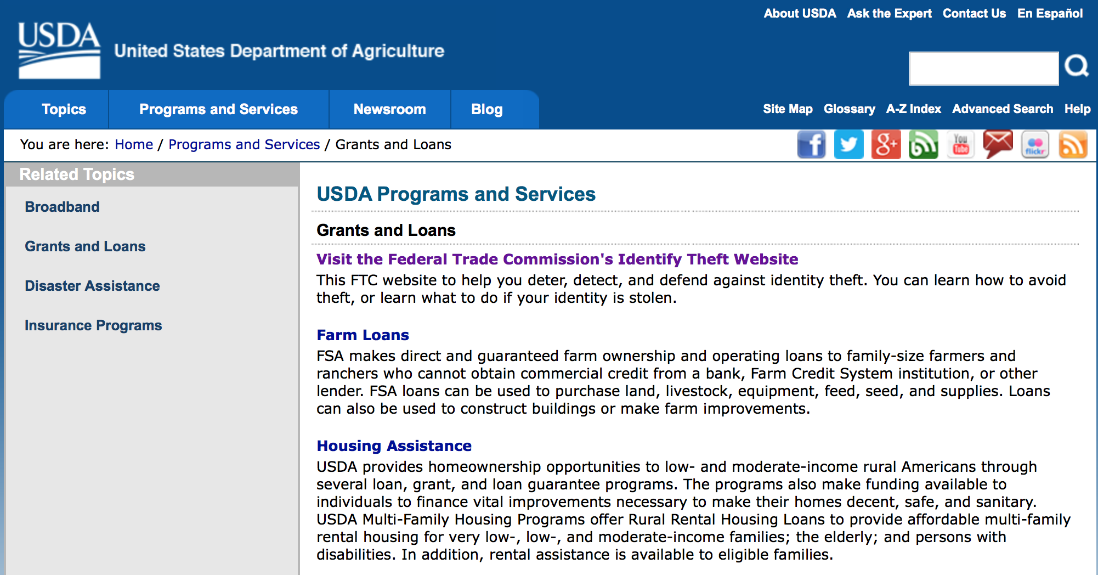
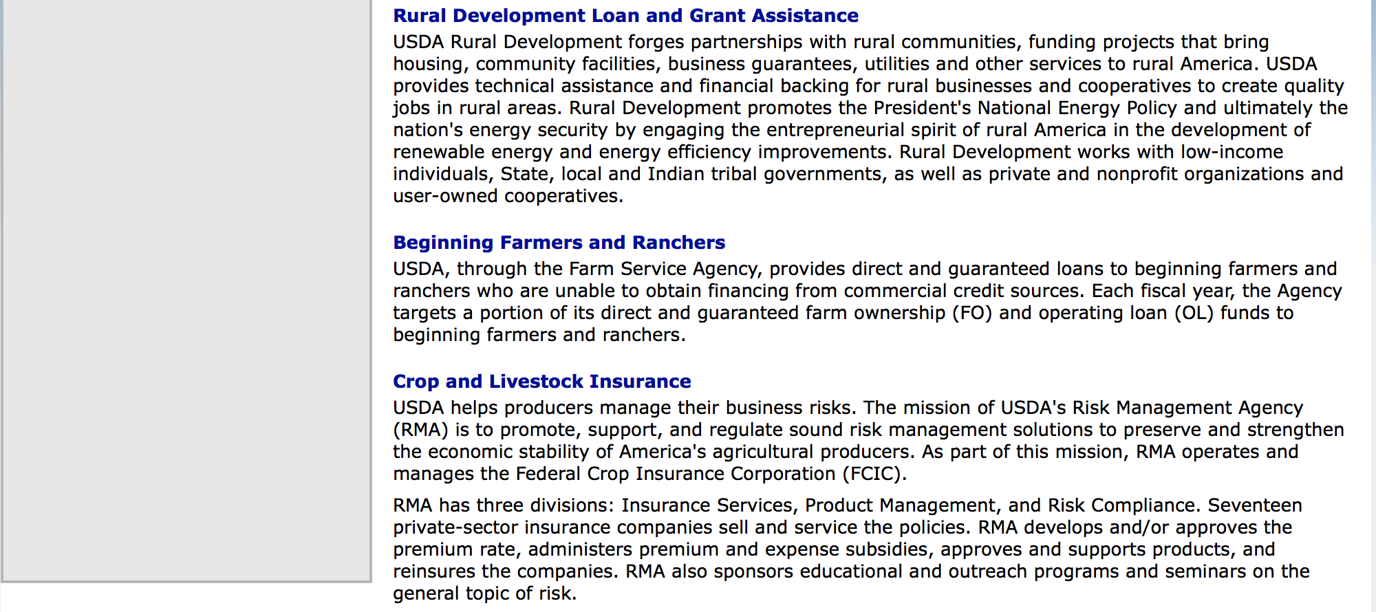

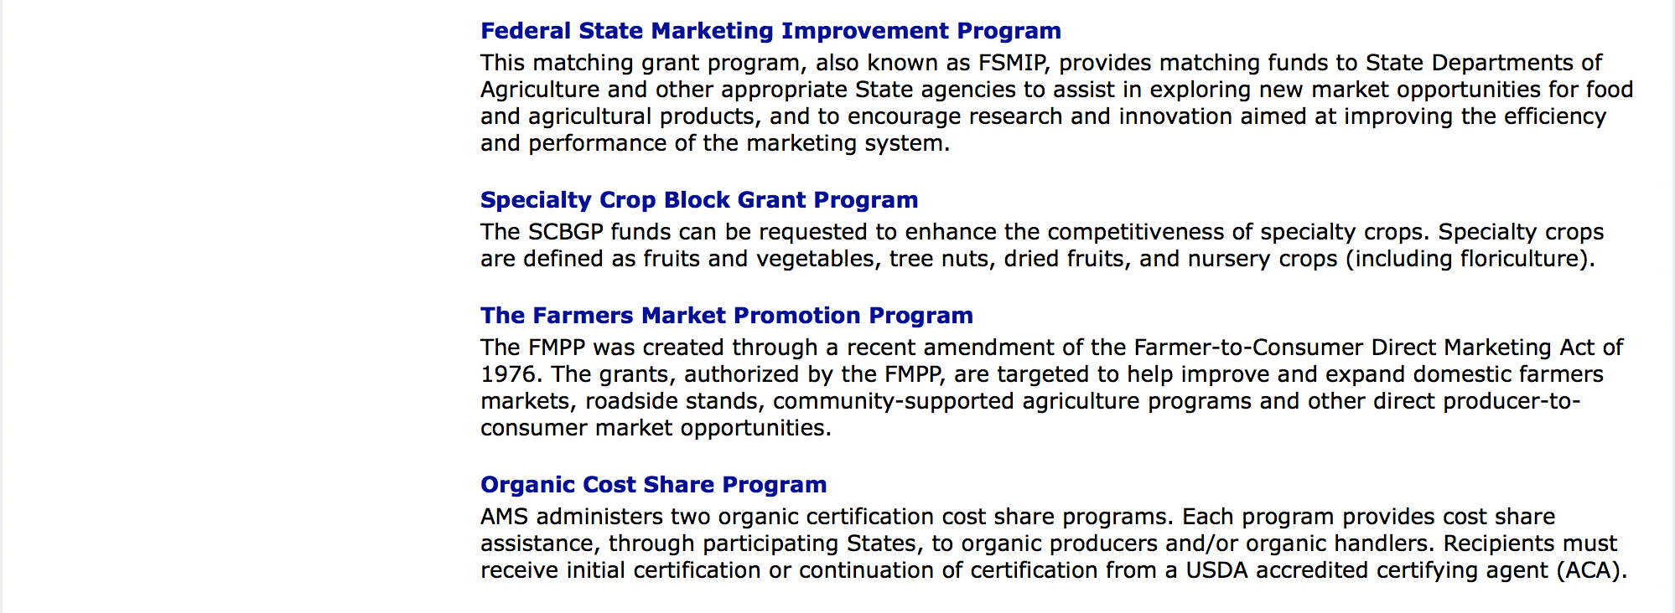

http://usda.gov/wps/portal/usda/usdahome?navid=GRANTS_LOANS

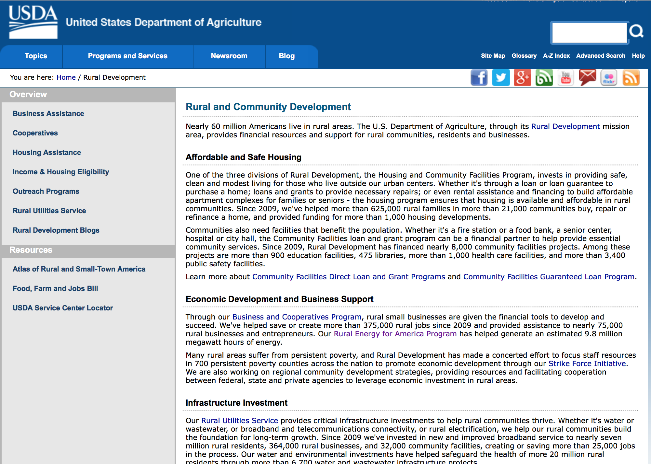

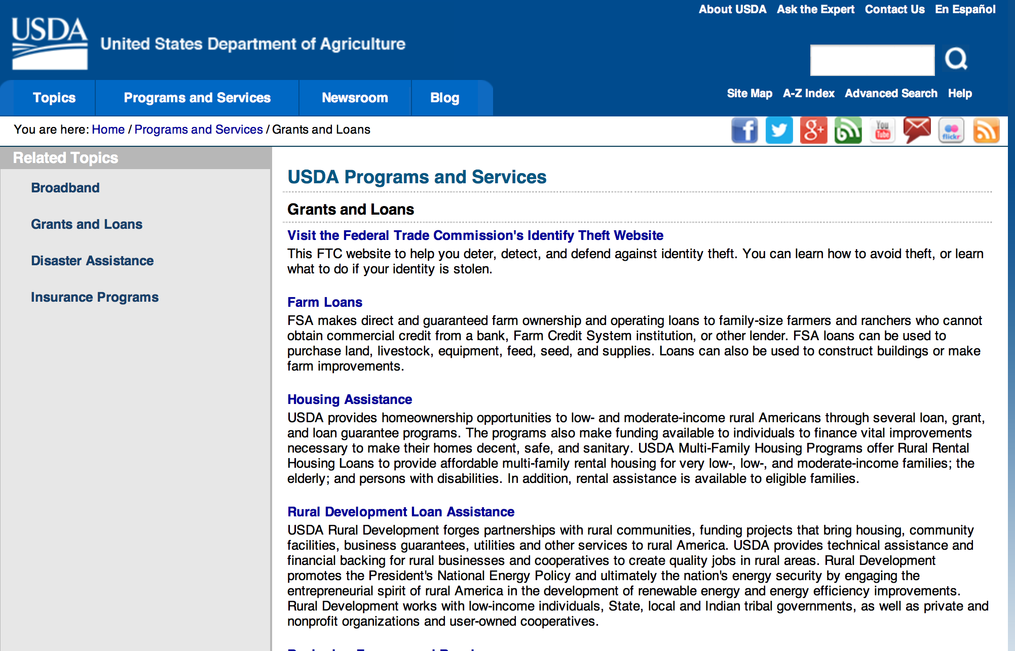

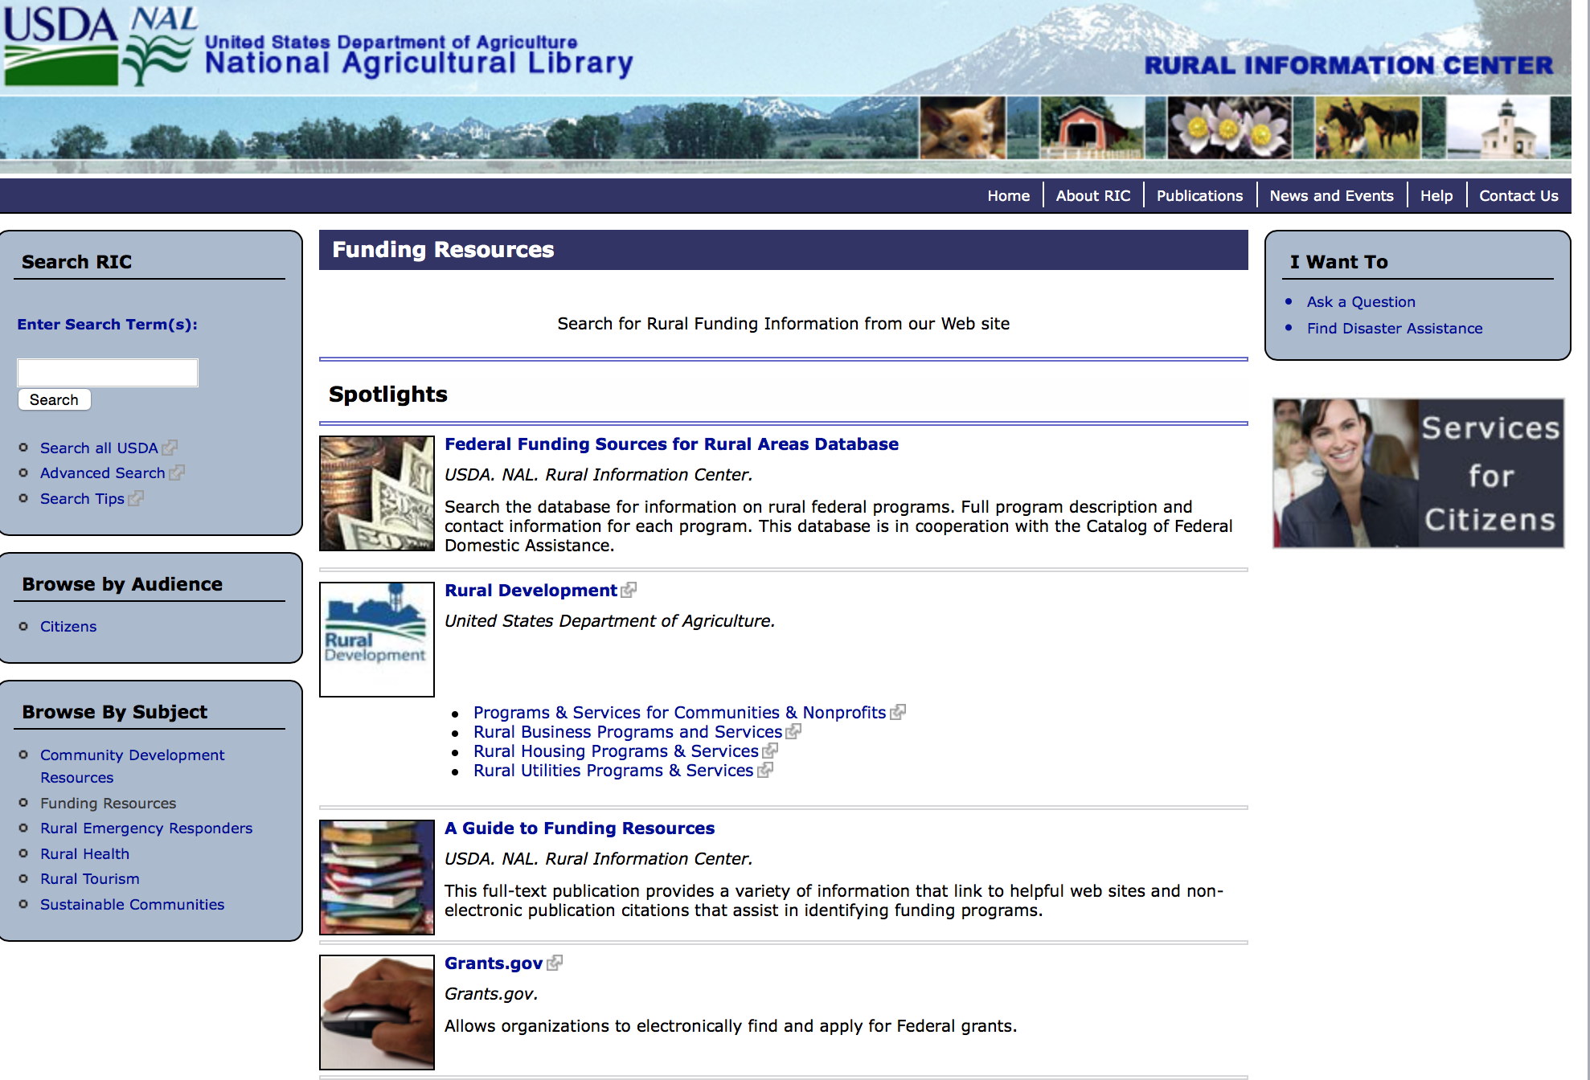

Federal Faith-Based Centers and Community Initiatives
USDA. NAL. Rural Information Center.
- Center for Faith-Based and Community Initiatives (link is external) , U.S. Department of Education
- Center for Faith-Based and Community Initiatives (link is external) , U.S. Department of Health and Human Services
- Center for Faith-Based and Community Initiatives (link is external) , U.S. Department of Labor
- Faith-Based and Community Initiatives (link is external) , U.S. Agency for International Development
- Faith-Based and Community Initiatives (link is external) , U.S. Department of Agriculture
- Faith-Based and Community Initiatives (link is external) , U.S. Department of Housing and Urban Development
- Faith-Based and Other Community Initiatives (link is external) , Corporation for National Community Service
- Task Force for Faith-Based and Community Initiatives (link is external) , U.S. Department of Justice

Grant Writing Resources
- Proposal Writing Short Course (link is external) Foundation Center.
- Data Universal Numbering System Fact sheet (link is external) [PDF | 302.2KB] USDA Rural Development.
- General Tips on Writing a Competitive Grant Proposal (link is external) U.S. Environmental Protection Agency.
- How to Write a Grant Proposal (link is external) Appalachian Regional Commission. <. li>

A Guide to Funding Resources USDA Rural Information Center.

http://ric.nal.usda.gov/funding-resources

http://usda.gov/wps/portal/usda/usdahome?navid=GRANTS_LOANS

Programs:

Food and Nutrition Service
FY 17 Farm to School Grant Program
Synopsis 1

Document Type: | Grants Notice
Funding Opportunity Number: | USDA-FNS-F2S-2017
Funding Opportunity Title: | FY 17 Farm to School Grant Program
Opportunity Category: | Discretionary
Opportunity Category Explanation:
Funding Instrument Type: | Cooperative Agreement
Category of Funding Activity: | Food and Nutrition
Category Explanation:
Expected Number of Awards: | 75
CFDA Number(s): | 10.575 -- Farm to School Grant Program
Cost Sharing or Matching Requirement: | Yes
Version: | Synopsis 1
Posted Date: | Sep 13, 2016
Last Updated Date: | Sep 13, 2016
Original Closing Date for Applications: | Dec 08, 2016
Current Closing Date for Applications: | Dec 08, 2016
Archive Date: | May 30, 2017
Estimated Total Program Funding: | $5,000,000
Award Ceiling: | $100,000
Award Floor: | $15,000
Eligible Applicants: | Others (see text field entitled "Additional Information on Eligibility" for clarification)
Additional Information on Eligibility: | The authorizing language specifies the following eligible entities: • Eligible schools; • State and local agencies; • Indian tribal organizations; • Agricultural producers or groups of agricultural producers; and, • Non-profit entities. ---Support Service Grants: Eligible Entities Only state and local agencies, Indian tribal organizations, agricultural producers or groups of agricultural producers, and non-profit entities are eligible to receive support service grants. ---Cooperative Extension Service programs are ineligible to apply for these grant projects. Implementation Grants: Eligible Entities Only pre-K-12 SFAs, non-profit private schools, charter schools, Indian tribal schools, and others that participate in the National School Lunch or Breakfast Programs, and/or operate USDA’s Summer Food Service Program/Seamless Summer Option or Child and Adult Care Food Program on-site, are eligible to receive implementation grants. ---Planning Grants: Eligible Entities Only pre-K-12 SFAs, non-profit private schools, charter schools, Indian tribal schools, and others that participate in the National School Lunch or Breakfast Programs, and/or operate USDA’s Summer Food Service Program/Seamless Summer Option or Child and Adult Care Food Program on-site, are eligible to receive planning grants. ---Training Grants: Eligible Entities Only state and local agencies, Indian tribal organizations, agricultural producers or groups of agricultural producers, and non-profit entities are eligible to receive training grant funds. Cooperative Extension Service programs are ineligible to apply for these grant projects.
Agency Name: | Food and Nutrition Service
Description: | The Healthy, Hunger-Free Kids Act of 2010 (HHFKA) amended Section 18 of the Richard B. Russell National School Lunch Act (NSLA) to establish a Farm to School Program in order to assist eligible entities, through grants and technical assistance, in implementing farm to school programs that improve access to local foods in eligible schools. To fulfill the farm to school mandate in the HHFKA, $5 million is provided to the United States Department of Agriculture (USDA) on an annual basis to support grants, technical assistance, and the Federal administrative costs related to USDA’s Farm to School Program. The USDA Farm to School Program is housed within the Food and Nutrition Services’ (FNS) Office of Community Food Systems (OCFS). This request for applications (RFA) provides additional details regarding the grants component of the USDA Farm to School Program. Authorizing language in the HHFKA directed the Secretary of Agriculture to award competitive grants for: (i) Training; (ii) Supporting operations; (iii) Planning; (iv) Purchasing equipment; (v) Developing school gardens; (vi) Developing partnerships; and, (vii) Implementing farm to school programs. The Secretary of Agriculture was also directed through the HHFKA to ensure geographical diversity and equitable treatment of urban, rural, and tribal communities, as well as give the highest priority to funding projects that, as determined by the Secretary – (a) Make local food products available on the menu of the eligible school; (b) Serve a high proportion of children who are eligible for free or reduced price lunches; (c) Incorporate experiential nutrition education activities in curriculum planning that encourage the participation of school children in farm and garden-based activities; (d) Demonstrate collaboration between eligible schools, nongovernmental and community-based organizations, agricultural producer groups, and other community partners; (e) Include adequate and participatory evaluation plans; (f) Demonstrate the potential for long-term program sustainability; and, (g) Meet any other criteria that the Secretary determines appropriate. Authorizing language also states that as a condition of receiving a USDA Farm to School Program Grant, each grant recipient shall provide matching support in the form of cash or in-kind contributions, and agree to cooperate in an evaluation of the program carried out using grant funds. Grant Tracks: Grant funds will be made available on a competitive basis, subject to availability of Federal funds, using four grants tracks: 1. Support Service grants are intended for eligible entities working with schools or school districts to further develop and provide broad reaching support services to farm to school initiatives. 2. Implementation grants are intended to help schools or school districts scale or further develop existing farm to school initiatives. 3. Planning grants are for schools or school districts just getting started on farm to school activities and are intended to help these entities organize and structure their efforts for maximum impact by embedding known best practices into early design considerations. 4. Training grants are intended for eligible entities to support trainings that strengthen farm to school supply chains, or trainings that provide technical assistance in the area of local procurement, food safety, culinary education, and/or integration of agriculture‐based curriculum. Awarded Amount per Grant Track/-Award Amounts: Support Service- $65,000 - $100,000 Implementation- $65,000 - $100,000 Planning - $20,000 - $45,000 Training Grants State- $15,000 - $25,000 Training Grants – Regional / National -$25,000 - $50,000
Link to Additional Information: | Farm to School Community Food System Website.
Grantor Contact Information: | If you have difficulty accessing the full announcement electronically, please contact:  Farm to School  Farm to School Contact

http://www.grants.gov/web/grants/view-opportunity.html?oppId=288870

National Institute of Food and Agriculture
Specialty Crop Research Initiative Request for Pre-applications
Synopsis 1
Document Type: | Grants Notice
Funding Opportunity Number: | USDA-NIFA-SCRI-006064
Funding Opportunity Title: | Specialty Crop Research Initiative Request for Pre-applications
Opportunity Category: | Mandatory
Opportunity Category Explanation:
Funding Instrument Type: | Grant
Category of Funding Activity: | Agriculture
Category Explanation:
Expected Number of Awards:
CFDA Number(s): | 10.309 -- Specialty Crop Research Initiative
Cost Sharing or Matching Requirement: | Yes
Version: | Synopsis 1
Posted Date: | Sep 27, 2016
Last Updated Date: | Sep 27, 2016
Original Closing Date for Applications: | Nov 15, 2016
Current Closing Date for Applications: | Nov 15, 2016
Archive Date: | Dec 15, 2016
Estimated Total Program Funding: | $48,128,978
Eligible Applicants: | Others (see text field entitled "Additional Information on Eligibility" for clarification)
Additional Information on Eligibility: | Pre-Applications may only be submitted by Federal agencies, national laboratories, colleges and universities, research institutions and organizations, private organizations or corporations, State Agricultural Experiment Stations, Cooperative Extension Services, individuals, or groups consisting of two or more of these entities.
Agency Name: | National Institute of Food and Agriculture
Description: | The purpose of the SCRI program is to address the critical needs of the specialty crop industry by awarding grants to support research and extension that address key challenges of national, regional, and multi-state importance in sustaining all components of food and agriculture, including conventional and organic food production systems. Projects must address at least one of five focus areas: Research in plant breeding, genetics, genomics, and other methods to improve crop characteristics; Efforts to identify and address threats from pests and diseases, including threats to specialty crop pollinators; Efforts to improve production efficiency, handling and processing, productivity, and profitability over the long term (including specialty crop policy and marketing) New innovations and technology, including improved mechanization and technologies that delay or inhibit ripening; and Methods to prevent, detect, monitor, control, and respond to potential food safety hazards in the production efficiency, handling and processing of specialty crops.
Link to Additional Information: | Specialty Crop Research Initiative Request for Pre-applications
Grantor Contact Information: | If you have difficulty accessing the full announcement electronically, please contact:  NIFA Help Desk Phone: 202-401-5048 Business hours are M-F, 7:00 am -5:00 pm ET, excluding Federal holidays  If you have any questions related to preparing application content

http://www.grants.gov/web/grants/view-opportunity.html?oppId=289172

National Institute of Food and Agriculture
Beginning Farmer and Rancher Development Program
Synopsis 1

Document Type: | Grants Notice
Funding Opportunity Number: | USDA-NIFA-BFR-006065
Funding Opportunity Title: | Beginning Farmer and Rancher Development Program
Opportunity Category: | Mandatory
Opportunity Category Explanation:
Funding Instrument Type: | Grant
Category of Funding Activity: | Agriculture
Category Explanation:
Expected Number of Awards:
CFDA Number(s): | 10.311 -- Beginning Farmer and Rancher Development Program
Cost Sharing or Matching Requirement: | Yes
Version: | Synopsis 1
Posted Date: | Sep 29, 2016
Last Updated Date: | Sep 29, 2016
Original Closing Date for Applications: | Dec 08, 2016
Current Closing Date for Applications: | Dec 08, 2016
Archive Date: | Jan 07, 2017
Estimated Total Program Funding: | $17,700,000
Eligible Applicants: | Others (see text field entitled "Additional Information on Eligibility" for clarification)
Additional Information on Eligibility: | Applications may only be submitted by a collaborative state, tribal, local, or regionally-based network or partnership of qualified public and/or private entities. These collaborations may include the following entities: State Cooperative Extension Services; Federal, State, or tribal agencies; community based organizations (CBOs); nongovernmental organizations (NGOs); junior and four-year colleges or universities or foundations maintained by a college or university; private for-profit organizations. Inclusion of beginning and/or non-beginning farmers and ranchers as part of the collaborative group is strongly encouraged. Applications submitted by individuals, or by organizations that do not involve other entities in a network or partnership, are not eligible for consideration under any category applicable to the BFRDP.
Agency Name: | National Institute of Food and Agriculture
Description: | Beginning farmer education for adult and young audiences in the United States can be generally traced back to the advent of the 1862 and the 1890 Morrill Land Grant Acts. But for the first time, the Food, Conservation, and Energy Act of 2008 (Pub .L. No. 110-234, Section 7410), appropriated $75 million for FY 2009 to FY 2012 to develop and offer education, training, outreach and mentoring programs to enhance the sustainability of the next generation of farmers. The Agriculture Act of 2014 provided an additional $20 million per year for 2014 through 2018. The reasons for the renewed interest in beginning farmer and rancher programs are: the rising average age of U.S. farmers, the 8% projected decrease in the number of farmers and ranchers between 2008 and 2018, and the growing recognition that new programs are needed to address the needs of the next generation of beginning farmers and ranchers.
Link to Additional Information: | Beginning Farmer and Rancher Development Program
Grantor Contact Information: | If you have difficulty accessing the full announcement electronically, please contact:  NIFA Help Desk Phone: 202-401-5048 Business hours are M-F, 7:00 am -5:00 pm ET, excluding Federal holidays  If you have any questions related to preparing application content

http://www.grants.gov/web/grants/view-opportunity.html?oppId=289254

Utilities Programs
RUS SWM Grant FY 2017
Synopsis 1

Document Type: | Grants Notice
Funding Opportunity Number: | SWMFY2017
Funding Opportunity Title: | RUS SWM Grant FY 2017
Opportunity Category: | Discretionary
Opportunity Category Explanation:
Funding Instrument Type: | Grant
Category of Funding Activity: | Other (see text field entitled "Explanation of Other Category of Funding Activity" for clarification)
Category Explanation: | The Solid Waste Management (SWM) Grant Program has been established to assist communities through free technical assistance and/or training provided by the grant recipients. Qualified organizations will receive SWM grant funds to reduce or eliminate pollution of water resources in rural areas, and improve planning and management of solid waste sites in rural areas.
Expected Number of Awards: | 30
CFDA Number(s): | 10.762 -- Solid Waste Management Grants
Cost Sharing or Matching Requirement: | No
Version: | Synopsis 1
Posted Date: | Oct 01, 2016
Last Updated Date: | Sep 30, 2016
Original Closing Date for Applications: | Dec 31, 2016
Current Closing Date for Applications: | Dec 31, 2016
Archive Date: | Jan 30, 2017
Estimated Total Program Funding: | $4,000,000
Award Ceiling: | $0
Award Floor: | $0
Eligible Applicants: | Others (see text field entitled "Additional Information on Eligibility" for clarification)
Additional Information on Eligibility: | An organization is eligible to receive a SWM grant if it:a. Is a private, non-profit organization that has tax-exempt status from the United States Internal Revenue Service (IRS);b. Is a Public body; c. Is a federally acknowledged or State-recognized Native American tribe or group; d. Is an Academic institution; e. Is legally established and located within one of the following: a state within the United States; the District of Columbia; the Commonwealth of Puerto Rico; a United States territory. Has the legal capacity and authority to carry out the grant purpose; g. Has a proven record of successfully providing technical assistance and/or training to rural areas; h. Has capitalization acceptable to the Agency, and is composed of at least 51 percent of the outstanding interest or membership being citizens of the United States or individuals who reside in the United States after being legally admitted for permanent residence; i. Has no delinquent debt to the Federal Government or no outstanding judgments to repay a Federal debt; j. Demonstrates that it possesses the financial, technical, and managerial capability to comply with Federal and State laws and requirements. k. Contracts with a nonaffiliated organization for not more than 49 percent of the grant to provide the proposed assistance.
Agency Name: | Utilities Programs
Description: | Funds may be used to: Evaluate current landfill conditions to determine threats to water resources in rural areas; provide technical assistance and/or training to enhance operator skills in the maintenance and operation of active landfills in rural areas; provide technical assistance and/or training to help associations reduce the solid waste stream; and provide technical assistance and/or training for operators of landfills in rural areas which are closed or will be closed in the near future with the development/implementation of closure plans, future land use plans, safety and maintenance planning, and closure scheduling within permit requirements. Grant funds may not be used to: Recruit preapplications/applications for any loan and/or grant program including RUS Water and Waste Disposal Loan and/or Grant Program; duplication of current services, replacement or substitution of support previously provided such as those performed by an association's consultant in developing a project; fund political activities; pay for capital assets, the purchase of real estate or vehicles, improve and renovate office space, or repair and maintain privately-owned property; pay for construction or operation and maintenance costs of water and waste facilities; and pay costs incurred prior to the effective date of grants made under 7 CFR 1775.
Link to Additional Information: | Program Website address
Grantor Contact Information: | If you have difficulty accessing the full announcement electronically, please contact:  LAVONDA PERNELL Community Programs Specialist Phone 202-720-9635  government address

http://www.grants.gov/web/grants/view-opportunity.html?oppId=289284

Modifications:

Reminders:

National Institute of Food and Agriculture
Food and Agricultural Sciences National Needs Graduate and Postgraduate Fellowship (NNF) Grants Program
Synopsis 1

Document Type: | Grants Notice
Funding Opportunity Number: | USDA-NIFA-HEP-006007
Funding Opportunity Title: | Food and Agricultural Sciences National Needs Graduate and Postgraduate Fellowship (NNF) Grants Program
Opportunity Category: | Discretionary
Opportunity Category Explanation:
Funding Instrument Type: | Grant
Category of Funding Activity: | Agriculture  Education
Category Explanation:
Expected Number of Awards:
CFDA Number(s): | 10.210 -- Higher Education - Graduate Fellowships Grant Program
Cost Sharing or Matching Requirement: | No
Posted Date: | Aug 12, 2016
Last Updated Date: | Aug 12, 2016
Original Closing Date for Applications: | Oct 11, 2016
Current Closing Date for Applications: | Oct 11, 2016
Archive Date: | Nov 10, 2016
Estimated Total Program Funding: | $3,100,000
Award Ceiling: | $262,500
Award Floor: | $4,500
Eligible Applicants: | Others (see text field entitled "Additional Information on Eligibility" for clarification)
Additional Information on Eligibility: | Pursuant to section 1417 of the NARETPA of 1977 (7 U.S.C. 3152), and administrative provisions that can be found in 7 CFR 3402 applications may be submitted by: (1) Land-grant institutions including the University of the District of Columbia; (2) Colleges and universities having significant minority enrollments and a demonstrable capacity to carry out the teaching of food and agricultural sciences; and (3) Other colleges and universities having a demonstrable capacity to carry out the teaching of food, and agricultural sciences.
Agency Name: | National Institute of Food and Agriculture
Description: | The purpose of the NNF Grants Program is to provide funding to support students’ training and completion of master’s and/or doctoral degree programs in identified national need areas within the Food, Agricultural, Natural Resources, and Human Sciences. Awards made under NNF are specifically intended to support traineeship programs that engage outstanding students to pursue and complete their degrees in areas where there is a national need for the development of scientific and professional expertise in the food and agricultural sciences. NNF awards invest in graduate training and relevant international experiential learning for a cadre of diverse individuals who demonstrate their potential to successfully complete graduate degree programs in disciplines relevant to the mission of the USDA.
Link to Additional Information: | Food and Agricultural Sciences National Needs Graduate and Postgraduate Fellowship (NNF) Grants Program
Grantor Contact Information: | If you have difficulty accessing the full announcement electronically, please contact:  NIFA Help Desk Phone: 202-401-5048 Business hours are M-F, 7:00 am -5:00 pm ET, excluding Federal holidays  If you have any questions related to preparing application content

http://www.grants.gov/web/grants/view-opportunity.html?oppId=287361

National Institute of Food and Agriculture
Agriculture and Food Research Initiative - Agriculture and Natural Resources Science for Climate Variability and Change Challenge Area
Synopsis 1

Document Type: | Grants Notice
Funding Opportunity Number: | USDA-NIFA-AFRI-005942
Funding Opportunity Title: | Agriculture and Food Research Initiative - Agriculture and Natural Resources Science for Climate Variability and Change Challenge Area
Opportunity Category: | Discretionary
Opportunity Category Explanation:
Funding Instrument Type: | Grant
Category of Funding Activity: | Agriculture
Category Explanation:
Expected Number of Awards:
CFDA Number(s): | 10.310 -- Agriculture and Food Research Initiative (AFRI)
Cost Sharing or Matching Requirement: | No
Version: | Synopsis 1
Posted Date: | Jul 12, 2016
Last Updated Date: | Jul 12, 2016
Original Closing Date for Applications: | Nov 17, 2016
Current Closing Date for Applications: | Nov 17, 2016
Archive Date: | Dec 17, 2016
Estimated Total Program Funding: | $8,400,000
Eligible Applicants: | Others (see text field entitled "Additional Information on Eligibility" for clarification)
Additional Information on Eligibility: | See Part III, A., Eligible Applicants. Eligibility is linked to the project type. All project types are described beginning in Part II, C.
Agency Name: | National Institute of Food and Agriculture
Description: | This AFRI Challenge Area focuses on the priority to mitigate and adapt to climate variability and change. It supports activities that reduce greenhouse gas emissions, increase carbon sequestration in agricultural and forest production systems, and prepare the nation's agriculture and forests to adapt to variable climates. The long-term outcome for this program is to reduce the use of energy, nitrogen fertilizer, and water by ten percent and increase carbon sequestration by fifteen percent through resilient agriculture and forest production systems. In order to achieve this outcome, this program will support multi-function Integrated Research, Education, and/or Extension Projects and Food and Agricultural Science Enhancement (FASE) Grants.
Link to Additional Information: | AFRI Agriculture and Natural Resources Science for Climate Variability and Change Challenge Area
Grantor Contact Information: | If you have difficulty accessing the full announcement electronically, please contact:  NIFA Help Desk Phone: 202-401-5048 Business hours are M-F, 7:00 am -5:00 pm ET, excluding Federal holidays  If you have any questions related to preparing application content

http://www.grants.gov/web/grants/view-opportunity.html?oppId=285990

Department of Commerce

Grants, Contracting, and Trade Opportunities at Commerce
Learn more information about grants, contracting and trade opportunities at the Department of Commerce using the information below.

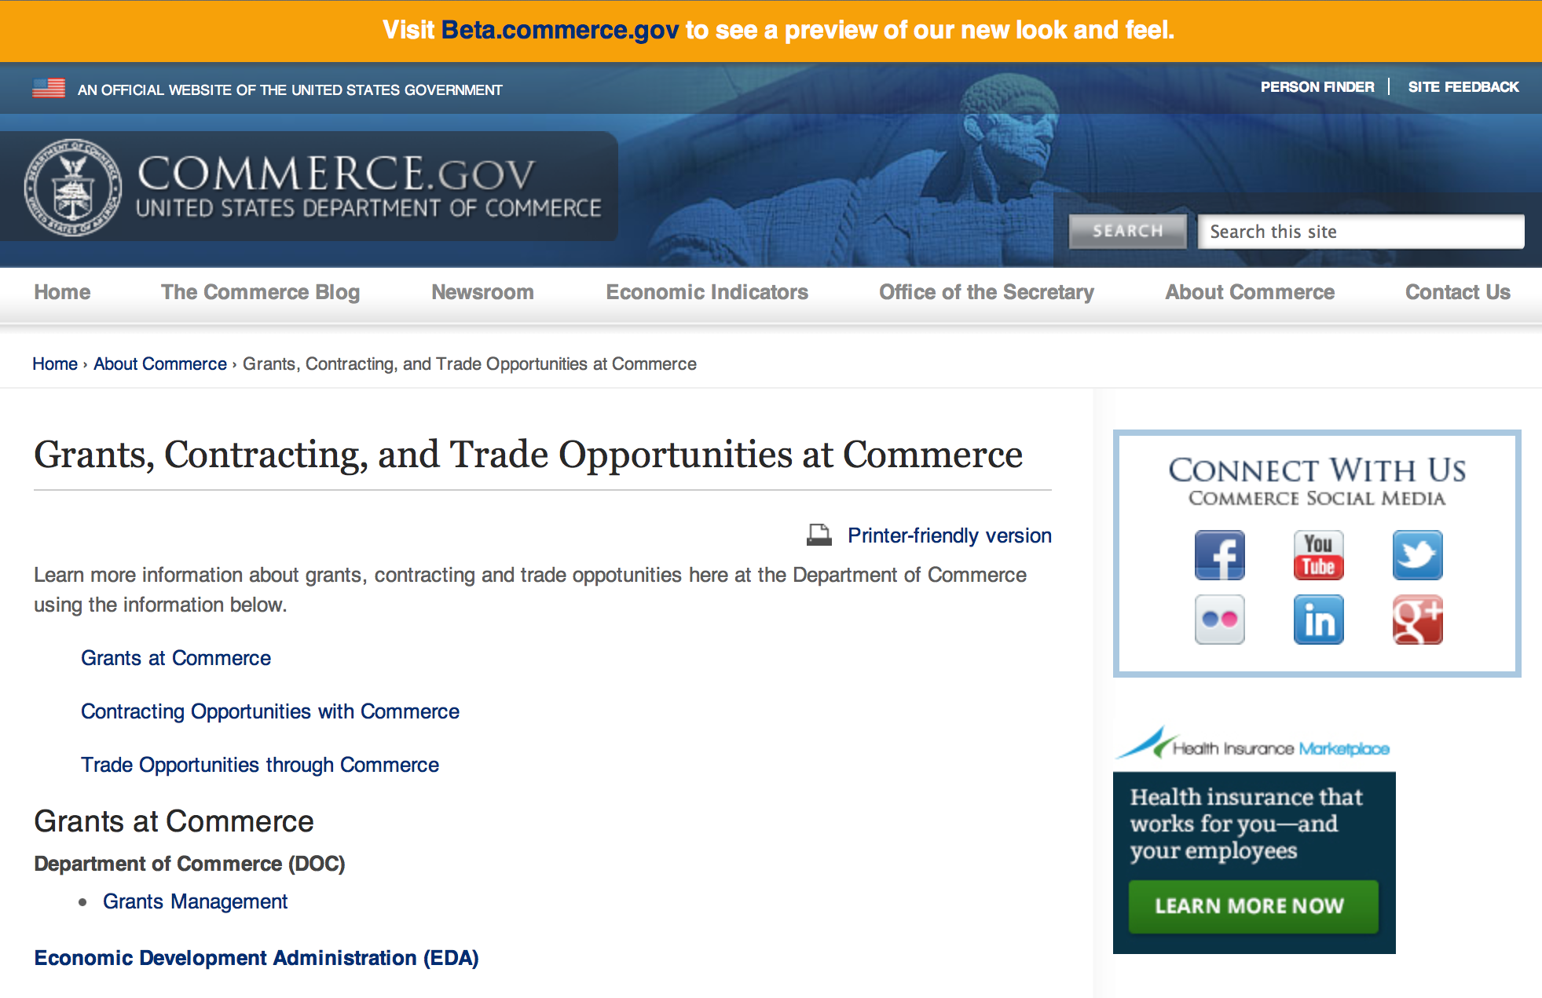
Grants at Commerce
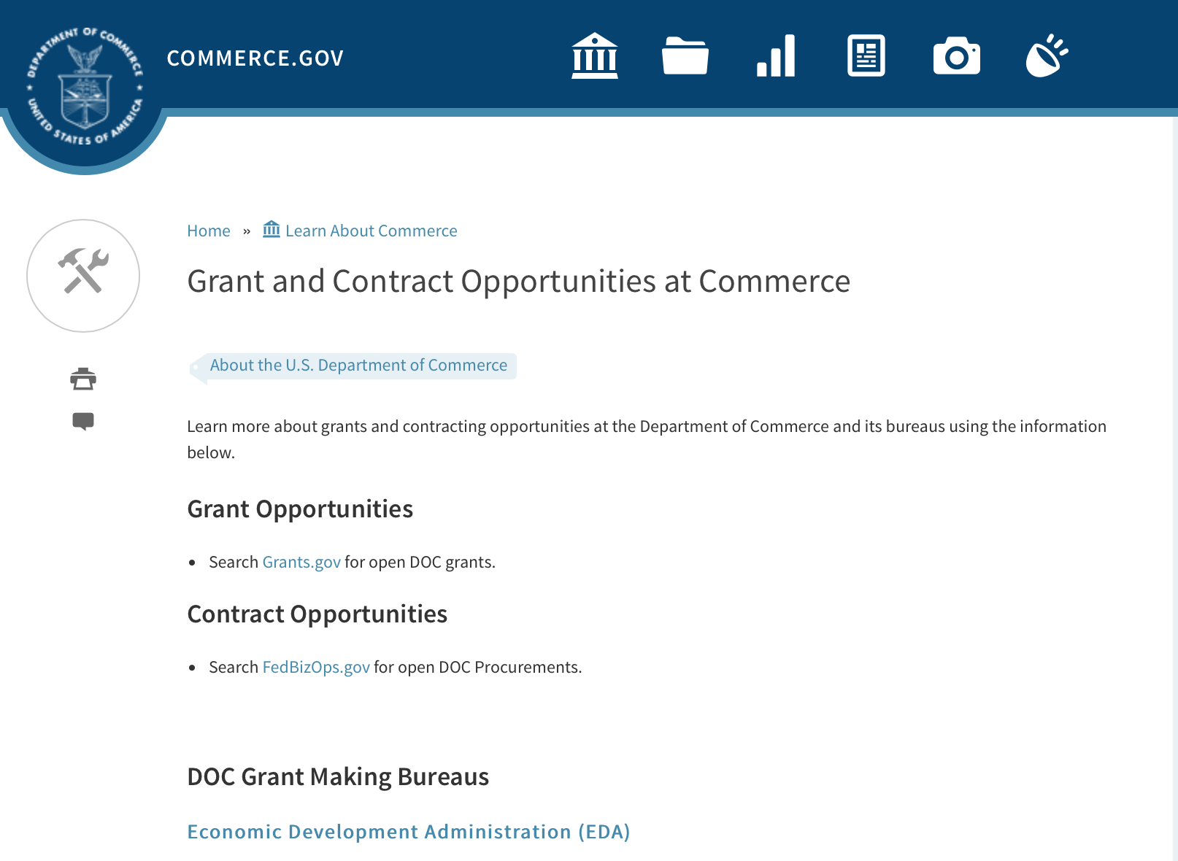

DOC Grant Making Bureaus
Economic Development Administration (EDA)
International Trade Administration (ITA)
- Market Development Cooperator Program
- Special American Business Internship Training Program (SABIT). A technical assistance initiative of the International Trade Administration of the U.S. Department of Commerce, SABIT offers organizations competitive grants and an opportunity to host industry-specific delegations. SABIT serves as an initial entry point for U.S. businesses seeking funding to establish long-term relationships with potential customers, distributors, or partners in the former Soviet Union. The program trains Eurasian managers and scientists in commonly accepted business practices as a means of facilitating cross border relationships. In turn, these personal relationships serve as a basis for business development and reduce market access barriers for U.S. businesses
National Institute of Standards & Technology (NIST)
- Funding Opportunities
National Telecommunications & Information Administration (NTIA)
- Telecommunications Grants
National Oceanic & Atmospheric Administration (NOAA)
- Coastal Ocean Program Grant Information
- Fisheries Saltonstall Kennedy Grant Program
- National Undersea Research Program Funding Opportunities
- Grants Management Division
- Fisheries Grants Program
- National Sea Grant
- Office of Global Programs
Contracting Resources for Contractors
- Office of Small and Disadvantaged Business Utilization (OSDBU) - he Office of Small and Disadvantaged Business Utilization (OSDBU) is an advocacy and advisory office responsible for promoting the use of small, small disadvantaged, 8(a), women-owned, veteran-owned, service-disabled veteran-owned, and HUBZone small businesses within the U.S. Department of Commerce's (DOC) acquisition process.
- Business.USA.gov's Find Opportunities Wizard where in a few quick steps, it will guide you towards federal government contracting programs and opportunities for your business!
- Planned Acquisitions: the Department of Commerce's search tool for our planned acquisitions over $100,000. As requirements change, these acquisition plans are updated by department personnel and this search tool is automatically updated.
- Small Business Administration's Contracting section of their web site where you can learn about how to "Get Started" and "Contracting Support for Small Business"
- The General Services Administration (GSA) has implemented a system for vendors doing business with the Federal Government to manage their entity information in one central location. This new database is the System for Award Management (SAM).

DOC Contracting Offices
- Patent and Trademark Office (PTO)
  - Office of Procurement
- National Institute of Standards & Technology (NIST)
NIST Acquisition Management Group
Contracting Opportunities with Commerce
Trade Opportunities through Commerce
http://www.commerce.gov/about-commerce/grants-contracting-trade-opportunities

Programs:

Research:

FY2017 Marine Debris Research
Synopsis 1
http://www.grants.gov/web/grants/view-opportunity.html?oppId=289016

FY 2017 Joint Hurricane Testbed (JHT), Hazardous Weather Testbed (HWT), and Hydrometeorology Testbed (HMT)
Synopsis 1
http://www.grants.gov/web/grants/view-opportunity.html?oppId=289114

Collaborative Science, Technology, and Applied Research (CSTAR) Program
Synopsis 1
http://www.grants.gov/web/grants/view-opportunity.html?oppId=289115

Regional Vulnerability Assessments for Ocean Acidification (RVA-OA17)
Synopsis 1
http://www.grants.gov/web/grants/view-opportunity.html?oppId=288520

Collaborative Science, Technology, and Applied Research (CSTAR) Program
Synopsis 2
http://www.grants.gov/web/grants/view-opportunity.html?oppId=289115

Modifications:

Reminders:

Fiscal Year 2018 National Sea Grant College Program Dean John A. Knauss Marine Policy Fellowship
Synopsis 1

Document Type: | Grants Notice
Funding Opportunity Number: | NOAA-OAR-SG-2018-2004993
Funding Opportunity Title: | Fiscal Year 2018 National Sea Grant College Program Dean John A. Knauss Marine Policy Fellowship
Opportunity Category: | Discretionary
Opportunity Category Explanation:
Funding Instrument Type: | Cooperative Agreement
Category of Funding Activity: | Environment  Natural Resources  Science and Technology and other Research and Development
Category Explanation:
Expected Number of Awards: | 30
CFDA Number(s): | 11.417 -- Sea Grant Support
Cost Sharing or Matching Requirement: | No
Posted Date: | Aug 11, 2016
Last Updated Date: | Aug 11, 2016
Original Closing Date for Applications: | Mar 31, 2017
Current Closing Date for Applications: | Mar 31, 2017
Archive Date: | Apr 30, 2017
Estimated Total Program Funding:
Award Ceiling: | $66,500
Award Floor: | $56,500
Eligible Applicants: | Others (see text field entitled "Additional Information on Eligibility" for clarification)
Additional Information on Eligibility: | An eligible applicant is any student, regardless of citizenship, who, on February 10, 2017, is enrolled towards a degree in a graduate program, that have an interest in ocean, coastal and Great Lakes resources and in the national policy decisions affecting those resources. The graduate degree needs to be awarded through a United States accredited institution of higher education in the United States or U.S. Territories.
Agency Name: | Department of Commerce
Description: | This notice announces that applications may be submitted for the 2018 National Sea Grant College Program Dean John A. Knauss Marine Policy Fellowship (Sea Grant Knauss Fellowship Program). Sea Grant anticipates funding not less than 30 selected applicants, of which those assigned to the Legislative branch may be limited to 12. Each award will be funded at a total of $56,500 in federal funding, with the option by the host office to add no more than $10,000 for fellow travel related to host office duties, for a maximum of $66,500.
Link to Additional Information:
Grantor Contact Information: | If you have difficulty accessing the full announcement electronically, please contact:  Julia Galkiewicz Sea Grant Knauss Fellowship Program Manager National Sea Grant College Program 1315 East-West Highway, R/SG, Room 11861 Silver Spring, MD 20910 (301) 734-1067 E-mail: OAR.SG.Fellows@noaa.gov  Work

http://www.grants.gov/web/grants/view-opportunity.html?oppId=287335

FY2017 Community-based Marine Debris Removal
Synopsis 1

Document Type: | Grants Notice
Funding Opportunity Number: | NOAA-NOS-ORR-2017-2004997
Funding Opportunity Title: | FY2017 Community-based Marine Debris Removal
Opportunity Category: | Discretionary
Opportunity Category Explanation:
Funding Instrument Type: | Cooperative Agreement
Category of Funding Activity: | Environment  Natural Resources  Science and Technology and other Research and Development
Category Explanation:
Expected Number of Awards: | 15
CFDA Number(s): | 11.999 -- Marine Debris Program
Cost Sharing or Matching Requirement: | Yes
Posted Date: | Aug 11, 2016
Last Updated Date: | Aug 11, 2016
Original Closing Date for Applications: | Oct 14, 2016
Current Closing Date for Applications: | Oct 14, 2016
Archive Date: | Nov 13, 2016
Estimated Total Program Funding: | $2,000,000
Award Ceiling: | $350,000
Award Floor: | $15,000
Eligible Applicants: | Others (see text field entitled "Additional Information on Eligibility" for clarification)
Additional Information on Eligibility: | In accordance with the Marine Debris Act, eligible applicants are state, local, and tribal governments whose activities affect research or regulation of marine debris and any institution of higher education, nonprofit organization, or commercial (for-profit) organization with expertise in a field related to marine debris. Applications from federal agencies or employees of federal agencies will not be considered. Interested federal agencies may collaborate with eligible applicants but may not receive funds through this competition. Foreign organizations and foreign public entities are not eligible to apply. All projects must take place within the United States or territories or their respective waterways. NOAA is strongly committed to broadening the participation of veterans, historically black colleges and universities, Hispanic-serving institutions, tribal colleges and universities, and institutions that work in under-served areas. NOAA encourages proposals involving any of the above institutions. Applications that have been submitted to other NOAA grant programs or as part of another NOAA grant may be considered under this solicitation
Agency Name: | Department of Commerce
Description: | The NOAA Marine Debris Program, authorized in the Marine Debris Research, Prevention, and Reduction Act, codified at 33 U.S.C. 1951-1958, provides funding to support locally-driven, marine debris prevention, assessment, and removal projects that will benefit coastal habitat, waterways, and NOAA trust resources. Funding for this purpose comes through the NOAA Marine Debris Program as appropriations to the Office of Response and Restoration, National Ocean Service. Projects awarded through this grant competition will implement effective, on-the-ground marine debris removal activities, with priority for those targeting medium- large-scale debris, including derelict fishing gear. Projects should also provide benefits to coastal communities, and create long-term ecological habitat improvements for NOAA trust resources. Through this solicitation NOAA identifies marine debris removal projects, fosters awareness of the effects of marine debris to further the conservation of living marine resource habitats, and contributes to the understanding of marine debris composition, distribution and impacts. Successful proposals through this solicitation will be funded through cooperative agreements.
Link to Additional Information:
Grantor Contact Information: | If you have difficulty accessing the full announcement electronically, please contact:  Mr. Tom Barry 240-533-0425 1305 East-West Hwy, Silver Spring, MD 20910-3281  Work

http://www.grants.gov/web/grants/view-opportunity.html?oppId=287350

Ocean Exploration FY 2017 Funding Opportunity
Synopsis 1

Document Type: | Grants Notice
Funding Opportunity Number: | NOAA-OAR-OER-2017-2004970
Funding Opportunity Title: | Ocean Exploration FY 2017 Funding Opportunity
Opportunity Category: | Discretionary
Opportunity Category Explanation:
Funding Instrument Type: | Cooperative Agreement  Grant
Category of Funding Activity: | Environment  Natural Resources  Science and Technology and other Research and Development
Category Explanation:
Expected Number of Awards: | 10
CFDA Number(s): | 11.011 -- Ocean Exploration
Cost Sharing or Matching Requirement: | No
Posted Date: | Aug 02, 2016
Last Updated Date: | Aug 02, 2016
Original Closing Date for Applications: | Dec 23, 2016
Current Closing Date for Applications: | Dec 23, 2016
Archive Date: | Jan 22, 2017
Estimated Total Program Funding: | $3,000,000
Award Ceiling: | $750,000
Award Floor: | $10,000
Eligible Applicants: | Others (see text field entitled "Additional Information on Eligibility" for clarification)
Additional Information on Eligibility: | Eligible applicants are institutions of higher education; non-profit institutions; for-profit organizations; state, local, and tribal governments, and U.S. territories that possess the statutory authority to accept funding for this type of work. Federal agencies that possess the statutory authority to accept funding for this type of work may also apply. Federal and state agencies are strongly encouraged to collaborate with partners from a non-federal eligible entity. OER funding will not be used to hire and/or fund the salaries and associated overhead of any permanent federal employees. Federal award recipients may use their funding to cover only travel, equipment, supplies, and contractual personnel costs associated with the proposed work. Foreign researchers may participate by submitting a sub-award through collaboration with an eligible U.S. entity. The DOC and NOAA support cultural and gender diversity and encourage women and minority individuals and groups to submit applications to this Announcement of Federal Funding Opportunity. In addition, DOC/NOAA is strongly committed to broadening the participation of historically black colleges and universities, Hispanic serving institutions, tribal colleges and universities, and institutions that work in underserved areas. DOC/NOAA encourages applications involving any of the above institutions to apply. PLEASE NOTE: Before non-NOAA Federal applicants may be funded, they must demonstrate that they have legal authority to receive funds from another Federal agency in excess of their appropriation.
Agency Name: | Department of Commerce
Description: | NOAA’s Office of Ocean Exploration & Research (OER) seeks to enhance ocean exploration and scientific knowledge of the unknown or poorly known areas of the ocean. This entails identifying, describing and creating baseline characterizations of new ocean habitats, marine resources and/or processes. In this Announcement, OER is seeking proposals focused on four themes: 1. Exploration of physical, chemical and biological environments and processes within the oceanic water column below ~200m; 2. Exploration of geological, physical, and biological environments as well as biogeochemical processes associated with seamounts; 3. Novel or innovative technologies and methodologies that could increase the pace and scope of ocean exploration, especially exploration of the water column, seamounts, and archaeological sites; and 4. Proposals focused on the discovery and exploration of historically significant submerged marine heritage sites, features and artifacts associated with WWII. Proposals that combine more than one of these exploration themes are encouraged. OER’s overarching objective is to investigate and document poorly known and unknown ocean areas through interdisciplinary exploration, and to advance and disseminate knowledge of the ocean’s physical, geological, chemical, biological, and archaeological environments. Findings from projects and expeditions are anticipated to result in new baseline characterizations; provide better scientific understanding of the processes on U.S. continental margins and the deep ocean; offer new insights into climate variability and marine ecosystems; reveal new or unconventional energy, mineral, biological, and archaeological resources; help identify hazards resulting from extreme events such as submarine volcanic eruptions, earthquakes and tsunamis; and deliver technology advancements (platforms, sensors, methodologies, etc.) that will increase observational capabilities in the ocean. OER is interested in characterization of seamounts located within regions of the U.S. EEZ or ECS, including the Gulf of Alaska, the NW Atlantic, and the deep regions of Marine Protected Areas. Characterization of physical, chemical, and biological ocean environments associated with seamounts in areas where ocean mining may occur (e.g., regions along the Clarion-Clipperton Fracture) is also of particular interest. OER may also consider proposals focused on other areas that are relevant to OER's and NOAA's missions and priorities that would include significant leveraged resources. Archaeology proposals are not restricted to any depth or geographic area.
Link to Additional Information:
Grantor Contact Information: | If you have difficulty accessing the full announcement electronically, please contact:  NOAA Office of Ocean Exploration and Research ATTN: OER FFO 2017, SSMC3, Rm 10316 1315 East West Highway Silver Spring, Maryland 20910 (301) 734-1014 oer.ffo2017@noaa.gov  Work

http://www.grants.gov/web/grants/view-opportunity.html?oppId=286859

National Competitive Harmful Algal Bloom Programs: The Ecology and Oceanography of Harmful Algal Blooms (ECOHAB) and Prevention, Control and Mitigation of Harmful Algal Blooms Program (PCMHAB)
Synopsis 1

Document Type: | Grants Notice
Funding Opportunity Number: | NOAA-NOS-NCCOS-2017-2004943
Funding Opportunity Title: | National Competitive Harmful Algal Bloom Programs: The Ecology and Oceanography of Harmful Algal Blooms (ECOHAB) and Prevention, Control and Mitigation of Harmful Algal Blooms Program (PCMHAB)
Opportunity Category: | Discretionary
Opportunity Category Explanation:
Funding Instrument Type: | Cooperative Agreement
Category of Funding Activity: | Environment  Natural Resources  Science and Technology and other Research and Development
Category Explanation:
Expected Number of Awards:
CFDA Number(s): | 11.478 -- Center for Sponsored Coastal Ocean Research Coastal Ocean Program
Cost Sharing or Matching Requirement: | No
Posted Date: | Aug 02, 2016
Last Updated Date: | Aug 02, 2016
Original Closing Date for Applications: | Nov 02, 2016
Current Closing Date for Applications: | Nov 02, 2016
Archive Date: | Dec 02, 2016
Estimated Total Program Funding: | $1,000,000
Award Ceiling: | $750,000
Award Floor: | $100,000
Eligible Applicants: | Others (see text field entitled "Additional Information on Eligibility" for clarification)
Additional Information on Eligibility: | Eligible applicants for Federal financial assistance in this competition are institutions of higher education, other non-profits, state, local, Indian Tribal Governments, for-profit organizations, U.S. Territories and Federal agencies that possess the statutory authority to receive transfers of funds. DOC/NOAA supports cultural and gender diversity and encourages women and minority individuals and groups to submit applications to the NCCOS/CSCOR programs. In addition, DOC/NOAA is strongly committed to broadening the participation of historically black colleges and universities, Hispanic serving institutions, tribal colleges and universities, and institutions that work in underserved areas. DOC/NOAA encourages applications involving any of the above institutions to apply. Please note that: (1) Principal Investigators should be employees of an eligible entity listed above; and applications should be submitted through that entity. Non-Federal researchers should comply with their institutional requirements for application submission. (2) Non-NOAA Federal applicants will be required to submit certifications or documentation showing that they have specific legal authority to accept funds for this type of research. (3) Foreign researchers must apply as subawards or contracts through an eligible US entity. (4) Non-Federal researchers affiliated with NOAA-University Cooperative/Joint Institutes will be funded through cooperative agreements. (5) NOAA/NOS/NCCOS researchers are ineligible to apply. A. They may not be included in applications as funded or unfunded investigators. B They may not provide letters of support for the application. C Applications that disregard either a. or b. will be rejected without review.
Agency Name: | Department of Commerce
Description: | The purpose of this document is to advise the public that NOAA/NOS/National Centers for Coastal Ocean Science (NCCOS)/Center for Sponsored Coastal Ocean Research (CSCOR) is soliciting proposals for the Ecology and Oceanography of Harmful Algal Blooms (ECOHAB) and Prevention and Control of Harmful Algal Blooms Program (PCMHAB). Funding is contingent upon the availability of Fiscal Year 2017 Federal appropriations. It is anticipated that projects funded under this announcement will have a September 1, 2017 start date.
Link to Additional Information:
Grantor Contact Information: | If you have difficulty accessing the full announcement electronically, please contact:  Technical Information: Quay Dortch, Program Manager for NCCOS/CSCOR, 240-533-0198, Internet: Quay.Dortch@noaa.gov, Grants Administration Information: Laura Golden, NCCOS/CSCOR Grants Administrator, 240-533-0285, Internet: Laurie.Golden@noaa.gov  Work

http://www.grants.gov/web/grants/view-opportunity.html?oppId=286886

2017 Saltonstall-Kennedy Competitive Research Program
Synopsis 1

Document Type: | Grants Notice
Funding Opportunity Number: | NOAA-NMFS-FHQ-2017-2004980
Funding Opportunity Title: | 2017 Saltonstall-Kennedy Competitive Research Program
Opportunity Category: | Discretionary
Opportunity Category Explanation:
Funding Instrument Type: | Cooperative Agreement  Grant
Category of Funding Activity: | Environment  Natural Resources  Science and Technology and other Research and Development
Category Explanation:
Expected Number of Awards: | 50
CFDA Number(s): | 11.427 -- Fisheries Development and Utilization Research and Development Grants and Cooperative Agreements Program
Cost Sharing or Matching Requirement: | No
Posted Date: | Jul 22, 2016
Last Updated Date: | Jul 22, 2016
Original Closing Date for Applications: | Dec 09, 2016
Current Closing Date for Applications: | Dec 09, 2016
Archive Date: | Jan 08, 2017
Estimated Total Program Funding: | $10,000,000
Award Ceiling: | $300,000
Award Floor: | $25,000
Eligible Applicants: | Others (see text field entitled "Additional Information on Eligibility" for clarification)
Additional Information on Eligibility: | You are eligible to apply for a grant or a cooperative agreement under the Saltonstall- Kennedy Grant Program if: 1. You are a citizen or national of the United States; 2. You represent an entity that is a corporation, partnership, association, or other non- Federal entity, non-profit or otherwise (including Indian tribes), if such entity is a citizen of the United States within the meaning of section 2 of the Shipping Act, 1916, as amended (46 U.S.C. app. 802); or 3. You are a citizen of the Republic of the Marshall Islands, Republic of Palau, or the Federated States of Micronesia. We recognize the interest of the Secretaries of Commerce and Interior in defining appropriate fisheries policies and programs that meet the needs of the U.S. insular areas, so we encourage applications from individuals, government entities, and businesses in U.S. insular areas. We support cultural and gender diversity in our programs and encourage women and minority individuals and groups to submit applications We are also committed to broadening the participation of Minority Serving Institutions (MSIs), which include Historically Black Colleges and Universities, Hispanic Serving Institutions, and Tribal Colleges and Universities, in our grant programs. To find out more about MSIs go to http: http://www2.ed.gov/about/offices/list/ocr/edlite-minorityinst.html. We encourage applications from members of the fishing community and applications that involve fishing community cooperation and participation. We will consider the extent of fishing community involvement when evaluating the potential benefit of funding a proposal. Eligible Applicants must submit a pre-proposal. Full proposals will not be reviewed or evaluated if a pre-proposal was not received and ranked. Non Eligible Applicants You are not eligible to submit an application under this program if you are an employee of any Federal agency; a Regional Fishery Management Council (Council); or an employee of a Council. However, Council members who are not Federal employees can submit an application to the S-K Program.
Agency Name: | Department of Commerce
Description: | The Saltonstall-Kennedy Act established a fund (known as the S-K fund) used by the Secretary of Commerce to provide grants or cooperative agreements for fisheries research and development projects addressing aspects of U.S. fisheries, including, but not limited to, harvesting, processing, marketing, and associated business infrastructures. Under this authority, grants and cooperative agreements are made on a competitive basis (subject to availability of funding) to assist in carrying out projects related to U.S. commercial and recreational fisheries. The term “fisheries” encompasses wild capture, marine aquaculture and recreational fishing. The objective of the S-K Grant Program is to address the needs of the fisheries and fishing communities in optimizing economic benefits by building and maintaining sustainable fisheries and practices, dealing with the impacts of conservation and management measures, and increasing other opportunities to use existing infrastructure to support keeping working waterfronts viable. U.S. fisheries include any fishery, commercial or recreational, that is, or may be, engaged in by citizens or nationals of the United States. Proposals submitted to this competition must address at least one of the following priorities: Marine Aquaculture; Fisheries Data Collection; Techniques for Reducing Bycatch and other Adverse Impacts; Adapting to Climate Change and Other Long Term Ecosystem Change; Promotion, Development and Marketing; Socio-Economic Research; and Territorial Science. This Federal Funding Opportunity includes information on application and criteria for research proposals requesting a maximum of $300,000 in total federal funding for up to a two-year period. Matching funds are not required. Awards are anticipated to start no earlier than September 1, 2017.
Link to Additional Information:
Grantor Contact Information: | If you have difficulty accessing the full announcement electronically, please contact:  Regional S-K Program point of contacts: Headquarters - Program Manager – Daniel Namur, telephone (301) 427-8730 email: Dan.Namur@noaa.gov, Alaska Region: Shawn Carey, telephone: (907) 586-7845; email: Shawn.Carey@noaa.gov; West Coast Region: Kim Raneses, telephone: (206) 526-6131; email: Kim.Raneses@noaa.gov, Pacific Islands Region: Scott Bloom, telephone: (808) 944-2218; email: Scott.Bloom@noaa.gov, Greater Atlantic Region: Susan Olsen, telephone (978) 281-9330; email: Susan.Olsen@noaa.gov; Southeast Region: Robert Sadler, telephone: (727) 551-5760; email: Robert.Sadler@noaa.gov  Work

http://www.grants.gov/web/grants/view-opportunity.html?oppId=286440

FY 2017 Climate Program Office
Synopsis 1

Document Type: | Grants Notice
Funding Opportunity Number: | NOAA-OAR-CPO-2017-2004896
Funding Opportunity Title: | FY 2017 Climate Program Office
Opportunity Category: | Discretionary
Opportunity Category Explanation:
Funding Instrument Type: | Cooperative Agreement
Category of Funding Activity: | Environment  Natural Resources  Science and Technology and other Research and Development
Category Explanation:
Expected Number of Awards: | 90
CFDA Number(s): | 11.431 -- Climate and Atmospheric Research
Cost Sharing or Matching Requirement: | No
Posted Date: | Jul 26, 2016
Last Updated Date: | Jul 26, 2016
Original Closing Date for Applications: | Oct 24, 2016
Current Closing Date for Applications: | Oct 24, 2016
Archive Date: | Nov 23, 2016
Estimated Total Program Funding: | $10,000,000
Award Ceiling: | $300,000
Award Floor: | $50,000
Eligible Applicants: | Others (see text field entitled "Additional Information on Eligibility" for clarification)
Additional Information on Eligibility: | Eligible applicants are institutions of higher education, other nonprofits, commercial organizations, international organizations, and state, local and Indian tribal governments. Federal agencies interested in receiving financial support for projects should contact the appropriate competition manager.
Agency Name: | Department of Commerce
Description: | FFO description: The National Oceanic and Atmospheric Administration (NOAA) is focused on providing the essential and highest quality environmental information vital to our Nation’s safety, prosperity and resilience. Toward this goal, the agency conducts and supports weather and climate research, oceanic and atmospheric observations, modeling, information management, assessments, interdisciplinary decision-support research, outreach, education, and partnership development. Climate variability and change present society with significant economic, health, safety, and security challenges and opportunities. In meeting these challenges, and as part of NOAA’s climate portfolio within the Office of Oceanic and Atmospheric Research (OAR), the Climate Program Office (CPO) advances scientific understanding, monitoring, and prediction of climate and its impacts, to enable effective decisions. These investments are key to NOAA’s mission of "Science, Service, and Stewardship" and are guided by the agency’s vision to create and sustain enhanced resilience in ecosystems, communities, and economies. Within this context, CPO manages competitive research programs through which NOAA funds high-priority climate science, assessments, decision support research, outreach, education, and capacity-building activities designed to advance our understanding of the Earth’s climate system, and to foster the application and use of this knowledge to improve the resilience of our Nation and its partners. CPO supports research that is conducted across the United States and internationally. CPO also provides strategic guidance for the agency’s climate science and services programs and supports NOAA’s contributions to the U.S. Global Change Research Program (USGCRP) and its National Climate Assessment, and similar international endeavors such as the Global Framework for Climate Services. CPO’s climate research portfolio is designed to achieve a fully integrated research and applications program. We meet this objective through a focus on climate intelligence and climate resilience, in support of NOAA’s goals. Climate intelligence defines CPO’s technical strength through its foundational capabilities, which include (1) Observations and monitoring, (2) Research to advance scientific understanding, (3) Modeling and prediction, (4) Communication, education, and engagement, and, (5) Climate and societal interactions. A focus on climate resilience leverages CPO’s climate intelligence to advance capabilities for responding to the urgent and growing demand for reliable, trusted, transparent, and timely climate information needed to sustain all sectors of our economy and environment. CPO’s strategy addresses challenges in the areas of, (1) Weather and climate extremes, (2) Climate impacts on water resources, (3) Coasts and climate resilience, (4) Sustainability of marine ecosystems, and (5) Changing atmospheric composition and its impacts. Making progress in addressing climate-related societal challenges and realizing benefits for NOAA’s public and private partners, requires that these mission-focused capabilities be integrated across CPO to align research, applications, transitions, and operations, and to meet the information needs of a resilient society. NOAA envisions a Nation that is prepared for, thriving, and resilient to climate variability and change. CPO’s activities support a unique and highly flexible climate research enterprise to improve scientific understanding of climate variability and change and to enable businesses and communities to derive the benefits of this investment in the present and into the future. Effectively coordinating across these components through the development and deployment of end-to-end research-based integrated information systems that address needs of high societal relevance, have been hallmarks of CPO’s success in linking environmental intelligence to resilience. Key components in this enterprise are Annual Federal Funding Opportunities, competitive grants programs and other types of support that advance and extend NOAA’s foundational capabilities and applications research. Proficiency in these core areas ensures that CPO’s infrastructure is always in place to meet the intelligence and resilience challenges of our changing climate. NOAA, OAR, and the Climate Program Office encourage applicants and awardees to support the principles of diversity and inclusion when writing their proposals and performing their work. Diversity is defined as a collection of individual attributes that together help organizations achieve objectives. Inclusion is defined as a culture that connects each employee to the organization. By promoting diversity and inclusion you can improve creativity, productivity, and the vitality of the research community.
Link to Additional Information:
Grantor Contact Information: | If you have difficulty accessing the full announcement electronically, please contact:  Agency Contacts: Please visit the CPO website for further information at or contact the CPO Grants Manager, Diane Brown, Please allow up to two weeks after receipt for a response.  Work

http://www.grants.gov/web/grants/view-opportunity.html?oppId=286560

National Institute of Standards and Technology
Measurement Science and Engineering (MSE) Research Grant Programs

Document Type: | Grants Notice
Funding Opportunity Number: | 2016-NIST-MSE-01
Funding Opportunity Title: | Measurement Science and Engineering (MSE) Research Grant Programs
Opportunity Category: | Discretionary
Opportunity Category Explanation:
Funding Instrument Type: | Cooperative Agreement  Grant
Category of Funding Activity: | Science and Technology and other Research and Development
Category Explanation:
Expected Number of Awards:
CFDA Number(s):
Cost Sharing or Matching Requirement: | No
Posted Date: | Feb 19, 2016
Last Updated Date: | Feb 19, 2016
Original Closing Date for Applications: | Applications will be accepted and considered on a rolling basis as they are received. See Section IV.4. in the text of the Full Announcement/FFO document. Applications may be submitted by paper or electronically through Grants.gov. Carefully read Section IV. of the Full Announcement/FFO document for details applying to electronic submissions and to paper submissions.
Current Closing Date for Applications: | Applications will be accepted and considered on a rolling basis as they are received. See Section IV.4. in the text of the Full Announcement/FFO document. Applications may be submitted by paper or electronically through Grants.gov. Carefully read Section IV. of the Full Announcement/FFO document for details applying to electronic submissions and to paper submissions.
Eligible Applicants: | Others (see text field entitled "Additional Information on Eligibility" for clarification)
Additional Information on Eligibility: | Eligibility for all programs listed in this FFO is open to all non-Federal entities. Eligible applicants include institutions of higher education, non-profit organizations, for-profit organizations, state and local governments, Indian tribes, hospitals, foreign public entities, and foreign governments. Applicants selected for awards under 15 U.S.C. § 278g-1 are encouraged, but not required, to select underrepresented minorities for participation. In addition, NIST is not able to accept an application from an individual unaffiliated with a sponsoring applicant organization.
Agency Name: | National Institute of Standards and Technology
Description: | NIST is soliciting applications for financial assistance for Fiscal Year 2016 (FY16) within the following NIST Laboratory grant programs: (1) the Material Measurement Laboratory (MML) Grant Program; (2) the Physical Measurement Laboratory (PML) Grant Program; (3) the Engineering Laboratory (EL) Grant Program; (4) the Fire Research (FR) Grant Program; (5) the Information Technology Laboratory (ITL) Grant Program; (6) the Communications Technology Laboratory (CTL) Grant Program; (7) the NIST Center for Neutron Research (NCNR) Grant Program; (8) the Center for Nanoscale Science and Technology (CNST) Grant Program; (9) the Special Programs Office (SPO) Grant Program; (10) the Standards Coordination Office (SCO) Grant Program; (11) the International and Academic Affairs Office (IAAO) Grant Program; and (12) the Associate Director for Laboratory Programs (ADLP) Grant Program.
Link to Additional Information: | 2016-NIST-MSE-01 Full Announcement/FFO document
Contact Information: | If you have difficulty accessing the full announcement electronically, please contact:  Christopher Hunton Management and Program Analyst Phone 301-975-5718  Agency Contact

http://www.grants.gov/web/grants/view-opportunity.html?oppId=281689

National Sea Grant College Program 2016-17 Special Projects Grant

Document Type: | Grants Notice
Funding Opportunity Number: | NOAA-OAR-SG-2016-2004772
Funding Opportunity Title: | National Sea Grant College Program 2016-17 Special Projects
Opportunity Category: | Discretionary
Funding Instrument Type: | Cooperative Agreement  Grant
Category of Funding Activity: | Environment  Natural Resources  Science and Technology and other Research and Development
Category Explanation:
Expected Number of Awards: | 30
CFDA Number(s): | 11.417 -- Sea Grant Support
Cost Sharing or Matching Requirement: | Yes
Posted Date: | Jan 7, 2016
Creation Date: | Jan 7, 2016
Original Closing Date for Applications: | Sep 30, 2017
Current Closing Date for Applications: | Sep 30, 2017
Archive Date: | Oct 30, 2017
Estimated Total Program Funding: | $4,000,000
Award Ceiling: | $1,000,000
Award Floor: | $1
Eligible Applicants: | Others (see text field entitled "Additional Information on Eligibility" for clarification)
Additional Information on Eligibility: | Sea Grant Programs (Sea Grant Colleges, Institutions, or Coherent Area Programs), the National Sea Grant Law Center, and the National Sea Grant Library.
Agency Name: | Department of Commerce
Description: | The purpose of this notice is to request proposals for special projects associated with the National Sea Grant College Program’s (Sea Grant) strategic focus areas, and to provide the general public with information and guidelines on how Sea Grant will select proposals and administer Federal assistance under this announcement. This announcement is a mechanism to encourage research or other projects that are not normally funded through Sea Grant national competitions. This opportunity is open only to Sea Grant Programs. Section III of this announcement describes eligibility requirements in more detail. Funding has not yet been made available to support applications submitted to this Federal Funding Opportunity (FFO), but such funding may become available during the year. Section II.A. below describes individual competition announcements that will be used to announce when funding is available; any restrictions or requirements on such funding, such as matching funds; and other funding details. Awards will be made under this FFO only if funds have been announced as provided in this FFO.
Link to Additional Information:
Contact Information: | If you have difficulty accessing the full announcement electronically, please contact:  Special Projects Competition Manager, NOAA R/SG National Sea Grant Office 1315 East-West Highway, Rm 11839 Silver Spring, MD 20910 301-734-1066  work

http://www.grants.gov/web/grants/view-opportunity.html?oppId=280846

FY 2016 – FY 2019 EDA Planning Program and Local Technical Assistance Program Grant

Document Type: | Grants Notice
Funding Opportunity Number: | EDA-HDQ-TA-HDQ-2016-2004759
Funding Opportunity Title: | FY 2016 – FY 2019 EDA Planning Program and Local Technical Assistance Program
Opportunity Category: | Discretionary
Funding Instrument Type: | Cooperative Agreement  Grant
Category of Funding Activity: | Other (see text field entitled "Explanation of Other Category of Funding Activity" for clarification)  Regional Development
Category Explanation: | Regional planning and local technical assistance
Expected Number of Awards:
CFDA Number(s): | 11.302 -- Economic Development Support for Planning Organizations  11.303 -- Economic Development Technical Assistance
Cost Sharing or Matching Requirement: | No
Posted Date: | Dec 10, 2015
Creation Date: | Dec 10, 2015
Original Closing Date for Applications: | Applications are accepted on a continuing basis and processed as received. This Planning and Local Technical Assistance opportunity will remain in effect until superseded by a future announcement.
Current Closing Date for Applications: | Applications are accepted on a continuing basis and processed as received. This Planning and Local Technical Assistance opportunity will remain in effect until superseded by a future announcement.
Archive Date:
Estimated Total Program Funding:
Award Ceiling: | $300,000
Award Floor: | $0
Eligible Applicants: | Nonprofits having a 501(c)(3) status with the IRS, other than institutions of higher education  City or township governments  Nonprofits that do not have a 501(c)(3) status with the IRS, other than institutions of higher education  Others (see text field entitled "Additional Information on Eligibility" for clarification)  Private institutions of higher education  Native American tribal governments (Federally recognized)  Public and State controlled institutions of higher education  State governments  Special district governments  County governments
Additional Information on Eligibility: | Pursuant to section 3 of the Public Works and Economic Development Act of 1965 (42 U.S.C. § 3122) (PWEDA) and EDA’s regulation at 13 C.F.R. § 300.3, the following types of entities are eligible to receive funding assistance from EDA: 1. District Organizations (as defined in 13 C.F.R. § 300.3); 2. Indian Tribes or a consortium of Indian Tribes; 3. States, cities, or other political subdivisions of a State, including a special purpose unit of a State or local government engaged in economic or infrastructure development activities, or a consortium of political subdivisions; 4. Institutions of higher education or a consortium of institutions of higher education; or 5. Public or private non-profit organizations or associations acting in cooperation with officials of a political subdivision of a State.
Agency Name: | Department of Commerce
Description: | Pursuant to PWEDA, EDA announces general policies and application procedures for grant-based investments under the Planning and Local Technical Assistance programs. Under the Planning program EDA assists eligible recipients in creating regional economic development plans designed to build capacity and guide the economic prosperity and resiliency of an area or region. As part of this program, EDA supports Partnership Planning investments to facilitate the development, implementation, revision, or replacement of Comprehensive Economic Development Strategies (CEDS), which articulate and prioritize the strategic economic goals of recipients’ respective regions. In general, EDA provides Partnership Planning grants to the designated planning organization (e.g., District Organization) serving EDA designated Economic Development Districts to enable these organizations to develop and implement relevant CEDS. In addition, EDA provides Partnership Planning grants to Indian Tribes to help develop and implement CEDS and associated economic development activities. The Planning program also helps support organizations, including District Organizations, Indian Tribes, and other eligible recipients, with Short Term and State Planning investments designed to guide the eventual creation and retention of high-quality jobs, particularly for the unemployed and underemployed in the Nation’s most economically distressed regions. The Local Technical Assistance program strengthens the capacity of local or State organizations, institutions of higher education, and other eligible recipients to undertake and promote effective economic development programs through projects such as feasibility analyses and impact studies.
Link to Additional Information: | www.eda.gov
Contact Information: | If you have difficulty accessing the full announcement electronically, please contact:  The EDA representative for your state. A complete list of EDA representatives is available on EDA's website at http://www.eda.gov/contact/

http://www.grants.gov/web/grants/view-opportunity.html?oppId=280447

FY 2016 Economic Development Assistance Programs ­ Application submission and program requirements for EDA’s Public Works and Economic Adjustment Assistance Programs Grant

Document Type: | Grants Notice
Funding Opportunity Number: | EDAP2016
Funding Opportunity Title: | FY 2016 Economic Development Assistance Programs ­ Application submission and program requirements for EDA’s Public Works and Economic Adjustment Assistance programs.
Opportunity Category: | Discretionary
Funding Instrument Type: | Cooperative Agreement  Grant
Category of Funding Activity: | Other (see text field entitled "Explanation of Other Category of Funding Activity" for clarification)
Category Explanation: | The Economic Development Administration's (EDA's) mission is to lead the Federal economic development agenda by promoting innovation and competitiveness, preparing American regions for economic growth and success in the worldwide economy. EDA fulfills this mission through strategic investments and partnerships that create the regional economic ecosystems required to foster globally competitive regions throughout the United States. EDA supports development in economically distressed areas of the United States by fostering job creation and attracting private investment. Specifically, under the Economic Development Assistance programs (EDAP) Federal Funding Opportunity (FFO) announcement, EDA will make construction, non-construction, and revolving loan fund investments under the Public Works and Economic Adjustment Assistance (EAA) Programs. Grants made under these programs will leverage regional assets to support the implementation of regional economic development strategies designed to create jobs, leverage private capital, encourage economic development, and strengthen America's ability to compete in the global marketplace. Through the EDAP FFO, EDA solicits applications from rural and urban communities to develop initiatives that advance new ideas and creative approaches to address rapidly evolving economic conditions.
Expected Number of Awards:
CFDA Number(s): | 11.300 -- Investments for Public Works and Economic Development Facilities  11.307 -- Economic Adjustment Assistance
Cost Sharing or Matching Requirement: | Yes
Posted Date: | Oct 26, 2015
Creation Date: | Oct 26, 2015
Original Closing Date for Applications: | There are no submission deadlines under this opportunity. Proposals and applications will be accepted on an ongoing basis until the publication of a new EDAP FFO.
Current Closing Date for Applications: | There are no submission deadlines under this opportunity. Proposals and applications will be accepted on an ongoing basis until the publication of a new EDAP FFO.
Archive Date:
Estimated Total Program Funding:
Award Ceiling: | $3,000,000
Award Floor: | $100,000
Eligible Applicants: | Others (see text field entitled "Additional Information on Eligibility" for clarification)  State governments  City or township governments  Native American tribal organizations (other than Federally recognized tribal governments)  Native American tribal governments (Federally recognized)  Private institutions of higher education  Special district governments  Nonprofits having a 501(c)(3) status with the IRS, other than institutions of higher education  County governments  Nonprofits that do not have a 501(c)(3) status with the IRS, other than institutions of higher education  Public and State controlled institutions of higher education
Additional Information on Eligibility: | Eligible applicants for EDA financial assistance under the Public Works and EAA programs include a(n): (i) District Organization of a designated Economic Development District; (ii) Indian Tribe or a consortium of Indian Tribes; (iii) State, county, city, or other political subdivision of a State, including a special purpose unit of a State or local government engaged in economic or infrastructure development activities, or a consortium of political subdivisions; (iv) institution of higher education or a consortium of institutions of higher education; or (v) public or private non-profit organization or association acting in cooperation with officials of a political subdivision of a State. See Section 3 of the Public Works and Economic Development Act of 1965 (PWEDA) (42 U.S.C. § 3122) and 13 C.F.R. § 300.3. EDA is not authorized to provide grants or cooperative agreements to individuals or to for profit entities. Requests from such entities will not be considered for funding.
Agency Name: | Economic Development Administration
Description: | Under this FFO, EDA solicits applications from applicants in rural and urban areas to provide investments that support construction, non-construction, technical assistance, and revolving loan fund projects under EDA’s Public Works and EAA programs. Grants and cooperative agreements made under these programs are designed to leverage existing regional assets and support the implementation of economic development strategies that advance new ideas and creative approaches to advance economic prosperity in distressed communities. EDA provides strategic investments on a competitive- merit-basis to support economic development, foster job creation, and attract private investment in economically distressed areas of the United States.
Link to Additional Information: | www.eda.gov
Contact Information: | If you have difficulty accessing the full announcement electronically, please contact:  the EDA representative for your state. A complete list of EDA representatives is available on EDA's website at http://www.eda.gov/contact/

http://www.grants.gov/web/grants/view-opportunity.html?oppId=279842

Economic Development Administration
Planning Program and Local Technical Assistance Program Grant

Document Type: | Grants Notice
Funding Opportunity Number: | EDAPLANNING2012
Opportunity Category: | Discretionary
Posted Date: | Aug 03, 2012
Creation Date: | Aug 03, 2012
Original Closing Date for Applications: | Applications are accepted on a continuing basis and processed as received. This Planning and Local Technical Assistance opportunity will remain in effect until superseded by a future announcement.
Current Closing Date for Applications: | Applications are accepted on a continuing basis and processed as received. This Planning and Local Technical Assistance opportunity will remain in effect until superseded by a future announcement.
Archive Date:
Funding Instrument Type: | Cooperative Agreement  Grant
Category of Funding Activity: | Other (see text field entitled "Explanation of Other Category of Funding Activity" for clarification)  Regional Development
Category Explanation: | Regional planning and local technical assistance
Expected Number of Awards: | 425
Estimated Total Program Funding:
Award Ceiling: | $100,000
Award Floor:
CFDA Number(s): | 11.302 -- Economic Development Support for Planning Organizations
 | 11.303 -- Economic Development Technical Assistance
Cost Sharing or Matching Requirement: | Yes

Eligible Applicants
State governments
County governments
City or township governments
Public and State controlled institutions of higher education
Native American tribal governments (Federally recognized)
Nonprofits having a 501(c)(3) status with the IRS, other than institutions of higher education
Nonprofits that do not have a 501(c)(3) status with the IRS, other than institutions of higher education
Private institutions of higher education
Others (see text field entitled "Additional Information on Eligibility" for clarification)

Additional Information on Eligibility:
Pursuant to section 3 of the Public Works and Economic Development Act of 1965 (42 U.S.C. § 3122) (PWEDA) and EDA’s regulation at 13 C.F.R. § 300.3, the following types of entities are eligible to receive funding assistance from EDA: 1. District Organizations (as defined in 13 C.F.R. § 300.3); 2. Indian Tribes or a consortium of Indian Tribes; 3. States, cities, or other political subdivisions of a State, including a special purpose unit of a State or local government engaged in economic or infrastructure development activities, or a consortium of political subdivisions; 4. Institutions of higher education or a consortium of institutions of higher education; or 5. Public or private non-profit organizations or associations acting in cooperation with officials of a political subdivision of a State.

Agency Name
Economic Development Administration

Description
Pursuant to PWEDA, EDA announces general policies and application procedures for grant-based investments under the Planning and Local Technical Assistance programs. Under the Planning program EDA assists eligible recipients in creating regional economic development plans designed to stimulate and guide the economic development efforts of a community or region. As part of this program, EDA supports Partnership Planning investments to facilitate the development, implementation, revision, or replacement of Comprehensive Economic Development Strategies (CEDS), which articulate and prioritize the strategic economic goals of recipients' respective regions. In general, EDA provides Partnership Planning grants to the designated planning organization (e.g., District Organization) serving EDA-designated Economic Development Districts to enable these organizations to develop and implement relevant CEDS. In addition, EDA provides Partnership Planning grants to Indian Tribes to help develop and implement CEDS and associated economic development activities. The Planning program also helps support planning organizations, including District Organizations, Indian Tribes, and other eligible Recipients, with Short Term and State Planning investments designed to guide the eventual creation and retention of higher-skill, higher-wage jobs, particularly for the unemployed and underemployed in the Nation’s most economically distressed regions. The Local Technical Assistance program strengthens the capacity of local or State organizations, institutions of higher education, and other eligible recipients to undertake and promote effective economic development programs through projects such as feasibility analyses and impact studies.

Link to Additional Information

If you have difficulty accessing the full announcement electronically, please contact:
David Ives Planning and Local TA email

http://www.grants.gov/web/grants/view-opportunity.html?oppId=189193

Deleted:

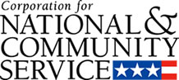

Corporation for National and Community Service

General Program Overview
AmeriCorps provides resources, both human and financial, to organizations that engage Americans in intensive service to meet our country’s critical needs.
Grantees use the funding to support AmeriCorps members for intensive service in their community. AmeriCorps grants partially cover the expense of operating an AmeriCorps program and do not cover general organizational expenses. A cash and in-kind match is required.

The main website can be accessed here: http://www.nationalservice.gov

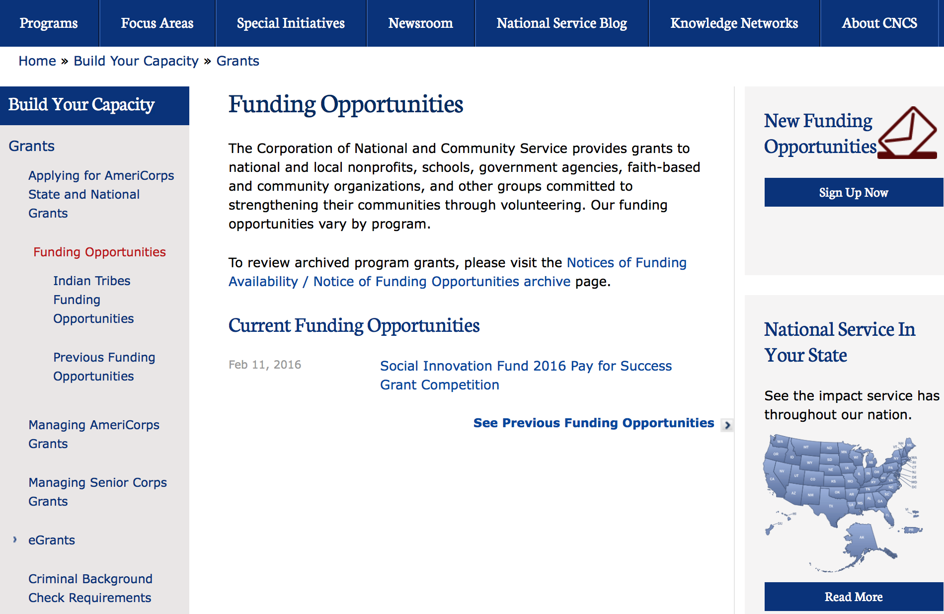

For access to further funding information: click here

http://www.nationalservice.gov/build-your-capacity/grants/funding-opportunities

Programs:

Research:

Reminders:

2017 AmeriCorps State and National Grants
Synopsis 1

Document Type: | Grants Notice
Funding Opportunity Number: | CNCS-8-17-2017
Funding Opportunity Title: | 2017 AmeriCorps State and National Grants
Opportunity Category: | Discretionary
Opportunity Category Explanation:
Funding Instrument Type: | Grant
Category of Funding Activity: | Agriculture  Arts (see "Cultural Affairs" in CFDA)  Community Development  Disaster Prevention and Relief  Education  Employment, Labor and Training  Energy  Environment  Food and Nutrition  Health  Housing  Income Security and Social Services  Law, Justice and Legal Services  Natural Resources  Regional Development
Category Explanation:
Expected Number of Awards:
CFDA Number(s): | 94.006 -- AmeriCorps
Cost Sharing or Matching Requirement: | Yes
Version: | Synopsis 1
Posted Date: | Aug 17, 2016
Last Updated Date: | Aug 17, 2016
Current Closing Date for Applications: | Jan 18, 2017 Notification of Intent to Apply: Applicants are strongly encouraged to submit a Notification of Intent to Apply for this competition. Notifications of Intent to Apply should be filed by Wednesday, December 7, 2016. Single-State applicants should provide this information directly to the Commission in the state in which the applicant intends to operate the program, not CNCS. The State Commissions’ deadlines are earlier than this deadline. See Types of Applicants section of the Notice for definitions of National Direct and Single-State applicants. Deadline: Applications are due Wednesday, January 18, 2017 at 5:00 p.m. Eastern Time to CNCS. Single-state applicant deadlines to State and Territory Commissions may be significantly before the CNCS deadlines, so prospective state applicants should contact the commission in the state or territory where they intend to apply as early as possible
Eligible Applicants: | State governments  Nonprofits having a 501(c)(3) status with the IRS, other than institutions of higher education  City or township governments  Private institutions of higher education  Public and State controlled institutions of higher education  Public housing authorities/Indian housing authorities  County governments  Native American tribal organizations (other than Federally recognized tribal governments)  Native American tribal governments (Federally recognized)  Nonprofits that do not have a 501(c)(3) status with the IRS, other than institutions of higher education  Special district governments  Independent school districts
Additional Information on Eligibility: | Eligible Applicants The following Non-Federal entities (as defined in 2 C.F.R. §200.69) who have DUNS numbers and are registered in System for Award Management (SAM) are eligible to apply: • Indian Tribes (2 C.F.R. §200.54) • Institutions of higher education (2 C. F.R. §200.54) • Local governments (2 C.F.R. §200.64) • Nonprofit organizations (2 C.F.R. §200.70) • States (2 C.F.R. §200.90) Previously receiving funds from CNCS or another federal agency is not a prerequisite to apply to this Notice. CNCS encourages organizations that have not received prior funding from CNCS to apply. The general practice is to award at least 20 member positions (slots) but no more than 50 member positions (slots) to organizations receiving an AmeriCorps grant for the first time. Continuation Applicants Organizations that have current AmeriCorps awards that do not end in FY17 must submit an application in order to be eligible to receive funding for the following year.
Agency Name: | Corporation for National and Community Service
Description: | AmeriCorps grants are awarded to eligible organizations proposing to engage AmeriCorps members in evidence-based or evidence-informed interventions to strengthen communities. An AmeriCorps member is an individual who engages in community service through an approved national service position. Members may receive a living allowance and other benefits while serving. Upon successful completion of their service, members earn a Segal AmeriCorps Education Award from the National Service Trust that members can use to pay for higher education expenses or apply to qualified student loans. Grant awards generally have two components: operating funds and AmeriCorps member positions. Grant award amounts vary – both in the level of operating funds and in the type and amount of AmeriCorps member positions. Unless otherwise specified, the grant generally covers a three-year project period. In approving a multi-year project period, CNCS generally makes an initial award for the first year of operation. In most cases, the application is submitted with a one-year budget. Continuation funding is not guaranteed.
Link to Additional Information: | Funding Opportunity Webpage
Grantor Contact Information: | If you have difficulty accessing the full announcement electronically, please contact:  AmeriCorps Program Office 202-606-7508  AmeriCorps Program Office Email

http://www.grants.gov/web/grants/view-opportunity.html?oppId=287588

National Service In Hawaii
National Service in Your State - Hawaii
2015-2016

Meeting Community Needs in Hawaii: More than 3,100 people of all ages and backgrounds are helping to meet local needs, strengthen communities, and increase civic engagement through national service in Hawaii. Serving at more than 450 locations throughout the state, these citizens tutor and mentor children, support veterans and military families, provide health services, restore the environment, respond to disasters, increase economic opportunity, and recruit and manage volunteers. This year, the Corporation for National and Community Service (CNCS) will commit more than $6,260,000 to support Hawaii communities through national service initiatives. Through a unique public-private partnership, this federal investment will leverage an additional $9,060,000 in other resources to strengthen community impact, build local support, and increase return on taxpayer dollars. Nationwide, CNCS, its grantees, and project sponsors generated more than $1.25 billion in outside resources from businesses, foundations, public agencies, and other sources in FY 2015.

AmeriCorps
This year, AmeriCorps will provide more than 560 individuals the opportunity to provide intensive, results-driven service to meet education, environmental, health, economic, and other pressing needs in communities across Hawaii. Most AmeriCorps grant funding goes to the Hawaii Commission on National & Community Service, which in turn awards grants to nonprofit groups to respond to local needs. Most of the remainder of the grant funding is distributed by CNCS directly to multi-state and national organizations through a competitive grants process. Other individuals serve through AmeriCorps VISTA, whose members help bring individuals and communities out of poverty by serving full-time to fight illiteracy, improve health services, create businesses, and increase housing opportunities, and AmeriCorps NCCC (National Civilian Community Corps), a 10-month, full time residential program for men and women between the ages of 18 and 24. In exchange for their service, AmeriCorps members earn an education award that can be used to pay for college or to pay back qualified student loans. Since 1994, more than 5,900 Hawaii residents have served more than 6.4 million hours and have qualified for Segal AmeriCorps Education Awards totaling more than $14,980,000.
Download: AmeriCorps in Hawaii (PDF)
Senior Corps
More than 2,500 seniors in Hawaii contribute their time and talents in one of three Senior Corps programs. Foster Grandparents serve one-on-one as tutors and mentors to more than 310 young people who have special needs. Senior Companions help more than 220 homebound seniors and other adults maintain independence in their own homes. RSVP volunteers conduct safety patrols, renovate homes, protect the environment, tutor and mentor youth, respond to natural disasters, and provide other services through more than 250 groups across Hawaii.
Download: Senior Corps in Hawaii (PDF)

The Corporation for National and Community Service is a federal agency that improves lives, strengthens communities, and fosters civic engagement through service and volunteering. CNCS annually engages more than five million Americans in service to meet local needs through Senior Corps, AmeriCorps, and national days of service; improves communities through the Social Innovation Fund, and leads President Obama's national call to service initiative, United We Serve. To learn more visit NationalService.gov or Serve.gov or call 202-606-5000 or TTY 1-800-833-3722.

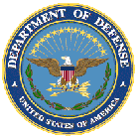

U.S. Department of Defense

Doing Business with the Department of Defense

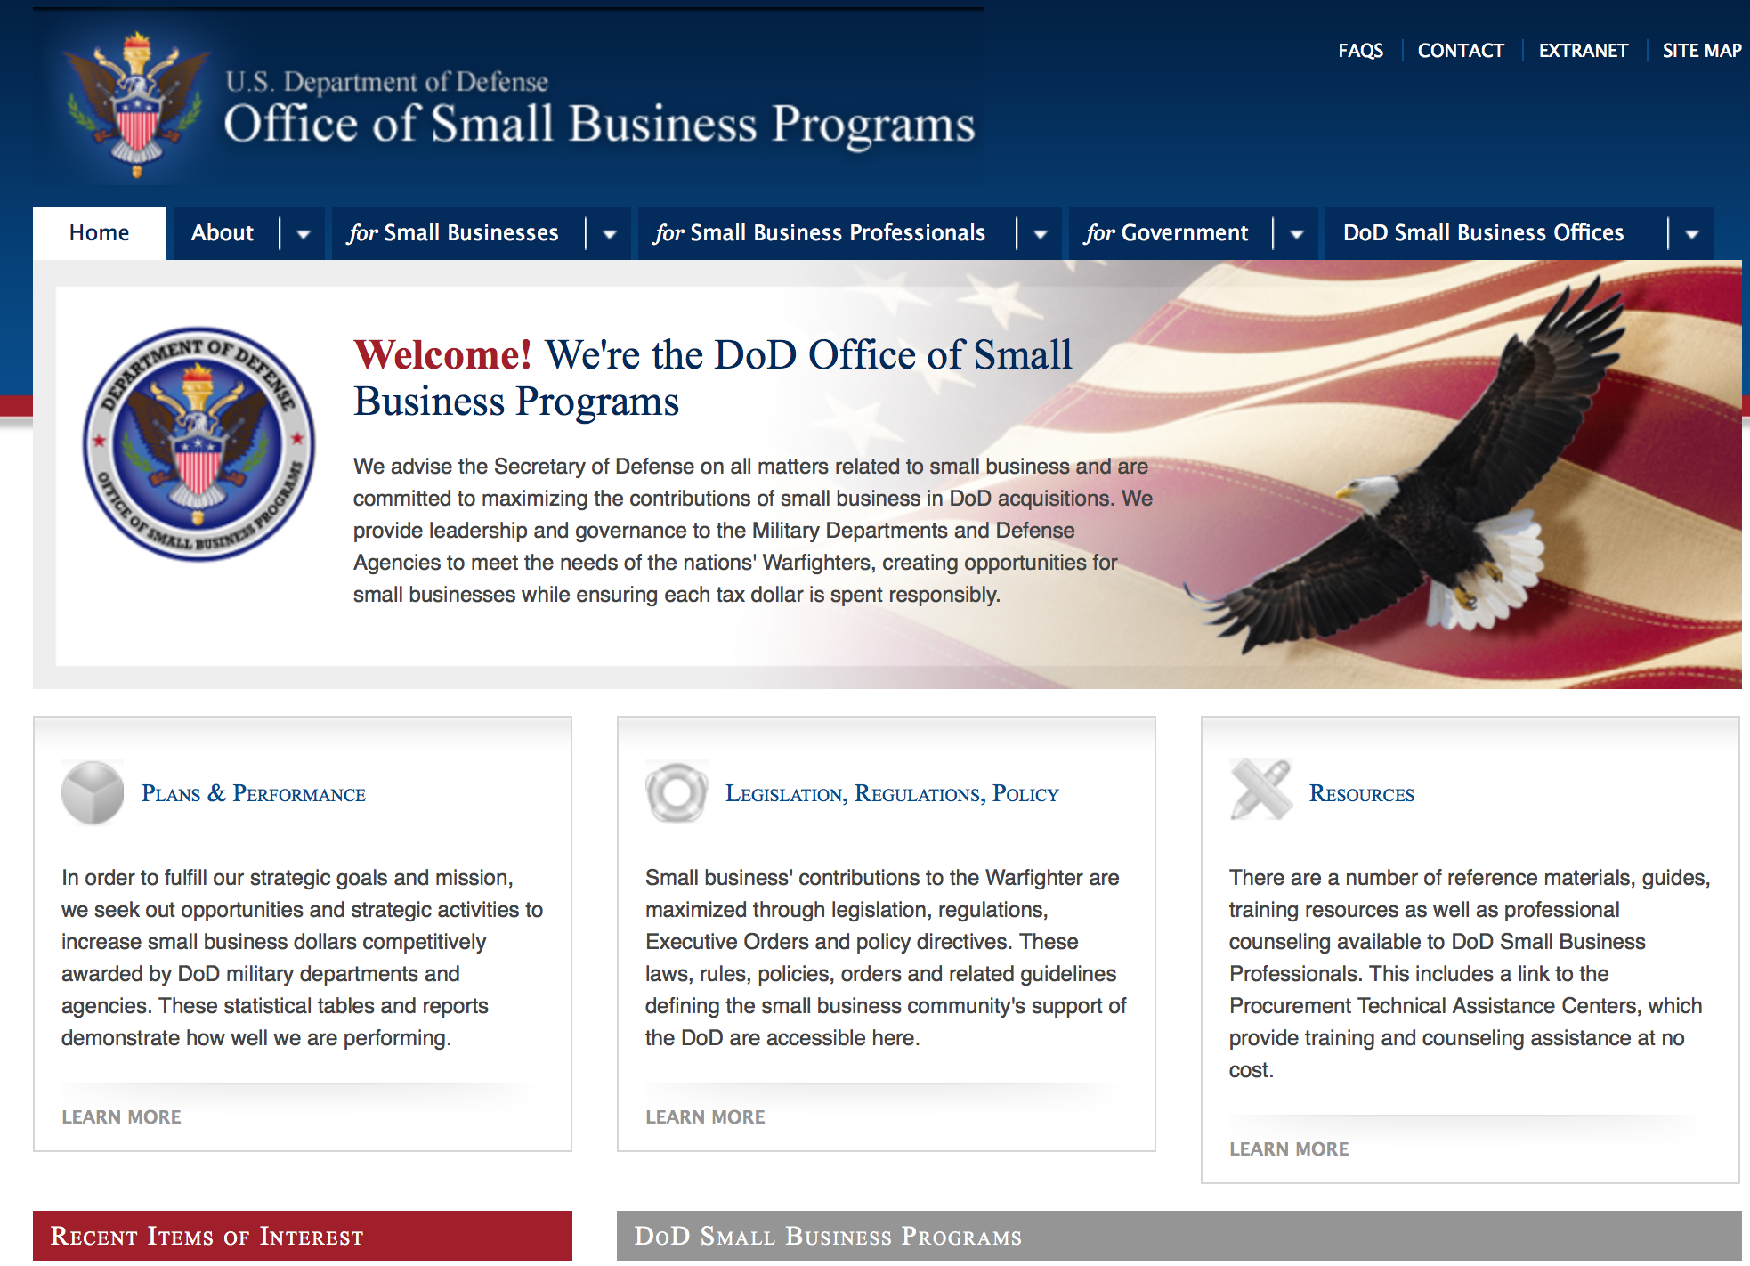

http://www.acq.osd.mil/osbp/

Doing Business with the DoD

Resources

Procurement Technical Assistance Centers (PTACs)

Procurement Technical Assistance Centers (PTACs) are charged with assisting businesses in learning how to do business with federal, state, and local governments. PTACs are a local resource available at no or nominal cost that can provide assistance to business firms in marketing their products and services. They offer training to businesses on how to research and bid on contracts, assist with registration requirements, provide bid-matching services, and assist with pre and post contracting issues.

Prime Contractors with Subcontracting Plans [xlsx]

Directory updated 4/19/11

This FY 2014 directory is intended for small business concerns seeking opportunities with DoD prime contractors. The directory is a listing of large business prime contractors who are required to establish subcontracting plans with goals. The report is generated from data contained in the Individual Subcontract Reports (ISRs) submitted in the Electronic Subcontracting Reporting System (eSRS) by contractors and from data contained in the Federal Procurement Data System (FPDS). The directory includes the name of the prime contractor; the major product/service code (PSC) provided to DoD; the major NAICS of the company; name, telephone number and email address of the company’s point of contact; contract number with the effective date and completion date, ultimate contract value and obligated dollars. In addition, many companies have websites with additional information which may be useful in your search for subcontracting opportunities or teaming arrangements.

Locate a Small Business Professional

Small Business Professionals serve as the primary liaison between private-sector small businesses seeking to do business with government agencies. Specialists advise small businesses regarding current acquisitions contracts available from the federal government.

Procurement Forecasts & the Department of Defense

The Department of Defense, due to its size and scope, does not have a single, comprehensive source for future procurements. Procurements are made locally and within the various services and agencies.

Business Intelligence, relative to future procurement planning, would be gathered at the local level.

For the purposes of forecasting, knowledge of past behavior is useful. Click here for a table of DoD acquisitions in FY10 summarized by NAICS code. The FY10 data has been validated but FPDS data is dynamic and changes continuously.

Non-Appropriated Fund Customers

Non-appropriated fund customers operate similar to non-profit organizations and include commissaries, exchanges, recreation and fitness centers, dining at officer/enlisted/civilian clubs, and barber/beauty services, just to name a few. For more information click here.

Research:

DARPA - Microsystems Technology Office
Reconfigurable Imaging (ReImagine)
Synopsis 1
http://www.grants.gov/web/grants/view-opportunity.html?oppId=288984

DARPA - Biological Technologies Office
Safe Genes
Synopsis 1
http://www.grants.gov/web/grants/view-opportunity.html?oppId=288890

DARPA - Microsystems Technology Office
Microsystems Technology Office Office-wide Broad Agency Announcement
Synopsis 1
http://www.grants.gov/web/grants/view-opportunity.html?oppId=288881

DARPA - Defense Sciences Office
Young Faculty Award (YFA)
Synopsis 1
http://www.grants.gov/web/grants/view-opportunity.html?oppId=289209

DARPA - Microsystems Technology Office
Common Heterogeneous Integration and IP Reuse Strategies (CHIPS)
Synopsis 1
http://www.grants.gov/web/grants/view-opportunity.html?oppId=289238

DARPA - Information Innovation Office
Modeling Adversarial Activity (MAA)
Synopsis 1
http://www.grants.gov/web/grants/view-opportunity.html?oppId=289311

Dept. of the Army -- USAMRAA
DoD USAMRMC FY17 Broad Agency Announcement for Extramural Medical Research
Synopsis 1
http://www.grants.gov/web/grants/view-opportunity.html?oppId=289274

Modifications:

Air Force -- Research Lab
University Small Grants Broad Agency Announcement
Synopsis 8
http://www.grants.gov/web/grants/view-opportunity.html?oppId=161214

Dept. of the Army -- USAMRAA
Joint Program Committee 1 (JPC-1)/ Medical Simulation and Information Sciences (MSIS) Developing Models for Military and/or Civilian Medical Training from Field Data Collected from Sensors (MATADOR)
Synopsis 2
http://www.grants.gov/web/grants/view-opportunity.html?oppId=288899

NSWC Indian Head
Naval Engineering Education Consortium (NEEC)
Synopsis 3
http://www.grants.gov/web/grants/view-opportunity.html?oppId=287157

Reminders:

Dept. of the Army -- Materiel Command
Army Research Office Broad Agency Announcement for Basic and Applied Scientific Research
Modification 8

Document Type: | Grants Notice
Funding Opportunity Number: | W911NF-12-R-0012
Funding Opportunity Title: | Army Research Office Broad Agency Announcement for Basic and Applied Scientific Research
Opportunity Category: | Discretionary
Funding Instrument Type: | Cooperative Agreement  Grant  Other  Procurement Contract
Category of Funding Activity: | Science and Technology and other Research and Development
Category Explanation:
Expected Number of Awards: | 1000
CFDA Number(s): | 12.431 -- Basic Scientific Research
Cost Sharing or Matching Requirement: | No
Posted Date: | Mar 27, 2015
Creation Date: | Mar 27, 2015
Original Closing Date for Applications: | Mar 31, 2017
Current Closing Date for Applications: | Mar 31, 2017
Archive Date: | Apr 30, 2017
Eligible Applicants: | Unrestricted (i.e., open to any type of entity above), subject to any clarification in text field entitled "Additional Information on Eligibility"
Agency Name: | Dept. of the Army -- Materiel Command
Description: | The purpose of this Broad Agency Announcement (BAA) is to solicit research proposals in the engineering, physical, life, and information sciences for submission to the Army Research Office (ARO) for consideration for possible funding. For ease of reference, this BAA is an extraction of the ARO sections of the Army Research Laboratory BAA. (www.arl.army.mil/www/default.cfm?page=8).
Link to Additional Information: | ARO CORE BAA-W911NF-12-R-0012-Mod 03
Contact Information: | If you have difficulty accessing the full announcement electronically, please contact:  ANDREW L. FISKE Procurement Analyst Army Contracting Command Aberdeen Proving Ground Research Triangle Park Division Phone: (919) 549-4338 FAX: (919) 549-4388 andrew.l.fiske.civ@mail.mil  Administrative POC

http://www.grants.gov/web/grants/view-opportunity.html?oppId=173593

Dept. of the Army -- USAMRAA
W81XWH-16-PRORP-EA - Peer Reviewed Orthopaedic Expansion Award
Deletion Comments: Opportunity deleted

Naval Supply Systems Command
NPS-BAA-15-002 - FY16 PROJECT ON ADVANCED SYSTEMS AND CONCEPTS FOR COUNTERING WMD (PASCC)
Deletion Comments: Synopsis deleted



Department of Education

Grant Programs Overview at the Department of Education

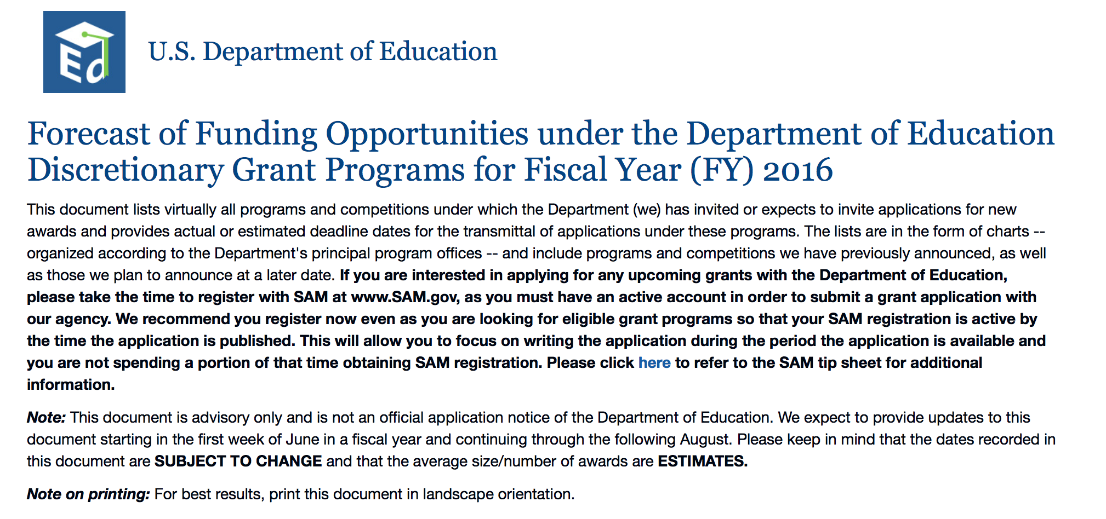To see the complete document click here: http://www2.ed.gov/fund/grant/find/edlite-forecast.html

The general information page for Education Grant funding is an excellent resource describing the three types of grants awarded by the Department of Education. See the screen shot of the Department of Education web page below:

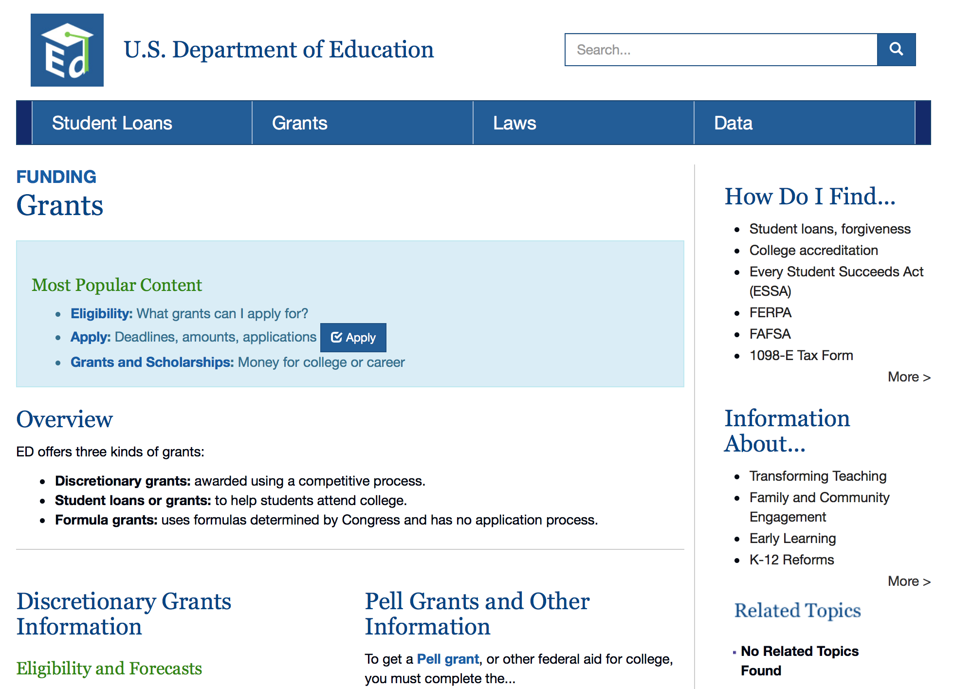

http://www.ed.gov/fund/grants-apply.html

Programs:

Research:

Modifications:

Reminders:

Office of Career, Technical, and Adult Education (OCTAE): Performance Partnership Pilots (P3) CFDA Number 84.420A
Synopsis 1

Document Type: | Grants Notice
Funding Opportunity Number: | ED-GRANTS-081516-001
Funding Opportunity Title: | Office of Career, Technical, and Adult Education (OCTAE): Performance Partnership Pilots (P3) CFDA Number 84.420A
Opportunity Category: | Discretionary
Opportunity Category Explanation:
Funding Instrument Type: | Cooperative Agreement
Category of Funding Activity: | Education
Category Explanation:
Expected Number of Awards: | 10
CFDA Number(s): | 84.420 -- Performance Partnership Pilots for Disconnected Youth
Cost Sharing or Matching Requirement: | No
Posted Date: | Aug 15, 2016
Last Updated Date: | Aug 15, 2016
Current Closing Date for Applications: | Oct 31, 2016 Applications Available: August 15, 2016. Deadline for Notice of Intent to Apply: September 29, 2016. Note: Submission of a notice of intent to apply is optional. We will be able to develop a more efficient process for reviewing applications if we know the approximate number of applicants that intend to apply under this competition. Therefore, we strongly encourage each potential applicant to notify us of the applicant's intent to apply by emailing to disconnectedyouth@ed.gov the following information: (1) The applicant organization's name and address and (2) the absolute priority the applicant intends to address. Applicants that do not submit a notice of intent to apply may still submit an application. Note: Submission of a notice of intent to apply is optional. Deadline for Transmittal of Applications: October 31, 2016.
Archive Date: | Nov 30, 2016
Estimated Total Program Funding: | $2,000,000
Eligible Applicants: | County governments  Others (see text field entitled "Additional Information on Eligibility" for clarification)  Special district governments  State governments  City or township governments  Native American tribal governments (Federally recognized)
Additional Information on Eligibility: | 1. Eligible Applicants: The lead applicant must be a State, local, or tribal government entity, represented by a Chief Executive, such as a governor, mayor, or other elected leader, or the head of a State, local, or tribal agency.
Agency Name: | Department of Education
Description: | Note: Each funding opportunity description is a synopsis of information in the Federal Register application notice. For specific information about eligibility, please see the official application notice. The official version of this document is the document published in the Federal Register. Free Internet access to the official edition of the Federal Register and the Code of Federal Regulations is available on GPO Access at: http://www.access.gpo.gov/nara/index.html. Please review the official application notice for pre-application and application requirements, application submission information, performance measures, priorities and program contact information. Purpose of Program: Performance Partnership Pilots (P3), first authorized by Congress for FY 2014 by the Consolidated Appropriations Act, 2014 (2014 Appropriations Act) and reauthorized for FY 2015 by the Consolidated and Further Continuing Appropriations Act, 2015 (2015 Appropriations Act) and for FY 2016 by the Consolidated Appropriations Act, 2016 (2016 Appropriations Act) (together, the Acts), enable pilot sites to test innovative, outcome-focused strategies to achieve significant improvements in educational, employment, and other key outcomes for disconnected youth using new flexibility to blend existing Federal funds and to seek waivers of associated program requirements. Catalog of Federal Domestic Assistance (CFDA) Number: 84.420A. Applications for grants under the P3 program, CFDA number 84.420A, must be submitted electronically using the Governmentwide Grants.gov Apply site at www.Grants.gov. Through this site, you will be able to download a copy of the application package, complete it offline, and then upload and submit your application. You may not email an electronic copy of a grant application to us. You may access the electronic grant application for P3 at www.Grants.gov. You must search for the downloadable application package for this competition by the CFDA number. Do not include the CFDA number's alpha suffix in your search (e.g., search for 84.420, not 84.420A).
Link to Additional Information: | Office of Career, Technical, and Adult Education (OCTAE): Performance Partnership Pilots (P3) CFDA Number 84.420A; Notice inviting applications for new awards for fiscal year (FY) 2016
Grantor Contact Information: | If you have difficulty accessing the full announcement electronically, please contact:  Julius Cotton ED Grants.gov FIND Systems Admin. Phone 202-245-6288 EducationGrantInquiries@ed.gov Program Manager: Braden Goetz, U.S. Department of Education, 400 Maryland Avenue SW., Room 11141, Potomac Center Plaza (PCP), Washington, DC 20202. Telephone: (202) 245-7405 or by email: disconnectedyouth@ed.gov.  e-Mail: Program Mailbox

http://www.grants.gov/web/grants/view-opportunity.html?oppId=287493

Deleted:



U.S. Department of Energy
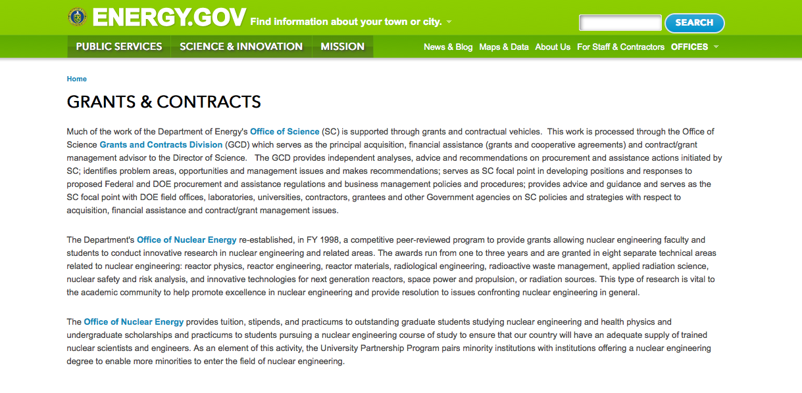
http://www.doe.gov/grants-contracts

Research:

Office of Science
FY 2017 Continuation of Solicitation for the Office of Science Financial Assistance Program
Synopsis 1

Document Type: | Grants Notice
Funding Opportunity Number: | DE-FOA-0001664
Funding Opportunity Title: | FY 2017 Continuation of Solicitation for the Office of Science Financial Assistance Program
Opportunity Category: | Discretionary
Opportunity Category Explanation:
Funding Instrument Type: | Cooperative Agreement  Grant
Category of Funding Activity: | Science and Technology and other Research and Development
Category Explanation:
Expected Number of Awards: | 200
CFDA Number(s): | 81.049 -- Office of Science Financial Assistance Program
Cost Sharing or Matching Requirement: | No
Version: | Synopsis 1
Posted Date: | Sep 30, 2016
Last Updated Date: | Sep 30, 2016
Original Closing Date for Applications: | Sep 30, 2017
Current Closing Date for Applications: | Sep 30, 2017
Archive Date: | Oct 30, 2017
Estimated Total Program Funding:
Award Ceiling: | $4,000,000
Award Floor: | $2,000
Eligible Applicants: | Unrestricted (i.e., open to any type of entity above), subject to any clarification in text field entitled "Additional Information on Eligibility"
Agency Name: | Office of Science
Description: | The Office of Science (SC) of the Department of Energy hereby announces its continuing interest in receiving grant applications for support of work in the following program areas: Advanced Scientific Computing Research, Basic Energy Sciences, Biological and Environmental Research, Fusion Energy Sciences, High Energy Physics, and Nuclear Physics. On September 3, 1992, DOE published in the Federal Register the Office of Energy Research Financial Assistance Program (now called the Office of Science Financial Assistance Program), 10 CFR 605, as a Final Rule, which contained a solicitation for this program. Information about submission of applications, eligibility, limitations, evaluation and selection processes and other policies and procedures are specified in 10 CFR 605.
Link to Additional Information:
Grantor Contact Information: | If you have difficulty accessing the full announcement electronically, please contact:  Kimberlie Laing Grant Analyst Phone 301-903-3026  kim.laing@science.doe.gov

http://www.grants.gov/web/grants/view-opportunity.html?oppId=289281

National Energy Technology Laboratory
Topics for Advanced Combustion Systems of the Future
Synopsis 1
http://www.grants.gov/web/grants/view-opportunity.html?oppId=289168

Golden Field Office
Notice of Intent to Issue: DE-FOA-0001660 - Deployment of Clean Energy and Energy Efficiency Projects on Indian Lands - 2016
Synopsis 1
http://www.grants.gov/web/grants/view-opportunity.html?oppId=289134

National Energy Technology Laboratory
Sensor and Modeling Approaches for Enhanced Observability and Controllability of Power Systems with Distributed Energy Resources (DERs)
Synopsis 1
http://www.grants.gov/web/grants/view-opportunity.html?oppId=289150

National Energy Technology Laboratory
H2 at Scale (Hydrogen at Scale): Determining Research, Development, and Demonstration (RD&D) Necessary for Clean Hydrogen Production to Enable Multisectoral Deep Decarbonization
Synopsis 1
http://www.grants.gov/web/grants/view-opportunity.html?oppId=288713

National Energy Technology Laboratory
University Turbine Systems Request for Information FY17
Synopsis 1

http://www.grants.gov/web/grants/view-opportunity.html?oppId=289245

Modifications:

Advanced Research Projects Agency Energy
ENERGY-EFFICIENT LIGHT-WAVE INTEGRATED TECHNOLOGY ENABLING NETWORKS THAT ENHANCE DATACENTERS (ENLITENED)
Synopsis 2
http://www.grants.gov/web/grants/view-opportunity.html?oppId=284531

Advanced Research Projects Agency Energy
Innovative Development in Energy-Related Applied Science (IDEAS) 2015
Synopsis 3
http://www.grants.gov/web/grants/view-opportunity.html?oppId=279527

Reminders:

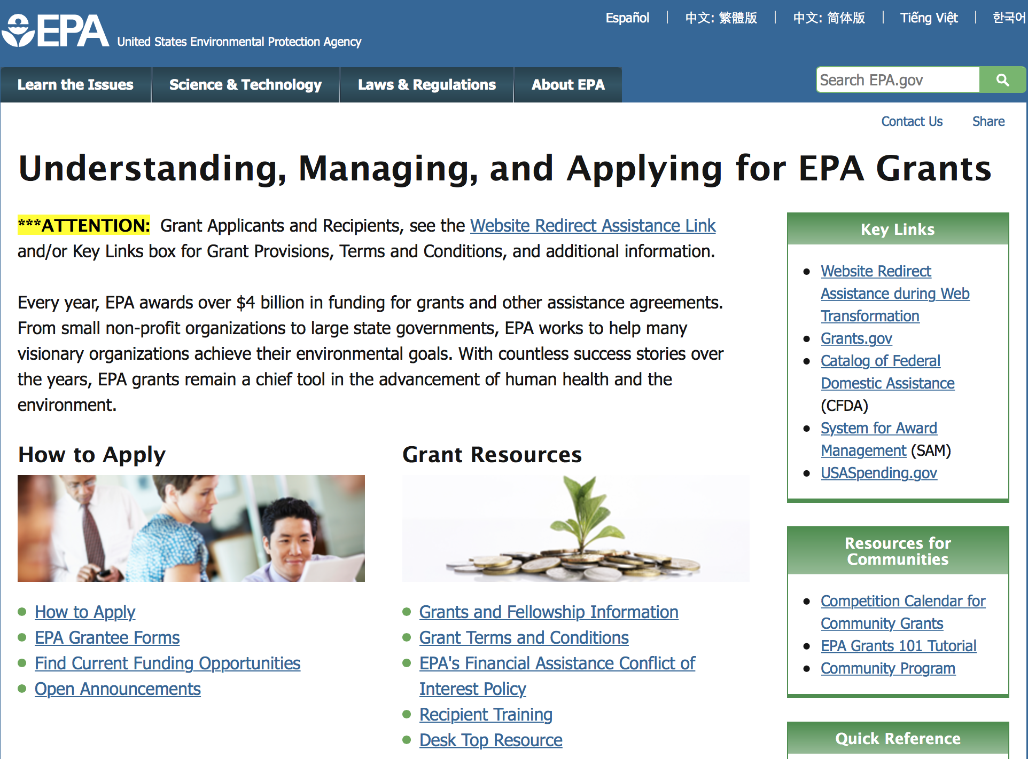

http://www.epa.gov/epahome/grants.htm

Programs:

Modifications:

Reminders:

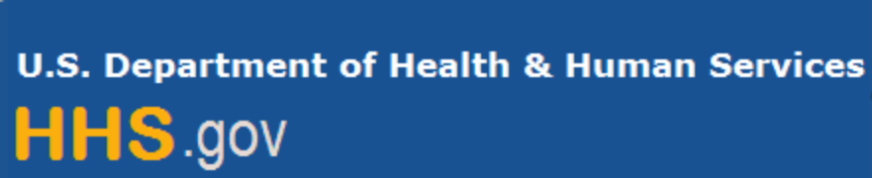

Department of Health and Human Services

Grants Forecast and Overview

The Department of Health and Human Services’ Grants Forecast is a database of planned grant opportunities proposed by its agencies. Each Forecast record contains actual or estimated dates and funding levels for grants that the agency intends to award during the fiscal year. Forecast opportunities are subject to change based on enactment of congressional appropriations. Go to the webpage below for more information.

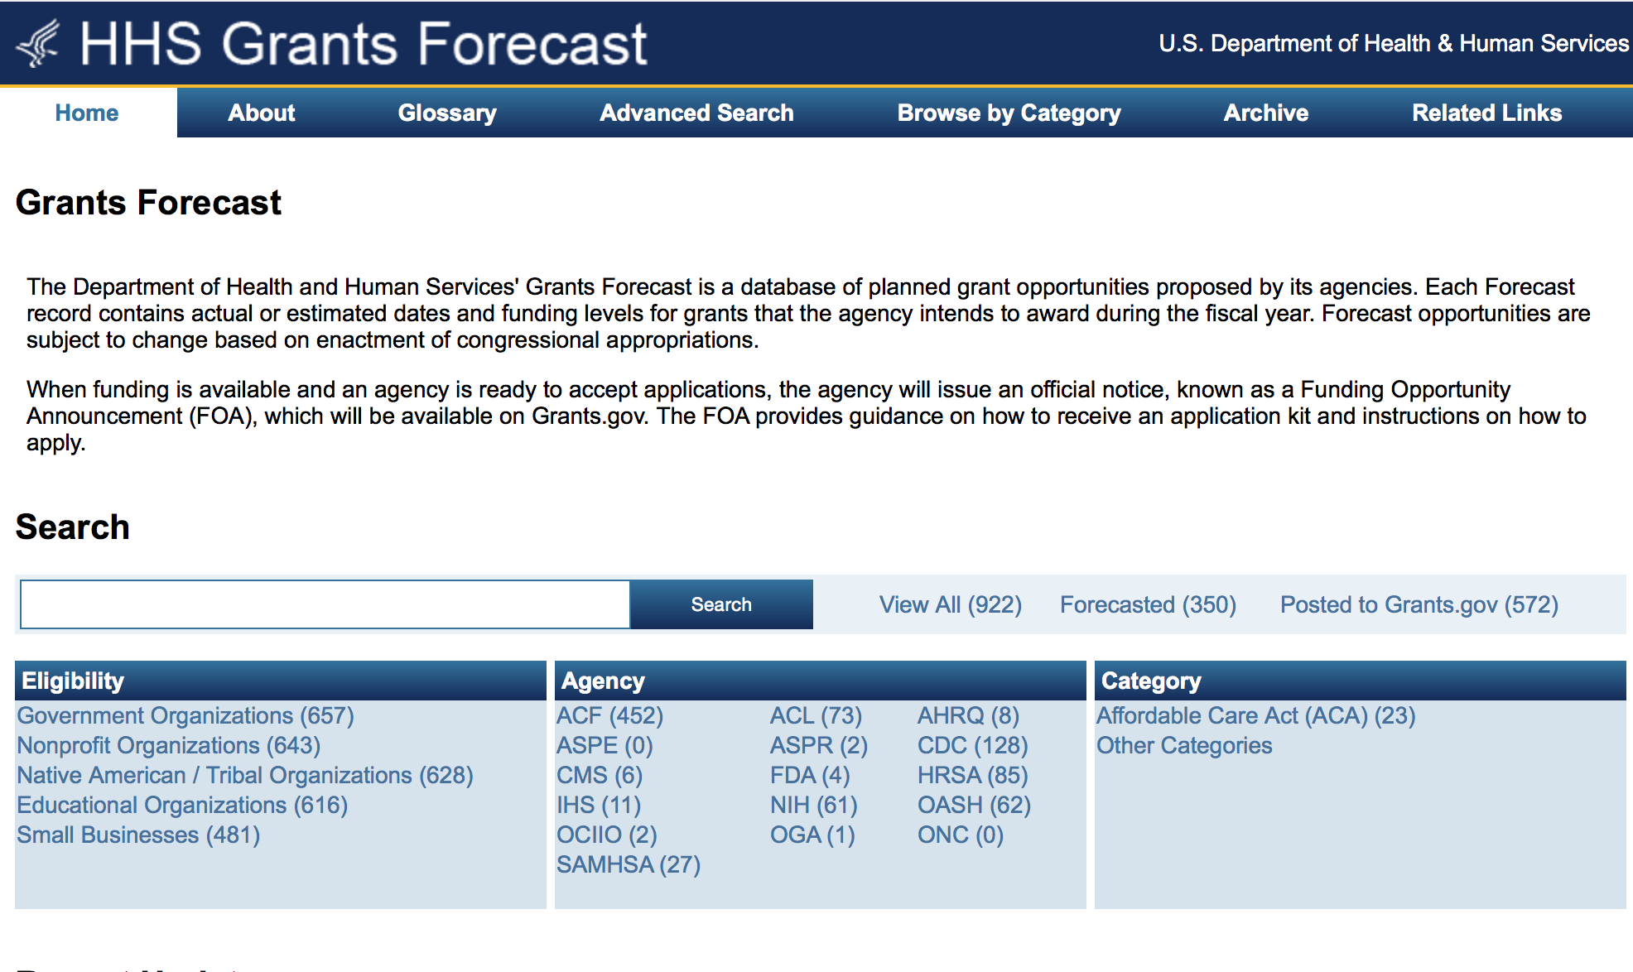
For more general information about HHS Grants and Funding go to the website below at: http://www.hhs.gov/grants/ .

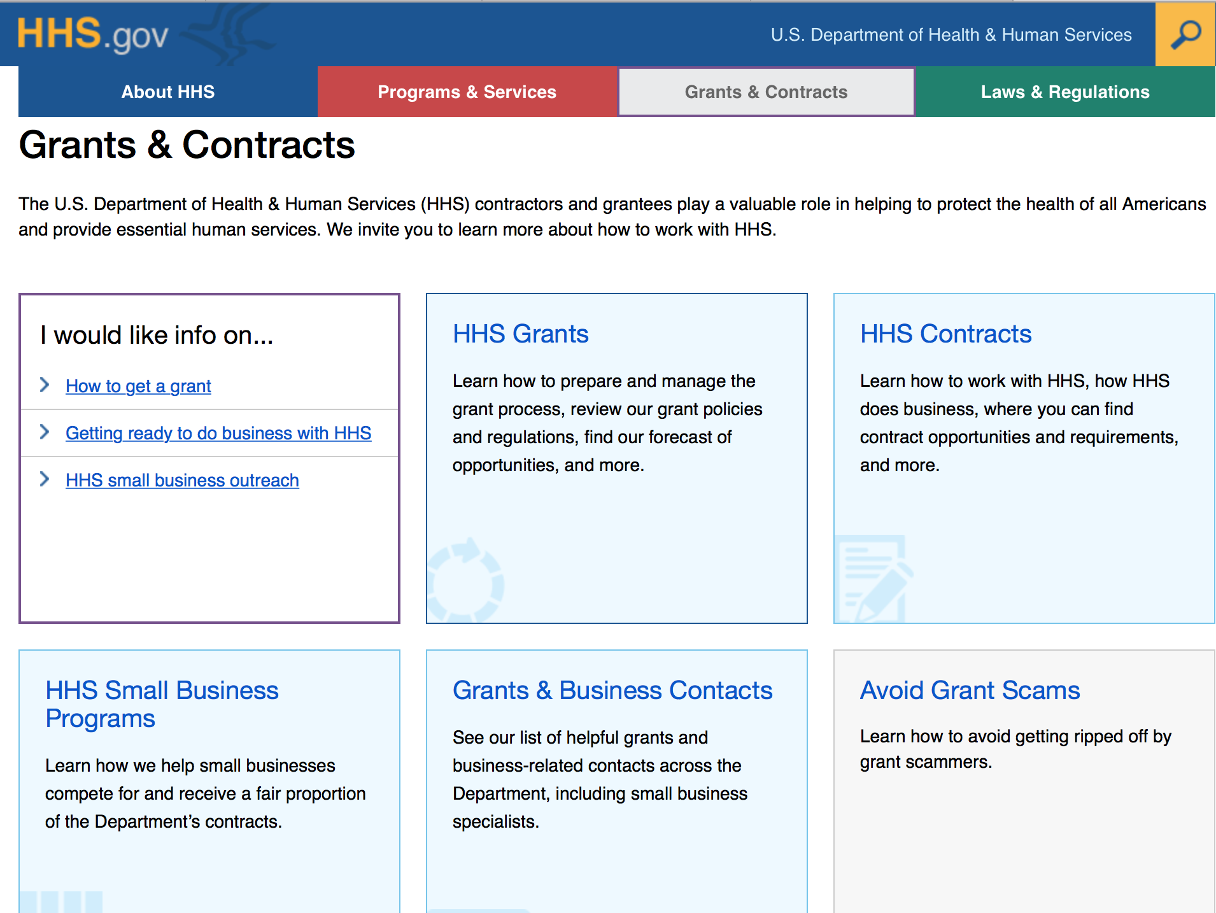

Programs:

Administration for Children & Families - ACYF/FYSB
Transitional Living Program and Maternity Group Homes
Forecast 1
Document Type: | Grants Notice
Opportunity Number: | HHS-2017-ACF-ACYF-CX-1233
Opportunity Title: | Transitional Living Program and Maternity Group Homes
Opportunity Category: | Discretionary
Opportunity Category Explanation:
Funding Instrument Type: | Grant
Category of Funding Activity: | Income Security and Social Services
Category Explanation:
Expected Number of Awards: | 103
CFDA Number(s): | 93.550 -- Transitional Living for Homeless Youth
Cost Sharing or Matching Requirement: | Yes
Version: | Forecast 1
Posted Date: | Sep 27, 2016
Last Updated Date: | Sep 27, 2016
Estimated Synopsis Post Date: | Apr 14, 2017
Estimated Application Due Date: | Jun 13, 2017 Electronically submitted applications must be submitted no later than 11:59 p.m., ET, on the listed application due date.
Estimated Award Date: | Sep 28, 2017
Estimated Project Start Date: | Sep 29, 2017
Fiscal Year: | 2017
Archive Date:
Estimated Total Program Funding: | $20,056,829
Award Ceiling: | $194,726
Award Floor: | $100,000
Eligible Applicants: | Native American tribal governments (Federally recognized)  Public and State controlled institutions of higher education  Nonprofits that do not have a 501(c)(3) status with the IRS, other than institutions of higher education  Native American tribal organizations (other than Federally recognized tribal governments)  Independent school districts  Special district governments  State governments  Others (see text field entitled "Additional Information on Eligibility" for clarification)  Private institutions of higher education  Public housing authorities/Indian housing authorities  City or township governments  Nonprofits having a 501(c)(3) status with the IRS, other than institutions of higher education  County governments
Additional Information on Eligibility: | In accordance with Section 321 of the Runaway and Homeless Youth (RHY) Act, the Secretary is authorized to make grants to provide technical assistance to public and nonprofit private entities to establish and operate transitional living youth projects for homeless youth. In selecting eligible applicants to receive grants under this Funding Opportunity Announcement, priority will be given to applicants who have experience working with runaway and homeless youth as required by the RHY Act. Additionally, ACF ensures that the applicants selected represent diverse geographic regions of the United States. Faith-based and community organizations that meet the eligibility requirements are eligible to receive awards under this funding opportunity announcement. Faith-based organizations are encouraged to review the ACF Policy on Grants to Faith-Based Organizations at: http: //www.acf.hhs.gov/acf-policy-on-grants-to-faith-based-organizations. Applications from individuals (including sole proprietorships) and foreign entities are not eligible and will be disqualified from competitive review and from funding under this announcement.
Agency Name: | Administration for Children & Families - ACYF/FYSB
Description: | The Family and Youth Services Bureau (FYSB) is forecasting a funding opportunity announcement for the Transitional Living Program (TLP) and for Maternity Group Homes (MGH) for a five year project period. The TLP and MGH projects will work to implement, enhance, and/or support promising intervention strategies for the effective transition of homeless youth (for the purposes of MGH projects, homeless youth and their dependent child(ren)) to self-sufficiency. Both projects must provide safe, stable, and appropriate shelter for up to 21 months and comprehensive services that supports the transition of homeless youth to stable living.
Link to Additional Information:
Grantor Contact Information: | Angie Webley  (202) 401-5490  Angie.Webley@acf.hhs.gov

http://www.grants.gov/web/grants/view-opportunity.html?oppId=289165

Administration for Children and Families - ORR
Ethnic Community Self Help Program
Forecast 1

Document Type: | Grants Notice
Opportunity Number: | HHS-2017-ACF-ORR-RE-1232
Opportunity Title: | Ethnic Community Self Help Program
Opportunity Category: | Discretionary
Opportunity Category Explanation:
Funding Instrument Type: | Grant
Category of Funding Activity: | Income Security and Social Services
Category Explanation:
Expected Number of Awards: | 13
CFDA Number(s): | 93.576 -- Refugee and Entrant Assistance Discretionary Grants
Cost Sharing or Matching Requirement: | No
Version: | Forecast 1
Posted Date: | Sep 21, 2016
Last Updated Date: | Sep 21, 2016
Estimated Synopsis Post Date: | Mar 31, 2017
Estimated Application Due Date: | May 30, 2017 Electronically submitted applications must be submitted no later than 11:59 p.m., ET, on the listed application due date.
Estimated Award Date: | Sep 29, 2017
Estimated Project Start Date: | Sep 30, 2017
Fiscal Year: | 2017
Archive Date:
Estimated Total Program Funding: | $2,000,000
Award Ceiling: | $200,000
Award Floor: | $100,000
Eligible Applicants: | Others (see text field entitled "Additional Information on Eligibility" for clarification)
Additional Information on Eligibility: | This Funding Opportunity Announcement (FOA) is open only to Ethnic Community-Based Organizations (ECBOs). For the purposes of this FOA, the Office of Refugee Resettlement considers an ECBO as a non-profit organization whose board of directors is comprised of at least 60 percent current and/or former refugees. The applicant must demonstrate that at the time of submission its board of directors is comprised of at least 60 percent current and/or former refugees. Faith-based and community organizations that meet the eligibility requirements are eligible to receive awards under this funding opportunity announcement. Faith-based organizations are encouraged to review the ACF Policy on Grants to Faith-Based Organizations at: http: //www.acf.hhs.gov/acf-policy-on-grants-to-faith-based-organizations. Applications from individuals (including sole proprietorships) and foreign entities are not eligible and will be disqualified from competitive review and from funding under this announcement.
Agency Name: | Administration for Children and Families - ORR
Description: | The Administration for Children and Families, Office of Refugee Resettlement invites the submission of applications for funding under the Ethnic Community Self-Help (ECSH) Program. The goal of this program is to support Ethnic Community-Based Organizations (ECBOs) in providing refugee populations with critical services to assist them in becoming integrated members of American society. Under the ECSH Program, the following three main objectives must be implemented: 1) to strengthen ECBOs'; provision of culturally and linguistically appropriate services to refugees within five years after their initial resettlement; 2) to support ECBOs' organizational development and engagement in capacity building by encouraging their collaboration with established refugee service providers and mainstream organizations; and 3) to support ECBOs in promoting community building and civic participation by refugee individuals and refugee community members.
Link to Additional Information:
Grantor Contact Information: | Anastasia Brown  (202) 401-4559  Anastasia.Brown@acf.hhs.gov

http://www.grants.gov/web/grants/view-opportunity.html?oppId=289035

Research:

Administration for Children and Families-IOAS-OTIP
Look Beneath the Surface Regional Anti-Trafficking Program
Forecast 1
http://www.grants.gov/web/grants/view-opportunity.html?oppId=289166

Administration for Children and Families - OCS
Community Economic Development Projects
Forecast 1
http://www.grants.gov/web/grants/view-opportunity.html?oppId=288729

Administration for Children and Families - OCS
Community Economic Development Healthy Food Financing Initiative Projects
Forecast 1
http://www.grants.gov/web/grants/view-opportunity.html?oppId=288730

Administration for Children and Families - ORR
Standing Announcement for Residential (Shelter) Services for Unaccompanied Children
Synopsis 4
http://www.grants.gov/web/grants/view-opportunity.html?oppId=284278

Agency for Health Care Research and Quality
AHRQ Conference Grant Programs (R13)
Synopsis 1

http://www.grants.gov/web/grants/view-opportunity.html?oppId=289256

Agency for Health Care Research and Quality
Large Health Services Research Demonstration and Dissemination Projects for Combating Antibiotic-Resistant Bacteria (CARB)(R18)
Synopsis 1
http://www.grants.gov/web/grants/view-opportunity.html?oppId=288550

Agency for Health Care Research and Quality
Advances in Patient Safety through Simulation Research (R18)
Synopsis 1
http://www.grants.gov/web/grants/view-opportunity.html?oppId=288531

Agency for Health Care Research and Quality
Large Research Projects for Combating Antibiotic-Resistant Bacteria (CARB) (R01)
Synopsis 1
http://www.grants.gov/web/grants/view-opportunity.html?oppId=288549

Agency for Health Care Research and Quality
Developing Measures of Shared Decision Making (R01)
Synopsis 1
http://www.grants.gov/web/grants/view-opportunity.html?oppId=288658

Centers for Disease Control and Prevention - ERA
Epidemiology of Zika Virus as a Sexually Transmitted Disease
Forecast 1
http://www.grants.gov/web/grants/view-opportunity.html?oppId=288976

Centers for Disease Control and Prevention - ERA
Natural Experiments of Policy and Built Environment Impact on Diabetes Risk
Forecast 1
http://www.grants.gov/web/grants/view-opportunity.html?oppId=289139

Centers for Medicare & Medicaid Services
Accountable Health Communities Track 1 - Awareness
Synopsis 1
http://www.grants.gov/web/grants/view-opportunity.html?oppId=288650

Health Resources and Services Administration
R40 Autism Field-Initiated Innovative Research Studies (Autism-FIRST) Program
Synopsis 1
http://www.grants.gov/web/grants/view-opportunity.html?oppId=288941

Health Resources and Services Administration
Leadership Education in Adolescent Health (LEAH)
Synopsis 1
http://www.grants.gov/web/grants/view-opportunity.html?oppId=288717

Health Resources and Services Administration
Service Area Competition
Synopsis 1
http://www.grants.gov/web/grants/view-opportunity.html?oppId=284905

Health Resources and Services Administration
Sickle Cell Disease Newborn Screening Follow-Up Program
Synopsis 1
http://www.grants.gov/web/grants/view-opportunity.html?oppId=288736

Health Resources and Services Administration
Nursing Workforce Diversity (NWD) Program
Synopsis 1
http://www.grants.gov/web/grants/view-opportunity.html?oppId=285581

Health Resources and Services Administration
Nurse Faculty Loan Program (NFLP)
Synopsis 1
http://www.grants.gov/web/grants/view-opportunity.html?oppId=285583

Health Resources and Services Administration
Health Care Workforce Assessment
Forecast 1
http://www.grants.gov/web/grants/view-opportunity.html?oppId=289062

Health Resources and Services Administration
Regional Genetics Networks
Synopsis 1
http://www.grants.gov/web/grants/view-opportunity.html?oppId=289040

Health Resources and Services Administration
Rural Health Network Development Program
Synopsis 1
http://www.grants.gov/web/grants/view-opportunity.html?oppId=284898

Health Resources and Services Administration
Service Area Competition
Synopsis 2
http://www.grants.gov/web/grants/view-opportunity.html?oppId=284904

Health Resources and Services Administration
Centers of Excellence (COE)
Forecast 1
http://www.grants.gov/web/grants/view-opportunity.html?oppId=289063

Health Resources and Services Administration
Advanced Nursing Education Workforce
Forecast 1
http://www.grants.gov/web/grants/view-opportunity.html?oppId=289064

Health Resources and Services Administration
Area Health Education Centers
Forecast 1
http://www.grants.gov/web/grants/view-opportunity.html?oppId=289066

National Institutes of Health
Genomics of HIV/AIDS Drug Response and Co-Morbidities (R01)
Synopsis 1
http://www.grants.gov/web/grants/view-opportunity.html?oppId=288979

National Institutes of Health
Facile Methods and Technologies for Synthesis of Biomedically Relevant Carbohydrates (U01)
Synopsis 1
http://www.grants.gov/web/grants/view-opportunity.html?oppId=288898

National Institutes of Health
"High" or "Medium" Priority AIDS Research on Non-AIDS-defining or AIDS-defining Cancers (R01)
Synopsis 1
http://www.grants.gov/web/grants/view-opportunity.html?oppId=288612

National Institutes of Health
NIAID Career Transition Award (K22)
Synopsis 1
http://www.grants.gov/web/grants/view-opportunity.html?oppId=288935

National Institutes of Health
Encouraging Appropriate Care Using Behavioral Economics through Electronic Health Records (R21/R33)
Synopsis 1
http://www.grants.gov/web/grants/view-opportunity.html?oppId=288937

National Institutes of Health
Core Centers for Clinical Research (CCCR) (P30)
Synopsis 1
http://www.grants.gov/web/grants/view-opportunity.html?oppId=288938

National Institutes of Health
Paul B. Beeson Emerging Leaders Career Development Award in Aging (K76)
Synopsis 1
http://www.grants.gov/web/grants/view-opportunity.html?oppId=288940

National Institutes of Health
"High" or "Medium" Priority AIDS Research on Non-AIDS-defining or AIDS-defining Cancers (R21)
Synopsis 1
http://www.grants.gov/web/grants/view-opportunity.html?oppId=288590

National Institutes of Health
Intramural NIGMS Postdoctoral Research Associate (PRAT) Program (Fi2)
Synopsis 1
http://www.grants.gov/web/grants/view-opportunity.html?oppId=288591

National Institutes of Health
T Cell Reagent Resource for the Study of Allergic Diseases (U19)
Synopsis 1
http://www.grants.gov/web/grants/view-opportunity.html?oppId=288592

National Institutes of Health
Health Promotion Among Racial and Ethnic Minority Males (R21)
Synopsis 1
http://www.grants.gov/web/grants/view-opportunity.html?oppId=288653

National Institutes of Health
Symptom Management in HIV-Infected Individuals with Comorbid Conditions (R01)
Synopsis 1
http://www.grants.gov/web/grants/view-opportunity.html?oppId=288655

National Institutes of Health
Symptom Management in HIV-Infected Individuals with Comorbid Conditions (R21)
Synopsis 1
http://www.grants.gov/web/grants/view-opportunity.html?oppId=288656

National Institutes of Health
Grand Opportunity in Medications Development for Substance-Use Disorders (U01)
Synopsis 1
http://www.grants.gov/web/grants/view-opportunity.html?oppId=288631

National Institutes of Health
Strategic Alliances for Medications Development to Treat Substance Use Disorders (R01)
Synopsis 1
http://www.grants.gov/web/grants/view-opportunity.html?oppId=288632

National Institutes of Health
Health Promotion Among Racial and Ethnic Minority Males (R01)
Synopsis 1
http://www.grants.gov/web/grants/view-opportunity.html?oppId=288633

National Institutes of Health
Health Promotion Among Racial and Ethnic Minority Males (R21)
Synopsis 1
http://www.grants.gov/web/grants/view-opportunity.html?oppId=288653

National Institutes of Health
Symptom Management in HIV-Infected Individuals with Comorbid Conditions (R01)
Synopsis 1
http://www.grants.gov/web/grants/view-opportunity.html?oppId=288655

National Institutes of Health
Symptom Management in HIV-Infected Individuals with Comorbid Conditions (R21)
Synopsis 1
http://www.grants.gov/web/grants/view-opportunity.html?oppId=288656

National Institutes of Health
Health Promotion Among Racial and Ethnic Minority Males (R01)
Synopsis 1
http://www.grants.gov/web/grants/view-opportunity.html?oppId=288633

National Institutes of Health
Grand Opportunity in Medications Development for Substance-Use Disorders (U01)
Synopsis 1
http://www.grants.gov/web/grants/view-opportunity.html?oppId=288631

National Institutes of Health
Strategic Alliances for Medications Development to Treat Substance Use Disorders (R01)
Synopsis 1
http://www.grants.gov/web/grants/view-opportunity.html?oppId=288632

National Institutes of Health
Drug Abuse Dissertation Research (R36)
Synopsis 1
http://www.grants.gov/web/grants/view-opportunity.html?oppId=289067

National Institutes of Health
Changes in Cellular Architecture During Aging (R01)
Synopsis 1
http://www.grants.gov/web/grants/view-opportunity.html?oppId=289072

National Institutes of Health
Expanding Alcohol-Focused High-Priority Translational Research for HIV/AIDS (UH2/UH3)
Synopsis 1
http://www.grants.gov/web/grants/view-opportunity.html?oppId=289074

National Institutes of Health
BRAIN Initiative: New Concepts and Early-Stage Research for Large-Scale Recording and Modulation in the Nervous System (R21)
Synopsis 1
http://www.grants.gov/web/grants/view-opportunity.html?oppId=289008

National Institutes of Health
BRAIN Initiative: Data Archives for the BRAIN Initiative (R24)
Synopsis 1
http://www.grants.gov/web/grants/view-opportunity.html?oppId=289027

National Institutes of Health
Selected Topics in Transfusion Medicine (R21)
Synopsis 1
http://www.grants.gov/web/grants/view-opportunity.html?oppId=289044

National Institutes of Health
Selected Topics in Transfusion Medicine (R01)
Synopsis 1
http://www.grants.gov/web/grants/view-opportunity.html?oppId=289045

National Institutes of Health
Support of Competitive Research (SCORE) Research Advancement Award (SC1)
Synopsis 1
http://www.grants.gov/web/grants/view-opportunity.html?oppId=289049

National Institutes of Health
Support of Competitive Research (SCORE) Pilot Project Award (SC2)
Synopsis 1
http://www.grants.gov/web/grants/view-opportunity.html?oppId=289028

National Institutes of Health
BRAIN Initiative: Standards to Define Experiments Related to the BRAIN Initiative (R24)
Synopsis 1
http://www.grants.gov/web/grants/view-opportunity.html?oppId=289036

National Institutes of Health
BRAIN Initiative: Integration and Analysis of BRAIN Initiative Data (R24)
Synopsis 1
http://www.grants.gov/web/grants/view-opportunity.html?oppId=289037

National Institutes of Health
Support of Competitive Research (SCORE) Research Continuance Award (SC3)
Synopsis 1
http://www.grants.gov/web/grants/view-opportunity.html?oppId=289039

National Institutes of Health
High Impact Neuroscience Research Resource Grants (R24)
Synopsis 1
http://www.grants.gov/web/grants/view-opportunity.html?oppId=289023

National Institutes of Health
BRAIN Initiative Fellows: Ruth L. Kirschstein National Research Service Award (NRSA) Individual Postdoctoral Fellowship (F32)
Synopsis 1
http://www.grants.gov/web/grants/view-opportunity.html?oppId=288994

National Institutes of Health
Improving the HIV Pre-Exposure Prophylaxis (PrEP) Cascade (R01)
Synopsis 1
http://www.grants.gov/web/grants/view-opportunity.html?oppId=289083

National Institutes of Health
Trophoblast Differentiation and Function (R21)
Synopsis 1
http://www.grants.gov/web/grants/view-opportunity.html?oppId=289084

National Institutes of Health
Model Continuums of Care Initiative (MCCI) for Women and Girls at Risk and Living With HIV/AIDS and Harmful Alcohol and Associated Comorbidities Planning Cooperative Agreement (U34)
Synopsis 1
http://www.grants.gov/web/grants/view-opportunity.html?oppId=289085

National Institutes of Health
Cardiovascular and Pulmonary Research on E-Cigarettes (R01)
Synopsis 1
http://www.grants.gov/web/grants/view-opportunity.html?oppId=289088

National Institutes of Health
Trophoblast Differentiation and Function (R01)
Synopsis 1
http://www.grants.gov/web/grants/view-opportunity.html?oppId=289093

National Institutes of Health
Perinatal Stroke (R01)
Synopsis 1
http://www.grants.gov/web/grants/view-opportunity.html?oppId=289095

National Institutes of Health
Collaborative Research in HIV/AIDS, Alcohol, and Related Comorbidities (U01)
Synopsis 1
http://www.grants.gov/web/grants/view-opportunity.html?oppId=289096

National Institutes of Health
Basic and Translational Research on Decision Making in Aging and Alzheimer's Disease (R01)
Synopsis 1
http://www.grants.gov/web/grants/view-opportunity.html?oppId=289099

National Institutes of Health
Basic and Translational Research on Decision Making in Aging and Alzheimer's Disease (R21)
Synopsis 1
http://www.grants.gov/web/grants/view-opportunity.html?oppId=289100

National Institutes of Health
Improving the HIV Pre-Exposure Prophylaxis (PrEP) Cascade (R34)
Synopsis 1
http://www.grants.gov/web/grants/view-opportunity.html?oppId=289082

National Institutes of Health
Short-term Measurements of Physical Resilience as a Predictor of Healthspan in Mice (R01)
Synopsis 1
http://www.grants.gov/web/grants/view-opportunity.html?oppId=289109

National Institutes of Health
NIAMS Clinical Trial Implementation Cooperative Agreement (U01)
Synopsis 1
http://www.grants.gov/web/grants/view-opportunity.html?oppId=289110

National Institutes of Health
NIAMS Clinical Trial Planning Grant (R34)
Synopsis 1
http://www.grants.gov/web/grants/view-opportunity.html?oppId=289111

National Institutes of Health
Learning Disabilities Research Centers (P50)
Synopsis 1
http://www.grants.gov/web/grants/view-opportunity.html?oppId=289112

National Institutes of Health
Kidney Precision Medicine Project - Technology Development and Validation (R43/R44)
Synopsis 1
http://www.grants.gov/web/grants/view-opportunity.html?oppId=289148

National Institutes of Health
Kidney Precision Medicine Project - Technology Development and Validation (R41/R42)
Synopsis 1
http://www.grants.gov/web/grants/view-opportunity.html?oppId=289186

National Institutes of Health
BRAIN Initiative: Next-Generation Invasive Devices for Recording and Modulation in the Human Central Nervous System (UG3/UH3)
Synopsis 1
http://www.grants.gov/web/grants/view-opportunity.html?oppId=289252

National Institutes of Health
BRAIN Initiative: SBIR Direct to Phase II Next-Generation Invasive Devices for Recording and Modulation in the Human Central Nervous System (U44)
Synopsis 1
http://www.grants.gov/web/grants/view-opportunity.html?oppId=289253

National Institutes of Health
BRAIN Initiative: New Technologies and Novel Approaches for Large-Scale Recording and Modulation in the Nervous System (U01)
Synopsis 1
http://www.grants.gov/web/grants/view-opportunity.html?oppId=289210

National Institutes of Health
BRAIN Initiative: Optimization of Transformative Technologies for Large Scale Recording and Modulation in the Nervous System (U01)
Synopsis 1
http://www.grants.gov/web/grants/view-opportunity.html?oppId=289211

National Institutes of Health
NIH-CASIS Coordinated Microphysiological Systems Program for Translational Research in Space (UG3/UH3)
Synopsis 1
http://www.grants.gov/web/grants/view-opportunity.html?oppId=289229

National Institutes of Health
Contraception Research Centers Program (U54)
Synopsis 1
http://www.grants.gov/web/grants/view-opportunity.html?oppId=289232

National Institutes of Health
International Bioethics Research Training Program (D43)
Synopsis 1
http://www.grants.gov/web/grants/view-opportunity.html?oppId=289233

National Institutes of Health
BRAIN Initiative: Next-Generation Invasive Devices for Recording and Modulation in the Human Central Nervous System (U44)
Synopsis 1
http://www.grants.gov/web/grants/view-opportunity.html?oppId=289234

National Institutes of Health
BRAIN Initiative: Clinical Studies to Advance Next-Generation Invasive Devices for Recording and Modulation in the Human Central Nervous System (UH3)
Synopsis 1
http://www.grants.gov/web/grants/view-opportunity.html?oppId=289235

National Institutes of Health
Multi-Site Pilot and Feasibility Studies for System-Level Implementation of Substance Use Prevention and Treatment Services (R34)
Synopsis 1
http://www.grants.gov/web/grants/view-opportunity.html?oppId=289249

National Institutes of Health
Multi-Site Studies for System-Level Implementation of Substance Use Prevention and Treatment Services (R01)
Synopsis 1
http://www.grants.gov/web/grants/view-opportunity.html?oppId=289278

Office of the Assistant Secretary for Health
Announcement of Availability of Funds for Embryo Donation/Adoption Grant Projects
Forecast 1
http://www.grants.gov/web/grants/view-opportunity.html?oppId=289300

Modifications:

Administration for Children and Families - OCS
Assets for Independence Demonstration Program
Synopsis 10
http://www.grants.gov/web/grants/view-opportunity.html?oppId=275744

Agency for Health Care Research and Quality
Exploratory and Developmental Grant to Improve Health Care Quality through Health Information Technology (IT) (R21)
Synopsis 2
http://www.grants.gov/web/grants/view-opportunity.html?oppId=247579

Agency for Health Care Research and Quality
Advancing Patient Safety Implementation through Safe Medication Use Research (R18)
Synopsis 3
http://www.grants.gov/web/grants/view-opportunity.html?oppId=247638

Agency for Health Care Research and Quality
Advances in Patient Safety through Simulation Research (R18)
Synopsis 3
http://www.grants.gov/web/grants/view-opportunity.html?oppId=248073

Centers for Disease Control and Prevention - ERA
PPHF 2015: Nutrition, Physical Activity
Synopsis 9
http://www.grants.gov/web/grants/view-opportunity.html?oppId=278124

Centers for Disease Control and Prevention - ERA
Vector-Borne Disease Regional Centers of Excellence
Synopsis 2
http://www.grants.gov/web/grants/view-opportunity.html?oppId=287052

Centers for Disease Control - CGH
Improving the Capacity of University Based Medical Education and Superior Training Institutions to Provide High Quality Education in the Republic of Mozambique under the President's Emergency Plan for AIDS Relief (PEPFAR)
Synopsis 4
http://www.grants.gov/web/grants/view-opportunity.html?oppId=284767

Health Resources and Services Administration
Service Area Competition
Forecast 2
http://www.grants.gov/web/grants/view-opportunity.html?oppId=284906

Health Resources and Services Administration
Nursing Workforce Diversity (NWD) Program
Synopsis 2
http://www.grants.gov/web/grants/view-opportunity.html?oppId=285581

Health Resources and Services Administration
State and Regional Primary Care Associations
Forecast 3
http://www.grants.gov/web/grants/view-opportunity.html?oppId=284907

Health Resources and Services Administration
National Training and Technical Assistance Cooperative Agreements (NCAs)
Forecast 3
http://www.grants.gov/web/grants/view-opportunity.html?oppId=284908

National Institutes of Health
Selected Topics in Transfusion Medicine (R21)
Synopsis 2
http://www.grants.gov/web/grants/view-opportunity.html?oppId=208073

National Institutes of Health
Big Data to Knowledge (BD2K) Community-based Data and Metadata Standards Efforts (R24)
Synopsis 2
http://www.grants.gov/web/grants/view-opportunity.html?oppId=287532

National Institutes of Health
Big Data to Knowledge (BD2K) Community-based Data and Metadata Standards Efforts (R24)
Synopsis 2
http://www.grants.gov/web/grants/view-opportunity.html?oppId=287532

National Institutes of Health
BRAIN Initiative: Development and Validation of Novel Tools to Analyze Cell-Specific and Circuit-Specific Processes in the Brain (R01)
Synopsis 2
http://www.grants.gov/web/grants/view-opportunity.html?oppId=287311

National Institutes of Health
BRAIN Initiative: Foundations of Non-Invasive Functional Human Brain Imaging and Recording - Bridging Scales and Modalities (R01)
Synopsis 2
http://www.grants.gov/web/grants/view-opportunity.html?oppId=287497

National Institutes of Health
BRAIN Initiative: Non-Invasive Neuromodulation - Mechanisms and Dose/Response Relationships for Targeted CNS Effects (R01)
Synopsis 2
http://www.grants.gov/web/grants/view-opportunity.html?oppId=287892

National Institutes of Health
BRAIN Initiative: Non-Invasive Neuromodulation - New Tools and Techniques for Spatiotemporal Precision (R01)
Synopsis 2
http://www.grants.gov/web/grants/view-opportunity.html?oppId=287893

Centers for Disease Control and Prevention - ERA
RFA-OT-17-012 - test
Deletion Comments: Opportunity deleted

Centers for Disease Control and Prevention - ERA
RFA-OT-17-013 - test
Deletion Comments: Opportunity deleted

Reminders:

Administration for Children and Families - ORR
Standing Announcement for Residential (Shelter) Services for Unaccompanied Children
Forecast 5
Document Type: | Grants Notice
Funding Opportunity Number: | HHS-2017-ACF-ORR-ZU-1132
Funding Opportunity Title: | Standing Announcement for Residential (Shelter) Services for Unaccompanied Children
Opportunity Category: | Discretionary
Opportunity Category Explanation:
Funding Instrument Type: | Cooperative Agreement
Category of Funding Activity: | Income Security and Social Services
Category Explanation:
Expected Number of Awards: | 10
CFDA Number(s): | 93.676 -- Unaccompanied Alien Children Program
Cost Sharing or Matching Requirement: | No
Version: | Synopsis 3
Posted Date: | May 31, 2016
Last Updated Date: | Aug 31, 2016
Original Closing Date for Applications: | Aug 01, 2016 Electronically submitted applications must be submitted no later than 11:59 p.m., ET, on the listed application due date.
Current Closing Date for Applications: | Oct 31, 2016 Electronically submitted applications must be submitted no later than 11:59 p.m., ET, on the listed application due date.
Archive Date: | Nov 30, 2016
Estimated Total Program Funding: | $100,000,000
Award Ceiling: | $45,000,000
Award Floor: | $600,000
Eligible Applicants: | City or township governments  Nonprofits having a 501(c)(3) status with the IRS, other than institutions of higher education  Public and State controlled institutions of higher education  Public housing authorities/Indian housing authorities  Private institutions of higher education  For profit organizations other than small businesses  Native American tribal governments (Federally recognized)  Unrestricted (i.e., open to any type of entity above), subject to any clarification in text field entitled "Additional Information on Eligibility"  Special district governments  Nonprofits that do not have a 501(c)(3) status with the IRS, other than institutions of higher education  Independent school districts  Small businesses  State governments  County governments  Native American tribal organizations (other than Federally recognized tribal governments)
Additional Information on Eligibility: | Care providers are required to be licensed or license eligible (temporary, provisional, or an equivalent license) with license being issued, by a state licensing agency, within 60 days of award to provide residential, group, or foster care services for dependent children. Faith-based and community organizations that meet the eligibility requirements are eligible to receive awards under this funding opportunity announcement. Faith-based organizations are encouraged to review the ACF Policy on Grants to Faith-Based Organizations at: http: //www.acf.hhs.gov/acf-policy-on-grants-to-faith-based-organizations. Applications from individuals (including sole proprietorships) and foreign entities are not eligible and will be disqualified from competitive review and from funding under this announcement.
Agency Name: | Administration for Children and Families - ORR
Description: | The Office of Refugee Resettlement/Division of Children's Services (ORR/DCS), within the Administration for Children and Families, provides temporary shelter care and other child welfare-related services to Unaccompanied Children (UC) in ORR custody. Residential care services begin once ORR accepts a UC for placement and ends when the minor is released from ORR custody, turns 18 years of age, or the minor's immigration case results in a final disposition of removal from the United States. Residential care and other child welfare-related services are provided by State-licensed residential care programs in the least restrictive setting appropriate for the UC's age and special needs. ORR is announcing this funding opportunity announcement (FOA) to seek shelter, to include group homes and transitional foster care, care providers. Residential care providers, operating a shelter facility, must be licensed by an appropriate State agency to provide residential, group, or foster care services for children. All entities, funded under this FOA, must also comply with the Flores Settlement Agreement, the Perez-Olano Settlement Agreement, Case No. CV05-3604 (C.D. Cal., Dec. 14, 2010), pertinent regulations, laws, and ORR policies, instructions, and procedures. ORR encourages applicants to review ORR's policies, instructions, and procedures at: http://www.acf.hhs.gov/programs/orr/resource/children-entering-the-united-states-unaccompanied as these will be critical to the overall program design.
Link to Additional Information: | https://ami.grantsolutions.gov/HHS-2017-ACF-ORR-ZU-1132
Grantor Contact Information: | If you have difficulty accessing the full announcement electronically, please contact:  ACF Applications Help Desk app_support@acf.hhs.gov  ACF Applications Help Desk

http://www.grants.gov/web/grants/view-opportunity.html?oppId=284278

Deletions:

Department of Homeland Security

The Department of Homeland Security enhances the ability of states, local and tribal jurisdictions, and other regional authorities in the preparation, prevention, and response to terrorist attacks and other disasters, by distributing grant funds. Localities can use grants for planning, equipment, training and exercise needs.

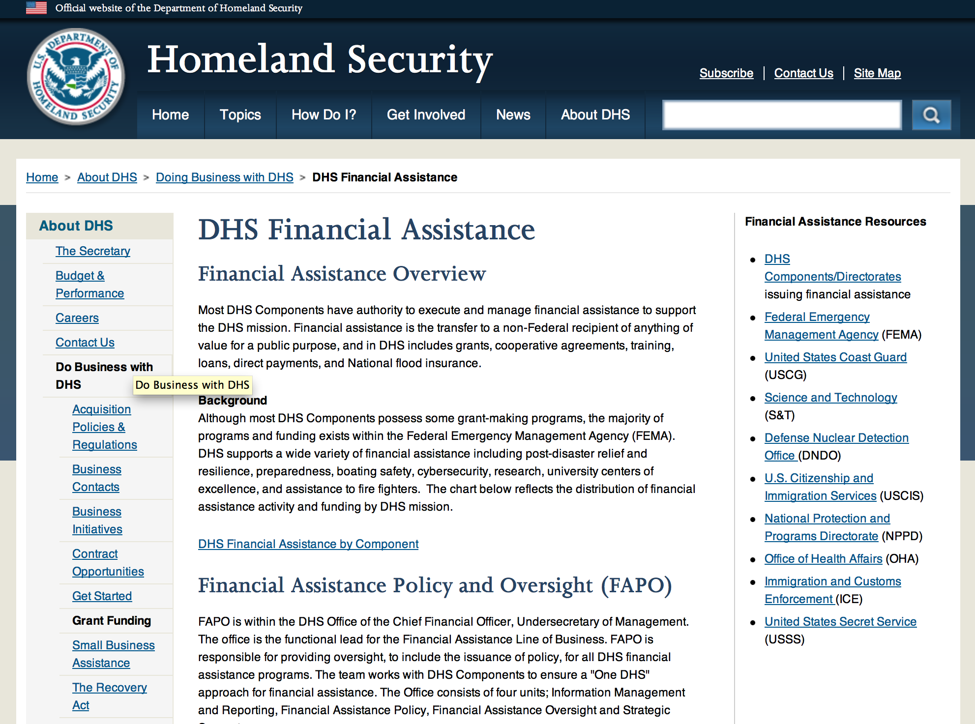

Webpage can be viewed at: http://www.dhs.gov/xopnbiz/grants/index.shtm#2

The FY 2016 Assistance to Firefighters Grants (AFG)
FY 2016 ASSISTANCE TO FIREFIGHTERS (AFG) GRANTS ANNOUNCEMENT
The FY 2016 AFG Open Application Period Dates Will Be As Follows: 8AM ET OCTOBER 11 through 5PM ET NOVEMBER 18
- FY 2016 Application Workshop Schedule
- FY 2016 AFG Application Guidance Materials The following documents are now available:
  - FY 2016 Notice of Funding Opportunity (NOFO) – Available Now
  - FY 2016 AFG Grant Application Get Ready Guide
  - FY 2016 AFG Narrative Get Ready Guide
  - FY 2016 AFG Self-Evaluation - Operations and Safety
  - FY 2016 AFG Self-Evaluation - Vehicle Acquisition
  - FY 2016 AFG Application Checklist
  - FY 2016 AFG Cost Share Calculator
FY 2016 AFG FAQs
For AFG program guidance materials, please visit our Documents page.

FY 2015 FIRE PREVENTION & SAFETY (FP&S) Grants
- FY 2015 Application Information Coming Soon
- FP&S Success Stories
FY 2014 FIRE PREVENTION & SAFETY (FP&S) Grants
- FY 2014 FP&S Award Announcements - View Awards List

FY 2015 STAFFING FOR ADEQUATE FIRE and EMERGENCY RESPONSE (SAFER) Grants
- FY 2015 Application Information Coming Soon
- SAFER Success Stories
FY 2014 STAFFING FOR ADEQUATE FIRE and EMERGENCY RESPONSE (SAFER) Grants
- FY 2014 FP&S Award Announcements - View Awards List
FP&S Success Stories

Resources

AFG Help Desk
Contact the AFG Program Help Desk toll-free at 866-274-0960, or email us at firegrants@dhs.gov.
The AFG Program has Fire Program Specialists in 10 federal regional centers. These Regional Fire Program Specialists respond to questions about the AFG program and carry out grant monitoring activities. View regional contacts

Popular AFG links
- AFG Workshop Schedule
- Assistance to Firefighters Grants (AFG)
- AFG Awards List
- AFG Success Stories
- Staffing for Adequate Fire & Emergency Response (SAFER) Grants (SAFER)
- SAFER Awards List
- SAFER Success Stories
- Fire Prevention & Safety (FP&S) Grants
- FP&S Awards List
- FP&S Success Stories
- Grant Closeout Tutorial
- Assistance to Firefighters Grant (AFG) Email Alert Archive
- Frequently Asked Questions
Contact Information For The Assistance to Firefighters Grant (AFG) Program and Help Desk

Federal Funding Alternative To AFG

State Administrative Agencies (SAA) apply for and administer Federal grants on behalf of their States, including FEMA Preparedness Grants. The SAA will work with eligible organizations to comply with the general requirements of grant programs or cooperative agreements. Contact your State’s SAA to find out what current Federal funding opportunities may be available to your organization. A listing of the SAAs and points of contact can be found at http://www.fema.gov/library/viewRecord.do?id=6363.

Programs:

Modifications:

Reminders:

Department of Homeland Security - FEMA
Assistance to Firefighters Grant (AFG)

Synopsis 1
Document Type: | Grants Notice
Funding Opportunity Number: | DHS-16-GPD-044-00-99
Funding Opportunity Title: | Assistance to Firefighters Grant (AFG)
Opportunity Category: | Discretionary
Opportunity Category Explanation:
Funding Instrument Type: | Grant
Category of Funding Activity: | Other (see text field entitled "Explanation of Other Category of Funding Activity" for clarification)
Category Explanation: | Firefighting and emergency medical service related equipment, training
Expected Number of Awards: | 2500
CFDA Number(s): | 97.044 -- Assistance to Firefighters Grant
Cost Sharing or Matching Requirement: | Yes
Posted Date: | Sep 01, 2016
Last Updated Date: | Sep 01, 2016
Original Closing Date for Applications: | Nov 18, 2016
Current Closing Date for Applications: | Nov 18, 2016
Archive Date: | Dec 18, 2016
Estimated Total Program Funding: | $310,500,000
Award Ceiling: | $3,450,000
Award Floor: | $0
Eligible Applicants: | Others (see text field entitled "Additional Information on Eligibility" for clarification)  City or township governments  County governments
Additional Information on Eligibility: | Fire Departments, nonaffiliated Emergency Medical Service (EMS) organizations, State Fire Training Academies.
Agency Name: | Department of Homeland Security - FEMA
Description: | The Department of Homeland Security (DHS) Federal Emergency Management Agency's (FEMA) Grant Programs Directorate implements and administers the Assistance to Firefighters Grant (AFG) program. The AFG program provides financial assistance to help fire departments, nonaffiliated Emergency Medical Service (EMS) organizations and State Fire Training Academies (SFTA); for critically needed resources to protect the public; to train emergency personnel, and to foster interoperability and support community resilience, as well as enhance through direct financial assistance, the safety of the public and to provide a continuum of support for emergency responders regarding fire, medical, and all hazard events.
Link to Additional Information: | Program Guidance
Grantor Contact Information: | If you have difficulty accessing the full announcement electronically, please contact:  AFG P&S Help Desk Phone: 8662740960 Email: firegrants@fema.gov  firegrants@fema.gov

http://www.grants.gov/web/grants/view-opportunity.html?oppId=288278

Office of Procurement Operations - Grants Division
DHS S&T Center of Excellence for Homeland Security Quantitative Analysis – Center Partner
Synopsis 1

Document Type: |  | Grants Notice
Funding Opportunity Number: |  | DHS-16-ST-061-HSQA-PARTNER
Funding Opportunity Title: |  | DHS S&T Center of Excellence for Homeland Security Quantitative Analysis – Center Partner
Opportunity Category: |  | Discretionary
Opportunity Category Explanation:
Funding Instrument Type: |  | Cooperative Agreement
Category of Funding Activity: |  | Science and Technology and other Research and Development
Category Explanation:
Expected Number of Awards: |  | 3
CFDA Number(s): |  | 97.061 -- Centers for Homeland Security
Cost Sharing or Matching Requirement: |  | No
Posted Date: |  | Aug 01, 2016
Last Updated Date: |  | Aug 01, 2016
Original Closing Date for Applications: |  | Nov 01, 2016
Current Closing Date for Applications: |  | Nov 01, 2016
Archive Date: |  | Dec 01, 2016
Estimated Total Program Funding: |  | $500,000
Award Ceiling: |  | $500,000
Award Floor: |  | $100,000
Eligible Applicants: |  | Private institutions of higher education  Public and State controlled institutions of higher education
Agency Name: | Office of Procurement Operations - Grants Division
Description: | IMPORTANT: DHS will conduct an informational webinar for interested applicants on August 23, 2016 at 3:00pm [EST]. The Department of Homeland Security (DHS) Science and Technology Directorate (S&T) Office of University Programs (OUP) is requesting applications from U.S. colleges and universities to serve as a partner institution for the Center for Homeland Security Quantitative Analysis (CHSQA). OUP is also posting a separate NOFO for eligible applicants to submit lead proposals for consideration. Please see NOFO Number DHS-16-ST-061-HSQA-Partner or 97.061 on http://www.grants.gov for directions on how to submit single project proposals. DHS will select qualified individual projects from applications received for either the Center Lead NOFO or the Center Partner NOFO, regardless of the institution that is awarded as lead institution. Principal Investigators that are already Partners under a Center Lead application may not submit the same application under this Partner NOFO.
Link to Additional Information: | Webinar Sign-Up Link
Grantor Contact Information: | If you have difficulty accessing the full announcement electronically, please contact:  Shareef Prater Grants Specialist Phone 202-447-5903  DHS Contact

http://www.grants.gov/web/grants/view-opportunity.html?oppId=286806

Department of Housing and Urban Development

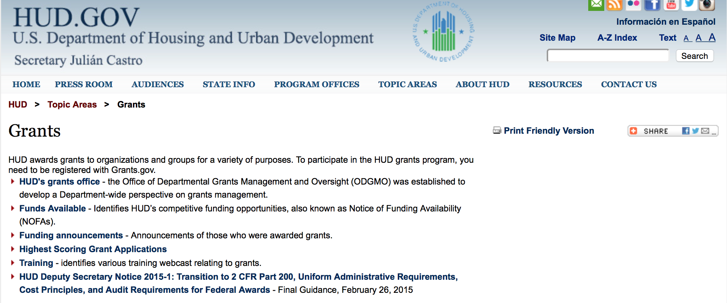

http://portal.hud.gov/hudportal/HUD?src=/topics/grants

HUD - Notice of Funds Available

For detailed information click here

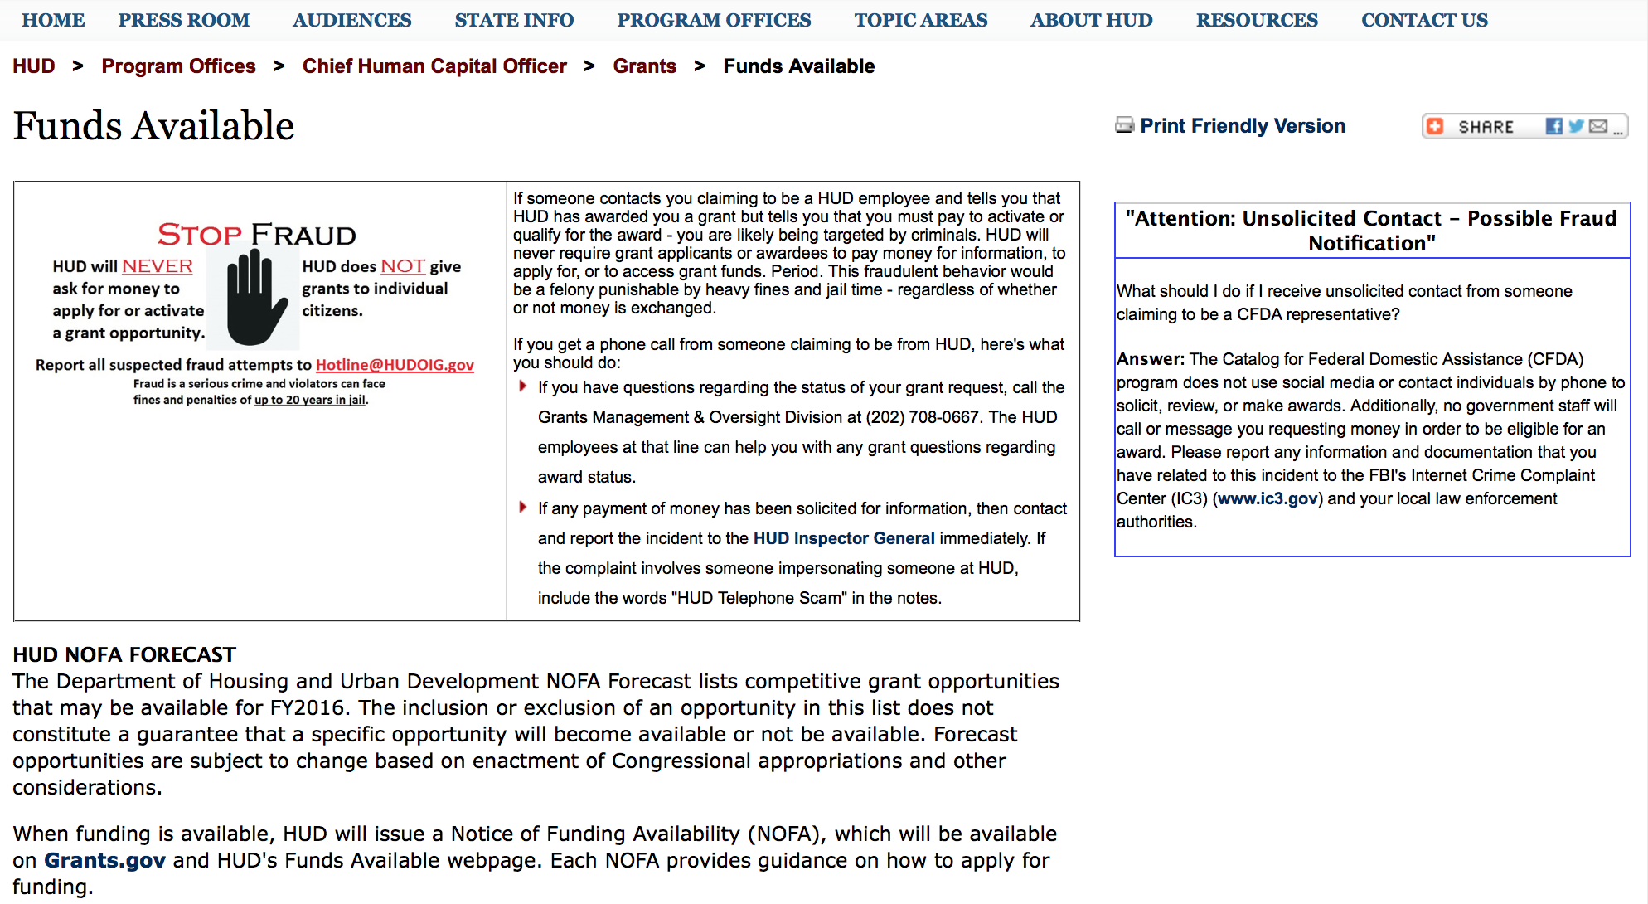

http://portal.hud.gov/hudportal/HUD?src=/program_offices/administration/grants/fundsavail

HUD NOFA FORECAST
The Department of Housing and Urban Development NOFA Forecast lists competitive grant opportunities that may be available for FY2016. The inclusion or exclusion of an opportunity in this list does not constitute a guarantee that a specific opportunity will become available or not be available. Forecast opportunities are subject to change based on enactment of Congressional appropriations and other considerations.
When funding is available, HUD will issue a Notice of Funding Availability (NOFA), which will be available on Grants.gov and HUD's Funds Available webpage. Each NOFA provides guidance on how to apply for funding.
Program Office | Funding Opportunity Title | Funding Opportunity Number | CFDA | Estimated Publication Date | Estimated Application Due Date
GMO | General Section to HUD's Fiscal Year 2016 Notice[s] of Funding Availability for Discretionary Programs (General Section) | FR-6000-N-01 | 14.506 | PUBLISHED | N/A
HSNG | Notice of Funding Availability (NOFA) for the Department's Fiscal Years 2016 and 2017 Comprehensive Housing Counseling Grant Program | FR-6000-N-33 | 14.169 | PUBLISHED | 4/4/2016
HSNG | NOFA for HUD's FY16-17 Housing Counseling Training Grant Program | FR-6000-N-30 | 14.316 | PUBLISHED | 4/4/2016
HSNG | Multifamily Energy and Water Conservation Pay For Success Pilot | FR-6000-N-36 | 14.157 | 9/14/2016 | 11/14/2016
OLHCHH | Lead Hazard Reduction Demonstration (LHRD) Grant Program | FR-6000-N-13 | 14.905 | PUBLISHED | 4/28/2016
OLHCHH | Lead-Based Paint Hazard Control (LBPHC) Grant Program | FR-6000-N-12 | 14.900 | PUBLISHED | 4/28/2016
OLHCHH | Healthy Homes Technical Studies Grant Program Pre and Full Application | FR-6000-N-15 | 14.906 | PUBLISHED | 6/1/2016
PIH | Resident Opportunity & Self-Sufficiency Program | FR-6000-N-05 | 14.870 | PUBLISHED | 5/16/2016
PIH | HOPE VI Main Street Grant Program | FR-6000-N-03 | 14.878 | PUBLISHED | 4/12/2016
PIH | Jobs Plus Initiative | FR-6000-N-14 | 14.895 | PUBLISHED | 6/13/2016
PIH | Family Self-Sufficiency Program | FR-6000-N-04 | 14.896 | PUBLISHED | 4/20/2016
PIH | Community Development Block Grant Program for Indian Tribes and Alaska Native Villages | FR-6000-N-23 | 14.862 | PUBLISHED | 6/14/2016
PIH | Choice Neighborhoods Implementation Grant Program | FR-6000-N-34 | 14.889 | PUBLISHED | 6/28/2016
PIH | Project SOAR | FR-6000-N-27 | 14.889 | 7/20/2016 | 9/19/2016
FHEO | Fair Housing Initiative Program - Private Enforcement Initiative | FR-6000-N-21C | 14.418 | PUBLISHED | 6/23/2016
FHEO | Fair Housing Initiative Program - Fair Housing Organization Initiative | FR-6000-N-21B | 14.417 | PUBLISHED | 6/23/2016
FHEO | Fair Housing Initiative Program - Education and Outreach Initiative | FR-6000-N-21A | 14.416 | PUBLISHED | 6/23/2016
PDR | Research and Evaluation, Demonstration, and Data Analysis and Utilization | FR-5900-N-29 | 14.536 | PUBLISHED | 6/6/2016
PDR | Research and Evaluation, Demonstration, and Data Analysis and Utilization | FR-6000-N-29 | 14.536 | 7/7/2016 | 8/23/2016
CPD | HUD Community Compass Technical Assistance and Capacity Building Program | FR-6000-N-06 | 14.259 | PUBLISHED | 7/19/2016
CPD | Capacity Building for Community Development and Affordable Housing Grants (Section 4) | FR-6000-N-07 | 14.252 | PUBLISHED | 8/9/2016
CPD | Building Capacity to End Youth Homelessness | FR-6000-N-37 | 14.270 | CANCELLED | CANCELLED
CPD | Youth Homelessness Demonstration Project | FR-6000-N-35 | 14.267 | 7/7/2016 | 9/1/2016
CPD | Continuum of Care Program Competition | FR-6000-N-25 | 14.276 | 6/30/2016 | 9/30/2016
CPD | Rural Capacity Building for Community Development and Affordable Housing Grants | FR-6000-N-08 | 14.265 | 7/8/2016 | 9/6/2016
CPD | Self-Help Homeownership Opportunity Program (SHOP) | FR-6000-N-19 | 14.247 | 10/12/2016 | 12/11/2016
- Updated 6/21/2016 General Section
- FONSI
- New Application Attachment Filename Requirement

Programs

Modifications:

Reminders

Self-Help Homeownership Opportunity Program (SHOP)
Synopsis 1

Document Type: | Grants Notice
Funding Opportunity Number: | FR-6000-N-19
Funding Opportunity Title: | Self-Help Homeownership Opportunity Program (SHOP)
Opportunity Category: | Discretionary
Opportunity Category Explanation:
Funding Instrument Type: | Grant
Category of Funding Activity: | Housing
Category Explanation:
Expected Number of Awards: | 4
CFDA Number(s): | 14.247 -- Self-Help Homeownership Opportunity Program
Cost Sharing or Matching Requirement: | Yes
Version: | Synopsis 1
Posted Date: | Aug 10, 2016
Last Updated Date: | Aug 10, 2016
Original Closing Date for Applications: | Oct 12, 2016 Electronically submitted applications must be submitted no later than 11:59:59 p.m., ET, on the listed application due date.
Current Closing Date for Applications: | Oct 12, 2016 Electronically submitted applications must be submitted no later than 11:59:59 p.m., ET, on the listed application due date.
Archive Date: | Nov 11, 2016
Estimated Total Program Funding: | $10,000,000
Award Ceiling: | $10,000,000
Award Floor: | $450,000
Eligible Applicants: | Others (see text field entitled "Additional Information on Eligibility" for clarification)
Additional Information on Eligibility: | Applicants must be a public or private non-profit organization, or a consortium of public or private non-profit organizations, as defined below, that have the capacity and experience to provide or facilitate self-help homeownership housing opportunities on a national or regional basis. Applicants must propose to undertake eligible SHOP activities directly and/or enter into a written agreement with one or more non-profit affiliate organizations to carry out eligible SHOP activities. Individuals, foreign entities, and sole proprietorship organizations are not eligible to compete for, or receive, awards made under this announcement.
Agency Name: | Department of Housing and Urban Development
Description: | This NOFA announces the availability of $10,000,000 of FY2016 Self-Help Homeownership Opportunity Program (SHOP) grant funds. SHOP funding is intended to facilitate and encourage innovative homeownership opportunities on a national and geographically-diverse basis. The program supports self-help housing programs that require a significant amount of sweat equity by the homebuyer toward the construction or rehabilitation of his or her home. Volunteer labor is also required. Eligible applicants for SHOP funding include national and regional non-profit organizations and consortia with experience facilitating homeownership opportunities on a national, geographically-diverse basis through the provision of self-help homeownership housing programs. Applicants must propose to use a significant amount of SHOP grant funds in at least two states and may award SHOP grant funds to local non-profit affiliate organizations to carry out the Grantee's SHOP program. These affiliate organizations must be located within the Grantee's service area. Individuals are not eligible to apply for SHOP grant funds. SHOP grant funds must be used for land acquisition, infrastructure improvements, and for reasonable and necessary planning and administration costs (not to exceed 20 percent) with the maximum average SHOP investment for land acquisition and infrastructure not exceeding $15,000 per SHOP unit. The construction or rehabilitation costs of each SHOP unit must be funded with other leveraged public and private funds. SHOP units must be decent, safe, and sanitary non-luxury dwellings that comply with state and local codes, ordinances, and zoning requirements, and with all other SHOP requirements, including but not limited to, the requirements for energy-efficiency, water conservation and accessibility. The SHOP units must be sold to homebuyers at prices below the prevailing market price.
Link to Additional Information: | http://portal.hud.gov/hudportal/HUD?src=/program_offices/administration/grants/fundsavail
Grantor Contact Information: | If you have difficulty accessing the full announcement electronically, please contact:  Thann Young Thann.Young@hud.gov  Grants Policy

http://www.grants.gov/web/grants/view-opportunity.html?oppId=287279

Youth Homelessness Demonstration Program
Synopsis 1

Document Type: | Grants Notice
Funding Opportunity Number: | FR-6000-N-35
Funding Opportunity Title: | Youth Homelessness Demonstration Program
Opportunity Category: | Discretionary
Opportunity Category Explanation:
Funding Instrument Type: | Grant
Category of Funding Activity: | Community Development
Category Explanation:
Expected Number of Awards: | 10
CFDA Number(s): | 14.276 -- Youth Homelessness Demonstration Program
Cost Sharing or Matching Requirement: | Yes
Version: | Synopsis 1
Posted Date: | Aug 22, 2016
Last Updated Date: | Aug 22, 2016
Original Closing Date for Applications: | Nov 30, 2016 Electronically submitted applications must be submitted no later than 11:59:59 p.m., ET, on the listed application due date.
Current Closing Date for Applications: | Nov 30, 2016 Electronically submitted applications must be submitted no later than 11:59:59 p.m., ET, on the listed application due date.
Archive Date: | Dec 30, 2016
Estimated Total Program Funding: | $33,000,000
Award Ceiling: | $15,000,000
Award Floor: | $1,000,000
Eligible Applicants: | Nonprofits having a 501(c)(3) status with the IRS, other than institutions of higher education  City or township governments  State governments  County governments
Additional Information on Eligibility: | Community Selection application: Available to Collaborative Applicants designated by CoCs registered through the FY 2016 CoC Program Registration process. The Collaborative Applicant can apply for any community located within its CoC. The Collaborative Applicant can also apply for multiple communities located within its CoC. Project application: Project applicants that are designated during the application process by the Collaborative Applicant are eligible to apply for grant funds as well as be subrecipients of grant funds. The Collaborative Applicant may apply for projects under this Demonstration as well. For-profit entities are not eligible to apply for grants or to be sub recipients of grant funds. To be considered for funding, project applicants must complete the information required by HUD, in the manner required by HUD, and receive the approval of the CoC to apply for funding, as signed off on by the Collaborative Applicant. This NOFA is for applying for community selection only. Project application will occur after communities have been selected - requirements for applying for projects are detailed in Appendix A. Individuals, foreign entities, and sole proprietorship organizations are not eligible to compete for, or receive, awards made under this announcement.
Agency Name: | Department of Housing and Urban Development
Description: | NOFA Highlights: HUD will select up to 10 communities to participate in the Youth Homelessness Demonstration Program (YHDP) to develop and execute a coordinated community approach to preventing and ending youth homelessness. Four of the 10 selected communities will be rural communities. [Section I.A.1] Only CoC Collaborative Applicants may apply to this NOFA [Section III.A] Applications are submitted through grants.gov, and are due by November 30, 2016 Communities represented by the CoC Collaborative Applicant must include a youth advisory board, the local or state public child welfare agency, and a broad array of other partners [Sections III.C.1, III.C.3.b, and V.A] The rating and ranking criteria included in this NOFA will be used to competitively select the communities [Section V.A] The selection of the 10 communities will be announced in January of 2017 [Section V.C] Selected Communities Will: Develop and implement a Coordinated Community Plan to prevent and end youth homelessness [Section III.C.3.b] Apply for project funding up to an amount between $1 million and $15 million per community, based on each community's youth population size and poverty rate, for a total demonstration amount of up to $33 million [Section II.C] Request project funding on a rolling basis using a project application in the e-snaps grants management system beginning in early 2017 [Appendix A] Requests funding for all project types allowed under the CoC Program to support homeless and at risk youth, as well as innovative project types that may require a waiver of CoC Program requirements [Appendix A and Appendix B] Request funding for a 2-year grant term that will be eligible for renewal under the CoC Program, as long as the project meets statutory CoC Program requirements [Section II.B] Receive a dedicated team of technical assistance providers to advise the development and implementation of the Coordinated Community Plan [Section I.A] Participate in an evaluation that will inform the federal strategy for preventing and ending youth homelessness [Section I.A and VI.B.] NOFA Priority The purpose of the YHDP is to learn how communities can successfully approach the goal of preventing and ending youth homelessness by building comprehensive systems of care for young people rather than implementing individual or unconnected projects that serve this population. In order to effectively implement a system that addresses the needs of youth experiencing homelessness, Continuums of Care (CoCs) must understand the subgroups of unaccompanied youth; including pregnant and parenting, Lesbian, Gay, Bisexual, Transgender, and Questioning (LGBTQ), and minor age youth; experiencing homelessness and the unique challenges they face within their communities. Additionally, CoCs must ensure that the appropriate type of housing assistance and level of services that are effective in providing safe and stable housing are available within the community and must reach out and partner with a comprehensive set of traditional and non-traditional youth homelessness stakeholders that provide youth with resources and services, advocate for them, and set policy on their behalf. Finally, CoCs must incorporate the experiences of homeless or formerly homeless unaccompanied youth; which is vital to understanding the needs, strengths, and perspectives of the youth in the community; and incorporate those understandings into the YHDP coordinated community plan and awarded projects. All of this will require CoCs to use innovative practices to design better projects and strong comprehensive plans to prevent and end youth homelessness. Background In 2010, the United States Interagency Council on Homelessness (USICH) presented Opening Doors: The Federal Strategic Plan to Prevent and End Homelessness to the President and Congress, identifying youth as one of four special populations and articulating a goal of preventing and ending youth homelessness by 2020. A coordinated community approach lies at the heart of the strategies advocated by Opening Doors[1]. By engaging in a system-wide crisis response, communities can better understand their system level needs and assets, plan for and allocate new and existing resources, prevent and quickly divert youth from homelessness, and identify, engage, and respond to the needs of youth experiencing homelessness. These concepts are described in the 2012 release of the Framework to End Youth Homelessness[2], and Preventing and Ending Youth Homelessness: A Coordinated Community Response by USICH in December of 2015[3]. The 2015 release included a Preliminary Vision for a Community Response; and illustrates the general components believed necessary for each community to prevent and end youth homelessness. Federal partner agencies with a stake in preventing and ending youth homelessness, are working tirelessly together to build on that vision. This work together and a commitment to developing and supporting a coordinated community approach guides the Department of Housing and Urban Development's (HUD) effort to prevent and end youth homelessness, and serves as the cornerstone value for the Youth Homelessness Demonstration. [1] http://dev2.usich.gov/resources/uploads/asses_library/USICH_OpeningDoors_Amendment2015_FINAL.pdf [2] https://www.usich.gov/tools-for-action/framework-for-ending-youth-homelessness [3] https://www.usich.gov/resources/uploads/asset_library/Youth_Homelessness_Coordinated_Response.pdf
Link to Additional Information: | http://portal.hud.gov/hudportal/HUD?src=/program_offices/administration/grants/fundsavail
Grantor Contact Information: | If you have difficulty accessing the full announcement electronically, please contact:  Ebony Rankin Ebony.W.Rankin@hud.gov  Grants Policy

http://www.grants.gov/web/grants/view-opportunity.html?oppId=287815

Technical Correction to the General Section to HUD's Fiscal Year 2016 Notice[s] of Funding Availability for Discretionary Programs
Modification 1

Document Type: | Grants Notice
Funding Opportunity Number: | FR-6000-N-01-C
Funding Opportunity Title: | Technical Correction to the General Section to HUD's Fiscal Year 2016 Notice[s] of Funding Availability for Discretionary Programs
Opportunity Category: | Discretionary
Opportunity Category Explanation:
Funding Instrument Type: | Grant
Category of Funding Activity: | Community Development
Category Explanation:
Expected Number of Awards: | 0
CFDA Number(s):
Cost Sharing or Matching Requirement: | No
Posted Date: | May 16, 2016
Last Updated Date: | May 16, 2016
Original Closing Date for Applications: | Dec 31, 2016 Electronically submitted applications to program NOFAs must be submitted no later than 11:59:59 p.m., ET, on the listed application due date. No applications are accepted in response to this Notice, which publishes policies and guidance only.
Current Closing Date for Applications: | Dec 31, 2016 Electronically submitted applications to program NOFAs must be submitted no later than 11:59:59 p.m., ET, on the listed application due date. No applications are accepted in response to this Notice, which publishes policies and guidance only.
Archive Date: | Jan 30, 2017
Estimated Total Program Funding: | $0
Award Ceiling: | $0
Award Floor: | $0
Eligible Applicants: | Public and State controlled institutions of higher education  Unrestricted (i.e., open to any type of entity above), subject to any clarification in text field entitled "Additional Information on Eligibility"  Nonprofits that do not have a 501(c)(3) status with the IRS, other than institutions of higher education  State governments  Private institutions of higher education  Public housing authorities/Indian housing authorities  County governments  Special district governments  City or township governments  Small businesses  Native American tribal governments (Federally recognized)  Independent school districts  Native American tribal organizations (other than Federally recognized tribal governments)  Individuals  Nonprofits having a 501(c)(3) status with the IRS, other than institutions of higher education  For profit organizations other than small businesses
Additional Information on Eligibility: | No applications will be accepted in response to this document. This Document is a policy document only. The individual program Notices of Funds Available (NOFA) will identify eligible applicants for each competition. Each Program NOFA will describe additional eligibility requirements for applicants. HUD does not provide direct services or products to individuals through its formula-based programs or its competitive Program NOFA process. Individuals seeking financial assistance should refer to www.GovBenefits.gov. Individuals, foreign entities, and sole proprietorship organizations are not eligible to compete for, or receive, awards made under this announcement.
Agency Name: | Department of Housing and Urban Development
Description: | HUD publishes a General Section each Fiscal Year (FY) that contains requirements for all of HUD’s competitive grant programs. Applications to HUD programs must meet all applicable requirements of the General Section and the requirements in the Program NOFA to be considered for funding. This updates paragraph V.C.8. Eminent Domain to reflect the 2016 Appropriations authority, and updates paragraph VI.A.1. Obtaining an Electronic Application.
Link to Additional Information: | http://portal.hud.gov/hudportal/HUD?src=/program_offices/administration/grants/fundsavail
Contact Information: | If you have difficulty accessing the full announcement electronically, please contact:  Loyd LaMois loyd.lamois@hud.gov  Grants Policy

http://www.grants.gov/web/grants/view-opportunity.html?oppId=283900

General Section to HUD's Fiscal Year 2016 Notice[s] of Funding Availability for Discretionary Programs (General Section)
Modification 1

Document Type: | Grants Notice
Funding Opportunity Number: | FR-6000-N-01
Funding Opportunity Title: | General Section to HUD's Fiscal Year 2016 Notice[s] of Funding Availability for Discretionary Programs (General Section)
Opportunity Category: | Discretionary
Funding Instrument Type: | Grant
Category of Funding Activity: | Community Development
Category Explanation:
Expected Number of Awards: | 0
CFDA Number(s):
Cost Sharing or Matching Requirement: | No
Posted Date: | Sep 24, 2015
Creation Date: | Sep 24, 2015
Original Closing Date for Applications: | Dec 30, 2016 Electronically submitted applications must be submitted no later than 11:59:59 p.m., ET, on the listed application due date published in the individual program NOFA.
Current Closing Date for Applications: | Dec 30, 2016 Electronically submitted applications must be submitted no later than 11:59:59 p.m., ET, on the listed application due date published in the individual program NOFA.
Archive Date: | Jan 29, 2017
Eligible Applicants: | Others (see text field entitled "Additional Information on Eligibility" for clarification)
Additional Information on Eligibility: | This Document is a policy document only. The individual program Notices of Funds Available (NOFA) will identify eligible applicants for each competition. Each Program NOFA will describe additional eligibility requirements for applicants. All applicants must have valid, active Registration in the System for Award Management (SAM) prior to submission of applications for financial assistance. HUD does not provide direct services or products to individuals through its formula-based programs or its competitive Program NOFA process. Individuals seeking financial assistance should refer to www.GovBenefits.gov. Individuals, foreign entities, and sole proprietorship organizations are not eligible to compete for, or receive, awards made under this announcement.
Agency Name: | Department of Housing and Urban Development
Description: | The General Section describes the requirements that are applicable to all HUD FY 2015 Program NOFAs. The General Section also provides information on HUD’s priorities and strategic goals. Each Program NOFA will describe additional applicable procedures and requirements, including a description of the eligible applicants, eligible activities, threshold requirements, cross-program requirements such as nondiscrimination, environmental protection, and any additional program requirements or limitations. To adequately address all of the application requirements for any program, please carefully read and respond to both this General Section and any applicable Program NOFA.
Link to Additional Information: | http://portal.hud.gov/hudportal/HUD?src=/program_offices/administration/grants/fundsavail
Contact Information: | If you have difficulty accessing the full announcement electronically, please contact:  Loyd LaMois loyd.lamois@hud.gov  Grants Policy

http://www.grants.gov/web/grants/view-opportunity.html?oppId=279206



Institute of Museum and Library Services

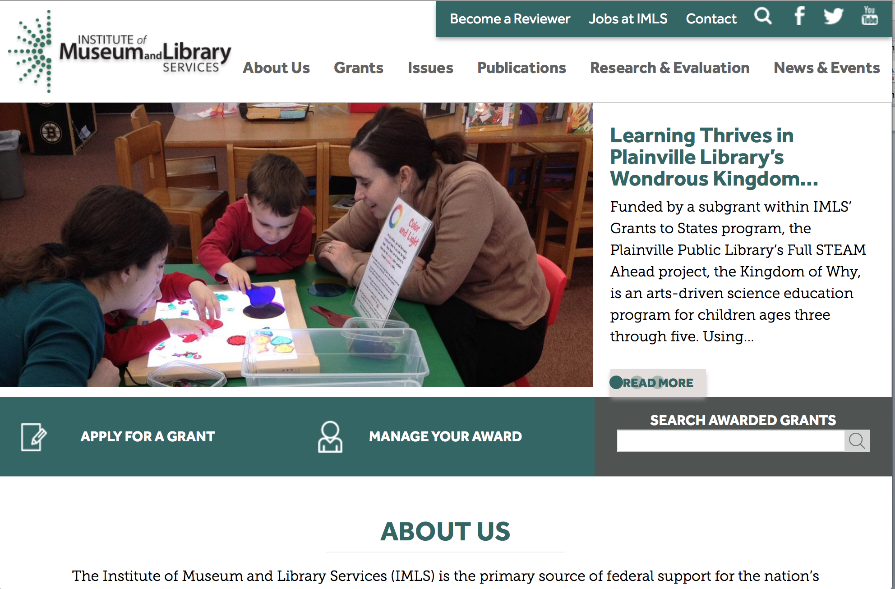

www.imls.gov

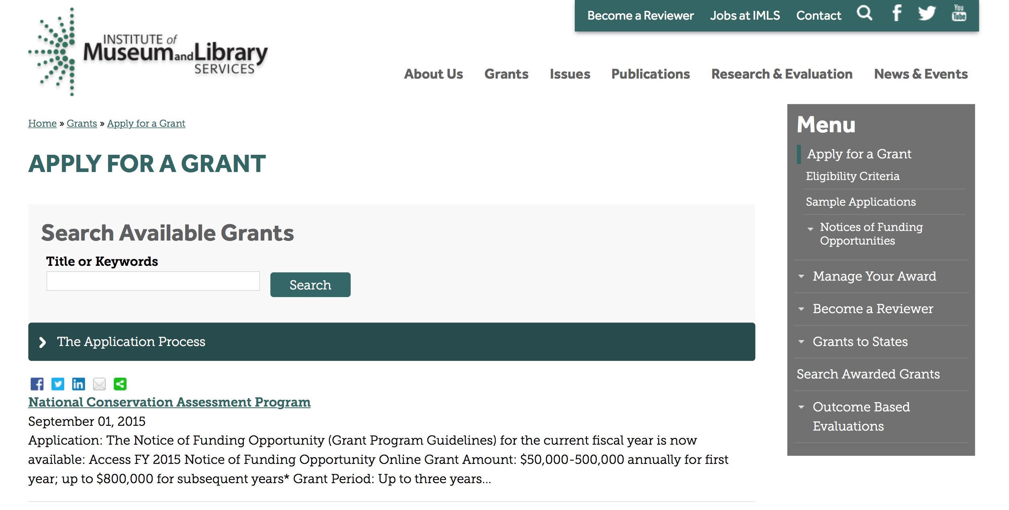
http://www.imls.gov/applicants/available_grants.aspx

Each grant program has specific eligibility requirements. The links below provide general eligibility criteria for museums, libraries, and tribal organizations, but please note that additional organizations may be eligible for grants under certain programs. Additionally, ineligible organizations may still be able to participate in grant programs through partnerships with eligible organizations. Please click on the links below to see general criteria and review Applications and Guidelines for specific information.
Museums Libraries

Institutions: Archives, Federally Recognized Native American Tribe, Historical Society, Library, Nonprofits that serve Native Hawaiians, Professional Association, Public or Private Non-profit Institutions of Higher Education, Regional Organization, State Library Administrative Agency, State or Local Government

Check out IMLS's Facebook page at:
https://www.facebook.com/USIMLS/

Programs:

National Leadership Grants for Museums
Synopsis 1

Document Type: | Grants Notice
Funding Opportunity Number: | NLG-MUSEUMS-FY17
Funding Opportunity Title: | National Leadership Grants for Museums
Opportunity Category: | Discretionary
Opportunity Category Explanation:
Funding Instrument Type: | Grant
Category of Funding Activity: | Arts (see "Cultural Affairs" in CFDA)  Humanities (see "Cultural Affairs" in CFDA)
Category Explanation:
Expected Number of Awards: | 15
CFDA Number(s): | 45.312 -- National Leadership Grants
Cost Sharing or Matching Requirement: | Yes
Version: | Synopsis 1
Posted Date: | Sep 08, 2016
Last Updated Date: | Sep 08, 2016
Original Closing Date for Applications: | Dec 01, 2016
Current Closing Date for Applications: | Dec 01, 2016
Archive Date: | Dec 31, 2016
Estimated Total Program Funding: | $6,500,000
Award Ceiling: | $1,000,000
Award Floor: | $5,000
Eligible Applicants: | Others (see text field entitled "Additional Information on Eligibility" for clarification)
Additional Information on Eligibility: | To be eligible for an award under this NLG for Museums notice of funding opportunity, you must be an organization that meets all three of the following criteria: 1. You must be either a unit of State or local government or be a private nonprofit organization that has tax-exempt status under the Internal Revenue Code; 2. You must be located in one of the 50 States of the United States of America, the District of Columbia, the Commonwealth of Puerto Rico, the U.S. Virgin Islands, Guam, American Samoa, the Commonwealth of the Northern Mariana Islands, the Republic of the Marshall Islands, the Federated States of Micronesia, or the Republic of Palau; and 3. You must qualify as one of the following: (a) A museum that, using a professional staff, is organized on a permanent basis for essentially educational or aesthetic purposes; owns or uses tangible objects, either animate or inanimate; cares for these objects; and exhibits these objects to the general public on a regular basis through facilities that it owns or operates. (b) An organization or association that engages in activities designed to advance the well-being of museums and the museum profession; (c) An institution of higher education, including public and nonprofit universities; or (d) A public or private nonprofit agency which is responsible for the operation of a museum that meets the eligibility criteria in 1, 2, and 3(a) above may apply on behalf of the museum. Native American tribal organizations may apply if they otherwise meet the above eligibility requirements. Please see the Notice of Funding Opportunity for additional clarification on eligibility criteria.
Agency Name: | Institute of Museum and Library Services
Description: | National Leadership Grants (NLG) for Museums support projects that address critical needs of the museum field and that have the potential to advance practice in the profession so that museums can improve services for the American public.
Link to Additional Information: | https://www.imls.gov/grants/available/national-leadership-grants-museums
Grantor Contact Information: | If you have difficulty accessing the full announcement electronically, please contact:  Sandra Narva, Senior Program Officer, 202-653-4634, snarva@imls.gov; Connie Bodner, Supervisory Grants Management Specialist, 202-653-4636, cbodner@imls.gov; Steve Shwartzman, Senior Program Officer, 202-653-4641, sshwartzman@imls.gov; Jill Connors-Joyner, Museum Program Specialist, 202-653-4791, jconnors-joyner@imls.gov; Laura Zamarripa, Museum Program Specialist, 202-653-4753, lzamarripa@imls.gov; Mark Feitl, Museum Program Specialist, 202-653-4635, mfeitl@imls.gov  imls-museumgrants@imls.gov

http://www.grants.gov/web/grants/view-opportunity.html?oppId=288660

Museums for America
Synopsis 1

Document Type: | Grants Notice
Funding Opportunity Number: | MFA-FY17
Funding Opportunity Title: | Museums for America
Opportunity Category: | Discretionary
Opportunity Category Explanation:
Funding Instrument Type: | Grant
Category of Funding Activity: | Arts (see "Cultural Affairs" in CFDA)  Humanities (see "Cultural Affairs" in CFDA)
Category Explanation:
Expected Number of Awards: | 126
CFDA Number(s): | 45.301 -- Museums for America
Cost Sharing or Matching Requirement: | Yes
Version: | Synopsis 1
Posted Date: | Sep 08, 2016
Last Updated Date: | Sep 08, 2016
Original Closing Date for Applications: | Dec 01, 2016
Current Closing Date for Applications: | Dec 01, 2016
Archive Date: | Dec 31, 2016
Estimated Total Program Funding: | $20,200,000
Award Ceiling: | $500,000
Award Floor: | $5,000
Eligible Applicants: | Others (see text field entitled "Additional Information on Eligibility" for clarification)
Additional Information on Eligibility: | To be eligible for an award under this MFA notice of funding opportunity, you must be an organization that meets all three of the following criteria: 1. You must be either a unit of State or local government or be a private nonprofit organization that has tax-exempt status under the Internal Revenue Code; 2. You must be located in one of the 50 States of the United States of America, the District of Columbia, the Commonwealth of Puerto Rico, the U.S. Virgin Islands, Guam, American Samoa, the Commonwealth of the Northern Mariana Islands, the Republic of the Marshall Islands, the Federated States of Micronesia, or the Republic of Palau; and 3. You must qualify as one of the following: (a) A museum that, using a professional staff, is organized on a permanent basis for essentially educational or aesthetic purposes; owns or uses tangible objects, either animate or inanimate; cares for these objects; and exhibits these objects to the general public on a regular basis through facilities that it owns or operates. (b) A public or private nonprofit agency which is responsible for the operation of a museum that meets the eligibility criteria in 1, 2, and 3(a) above may apply on behalf of the museum. Native American tribal organizations may apply if they otherwise meet the above eligibility requirements. Please see the Notice of Funding Opportunity for additional clarification on eligibility.
Agency Name: | Institute of Museum and Library Services
Description: | Museums for America (MFA) grants support projects that strengthen the ability of an individual museum to serve its public.
Link to Additional Information: | https://www.imls.gov/grants/available/museums-america
Grantor Contact Information: | If you have difficulty accessing the full announcement electronically, please contact:  Sandra Narva, Senior Program Officer, 202-653-4634, snarva@imls.gov; Connie Bodner, Supervisory Grants Management Specialist, 202-653-4636, cbodner@imls.gov; Steve Shwartzman, Senior Program Officer, 202-653-4641, sshwartzman@imls.gov; Jill Connors-Joyner, Museum Program Specialist, 202-653-4791, jconnors-joyner@imls.gov; Laura Zamarripa, Museum Program Specialist, 202-653-4753, lzamarripa@imls.gov; Mark Feitl, Museum Program Specialist, 202-653-4635, mfeitl@imls.gov  imls-museumgrants@imls.gov

http://www.grants.gov/web/grants/view-opportunity.html?oppId=288661

Modifications:

Reminders:

Deleted:

NANH-FY16 - Native American/Native Hawaiian Museum Services
Deletion Comments: Opportunity deleted

AAHC-FY16 - Museum Grants for African American History and Culture
Deletion Comments: Opportunity deleted

Department of the Interior
Working with Interior

The Interior Department provides assistance to the public, local governments and businesses through a number of programs. For a general overview see: http://www.doi.gov/index.cfm

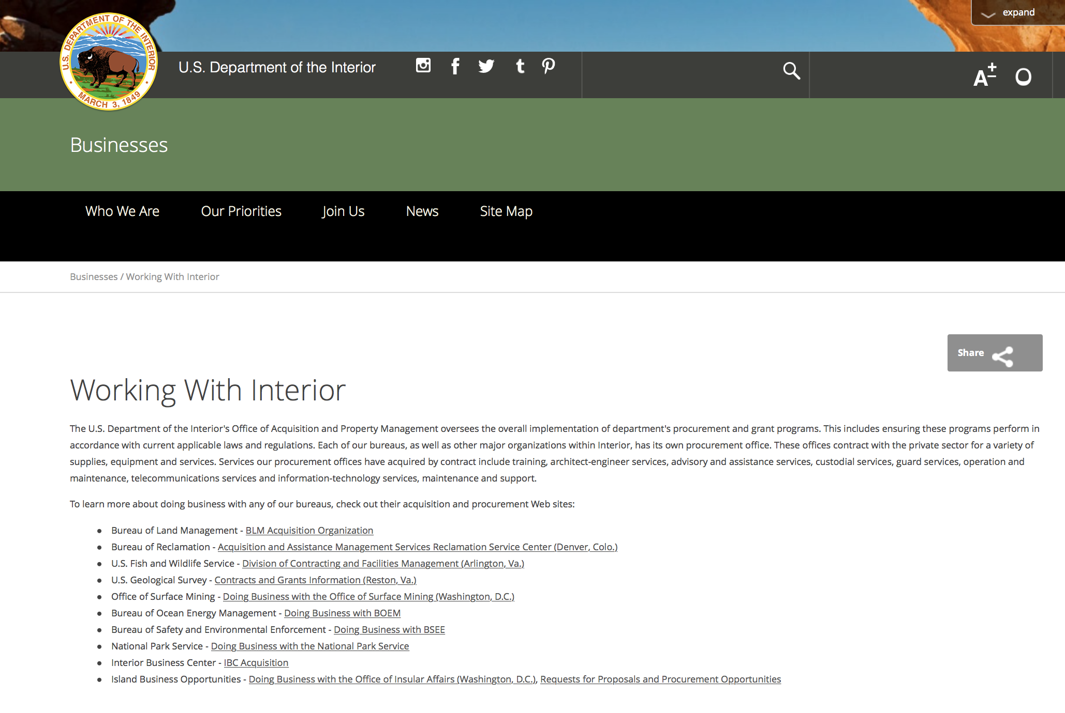

http://www.doi.gov/businesses/working-with-interior.cfm

Programs:

Bureau of Land Management
Joint Fire Science Program (JFSP) Primary Announcement (6 Task Statements)
Synopsis 1

Document Type: | Grants Notice
Funding Opportunity Number: | FA-FON0017-0001
Funding Opportunity Title: | Joint Fire Science Program (JFSP) Primary Announcement (6 Task Statements)
Opportunity Category: | Discretionary
Opportunity Category Explanation:
Funding Instrument Type: | Cooperative Agreement
Category of Funding Activity: | Science and Technology and other Research and Development
Category Explanation:
Expected Number of Awards: | 20
CFDA Number(s): | 15.232 -- Wildland Fire Research and Studies
Cost Sharing or Matching Requirement: | No
Version: | Synopsis 1
Posted Date: | Sep 15, 2016
Last Updated Date: | Sep 15, 2016
Original Closing Date for Applications: | Nov 17, 2016
Current Closing Date for Applications: | Nov 17, 2016
Archive Date: | Dec 17, 2016
Estimated Total Program Funding: | $5,500,000
Award Ceiling: | $0
Award Floor: | $0
Eligible Applicants: | Unrestricted (i.e., open to any type of entity above), subject to any clarification in text field entitled "Additional Information on Eligibility"
Agency Name: | Bureau of Land Management
Description: | The Joint Fire Science Program provides funding for scientific studies associated with managing wildland fuels, fires, and fire-impacted ecosystems. Current priorities are identified as task statements in the Funding Opportunity Notice (FON). All proposals must be submitted by 5:00 p.m. MST November 17, 2016, using the electronic submission process provided on the JFSP website (www.firescience.gov). Proposals should not be submitted through Grants.gov. No exceptions are allowed to this closing date and time.
Link to Additional Information:
Grantor Contact Information: | If you have difficulty accessing the full announcement electronically, please contact:  Becky Jenison Program Analyst  FA-FON0017-0001

http://www.grants.gov/web/grants/view-opportunity.html?oppId=288901

Bureau of Land Management
Joint Fire Science Program (JFSP) Graduate Research Innovation (GRIN) Announcement (1 Task Statement)
Synopsis 1
Document Type: | Grants Notice
Funding Opportunity Number: | FA-FON0017-0002
Funding Opportunity Title: | Joint Fire Science Program (JFSP) Graduate Research Innovation (GRIN) Announcement (1 Task Statement)
Opportunity Category: | Discretionary
Opportunity Category Explanation:
Funding Instrument Type: | Cooperative Agreement
Category of Funding Activity: | Science and Technology and other Research and Development
Category Explanation:
Expected Number of Awards:
CFDA Number(s): | 15.232 -- Wildland Fire Research and Studies
Cost Sharing or Matching Requirement: | No
Version: | Synopsis 1
Posted Date: | Sep 15, 2016
Last Updated Date: | Sep 15, 2016
Original Closing Date for Applications: | Nov 17, 2016
Current Closing Date for Applications: | Nov 17, 2016
Archive Date: | Dec 17, 2016
Estimated Total Program Funding: | $150,000
Award Ceiling: | $25,000
Award Floor: | $0
Eligible Applicants: | Unrestricted (i.e., open to any type of entity above), subject to any clarification in text field entitled "Additional Information on Eligibility"
Agency Name: | Bureau of Land Management
Description: | The Joint Fire Science Program provides funding for scientific studies associated with managing wildland fuels, fires, and fire-impacted ecosystems. The purpose of a GRIN award is to enhance student exposure to the management and policy relevance of their research to achieve beneficial outcomes of funded work. All proposals must be submitted by 5:00 p.m. MST November 17, 2016, using the electronic submission process provided on the JFSP website (www.firescience.gov). Proposals should not be submitted through Grants.gov. No exceptions are allowed to this closing date and time.
Link to Additional Information:
Grantor Contact Information: | If you have difficulty accessing the full announcement electronically, please contact:  Becky Jenison Program Analyst  FA-FON0017-0002

http://www.grants.gov/web/grants/view-opportunity.html?oppId=288902

Geological Survey
The Educational Component of the National Cooperative Geologic Mapping Program
Synopsis 1

Document Type: | Grants Notice
Funding Opportunity Number: | G17AS00005
Funding Opportunity Title: | The Educational Component of the National Cooperative Geologic Mapping Program
Opportunity Category: | Discretionary
Opportunity Category Explanation:
Funding Instrument Type: | Cooperative Agreement
Category of Funding Activity: | Education
Category Explanation:
Expected Number of Awards: | 20
CFDA Number(s): | 15.810 -- National Cooperative Geologic Mapping
Cost Sharing or Matching Requirement: | Yes
Version: | Synopsis 1
Posted Date: | Sep 08, 2016
Last Updated Date: | Sep 08, 2016
Original Closing Date for Applications: | Nov 09, 2016
Current Closing Date for Applications: | Nov 09, 2016
Archive Date: | Dec 09, 2016
Estimated Total Program Funding: | $429,000
Award Ceiling: | $50,000
Award Floor: | $0
Eligible Applicants: | Others (see text field entitled "Additional Information on Eligibility" for clarification)
Additional Information on Eligibility: | U.S. accredited university Geoscience or related Departments are eligible for EDMAP funds. University professors must write and submit the proposals. EDMAP cooperative agreements are intended to fund students doing geologic mapping in the field. While it is proper for the professors advisors to ask for some logistical support so that they may be with their student(s) in the field for a credible amount of time, the bulk of the award is intended to support the students mapping efforts. EDMAP cooperative agreements do not support faculty salaries. Masters and Doctoral students of Geoscience or related Departments at accredited United States colleges and universities are eligible applicants to the EDMAP Program. In addition, qualified undergraduate Juniors and Seniors are also eligible. These undergraduates should have received some basic mineralogy, petrology and structural geology training prior to the time they will do the geologic mapping proposed in this proposal.
Agency Name: | Geological Survey
Description: | The primary objective of the EDMAP component of the NCGMP is to train the next generation of geologic mappers. To do this NCGMP provides funds for graduate and selected undergraduate students in academic research projects that involve geologic mapping as a major component. Through these cooperative agreements NCGMP hopes to expand the research and educational capacity of academic programs that teach earth science students the techniques of geologic mapping and field data analysis. Another important goal is to increase the level of communication between the Nations geologic surveys (both State Geological Surveys and the USGS) and geologic mappers in the academic community. We hope that this improved communication will have two results: 1) that the academic mapping community will learn more about the societal needs that drive geologic mapping projects at the USGS and State Geologic Surveys, and 2) more geologic maps produced in academia will eventually be made available to the public.
Link to Additional Information: | http://www.grants.gov
Grantor Contact Information: | If you have difficulty accessing the full announcement electronically, please contact:  Grant Specialist Kimberly Dove 703-648-7487 kdove@usgs.gov  kdove@usgs.gov

http://www.grants.gov/web/grants/view-opportunity.html?oppId=288663

Modifications:

Fish and Wildlife Service
NAWCA U.S. Small Grants
Synopsis 3

Document Type: | Grants Notice
Funding Opportunity Number: | F16AS00445
Funding Opportunity Title: | NAWCA U.S. Small Grants
Opportunity Category: | Discretionary
Opportunity Category Explanation:
Funding Instrument Type: | Grant
Category of Funding Activity: | Natural Resources
Category Explanation:
Expected Number of Awards: | 50
CFDA Number(s): | 15.623 -- North American Wetlands Conservation Fund
Cost Sharing or Matching Requirement: | Yes
Version: | Synopsis 3
Posted Date: | Sep 01, 2016
Last Updated Date: | Sep 16, 2016
Original Closing Date for Applications: | Nov 03, 2016 4pm EST November 3, 2016 All applicants submit SF-424 in grants.gov. In the grants.gov package, lease budget table and project narrative forms blank but submit with SF-424. Email proposal & support docs: nawca_smallgrants@fws.gov
Current Closing Date for Applications: | Nov 03, 2016 Due 4pm EST; All applicants submit SF-424 in grants.gov. In the grants.gov package, please leave project narrative form blank but submit with SF-424. Email proposal & support docs: nawca_smallgrants@fws.gov
Archive Date: | Nov 04, 2016
Estimated Total Program Funding: | $3,000,000
Award Ceiling: | $100,000
Award Floor: | $1,000
Eligible Applicants: | Unrestricted (i.e., open to any type of entity above), subject to any clarification in text field entitled "Additional Information on Eligibility"
Agency Name: | Fish and Wildlife Service
Description: | The U.S. Small Grants Program is a competitive, matching grants program that supports public-private partnerships carrying out projects in the United States that further the goals of the North American Wetlands Conservation Act. These projects must involve long-term protection, restoration, enhancement and/or establishment of wetlands and associated uplands habitats for the benefit of all wetlands-associated migratory birds. A 1:1 match is required. Research funding is ineligible. In June 2016, U.S. Small Grants Program award ceiling increased from $75,000 to $100,000 by the North American Wetlands Conservation Council (NAWCC).
Link to Additional Information: | U.S. Small Grants Instructions and Proposal Outline
Grantor Contact Information: | If you have difficulty accessing the full announcement electronically, please contact:  Rodecia Mcknight 7033582266  U.S. Small Grant Coordinator

http://www.grants.gov/web/grants/view-opportunity.html?oppId=288249

Fish and Wildlife Service
Neotropical Migratory Bird Conservation Act grants
Synopsis 4, 5 & 6

Document Type: | Grants Notice
Funding Opportunity Number: | F16AS00461
Funding Opportunity Title: | Neotropical Migratory Bird Conservation Act grants
Opportunity Category: | Discretionary
Opportunity Category Explanation:
Funding Instrument Type: | Grant
Category of Funding Activity: | Natural Resources
Category Explanation:
Expected Number of Awards: | 30
CFDA Number(s): | 15.635 -- Neotropical Migratory Bird Conservation
Cost Sharing or Matching Requirement: | Yes
Version: | Synopsis 6
Posted Date: | Sep 16, 2016
Last Updated Date: | Sep 29, 2016
Original Closing Date for Applications: | Nov 16, 2016
Current Closing Date for Applications: | Nov 16, 2016 Due midnight Pacific time on Nov 16, 2016; All applicants must submit SF-424 via the Grant Opportunity Package in grants.gov. In the grants.gov package, please upload your Project Narrative document as an Adobe Acrobat file in the Project Narrative Attachment Form. Other accompanying materials can be attached in section 15. Mail proposal & support documents: neotropical@fws.gov
Archive Date: | Nov 17, 2016
Estimated Total Program Funding: | $4,000,000
Award Ceiling: | $200,000
Award Floor: | $10,000
Eligible Applicants: | Unrestricted (i.e., open to any type of entity above), subject to any clarification in text field entitled "Additional Information on Eligibility"
Agency Name: | Fish and Wildlife Service
Description: | The United States Neotropical Migratory Bird Conservation Act (NMBCA) established an annual, competitive grants program to support projects that promote the conservation of neotropical migratory birds and their habitats in the United States, Canada, Latin America and the Caribbean. The U.S. Fish and Wildlife Service's Division of Bird Habitat Conservation (DBHC) is responsible for managing the NMBCA grants program and administers all grants. Applicants submit project proposals, using Grants.gov, to the DBHC during the program's one funding cycle per year. The FWS Director selects the projects for funding.
Link to Additional Information: | Visit the Neotropical Migratory Birds Conservation Act website for more information
Grantor Contact Information: | If you have difficulty accessing the full announcement electronically, please contact:  Guy Foulks NMBCA Coordinator (703) 358-1944  NMBCA Coordinator contact information

http://www.grants.gov/web/grants/view-opportunity.html?oppId=288939

Geological Survey
Cooperative Research Units Program FY 2017
Synopsis 2

Document Type: | Grants Notice
Funding Opportunity Number: | G17AS00004
Funding Opportunity Title: | Cooperative Research Units Program FY 2017
Opportunity Category: | Discretionary
Opportunity Category Explanation:
Funding Instrument Type: | Cooperative Agreement
Category of Funding Activity: | Environment  Natural Resources  Science and Technology and other Research and Development
Category Explanation:
Expected Number of Awards: | 0
CFDA Number(s): | 15.812 -- Cooperative Research Units
Cost Sharing or Matching Requirement: | No
Version: | Synopsis 2
Posted Date: | Sep 23, 2016
Last Updated Date: | Sep 23, 2016
Original Closing Date for Applications: | June 20, 2017 (new or changes in scope of work or total estimated cost) August 9, 2017 (other changes not involving change to scope of work or total estimated cost)
Current Closing Date for Applications: | June 20, 2017 (new or changes in scope of work or total estimated cost) August 9, 2017 (other changes not involving change to scope of work or total estimated cost)
Archive Date: | Oct 31, 2017
Estimated Total Program Funding: | $0
Award Ceiling: | $0
Award Floor: | $0
Eligible Applicants: | Others (see text field entitled "Additional Information on Eligibility" for clarification)
Additional Information on Eligibility: | Only CRU Cooperating Universities are eligible to apply to the RWO component of the Cooperative Research Unit Program pursuant to the Cooperative Research Unit Act (Public Law 86-686).
Agency Name: | Geological Survey
Description: | The Cooperative Research Units Program is a unique collaborative relationship between States, Universities, the Federal government and a non-profit organization. The program is comprised of 40 Cooperative Fish and Wildlife Research Units on university campuses in 38 states. Since the original nine Units were established in the 1930s, additional Units were established by Congress at specified universities. The 40 units in the program are jointly supported by the US Geological Survey, Host Universities, State Natural Resource Agencies, Wildlife Management Institute, and the US Fish and Wildlife Service.
Link to Additional Information: | http://www.grants.gov/
Grantor Contact Information: | If you have difficulty accessing the full announcement electronically, please contact:  Melissa Thode (703) 648-4265  CRU Headquarters Office

http://www.grants.gov/web/grants/view-opportunity.html?oppId=289097

Reminders:

National Park Service
2017 Preservation Technology and Training Grants
Synopsis 3

Document Type: | Grants Notice
Funding Opportunity Number: | P16AS00579
Funding Opportunity Title: | 2017 Preservation Technology and Training Grants
Opportunity Category: | Discretionary
Opportunity Category Explanation:
Funding Instrument Type: | Grant
Category of Funding Activity: | Arts (see "Cultural Affairs" in CFDA)  Humanities (see "Cultural Affairs" in CFDA)  Other (see text field entitled "Explanation of Other Category of Funding Activity" for clarification)  Science and Technology and other Research and Development
Category Explanation: | Historic Preservation
Expected Number of Awards: | 10
CFDA Number(s): | 15.923 -- National Center for Preservation Technology and Training
Cost Sharing or Matching Requirement: | No
Posted Date: | Sep 02, 2016
Last Updated Date: | Sep 02, 2016
Original Closing Date for Applications: | Nov 03, 2016
Current Closing Date for Applications: | Nov 03, 2016
Archive Date: | Sep 02, 2017
Estimated Total Program Funding: | $300,000
Award Ceiling: | $40,000
Award Floor: | $5,000
Eligible Applicants: | Others (see text field entitled "Additional Information on Eligibility" for clarification)  Nonprofits having a 501(c)(3) status with the IRS, other than institutions of higher education  Native American tribal governments (Federally recognized)  Public and State controlled institutions of higher education  County governments  State governments  Private institutions of higher education  Special district governments  Native American tribal organizations (other than Federally recognized tribal governments)  City or township governments
Additional Information on Eligibility: | Federal Agencies
Agency Name: | National Park Service
Description: | 2017 Preservation Technology and Training Grants (PTT Grants) are intended to create better tools, better materials, and better approaches to conserving buildings, landscapes, sites, and collections. The PTT Grants are administered by the National Center for Preservation Technology and Training (NCPTT), the National Park Service's innovation center for the preservation community. The competitive grants program will provide funding to federal agencies, states, tribes, local governments, and non-profit organizations. PTT Grants will support the following activities: Innovative research that develops new technologies or adapts existing technologies to preserve cultural resources (typically $25,000 to $40,000)Specialized workshops or symposia that identify and address national preservation needs (typically $15,000 to $25,000)How-to videos, mobile applications, podcasts, best practices publications, or webinars that disseminate practical preservation methods or provide better tools for preservation practice (typically $5,000 to $15,000)The maximum grant award is $40,000. The actual grant award amount is dependent on the scope of the proposed activity. NCPTT does not fund "bricks and mortar" grants.
Link to Additional Information: | https://www.ncptt.nps.gov/grants/
Grantor Contact Information: | If you have difficulty accessing the full announcement electronically, please contact:  Chief, Materials Conservation Mary Striegel 318-356-7444 Mary_Striegel@nps.gov  Mary_striegel@nps.gov

http://www.grants.gov/web/grants/view-opportunity.html?oppId=288174

Fish and Wildlife Service
NAWCA U.S. Small Grants
Synopsis 2

Document Type: | Grants Notice
Funding Opportunity Number: | F16AS00445
Funding Opportunity Title: | NAWCA U.S. Small Grants
Opportunity Category: | Discretionary
Opportunity Category Explanation:
Funding Instrument Type: | Grant
Category of Funding Activity: | Natural Resources
Category Explanation:
Expected Number of Awards: | 50
CFDA Number(s): | 15.623 -- North American Wetlands Conservation Fund
Cost Sharing or Matching Requirement: | Yes
Version: | Synopsis 2
Posted Date: | Sep 01, 2016
Last Updated Date: | Aug 31, 2016
Original Closing Date for Applications: | Nov 03, 2016 4pm EST November 3, 2016 All applicants submit SF-424 in grants.gov. In the grants.gov package, lease budget table and project narrative forms blank but submit with SF-424. Email proposal & support docs: nawca_smallgrants@fws.gov
Current Closing Date for Applications: | Nov 03, 2016 4pm EST November 3, 2016 All applicants submit SF-424 in grants.gov. In the grants.gov package, lease budget table and project narrative forms blank but submit with SF-424. Email proposal & support docs: nawca_smallgrants@fws.gov
Archive Date: | Nov 04, 2016
Estimated Total Program Funding: | $3,000,000
Award Ceiling: | $100,000
Award Floor: | $1,000
Eligible Applicants: | Unrestricted (i.e., open to any type of entity above), subject to any clarification in text field entitled "Additional Information on Eligibility"
Agency Name: | Fish and Wildlife Service
Description: | The U.S. Small Grants Program is a competitive, matching grants program that supports public-private partnerships carrying out projects in the United States that further the goals of the North American Wetlands Conservation Act. These projects must involve long-term protection, restoration, enhancement and/or establishment of wetlands and associated uplands habitats for the benefit of all wetlands-associated migratory birds. A 1:1 match is required. Research funding is ineligible. In June 2016, U.S. Small Grants Program award ceiling increased from $75,000 to $100,000 by the North American Wetlands Conservation Council (NAWCC).
Link to Additional Information: | U.S. Small Grants Instructions and Proposal Outline
Grantor Contact Information: | If you have difficulty accessing the full announcement electronically, please contact:  Rodecia Mcknight 7033582266  U.S. Small Grant Coordinator

http://www.grants.gov/web/grants/view-opportunity.html?oppId=288249

Deleted :

Department of Justice

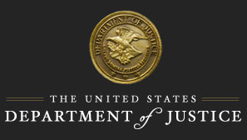

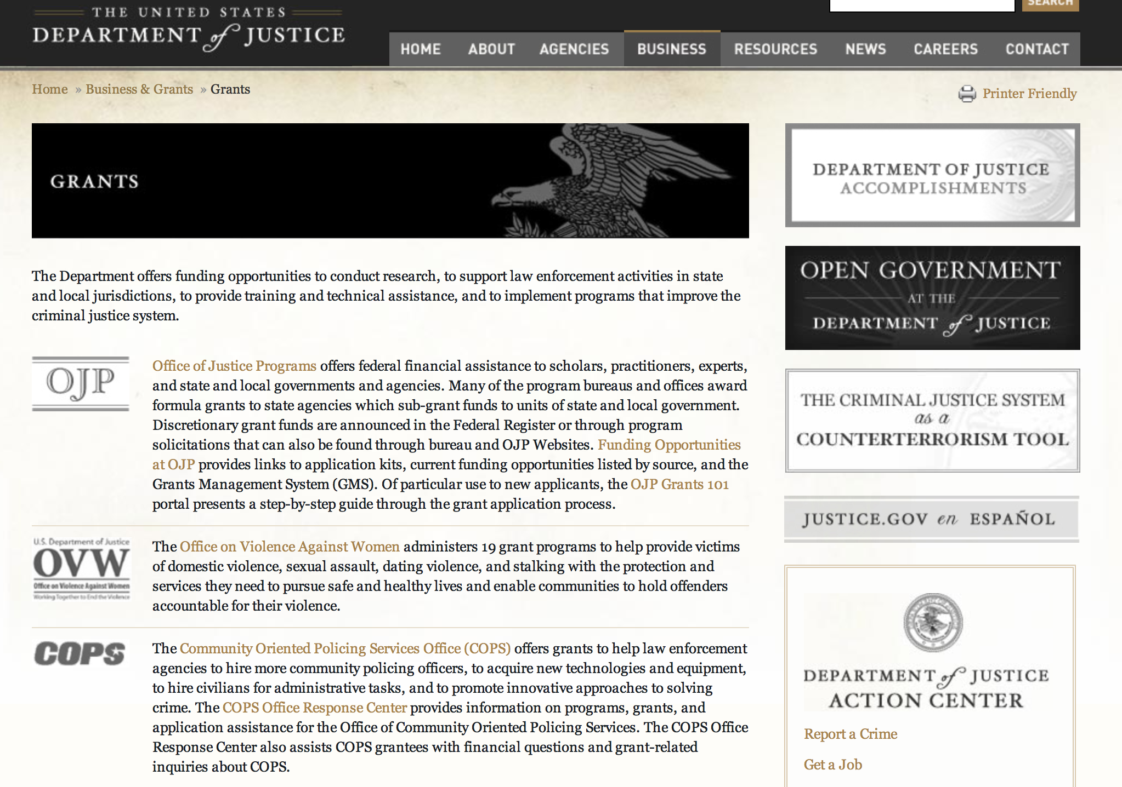

The DOJ agencies listed below also have sites that provide grant information specific to that agency. Examples of what can be found on these sites are programs, funding opportunities, application assistance, and other useful information.

Bureau of Justice Assistance (BJA)

Bureau of Justice Statistics (BJS)

National Criminal Justice Reference Service (NCJRS)

National Institute of Justice (NIJ)

Office of Juvenile Justice and Delinquency Prevention (OJJDP)

Office of Sex Offender Sentencing, Monitoring, Apprehending, Registering, and Tracking (SMART)

Office for Victims of Crime (OVC)

http://www.justice.gov/business/

Programs:

Research:

National Institute of Justice
FY17 Graduate Research Fellowship Program in the Social and Behavioral Sciences
Synopsis 1, 2 & 3
http://www.grants.gov/web/grants/view-opportunity.html?oppId=288829

National Institute of Justice
Graduate Research Fellowship Program in Science, Technology, Engineering and Mathematics
Synopsis 1 & 2
http://www.grants.gov/web/grants/view-opportunity.html?oppId=288806

Modifications:

Reminders:

Deleted:



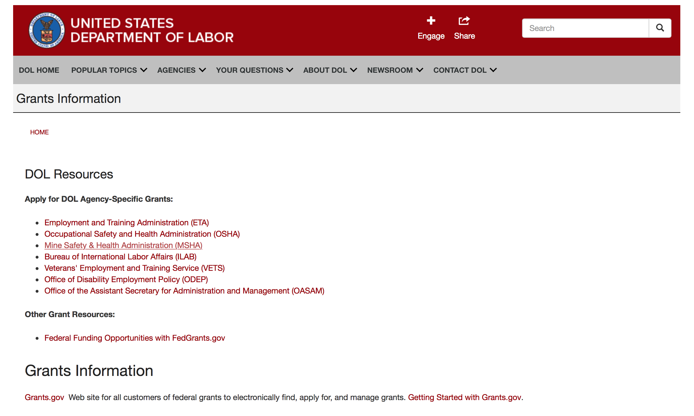

Agency Grants and Contract General Overview

DOL Resources
Apply for DOL Agency-Specific Grants:
- Employment and Training Administration (ETA)
- Occupational Safety and Health Administration (OSHA)
- Mine Safety & Health Administration (MSHA)
- Bureau of International Labor Affairs (ILAB)
- Veterans' Employment and Training Service (VETS)
- Office of Disability Employment Policy (ODEP)
- Office of the Assistant Secretary for Administration and Management (OASAM)

Other Grant Resources:
- Federal Funding Opportunities with FedGrants.gov
Grants Information
Grants.gov — Web site for all customers of federal grants to electronically find, apply for, and manage grants. Getting Started with Grants.gov.

DOL Resources and Instructions for Applying for a Grant
- DOL Guidance Clarifying the Effect of the Religious Freedom Restoration Act on Faith-Based Organizations
- Grant and Contract Information
- Contracting and Grant Program Overview
- Annual Acquisition Plan & Procurement Forecast
- Civil Rights Enforcement for Department of Labor Grant Recipients
- More Information About Grants
- Use of Contracts, Grants & Cooperative Agreements

Other Federal Government Grant Information
- List of Parties Excluded From Federal Procurement and Nonprocurement Programs (as created and maintained by GSA)
- Grant Opportunities (Catalog of Federal Domestic Assistance)

Department of Labor Grant Programs

- Bureau of International Labor Affairs (ILAB): provides grants (cooperative agreements) for the implementation of projects designed to assist developing countries combat the worse forms of child labor, forced labor, and human trafficking; and support worker rights and improve working conditions. http://www.dol.gov/general/business.
- Bureau of Labor Statistics (BLS): provides project grants (cooperative agreements) and the dissemination of technical statistical data and related information on labor force activities; provides data on prices (CPI) and cost of living; data on productivity and technology data; data on compensation and working conditions; data on employment projections.
- Employment and Training (ETA): ETA administers financial assistance programs pursuant to the Workforce Investment Act (WIA), administering State formula grant programs for youth, adults and dislocated workers, national emergency grants for workers affected by mass layoffs, plant closures, and disasters; grant programs for workers with disabilities, Indians and Native Americans, and for migrant and seasonal farmworkers. ETA also administers grant programs for older American workers, apprenticeship programs, Trade Adjustment Assistance (TAA) programs, and assistance for research and development of workforce programs. In addition, ETA is responsible for the operation and maintenance of a national system of public employment service offices and for the national unemployment insurance program.
- Mine Safety and Health (MSHA): provides grants for research, education and training programs to ensure an adequate and competent staff of trained inspectors; and assistance for establishing or improving State mine health and safety programs through technical assistance.
- Occupational Safety and Health (OSHA): provides grants to non-profit organizations to provide training, educational services, and technical assistance; assistance to states to administer and enforce state programs; assistance to states to provide occupational safety and health technical assistance and consultant services.
- Office of Disability Employment Policy (ODEP): The Office of Disability Employment Policy awards competitive grants establishing short-term pilot and technical assistance projects designed to identify, develop, test, evaluate, and disseminate policies to increase employment by expanding access to training, education, employment supports, assistive and systems technology, integrated employment, entrepreneurial development, and small business opportunities for adults and youth with disabilities. Current pilots projects focus on customized employment, Olmstead populations, and innovative demonstration youth grants, among others. Solicitations for grant applications are published in the Federal Register and announced at www.dol.gov/odep. ODEP grants are awarded by the OASAM grant office.
- Veterans' Employment and Training (VETS): provides special employment and training assistance for veterans through the Disabled Veterans' Outreach Program (DVOP) Solicitation for Grant Applications; the Local Veterans' Employment Representative Program (LVER); Veterans' Workforce Investment Program (VWIP); elaws Advisor on veterans' employment and reemployment rights; and the Homeless Veterans Reintegration Project (HVRP). VETS grants are awarded by the OASAM grant office.

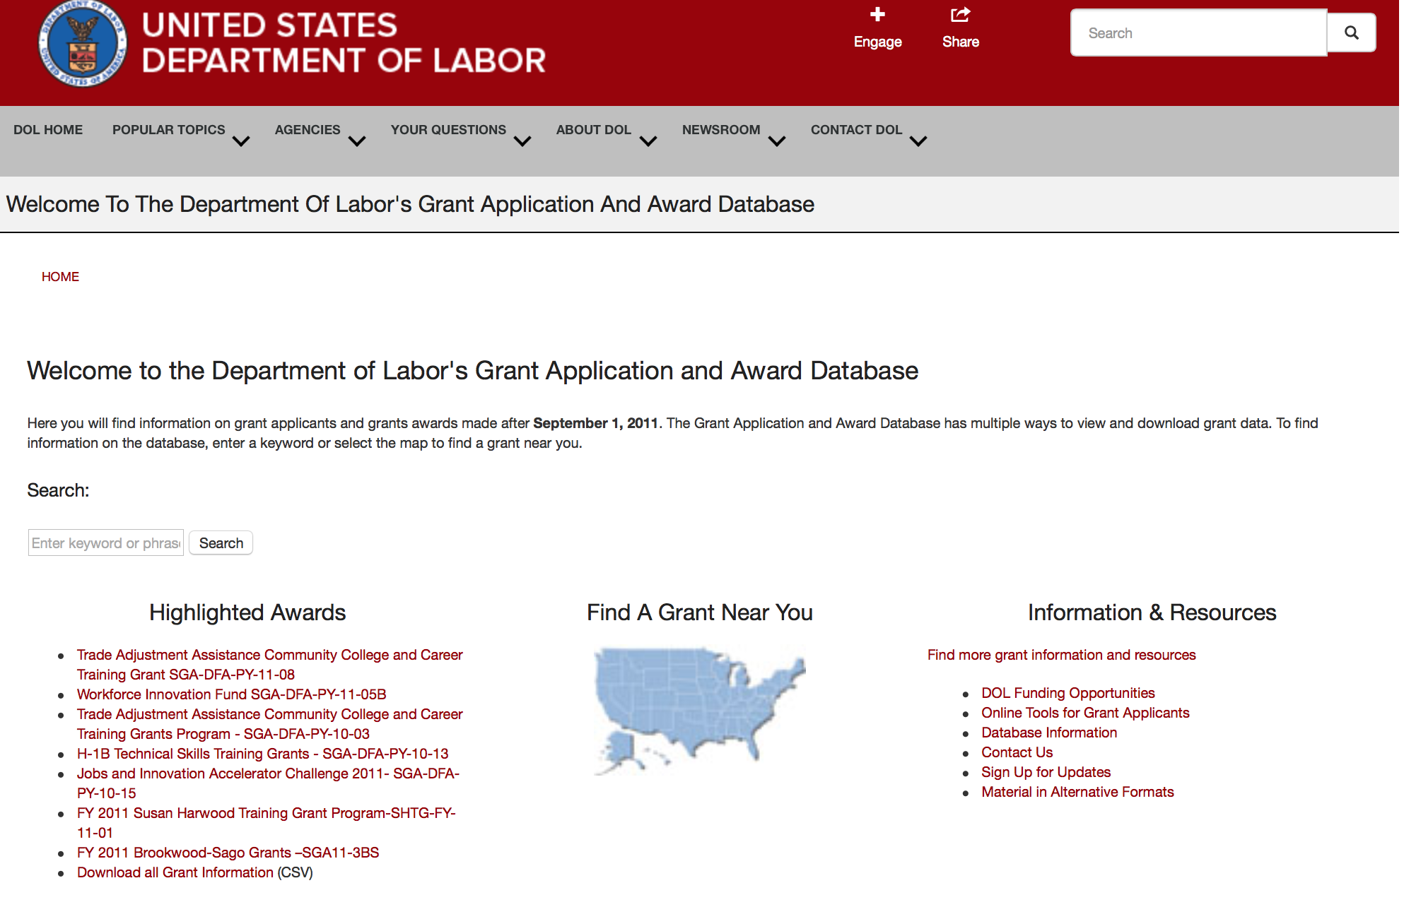

http://www.dol.gov/dol/grants/

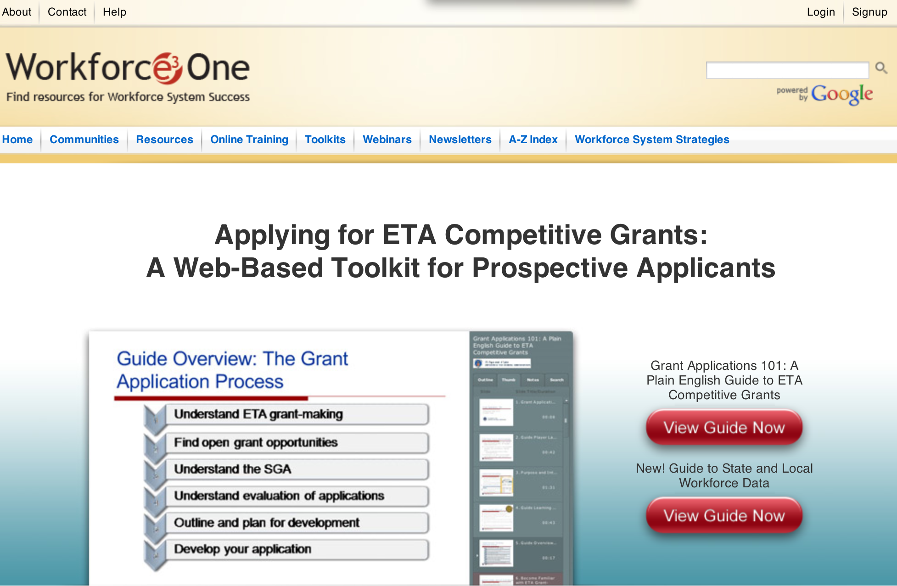

https://www.workforce3one.org/ws/www/pages/grants_toolkit.aspx?pparams=/

Programs

Employment and Training Administration
DEPARTMENT OF LABOR RESEARCH AND EVALUATION GRANTS
Synopsis 2

Document Type: | Grants Notice
Funding Opportunity Number: | FOA-CEO-16-01
Funding Opportunity Title: | DEPARTMENT OF LABOR RESEARCH AND EVALUATION GRANTS
Opportunity Category: | Discretionary
Opportunity Category Explanation:
Funding Instrument Type: | Grant
Category of Funding Activity: | Employment, Labor and Training
Category Explanation:
Expected Number of Awards: | 10
CFDA Number(s): | 17.791 -- Department of Labor Chief Evaluation Office
Cost Sharing or Matching Requirement: | No
Version: | Synopsis 2
Posted Date: | Aug 03, 2016
Last Updated Date: | Sep 20, 2016
Original Closing Date for Applications: | Oct 03, 2016 Applications must be received no later than 4:00:00 p.m. Eastern Time.
Current Closing Date for Applications: | Nov 04, 2016 Applications must be received no later than 4:00:00 p.m. Eastern Time.
Archive Date: | Dec 04, 2016
Estimated Total Program Funding: | $2,000,000
Award Ceiling: | $250,000
Award Floor: | $100,000
Eligible Applicants: | Others (see text field entitled "Additional Information on Eligibility" for clarification)
Additional Information on Eligibility: | The following organizations are eligible to apply:• Public/State Controlled Institution of Higher Education• Indian/Native American Tribal Government (Federally Recognized)• Indian/Native American Tribal Government (Other than Federally Recognized)• Indian/Native American Tribally Designated Organization• Private Institution of Higher Education• Hispanic-serving Institution• Historically Black Colleges and Universities (HBCUs)• Tribally Controlled Colleges and Universities (TCCUs)• Alaska Native and Native Hawaiian Serving Institutions
Agency Name: | Employment and Training Administration
Description: | The Office of the Assistant Secretary for Policy – Chief Evaluation Office (CEO), U.S. Department of Labor (DOL, or the Department, or we), announces the availability of approximately $2 million in grant funds authorized by the Consolidated Appropriations Act of 2016 (PL. 114-113) for the Department of Labor Research and Evaluation (LRE) grants. The CEO is soliciting applications from university-based researchers to fund up to ten Department of Labor Research and Evaluation (LRE) grants for a period of up to two years. Grants of no more than $250,000 per grantee over a two-year period will be awarded. Suggested topic areas for an LRE grant that are of priority interest to DOL include but are not limited to:• Employee Benefits Security,• Miners’ Safety and Health,• Wage and Hour and Labor Standards, • Worker and Workplace Safety and Health,• Workers’ Compensation,• Labor/Management Relations,• International Topics in Worker Protection including child and forced labor issues,• Improving Equal Employment Opportunities for Targeted Populations,• Innovative approaches to evaluating the impact of DOL worker protection programs and policies using existing administrative or other data, and • Low-cost randomized controlled trials or natural experiments to evaluate the impact of DOL programs. The period of performance for the LRE grants is between 12 and 24 months with an anticipated start date of December 1, 2016. This performance period includes all necessary implementation and start-up activities. Depending on the nature of the research, LRE applicants may propose a 12-, 18- or 24- month period of performance. No federal funding is anticipated beyond the initial grant period.
Link to Additional Information:
Grantor Contact Information: | If you have difficulty accessing the full announcement electronically, please contact:  Charese Moore Grants Management Specialist  Moore.Charese@dol.gov

http://www.grants.gov/web/grants/view-opportunity.html?oppId=286915

Modifications

Reminders



National Aeronautics and Space Administration

Research and Contracting Opportunities

NASA Research Opportunities Online

- Various NASA offices publish their research announcements over the Internet, broadening the opportunity for researchers to apply for funding. This site provides access to current research announcements along with their specific due dates.

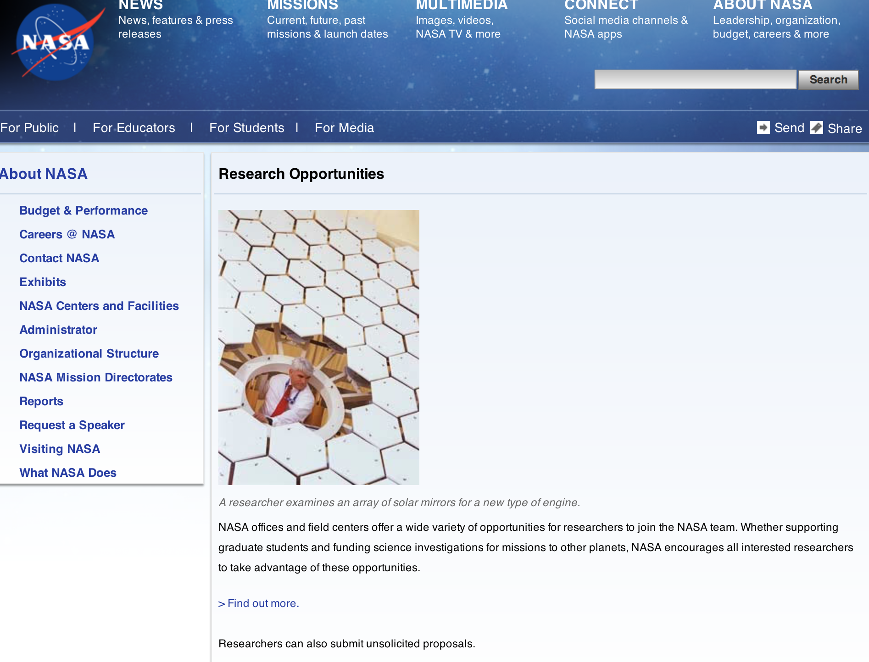

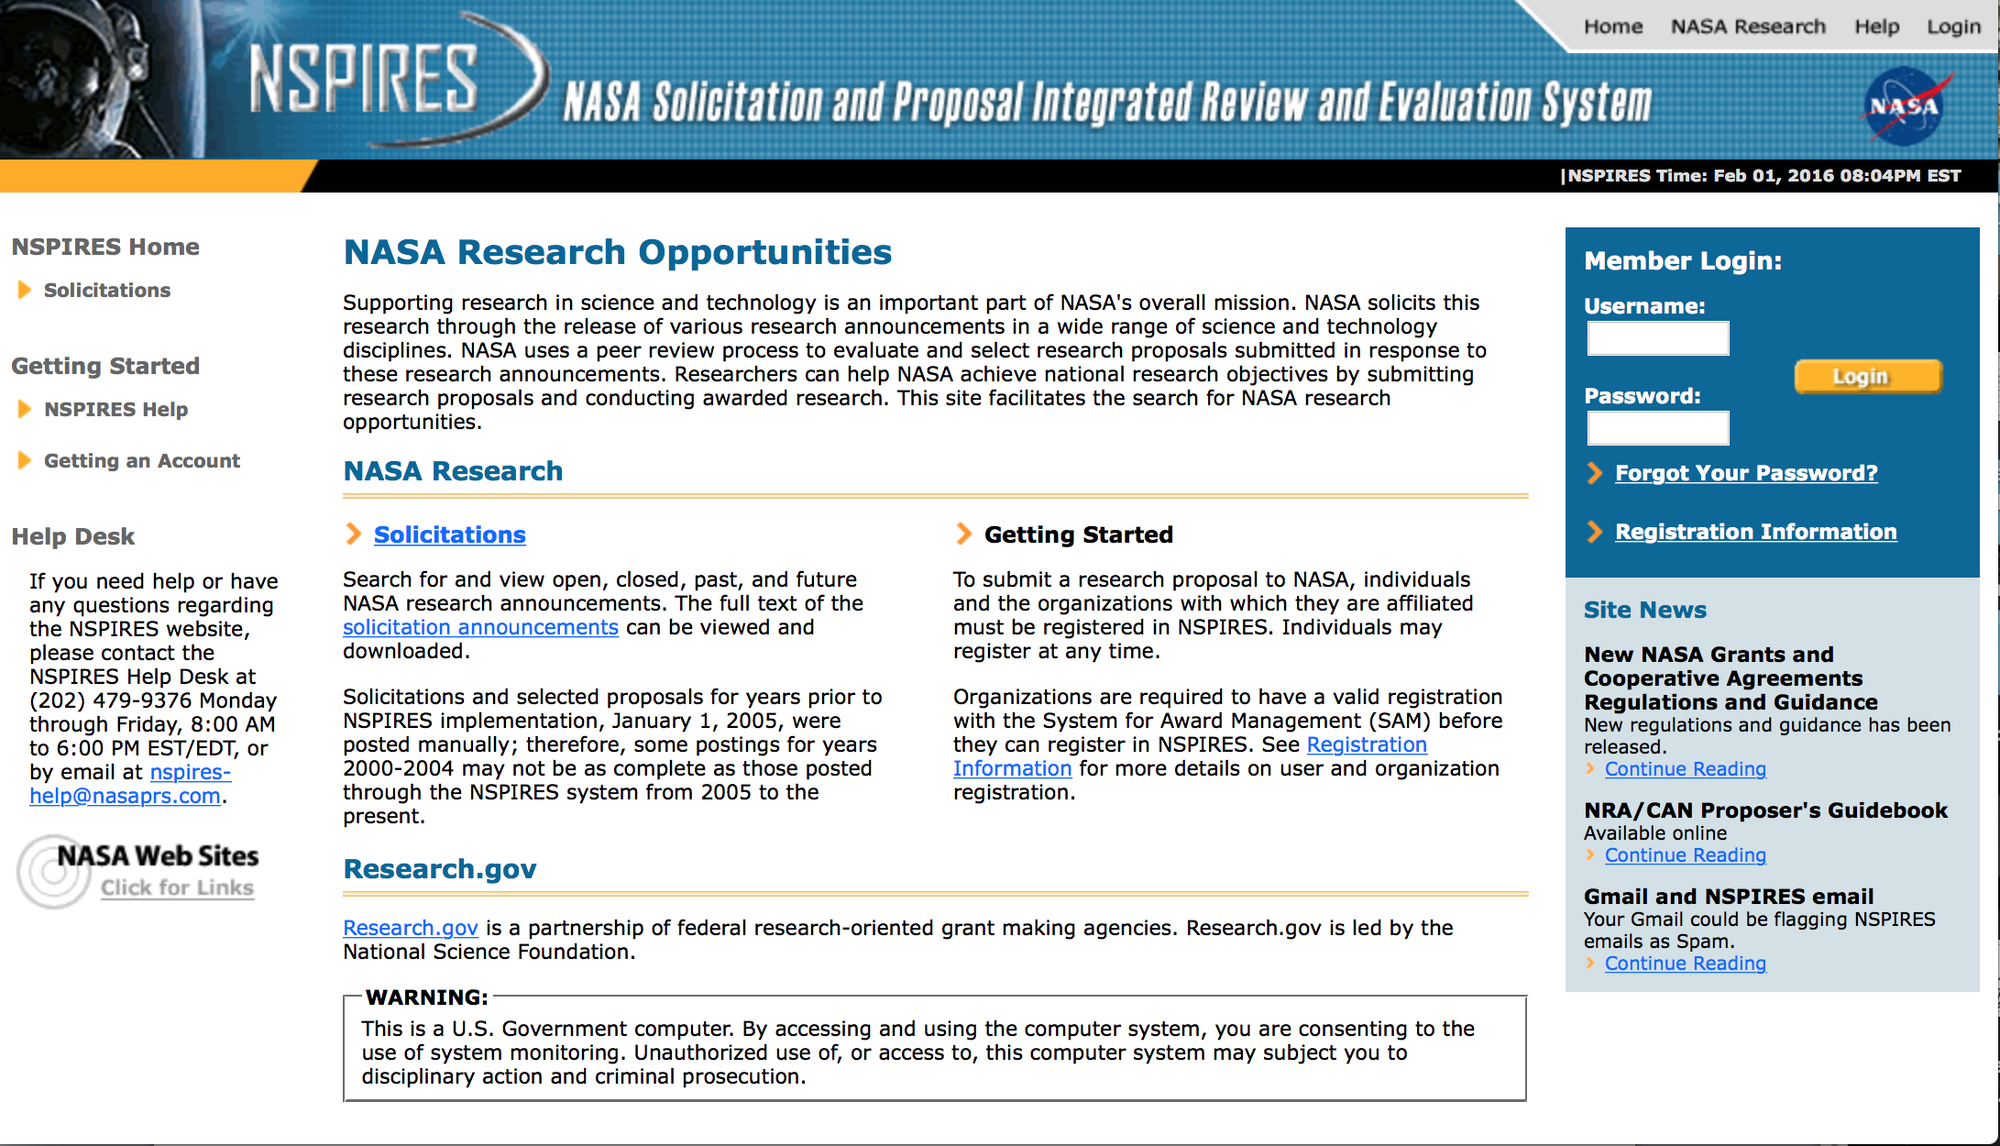

http://nspires.nasaprs.com/external/

Research Programs:

National Aeronautics and Space Administration
NASA Headquarters
ROSES 2016: K2 Guest Observer - Cycle 5
Synopsis 1
http://www.grants.gov/web/grants/view-opportunity.html?oppId=289059

NASA Headquarters
NASA SPACE TECHNOLOGY RESEARCH FELLOWSHIPS - FALL 2017
Synopsis 1
http://www.grants.gov/web/grants/view-opportunity.html?oppId=288793

NASA Headquarters
Use of the NASA Physical Sciences Informatics System - Appendix C
Synopsis 1
http://www.grants.gov/web/grants/view-opportunity.html?oppId=288867

NASA Headquarters
ARM-UP Appendix B: ARM Investigation Team Phase 1
Synopsis 1
http://www.grants.gov/web/grants/view-opportunity.html?oppId=288512

NASA Headquarters
Advanced Air Transport Technology (AATT1) Project
Synopsis 1
http://www.grants.gov/web/grants/view-opportunity.html?oppId=289272

NASA Headquarters
ROSES 2016: Hot Operating Temperature Technology
Synopsis 1
http://www.grants.gov/web/grants/view-opportunity.html?oppId=289275

NASA Headquarters
ROSES 2016: Interdisciplinary Science for Eclipse 2017
Synopsis 1
http://www.grants.gov/web/grants/view-opportunity.html?oppId=289276

Modifications:

NASA Headquarters
ROSES 2016: Discovery Data Analysis Program
Synopsis 2
http://www.grants.gov/web/grants/view-opportunity.html?oppId=286882

NASA Headquarters
ROSES 2016: Heliophysics U.S. Participating Investigator
Synopsis 3
http://www.grants.gov/web/grants/view-opportunity.html?oppId=286878

NASA Headquarters
ROSES 2016: Mars Data Analysis Program
Synopsis 2
http://www.grants.gov/web/grants/view-opportunity.html?oppId=285393

NASA Johnson Space Center
EXPLORATION TECHNOLOGY DEMONSTRATION AND NATIONAL LAB UTILIZATION ENHANCEMENTS
Synopsis 8
http://www.grants.gov/web/grants/view-opportunity.html?oppId=207073

National Archives and Records Administration

Grant Opportunities General Overview

To access the information below: click here

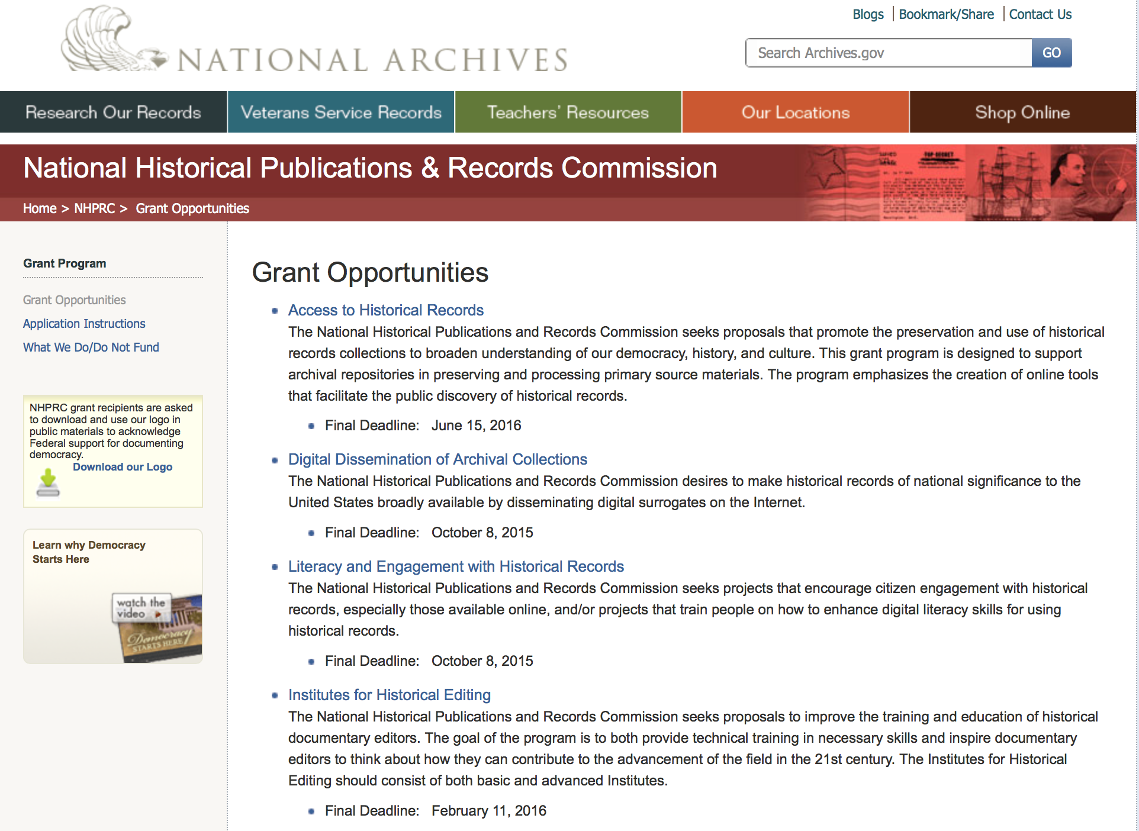

Reminders:

Access to Historical Records - Major Initiatives

Document Type: | Grants Notice
Funding Opportunity Number: | MAJOR-201707
Funding Opportunity Title: | Access to Historical Records - Major Initiatives
Opportunity Category: | Discretionary
Opportunity Category Explanation:
Funding Instrument Type: | Grant
Category of Funding Activity: | Humanities (see "Cultural Affairs" in CFDA)
Category Explanation:
Expected Number of Awards: | 5
CFDA Number(s): | 89.003 -- National Historical Publications and Records Grants
Cost Sharing or Matching Requirement: | Yes
Posted Date: | Jul 25, 2016
Last Updated Date: | Jul 25, 2016
Original Closing Date for Applications: | Jul 12, 2017
Current Closing Date for Applications: | Jul 12, 2017
Archive Date: | Aug 11, 2017
Estimated Total Program Funding: | $1,000,000
Award Ceiling: | $350,000
Award Floor: | $1
Eligible Applicants: | Private institutions of higher education  County governments  Native American tribal governments (Federally recognized)  Public and State controlled institutions of higher education  City or township governments  Nonprofits having a 501(c)(3) status with the IRS, other than institutions of higher education  State governments
Agency Name: | National Archives and Records Administration
Description: | The National Historical Publications and Records Commission seeks projects that will significantly improve public discovery and use of major historical records collections. All types of historical records are eligible, including documents, photographs, born-digital records, and analog audio and moving images. Projects may: • Digitize historical records collections, or related collections, held by a single institution and make them freely available online • Provide access to born-digital records • Create new freely-available virtual collections drawn from historical records held by multiple institutions • Create new tools and methods for users to access records The NHPRC welcomes collaborative projects, particularly for bringing together related records from multiple institutions. Projects that address significant needs in the field and result in replicable and scalable approaches will be more competitive. We also encourage organizations to actively engage the public in the work of the project. For a comprehensive list of Commission limitations on funding, please see “What we do and do not fund” (http://www.archives.gov/nhprc/apply/eligibility.html). Applications that consist entirely of ineligible activities will not be considered. Award Information A grant is for one to three years and for up to $350,000. We expect to make up to five grants in this category for a total of up to $1,000,000. Grants begin no earlier than January 1, 2018. Eligible applicants: • Nonprofit organizations or institutions • Colleges, universities, and other academic institutions • State or local government agencies • Federally-acknowledged or state-recognized Native American tribes or groups Cost Sharing The total costs of a project are shared between the NHPRC and the applicant organization. The Commission provides no more than 50 per cent of total project costs in the Access to Historical Records: Major Initiatives category. NHPRC grant recipients are not permitted to use grant funds for indirect costs (as indicated in 2 CFR 2600.101). Cost sharing is required. The applicant’s financial contribution may include both direct and indirect expenses, in-kind contributions, non-Federal third-party contributions, and any income earned directly by the project. Indirect costs must be listed under the applicant’s cost sharing contribution. Other Requirements Applicant organizations must be registered in the System for Award Management (SAM) prior to submitting an application, maintain SAM registration throughout the application and award process, and include a valid DUNS number in their application. Details on SAM registration and requesting a DUNS number can be found at the System for Award Management website at http://sam.gov. Please refer to the User Guides section and the Grants Registrations PDF. APPLICATION AND SUBMISSION INFORMATION You must use Grants.gov to submit a Full Proposal. All information necessary to apply is included in this announcement, the Application Instructions, and the forms on Grants.gov. If you need the information supplied in an alternative format, please call the NHPRC at 202-357-5010. Applying for the Access to Historical Records: Major Initiatives program is a two-phase process. Phase One All applicants must have submitted a five-page preliminary proposal and Application for Federal Domestic Assistance – Short Organizational form SF424 and the Budget Information for Non-Construction Projects form SF424A by January 19, 2017 using the preliminary proposal Major Initiatives grant announcement (insert link). Only those applicants who have successfully completed Phase One and who have been invited by the Commission to submit a full proposal to the Access to Historical Records: Major Initiatives program are eligible to participate in the second phase of the process. Phase Two Using this announcement, invited applicants will prepare and submit a complete application via Grants.gov by July 12, 2017. A complete application includes the Application for Federal Assistance (Standard Form 424), Assurances -- Non-Construction Programs (Standard Form 424B), a Project Narrative, Supplementary Materials, and Budget. Applications lacking any of these items will not be considered. Applicants may consult with the Director of the Access Program, Alex Lorch (alexander.lorch@nara.gov) during both the preliminary and full proposal project phases. In order to ensure eligibility, applicants should first review the rules and regulations governing NHPRC grants under the Administering an NHPRC Grant section.
Link to Additional Information: | Link to full grant announcement, including additional requirements
Grantor Contact Information: | If you have difficulty accessing the full announcement electronically, please contact:  Jeff de la Concepcion Grant Program Specialist Phone 202-357-5022  Grant Information Specialist

http://www.grants.gov/web/grants/view-opportunity.html?oppId=286436

Access to Historical Records – Archival Projects

Document Type: | Grants Notice
Funding Opportunity Number: | ARCHIVAL-201612
Funding Opportunity Title: | Access to Historical Records – Archival Projects
Opportunity Category: | Discretionary
Opportunity Category Explanation:
Funding Instrument Type: | Grant
Category of Funding Activity: | Humanities (see "Cultural Affairs" in CFDA)
Category Explanation:
Expected Number of Awards: | 10
CFDA Number(s): | 89.003 -- National Historical Publications and Records Grants
Cost Sharing or Matching Requirement: | No
Posted Date: | Jul 25, 2016
Last Updated Date: | Jul 25, 2016
Original Closing Date for Applications: | Dec 06, 2016
Current Closing Date for Applications: | Dec 06, 2016
Archive Date: | Jan 05, 2017
Estimated Total Program Funding: | $700,000
Award Ceiling: | $100,000
Award Floor: | $1
Eligible Applicants: | Private institutions of higher education  Nonprofits having a 501(c)(3) status with the IRS, other than institutions of higher education  State governments  City or township governments  Public and State controlled institutions of higher education  County governments  Native American tribal governments (Federally recognized)
Agency Name: | National Archives and Records Administration
Description: | The National Historical Publications and Records Commission seeks projects that ensure online public discovery and use of historical records collections. All types of historical records are eligible, including documents, photographs, born-digital records, and analog audio and moving images. Projects may preserve and process historical records to: • Create new online Finding Aids to collections • Digitize historical records collections and make them freely available online The NHPRC encourages organizations to actively engage the public in the work of the project. For a comprehensive list of Commission limitations on funding, please see “What we do and do not fund” (http://www.archives.gov/nhprc/apply/eligibility.html). Applications that consist entirely of ineligible activities will not be considered. Award Information A grant is for one to two years and for up to $100,000. The Commission expects to make up to 10 grants in this category for a total of up to $700,000. Grants begin no earlier than July 1, 2017. The Commission requires that grant recipients acknowledge NHPRC grant assistance in all publicity, publications, and other products that result from its support. Eligibility Information Eligible applicants: • Nonprofit organizations or institutions • Colleges, universities, and other academic institutions • State or local government agencies • Federally-acknowledged or state-recognized Native American tribes or groups Cost Sharing The total costs of a project are shared between the NHPRC and the applicant organization. The Commission provides no more than 75 per cent of total project costs in the Access to Historical Records – Archival Projects category. NHPRC grant recipients are not permitted to use grant funds for indirect costs (as indicated in 2 CFR 2600.101). Cost sharing is required. The applicant’s financial contribution may include both direct and indirect expenses, in-kind contributions, non-Federal third-party contributions, and any income earned directly by the project. Indirect costs must be listed under the applicant’s cost sharing contribution. Other Requirements Applicant organizations must be registered in the System for Award Management (SAM) prior to submitting an application, maintain SAM registration throughout the application and award process, and include a valid DUNS number in their application. Details on SAM registration and requesting a DUNS number can be found at the System for Award Management website at http://sam.gov. Please refer to the User Guides section and the Grants Registrations PDF. A complete application includes the Application for Federal Assistance (Standard Form 424), Assurances -- Non-Construction Programs (Standard Form 424B), a Project Narrative, Summary, Supplementary Materials, and Budget. Applications lacking any of these items will not be considered. Ineligible applications will not be reviewed.
Link to Additional Information: | Link to full grant announcement, including additional requirements
Grantor Contact Information: | If you have difficulty accessing the full announcement electronically, please contact:  Jeff de la Concepcion Grant Program Specialist Phone 202-357-5022  Grant Information Specialist

http://www.grants.gov/web/grants/view-opportunity.html?oppId=286450

National Endowment for the Arts

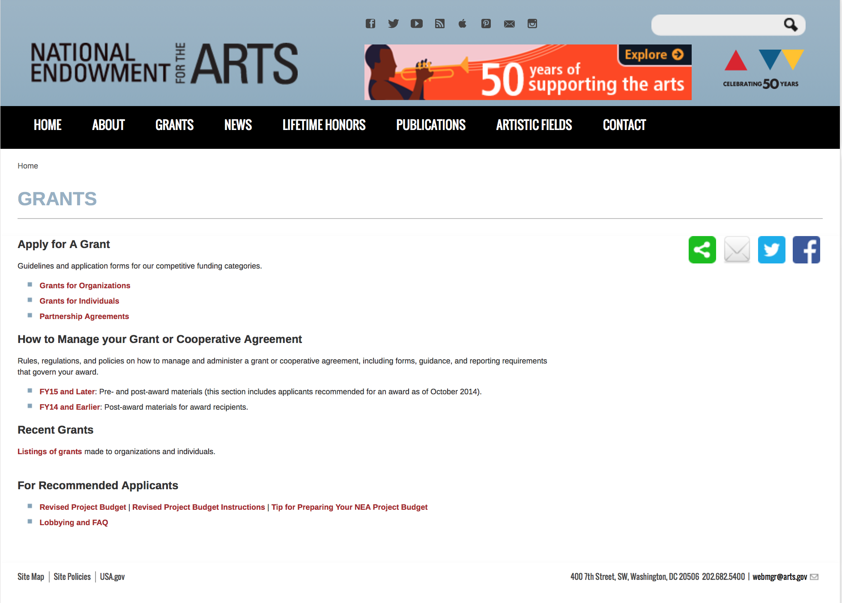

http://arts.gov/grants

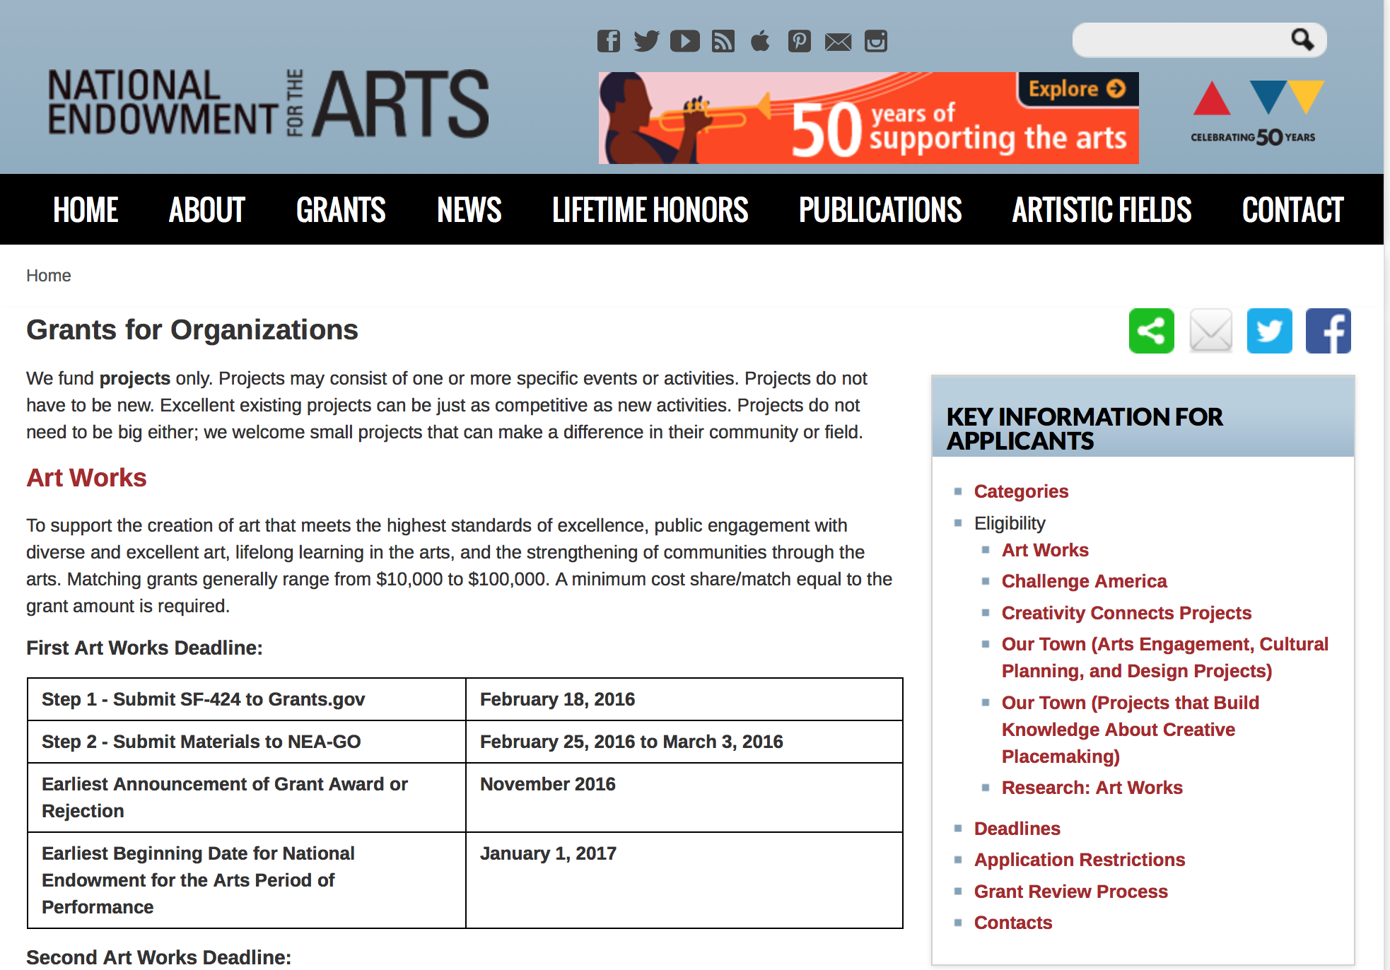
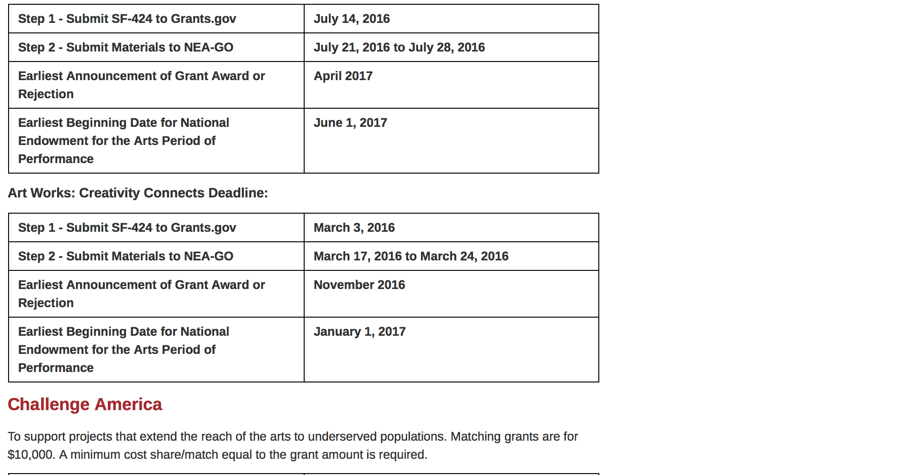
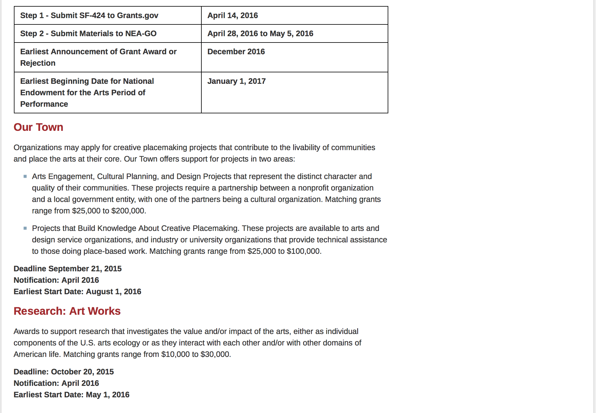
See more at: https://www.arts.gov/grants/apply-grant/grants-organizations

Programs:

NEA Poetry Out Loud: 2018 National Finals Competition
Synopsis 1

Document Type: | Grants Notice
Funding Opportunity Number: | NEAPS1604
Funding Opportunity Title: | NEA Poetry Out Loud: 2018 National Finals Competition
Opportunity Category: | Discretionary
Opportunity Category Explanation:
Funding Instrument Type: | Cooperative Agreement
Category of Funding Activity: | Arts (see "Cultural Affairs" in CFDA)
Category Explanation:
Expected Number of Awards:
CFDA Number(s): | 45.024 -- Promotion of the Arts Grants to Organizations and Individuals
Cost Sharing or Matching Requirement: | No
Version: | Synopsis 1
Posted Date: | Sep 28, 2016
Last Updated Date: | Sep 28, 2016
Original Closing Date for Applications: | Jan 05, 2017 The Grants.gov system must receive your proposal no later than 11:59 p.m., Eastern Time, on January 5, 2017. We strongly recommend that you submit your application by December 27, 2016 to give yourself ample time to resolve any problems that you might encounter.
Current Closing Date for Applications: | Jan 05, 2017 The Grants.gov system must receive your proposal no later than 11:59 p.m., Eastern Time, on January 5, 2017. We strongly recommend that you submit your application by December 27, 2016 to give yourself ample time to resolve any problems that you might encounter.
Archive Date: | Feb 04, 2017
Estimated Total Program Funding:
Award Ceiling: | $195,000
Award Floor: | $195,000
Eligible Applicants: | Native American tribal governments (Federally recognized)  Private institutions of higher education  Nonprofits having a 501(c)(3) status with the IRS, other than institutions of higher education  City or township governments  Special district governments  Public and State controlled institutions of higher education  State governments  Independent school districts  County governments
Additional Information on Eligibility: | An organization may submit only one proposal under this program solicitation. This Cooperative Agreement will begin no earlier than June 1, 2017, and may extend for up to 15 months. Applicant Eligibility Nonprofit, tax-exempt 501(c)(3), U.S. organizations; units of state or local government; the six U.S. regional arts organizations; or federally recognized tribal communities or tribes may apply.
Agency Name: | National Endowment for the Arts
Description: | An organization may submit only one proposal under this program solicitation. This Cooperative Agreement will begin no earlier than June 1, 2017, and may extend for up to 15 months. Program Description Through this Program Solicitation, the National Endowment for the Arts seeks a Cooperator to produce and administer the 2018 Poetry Out Loud National Finals competition to take place April 23-25, 2018 in Washington, DC. The National Finals are the culmination of the nationwide Poetry Out Loud (POL) program that encourages more than 365,000 high school students each year to learn about classic and contemporary poetry through memorization and performance. Students select, memorize, and recite poems from an anthology and compete for the title of National Poetry Out Loud Champion. Through a pyramid structure competition, winners advance from classroom recitation contests to school-wide competitions, then to the state competitions and, ultimately, to the National Finals. One student from every state, the District of Columbia, the U.S. Virgin Islands, and Puerto Rico travel to the National Finals to compete for the national championship. Scope of Work The purpose of this Program Solicitation is to select an organization (Cooperator) to produce and coordinate the three-day 2018 POL National Finals competition of state and jurisdictional champions of the POL program, in conjunction with the National Endowment for the Arts and its partners. That National Finals will take place April 23-25, 2018 in Washington, DC. The National Finals competition venue and hotel have already been reserved to ensure the availability of space.
Link to Additional Information: | NEA Web Site Announcement
Grantor Contact Information: | If you have difficulty accessing the full announcement electronically, please contact:  NEA Web Manager  NEA Web Manager

http://www.grants.gov/web/grants/view-opportunity.html?oppId=289143

Modifications:

Reminders:

NEA Literature Fellowships: Translation Projects, FY 2018
Synopsis 1

Document Type: | Grants Notice
Funding Opportunity Number: | 2017NEA03LFTP
Funding Opportunity Title: | NEA Literature Fellowships: Translation Projects, FY 2018
Opportunity Category: | Discretionary
Opportunity Category Explanation:
Funding Instrument Type: | Grant
Category of Funding Activity: | Arts (see "Cultural Affairs" in CFDA)
Category Explanation:
Expected Number of Awards:
CFDA Number(s): | 45.024 -- Promotion of the Arts Grants to Organizations and Individuals
Cost Sharing or Matching Requirement: | No
Posted Date: | Aug 16, 2016
Last Updated Date: | Aug 16, 2016
Original Closing Date for Applications: | Dec 06, 2016 The Grants.gov system must receive your validated and accepted application no later than 11:59 p.m., Eastern Time, on December 6, 2016.
Current Closing Date for Applications: | Dec 06, 2016 The Grants.gov system must receive your validated and accepted application no later than 11:59 p.m., Eastern Time, on December 6, 2016.
Archive Date: | Jan 05, 2017
Estimated Total Program Funding:
Award Ceiling: | $25,000
Award Floor: | $12,500
Eligible Applicants: | Individuals
Additional Information on Eligibility: | An individual may submit only one application for FY 2018 funding. You may not apply for both a Translation Project under this deadline (December 6, 2016) and a Literature Fellowship (in prose or poetry) under the 2017 deadline (when fellowships in prose are offered). The Arts Endowment’s support of a project may begin any time between November 1, 2017, and November 1, 2018, and extend for up to two years. Applicant Eligibility Individual translators who meet the publication requirements that are listed below are eligible to apply. Applicants must be citizens or permanent residents of the United States. See "How to Prepare and Submit an Application" LINK for the documentation that is required to demonstrate eligibility. Ineligible applications will be rejected without panel review. An individual may submit only one application for FY 2018 funding. You may not apply for both a Translation Project under this deadline (December 6, 2016) and a Literature Fellowship (in prose or poetry) under the 2017 deadline (when fellowships in prose are offered). See Literature Fellowships LINK for more information. You are not eligible to apply if you have received three or more Fellowships (in poetry, prose, or for translation) from the National Endowment for the Arts. In addition, you may not apply in Translation if you have received any National Endowment for the Arts Literature Fellowships (in prose or poetry) or Translation Fellowship on or after October 1, 2013 (FY 2014). Finally, you may not apply in Translation with the same project for more than three consecutive years. Former grantees must have submitted acceptable Final Report packages by the due date(s) for all National Endowment for the Arts award(s) previously received.
Agency Name: | National Endowment for the Arts
Description: | An individual may submit only one application for FY 2018 funding. You may not apply for both a Translation Project under this deadline (December 6, 2016) and a Literature Fellowship (in prose or poetry) under the 2017 deadline (when fellowships in prose are offered). The Arts Endowment’s support of a project may begin any time between November 1, 2017, and November 1, 2018, and extend for up to two years. Grant Program Description Through fellowships to published translators, the National Endowment for the Arts supports projects for the translation of specific works of prose, poetry, or drama from other languages into English. We encourage translations of writers and of work that are not well represented in English translation. All proposed projects must be for creative translations of literary material into English. The work to be translated should be of interest for its literary excellence and value. Priority will be given to projects that involve work that has not previously been translated into English. Competition for fellowships is rigorous. Potential applicants should consider carefully whether their work will be competitive at the national level.
Link to Additional Information: | NEA Complete Website Announcement
Grantor Contact Information: | If you have difficulty accessing the full announcement electronically, please contact:  NEA Web Manager  NEA Web Manager

http://www.grants.gov/web/grants/view-opportunity.html?oppId=287530

NEA Research: Art Works Application, FY 2017

Document Type: | Grants Notice
Funding Opportunity Number: | 2017NEAORA
Funding Opportunity Title: | NEA Research: Art Works Application, FY 2017
Opportunity Category: | Discretionary
Opportunity Category Explanation:
Funding Instrument Type: | Grant
Category of Funding Activity: | Arts (see "Cultural Affairs" in CFDA)
Category Explanation:
Expected Number of Awards:
CFDA Number(s): | 45.024 -- Promotion of the Arts Grants to Organizations and Individuals
Cost Sharing or Matching Requirement: | Yes
Posted Date: | Jul 20, 2016
Last Updated Date: | Jul 20, 2016
Original Closing Date for Applications: | Oct 11, 2016 The Grants.gov system must receive your validated and accepted application no later than 11:59 p.m., Eastern Time, on October 11, 2016. Submit your SF-424 no later than October 1, 2016 to give yourself ample time to resolve any problems you might encounter. You take a significant risk by waiting until the day of the deadline to submit.
Current Closing Date for Applications: | Oct 11, 2016 The Grants.gov system must receive your validated and accepted application no later than 11:59 p.m., Eastern Time, on October 11, 2016. Submit your SF-424 no later than October 1, 2016 to give yourself ample time to resolve any problems you might encounter. You take a significant risk by waiting until the day of the deadline to submit.
Archive Date: | Nov 10, 2016
Estimated Total Program Funding:
Award Ceiling: | $100,000
Award Floor: | $10,000
Eligible Applicants: | City or township governments  Native American tribal governments (Federally recognized)  Public and State controlled institutions of higher education  Private institutions of higher education  State governments  Independent school districts  Special district governments  Nonprofits having a 501(c)(3) status with the IRS, other than institutions of higher education  County governments
Additional Information on Eligibility: | The Arts Endowment’s support of a project may start on May 1, 2017, or any time thereafter. Grants generally may cover a period of performance of up to two years, with an exception for projects that include primary data collection as part of the proposed activity. Projects that include primary data collection may request up to three years. Projects that extend beyond one year will be required to submit an annual progress report. A grantee may not receive more than one National Endowment for the Arts grant for the same project during the same period of performance. Official applicant organizations must be nonprofit, tax-exempt 501(c)(3), U.S. organizations; units of state or local government; or federally recognized tribal communities or tribes. This may include, but is not limited to, colleges and universities. For projects that involve multiple organizations, one organization that meets the eligibility requirements below must act as the official applicant, submit the application, and assume full responsibility for the grant. Partnering organizations are not required to meet the same eligibility requirements as the official applicant organization.
Agency Name: | National Endowment for the Arts
Description: | The Arts Endowment’s support of a project may start on May 1, 2017, or any time thereafter. Grants generally may cover a period of performance of up to two years, with an exception for projects that include primary data collection as part of the proposed activity. Projects that include primary data collection may request up to three years. Projects that extend beyond one year will be required to submit an annual progress report. A grantee may not receive more than one National Endowment for the Arts grant for the same project during the same period of performance. Program Description The National Endowment for the Arts’ Office of Research & Analysis makes awards to support research that investigates the value and/or impact of the arts, either as individual components of the U.S. arts ecology or as they interact with each other and/or with other domains of American life. In past years, the Research: Art Works category has invited researchers to propose studies that examine topics related to any area(s) on the How Art Works system map (see Grant Program Description). These projects have used quantitative, qualitative, or mixed-methods approaches, and have relied on primary and/or secondary data for analysis. Examples of previously funded research can be found via the "Grant Search" engine or by viewing Research: Art Works Grants Final Papers. This year, Research: Art Works offers support for projects in two areas: • Track One: Value and Impact. These research projects aim to examine the value and/or impact of the arts in any topic area(s) by using data and methods appropriate to the proposed research questions. Matching grants range from $10,000-$30,000. o Projects relying primarily on experimental/quasi-experimental design methods are not eligible under this Track and should apply to Track Two. • Track Two: Experimental and Quasi-Experimental Designs. These research projects aim to test the causal or inferred-causal impact of the arts on individual or cohort outcomes by using experimental or quasi-experimental design methods appropriate to the proposed research questions. Matching grants range from $30,000-$100,000. o This Track is only for projects relying primarily on experimental or quasi-experimental research methods.
Link to Additional Information: | NEA Web Site Announcement
Grantor Contact Information: | If you have difficulty accessing the full announcement electronically, please contact:  NEA Web Manager  NEA Web Manager

http://www.grants.gov/web/grants/view-opportunity.html?oppId=286351

National Endowment for the Humanities

Grant Overview -

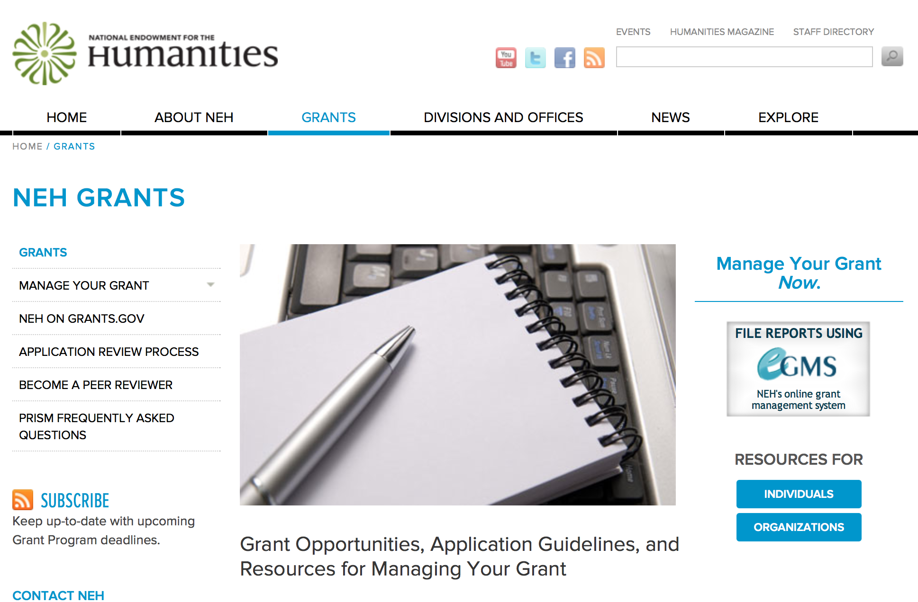

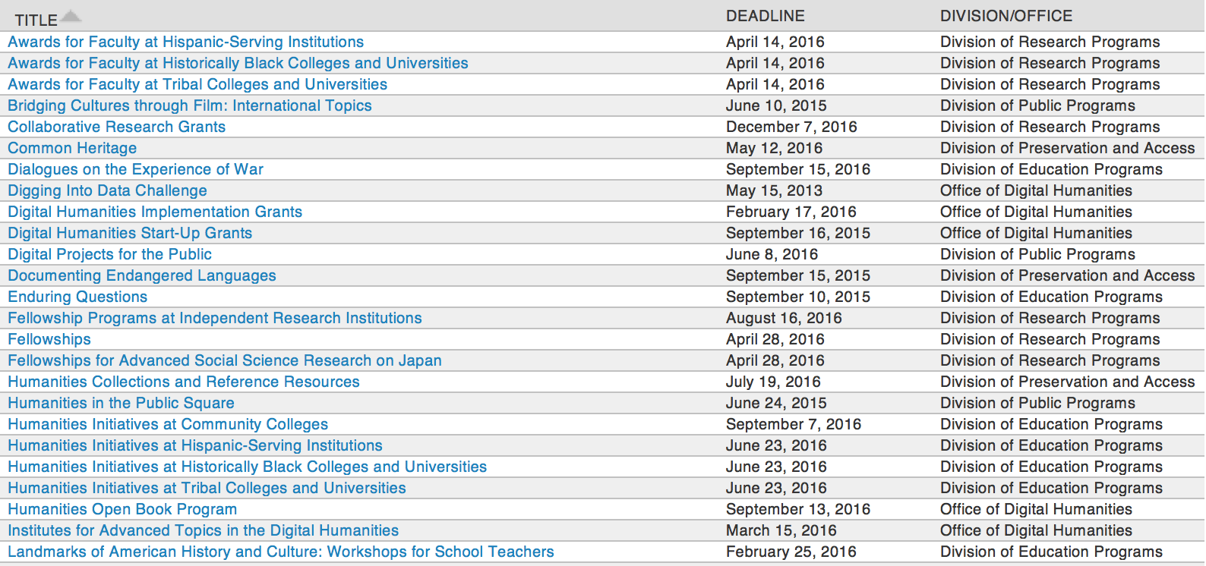

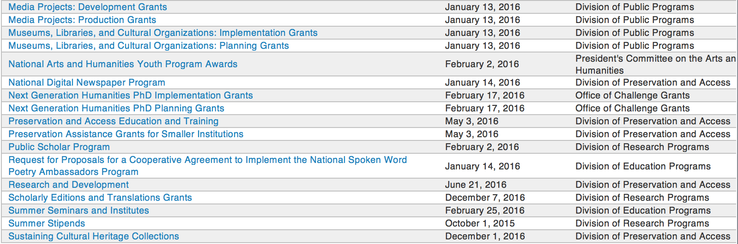

http://www.neh.gov/grants/grantsbydivision.html

Programs:

Digital Humanities Advancement Grants
Synopsis 1

Document Type: | Grants Notice
Funding Opportunity Number: | 20170111-HAA
Funding Opportunity Title: | Digital Humanities Advancement Grants
Opportunity Category: | Discretionary
Opportunity Category Explanation:
Funding Instrument Type: | Grant
Category of Funding Activity: | Humanities (see "Cultural Affairs" in CFDA)
Category Explanation:
Expected Number of Awards:
CFDA Number(s): | 45.169 -- Promotion of the Humanities Office of Digital Humanities
Cost Sharing or Matching Requirement: | No
Version: | Synopsis 1
Posted Date: | Sep 06, 2016
Last Updated Date: | Sep 06, 2016
Original Closing Date for Applications: | Jan 11, 2017
Current Closing Date for Applications: | Jan 11, 2017
Archive Date:
Estimated Total Program Funding:
Award Ceiling: | $375,000
Award Floor: | $1
Eligible Applicants: | Nonprofits that do not have a 501(c)(3) status with the IRS, other than institutions of higher education  State governments  City or township governments  Public and State controlled institutions of higher education  County governments  Nonprofits having a 501(c)(3) status with the IRS, other than institutions of higher education  Special district governments  Native American tribal governments (Federally recognized)  Private institutions of higher education
Agency Name: | National Endowment for the Humanities
Description: | Digital Humanities Advancement Grants (DHAG) support digital projects throughout their lifecycles, from early start-up phases through implementation and long-term sustainability. Experimentation, reuse, and extensibility are hallmarks of this grant category, leading to innovative work that can scale to enhance research, teaching, and public programming in the humanities. This program combines the former Digital Humanities Start-Up Grants and Digital Humanities Implementation Grants programs; the combined program is offered twice per year. Proposals are welcome for digital initiatives in any area of the humanities. Through a special partnership, the Institute of Museum and Library Services (IMLS) anticipates providing additional funding to this program to encourage innovative collaborations between museum or library professionals and humanities professionals to advance preservation of, access to, use of, and engagement with digital collections and services. Through this partnership, IMLS and NEH may jointly fund some DHAG projects that involve collaborations with museums and/or libraries. Digital Humanities Advancement Grants may involve • creating or enhancing experimental, computationally-based methods or techniques that contribute to the humanities; • pursuing scholarship that examines the history, criticism, and philosophy of digital culture and its impact on society, or explores the philosophical or practical implications and impact of digital humanities in specific fields or disciplines; or • revitalizing and/or recovering existing digital projects that promise to contribute substantively to scholarship, teaching, or public knowledge of the humanities.
Link to Additional Information: | http://www.neh.gov/grants/odh/digital-humanities-advancement-grants
Grantor Contact Information: | If you have difficulty accessing the full announcement electronically, please contact:  If you have questions about the program, contact the ODH staff at odh@neh.gov. Applicants wishing to speak to a staff member by telephone should provide in an e-mail message a telephone number and a preferred time to call. odh@neh.gov  odh@neh.gov

http://www.grants.gov/web/grants/view-opportunity.html?oppId=288529

Collaborative Research Grants
Synopsis 1

Document Type: | Grants Notice
Funding Opportunity Number: | 20161207-RZ
Funding Opportunity Title: | Collaborative Research Grants
Opportunity Category: | Discretionary
Opportunity Category Explanation:
Funding Instrument Type: | Grant
Category of Funding Activity: | Humanities (see "Cultural Affairs" in CFDA)
Category Explanation:
Expected Number of Awards:
CFDA Number(s): | 45.161 -- Promotion of the Humanities Research
Cost Sharing or Matching Requirement: | No
Version: | Synopsis 1
Posted Date: | Sep 20, 2016
Last Updated Date: | Sep 20, 2016
Original Closing Date for Applications: | Dec 07, 2016
Current Closing Date for Applications: | Dec 07, 2016
Archive Date:
Estimated Total Program Funding:
Award Ceiling: | $300,000
Award Floor: | $1
Eligible Applicants: | City or township governments  Public and State controlled institutions of higher education  County governments  State governments  Individuals  Nonprofits that do not have a 501(c)(3) status with the IRS, other than institutions of higher education  Native American tribal governments (Federally recognized)  Special district governments  Nonprofits having a 501(c)(3) status with the IRS, other than institutions of higher education  Private institutions of higher education
Agency Name: | National Endowment for the Humanities
Description: | Collaborative Research Grants support interpretive humanities research undertaken by two or more collaborating scholars, for full-time or part-time activities for periods of one to three years. Support is available for various combinations of scholars, consultants, and research assistants; project-related travel and archival research; field work; and technical support and services. All grantees are expected to disseminate the results of their work to the appropriate scholarly and public audiences. Eligible projects include • research that significantly adds to knowledge and understanding of the humanities; • conferences on topics of major importance in the humanities that will benefit scholarly research; and • archaeological projects that emphasize interpretation, data reuse, and dissemination of results.
Link to Additional Information: | http://www.neh.gov/grants/research/collaborative-research-grants
Grantor Contact Information: | If you have difficulty accessing the full announcement electronically, please contact:  If you have questions about the program, contact NEH's Division of Research Programs at 202-606-8200 and collaborative@neh.gov. collaborative@neh.gov  collaborative@neh.gov

http://www.grants.gov/web/grants/view-opportunity.html?oppId=289001

Scholarly Editions and Translations Grants
Synopsis 1

Document Type: | Grants Notice
Funding Opportunity Number: | 20161207-RQ
Funding Opportunity Title: | Scholarly Editions and Translations Grants
Opportunity Category: | Discretionary
Opportunity Category Explanation:
Funding Instrument Type: | Grant
Category of Funding Activity: | Humanities (see "Cultural Affairs" in CFDA)
Category Explanation:
Expected Number of Awards:
CFDA Number(s): | 45.161 -- Promotion of the Humanities Research
Cost Sharing or Matching Requirement: | No
Version: | Synopsis 1
Posted Date: | Sep 20, 2016
Last Updated Date: | Sep 20, 2016
Original Closing Date for Applications: | Dec 07, 2016
Current Closing Date for Applications: | Dec 07, 2016
Archive Date:
Estimated Total Program Funding:
Award Ceiling: | $300,000
Award Floor: | $1
Eligible Applicants: | Native American tribal governments (Federally recognized)  County governments  Individuals  Special district governments  Nonprofits that do not have a 501(c)(3) status with the IRS, other than institutions of higher education  State governments  City or township governments  Nonprofits having a 501(c)(3) status with the IRS, other than institutions of higher education  Private institutions of higher education  Public and State controlled institutions of higher education
Agency Name: | National Endowment for the Humanities
Description: | Scholarly Editions and Translations grants support the preparation of editions and translations of pre-existing texts of value to the humanities that are currently inaccessible or available in inadequate editions. Typically, the texts and documents are significant literary, philosophical, and historical materials; but other types of work, such as musical notation, are also eligible. Projects must be undertaken by at least one editor or translator and one other collaborating scholar. These grants support full-time or part-time activities for periods of one to three years. Applicants should demonstrate familiarity with the best practices recommended by the Association for Documentary Editing or the Modern Language Association Committee on Scholarly Editions. Translation projects should also explain the theory and method adopted for the particular work to be translated. Editions and translations produced with NEH support contain scholarly and critical apparatus appropriate to the subject matter and format of the edition. This usually means introductions and annotations that provide essential information about a text’s form, transmission, and historical and intellectual context. Proposals for editions of foreign language materials in the original language are eligible for funding, as well as proposals for editions of translated materials.
Link to Additional Information: | http://www.neh.gov/grants/research/scholarly-editions-and-translations-grants
Grantor Contact Information: | If you have difficulty accessing the full announcement electronically, please contact:  If you have questions about the program, contact NEH's Division of Research Programs at 202-606-8200 and editions@neh.gov. editions@neh.gov  editions@neh.gov

http://www.grants.gov/web/grants/view-opportunity.html?oppId=289002

Modifications:

Reminders:

Dialogues on the Experience of War
Synopsis 1

Document Type: | Grants Notice
Funding Opportunity Number: | 20161102-AV
Funding Opportunity Title: | Dialogues on the Experience of War
Opportunity Category: | Discretionary
Opportunity Category Explanation:
Funding Instrument Type: | Grant
Category of Funding Activity: | Humanities (see "Cultural Affairs" in CFDA)
Category Explanation:
Expected Number of Awards:
CFDA Number(s): | 45.163 -- Promotion of the Humanities Professional Development
Cost Sharing or Matching Requirement: | No
Posted Date: | Sep 02, 2016
Last Updated Date: | Sep 02, 2016
Original Closing Date for Applications: | Nov 02, 2016
Current Closing Date for Applications: | Nov 02, 2016
Archive Date:
Estimated Total Program Funding:
Award Ceiling: | $100,000
Award Floor: | $1
Eligible Applicants: | City or township governments  Special district governments  Nonprofits having a 501(c)(3) status with the IRS, other than institutions of higher education  Nonprofits that do not have a 501(c)(3) status with the IRS, other than institutions of higher education  State governments  Public and State controlled institutions of higher education  Native American tribal governments (Federally recognized)  Private institutions of higher education  County governments
Agency Name: | National Endowment for the Humanities
Description: | As a part of its current initiative, Standing Together: The Humanities and the Experience of War, the National Endowment for the Humanities offers the Dialogues on the Experience of War program. The program supports the study and discussion of important humanities sources about war, in the belief that these sources can help U.S. military veterans and others to think more deeply about the issues raised by war and military service. The humanities sources can be drawn from history, philosophy, literature, and film—and they may and should be supplemented by testimonials from those who have served. The discussions are intended to promote serious exploration of important questions about the nature of duty, heroism, suffering, loyalty, and patriotism. The program awards grants of up to $100,000 that will support 1. the recruitment and training of discussion leaders; and 2. following the training program, the convening of at least two discussion programs. The discussion programs can take place on college and university campuses, in veterans’ centers, at public libraries and museums, and at other community venues. Most of the participants in the discussion programs should be military veterans; others, such as men and women in active service, military families, and interested members of the public, may participate as well.
Link to Additional Information: | http://www.neh.gov/grants/education/dialogues-the-experience-war
Grantor Contact Information: | If you have difficulty accessing the full announcement electronically, please contact:  Division of Education Programs National Endowment for the Humanities 400 Seventh Street, SW Washington, DC 20506 202-606-8471 dew@neh.gov dew@neh.gov  dew@neh.gov

http://www.grants.gov/web/grants/view-opportunity.html?oppId=288369

Funding Opportunity Number: 20170112-AE
Humanities Initiatives at Community Colleges

Posted Date: Jul 05, 2016
Document Type: | Grants Notice
Funding Opportunity Number: | 20170112-AE
Funding Opportunity Title: | Humanities Initiatives at Community Colleges
Opportunity Category: | Discretionary
Opportunity Category Explanation:
Funding Instrument Type: | Grant
Category of Funding Activity: | Humanities (see "Cultural Affairs" in CFDA)
Category Explanation:
Expected Number of Awards:
CFDA Number(s): | 45.162 -- Promotion of the Humanities Teaching and Learning Resources and Curriculum Development
Cost Sharing or Matching Requirement: | No
Posted Date: | Jul 05, 2016
Last Updated Date: | Jul 05, 2016
Original Closing Date for Applications: | Jan 12, 2017
Current Closing Date for Applications: | Jan 12, 2017
Archive Date:
Estimated Total Program Funding:
Award Ceiling: | $100,000
Award Floor: | $1
Eligible Applicants: | Others (see text field entitled "Additional Information on Eligibility" for clarification)
Additional Information on Eligibility: | The only eligible applicants are U.S. nonprofit tax-exempt two-year colleges.
Agency Name: | National Endowment for the Humanities
Description: | The humanities can play a vital role at community colleges by expanding students’ intellectual horizons and by increasing their capacity to read, write, and think analytically. By effecting these changes, the humanities can help prepare students for careers and for lives as engaged citizens. Humanities Initiatives at Community Colleges support community colleges’ commitment to educating students on a variety of educational and career paths. The program funds curricular and faculty development projects that help strengthen humanities programs and/or incorporate humanistic approaches in fields outside the humanities. Each project must be organized around a core topic or set of themes, drawn from subjects such as history, philosophy, and literature. Each project must also incorporate a broader institutional vision for the humanities at a community college. NEH Humanities Initiatives may • develop bridge programs for at-risk and nontraditional students; • integrate substantial humanities content or texts in required or developmental courses that focus on close reading, analytical writing, and/or effective speaking; • support new humanities programs (which may include but are not limited to new humanities minors, first-year seminars, and capstone courses) and enhance existing ones; • infuse humanistic learning into professional training (in such fields as business, law, engineering, technology, hospitality, and nursing and medicine); • create or improve curricular pathways towards graduation and/or transfer to four-year institutions; • create opportunities for faculty members to study together, in order to improve their capacity to teach the humanities; and • support collaborative projects in the humanities between the applicant institution and another institution, such as a college or university, a school or school system, a museum or library, or a historical or cultural society. Applicants are encouraged to draw on the knowledge of outside scholars who would contribute expertise and fresh insights to the project.
Link to Additional Information: | http://www.neh.gov/grants/education/humanities-initiatives-community-colleges
Grantor Contact Information: | If you have difficulty accessing the full announcement electronically, please contact:  Division of Education Programs National Endowment for the Humanities 400 Seventh Street, SW Washington, DC 20506 202-606-8471 hi@neh.gov hi@neh.gov  hi@neh.gov

Link: http://www.grants.gov/web/grants/view-opportunity.html?oppId=285749



National Science Foundation

General Funding Overview

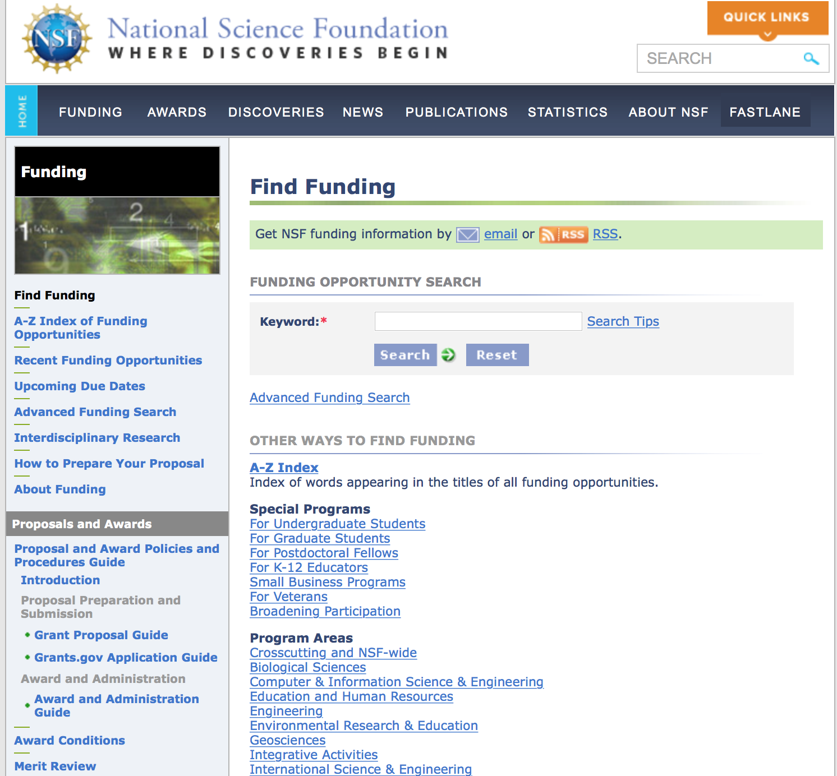
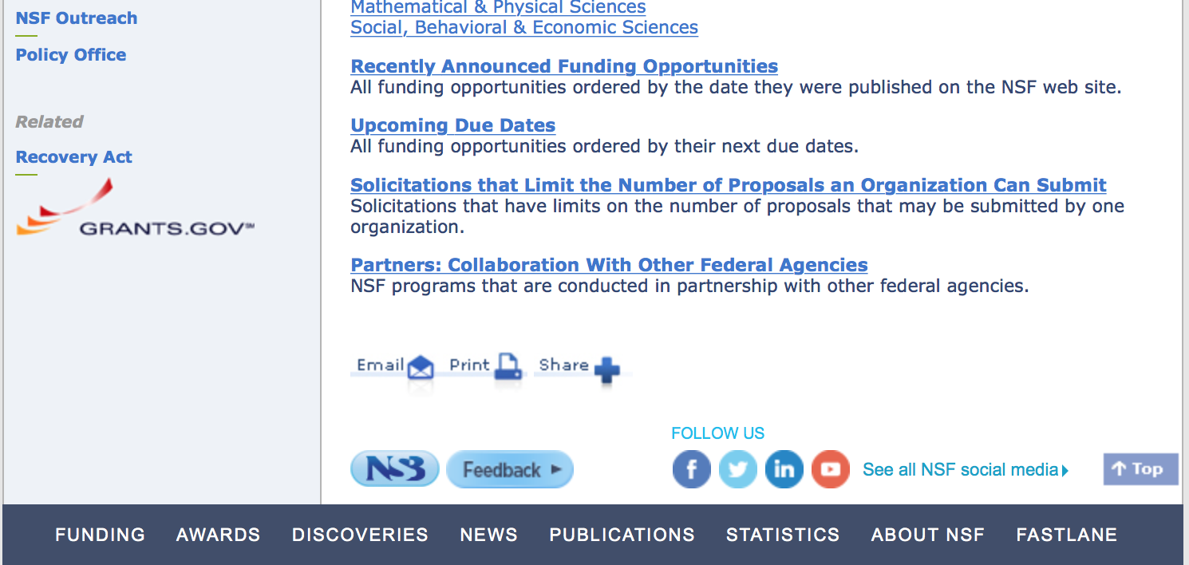

For assistance in finding funding: http://nsf.gov/funding/index.jsp - areas

The National Science Foundation funds research and education in most fields of science and engineering. It does this through grants, and cooperative agreements to more than 2,000 colleges, universities, K-12 school systems, businesses, informal science organizations and other research organizations throughout the United States. The Foundation accounts for about one-fourth of federal support to academic institutions for basic research.
NSF receives approximately 40,000 proposals each year for research, education and training projects, of which approximately 11,000 are funded. In addition, the Foundation receives several thousand applications for graduate and postdoctoral fellowships.
The agency operates no laboratories itself but does support National Research Centers, user facilities, certain oceanographic vessels and Antarctic research stations. The Foundation also supports cooperative research between universities and industry, US participation in international scientific and engineering efforts, and educational activities at every academic level.

For details on active funding deadline dates: http://nsf.gov/funding/pgm_list.jsp?org=NSF&ord=date

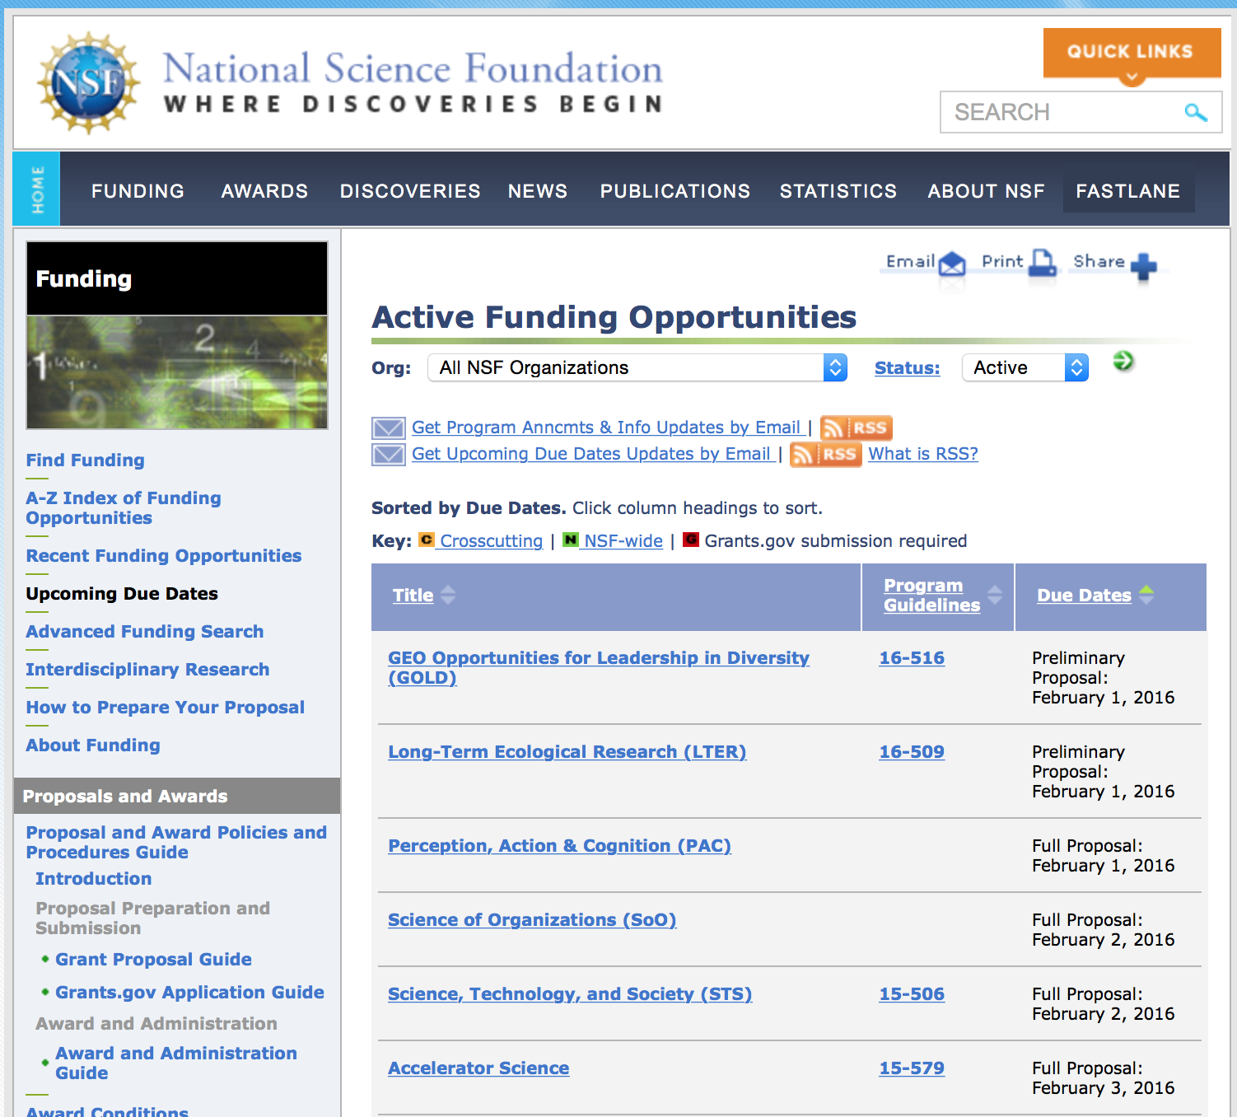

Research and Program Grants:

Algorithms in the Field
Synopsis 1
http://www.grants.gov/web/grants/view-opportunity.html?oppId=288885

Applied Mathematics
Synopsis 1
http://www.grants.gov/web/grants/view-opportunity.html?oppId=289151

Architectures
Synopsis 1
http://www.grants.gov/web/grants/view-opportunity.html?oppId=288974

Biomechanics and Mechanobiology
Synopsis 1
http://www.grants.gov/web/grants/view-opportunity.html?oppId=289081

Collaborative Research in Computational Neuroscience
Synopsis 1
http://www.grants.gov/web/grants/view-opportunity.html?oppId=289012

Critical Resilient Interdependent Infrastructure Systems and Processes
Synopsis 1
http://www.grants.gov/web/grants/view-opportunity.html?oppId=289307

Designing Materials to Revolutionize and Engineer our Future
Synopsis 1
http://www.grants.gov/web/grants/view-opportunity.html?oppId=289106

Documenting Endangered Languages - Doctoral Dissertation Research Improvement Grants
Synopsis 1
http://www.grants.gov/web/grants/view-opportunity.html?oppId=289187

Dynamics, Control and Systems Diagnostics
Synopsis 1
http://www.grants.gov/web/grants/view-opportunity.html?oppId=289157

Earth Sciences: Instrumentation and Facilities (IF)
Synopsis 1
http://www.grants.gov/web/grants/view-opportunity.html?oppId=289102

EMERGING FRONTIERS IN RESEARCH AND INNOVATION (EFRI)
Synopsis 1
http://www.grants.gov/web/grants/view-opportunity.html?oppId=289103

Earth Sciences: Instrumentation and Facilities (IF)
Synopsis 1
http://www.grants.gov/web/grants/view-opportunity.html?oppId=289104

Engineering for Natural Hazards
Synopsis 1
http://www.grants.gov/web/grants/view-opportunity.html?oppId=289155

Engineering and Systems Design
Synopsis 1
http://www.grants.gov/web/grants/view-opportunity.html?oppId=289079

Geotechnical Engineering and Materials
Synopsis 1
http://www.grants.gov/web/grants/view-opportunity.html?oppId=289152

Infrastructure Management and Extreme Events
Synopsis 1
http://www.grants.gov/web/grants/view-opportunity.html?oppId=289154

Manufacturing Machines and Equipment
Synopsis 1
http://www.grants.gov/web/grants/view-opportunity.html?oppId=289308

Materials Engineering and Processing
Synopsis 1
http://www.grants.gov/web/grants/view-opportunity.html?oppId=289078

Mechanics of Materials and Structures
Synopsis 1
http://www.grants.gov/web/grants/view-opportunity.html?oppId=289080

Nanomanufacturing
Synopsis 1
http://www.grants.gov/web/grants/view-opportunity.html?oppId=289092

NSF/Intel Partnership on Computer Assisted Programming for Heterogeneous Architectures
Synopsis 1
http://www.grants.gov/web/grants/view-opportunity.html?oppId=288974

Plant Genome Research Program
Synopsis 1
http://www.grants.gov/web/grants/view-opportunity.html?oppId=289156

Scalable Nanomanufacturing for Integrated Systems
Synopsis 1
http://www.grants.gov/web/grants/view-opportunity.html?oppId=288886

Scalable Parallelism in the Extreme
Synopsis 1
http://www.grants.gov/web/grants/view-opportunity.html?oppId=288905

Science of Learning
Synopsis 1
http://www.grants.gov/web/grants/view-opportunity.html?oppId=288849

Smart and Autonomous Systems
Synopsis 1
http://www.grants.gov/web/grants/view-opportunity.html?oppId=289041

Smart and Connected Communities
Synopsis 1
http://www.grants.gov/web/grants/view-opportunity.html?oppId=289105

Smart and Connected Health
Synopsis 1
http://www.grants.gov/web/grants/view-opportunity.html?oppId=288749

Structural and Architectural Engineering and Materials
Synopsis 1
http://www.grants.gov/web/grants/view-opportunity.html?oppId=289153

Small Business Technology Traer Program Phase I
Synopsis 1
http://www.grants.gov/web/grants/view-opportunity.html?oppId=288689

Solar and Planetary Research Grants
Synopsis 1
http://www.grants.gov/web/grants/view-opportunity.html?oppId=288750

Spectrum Efficiency, Energy Efficiency, and Security (SpecEES): Enabling Spectrum for All
Synopsis 1
http://www.grants.gov/web/grants/view-opportunity.html?oppId=289178

Structural and Architectural Engineering and Materials
Synopsis 1
http://www.grants.gov/web/grants/view-opportunity.html?oppId=289153

Systems Science
Synopsis 1
http://www.grants.gov/web/grants/view-opportunity.html?oppId=289094

Transdisciplinary Research in Principles of Data Science
Synopsis 1

http://www.grants.gov/web/grants/view-opportunity.html?oppId=289177

Modifications:

Reminders:

Deleted:

PD-10-1266 - Applied Mathematics
Deletion Comments: Opportunity deleted

PD-14-7479 - Biomechanics and Mechanobiology
Deletion Comments: Opportunity deleted

16-549 - Cyber-Physical Systems
Deletion Comments: Opportunity deleted

14-580 - Documenting Endangered Languages
Deletion Comments: Opportunity deleted

PD-15-7569 - Dynamics, Control and Systems Diagnostics
Deletion Comments: Opportunity deleted

15-516 - Earth Sciences: Instrumentation and Facilities
Deletion Comments: Opportunity deleted

PD-16-014Y - Engineering for Natural Hazards
Deletion Comments: Opportunity deleted

15-589 - Engineering Research Centers
Deletion Comments: Opportunity deleted

PD-14-1464 - Engineering and Systems Design
Deletion Comments: Opportunity deleted

15-589 - Engineering Research Centers
Deletion Comments: Opportunity deleted

PD-15-1636 - Geotechnical Engineering and Materials
Deletion Comments: Opportunity deleted

16-544 - Inclusion across the Nation of Communities of Learners of Underrepresented Discoverers in Engineering and Science
Deletion Comments: Opportunity deleted

PD-15-1638 - Infrastructure Management and Extreme Events
Deletion Comments: Opportunity deleted

PD-16-1468 - Manufacturing Machines and Equipment
Deletion Comments: Opportunity deleted

PD-16-8092 - Materials Engineering and Processing
Deletion Comments: Opportunity deleted

PD-15-1630 - Mechanics of Materials and Structures
Deletion Comments: Opportunity deleted

PD-16-1788 - Nanomanufacturing
Deletion Comments: Opportunity deleted

16-534 - Presidential Awards for Excellence in Science, Mathematics and Engineering Mentoring
Deletion Comments: Opportunity deleted

PD-07-7278 - Science of Learning Centers
Deletion Comments: Opportunity deleted

16-548 - Science Learning+ Partnership Grants
Deletion Comments: Opportunity deleted

PD-16-1637 - Structural and Architectural Engineering and Materials
Deletion Comments: Opportunity deleted

PD-14-8085 - Systems Science
Deletion Comments: Opportunity deleted

16-553 - US Ignite:
Deletion Comments: Opportunity deleted

Nuclear Regulatory Commission

Reminders:

U.S. Nuclear Regulatory Commission Funding Opportunity Announcement (FOA), Scholarship and Fellowship Education Grant, Faculty Development Grant, and Trade School and Community College Scholarship Grant, Fiscal Year (FY) 2017.
Synopsis 1

Document Type: | Grants Notice
Funding Opportunity Number: | NRC-HQ-60-17-FOA-0001
Funding Opportunity Title: | U.S. Nuclear Regulatory Commission Funding Opportunity Announcement (FOA), Scholarship and Fellowship Education Grant, Faculty Development Grant, and Trade School and Community College Scholarship Grant, Fiscal Year (FY) 2017.
Opportunity Category: | Discretionary
Opportunity Category Explanation:
Funding Instrument Type: | Grant
Category of Funding Activity: | Education
Category Explanation:
Expected Number of Awards: | 50
CFDA Number(s): | 77.008 -- U.S. Nuclear Regulatory Commission Scholarship and Fellowship Program
Cost Sharing or Matching Requirement: | No
Posted Date: | Aug 12, 2016
Last Updated Date: | Aug 11, 2016
Original Closing Date for Applications: | Oct 14, 2016
Current Closing Date for Applications: | Oct 14, 2016
Archive Date: | Nov 13, 2016
Estimated Total Program Funding: | $15,000,000
Award Ceiling: | $450,000
Award Floor: | $100,000
Eligible Applicants: | Public and State controlled institutions of higher education  Private institutions of higher education  Others (see text field entitled "Additional Information on Eligibility" for clarification)
Additional Information on Eligibility: | •Public/State Controlled Institutions of Higher Education • Private Institutions of Higher Education • Hispanic-Serving Institutions (HSIs) • Historically Black Colleges and Universities (HBCUs) • Tribally Controlled Colleges and Universities (TCCUs) • Alaska Native and Native Hawaiian Serving Institutions • Predominately Black Institutions (PBIs) • Asian American and Native American Pacific Islander Serving Institutions (AAPIs)
Agency Name: | Nuclear Regulatory Commission
Description: | • Scholarship - The primary objective is to support scholarships for nuclear science, engineering, technology and related disciplines to develop a workforce capable of supporting the design, construction, operation, and regulation of nuclear facilities and the safe handling of nuclear materials. The nuclear-related discipline supported by this funding is intended to benefit nuclear safety and security sector broadly. • Fellowship - The primary objective is to support fellowships for nuclear science, engineering, technology and related disciplines to develop a workforce capable of supporting the design, construction, operation, and regulation of nuclear facilities and the safe handling of nuclear materials. The nuclear related discipline supported by this funding is intended to benefit the nuclear sector broadly. • Faculty Development - The primary objective is to support faculty development for nuclear science, engineering, technology and related disciplines to develop a workforce capable of supporting the design, construction, operation, and regulation of nuclear facilities and the safe handling of nuclear materials. Proposed faculty can be supported for up to one 3 year period. The objectives are to attract and retain highly-qualified individuals in academic teaching careers. The grants specifically target probationary, tenure-track faculty during the first 6 years of their career and new faculty hires in the following academic areas: Nuclear, Mechanical, Civil, Environmental, Electrical, Fire Protection, and Materials Sciences Engineering as well as Health Physics. The NRC has interest in topics including but not limited to Fuels, Neutronics, Thermal-hydraulics, Accident-Progression (e.g., performance of safety relief valves), Consequence, Emergency Preparedness, and Radiation Protection Analysis; Radiochemistry, Probabilistic Risk Assessment, Seismology, Fire Risk Analysis, advanced reactor (non-light water reactor), safety systems and other related disciplines. Grants may include support for developing applications for new research or continuing research projects in their areas of expertise. The program provides support to enable newer faculty to enhance their careers as professors and researchers in the university department where employed. The research supported by this announcement is intended to benefit the nuclear sector broadly. • Trade School and Community College Scholarships - The primary objective is to support scholarships for nuclear science, engineering, technology, and related disciplines to develop a workforce capable of supporting the design, construction, operation, and regulation of nuclear facilities and the safe handling of nuclear materials. The nuclear-related discipline supported by this funding is intended to benefit the nuclear sector broadly.
Link to Additional Information:
Grantor Contact Information: | If you have difficulty accessing the full announcement electronically, please contact:  M`Lita Carr Grant Specialist Phone 301-415-6869  E-Mail

http://www.grants.gov/web/grants/view-opportunity.html?oppId=287302



Small Business Administration

General Overview Finding Loans & Grants

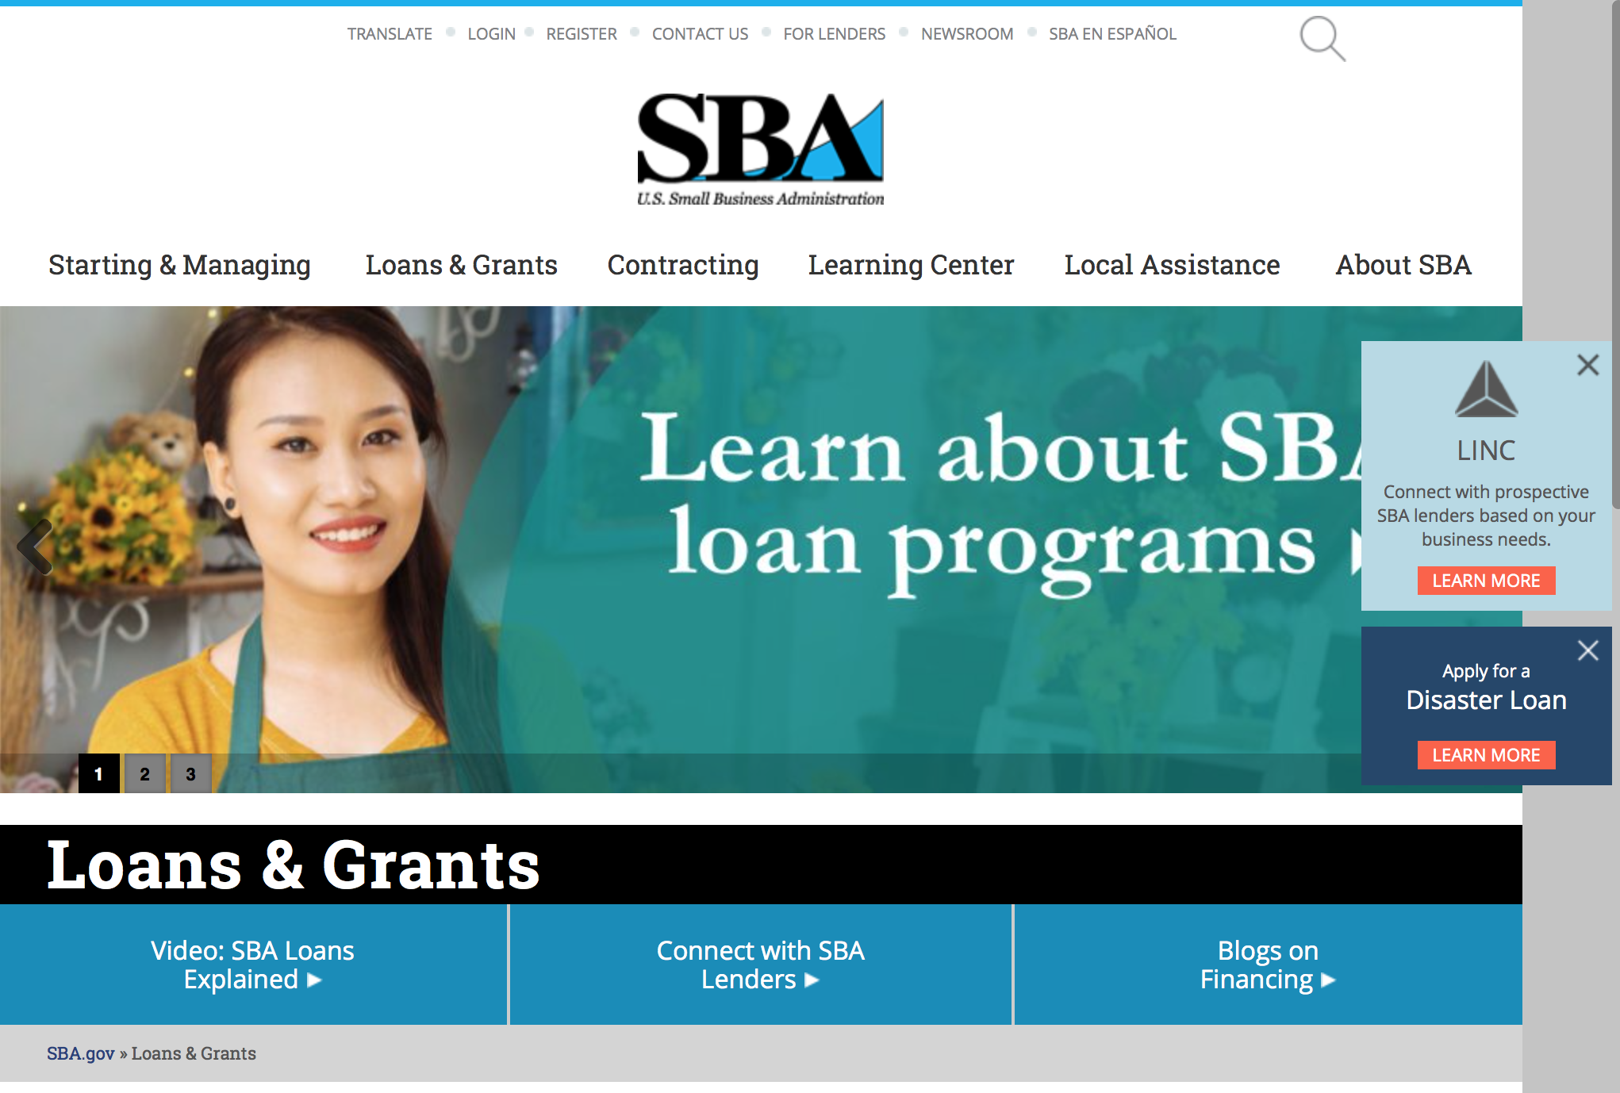
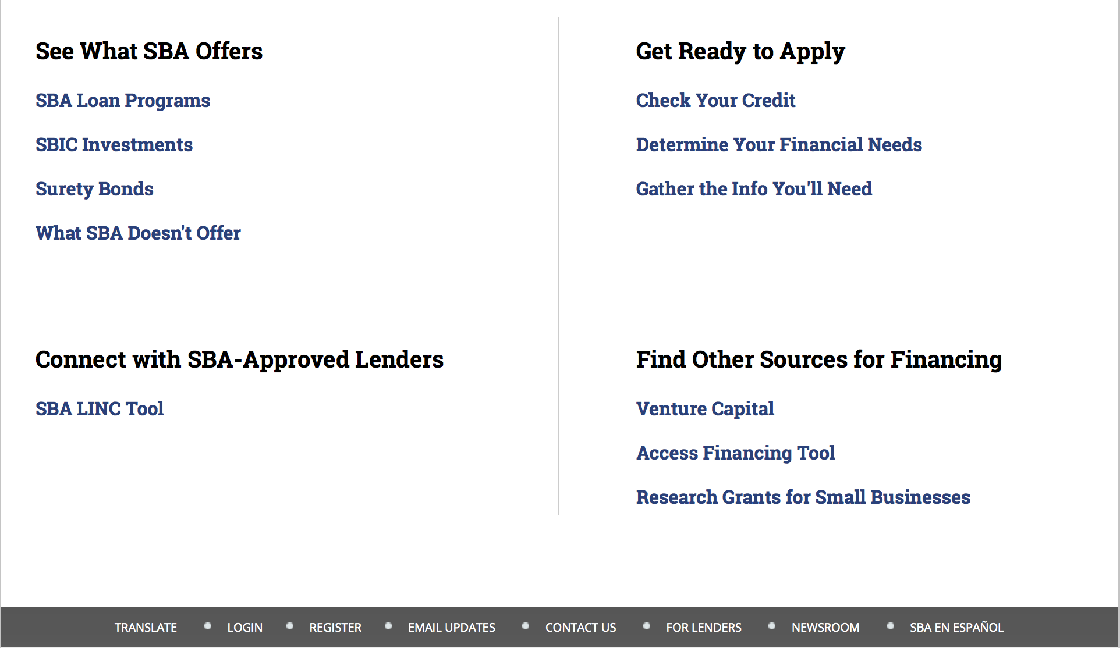

https://www.sba.gov/category/navigation-structure/loans-grants
Federal, state and local governments offer a wide range of financing programs to help small businesses start and grow their operations. These programs include low-interest loans, venture capital, and scientific and economic development grants.

Use SBA.gov's Loans and Grants Search Tool to get a list of financing programs for which you may qualify, or visit the resources below to learn more about small business financing programs. 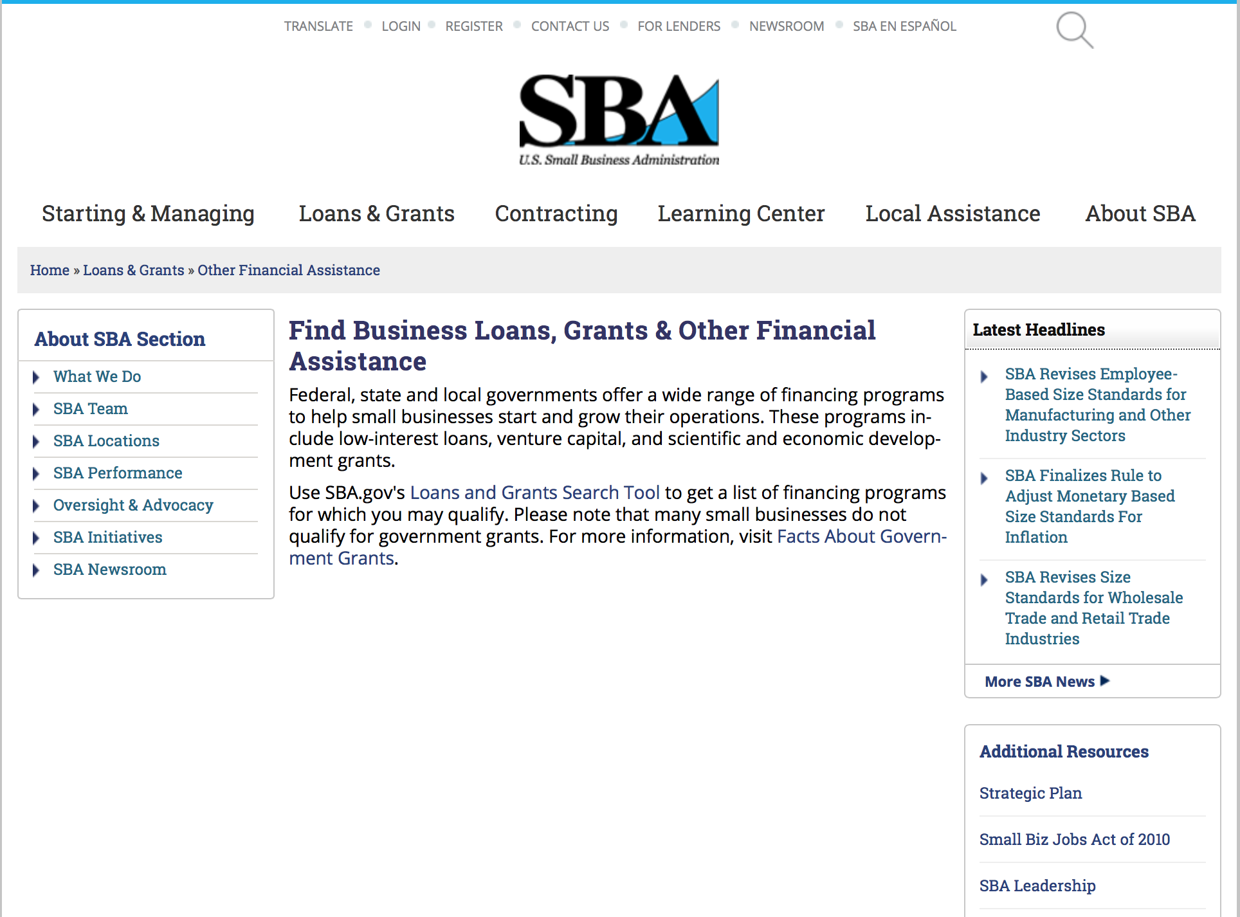
To get to the main SBA.gov funding page click here
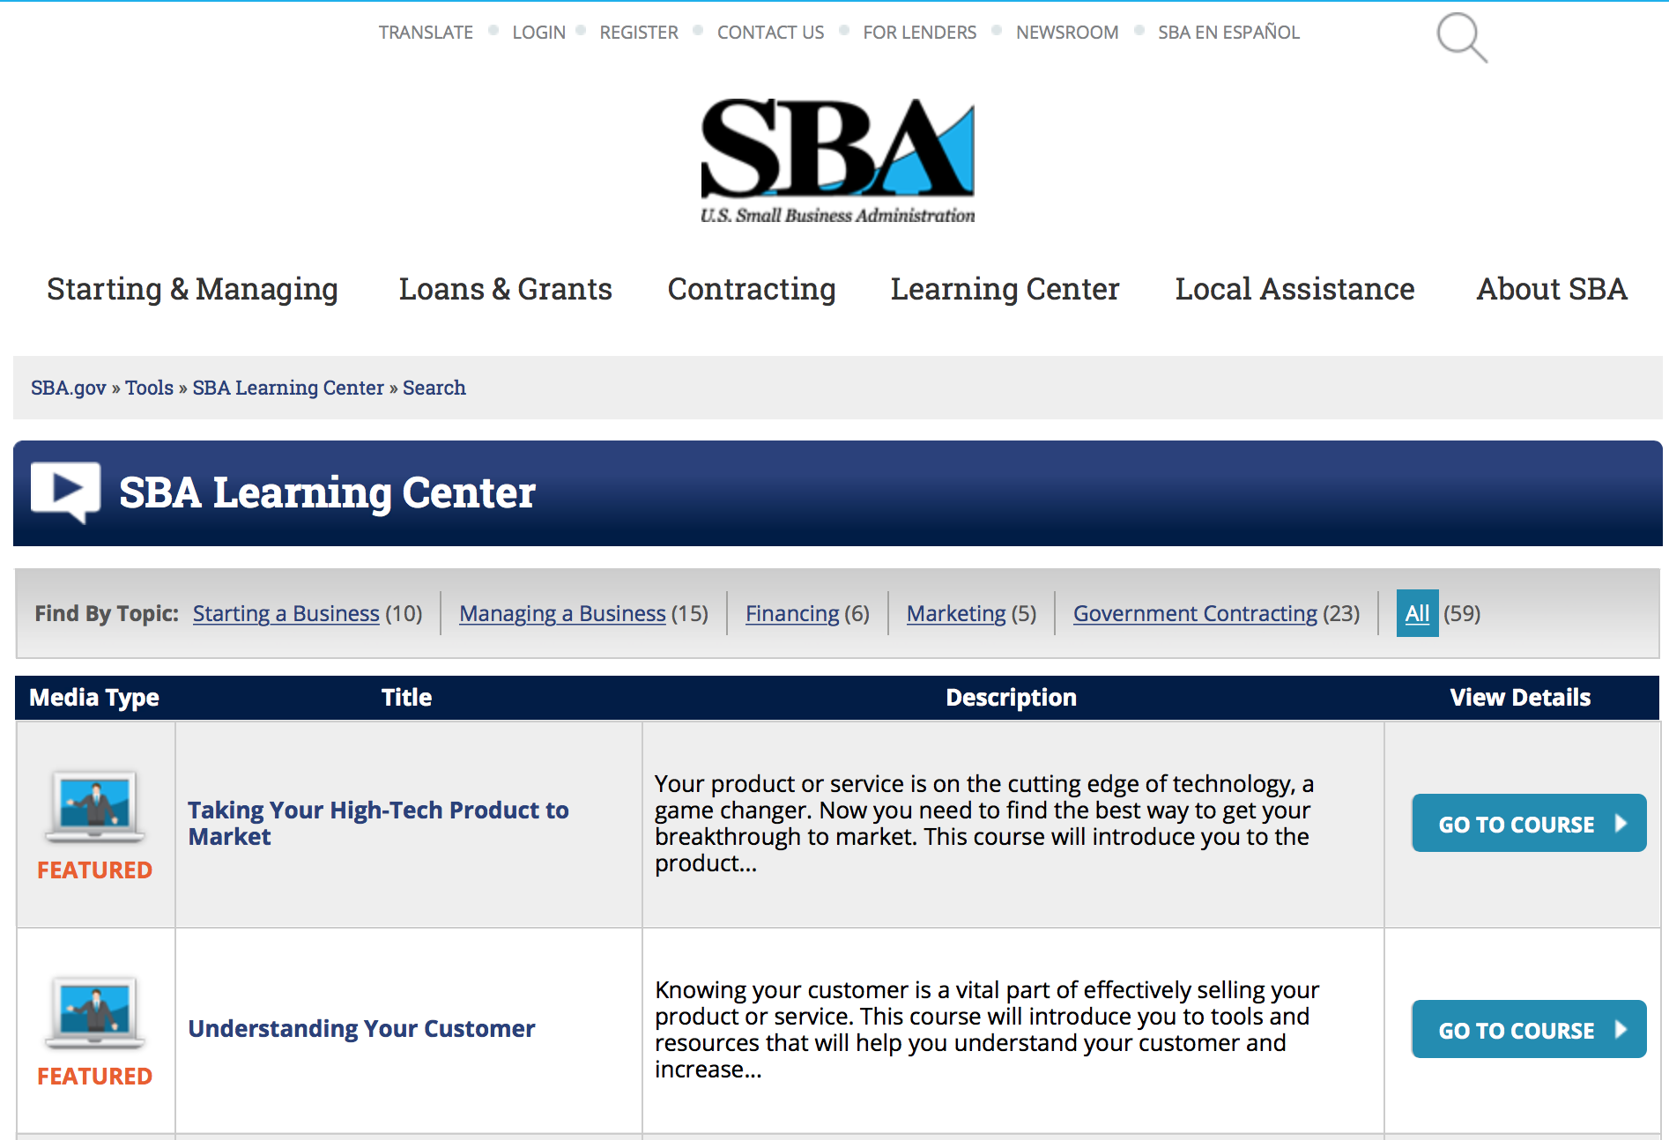
https://www.sba.gov/tools/sba-learning-center/search/training
Programs:

Reminders:

SBA Trainings

Contracting Opportunities for Veteran Entrepreneurs
This self-paced training exercise is an introduction to Federal contracting opportunities for Veterans.
Topics include basic information about Veteran-owned businesses and opportunities, services available to small Veteran-owned businesses, small business incentives, and government procurement methods.
Duration: 00:30:00

http://www.sba.gov/tools/sba-learning-center/training/contracting-opportunities-veteran-entrepreneurs

Interested in Exporting? These Four Resources Can Help
Did you know that two-thirds of the world’s purchasing power is in foreign countries? As the numbers show, the international marketplace is a big one. So if you’re interested in exploring the world of exporting – or have gotten started but could use some guidance – check out these resources to help.
- Read more

Upcoming Trainings: Check out SBA's Online Training!
- Financing Options for Small Businesses
How to Prepare Government Contract Proposals
Getting Started With Exporting: Training and Educational Resources
Exporting represents a big opportunity to tap in to new markets, expand your customer base and grow your business. But getting started with exporting can sometimes feel like a maze of regulations, policies, and other barriers. Here are some free training and educational resources to help.
- Read more

For Specific Information in Hawaii see the following links:
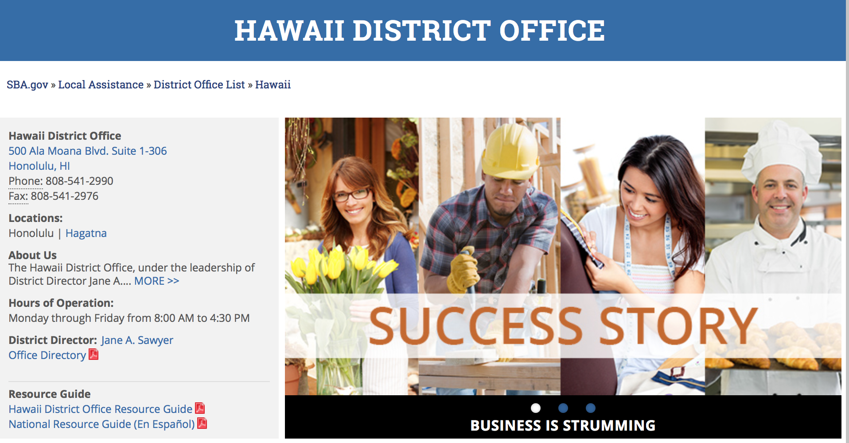

https://www.sba.gov/offices/district/hi/Honolulu

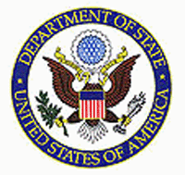

State Department General Overview and Resources for Program Administrators

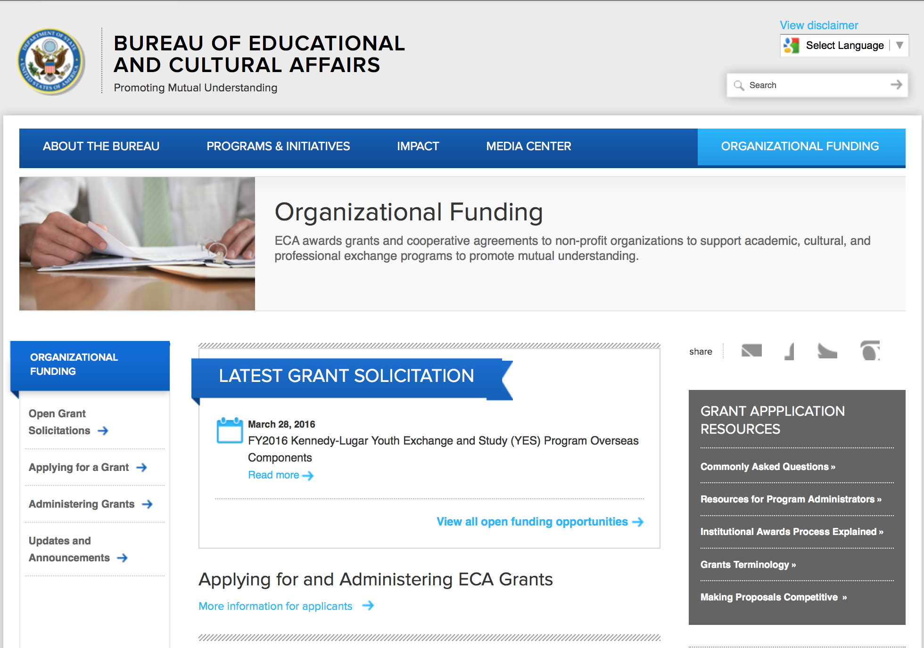
http://eca.state.gov/search/solr/grants?search_referrer=node/237
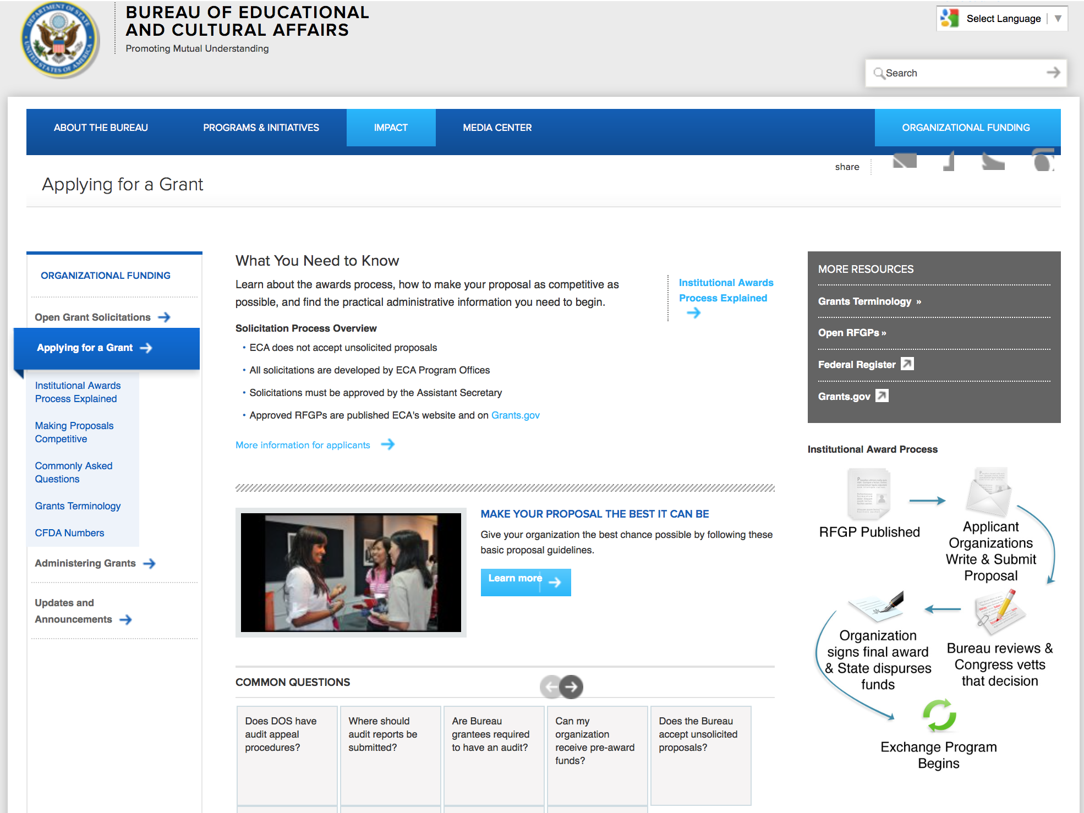

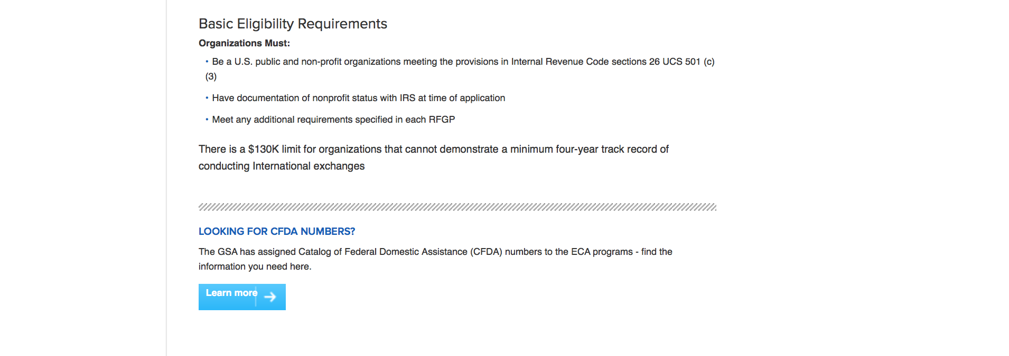
http://eca.state.gov/organizational-funding/applying-grant

General Information:
- Bureau of Educational and Cultural Affairs Grants Division
- Open Grant Opportunities (Requests for Grant Proposals)

For General Information click here

Program Grants:

International Narcotics and Law Enforcement Affair
Citizen Security through Neighborhood Watch
Synopsis 1
http://www.grants.gov/web/grants/view-opportunity.html?oppId=288510

PM Weapons Removal and Abatement
16.PMWRA.Ukraine.HMA.NOFO
Synopsis 1
http://www.grants.gov/web/grants/view-opportunity.html?oppId=289011

Bureau of Democracy, Human Rights and Labor
Human Rights and Fundamental Freedoms in ASEAN
Synopsis 1
http://www.grants.gov/web/grants/view-opportunity.html?oppId=288992

Bureau of Democracy, Human Rights and Labor
Promoting International Labor Rights in Vietnam, South Asia and the Gulf
Synopsis 1
http://www.grants.gov/web/grants/view-opportunity.html?oppId=289131

Modifications:

Bureau of Democracy, Human Rights and Labor
Human Rights, Accountability, and Access to Information in the Democratic People Republic of Korea (DPRK or North Korea)
Synopsis 2
http://www.grants.gov/web/grants/view-opportunity.html?oppId=289007

Bureau of Democracy, Human Rights and Labor
Human Rights and Fundamental Freedoms in ASEAN
Synopsis 2
http://www.grants.gov/web/grants/view-opportunity.html?oppId=289014

Bureau of Democracy, Human Rights and Labor
DRL Request for Statements of Interest on Programs to Support Inclusive Political and Economic Reform, and International Religious Freedom and Human Rights in Burma
Synopsis 2
http://www.grants.gov/web/grants/view-opportunity.html?oppId=289015

S Bureau Grants Offices
Prime Recipients for Key Populations Investment Fund (KPIF)
Synopsis 4
http://www.grants.gov/web/grants/view-opportunity.html?oppId=287874

Bureau of Democracy, Human Rights and Labor
DRL Global Religious Freedom Programs
Synopsis 2
http://www.grants.gov/web/grants/view-opportunity.html?oppId=288041

Reminders:

Deleted:

Bureau of Democracy, Human Rights and Labor
DRLA-DRLAQM-16-093 - Human Rights, Accountability, and Access to Information in the Democratic People Republic of Korea (DPRK or North Korea)
Deletion Comments: Opportunity deleted

Bureau of Democracy, Human Rights and Labor
DRLA-DRLAQM-16-094 - Human Rights and Fundamental Freedoms in ASEAN
Deletion Comments: Opportunity deleted

Bureau of Democracy, Human Rights and Labor
DRLA-DRLAQM-16-095 - DRL Nicaragua
Deletion Comments: Limited source

Department of Transportation

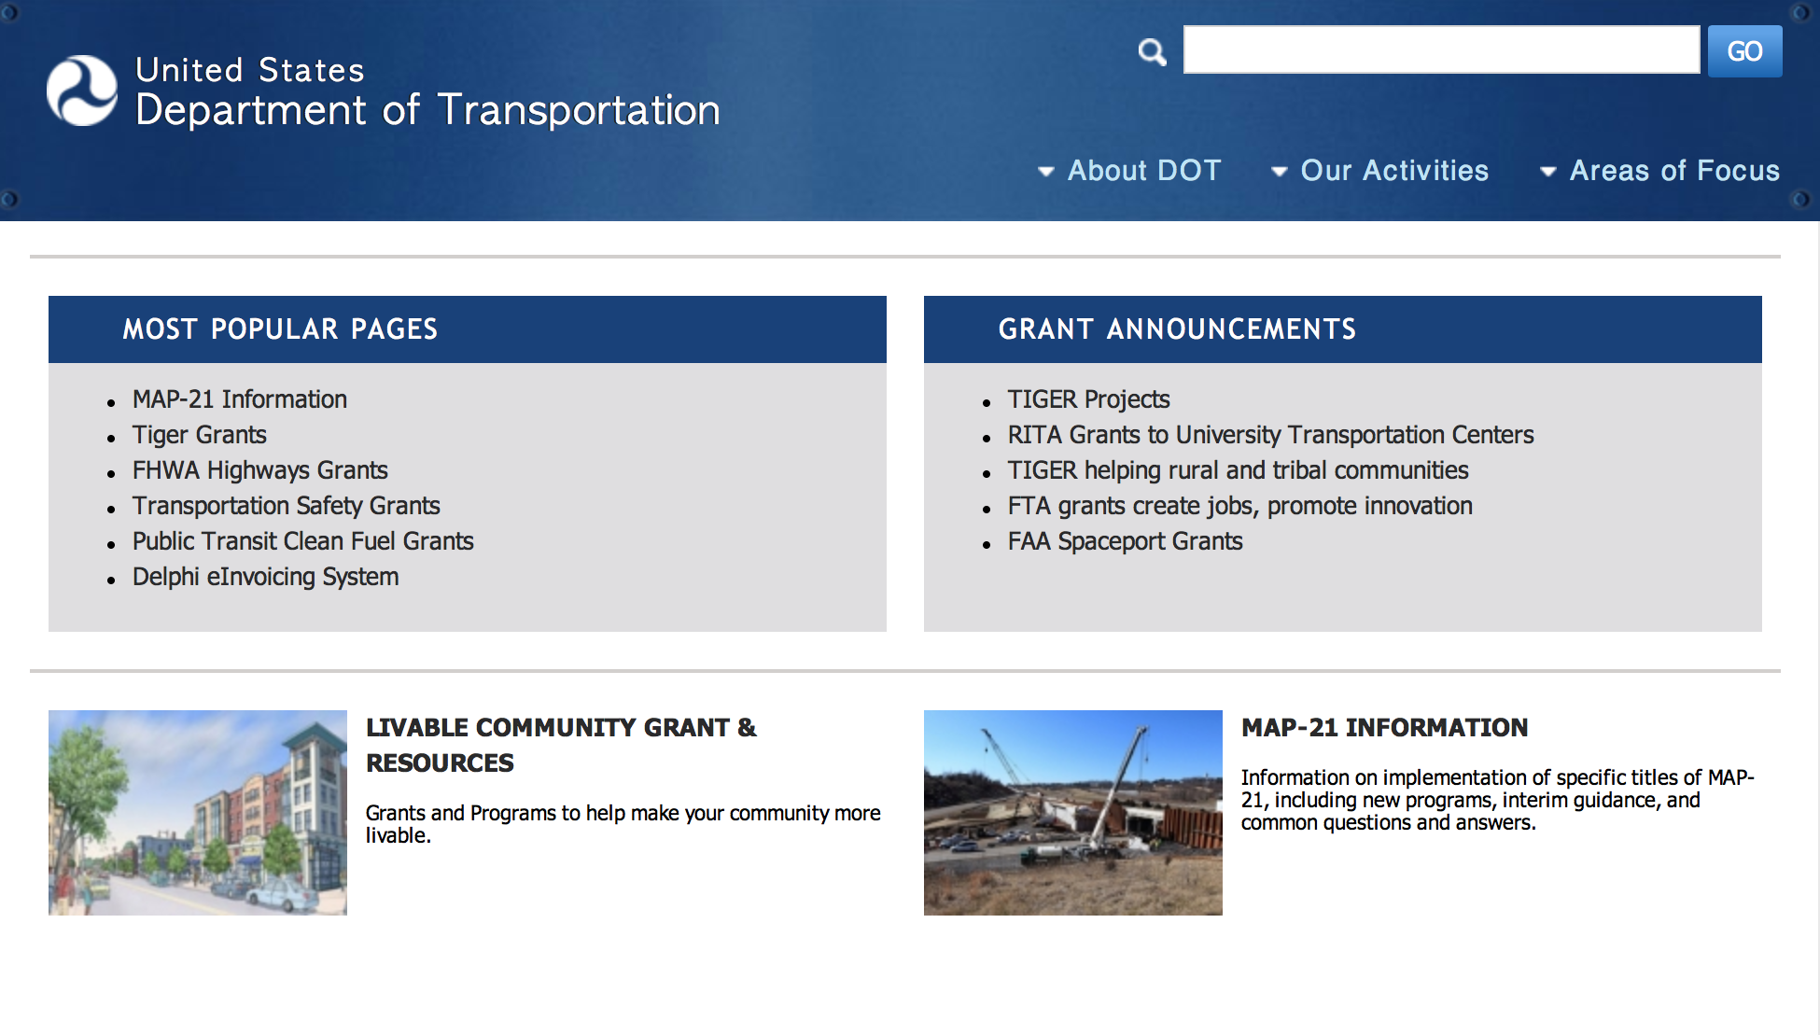
General Grant Program Overview https://www.transportation.gov/grants

Programs:

Modifications:

Reminders:

DOT Federal Aviation Administration
DOT - FAA Aviation Research Grants
FAA Aviation Research and Development Grants
Modifications 3 & 4

Document Type: | Grants Notice
Funding Opportunity Number: | 12-01
Funding Opportunity Title: | FAA Aviation Research and Development Grants
Opportunity Category: | Discretionary
Opportunity Category Explanation:
Funding Instrument Type: | Grant
Category of Funding Activity: | Transportation
Category Explanation:
Expected Number of Awards:
CFDA Number(s): | 20.108 -- Aviation Research Grants
Cost Sharing or Matching Requirement: | No
Version: | Synopsis 5
Posted Date: | Jan 01, 2012
Last Updated Date: | Jun 09, 2016
Original Closing Date for Applications: | Dec 31, 2019
Current Closing Date for Applications: | Dec 31, 2019
Archive Date: | Jan 30, 2020
Estimated Total Program Funding:
Award Ceiling: | $5,000,000
Eligible Applicants: | Nonprofits having a 501(c)(3) status with the IRS, other than institutions of higher education  Private institutions of higher education  Public and State controlled institutions of higher education
Agency Name: | DOT - FAA Aviation Research Grants
Description: | The FAA is soliciting proposals for research grants and cooperative agreements to pursue the long-term growth and short-term technical needs of civil aviation. In order to streamline the application process, it is recommended that all prospective grantees submit a white paper (letter of intent) for agency technical review before complete proposal submission. Please be sure to identify the specific area of interest (Solicitation FAA-12-01 – Chapter I. FAA Research Grants Program, Technical Areas of Research #1-#9). The white paper shall be no longer than three (3) pages and shall detail overall research objectives.
Link to Additional Information:
Grantor Contact Information: | If you have difficulty accessing the full announcement electronically, please contact:  Debra Monzo Grants Officer Phone 609-485-4962  business

http://www.grants.gov/web/grants/view-opportunity.html?oppId=134953

Deleted:

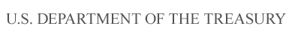

Department of the Treasury

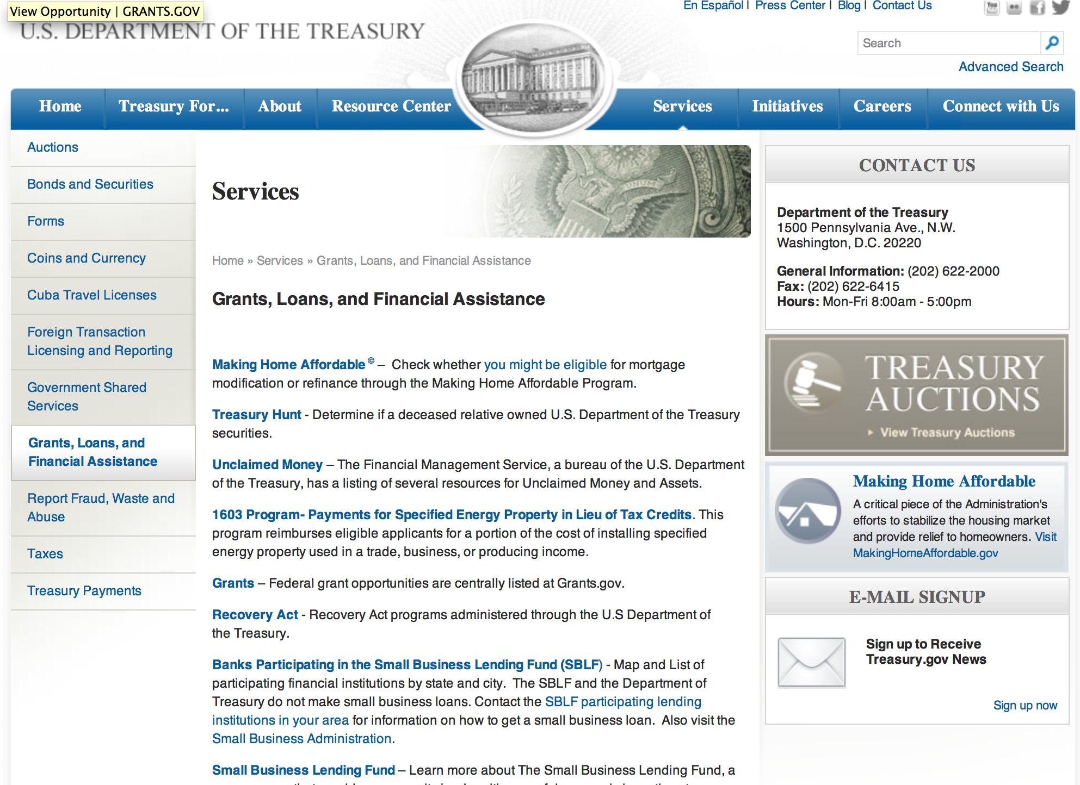

http://www.treasury.gov/services/Pages/Grants-Loans-and-Financial-Assistance.aspx

Programs:

Modifications:

Reminders:

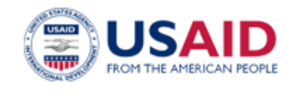

U.S. Agency for International Development

www.usaid.gov

General Overview Funding Opportunities

USAID has working relationships with thousands of American companies and hundreds of U.S.-based private voluntary organizations. For more information on our business and procurement opportunities, please visit our Business section.

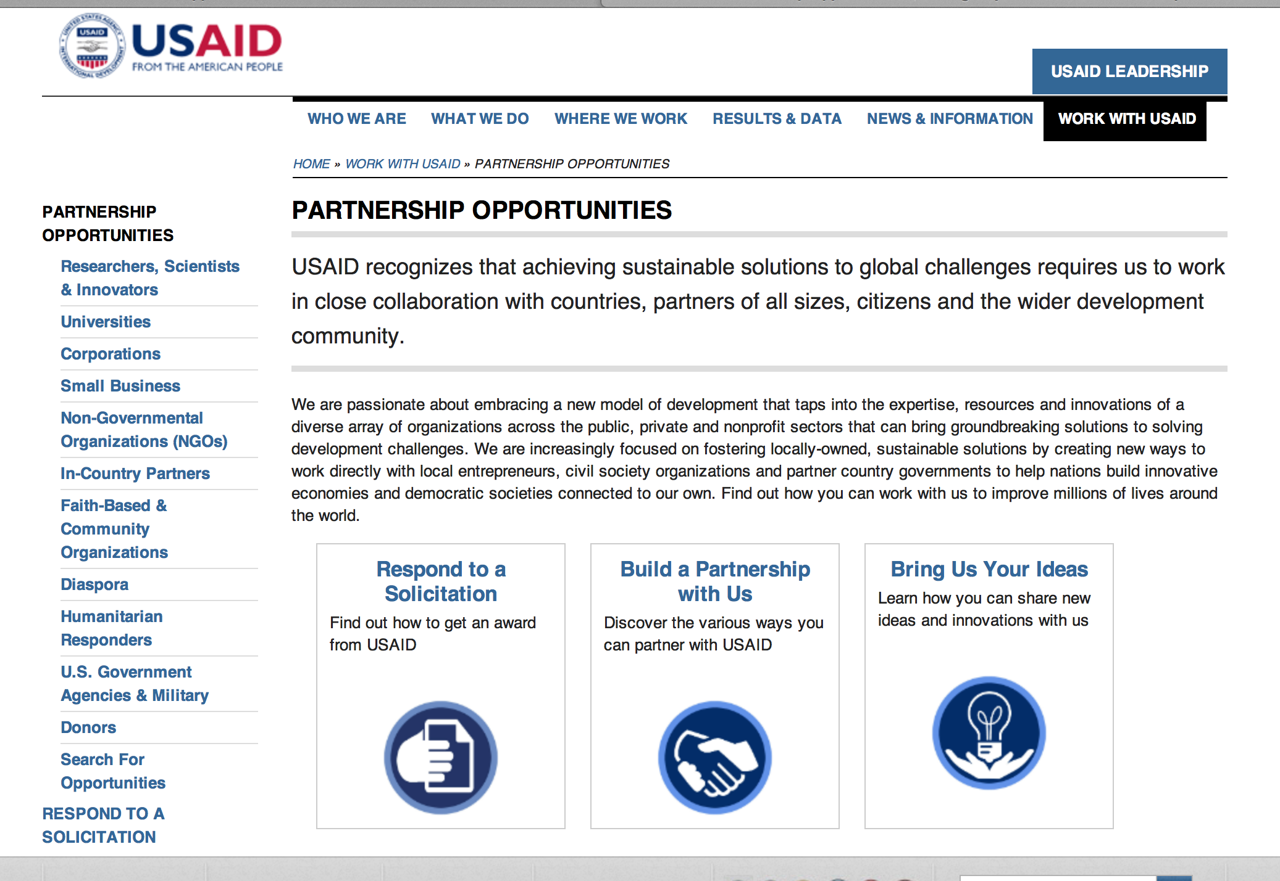
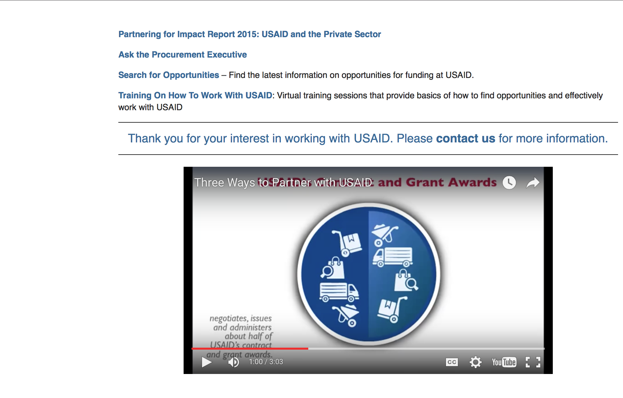

http://www.usaid.gov/partnerships

Programs:

Armenia -Yerevan
Media Enabling Democracy, Inclusion and Accountability in Moldova (MEDIA-M)
Synopsis 1
http://www.grants.gov/web/grants/view-opportunity.html?oppId=289042

Modifications:

South Sudan (USAID)-Juba
USAID’s Biodiversity Annual Program Statement (APS)
Synopsis 6
http://www.grants.gov/web/grants/view-opportunity.html?oppId=282448

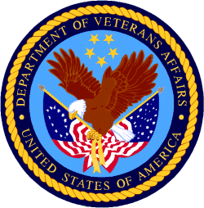

Department of Veterans Affairs

