Senator Mazie Hirono

Grants Assistance Information Newsletter

OCTOBER 2017

G.A.I.N. INDEX

Click on Index Links below to read summaries of the announcements by agency in this document. Once you reach the item, if you cannot open the links for further information, copy the selected URL website address into your browser.

Modified sections from previous listings are shown in a GREY background

Notices is Teal are items with immediate deadline dates.

Notices in Yellow are of special interest.

Notices is Green are items of special interest with immediate deadline dates.

Items in this type color are aimed at Small Businesses

Items in this type color have a Faith-Based Organization component

Special Federal Program Notices

Grant Writing Resources

SAM and Grants.Gov Information

SBIR – Small Business Innovation Research

Programs specific to Hawaii

Current Notices

Reminders

See Individual Departments for information and webpages representing the best and most accessible information on the agency funding opportunities

Federal Grant and Cooperative Agreement Program Summaries

U.S. Department of Agriculture

Grants and Loans Overview

Programs

Utilities Programs
TAT Grant Program FY18

Utilities Programs
Solid Waste Management Grant Program

National Institute of Food and Agriculture
Food Insecurity Nutrition Incentive Competitive Grant Program

National Institute of Food and Agriculture
Community Food Projects Competitive Grant Program

Research

National Institute of Food and Agriculture
Specialty Crop Research Initiative Request for Pre-Applications

Modifications

National Institute of Food and Agriculture
Higher Education Multicultural Scholars Program (MSP)

Reminders

Business and Cooperative Programs
VALUE ADDED PRODUCER GRANT

National Institute of Food and Agriculture
Food and Agricultural Sciences National Needs Graduate and Postgraduate Fellowship (NNF) Grants Program

Agricultural Marketing Service
USDA-AMS-TM-SCMP-G-17-0005

Fish and Wildlife Service
2017 National Fish Habitat Action Plan

Deleted:

Department of Commerce

Grants at Commerce

Programs

National Telecommunications and Information Admin
State and Local Implementation Grant Program (SLIGP) 2.0

Modifications

FY2018 Marine Debris Prevention

Climate Program Office 2018

Research

2018/2019 Sea Scallop Research Set Aside

Reminders

FY18 Saltonstall Kennedy Competition

FY 2018 Marine Fisheries Initiative (MARFIN)

Fiscal Year 2018 NOAA Gulf of Mexico Bay-Watershed Education and Training (B-WET) Program

FY18-19 CRCP International Coral Reef Conservation Cooperative Agreements

FY18 Marine Debris Removal

John H. Prescott Marine Mammal Rescue Assistance Grant Program (Prescott Grant Program) for Fiscal Year 2018

Ocean Exploration FY 2018 Funding Opportunity

Economic Development Administration
FY 2017 Economic Development Assistance Programs ­ Application submission and program requirements for EDA’s Public Works and Economic Adjustment Assistance programs.

National Institute of Standards and Technology
Embedding MEP in Manufacturing USA Institutes Pilot Projects – Round 3

National Institute of Standards and Technology
Measurement Science and Engineering (MSE) Research Grant Programs

FY 2016 – FY 2019 EDA Planning Program and Local Technical Assistance Program Grant

Economic Development Administration
Planning Program and Local Technical Assistance Program Grant

Deleted

Corporation for National and Community Service

General Program Overview

Programs

Reminders

AmeriCorps State and National Grants FY2018

National Service in Hawaii

Department of Defense

Doing Business with the Department of Defense

DoD Small Business Opportunities and Forecasting

Research Grants

Modifications

Deleted

Reminders

Department of Education

Grant Programs Overview

Programs

Research

Institutes of Education Sciences (IES): Education Research and Development Centers CFDA Number 84.305C

Institute of Education Sciences (IES): Research Networks Focused on Critical Problems of Policy and Practice in Special Education CFDA Number 84.324N

Modifications

Reminders

Deleted

US Department of Energy

Grants Overview

Research

Modifications

Reminders

Environmental Protection Agency

Grants and Contracts Overview

Programs

FY18 Guidelines For Brownfields Cleanup Grants

FY18 Guidelines For Brownfields Revolving Loan Fund Grants

FY18 Guidelines For Brownfields Assessment Grants

Modifications

Research

Reminders

2017 Targeted Air Shed Grant Program

Department of Health and Human Services

Grants Overview

Program

Research Grants

Modifications

Deleted

Reminders

Department of Homeland Security
Grants Overview

Programs

Modifications

Reminders

Department of Homeland Security - FEMA
FY17 Flood Mitigation Assistance

Department of Homeland Security - FEMA
FY17 Pre-Disaster Mitigation

Department of Housing and Urban Development

HUD - Notice of Funds Available

Programs

Rural Capacity Building for Community Development and Affordable Housing Grants (RCB)

Modifications

Choice Neighborhoods Implementation Grant Program

Jobs Plus Initiative

Resident Opportunity & Self-Sufficiency Program

Deleted

Reminders

Choice Neighborhoods Implementation Grant Program

Institute of Museum and Library Services

Grants Overview

IMLS is on Facebook!

Programs

Institute of Museum and Library Services
National Leadership Grants for Museums

Museums for America

Modifications

Reminders

Deleted

Department of Interior

Grants and Contract Overview

Programs

Geological Survey
The Educational Component of the National Cooperative Geologic Mapping Program

Modifications

Reminders

Deleted

Department of Justice

Grants and Contract Overview

Programs

Office on Violence Against Women
Supplemental OVW Fiscal Year 2017 Enhanced Training And Services To End Abuse In Later Life Program Solicitation

Research

Modifications

Deleted

Reminders

________________________________________________________________________

Department of Labor

Grants and Contract General Overview

Programs

Modifications

Reminders

National Aeronautics and Space Administration

Research Grant and Contract General Overview

Programs

Modifications

_______________________________________________________________
National Archives and Records Administration

Grant Opportunities General Overview

Programs

Reminders

Access to Historical Records: Major Initiatives (Preliminary)

Access to Historical Records: Major Initiatives

_______________________________________________________________
National Endowment for the Arts

Grant Opportunities General Overview

Programs

Modifications

2018NEAAEAC - NEA Arts Engagement In American Communities (AEAC), FY2018
Deletion Comments: Synopsis deleted

Reminders

NEA Research: Art Works, FY2018

NEA Literature Fellowships: Translation Projects, FY2019
_______________________________________________________________

National Endowment for the Humanities

Grant Opportunities General Overview

Programs

Next Generation Humanities PhD Planning Grants

Reminders

National Endowment for the Humanities
Dialogues on the Experience of War

Humanities Connections

_______________________________________________________________
National Science Foundation

Grant Opportunities General Overview

Research and Program Grants

Modifications

Reminders

Deleted

Nuclear Regulatory Commission

U.S. Nuclear Regulatory Commission Funding Opportunity Announcement (FOA), Scholarship and Fellowship Education Grant, Faculty Development Grant, and Trade School and Community College Scholarship Grant, Fiscal Year (FY) 2018

Reminders

Small Business Administration

General Overview Finding Loans & Grants

Programs

Modifications

Reminders

Deleted

Upcoming Trainings

Links Specific to Hawaii

State Department

General Overview and Resources for Program Administrators

Programs

Modifications

Reminders

U.S. Department of Transportation

General Grant Program Overview

Programs

FY 2017 National Infrastructure Investments

Research

Modifications

Reminders

INFRA Grants

DOT Federal Aviation Administration
DOT - FAA Aviation Research Grants
FAA Aviation Research and Development Grants
Modifications 3 & 4

Deleted

Department of the Treasury

Programs

Community Development Financial Institutions
FY 2017 Bank Enterprise Award Program Application

Modifications

Reminders

US Agency for International Development

General Funding Opportunity Overview

Programs
Modifications

Deleted

Department of Veterans Affairs

Special Federal Program Notices

Grant Writing Resources

The following links are a great resource for faith-based non-profits and other community organizations :

- Center for Faith-Based and Community Initiatives (link is external) , U.S. Department of Labor

- http://www.usaid.gov/partnership-opportunities/fbci. U.S. Agency for International Development

- Faith-Based and Other Community Initiatives (link is external) , Corporation for National Community Service

- Task Force for Faith-Based and Community Initiatives (link is external) , U.S. Department of Justice

- Proposal Writing Short Course (link is external) Foundation Center.
- General Tips on Writing a Competitive Grant Proposal (link is external) U.S. Environmental Protection Agency.
- How to Write a Grant Proposal (link is external) Appalachian Regional Commission.
- A Guide to Funding Resources USDA Rural Information Center.

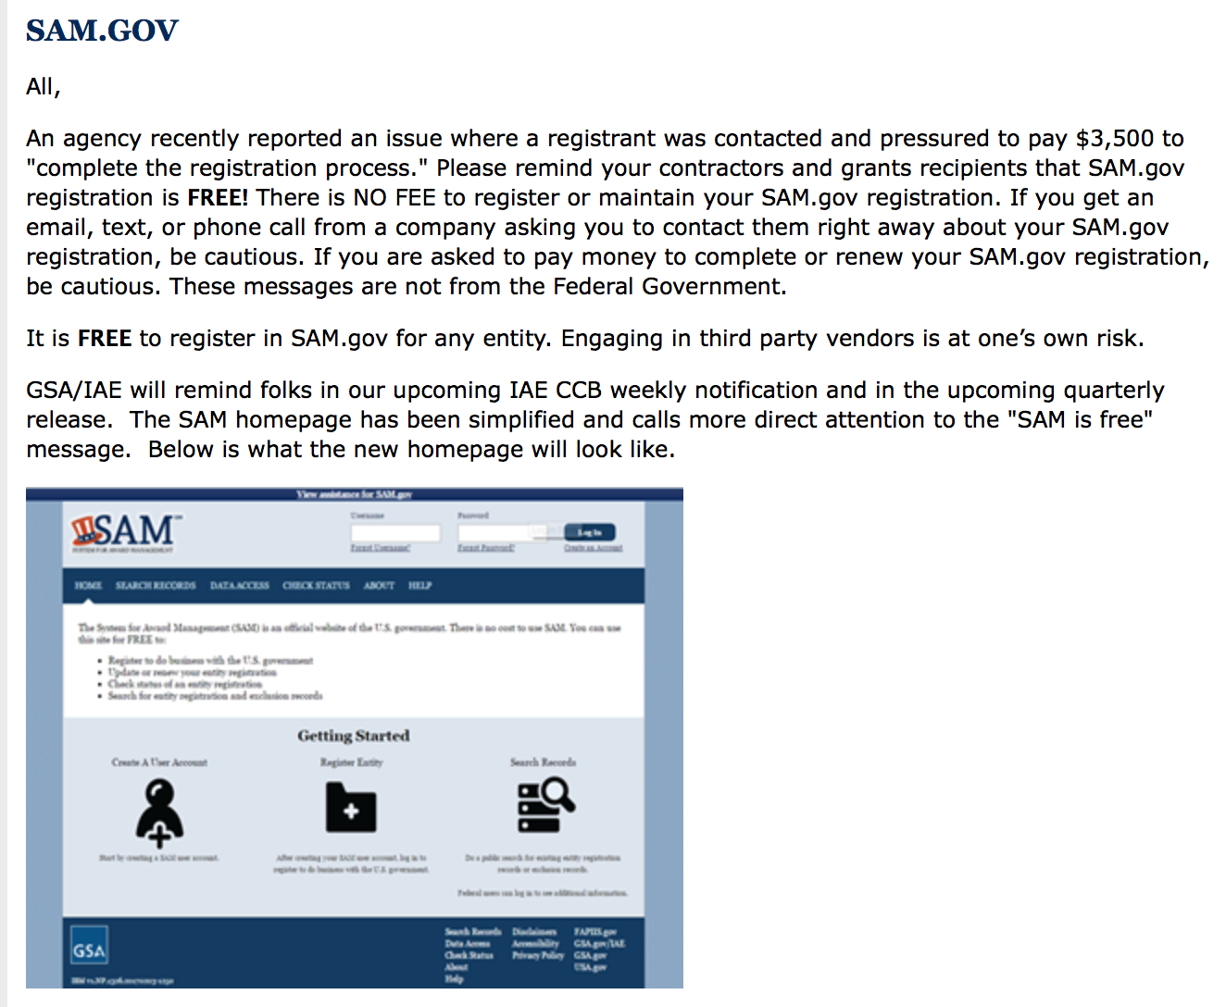

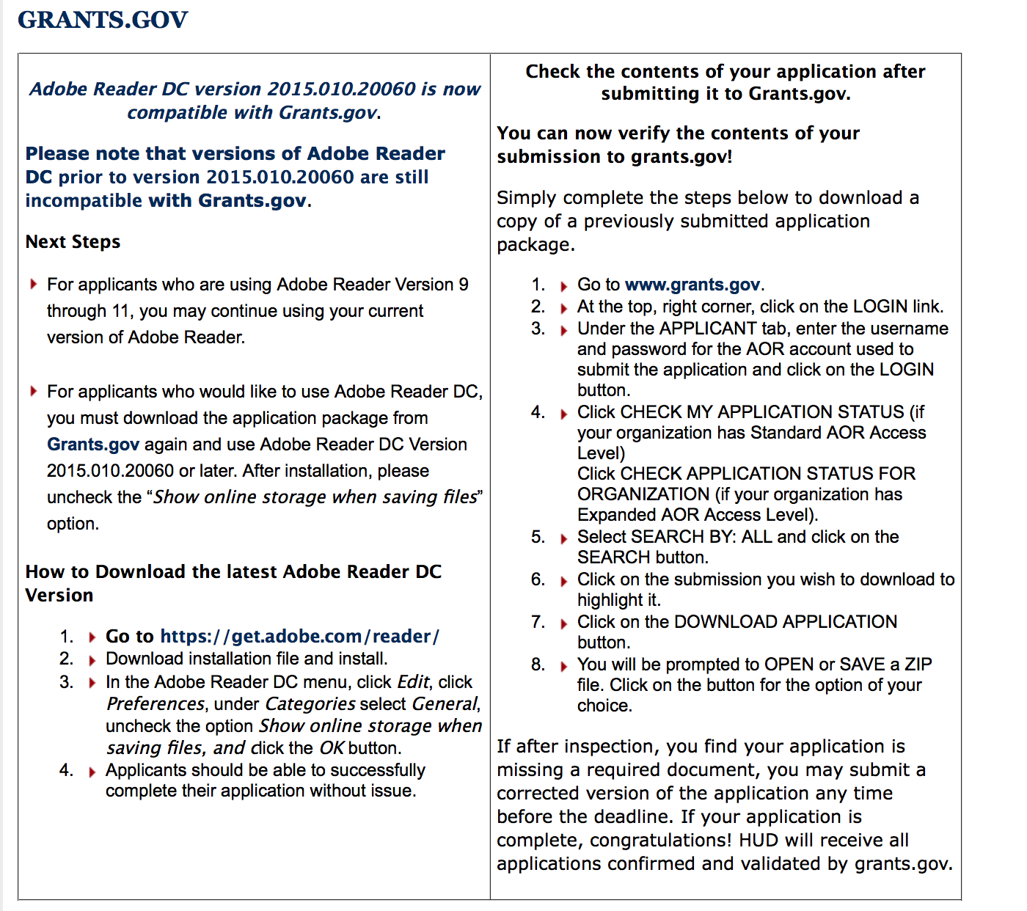

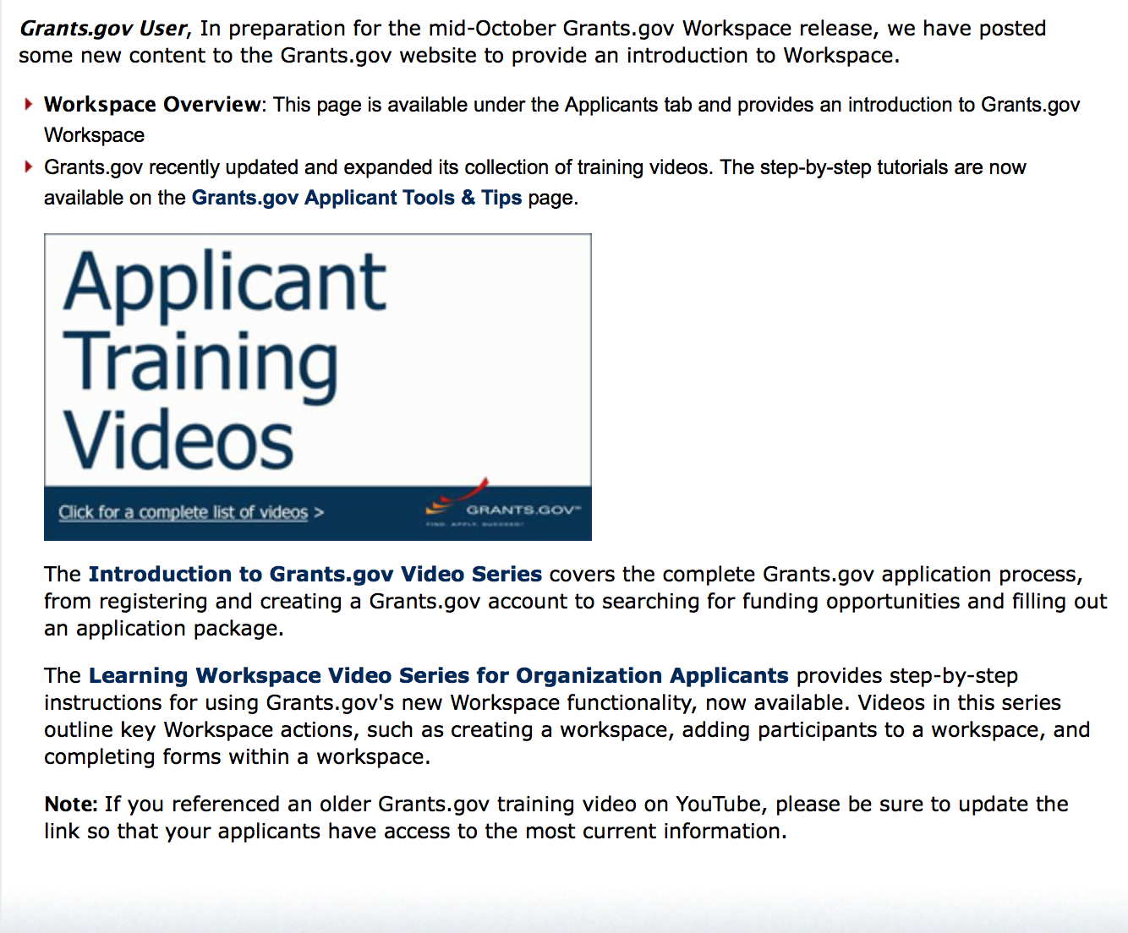
https://portal.hud.gov/hudportal/HUD?src=/program_offices/administration/grants/fundsavail

The Small Business Innovative Research Program - SBIR Program

The Small Business Innovation Research (SBIR) program is a highly competitive program that encourages domestic small businesses to engage in Federal Research/Research and Development (R/R&D) that has the potential for commercialization. Through a competitive awards-based program, SBIR enables small businesses to explore their technological potential and provides the incentive to profit from its commercialization. By including qualified small businesses in the nation's R&D arena, high-tech innovation is stimulated and the United States gains entrepreneurial spirit as it meets its specific research and development needs.

SBIR Mission and Program Goals
The mission of the SBIR program is to support scientific excellence and technological innovation through the investment of Federal research funds in critical American priorities to build a strong national economy.
The program’s goals are four-fold:
- Stimulate technological innovation
- Meet Federal research and development needs.
- Foster and encourage participation in innovation and entrepreneurship by socially and economically disadvantaged persons.
- Increase private-sector commercialization of innovations derived from Federal research and development funding.

SBIR-Participating Agencies
Each year, Federal agencies with extramural research and development (R&D) budgets that exceed $100 million are required to allocate 2.5 percent of their R&D budget to these programs. Currently, eleven Federal agencies participate in the program:
- Department of Agriculture
- Department of Commerce - National Institute of Standards and Technology
- Department of Commerce - National Oceanic and Atmospheric Administration
- Department of Defense
- Department of Education
- Department of Energy
- Department of Health and Human Services
- Department of Homeland Security
- Department of Transportation
- Environmental Protection Agency
- National Aeronautics and Space Administration
- National Science Foundation
Each agency administers its own individual program within guidelines established by Congress. These agencies designate R&D topics in their solicitations and accept proposals from small businesses. Awards are made on a competitive basis after proposal evaluation.

Three-Phase Program
The SBIR Program is structured in three phases:
Phase I. The objective of Phase I is to establish the technical merit, feasibility, and commercial potential of the proposed R/R&D efforts and to determine the quality of performance of the small business awardee organization prior to providing further Federal support in Phase II. SBIR Phase I awards normally do not exceed $150,000 total costs for 6 months.
Phase II. The objective of Phase II is to continue the R/R&D efforts initiated in Phase I. Funding is based on the results achieved in Phase I and the scientific and technical merit and commercial potential of the project proposed in Phase II. Only Phase I awardees are eligible for a Phase II award. SBIR Phase II awards normally do not exceed $1,000,000 total costs for 2 years.
Phase III. The objective of Phase III, where appropriate, is for the small business to pursue commercialization objectives resulting from the Phase I/II R/R&D activities. The SBIR program does not fund Phase III. Some Federal agencies, Phase III may involve follow-on non-SBIR funded R&D or production contracts for products, processes or services intended for use by the U.S. Government
SBIR NewsLetter

- SBIR Newsletter
Sign up for e-mail updates

HAWAII APPLICANTS ENCOURAGED

Current Notices:

Reminders:

Please review each department’s General Grant and Funding Overview. These overviews are the key web pages on each departmental website dedicated to the agency’s funding opportunities. Check back often to note the department updates and use these sources to assist you in your planning.

Federal Grant and Cooperative Agreement Program Summaries

U.S. Department of Agriculture

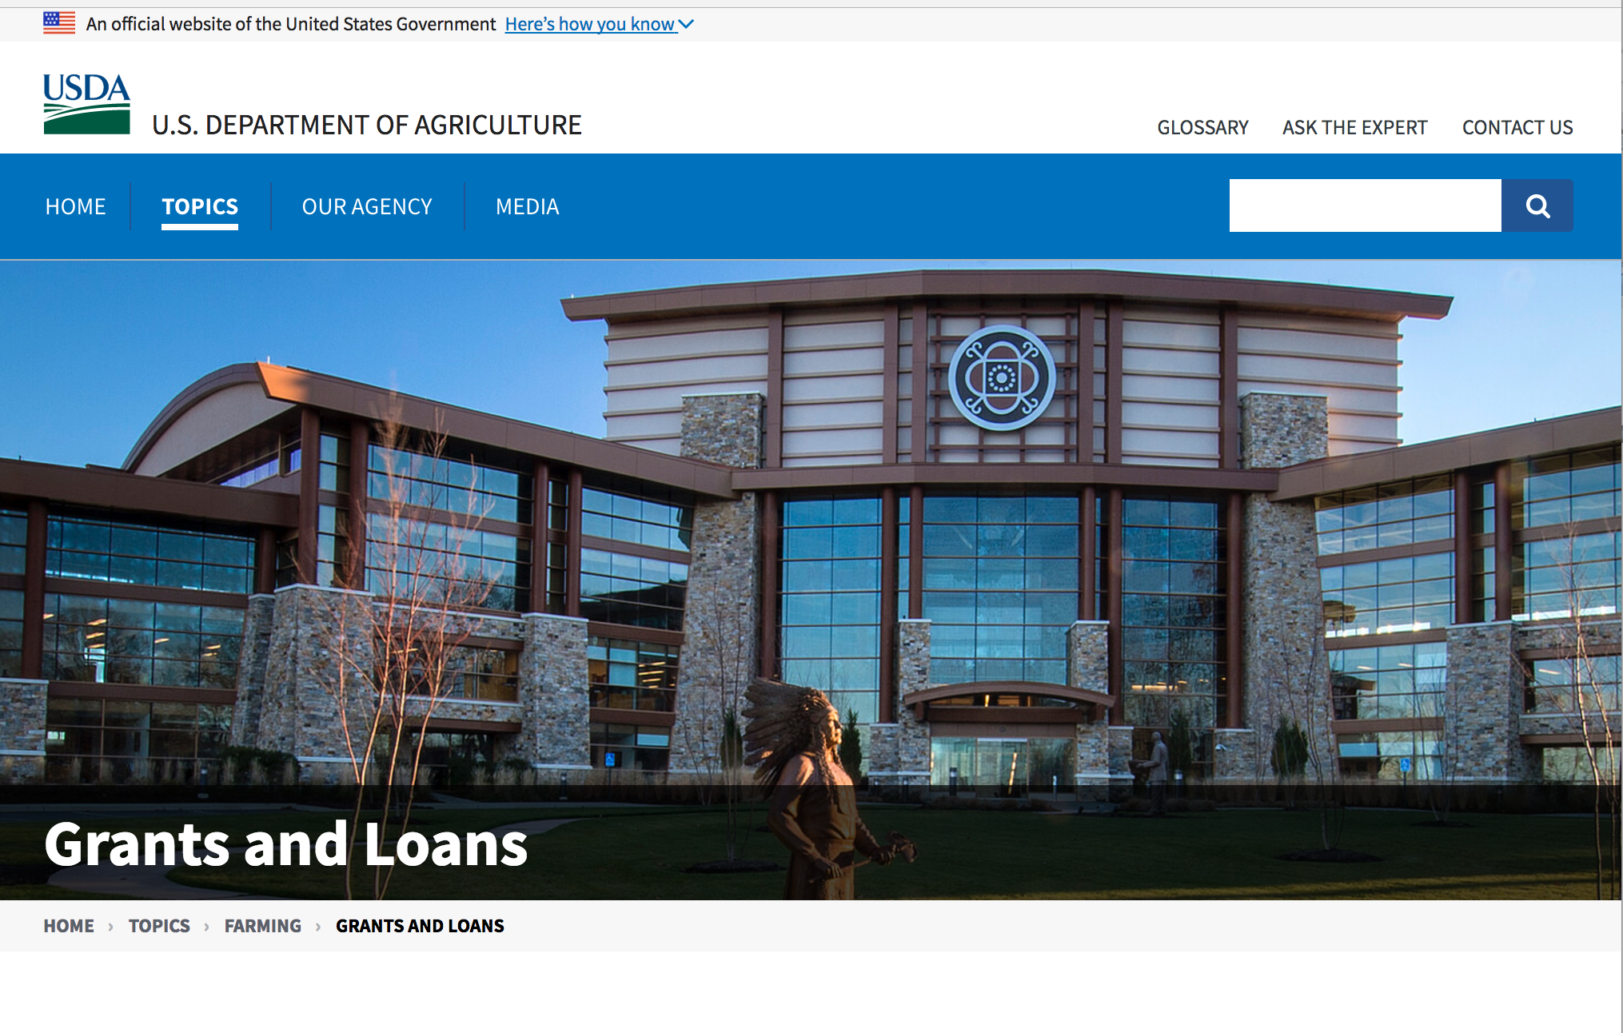

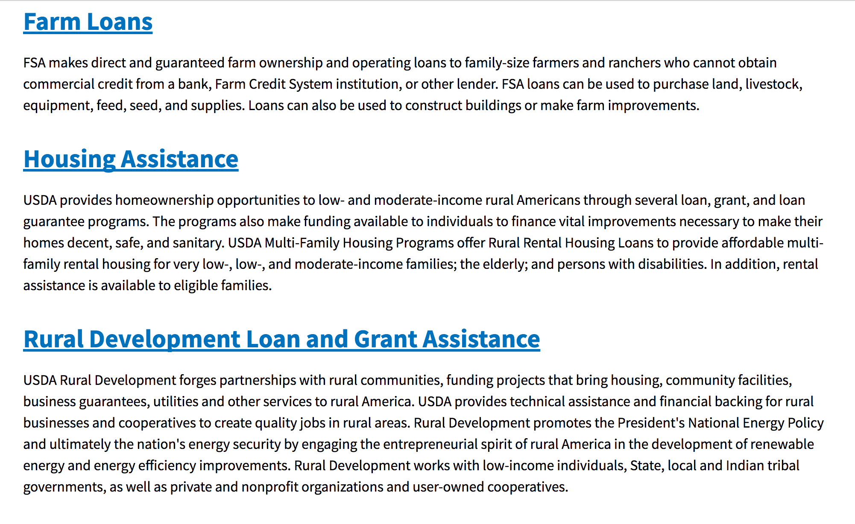

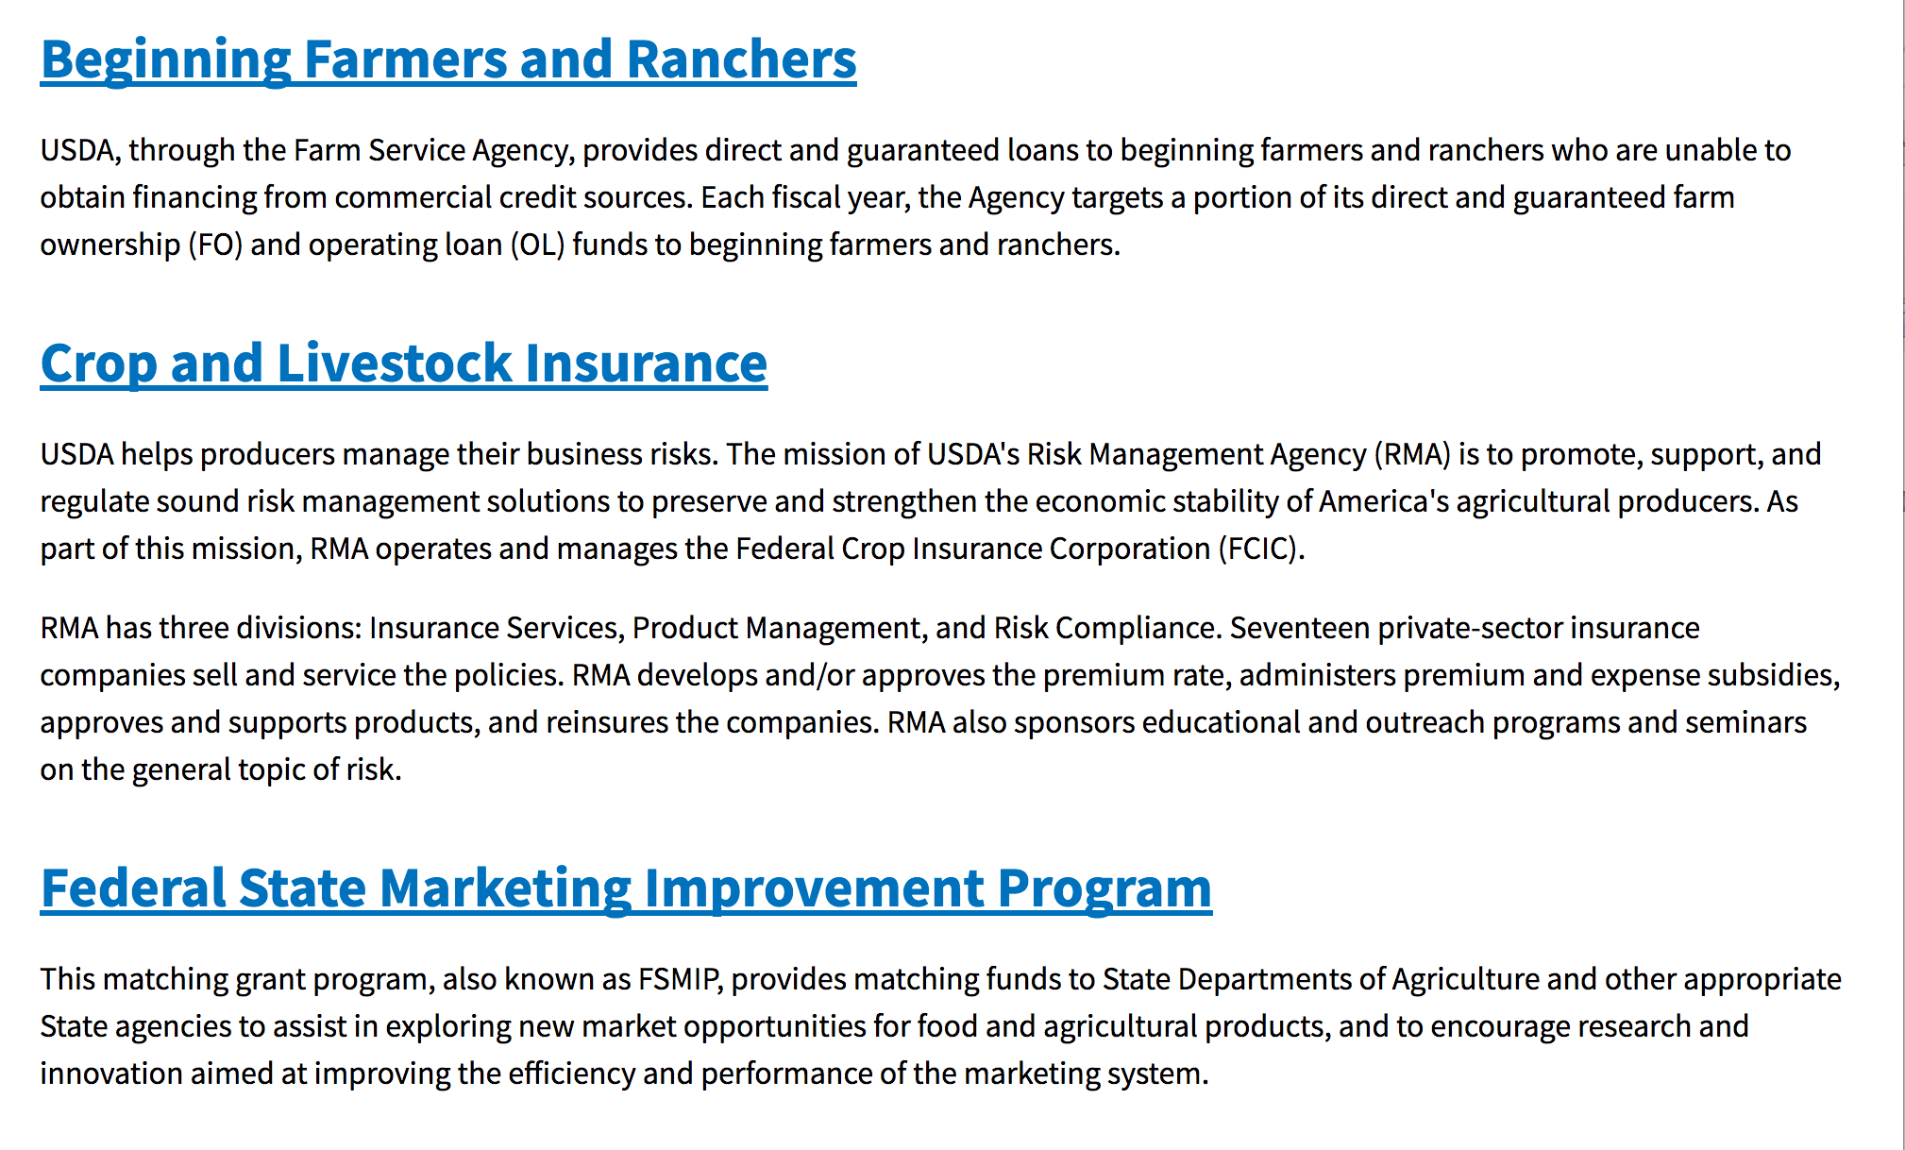
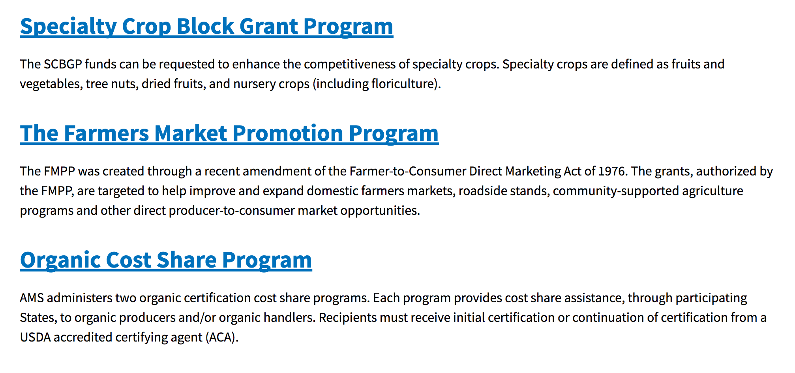
https://www.usda.gov/topics/farming/grants-and-loans

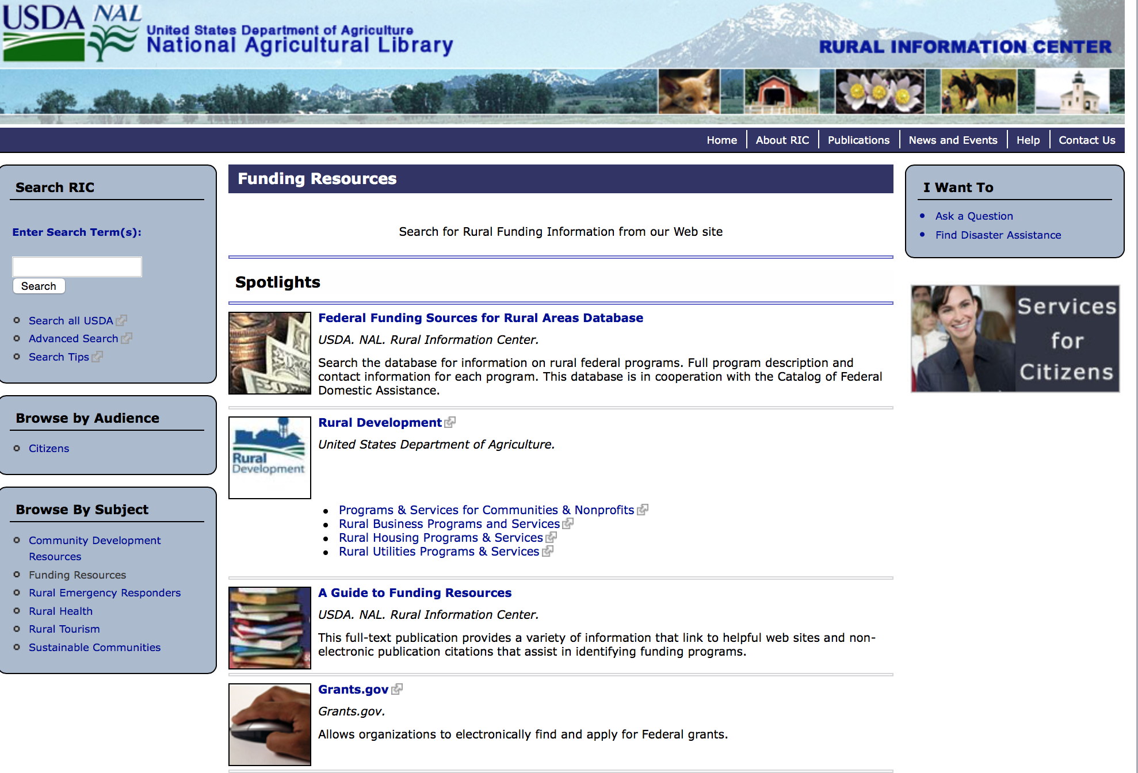

http://ric.nal.usda.gov/funding-resources

Programs:

Utilities Programs
TAT Grant Program FY18
Synopsis 1
Document Type: | Grants Notice
Funding Opportunity Number: | TATFY18
Funding Opportunity Title: | TAT Grant Program FY18
Opportunity Category: | Discretionary
Opportunity Category Explanation:
Funding Instrument Type: | Grant
Category of Funding Activity: | Other (see text field entitled "Explanation of Other Category of Funding Activity" for clarification)
Category Explanation: | The Technical Assistance and Training (TAT) Grant Program has been established to communities with water or wastewater systems through free technical assistance and/or training provided by the grant recipients. Qualified private non-profit organizations will receive TAT grant funds to identify and evaluate solutions to water and waste disposal problems in rural areas, assist applicants in preparing applications for water and waste grants made at the State level offices, and improve operation and maintenance of existing water and waste disposal facilities in rural areas.
Expected Number of Awards: | 17
CFDA Number(s): | 10.761 -- Technical Assistance and Training Grants
Cost Sharing or Matching Requirement: | No
Version: | Synopsis 1
Posted Date: | Oct 02, 2017
Last Updated Date: | Oct 02, 2017
Original Closing Date for Applications: | Jan 02, 2018 Close date has been changed to 1/1/2018 since 12/31/17 deadline falls on a Sunday and next available day is a federal holiday.
Current Closing Date for Applications: | Jan 02, 2018 Close date has been changed to 1/1/2018 since 12/31/17 deadline falls on a Sunday and next available day is a federal holiday.
Archive Date: | Feb 01, 2018
Estimated Total Program Funding: | $20,000,000
Eligible Applicants: | Others (see text field entitled "Additional Information on Eligibility" for clarification)
Additional Information on Eligibility: | Eligibility criteria for TAT grants is as follows: (a) Entities eligible for grants must be private nonprofit organizations with tax exempt status, designated by the Internal Revenue Service. A nonprofit organization is defined as any corporation, trust, association, cooperative, or other organization that: (1) Is operated primarily for scientific, education, service, charitable, or similar purposes in the public interest. (2) Is not organized primarily for profit. (3) Uses its net proceeds to maintain, improve, and/or expand its operations. (b) Entities must be legally established and located within a state as defined inï¿½ 1775.2. (c) Organizations must be incorporated by December 31 of the year the application period occurs to be eligible for funds. (d)Private businesses, Federal agencies, public bodies, and individuals are ineligible for these grants.(e) Applicants must also have the proven ability, background, experience (as evidenced by the organization's satisfactory completion of project(s)similar to those proposed), legal authority, and actual capacity to provide technical assistance and/or training on a regional basis to associations as provided in 7 CFR 1775.33. To meet the requirement of actual capacity, an applicant must either:(1) Have the necessary resources to provide technical assistance and/or training to associations in rural areas through its staff, or (2) Be assisted by an affiliate or member organization which has such background and experience and which agrees, in writing, that it will provide the assistance, or (3) Contract with a non-affiliated organization for not more than 49 percent of the grant to provide the proposed assistance.
Agency Name: | Utilities Programs
Description: | Funds may be used to pay expenses associated with providing technical assistance and/or training (TAT) to identify and evaluate solutions to water problems relating to source, storage, treatment, and distribution, and to waste disposal problems relating to collection, treatment, and disposal; assist applicants that have filed an preapplication with RUS in the preparation of water and/or waste disposal loan and/or grant applications; and to provide training that will improve the management, operation and maintenance of water and waste disposal facilities. Grant funds may not be used to recruit applications, duplicate current services such as those performed by a consultant in developing a project, fund political activities, pay for capital assets, purchase real estate or vehicles, improve and renovate office space or repair and maintain privately owned property, pay construction or O&M costs, and pay costs incurred prior to the effective date of grants made.
Link to Additional Information:
Grantor Contact Information: | If you have difficulty accessing the full announcement electronically, please contact:  Anita OBrien Loan Specialist Phone 202-690-3789  Government Email Address

http://www.grants.gov/web/grants/view-opportunity.html?oppId=297811

Utilities Programs
Solid Waste Management Grant Program
Synopsis 1

Document Type: | Grants Notice
Funding Opportunity Number: | SWMFY2018
Funding Opportunity Title: | Solid Waste Management Grant Program
Opportunity Category: | Discretionary
Opportunity Category Explanation:
Funding Instrument Type: | Grant
Category of Funding Activity: | Community Development  Environment
Category Explanation: | The Solid Waste Management (SWM) Grant Program has been established to assist communities through free technical assistance and/or training provided by the grant recipients. Qualified organizations will receive SWM grant funds to reduce or eliminate pollution of water resources in rural areas, and improve planning and management of solid waste sites in rural areas.
Expected Number of Awards: | 33
CFDA Number(s): | 10.762 -- Solid Waste Management Grants
Cost Sharing or Matching Requirement: | No
Version: | Synopsis 1
Posted Date: | Oct 02, 2017
Last Updated Date: | Oct 02, 2017
Original Closing Date for Applications: | Jan 02, 2018 Close date for FY 2018 has been changed to January 2, 2018 due to normal close date (12/31) falling on Sunday. Applications must be submitted by 11:59pm (Eastern Time) on Jan, 2, 2018
Current Closing Date for Applications: | Jan 02, 2018 Close date for FY 2018 has been changed to January 2, 2018 due to normal close date (12/31) falling on Sunday. Applications must be submitted by 11:59pm (Eastern Time) on Jan, 2, 2018
Archive Date: | Feb 01, 2018
Estimated Total Program Funding: | $4,000,000
Award Ceiling: | $1,000,000
Eligible Applicants: | Others (see text field entitled "Additional Information on Eligibility" for clarification)
Additional Information on Eligibility: | An organization is eligible to receive a SWM grant if it: a. Is a private, non-profit organization that has tax-exempt status from the United States Internal Revenue Service (IRS);b. Is a Public body; c. Is a federally acknowledged or State-recognized Native American tribe or group; d. Is an Academic institution; e. Is legally established and located within one of the following: a state within the United States; the District of Columbia; the Commonwealth of Puerto Rico; a United States territory. Has the legal capacity and authority to carry out the grant purpose; g. Has a proven record of successfully providing technical assistance and/or training to rural areas; h. Has capitalization acceptable to the Agency, and is composed of at least 51 percent of the outstanding interest or membership being citizens of the United States or individuals who reside in the United States after being legally admitted for permanent residence; i. Has no delinquent debt to the Federal Government or no outstanding judgments to repay a Federal debt; j. Demonstrates that it possesses the financial, technical, and managerial capability to comply with Federal and State laws and requirements. k. Contracts with a nonaffiliated organization for not more than 49 percent of the grant to provide the proposed assistance.
Agency Name: | Utilities Programs
Description: | Funds may be used to: Evaluate current landfill conditions to determine threats to water resources in rural areas; provide technical assistance and/or training to enhance operator skills in the maintenance and operation of active landfills in rural areas; provide technical assistance and/or training to help associations reduce the solid waste stream; and provide technical assistance and/or training for operators of landfills in rural areas which are closed or will be closed in the near future with the development/implementation of closure plans, future land use plans, safety and maintenance planning, and closure scheduling within permit requirements. Grant funds may not be used to: Recruit pre-applications/applications for any loan and/or grant program including RUS Water and Waste Disposal Loan and/or Grant Program; duplication of current services, replacement or substitution of support previously provided such as those performed by an association's consultant in developing a project; fund political activities; pay for capital assets, the purchase of real estate or vehicles, improve and renovate office space, or repair and maintain privately-owned property; pay for construction or operation and maintenance costs of water and waste facilities; and pay costs incurred prior to the effective date of grants made under 7 CFR 1775.
Link to Additional Information: | government website
Grantor Contact Information: | If you have difficulty accessing the full announcement electronically, please contact:  LAVONDA PERNELL Community Programs Specialist Phone 202-720-9635  Grant Manager

http://www.grants.gov/web/grants/view-opportunity.html?oppId=297812

National Institute of Food and Agriculture
Food Insecurity Nutrition Incentive Competitive Grant Program
Synopsis 1

 | Document Type: | Grants Notice
 | Funding Opportunity Number: | USDA-NIFA-FINI-006393
 | Funding Opportunity Title: | Food Insecurity Nutrition Incentive Competitive Grant Program
 | Opportunity Category: | Mandatory
 | Opportunity Category Explanation:
 | Funding Instrument Type: | Grant
 | Category of Funding Activity: | Agriculture
 | Category Explanation:
 | Expected Number of Awards:
 | CFDA Number(s): | 10.331 -- Food Insecurity Nutrition Incentive Grants Program
 | Cost Sharing or Matching Requirement: | Yes
 | Version: | Synopsis 1
 | Posted Date: | Sep 22, 2017
 | Last Updated Date: | Sep 22, 2017
 | Original Closing Date for Applications: | Dec 13, 2017
 | Current Closing Date for Applications: | Dec 13, 2017
 | Archive Date: | Jan 12, 2018
 | Estimated Total Program Funding: | $21,000,000
 | Award Ceiling: | $500,000
 | Award Floor: | $100,000
 | Eligible Applicants: | Others (see text field entitled "Additional Information on Eligibility" for clarification)
 | Additional Information on Eligibility: | Applications may only be submitted by government agencies and non-profit organizations.
Agency Name: |  | National Institute of Food and Agriculture
Description: |  | The Food Insecurity Nutrition Incentive (FINI) Grant Program for fiscal year (FY) 2018 to support projects to increase the purchase of fruits and vegetables among low-income consumers participating in the Supplemental Nutrition Assistance Program (SNAP) by providing incentives at the point of purchase.
Link to Additional Information: |  | Error! Hyperlink reference not valid.
Grantor Contact Information: |  | If you have difficulty accessing the full announcement electronically, please contact:  NIFA Help Desk Phone: 202-401-5048 Business hours are M-F, 7:00 am -5:00 pm ET, excluding Federal holidays  If you have any questions related to preparing application content

http://www.grants.gov/web/grants/view-opportunity.html?oppId=297637

National Institute of Food and Agriculture
Community Food Projects Competitive Grant Program
Synopsis 1

Document Type: | Grants Notice
Funding Opportunity Number: | USDA-NIFA-CFP-006392
Funding Opportunity Title: | Community Food Projects Competitive Grant Program
Opportunity Category: | Mandatory
Opportunity Category Explanation:
Funding Instrument Type: | Grant
Category of Funding Activity: | Agriculture
Category Explanation:
Expected Number of Awards:
CFDA Number(s): | 10.225 -- Community Food Projects
Cost Sharing or Matching Requirement: | Yes
Version: | Synopsis 1
Posted Date: | Sep 12, 2017
Last Updated Date: | Sep 12, 2017
Original Closing Date for Applications: | Dec 04, 2017
Current Closing Date for Applications: | Dec 04, 2017
Archive Date: | Jan 03, 2018
Estimated Total Program Funding: | $8,640,000
Eligible Applicants: | Others (see text field entitled "Additional Information on Eligibility" for clarification)
Additional Information on Eligibility: | Public food program service providers, tribal organizations, or private nonprofit entities, including gleaners (see Definition in Part VIII, E.). Please refer to Part III, Eligibility in the RFA.
Agency Name: | National Institute of Food and Agriculture
Description: | In FY 2018, NIFA's CFP intends to solicit applications and fund two types of grants. The types are entitled (1) Community Food Projects (CFP) and (2) Planning Projects (PP). The primary goals of the CFP are to: Meet the food needs of low-income individuals through food distribution, community outreach to assist in participation in Federally assisted nutrition programs, or improving access to food as part of a comprehensive service; Increase the self-reliance of communities in providing for the food needs of the communities; Promote comprehensive responses to local food access, farm, and nutrition issues; and Meet specific state, local or neighborhood food and agricultural needs including needs relating to: Equipment necessary for the efficient operation of a project; Planning for long-term solutions; or The creation of innovative marketing activities that mutually benefit agricultural producers and low-income consumers.
Link to Additional Information: | Community Food Projects Competitive Grant Program
Grantor Contact Information: | If you have difficulty accessing the full announcement electronically, please contact:  NIFA Help Desk Phone: 202-401-5048 Business hours are M-F, 7:00 am -5:00 pm ET, excluding Federal holidays  If you have any questions related to preparing application content

http://www.grants.gov/web/grants/view-opportunity.html?oppId=297333

Research:

National Institute of Food and Agriculture
Specialty Crop Research Initiative Request for Pre-Applications
Synopsis 1
http://www.grants.gov/web/grants/view-opportunity.html?oppId=297651

Modifications:

National Institute of Food and Agriculture
Higher Education Multicultural Scholars Program (MSP)
Synopsis 2 & 3
Document Type: | Grants Notice
Funding Opportunity Number: | USDA-NIFA-HEMS-006391
Funding Opportunity Title: | Higher Education Multicultural Scholars Program (MSP)
Opportunity Category: | Discretionary
Opportunity Category Explanation:
Funding Instrument Type: | Grant
Category of Funding Activity: | Agriculture
Category Explanation:
Expected Number of Awards:
CFDA Number(s): | 10.220 -- Higher Education - Multicultural Scholars Grant Program
Cost Sharing or Matching Requirement: | No
Version: | Synopsis 3
Posted Date: | Sep 07, 2017
Last Updated Date: | Sep 12, 2017
Original Closing Date for Applications: | Oct 31, 2017
Current Closing Date for Applications: | Oct 31, 2017
Archive Date: | Nov 30, 2017
Estimated Total Program Funding: | $945,000
Eligible Applicants: | Others (see text field entitled "Additional Information on Eligibility" for clarification)
Additional Information on Eligibility: | A. Eligible Applicants Pursuant to section 1417 of the NARETPA of 1977 (99 Stat. 1548; 7 U.S.C. 3152), applications may be submitted by: (1) land-grant institutions, (2) colleges and universities having significant minority enrollments and a demonstrable capacity to carry out the teaching of food and agricultural sciences, and (3) other colleges and universities having a demonstrable capacity to carry out the teaching of food, and agricultural sciences. Research foundations maintained by an eligible college or university are eligible to submit undergraduate and/or D.V.M. training proposals under this RFA. Applicants should be institutions that confer an undergraduate or D.V.M. degree in at least one of the disciplines in the food and agricultural sciences. Students attending two-year colleges that are legally authorized to offer a two-year or equivalent program of college-level studies which are principally creditable toward a baccalaureate degree, may be awarded a MSP Scholarship from eligible baccalaureate institutions in cases where an articulation agreement, bridging agreement, or other type of collaborative arrangement exists between the subject baccalaureate-level institution(s) and the two year college. MSP Scholars from 2-year colleges are expected to transfer and complete their baccalaureate degrees in the partner 4-year institution(s). In such instances, the baccalaureate-level institution must be the applicant. Award recipients may subcontract to organizations not eligible to apply provided such organizations are necessary for the conduct of the project. Failure to meet an eligibility criterion by the application deadline may result in the application being excluded from consideration or, even though an application may be reviewed, will preclude NIFA from making an award.
Agency Name: | National Institute of Food and Agriculture
Description: | The purpose of this competitive undergraduate scholarship grant program is to increase the multicultural diversity of the food and agricultural scientific and professional workforce, and advance the educational achievement of all Americans by providing competitive grants to colleges and universities.
Link to Additional Information: | Higher Education Multicultural Scholars Program (MSP
Grantor Contact Information: | If you have difficulty accessing the full announcement electronically, please contact:  https://nifa.usda.gov/funding-opportunity/higher-education-multicultural-scholars-program-msp  If you have any questions related to preparing application content.

http://www.grants.gov/web/grants/view-opportunity.html?oppId=297179

Reminders:

Business and Cooperative Programs
VALUE ADDED PRODUCER GRANT
Synopsis 3
Document Type: | Grants Notice
Funding Opportunity Number: | RDBCP-VAPG-2017
Funding Opportunity Title: | VALUE ADDED PRODUCER GRANT
Opportunity Category: | Discretionary
Opportunity Category Explanation:
Funding Instrument Type: | Grant
Category of Funding Activity: | Agriculture
Category Explanation:
Expected Number of Awards: | 200
CFDA Number(s): | 10.352 -- Value-Added Producer Grants
Cost Sharing or Matching Requirement: | Yes
Version: | Synopsis 3
Posted Date: | Aug 29, 2017
Last Updated Date: | Aug 29, 2017
Original Closing Date for Applications: | Jan 31, 2018
Current Closing Date for Applications: | Jan 24, 2018
Archive Date: | Mar 02, 2018
Estimated Total Program Funding:
Award Ceiling: | $250,000
Eligible Applicants: | Others (see text field entitled "Additional Information on Eligibility" for clarification)
Additional Information on Eligibility: | Independent Producers, Agricultural Producer Groups, Farmer or Rancher Cooperatives, or Majority-Controlled Producer-Based Business
Agency Name: | Business and Cooperative Programs
Description: | This Notice announces that the Rural Business-Cooperative Service (Agency) is accepting applications for the Value-Added Producer Grant (VAPG) program. Approximately $18 million is currently available. The Agency may also utilize any funding that become available after publishing this notice. Enactment of a continuing resolution or an appropriations act may affect the availability or level of funding for this program. The Agency will publish the program funding level on the Rural Development website (https://www.rd.usda.gov/programs-services/value-added-producer-grants ). Section VII also announces solicitation of non-Federal independent grant reviewers to evaluate and score applications submitted under this Notice.
Link to Additional Information: | Link to Federal Register
Grantor Contact Information: | If you have difficulty accessing the full announcement electronically, please contact:  Shantelle Gordon Management Analyst Phone 2026901374  CPGrants@wdc.usda.gov

http://www.grants.gov/web/grants/view-opportunity.html?oppId=296903

National Institute of Food and Agriculture
Food and Agricultural Sciences National Needs Graduate and Postgraduate Fellowship (NNF) Grants Program
Synopsis 1 and 2
Document Type: | Grants Notice
Funding Opportunity Number: | USDA-NIFA-HEP-006390
Funding Opportunity Title: | Food and Agricultural Sciences National Needs Graduate and Postgraduate Fellowship (NNF) Grants Program
Opportunity Category: | Discretionary
Opportunity Category Explanation:
Funding Instrument Type: | Grant
Category of Funding Activity: | Agriculture
Category Explanation:
Expected Number of Awards:
CFDA Number(s): | 10.210 -- Higher Education � Graduate Fellowships Grant Program
Cost Sharing or Matching Requirement: | No
Version: | Synopsis 1
Posted Date: | Sep 01, 2017
Last Updated Date: | Sep 01, 2017
Original Closing Date for Applications: | Oct 31, 2017
Current Closing Date for Applications: | Oct 31, 2017
Archive Date: | Nov 30, 2017
Estimated Total Program Funding: | $3,100,000
Award Ceiling: | $262,500
Award Floor: | $4,500
Eligible Applicants: | Others (see text field entitled "Additional Information on Eligibility" for clarification)
Additional Information on Eligibility: | Pursuant to section 1417 of the NARETPA of 1977 (7 U.S.C. 3152), and administrative provisions that can be found in 7 CFR 3402 applications may be submitted by:(1) Land-grant institutions (1862, 1890 and 1994 Institutions);(2) Colleges and universities having significant minority enrollments and a demonstrable capacity to carry out the teaching of food and agricultural sciences; and (3) Other colleges and universities having a demonstrable capacity to carry out the teaching of food, and agricultural sciences.
Agency Name: | National Institute of Food and Agriculture
Description: | This grant program supports: (1) training students for Master's and doctoral degrees in food, agricultural and natural resource sciences, and; (2) Special International Study or Thesis/Dissertation Research Travel Allowances (IRTA) for eligible USDA NNF beneficiaries. Awards are specifically intended to support traineeship programs that engage outstanding students to pursue and complete their degrees in USDA mission areas. Applicants provide clarity about the philosophy of their graduate training, and relevance to USDA mission sciences, NIFA priorities and national science education policies and statistics. Applications are being solicited from institutions that confer a graduate degree in at least one of the following Targeted Expertise Shortage Areas: 1) animal and plant production; 2) forest resources; 3) agricultural educators and communicators; 4) agricultural management and economics; 5) food science and human nutrition; 6) sciences for agricultural biosecurity; and 7) training in integrative biosciences for sustainable food and agricultural systems.
Link to Additional Information: | Food and Agricultural Sciences National Needs Graduate and Postgraduate Fellowship (NNF) Grants Program
Grantor Contact Information: | If you have difficulty accessing the full announcement electronically, please contact:  NIFA Help Desk Phone: 202-401-5048 Business hours are M-F, 7:00 am -5:00 pm ET, excluding Federal holidays  If you have any questions related to preparing application content

http://www.grants.gov/web/grants/view-opportunity.html?oppId=297013

Agricultural Marketing Service
USDA-AMS-TM-SCMP-G-17-0005
Synopsis 2
Document Type: | Grants Notice
Funding Opportunity Number: | USDA-AMS-TM-SCMP-G-17-0005
Funding Opportunity Title: | USDA-AMS-TM-SCMP-G-17-0005
Opportunity Category: | Discretionary
Opportunity Category Explanation:
Funding Instrument Type: | Grant
Category of Funding Activity: | Agriculture
Category Explanation:
Expected Number of Awards: | 10
CFDA Number(s): | 10.170 -- Specialty Crop Block Grant Program - Farm Bill
Cost Sharing or Matching Requirement: | No
Version: | Synopsis 2
Posted Date: | Jun 26, 2017
Last Updated Date: | Jun 26, 2017
Original Closing Date for Applications: | Oct 24, 2017
Current Closing Date for Applications: | Oct 24, 2017
Archive Date: | Nov 23, 2017
Estimated Total Program Funding: | $7,000,000
Award Ceiling: | $1,000,000
Award Floor: | $250,000
Eligible Applicants: | Public and State controlled institutions of higher education
Agency Name: | Agricultural Marketing Service
Description: | The Agricultural Marketing Service (AMS) announces the availability of approximately $7 million in competitive grant funds to solely enhance the competitiveness of specialty crops through collaborative, multi-state projects that address the following regional or national level specialty crop issues: food safety; plant pests and disease; research; crop-specific common issues; and marketing and promotion. Specialty crops are defined as fruits and vegetables, dried fruit, tree nuts, horticulture and nursery crops, including floriculture. States are encouraged to submit projects that bring together multi-state teams of partners to research and develop solutions to practical problems that cross state boundaries and address the needs of specialty crop growers. Applications are due October 24, 2017.
Link to Additional Information: | SCMP website
Grantor Contact Information: | If you have difficulty accessing the full announcement electronically, please contact:  Martin Rosier Grants Manager Phone 2022608449  SCMP Office

http://www.grants.gov/web/grants/view-opportunity.html?oppId=295033

Fish and Wildlife Service
2017 National Fish Habitat Action Plan
Synopsis 1

Document Type: | Grants Notice
Funding Opportunity Number: | F17AS00016
Funding Opportunity Title: | 2017 National Fish Habitat Action Plan
Opportunity Category: | Discretionary
Opportunity Category Explanation:
Funding Instrument Type: | Cooperative Agreement  Grant
Category of Funding Activity: | Natural Resources
Category Explanation:
Expected Number of Awards: | 70
CFDA Number(s): | 15.608 -- Fish and Wildlife Management Assistance
Cost Sharing or Matching Requirement: | No
Posted Date: | Nov 08, 2016
Last Updated Date: | Nov 08, 2016
Original Closing Date for Applications: | Applications are accepted on a rolling basis.
Current Closing Date for Applications: | Applications are accepted on a rolling basis.
Archive Date: | May 31, 2017
Estimated Total Program Funding: | $0
Award Ceiling: | $300,000
Award Floor: | $5,000
Eligible Applicants: | Unrestricted (i.e., open to any type of entity above), subject to any clarification in text field entitled "Additional Information on Eligibility"
Additional Information on Eligibility: | Applications are accepted on a rolling basis.
Agency Name: | Fish and Wildlife Service
Description: | The National Fish Habitat Action Plan is a national investment strategy to leverage federal and privately raised funds to protect, restore, and enhance the nation's fish and aquatic habitats through partnerships that foster fish habitat conservation. Funds appropriated to the U.S. Fish and Wildlife Service's (Service) Fish and Aquatic Conservation (FAC) Program specifically to implement the Action Plan will be utilized in collaboration with the National Fish Habitat Board and Fish Habitat Partnerships. Fish Habitat Partnerships are the primary work units of the Action Plan, formed around distinct geographic areas, "keystone" fish species, or system types (e.g. large lakes, impoundments, estuaries). Funds will support national and regional science and coordination activities to protect, restore, or enhance fish habitats. All or a portion or project funds may be transferred to partner organizations if the Service lacks the capability to implement a project. Projects must protect, restore, or enhance fish and aquatic habitats or otherwise directly support habitat-related priorities of Fish Habitat Partnerships or the National Fish Habitat Board. Every project must be identified in the Fisheries Operational Needs System (FONS), a database that identifies the operational needs of FAC field stations, including fish habitat project needs. FAC field offices will work with Fish Habitat Partnerships to identify fish habitat projects, and enter them into the FONS. Entities that seek to propose a fish habitat conservation project for consideration should contact a local or regional office of the Service FAC Program.
Link to Additional Information: | http://www.grants.gov
Grantor Contact Information: | If you have difficulty accessing the full announcement electronically, please contact:  Cecilia Lewis 703-358-2102 Cecilia_Lewis@fws.gov  Fish Biologist

http://www.grants.gov/web/grants/view-opportunity.html?oppId=289987

Deleted:

Department of Commerce

Grants, Contracting, and Trade Opportunities at Commerce
Learn more information about grants, contracting and trade opportunities at the Department of Commerce using the information below.

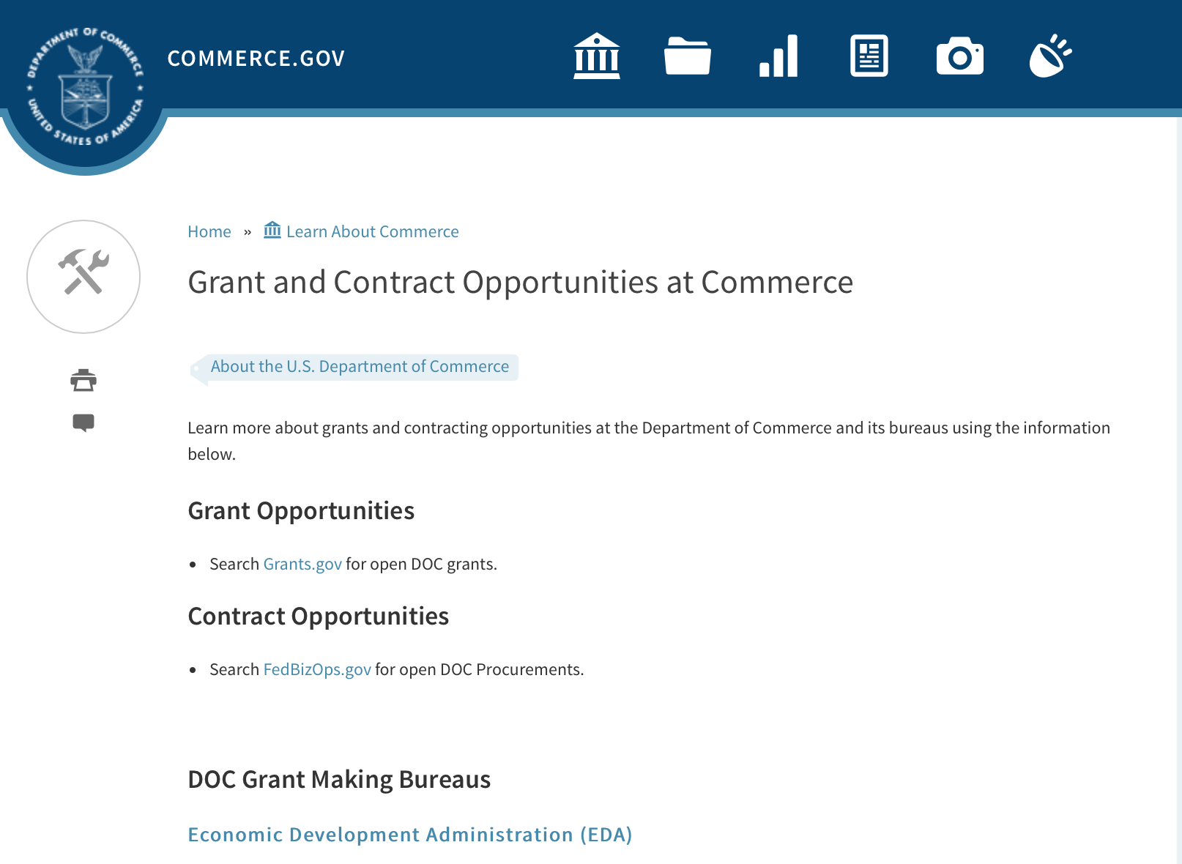
Grants at Commerce
DOC Grant Making Bureaus
Economic Development Administration (EDA)
International Trade Administration (ITA)
- Market Development Cooperator Program
- Special American Business Internship Training Program (SABIT). A technical assistance initiative of the International Trade Administration of the U.S. Department of Commerce, SABIT offers organizations competitive grants and an opportunity to host industry-specific delegations. SABIT serves as an initial entry point for U.S. businesses seeking funding to establish long-term relationships with potential customers, distributors, or partners in the former Soviet Union. The program trains Eurasian managers and scientists in commonly accepted business practices as a means of facilitating cross border relationships. In turn, these personal relationships serve as a basis for business development and reduce market access barriers for U.S. businesses
National Institute of Standards & Technology (NIST)
- Funding Opportunities
National Telecommunications & Information Administration (NTIA)
- Telecommunications Grants
National Oceanic & Atmospheric Administration (NOAA)
- Coastal Ocean Program Grant Information
- Fisheries Saltonstall Kennedy Grant Program
- National Undersea Research Program Funding Opportunities
- Grants Management Division
- Fisheries Grants Program
- National Sea Grant
- Office of Global Programs
Contracting Resources for Contractors
- Office of Small and Disadvantaged Business Utilization (OSDBU) - he Office of Small and Disadvantaged Business Utilization (OSDBU) is an advocacy and advisory office responsible for promoting the use of small, small disadvantaged, 8(a), women-owned, veteran-owned, service-disabled veteran-owned, and HUBZone small businesses within the U.S. Department of Commerce's (DOC) acquisition process.
- Business.USA.gov's Find Opportunities Wizard where in a few quick steps, it will guide you towards federal government contracting programs and opportunities for your business!
- Planned Acquisitions: the Department of Commerce's search tool for our planned acquisitions over $100,000. As requirements change, these acquisition plans are updated by department personnel and this search tool is automatically updated.
- Small Business Administration's Contracting section of their web site where you can learn about how to "Get Started" and "Contracting Support for Small Business"
- The General Services Administration (GSA) has implemented a system for vendors doing business with the Federal Government to manage their entity information in one central location. This new database is the System for Award Management (SAM).

DOC Contracting Offices
- Patent and Trademark Office (PTO)
  - Office of Procurement
- National Institute of Standards & Technology (NIST)
NIST Acquisition Management Group
Contracting Opportunities with Commerce
Trade Opportunities through Commerce
http://www.commerce.gov/about-commerce/grants-contracting-trade-opportunities

Programs:

National Telecommunications and Information Admin
State and Local Implementation Grant Program (SLIGP) 2.0
Synopsis 1

Document Type: | Grants Notice
Funding Opportunity Number: | 2018-NTIA-SLIGP-2
Funding Opportunity Title: | State and Local Implementation Grant Program (SLIGP) 2.0
Opportunity Category: | Discretionary
Opportunity Category Explanation:
Funding Instrument Type: | Grant
Category of Funding Activity: | Other (see text field entitled "Explanation of Other Category of Funding Activity" for clarification)
Category Explanation: | State and Local Implementation Grant Program
Expected Number of Awards:
CFDA Number(s): | 11.549 -- State and Local Implementation Grant Program
Cost Sharing or Matching Requirement: | Yes
Version: | Synopsis 2
Posted Date: | Sep 27, 2017
Last Updated Date: | Sep 29, 2017
Original Closing Date for Applications: | Applications will be accepted from September 27, 2017 until December 28, 2017 at 11:59 p.m. Eastern Time; or from September 27, 2017 until 11:59 p.m. Eastern Time on the 91st calendar day from the date that the Governor of an applicant State receives notice from FirstNet of its final State Plan, whichever is later.
Current Closing Date for Applications: | Applications will be accepted from September 27, 2017 until December 28, 2017 at 11:59 p.m. Eastern Time; or from September 27, 2017 until 11:59 p.m. Eastern Time on the 91st calendar day from the date that the Governor of an applicant State receives notice from FirstNet of its final State Plan, whichever is later.
Archive Date: | Jan 31, 2018
Eligible Applicants: | Others (see text field entitled "Additional Information on Eligibility" for clarification)
Additional Information on Eligibility: | Any State, territory, or the District of Columbia is eligible for a grant under the SLIGP 2.0
Agency Name: | National Telecommunications and Information Admin
Description: | The National Telecommunications and Information Administration (NTIA) issues this NOFO to describe the requirements under which NTIA will award grants for the State and Local Implementation Grant Program 2.0 (SLIGP 2.0), authorized by section 6302 of the Middle Class Tax Relief and Job Creation Act of 2012 (Act), to assist state, local and tribal governments with planning activities for the nationwide interoperable public safety broadband network.
Link to Additional Information: | 2018-NTIA-SLIGP-2 NOFO
Grantor Contact Information: | If you have difficulty accessing the full announcement electronically, please contact:  Michael Dame Program Director Phone 202 482-1181  Agency Contact

http://www.grants.gov/web/grants/view-opportunity.html?oppId=297692

Modifications:

FY2018 Marine Debris Prevention
Synopsis 4

Document Type: | Grants Notice
Funding Opportunity Number: | NOAA-NOS-ORR-2018-2005333
Funding Opportunity Title: | FY2018 Marine Debris Prevention
Opportunity Category: | Discretionary
Opportunity Category Explanation:
Funding Instrument Type: | Cooperative Agreement
Category of Funding Activity: | Environment  Natural Resources  Science and Technology and other Research and Development
Category Explanation:
Expected Number of Awards: | 10
CFDA Number(s): | 11.999 -- Marine Debris Program
Cost Sharing or Matching Requirement: | Yes
Version: | Synopsis 4
Posted Date: | Aug 23, 2017
Last Updated Date: | Sep 26, 2017
Original Closing Date for Applications: | Dec 16, 2017
Current Closing Date for Applications: | Dec 16, 2017
Archive Date: | Jan 15, 2018
Estimated Total Program Funding: | $1,500,000
Award Ceiling: | $250,000
Award Floor: | $50,000
Eligible Applicants: | Others (see text field entitled "Additional Information on Eligibility" for clarification)
Additional Information on Eligibility: | NOTICE: The Letter of Intent (LOI) due date has been changed to October 5, 2017. Please note: to apply for marine debris prevention funding through this opportunity, applicants must first submit a Letter of Intent (LOI), via email, to grants.marinedebris@noaa.gov, in accordance with the guidelines described in Section IV.B. of the funding opportunity announcement. The deadline for LOI submission is October 5, 2017. After NOAA reviews all submitted LOIs, only those invited to submit a full proposal will be considered for funding. Applicants will be notified by November 1, 2017 if they have been invited to submit a full proposal. In accordance with the Marine Debris Act, eligible applicants are state, local, and tribal governments whose activities affect research or regulation of marine debris and any institution of higher education, nonprofit organization, or commercial (for-profit) organization with expertise in a field related to marine debris. Applications from federal agencies or employees of federal agencies will not be considered. Interested federal agencies may collaborate with eligible applicants but may not receive funds through this competition. All projects must take place within the United States or territories or their respective waterways. Foreign organizations and foreign public entities are not eligible to apply as the primary applicant but can be listed as a sub-awardee or contractor. NOAA is strongly committed to broadening the participation of veterans, minority-serving institutions, and entities that work in underserved areas. The NOAA MDP encourages proposals from, or involving any of the above types of institutions. Applications that have been submitted to other NOAA grant programs or as part of another NOAA grant may be considered under this solicitation.
Agency Name: | Department of Commerce
Description: | The NOAA Marine Debris Program, authorized in the Marine Debris Act (33 U.S.C. 1951-1958), provides funding to prevent the introduction of marine debris into the marine and coastal environment. Projects awarded through this grant competition will encourage changes in behavior of a target audience (such as students, teachers, industries, or the public) to address a specific marine debris issue, and will actively engage these groups in hands-on personal participation. Successful proposals through this solicitation will be funded through cooperative agreements. Funding of up to $1,500,000 is expected to be available for Marine Debris Prevention grants in FY2018. Typical awards will range from $50,000 - $150,000. Funding for this purpose comes through the NOAA Marine Debris Program as appropriations to the Office of Response and Restoration, National Ocean Service. This solicitation is focused on efforts to prevent marine debris from entering the environment through targeted behavior change. It is not intended for large-scale debris removal projects, deployment of catchment basins, or scientific research.
Link to Additional Information:
Grantor Contact Information: | If you have difficulty accessing the full announcement electronically, please contact:  Tom Barry (tom.barry@noaa.gov, 240-533-0425).  Work

http://www.grants.gov/web/grants/view-opportunity.html?oppId=296756

Climate Program Office 2018
Synopsis 3 & 4
Document Type: | Grants Notice
Funding Opportunity Number: | NOAA-OAR-CPO-2018-2005133
Funding Opportunity Title: | Climate Program Office 2018
Opportunity Category: | Discretionary
Opportunity Category Explanation:
Funding Instrument Type: | Grant
Category of Funding Activity: | Environment  Natural Resources  Science and Technology and other Research and Development
Category Explanation:
Expected Number of Awards: | 90
CFDA Number(s): | 11.431 -- Climate and Atmospheric Research
Cost Sharing or Matching Requirement: | No
Version: | Synopsis 4
Posted Date: | May 15, 2017
Last Updated Date: | Sep 15, 2017
Original Closing Date for Applications: | Sep 11, 2017
Current Closing Date for Applications: | Sep 25, 2017
Archive Date: | Oct 11, 2017
Estimated Total Program Funding: | $8,000,000
Award Ceiling: | $300,000
Award Floor: | $50,000
Eligible Applicants: | Others (see text field entitled "Additional Information on Eligibility" for clarification)
Additional Information on Eligibility: | Eligible applicants are institutions of higher education, other nonprofits, commercial organizations, international organizations, and state, local and Indian tribal governments. Federal agencies interested in receiving financial support for projects should contact the appropriate competition manager.
Agency Name: | Department of Commerce
Description: | The National Oceanic and Atmospheric Administration (NOAA) is focused on providing the essential and highest quality environmental information vital to our Nation’s safety, prosperity and resilience. Toward this goal, the agency conducts and supports weather and climate research, oceanic and atmospheric observations, modeling, information management, assessments, interdisciplinary decision-support research, outreach, education, and partnership development. Climate variability and change present society with significant economic, health, safety, and security challenges and opportunities. In meeting these challenges, and as part of NOAA’s climate portfolio within the Office of Oceanic and Atmospheric Research (OAR), the Climate Program Office (CPO) advances scientific understanding, monitoring, and prediction of climate and its impacts, to enable effective decisions. These investments are key to NOAA’s mission of "Science, Service, and Stewardship" and are guided by the agency’s vision to create and sustain enhanced resilience in ecosystems, communities, and economies. Within this context, CPO manages competitive research programs through which NOAA funds high-priority climate science, assessments, decision support research, outreach, education, and capacity-building activities designed to advance our understanding of the Earth’s climate system, and to foster the application and use of this knowledge to improve the resilience of our Nation and its partners. CPO supports research that is conducted across the United States and internationally. CPO also provides strategic guidance for the agency’s climate science and services programs and supports NOAA’s contributions to the U.S. Global Change Research Program (USGCRP) and its National Climate Assessment, and similar international endeavors such as the Global Framework for Climate Services. CPO’s climate research portfolio is designed to achieve a fully integrated research and applications program. We meet this objective through a focus on climate intelligence and climate resilience, in support of NOAA’s goals. Climate intelligence defines CPO’s technical strength through its foundational capabilities, which include (1) Observations and monitoring, (2) Research to advance scientific understanding, (3) Modeling and prediction, (4) Communication, education, and engagement, and, (5) Climate and societal interactions. A focus on climate resilience leverages CPO’s climate intelligence to advance capabilities for responding to the urgent and growing demand for reliable, trusted, transparent, and timely climate information needed to sustain all sectors of our economy and environment. CPO’s strategy addresses challenges in the areas of, (1) Weather and climate extremes, (2) Climate impacts on water resources, (3) Coasts and climate resilience, (4) Sustainability of marine ecosystems, and (5) Changing atmospheric composition and its impacts. Making progress in addressing climate-related societal challenges and realizing benefits for NOAA’s public and private partners, requires that these mission-focused capabilities be integrated across CPO to align research, applications, transitions, and operations, and to meet the information needs of a resilient society. NOAA envisions a Nation that is prepared for, thriving, and resilient to climate variability and change. CPO’s activities support a unique and highly flexible climate research enterprise to improve scientific understanding of climate variability and change and to enable businesses and communities to derive the benefits of this investment in the present and into the future. Effectively coordinating across these components through the development and deployment of end-to-end research-based integrated information systems that address needs of high societal relevance, have been hallmarks of CPO’s success in linking environmental intelligence to resilience. Key components in this enterprise are annual Federal Funding Opportunities, competitive grants programs and other types of support that advance and extend NOAA’s foundational capabilities and applications research. Proficiency in these core areas ensures that CPO’s infrastructure is always in place to meet the intelligence and resilience challenges of our changing climate. NOAA, OAR, and the Climate Program Office encourage applicants and awardees to support the principles of diversity and inclusion when writing their proposals and performing their work. Diversity is defined as a collection of individual attributes that together help organizations achieve objectives. Inclusion is defined as a culture that connects each employee to the organization. By promoting diversity and inclusion you can improve creativity, productivity, and the vitality of the research community.
Link to Additional Information:
Grantor Contact Information: | If you have difficulty accessing the full announcement electronically, please contact:  Diane Brown CPO Grants Manager  work

http://www.grants.gov/web/grants/view-opportunity.html?oppId=293866

Research:

2018/2019 Sea Scallop Research Set Aside
Synopsis 1
http://www.grants.gov/web/grants/view-opportunity.html?oppId=297142

Reminders:

FY18 Saltonstall Kennedy Competition
Synopsis 1
Document Type: | Grants Notice
Funding Opportunity Number: | NOAA-NMFS-FHQ-2018-2005332
Funding Opportunity Title: | FY18 Saltonstall Kennedy Competition
Opportunity Category: | Discretionary
Opportunity Category Explanation:
Funding Instrument Type: | Cooperative Agreement  Grant
Category of Funding Activity: | Environment  Natural Resources  Science and Technology and other Research and Development
Category Explanation:
Expected Number of Awards: | 50
CFDA Number(s): | 11.427 -- Fisheries Development and Utilization Research and Development Grants and Cooperative Agreements Program
Cost Sharing or Matching Requirement: | No
Version: | Synopsis 1
Posted Date: | Aug 11, 2017
Last Updated Date: | Aug 11, 2017
Original Closing Date for Applications: | Oct 10, 2017
Current Closing Date for Applications: | Oct 10, 2017
Archive Date: | Nov 09, 2017
Estimated Total Program Funding: | $10,000,000
Award Ceiling: | $300,000
Award Floor: | $25,000
Eligible Applicants: | Others (see text field entitled "Additional Information on Eligibility" for clarification)
Additional Information on Eligibility: | You are eligible to apply for a grant or a cooperative agreement under the Saltonstall-Kennedy Grant Program if: 1. You are a citizen or national of the United States; 2. You represent an entity that is a corporation, partnership, association, or other non-Federal entity, non-profit or otherwise (including Indian tribes), if such entity is a citizen of the United States within the meaning of section 2 of the Shipping Act, 1916, as amended (46 U.S.C. app. 802); or 3. You are a citizen of the Republic of the Marshall Islands, Republic of Palau, or the Federated States of Micronesia. We recognize the interest of the Secretaries of Commerce and Interior in defining appropriate fisheries policies and programs that meet the needs of the U.S. insular areas, so we encourage applications from individuals, government entities, and businesses in U.S. insular areas. We support cultural and gender diversity in our programs and encourage women and minority individuals and groups to submit applications. We are also committed to broadening the participation of Minority Serving Institutions (MSIs), which include Historically Black Colleges and Universities, Hispanic Serving Institutions, and Tribal Colleges and Universities, in our grant programs. To find out more about MSIs go to http://www2.ed.gov/about/offices/list/ocr/edlite-minorityinst.html. We encourage applications from members of the fishing community and applications that involve fishing community cooperation and participation. We will consider the extent of fishing community involvement when evaluating the potential benefit of funding a proposal. Eligible Applicants must submit a pre-proposal that meets the submission requirements listing in this FFO by the established due date. Full proposals will not be reviewed or evaluated if a pre-proposal was not received on time and ranked. Non Eligible Applicants You are not eligible to submit an application under this program if you are an employee of any Federal agency; a Regional Fishery Management Council (Council); or an employee of a Council. However, Council members who are not Federal employees can submit an application to the S-K Program.
Agency Name: | Department of Commerce
Description: | The Saltonstall-Kennedy Act established a fund (known as the S-K fund) used by the Secretary of Commerce to provide grants or cooperative agreements for fisheries research and development projects addressing aspects of U.S. fisheries, including, but not limited to, harvesting, processing, marketing, and associated business infrastructures. Under this authority, grants and cooperative agreements are made on a competitive basis (subject to availability of funding) to assist in carrying out projects related to U.S. commercial and recreational fisheries. The term “fisheries” encompasses wild capture, marine aquaculture and recreational fishing. The objective of the S-K Grant Program is to address the needs of the fisheries and fishing communities in optimizing economic benefits by building and maintaining sustainable fisheries and practices, dealing with the impacts of conservation and management measures, and increasing other opportunities to use existing infrastructure to support keeping working waterfronts viable. U.S. fisheries include any fishery, commercial or recreational, that is, or may be, engaged in by citizens or nationals of the United States. Proposals submitted to this competition must address at least one of the following priorities: Marine Aquaculture; Adapting to Environmental Change and Other Long Term Ecosystem Change; Promotion, Development and Marketing; or Territorial Science. This Federal Funding Opportunity includes information on application and criteria for research proposals requesting a maximum of $300,000 in Federal funding for up to a two-year period. Matching funds are not required, nor will they be considered during the evaluation process. Awards are anticipated to start no earlier than September 1, 2018. Grant awards are dependent on the availability of Federal funding as provided in enacted Appropriations Acts. This FFO is being released prior to final appropriations due to award process time frames. While the FY 2018 President's budget proposed $0 for this program, final Congressional direction has not been determined. Applicants are not guaranteed any level of funding. Should funds not be available in FY2018 submitted applications may be carried over to subsequent fiscal year for review and obligation should funds be available and the Agency deems this the most appropriate administrative process.
Link to Additional Information:
Grantor Contact Information: | If you have difficulty accessing the full announcement electronically, please contact:  Daniel Namur, telephone (301) 427-8730 email: Dan.Namur@noaa.gov  Work

http://www.grants.gov/web/grants/view-opportunity.html?oppId=296392

FY18 Marine Debris Removal
Synopsis 1
Document Type: | Grants Notice
Funding Opportunity Number: | NOAA-NOS-ORR-2018-2005335
Funding Opportunity Title: | FY18 Marine Debris Removal
Opportunity Category: | Discretionary
Opportunity Category Explanation:
Funding Instrument Type: | Cooperative Agreement
Category of Funding Activity: | Environment  Natural Resources  Science and Technology and other Research and Development
Category Explanation:
Expected Number of Awards: | 15
CFDA Number(s): | 11.999 -- Marine Debris Program
Cost Sharing or Matching Requirement: | Yes
Version: | Synopsis 1
Posted Date: | Aug 23, 2017
Last Updated Date: | Aug 23, 2017
Original Closing Date for Applications: | Nov 01, 2017
Current Closing Date for Applications: | Nov 01, 2017
Archive Date: | Dec 01, 2017
Estimated Total Program Funding: | $2,000,000
Award Ceiling: | $150,000
Award Floor: | $50,000
Eligible Applicants: | Others (see text field entitled "Additional Information on Eligibility" for clarification)
Additional Information on Eligibility: | In accordance with the Marine Debris Act, eligible applicants are state, local, and tribal governments whose activities affect research or regulation of marine debris and any institution of higher education, nonprofit organization, or commercial (for-profit) organization with expertise in a field related to marine debris. Applications from federal agencies or employees of federal agencies will not be considered. Interested federal agencies may collaborate with eligible applicants but may not receive funds through this competition. All projects must take place within the United States or territories or their respective waterways. Foreign organizations and foreign public entities are not eligible to apply as the primary applicant but can be listed as a sub-awardee or contractor. NOAA is strongly committed to broadening the participation of veterans, minority-serving institutions, and entities that work in underserved areas. The NOAA MDP encourages proposals from, or involving any of the above types of institutions. Applications that have been submitted to other NOAA grant programs or as part of another NOAA grant may be considered under this solicitation.
Agency Name: | Department of Commerce
Description: | The NOAA Marine Debris Program, authorized in the Marine Debris Research, Prevention, and Reduction Act, codified at 33 U.S.C. 1951-1958, supports the development and implementation of locally-driven, marine debris prevention, assessment, and removal projects that benefit coastal habitat, waterways, and NOAA trust resources. Projects awarded through this grant competition will create long-term, quantifiable ecological habitat improvements for NOAA trust resources through on-the-ground marine debris removal activities, with priority for those targeting derelict fishing gear and other medium- and large-scale debris. Projects should also foster awareness of the effects of marine debris to further the conservation of living marine resource habitats, and contribute to the understanding of marine debris composition, distribution and impacts. Successful proposals through this solicitation will be funded through cooperative agreements. Funding of up to $2,000,000 is expected to be available for Community-based Marine Debris Removal Project Grants in Fiscal Year 2018. Typical awards will range from $50,000 to $150,000. Funding for this grant competition comes through the NOAA Marine Debris Program as appropriations to the Office of Response and Restoration, National Ocean Service.
Link to Additional Information:
Grantor Contact Information: | If you have difficulty accessing the full announcement electronically, please contact:  Tom Barry, tom.barry@noaa.gov, 240-533-0425  Work

http://www.grants.gov/web/grants/view-opportunity.html?oppId=296757

FY 2018 Marine Fisheries Initiative (MARFIN)
Synopsis 1
Document Type: | Grants Notice
Funding Opportunity Number: | NOAA-NMFS-SE-2018-2005326
Funding Opportunity Title: | FY 2018 Marine Fisheries Initiative (MARFIN)
Opportunity Category: | Discretionary
Opportunity Category Explanation:
Funding Instrument Type: | Cooperative Agreement  Grant
Category of Funding Activity: | Environment  Natural Resources  Science and Technology and other Research and Development
Category Explanation:
Expected Number of Awards: | 10
CFDA Number(s): | 11.433 -- Marine Fisheries Initiative
Cost Sharing or Matching Requirement: | No
Version: | Synopsis 1
Posted Date: | Aug 24, 2017
Last Updated Date: | Aug 24, 2017
Original Closing Date for Applications: | Oct 31, 2017
Current Closing Date for Applications: | Oct 31, 2017
Archive Date: | Nov 30, 2017
Estimated Total Program Funding: | $525,000
Award Ceiling: | $175,000
Award Floor: | $1
Eligible Applicants: | Others (see text field entitled "Additional Information on Eligibility" for clarification)
Additional Information on Eligibility: | Eligible applicants may be institutions of higher education, nonprofits, individuals, and state, local, and Indian tribal governments. Federal agencies or institutions are not eligible. Foreign governments, organizations under the jurisdiction of foreign governments, and international organizations are excluded for purposes of this solicitation since the objective of the MARFIN program is to optimize research and development benefits from U.S. marine fishery resources.
Agency Name: | Department of Commerce
Description: | The National Marine Fisheries Service (NMFS), Southeast Region, is seeking proposals under the Marine Fisheries Initiative Program (MARFIN), for research and development projects that optimize the use of fisheries in the Gulf of Mexico, Puerto Rico, the U.S. Virgin Islands, and off the South Atlantic states of North Carolina, South Carolina, Georgia, and Florida, involving the U.S. fishing industry (recreational and commercial), including fishery biology, resources assessment, socio-economic assessment, management and conservation, selected harvesting methods, and fish handling and processing. This program addresses NOAA's mission goal "Healthy Oceans."
Link to Additional Information:
Grantor Contact Information: | If you have difficulty accessing the full announcement electronically, please contact:  Kelly Donnelly Grants Management Branch (727) 551-5731  work email

http://www.grants.gov/web/grants/view-opportunity.html?oppId=296795

Fiscal Year 2018 NOAA Gulf of Mexico Bay-Watershed Education and Training (B-WET) Program
Synopsis 1
Document Type: | Grants Notice
Funding Opportunity Number: | NOAA-NMFS-SE-2018-2005331
Funding Opportunity Title: | Fiscal Year 2018 NOAA Gulf of Mexico Bay-Watershed Education and Training (B-WET) Program
Opportunity Category: | Discretionary
Opportunity Category Explanation:
Funding Instrument Type: | Cooperative Agreement  Grant
Category of Funding Activity: | Environment  Natural Resources  Science and Technology and other Research and Development
Category Explanation:
Expected Number of Awards: | 7
CFDA Number(s): | 11.008 -- NOAA Mission-Related Education Awards
Cost Sharing or Matching Requirement: | No
Version: | Synopsis 1
Posted Date: | Aug 24, 2017
Last Updated Date: | Aug 24, 2017
Original Closing Date for Applications: | Nov 03, 2017
Current Closing Date for Applications: | Nov 03, 2017
Archive Date: | Dec 03, 2017
Estimated Total Program Funding: | $600,000
Award Ceiling: | $100,000
Award Floor: | $25,000
Eligible Applicants: | Others (see text field entitled "Additional Information on Eligibility" for clarification)
Additional Information on Eligibility: | Eligible applicants are K-12 public and independent schools and school systems, institutions of higher education, nonprofit organizations, state or local government agencies, interstate agencies, and Indian tribal governments. Federal agencies are not allowed to receive funds under this announcement but may serve as collaborative project partners and may contribute services in kind. Applicants may be physically located in any U.S. state; however, education projects must target teachers and/or students in Gulf of Mexico coastal counties, which are listed on page 48-49 of the following document: National Ocean Service, NOAA. 2011. The Gulf of Mexico at a Glance: A Second Glance. Washington, DC: U.S. Department of Commerce, http://goo.gl/HQ5IDg. Additionally, priority will be given to applicants who 1) show prior experience in working in the Gulf of Mexico region, 2) show prior experience with Gulf of Mexico regional issues, or 3) demonstrate partnerships with local organizations in the Gulf of Mexico region on proposed projects. The Department of Commerce/NOAA is strongly committed to broadening the participation of historically black colleges and universities, Hispanic serving institutions, tribal colleges and universities, and institutions that work in underserved areas. The NOAA B-WET program encourages proposals involving any of the above institutions as well as other organizations that work with underserved or underrepresented audiences.
Agency Name: | Department of Commerce
Description: | The National Marine Fisheries Service Southeast Regional Office (Fisheries Southeast Regional Office) is seeking proposals under the Gulf of Mexico B-WET Program (http://sero.nmfs.noaa.gov/outreach_education/gulf_b_wet/). The Gulf of Mexico B-WET program is a competitive, environmental education, grants program that promotes locally relevant, experiential learning in the K-12 environment. Funded projects provide Meaningful Watershed Educational Experiences (MWEEs) for students, related professional development for teachers, and help to support regional education and environmental priorities in the Gulf of Mexico. This program addresses NOAA's Long-Term Goal of "Healthy Oceans: Marine fisheries, habitats, and biodiversity are sustained within healthy and productive ecosystems" and "NOAA's Engagement Enterprise Objective for An engaged and educated public with an improved capacity to make scientifically informed environmental decisions".
Link to Additional Information:
Grantor Contact Information: | If you have difficulty accessing the full announcement electronically, please contact:  Amy Clark Gulf of Mexico B-WET Program Manager Amy.Clark@noaa.gov (228) 688-1520  Work

http://www.grants.gov/web/grants/view-opportunity.html?oppId=296792

FY18-19 CRCP International Coral Reef Conservation Cooperative Agreements
Synopsis 1

Document Type: | Grants Notice
Funding Opportunity Number: | NOAA-NOS-OCM-2018-2005319
Funding Opportunity Title: | FY18-19 CRCP International Coral Reef Conservation Cooperative Agreements
Opportunity Category: | Discretionary
Opportunity Category Explanation:
Funding Instrument Type: | Cooperative Agreement
Category of Funding Activity: | Environment  Natural Resources  Science and Technology and other Research and Development
Category Explanation:
Expected Number of Awards: | 10
CFDA Number(s): | 11.482 -- Coral Reef Conservation Program
Cost Sharing or Matching Requirement: | Yes
Version: | Synopsis 1
Posted Date: | Aug 30, 2017
Last Updated Date: | Aug 30, 2017
Original Closing Date for Applications: | Feb 15, 2018
Current Closing Date for Applications: | Feb 15, 2018
Archive Date: | Mar 17, 2018
Estimated Total Program Funding: | $600,000
Award Ceiling: | $300,000
Award Floor: | $75,000
Eligible Applicants: | Others (see text field entitled "Additional Information on Eligibility" for clarification)
Additional Information on Eligibility: | Eligible applicants are institutions of higher education, non-profit organizations, non-U.S. government natural resource management agencies, foreign public entities and foreign organizations, and for-profit organizations. An eligible organization may include proposed sub-recipients, contractors, or other collaborators, which may include governmental authorities, effectively forming a team. Federal agencies and employees may participate in projects as collaborative project partners at the agency’s expense, as this announcement does not cover their funding. Federal agencies’ and employees’ in-kind services and equipment are generally not allowed as part of an applicant’s match on shared costs. If an applicant proposes federal agency collaborators, applicants should provide detail on the expected level of federal engagement in the application. Examples might include, but are not limited to partnership services; serving in a review capacity; or participating in priority task teams, working groups, or leadership teams. Proposals are expected to target the following specific countries: 1) For proposals that address the NOAA-GCFI Assessment, projects must be conducted in at least two of the following Non-US countries and territories of the Wider Caribbean: Bahamas, Belize, British Virgin Islands, Grenada, Honduras, Mexico, Saba and St. Eustatius, St. Lucia, St. Vincent and the Grenadines, and Turks and Caicos Islands. For eligible MPA sites in each country please refer to the above Section B., Program Priorities. 2) Proposals for the South East Asia and South Pacific regions must be conducted in one or more of the following countries: Cook Islands, Federated States of Micronesia, Fiji, Indonesia, Kiribati, Malaysia, Nauru, Niue, Palau, Papua New Guinea, Philippines, Republic of the Marshall Islands, Samoa, Solomon Islands, Timor-Leste, Tonga, Tuvalu, and Vanuatu. 3) For Micronesia proposals, the project must only be conducted in all of the following independent countries under compacts of free association with the United States: the Republic of the Marshall Islands; the Republic of Palau; and the Federated States of Micronesia.
Agency Name: | Department of Commerce
Description: | The NOAA Coral Reef Conservation Program (CRCP) provides matching grants for international coral reef conservation projects. CRCP solicits proposals that will support the NOAA Coral Reef Conservation Program’s International Strategy 2010-2015 (International Strategy). The International Strategy focuses on supporting existing regional efforts in four priority regions based on their interconnections with U.S. reef ecosystems and existing initiatives and partnerships. The following three priority regions will be considered under this Federal Funding Opportunity: the Wider Caribbean, South East Asia and South Pacific, and Micronesia. Funding for the Fiscal Year 2018 competition is subject to the availability of Congressional appropriations and is expected to be approximately $600,000. NOAA expects each applicant will request between $75,000 and $300,000 annually for an award with a project period up to two years. Funding after the first year generally depends on future Congressional appropriations, NOAA/CRCP priorities, and recipient performance in the first year(s) of the award.
Link to Additional Information:
Grantor Contact Information: | If you have difficulty accessing the full announcement electronically, please contact:  Scot Frew NOAA/OCM Corel Reef Program 1305 East West Highway 10th Floor, N/OCM6 Silver Spring, MD 20910 (240) 533-0774  Work email

http://www.grants.gov/web/grants/view-opportunity.html?oppId=296927

FY2018 Marine Debris Prevention
Synopsis 2 & 3

Document Type: | Grants Notice
Funding Opportunity Number: | NOAA-NOS-ORR-2018-2005333
Funding Opportunity Title: | FY2018 Marine Debris Prevention
Opportunity Category: | Discretionary
Opportunity Category Explanation:
Funding Instrument Type: | Cooperative Agreement
Category of Funding Activity: | Environment  Natural Resources  Science and Technology and other Research and Development
Category Explanation:
Expected Number of Awards: | 10
CFDA Number(s): | 11.999 -- Marine Debris Program
Cost Sharing or Matching Requirement: | Yes
Version: | Synopsis 3
Posted Date: | Aug 23, 2017
Last Updated Date: | Aug 29, 2017
Original Closing Date for Applications: | Dec 16, 2017
Current Closing Date for Applications: | Dec 16, 2017
Archive Date: | Jan 15, 2018
Estimated Total Program Funding: | $1,500,000
Award Ceiling: | $250,000
Award Floor: | $50,000
Eligible Applicants: | Others (see text field entitled "Additional Information on Eligibility" for clarification)
Additional Information on Eligibility: | Please note: to apply for marine debris prevention funding through this opportunity, applicants must first submit a Letter of Intent (LOI), via email, to grants.marinedebris@noaa.gov, in accordance with the guidelines described in Section IV.B. of the funding opportunity announcement. The deadline for LOI submission is September 28, 2017. After NOAA reviews all submitted LOIs, only those invited to submit a full proposal will be considered for funding. Applicants will be notified by November 1, 2017 if they have been invited to submit a full proposal. In accordance with the Marine Debris Act, eligible applicants are state, local, and tribal governments whose activities affect research or regulation of marine debris and any institution of higher education, nonprofit organization, or commercial (for-profit) organization with expertise in a field related to marine debris. Applications from federal agencies or employees of federal agencies will not be considered. Interested federal agencies may collaborate with eligible applicants but may not receive funds through this competition. All projects must take place within the United States or territories or their respective waterways. Foreign organizations and foreign public entities are not eligible to apply as the primary applicant but can be listed as a sub-awardee or contractor. NOAA is strongly committed to broadening the participation of veterans, minority-serving institutions, and entities that work in underserved areas. The NOAA MDP encourages proposals from, or involving any of the above types of institutions Applications that have been submitted to other NOAA grant programs or as part of another NOAA grant may be considered under this solicitation.
Agency Name: | Department of Commerce
Description: | The NOAA Marine Debris Program, authorized in the Marine Debris Act (33 U.S.C. 1951-1958), provides funding to prevent the introduction of marine debris into the marine and coastal environment. Projects awarded through this grant competition will encourage changes in behavior of a target audience (such as students, teachers, industries, or the public) to address a specific marine debris issue, and will actively engage these groups in hands-on personal participation. Successful proposals through this solicitation will be funded through cooperative agreements. Funding of up to $1,500,000 is expected to be available for Marine Debris Prevention grants in FY2018. Typical awards will range from $50,000 - $150,000. Funding for this purpose comes through the NOAA Marine Debris Program as appropriations to the Office of Response and Restoration, National Ocean Service. This solicitation is focused on efforts to prevent marine debris from entering the environment through targeted behavior change. It is not intended for large-scale debris removal projects, deployment of catchment basins, or scientific research.
Link to Additional Information:
Grantor Contact Information: | If you have difficulty accessing the full announcement electronically, please contact:  Tom Barry (tom.barry@noaa.gov, 240-533-0425).  Work

http://www.grants.gov/web/grants/view-opportunity.html?oppId=296756

John H. Prescott Marine Mammal Rescue Assistance Grant Program (Prescott Grant Program) for Fiscal Year 2018
Synopsis 1

Document Type: | Grants Notice
Funding Opportunity Number: | NOAA-NMFS-PRPO-2018-2005309
Funding Opportunity Title: | John H. Prescott Marine Mammal Rescue Assistance Grant Program (Prescott Grant Program) for Fiscal Year 2018
Opportunity Category: | Discretionary
Opportunity Category Explanation:
Funding Instrument Type: | Cooperative Agreement  Grant
Category of Funding Activity: | Environment  Natural Resources  Science and Technology and other Research and Development
Category Explanation:
Expected Number of Awards: | 40
CFDA Number(s): | 11.439 -- Marine Mammal Data Program
Cost Sharing or Matching Requirement: | Yes
Version: | Synopsis 1
Posted Date: | Jul 24, 2017
Last Updated Date: | Jul 24, 2017
Original Closing Date for Applications: | Oct 17, 2017
Current Closing Date for Applications: | Oct 17, 2017
Archive Date: | Nov 16, 2017
Estimated Total Program Funding: | $4,000,000
Award Ceiling: | $100,000
Award Floor: | $0
Eligible Applicants: | Others (see text field entitled "Additional Information on Eligibility" for clarification)
Additional Information on Eligibility: | : All eligible applicants must currently be an active, authorized participant or researcher in the National Marine Mammal Stranding Network. Eligible applicants must be: 1) Stranding Agreement (SA) holders or their designee organizations recognized by the applicable NMFS Region; or 2) Holders of researcher authorization letters issued by a NMFS Regional Administrator and/or an MMPA and/or ESA scientific research or enhancement permit (when applicable) including Co-Investigator authorization; or 3) An eligible Federal, state, or local government personnel or tribal personnel (pursuant to Section 109(h) of the MMPA (16 U.S.C. 1379(h)); or 4) Diagnostic or service organizations performing services for the stranding network. Federal agencies in the DOC or Department of the Interior (DOI) are not eligible to receive Federal assistance under this notice. 1. "In Good Standing Criteria". All eligible applicants must meet the following "in good standing" criteria: a. If the applicant is a designated Principal Investigator on a MMPA and/or ESA scientific research or enhancement permit or a Co-Investigator on the MMHSRP's MMPA/ESA scientific research and enhancement permit (permit No. 18786-01), the applicant must have fulfilled all permit requirements. The applicant must not have any pending or outstanding enforcement actions under the MMPA or ESA. b. The applicant must have complied with the terms and responsibilities of the appropriate SA, MMPA Section 109(h) authorization, or researcher authorization letter. This includes, but is not limited to: 1) completion of all reporting requirements; 2) cooperation with state, local, and federal officials; 3) cooperation with state and local officials in the disposition of stranded marine mammals; and 4) cooperation with stranding network participants. c. The applicant must have cooperated in a timely manner with NMFS in collecting and submitting Level B and Level C data and samples, when requested. d. The applicant must not have any current enforcement investigations for the take of marine mammals contrary to MMPA or ESA regulations. e. The applicant must not have any pending NMFS notice of violation(s) regarding the policies governing the goals and operations of the Stranding Network and SA, if applicable (e.g., probation, suspension, or termination). 2. Category Specific Criteria. Organizations and individuals must meet all of the following eligibility criteria specific to their category of participation in order for a proposal to be considered for funding: a. SA Holder Participant or SA Designee Participant - SA participants must hold a current, active SA for stranding response and/or rehabilitation from a NMFS Regional Administrator or the Assistant Administrator. SA Designee participants must be holding a current, active letter of designation from a NMFS SA holder authorized by NMFS. Designees cannot request authorization for activities beyond the scope of what is authorized by the SA to the agreement holder. b. Researcher Participant - Researcher participants must hold a current, active authorizing letter for the proposed award period from the appropriate NMFS Regional Administrator or the Assistant Administrator to salvage stranded marine mammal specimens, parts and samples for the purpose of utilization in scientific research (50 CFR 216.22). Researchers who are authorized under a MMPA/ESA scientific research or enhancement permit must still obtain an authorizing letter from the Regional Stranding Coordinator in order to use parts or specimens from stranded animals. Researcher participants that would not require an authorizing letter from the NMFS Regional Administrator (i.e., they will be working with data only and not possessing samples or specimens) must still provide a letter of eligibility from the Regional Stranding Coordinator (see section III.A.3. of this FFO). Researcher participants must also have designated Co-Investigator(s) that are active NMFS authorized Stranding Network participants in good standing, and provide documentation to this effect. c. State, Local, Federal Government Employees or Tribal Participants - State and local government officials or employees participating pursuant to Section 109(h) of the MMPA (16 U.S.C. 1379(h)) for marine mammal species not listed under the ESA must fulfill reporting obligations outlined in 50 CFR § 216.22. d. Diagnostic Laboratories – While diagnostic laboratories performing analyses for Stranding Network members do not need authorization from NMFS to receive and possess samples or specimens from stranded marine mammals (50 CFR § 216.22(c)(8)), diagnostic laboratory applicants must still provide a letter of eligibility from the MMHSRP at NMFS Headquarters (see section IV.B.7.a. of this FFO). When requesting a letter of eligibility, laboratories should submit examples of their diagnostic capabilities, diagnostic services proposed and their testing turn-around time to the MMHSRP (see section VII of this FFO for contact information). e. Service Organizations – Organizations without an existing SA that are receiving parts from the stranding network to perform analyses that are not diagnostic analyses (see Section VIII for definitions) must have a valid transfer authorization letter issued by the applicable NMFS Region. Organizations working with carcasses or live stranded animals in coordination with a stranding network member may or may not require additional authorization depending upon the service. All service organizations must provide a letter of eligibility from the MMHSRP at NMFS Headquarters (see section IV.B.7.a of this FFO). When requesting a letter of eligibility, service organizations should submit examples of their capabilities, services proposed, and their turn-around time (if applicable) to the MMHSRP (see section VII of this FFO for contact information). 3. Letter of Eligibility. All applicants must submit a letter of eligibility issued by the appropriate NMFS Regional Stranding Coordinator or the MMHSRP at NMFS Headquarters. This letter is required in order to be considered for an award in this funding cycle. The letter of eligibility states that you are: 1) an eligible Stranding Network participant, diagnostic laboratory, service organization, or permitted researcher at the time of the application submission and during the award period; 2) in good standing; 3) have a history of participation in/with the Stranding Network or that your organization is from a local area with no pre-existing stranding response and/or rehabilitation capabilities or your organization provides diagnostic or other services. A copy of your SA or research authorization will not be considered as proof of eligibility. Any proposal that does not provide a letter of eligibility from the NMFS Regional Stranding Coordinator (or NMFS Headquarters) will not be considered eligible and will not be considered for further review. Contact the NMFS Regional Stranding Coordinators (http://www.nmfs.noaa.gov/pr/health/coordinators.htm) or the Prescott Grant Program at the address in the Agency Contacts, Section VII of this FFO to request this letter. Federal agencies in the DOC or DOI are not eligible to receive Federal assistance under this notice. In addition, federal employees shall not provide assistance in writing any application, writing letters of support for any application, or otherwise confer any unfair advantage on a particular application. However, for activities involving collaboration with current NOAA programs, NOAA employees can write a letter verifying that they are collaborating with the project. This collaboration letter cannot support or endorse the applicant or project. MMHSRP staff and other Federal Program Officers can provide guidance on application procedures and proper completion of required forms. Applications encompassing activities conducted under the authority of a MMPA/ESA scientific research or enhancement permit issued to the DOC or DOI should include a copy of the permit and a letter from the Principal Investigator (DOC/DOI employee) verifying that the work is being conducted with their approval. Federal employee travel costs or salaries are not allowable costs under this program. Refer any questions about potential collaboration or support by non-DOC/DOI Federal employees to the official listed in Agency Contacts, Section VII. of this FFO.
Agency Name: | Department of Commerce
Description: | NOAA NMFS' Marine Mammal Health and Stranding Response Program is directed under the Marine Mammal Protection Act (MMPA) to facilitate the collection and dissemination of reference data on stranded marine mammals and health trends of marine mammal populations in the wild. The John H. Prescott Marine Mammal Rescue Assistance Grant Program is administered by NOAA to provide Federal assistance to eligible members of the National Marine Mammal Stranding Network to: 1) support basic needs of organizations for response, treatment, and data collection from living and dead stranded marine mammals, 2) fund scientific research objectives designed to answer questions about marine mammal strandings, health, or rehabilitation techniques utilizing data from living and dead stranded marine mammals, and 3) support facility operations directly related to the recovery, treatment, and data collection from living and dead stranded marine mammals. This document describes how to submit proposals for funding in fiscal year (FY) 2018 and how NMFS will determine which proposals may be funded. This announcement should be read in its entirety, as some information has changed from the previous year.
Link to Additional Information:
Grantor Contact Information: | If you have difficulty accessing the full announcement electronically, please contact:  Jaclyn Taylor Prescott Grant Program NOAA/NMFS/Office of Protected Resources (F/PR) 1315 East-West Highway, Room 13622 Silver Spring, MD 20910 Phone: (301) 427-8402 e-mail at Jaclyn.Taylor@noaa.gov  Work

http://www.grants.gov/web/grants/view-opportunity.html?oppId=295831

Ocean Exploration FY 2018 Funding Opportunity
Synopsis 1 & 2
Document Type: | Grants Notice
Funding Opportunity Number: | NOAA-OAR-OER-2018-2005296
Funding Opportunity Title: | Ocean Exploration FY 2018 Funding Opportunity
Opportunity Category: | Discretionary
Opportunity Category Explanation:
Funding Instrument Type: | Cooperative Agreement  Grant
Category of Funding Activity: | Environment  Natural Resources  Science and Technology and other Research and Development
Category Explanation:
Expected Number of Awards: | 10
CFDA Number(s): | 11.011 -- Ocean Exploration
Cost Sharing or Matching Requirement: | No
Version: | Synopsis 2
Posted Date: | Jul 12, 2017
Last Updated Date: | Jul 14, 2017
Original Closing Date for Applications: | Dec 08, 2017
Current Closing Date for Applications: | Dec 08, 2017
Archive Date: | Jan 07, 2018
Estimated Total Program Funding: | $3,000,000
Award Ceiling: | $750,000
Award Floor: | $10,000
Eligible Applicants: | Others (see text field entitled "Additional Information on Eligibility" for clarification)
Additional Information on Eligibility: | Eligible applicants are institutions of higher education; non-profit institutions; state, local, and tribal governments; for-profit organizations; and U.S. territories that possess the statutory authority to accept funding for this type of work.
Agency Name: | Department of Commerce
Description: | NOAA’s Office of Ocean Exploration & Research (OER) seeks to enhance ocean exploration and scientific knowledge of the unknown or poorly known areas of the ocean. This entails identifying, describing and creating baseline characterizations of new ocean habitats, marine resources and/or processes. In this Announcement, OER is seeking proposals focused on three topics including: 1. Exploration of the deep marine environments in the US EEZ and US Outer Continental Shelf (OCS) of the Gulf of Mexico; 2. Discovery and exploration of prehistorically and historically significant submerged marine heritage sites in the Gulf of Mexico within the US EEZ and the US Outer Continental Shelf (OCS); and 3. Novel or innovative technologies and methodologies that could increase the pace and scope of ocean exploration, especially exploration of deep environments including the water column and archaeological sites. For themes 1 and 2, OER will not entertain proposals outside the US EEZ and the US Outer Continental Shelf (OCS) in the Gulf of Mexico. Proposals that combine more than one of these exploration topics are encouraged. All correspondence regarding this FFO must be sent to the email: oer.ffo2018@noaa.gov Applicants are required to submit pre-proposals and, ultimately, full proposals that support OER’s exploration mission. OER’s overarching objective is to investigate and document poorly known and unknown ocean areas through interdisciplinary exploration, and to advance and disseminate knowledge of the ocean’s physical, geological, chemical, biological, and archaeological environments. OER’s mission is compliant with NOAA’s Next Generation Strategic Plan (http://www.performance.noaa.gov/ngsp/) which outlines NOAA goals of Science, Service and Stewardship. Findings from projects and expeditions are anticipated to result in new baseline characterizations; provide better scientific understanding of the processes on US continental margins; offer new insights into climate variability and marine ecosystems; reveal new or unconventional energy, mineral, biological, and/or archaeological resources; help identify hazards resulting from extreme events such as submarine volcanic eruptions, earthquakes and tsunamis; and deliver technology advancements (platforms, sensors, methodologies, etc.) that will increase observational capabilities of the ocean. In FY18, OER anticipates availability of approximately $3,000,000 for this Funding Opportunity (this amount includes of costs for any required ship and/or submersible assets). Note: Ship time on the NOAA Ship Okeanos Explorer will not be funded through this announcement. Background information on how to apply and other informational documents are accessible through the OER Office Website: http://oceanexplorer.noaa.gov/about/what-we-do/funding-opportunities.html. Eligible applicants are institutions of higher education; non-profit institutions; for-profit organizations; state, local, and tribal governments, as well as U.S. territories that possess the statutory authority to accept funding for this type of work. Federal agencies that possess the statutory authority to accept funding for this type of work may also apply and must agree to take FY2018 funding for proposed projects. Federal and state agencies are strongly encouraged to collaborate with partners from a non-federal/non-state eligible entity. For the purpose of this opportunity, the buying of ship time and/or other ocean data collection platform support (remotely operated vehicles, autonomous underwater vehicles, etc.) is considered a rental cost and therefore not included in Modified Total Direct Cost (MTDC). OER funding will not be provided to hire and/or fund the salaries and associated overhead costs of any permanent federal or state government employee. OER will not pay Facilities and Administrative (F&A or "overhead") fees to federal and state agencies for subawards such as ship time or other ocean data collection platform support. Federal and state award recipients may use funding to cover travel, equipment, supplies, and contractual personnel costs associated with the proposed work. Foreign researchers may participate by submitting a subaward through collaboration with an eligible U.S. entity. The DOC and NOAA support cultural and gender diversity and encourage women and minority individuals and groups to submit applications to this Announcement of Federal Funding Opportunity. In addition, DOC/NOAA is strongly committed to broadening the participation of historically black colleges and universities, Hispanic serving institutions, tribal colleges and universities, and institutions that work in underserved areas. DOC/NOAA encourages applications involving any of the above institutions to apply.
Link to Additional Information:
Grantor Contact Information: | If you have difficulty accessing the full announcement electronically, please contact:  NOAA Office of Ocean Exploration and Research OER FFO 2018, SSMC3, Rm 10316, 1315 East West Highway, Silver Spring, Maryland 20910 (301) 734-1014  OER Group email

http://www.grants.gov/web/grants/view-opportunity.html?oppId=295442

Economic Development Administration
FY 2017 Economic Development Assistance Programs ­ Application submission and program requirements for EDA’s Public Works and Economic Adjustment Assistance programs.
Synopsis 1
Document Type: | Grants Notice
Funding Opportunity Number: | EDAP-2017
Funding Opportunity Title: | FY 2017 Economic Development Assistance Programs Application submission and program requirements for EDA’s Public Works and Economic Adjustment Assistance programs.
Opportunity Category: | Discretionary
Opportunity Category Explanation:
Funding Instrument Type: | Cooperative Agreement  Grant
Category of Funding Activity: | Other (see text field entitled "Explanation of Other Category of Funding Activity" for clarification)
Category Explanation: | The Economic Development Administration's (EDA's) mission is to lead the Federal economic development agenda by promoting innovation and competitiveness, preparing American regions for economic growth and success in the worldwide economy. EDA fulfills this mission through strategic investments and partnerships that create the regional economic ecosystems required to foster globally competitive regions throughout the United States. EDA supports development in economically distressed areas of the United States by fostering job creation and attracting private investment. Specifically, under the Economic Development Assistance programs (EDAP) Notice of Funding Availability (NOFA), EDA will make construction, non-construction, and revolving loan fund investments under the Public Works and Economic Adjustment Assistance (EAA) Programs. Through this NOFA, EDA will also designate a portion of its EAA funding to support communities and regions that have been negatively impacted by changes in the coal economy (Assistance to Coal Communities, or ACC 2017). Grants made under these programs will leverage regional assets to support the implementation of regional economic development strategies designed to create jobs, leverage private capital, encourage economic development, and strengthen America's ability to compete in the global marketplace. Through the EDAP NOFA, EDA solicits applications from rural and urban communities to develop initiatives that advance new ideas and creative approaches to address rapidly evolving economic conditions.
Expected Number of Awards:
CFDA Number(s): | 11.300 -- Investments for Public Works and Economic Development Facilities  11.307 -- Economic Adjustment Assistance
Cost Sharing or Matching Requirement: | Yes
Version: | Synopsis 1
Posted Date: | Jun 19, 2017
Last Updated Date: | Jun 19, 2017
Original Closing Date for Applications: | There are no submission deadlines under this opportunity. Proposals and applications will be accepted on an ongoing basis until the publication of a new EDAP NOFA.
Current Closing Date for Applications: | There are no submission deadlines under this opportunity. Proposals and applications will be accepted on an ongoing basis until the publication of a new EDAP NOFA.
Archive Date:
Estimated Total Program Funding:
Award Ceiling: | $3,000,000
Award Floor: | $100,000
Eligible Applicants: | Native American tribal organizations (other than Federally recognized tribal governments)  Special district governments  Others (see text field entitled "Additional Information on Eligibility" for clarification)  Private institutions of higher education  County governments  Native American tribal governments (Federally recognized)  City or township governments  Nonprofits that do not have a 501(c)(3) status with the IRS, other than institutions of higher education  State governments  Nonprofits having a 501(c)(3) status with the IRS, other than institutions of higher education  Public and State controlled institutions of higher education
Additional Information on Eligibility: | Eligible applicants for EDA financial assistance under the Public Works and EAA programs (including ACC 2017 funding) include a(n): (i) District Organization of a designated Economic Development District; (ii) Indian Tribe or a consortium of Indian Tribes; (iii) State, county, city, or other political subdivision of a State, including a special purpose unit of a State or local government engaged in economic or infrastructure development activities, or a consortium of political subdivisions; (iv) institution of higher education or a consortium of institutions of higher education; or (v) public or private non-profit organization or association acting in cooperation with officials of a political subdivision of a State. See Section 3 of the Public Works and Economic Development Act of 1965 (PWEDA) (42 U.S.C. § 3122) and 13 C.F.R. § 300.3. EDA is not authorized to provide grants or cooperative agreements to individuals or to for profit entities. Requests from such entities will not be considered for funding. For ACC 2017 funding, projects must be located within and targeted to communities or regions that have been impacted, or can reasonably demonstrate that they will be impacted, by coal mining or coal power plant employment loss, or employment loss in the supply chain industries of either.
Agency Name: | Economic Development Administration
Description: | Under this NOFA, EDA solicits applications from applicants in rural and urban areas to provide investments that support construction, non-construction, technical assistance, and revolving loan fund projects under EDA’s Public Works and EAA programs. Grants and cooperative agreements made under these programs are designed to leverage existing regional assets and support the implementation of economic development strategies that advance new ideas and creative approaches to advance economic prosperity in distressed communities, including communities and regions that have been impacted, or can reasonably demonstrate that they will be impacted, by coal mining or coal power plant employment loss, or employment loss in the supply chain industries of either. EDA provides strategic investments on a competitive- merit-basis to support economic development, foster job creation, and attract private investment in economically distressed areas of the United States. This EDAP NOFA supersedes the EDAP Federal Funding Opportunity dated December 23, 2016.
Link to Additional Information: | Economic Development Administration
Grantor Contact Information: | If you have difficulty accessing the full announcement electronically, please contact:  If you have difficulty accessing the full announcement electronically, please contact: the EDA representative for your state. A complete list of EDA representatives is available on EDA's website at http://www.eda.gov/contact/  http://www.eda.gov/contact/

http://www.grants.gov/web/grants/view-opportunity.html?oppId=294771

National Institute of Standards and Technology
Measurement Science and Engineering (MSE) Research Grant Programs

Document Type: | Grants Notice
Funding Opportunity Number: | 2016-NIST-MSE-01
Funding Opportunity Title: | Measurement Science and Engineering (MSE) Research Grant Programs
Opportunity Category: | Discretionary
Opportunity Category Explanation:
Funding Instrument Type: | Cooperative Agreement  Grant
Category of Funding Activity: | Science and Technology and other Research and Development
Category Explanation:
Expected Number of Awards:
CFDA Number(s):
Cost Sharing or Matching Requirement: | No
Posted Date: | Feb 19, 2016
Last Updated Date: | Feb 19, 2016
Original Closing Date for Applications: | Applications will be accepted and considered on a rolling basis as they are received. See Section IV.4. in the text of the Full Announcement/FFO document. Applications may be submitted by paper or electronically through Grants.gov. Carefully read Section IV. of the Full Announcement/FFO document for details applying to electronic submissions and to paper submissions.
Current Closing Date for Applications: | Applications will be accepted and considered on a rolling basis as they are received. See Section IV.4. in the text of the Full Announcement/FFO document. Applications may be submitted by paper or electronically through Grants.gov. Carefully read Section IV. of the Full Announcement/FFO document for details applying to electronic submissions and to paper submissions.
Eligible Applicants: | Others (see text field entitled "Additional Information on Eligibility" for clarification)
Additional Information on Eligibility: | Eligibility for all programs listed in this FFO is open to all non-Federal entities. Eligible applicants include institutions of higher education, non-profit organizations, for-profit organizations, state and local governments, Indian tribes, hospitals, foreign public entities, and foreign governments. Applicants selected for awards under 15 U.S.C. § 278g-1 are encouraged, but not required, to select underrepresented minorities for participation. In addition, NIST is not able to accept an application from an individual unaffiliated with a sponsoring applicant organization.
Agency Name: | National Institute of Standards and Technology
Description: | NIST is soliciting applications for financial assistance for Fiscal Year 2016 (FY16) within the following NIST Laboratory grant programs: (1) the Material Measurement Laboratory (MML) Grant Program; (2) the Physical Measurement Laboratory (PML) Grant Program; (3) the Engineering Laboratory (EL) Grant Program; (4) the Fire Research (FR) Grant Program; (5) the Information Technology Laboratory (ITL) Grant Program; (6) the Communications Technology Laboratory (CTL) Grant Program; (7) the NIST Center for Neutron Research (NCNR) Grant Program; (8) the Center for Nanoscale Science and Technology (CNST) Grant Program; (9) the Special Programs Office (SPO) Grant Program; (10) the Standards Coordination Office (SCO) Grant Program; (11) the International and Academic Affairs Office (IAAO) Grant Program; and (12) the Associate Director for Laboratory Programs (ADLP) Grant Program.
Link to Additional Information: | 2016-NIST-MSE-01 Full Announcement/FFO document
Contact Information: | If you have difficulty accessing the full announcement electronically, please contact:  Christopher Hunton Management and Program Analyst Phone 301-975-5718  Agency Contact

http://www.grants.gov/web/grants/view-opportunity.html?oppId=281689

FY 2016 – FY 2019 EDA Planning Program and Local Technical Assistance Program Grant

Document Type: | Grants Notice
Funding Opportunity Number: | EDA-HDQ-TA-HDQ-2016-2004759
Funding Opportunity Title: | FY 2016 – FY 2019 EDA Planning Program and Local Technical Assistance Program
Opportunity Category: | Discretionary
Funding Instrument Type: | Cooperative Agreement  Grant
Category of Funding Activity: | Other (see text field entitled "Explanation of Other Category of Funding Activity" for clarification)  Regional Development
Category Explanation: | Regional planning and local technical assistance
Expected Number of Awards:
CFDA Number(s): | 11.302 -- Economic Development Support for Planning Organizations  11.303 -- Economic Development Technical Assistance
Cost Sharing or Matching Requirement: | No
Posted Date: | Dec 10, 2015
Creation Date: | Dec 10, 2015
Original Closing Date for Applications: | Applications are accepted on a continuing basis and processed as received. This Planning and Local Technical Assistance opportunity will remain in effect until superseded by a future announcement.
Current Closing Date for Applications: | Applications are accepted on a continuing basis and processed as received. This Planning and Local Technical Assistance opportunity will remain in effect until superseded by a future announcement.
Archive Date:
Estimated Total Program Funding:
Award Ceiling: | $300,000
Award Floor: | $0
Eligible Applicants: | Nonprofits having a 501(c)(3) status with the IRS, other than institutions of higher education  City or township governments  Nonprofits that do not have a 501(c)(3) status with the IRS, other than institutions of higher education  Others (see text field entitled "Additional Information on Eligibility" for clarification)  Private institutions of higher education  Native American tribal governments (Federally recognized)  Public and State controlled institutions of higher education  State governments  Special district governments  County governments
Additional Information on Eligibility: | Pursuant to section 3 of the Public Works and Economic Development Act of 1965 (42 U.S.C. § 3122) (PWEDA) and EDA’s regulation at 13 C.F.R. § 300.3, the following types of entities are eligible to receive funding assistance from EDA: 1. District Organizations (as defined in 13 C.F.R. § 300.3); 2. Indian Tribes or a consortium of Indian Tribes; 3. States, cities, or other political subdivisions of a State, including a special purpose unit of a State or local government engaged in economic or infrastructure development activities, or a consortium of political subdivisions; 4. Institutions of higher education or a consortium of institutions of higher education; or 5. Public or private non-profit organizations or associations acting in cooperation with officials of a political subdivision of a State.
Agency Name: | Department of Commerce
Description: | Pursuant to PWEDA, EDA announces general policies and application procedures for grant-based investments under the Planning and Local Technical Assistance programs. Under the Planning program EDA assists eligible recipients in creating regional economic development plans designed to build capacity and guide the economic prosperity and resiliency of an area or region. As part of this program, EDA supports Partnership Planning investments to facilitate the development, implementation, revision, or replacement of Comprehensive Economic Development Strategies (CEDS), which articulate and prioritize the strategic economic goals of recipients’ respective regions. In general, EDA provides Partnership Planning grants to the designated planning organization (e.g., District Organization) serving EDA designated Economic Development Districts to enable these organizations to develop and implement relevant CEDS. In addition, EDA provides Partnership Planning grants to Indian Tribes to help develop and implement CEDS and associated economic development activities. The Planning program also helps support organizations, including District Organizations, Indian Tribes, and other eligible recipients, with Short Term and State Planning investments designed to guide the eventual creation and retention of high-quality jobs, particularly for the unemployed and underemployed in the Nation’s most economically distressed regions. The Local Technical Assistance program strengthens the capacity of local or State organizations, institutions of higher education, and other eligible recipients to undertake and promote effective economic development programs through projects such as feasibility analyses and impact studies.
Link to Additional Information: | www.eda.gov
Contact Information: | If you have difficulty accessing the full announcement electronically, please contact:  The EDA representative for your state. A complete list of EDA representatives is available on EDA's website at http://www.eda.gov/contact/

http://www.grants.gov/web/grants/view-opportunity.html?oppId=280447

Economic Development Administration
Planning Program and Local Technical Assistance Program Grant

Document Type: | Grants Notice
Funding Opportunity Number: | EDAPLANNING2012
Opportunity Category: | Discretionary
Posted Date: | Aug 03, 2012
Creation Date: | Aug 03, 2012
Original Closing Date for Applications: | Applications are accepted on a continuing basis and processed as received. This Planning and Local Technical Assistance opportunity will remain in effect until superseded by a future announcement.
Current Closing Date for Applications: | Applications are accepted on a continuing basis and processed as received. This Planning and Local Technical Assistance opportunity will remain in effect until superseded by a future announcement.
Archive Date:
Funding Instrument Type: | Cooperative Agreement  Grant
Category of Funding Activity: | Other (see text field entitled "Explanation of Other Category of Funding Activity" for clarification)  Regional Development
Category Explanation: | Regional planning and local technical assistance
Expected Number of Awards: | 425
Estimated Total Program Funding:
Award Ceiling: | $100,000
Award Floor:
CFDA Number(s): | 11.302 -- Economic Development Support for Planning Organizations
 | 11.303 -- Economic Development Technical Assistance
Cost Sharing or Matching Requirement: | Yes

Eligible Applicants
State governments
County governments
City or township governments
Public and State controlled institutions of higher education
Native American tribal governments (Federally recognized)
Nonprofits having a 501(c)(3) status with the IRS, other than institutions of higher education
Nonprofits that do not have a 501(c)(3) status with the IRS, other than institutions of higher education
Private institutions of higher education
Others (see text field entitled "Additional Information on Eligibility" for clarification)

Additional Information on Eligibility:
Pursuant to section 3 of the Public Works and Economic Development Act of 1965 (42 U.S.C. § 3122) (PWEDA) and EDA’s regulation at 13 C.F.R. § 300.3, the following types of entities are eligible to receive funding assistance from EDA: 1. District Organizations (as defined in 13 C.F.R. § 300.3); 2. Indian Tribes or a consortium of Indian Tribes; 3. States, cities, or other political subdivisions of a State, including a special purpose unit of a State or local government engaged in economic or infrastructure development activities, or a consortium of political subdivisions; 4. Institutions of higher education or a consortium of institutions of higher education; or 5. Public or private non-profit organizations or associations acting in cooperation with officials of a political subdivision of a State.

Agency Name
Economic Development Administration

Description
Pursuant to PWEDA, EDA announces general policies and application procedures for grant-based investments under the Planning and Local Technical Assistance programs. Under the Planning program EDA assists eligible recipients in creating regional economic development plans designed to stimulate and guide the economic development efforts of a community or region. As part of this program, EDA supports Partnership Planning investments to facilitate the development, implementation, revision, or replacement of Comprehensive Economic Development Strategies (CEDS), which articulate and prioritize the strategic economic goals of recipients' respective regions. In general, EDA provides Partnership Planning grants to the designated planning organization (e.g., District Organization) serving EDA-designated Economic Development Districts to enable these organizations to develop and implement relevant CEDS. In addition, EDA provides Partnership Planning grants to Indian Tribes to help develop and implement CEDS and associated economic development activities. The Planning program also helps support planning organizations, including District Organizations, Indian Tribes, and other eligible Recipients, with Short Term and State Planning investments designed to guide the eventual creation and retention of higher-skill, higher-wage jobs, particularly for the unemployed and underemployed in the Nation’s most economically distressed regions. The Local Technical Assistance program strengthens the capacity of local or State organizations, institutions of higher education, and other eligible recipients to undertake and promote effective economic development programs through projects such as feasibility analyses and impact studies.

Link to Additional Information

If you have difficulty accessing the full announcement electronically, please contact:
David Ives Planning and Local TA email

http://www.grants.gov/web/grants/view-opportunity.html?oppId=189193

Deleted:

ITA-INA-OPCM-2017-2004912 - Market Development Cooperator Program 2017
Deletion Comments: Opportunity deleted. Per the Program Officer email dated 3/22/17 this FFO is being deleted.

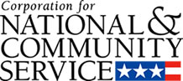

Corporation for National and Community Service

General Program Overview
AmeriCorps provides resources, both human and financial, to organizations that engage Americans in intensive service to meet our country’s critical needs.
Grantees use the funding to support AmeriCorps members for intensive service in their community. AmeriCorps grants partially cover the expense of operating an AmeriCorps program and do not cover general organizational expenses. A cash and in-kind match is required.

The main website can be accessed here: http://www.nationalservice.gov

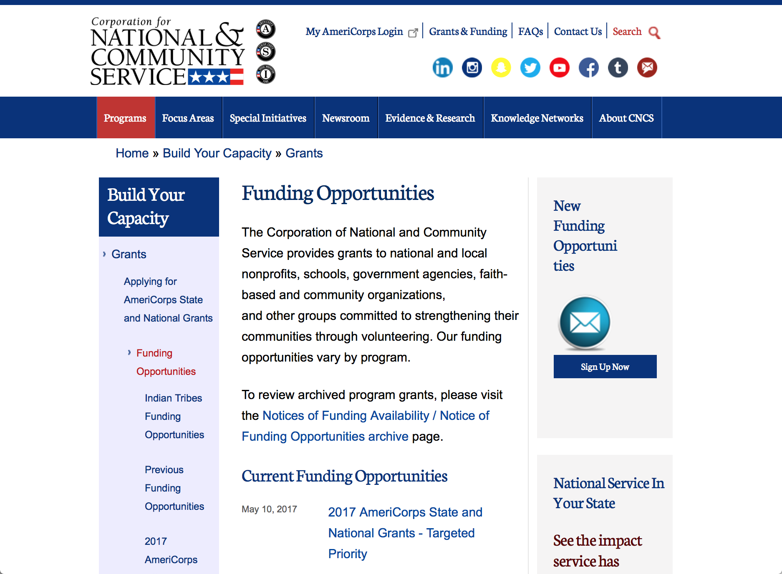

Current Funding Opportunities
There are no current funding opportunities.

For access to further funding information: click here

http://www.nationalservice.gov/build-your-capacity/grants/funding-opportunities

Programs:

Research:

Reminders:

AmeriCorps State and National Grants FY2018
Synopsis 1
Document Type: | Grants Notice
Funding Opportunity Number: | CNCS-08-24-17
Funding Opportunity Title: | AmeriCorps State and National Grants FY2018
Opportunity Category: | Discretionary
Opportunity Category Explanation:
Funding Instrument Type: | Grant
Category of Funding Activity: | Community Development  Disaster Prevention and Relief  Education  Employment, Labor and Training  Environment  Food and Nutrition  Health  Housing  Natural Resources
Category Explanation:
Expected Number of Awards:
CFDA Number(s): | 94.006 -- AmeriCorps
Cost Sharing or Matching Requirement: | Yes
Version: | Synopsis 1
Posted Date: | Aug 24, 2017
Last Updated Date: | Aug 24, 2017
Original Closing Date for Applications: | Jan 17, 2018
Current Closing Date for Applications: | Jan 17, 2018
Archive Date: | Jan 18, 2018
Eligible Applicants: | Private institutions of higher education  City or township governments  State governments  Nonprofits that do not have a 501(c)(3) status with the IRS, other than institutions of higher education  Nonprofits having a 501(c)(3) status with the IRS, other than institutions of higher education  Native American tribal organizations (other than Federally recognized tribal governments)  Public housing authorities/Indian housing authorities  Public and State controlled institutions of higher education  Native American tribal governments (Federally recognized)  County governments  Special district governments  Independent school districts
Additional Information on Eligibility:
Agency Name: | Corporation for National and Community Service
Description: | AmeriCorps grants are awarded to eligible organizations proposing to engage AmeriCorps members in evidence-based or evidence-informed interventions to strengthen communities. An AmeriCorps member is an individual who engages in community service through an approved national service position. Members may receive a living allowance and other benefits while serving. Upon successful completion of their service, members earn a Segal AmeriCorps Education Award from the National Service Trust that members can use to pay for higher education expenses or apply to qualified student loans.
Link to Additional Information: | Full competition information and resources.
Grantor Contact Information: | If you have difficulty accessing the full announcement electronically, please contact:  (202) 606-7508  Competition inbox

http://www.grants.gov/web/grants/view-opportunity.html?oppId=296773

National Service In Hawaii
National Service in Your State - Hawaii
2015-2016

Meeting Community Needs in Hawaii: More than 3,100 people of all ages and backgrounds are helping to meet local needs, strengthen communities, and increase civic engagement through national service in Hawaii. Serving at more than 450 locations throughout the state, these citizens tutor and mentor children, support veterans and military families, provide health services, restore the environment, respond to disasters, increase economic opportunity, and recruit and manage volunteers. This year, the Corporation for National and Community Service (CNCS) will commit more than $6,260,000 to support Hawaii communities through national service initiatives. Through a unique public-private partnership, this federal investment will leverage an additional $9,060,000 in other resources to strengthen community impact, build local support, and increase return on taxpayer dollars. Nationwide, CNCS, its grantees, and project sponsors generated more than $1.25 billion in outside resources from businesses, foundations, public agencies, and other sources in FY 2015.

AmeriCorps
This year, AmeriCorps will provide more than 560 individuals the opportunity to provide intensive, results-driven service to meet education, environmental, health, economic, and other pressing needs in communities across Hawaii. Most AmeriCorps grant funding goes to the Hawaii Commission on National & Community Service, which in turn awards grants to nonprofit groups to respond to local needs. Most of the remainder of the grant funding is distributed by CNCS directly to multi-state and national organizations through a competitive grants process. Other individuals serve through AmeriCorps VISTA, whose members help bring individuals and communities out of poverty by serving full-time to fight illiteracy, improve health services, create businesses, and increase housing opportunities, and AmeriCorps NCCC (National Civilian Community Corps), a 10-month, full time residential program for men and women between the ages of 18 and 24. In exchange for their service, AmeriCorps members earn an education award that can be used to pay for college or to pay back qualified student loans. Since 1994, more than 5,900 Hawaii residents have served more than 6.4 million hours and have qualified for Segal AmeriCorps Education Awards totaling more than $14,980,000.
Download: AmeriCorps in Hawaii (PDF)
Senior Corps
More than 2,500 seniors in Hawaii contribute their time and talents in one of three Senior Corps programs. Foster Grandparents serve one-on-one as tutors and mentors to more than 310 young people who have special needs. Senior Companions help more than 220 homebound seniors and other adults maintain independence in their own homes. RSVP volunteers conduct safety patrols, renovate homes, protect the environment, tutor and mentor youth, respond to natural disasters, and provide other services through more than 250 groups across Hawaii.
Download: Senior Corps in Hawaii (PDF)

The Corporation for National and Community Service is a federal agency that improves lives, strengthens communities, and fosters civic engagement through service and volunteering. CNCS annually engages more than five million Americans in service to meet local needs through Senior Corps, AmeriCorps, and national days of service; improves communities through the Social Innovation Fund, and leads President Obama's national call to service initiative, United We Serve. To learn more visit NationalService.gov or Serve.gov or call 202-606-5000 or TTY 1-800-833-3722.

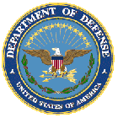

U.S. Department of Defense

Doing Business with the Department of Defense

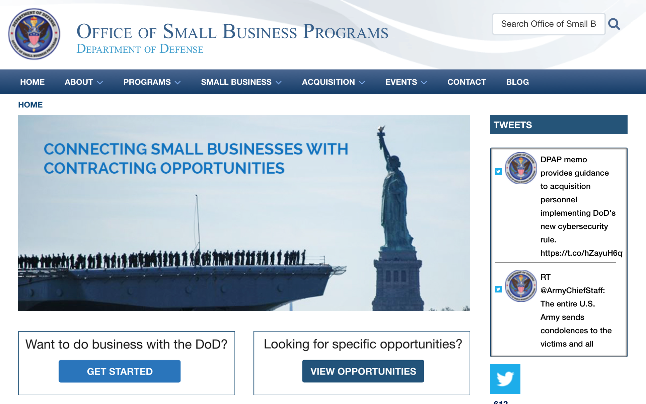

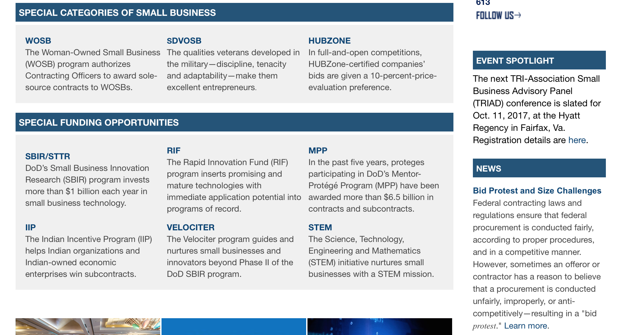

http://business.defense.gov

http://www.acq.osd.mil/osbp/

Doing Business with the DoD

Resources

Procurement Technical Assistance Centers (PTACs)

Procurement Technical Assistance Centers (PTACs) are charged with assisting businesses in learning how to do business with federal, state, and local governments. PTACs are a local resource available at no or nominal cost that can provide assistance to business firms in marketing their products and services. They offer training to businesses on how to research and bid on contracts, assist with registration requirements, provide bid-matching services, and assist with pre and post contracting issues.

Prime Contractors with Subcontracting Plans [xlsx]

Directory last updated 6/2017

This FY 2014 directory is intended for small business concerns seeking opportunities with DoD prime contractors. The directory is a listing of large business prime contractors who are required to establish subcontracting plans with goals. The report is generated from data contained in the Individual Subcontract Reports (ISRs) submitted in the Electronic Subcontracting Reporting System (eSRS) by contractors and from data contained in the Federal Procurement Data System (FPDS). The directory includes the name of the prime contractor; the major product/service code (PSC) provided to DoD; the major NAICS of the company; name, telephone number and email address of the company’s point of contact; contract number with the effective date and completion date, ultimate contract value and obligated dollars. In addition, many companies have websites with additional information which may be useful in your search for subcontracting opportunities or teaming arrangements.

Locate a Small Business Professional

Non-Appropriated Fund Customers

Non-appropriated fund customers operate similar to non-profit organizations and include commissaries, exchanges, recreation and fitness centers, dining at officer/enlisted/civilian clubs, and barber/beauty services, just to name a few.

For more information click here.

Research:

Dept. of the Army -- USAMRAA
DoD Psychological Health/ Traumatic Brain Injury Research Program, Complex Traumatic Brain Injury Rehabilitation Research Clinical Research Award
Synopsis 1 & 2
http://www.grants.gov/web/grants/view-opportunity.html?oppId=297121

Dept. of the Army -- USAMRAA
DoD Military Burn Clinical Trial Award
Synopsis 2
http://www.grants.gov/web/grants/view-opportunity.html?oppId=294473

Dept. of the Army -- USAMRAA
DoD Psychological Health/ Traumatic Brain Injury Research Program, Complex Traumatic Brain Injury Rehabilitation Research Clinical Trial Award
Synopsis 1 & 2
http://www.grants.gov/web/grants/view-opportunity.html?oppId=297139

Dept. of the Army -- USAMRAA
DoD Hearing Restoration Research Program Translational Research Award
Synopsis 1
http://www.grants.gov/web/grants/view-opportunity.html?oppId=297413

DARPA - Information Innovation Office
Active Social Engineering Defense (ASED)
Synopsis 1
http://www.grants.gov/web/grants/view-opportunity.html?oppId=297238

DARPA - Microsystems Technology Office
Electronics Resurgence Initiative: Page 3 Investments Design Thrust
Synopsis 1
http://www.grants.gov/web/grants/view-opportunity.html?oppId=297340

DARPA - Microsystems Technology Office
Electronics Resurgence Initiative: Page 3 Materials and Integration
Synopsis 1
http://www.grants.gov/web/grants/view-opportunity.html?oppId=297341

DARPA - Defense Sciences Office
Young Faculty Award (YFA)
Synopsis 1
http://www.grants.gov/web/grants/view-opportunity.html?oppId=297218

DARPA - Microsystems Technology Office
Electronics Resurgence Initiative: Page 3 Investments Architectures Thrust
Synopsis 1
http://www.grants.gov/web/grants/view-opportunity.html?oppId=297375

Office of Naval Research
FY18 Long Range Broad Agency Announcement (BAA) for Navy and Marine Corps Science and Technology
Synopsis 1
http://www.grants.gov/web/grants/view-opportunity.html?oppId=297771

Office of Naval Research
FY2018 Historically Black Colleges and Universities/Minority Institutions (HBCU/MI) Program
Synopsis 1
http://www.grants.gov/web/grants/view-opportunity.html?oppId=297719

Modifications:

Dept. of the Army -- USAMRAA
DoD Orthotics and Prosthetics Outcomes Research Award
Synopsis 2
http://www.grants.gov/web/grants/view-opportunity.html?oppId=297071

Naval Supply Systems Command
FY17 - FY18 Department of Defense HIV/AIDS Prevention Program: Military Specific HIV/AIDS Prevention, Care, and Treatment Program for PEPFAR (President's Emergency Plan for AID Relief) Funded Countries
Synopsis 5
http://www.grants.gov/web/grants/view-opportunity.html?oppId=290111

Naval Supply Systems Command
FY17 - FY18 Department of Defense HIV/AIDS Prevention Program: Military Specific HIV/AIDS Prevention, Care, and Treatment Program for Non-PEPFAR (President's Emergency Plan for AIDS Relief) Funded Countries
Synopsis 4
http://www.grants.gov/web/grants/view-opportunity.html?oppId=290364

Dept. of the Army -- USAMRAA
DoD Breast Cancer, Distinguished Investigator Award
Synopsis 2
http://www.grants.gov/web/grants/view-opportunity.html?oppId=296242

Dept. of the Army -- USAMRAA
DoD Breast Cancer, Breakthrough Award Levels 3 & 4
Synopsis 2
http://www.grants.gov/web/grants/view-opportunity.html?oppId=296274

Dept. of the Army -- USAMRAA
DoD Breast Cancer, Innovator Award
Synopsis 2
http://www.grants.gov/web/grants/view-opportunity.html?oppId=296276

DARPA - Microsystems Technology Office
Electronics Resurgence Initiative: Page 3 Investments Design Thrust
Synopsis 2
http://www.grants.gov/web/grants/view-opportunity.html?oppId=297340

DARPA - Microsystems Technology Office
Electronics Resurgence Initiative: Page 3 Materials and Integration
Synopsis 2
http://www.grants.gov/web/grants/view-opportunity.html?oppId=297341

DARPA - Microsystems Technology Office
Electronics Resurgence Initiative: Page 3 Investments Architectures Thrust
Synopsis 2
http://www.grants.gov/web/grants/view-opportunity.html?oppId=297375

Deleted:

Reminders:



Department of Education
Grant Programs Overview at the Department of Education

The general information page for Education Grant funding is an excellent resource describing the three types of grants awarded by the Department of Education. See the screen shot of the Department of Education web page below:

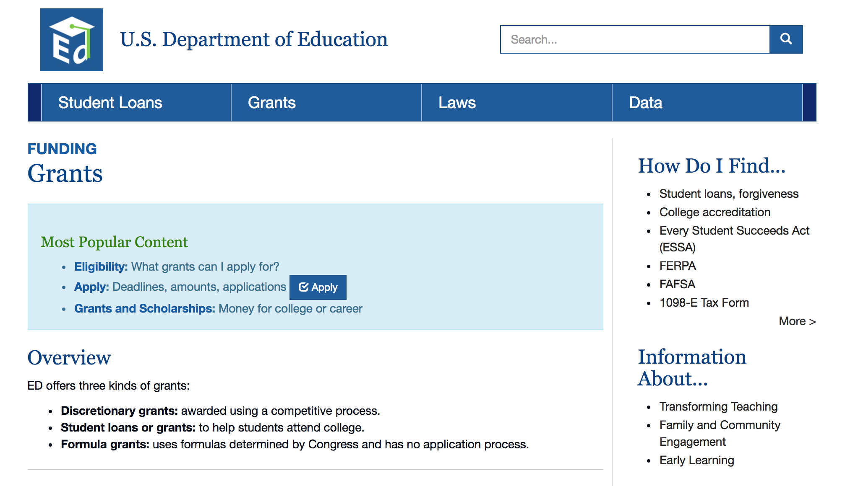
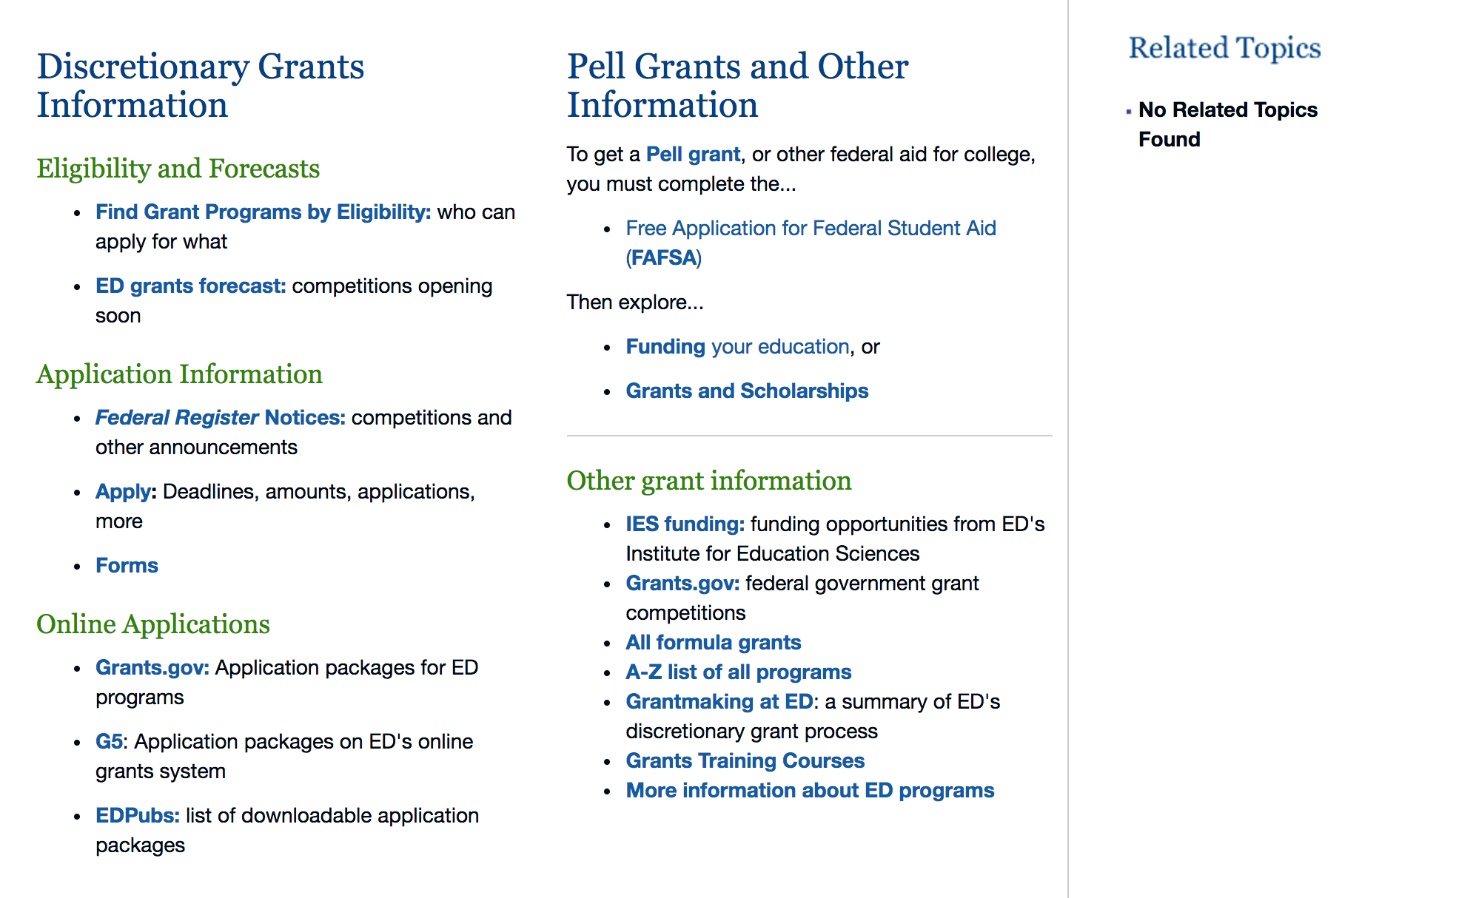

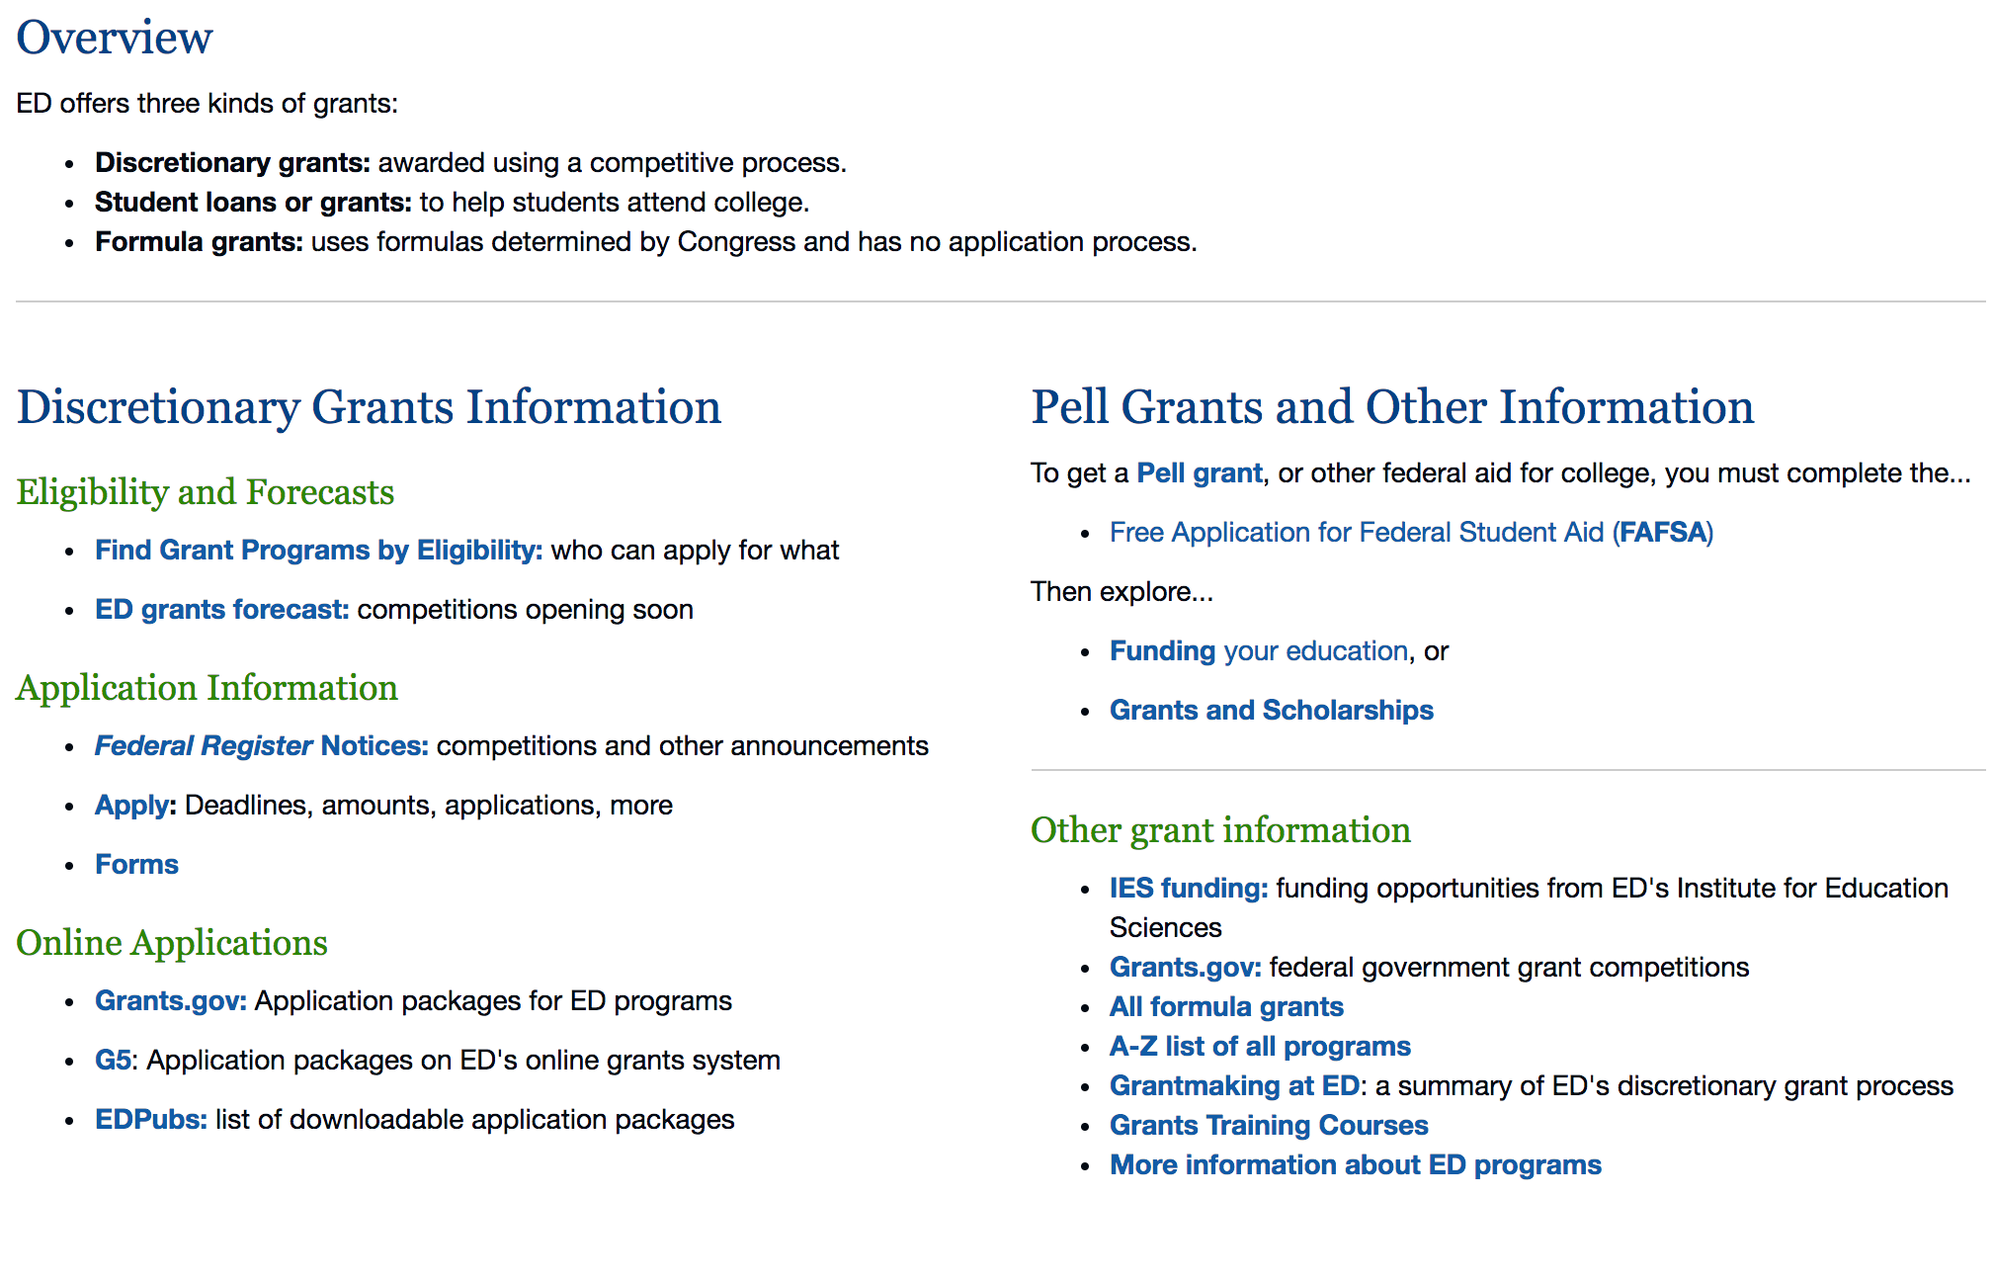

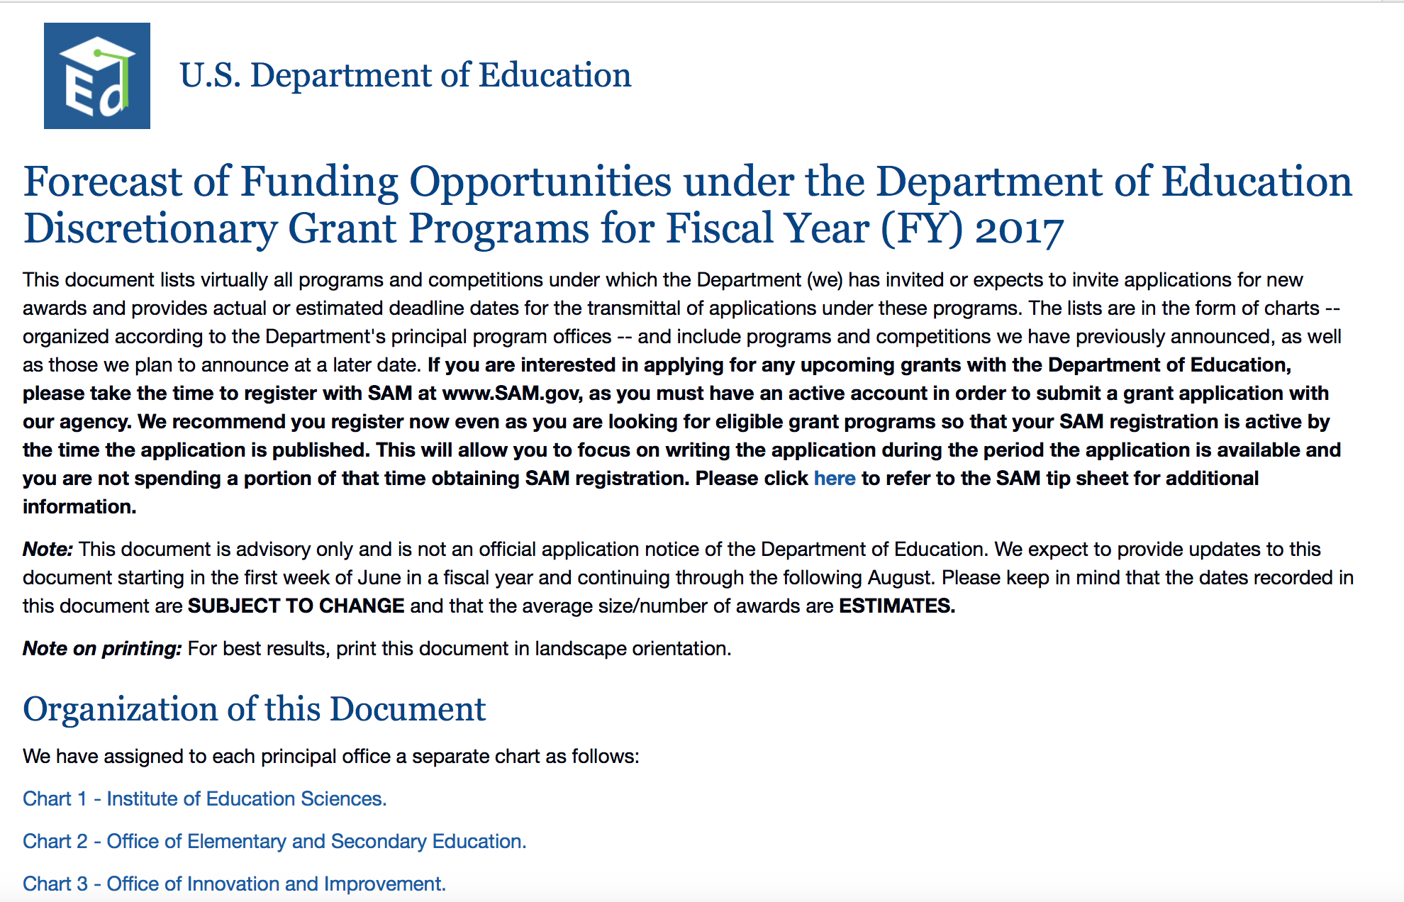
https://www2.ed.gov/fund/grants-apply.html?src=pn

https://www2.ed.gov/fund/grant/find/edlite-forecast.html

Programs:

Research:

Institutes of Education Sciences (IES): Education Research and Development Centers CFDA Number 84.305C
Synopsis 1
http://www.grants.gov/web/grants/view-opportunity.html?oppId=297687

Institute of Education Sciences (IES): Research Networks Focused on Critical Problems of Policy and Practice in Special Education CFDA Number 84.324N
Synopsis 1
http://www.grants.gov/web/grants/view-opportunity.html?oppId=297689

Modifications:

Reminders:

Deleted:

U.S. Department of Energy

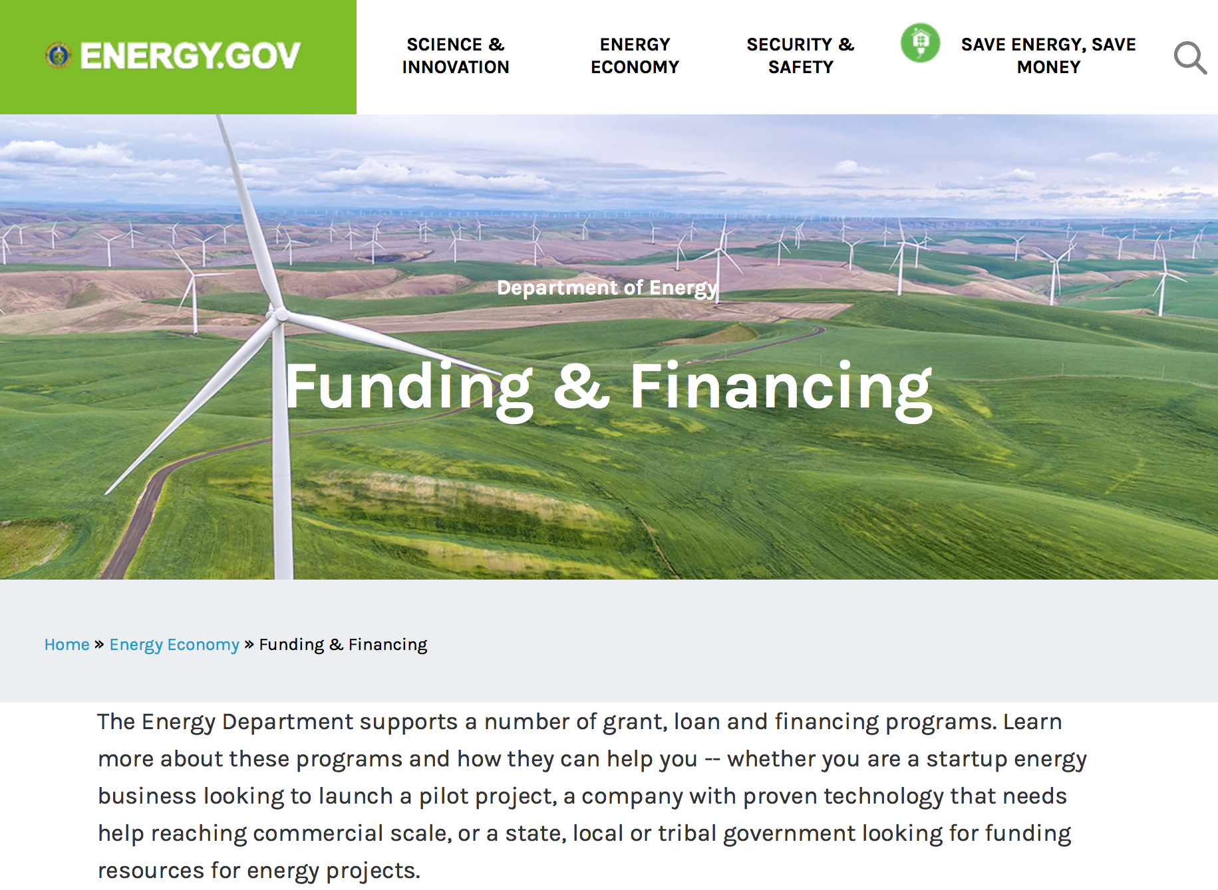

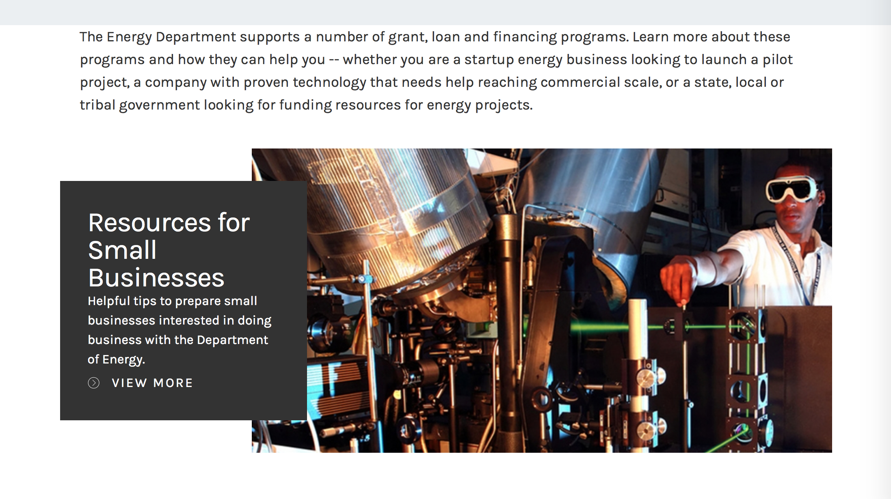

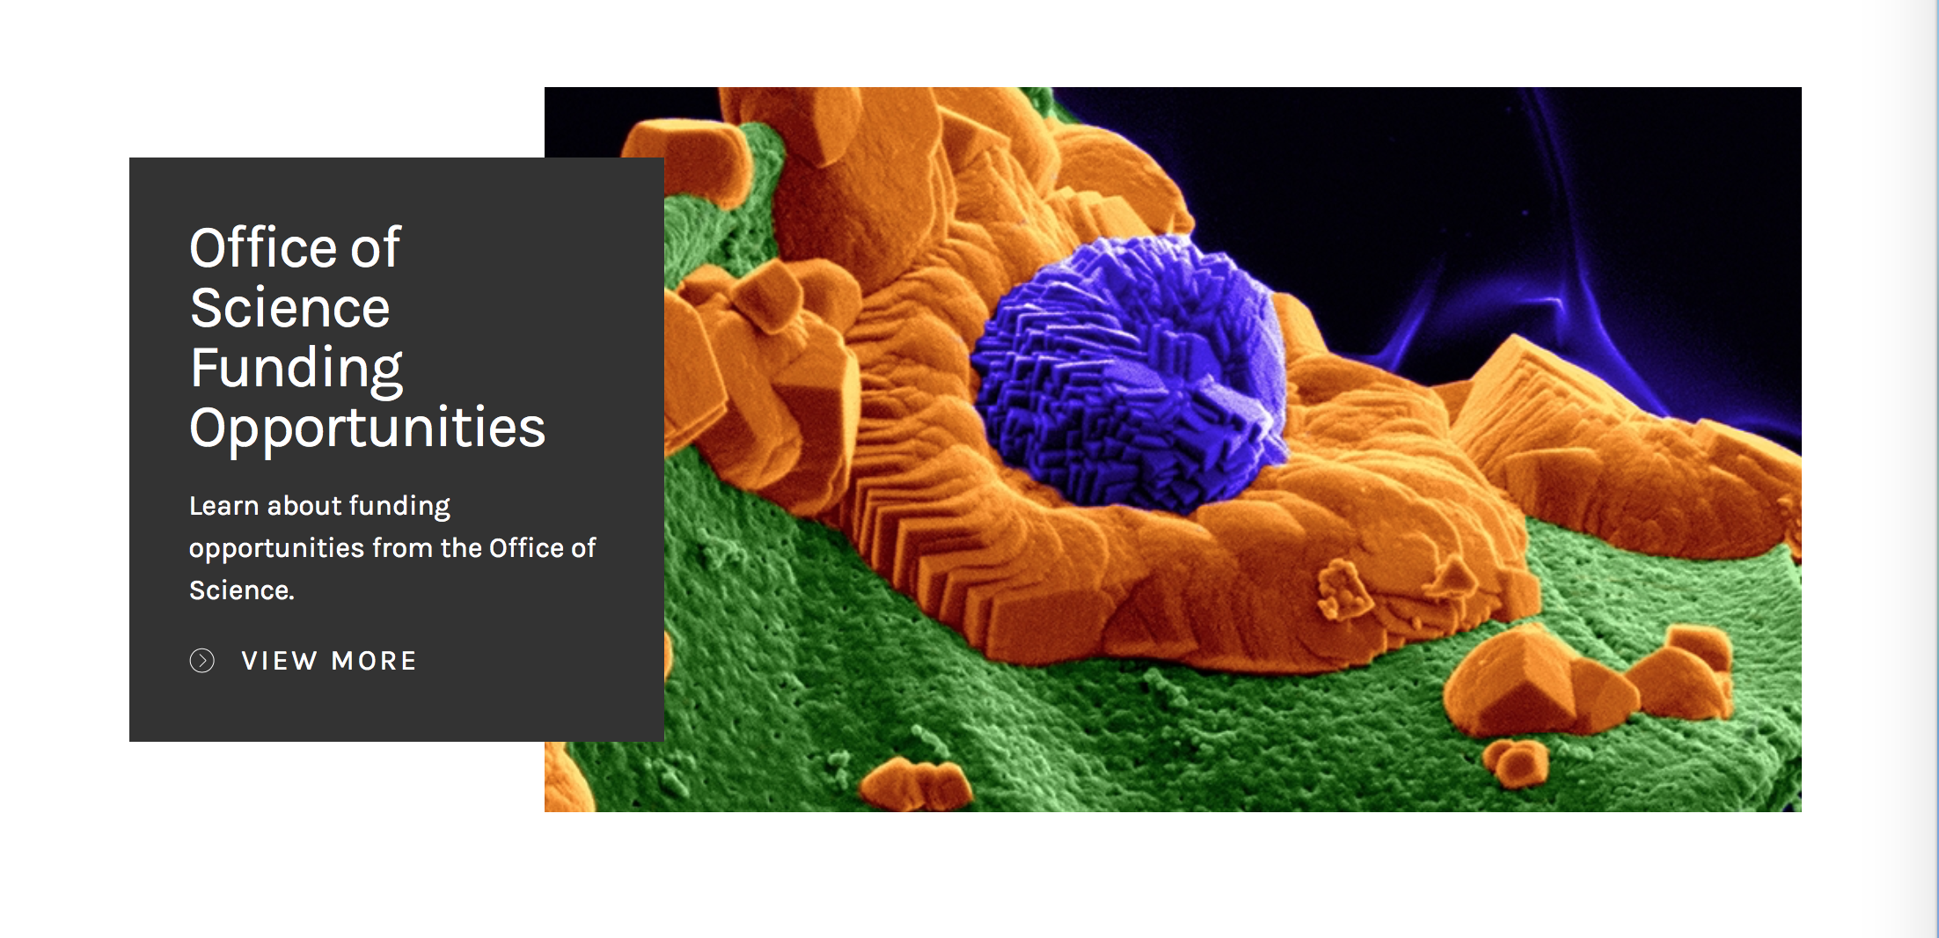

https://www.energy.gov/energy-economy/funding-financing

Research:

Golden Field Office
Generation 3 Concentrating Solar Power Systems
Synopsis 1
http://www.grants.gov/web/grants/view-opportunity.html?oppId=297296

Golden Field Office
Notice of Intent (NOI) - Solar Desalination
Synopsis 1
http://www.grants.gov/web/grants/view-opportunity.html?oppId=297299

Golden Field Office
Advanced Power Electronics Design for Solar Applications
Synopsis 1
http://www.grants.gov/web/grants/view-opportunity.html?oppId=297217

National Energy Technology Laboratory
Notice of Intent to Issue Funding Opportunity Announcement entitled FY 2017 Vehicle Technologies Office Batteries and Electrification to Enable Extreme Fast Charging Funding Opportunity Announcement
Synopsis 1
http://www.grants.gov/web/grants/view-opportunity.html?oppId=297127

National Energy Technology Laboratory
Notice of Intent to Issue Funding Opportunity Announcement entitled Medium/Heavy-Duty, On-Road Natural Gas Engine Research and Development
Synopsis 1
http://www.grants.gov/web/grants/view-opportunity.html?oppId=297306

National Energy Technology Laboratory
Design and Testing of Advanced Carbon Capture Technologies
Synopsis 1
http://www.grants.gov/web/grants/view-opportunity.html?oppId=297592

Modifications:

Golden Field Office
Advanced Manufacturing Graduate-Level Traineeships
Synopsis 3
http://www.grants.gov/web/grants/view-opportunity.html?oppId=295605

National Energy Technology Laboratory
Fossil Fuel Large-Scale Pilots
Synopsis 2
http://www.grants.gov/web/grants/view-opportunity.html?oppId=296746

National Energy Technology Laboratory
Carbon Storage Assurance Facility Enterprise (CarbonSAFE): Storage Complex Facility
Synopsis 5
http://www.grants.gov/web/grants/view-opportunity.html?oppId=285360

National Energy Technology Laboratory
Fossil Fuel Large-Scale Pilots
Synopsis 3
http://www.grants.gov/web/grants/view-opportunity.html?oppId=296746

PAMS
Department of Energy - Office of Science
Office of Science
FY 2017 Continuation of Solicitation for the Office of Science Financial Assistance Program
Synopsis 3
http://www.grants.gov/web/grants/view-opportunity.html?oppId=289281

NNSA
Nonproliferation & Arms Control Program Studies, Training, & Outreach
Synopsis 2
http://www.grants.gov/web/grants/view-opportunity.html?oppId=296911

Reminders:

Environmental Protection Agency

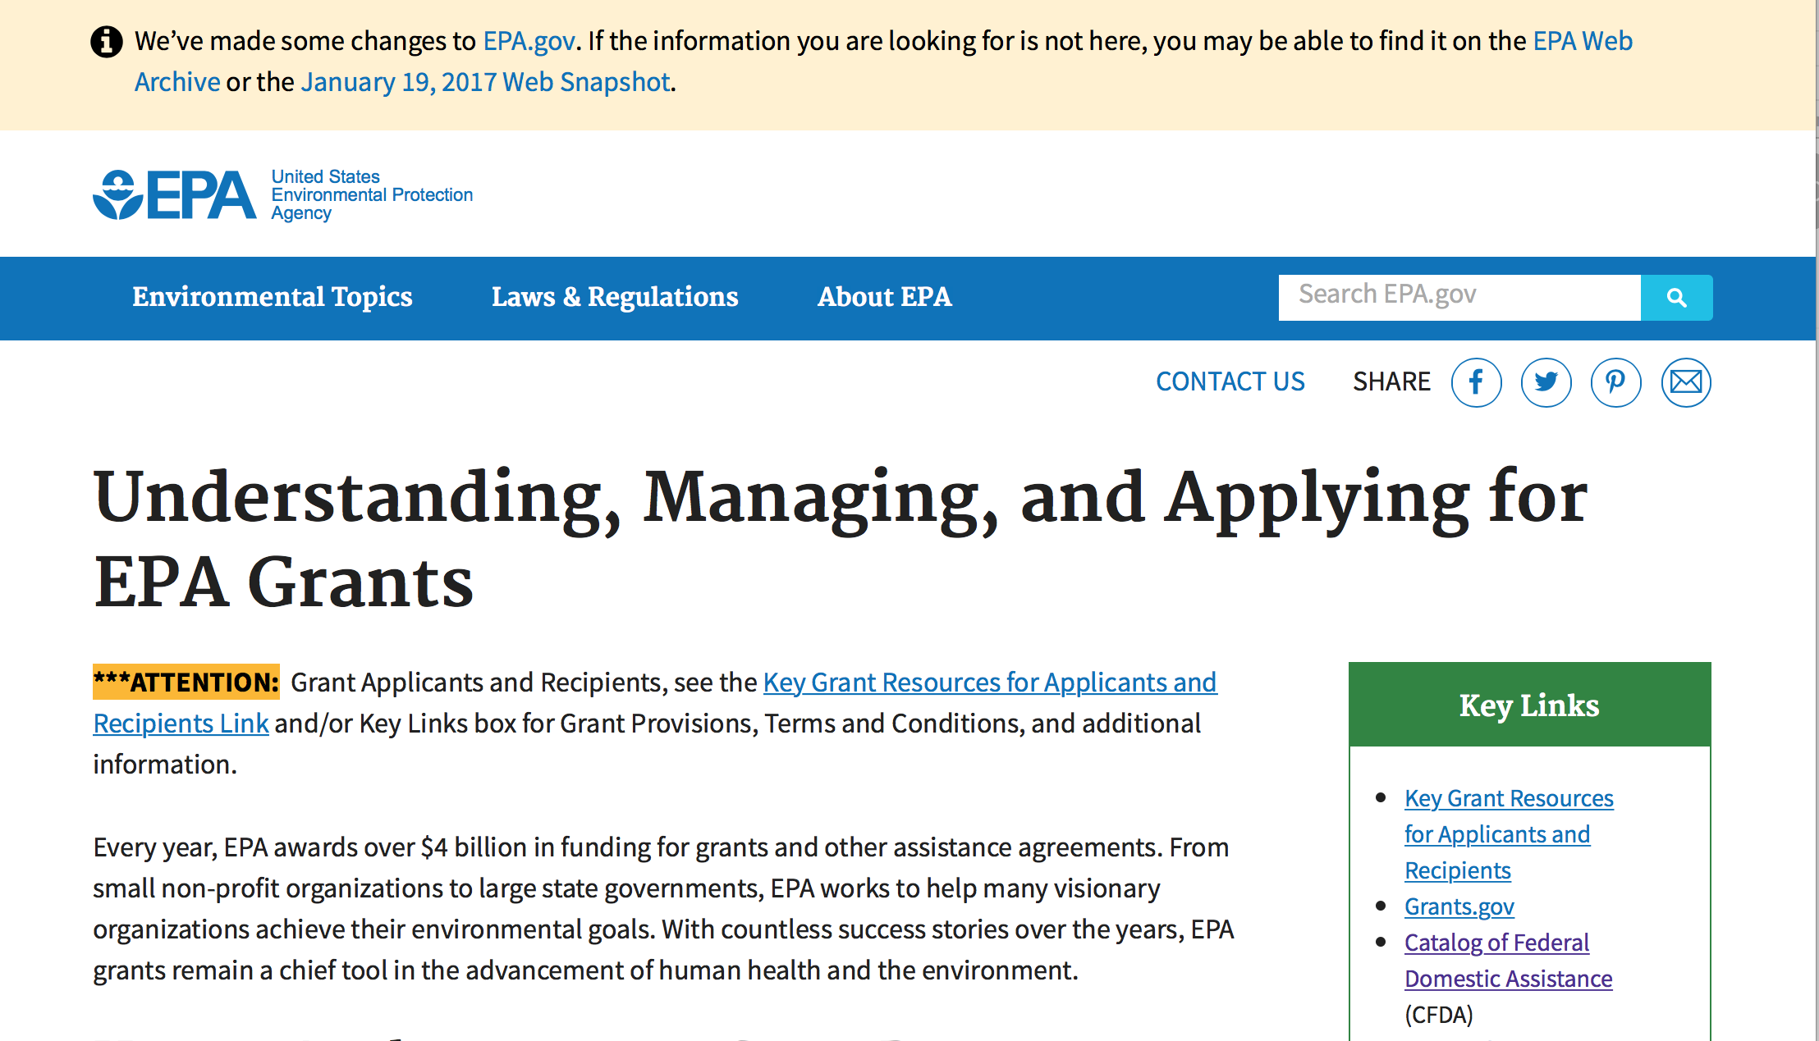
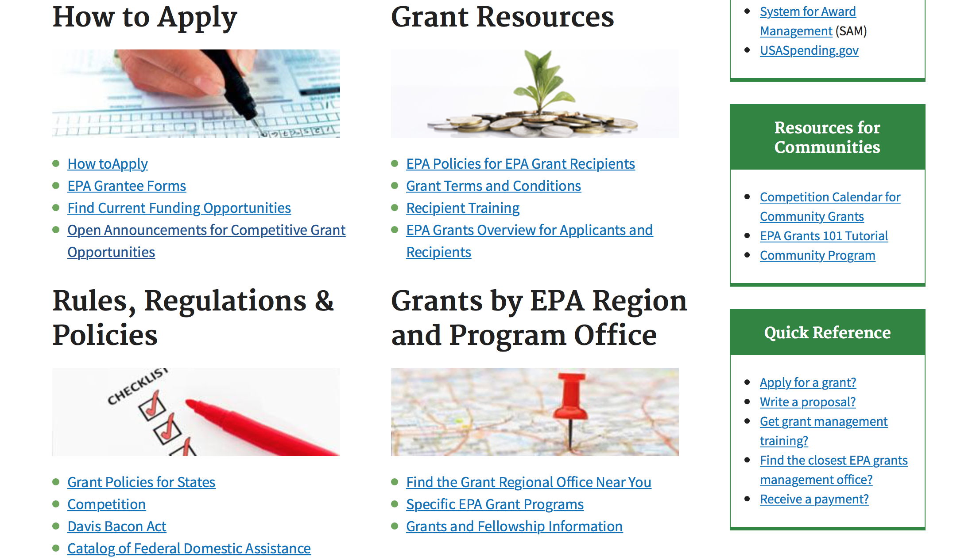

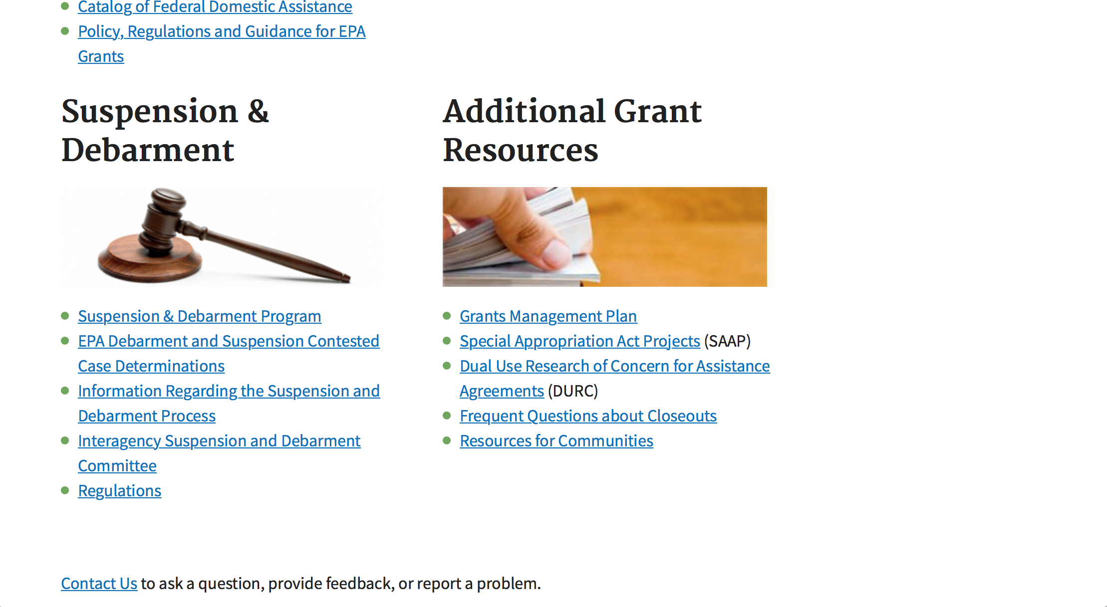

http://www.epa.gov/epahome/grants.htm

Programs:

FY18 GUIDELINES FOR BROWNFIELDS CLEANUP GRANTS
Synopsis 1
Document Type: | Grants Notice
Funding Opportunity Number: | EPA-OLEM-OBLR-17-09
Funding Opportunity Title: | FY18 GUIDELINES FOR BROWNFIELDS CLEANUP GRANTS
Opportunity Category: | Discretionary
Opportunity Category Explanation:
Funding Instrument Type: | Cooperative Agreement
Category of Funding Activity: | Environment
Category Explanation:
Expected Number of Awards: | 38
CFDA Number(s): | 66.818 -- Brownfields Assessment and Cleanup Cooperative Agreements
Cost Sharing or Matching Requirement: | Yes
Version: | Synopsis 1
Posted Date: | Sep 19, 2017
Last Updated Date: | Sep 19, 2017
Original Closing Date for Applications: | Nov 16, 2017 See Section IV of solicitation for additional close date information.
Current Closing Date for Applications: | Nov 16, 2017 See Section IV of solicitation for additional close date information.
Archive Date: | Dec 16, 2017
Estimated Total Program Funding: | $7,500,000
Award Ceiling: | $200,000
Eligible Applicants: | Others (see text field entitled "Additional Information on Eligibility" for clarification)
Additional Information on Eligibility: | See Section III of the solicitation for additional information about eligibility.
Agency Name: | Environmental Protection Agency
Description: | The Small Business Liability Relief and Brownfields Revitalization Act (“Brownfields Law,” P.L. 107-118) requires the U.S. Environmental Protection Agency (EPA) to publish guidance to assist applicants in preparing proposals for grants to assess and clean up brownfield sites. EPA’s Brownfields Program provides funds to empower states, communities, tribes, and nonprofits to prevent, inventory, assess, clean up, and reuse brownfield sites. EPA provides brownfields funding for three types of grants: Brownfields Assessment Grants, Brownfields Revolving Loan Fund (RLF) Grants, and Brownfields Cleanup Grants. Under this RFP, EPA is seeking proposals for Cleanup Grants, only, to provide funds to carry out cleanup activities at a specific brownfield site owned by the applicant.
Link to Additional Information: | FY 2018 Guidelines for Brownfields Cleanup Grants
Grantor Contact Information: | If you have difficulty accessing the full announcement electronically, please contact:  M. Jerry Minor-Gordon Phone: (202) 566-1817  Minor-Gordon.Jerry@epa.gov

http://www.grants.gov/web/grants/view-opportunity.html?oppId=297578

FY18 GUIDELINES FOR BROWNFIELDS REVOLVING LOAN FUND GRANTS
Synopsis 1
Document Type: | Grants Notice
Funding Opportunity Number: | EPA-OLEM-OBLR-17-08
Funding Opportunity Title: | FY18 GUIDELINES FOR BROWNFIELDS REVOLVING LOAN FUND GRANTS
Opportunity Category: | Discretionary
Opportunity Category Explanation:
Funding Instrument Type: | Cooperative Agreement
Category of Funding Activity: | Environment
Category Explanation:
Expected Number of Awards: | 15
CFDA Number(s): | 66.818 -- Brownfields Assessment and Cleanup Cooperative Agreements
Cost Sharing or Matching Requirement: | Yes
Version: | Synopsis 1
Posted Date: | Sep 18, 2017
Last Updated Date: | Sep 18, 2017
Original Closing Date for Applications: | Nov 16, 2017 Please see the announcement for additional submission information.
Current Closing Date for Applications: | Nov 16, 2017 Please see the announcement for additional submission information.
Archive Date: | Dec 16, 2017
Estimated Total Program Funding: | $9,000,000
Award Ceiling: | $1,000,000
Version: | Synopsis 1
Posted Date: | Sep 18, 2017
Last Updated Date: | Sep 18, 2017
Original Closing Date for Applications: | Nov 16, 2017 Please see the announcement for additional submission information.
Current Closing Date for Applications: | Nov 16, 2017 Please see the announcement for additional submission information.
Archive Date: | Dec 16, 2017
Estimated Total Program Funding: | $9,000,000
Award Ceiling: | $1,000,000
Eligible Applicants: | Others (see text field entitled "Additional Information on Eligibility" for clarification)
Additional Information on Eligibility: | Please see the announcement including Section III for additional eligibility information.
Agency Name: | Environmental Protection Agency
Description: | The Small Business Liability Relief and Brownfields Revitalization Act (“Brownfields Law”, P.L. 107-118) requires the U.S. Environmental Protection Agency (EPA) to publish guidance for grants to assess and clean up brownfield sites. EPA’s Brownfields Program provides funds to empower states, communities, tribes, and nonprofits to prevent, inventory, assess, clean up, and reuse brownfield sites. Under these guidelines, EPA is seeking proposals for Revolving Loan Fund Grants only. If you are interested in requesting funding for Assessment Grants and/or Cleanup Grants, please refer to announcement EPA-OLEM-OBLR-17-07 (Assessment Grant Guidelines) or EPA-OLEM-OBLR-17-09 (Cleanup Grant Guidelines) posted separately on www.grants.gov and www.epa.gov/brownfields/apply-brownfields-grant-funding.
Link to Additional Information: | FY18 GUIDELINES FOR BROWNFIELDS REVOLVING LOAN FUND GRANTS
Grantor Contact Information: | If you have difficulty accessing the full announcement electronically, please contact:  See Section VII of solicitation  See Section VII of solicitation

http://www.grants.gov/web/grants/view-opportunity.html?oppId=297557

FY18 GUIDELINES FOR BROWNFIELDS ASSESSMENT GRANTS
Synopsis 1
Document Type: | Grants Notice
Funding Opportunity Number: | EPA-OLEM-OBLR-17-07
Funding Opportunity Title: | FY18 GUIDELINES FOR BROWNFIELDS ASSESSMENT GRANTS
Opportunity Category: | Discretionary
Opportunity Category Explanation:
Funding Instrument Type: | Cooperative Agreement
Category of Funding Activity: | Environment
Category Explanation:
Expected Number of Awards: | 145
CFDA Number(s): | 66.818 -- Brownfields Assessment and Cleanup Cooperative Agreements
Cost Sharing or Matching Requirement: | No
Version: | Synopsis 1
Posted Date: | Sep 18, 2017
Last Updated Date: | Sep 18, 2017
Original Closing Date for Applications: | Nov 16, 2017 Please see the announcement for additional submission information.
Current Closing Date for Applications: | Nov 16, 2017 Please see the announcement for additional submission information.
Archive Date: | Dec 16, 2017
Estimated Total Program Funding: | $33,500,000
Award Ceiling: | $600,000
Eligible Applicants: | Others (see text field entitled "Additional Information on Eligibility" for clarification)
Additional Information on Eligibility: | Please see the announcement for additional eligibility information.
Agency Name: | Environmental Protection Agency
Description: | The Small Business Liability Relief and Brownfields Revitalization Act (“Brownfields Law”, P.L. 107-118) requires the U.S. Environmental Protection Agency (EPA) to publish guidance for grants to assess and clean up brownfield sites. EPA’s Brownfields Program provides funds to empower states, communities, tribes, and nonprofits to prevent, inventory, assess, clean up, and reuse brownfield sites. Under these guidelines, EPA is seeking proposals for Assessment Grants only. If you are interested in requesting funding for Cleanup Grants and/or Revolving Loan Fund Grants, please refer to announcement EPA-OLEM-OBLR-17-08 (Revolving Loan Fund Grant Guidelines) or EPA-OLEM-OBLR-17-09 (Cleanup Grant Guidelines) posted separately on www.grants.gov and www.epa.gov/brownfields/apply-brownfields-grant-funding.
Link to Additional Information: | FY18 GUIDELINES FOR BROWNFIELDS ASSESSMENT GRANTS
Grantor Contact Information: | If you have difficulty accessing the full announcement electronically, please contact:  See Section VII of solicitation  See Section VII of solicitation

http://www.grants.gov/web/grants/view-opportunity.html?oppId=297558

Research:

Modifications:

Reminders:

2017 Targeted Air Shed Grant Program
Synopsis 1
Document Type: | Grants Notice
Funding Opportunity Number: | EPA-OAR-OAQPS-17-06
Funding Opportunity Title: | 2017 Targeted Air Shed Grant Program
Opportunity Category: | Discretionary
Opportunity Category Explanation:
Funding Instrument Type: | Cooperative Agreement  Grant
Category of Funding Activity: | Environment
Category Explanation:
Expected Number of Awards: | 7
CFDA Number(s): | 66.202 -- Congressionally Mandated Projects
Cost Sharing or Matching Requirement: | No
Version: | Synopsis 1
Posted Date: | Jul 19, 2017
Last Updated Date: | Jul 19, 2017
Original Closing Date for Applications: | Oct 18, 2017 Please see the announcement including Section IV for additional submission information.
Current Closing Date for Applications: | Oct 18, 2017 Please see the announcement including Section IV for additional submission information.
Archive Date: | Nov 17, 2017
Estimated Total Program Funding: | $30,000,000
Award Ceiling: | $4,000,000
Award Floor: | $0
Eligible Applicants: | Others (see text field entitled "Additional Information on Eligibility" for clarification)
Additional Information on Eligibility: | Please see the announcement including Section III for additional eligibility information.
Agency Name: | Environmental Protection Agency
Description: | This notice announces the availability of funds and solicits applications from eligible entities to compete for financial assistance through the Targeted Air Shed Grant Program. This program will assist local, state and/or tribal air pollution control agencies in developing plans, conducting demonstrations, and implementing projects to reduce air pollution in nonattainment areas that EPA determines are the top five most polluted areas relative to ozone (O3), annual average fine particulate matter (PM2.5), or 24-hour PM2.5 National Ambient Air Quality Standards (NAAQS). The overall goal of the Targeted Air Shed Grant program is to reduce air pollution in the Nation’s areas with the highest levels of ozone and PM2.5 ambient air concentrations.
Link to Additional Information: | 2017 Targeted Air Shed Grant Program
Grantor Contact Information: | If you have difficulty accessing the full announcement electronically, please contact:  Gary Blais, 919-541-3223  Gary Blais

http://www.grants.gov/web/grants/view-opportunity.html?oppId=295677

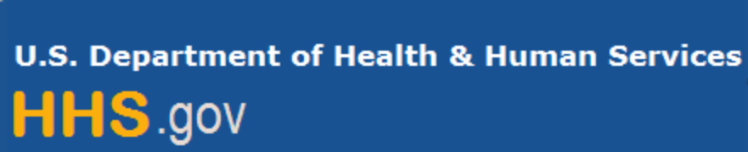

Department of Health and Human Services

Grants Forecast and Overview

The Department of Health and Human Services’ Grants Forecast is a database of planned grant opportunities proposed by its agencies. Each Forecast record contains actual or estimated dates and funding levels for grants that the agency intends to award during the fiscal year. Forecast opportunities are subject to change based on enactment of congressional appropriations.

For more general information about HHS Grants and Funding go to the website below at:

https://www.hhs.gov/grants/grants/index.html

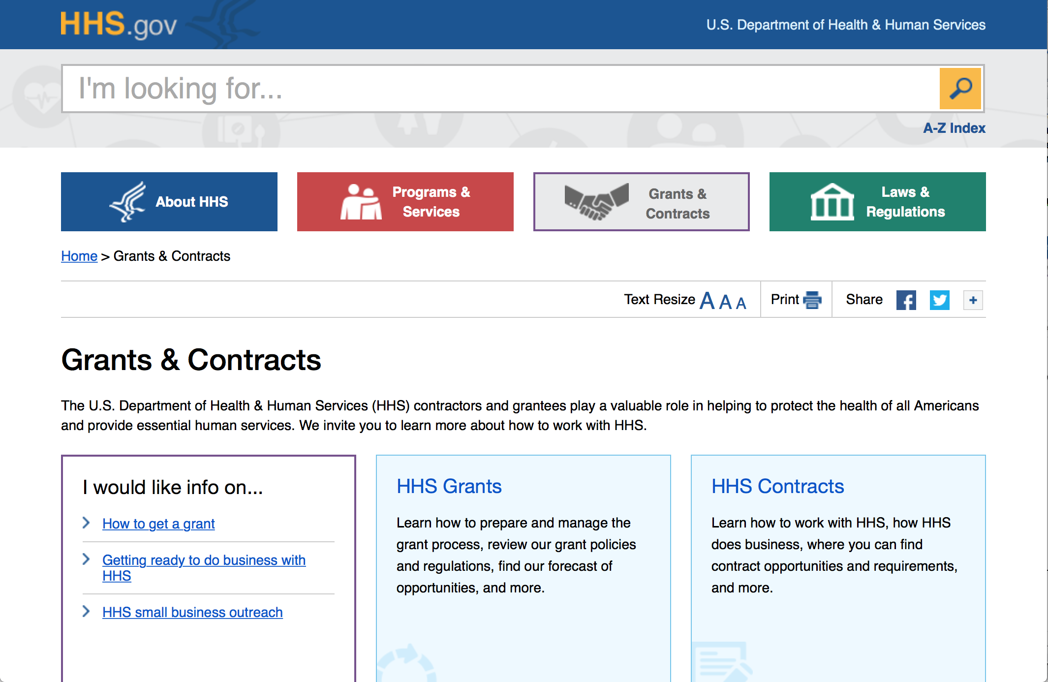

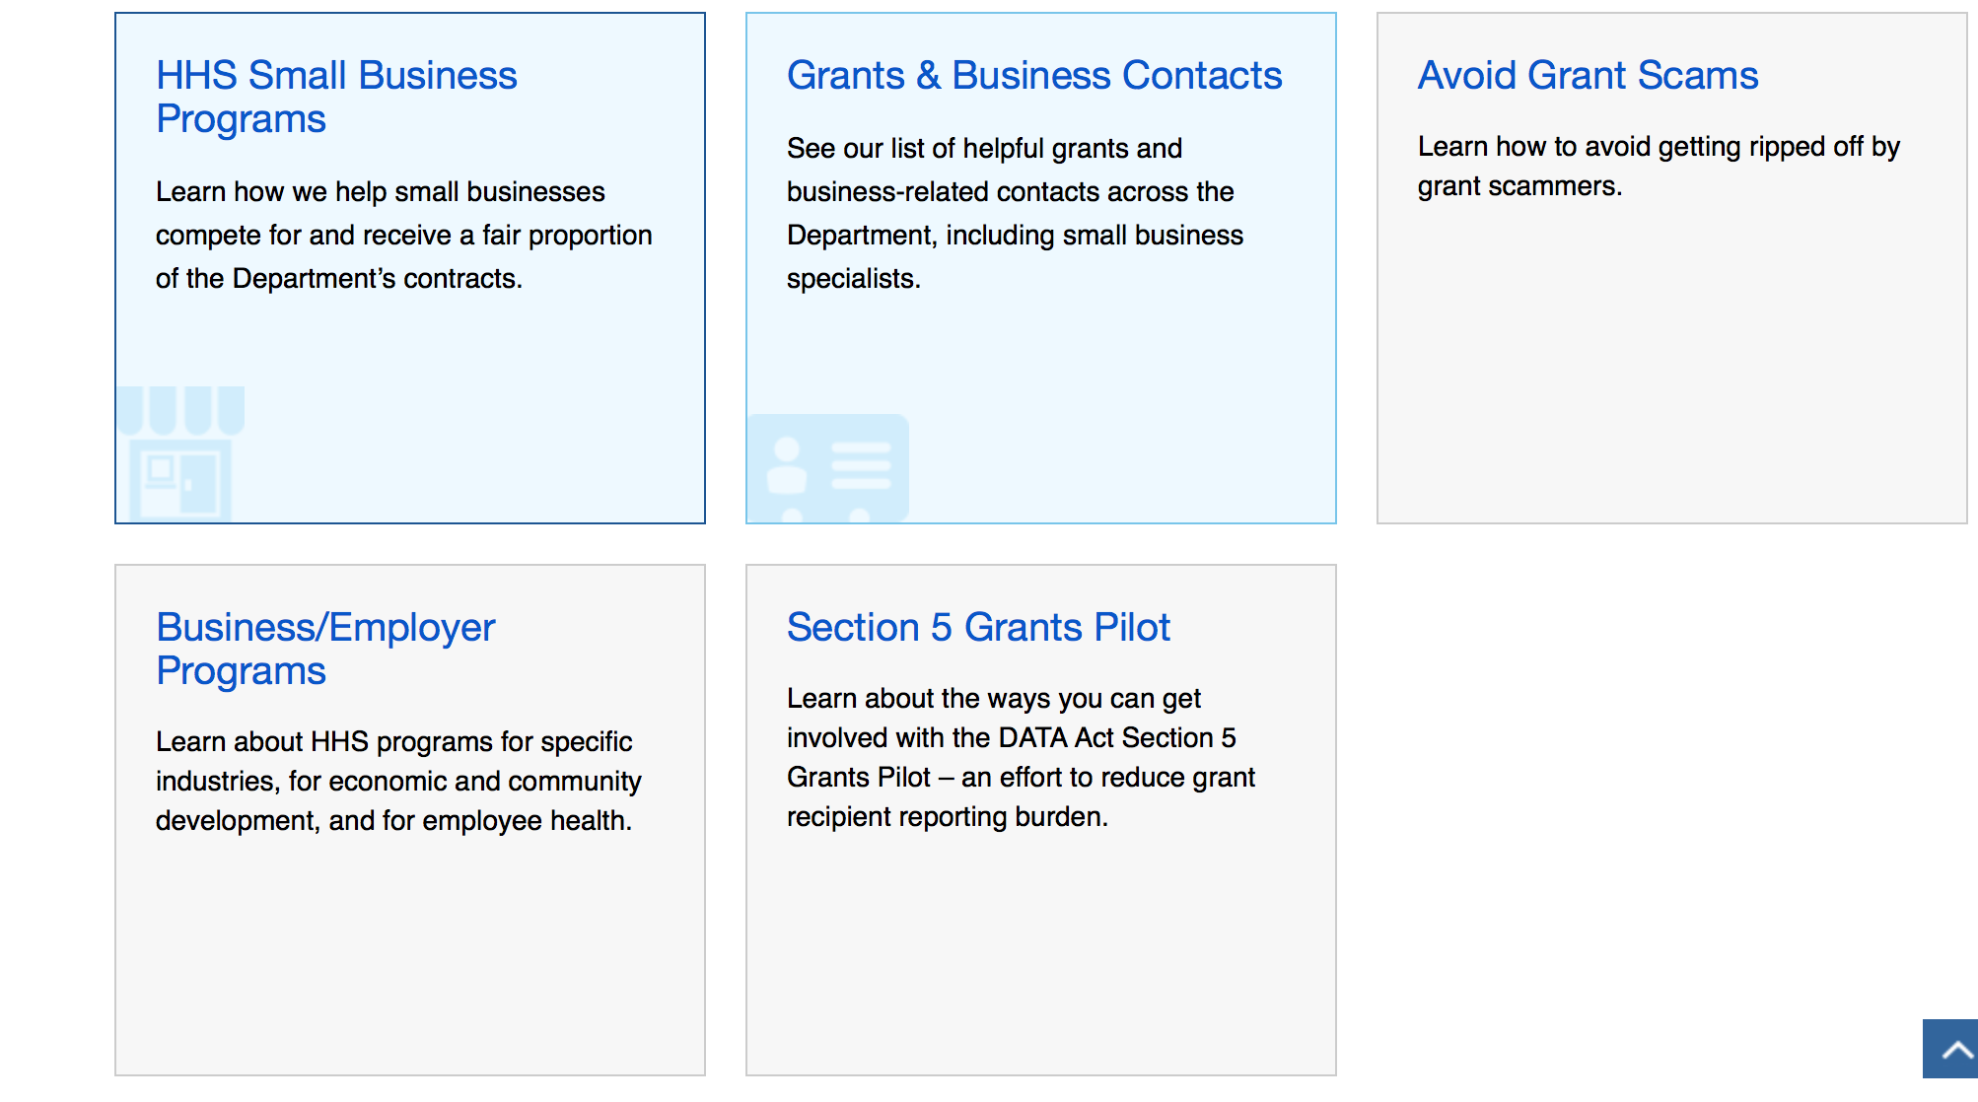

Programs:

Research:

Agency for Health Care Research and Quality
Agency for Healthcare Research and Quality (AHRQ)-sponsored National Research Service Award (NRSA) Individual Postdoctoral Fellowship (F32)
Synopsis 1
http://www.grants.gov/web/grants/view-opportunity.html?oppId=297331

Centers for Disease Control and Prevention - ERA
Research Grants for Preventing Violence and Violence Related Injury (R01)
Forecast 1
http://www.grants.gov/web/grants/view-opportunity.html?oppId=297345

Centers for Disease Control and Prevention - ERA
Identify, Analyze and Evaluate Potential Risk Factors for Amyotrophic Lateral Sclerosis (ALS)
Forecast 1
http://www.grants.gov/web/grants/view-opportunity.html?oppId=297380

Centers for Disease Control and Prevention - ERA
Injury Control Research Centers
Forecast 1
http://www.grants.gov/web/grants/view-opportunity.html?oppId=297572

Centers for Disease Control - NCIPC
DELTA (Domestic Violence Prevention Enhancement and Leadership Through Alliances) Impact
Synopsis 1
http://www.grants.gov/web/grants/view-opportunity.html?oppId=297628

Health Resources and Services Administration
Service Area Competition (Round 6)
Synopsis 1
http://www.grants.gov/web/grants/view-opportunity.html?oppId=295217

Health Resources and Services Administration
Service Area Competition
Synopsis 1
http://www.grants.gov/web/grants/view-opportunity.html?oppId=295216

Health Resources and Services Administration
AIDS Drug Assistance Program (ADAP) Emergency Relief Funds (ERF)
Synopsis 1
http://www.grants.gov/web/grants/view-opportunity.html?oppId=295197

Health Resources and Services Administration
Nurse Faculty Loan Program (NFLP)
Synopsis 1
http://www.grants.gov/web/grants/view-opportunity.html?oppId=297699

National Institutes of Health
NCI Outstanding Investigator Award (R35)
Synopsis 1
http://www.grants.gov/web/grants/view-opportunity.html?oppId=297701

National Institutes of Health
NIH Blueprint Diversity Specialized Predoctoral to Postdoctoral Advancement in Neuroscience (D-SPAN) Award (F99/K00)
Synopsis 1
http://www.grants.gov/web/grants/view-opportunity.html?oppId=297702

National Institutes of Health
Implementing the Most Successful Interventions to Improve HIV/AIDS Outcomes in U.S. Communities (R01 Clinical Trial Optional)
Synopsis 1
http://www.grants.gov/web/grants/view-opportunity.html?oppId=297667

National Institutes of Health
Addressing Chronic Wound Trajectories Through Social Genomics Research (R01 Clinical Trial Optional)
Synopsis 1
http://www.grants.gov/web/grants/view-opportunity.html?oppId=297668

National Institutes of Health
BRAIN Initiative: Exploratory Team-Research BRAIN Circuit Programs - eTeamBCP (U01)
Synopsis 1
http://www.grants.gov/web/grants/view-opportunity.html?oppId=297688

National Institutes of Health
Continuation of the AMP-AD Target Discovery and Preclinical Validation Consortium (U01 Clinical Trial Optional)
Synopsis 1
http://www.grants.gov/web/grants/view-opportunity.html?oppId=297691

National Institutes of Health
Implementing the Most Successful Interventions to Improve HIV/AIDS Outcomes in U.S. Communities (R21 Clinical Trial Optional)
Synopsis 1
http://www.grants.gov/web/grants/view-opportunity.html?oppId=297693

National Institutes of Health
Addressing Chronic Wound Trajectories Through Social Genomics Research (R21 Clinical Trial Optional)
Synopsis 1
http://www.grants.gov/web/grants/view-opportunity.html?oppId=297694

National Institutes of Health
Multilevel Interventions in Cancer Care Delivery: Follow-up to Abnormal Screening Tests (R01 Clinical Trial Optional)
Synopsis 1
http://www.grants.gov/web/grants/view-opportunity.html?oppId=297727

National Institutes of Health
Research to Improve Native American Health (R21 Clinical Trial Optional)
Synopsis 1
http://www.grants.gov/web/grants/view-opportunity.html?oppId=297728

National Institutes of Health
Intervention Research to Improve Native American Health (R01 Clinical Trial Optional)
Synopsis 1
http://www.grants.gov/web/grants/view-opportunity.html?oppId=297729

National Institutes of Health
Collaborative Program Grant for Multidisciplinary Teams (RM1)
Synopsis 1
http://www.grants.gov/web/grants/view-opportunity.html?oppId=297620

National Institutes of Health
Population-Based Model Organism Research for G x E Exploration in Complex Disease Outcomes (R01 Clinical Trial Not Allowed)
Synopsis 1
http://www.grants.gov/web/grants/view-opportunity.html?oppId=297631

National Institutes of Health
Development of Valid Reliable Markers of Aging-Related Biologic Mechanisms for Human Studies (U01)
Synopsis 1
http://www.grants.gov/web/grants/view-opportunity.html?oppId=297632

National Institutes of Health
Pediatric Immunotherapy Translational Science Network (PI-TSN)(U54)
Synopsis 1
http://www.grants.gov/web/grants/view-opportunity.html?oppId=297681

National Institutes of Health
Pediatric Immunotherapy Translational Science Network (PI-TSN)(U01)
Synopsis 1
http://www.grants.gov/web/grants/view-opportunity.html?oppId=297682

National Institutes of Health
Opioid Use Disorder in Pregnancy (R01)
Synopsis 1
http://www.grants.gov/web/grants/view-opportunity.html?oppId=297653

National Institutes of Health
Lymphatics in Health and Disease in the Digestive System (R01 - Clinical Trials Not Allowed)
Synopsis 1
http://www.grants.gov/web/grants/view-opportunity.html?oppId=297654

National Institutes of Health
Diabetic Foot Consortium - Clinical Research Units (U01)
Synopsis 1
http://www.grants.gov/web/grants/view-opportunity.html?oppId=297671

National Institutes of Health
Analyzing and Interpreting Clinician and Patient Adverse Event Data to Better Understand Tolerability (U01)
Synopsis 1
http://www.grants.gov/web/grants/view-opportunity.html?oppId=297672

National Institutes of Health
BRAIN Initiative: Tools to target, identify and characterize non-neuronal cells in the brain (R01 Clinical Trial Not Allowed)
Synopsis 1
http://www.grants.gov/web/grants/view-opportunity.html?oppId=297638

National Institutes of Health
BRAIN Initiative: Research Resource Grants for Technology Integration and Dissemination (U24)
Synopsis 1
http://www.grants.gov/web/grants/view-opportunity.html?oppId=297590

National Institutes of Health
High Impact Neuroscience Research Resource Grants (R24)
Synopsis 1
http://www.grants.gov/web/grants/view-opportunity.html?oppId=297601

National Institutes of Health
Short-term Mentored Career Enhancement Awards for Mid-Career Investigators to Integrate Basic Behavioral and Social Sciences (K18)
Synopsis 1
http://www.grants.gov/web/grants/view-opportunity.html?oppId=297544

National Institutes of Health
Human Heredity and Health in Africa (H3Africa): Ethical, Legal, and Societal Issues (ELSI) Collaborative Centers (U54)
Synopsis 1
http://www.grants.gov/web/grants/view-opportunity.html?oppId=297547

National Institutes of Health
Science of Behavior Change: Use-inspired Research to Optimize Adherence, Behavior Change Interventions, and Outcomes (R21)
Synopsis 1
http://www.grants.gov/web/grants/view-opportunity.html?oppId=297554

National Institutes of Health
Science of Behavior Change: Revision Applications for Use-inspired Research to Optimize Adherence, Behavior Change Interventions, and Outcomes (R01)
Synopsis 1
http://www.grants.gov/web/grants/view-opportunity.html?oppId=297555

National Institutes of Health
Science of Behavior Change: Revision Applications for Use-inspired Research to Optimize Adherence, Behavior Change Interventions, and Outcomes (U01)
Synopsis 1
http://www.grants.gov/web/grants/view-opportunity.html?oppId=297536

National Institutes of Health
Innovative Approaches or Technologies to Investigate Regional, Structural and Functional Heterogeneity of CNS Small Blood and Lymphatic Vessels (R01)
Synopsis 1
http://www.grants.gov/web/grants/view-opportunity.html?oppId=297537

National Institutes of Health
Human Studies of Target Identification, Biomarkers and Disease Mechanisms Specific to CNS Small Blood and Lymphatic Vessels (R01)
Synopsis 1
http://www.grants.gov/web/grants/view-opportunity.html?oppId=297538

National Institutes of Health
NIH Science Education Partnership Award (SEPA) (R25)
Synopsis 1
http://www.grants.gov/web/grants/view-opportunity.html?oppId=297539

National Institutes of Health
Human Heredity and Health in Africa (H3Africa): Ethical, Legal, and Societal Issues (ELSI) Research Program (U01)
Synopsis 1
http://www.grants.gov/web/grants/view-opportunity.html?oppId=297575

National Institutes of Health
New Onset Depressive Symptoms in Acute Illness (R01 Clinical Trial Not Allowed)
Synopsis 1
http://www.grants.gov/web/grants/view-opportunity.html?oppId=297576

National Institutes of Health
New Onset Depressive Symptoms in Acute Illness (R21 Clinical Trial Not Allowed)
Synopsis 1
http://www.grants.gov/web/grants/view-opportunity.html?oppId=297577

National Institutes of Health
Biology Of Aging Dental, Oral And Craniofacial Tissues (R21 - Clinical Trial Not Allowed)
Synopsis 1
http://www.grants.gov/web/grants/view-opportunity.html?oppId=297579

National Institutes of Health
Biology Of Aging Dental, Oral And Craniofacial Tissues (R01 - Clinical Trial Not Allowed)
Synopsis 1
http://www.grants.gov/web/grants/view-opportunity.html?oppId=297580

National Institutes of Health
Science of Behavior Change: Revision Applications for Use-inspired Research to Optimize Adherence, Behavior Change Interventions, and Outcomes (R34)
Synopsis 1
http://www.grants.gov/web/grants/view-opportunity.html?oppId=297535

National Institutes of Health
Exploiting HIV and/or Host Genomic Information to Understand HIV Compartments or Reactivation in Individuals with Substance Use Disorders (R61/R33)
Synopsis 1
http://www.grants.gov/web/grants/view-opportunity.html?oppId=297390

National Institutes of Health
Collaborative Minority Health and Health Disparities Research with Tribal Epidemiology Centers (R01)
Synopsis 1
http://www.grants.gov/web/grants/view-opportunity.html?oppId=297373

National Institutes of Health
Collaborative Minority Health and Health Disparities Research with Tribal Epidemiology Centers (R21)
Synopsis 1
http://www.grants.gov/web/grants/view-opportunity.html?oppId=297374

National Institutes of Health
Comparative Genomics Research Program (R01)
Synopsis 1
http://www.grants.gov/web/grants/view-opportunity.html?oppId=297339

National Institutes of Health
Research on Transgender Health (R01)
Synopsis 1
http://www.grants.gov/web/grants/view-opportunity.html?oppId=297230

National Institutes of Health
Research on Transgender Health (R21)
Synopsis 1
http://www.grants.gov/web/grants/view-opportunity.html?oppId=297232

National Institutes of Health
NINDS Renewal Awards of SBIR Phase II Grants (Phase IIB) for Pre-Clinical Research (R44)
Synopsis 1
http://www.grants.gov/web/grants/view-opportunity.html?oppId=297292

National Institutes of Health
NINDS Renewal Awards of SBIR Phase II Grants (Phase IIB) for Clinical Trials and Clinical Research (R44)
Synopsis 1
http://www.grants.gov/web/grants/view-opportunity.html?oppId=297293

National Institutes of Health
NINR Center of Excellence (P30)
Synopsis 1
http://www.grants.gov/web/grants/view-opportunity.html?oppId=297409

National Institutes of Health
NIMH Research Education Mentoring Programs for HIV/AIDS Researchers (R25)
Synopsis 1
http://www.grants.gov/web/grants/view-opportunity.html?oppId=297431

National Institutes of Health
Electronic Nicotine Delivery Systems (ENDS): Basic Mechanisms of Health Effects (R01 - Clinical Trial Not Allowed)
Synopsis 1
http://www.grants.gov/web/grants/view-opportunity.html?oppId=297178

National Institutes of Health
Electronic Nicotine Delivery Systems (ENDS): Basic Mechanisms of Health Effects (R21 - Clinical Trial Not Allowed)
Synopsis 1
http://www.grants.gov/web/grants/view-opportunity.html?oppId=297214

National Institutes of Health
Repurposing Target-Based Pharmaceutical Libraries for Discovery of Therapeutics against Eukaryotic Pathogens (R21/R33)
Synopsis 1
http://www.grants.gov/web/grants/view-opportunity.html?oppId=297305

National Institutes of Health
Next Generation Multipurpose Prevention Technologies (NGM) (R61/R33 Clinical Trial Optional)
Synopsis 1
http://www.grants.gov/web/grants/view-opportunity.html?oppId=297330

Modifications:

Administration for Children and Families - OFA
TANF Policy Academy for Innovative Employment Strategies-Coaching
Forecast 5
http://www.grants.gov/web/grants/view-opportunity.html?oppId=293925

Agency for Health Care Research and Quality
Agency for Healthcare Research and Quality and Patient-Centered Outcomes Research Institute Learning Health Systems Mentored Career Development Program (K12)
Synopsis 2
http://www.grants.gov/web/grants/view-opportunity.html?oppId=297101

Centers for Disease Control - CGH
Strengthening Implementation and Use of Effective Health Information Systems through Improved Governance, Design, Planning, Capacity Development, and Technical Implementation under the President's Emergency Plan for AIDS Relief (PEPFAR)
Synopsis 4 & 6
http://www.grants.gov/web/grants/view-opportunity.html?oppId=293340

Centers for Disease Control - CGH
Supporting HIV-Related Laboratory Networks and Partnerships to Facilitate Laboratory Strengthening and Management Activities for Countries Supported under the President's Emergency Plan for AIDS Relief (PEPFAR)
Synopsis 4
http://www.grants.gov/web/grants/view-opportunity.html?oppId=293393

Health Resources and Services Administration
Service Area Competition
Synopsis 3
http://www.grants.gov/web/grants/view-opportunity.html?oppId=295217

National Institutes of Health
NIMH Career Transition Award for Tenure-Track and Tenured Intramural Investigators (K22)
Synopsis 2
http://www.grants.gov/web/grants/view-opportunity.html?oppId=287057

National Institutes of Health
Research on Transgender Health (R01)
Synopsis 2
http://www.grants.gov/web/grants/view-opportunity.html?oppId=297230

National Institutes of Health
Research on Transgender Health (R21)
Synopsis 2
http://www.grants.gov/web/grants/view-opportunity.html?oppId=297232

Deleted:

Centers for Disease Control - OPHPR
CDC-RFA-TP17-1703 - Cooperative Agreement for Emergency Response: Public Health Crisis Response
Deletion Comments: Opportunity deleted

Centers for Medicare & Medicaid Services
345345345 - DNP CG2
Deletion Comments: Opportunity deleted

Centers for Medicare & Medicaid Services
Centers for Medicare & Medicaid Services
CMS-1FE-18-128 - Your FOA is not better than mine
Deletion Comments: Opportunity deleted

Centers for Disease Control - NCIRD
CDC-RFA-IP18-1801 - Immunization Information Systems Sentinel Site Project
Deletion Comments: Opportunity deleted

FORECAST-OCIIO - test posting to GMM/GG 1
Deletion Comments: Opportunity deleted

CCIIO
345345345 - DNP CG2
Deletion Comments: Opportunity deleted

Reminders:

Department of Homeland Security

The Department of Homeland Security enhances the ability of states, local and tribal jurisdictions, and other regional authorities in the preparation, prevention, and response to terrorist attacks and other disasters, by distributing grant funds. Localities can use grants for planning, equipment, training and exercise needs.

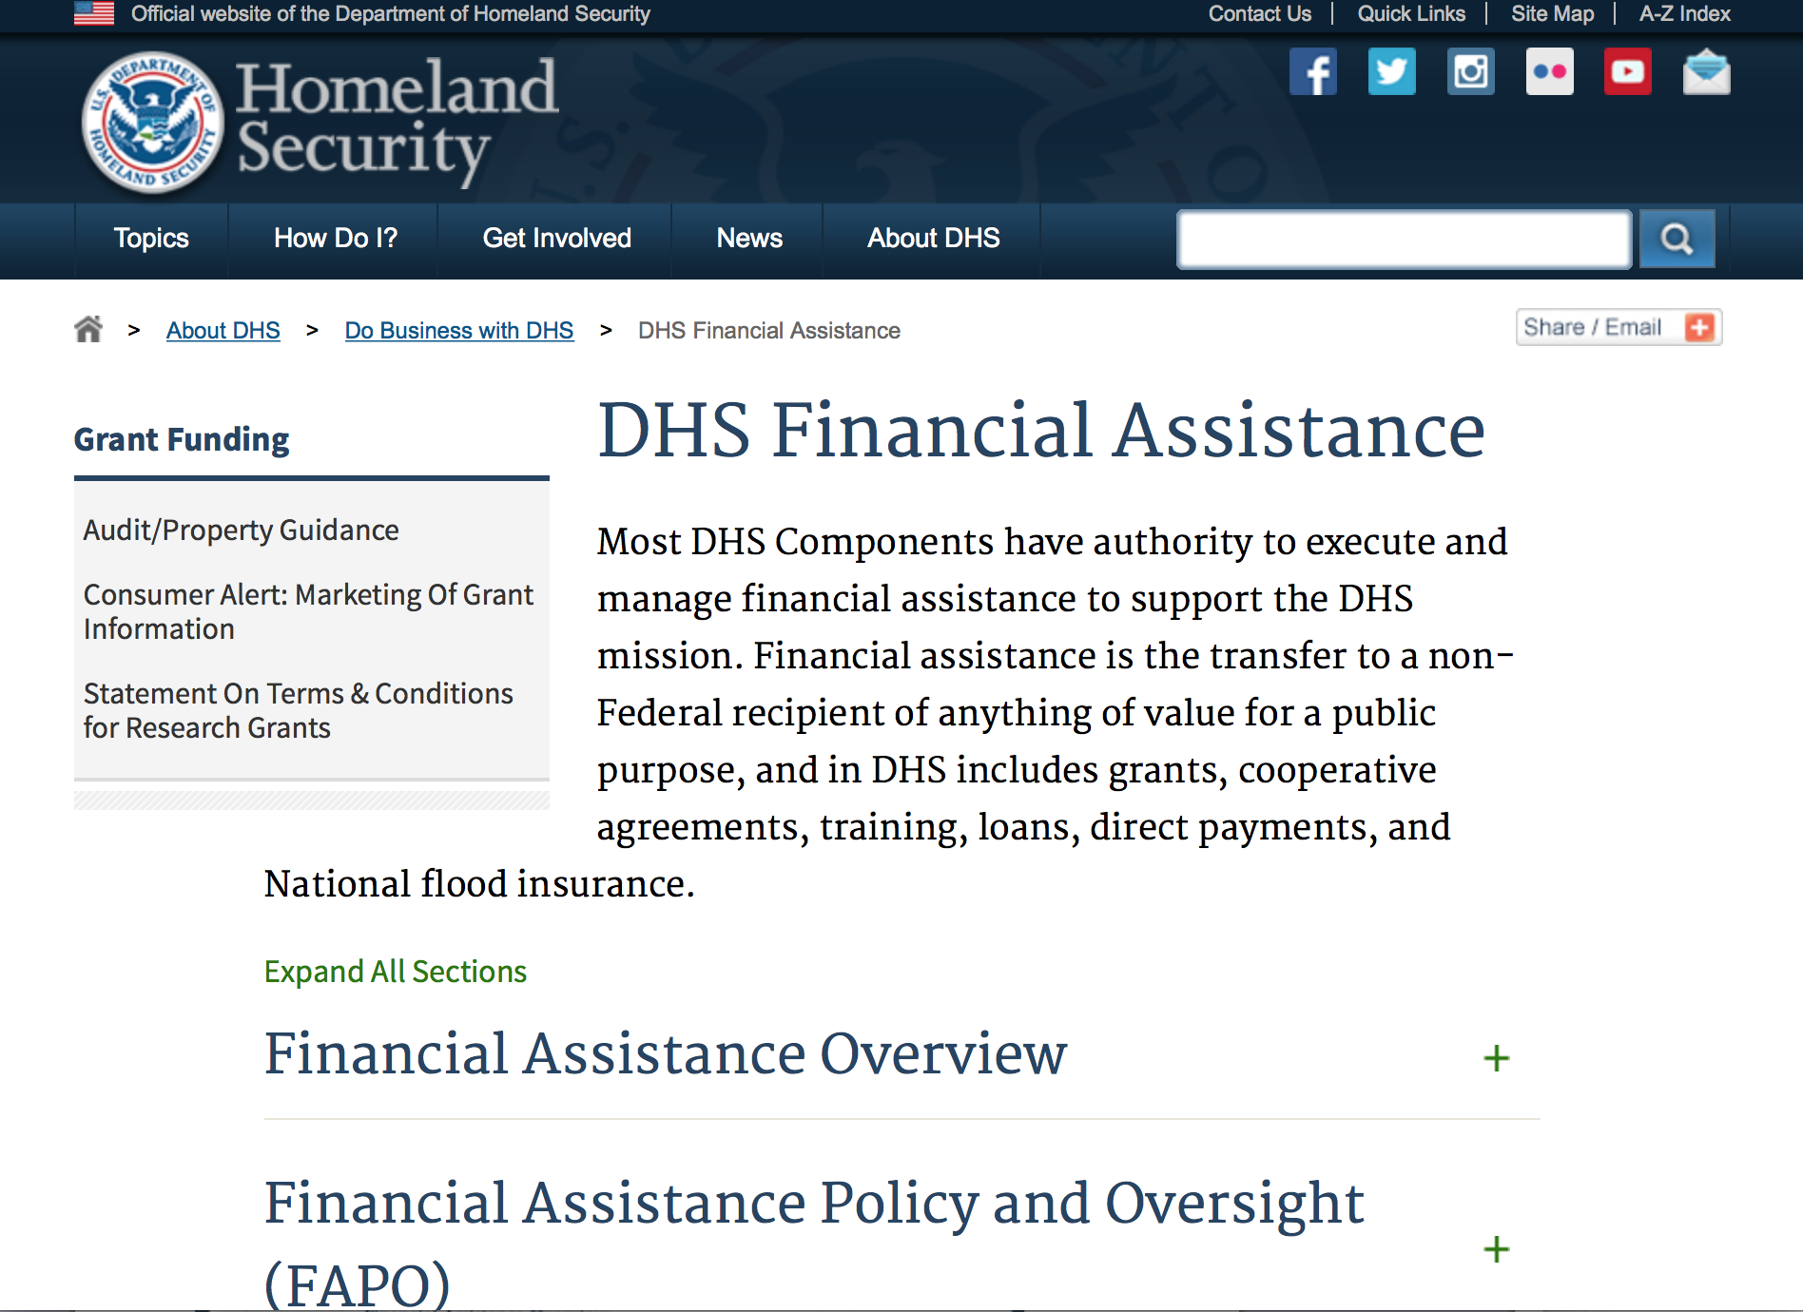
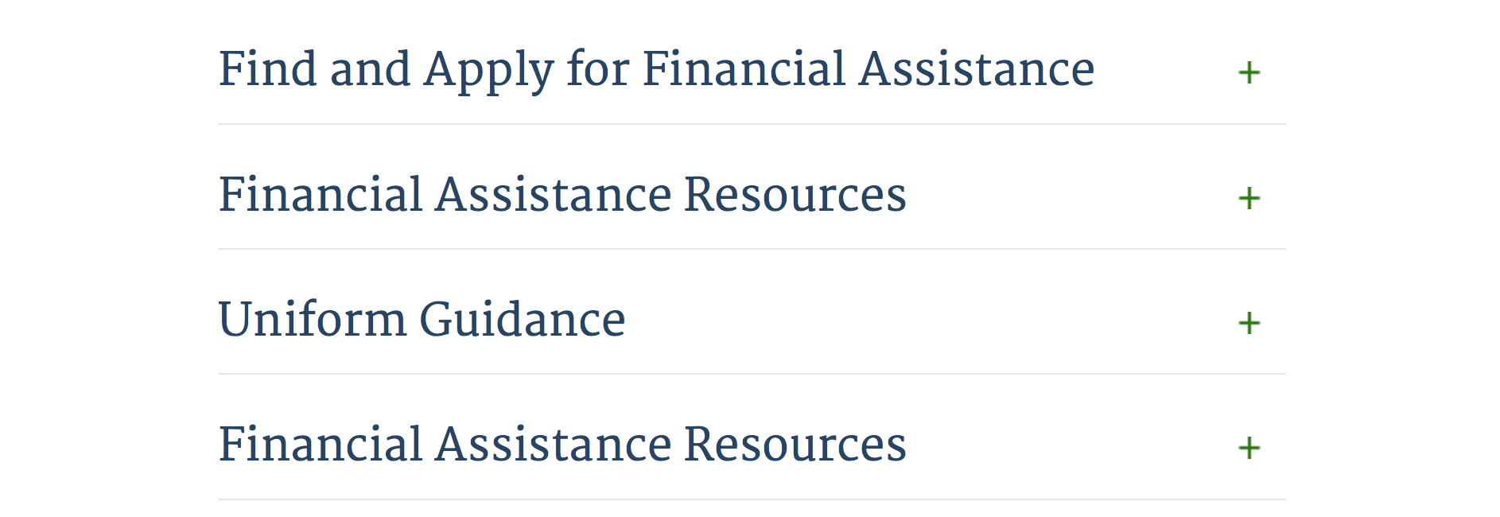

Webpage can be viewed at: http://www.dhs.gov/xopnbiz/grants/index.shtm#2

Information about 2016 for reference only
The FY 2016 Assistance to Firefighters Grants (AFG)
FY 2016 ASSISTANCE TO FIREFIGHTERS (AFG) GRANTS IS CLOSED AT THIS TIME
- FY 2016 Application Workshop Schedule
- FY 2016 AFG Application Guidance Materials The following documents are now available:
  - FY 2016 Notice of Funding Opportunity (NOFO) – Available Now
  - FY 2016 AFG Grant Application Get Ready Guide
  - FY 2016 AFG Narrative Get Ready Guide
  - FY 2016 AFG Self-Evaluation - Operations and Safety
  - FY 2016 AFG Self-Evaluation - Vehicle Acquisition
  - FY 2016 AFG Application Checklist
  - FY 2016 AFG Cost Share Calculator
FY 2016 AFG FAQs
For AFG program guidance materials, please visit our Documents page.

Resources

AFG Help Desk
Contact the AFG Program Help Desk toll-free at 866-274-0960, or email us at firegrants@dhs.gov.
The AFG Program has Fire Program Specialists in 10 federal regional centers. These Regional Fire Program Specialists respond to questions about the AFG program and carry out grant monitoring activities. View regional contacts

Popular AFG links
- AFG Workshop Schedule
- Assistance to Firefighters Grants (AFG)
- AFG Awards List
- AFG Success Stories
- Staffing for Adequate Fire & Emergency Response (SAFER) Grants (SAFER)
- SAFER Awards List
- SAFER Success Stories
- Fire Prevention & Safety (FP&S) Grants
- FP&S Awards List
- FP&S Success Stories
- Grant Closeout Tutorial
- Assistance to Firefighters Grant (AFG) Email Alert Archive
- Frequently Asked Questions
Contact Information For The Assistance to Firefighters Grant (AFG) Program and Help Desk

Federal Funding Alternative To AFG

State Administrative Agencies (SAA) apply for and administer Federal grants on behalf of their States, including FEMA Preparedness Grants. The SAA will work with eligible organizations to comply with the general requirements of grant programs or cooperative agreements. Contact your State’s SAA to find out what current Federal funding opportunities may be available to your organization. A listing of the SAAs and points of contact can be found at http://www.fema.gov/library/viewRecord.do?id=6363.

Programs:

Modifications:

Reminders:

Department of Homeland Security - FEMA
FY17 Flood Mitigation Assistance
Synopsis 1
Document Type: | Grants Notice
Funding Opportunity Number: | DHS-17-MT-029-000-99
Funding Opportunity Title: | FY17 Flood Mitigation Assistance
Opportunity Category: | Discretionary
Opportunity Category Explanation:
Funding Instrument Type: | Grant
Category of Funding Activity: | Other (see text field entitled "Explanation of Other Category of Funding Activity" for clarification)
Category Explanation: | The Flood Mitigation Assistance (FMA) Program makes available Federal funds to State, Local and Tribal Governments to reduce or eliminate the risk of repetitive flood damage to buildings and structures insured under the National Flood Insurance Program (NFIP).
Expected Number of Awards: | 200
CFDA Number(s): | 97.029 -- Flood Mitigation Assistance
Cost Sharing or Matching Requirement:

Version: | Synopsis 1
Posted Date: | Jul 10, 2017
Last Updated Date: | Jul 10, 2017
Original Closing Date for Applications: | Nov 14, 2017
Current Closing Date for Applications: | Nov 14, 2017
Archive Date: | Dec 14, 2017
Estimated Total Program Funding: | $160,000,000
Eligible Applicants: | State governments  Others (see text field entitled "Additional Information on Eligibility" for clarification)  Native American tribal governments (Federally recognized)
Additional Information on Eligibility: | District of Columbia; U.S. Territories. Local governments must apply through their state.
Agency Name: | Department of Homeland Security - FEMA
Description: | The Flood Mitigation Assistance (FMA) Program makes available Federal funds to State, Local and Tribal Governments to reduce or eliminate the risk of repetitive flood damage to buildings and structures insured under the National Flood Insurance Program (NFIP). In FY17, the FMA Program will prioritize proposals that address community flood risk by setting aside $70 million for this purpose. FEMA will seek to fund two types of community flood mitigation activities: Advance Assistance for flood mitigation design and development of community flood mitigation projects and mitigation projects that address community flood risk for the purpose of reducing NFIP flood claim payments. The remaining funding, at least $90,000,000, will be used for FMA technical assistance, mitigation planning, and mitigation projects reducing risk to severe repetitive loss (SRL) and repetitive loss (RL) properties. Applicants must submit applications via the Mitigation eGrants system on the FEMA Grants Portal: https://portal.fema.gov. Applicants may submit a maximum of 1 advanced assistance and 1 community mitigation project sub-application.
Link to Additional Information:
Grantor Contact Information: | If you have difficulty accessing the full announcement electronically, please contact:  Mitigation eGrants System Helpdesk Phone: 1-855-228-3362  MTeGrants@fema.dhs.gov

http://www.grants.gov/web/grants/view-opportunity.html?oppId=295313

Department of Homeland Security - FEMA
FY17 Pre-Disaster Mitigation
Synopsis 1

Document Type: | Grants Notice
Funding Opportunity Number: | DHS-17-MT-047-000-99
Funding Opportunity Title: | FY17 Pre-Disaster Mitigation
Opportunity Category: | Discretionary
Opportunity Category Explanation:
Funding Instrument Type: | Grant
Category of Funding Activity: | Other (see text field entitled "Explanation of Other Category of Funding Activity" for clarification)
Category Explanation: | The Robert T. Stafford Disaster Relief and Emergency Assistance Act, Public Law 93-288, as amended, (42 U.S.C. 5133), Section 203 authorizes FEMA to make grants for the purpose of implementing a sustained pre-disaster natural hazard mitigation program to reduce overall risk to the population and structures from future hazard events, while also reducing reliance on Federal funding from future disasters.
Expected Number of Awards: | 250
CFDA Number(s): | 97.047 -- Pre-Disaster Mitigation
Cost Sharing or Matching Requirement: | No
Version: | Synopsis 1
Posted Date: | Jul 10, 2017
Last Updated Date: | Jul 10, 2017
Original Closing Date for Applications: | Nov 14, 2017
Current Closing Date for Applications: | Nov 14, 2017
Archive Date: | Dec 14, 2017
Estimated Total Program Funding: | $90,000,000
Award Ceiling: | $15,000,000
Eligible Applicants: | State governments  Native American tribal governments (Federally recognized)  Others (see text field entitled "Additional Information on Eligibility" for clarification)
Additional Information on Eligibility: | District of Columbia; U.S. Territories. Local governments must apply through their state.
Agency Name: | Department of Homeland Security - FEMA
Description: | The Pre-Disaster Mitigation (PDM) program makes available Federal funds to State, Local and Tribal Governments to implement and sustain cost-effective measures designed to reduce the risk to individuals and property from natural hazards, while also reducing reliance on Federal funding from future disasters. FEMA will provide allocations of $575,000 as required by the Stafford Act to states and territories; and a tribal set aside of $10 million for allocations up to $575,000 for Native American Indian tribal governments to support overall mitigation planning and projects. The remaining PDM funds will be awarded on a competitive basis with a focus on multi-state/tribal mitigation initiatives. Applicants must submit applications via the Mitigation eGrants system on the FEMA Grants Portal: https://portal.fema.gov. Applicants may submit a maximum of 9 project sub-applications notwithstanding any project(s) submitted for the state/territory allocation or tribal set aside. In addition, any state or tribe willing to serve as the applicant for a multi-state or tribal activity may submit one additional plan or project subapplication.
Link to Additional Information:
Grantor Contact Information: | If you have difficulty accessing the full announcement electronically, please contact:  Mitigation eGrants System Helpdesk Phone: 1-855-228-3362  MTeGrants@fema.dhs.gov

http://www.grants.gov/web/grants/view-opportunity.html?oppId=295314

Department of Housing and Urban Development

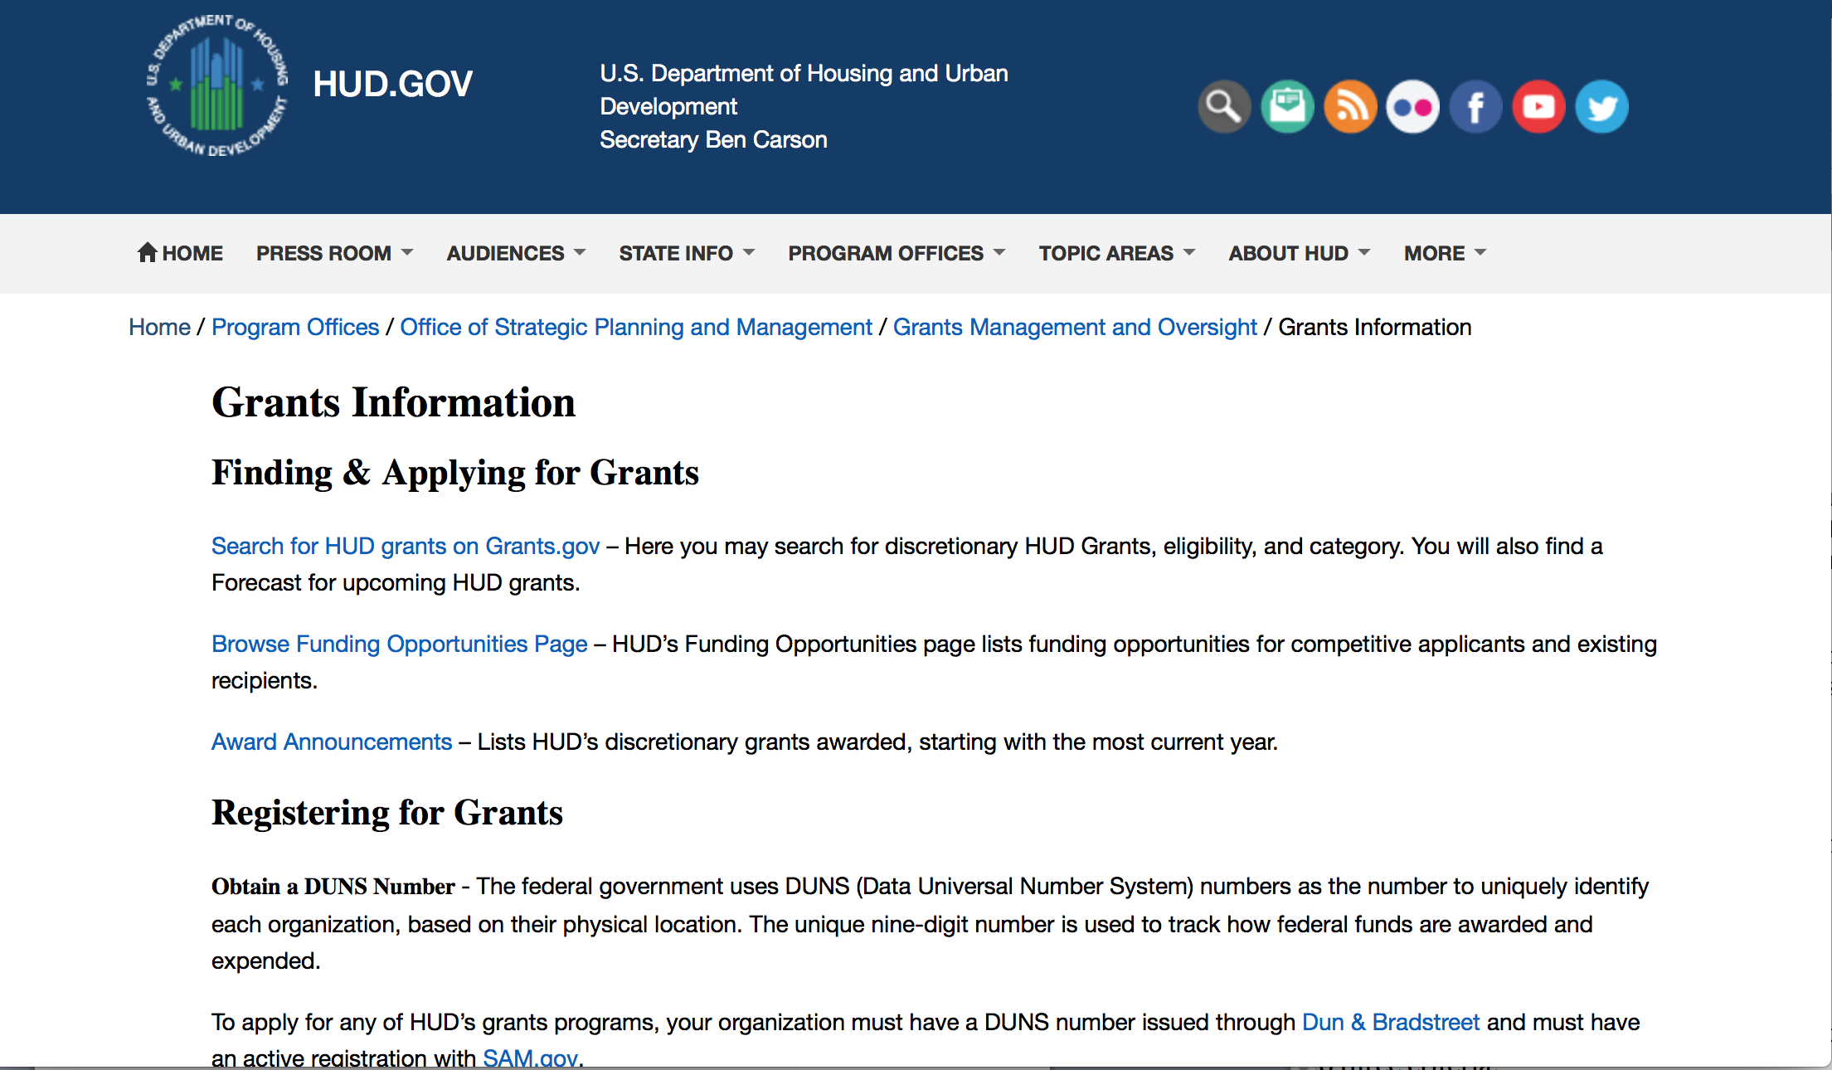
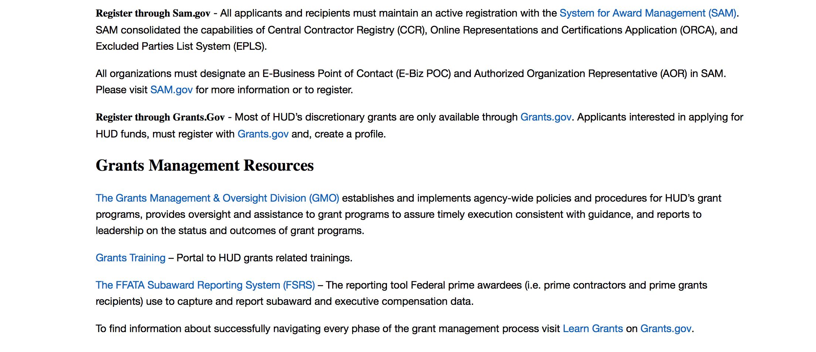
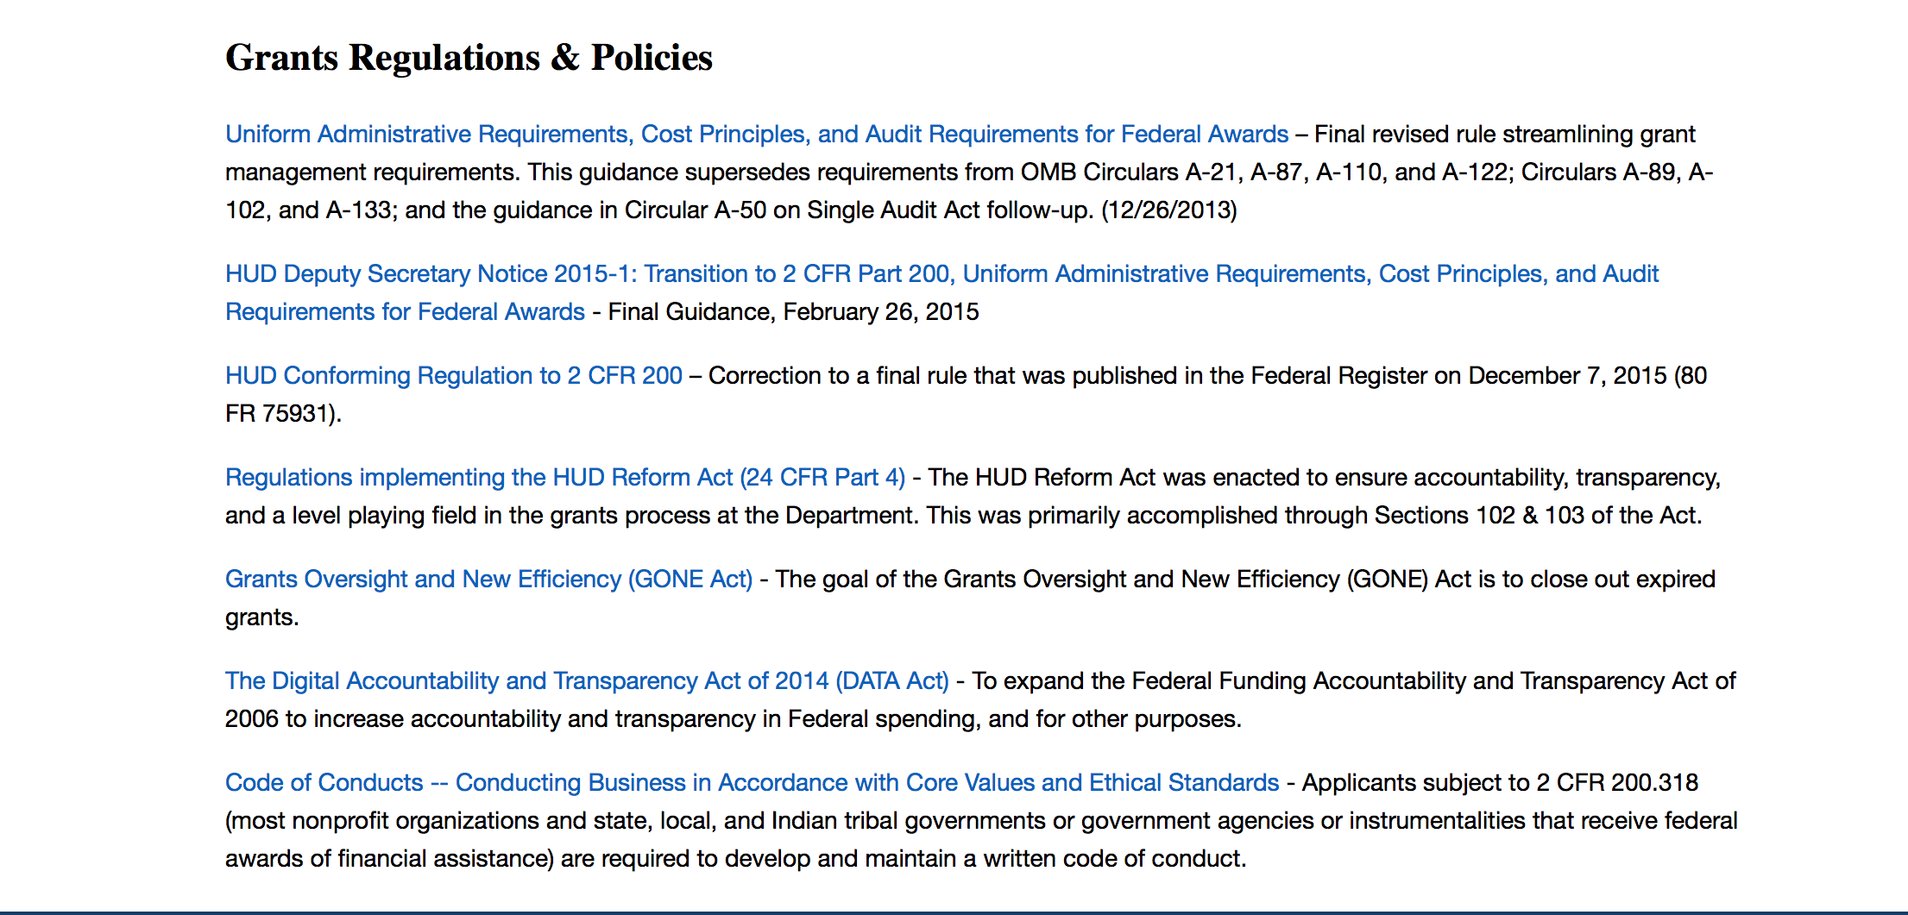

http://portal.hud.gov/hudportal/HUD?src=/topics/grants

HUD - Notice of Funds Available
For detailed information click here

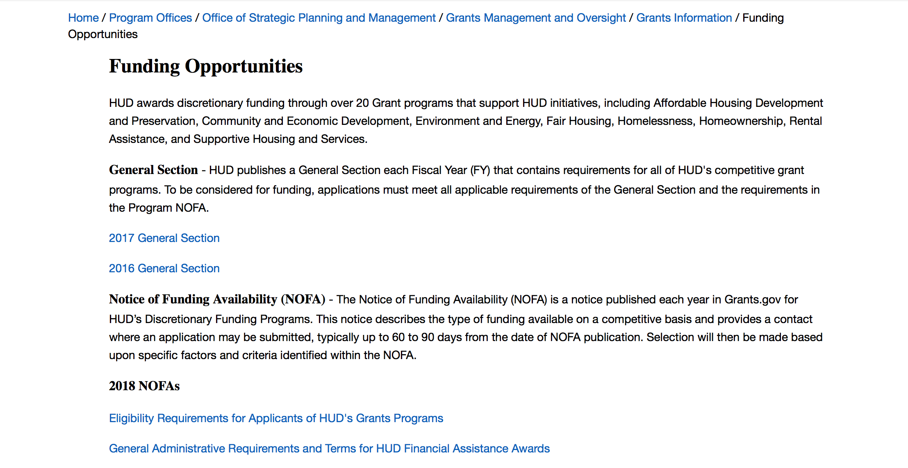

http://portal.hud.gov/hudportal/HUD?src=/program_offices/administration/grants/fundsavail

HUD NOFA FORECAST
The Department of Housing and Urban Development NOFA Forecast lists competitive grant opportunities that may be available for FY2016. The inclusion or exclusion of an opportunity in this list does not constitute a guarantee that a specific opportunity will become available or not be available. Forecast opportunities are subject to change based on enactment of Congressional appropriations and other considerations.
When funding is available, HUD will issue a Notice of Funding Availability (NOFA), which will be available on Grants.gov

Programs:

Rural Capacity Building for Community Development and Affordable Housing Grants (RCB)
Synopsis 1
Document Type: | Grants Notice
Funding Opportunity Number: | FR-6100-N-08
Funding Opportunity Title: | Rural Capacity Building for Community Development and Affordable Housing Grants (RCB)
Opportunity Category: | Discretionary
Opportunity Category Explanation:
Funding Instrument Type: | Grant
Category of Funding Activity: | Community Development
Category Explanation:
Expected Number of Awards: | 4
CFDA Number(s): | 14.265 -- Rural Capacity Building for Community Development and Affordable Housing Grants
Cost Sharing or Matching Requirement: | No
Version: | Synopsis 1
Posted Date: | Sep 28, 2017
Last Updated Date: | Sep 28, 2017
Original Closing Date for Applications: | Dec 07, 2017 Electronically submitted applications must be submitted no later than 11:59 p.m., ET, on the listed application due date.
Current Closing Date for Applications: | Dec 07, 2017 Electronically submitted applications must be submitted no later than 11:59 p.m., ET, on the listed application due date.
Archive Date: | Jan 06, 2018
Estimated Total Program Funding: | $5,000,000
Award Ceiling: | $2,500,000
Award Floor: | $1,000,000
Eligible Applicants: | Nonprofits having a 501(c)(3) status with the IRS, other than institutions of higher education
Additional Information on Eligibility: | Only National Organizations that are 501(c)(3) nonprofits can apply for HUD funding. For the purpose of determining eligibility for the RCB program, a national organization must be a single organization that meets all of these criteria: Has experience conducting activities from the first and/or the second RCB NOFA eligible activities in rural areas. Has experience working in rural areas with rural housing development organizations, Community Development Corporations (CDCs), Community Housing Development Organizations (CHDOs), local governments, and/or Indian tribes, and Has experience working, within the last ten years, in one or more states in at least seven Federal regions described on HUD's website at http://portal.hud.gov/hudportal/HUD?src=/localoffices/regions. Individuals, foreign entities, and sole proprietorship organizations are not eligible to compete for, or receive, awards made under this announcement.
Agency Name: | Department of Housing and Urban Development
Description: | Purpose: Through funding of national organizations with expertise in rural housing and community development, the Rural Capacity Building (RCB) program enhances the capacity and ability of rural housing development organizations, Community Development Corporations (CDCs), Community Housing Development Organizations (CHDOs), local governments, and Indian tribes to carry out community development and affordable housing activities that benefit low- and moderate-income families and persons in rural areas. a. Eligible Program Activities. Funds may be used to provide the following services: Training, education, support, and advice to enhance the technical and administrative capabilities of rural housing development organizations, CDCs, CHDOs, local governments, and Indian tribes, including the capacity to participate in consolidated planning, as well as in fair housing planning and Continuum of Care homeless assistance efforts that help ensure community-wide participation in assessing area needs; consulting broadly within the community; cooperatively planning for the use of available resources in a comprehensive and holistic manner; and assisting in evaluating performance under these community efforts and in linking plans with neighboring communities in order to foster regional planning; Loans, pass-through grants or other financial assistance to rural housing organizations, CDCs, CHDOs, local governments, and Indian tribes to carry-out community development and affordable housing activities that benefit low-income or low- and moderate-income families and persons by building the capacity of those eligible beneficiaries to serve rural communities over time. Such other activities as may be determined by the grantees in consultation with the Secretary or his or her designee. Program Priorities. Activities undertaken as part of, or as a result of, capacity building efforts described in this section shall support the implementation of other HUD programs in rural areas, including, but not limited to, the Community Development Block Grant Program (CDBG), HOME Investment Partnerships, Housing Opportunities for Persons With AIDS (HOPWA), Emergency Solutions Grant Program (ESG), and the Continuum of Care program, in addition to issues related to sustainability and comprehensive neighborhood revitalization activities. Through the eligible activities of this NOFA, grantees are encouraged to build the capacity of entities in rural areas that lack designated rural housing development organizations, CDCs or CHDOs and to ensure that those entities gain new access or expand existing access to federal funding. Grantees are encouraged to align with and support projects that create opportunities for transformative revitalization and investments focused on job growth, economic recovery, and neighborhood revitalization. Grantees are encouraged to consider how eligible beneficiaries may align investments with regional planning for sustainable economic development if such efforts are underway in a given jurisdiction.
Link to Additional Information: | https://hud.gov/program_offices/spm/gmomgmt/grantsinfo/fundingopps
Grantor Contact Information: | If you have difficulty accessing the full announcement electronically, please contact:  Diane Schmutzler Diane.M.Schmutzler@hud.gov  Grants Policy

http://www.grants.gov/web/grants/view-opportunity.html?oppId=297733

Modifications:

Choice Neighborhoods Implementation Grant Program
Synopsis 2
Document Type: | Grants Notice
Funding Opportunity Number: | FR-6100-N-34
Funding Opportunity Title: | Choice Neighborhoods Implementation Grant Program
Opportunity Category: | Discretionary
Opportunity Category Explanation:
Funding Instrument Type: | Grant
Category of Funding Activity: | Housing
Category Explanation:
Expected Number of Awards: | 5
CFDA Number(s): | 14.889 -- Choice Neighborhoods Implementation Grants
Cost Sharing or Matching Requirement: | Yes
Version: | Synopsis 2
Posted Date: | Aug 24, 2017
Last Updated Date: | Sep 14, 2017
Original Closing Date for Applications: | Nov 22, 2017 Electronically submitted applications must be submitted no later than 11:59 p.m., ET, on the listed application due date.
Current Closing Date for Applications: | Nov 22, 2017 Electronically submitted applications must be submitted no later than 11:59 p.m., ET, on the listed application due date.
Archive Date: | Dec 22, 2017
Estimated Total Program Funding: | $132,000,000
Award Ceiling: | $30,000,000
Award Floor: | $1
Eligible Applicants: | Others (see text field entitled "Additional Information on Eligibility" for clarification)
Additional Information on Eligibility: | The Lead Applicant must be a Public Housing Agency (PHA), a local government, or a tribal entity. If there is also a Co-Applicant, it must be a PHA, a local government, a tribal entity, a nonprofit, or a for-profit developer. Individuals, foreign entities, and sole proprietorship organizations are not eligible to compete for, or receive, awards made under this announcement.
Agency Name: | Department of Housing and Urban Development
Description: | Choice Neighborhoods Implementation Grants support the implementation of comprehensive neighborhood revitalization plans that are expected to achieve the following three core goals: 1. Housing: Replace distressed public and assisted housing with high-quality mixed-income housing that is well-managed and responsive to the needs of the surrounding neighborhood; 2. People: Improve intergenerational mobility with a focus on children and families; employment, health, and education outcomes; and 3. Neighborhood: Create the conditions necessary for public and private reinvestment in distressed neighborhoods to offer the kinds of amenities and assets, including safety, good schools, and commercial activity, that are important to families'; choices about their community.
Link to Additional Information: | http://portal.hud.gov/hudportal/HUD?src=/program_offices/spm/gmomgmt/grantsinfo/fundingopps
Grantor Contact Information: | If you have difficulty accessing the full announcement electronically, please contact:  Choice Neighborhoods office ChoiceNeighborhoods@hud.gov  Grants Policy

http://www.grants.gov/web/grants/view-opportunity.html?oppId=296794

Jobs Plus Initiative
Synopsis 2
Document Type: | Grants Notice
Funding Opportunity Number: | FR-6100-N-14
Funding Opportunity Title: | Jobs Plus Initiative
Opportunity Category: | Discretionary
Opportunity Category Explanation:
Funding Instrument Type: | Grant
Category of Funding Activity: | Housing
Category Explanation:
Expected Number of Awards: | 5
CFDA Number(s): | 14.895 -- Jobs-Plus Pilot Initiative
Cost Sharing or Matching Requirement: | Yes
Version: | Synopsis 2
Posted Date: | Sep 15, 2017
Last Updated Date: | Sep 15, 2017
Original Closing Date for Applications: | Nov 17, 2017 Electronically submitted applications must be submitted no later than 11:59 p.m., ET, on the listed application due date.
Current Closing Date for Applications: | Nov 17, 2017 Electronically submitted applications must be submitted no later than 11:59 p.m., ET, on the listed application due date.
Archive Date: | Dec 17, 2017
Estimated Total Program Funding: | $15,000,000
Award Ceiling: | $3,700,000
Award Floor: | $1,000,000
Eligible Applicants: | Others (see text field entitled "Additional Information on Eligibility" for clarification)
Additional Information on Eligibility: | Conditions for Eligibility of Public Housing Authorities Eligible applicants are PHAs that operate one or more public housing developments that meet the criteria outlined in this NOFA. A list of developments that meet the criteria is provided in Appendix B, however, the mere appearance of a development on this list does not mean that the development is appropriate for a Jobs Plus program. PHAs that received a Jobs Plus program grant in 2014, 2015 or 2016 are not eligible for 2017 grant funds. Federally designated tribes and tribally designated housing entities are not eligible entities under this award. Successful applicants will be required to implement the full 48-month term of the grant at the public housing site(s) for which funds were awarded. Successful applicants will be required to inform HUD of any planned Rental Assistance Demonstration (RAD) conversions at the Jobs Plus site. RAD Conversion of Jobs Plus sites will be permitted if the planned conversion will take place post award. Pursuant to the RAD Notice (Rental Assistance Demonstration &; Final Implementation, PIH-2012-32 (HA), as amended from time to time), Jobs Plus grantees that convert Jobs Plus target project(s) to PBV or PBRA through RAD will be able to finish out their Jobs Plus period of performance unless significant relocation and/or change in building occupancy is planned. If either is planned at the Jobs Plus target project(s), HUD may allow for a modification of the Jobs Plus work plan or may, at the Secretary's discretion, choose to end the Jobs Plus program at that project. Individuals, foreign entities, and sole proprietorship organizations are not eligible to compete for, or receive, awards made under this announcement.
Agency Name: | Department of Housing and Urban Development
Description: | 1. Purpose. The purpose of the Jobs Plus Pilot program is to develop locally-based, job-driven approaches to increase earnings and advance employment outcomes through work readiness, employer linkages, job placement, educational advancement, technology skills, and financial literacy for residents of public housing. The place-based Jobs Plus Pilot program addresses poverty among public housing residents by incentivizing and enabling employment through earned income disregards for working families, and a set of services designed to support work including employer linkages, job placement and counseling, educational advancement, and financial counseling. Ideally, these incentives will saturate the target developments, building a culture of work and making working families the norm. The Jobs Plus Pilot program consists of the following three core components: Employment-Related Services Financial Incentives &; Jobs Plus Earned Income Disregard (JPEID) Community Supports for Work Applicants are encouraged to develop key partnerships to connect participants with any other needed services to remove barriers to work. An Individualized Training and Services Plan (ITSP) should be developed for each participant to establish goals and service strategies, and to track progress. Background HUD, the Rockefeller Foundation, and the MDRC, through a public-private partnership, designed and supported the Jobs Plus program model between 1998 and 2003. HUD has issued two separate evaluation reports on the demonstration, in an effort to identify and document the most promising approaches to increasing employment among families in public housing. Each evaluation showed ongoing positive effects for residents when the program was well-implemented and included the three core elements. More information on the findings can be found at http://www.mdrc.org/project/jobs-plus-community-revitalization-initiative-public-housing-families#overview. Employment-Related Services Successful applicants must partner with the Department of Labor Workforce Investment Board (WIB) and American Job Center (AJC)/One-Stop in their area to offer multiple employment-related services for residents with a range of employment needs. Local Labor Market Information (LMI) should be used both for initial planning and analysis of which employment opportunities are most available locally, as well as for monitoring ongoing trends. Program services provided on-site should include, but need not be limited to, the following: Career exploration/job readiness workshops Job search and job placement assistance Work experience including on-the-job training, internships, pre-apprenticeships and Registered Apprenticeships (HUD encourages opportunities for residents to be paid while training whenever possible) Facilitated connections to education and training opportunities Rapid re-employment assistance in the event of job loss Proactive post-placement job retention support and career advancement coaching Access to computers, phones, fax, and copy machines and other supplies, for participants'; employment-related uses as well as adequate training on how to use these technologies To facilitate these employment services, applicants may consider having dedicated, on-site, workforce system staff to perform job developer and case manager functions. Job developers work directly with the business community to identify and create employment opportunities and act as liaisons with local employment agencies. Case managers work one-on-one with participants to guide them through the employment process and help them achieve employment-related goals. Financial Incentives &; Jobs Plus Earned Income Disregard (JPEID) Successful applicants must also implement a financial incentive to program participants, known as the Jobs Plus Earned Income Disregard (JPEID). This component will neutralize any rent increase due to rising income for Jobs Plus participants, removing a major disincentive to employment. Rent incentives offered through JPEID will be reimbursed to the PHA via Jobs Plus appropriations, and should be included in the program budget. Any other compensation to the PHA for lost rent revenues, such as by the standard EID calculation in the Operating Fund, will be offset manually to prevent overpayment of HUD funds to grant recipients. Further guidance will be available at the time of the award. All residents in a Jobs Plus development are eligible to receive the JPEID benefit, but in order to access JPEID they must sign up for the Jobs Plus program even if they do not actively participate in other Jobs Plus Activities. Residents who previously used up some or all of their lifetime EID eligibility are eligible to receive the full JPEID benefit. Disregarded Amount. The JPEID excludes from the Family Rent calculation 100 percent of incremental earned income for the entire period of the Jobs Plus program. Calculation of the JPEID. Once the JPEID is triggered for a family, their baseline income will not change for the duration of the term of the grant (so participants who enroll early may benefit from the JPEID longer than residents who enroll later.) To facilitate reimbursements for rent revenue losses due to the JPEID, grantees must calculate and document each participant's Family Rent both before and after the inclusion of any incremental earned income. The difference between these two rents is the amount to be reimbursed to the PHA through JPEID. These calculations must be provided to HUD when drawing reimbursement funds. As with any government benefit, an increase in earned income may result in the reduction or loss of other benefits that an individual was previously receiving. Grantees, through case management or other means, must be prepared to help residents understand the overall financial impact of an increase in earned income and the JPEID. It is also expected that grantees will encourage participants to take advantage of other financial work incentives they may be entitled to, such as the Earned Income Tax Credit (EITC). Community Supports for Work Successful applicants will incorporate a robust engagement strategy for involving the residents in the targeted development and creating a working community. Engagement is more than signing up; sustained involvement in the program leading to residents' ownership of their own growth and experiences, as well as that of peers, will yield continued benefits for both participants and future residents of the development beyond the grant period. Program outreach should be directed towards residents at all points along the employment spectrum; from unemployed individuals with no work history to working underemployed families with substantial work history. Unless an application specifies that the applicant will target a limited sub-group, the application narrative should include strategies to target this wide range of potential participants, as well as strategies for retention. One key strategy for retention should include the use of residents as Community Coaches. Community Coaches can market the various aspects of the Jobs Plus program, disseminate information about job opportunities and programs via resident social networks in the development, mentor specific individuals or groups who enroll in Jobs Plus, and help shape program offerings and outreach efforts based on their intimate knowledge of the needs and strengths of the community. Partnerships with Local Agencies The comprehensive nature of the Jobs Plus Pilot model requires that PHAs establish partnerships with American Job Centers and other key social service agencies within the community. HUD and DOL have developed a toolkit and webinar which describes effective strategies for establishing partnerships between PHAs and WIBs/AJCs (see; From the Ground Up: Creating Partnerships between Public Housing Authorities and Workforce Investment Boards; at (http://portal.hud.gov/hudportal/documents/huddoc?id=14_dol_publication.pdf) The toolkit provides several models for partnership that prospective applicants may want to consider. These partnerships will serve to strengthen program planning and implementation, as well as streamline access to services for participants. For each partner identified, applicants must describe the role of the partner agency and a description of the services to be provided by the partner agency, as well as the amount of grant funding (if any) that partners will receive. Applicants should demonstrate their ability to build collaboration among all partners, regardless of whether a partner will be receiving grant funding for their services, or if the services will be provided in-kind. Partners should include: Workforce Investment Boards/American Job Centers Local welfare agencies Employment and training organizations Vocational training providers Community colleges and four-year educational institutions Other supportive service agencies providing either direct services or referrals to services that are critical for supporting successful employment In addition to employment, training and educational supports, grantees will have the flexibility to provide other supportive services based on resident needs and local capacity. HUD expects that all services that are generally available to residents of the community will be leveraged in-kind from partners. Grant funds should only be used to procure services that are not already available (either by service type or amount). Examples of the types of services that may be provided by grant funds, formal partners or the program's referral network include but are not limited to the following: Child care services and/or after school programs Transportation assistance Financial literacy workshops Legal services (e.g. expungement) Domestic violence prevention services Services for formerly incarcerated/returning citizens Life Skills Other applicable local business support
Link to Additional Information: | http://portal.hud.gov/hudportal/HUD?src=/program_offices/administration/grants/fundsavail
Grantor Contact Information: | If you have difficulty accessing the full announcement electronically, please contact:  Jobs Plus jobsplus@hud.gov  Grants Policy

http://www.grants.gov/web/grants/view-opportunity.html?oppId=297406

Resident Opportunity & Self-Sufficiency Program
Synopsis 3
Document Type: | Grants Notice
Funding Opportunity Number: | FR-6100-N-05
Funding Opportunity Title: | Resident Opportunity & Self-Sufficiency Program
Opportunity Category: | Discretionary
Opportunity Category Explanation:
Funding Instrument Type: | Grant
Category of Funding Activity: | Housing
Category Explanation:
Expected Number of Awards: | 110
CFDA Number(s): | 14.870 -- Resident Opportunity and Supportive Services - Service Coordinators
Cost Sharing or Matching Requirement: | Yes
Version: | Synopsis 3
Posted Date: | Aug 24, 2017
Last Updated Date: | Sep 19, 2017
Original Closing Date for Applications: | Oct 23, 2017 Electronically submitted applications must be submitted no later than 11:59 p.m., ET, on the listed application due date.
Current Closing Date for Applications: | Oct 23, 2017 Electronically submitted applications must be submitted no later than 11:59 p.m., ET, on the listed application due date.
Archive Date: | Nov 22, 2017
Estimated Total Program Funding: | $35,000,000
Award Ceiling: | $738,000
Award Floor: | $0
Eligible Applicants: | Native American tribal governments (Federally recognized)  Public housing authorities/Indian housing authorities  Nonprofits having a 501(c)(3) status with the IRS, other than institutions of higher education  Nonprofits that do not have a 501(c)(3) status with the IRS, other than institutions of higher education
Additional Information on Eligibility: | The following entities are eligible to apply for FY17 ROSS-SC Funding: Native American tribal governments (federally recognized) Indian Housing Authorities/ Tribally Designated Housing Entities (TDHEs) Public Housing Agencies (PHAs) Nonprofits, including Resident Associations (RAs), having a 501(c)(3) status with the IRS, other than institutions of higher education Nonprofits, including Resident Associations (RAs), locally incorporated without 501(c)(3) status with the IRS, other than institutions of higher education All applicants should see Section III.C " Threshold Requirements" and Section IV.B "Content and Form of Application Submission" for more information on eligibility for funding requirements. EDSC Provision: PHAs that are currently eligible to receive annual funding under the Elderly/Disabled Service Coordinator (EDSC) program from the Public Housing Operating Fund that apply to serve elderly/disabled resident through this NOFA will forgo all future eligibility for EDSC funding through the Operating Fund. If you are receiving EDSC funds, you may apply to serve families only on the HUD-52768 to not risk your EDSC funding. To confirm if your PHA is affected by this EDSC provision, please see the list of PHAs that are eligible to receive EDSC funding (http://portal.hud.gov/hudportal/documents/huddoc?id=EDSC-FY16-ROSS-AWARDS.xls). Individuals, foreign entities, and sole proprietorship organizations are not eligible to compete for, or receive, awards made under this announcement.
Agency Name: | Department of Housing and Urban Development
Description: | Program Overview: The Resident Opportunity & Self Sufficiency (ROSS) Service Coordinator (SC) program funds eligible applicants to hire Service Coordinators to coordinate use of assistance under the Public Housing program with public and private resources, for supportive services and resident empowerment activities. Service Coordinators assess the needs of public and Indian housing residents and link them to supportive services that enable participants to increase earned income, reduce or eliminate the need for welfare assistance, and make progress toward achieving economic independence and housing self-sufficiency. In the case of elderly/disabled residents, the Service Coordinator links participants to supportive services which enable them to age/remain in-place thereby avoiding costlier forms of care. Funds awarded to applicants may be used for (1)service coordinator functions, (2) training and travel related to professional and/or program development, (3) and administration cost.
Link to Additional Information: | https://portal.hud.gov/hudportal/HUD?src=/program_offices/spm/gmomgmt/grantsinfo/fundingopps/fy17ROSS
Grantor Contact Information: | If you have difficulty accessing the full announcement electronically, please contact:  Tremayne Youmans Tremayne.E.Youmans@hud.gov  Grants Policy

http://www.grants.gov/web/grants/view-opportunity.html?oppId=296791

Deleted:

Reminders:

Choice Neighborhoods Implementation Grant Program
Synopsis 1
Document Type: | Grants Notice
Funding Opportunity Number: | FR-6100-N-34
Funding Opportunity Title: | Choice Neighborhoods Implementation Grant Program
Opportunity Category: | Discretionary
Opportunity Category Explanation:
Funding Instrument Type: | Grant
Category of Funding Activity: | Housing
Category Explanation:
Expected Number of Awards: | 5
CFDA Number(s): | 14.889 -- Choice Neighborhoods Implementation Grants
Cost Sharing or Matching Requirement: | Yes
Version: | Synopsis 1
Posted Date: | Aug 24, 2017
Last Updated Date: | Aug 24, 2017
Original Closing Date for Applications: | Nov 22, 2017 Electronically submitted applications must be submitted no later than 11:59 p.m., ET, on the listed application due date.
Current Closing Date for Applications: | Nov 22, 2017 Electronically submitted applications must be submitted no later than 11:59 p.m., ET, on the listed application due date.
Archive Date: | Dec 22, 2017
Estimated Total Program Funding: | $132,000,000
Award Ceiling: | $30,000,000
Award Floor: | $1
Eligible Applicants: | Others (see text field entitled "Additional Information on Eligibility" for clarification)
Additional Information on Eligibility: | The Lead Applicant must be a Public Housing Agency (PHA), a local government, or a tribal entity. If there is also a Co-Applicant, it must be a PHA, a local government, a tribal entity, a nonprofit, or a for-profit developer. Individuals, foreign entities, and sole proprietorship organizations are not eligible to compete for, or receive, awards made under this announcement.
Agency Name: | Department of Housing and Urban Development
Description: | Choice Neighborhoods Implementation Grants support the implementation of comprehensive neighborhood revitalization plans that are expected to achieve the following three core goals: 1. Housing: Replace distressed public and assisted housing with high-quality mixed-income housing that is well-managed and responsive to the needs of the surrounding neighborhood; 2. People: Improve intergenerational mobility with a focus on children and families'; employment, health, and education outcomes; and 3. Neighborhood: Create the conditions necessary for public and private reinvestment in distressed neighborhoods to offer the kinds of amenities and assets, including safety, good schools, and commercial activity, that are important to families'; choices about their community.
Link to Additional Information: | http://portal.hud.gov/hudportal/HUD?src=/program_offices/spm/gmomgmt/grantsinfo/fundingopps
Grantor Contact Information: | If you have difficulty accessing the full announcement electronically, please contact:  Choice Neighborhoods office ChoiceNeighborhoods@hud.gov  Grants Policy

http://www.grants.gov/web/grants/view-opportunity.html?oppId=296794

Institute of Museum and Library Services

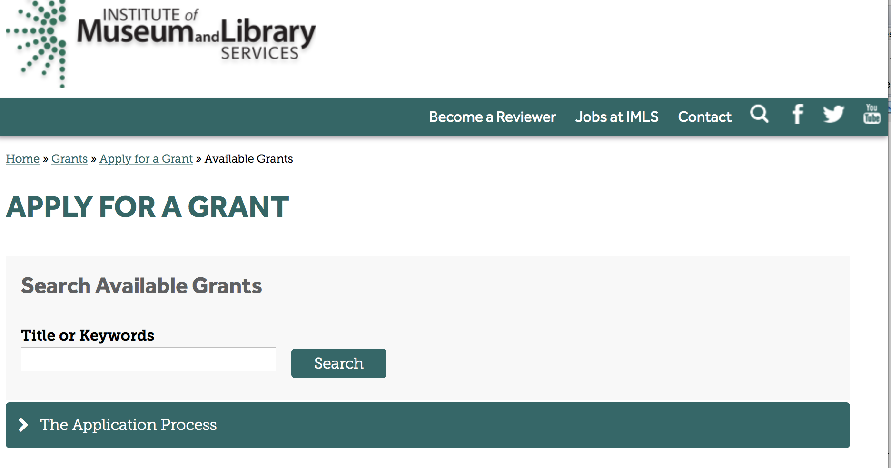

https://www.imls.gov/grants/apply-grant/available-grants

Each grant program has specific eligibility requirements. The links below provide general eligibility criteria for museums, libraries, and tribal organizations, but please note that additional organizations may be eligible for grants under certain programs. Additionally, ineligible organizations may still be able to participate in grant programs through partnerships with eligible organizations. Please click on the links below to see general criteria and review Applications and Guidelines for specific information.
Museums Libraries

Institutions: Archives, Federally Recognized Native American Tribe, Historical Society, Library, Nonprofits that serve Native Hawaiians, Professional Association, Public or Private Non-profit Institutions of Higher Education, Regional Organization, State Library Administrative Agency, State or Local Government

Check out IMLS's Facebook page at:
https://www.facebook.com/USIMLS/

Programs:

Institute of Museum and Library Services
National Leadership Grants for Museums
Synopsis 1

Document Type: | Grants Notice
Funding Opportunity Number: | NLG-M-FY18
Funding Opportunity Title: | National Leadership Grants for Museums
Opportunity Category: | Discretionary
Opportunity Category Explanation:
Funding Instrument Type: | Grant
Category of Funding Activity: | Arts (see "Cultural Affairs" in CFDA)  Humanities (see "Cultural Affairs" in CFDA)
Category Explanation:
Expected Number of Awards: | 11
CFDA Number(s): | 45.312 -- National Leadership Grants
Cost Sharing or Matching Requirement: | Yes
Version: | Synopsis 1
Posted Date: | Sep 29, 2017
Last Updated Date: | Sep 29, 2017
Original Closing Date for Applications: | Dec 01, 2017
Current Closing Date for Applications: | Dec 01, 2017
Archive Date: | Dec 31, 2017
Estimated Total Program Funding: | $6,500,000
Award Ceiling: | $1,000,000
Award Floor: | $5,000
Eligible Applicants: | Others (see text field entitled "Additional Information on Eligibility" for clarification)
Additional Information on Eligibility: | Please see the Notice of Funding Opportunity for eligibility information.
Agency Name: | Institute of Museum and Library Services
Description: | National Leadership Grants for Museums support projects that address critical needs of the museum field and that have the potential to advance practice in the profession so that museums can improve services for the American public.
Link to Additional Information: | https://www.imls.gov/grants/available/national-leadership-grants-museums
Grantor Contact Information: | If you have difficulty accessing the full announcement electronically, please contact:  Helen Wechsler, Supervisory Grants Management Specialist, 202-653-4779, hwechsler@imls.gov; Sandra Narva, Senior Program Officer, 202-653-4791, snarva@imls.gov; Connie Bodner, Supervisory Grants Management Specialist, 202-653-4636, cbodner@imls.gov; Steve Shwartzman, Senior Program Officer, 202-653-4641, sshwartzman@imls.gov; Jill Connors-Joyner, Museum Program Specialist, 202-653-4791, jconnors-joyner@imls.gov; Reagan Moore, Museum Program Specialist, 202-653-4637, rmoore@imls.gov; Mark Feitl, Museum Program Specialist, 202-653-4635, mfeitl@imls.gov  imls-museumgrants@imls.gov

http://www.grants.gov/web/grants/view-opportunity.html?oppId=297756

Museums for America
Synopsis 1
Document Type: | Grants Notice
Funding Opportunity Number: | MFA-FY18
Funding Opportunity Title: | Museums for America
Opportunity Category: | Discretionary
Opportunity Category Explanation:
Funding Instrument Type: | Grant
Category of Funding Activity: | Arts (see "Cultural Affairs" in CFDA)  Humanities (see "Cultural Affairs" in CFDA)
Category Explanation:
Expected Number of Awards: | 130
CFDA Number(s): | 45.301 -- Museums for America
Cost Sharing or Matching Requirement: | Yes
Version: | Synopsis 1
Posted Date: | Sep 29, 2017
Last Updated Date: | Sep 29, 2017
Original Closing Date for Applications: | Dec 01, 2017
Current Closing Date for Applications: | Dec 01, 2017
Archive Date: | Dec 31, 2017
Estimated Total Program Funding: | $19,150,000
Award Ceiling: | $250,000
Award Floor: | $5,000
Eligible Applicants: | Others (see text field entitled "Additional Information on Eligibility" for clarification)
Additional Information on Eligibility: | Please see the Notice of Funding Opportunity for eligibility information.
Agency Name: | Institute of Museum and Library Services
Description: | The Museums for America (MFA) program supports projects that strengthen the ability of an individual museum to serve its public.
Link to Additional Information: | https://www.imls.gov/grants/available/museums-america
Grantor Contact Information: | If you have difficulty accessing the full announcement electronically, please contact:  Sandra Narva, Senior Program Officer, 202-653-4791, snarva@imls.gov; Connie Bodner, Supervisory Grants Management Specialist, 202-653-4636, cbodner@imls.gov; Helen Wechsler, Supervisory Grants Management Specialist, 202-653-4779, hwechsler@imls.gov; Steve Shwartzman, Senior Program Officer, 202-653-4641, sshwartzman@imls.gov; Jill Connors-Joyner, Museum Program Specialist, 202-653-4791, jconnors-joyner@imls.gov; Reagan Moore, Museum Program Specialist, 202-653-4637, rmoore@imls.gov; Mark Feitl, Museum Program Specialist, 202-653-4635, mfeitl@imls.gov  imls-museumgrants@imls.gov

http://www.grants.gov/web/grants/view-opportunity.html?oppId=297772

Modifications:

Reminders:

Deleted:

Department of the Interior
Working with Interior

The Interior Department provides assistance to the public, local governments and businesses through a number of programs. For a general overview see: http://www.doi.gov/index.cfm

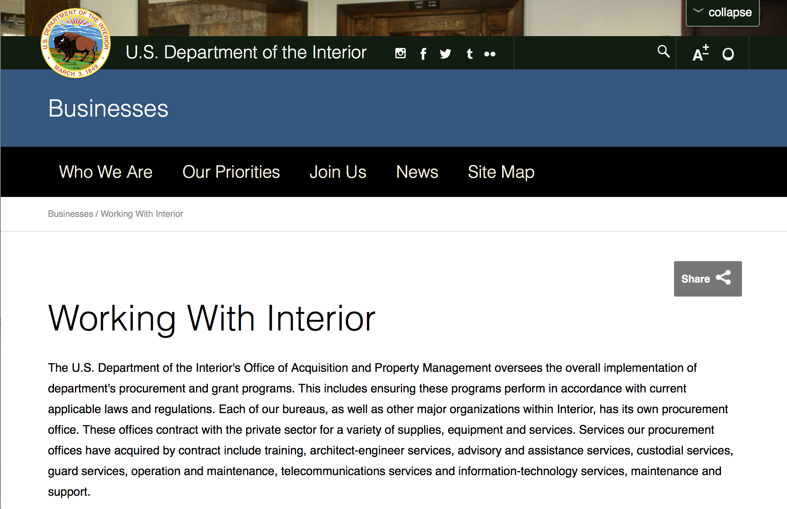

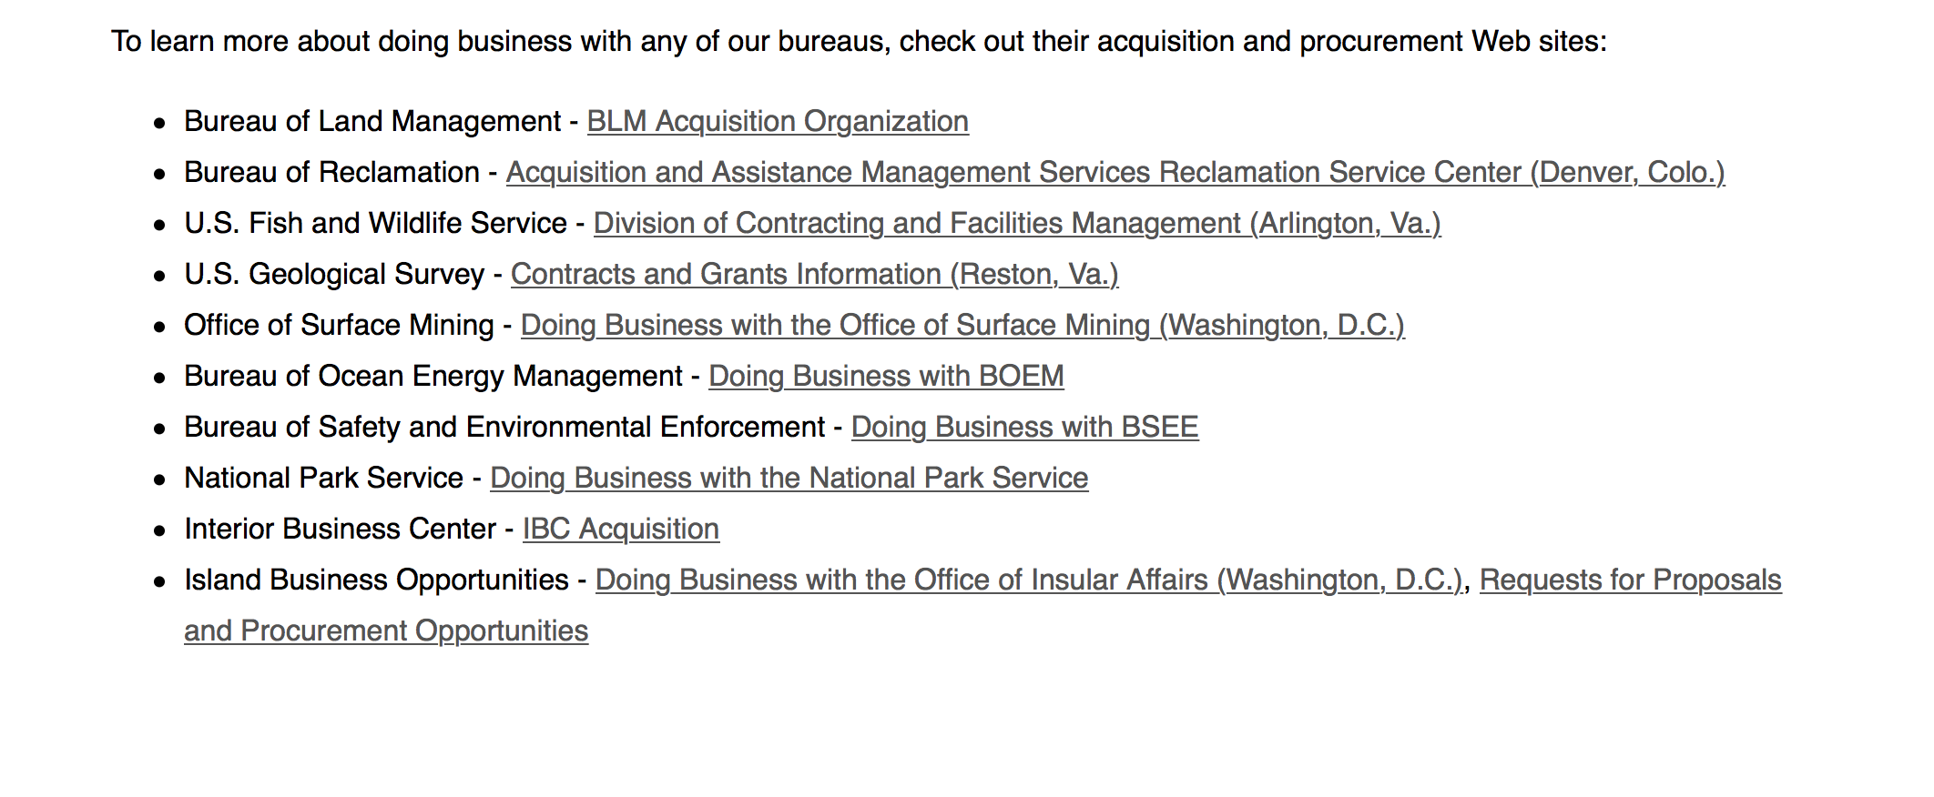
http://www.doi.gov/businesses/working-with-interior.cfm

Programs:

Geological Survey
The Educational Component of the National Cooperative Geologic Mapping Program
Synopsis 1
Document Type: | Grants Notice
Funding Opportunity Number: | G18AS00005
Funding Opportunity Title: | The Educational Component of the National Cooperative Geologic Mapping Program
Opportunity Category: | Discretionary
Opportunity Category Explanation:
Funding Instrument Type: | Cooperative Agreement
Category of Funding Activity: | Education
Category Explanation:
Expected Number of Awards: | 0
CFDA Number(s): | 15.810 -- National Cooperative Geologic Mapping
Cost Sharing or Matching Requirement: | Yes
Version: | Synopsis 1
Posted Date: | Sep 07, 2017
Last Updated Date: | Sep 07, 2017
Original Closing Date for Applications: | Nov 08, 2017
Current Closing Date for Applications: | Nov 08, 2017
Archive Date: | Dec 08, 2017
Estimated Total Program Funding: | $429,000
Award Ceiling: | $50,000
Award Floor: | $0
Eligible Applicants: | Others (see text field entitled "Additional Information on Eligibility" for clarification)
Additional Information on Eligibility: | U.S. accredited university Geoscience or related Departments are eligible for EDMAP funds. University professors must write and submit the proposals. EDMAP cooperative agreements are intended to fund students doing geologic mapping in the field. While it is proper for the professor’s advisors to ask for some logistical support so that they may be with their student(s) in the field for a credible amount of time, the bulk of the award is intended to support the students mapping efforts. EDMAP cooperative agreements do not support faculty salaries. Masters and Doctoral students of Geoscience or related Departments at accredited United States colleges and universities are eligible applicants to the EDMAP Program. In addition, qualified undergraduate Juniors and Seniors are also eligible. These undergraduates should have received some basic mineralogy, petrology and structural geology training prior to the time they will do the geologic mapping proposed in this proposal.
Agency Name: | Geological Survey
Description: | The primary objective of the EDMAP component of the NCGMP is to train the next generation of geologic mappers. To do this NCGMP provides funds for graduate and selected undergraduate students in academic research projects that involve geologic mapping as a major component. Through these cooperative agreements NCGMP hopes to expand the research and educational capacity of academic programs that teach earth science students the techniques of geologic mapping and field data analysis. Another important goal is to increase the level of communication between the Nations geologic surveys (both State Geological Surveys and the USGS) and geologic mappers in the academic community. We hope that this improved communication will have two results: 1) that the academic mapping community will learn more about the societal needs that drive geologic mapping projects at the USGS and State Geologic Surveys, and 2) more geologic maps produced in academia will eventually be made available to the public.
Link to Additional Information: | http://www.grants.gov
Grantor Contact Information: | If you have difficulty accessing the full announcement electronically, please contact:  Grant Specialist Kimberly Dove 703-648-7487 kdove@usgs.gov  kdove@usgs.gov

http://www.grants.gov/web/grants/view-opportunity.html?oppId=297215

Modifications:

Reminders:

Deleted:

Department of Justice

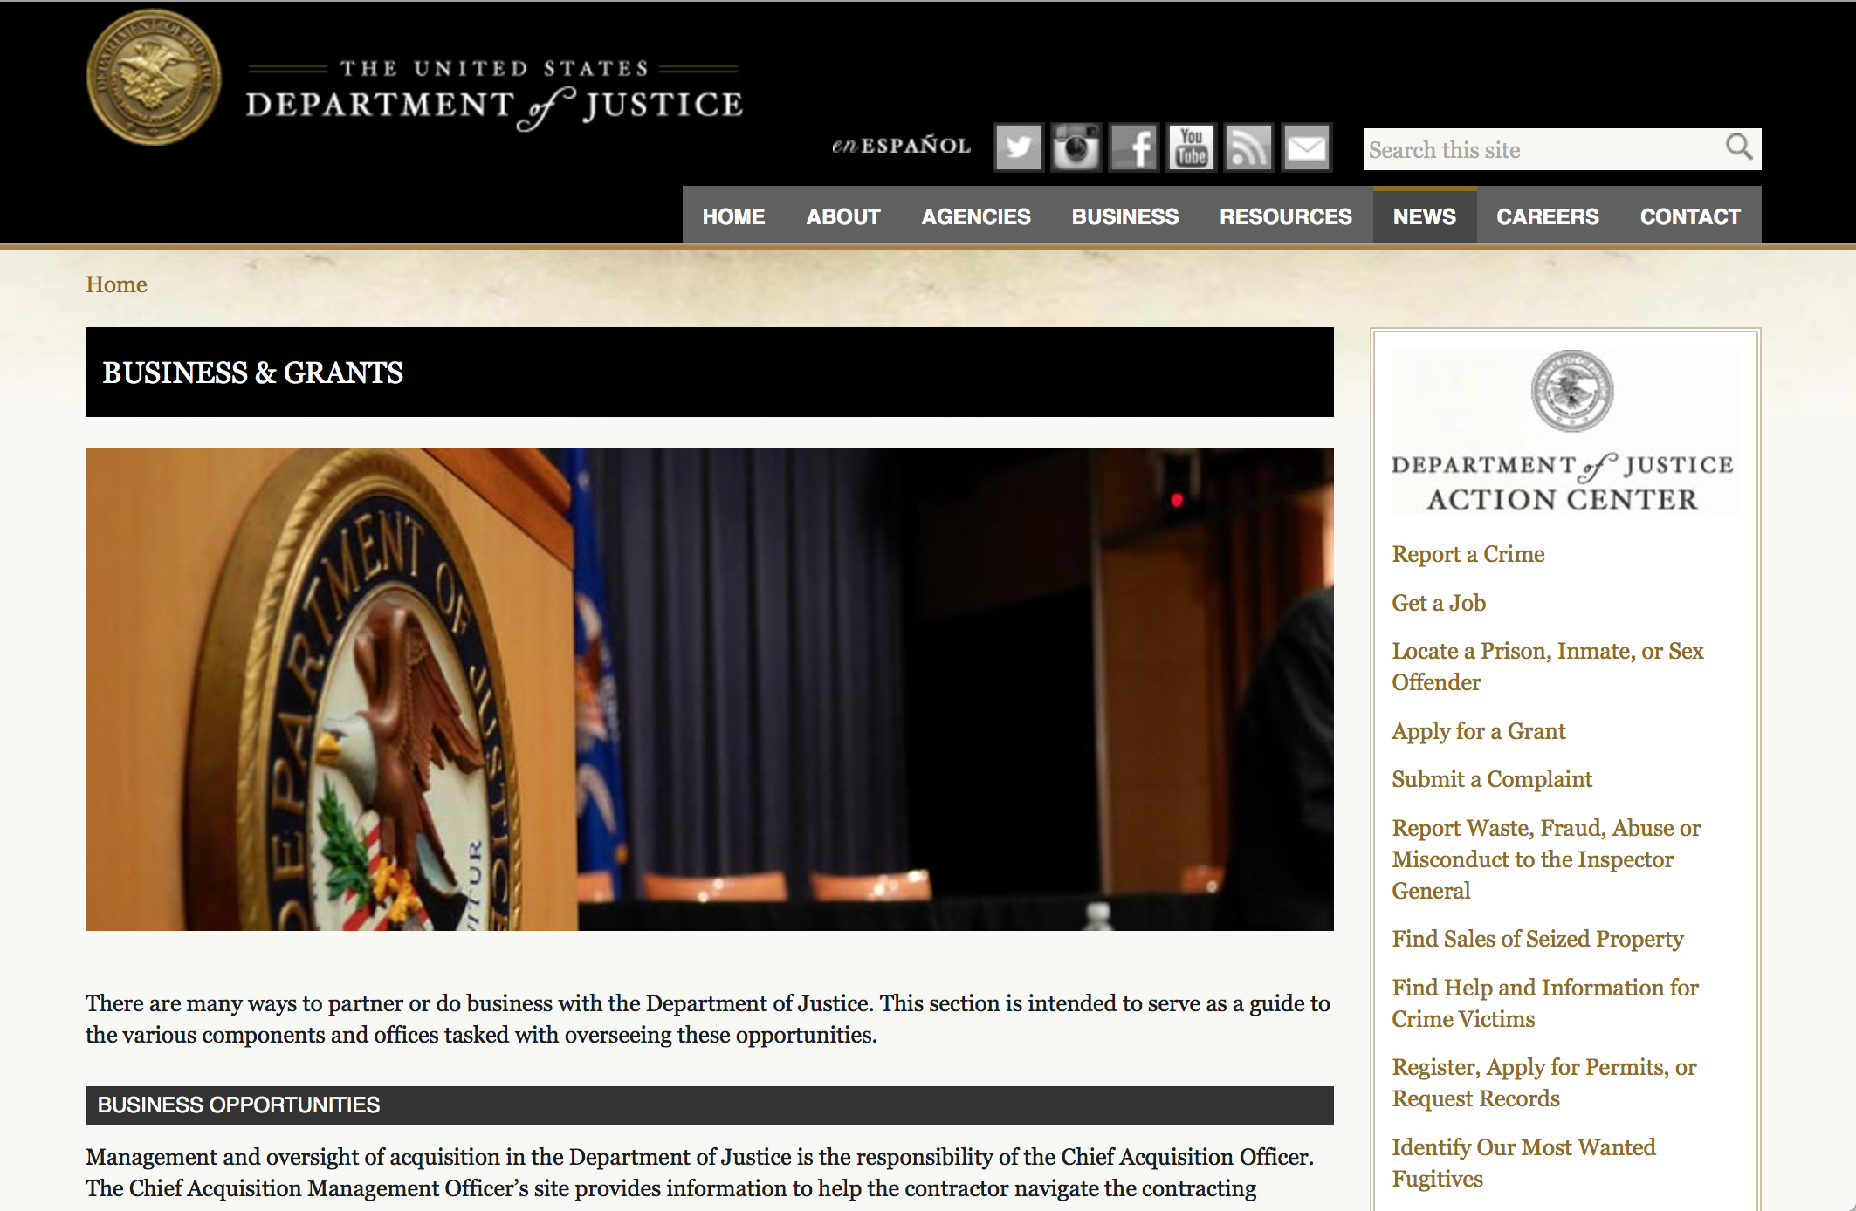

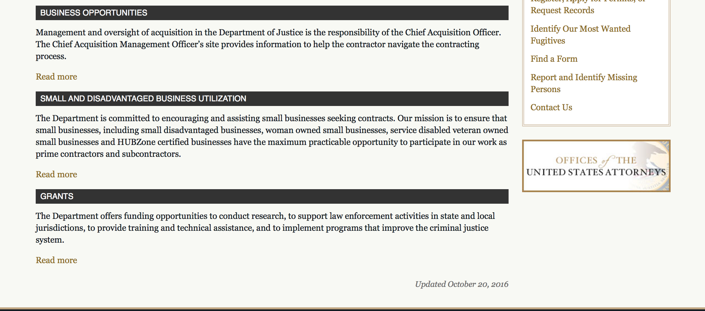

The DOJ agencies listed below also have sites that provide grant information specific to that agency. Examples of what can be found on these sites are programs, funding opportunities, application assistance, and other useful information.

Bureau of Justice Assistance (BJA)

Bureau of Justice Statistics (BJS)

National Criminal Justice Reference Service (NCJRS)

National Institute of Justice (NIJ)

Office of Sex Offender Sentencing, Monitoring, Apprehending, Registering, and Tracking (SMART)

http://www.justice.gov/business/

Programs:

Office on Violence Against Women
Supplemental OVW Fiscal Year 2017 Enhanced Training And Services To End Abuse In Later Life Program Solicitation
Synopsis 1

Document Type: | Grants Notice
Funding Opportunity Number: | OVW-2017-13480
Funding Opportunity Title: | Supplemental OVW Fiscal Year 2017 Enhanced Training And Services To End Abuse In Later Life Program Solicitation
Opportunity Category: | Discretionary
Opportunity Category Explanation:
Funding Instrument Type: | Cooperative Agreement
Category of Funding Activity: | Law, Justice and Legal Services
Category Explanation:
Expected Number of Awards: | 8
CFDA Number(s): | 16.528 -- Enhanced Training and Services to End Violence and Abuse of Women Later in Life
Cost Sharing or Matching Requirement: | No
Version: | Synopsis 1
Posted Date: | Sep 13, 2017
Last Updated Date: | Sep 13, 2017
Original Closing Date for Applications: | Nov 08, 2017
Current Closing Date for Applications: | Nov 08, 2017
Archive Date:
Estimated Total Program Funding: | $2,300,000
Award Ceiling: | $400,000
Award Floor: | $0
Eligible Applicants: | State governments  Native American tribal organizations (other than Federally recognized tribal governments)  Native American tribal governments (Federally recognized)  Nonprofits having a 501(c)(3) status with the IRS, other than institutions of higher education  County governments  Others (see text field entitled "Additional Information on Eligibility" for clarification)  City or township governments
Additional Information on Eligibility: | • Population specific organizations with demonstrated experience in assisting individuals over 50 years of age; • Victim service providers with demonstrated experience in addressing domestic violence, dating violence, sexual assault, and stalking; and • State, tribal, or territorial domestic violence or sexual assault coalitions
Agency Name: | Office on Violence Against Women
Description: | Enhanced Training And Services To End Abuse In Later Life Program (Abuse in Later Life) provides or enhances training and services to address elder abuse, neglect, and exploitation, including domestic violence, dating violence, sexual assault, or stalking, involving victims who are 50 years of age or older. In FY 2017, OVW will fund projects that will focus on providing training to assist criminal justice and other professionals in recognizing and addressing instances of elder abuse; providing services for older victims of abuse in later life; and supporting multidisciplinary collaborative community responses to victims of abuse in later life.
Link to Additional Information: | Full Solicitation
Grantor Contact Information: | If you have difficulty accessing the full announcement electronically, please contact:  Janice A. Green Sr. Program Specialist 202-616-6728 janice.a.green@usdoj.gov  janice.a.green@usdoj.gov

http://www.grants.gov/web/grants/view-opportunity.html?oppId=297344

Research:

Modifications:

Deleted:

Reminders:



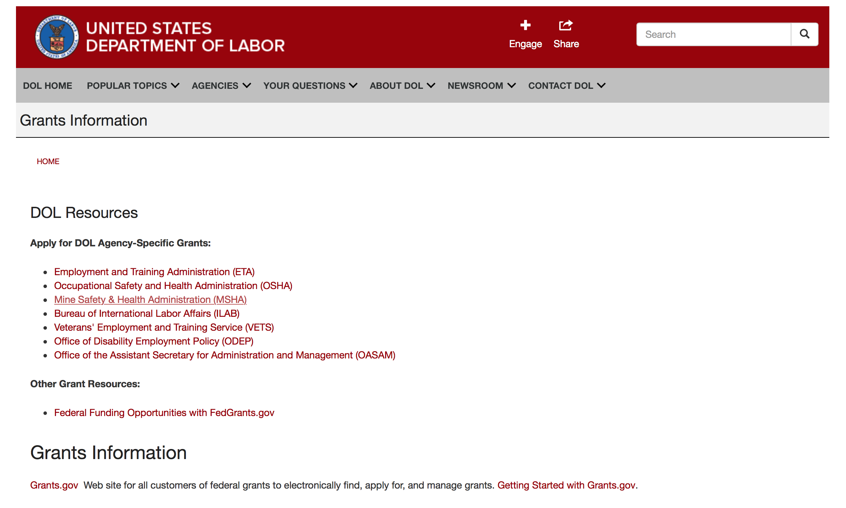

Agency Grants and Contract General Overview

DOL Resources
Apply for DOL Agency-Specific Grants:
- Employment and Training Administration (ETA)
- Occupational Safety and Health Administration (OSHA)
- Mine Safety & Health Administration (MSHA)
- Bureau of International Labor Affairs (ILAB)
- Veterans' Employment and Training Service (VETS)
- Office of Disability Employment Policy (ODEP)
- Office of the Assistant Secretary for Administration and Management (OASAM)

Other Grant Resources:
- Federal Funding Opportunities with FedGrants.gov
Grants Information
Grants.gov — Web site for all customers of federal grants to electronically find, apply for, and manage grants. Getting Started with Grants.gov.

DOL Resources and Instructions for Applying for a Grant
- DOL Guidance Clarifying the Effect of the Religious Freedom Restoration Act on Faith-Based Organizations
- Grant and Contract Information
- Contracting and Grant Program Overview
- Civil Rights Enforcement for Department of Labor Grant Recipients
- More Information About Grants
- Use of Contracts, Grants & Cooperative Agreements

Other Federal Government Grant Information
- Grant Opportunities (Catalog of Federal Domestic Assistance)

Department of Labor Grant Programs

- Bureau of International Labor Affairs (ILAB): provides grants (cooperative agreements) for the implementation of projects designed to assist developing countries combat the worse forms of child labor, forced labor, and human trafficking; and support worker rights and improve working conditions. http://www.dol.gov/general/business.
- Bureau of Labor Statistics (BLS): provides project grants (cooperative agreements) and the dissemination of technical statistical data and related information on labor force activities; provides data on prices (CPI) and cost of living; data on productivity and technology data; data on compensation and working conditions; data on employment projections.
- Employment and Training (ETA): ETA administers financial assistance programs pursuant to the Workforce Investment Act (WIA), administering State formula grant programs for youth, adults and dislocated workers, national emergency grants for workers affected by mass layoffs, plant closures, and disasters; grant programs for workers with disabilities, Indians and Native Americans, and for migrant and seasonal farmworkers. ETA also administers grant programs for older American workers, apprenticeship programs, Trade Adjustment Assistance (TAA) programs, and assistance for research and development of workforce programs. In addition, ETA is responsible for the operation and maintenance of a national system of public employment service offices and for the national unemployment insurance program.
- Mine Safety and Health (MSHA): provides grants for research, education and training programs to ensure an adequate and competent staff of trained inspectors; and assistance for establishing or improving State mine health and safety programs through technical assistance.
- Occupational Safety and Health (OSHA): provides grants to non-profit organizations to provide training, educational services, and technical assistance; assistance to states to administer and enforce state programs; assistance to states to provide occupational safety and health technical assistance and consultant services.
- Office of Disability Employment Policy (ODEP): The Office of Disability Employment Policy awards competitive grants establishing short-term pilot and technical assistance projects designed to identify, develop, test, evaluate, and disseminate policies to increase employment by expanding access to training, education, employment supports, assistive and systems technology, integrated employment, entrepreneurial development, and small business opportunities for adults and youth with disabilities. Current pilots projects focus on customized employment, Olmstead populations, and innovative demonstration youth grants, among others. Solicitations for grant applications are published in the Federal Register and announced at www.dol.gov/odep. ODEP grants are awarded by the OASAM grant office.
- Veterans' Employment and Training (VETS): provides special employment and training assistance for veterans through the Disabled Veterans' Outreach Program (DVOP) Solicitation for Grant Applications; the Local Veterans' Employment Representative Program (LVER); Veterans' Workforce Investment Program (VWIP); elaws Advisor on veterans' employment and reemployment rights; and the Homeless Veterans Reintegration Project (HVRP). VETS grants are awarded by the OASAM grant office.

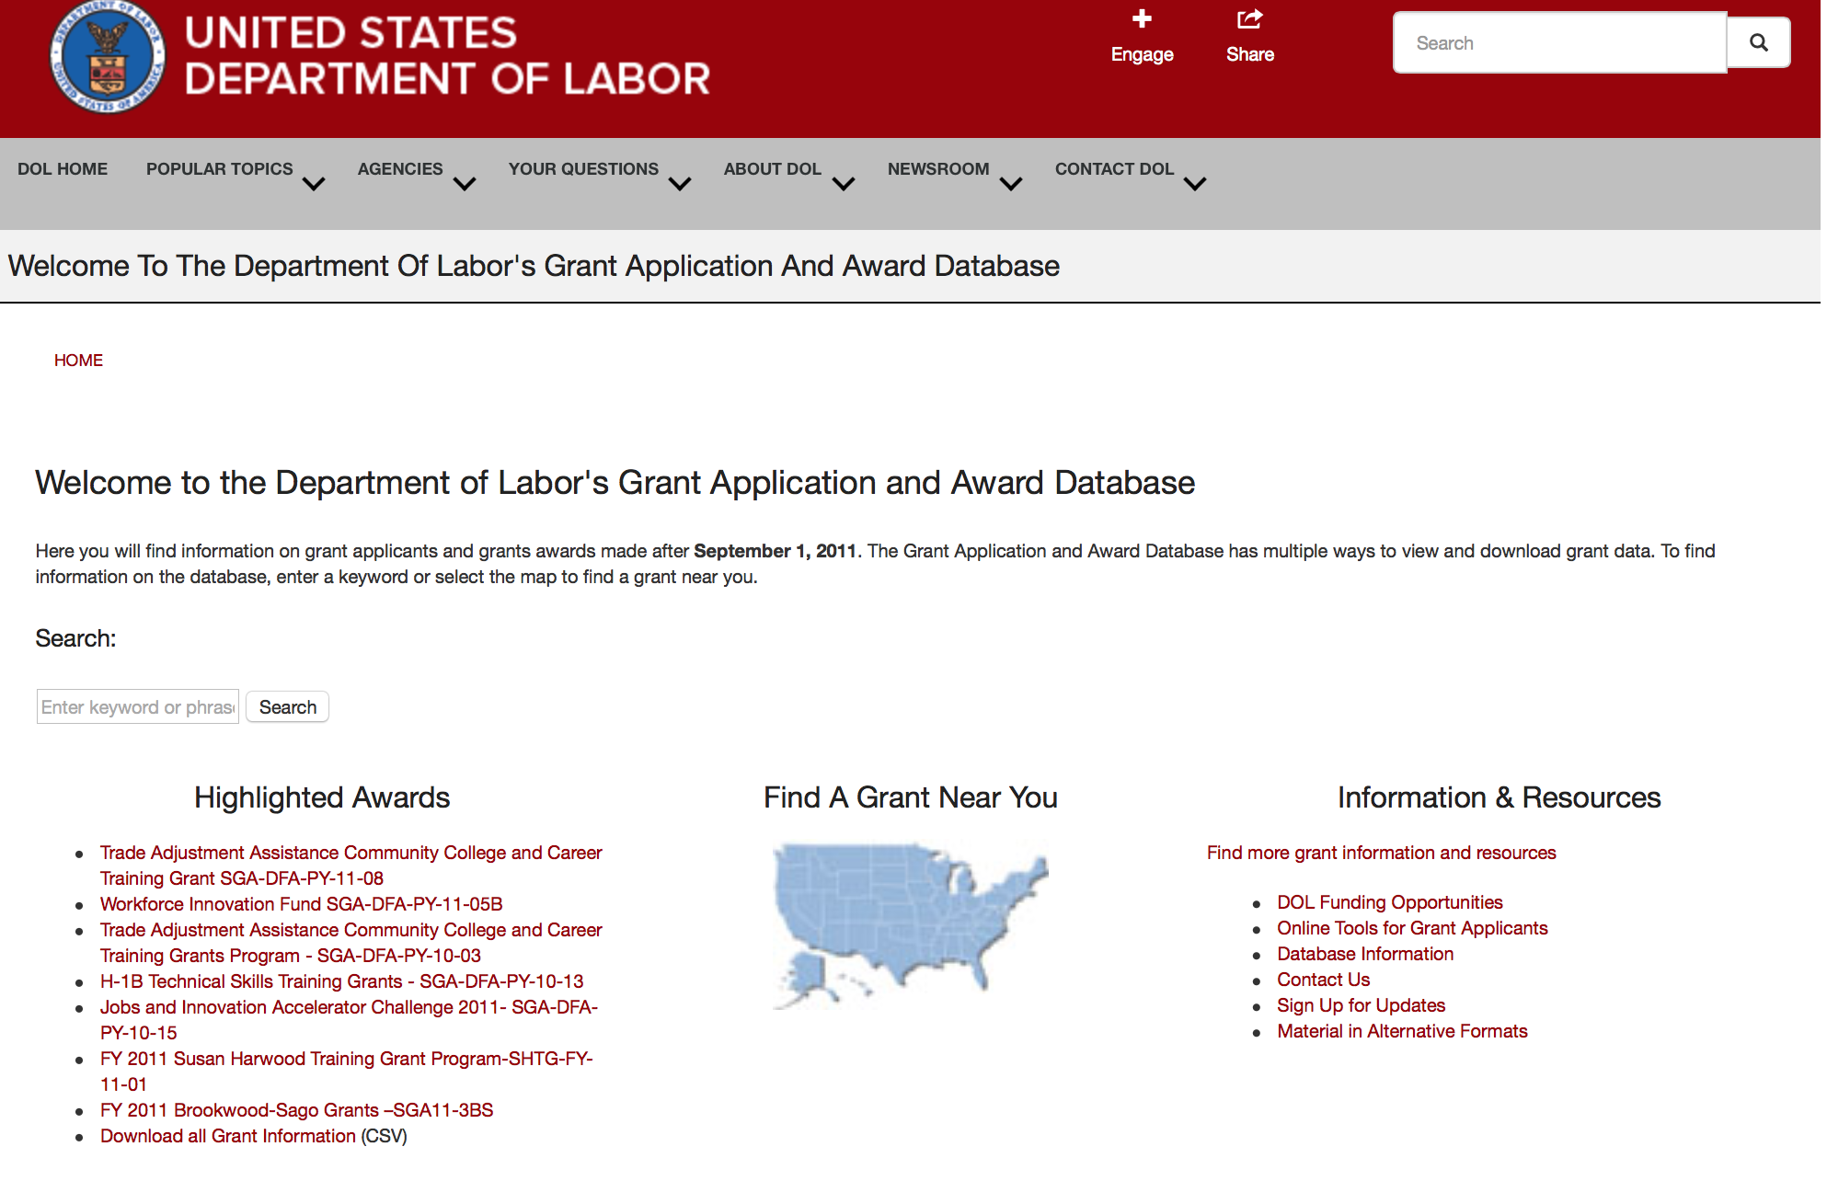

http://www.dol.gov/dol/grants/

Programs

Modifications

Reminders



National Aeronautics and Space Administration

Research and Contracting Opportunities

NASA Research Opportunities Online

- Various NASA offices publish their research announcements over the Internet, broadening the opportunity for researchers to apply for funding. This site provides access to current research announcements along with their specific due dates.

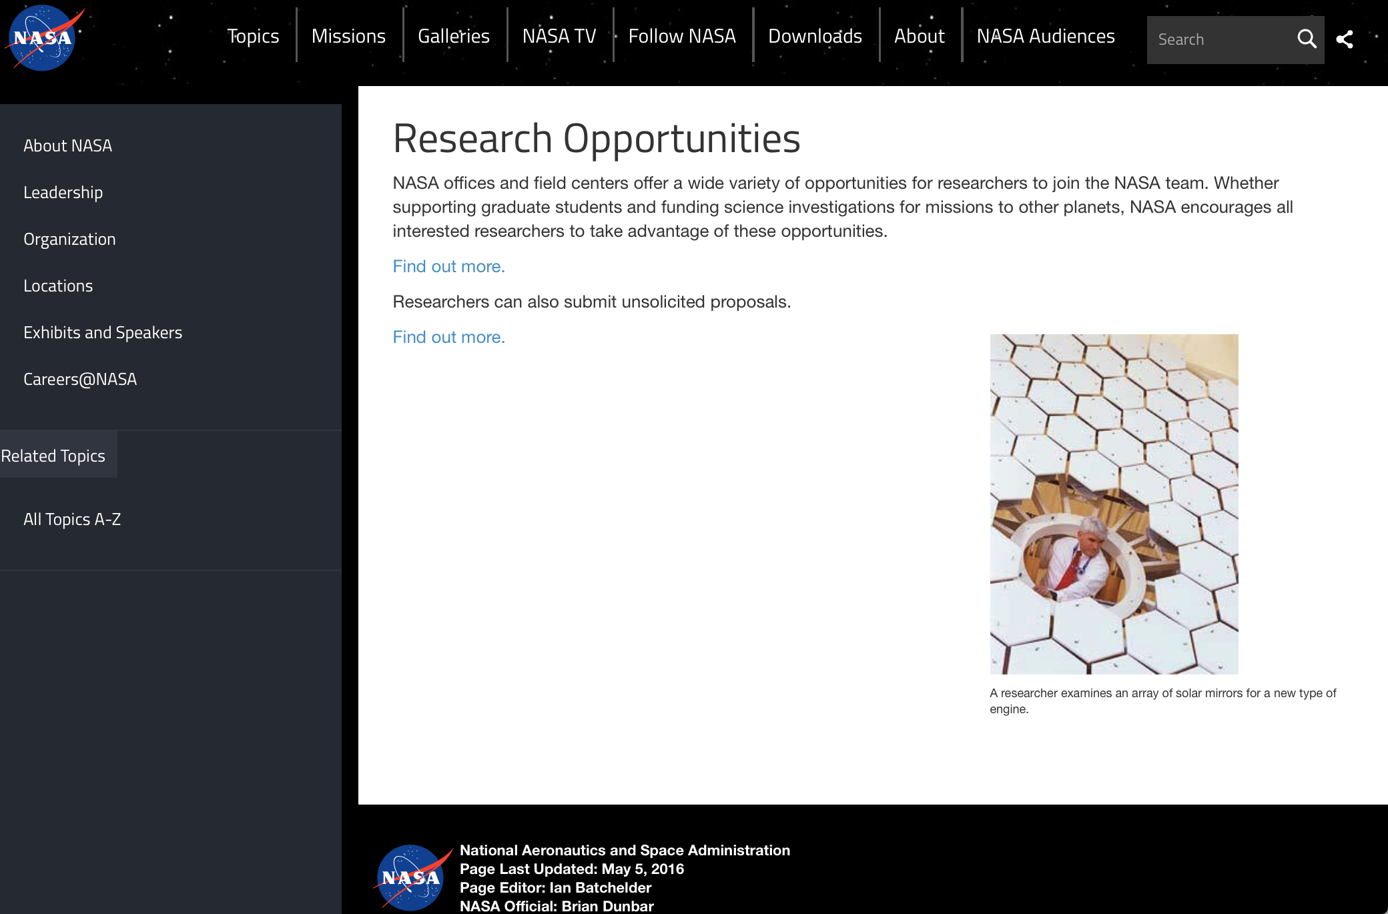

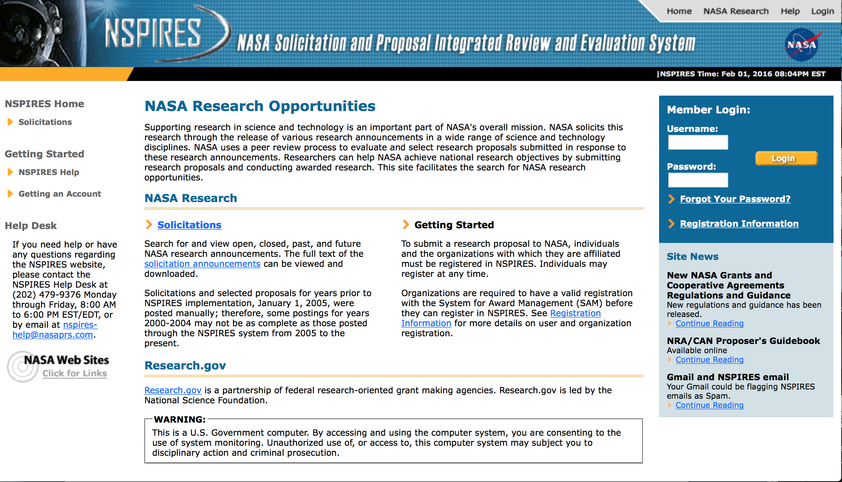
http://nspires.nasaprs.com/external/

Research Programs:

NASA Headquarters
ROSES 2017: X-ray Astronomy Recovery Mission (XARM) Participating Scientists
Synopsis 1
http://www.grants.gov/web/grants/view-opportunity.html?oppId=297335

Modifications:

NASA Headquarters
ROSES 2017: Exobiology
Synopsis 2
http://www.grants.gov/web/grants/view-opportunity.html?oppId=293767

NASA Headquarters
ROSES 2017: Earth Science Applications: Health and Air Quality
Synopsis 2
http://www.grants.gov/web/grants/view-opportunity.html?oppId=296313

NASA Headquarters
ROSES 2017: New (Early Career) Investigator Program
Synopsis 4
http://www.grants.gov/web/grants/view-opportunity.html?oppId=293790

NASA Headquarters
ROSES 2017: Mars Data Analysis Program
Synopsis 2
http://www.grants.gov/web/grants/view-opportunity.html?oppId=296159

NASA Headquarters
ROSES 2017: Heliophysics Supporting Research
Synopsis 4
http://www.grants.gov/web/grants/view-opportunity.html?oppId=294198

NASA Headquarters
ROSES 2017: Planetary Instrument Concepts for the Advancement of Solar System Observations
Synopsis 3
http://www.grants.gov/web/grants/view-opportunity.html?oppId=296248

National Archives and Records Administration

Grant Opportunities General Overview

To access the information below: click here

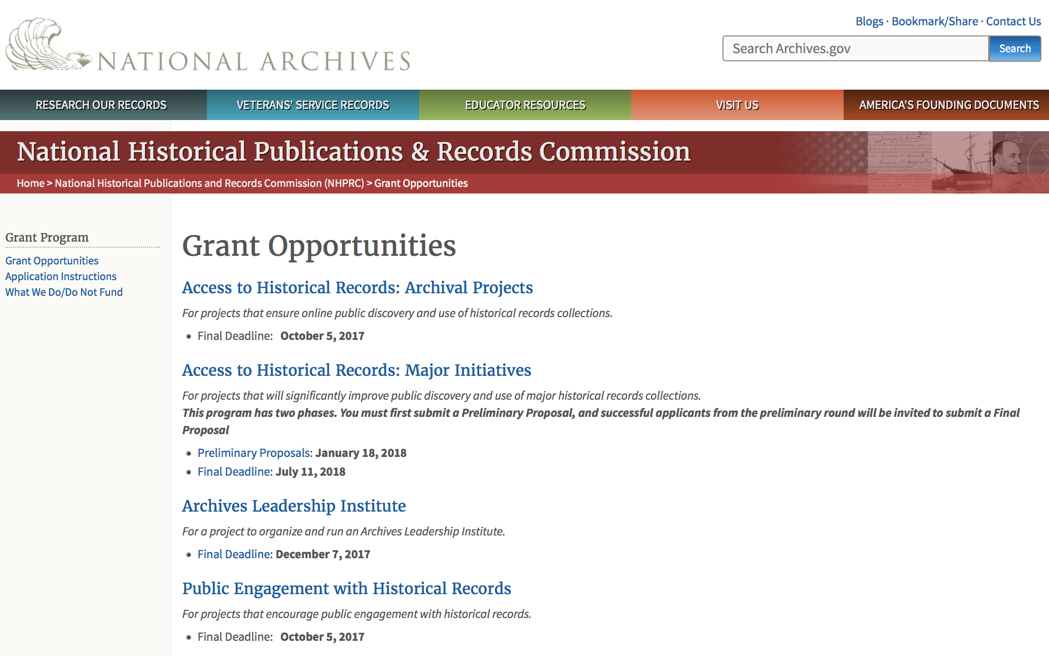

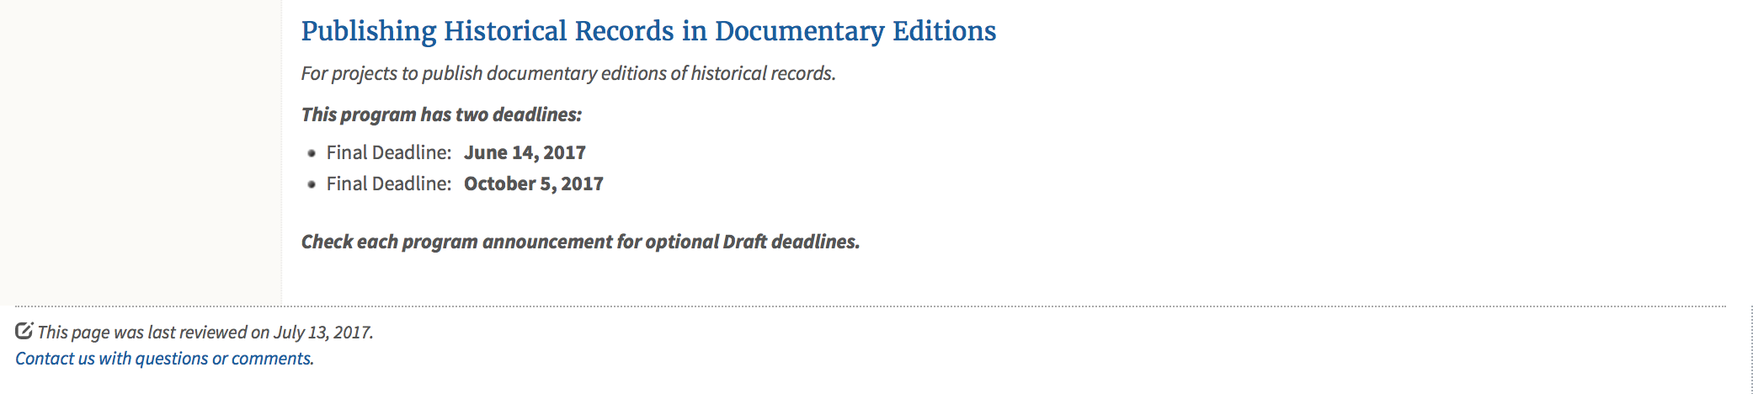
https://www.archives.gov/nhprc/announcement

Programs:

Reminders:

Access to Historical Records: Major Initiatives (Preliminary)
Synopsis 1

Document Type: | Grants Notice
Funding Opportunity Number: | PRELIM-201801
Funding Opportunity Title: | Access to Historical Records: Major Initiatives (Preliminary)
Opportunity Category: | Discretionary
Opportunity Category Explanation:
Funding Instrument Type: | Grant
Category of Funding Activity: | Humanities (see "Cultural Affairs" in CFDA)
Category Explanation:
Expected Number of Awards: | 5
CFDA Number(s): | 89.003 -- National Historical Publications and Records Grants
Cost Sharing or Matching Requirement: | Yes
Version: | Synopsis 3
Posted Date: | Jul 14, 2017
Last Updated Date: | Jul 24, 2017
Original Closing Date for Applications: | Jan 18, 2018
Current Closing Date for Applications: | Jan 18, 2018
Archive Date:
Estimated Total Program Funding: | $1,000,000
Award Ceiling: | $350,000
Award Floor: | $100,000
Eligible Applicants: | State governments  County governments  Nonprofits having a 501(c)(3) status with the IRS, other than institutions of higher education  Private institutions of higher education  Native American tribal governments (Federally recognized)  Public and State controlled institutions of higher education  City or township governments
Agency Name: | National Archives and Records Administration
Description: | The National Historical Publications and Records Commission seeks projects that will significantly improve public discovery and use of major historical records collections. All types of historical records are eligible, including documents, photographs, born-digital records, and analog audio and moving images. Projects may: • Digitize historical records collections, or related collections, held by a single institution and make them freely available online• Provide access to born-digital records• Create new freely-available virtual collections drawn from historical records held by multiple institutions• Create new tools and methods for users to access records The NHPRC welcomes collaborative projects, particularly for bringing together related records from multiple institutions. Projects that address significant needs in the field and result in replicable and scalable approaches will be more competitive. We also encourage organizations to actively engage the public in the work of the project. Applicants should also consult Access to Historical Records: Archival Projects program, which has different requirements and award amounts. For a comprehensive list of Commission limitations on funding, please see: "What we do and do not fund" (http://www.archives.gov/nhprc/apply/eligibility.html). Applications that consist entirely of ineligible activities will not be considered. Award Information A grant is for one to three years and for between $100,000 and $350,000. We expect to make up to five grants in this category for a total of up to $1,000,000. Grants begin no earlier than January 1, 2019.The Commission requires that grant recipients acknowledge NHPRC grant assistance in all publications and other products that result from its support. Eligibility Eligible applicants:• Nonprofit organizations or institutions• Colleges, universities, and other academic institutions• State or local government agencies• Federally-acknowledged or state-recognized Native American tribes or groups Cost Sharing The total costs of a project are shared between the NHPRC and the applicant organization. The Commission provides no more than 50 per cent of total project costs in the Access to Historical Records: Major Initiatives category. NHPRC grant recipients are not permitted to use grant funds for indirect costs (as indicated in 2 CFR 2600.101).Cost sharing is required. The applicant's financial contribution may include both direct and indirect expenses, in-kind contributions, non-Federal third-party contributions, and any income earned directly by the project. Indirect costs must be listed under the applicant's cost sharing contribution. Other Requirements Applicant organizations must be registered in the System for Award Management (SAM) prior to submitting an application, maintain SAM registration throughout the application and award process, and include a valid DUNS number in their application. Details on SAM registration and requesting a DUNS number can be found at the System for Award Management website at https://sam.gov. Please refer to the User Guides section and the Grants Registrations PDF. Application Information You must use Grants.gov to submit a Preliminary Proposal. All information necessary to apply is included in this announcement, the Application Instructions, and the forms on Grants.gov. If you need the information supplied in an alternative format, please call the NHPRC at 202-357-5010.In order to ensure eligibility, applicants should first review the rules and regulations governing NHPRC grants under the Administering an NHPRC Grant section. Applying to the Access to Historical Records: Major Initiatives program is a two-phase process. Phase One• Using this announcement, all applicants must submit an Application Package that includes the Application for Federal Domestic Assistance Form SF424, a completed NHPRC Budget, and five-page Project Narrative via Grants.gov by January 18, 2018.• Preliminary proposals will then undergo peer and staff review. Based on those reviews, a selection of promising applicants will be invited by April 16, 2018 to participate in the second phase of the process. Phase Two• Invited applicants will then prepare and submit a complete application to the full Major Initiatives grant announcement via Grants.gov by July 11, 2018. • Applicants may consult with the Director of the Access Program, Alex Lorch (alexander.lorch@nara.gov), or with the Director for Technology Initiatives, Nancy Melley (nancy.melley@nara.gov), during both the preliminary and full proposal project phases. • In order to ensure eligibility, applicants should first review the rules and regulations governing NHPRC grants under the Administering an NHPRC Grant section.
Link to Additional Information: | Link to full grant announcement, including additional requirements
Grantor Contact Information: | If you have difficulty accessing the full announcement electronically, please contact:  Jeff de la Concepcion Jeff.delaconcepcion@Nara.gov  Grant Information Specialist

http://www.grants.gov/web/grants/view-opportunity.html?oppId=295495

Access to Historical Records: Major Initiatives
Synopsis 1

Document Type: | Grants Notice
Funding Opportunity Number: | MAJOR-201807
Funding Opportunity Title: | Access to Historical Records: Major Initiatives
Opportunity Category: | Discretionary
Opportunity Category Explanation:
Funding Instrument Type: | Grant
Category of Funding Activity: | Humanities (see "Cultural Affairs" in CFDA)
Category Explanation:
Expected Number of Awards: | 5
CFDA Number(s): | 89.003 -- National Historical Publications and Records Grants
Cost Sharing or Matching Requirement: | Yes
Version: | Synopsis 1
Posted Date: | Jul 14, 2017
Last Updated Date: | Jul 14, 2017
Original Closing Date for Applications: | Jul 11, 2018
Current Closing Date for Applications: | Jul 11, 2018
Archive Date:
Estimated Total Program Funding: | $1,000,000
Award Ceiling: | $350,000
Award Floor: | $100,000
Eligible Applicants: | Public and State controlled institutions of higher education  County governments  Nonprofits having a 501(c)(3) status with the IRS, other than institutions of higher education  State governments  City or township governments  Private institutions of higher education  Native American tribal governments (Federally recognized)
Agency Name: | National Archives and Records Administration
Description: | The National Historical Publications and Records Commission seeks projects that will significantly improve public discovery and use of major historical records collections. All types of historical records are eligible, including documents, photographs, born-digital records, and analog audio and moving images. Projects may: • Digitize historical records collections, or related collections, held by a single institution and make them freely available online • Provide access to born-digital records • Create new freely-available virtual collections drawn from historical records held by multiple institutions • Create new tools and methods for users to access records The NHPRC welcomes collaborative projects, particularly for bringing together related records from multiple institutions. Projects that address significant needs in the field and result in replicable and scalable approaches will be more competitive. We also encourage organizations to actively engage the public in the work of the project. Applicants should also consult Access to Historical Records: Archival Projects program, which has different requirements and award amounts. For a comprehensive list of Commission limitations on funding, please see: "What we do and do not fund" (http://www.archives.gov/nhprc/apply/eligibility.html). Applications that consist entirely of ineligible activities will not be considered. Award Information A grant is for one to three years and between $100,000 and $350,000. We expect to make up to five grants in this category for a total of up to $1,000,000. Grants begin no earlier than January 1, 2019. The Commission requires that grant recipients acknowledge NHPRC grant assistance in all publicity, publications, and other products that result from its support. Eligibility Eligible applicants: • U.S. nonprofit organizations or institutions • U.S. colleges, universities, and other academic institutions • State or local government agencies • Federally-acknowledged or state-recognized Native American tribes or groups Cost Sharing The total costs of a project are shared between the NHPRC and the applicant organization. The Commission provides no more than 50 per cent of total project costs in the Access to Historical Records: Major Initiatives category. NHPRC grant recipients are not permitted to use grant funds for indirect costs (as indicated in 2 CFR 2600.101). Cost sharing is required. The applicant's financial contribution may include both direct and indirect expenses, in-kind contributions, non-Federal third-party contributions, and any income earned directly by the project. Indirect costs must be listed under the applicant's cost sharing contribution. Other Requirements Applicant organizations must be registered in the System for Award Management (SAM) prior to submitting an application, maintain SAM registration throughout the application and award process, and include a valid DUNS number in their application. Details on SAM registration and requesting a DUNS number can be found at the System for Award Management website at https://sam.gov. Please refer to the User Guides section and the Grants Registrations PDF. Application Information You must use Grants.gov to submit your Full Proposal. All information necessary to apply is included in this announcement, the Application Instructions, and the forms on Grants.gov. If you need the information supplied in an alternative format, please call the NHPRC at 202-357-5010. In order to ensure eligibility, applicants should first review the rules and regulations governing NHPRC grants under the Administering an NHPRC Grant section. Applying to the Access to Historical Records: Major Initiatives program is a two-phase process. Phase One • All applicants must have submitted a Preliminary Proposal by January 18, 2018. • Only those applicants who have successfully completed Phase One and who have been invited by the Commission to submit a full proposal to the Access to Historical Records: Major Initiatives program are eligible to participate in the second phase of the process. Phase Two • If you have been invited, prepare and submit a complete application to the full Major Initiatives grant announcement via Grants.gov by July 11, 2018. • Applicants may consult with the Director of the Access Program, Alex Lorch (alexander.lorch@nara.gov), or with the Director for Technology Initiatives, Nancy Melley (nancy.melley@nara.gov), during both the preliminary and full proposal project phases.
Link to Additional Information: | Link to full grant announcement, including additional requirements
Grantor Contact Information: | If you have difficulty accessing the full announcement electronically, please contact:  Jeff de la Concepcion Jeff.delaconcepcion@nara.gov  Grant Information Specialist

http://www.grants.gov/web/grants/view-opportunity.html?oppId=295496

National Endowment for the Arts

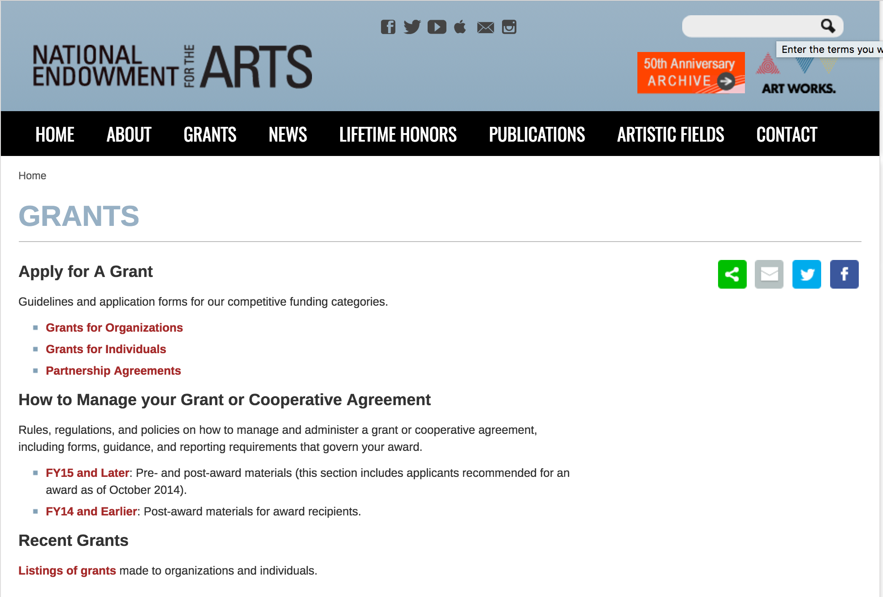

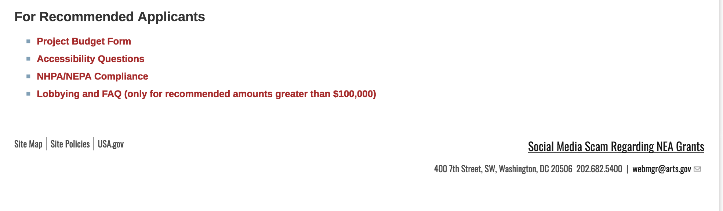
See more at: https://www.arts.gov/grants

Programs:

Modifications:

2018NEAAEAC - NEA Arts Engagement In American Communities (AEAC), FY2018
Deletion Comments: Synopsis deleted

Reminders:

NEA Research: Art Works, FY2018
Synopsis 2
Document Type: | Grants Notice
Funding Opportunity Number: | 2018NEAORA
Funding Opportunity Title: | NEA Research: Art Works, FY2018
Opportunity Category: | Discretionary
Opportunity Category Explanation:
Funding Instrument Type: | Grant
Category of Funding Activity: | Arts (see "Cultural Affairs" in CFDA)
Category Explanation:
Expected Number of Awards:
CFDA Number(s): | 45.024 -- Promotion of the Arts Grants to Organizations and Individuals
Cost Sharing or Matching Requirement: | Yes
Version: | Synopsis 2
Posted Date: | Aug 04, 2017
Last Updated Date: | Aug 31, 2017
Original Closing Date for Applications: | Oct 10, 2017
Current Closing Date for Applications: | Oct 17, 2017 NOTICE: The Research: Art Works application deadline has been extended due to Hurricane Harvey.
Archive Date:
Estimated Total Program Funding:
Award Ceiling: | $100,000
Award Floor: | $10,000
Eligible Applicants: | Private institutions of higher education  Nonprofits having a 501(c)(3) status with the IRS, other than institutions of higher education  Native American tribal governments (Federally recognized)  City or township governments  County governments  Special district governments  State governments  Independent school districts  Public and State controlled institutions of higher education
Agency Name: | National Endowment for the Arts
Description: | The Arts Endowment’s support of a project may start on May 1, 2018, or any time thereafter. Grants generally may cover a period of performance of up to two years, with an exception for projects that include primary data collection as part of the proposed activity. Projects that include primary data collection may request up to three years. Projects that extend beyond one year will be required to submit an annual progress report. A grantee may not receive more than one National Endowment for the Arts grant for the same project during the same period of performance. Program Description In September 2012, the National Endowment for the Arts' (NEA) Office of Research & Analysis published a five-year research agenda, supported by a system map and measurement model. Titled How Art Works, the report offers a framework for studying research topics critical to a broader public understanding of the arts' value and/or impact for individuals and communities. In December 2016, the NEA’s research office updated its five-year agenda for 2017-2021, which reflects a tighter focus on Arts Participation and Arts/Cultural Assets as essential research topics. Arts Participation, in the new agenda, remains inclusive of various modes of participation and specific arts activities. These modes are: attending arts events; reading literature; creating or performing art; consuming art via electronic media; and learning in the arts. Arts/Cultural Assets denotes artists and arts workers, arts venues and platforms, and arts organizations and industries. The NEA is interested in research seeking to identify and to examine:• Factors that enhance or inhibit Arts Participation or Arts/Cultural Assets;• Detailed characteristics of Arts Participation or Arts Cultural/Assets, and their interrelationships; • Individual-level outcomes of Arts Participation, including those corresponding with the following domains: social and emotional well-being creativity, cognition, and learning physiological processes of health and healing; and• Societal or community-level outcomes, including those corresponding with the following domains: civic and corporate innovation attraction for neighborhoods and businesses national and/or state-level economic growth
Link to Additional Information: | NEA Website Announcement
Grantor Contact Information: | If you have difficulty accessing the full announcement electronically, please contact:  NEA Web Manager webmgr@arts.gov  NEA Web Manager

http://www.grants.gov/web/grants/view-opportunity.html?oppId=296130

NEA Literature Fellowships: Translation Projects, FY2019
Synopsis 1
Document Type: | Grants Notice
Funding Opportunity Number: | 2018NEA03LFTP
Funding Opportunity Title: | NEA Literature Fellowships: Translation Projects, FY2019
Opportunity Category: | Discretionary
Opportunity Category Explanation:
Funding Instrument Type: | Grant
Category of Funding Activity: | Arts (see "Cultural Affairs" in CFDA)
Category Explanation:
Expected Number of Awards:
CFDA Number(s): | 45.024 -- Promotion of the Arts Grants to Organizations and Individuals
Cost Sharing or Matching Requirement: | No
Version: | Synopsis 1
Posted Date: | Jul 25, 2017
Last Updated Date: | Jul 25, 2017
Original Closing Date for Applications: | Dec 05, 2017
Current Closing Date for Applications: | Dec 05, 2017
Archive Date:
Estimated Total Program Funding:
Award Ceiling: | $25,000
Award Floor: | $12,500
Eligible Applicants: | Individuals
Agency Name: | National Endowment for the Arts
Description: | An individual may submit only one application for FY 2019 funding. You may not apply for both a Translation Project under this deadline (December 5, 2017) and a Literature Fellowship (in prose or poetry) under the 2018 deadline (when fellowships in prose are offered). The Arts Endowment’s support of a project may begin any time between November 1, 2018, and November 1, 2019, and extend for up to two years. Program Description Through fellowships to published translators, the National Endowment for the Arts supports projects for the translation of specific works of prose, poetry, or drama from other languages into English. We encourage translations of writers and of work that are not well represented in English translation. All proposed projects must be for creative translations of literary material into English. The work to be translated should be of interest for its literary excellence and value. Priority will be given to projects that involve work that has not previously been translated into English. Competition for fellowships is rigorous. Potential applicants should consider carefully whether their work will be competitive at the national level.
Link to Additional Information: | NEA Website Announcement
Grantor Contact Information: | If you have difficulty accessing the full announcement electronically, please contact:  NEA Web Manager webmgr@arts.gov  NEA Web Manager

http://www.grants.gov/web/grants/view-opportunity.html?oppId=295826

National Endowment for the Humanities

Grant Overview -

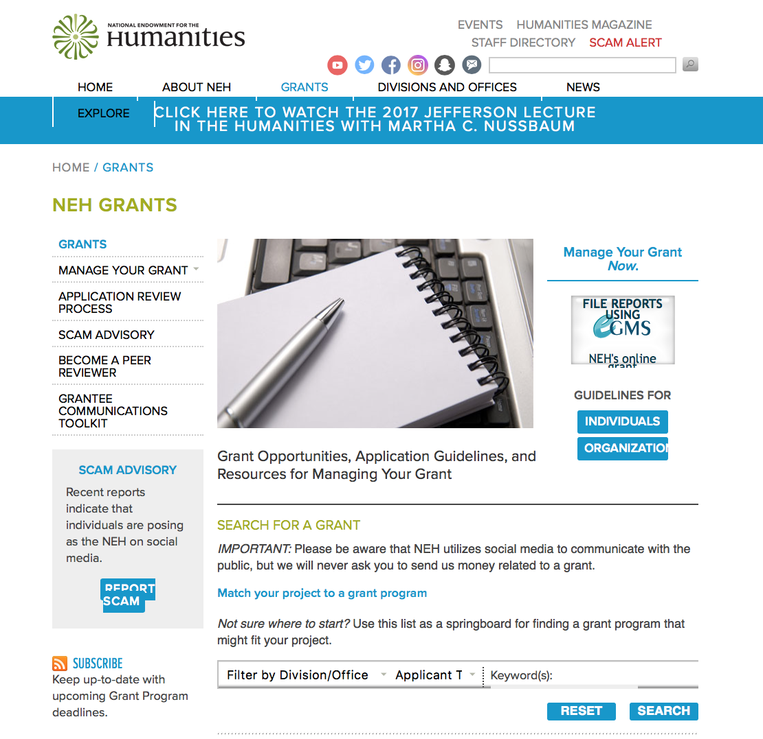

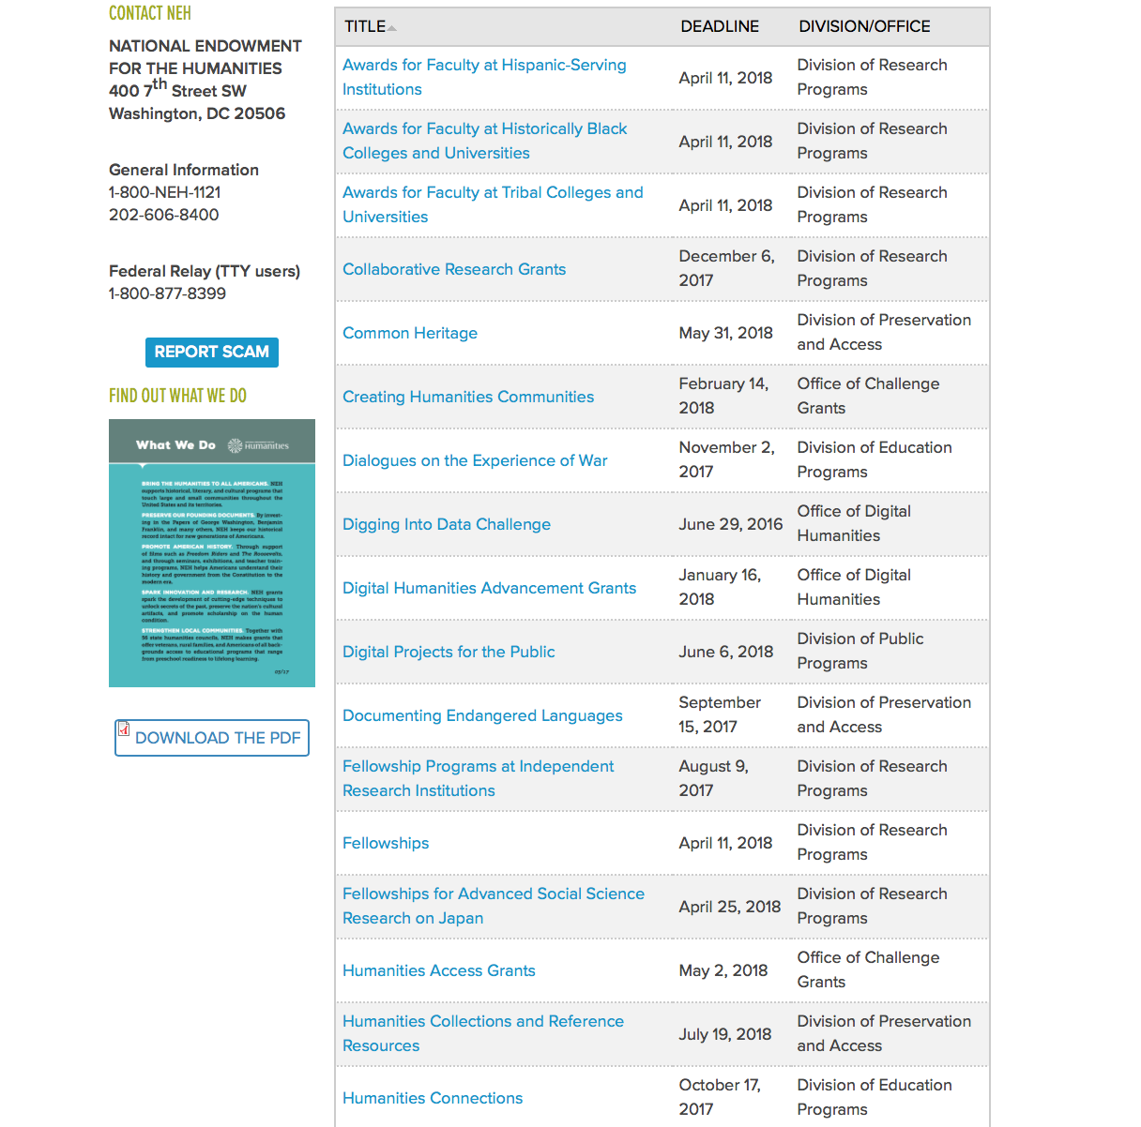

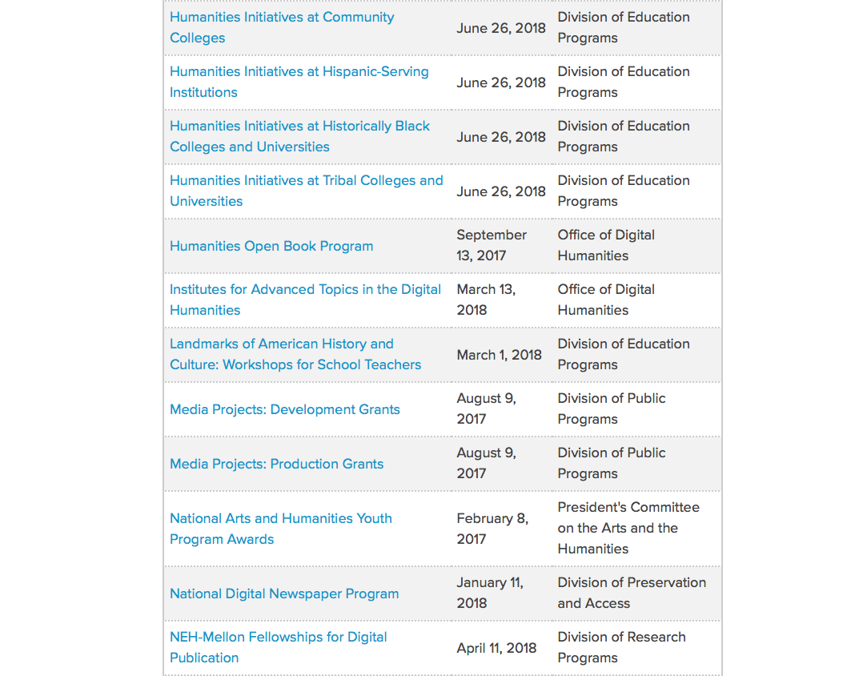

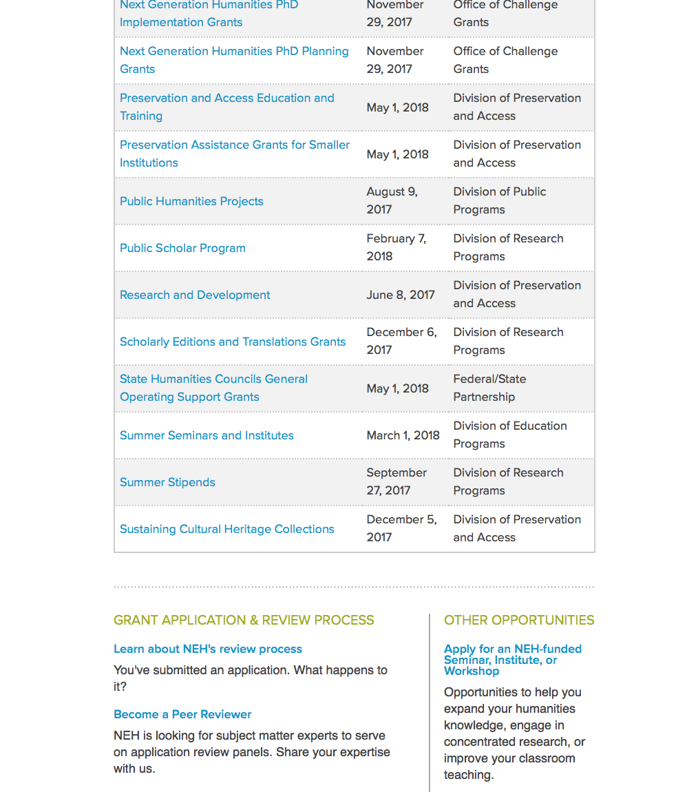

https://www.neh.gov/grants
Programs:

Next Generation Humanities PhD Planning Grants
Synopsis 1
Document Type: | Grants Notice
Funding Opportunity Number: | 20171129-ZA
Funding Opportunity Title: | Next Generation Humanities PhD Planning Grants
Opportunity Category: | Discretionary
Opportunity Category Explanation:
Funding Instrument Type: | Grant
Category of Funding Activity: | Humanities (see "Cultural Affairs" in CFDA)
Category Explanation:
Expected Number of Awards:
CFDA Number(s): | 45.162 -- Promotion of the Humanities Teaching and Learning Resources and Curriculum Development
Cost Sharing or Matching Requirement: | Yes
Version: | Synopsis 1
Posted Date: | Sep 14, 2017
Last Updated Date: | Sep 14, 2017
Original Closing Date for Applications: | Nov 29, 2017
Current Closing Date for Applications: | Nov 29, 2017
Archive Date:
Estimated Total Program Funding:
Award Ceiling: | $50,000
Award Floor: | $2
Eligible Applicants: | Others (see text field entitled "Additional Information on Eligibility" for clarification)
Additional Information on Eligibility: | The only eligible applicants are U.S. nonprofit institutions of higher education with PhD programs in the humanities.
Agency Name: | National Endowment for the Humanities
Description: | In recent years, research published by Humanities Indicators, among others, has revealed that humanities PhDs pursue careers in many different professions—both inside and outside academia. Yet most humanities PhD programs in the United States still prepare students primarily for tenure-track professor positions at colleges and universities. The increasing shortage of such positions has changed students’ expected career outcomes. NEH therefore hopes to assist universities in devising a new model of doctoral education, which can both transform the understanding of what it means to be a humanities scholar and promote the integration of the humanities in the public sphere. Next Generation Humanities PhD Planning Grants support universities in preparing to institute wide-ranging changes in humanities doctoral programs. Humanities knowledge and methods can make an even more substantial impact on society if students are able to translate what they learn in doctoral programs into a multitude of careers. Next Generation Humanities PhD Planning Grants are designed to bring together various important constituencies to discuss and strategize, and then to produce plans that will transform scholarly preparation in the humanities at the doctoral level. Students will be prepared to undertake various kinds of careers, and humanities PhD programs will increase their relevance for the twenty-first century. Grantee institutions must provide funds raised from nonfederal third parties equal to the grant funds released by NEH.
Link to Additional Information: | https://www.neh.gov/grants/education/next-generation-humanities-phd-planning-grants
Grantor Contact Information: | If you have difficulty accessing the full announcement electronically, please contact:  nextgen@neh.gov 202-606-8500 nextgen@neh.gov  nextgen@neh.gov

http://www.grants.gov/web/grants/view-opportunity.html?oppId=297393

Modifications:

Reminders:

National Endowment for the Humanities
Dialogues on the Experience of War
Synopsis 1
Document Type: | Grants Notice
Funding Opportunity Number: | 20171102-AV
Funding Opportunity Title: | Dialogues on the Experience of War
Opportunity Category: | Discretionary
Opportunity Category Explanation:
Funding Instrument Type: | Grant
Category of Funding Activity: | Humanities (see "Cultural Affairs" in CFDA)
Category Explanation:
Expected Number of Awards:
CFDA Number(s): | 45.163 -- Promotion of the Humanities Professional Development
Cost Sharing or Matching Requirement: | No
Version: | Synopsis 1
Posted Date: | Sep 01, 2017
Last Updated Date: | Sep 01, 2017
Original Closing Date for Applications: | Nov 02, 2017
Current Closing Date for Applications: | Nov 02, 2017
Archive Date:
Estimated Total Program Funding:
Award Ceiling: | $100,000
Award Floor: | $1
Eligible Applicants: | County governments  Public and State controlled institutions of higher education  Native American tribal governments (Federally recognized)  Private institutions of higher education  Nonprofits having a 501(c)(3) status with the IRS, other than institutions of higher education  City or township governments  State governments  Special district governments
Agency Name: | National Endowment for the Humanities
Description: | The National Endowment for the Humanities offers the Dialogues on the Experience of War program as part of its current initiative, Standing Together: The Humanities and the Experience of War. The program supports the study and discussion of important humanities sources about war, in the belief that these sources can help U.S. military veterans and others think more deeply about the issues raised by war and military service. Although the program is primarily designed to reach military veterans, men and women in active service, military families, and interested members of the public may also participate. The program awards grants of up to $100,000 that will support • the convening of at least two discussion programs for no fewer than fifteen participants; and • the creation of a preparatory program to recruit and train program discussion leaders (NEH Discussion Leaders). Discussion programs may take place on college and university campuses, in veterans’ centers, at public libraries and museums, and at other community venues.
Link to Additional Information: | https://www.neh.gov/grants/education/dialogues-the-experience-war
Grantor Contact Information: | If you have difficulty accessing the full announcement electronically, please contact:  Division of Education Programs National Endowment for the Humanities 400 Seventh Street, SW Washington, DC 20506 202-606-8337 dew@neh.gov dew@neh.gov  dew@neh.gov

http://www.grants.gov/web/grants/view-opportunity.html?oppId=296998

Humanities Connections
Synopsis 1

Document Type: | Grants Notice
Funding Opportunity Number: | 20171017-AKA
Funding Opportunity Title: | Humanities Connections
Opportunity Category: | Discretionary
Opportunity Category Explanation:
Funding Instrument Type: | Grant
Category of Funding Activity: | Humanities (see "Cultural Affairs" in CFDA)
Category Explanation:
Expected Number of Awards:
CFDA Number(s): | 45.162 -- Promotion of the Humanities Teaching and Learning Resources and Curriculum Development
Cost Sharing or Matching Requirement: | No
Version: | Synopsis 1
Posted Date: | Aug 17, 2017
Last Updated Date: | Aug 17, 2017
Original Closing Date for Applications: | Oct 17, 2017
Current Closing Date for Applications: | Oct 17, 2017
Archive Date:
Estimated Total Program Funding:
Award Ceiling: | $100,000
Award Floor: | $1
Eligible Applicants: | Others (see text field entitled "Additional Information on Eligibility" for clarification)
Additional Information on Eligibility: | The only eligible applicants are U.S. two- or four-year colleges or universities with 501(c)(3) tax-exempt status.
Agency Name: | National Endowment for the Humanities
Description: | The Humanities Connections grant program seeks to expand the role of the humanities in undergraduate education at two- and four-year institutions. Grants will support innovative curricular approaches that foster productive partnerships among humanities faculty and their counterparts in the social and natural sciences and in pre-service or professional programs (such as business, engineering, health sciences, law, computer science, and other technology-driven fields). Competitive applications will demonstrate • that the proposed curricular projects address significant and compelling topics or issues in undergraduate education at the applicant institution(s); • that these projects engage the intellectual skills and habits of mind cultivated by the humanities; and • that faculty and students will benefit from meaningful collaborations in teaching and learning across disciplines as a result of the project. Humanities Connections projects have four core features: 1. integration of the subject matter, perspectives, and goals of two or more disciplines (with a minimum of one in and one outside of the humanities); 2. collaboration between faculty from two or more separate departments or schools at one or more institutions; 3. experiential learning as an intrinsic part of the curricular plan; and 4. long-term institutional support for the proposed curriculum innovation(s). If the project addresses core or general education requirements, or requirements for specific pathways or pre-professional programs, it must incorporate a fresh approach in doing so. Humanities Connections grants are funded at two levels: Planning and Implementation. Planning Grants (up to twelve months) support the interdisciplinary collaboration of faculty from two or more separate departments or schools (a minimum of one in and one outside of the humanities), with the goal of designing a new, coherent curricular program or initiative. The grant gives the institution(s) the opportunity to create a firm foundation for implementing the program. Planning goals will include identifying the members of a planning committee and organizing the planning process; defining the rationale, design, and structure that would undergird a comprehensive and institutionally sustainable effort; and establishing potential scenarios for curriculum development. Institutions may draw on current short-term initiatives or curricular programs run by individual departments in this effort. The outcome of a successful planning phase should be a project in, or ready for, the implementation stage. Implementation grants (up to three years) support the interdisciplinary collaboration of faculty from two or more separate departments or schools (a minimum of one in and one outside of the humanities), with the implementation of a sustainable curricular program or initiative as the outcome. Implementation grant proposals must show unambiguous evidence of preceding planning work and present a defined rationale with clear intellectual and logistical objectives that are supported by institutional commitment. The grant gives applicants the opportunity to build on faculty/administrative or institutional partnerships and to develop and refine the project’s intellectual content, design, and scope. For example, the applicant should be able to demonstrate potential commitments of any partners or collaborators; outline preferred approaches to curriculum building/consolidation; and explain outreach strategies that will be employed to attract students to the new educational opportunity.
Link to Additional Information: | https://www.neh.gov/grants/humanities-connections
Grantor Contact Information: | If you have difficulty accessing the full announcement electronically, please contact:  Humanities Connections Division of Education Programs National Endowment for the Humanities 400 Seventh Street, SW Washington, DC 20506 202-606-8337 humanitiesconnections@neh.gov humanitiesconnections@neh.gov  humanitiesconnections@neh.gov

http://www.grants.gov/web/grants/view-opportunity.html?oppId=296563



National Science Foundation

General Funding Overview

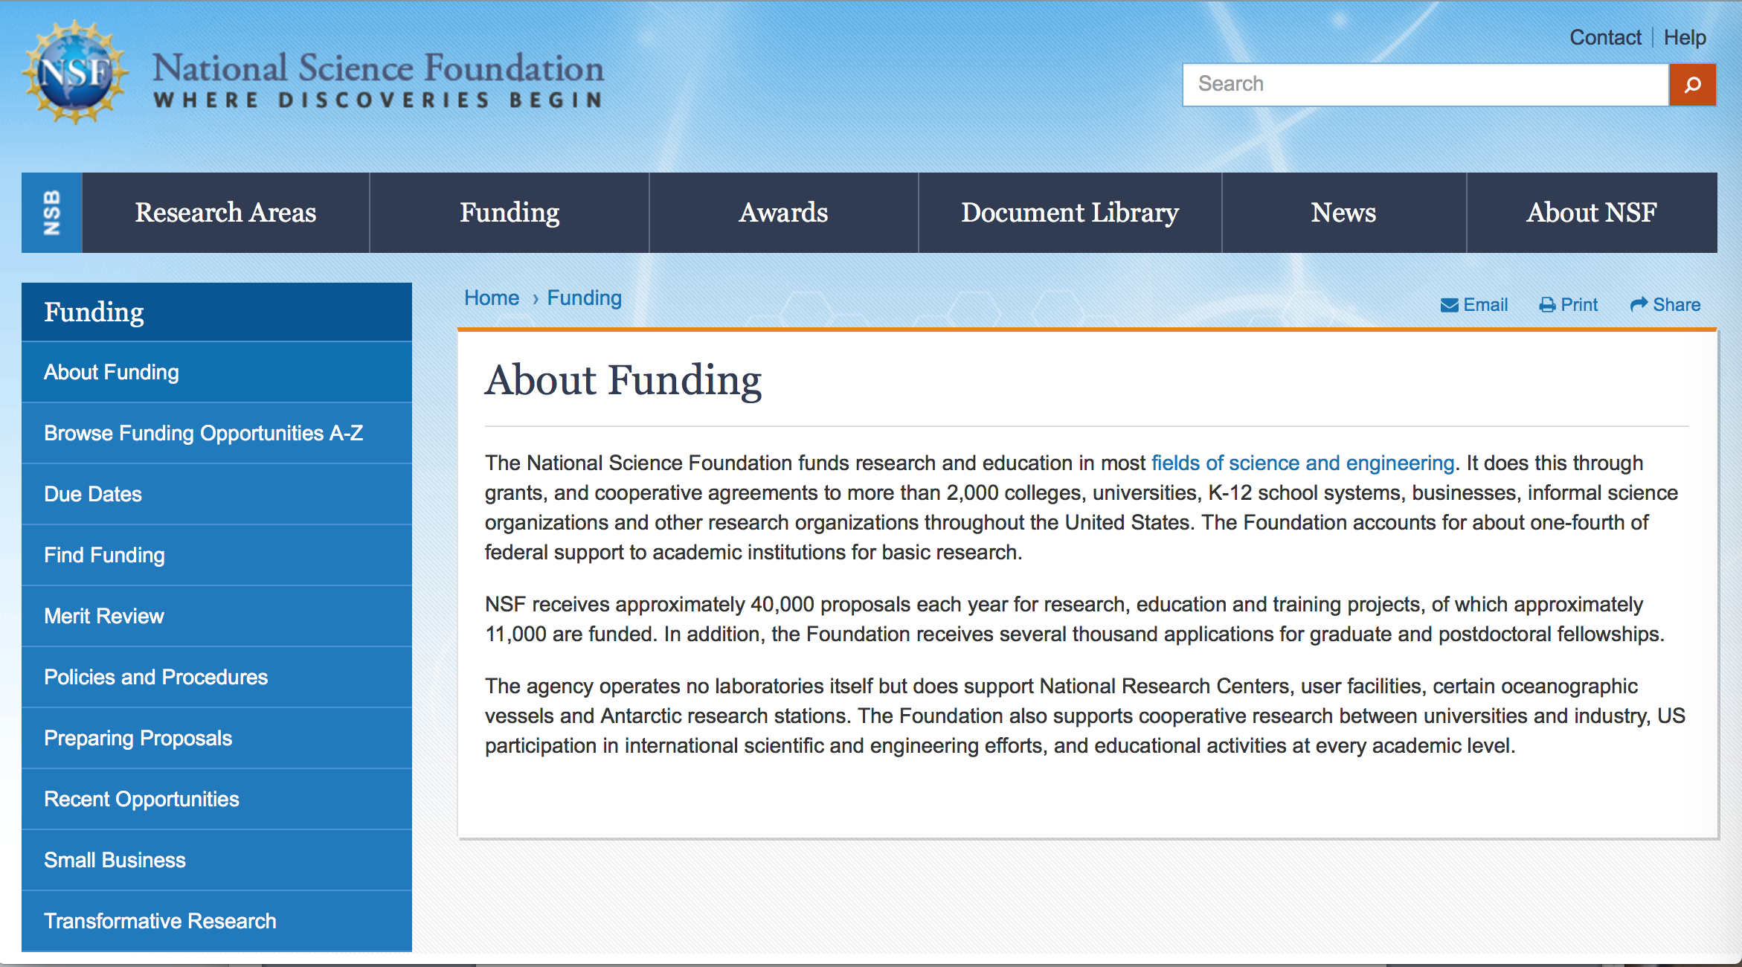

For assistance: https://nsf.gov/funding/aboutfunding.jsp

The National Science Foundation funds research and education in most fields of science and engineering. It does this through grants, and cooperative agreements to more than 2,000 colleges, universities, K-12 school systems, businesses, informal science organizations and other research organizations throughout the United States. The Foundation accounts for about one-fourth of federal support to academic institutions for basic research.
NSF receives approximately 40,000 proposals each year for research, education and training projects, of which approximately 11,000 are funded. In addition, the Foundation receives several thousand applications for graduate and postdoctoral fellowships.
The agency operates no laboratories itself but does support National Research Centers, user facilities, certain oceanographic vessels and Antarctic research stations. The Foundation also supports cooperative research between universities and industry, US participation in international scientific and engineering efforts, and educational activities at every academic level.

For details on active funding deadline dates: http://nsf.gov/funding/pgm_list.jsp?org=NSF&ord=date

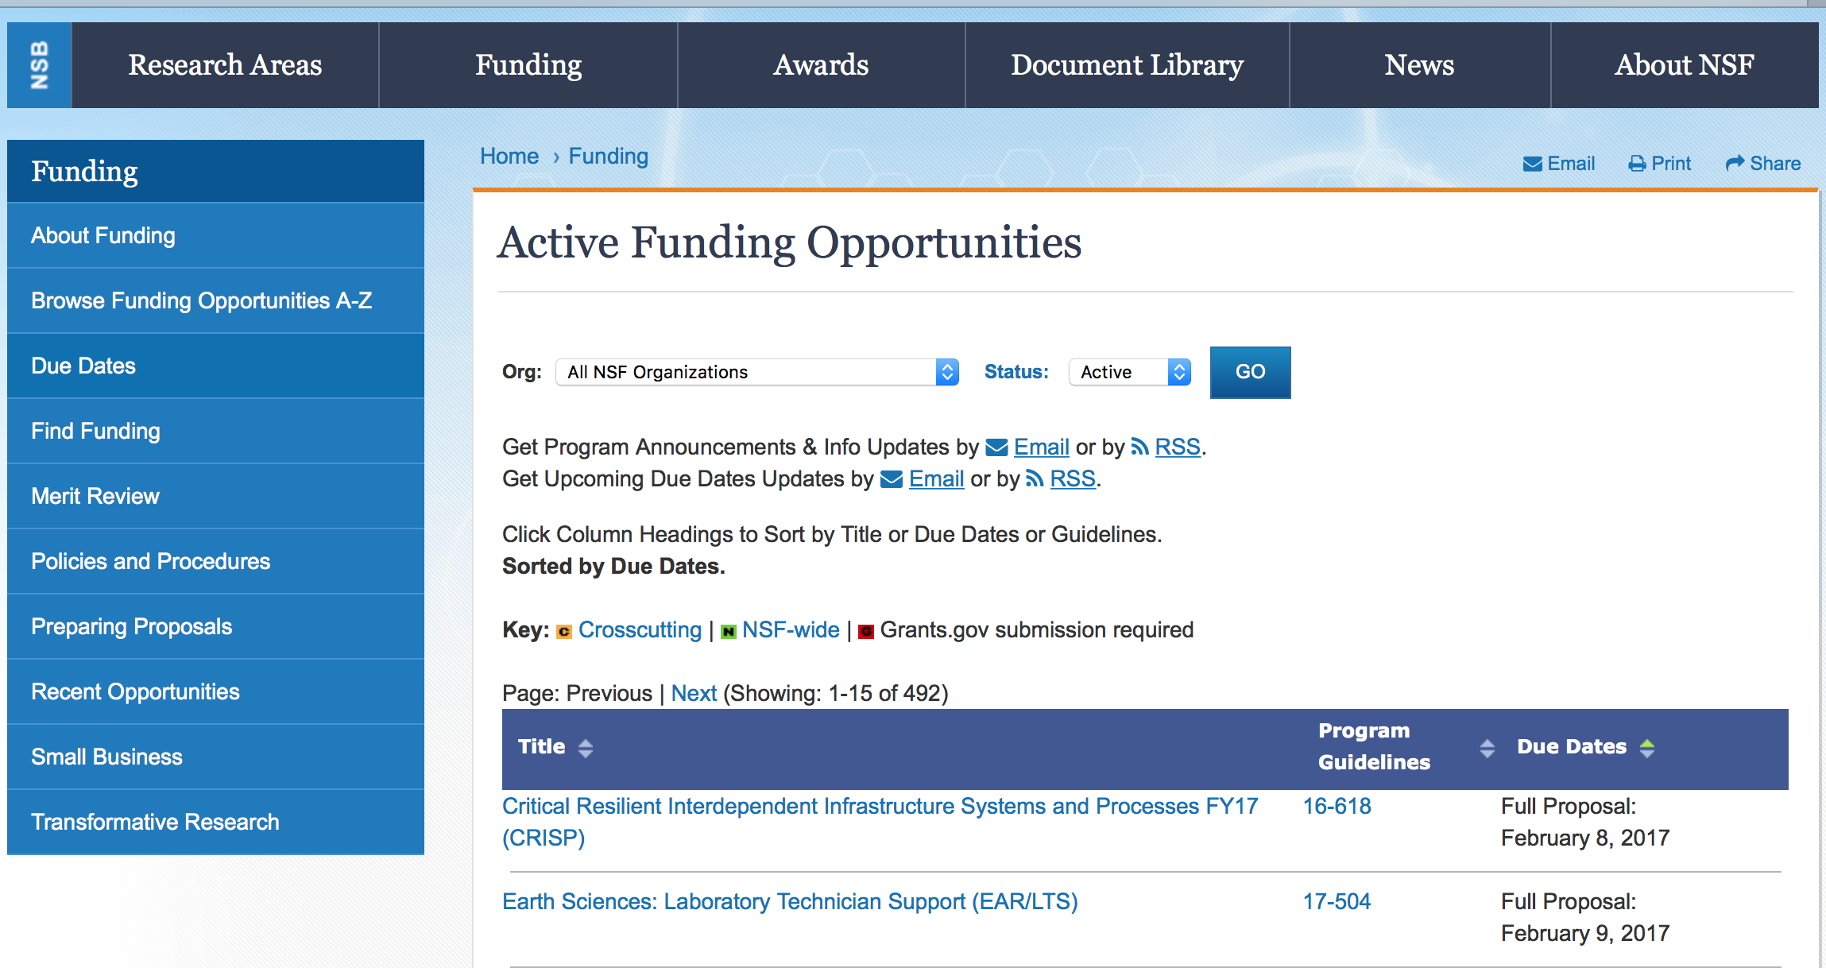

Cyberlearning for Work at the Human-Technology Frontier
Synopsis 1
http://www.grants.gov/web/grants/view-opportunity.html?oppId=297589

Engineering for Civil Infrastructure
Synopsis 1
http://www.grants.gov/web/grants/view-opportunity.html?oppId=297659

Engineering Design and System Engineering
Synopsis 1
http://www.grants.gov/web/grants/view-opportunity.html?oppId=297660

Leading Engineering for America's Prosperity, Health, and Infrastructure
Synopsis 1
http://www.grants.gov/web/grants/view-opportunity.html?oppId=297735

NSF/Intel Partnership on Foundational Microarchitecture Research
Synopsis 1
http://www.grants.gov/web/grants/view-opportunity.html?oppId=297188

Partnerships for Research and Education in Materials
Synopsis 1
http://www.grants.gov/web/grants/view-opportunity.html?oppId=297619

Scalable Parallelism in the Extreme
Synopsis 1
http://www.grants.gov/web/grants/view-opportunity.html?oppId=297629

Spectrum Efficiency, Energy Efficiency, and Security (SpecEES): Enabling Spectrum for All
Synopsis 1
http://www.grants.gov/web/grants/view-opportunity.html?oppId=297684

Modifications:

Reminders:

Deleted:

PD-12-8086 - Design of Engineering Material Systems
Deletion Comments: Opportunity deleted

14-589 - Enriched Doctoral Training in the Mathematical Sciences
Deletion Comments: Opportunity deleted

PD-17-014Y - Engineering for Natural Hazards
Deletion Comments: Opportunity deleted

PD-17-1464 - Engineering and Systems Design
Deletion Comments: Opportunity deleted

PD-17-1637 - Structural and Architectural Engineering and Materials
Deletion Comments: Opportunity deleted

PD-17-8085 - Systems Science
Deletion Comments: Opportunity deleted

Nuclear Regulatory Commission

U.S. Nuclear Regulatory Commission Funding Opportunity Announcement (FOA), Scholarship and Fellowship Education Grant, Faculty Development Grant, and Trade School and Community College Scholarship Grant, Fiscal Year (FY) 2018
Synopsis 1
Document Type: | Grants Notice
Funding Opportunity Number: | NRC-HQ-60-17-FOA-0002
Funding Opportunity Title: | U.S. Nuclear Regulatory Commission Funding Opportunity Announcement (FOA), Scholarship and Fellowship Education Grant, Faculty Development Grant, and Trade School and Community College Scholarship Grant, Fiscal Year (FY) 2018
Opportunity Category: | Discretionary
Opportunity Category Explanation:
Funding Instrument Type: | Grant
Category of Funding Activity: | Education
Category Explanation:
Expected Number of Awards: | 50
CFDA Number(s): | 77.008 -- U.S. Nuclear Regulatory Commission Scholarship and Fellowship Program
Cost Sharing or Matching Requirement: | No
Version: | Synopsis 1
Posted Date: | Aug 30, 2017
Last Updated Date: | Aug 30, 2017
Original Closing Date for Applications: | Oct 30, 2017
Current Closing Date for Applications: | Oct 30, 2017
Archive Date: | Nov 29, 2017
Estimated Total Program Funding: | $15,000,000
Award Ceiling: | $450,000
Award Floor: | $100,000
Eligible Applicants: | Public and State controlled institutions of higher education  Others (see text field entitled "Additional Information on Eligibility" for clarification)  Private institutions of higher education
Additional Information on Eligibility: | • Public/State Controlled Institutions of Higher Education • Private Institutions of Higher Education • Hispanic-Serving Institutions (HSIs) • Historically Black Colleges and Universities (HBCUs) • Tribally Controlled Colleges and Universities (TCCUs) • Alaska Native and Native Hawaiian Serving Institutions • Predominately Black Institutions (PBIs) • Asian American and Native American Pacific Islander Serving Institutions (AAPIs)
Agency Name: | Nuclear Regulatory Commission
Description: | •Scholarship The primary objective is to support scholarships for nuclear science, engineering, technology and related disciplines to develop a workforce capable of supporting the design, construction, operation, and regulation of nuclear facilities and the safe handling of nuclear materials. The nuclear-related discipline supported by this funding is intended to benefit nuclear safety and security sector broadly. •Fellowship The primary objective is to support fellowships for nuclear science, engineering, technology and related disciplines to develop a workforce capable of supporting the design, construction, operation, and regulation of nuclear facilities and the safe handling of nuclear materials. The nuclear related discipline supported by this funding is intended to benefit the nuclear sector broadly. •Faculty Development The primary objective is to support faculty development for nuclear science, engineering, technology and related disciplines to develop a workforce capable of supporting the design, construction, operation, and regulation of nuclear facilities and the safe handling of nuclear materials. Proposed faculty can be supported for up to one 3-year period. The objectives are to attract and retain highly-qualified individuals in academic teaching careers. The grants specifically target probationary, tenure-track faculty during the first 6 years of their career and new faculty hires in the following academic areas: Nuclear, Mechanical, Civil, Environmental, Electrical, Fire Protection, Geotechnical, Structural and Materials Sciences Engineering as well as Health Physics. The NRC has interest in topics including but not limited to Fuels, Neutronics, Thermal-hydraulics, Accident-Progression (e.g., performance of safety relief valves), Consequence, Emergency Preparedness, and Radiation Protection Analysis; Radiochemistry, Probabilistic Risk Assessment, Seismology, Fire Risk Analysis, advanced reactor (non-light water reactor), safety systems and other related disciplines. Grants may include support for developing applications for new research or continuing research projects in their areas of expertise. The program provides support to enable newer faculty to enhance their careers as professors and researchers in the university department where employed. The research supported by this announcement is intended to benefit the nuclear sector broadly. •Trade School and Community College Scholarships The primary objective is to support scholarships for nuclear science, engineering, technology, and related disciplines to develop a workforce capable of supporting the design, construction, operation, and regulation of nuclear facilities and the safe handling of nuclear materials. The nuclear-related discipline supported by this funding is intended to benefit the nuclear sector broadly.
Link to Additional Information:
Grantor Contact Information: | If you have difficulty accessing the full announcement electronically, please contact:  M`Lita Carr Grant and Contract Specialist Phone 301-415-6869  Office

http://www.grants.gov/web/grants/view-opportunity.html?oppId=296930

Reminders:

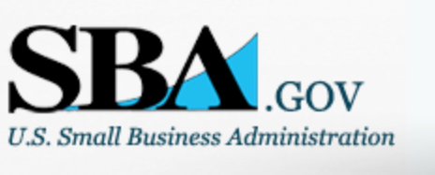

Small Business Administration

General Overview Finding Loans & Grants

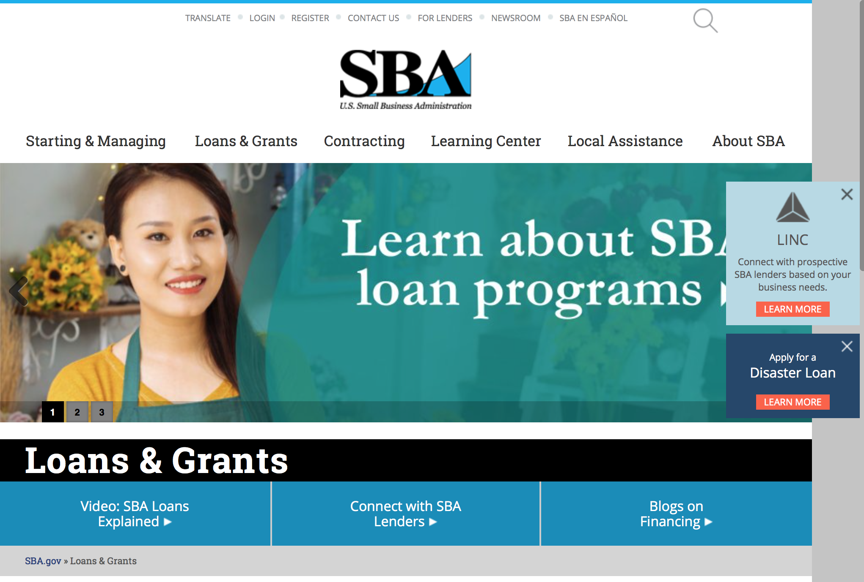
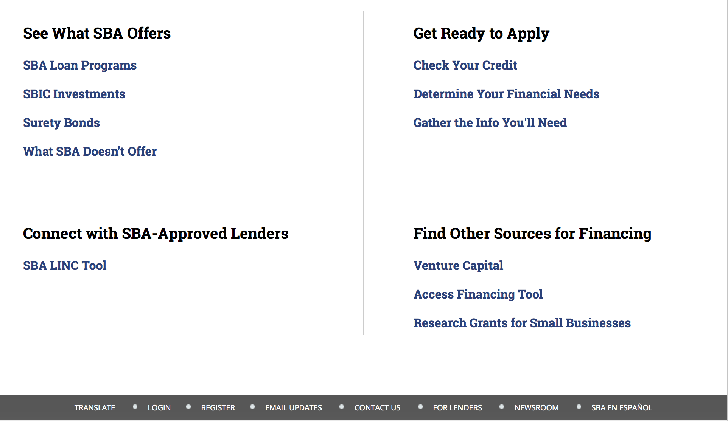

https://www.sba.gov/category/navigation-structure/loans-grants
Federal, state and local governments offer a wide range of financing programs to help small businesses start and grow their operations. These programs include low-interest loans, venture capital, and scientific and economic development grants.
Use SBA.gov's Loans and Grants Search Tool to get a list of financing programs for which you may qualify, or visit the resources below to learn more about small business financing programs.
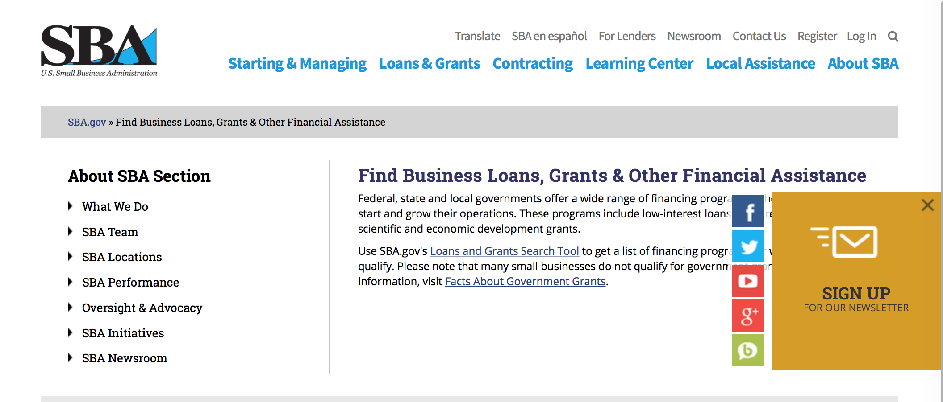
To get to the main SBA.gov funding page click here
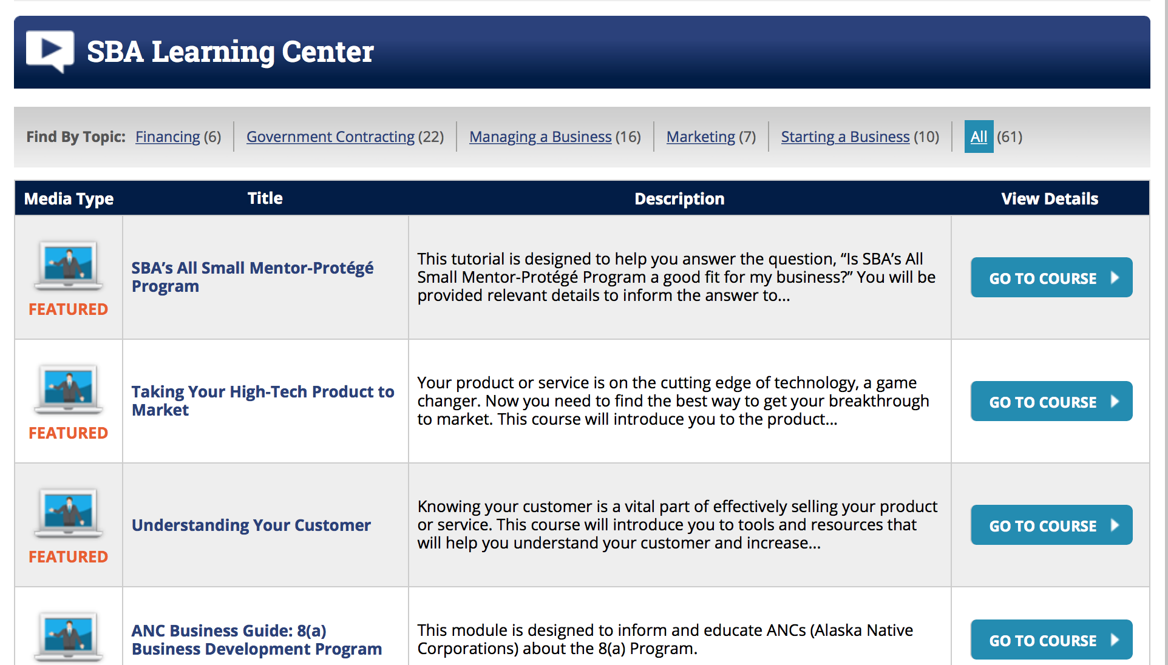
https://www.sba.gov/tools/sba-learning-center/search/training

Programs:

Modifications

Reminders:

Deleted:

SBA Trainings

Contracting Opportunities for Veteran Entrepreneurs
This self-paced training exercise is an introduction to Federal contracting opportunities for Veterans.
Topics include basic information about Veteran-owned businesses and opportunities, services available to small Veteran-owned businesses, small business incentives, and government procurement methods.
Duration: 00:30:00

http://www.sba.gov/tools/sba-learning-center/training/contracting-opportunities-veteran-entrepreneurs

Interested in Exporting? These Four Resources Can Help
Did you know that two-thirds of the world’s purchasing power is in foreign countries? As the numbers show, the international marketplace is a big one. So if you’re interested in exploring the world of exporting – or have gotten started but could use some guidance – check out these resources to help.
- Read more

Upcoming Trainings: Check out SBA's Online Training!
- Financing Options for Small Businesses
How to Prepare Government Contract Proposals
Getting Started With Exporting: Training and Educational Resources
Exporting represents a big opportunity to tap in to new markets, expand your customer base and grow your business. But getting started with exporting can sometimes feel like a maze of regulations, policies, and other barriers. Here are some free training and educational resources to help.
- Read more

For Specific Information in Hawaii see the following links:
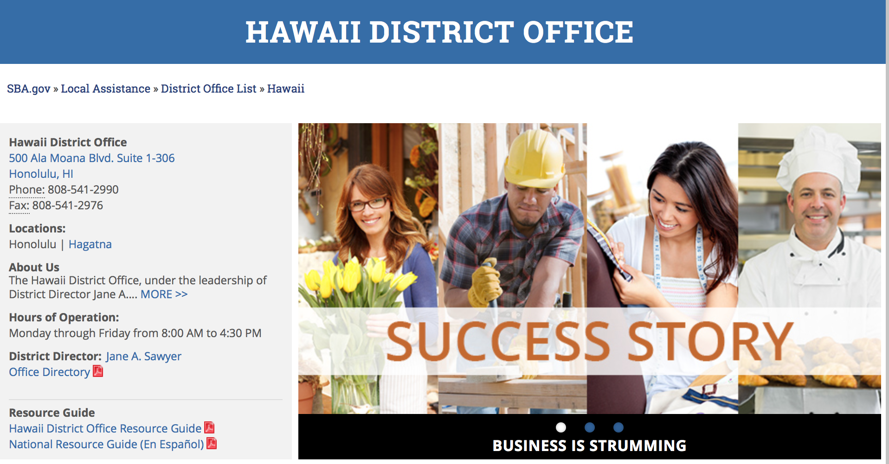

https://www.sba.gov/offices/district/hi/Honolulu

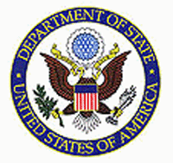

State Department General Overview and Resources for Program Administrators

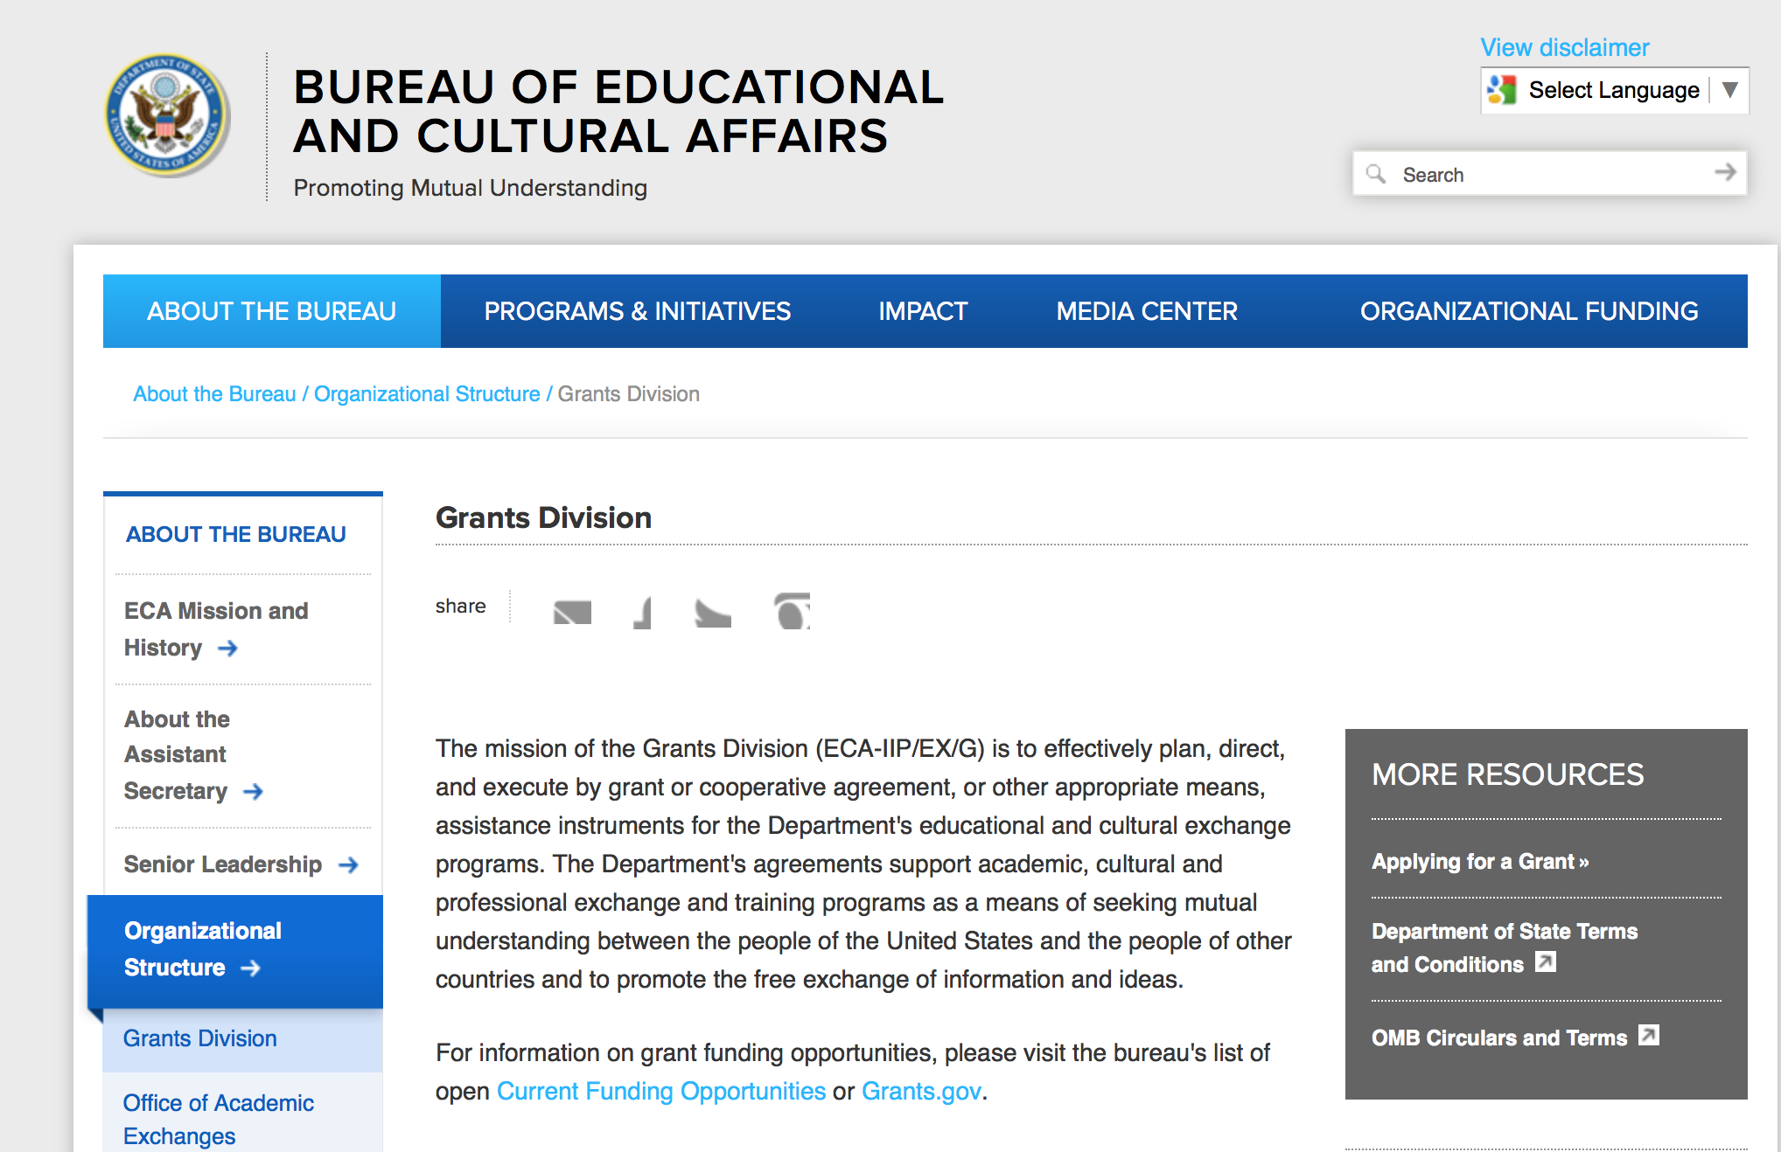

https://eca.state.gov/about-bureau/organizational-structure/grants-division

http://eca.state.gov/search/solr/grants?search_referrer=node/237

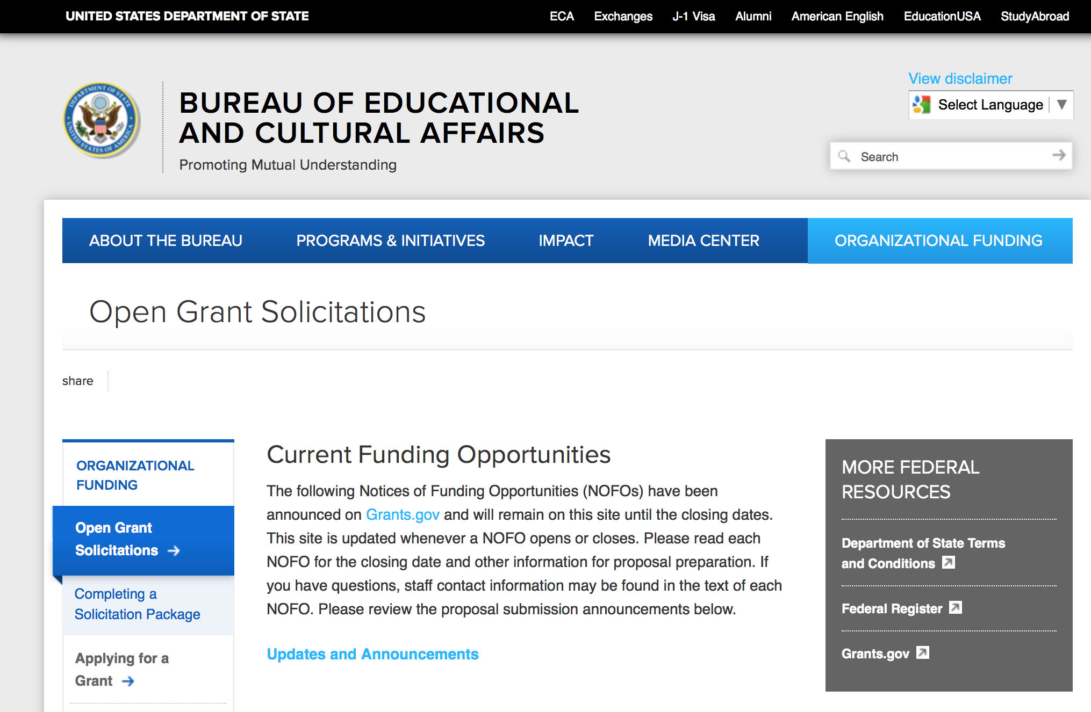
https://eca.state.gov/organizational-funding/open-grant-solicitations

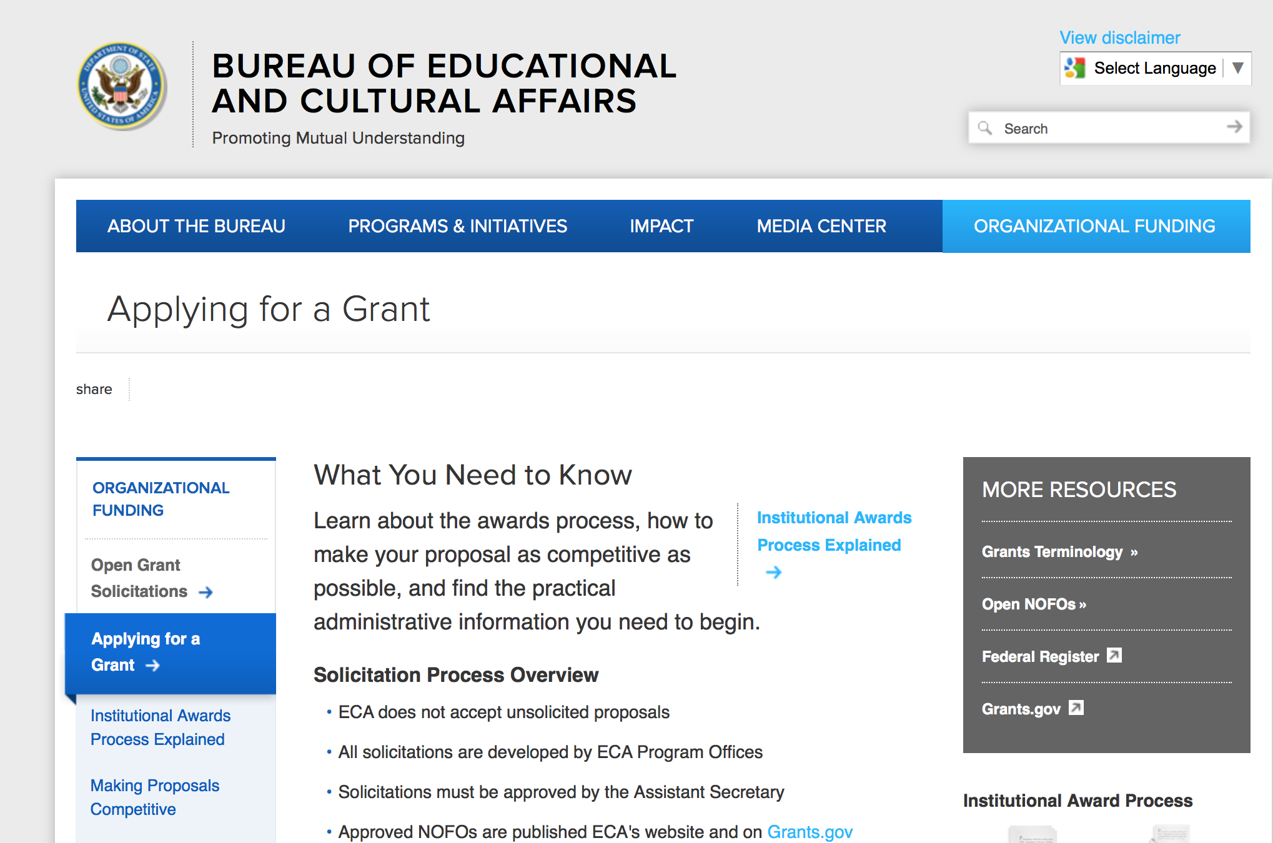
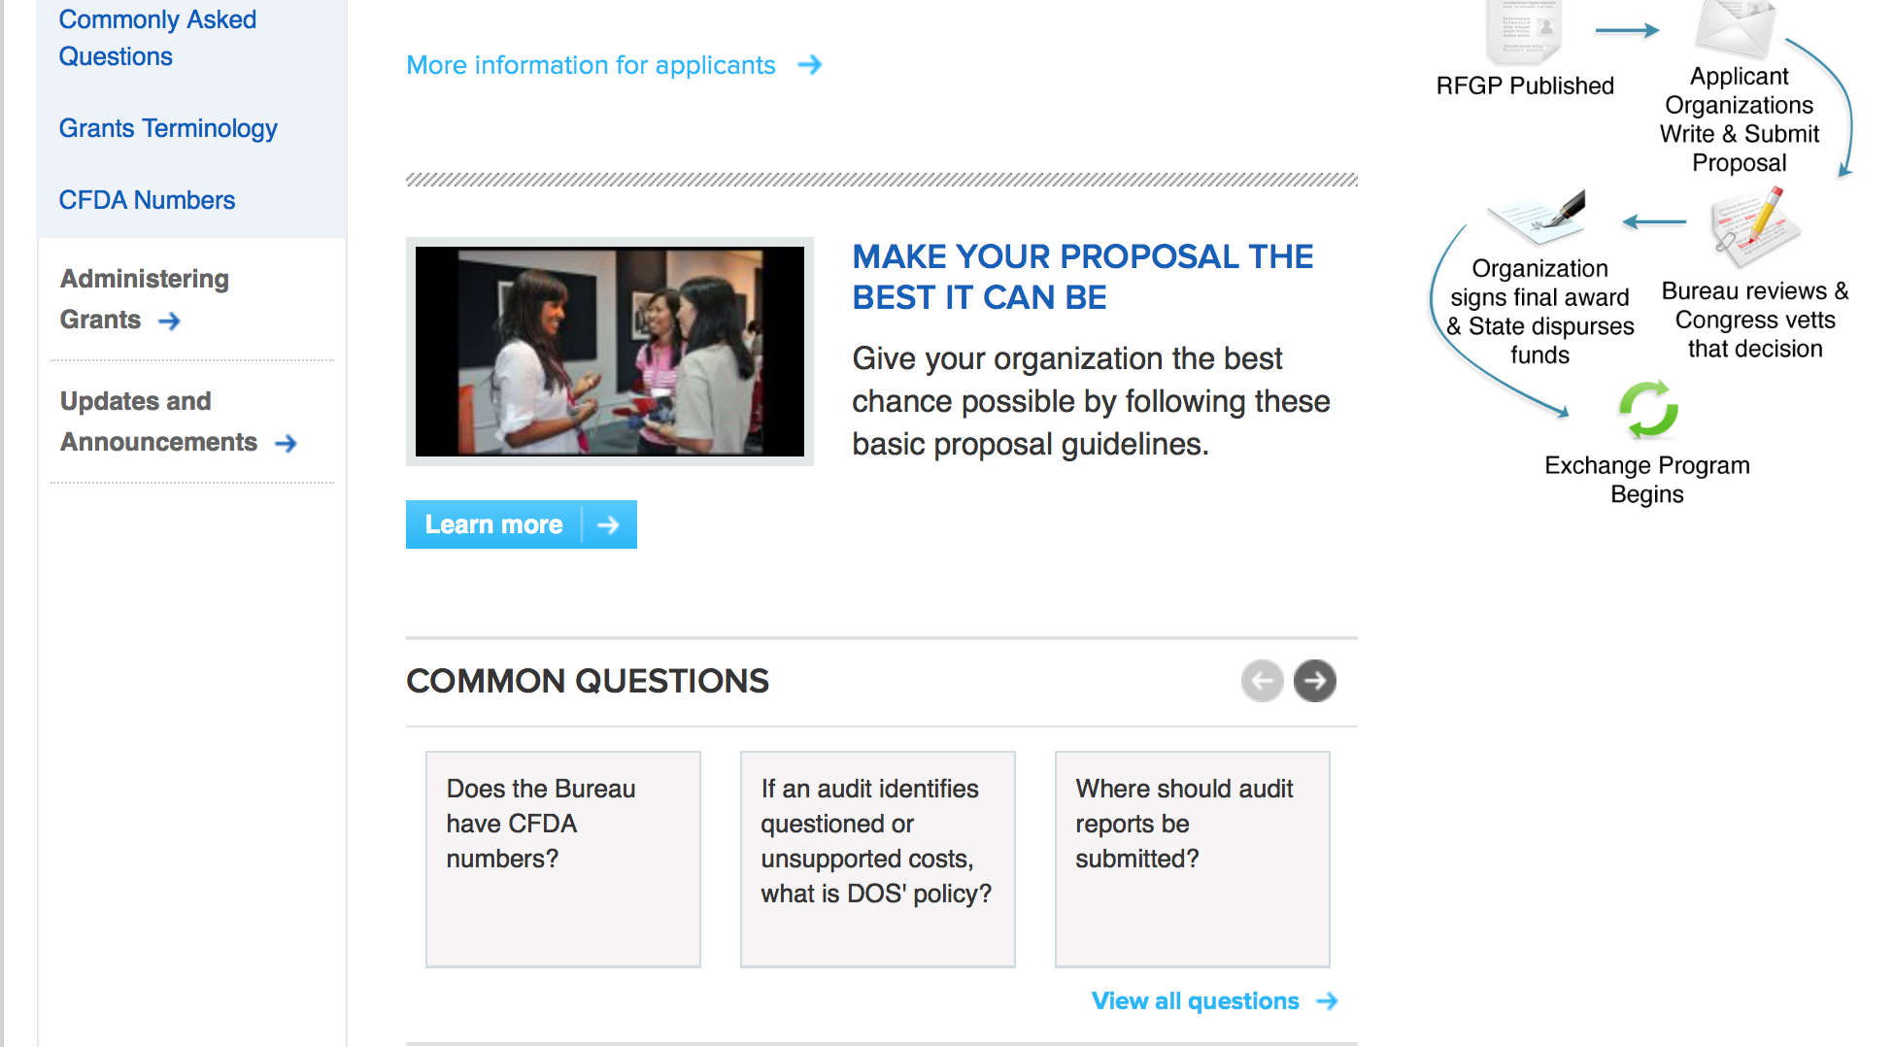
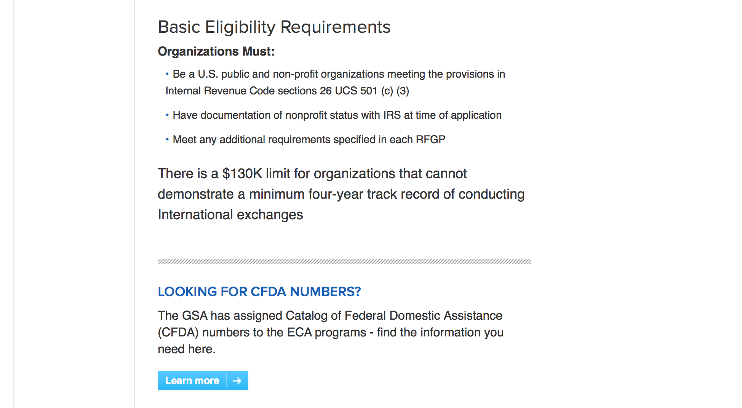
http://eca.state.gov/organizational-funding/applying-grant

General Information:
- Bureau of Educational and Cultural Affairs Grants Division
- Open Grant Opportunities (Requests for Grant Proposals)

For General Information click here

Program Grants:

Bureau of Democracy Human Rights and Labor
DRL Global Religious Freedom Programs (FY17/18)
Synopsis 1
http://www.grants.gov/web/grants/view-opportunity.html?oppId=297673

Bureau of Democracy Human Rights and Labor
Promotion and Protection of the Human Rights of LGBTI Persons
Synopsis 1
http://www.grants.gov/web/grants/view-opportunity.html?oppId=297674

Bureau of Democracy Human Rights and Labor
Bureau of Democracy, Human Rights and Labor Request for Statements of Interest: China Programs
Synopsis 1
http://www.grants.gov/web/grants/view-opportunity.html?oppId=297652

Bureau of Democracy Human Rights and Labor
Promote and Protect the Human Rights of Persons with Disabilities, Women and Girls, LGBTI persons and other Marginalized Individuals
Synopsis 1
http://www.grants.gov/web/grants/view-opportunity.html?oppId=297773

PM Weapons Removal and Abatement
17.PMWRA.UnsolicitedConceptNotes.October2017
Synopsis 1
http://www.grants.gov/web/grants/view-opportunity.html?oppId=297553

U.S. Mission to India
Engaging Youth and Political Leaders from North India (REPOST)
Synopsis 1
http://www.grants.gov/web/grants/view-opportunity.html?oppId=297271

U.S. Mission to India
Engaging Youth and Political Leaders from North India (REPOST)
Synopsis 1
http://www.grants.gov/web/grants/view-opportunity.html?oppId=297271

U.S. Mission to India
U.S. Universities Alumni: The East and Northeast India Connect Program (REPOST)
Synopsis 1
http://www.grants.gov/web/grants/view-opportunity.html?oppId=297291

Modifications:

Bureau of Democracy Human Rights and Labor
DRL Global Religious Freedom Programs (FY17/18)
Synopsis 3
http://www.grants.gov/web/grants/view-opportunity.html?oppId=297673

Bureau Of Educational and Cultural Affairs
FY 2018 English Language Fellow and Specialist Program
Synopsis 1
http://www.grants.gov/web/grants/view-opportunity.html?oppId=297574

Bureau of International Narcotics-Law Enforcement
CRIMINAL JUSTICE CIVIL SOCIETY PROGRAM
Synopsis 1
http://www.grants.gov/web/grants/view-opportunity.html?oppId=297149

Bureau of Population Refugees and Migration
2018 Cultural Orientation Technical Assistance
Synopsis 2 & 3
http://www.grants.gov/web/grants/view-opportunity.html?oppId=297329

Reminders:

Deleted:

Bureau of East Asian and Pacific Affairs
SFOP0002367 - FY18 International Media Reporting Program
Deletion Comments: Opportunity deleted

Deletion Comments: Withdrawal U.S. Mission to Nicaragua
SNU700-FY18-PAS-01 - Managua Annual Program Statement - PAS Small Grants Program
Deletion Comments: Opportunity deleted

Bureau of International Narcotics-Law Enforcement
INL-17CA0064-WHPHONDURAS-GBV-PREV-091717 - Building Capacity in Police Forces, Local Governments and Communities in Gender Based Violence
Deletion Comments: Opportunity deleted

Department of Transportation

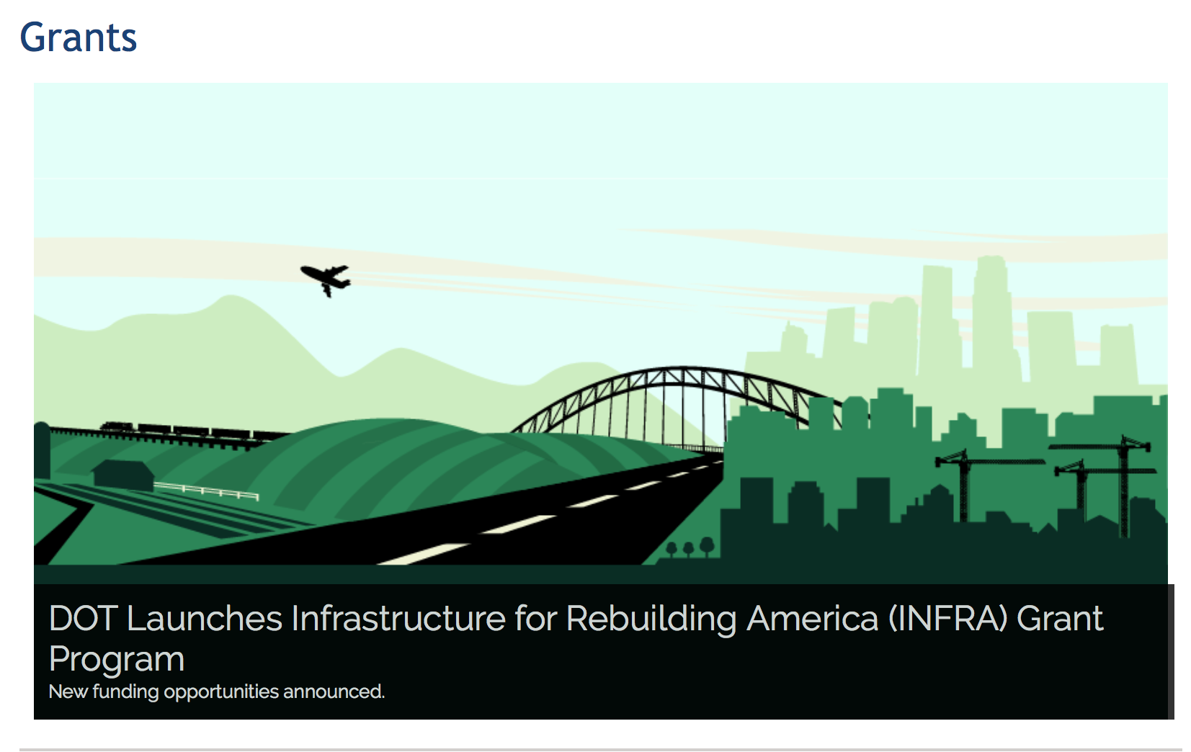

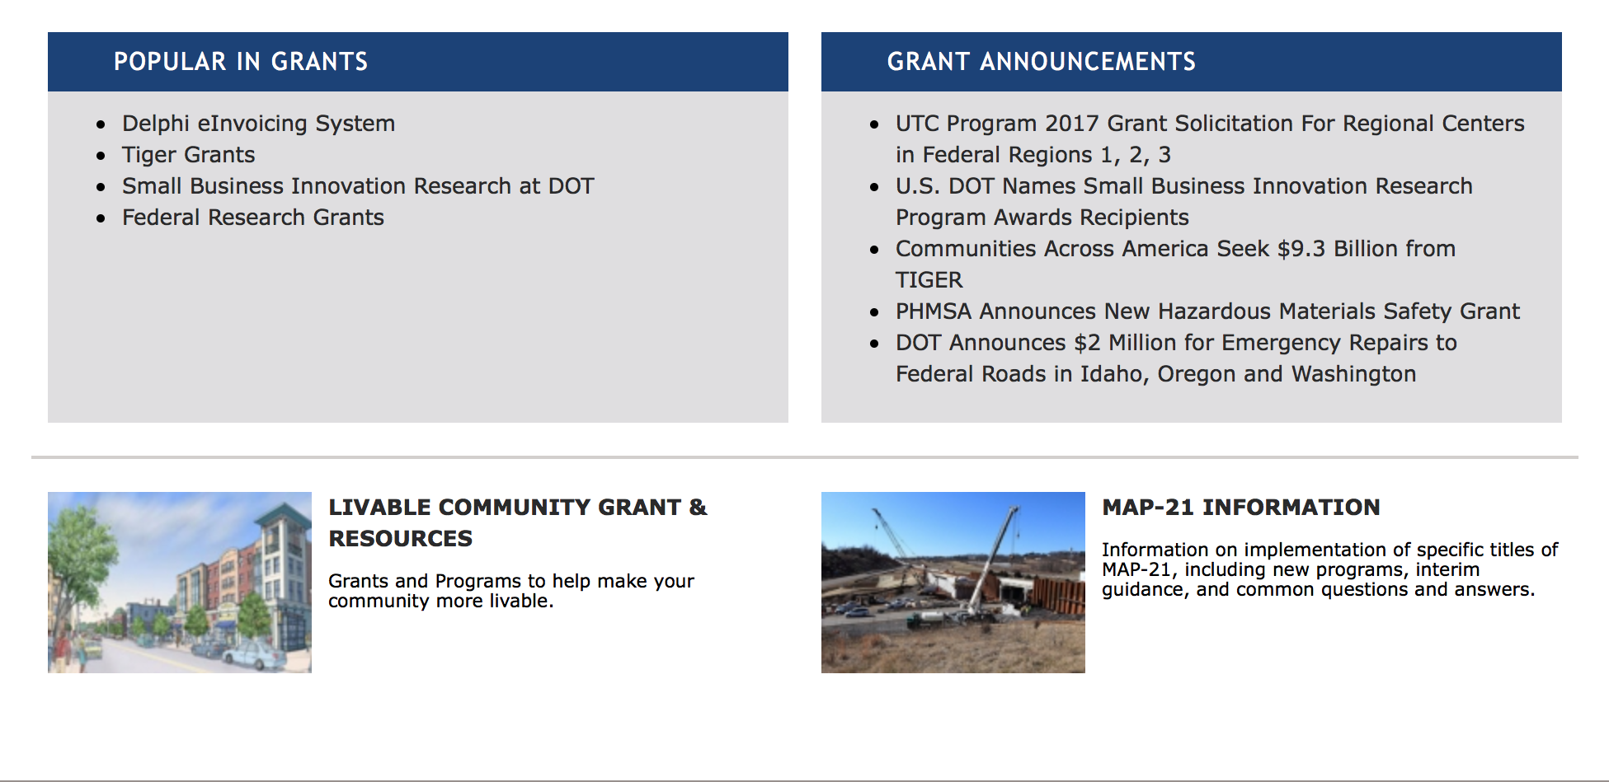

General Grant Program Overview https://www.transportation.gov/grants

Programs:

FY 2017 National Infrastructure Investments
Synopsis 1
Document Type: | Grants Notice
Funding Opportunity Number: | DTOS59-17-RA-TIGER9
Funding Opportunity Title: | FY 2017 National Infrastructure Investments
Opportunity Category: | Discretionary
Opportunity Category Explanation:
Funding Instrument Type: | Grant
Category of Funding Activity: | Transportation
Category Explanation:
Expected Number of Awards:
CFDA Number(s): | 20.933 -- National Infrastructure Investments
Cost Sharing or Matching Requirement: | Yes
Version: | Synopsis 1
Posted Date: | Sep 07, 2017
Last Updated Date: | Sep 06, 2017
Current Closing Date for Applications: | Oct 16, 2017 NOTE: Detailed Instructions on "How to Apply" for TIGER Discretionary Grants can be found on the TIGER Website (www.transportation.gov/tiger). Application Instructions: Applications must be submitted through Grants.gov. The Grants.gov “Apply” function opens on Sept 7, 2017. Please be aware that you must complete the Grants.gov registration process before submitting the Application, and that this process usually takes 2-4 weeks to complete. Applications must be submitted by 8:00 PM E.D.T. on Oct 16, 2017. Applicants are strongly encouraged to make submissions in advance of the deadline.*Late Applications: Applications received after the deadline will not be considered except in the case of unforeseen technical difficulties outlined below. Late applications that are the result of failure to register or comply with Grants.gov applicant requirements in a timely manner will not be considered. Applicants experiencing technical issues with Grants.gov that are beyond the applicant’s control must contact TIGERGrants@dot.gov or Howard Hill at 202-366-0301 prior to the deadline with the user name of the registrant and details of the technical issue experienced. The applicant must provide 1: Details of the technical issue experienced 2: Screen capture(s) of the technical issue experienced along corresponding “Grant tracking number” (Grants.gov) 3: The "Legal Business Name" for the applicant that was provided in the SF-424. 4: The AOR name submitted in the SF-424 (Grants.gov). 5: The DUNS number associated with the Application. 6: The Grants.gov Help Desk Tracking Number. To ensure a fair competition for limited discretionary funds, the following conditions are not valid reasons to permit late submissions: (1) failure to complete the registration process before the deadline date; (2) failure to follow Grants.gov instructions on how to register and apply as posted on its website; (3) failure to follow all of the instructions in this notice of funding availability; and (4) technical issues experienced with the applicant’s computer or information technology (IT) environment. After DOT staff review all of the information submitted and contact the Grants.gov Help Desk to validate the technical issues you reported, DOT staff will contact you to either approve or deny your request to submit a late application through Grants.gov. If the technical issues you reported cannot be validated, your application will be rejected as untimely.
Archive Date: | Sep 18, 2018
Estimated Total Program Funding: | $500,000,000
Award Ceiling: | $25,000,000
Award Floor: | $1,000,000
Eligible Applicants: | Others (see text field entitled "Additional Information on Eligibility" for clarification)
Additional Information on Eligibility: | Eligible Applicants for TIGER Discretionary Grants are State, local and tribal governments, including U.S. territories, transit agencies, port authorities, metropolitan planning organizations (MPOs), and other political subdivisions of State or local governments. Multiple States or jurisdictions may submit a joint application and must identify a lead applicant as the primary point of contact. Each project party in a joint application must be an Eligible Applicant. Joint applications must include a description of the roles and responsibilities of each project party and must be signed by each project party.
Agency Name: | Department of Transportation
Description: | The FY 2017 Appropriations Act appropriated $500 million to be awarded by DOT for the TIGER Discretionary Grants program. The FY 2017 TIGER Discretionary Grants are for capital investments in surface transportation infrastructure and are to be awarded on a competitive basis for projects that will have a significant impact on the Nation, a metropolitan area, or a region. The Act also allows DOT to use a small portion of the $500 million for oversight and administration of grants. If this solicitation does not result in the award and obligation of all available funds, DOT may publish additional solicitations. The Consolidated Appropriations Act, 2017 specifies that TIGER Discretionary Grants may not be less than $5 million and not greater than $25 million, except that for projects located in rural areas the minimum TIGER Discretionary Grant size is $1 million. Pursuant to the FY Consolidated Appropriations Act, 2017, no more than 20 percent of the funds made available for TIGER Discretionary Grants (or $50 million) may be awarded to projects in a single State. The Consolidated Appropriations Act, 2017 directs that not less than 20 percent of the funds provided for TIGER Discretionary Grants (or $100 million) shall be used for projects located in rural areas. Further, pursuant to the Consolidated Appropriations Act, 2017, DOT must take measures to ensure an equitable geographic distribution of grant funds, an appropriate balance in addressing the needs of urban and rural areas, and investment in a variety of transportation modes. The Consolidated Appropriations Act, 2017 requires that FY 2017 TIGER funds are only available for obligation through September 30, 2020. No FY 2017 TIGER funds may be expended after September 30, 2025. As part of the review and selection process described in the Notice of Funding Opportunity, DOT will consider whether a project is ready to proceed with an obligation of grant funds from DOT within the statutory time provided. Under the FY 2017 Appropriations Act, no waiver is possible for these deadlines. The FY 2017 Appropriations Act allows for up to 20 percent of available funds (or $100 million) to be used by the Department to pay the subsidy and administrative costs for a project receiving credit assistance under the Transportation Infrastructure Finance and Innovation Act of 1998 (“TIFIA”) program, if it would further the purposes of the TIGER Discretionary Grant program. Recipients of prior TIGER Discretionary Grants may apply for funding to support additional phases of a project awarded funds in earlier rounds of this program. However, to be competitive, the applicant should demonstrate the extent to which the previously funded project phase has been able to meet estimated project schedules and budget, as well as the ability to realize the benefits expected for the project. DOT expects that each TIGER Discretionary Grant will be administered by one of the relevant modal administrations, pursuant to a grant agreement between the TIGER Discretionary Grant recipient and the relevant modal administration.
Link to Additional Information: | TIGER Discretionary Grant Program
Grantor Contact Information: | If you have difficulty accessing the full announcement electronically, please contact:  Robert Mariner Deputy Director Phone 202-366-8914  TIGER Program Manager

http://www.grants.gov/web/grants/view-opportunity.html?oppId=297147

Modifications:

Research:

Reminders:

INFRA Grants
Synopsis 1
Document Type: | Grants Notice
Funding Opportunity Number: | NSFHP-17-18-INFRA
Funding Opportunity Title: | INFRA Grants
Opportunity Category: | Discretionary
Opportunity Category Explanation:
Funding Instrument Type: | Grant
Category of Funding Activity: | Transportation
Category Explanation:
Expected Number of Awards:
CFDA Number(s): | 20.934 -- Nationally Significant Freight and Highway Projects
Cost Sharing or Matching Requirement: | Yes
Version: | Synopsis 1
Posted Date: | Aug 02, 2017
Last Updated Date: | Aug 02, 2017
Original Closing Date for Applications: | Nov 02, 2017
Current Closing Date for Applications: | Nov 02, 2017
Archive Date: | Dec 02, 2017
Estimated Total Program Funding: | $1,560,000,000
Award Ceiling: | $1,400,000,000
Award Floor: | $5,000,000
Eligible Applicants: | Others (see text field entitled "Additional Information on Eligibility" for clarification)
Additional Information on Eligibility: | Eligible applicants for INFRA grants are 1) a State or group of States; 2) a metropolitan planning organization that serves an urbanized area (as defined by the Bureau of the Census) with a population of more than 200,000 individuals; 3) a unit of local government or group of local governments; 4) a political subdivision of a State or local government; 5) a special purpose district or public authority with a transportation function, including a port authority; 6) a Federal land management agency that applies jointly with a State or group of States; 7) a tribal government or a consortium of tribal governments; or 8) a multi-State or multi-jurisdictional group of public entities. Multiple States or jurisdictions that submit a joint application should identify a lead applicant as the primary point of contact. Each applicant in a joint application must be an Eligible Applicant. Joint applications must include a description of the roles and responsibilities of each applicant and must be signed by each applicant.
Agency Name: | Department of Transportation
Description: | The Nationally Significant Freight and Highway Projects (NSFHP) program provides Federal financial assistance to highway and freight projects of national or regional significance. The Department of Transportation is referring to this program as the Infrastructure for Rebuilding America (INFRA) program. This notice solicits applications for awards under the program’s FY 2017 and FY 2018 funding, subject to future appropriations.
Link to Additional Information: | INFRA Grants Website
Grantor Contact Information: | If you have difficulty accessing the full announcement electronically, please contact:  Robert Mariner Deputy Director, Office of Infrastructure Finance and Innovation Phone 202-366-8914  USDOT Contact

http://www.grants.gov/web/grants/view-opportunity.html?oppId=296083

DOT Federal Aviation Administration
DOT - FAA Aviation Research Grants
FAA Aviation Research and Development Grants
Modifications 3 & 4

Document Type: | Grants Notice
Funding Opportunity Number: | 12-01
Funding Opportunity Title: | FAA Aviation Research and Development Grants
Opportunity Category: | Discretionary
Opportunity Category Explanation:
Funding Instrument Type: | Grant
Category of Funding Activity: | Transportation
Category Explanation:
Expected Number of Awards:
CFDA Number(s): | 20.108 -- Aviation Research Grants
Cost Sharing or Matching Requirement: | No
Version: | Synopsis 5
Posted Date: | Jan 01, 2012
Last Updated Date: | Jun 09, 2016
Original Closing Date for Applications: | Dec 31, 2019
Current Closing Date for Applications: | Dec 31, 2019
Archive Date: | Jan 30, 2020
Estimated Total Program Funding:
Award Ceiling: | $5,000,000
Eligible Applicants: | Nonprofits having a 501(c)(3) status with the IRS, other than institutions of higher education  Private institutions of higher education  Public and State controlled institutions of higher education
Agency Name: | DOT - FAA Aviation Research Grants
Description: | The FAA is soliciting proposals for research grants and cooperative agreements to pursue the long-term growth and short-term technical needs of civil aviation. In order to streamline the application process, it is recommended that all prospective grantees submit a white paper (letter of intent) for agency technical review before complete proposal submission. Please be sure to identify the specific area of interest (Solicitation FAA-12-01 – Chapter I. FAA Research Grants Program, Technical Areas of Research #1-#9). The white paper shall be no longer than three (3) pages and shall detail overall research objectives.
Link to Additional Information:
Grantor Contact Information: | If you have difficulty accessing the full announcement electronically, please contact:  Debra Monzo Grants Officer Phone 609-485-4962  business

http://www.grants.gov/web/grants/view-opportunity.html?oppId=134953

Deleted:

Department of the Treasury

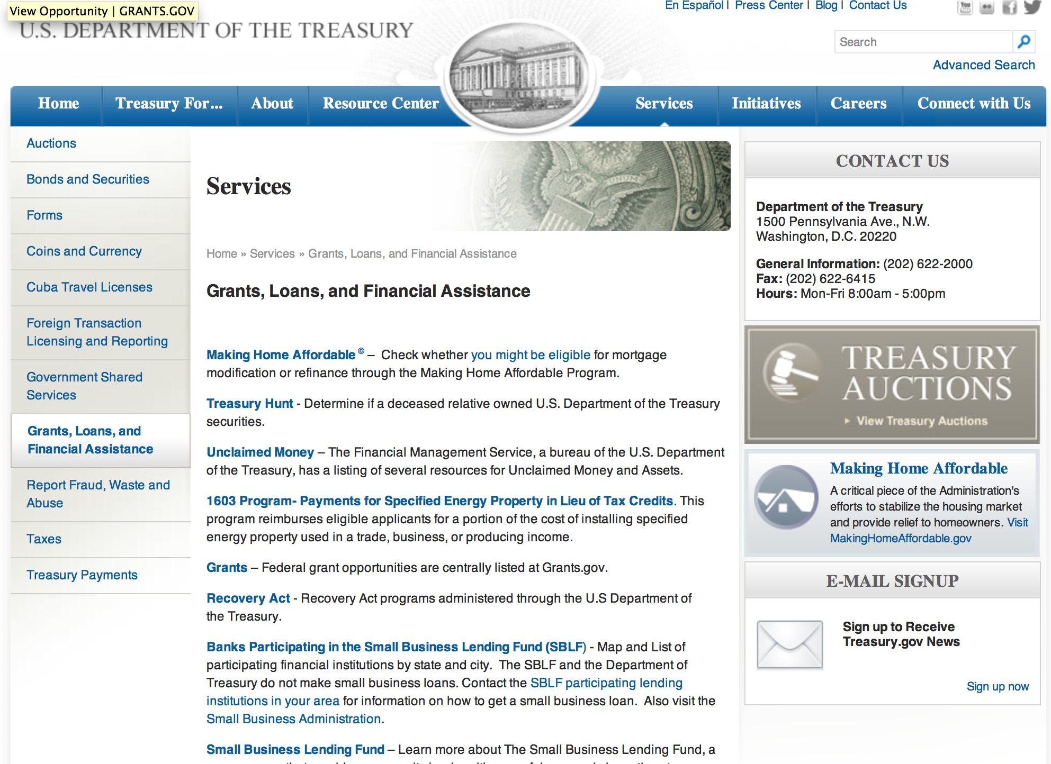

http://www.treasury.gov/services/Pages/Grants-Loans-and-Financial-Assistance.aspx

Programs:

Community Development Financial Institutions
FY 2017 Bank Enterprise Award Program Application
Synopsis 1

Document Type: | Grants Notice
Funding Opportunity Number: | CDFI-2017-BEA
Funding Opportunity Title: | FY 2017 Bank Enterprise Award Program Application
Opportunity Category: | Discretionary
Opportunity Category Explanation:
Funding Instrument Type: | Grant
Category of Funding Activity: | Community Development
Category Explanation:
Expected Number of Awards: | 90
CFDA Number(s): | 21.021 -- Bank Enterprise Award Program
Cost Sharing or Matching Requirement: | No
Version: | Synopsis 1
Posted Date: | Sep 29, 2017
Last Updated Date: | Sep 28, 2017
Original Closing Date for Applications: | Nov 16, 2017
Current Closing Date for Applications: | Nov 16, 2017
Archive Date: | Dec 16, 2017
Estimated Total Program Funding: | $23,000,000
Award Ceiling: | $1,000,000
Award Floor: | $1,500
Eligible Applicants: | Others (see text field entitled "Additional Information on Eligibility" for clarification)
Additional Information on Eligibility: | Applicants must be FDIC-Insured Depository Institutions (banks and thrifts).
Agency Name: | Community Development Financial Institutions
Description: | Through the Bank Enterprise Award Program (BEA Program), the U.S. Department of the Treasury’s Community Development Financial Institutions Fund (CDFI Fund) supports FDIC-insured financial institutions around the country that are dedicated to financing and supporting community and economic development activities. The BEA Program complements the community development activities of insured depository institutions (i.e., banks and thrifts) by providing monetary awards for increasing investments in CDFIs and for increasing qualified lending, investment, and service activities within economically distressed communities. Providing BEA Program awards for increasing community development activities leverages the CDFI Fund’s dollars and puts more capital to work in distressed communities throughout the nation.
Link to Additional Information: | A webpage on the CDFI Fund's website with all the relevant details regarding the Bank Enterprise Award Program.
Grantor Contact Information: | If you have difficulty accessing the full announcement electronically, please contact:  CDFI Fund Help Desk (202) 653-0421  CDFI Fund Help Desk

http://www.grants.gov/web/grants/view-opportunity.html?oppId=297731

Modifications:

Reminders:

U.S. Agency for International Development

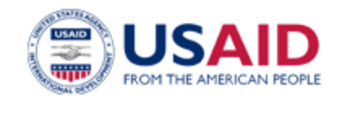

www.usaid.gov

General Overview Funding Opportunities

USAID has working relationships with thousands of American companies and hundreds of U.S.-based private voluntary organizations. For more information on our business and procurement opportunities, please visit our Business section.

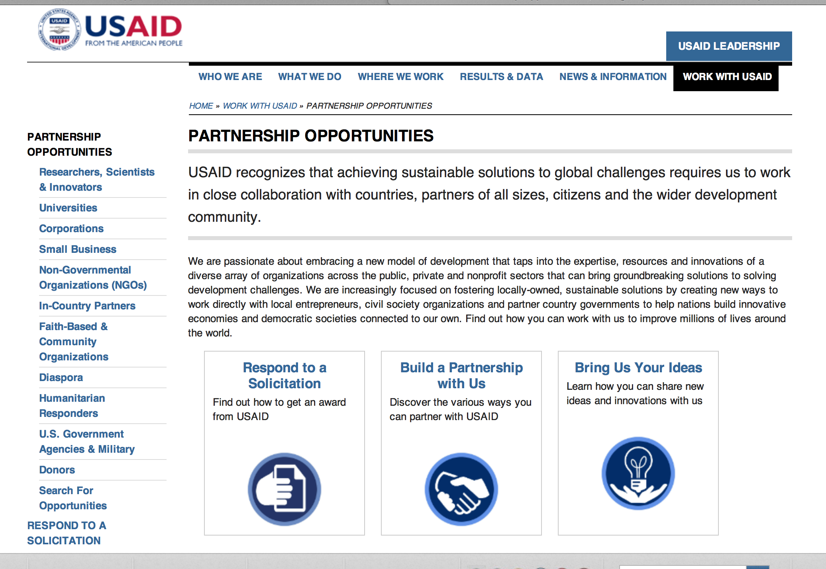
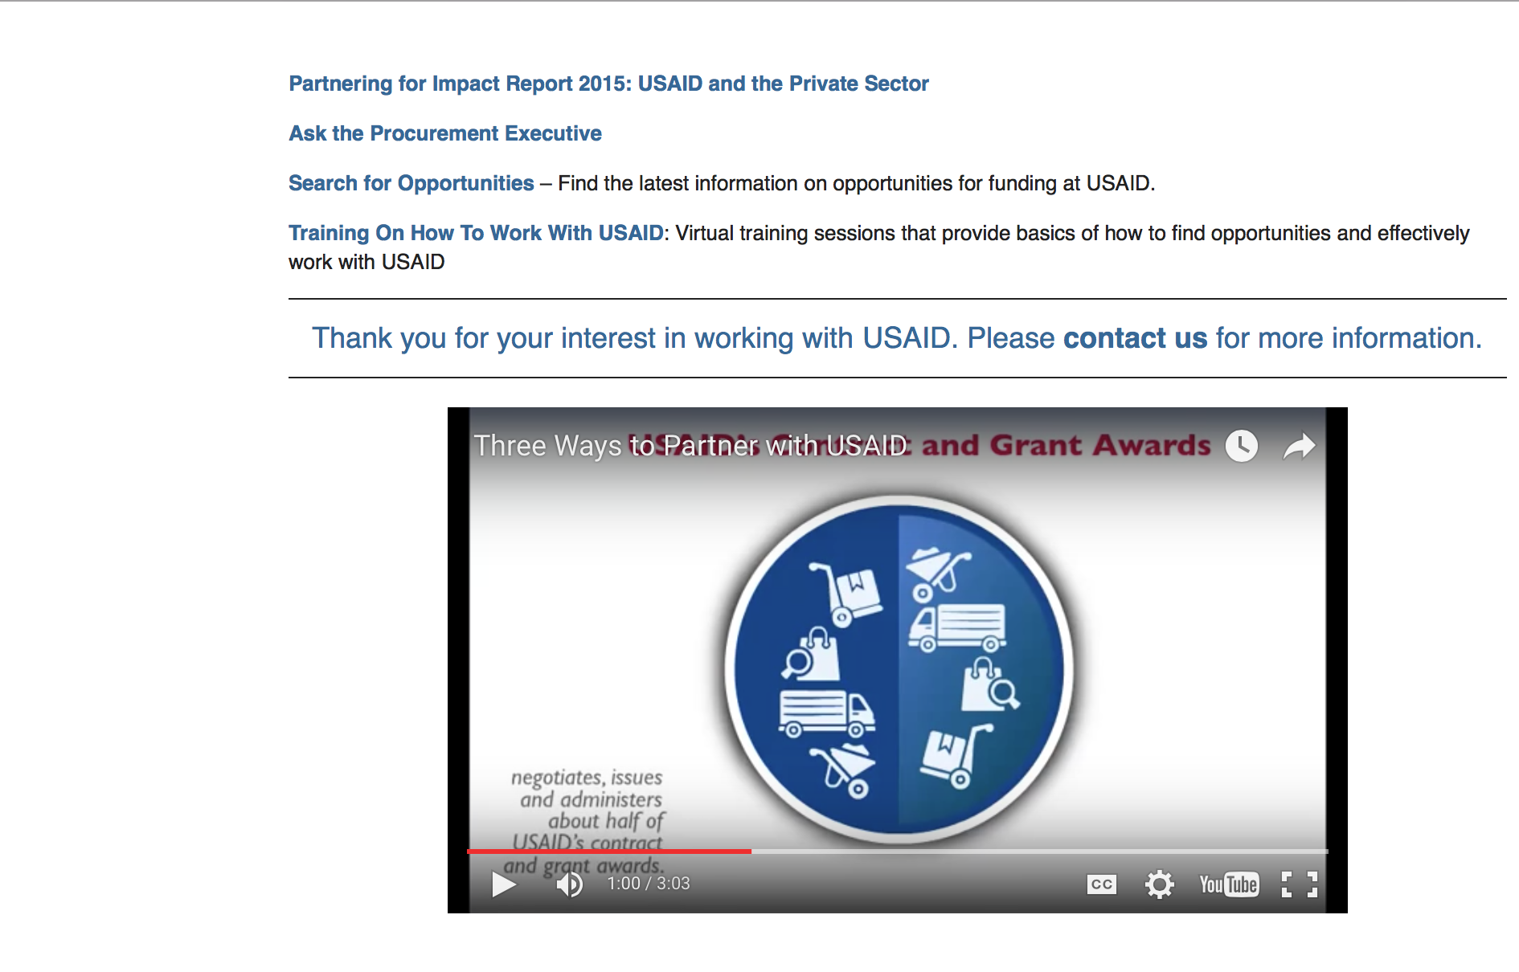

http://www.usaid.gov/partnerships

Programs:

Reading for All
Synopsis 1
http://www.grants.gov/web/grants/view-opportunity.html?oppId=297679

USAID/DRC Request for Information: Responsible Minerals Program Planning
Synopsis 1
http://www.grants.gov/web/grants/view-opportunity.html?oppId=297661

(ME/ED) UMBRELLA ANNUAL PROGRAM STATEMENT (APS)
Synopsis 1
http://www.grants.gov/web/grants/view-opportunity.html?oppId=297734

Modifications:

Democratic Republic of the Congo USAID-Kinshasa
COMMUNITY BASED COUNTER WILDLIFE TRAFFICKING
Forecast 2
http://www.grants.gov/web/grants/view-opportunity.html?oppId=297663

Germany USAID - Frankfurt
Market Research for USAID/YEMEN activity planning
Forecast 1
http://www.grants.gov/web/grants/view-opportunity.html?oppId=297695

Germany USAID - Frankfurt
Market Research for USAID/YEMEN activity planning
Forecast 2
http://www.grants.gov/web/grants/view-opportunity.html?oppId=297695

Round 2 - Harnessing Local Innovations, Expertise and Partnerships to Solve Development Challenges in Asia
Synopsis 3
http://www.grants.gov/web/grants/view-opportunity.html?oppId=297606

Sustaining Technical and Analytic Resources (STAR)
Synopsis 2
http://www.grants.gov/web/grants/view-opportunity.html?oppId=296394

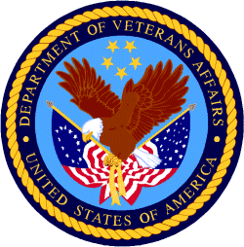

Department of Veterans Affairs

