Senator Mazie Hirono

Grants Assistance Information Newsletter
WITH DISASTER ASSISTANCE SUPPLEMENT
OCTOBER 2023

PART 1– CURRENT FEDERAL AGENCY DISCRETIONARY GRANT OPPORTUNITIES

PART 2 - GENERAL FEDERAL AGENCY GRANTS INFORMATION

INDEX

PART 1 – Current General Federal Agency Grant and Cooperative Agreement Discretionary Program Summaries

Programs Specific To Hawai’i

President Biden’s Bipartisan Infrastructure Law’s Distribution of funding in Hawai’i

Federal Disaster Assistance

Biden-Harris Administration’s Latest Actions to Support Communities Impacted by Maui Wildfires

How to Apply for Disaster Assistance

Voluntary Organizations Active in Disaster Relief

Coordinated Federal Agency Disaster Response

Verifying Home Ownership

Updated Small Business Disaster Assistance Details

Current Notices

Environmental Education Local Grants Program for Region 9

Region 9 Fiscal Year 2023 Wetland Program Development Grants

Reminders

Native American/Native Hawaiian Museum Services (2024)

National Park Service
Alaska Native and Native Hawaiian Culture and Arts Development Grant Program – Fiscal Year 2023/2024

National Park Service
Japanese American Confinement Sites Grant Program
Health Resources and Services Administration
FY 2024 Native Hawaiian Health Care Improvement Act

General National Programs by Federal Agency

U.S. Department of Agriculture

Programs
Rural Utilities Service
Solid Waste Management Grant Program

Research

Modifications

Rural Utilities Service
Technical Assistance and Training Grant Program

Rural Utilities Service
Calendar Year 2022 Disaster Circuit Rider Technical Assistance Grants Program

Agricultural Marketing Service
Farm Labor Stabilization and Protection Pilot Program

Reminders

Agricultural Marketing Service
Specialty Crop Multi-State Program
Forest Service
USDA Forest Service Inflation Reduction Act Forest Landowner Support

Natural Resources Conservation Service
Announcement for Program Funding for NRCS’s Conservation Innovation Grants (CIG) Classic Program for Federal fiscal year (FY) 2023

Rural Utilities Service
Assistance to High Energy Cost Communities
Natural Resources Conservation Service
Conservation Innovation Grants (CIG) On-Farm Conservation Innovation Trials for fiscal year (FY) 2023
Rural Business-Cooperative Service
Meat and Poultry Processing Expansion Program - Phase 2
Forest Service
USDA Forest Service Inflation Reduction Act Forest Landowner Support

Animal and Plant Health Inspection Service
National Animal Disease Preparedness and Response Program Fiscal Year 2024
Food and Nutrition Service
Farm To School Technical Assistance-Cooperative Agreement
National Institute of Food and Agriculture
Community Food Projects Competitive Grant Program

Rural Housing Service
Community Facilities Program Disaster Repair Grants

Agricultural Marketing Service
Farm Labor Stabilization and Protection Pilot Program
Forest Service
Community Wildfire Defense Grant 2023 West
Rural Utilities Service
Empowering Rural America (New ERA) Program

Rural Utilities Service
Calendar Year 2022 Disaster Water Grants
National Institute of Food and Agriculture
Small Business Innovation Research and Small Business Technology Transfer Programs Phase I
Rural Business-Cooperative Service
Higher Blends Infrastructure Incentive Program (HBIIP)
Rural Utilities Service
Powering Affordable Clean Energy

National Institute of Food and Agriculture
Agriculture and Food Research Initiative Competitive Grants Program Education and Workforce Development
National Institute of Food and Agriculture
Agriculture and Food Research Initiative Competitive Grants Program Foundational and Applied Science Program

Department of Commerce

Programs
DOC NOAA - ERA Production
FY2024-2025 National Sea Grant BIL Marine Debris Challenge Competition
DOC NOAA - ERA Production
FY2024-2025 National Sea Grant BIL Marine Debris Community Action Coalitions
2024 Effects of Sea Level Rise
DOC NOAA - ERA Production
Fiscal Year 2025 National Sea Grant College Program Dean John A. Knauss Marine Policy Fellowship

2024 Bycatch Reduction Engineering Program
Research
NOAA SBIR FY 2024 Phase I

Modifications

National Institute of Standards and Technology
CHIPS Incentives Program – Facilities for Semiconductor Materials and Manufacturing Equipment
FY2024 Coastal and Ocean Modeling Testbed Project
Reminders

FY24 NOAA Marine Debris Removal under the Bipartisan Infrastructure Law

FY2024 Weather Program Office Research Programs

National Institute of Standards and Technology
Standards Development Organization Grants for Forensic Science Standards (SDO GFSS)
Coastal Habitat Restoration and Resilience Grants for Tribes and Underserved Communities, Under the BIL and IRA
FY24 NOAA Marine Debris Interception Technologies under the Bipartisan Infrastructure Law
Social, Cultural and Economic Assessment of Harmful Algal Blooms
NOAA's Transformational Habitat Restoration and Coastal Resilience Grants Under the Bipartisan Infrastructure Law and Inflation Reduction Act

NOAA's Restoring Fish Passage through Barrier Removal Grants Under the BIL and IRA
Fiscal Year 2024 - FY2025 Margaret A. Davidson Graduate Fellowships for the National Estuarine Research Reserve System
NERRS Habitat Protection and Restoration Bipartisan Infrastructure Law (BIL) Competition
Ocean Acidification Coastal Research: Uniting Investigations and Shipboard Experiments (OA CRUISE)
NOAA Ocean Acidification Program Education Mini-Grant Program
2023 Inflation Reduction Act Climate-Ready Workforce for Coastal States and Territories Competition

National Institute of Standards and Technology
Measurement Science and Engineering (MSE) Research Grant Programs

National Institute of Standards and Technology
CHIPS Incentives Program – Commercial Fabrication Facilities

FY 2021 - 2023 Economic Development RNTA
National Institute of Standards and Technology
Measurement Science and Engineering (MSE) Research Grant Programs
National Institute of Standards and Technology
NIST Manufacturing USA National Emergency Assistance Program
Economic Development Administration
FY 2020 EDA Public Works and Economic Adjustment Assistance Programs

Consumer Product Safety Commission

Nicholas and Zachary Burt Memorial Carbon Monoxide Poisoning Prevention Grant Program

Corporation for National and Community Service

Programs

Reminders

Fiscal Year (FY) 2024 AmeriCorps State and National Competitive Grants

Department of Defense

Programs

Research Grants

Reminders

Dept of the Army -- Materiel Command
United States Army Research Institute For The Behavioral And Social Sciences (ARI) Broad Agency Announcement For Basic, Applied, And Advanced Scientific Research

Dept of the Army -- Materiel Command
DEVCOM Analysis Center Broad Agency Announcement For Applied Research

Dept of the Army -- Materiel Command
DEVCOM Army Research Laboratory Broad Agency Announcement For Foundational Research

Department of Education

Programs
Research

Institute of Education Sciences (IES): National Center for Education Research (NCER): Research Networks Focused on Critical Problems of Education Policy and Practice, Assistance Listing Number (ALN) 84.305N

Institute of Education Sciences (IES): National Center for Education Research (NCER): Statistical and Research Methodology in Education, Assistance Listing Number (ALN) 84.305D
Institute of Education Sciences (IES): National Center for Education Research (NCER): Research Training Programs in The Education Sciences, Assistance Listing Number (ALN) 84.305B

Modifications
Office of Elementary and Secondary Education (OESE): Charter School Program (CSP): Grants to Charter Management Organizations for the Replication and Expansion of High-Quality Charter Schools (CMO Grants), Assistance Listing Number (ALN) 84.282M

Reminders

US Department of Energy

Programs

Office of Science
FY 2024 Continuation of Solicitation for the Office of Science Financial Assistance Program

Research

Modifications

Reminders

National Energy Technology Laboratory
Inflation Reduction Act - Transmission Siting and Economic Development Program
National Energy Technology Laboratory
BIL - Carbon Utilization Procurement Grants under Bipartisan Infrastructure Law Section 40302
National Energy Technology Laboratory
Bipartisan Infrastructure Law (BIL) Consumer Electronics Battery Recycling, Reprocessing, and Battery Collection

Environmental Protection Agency

Programs
FY24 Guidelines For Brownfield Assessment Grants (Assessment Coalition Grants)
FY24 Guidelines For Brownfield Assessment Grants (Community-Wide Assessment Grants)
FY24 Guidelines For Brownfield Cleanup Grants

FY24 Guidelines For Brownfield Multipurpose Grants
Promoting Readiness and Enhancing Proficiency to Advance Reporting and Data
Climate Pollution Reduction Grants Program: Implementation Grants (General Competition)

Innovative Water Infrastructure Workforce Development Grant Program
Reducing Embodied Greenhouse Gas Emissions for Construction Materials and Products
Modifications
Reminders

Drinking Water System Infrastructure Resilience and Sustainability Program

Clean Communities Investment Accelerator (CCIA)
Solar for All

Department of Health and Human Services

Programs

Health Resources and Services Administration
Healthy Start Initiative: Eliminating Disparities in Perinatal Health
Research Grants

Modifications

Reminders
Health Resources and Services Administration
Service Area Competition
Health Resources and Services Administration
Healthy Start Initiative: Eliminating Disparities in Perinatal Health
Health Resources and Services Administration
FY 2024 Service Area Competition

Health Resources and Services Administration
Behavioral Health Workforce Education and Training Program- Professionals
Health Resources and Services Administration
FY 2024 Behavioral Health Service Expansion
Health Resources and Services Administration
FY 2024 Expanded Hours
Health Resources and Services Administration
FY 2024 New Access Points

Department of Homeland Security
Programs
Reminders

Department of Housing and Urban Development

Programs
Fiscal Year (FY) 2023 Housing Opportunities for Persons With AIDS (HOPWA) Competitive Grant: Housing Interventions (HINT) to End the HIV Epidemic
Healthy Homes Production Grant Program
Lead and Healthy Homes Technical Studies (LHHTS) Grant Program
Pathways to Removing Obstacles to Housing (PRO Housing)

HUD FY2023 Healthy Homes and Weatherization Cooperation Demonstration
Fair Housing Initiatives Program - Education and Outreach Initiative
Fair Housing Initiative Program - Fair Housing Organizations Initiative
Fair Housing Initiatives Program – Private Enforcement Initiative
Modifications

Older Adults Home Modification Grant Program

Reminders
FY2023 and FY2024 Authority to Accept Unsolicited Proposals for Research Partnerships
Green and Resilient Retrofit Program (GRRPC) Comprehensive

Green and Resilient Retrofit Program (GRRPE) Elements

Green and Resilient Retrofit Program (GRRP) Leading Edge

Institute of Museum and Library Services
Programs
Modifications
Reminders
Inspire! Grants for Small Museums (2024)
Museums Empowered (2024)

Museums for America (2024)
National Leadership Grants for Museums (2024)

National Leadership Grants for Libraries (2024)

Laura Bush 21st Century Librarian Program (2024)

Department of Interior

Programs

National Park Service
FY2023 Historic Preservation Fund- Save America's Treasures Collection Grants
National Park Service
FY2023 Historic Preservation Fund- Save America's Treasures Preservation Grants

National Park Service
FY2023 Historic Preservation Fund- African American Civil Rights - AACRN Preservation

Bureau of Reclamation
FY24 Desalination and Water Purification Research Program: Research Projects

Fish and Wildlife Service
F24AS00011- FY24 Neotropical Migratory Bird Conservation Act Grants
National Park Service
National Park Service 21st Century Conservation Service Corps & Civilian Climate Corps Program - National Youth Cooperative Agreements
Fish and Wildlife Service
F24AS00022 - Coastal Program - FY24
Geological Survey
The Educational Component of the National Cooperative Geologic Mapping Program
Geological Survey
Groundwater and Streamflow Information Program, National Ground-Water Monitoring Network

Modifications

Bureau of Reclamation
Small Surface Water and Groundwater Storage Projects
Geological Survey
Cooperative Research Units Program Department of the Interior Geological Survey

Reminders

Fish and Wildlife Service
F24AS00012 - NAWCA 2024 US Small Grants
Fish and Wildlife Service
F24AS00017 - Species Conservation Catalyst Fund on Songbird Trade
Bureau of Reclamation
WaterSMART Cooperative Watershed Management Program Phase I for Fiscal Year 2023

Bureau of Reclamation
WaterSMART-Applied Science Grants for Fiscal Year 2023

Fish and Wildlife Service
F23AS00395 National Fire Plan-Wildland Urban Interface Community Fire Assistance
Fish and Wildlife Service
F23AS00249 National Fish Passage Program Base Funding Fiscal Year 2023
National Park Service
FY2023 ABPP - Battlefield Land Acquisition Grant

National Park Service
NPS Cooperative Ecosystems Studies Units (CESU) Master Cooperative Agreements
Fish and Wildlife Service
F23AS00078 National Fish Passage Program Bipartisan Infrastructure Law Fiscal Year 2023

Department of Justice

Programs
Modifications

Research

Reminders

________________________________________________________________________

Department of Labor

Programs
Modifications

Reminders

Veterans Employment and Training Service
Announcement of Stand Down Grants

Employment and Training Administration
National Dislocated Worker Grants Program Guidance

Library of Congress

National Aeronautics and Space Administration

Research

_______________________________________________________________
National Archives and Records Administration

Programs

Reminders

Archival Projects
Public Engagement with Historical Records
Publishing Historical Records in Collaborative Digital Editions
_______________________________________________________________
National Endowment for the Arts

Programs
Modifications

Reminders

NEA Literature Fellowships: Translation Projects, FY2025

___________________________________________________________

National Endowment for the Humanities

Programs

Dialogues on the Experience of War
Humanities Connections

Climate Smart Humanities Organizations
Summer Stipends
Modifications

Reminders

Digital Humanities Advancement Grants
Dangers and Opportunities of Technology: Perspectives from the Humanities
Collaborative Research

Cultural and Community Resilience
Digital Projects for the Public
Fellowships
Humanities Collections and Reference Resources
Humanities Initiatives
Public Impact Projects at Smaller Organizations
Research and Development
Spotlight on Humanities in Higher Education

Fellowships for Digital Publication

Preservation and Access Education and Training

Collaborative Research

Digital Humanities Advancement Grants

Institutes for Higher Education Faculty Institutes for K-12 Educators
Landmarks of American History and Culture

National Digital Newspaper Program
Preservation Assistance Grants for Smaller Institutions
Sustaining Cultural Heritage Collections

Fellowships Open Book Program
_______________________________________________________________
National Science Foundation

Research and Program Grants

Modifications

Reminders

Nuclear Regulatory Commission

Programs

Small Business Administration

Programs
Modifications

Reminders

State Department

Programs

Reminders

U.S. Department of Transportation

Programs
DOT Federal Highway Administration
Electric Vehicle Charger Reliability and Accessibility Accelerator

Modifications
FAA - Aviation Next Gen
Fueling Aviation’s Sustainable Transition via Sustainable Aviation Fuels (FAST-SAF) and Low-Emission Aviation Technologies (FAST-Tech) Grant Program

Airport Improvement Program Discretionary Grants
FY 2024 Notice of Funding Opportunity: Bipartisan Infrastructure Law (BIL) Airport Terminal Program (ATP) Grants
69A345 Office of the Under Secretary for Policy
Cooperative Agreements with Technical Assistance Providers for the Fiscal Year 2023 Thriving Communities Program
Reminders

69A345 Office of the Under Secretary for Policy
Cooperative Agreements with Technical Assistance Providers for the Fiscal Year 2023 Thriving Communities Program
69A345 Office of the Under Secretary for Policy
Innovative Finance and Asset Concessions Grant Program
DOT/Federal Transit Administration
FY 2023 Emergency Relief Grants for Public Transportation Systems Affected by Major Declared Disasters in Calendar Years 2017, 2020, 2021, and 2022

Department of the Treasury

Programs

Modifications

Reminders

US Agency for International Development

Programs

Department of Veterans Affairs

Programs
Supportive Services for Veteran Families
VA Supportive Services for Veteran Families Program

National Veterans Sports Programs
Grants for Adaptive Sports Programs for Disabled Veterans and Disabled Members of the Armed Forces (Equine Assisted Therapy)
National Veterans Sports Programs
Grants for Adaptive Sports Programs for Disabled Veterans and Members of the Armed Forces program
Veterans Legacy Grant Program

Reminders

Part 2 – GENERAL FEDERAL AGENCY GRANTS INFORMATION

Federal Agencies Discretionary Grants and Contract Website Links

Native Hawaiian Programs

U.S. Department of Agriculture

Grants and Loans Overview

Department of Commerce

Grants at Commerce

Economic Development Administration Hawai’i Contacts

Corporation for National and Community Service

General Program Overview

National Service in Hawai’i

Department of Defense

Doing Business with the Department of Defense

Department of Education

Grant Programs Overview

US Department of Energy

Grants Overview

Environmental Protection Agency

Grants and Contracts Overview

Federal Mediation and Conciliation Service

Grants Overview

Department of Health and Human Services

Grants Overview

Department of Homeland Security
Grants Overview

Department of Housing and Urban Development

HUD - Notice of Funds Available

Institute of Museum and Library Services
Grants Overview

IMLS is on Facebook!

Department of Interior

Grants and Contract Overview

Department of Justice

Grants and Contract Overview

Hawai’i State Administrative Agency Contacts
________________________________________________________________________

Department of Labor

Grants and Contract General Overview

National Aeronautics and Space Administration

Research Grant and Contract General Overview
_______________________________________________________________
National Archives and Records Administration

Grant Opportunities General Overview
_______________________________________________________________
National Endowment for the Arts

Grant Opportunities General Overview
_______________________________________________________________

National Endowment for the Humanities

Grant Opportunities General Overview
_______________________________________________________________
National Science Foundation

Grant Opportunities General Overview

Small Business Administration

General Overview Finding Loans & Grants

Links Specific to Hawai‘i

State Department

General Overview and Resources for Program Administrators

_________________________________________________________________________________

U.S. Department of Transportation

General Grant Program Overview

Department of the Treasury

Overview

US Agency for International Development

General Funding Opportunity Overview

Department of Veterans Affairs

Programs

Grants.Gov Links

Grant Writing Resources

SBIR – Small Business Innovation Research

PART 1 – Current General Federal Agency Grant and Cooperative Agreement Discretionary Program Summaries

Click on Index Links below to find summaries of the current announcements listed by agency in this document. Once you reach the item, if you cannot open the links for further information, copy the selected URL website address into your browser.

Notices is Teal are items with immediate deadline dates.

Notices in Yellow are of special interest.

Notices is Green are items of special interest with immediate deadline dates.

Several Agencies have research or program opportunities that are not individually listed because they are for very technical or specific audiences. Click on the Agency Index Research or Program designation to review those grant and contract notices.

If an Agency does not have listings, it is due to the lack of competitive open opportunities at that Agency this month. Please review Part 2 for general information not specific to a current deadline date for general funding cycle information.

President Biden’s Bipartisan Infrastructure Law’s Distribution of funding in Hawai‘i

Current Federal Agency Grant and Cooperative Agreement Discretionary Program Summaries

Programs Of Special Interest In Hawai‘i

Special Programs:

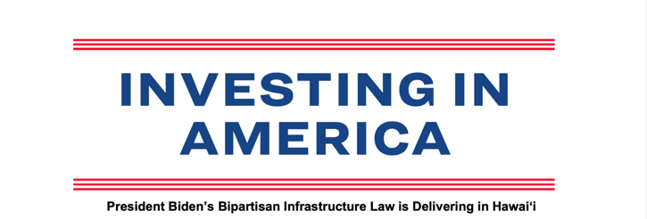
As of September 2023 - For complete linkable document please go to: https://www.whitehouse.gov/wp-content/uploads/2023/10/Hawai_i-Fact-Sheet.pdf
The Biden-Harris Administration has hit the ground running to implement the Bipartisan
Infrastructure Law, and it is already delivering results for the people of Hawai'i. To date,
$1.4 billion in Bipartisan Infrastructure Law funding has been announced and is headed
to Hawai'i with over 71 specific projects identified for funding. Since the Bipartisan
Infrastructure Law passed, approximately $1 billion has been announced for
transportation – to invest in roads, bridges, public transit, ports and airports – and
roughly $164 million has been announced for clean water. Hawai'i received $149.5
million to connect everyone in the state to reliable high-speed internet and, as of today,
more than 50,000 Hawai'i households are already saving on their monthly internet bill
due to the Bipartisan Infrastructure Law. Many more projects will be added in the
coming months, as funding opportunities become grant awards and as formula funds
become specific projects. By reaching communities all across Hawai'i – including rural
communities and historically underserved populations – the law makes critical
investments that will improve lives for Hawai'ians and position the state for success.

Roads and Bridges: In Hawai'i, there are 74 bridges and over 612 miles of highway in
poor condition. The Bipartisan Infrastructure Law will rebuild our roads and includes the
single largest dedicated bridge investment since the construction of the interstate
highway system. Based on formula funding alone, Hawai'i is expected to receive
approximately $1.5 billion over five years in federal funding for highways and bridges.

● Announced funding to date: To date, $698.2 million has been announced in
Hawai'i for roads, bridges, roadway safety, and major projects. This includes:
o $452.6 million in highway formula funding and $145.7 million in dedicated
formula funding for bridges in 2022 and 2023.
o $99.8 million through the RAISE program in 2022 and 2023.

Internet: High-speed internet is necessary for Americans to do their jobs, participate in
school, access health care, and stay connected. Yet, over 11,671 homes and small
businesses in Hawai'i do not have access to high-speed internet infrastructure. The
Bipartisan Infrastructure Law invests $65 billion to provide affordable, high-speed
internet to everyone in America. The Biden-Harris Administration worked with internet
providers to offer high-speed internet plans that are fully covered by the Affordable
Connectivity Program — meaning most eligible households can now get high-speed
internet without paying a dime.

● Announced funding to date: Hawai'i has received $149.5 million through the
Broadband Equity, Access, and Deployment Program (BEAD) to provide access
to high-speed internet to everyone in Hawai'i. In addition, about 50,000
households in Hawai'i are enrolled in the Affordable Connectivity Program, with
more signing up every day. Households can check their eligibility, sign up, and
find fully covered internet plans at GetInternet.gov.

Water: The Bipartisan Infrastructure Law represents the largest investment in clean
drinking water in American history, including the first-ever dedicated federal funding to
replace lead service lines and address dangerous PFAS chemicals.

● Announced funding to date: To date, $144 million has been announced in
Hawai'i to provide clean and safe water across the state and improve water
infrastructure. This includes:
○ $144 million available in fiscal years 2022 and 2023 to provide clean and
safe water across the state through the Environmental Protection Agency.
Of this funding, $57 million is dedicated to lead pipe and service line
replacement, with another $39 million for safe drinking water investments
that can also support lead pipe replacement in fiscal year 2022 and 2023.

Public Transit: The Bipartisan Infrastructure Law makes the largest investment in
public transit in U.S. history. Based on formula funding alone, Hawai'i would expect to
receive approximately $316 million over five years under the Bipartisan Infrastructure
Law to improve public transit across the state.1 This funding will expand healthy,
sustainable transportation options in Hawai'i, where non-white households are 2.2 times
more likely to commute via public transportation and 41% of transit vehicles in the state
are currently past useful life.

1 Transit formula funding amounts are subject to changes resulting from the 2020 census or from annual
transit service data reported to FTA’s National Transit Database.
● Announced funding to date: To date, Hawai'i has been allocated $60.6 million
to improve public transportation options across the state in fiscal year 2022 and
2023.

Clean Buses: The Bipartisan Infrastructure Law invests over $10 billion for clean public
transit and school buses. This includes a $5 billion investment over the next five years
to replace existing school buses with zero-emission and low-emission models. Use of
clean school buses promotes cleaner air, reduced health risks, especially for children,
and reduced greenhouse gas emissions. This year alone, funding from the Bipartisan
Infrastructure Law will help double the number of clean public transit buses on
America’s roads.
● Announced funding to date: To date, schools in Hawai'i have been awarded $5
million through the Environmental Protection Agency’s Clean School Bus
Program. In addition, communities in Hawai'i were awarded $63.2 million for
clean transit buses and improved bus service through DOT’s Low- and No-
Emission Bus and Bus and Bus Facilities Program.

Electric Vehicle Charging: The Bipartisan Infrastructure Law invests $7.5 billion to
build the first-ever national network of electric vehicle chargers in the United States and
is a critical element of President Biden’s plan to address the climate crisis and support
domestic manufacturing jobs. Through the National Electric Vehicle Infrastructure
Program alone, Hawai'i should expect to receive roughly $18 million in formula funding
over five years to support the expansion of electric vehicle charging in the state.

● Announced funding to date: Hawai'i has been allocated $6.4 million in 2022
and 2023 to build out a network of EV chargers across the state.

Clean Energy & Power: Power outages cost the U.S. economy more than $70 billion
annually. The Bipartisan Infrastructure Law makes a historic investment to upgrade our
power infrastructure by making the grid more resilient and building thousands of miles of
new transmission lines to deliver clean, affordable electricity. The law also makes a
historic investment in clean energy technologies like advanced nuclear, clean hydrogen,
carbon capture, and batteries, as well as a historic $3.5 billion investment in
weatherization to improve energy efficiency of homes and lower energy costs for
impacted households by an average of $372 per year.

● Announced funding to date: To date, approximately $16.2 million has been
allocated to Hawai'i for clean energy, energy efficiency, and power in 2022 and
2023. This includes:
o $3.6 million for weatherization;
o $3.5 million through the State Energy Program;
o $2.9 million through the Energy Efficiency and Conservation Block Grant
Program; andAnnounced Bipartisan Infrastructure Law funding is as of September 7, 2023
o $6.1 million to prevent outages and make the power grid more resilient.
Additional grid funding will be made available in the coming months.

Airports: According to some rankings, no U.S. airports rank in the top 25 of airports
worldwide. The Bipartisan Infrastructure Law invests $25 billion in airports to replace
and modernize airport infrastructure, which helps the U.S. become more economically
competitive globally, creates good jobs, and revitalizes and supports more efficient and
enhanced traveler experience.

● Announced funding to date: To date, Hawai'i has received approximately
$110.7 million in 2022 and 2023 for airports.

Ports and Waterways: Our ports and waterways are in need of repair and
investment. The Bipartisan Infrastructure Law invests $17 billion in port infrastructure to
strengthen our supply chains, address maintenance backlogs, and reduce congestion
and emissions near ports– ultimately helping our country move goods more quickly and
at lower cost.
● Announced funding to date: To date, Hawai'i has received roughly $57.4
million in 2022 and 2023 for ports and waterways. Hawai'i was awarded $47.3
million for 1 port projects through the Port Infrastructure Development Program.

Resilience: Millions of Americans feel the effects of climate change and extreme
weather every day. More frequent hurricanes, wildfires, heat waves, floods,
unprecedented power outages, and persistent droughts devastate our communities and
threaten our infrastructure. In the last decade, Hawai'i has experienced 145 extreme
weather events, costing the state up to $921 million in damages. The Bipartisan
Infrastructure Law makes a historic investment to bolster our resilience against pressing
challenges like impacts of climate change, extreme weather events, and other hazards
like cyberattacks.

● Announced funding to date: To date, approximately $36.4 million has been
allocated to Hawai'i for infrastructure resilience in 2022 and 2023 including $3.8
million through the Army Corps of Engineers for flood mitigation.

Legacy Pollution Cleanup: Across the country, thousands of former industrial,
chemical, and energy sites emit harmful pollutants into surrounding communities. These
sites pose harms to health, welfare, and economic prosperity — and disproportionately
impact communities of color: 26% of Black Americans and 29% of Hispanic Americans
live within 3 miles of a Superfund site, a higher percentage than for Americans
overall. The Bipartisan Infrastructure Law will deliver the largest investment in tackling
legacy pollution in American history by cleaning up Superfund and brownfield sites,
reclaiming abandoned mines, and capping orphaned oil and gas wells.Announced Bipartisan Infrastructure Law funding is as of September 7, 2023

● Announced funding to date: To date, approximately $1 million has been
allocated to cleaning up brownfield sites.
For more information, click here to see a map of funding and announced projects in
your community through the Bipartisan Infrastructure Law.
Hawai'i Project Spotlights

RAISE Project Spotlight

Ala Wai Bridge
The Department of Transportation awarded $25 million to the City of Honolulu to
construct an approximately 300-foot pedestrian and bicycle crossing of the Ala Wai
Canal that features an asymmetrical concrete cable-stayed bridge. This iconic bridge
will connect many of the neighborhoods, businesses, parks, schools, and recreational
activities north of the canal with Waikiki.
See here for a full list of RAISE projects.

Middle Mile Project Spotlight
Project URGENT
The Department of Commerce awarded $37.4 million to Hawaiian Telcom, Inc to build 5
new terrestrial and undersea routes and over 600 kilometers of fiber. The Middle Mile
Broadband Infrastructure Program plays a critical role in providing quality, affordable
high-speed Internet and connecting unserved regions to the Internet backbone.
See here for more information about Enabling Middle Mile Broadband Infrastructure
Program award recipients.

Airport Project Spotlight
Daniel K. Inouye International Airport Roadway Reconstruction
The Department of Transportation has awarded $10 million from DOT’s Airport
Terminals Program (ATP) and $20.9 million through DOT’s Airport Infrastructure Grant
Program to Daniel K. Inouye International. The ATP portion of the funding will go
towards reconstructing a 1970s terminal roadway including approximately 142,000
square feet of pavement, select draining and lighting on terminal floors 2 and 3.
See here for a map and list of the 2022 Airport Terminal awards.Announced Bipartisan Infrastructure Law funding is as of September 7, 2023

Ports and Waterways Project Spotlight
Kapalama Container Terminal Project
The Federal Maritime Administration’s grant of $47 million will help upgrade electrified
ship-to-shore cranes and allow for the installation of solar panels on terminal buildings,
ultimately improving the reliability of port operations. Integration of smart gate and
security technology will also improve safety and operational efficiency, while a new
electrical micro-grid will improve resilience. Finally, collaboration with local stakeholders
and residents will allow for the development of a Facility Resiliency Plan and a Terminal
Electrification Plan to support additional environmental and resilience improvements in
the future.
See here for more information on PIDP programs that have been announced.

Bus Facilities and Low- and No-Emission (Low-No) Vehicle Spotlight
Honolulu Department of Transportation Services
The Department of Transportation awarded $20 million to the Honolulu Department of
Transportation Services to buy battery-electric buses and charging equipment to work
on buses en route and in the Pearl City Bus Depot and develop a workforce training
plan. The project will support Honolulu's climate goals and provide rides in historically
disadvantaged communities.
See here for a full list of FY23 Bus and Low- and No-Emission Grant projects.

Harbor Project Spotlight
Kaunakakai Harbor
The U.S. Army Corps of Engineers announced $3.3 million to complete operations and
maintenance work at the Kaunakakai Harbor to support Molokaʻi’s local economy.
Funding will go toward maintenance dredging and completing surveys at the harbor.
The site was last maintenance dredged in 1973.
See here for a list of projects funded under the Army Civil Works Program.

Airport Project Spotlight
Lānaʻi Airport (LNY)Announced Bipartisan Infrastructure Law funding is as of September 7, 2023
The Department of Transportation’s Federal Aviation Administration announced $1
million in funding through the Airport Infrastructure Grant Program to the Lānaʻi Airport
(LNY).
See here for the full list of announced Airport Infrastructure Grant projects.

Community Wildfire Prevention Spotlight
South Kona Community Wildfire Prevention Update
The Department of Agriculture’s Forest Service has awarded $84,700 to the Hawaiʻi
Department of Land & Natural Resources to engage community and agency partners in
order to collaboratively complete a revised hazard assessment. The project will also
identify shared wildfire concerns and begin prioritizing risk-reducing actions for
purposes of updating a Community Wildfire Protection Plan from 2015.
See here for more information on the Community Wildfire Defense Grants.

Transportation Project Spotlight
Poʻipū Road Safety and Mobility
The County of Kauaʻi will receive $24.8 million to improve approximately 3.3 miles of
Poʻipū Road, from Kōloa Town to Poʻipū, Kauaʻi’s primary economic sector. The project
includes three roundabouts, bicycle lanes, sidewalks, pedestrian crossings, bus stops,
landscaped medians, resurfaced roadway, and drainage improvements. This project will
improve safety for school children and commuters by making roadways improvements
and adding pedestrian and bicycle infrastructure.
See here for more information on awarded grants through the RAISE program.

To learn more about how the Bipartisan Infrastructure Law will rebuild our roads and bridges, replace lead pipes for clean water, and more, click here.

https://www.whitehouse.gov/build/guidebook/
OPEN AND UPCOMING INFRASTRUCTURE FUNDING OPPORTUNITIES

This document highlights funding opportunities that communities can apply for today, along with a calendar for funding opportunities across Fall 2023-Winter 2024. The list includes information on the program, the deadline for applying, and a link to the application, where applicable.
For more information on the full set of programs in the Bipartisan Infrastructure Law, including upcoming milestones, visit build.gov.

. 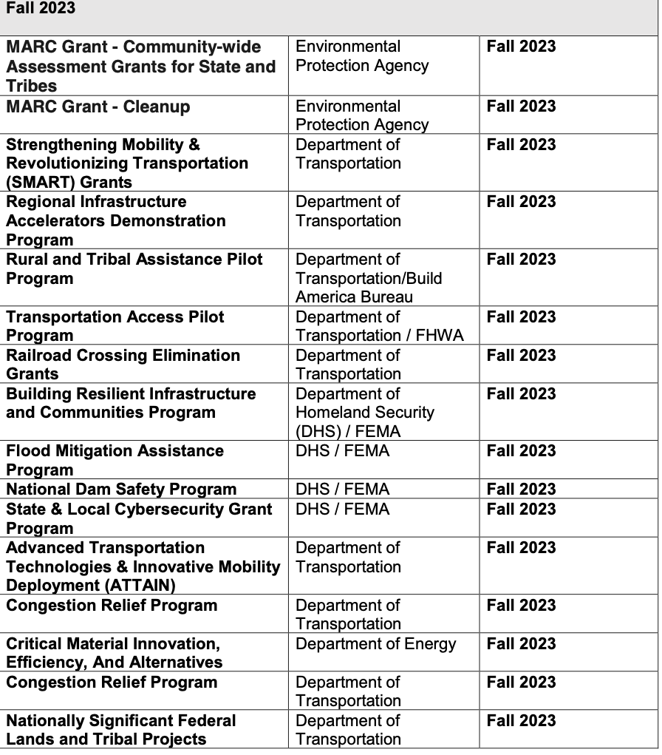

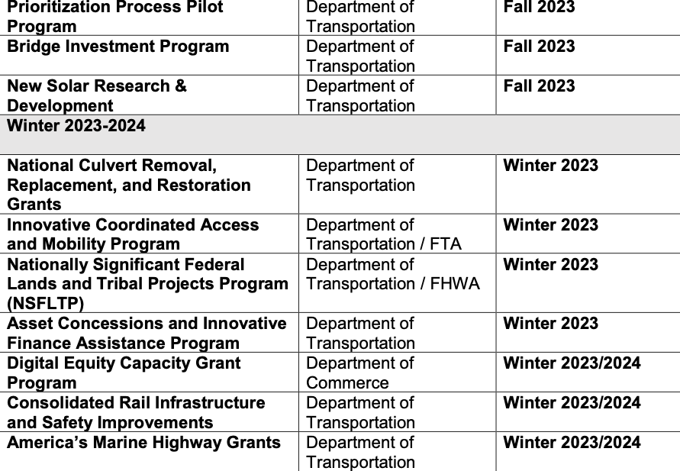

For more information on open funding opportunities under the Inflation reduction act see this page on CleanEnergy.gov

Federal Disaster Assistance Information

Biden- Harris Administration’s Latest Actions
to Support Communities Impacted by Maui Wildfires
President Biden announces $95 million through the Bipartisan Infrastructure Law to harden Hawai‘i’s power grid and position the state to better withstand future storms
This press release has not been recently updated and is included this month
for reference purposes only
Since the onset of the unprecedented wildfires on Maui, Hawaiʻi, President Biden launched a whole-of-government effort to support survivors and affected communities, and as soon as Hawaiʻi Governor Josh Green requested a Major Disaster Declaration, the President signed it. Today, as part of this commitment, President Biden is convening Cabinet and Agency officials who are supporting long-term recovery and rebuilding efforts on the ground – to discuss the work underway to support the people of Maui as they heal, rebuild, and recover over the long-term.
As President Biden made clear during his visit to Maui last week, the Biden-Harris Administration will do everything in its power to help Maui recover and rebuild from this tragedy. And throughout these efforts, the Administration will remain focused on respecting sacred lands, cultures, and traditions. The Administration will be there as long as it takes to complete response efforts.
As part of this commitment, President Biden is today announcing the Department of Energy is providing $95 million through the Bipartisan Infrastructure Law to harden Hawai‘i’s electric grid, improve service, limit damage during future events, and help prevent failures in the future that could lead to severe events. The funding will help strengthen critical transmission lines, including two on Maui; harden poles supporting critical facilities such as hospitals, water facilities, emergency response, and military; replace wooden poles with
fire-resistant material; deploy intelligent switches and materials to help reduce wildfire risk; remove hazard trees; and relocate the Maui control center to a more secure and resilient location. This investment will help reduce the likelihood of outages, reduce restoration times following outages, reduce risk of wildfire events, and increase grid operational resilience.
Hundreds of personnel from across dozens of Federal departments and agencies continue working with state and local partners on the ground to assess ongoing needs and provide resources and personnel to support response efforts.
The Administration encourages individuals impacted by the disaster to register for Federal assistance at www.disasterassistance.gov or by calling 1-800-621-3362 (24 hours a day, 7 days a week). Additionally, as we work to provide communications to meet the needs of those impacted by the Hawaiʻi wildfires, FEMA has multiple language translations available.
Impacted individuals can also visit FEMA’s joint Disaster Recovery Centers (DRCs) at the University of Hawaiʻi Maui College, located at 310 W. Ka’ahumanu Avenue, Kahului, Hawaiʻi or at the Mayor Hannibal Tavares Community Center, located at 91 Pukalani St., Makawao, Hawaiʻi, to speak personally with FEMA specialists, get assistance registering for disaster assistance, get in touch with voluntary organizations offering additional support services, and have access to other federal and state resources. The doors are open from 8 a.m. to 7 p.m. HST seven days a week.
Here is an update on the Biden-Harris Administration’s coordinated federal response:
- More than 1,000 federal personnel are on the ground on Maui assisting residents in their greatest time of need, including FEMA’s Disaster Survivor Assistance teams who are reaching people where they are to help survivors register for assistance.
- To date, the Biden-Harris Administration has approved more than $16 million in assistance to 4,200 households.
- FEMA has made available more than 50,000 meals, 75,000 liters of water, 5,000 cots and 10,000 blankets and shelter supplies to the county government for distribution.
- Thanks to the significant partnership between the Hawaiʻi Fire Relief Housing program administered by the American Red Cross and funded by FEMA, all congregate shelters have been closed as more than 2,500 residents have successfully been moved into hotels. More than 350 Red Cross disaster responders are working in coordination with partners to ensure people receive help as quickly as possible.
- In the wake of the wildfires, President Biden made additional disaster funding available to the state of Hawaiʻi, unlocking the federal government’s ability to cover all eligible expenses for debris removal and emergency protective measures in Maui County and assistance for emergency protective measures for Hawaiʻi County. The President authorized the federal cost share to be increased from 75% to 100% for 30 days that the Governor selects within the first 120 days.
- More than 700 personnel from the Department of Defense and 119 members of the Coast Guard are actively participating in the coordinated response to the Western Maui Wildfire. They are assisting with fire suppression, searching debris for remains, distributing fuel, installing generators for emergency power, assisting portable water distribution support, providing grief counseling and emotional support, and providing additional life-sustaining support.
- The Federal Bureau of Investigation’s Honolulu Division is assisting the Maui Police Department with their efforts to locate and identify those who are missing or may be victims of the wildfires in Lahaina, Hawai‘i, by helping collect DNA samples from family members. Family members are encouraged to visit family assistance centers in Maui to provide a DNA sample or reach out to the FBI at (808) 566-4300 or to HN-COMMAND-POST@ic.fbi.gov for guidance.
- The U.S. Army Corps of Engineers has deployed 48 responders, 25 remote personnel, and 51 contractors who are assisting with public works and engineering support, which includes installing 20 generators for temporary emergency power, planning to execute debris collection and removal, and scoping potential requirements for temporary construction of critical public facilities such as schools, fire and police stations.
- The Environmental Protection Agency (EPA) has deployed more than 130 responders to Maui following the Hawaiʻi wildfires and has a full incident command team on the ground working closely with FEMA and other federal, state, and local partners. The agency’s efforts are focused on monitoring air and water quality and identifying, removing, and safely disposing of household hazardous materials and disaster debris to protect residents from environmental and health hazards. This is the critical step in the recovery process before the clearing of non-hazardous debris. EPA’s response efforts while on Maui are guided by its cultural resources and historic properties plan that the agency developed with the Maui County cultural leaders and Hawaiʻi State Historic Preservation Division. This plan is helping responders across the entire federal family identify, protect, and properly handle cultural resources, which were significantly impacted during the wildfire.
- The Department of the Interior (DOI) is supporting firefighting and search and rescue operations while working to protect natural and cultural resources on Maui in coordination with federal and state partners. DOI personnel are also assisting with assessment and recovery operations, working to determine impacts to wildlife habitats — including coral reefs — as well as assessing the potential for debris-flow and ash sediment run-off. The Department is in close contact with Native Hawaiian leaders and organizations to coordinate the availability of services, information, and culturally sensitive opportunities for engagement and healing.
- The Department of Energy (DOE) is announcing a $95 million grant through the Bipartisan Infrastructure Law to harden Hawaiʻi’s electric grid. Additionally, DOE has deployed emergency responders to support the Federal response to the wildfires on Maui. DOE is working closely with the Federal Emergency Management Agency, Hawaiʻi State Energy Office, and the Hawaiʻi Office of Emergency Management.
- The Department of Commerce’s National Oceanic and Atmospheric Administration (NOAA) is providing enhanced monitoring of the areas affected by the wildfires using high-resolution monitoring tools to detect potential flood threats due to increased runoff potential from burn scar areas. Additionally, the Department of Commerce’s National Telecommunications and Information Administration (NTIA), through FirstNet – a public-private partnership between the First Responder Network Authority and AT&T – is providing wireless high-speed Internet connectivity and voice communications for first responders and emergency management. FirstNet used its resilient deployable assets such as Cell on Light Trucks (COLTS) and other deployable assets to restore or enhance cellular coverage for 10 locations on Maui. The Maui Police Department, Hawai‘i State agencies, and Federal and State Urban Search and Rescue teams are all using FirstNet for critical communications in response to this devastating wildfire.
- The U.S. Department of Health and Human Services (HHS) Administration for Strategic Preparedness and Response (ASPR) has deployed responders from ASPR, including experts from their Victim Identification Center team to assist Maui County with victim identification. ASPR also deployed a portable morgue unit to help with processing human remains and additional personnel to bolster mental health staff and resources available at Lahaina Comprehensive Health Center. In addition, ASPR activated the Emergency Prescription Assistance Program, a federal program that helps people in a federally-identified disaster area who do not have health insurance get the prescription drugs, vaccinations, medical supplies, and equipment that they need. Secretary Becerra also issued a Public Health Emergency shortly after the President’s disaster declaration, giving CMS health care providers and suppliers greater flexibility in meeting emergency health needs of Medicare and Medicaid beneficiaries on the ground. HHS’ Disaster Distress Helpline – 1-800-985-5990 – is available to provide immediate counseling to anyone affected by the wildfires.
- The U.S. Small Business Administration’s (SBA) Office of Disaster Recovery and Resilience has 61 staff on the ground in Hawaiʻi and more are being phased in. Survivors and businesses who register for FEMA assistance will also be eligible for low-interest disaster loans. SBA has approved more than $13 million in federal disaster loans for Hawaiʻi businesses and residents impacted by wildfires. To be considered for all forms of disaster assistance, survivors must first register with FEMA. SBA continues to operate the Disaster Business Recovery Center (BRC) for survivors of the Maui wildfires and is part of the multi-agency presence at the DRCs. Information and details on the location of the business recovery center and disaster recovery centers are available by calling the SBA Customer Service Center at (800) 659-2955. These Centers provide services to survivors including homeowners, renters, and small business owners seeking financial assistance. The SBA Disaster Business Recovery Center is located at Hawaiʻi Technology Development Corporation, Maui Research Technology Center, Building #A, Ste. 119 (Conference Room), 590 Lipoa Pkwy, Kihei, HI 96753.
SBA is also conducting outreach to businesses throughout Maui County to take advantage of the Physical damage and Economic Injury Disaster Loan program, and staff are working with survivors where they are by conducting outreach in state-run Family Assistance Centers and door-to-door campaigns.
- The U.S. Department of Agriculture Food and Nutrition Service approved waivers, including those that will allow Supplemental Nutrition Assistance Program (SNAP) households in Hawaiʻi, including on Maui, to purchase hot foods with SNAP benefits through September 14; allow package size flexibility for those using the Special Supplemental Nutrition Program for Women, Infants, and Children (WIC) program through October 31 so they have more options to purchase what is available; and allow parents or guardians to pick up meals for children at grab ‘n go sites. Additionally, the U.S. Department of Agriculture’s Forest Service has deployed a Burned Area Emergency Response (BAER) team, as well as a National Incident Management Organization (NIMO) team to Hawaiʻi. The BAER team will analyze and map the impacts of the fire to watersheds, including the potential for runoff and debris flows to carry hazardous materials, and support state and local staff in assessing post-fire watershed conditions and post-fire slope stability issues. The NIMO team will be the central point of coordination for those implementing USDA response and recovery programs on the ground in Hawai‘i.
- The U.S. Department of Housing and Urban Development (HUD) announced last weeka $1.3 million funding allocation to help communities on Maui in the wake of the wildfires through the department’s new Rapid Unsheltered Survivor Housing (RUSH) program, a rapid response program to address homelessness by filling in federal assistance gaps in communities hit by disasters. RUSH funding is available to help communities provide outreach, emergency shelter, rapid re-housing, and other assistance to people experiencing or at risk of homelessness who are in a disaster affected area but who cannot access all services provided by FEMA programs.
Additionally, HUD is providing a 90-day relief from foreclosures of Federal Housing Administration-insured mortgages and home equity conversion mortgages. Homeowners affected by the disaster should contact their mortgage or loan servicer immediately. They can also call the FHA Resource Center at 1-800-304-9320 for additional information and visit the FHA Disaster Relief site to learn more about disaster relief options for FHA homeowners. HUD also released regulatory and administrative waivers to help communities accelerate their recovery. This includes funding for housing rehabilitation and reconstruction, homebuyer programs replacing disaster damaged residences, infrastructure improvements and assistance to people at risk of homelessness. HUD has assigned experienced Disaster Technical Assistance providers that will be available remotely and, on the ground, to support local leaders help communities and families that were experiencing homelessness before the devastating fires and those that may require homeless services because of the fires.
- The U.S. Consumer Financial Protection Bureau has created a disaster and emergencies guide to handling finances, including resources to help impacted residents recover, such as tackling housing issues, protecting your finances, dealing with property damage, managing your bills, and asking for help from financial companies like banks, credit cards and other lenders. If residents are having trouble with a financial company, they can submit a complaint online or by calling (855) 411-CFPB (2372).
- The U.S. Department of Transportation (DOT) has made available $3 million, the full amount of “quick release” Emergency Relief (ER) funds requested by the Hawaiʻi Department of Transportation (HDOT), to offset costs associated with traffic management services in the wake of the wildfires. Additionally, DOT currently has three temporary flight restrictions in place to help facilitate search and rescue missions and has worked with major U.S. airlines that serve Kahului Airport to promote flexible travel policies.
- The Heritage Emergency National Task Force (HENTF), a partnership between FEMA and Smithsonian Institution, is working through the Hawaiʻi Emergency Management Agency to ensure that museums and cultural heritage sites are incorporated into FEMA preliminary damage assessments to anticipate needs associated with long-term recovery planning.
###
https://www.whitehouse.gov/briefing-room/statements-releases/2023/08/30/fact-sheet-biden-harris-administrations-latest-actions-to-support-communities-impacted-by-maui-wildfires-4/

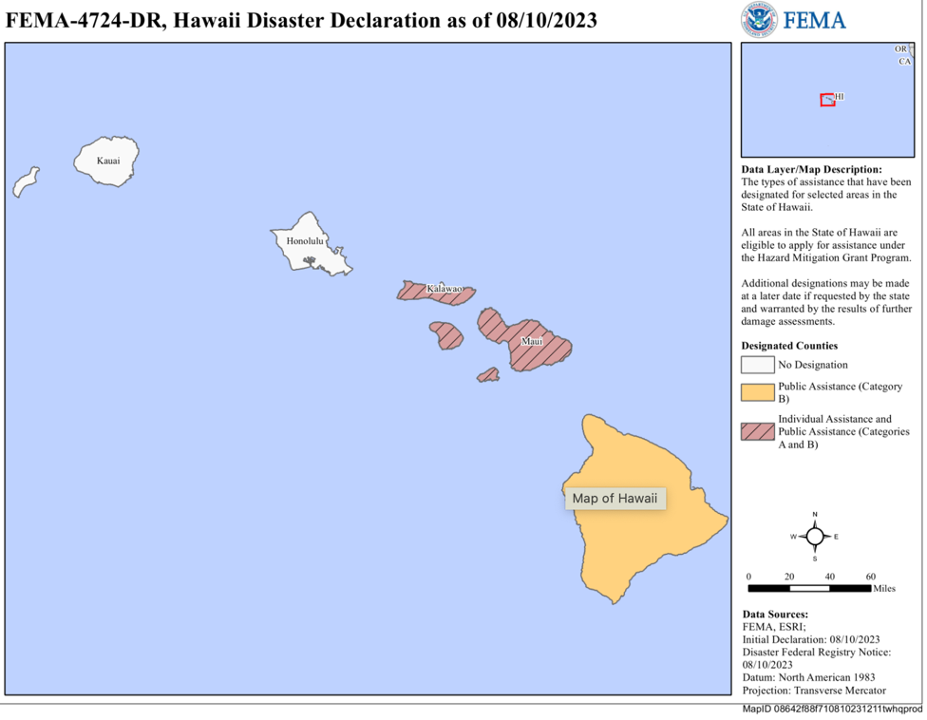

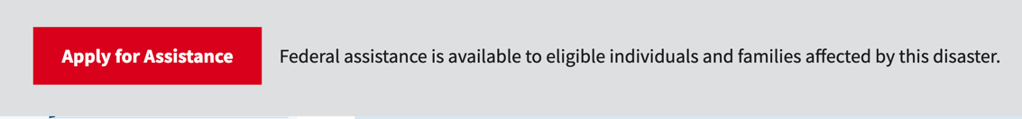
HOW TO APPLY FOR ASSISTANCE
To apply for this assistance, visit DisasterAssistance.gov or download the FEMA mobile app. Applicants can also call the FEMA Helpline at 800-621-3362, with language translation services available. The helpline is open and available 24 hours a day, 7 days a week, with no cost for Hawaii residents to call.
If you use video relay service (VRS), captioned telephone service or others, give FEMA your number for that service.
When applying for assistance, have the following information ready:
- A current phone number where you can be contacted
- Your address at the time of the disaster and the address where you are not staying
- Your social security number
- A general list of damage and losses
- Banking information if you choose direct deposit
- If insured, the policy number or the agent and/or the company name
Survivors may be eligible to receive assistance for uninsured and underinsured damage and losses resulting from the Hawaii wildfires. If you have homeowners or renters insurance, you should file a claim as soon as possible. FEMA cannot duplicate benefits for losses covered by insurance. If your policy does not cover all your disaster expenses, you may be eligible for federal assistance.
Take photos to document damage and begin cleanup and repairs to prevent further damage. Remember to keep receipts from all purchases related to the cleanup and repair.
Disaster assistance may include financial help with temporary lodging and home repairs, as well as other disaster-related expenses.
For an accessible video on how to apply for assistance visit: youtube.com/watch?v=LU7wzRjByhI&list=PL720Kw_OojlKOhtKG7HM_0n_kEawus6FC&index=6.
For information on Hawaii’s disaster recovery, visit fema.gov/disaster/4724. Follow FEMA at twitter.com/femaregion9 and at facebook.com/fema.

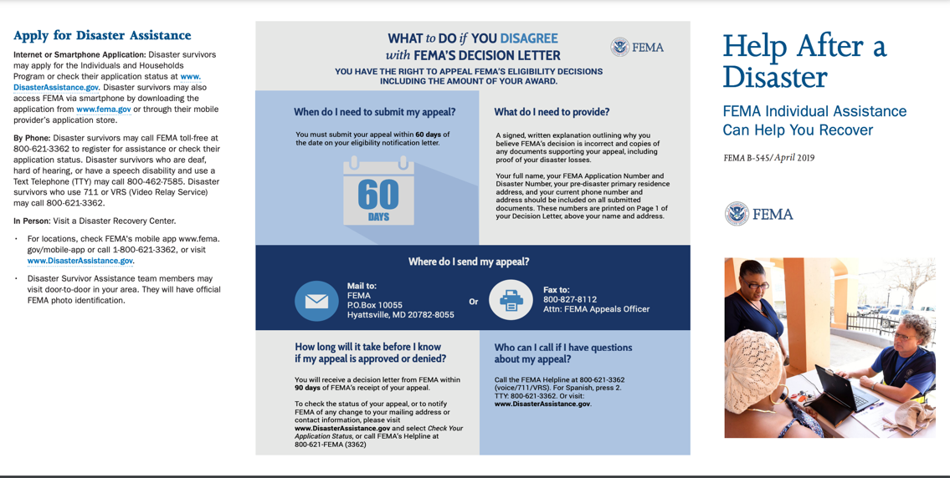
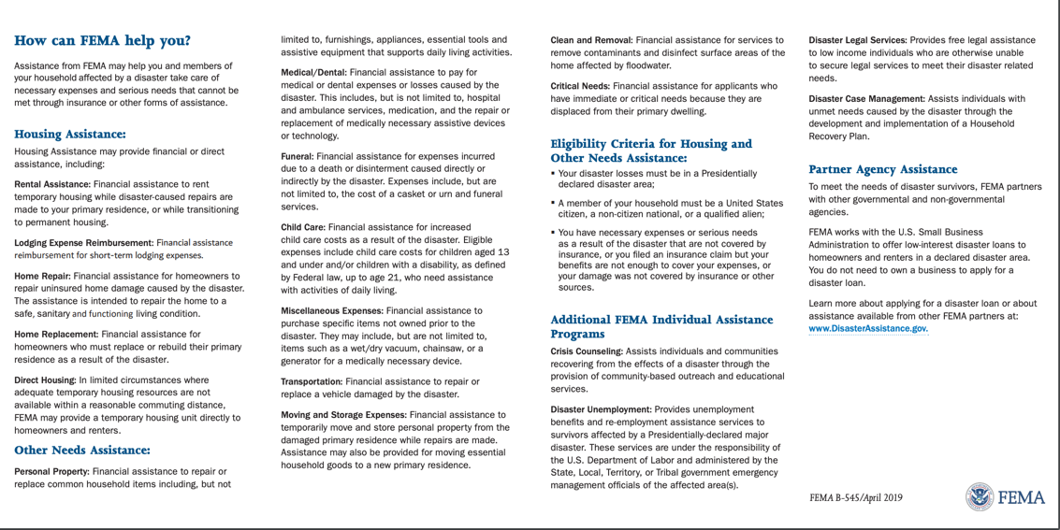
To view this online: https://www.fema.gov/sites/default/files/2020-08/fema_help-after-disaster_english_trifold.pdf
Housing - Verifying Home Ownership -

Maui: if you are applying for disaster assistance & need guidance on how to provide proof of home ownership or occupancy, you have options. FEMA accepts lots of documents, many that can be accessed online.

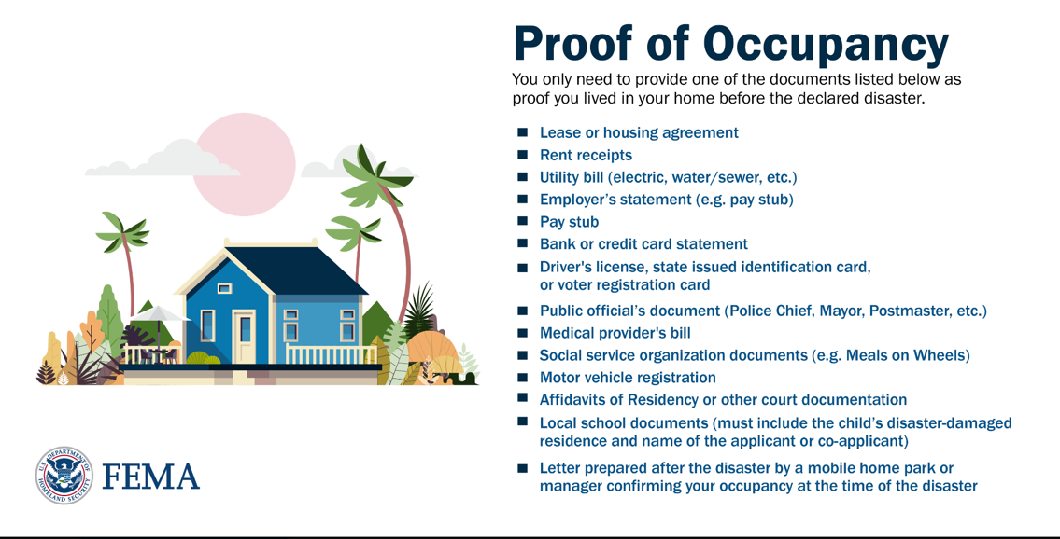

Proof of Ownership

FEMA accepts the following documents as proof you owned your home before the declared disaster. You only need to provide one of the documents listed below.
- Deed or Official Record
- Mortgage documentation
- Homeowners insurance documentation
- Property tax receipt or bill
- Manufactured home certificate or title
- Home purchase contracts (e.g. Bill of Sale, Bond for Title, Land Installment Contract, etc.)
- Will or Affidavit or heirship (with death certificate) naming you heir to the property
- Receipts for major repairs or maintenance dated within 5 years prior to the disaster
- Court documents
- Letter prepared after the disaster from a mobile home park owner or manager or public official that meets FEMA requirements

Most documents can be dated within 1 year prior to the disaster or within the 18-month period of assistance.

Expanded Flexibility

FEMA understands that disaster survivors in some situations may experience additional difficulty gathering specific documents. As a result, FEMA has made recent policy changes to provide additional flexibility to allow applicants who are unable to provide the standard types of documents to provide written self-declarative statements as a last resort in specific situations.

Proof of Occupancy

If your pre-disaster residence was a mobile home or travel trailer or you live in an insular area, island or tribal land and you do not have any acceptable forms of occupancy, FEMA may accept a written self-declarative statement as a last resort, due to challenges with obtaining traditional forms of documentation for these types of homes.

A self-declarative statement for proof of occupancy must include all of the below items:
- The address of the disaster-damaged residence.
- Length of time you lived in the disaster-damaged home, as your primary residence, prior to the Presidential disaster declaration.
- Your or your co-applicant’s name and signature.
- The major elements of the following statement and additional explanation:

"I have made a good faith effort, in coordination with FEMA, to obtain and provide a copy of acceptable occupancy documentation. I was unable to obtain this documentation because [provide an explanation of the circumstances that prevent standard occupancy verification to include why the other document types were not available to the applicant or how the available documents do not meet FEMA's requirements]. I hereby declare under penalty of perjury that the foregoing is true and correct."

Proof of Ownership

If you own a home, live in an insular area, island, or tribal land or in a travel trailer or mobile home, and do not have any acceptable forms of ownership, FEMA will accept a written self-declarative statement as proof of ownership as a last resort.

A self-declarative statement for proof of ownership must include all of the below items:
- The address of the disaster-damaged residence.
- Length of time you lived in the disaster-damaged home, as your primary residence, prior to the Presidential disaster declaration.
- Your or your co-applicant’s name and signature.
- The major elements of the following statement and additional explanation:

"I have made a good faith effort, in coordination with FEMA, to obtain and provide a copy of acceptable ownership documentation. I do meet FEMA's definition of an owner-occupant because I am either [(A) the legal owner of the home. (B) pay no rent, but am responsible for the payment of taxes or maintenance for the residence, or (C) hold lifetime occupancy rights]. I was unable to obtain this documentation because [provide an explanation of the circumstances that prevent standard ownership verification of the appropriate owner-occupant category]. I hereby declare under penalty of perjury that the foregoing is true and correct."

If you own and live in a home that was passed down via heirship and do not have any acceptable forms of ownership, FEMA, as a last resort, will accept a written self-declarative statement as proof of ownership.

A self-declarative statement for proof of ownership passed down via heirship must include all of the below items:
- The address of the disaster-damaged residence.
- Length of time you lived in the disaster-damaged home, as your primary residence, prior to the Presidential disaster declaration.
- Your or your co-applicant’s name and signature.
- A copy of the decedent’s death certification.
- The major elements of the following statement and additional explanation:

"I have made a good faith effort, in coordination with FEMA, to obtain and provide a copy of acceptable ownership documentation. I was unable to obtain this documentation because [provide an explanation of the circumstances that prevent standard ownership verification]."

AND, the major elements of the following statement:

"As the nearest relative of the deceased in the line of succession, my ownership includes all the rights and obligations of the deceased. The decedent's name is ________________, and they died on ________________. I understand I must submit the death certificate along with this declaration. I hereby declare under penalty of perjury that the foregoing is true and correct."

https://www.fema.gov/assistance/individual/after-applying/verifying-home-ownership-occupancy

Beware of Scams and Fraud
After a disaster, scam artists often attempt to take advantage of disaster survivors. We encourage survivors to watch for and report any suspicious activity.
Ways to report fraud:
- Email: StopFEMAFraud@fema.dhs.gov
- Call: 1-866-223-0814
- Fax: 202-212-4926
For more information, visit fema.gov/disaster-fraud.

Small Business Disaster Assistance -

SBA Stands Ready to Assist Hawai’i Businesses and Residents Affected by the Wildfires

SACRAMENTO, Calif. August 10, 2023 – Low-interest federal disaster loans are now available to Hawai’i businesses and residents as a result of President Biden’s major disaster declaration, U.S. Small Business Administration’s Guzman announced.
The declaration covers Maui County as a result of the wildfires that began on Aug. 8.
“SBA’s mission-driven team stands ready to help Hawai’i’s small businesses and residents impacted by wildfires,” said Administrator Guzman. “We’re committed to providing federal disaster loans swiftly and efficiently, with a customer-centric approach to help businesses and communities recover and rebuild.”
Businesses of all sizes and private nonprofit organizations may borrow up to $2 million to repair or replace damaged or destroyed real estate, machinery and equipment, inventory and other business assets. SBA can also lend additional funds to businesses and homeowners to help with the cost of improvements to protect, prevent or minimize the disaster damage from occurring in the future.
For small businesses, small agricultural cooperatives, small businesses engaged in aquaculture and most private nonprofit organizations of any size, SBA offers Economic Injury Disaster Loans to help meet working capital needs caused by the disaster. Economic injury assistance is available to businesses regardless of any property damage.
Disaster loans up to $500,000 are available to homeowners to repair or replace damaged or destroyed real estate. Homeowners and renters are eligible for up to $100,000 to repair or replace damaged or destroyed personal property, including personal vehicles.
Interest rates can be as low as 4 percent for businesses, 2.375 percent for private nonprofit organizations and 2.5 percent for homeowners and renters with terms up to 30 years. Loan amounts and terms are set by SBA and are based on each applicant’s financial condition.
To be considered for all forms of disaster assistance, survivors must first contact the Federal Emergency Management Agency at www.disasterassistance.gov. As soon as Federal-State Disaster Recovery Centers open throughout the affected area, SBA will provide one-on-one assistance to disaster loan applicants. Additional information and details on the location of disaster recovery centers is available by calling the SBA Customer Service Center at (800) 659-2955.

- Loans
- Investment capital
- Disaster assistance
  - Physical damage loans

  - Mitigation assistance
  - Economic Injury Disaster Loans
  - Military reservist loan
  - Hawai’i wildfires
- Grants

Hawai’i wildfires

Areas eligible for SBA disaster loans
The county of Maui, Hawai’i is eligible for SBA disaster assistance as a result of the Hawai’i wildfires. Additionally, the counties of Hawai’i, Honolulu, Kalawao, and Kauai are eligible for economic injury assistance.
Application filing deadlines:
- Physical damage: November 9, 2023
- Economic injury: May 10, 2024
*Information current as of October 5, 2023
Apply for disaster loans

Types of available disaster loans
- Home Disaster Loans – Loans to homeowners or renters to repair or replace disaster-damaged real estate and personal property, including automobiles.
- Business Physical Disaster Loans – Loans to businesses to repair or replace disaster-damaged property owned by the business, including real estate, inventories, supplies, machinery and equipment. Businesses of any size are eligible. Private, non-profit organizations such as charities, churches, private universities, etc., are also eligible.
- Economic Injury Disaster Loans (EIDL) – Working capital loans to help small businesses, small agricultural cooperatives, small businesses engaged in aquaculture, and most private, non-profit organizations of all sizes meet their ordinary and necessary financial obligations that cannot be met as a direct result of the disaster. These loans are intended to assist through the disaster recovery period.
More detailed information can be found in the Hawai’i wildfires disaster fact sheet.

Get help with your application
Applicants are encouraged to apply online for a disaster loan. Please call us at 800‐659‐2955 if you have any questions. SBA's disaster call center hours are Monday through Friday from 8:00 a.m. – 8:00 p.m. ET and Saturday from 9:00 a.m. – 3:00 p.m. ET. Due to a federal holiday, the call center will be closed on Monday, October 9th.

Disaster assistance jobs
SBA is hiring temporary employees to assist with disaster relief efforts. Many positions are virtual. Bilingual skills are a plus. Learn more and apply now.

Government-wide information and updates
FEMA's Hawai’i wildfires page has the latest response and recovery information from FEMA and DHS. It is available in several languages.
For information on what other agencies are doing and the government-wide response, visit the Hawai’i wildfires page on USA.gov.

Information in other languages
- E aʻo mai ʻoe e pili ana i ke koho kōkua pōʻino SBA ma ka ʻŌlelo Hawaiʻi
- SBAの災害支援オプションについて、日本語でご覧いただけます
- 以普通话了解 SBA 灾难援助选项
- Alamin ang tungkol sa mga opsiyon ng SBA para sa tulong sa sakuna sa wikang Tagalog
- Tìm hiểu về các phương án hỗ trợ thảm họa của SBA bằng tiếng Việt
Last updated October 5, 2023

https://www.sba.gov/Hawai’i-wildfires#id-types-of-available-disaster-loans

- Get help with your application
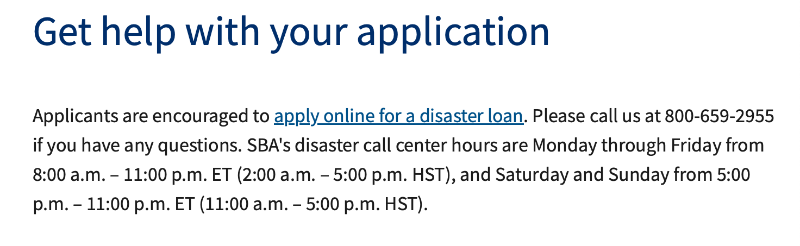
- Disaster assistance jobs
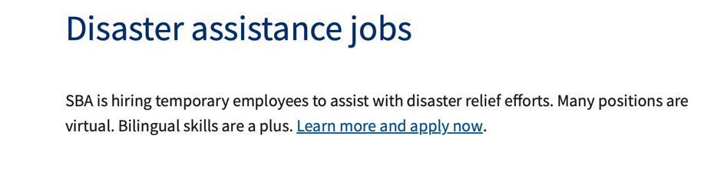
- Government-wide information and updates
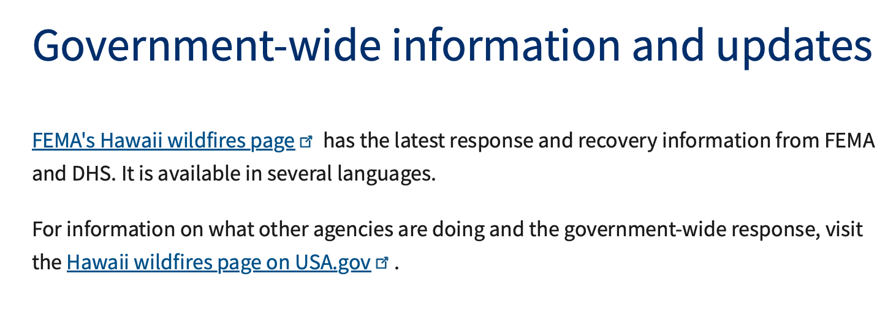
- Information in other languages
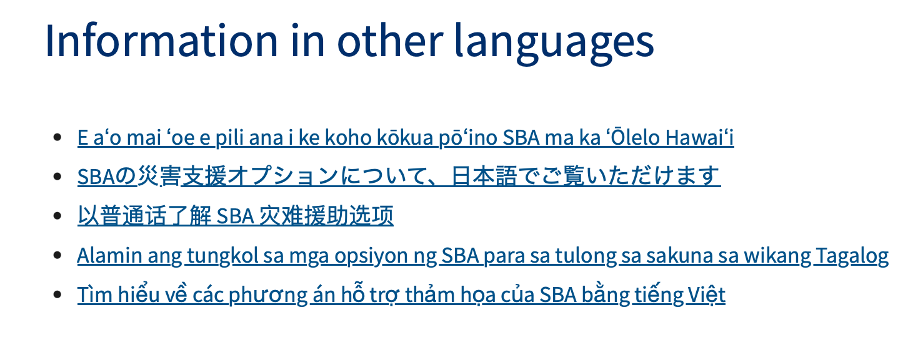

Areas eligible for SBA disaster loans

The county of Maui, Hawai’i is eligible for SBA disaster assistance as a result of the Hawai’i wildfires. Additionally, the county of Kalawao, Hawai’i is eligible for economic injury assistance. Application filing deadlines:

Physical damage: November 9, 2023 Economic injury: May 10, 202
Apply for disaster loans
https://disasterloanassistance.sba.gov/ela/s/
For information on what other agencies are doing and the government-wide response, visit the Hawai’i wildfires page on USA.gov.

Information in other languages
- E aʻo mai ʻoe e pili ana i ke koho kōkua pōʻino SBA ma ka ʻŌlelo Hawaiʻi
- SBAの災害支援オプションについて、日本語でご覧いただけます
- 以普通话了解 SBA 灾难援助选项
- Alamin ang tungkol sa mga opsiyon ng SBA para sa tulong sa sakuna sa wikang Tagalog
- Tìm hiểu về các phương án hỗ trợ thảm họa của SBA bằng tiếng Việt

NOTE: AFTER OUR ADVOCACY WITH OUR CONGRESSIONAL DELEGATION THE PHYSICAL DAMAGE DEADLINE HAS BEEN EXTTENDED TO NOVEMBER 9, 2023

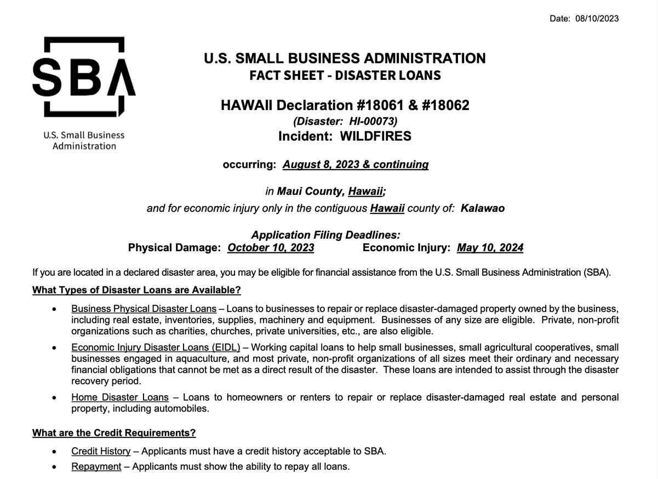
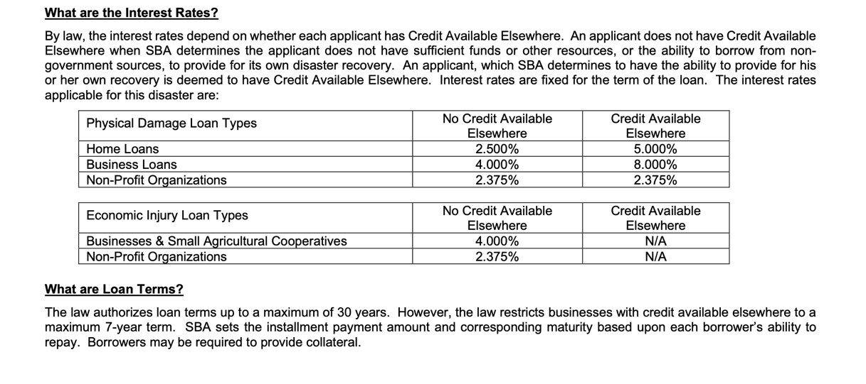
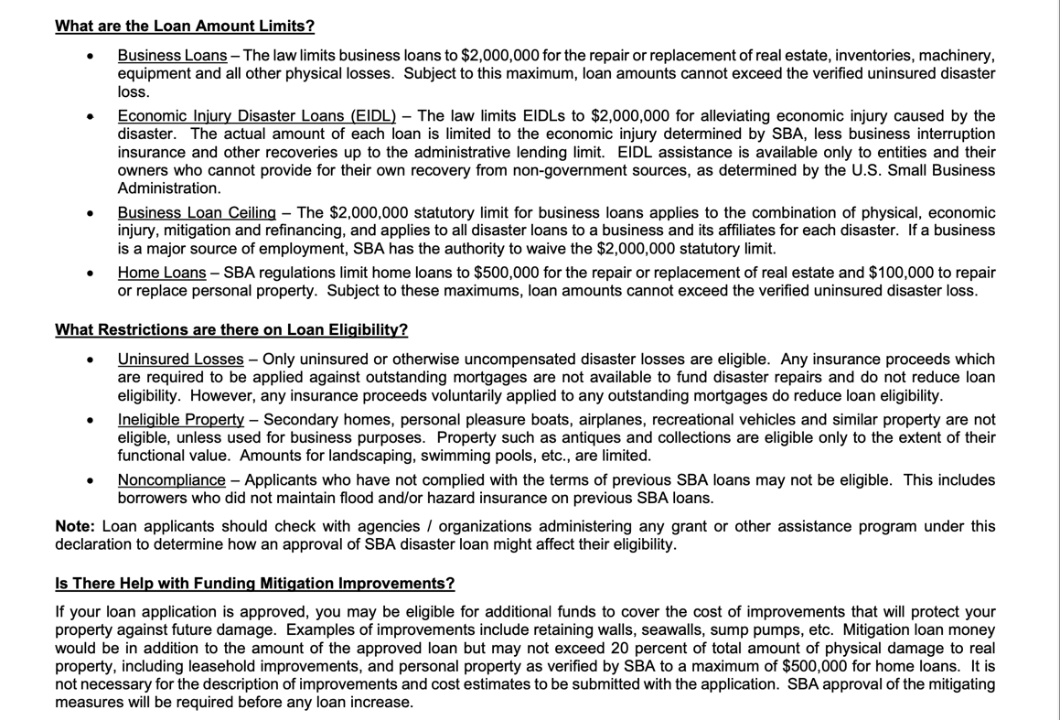
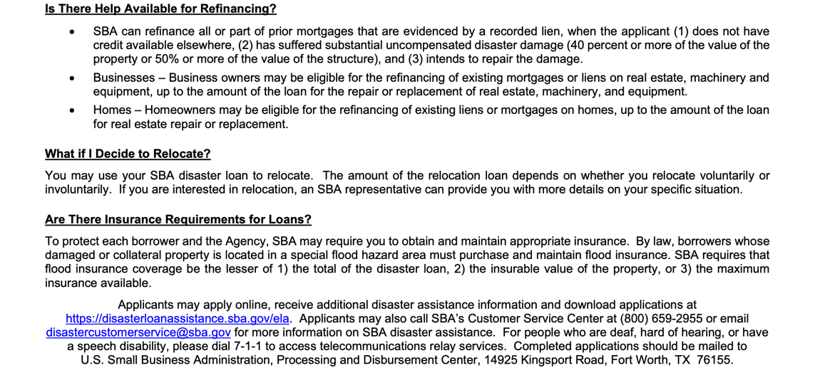

General Discretionary Programs Specific to Hawai‘i:

Current Notices

Environmental Education Local Grants Program for Region 9
Synopsis 1

Document Type: Grants Notice  Funding Opportunity Number: EPA-EE-23-09  Funding Opportunity Title: Environmental Education Local Grants Program for Region 9  Opportunity Category: Discretionary  Opportunity Category Explanation:  Funding Instrument Type: Grant  Category of Funding Activity: Environment  Category Explanation:  Expected Number of Awards: 5  CFDA Number(s): 66.951 -- Environmental Education Grants Program  Cost Sharing or Matching Requirement: Yes | Version: Synopsis 1  Posted Date: Sep 14, 2023  Last Updated Date: Sep 14, 2023  Original Closing Date for Applications: Nov 08, 2023  Current Closing Date for Applications: Nov 08, 2023  Archive Date: Dec 08, 2023  Estimated Total Program Funding: $360,000  Award Ceiling: $100,000  Award Floor: $50,000

Eligible Applicants: | Others (see text field entitled "Additional Information on Eligibility" for clarification)
Additional Information on Eligibility: | See Section III of the Notice of Funding Opportunity for eligibility information.

Agency Name: | Environmental Protection Agency
Description: | The Environmental Education Grant Program is seeking applications from eligible applicants to support locally focused environmental education projects that promote environmental stewardship and help develop knowledgeable and responsible students, teachers, and community members. This grant program provides financial support for projects that design, demonstrate, and/or disseminate environmental education practices, methods, or techniques that increase public awareness and knowledge about local environmental issues and provides participants in its programs the skills necessary to make informed decisions and to take responsible actions toward the environment
Link to Additional Information: | See Related Documents
Grantor Contact Information: | If you have difficulty accessing the full announcement electronically, please contact:  Eileen Shanahan, Region 9 (Electronic Submissions Contact) Michael Band, HQ (Eligibility and General NOFO Contact)  Shanahan.Eileen@epa.gov; EEGrants@epa.gov
https://www.grants.gov/web/grants/view-opportunity.html?oppId=350214

Region 9 Fiscal Year 2023 Wetland Program Development Grants
Synopsis 1
Document Type: Grants Notice  Funding Opportunity Number: EPA-REGIX-WPDG-23-24  Funding Opportunity Title: Region 9 Fiscal Year 2023 Wetland Program Development Grants  Opportunity Category: Discretionary  Opportunity Category Explanation:  Funding Instrument Type: Cooperative Agreement Grant  Category of Funding Activity: Environment  Category Explanation:  Expected Number of Awards: 14  CFDA Number(s): 66.461 -- Regional Wetland Program Development Grants  Cost Sharing or Matching Requirement: Yes | Version: Synopsis 1  Posted Date: Oct 05, 2023  Last Updated Date: Oct 05, 2023  Original Closing Date for Applications: Nov 20, 2023  Current Closing Date for Applications: Nov 20, 2023  Archive Date: Dec 20, 2023  Estimated Total Program Funding: $3,292,443  Award Ceiling: $3,292,443  Award Floor:

Eligible Applicants: | Others (see text field entitled "Additional Information on Eligibility" for clarification)
Additional Information on Eligibility: | See Section III of the Notice of Funding Opportunity for eligibility information.

Agency Name: | Environmental Protection Agency
Description: | The goals of EPA’s wetland program include increasing the quantity and quality of wetlands in the U.S. by conserving and restoring wetland acreage and improving wetland condition. In pursuing these goals, EPA seeks to develop the capacity of all levels of government to develop and/or refine effective, comprehensive programs for wetland protection and management. In addition to developing and/or refining wetland protection and management programs EPA seeks to build wetlands programs to incorporate climate change and environmental justice considerations as described in Section I.C.2.a: Climate Change and Section 1.C.2.b: Justice40 (J40) of the announcement on the program’s National Priorities.
Link to Additional Information: | See Related Documents
Grantor Contact Information: | If you have difficulty accessing the full announcement electronically, please contact:  Sarvy Mahdavi EPA Region 9 213-244-1830  mahdavi.sarvy@epa.gov
https://www.grants.gov/web/grants/view-opportunity.html?oppId=350474

Reminders

Native American/Native Hawaiian Museum Services (2024)
Synopsis 1
Document Type: Grants Notice  Funding Opportunity Number: NANH-FY24  Funding Opportunity Title: Native American/Native Hawaiian Museum Services (2024)  Opportunity Category: Discretionary  Opportunity Category Explanation:  Funding Instrument Type: Grant  Category of Funding Activity: Arts (see "Cultural Affairs" in CFDA) Humanities (see "Cultural Affairs" in CFDA)  Category Explanation:  Expected Number of Awards: 25  CFDA Number(s): 45.308 -- Native American/Native Hawaiian Museum Services Program  Cost Sharing or Matching Requirement: No | Version: Synopsis 1  Posted Date: Aug 15, 2023  Last Updated Date: Aug 15, 2023  Original Closing Date for Applications: Nov 15, 2023  Current Closing Date for Applications: Nov 15, 2023  Archive Date:  Estimated Total Program Funding: $3,772,000  Award Ceiling: $250,000  Award Floor: $5,000

Eligible Applicants: | Others (see text field entitled "Additional Information on Eligibility" for clarification)
Additional Information on Eligibility: | See the Notice of Funding Opportunity for program eligibility criteria.

Agency Name: | Institute of Museum and Library Services
Description: | The Native American/Native Hawaiian Museum Services (NANH) grant program is designed to support Indian tribes and organizations that primarily serve and represent Native Hawaiians in sustaining indigenous heritage, culture, and knowledge. The program supports projects such as exhibitions, educational services and programming, workforce professional development, organizational capacity building, and collections stewardship.
Link to Additional Information: | https://www.imls.gov/grants/available/native-americannative-Hawaiian-museum-services-program
Grantor Contact Information: | If you have difficulty accessing the full announcement electronically, please contact:  Sarah Glass Senior Museum Program Officer sglass@imls.gov imls-museumgrants@imls.gov  imls-museumgrants@imls.gov
https://www.grants.gov/web/grants/view-opportunity.html?oppId=349276

National Park Service
Alaska Native and Native Hawaiian Culture and Arts Development Grant Program – Fiscal Year 2023/2024
Synopsis 1

Document Type: Grants Notice  Funding Opportunity Number: P24AS00019  Funding Opportunity Title: Alaska Native and Native Hawaiian Culture and Arts Development Grant Program – Fiscal Year 2023/2024  Opportunity Category: Discretionary  Opportunity Category Explanation:  Funding Instrument Type: Grant  Category of Funding Activity: Arts (see "Cultural Affairs" in CFDA)  Category Explanation:  Expected Number of Awards:  CFDA Number(s): 15.071 -- Pacific Northwest and Hawaiian Islands Arts  Cost Sharing or Matching Requirement: No | Version: Synopsis 1  Posted Date: Aug 18, 2023  Last Updated Date: Aug 18, 2023  Original Closing Date for Applications: Oct 27, 2023 Electronically submitted applications must be submitted no later than 11:59 PM, ET, on the listed application due date.  Current Closing Date for Applications: Oct 27, 2023 Electronically submitted applications must be submitted no later than 11:59 PM, ET, on the listed application due date.  Archive Date:  Estimated Total Program Funding: $1,500,000  Award Ceiling: $750,000  Award Floor: $150,000

Eligible Applicants: | Private institutions of higher education  Others (see text field entitled "Additional Information on Eligibility" for clarification)  Native American tribal organizations (other than Federally recognized tribal governments)  Nonprofits having a 501(c)(3) status with the IRS, other than institutions of higher education  Nonprofits that do not have a 501(c)(3) status with the IRS, other than institutions of higher education
Additional Information on Eligibility: | Private Organizations such as Native Hawaiian Organizations (NHOs) without 501(c)(3) status.

Agency Name: | National Park Service
Description: | The National Park Service administers this grant and is interested in developing this program for Alaska Native and Native Hawaiian culture and arts. Public Law 117-328, the Consolidated Appropriations Act, 2023, provides $1,500,000 in Fiscal Year 2023/2024 to encourage new entities to apply.
Link to Additional Information: | See Related Documents
Grantor Contact Information: | If you have difficulty accessing the full announcement electronically, please contact:  Erica Cordeiro Erica_Cordeiro@nps.gov  Erica_Cordeiro@nps.gov
https://www.grants.gov/web/grants/view-opportunity.html?oppId=349924

National Park Service
Japanese American Confinement Sites Grant Program
Synopsis 1
Document Type: Grants Notice  Funding Opportunity Number: P24AS00023  Funding Opportunity Title: Japanese American Confinement Sites Grant Program  Opportunity Category: Discretionary  Opportunity Category Explanation:  Funding Instrument Type: Grant  Category of Funding Activity: Environment  Category Explanation:  Expected Number of Awards:  CFDA Number(s): 15.933 -- Preservation of Japanese American Confinement Sites  Cost Sharing or Matching Requirement: Yes | Version: Synopsis 1  Posted Date: Aug 31, 2023  Last Updated Date: Aug 31, 2023  Original Closing Date for Applications: Nov 01, 2023 Electronically submitted applications must be submitted no later than 05:00 PM, MT, on the listed application due date.  Current Closing Date for Applications: Nov 01, 2023 Electronically submitted applications must be submitted no later than 05:00 PM, MT, on the listed application due date.  Archive Date: Nov 15, 2023  Estimated Total Program Funding: $3,000,000  Award Ceiling: $3,000,000  Award Floor: $5,000

Eligible Applicants: | Special district governments  Native American tribal governments (Federally recognized)  Nonprofits that do not have a 501(c)(3) status with the IRS, other than institutions of higher education  City or township governments  Others (see text field entitled "Additional Information on Eligibility" for clarification)  Public and State controlled institutions of higher education  Nonprofits having a 501(c)(3) status with the IRS, other than institutions of higher education  State governments  County governments  Private institutions of higher education
Additional Information on Eligibility: | In accordance with Public Law 109-441 (120 Stat. 3288), organizations and entities working to preserve historic Japanese American confinement sites and their history, including: State and local agencies, public or private nonprofit institutions/organizations, Federally recognized Indian tribal governments, State colleges and universities, public and private colleges and universities are eligible to apply. Non-Federal entities who are partnering with Federal agencies that own eligible historic resources may submit applications regarding the Federal property.

Agency Name: | National Park Service
Description: | The Japanese American Confinement Sites Grant Program provides financial assistance to organizations and entities working to preserve historic Japanese American confinement sites and their history, including: private nonprofit organizations; educational institutions; state, local, and tribal governments; and other public entities, for the preservation and interpretation of U.S. confinement sites where Japanese Americans were detained during World War II. The authorizing legislation for the Japanese American Confinement Sites Grant Program identifies up to $38 million for the entire life of the grant program for projects to identify, research, evaluate, interpret, protect, restore, repair, and acquire historic confinement sites in order that present and future generations may learn and gain inspiration from these sites and that these sites will demonstrate the Nation’s commitment to equal justice under the law (Public Law 109-441, 120 Stat. 3288; as amended by Public Law 111-88). Projects funded through the Japanese American Confinement Sites Grant Program must benefit one or more historic Japanese American confinement sites. The term historic confinement sites is defined as the ten War Relocation Authority sites (Gila River, Granada, Heart Mountain, Jerome, Manzanar, Minidoka, Poston, Rohwer, Topaz, and Tule Lake), as well as other historically significant locations, as determined by the Secretary of the Interior, where Japanese Americans were detained during World War II. These sites are specifically identified in Confinement and Ethnicity: An Overview of World War II Japanese American Relocation Sites, published by the Department of the Interior, National Park Service, Western Archaeological and Conservation Center, in 1999. This document may be seen at www.nps.gov/history/history/online_books/anthropology74 and at other internet sites.
Link to Additional Information: | See Related Documents
Grantor Contact Information: | If you have difficulty accessing the full announcement electronically, please contact:  Todd Wilson todd_wilson@nps.gov  todd_wilson@nps.gov
https://www.grants.gov/web/grants/view-opportunity.html?oppId=350063

Health Resources and Services Administration
FY 2024 Native Hawaiian Health Care Improvement Act
Forecast 1
Document Type: Grants Notice  Opportunity Number: HRSA-24-030  Opportunity Title: FY 2024 Native Hawaiian Health Care Improvement Act  Opportunity Category: Discretionary  Opportunity Category Explanation:  Funding Instrument Type: Grant  Category of Funding Activity: Health  Category Explanation:  Expected Number of Awards: 6  CFDA Number(s): 93.932 -- Native Hawaiian Health Care Systems  Cost Sharing or Matching Requirement: No | Version: Forecast 1  Forecasted Date: Jul 03, 2023  Last Updated Date: Jul 03, 2023  Estimated Post Date: Dec 15, 2023  Estimated Application Due Date: Mar 15, 2024  Estimated Award Date:  Estimated Project Start Date: Aug 01, 2024  Fiscal Year: 2024  Archive Date:  Estimated Total Program Funding: $27,000,000  Award Ceiling:  Award Floor:

Eligible Applicants: | Others (see text field entitled "Additional Information on Eligibility" for clarification)
Additional Information on Eligibility: | Organizations as eligible under the NHHCIA

Agency Name: | Health Resources and Services Administration
Description: | The purpose of this funding opportunity is to distribute funding under the Native Hawaiian Health Care Improvement Act (NHHCIA) program. The NHHCIA, as amended (42 U.S.C. 11701 - 11714), states that “it is the policy of the United States in fulfillment of its special responsibilities and legal obligations to the indigenous people of Hawai‘i to (1) raise the health status of Native Hawaiians to the highest possible health level; and (2) provide existing Native Hawaiian health care programs with all resources necessary to effectuate this policy” [see 42 U.S.C. 11702(a)].
Link to Additional Information:
Grantor Contact Information: | NH Technical Assistance Team  (301)594-4300  BPHCFunding@hrsa.gov
https://www.grants.gov/web/grants/view-opportunity.html?oppId=349044

General National Programs by Federal Agency

U.S. Department of Agriculture

Programs:

Rural Utilities Service
Solid Waste Management Grant Program
Synopsis 1
Document Type: Grants Notice  Funding Opportunity Number: SWMFY24  Funding Opportunity Title: Solid Waste Management Grant Program  Opportunity Category: Discretionary  Opportunity Category Explanation:  Funding Instrument Type: Grant  Category of Funding Activity: Community Development Environment Opportunity Zone Benefits  Category Explanation: The Solid Waste Management (SWM) Grant Program has been established to assist communities through free technical assistance and/or training provided by the grant recipients. Qualified organizations will receive SWM grant funds to reduce or eliminate pollution of water resources in rural areas, and improve planning and management of solid waste sites in rural areas.  Expected Number of Awards: 40  CFDA Number(s): 10.762 -- Solid Waste Management Grants  Cost Sharing or Matching Requirement: No | Version: Synopsis 1  Posted Date: Oct 02, 2023  Last Updated Date: Sep 29, 2023  Original Closing Date for Applications: Jan 02, 2024  Current Closing Date for Applications: Jan 02, 2024  Archive Date: Jan 31, 2024  Estimated Total Program Funding: $4,000,000  Award Ceiling: $1,000,000  Award Floor: $0

Eligible Applicants: | Others (see text field entitled "Additional Information on Eligibility" for clarification)
Additional Information on Eligibility: | An organization is eligible to receive a SWM grant if it: a) is a private, non-profit organization that has tax-exempt status from the U.S. Internal Revenue Service (IRS); b) Is a Public Body; c) Is a federally acknowledged or State-recognized Native American tribe or group; d) Is an Academic Institution; e) Is legally established and located within one of the following: a state within the U.S.; the District of Columbia; the Commonwealth of Puerto Rico; a U.S territory. f) Has the legal capacity and authority to carry out the grant purpose; g) Has a proven record of successfully providing technical assistance and/or training to rural areas; h) Has capitalization acceptable to the Agency and is composed of at least 51 percent of the outstanding interest or membership being citizens of the U.S. or individuals who reside in the U.S. after being legally admitted for permanent residence; I) Has no delinquent debt to the Federal Government or no outstanding judgments to repay a Federal debt; j) Demonstrates that it possesses the financial, technical, and managerial capability to comply with Federal and State laws and requirements; k)Contracts with a non-affiliated organization for not more than 49 percent of the grant to provide proposed assistance.

Agency Name: | Rural Utilities Service
Description: | Funds may be used to:  Evaluate current landfill conditions to determine threats to water resources; provide technical assistance and/or training to enhance operator skills in the operation and maintenance of active landfills; provide technical assistance and/or training to help communities reduce the solid waste stream; provide technical assistance and/or training for operators of landfills which are closed or will be closed in the near future with the development and implementation of closure plans, future land use plans, safety and maintenance planning, and closure scheduling within permit requirements. Grant funds may not be used to: recruit applications for the Agency’s water and waste loan and/or any loan and/or grant program; duplicate current services, or replace or substitute support normally provided by other means, such as those performed by an association’s consultant in developing a project, including feasibility, design, and cost estimates; fund political or lobbying activities; pay for capital assets; purchase real estate or vehicles, improve or renovate office space, or repair and maintain privately owned property; pay the costs for construction, improvement, rehabilitation, modification or operation and maintenance of water, wastewater, and solid waste disposal facilities and pay costs incurred prior to effective date of grants made under 7 CFR 1775.
Link to Additional Information: | Government Website
Grantor Contact Information: | If you have difficulty accessing the full announcement electronically, please contact:  Dolores Maratita Community Programs Specialist Phone 615-714-8883  Grant Manager
https://www.grants.gov/web/grants/view-opportunity.html?oppId=350412
Research:

Modifications:

Rural Utilities Service
Technical Assistance and Training Grant Program
Synopsis 5
Document Type: Grants Notice  Funding Opportunity Number: TATFY24  Funding Opportunity Title: Technical Assistance and Training Grant Program  Opportunity Category: Discretionary  Opportunity Category Explanation:  Funding Instrument Type: Grant  Category of Funding Activity: Community Development Employment, Labor and Training Environment Opportunity Zone Benefits  Category Explanation: The Technical Assistance and Training (TAT) Grant Program has been established to assist communities with water or wastewater systems through free technical assistance and/or training provided by the grant recipients. Qualified private non-profit organizations will receive TAT grant funds to identify and evaluate solutions to water and waste disposal problems in rural areas, assist applicants in preparing applications for water and waste grants made at the State level offices, and improve operation and maintenance of existing water and waste disposal facilities in rural areas.  Expected Number of Awards: 40  CFDA Number(s): 10.761 -- Technical Assistance and Training Grants  Cost Sharing or Matching Requirement: No | Version: Synopsis 5  Posted Date: Oct 02, 2023  Last Updated Date: Sep 29, 2023  Original Closing Date for Applications: Jan 02, 2024  Current Closing Date for Applications: Jan 02, 2024  Archive Date: Jan 31, 2024  Estimated Total Program Funding: $37,500,000  Award Ceiling: $0  Award Floor: $0

Eligible Applicants: | Nonprofits having a 501(c)(3) status with the IRS, other than institutions of higher education
Additional Information on Eligibility: | (a) Entities eligible for grants must be private nonprofit organizations with tax exempt status, designated by the Internal Revenue Service. A nonprofit organization is defined as any corporation, trust, association, cooperative, or other organization that:(1) Is operated primarily for scientific, education, service, charitable, or similar purposes in the public interest.(2) Is not organized primarily for profit.(3) Uses its net proceeds to maintain, improve, and/or expand its operations.(b) Entities must be legally established and located within a state as defined in §1775.2.(c) Organizations must be incorporated by December 31 of the year the application period occurs to be eligible for funds.(d) Private businesses, Federal agencies, public bodies, and individuals are ineligible for these grants.(e) Applicants must also have the proven ability, background, experience (as evidenced by the organization's satisfactory completion of project(s) similar to those proposed), legal authority, and actual capacity to provide technical assistance and/or training on a regional basis to associations as provided in §1775.33. To meet the requirement of actual capacity, an applicant must either:(1) Have the necessary resources to provide technical assistance and/or training to associations in rural areas through its staff, or (2) Be assisted by an affiliate or member organization which has such background and experience, and which agrees, in writing, that it will provide the assistance, or (3) Contract with a nonaffiliated organization for not more than 49 percent of the grant to provide the proposed assistance. Eligible Projects. Grants may be made to organizations as defined in §1775.35 to enable such organizations to assist associations to: (a) Identify and evaluate solutions to water problems of associations in rural areas relating to source, storage, treatment, and/or distribution (b) Identify and evaluate solutions to waste problems of associations in rural areas relating to collection, treatment, and/or disposal (c ) Prepare water and/or waste disposal loan/grant applications (d) Provide technical assistance/training to association personnel that will improve the management, operation, and maintenance of water and waste facilities (e) Pay the expenses associated with providing the technical assistance and/or training authorized in paragraphs (a) through (d) of this section.

Agency Name: | Rural Utilities Service
Description: | Funds may be used to pay expenses associated with providing technical assistance and/or training (TAT) to: Identify and evaluate solutions to water problems relating to source, storage, treatment, or distribution; identify and evaluate solutions to waste problems relating to collection, treatment, or disposal: assist applicants, that have filed a pre-application with RUS, in the preparation of water and/or waste loan and/or grant applications; and/or provide technical assistance and/or training to water/wastewater system personnel that will improve the management, operation and maintenance of water and waste disposal facilities. Grant funds may not be used to duplicate current services, such as those performed by an association’s consultant in developing a project; fund political or lobbying activities; pay for capital assets; purchase real estate or vehicles; improve or renovate office space, or repair and maintain privately owned property; pay the costs for construction, improvement, rehabilitation, modification or operation and maintenance of water, wastewater, and solid waste disposal facilities; and pay costs incurred prior to effective date of grant.
Link to Additional Information: | Government website
Grantor Contact Information: | If you have difficulty accessing the full announcement electronically, please contact:  LORRIE A. DAVIS Community Programs Specialist Phone 202-568-9046  TAT Grant Manager
https://www.grants.gov/web/grants/view-opportunity.html?oppId=350205

Rural Utilities Service
Calendar Year 2022 Disaster Circuit Rider Technical Assistance Grants Program
Synopsis 8
Document Type: Grants Notice  Funding Opportunity Number: RD-RUS-CY22DISASTERCRTA  Funding Opportunity Title: Calendar Year 2022 Disaster Circuit Rider Technical Assistance Grants Program  Opportunity Category: Discretionary  Opportunity Category Explanation:  Funding Instrument Type: Grant  Category of Funding Activity: Community Development  Category Explanation:  Expected Number of Awards:  CFDA Number(s): 10.761 -- Water and Waste Technical Assistance and Training Grants  Cost Sharing or Matching Requirement: No | Version: Synopsis 8  Posted Date: Sep 28, 2023  Last Updated Date: Sep 28, 2023  Original Closing Date for Applications: Oct 30, 2023  Current Closing Date for Applications: Oct 30, 2023  Archive Date: Nov 29, 2023  Estimated Total Program Funding:  Award Ceiling: $0  Award Floor: $0

Eligible Applicants: | Others (see text field entitled "Additional Information on Eligibility" for clarification)
Additional Information on Eligibility: | Eligible Applicants. See information on eligibility under Description below.

Agency Name: | Rural Utilities Service
Description: | Purpose of Program. The Calendar Year 2022 Disaster Circuit Rider Technical Assistance (CRTA) Grants Program is designed to award funding to qualified organizations that will provide technical assistance on a national basis to water, wastewater, stormwater, and solid waste systems in rural areas with populations of up to 35,000. Grant funds must be used to support water infrastructure systems damaged by Presidentially declared disasters in CY 2022. Eligible uses of funds include providing on-site technical assistance to support post-disaster mitigation of eligible events, to identify and evaluate solutions to water, wastewater, stormwater, and solid waste challenges, help communities develop and prepare applications for water and waste loans and grants, deliver training and other resources to operators, managers, and other system personnel, and pay certain expenses associated with the provision of such services. For the most current list of Presidentially declared disasters, visit the United States (U.S.) Department of Homeland Security, Federal Emergency Management Agency (FEMA) website at: https://www.fema.gov/disaster/declarations.  Eligible Applicants. CY 2022 Disaster CRTA grant funding is available to associations, including corporations not operated for profit, Indian tribes on Federal and State reservations and other federally recognized Indian tribes, and public and quasi-public agencies. Additionally, an applicant must:  (a) Be legally established prior to submitting the application and be located within a State as defined in §1775.2, and  (b) Possess and document legal authority to receive and administer a federal award, and to provide the proposed technical assistance on a national basis, to eligible communities, including federally recognized tribes, and  (c) Document proven technical, managerial and financial capacity and experience to carry out the objectives of this program and to comply with state and federal laws and regulations, as evidenced by the applicant’s satisfactory accomplishment of technical assistance similar to that proposed, and  (d) Have no delinquent debt to the federal government or outstanding judgments to repay a federal debt, and  (e) Not be a corporation that has been convicted of a felony or had an officer or agent acting on behalf of the corporation convicted of a felony, within the past 24 months. Any corporation that has any unpaid federal tax liability that has been assessed, for which all judicial and administrative remedies have been exhausted or have lapsed, and that is not being paid in a timely manner pursuant to an agreement with the authority responsible for collecting the tax liability is not eligible.
Link to Additional Information: | Government website
Grantor Contact Information: | If you have difficulty accessing the full announcement electronically, please contact:  Penny Douglas Grantor Phone 202-253-0504  Government email
https://www.grants.gov/web/grants/view-opportunity.html?oppId=350292

Agricultural Marketing Service
Farm Labor Stabilization and Protection Pilot Program
Synopsis 2
Document Type: Grants Notice  Funding Opportunity Number: USDA-FSA-OA-FLSP-G-23-0001  Funding Opportunity Title: Farm Labor Stabilization and Protection Pilot Program  Opportunity Category: Discretionary  Opportunity Category Explanation:  Funding Instrument Type: Grant  Category of Funding Activity: Agriculture  Category Explanation:  Expected Number of Awards:  CFDA Number(s): 10.978 -- Farm Labor Stabilization and Protection Pilot Grant Program  Cost Sharing or Matching Requirement: No | Version: Synopsis 2  Posted Date: Sep 21, 2023  Last Updated Date: Sep 21, 2023  Original Closing Date for Applications: Nov 28, 2023  Current Closing Date for Applications: Nov 28, 2023  Archive Date: Dec 28, 2023  Estimated Total Program Funding:  Award Ceiling: $2,000,000  Award Floor: $25,000

Eligible Applicants: | Small businesses
Additional Information on Eligibility:

Agency Name: | Agricultural Marketing Service
Description: | USDA requests applications for the fiscal year (FY) 2023 Farm Labor Stabilization and Protection Pilot (FLSP) grant program. Section 1001(b)(4) of the American Rescue Plan Act (ARPA) (Pub. L. No. 117-2) provides funds for the FLSP program, for the purpose of providing “loans and grants and other assistance to maintain and improve food and agricultural supply chain resiliency.” The USDA Farm Service Agency (FSA) will provide the FLSP Program funding; however, USDA Agricultural Marketing Service (AMS) will administer the program. This Notice will refer to FSA and AMS jointly as USDA.  The FLSP program aims to improve food and agricultural supply chain resiliency by addressing challenges agricultural employers face with labor shortages and instability. The FLSP Program seeks to advance the following Administration priorities and funds will be awarded with the purpose described below:  - Goal 1: Drive U.S. economic recovery and safeguard domestic food supply by addressing  - current labor shortages in agriculture;  - Goal 2: Reduce irregular migration from Northern Central America through the expansion of regular pathways; and  - Goal 3: Improve working conditions for all farmworkers.  USDA will advance these priorities by awarding grants to agricultural employers, to be known as Awardees, that commit to all Baseline Requirements and choose to apply for employees through the H-2A Temporary, Agricultural Employment of Foreign Workers Program (“the H-2A program”) as outlined in Section 218 of the Immigration and Nationality Act, and based on the additional competitiveness of their application.  Awardees must demonstrate an effort to effectively recruit U.S. based workers and hire all willing, able, and qualified U.S. applicants; if Awardees are unable to meet their labor needs through this recruitment, they must submit an application for Temporary Employment Certification (Form 9142A), in accordance with U.S. Department of Labor (DOL) H-2A program. More information on eligibility and the H-2A Temporary, Agricultural Employment of Foreign Workers Program (“the H-2A program”) as outlined in Section 218 of the Immigration and Nationality Act, including DOL and U.S. Department of Homeland Security (DHS) requirements can be found in the NFO.
Link to Additional Information: | See Related Documents
Grantor Contact Information: | If you have difficulty accessing the full announcement electronically, please contact:  FLSP Program Website: www.ams.usda.gov/flsp  FLSP Email Address
https://www.grants.gov/web/grants/view-opportunity.html?oppId=350275

Reminders:

Agricultural Marketing Service
Specialty Crop Multi-State Program
Synopsis 1
Document Type: Grants Notice  Funding Opportunity Number: USDA-AMS-TM-SCMP-G-23-0020  Funding Opportunity Title: Specialty Crop Multi-State Program  Opportunity Category: Discretionary  Opportunity Category Explanation:  Funding Instrument Type: Grant  Category of Funding Activity: Agriculture  Category Explanation:  Expected Number of Awards: 80  CFDA Number(s): 10.170 -- Specialty Crop Block Grant Program - Farm Bill  Cost Sharing or Matching Requirement: No | Version: Synopsis 1  Posted Date: Aug 24, 2023  Last Updated Date: Aug 24, 2023  Original Closing Date for Applications: Dec 22, 2023 Only applications submitted and validated by 11:59 pm Eastern Time on  Current Closing Date for Applications: Dec 22, 2023 Only applications submitted and validated by 11:59 pm Eastern Time on  Archive Date: Jan 21, 2024  Estimated Total Program Funding: $10,000,000  Award Ceiling: $1,000,000  Award Floor: $250,000
Eligibility
Eligible Applicants: | Public and State controlled institutions of higher education  Nonprofits having a 501(c)(3) status with the IRS, other than institutions of higher education  State governments  Native American tribal governments (Federally recognized)
Additional Information on Eligibility:
Additional Information
Agency Name: | Agricultural Marketing Service
Description: | The SCMP supports collaborative multi-state partnerships to enhance the competitiveness of specialty crops through competitively funded projects. A multi-state partnership is a project that implements activities with measurable outcomes that benefit two or more U.S. States and/or Territories along with Non-Profit entities. The focus is to address regional or national level specialty crop issues, including, but not limited to, food safety, plant pests and disease, research, crop-specific projects addressing common issues, and marketing and promotion. Projects must enhance the competitiveness of U.S. or U.S. territory-grown specialty crops in either domestic or foreign markets.
Link to Additional Information: | See Related Documents
Grantor Contact Information: | If you have difficulty accessing the full announcement electronically, please contact:  sagpgrants@usda.gov sagpgrants@usda.gov  sagpgrants@usda.gov
https://www.grants.gov/web/grants/view-opportunity.html?oppId=349977

Forest Service
USDA Forest Service Inflation Reduction Act Forest Landowner Support
Forecast 1
Document Type: Grants Notice  Funding Opportunity Number: USDA-FS-2023-IRA-FLS-01  Funding Opportunity Title: USDA Forest Service Inflation Reduction Act Forest Landowner Support  Opportunity Category: Discretionary  Opportunity Category Explanation:  Funding Instrument Type: Cooperative Agreement Grant  Category of Funding Activity: Environment Natural Resources Other (see text field entitled "Explanation of Other Category of Funding Activity" for clarification)  Category Explanation: Inflation Reduction Act  Expected Number of Awards:  CFDA Number(s): 10.731 -- Inflation Reduction Act Landscape Scale Restoration  Cost Sharing or Matching Requirement: No | Version: Synopsis 4  Posted Date: Aug 22, 2023  Last Updated Date: Aug 22, 2023  Current Closing Date for Applications: Aug 21, 2024 Track A: Proposal budgets greater than or equal to $2 million and less than $25 million are due by October 21, 2023, 60 days following publication. Track B: Proposal budgets less than $2 million will be considered for funding on a quarterly basis beginning at least 60 days following publication. Track C: Proposals to administer a national competitive regranting program may also be considered. Budgets must be greater than or equal to $5 million, less than $50 million, and include at least 80% sub-awards. Proposals will be considered on a rolling basis and reviewed at least quarterly.  Archive Date: Sep 30, 2024  Estimated Total Program Funding: $150,000,000  Award Ceiling: $50,000,000  Award Floor: $0

Eligible Applicants: | Independent school districts  Nonprofits that do not have a 501(c)(3) status with the IRS, other than institutions of higher education  Native American tribal organizations (other than Federally recognized tribal governments)  Native American tribal governments (Federally recognized)  Special district governments  Public and State controlled institutions of higher education  Small businesses  Nonprofits having a 501(c)(3) status with the IRS, other than institutions of higher education  State governments  City or township governments  For profit organizations other than small businesses  County governments  Private institutions of higher education
Additional Information on Eligibility:

Agency Name: | Forest Service
Description: | This notice of funding opportunity (NOFO) is the first in an anticipated series of Landowner Support for Forest Resilience NOFOs. Landowner Support for Forest Resilience is currently funded by four Inflation Reduction Act (IRA) provisions (Public Law No: 117-169. Subtitle D, Sec. 23002(a) (1 ), (2), (3), and (4)), which encompass cost share and payment incentives for forestry practices and support participation of underserved landowners and small-acreage landowners (owning less than 2,500 acres) in emerging private markets for climate mitigation or forest resilience. Landowner Support for Forest Resilience falls under the USDA Forest Service's existing Landscape Scale Restoration Program, as authorized under Section 13A of the Cooperative Forestry Assistance Act of 1978 (16 U.S.C. 2109a). This program advances the Biden-Harris Administration's Justice40 Initiative. Established by Executive Order 14008 on Tackling the Climate Crisis at Home and Abroad, the Justice40 Initiative has made it a goal that 40 percent of the overall benefits of certain federal investments, such as climate, clean energy, and other areas, flow to disadvantaged communities. This notice of funding opportunity (NOFO) solicits proposals for two IRA provisions: Subtitle D, Sec. 23002 (a)(2) and Subtitle D, Sec. 23002 (a)(3). These provisions provide the USDA Forest Service with funding to:  - Support the participation of underserved forest landowners in emerging private markets for climate mitigation or forest resilience.  - Support the participation of forest landowners who own less than 2,500 acres of forest land in emerging private markets for climate mitigation or forest resilience.
Link to Additional Information: | USDA Forest Service, Inflation Reduction Act Forest Landowner Support
Grantor Contact Information: | If you have difficulty accessing the full announcement electronically, please contact:  USDA Forest Service Cooperative Forestry, Forest Landowner Support  Forest Landowner Support Staff Mailbox
https://www.grants.gov/web/grants/view-opportunity.html?oppId=349857

Natural Resources Conservation Service
Announcement for Program Funding for NRCS’s Conservation Innovation Grants (CIG) Classic Program for Federal fiscal year (FY) 2023
Synopsis 2
Document Type: Grants Notice  Funding Opportunity Number: USDA-NRCS-NHQ-CIGCLASSIC-23-NOFO0001311  Funding Opportunity Title: Announcement for Program Funding for NRCS’s Conservation Innovation Grants (CIG) Classic Program for Federal fiscal year (FY) 2023  Opportunity Category: Discretionary  Opportunity Category Explanation:  Funding Instrument Type: Grant  Category of Funding Activity: Agriculture Business and Commerce Energy Environment Natural Resources Science and Technology and other Research and Development  Category Explanation:  Expected Number of Awards: 17  CFDA Number(s): 10.912 -- Environmental Quality Incentives Program  Cost Sharing or Matching Requirement: Yes | Version: Synopsis 2  Posted Date: Aug 31, 2023  Last Updated Date: Aug 31, 2023  Original Closing Date for Applications: Oct 30, 2023 Applications must be received by 11:59 pm Eastern Time.  Current Closing Date for Applications: Oct 30, 2023 Applications must be received by 11:59 pm Eastern Time.  Archive Date: Nov 29, 2023  Estimated Total Program Funding: $15,000,000  Award Ceiling: $2,000,000  Award Floor: $250,000

Eligible Applicants: | Others (see text field entitled "Additional Information on Eligibility" for clarification)  Unrestricted (i.e., open to any type of entity above), subject to any clarification in text field entitled "Additional Information on Eligibility"
Additional Information on Eligibility: | This opportunity is open to all non-Federal domestic applicants.

Agency Name: | Natural Resources Conservation Service
Description: | Notice of Funding Opportunity Summary  NRCS is announcing the availability of up to $15 million in CIG funding to stimulate the development and adoption of innovative conservation approaches and technologies in conjunction with agricultural production. CIG projects are expected to lead to the transfer of conservation technologies, management systems, and innovative approaches (such as market-based systems) to agricultural producers through the development of technical manuals, guides and for practical instruction for the private sector.  Applications will be accepted from all non-Federal entities and individuals based in the United States (see Section III(A) Eligible Applicants). Projects may be between 1 and 3 years in duration. The maximum award amount for a single award in FY 2023 is $2 million.  For new users of Grants.gov, see Section IV(A) for information about steps required before submitting an application through Grants.gov.  Key Dates  Applicants must submit their applications through Grants.gov by 11:59 pm Eastern Time on October 30, 2023. For technical issues with Grants.gov, contact Grants.gov Applicant Support at 1-800-518-4726 or support@grants.gov. Awarding agency staff cannot support applicants regarding Grants.gov accounts.  For inquiries specific to the content of the Notice of Funding Opportunity (NFO) requirements, contact the Federal awarding agency (Section VII of this NFO). Please limit questions to specific information contained in this NFO (such as dates, page numbers, clarification of discrepancies, etc.). Questions related to eligibility, or the merits of a specific proposal will not be addressed.  A webinar for CIG Classic applicants is scheduled for September 12, 2023 at 2pm Eastern Time. Information on how to participate in the Microsoft Teams webinar can be obtained through the following link and phone number:  Join on your computer, mobile app or room device  Click here to join the meeting  Or call in (audio only)  +1 202-650-0123  Phone Conference ID: 621 758 351#  Applicants are encouraged to visit the CIG website to learn more about the CIG program. Questions about this announcement can be directed to: nrcscig@usda.gov.  The agency anticipates making selections by January 15, 2024 and expects to execute awards by May 31, 2024. These dates are estimates and are subject to change.
Link to Additional Information: | See Related Documents
Grantor Contact Information: | If you have difficulty accessing the full announcement electronically, please contact:  Name: CIG Staff Email: nrcscig@usda.gov Send a copy to: FPAC.BC.GAD@USDA.GOV  If you have any questions related to preparing application content.
https://www.grants.gov/web/grants/view-opportunity.html?oppId=350000

Rural Utilities Service
Assistance to High Energy Cost Communities
Synopsis 2
Document Type: Grants Notice  Funding Opportunity Number: RD-RUS-HECG23  Funding Opportunity Title: Assistance to High Energy Cost Communities  Opportunity Category: Discretionary  Opportunity Category Explanation:  Funding Instrument Type: Grant  Category of Funding Activity: Business and Commerce Community Development Energy  Category Explanation:  Expected Number of Awards: 10  CFDA Number(s): 10.859 -- Assistance to High Energy Cost Rural Communities  Cost Sharing or Matching Requirement: No | Version: Synopsis 2  Posted Date: Sep 01, 2023  Last Updated Date: Sep 01, 2023  Original Closing Date for Applications: Oct 31, 2023  Current Closing Date for Applications: Oct 31, 2023  Archive Date: Nov 30, 2023  Estimated Total Program Funding: $10,000,000  Award Ceiling: $3,000,000  Award Floor: $100,000

Eligible Applicants: | Individuals  Nonprofits having a 501(c)(3) status with the IRS, other than institutions of higher education  Nonprofits that do not have a 501(c)(3) status with the IRS, other than institutions of higher education  Independent school districts  Public and State controlled institutions of higher education  Others (see text field entitled "Additional Information on Eligibility" for clarification)  State governments  For profit organizations other than small businesses  City or township governments  Native American tribal organizations (other than Federally recognized tribal governments)  County governments  Special district governments  Small businesses  Public housing authorities/Indian housing authorities  Private institutions of higher education  Native American tribal governments (Federally recognized)
Additional Information on Eligibility: | Grants are for projects that serve an eligible community; grants are not for the benefit of individuals or a single business. Individuals may apply on behalf of entities not yet incorporated but award will not be made directly to individuals. Applicants must be located in the United States, a U.S. Territory or other area authorized by law to participate in programs of the Rural Utilities Service or under the Rural Electrification Act.

Agency Name: | Rural Utilities Service
Description: | The Rural Utilities Service (RUS), an agency of the United States Department of Agriculture (USDA) announces the availability of up to $10 million in competitive grants to assist communities with extremely high energy costs. The grant funds may be used to acquire, construct, or improve energy generation, transmission, or distribution facilities serving communities where the average annual residential expenditure for home energy exceeds 275% of the national average. Eligible projects also include on-grid and off-grid renewable energy projects and the implementation of energy efficiency and energy conservation projects for eligible communities. Projects cannot be for the primary benefit of a single household or business. Grant funds may not be used for the preparation of the grant application, operating costs, or for the purchase of any equipment, structures, or real estate not directly associated with the provision of community energy services.
Link to Additional Information: | https://www.rd.usda.gov/programs-services/electric-programs/high-energy-cost-grants
Grantor Contact Information: | If you have difficulty accessing the full announcement electronically, please contact:  Robin L Meigle Finance Specialist Phone 202 720 9452  Homepage for the USDA High Energy Cost Grant Program

https://www.grants.gov/web/grants/view-opportunity.html?oppId=350043
Natural Resources Conservation Service
Conservation Innovation Grants (CIG) On-Farm Conservation Innovation Trials for fiscal year (FY) 2023
Synopsis 6
Document Type: Grants Notice  Funding Opportunity Number: USDA-NRCS-NHQ-CIGOFT-23-NOFO0001312  Funding Opportunity Title: Conservation Innovation Grants (CIG) On-Farm Conservation Innovation Trials for fiscal year (FY) 2023  Opportunity Category: Discretionary  Opportunity Category Explanation:  Funding Instrument Type: Grant  Category of Funding Activity: Agriculture Environment Natural Resources Science and Technology and other Research and Development  Category Explanation:  Expected Number of Awards: 15  CFDA Number(s): 10.912 -- Environmental Quality Incentives Program  Cost Sharing or Matching Requirement: No | Version: Synopsis 6  Posted Date: Aug 31, 2023  Last Updated Date: Aug 31, 2023  Original Closing Date for Applications: Oct 30, 2023 Applications must be received by 11:59 pm Eastern Time.  Current Closing Date for Applications: Oct 30, 2023 Applications must be received by 11:59 pm Eastern Time.  Archive Date: Nov 29, 2023  Estimated Total Program Funding: $50,000,000  Award Ceiling: $5,000,000  Award Floor: $250,000

Eligible Applicants: | Private institutions of higher education  Public and State controlled institutions of higher education  County governments  Nonprofits having a 501(c)(3) status with the IRS, other than institutions of higher education  Nonprofits that do not have a 501(c)(3) status with the IRS, other than institutions of higher education  State governments  Special district governments  For profit organizations other than small businesses  Small businesses  Native American tribal governments (Federally recognized)  Native American tribal organizations (other than Federally recognized tribal governments)  City or township governments
Additional Information on Eligibility: | For-profit entities are eligible for On-Farm Trials if their primary business is related to agriculture. Nonprofit entities are eligible for On-Farm Trials if they have experience working with agricultural producers.

Agency Name: | Natural Resources Conservation Service
Description: | Notice of Funding Opportunity Summary  NRCS is announcing the availability of CIG On-Farm Conservation Innovation Trials (On-Farm Trials) to stimulate the adoption and evaluation of innovative conservation approaches in partnership with agricultural producers. For 2023, applications will be accepted from eligible entities for projects addressing at least one of the following priorities: irrigation management technologies; feed management and enteric methane reduction; grazing lands; nutrient management; and soil health demonstration (SHD) trials. Up to $50 million is available for On-Farm Trials in 2023. On-Farm Trials projects may be between 3 and 5 years in duration.  For new users of Grants.gov, see Section IV for information about steps required before submitting your application through Grants.gov.  Key Dates  Applicants must submit their applications through Grants.gov by 11:59 pm Eastern Time on October 30, 2023. For technical issues with Grants.gov, contact Grants.gov Applicant Support at 1-800-518-4726 or support@grants.gov. Awarding agency staff cannot support applicants regarding Grants.gov accounts.  For inquiries specific to the content of the Notice of Funding Opportunity (NFO) requirements, contact the Federal awarding agency (Section VII of this NFO). Please limit questions to specific information contained in this NFO (such as dates, page numbers, clarification of discrepancies, etc.). Questions related to eligibility, or the merits of a specific proposal will not be addressed.  A webinar for On-Farm Trials applicants is scheduled for September 13, 2023 at 3 p.m. Eastern Time. Information on how to participate in the Microsoft Teams webinar can be obtained through the following link and phone number:  Join on your computer or mobile app  Click here to join the meeting  Or call in (audio only)  +1 202-650-0123  Phone Conference ID: 565 622 505#  The agency anticipates making selections by January 15, 2024 and expects to execute awards by May 31, 2024. These dates are estimates and are subject to change.
Link to Additional Information: | See Related Documents
Grantor Contact Information: | If you have difficulty accessing the full announcement electronically, please contact:  For questions regarding this opportunity, please email the following individual, providing the opportunity number in the subject line: Name: CIG Staff Email: nrcscig@usda.gov Send a copy to: FPAC.BC.GAD@USDA.GOV  If you have any questions related to preparing application content.
https://www.grants.gov/web/grants/view-opportunity.html?oppId=349853

Rural Business-Cooperative Service
Meat and Poultry Processing Expansion Program - Phase 2
Synopsis 2
Document Type: Grants Notice  Funding Opportunity Number: RD-RBS-23-02-MPPEP  Funding Opportunity Title: Meat and Poultry Processing Expansion Program - Phase 2  Opportunity Category: Discretionary  Opportunity Category Explanation:  Funding Instrument Type: Grant  Category of Funding Activity: Business and Commerce Food and Nutrition  Category Explanation:  Expected Number of Awards:  CFDA Number(s): 10.381 -- Meat and Poultry Processing Expansion Program  Cost Sharing or Matching Requirement: Yes | Version: Synopsis 2  Posted Date: Aug 24, 2023  Last Updated Date: Aug 24, 2023  Original Closing Date for Applications: Nov 22, 2023  Current Closing Date for Applications: Nov 22, 2023  Archive Date: Dec 22, 2023  Estimated Total Program Funding: $123,000,000  Award Ceiling: $10,000,000  Award Floor: $250,000

Eligible Applicants: | County governments  For profit organizations other than small businesses  Small businesses  State governments  Native American tribal governments (Federally recognized)  Nonprofits having a 501(c)(3) status with the IRS, other than institutions of higher education  Native American tribal organizations (other than Federally recognized tribal governments)  Others (see text field entitled "Additional Information on Eligibility" for clarification)  City or township governments
Additional Information on Eligibility: | Producer-owned cooperatives and corporations, Certified benefit corporations, other business types

Agency Name: | Rural Business-Cooperative Service
Description: | The U.S. Department of Agriculture (USDA), Rural Development (RD) Rural Business‐Cooperative Service (RBCS or Agency), requests applications for the Meat and Poultry Processing Expansion Program—Phase 2 (MPPEP). MPPEP is authorized under Section 1001(b)(4) of the American Rescue Plan Act (ARPA), which provides funding to make “loans and grants and provide other assistance to maintain and improve food and agricultural supply chain resiliency.” Pursuant to this authority, USDA is making grant funding available to meat and poultry processors for new facilities and for the renovation and expansion of existing facilities. This will promote competition and give more and better options to producers by increasing meat and poultry processing capacity. Grants to meat and poultry processors have been delivered in two phases. This RFA is for MPPEP Phase 2; a separate RFA was issued in 2022 for MPPEP Phase I.  The Agency has entered into a cooperative agreement (the “Cooperative Agreement”) with the New Hampshire Community Loan Fund (the “Cooperator”) to assist the Agency with the administration of the Program, including but not limited to: working with the Agency on the selection of program awards; the management and disbursement of grant funds; the servicing of grant awards; the monitoring and tracking of projects, including conducting site visits; and will perform other related matters in connection with the administration of the Program. The Agency will remain responsible for program outreach, applicant eligibility determinations, and the scoring of program applications. Pursuant to the Cooperative Agreement, the Agency has obligated funds in the amount of $123 million to the Cooperator to be made available for program applicants. The maximum award is $10 million or 30 percent of total project costs, whichever is less. The minimum award is $250,000. A cost share of 70 percent of the total project cost is required. Applicants will be required to identify sources and amounts to make up the 70 percent cost share in the application.  RBCS will award competitive grants to eligible applicants that submit high quality proposals that meet the purpose and requirements of this program. This announcement provides eligibility criteria for applicants and projects, details on cost share requirements, and the forms and instructions required to apply for an award. Eligible applicants include Tribes and tribal entities, for‐profit and nonprofit entities, producer-owned cooperatives and corporations, certified benefit corporations, State or local government entities, and other business types (regardless of legal structure). Applicants must engage or propose to engage in either slaughter or slaughter and further processing with plans to operate under USDA or state‐equivalent inspection. Private entities must be independently owned and operated, and all entities must be domestically owned. Additionally, applicants’ meat and poultry processing facilities must be physically located and operated in the United States (U.S.) or its territories.  Applicants that are nationally dominant in beef, pork, chicken, or turkey processing are ineligible; for the purpose of this RFA, nationally dominant is characterized as holding a market share greater than or equal to the entity that holds the fourth largest share of the market for beef, pork, chicken, or turkey processing.  Eligible projects must process meat and poultry for human consumption. The Agency may also consider geography, operation size, species, ownership structure, business model, underserved communities, and climate and environmental impacts to maximize diversity among awards.  USDA is offering technical assistance to help applicants prepare grant applications.
Link to Additional Information: | MPPEP Website
Grantor Contact Information: | If you have difficulty accessing the full announcement electronically, please contact:  MPPEP Staff  MPPEP Staff
https://www.grants.gov/web/grants/view-opportunity.html?oppId=349972

Forest Service
USDA Forest Service Inflation Reduction Act Forest Landowner Support
Synopsis 4
Document Type: Grants Notice  Funding Opportunity Number: USDA-FS-2023-IRA-FLS-01  Funding Opportunity Title: USDA Forest Service Inflation Reduction Act Forest Landowner Support  Opportunity Category: Discretionary  Opportunity Category Explanation:  Funding Instrument Type: Cooperative Agreement Grant  Category of Funding Activity: Environment Natural Resources Other (see text field entitled "Explanation of Other Category of Funding Activity" for clarification)  Category Explanation: Inflation Reduction Act  Expected Number of Awards:  CFDA Number(s): 10.731 -- Inflation Reduction Act Landscape Scale Restoration  Cost Sharing or Matching Requirement: No | Version: Synopsis 4  Posted Date: Aug 22, 2023  Last Updated Date: Aug 22, 2023  Current Closing Date for Applications: Aug 21, 2024 Track A: Proposal budgets greater than or equal to $2 million and less than $25 million are due by October 21, 2023, 60 days following publication. Track B: Proposal budgets less than $2 million will be considered for funding on a quarterly basis beginning at least 60 days following publication. Track C: Proposals to administer a national competitive regranting program may also be considered. Budgets must be greater than or equal to $5 million, less than $50 million, and include at least 80% sub-awards. Proposals will be considered on a rolling basis and reviewed at least quarterly.  Archive Date: Sep 30, 2024  Estimated Total Program Funding: $150,000,000  Award Ceiling: $50,000,000  Award Floor: $0

Eligible Applicants: | Small businesses  County governments  Public and State controlled institutions of higher education  Nonprofits having a 501(c)(3) status with the IRS, other than institutions of higher education  State governments  Special district governments  Native American tribal governments (Federally recognized)  Native American tribal organizations (other than Federally recognized tribal governments)  Private institutions of higher education  For profit organizations other than small businesses  Nonprofits that do not have a 501(c)(3) status with the IRS, other than institutions of higher education  Independent school districts  City or township governments
Additional Information on Eligibility:

Agency Name: | Forest Service
Description: | This notice of funding opportunity (NOFO) is the first in an anticipated series of Landowner Support for Forest Resilience NOFOs. Landowner Support for Forest Resilience is currently funded by four Inflation Reduction Act (IRA) provisions (Public Law No: 117-169. Subtitle D, Sec. 23002(a) (1 ), (2), (3), and (4)), which encompass cost share and payment incentives for forestry practices and support participation of underserved landowners and small-acreage landowners (owning less than 2,500 acres) in emerging private markets for climate mitigation or forest resilience. Landowner Support for Forest Resilience falls under the USDA Forest Service's existing Landscape Scale Restoration Program, as authorized under Section 13A of the Cooperative Forestry Assistance Act of 1978 (16 U.S.C. 2109a). This program advances the Biden-Harris Administration's Justice40 Initiative. Established by Executive Order 14008 on Tackling the Climate Crisis at Home and Abroad, the Justice40 Initiative has made it a goal that 40 percent of the overall benefits of certain federal investments, such as climate, clean energy, and other areas, flow to disadvantaged communities. This notice of funding opportunity (NOFO) solicits proposals for two IRA provisions: Subtitle D, Sec. 23002 (a)(2) and Subtitle D, Sec. 23002 (a)(3). These provisions provide the USDA Forest Service with funding to:  - Support the participation of underserved forest landowners in emerging private markets for climate mitigation or forest resilience.  - Support the participation of forest landowners who own less than 2,500 acres of forest land in emerging private markets for climate mitigation or forest resilience.
Link to Additional Information: | USDA Forest Service, Inflation Reduction Act Forest Landowner Support
Grantor Contact Information: | If you have difficulty accessing the full announcement electronically, please contact:  USDA Forest Service Cooperative Forestry, Forest Landowner Support  Forest Landowner Support Staff Mailbox
https://www.grants.gov/web/grants/view-opportunity.html?oppId=349857

Animal and Plant Health Inspection Service
National Animal Disease Preparedness and Response Program Fiscal Year 2024
Synopsis 1
Document Type: Grants Notice  Funding Opportunity Number: USDA-APHIS-10025-VSSP0000-24-0001  Funding Opportunity Title: National Animal Disease Preparedness and Response Program Fiscal Year 2024  Opportunity Category: Discretionary  Opportunity Category Explanation:  Funding Instrument Type: Cooperative Agreement Other  Category of Funding Activity: Agriculture  Category Explanation:  Expected Number of Awards:  CFDA Number(s): 10.025 -- Plant and Animal Disease, Pest Control, and Animal Care  Cost Sharing or Matching Requirement: No | Version: Synopsis 1  Posted Date: Jul 27, 2023  Last Updated Date: Jul 27, 2023  Original Closing Date for Applications: Oct 20, 2023  Current Closing Date for Applications: Oct 20, 2023  Archive Date: Nov 19, 2023  Estimated Total Program Funding:  Award Ceiling:  Award Floor:

Eligible Applicants: | Others (see text field entitled "Additional Information on Eligibility" for clarification)
Additional Information on Eligibility: | 1. State departments of agriculture2. Offices of the chief animal health official of a State3. Land-Grant Universities and other entities eligible to receive funds under a capacity and infrastructure program (as defined in section 251(f)(1)(C) of the Department of Agriculture Reorganization Act of 1994 (7 U.S.C. 6971(f)(1)(C))). This includes entities eligible for the National Institute of Food and Agriculture Federal Assistance Programs.4. Colleges of veterinary medicine, including a veterinary emergency team at such college5. State or national livestock, poultry, or aquaculture producer organizations with direct and significant economic interest in livestock, poultry, or aquaculture production6. State emergency agencies7. State, national, allied, or regional veterinary organizations or specialty boards recognized by the American Veterinary Medical Association8. Indian Tribes9. Federal agencies.

Agency Name: | Animal and Plant Health Inspection Service
Description: | The U.S. Department of Agriculture (USDA), Animal and Plant Health Inspection Service (APHIS), Veterinary Services (VS) is announcing the availability of up to $17,000,000 in funds in the National Animal Disease Preparedness and Response Program (NADPRP) to support projects in the priority topics listed below.  1. Develop, enhance, and exercise State and Tribal animal disease outbreak emergency response plans.  2. Support livestock1 and poultry biosecurity measures and programs.  3. Enhance capability and capacity for depopulation, carcass disposal, and decontamination in a disease outbreak.  4. Support animal movement decisions in a disease outbreak.  5. Enhance animal disease traceability during a disease outbreak.  6. Support outreach & education on animal disease prevention, preparedness, and response.  7. Develop and deliver training & exercises for animal agriculture sector responders.  8. Advance the development of sheep and goat vaccines.  9. Enhance aquatic animal disease preparedness and response.
Link to Additional Information: | See Related Documents
Grantor Contact Information: | If you have difficulty accessing the full announcement electronically, please contact:  Julie Wallin, NADPRP Program Coordinator, julie.e.wallin@usda.gov, 970-494-7258  For questions about the NADPRP program, required documents, or the ezFedGrants application process
https://www.grants.gov/web/grants/view-opportunity.html?oppId=349582

Food and Nutrition Service
Farm To School Technical Assistance-Cooperative Agreement
Synopsis 1
Document Type: Grants Notice  Funding Opportunity Number: USDA-FNS-F2S-TECH-COOP-24  Funding Opportunity Title: Farm To School Technical Assistance-Cooperative Agreement  Opportunity Category: Discretionary  Opportunity Category Explanation:  Funding Instrument Type: Cooperative Agreement  Category of Funding Activity: Food and Nutrition  Category Explanation:  Expected Number of Awards: 9  CFDA Number(s): 10.531 -- State Agency: Farm to School Program Training and Curricula  Cost Sharing or Matching Requirement: No | Version: Synopsis 1  Posted Date: Jul 27, 2023  Last Updated Date: Jul 27, 2023  Original Closing Date for Applications: Oct 10, 2023  Current Closing Date for Applications: Oct 10, 2023  Archive Date: Nov 09, 2023  Estimated Total Program Funding: $3,000,000  Award Ceiling: $1,000,000  Award Floor: $500,000

Eligible Applicants: | Native American tribal governments (Federally recognized)  Nonprofits having a 501(c)(3) status with the IRS, other than institutions of higher education
Additional Information on Eligibility: | To apply to this Farm to School Technical Assistance Cooperative Agreement, the recipient must be either a 501(c)3 non-profit organization or Indian Tribal Organization (ITO) meeting the criteria listed below. • Must be a regional or national organization. A regional organization includes one working with at least three adjacent States (interstate) or territories within one USDA-FNS region. A national organization provides services and conducts activities nationwide. Farm to school experience is preferred. • Must have a history of meaningful engagement with the intended audience of the track (for example, multiple years of collaboration on a variety of topics and existing relationships with stakeholders in the required audience). The applicant’s proposal and supporting documentation should build a case that demonstrates a history of meaningful engagement; applicants who cannot demonstrate sufficient experience working with the appropriate audience will not be considered. • Supporting Tribal Engagement Track - Must be led/staffed by Tribal members and have partnerships and strong history with indigenous food producers and CNP operators. • Supporting Producer Engagement Track - Demonstrated experience supporting organizations that working with new, small, and/or historically underserved farmers, ranchers, and/or fishers. Applicants that are non-profits must provide a copy of their 501(c)3 Determination Letter to indicate nonprofit status. Applicants must clearly describe how their organization satisfies the criteria for an “eligible entity” as stated above.

Agency Name: | Food and Nutrition Service
Description: | The purpose of the Farm to School Technical Assistance Cooperative Agreement described in this request for applications (RFA) is to support nonprofit entities and Indian Tribal Organizations to implement national- and/or regional-level farm to school activities. Awardees under this cooperative agreement will undertake projects supporting USDA’s priorities of Food System Transformation, Improving Child Health through Nutritious School Meals, and Indigenous Food Sovereignty. There are three funding tracks available, corresponding with each USDA priority. Applicants to the Supporting Community Engagement track (aligned with USDA’s priority of Improving Child Health through Nutritious School Meals) will propose projects that expand farm to school institutes. The Supporting Producer Engagement track aligns with USDA’s Food Systems Transformation priority and will fund projects that strengthen producer engagement with the Child Nutrition Programs market. Finally, the Supporting Tribal Engagement track will fund an entity to conduct Tribal dialogues with the purpose of supporting FNS’s farm to school grantmaking and technical assistance for Tribal entities, in alignment with USDA’s Indigenous Food Sovereignty priority. Available funding ranges from $500,000 to $1 million depending on the applicant’s choice of track. Eligible applicants are national and/or regional level nonprofit entities and Indian Tribal Organizations with a history of meaningful engagement with the target audience for this cooperative agreement
Link to Additional Information: | FNS Grant Opportunities
Grantor Contact Information: | If you have difficulty accessing the full announcement electronically, please contact:  Jean Bingham Grants Officer  grant officer
https://www.grants.gov/web/grants/view-opportunity.html?oppId=349583
National Institute of Food and Agriculture
Community Food Projects Competitive Grant Program
Synopsis 1
Document Type: Grants Notice  Funding Opportunity Number: USDA-NIFA-CFP-009982  Funding Opportunity Title: Community Food Projects Competitive Grant Program  Opportunity Category: Discretionary  Opportunity Category Explanation:  Funding Instrument Type: Grant  Category of Funding Activity: Agriculture  Category Explanation:  Expected Number of Awards:  CFDA Number(s): 10.225 -- Community Food Projects  Cost Sharing or Matching Requirement: Yes | Version: Synopsis 2  Posted Date: Aug 01, 2023  Last Updated Date: Aug 02, 2023  Original Closing Date for Applications: Oct 30, 2023  Current Closing Date for Applications: Oct 30, 2023  Archive Date: Nov 29, 2023  Estimated Total Program Funding: $4,800,000  Award Ceiling: $400,000  Award Floor: $25,000

Eligible Applicants: | Others (see text field entitled "Additional Information on Eligibility" for clarification)
Additional Information on Eligibility: | Eligibility Requirements Applicants for the CFPCGP must meet all the requirements stated in this RFA. Failure to meet the eligibility criteria by the application deadline may result in exclusion from consideration or preclude NIFA from making an award. For those new to Federal financial assistance, NIFA’s Grants Overview provides highly recommended information about grants and other resources to help understand the Federal awards process. To be eligible for a grant under CFPCGP, a public food program service provider, a tribal organization, or a private nonprofit entity, including gleaners, must1) have experience in the area of-a) community food work, particularly concerning small and medium-sized farms, including the provision of food to people in communities with low incomes and the development of new markets in communities with low incomes for agricultural producers; b) job training and business development activities for food-related activities in communities with low incomes; orc) efforts to reduce food insecurity in the community, including food distribution, improving access to services, or coordinating services and programs;2) demonstrate competency to implement a project, provide fiscal accountability, collect data, and prepare reports and other necessary documentation;3) demonstrate a willingness to share information with researchers, practitioners, and other interested parties; and4) collaborate with one or more local partner organizations using one or more action steps proposed by congress to achieve a “hunger-free communities' goal. “Private Nonprofit entities” are defined as any nongovernmental corporation, trust, association, cooperative or other organization which: (i) is operated primarily for scientific, educational, service, charitable, or similar purposes in the public interest; (ii) is not organized primarily for profit; and (iii) uses its net proceeds to maintain, improve, and/or expand its operations. Acceptable evidence of non-profit eligibility in this program includes the following: (i) A copy of a currently valid Internal Revenue Service tax exemption certificate; (ii) A statement from a state taxing body, State Attorney General, or other appropriate state official certifying that the applicant organization has a non- profit status; (iii) A certified copy of the organization’s certificate of incorporation or similar document that clearly establishes non-profit status; or (iii) Any of the above proof for a state or national parent organization and a statement signed by the parent organization that the applicant organization is a local non-profit affiliate. See the NIFA Policy Guide for additional information. To demonstrate competency to implement a project and provide fiscal accountability, an applicant must assign a Fiscal Agent. A Fiscal Agent is an organization managing financial responsibilities on behalf of the applicant. If an institution/organization cannot accept Federal funds directly, a letter must be included in the application stating that in the event the application results in an award, the award funds must be administered through a Fiscal Agent on their behalf. This agent must be identified in the letter from the applicant and the letter must be countersigned by an authorized representative of the fiscal agent organization. The letter should include the Fiscal Agent’s point of contact, address, telephone number, fax number and e-mail address. This letter is to be included as an attachment to Field 12, Other Attachments (see Part IV § B of this RFA). In the event an application is recommended for funding, NIFA will request that both the applicant or institution/organization and the fiscal agent organization submit complete management information (see Part V § C of this RFA).

Agency Name: | National Institute of Food and Agriculture
Description: | This notice identifies the objectives for Community Food Projects Competitive Grant Program (CFPCGP) projects, deadlines, funding information, eligibility criteria for projects and applicants, and application forms and associated instructions. In FY 2024 NIFA’s CFPCGP intends to solicit applications and fund two types of grants. The grant types are (1) Planning Projects (PP) and (2) Community Food Projects (CFP).
Link to Additional Information: | Community Food Projects Competitive Grant Program
Grantor Contact Information: | If you have difficulty accessing the full announcement electronically, please contact:  NIFA Support Key Information: Business hours: Monday thru Friday, 7a.m. – 5p.m. ET, except federal holidays  If you have any questions related to preparing application content.
https://www.grants.gov/web/grants/view-opportunity.html?oppId=349690

Rural Housing Service
Community Facilities Program Disaster Repair Grants
Synopsis 3
Document Type: Grants Notice  Funding Opportunity Number: USDA-RHS-CFDG-2023  Funding Opportunity Title: Community Facilities Program Disaster Repair Grants  Opportunity Category: Discretionary  Opportunity Category Explanation:  Funding Instrument Type: Grant  Category of Funding Activity: Other (see text field entitled "Explanation of Other Category of Funding Activity" for clarification)  Category Explanation: Supplemental Disaster Grant funding received under the Consolidated Appropriations Act, 2023.  Expected Number of Awards: 30  CFDA Number(s): 10.766 -- Community Facilities Loans and Grants  Cost Sharing or Matching Requirement: Yes | Version: Synopsis 3  Posted Date: Jul 26, 2023  Last Updated Date: Jul 26, 2023  Original Closing Date for Applications: Applications for the Community Facilities Disaster Repair Grant Program will be accepted on a continual basis by the USDA RD Office for the state where the project is located, beginning on the publication date of this notice, until funds are exhausted. Interested applicants must contact the RD Office for the state where the project is located to discuss potential projects prior to preparing their application and to connect with a technical assistance provider. Agency state office contact information is available at https://www.rd.usda.gov/about-rd/state-offices.  Current Closing Date for Applications: Applications for the Community Facilities Disaster Repair Grant Program will be accepted on a continual basis by the USDA RD Office for the state where the project is located, beginning on the publication date of this notice, until funds are exhausted. Interested applicants must contact the RD Office for the state where the project is located to discuss potential projects prior to preparing their application and to connect with a technical assistance provider. Agency state office contact information is available at https://www.rd.usda.gov/about-rd/state-offices.  Archive Date:  Estimated Total Program Funding: $50,000,000  Award Ceiling: $10  Award Floor: $1

Eligible Applicants: | Native American tribal governments (Federally recognized)  City or township governments  Others (see text field entitled "Additional Information on Eligibility" for clarification)  County governments  Nonprofits having a 501(c)(3) status with the IRS, other than institutions of higher education
Additional Information on Eligibility: | An eligible applicant must be a public body, nonprofit corporation, or Federally-recognized tribe. To be eligible for grant funds under this Notice, the project must be located in a rural area in a county (or a rural area of a Reservation for Indian tribes) with a disaster declaration as declared by the President of the United States; the disaster declaration must be related to the consequences of a disaster occurring in CY 2022; the Federal Emergency Management Agency (FEMA) must have provided a notice declaring the disaster. The term rural or rural area is defined in Section 343(a)(13)(C) of the Consolidated Farm and Rural Development Act (7 U.S.C. 1991(a)(13)(C)), as amended, as a city, town or unincorporated area that has a population of not more than 20,000 inhabitants.
Additional Information
Agency Name: | Rural Housing Service
Description: | This program provides up to $50 million in grant funding to eligible public bodies, non-profits, and Federally-recognized tribes. Grants may cover up to 75 percent of total project cost. There is no minimum or maximum award amount.  Grants will be provided to eligible applicants to repair eligible essential community facilities damaged by Presidentially Declared Disasters that occurred in CY 2022 . Subject to any updates to the Presidentially Declared Disasters, the following states have been identified with areas that have been impacted by qualifying events during CY 2022: Alaska, American Samoa, Arizona, California, Colorado, Florida, Hawai‘i, Idaho, Illinois, Iowa, Kansas, Kentucky, Maine, Massachusetts, Minnesota, Mississippi, Missouri, Montana, Nebraska, Nevada, New Mexico, New York, North Carolina, North Dakota, Oklahoma, Oregon, Puerto Rico, Rhode Island, South Carolina, South Dakota, Tennessee, Texas, U.S. Virgin Islands, Virginia, Washington, and West Virginia.  Applications for the CF Program Disaster Repair Grants must be submitted to the applicable USDA RD Office. Applications will be accepted on a continual basis, beginning on the publication date of this notice, until funds are exhausted. The applicable USDA RD State Office will conduct an initial review, rating, and selection of complete applications.
Link to Additional Information: | Announcement of the Availability of Community Facilities Program Disaster Repair Grants
Grantor Contact Information: | If you have difficulty accessing the full announcement electronically, please contact:  Surabhi Dabir Phone 202 768-5875  Email for Surabhi Dabir
https://www.grants.gov/web/grants/view-opportunity.html?oppId=348870

Forest Service
Community Wildfire Defense Grant 2023 West
Synopsis 5
Document Type: Grants Notice  Funding Opportunity Number: USDA-FS-2023-CWDG-CWSF  Funding Opportunity Title: Community Wildfire Defense Grant 2023 West  Opportunity Category: Discretionary  Opportunity Category Explanation:  Funding Instrument Type: Grant  Category of Funding Activity: Disaster Prevention and Relief Natural Resources  Category Explanation:  Expected Number of Awards: 500  CFDA Number(s): 10.720 -- Infrastructure Investment and Jobs Act Community Wildfire Defense Grants  Cost Sharing or Matching Requirement: Yes | Version: Synopsis 5  Posted Date: Jul 31, 2023  Last Updated Date: Jul 31, 2023  Original Closing Date for Applications: Oct 31, 2023  Current Closing Date for Applications: Oct 31, 2023  Archive Date: Nov 04, 2023  Estimated Total Program Funding: $250,000,000  Award Ceiling: $10,000,000  Award Floor: $0

Eligible Applicants: | Special district governments  Nonprofits having a 501(c)(3) status with the IRS, other than institutions of higher education  Nonprofits that do not have a 501(c)(3) status with the IRS, other than institutions of higher education  City or township governments  Native American tribal organizations (other than Federally recognized tribal governments)  County governments  Public and State controlled institutions of higher education  State governments  Native American tribal governments (Federally recognized)
Additional Information on Eligibility:

Agency Name: | Forest Service
Description: | This announcement contains the Notice of Funding Opportunity (NOFO)/Instructions. To apply after reading the NOFO, visit the application portal at cwdg.forestrygrants.org.  The purpose of the Community Wildfire Defense Grant is to assist at-risk local communities and Indian Tribes with planning and mitigating against the risk created by wildfire.  The Act prioritizes at-risk communities in an area identified as having high or very high wildfire hazard potential, are low-income, and/or have been impacted by a severe disaster. More details on these three priorities can be found in the Notices of Funding Opportunity (NOFOs).  The CWDG helps communities in the wildland urban interface (WUI) implement the three goals of the National Cohesive Wildland Fire Management Strategy (Cohesive Strategy):  - Restore and Maintain Landscapes: Landscapes, regardless of jurisdictional boundaries, are resilient to fire, insect, disease, invasive species, and climate change disturbances, in accordance with management objectives.  - Create Fire Adapted Communities: Human populations and infrastructure are as prepared as possible to receive, respond to, and recover from wildland fire.  - Improve Wildfire Response: All jurisdictions participate in making and implementing safe, effective, efficient risk-based wildfire management decisions.  This program is authorized in Public Law 117-58, Infrastructure Investment and Jobs Act, commonly referred to as the Bipartisan Infrastructure Law (BIL).  There are two primary project types for which the grant provides funding:  - The development and revision of Community Wildfire Protection Plans (CWPP)  - The implementation of projects described in a CWPP that is less than ten years old  Applicant Webinars for CWDG Round 2 have been scheduled as follows. The application process in Round 2 is the same for all applicants (versus Round 1 where there were different processes for different regions), and any applicant in any region, area, or Tribe may attend any webinar, they will all have the same content, however, the August 10 Webinar will be more focused on Tribal applications and Tribal application Q&A.  This information will also be on the Forest Service CWDG website, link below.  To attend a webinar, please register in advance by clicking on the link following each date:  August 4, 2pm-4pm Eastern  https://us06web.zoom.us/webinar/register/WN_DOtCNZHVRym3gFKdzYlLUg  August 9, 2pm-4pm Eastern  https://us06web.zoom.us/webinar/register/WN_Q-NLfp_HRR2zWoOQZgMprw  August 10, 2pm-4pm Eastern  https://us06web.zoom.us/webinar/register/WN_yxe-tURVSqqKl7EMJ5zOmQ  August 15, 2pm-4pm Eastern  https://us06web.zoom.us/webinar/register/WN_8XdtEXfHSYyk_XxdkOeGgA  Applicant Webinar recordings will be made available soon after the webinars for those unable to attend one of the live offerings, check back on the Forest Service CWDG website for recordings.
Link to Additional Information: | CWDG Homepage
Grantor Contact Information: | If you have difficulty accessing the full announcement electronically, please contact:  Branch Chief, Cooperative Fire  USFS Cooperative Fire Branch-CWDG Program
https://www.grants.gov/web/grants/view-opportunity.html?oppId=349612

Rural Utilities Service
Empowering Rural America (New ERA) Program
Synopsis 6
Document Type: Grants Notice  Funding Opportunity Number: RUS-NEWERA-2023  Funding Opportunity Title: Empowering Rural America (New ERA) Program  Opportunity Category: Discretionary  Opportunity Category Explanation:  Funding Instrument Type: Grant Other  Category of Funding Activity: Other (see text field entitled "Explanation of Other Category of Funding Activity" for clarification)  Category Explanation: Inflation Reduction Act (IRA)  Expected Number of Awards:  CFDA Number(s): 10.758 -- New Empowering Rural America (New ERA) Program  Cost Sharing or Matching Requirement: Yes | Version: Synopsis 6  Posted Date: Jul 31, 2023  Last Updated Date: Jul 31, 2023  Original Closing Date for Applications: Sep 15, 2023  Current Closing Date for Applications: Sep 15, 2023  Archive Date: Jun 30, 2024  Estimated Total Program Funding:  Award Ceiling: $970,000,000  Award Floor: $0

Eligible Applicants: | Others (see text field entitled "Additional Information on Eligibility" for clarification)
Additional Information on Eligibility: | RUS will accept Letters of Interest from the following: An electric cooperative described in section 501(c)(12) or 1381(a)(2) of the Internal Revenue Code of 1986 and is or has been a RUS or Rural Electrification Administration (REA) electric loan borrower pursuant to the Rural Electrification Act of 1936 (RE Act) or is serving a predominantly Rural Area (or a wholly or jointly owned subsidiary of any the preceding listed such electric cooperatives).

Agency Name: | Rural Utilities Service
Description: | The New ERA Program provides Rural Utilities Service (RUS) with $9.7 billion in appropriated loan and grant funds under the Inflation Reduction Act (IRA). In keeping with the statutory authority for the program, RUS will utilize the New ERA funds to assist Eligible Entities to achieve the greatest reduction in Greenhouse Gas (GHG) emissions while advancing the long-term resiliency, reliability, and affordability of rural electric systems.  As provided in Section 22004 of IRA, no one Applicant may receive an amount equal to more than 10 percent of the total $9.7 billion of budget authority appropriated under Section 22004, which equals $970 million. The Applicant’s Portfolio of Actions may cost more than $970 million as long as the funded application uses less than $970 million in budget authority.  Funds can be used to make energy efficiency improvements to eligible generation and transmission systems, to purchase, build, or deploy renewable energy, zero-emission systems, carbon capture storage systems, or to purchase renewable/ clean energy.  The following types of financial assistance can be requested:  • Loan: The interest rate for loans will be set either at the U.S. Treasury rate or at a fixed rate as low as 2 percent. Treasury interest rates are set at the time funds are drawn. A zero percent interest rate is available to refinance debt related to stranded fossil assets or for projects that serve predominantly distressed, disadvantaged, or energy communities (as defined in the funding notice).  • Grant: Applicants can apply for a grant only that equals no more than 25 percent of the total project cost. Applicants would have to demonstrate the ability to meet the remaining 75 percent of the project cost.  • Loan and Grant Combinations: Applicants can request loan and grant combination financing for proposed projects.  • Loan Refinancing or Loan Modification: In addition to loan and grant combinations, applicants may propose to refinance debt related to a stranded fossil assets if the applicant utilizes the refinancing savings to fund eligible clean energy project(s).  Letters of Interest will be scored and ranked on the greatest reduction in cost-per-unit measure of greenhouse gases. Projects must be reliable, resilient (able to recover quickly following an unexpected disruption), and affordable.
Link to Additional Information: | New ERA website
Grantor Contact Information: | If you have difficulty accessing the full announcement electronically, please contact:  Tasha Deardorff Grantor  New ERA email box
https://www.grants.gov/web/grants/view-opportunity.html?oppId=349588

Rural Utilities Service
Calendar Year 2022 Disaster Water Grants
Synopsis 21
Document Type: Grants Notice  Funding Opportunity Number: RD-RUS-CY22DISASTER  Funding Opportunity Title: Calendar Year 2022 Disaster Water Grants  Opportunity Category: Discretionary  Opportunity Category Explanation:  Funding Instrument Type: Grant  Category of Funding Activity: Community Development  Category Explanation:  Expected Number of Awards:  CFDA Number(s): 10.760 -- Water and Waste Disposal Systems for Rural Communities  Cost Sharing or Matching Requirement: No | Version: Synopsis 21  Posted Date: Jun 22, 2023  Last Updated Date: Jun 22, 2023  Original Closing Date for Applications: Applications will be accepted continuously until funds are exhausted.  Current Closing Date for Applications: Applications will be accepted continuously until funds are exhausted.  Archive Date:  Estimated Total Program Funding:  Award Ceiling: $0  Award Floor: $0

Eligible Applicants: | Others (see text field entitled "Additional Information on Eligibility" for clarification)
Additional Information on Eligibility: | Eligible Applicants. See information on eligibility under Description below.

Agency Name: | Rural Utilities Service
Description: | APPLICATIONS ARE TO BE SUBMITTED ELECTRONICALLY THROUGH RD APPLY AT: https://rdapply.sc.egov.usda.gov/. This posting at grants.gov is informational only.  ﻿The CY 2022 Disaster Water Grants Program is designed to assist communities by awarding grant funds to qualified entities for expenses related to water infrastructure systems in designated areas that were impacted by events that occurred during CY 2022 and were recognized through Presidentially Declared Disasters. In addition to damage repairs, these grants are also intended to develop system capacity and resiliency in order to reduce or eliminate long-term risks from future events. Water infrastructure systems include drinking water, wastewater, solid waste, and stormwater projects serving eligible communities. Adequate documentation must be provided to demonstrate impacts to the water infrastructure systems.  Eligible applicants must meet the following eligibility requirements:  (a) Be either a Public Body, an organization operated on a not-for-profit basis, a tribe, or a prefabricated home organization operating an eligible community-based system. Non-tribal applicants proposing to serve tribes and tribal areas should have the support of those tribes either in the form of a Tribal Resolution and/or letter of support for the project impacting their communities.  (b) Be eligible to receive and administer a Federal grant under Federal law.  (c) Each applicant must:  (1) Have or will obtain the legal authority necessary for owning, constructing, operating, and maintaining the facility or service to be repaired or replaced and for issuing security for the proposed grant;  (2) Be responsible for operating, maintaining, and managing the facility, and providing for its continued availability and use at reasonable user rates and charges; and  (3) Retain this responsibility even though the facility may be operated, maintained, or managed by a third party under contract or management agreement.  (d) Demonstrate that they possess the technical, managerial, and financial capability necessary to consistently comply with pertinent Federal and State laws and requirements.  (e) Have no delinquent debt to the federal government or no outstanding judgments to repay a federal debt.
Link to Additional Information: | Government website
Grantor Contact Information: | If you have difficulty accessing the full announcement electronically, please contact:  Angela Tilghman Grantor Phone 302-857-3598  Government email
https://www.grants.gov/web/grants/view-opportunity.html?oppId=348809

National Institute of Food and Agriculture
Small Business Innovation Research and Small Business Technology Transfer Programs Phase I
Synopsis 1
Document Type: Grants Notice  Funding Opportunity Number: USDA-NIFA-SBIR-009962  Funding Opportunity Title: Small Business Innovation Research and Small Business Technology Transfer Programs Phase I  Opportunity Category: Discretionary  Opportunity Category Explanation:  Funding Instrument Type: Grant  Category of Funding Activity: Agriculture  Category Explanation:  Expected Number of Awards:  CFDA Number(s): 10.212 -- Small Business Innovation Research  Cost Sharing or Matching Requirement: No | Version: Synopsis 1  Posted Date: Jul 07, 2023  Last Updated Date: Jul 07, 2023  Original Closing Date for Applications: Sep 19, 2023  Current Closing Date for Applications: Sep 19, 2023  Archive Date: Oct 19, 2023  Estimated Total Program Funding: $15,500,000  Award Ceiling: $181,500  Award Floor: $125,000

Eligible Applicants: | Others (see text field entitled "Additional Information on Eligibility" for clarification)
Additional Information on Eligibility: | Applicants for the SBIR/STTR Phase I must meet all the requirements discussed in this RFA. Failure to meet the eligibility criteria by the application deadline may result in exclusion from consideration or preclude NIFA from making an award. For those new to Federal financial assistance, NIFA’s Grants Overview provides highly recommended information about grants and other resources to help understand the Federal awards process. Each applicant must qualify as an SBC through registration with the SBA for R/R&D purposes at the time of selection (see definitions in section Part VIII of this RFA). Failure to meet an eligibility criterion by the application deadline may result in the application being excluded from consideration or, even though an application may be reviewed, will preclude NIFA from making an award. SBIR/STTR eligibility requirements are in place to ensure that the funds go only to small, independent US businesses. The regulations include restrictions about (1) the type of firm, (2) its ownership structure, and (3) the firm’s size in terms of the number of employees.

Agency Name: | National Institute of Food and Agriculture
Description: | The USDA SBIR/STTR programs focus on transforming scientific discovery into products and services with commercial potential and/or societal benefit. Unlike fundamental research, the USDA SBIR/STTR programs support small businesses in the creation of innovative, disruptive technologies and enable the application of research advancements from conception into the market. The STTR program aims to foster technology transfer through formal cooperative R&D between small businesses and nonprofit research institutions.  Projects dealing with agriculturally-related manufacturing and alternative and renewable energy technologies are encouraged across all SBIR/STTR topic areas. USDA SBIR/STTR's flexible research areas ensure innovative projects consistent with USDA's vision of a healthy and productive nation in harmony with the land, air, and water. The USDA SBIR/STTR programs have awarded over 2000 research and development projects since 1983, allowing hundreds of small businesses to explore their technological potential, and providing an incentive to profit from the commercialization of innovative ideas. Click below for more SBIR/STTR information.
Link to Additional Information: | Small Business Innovation Research and Small Business Technology Transfer Programs Phase I
Grantor Contact Information: | If you have difficulty accessing the full announcement electronically, please contact:  NIFA Support Key Information: Business hours: Monday thru Friday, 7a.m. – 5p.m. ET, except federal holidays  If you have any questions related to preparing application content.
https://www.grants.gov/web/grants/view-opportunity.html?oppId=349159

Rural Business-Cooperative Service
Higher Blends Infrastructure Incentive Program (HBIIP)
Synopsis 4
Document Type: Grants Notice  Funding Opportunity Number: RBCS-2023-2024-01-HBIIP  Funding Opportunity Title: Higher Blends Infrastructure Incentive Program (HBIIP)  Opportunity Category: Discretionary  Opportunity Category Explanation:  Funding Instrument Type: Grant  Category of Funding Activity: Business and Commerce Energy Environment Transportation  Category Explanation:  Expected Number of Awards: 900  CFDA Number(s): 10.754 -- Higher Blends Infrastructure Incentive Program  Cost Sharing or Matching Requirement: Yes | Version: Synopsis 4  Posted Date: Jun 28, 2023  Last Updated Date: Jun 22, 2023  Original Closing Date for Applications: Sep 30, 2024  Current Closing Date for Applications: Sep 30, 2024  Archive Date: Oct 30, 2024  Estimated Total Program Funding: $500,000,000  Award Ceiling: $5,000,000  Award Floor: $0

Eligible Applicants: | Small businesses  Public and State controlled institutions of higher education  City or township governments  County governments  Special district governments  Nonprofits that do not have a 501(c)(3) status with the IRS, other than institutions of higher education  For profit organizations other than small businesses  Native American tribal governments (Federally recognized)  Native American tribal organizations (other than Federally recognized tribal governments)  Individuals  Nonprofits having a 501(c)(3) status with the IRS, other than institutions of higher education  Private institutions of higher education  Independent school districts  State governments
Additional Information on Eligibility:

Agency Name: | Rural Business-Cooperative Service
Description: | Please note that applications for this program are not accepted through Grants.Gov. You must gain access to the Online Application System for the program and submit your application through it. For more information, visit https://www.rd.usda.gov/hbiip, select "How To Apply", and then the "To Apply" tab.  What does this program do?  The purpose of HBIIP is to significantly increase the sales and use of higher blends of ethanol and biodiesel by expanding the infrastructure for renewable fuels derived from U.S. agricultural products.  The program is also intended to encourage a more comprehensive approach to market higher blends by sharing the costs related to building out biofuel-related infrastructure.  Who may apply?  Transportation fueling facilities including:  - Fueling stations, convenience stores, hypermarket fueling stations, fleet facilities (including rail and marine), and similar entities with capital investments;  Fuel distribution facilities, such as:  - Terminal operations, depots, and midstream partners, and similarly equivalent operations.  - Home heating oil distribution facilities.  What funding is available?  Under HBIIP, approximately $90 million is made available each quarter to:  - Fueling stations, convenience stores, hypermarket fueling stations, fleet facilities, and similar entities with capital investments) for eligible implementation activities related to higher blends of fuel ethanol greater than 10 percent ethanol, such as E15 or higher; and biodiesel greater than 5 percent biodiesel, such as B20 or higher; and  - Terminal operations, depots, midstream partners, and home heating oil distributors, for eligible implementation activities related to higher blends of fuel ethanol greater than 10 percent ethanol, such as E15 or higher, and biodiesel greater than 5 percent biodiesel, such as B20 or higher.  What are the terms?  Awards to successful applicants will be in the form of cost-share grants for up to 75 percent of total eligible project costs, but not to exceed $5 million, whichever is less.
Link to Additional Information: | HBIIP Program Website
Grantor Contact Information: | If you have difficulty accessing the full announcement electronically, please contact:  Jeff Carpenter HBIIP Manager Phone 402-437-5554  HBIIP Inbox
https://www.grants.gov/web/grants/view-opportunity.html?oppId=348100

Rural Utilities Service
Powering Affordable Clean Energy
Synopsis 7
Document Type: Grants Notice  Funding Opportunity Number: RUS-PACE-2023  Funding Opportunity Title: Powering Affordable Clean Energy  Opportunity Category: Discretionary  Opportunity Category Explanation:  Funding Instrument Type: Other  Category of Funding Activity: Other (see text field entitled "Explanation of Other Category of Funding Activity" for clarification)  Category Explanation: Inflation Reduction Act (IRA)  Expected Number of Awards:  CFDA Number(s): 10.757 -- Powering Affordable Clean Energy (PACE) Program  Cost Sharing or Matching Requirement: Yes | Version: Synopsis 7  Posted Date: Jul 10, 2023  Last Updated Date: Jul 10, 2023  Original Closing Date for Applications: Sep 29, 2023  Current Closing Date for Applications: Sep 29, 2023  Archive Date: Dec 29, 2023  Estimated Total Program Funding:  Award Ceiling: $100,000,000  Award Floor: $1,000,000

Eligible Applicants: | Others (see text field entitled "Additional Information on Eligibility" for clarification)
Additional Information on Eligibility: | RUS will accept Letters of Interest from the following entities: (a) For-profit organizations.(b) State or local governments.(c) Indian Tribes defined by the Federally Recognized Indian Tribe List Act of 1994 (Public Law 103-454; 108 Stat. 4791, 4792), including their wholly arms and instrumentalities.(d) Alaska Native Corporations, including regional or village corporations as defined under or established pursuant to the Alaska Native Claims Settlement Act (Public Law 104-42; 85 State. 688) (e) Nonprofits. (f) Institutions of higher education.(g) Community-based organizations, distribution electric cooperatives, and generation and transmission electric cooperatives.

Agency Name: | Rural Utilities Service
Description: | The Powering Affordable Clean Energy (PACE) program is part of the Inflation Reduction Act. With $1 billion in funding, PACE helps make clean, affordable, and reliable energy accessible to the people of rural America. Under PACE, USDA Rural Development’s Rural Utilities Service (RUS) will forgive up to 60 percent of loans for renewable energy projects that use wind, solar, hydropower, geothermal, or biomass, as well as for renewable energy storage projects.  The PACE program allocates funding across three applicant categories:  (a) Category 1: Provides up to 20 percent total loan forgiveness.  (b) Category 2: Up to 40 percent total loan forgiveness if 50 percent or more of the population served by the proposed service area is located within the following areas: (1) Energy Communities; or (2) Distressed or Disadvantaged Communities.  (c) Category 3: Provides up to 60 percent total loan forgiveness if: (1) The proposed service area is located in Puerto Rico, United States Virgin Islands (USVI), Guam, American Samoa or other U.S. territories or Compact of Free Association (COFA) states; or (2) The proposed service area consists of 60 percent or more of a Tribal area or serves an area that constitutes a SUTA; or (3) The Project is owned by an Indian Tribe defined by the Federally Recognized Indian Tribe List Act of 1994 (Public Law 103-454; 108 Stat. 4791, 4792), including their wholly owned arms and instrumentalities, or an Alaska Native Corporation, including regional or village corporations, as defined under or established pursuant to the Alaska Native Claims Settlement Act (Public Law 104-42; 85 State. 688).
Link to Additional Information: | RUS PACE website
Grantor Contact Information: | If you have difficulty accessing the full announcement electronically, please contact:  Tasha Deardorff Grantor  RUS PACE email account
https://www.grants.gov/web/grants/view-opportunity.html?oppId=349160

National Institute of Food and Agriculture
Agriculture and Food Research Initiative Competitive Grants Program Education and Workforce Development
Synopsis 1
Document Type: Grants Notice  Funding Opportunity Number: USDA-NIFA-AFRI-009842  Funding Opportunity Title: Agriculture and Food Research Initiative Competitive Grants Program Education and Workforce Development  Opportunity Category: Discretionary  Opportunity Category Explanation:  Funding Instrument Type: Grant  Category of Funding Activity: Agriculture  Category Explanation:  Expected Number of Awards:  CFDA Number(s): 10.310 -- Agriculture and Food Research Initiative (AFRI)  Cost Sharing or Matching Requirement: Yes | Version: Synopsis 1  Posted Date: May 02, 2023  Last Updated Date: May 02, 2023  Original Closing Date for Applications: Dec 07, 2023  Current Closing Date for Applications: Dec 07, 2023  Archive Date: Jan 06, 2024  Estimated Total Program Funding: $49,000,000  Award Ceiling: $750,000  Award Floor: $20,000

Eligible Applicants: | Others (see text field entitled "Additional Information on Eligibility" for clarification)
Additional Information on Eligibility: | Eligibility Requirements Applicants for AFRI must meet all the requirements discussed in this RFA. Failure to meet the eligibility criteria by the application deadline may result in exclusion from consideration or, preclude NIFA from making an award. For those new to Federal financial assistance, NIFA’s Grants Overview provides highly recommended information about grants and other resources to help understand the Federal awards process. Eligibility is linked to the project type as specified below. 1. Research, Education, or Extension Projects Eligible applicants for single-function Research, Education or Extension Projects include: a) State Agricultural Experiment Station; b) colleges and universities (including junior colleges offering associate degrees or higher); c) university research foundations; d) other research institutions and organizations; e) Federal agencies; f) national laboratories; g) private organizations or corporations; h) individuals who are U.S. citizens, nationals, or permanent residents; and i) any group consisting of two or more entities identified in a) through h). Eligible institutions do not include foreign and international organizations. 2. Integrated Projects Eligible applicants for Integrated Projects include: a) colleges and universities; b) 1994 Land-Grant Institutions; and c) Hispanic-serving agricultural colleges and universities (see NIFA’s Hispanic-Serving Agricultural Colleges and Universities page). For item a) under Integrated Projects, the terms “college” and “university” mean an educational institution in any state which: a) admits as regular students only persons having a certificate of graduation from a school providing secondary education, or the recognized equivalent of such a certificate; b) is legally authorized within such state to provide a program of education beyond secondary education; c) provides an educational program for which a bachelor’s degree or any other higher degree is awarded; d) is a public or other nonprofit institution; and e) is accredited by a nationally recognized accrediting agency or association. A research foundation maintained by a college or university is eligible to receive an award under this program. 3. Food and Agricultural Science Enhancement Grants Part II C.2 contains the eligibility details for Food and Agricultural Science Enhancement (FASE) Grants. Note that under FASE program, New Investigator, Strengthening Standard, Strengthening Conference, Seed, Equipment and Sabbatical Grants are solicited in this RFA. Applicants must respond to the program area priorities and deadlines found in Part I C. Grant recipients may subcontract to organizations not eligible to apply provided such organizations are necessary for the conduct of the project. Failure to meet an eligibility criterion by the application deadline may result in the application being excluded from consideration or, even though an application may be reviewed, will preclude NIFA from making an award (see Part III B).

Agency Name: | National Institute of Food and Agriculture
Description: | The Agriculture and Food Research Initiative - Education and Workforce Development (EWD) focuses on developing the next generation of research, education, and extension professionals in the food and agricultural sciences. In 2023, the National Institute of Food and Agriculture (NIFA) requests applications for the AFRI’s Education and Workforce Development program areas to support:  1. professional development opportunities for K-14 educational professionals;  2. non-formal education that cultivates food and agricultural interest in youth;  3. workforce training at community, junior, and technical colleges;  4. training of undergraduate students in research and extension;  5. fellowships for predoctoral candidates and postdoctoral scholars.
Link to Additional Information: | Agriculture and Food Research Initiative Competitive Grants Program Education and Workforce Development
Grantor Contact Information: | If you have difficulty accessing the full announcement electronically, please contact:  NIFA Support Key Information: Business hours: Monday thru Friday, 7a.m. – 5p.m. ET, except federal holidays  If you have any questions related to preparing application content.
https://www.grants.gov/web/grants/view-opportunity.html?oppId=347879

National Institute of Food and Agriculture
Agriculture and Food Research Initiative Competitive Grants Program Foundational and Applied Science Program
Synopsis 1
Document Type: Grants Notice  Funding Opportunity Number: USDA-NIFA-AFRI-009755  Funding Opportunity Title: Agriculture and Food Research Initiative Competitive Grants Program Foundational and Applied Science Program  Opportunity Category: Discretionary  Opportunity Category Explanation:  Funding Instrument Type: Grant  Category of Funding Activity: Agriculture  Category Explanation:  Expected Number of Awards:  CFDA Number(s): 10.310 -- Agriculture and Food Research Initiative (AFRI)  Cost Sharing or Matching Requirement: No | Version: Synopsis 1  Posted Date: Feb 03, 2023  Last Updated Date: Feb 03, 2023  Original Closing Date for Applications: Dec 29, 2023  Current Closing Date for Applications: Dec 29, 2023  Archive Date: Jan 28, 2024  Estimated Total Program Funding: $300,000,000  Award Ceiling: $15,000,000  Award Floor: $0

Eligible Applicants: | Others (see text field entitled "Additional Information on Eligibility" for clarification)
Additional Information on Eligibility: | A. Eligibility Requirements Applicants for AFRI must meet all the requirements discussed in this RFA. Failure to meet the eligibility criteria by the application deadline may result in exclusion from consideration or, preclude NIFA from making an award. For those new to Federal financial assistance, NIFA’s Grants Overview provides highly recommended information about grants and other resources to help understand the Federal awards process. Eligibility is linked to the project type as specified below. 1. Research, Education or Extension Projects Eligible applicants for single-function Research, Education or Extension Projects include: a) State Agricultural Experiment Station; b) colleges and universities (including junior colleges offering associate degrees or higher); c) university research foundations; d) other research institutions and organizations; e) Federal agencies; f) national laboratories; g) private organizations or corporations; h) individuals who are U.S. citizens, nationals, or permanent residents; and i) any group consisting of two or more entities identified in a) through h). Eligible institutions do not include foreign and international organizations. 2. Integrated Projects Eligible applicants for Integrated Projects include: a) colleges and universities; b) 1994 Land-Grant Institutions; and c) Hispanic-serving agricultural colleges and universities (see NIFA's Hispanic-Serving Agricultural Colleges and Universities page). For item a) under Integrated Projects, the terms "college" and "university" mean an educational institution in any state which a) admits as regular students only persons having a certificate of graduation from a school providing secondary education, or the recognized equivalent of such a certificate; b) is legally authorized within such state to provide a program of education beyond secondary education; c) provides an educational program for which a bachelor’s degree or any other higher degree is awarded; d) is a public or other nonprofit institution; and e) is accredited by a nationally recognized accrediting agency or association. A research foundation maintained by a college or university is eligible to receive an award under this program. 115 3. Food and Agricultural Science Enhancement Grants Part II § C.2 contains the eligibility details for Food and Agricultural Science Enhancement (FASE) Grants. Note that under FASE program, New Investigator, Strengthening Standard, Strengthening Conference, Seed, Equipment and Sabbatical Grants are solicited in this RFA. Applicants must respond to the program area priorities and deadlines found in Part I § C. Grant recipients may subcontract to organizations not eligible to apply provided such organizations are necessary for the conduct of the project. Failure to meet an eligibility criterion by the application deadline may result in the application being excluded from consideration or, even though an application may be reviewed, will preclude NIFA from making an award (see Part III § B).

Agency Name: | National Institute of Food and Agriculture
Description: | The AFRI Foundational and Applied Science Program supports grants in six AFRI priority areas to advance knowledge in both fundamental and applied sciences important to agriculture. The six priority areas are: Plant Health and Production and Plant Products; Animal Health and Production and Animal Products; Food Safety, Nutrition, and Health; Bioenergy, Natural Resources, and Environment; Agriculture Systems and Technology; and Agriculture Economics and Rural Communities. Research-only, extension-only, and integrated research, education and/or extension projects are solicited in this Request for Applications (RFA). See Foundational and Applied Science RFA for specific detail.
Link to Additional Information: | Agriculture and Food Research Initiative - Foundational and Applied Science Program
Grantor Contact Information: | If you have difficulty accessing the full announcement electronically, please contact:  NIFA Support Key Information: Business hours: Monday thru Friday, 7a.m. – 5p.m. ET, except federal holidays  If you have any questions related to preparing application content.
https://www.grants.gov/web/grants/view-opportunity.html?oppId=345796

Department of Commerce

Programs:
DOC NOAA - ERA Production
FY2024-2025 National Sea Grant BIL Marine Debris Challenge Competition
Synopsis 1
Document Type: Grants Notice  Funding Opportunity Number: NOAA-OAR-SG-2024-23706  Funding Opportunity Title: FY2024-2025 National Sea Grant BIL Marine Debris Challenge Competition  Opportunity Category: Discretionary  Opportunity Category Explanation:  Funding Instrument Type: Cooperative Agreement Grant  Category of Funding Activity: Infrastructure Investment and Jobs Act (IIJA)  Category Explanation:  Expected Number of Awards: 12  CFDA Number(s): 11.417 -- Sea Grant Support  Cost Sharing or Matching Requirement: No | Version: Synopsis 1  Posted Date: Sep 13, 2023  Last Updated Date: Sep 13, 2023  Original Closing Date for Applications: Mar 27, 2024  Current Closing Date for Applications: Mar 27, 2024  Archive Date: Apr 26, 2024  Estimated Total Program Funding:  Award Ceiling: $3,000,000  Award Floor: $250,000

Eligible Applicants: | Others (see text field entitled "Additional Information on Eligibility" for clarification)
Additional Information on Eligibility: | This opportunity is open to any person or group within the United States or its territories, as well as tribal nations within those geographies. Applicants must submit proposals in partnership with a relevant Sea Grant program. Please note that it is not a requirement that investigators, including the PI, are part of a Sea Grant program. Contact information for Sea Grant programs can be found at: https://seagrant.noaa.gov/About. If you need further assistance in identifying a program to partner with, please contact one of the Sea Grant Marine Debris Team listed below in Section VII. Agency Contacts. Federal agencies and their personnel are not permitted to receive federal funding under this competition; however, federal scientists and other employees can serve as uncompensated partners or co-Principal Investigators on applications. Federal labs and offices can also make available specialized expertise, facilities, or equipment to applicants but cannot be compensated under this competition for their use. The National Sea Grant College Program champions diversity, equity, inclusion, justice, and accessibility (DEIJA) by recruiting, retaining, and preparing a diverse workforce, and proactively engaging and serving the diverse populations of coastal communities. Sea Grant is committed to building inclusive research, extension, communication, and education programs that serve people with unique backgrounds, circumstances, needs, perspectives, and ways of thinking. We encourage applicants of all ages, races, ethnicities, national origins, gender identities, sexual orientations, disabilities, cultures, religions, citizenship types, marital statuses, education levels, job classifications, veteran status types, income, and socioeconomic status types to apply for this opportunity.

Agency Name: | DOC NOAA - ERA Production
Description: | NOAA works through Sea Grant institutions to increase the understanding, assessment, development, management, utilization, and conservation of the Nation’s ocean, coastal, and Great Lakes resources by providing assistance to promote a strong educational base, responsive research and training activities, broad and prompt dissemination of knowledge and techniques, and multidisciplinary approaches to environmental problems, in accordance with 33 USC 1121(b).  There are many types, sources, and causes of marine debris, defined by statute as "any persistent solid material that is manufactured or processed and directly or indirectly, intentionally or unintentionally, disposed of or abandoned into the marine environment or the Great Lakes" (15 C.F.R. § 909.1). Marine debris has long been a significant issue and may include (but is not limited to) plastic waste, trash, derelict vessels, lost or discarded fishing gear, and microplastics. The mass production of plastics, and their ubiquity of application and use across every economic sector, has ultimately resulted in an inescapable global marine debris problem. The United States is the top generator of plastic waste in the world (Law 2020), with a per capita generation rate of 2.22 to 2.72 kg per person per day (EREF 2016, Powell and Chertow 2019, U.S. EPA 2021a). The management of solid plastic waste varies per state and local government and consists of landfilling, recycling, and incineration. An unquantified amount of waste, however, is mismanaged and leaked into the environment. Recognizing the imperative to address the fate of plastics into marine environments, in 2004, the U.S. Commission on Ocean Policy identified marine “debris,” a term used to describe a wide-range of aquatic-solid waste pollution, as a national ocean priority (National Academies of Sciences, Engineering, and Medicine 2021. Reckoning with the U.S. Role in Global Ocean Plastic Waste). To strengthen efforts in prevention and mitigation, the Bipartisan Infrastructure Law (BIL), has directed NOAA’s National Sea Grant College Program to execute $50.0 million over five years for the prevention and removal of marine debris. While plastics are a key focus, this work will also address other relevant types of marine debris, as appropriate. This work will complement broader NOAA efforts, particularly, the National Ocean Service’s Marine Debris Program, focused on active removal, cleanup, mitigation, and prevention of marine debris. Each Sea Grant program will determine and prioritize local needs and research-driven solutions that fully integrate the needs of historically underserved communities as defined by Executive Order 13985 (Section 2(b)).  This competition will support innovative research to application (R2A) projects that will address the prevention and/or removal of marine debris and provide the potential for transformational behavior change. “Research to application” or R2A refers to research that transitions into tangible outputs. Example outputs include (but are not limited to) inventive prototypes, commercial products, specialized services, or cutting-edge tools. Big ideas and risk taking are encouraged. Planning and capacity building activities are allowed but must accompany subsequent implementation activities; the end result of these projects cannot be solely academic or non-tangible outputs (e.g., scientific publications, awareness/training). A strong application will clearly outline how the project will produce new and effective deliverables that change the landscape for marine debris prevention and/or removal. Projects will communicate these outputs to the public (communities, stakeholders, industry, etc.) with the aim of addressing critical gaps with respect to marine debris. Proposals may address (but are not limited to) innovative or non-proven interception and/or removal technologies (i.e. prototype devices that require additional research and development prior to deployment, and/or need to be tested in new environments), reusable systems, and/or the detection and mitigation of microplastics and/or nanoplastics. See Section I.B. Program Priorities for more details.  Competitive projects will include funding for Sea Grant education and extension professionals and display a diverse coalition of partners including (but not limited to) community representatives, stakeholder groups, and industry collaborators. Projects will proactively incorporate principles of diversity, equity, inclusion, justice, and accessibility at every level of the work.  Principal investigators of proposals selected for funding will be required to participate in annual National Sea Grant Marine Debris meetings to share results of work conducted, discuss challenges, synthesize outputs, and to plan next steps. Cost sharing, leveraged funds, and in-kind support will make projects more competitive. Applicants are strongly encouraged to combine NOAA federal funding with formal matching contributions and informal leverage from a broad range of sources in the public and private sectors. To this end, applicants should note that cost sharing and leverage of other funds is an element considered in the evaluation criteria.
Link to Additional Information: | See Related Documents
Grantor Contact Information: | If you have difficulty accessing the full announcement electronically, please contact:  National Sea Grant Office NOAA Sea Grant 1315 East-West Highway Silver Spring, MD 20910 sg.grants@noaa.gov  Business
https://www.grants.gov/web/grants/view-opportunity.html?oppId=350193
DOC NOAA - ERA Production
FY2024-2025 National Sea Grant BIL Marine Debris Community Action Coalitions
Synopsis 1
Document Type: Grants Notice  Funding Opportunity Number: NOAA-OAR-SG-2024-23704  Funding Opportunity Title: FY2024-2025 National Sea Grant BIL Marine Debris Community Action Coalitions  Opportunity Category: Discretionary  Opportunity Category Explanation:  Funding Instrument Type: Cooperative Agreement Grant  Category of Funding Activity: Infrastructure Investment and Jobs Act (IIJA)  Category Explanation:  Expected Number of Awards: 20  CFDA Number(s): 11.417 -- Sea Grant Support  Cost Sharing or Matching Requirement: No | Version: Synopsis 1  Posted Date: Sep 13, 2023  Last Updated Date: Sep 13, 2023  Original Closing Date for Applications: Mar 05, 2024  Current Closing Date for Applications: Mar 05, 2024  Archive Date: Apr 04, 2024  Estimated Total Program Funding:  Award Ceiling: $300,000  Award Floor: $150,000

Eligible Applicants: | Others (see text field entitled "Additional Information on Eligibility" for clarification)
Additional Information on Eligibility: | The following entities are eligible to submit to this opportunity: Sea Grant Programs (Sea Grant Colleges, Institutions, or Coherent Area Programs). The National Sea Grant College Program champions diversity, equity, and inclusion (DEI) by recruiting, retaining, and preparing a diverse workforce, and proactively engaging and serving the diverse populations of coastal communities. Sea Grant is committed to building inclusive research, extension, communication, and education programs that serve people with unique backgrounds, circumstances, needs, perspectives, and ways of thinking. We encourage Sea Grant program applications to reflect diverse participation with regards to age, race, ethnicities, national origins, gender identities, sexual orientations, disabilities, cultures, religions, citizenship types, marital statuses, education levels, job classifications, veteran status types, income, and socioeconomic status.

Agency Name: | DOC NOAA - ERA Production
Description: | To strengthen efforts in prevention and mitigation of marine debris, the Bipartisan Infrastructure Law (BIL) has directed NOAA’s National Sea Grant College Program to execute $50 million over five years “for marine debris prevention and removal.” There are many types, sources, and causes of marine debris, defined for the purposes of this competition as "any persistent solid material that is manufactured or processed and directly or indirectly, intentionally or unintentionally, disposed of or abandoned into the marine environment or the Great Lakes" (15 C.F.R. § 909.1).  While marine debris is a global issue, it is also intensely local – the activities and attitudes of individuals, communities, and industries drive the global problem. It is important for marine debris prevention and removal to be addressed at the local scale, along with other efforts at larger scales, with the support of key players in the community. Community coalitions and local partnerships are essential to creating effective and long-lasting action on marine debris.  Due to lack of resources, entire segments of our society have not yet been able to invest funding and time into addressing challenges related to the prevention and removal of marine debris. This includes Tribes and Indigenous People who face additional institutional barriers in order to mitigate local marine debris and pollutants. Executive Order 14096, “Revitalizing Our Nation's Commitment to Environmental Justice for All (https://www.federalregister.gov/documents/2023/04/26/2023-08955/revitalizing-our-nations-commitment-to-environmental-justice-for-all), and E.O.13985 (https://www.federalregister.gov/documents/2021/01/25/2021-01753/advancing-racial-equity-and-support-for-underserved-communities-through-the-federal-government), emphasize the need for Federal agencies to take actions to redress unfair disparities and remove barriers to government programs and services. E.O. 14096 places even greater urgency on the Federal Government to “. . . build upon and strengthen its commitment to deliver environmental justice to all communities across America. Our Nation needs . . . ". Executive Order 14008, “Tackling the Climate Crisis at Home and Abroad”, also established the Justice40 Initiative, directing that 40% of the overall benefits from certain federal investments, such as climate, clean energy, and other areas, flow to disadvantaged communities and that such communities accrue the benefits of those investments. For more information, see E.O. 14008, Tackling the Climate Crisis at Home and Abroad (Jan. 27, 2023), https://www.federalregister.gov/documents/2021/02/01/2021-02177/tackling-the-climate-crisis-at-home-and-abroad; Justice40 Initiative, https://www.whitehouse.gov/environmentaljustice/justice40/. This funding opportunity will support the creation of coalitions and partnerships among communities, groups, and localities, especially those that have been traditionally underserved, to address various marine debris challenges.  Applicants and awardees from the FY22 National Sea Grant Infrastructure Investment and Jobs Act (IIJA) Marine Debris Community Action Coalitions Competition are eligible to apply for these funds. Current awardees should make clear in their application how additional funds are additive to their original award and how these additional funds would advance outcomes beyond those committed as part of their originally funded project. These applicants can focus on scaling the impact of their original proposal or adding complementary activities that will improve outcomes. NOAA also encourages new applicants or previous applicants with new project ideas to apply.  This is one of two National Sea Grant federal funding opportunities in support of the Bipartisan Infrastructure Law (BIL) to address the prevention and removal of marine debris, focusing on bringing communities together to address local issues in marine debris. A second opportunity NOAA-OAR-SG-XXX, the “Bipartisan Infrastructure Law (BIL) Marine Debris Challenge Competition,” will support original, innovative, and transformational marine debris prevention and removal research that pushes the boundaries of existing technologies and approaches, changes the current landscape of marine debris mitigation, and ties that research to tangible outputs. The two Sea Grant BIL NOFOs complement two NOAA Marine Debris Program funding opportunities (NOAA-NOS-ORR-2024-2007993 “FY24 NOAA Marine Debris Removal under the Bipartisan Infrastructure Law”; and NOAA-NOS-ORR-2024-2007991 “FY24 NOAA Marine Debris Interception Technologies under the Bipartisan Infrastructure Law”) that will fund large scale marine debris removal and interception projects.
Link to Additional Information: | See Related Documents
Grantor Contact Information: | If you have difficulty accessing the full announcement electronically, please contact:  National Sea Grant Office NOAA Sea Grant 1315 East-West Highway Silver Spring, MD 20910 sg.grants@noaa.gov  Business
https://www.grants.gov/web/grants/view-opportunity.html?oppId=350192

2024 Effects of Sea Level Rise
Synopsis 1
Document Type: Grants Notice  Funding Opportunity Number: NOAA-NOS-NCCOS-2024-2008163  Funding Opportunity Title: 2024 Effects of Sea Level Rise  Opportunity Category: Discretionary  Opportunity Category Explanation:  Funding Instrument Type: Cooperative Agreement  Category of Funding Activity: Law, Justice and Legal Services  Category Explanation: The Competitive Research Program (CRP), part of the National Oceanic and Atmospheric Administration (NOAA) National Centers for Coastal Ocean Science (NCCOS), supports the development of actionable information and tools that improve how the nation protects, manages, and conserves ocean and coastal ecosystems. NCCOS/CRP funds regional-scale and targeted research through a competitive, peer-reviewed process to address our Nation’s most pressing issues including harmful algal blooms and hypoxia research as authorized under the Harmful Algal Bloom and Hypoxia Research and Control Act, coastal resiliency, sea-level rise, ocean acidification, mesophotic coral ecosystems, and effective ecosystem-based management. Research supported by NCCOS/CRP seeks to produce actionable information and user-driven products that will enable resource managers to assess management and policy strategies, as well as increase scientific understanding on issues threatening ecosystems and communities. To accomplish this, NCCOS/CRP emphasizes a collaborative research process that involves resource managers, planners, policymakers, and impacted communities as research project partners or advisors. To ensure useful results, NCCOS/CRP requires articulation of outcomes that benefit management in proposals, and recipients must report progress toward achieving outcome-based goals annually (see Section IV.B.).  Expected Number of Awards: 6  CFDA Number(s): 11.478 -- Center for Sponsored Coastal Ocean Research Coastal Ocean Program  Cost Sharing or Matching Requirement: No | Version: Synopsis 3  Posted Date: Sep 21, 2023  Last Updated Date: Sep 25, 2023  Original Closing Date for Applications: Jan 24, 2024  Current Closing Date for Applications: Jan 24, 2024  Archive Date: Feb 23, 2024  Estimated Total Program Funding:  Award Ceiling: $500,000  Award Floor: $200,000

Eligible Applicants: | Others (see text field entitled "Additional Information on Eligibility" for clarification)
Additional Information on Eligibility: | Eligible applicants for Federal financial assistance in this competition are U.S. institutions of higher education, other non-profits, state and local governments, tribal government entities, U.S. Territories, U.S. Affiliated Pacific Islands institutions, and for-profit organizations. Federal agencies that possess the statutory authority to receive transfers of funds are eligible to submit applications for intra- or inter- agency funds transfers through this competition. Department of Commerce (DOC)/NOAA supports cultural and gender diversity and encourages women and minority individuals and groups to submit applications to its programs. In addition, DOC/NOAA is strongly committed to broadening the participation of Historically Black Colleges and Universities, Hispanic-serving institutions, Tribal colleges and universities, Alaskan Native and Native Hawaiian institutions, Asian American and Native Pacific Islander serving institutions, and institutions that work in underserved areas. DOC/NOAA encourages applications involving any of the above institutions to apply. Please note that:1. PIs must be employees of an eligible entity listed above; and applications must be submitted through that entity. Non-Federal researchers should comply with Notice of Federal Funding Page 22 of 60 their institutional requirements for application submission.2. Non-Federal researchers affiliated with NOAA-University Cooperative/Joint Institutes will be funded through cooperative agreements.3. Foreign researchers must apply as subawards or contracts through an eligible U.S. entity.4. Federal applicants are eligible to submit applications for intra- or inter-agency funds transfers through this competition. Non-NOAA Federal applicants will be required to submit certifications or documentation showing that they have specific legal authority to accept funds for this type of research.5. An eligible U.S. entity may propose Federal agency researchers as funded or unfunded collaborators. If Federal agency researchers are proposed as funded collaborators, the applicant should present the collaborator's funding request in the application in the same way documentation is provided for a subrecipient for purposes of project evaluation, even though intra- or inter-agency funding transfers will generally be used if the project is selected.6. NCCOS researchers may apply through an eligible U.S. entity as funded or unfunded collaborators, but cannot be the lead PI on the application. NOAA Federal salaries will not be paid.
Additional Information
Agency Name: | Department of Commerce
Description: | Rising sea level represents a significant threat to coastal ecosystems, communities, and infrastructure through land loss, altered habitats, and increased vulnerability to coastal storms, nuisance flooding, and wave actions such as wave run-up, wave forces, wave induced buoyancy, and erosion. Trends in increasing coastal sea level have been well documented and are expected to continue increasing, if not accelerate, in the coming decades (Sweet et al. 2022). While global consequences of SLR provide a Notice of Federal Funding Page 5 of 60 sobering assessment for possible coastal conditions in the future, significant variability in the rates of SLR and the impacts to coastal communities and ecosystems at the regional and local levels exists. The actual impact from changing sea levels in a region varies substantially as a function of shoreline geomorphology, ecosystem type, level of development, and human response (e.g., beach nourishment, setbacks) to changes. Damages and economic losses experienced by coastal communities could be reduced with improved knowledge on the potential extent and impacts of SLR and inundation, as well as options for mitigation and adaptation (Council on Climate Preparedness and  Resilience 2016, FEMA 2021). In recognition of the need to facilitate increased coastal resiliency and improve adaptation and mitigation capabilities, numerous informational reports and tools have been produced to provide guidance to scientists, managers, and communities. The ESLR Program aims to contribute to this information, delivering effective information to guide policy, land management decisions, and infrastructure design. Where appropriate, projects should build on existing information sources used by the end-user community before developing new outputs including tools and interactive applications.
Link to Additional Information: | See Related Documents
Grantor Contact Information: | If you have difficulty accessing the full announcement electronically, please contact:  For inquiries and technical information, please contact the following ESLR Program Managers, Rebecca Atkins (email: Rebecca.Atkins@noaa.gov) and Trevor Meckley (email: Trevor.Meckley@noaa.gov). For Grants administration information, contact Laura Golden (NCCOS Business Support Branch, email: laurie.golden@noaa.gov).  E-mail
https://www.grants.gov/web/grants/view-opportunity.html?oppId=350281

DOC NOAA - ERA Production
Fiscal Year 2025 National Sea Grant College Program Dean John A. Knauss Marine Policy Fellowship
Synopsis 1
Document Type: Grants Notice  Funding Opportunity Number: NOAA-OAR-SG-2025-23655  Funding Opportunity Title: Fiscal Year 2025 National Sea Grant College Program Dean John A. Knauss Marine Policy Fellowship  Opportunity Category: Discretionary  Opportunity Category Explanation:  Funding Instrument Type: Cooperative Agreement Grant  Category of Funding Activity: Business and Commerce Science and Technology and other Research and Development  Category Explanation:  Expected Number of Awards: 35  CFDA Number(s): 11.417 -- Sea Grant Support  Cost Sharing or Matching Requirement: No | Version: Synopsis 1  Posted Date: Sep 28, 2023  Last Updated Date: Sep 28, 2023  Original Closing Date for Applications: Feb 15, 2024  Current Closing Date for Applications: Feb 15, 2024  Archive Date: Mar 16, 2024  Estimated Total Program Funding:  Award Ceiling: $93,900  Award Floor: $71,400

Eligible Applicants: | Others (see text field entitled "Additional Information on Eligibility" for clarification)
Additional Information on Eligibility: | The following entities are eligible to submit to this opportunity: Any student, regardless of citizenship, is eligible to submit to this opportunity if: (1) The student is enrolled towards a degree in a graduate program at any point between the onset of the 2023 Fall Term (quarter, trimester, semester, etc.) and February 15, 2024; (2) The graduate degree will be awarded through an accredited institution of higher education in the United States or U.S. Territories, and; (3) The student has an interest in ocean, coastal, and Great Lakes resources and in the national policy decisions affecting those resources. Application submission is through an application to the Sea Grant program in the state in which the student is earning their degree. If there is no Sea Grant program, a Sea Grant program will be assigned (see Section IV.D.) The National Sea Grant College Program champions diversity, equity, and inclusion (DEI) by working to create a marine science workforce that reflects the communities we serve. We are recruiting, retaining, and preparing a diverse workforce, and proactively engaging and serving the diverse populations of coastal communities. Sea Grant is committed to building inclusive research, extension, communication, and education programs that serve people with unique backgrounds, circumstances, needs, perspectives, and ways of thinking. We encourage student applicants of all ages, races, ethnicities, national origins, gender identities, sexual orientations, disabilities, cultures, religions, citizenship types, marital statuses, education levels, job classifications, veteran status types, income, and socioeconomic status types to apply for this opportunity.

Agency Name: | DOC NOAA - ERA Production
Description: | NOAA provides funding to Sea Grant institutions to increase the understanding, assessment, development, management, utilization, and conservation of the Nation’s ocean, coastal, and Great Lakes resources by providing assistance to promote a strong educational base, responsive research and training activities, broad and prompt dissemination of knowledge and techniques, and multidisciplinary approaches to environmental problems, in accordance with 33 USC 1121(b).  ﻿The Sea Grant Act includes a legislative mandate to provide an educational experience in the policies and processes of the legislative and executive branches of the federal government for students enrolled in graduate or professional programs that have an interest in ocean, coastal and Great Lakes resources and in the national policy decisions affecting those resources. In 1979, the National Oceanic and Atmospheric Administration's (NOAA's) National Sea Grant College Program (Sea Grant) initiated the Sea Grant Knauss Fellowship Program to help fulfill its broad educational responsibilities and meet this legislative mandate. The Sea Grant Knauss Fellowship Program meets NOAA's mission of “Science, service and stewardship.  The National Sea Grant College Program values diversity, equity, and inclusion (DEI) in both our organization and the communities we serve. Through the Sea Grant Knauss Fellowship we strive to provide an educational and employment opportunity for current and recent graduate students interested in ocean, coastal and Great Lakes resources and the national policy decisions affecting those resources, regardless of race, color, religion, place of origin, gender, sexual orientation, age, socio-economic status, disability or veteran status.
Link to Additional Information: | See Related Documents
Grantor Contact Information: | If you have difficulty accessing the full announcement electronically, please contact:  National Sea Grant College Program Tel: (240) 507-3712 E-mail: oar.sg.fellows@noaa.gov  Business
https://www.grants.gov/web/grants/view-opportunity.html?oppId=350379

2024 Bycatch Reduction Engineering Program
Synopsis 1
Document Type: Grants Notice  Funding Opportunity Number: NOAA-NMFS-FHQ-2024-2008210  Funding Opportunity Title: 2024 Bycatch Reduction Engineering Program  Opportunity Category: Discretionary  Opportunity Category Explanation:  Funding Instrument Type: Cooperative Agreement  Category of Funding Activity: Environment Natural Resources Science and Technology and other Research and Development  Category Explanation:  Expected Number of Awards:  CFDA Number(s): 11.472 -- Unallied Science Program  Cost Sharing or Matching Requirement: No | Version: Synopsis 1  Posted Date: Sep 28, 2023  Last Updated Date: Sep 28, 2023  Original Closing Date for Applications: Mar 20, 2024  Current Closing Date for Applications: Mar 20, 2024  Archive Date: Apr 19, 2024  Estimated Total Program Funding: $2,300,000  Award Ceiling: $200,000  Award Floor: $50,000

Eligible Applicants: | Native American tribal organizations (other than Federally recognized tribal governments)  Native American tribal governments (Federally recognized)  State governments  Nonprofits that do not have a 501(c)(3) status with the IRS, other than institutions of higher education  Public and State controlled institutions of higher education  City or township governments  Small businesses  Special district governments  Individuals  County governments  Independent school districts  Private institutions of higher education  For profit organizations other than small businesses  Public housing authorities/Indian housing authorities  Nonprofits having a 501(c)(3) status with the IRS, other than institutions of higher education
Additional Information on Eligibility:

Agency Name: | Department of Commerce
Description: | The mission of the National Bycatch Reduction Engineering Program (BREP) is to support the development of technological solutions and changes in fishing practices designed to minimize bycatch of fish and protected species (including Endangered Species Act-listed fish, marine mammals, seabirds, and sea turtles) and to reduce impacts to invertebrates (including sponges, deep-sea corals, and shallow (tropical) corals.) In addition, BREP may support projects that quantify post-release mortality and identify ways to minimize mortality and injury of bycaught species (including post-release injury and mortality). Projects should produce outcomes that can directly influence management needs of federally managed living marine resources. For Fiscal Year 2024, NMFS anticipates that approximately $2,300,000 could be made available for approximately 10-15 projects that address bycatch research as identified in the Program Priority Section (I.B.1 - I.B.5).
Link to Additional Information: | See Related Documents
Grantor Contact Information: | If you have difficulty accessing the full announcement electronically, please contact:  Justin Pearce Office of Sustainable Fisheries 1315 East-West Highway Silver Spring, MD 20910 301-427-8521 NMFS.HQ.BREP@noaa.gov  Work
https://www.grants.gov/web/grants/view-opportunity.html?oppId=350380

Research:

NOAA SBIR FY 2024 Phase I
Synopsis 1
Document Type: Grants Notice  Funding Opportunity Number: NOAA-OAR-TPO-2024-2008184  Funding Opportunity Title: NOAA SBIR FY 2024 Phase I  Opportunity Category: Discretionary  Opportunity Category Explanation:  Funding Instrument Type: Grant  Category of Funding Activity: Business and Commerce Education Environment Natural Resources Science and Technology and other Research and Development  Category Explanation:  Expected Number of Awards: 15  CFDA Number(s): 11.021 -- NOAA Small Business Innovation Research (SBIR) Program  Cost Sharing or Matching Requirement: No | Version: Synopsis 1  Posted Date: Sep 28, 2023  Last Updated Date: Sep 28, 2023  Original Closing Date for Applications: Dec 20, 2023  Current Closing Date for Applications: Dec 20, 2023  Archive Date: Jan 19, 2024  Estimated Total Program Funding: $4,375,000  Award Ceiling: $175,000  Award Floor: $100,000

Eligible Applicants: | Others (see text field entitled "Additional Information on Eligibility" for clarification)
Additional Information on Eligibility: | Each applicant must qualify as a Small Business Concern (SBC) for R/R&D purposes, as defined in Section 1.5 of this NOFO, at the time of the award and at any other time set forth in the Small Business Administration (SBA)’s regulations at 13 CFR 121.701- 121.705. Each awardee, at the time of the award (but not at the time of the application), must submit a certification (See Appendix B) stating that it meets the size, ownership, and other requirements of the SBIR Program and at any other time set forth in SBA’s regulations at 13 CFR 121.701-705 in order to qualify for the award. Review the NOFO Section 1.5.1 for addition information.

Agency Name: | Department of Commerce
Description: | The Department of Commerce (DOC) National Oceanic and Atmospheric Administration (NOAA) invites small businesses to submit research proposals under this NOFO. Firms with the capability to conduct research and development (R&D) in any of the research topic areas listed in Section 9.0 of this announcement and to commercialize the results of that R&D are encouraged to participate. The Small Business Innovation Research (SBIR) Program is not a substitute for existing unsolicited proposal mechanisms. Unsolicited proposals are not accepted under the SBIR program.  Only FY 2024 Phase I applications may be submitted in response to this NOFO. Phase II applications are not being accepted at this time. NOAA will publish a Phase II NOFO approximately 30 days prior to the end of the previous year’s Phase I period of performance to request Phase II applications. That NOFO will provide instructions for Phase I awardees to prepare a Phase II application and the closing date for submission of applications; only the previous year’s Phase I awardees are eligible to submit a Phase II application.  The Small Business Innovation Research (SBIR) program was originally established in 1982 by the Small Business Innovation Development Act (P.L. 97-219), codified at 15 U.S.C. § 638. It was then expanded and extended by the Small Business Research and Development Enhancement Act of 1992 (P.L. 102-564), and received subsequent reauthorization and extensions, the most recent of which extends the SBIR program through 2025. (P.L. 117-183).  Each Federal agency with an extramural budget for research/research and Development (R/R&D) in excess of $100,000,000 must participate in the SBIR program and spend (obligate) a minimum percentage of their extramural R/R&D budgets (obligations) of not less than 3.2% of such budget in fiscal year 2017 and for the percentage required by statute for each fiscal year after for awards to small business concerns (SBCs) for R/R&D under the SBIR program. The objectives of the SBIR program are to: stimulate technological innovation in the private sector; strengthen the role of small business in meeting Federal R&D needs; foster and encourage participation by businesses owned by socially and economically disadvantaged persons and women-owned SBCs in technological innovation; and increase private sector commercialization of innovations derived from federal R&D funding.  Fostering diversity by encouraging the participation of individuals from nationally underrepresented groups in the scientific research workforce is longstanding interest of Congress, and a key component of NOAA’s commitment to diversity, equity, inclusion, and accessibility (e.g., Public Law 114-329, American Innovation and Competitiveness Act of 2017, and https://tpo-dev.oar.woc.noaa.gov/abouttpo/dei-statement/). Increasing participation by socially and economically disadvantaged and women-owned small businesses is critical to the success of the SBIR program.
Link to Additional Information: | See Related Documents
Grantor Contact Information: | If you have difficulty accessing the full announcement electronically, please contact:  Genevieve Lind Phone 2027349715 1305 East West Highway, SSMC4, Room 7602, Silver Spring, MD 20910  Work
https://www.grants.gov/web/grants/view-opportunity.html?oppId=350392

Modifications:
National Institute of Standards and Technology
CHIPS Incentives Program – Facilities for Semiconductor Materials and Manufacturing Equipment
Synopsis 8
Document Type: Grants Notice  Funding Opportunity Number: 2023-NIST-CHIPS-SMME-01  Funding Opportunity Title: CHIPS Incentives Program – Facilities for Semiconductor Materials and Manufacturing Equipment  Opportunity Category: Discretionary  Opportunity Category Explanation:  Funding Instrument Type: Cooperative Agreement  Category of Funding Activity: Science and Technology and other Research and Development  Category Explanation:  Expected Number of Awards:  CFDA Number(s): 11.037 -- CHIPS Incentives Program  Cost Sharing or Matching Requirement: No | Version: Synopsis 8  Posted Date: Sep 29, 2023  Last Updated Date: Sep 29, 2023  Original Closing Date for Applications: Rolling NOFO  Current Closing Date for Applications: Rolling NOFO  Archive Date: Mar 02, 2024  Estimated Total Program Funding:  Award Ceiling:  Award Floor:

Eligible Applicants: | Others (see text field entitled "Additional Information on Eligibility" for clarification)
Additional Information on Eligibility: | An applicant must be a “covered entity” to receive CHIPS Incentives. For purposes of this NOFO, a “covered entity” means a nonprofit entity; a private-sector entity; a consortium of private-sector entities; or a consortium of nonprofit, public, and private-sector entities with a demonstrated ability to substantially finance, construct, expand, or modernize a facility relating to the fabrication, assembly, testing, advanced packaging, production, or research and development of semiconductors, materials used to manufacture semiconductors or semiconductor manufacturing equipment.

Agency Name: | National Institute of Standards and Technology
Description: | The CHIPS Incentives Program aims to catalyze long-term economically sustainable growth in the domestic semiconductor industry in support of U.S. economic and national security. This is the second Notice of Funding Opportunity under this program and seeks applications for projects for the construction, expansion, or modernization of commercial facilities for semiconductor materials and manufacturing equipment for which the capital investment falls below $300 million.  For more information, additional resources, and instructions on how to apply, please visit chips.gov. Note that all applications must be submitted through the CHIPS Incentives Portal at https://applications.chips.gov. If you have any questions on how to apply, please email apply@chips.gov.
Link to Additional Information: | CHIPS Application Portal
Grantor Contact Information: | If you have difficulty accessing the full announcement electronically, please contact:  Misty Roosa Management Analyst  Agency Contact
https://www.grants.gov/web/grants/view-opportunity.html?oppId=350338

FY2024 Coastal and Ocean Modeling Testbed Project
Synopsis 2
Document Type: Grants Notice  Funding Opportunity Number: NOAA-NOS-IOOS-2024-2008197  Funding Opportunity Title: FY2024 Coastal and Ocean Modeling Testbed Project  Opportunity Category: Discretionary  Opportunity Category Explanation:  Funding Instrument Type: Cooperative Agreement  Category of Funding Activity: Environment Natural Resources  Category Explanation: The U.S. Integrated Ocean Observing System (IOOS®) is a national and regional partnership working to provide ocean, coastal and Great Lakes observations, data, tools, and forecasts to improve safety, enhance the economy, and protect our environment. NOAA and IOOS stakeholders view a coastal and ocean modeling test environment as essential to achieve a sustained and operational IOOS. The Coastal and Ocean Modeling Testbed (COMT) was established to advance predictions and forecasts by fostering continued coordination of development and testing work between federal and non-federal operational and research partners. The COMT aims to support projects that facilitate and accelerate the transition of models and model based technologies from research environments toward operational readiness. The goal of this effort is to grow the federal suite of operational ocean modeling products to better understand coastal, ocean and lake processes and to improve predictions of events and changes that impact coastal lives and livelihoods. Of particular interest are coastal, ocean and lake phenomena that intersect the mission goals of NOAA, other operational agencies, and the IOOS Regional Associations. The U.S. IOOS Program is seeking to fund projects which advance new or existing solutions that address long standing and emerging coastal modeling and forecast product development challenges. This announcement specifically funds activities needed to progress through the transitional stages from research toward full operations (such as system integration, testing, validation, and verification). Projects will be expected to participate in and advance the operation of the U.S. IOOS COMT under a community modeling environment. Funding will be targeted to models, tools or products, with demonstrated operators and end users, that are sufficiently mature for evaluation and transition to long term operations.  Expected Number of Awards: 5  CFDA Number(s): 11.012 -- Integrated Ocean Observing System (IOOS)  Cost Sharing or Matching Requirement: No | Version: Synopsis 2  Posted Date: Oct 03, 2023  Last Updated Date: Oct 03, 2023  Original Closing Date for Applications: Feb 26, 2024  Current Closing Date for Applications: Feb 26, 2024  Archive Date: Mar 27, 2024  Estimated Total Program Funding: $1,500,000  Award Ceiling: $300,000  Award Floor: $100,000

Eligible Applicants: | Others (see text field entitled "Additional Information on Eligibility" for clarification)
Additional Information on Eligibility: | Eligible funding applicants for this competition are institutions of higher education, nonprofit and for-profit organizations, and State, local and tribal governments. Federal agencies or institutions and foreign governments may not be the primary recipient of awards under this announcement, but they are encouraged to partner with applicants when appropriate. If an applicant has a partner(s) who would receive funds, the lead grantee will be expected to use subcontracts or other appropriate mechanisms to provide funds to the partner(s). If a partner is a NOAA office or laboratory, the IOOS office will transfer funds internally. Applicants should note that paying for transportation, travel, or other expenses for any Federal employee are unallowable costs.

Agency Name: | Department of Commerce
Description: | The overarching purpose of the U.S. Integrated Ocean Observing System (IOOS®) is to address regional and national needs for ocean information, to gather reliable data on key coastal, ocean, and Great Lakes variables, and to ensure timely and sustained dissemination  and availability of these data. IOOS is a national, regional and private-sector partnership working to enhance the nation’s ability to collect, disseminate, and use ocean information. U.S. IOOS is designed to address regional and national needs for ocean information, to gather specific data on key coastal, ocean, and Great Lakes variables, and to ensure timely and sustained dissemination and availability of these data to support national defense, marine commerce, navigation safety, weather, climate, and marine forecasting, energy siting and production, economic development, ecosystem-based marine, coastal, and Great Lakes resource management, public safety, and public outreach training and education.  The IOOS Coastal and Ocean Modeling Testbed (COMT) is an ongoing, multi-year effort to transition prototype ocean, coastal, and Great Lakes models, modeling tools and techniques, products, and data management advances to operations using a process that includes stakeholder engagement from industry, government, academia, and others invested in the modeling and prediction of the nation’s ocean and coastal regions. IOOS, along with the other seven program offices within the National Ocean Service (NOS), has recently published a NOS Modeling Strategy (https://aambpublicoceanservice.blob.core.windows.net/oceanserviceprod/tools/coastalpredictions/ NOS-Modeling-Strategy-2023.pdf) that describes a holistic, interdisciplinary, and community built modeling portfolio to deliver the applications and services needed to reduce risks to life and property, enhance the economy, and promote social well-being in concert with our ocean, coastal, and Great Lakes environments. The COMT program aims to bring this vision to fruition through co-development of operational models. Operational mode is defined as the actual application of the technology in its final form and under  mission requirements. Within this context, the U.S. IOOS Program is managing a competitive research and development project in which the IOOS Program funds advanced ocean, coastal, and Great Lakes modeling, prediction innovation projects designed to enable evaluation and transition of these models, modeling tools and techniques to operations mode. This funding will support modeling and prediction transitions in regions across the United States.
Link to Additional Information: | See Related Documents
Grantor Contact Information: | If you have difficulty accessing the full announcement electronically, please contact:  Name: Debra Esty Title: Management and Program Analyst  E-mail
https://www.grants.gov/web/grants/view-opportunity.html?oppId=350456

Reminders:

FY24 NOAA Marine Debris Removal under the Bipartisan Infrastructure Law
Synopsis 1
Document Type: Grants Notice  Funding Opportunity Number: NOAA-NOS-ORR-2024-2007993  Funding Opportunity Title: FY24 NOAA Marine Debris Removal under the Bipartisan Infrastructure Law  Opportunity Category: Discretionary  Opportunity Category Explanation:  Funding Instrument Type: Grant  Category of Funding Activity: Other (see text field entitled "Explanation of Other Category of Funding Activity" for clarification)  Category Explanation: The overall objective of this funding opportunity is to support impactful, large marine debris removal projects that will improve the resilience of the coastal and marine environment and implement strategies to prevent the re-accumulation of marine debris. “Impactful” projects are considered to be those that will have long-lasting, transformational benefits to marine and coastal NOAA trust resources, coastal communities, and/or local economies. This funding opportunity will openly compete funding made available through the Bipartisan Infrastructure Law (PL 117-58), and will focus support for impactful marine debris removal efforts throughout the coastal United States (including coastal riverine systems), Great Lakes, territories, and freely associated states, including Tribal and underserved communities. The NOAA Marine Debris Program (MDP), a division of the Office of Response and Restoration, leads national efforts to address marine debris. The mission of the NOAA MDP is to investigate and prevent the adverse impacts of marine debris. This mission is achieved through research, prevention, and removal activities that aim to conserve and protect our nation’s marine environment and coastal economy, as well as ensure navigation safety. Marine debris is defined as "any persistent solid material that is manufactured or processed and directly or indirectly, intentionally or unintentionally, disposed of or abandoned into the marine environment or the Great Lakes" (15 C.F.R. § 909.1). For the purposes of this funding opportunity, “large debris” is defined as abandoned and derelict vessels (ADVs), derelict fishing gear (DFG), and other debris that is unable to be easily collected by hand. In alignment with the Executive Order 13985 on Advancing Racial Equity and Support for Underserved Communities through the Federal Government, the NOAA MDP encourages applicants and awardees to support the principles of diversity, equity, inclusion, justice, and accessibility when writing their proposals and performing their work. Ensuring these principles means paying particular attention to the most vulnerable or underserved communities, which are often low-income, those already overburdened by pollution, those who lack economic or social opportunity, and people facing disenfranchisement.  Expected Number of Awards: 10  CFDA Number(s): 11.999 -- Marine Debris Program  Cost Sharing or Matching Requirement: No | Version: Synopsis 1  Posted Date: Aug 28, 2023  Last Updated Date: Aug 28, 2023  Original Closing Date for Applications: Feb 23, 2024  Current Closing Date for Applications: Feb 23, 2024  Archive Date: Mar 24, 2024  Estimated Total Program Funding: $24,000,000  Award Ceiling: $6,000,000  Award Floor: $800,000

Eligible Applicants: | Others (see text field entitled "Additional Information on Eligibility" for clarification)
Additional Information on Eligibility: | As outlined in the Marine Debris Act, eligible applicants for projects taking place in the coastal United States, Great Lakes, territories, and freely associated states (or their adjacent waterways), are state, local, Tribal, and territory governments whose activities affect research or regulation of marine debris. Equally eligible are any institution of higher education, nonprofit organization, or commercial (for-profit) organization with expertise in a field related to marine debris. Applications from federal agencies or employees of federal agencies will not be considered. Interested federal agencies may collaborate with eligible applicants but may not receive funds through this competition. Foreign public entities (see 2 CFR 200.1) from outside of the freely associated states are not eligible to apply. NOAA is strongly committed to broadening the participation of veterans, minority-serving institutions, and entities that work in underserved and underrepresented areas. The NOAA MDP encourages applicants of all backgrounds, circumstances, perspectives, and ways of thinking to apply. Applications that have been submitted to other NOAA grant programs or as part of another NOAA grant may be considered under this solicitation. Applicants should indicate if the proposal has been submitted elsewhere for funding as described in the Budget Justification referenced in Section IV. Application and Submission Information (Subsection B “Content and Form of Application”) of this announcement.

Agency Name: | Department of Commerce
Description: | The NOAA Marine Debris Program, authorized in the Marine Debris Act, codified at 33 U.S.C. § 1951 et seq., supports the development and implementation of marine debris removal and prevention projects that benefit coastal habitat, waterways, and marine and Great Lake resources. Through this solicitation, NOAA seeks to openly compete funding made available through the Bipartisan Infrastructure Law (PL 117-58) to support large-scale marine debris removal efforts throughout the coastal United States, Great Lakes, territories, and freely associated states, including in Tribal or underserved communities.  The overall objective of this funding opportunity is to support impactful, large marine debris removal projects that will improve the resilience of the coastal and marine environment. This competition considers impactful projects to be those that will have long-lasting, transformational benefits to marine and coastal NOAA Trust Resources, coastal communities, and/or local economies. To accomplish this, the Marine Debris Program seeks proposals for impactful projects that remove and dispose of large marine debris (such as abandoned and derelict vessels, derelict fishing gear, and other large debris) and prevent the re-accumulation of marine debris in the environment.  The Notice of Funding Opportunity (NOFO) describes the types of projects that are eligible for funding, as well as the proposal requirements and criteria under which applications will be evaluated for funding consideration. Funding of up to $24,000,000 is expected to be available for this grant solicitation. NOAA MDP expects the majority of the funded projects to be between $1M and $4M. The minimum federal request for this solicitation is $800,000 and, in some cases, up to $6M may be awarded. NOAA expects to support between four to eight projects from this competition but may support more or fewer based on the merit of submitted applications and their proposed geographies and scale. Cost sharing, leveraged funds, and in-kind support are important to ensuring these projects are impactful and well supported. Applicants are strongly encouraged to explore the opportunity to combine NOAA federal funding with formal matching contributions and informal leverage from a broad range of sources in the public and private sectors.  NOAA-NOS-ORR-2024-2007993: This funding opportunity requires a Letter of Intent to be submitted for competitive review before a full proposal can be submitted. LOIs must be received via e-mail as an attachment (to grants.marinedebris@noaa.gov) no later than 11:59 p.m. Eastern time, October 27, 2023. If invited per the instructions in this announcement, full proposals must then be submitted through and validated by Grants.gov on or before11:59 p.m. EST, February 23, 2024. Due to limited staffing of federal offices, hardcopy LOIs or full applications will not be accepted. Please follow all LOI submission guidelines and instructions outlined in the notice of funding opportunity.
Link to Additional Information: | See Related Documents
Grantor Contact Information: | If you have difficulty accessing the full announcement electronically, please contact:  Amanda Dwyer 240-533-0402  NOS Office of Response and Restoration
https://www.grants.gov/web/grants/view-opportunity.html?oppId=349974

FY2024 Weather Program Office Research Programs
Synopsis 1
Document Type: Grants Notice  Funding Opportunity Number: NOAA-OAR-WPO-2024-2008082  Funding Opportunity Title: FY2024 Weather Program Office Research Programs  Opportunity Category: Discretionary  Opportunity Category Explanation:  Funding Instrument Type: Cooperative Agreement Grant  Category of Funding Activity: Environment Natural Resources Science and Technology and other Research and Development  Category Explanation:  Expected Number of Awards: 6  CFDA Number(s): 11.459 -- Weather and Air Quality Research  Cost Sharing or Matching Requirement: No | Version: Synopsis 1  Posted Date: Aug 25, 2023  Last Updated Date: Aug 25, 2023  Original Closing Date for Applications: Nov 16, 2023  Current Closing Date for Applications: Nov 16, 2023  Archive Date: Dec 16, 2023  Estimated Total Program Funding: $2,000,000  Award Ceiling: $400,000  Award Floor: $200,000

Eligible Applicants: | Others (see text field entitled "Additional Information on Eligibility" for clarification)
Additional Information on Eligibility: | Applicants are responsible for ensuring that they are eligible for the competition for which they are applying. If any applicants requesting funding are ineligible, the application(s) will be rejected without review. Eligible applicants are from: -U.S. institutions of higher education, including in U.S. Territories; -Cooperative Institutes; -U.S.-based commercial organizations; -State, local and Indian tribal governments in the U.S.; and -U.S. non-profit organizations. No foreign (based outside of the U.S.) applicants may request funding. Applicability to Federal Employees and Contractors: Federal employees may serve as co-PIs or co-Investigators (co-Is) but their salary costs are ineligible expenses to be covered by awards from this NOFO. Any NOAA Federal applicant is required to partner with one or more eligible non-federal institution(s) who would submit the application for the competition through Grants.gov per instructions in Section IV.G “Other Submission Requirements.” Eligibility also depends on the statutory authority that permits NOAA to fund the proposed activity. For the purposes of this funding announcement, contractors for the Federal government have the same eligibility restrictions as Federal employees. Costs incurred by NOAA federal collaborators are eligible for funding through this NOFO only if they fit into one of the categories listed below. Further details are provided in the attached NOFO Information Sheet. -Allowed: NOAA federal collaborator travel is only eligible in critical project-dependent cases, not including conference or workshop travel. -Allowed: NOAA Federal funding may also cover project-critical equipment, indirect (overhead) costs for NOAA affiliate institutions, infrastructure, and testbed-related costs. -NOT Allowed: Any other direct funding for federal institutions, including employee salaries or other costs not listed as eligible in Section III.A, will not be considered as part of this funding opportunity. All funded investigators must assure and verify, if requested, that they will not be allocated for greater than 100% of their annual employment time should their proposal be selected for funding. NOAA will verify this requirement if the proposal is recommended for funding.

Agency Name: | Department of Commerce
Description: | NOAA’s Weather Program Office (WPO, wpo.noaa.gov/nofo) is soliciting proposals for two grant competitions from this notification, valued at approximately $2.0 million per year as follows: 1) Climate Testbed (CTB), and 2) Fire Weather.  In alignment with the Weather Research and Forecasting Innovation Act of 2017 (Public Law 115-25), this funding opportunity will allow NOAA to support new weather, water, and earth system observing and forecasting applications, including improved analysis techniques, better statistical or dynamic forecast models and techniques, and communication of that information to better inform the public. In particular, projects are sought that are responsive to the priorities articulated in the Science Advisory Board's 2021 Priorities for Weather Research Report (https://sab.noaa.gov/wp-content/uploads/2021/12/PWR-Report_Final_12-9-21.pdf).  For the purposes of NOAA-funded projects, the maturity of projects is broadly classified using Readiness Levels (RLs), as adopted by NOAA and other federal agencies. The numerical RL scale from 1 to 9 is designed to track project maturity across a progressive spectrum from research to development to demonstration to deployment. Some competitions and science priorities in this announcement may target research at a specific maturity level and restrict proposals to specific RL ranges. Additional information can be found in the Program Objectives (Section I.A) and Priorities (Section I.B), and definitions of RLs can be found in the NOFO Information Sheets accompanying this announcement.  NOAA, OAR, and WPO encourage applicants and awardees to write their proposals and perform their work in a manner consistent with NOAA’s core values, including those on diversity, inclusion, accessibility, civil rights, and scientific integrity. Promoting diversity and inclusion improves creativity, productivity, and the vitality of the weather and water research community in which WPO engages.  Included under the ‘Related Documents’ tab of this announcement are several information sheets as well as external forms required to be submitted with proposals. If there is any conflicting information between the NOFO announcement and the attached Information Sheets, then the NOFO announcement takes priority and should be followed over any external attachments.
Link to Additional Information: | See Related Documents
Grantor Contact Information: | If you have difficulty accessing the full announcement electronically, please contact:  For general questions about this announcement, please contact WPO at oar.wpo.nofocompetition@noaa.gov. For specific questions about a specific competition, please contact the appropriate Federal Program Manager below: Climate Testbed: Jordan Dale (jordan.dale@noaa.gov; 240.475.7182) Fire Weather: Lingyan Xin (lingyan.xin@noaa.gov, 240.624.0141)  Work
https://www.grants.gov/web/grants/view-opportunity.html?oppId=350001

National Institute of Standards and Technology
Standards Development Organization Grants for Forensic Science Standards (SDO GFSS)
Synopsis 1
Document Type: Grants Notice  Funding Opportunity Number: 2023-NIST-SDO-01  Funding Opportunity Title: Standards Development Organization Grants for Forensic Science Standards (SDO GFSS)  Opportunity Category: Discretionary  Opportunity Category Explanation:  Funding Instrument Type: Grant  Category of Funding Activity: Science and Technology and other Research and Development  Category Explanation:  Expected Number of Awards:  CFDA Number(s): 11.609 -- Measurement and Engineering Research and Standards  Cost Sharing or Matching Requirement: No | Version: Synopsis 1  Posted Date: Aug 31, 2023  Last Updated Date: Aug 31, 2023  Original Closing Date for Applications: Sep 30, 2023  Current Closing Date for Applications: Sep 30, 2023  Archive Date: Oct 30, 2023  Estimated Total Program Funding:  Award Ceiling:  Award Floor:

Eligible Applicants: | Others (see text field entitled "Additional Information on Eligibility" for clarification)
Additional Information on Eligibility: | Nongovernmental standards development organizations (including associations or technical societies), located in the United States or its territories, that plan, develop, establish, or coordinate voluntary consensus standards using a voluntary consensus standards development process and operate in conformity with the American National Standards Institute (ANSI) Essential Requirements for American National Standards.

Agency Name: | National Institute of Standards and Technology
Description: | The NIST Standards Development Organization Grants for Forensic Science Standards (SDO GFSS)  is seeking applications from eligible applicants to develop, approve, disseminate, maintain, and review forensic science voluntary consensus standards and best practices that shall be made available to the public free of charge.
Link to Additional Information: | See Related Documents
Grantor Contact Information: | If you have difficulty accessing the full announcement electronically, please contact:  Misty Roosa Management Analyst  Agency Contact
https://www.grants.gov/web/grants/view-opportunity.html?oppId=350059

Coastal Habitat Restoration and Resilience Grants for Tribes and Underserved Communities, Under the BIL and IRA
Synopsis 4
Document Type: Grants Notice  Funding Opportunity Number: NOAA-NMFS-HCPO-2023-2008173  Funding Opportunity Title: Coastal Habitat Restoration and Resilience Grants for Tribes and Underserved Communities, Under the BIL and IRA  Opportunity Category: Discretionary  Opportunity Category Explanation:  Funding Instrument Type: Cooperative Agreement  Category of Funding Activity: Environment Infrastructure Investment and Jobs Act (IIJA) Natural Resources Other (see text field entitled "Explanation of Other Category of Funding Activity" for clarification)  Category Explanation: Inflation Reduction Act  Expected Number of Awards:  CFDA Number(s): 11.463 -- Habitat Conservation  Cost Sharing or Matching Requirement: No | Version: Synopsis 4  Posted Date: Sep 01, 2023  Last Updated Date: Sep 01, 2023  Original Closing Date for Applications: Dec 19, 2023  Current Closing Date for Applications: Dec 19, 2023  Archive Date: Jan 18, 2024  Estimated Total Program Funding:  Award Ceiling: $3,000,000  Award Floor: $75,000

Eligible Applicants: | Public and State controlled institutions of higher education  Public housing authorities/Indian housing authorities  Special district governments  Small businesses  Independent school districts  Others (see text field entitled "Additional Information on Eligibility" for clarification)  City or township governments  County governments  Nonprofits that do not have a 501(c)(3) status with the IRS, other than institutions of higher education  For profit organizations other than small businesses  Native American tribal organizations (other than Federally recognized tribal governments)  Nonprofits having a 501(c)(3) status with the IRS, other than institutions of higher education  Native American tribal governments (Federally recognized)  Private institutions of higher education  State governments
Additional Information on Eligibility: | Eligible applicants are tribes, applicants that can demonstrate status as a tribal entity, an underserved community (see definitions in Section I.A.), or entities that partner with tribes, tribal entities, and/or underserved communities such as institutions of higher education, nonprofit organizations, commercial (for profit) organizations, U.S. territories, and state, local, and Native American and Alaska Native tribal governments. As part of their applications, applicants must demonstrate their status as, or connection to, a tribe, tribal entity, and/or an underserved community. This status or connection will be reviewed by NOAA as part of the initial eligibility review, and through the application merit review process. NOAA will validate the applicant’s description against publicly available demographic and economic data. Applications from federal agencies or employees of federal agencies will not be considered. However, federal agencies or employees may serve as unfunded collaborative project partners. Foreign entities should participate as partners (contractors, sub-recipients, or informal collaborators) of a prime recipient based in the U.S. Applicants must propose work in coastal, estuarine, marine, or Great Lakes areas (Section I.B), see Section I.A. for a definition of coastal areas. Eligible applicants for Great Lakes projects must propose work within one of the eight U.S. Great Lakes states (New York, Pennsylvania, Ohio, Michigan, Indiana, Illinois, Wisconsin, and Minnesota). Applications that propose projects in the Commonwealth and Territories of the United States, for this funding opportunity defined as American Samoa, Guam, Northern Mariana Islands, U.S. Virgin Islands, and Puerto Rico, are eligible, but those in the Freely Associated States (the Republic of the Marshall Islands (RMI), Palau, and the Federated States of Micronesia) are not eligible to submit an application.

Agency Name: | Department of Commerce
Description: | The principal objective of this funding opportunity is to support opportunities for tribes, and/or tribal entities, and underserved communities to meaningfully engage in coastal habitat restoration activities. NOAA anticipates up to $45 million will be available under this opportunity, of which $20 million will specifically be available as direct awards and subawards to Indian tribes (as defined in 25 U.S.C. Section 5304 (e)) and Native American organizations that represent Indian tribes through formal legal agreements (e.g. tribal commissions, tribal consortia, tribal conservation districts, and tribal cooperatives). The remaining $25 million will be available to all eligible applicants. Funding will prioritize capacity building, science support, and restoration project activities that enhance resilience of tribes, tribal entities, and underserved communities and have the greatest potential to lead to habitat restoration in coastal, estuarine, marine, and Great Lakes areas.  This funding opportunity is authorized under the Infrastructure Investment and Jobs Act (Bipartisan Infrastructure Law) (BIL, Public Law 117-58), 135 STAT. 1356 (Nov. 15, 2021) and the Inflation Reduction Act (IRA, Public Law 117-169). This funding opportunity does not have a formal matching requirement.  Projects that are most responsive to the program priorities will be more competitive. Potential activities include: 1) Capacity building, which may include (but is not limited to) participation in municipal or regional-scale resilience planning, project planning and feasibility studies, stakeholder engagement, proposal development for future funding, and outreach and education, as well as hiring of staff to increase capacity to support the planning, design and implementation of restoration actions, as well as capacity to support overall award management including tracking, reporting, and project coordination/development; 2) actionable science support, such as the collection and/or analysis of climate, habitat or other community- or conservation-related data that informs planning and decision making and/or future restoration actions of tribes, tribal entities, and/or underserved communities; and/or 3) restoration project activities, including for demonstration projects, which may include engineering and design, permitting, on-the-ground restoration, and pre- and post-project implementation monitoring. Competitive applications will directly benefit tribes or underserved communities. Applicants may apply for funding to support one or more of these activities.  This funding opportunity supports NOAA’s efforts to enhance coastal resilience. Coastal areas support the nation’s largest and often fastest-growing population centers, as well as key natural assets. Strengthening coastal resilience means preparing and adapting coastal communities to mitigate the impacts of and more quickly recover after extreme events such as hurricanes, coastal storms, flooding, and sea level rise. Habitat restoration and natural and nature-based solutions are critical to doing so by: protecting lives and property; sustaining commercial, recreational, and subsistence fishing; recovering threatened and endangered species; and maintaining and fostering vibrant coastal economies and lifestyles. This funding opportunity – along with those for National Oceans and Coastal Security Fund Grants, Climate Resilience Regional Challenge Grants, Transformational Habitat Restoration and Coastal Resilience Grants, Coastal Zone Management, and National Estuarine Research Reserves – aims to fund projects that enhance coastal resilience. This funding opportunity in particular focuses on building organizational capacity and/or supporting restoration activities that benefit tribes, tribal entities, and/or underserved communities and enhance their resilience to climate hazards.  Through this funding opportunity, NOAA offers funding for tribes, tribal entities, and/or underserved community applicants to meaningfully engage their communities through outreach and education throughout the project. Meaningful engagement ensures community members are integral to the visioning, decision-making, and leadership for coastal habitat restoration projects that may affect their environment, and/or health and well-being. For applicants demonstrating a connection to tribes, tribal entities, and/or underserved communities, meaningful engagement of tribes, tribal entities, and/or underserved communities is intended to ensure that community members are integral to the visioning, decision-making, and leadership for coastal habitat restoration projects; to ensure that the scope of such projects are inclusive of the priorities and needs of communities; and/or to ensure that the benefits of such projects flow back to tribes, tribal entities, or underserved communities.  NOAA is committed to the goals of advancing equity and support for underserved communities. NOAA encourages applicants to include and demonstrate principles of diversity, equity, inclusion, and accessibility through proactive, meaningful, and equitable community engagement in the identification, design, and/or implementation of proposed projects. NOAA also encourages applicants to appropriately consider and elevate local or Indigenous knowledge in project design, implementation, and evaluation. Guidance on Indigenous Knowledge is available at https://www.whitehouse.gov/wp-content/uploads/2022/12/OSTP-CEQ-IK-Guidance.pdf  Applicants should identify if the project is located within tribal or underserved communities and/or whether a portion of the resilience benefits from the proposed work will flow to tribal, tribal entities, or underserved communities. This program will advance the Biden-Harris Administration’s Justice40 Initiative. Established by Executive Order 14008 on Tackling the Climate Crisis at Home and Abroad, the Justice40 Initiative set the goal that 40 percent of the overall benefits of certain federal investments, such as climate, clean energy, and other areas, flow to disadvantaged communities that are marginalized and overburdened by pollution and underinvestment.  Proposals selected for funding through this opportunity will be funded through cooperative agreements. NOAA encourages a period of performance of up to three years, with the potential for up to five years, if necessary and approved by NOAA. NOAA anticipates typical federal funding for awards will range from $250,000 to $1 million over three years. NOAA will not accept proposals with a total federal funding request of less than $75,000 or more than $3 million for the entire award. Projects requesting the upper limit of funding are expected to implement restoration actions and science support or capacity-building, versus being solely focused on capacity-building and/or science support. Funds will be administered by the NOAA Office of Habitat Conservation, as directed by the Bipartisan Infrastructure Law.
Link to Additional Information: | See Related Documents
Grantor Contact Information: | If you have difficulty accessing the full announcement electronically, please contact:  Julia Royster (301) 427-8686 underserved.community.grants@noaa.gov  Work
https://www.grants.gov/web/grants/view-opportunity.html?oppId=350054

FY24 NOAA Marine Debris Interception Technologies under the Bipartisan Infrastructure Law
Synopsis 6
Document Type: Grants Notice  Funding Opportunity Number: NOAA-NOS-ORR-2024-2007991  Funding Opportunity Title: FY24 NOAA Marine Debris Interception Technologies under the Bipartisan Infrastructure Law  Opportunity Category: Discretionary  Opportunity Category Explanation:  Funding Instrument Type: Grant  Category of Funding Activity: Other (see text field entitled "Explanation of Other Category of Funding Activity" for clarification)  Category Explanation: The overall objective of this funding opportunity is to support the installation, monitoring, and maintenance of proven marine debris interception technologies to benefit marine and coastal NOAA trust resources, coastal communities, and/or local economies. This funding opportunity will openly compete funding made available through the Bipartisan Infrastructure Law (PL 117-58) to support marine debris removal through the deployment and management of proven debris interception technologies throughout the coastal United States, Great Lakes, territories, and freely associated states, including in Tribal and underserved communities. The NOAA Marine Debris Program (MDP), a division of the Office of Response and Restoration, leads national efforts to address marine debris. The mission of the NOAA MDP is to investigate and prevent the adverse impacts of marine debris. This mission is achieved through research, prevention, and removal activities that aim to conserve and protect our nation’s marine environment and coastal economy, as well as ensure navigation safety. Marine debris is defined as "any persistent solid material that is manufactured or processed and directly or indirectly, intentionally or unintentionally, disposed of or abandoned into the marine environment or the Great Lakes" (15 C.F.R. § 909.1). This funding opportunity focuses on the removal of marine debris from coastal and marine waters (including the Great Lakes and coastal riverine systems) of the United States, territories, and freely associated states. In alignment with the Executive Order 13985 on Advancing Racial Equity and Support for Underserved Communities through the Federal Government, the NOAA MDP encourages applicants and awardees to support the principles of justice, equity, diversity, inclusion, and accessibility when writing their proposals and performing their work. Ensuring these principles means paying particular attention to the most vulnerable or underserved communities, which are often low-income, those already overburdened by pollution, those who lack economic or social opportunity, and people facing disenfranchisement.  Expected Number of Awards: 10  CFDA Number(s): 11.999 -- Marine Debris Program  Cost Sharing or Matching Requirement: No | Version: Synopsis 6  Posted Date: Aug 28, 2023  Last Updated Date: Aug 28, 2023  Original Closing Date for Applications: May 15, 2024  Current Closing Date for Applications: Mar 15, 2024  Archive Date: Jun 14, 2024  Estimated Total Program Funding: $4,000,000  Award Ceiling: $1,000,000  Award Floor: $100,000

Eligible Applicants: | Others (see text field entitled "Additional Information on Eligibility" for clarification)
Additional Information on Eligibility: | As outlined in the Marine Debris Act, eligible applicants for projects taking place in the coastal United States, Great Lakes, territories, and freely associated states (or their adjacent waterways), are state, local, Tribal, and territory governments whose activities affect research or regulation of marine debris. Equally eligible are any institution of higher education, nonprofit organization, or commercial (for-profit) organization with expertise in a field related to marine debris. Applications from federal agencies or employees of federal agencies will not be considered. Interested federal agencies may collaborate with eligible applicants but may not receive funds through this competition. Foreign public entities (see 2 CFR 200.1) from outside of the freely associated states are not eligible to apply. NOAA is strongly committed to broadening the participation of veterans, minority-serving institutions, and entities that work in underserved and underrepresented areas. The NOAA MDP encourages applicants of all backgrounds, circumstances, perspectives, and ways of thinking to apply. Applications that have been submitted to other NOAA grant programs or as part of another NOAA grant may be considered under this solicitation. Applicants should indicate if the proposal has been submitted elsewhere for funding as described in the Budget Justification referenced in Section IV.B (“Content and Form of Application”) of this announcement.

Agency Name: | Department of Commerce
Description: | The NOAA Marine Debris Program, authorized in the Marine Debris Act, codified at 33 U.S.C. § 1951 et seq., supports the development and implementation of marine debris assessment, removal, and prevention projects that benefit coastal habitat, waterways, and marine and Great Lake resources. Through this solicitation, NOAA seeks to openly compete funding made available through the Bipartisan Infrastructure Law (PL 117-58) to support marine debris removal through the deployment and management of proven debris interception technologies throughout the coastal United States, Great Lakes, territories, and freely associated states, including in Tribal and underserved communities.  The overall objective of this funding opportunity is to support the installation, monitoring, and maintenance of proven marine debris interception technologies that will capture marine debris at or close to known marine debris sources or pathways and which benefit marine and coastal NOAA trust resources, coastal communities, and/or local economies. The Notice of Funding Opportunity (NOFO) describes the types of projects that are eligible for funding, as well as the proposal requirements and criteria under which applications will be evaluated for funding consideration. Funding of up to $4,000,000 is expected to be available for this grant solicitation. The minimum federal request for this solicitation is $100,000. The maximum federal request is $1,000,000. The typical funding level for the federal share of project awards ranges from $250,000 to $750,000. The exact amount of funds to be awarded and the number of awards made will be at the discretion of NOAA following pre-award negotiations with highly meritorious applicants.  NOAA-NOS-ORR-2024-2007991: This funding opportunity requires a Letter of Intent to be submitted for competitive review before a full proposal can be submitted. LOIs must be received via e-mail as an attachment (to grants.marinedebris@noaa.gov) no later than 11:59 p.m. Eastern time, November 15, 2023. If invited per the instructions in this announcement, full proposals must then be submitted through and validated by Grants.gov on or before11:59 p.m. EST, March 15, 2024. Due to limited staffing of federal offices, hardcopy LOIs or full applications will not be accepted. Please follow all LOI submission guidelines and instructions outlined in the notice of funding opportunity.
Link to Additional Information: | See Related Documents
Grantor Contact Information: | If you have difficulty accessing the full announcement electronically, please contact:  Sarah Lowe 419-287-6766  work email address
https://www.grants.gov/web/grants/view-opportunity.html?oppId=349978

Social, Cultural and Economic Assessment of Harmful Algal Blooms
Synopsis 5
Document Type: Grants Notice  Funding Opportunity Number: NOAA-NOS-NCCOS-2024-2008101  Funding Opportunity Title: Social, Cultural and Economic Assessment of Harmful Algal Blooms  Opportunity Category: Discretionary  Opportunity Category Explanation:  Funding Instrument Type: Cooperative Agreement  Category of Funding Activity: Environment  Category Explanation:  Expected Number of Awards: 5  CFDA Number(s): 11.478 -- Center for Sponsored Coastal Ocean Research Coastal Ocean Program  Cost Sharing or Matching Requirement: No | Version: Synopsis 6  Posted Date: Aug 22, 2023  Last Updated Date: Aug 23, 2023  Original Closing Date for Applications: Oct 13, 2023  Current Closing Date for Applications: Jan 17, 2024  Archive Date: Feb 16, 2024  Estimated Total Program Funding: $1,500,000  Award Ceiling: $400,000  Award Floor: $300,000
Eligibility
Eligible Applicants: | Others (see text field entitled "Additional Information on Eligibility" for clarification)
Additional Information on Eligibility: | Eligible applicants for Federal financial assistance in this competition are U.S institutions of higher education, other non-profits, state, local, tribal government entities, U.S. Territories, and for-profit organizations. Federal agencies that possess the statutory authority to receive transfers of funds are eligible to submit applications for intra- or inter-agency funds transfers through this competition. Department of Commerce (DOC)/NOAA supports cultural and gender diversity and encourages women and minority individuals and groups to submit applications to its programs. In addition, DOC/NOAA is strongly committed to broadening the participation of historically black colleges and universities, Hispanic serving institutions, tribal colleges and universities, Asian American and Native American Pacific Islander-Serving Institutions, and institutions that work in underserved areas. DOC/NOAA encourages applications involving any of the above institutions to apply. Please note that: (1) PIs must be employees of an eligible entity listed above; and applications must be submitted through that entity. Non-Federal researchers should comply with their institutional requirements for application submission. (2) Non-Federal researchers affiliated with NOAA-University Cooperative/Joint Institutes will be funded through cooperative agreements. (3) Foreign researchers must apply as subawards or contracts through an eligible U.S. entity. (4) Federal applicants are eligible to submit applications for intra- or inter-agency funds transfers through this competition. Non-NOAA Federal applicants will be required to submit certifications or documentation showing that they have specific legal authority to accept funds for this type of research. (5) An eligible U.S. entity may propose Federal agency researchers as funded or unfunded collaborators. If Federal agency researchers are proposed as funded collaborators, the applicant should present the collaborator's funding request in the application in the same way documentation is provided for a subrecipient for purposes of project evaluation, even though intra- or inter-agency funding transfers will generally be used if the project is selected. (6) NCCOS researchers may apply through an eligible U.S. entity as funded or unfunded collaborators but cannot be the lead PI on the application. NOAA Federal salaries will not be paid.
Additional Information
Agency Name: | Department of Commerce
Description: | The purpose of this document is to advise the public that NOAA/NOS/National Centers for Coastal Ocean Science (NCCOS)/Competitive Research Program (CRP) [formerly Center for Sponsored Coastal Ocean Research (CSCOR)/Coastal Ocean Program (COP)] is soliciting proposals for the Social, Cultural and Economic Assessment of Harmful Algal Bloom program. Funding is contingent upon the availability of Fiscal Year 2024 Federal appropriations. It is anticipated that projects funded under this announcement will have a September 1, 2024 start date. An informational webinar on this solicitation will be offered within approximately two weeks from the publication date of the NOFO. Information regarding this announcement, including webinars and additional background information, is available on the NCCOS funding opportunities website (https://coastalscience.noaa.gov/about/funding-opportunities/ ).  It is anticipated that up to approximately $1,500,000 may be available in Fiscal Year 2024 for the first year for all projects combined. If funds become available for this program, 3 to 5 projects are expected to be funded at the level of $300,000 to $400,000 per year per proposal. Projects are not expected to exceed 3 years in duration. NCCOS/CRP may reject any proposals submitted with an annual budget that is greater than $400,000 for any year.  NOAA encourages applicants and awardees to support the principles of diversity, equity, and inclusion when writing their proposals and performing their work. NOAA defines diversity as the mixture of the unique attributes that shape an individual’s identity which they bring into the workplace to help NOAA accomplish its goals (1). Diversity refers to demographic diversity (e.g., race, gender, sexual orientation), experiential diversity (e.g., affinities, hobbies, and abilities), and cognitive diversity (e.g., sensory processing and problem solving). Equity is defined as the consistent and systematic fair, just, and impartial treatment of all individuals, including individuals who belong to underserved communities that have been denied such treatment (2,3). NOAA defines inclusion as a culture that values the unique attributes of all team members. Inclusion is an environment which is respectful, collaborative, supportive, and one that allows for equal access (1). Inclusion requires active and intentional engagement on the part of everyone and provides a feeling of belonging. By promoting diversity, equity, and inclusion NOAA seeks to improve the creativity, productivity, and the vitality of its research community.  The required LOI should be sent by e-mail to nccos.grant.awards@noaa.gov. Full proposals will not be considered if a LOI was not submitted.  Electronic Access: Proposals should be submitted through Grants.gov, http://www.grants.gov . Sign up to receive any potential amendments to this Announcement via www.grants.gov.
Link to Additional Information: | See Related Documents
Grantor Contact Information: | If you have difficulty accessing the full announcement electronically, please contact:  SEAHAB Program Manager, NCCOS/CRP Brittany King, (301) 941-7968, Grants Administration Information: NCCOS Business Support Branch, Laura Golden, (240) 533-0285  NCCOS Business Support Branch

https://www.grants.gov/web/grants/view-opportunity.html?oppId=349953

NOAA's Transformational Habitat Restoration and Coastal Resilience Grants Under the Bipartisan Infrastructure Law and Inflation Reduction Act
Synopsis 3
Document Type: Grants Notice  Funding Opportunity Number: NOAA-NMFS-HCPO-2023-2008081  Funding Opportunity Title: NOAA's Transformational Habitat Restoration and Coastal Resilience Grants Under the Bipartisan Infrastructure Law and Inflation Reduction Act  Opportunity Category: Discretionary  Opportunity Category Explanation:  Funding Instrument Type: Cooperative Agreement  Category of Funding Activity: Environment Infrastructure Investment and Jobs Act (IIJA) Natural Resources Other (see text field entitled "Explanation of Other Category of Funding Activity" for clarification)  Category Explanation: Inflation Reduction Act  Expected Number of Awards:  CFDA Number(s): 11.463 -- Habitat Conservation  Cost Sharing or Matching Requirement: No | Version: Synopsis 3  Posted Date: Aug 15, 2023  Last Updated Date: Aug 15, 2023  Original Closing Date for Applications: Nov 17, 2023  Current Closing Date for Applications: Nov 17, 2023  Archive Date: Dec 17, 2023  Estimated Total Program Funding: $240,000,000  Award Ceiling: $25,000,000  Award Floor: $1,000,000

Eligible Applicants: | State governments  City or township governments  Independent school districts  Nonprofits that do not have a 501(c)(3) status with the IRS, other than institutions of higher education  Others (see text field entitled "Additional Information on Eligibility" for clarification)  Nonprofits having a 501(c)(3) status with the IRS, other than institutions of higher education  Native American tribal organizations (other than Federally recognized tribal governments)  Special district governments  Public and State controlled institutions of higher education  County governments  Public housing authorities/Indian housing authorities  Native American tribal governments (Federally recognized)  Private institutions of higher education  For profit organizations other than small businesses  Small businesses
Additional Information on Eligibility: | Eligible applicants are institutions of higher education, non-profits, commercial (for profit) organizations, U.S. territories, and state, local, and tribal governments. Applications from federal agencies or employees of federal agencies will not be considered. Federal agencies and employees are not allowed to receive funds under this solicitation, but may serve as collaborative project partners. Foreign entities can participate as partners (contractors, sub-recipients, or informal collaborators) of a prime recipient based in the U.S.Applicants must propose work in coastal, marine, or estuarine areas that benefit species or fisheries outlined within the program priorities (Section I.B). See Section I.A. for a definition of coastal areas. Eligible applicants for Great Lakes projects must propose work within one of the eight U.S. Great Lakes states (New York, Pennsylvania, Ohio, Michigan, Indiana, Illinois, Wisconsin, and Minnesota). Applications that propose projects in the Commonwealth and Territories of the United States, for this solicitation defined as American Samoa, Guam, Northern Mariana Islands, U.S. Virgin Islands, and Puerto Rico, are eligible, but those in the Freely Associated States are not eligible to submit an application.

Agency Name: | Department of Commerce
Description: | The principal objective of this solicitation is to support transformational habitat restoration projects that restore marine, estuarine, coastal, or Great Lakes ecosystems, using approaches that enhance community and ecosystem resilience to climate hazards. Funding will prioritize habitat restoration actions that: demonstrate significant impacts; rebuild productive and sustainable fisheries; contribute to the recovery and conservation of threatened and endangered species; promote climate-resilient ecosystems, especially in tribal, indigenous, and/or underserved communities; and improve economic vitality, including local employment. This solicitation is authorized under the Infrastructure Investment and Jobs Act (Bipartisan Infrastructure Law) (BIL, Public Law 117-58), 135 STAT.1356 (Nov. 15, 2021) and the Inflation Reduction Act (IRA, Public Law 117-169). See full announcement.
Link to Additional Information: | See Related Documents
Grantor Contact Information: | If you have difficulty accessing the full announcement electronically, please contact:  Natalie McLenaghan Competition Manager Phone (240) 614-3192 Email: resilience.grants@noaa.gov  Office
https://www.grants.gov/web/grants/view-opportunity.html?oppId=349865

NOAA's Restoring Fish Passage through Barrier Removal Grants Under the BIL and IRA
Synopsis 3
Document Type: Grants Notice  Funding Opportunity Number: NOAA-NMFS-HCPO-2023-2008056  Funding Opportunity Title: NOAA's Restoring Fish Passage through Barrier Removal Grants Under the BIL and IRA  Opportunity Category: Discretionary  Opportunity Category Explanation:  Funding Instrument Type: Cooperative Agreement  Category of Funding Activity: Environment Infrastructure Investment and Jobs Act (IIJA) Natural Resources Other (see text field entitled "Explanation of Other Category of Funding Activity" for clarification)  Category Explanation: Inflation Reduction Act  Expected Number of Awards:  CFDA Number(s): 11.463 -- Habitat Conservation  Cost Sharing or Matching Requirement: No | Version: Synopsis 3  Posted Date: Jul 31, 2023  Last Updated Date: Jul 31, 2023  Original Closing Date for Applications: Oct 16, 2023  Current Closing Date for Applications: Oct 16, 2023  Archive Date: Nov 15, 2023  Estimated Total Program Funding: $175,000,000  Award Ceiling: $20,000,000  Award Floor: $1,000,000

Eligible Applicants: | Public and State controlled institutions of higher education  Public housing authorities/Indian housing authorities  Small businesses  Special district governments  Native American tribal governments (Federally recognized)  For profit organizations other than small businesses  State governments  City or township governments  Nonprofits having a 501(c)(3) status with the IRS, other than institutions of higher education  Independent school districts  Native American tribal organizations (other than Federally recognized tribal governments)  County governments  Nonprofits that do not have a 501(c)(3) status with the IRS, other than institutions of higher education  Private institutions of higher education  Others (see text field entitled "Additional Information on Eligibility" for clarification)
Additional Information on Eligibility: | Eligible applicants are institutions of higher education, non-profits, commercial (for profit) organizations, U.S. territories, and state, local, and Native American and Alaska Native tribal governments. Applications from federal agencies or employees of federal agencies will not be considered. Federal agencies are strongly encouraged to work with applicants who are eligible to apply. Applicants must propose work in areas that benefit United States migratory fish as defined in the Program Objective (Section I.A). Eligible applicants for Great Lakes projects must propose work within one of the eight U.S. Great Lakes states (New York, Pennsylvania, Ohio, Michigan, Indiana, Illinois, Wisconsin, and Minnesota), within the Great Lakes basin. Eligible applicants that propose projects in the Commonwealth and Territories of the United States must propose work in American Samoa, Guam, Northern Mariana Islands, U.S. Virgin Islands, or Puerto Rico.

Agency Name: | Department of Commerce
Description: | The principal objective of NOAA’s Restoring Fish Passage through Barrier Removal Notice of Funding Opportunity is to provide federal financial and technical assistance to fish passage through the removal of dams and other in-stream barriers for native migratory or sea-run fish. Funding will be used for fish passage that rebuilds productive and sustainable fisheries, contributes to the recovery and conservation of threatened and endangered species, enhances watershed health, promotes resilient ecosystems and communities, especially in underserved communities, and improves economic vitality, including local employment. This funding opportunity announcement is authorized under the Infrastructure Investment and Jobs Act (Bipartisan Infrastructure Law (BIL), Public Law 117-58) and the Inflation Reduction Act (IRA, Public Law 117-169). See full announcement.
Link to Additional Information: | See Related Documents
Grantor Contact Information: | If you have difficulty accessing the full announcement electronically, please contact:  Melanie Gange Competition Manager Phone 301-427-8664 E-mail: fish.passage.grants@noaa.gov  Office
https://www.grants.gov/web/grants/view-opportunity.html?oppId=349628

Fiscal Year 2024 - FY2025 Margaret A. Davidson Graduate Fellowships for the National Estuarine Research Reserve System
Synopsis 1
Document Type: Grants Notice  Funding Opportunity Number: NOAA-NOS-OCM-2023-2008028  Funding Opportunity Title: Fiscal Year 2024 - FY2025 Margaret A. Davidson Graduate Fellowships for the National Estuarine Research Reserve System  Opportunity Category: Discretionary  Opportunity Category Explanation:  Funding Instrument Type: Cooperative Agreement  Category of Funding Activity: Other (see text field entitled "Explanation of Other Category of Funding Activity" for clarification)  Category Explanation: The purpose of this notice is to solicit grant proposals for the NOAA Margaret A. Davidson Graduate Fellowship (Davidson Fellowship) at the National Estuarine Research Reserves. Eligible fellows are master’s and doctoral students admitted to or enrolled full-time in a graduate program at an accredited university. The National Estuarine Research Reserve System is a program of NOAA’s Office for Coastal Management and authorized by the Coastal Zone Management Act. The research reserve program aims to balance the needs of the natural environment and coastal communities. The goal of the Davidson Fellowship is to provide research that meets priority management needs of the reserves and their coastal communities, while building the next generation of leaders in estuarine science and coastal management by affording qualified graduate students the opportunity to conduct collaborative science within National Estuarine Research Reserves (reserves); partake in professional development opportunities; and receive mentoring to support professional growth. All Davidson Fellowship projects must be conducted in coordination with the reserve specified in the application and be designed to address one of the reserve’s priority management questions. Approaches to these questions may employ a variety of disciplines, spanning the range of natural and social sciences. Cross-discipline approaches are encouraged. Mentoring and professional development activities will be provided to enhance the fellow’s skill set and contribute to the program’s goal of building capable leaders. The program is also designed to create a strong network among the fellows during their tenure and into the early portion of their careers. One fellow will be selected for each of the 30 reserves for a two-year duration. Total anticipated funding for all awards is approximately $1,800,000 per year and is subject to the availability of fiscal year (FY) 2024 and FY 2025 appropriations. The federal funding for each award must not exceed $60,000 per year (direct and indirect) for a 24-month project period. Of that amount, direct costs must not exceed $45,000 per year. Direct costs may include stipend, supplies, travel, and tuition to support the student. Awards will be made to the fellow's graduate institution through the use of a cooperative agreement. Funds are expected to be available on a competitive basis. To be eligible, fellows must be citizens or permanent residents of U.S. states or territories an  Expected Number of Awards: 30  CFDA Number(s): 11.420 -- Coastal Zone Management Estuarine Research Reserves  Cost Sharing or Matching Requirement: No | Version: Synopsis 1  Posted Date: Jun 08, 2023  Last Updated Date: Jun 08, 2023  Original Closing Date for Applications: Dec 04, 2023  Current Closing Date for Applications: Dec 04, 2023  Archive Date: Jan 03, 2024  Estimated Total Program Funding: $1,800,000  Award Ceiling: $60,000  Award Floor: $45,000

Eligible Applicants: | Others (see text field entitled "Additional Information on Eligibility" for clarification)
Additional Information on Eligibility: | Eligible applicants are institutions of higher education or other research-related organizations. Students interested in this fellowship opportunity should work with their advisor and the university’s office of sponsored programs, or their equivalent. An authorized representative of the sponsoring organization will submit the application to Grants.gov. Awards will be made to the fellow's graduate institution through the use of a cooperative agreement. Funds are expected to be available on a competitive basis to qualified graduate students for research within a reserve(s) leading to a graduate degree. To be eligible to participate, prospective fellows must be citizens or permanent residents of U.S. states or territories, and admitted to or enrolled full-time in a master's or doctoral program at a U.S. accredited university. A prospective fellow may submit a signed letter from the institution indicating provisional acceptance to a graduate degree program conditional on obtaining financial support, such as this fellowship. The intent is for a two-year fellowship, thus successful prospective fellows must plan to be enrolled for all of the first year and at least the majority of the second year of funding. Federal agencies and employees are not allowed to receive funds under this announcement but may serve as project partners. If federal agencies are collaborators, applicants are expected to provide details on the planned level of federal engagement in the application. Examples might include, but are not limited to, participating in an advisory capacity or providing facilities for research. National Estuarine Research Reserve System staff are ineligible to submit an application for a fellowship under this announcement. The Department of Commerce and NOAA support cultural and gender diversity and encourage women and minorities to submit applications to this program. In addition, the Department of Commerce and NOAA are strongly committed to broadening the participation of historically Black colleges and universities, Hispanic serving institutions, Tribal colleges and universities, and institutions that work in underserved areas. The Department of Commerce and NOAA encourage applications involving any of the above institutions.

Agency Name: | Department of Commerce
Description: | The goal of the Davidson Fellowship is to provide research that meets priority management needs of the reserves and their coastal communities, while building the next generation of leaders in estuarine science and coastal management by affording qualified graduate students the opportunity to conduct collaborative science within the National Estuarine Research Reserve System; partake in professional development opportunities; and receive mentoring to support professional growth. The program is also designed to create a strong network among the fellows during their tenure and into the early portion of their careers.  Proposed outcomes include:  Critical reserve management priorities are addressed through high-quality collaborative research directed towards local coastal and estuarine issues and contributing to regional and national efforts.  A diverse cadre of next-generation leaders in estuarine science and coastal management are supported and develop a strong network that continues after the fellowship and into their careers.  The National Oceanic and Atmospheric Administration (NOAA) recognizes the need to ensure that research in the National Estuarine Research Reserve System addresses critical gaps in knowledge about estuarine systems, ecological processes, socioeconomics, and related areas. The nature of research conducted at the reserves, as well as interactions with reserve staff, partners, and academic institutions with similar goals, can help students fulfill their degree requirements through work benefiting the reserves and the field of coastal resource management.  Office for Coastal Management fellowships are committed to being accessible to all interested and eligible candidates, allowing all fellows to be comfortable in their identities and participate fully in their fellowships, and removing barriers to becoming part of the next generation of coastal leaders. NOAA supports cultural and gender diversity and encourages women and individuals from minority groups to submit applications to this program. In addition, the Department of Commerce and NOAA are strongly committed to broadening the participation of Historically Black Colleges and Universities, Hispanic-serving Institutions, Tribal Colleges and Universities, and institutions that work in underserved areas.
Link to Additional Information: | See Related Documents
Grantor Contact Information: | If you have difficulty accessing the full announcement electronically, please contact:  OCM Program Office  OCM Program Office
https://www.grants.gov/web/grants/view-opportunity.html?oppId=348621

NERRS Habitat Protection and Restoration Bipartisan Infrastructure Law (BIL) Competition
Synopsis 1
Document Type: Grants Notice  Funding Opportunity Number: NOAA-NOS-OCM-2023-2008058  Funding Opportunity Title: NERRS Habitat Protection and Restoration Bipartisan Infrastructure Law (BIL) Competition  Opportunity Category: Discretionary  Opportunity Category Explanation:  Funding Instrument Type: Cooperative Agreement  Category of Funding Activity: Infrastructure Investment and Jobs Act (IIJA)  Category Explanation: The National Estuarine Research Reserve System (NERRS) consists of estuarine areas of the United States and its territories designated and managed for research and educational purposes (Reserves). Each Reserve within the NERRS is chosen to represent a different biogeographic region and to include a variety of ecosystem types in accordance with the classification scheme of the national program as specified in 15 C.F.R. § 921. By funding designated Reserve agencies and universities to conduct land acquisition and habitat restoration projects that support the NERRS mission, NOAA will strengthen protection of key land and water areas, improve climate resilience, enhance long-term protection of Reserve areas for research and education, and support the habitat protection goals and priorities of the National Coastal Zone Management Act. Funding under this opportunity will enable Reserves to protect and restore ecologically significant habitats, including conserving lands that play a critical role in helping coastal communities become more resilient to storms, flooding, inundation, erosion, tsunamis, sea level rise and lake level changes and other natural hazards affecting the U.S. coastlines. This Notice of Funding Opportunity (NOFO) supports NOAA’s efforts to reduce the impacts of climate change. A key pillar is resilience to climate change and its impacts, throughout our communities and ecosystems. Specifically, this NOFO seeks projects that enhance coastal resilience. Coastal areas support the nation’s largest and often fastest-growing population centers as well as key natural assets. Strengthening coastal resilience means preparing and adapting coastal communities to mitigate the impacts of and more quickly recover after extreme events such as hurricanes, coastal storms, flooding, and sea level rise. Habitat restoration and natural and nature-based infrastructure and solutions are critical to doing so by protecting lives and property; sustaining commercial, recreational, and subsistence fishing; recovering threatened and endangered species; and maintaining and fostering vibrant coastal economies and lifestyles. This NOFO – along with the NOFOs for National Coastal Resilience Fund; Transformational Habitat Restoration and Coastal Resilience Grants; Coastal Habitat and Resilience Grants for Underserved Communities; and Coastal Zone Management Habitat Protection and Restoration grants– aims to fund projects that support the overarching goal of e  Expected Number of Awards: 10  CFDA Number(s): 11.473 -- Office for Coastal Management  Cost Sharing or Matching Requirement: No | Version: Synopsis 1  Posted Date: Jun 13, 2023  Last Updated Date: Jun 13, 2023  Original Closing Date for Applications: Jan 10, 2024  Current Closing Date for Applications: Jan 10, 2024  Archive Date: Feb 09, 2024  Estimated Total Program Funding: $16,000,000  Award Ceiling: $4,000,000  Award Floor: $200,000

Eligible Applicants: | Nonprofits that do not have a 501(c)(3) status with the IRS, other than institutions of higher education
Additional Information on Eligibility: | Eligible applicants are NERRS lead state agencies or universities designated to receive NERRS operations funding through a Memorandum of Understanding with NOAA in coastal states and territories including the Pacific, Gulf of Mexico, Caribbean, Atlantic Coast and Great Lakes. Eligible applicants should meet requirements as stated in the NERRS regulations codified at 15 C.F.R. § 921.32 that are available online at http://go.usa.gov/xkGEf. Each applicant may submit no more than three letters of intent for consideration under this competition. NOAA may, with concurrence of the NERRS lead state agency or university, make a grant directly to an eligible Reserve partner in order to expedite completion of an approved project. For these projects, the NERRS lead state agency or university would submit the Letter of Intent and include a description of which Reserve partner would be the final grant recipient. If the Reserve is invited to submit a final application for this proposal, then the Reserve partner would submit the final application through grants.gov. These final proposals should include a letter of support from the Reserve. In such cases, the Reserve Partner (as the grant recipient) will be responsible for ensuring that allocated funds are used for the approved purposes and in a manner consistent with this program. Non-governmental organizations may serve as the lead applicant for habitat restoration projects or for habitat restoration engineering, design and planning projects. As noted in section III C.3. Public Benefit, all projects must be located on publicly-owned land, or land where a public entity holds a lease or easement that provides for adequate public control of the property. For these projects, the project application should also include a letter of support from the public entity who holds title or a legal interest on the project site. Non-governmental organizations are not eligible to hold title to lands acquired with these funds and therefore may not serve as the lead applicant for habitat conservation projects and also should not be listed as a subawardee for the land acquisition portion of the project However, non-governmental organizations may participate as partners with eligible entities in the acquisition, restoration and long-term stewardship of lands through this program, such as: identifying target properties; conducting or assisting in acquisition negotiations to secure properties; conducting restoration activities; and providing stewardship and management of properties in perpetuity, including holding a secondary easement or other stewardship agreement for these lands. DOC/NOAA supports cultural and gender diversity and is strongly committed to broadening the participation of Minority Service Institutions, including historically black colleges and universities, Hispanic serving institutions, tribal colleges and universities, and Asian American and Pacific Islander serving institutions that work in underserved areas. While this program limits applicants to NERRS lead agencies or universities, DOC/NOAA encourages applicants to include partners and contributors from any of the above groups or institutions.

Agency Name: | Department of Commerce
Description: | The purpose of this notice is to solicit grant proposals from National Estuarine Research Reserves (NERRS or Reserves) for coastal habitat restoration; coastal habitat restoration planning, engineering, and design; and land conservation projects that support the goals and intent of the Coastal Zone Management Act (CZMA), the Coastal and Estuarine Land Conservation Program (CELCP), and the Infrastructure Investment and Jobs Act, Public Law 117-58. For the purposes of this funding opportunity, coastal habitat conservation is defined as the acquisition of fee simple interest in real property or conservation easements.  NOAA anticipates that approximately $16 million will be competitively awarded to Reserves’ designated state lead agency or university. For habitat restoration engineering, design and planning, it is anticipated that projects will range from approximately $200,000-$350,000. For habitat restoration, it is anticipated that projects will range from approximately $2 million to $4 million. For land conservation, it is anticipated that projects will range from approximately $500,000 to $1.5 million. Applicants may propose projects with a Federal funding request less than or more than these amounts, up to $4 million.  The NOAA Office for Coastal Management (OCM) encourages applicants and awardees to support the principles of equity and inclusion when writing their proposals and performing their work. Promoting equity and inclusion through community engagement, co-development, and partnership improves creativity, productivity, and the vitality of the coastal management community that OCM supports.
Link to Additional Information: | See Related Documents
Grantor Contact Information: | If you have difficulty accessing the full announcement electronically, please contact:  Office for Coastal Management  E-mail
https://www.grants.gov/web/grants/view-opportunity.html?oppId=348703

NOAA Ocean Acidification Program Education Mini-Grant Program
Synopsis 1
Document Type: Grants Notice  Funding Opportunity Number: NOAA-OAR-OAP-2024-2008061  Funding Opportunity Title: NOAA Ocean Acidification Program Education Mini-Grant Program  Opportunity Category: Discretionary  Opportunity Category Explanation:  Funding Instrument Type: Cooperative Agreement Grant  Category of Funding Activity: Business and Commerce Education Environment Natural Resources Science and Technology and other Research and Development  Category Explanation:  Expected Number of Awards: 8  CFDA Number(s): 11.017 -- Ocean Acidification Program (OAP)  Cost Sharing or Matching Requirement: No | Version: Synopsis 1  Posted Date: Jun 29, 2023  Last Updated Date: Jun 29, 2023  Original Closing Date for Applications: Feb 23, 2024  Current Closing Date for Applications: Feb 23, 2024  Archive Date: Mar 24, 2024  Estimated Total Program Funding:  Award Ceiling: $400,000  Award Floor: $50,000

Eligible Applicants: | Others (see text field entitled "Additional Information on Eligibility" for clarification)
Additional Information on Eligibility: | Eligible applicants are United States institutions of higher education; other nonprofits; commercial organizations; state, local and Indian tribal governments; and Federal agencies. Applications from non-Federal and Federal applicants will be competed against each other. Proposals selected for funding from non-Federal applicants will be funded through a grant as described above in section II. C. of this notice. Proposals selected for funding from NOAA scientists shall be affected by an intra-agency fund transfer. Proposals selected for funding from a non-NOAA Federal agency will be funded through an inter-agency transfer. PLEASE NOTE: Before non-NOAA Federal applicants may be funded, they must demonstrate, with a statement from appropriate agency counsel, that they have legal authority to receive funds from another Federal agency in excess of their appropriation. Because this announcement is not proposing to procure goods or services from applicants, the Economy Act (31 USC 1535) is not an appropriate legal basis.

Agency Name: | Department of Commerce
Description: | NOAA's Ocean Acidification Program (OAP) Education Mini-Grant Program, is a competitively-based initiative that supports coastal and ocean acidification education programs that are responsive to the goals of the NOAA Ocean Acidification Education Implementation Plan and the 2021-2040 NOAA Education Strategic Plan. Priority goals include engaging diverse audiences in ocean acidification education and outreach, matching ocean acidification communication needs with existing research, education and outreach activities, while developing innovative approaches for community involvement. These goals are part of NOAA's efforts to increase Diversity, Equity, Inclusion, and Accessibility (DEIA) (https://www.whitehouse.gov/briefing-room/presidential-actions/2021/06/25/executive-order-on-diversity-equity-inclusion-and-accessibility-in-the-federal-workforce/) in ocean literacy, stewardship, and workforce development, particularly in underserved and/or Indigenous communities or Tribes.
Link to Additional Information: | See Related Documents
Grantor Contact Information: | If you have difficulty accessing the full announcement electronically, please contact:  Alexandra Puritz  Business
https://www.grants.gov/web/grants/view-opportunity.html?oppId=348989

2023 Inflation Reduction Act Climate-Ready Workforce for Coastal States and Territories Competition
Synopsis 1
Document Type: Grants Notice  Funding Opportunity Number: NOAA-OAR-SG-2024-2007783  Funding Opportunity Title: 2023 Inflation Reduction Act Climate-Ready Workforce for Coastal States and Territories Competition  Opportunity Category: Discretionary  Opportunity Category Explanation:  Funding Instrument Type: Cooperative Agreement Grant  Category of Funding Activity: Business and Commerce Education Environment Natural Resources Science and Technology and other Research and Development  Category Explanation:  Expected Number of Awards: 20  CFDA Number(s): 11.417 -- Sea Grant Support  Cost Sharing or Matching Requirement: No | Version: Synopsis 2  Posted Date: Jun 29, 2023  Last Updated Date: Jun 30, 2023  Original Closing Date for Applications: Feb 13, 2024  Current Closing Date for Applications: Feb 13, 2024  Archive Date: Mar 14, 2024  Estimated Total Program Funding:  Award Ceiling: $10,000,000  Award Floor: $500,000

Eligible Applicants: | Others (see text field entitled "Additional Information on Eligibility" for clarification)

Agency Name: | Department of Commerce
Description: | A climate ready nation requires a climate ready workforce. NOAA will assist communities in coastal and Great Lakes states and territories so they may form partnerships that train workers and place them into jobs that enhance climate resilience. This competition is designed to meet the emerging and existing skills needs of employers while helping workers enter good jobs, so that together they may enhance climate resilience. NOAA envisions making between 10-20 awards under this competition, at amounts ranging from $500,000 to $10 million each. NOAA is issuing this Notice of Funding Opportunity (NOFO) for qualified organizations to form and support partnerships that will work collaboratively to support regional economies and their associated workforces by developing training programs that build in-demand skills, offering wraparound services that allow workers to successfully enroll in and complete training, and helping workers enter or advance into good jobs that enhance climate resilience. Wraparound services allow people to overcome barriers to participate in the program, especially individuals in underserved groups. Examples of wraparound services include transportation, childcare, elder care, and housing services. NOAA heavily prioritizes efforts to reach individuals from historically underserved communities (see Executive Order (EO) 13985; see https://www.whitehouse.gov/briefing-room/presidential-actions/2021/01/20/executive-order-adva ncing-racial-equity-and-support-for-underserved-communities-through-the-federal-government/), , and to benefit disadvantaged communities (see Executive Order 14008; see https://www.whitehouse.gov/briefing-room/presidential-actions/2021/01/27/executive-order-on-tackling-the-climate-crisis-at-home-and-abroad/ and defined in M-23-09, https://www.whitehouse.gov/wp-content/uploads/2023/01/M-23-09_Signed_CEQ_CPO.pdf).  Moreover, Executive Order 14096 recognizes that the Federal Government must continue to remove barriers to the meaningful involvement of the public in such decision-making, particularly those barriers that affect members of communities with environmental justice concerns (see https://www.whitehouse.gov/briefing-room/presidential-actions/2023/04/21/executive-order-on-revitalizing-our-nations-commitment-to-environmental-justice-for-all/). Ultimately, the purpose of this NOFO is to ensure workers in coastal states and territories are trained for and hired into quality private- and public-sector jobs in the U.S. economy that are needed to increase resilience to climate-related hazards (https://www.noaa.gov/sites/default/files/2022-06/NOAA_FY2226_Strategic_Plan.pdf).  This document sets out requirements for submitting to NOAA-OAR-SG-2024-2007783.
Link to Additional Information: | See Related Documents
Grantor Contact Information: | If you have difficulty accessing the full announcement electronically, please contact:  NOAA Sea Grant 1315 East-West Highway Silver Spring, MD 20910  Business
https://www.grants.gov/web/grants/view-opportunity.html?oppId=348990
National Institute of Standards and Technology
Measurement Science and Engineering (MSE) Research Grant Programs
Synopsis 1
Document Type: Grants Notice  Funding Opportunity Number: 2023-NIST-MSE-01  Funding Opportunity Title: Measurement Science and Engineering (MSE) Research Grant Programs  Opportunity Category: Discretionary  Opportunity Category Explanation:  Funding Instrument Type: Cooperative Agreement Grant  Category of Funding Activity: Science and Technology and other Research and Development  Category Explanation:  Expected Number of Awards: 300  CFDA Number(s): 11.609 -- Measurement and Engineering Research and Standards 11.619 -- Arrangements for Interdisciplinary Research Infrastructure 11.620 -- Science, Technology, Business and/or Education Outreach  Cost Sharing or Matching Requirement: No | Version: Synopsis 1  Posted Date: Apr 14, 2023  Last Updated Date: Apr 14, 2023  Original Closing Date for Applications: Apr 14, 2025 Rolling NOFO  Current Closing Date for Applications: Apr 14, 2025 Rolling NOFO  Archive Date: May 14, 2025  Estimated Total Program Funding:  Award Ceiling:  Award Floor:

Eligible Applicants: | Others (see text field entitled "Additional Information on Eligibility" for clarification)
Additional Information on Eligibility: | Eligibility for all programs listed in this NOFO is open to all non-Federal entities. Eligible applicants include institutions of higher education, non-profit organizations, for-profit organizations, state and local governments, Indian tribes, hospitals, foreign public entities, and foreign governments. NIST seeks to collaborate with a wide range of organizations and encourages minority-serving institutions of higher education to apply. Please note that individuals and unincorporated sole proprietors are not considered “non-Federal entities” and are not eligible to apply under this NOFO.

Agency Name: | National Institute of Standards and Technology
Description: | NIST’s mission is to drive innovation and industrial competitiveness through measurement science and standards by cultivating a culture of belonging that integrates diversity, equity, inclusion, and accessibility in all ways of working. One component of this mission is NIST’s ongoing effort to develop a diverse, world-class pool of scientists and engineers to engage in NIST's measurement science and standards research, and to support the development of a general population that understands and appreciates measurement science and standards. NIST also seeks to collaborate with a wide range of organizations, including but not limited to minority-serving institutions such as Historically Black colleges and universities, as well as community colleges, in support of NIST's mission.
Link to Additional Information: | See Related Documents
Grantor Contact Information: | If you have difficulty accessing the full announcement electronically, please contact:  Misty L Roosa Management Analyst  Agency Contact
https://www.grants.gov/web/grants/view-opportunity.html?oppId=347512

National Institute of Standards and Technology
CHIPS Incentives Program – Commercial Fabrication Facilities
Synopsis 14
Document Type: Grants Notice  Funding Opportunity Number: 2023-NIST-CHIPS-CFF-01  Funding Opportunity Title: CHIPS Incentives Program – Commercial Fabrication Facilities  Opportunity Category: Discretionary  Opportunity Category Explanation:  Funding Instrument Type: Other  Category of Funding Activity: Science and Technology and other Research and Development  Category Explanation:  Expected Number of Awards: 500  CFDA Number(s): 11.037 -- CHIPS Incentives Program  Cost Sharing or Matching Requirement: No | Version: Synopsis 14  Posted Date: Feb 28, 2023  Last Updated Date: Feb 28, 2023  Original Closing Date for Applications: Rolling NOFO  Current Closing Date for Applications: Rolling NOFO  Archive Date:  Estimated Total Program Funding:  Award Ceiling:  Award Floor:

Eligible Applicants: | Others (see text field entitled "Additional Information on Eligibility" for clarification)
Additional Information on Eligibility: | An applicant must be a “covered entity” to receive CHIPS Incentives. For purposes of this NOFO, a “covered entity” means a nonprofit entity; a private-sector entity; a consortium of private-sector entities; or a consortium of nonprofit, public, and private-sector entities with a demonstrated ability to substantially finance, construct, expand, or modernize a facility relating to fabrication, assembly, testing, advanced packaging, or production of semiconductors.

Agency Name: | National Institute of Standards and Technology
Description: | The CHIPS Incentives Program aims to catalyze long-term economically sustainable growth in the domestic semiconductor industry in support of U.S. economic and national security. This is the first Notice of Funding Opportunity under this program. It seeks applications for projects for the construction, expansion, or modernization of commercial facilities for the front- and back-end fabrication of leading-edge, current-generation, and mature-node semiconductors.  For more information, additional resources, and instructions on how to apply, please visit chips.gov. Note that all applications must be submitted through the CHIPS Incentives Portal at http://applications.chips.gov. If you have any questions on how to apply, please email apply@chips.gov.
Link to Additional Information: | CHIPS Application portal
Grantor Contact Information: | If you have difficulty accessing the full announcement electronically, please contact:  Misty Roosa Management Analyst  Agency Contact
https://www.grants.gov/web/grants/view-opportunity.html?oppId=346349

FY 2021 - 2023 Economic Development RNTA
Synopsis 1
Document Type: Grants Notice  Funding Opportunity Number: EDA-HDQ-RNTA-2021-2006892  Funding Opportunity Title: FY 2021 - 2023 Economic Development RNTA  Opportunity Category: Discretionary  Opportunity Category Explanation:  Funding Instrument Type: Cooperative Agreement Grant  Category of Funding Activity: Other (see text field entitled "Explanation of Other Category of Funding Activity" for clarification) Opportunity Zone Benefits  Category Explanation: EDA provides strategic investments on a competitive merit basis to support economic development, foster job creation, and attract private investment in economically distressed areas of the United States. Under this NOFO, EDA solicits applications from applicants in order to provide investments that support research and technical assistance projects under EDA’s R&E and NTA programs. Grants and cooperative agreements made under these programs are designed to leverage existing regional assets and support the implementation of economic development strategies that advance new ideas and creative approaches to advance economic prosperity in distressed communities. EDA reserves the right to determine if an award will be structured as a grant or a cooperative agreement. EDA may make changes or additions to this NOFO. All changes will be communicated on Grants.gov.  Expected Number of Awards: 15  CFDA Number(s): 11.303 -- Economic Development Technical Assistance 11.312 -- Research and Evaluation Program  Cost Sharing or Matching Requirement: No | Version: Synopsis 1  Posted Date: Apr 02, 2021  Last Updated Date: Apr 02, 2021  Original Closing Date for Applications: There are no submission deadlines under this NOFO. Applications will be accepted on an ongoing basis until the termination of this NOFO or publication of a superseding RNTA NOFO.  Current Closing Date for Applications: There are no submission deadlines under this NOFO. Applications will be accepted on an ongoing basis until the termination of this NOFO or publication of a superseding RNTA NOFO.  Archive Date:  Estimated Total Program Funding:  Award Ceiling: $1,500,000  Award Floor: $0

Eligible Applicants: | Others (see text field entitled "Additional Information on Eligibility" for clarification)
Additional Information on Eligibility: | Pursuant to Section 3(4) of PWEDA (42 U.S.C. § 3122(4)) and 13 C.F.R. § 300.3 (Eligible Recipient), eligible applicants for and recipients of EDA RNTA investment assistance include: a District Organization; an Indian Tribe or a consortium of Indian Tribes; a State; a city or other political subdivision of a State, including a special purpose unit of a State or local government engaged in economic or infrastructure development activities, or a consortium of political subdivisions; an institution of higher education or a consortium of institutions of higher education; a public or private non-profit organization or association acting in cooperation with officials of a political subdivision of a State; private individual; or a for-profit organization.

Agency Name: | Department of Commerce
Description: | EDA provides strategic investments on a competitive merit basis to support economic development, foster job creation, and attract private investment in economically distressed areas of the United States. Under this NOFO, EDA solicits applications from applicants in order to provide investments that support research and technical assistance projects under EDA’s R&E and NTA programs. Grants and cooperative agreements made under these programs are designed to leverage existing regional assets and support the implementation of economic development strategies that advance new ideas and creative approaches to advance economic prosperity in distressed communities.
Link to Additional Information: | See Related Documents
Grantor Contact Information: | If you have difficulty accessing the full announcement electronically, please contact:  rnta@eda.gov  rnta@eda.gov
https://www.grants.gov/web/grants/view-opportunity.html?oppId=332576

National Institute of Standards and Technology
Measurement Science and Engineering (MSE) Research Grant Programs
Synopsis 1
Document Type: Grants Notice  Funding Opportunity Number: 2021-NIST-MSE-01  Funding Opportunity Title: Measurement Science and Engineering (MSE) Research Grant Programs  Opportunity Category: Discretionary  Opportunity Category Explanation:  Funding Instrument Type: Cooperative Agreement Grant  Category of Funding Activity: Science and Technology and other Research and Development  Category Explanation:  Expected Number of Awards:  CFDA Number(s): 11.609 -- Measurement and Engineering Research and Standards 11.619 -- Arrangements for Interdisciplinary Research Infrastructure 11.620 -- Science, Technology, Business and/or Education Outreach  Cost Sharing or Matching Requirement: No | Version: Synopsis 1  Posted Date: Jan 26, 2021  Last Updated Date: Jan 26, 2021  Original Closing Date for Applications: Applications will be accepted and considered on a rolling basis as they are received. See Section IV.4. in the Full Announcement Text of this NOFO.  Current Closing Date for Applications: Applications will be accepted and considered on a rolling basis as they are received. See Section IV.4. in the Full Announcement Text of this NOFO.  Archive Date:  Estimated Total Program Funding:  Award Ceiling:  Award Floor:

Eligible Applicants: | Others (see text field entitled "Additional Information on Eligibility" for clarification)
Additional Information on Eligibility: | Eligibility for all programs listed in this NOFO is open to all non-Federal entities. Eligible applicants include institutions of higher education, non-profit organizations, for-profit organizations, state and local governments, Indian tribes, hospitals, foreign public entities, and foreign governments. Please note that individuals and unincorporated sole proprietors are not considered “non-Federal entities” and are not eligible to apply under this NOFO.

Agency Name: | National Institute of Standards and Technology
Description: | NIST is soliciting applications for financial assistance for Fiscal Year 2021 (FY21) within the following NIST grant programs:  - the Associate Director for Innovation and Industry Services (ADIIS);  - the Associate Director for Laboratory Programs (ADLP);  - the Communications Technology Laboratory (CTL);  - the Engineering Laboratory (EL);  - Fire Research (FR);  - the Information Technology Laboratory (ITL);  - the International and Academic Affairs Office (IAAO);  - the Material Measurement Laboratory (MML);  - the NIST Center for Neutron Research (NCNR);  - the Physical Measurement Laboratory (PML);  - the Special Programs Office (SPO); and  - the Standards Coordination Office (SCO).
Link to Additional Information: | See Related Documents
Grantor Contact Information: | If you have difficulty accessing the full announcement electronically, please contact:  Misty L Roosa Management Analyst Phone 301-975-3007  Agency Contact
https://www.grants.gov/web/grants/view-opportunity.html?oppId=331121

National Institute of Standards and Technology
NIST Public Safety Innovation Accelerator Program (PSIAP) – Follow-on Funding for Technical and Business Assistance and Demonstration Projects with Public Safety Agencies
Synopsis 1
Document Type: Grants Notice  Funding Opportunity Number: 2020-NIST-PSIAP-TABA-01  Funding Opportunity Title: NIST Public Safety Innovation Accelerator Program (PSIAP) – Follow-on Funding for Technical and Business Assistance and Demonstration Projects with Public Safety Agencies  Opportunity Category: Discretionary  Opportunity Category Explanation:  Funding Instrument Type: Cooperative Agreement Grant  Category of Funding Activity: Science and Technology and other Research and Development  Category Explanation:  Expected Number of Awards:  CFDA Number(s): 11.620 -- Science, Technology, Business and/or Education Outreach  Cost Sharing or Matching Requirement: No | Version: Synopsis 10  Posted Date: May 14, 2020  Last Updated Date: Oct 17, 2022  Original Closing Date for Applications: Applications will be accepted and considered on a rolling basis as they are received. This announcement will remain open until the next version is published. See Section IV.4 in the Full Announcement Text of this NOFO.  Current Closing Date for Applications: Jul 21, 2022  Archive Date:  Estimated Total Program Funding:  Award Ceiling:  Award Floor:

Eligible Applicants: | Others (see text field entitled "Additional Information on Eligibility" for clarification)
Additional Information on Eligibility: | This NOFO is open to entities that have been awarded a grant or cooperative agreement (including Small Business Innovation Research and Small Business Technology Transfer awards originally made in the form of a procurement contract), or received an award as part of a prize challenge, from a federal agency (“entities with a previous award”) for a public-safety focused communication technology innovation. NIST will only consider one application per applicant, for a single technology innovation, at a time. Applicants may only request funding for either (1) technical and business assistance or (2) a demonstration project, in a single application. Entities with multiple eligible technology innovation awards may submit multiple applications, but only one application per technology innovation will be considered at a time. After the applicant has completed their proposed technical and business assistance or demonstration project (or been notified that their initial application will not be funded), they may reapply to this NOFO for the other funding opportunity (i.e., the same technology innovation may not receive two technical and business assistance awards or two demonstration project awards, but may receive one of each type).

Agency Name: | National Institute of Standards and Technology
Description: | The NIST PSIAP is seeking applications from eligible organizations - entities that previously were awarded a grant, cooperative agreement, prize challenge, including a Small Business Innovation Research or Small Business Technology Transfer award originally made in the form of a procurement contract, or subaward by a federal entity (‘entities with a previous award”), such as NIST Public Safety Communications Research Division, National Telecommunications and Information Administration, Department of Homeland Security, etc., for a public-safety focused communication technology innovation - to propose activities that will either: (1) more rapidly advance their prototypes through needed technical and business assistance or (2) a demonstration project with a partnering public safety agency, to provide additional testing and research.
Link to Additional Information: | See Related Documents
Grantor Contact Information: | If you have difficulty accessing the full announcement electronically, please contact:  Ashley Smothers NOFO Coordinator  grants@nist.gov
https://www.grants.gov/web/grants/view-opportunity.html?oppId=327052

National Institute of Standards and Technology
NIST Manufacturing USA National Emergency Assistance Program
Synopsis 1
Document Type: Grants Notice  Funding Opportunity Number: 2020-NIST-MFGUSA-NEAP-01  Funding Opportunity Title: NIST Manufacturing USA National Emergency Assistance Program  Opportunity Category: Discretionary  Opportunity Category Explanation:  Funding Instrument Type: Cooperative Agreement Grant  Category of Funding Activity: Science and Technology and other Research and Development  Category Explanation:  Expected Number of Awards:  CFDA Number(s): 11.620 -- Science, Technology, Business and/or Education Outreach  Cost Sharing or Matching Requirement: No | Version: Synopsis 1  Posted Date: Mar 30, 2020  Last Updated Date: Mar 27, 2020  Original Closing Date for Applications: Applications for funding pursuant to this NOFO will be reviewed and considered on a rolling basis as they are received. Applications will be accepted until an amendment indicating 90 days to close this NOFO, subject to the publication of a superseding NOFO. Funding is subject to availability.  Current Closing Date for Applications: Applications for funding pursuant to this NOFO will be reviewed and considered on a rolling basis as they are received. Applications will be accepted until an amendment indicating 90 days to close this NOFO, subject to the publication of a superseding NOFO. Funding is subject to availability.  Archive Date:  Estimated Total Program Funding:  Award Ceiling:  Award Floor:

Eligible Applicants: | Others (see text field entitled "Additional Information on Eligibility" for clarification)
Additional Information on Eligibility: | NIST invites applications from current Manufacturing USA institutes not receiving financial assistance under Section 1741(e) of the National Defense Authorization Act for Fiscal Year 2020 ((Pub. L. 116-92, December 20, 2019), to be codified at 15 U.S.C. § 278s(e)) at the time of proposal submission. An institute may work individually or may include proposed subawards to other institutes and/or proposed contracts with other organizations as part of the applicant’s proposal.

Agency Name: | National Institute of Standards and Technology
Description: | NIST invites Manufacturing USA institutes to propose high-impact projects designed to respond to the COVID-19 pandemic.
Link to Additional Information: | See Related Documents
Grantor Contact Information: | If you have difficulty accessing the full announcement electronically, please contact:  Leon Sampson NOFO Coordinator Phone 301-975-3086  Agency Contact
https://www.grants.gov/web/grants/view-opportunity.html?oppId=325811

Economic Development Administration
FY 2020 EDA Public Works and Economic Adjustment Assistance Programs
Synopsis 10
Document Type: Grants Notice  Funding Opportunity Number: PWEAA2020  Funding Opportunity Title: FY 2020 EDA Public Works and Economic Adjustment Assistance Programs including CARES Act Funding  Opportunity Category: Discretionary  Opportunity Category Explanation:  Funding Instrument Type: Cooperative Agreement Grant  Category of Funding Activity: Other (see text field entitled "Explanation of Other Category of Funding Activity" for clarification) Opportunity Zone Benefits  Category Explanation: **This section reflects the availability of financial assistance for CARES Act Recovery Assistance Projects.** The Economic Development Administration's (EDA's) mission is to lead the Federal economic development agenda by promoting innovation and competitiveness, preparing American regions for economic growth and success in the worldwide economy. EDA fulfills this mission through strategic investments and partnerships that create the regional economic ecosystems required to foster globally competitive regions throughout the United States. EDA supports development in economically distressed areas of the United States by fostering job creation and attracting private investment. Under this NOFO, EDA solicits applications from applicants in order to provide investments that support construction, non-construction, planning, technical assistance, and revolving loan fund projects under EDA’s Public Works program and EAA program (which includes Assistance to Coal Communities and Nuclear Closure Communities). Grants and cooperative agreements made under these programs are designed to leverage existing regional assets and support the implementation of economic development strategies that advance new ideas and creative approaches to advance economic prosperity in distressed communities, including those negatively impacted by changes to the coal economy and nuclear power plant closures. Details about financial assistance for CARES Act Recovery Assistance Projects are located in the addendum released 05/07/2020.  Expected Number of Awards: 3000  CFDA Number(s): 11.300 -- Investments for Public Works and Economic Development Facilities 11.307 -- Economic Adjustment Assistance  Cost Sharing or Matching Requirement: Yes | Version: Synopsis 10  Posted Date: Oct 18, 2019  Last Updated Date: Apr 05, 2023  Original Closing Date for Applications: There are no submission deadlines under this opportunity. Applications will be accepted on an ongoing basis until the publication of a new PWEAA NOFO.  Current Closing Date for Applications: Apr 06, 2023  Archive Date:  Estimated Total Program Funding:  Award Ceiling: $30,000,000  Award Floor: $100,000

Eligible Applicants: | Nonprofits having a 501(c)(3) status with the IRS, other than institutions of higher education  State governments  Others (see text field entitled "Additional Information on Eligibility" for clarification)  Public and State controlled institutions of higher education  Special district governments  City or township governments  Nonprofits that do not have a 501(c)(3) status with the IRS, other than institutions of higher education  County governments  Native American tribal governments (Federally recognized)  Private institutions of higher education
Additional Information on Eligibility: | Eligible applicants for EDA financial assistance under the Public Works and EAA programs include a(n): (i) District Organization of a designated Economic Development District; (ii) Indian Tribe or a consortium of Indian Tribes; (iii) State, county, city, or other political subdivision of a State, including a special purpose unit of a State or local government engaged in economic or infrastructure development activities, or a consortium of political subdivisions; (iv) institution of higher education or a consortium of institutions of higher education; or (v) public or private non-profit organization or association acting in cooperation with officials of a political subdivision of a State. See Section 3 of the Public Works and Economic Development Act of 1965 (PWEDA) (42 U.S.C. § 3122) and 13 C.F.R. § 300.3. EDA is not authorized to provide grants or cooperative agreements to individuals or to for profit entities. Requests from such entities will not be considered for funding. For ACC funding, projects must be located within and targeted to communities or regions that have been impacted, or can reasonably demonstrate that they will be impacted, by coal mining or coal power plant employment loss, or employment loss in the supply chain industries of either. For NCC funding, eligible regions have been impacted, or can reasonably demonstrate that they will be impacted, by one or more nuclear power plant closures. For CARES Act funding, applicants must explain clearly in their application how the proposed project would “prevent, prepare for, and respond to coronavirus” or respond to “economic injury as a result of coronavirus.”

Agency Name: | Economic Development Administration
Description: | *NOTICE - PLEASE READ FOR UPDATE ON APPLICATION PROCESS*  EDA is excited to announce the launch of its new grants management platform: the Economic Development Grants Experience (EDGE). EDGE was developed to streamline the application and grants management process by implementing a single platform with increased transparency, improved user experience, higher data quality, and more efficiency throughout the entire grant lifecycle.  As of April 6th, 2023, this NOFO is closed and PWEAA applications can no longer be submitted on Grants.gov. To apply for the new PWEAA2023 NOFO, please go here to access the NOFO and go to: sfgrants.eda.gov to apply. More information on how to apply is provided in the full NOFO.  *PREVIOUS UPDATE ON CARES ACT FUNDING AVAILABILITY*  Due to the extraordinary level of interest in EDA’s CARES Act Recovery Assistance there has been an unusually high volume of applications received. Prospective applicants are strongly encouraged to contact their applicable EDA Regional Office representatives to discuss their needs and availability of funds. Prospective applicants can find current contact information for EDA Regional Office staff at https://www.eda.gov/contact/.  Under this NOFO, EDA solicits applications from applicants in rural and urban areas to provide investments that support construction, non-construction, technical assistance, and revolving loan fund projects under EDA’s Public Works and EAA programs. Grants and cooperative agreements made under these programs are designed to leverage existing regional assets and support the implementation of economic development strategies that advance new ideas and creative approaches to advance economic prosperity in distressed communities. EDA provides strategic investments on a competitive- merit-basis to support economic development, foster job creation, and attract private investment in economically distressed areas of the United States. If you are interested in applying for a project of national impact/scope under the CARES Act; please inquire at RNTA@eda.gov.  **Please note: While the published Notice of Funding Opportunity (available under "Related Documents") states that the ED900A form and the SF424B form are both required for a complete application in some cases, these forms are no longer required and have therefore been removed from the relevant package templates. The rest of the ED900 application forms have all been updated in the appropriate packages on April 1, 2022 and are expected to be used for all applications submitted after April 1, 2022.
Link to Additional Information: | EDA Website
Grantor Contact Information: | If you have difficulty accessing the full announcement electronically, please contact:  If you have difficulty accessing the full announcement electronically, please contact: the EDA representative for your state. A complete list of EDA representatives is available on EDA's website at http://www.eda.gov/contact/  http://www.eda.gov/contact/
https://www.grants.gov/web/grants/view-opportunity.html?oppId=321695

Consumer Product Safety Commission

Nicholas and Zachary Burt Memorial Carbon Monoxide Poisoning Prevention Grant Program
Synopsis 1
Document Type: Grants Notice  Funding Opportunity Number: CP-NZB-23-001  Funding Opportunity Title: Nicholas and Zachary Burt Memorial Carbon Monoxide Poisoning Prevention Grant Program  Opportunity Category: Discretionary  Opportunity Category Explanation:  Funding Instrument Type: Grant  Category of Funding Activity: Consumer Protection  Category Explanation:  Expected Number of Awards: 100  CFDA Number(s): 87.003 -- Nicholas and Zachary Burt Memorial Carbon Monoxide Poisoning Prevention Grants  Cost Sharing or Matching Requirement: Yes | Version: Synopsis 1  Posted Date: Sep 28, 2023  Last Updated Date: Sep 27, 2023  Original Closing Date for Applications: Dec 15, 2023 No Explanation  Current Closing Date for Applications: Dec 15, 2023 No Explanation  Archive Date: Jan 14, 2024  Estimated Total Program Funding:  Award Ceiling: $400,000  Award Floor: $50,000

Eligible Applicants: | State governments  City or township governments  County governments  Special district governments  Native American tribal organizations (other than Federally recognized tribal governments)  Native American tribal governments (Federally recognized)
Additional Information on Eligibility:

Agency Name: | Consumer Product Safety Commission
Description: | Nicholas and Zachary Burt Memorial Carbon Monoxide Poisoning Prevention Grant Program. This program aims to prevent carbon monoxide poisoning of children and the elderly in dwelling units and other facilities by providing funding to state, local, and tribal governments that support the installation of CO alarms and training and public education programs to promote the health and public safety of citizens throughout the United States.
Link to Additional Information: | Nicholas and Zachary Burt Memorial Carbon Monoxide Poisoning Prevention Grant Program
Grantor Contact Information: | If you have difficulty accessing the full announcement electronically, please contact:  Grants.gov Contact Center Phone Number: 1-800-518-4726 Hours of operation are 24 hours a day, 7 days a week. The contact center is closed on federal holidays. support@grants.gov  Grants.gov Customer Support
https://www.grants.gov/web/grants/view-opportunity.html?oppId=350365

Corporation for National and Community Service

Programs:

Research:

Reminders:

Fiscal Year (FY) 2024 AmeriCorps State and National Competitive Grants
Synopsis 3
Document Type: Grants Notice  Funding Opportunity Number: AC-08-18-23  Funding Opportunity Title: Fiscal Year (FY) 2024 AmeriCorps State and National Competitive Grants  Opportunity Category: Discretionary  Opportunity Category Explanation:  Funding Instrument Type: Grant  Category of Funding Activity: Community Development Disaster Prevention and Relief Education Employment, Labor and Training Environment Food and Nutrition Health Housing Other (see text field entitled "Explanation of Other Category of Funding Activity" for clarification)  Category Explanation: Economic Opportunity; Veterans and Military Families  Expected Number of Awards:  CFDA Number(s): 94.006 -- AmeriCorps State and National 94.006  Cost Sharing or Matching Requirement: Yes | Version: Synopsis 3  Posted Date: Aug 18, 2023  Last Updated Date: Aug 18, 2023  Original Closing Date for Applications: Jan 04, 2024  Current Closing Date for Applications: Jan 04, 2024  Archive Date: Jan 05, 2024  Estimated Total Program Funding:  Award Ceiling:  Award Floor:

Eligible Applicants: | City or township governments  Native American tribal organizations (other than Federally recognized tribal governments)  Nonprofits having a 501(c)(3) status with the IRS, other than institutions of higher education  Private institutions of higher education  County governments  Others (see text field entitled "Additional Information on Eligibility" for clarification)  State governments  Special district governments  Public and State controlled institutions of higher education  Native American tribal governments (Federally recognized)  Nonprofits that do not have a 501(c)(3) status with the IRS, other than institutions of higher education
Additional Information on Eligibility: | State Service Commission and/or States and US Territories

Agency Name: | AmeriCorps
Description: | AmeriCorps improves lives, strengthens communities, and fosters civic engagement through service and volunteering. AmeriCorps brings people together to tackle some of the country’s most pressing challenges through national service and volunteerism. AmeriCorps members and AmeriCorps Seniors volunteers serve with organizations dedicated to the improvement of communities and those serving. AmeriCorps helps make service a cornerstone of our national culture.  AmeriCorps grants are awarded to eligible organizations (Use Section C.1. Eligible Applicants) proposing to engage AmeriCorps members in evidence-based or evidence-informed interventions/practices to strengthen communities. An AmeriCorps member is an individual who engages in community service through an approved national service position. Members may receive a living allowance and other benefits while serving. Upon successful completion of their service, members earn a Segal AmeriCorps Education Award that they can use to pay for higher education expenses or apply to qualified student loans.
Link to Additional Information: | Full competition information and resources
Grantor Contact Information: | If you have difficulty accessing the full announcement electronically, please contact:  americorpsgrants@cns.gov  Competition Inbox
https://www.grants.gov/web/grants/view-opportunity.html?oppId=349881

U.S. Department of Defense

Programs:

Research:

DARPA - Microsystems Technology Office
Intensity-Squeezed Photonic Integration for Revolutionary Detectors (INSPIRED)
Synopsis 1
https://www.grants.gov/web/grants/view-opportunity.html?oppId=350283
DARPA - Defense Sciences Office
Defense Sciences Office (DSO) Office-wide BAA
Synopsis 1
https://www.grants.gov/web/grants/view-opportunity.html?oppId=350355

DARPA - Microsystems Technology Office
Ultra-Wide BandGap Semiconductors (UWBGS)
Synopsis 1
https://www.grants.gov/web/grants/view-opportunity.html?oppId=350399
Office of Naval Research
Long Range Broad Agency Announcement (BAA) for Navy and Marine Corps Science and Technology
Synopsis 1
https://www.grants.gov/web/grants/view-opportunity.html?oppId=350427

Office of Naval Research
Basic Research for Electro-Optic/Infrared (EO/IR) Sensors and Sensor Processing
Synopsis 2
https://www.grants.gov/web/grants/view-opportunity.html?oppId=350455
Reminders:

Dept of the Army -- Materiel Command
United States Army Research Institute For The Behavioral And Social Sciences (ARI) Broad Agency Announcement For Basic, Applied, And Advanced Scientific Research
Synopsis 2
Document Type: Grants Notice  Funding Opportunity Number: W911NF-23-S-0010  Funding Opportunity Title: UNITED STATES ARMY RESEARCH INSTITUTE FOR THE BEHAVIORAL AND SOCIAL SCIENCES (ARI) BROAD AGENCY ANNOUNCEMENT FOR BASIC, APPLIED, AND ADVANCED SCIENTIFIC RESEARCH  Opportunity Category: Discretionary  Opportunity Category Explanation:  Funding Instrument Type: Cooperative Agreement Grant Other Procurement Contract  Category of Funding Activity: Science and Technology and other Research and Development  Category Explanation:  Expected Number of Awards: 1000  CFDA Number(s): 12.630 -- Basic, Applied, and Advanced Research in Science and Engineering  Cost Sharing or Matching Requirement: No | Version: Synopsis 2  Posted Date: May 01, 2023  Last Updated Date: May 01, 2023  Original Closing Date for Applications: Apr 30, 2028  Current Closing Date for Applications: Apr 30, 2028  Archive Date: May 30, 2028  Estimated Total Program Funding:  Award Ceiling:  Award Floor:

Eligible Applicants: | Others (see text field entitled "Additional Information on Eligibility" for clarification)
Additional Information on Eligibility: | Proposals are sought from institutions of higher education, non-profit organizations, and for- profit organizations, domestic or foreign, for research and development (R&D) in those areas specified in SECTION II. A of this BAA. Foreign organization and foreign public entities are advised that security restrictions may apply that could preclude their participation in these efforts. Countries included on the U.S. State Department List of Countries that Support Terrorism are excluded from participation in these efforts. Government Laboratories, Federal Funded Research and Development Centers (FFRDCs), and U.S. Service Academies are not eligible to participate as prime Contractors or Recipients under this BAA. If a proposal selected for award includes the involvement of a Government laboratory, Federally Funded Research and Development Center, or U.S. Service Academy, award funds allocated for the involvement of Government laboratories, FFRDCs, and/or U.S. Service Academies will be directly provided from ARI to the respective Government laboratory, FFRDC or U.S. Service Academy via a Military Interdepartmental Purchase Request (MIPR). No award funds will be channeled directly from a prime awardee (e.g., Contractor or Recipient) to a Government laboratory, FFRDC, or U.S. Service Academy.

Agency Name: | Dept of the Army -- Materiel Command
Description: | This Broad Agency Announcement (BAA), which sets forth research areas of interest to the United States Army Research Institute for the Behavioral and Social Sciences (ARI), is issued under the provisions of paragraph 6.102(d)(2) and 35.016 of the Federal Acquisition Regulation (FAR), which provides for the acquisition of basic and applied research and that part of development not related to the development of a specific system or hardware procurement through the competitive selection of proposals, and 10 U.S.C. 4001, 10 U.S.C. 4021, and 10 U.S.C. 4022, which provide the authorities for issuing awards under this announcement for basic and applied research. Proposals submitted in response to this BAA and selected for award are considered to be the result of full and open competition and in full compliance with the provisions of Public Law 98-369, "The Competition in Contracting Act of 1984" and subsequent amendments.  ARI is the Army’s lead agency for the conduct of research, development, and analyses for Army readiness and performance via research advances and applications of the behavioral and social sciences that address personnel, organization, and Soldier and leader development issues. Programs funded under this BAA include basic research, applied research, and advanced technology development that can improve human performance and Army readiness.  Funding of research and development (R&D) within ARI areas of interest will be determined by funding constraints and priorities set during each budget cycle. Those contemplating submission of a proposal are encouraged to contact the ARI Technical Point of Contact (TPOC) identified in Section G of this BAA or the responsible ARI Manager noted at the end of the technical area entry (Part II Section A of this BAA) to determine whether the proposed R&D warrants further inquiry. If the proposed R&D warrants further inquiry and funding is available, submission of a white paper or proposal will be entertained. The recommended three-step sequence is (1) initial contact with the ARI TPOC or responsible ARI Manager, (2) white paper submission, (3) proposal submission.  This sequence allows earliest determination of the potential for funding and minimizes the labor and cost associated with submission of proposals that have minimal probability of being selected for funding. Costs associated with white paper or proposal submissions in response to this BAA are not considered allowable direct charges to any resulting award. These costs may be allowable expenses to normal bid and proposal indirect costs specified in FAR 31.205-18.  Applicants submitting proposals are cautioned that only a Government Contracting or Grants Officer may obligate the Government to any agreement involving expenditure of Government funds.  To be eligible for an award under this announcement, a prospective awardee must meet certain minimum standards pertaining to financial resources and responsibility, ability to comply with the performance schedule, past performance, integrity, experience, technical capabilities, operational controls, and facilities. In accordance with Federal statutes, regulations, and Department of Defense (DoD) and Army policies, no person on grounds of race, color, age, sex, national origin, or disability shall be excluded from participation in, be denied the benefits of, or be subjected to discrimination under any program or activity receiving financial assistance from the Army.
Link to Additional Information: | See Related Documents
Grantor Contact Information: | If you have difficulty accessing the full announcement electronically, please contact:  Wilveria A Sanders Grantor  Point of Contact
https://www.grants.gov/web/grants/view-opportunity.html?oppId=347858

Dept of the Army -- Materiel Command
DEVCOM Analysis Center Broad Agency Announcement For Applied Research
Synopsis 1
Document Type: Grants Notice  Funding Opportunity Number: W911NF-23-S-0003  Funding Opportunity Title: DEVCOM ANALYSIS CENTER BROAD AGENCY ANNOUNCEMENT FOR APPLIED RESEARCH  Opportunity Category: Discretionary  Opportunity Category Explanation:  Funding Instrument Type: Cooperative Agreement Grant Other Procurement Contract  Category of Funding Activity: Science and Technology and other Research and Development  Category Explanation:  Expected Number of Awards: 1000  CFDA Number(s): 12.431 -- Basic Scientific Research  Cost Sharing or Matching Requirement: No | Version: Synopsis 1  Posted Date: Jan 05, 2023  Last Updated Date: Jan 05, 2023  Original Closing Date for Applications: Jan 04, 2028  Current Closing Date for Applications: Jan 04, 2028  Archive Date: Feb 03, 2028  Estimated Total Program Funding:  Award Ceiling:  Award Floor:

Eligible Applicants: | Others (see text field entitled "Additional Information on Eligibility" for clarification)
Additional Information on Eligibility: | Unless dictated by the award instrument type, eligible applicants under this BAA include institutions of higher education, nonprofit organizations, state and local governments, foreign organizations, foreign public entities, and for-profit organizations (i.e. large and small businesses). For specific Other Transactions for Prototypes eligibility requirements, please see the “Other Transaction for Prototype or Production” section within the II.B. Federal Award Information section.

Agency Name: | Dept of the Army -- Materiel Command
Description: | The purpose of this Broad Agency Announcement (BAA) under Federal Acquisition Regulation (FAR) Part 35 and Funding Opportunity Announcement (FOA) under 2 Code of Federal Regulations (CFR) 200.204 (henceforth referred to as “BAA”) is to solicit research proposals for submission to the U.S. Army Combat Capabilities Development Command (DEVCOM) Analysis Center (DAC) for funding consideration.  The DAC is the Army's foundation for data-driven analytical decisions across the lifecycle to ensure overmatch for a lethal Army. DAC’s mission is to: Inform Army modernization and readiness decisions with objective Analysis enabled through Tool development and Data curation.  DAC partners across the national security enterprise to deliver fundamentally advantageous change that is rooted in the creation and exploitation of scientific knowledge. DAC accomplishes this mission by funding the areas of applied research (budget activity 6.2), as defined by 32 CFR 22.105, advanced technology development (budget activity 6.3), and advanced component development and prototypes (budget activity 6.4).  Whitepapers for initial concept reviews and full proposals are sought from institutions of higher education, nonprofit organizations, state and local governments, foreign organizations, foreign public entities, and for-profit organizations (i.e. large and small businesses) for scientific research that supports the DAC mission. The DAC BAA generally conforms to the portfolio structured around research area based mission execution. Whitepapers and full proposals are expected to be for cutting-edge innovative research that could produce discoveries with a significant impact to enable new and improved Army technologies and related operational capabilities and related technologies.  In an effort to provide DAC's research topics and related information in an easy to digest format, DAC has published the following public website listing all current DAC research topics: https://www.army.mil/article/261533, hereafter referenced as the DAC BAA topics website. DAC focuses on executing in-house research programs but supplements our efforts with support from the broader technology base and Academia. DAC funds a modest amount of extramural research in certain specific areas, and those areas are described on the DAC BAA topics website. Changes to these topics will be made using this website on an as needed basis. A change to the DAC BAA topics website is not an amendment to this BAA and will not be posted on https://www.grants.gov/ and https://sam.gov/. A change to this document, the BAA itself, is an amendment and will be posted on https://www.grants.gov/ and https://sam.gov/. DAC will maintain a daily static snapshot of the DAC BAA topics website to ensure submissions are aligned with listed research topics on the day of submission.  Interested parties are encouraged to continually browse the DAC BAA topics website for white paper and proposal topics that DAC desires to explore. These specific research topics should be viewed as suggestive, rather than limiting. DAC is always interested in considering other innovative research concepts of relevance to the Army if those concepts align with DAC's mission. Please see Section II, Detailed Information about the Funding Opportunity, for more information on the DAC research topics advertised through this BAA. Interested parties should also review https://www.grants.gov/ and https://sam.gov/ to obtain the latest version of the BAA for whitepaper and proposal submission requirements.
Link to Additional Information: | DAC Listing of Research Topics
Grantor Contact Information: | If you have difficulty accessing the full announcement electronically, please contact:  Kia S McCormick Procurement Analyst Phone 919-549-4281  Point of Contact
https://www.grants.gov/web/grants/view-opportunity.html?oppId=345241

Dept of the Army -- Materiel Command
DEVCOM Army Research Laboratory Broad Agency Announcement For Foundational Research
Synopsis 1

Document Type: Grants Notice  Funding Opportunity Number: W911NF-23-S-0001  Funding Opportunity Title: DEVCOM ARMY RESEARCH LABORATORY BROAD AGENCY ANNOUNCEMENT FOR FOUNDATIONAL RESEARCH  Opportunity Category: Discretionary  Opportunity Category Explanation:  Funding Instrument Type: Cooperative Agreement Grant Other Procurement Contract  Category of Funding Activity: Science and Technology and other Research and Development  Category Explanation:  Expected Number of Awards: 2000  CFDA Number(s): 12.431 -- Basic Scientific Research  Cost Sharing or Matching Requirement: No | Version: Synopsis 1  Posted Date: Nov 21, 2022  Last Updated Date: Nov 21, 2022  Original Closing Date for Applications: Nov 20, 2027  Current Closing Date for Applications: Nov 20, 2027  Archive Date: Dec 20, 2027  Estimated Total Program Funding:  Award Ceiling:  Award Floor:

Eligible Applicants: | Others (see text field entitled "Additional Information on Eligibility" for clarification)
Additional Information on Eligibility: | Eligible applicants under this BAA include institutions of higher education, nonprofit organizations, state and local governments, foreign organizations, foreign public entities, and for-profit organizations (i.e. large and small businesses). For ARO Targeted Opportunities, please see the specific eligibility requirements in the II.A.3 ARO Targeted Opportunities section above. For specific Other Transactions for Prototypes eligibility requirements, please see the “Other Transaction for Prototype or Production” section within the II.B. Federal Award Information section.

Agency Name: | Dept of the Army -- Materiel Command
Description: | The purpose of this combined Broad Agency Announcement (BAA) under Federal Acquisition Regulation (FAR) Part 35 and Funding Opportunity Announcement (FOA) under 2 Code of Federal Regulations (CFR) 200.204 (henceforth referred to as “BAA”) is to solicit research proposals for submission to the U.S. Army Combat Capabilities Development Command (DEVCOM) Army Research Laboratory (ARL) for funding consideration.  Prior to this announcement, ARL announced two separate BAAs to support the mission: 1) W911NF-17-S-0002 titled “Army Research Laboratory Army Research Office Broad Agency Announcement for Fundamental Research”; and 2) W911NF-17-S-0003 titled “Army Research Laboratory Broad Agency Announcement for Basic and Applied Scientific Research”. This announcement succeeds BAA W911NF-17-S-0002 and BAA W911NF-17-S-0003 combining the opportunities into a single announcement.  ARL’s mission as the Army’s foundational research laboratory is to Operationalize Science to ensure overmatch in any future conflict. ARL’s foundational research mission spans basic research (budget activity 6.1) and applied research (budget activity 6.2) as defined by 32 CFR 22.105 but may include advanced technology development (budget activity 6.3) and advanced component development and prototypes (budget activity 6.4) when opportunities arise to help directly or indirectly achieve ARL’s mission. ARL partners across the national security enterprise to deliver fundamentally advantageous change that is rooted in the creation and exploitation of scientific knowledge.  This publication constitutes a BAA for awards as contemplated in FAR 6.102(d)(2) and 35.016 as well as a merit-based, competitive procedure in accordance with the Department of Defense Grant and Agreement Regulations (DoDGARS) at 32 CFR 22.315(a) and the Office of the Under Secretary of Defense for Acquisition and Sustainment Other Transaction Guide version 1.0 dated November, 2018.  This BAA document, and the online list of research topics found on the ARL BAA topics website at https://www.arl.army.mil/opportunities/arl-baa/, sets forth ARL’s research topics of interest for whitepapers and proposals. This BAA is issued under FAR 6.102(d)(2), which provides for the competitive selection of basic and applied research proposals, and 10 U.S.C. 4001, 10 U.S.C. 4021, and 10 U.S.C. 4022, which provide the authorities for issuing awards under this announcement for basic and applied research. The definitions of basic and applied research may be found at 32 CFR 22.105.  Proposals submitted in response to this BAA and selected for award are considered to be the result of full and open competition and in full compliance with the provision of Public Law 98-369, “The Competition in Contracting Act of 1984” and subsequent amendments.
Link to Additional Information: | ARL BAA topics website
Grantor Contact Information: | If you have difficulty accessing the full announcement electronically, please contact:  U.S. Army Contracting Command Aberdeen Proving Ground Research Triangle Park Division P. O. Box 12211 Research Triangle Park, NC 27709-2211  Point of Contact
https://www.grants.gov/web/grants/view-opportunity.html?oppId=344592

Department of Education

Programs:

Research:

Institute of Education Sciences (IES): National Center for Education Research (NCER): Research Networks Focused on Critical Problems of Education Policy and Practice, Assistance Listing Number (ALN) 84.305N
Synopsis 2
Document Type: Grants Notice  Funding Opportunity Number: ED-GRANTS-091123-003  Funding Opportunity Title: Institute of Education Sciences (IES): National Center for Education Research (NCER): Research Networks Focused on Critical Problems of Education Policy and Practice, Assistance Listing Number (ALN) 84.305N  Opportunity Category: Discretionary  Opportunity Category Explanation:  Funding Instrument Type: Cooperative Agreement Grant  Category of Funding Activity: Education  Category Explanation:  Expected Number of Awards:  CFDA Number(s): 84.305 -- Education Research, Development and Dissemination  Cost Sharing or Matching Requirement: No | Version: Synopsis 3  Posted Date: Sep 11, 2023  Last Updated Date: Sep 15, 2023  Current Closing Date for Applications: Jan 11, 2024 Posting Date: September 11, 2023. Publication Date for The Notice Inviting Applications for New Awards for Fiscal Year (FY) 2024 Document: September 11, 2023. Application Package Available: October 26, 2023. Deadline for Transmittal of Applications: January 11, 2024. For Further Information Contact: Erin Higgins, U.S. Department of Education, Institute of Education Sciences (IES), e-Mail: Erin.Higgens@ed.gov, Telephone: (202) 987-1532 or Corinne Alfeld, U.S. Department of Education, Institute of Education Sciences (IES), e-Mail: Corinne.Alfeld@ed.gov, Telephone: (202) 987-0835  Archive Date: Feb 10, 2024  Estimated Total Program Funding:  Award Ceiling: $800,000  Award Floor:

Eligible Applicants: | Nonprofits that do not have a 501(c)(3) status with the IRS, other than institutions of higher education  Private institutions of higher education  For profit organizations other than small businesses  State governments  County governments  Nonprofits having a 501(c)(3) status with the IRS, other than institutions of higher education  City or township governments  Special district governments  Public and State controlled institutions of higher education  Others (see text field entitled "Additional Information on Eligibility" for clarification)
Additional Information on Eligibility: | For all other competitions in this notice, applicants that have the ability and capacity to conduct rigorous research are eligible to apply. Eligible applicants include, but are not limited to, nonprofit and for-profit organizations and public and private agencies and institutions of higher education, such as colleges and universities.
Additional Information
Agency Name: | Department of Education
Description: | Note: Each funding opportunity description is a synopsis of information in the Federal Register application notice. For specific information about eligibility, please see the official application notice. The official version of this document is the document published in the Federal Register. Free Internet access to the official edition of the Federal Register and the Code of Federal Regulations is available on GPO Access at: http://www.access.gpo.gov/nara/index.html. Please review the official application notice for pre-application and application requirements, application submission information, performance measures, priorities and program contact information.  For the addresses for obtaining and submitting an application, please refer to our Revised Common Instructions for Applicants to Department of Education Discretionary Grant Programs, published in the Federal Register on December 7, 2022.  Purpose of Program: In awarding the research grants, the Institute of Education Sciences (IES) intends to provide national leadership in expanding knowledge and understanding of (1) education outcomes for all learners from early childhood education through postsecondary and adult education, and (2) employment and wage outcomes when relevant (such as for those engaged in career and technical, postsecondary, or adult education). IES research grant programs are designed to provide interested individuals and the general public with reliable and valid information about education practices that support learning and improve academic achievement and access to education opportunities for all learners. These interested individuals include parents, educators, learners, researchers, and policymakers. In carrying out its grant programs, IES provides support for programs of research in areas of demonstrated national need. In awarding research training grant programs, IES aims to prepare individuals to conduct rigorous and relevant education and special education research that advances knowledge within the field and addresses issues important to education policymakers and practitioners.  Assistance Listing Number (ALN) 84.305N.
Link to Additional Information: | Institute of Education Sciences (IES): National Center for Education Research (NCER): Research Networks Focused on Critical Problems of Education Policy and Practice, Assistance Listing Number (ALN) 84.305N; Notice Inviting Applications
Grantor Contact Information: | If you have difficulty accessing the full announcement electronically, please contact:  Julius C Cotton ED Grants.gov FIND Systems Admin. Phone 202-245-6288 julius.cotton@ed.gov Program Managers: Erin Higgins, U.S. Department of Education, Institute of Education Sciences (IES), e-Mail: Erin.Higgens@ed.gov, Telephone: (202) 987-1532 or Corinne Alfeld, U.S. Department of Education, Institute of Education Sciences (IES), e-Mail: Corinne.Alfeld@ed.gov, Telephone: (202) 987-0835  Program Manager
https://www.grants.gov/web/grants/view-opportunity.html?oppId=350121

Institute of Education Sciences (IES): National Center for Education Research (NCER): Statistical and Research Methodology in Education, Assistance Listing Number (ALN) 84.305D
Synopsis 2
Document Type: Grants Notice  Funding Opportunity Number: ED-GRANTS-091123-002  Funding Opportunity Title: Institute of Education Sciences (IES): National Center for Education Research (NCER): Statistical and Research Methodology in Education, Assistance Listing Number (ALN) 84.305D  Opportunity Category: Discretionary  Opportunity Category Explanation:  Funding Instrument Type: Cooperative Agreement Grant  Category of Funding Activity: Education  Category Explanation:  Expected Number of Awards:  CFDA Number(s): 84.305 -- Education Research, Development and Dissemination  Cost Sharing or Matching Requirement: No | Version: Synopsis 2  Posted Date: Sep 11, 2023  Last Updated Date: Sep 11, 2023  Current Closing Date for Applications: Jan 11, 2024 Posting Date on The Grants.gov Server: September 11, 2023. Application Package Available: September 28, 2023. Deadline for Transmittal of Applications: January 11, 2024. For Further Information Contact: Charles Laurin, U.S. Department of Education, Institute of Education Sciences (IES), e-Mail: Charles.Laurin@ed.gov, Telephone: (202) 987-0919  Archive Date: Feb 10, 2024  Estimated Total Program Funding:  Award Ceiling: $300,000  Award Floor:
Eligibility
Eligible Applicants: | Nonprofits having a 501(c)(3) status with the IRS, other than institutions of higher education  For profit organizations other than small businesses  County governments  Others (see text field entitled "Additional Information on Eligibility" for clarification)  City or township governments  Public and State controlled institutions of higher education  Private institutions of higher education  State governments  Special district governments  Nonprofits that do not have a 501(c)(3) status with the IRS, other than institutions of higher education
Additional Information on Eligibility: | For all other competitions in this notice, applicants that have the ability and capacity to conduct rigorous research are eligible to apply. Eligible applicants include, but are not limited to, nonprofit and for-profit organizations and public and private agencies and institutions of higher education, such as colleges and universities.
Additional Information
Agency Name: | Department of Education
Description: | Note: Each funding opportunity description is a synopsis of information in the Federal Register application notice. For specific information about eligibility, please see the official application notice. The official version of this document is the document published in the Federal Register. Free Internet access to the official edition of the Federal Register and the Code of Federal Regulations is available on GPO Access at: http://www.access.gpo.gov/nara/index.html. Please review the official application notice for pre-application and application requirements, application submission information, performance measures, priorities and program contact information.  For the addresses for obtaining and submitting an application, please refer to our Revised Common Instructions for Applicants to Department of Education Discretionary Grant Programs, published in the Federal Register on December 7, 2022.  Purpose of Program: In awarding the research grants, the Institute of Education Sciences (IES) intends to provide national leadership in expanding knowledge and understanding of (1) education outcomes for all learners from early childhood education through postsecondary and adult education, and (2) employment and wage outcomes when relevant (such as for those engaged in career and technical, postsecondary, or adult education). IES research grant programs are designed to provide interested individuals and the general public with reliable and valid information about education practices that support learning and improve academic achievement and access to education opportunities for all learners. These interested individuals include parents, educators, learners, researchers, and policymakers. In carrying out its grant programs, IES provides support for programs of research in areas of demonstrated national need. In awarding research training grant programs, IES aims to prepare individuals to conduct rigorous and relevant education and special education research that advances knowledge within the field and addresses issues important to education policymakers and practitioners.  Assistance Listing Number (ALN) 84.305D.
Link to Additional Information: | Institute of Education Sciences (IES): National Center for Education Research (NCER): Statistical and Research Methodology in Education, Assistance Listing Number (ALN) 84.305D; Notice Inviting Applications for New Awards for Fiscal Year (FY) 2024
Grantor Contact Information: | If you have difficulty accessing the full announcement electronically, please contact:  Julius C Cotton ED Grants.gov FIND Systems Admin. Phone 202-245-6288 julius.cotton@ed.gov Program Manager: Charles Laurin, U.S. Department of Education, Institute of Education Sciences (IES), e-Mail: Charles.Laurin@ed.gov, Telephone: (202) 987-0919  Program Manager
https://www.grants.gov/web/grants/view-opportunity.html?oppId=350120

Institute of Education Sciences (IES): National Center for Education Research (NCER): Research Training Programs in The Education Sciences, Assistance Listing Number (ALN) 84.305B
Synopsis 4
Document Type: Grants Notice  Funding Opportunity Number: ED-GRANTS-091123-001  Funding Opportunity Title: Institute of Education Sciences (IES): National Center for Education Research (NCER): Research Training Programs in The Education Sciences, Assistance Listing Number (ALN) 84.305B  Opportunity Category: Discretionary  Opportunity Category Explanation:  Funding Instrument Type: Cooperative Agreement Grant  Category of Funding Activity: Education  Category Explanation:  Expected Number of Awards:  CFDA Number(s): 84.305 -- Education Research, Development and Dissemination  Cost Sharing or Matching Requirement: No | Version: Synopsis 4  Posted Date: Sep 11, 2023  Last Updated Date: Sep 11, 2023  Current Closing Date for Applications: Jan 11, 2024 Posting Date on The Grants.gov Server: September 11, 2023. Application Package Available: September 28, 2023. Deadline for Transmittal of Applications: January 11, 2024. For Further Information Contact: Katina Stapleton, U.S. Department of Education, Institute of Education Sciences (IES), e-Mail: Katina.Stapleton@ed.gov. Telephone: (202) 245-6181  Archive Date: Feb 10, 2024  Estimated Total Program Funding:  Award Ceiling: $267,000  Award Floor:
Eligibility
Eligible Applicants: | Others (see text field entitled "Additional Information on Eligibility" for clarification)
Additional Information on Eligibility: | Eligible Applicants: For the Early Career Development and Mentoring Program for Faculty at Minority-Serving Institutions under the Research Training Programs in the Education Sciences competition (ALN 84.305B), applicants must be a minority-serving institution (MSI) located in the territorial United States that confers bachelor’s, master’s, or doctoral degrees in academic fields relevant to education. For the Methods Training for Education Researchers topic under the Research Training Programs in the Education Sciences competition (ALN 84.305B), applicants must be located in the territorial United States and have the ability and capacity to conduct training in scientific research methods for education research.
Additional Information
Agency Name: | Department of Education
Description: | Note: Each funding opportunity description is a synopsis of information in the Federal Register application notice. For specific information about eligibility, please see the official application notice. The official version of this document is the document published in the Federal Register. Free Internet access to the official edition of the Federal Register and the Code of Federal Regulations is available on GPO Access at: http://www.access.gpo.gov/nara/index.html. Please review the official application notice for pre-application and application requirements, application submission information, performance measures, priorities and program contact information.  For the addresses for obtaining and submitting an application, please refer to our Revised Common Instructions for Applicants to Department of Education Discretionary Grant Programs, published in the Federal Register on December 7, 2022.  Purpose of Program: In awarding the research grants, the Institute of Education Sciences (IES) intends to provide national leadership in expanding knowledge and understanding of (1) education outcomes for all learners from early childhood education through postsecondary and adult education, and (2) employment and wage outcomes when relevant (such as for those engaged in career and technical, postsecondary, or adult education). IES research grant programs are designed to provide interested individuals and the general public with reliable and valid information about education practices that support learning and improve academic achievement and access to education opportunities for all learners. These interested individuals include parents, educators, learners, researchers, and policymakers. In carrying out its grant programs, IES provides support for programs of research in areas of demonstrated national need. In awarding research training grant programs, IES aims to prepare individuals to conduct rigorous and relevant education and special education research that advances knowledge within the field and addresses issues important to education policymakers and practitioners.  Assistance Listing Number (ALN) 84.305B.
Link to Additional Information: | Institute of Education Sciences (IES): National Center for Education Research (NCER): Research Training Programs in The Education Sciences, Assistance Listing Number (ALN) 84.305B; Notice Inviting Applications for New Awards for Fiscal Year (FY) 202
Grantor Contact Information: | If you have difficulty accessing the full announcement electronically, please contact:  Julius C Cotton ED Grants.gov FIND Systems Admin. Phone 202-245-6288 julius.cotton@ed.gov Program Manager: Katina Stapleton, U.S. Department of Education, Institute of Education Sciences (IES), e-Mail: Katina.Stapleton@ed.gov. Telephone: (202) 245-6181  Program Manager
https://www.grants.gov/web/grants/view-opportunity.html?oppId=350118

Modifications:

Office of Elementary and Secondary Education (OESE): Charter School Program (CSP): Grants to Charter Management Organizations for the Replication and Expansion of High-Quality Charter Schools (CMO Grants), Assistance Listing Number (ALN) 84.282M
Synopsis 4
Document Type: Grants Notice  Funding Opportunity Number: ED-GRANTS-092623-001  Funding Opportunity Title: Office of Elementary and Secondary Education (OESE): Charter School Program (CSP): Grants to Charter Management Organizations for the Replication and Expansion of High-Quality Charter Schools (CMO Grants), Assistance Listing Number (ALN) 84.282M  Opportunity Category: Discretionary  Opportunity Category Explanation:  Funding Instrument Type: Grant  Category of Funding Activity: Education  Category Explanation:  Expected Number of Awards: 15  CFDA Number(s): 84.282 -- Charter Schools  Cost Sharing or Matching Requirement: No | Version: Synopsis 4  Posted Date: Sep 26, 2023  Last Updated Date: Sep 26, 2023  Current Closing Date for Applications: Jan 05, 2024 Applications Available: September 26, 2023. Notice of Intent to Apply: Applicants are strongly encouraged but not required to submit a notice of intent to apply by October 2, 2023. Applicants that do not meet this deadline may still apply. Deadline for Transmittal of Applications: January 5, 2024. Deadline for Intergovernmental Review: March 5, 2024. Pre-Application Webinar Information: The Department will hold a pre-application meeting via webinar to provide technical assistance to prospective applicants. Detailed information regarding this webinar will be provided at https://oese.ed.gov/offices/office-of-discretionary-grants-support-services/charter-school-programs/charter-schools-program-grants-for-replications-and-expansion-of-high-quality-charter-schools/. Note: For prospective new applicants unfamiliar with grantmaking at the Department, please consult our funding basics resource at https://www2.ed.gov/fund/grant/about/discretionary/index.html. FOR FURTHER INFORMATION CONTACT: Stephanie S. Jones, U.S. Department of Education, 400 Maryland Avenue, SW, Washington, DC 20202-5970. Telephone: (202) 453-5563. Email: CMOCompetition2024@ed.gov.  Archive Date: Feb 04, 2024  Estimated Total Program Funding: $122,000,000  Award Ceiling:  Award Floor:

Eligible Applicants: | Others (see text field entitled "Additional Information on Eligibility" for clarification)
Additional Information on Eligibility: | 1. Eligible Applicants: CMOs. Eligible applicants may apply individually or as part of a group or consortium. Note: Under 34 CFR 75.51, an applicant may show that it is a nonprofit organization by any of the following means: (1) proof that the Internal Revenue Service currently recognizes the applicant as an organization to which contributions are tax deductible under section 501(c)(3) of the Internal Revenue Code; (2) a statement from a State taxing body or the State attorney general certifying that the organization is a nonprofit organization operating within the State and that no part of its net earnings may lawfully benefit any private shareholder or individual; (3) a certified copy of the applicant's certificate of incorporation or similar document if it clearly establishes the nonprofit status of the applicant; or (4) any item described above if that item applies to a State or national parent organization, together with a statement by the State or parent organization that the applicant is a local nonprofit affiliate; or (5) for an entity that holds a sincerely held religious belief that it cannot apply for a determination as an entity that is tax-exempt under section 501(c)(3) of the Internal Revenue Code, evidence sufficient to establish that the entity would otherwise qualify as a nonprofit organization under (1) through (4) above.

Agency Name: | Department of Education
Description: | Note: Each funding opportunity description is a synopsis of information in the Federal Register application notice. For specific information about eligibility, please see the official application notice. The official version of this document is the document published in the Federal Register. Free Internet access to the official edition of the Federal Register and the Code of Federal Regulations is available on GPO Access at: http://www.access.gpo.gov/nara/index.html. Please review the official application notice for pre-application and application requirements, application submission information, performance measures, priorities and program contact information.  For the addresses for obtaining and submitting an application, please refer to our Revised Common Instructions for Applicants to Department of Education Discretionary Grant Programs, published in the Federal Register on December 7, 2022.  Purpose of Program: The CSP CMO Grant program (ALN 84.282M) is authorized under Title IV, Part C of the Elementary and Secondary Education Act of 1965, as amended by the Every Student Succeeds Act (ESEA) (20 U.S.C. 7221-7221j). Through CSP CMO Grants, the Department awards grants to charter management organizations (CMOs)[1] on a competitive basis to enable them to replicate or expand one or more high-quality charter schools. Grant funds may be used to significantly increase the enrollment of, or add one or more grades to, an existing high-quality charter school or to open one or more new charter schools or new campuses of a high-quality charter school based on the educational model of an existing high-quality charter school. Charter schools that receive financial assistance through CSP CMO Grants provide elementary or secondary education programs, or both, and may also serve students in early childhood education programs or postsecondary students, consistent with the terms of their charter.  Assistance Listing Number (ALN) 84.282M.  [1] Terms defined in this notice are italicized the first time each term is used.
Link to Additional Information: | Office of Elementary and Secondary Education (OESE): Charter School Program (CSP): Grants to Charter Management Organizations for the Replication and Expansion of High-Quality Charter Schools (CMO Grants), Assistance Listing Number (ALN) 84.282M
Grantor Contact Information: | If you have difficulty accessing the full announcement electronically, please contact:  Julius C Cotton ED Grants.gov FIND Systems Admin. Phone 202-245-6288 julius.cotton@ed.gov Program Manager: Stephanie S. Jones, U.S. Department of Education, 400 Maryland Avenue, SW, Washington, DC 20202-5970. Telephone: (202) 453-5563. Email: CMOCompetition2024@ed.gov.  Program Mailbox
https://www.grants.gov/web/grants/view-opportunity.html?oppId=350321
Reminders:

U.S. Department of Energy

Programs

Office of Science
FY 2024 Continuation of Solicitation for the Office of Science Financial Assistance Program
Synopsis 1
Document Type: Grants Notice  Funding Opportunity Number: DE-FOA-0003177  Funding Opportunity Title: FY 2024 Continuation of Solicitation for the Office of Science Financial Assistance Program  Opportunity Category: Discretionary  Opportunity Category Explanation:  Funding Instrument Type: Grant  Category of Funding Activity: Science and Technology and other Research and Development  Category Explanation:  Expected Number of Awards: 300  CFDA Number(s): 81.049 -- Office of Science Financial Assistance Program  Cost Sharing or Matching Requirement: No | Version: Synopsis 1  Posted Date: Sep 29, 2023  Last Updated Date: Sep 29, 2023  Original Closing Date for Applications: Sep 30, 2024  Current Closing Date for Applications: Sep 30, 2024  Archive Date: Oct 30, 2024  Estimated Total Program Funding: $500,000,000  Award Ceiling: $5,000,000  Award Floor: $5,000

Eligible Applicants: | Unrestricted (i.e., open to any type of entity above), subject to any clarification in text field entitled "Additional Information on Eligibility"
Additional Information on Eligibility:

Agency Name: | Office of Science
Description: | The Office of Science (SC) of the Department of Energy (DOE) hereby announces its continuing interest in receiving grant applications for support of work in the following program areas: Advanced Scientific Computing Research, Basic Energy Sciences, Biological and Environmental Research, Fusion Energy Sciences, High Energy Physics, Nuclear Physics, Isotope R&D and Production, and Accelerator R&D and Production. On September 3, 1992, DOE published in the Federal Register the Office of Energy Research Financial Assistance Program (now called the Office of Science Financial Assistance Program), 10 CFR 605, as a Final Rule, which contained a solicitation for this program. Information about submission of applications, eligibility, limitations, evaluation and selection processes and other policies and procedures are specified in 10 CFR 605.
Link to Additional Information: | See Related Documents
Grantor Contact Information: | If you have difficulty accessing the full announcement electronically, please contact:  SC.Grantsandcontracts@science.doe.gov  SC.grantsandcontracts@science.doe.gov
https://www.grants.gov/web/grants/view-opportunity.html?oppId=350408

Research:
Golden Field Office
DE-FOA-0003132 Bipartisan Infrastructure Law (BIL) 40513: Career Skills Training
Synopsis 1
https://www.grants.gov/web/grants/view-opportunity.html?oppId=350254
Golden Field Office
Solar-thermal Fuels and Thermal Energy Storage via Concentrated Solar-thermal Energy
Synopsis 1
https://www.grants.gov/web/grants/view-opportunity.html?oppId=350272

Golden Field Office
Advancing U.S. Thin-Film Solar Photovoltaics
Synopsis 1
https://www.grants.gov/web/grants/view-opportunity.html?oppId=350183
Golden Field Office
DE-FOA-0003126 Grid Development Office (GDO) Wholesale Electricity Market Studies and Engagements Funding Opportunity Announcement (FOA)
Synopsis 1
https://www.grants.gov/web/grants/view-opportunity.html?oppId=350396
Golden Field Office
Installation Noise Reduction and Reliable Moorings for Offshore Wind and Marine Energy
Synopsis 1
https://www.grants.gov/web/grants/view-opportunity.html?oppId=350420

National Energy Technology Laboratory
Cybersecurity, Physical Security and Supply Chain Risk Management for the Energy Sector Request for Information
Synopsis 1
https://www.grants.gov/web/grants/view-opportunity.html?oppId=350090

National Energy Technology Laboratory
University Turbine Systems Research (UTSR)
Synopsis 1
https://www.grants.gov/web/grants/view-opportunity.html?oppId=350126
Headquarters
BIL 41003c-Critical Material Innovation, Efficiency, and Alternatives
Synopsis 2
https://www.grants.gov/web/grants/view-opportunity.html?oppId=350065

Reminders:

National Energy Technology Laboratory
Inflation Reduction Act - Transmission Siting and Economic Development Program
Synopsis 1
Document Type: Grants Notice  Funding Opportunity Number: DE-FOA-0003101  Funding Opportunity Title: Inflation Reduction Act - Transmission Siting and Economic Development Program  Opportunity Category: Discretionary  Opportunity Category Explanation:  Funding Instrument Type: Grant  Category of Funding Activity: Energy  Category Explanation:  Expected Number of Awards: 80  CFDA Number(s): 81.254 -- Grid Infrastructure Deployment and Resilience  Cost Sharing or Matching Requirement: Yes | Version: Synopsis 1  Posted Date: Aug 29, 2023  Last Updated Date: Aug 29, 2023  Original Closing Date for Applications: Apr 05, 2024  Current Closing Date for Applications: Apr 05, 2024  Archive Date: May 05, 2024  Estimated Total Program Funding: $300,000,000  Award Ceiling: $50,000,000  Award Floor: $1

Eligible Applicants: | Native American tribal governments (Federally recognized)  Special district governments  State governments  City or township governments  County governments
Additional Information on Eligibility:

Agency Name: | National Energy Technology Laboratory
Description: | The U.S. Department of Energy (DOE)/National Energy Technology Laboratory (NETL) is issuing, on behalf of the Grid Deployment Office (GDO), this Funding Opportunity Announcement (FOA). Awards made under this FOA will be funded, in whole or in part, with funds appropriated by Section 50152 of the Inflation Reduction Act of 2022 (IRA) – Grants to Facilitate the Siting of Interstate Electricity Transmission Lines.
Link to Additional Information: | Infrastructure Exchange
Grantor Contact Information: | If you have difficulty accessing the full announcement electronically, please contact:  Maureen B. Davison 412-386-5163 Maureen.Davison@NETL.DOE.GOV  Click to email contact
https://www.grants.gov/web/grants/view-opportunity.html?oppId=350022

National Energy Technology Laboratory
BIL - Carbon Utilization Procurement Grants under Bipartisan Infrastructure Law Section 40302
Synopsis 1
Document Type: Grants Notice  Funding Opportunity Number: DE-FOA-0002829  Funding Opportunity Title: BIL - Carbon Utilization Procurement Grants under Bipartisan Infrastructure Law Section 40302  Opportunity Category: Discretionary  Opportunity Category Explanation:  Funding Instrument Type: Grant  Category of Funding Activity: Energy  Category Explanation:  Expected Number of Awards: 100  CFDA Number(s): 81.089 -- Fossil Energy Research and Development  Cost Sharing or Matching Requirement: Yes | Version: Synopsis 1  Posted Date: Jul 24, 2023  Last Updated Date: Jul 24, 2023  Original Closing Date for Applications: Apr 30, 2024  Current Closing Date for Applications: Apr 30, 2024  Archive Date: May 30, 2024  Estimated Total Program Funding: $50,000,000  Award Ceiling: $500,000  Award Floor: $1

Eligible Applicants: | County governments  City or township governments  Others (see text field entitled "Additional Information on Eligibility" for clarification)  State governments
Additional Information on Eligibility: | See Section III of the Funding Opportunity Announcement for a full description of restricted eligibility.

Agency Name: | National Energy Technology Laboratory
Description: | Funding Opportunity Announcement No. DE-FOA-0002829, titled BIL-Carbon Utilization Procurement Grants Under Bipartisan Infrastructure Law Section 40302 The overall objective of the planned Funding Opportunity Announcement is to support DOE’s current vision of the Carbon Utilization Procurement Grants Program which will illustrate that several incumbent products can be replaced or supplemented with alternatives that are derived from the conversion of anthropogenic carbon oxides, demonstrating that significant net reductions in greenhouse gas emissions are possible. These grants will illustrate that more sustainable alternatives are viable and will promote the deployment of these products even after the grant ends.
Link to Additional Information: | FedConnect
Grantor Contact Information: | If you have difficulty accessing the full announcement electronically, please contact:  Jacqulyn M. Wilson 304-285-4135 jacqulyn.wilson@netl.doe.gov  Click to email contact
https://www.grants.gov/web/grants/view-opportunity.html?oppId=349523

National Energy Technology Laboratory
Bipartisan Infrastructure Law (BIL) Consumer Electronics Battery Recycling, Reprocessing, and Battery Collection
Synopsis 2
Document Type: Grants Notice  Funding Opportunity Number: DE-FOA-0002897  Funding Opportunity Title: Bipartisan Infrastructure Law (BIL) Consumer Electronics Battery Recycling, Reprocessing, and Battery Collection  Opportunity Category: Discretionary  Opportunity Category Explanation:  Funding Instrument Type: Grant  Category of Funding Activity: Energy  Category Explanation:  Expected Number of Awards: 70  CFDA Number(s): 81.086 -- Conservation Research and Development  Cost Sharing or Matching Requirement: Yes | Version: Synopsis 2  Posted Date: Jun 12, 2023  Last Updated Date: Jun 12, 2023  Original Closing Date for Applications: Nov 29, 2023  Current Closing Date for Applications: Nov 29, 2023  Archive Date: Dec 29, 2023  Estimated Total Program Funding: $125,000,000  Award Ceiling: $10,000,000  Award Floor: $1

Eligible Applicants: | Unrestricted (i.e., open to any type of entity above), subject to any clarification in text field entitled "Additional Information on Eligibility"
Additional Information on Eligibility:

Agency Name: | National Energy Technology Laboratory
Description: | Bipartisan Infrastructure Law (BIL) - Consumer Electronics Battery Recycling, Reprocessing, and Battery Collection - DE-FOA-0002897. This Funding Opportunity Announcement will provide funding to support the recycling of consumer electronics batteries and battery-containing devices to help build a robust domestic critical material supply chain for EV batteries in the United States. The program will accomplish this by: 1) Increasing participation by consumers in recycling programs; 2) Improving the economics of consumer battery recycling to create a market for recycling, including battery recycling research, development, and demonstration activities to create innovative and practical approaches to increase the reuse and recycling of batteries; and 3) Increasing the number of these programs, including state and local programs to assist in the establishment or enhancement of state consumer electronics battery collection, recycling, and reprocessing programs and to establish collection points at retailers.
Link to Additional Information: | EERE Exchange
Grantor Contact Information: | If you have difficulty accessing the full announcement electronically, please contact:  Caitlin A. Lecker 412-386-9427 DE-FOA-0002897@netl.doe.gov  Click to email contact
https://www.grants.gov/web/grants/view-opportunity.html?oppId=348660

Environmental Protection Agency

Programs:

FY24 Guidelines For Brownfield Assessment Grants (Assessment Coalition Grants)
Synopsis 1
Document Type: Grants Notice  Funding Opportunity Number: EPA-OLEM-OBLR-23-13  Funding Opportunity Title: FY24 GUIDELINES FOR BROWNFIELD ASSESSMENT GRANTS (ASSESSMENT COALITION GRANTS)  Opportunity Category: Discretionary  Opportunity Category Explanation:  Funding Instrument Type: Cooperative Agreement  Category of Funding Activity: Environment  Category Explanation:  Expected Number of Awards: 26  CFDA Number(s): 66.818 -- Brownfields Multipurpose, Assessment, Revolving Loan Fund, and Cleanup Cooperative Agreements  Cost Sharing or Matching Requirement: No | Version: Synopsis 1  Posted Date: Sep 21, 2023  Last Updated Date: Sep 21, 2023  Original Closing Date for Applications: Nov 13, 2023  Current Closing Date for Applications: Nov 13, 2023  Archive Date: Dec 13, 2023  Estimated Total Program Funding: $40,000,000  Award Ceiling: $1,500,000  Award Floor:

Eligible Applicants: | Others (see text field entitled "Additional Information on Eligibility" for clarification)
Additional Information on Eligibility: | See Section III of the funding opportunity announcement for eligibility information.

Agency Name: | Environmental Protection Agency
Description: | The Comprehensive Environmental Response, Compensation, and Liability Act (CERCLA) was amended by the Small Business Liability Relief and Brownfields Revitalization Act in 2002 to include Section 104(k), which provides federal financial assistance authorities for brownfields revitalization, including grants for assessment, cleanup, and revolving loan funds. The Brownfields Utilization, Investment, and Local Development (BUILD) Act (Public Law 115-141) enacted in 2018 reauthorized EPA’s Brownfields Program and made additional amendments to CERCLA that affect EPA’s brownfield grant authorities, and ownership and liability provisions. EPA’s Brownfields Program provides funds to empower states, Tribal Nations, communities, and nonprofit organizations to prevent, inventory, assess, clean up, and reuse brownfield sites. This guidance provides information on applying for Assessment Coalition Grants.
Link to Additional Information: | See Related Documents
Grantor Contact Information: | If you have difficulty accessing the full announcement electronically, please contact:  Jerry Minor-Gordon Office of Brownfields and Land Revitalization  brownfields@epa.gov
https://www.grants.gov/web/grants/view-opportunity.html?oppId=350285

FY24 Guidelines For Brownfield Assessment Grants (Community-Wide Assessment Grants)
Synopsis 1
Document Type: Grants Notice  Funding Opportunity Number: EPA-OLEM-OBLR-23-12  Funding Opportunity Title: FY24 GUIDELINES FOR BROWNFIELD ASSESSMENT GRANTS (COMMUNITY-WIDE ASSESSMENT GRANTS)  Opportunity Category: Discretionary  Opportunity Category Explanation:  Funding Instrument Type: Cooperative Agreement  Category of Funding Activity: Environment  Category Explanation:  Expected Number of Awards: 60  CFDA Number(s): 66.818 -- Brownfields Multipurpose, Assessment, Revolving Loan Fund, and Cleanup Cooperative Agreements  Cost Sharing or Matching Requirement: No | Version: Synopsis 1  Posted Date: Sep 21, 2023  Last Updated Date: Sep 21, 2023  Original Closing Date for Applications: Nov 13, 2023  Current Closing Date for Applications: Nov 13, 2023  Archive Date: Dec 13, 2023  Estimated Total Program Funding: $30,000,000  Award Ceiling: $500,000  Award Floor:

Eligible Applicants: | Others (see text field entitled "Additional Information on Eligibility" for clarification)
Additional Information on Eligibility: | See Section III of the funding opportunity announcement for eligibility information.

Agency Name: | Environmental Protection Agency
Description: | The Comprehensive Environmental Response, Compensation, and Liability Act (CERCLA) was amended by the Small Business Liability Relief and Brownfields Revitalization Act in 2002 to include Section 104(k), which provides federal financial assistance authorities for brownfields revitalization, including grants for assessment, cleanup, and revolving loan funds. The Brownfields Utilization, Investment, and Local Development (BUILD) Act (Public Law 115-141) enacted in 2018 reauthorized EPA’s Brownfields Program and made additional amendments to CERCLA that affect EPA’s brownfield grant authorities, and ownership and liability provisions. EPA’s Brownfields Program provides funds to empower states, tribal nations, communities, and nonprofit organizations to prevent, inventory, assess, clean up, and reuse brownfield sites. This guidance provides information on applying for Community-wide Assessment Grants.
Link to Additional Information: | See Related Documents
Grantor Contact Information: | If you have difficulty accessing the full announcement electronically, please contact:  Jerry Minor-Gordon Office of Brownfields and Land Revitalization  brownfields@epa.gov
https://www.grants.gov/web/grants/view-opportunity.html?oppId=350284
FY24 Guidelines For Brownfield Cleanup Grants
Synopsis 1
Document Type: Grants Notice  Funding Opportunity Number: EPA-I-OLEM-OBLR-23-15  Funding Opportunity Title: FY24 GUIDELINES FOR BROWNFIELD CLEANUP GRANTS  Opportunity Category: Discretionary  Opportunity Category Explanation:  Funding Instrument Type: Cooperative Agreement  Category of Funding Activity: Environment Infrastructure Investment and Jobs Act (IIJA)  Category Explanation:  Expected Number of Awards: 65  CFDA Number(s): 66.818 -- Brownfields Multipurpose, Assessment, Revolving Loan Fund, and Cleanup Cooperative Agreements  Cost Sharing or Matching Requirement: No | Version: Synopsis 1  Posted Date: Sep 21, 2023  Last Updated Date: Sep 21, 2023  Original Closing Date for Applications: Nov 13, 2023  Current Closing Date for Applications: Nov 13, 2023  Archive Date: Dec 13, 2023  Estimated Total Program Funding: $95,000,000  Award Ceiling: $5,000,000  Award Floor:

Eligible Applicants: | Others (see text field entitled "Additional Information on Eligibility" for clarification)
Additional Information on Eligibility: | See Section III of the funding opportunity announcement for eligibility information.

Agency Name: | Environmental Protection Agency
Description: | The Comprehensive Environmental Response, Compensation, and Liability Act (CERCLA) was amended by the Small Business Liability Relief and Brownfields Revitalization Act in 2002 to include Section 104(k), which provides federal financial assistance authorities for brownfields revitalization, including grants for assessment, cleanup, and revolving loan funds. The Brownfields Utilization, Investment, and Local Development (BUILD) Act (Public Law 115-141) enacted in 2018 reauthorized EPA’s Brownfields Program and made additional amendments to CERCLA that affect EPA’s brownfield grant authorities, and ownership and liability provisions. EPA’s Brownfields Program provides funds to empower states, Tribal Nations, communities, and nonprofit organizations to prevent, inventory, assess, clean up, and reuse brownfield sites. This guidance provides information on applying for Cleanup Grants. This program is being funded by the Infrastructure Investment and Jobs Act (Public Law 117-58, the “Bipartisan Infrastructure Law”).
Link to Additional Information: | See Related Documents
Grantor Contact Information: | If you have difficulty accessing the full announcement electronically, please contact:  Jerry Minor-Gordon Office of Brownfields and Land Revitalization  brownfields@epa.gov
https://www.grants.gov/web/grants/view-opportunity.html?oppId=350287

FY24 Guidelines For Brownfield Multipurpose Grants
Synopsis 1
Document Type: Grants Notice  Funding Opportunity Number: EPA-OLEM-OBLR-23-11  Funding Opportunity Title: FY24 GUIDELINES FOR BROWNFIELD MULTIPURPOSE GRANTS  Opportunity Category: Discretionary  Opportunity Category Explanation:  Funding Instrument Type: Cooperative Agreement  Category of Funding Activity: Environment  Category Explanation:  Expected Number of Awards: 20  CFDA Number(s): 66.818 -- Brownfields Multipurpose, Assessment, Revolving Loan Fund, and Cleanup Cooperative Agreements  Cost Sharing or Matching Requirement: No | Version: Synopsis 1  Posted Date: Sep 21, 2023  Last Updated Date: Sep 21, 2023  Original Closing Date for Applications: Nov 13, 2023  Current Closing Date for Applications: Nov 13, 2023  Archive Date: Dec 13, 2023  Estimated Total Program Funding: $20,000,000  Award Ceiling: $1,000,000  Award Floor:

Eligible Applicants: | Others (see text field entitled "Additional Information on Eligibility" for clarification)
Additional Information on Eligibility: | See Section III of the Notice of Funding Opportunity for eligibility information

Agency Name: | Environmental Protection Agency
Description: | The Comprehensive Environmental Response, Compensation, and Liability Act (CERCLA) was amended by the Small Business Liability Relief and Brownfields Revitalization Act in 2002 to include Section 104(k), which provides federal financial assistance authorities for brownfields revitalization, including grants for assessment, cleanup, and revolving loan funds. The Brownfields Utilization, Investment, and Local Development (BUILD) Act (Public Law 115-141) enacted in 2018 reauthorized EPA’s Brownfields Program and made additional amendments to CERCLA that affect EPA’s brownfield grant authorities, and ownership and liability provisions. EPA’s Brownfields Program provides funds to empower states, tribal nations, communities, and nonprofit organizations to prevent, inventory, assess, clean up, and reuse brownfield sites. This guidance provides information on applying for Multipurpose Grants.
Link to Additional Information: | See Related Documents
Grantor Contact Information: | If you have difficulty accessing the full announcement electronically, please contact:  Jerry Minor-Gordon Office of Brownfields and Land Revitalization  brownfields@epa.gov
https://www.grants.gov/web/grants/view-opportunity.html?oppId=350282
Promoting Readiness and Enhancing Proficiency to Advance Reporting and Data
Synopsis 1
Document Type: Grants Notice  Funding Opportunity Number: EPA-I-R-OCFO-01  Funding Opportunity Title: Promoting Readiness and Enhancing Proficiency to Advance Reporting and Data  Opportunity Category: Discretionary  Opportunity Category Explanation:  Funding Instrument Type: Cooperative Agreement  Category of Funding Activity: Environment Infrastructure Investment and Jobs Act (IIJA)  Category Explanation:  Expected Number of Awards: 8  CFDA Number(s): 66.203 -- Environmental Finance Center Grants  Cost Sharing or Matching Requirement: No | Version: Synopsis 1  Posted Date: Sep 22, 2023  Last Updated Date: Sep 22, 2023  Original Closing Date for Applications: Nov 30, 2023  Current Closing Date for Applications: Nov 30, 2023  Archive Date: Dec 30, 2023  Estimated Total Program Funding: $4,000,000  Award Ceiling: $500,000  Award Floor:

Eligible Applicants: | Others (see text field entitled "Additional Information on Eligibility" for clarification)
Additional Information on Eligibility: | See Section III of the funding opportunity for eligibility information.

Agency Name: | Environmental Protection Agency
Description: | The U.S. Environmental Protection Agency (EPA) is seeking applications for cooperative agreements to support the data, reporting, and evidence-building capacity of program beneficiaries, which include, recipients of grant funding from EPA as direct recipients of EPA funding and subrecipients who can participate in the Clean Water and Safe Drinking Water programs, particularly for those representing small, underserved, and/or tribal communities that are applying for or receiving EPA grant funding, including but not limited to funding under the Infrastructure Investment and Jobs Act (IIJA), Public Law 117-58 [also known as the Bipartisan Infrastructure Law (BIL)] funding and the Inflation Reduction Act (IRA), Public Law 117-169.
Link to Additional Information: | See Related Documents
Grantor Contact Information: | If you have difficulty accessing the full announcement electronically, please contact:  EPA Evidence and Evaluation Team  EvidenceandEvaluation@epa.gov
https://www.grants.gov/web/grants/view-opportunity.html?oppId=350288
Climate Pollution Reduction Grants Program: Implementation Grants (General Competition)
Synopsis 1
Document Type: Grants Notice  Funding Opportunity Number: EPA-R-OAR-CPRGI-23-07  Funding Opportunity Title: Climate Pollution Reduction Grants Program: Implementation Grants (General Competition)  Opportunity Category: Discretionary  Opportunity Category Explanation:  Funding Instrument Type: Grant  Category of Funding Activity: Environment  Category Explanation:  Expected Number of Awards: 115  CFDA Number(s): 66.046 -- Climate Pollution Reduction Grants  Cost Sharing or Matching Requirement: No | Version: Synopsis 1  Posted Date: Sep 20, 2023  Last Updated Date: Sep 20, 2023  Original Closing Date for Applications: Apr 01, 2024  Current Closing Date for Applications: Apr 01, 2024  Archive Date: May 01, 2024  Estimated Total Program Funding: $4,300,000,000  Award Ceiling: $500,000,000  Award Floor: $2,000,000

Eligible Applicants: | Others (see text field entitled "Additional Information on Eligibility" for clarification)
Additional Information on Eligibility: | See Section III of funding opportunity announcement for eligibility information.

Agency Name: | Environmental Protection Agency
Description: | This notice of funding opportunity (NOFO) announces the availability of up to $4.3 billion for the for competitive grants to eligible applicants to implement GHG reduction programs, policies, projects, and measures (collectively referred to as “GHG reduction measures,” or “measures”) identified in a PCAP developed under a CPRG planning grant. Lead organizations for CPRG planning grants must submit their PCAPs to EPA by the deadline of March 1, 2024, in order for lead organizations and other eligible applicants under this announcement to submit grant applications to fund measures contained in those plans. EPA anticipates awarding approximately 30 to 115 grants ranging between $2 million and $500 million under this general competition. Further detail on award tiers can be found in Table 1 of Section II.B.
Link to Additional Information: | See Related Documents
Grantor Contact Information: | If you have difficulty accessing the full announcement electronically, please contact:  CPRG@epa.gov  CPRG@epa.gov
https://www.grants.gov/web/grants/view-opportunity.html?oppId=350252

Innovative Water Infrastructure Workforce Development Grant Program
Synopsis 1
Document Type: Grants Notice  Funding Opportunity Number: EPA-R-OW-OWM-23-02  Funding Opportunity Title: Innovative Water Infrastructure Workforce Development Grant Program  Opportunity Category: Discretionary  Opportunity Category Explanation:  Funding Instrument Type: Cooperative Agreement  Category of Funding Activity: Infrastructure Investment and Jobs Act (IIJA)  Category Explanation:  Expected Number of Awards: 20  CFDA Number(s): 66.445 -- Innovative Water Infrastructure Workforce Development Program (SDWA 1459E) 66.616 -- Environmental and Climate Justice Block Grant Program  Cost Sharing or Matching Requirement: No | Version: Synopsis 1  Posted Date: Sep 25, 2023  Last Updated Date: Sep 25, 2023  Original Closing Date for Applications: Nov 17, 2023 See Section IV of funding opportunity announcement for closing date information.  Current Closing Date for Applications: Nov 17, 2023 See Section IV of funding opportunity announcement for closing date information.  Archive Date: Dec 17, 2023  Estimated Total Program Funding: $20,800,000  Award Ceiling: $1,000,000  Award Floor: $0

Eligible Applicants: | Others (see text field entitled "Additional Information on Eligibility" for clarification)
Additional Information on Eligibility: | Please see Section III of the funding opportunity announcement for eligibility information.

Agency Name: | Environmental Protection Agency
Description: | The nation has made significant progress in addressing environmental and public health needs over the past fifty years, but more remains to be done. To further the goal of ensuring a strong pipeline of skilled and diverse workers in the water utilities sector, Congress, under the American Water Infrastructure Act of 2018, authorized the U.S. Environmental Protection Agency (EPA) to develop a grant program under Section 1459E of the Safe Drinking Water Act, to accelerate career pipelines in the water utilities sector and provide access to water utility workforce opportunities. In addition, under Clean Air Act Section 138(b)(2), which was created by the Inflation Reduction Act (IRA), Congress authorized EPA to award grants for workforce development activities that help reduce green-house gas emissions and other air pollutants that benefit disadvantaged communities as defined by the EPA Administrator and we are soliciting projects for this under project area 6 in Section I.C. of this Request for Applications (RFA).  Through this grant program, EPA is soliciting applications from eligible applicants as described in Section III.A of the RFA to assist in the development and utilization of innovative activities relating to workforce development and career opportunities in the water utility sector, which may include:  (A) expanding the use and availability of activities and resources that relate to the recruitment, including the promotion of diversity within that recruitment, of individuals to careers in the drinking water and wastewater utility sector, including stormwater;  (B) expanding the availability of training opportunities for (i) individuals entering the water and wastewater utility sector; and (ii) individuals seeking to advance careers within the water and wastewater utility sector;  (C) expanding the use and availability of activities and strategies, including the development of innovative activities and strategies, that relate to the maintenance and retention of a sustainable workforce in the water and wastewater utility sector; and  (D) expanding the availability of workforce development and training that enables drinking water and wastewater utility workers to reduce greenhouse gas (GHG) emissions and other air pollutants to benefit disadvantaged communities.
Link to Additional Information: | See Related Documents
Grantor Contact Information: | If you have difficulty accessing the full announcement electronically, please contact:  Hana Abate Email: WaterWorkforceRFA@epa.gov  WaterWorkforceRFA@epa.gov
https://www.grants.gov/web/grants/view-opportunity.html?oppId=350314

Reducing Embodied Greenhouse Gas Emissions for Construction Materials and Products
Synopsis 1
Document Type: Grants Notice  Funding Opportunity Number: EPA-R-OCSPP-OPPT-FY2023-001  Funding Opportunity Title: Reducing Embodied Greenhouse Gas Emissions for Construction Materials and Products  Opportunity Category: Discretionary  Opportunity Category Explanation:  Funding Instrument Type: Cooperative Agreement Grant  Category of Funding Activity: Environment  Category Explanation:  Expected Number of Awards: 40  CFDA Number(s): 66.721 -- Reducing Embodied Greenhouse Gas Emissions for Construction Materials and Products  Cost Sharing or Matching Requirement: No | Version: Synopsis 1  Posted Date: Sep 28, 2023  Last Updated Date: Sep 28, 2023  Original Closing Date for Applications: Jan 08, 2024  Current Closing Date for Applications: Jan 08, 2024  Archive Date: Feb 07, 2024  Estimated Total Program Funding: $100,000,000  Award Ceiling: $10,000,000  Award Floor: $250,000

Eligible Applicants: | Others (see text field entitled "Additional Information on Eligibility" for clarification)
Additional Information on Eligibility: | See Section III of the funding opportunity for eligibility information.

Agency Name: | Environmental Protection Agency
Description: | The Reducing Embodied Greenhouse Gas Emissions for Construction Materials and Products grant program will advance the goals of EPA’s Environmental Product Declarations Assistance Program as follows: Increase the robustness of greenhouse gas emissions data associated with the production, use, and disposal of construction materials and products; Assist businesses in disclosing and verifying these data via robust EPDs, as well as states, Indian tribes and non-profit organizations that assist these businesses; and Spur market demand for construction materials and products that have lower embodied greenhouse gas emissions.  To support these goals, EPA plans to award up to 40 grants and/or cooperative agreements in FY2024, including:  • Grants and/or cooperative agreements to businesses that manufacture construction materials and products for developing and verifying Environmental Product Declarations, and to States, Indian Tribes, and nonprofit organizations that will support such businesses.  • Cooperative agreements to pass-through entities that will collaborate with EPA to design and build their own processes to receive and evaluate subaward applications from businesses that manufacture construction materials and products for developing and verifying Environmental Product Declarations, and to States, Indian Tribes, and nonprofit organizations that will support such businesses. Per the Code of Federal Regulations (2 CFR 200.74), a pass-through entity is defined as a non-Federal entity that provides a subaward7 to a subrecipient to carry out part of a federal program. See Sections I.B, III.A, IV.E for more details on pass-through entities.
Link to Additional Information: | See Related Documents
Grantor Contact Information: | If you have difficulty accessing the full announcement electronically, please contact:  embodiedcarbon@epa.gov  embodiedcarbon@epa.gov
https://www.grants.gov/web/grants/view-opportunity.html?oppId=350373

Modifications:

Reminders:

Drinking Water System Infrastructure Resilience and Sustainability Program
Synopsis 1
Document Type: Grants Notice  Funding Opportunity Number: EPA-OW-OGWDW-23-01  Funding Opportunity Title: Drinking Water System Infrastructure Resilience and Sustainability Program  Opportunity Category: Discretionary  Opportunity Category Explanation:  Funding Instrument Type: Cooperative Agreement Grant  Category of Funding Activity: Environment  Category Explanation:  Expected Number of Awards: 25  CFDA Number(s): 66.448 -- Drinking Water System Infrastructure Resilience and Sustainability Program SDWA 1459A(l)  Cost Sharing or Matching Requirement: No | Version: Synopsis 1  Posted Date: Sep 05, 2023  Last Updated Date: Sep 05, 2023  Original Closing Date for Applications: Nov 06, 2023 See Section IV of funding opportunity announcement for closing date information.  Current Closing Date for Applications: Nov 06, 2023 See Section IV of funding opportunity announcement for closing date information.  Archive Date: Dec 06, 2023  Estimated Total Program Funding: $19,000,000  Award Ceiling: $6,650,000  Award Floor: $0

Eligible Applicants: | Others (see text field entitled "Additional Information on Eligibility" for clarification)
Additional Information on Eligibility: | Please see Section III of the funding opportunity announcement for eligibility information.

Agency Name: | Environmental Protection Agency
Description: | EPA is soliciting applications from eligible entities for projects in underserved communities that are disadvantaged or serve a population of less than 10,000 individuals to increase drinking water system resilience to natural hazards as described in Assistance Listing 66.448. For the purposes of this grant program, the term “resilience,” as defined in (SDWA section 1433(h) and incorporated by reference in SDWA section 1459A, means the ability of a community water system or an asset of a community water system, for example the equipment, buildings, land, people, and other components needed to deliver safe and clean water, to adapt to or withstand the effects of a natural hazard without interruption to the corresponding function, or if the function is interrupted, to rapidly return to a normal operating condition. For the purposes of this grant program, the term “natural hazard” means a natural event, such as an earthquake, tornado, flood, hurricane, wildfire, drought, freezing or hydrologic change that threatens the functioning of a community water system, as defined in Section 1433(h) of the SDWA and incorporated by reference in section 1459A. When considering these natural disaster threats, a public water system may take into account risks associated with climate change to ensure that resilience-building activities address future conditions such as increasing or decreasing temperatures, changes in precipitation, and, where applicable, sea-level rise. The goal of the first National Priority Area is to increase drinking water system resilience by implementing smaller-scale resilience projects informed by drinking water system plans. The goal of the second National Priority Area is to improve drinking water system resilience through large-scale infrastructure improvements and/or optimization of mitigation measures at a drinking water system.
Link to Additional Information: | See Related Documents
Grantor Contact Information: | If you have difficulty accessing the full announcement electronically, please contact:  Claudette Ojo; E-mail:ResiliencyGrant@epa.gov  ResiliencyGrant@epa.gov

https://www.grants.gov/web/grants/view-opportunity.html?oppId=350091

Clean Communities Investment Accelerator (CCIA)
Synopsis 1
Document Type: Grants Notice  Funding Opportunity Number: EPA-R-HQ-CCIA-23  Funding Opportunity Title: Clean Communities Investment Accelerator (CCIA)  Opportunity Category: Discretionary  Opportunity Category Explanation:  Funding Instrument Type: Cooperative Agreement Grant  Category of Funding Activity: Environment  Category Explanation:  Expected Number of Awards: 7  CFDA Number(s): 66.957 -- Greenhouse Gas Reduction Fund: Section 134(a)(2) & Section 134(a)(3) - General Assistance & Low-Income & Disadvantaged Communities Grant Program  Cost Sharing or Matching Requirement: No | Version: Synopsis 1  Posted Date: Jul 14, 2023  Last Updated Date: Jul 14, 2023  Original Closing Date for Applications: Oct 12, 2023  Current Closing Date for Applications: Oct 12, 2023  Archive Date: Nov 11, 2023  Estimated Total Program Funding: $6,000,000,000  Award Ceiling: $6,000,000,000  Award Floor:

Eligible Applicants: | Others (see text field entitled "Additional Information on Eligibility" for clarification)
Additional Information on Eligibility: | See Section III of funding opportunity for eligibility information.

Agency Name: | Environmental Protection Agency
Description: | President Biden’s Inflation Reduction Act authorized the U.S. Environmental Protection Agency to implement the Greenhouse Gas Reduction Fund, creating a historic $27 billion investment in communities across the country—from states to territories to Tribal lands, from the largest urban cities to the most remote rural towns. This bold investment will not only deploy clean energy and combat the climate crisis but also improve health outcomes, lower energy costs, and create high-quality jobs for Americans—all while strengthening our country’s economic competitiveness and ensuring energy security.  As part of this investment, EPA is launching three distinct but complementary grant competitions: a $14 billion National Clean Investment Fund competition to finance clean technology deployment nationally; a $6 billion Clean Communities Investment Accelerator competition to finance clean technology deployment in low-income and disadvantaged communities while simultaneously building the capacity of community lenders that serve those communities; and a $7 billion Solar for All competition to spur adoption of clean distributed solar energy that lowers energy bills for millions of Americans in low-income and disadvantaged communities.  This Notice of Funding Opportunity provides details on the $6 billion Clean Communities Investment Accelerator competition. This competition will provide grants to 2–7 hub nonprofits that will provide funding and technical assistance to specific industry networks of public, quasi-public, not-for-profit, and nonprofit community lenders, supporting the goal that every community in the country has access to the capital they need to deploy clean technology projects in their homes, small businesses, schools, and community institutions. These community lenders could include community development financial institutions (including Certified Native CDFIs), credit unions, green banks, housing finance agencies, minority depository institutions, and other types of lenders.
Link to Additional Information: | See Related Documents
Grantor Contact Information: | If you have difficulty accessing the full announcement electronically, please contact:  ggrf@epa.gov  ggrf@epa.gov
https://www.grants.gov/web/grants/view-opportunity.html?oppId=349233

Department of Health and Human Services

Programs:

Health Resources and Services Administration
Healthy Start Initiative: Eliminating Disparities in Perinatal Health
Synopsis 1
Document Type: Grants Notice  Funding Opportunity Number: HRSA-24-033  Funding Opportunity Title: Healthy Start Initiative: Eliminating Disparities in Perinatal Health  Opportunity Category: Discretionary  Opportunity Category Explanation:  Funding Instrument Type: Grant  Category of Funding Activity: Health  Category Explanation: https://grants.hrsa.gov/2010/Web2External/Interface/FundingCycle/ExternalView.aspx?fCycleID=9bee9018-16c0-45fb-92dd-2a0dc43eec16  Expected Number of Awards: 103  CFDA Number(s): 93.926 -- Healthy Start Initiative  Cost Sharing or Matching Requirement: No | Version: Synopsis 1  Posted Date: Sep 22, 2023  Last Updated Date: Sep 22, 2023  Original Closing Date for Applications: Dec 15, 2023  Current Closing Date for Applications: Dec 15, 2023  Archive Date:  Estimated Total Program Funding: $113,645,000  Award Ceiling: $1,100,000  Award Floor: $0

Eligible Applicants: | Native American tribal governments (Federally recognized)  Nonprofits having a 501(c)(3) status with the IRS, other than institutions of higher education  Independent school districts  Public housing authorities/Indian housing authorities  Native American tribal organizations (other than Federally recognized tribal governments)  County governments  State governments  Special district governments  City or township governments  Public and State controlled institutions of higher education  Nonprofits that do not have a 501(c)(3) status with the IRS, other than institutions of higher education  Private institutions of higher education  Others (see text field entitled "Additional Information on Eligibility" for clarification)
Additional Information on Eligibility: | You can apply if your organization is in the United States and is: Public or private Community-based Tribal (governments, organizations) Additional Notes: If you are a recipient of the Healthy Start Initiative Enhanced (HRSA-23-130) (HSE) you are still eligible to apply for this grant if you are proposing a new project area, that is, an area not currently served by your or an existing HSE award. HSE grant project areas have been settled and it is not HRSAs intent to alter or reset existing HSE project areas. Therefore, if you propose to serve a project area that fully overlaps with your own award or another HSE award, your application will be deemed ineligible and will not be considered. Please see Appendix H for a list of Healthy Start Initiative Enhanced project areas.

Agency Name: | Health Resources and Services Administration
Description: | This notice announces the opportunity to apply for funding under the Healthy Start Initiative: Eliminating Disparities in Perinatal Health (Healthy Start or HS) Program. The purpose of HS is to improve health outcomes before, during, and after pregnancy and reduce the well-documented racial/ethnic differences in rates of infant death and adverse perinatal outcomes.[1],[2],[3] HS is intended to support projects in communities and populations experiencing the greatest disparities in maternal and infant health outcomes. HS has two focus areas: 1) providing direct and enabling services (for example, screening and referrals, case management and care coordination, health and parenting education, and linkage to clinical care) to enrolled HS participants; and 2) convening Community Consortia (formerly known as Community Action Networks or “CANs”) comprised of diverse, multi-sector partners to advise and inform HS activities as well as to develop and implement plans to improve perinatal outcomes within the selected project area. HS continues to have an increased emphasis on addressing social determinants of health, such as access to adequate food, housing, and transportation, to improve disparities in maternal and infant health outcomes. Based on stakeholder feedback, this FY 2024 HS competition also provides recipients with increased flexibility to tailor interventions to the unique needs of their community and/or target population. The goals of HS are to: 1) Continue reducing infant mortality rates in the United States, and 2) Decrease disparities in infant mortality and poor perinatal health outcomes in areas where those rates are high.
Link to Additional Information: | See Related Documents
Grantor Contact Information: | If you have difficulty accessing the full announcement electronically, please contact:  Department of Health and Human Services, Health Resources and Services Administration MCHBHealthyStart@hrsa.gov  Contact Mia Morrison, MPH at (301)443-2521 or email MCHBHealthyStart@hrsa.gov
https://www.grants.gov/web/grants/view-opportunity.html?oppId=349416

Research:

Administration for Children & Families - ACYF/FYSB
FY 2024 Maternity Group Home Program
Forecast 1
https://www.grants.gov/web/grants/view-opportunity.html?oppId=350191

Centers for Disease Control - NCHHSTP
STD Surveillance Network (SSuN) Cycle 5
Forecast 1
https://www.grants.gov/web/grants/view-opportunity.html?oppId=350137

Centers for Disease Control - NCBDDD
Surveillance of Congenital Heart Defects Among Children, Adolescents, and Adults
Forecast 1
https://www.grants.gov/web/grants/view-opportunity.html?oppId=350136
Centers for Disease Control - NCBDDD
Surveillance of Muscular Dystrophies
Forecast 1
https://www.grants.gov/web/grants/view-opportunity.html?oppId=350111

Centers for Disease Control and Prevention - ERA
World Trade Center Health Program Mentored Research Scientist Career Development Award (K01)
Synopsis 1
https://www.grants.gov/web/grants/view-opportunity.html?oppId=347827
Centers for Disease Control and Prevention - ERA
Health Promotion and Disease Prevention Research Centers: 2024 Special Interest Project Competitive Supplements (SIPS)
Forecast 1
https://www.grants.gov/web/grants/view-opportunity.html?oppId=350454

Centers for Disease Control and Prevention - ERA
Network of Community Cohorts for Monitoring Changes in Respiratory Virus Epidemiology (Pandemic Preparedness Cohorts)
Forecast 1
https://www.grants.gov/web/grants/view-opportunity.html?oppId=350453

Health Resources and Services Administration
State Primary Care Offices
Synopsis 1
https://www.grants.gov/web/grants/view-opportunity.html?oppId=349141

National Institutes of Health
Ending the Epidemic: New Models of Integrated HIV/AIDS, Addiction, and Primary Care Services (R34 Clinical Trial Optional)
Synopsis 1
https://www.grants.gov/web/grants/view-opportunity.html?oppId=350468

National Institutes of Health
HIV Vaccine Research and Design (HIVRAD) Program (P01 Clinical Trial Not Allowed)
Synopsis 1
https://www.grants.gov/web/grants/view-opportunity.html?oppId=350461
National Institutes of Health
R25 for Short Courses on Techniques for Measuring Intimate Partner Violence (IPV) in Different Populations (R25 Clinical Trial Not Allowed)
Synopsis 1
https://www.grants.gov/web/grants/view-opportunity.html?oppId=350459
National Institutes of Health
Cancer Research Education Grants Program - Curriculum or Methods Development (R25 Clinical Trial Not Allowed)
Synopsis 1
https://www.grants.gov/web/grants/view-opportunity.html?oppId=350280

National Institutes of Health
Cancer Research Education Grants Program - Research Experiences (R25 Clinical Trial Not Allowed)
Synopsis 1
https://www.grants.gov/web/grants/view-opportunity.html?oppId=350279

National Institutes of Health
HEAL Initiative: Research to Increase Implementation of Substance Use Preventive Services (R61/R33 Clinical Trial Optional)
Synopsis 1
https://www.grants.gov/web/grants/view-opportunity.html?oppId=350294

National Institutes of Health
HEAL Initiative: Research to Increase Implementation of Substance Use Preventive Services (R01 Clinical Trial Optional)
Synopsis 1
https://www.grants.gov/web/grants/view-opportunity.html?oppId=350295
National Institutes of Health
Single Cell Opioid Responses in the Context of HIV (SCORCH) Program: Data Mining and Functional (R01 Clinical Trial Not Allowed)
Synopsis 1
https://www.grants.gov/web/grants/view-opportunity.html?oppId=350273
National Institutes of Health
Single Cell Opioid Responses in the Context of HIV (SCORCH) Program: Data Mining and Functional (R21 Clinical Trial Not Allowed)
Synopsis 1
https://www.grants.gov/web/grants/view-opportunity.html?oppId=350274

National Institutes of Health
Single Source: Single Cell Opioid Responses in the Context of HIV (SCORCH) Program: Data Coordination, Analysis, and Scientific Outreach (UM1 Clinical Trial Not Allowed)
Synopsis 1
https://www.grants.gov/web/grants/view-opportunity.html?oppId=350271
National Institutes of Health
Specialized Programs of Research Excellence (SPOREs) in Human Cancers for Years 2024, 2025, and 2026 (P50 Clinical Trial Required)
Synopsis 1
https://www.grants.gov/web/grants/view-opportunity.html?oppId=350299

National Institutes of Health
Approaches to Identifying Preteen Suicide Risk and Protective Factors (R01 Clinical Trial Not Allowed)
Synopsis 1
https://www.grants.gov/web/grants/view-opportunity.html?oppId=350143

National Institutes of Health
Cohort Studies of HIV/AIDS and Substance Use (U01 Clinical Trial Not Allowed)
Synopsis 1
https://www.grants.gov/web/grants/view-opportunity.html?oppId=350163

National Institutes of Health
Computational Models of Influenza Immunity (U01 Clinical Trial Not Allowed)
Synopsis 1
https://www.grants.gov/web/grants/view-opportunity.html?oppId=350198
National Institutes of Health
Data Coordinating Center for Approaches to Identifying Preteen Suicide Risk and Protective Factors (U24 Clinical Trial Not Allowed)
Synopsis 1
https://www.grants.gov/web/grants/view-opportunity.html?oppId=350144
National Institutes of Health
Intervention Research to Improve Native American Health (R01 Clinical Trial Optional)
Synopsis 1
https://www.grants.gov/web/grants/view-opportunity.html?oppId=350160
National Institutes of Health
Intervention Research to Improve Native American Health (R21 Clinical Trials Optional)
Synopsis 1
https://www.grants.gov/web/grants/view-opportunity.html?oppId=350161

National Institutes of Health
Intervention Research to Improve Native American Health (R34 Clinical Trial Optional)
Synopsis 1
https://www.grants.gov/web/grants/view-opportunity.html?oppId=350162

National Institutes of Health
NIAID and NIDDK Research Opportunities for New and "At-Risk" Investigators to Promote Workforce Diversity (R01 Clinical Trial Optional)
Synopsis 1
https://www.grants.gov/web/grants/view-opportunity.html?oppId=350199

National Institutes of Health
Ruth L. Kirschstein National Research Service Award (NRSA) Individual Predoctoral Fellowship to Promote Diversity in Health-Related Research (Parent F31-Diversity)
Synopsis 1
https://www.grants.gov/web/grants/view-opportunity.html?oppId=350174
National Institutes of Health
Continuation of the Childhood Liver Disease Research Network (ChiLDReN) Clinical Centers (U01 Clinical Trial Required)
Synopsis 1
https://www.grants.gov/web/grants/view-opportunity.html?oppId=350139
National Institutes of Health
Continuation of the Childhood Liver Disease Research Network (ChiLDReN) Scientific and Data Coordinating Center (U24 Clinical Trial Optional)
Synopsis 1
https://www.grants.gov/web/grants/view-opportunity.html?oppId=350128
National Institutes of Health
Improving Care and Outcomes for Cancer Survivors from Sexual and Gender Minority (SGM) Populations (R01 Clinical Trial Optional)
Synopsis 1
https://www.grants.gov/web/grants/view-opportunity.html?oppId=350132

National Institutes of Health
Limited Competition for the Continuation of the Nonalcoholic Steatohepatitis Clinical Research Network (NASH CRN) Clinical Centers (U01 Clinical Trial Required)
Synopsis 1
https://www.grants.gov/web/grants/view-opportunity.html?oppId=350130
National Institutes of Health
Ruth L. Kirschstein National Research Service Award (NRSA) Individual Fellowship for Students at Institutions Without NIH-Funded Institutional Predoctoral Dual-Degree Training Programs (Parent F30)
Synopsis 1
https://www.grants.gov/web/grants/view-opportunity.html?oppId=350134
National Institutes of Health
Ruth L. Kirschstein National Research Service Award (NRSA) Individual Postdoctoral Fellowship (Parent F32)
Synopsis 1
https://www.grants.gov/web/grants/view-opportunity.html?oppId=350135
National Institutes of Health
Single Source: Molecular Atlas of Lung Development Program (LungMAP) Phase 3 - Data Coordinating Center (U24- Clinical Trial Not Allowed)
Synopsis 1
https://www.grants.gov/web/grants/view-opportunity.html?oppId=350113

National Institutes of Health
Single Source: Molecular Atlas of Lung Development Program (LungMAP) Phase 3 - Human Tissue Core (U01- Clinical Trial Not Allowed)
Synopsis 1
https://www.grants.gov/web/grants/view-opportunity.html?oppId=350110

National Institutes of Health
Single Source for the Continuation of the Nonalcoholic Steatohepatitis Clinical Research Network (NASH CRN) Data Coordinating Center (U24 Clinical Trial Required)
Synopsis 1
https://www.grants.gov/web/grants/view-opportunity.html?oppId=350129
National Institutes of Health
Computational Approaches for Validating Dimensional Constructs of Relevance to Psychopathology (R01 Clinical Trial Optional)
Synopsis 1
https://www.grants.gov/web/grants/view-opportunity.html?oppId=350246
National Institutes of Health
Computationally-Defined Behaviors in Psychiatry (R21 Clinical Trial Optional)
Synopsis 1
https://www.grants.gov/web/grants/view-opportunity.html?oppId=350245
National Institutes of Health
Improving Choice, Use, and Equitable Implementation of Biomedical HIV Prevention for Women (R01 Clinical Trial Optional)
Synopsis 1
https://www.grants.gov/web/grants/view-opportunity.html?oppId=350267

National Institutes of Health
Improving Choice, Use, and Equitable Implementation of Biomedical HIV Prevention for Women (R21 Clinical Trial Optional)
Synopsis 1
https://www.grants.gov/web/grants/view-opportunity.html?oppId=350268
National Institutes of Health
Improving Choice, Use, and Equitable Implementation of Biomedical HIV Prevention for Women (R34 Clinical Trial Optional)
Synopsis 1
https://www.grants.gov/web/grants/view-opportunity.html?oppId=350269
National Institutes of Health
Exploratory studies to investigate mechanisms of HIV infection, replication, latency, and/or pathogenesis in the context of substance use disorders (R01 Clinical Trial Not Allowed)
Synopsis 1
https://www.grants.gov/web/grants/view-opportunity.html?oppId=350481
National Institutes of Health
Limited Competition: Development and Renovation of Facilities for Expanding the Breeding Capacity of Specific Pathogen Free Non-Human Primates to Support HIV/AIDS-related Research (C06 Clinical Trial Not Allowed)
Synopsis 1
https://www.grants.gov/web/grants/view-opportunity.html?oppId=350486

National Institutes of Health
National Institute of General Medical Sciences Predoctoral Basic Biomedical Sciences Research Training Program (T32)
Synopsis 1
https://www.grants.gov/web/grants/view-opportunity.html?oppId=350485
National Institutes of Health
NIDA REI: Academic Research Enhancement Award (AREA) Training a Diverse Data Science Workforce for Addiction Research (R15 Clinical Trial Not Allowed)
Synopsis 1
https://www.grants.gov/web/grants/view-opportunity.html?oppId=350261
National Institutes of Health
NIDA REI: Training a Diverse Data Science Workforce for Addiction Research (R25 Clinical Trial Not Allowed)
Synopsis 1
https://www.grants.gov/web/grants/view-opportunity.html?oppId=350260
National Institutes of Health
Opportunities for HIV Cure Strategies at the Time of ART Initiation (R21 Clinical Trial Not Allowed)
Synopsis 1
https://www.grants.gov/web/grants/view-opportunity.html?oppId=350263

National Institutes of Health
Opportunities for HIV Cure Strategies at the Time of ART Initiation (R01 Clinical Trial Not Allowed)
Synopsis 1
https://www.grants.gov/web/grants/view-opportunity.html?oppId=350264
National Institutes of Health
Developing novel theory and methods for understanding the genetic architecture of complex human traits (R21 Clinical Trial Not Allowed)
Synopsis 1
https://www.grants.gov/web/grants/view-opportunity.html?oppId=350333
National Institutes of Health
Developing novel theory and methods for understanding the genetic architecture of complex human traits (R01 Clinical Trial Not Allowed)
Synopsis 1
https://www.grants.gov/web/grants/view-opportunity.html?oppId=350334
National Institutes of Health
Fc-Dependent Mechanisms of Antibody-Mediated Killing (R01 Clinical Trial Not Allowed)
Synopsis 1
https://www.grants.gov/web/grants/view-opportunity.html?oppId=350342

National Institutes of Health
Health and Health Care Disparities Among Persons Living with Disabilities (R01 - Clinical Trials Optional)
Synopsis 1
https://www.grants.gov/web/grants/view-opportunity.html?oppId=350330
National Institutes of Health
Interventions to Address HIV-Related Comorbidities among Highly Affected Populations Experiencing Health Disparities (R01 - Clinical Trial Required)
Synopsis 1
https://www.grants.gov/web/grants/view-opportunity.html?oppId=350317

National Institutes of Health
Notice of Intent to Publish a Funding Opportunity Announcement for CCRP Initiative: NIH Countermeasures Against Chemical Threats (CounterACT) Basic Research on Chemical Threats that Affect the Nervous System (R01 Clinical Trial Not Allowed)
Forecast 1
https://www.grants.gov/web/grants/view-opportunity.html?oppId=350306
National Institutes of Health
Notice of Intent to Publish a Funding Opportunity Announcement for Human Tumor Atlas (HTA) Research Centers (U01 Clinical Trial Not Allowed)
Forecast 1
https://www.grants.gov/web/grants/view-opportunity.html?oppId=350310

National Institutes of Health
Notice of Intent to Publish a Funding Opportunity Announcement for Justice Community Overdose Innovation Network - Phase II Research Hubs (U01 Clinical Trial Required)
Forecast 1
https://www.grants.gov/web/grants/view-opportunity.html?oppId=350311
National Institutes of Health
Notice of Intent to Publish a Funding Opportunity for The NCI Worta McCaskill-Stevens Career Development Award for Community Oncology and Prevention Research (K12 Clinical Trial Optional)
Forecast 1
https://www.grants.gov/web/grants/view-opportunity.html?oppId=350304

National Institutes of Health
Notice of Intent to Publish a Funding Opportunity Announcement for NHLBI Clinical Trial Pilot Studies (R34 Clinical Trial Optional)
Forecast 1
https://www.grants.gov/web/grants/view-opportunity.html?oppId=350312
National Institutes of Health
Notice of Intent to Publish a Funding Opportunity Announcement for NHLBI Program Project Applications (P01 Clinical Trials Optional)
Forecast 1
https://www.grants.gov/web/grants/view-opportunity.html?oppId=350308
National Institutes of Health
Notice of Intent to Publish a Funding Opportunity Announcement for Pre-Cancer Atlas (PCA) Research Centers (U01 Clinical Trial Not Allowed)
Forecast 1
https://www.grants.gov/web/grants/view-opportunity.html?oppId=350309

National Institutes of Health
Notice of Intent to Publish a Funding Opportunity Announcement for Stephen I. Katz Early Stage Investigator Research Project Grant (R01 Clinical Trial Not Allowed)
Forecast 1
https://www.grants.gov/web/grants/view-opportunity.html?oppId=350303
National Institutes of Health
Notice of Intent to Publish a Funding Opportunity Announcement for Stephen I. Katz Early Stage Investigator Research Project Grant (R01 Basic Experimental Studies with Human Required)
Forecast 1
https://www.grants.gov/web/grants/view-opportunity.html?oppId=350313

National Institutes of Health
Senator Paul D. Wellstone Muscular Dystrophy Specialized Research Centers (MDSRC) (P50 Clinical Trial Optional)
Synopsis 1
https://www.grants.gov/web/grants/view-opportunity.html?oppId=350331
Cancer Research Education Grants Program - Courses for Skills Development (R25 Clinical Trial Not Allowed)
Synopsis 1
https://www.grants.gov/web/grants/view-opportunity.html?oppId=350415
National Institutes of Health
Mechanistic Research on Neuromodulation for Substance Use Disorders Treatment (R01 Clinical Trial Optional)
Synopsis 1
https://www.grants.gov/web/grants/view-opportunity.html?oppId=350389

National Institutes of Health
Mechanistic Research on Neuromodulation for Substance Use Disorders Treatment (R01 Basic Experimental Studies with Humans Required)
Synopsis 1
https://www.grants.gov/web/grants/view-opportunity.html?oppId=350400
National Institutes of Health
Mechanistic Research on Neuromodulation for Substance Use Disorders Treatment (R61/R33 Clinical Trial Optional)
Synopsis 1
https://www.grants.gov/web/grants/view-opportunity.html?oppId=350401
National Institutes of Health
Mechanistic Research on Neuromodulation for Substance Use Disorders Treatment (R61/R33 Basic Experimental Studies with Humans Required)
Synopsis 1
https://www.grants.gov/web/grants/view-opportunity.html?oppId=350407
National Institutes of Health
NIDCR Award for Sustaining Outstanding Achievement in Research (SOAR) (R35 Clinical Trial Not Allowed)
Synopsis 1
https://www.grants.gov/web/grants/view-opportunity.html?oppId=350383
National Institutes of Health
Seeking Products to Address Social Needs impacting Substance Use Disorders (SUD) (R41/R42 Clinical Trial Optional)
Synopsis 1
https://www.grants.gov/web/grants/view-opportunity.html?oppId=350387
National Institutes of Health
Seeking Products to Address Social Needs impacting Substance Use Disorders (SUD) (R43/R44 Clinical Trial Optional)
Synopsis 1
https://www.grants.gov/web/grants/view-opportunity.html?oppId=350388

Substance Abuse and Mental Health Services Administration
Statewide Consumer Network Program
Forecast 1
https://www.grants.gov/web/grants/view-opportunity.html?oppId=350337

Substance Abuse and Mental Health Services Administration
Screening, Brief Intervention, and Referral to Treatment (SBIRT)
Forecast 1
https://www.grants.gov/web/grants/view-opportunity.html?oppId=350448

Modifications:

Reminders:

Health Resources and Services Administration
Service Area Competition
Synopsis 1
Document Type: | Grants Notice
Funding Opportunity Number: | HRSA-24-071
Funding Opportunity Title: | Service Area Competition
Opportunity Category: | Discretionary
Opportunity Category Explanation:
Funding Instrument Type: | Grant
Category of Funding Activity: | Health
Category Explanation: | https://grants.hrsa.gov/2010/Web2External/Interface/FundingCycle/ExternalView.aspx?fCycleID=5ef2c66b-5e34-4484-b51f-7c36123645e7
Expected Number of Awards: | 163
CFDA Number(s): | 93.224 -- Health Center Program (Community Health Centers, Migrant Health Centers, Health Care for the Homeless, and Public Housing Primary Care)
Cost Sharing or Matching Requirement: | No

Version: | Synopsis 1
Posted Date: | Aug 31, 2023
Last Updated Date: | Aug 31, 2023
Original Closing Date for Applications: | Oct 30, 2023
Current Closing Date for Applications: | Oct 30, 2023
Archive Date:
Estimated Total Program Funding: | $412,967,055
Award Ceiling: | $0
Award Floor: | $0

Eligible Applicants: | Native American tribal governments (Federally recognized)  Nonprofits having a 501(c)(3) status with the IRS, other than institutions of higher education  State governments  Native American tribal organizations (other than Federally recognized tribal governments)  City or township governments  Special district governments  Others (see text field entitled "Additional Information on Eligibility" for clarification)  Independent school districts  County governments
Additional Information on Eligibility: | You must be a domestic public or private, nonprofit entity, as demonstrated through the submission of the Evidence of Non-profit/Public Center Status (Attachment 11), outlined in Section IV.2.vi. Faith-based and community-based organizations, Tribes, and tribal organizations are eligible to apply.

Agency Name: | Health Resources and Services Administration
Description: | This notice announces the opportunity to apply for funding under the Health Center Program’s Service Area Competition (SAC). The Health Center Program supports domestic public or private, nonprofit community-based and patient-directed organizations that provide primary health care services to the Nation’s medically underserved populations. The purpose of the SAC notice of funding opportunity (NOFO) is to ensure continued access to comprehensive, culturally competent, high-quality primary health care services for communities and populations currently served by the Health Center Program.
Link to Additional Information: | See Related Documents
Grantor Contact Information: | If you have difficulty accessing the full announcement electronically, please contact:  Department of Health and Human Services, Health Resources and Services Administration BPHCSAC@hrsa.gov  Contact Julia Tillman and Chrissy James at (301)594-4300 or email BPHCSAC@hrsa.gov
https://www.grants.gov/web/grants/view-opportunity.html?oppId=348908

Health Resources and Services Administration
Healthy Start Initiative: Eliminating Disparities in Perinatal Health
Forecast 1
Document Type: Grants Notice  Opportunity Number: HRSA-24-033  Opportunity Title: Healthy Start Initiative: Eliminating Disparities in Perinatal Health  Opportunity Category: Discretionary  Opportunity Category Explanation:  Funding Instrument Type: Grant  Category of Funding Activity: Health  Category Explanation:  Expected Number of Awards: 101  CFDA Number(s): 93.926 -- Healthy Start Initiative  Cost Sharing or Matching Requirement: No | Version: Forecast 2  Forecasted Date: Jul 19, 2023  Last Updated Date: Jul 20, 2023  Estimated Post Date: Aug 18, 2023  Estimated Application Due Date: Nov 16, 2023  Estimated Award Date:  Estimated Project Start Date: Apr 01, 2024  Fiscal Year: 2024  Archive Date:  Estimated Total Program Funding: $113,645,000  Award Ceiling:  Award Floor:

Eligible Applicants: | Special district governments  Independent school districts  Native American tribal governments (Federally recognized)  City or township governments  Public and State controlled institutions of higher education  Public housing authorities/Indian housing authorities  Native American tribal organizations (other than Federally recognized tribal governments)  Nonprofits having a 501(c)(3) status with the IRS, other than institutions of higher education  County governments  State governments  Private institutions of higher education
Additional Information on Eligibility:

Agency Name: | Health Resources and Services Administration
Description: | The purpose of the Healthy Start Initiative – Eliminating Racial/Ethnic Disparities program is to improve health outcomes before, during, and after pregnancy and to reduce racial/ethnic differences in rates of infant death and adverse perinatal outcomes. MCHB
Link to Additional Information:
Grantor Contact Information: | Mia Morrison, MPH  (301)443-2521  MCHBHealthyStart@hrsa.gov
https://www.grants.gov/web/grants/view-opportunity.html?oppId=349416

Health Resources and Services Administration
Behavioral Health Workforce Education and Training Program- Professionals
Forecast 1
Document Type: Grants Notice  Opportunity Number: HRSA-24-095  Opportunity Title: Behavioral Health Workforce Education and Training Program- Professionals  Opportunity Category: Discretionary  Opportunity Category Explanation:  Funding Instrument Type: Grant  Category of Funding Activity: Health  Category Explanation:  Expected Number of Awards: 204  CFDA Number(s): 93.732 -- Mental and Behavioral Health Education and Training Grants  Cost Sharing or Matching Requirement: No | Version: Forecast 1  Forecasted Date: Jul 07, 2023  Last Updated Date: Jul 07, 2023  Estimated Post Date: Nov 28, 2023  Estimated Application Due Date: Jan 29, 2024  Estimated Award Date:  Estimated Project Start Date: Jul 01, 2024  Fiscal Year: 2024  Archive Date:  Estimated Total Program Funding: $153,000,000  Award Ceiling:  Award Floor:

Eligible Applicants: | For profit organizations other than small businesses  Public and State controlled institutions of higher education
Additional Information on Eligibility:

Agency Name: | Health Resources and Services Administration
Description: | The purpose of this program is to increase the supply of behavioral health professionals trained to work with children, adolescents and transitional-aged youth at risk for behavioral health disorders by engaging and retaining families in mental health prevention and intervention programs.
Link to Additional Information:
Grantor Contact Information: | Tracey Smith  (301)443-3612  bhwet@hrsa.gov
https://www.grants.gov/web/grants/view-opportunity.html?oppId=349144
Health Resources and Services Administration
FY 2024 Behavioral Health Service Expansion
Forecast 1
Document Type: Grants Notice  Opportunity Number: HRSA-24-078  Opportunity Title: FY 2024 Behavioral Health Service Expansion  Opportunity Category: Discretionary  Opportunity Category Explanation:  Funding Instrument Type: Grant  Category of Funding Activity: Health  Category Explanation:  Expected Number of Awards: 1370  CFDA Number(s): 93.224 -- Health Center Program (Community Health Centers, Migrant Health Centers, Health Care for the Homeless, and Public Housing Primary Care)  Cost Sharing or Matching Requirement: No | Version: Forecast 1  Forecasted Date: Jul 03, 2023  Last Updated Date: Jul 03, 2023  Estimated Post Date: Jan 12, 2024  Estimated Application Due Date: Mar 14, 2024  Estimated Award Date:  Estimated Project Start Date: Aug 01, 2024  Fiscal Year: 2024  Archive Date:  Estimated Total Program Funding: $700,000,000  Award Ceiling: $500,000  Award Floor:

Eligible Applicants: | State governments  County governments  Independent school districts  Others (see text field entitled "Additional Information on Eligibility" for clarification)  City or township governments  Special district governments  Native American tribal organizations (other than Federally recognized tribal governments)  Nonprofits having a 501(c)(3) status with the IRS, other than institutions of higher education  Native American tribal governments (Federally recognized)
Additional Information on Eligibility: | Only organizations that currently receive an H80 grant award are eligible for funding

Agency Name: | Health Resources and Services Administration
Description: | Fiscal year (FY) 2024 Behavioral Health Service Expansion funding will increase equitable access to high quality integrated mental health and substance use disorder (SUD) services.
Link to Additional Information:
Grantor Contact Information: | BH Technical Assistance Team  (301)594-4300  BPHCFunding@hrsa.gov
https://www.grants.gov/web/grants/view-opportunity.html?oppId=349049
Health Resources and Services Administration
FY 2024 Expanded Hours
Forecast 1
Document Type: Grants Notice  Opportunity Number: HRSA-24-031  Opportunity Title: FY 2024 Expanded Hours  Opportunity Category: Discretionary  Opportunity Category Explanation:  Funding Instrument Type: Grant  Category of Funding Activity: Health  Category Explanation:  Expected Number of Awards: 500  CFDA Number(s): 93.224 -- Health Center Program (Community Health Centers, Migrant Health Centers, Health Care for the Homeless, and Public Housing Primary Care)  Cost Sharing or Matching Requirement: No | Version: Forecast 1  Forecasted Date: Jul 03, 2023  Last Updated Date: Jul 03, 2023  Estimated Post Date: Dec 01, 2023  Estimated Application Due Date: Jan 30, 2024  Estimated Award Date:  Estimated Project Start Date: Sep 01, 2024  Fiscal Year: 2024  Archive Date:  Estimated Total Program Funding:  Award Ceiling:  Award Floor:

Eligible Applicants: | Native American tribal governments (Federally recognized)  Others (see text field entitled "Additional Information on Eligibility" for clarification)  Nonprofits having a 501(c)(3) status with the IRS, other than institutions of higher education  County governments  City or township governments  Special district governments  Independent school districts  State governments
Additional Information on Eligibility: | Only organizations that currently receive an H80 grant award are eligible for funding

Agency Name: | Health Resources and Services Administration
Description: | The purpose of the Expanded Services funding opportunity is to expand access to health center services and support health centers to meet identified patient needs by increasing the number of health center operating hours.
Link to Additional Information:
Grantor Contact Information: | EH Technical Assistance Team  (301)594-4300  BPHCFunding@hrsa.gov
https://www.grants.gov/web/grants/view-opportunity.html?oppId=349045
Health Resources and Services Administration
FY 2024 New Access Points
Forecast 1
Document Type: Grants Notice  Opportunity Number: HRSA-24-032  Opportunity Title: FY 2024 New Access Points  Opportunity Category: Discretionary  Opportunity Category Explanation:  Funding Instrument Type: Grant  Category of Funding Activity: Health  Category Explanation:  Expected Number of Awards: 230  CFDA Number(s): 93.224 -- Health Center Program (Community Health Centers, Migrant Health Centers, Health Care for the Homeless, and Public Housing Primary Care)  Cost Sharing or Matching Requirement: No | Version: Forecast 1  Forecasted Date: Jul 03, 2023  Last Updated Date: Jul 03, 2023  Estimated Post Date: Dec 12, 2023  Estimated Application Due Date: Feb 12, 2024  Estimated Award Date:  Estimated Project Start Date: Sep 01, 2024  Fiscal Year: 2024  Archive Date:  Estimated Total Program Funding: $150,000,000  Award Ceiling:  Award Floor: $650,000

Eligible Applicants: | Native American tribal governments (Federally recognized)  State governments  Special district governments  City or township governments  County governments  Independent school districts  Nonprofits having a 501(c)(3) status with the IRS, other than institutions of higher education
Additional Information on Eligibility:

Agency Name: | Health Resources and Services Administration
Description: | The purpose of the New Access Point (NAP) funding is to provide operational support for new service delivery sites under the Health Center Program. These new sites will improve the health of the nation’s underserved communities and populations by expanding access to comprehensive, culturally competent, quality primary health care services.
Link to Additional Information:
Grantor Contact Information: | NAP Technical Assistance Team  (301) 594-4300  BPHCFunding@hrsa.gov
https://www.grants.gov/web/grants/view-opportunity.html?oppId=349046

Department of Homeland Security

Programs:

Reminders:

Department of Housing and Urban Development

Programs:

Fiscal Year (FY) 2023 Housing Opportunities for Persons With AIDS (HOPWA) Competitive Grant: Housing Interventions (HINT) to End the HIV Epidemic
Synopsis 1
Document Type: Grants Notice  Funding Opportunity Number: FR-6700-N-11  Funding Opportunity Title: Fiscal Year (FY) 2023 Housing Opportunities for Persons With AIDS (HOPWA) Competitive Grant: Housing Interventions (HINT) to End the HIV Epidemic  Opportunity Category: Discretionary  Opportunity Category Explanation:  Funding Instrument Type: Grant  Category of Funding Activity: Health Housing  Category Explanation:  Expected Number of Awards: 20  CFDA Number(s): 14.241 -- Housing Opportunities for Persons with AIDS  Cost Sharing or Matching Requirement: No | Version: Synopsis 1  Posted Date: Sep 15, 2023  Last Updated Date: Sep 15, 2023  Original Closing Date for Applications: Jan 31, 2024 The application deadline is 11:59:59 PM Eastern time on  Current Closing Date for Applications: Jan 31, 2024 The application deadline is 11:59:59 PM Eastern time on  Archive Date:  Estimated Total Program Funding: $50,000,000  Award Ceiling: $2,500,000  Award Floor: $600,000

Eligible Applicants: | Others (see text field entitled "Additional Information on Eligibility" for clarification)  State governments  County governments  Nonprofits having a 501(c)(3) status with the IRS, other than institutions of higher education  City or township governments  Nonprofits that do not have a 501(c)(3) status with the IRS, other than institutions of higher education
Additional Information on Eligibility: | Eligible applicants for funding under this NOFO are States, units of general local government, and nonprofit organizations. To be eligible, nonprofit organizations must meet the definition of an eligible “nonprofit organization” under the HOPWA program regulations at 24 CFR 574.3. Individuals, foreign entities, and sole proprietorship organizations are not eligible to compete for, or receive, awards made under this announcement.

Agency Name: | Department of Housing and Urban Development
Description: | The Fiscal Year (FY) 2023 Housing Opportunities for Persons With AIDS (HOPWA) Competitive Grant: Housing Interventions (HINT) to End the HIV Epidemic Notice of Funding Opportunity (NOFO) announces the availability of funding under the authority for HOPWA Special Projects of National Significance (SPNS) at Section 854(c)(5) of the AIDS Housing Opportunity Act (42 U.S.C. 12903(c)(5)). This funding will provide communities an opportunity to create and implement new projects that align with initiatives aimed at ending the HIV epidemic, and elevate housing as an effective structural intervention in ending the epidemic. HUD is seeking projects with exemplary and innovative qualities, including incorporation of Housing First principles, community-level coordination, data collection with emphasis on stable housing and positive health outcomes, the use of cultural humility in providing housing and services, and a systemic approach to advance equity in underserved communities that can serve as a national place-based model. Each project must be designed for the Grantee to achieve the following six required project objectives: Implement and document a low-barrier model using Housing First principles to provide housing and services to low-income people with HIV and their families that is innovative and replicable in other similar localities or nationally; Increase alignment with new or existing local initiatives or strategies to end the HIV epidemic by elevating housing as an effective structural intervention; Improve use of available community resources and coordination among local housing and service providers; Increase the amount of quality data collected and used for data-driven decision making with an emphasis on stable housing, positive health outcomes, and equity; Assess and document replicable practices that ensure equitable access and cultural humility in providing housing and services for populations of people with HIV experiencing service gaps; and Prioritize sustainable, effective, and equitable approaches to providing housing and services to people with HIV and their families that can be continued past the funded project’s period of performance. Each successful applicant under this NOFO will receive a one-time, non-renewable grant to fund housing assistance and supportive services for eligible individuals and families, coordination and planning activities, and grants management and administration. Reporting requirements under this NOFO are more comprehensive than traditional HOPWA program reporting. Grantees will be required to collect client-level data to produce a programmatic HIV Housing Care Continuum Model at the end of each operating year. At the end of the grant period of performance, each grantee must also develop a SPNS Grant Model, consisting of promising practices for and lessons learned in using housing as a structural intervention to end the HIV epidemic. Each SPNS Grant Model will be shared with the public, and lessons learned through these grantee efforts will help inform national and community policy and actions.
Link to Additional Information: | https://www.hud.gov/program_offices/comm_planning/hopwa
Grantor Contact Information: | If you have difficulty accessing the full announcement electronically, please contact:  HUD Office of HIV/AIDS Housing HOPWA@hud.gov  General HOPWA Program Inbox
https://www.grants.gov/web/grants/view-opportunity.html?oppId=350225

Healthy Homes Production Grant Program
Synopsis 1
Document Type: Grants Notice  Funding Opportunity Number: FR-6700-N-44  Funding Opportunity Title: Healthy Homes Production Grant Program  Opportunity Category: Discretionary  Opportunity Category Explanation:  Funding Instrument Type: Grant  Category of Funding Activity: Housing  Category Explanation:  Expected Number of Awards: 20  CFDA Number(s): 14.913 -- Healthy Homes Production Program  Cost Sharing or Matching Requirement: Yes | Version: Synopsis 1  Posted Date: Sep 15, 2023  Last Updated Date: Sep 15, 2023  Original Closing Date for Applications: Nov 07, 2023 The application deadline is 11:59:59 PM Eastern time on  Current Closing Date for Applications: Nov 07, 2023 The application deadline is 11:59:59 PM Eastern time on  Archive Date:  Estimated Total Program Funding: $40,000,000  Award Ceiling: $2,000,000  Award Floor: $1,000,000

Eligible Applicants: | City or township governments  Nonprofits having a 501(c)(3) status with the IRS, other than institutions of higher education  Native American tribal governments (Federally recognized)  County governments  State governments  Others (see text field entitled "Additional Information on Eligibility" for clarification)
Additional Information on Eligibility: | Multiple organizations or multiple units of local government may apply as a consortium, provided an eligible entity is the principal (lead) applicant responsible for ensuring compliance with NOFO requirements, and each entity must meet the Resolution of Civil Rights Matters threshold requirement. If an applicant’s department or agency does not report directly or through a direct chain of command to a jurisdiction’s chief executive officer (governor, county executive, mayor, etc.), the applicant must identify the specific statute(s) (e.g., 1 MyState Revised Code 2345) establishing it as a part of the government, and either attach the relevant wording, or include the specific freely accessible web address(es) in the application. If you were awarded a grant under the FY 2021 or FY2022 HHP NOFO, you are ineligible to apply for FY 2023 HHP funding. Documentation or proof of Nonprofit 501(c)(3) designation status must be provided at time of application. Individuals, foreign entities, and sole proprietorship organizations are not eligible to compete for, or receive, awards made under this announcement.

Agency Name: | Department of Housing and Urban Development
Description: | 1. Purpose The Healthy Homes Production Program (HHP) is part of HUD’s overall Healthy Homes Initiative launched in 1999. The program takes a comprehensive approach to addressing multiple childhood diseases and injuries in the home by focusing on housing-related hazards in a coordinated fashion, rather than addressing a single hazard at a time. The program builds upon HUD’s successful Lead Hazard Control programs to expand the Department’s efforts to address a variety of high-priority environmental health and safety hazards. Applicants receiving a Healthy Homes Production Award will be expected to accomplish the following objectives: Maximize both the number of vulnerable residents protected from housing-related environmental health and safety hazards and the number of housing units where these hazards are controlled; Identify and remediate housing-related health and safety hazards in privately owned, low-income rental and/or owner-occupied housing, especially in units and/or buildings where families with children, older adults 62 years and older, or families with persons with disabilities reside; Promote cost-effective and efficient healthy home methods and approaches that can be replicated and sustained; Support public education and outreach that furthers the goal of protecting children and other vulnerable populations from housing-related health and safety hazards; Build local capacity to operate sustainable programs that will prevent and control housing-related environmental health and safety hazards in low- and very low-income residences, and develop a professional workforce that is trained in healthy homes assessment and principles; Promote integration of this grant program with housing rehabilitation, property maintenance, weatherization, healthy homes initiatives, local lead-based paint hazard control programs, health and safety programs, and energy efficiency improvement activities and programs; Build and enhance partner resources to develop the most cost-effective methods for identifying and controlling key housing-related environmental health and safety hazards; Promote collaboration, data sharing, and targeting between health and housing departments; Ensure to the greatest extent feasible that job training, employment, contracting, and other economic opportunities generated by this grant will be directed to low- and very-low-income persons, particularly those who are recipients of government assistance for housing, and to businesses that provide economic opportunities to low- and very low-income persons in the area in which the project is located. For more information, see 24 CFR 135 (Section 3);Further environmental justice, the fair treatment, and meaningful involvement of all people within the target communities regardless of race, color, national origin, disability, religion, sex (including sexual orientation and gender identify), familial status or income regarding the development, implementation, and enforcement of environmental laws, regulations, and policies; k. Comply with Section 504 of the Rehabilitation Act of 1973 (“Section 504”) and its implementing regulations at 24 CFR part 8, as well as Titles II and III of the Americans with Disabilities Act when applicable. Each of these prohibits discrimination based on disability. In addition to these requirements, recipients have an obligation to comply with the Fair Housing Act, including the obligation to affirmatively further fair housing, and Title VI of the Civil Rights Act of 1964. Note that besides being an “objective” of this NOFO, the obligation to affirmatively further fair housing is also a civil right related statutory and program requirement.
Link to Additional Information: | None.
Grantor Contact Information: | If you have difficulty accessing the full announcement electronically, please contact:  Sacsheen S. Scott Sacsheen.S.Scott@hud.gov  Government email.
https://www.grants.gov/web/grants/view-opportunity.html?oppId=350229

Lead and Healthy Homes Technical Studies (LHHTS) Grant Program
Synopsis 1
Document Type: Grants Notice  Funding Opportunity Number: FR-6700-N-15  Funding Opportunity Title: Lead and Healthy Homes Technical Studies (LHHTS) Grant Program  Opportunity Category: Discretionary  Opportunity Category Explanation:  Funding Instrument Type: Cooperative Agreement  Category of Funding Activity: Housing  Category Explanation:  Expected Number of Awards: 13  CFDA Number(s): 14.902 -- Lead Technical Studies Grants 14.906 -- Healthy Homes Technical Studies Grants  Cost Sharing or Matching Requirement: No | Version: Synopsis 1  Posted Date: Sep 15, 2023  Last Updated Date: Sep 15, 2023  Original Closing Date for Applications: Oct 30, 2023 The application deadline is 11:59:59 PM Eastern time on  Current Closing Date for Applications: Oct 30, 2023 The application deadline is 11:59:59 PM Eastern time on  Archive Date:  Estimated Total Program Funding: $7,000,000  Award Ceiling: $1,000,000  Award Floor: $300,000

Eligible Applicants: | Public and State controlled institutions of higher education  Special district governments  Native American tribal organizations (other than Federally recognized tribal governments)  City or township governments  Nonprofits having a 501(c)(3) status with the IRS, other than institutions of higher education  Small businesses  Native American tribal governments (Federally recognized)  Private institutions of higher education  Public housing authorities/Indian housing authorities  Independent school districts  Nonprofits that do not have a 501(c)(3) status with the IRS, other than institutions of higher education  County governments  For profit organizations other than small businesses  State governments
Additional Information on Eligibility: | Applications to supplement existing projects are eligible to compete with applications for new awards. However, Federal agencies and organizations with the same Principal Investigator (PI) that received an award under the FY 2021 or FY 2022 Lead and Healthy Homes Technical Studies Grant Program cycle are ineligible. Individuals, foreign entities, and sole proprietorship organizations are not eligible to compete for, or receive, awards made under this announcement.

Agency Name: | Department of Housing and Urban Development
Description: | HUD is funding studies to improve knowledge of housing-related health and safety hazards and to improve or develop new hazard assessment and control methods, with a focus on lead and other key residential health and safety hazards. HUD is especially interested in applications that will advance our knowledge of priority healthy homes issues by addressing important gaps in science related to the accurate and efficient identification of hazards and the implementation of cost-effective hazard mitigation. This includes studies using implementation sciences in identifying specific conditions under which residential environmental hazard interventions, that have been shown to be effective in specific housing types and residential settings, can be assessed in other contexts.
Link to Additional Information: | https://www.hud.gov/program_offices/healthy_homes/hhi/hhts
Grantor Contact Information: | If you have difficulty accessing the full announcement electronically, please contact:  Brenda M. Reyes, MD, MPH Brenda.m.reyes@hud.gov  For programmatic questions on the Lead and Healthy Homes Technical Studies program
https://www.grants.gov/web/grants/view-opportunity.html?oppId=350226

Pathways to Removing Obstacles to Housing (PRO Housing)
Synopsis 1
Document Type: Grants Notice  Funding Opportunity Number: FR-6700-N-98  Funding Opportunity Title: Pathways to Removing Obstacles to Housing (PRO Housing)  Opportunity Category: Discretionary  Opportunity Category Explanation:  Funding Instrument Type: Grant  Category of Funding Activity: Community Development Housing  Category Explanation:  Expected Number of Awards: 20  CFDA Number(s): 14.023 -- Community Development Block Grant- PRO Housing Competition  Cost Sharing or Matching Requirement: No | Version: Synopsis 1  Posted Date: Sep 07, 2023  Last Updated Date: Sep 07, 2023  Original Closing Date for Applications: Oct 30, 2023 The application deadline is 11:59:59 PM Eastern time on  Current Closing Date for Applications: Oct 30, 2023 The application deadline is 11:59:59 PM Eastern time on  Archive Date:  Estimated Total Program Funding: $85,000,000  Award Ceiling: $10,000,000  Award Floor: $1,000,000

Eligible Applicants: | City or township governments  County governments  State governments  Others (see text field entitled "Additional Information on Eligibility" for clarification)
Additional Information on Eligibility: | Other eligible applicants include Metropolitan Planning Organizations (MPOs) and Multijurisdictional Entities. Refer to the Program Definitions in Section I.A to review how these terms are defined in the PRO Housing program. Individuals, foreign entities, and sole proprietorship organizations are not eligible to compete for, or receive, awards made under this announcement.

Agency Name: | Department of Housing and Urban Development
Description: | Communities nationwide are suffering from a lack of affordable housing, and housing production is not meeting the increasing demand for accessible and available units in many urban and rural areas, particularly areas of high opportunity. Pathways to Removing Obstacles to Housing (PRO Housing) empowers communities that are actively taking steps to remove barriers to affordable housing and seeking to increase housing production and lower housing costs for families over the long term. Barriers to affordable housing can be caused by zoning decisions, land use policies, or regulations; inefficient procedures; gaps in available resources for development; deteriorating or inadequate infrastructure; lack of neighborhood amenities; or challenges to preserving existing housing stock such as increasing threats from natural hazards, redevelopment that reduces the number of affordable units, or expiration of affordability requirements. Across the United States, regulatory and other barriers have made it difficult to produce, preserve, and access affordable housing. Constrained supply drives up housing costs and this reduces affordability over the long term. According to American Community Survey estimates in 2021, 39.3 million households (20.9 million renters and 18.4 million homeowners) have been classified as “cost-burdened,” spending more than 30 percent of their income on housing. When broken down by race, Black families face affordability challenges as homeowners and renters more than any other race/ethnic group, spending between 30 to 50 percent of their income on housing. In Puerto Rico, cost-burdened households face severe affordability challenges, spending between 50 to 90 percent of their income on housing. Limited access to housing has long-term effects on access to opportunity and ability to build generational wealth, especially for underserved communities of color and low-income people. Affordability challenges and the lack of affordable housing supply further increase eviction pressures and likelihood of homelessness for low-income people. HUD is issuing this NOFO under the authority of the Consolidated Appropriations Act, 2023 (Public Law 117-328, approved December 29, 2022) (Appropriations Act), which appropriates $85 million for competitive grant funding for the identification and removal of barriers to affordable housing production and preservation. Congress has directed HUD to undertake a competition using the Community Development Block Grant (CDBG) statutory and regulatory framework. Under this NOFO, HUD will provide PRO Housing grants to identify and remove barriers to affordable housing production and preservation. Grantees may use awards to further develop, evaluate, and implement housing policy plans, improve housing strategies, and facilitate affordable housing production and preservation. Eligible applicants are local and state governments, metropolitan planning organizations (MPOs), and multijurisdictional entities. HUD has six goals for this competition: Fairly and effectively award the PRO Housing grant funding Elevate and enable promising practices dedicated to identifying and removing barriers to affordable housing production and preservation, while preventing displacement Institutionalize state and local analysis and implementation of effective, equitable, and resilient approaches to affordable housing production and preservation Provide technical assistance to help communities better fulfill the Consolidated Plan’s requirement of identifying barriers to affordable housing and implementing solutions to address those barriers Affirmatively further fair housing by addressing and removing barriers that perpetuate segregation, barriers that inhibit access to well-resourced areas of opportunity for protected class groups and vulnerable populations, and barriers that concentrate affordable housing in under-resourced areas. Facilitate collaboration and harness innovative approaches from jurisdictions, researchers, advocates, and stakeholders. HUD will prioritize applicants that demonstrate: (1) progress and a commitment to overcoming local barriers to facilitate the increase in affordable housing production and preservation; and (2) an acute demand for housing affordable to households with incomes below 100 percent of the area median income. If applicable, proposals should also explain how the funds would be used to identify and remove barriers to affordable housing in a manner that affirmatively furthers fair housing by expanding access to housing opportunities in well-resourced areas for protected class groups. HUD will also prioritize applicants that demonstrate a commitment and ability to identify and remove barriers to (1) expanding affordable housing in a manner that would promote desegregation; (2) expanding affordable housing in well-resourced areas of opportunity for protected class groups that have systematically been denied equitable access to such areas; or (3) deconcentrating affordable housing and increasing housing choice. HUD encourages applications that incorporate a discussion of key barriers related to land-use regulations, permitting, or related procedural issues. HUD further encourages applicants to outline and discuss how their proposed activities will advance equity, locate affordable accessible housing near transit and bolster access to services and opportunities, increase community resilience and mitigate the effects of natural and environmental hazards, and develop and preserve affordable housing in accordance with input from community members and other stakeholders. As with all CDBG assistance, the priority is to serve low- and moderate-income people.PRO Housing grantees must administer the PRO Housing grant in a manner that affirmatively furthers fair housing, which means taking meaningful actions, in addition to combating discrimination, to overcome patterns of segregation and foster inclusive communities free from barriers that restrict access to opportunity based on protected characteristics. Specifically, affirmatively furthering fair housing means taking meaningful actions that, taken together, address significant disparities in housing needs and in access to opportunities, replacing segregated living patterns with truly integrated and balanced living patterns, transforming racially and ethnically concentrated areas of poverty into areas of opportunity, and fostering and maintaining compliance with civil rights and fair housing laws.
Link to Additional Information: | https://www.hud.gov/program_offices/comm_planning/pro_housing
Grantor Contact Information: | If you have difficulty accessing the full announcement electronically, please contact:  CDBG-PROHousing@hud.gov CDBG-PROHousing@hud.gov  Centralized email
https://www.grants.gov/web/grants/view-opportunity.html?oppId=350133

HUD FY2023 Healthy Homes and Weatherization Cooperation Demonstration
Synopsis 1
Document Type: Grants Notice  Funding Opportunity Number: FR-6700-N-62  Funding Opportunity Title: HUD FY2023 Healthy Homes and Weatherization Cooperation Demonstration  Opportunity Category: Discretionary  Opportunity Category Explanation:  Funding Instrument Type: Cooperative Agreement  Category of Funding Activity: Housing  Category Explanation:  Expected Number of Awards: 9  CFDA Number(s): 14.901 -- Healthy Homes Demonstration Grants  Cost Sharing or Matching Requirement: No | Version: Synopsis 1  Posted Date: Sep 19, 2023  Last Updated Date: Sep 19, 2023  Original Closing Date for Applications: Oct 31, 2023 The application deadline is 11:59:59 PM Eastern time on  Current Closing Date for Applications: Oct 31, 2023 The application deadline is 11:59:59 PM Eastern time on  Archive Date:  Estimated Total Program Funding: $9,000,000  Award Ceiling: $1,000,000  Award Floor: $1,000,000

Eligible Applicants: | City or township governments  Nonprofits having a 501(c)(3) status with the IRS, other than institutions of higher education  Special district governments  State governments  County governments  Native American tribal governments (Federally recognized)
Additional Information on Eligibility: | Eligible to Apply Only current holders of an active DOE Weatherization Assistance Program (WAP) grant, WAP subgrant (not a contract or partnership) or a HUD Healthy Homes Production (HHP) grant (not an HHP sub-grantee, contract, or partnership) are eligible to apply for this HHWCD grant program. If an entity holds both a WAP grant or WAP subgrant and an HHP grant (whether it is implementing the two grants from the same office or division or different offices or divisions), that entity may only submit a single application. Individuals, foreign entities, and sole proprietorship organizations are not eligible to compete for, or receive, awards made under this announcement.

Agency Name: | Department of Housing and Urban Development
Description: | To fund Healthy Homes and Weatherization Cooperation Demonstration grants in up to 5 communities that provide housing interventions in lower-income households that are served by both HUD’s Healthy Homes Production (HHP) program and DOE’s Weatherization Assistance Program (WAP) to determine whether coordination between the programs concerning the implementation of healthy homes remediation activities and energy conservation measures achieves cost-effectiveness and better outcomes in improving the safety and quality of homes. The following are the major goals and objectives of this NOFO: (1) Demonstrate effective strategies for coordination between HUD’s HHP and DOE’s WAP programs that maximize program efficiencies and benefits to occupants.(2) Reduce WAP deferrals through coordination with HHP programs.(3) Demonstrate sustainable models of inter-program cooperation, including data sharing, reporting, and targeting/recruiting clients.(4) Demonstrate effective models for the sustainable financing of coordinated healthy homes/weatherization interventions.(5) Support the collection of data to evaluate the housing interventions conducted through inter-program coordination (e.g., program cost efficiencies that can be achieved, improvements in indoor environmental quality, improved health outcomes, and additional safety benefits to households).
Link to Additional Information: | https://www.hud.gov/program_offices/spm/gmomgmt/grantsinfo/fundingopps/fy22_hhwcd
Grantor Contact Information: | If you have difficulty accessing the full announcement electronically, please contact:  Brenda M. Reyes, MD, MPH Brenda.M.Reyes@hud.gov Brenda.m.reyes@hud.gov  For Programmatic questions on the Healthy Homes Weatherization Cooperation Demonstration grant program
https://www.grants.gov/web/grants/view-opportunity.html?oppId=350249

Fair Housing Initiatives Program - Education and Outreach Initiative
Synopsis 1
Document Type: Grants Notice  Funding Opportunity Number: FR-6700-N-21-A  Funding Opportunity Title: Fair Housing Initiatives Program - Education and Outreach Initiative  Opportunity Category: Discretionary  Opportunity Category Explanation:  Funding Instrument Type: Grant  Category of Funding Activity: Housing  Category Explanation:  Expected Number of Awards: 70  CFDA Number(s): 14.416 -- Education and Outreach Initiatives  Cost Sharing or Matching Requirement: No | Version: Synopsis 1  Posted Date: Sep 29, 2023  Last Updated Date: Sep 29, 2023  Original Closing Date for Applications: Nov 30, 2023 The application deadline is 11:59:59 PM Eastern time on  Current Closing Date for Applications: Nov 30, 2023 The application deadline is 11:59:59 PM Eastern time on  Archive Date:  Estimated Total Program Funding: $9,466,347  Award Ceiling: $1,300,000  Award Floor: $75,000

Eligible Applicants: | Others (see text field entitled "Additional Information on Eligibility" for clarification)
Additional Information on Eligibility: | Eligible applicants may be Qualified Fair Housing Enforcement Organizations (QFHOs) and Fair Housing Enforcement Organizations (FHOs), public or private not-for-profit organizations or institutions, and other public or private entities that are formulating or carrying out programs to prevent or eliminate discriminatory housing practices; agencies of State or local governments; and agencies that participate in the Fair Housing Assistance Program (FHAP). All applicants are required to complete Appendix B, EOI Eligibility Certification and submit as a part of their application. HUD will not evaluate applications from ineligible applicants. Individuals, foreign entities, and sole proprietorship organizations are not eligible to compete for, or receive, awards made under this announcement.

Agency Name: | Department of Housing and Urban Development
Description: | The Fair Housing Initiatives Program (FHIP) funds fair housing organizations and other non-profits and currently provides funds to eligible organizations through competitive grants under several Initiatives to carry out education and outreach and enforcement activities to prevent or eliminate discriminatory housing practices and to inform individuals of their rights and responsibilities under the Fair Housing Act (FHA). The Initiatives are the Fair Housing Organizations Initiative (FHOI), the Private Enforcement Initiative (PEI) and the Education and Outreach Initiative (EOI). In addition, consistent with HUD appropriations directives, FHEO is publishing a separate NOFO under the EOI for Test Coordinator Training. This EOI NOFO makes available approximately $9,466,347 to develop, implement, carry out, and coordinate education and outreach programs designed to inform members of the public about their rights and obligations under the provisions of the FHA. Under this EOI NOFO, activities are divided into five categories’ National – National Media Campaign Component The national fair housing media campaign will focus on advancing racial equity and access to housing opportunities, especially in underserved communities. The campaign will include addressing barriers that may arise when people exercise their fair housing rights to expand housing choice. The campaign will also focus on educating the public about the forms of inequities based on race and national origin that can occur in real estate related transactions, including in the residential lending and appraisal markets. The campaign must provide for meaningful language access for persons of Limited English Proficiency and alternative forms of communication for individuals with disabilities. The campaign will provide information on how to file a housing discrimination complaint through HUD.EOI - Sexual Orientation and Gender Identity Component This NOFO includes funding for fair housing organizations to create materials and/or update and disseminate existing materials to reflect the clarification that after the U.S. Supreme Court’s Bostock decision (Bostock v. Clayton Cty., 140 S. Ct. 1731 (2020)), the FHA bars discrimination based on sexual orientation and gender identity. EOI - Advancing Racial [formerly Striving for Housing] Equity Component This component will fund local and community-based education and outreach projects to promote racial desegregation, equity and justice in housing, and to address barriers that may arise when people protected under the FHA exercise their fair housing rights to expand their housing choice, consistent with the purpose of the FHA. These barriers include but are not limited to opposition to the creation and/or location of affordable housing, neighbor harassment based on race, and obstruction of persons who are seeking to enforce their fair housing rights. EOI - Targeted Fair Housing Component This component targets organizations that demonstrate a need in their geographic area to work directly with populations of persons with Limited English Proficiency (LEP) to ensure they are aware of and understand their rights under the FHA. Funding may also be used for targeted education and outreach activities including fair housing services to underserved communities and underserved populations .EOI - General Component This component provides funding for general fair housing education and outreach activities to inform people of their rights and responsibilities under the FHA. The Department encourages proposals which target antisemitic and Islamophobic discrimination among other forms of housing discrimination.
Link to Additional Information: | https://hud.gov/fairhousing
Grantor Contact Information: | If you have difficulty accessing the full announcement electronically, please contact:  Stephanie Thomas Stephanie.W.Thomas@hud.gov  Stephanie.W.Thomas@hud.gov
https://www.grants.gov/web/grants/view-opportunity.html?oppId=350421
Fair Housing Initiative Program - Fair Housing Organizations Initiative
Synopsis 1
Document Type: Grants Notice  Funding Opportunity Number: FR-6700-N-21-B  Funding Opportunity Title: Fair Housing Initiative Program - Fair Housing Organizations Initiative  Opportunity Category: Discretionary  Opportunity Category Explanation:  Funding Instrument Type: Grant  Category of Funding Activity: Housing  Category Explanation:  Expected Number of Awards: 8  CFDA Number(s): 14.417 -- Fair Housing Organization Initiatives  Cost Sharing or Matching Requirement: No | Version: Synopsis 1  Posted Date: Sep 29, 2023  Last Updated Date: Sep 29, 2023  Original Closing Date for Applications: Nov 30, 2023 The application deadline is 11:59:59 PM Eastern time on  Current Closing Date for Applications: Nov 30, 2023 The application deadline is 11:59:59 PM Eastern time on  Archive Date:  Estimated Total Program Funding: $3,700,000  Award Ceiling: $1,880,000  Award Floor: $100,000

Eligible Applicants: | Others (see text field entitled "Additional Information on Eligibility" for clarification)
Additional Information on Eligibility: | Eligible applicants under the Continued Development Component (CDC) are Qualified Fair Housing Enforcement Organizations (QFHOs), Fair Housing Enforcement Organizations (FHOs), and other private nonprofit organizations seeking to build their capacity to conduct fair housing enforcement activities. All applicants are required to complete Appendix B, FHOI Eligibility Certification, and submit it as a part of their application. Eligible applicants for the Establishing New Organizations Component (ENOC) are QFHOs that are sponsoring the creation of a new organization to conduct fair housing enforcement activities in areas of the country which are currently unserved or underserved. As a threshold requirement for FHOI-ENOC, the ENOC-sponsored organization is not eligible for additional funding under PEI until it becomes a QFHO or FHO. However, the ENOC sponsored organization is eligible to apply for additional EOI or FHOI-CDC funding. FHOI-ENOC Sponsoring Organization Certification. Under the FHOI-ENOC competition, the sponsoring QFHO must submit the application and certify (Appendix B, Sections 1 and 2) that the proposed new organization has the ability to become a FHO by the end of the grant period of performance. The Sponsoring Organization’s Statement of Work (SOW) should reflect enforcement related activities for the sponsored organization by year two of the grant. Total funding is awarded to the sponsoring organization, which is responsible for distributing funding to the sponsored organization. The HUD GTR will conduct a monitoring review of the sponsored and sponsoring organizations to ensure all financial and management systems are adequate. If HUD makes the determination that financial and management systems of one or both of the organizations are inadequate, HUD may provide technical assistance or terminate the grant. The sponsoring organization will receive administrative funds not to exceed 25% of the grant funding per year to sponsor the new organization. The sponsoring organization may only expend up to that amount for its administrative purposes outlined in the Statement of Work. All other funds must be used for the purpose of establishing the new organization. Individuals, foreign entities, and sole proprietorship organizations are not eligible to compete for, or receive, awards made under this announcement.

Agency Name: | Department of Housing and Urban Development
Description: | The Fair Housing Initiatives Program (FHIP) funds non-profits and other fair housing organizations and currently provides funding to eligible organizations through competitive grants under several Initiatives to carry out education and outreach and enforcement activities to prevent or eliminate discriminatory housing practices and to inform individuals of their rights and responsibilities under the Fair Housing Act (FHA). The Initiatives are the Fair Housing Organizations Initiative (FHOI), the Private Enforcement Initiative (PEI) and the Education and Outreach Initiative (EOI). In addition, consistent with FY2023 HUD appropriations directives, FHEO is publishing a separate NOFO for EOI Test Coordinator Training. This FHOI NOFO makes available $1,820,000 under the Continued Development Component (CDC) and $1,880,000 under the Establishing New Organizations Component (ENOC). The CDC provides funds to eligible non-profit fair housing organizations to build their capacity and effectiveness to conduct enforcement related activities eligible for funding such as but not limited to: investigating discrimination allegations based on sexual orientation and gender identity, source of income and religious bias, or expanding testing experience in mortgage lending discrimination or appraisal bias. The ENOC provides funds to Qualified Fair Housing Enforcement Organizations (QFHOs) (“sponsoring organizations”) to establish new, separate organizations (“sponsored organizations”) to engage in fair housing work, particularly in areas of the country which are currently unserved or underserved by fair housing enforcement organizations. Eligible activities under the ENOC are those that establish a single organization to become a viable regional/local fair housing enforcement organization that will conduct testing and other fair housing enforcement-related activities. This NOFO will receive applications for the FHOI NOFO only. Please see the FY2023 PEI and EOI NOFOs for additional FHIP funding opportunities.
Link to Additional Information: | https://hud.gov/fairhousing
Grantor Contact Information: | If you have difficulty accessing the full announcement electronically, please contact:  Stephanie Thomas Stephanie.W.Thomas@hud.gov  Stephanie.W.Thomas@hud.gov
https://www.grants.gov/web/grants/view-opportunity.html?oppId=350422

Fair Housing Initiatives Program – Private Enforcement Initiative
Synopsis 1
Document Type: Grants Notice  Funding Opportunity Number: FR-6700-N-21-C  Funding Opportunity Title: Fair Housing Initiatives Program – Private Enforcement Initiative  Opportunity Category: Discretionary  Opportunity Category Explanation:  Funding Instrument Type: Grant  Category of Funding Activity: Housing  Category Explanation:  Expected Number of Awards: 42  CFDA Number(s): 14.418 -- Private Enforcement Initiatives  Cost Sharing or Matching Requirement: No | Version: Synopsis 1  Posted Date: Sep 29, 2023  Last Updated Date: Sep 29, 2023  Original Closing Date for Applications: Nov 30, 2023 The application deadline is 11:59:59 PM Eastern time on  Current Closing Date for Applications: Nov 30, 2023 The application deadline is 11:59:59 PM Eastern time on  Archive Date:  Estimated Total Program Funding: $16,704,250  Award Ceiling: $400,000  Award Floor: $100,000

Eligible Applicants: | Others (see text field entitled "Additional Information on Eligibility" for clarification)
Additional Information on Eligibility: | Under this NOFO, an eligible applicant must be: (1) a Qualified Fair Housing Enforcement Organization (QFHO) with at least two years of experience in complaint intake, complaint investigation, testing for fair housing violations, and enforcement related experience of meritorious claims in the three years prior to filing this application; or (2) a Fair Housing Enforcement Organization (FHO) with at least one year of experience in the enforcement-related activities listed above during the two years prior to the filing of the application. If the applicant is neither a QFHO nor a FHO with the requisite experience, the organization is ineligible for funding through this NOFO. Both FHOs and QFHOs must currently conduct all the enforcement activities listed above and operate a full-service program. Applicants must complete Appendix B, "Certification for PEI Applicants," to certify QFHO or FHO status. If an organization does not currently have sufficient experience to qualify as a FHO or QFHO (see 24 CFR §§ 125.103 and 125.401), the organization may be eligible to apply under FHIP's Education and Outreach Initiative (FR-6700-N-21-A), Tester Coordinator Training (FR-6700-N-71-A), and/or Fair Housing Organizations Initiative (FR-6700-N-21-B) NOFOs. Please see each corresponding NOFO for specific eligibility requirements. If an applicant applies for both a PEI and FHOI Continuing Development Component (CDC) grant and receives an award for both, funding for the FHOI-CDC will be rescinded if a determination is made that the activities for both awards are exactly alike or similar. Applicants must submit a separate complete application for each FHIP Initiative/component for which they apply. Individuals, foreign entities, and sole proprietorship organizations are not eligible to compete for, or receive, awards made under this announcement.

Agency Name: | Department of Housing and Urban Development
Description: | The Fair Housing Initiatives Program (FHIP) funds non-profits and other fair housing organizations and currently provides funds to eligible organizations through competitive grants under several initiatives to carry out education and outreach and enforcement activities to prevent or eliminate discriminatory housing practices and to inform individuals of their rights and responsibilities under the Fair Housing Act (FHA). The Initiatives are: the Fair Housing Organization Initiative (FHOI), the Private Enforcement Initiative (PEI), and the Education and Outreach Initiative (EOI). In addition, consistent with HUD appropriations directives, FHEO is publishing a separate NOFO for Test Coordinator Training under the Education and Outreach Initiative. PEI provides funding to private, non-profit fair housing enforcement organizations that meet statutory requirements to conduct testing, investigate violations and obtain enforcement of the rights granted under the FHA or State or local laws that are substantially equivalent to the rights and remedies provided in the FHA. This NOFO announces the availability of $16,704,318.47 through the PEI Multi-Year Funding Component to fund new FY2023 grant awards. The PEI Multi-Year Component provides grants of up to $400,000 per year per grantee for a three-year duration, with future years’ funding subject to appropriations. This NOFO will accept applications for PEI only. Please see the FHOI and EOI NOFOs for the additional FHIP funding opportunities.
Link to Additional Information: | https://hud.gov/fairhousing
Grantor Contact Information: | If you have difficulty accessing the full announcement electronically, please contact:  Stephanie Thomas Stephanie.W.Thomas@hud.gov  Stephanie.W.Thomas@hud.gov
https://www.grants.gov/web/grants/view-opportunity.html?oppId=350423

Modifications:

Older Adults Home Modification Grant Program
Synopsis 2
Document Type: Grants Notice  Funding Opportunity Number: FR-6700-N-69  Funding Opportunity Title: Older Adults Home Modification Grant Program  Opportunity Category: Discretionary  Opportunity Category Explanation:  Funding Instrument Type: Cooperative Agreement  Category of Funding Activity: Health Housing  Category Explanation:  Expected Number of Awards: 25  CFDA Number(s): 14.921 -- Older Adults Home Modification Grant Program  Cost Sharing or Matching Requirement: No | Version: Synopsis 2  Posted Date: Sep 15, 2023  Last Updated Date: Sep 15, 2023  Original Closing Date for Applications: Oct 16, 2023 The application deadline is 11:59:59 PM Eastern time on  Current Closing Date for Applications: Oct 16, 2023 The application deadline is 11:59:59 PM Eastern time on  Archive Date:  Estimated Total Program Funding: $30,520,367  Award Ceiling: $1,250,000  Award Floor: $500,000

Eligible Applicants: | State governments  City or township governments  County governments  Special district governments  Public housing authorities/Indian housing authorities  Nonprofits having a 501(c)(3) status with the IRS, other than institutions of higher education
Additional Information on Eligibility: | Eligible applicants include experienced nonprofit organizations, states and local governments, and public housing authorities that have at least 3 years of experience in providing services to elderly adults. Nonprofit organizations are Internal Revenue Service recognized 501(c)(3) organizations. Applicants must satisfy the threshold requirements contained in Section III for their application to be considered. Individuals, foreign entities, and sole proprietorship organizations are not eligible to compete for, or receive, awards made under this announcement.

Agency Name: | Department of Housing and Urban Development
Description: | The overall purpose of the Older Adult Home Modification Program (OAHMP) is to assist experienced nonprofit organizations, state and local governments, and public housing authorities in undertaking comprehensive programs that make safety and functional home modification repairs and renovations to meet the needs of low-income seniors. The goal of the home modification program is to enable low-income elderly persons to remain in their homes through low-cost, low barrier, high impact home modifications to reduce older adults’ risk of falling, improve general safety, increase accessibility, and to improve their functional abilities in their home. This will enable older adults to remain in their homes, that is, to “age in place,” rather than move to nursing homes or other assisted care facilities.
Link to Additional Information: | https://www.hud.gov/program_offices/cfo/gmomgmt/grantsinfo/fundingopps
Grantor Contact Information: | If you have difficulty accessing the full announcement electronically, please contact:  Dr. Taneka Blue Taneka.M.Blue@hud.gov  Taneka.M.Blue@hud.gov
https://www.grants.gov/web/grants/view-opportunity.html?oppId=350228

Reminders:

FY2023 and FY2024 Authority to Accept Unsolicited Proposals for Research Partnerships
Synopsis 1
Document Type: Grants Notice  Funding Opportunity Number: FR-6700-N-USP  Funding Opportunity Title: FY2023 and FY2024 Authority to Accept Unsolicited Proposals for Research Partnerships  Opportunity Category: Discretionary  Opportunity Category Explanation:  Funding Instrument Type: Cooperative Agreement  Category of Funding Activity: Housing Science and Technology and other Research and Development  Category Explanation:  Expected Number of Awards: 12  CFDA Number(s): 14.506 -- General Research and Technology Activity  Cost Sharing or Matching Requirement: Yes | Version: Synopsis 1  Posted Date: Jul 03, 2023  Last Updated Date: Jul 03, 2023  Original Closing Date for Applications: Jun 30, 2025 Proposals may be submitted at any time from the date of this Notice until 11:59:59 PM Eastern time on  Current Closing Date for Applications: Jun 30, 2025 Proposals may be submitted at any time from the date of this Notice until 11:59:59 PM Eastern time on  Archive Date:  Estimated Total Program Funding: $3,000,000  Award Ceiling: $1,000,000  Award Floor: $0

Eligible Applicants: | Others (see text field entitled "Additional Information on Eligibility" for clarification)
Additional Information on Eligibility: | Eligible applicants under this Notice include: philanthropic entities, other Federal agencies, State or local governments and their agencies, Indian Tribes, tribally-designated housing entities, colleges or universities located in the United States. Financial proposals may not include a line for profit because successful applicants may not earn profit under their financial arrangements with HUD. For the purposes of this Notice, HUD defines a philanthropic entity as one among the subset of 501(c)(3) organizations whose articles of incorporation or other organizational documents include the direct funding of research activities and other charitable purposes. These include private foundations, educational institutions that may have a separate foundation, public charities, and operating foundations. A philanthropic entity must identify and provide, as part of its proposal, the specific part of its articles of incorporation or other organizational documentation establishing it as a philanthropic entity. Individuals, foreign entities, and sole proprietorship organizations are not eligible to compete for, or receive, awards made under this announcement.

Agency Name: | Department of Housing and Urban Development
Description: | The U.S. Department of Housing and Urban Development (HUD), Office of Policy Development and Research (PD&R) issues this Notice to announce that it has authority to accept unsolicited research proposals that address the current research priorities, which are included in this Notice. In accordance with statutory requirements, the research proposals must be submitted by eligible applicants and provide cost sharing of at least 50 percent of total project cost from philanthropic entities or Federal, state, or local government agencies. This Notice also announces that HUD is accepting research proposals for such research partnerships and provides a general description of information that should be included in any research proposal. Any organization that expects to submit a proposal to HUD should carefully read all information in this Notice to avoid sending an incomplete or ineligible proposal. Failure to respond accurately to any submission requirement could result in an incomplete or ineligible proposal. For further information regarding this Notice, direct questions regarding the specific requirements of this Notice to the agency contact identified in section VII.
Link to Additional Information: | https://www.hud.gov/program_offices/spm/gmomgmt/grantsinfo/fundingopps
Grantor Contact Information: | If you have difficulty accessing the full announcement electronically, please contact:  Katina L Jordan or Leatha M Blanks katina.l.jordan@hud.gov; leatha.m.blanks@hud.gov  Email the Grantor Contacts
https://www.grants.gov/web/grants/view-opportunity.html?oppId=349076
Green and Resilient Retrofit Program (GRRPC) Comprehensive
Synopsis 2
Document Type: Grants Notice  Funding Opportunity Number: FR-6700-N-91A  Funding Opportunity Title: Green and Resilient Retrofit Program (GRRPC) Comprehensive  Opportunity Category: Discretionary  Opportunity Category Explanation:  Funding Instrument Type: Other  Category of Funding Activity: Housing  Category Explanation:  Expected Number of Awards: 300  CFDA Number(s): 14.021 -- Green and Resilient Retrofit Program  Cost Sharing or Matching Requirement: Yes | Version: Synopsis 2  Posted Date: May 11, 2023  Last Updated Date: May 11, 2023  Original Closing Date for Applications: May 30, 2024 The application deadline is 11:59:59 PM Eastern time on  Current Closing Date for Applications: May 30, 2024 The application deadline is 11:59:59 PM Eastern time on  Archive Date:  Estimated Total Program Funding: $1,470,000,000  Award Ceiling: $20,000,000  Award Floor: $1

Eligible Applicants: | Unrestricted (i.e., open to any type of entity above), subject to any clarification in text field entitled "Additional Information on Eligibility"
Additional Information on Eligibility: | An entity is an Eligible Applicant and may apply under this NOFO if it:1. Owns a property that is assisted under one of the following forms of assistance contract with HUD: Properties assisted by the following types of Project-Based Rental Assistance (PBRA) Housing Assistance Payments (HAP) Contracts: New Construction State Housing Agencies Program Substantial Rehabilitation Section 202/8Rural Housing Services Section 515/8 (including Section 8 Farmer Home Administration (FmHA))Loan Management Set-Aside (LMSA)Property Disposition Set-Aside (PDSA)Rental Assistance Demonstration (RAD) PBRA Contracts executed on or before September 30, 2021Pension Fund PBRA Contracts executed on or before September 30, 2021.Properties assisted under Section 202 of the Housing Act of 1959 (12 U.S.C. 1701q) and Section 202 of the Housing Act of 1959 (former 12 U.S.C. 1701q), as such section existed before the enactment of the Cranston-Gonzalez National Affordable Housing Act (“Section 202”), including: Section 202/162 Project Assistance Contract (PAC)Section 202 Capital Advance (commonly known as “Section 202 Project Rental Assistance Contract” (PRAC) properties)Section 202 Direct Loans (commonly known as “Pre-1974 Section 202 Direct Loan” properties)Properties assisted under Section 811 of the Cranston-Gonzalez National Affordable Housing Act (42 U.S.C. 8013) (“Section 811”), including: Section 811 Capital Advance (commonly known as “Section 811 Project Rental Assistance Contract” (PRAC) properties)Section 811 Project Rental Assistance (PRA)Properties assisted under Section 236 of the National Housing Act (12 U.S.C. 1715z-1) which are receiving Section 236 Interest Reduction Payments (IRP)2. Has a signed purchase agreement, purchase option, or an agreement or option to enter into a long-term ground leasehold interest (more than 50 years) for a property assisted under the programs listed above, provided that A) the applicant submits a consent to the application executed by the owner; B) at the time of any request by HUD for confirmation between the date of application and the financial closing, the purchase has either been consummated or the purchase agreement or purchase option remains valid; and C) the applicant or its assignee is the legal owner of the property at the point of Closing as defined in Housing Notice H 2023-05. Individuals, foreign entities, and sole proprietorship organizations are not eligible to compete for, or receive, awards made under this announcement.

Agency Name: | Department of Housing and Urban Development
Description: | The Green and Resilient Retrofit Program (GRRP) is authorized and funded by Section 30002 of the Inflation Reduction Act of 2022, (Public Law 117-169) (the “IRA”), titled “Improving Energy Efficiency or Water Efficiency or Climate Resilience of Affordable Housing.” The program seeks to amplify recent technological advancements in utility efficiency and energy generation, bring a new focus on preparing for climate hazards by reducing residents’ and properties’ exposure to hazards, and protecting life, livability, and property when disaster strikes. GRRP is the first HUD program to simultaneously invest in energy efficiency, energy generation, and climate resilience strategies specifically in HUD-assisted multifamily housing. All of the investments under the GRRP will be made in affordable housing communities serving low-income families in alignment with the Administration’s Justice 40 goals. HUD is offering GRRP funding through three separate cohorts designed to meet the different needs of HUD’s assisted multifamily portfolio. Round One of the GRRP consists of three cohorts of awards, implemented through three parallel Notices of Funding Opportunity (NOFOs):The Elements NOFO provides modest awards designed to add proven and highly impactful climate resilience and carbon reduction measures to the construction scopes of in-progress recapitalization transactions. The Leading Edge NOFO provides funding to Owners aiming to quickly meet ambitious carbon reduction and resilience goals without requiring extensive collaboration with HUD. The Comprehensive NOFO provides funding to initiate recapitalization investments designed from inception around deep retrofits, focused on innovative energy efficiency and greening measures, renewable energy generation, use of structural building materials with lower embodied carbon, and climate resilience investments. Comprehensive Awards are designed for the widest range of properties, including those that have not yet developed a recapitalization plan. To the greatest extent feasible, these approaches will: Substantially improve energy and water efficiency, including moving properties toward net zero, zero energy ready, or zero over time energy performance; Address climate resilience, including synergies that can be achieved between efficiency and resilience investments; Enhance indoor air quality and resident health; Implement the use of zero-emission electricity generation and energy storage; Minimize embodied carbon and incorporate low-emission building materials or processes; and Support building electrification.
Link to Additional Information: | For additional training and technical assistance materials for applicants, please click above.
Grantor Contact Information: | If you have difficulty accessing the full announcement electronically, please contact:  HUD GRRP Team GRRP@hud.gov  Questions related to this NOFO.
https://www.grants.gov/web/grants/view-opportunity.html?oppId=348061

Green and Resilient Retrofit Program (GRRPE) Elements
Synopsis 2
Document Type: Grants Notice  Funding Opportunity Number: FR-6700-N-91B  Funding Opportunity Title: Green and Resilient Retrofit Program (GRRPE) Elements  Opportunity Category: Discretionary  Opportunity Category Explanation:  Funding Instrument Type: Other  Category of Funding Activity: Housing  Category Explanation:  Expected Number of Awards: 200  CFDA Number(s): 14.021 -- Green and Resilient Retrofit Program  Cost Sharing or Matching Requirement: No | Version: Synopsis 2  Posted Date: May 11, 2023  Last Updated Date: May 11, 2023  Original Closing Date for Applications: Mar 28, 2024 The application deadline is 11:59:59 PM Eastern time on  Current Closing Date for Applications: Mar 28, 2024 The application deadline is 11:59:59 PM Eastern time on  Archive Date:  Estimated Total Program Funding: $140,000,000  Award Ceiling: $750,000  Award Floor: $1

Eligible Applicants: | Unrestricted (i.e., open to any type of entity above), subject to any clarification in text field entitled "Additional Information on Eligibility"
Additional Information on Eligibility: | An entity is an Eligible Applicant and may apply under this NOFO if it:1. Owns a property that is assisted under one of the following forms of assistance contract with HUD: Properties assisted by the following types of Project-Based Rental Assistance (PBRA) Housing Assistance Payments (HAP) Contracts: New Construction State Housing Agencies Program Substantial Rehabilitation Section 202/8Rural Housing Services Section 515/8 (including Section 8 Farmer Home Administration (FmHA))Loan Management Set-Aside (LMSA)Property Disposition Set-Aside (PDSA)Rental Assistance Demonstration (RAD) PBRA Contracts executed on or before September 30, 2021Pension Fund PBRA Contracts executed on or before September 30, 2021.Properties assisted under Section 202 of the Housing Act of 1959 (12 U.S.C. 1701q) and Section 202 of the Housing Act of 1959 (former 12 U.S.C. 1701q), as such section existed before the enactment of the Cranston-Gonzalez National Affordable Housing Act (“Section 202”), including: Section 202/162 Project Assistance Contract (PAC)Section 202 Capital Advance (commonly known as “Section 202 Project Rental Assistance Contract” (PRAC) properties)Section 202 Direct Loans (commonly known as “Pre-1974 Section 202 Direct Loan” properties)Properties assisted under Section 811 of the Cranston-Gonzalez National Affordable Housing Act (42 U.S.C. 8013) (“Section 811”), including: Section 811 Capital Advance (commonly known as “Section 811 Project Rental Assistance Contract” (PRAC) properties)Section 811 Project Rental Assistance (PRA)Properties assisted under Section 236 of the National Housing Act (12 U.S.C. 1715z-1) which are receiving Section 236 Interest Reduction Payments (IRP)2. Has a signed purchase agreement, purchase option, or an agreement or option to enter into a long-term ground leasehold interest (more than 50 years) for a property assisted under the programs listed above, provided that A) the applicant submits a consent to the application executed by the owner; B) at the time of any request by HUD for confirmation between the date of application and the financial closing, the purchase has either been consummated or the purchase agreement or purchase option remains valid; and C) the applicant or its assignee is the legal owner of the property at the point of Closing as defined in Housing Notice H 2023-05. Individuals, foreign entities, and sole proprietorship organizations are not eligible to compete for, or receive, awards made under this announcement.

Agency Name: | Department of Housing and Urban Development
Description: | The Green and Resilient Retrofit Program (GRRP) is authorized and funded by Section 30002 of the Inflation Reduction Act of 2022, (Public Law 117-169) (the “IRA”), titled “Improving Energy Efficiency or Water Efficiency or Climate Resilience of Affordable Housing.” The program seeks to amplify recent technological advancements in utility efficiency and energy generation, bring a new focus on preparing for climate hazards by reducing residents’ and properties’ exposure to hazards, and protecting life, livability, and property when disaster strikes. GRRP is the first HUD program to simultaneously invest in energy efficiency, energy generation, and climate resilience strategies specifically in HUD-assisted multifamily housing. All of the investments under the GRRP will be made in affordable housing communities serving low-income families in alignment with the Administration’s Justice 40 goals. HUD is offering GRRP funding through three separate cohorts designed to meet the different needs of HUD’s assisted multifamily portfolio. Round One of the GRRP consists of three cohorts of awards, implemented through three parallel Notices of Funding Opportunity (NOFOs):The Elements NOFO provides modest awards designed to add proven and highly impactful climate resilience and carbon reduction measures to the construction scopes of in-progress recapitalization transactions. The Leading Edge NOFO provides funding to Owners aiming to quickly meet ambitious carbon reduction and resilience goals without requiring extensive collaboration with HUD. The Comprehensive NOFO provides funding to initiate recapitalization investments designed from inception around deep retrofits, focused on innovative energy efficiency and greening measures, renewable energy generation, use of structural building materials with lower embodied carbon, and climate resilience investments. Comprehensive Awards are designed for the widest range of properties, including those that have not yet developed a recapitalization plan. To the greatest extent feasible, these approaches will: Substantially improve energy and water efficiency, including moving properties toward net zero, zero energy ready, or zero over time energy performance; /Address climate resilience, including synergies that can be achieved between efficiency and resilience investments; Enhance indoor air quality and resident health; Implement the use of zero-emission electricity generation and energy storage; Minimize embodied carbon and incorporate low-emission building materials or processes; and Support building electrification.
Link to Additional Information: | For additional training and technical assistance materials for applicants click the link above.
Grantor Contact Information: | If you have difficulty accessing the full announcement electronically, please contact:  HUD GRRP Team GRRP@hud.gov  n/a
https://www.grants.gov/web/grants/view-opportunity.html?oppId=348062

Green and Resilient Retrofit Program (GRRP) Leading Edge
Synopsis 2
Document Type: Grants Notice  Funding Opportunity Number: FR-6700-N-91C  Funding Opportunity Title: Green and Resilient Retrofit Program (GRRP) Leading Edge  Opportunity Category: Discretionary  Opportunity Category Explanation:  Funding Instrument Type: Other  Category of Funding Activity: Housing  Category Explanation:  Expected Number of Awards: 100  CFDA Number(s): 14.021 -- Green and Resilient Retrofit Program  Cost Sharing or Matching Requirement: No | Version: Synopsis 2  Posted Date: May 11, 2023  Last Updated Date: May 11, 2023  Original Closing Date for Applications: Apr 30, 2024 The application deadline is 11:59:59 PM Eastern time on  Current Closing Date for Applications: Apr 30, 2024 The application deadline is 11:59:59 PM Eastern time on  Archive Date:  Estimated Total Program Funding: $400,000,000  Award Ceiling: $10,000,000  Award Floor: $1

Eligible Applicants: | Unrestricted (i.e., open to any type of entity above), subject to any clarification in text field entitled "Additional Information on Eligibility"
Additional Information on Eligibility: | An entity is an Eligible Applicant and may apply under this NOFO if it:1. Owns a property that is assisted under one of the following forms of assistance contract with HUD: Properties assisted by the following types of Project-Based Rental Assistance (PBRA) Housing Assistance Payments (HAP) Contracts: New Construction State Housing Agencies Program Substantial Rehabilitation Section 202/8Rural Housing Services Section 515/8 (including Section 8 Farmer Home Administration (FmHA))Loan Management Set-Aside (LMSA)Property Disposition Set-Aside (PDSA)Rental Assistance Demonstration (RAD) PBRA Contracts executed on or before September 30, 2021Pension Fund PBRA Contracts executed on or before September 30, 2021.Properties assisted under Section 202 of the Housing Act of 1959 (12 U.S.C. 1701q) and Section 202 of the Housing Act of 1959 (former 12 U.S.C. 1701q), as such section existed before the enactment of the Cranston-Gonzalez National Affordable Housing Act (“Section 202”), including: Section 202/162 Project Assistance Contract (PAC)Section 202 Capital Advance (commonly known as “Section 202 Project Rental Assistance Contract” (PRAC) properties)Section 202 Direct Loans (commonly known as “Pre-1974 Section 202 Direct Loan” properties)Properties assisted under Section 811 of the Cranston-Gonzalez National Affordable Housing Act (42 U.S.C. 8013) (“Section 811”), including: Section 811 Capital Advance (commonly known as “Section 811 Project Rental Assistance Contract” (PRAC) properties)Section 811 Project Rental Assistance (PRA)Properties assisted under Section 236 of the National Housing Act (12 U.S.C. 1715z-1) which are receiving Section 236 Interest Reduction Payments (IRP)2. Has a signed purchase agreement, purchase option, or an agreement or option to enter into a long-term ground leasehold interest (more than 50 years) for a property assisted under the programs listed above, provided that A) the applicant submits a consent to the application executed by the owner; B) at the time of any request by HUD for confirmation between the date of application and the financial closing, the purchase has either been consummated or the purchase agreement or purchase option remains valid; and C) the applicant or its assignee is the legal owner of the property at the point of Closing as defined in Housing Notice H 2023-05. Individuals, foreign entities, and sole proprietorship organizations are not eligible to compete for, or receive, awards made under this announcement.
Additional Information
Agency Name: | Department of Housing and Urban Development
Description: | The Green and Resilient Retrofit Program (GRRP) is authorized and funded by Section 30002 of the Inflation Reduction Act of 2022, (Public Law 117-169) (the “IRA”), titled “Improving Energy Efficiency or Water Efficiency or Climate Resilience of Affordable Housing.” The program seeks to amplify recent technological advancements in utility efficiency and energy generation, bring a new focus on preparing for climate hazards by reducing residents’ and properties’ exposure to hazards, and protecting life, livability, and property when disaster strikes. GRRP is the first HUD program to simultaneously invest in energy efficiency, energy generation, and climate resilience strategies specifically in HUD-assisted multifamily housing. All of the investments under the GRRP will be made in affordable housing communities serving low-income families in alignment with the Administration’s Justice 40 goals. HUD is offering GRRP funding through three separate cohorts designed to meet the different needs of HUD’s assisted multifamily portfolio. Round One of the GRRP consists of three cohorts of awards, implemented through three parallel Notices of Funding Opportunity (NOFOs):The Elements NOFO provides modest awards designed to add proven and highly impactful climate resilience and carbon reduction measures to the construction scopes of in-progress recapitalization transactions. The Leading Edge NOFO provides funding to Owners aiming to quickly meet ambitious carbon reduction and resilience goals without requiring extensive collaboration with HUD. The Comprehensive NOFO provides funding to initiate recapitalization investments designed from inception around deep retrofits, focused on innovative energy efficiency and greening measures, renewable energy generation, use of structural building materials with lower embodied carbon, and climate resilience investments. Comprehensive Awards are designed for the widest range of properties, including those that have not yet developed a recapitalization plan. To the greatest extent feasible, these approaches will: Substantially improve energy and water efficiency, including moving properties toward net zero, zero energy ready, or zero over time energy performance; Address climate resilience, including synergies that can be achieved between efficiency and resilience investments; Enhance indoor air quality and resident health; Implement the use of zero-emission electricity generation and energy storage; Minimize embodied carbon and incorporate low-emission building materials or processes; and Support building electrification.
Link to Additional Information: | For additional training and technical assistance materials for applicants please click link above.
Grantor Contact Information: | If you have difficulty accessing the full announcement electronically, please contact:  HUD GRRP Team GRRP@hud.gov  n/a
https://www.grants.gov/web/grants/view-opportunity.html?oppId=348063

Institute of Museum and Library Services

Programs:

Modifications:

Reminders:

Inspire! Grants for Small Museums (2024)
Synopsis 1
Document Type: Grants Notice  Funding Opportunity Number: IGSM-FY24  Funding Opportunity Title: Inspire! Grants for Small Museums (2024)  Opportunity Category: Discretionary  Opportunity Category Explanation:  Funding Instrument Type: Grant  Category of Funding Activity: Arts (see "Cultural Affairs" in CFDA) Humanities (see "Cultural Affairs" in CFDA)  Category Explanation:  Expected Number of Awards: 60  CFDA Number(s): 45.301 -- Museums for America  Cost Sharing or Matching Requirement: Yes | Version: Synopsis 1  Posted Date: Aug 15, 2023  Last Updated Date: Aug 15, 2023  Original Closing Date for Applications: Nov 15, 2023  Current Closing Date for Applications: Nov 15, 2023  Archive Date:  Estimated Total Program Funding: $2,600,000  Award Ceiling: $75,000  Award Floor: $5,000

Eligible Applicants: | Others (see text field entitled "Additional Information on Eligibility" for clarification)
Additional Information on Eligibility: | See the Notice of Funding Opportunity for program eligibility criteria.

Agency Name: | Institute of Museum and Library Services
Description: | Inspire! Grants for Small Museums is a special initiative of the Museums for America program. It is designed to support small museums of all disciplines in project-based efforts to serve the public through exhibitions, educational/interpretive programs, digital learning resources, policy development and institutional planning, technology enhancements, professional development, community outreach, audience development, and/or collections management, curation, care, and conservation. Inspire! has three project categories: • Lifelong Learning • Institutional Capacity • Collections Stewardship and Access For the FY2024 grant cycle, the IMLS invites applications that commemorate America’s 250th anniversary as part of the agency’s IMLS250: All Stories, All People, All Places initiative. IMLS believes that the semiquincentennial is an opportunity to commemorate all lived experiences through civic engagement, public programs, and collections stewardship in preparation for 2026
Link to Additional Information: | https://imls.gov/grants/available/inspire-grants-small-museums
Grantor Contact Information: | If you have difficulty accessing the full announcement electronically, please contact:  Lifelong Learning: Reagan Moore Senior Museum Program Officer rmoore@imls.gov Institutional Capacity: Reagan Moore Senior Museum Program Officer rmoore@imls.gov Collections Stewardship and Access: Mark Isaksen Supervisory Grants Management Specialist misaksen@imls.gov imls-museumgrants@imls.gov  imls-museumgrants@imls.gov
https://www.grants.gov/web/grants/view-opportunity.html?oppId=349273

Museums Empowered (2024)
Synopsis 1
Document Type: Grants Notice  Funding Opportunity Number: ME-FY24  Funding Opportunity Title: Museums Empowered (2024)  Opportunity Category: Discretionary  Opportunity Category Explanation:  Funding Instrument Type: Grant  Category of Funding Activity: Arts (see "Cultural Affairs" in CFDA) Humanities (see "Cultural Affairs" in CFDA)  Category Explanation:  Expected Number of Awards: 20  CFDA Number(s): 45.301 -- Museums for America  Cost Sharing or Matching Requirement: Yes | Version: Synopsis 1  Posted Date: Aug 15, 2023  Last Updated Date: Aug 15, 2023  Original Closing Date for Applications: Nov 15, 2023  Current Closing Date for Applications: Nov 15, 2023  Archive Date:  Estimated Total Program Funding: $4,299,000  Award Ceiling: $250,000  Award Floor: $5,000

Eligible Applicants: | Others (see text field entitled "Additional Information on Eligibility" for clarification)
Additional Information on Eligibility: | See the Notice of Funding Opportunity for program eligibility criteria.

Agency Name: | Institute of Museum and Library Services
Description: | Museums Empowered: Professional Development Opportunities for Museum Staff is a special initiative of the Museums for America grant program. It is designed to support projects that use the transformative power of professional development and training to generate systemic change within museums of all types and sizes. Museums Empowered has four project categories: • Digital Technology: Provide museum staff with the skills to integrate digital technology into museum operations. • Diversity, Equity, and Inclusion: Support museum staff in providing inclusive and equitable services to people of diverse geographic, cultural, and socioeconomic backgrounds and to individuals with disabilities. • Evaluation: Strengthen the ability of museum staff to use evaluation as a tool to shape museum programs and improve outcomes. • Organizational Management: Strengthen and support museum staff as the essential part of a resilient organizational culture.
Link to Additional Information: | https://www.imls.gov/grants/available/museums-empowered-professional-development-opportunities-museum-staff
Grantor Contact Information: | If you have difficulty accessing the full announcement electronically, please contact:  Mark Isaksen Supervisory Grants Management Specialist misaksen@imls.gov imls-museumgrants@imls.gov  imls-museumgrants@imls.gov
https://www.grants.gov/web/grants/view-opportunity.html?oppId=349274

Museums for America (2024)
Synopsis 1
Document Type: Grants Notice  Funding Opportunity Number: MFA-FY24  Funding Opportunity Title: Museums for America (2024)  Opportunity Category: Discretionary  Opportunity Category Explanation:  Funding Instrument Type: Grant  Category of Funding Activity: Arts (see "Cultural Affairs" in CFDA) Humanities (see "Cultural Affairs" in CFDA)  Category Explanation:  Expected Number of Awards: 120  CFDA Number(s): 45.301 -- Museums for America  Cost Sharing or Matching Requirement: Yes | Version: Synopsis 1  Posted Date: Aug 15, 2023  Last Updated Date: Aug 15, 2023  Original Closing Date for Applications: Nov 15, 2023  Current Closing Date for Applications: Nov 15, 2023  Archive Date:  Estimated Total Program Funding: $21,699,000  Award Ceiling: $250,000  Award Floor: $5,000

Eligible Applicants: | Others (see text field entitled "Additional Information on Eligibility" for clarification)
Additional Information on Eligibility: | See the Notice of Funding Opportunity for program eligibility criteria.

Agency Name: | Institute of Museum and Library Services
Description: | The Museums for America program supports museums of all sizes and disciplines in strategic, project-based efforts to serve the public through exhibitions, educational/interpretive programs, digital learning resources, professional development, community debate and dialogue, audience-focused studies, and/or collections management, curation, care, and conservation. Museums for America has three project categories: • Lifelong Learning • Community Engagement • Collections Stewardship and Access
Link to Additional Information: | https://www.imls.gov/grants/available/museums-america
Grantor Contact Information: | If you have difficulty accessing the full announcement electronically, please contact:  Lifelong Learning: Helen Wechsler Supervisory Grants Management Specialist hwechsler@imls.gov Community Engagement: Sarah Glass Senior Museum Program Officer sglass@imls.gov Collections Stewardship and Access: Mark Feitl Senior Museum Program Officer mfeitl@imls.gov imls-museumgrants@imls.gov  imls-museumgrants@imls.gov
https://www.grants.gov/web/grants/view-opportunity.html?oppId=349275

National Leadership Grants for Museums (2024)
Synopsis 1
Document Type: Grants Notice  Funding Opportunity Number: NLG-M-FY24  Funding Opportunity Title: National Leadership Grants for Museums (2024)  Opportunity Category: Discretionary  Opportunity Category Explanation:  Funding Instrument Type: Grant  Category of Funding Activity: Arts (see "Cultural Affairs" in CFDA) Humanities (see "Cultural Affairs" in CFDA)  Category Explanation:  Expected Number of Awards: 15  CFDA Number(s): 45.312 -- National Leadership Grants  Cost Sharing or Matching Requirement: Yes | Version: Synopsis 1  Posted Date: Aug 15, 2023  Last Updated Date: Aug 15, 2023  Original Closing Date for Applications: Nov 15, 2023  Current Closing Date for Applications: Nov 15, 2023  Archive Date:  Estimated Total Program Funding: $5,800,000  Award Ceiling: $750,000  Award Floor: $50,000

Eligible Applicants: | Others (see text field entitled "Additional Information on Eligibility" for clarification)
Additional Information on Eligibility: | See the Notice of Funding Opportunity for program eligibility criteria.

Agency Name: | Institute of Museum and Library Services
Description: | National Leadership Grants for Museums support projects that address critical needs of the museum field and that have the potential to advance practice in the profession to strengthen museum services for the American public.
Link to Additional Information: | https://imls.gov/grants/available/national-leadership-grants-museums
Grantor Contact Information: | If you have difficulty accessing the full announcement electronically, please contact:  Helen Wechsler Supervisory Grants Management Specialist hwechsler@imls.gov imls-museumgrants@imls.gov  imls-museumgrants@imls.gov
https://www.grants.gov/web/grants/view-opportunity.html?oppId=349277

National Leadership Grants for Libraries (2024)
Synopsis 1
Document Type: Grants Notice  Funding Opportunity Number: NLG-LIBRARIES-FY24  Funding Opportunity Title: National Leadership Grants for Libraries (2024)  Opportunity Category: Discretionary  Opportunity Category Explanation:  Funding Instrument Type: Grant  Category of Funding Activity: Arts (see "Cultural Affairs" in CFDA) Humanities (see "Cultural Affairs" in CFDA)  Category Explanation:  Expected Number of Awards: 39  CFDA Number(s): 45.312 -- National Leadership Grants  Cost Sharing or Matching Requirement: Yes | Version: Synopsis 1  Posted Date: Jul 13, 2023  Last Updated Date: Jul 13, 2023  Original Closing Date for Applications: Mar 20, 2024  Current Closing Date for Applications: Mar 20, 2024  Archive Date:  Estimated Total Program Funding: $11,500,000  Award Ceiling: $1,000,000  Award Floor: $50,000

Eligible Applicants: | Others (see text field entitled "Additional Information on Eligibility" for clarification)
Additional Information on Eligibility: | See the Notice of Funding Opportunity for eligibility requirements.

Agency Name: | Institute of Museum and Library Services
Description: | The National Leadership Grants for Libraries Program (NLG-L) supports projects that address critical needs of the library and archives fields and have the potential to advance practice and strengthen library and archival services for the American public. Successful proposals will generate results such as new models, tools, research findings, services, practices, and/or alliances that can be widely used, adapted, scaled, or replicated to extend and leverage the benefits of federal investment. Applications to IMLS should both advance knowledge and understanding and ensure that the federal investment made generates benefits to society. Specifically, the goals for this program are to generate projects of far-reaching impact that: • Build the workforce and institutional capacity for managing the national information infrastructure and serving the information and education needs of the public. • Build the capacity of libraries and archives to lead and contribute to efforts that improve community well-being and strengthen civic engagement. • Improve the ability of libraries and archives to provide broad access to and use of information and collections with emphasis on collaboration to avoid duplication and maximize reach. • Strengthen the ability of libraries to provide services to affected communities in the event of an emergency or disaster. • Strengthen the ability of libraries, archives, and museums to work collaboratively for the benefit of the communities they serve. Throughout its work, IMLS places importance on diversity, equity, and inclusion. This may be reflected in an IMLS-funded project in a wide range of ways, including efforts to serve individuals of diverse geographic, cultural, and socioeconomic backgrounds; individuals with disabilities; individuals with limited functional literacy or information skills; individuals having difficulty using a library or museum; and underserved urban and rural communities, including children from families with incomes below the poverty line. Application Process: The application process for the NLG-L program has two phases; applicants must begin by applying for Phase I. For Phase I, all applicants must submit Preliminary Proposals by the September 20th deadline listed for this Notice of Funding Opportunity. For Phase II, only selected applicants will be invited to submit Full Proposals, and only those Invited Full Proposals will be considered for funding. Invited Full Proposals will be due March 20, 2024.
Link to Additional Information: | https://www.imls.gov/grants/available/national-leadership-grants-libraries
Grantor Contact Information: | If you have difficulty accessing the full announcement electronically, please contact:  Erin Barsan, Senior Program Officer, ebarsan@imls.gov Jill Connors-Joyner, Senior Program Officer, jconnors-joyner@imls.gov Sarah Fuller, Senior Program Officer, sfuller@imls.gov James Neal, Senior Program Officer, jneal@imls.gov Dr. Ashley Sands, Senior Program Officer, asands@imls.gov imls-librarygrants@imls.gov  imls-librarygrants@imls.gov
https://www.grants.gov/web/grants/view-opportunity.html?oppId=349005

Laura Bush 21st Century Librarian Program (2024)
Synopsis 3
Document Type: Grants Notice  Funding Opportunity Number: LB21-FY24  Funding Opportunity Title: Laura Bush 21st Century Librarian Program (2024)  Opportunity Category: Discretionary  Opportunity Category Explanation:  Funding Instrument Type: Grant  Category of Funding Activity: Arts (see "Cultural Affairs" in CFDA) Humanities (see "Cultural Affairs" in CFDA)  Category Explanation:  Expected Number of Awards: 31  CFDA Number(s): 45.313 -- Laura Bush 21st Century Librarian Program  Cost Sharing or Matching Requirement: Yes | Version: Synopsis 3  Posted Date: Jul 13, 2023  Last Updated Date: Jul 13, 2023  Original Closing Date for Applications: Mar 20, 2024  Current Closing Date for Applications: Mar 20, 2024  Archive Date:  Estimated Total Program Funding: $8,500,000  Award Ceiling: $1,000,000  Award Floor: $50,000

Eligible Applicants: | Others (see text field entitled "Additional Information on Eligibility" for clarification)
Additional Information on Eligibility: | See the Notice of Funding Opportunity for eligibility requirements.

Agency Name: | Institute of Museum and Library Services
Description: | The Laura Bush 21st Century Librarian Program (LB21) supports the training and professional development of library and archives professionals; developing faculty and information leaders; and recruiting, educating, and retaining the next generation of library and archives professionals in order to develop a diverse library and archival workforce and meet the information needs of their communities. Applications to IMLS should both advance knowledge and understanding and ensure that the federal investment made generates benefits to society. Specifically, the goals for this program are to generate projects of far-reaching impact that: • Recruit, train, develop, and retain a diverse workforce of library and archives professionals. • Develop faculty, library, and archives leaders by increasing the institutional capacity of libraries, archives, and graduate programs related to library and information science. • Enhance the training and professional development of the library and archival workforce to meet the needs of their communities. Throughout its work, IMLS places importance on diversity, equity, and inclusion. This may be reflected in an IMLS-funded project in a wide range of ways, including efforts to serve individuals of diverse geographic, cultural, and socioeconomic backgrounds; individuals with disabilities; individuals with limited functional literacy or information skills; individuals having difficulty using a library or museum; and underserved urban and rural communities, including children from families with incomes below the poverty line. Application Process: The application process for the LB21 program has two phases; applicants must begin by applying for Phase I. For Phase I, all applicants must submit Preliminary Proposals by the September 20th deadline listed for this Notice of Funding Opportunity. For Phase II, only selected applicants will be invited to submit Full Proposals, and only those Invited Full Proposals will be considered for funding. Invited Full Proposals will be due March 20, 2024.
Link to Additional Information: | https://www.imls.gov/grants/available/laura-bush-21st-century-librarian-program
Grantor Contact Information: | If you have difficulty accessing the full announcement electronically, please contact:  Erin Barsan, Senior Program Officer, ebarsan@imls.gov Jill Connors-Joyner, Senior Program Officer, jconnors-joyner@imls.gov Sarah Fuller, Senior Program Officer, sfuller@imls.gov James Neal, Senior Program Officer, jneal@imls.gov Dr. Ashley Sands, Senior Program Officer, asands@imls.gov imls-librarygrants@imls.gov  imls-librarygrants@imls.gov
https://www.grants.gov/web/grants/view-opportunity.html?oppId=349007

Department of the Interior
Programs:

National Park Service
FY2023 Historic Preservation Fund- Save America's Treasures Collection Grants
Synopsis 1
Document Type: Grants Notice  Funding Opportunity Number: P23AS00500  Funding Opportunity Title: FY2023 Historic Preservation Fund- Save America's Treasures Collection Grants  Opportunity Category: Discretionary  Opportunity Category Explanation:  Funding Instrument Type: Grant  Category of Funding Activity: Other (see text field entitled "Explanation of Other Category of Funding Activity" for clarification)  Category Explanation: Historic Preservation  Expected Number of Awards:  CFDA Number(s): 15.929 -- Save America's Treasures  Cost Sharing or Matching Requirement: Yes | Version: Synopsis 1  Posted Date: Oct 03, 2023  Last Updated Date: Oct 03, 2023  Original Closing Date for Applications: Dec 19, 2023 Electronically submitted applications must be submitted no later than 11:59 PM, ET, on the listed application due date.  Current Closing Date for Applications: Dec 19, 2023 Electronically submitted applications must be submitted no later than 11:59 PM, ET, on the listed application due date.  Archive Date: Sep 30, 2024  Estimated Total Program Funding: $26,500,000  Award Ceiling: $750,000  Award Floor: $25,000

Eligible Applicants: | Special district governments  Others (see text field entitled "Additional Information on Eligibility" for clarification)  Independent school districts  Public and State controlled institutions of higher education  Native American tribal governments (Federally recognized)  County governments  Nonprofits having a 501(c)(3) status with the IRS, other than institutions of higher education  Nonprofits that do not have a 501(c)(3) status with the IRS, other than institutions of higher education  State governments  City or township governments  Private institutions of higher education  Native American tribal organizations (other than Federally recognized tribal governments)
Additional Information on Eligibility: | Federal agencies, with the exception of the National Park Service (NPS). Federal agencies collaborating with a nonprofit partner to preserve the historic properties or collections owned by the federal agency may submit applications through the nonprofit partner. Federally-recognized Indian Tribes, Alaska Natives, and Native Hawaiian Organizations, as defined by 54 USC § 300300. Grants are not available for sites or collections owned by the NPS.

Agency Name: | National Park Service
Description: | Save America’s Treasures grants from the Historic Preservation Fund provide preservation and/or conservation assistance to nationally significant historic properties and collections. Grants are awarded through a competitive process and require a dollar-for-dollar, non-Federal match, which can be cash or documented in-kind. The grant program is administered by the National Park Service (NPS) in partnership with the National Endowment for the Arts (NEA), the National Endowment for the Humanities (NEH), and the Institute of Museum and Library Services (IMLS).There are separate opportunities for preservation and collections projects. The collections opportunity can be found under opportunity number P23AS00500. The preservation opportunity can be found under opportunity Number P23AS00499.FY2023 Public Law 117-328 provides $26.5 million for the SAT Grant Program.
Link to Additional Information: | http://go.nps.gov/sat
Grantor Contact Information: | If you have difficulty accessing the full announcement electronically, please contact:  State, Tribal, Local, Plans & Grants Staff STLPG@nps.gov  STLPG@nps.gov
https://www.grants.gov/web/grants/view-opportunity.html?oppId=350441
National Park Service
FY2023 Historic Preservation Fund- Save America's Treasures Preservation Grants
Synopsis 1
Document Type: Grants Notice  Funding Opportunity Number: P23AS00499  Funding Opportunity Title: FY2023 Historic Preservation Fund- Save America's Treasures Preservation Grants  Opportunity Category: Discretionary  Opportunity Category Explanation:  Funding Instrument Type: Grant  Category of Funding Activity: Other (see text field entitled "Explanation of Other Category of Funding Activity" for clarification)  Category Explanation: Historic Preservation  Expected Number of Awards:  CFDA Number(s): 15.929 -- Save America's Treasures  Cost Sharing or Matching Requirement: Yes | Version: Synopsis 1  Posted Date: Oct 03, 2023  Last Updated Date: Oct 03, 2023  Original Closing Date for Applications: Dec 19, 2023 Electronically submitted applications must be submitted no later than 11:59 PM, ET, on the listed application due date.  Current Closing Date for Applications: Dec 19, 2023 Electronically submitted applications must be submitted no later than 11:59 PM, ET, on the listed application due date.  Archive Date: Sep 30, 2024  Estimated Total Program Funding: $26,500,000  Award Ceiling: $750,000  Award Floor: $125,000

Eligible Applicants: | County governments  State governments  Nonprofits that do not have a 501(c)(3) status with the IRS, other than institutions of higher education  Private institutions of higher education  Independent school districts  Native American tribal governments (Federally recognized)  City or township governments  Native American tribal organizations (other than Federally recognized tribal governments)  Public and State controlled institutions of higher education  Nonprofits having a 501(c)(3) status with the IRS, other than institutions of higher education  Special district governments
Additional Information on Eligibility: | Federal agencies, with the exception of the National Park Service (NPS).Grants will not be available for work on sites or collections owned by the NPS. Federal agencies collaborating with a nonprofit partner to preserve the historic properties or collections owned by the federal agency may submit applications through the nonprofit partner .Federally-recognized Indian Tribes, Alaska Natives, and Native Hawaiian Organizations, as defined by 54 USC § 300300Grants are not available for sites or collections owned by the NPS.

Agency Name: | National Park Service
Description: | Save America’s Treasures grants from the Historic Preservation Fund provide preservation and/or conservation assistance to nationally significant historic properties and collections. Grants are awarded through a competitive process and require a dollar-for-dollar, non-Federal match, which can be cash or documented in-kind. The grant program is administered by the National Park Service (NPS) in partnership with the National Endowment for the Arts (NEA), the National Endowment for the Humanities (NEH), and the Institute of Museum and Library Services (IMLS).There are separate opportunities for preservation and collections projects. The preservation opportunity can be found under opportunity number P23AS00499. The collections opportunity can be found under opportunity Number P23AS00500.FY2023 Public Law 117-328 provides $26,500,000 million for the SAT Grant Program.
Link to Additional Information: | http://go.nps.gov/sat
Grantor Contact Information: | If you have difficulty accessing the full announcement electronically, please contact:  STLPG Staff STLPG@nps.gov  STLPG@nps.gov
https://www.grants.gov/web/grants/view-opportunity.html?oppId=350440

National Park Service
FY2023 Historic Preservation Fund- African American Civil Rights - AACRN Preservation
Synopsis 1
Document Type: Grants Notice  Funding Opportunity Number: P23AS00496  Funding Opportunity Title: FY2023 Historic Preservation Fund- African American Civil Rights - AACRN Preservation  Opportunity Category: Discretionary  Opportunity Category Explanation:  Funding Instrument Type: Grant  Category of Funding Activity: Other (see text field entitled "Explanation of Other Category of Funding Activity" for clarification)  Category Explanation: Historic Preservation  Expected Number of Awards:  CFDA Number(s): 15.904 -- Historic Preservation Fund Grants-In-Aid  Cost Sharing or Matching Requirement: No | Version: Synopsis 1  Posted Date: Sep 21, 2023  Last Updated Date: Sep 21, 2023  Current Closing Date for Applications: Nov 15, 2023 Electronically submitted applications must be submitted no later than 11:59 PM, ET on the listed application due date. Applicants are held responsible for their proposals being submitted to the National Park Service. Applications must be received by the date above. Applicants are encouraged to submit the application well before the deadline. Application preparation time may take several weeks. Start the application process as soon as possible. Applications received after the deadline will not be reviewed or considered for award. If it is determined that a proposal was not considered due to lateness, the applicant will be notified after the selection process.  Archive Date: Sep 30, 2024  Estimated Total Program Funding: $5,000,000  Award Ceiling: $5,000,000  Award Floor: $750,000

Eligible Applicants: | Others (see text field entitled "Additional Information on Eligibility" for clarification)
Additional Information on Eligibility: | Eligible applicants are current members of the National Park Service African American Civil Rights Network. For information on membership in the African American Civil Rights Network, contact aacrn@nps.gov .

Agency Name: | National Park Service
Description: | The National Park Service’s (NPS) African American Civil Rights Grant Program (AACR) will document, interpret, and preserve the sites and stories of the full history of the African American struggle to gain equal rights as citizens from the transatlantic slave trade forward. The NPS 2008 report, Civil Rights in America, A Framework for Identifying Significant Sites, will serve as a guide in determining the appropriateness of proposed projects and properties. African American Civil Rights Network (AACRN) Preservation Grants are funded by the Historic Preservation Fund (HPF), administered by the NPS, and will fund a broad range of preservation projects for historic sites including: architectural services, historic structure reports, preservation plans, and physical preservation to structures. Grants are awarded through a competitive process and do not require non-Federal match.FY2023 Public Law 117-328 provides $24 million for the AACR Grant Program, of that $5 million is available for these AACRN Preservation Grants.
Link to Additional Information: | http://go.nps.gov/civilrightsgrant
Grantor Contact Information: | If you have difficulty accessing the full announcement electronically, please contact:  STLPG Staff STLPG@nps.gov  STLPG@nps.gov
https://www.grants.gov/web/grants/view-opportunity.html?oppId=350278

Bureau of Reclamation
FY24 Desalination and Water Purification Research Program: Research Projects
Synopsis 1
Document Type: Grants Notice  Funding Opportunity Number: R24AS00016  Funding Opportunity Title: FY24 Desalination and Water Purification Research Program: Research Projects  Opportunity Category: Discretionary  Opportunity Category Explanation:  Funding Instrument Type: Cooperative Agreement Grant  Category of Funding Activity: Natural Resources  Category Explanation:  Expected Number of Awards:  CFDA Number(s): 15.506 -- Water Desalination Research and Development  Cost Sharing or Matching Requirement: Yes | Version: Synopsis 1  Posted Date: Sep 12, 2023  Last Updated Date: Sep 12, 2023  Current Closing Date for Applications: Nov 15, 2023 Due Date for Applications: November 15, 2023, at 4:00 pm Mountain Standard Time (MST). Applications must be submitted to Grants.gov no later than this due date and time. Proposals received after the application deadline will not be considered unless it can be determined that the delay was caused by Reclamation mishandling or technical issues with the Grants.gov application system. Please note that difficulties related to an applicant’s Grants.gov profile (e.g., incorrect organizational representative), uploading documents to Grants.gov, or an applicant’s SAM registration are not considered technical issues with the Grants.gov system.ations must be submitted no later than 5:00 p.m., ET, on the listed application due date.  Archive Date:  Estimated Total Program Funding: $2,000,000  Award Ceiling: $800,000  Award Floor: $0

Eligible Applicants: | Special district governments  Individuals  County governments  Native American tribal governments (Federally recognized)  Nonprofits that do not have a 501(c)(3) status with the IRS, other than institutions of higher education  Native American tribal organizations (other than Federally recognized tribal governments)  For profit organizations other than small businesses  Others (see text field entitled "Additional Information on Eligibility" for clarification)  Small businesses  City or township governments  State governments  Nonprofits having a 501(c)(3) status with the IRS, other than institutions of higher education  Public and State controlled institutions of higher education  Private institutions of higher education
Additional Information on Eligibility: | Applicants ineligible to receive an award include: Federal Governmental entities Foreign entities

Agency Name: | Bureau of Reclamation
Description: | The United States Department of the Interior (Department), Bureau of Reclamation’s (Reclamation) Desalination and Water Purification Research Program (DWPR) works with Reclamation researchers and partners to develop innovative, cost-effective, and technologically efficient ways to desalinate and treat water. DWPR funding plays a critical role in iterating an idea from the lab to a real-world demonstration, yielding products that serve the water treatment community and attract commercialization interest. Reclamation is interested in research where the benefits are widespread but where private-sector entities are not able to make the full investment and assume all the risks. Reclamation is also interested in research that has a national significance—where the issues are of large-scale concern and the benefits accrue to a large sector of the public. The goal of the DWPR program is to address the need to reduce the costs, energy requirements, and environmental impacts of treating impaired and unusable water. The program also aligns with Executive Order (E.O.) 14008, “Tackling the Climate Crisis at Home and Abroad,” by investing in development and application of advanced water treatment technologies that expand access to otherwise unusable water resources, thereby increasing water supply flexibility under the risks of long-term climate change and shorter-term drought. For further information on the DWPR Program, see www.usbr.gov/research/dwpr.
Link to Additional Information: | See Related Documents
Grantor Contact Information: | If you have difficulty accessing the full announcement electronically, please contact:  Christina Munoz bor-sha-fafoa@usbr.gov  bor-sha-fafoa@usbr.gov
https://www.grants.gov/web/grants/view-opportunity.html?oppId=350182
Fish and Wildlife Service
F24AS00011- FY24 Neotropical Migratory Bird Conservation Act Grants
Synopsis 1
Document Type: Grants Notice  Funding Opportunity Number: F24AS00011  Funding Opportunity Title: F24AS00011- FY24 Neotropical Migratory Bird Conservation Act Grants  Opportunity Category: Discretionary  Opportunity Category Explanation:  Funding Instrument Type: Grant  Category of Funding Activity: Natural Resources  Category Explanation:  Expected Number of Awards:  CFDA Number(s): 15.635 -- Neotropical Migratory Bird Conservation  Cost Sharing or Matching Requirement: Yes | Version: Synopsis 1  Posted Date: Sep 06, 2023  Last Updated Date: Sep 06, 2023  Original Closing Date for Applications: Nov 02, 2023 Electronically submitted applications must be submitted no later than 11:59 p.m., Eastern Time, on the listed application due date.  Current Closing Date for Applications: Nov 02, 2023 Electronically submitted applications must be submitted no later than 11:59 p.m., Eastern Time, on the listed application due date.  Archive Date: Nov 03, 2023  Estimated Total Program Funding: $4,000,000  Award Ceiling: $200,000  Award Floor: $10,000

Eligible Applicants: | Public and State controlled institutions of higher education  Native American tribal organizations (other than Federally recognized tribal governments)  Independent school districts  Nonprofits having a 501(c)(3) status with the IRS, other than institutions of higher education  Private institutions of higher education  County governments  Native American tribal governments (Federally recognized)  Small businesses  City or township governments  Special district governments  Nonprofits that do not have a 501(c)(3) status with the IRS, other than institutions of higher education  State governments
Additional Information on Eligibility: | For additional information on NMBCA Program, visit: https://fws.gov/service/neotropical-migratory-bird-conservation-act-nmbca-grant

Agency Name: | Fish and Wildlife Service
Description: | The United States Neotropical Migratory Bird Conservation Act (NMBCA) established an annual, competitive grants program to support projects that promote the conservation of neotropical migratory birds and their habitats in the United States, Canada, Latin America and the Caribbean. The U.S. Fish and Wildlife Service's Division of Bird Habitat Conservation (DBHC) is responsible for managing the NMBCA grants program and administers all grants. Applicants submit project proposals to the DBHC during the program's one funding cycle per year. The FWS Director selects the projects for funding. This program supports the DOI and FWS mission of protecting and managing the nation's natural resources by collaborating with partners and stakeholders to conserve land and water and to expand outdoor recreation and access. NMBCA proposals contribute to efforts to support climate resilience, leverage partnerships, and support land conservation and biodiversity efforts.
Link to Additional Information: | See Related Documents
Grantor Contact Information: | If you have difficulty accessing the full announcement electronically, please contact:  Guy Foulks guy_b_foulks@fws.gov  Work email
https://www.grants.gov/web/grants/view-opportunity.html?oppId=350117

National Park Service
National Park Service 21st Century Conservation Service Corps & Civilian Climate Corps Program - National Youth Cooperative Agreements
Synopsis 1
Document Type: Grants Notice  Funding Opportunity Number: P24AS00064  Funding Opportunity Title: National Park Service 21st Century Conservation Service Corps & Civilian Climate Corps Program - National Youth Cooperative Agreements  Opportunity Category: Discretionary  Opportunity Category Explanation:  Funding Instrument Type: Cooperative Agreement  Category of Funding Activity: Environment  Category Explanation:  Expected Number of Awards:  CFDA Number(s): 15.931 -- Youth and Veteran Organizations Conservation Activities  Cost Sharing or Matching Requirement: Yes | Version: Synopsis 1  Posted Date: Sep 27, 2023  Last Updated Date: Sep 27, 2023  Original Closing Date for Applications: Sep 30, 2028 Electronically submitted applications must be submitted no later than 05:00 PM, MT, on the listed application due date.  Current Closing Date for Applications: Sep 30, 2028 Electronically submitted applications must be submitted no later than 05:00 PM, MT, on the listed application due date.  Archive Date: Nov 01, 2028  Estimated Total Program Funding: $0  Award Ceiling: $0  Award Floor: $0

Eligible Applicants: | County governments  Nonprofits having a 501(c)(3) status with the IRS, other than institutions of higher education  Native American tribal governments (Federally recognized)  Private institutions of higher education  Public and State controlled institutions of higher education  City or township governments  Others (see text field entitled "Additional Information on Eligibility" for clarification)  Special district governments  State governments
Additional Information on Eligibility: | NPS is authorized to enter into cooperative agreements with any entity type (e.g., states, subdivisions of states, territories, Indian tribes, public or private nonprofit organizations, and institutions of higher education) qualified as youth or conservation corps to perform appropriate conservation projects, as defined in Section A, Applicant Organization Requirements, Program Quality Assurance. Non-profit applicants must be Section 501(c)(3) compliant. Non-Profit Organizations Section 501(c)(3) of the IRS code exempts payment of federal income taxes for charitable, religious, scientific, literary and educational organizations. It is the most commonly used section in the IRS code granting tax exemption. Unless a non-profit corporation files a 501(c)(3) application with the IRS, it will not be exempt from paying federal income taxes. For-profit entities are not eligible to apply.

Agency Name: | National Park Service
Description: | The 21st Century Conservation Service Corps and Civilian Climate Corps Programs Overview: NPS Youth and Veteran Development Programs represent the future of the NPS and encompasses a full range of 21CSC/CCC oriented developmental programs and projects conducted in and around national park units, NPS support offices, as well as in local communities and with partner organizations. NPS Youth Development Programs are committed to evolving and advancing vibrant and relevant youth and young adult programming that emphasize the mission of the NPS. NPS Youth Development Programs are designed to provide employment, education, experiential learning, and public service opportunities to U.S. citizens and legal residents who are between the ages of 16 and 30, and veterans up to 35 years of age. The 21CSC/CCC is a collaborative effort between federal government agencies and non-profit service organizations to put America’s youth and veterans to work protecting, restoring and enhancing America’s great outdoors. Through the 21CSC/CCC, young people and veterans will accomplish meaningful work, and gain important personal and professional skills while building a lifelong connection to the outdoors. The 21CSC/CCC strives to achieve the following public purpose goals and objectives:1) Put Americans to Work: The 21CSC/CCC will provide service, training, education and employment opportunities for thousands of young Americans and veterans, including low income and disadvantaged youth.2) Preserve, Protect, and Promote America's Greatest Gifts: The 21CSC/CCC will protect, restore, and enhance public and tribal lands and waters as well as natural, cultural, and historical resources and treasures. By producing high-quality, cost-effective project work from the 21CSC/CCC will also increase public access and use while spurring economic development and outdoor recreation.3) Build America's Future: Through service to the United States of America, the 21CSC/CCC will help develop a generation of skilled workers, educated and active citizens, future leaders, and stewards of natural and cultural resources, communities, and the nation.4) Provide a Living Wage: A reasonable living wage which is at the minimum equivalent to the minimum wage for the area. A continuum of benefits to support a corps members whole person can include compensation, housing, and other benefits.5) Provide a Pathway to Employment: Build a pipeline of talent and skilled labor of individuals inspired to enter public service or set them up for good-paying careers through intentional labor partnerships, pre-apprenticeship programs, and more.6) Represent America: Corps members should reflect the rich diversity of America, including hiring people from underserved communities, individuals with disabilities, Native Tribes, returning veterans, and unskilled young adults seeking vocational, internship, and educational opportunities.7) Tackle Climate Change: Tackle climate change from all angles by expanding the scope of climate solutions projects eligible for federal government support.8) Appropriate conservation projects and other appropriate projects to be carried out on federal, state, local, or private land as part of a federal disaster prevention or relief effort. Purpose: The NPS Youth Development Programs Division seeks to develop collaborative partnerships with non-profit youth-serving organizations who have the expertise to develop and administrator 21CSC programs that focus on providing employment, education, and engagement opportunities for U.S. citizens and legal residents in NPS units and affiliated sites such as National Register of Historic Places, National Heritage Areas, National Wild and Scenic Rivers, National Historic Landmarks, National Trails, and adjacent gateway communities. The primary purpose of the funds is for the benefit of the interns participating in the program. Participant Requirements: U.S. citizens and legal residents between the ages of 16 and 30 years of age, and veterans up to 35 years of age. Types of Projects: Natural and cultural resource conservation projects that are developed in collaboration with NPS officials with an emphasis on public purpose for the benefit of the American public, as well as, for providing employment and educational opportunities to young people and veterans. These projects will provide the participants with job skills training, education, and/or professional development. The employment focused projects are organized in either: 1) a crew-based format where the participants work collectively and intensely together and are directly supervised by trained and experienced crew leaders or conservation professionals; or 2) a individual or small team-based format where participants work individually or in coordinated teams under the direction of conservation professionals on initiatives that require specific skills and dedicated attention. The work projects include significant outdoor activity and/or helps young people and veterans connect with “America’s Great Outdoors”. Some projects may include work primarily indoors (i.e., research, policy, web development, visitor services, or administration) but also has a clear and direct connection to natural and cultural resource conservation. Project Examples: Climate change mitigation and resilience Cyclic maintenance Development of educational resource materials for visitors Ecosystem restoration Enhancing recreational opportunities Field-based service such as trail building/restoration, removing invasive species and habitat restoration. GIS and mapping resources Interpretation of natural and cultural resources Museum curation Preserving historic structures Protecting of wildlife and preserving lands and structuresResearch such as scientific, historic, archival, archaeological digs, oral histories, historic preservation, and habitat surveys etc. Restoration and rehabilitation of facilities Support management of natural and cultural resources such as developing and implementing resource stewardship plans, developing educational and informational materials for park visitors Technologically based natural and cultural resource educational programs and communication outreach Visitor education: Education Projects: The National Park Service is committed to providing educational opportunities to 21CSC qualified individuals that help them to learn about American values, civic engagement, and citizenship stewardship. These projects utilize various educational techniques to convey and teach the NPS mission of natural and resource conservation. Education Project Examples: Projects that target 21CSC qualified participants and provide place-based learning opportunities with a focus on natural and/or cultural resource stewardship. Seminars that provide training opportunities for 21CSC qualified participants that promote natural and cultural resource stewardship and gateway community collaboration. Applicant Organizational Requirements The applicant organization should be able to clearly demonstrate their ability to design natural and cultural resource conservation projects that accomplish needed and important work on public lands while at the same time providing their 21CSC participants with educational, technical, life, and leadership skills. Each participant should develop a sense of community and purpose from their work on these projects. NPS may give preference to qualified youth or conservation corps organizations (see definition below) located in a specific area that have a substantial portion of members who are economically, physically, or educationally disadvantaged to carry out projects within the area. Park asset acquisition or personal services are not allowable. Public Land Corps Law Definition Qualified Youth or Conservation Corps means any program established and administered by a State or local government, by the governing body of any Indian tribe, or a nonprofit organization that: 1) Carries out appropriate conservation projects on or related to eligible service land; 2) Is capable of offering meaningful, full-time, productive work for individuals between the ages of 16 and 30, inclusive, or veterans age 35 or younger, in a natural or cultural resource setting; 3) Engages participants in a variety of work experience, basic and life skills, education, training, and support services; 4) Provides participants with the opportunity to develop citizenship values and skills through service to their community and the United States; and 5) Provides the individual with a living allowance, stipend, or wages.
Link to Additional Information: | See Related Documents
Grantor Contact Information: | If you have difficulty accessing the full announcement electronically, please contact:  Todd Wilson youth_nofo@nps.gov  youth_nofo@nps.gov
https://www.grants.gov/web/grants/view-opportunity.html?oppId=350363
Fish and Wildlife Service
F24AS00022 - Coastal Program - FY24
Synopsis 1
Document Type: Grants Notice  Funding Opportunity Number: F24AS00022  Funding Opportunity Title: F24AS00022 - Coastal Program - FY24  Opportunity Category: Discretionary  Opportunity Category Explanation:  Funding Instrument Type: Cooperative Agreement Grant  Category of Funding Activity: Natural Resources  Category Explanation:  Expected Number of Awards:  CFDA Number(s): 15.630 -- Coastal  Cost Sharing or Matching Requirement: No | Version: Synopsis 1  Posted Date: Sep 29, 2023  Last Updated Date: Sep 29, 2023  Current Closing Date for Applications: Sep 30, 2024 Electronically submitted applications must be submitted no later than 11:59 PM, ET, on the listed application due date. Applications are accepted on a rolling basis between October 1, 2023 and September 30, 2024. In order for applications to be considered for funding in FY24, they must be submitted by May 30, 2024. Applications received after May 30, 2024 may not be awarded until the following fiscal year.  Archive Date:  Estimated Total Program Funding: $6,000,000  Award Ceiling: $500,000  Award Floor: $1

Eligible Applicants: | Public and State controlled institutions of higher education  Special district governments  Nonprofits that do not have a 501(c)(3) status with the IRS, other than institutions of higher education  For profit organizations other than small businesses  Independent school districts  Native American tribal organizations (other than Federally recognized tribal governments)  State governments  Public housing authorities/Indian housing authorities  Native American tribal governments (Federally recognized)  City or township governments  Unrestricted (i.e., open to any type of entity above), subject to any clarification in text field entitled "Additional Information on Eligibility"  County governments  Nonprofits having a 501(c)(3) status with the IRS, other than institutions of higher education  Private institutions of higher education  Small businesses  Individuals
Additional Information on Eligibility: | The Coastal Program staff reserves the right to reject projects that do not align with the regional strategic plans or headquarters priorities. We cannot support projects that generate compensatory mitigation credits under a Federal or state regulatory program or accept mitigation or in-lieu funds as non-Federal cost share for a project. The Coastal Program cannot acquire a fee-title interest in real property. Applicants seeking technical or financial assistance from the Coastal Program are requested to consult with the regional or local Coastal Program office BEFORE developing or submitting an application (Visit https://www.fws.gov/program/coastal/contact-us for regional Coastal Program contacts). Applications must be submitted through GrantSolutions at: https://home.grantsolutions.gov/home/. Application submitted through Grants.gov will not be evaluated.

Agency Name: | Fish and Wildlife Service
Description: | The U.S. Fish and Wildlife Service (Service) Coastal Program is a voluntary, community-based program that provides technical and financial assistance primarily through cooperative agreements to coastal communities, conservation partners, and landowners to restore and protect fish and wildlife habitat on public and private lands. The Coastal Program staff coordinates with partners, stakeholders and other Service programs to identify geographic focus areas and develop habitat conservation goals and priorities within these focus areas. Geographic focus areas are where the Coastal Program directs resources to conserve Federal trust species and their habitats. Projects are developed in collaboration with partners, and with substantial involvement from Service field staff. Coastal Program projects must support the missions of the U.S. Department of the Interior (DOI), U.S. Fish and Wildlife Service (Service), and the Coastal Program, and be based on biological principles and the best available science. The Coastal Program takes an adaptive approach to designing and implementing coastal ecosystem habitat protection and restoration strategies that anticipate and ameliorate the impacts of climate change and other environmental stressors. Coastal Program habitat improvement projects strive to increase coastal resiliency by improving the ability of coastal ecosystems to adapt to environmental changes and supporting natural and nature-based infrastructure projects to protect and enhance coastal habitats. Applicants seeking technical or financial assistance from the Coastal Program are requested to consult with the regional or local Coastal Program office BEFORE developing or submitting an application (Visit https://www.fws.gov/program/coastal/contact-us for Coastal Program contacts). Applications must be submitted through GrantSolutions at: https://home.grantsolutions.gov/home/. Application submitted through Grants.gov will not be evaluated.
Link to Additional Information: | See Related Documents
Grantor Contact Information: | If you have difficulty accessing the full announcement electronically, please contact:  Chris Darnell chris_darnell@fws.gov  chris_darnell@fws.gov
https://www.grants.gov/web/grants/view-opportunity.html?oppId=350418

Geological Survey
The Educational Component of the National Cooperative Geologic Mapping Program
Synopsis 1
Document Type: Grants Notice  Funding Opportunity Number: G24AS00077  Funding Opportunity Title: The Educational Component of the National Cooperative Geologic Mapping Program  Opportunity Category: Discretionary  Opportunity Category Explanation:  Funding Instrument Type: Cooperative Agreement  Category of Funding Activity: Science and Technology and other Research and Development  Category Explanation:  Expected Number of Awards:  CFDA Number(s): 15.810 -- National Cooperative Geologic Mapping  Cost Sharing or Matching Requirement: Yes | Version: Synopsis 1  Posted Date: Sep 29, 2023  Last Updated Date: Sep 29, 2023  Original Closing Date for Applications: Jan 12, 2024 Electronically submitted applications must be submitted no later than 3:00 p.m., ET, on the listed application due date.  Current Closing Date for Applications: Jan 12, 2024 Electronically submitted applications must be submitted no later than 3:00 p.m., ET, on the listed application due date.  Archive Date:  Estimated Total Program Funding:  Award Ceiling: $100,000  Award Floor: $0

Eligible Applicants: | Public and State controlled institutions of higher education
Additional Information on Eligibility: | EDMAP is restricted to U.S. Universities with geoscience or related departments or programs.

Agency Name: | Geological Survey
Description: | The primary objective of the EDMAP component of the NCGMP is to train the next generation of geologic mappers. To do this, the NCGMP provides funds for undergraduate and graduate student research projects that involve all activities relevant to the creation of geologic maps (defined broadly as all maps that characterize the solid Earth and/or its constituents). Through these cooperative agreements, the NCGMP hopes to expand the research and educational capacity of national academic programs that teach Earth science students the broad range of techniques relevant to geologic mapping and the analysis of field, geophysical, borehole, and remote sensing data. As of 2023, EDMAP has funded more than 1,440 students from more than 173 universities.
Link to Additional Information: | See Related Documents
Grantor Contact Information: | If you have difficulty accessing the full announcement electronically, please contact:  Amber Brazil abrazil@usgs.gov  abrazil@usgs.gov
https://www.grants.gov/web/grants/view-opportunity.html?oppId=350414

Geological Survey
Groundwater and Streamflow Information Program, National Ground-Water Monitoring Network
Synopsis 1
Document Type: Grants Notice  Funding Opportunity Number: G24AS00405  Funding Opportunity Title: Groundwater and Streamflow Information Program, National Ground-Water Monitoring Network  Opportunity Category: Discretionary  Opportunity Category Explanation:  Funding Instrument Type: Cooperative Agreement  Category of Funding Activity: Natural Resources  Category Explanation:  Expected Number of Awards:  CFDA Number(s): 15.980 -- National Ground-Water Monitoring Network  Cost Sharing or Matching Requirement: No | Version: Synopsis 1  Posted Date: Sep 29, 2023  Last Updated Date: Sep 29, 2023  Original Closing Date for Applications: Jan 18, 2024 Electronically submitted applications must be submitted no later than 4:00 p.m., ET, on the listed application due date.  Current Closing Date for Applications: Jan 18, 2024 Electronically submitted applications must be submitted no later than 4:00 p.m., ET, on the listed application due date.  Archive Date:  Estimated Total Program Funding: $1,700,000  Award Ceiling: $300,000  Award Floor: $5,000

Eligible Applicants: | County governments  City or township governments  Others (see text field entitled "Additional Information on Eligibility" for clarification)  State governments
Additional Information on Eligibility: | Applicants can be state or local water-resource agencies which collect groundwater data.

Agency Name: | Geological Survey
Description: | The Groundwater and Streamflow Information Program of the USGS is offering a cooperative agreement funding opportunity to state or local water-resources agencies that collect groundwater data to participate in the National Ground-Water Monitoring Network. The USGS is working to develop and administer the National Ground-Water Monitoring Network (NGWMN). This funding opportunity is to support data providers for the National Ground-Water Monitoring Network. Legal authority for this opportunity is provided under Public Law 111-11, Subtitle F—Secure Water: Section 9507 “Water Data Enhancement by the United States Geological Survey.” Funds will be used to support connecting new data providers to the Network and to support existing data providers to maintain persistent data service and to enhance the NGWMN. The funding available for this Program Announcement is expected to be up to $1,700,000 for Federal FY2024. This estimate does not bind the USGS to a specific number of awards or to the amount of any individual award. Congress has not yet authorized FY2024 funds for the National Ground-Water Monitoring Network, so awards cannot be made until this funding is appropriated. Work performance under these awards must be completed within the two-year cycle from the start date. The timing of funds availability and the signing of the award will determine the start date. Individual applications are restricted to a funding level of $150,000 for a one-year project or $300,000 for a two-year project. Funding for routine work under Objective 2A to maintain persistent data services is limited to $20,000 per year. However, agencies serving more than 500 sites can apply for up $40,000 per year for Objective 2A work. Substantial involvement of the USGS is anticipated to provide support to new data providers during the site selection and classification process and to establish web services that interact with the NGWMN Data Portal. USGS also will provide guidance to existing data providers on techniques for collection of site information, on well maintenance activities, and on well drilling to support development of the NGWMN. Therefore, these awards will be in the form of cooperative agreements. All projects should propose start dates between July 1, 2023 and September 30, 2023.
Link to Additional Information: | See Related Documents
Grantor Contact Information: | If you have difficulty accessing the full announcement electronically, please contact:  Sara Roser sroser@usgs.gov  sroser@usgs.gov
https://www.grants.gov/web/grants/view-opportunity.html?oppId=350394

Modifications:

Bureau of Reclamation
Small Surface Water and Groundwater Storage Projects
Synopsis 2
Document Type: Grants Notice  Funding Opportunity Number: R24AS00010  Funding Opportunity Title: Small Surface Water and Groundwater Storage Projects  Opportunity Category: Discretionary  Opportunity Category Explanation:  Funding Instrument Type: Cooperative Agreement Grant  Category of Funding Activity: Natural Resources  Category Explanation:  Expected Number of Awards:  CFDA Number(s): 15.074 -- Small Surface Water and Groundwater Storage Projects  Cost Sharing or Matching Requirement: Yes | Version: Synopsis 2  Posted Date: Sep 18, 2023  Last Updated Date: Sep 18, 2023  Original Closing Date for Applications: Nov 30, 2023 Electronically submitted applications must be submitted no later than 5:00 p.m., MST, on the listed application due date.  Current Closing Date for Applications: Nov 30, 2023 Electronically submitted applications must be submitted no later than 5:00 p.m., MST, on the listed application due date.  Archive Date:  Estimated Total Program Funding:  Award Ceiling: $30,000,000  Award Floor: $0

Eligible Applicants: | City or township governments  State governments  Native American tribal organizations (other than Federally recognized tribal governments)  Others (see text field entitled "Additional Information on Eligibility" for clarification)  County governments  Special district governments  Nonprofits having a 501(c)(3) status with the IRS, other than institutions of higher education  Public and State controlled institutions of higher education  Native American tribal governments (Federally recognized)
Additional Information on Eligibility: | Joint powers authorities organized pursuant to state law.

Agency Name: | Bureau of Reclamation
Description: | The U.S. Department of the Interior, through the Bureau of Reclamation, administers the Small Surface and Groundwater Storage Program (Small Storage Program) to promote Federal assistance to enhance water storage opportunities for future generations in support of the Department’s priorities. Reclamation leverages Federal and non-Federal funding to support stakeholder efforts to stretch scarce water supplies and avoid conflicts over water. Congress enacted the BIL on November 15, 2021. Title IX—Western Water Infrastructure was enacted to address water storage infrastructure that is critical to the Nation’s economic growth, health, and competitiveness. Section 40903 authorizes Reclamation to provide funding for small surface water storage and groundwater storage projects. Surface water and groundwater storage are essential tools in stretching the limited water supplies in the Western United States. Water storage projects enhance and make more reliable municipal and irrigation water supplies as well as provide opportunities to enhance groundwater management abilities and to provide water quality improvements and ecosystem benefits. These projects will provide Western communities with new sources of water and increase water management flexibility, making water supply more reliable. Water storage projects help water managers increase resilience to climate change and are directly aligned with Executive Order (EO) 14008, Tackling the Climate Crisis at Home and Abroad, see https://www.whitehouse.gov/briefing-room/presidential-actions/2021/01/27/executive-order-on-tackling-the-climate-crisis-at-home-and-abroad. Further, EO 13985, Advancing Racial Equity and Support for Underserved Communities Through the Federal Government, calls on agencies to advance equity through identifying and addressing barriers to equal opportunities across policies and programs, including grant opportunities. Water storage projects are an important part of Reclamation and the Department’s priorities. The objective of this NOFO is to invite sponsors of small surface water and groundwater storage projects (projects) to request cost-shared funding for the planning, design, and/or construction of those projects.
Link to Additional Information: | See Related Documents
Grantor Contact Information: | If you have difficulty accessing the full announcement electronically, please contact:  Christina Munoz bor-sha-fafoa@usbr.gov  bor-sha-fafoa@usbr.gov
https://www.grants.gov/web/grants/view-opportunity.html?oppId=350235

Geological Survey
Cooperative Research Units Program Department of the Interior Geological Survey
Synopsis 2
Document Type: Grants Notice  Funding Opportunity Number: G24AS00500  Funding Opportunity Title: Cooperative Research Units Program Department of the Interior Geological Survey  Opportunity Category: Discretionary  Opportunity Category Explanation:  Funding Instrument Type: Cooperative Agreement  Category of Funding Activity: Science and Technology and other Research and Development  Category Explanation:  Expected Number of Awards:  CFDA Number(s): 15.812 -- Cooperative Research Units  Cost Sharing or Matching Requirement: No | Version: Synopsis 2  Posted Date: Oct 04, 2023  Last Updated Date: Oct 04, 2023  Current Closing Date for Applications: Jul 24, 2024 Electronically submitted The announcement shall open each year for new Research Work Orders and modifications to be submitted from October 2nd through the due date stipulated by the USGS. For FY 2024, due dates are as follows: June 20, 2024, (new or changes in scope of work or total estimated cost)July 24, 2024 (other changes not involving change to scope of work or total estimated cost) applications must be submitted no later than 5:00 p.m., ET, on the listed application due date.  Archive Date:  Estimated Total Program Funding:  Award Ceiling: $100,000  Award Floor: $0

Eligible Applicants: | Others (see text field entitled "Additional Information on Eligibility" for clarification)
Additional Information on Eligibility: | Only CRU Cooperating Universities are eligible to apply to the RWO component of the Cooperative Research UnitProgram pursuant to the Cooperative Research Unit Act (Public Law 86-686).

Agency Name: | Geological Survey
Description: | The Cooperative Research Units (CRU) Program is a unique collaborative relationship between States, Universities, the Federal government and a non-profit organization. The program is comprised of 440 states. Since the original nine Units were established in the 1930s, additional Units were established by Congress at specified universities. The 41 units in the program are jointly supported by the US Geological Survey, Host Universities, State Natural Resource Agencies, Wildlife Management Institute, and the US Fish and Wildlife Service.
Link to Additional Information: | See Related Documents
Grantor Contact Information: | If you have difficulty accessing the full announcement electronically, please contact:  FAITH GRAVES fgraves@usgs.gov  fgraves@usgs.gov
https://www.grants.gov/web/grants/view-opportunity.html?oppId=350458

Reminders:

Fish and Wildlife Service
F24AS00012 - NAWCA 2024 US Small Grants
Synopsis 1
Document Type: Grants Notice  Funding Opportunity Number: F24AS00012  Funding Opportunity Title: F24AS00012 - NAWCA 2024 US Small Grants  Opportunity Category: Discretionary  Opportunity Category Explanation:  Funding Instrument Type: Grant  Category of Funding Activity: Natural Resources  Category Explanation:  Expected Number of Awards:  CFDA Number(s): 15.623 -- North American Wetlands Conservation Fund  Cost Sharing or Matching Requirement: Yes | Version: Synopsis 1  Posted Date: Aug 09, 2023  Last Updated Date: Aug 09, 2023  Original Closing Date for Applications: Oct 12, 2023 Electronically submitted applications must be submitted no later than 11:59p.m., ET, on the listed application due date 10/12/2023.  Current Closing Date for Applications: Oct 12, 2023 Electronically submitted applications must be submitted no later than 11:59p.m., ET, on the listed application due date 10/12/2023.  Archive Date: Oct 13, 2023  Estimated Total Program Funding: $3,000,000  Award Ceiling: $250,000  Award Floor: $1,000

Eligible Applicants: | Small businesses  County governments  Independent school districts  State governments  City or township governments  Nonprofits having a 501(c)(3) status with the IRS, other than institutions of higher education  Special district governments  Nonprofits that do not have a 501(c)(3) status with the IRS, other than institutions of higher education  Private institutions of higher education  Public and State controlled institutions of higher education  Native American tribal governments (Federally recognized)  Native American tribal organizations (other than Federally recognized tribal governments)
Additional Information on Eligibility: | For additional eligibility criteria on the NAWCA Small Program, visit: https://fws.gov/service/north-american-wetlands-conservation-act-nawca-grants-us-small

Agency Name: | Fish and Wildlife Service
Description: | The U.S. Small Grants Program is a competitive, matching grants program that supports public-private partnerships carrying out projects in the United States that further the goals of the North American Wetlands Conservation Act. Projects must involve only long-term protection, restoration, enhancement and/or establishment of wetland and associated upland habitats to benefit migratory birds. The program requires a 1:1 non-federal match and research funding is ineligible. This program supports the DOI and FWS mission of protecting and managing the nation's natural resources by collaborating with partners and stakeholders to conserve land and water and to expand outdoor recreation and access.
Link to Additional Information: | See Related Documents
Grantor Contact Information: | If you have difficulty accessing the full announcement electronically, please contact:  Rodecia McKnight rodecia_mcknight@fws.gov  rodecia_mcknight@fws.gov
https://www.grants.gov/web/grants/view-opportunity.html?oppId=349808
Fish and Wildlife Service
F24AS00017 - Species Conservation Catalyst Fund on Songbird Trade
Synopsis 1
Document Type: Grants Notice  Funding Opportunity Number: F24AS00017  Funding Opportunity Title: F24AS00017 - Species Conservation Catalyst Fund on Songbird Trade  Opportunity Category: Discretionary  Opportunity Category Explanation:  Funding Instrument Type: Cooperative Agreement Grant  Category of Funding Activity: Environment  Category Explanation:  Expected Number of Awards:  CFDA Number(s): 15.679 -- Combating Wildlife Trafficking  Cost Sharing or Matching Requirement: No | Version: Synopsis 3  Posted Date: Aug 02, 2023  Last Updated Date: Aug 04, 2023  Current Closing Date for Applications: Dec 08, 2023 Electronically submitted applications must be submitted through GrantSolutions no later than 11:59 PM ET, on the listed application due date. Applications must be submitted in English. Late applications will not be accepted. A confirmation email containing an assigned application number beginning with “FWS-” will be sent to applicants upon submission. If you do not receive this email within five days of the opportunity closing date, contact cwt@fws.gov. DO NOT SUBMIT YOUR APPLICATION MORE THAN ONCE. Duplicate applications will be discarded. Please see more information about submission requirements in section D7. Other Submission Requirements. Applicants must have an active registration in SAM to apply.  Archive Date:  Estimated Total Program Funding: $1,400,000  Award Ceiling: $1,000,000  Award Floor: $100,000

Eligible Applicants: | Others (see text field entitled "Additional Information on Eligibility" for clarification)
Additional Information on Eligibility: | Applicants can be individuals, multi-national secretariats, foreign, national, and local government agencies, non-profit non-governmental organizations, for-profit organizations, and public and private institutions of higher education.

Agency Name: | Fish and Wildlife Service
Description: | The U.S. Fish and Wildlife Service’s mission is to work with others to conserve, protect and enhance fish, wildlife, plants, and their habitats for the continuing benefit of the American people. The International Affairs Program delivers on this mission through its technical expertise, international conservation experience, and financial assistance by supporting strategic projects that deliver measurable conservation results for priority species and their habitats around the world. The Combating Wildlife Trafficking Program supports innovative projects to reduce wildlife trafficking. In 2022, the program launched the Species Conservation Catalyst Fund (SCCF) to reduce wildlife trafficking for selected species within the complex social-ecological systems across a species’ trade chain. This Notice of Funding Opportunity launches the SCCF’s third species group, songbirds (suborder Passeri or Oscines, order Passeriformes) native to the Guiana Shield and Caribbean. A distinct market within the widespread caged bird trade of Latin America and the Caribbean is the trade of songbirds for singing competitions. Popular in the Guiana Shield of South America and the Caribbean, this sport consists of “racing” male songbirds to assess which bird can sing a specific song the most in a given time. Evidence suggests that potentially 15 wild bird species native to the Guiana Shield and Caribbean – primarily seed-finches, seedeaters, buntings and grosbeaks – may be experiencing local or range-wide declines due to wild harvest for singing competitions. Current practices of international trade of these songbird species for singing competitions is suspected to be a primary driver of declines, in part because songbirds are typically trafficked with high mortality. This funding opportunity solicits projects to reduce the illegal, unsustainable international trade of native songbirds from the Guiana Shield and Caribbean for singing competitions. Proposals are invited for two broad Objectives: (1) addressing the illegal, unsustainable trade of songbirds or (2) convening and coordinating SCCF Songbird award recipients for projects aimed at meeting Objective 1. Support will be provided for 2–5-year grants and cooperative agreements ranging from $50,000 to $200,000 per year. Please review the full “NOFO Description” file in Related Documents for complete details.
Link to Additional Information: | See Related Documents
Grantor Contact Information: | If you have difficulty accessing the full announcement electronically, please contact:  Jen Miller, Program Officer cwt@fws.gov  cwt@fws.gov
https://www.grants.gov/web/grants/view-opportunity.html?oppId=349725

Bureau of Reclamation
WaterSMART Cooperative Watershed Management Program Phase I for Fiscal Year 2023
Synopsis 4
Document Type: Grants Notice  Funding Opportunity Number: R23AS00362  Funding Opportunity Title: WaterSMART Cooperative Watershed Management Program Phase I for Fiscal Year 2023  Opportunity Category: Discretionary  Opportunity Category Explanation:  Funding Instrument Type: Cooperative Agreement Grant  Category of Funding Activity: Natural Resources  Category Explanation:  Expected Number of Awards:  CFDA Number(s): 15.554 -- Cooperative Watershed Management  Cost Sharing or Matching Requirement: No | Version: Synopsis 4  Posted Date: Aug 07, 2023  Last Updated Date: Aug 07, 2023  Original Closing Date for Applications: Dec 05, 2023 First application period: Tuesday, December 5, 2023, 4:00 p.m. Mountain Standard Time. Second application period: Tuesday, September 3, 2024,4:00 p.m., Mountain Daylight Time. Electronic applications must be submitted no later than 4:00 p.m., MDT, on the listed application due date.  Current Closing Date for Applications: Sep 03, 2024 First application period: Tuesday, December 5, 2023, 4:00 p.m. Mountain Standard Time. Second application period: Tuesday, September 3, 2024,4:00 p.m., Mountain Daylight Time. Electronic applications must be submitted no later than 4:00 p.m., MDT, on the listed application due date.  Archive Date:  Estimated Total Program Funding:  Award Ceiling: $300,000  Award Floor: $10,000

Eligible Applicants: | State governments  Nonprofits that do not have a 501(c)(3) status with the IRS, other than institutions of higher education  Others (see text field entitled "Additional Information on Eligibility" for clarification)  City or township governments  County governments  Native American tribal governments (Federally recognized)  Special district governments  Nonprofits having a 501(c)(3) status with the IRS, other than institutions of higher education
Additional Information on Eligibility: | Applicants eligible to receive an award as a Watershed Group include states, Indian Tribes, local and special districts (e.g., irrigation and water districts), local governmental entities, interstate organizations, non-profit organizations, and institutes of higher education sponsoring a watershed group and must be located in one of the state or territories: Alaska, Arizona, California, Colorado, Hawai‘i, Idaho, Kansas, Montana, Nebraska, Nevada, New Mexico, North Dakota, Oklahoma, Oregon, South Dakota, Texas, Utah, Washington, Wyoming, American Samoa, Guam, the Northern Mariana Islands, the Virgin Islands, and Puerto Rico.

Agency Name: | Bureau of Reclamation
Description: | The objective of this NOFO is to invite states, Indian Tribes, irrigation districts, water districts, local governmental entities, non-profit organizations, Existing Watershed Groups, and local and special districts (e.g., irrigation and water districts, conservation districts, natural resource districts) to submit proposals for Phase I activities to develop a watershed group, complete watershed restoration planning activities, and design watershed management projects. See Section C.4. Eligible Projects for a more comprehensive description of eligible activities. A “watershed group,” as defined in Section 6001(6) of the Cooperative Watershed Management Act (see Section A.1. Authority for full citation) is a grassroots, non-regulatory entity that addresses water availability and quality issues within the relevant watershed, is capable of promoting the sustainable use of water resources in the watershed, makes decisions on a consensus basis, and represents a diverse group of stakeholders, including hydroelectric producers, livestock grazing, timber production, land development, recreation or tourism, irrigated agriculture, the environment, municipal water supplies, private property owners, Federal, state and local governments, Tribes, and disadvantaged communities.
Link to Additional Information: | See Related Documents
Grantor Contact Information: | If you have difficulty accessing the full announcement electronically, please contact:  Christina Munoz bor-sha-fafoa@usbr.gov  bor-sha-fafoa@usbr.gov
https://www.grants.gov/web/grants/view-opportunity.html?oppId=349783

Bureau of Reclamation
WaterSMART-Applied Science Grants for Fiscal Year 2023
Synopsis 1
Document Type: Grants Notice  Funding Opportunity Number: R23AS00446  Funding Opportunity Title: WaterSMART-Applied Science Grants for Fiscal Year 2023  Opportunity Category: Discretionary  Opportunity Category Explanation:  Funding Instrument Type: Cooperative Agreement Grant  Category of Funding Activity: Science and Technology and other Research and Development  Category Explanation:  Expected Number of Awards:  CFDA Number(s): 15.557 -- Applied Science Grants  Cost Sharing or Matching Requirement: Yes | Version: Synopsis 1  Posted Date: Jun 29, 2023  Last Updated Date: Jun 29, 2023  Original Closing Date for Applications: Oct 17, 2023 The submission deadline for applications submitted electronically in Grants.gov is: October 17, 2023, at 10:00 p.m. MDT. The submission deadline for applications submitted by mail, overnight delivery, or courier is October 17, 2023, at 5:00 p.m. MDT.  Current Closing Date for Applications: Oct 17, 2023 The submission deadline for applications submitted electronically in Grants.gov is: October 17, 2023, at 10:00 p.m. MDT. The submission deadline for applications submitted by mail, overnight delivery, or courier is October 17, 2023, at 5:00 p.m. MDT.  Archive Date:  Estimated Total Program Funding: $400,000  Award Ceiling: $400,000  Award Floor: $0

Eligible Applicants: | Others (see text field entitled "Additional Information on Eligibility" for clarification)
Additional Information on Eligibility: | Applicants eligible to receive an award under this NOFO include: Category A: States, Indian Tribes, irrigation districts, and water districts; State, regional, or local authorities, which include one or more organizations with water or power delivery authority as members; and Other organizations with water or power delivery authority. To be eligible, Category A applicants must also be located in one of the following United States or specific Territories: Alaska, Arizona, California, Colorado, Hawai‘i, Idaho, Kansas, Montana, Nebraska, Nevada, New Mexico, North Dakota, Oklahoma, Oregon, South Dakota, Texas, Utah, Washington, Wyoming, American Samoa, Guam, the Northern Mariana Islands, and the Virgin Islands, or Puerto Rico. Category Universities, nonprofit research institutions, federally funded research and development centers, and non-profit entities (including 501[c][3] organizations) that are acting in partnership with and with the agreement of an entity described in Category A. Category B applicants should include with their application a letter from the Category A partner, stating that the Category A partner: Is acting in partnership with the applicant; Agrees to the submittal and content of the application; and Intends to participate in the project in some way, for example, by providing input, feedback, or other support for the project. Note: Partners do not necessarily need to contribute cost share funding. All Category B applicants must be in the United States, or the specific Territories identified above.

Agency Name: | Bureau of Reclamation
Description: | The objective of this NOFO is to invite eligible non-Federal entities to leverage their money and resources by cost sharing with Reclamation on applied science projects (Project) to improve access to and use of hydrologic data, develop and improve water management tools, improve modeling and forecasting capabilities. Results from these projects will be used by water managers to increase water supply reliability, provide flexibility in water operations, improve water management, and support nature-based solutions. Project results must be readily applicable by managers—resulting in tools and information that can be used to support: water supply reliability, water delivery management, water marketing activities, drought management activities, conjunctive use of ground and surface water, water rights administration, ability to meet endangered species requirements, watershed health, conservation and efficiency, support for nature-based solutions and other water management objectives. Note: Projects that support nature-based solutions have been added to the NOFO objectives in this announcement.
Link to Additional Information: | https://www.usbr.gov/watersmart/appliedscience/index.html
Grantor Contact Information: | If you have difficulty accessing the full announcement electronically, please contact:  Nathan Moeller nmoeller@usbr.gov  nmoeller@usbr.gov
https://www.grants.gov/web/grants/view-opportunity.html?oppId=349002

Fish and Wildlife Service
F23AS00249 National Fish Passage Program Base Funding Fiscal Year 2023
Synopsis 1
Document Type: Grants Notice  Funding Opportunity Number: F23AS00249  Funding Opportunity Title: F23AS00249 National Fish Passage Program Base Funding Fiscal Year 2023  Opportunity Category: Discretionary  Opportunity Category Explanation:  Funding Instrument Type: Cooperative Agreement Grant  Category of Funding Activity: Environment  Category Explanation:  Expected Number of Awards:  CFDA Number(s): 15.685 -- National Fish Passage  Cost Sharing or Matching Requirement: No | Version: Synopsis 2  Posted Date: Feb 10, 2023  Last Updated Date: Mar 03, 2023  Current Closing Date for Applications: Dec 31, 2023 Due Date for applications December 31, 2023 in Grant Solutions. Applications accepted on a rolling basis. Electronically submitted applications must be submitted no later than 11:59 p.m., ET, on the listed application due date. Applications should only be submitted in GrantSolutions following invitation by appropriate Regional staff. Regional staff should be contacted to determine appropriate deadlines and application process. Applications may be submitted continuously between date Funding Opportunity Announcement is posted, and December 31, 2023. Electronically submitted applications must be submitted no later than 5:00 p.m., ET, on December 31, 2023.  Archive Date: Dec 31, 2024  Estimated Total Program Funding: $9,200,000  Award Ceiling: $2,000,000  Award Floor: $500

Eligible Applicants: | Nonprofits having a 501(c)(3) status with the IRS, other than institutions of higher education  Others (see text field entitled "Additional Information on Eligibility" for clarification)  Native American tribal organizations (other than Federally recognized tribal governments)  Native American tribal governments (Federally recognized)  For profit organizations other than small businesses  Nonprofits that do not have a 501(c)(3) status with the IRS, other than institutions of higher education  Special district governments  Independent school districts  Small businesses  Public housing authorities/Indian housing authorities  Individuals  Public and State controlled institutions of higher education  State governments  Private institutions of higher education
Additional Information on Eligibility: | For eligible applicants to receive funding, NFPP projects must be implemented in coordination with FAC staff. FAC Program staff work collaboratively with potential applicants to identify common conservation priorities. We strongly suggest that all potential applicants work with the local FAC Program staff to ensure that their project meets conservation needs of the Service. Projects are considered for funding throughout the year, depending on the availability of funds. Applicants must ensure that activities occurring outside the United States, or its territories are coordinated as necessary with appropriate U.S. and foreign government authorities and that any necessary licenses, permits, or approvals are obtained prior to undertaking proposed activities. The Service does not assume responsibility for recipient compliance with the laws and regulations of the country in which the work is to be conducted.

Agency Name: | Fish and Wildlife Service
Description: | The National Fish Passage Program (NFPP) is a voluntary program that provides direct technical and financial assistance to partners to remove instream barriers and restore aquatic organism passage and aquatic connectivity for the benefit of Federal trust resources. In doing so, NFPP aims to maintain or increase fish populations to improve ecosystem resiliency and provide quality fishing experiences for the American people. Activities that restore fish passage also support the modernization of the country’s infrastructure such as road culverts, bridges, and water diversions contributing to enhanced community resilience to the impacts from climate change and other public safety hazards. NFPP funds a variety of project types including, but not limited to, dam removals, culvert replacements, floodplain restoration, and the installation of fishways. This funding is available through annual appropriations to the NFPP and is separate from NFPP funding provided through the Infrastructure Investment and Jobs Act (also known as the Bipartisan Infrastructure Law). The NFPP is delivered through the Fish and Aquatic Conservation Program (FAC) across all States and territories. FAC staff coordinate with project partners, stakeholders, and other Service programs to identify and collaboratively implement projects within regional priority areas. Project work plans are developed strategically, in coordination with partners, and with substantial involvement from FAC staff. Projects must be based upon sound scientific principles, advance the Service mission, and promote biological diversity. Applicants seeking funding under this program should contact the regional NFPP Coordinator that corresponds to the location of the project for additional information on regional priorities and coordination with FAC staff prior to applying for funding. Contacts are listed at end of this announcement. We use our staff and cooperative partnerships to provide: (1) information on habitat needs of fish and other aquatic species; (2) methods for fish to bypass barriers; (3) technical engineering support to develop or review project designs and recommend the most cost-effective techniques; (4) assistance to partners in planning and prioritizing fish passage projects; and (5) assistance in fulfilling environmental compliance requirements. Activities proposed under this award may include project planning and feasibility studies, engineering and design, permitting, on-the-ground fish passage restoration, near-term implementation monitoring, project outreach, and capacity to manage these project-related activities.
Link to Additional Information: | See Related Documents
Grantor Contact Information: | If you have difficulty accessing the full announcement electronically, please contact:  Shannon Boyle shannon_boyle@fws.gov  shannon_boyle@fws.gov
https://www.grants.gov/web/grants/view-opportunity.html?oppId=345976
National Park Service
FY2023 ABPP - Battlefield Land Acquisition Grant
Synopsis 1
Document Type: Grants Notice  Funding Opportunity Number: P23AS00469  Funding Opportunity Title: FY2023 ABPP - Battlefield Land Acquisition Grant  Opportunity Category: Discretionary  Opportunity Category Explanation:  Funding Instrument Type: Grant  Category of Funding Activity: Other (see text field entitled "Explanation of Other Category of Funding Activity" for clarification)  Category Explanation: Non-Federal acquisition of property or interest in property.  Expected Number of Awards:  CFDA Number(s): 15.928 -- Battlefield Land Acquisition Grants  Cost Sharing or Matching Requirement: Yes | Version: Synopsis 1  Posted Date: Dec 30, 2022  Last Updated Date: Dec 30, 2022  Current Closing Date for Applications: Dec 31, 2023 This Notice of Funding Opportunity will remain open until December 31, 2023, or until it is succeeded by another issuance. Electronically submitted applications and associated required documents will be accepted throughout the calendar year, but must be submitted no later than 11:59 PM, ET, on December 31, 2023.  Archive Date:  Estimated Total Program Funding: $17,400,000  Award Ceiling: $0  Award Floor: $0

Eligible Applicants: | State governments  City or township governments  County governments
Additional Information on Eligibility: | In accordance with 54 U.S.C. § 308103(b), Battlefield Acquisition Grant Program, this funding opportunity is limited to state or local governments. Nonprofit organizations may acquire an interest in an eligible site by partnering in an application from a state or local government which has jurisdiction over the property interest to be acquired. The government agency will be the grant recipient and serve as a pass-through entity for Federal funds to the nonprofit organization (2 C.F.R. § 200.74 and 2 C.F.R. § 200.86).

Agency Name: | National Park Service
Description: | Battlefields and sites of armed conflict are powerful reminders of the shared heritage of all Americans. To learn and heal from the past, the National Park Service’s American Battlefield Protection Program (NPS ABPP) promotes the preservation and interpretation of these important places. NPS ABPP supports community-driven stewardship of historic resources through four grant programs: Preservation Planning, Battlefield Restoration, Battlefield Interpretation, and Battlefield Land Acquisition. NPS ABPP offers Battlefield Land Acquisition Grants (BLAGs) to assist state and local governments and, when applicable, their nonprofit partners acquire and preserve eligible Revolutionary War, War of 1812, and Civil War battlefield lands. Funding for the BLAG program is made available from the Land and Water Conservation Fund (LWCF) and is awarded competitively. Each grant requires a dollar-for-dollar non-Federal match. Grants are available to purchase 1) land in fee simple or 2) permanent, protective interests in land (easements) at Civil War battlefields listed in the Civil War sites Advisory Commission's (CWSAC) Report on the Nation's Civil War Battlefields (1993) and the principal battlefields and associated sites of the Revolutionary War and War of 1812 identified in NPS ABPP’s Report to Congress on the Historic Preservation of Revolutionary War and War of 1812 Sites in the United States (2007) (Survey Reports). Applications are accepted and evaluated on a rolling basis. Applications for acquisition of lands at eligible battlefield and associated sites rated as Preservation Priority I and II properties will be given precedence in processing, evaluation, and award recommendations. Eligible battlefields and associated sites (“eligible sites”) have been assigned a battlefield or “survey” code in the Survey Reports. Boundaries for most eligible battlefields are defined in NPS survey data. Eligible acquisitions should lie within the boundaries of eligible sites. If the land to be acquired overlaps the battlefield boundary, a majority (more than 50%) of the land must be within the boundary for the proposal to be eligible for funding.
Link to Additional Information: | https://www.nps.gov/orgs/2287/index.htm
Grantor Contact Information: | If you have difficulty accessing the full announcement electronically, please contact:  James E. Modrick james_modrick@nps.gov  james_modrick@nps.gov
https://www.grants.gov/web/grants/view-opportunity.html?oppId=345162

National Park Service
NPS Cooperative Ecosystems Studies Units (CESU) Master Cooperative Agreements
Synopsis 1
Document Type: Grants Notice  Funding Opportunity Number: P23AS00132  Funding Opportunity Title: NPS Cooperative Ecosystems Studies Units (CESU) Master Cooperative Agreements  Opportunity Category: Discretionary  Opportunity Category Explanation:  Funding Instrument Type: Cooperative Agreement  Category of Funding Activity: Environment  Category Explanation:  Expected Number of Awards:  CFDA Number(s): 15.945 -- Cooperative Research and Training Programs ��� Resources of the National Park System  Cost Sharing or Matching Requirement: No | Version: Synopsis 1  Posted Date: Dec 22, 2022  Last Updated Date: Dec 22, 2022  Original Closing Date for Applications: Dec 31, 2027 Electronically submitted applications must be submitted no later than 05:00 PM, ET, on the listed application due date.  Current Closing Date for Applications: Dec 31, 2027 Electronically submitted applications must be submitted no later than 05:00 PM, ET, on the listed application due date.  Archive Date: Jan 01, 2028  Estimated Total Program Funding:  Award Ceiling: $0  Award Floor: $0

Eligible Applicants: | Others (see text field entitled "Additional Information on Eligibility" for clarification)
Additional Information on Eligibility: | All applicants must be a partner of the CESU network prior to being considered for an award of a master cooperative agreement under this announcement. Information on how to join the CESU network can be found at: www.cesu.org.

Agency Name: | National Park Service
Description: | The National Park Service (NPS) are seeking applications for Master Cooperative Agreements from CESU network participants in the following CESU network regions: North and West Alaska Californian Chesapeake Watershed Colorado Plateau Desert Southwest Great Basin Great Lakes Northern Forest Great Plains Great Rivers Gulf Coast Hawai’i/Pacific Islands North Atlantic Coast Pacific Northwest Piedmont-South Atlantic Coast Rocky Mountains South Florida Caribbean Southern Appalachian Cooperative agreements to CESU network participants residing in CESU network regions other than those listed above will be pursued separate from this notice of funding opportunity; however, those CESU network participants may still apply for a Master Cooperative Agreement under this announcement. Application instructions are found in Section D. Application and Submission Information. Applications will be reviewed and evaluated as they are received and may be submitted at any time up until the closing date of this announcement. The Cooperative Ecosystem Studies Units network is a national consortium of Federal agencies, tribes, academic institutions, state and local governments, nongovernmental conservation organizations, and other partners working together to support informed public trust resource stewardship. The CESU network includes 390 non-Federal partners and 15 Federal Agencies in seventeen (17) CESUs representing biogeographic regions encompassing all 50 states and U.S. territories. The CESU network is well positioned as a platform to support research, technical assistance, education and capacity building that is responsive to long-standing and contemporary science and resource management priorities. The seventeen (17) CESUs bring together scientists, resource managers, students, and other conservation professionals, drawing upon expertise from across the biological, physical, social, cultural, and engineering disciplines (from Anthropology to Zoology) to conduct collaborative and interdisciplinary applied projects that address natural and cultural heritage resource issues at multiple scales and in an ecosystem context. Each CESU is structured as a working collaborative with participation from numerous Federal and non-Federal institutional partners. CESUs are based at host universities and focused on a particular biogeographic region of the country. The NPS is required under “Research Mandate” 54 USC 100702 to ensure the management of NPS units are “enhanced by the availability and utilization of a broad program of the highest quality science and information.” To help answer this mandate, the NPS works cooperatively with approved CESU cooperators. Annually the NPS obligates between $30M and $40M in CESU cooperative agreements agency wide. Individual projects are up to five (5) years in duration with an average of approximately $60,000 per agreement. The NPS plans to create Master Cooperative Agreements with CESU partners to carry out the CFDA program 15.945, Cooperative Research and Training Programs – Resources of the National Park System. The NPS is announcing the intent to solicit proposals from organizations within the CESU network. The objectives of the CESU program are: a. Provide usable knowledge to support informed decision making. b. Ensure the independence and objectivity of research. c. Create and maintain effective partnerships among the Federal agencies and universities to share resources and expertise. d. Take full advantage of university resources while benefiting faculty and students. e. Encourage professional development of current and future Federal scientists, resource managers, and environmental leaders. f. Manage Federal resources effectively.
Link to Additional Information: | See Related Documents
Grantor Contact Information: | If you have difficulty accessing the full announcement electronically, please contact:  Melissa Jacobi melissa_a_jacobi@nps.gov  Email
https://www.grants.gov/web/grants/view-opportunity.html?oppId=345083

Fish and Wildlife Service
F23AS00078 National Fish Passage Program Bipartisan Infrastructure Law Fiscal Year 2023
Synopsis 1
Document Type: Grants Notice  Funding Opportunity Number: F23AS00078  Funding Opportunity Title: F23AS00078 National Fish Passage Program Bipartisan Infrastructure Law Fiscal Year 2023  Opportunity Category: Discretionary  Opportunity Category Explanation:  Funding Instrument Type: Cooperative Agreement Grant Other Procurement Contract  Category of Funding Activity: Natural Resources  Category Explanation:  Expected Number of Awards:  CFDA Number(s): 15.685 -- National Fish Passage  Cost Sharing or Matching Requirement: No | Version: Synopsis 2  Posted Date: Nov 17, 2022  Last Updated Date: Nov 22, 2022  Current Closing Date for Applications: Dec 31, 2023 Letters of Intent must be received via email to the appropriate NFPP Regional Coordinator by 11:59 p.m. Eastern Time on December 16, 2022 (see Section G1 for contact information). Full proposals (by invitation only) are due in GrantSolutions by 11:59 p.m. Eastern Time on December 31, 2023. See Section D2 Content and Form of Application Submission for more information.  Archive Date: May 01, 2024  Estimated Total Program Funding: $38,000,000  Award Ceiling: $2,000,000  Award Floor: $100,000

Eligible Applicants: | Others (see text field entitled "Additional Information on Eligibility" for clarification)  Native American tribal governments (Federally recognized)  Public and State controlled institutions of higher education  Private institutions of higher education  Small businesses  Individuals  City or township governments  Special district governments  Public housing authorities/Indian housing authorities  State governments  Nonprofits that do not have a 501(c)(3) status with the IRS, other than institutions of higher education  Independent school districts  County governments  Unrestricted (i.e., open to any type of entity above), subject to any clarification in text field entitled "Additional Information on Eligibility"  Nonprofits having a 501(c)(3) status with the IRS, other than institutions of higher education  For profit organizations other than small businesses  Native American tribal organizations (other than Federally recognized tribal governments)
Additional Information on Eligibility: | For eligible applicants to receive funding, NFPP BIL projects must be developed and implemented in coordination with FAC staff. FAC Program staff work collaboratively with potential applicants to identify common conservation priorities and provide technical assistance to applicants in the generation and development of projects. To be eligible for this funding, potential applicants must work with their local FAC Program staff to ensure the eligibility of their project (see Section D2 for application submission process and Section E2 for project review and selection process). Applicants must ensure that activities occurring outside the United States, or its territories are coordinated as necessary with appropriate U.S. and foreign government authorities and that any necessary licenses, permits, or approvals are obtained prior to undertaking proposed activities. The Service does not assume responsibility for recipient compliance with the laws and regulations of the country in which the work is to be conducted.

Agency Name: | Fish and Wildlife Service
Description: | The Infrastructure Investment and Jobs Act of 2021 (Pub. L. 117-58, November 15, 2021, “Bipartisan Infrastructure Law,” or “BIL”) provided $200 million for Federal Fiscal Years (FY) 2022 to 2026 to the U.S. Fish and Wildlife Service’s (Service) National Fish Passage Program (NFPP). This funding opportunity announcement outlines the criteria and process to select projects for NFPP BIL FY2023 funding. The NFPP is a voluntary program that provides direct technical and financial assistance to partners to remove instream barriers and restore aquatic organism passage and aquatic connectivity for the benefit of Federal trust resources. In doing so, NFPP aims to maintain or increase fish populations to improve ecosystem resiliency and provide quality fishing experiences for the American people. Activities that restore fish passage also support the modernization of the country’s infrastructure such as road culverts, bridges, and water diversions contributing to enhanced community resilience to the impacts from climate change and other public safety hazards. NFPP funds a variety of project types including, but not limited to, dam removals, culvert replacements, floodplain restoration, and the installation of fishways. The NFPP is delivered through the Fish and Aquatic Conservation Program (FAC) across all States and territories. FAC staff coordinate with project partners, stakeholders, and other Service programs to identify and collaboratively implement projects within regional priority areas. Project work plans are developed strategically, in coordination with partners, and with substantial involvement from FAC staff. Projects must be based upon sound scientific principles, advance the Service mission, and promote biological diversity. Applicants seeking funding under this program should contact the regional NFPP Coordinator that corresponds to the location of the project for additional information on regional priorities and coordination with FAC staff prior to applying for funding. Contact is listed at the end of the announcement.
Link to Additional Information: | See Related Documents
Grantor Contact Information: | If you have difficulty accessing the full announcement electronically, please contact:  Sara Nicole Williams sara_n_williams@fws.gov  sara_n_williams@fws.gov
https://www.grants.gov/web/grants/view-opportunity.html?oppId=344533

Department of Justice

Programs:

Modifications:

Research:

Reminders:

Department of Labor

Programs:

Modifications:

Reminders:

Veterans Employment and Training Service
Announcement of Stand Down Grants
Synopsis 1
Document Type: Grants Notice  Funding Opportunity Number: VPL-01-23  Funding Opportunity Title: Announcement of Stand Down Grants  Opportunity Category: Discretionary  Opportunity Category Explanation:  Funding Instrument Type: Grant  Category of Funding Activity: Employment, Labor and Training  Category Explanation:  Expected Number of Awards:  CFDA Number(s): 17.805 -- Homeless Veterans’ Reintegration Program  Cost Sharing or Matching Requirement: No | Version: Synopsis 2  Posted Date: Jan 10, 2023  Last Updated Date: Jan 11, 2023  Original Closing Date for Applications: Sep 30, 2025  Current Closing Date for Applications: Sep 30, 2025  Archive Date: Oct 30, 2025  Estimated Total Program Funding:  Award Ceiling: $10,000  Award Floor: $0

Eligible Applicants: | Others (see text field entitled "Additional Information on Eligibility" for clarification)
Additional Information on Eligibility: | See VPL 01-23 Section IV for the list of eligible applicants. Note: Organizations registered with the Internal Revenue Service as 501(c)(4) entities are ineligible to apply for this funding opportunity.

Agency Name: | Veterans Employment and Training Service
Description: | The U.S. Department of Labor’s (DOL) Veterans’ Employment and Training Service (VETS) supports local Stand Down events that assist veterans experiencing homelessness by providing a wide range of employment, social, and health services.  Stand Down is a military term referring to an opportunity to achieve a brief respite from combat. Troops assemble in a base camp to receive new clothing, hot food, support services, and a relative degree of safety before returning to combat action. A DOL VETS-funded Stand Down event serves a similar purpose; however, it is intended for veterans experiencing or at-risk of homelessness. The critical services provided at these events are often the catalyst that enables those individuals to reenter the workforce.  VETS awards these noncompetitive grants on a first-come, first-served basis to support one-day or multi-day events at up to $7,000 or $10,000, respectively. They are collaborative events coordinated between VA, DOL, other federal, state, and local government agencies and community-based organizations providing services and supplies to veterans experiencing and at risk of homelessness. In the event of a federal disaster declaration, VETS will accept applications up to $50,000 to conduct Stand Down events in the impacted areas.  State, Territory, and Possession, county, city, local, special district, and Native American tribal governments and agencies, non-profit and for-profit entities, state and local workforce boards, institutions of higher education, public and tribal housing authorities and faith-based organizations are eligible to apply.
Link to Additional Information: | DVET State Contact Information
Grantor Contact Information: | If you have difficulty accessing the full announcement electronically, please contact:  Questions regarding a SD grant application should be sent to the DVET in the state in which the event will take place. Contact information for the DVET is available at: https://www.dol.gov/vets/aboutvets/regionaloffices/map.htm.  N/A

https://www.grants.gov/web/grants/view-opportunity.html?oppId=345327

Employment and Training Administration
National Dislocated Worker Grants Program Guidance
Synopsis 1

Document Type: Grants Notice  Funding Opportunity Number: ETA-TEGL-12-19  Funding Opportunity Title: National Dislocated Worker Grants Program Guidance  Opportunity Category: Discretionary  Opportunity Category Explanation:  Funding Instrument Type: Grant  Category of Funding Activity: Employment, Labor and Training  Category Explanation:  Expected Number of Awards: 150  CFDA Number(s): 17.277 -- WIOA National Dislocated Worker Grants / WIA National Emergency Grants  Cost Sharing or Matching Requirement: No | Version: Synopsis 2  Posted Date: Mar 19, 2020  Last Updated Date: Apr 10, 2020  Original Closing Date for Applications: ETA-TEGL-12-19 is a rolling grant solicitation. Currently, there is no closing date for this opportunity.  Current Closing Date for Applications: ETA-TEGL-12-19 is a rolling grant solicitation. Currently, there is no closing date for this opportunity.  Archive Date:  Estimated Total Program Funding: $300,000,000  Award Ceiling: $100,000,000  Award Floor: $150,000

Eligible Applicants: | Others (see text field entitled "Additional Information on Eligibility" for clarification)
Additional Information on Eligibility: | Eligibility varies depending upon the type of National Dislocated Worker Grant requested, as noted below. Please reference the text of TEGL 12-19 for additional requirements. Disaster Recovery DWGs: 1. States, as defined by the Workforce Innovation and Opportunity Act (WIOA) in Section 3(56);2. Outlying areas as defined by WIOA, Section 3(45); and,3. Indian tribal governments as defined by the Stafford Act, 42 U.S.C. 5122(6) Employment Recovery DWGs: 1. a state or outlying area (as defined by WIOA, Section 3), or a consortium of states;2. a local Workforce Development Board (WDB) or a consortium of WDBs;3. an entity eligible for funding through the Indian and Native American program in WIOA Section 166(c);4. entities determined to be appropriate by the governor of the state or outlying area involved; and,5. entities that demonstrate to the Secretary of Labor their capability to effectively respond to circumstances related to particular dislocations.

Agency Name: | Employment and Training Administration
Description: | National Dislocated Worker Grants (DWGs) are discretionary grants awarded by the Secretary of Labor under Section 170 of the Workforce Innovation and Opportunity Act (WIOA) to provide employment-related services for dislocated workers. The Department funds two types of DWGs: Disaster Recovery and Employment Recovery.  Disaster Recovery DWGs provide funding to create temporary employment opportunities to assist with clean-up and recovery efforts when an area impacted by an emergency or major disaster is declared eligible for public assistance by the Federal Emergency Management Agency (FEMA), or is declared, or otherwise recognized, as an emergency or disaster of national significance by a Federal agency with authority or jurisdiction over Federal response to the disaster or emergency.  Employment Recovery DWGs temporarily expand capacity to serve dislocated workers and to meet the increased demand for employment and training services following a qualifying event. Qualifying events include major economic dislocations, such as plant closures, mass layoffs, or higher-than-average demand for employment and training activities for dislocated members of the Armed Forces and their spouses. Under 20 CFR 687.110(a)(5), the Secretary of Labor may determine other major dislocations eligible for Employment Recovery DWGs.
Link to Additional Information: | See Related Documents
Grantor Contact Information: | If you have difficulty accessing the full announcement electronically, please contact:  Jenifer McEnery Grants Management Specialist McEnery.Jenifer@dol.gov  McEnery.Jenifer@dol.gov
https://www.grants.gov/web/grants/view-opportunity.html?oppId=325616

Library of Congress

National Aeronautics and Space Administration

Research Programs:

NASA Headquarters
ROSES 2023: E.8 Physical Sciences Informatics
Synopsis 1
https://www.grants.gov/web/grants/view-opportunity.html?oppId=350220
NASA Headquarters
ROSES 2023: B.21 Heliophysics Citizen Science Investigations
Synopsis 1
https://www.grants.gov/web/grants/view-opportunity.html?oppId=350329
NASA Johnson Space Center
2024 HERO Appendix A: NASA Human Research Program Flagship Opportunity
Synopsis 1
https://www.grants.gov/web/grants/view-opportunity.html?oppId=350443

NASA Johnson Space Center
2024 HERO Appendix C: NASA Human Research Program NSCOR Opportunity
Synopsis 1
https://www.grants.gov/web/grants/view-opportunity.html?oppId=350447

NASA Johnson Space Center
2024 Human Exploration Research Opportunities (HERO) Overview
Synopsis 2
https://www.grants.gov/web/grants/view-opportunity.html?oppId=350442

National Archives and Records Administration

Programs:

Reminders:

Archival Projects
Synopsis 2
Document Type: Grants Notice  Funding Opportunity Number: ARCHIVAL-202311  Funding Opportunity Title: Archival Projects  Opportunity Category: Discretionary  Opportunity Category Explanation:  Funding Instrument Type: Grant  Category of Funding Activity: Humanities (see "Cultural Affairs" in CFDA)  Category Explanation:  Expected Number of Awards: 12  CFDA Number(s): 89.003 -- National Historical Publications and Records Grants  Cost Sharing or Matching Requirement: Yes | Version: Synopsis 2  Posted Date: May 18, 2023  Last Updated Date: May 18, 2023  Original Closing Date for Applications: Nov 02, 2023  Current Closing Date for Applications: Nov 02, 2023  Archive Date:  Estimated Total Program Funding: $1,200,000  Award Ceiling: $150,000  Award Floor: $1

Eligible Applicants: | Native American tribal governments (Federally recognized)  Nonprofits having a 501(c)(3) status with the IRS, other than institutions of higher education  City or township governments  Native American tribal organizations (other than Federally recognized tribal governments)  County governments  Public and State controlled institutions of higher education  Private institutions of higher education  State governments
Additional Information on Eligibility:

Agency Name: | National Archives and Records Administration
Description: | The NHPRC seeks archival projects that will significantly improve online public discovery and use of historical records collections. We welcome projects that engage the public, expand civic education, and promote understanding of the nation’s history, democracy, and culture from the founding era to the present day. The Commission encourages projects focused on collections of America’s early legal records, such as the records of colonial, territorial, county, and early statehood and tribal proceedings that document the evolution of the nation’s legal history. Collections that center the voices and document the history of Black, Indigenous, and People of Color are especially welcome. In addition, with the 250th anniversary of the Declaration of Independence approaching, the Commission is particularly interested in projects that promote discovery and access to collections that explore the ideals behind our nation’s founding and the continuous debate over those ideals to the present day. Projects, to preserve and process historical records, may:? Convert existing description for online access? Create new online finding aids to collections? Digitize historical records collections and make them freely available online All types of historical records are eligible, including documents, photographs, born-digital records, and analog audio and moving images. The successful application will:? demonstrate the value of the collections to the understanding of United States democracy, history, and culture;? outline a work plan that uses archival best practices,? be appropriately staffed with archivists;? propose a cost-effective budget; and outline activities that connect researchers to the project’s collections, as well as the rest of the repository’s holdings. For a comprehensive list of Commission limitations on funding, please see: "What we do and do not fund”. Award Information A grant is for one to two years and for up to $150,000. The Commission expects to make up to 12 grants in this category for a total of up to $1,200,000. The Commission requires that grant recipients acknowledge NHPRC grant assistance in all publicity, publications, and other products that result from its support. Eligibility Eligible applicants:? Nonprofit organizations or institutions? Colleges, universities, and other academic institutions? State or local government agencies? Federally-recognized or -acknowledged or state-recognized Native American tribes or groups Projects must include at least one of the eligible activities described for this program. Applications must include all required elements (SF424, Narrative, NHPRC Budget form, and Supplemental Materials). Applications that do not meet both of these criteria will not be considered. In order to ensure eligibility, applicants should first review the rules and regulations governing NHPRC grants under the Administering an NHPRC Grant section. Cost Sharing The total costs of a project are shared between the NHPRC and the applicant organization. Cost sharing is required. The applicant's financial contribution may include both direct and indirect expenses, in-kind contributions, non-Federal third-party contributions, and any income earned directly by the project. NHPRC grant recipients are not permitted to use grant funds for indirect costs (as indicated in 2 CFR 2600.101). Indirect costs must be listed under the applicant's cost sharing contribution if they are included in the budget. The Commission provides no more than 75 percent of total project costs in the Archival Projects program. For example, a total project cost of $100,000 means the applicant institution can request up to $75,000 in NHPRC grant funds and must provide at least $25,000 in cost share. Other Requirements Applicant organizations must be registered in the System for Award Management (SAM) prior to submitting an application, maintain SAM registration throughout the application and award process, and include a valid Unique Entity Identifier (UEI) in their application. Details on SAM registration and requesting a UEI can be found at the System for Award Management website at https://sam.gov. Please refer to the User Guides section and the Grants Registrations PDF. Ensure your SAM.gov and Grants.gov registrations and passwords are current. It may take up to one month to register or reactivate your registration with SAM.gov and Grants.gov. NHPRC will not grant deadline extensions for lack of registration.
Link to Additional Information: | Link to full grant announcement, including additional requirements
Grantor Contact Information: | If you have difficulty accessing the full announcement electronically, please contact:  Nancy Melley nancy.melley@nara.gov  Director for Access Programs
https://www.grants.gov/web/grants/view-opportunity.html?oppId=348207

Public Engagement with Historical Records
Synopsis 3
Document Type: Grants Notice  Funding Opportunity Number: ENGAGEMENT-202311  Funding Opportunity Title: Public Engagement with Historical Records  Opportunity Category: Discretionary  Opportunity Category Explanation:  Funding Instrument Type: Grant  Category of Funding Activity: Humanities (see "Cultural Affairs" in CFDA)  Category Explanation:  Expected Number of Awards: 5  CFDA Number(s): 89.003 -- National Historical Publications and Records Grants  Cost Sharing or Matching Requirement: Yes | Version: Synopsis 3  Posted Date: May 18, 2023  Last Updated Date: May 18, 2023  Original Closing Date for Applications: Nov 02, 2023  Current Closing Date for Applications: Nov 02, 2023  Archive Date:  Estimated Total Program Funding: $600,000  Award Ceiling: $150,000  Award Floor: $50,000

Eligible Applicants: | Native American tribal governments (Federally recognized)  City or township governments  Private institutions of higher education  Public and State controlled institutions of higher education  Nonprofits having a 501(c)(3) status with the IRS, other than institutions of higher education  State governments  County governments  Native American tribal organizations (other than Federally recognized tribal governments)
Additional Information on Eligibility:
Additional Information
Agency Name: | National Archives and Records Administration
Description: | The National Historical Publications and Records Commission seeks projects that encourage public engagement with historical records. The idea behind this program is to form collaborations among archivists, educators, historians (including documentary editors) and people working in community- based archives to involve the public in discovering and using historical records. The NHPRC is looking for collaborative projects that create models, tools, and technologies that other institutions can freely adopt to serve other communities. Projects that center the voices and document the history of Black, Indigenous, and People of Color are especially welcome. In addition, with the 250th anniversary of the Declaration of Independence approaching, the Commission is interested in projects that promote discovery and access to collections that explore the ideals behind our nation’s founding and the continuous debate over those ideals to the present day. We are seeking programs that will engage people in the study and use of historical records for institutional, educational or personal reasons. For example, an applicant can:? Enlist volunteer “citizen archivists” in projects to accelerate access to historical records, especially those online. This may include, but is not limited to, efforts to identify, tag, transcribe, annotate, or otherwise enhance digitized historical records.? Develop educational or creative programs for K-12 students, undergraduate classes, or community members that encourage them to discover and use historical records already in repositories or that are collected as part of the project.? Collect primary source material from people through public gatherings and sponsor discussions or websites about the results.? Use historical records for artistic endeavors in educational settings. This could include K-12 students, undergraduate classes, or community members. Examples include projects that encourage researching and writing life stories for performance; using record facsimiles in painting, sculpture, or audiovisual collages; or using text as lyrics for music or as music. For a comprehensive list of the Commission’s limitations on funding, please see “What we do and do not fund”. Applications that consist entirely of ineligible activities will not be considered. A grant normally is for one to three years. The Commission expects to make up to five grants of between $50,000 and $150,000. The total amount allocated for this program is up to $600,000. Grants begin no earlier than July 1, 2024.The Commission requires that grant recipients acknowledge NHPRC grant assistance in all publications and other products that result from its support. Eligibility: Eligible applicants:? Nonprofit organizations or institutions? Colleges, universities, and other academic institutions? State or local government agencies ? Federally-recognized or -acknowledged or state-recognized Native American tribes or groups Projects must include at least one of the eligible activities described for this program. Applications must include all required elements (SF424, Narrative, NHPRC Budget form, and Supplemental Materials). Applications that do not meet both of these criteria will not be considered. In order to ensure eligibility, applicants should first review the rules and regulations governing NHPRC grants under the Administering an NHPRC Grant section. Cost Sharing The total costs of a project are shared between the NHPRC and the applicant organization. Cost sharing is required. The applicant's financial contribution may include both direct and indirect expenses, in-kind contributions, non-Federal third-party contributions, and any income earned directly by the project. NHPRC grant recipients are not permitted to use grant funds for indirect costs (as indicated in 2 CFR 2600.101). Indirect costs must be listed under the applicant's cost sharing contribution if they are included in the budget. The Commission provides no more than 75 percent of total project costs in the Public Engagement with Historical Records category. For example, a total project cost of $100,000 means the applicant institution can request up to $75,000 in NHPRC grant funds and must provide at least $25,000 in cost share. Applicant organizations must be registered in the System for Award Management (SAM) prior to submitting an application, maintain SAM registration throughout the application and award process, and include a valid Unique Entity Identifier (UEI) in their application. Details on SAM registration and requesting a UEI can be found at the System for Award Management website at www.sam.gov. Please refer to the User Guides section and the Grants Registrations PDF. Ensure your SAM.gov and Grants.gov registrations and passwords are current. It may take up to one month to register or reactivate your registration with SAM.gov and Grants.gov. NHPRC will not grant deadline extensions for lack of registration.
Link to Additional Information: | Link to full grant announcement, including additional requirements
Grantor Contact Information: | If you have difficulty accessing the full announcement electronically, please contact:  Nancy Melley Nancy.Melley@nara.gov  Director for Access Programs
https://www.grants.gov/web/grants/view-opportunity.html?oppId=348208

Publishing Historical Records in Collaborative Digital Editions
Synopsis 1
Document Type: Grants Notice  Funding Opportunity Number: EDITIONS-202311  Funding Opportunity Title: Publishing Historical Records in Collaborative Digital Editions  Opportunity Category: Discretionary  Opportunity Category Explanation:  Funding Instrument Type: Grant  Category of Funding Activity: Humanities (see "Cultural Affairs" in CFDA)  Category Explanation:  Expected Number of Awards: 35  CFDA Number(s): 89.003 -- National Historical Publications and Records Grants  Cost Sharing or Matching Requirement: Yes | Version: Synopsis 1  Posted Date: Nov 29, 2022  Last Updated Date: Nov 29, 2022  Original Closing Date for Applications: Nov 02, 2023  Current Closing Date for Applications: Nov 02, 2023  Archive Date:  Estimated Total Program Funding: $4,000,000  Award Ceiling: $125,000  Award Floor: $1

Eligible Applicants: | Private institutions of higher education  County governments  Nonprofits having a 501(c)(3) status with the IRS, other than institutions of higher education  State governments  Public and State controlled institutions of higher education  City or township governments  Native American tribal governments (Federally recognized)
Additional Information on Eligibility:

Agency Name: | National Archives and Records Administration
Description: | The National Historical Publications and Records Commission seeks proposals to publish online editions of historical records. All types of historical records are eligible, including documents, photographs, born-digital records, and analog audio. Projects may focus on broad historical movements in U.S. history, including any aspect of African American, Asian American, Hispanic American, and Native American history, such as law (including the social and cultural history of the law), politics, social reform, business, military, the arts, and other aspects of the national experience. Projects that center the voices and document the history of Black, Indigenous, and People of Color are especially welcome. With the 250th anniversary of the Declaration of Independence approaching, the Commission also invites projects that promote discovery and access to collections that explore the ideals behind our nation’s founding and the continuous debate over those ideals to the present day. The goal of this program is to provide access to, and editorial context for, the historical documents and records that tell the American story. Applicants should demonstrate familiarity with the best practices recommended by the Association for Documentary Editing (ADE) or the Modern Language Association (MLA) Committee on Scholarly Editions. This grant program does not support the production of film or video documentaries. For a comprehensive list of the Commission's limitations on funding, please see What We Do and Do Not Fund. Applications that consist entirely of ineligible activities will not be considered. New Projects All new projects (those which have never received NHPRC funding) must have definitive plans for publishing and preserving a digital edition which provides online access to a searchable, fully-transcribed and annotated collection of documents. New projects may also prepare print editions as part of their overall publishing plan, but the contents of those volumes must be published in a fully-searchable digital edition within a reasonable period of time following print publication. The NHPRC encourages projects to provide free public access to online editions. Projects that do not have suitable plans for digital dissemination and preservation in place at the time of application will not be considered. Collaboration Grants are awarded to collaborative teams (including at least two scholar-editors, in addition to one or more archivists, digital scholars, data curators, and/or other support and technical staff, as necessary) for collecting, describing, preserving, compiling, transcribing, annotating, editing, encoding, and publishing documentary source materials online. We strongly encourage applications from collaborative teams that include diverse faculty and staff in key positions, and that include editorial, archival, and technical staff at Historically Black Colleges and Universities, Hispanic- and Minority-Serving Institutions, Tribal Colleges, and/or other Indigenous and Native American tribal scholars and community members, and institutions serving Asian American communities. We also encourage projects to seek out community members as well as undergraduate and graduate students to contribute to (and benefit from) participation in all phases of the project. **Notice of Funding Renewal Limitation: The NHPRC now limits the number of years it will support projects in this grant category. All projects seeking renewed funding are limited to a maximum of up to 10 years total funding support, beginning with and including any funds awarded for the FY 2022 funding year. (Funding years need not be consecutive.) Applicants seeking renewed funding in this grant category must demonstrate that they have successfully achieved the performance objectives associated with previous NHPRC awards; provide updated, current information, including a description of the new activities; describe the content and historical significance of the specific materials to be edited during the proposed grant period; show progress towards completing the edition; and justify costs in a new budget. Award Information A grant is for one year and for up to $125,000 per year. The Commission expects to make up to 35 grants in this category for a total of up to $4,000,000, contingent on the availability of appropriated funds. Grants begin no earlier than January 1, 2024. The Commission requires that grant recipients acknowledge NHPRC grant assistance in all publications, publicity, and other products that result from its support. Eligibility ? U.S. nonprofit organizations or institutions ? U.S. colleges, universities, and other academic institutions ? State or local government agencies ? Federally-acknowledged or state-recognized Native American tribes or groups In order to ensure eligibility, applicants should first review the rules and regulations governing NHPRC grants under the Administering an NHPRC Grant section. Cost Sharing The total costs of a project are shared between the NHPRC and the applicant organization. Cost sharing is required. The applicant's financial contribution may include both direct and indirect expenses, in-kind contributions, non-Federal third-party contributions, and any income earned directly by the project. NHPRC grant recipients are not permitted to use grant funds for indirect costs (as indicated in 2 CFR 2600.101). Indirect costs must be listed under the applicant's cost sharing contribution if they are included in the budget. The Commission provides no more than 75 percent of total project costs in the Publishing Historical Records in Collaborative Digital Editions category. For example, a request of $75,000 in NHPRC grant funds means the applicant institution must provide at least $25,000 in cost share. Other Requirements Applicant organizations must be registered in the System for Award Management (SAM) prior to submitting an application, maintain SAM registration throughout the application and award process, and include a valid Unique Entity ID in their application. To register or request a Unique Entity ID, go to https://sam.gov. Already manage an entity that does business with the federal government? You may want to consult this article on the transition from DUNS to the Unique Entity ID. Ensure your SAM.gov and Grants.gov registrations and passwords are current. It may take up to one month to register or reactivate your registration with SAM.gov and Grants.gov. NHPRC will not grant deadline extensions for lack of registration.
Link to Additional Information: | Link to full grant announcement, including additional requirements
Grantor Contact Information: | If you have difficulty accessing the full announcement electronically, please contact:  Darrell Meadows Darrell.Meadows@nara.gov  NHPRC Acting Deputy Director
https://www.grants.gov/web/grants/view-opportunity.html?oppId=344692

National Endowment for the Arts

Programs:

Modifications:

Reminders:

NEA Literature Fellowships: Translation Projects, FY2025
Synopsis 1
Document Type: Grants Notice  Funding Opportunity Number: 2024NEA03LFTP  Funding Opportunity Title: NEA Literature Fellowships: Translation Projects, FY2025  Opportunity Category: Discretionary  Opportunity Category Explanation:  Funding Instrument Type: Grant  Category of Funding Activity: Arts (see "Cultural Affairs" in CFDA)  Category Explanation:  Expected Number of Awards:  CFDA Number(s): 45.024 -- Promotion of the Arts Grants to Organizations and Individuals  Cost Sharing or Matching Requirement: No | Version: Synopsis 1  Posted Date: Jul 19, 2023  Last Updated Date: Jul 19, 2023  Original Closing Date for Applications: Jan 18, 2024  Current Closing Date for Applications: Jan 18, 2024  Archive Date:  Estimated Total Program Funding:  Award Ceiling: $25,000  Award Floor: $10,000

Eligible Applicants: | Individuals
Additional Information on Eligibility:

Agency Name: | National Endowment for the Arts
Description: | For application guidelines and instructions see here: https://www.arts.gov/grants/translation-projects
Link to Additional Information: | Guidelines and Application Instructions
Grantor Contact Information: | If you have difficulty accessing the full announcement electronically, please contact:  NEA Web Manager webmgr@arts.gov  NEA Web Manager
https://www.grants.gov/web/grants/view-opportunity.html?oppId=349439

National Endowment for the Humanities

Programs:
Dialogues on the Experience of War
Forecast 1
Document Type: Grants Notice  Opportunity Number: 20240905-AV  Opportunity Title: Dialogues on the Experience of War  Opportunity Category: Discretionary  Opportunity Category Explanation:  Funding Instrument Type: Grant  Category of Funding Activity: Humanities (see "Cultural Affairs" in CFDA)  Category Explanation:  Expected Number of Awards: 10  CFDA Number(s): 45.163 -- Promotion of the Humanities Professional Development  Cost Sharing or Matching Requirement: No | Version: Forecast 1  Forecasted Date: Sep 18, 2023  Last Updated Date: Sep 18, 2023  Estimated Post Date: Jun 05, 2024  Estimated Application Due Date: Sep 05, 2024  Estimated Award Date: Mar 31, 2025  Estimated Project Start Date: May 01, 2025  Fiscal Year: 2025  Archive Date:  Estimated Total Program Funding: $1,000,000  Award Ceiling: $100,000  Award Floor: $1

Eligible Applicants: | County governments  City or township governments  Special district governments  Native American tribal governments (Federally recognized)  Nonprofits having a 501(c)(3) status with the IRS, other than institutions of higher education  State governments  Private institutions of higher education  Public and State controlled institutions of higher education
Additional Information on Eligibility:

Agency Name: | National Endowment for the Humanities
Description: | This program supports the study and discussion of important humanities sources about war and military service, in the belief that these sources can help U.S. military veterans and others think more deeply about the issues that they raise.
Link to Additional Information: | https://www.neh.gov/grants/education/dialogues-the-experience-war
Grantor Contact Information: | Division of Education Programs National Endowment for the Humanities 400 Seventh Street, SW Washington, DC 20506  (202) 606-8500  dew@neh.gov
https://www.grants.gov/web/grants/view-opportunity.html?oppId=350233
Humanities Connections
Forecast 1
Document Type: Grants Notice  Opportunity Number: 20240905-AKA-AKB  Opportunity Title: Humanities Connections  Opportunity Category: Discretionary  Opportunity Category Explanation:  Funding Instrument Type: Grant  Category of Funding Activity: Humanities (see "Cultural Affairs" in CFDA)  Category Explanation:  Expected Number of Awards: 20  CFDA Number(s): 45.162 -- Promotion of the Humanities Teaching and Learning Resources and Curriculum Development  Cost Sharing or Matching Requirement: No | Version: Forecast 1  Forecasted Date: Sep 18, 2023  Last Updated Date: Sep 18, 2023  Estimated Post Date: Jun 05, 2024  Estimated Application Due Date: Sep 05, 2024  Estimated Award Date: Mar 31, 2025  Estimated Project Start Date: Jun 01, 2025  Fiscal Year: 2025  Archive Date:  Estimated Total Program Funding: $1,500,000  Award Ceiling: $150,000  Award Floor: $1

Eligible Applicants: | Private institutions of higher education  Public and State controlled institutions of higher education
Additional Information on Eligibility:

Agency Name: | National Endowment for the Humanities
Description: | This program seeks to expand the role of the humanities in undergraduate education at two- and four-year institutions by encouraging partnerships between humanities faculty and their counterparts in other areas of study.
Link to Additional Information: | https://www.neh.gov/grants/education/humanities-connections
Grantor Contact Information: | Division of Education Programs National Endowment for the Humanities 400 Seventh Street, SW Washington, DC 20506  202-606-8337  hc@neh.gov
https://www.grants.gov/web/grants/view-opportunity.html?oppId=350234

Climate Smart Humanities Organizations
Forecast 1
Document Type: Grants Notice  Opportunity Number: 20240912-CLI  Opportunity Title: Climate Smart Humanities Organizations  Opportunity Category: Discretionary  Opportunity Category Explanation:  Funding Instrument Type: Grant  Category of Funding Activity: Humanities (see "Cultural Affairs" in CFDA)  Category Explanation:  Expected Number of Awards: 25  CFDA Number(s): 45.130 -- Promotion of the Humanities Challenge Grants  Cost Sharing or Matching Requirement: Yes | Version: Forecast 1  Forecasted Date: Oct 02, 2023  Last Updated Date: Oct 02, 2023  Estimated Post Date: Jun 12, 2024  Estimated Application Due Date: Sep 12, 2024  Estimated Award Date: Apr 30, 2025  Estimated Project Start Date: May 01, 2025  Fiscal Year: 2025  Archive Date:  Estimated Total Program Funding: $6,000,000  Award Ceiling: $300,000  Award Floor: $1

Eligible Applicants: | State governments  Special district governments  Native American tribal governments (Federally recognized)  County governments  Nonprofits having a 501(c)(3) status with the IRS, other than institutions of higher education  Private institutions of higher education  Public and State controlled institutions of higher education  City or township governments
Additional Information on Eligibility:

Agency Name: | National Endowment for the Humanities
Description: | The Climate Smart Humanities Organizations program supports comprehensive assessment and strategic planning efforts by humanities organizations to mitigate physical and operational environmental impacts and adapt to a changing climate. Projects will result in climate action and adaptation planning documents or similar detailed assessments including prioritized, measurable actions and their expected outcomes.
Link to Additional Information: | https://www.neh.gov/program/climate-smart-humanities-organizations-0
Grantor Contact Information: | Office of Challenge Programs National Endowment for the Humanities 400 Seventh Street, SW Washington, DC 20506  202-606-8309  challenge@neh.gov
https://www.grants.gov/web/grants/view-opportunity.html?oppId=350428
Summer Stipends
Forecast 1
Document Type: Grants Notice  Opportunity Number: 20240918-FT  Opportunity Title: Summer Stipends  Opportunity Category: Discretionary  Opportunity Category Explanation:  Funding Instrument Type: Grant  Category of Funding Activity: Humanities (see "Cultural Affairs" in CFDA)  Category Explanation:  Expected Number of Awards: 90  CFDA Number(s): 45.160 -- Promotion of the Humanities Fellowships and Stipends  Cost Sharing or Matching Requirement: No | Version: Forecast 1  Forecasted Date: Oct 02, 2023  Last Updated Date: Oct 02, 2023  Estimated Post Date: Jun 18, 2024  Estimated Application Due Date: Sep 18, 2024  Estimated Award Date: Apr 30, 2025  Estimated Project Start Date: May 01, 2025  Fiscal Year: 2025  Archive Date:  Estimated Total Program Funding: $600,000  Award Ceiling: $6,000  Award Floor: $6,000

Eligible Applicants: | Individuals
Additional Information on Eligibility:

Agency Name: | National Endowment for the Humanities
Description: | The purpose of the Summer Stipends program is to stimulate new research and publication in the humanities. Summer Stipends support continuous, full-time work on a humanities project for a period of two consecutive months. NEH funds may support recipients’ compensation, travel, and other costs related to the proposed scholarly research.
Link to Additional Information: | https://www.neh.gov/grants/research/summer-stipends
Grantor Contact Information: | Division of Research Programs National Endowment for the Humanities 400 Seventh Street, SW Washington, DC 20506  202-606-8200  stipends@neh.gov
https://www.grants.gov/web/grants/view-opportunity.html?oppId=350431

Modifications:

Reminders:

Digital Humanities Advancement Grants
Synopsis 2
Document Type: Grants Notice  Funding Opportunity Number: 20240111-HAA  Funding Opportunity Title: Digital Humanities Advancement Grants  Opportunity Category: Discretionary  Opportunity Category Explanation:  Funding Instrument Type: Grant  Category of Funding Activity: Humanities (see "Cultural Affairs" in CFDA)  Category Explanation:  Expected Number of Awards: 10  CFDA Number(s): 45.169 -- Promotion of the Humanities Office of Digital Humanities  Cost Sharing or Matching Requirement: No | Version: Synopsis 2  Posted Date: Aug 22, 2023  Last Updated Date: Aug 22, 2023  Original Closing Date for Applications: Jan 11, 2024  Current Closing Date for Applications: Jan 11, 2024  Archive Date:  Estimated Total Program Funding: $2,200,000  Award Ceiling: $350,000  Award Floor: $1

Eligible Applicants: | State governments  Special district governments  County governments  Nonprofits having a 501(c)(3) status with the IRS, other than institutions of higher education  City or township governments  Native American tribal governments (Federally recognized)  Private institutions of higher education  Public and State controlled institutions of higher education
Additional Information on Eligibility:

Agency Name: | National Endowment for the Humanities
Description: | The National Endowment for the Humanities (NEH) Office of Digital Humanities is accepting applications for the Digital Humanities Advancement Grants program. The program supports innovative, experimental, and/or computationally challenging digital projects leading to work that can scale to enhance scholarly research, teaching, and public programming in the humanities.
Link to Additional Information: | https://www.neh.gov/grants/odh/digital-humanities-advancement-grants
Grantor Contact Information: | If you have difficulty accessing the full announcement electronically, please contact:  Office of Digital Humanities National Endowment for the Humanities 400 Seventh Street, SW Washington, DC 20506 odh@neh.gov  odh@neh.gov
https://www.grants.gov/web/grants/view-opportunity.html?oppId=349156

Dangers and Opportunities of Technology: Perspectives from the Humanities
Synopsis 1
Document Type: Grants Notice  Funding Opportunity Number: 20231011-DOI-DOC  Funding Opportunity Title: Dangers and Opportunities of Technology: Perspectives from the Humanities  Opportunity Category: Discretionary  Opportunity Category Explanation:  Funding Instrument Type: Grant  Category of Funding Activity: Humanities (see "Cultural Affairs" in CFDA)  Category Explanation:  Expected Number of Awards: 12  CFDA Number(s): 45.169 -- Promotion of the Humanities Office of Digital Humanities  Cost Sharing or Matching Requirement: No | Version: Synopsis 1  Posted Date: Jul 25, 2023  Last Updated Date: Jul 25, 2023  Original Closing Date for Applications: Oct 11, 2023  Current Closing Date for Applications: Oct 11, 2023  Archive Date:  Estimated Total Program Funding: $1,000,000  Award Ceiling: $150,000  Award Floor: $1

Eligible Applicants: | Native American tribal governments (Federally recognized)  State governments  Private institutions of higher education  Public and State controlled institutions of higher education  Special district governments  Nonprofits having a 501(c)(3) status with the IRS, other than institutions of higher education  County governments  City or township governments
Additional Information on Eligibility:

Agency Name: | National Endowment for the Humanities
Description: | The National Endowment for the Humanities (NEH) Office of Digital Humanities is accepting applications for the Dangers & Opportunities of Technology: Perspectives from the Humanities program. This program supports research that examines technology and its relationship to society through the lens of the humanities, with a focus on the dangers and/or opportunities presented by technology, broadly defined. NEH is particularly interested in projects that examine the role of technology in shaping current social and cultural issues.
Link to Additional Information: | https://www.neh.gov/program/dangers-and-opportunities-technology-perspectives-humanities
Grantor Contact Information: | If you have difficulty accessing the full announcement electronically, please contact:  Office of Digital Humanities National Endowment for the Humanities 400 Seventh Street, SW Washington, DC 20506 Office of Digital Humanities National Endowment for the Humanities 400 Seventh Street, SW Washington, DC 20506 odh@neh.gov  odh@neh.gov
https://www.grants.gov/web/grants/view-opportunity.html?oppId=348930

Collaborative Research
Synopsis 1
Document Type: Grants Notice  Funding Opportunity Number: 20231129-RZ  Funding Opportunity Title: Collaborative Research  Opportunity Category: Discretionary  Opportunity Category Explanation:  Funding Instrument Type: Grant  Category of Funding Activity: Humanities (see "Cultural Affairs" in CFDA)  Category Explanation:  Expected Number of Awards: 15  CFDA Number(s): 45.161 -- Promotion of the Humanities Research  Cost Sharing or Matching Requirement: No | Version: Synopsis 1  Posted Date: Aug 01, 2023  Last Updated Date: Aug 01, 2023  Original Closing Date for Applications: Nov 29, 2023  Current Closing Date for Applications: Nov 29, 2023  Archive Date:  Estimated Total Program Funding: $2,500,000  Award Ceiling: $300,000  Award Floor: $1

Eligible Applicants: | State governments  City or township governments  Private institutions of higher education  Special district governments  Public and State controlled institutions of higher education  Native American tribal governments (Federally recognized)  County governments  Nonprofits having a 501(c)(3) status with the IRS, other than institutions of higher education
Additional Information on Eligibility: | See C. Eligibility Information in the Notice of Funding Opportunity

Agency Name: | National Endowment for the Humanities
Description: | The National Endowment for the Humanities (NEH) Division of Research Programs is accepting applications for the Collaborative Research program. This program supports groups of two or more scholars seeking to increase humanistic knowledge through convenings, manuscript preparation for collaborative publications, the creation of scholarly digital projects, or the planning of an international collaboration. Projects must pursue significant research questions and lead to a tangible interpretive product. The collaborative work can be rooted in a single field or cross disciplines. NEH encourages collaboration with scholars working in the natural or social sciences, but projects must focus on humanistic content and employ humanistic methods.
Link to Additional Information: | https://www.neh.gov/grants/research/collaborative-research-grants
Grantor Contact Information: | If you have difficulty accessing the full announcement electronically, please contact:  Division of Research Programs National Endowment for the Humanities 400 Seventh Street, SW Washington, DC 20506 202-606-8200 collaborative@neh.gov  collaborative@neh.gov
https://www.grants.gov/web/grants/view-opportunity.html?oppId=349149

Cultural and Community Resilience
Forecast 1
Document Type: Grants Notice  Opportunity Number: 20240521-PN  Opportunity Title: Cultural and Community Resilience  Opportunity Category: Discretionary  Opportunity Category Explanation:  Funding Instrument Type: Grant  Category of Funding Activity: Humanities (see "Cultural Affairs" in CFDA)  Category Explanation:  Expected Number of Awards: 12  CFDA Number(s): 45.149 -- Promotion of the Humanities Division of Preservation and Access  Cost Sharing or Matching Requirement: No | Version: Forecast 1  Forecasted Date: Aug 02, 2023  Last Updated Date: Aug 02, 2023  Estimated Post Date: Feb 21, 2024  Estimated Application Due Date: May 21, 2024  Estimated Award Date: Dec 31, 2024  Estimated Project Start Date: Feb 01, 2025  Fiscal Year: 2025  Archive Date:  Estimated Total Program Funding: $1,500,000  Award Ceiling: $150,000  Award Floor: $1

Eligible Applicants: | Public and State controlled institutions of higher education  City or township governments  Private institutions of higher education  Nonprofits having a 501(c)(3) status with the IRS, other than institutions of higher education  State governments  County governments  Special district governments  Native American tribal governments (Federally recognized)
Additional Information on Eligibility:

Agency Name: | National Endowment for the Humanities
Description: | The Cultural and Community Resilience program supports community-based efforts to mitigate climate change and COVID-19 pandemic impacts, safeguard cultural resources, and foster cultural resilience through identifying, documenting, and/or collecting cultural heritage and community experience. The program prioritizes projects from disadvantaged communities in the United States or its jurisdictions, and NEH encourages applications that employ inclusive methodologies.
Link to Additional Information: | https://www.neh.gov/program/cultural-and-community-resilience
Grantor Contact Information: | Division of Preservation and Access National Endowment for the Humanities 400 Seventh Street, SW Washington, DC 20506  202-606-8570  preservation@neh.gov
https://www.grants.gov/web/grants/view-opportunity.html?oppId=349718
Digital Projects for the Public
Forecast 1
Document Type: Grants Notice  Opportunity Number: 20240612-MD-MN-MT  Opportunity Title: Digital Projects for the Public  Opportunity Category: Discretionary  Opportunity Category Explanation:  Funding Instrument Type: Grant  Category of Funding Activity: Humanities (see "Cultural Affairs" in CFDA)  Category Explanation:  Expected Number of Awards: 14  CFDA Number(s): 45.164 -- Promotion of the Humanities Public Programs  Cost Sharing or Matching Requirement: No | Version: Forecast 1  Forecasted Date: Aug 02, 2023  Last Updated Date: Aug 02, 2023  Estimated Post Date: Mar 12, 2024  Estimated Application Due Date: Jun 12, 2024  Estimated Award Date: Dec 31, 2024  Estimated Project Start Date: Feb 01, 2025  Fiscal Year: 2025  Archive Date:  Estimated Total Program Funding: $1,500,000  Award Ceiling: $400,000  Award Floor: $1

Eligible Applicants: | Special district governments  Private institutions of higher education  City or township governments  Public and State controlled institutions of higher education  County governments  Native American tribal governments (Federally recognized)  Nonprofits having a 501(c)(3) status with the IRS, other than institutions of higher education  State governments
Additional Information on Eligibility:

Agency Name: | National Endowment for the Humanities
Description: | The Digital Projects for the Public program supports projects that interpret and analyze humanities content in primarily digital platforms and formats, such as websites, mobile applications and tours, interactive touch screens and kiosks, games, and virtual environments.
Link to Additional Information: | https://www.neh.gov/grants/public/digital-projects-the-public
Grantor Contact Information: | Division of Public Programs National Endowment for the Humanities 400 Seventh Street, SW Washington, DC 20506  202-606-8494  publicpgms@neh.gov
https://www.grants.gov/web/grants/view-opportunity.html?oppId=349720

Fellowships
Forecast 1
Document Type: Grants Notice  Opportunity Number: 20240410-FEL  Opportunity Title: Fellowships  Opportunity Category: Discretionary  Opportunity Category Explanation:  Funding Instrument Type: Grant  Category of Funding Activity: Humanities (see "Cultural Affairs" in CFDA)  Category Explanation:  Expected Number of Awards: 80  CFDA Number(s): 45.160 -- Promotion of the Humanities Fellowships and Stipends  Cost Sharing or Matching Requirement: No | Version: Forecast 1  Forecasted Date: Jul 31, 2023  Last Updated Date: Jul 31, 2023  Estimated Post Date: Jan 10, 2024  Estimated Application Due Date: Apr 10, 2024  Estimated Award Date: Dec 15, 2024  Estimated Project Start Date: Jan 01, 2025  Fiscal Year: 2025  Archive Date:  Estimated Total Program Funding: $4,800,000  Award Ceiling: $60,000  Award Floor: $1

Eligible Applicants: | Individuals
Additional Information on Eligibility:

Agency Name: | National Endowment for the Humanities
Description: | The Fellowships program supports individual scholars pursuing projects that embody exceptional humanistic research, rigorous analysis, and clear writing. Fellowships provide recipients time to conduct research or to produce books, monographs, peer-reviewed articles, e-books, digital materials, translations with annotations or a critical apparatus, or critical editions resulting from previous research.
Link to Additional Information: | https://www.neh.gov/grants/research/fellowships
Grantor Contact Information: | Division of Research Programs National Endowment for the Humanities 400 Seventh Street, SW Washington, DC 20506  202-606-8200  fellowships@neh.gov
https://www.grants.gov/web/grants/view-opportunity.html?oppId=349634

Humanities Collections and Reference Resources
Forecast 1
Document Type: Grants Notice  Opportunity Number: 20240716-PW  Opportunity Title: Humanities Collections and Reference Resources  Opportunity Category: Discretionary  Opportunity Category Explanation:  Funding Instrument Type: Grant  Category of Funding Activity: Humanities (see "Cultural Affairs" in CFDA)  Category Explanation:  Expected Number of Awards: 35  CFDA Number(s): 45.149 -- Promotion of the Humanities Division of Preservation and Access  Cost Sharing or Matching Requirement: No | Version: Forecast 1  Forecasted Date: Jul 31, 2023  Last Updated Date: Jul 31, 2023  Estimated Post Date: Apr 16, 2024  Estimated Application Due Date: Jul 16, 2024  Estimated Award Date: Apr 30, 2025  Estimated Project Start Date: Jun 01, 2025  Fiscal Year: 2025  Archive Date:  Estimated Total Program Funding: $7,500,000  Award Ceiling: $350,000  Award Floor: $1

Eligible Applicants: | Private institutions of higher education  County governments  Special district governments  Nonprofits having a 501(c)(3) status with the IRS, other than institutions of higher education  Native American tribal governments (Federally recognized)  State governments  Public and State controlled institutions of higher education  City or township governments
Additional Information on Eligibility: | See C. Eligibility Information in the Notice of Funding Opportunity.

Agency Name: | National Endowment for the Humanities
Description: | The Humanities Collections and Reference Resource program supports projects that provide an essential underpinning for scholarship, education, and public engagement in the humanities. It strengthens efforts to extend the reach of humanities collections and make their intellectual content widely accessible.
Link to Additional Information: | https://www.neh.gov/grants/preservation/humanities-collections-and-reference-resources
Grantor Contact Information: | Division of Preservation and Access National Endowment for the Humanities 400 Seventh Street, SW Washington, DC 20506  202-606-8570  preservation@neh.gov
https://www.grants.gov/web/grants/view-opportunity.html?oppId=349625

Humanities Initiatives
Forecast 1
Document Type: Grants Notice  Opportunity Number: 20240507-AA-AB-AC-AD-AE  Opportunity Title: Humanities Initiatives  Opportunity Category: Discretionary  Opportunity Category Explanation:  Funding Instrument Type: Grant  Category of Funding Activity: Humanities (see "Cultural Affairs" in CFDA)  Category Explanation:  Expected Number of Awards: 20  CFDA Number(s): 45.162 -- Promotion of the Humanities Teaching and Learning Resources and Curriculum Development  Cost Sharing or Matching Requirement: No | Version: Forecast 1  Forecasted Date: Aug 02, 2023  Last Updated Date: Aug 02, 2023  Estimated Post Date: Feb 07, 2024  Estimated Application Due Date: May 07, 2024  Estimated Award Date: Dec 31, 2024  Estimated Project Start Date: Feb 01, 2025  Fiscal Year: 2025  Archive Date:  Estimated Total Program Funding: $3,000,000  Award Ceiling: $150,000  Award Floor: $1

Eligible Applicants: | Private institutions of higher education  Public and State controlled institutions of higher education
Additional Information on Eligibility: | See the Notice of Funding Opportunity for the eligibility criteria for the five Humanities Initiatives awards.

Agency Name: | National Endowment for the Humanities
Description: | Humanities Initiatives programs strengthen the teaching and study of the humanities at institutions of higher education by developing new or enhancing existing programs, resources (including those in digital format), or courses that explore, interpret, and preserve the diversity of human cultures, ideas, and practices, past and present.
Link to Additional Information: | Each of the five Humanities Initiatives programs has its own URL. See the Notice of Funding Opportunity for more information.
Grantor Contact Information: | Division of Education Programs National Endowment for the Humanities 400 Seventh Street, SW Washington, DC 20506  202-606-2324  hi@neh.gov
https://www.grants.gov/web/grants/view-opportunity.html?oppId=349717

Public Impact Projects at Smaller Organizations
Forecast 1
Document Type: Grants Notice  Opportunity Number: 20240626-TA  Opportunity Title: Public Impact Projects at Smaller Organizations  Opportunity Category: Discretionary  Opportunity Category Explanation:  Funding Instrument Type: Grant  Category of Funding Activity: Humanities (see "Cultural Affairs" in CFDA)  Category Explanation:  Expected Number of Awards: 50  CFDA Number(s): 45.164 -- Promotion of the Humanities Public Programs  Cost Sharing or Matching Requirement: No | Version: Forecast 1  Forecasted Date: Jul 31, 2023  Last Updated Date: Jul 31, 2023  Estimated Post Date: Mar 26, 2024  Estimated Application Due Date: Jun 26, 2024  Estimated Award Date: Dec 31, 2024  Estimated Project Start Date: Mar 01, 2025  Fiscal Year: 2025  Archive Date:  Estimated Total Program Funding: $1,250,000  Award Ceiling: $25,000  Award Floor: $1

Eligible Applicants: | State governments  County governments  Public and State controlled institutions of higher education  Nonprofits having a 501(c)(3) status with the IRS, other than institutions of higher education  City or township governments  Special district governments  Native American tribal governments (Federally recognized)  Private institutions of higher education
Additional Information on Eligibility:

Agency Name: | National Endowment for the Humanities
Description: | The Public Impact Projects at Smaller Organizations program supports small and mid-sized museums and cultural organizations in the creation of public humanities programming and strengthens their capacity to develop such programming.
Link to Additional Information: | https://www.neh.gov/program/public-impact-projects-smaller-organizations
Grantor Contact Information: | Division of Public Programs National Endowment for the Humanities 400 Seventh Street, SW Washington, DC 20506  202-606-8269  publicpgms@neh.gov
https://www.grants.gov/web/grants/view-opportunity.html?oppId=349632

Research and Development
Forecast 1
Document Type: Grants Notice  Opportunity Number: 20240521-PR  Opportunity Title: Research and Development  Opportunity Category: Discretionary  Opportunity Category Explanation:  Funding Instrument Type: Grant  Category of Funding Activity: Humanities (see "Cultural Affairs" in CFDA)  Category Explanation:  Expected Number of Awards: 7  CFDA Number(s): 45.149 -- Promotion of the Humanities Division of Preservation and Access  Cost Sharing or Matching Requirement: No | Version: Forecast 1  Forecasted Date: Aug 01, 2023  Last Updated Date: Aug 01, 2023  Estimated Post Date: Feb 21, 2024  Estimated Application Due Date: May 21, 2024  Estimated Award Date: Dec 31, 2024  Estimated Project Start Date: Mar 01, 2025  Fiscal Year: 2025  Archive Date:  Estimated Total Program Funding: $1,500,000  Award Ceiling: $350,000  Award Floor: $1

Eligible Applicants: | Nonprofits having a 501(c)(3) status with the IRS, other than institutions of higher education  Private institutions of higher education  Public and State controlled institutions of higher education  County governments  City or township governments  State governments  Native American tribal governments (Federally recognized)  Special district governments
Additional Information on Eligibility:

Agency Name: | National Endowment for the Humanities
Description: | The Research and Development program supports projects that address major challenges in preserving or providing access to humanities collections and resources. Research and Development offers two funding tiers to address projects at all stages of development and implementation.
Link to Additional Information: | https://www.neh.gov/grants/preservation/research-and-development
Grantor Contact Information: | Division of the Preservation & Access National Endowment for the Humanities 400 Seventh Street, SW Washington, DC 20506  202-606-8570  preservation@neh.gov
https://www.grants.gov/web/grants/view-opportunity.html?oppId=349689

Spotlight on Humanities in Higher Education
Synopsis 1
Document Type: Grants Notice  Funding Opportunity Number: 20231011-ASA-ASB  Funding Opportunity Title: Spotlight on Humanities in Higher Education  Opportunity Category: Discretionary  Opportunity Category Explanation:  Funding Instrument Type: Grant  Category of Funding Activity: Humanities (see "Cultural Affairs" in CFDA)  Category Explanation:  Expected Number of Awards: 25  CFDA Number(s): 45.162 -- Promotion of the Humanities Teaching and Learning Resources and Curriculum Development  Cost Sharing or Matching Requirement: No | Version: Synopsis 7  Posted Date: Aug 02, 2023  Last Updated Date: Aug 03, 2023  Original Closing Date for Applications: Oct 18, 2023  Current Closing Date for Applications: Oct 18, 2023  Archive Date:  Estimated Total Program Funding: $1,000,000  Award Ceiling: $60,000  Award Floor: $1

Eligible Applicants: | Public and State controlled institutions of higher education  Native American tribal governments (Federally recognized)  Nonprofits having a 501(c)(3) status with the IRS, other than institutions of higher education  County governments  State governments  City or township governments  Special district governments  Private institutions of higher education
Additional Information on Eligibility:

Agency Name: | National Endowment for the Humanities
Description: | Spotlight on Humanities in Higher Education program supports the exploration and development of small projects that would benefit underserved populations through the teaching and study of the humanities at small and medium-sized colleges and universities. NEH invites applications from two- and four-year institutions of higher education, as well as from nonprofit organizations and state, local, or Native American Tribal governments aiming to advance the humanities at these institutions. The program especially aims to benefit community colleges; minority-serving institutions; rural colleges and universities; colleges and universities enrolling a majority of students receiving Pell grants; and institutions that have not received funding from the NEH Division of Education Programs since 2018.
Link to Additional Information: | https://www.neh.gov/program/spotlight-humanities-higher-education
Grantor Contact Information: | If you have difficulty accessing the full announcement electronically, please contact:  National Endowment for the Humanities 400 Seventh Street, SW Washington, DC 20506 spotlight@neh.gov  spotlight@neh.gov
https://www.grants.gov/web/grants/view-opportunity.html?oppId=348929

Fellowships for Digital Publication
Forecast 2
Document Type: Grants Notice  Opportunity Number: 20240417-FEL  Opportunity Title: Fellowships for Digital Publication  Opportunity Category: Discretionary  Opportunity Category Explanation:  Funding Instrument Type: Grant  Category of Funding Activity: Humanities (see "Cultural Affairs" in CFDA)  Category Explanation:  Expected Number of Awards: 5  CFDA Number(s): 45.160 -- Promotion of the Humanities Fellowships and Stipends  Cost Sharing or Matching Requirement: No | Version: Forecast 2  Forecasted Date: Aug 01, 2023  Last Updated Date: Aug 01, 2023  Estimated Post Date: Jan 01, 2024  Estimated Application Due Date: Apr 17, 2024  Estimated Award Date: Dec 15, 2024  Estimated Project Start Date: Jan 01, 2025  Fiscal Year: 2025  Archive Date:  Estimated Total Program Funding: $300,000  Award Ceiling: $60,000  Award Floor: $30,000

Eligible Applicants: | Individuals
Additional Information on Eligibility: | See the Notice of Funding Opportunity for eligibility details.

Agency Name: | National Endowment for the Humanities
Description: | The Fellowships for Digital Publication program supports individual scholars pursuing significant humanities projects that require digital expression and publication. It provides recipients time to conduct research, prepare publications, and develop and incorporate multimedia or interactive components using existing technologies and platforms. Recipients must publish their products in digital form.
Link to Additional Information: | https://www.neh.gov/grants/research/fellowships-digital-publication
Grantor Contact Information: | Division of Research Programs National Endowment for the Humanities 400 Seventh Street, SW Washington, DC 20506  202-606-8494  fellowships@neh.gov
https://www.grants.gov/web/grants/view-opportunity.html?oppId=349677

Preservation and Access Education and Training
Forecast 2
Document Type: Grants Notice  Opportunity Number: 20240521-PE  Opportunity Title: Preservation and Access Education and Training  Opportunity Category: Discretionary  Opportunity Category Explanation:  Funding Instrument Type: Grant  Category of Funding Activity: Humanities (see "Cultural Affairs" in CFDA)  Category Explanation:  Expected Number of Awards: 10  CFDA Number(s): 45.149 -- Promotion of the Humanities Division of Preservation and Access  Cost Sharing or Matching Requirement: No | Version: Forecast 2  Forecasted Date: Aug 02, 2023  Last Updated Date: Aug 02, 2023  Estimated Post Date: Feb 21, 2024  Estimated Application Due Date: May 21, 2024  Estimated Award Date: Dec 31, 2024  Estimated Project Start Date: Mar 01, 2025  Fiscal Year: 2025  Archive Date:  Estimated Total Program Funding: $2,700,000  Award Ceiling: $350,000  Award Floor: $1

Eligible Applicants: | Public and State controlled institutions of higher education  City or township governments  Special district governments  Nonprofits having a 501(c)(3) status with the IRS, other than institutions of higher education  Native American tribal governments (Federally recognized)  State governments  County governments  Private institutions of higher education
Additional Information on Eligibility:

Agency Name: | National Endowment for the Humanities
Description: | The Preservation and Access Education and Training program supports training programs that develop knowledge and skills among professionals responsible for preserving and establishing access to humanities collections. NEH will issue awards to organizations that offer national, regional, or statewide education and training programs that provide staff of cultural institutions with the knowledge and skills they need to serve as effective stewards of humanities collections.
Link to Additional Information: | https://www.neh.gov/grants/preservation/preservation-and-access-education-and-training
Grantor Contact Information: | Division of Preservation and Access National Endowment for the Humanities 400 Seventh Street, SW Washington, DC 20506  202-606-8570  preservation@neh.gov
https://www.grants.gov/web/grants/view-opportunity.html?oppId=349716

Collaborative Research
Forecast 1
Document Type: Grants Notice  Opportunity Number: 20231129-RZ  Opportunity Title: Collaborative Research  Opportunity Category: Discretionary  Opportunity Category Explanation:  Funding Instrument Type: Grant  Category of Funding Activity: Humanities (see "Cultural Affairs" in CFDA)  Category Explanation:  Expected Number of Awards: 15  CFDA Number(s): 45.161 -- Promotion of the Humanities Research  Cost Sharing or Matching Requirement: No | Version: Forecast 1  Forecasted Date: Jul 07, 2023  Last Updated Date: Jul 07, 2023  Estimated Post Date: Aug 01, 2023  Estimated Application Due Date: Nov 29, 2023  Estimated Award Date: Aug 01, 2024  Estimated Project Start Date: Oct 01, 2024  Fiscal Year: 2024  Archive Date:  Estimated Total Program Funding: $2,500,000  Award Ceiling: $300,000  Award Floor: $1

Eligible Applicants: | Native American tribal governments (Federally recognized)  Private institutions of higher education  City or township governments  State governments  Public and State controlled institutions of higher education  Nonprofits having a 501(c)(3) status with the IRS, other than institutions of higher education  Special district governments  County governments
Additional Information on Eligibility:

Agency Name: | National Endowment for the Humanities
Description: | The Collaborative Research program supports groups of two or more scholars seeking to increase humanistic knowledge through convenings, manuscript preparation for collaborative publications, the creation of scholarly digital projects, or the planning of an international collaboration Projects must pursue significant research questions and lead to a tangible interpretive product. The collaborative work can be rooted in a single field or cross disciplines.
Link to Additional Information: | https://www.neh.gov/grants/research/collaborative-research-grants
Grantor Contact Information: | Division of Research Programs National Endowment for the Humanities 400 Seventh Street, SW Washington, DC 20506 202-606-8200  202-606-8200  collaborative@neh.gov
https://www.grants.gov/web/grants/view-opportunity.html?oppId=349149

Institutes for Higher Education Faculty Institutes for K-12 Educators
Forecast 1
Document Type: Grants Notice  Opportunity Number: 20240214-EH-ES  Opportunity Title: Institutes for Higher Education Faculty Institutes for K-12 Educators  Opportunity Category: Discretionary  Opportunity Category Explanation:  Funding Instrument Type: Grant  Category of Funding Activity: Humanities (see "Cultural Affairs" in CFDA)  Category Explanation:  Expected Number of Awards: 18  CFDA Number(s): 45.163 -- Promotion of the Humanities Professional Development  Cost Sharing or Matching Requirement: No | Version: Forecast 1  Forecasted Date: Jul 07, 2023  Last Updated Date: Jul 07, 2023  Estimated Post Date: Sep 01, 2023  Estimated Application Due Date: Feb 14, 2024  Estimated Award Date: Aug 01, 2024  Estimated Project Start Date: Oct 01, 2024  Fiscal Year: 2024  Archive Date:  Estimated Total Program Funding: $3,000,000  Award Ceiling: $220,000  Award Floor: $1

Eligible Applicants: | Nonprofits having a 501(c)(3) status with the IRS, other than institutions of higher education  City or township governments  Special district governments  Public and State controlled institutions of higher education  Native American tribal governments (Federally recognized)  Private institutions of higher education  County governments  State governments
Additional Information on Eligibility:

Agency Name: | National Endowment for the Humanities
Description: | The Institutes for Higher Education Faculty and Institutes for K-12 Educators programs are professional development programs that convene higher education faculty or K-12 educators from across the nation to deepen and enrich their understanding of significant topics in the humanities and enrich their capacity for effective scholarship and teaching.
Link to Additional Information: | Higher Education Faculty: https://www.neh.gov/grants/education/institutes-higher-education-faculty. K-12 Educators: https://www.neh.gov/grants/education/institutes-k-12-educators
Grantor Contact Information: | Division of Education Programs National Endowment for the Humanities 400 Seventh Street, SW Washington, DC 20506  202-606-2324  institutes@neh.gov
https://www.grants.gov/web/grants/view-opportunity.html?oppId=349158

Landmarks of American History and Culture
Forecast 1
Document Type: Grants Notice  Opportunity Number: 20240214-BH-BG  Opportunity Title: Landmarks of American History and Culture  Opportunity Category: Discretionary  Opportunity Category Explanation:  Funding Instrument Type: Grant  Category of Funding Activity: Humanities (see "Cultural Affairs" in CFDA)  Category Explanation:  Expected Number of Awards: 13  CFDA Number(s): 45.163 -- Promotion of the Humanities Professional Development  Cost Sharing or Matching Requirement: No | Version: Forecast 1  Forecasted Date: Jul 07, 2023  Last Updated Date: Jul 07, 2023  Estimated Post Date: Sep 01, 2023  Estimated Application Due Date: Feb 14, 2024  Estimated Award Date: Aug 01, 2024  Estimated Project Start Date: Oct 01, 2024  Fiscal Year: 2024  Archive Date:  Estimated Total Program Funding: $2,500,000  Award Ceiling: $190,000  Award Floor: $1

Eligible Applicants: | City or township governments  Public and State controlled institutions of higher education  Nonprofits having a 501(c)(3) status with the IRS, other than institutions of higher education  Private institutions of higher education  State governments  County governments  Native American tribal governments (Federally recognized)  Special district governments
Additional Information on Eligibility:

Agency Name: | National Endowment for the Humanities
Description: | The Landmarks of American History and Culture program supports a series of one-week residential, virtual, and combined format workshops across the nation to enhance and strengthen how K-12 educators, higher education faculty, and humanities professionals incorporate place-based teaching and learning in the humanities.
Link to Additional Information: | https://www.neh.gov/grants/education/landmarks-american-history-and-culture-workshops-school-teachers
Grantor Contact Information: | Division of Education Programs National Endowment for the Humanities 400 Seventh Street, SW Washington, DC 20506  202-606-8494  landmarks@neh.gov
https://www.grants.gov/web/grants/view-opportunity.html?oppId=349157

National Digital Newspaper Program
Forecast 1
Document Type: Grants Notice  Opportunity Number: 20240111-PJ  Opportunity Title: National Digital Newspaper Program  Opportunity Category: Discretionary  Opportunity Category Explanation:  Funding Instrument Type: Cooperative Agreement  Category of Funding Activity: Humanities (see "Cultural Affairs" in CFDA)  Category Explanation:  Expected Number of Awards: 10  CFDA Number(s): 45.149 -- Promotion of the Humanities Division of Preservation and Access  Cost Sharing or Matching Requirement: No | Version: Forecast 1  Forecasted Date: Jul 07, 2023  Last Updated Date: Jul 07, 2023  Estimated Post Date: Sep 01, 2023  Estimated Application Due Date: Jan 11, 2024  Estimated Award Date: Aug 01, 2024  Estimated Project Start Date: Sep 01, 2024  Fiscal Year: 2024  Archive Date:  Estimated Total Program Funding: $2,500,000  Award Ceiling: $325,000  Award Floor: $1

Eligible Applicants: | State governments  Public and State controlled institutions of higher education  Private institutions of higher education  City or township governments  Special district governments  Nonprofits having a 501(c)(3) status with the IRS, other than institutions of higher education  County governments  Native American tribal governments (Federally recognized)
Additional Information on Eligibility:

Agency Name: | National Endowment for the Humanities
Description: | The National Digital Newspaper Program creates a national digital resource of historically significant newspapers published between 1690 and 1963 from all 56 states and U.S. jurisdictions. The Library of Congress (LC) maintains this freely accessible, searchable online database.
Link to Additional Information: | https://www.neh.gov/grants/preservation/national-digital-newspaper-program
Grantor Contact Information: | Division of Preservation and Access National Endowment for the Humanities 400 Seventh Street, SW Washington, DC 20506 202-606-8570  202-606-8570  preservation@neh.gov
https://www.grants.gov/web/grants/view-opportunity.html?oppId=349155

Preservation Assistance Grants for Smaller Institutions
Forecast 1
Document Type: Grants Notice  Opportunity Number: 20240111-PG  Opportunity Title: Preservation Assistance Grants for Smaller Institutions  Opportunity Category: Continuation  Opportunity Category Explanation:  Funding Instrument Type: Grant  Category of Funding Activity: Humanities (see "Cultural Affairs" in CFDA)  Category Explanation:  Expected Number of Awards: 65  CFDA Number(s): 45.149 -- Promotion of the Humanities Division of Preservation and Access  Cost Sharing or Matching Requirement: No | Version: Forecast 1  Forecasted Date: Jul 07, 2023  Last Updated Date: Jul 07, 2023  Estimated Post Date: Sep 01, 2023  Estimated Application Due Date: Jan 11, 2024  Estimated Award Date: Aug 01, 2024  Estimated Project Start Date: Sep 01, 2024  Fiscal Year: 2024  Archive Date:  Estimated Total Program Funding: $650,000  Award Ceiling: $10,000  Award Floor: $1

Eligible Applicants: | Special district governments  Public and State controlled institutions of higher education  State governments  City or township governments  Native American tribal governments (Federally recognized)  Private institutions of higher education  Nonprofits having a 501(c)(3) status with the IRS, other than institutions of higher education  County governments
Additional Information on Eligibility:

Agency Name: | National Endowment for the Humanities
Description: | The Preservation Assistance Grants for Smaller Institutions program helps small and mid-sized institutions improve their ability to preserve and care for their significant humanities collections.
Link to Additional Information: | https://www.neh.gov/grants/preservation/preservation-assistance-grants-smaller-institutions
Grantor Contact Information: | Division of Preservation and Access National Endowment for the Humanities 400 Seventh Street, SW Washington, DC 20506 202-606-8570  202-606-8570  preservation@neh.gov
https://www.grants.gov/web/grants/view-opportunity.html?oppId=349152

Sustaining Cultural Heritage Collections
Forecast 1
Document Type: Grants Notice  Opportunity Number: 20240111-PF  Opportunity Title: Sustaining Cultural Heritage Collections  Opportunity Category: Discretionary  Opportunity Category Explanation:  Funding Instrument Type: Grant  Category of Funding Activity: Humanities (see "Cultural Affairs" in CFDA)  Category Explanation:  Expected Number of Awards: 15  CFDA Number(s): 45.149 -- Promotion of the Humanities Division of Preservation and Access  Cost Sharing or Matching Requirement: No | Version: Forecast 1  Forecasted Date: Jul 07, 2023  Last Updated Date: Jul 07, 2023  Estimated Post Date: Sep 01, 2023  Estimated Application Due Date: Jan 11, 2024  Estimated Award Date: Aug 01, 2024  Estimated Project Start Date: Oct 01, 2024  Fiscal Year: 2024  Archive Date:  Estimated Total Program Funding: $2,000,000  Award Ceiling: $350,000  Award Floor: $1

Eligible Applicants: | County governments  Special district governments  Public and State controlled institutions of higher education  Native American tribal governments (Federally recognized)  City or township governments  Private institutions of higher education  State governments  Nonprofits having a 501(c)(3) status with the IRS, other than institutions of higher education
Additional Information on Eligibility:

Agency Name: | National Endowment for the Humanities
Description: | The Sustaining Cultural Heritage Collections program helps cultural institutions meet the complex challenge of preserving large and diverse holdings of humanities materials for future generations by supporting environmentally sustainable preventive care measures that mitigate deterioration, prolong the useful life of collections, reduce energy consumption, and strengthen institutional resilience to disasters resulting from current and future effects of climate change or human activity.
Link to Additional Information: | https://www.neh.gov/grants/preservation/sustaining-cultural-heritage-collections
Grantor Contact Information: | Division of Preservation and Access National Endowment for the Humanities 400 Seventh Street, SW Washington, DC 20506 202-606-8570  202-606-8570  preservation@neh.gov
https://www.grants.gov/web/grants/view-opportunity.html?oppId=349150

Fellowships Open Book Program
Synopsis 1
Document Type: Grants Notice  Funding Opportunity Number: 20230315-DR  Funding Opportunity Title: Fellowships Open Book Program  Opportunity Category: Discretionary  Opportunity Category Explanation:  Funding Instrument Type: Grant  Category of Funding Activity: Humanities (see "Cultural Affairs" in CFDA)  Category Explanation:  Expected Number of Awards: 45  CFDA Number(s): 45.169 -- Promotion of the Humanities Office of Digital Humanities  Cost Sharing or Matching Requirement: No | Version: Synopsis 1  Posted Date: Nov 21, 2022  Last Updated Date: Nov 21, 2022  Original Closing Date for Applications: Nov 15, 2023  Current Closing Date for Applications: Nov 15, 2023  Archive Date:  Estimated Total Program Funding: $450,000  Award Ceiling: $5,500  Award Floor: $5,500

Eligible Applicants: | Public and State controlled institutions of higher education  Private institutions of higher education  Nonprofits having a 501(c)(3) status with the IRS, other than institutions of higher education
Additional Information on Eligibility: | Eligibility is limited to publishers who have published during or after 2016 (or will publish within the period of performance) a book whose research was supported by an NEH fellowship or grant program, including books that were reissued or published in new editions during this period. See A. Program Description in the Notice of Funding Opportunity for additional information.

Agency Name: | National Endowment for the Humanities
Description: | The National Endowment for the Humanities (NEH) Office of Digital Humanities, in partnership with the NEH Division of Research Programs, is accepting applications for the Fellowships Open Book Program. This limited competition awards publishers a $5,500 grant to release open access digital editions of books whose underlying research was funded by an eligible NEH fellowship or grant. (See A. Program Description for a complete list of eligible programs.) Publishers must release e-books under a Creative Commons license, making those books free for anyone to download. The book could be a forthcoming title (to be open access upon first release) or it could be a book that was published, reissued, or printed in a new edition during or after calendar year 2016.
Link to Additional Information: | https://www.neh.gov/grants/odh/FOBP
Grantor Contact Information: | If you have difficulty accessing the full announcement electronically, please contact:  Office of Digital Humanities National Endowment for the Humanities 400 Seventh Street, SW Washington, DC 20506 odh@neh.gov  odh@neh.gov
https://www.grants.gov/web/grants/view-opportunity.html?oppId=344601

National Science Foundation

Programs:

Competition for the Management of Operation and Maintenance of the National Geophysical Facility
Synopsis 1
https://www.grants.gov/web/grants/view-opportunity.html?oppId=350322
Enabling Partnerships to Increase Innovation Capacity
Synopsis 1
https://www.grants.gov/web/grants/view-opportunity.html?oppId=350348
Ethical and Responsible Research
Synopsis 1
https://www.grants.gov/web/grants/view-opportunity.html?oppId=350425
Focused Research Groups in the Mathematical Sciences
Synopsis 1
https://www.grants.gov/web/grants/view-opportunity.html?oppId=350122
Ideas Lab: Personalized Engineering Learning
Synopsis 1
https://www.grants.gov/web/grants/view-opportunity.html?oppId=350346

Mathematical and Physical Sciences Ascending Faculty Catalyst Awards
Synopsis 1
https://www.grants.gov/web/grants/view-opportunity.html?oppId=350369
NSF Trailblazer Engineering Impact Award (Trailblazer)
Synopsis 1
https://www.grants.gov/web/grants/view-opportunity.html?oppId=350393

Organismal Response to Climate Change
Synopsis 1
https://www.grants.gov/web/grants/view-opportunity.html?oppId=350239

Research in the Formation of Engineers
Synopsis 1
https://www.grants.gov/web/grants/view-opportunity.html?oppId=350230

Research on Innovative Technologies for Enhanced Learning
Synopsis 1
https://www.grants.gov/web/grants/view-opportunity.html?oppId=350347
Research Infrastructure in the Social and Behavioral Sciences
Synopsis 1
https://www.grants.gov/web/grants/view-opportunity.html?oppId=350469
Modifications:

Reminders:

Nuclear Regulatory Commission

Programs:

Small Business Administration

Programs:

Modifications:

Reminders:

State Department

Program Grants:
Reminders:

Department of Transportation
Programs:
DOT Federal Highway Administration
Electric Vehicle Charger Reliability and Accessibility Accelerator
Synopsis 1
Document Type: Grants Notice  Funding Opportunity Number: 693JJ324NF00001  Funding Opportunity Title: Electric Vehicle Charger Reliability and Accessibility Accelerator  Opportunity Category: Discretionary  Opportunity Category Explanation:  Funding Instrument Type: Grant  Category of Funding Activity: Infrastructure Investment and Jobs Act (IIJA)  Category Explanation:  Expected Number of Awards:  CFDA Number(s): 20.205 -- Highway Planning and Construction  Cost Sharing or Matching Requirement: Yes | Version: Synopsis 2  Posted Date: Sep 13, 2023  Last Updated Date: Sep 14, 2023  Original Closing Date for Applications: Nov 13, 2023  Current Closing Date for Applications: Nov 13, 2023  Archive Date: Dec 13, 2023  Estimated Total Program Funding: $100,000,000  Award Ceiling:  Award Floor:

Eligible Applicants: | Others (see text field entitled "Additional Information on Eligibility" for clarification)
Additional Information on Eligibility: | Eligible applicants include only State DOTs and local governments. States and localities are encouraged to coordinate to the extent possible to address broken and non-operational chargers. NOTE: See 2 CFR 200.64 for a definition of Local Government.

Agency Name: | DOT Federal Highway Administration
Description: | UPDATE: Public Webinar: You are invited to attend a public webinar about this NOFO on Thursday, September 21, 2023, 3:00-4:00 p.m. EST. Register here: https://tinyurl.com/4d6ez49c  Public Webinar Topic: Electric Vehicle Charger Reliability and Accessibility Accelerator NOFO Webinar to provide outreach to applicants that are interested in this program. FHWA does intend to record the webinar and share the recording and slides online afterwards. The link to the recording and slides will be added to this Grants.gov Notice when it is available.  This Notice of Funding Opportunity (NOFO) announces the availability of up to $100 million in Federal funding to repair and replace existing, but non-operational, electric vehicle (EV) charging infrastructure. Under this NOFO entitled Electric Vehicle Charger Reliability and Accessibility Accelerator, the Government intends to award multiple grants to eligible applicants. Eligible applicants for this program are limited to State departments of transportation and local governments. See the complete NOFO document for details on the program requirements, applicant eligibility, and application content and submittal instructions. The Full Announcement NOFO document will be available for download from the tab entitled RELATED DOCUMENTS.  This NOFO requires applicants to use Grants.gov to submit applications. Applicants must register and use the system to submit applications electronically. Approval of new user registrations for Grants.gov may take multiple weeks. Applicants are encouraged to register in advance of the submission deadline, and to click “Subscribe” under this NOFO number to receive notifications of updates/amendments. It is the Applicant’s responsibility to monitor Grants.gov for any updates/amendments to this NOFO. Complete instructions on how to register as a new user and submit an application can be found at Grants.gov. If interested parties experience difficulties at any point during registration or application submittal process, please contact Grants.gov for assistance. Grants.gov technical support is available: Online: http://www.grants.gov/web/grants/support.html, by phone (24 hours a day, 7 days a week): 1-800-518-4726, and by email at support@grants.gov. Note: USDOT staff cannot assist with technical Grants.gov system questions.  To receive notifications of updates/amendments to this Notice, click the red SUBSCRIBE button above.
Link to Additional Information: | https://www.fhwa.dot.gov/environment/nevi/evc_raa/
Grantor Contact Information: | If you have difficulty accessing the full announcement electronically, please contact:  RAA-NEVI@dot.gov  RAA-NEVI@dot.gov
https://www.grants.gov/web/grants/view-opportunity.html?oppId=350190

Modifications:

FAA - Aviation Next Gen
Fueling Aviation’s Sustainable Transition via Sustainable Aviation Fuels (FAST-SAF) and Low-Emission Aviation Technologies (FAST-Tech) Grant Program
Synopsis 2
Document Type: Grants Notice  Funding Opportunity Number: 23-FAA-FAST-001  Funding Opportunity Title: Fueling Aviation’s Sustainable Transition via Sustainable Aviation Fuels (FAST-SAF) and Low-Emission Aviation Technologies (FAST-Tech) Grant Program  Opportunity Category: Discretionary  Opportunity Category Explanation:  Funding Instrument Type: Grant  Category of Funding Activity: Energy Environment Transportation  Category Explanation:  Expected Number of Awards:  CFDA Number(s): 20.115 -- Fueling Aviation���s Sustainable Transition via Sustainable Aviation Fuels (FAST-SAF) and Low-Emissions Aviation Technologies (FAST-Tech) Grant  Cost Sharing or Matching Requirement: Yes | Version: Synopsis 2  Posted Date: Sep 25, 2023  Last Updated Date: Sep 25, 2023  Original Closing Date for Applications: Nov 27, 2023  Current Closing Date for Applications: Nov 27, 2023  Archive Date: Dec 27, 2023  Estimated Total Program Funding:  Award Ceiling: $50,000,000  Award Floor: $0

Eligible Applicants: | Others (see text field entitled "Additional Information on Eligibility" for clarification)
Additional Information on Eligibility: | See NOFO

Agency Name: | FAA - Aviation Next Gen
Description: | The Department of Transportation (DOT), Federal Aviation Administration (FAA) announces the opportunity to apply for funds for the FAA Fueling Aviation’s Sustainable Transition (FAST) Grant Program, established under Section 40007 of the Inflation Reduction Act of 2022. The grant program will have elements focused on sustainable aviation fuel (SAF), to be termed FAST-SAF, and elements focused on low-emission aviation technologies, to be termed FAST-Tech. The amount of available funding for the FAST Grant Program is $244.53M and $46.53M for FAST-SAF and FAST-Tech, respectively. The purpose of the FAST Grant Program is to make grants available to eligible entities for projects that support sustainable aviation fuels and low-emission aviation technologies in line with the goals of the United States Aviation Climate Action Plan available at https://www.faa.gov/sites/faa.gov/files/2021-11/Aviation_Climate_Action_Plan.pdf.
Link to Additional Information: | See Related Documents
Grantor Contact Information: | If you have difficulty accessing the full announcement electronically, please contact:  FAST Program Office  FAST-SAFTECH@faa.gov
https://www.grants.gov/web/grants/view-opportunity.html?oppId=350315
Airport Improvement Program Discretionary Grants
FY 2024 Notice of Funding Opportunity: Bipartisan Infrastructure Law (BIL) Airport Terminal Program (ATP) Grants
Synopsis 2
Document Type: Grants Notice  Funding Opportunity Number: FAA-ARP-BIL-G-23-002  Funding Opportunity Title: FY 2024 Notice of Funding Opportunity: Bipartisan Infrastructure Law (BIL) Airport Terminal Program (ATP) Grants  Opportunity Category: Discretionary  Opportunity Category Explanation:  Funding Instrument Type: Grant  Category of Funding Activity: Transportation  Category Explanation:  Expected Number of Awards:  CFDA Number(s): 20.106 -- Airport Improvement Program, COVID-19 Airports Programs, and Infrastructure Investment and Jobs Act Programs  Cost Sharing or Matching Requirement: Yes | Version: Synopsis 2  Posted Date: Sep 14, 2023  Last Updated Date: Sep 14, 2023  Current Closing Date for Applications: Oct 16, 2023 Airport sponsors that wish to be considered for FY 2024 ATP discretionary funding should submit an application that meets the requirements within the FY24 ATP Notice of Funding Opportunity (NOFO) as soon as possible, but no later than 5:00 pm Eastern time, October 16, 2023.  Archive Date: Nov 15, 2023  Estimated Total Program Funding: $970,000,000  Award Ceiling: $970,000,000  Award Floor: $25,000

Eligible Applicants: | City or township governments  Others (see text field entitled "Additional Information on Eligibility" for clarification)  Special district governments  County governments  State governments
Additional Information on Eligibility: | See the link to the FY 2024 NOFO for eligibility information. Eligible applicants are those airport sponsors normally eligible for Airport Improvement Program (AIP) discretionary grants as defined in 49 U.S.C. §47115. This includes a public agency, private entity, state agency, Indian Tribe or Pueblo owning a public-use National Plan of Integrated Airport Systems (NPIAS) airport, the Secretary of the Interior for Midway Island airport, the Republic of the Marshall Islands, the Federated States of Micronesia, and the Republic of Palau. For additional eligibility categories and further details on each eligible applicant category, see AIP Handbook Table 2-1 in the following weblink: https://www.faa.gov/airports/aip/aip_handbook/media/AIP-Handbook-Order-5100-38D-Chg1.pdf. For more information on the National Plan of Integrated Airport Systems (NPIAS), visit : https://www.faa.gov/airports/planning_capacity/npias/

Agency Name: | Airport Improvement Program Discretionary Grants
Description: | The Department of Transportation (DOT), Federal Aviation Administration (FAA) announces the opportunity to apply for approximately $1 billion in FY 2024 discretionary funds for the Airport Terminal Program (ATP), made available under the Infrastructure Investment and Jobs Act of 2021 (IIJA), Pub. L. 117-58, herein referred to as the Bipartisan Infrastructure Law (BIL). The purpose of the ATP is to make annual grants available to eligible airports for airport terminal and airport-owned Airport Traffic Control Towers development projects that address the aging infrastructure of our nation’s airports. In addition, ATP grants will align with DOT’s Strategic Framework FY2022-2026 at https://www.transportation.gov/administrations/office-policy/fy2022-2026-strategic-framework. The FY 2024 ATP will be implemented consistent with law and in alignment with the priorities in Executive Order 14052, Implementation of the Infrastructure Investments and Jobs Act (86 FR 64355), which are to invest efficiently and equitably; promote the competitiveness of the U.S. economy; improve job opportunities by focusing on high labor standards; strengthen infrastructure resilience to all hazards including climate change; and to effectively coordinate with State, local, Tribal, and territorial government partners.
Link to Additional Information: | FY 2024 Notice of Funding Opportunity: Bipartisan Infrastructure Law Airport Terminal Program (ATP) Grants
Grantor Contact Information: | If you have difficulty accessing the full announcement electronically, please contact:  Grant applicant communications for the FAA FY 24 BIL ATP grants are handled by FAA ARP Regional Offices (RO) or Airport District Offices (ADO). RO/ADO contact information is available at: https://www.faa.gov/about/office_org/headquarters_offices/arp/offices/regional_offices. Sponsors may also contact Robin K. Hunt, Manager, BIL Branch APP-540, FAA Office of Airports, at: 9-ARP-BILAirports@faa.gov for question related to this funding opportunity.  The FAA website sited lists contacts for FAA Office of Airports Regional Offices and Airports District

https://www.grants.gov/web/grants/view-opportunity.html?oppId=350202

69A345 Office of the Under Secretary for Policy
Cooperative Agreements with Technical Assistance Providers for the Fiscal Year 2023 Thriving Communities Program
Synopsis 3
Document Type: Grants Notice  Funding Opportunity Number: DOT-TCP-FY23-01  Funding Opportunity Title: Cooperative Agreements with Technical Assistance Providers for the Fiscal Year 2023 Thriving Communities Program  Opportunity Category: Discretionary  Opportunity Category Explanation:  Funding Instrument Type: Cooperative Agreement  Category of Funding Activity: Transportation  Category Explanation:  Expected Number of Awards: 9  CFDA Number(s): 20.942 -- Thriving Communities Program Capacity Builders Cooperative Agreements  Cost Sharing or Matching Requirement: No | Version: Synopsis 3  Posted Date: Sep 14, 2023  Last Updated Date: Sep 11, 2023  Original Closing Date for Applications: Nov 28, 2023 75 days after publication of NOFO  Current Closing Date for Applications: Nov 28, 2023 75 days after publication of NOFO  Archive Date: Dec 28, 2023  Estimated Total Program Funding: $22,000,000  Award Ceiling: $5,000,000  Award Floor: $1,000,000

Eligible Applicants: | Private institutions of higher education  City or township governments  Nonprofits that do not have a 501(c)(3) status with the IRS, other than institutions of higher education  County governments  Native American tribal governments (Federally recognized)  State governments  Special district governments  Public and State controlled institutions of higher education  For profit organizations other than small businesses  Nonprofits having a 501(c)(3) status with the IRS, other than institutions of higher education
Additional Information on Eligibility: | For the TCP-N Capacity Builders, eligible lead applicants are non-profit organizations, philanthropic entities, and other technical assistance providers including but not limited to for-profit organizations and academic institutions, with a demonstrated capacity to develop and provide technical assistance, planning, and capacity building to a range of communities located across multiple states and regions (i.e., applicants must demonstrate capacity to provide support at a national level, not just within specific regions or geographies). For the TCP-R, eligible lead applicants are state governments and their agencies; local governments and their agencies; Tribal governments; regional, Tribal, or Statewide planning non-profit organizations; and governmental planning, economic development, or transportation organization working at the regional or metropolitan level involved with transportation issues. For communities seeking to receive technical assistance support funded by this program, a separate Call for Letters of Interest us available at https://www.transportation.gov/grants/thriving-communities

Agency Name: | 69A345 Office of the Under Secretary for Policy
Description: | This Notice of Funding Opportunity (NOFO) continues investment in a national technical assistance program and provides new opportunities for state-, Tribal-, local-, and regional-level community support through the Thriving Communities Regional Pilot Program that will drive innovation, advance equity outcomes, and build a national pipeline of community-driven infrastructure projects. The Thriving Communities Program will offer deep-dive technical assistance to through cooperative agreements with eligible entities. Entities awarded a cooperative agreement will be "capacity builders" that will directly assist local governments that request technical assistance. Priority is given to assisting communities that are disadvantaged and/or transportation burdened or those that have limited technical capacity or budgets. The intent of technical assistance is to plan for, prepare, secure funding for, and deliver transformative infrastructure projects.  Eligible TCP capacity builders should propose strategies to provide deep-dive technical assistance, planning and capacity building and build a robust Community of Practice involving diverse transportation and community stakeholders. Specifically, this includes facilitating the scoping, planning, development and delivery of transportation and community revitalization activities supported by DOT under titles 23, 46, and 49, United States Code, that increase mobility, reduce pollution from transportation sources, expand affordable transportation options, facilitate efficient land use, preserve or expand jobs, improve housing conditions, enhance connections to health care, education, and food security, or improve health outcomes.  For FY23, the Department expects to award two different types of cooperative agreements through this NOFO, with up to $22 million total being available for award:  - TCP-National Capacity Builder cooperative agreements are anticipated to be in the range of $4-5 million each. Each National Capacity Builder will provide support to 15-20 communities selected by DOT. A National Capacity Builder may specialize in a specific subject area to create a national community of practice. Communities assigned to a National Capacity Builder will be located across the country. Up to five awards are expected for National Capacity Builders.  - TCP-Regional Capacity Builder cooperative agreements are anticipated to be in the range of $1-2 million each. Regional Capacity Builders will work with communities located in a specific region. The Regional Capacity Builder will identify the communities to receive technical assistance. Regional Capacity Builders are not forecasted to specialize on any one subject area. Up to five awards are expected for Regional Capacity Builders.
Link to Additional Information: | Program Website
Grantor Contact Information: | If you have difficulty accessing the full announcement electronically, please contact:  Monica Guerra Grantor 202-366-7738  Email
https://www.grants.gov/web/grants/view-opportunity.html?oppId=349818

Reminders:

69A345 Office of the Under Secretary for Policy
Cooperative Agreements with Technical Assistance Providers for the Fiscal Year 2023 Thriving Communities Program
Forecast 1
Document Type: Grants Notice  Opportunity Number: DOT-TCP-FY23-01  Opportunity Title: Cooperative Agreements with Technical Assistance Providers for the Fiscal Year 2023 Thriving Communities Program  Opportunity Category: Discretionary  Opportunity Category Explanation:  Funding Instrument Type: Cooperative Agreement  Category of Funding Activity: Transportation  Category Explanation:  Expected Number of Awards: 9  CFDA Number(s): 20.942 -- Thriving Communities Program Capacity Builders Cooperative Agreements  Cost Sharing or Matching Requirement: No | Version: Forecast 2  Forecasted Date: Aug 16, 2023  Last Updated Date: Aug 18, 2023  Estimated Post Date: Sep 22, 2023  Estimated Application Due Date: Dec 15, 2023 75 days after publication of NOFO  Estimated Award Date: Feb 15, 2024  Estimated Project Start Date: Apr 01, 2024  Fiscal Year: 2023  Archive Date: Sep 30, 2024  Estimated Total Program Funding: $22,000,000  Award Ceiling: $5,000,000  Award Floor: $1,000,000

Eligible Applicants: | Nonprofits that do not have a 501(c)(3) status with the IRS, other than institutions of higher education  Native American tribal governments (Federally recognized)  Nonprofits having a 501(c)(3) status with the IRS, other than institutions of higher education  City or township governments  Private institutions of higher education  County governments  Special district governments  State governments  Public and State controlled institutions of higher education  For profit organizations other than small businesses
Additional Information on Eligibility: | For the TCP-N Capacity Builders, eligible lead applicants are non-profit organizations, philanthropic entities, and other technical assistance providers including but not limited to for-profit organizations and academic institutions, with a demonstrated capacity to develop and provide technical assistance, planning, and capacity building to a range of communities located across multiple states and regions (i.e., applicants must demonstrate capacity to provide support at a national level, not just within specific regions or geographies). For the TCP-R, eligible lead applicants are state governments and their agencies; local governments and their agencies; Tribal governments; regional, Tribal, or Statewide planning non-profit organizations; and governmental planning, economic development, or transportation organization working at the regional or metropolitan level involved with transportation issues.

Agency Name: | 69A345 Office of the Under Secretary for Policy
Description: | This Notice of Funding Opportunity (NOFO) continues investment in a national technical assistance program and provides new opportunities for state-, Tribal-, local-, and regional-level community support through the Thriving Communities Regional Pilot Program that will drive innovation, advance equity outcomes, and build a national pipeline of community-driven infrastructure projects. The Thriving Communities Program will offer deep-dive technical assistance to through cooperative agreements with eligible entities. Entities awarded a cooperative agreement will be "capacity builders" that will directly assist local governments that request technical assistance. Priority is given to assisting communities that are disadvantaged and/or transportation burdened or those that have limited technical capacity or budgets. The intent of technical assistance is to plan for, prepare, secure funding for, and deliver transformative infrastructure projects.  Eligible TCP capacity builders should propose strategies to provide deep-dive technical assistance, planning and capacity building and build a robust Community of Practice involving diverse transportation and community stakeholders. Specifically, this includes facilitating the scoping, planning, development and delivery of transportation and community revitalization activities supported by DOT under titles 23, 46, and 49, United States Code, that increase mobility, reduce pollution from transportation sources, expand affordable transportation options, facilitate efficient land use, preserve or expand jobs, improve housing conditions, enhance connections to health care, education, and food security, or improve health outcomes.  For FY23, the Department expects to award two different types of cooperative agreements through this NOFO, with up to $22 million total being available for award:  - TCP-National Capacity Builder cooperative agreements are anticipated to be in the range of $4-5 million each. Each National Capacity Builder will provide support to 15-20 communities selected by DOT. A National Capacity Builder may specialize in a specific subject area to create a national community of practice. Communities assigned to a National Capacity Builder will be located across the country. Up to five awards are expected for National Capacity Builders.  - TCP-Regional Capacity Builder cooperative agreements are anticipated to be in the range of $1-2 million each. Regional Capacity Builders will work with communities located in a specific region. The Regional Capacity Builder will identify the communities to receive technical assistance. Regional Capacity Builders are not forecasted to specialize on any one subject area. Up to five awards are expected for Regional Capacity Builders.
Link to Additional Information: | Program Website
Grantor Contact Information: | Monica Guerra Grantor  202-819-0602  Email
https://www.grants.gov/web/grants/view-opportunity.html?oppId=349818

69A345 Office of the Under Secretary for Policy
Innovative Finance and Asset Concessions Grant Program
Forecast 1
Document Type: Grants Notice  Opportunity Number: DOT-IFACGP-FY2223-01  Opportunity Title: Innovative Finance and Asset Concessions Grant Program  Opportunity Category: Discretionary  Opportunity Category Explanation:  Funding Instrument Type: Cooperative Agreement Grant  Category of Funding Activity: Infrastructure Investment and Jobs Act (IIJA) Transportation  Category Explanation:  Expected Number of Awards: 30  CFDA Number(s): 20.945 -- Asset Concessions and Innovative Finance Assistance  Cost Sharing or Matching Requirement: No | Version: Forecast 3  Forecasted Date: Aug 16, 2023  Last Updated Date: Aug 21, 2023  Estimated Post Date: Sep 22, 2023  Estimated Application Due Date: Nov 17, 2023 60 days after NOFO publication  Estimated Award Date: Jan 12, 2024  Estimated Project Start Date: Mar 01, 2024  Fiscal Year: 2023  Archive Date: Sep 27, 2024  Estimated Total Program Funding: $38,800,000  Award Ceiling: $2,000,000  Award Floor: $100,000

Eligible Applicants: | County governments  Native American tribal governments (Federally recognized)  Special district governments  City or township governments  State governments
Additional Information on Eligibility:

Agency Name: | 69A345 Office of the Under Secretary for Policy
Description: | The purpose of this notice is to solicit applications for the Innovative Finance and Asset Concession Grant Program (IFACGP or the Program). Up to $38.86 million will be awarded on a competitive basis to assist eligible public entities in facilitating and evaluating public-private partnerships and exploring opportunities for innovative financing and delivery for eligible transportation infrastructure projects, including highway, transit, passenger rail, certain freight facilities, certain port projects, rural infrastructure projects, airports, and transit-oriented development projects.  Eligible applicants for this Program are public entities that own, control, or maintain assets that could be developed into enhanced assets. Eligible assets are those activities that would reasonably be deemed eligible to receive a Transportation Infrastructure Finance and Innovation Act (TIFIA) loan through the Bureau.
Link to Additional Information: | Website
Grantor Contact Information: | Alexander T Bond Grantor  202-366-2414  Email
https://www.grants.gov/web/grants/view-opportunity.html?oppId=349860

DOT/Federal Transit Administration
FY 2023 Emergency Relief Grants for Public Transportation Systems Affected by Major Declared Disasters in Calendar Years 2017, 2020, 2021, and 2022
Synopsis 1

Document Type: Grants Notice  Funding Opportunity Number: FTA-2023-011-TPM-ER  Funding Opportunity Title: FY 2023 Emergency Relief Grants for Public Transportation Systems Affected by Major Declared Disasters in Calendar Years 2017, 2020, 2021, and 2022  Opportunity Category: Discretionary  Opportunity Category Explanation:  Funding Instrument Type: Grant  Category of Funding Activity: Transportation  Category Explanation:  Expected Number of Awards: 5  CFDA Number(s): 20.527 -- Public Transportation Emergency Relief Program  Cost Sharing or Matching Requirement: No | Version: Synopsis 1  Posted Date: Aug 02, 2023  Last Updated Date: Aug 02, 2023  Original Closing Date for Applications: Oct 31, 2023  Current Closing Date for Applications: Oct 31, 2023  Archive Date: Nov 30, 2023  Estimated Total Program Funding: $109,975,497  Award Ceiling: $0  Award Floor: $0

Eligible Applicants: | Others (see text field entitled "Additional Information on Eligibility" for clarification)  State governments  County governments  Native American tribal governments (Federally recognized)  City or township governments
Additional Information on Eligibility: | Eligible applicants are public transportation agencies, States, territories, local governmental authorities, Indian tribes, and other FTA grant recipients that provide or fund public transportation service.

Agency Name: | DOT/Federal Transit Administration
Description: | The Federal Transit Administration (FTA) announces the opportunity to apply for $109,975,497 in grants under the Public Transportation Emergency Relief Program (Emergency Relief Program) for states, territories, local government authorities, Indian tribes, and other FTA recipients affected by major declared disasters in calendar years 2017, 2020, 2021, and 2022. Projects may include costs for disaster response, recovery, and rebuilding activities. Costs related to the COVID-19 pandemic are not eligible for this funding. FTA will distribute these funds in a manner consistent with the eligibility requirements of this program, subject to the priorities set forth in the Notice of Availability of Emergency Relief Funding. FTA will review applications and make additional funding allocations on a rolling basis, with the first review taking place for any application submitted within the first 30 days (9/1/2023) of the publication of this notice. If funding remains, additional applications will be evaluated after the final submission deadline of 10/31/2023.
Link to Additional Information: | FTA NOFO Website
Grantor Contact Information: | If you have difficulty accessing the full announcement electronically, please contact:  Thomas Wilson Emergency Relief Program Manager Office of Program Management Phone: (202) 366-5279  FTA Office of Program Management
https://www.grants.gov/web/grants/view-opportunity.html?oppId=349697

Department of the Treasury

Programs:

Modifications:

Reminders:

U.S. Agency for International Development
Programs:

RFI - Regional Support for Post-Pandemic Equitable Education
Forecast 3
https://www.grants.gov/web/grants/view-opportunity.html?oppId=350417

Morocco USAID-Rabat
FORSATY Research for Adaptation and Learning (REAL) Program
Synopsis 1
https://www.grants.gov/web/grants/view-opportunity.html?oppId=350362

Sri Lanka USAID-Colombo
Social Cohesion Activity
Synopsis 1
https://www.grants.gov/web/grants/view-opportunity.html?oppId=349889

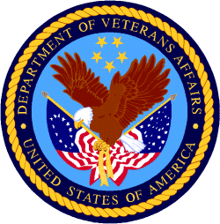

Department of Veterans Affairs

Programs:

Reminders:

Supportive Services for Veteran Families
VA Supportive Services for Veteran Families Program
Forecast 2
Document Type: Grants Notice  Opportunity Number: VA-SSVF-2025  Opportunity Title: VA Supportive Services for Veteran Families Program  Opportunity Category: Discretionary  Opportunity Category Explanation:  Funding Instrument Type: Grant  Category of Funding Activity: Housing  Category Explanation:  Expected Number of Awards: 256  CFDA Number(s): 64.033 -- VA Supportive Services for Veteran Families Program  Cost Sharing or Matching Requirement: No | Version: Forecast 3  Forecasted Date: Aug 30, 2023  Last Updated Date: Aug 31, 2023  Estimated Post Date: Oct 27, 2023  Estimated Application Due Date: Feb 09, 2024  Estimated Award Date: Aug 01, 2024  Estimated Project Start Date: Oct 01, 2024  Fiscal Year: 2025  Archive Date:  Estimated Total Program Funding:  Award Ceiling:  Award Floor:

Eligible Applicants: | Nonprofits having a 501(c)(3) status with the IRS, other than institutions of higher education
Additional Information on Eligibility:

Agency Name: | Supportive Services for Veteran Families
Description: | The Department of Veterans Affairs (VA) plans to announce the availability of funds for supportive services grants under the  Supportive Services for Veteran Families (SSVF) Program. This NOFA will contain information concerning the SSVF Program, initial supportive  services grant application processes, and the amount of funding available. Awards made for supportive services grants will fund  operations beginning October 1, 2024.  This NOFA announces the availability of funds for supportive services grants under the SSVF Program and pertains to proposals for renewal of existing supportive services grant programs. New applications for SSVF grant awards will not be funded through this NOFA.
Link to Additional Information:
Grantor Contact Information: | Jennifer Colbert Supervisor  ssvf@va.gov  National SSVF Inbox
https://www.grants.gov/web/grants/view-opportunity.html?oppId=350029

National Veterans Sports Programs
Grants for Adaptive Sports Programs for Disabled Veterans and Disabled Members of the Armed Forces (Equine Assisted Therapy)
Forecast 1
Document Type: Grants Notice  Opportunity Number: VA-EQUINE-24  Opportunity Title: Grants for Adaptive Sports Programs for Disabled Veterans and Disabled Members of the Armed Forces (Equine Assisted Therapy)  Opportunity Category: Discretionary  Opportunity Category Explanation:  Funding Instrument Type: Grant  Category of Funding Activity: Other (see text field entitled "Explanation of Other Category of Funding Activity" for clarification)  Category Explanation: Adaptive Sports and Equine Therapy Activities for Disabled Veterans and Disabled Members of the Armed Forces as authorized by 38 U.S.C. 521A.  Expected Number of Awards:  CFDA Number(s): 64.034 -- VA Grants for Adaptive Sports Programs for Disabled Veterans and Disabled Members of the Armed Forces  Cost Sharing or Matching Requirement: No | Version: Forecast 1  Forecasted Date: Aug 30, 2023  Last Updated Date: Aug 30, 2023  Estimated Post Date: Nov 15, 2023  Estimated Application Due Date: Jan 15, 2024  Estimated Award Date: Sep 30, 2024  Estimated Project Start Date: Oct 01, 2024  Fiscal Year: 2024  Archive Date:  Estimated Total Program Funding:  Award Ceiling:  Award Floor:
Eligibility
Eligible Applicants: | Others (see text field entitled "Additional Information on Eligibility" for clarification)
Additional Information on Eligibility: | Eligible applicants must qualify as a non-Federal Government entity with significant experience in managing a large-scale adaptive sports program for persons with disabilities if those disabilities are those that disabled Veterans and disabled members of the Armed Forces may have.
Additional Information
Agency Name: | National Veterans Sports Programs
Description: | Eligible applicants must qualify as a non-Federal Government entity with significant experience in managing a large-scale adaptive sports program for persons with disabilities if those disabilities are those that disabled Veterans and disabled members of the Armed Forces may have.  The Adaptive Sports Grant Program provides grants to eligible adaptive sports entities to plan, develop, manage, and implement programs to provide adaptive sports activities for Veterans and members of the Armed Forces with disabilities. For the purpose of this program, adaptive sports activities include: (1) instruction, participation, and competition in adaptive sports; (2) training and technical assistance to program administrators, coaches, recreation therapists, instructors, VA employees, and other appropriate individuals; (3) coordination, Paralympic classification of athletes, athlete assessment, sport-specific training techniques, program development (including programs at the local level), sports equipment, supplies, program evaluation, and other activities related to the implementation and operation of the program.  The primary goal for this Notice of Funding Availability (NOFA) is to ensure that appropriate levels of resources are provided to eligible adaptive sports entities with capabilities that are well-suited to meet the needs and priorities for Veterans with disabilities and members of the Armed Forces with disabilities.  This NOFA announces the availability of $1,500,000 to be awarded for proposals providing equine therapy targeted for Veterans and members of the Armed Forces with disabilities related to mental health issues. Adaptive Sports proposals not focused on equine therapy should apply to VA-SPORTS-24.
Link to Additional Information: | https://www.blogs.va.gov/nvspse/grant-program/
Grantor Contact Information: | Vanietta Armstrong Supervisory Grants Management Spc  Grants4vets@va.gov  Adaptive Sports
https://www.grants.gov/web/grants/view-opportunity.html?oppId=350047

National Veterans Sports Programs
Grants for Adaptive Sports Programs for Disabled Veterans and Members of the Armed Forces program
Forecast 1
Document Type: Grants Notice  Opportunity Number: VA-SPORTS-24  Opportunity Title: Grants for Adaptive Sports Programs for Disabled Veterans and Members of the Armed Forces program  Opportunity Category: Discretionary  Opportunity Category Explanation:  Funding Instrument Type: Grant  Category of Funding Activity: Other (see text field entitled "Explanation of Other Category of Funding Activity" for clarification)  Category Explanation: Adaptive Sports and Equine Therapy Activities for Disabled Veterans and Disabled Members of the Armed Forces as authorized by 38 U.S.C. 521A  Expected Number of Awards:  CFDA Number(s): 64.034 -- VA Grants for Adaptive Sports Programs for Disabled Veterans and Disabled Members of the Armed Forces  Cost Sharing or Matching Requirement: No | Version: Forecast 1  Forecasted Date: Aug 30, 2023  Last Updated Date: Aug 30, 2023  Estimated Post Date: Nov 15, 2023  Estimated Application Due Date: Jan 15, 2024  Estimated Award Date: Sep 30, 2024  Estimated Project Start Date: Oct 01, 2024  Fiscal Year: 2024  Archive Date:  Estimated Total Program Funding:  Award Ceiling:  Award Floor:

Eligible Applicants: | Others (see text field entitled "Additional Information on Eligibility" for clarification)
Additional Information on Eligibility: | Eligible applicants must qualify as a non-Federal Government entity with significant experience in managing a large-scale adaptive sports program for persons with disabilities if those disabilities are those that disabled Veterans and disabled members of the Armed Forces may have.

Agency Name: | National Veterans Sports Programs
Description: | The Adaptive Sports Grant Program provides grants to eligible adaptive sports entities to plan, develop, manage, and implement programs to provide adaptive sports activities for Veterans and members of the Armed Forces with disabilities. For the purpose of this program, adaptive sports activities include: (1) instruction, participation, and competition in adaptive sports; (2) training and technical assistance to program administrators, coaches, recreation therapists, instructors, VA employees, and other appropriate individuals; (3) coordination, Paralympic classification of athletes, athlete assessment, sport-specific training techniques, program development (including programs at the local level), sports equipment, supplies, program evaluation, and other activities related to the implementation and operation of the program.  The primary goal for this Notice of Funding Availability (NOFA) is to ensure that appropriate levels of resources are provided to eligible adaptive sports entities with capabilities that are well-suited to meet the needs and priorities for Veterans with disabilities and members of the Armed Forces with disabilities.  This NOFA announces the availability of up to $14,500,000 for initial grants to provide adaptive sports activities under the Adaptive Sports Grant Program to Veterans, and members of the Armed Forces, with disabilities. Proposals with a focus on providing equine therapy targeted for Veterans and members of the Armed Forces should apply to VA-SPORTS-24.
Link to Additional Information: | https://www.blogs.va.gov/nvspse/grant-program/
Grantor Contact Information: | Vanietta Armstrong Supervisory Grants Management Spc  Grants4vets@va.gov  Adaptive Sports
https://www.grants.gov/web/grants/view-opportunity.html?oppId=350048

Veterans Legacy Grant Program
Forecast 1
Document Type: Grants Notice  Opportunity Number: VLGP-FY2024  Opportunity Title: Veterans Legacy Grant Program  Opportunity Category: Discretionary  Opportunity Category Explanation:  Funding Instrument Type: Grant  Category of Funding Activity: Other (see text field entitled "Explanation of Other Category of Funding Activity" for clarification)  Category Explanation: Veterans Legacy Grant Program  Expected Number of Awards: 10  CFDA Number(s): 64.204 -- Veterans Legacy Grants Program  Cost Sharing or Matching Requirement: No | Version: Forecast 1  Forecasted Date: Aug 31, 2023  Last Updated Date: Aug 31, 2023  Estimated Post Date: Apr 01, 2024  Estimated Application Due Date: May 01, 2024  Estimated Award Date: Jul 31, 2024  Estimated Project Start Date: Sep 01, 2024  Fiscal Year: 2024  Archive Date:  Estimated Total Program Funding: $2,200,000  Award Ceiling: $500,000  Award Floor:

Eligible Applicants: | Public and State controlled institutions of higher education  Private institutions of higher education  Independent school districts  Nonprofits having a 501(c)(3) status with the IRS, other than institutions of higher education
Additional Information on Eligibility: | Veterans Service Organizations

Agency Name: | Veterans Legacy Grants Program
Description: | The Department of Veterans Affairs (VA) National Cemetery Administration (NCA) is awarding grants for a maximum of $500,000 per awardee through the Veterans Legacy Grants Program (VLGP), authorized under 38 U.S.C. 2400 note to provide funding to educational institutions and other eligible entities to conduct cemetery research and produce educational tools for the public to utilize and learn about the histories of Veterans interred in VA national cemeteries and VA grant-funded State and Tribal Veterans’ cemeteries. This notice includes information about the process for applying for a VLGP grant; criteria for evaluating applications; priorities related to the award of grants; and other requirements and guidance regarding VLGP grants.
Link to Additional Information: | VA’s Veterans Legacy Grant Program website
Grantor Contact Information: | John D Williams  vlgp@va.gov  Veterans Legacy Grant Program inbox
https://www.grants.gov/web/grants/view-opportunity.html?oppId=350062

VA accesses resources to increase housing assistance for vulnerable Veterans
The Department of Veterans Affairs updated regulations Nov. 10 governing the Supportive Services for Veteran Families grant program to provide a more effective subsidy to Veterans in high-cost rental markets and to increase the cap in general housing assistance available to the most vulnerable Veteran families.
Under the new regulations, in certain communities, the SSVF grant will cover up to 50%, an increase from 35% of eligible Veterans’ reasonable rent for two years without need for recertification.
“We know Veterans are increasingly vulnerable to homelessness and housing insecurity,” said VA Secretary Denis McDonough. “The updated regulations give Supportive Services for Veteran Families grantees more flexibility and tools to keep Veterans housed while also helping them increase their income and access permanent affordable housing solutions.”
The new rule also expands the maximum stay in emergency housing for unsheltered Veterans.
The original rule authorized placement for a Veteran and his or her spouse with dependents in emergency housing for up to 45 days, which proved often not enough time to locate stable and affordable permanent housing in highly competitive rental markets.
A Veteran and his or her spouse with dependents can now stay in emergency housing for a maximum of 60 days. The 15-day increase in length-of-stay is expected to have the most significant benefit to Veteran families in rental markets with few vacancies, as well as unsheltered homeless Veterans families.
Ending Veteran homelessness is a top priority for VA, aligned with the White House’s priority to promote housing stability by supporting vulnerable tenants.
Learn more about VA’s mission to end homelessness among Veterans and how you can help.

PART 2 – GENERAL FEDERAL AGENCY GRANTS INFORMATION
OCTOBER 2023

Please review each department’s General Grant and Funding Overview. These overviews are the key web pages on each departmental website dedicated to the agency’s funding opportunities. Check back often to note the department updates.

(See Part 1 for current grant opportunity notices)

Federal Agencies Discretionary Grants and Contract Website Links

Native Hawaiian Programs

U.S. Department of Agriculture

Grants and Loans Overview

Department of Commerce

Grants at Commerce

Economic Development Administration Hawai‘i Contacts

Corporation for National and Community Service

General Program Overview

National Service in Hawai‘i

Department of Defense

Doing Business with the Department of Defense

Department of Education

Grant Programs Overview

US Department of Energy

Grants Overview

Environmental Protection Agency

Grants and Contracts Overview

Department of Health and Human Services

Grants Overview

Department of Homeland Security
Grants Overview

Department of Housing and Urban Development

HUD - Notice of Funds Available

Institute of Museum and Library Services
Grants Overview

IMLS is on Facebook!

Department of Interior

Grants and Contract Overview

Department of Justice

Grants and Contract Overview

Hawai‘i State Administrative Agency Contacts
________________________________________________________________________

Department of Labor

Grants and Contract General Overview

National Aeronautics and Space Administration

Research Grant and Contract General Overview
_______________________________________________________________
National Archives and Records Administration

Grant Opportunities General Overview
_______________________________________________________________
National Endowment for the Arts

Grant Opportunities General Overview
_______________________________________________________________

National Endowment for the Humanities

Grant Opportunities General Overview
_______________________________________________________________
National Science Foundation

Grant Opportunities General Overview

Small Business Administration

General Overview Finding Loans & Grants

Links Specific to Hawai‘i

State Department

General Overview and Resources for Program Administrators

_________________________________________________________________________________

U.S. Department of Transportation

General Grant Program Overview

Department of the Treasury

Overview

US Agency for International Development

General Funding Opportunity Overview

Department of Veterans Affairs

Programs

Grants.Gov Links

Grant Writing Resources

SBIR – Small Business Innovation Research

Federal Agency Discretionary Grant and Contract Websites and Overviews

Please review each department’s General Grant and Funding Overview. These overviews are the key web pages on each departmental website dedicated to the agency’s funding opportunities. Check back often to note the department updates.

(See Part 2 for current grant opportunity notices)

Federal Offices of Likely Interest to Native Hawaiians
- U.S. Department of Education
Office of Elementary and Secondary Education
Native Hawaiian Education Programs
White House Initiative on Asian Americans and Pacific Islanders
- U.S. Department of Health and Human Services
Health Resources & Services Administration
Native Hawaiian Health Care Systems
Office of Regional Operations Region 9 Office
Administration for Native Americans
ANA Pacific Region Training and Technical Assistance Center
- U.S. Department of Housing and Urban Development
Federal Housing Administration
Insured Mortgages on Hawaiian Home Lands, FHA Section 247
Office of Native American Programs
Native Hawaiian Housing
Hawai‘i State Home Page
- U.S. Department of the Interior
National Park Service
Hawai‘i Parks
National NAGPRA Program
U.S. Fish and Wildlife Service
Pacific Islands Fish and Wildlife Office
Office of the Region One Tribal Liaison
U.S. Geological Survey
Pacific Region - Hawaii
- U.S. Department of Agriculture
Cooperative Research and Extension Services
Farm Service Agency - Hawaii and Pacific Basin
Natural Resources Conservation Services - Pacific Islands Area
Rural Development - Hawaii
- U.S. Department of Defense
Office of the Deputy Under Secretary of Defense (Installations & Environment)
Senior Advisor and Liaison for Native American Affairs
Native Hawaiian Affairs
- Advisory Council on Historic Preservation
Office of Native American Affairs
- U.S. Department of Commerce
U.S. Economic Development Administration
University Center Economic Development Program
Representative covering the State of Hawaii
National Oceanic and Atmospheric Administration
NOAA in Your State - Hawaii
- U.S. Small Business Administration
Hawaii District Office
8(a) Business Development Program (open to qualified Native Hawaiian businesses)
- U.S. Department of the Treasury
Community Development Financial Institution Fund (CDFI Fund)
- U.S. Department of Veteran Affairs
Center for Minority Veterans
Office of Diversity and Inclusion

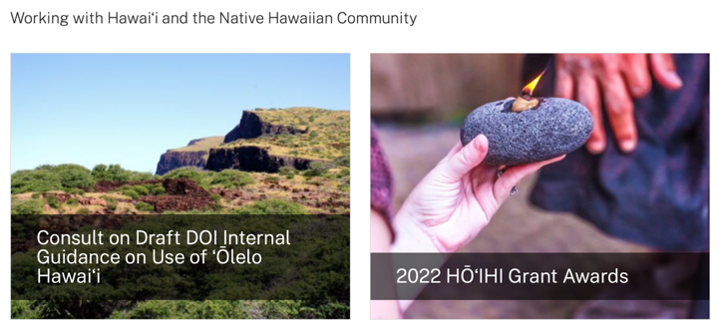
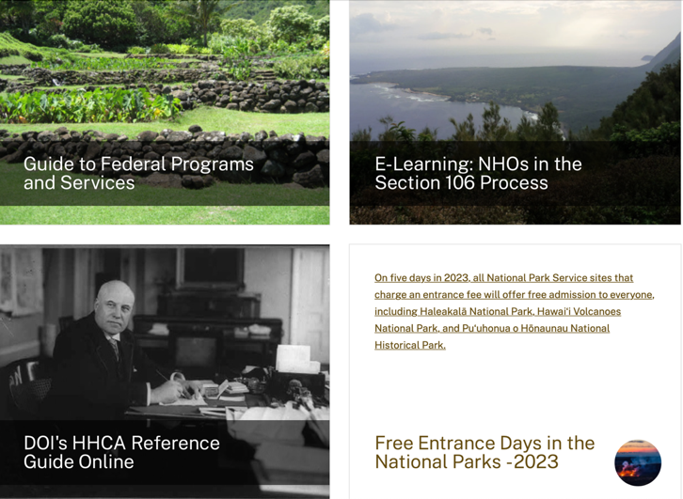
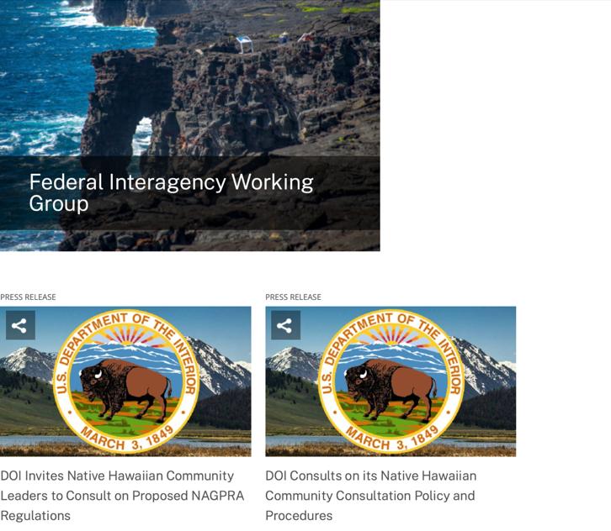
https://www.doi.gov/Hawaiian

Office of Hawaiian Affairs Community Grants Program
Grants – The purpose of the Office of Hawaiian Affairs Grants Program is to support Hawaiʻi based nonprofit organizations that have projects, programs, and initiatives to serve our Lāhui in alignment with OHA’s Strategic Foundations, Directions & Outcomes.
Reminder, to be eligible for funding consideration, an applicant shall:
- Be registered to do business in the State of Hawaiʻi
- Provide services to Native Hawaiians and/or Native Hawaiian community(ies) in the State of Hawaiʻi
- Have an IRS letter of Determination
- Compliant with Hawaiʻi Compliance Express

https://www.oha.org/resources/

Resources
Providing resources is among the key ways that the Office of Hawaiian Affairs fulfills its purpose.
The best possible Native Hawaiian historical and cultural information has been just a click away since the launch in April 2013 of the Kipuka Database. It is a searchable online geographic information system that makes data that once would have taken long to compile, now available within seconds. The database helps complement our other key research tools, such as the Native Hawaiian Data Book and the Papakilo Database, which is a digital library for Native Hawaiian historical and cultural information.
In addition, we launched Kamakako’i, an issues-based digital media tool that has been years in the making. The cutting-edge website provides a platform to quickly engage key audiences and inspire action on policy matters important to the Native Hawaiian community.

Resources
- Grants – The purpose of the Office of Hawaiian Affairs Community Grants Program is to support projects, programs and initiatives that address OHA’s six Strategic Priorities and accompanying Strategic Results contained in OHA’s 2010-2018 Strategic Plan.
- Kamakakoʻi – A cutting edge tool that leverages technology to engage, inform, activate and rally the Hawaiʻi community around voices on the cutting edge of community issues. It is produced and maintained by the Office of Hawaiian Affairs.
- Ka Wai Ola – Ka Wai Ola is a monthly newspaper published by OHA. The Ka Wai Ola operates under the Communications division of Community Engagement. The Ka Wai Ola has about 60,000 subscribers and strives to create rich content geared toward captivating the Hawaiian community.
- Kīpuka Database – A geographical information system (GIS) that utilizes the latest mapping technologies to provide a window into native Hawaiian land, culture and history.
- Loans – The Office of Hawaiian Affairs is committed to ensuring Native Hawaiian and their ‘ohana have access to resources to assist them in pursuing their financial goals.
- OHA Native Hawaiian Data Book – A compilation of basic demographic data on Hawaiian and data to identify gaps and important issues to ensure OHA’s actions and initiatives are based on the best information available.
- Papakilo Data Base – A comprehensive “Database of Databases” consisting of varied collections of data pertaining to historically and culturally significant places, events, and documents in Hawai‘i’s history.
- Reports and Research – A collection of reports and surveys intended to help guide strategic direction and policy decisions.
- Scholarships – Each year OHA provides funding for scholarships through its Higher Education Scholarship Programs.

U.S. Department of Agriculture

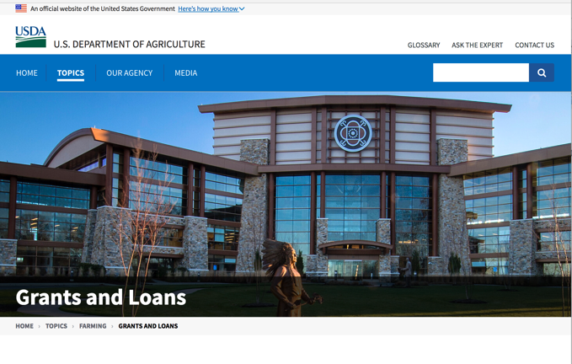

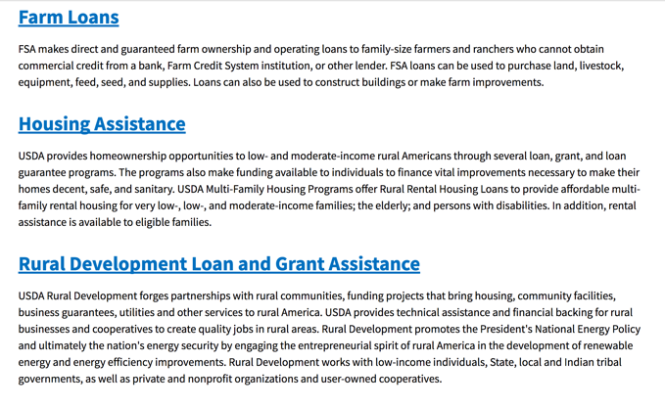

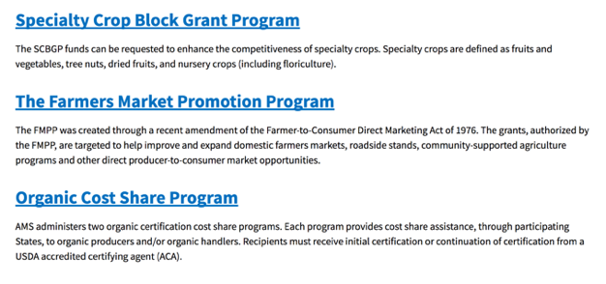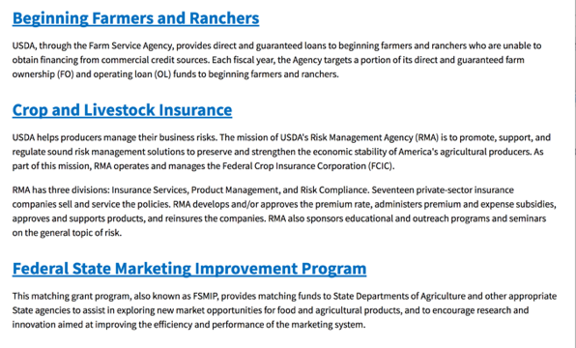
https://www.usda.gov/topics/farming/grants-and-loans
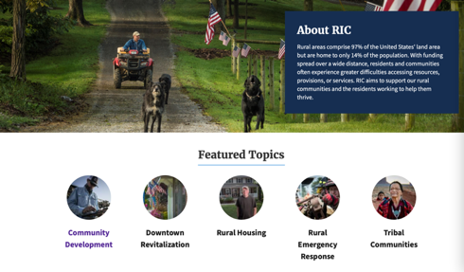https://www.nal.usda.gov/ric/community-development-resources

Department of Commerce

Grants, Contracting, and Trade Opportunities at Commerce
Learn more information about grants, contracting and trade opportunities at the Department of Commerce using the information below
https://www.commerce.gov/work-with-us/grants-and-contract-opportunities
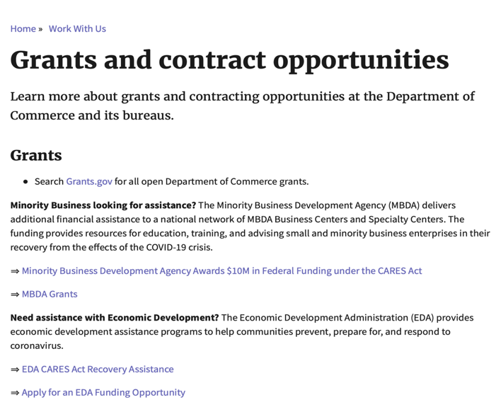

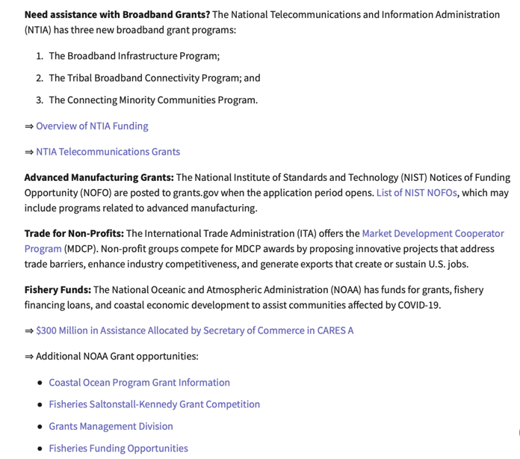
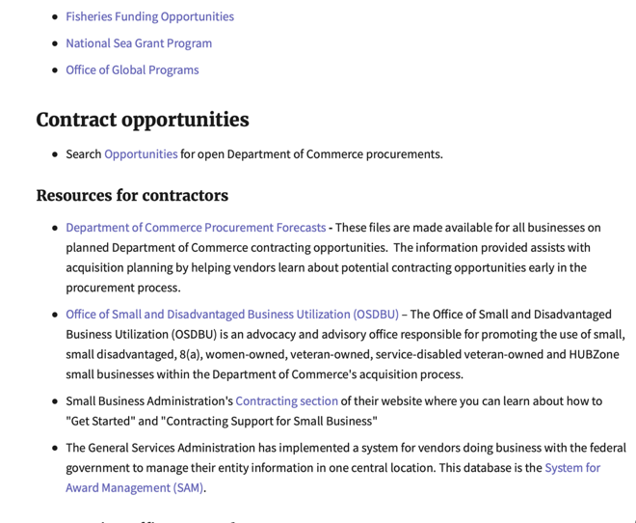
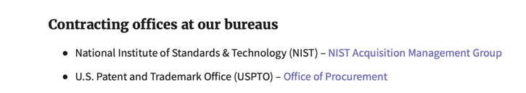
DOC Grant Making Bureaus
Economic Development Administration (EDA)
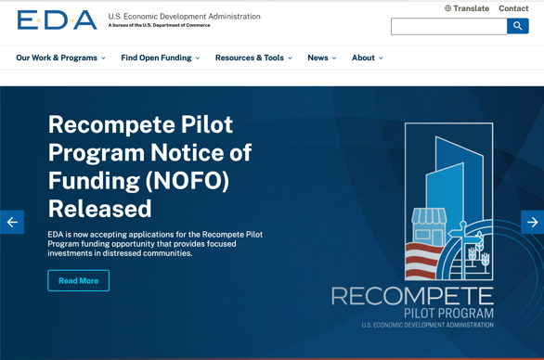
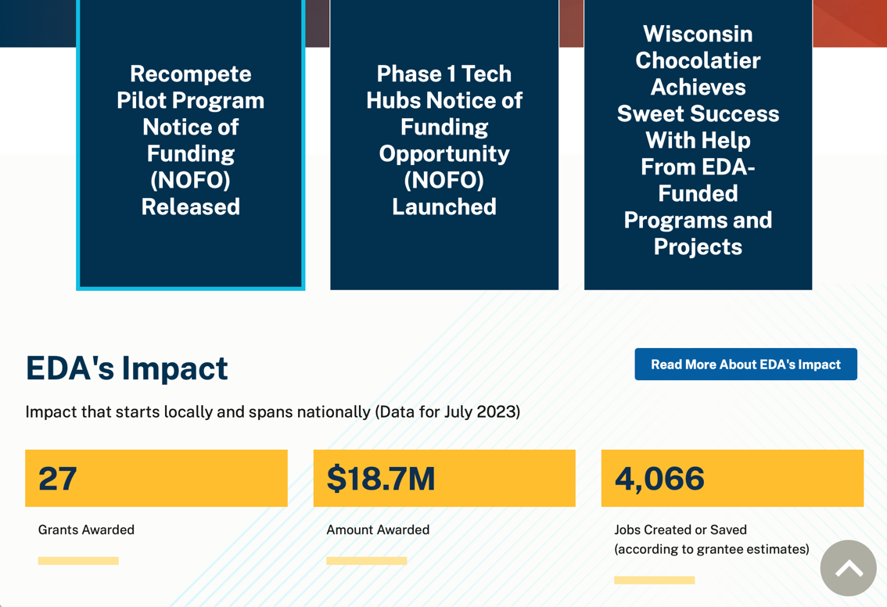
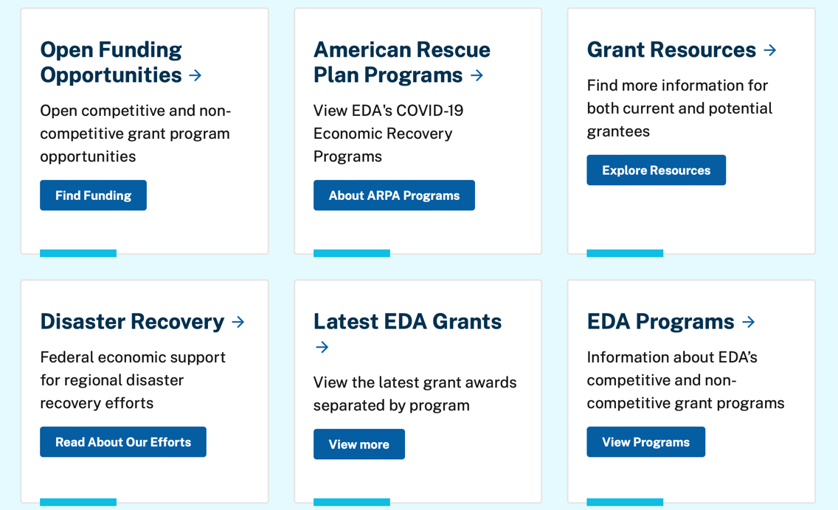

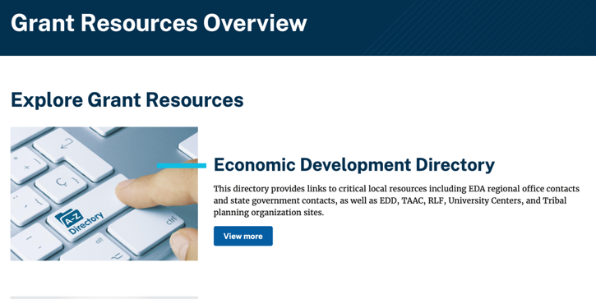
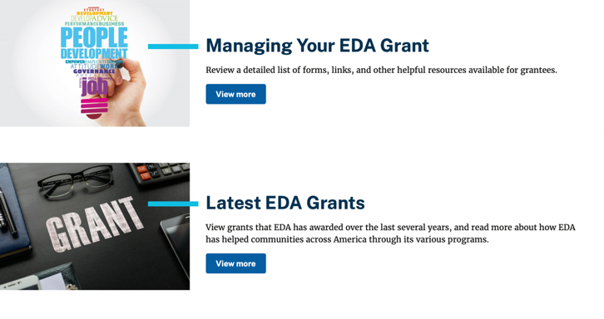

https://www.eda.gov/grant-resources

Economic Development Administration Hawai‘i Contacts

https://www.eda.gov/archives/2016/resources/economic-development-directory/states/hi.htm

International Trade Administration (ITA)
- Market Development Cooperator Program
- Special American Business Internship Training Program (SABIT). A technical assistance initiative of the International Trade Administration of the U.S. Department of Commerce, SABIT offers organizations competitive grants and an opportunity to host industry-specific delegations. SABIT serves as an initial entry point for U.S. businesses seeking funding to establish long-term relationships with potential customers, distributors, or partners in the former Soviet Union. The program trains Eurasian managers and scientists in commonly accepted business practices as a means of facilitating cross border relationships. In turn, these personal relationships serve as a basis for business development and reduce market access barriers for U.S. businesses.
National Institute of Standards & Technology (NIST)
- Funding Opportunities
National Telecommunications & Information Administration (NTIA)
- Telecommunications Grants
National Oceanic & Atmospheric Administration (NOAA)
- Coastal Ocean Program Grant Information
- Fisheries Saltonstall Kennedy Grant Program
- National Undersea Research Program Funding Opportunities
- Grants Management Division
- Fisheries Grants Program
- National Sea Grant
- Office of Global Programs
Contracting Resources for Contractors
- Office of Small and Disadvantaged Business Utilization (OSDBU) - the Office of Small and Disadvantaged Business Utilization (OSDBU) is an advocacy and advisory office responsible for promoting the use of small, small disadvantaged, 8(a), women-owned, veteran-owned, service-disabled veteran-owned, and HUBZone small businesses within the U.S. Department of Commerce's (DOC) acquisition process.
- Business.USA.gov's Find Opportunities Wizard where in a few quick steps, it will guide you towards federal government contracting programs and opportunities for your business!
- Planned Acquisitions: the Department of Commerce's search tool for our planned acquisitions over $100,000. As requirements change, these acquisition plans are updated by department personnel and this search tool is automatically updated.
- Small Business Administration's Contracting section of their web site where you can learn about how to "Get Started" and "Contracting Support for Small Business."
- The General Services Administration (GSA) has implemented a system for vendors doing business with the Federal Government to manage their entity information in one central location. This new database is the System for Award Management (SAM).
DOC Contracting Offices
- Patent and Trademark Office (PTO)
  - Office of Procurement

- National Institute of Standards & Technology (NIST)
Trade Opportunities through Commerce
http://www.commerce.gov

Corporation for National and Community Service

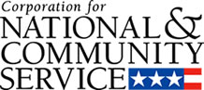

General Program Overview

AmeriCorps provides resources, both human and financial, to organizations that engage Americans in intensive service to meet our country’s critical needs.
Grantees use the funding to support AmeriCorps members for intensive service in their community. AmeriCorps grants partially cover the expense of operating an AmeriCorps program and do not cover general organizational expenses. A cash and in-kind match are required.

The main website can be accessed here: http://www.nationalservice.gov

For access to further funding information: https://americorps.gov/partner/funding-opportunities

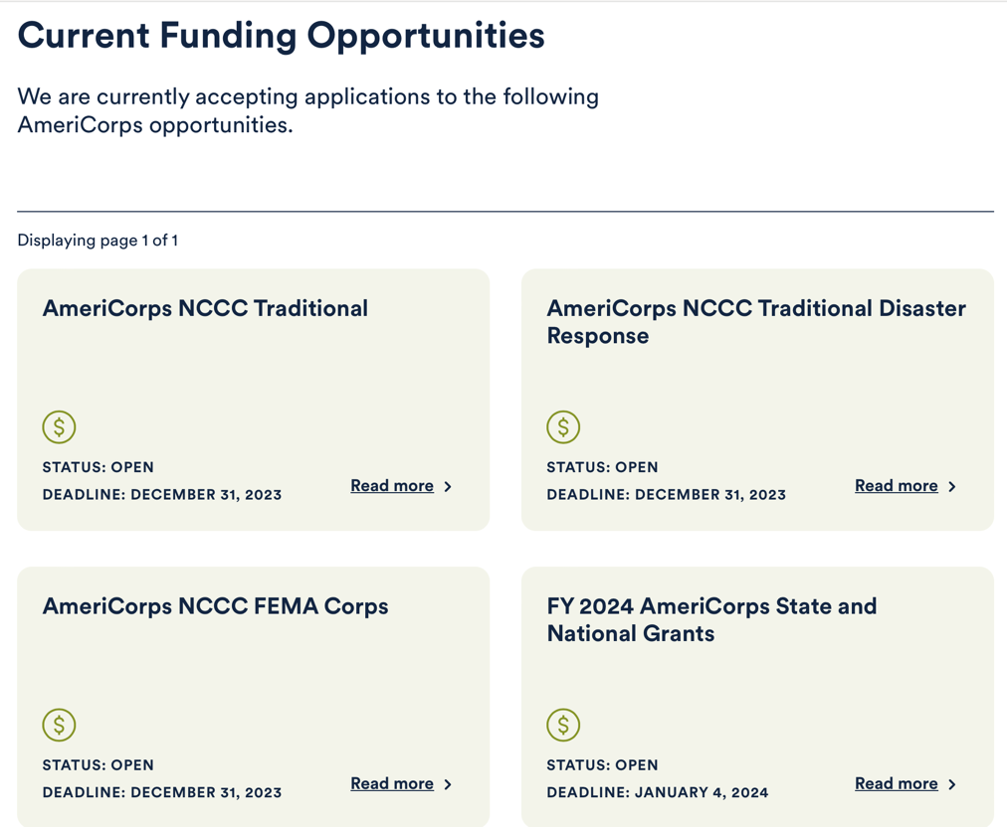
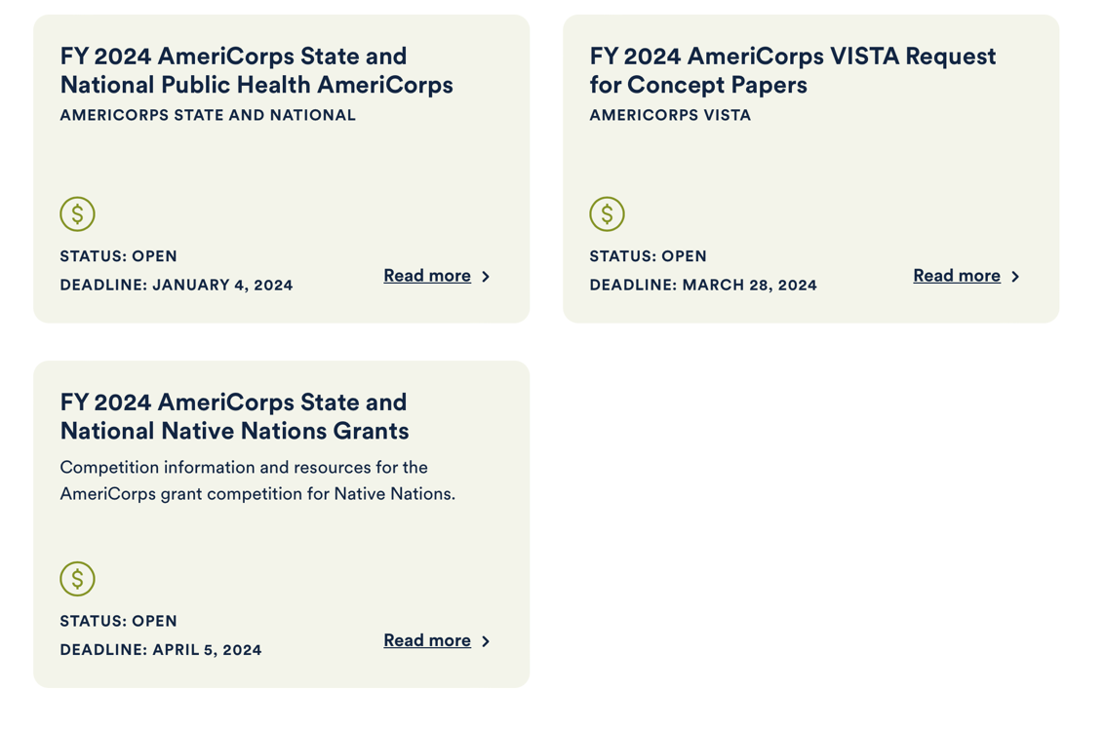
Read more

Closed Funding Opportunities
Past funding opportunities, archived for public record.

Funded Grants
AmeriCorps, AmeriCorps Seniors, and Day of Service awards.

https://www.americorps.gov/partner/funding-opportunities

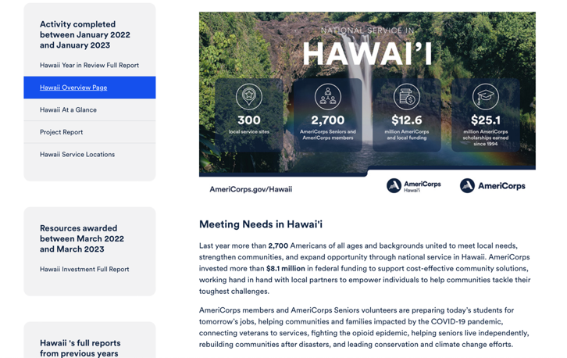
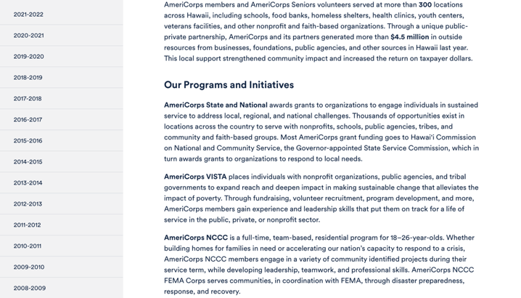
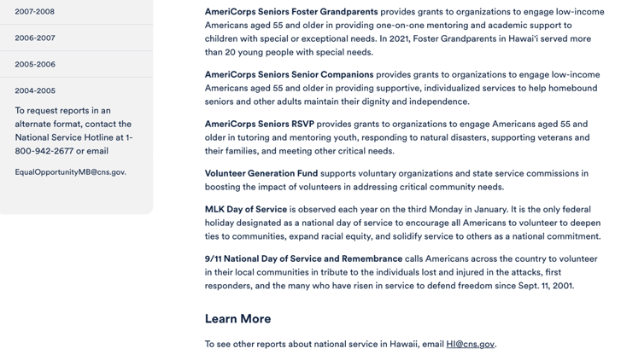

Learn More https://americorps.gov/national-service-report/hi
To see other reports about national service in Hawai‘i, please contact HI@cns.gov.
The Corporation for National and Community Service is a federal agency that improves lives, strengthens communities, and fosters civic engagement through service and volunteering. To learn more, visit www.NationalService.gov or call 202-606-5000 or TTY 1-800-833-3722.

U.S. Department of Defense

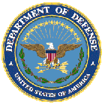

Doing Business with the Department of Defense

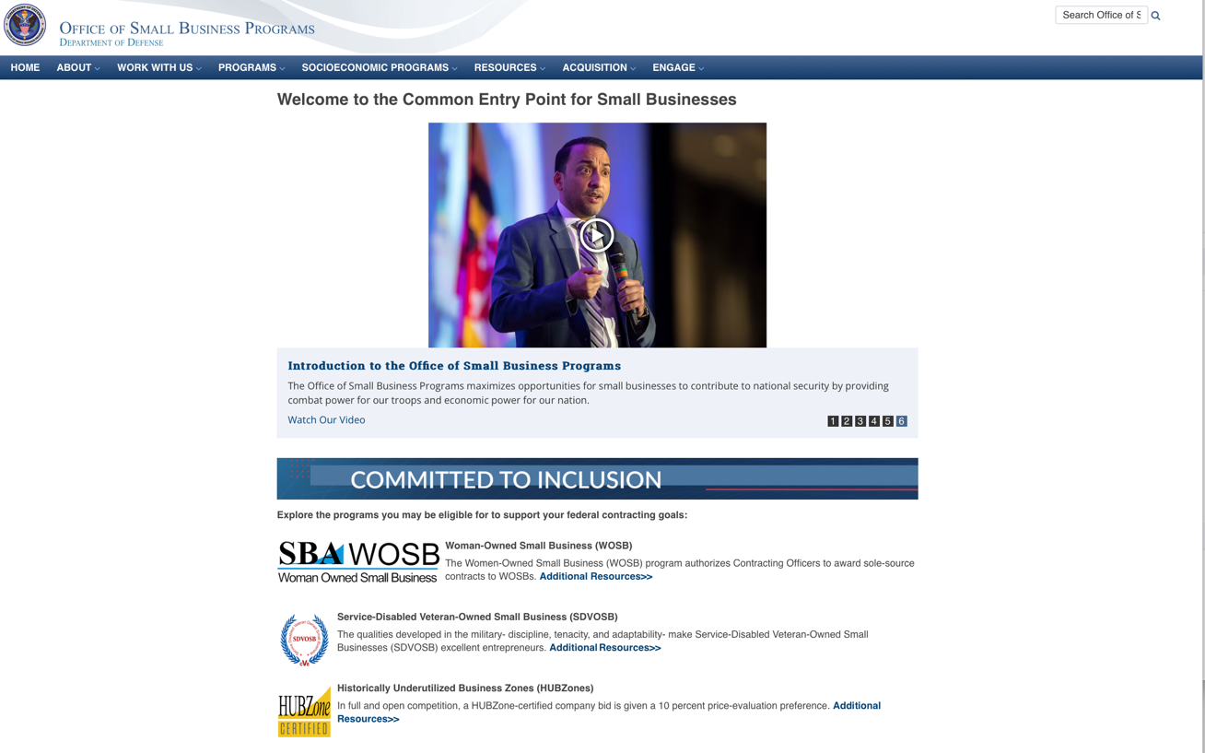

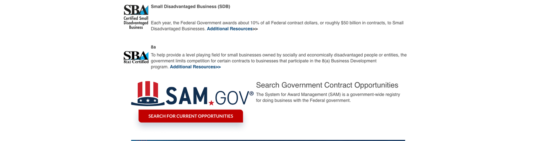

http://business.defense.gov

Department of Education


Grant Programs Overview at the Department of Education

The general information page for Education Grant funding is an excellent resource describing the three types of grants awarded by the Department of Education. See the screen shot of the Department of Education web page below:

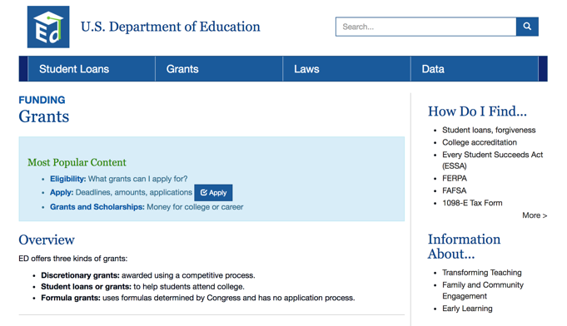
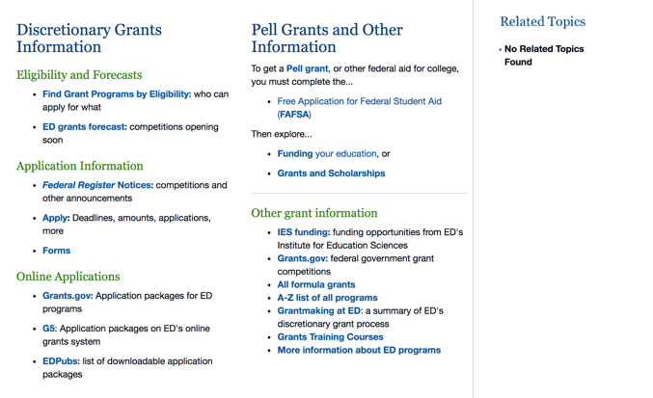

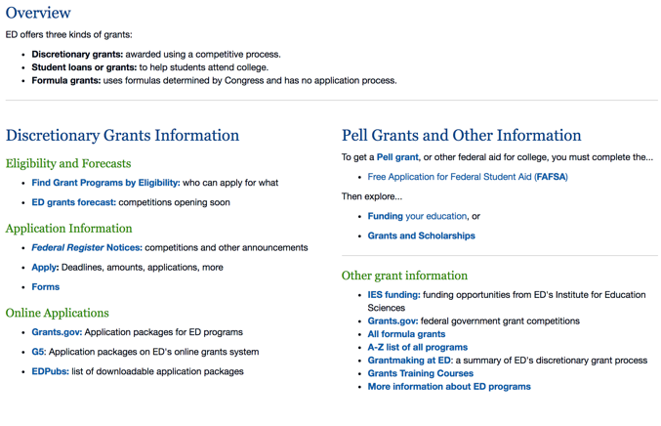

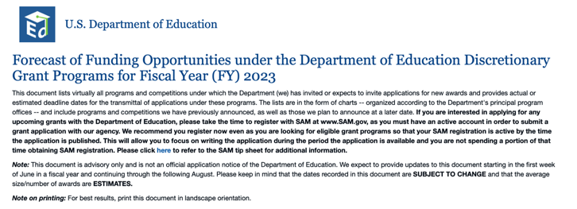

https://www2.ed.gov/fund/grant/find/edlite-forecast.html

U.S. Department of Energy

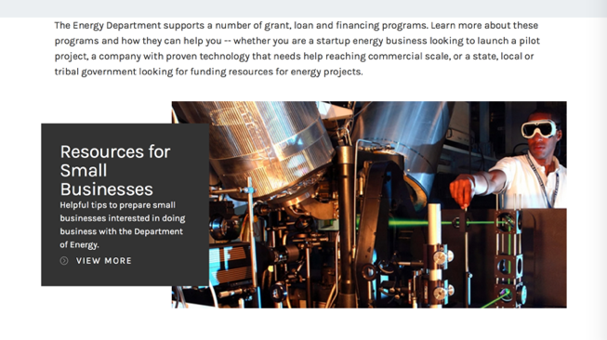
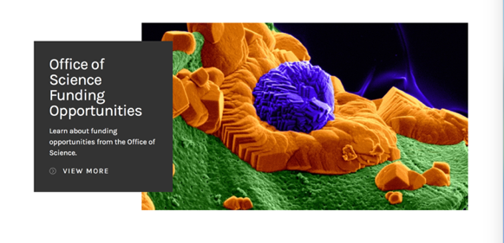

https://www.energy.gov/energy-economy/funding-financing

Environmental Protection Agency

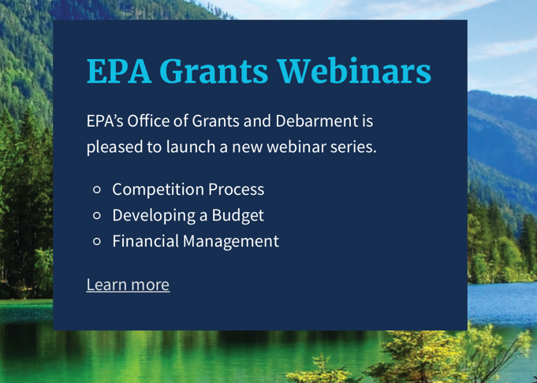

Quick Links

EPA References
- EPA’s Grants Management Plan
- EPA Financial Services (Receive a Payment)
- Disadvantaged Business Enterprises (DBE)
- Financial Assistance Infrastructure Programs Subject to BABAA
- Financial Assistance Programs subject to Executive Order 12372 (Intergovernmental Review)

Federal Grants Websites
- Grants.gov
- System for Award Management (SAM)
- EPA Assistance Listings
- USASpending.gov

https://www.epa.gov/grants/epa-grants-webinars

https://www.epa.gov/grants

Department of Health and Human Services

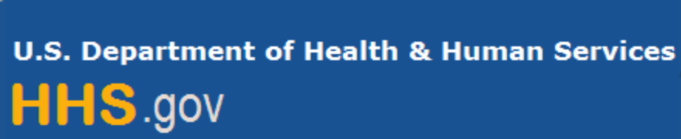

Grants Forecast and Overview

The Department of Health and Human Services’ Grants Forecast is a database of planned grant opportunities proposed by its agencies. Each Forecast record contains actual or estimated dates and funding levels for grants that the agency intends to award during the fiscal year. Forecast opportunities are subject to change based on enactment of congressional appropriations.

For more general information about HHS Grants and Funding go to the website below at:

https://www.hhs.gov/grants/grants/index.html

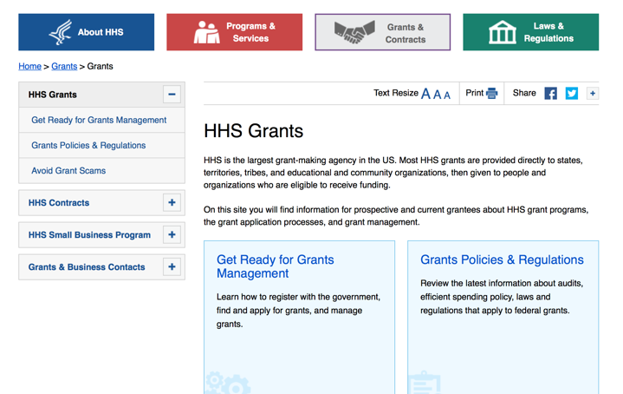

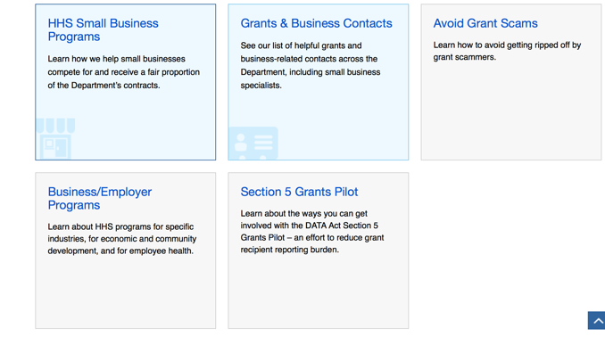

Department of Homeland Security

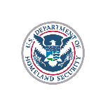

The Department of Homeland Security enhances the ability of states, local and tribal jurisdictions, and other regional authorities in the preparation, prevention, and response to terrorist attacks and other disasters, by distributing grant funds. Localities can use grants for planning, equipment, training and exercise needs.

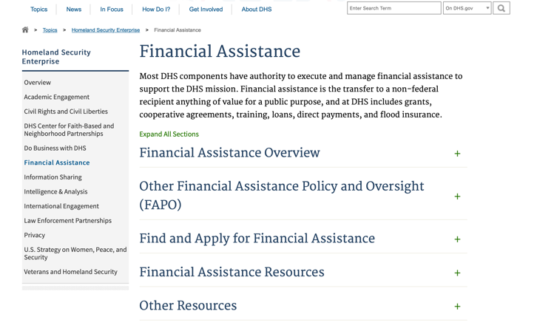

Webpage can be viewed at: https://www.dhs.gov/dhs-financial-assistance#2

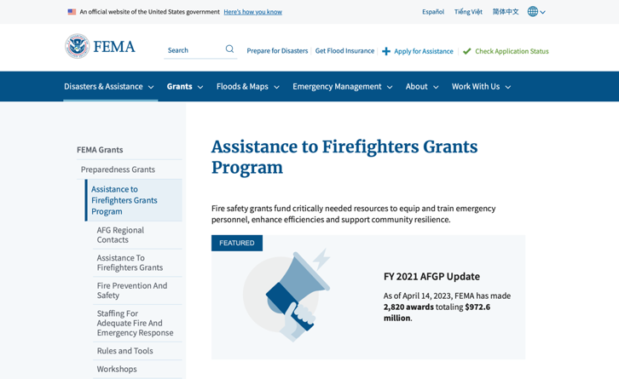
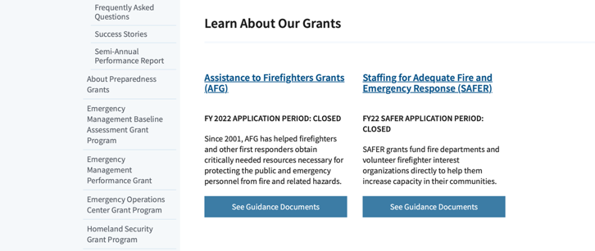
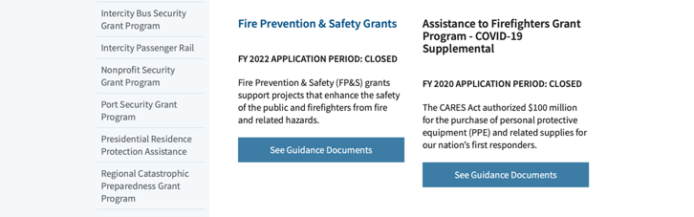

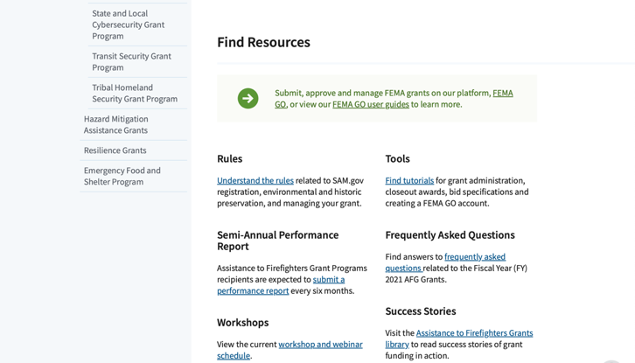
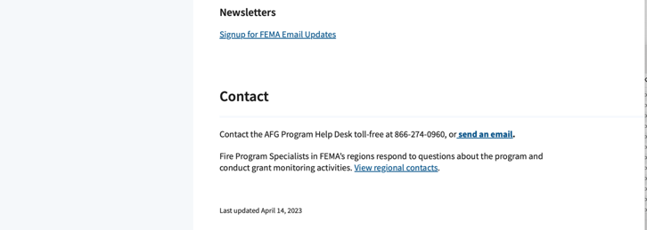
(Most recent update as of 8/8/2023)

https://www.fema.gov/welcome-assistance-firefighters-grant-program

For AFG program guidance materials, please visit our Documents page.

Resources

AFG Help Desk
Contact the AFG Program Help Desk toll-free at 866-274-0960, or email us at firegrants@dhs.gov.
The AFG Program has Fire Program Specialists in 10 federal regional centers. These Regional Fire Program Specialists respond to questions about the AFG program and carry out grant monitoring activities. View regional contacts

Popular AFG links
- Assistance to Firefighters Grants (AFG)
- AFG Awards List
- Staffing for Adequate Fire & Emergency Response (SAFER) Grants (SAFER)
- SAFER Awards List
- SAFER Success Stories
- Fire Prevention & Safety (FP&S) Grants
- FP&S Awards List
- FP&S Success Stories
- Grant Closeout Tutorial
- Assistance to Firefighters Grant (AFG) Email Alert Archive
- Frequently Asked Questions
Contact Information For The Assistance to Firefighters Grant (AFG) Program and Help Desk

Federal Funding Alternative To AFG

https://www.fema.gov

Department of Housing and Urban Development

https://www.hud.gov/program_offices/spm/gmomgmt/grantsinfo

HUD - Notice of Funds Available
For detailed information click here

Fiscal Year 2023 Funding Opportunities
HUD awards discretionary funding through over 20 Grant programs that support HUD initiatives, including Affordable Housing Development and Preservation, Community and Economic Development, Environment and Energy, Fair Housing, Homelessness, Homeownership, Rental Assistance, Supportive Housing and Services.
Notice of Funding Opportunity (NOFO) – The Notice of Funding Opportunities (NOFO) is a published each year on Grants.gov for HUD’s Discretionary Funding Programs. These NOFOs describe the type of funding available on a competitive basis and provides information on submission of an application, typically up to 30 to 90 days from the date of the NOFO publication on grants.gov.

Additional Information Related to HUD's Funding Opportunities
- 2 CFR Crosswalk - On August 13, 2020, the Office of Management and Budget (OMB) revised Federal Guidance for Grants and Agreements, to include 2 CFR 25, 2 CFR 170, 2 CFR 183, and 2 CFR 200. An index of those changes was consolidated in a document for reference. Here is the link to the document: https://www.cfo.gov/wp-content/uploads/2020/12/2-CFR-Crosswalk_20201106.xlsx
- Part 200 of Title 2 of the Code of Federal Regulations (2 CFR Part 200)
- Eligibility Requirements for Applicants of HUD's Grants Programs - 2023
- Eligibility Requirements for Applicants of HUD's Grants Programs - 2022
- Administrative, National & Departmental Policy Requirements and Terms for HUDs Financial Assistance - 2023
- Administrative, National & Departmental Policy Requirements and Terms for HUDs Financial Assistance - 2022
- Build American, Buy America Act (BABA)
  - This site provides a comprehensive collection of proposed, currently effective, and expired waivers (as they become available) of the Build America, Buy America Act (BABA) domestic content procurement preference as applied to HUD’s Federal Financial Assistance programs
- Environmental Requirements
  - E.O. 12898 Federal Actions to Address Environmental Justice
  - E.O. 14008 Tackling the Climate Crisis
- Code of Conducts Page

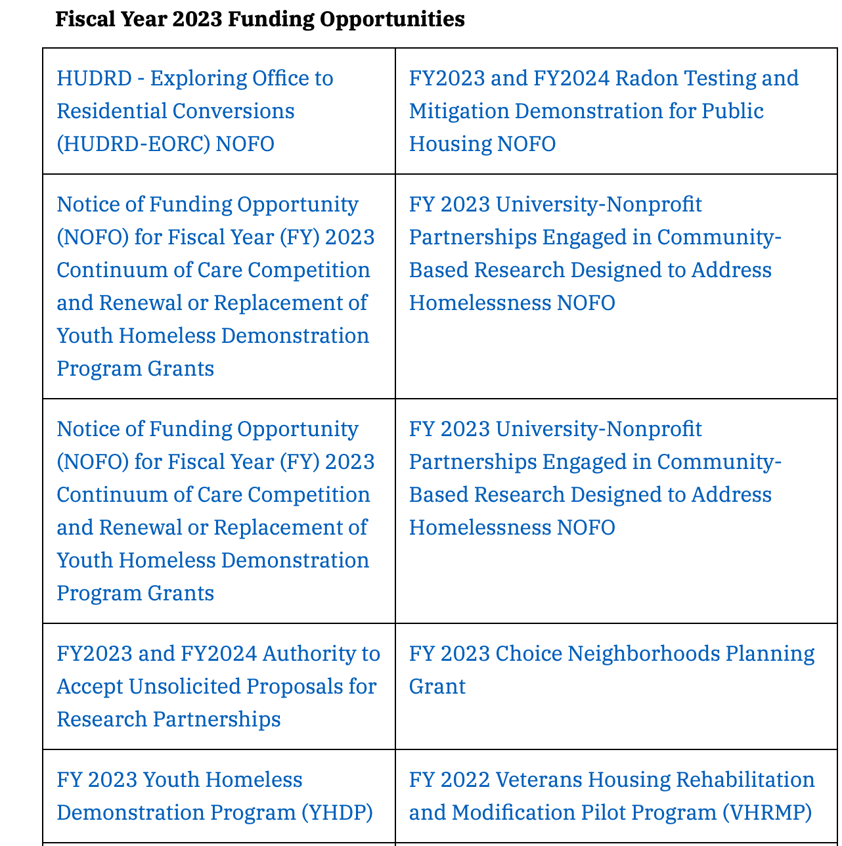
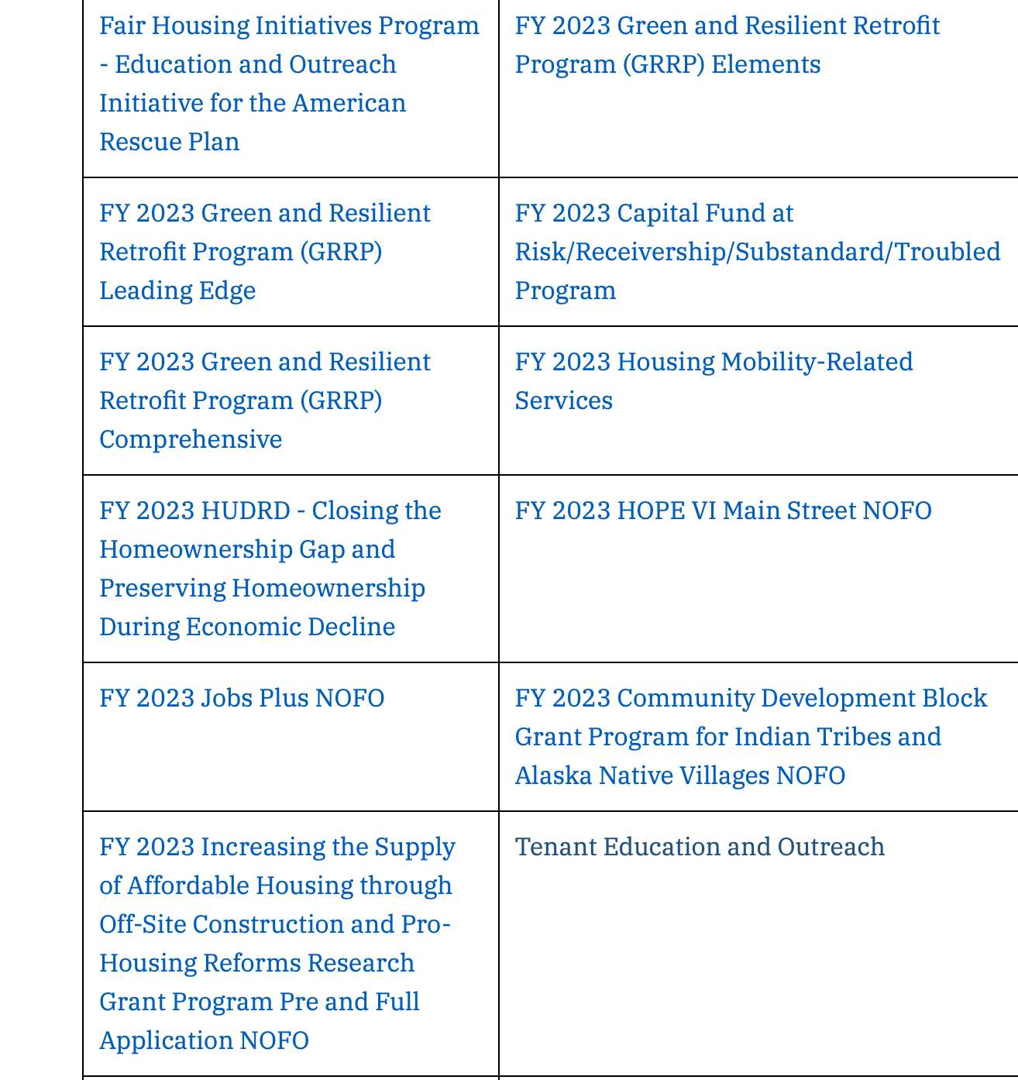
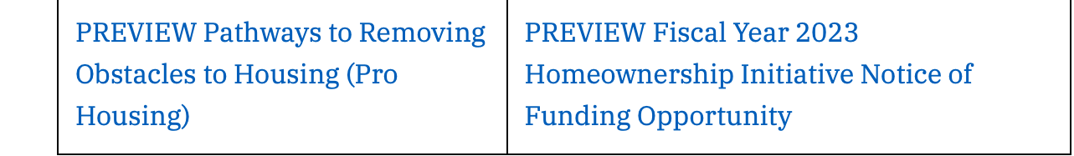

Forecast for Expected Fiscal Year 2023 Funding Opportunities
The Department of Housing and Urban Development NOFO Forecast list below identifies competitive grant opportunities that may be available for Fiscal Year (FY) 2023. The inclusion or exclusion of an opportunity in the listing below does not constitute a guarantee that a specific opportunity will become available or not be available. Forecast opportunities are subject to change based on enactment of Congressional appropriations and other considerations.
When funding is available, HUD will issue a Notice of Funding Opportunity (NOFO), which will be published on Grants.gov and the Funds Available webpage will be updated to indicate the NOFO has been published. Each NOFA provides guidance on how to apply for funding.
Office of Community Planning and Development (CPD)
- Self-Help Homeownership Opportunity Program (SHOP)
- Section 4 Capacity Building for Community Development and Affordable Housing (RCB)
- The Youth Homelessness Systems Improvement Program
- Continuum of Care Competition and Renewal or Replacement of Youth Homeless Demonstration Program
- Housing Opportunities for Persons with AIDS (HOPWA) Competitive Grant: Housing Interventions HINT) to End the HIV Epidemic
- Community Development Block Grant (CDBG) Pro – Housing
- Community Development Block Grant (CDBG) Price
Office of Fair Housing and Equal Opportunity (FHEO)
- Fair Housing Initiatives Program – Education Outreach Initiative
- Fair Housing Initiatives Program – Fair Housing Organization Initiative
- Fair Housing Initiatives Program – Private Enforcement Initiative

Office of Healthy Homes Lead Hazard Control (OHHLHC)
- FY2023 and FY2024 Radon Testing and Mitigation Demonstration for Public Housing
- Lead and Healthy Homes Technical Studies (LHHTS) Grant Program Pre- and Full Application
- Healthy Homes Production Grant Program
- Older Adult Modification Grant Program
- Healthy Homes Weatherization Cooperative Demonstration
Office of Housing (HSNG)
- Green and Resilient Retrofit Program Comprehensive
- Green and Resilient Retrofit Program Elements
- Green and Resilient Retrofit Program Leading Edge
- Section 811 Supportive Housing for Persons with Disabilities - Capitol Advance
- Section 811 Supportive Housing for Persons with Disabilities – Project Rental Assistance
- Fiscal Years 2022 and 2023 Homeownership Initiative Grant
- Comprehensive Housing Counseling Grant Program
- Service Coordinators in Multifamily Housing (SCMF) Discretionary
- Tenant Education and Outreach
Office of Policy Development and Research (PD&R)
- FY23 HUDRD - FHA’s Role in Closing the Homeownership Gap and Preserving Homeownership During Economic Decline
- FY2023 and FY2024 Authority to Accept Unsolicited Proposals for Research Partnerships
- Increasing the Supply of Affordable Housing through Off-Site Construction and Pro-Housing Reforms Research Grant Program Pre and Full Application
- Eviction Protection Grant Program

Office of Public and Indian Housing (PIH)
- Community Development Block Grant Program for Indian Tribes and Alaska Native Villages
- Housing Mobility-Related Services
- Indian Community Development Block Grant
- Capital Fund at Risk/Receivership/ Substandard/ Troubled Program
- Foster Youth to Independence (FYI) Competitive
- Resident Opportunity and Self-Sufficiency (ROSS) Service Coordinator Program
- Jobs Plus NOFO
- FY2023 HOPE VI Main Street Grant Program
- Choice Neighborhoods Implementation Grants

Updated 10/4/2023

http://portal.hud.gov/hudportal/HUD?src=/program_offices/Administration/grants/fundsavail

Institute of Museum and Library Services

https://www.imls.gov/grants/apply-grant/available-grants

The Application Process
1. Search for available grants
Grant programs and deadlines can be searched by name, by eligible institution type, and by project type.
2. Check eligibility requirements
Eligibility criteria will vary by program. Checking the program-specific criteria will help you ensure you're applying for the right grant for your institution. Read more.
3. Read application Notice of Funding Opportunities
Read through the application Notice of Funding Opportunities carefully to get all the information you need on the grant program. Read more.
4. Compose your application
Use the following Applicant Tools & Materials links to help you compose a stronger, more competitive application.
a. Sample Applications - Examples of successful applications from previous years
b. Outcome Based Evaluations - Introduction to and resources for successful program evaluation
c. Shaping Outcomes - An IMLS-funded online course on outcomes-based planning and evaluation, which will help participants improve program designs and evaluations.
d. Grantee Requirements - Administration and dissemination requirements for all grantees
e. Reviewer Materials - Guidelines and handbooks used during application review
5. Contact an IMLS Staff Member
We welcome calls from applicants and are happy to answer any questions about the grant application and review process. Conversations with staff can provide useful guidance and help you to explore how your idea may match the goals of a grant program. To reach an IMLS staff member please click on a link below for the grant program in which you are interested.
6. Submit your application via Grants.gov
Consult our Grants.gov guidelines to ensure we will receive your application, complete and on-time. Read more.
7. What happens next?
Learn how applications are reviewed and when grant announcements are made. Read more.

Museum Grants for African American History and Culture
Deadline: November 15, 2023
The FY 2024 Notice of Funding Opportunity is now available.
Native American/Native Hawaiian Museum Services Program
Deadline: November 15, 2023
The FY 2024 Notice of Funding Opportunity is now available.
Museums for America
Deadline: November 15, 2023
The FY 2024 Notice of Funding Opportunity is now available.
Museums Empowered: Professional Development Opportunities for Museum Staff
Deadline: November 15, 2023
The FY 2024 Notice of Funding Opportunity is now available.
National Leadership Grants for Museums
Deadline: November 15, 2023
The FY 2024 Notice of Funding Opportunity is now available.
Inspire! Grants for Small Museums
Deadline: November 15, 2023
The FY 2024 Notice of Funding Opportunity is now available.
Digital Humanities Advancement Grants
Deadline: January 11, 2024
Application: Please visit National Endowment for the Humanities for application information.
Program Overview: This program is designed to support innovative, experimental, and computationally challenging digital projects at different stages of their lifecycles.

Each grant program has specific eligibility requirements. The links below provide general eligibility criteria for museums, libraries, and tribal organizations, but please note that additional organizations may be eligible for grants under certain programs. Additionally, ineligible organizations may still be able to participate in grant programs through partnerships with eligible organizations. Please click on the links below to see general criteria and review Applications and Guidelines for specific information.
Museums Libraries
Institutions: Archives, Federally Recognized Native American Tribe, Historical Society, Library, Nonprofits that serve Native Hawaiian, Professional Association, Public or Private Non-profit Institutions of Higher Education, Regional Organization, State Library Administrative Agency, State or Local Government.

Check out IMLS's Facebook page at:
https://www.facebook.com/USIMLS/

Department of the Interior
The Interior Department provides assistance to the public, local governments and businesses through a number of programs. For a general overview see: http://www.doi.gov/index.cfm

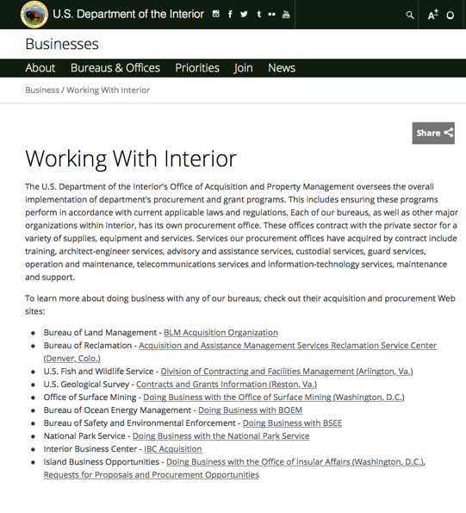

http://www.doi.gov/businesses/working-with-interior.cfm

Department of Justice

http://www.justice.gov/business/

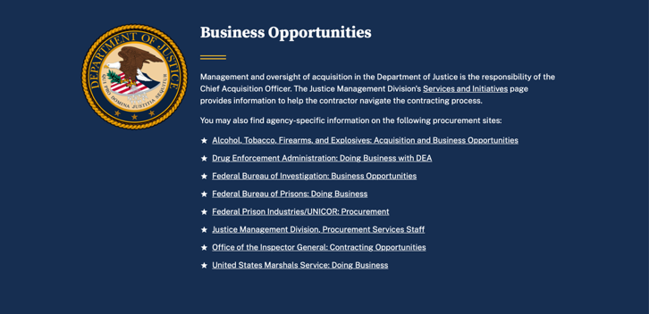

The DOJ agencies listed below also have sites that provide grant information specific to that agency. Examples of what can be found on these sites are programs, funding opportunities, application assistance, and other useful information.

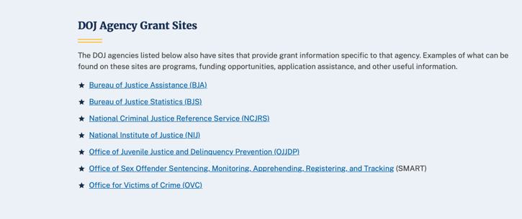

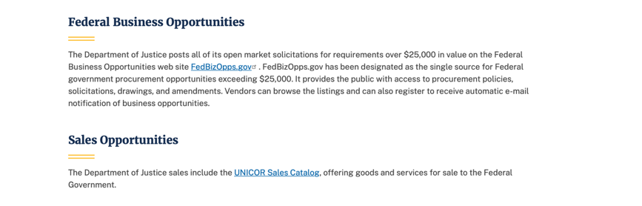

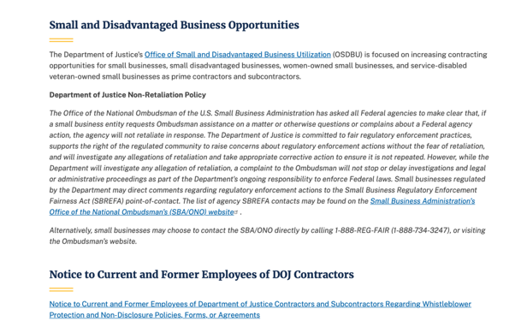

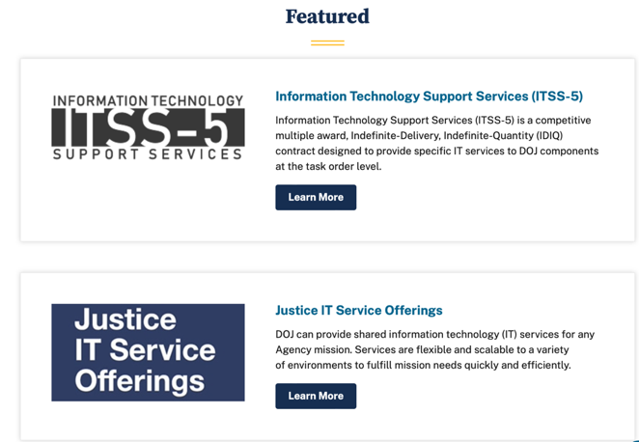

Bureau of Justice Assistance (BJA)

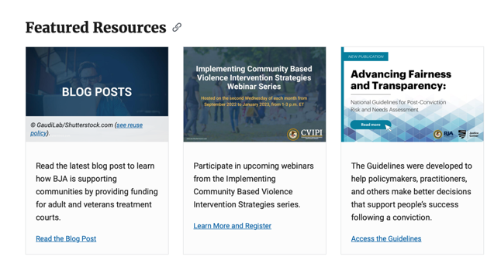

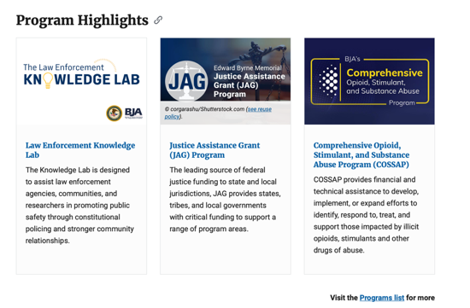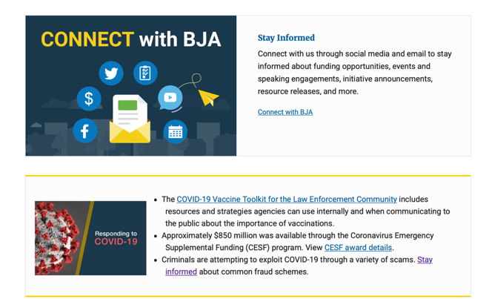

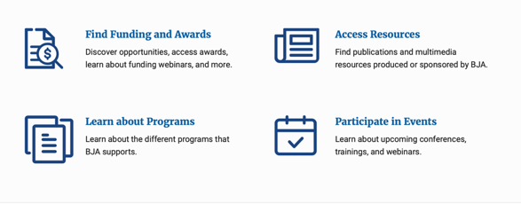

Bureau of Justice Statistics (BJS)

National Criminal Justice Reference Service (NCJRS)

National Institute of Justice (NIJ)

Office of Sex Offender Sentencing, Monitoring, Apprehending, Registering, and Tracking (SMART)

Hawai’i State Administrative Agency Contacts

HAWAI’I DEPARTMENT OF THE ATTORNEY GENERAL, CRIME PREVENTION & JUSTICE ASSISTANCE DIVISION
235 S Beretania Street, Suite 401
Honolulu, HI 96813
(808) 586-1150
Agency Head: Julie Ebato, Administrator
JAG Contact: Shaleigh Tice, Grants & Planning Branch Chief
SAC Director: Paul Perrone, Chief of Research and Statistics

https://ag.Hawai’i.gov/cpja/gp/

Department of Labor

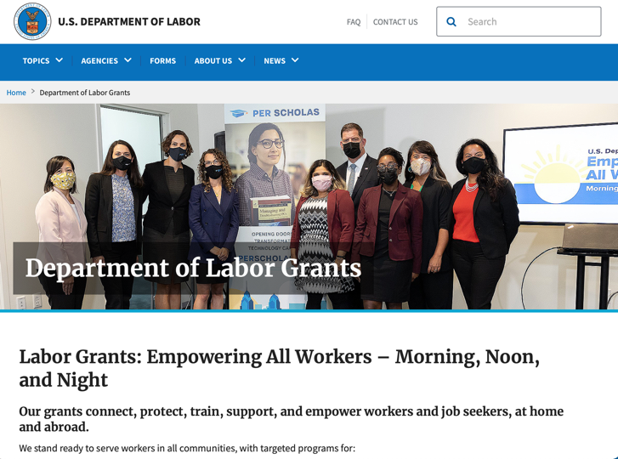
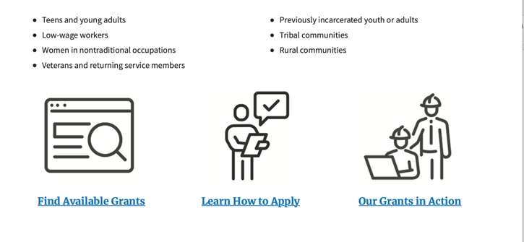

https://www.dol.gov/general/grants/howto

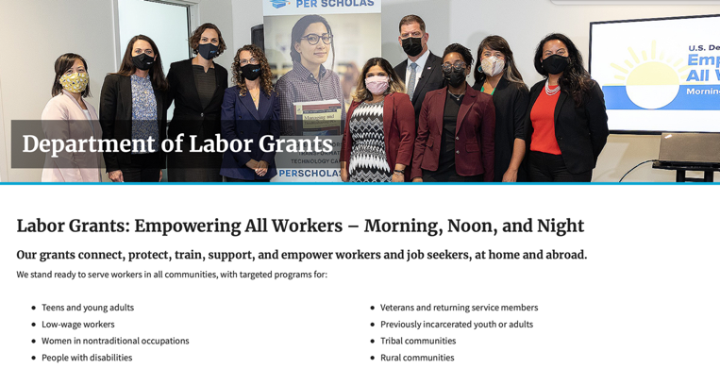

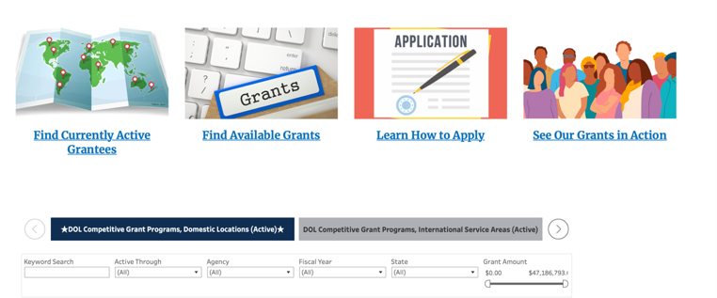

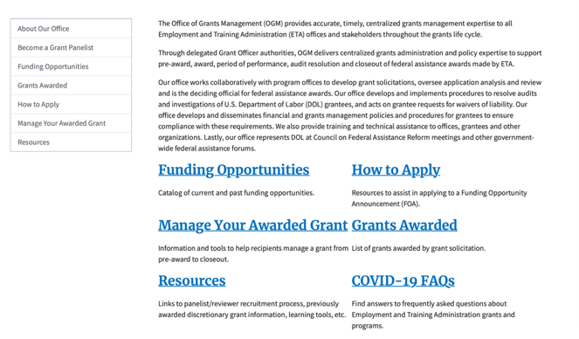

https://www.doleta.gov/grants/

Agency Grants and Contract General Overview

DOL Resources
Apply for DOL Agency-Specific Grants:
- Employment and Training Administration (ETA)
- Occupational Safety and Health Administration (OSHA)
- Bureau of International Labor Affairs (ILAB)
- Veterans' Employment and Training Service (VETS)
- Office of Disability Employment Policy (ODEP)
- Office of the Assistant Secretary for Administration and Management (OASAM)

Other Grant Resources:

DOL Resources and Instructions for Applying for a Grant
- DOL Guidance Clarifying the Effect of the Religious Freedom Restoration Act on Faith-Based Organizations
- Grant and Contract Information
- More Information About Grants

Other Federal Government Grant Information
- Grant Opportunities (Catalog of Federal Domestic Assistance)

Department of Labor Grant Programs

- Bureau of International Labor Affairs (ILAB): provides grants (cooperative agreements) for the implementation of projects designed to assist developing countries combat the worse forms of child labor, forced labor, and human trafficking; and support worker rights and improve working conditions. http://www.dol.gov/general/business.
- Bureau of Labor Statistics (BLS): provides project grants (cooperative agreements) and the dissemination of technical statistical data and related information on labor force activities; provides data on prices (CPI) and cost of living; data on productivity and technology data; data on compensation and working conditions; data on employment projections.
- Employment and Training (ETA): ETA Administers financial assistance programs pursuant to the Workforce Investment Act (WIA), administering State formula grant programs for youth, adults and dislocated workers, national emergency grants for workers affected by mass layoffs, plant closures, and disasters; grant programs for workers with disabilities, Indians and Native Americans, and for migrant and seasonal farmworkers. ETA also administers grant programs for older American workers, apprenticeship programs, Trade Adjustment Assistance (TAA) programs, and assistance for research and development of workforce programs. In addition, ETA is responsible for the operation and maintenance of a national system of public employment service offices and for the national unemployment insurance program.
- Mine Safety and Health (MSHA): provides grants for research, education and training programs to ensure an adequate and competent staff of trained inspectors; and assistance for establishing or improving State mine health and safety programs through technical assistance.
- Occupational Safety and Health (OSHA): provides grants to non-profit organizations to provide training, educational services, and technical assistance; assistance to states to administer and enforce state programs; assistance to states to provide occupational safety and health technical assistance and consultant services.
- Office of Disability Employment Policy (ODEP): The Office of Disability Employment Policy awards competitive grants establishing short-term pilot and technical assistance projects designed to identify, develop, test, evaluate, and disseminate policies to increase employment by expanding access to training, education, employment supports, assistive and systems technology, integrated employment, entrepreneurial development, and small business opportunities for adults and youth with disabilities. Current pilots projects focus on customized employment, Olmstead populations, and innovative demonstration youth grants, among others. Solicitations for grant applications are published in the Federal Register and announced at www.dol.gov/odep. ODEP grants are awarded by the OASAM grant office.
- Veterans' Employment and Training (VETS): provides special employment and training assistance for veterans through the Disabled Veterans' Outreach Program (DVOP) Solicitation for Grant Applications; the Local Veterans' Employment Representative Program (LVER); Veterans' Workforce Investment Program (VWIP); elaws Advisor on veterans' employment and reemployment rights; and the Homeless Veterans Reintegration Project (HVRP). VETS grants are awarded by the OASAM grant office.

https://www.dol.gov/general/grants/howto

National Aeronautics and Space Administration

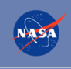 NASA Research Opportunities Online

- Various NASA offices publish their research announcements over the Internet, broadening the opportunity for researchers to apply for funding. This site provides access to current research announcements along with their specific due dates.

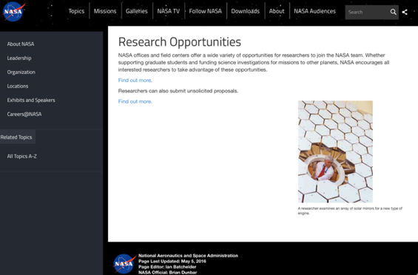
http://nspires.nasaprs.com/external/

National Archives and Records Administration

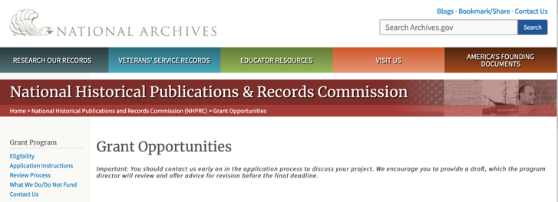

Archival Projects
For projects that ensure online public discovery and use of historical records collections.
- Draft Deadline (optional): August 15, 2023
- Final Deadline: November 2, 2023

Public Engagement with Historical Records
For projects that encourage public engagement with historical records.
- Draft Deadline (optional): August 15, 2023
- Final Deadline: November 2, 2023

Publishing Historical Records in Collaborative Digital Editions
For projects to publish documentary editions of historical records. This program has two application cycles.
First cycle:
- Draft Deadline: February 15, 2023
- Final Deadline: May 3, 2023
Second Cycle:
- Draft Deadline: August 15, 2023
- Final Deadline: November 2, 2023

NHPRC-Mellon Planning Grants for Collaborative Digital Editions in African American, Asian American, Hispanic American, and Native American History and Ethnic Studies
For projects to publish collaborative digital editions in African American, Asian American, Hispanic American, and Native American History and Ethnic Studies.
- Draft Deadline: April 1, 2023
- Final Deadline: June 7, 2023

The deadline for the opportunities listed below has passed. These guidelines may be used for reference, but should NOT be used to prepare an application. New announcements will be published in November 2023.

Major Collaborative Archival Initiatives
For collaborative projects that will significantly improve public discovery and use of major historical records collections.
- Draft Deadline: February 15, 2023
- Final Deadline: May 3, 2023

Archives Collaboratives
For projects to plan and develop a working collaborative designed to enhance the capacity of small and diverse organizations with historical records collections.
- Draft Deadline: February 15, 2023
- Final Deadline: May 3, 2023

State Board Programming Grants
For projects that strengthen the nation’s archival network through activities undertaken by state historical records advisory boards.
- Draft Deadline: February 15, 2023
- Final Deadline: May 3, 2023

NHPRC-Mellon Planning Grants for Collaborative Digital Editions in African American, Asian American, Hispanic American, and Native American History and Ethnic Studies
For projects to publish collaborative digital editions in African American, Asian American, Hispanic American, and Native American History and Ethnic Studies.
- Draft Deadline: April 1, 2023
- Final Deadline: June 7, 2023

This page was last reviewed on 8/8/ 2023
To access the information above: click here

https://www.archives.gov/nhprc/announcement

National Endowment for the Arts

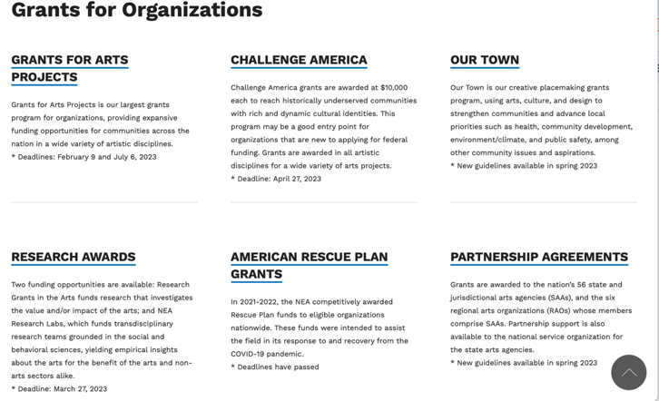

See more at: https://www.arts.gov/grants

National Endowment for the Humanities

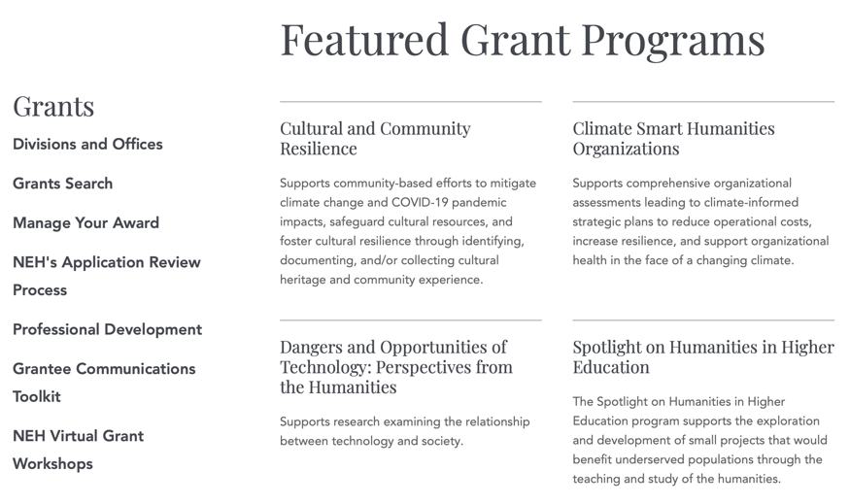

https://www.neh.gov/grants

National Science Foundation



For assistance: https://nsf.gov/funding/aboutfunding.jsp

The National Science Foundation funds research and education in most fields of science and engineering. It does this through grants, and cooperative agreements to more than 2,000 colleges, universities, K-12 school systems, businesses, informal science organizations and other research organizations throughout the United States. The Foundation accounts for about one-fourth of federal support to academic institutions for basic research.
NSF receives approximately 40,000 proposals each year for research, education and training projects, of which approximately 11,000 are funded. In addition, the Foundation receives several thousand applications for graduate and postdoctoral fellowships.
The agency operates no laboratories itself but does support National Research Centers, user facilities, certain oceanographic vessels and Antarctic research stations. The Foundation also supports cooperative research between universities and industry, US participation in international scientific and engineering efforts, and educational activities at every academic level.

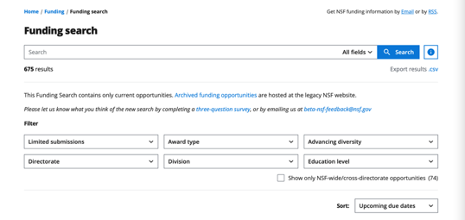

For details on active funding deadline dates: http://nsf.gov/funding/pgm_list.jsp?org=NSF&ord=date

Small Business Administration

https://www.sba.gov/funding-programs/loans
Federal, state and local governments offer a wide range of financing programs to help small businesses start and grow their operations. These programs include low-interest loans, venture capital, and scientific and economic development grants.
Use SBA.gov's Loans and Grants Search Tool to get a list of financing programs for which you may qualify, or visit the resources below to learn more about small business financing programs.

https://www.sba.gov/funding-programs/grants
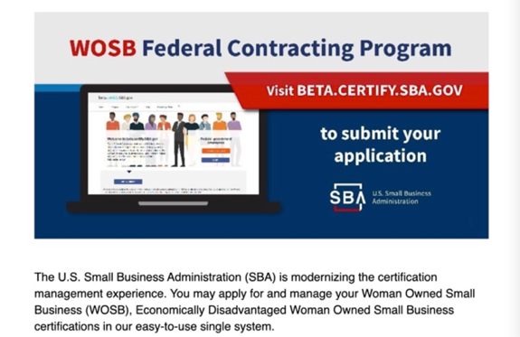
Learn more
https://www.sba.gov/learning-center

SBA Trainings

https://www.sba.gov/learning-center
Upcoming Trainings: Check out SBA's Online Training!
- Financing Options for Small Businesses
For Specific Information in Hawai’i see the following links:

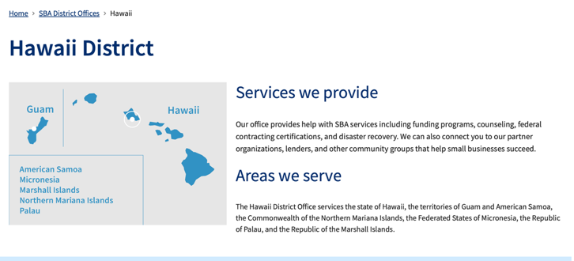
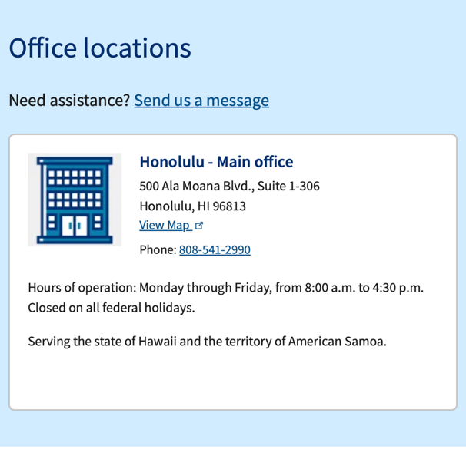

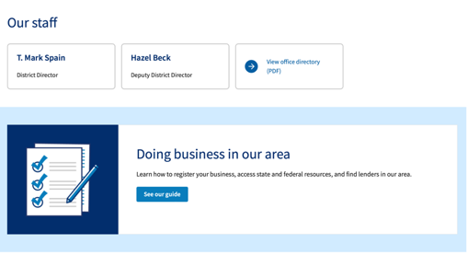

https://www.sba.gov/offices/district/hi/Honolulu

State Department

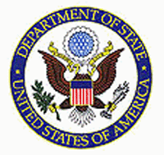

https://eca.state.gov/about-bureau/organizational-structure/grants-division

http://eca.state.gov/search/solr/grants?search_referrer=node/237

https://eca.state.gov/organizational-funding/open-grant-solicitations

http://eca.state.gov/organizational-funding/applying-grant

General Information:
- Bureau of Educational and Cultural Affairs Grants Division
- Open Grant Opportunities (Requests for Grant Proposals)

For General Information click here

Department of Transportation

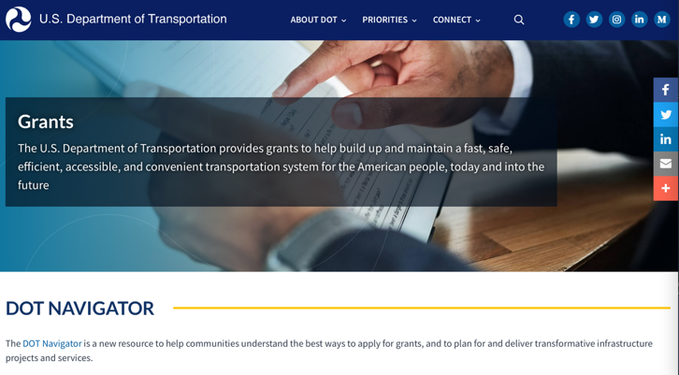

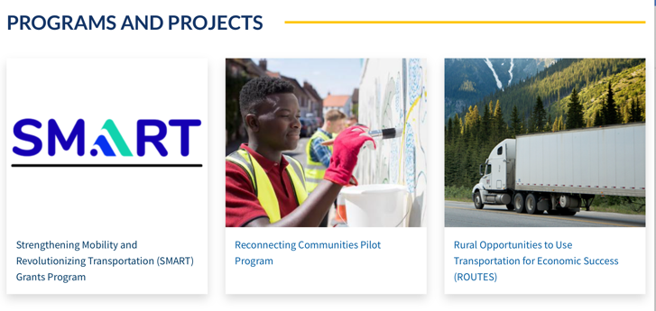

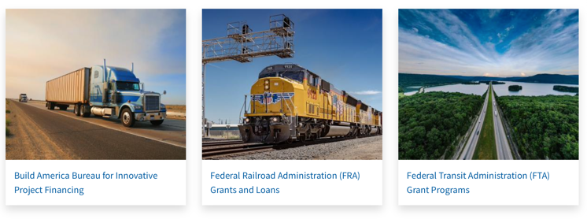

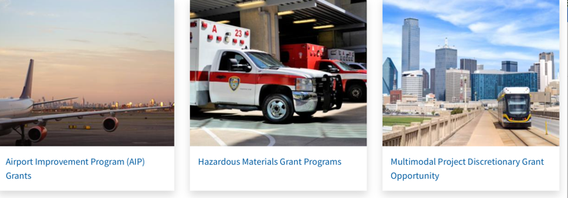

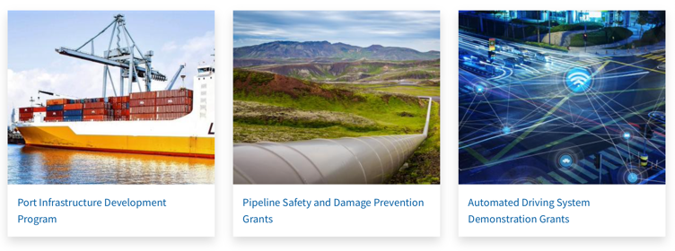
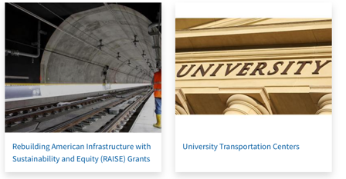

General Grant Program Overview https://www.transportation.gov/grants

Department of the Treasury

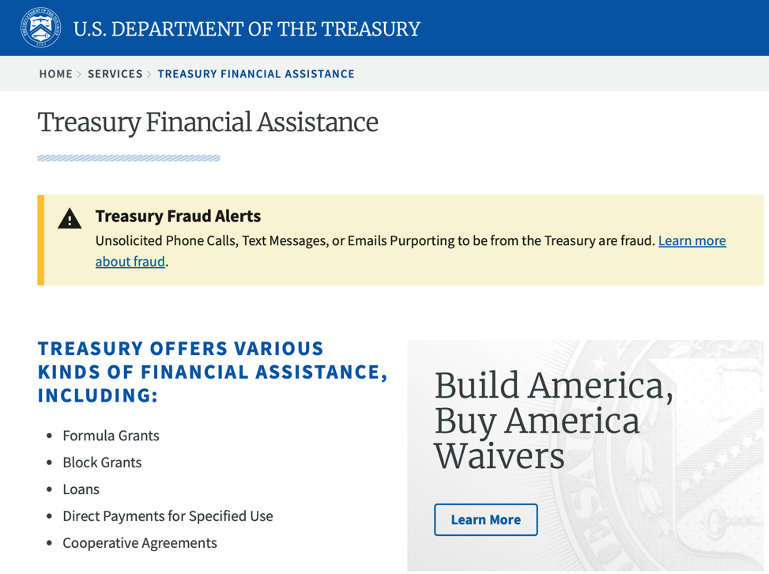
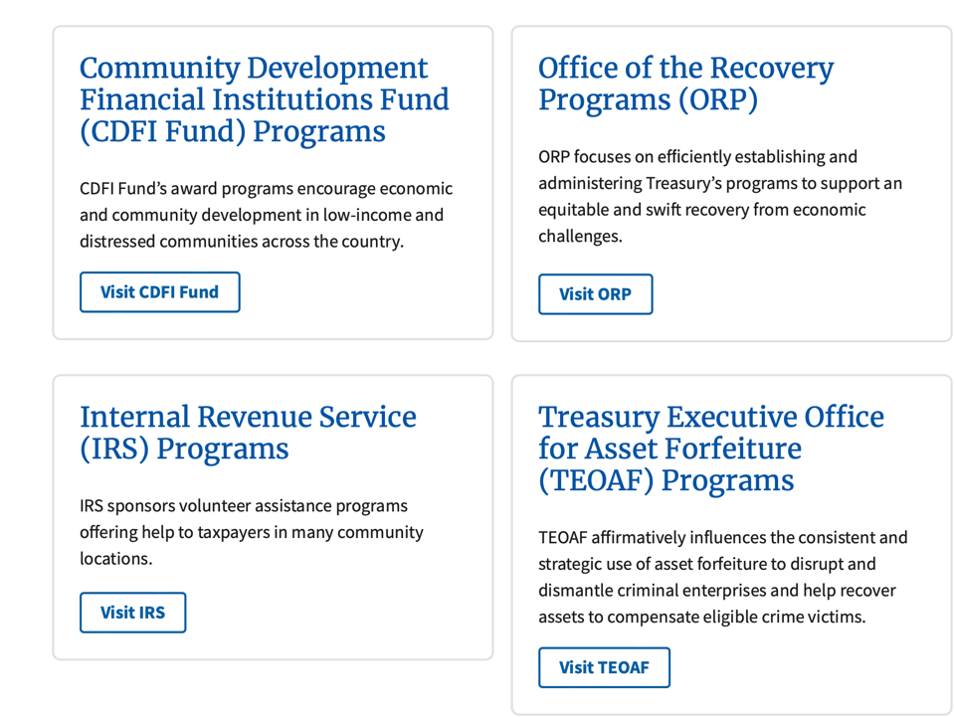

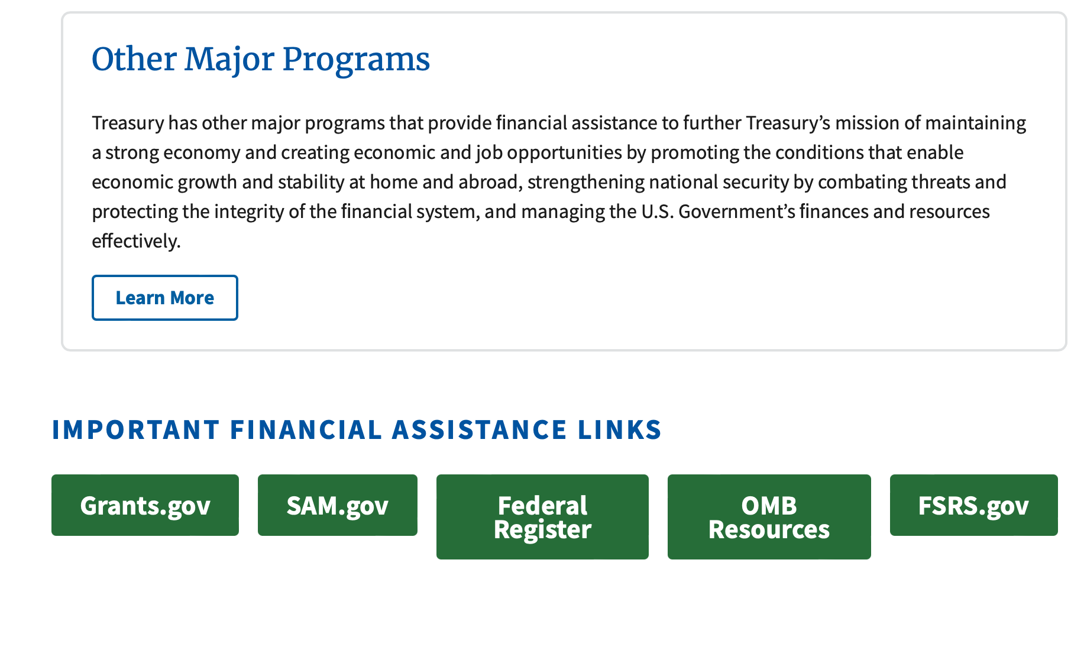
https://home.treasury.gov/services/grant-programs

U.S. Agency for International Development
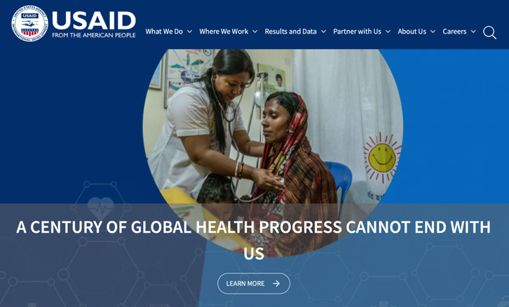

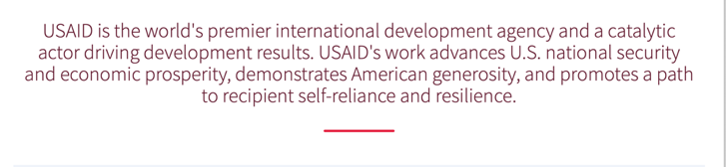

www.usaid.gov

General Overview Funding Opportunities

USAID has working relationships with thousands of American companies and hundreds of U.S.-based private voluntary organizations. For more information on our business and procurement opportunities, \

Department of Veterans Affairs

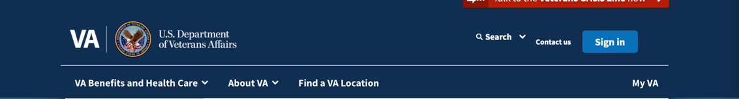

VA Homeless Programs

Grant and Per Diem Program

Program Description
VA's Grant and Per Diem (GPD) Program is offered annually (as funding permits) by the Department of Veterans Affairs to fund community agencies providing services to Veterans experiencing homelessness. The purpose of the transitional housing component of the program is to promote the development and provision of supportive housing and services with the goal of helping homeless Veterans achieve residential stability, increase their skill levels and/or income, and obtain greater self-determination. Additionally, the GPD Program offers Case Management grants to support housing retention for Veterans who were previously homeless and are transitioning to permanent housing.
Operational costs, including salaries, may be funded by the per diem component. For supportive housing, the maximum amount payable under the per diem is $64.52 per day per Veteran housed. Veterans in supportive housing may be asked to pay rent if it does not exceed 30% of the Veteran's monthly-adjusted income. In addition, "reasonable" fees may be charged for services not paid with per diem funds. The maximum hourly per diem rate for a service center not connected with supportive housing is 1/8 of the daily cost of care, not to exceed $8.06 per hour. Payment for a Veteran in a service center will not exceed 8 hours in any day.
Applications are only accepted in response to a Notice of Funding Opportunity (NOFO) published in Grants.gov. Funds will be awarded to programs determined to be the most qualified. Chelsea Watson is the director of the GPD Program. Ms. Watson and the GPD team may be contacted via email at GPDgrants@va.gov.

GPD Grants & Funding Fact Sheet
Access our GPD Fact Sheet here to learn more.

GPD Works! Success Stories

Feature Article:
- How VA's Grant and Per Diem Program Reduces Long-Term Homelessness Among Veterans

Good News Stories:
- How GPD Has Evolved to Meet Veterans’ Needs - VA Homeless Programs
- “I only dreamed of this.” VA program finds Veteran Lorenzo Campbell a home - VAntage Point
- VA and Volunteers of America help Veteran Robert Irvin go from homeless to home - VAntage Point
- Army Veteran finds employment and housing in months thanks to HUD-VASH - VAntage Point

Active GPD Awards
Per Diem Only (PDO) Award List (October 2023)
Transition In Place (TIP) Award List (October 2023)
Case Management Award List (October 2023)
Capital Grant Awards List (Published March 2022)
Special Need Award List (March 2022)
Capital Grant Awards List (Published August 2021)

Grant Applicant Resources
- Case Management Notice of Funding Opportunity (NOFO)
- TIP Notice of Funding Opportunity (NOFO)
- PDO Notice of Funding Opportunity (NOFO)
- Electronic Grants Management System (eGMS) Login Page
- How-to: Register a New Organization in eGMS
- How-to: Add or Update Contacts in eGMS
- Application for Federal Assistance (SF-424) (NOTE: first download and save any SF PDF files to your computer and then open it from the saved location)
- Certification of De Minimis Indirect Cost Rate
- Assurances for Non-Construction Programs (SF-424B) - (for awareness, applicants are not required to submit the SF-424B)
- GPD General Terms and Conditions of Award (May 2020)
- GPD Regulations (38 CFR part 61.0)
Back to Top

Helpful Resources
Grants.gov *
Federal Register *
Electronic Uniform Administrative Requirements (2 CFR part 200) *
GPD Provider Webpage
eGMS Login Page*
*Links will take you outside of the Department of Veterans Affairs website. VA does not endorse and is not responsible for the content of the linked websites.
Back to Top

Other Sites of Interest
Housing & Urban Development (HUD) *
HUD Vet Resource Center *
Health & Human Services (HHS) *
Social Security Administration (SSA) *
Department of Labor (DOL) *
SAMHSA Homelessness Resource Center *
National Coalition for Homeless Veterans *
National Law Center *
United States Department of Justice *
State Side Legal *
*Links will take you outside of the Department of Veterans Affairs website. VA does not endorse and is not responsible for the content of the linked websites.
Back to Top


Make the Call
Dial 1-877-4AID-VET
(1-877-424-3838)
Access VA’s services for homeless and at-risk Veterans, available 24/7.


Chat Online
Homeless Veteran Chat
Confidential, 24/7 online support for Veterans and friends
Chat Now

VA Medical Center
(VAMC) Locator
Locate Your Local
VA Medical Center Now
Veterans who are homeless or at risk of homelessness can call or visit their local VA Medical Center (VAMC) and ask for a Homeless Coordinator. Use the VA locator tool www.va.gov/directory to find your nearest VAMC and call or visit today.
return to top
Learn what the PACT Act means for your VA benefits
Last updated: October 4, 2023

Page reviewed on 9/4 2023

https://www.va.gov/homeless/gpd.asp

Locations

Spark M. Matsunaga Department of Veterans Affairs Medical Center
459 Patterson Road
Honolulu, HI 96819-1522
Get directions on Google Mapsto Spark M. Matsunaga Department of Veterans Affairs Medical Center
Main phone: 800-214-1306
Mental health care: 808-433-0660
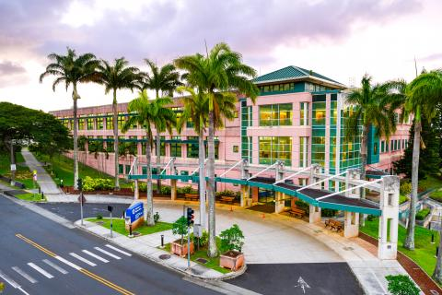
See all locations

Manage your health online
Refill and track your prescriptions
Send a secure message to your health care team
Schedule and manage health appointments
Download your VA medical records (Blue Button)
View your lab and test results
Order hearing aid batteries
and accessories

In the spotlight at VA Pacific Islands health care
Get help from a patient advocate Access your health records Find a phone number
Check your billing, insurance, and payment options Volunteer or donate Women Veterans Care

Get updates from VA Pacific Islands health care
Subscribe to VA Pacific Islands health care news and announcements
Subscribe to VA Pacific Islands health care emergency notifications
VA Pacific Islands health care operating status
VA Pacific Islands Healthcare System Facebook page

https://www.va.gov/pacific-islands-health-care/

Grants General Tips and Information

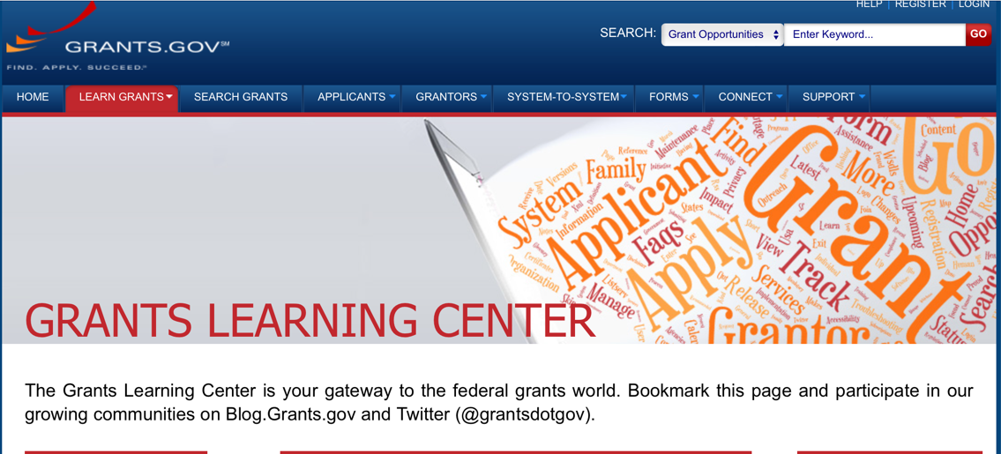

Provides a Grants Learning Center as a gateway to the federal grants world. Bookmark the following link and participate at blog.grants.gov or on twitter @grantsdotgov

Topics include: Grants 101, Grant Policies, Grant Eligibility, Grant Terms, Grant Agencies , Grant Systems, Grant Programs, Grant Careers, Grant Reporting, Grant Fraud and Grant Events

https://www.grants.gov/web/grants/learn-grants.html

Grants.gov maintains a blog. This reprinted article provides some helpful tips:

Grant Writing: 3 Tips for Crafting Need Statements in Federal Grant Proposals
Originally Posted on March 27, 2019 by Grants.gov
In this space, we have previously shared tips about the pre-writing phase of completing a federal grant application – for example, the importance of reading (and re-reading) the grant announcement, and the importance of understanding the criteria by which your application will be evaluated.
In this post, we dip our toes into the grant writing process itself and share some tips about crafting a need statement. These tips are adapted from the U.S. Department of Health and Human Services Health Resources & Services Administration’s grant writing guide, titled “Tips for Writing and Submitting Good Grant Proposals”. Along with each tip, we also include an excerpt from an award-winning federal grant proposal that can be viewed in full on the website of the Institute of Museum and Library Services. (IMLS has an excellent collection of proposals that are worthy of review – especially for new federal grant applicants.)

https://grantsgovprod.wordpress.com/2019/03/27/3-tips-for-crafting-need-statements-in-federal-grant-proposals/?utm_source=newsletter&utm_medium=email&utm_campaign=noprofile&utm_content=june2020

Grant Writing Resources

The following links are a great resource for Faith-Based Non-profits and other community organizations:

U.S. Department of Justice
Task Force for Faith-Based and Community Initiatives

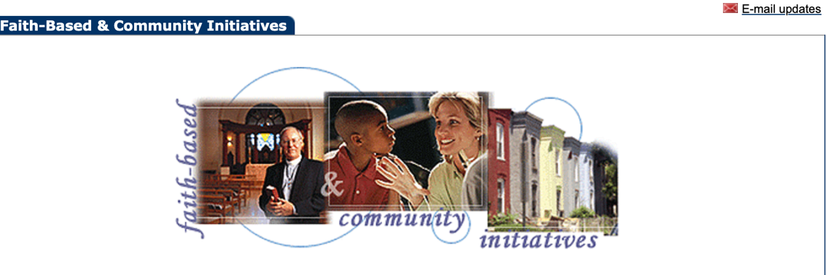

Foundation Center
Proposal Writing Short Course

USDA Rural Information Center
A Guide to Funding Resources

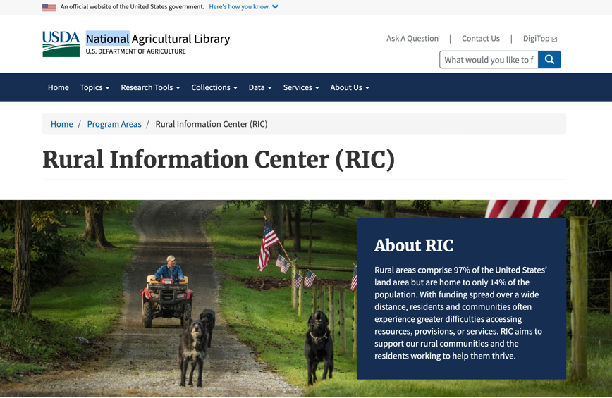

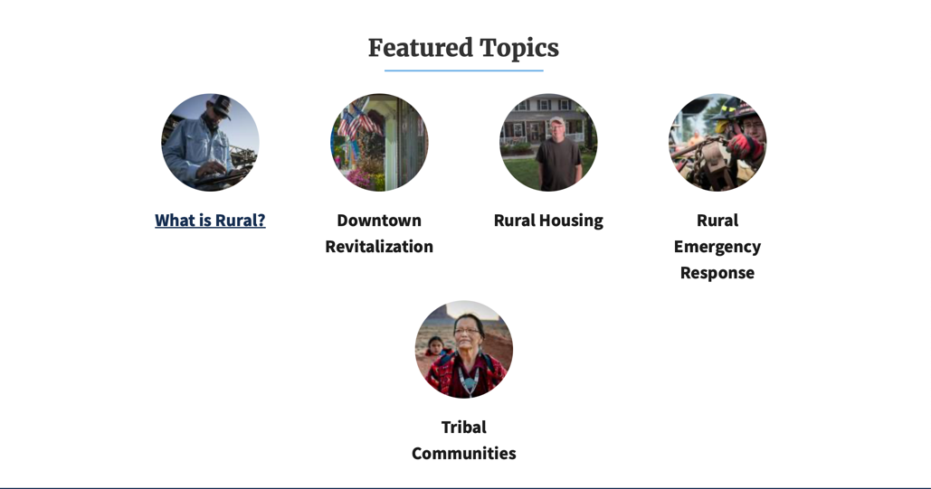
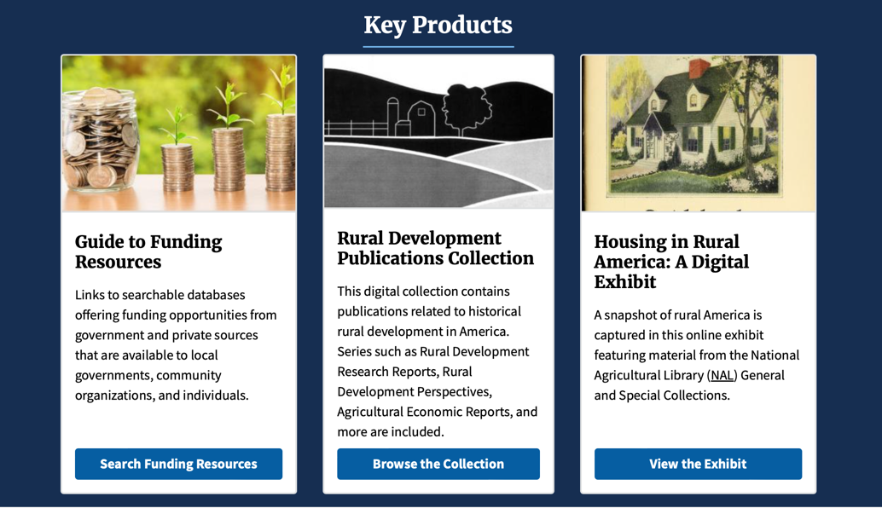
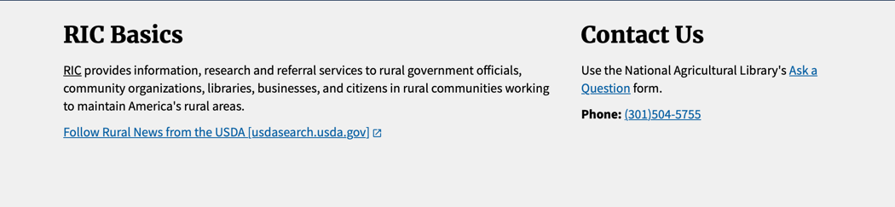

The Small Business Innovative Research Program - SBIR Program

The Small Business Innovation Research (SBIR) program is a highly competitive program that encourages domestic small businesses to engage in Federal Research/Research and Development (R/R&D) that has the potential for commercialization. Through a competitive awards-based program, SBIR enables small businesses to explore their technological potential and provides the incentive to profit from its commercialization. By including qualified small businesses in the nation's R&D arena, high-tech innovation is stimulated, and the United States gains entrepreneurial spirit as it meets its specific research and development needs.

SBIR Mission and Program Goals
The mission of the SBIR program is to support scientific excellence and technological innovation through the investment of Federal research funds in critical American priorities to build a strong national economy.
The program’s goals are four-fold:
- Stimulate technological innovation
- Meet Federal research and development needs.
- Foster and encourage participation in innovation and entrepreneurship by socially and economically disadvantaged persons.
- Increase private-sector commercialization of innovations derived from Federal research and development funding.

SBIR-Participating Agencies
Each year, Federal agencies with extramural research and development (R&D) budgets that exceed $100 million are required to allocate 2.5 percent of their R&D budget to these programs. Currently,
- eDepartment of Commerce - National Institute of Standards and Technology
- Department of Energy
- Department of Health and Human Services
- Department of Transportation
- National Aeronautics and Space Administration
- National Science Foundation
Each agency administers its own individual program within guidelines established by Congress. These agencies designate R&D topics in their solicitations and accept proposals from small businesses. Awards are made on a competitive basis after proposal evaluation.

Three-Phase Program
The SBIR Program is structured in three phases:
Phase I. The objective of Phase I is to establish the technical merit, feasibility, and commercial potential of the proposed R/R&D efforts and to determine the quality of performance of the small business awardee organization prior to providing further Federal support in Phase II. SBIR Phase I awards normally do not exceed $150,000 total costs for 6 months.
Phase II. The objective of Phase II is to continue the R/R&D efforts initiated in Phase I. Funding is based on the results achieved in Phase I and the scientific and technical merit and commercial potential of the project proposed in Phase II. Only Phase I awardees are eligible for a Phase II award. SBIR Phase II awards normally do not exceed $1,000,000 total costs for 2 years.
Phase III. The objective of Phase III, where appropriate, is for the small business to pursue commercialization objectives resulting from the Phase I/II R/R&D activities. The SBIR program does not fund Phase III. Some Federal agencies, Phase III may involve follow-on non-SBIR funded R&D or production contracts for products, processes or services intended for use by the U.S. Government

