Senator Mazie Hirono

Grants Assistance Information
Newsletter
September 2016

G.A.I.N. INDEX

Click on Index Links below to read summaries of the announcements by agency in this document.
Once you reach the item, if you cannot open the links for further information, copy the selected
URL website address into your browser.

Modified sections from previous listings are shown in a GREY background

Notices is Teal are items with immediate deadline dates.

Notices in Yellow are of special interest.

Notices is Green are items of special interest with immediate deadline dates.

Items in this type color are aimed at Small Businesses

Items in this type color have a Faith-Based Organization component

Special Federal Program Notices

SBIR – Small Business Innovation Research

Programs specific to Hawaii

Current Notices

Department of Commerce
FY2017 NOAA Bay Watershed Education and Training (B-WET) Hawaii Program

Reminders

Office of Procurement Operations - Grants Division
2016 DHS Scientific Leadership Awards for Minority Serving Institutions (MSI) Granting Bachelor Degrees

Employment and Training Administration
Department Of Labor Research And Evaluation Grants

See Individual Departments for information and webpages representing the best and most accessible information on the agency funding opportunities

Federal Grant and Cooperative Agreement Program Summaries

U.S. Department of Agriculture

Grants and Loans Overview

Programs

National Institute of Food and Agriculture
Food and Agricultural Sciences National Needs Graduate and Postgraduate Fellowship (NNF) Grants Program

Modifications

National Institute of Food and Agriculture
Higher Education Multicultural Scholars Program (MSP)
Synopsis 2

Reminders

National Institute of Food and Agriculture
Agriculture and Food Research Initiative - Agriculture and Natural Resources Science for Climate Variability and Change Challenge Area

National Institute of Food and Agriculture
Small Business Innovation Research Program Phase I

National Institute of Food and Agriculture
Higher Education Multicultural Scholars Program (MSP)

AFRI Sustainable Bioenergy and Bioproducts RFA Grant

Department of Commerce

Programs

Fiscal Year 2018 National Sea Grant College Program Dean John A. Knauss Marine Policy Fellowship

FY2017 Community-based Marine Debris Removal

Research

Modifications

Reminders

Ocean Exploration FY 2017 Funding Opportunity

National Competitive Harmful Algal Bloom Programs: The Ecology and Oceanography of Harmful Algal Blooms (ECOHAB) and Prevention, Control and Mitigation of Harmful Algal Blooms Program (PCMHAB)

2017 Saltonstall-Kennedy Competitive Research Program

National Institute of Standards and Technology
Disaster Resilience (DR) Research Grants Program

FY 2017 Climate Program Office

John H. Prescott Marine Mammal Rescue Assistance Grant Program (Prescott Grant Program) for Fiscal Year 2017

National Institute of Standards and Technology
Project to Develop, Produce, and Distribute a Documentary Film about Rebooting the International Measurement System

National Institute of Standards and Technology
Measurement Science and Engineering (MSE) Research Grant Programs

National Sea Grant College Program 2016-17 Special Projects Grant

FY 2016 – FY 2019 EDA Planning Program and Local Technical Assistance Program Grant

FY 2016 Economic Development Assistance Programs ­ Application submission and program requirements for EDA’s Public Works and Economic Adjustment Assistance Programs

Economic Development Administration
Planning Program and Local Technical Assistance Program Grant

Deleted

Corporation for National and Community Service

General Program Overview

Programs

Round 2: FY 2016 Social Innovation Fund Pay for Success Cooperative Agreement

2017 AmeriCorps State and National Grants

Reminders

National Service in Hawaii

Department of Defense

Doing Business with the Department of Defense

DoD Small Business Opportunities and Forecasting

Research Grants

Modifications

Reminders

Dept. of the Army -- Materiel Command
Army Research Office Broad Agency Announcement for Basic and Applied Scientific Research
Modification 8

Department of Education

Grant Programs Overview

Programs

Office of Career, Technical, and Adult Education (OCTAE): Performance Partnership Pilots (P3) CFDA Number 84.420A

Office of Elementary and Secondary Education (OESE): Preschool Development Grants: Preschool Pay for Success Feasibility Pilot CFDA Number 84.419C

Research

Modifications

Reminders

Deleted

US Department of Energy

Grants Overview

Programs

Modifications

Reminders

Environmental Protection Agency

Grants and Contracts Overview

Programs

Training and Technical Assistance to Improve Water Quality and Enable Small Public Water Systems to Provide Safe Drinking Water

Modifications

Reminders

Modeling of Climate Change Mitigation, Impacts and Adaptation

Department of Health and Human Services

Grants Overview

Program

Administration for Children and Families - ORR
Standing Announcement for Residential (Shelter) Services for Unaccompanied Children
Forecast 5

Research Grants

Modifications

Reminders

Deleted

Department of Homeland Security
Grants Overview

Programs

Department of Homeland Security - FEMA
Assistance to Firefighters Grant (AFG)

Modifications

Office of Procurement Operations - Grants Division
2016 DHS Scientific Leadership Awards for Minority Serving Institutions (MSI) Granting Bachelor Degrees
Synopsis 2

Reminders

Office of Procurement Operations - Grants Division
DHS S&T Center of Excellence for Homeland Security Quantitative Analysis – Center Partner

Department of Housing and Urban Development

HUD - Notice of Funds Available

Programs

Self-Help Homeownership Opportunity Program (SHOP)

Youth Homelessness Demonstration Program

Modifications

FY2016 Continuum of Care
Synopsis 5

Reminders

Rural Capacity Building for Community Development and Affordable Housing Grants

ROSS for Education

FY2016 Continuum of Care
Modification 4

Technical Correction to the General Section to HUD's Fiscal Year 2016 Notice[s] of Funding Availability for Discretionary Programs
Modification 1

General Section to HUD's Fiscal Year 2016 Notice[s] of Funding Availability for Discretionary Programs (General Section)
Modification 1

Institute of Museum and Library Services

Grants Overview

IMLS is on Facebook!

Modifications

Reminders

Deleted

Department of Interior

Grants and Contract Overview

Programs

Modifications

National Park Service
2017 Preservation Technology and Training Grants
Synopsis 3

Fish and Wildlife Service
NAWCA U.S. Small Grants
Synopsis 2

Reminders

Fish and Wildlife Service
Marine Turtle Conservation Fund

Deleted

Department of Justice

Grants and Contract Overview

Programs

Research

Modifications

Reminders

Department of Labor

Grants and Contract General Overview

Programs

Modifications

Reminders

Mine Safety and Health Administration
Brookwood Sago Grant

National Aeronautics and Space Administration

Research Grant and Contract General Overview

Programs

Modifications

_______________________________________________________________
National Archives and Records Administration

Grant Opportunities General Overview

Reminders

Access to Historical Records - Major Initiatives

Access to Historical Records – Archival Projects

Public Engagement with Historical Records Grant

Publishing Historical Records in Documentary Editions Grant

_______________________________________________________________
National Endowment for the Arts

Grant Opportunities General Overview

Programs

NEA Literature Fellowships: Translation Projects, FY 2018

Modifications

Reminders

NEA Research: Art Works Application, FY 2017

Our Town FY 17 Grant

_______________________________________________________________

National Endowment for the Humanities

Grant Opportunities General Overview

Programs

Dialogues on the Experience of War
Synopsis 1

Modifications

Reminders

Humanities Initiatives at Community Colleges

Summer Stipends Grant

Humanities Connections Grant

Humanities Open Book Program Grant

National Science Foundation

Grant Opportunities General Overview

Research and Program Grants

Modifications

Reminders

Deleted

Nuclear Regulatory Commission

U.S. Nuclear Regulatory Commission Funding Opportunity Announcement (FOA), Scholarship and Fellowship Education Grant, Faculty Development Grant, and Trade School and Community College Scholarship Grant, Fiscal Year (FY) 2017

Reminders

Small Business Administration

General Overview Finding Loans & Grants

Programs

Reminders

Upcoming Trainings

Links Specific to Hawaii

State Department

General Overview and Resources for Program Administrators

Programs

Modifications

Reminders

U.S. Department of Transportation

General Grant Program Overview

Programs

Reminders

DOT/Federal Railroad Administration
FY 2017 Positive Train Control Grant Funds

DOT Federal Aviation Administration
DOT - FAA Aviation Research Grants
FAA Aviation Research and Development Grants
Modifications 3 & 4

Deleted

Department of the Treasury

Programs

Modifications

Reminders

US Agency for International Development

General Funding Opportunity Overview

Programs
Modifications

Deleted

Department of Veterans Affairs

Special Federal Program Notices

The Small Business Innovative Research Program - SBIR Program
The Small Business Innovation Research (SBIR) program is a highly competitive program that encourages domestic small businesses to engage in Federal Research/Research and Development (R/R&D) that has the potential for commercialization. Through a competitive awards-based program, SBIR enables small businesses to explore their technological potential and provides the incentive to profit from its commercialization. By including qualified small businesses in the nation's R&D arena, high-tech innovation is stimulated and the United States gains entrepreneurial spirit as it meets its specific research and development needs.

SBIR Mission and Program Goals
The mission of the SBIR program is to support scientific excellence and technological innovation through the investment of Federal research funds in critical American priorities to build a strong national economy.
The program’s goals are four-fold:
- Stimulate technological innovation
- Meet Federal research and development needs.
- Foster and encourage participation in innovation and entrepreneurship by socially and economically disadvantaged persons.
- Increase private-sector commercialization of innovations derived from Federal research and development funding.

SBIR-Participating Agencies
Each year, Federal agencies with extramural research and development (R&D) budgets that exceed $100 million are required to allocate 2.5 percent of their R&D budget to these programs. Currently, eleven Federal agencies participate in the program:
- Department of Agriculture
- Department of Commerce - National Institute of Standards and Technology
- Department of Commerce - National Oceanic and Atmospheric Administration
- Department of Defense
- Department of Education
- Department of Energy
- Department of Health and Human Services
- Department of Homeland Security
- Department of Transportation
- Environmental Protection Agency
- National Aeronautics and Space Administration
- National Science Foundation
Each agency administers its own individual program within guidelines established by Congress. These agencies designate R&D topics in their solicitations and accept proposals from small businesses. Awards are made on a competitive basis after proposal evaluation.

Three-Phase Program
The SBIR Program is structured in three phases:
Phase I. The objective of Phase I is to establish the technical merit, feasibility, and commercial potential of the proposed R/R&D efforts and to determine the quality of performance of the small business awardee organization prior to providing further Federal support in Phase II. SBIR Phase I awards normally do not exceed $150,000 total costs for 6 months.
Phase II. The objective of Phase II is to continue the R/R&D efforts initiated in Phase I. Funding is based on the results achieved in Phase I and the scientific and technical merit and commercial potential of the project proposed in Phase II. Only Phase I awardees are eligible for a Phase II award. SBIR Phase II awards normally do not exceed $1,000,000 total costs for 2 years.
Phase III. The objective of Phase III, where appropriate, is for the small business to pursue commercialization objectives resulting from the Phase I/II R/R&D activities. The SBIR program does not fund Phase III. Some Federal agencies, Phase III may involve follow-on non-SBIR funded R&D or production contracts for products, processes or services intended for use by the U.S. Government
SBIR NewsLetter

- SBIR Newsletter
Sign up for e-mail updates

HAWAII APPLICANTS ENCOURAGED

Current Notices:

Department of Commerce
FY2017 NOAA Bay Watershed Education and Training (B-WET) Hawaii Program
Synopsis 1

Document Type: | Grants Notice
Funding Opportunity Number: | NOAA-NOS-OCM-2017-2004984
Funding Opportunity Title: | FY2017 NOAA Bay Watershed Education and Training (B-WET) Hawaii Program
Opportunity Category: | Discretionary
Opportunity Category Explanation:
Funding Instrument Type: | Cooperative Agreement  Grant
Category of Funding Activity: | Environment  Natural Resources  Science and Technology and other Research and Development
Category Explanation:
Expected Number of Awards:
CFDA Number(s): | 11.473 -- Office for Coastal Management
Cost Sharing or Matching Requirement: | No
Posted Date: | Aug 31, 2016
Last Updated Date: | Aug 31, 2016
Original Closing Date for Applications: | Nov 04, 2016
Current Closing Date for Applications: | Nov 04, 2016
Archive Date: | Dec 04, 2016
Estimated Total Program Funding: | $1,000,000
Award Ceiling: | $150,000
Award Floor: | $25,000
Eligible Applicants: | Others (see text field entitled "Additional Information on Eligibility" for clarification)
Additional Information on Eligibility: | Eligible funding applicants are K-12 public and independent schools and school systems, institutions of higher education, for-profit and nonprofit organizations, state or local government agencies, and Indian tribal governments conducting projects in Hawaii (Islands of Hawaii, Maui, Lanai, Molokai, Oahu, Kauai, Kahoolawe, Niihau, and/or the Northwestern Hawaiian Islands). Individual applicants and Federal agencies are not eligible. Federal agencies and employees are not allowed to receive funds under this announcement but may serve as collaborative project partners and may contribute services in kind. Federal agencies and employees ‘in-kind services cannot be considered as part of an applicant’s match on shared costs. If federal agencies are collaborators, applicants must provide detail on the expected level of federal engagement in the application. Examples might include, but are not limited to partnership services; serving in a review capacity; or participating in priority task teams, working groups, or leadership teams.
Agency Name: | Department of Commerce
Description: | The NOAA Bay Watershed Education and Training (B-WET) Hawaii Program is a federal funding opportunity which meets NOAA's mission of science, service, and stewardship. This B-WET program supports the vision of a future where societies and their ecosystems are healthy and resilient in the face of sudden or prolonged change. The purpose for this financial assistance is to support our communities by developing a well-informed citizenry involved in decision-making that positively impacts our coastal, marine, and watershed ecosystems in the State of Hawaii. This opportunity is a competitively-based grant that provides funding to assist in the development of new programs, encourage innovative partnerships among environmental education programs, and support geographically targeted programs to advance environmental education efforts that complement national and state school requirements. The B-WET Hawaii Program plays a foundational role as an environmental education program that promotes locally relevant, experiential learning in the K-12 environment on priority topics such understanding climate, ocean and earth sciences, and community resilience to hazards. Funded projects provide meaningful watershed educational experiences for students, professional development for teachers, service learning opportunities for students, and support regional education and environmental priorities. More information about the B-WET program is online at http://www.noaa.gov/office-education/bwet.
Link to Additional Information:
Grantor Contact Information: | If you have difficulty accessing the full announcement electronically, please contact:  Jim Foley B-WET Hawaii Coordinator NOAA Inouye Regional Center NOS/Office for Coastal Management 1845 Wasp Blvd., Bldg. 176 Honolulu, HI, 96818 (808) 725-5284 jim.foley@noaa.gov Stephanie Bennett (808) 725-5254 stephanie.bennett@noaa.gov  Work

http://www.grants.gov/web/grants/view-opportunity.html?oppId=288218

Reminders:

Office of Procurement Operations - Grants Division
2016 DHS Scientific Leadership Awards for Minority Serving Institutions (MSI) Granting Bachelor Degrees
Synopsis 1

Document Type: | Grants Notice
Funding Opportunity Number: | DHS-16-ST-062-001
Funding Opportunity Title: | 2016 DHS Scientific Leadership Awards for Minority Serving Institutions (MSI) Granting Bachelor Degrees
Opportunity Category: | Discretionary
Opportunity Category Explanation:
Funding Instrument Type: | Grant
Category of Funding Activity: | Education
Category Explanation:
Expected Number of Awards: | 6
CFDA Number(s): | 97.062 -- Scientific Leadership Awards
Cost Sharing or Matching Requirement: | No
Posted Date: | Aug 03, 2016
Last Updated Date: | Aug 03, 2016
Original Closing Date for Applications: | Oct 05, 2016
Current Closing Date for Applications: | Oct 05, 2016
Archive Date: | Nov 04, 2016
Estimated Total Program Funding: | $3,600,000
Award Ceiling: | $1,200,000
Award Floor: | $1,000,000
Eligible Applicants: | Private institutions of higher education  Public and State controlled institutions of higher education
Agency Name: | Office of Procurement Operations - Grants Division
Description: | The Science and Technology Directorate (S&T) is DHS’s primary research and development (R&D) arm. S&T manages science and technology research, from development through transition, for the department's operational components and the nation’s first responders. S&T’s engineers, scientists and researchers work closely with industry and academic partners to ensure R&D investments address the high-priority needs of today and the growing demands of the future. The DHS Scientific Leadership Awards (SLA) program is one of several programs administered by the S&T Office of University Programs. Through the SLA program, OUP seeks to build a diverse, highly capable, technical workforce for the homeland security enterprise. This NOFO is soliciting applications from Minority Serving Intuitions (MSIs) to establish programs that relevant to S&T’s mission within their institutions or MSI networks.
Link to Additional Information:
Grantor Contact Information: | If you have difficulty accessing the full announcement electronically, please contact:  Stephanie dawkins grants specialist Phone 202-447-0495  stephanie.dawkins@hq.dhs.gov

http://www.grants.gov/web/grants/view-opportunity.html?oppId=286814

Employment and Training Administration
Department Of Labor Research And Evaluation Grants
Synopsis 1

Document Type: | Grants Notice
Funding Opportunity Number: | FOA-CEO-16-01
Funding Opportunity Title: | DEPARTMENT OF LABOR RESEARCH AND EVALUATION GRANTS
Opportunity Category: | Discretionary
Opportunity Category Explanation:
Funding Instrument Type: | Grant
Category of Funding Activity: | Employment, Labor and Training
Category Explanation:
Expected Number of Awards: | 10
CFDA Number(s): | 17.791 -- Department of Labor Chief Evaluation Office
Cost Sharing or Matching Requirement: | No
Posted Date: | Aug 03, 2016
Last Updated Date: | Aug 03, 2016
Original Closing Date for Applications: | Oct 03, 2016 Applications must be received no later than 4:00:00 p.m. Eastern Time.
Current Closing Date for Applications: | Oct 03, 2016 Applications must be received no later than 4:00:00 p.m. Eastern Time.
Archive Date: | Nov 02, 2016
Estimated Total Program Funding: | $2,000,000
Award Ceiling: | $250,000
Award Floor: | $100,000
Eligible Applicants: | Others (see text field entitled "Additional Information on Eligibility" for clarification)
Additional Information on Eligibility: | The following organizations are eligible to apply: • Public/State Controlled Institution of Higher Education • Indian/Native American Tribal Government (Federally Recognized) • Indian/Native American Tribal Government (Other than Federally Recognized) • Indian/Native American Tribally Designated Organization • Private Institution of Higher Education • Hispanic-serving Institution • Historically Black Colleges and Universities (HBCUs) • Tribally Controlled Colleges and Universities (TCCUs) • Alaska Native and Native Hawaiian Serving Institutions
Agency Name: | Employment and Training Administration
Description: | The Office of the Assistant Secretary for Policy – Chief Evaluation Office (CEO), U.S. Department of Labor (DOL, or the Department, or we), announces the availability of approximately $2 million in grant funds authorized by the Consolidated Appropriations Act of 2016 (PL. 114-113) for the Department of Labor Research and Evaluation (LRE) grants. The CEO is soliciting applications from university-based researchers to fund up to ten Department of Labor Research and Evaluation (LRE) grants for a period of up to two years. Grants of no more than $250,000 per grantee over a two-year period will be awarded. Suggested topic areas for an LRE grant that are of priority interest to DOL include but are not limited to: • Employee Benefits Security, • Miners’ Safety and Health, • Wage and Hour and Labor Standards, • Worker and Workplace Safety and Health, • Workers’ Compensation, • Labor/Management Relations, • International Topics in Worker Protection including child and forced labor issues, • Improving Equal Employment Opportunities for Targeted Populations, • Innovative approaches to evaluating the impact of DOL worker protection programs and policies using existing administrative or other data, and • Low-cost randomized controlled trials or natural experiments to evaluate the impact of DOL programs. The period of performance for the LRE grants is between 12 and 24 months with an anticipated start date of December 1, 2016. This performance period includes all necessary implementation and start-up activities. Depending on the nature of the research, LRE applicants may propose a 12-, 18- or 24- month period of performance. No federal funding is anticipated beyond the initial grant period.
Link to Additional Information:
Grantor Contact Information: | If you have difficulty accessing the full announcement electronically, please contact:  Charese Moore Grants Management Specialist  Moore.Charese@dol.gov

http://www.grants.gov/web/grants/view-opportunity.html?oppId=286915

Please review each department’s General Grant and Funding Overview. These overviews are the key web pages on each departmental website dedicated to the agency’s funding opportunities. Check back often to note the department updates and use these sources to assist you in your planning.

Federal Grant and Cooperative Agreement Program Summaries

U.S. Department of Agriculture



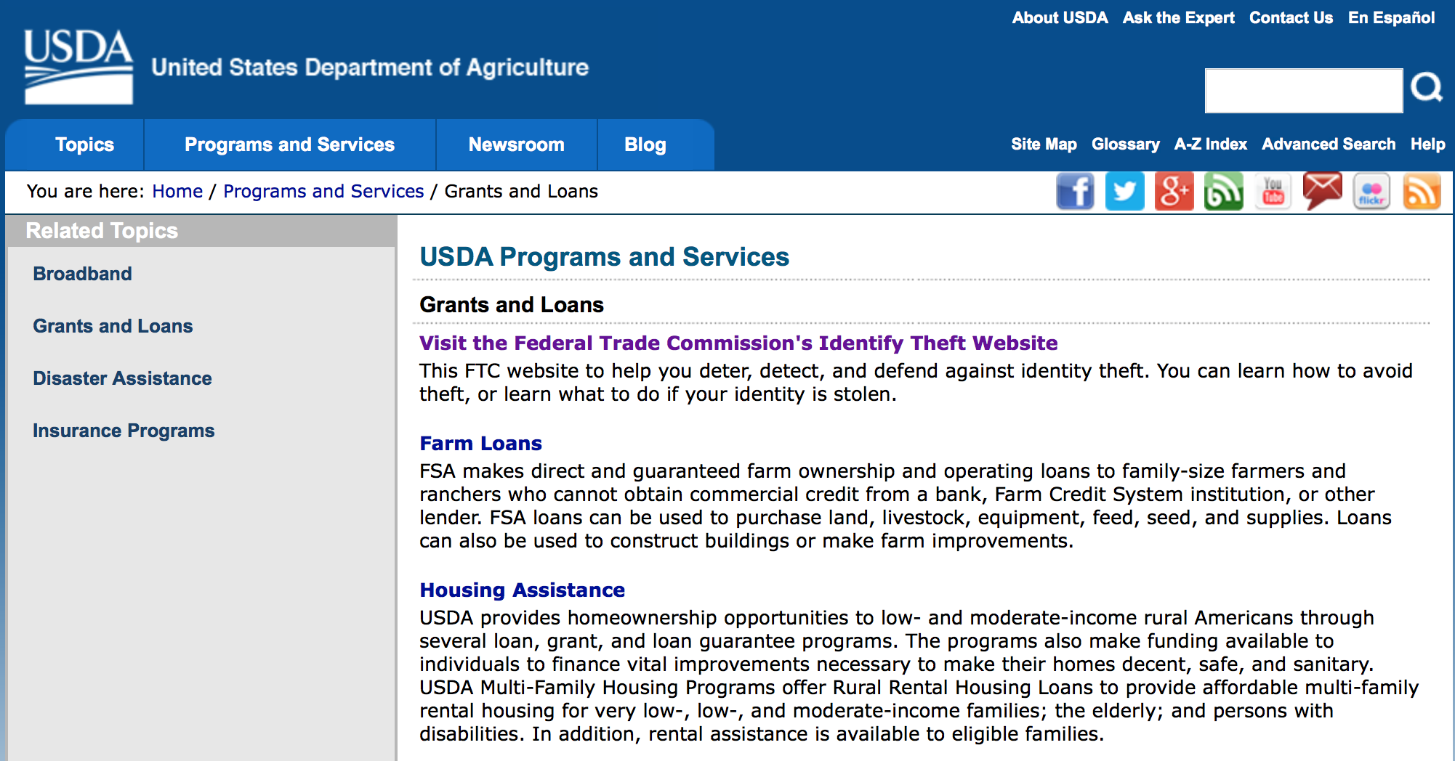
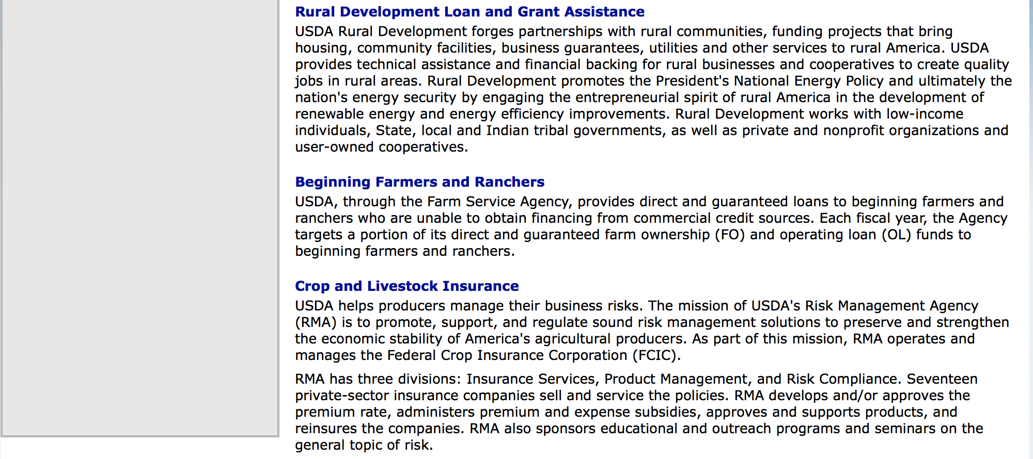

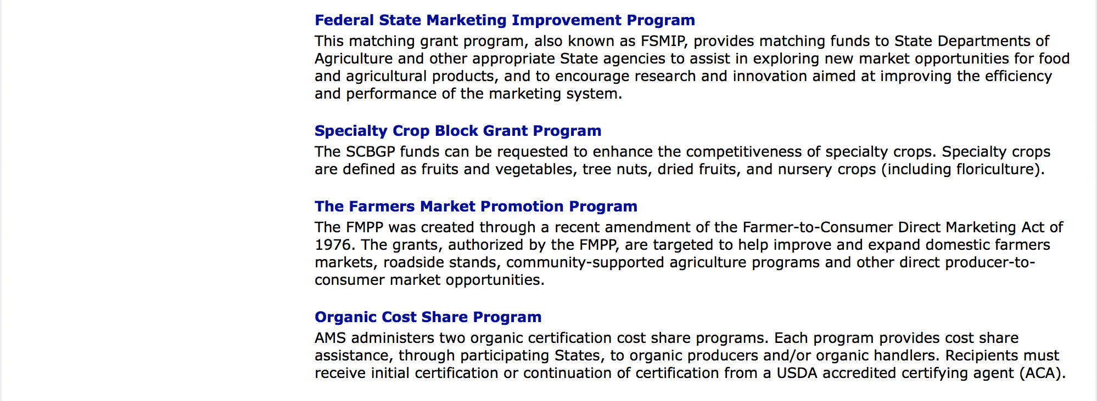

http://usda.gov/wps/portal/usda/usdahome?navid=GRANTS_LOANS

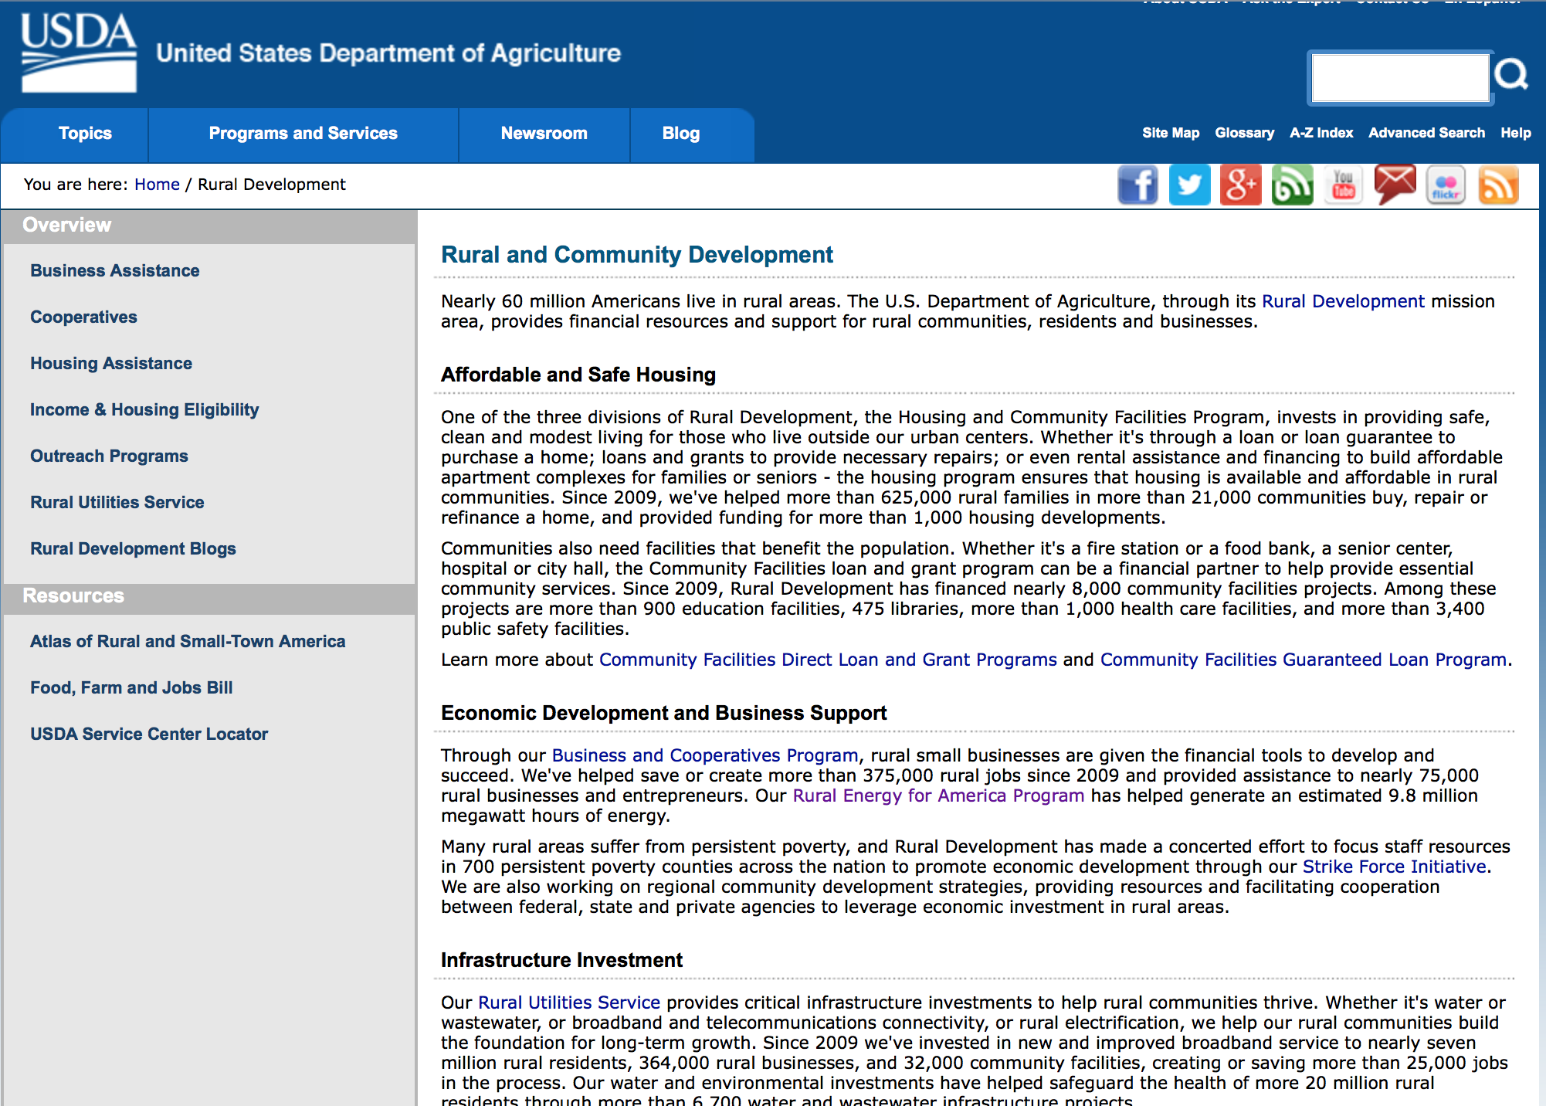

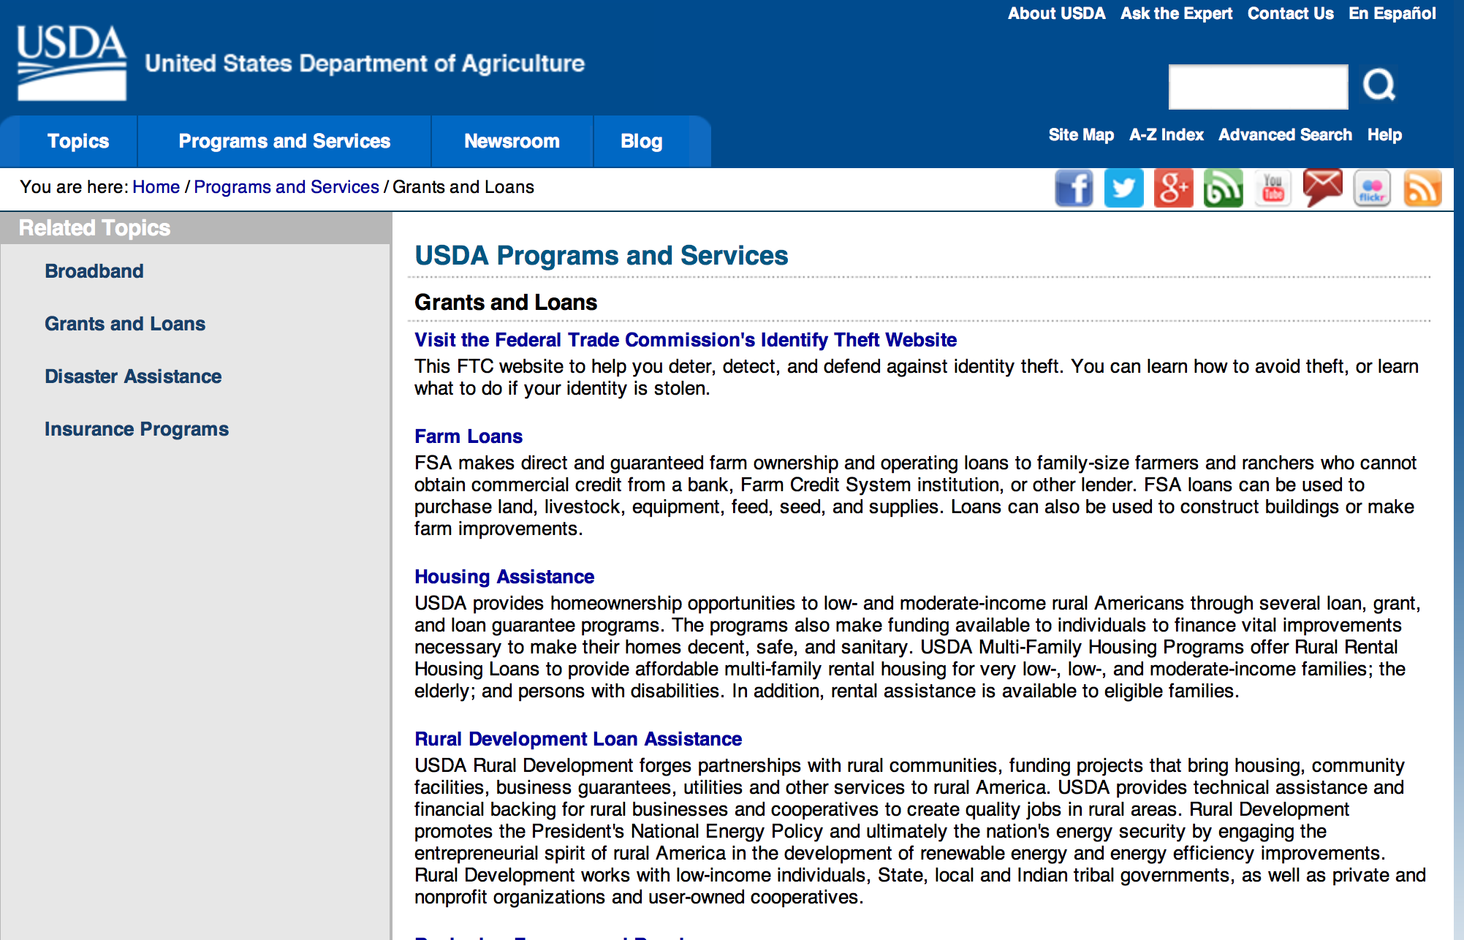

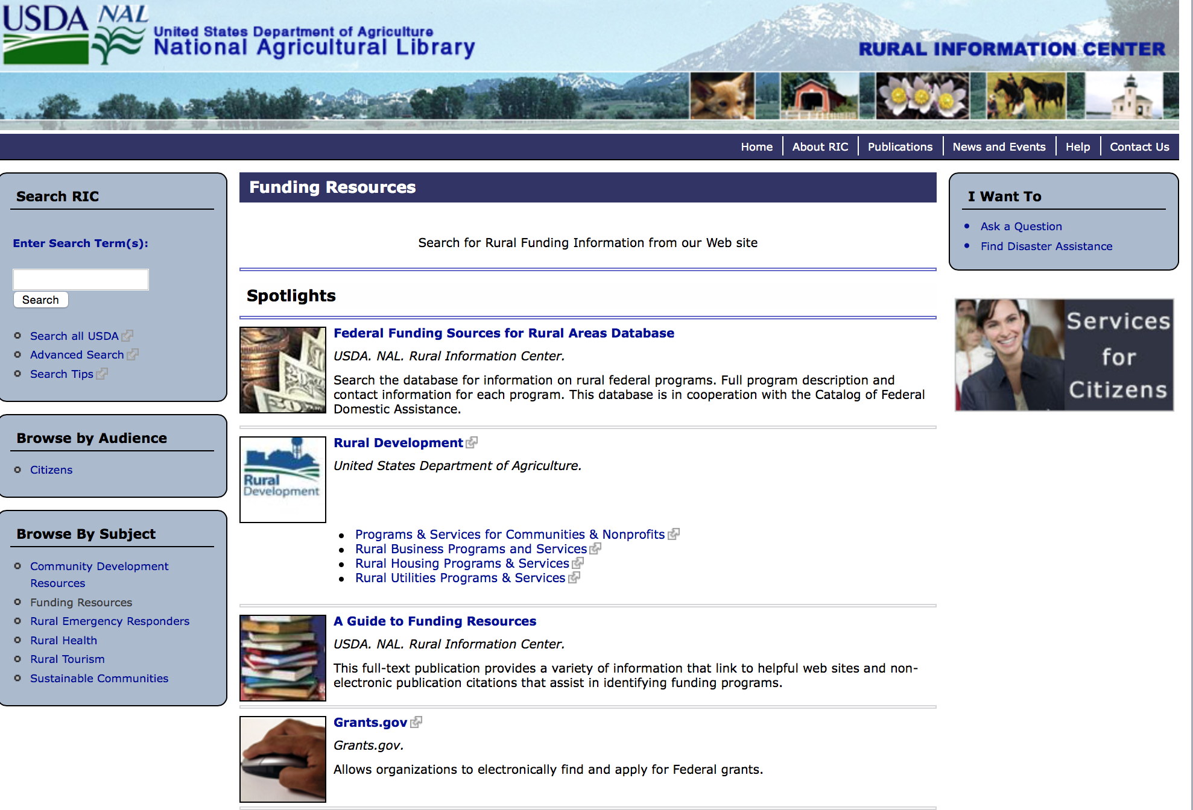

Federal Faith-Based Centers and Community Initiatives
USDA. NAL. Rural Information Center.
- Center for Faith-Based and Community Initiatives (link is external) , U.S. Department of Education
- Center for Faith-Based and Community Initiatives (link is external) , U.S. Department of Health and Human Services
- Center for Faith-Based and Community Initiatives (link is external) , U.S. Department of Labor
- Faith-Based and Community Initiatives (link is external) , U.S. Agency for International Development
- Faith-Based and Community Initiatives (link is external) , U.S. Department of Agriculture
- Faith-Based and Community Initiatives (link is external) , U.S. Department of Housing and Urban Development
- Faith-Based and Other Community Initiatives (link is external) , Corporation for National Community Service
- Task Force for Faith-Based and Community Initiatives (link is external) , U.S. Department of Justice

Grant Writing Resources
- Proposal Writing Short Course (link is external) Foundation Center.
- Data Universal Numbering System Fact sheet (link is external) [PDF | 302.2KB] USDA Rural Development.
- General Tips on Writing a Competitive Grant Proposal (link is external) U.S. Environmental Protection Agency.
- How to Write a Grant Proposal (link is external) Appalachian Regional Commission. <. li>

A Guide to Funding Resources USDA Rural Information Center.

http://ric.nal.usda.gov/funding-resources

http://usda.gov/wps/portal/usda/usdahome?navid=GRANTS_LOANS

Programs:

National Institute of Food and Agriculture
Food and Agricultural Sciences National Needs Graduate and Postgraduate Fellowship (NNF) Grants Program
Synopsis 1

Document Type: | Grants Notice
Funding Opportunity Number: | USDA-NIFA-HEP-006007
Funding Opportunity Title: | Food and Agricultural Sciences National Needs Graduate and Postgraduate Fellowship (NNF) Grants Program
Opportunity Category: | Discretionary
Opportunity Category Explanation:
Funding Instrument Type: | Grant
Category of Funding Activity: | Agriculture  Education
Category Explanation:
Expected Number of Awards:
CFDA Number(s): | 10.210 -- Higher Education - Graduate Fellowships Grant Program
Cost Sharing or Matching Requirement: | No
Posted Date: | Aug 12, 2016
Last Updated Date: | Aug 12, 2016
Original Closing Date for Applications: | Oct 11, 2016
Current Closing Date for Applications: | Oct 11, 2016
Archive Date: | Nov 10, 2016
Estimated Total Program Funding: | $3,100,000
Award Ceiling: | $262,500
Award Floor: | $4,500
Eligible Applicants: | Others (see text field entitled "Additional Information on Eligibility" for clarification)
Additional Information on Eligibility: | Pursuant to section 1417 of the NARETPA of 1977 (7 U.S.C. 3152), and administrative provisions that can be found in 7 CFR 3402 applications may be submitted by: (1) Land-grant institutions including the University of the District of Columbia; (2) Colleges and universities having significant minority enrollments and a demonstrable capacity to carry out the teaching of food and agricultural sciences; and (3) Other colleges and universities having a demonstrable capacity to carry out the teaching of food, and agricultural sciences.
Agency Name: | National Institute of Food and Agriculture
Description: | The purpose of the NNF Grants Program is to provide funding to support students’ training and completion of master’s and/or doctoral degree programs in identified national need areas within the Food, Agricultural, Natural Resources, and Human Sciences. Awards made under NNF are specifically intended to support traineeship programs that engage outstanding students to pursue and complete their degrees in areas where there is a national need for the development of scientific and professional expertise in the food and agricultural sciences. NNF awards invest in graduate training and relevant international experiential learning for a cadre of diverse individuals who demonstrate their potential to successfully complete graduate degree programs in disciplines relevant to the mission of the USDA.
Link to Additional Information: | Food and Agricultural Sciences National Needs Graduate and Postgraduate Fellowship (NNF) Grants Program
Grantor Contact Information: | If you have difficulty accessing the full announcement electronically, please contact:  NIFA Help Desk Phone: 202-401-5048 Business hours are M-F, 7:00 am -5:00 pm ET, excluding Federal holidays  If you have any questions related to preparing application content

http://www.grants.gov/web/grants/view-opportunity.html?oppId=287361

Modifications:

National Institute of Food and Agriculture
Higher Education Multicultural Scholars Program (MSP)
Synopsis 2

Document Type: | Grants Notice
Funding Opportunity Number: | USDA-NIFA-HEMS-005962
Funding Opportunity Title: | Higher Education Multicultural Scholars Program (MSP)
Opportunity Category: | Discretionary
Opportunity Category Explanation:
Funding Instrument Type: | Grant
Category of Funding Activity: | Agriculture
Category Explanation:
Expected Number of Awards:
CFDA Number(s): | 10.220 -- Higher Education - Multicultural Scholars Grant Program
Cost Sharing or Matching Requirement: | No
Version: | Synopsis 2
Posted Date: | Jul 21, 2016
Last Updated Date: | Aug 26, 2016
Original Closing Date for Applications: | Sep 22, 2016
Current Closing Date for Applications: | Sep 29, 2016
Archive Date: | Oct 29, 2016
Estimated Total Program Funding: | $945,400
Award Ceiling: | $200,000
Eligible Applicants: | Others (see text field entitled "Additional Information on Eligibility" for clarification)
Additional Information on Eligibility: | Pursuant to section 1417 of the NARETPA of 1977 (99 Stat. 1548; 7 U.S.C. 3152), applications may be submitted by: (1) land-grant institutions, (2) colleges and universities having significant minority enrollments and a demonstrable capacity to carry out the teaching of food and agricultural sciences, and (3) other colleges and universities having a demonstrable capacity to carry out the teaching of food, and agricultural sciences. Research foundations maintained by an eligible college or university are eligible to submit undergraduate and/or D.V.M. training proposals under this RFA. Applicants should be institutions that confer an undergraduate or D.V.M. degree in at least one of the disciplines in the food and agricultural sciences.
Agency Name: | National Institute of Food and Agriculture
Description: | The purpose of this competitive undergraduate scholarship grant program is to increase the multicultural diversity of the food and agricultural scientific and professional workforce, and advance the educational achievement of all Americans by providing competitive grants to colleges and universities.
Link to Additional Information: | Higher Education Multicultural Scholars Program (MSP)
Grantor Contact Information: | If you have difficulty accessing the full announcement electronically, please contact:  NIFA Help Desk Phone: 202-401-5048 Business hours are M-F, 7:00 am -5:00 pm ET, excluding Federal holidays  If you have any questions related to preparing application content

http://www.grants.gov/web/grants/view-opportunity.html?oppId=286394

Reminders:

National Institute of Food and Agriculture
Agriculture and Food Research Initiative - Agriculture and Natural Resources Science for Climate Variability and Change Challenge Area
Synopsis 1

Document Type: | Grants Notice
Funding Opportunity Number: | USDA-NIFA-AFRI-005942
Funding Opportunity Title: | Agriculture and Food Research Initiative - Agriculture and Natural Resources Science for Climate Variability and Change Challenge Area
Opportunity Category: | Discretionary
Opportunity Category Explanation:
Funding Instrument Type: | Grant
Category of Funding Activity: | Agriculture
Category Explanation:
Expected Number of Awards:
CFDA Number(s): | 10.310 -- Agriculture and Food Research Initiative (AFRI)
Cost Sharing or Matching Requirement: | No
Version: | Synopsis 1
Posted Date: | Jul 12, 2016
Last Updated Date: | Jul 12, 2016
Original Closing Date for Applications: | Nov 17, 2016
Current Closing Date for Applications: | Nov 17, 2016
Archive Date: | Dec 17, 2016
Estimated Total Program Funding: | $8,400,000
Eligible Applicants: | Others (see text field entitled "Additional Information on Eligibility" for clarification)
Additional Information on Eligibility: | See Part III, A., Eligible Applicants. Eligibility is linked to the project type. All project types are described beginning in Part II, C.
Agency Name: | National Institute of Food and Agriculture
Description: | This AFRI Challenge Area focuses on the priority to mitigate and adapt to climate variability and change. It supports activities that reduce greenhouse gas emissions, increase carbon sequestration in agricultural and forest production systems, and prepare the nation's agriculture and forests to adapt to variable climates. The long-term outcome for this program is to reduce the use of energy, nitrogen fertilizer, and water by ten percent and increase carbon sequestration by fifteen percent through resilient agriculture and forest production systems. In order to achieve this outcome, this program will support multi-function Integrated Research, Education, and/or Extension Projects and Food and Agricultural Science Enhancement (FASE) Grants.
Link to Additional Information: | AFRI Agriculture and Natural Resources Science for Climate Variability and Change Challenge Area
Grantor Contact Information: | If you have difficulty accessing the full announcement electronically, please contact:  NIFA Help Desk Phone: 202-401-5048 Business hours are M-F, 7:00 am -5:00 pm ET, excluding Federal holidays  If you have any questions related to preparing application content

http://www.grants.gov/web/grants/view-opportunity.html?oppId=285990

National Institute of Food and Agriculture
Small Business Innovation Research Program Phase I
Synopsis 1

Document Type: | Grants Notice
Funding Opportunity Number: | USDA-NIFA-SBIR-005943
Funding Opportunity Title: | Small Business Innovation Research Program Phase I
Opportunity Category: | Discretionary
Opportunity Category Explanation:
Funding Instrument Type: | Grant
Category of Funding Activity: | Agriculture
Category Explanation:
Expected Number of Awards:
CFDA Number(s): | 10.212 -- Small Business Innovation Research
Cost Sharing or Matching Requirement: | No
Version: | Synopsis 1
Posted Date: | Jul 14, 2016
Last Updated Date: | Jul 14, 2016
Original Closing Date for Applications: | Oct 06, 2016
Current Closing Date for Applications: | Oct 06, 2016
Archive Date: | Nov 05, 2016
Estimated Total Program Funding: | $8,000,000
Eligible Applicants: | Others (see text field entitled "Additional Information on Eligibility" for clarification)
Additional Information on Eligibility: | See section 1.4 on the RFA.
Agency Name: | National Institute of Food and Agriculture
Description: | Proposed Phase I projects should prove the scientific or technical feasibility of the approach or concept. Projects dealing with agriculturally related manufacturing and alternative and renewable energy technologies are encouraged across all SBIR topic areas. USDA SBIR's flexible research areas ensure innovative projects consistent with USDA's vision of a healthy and productive nation in harmony with the land, air, and water. USDA SBIR Program has awarded over 2000 research and development projects since 1983, allowing hundreds of small businesses to explore their technological potential, and providing an incentive to profit from the commercialization of innovative ideas.
Link to Additional Information: | Small Business Innovation Research Program - Phase I
Grantor Contact Information: | If you have difficulty accessing the full announcement electronically, please contact:  NIFA Help Desk Phone: 202-401-5048 Business hours are M-F, 7:00 am -5:00 pm ET, excluding Federal holidays  If you have any questions related to preparing application content

http://www.grants.gov/web/grants/view-opportunity.html?oppId=286096

National Institute of Food and Agriculture
Higher Education Multicultural Scholars Program (MSP)
Synopsis 1
Document Type: | Grants Notice
Funding Opportunity Number: | USDA-NIFA-HEMS-005962
Funding Opportunity Title: | Higher Education Multicultural Scholars Program (MSP)
Opportunity Category: | Discretionary
Opportunity Category Explanation:
Funding Instrument Type: | Grant
Category of Funding Activity: | Agriculture
Category Explanation:
Expected Number of Awards:
CFDA Number(s): | 10.220 -- Higher Education - Multicultural Scholars Grant Program
Cost Sharing or Matching Requirement: | No
Posted Date: | Jul 21, 2016
Last Updated Date: | Jul 21, 2016
Original Closing Date for Applications: | Sep 22, 2016
Current Closing Date for Applications: | Sep 22, 2016
Archive Date: | Oct 22, 2016
Estimated Total Program Funding: | $945,400
Award Ceiling: | $200,000
Eligible Applicants: | Others (see text field entitled "Additional Information on Eligibility" for clarification)
Additional Information on Eligibility: | Pursuant to section 1417 of the NARETPA of 1977 (99 Stat. 1548; 7 U.S.C. 3152), applications may be submitted by: (1) land-grant institutions, (2) colleges and universities having significant minority enrollments and a demonstrable capacity to carry out the teaching of food and agricultural sciences, and (3) other colleges and universities having a demonstrable capacity to carry out the teaching of food, and agricultural sciences. Research foundations maintained by an eligible college or university are eligible to submit undergraduate and/or D.V.M. training proposals under this RFA. Applicants should be institutions that confer an undergraduate or D.V.M. degree in at least one of the disciplines in the food and agricultural sciences.
Agency Name: | National Institute of Food and Agriculture
Description: | The purpose of this competitive undergraduate scholarship grant program is to increase the multicultural diversity of the food and agricultural scientific and professional workforce, and advance the educational achievement of all Americans by providing competitive grants to colleges and universities.
Link to Additional Information: | Higher Education Multicultural Scholars Program (MSP)
Grantor Contact Information: | If you have difficulty accessing the full announcement electronically, please contact:  NIFA Help Desk Phone: 202-401-5048 Business hours are M-F, 7:00 am -5:00 pm ET, excluding Federal holidays  If you have any questions related to preparing application content

http://www.grants.gov/web/grants/view-opportunity.html?oppId=286394

National Institute of Food and Agriculture
AFRI Sustainable Bioenergy and Bioproducts RFA Grant

Document Type: | Grants Notice
Funding Opportunity Number: | USDA-NIFA-AFRI-005460
Funding Opportunity Title: | AFRI Sustainable Bioenergy and Bioproducts RFA
Opportunity Category: | Discretionary
Opportunity Category Explanation:
Funding Instrument Type: | Grant
Category of Funding Activity: | Agriculture  Energy  Natural Resources
Category Explanation:
Expected Number of Awards:
CFDA Number(s): | 10.310 -- Agriculture and Food Research Initiative (AFRI)
Cost Sharing or Matching Requirement: | Yes
Posted Date: | May 13, 2016
Last Updated Date: | May 13, 2016
Original Closing Date for Applications: | Sep 22, 2016 1.The Letter of intent must be received at NIFA by 5:00 p.m. Eastern Time on the dates indicated in the Program Area Descriptions beginning in Part I, C and in the format specified in Part IV, A. 2.Applications must be received by Grants.gov by 5:00 p.m. Eastern Time on the dates indicated in the Program Area Descriptions beginning in Part I, C.
Current Closing Date for Applications: | Sep 22, 2016 1.The Letter of intent must be received at NIFA by 5:00 p.m. Eastern Time on the dates indicated in the Program Area Descriptions beginning in Part I, C and in the format specified in Part IV, A. 2.Applications must be received by Grants.gov by 5:00 p.m. Eastern Time on the dates indicated in the Program Area Descriptions beginning in Part I, C.
Archive Date: | Oct 22, 2016
Estimated Total Program Funding: | $21,000,000
Eligible Applicants: | Others (see text field entitled "Additional Information on Eligibility" for clarification)
Additional Information on Eligibility: | Applications may only be submitted by eligible entities. Eligibility is linked to the project type. All project types are described beginning in Part II, C. See Part III, A. Eligibility Information for details.
Agency Name: | National Institute of Food and Agriculture
Description: | In the Agriculture and Food Research Initiative Sustainable Bioenergy and Bioproducts (SBEBP) Challenge Area specific program areas are designed to achieve the long term outcome of reducing the national dependence on foreign oil through the development and production of regionally-appropriate sustainable bioenergy systems that materially deliver advanced liquid transportation biofuels, biopower, and bioproducts.
Link to Additional Information: | Agriculture and Food Research Initiative Sustainable Bioenergy and Bioproducts (SBEBP) Challenge Area
Contact Information: | If you have difficulty accessing the full announcement electronically, please contact:  NIFA Help Desk Phone: 202-401-5048 Business hours are M-F, 7:00 am -5:00 pm ET, excluding Federal holidays  If you have any questions related to preparing application content

http://www.grants.gov/web/grants/view-opportunity.html?oppId=283812

Department of Commerce

Grants, Contracting, and Trade Opportunities at Commerce
Learn more information about grants, contracting and trade opportunities at the Department of Commerce using the information below.

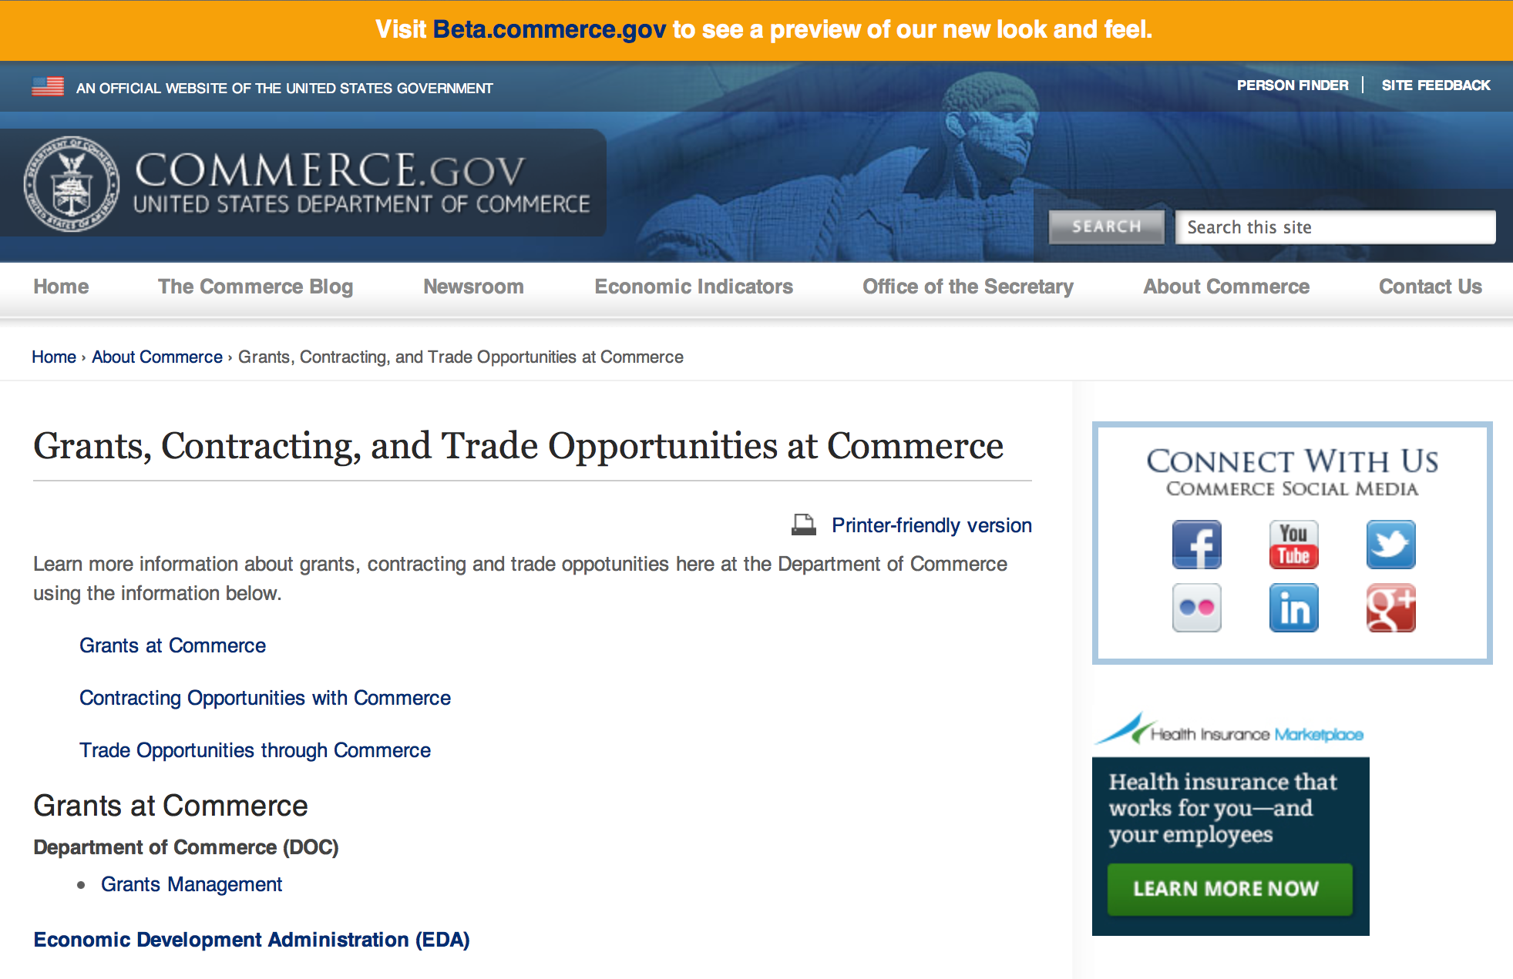
Grants at Commerce
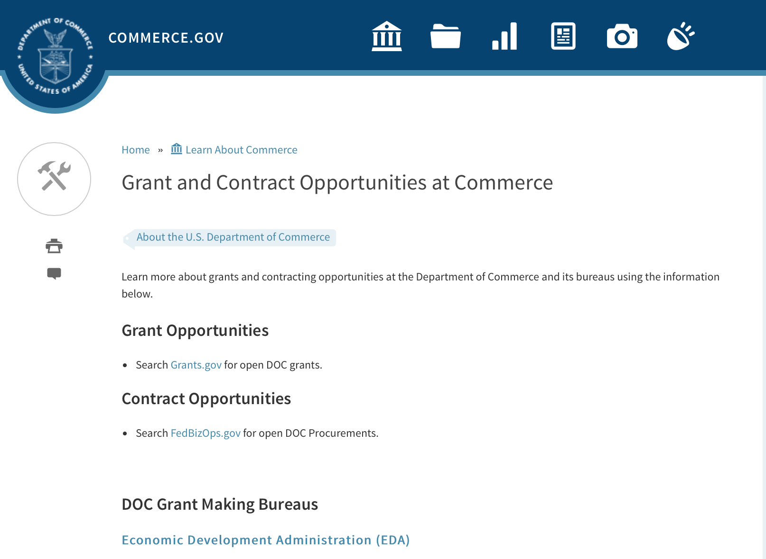

DOC Grant Making Bureaus
Economic Development Administration (EDA)
International Trade Administration (ITA)
- Market Development Cooperator Program
- Special American Business Internship Training Program (SABIT). A technical assistance initiative of the International Trade Administration of the U.S. Department of Commerce, SABIT offers organizations competitive grants and an opportunity to host industry-specific delegations. SABIT serves as an initial entry point for U.S. businesses seeking funding to establish long-term relationships with potential customers, distributors, or partners in the former Soviet Union. The program trains Eurasian managers and scientists in commonly accepted business practices as a means of facilitating cross border relationships. In turn, these personal relationships serve as a basis for business development and reduce market access barriers for U.S. businesses
National Institute of Standards & Technology (NIST)
- Funding Opportunities
National Telecommunications & Information Administration (NTIA)
- Telecommunications Grants
National Oceanic & Atmospheric Administration (NOAA)
- Coastal Ocean Program Grant Information
- Fisheries Saltonstall Kennedy Grant Program
- National Undersea Research Program Funding Opportunities
- Grants Management Division
- Fisheries Grants Program
- National Sea Grant
- Office of Global Programs
Contracting Resources for Contractors
- Office of Small and Disadvantaged Business Utilization (OSDBU) - he Office of Small and Disadvantaged Business Utilization (OSDBU) is an advocacy and advisory office responsible for promoting the use of small, small disadvantaged, 8(a), women-owned, veteran-owned, service-disabled veteran-owned, and HUBZone small businesses within the U.S. Department of Commerce's (DOC) acquisition process.
- Business.USA.gov's Find Opportunities Wizard where in a few quick steps, it will guide you towards federal government contracting programs and opportunities for your business!
- Planned Acquisitions: the Department of Commerce's search tool for our planned acquisitions over $100,000. As requirements change, these acquisition plans are updated by department personnel and this search tool is automatically updated.
- Small Business Administration's Contracting section of their web site where you can learn about how to "Get Started" and "Contracting Support for Small Business"
- The General Services Administration (GSA) has implemented a system for vendors doing business with the Federal Government to manage their entity information in one central location. This new database is the System for Award Management (SAM).

DOC Contracting Offices
- Patent and Trademark Office (PTO)
  - Office of Procurement
- National Institute of Standards & Technology (NIST)
NIST Acquisition Management Group
Contracting Opportunities with Commerce
Trade Opportunities through Commerce
http://www.commerce.gov/about-commerce/grants-contracting-trade-opportunities

Programs:

Fiscal Year 2018 National Sea Grant College Program Dean John A. Knauss Marine Policy Fellowship
Synopsis 1

Document Type: | Grants Notice
Funding Opportunity Number: | NOAA-OAR-SG-2018-2004993
Funding Opportunity Title: | Fiscal Year 2018 National Sea Grant College Program Dean John A. Knauss Marine Policy Fellowship
Opportunity Category: | Discretionary
Opportunity Category Explanation:
Funding Instrument Type: | Cooperative Agreement
Category of Funding Activity: | Environment  Natural Resources  Science and Technology and other Research and Development
Category Explanation:
Expected Number of Awards: | 30
CFDA Number(s): | 11.417 -- Sea Grant Support
Cost Sharing or Matching Requirement: | No
Posted Date: | Aug 11, 2016
Last Updated Date: | Aug 11, 2016
Original Closing Date for Applications: | Mar 31, 2017
Current Closing Date for Applications: | Mar 31, 2017
Archive Date: | Apr 30, 2017
Estimated Total Program Funding:
Award Ceiling: | $66,500
Award Floor: | $56,500
Eligible Applicants: | Others (see text field entitled "Additional Information on Eligibility" for clarification)
Additional Information on Eligibility: | An eligible applicant is any student, regardless of citizenship, who, on February 10, 2017, is enrolled towards a degree in a graduate program, that have an interest in ocean, coastal and Great Lakes resources and in the national policy decisions affecting those resources. The graduate degree needs to be awarded through a United States accredited institution of higher education in the United States or U.S. Territories.
Agency Name: | Department of Commerce
Description: | This notice announces that applications may be submitted for the 2018 National Sea Grant College Program Dean John A. Knauss Marine Policy Fellowship (Sea Grant Knauss Fellowship Program). Sea Grant anticipates funding not less than 30 selected applicants, of which those assigned to the Legislative branch may be limited to 12. Each award will be funded at a total of $56,500 in federal funding, with the option by the host office to add no more than $10,000 for fellow travel related to host office duties, for a maximum of $66,500.
Link to Additional Information:
Grantor Contact Information: | If you have difficulty accessing the full announcement electronically, please contact:  Julia Galkiewicz Sea Grant Knauss Fellowship Program Manager National Sea Grant College Program 1315 East-West Highway, R/SG, Room 11861 Silver Spring, MD 20910 (301) 734-1067 E-mail: OAR.SG.Fellows@noaa.gov  Work

http://www.grants.gov/web/grants/view-opportunity.html?oppId=287335

FY2017 Community-based Marine Debris Removal
Synopsis 1

Document Type: | Grants Notice
Funding Opportunity Number: | NOAA-NOS-ORR-2017-2004997
Funding Opportunity Title: | FY2017 Community-based Marine Debris Removal
Opportunity Category: | Discretionary
Opportunity Category Explanation:
Funding Instrument Type: | Cooperative Agreement
Category of Funding Activity: | Environment  Natural Resources  Science and Technology and other Research and Development
Category Explanation:
Expected Number of Awards: | 15
CFDA Number(s): | 11.999 -- Marine Debris Program
Cost Sharing or Matching Requirement: | Yes
Posted Date: | Aug 11, 2016
Last Updated Date: | Aug 11, 2016
Original Closing Date for Applications: | Oct 14, 2016
Current Closing Date for Applications: | Oct 14, 2016
Archive Date: | Nov 13, 2016
Estimated Total Program Funding: | $2,000,000
Award Ceiling: | $350,000
Award Floor: | $15,000
Eligible Applicants: | Others (see text field entitled "Additional Information on Eligibility" for clarification)
Additional Information on Eligibility: | In accordance with the Marine Debris Act, eligible applicants are state, local, and tribal governments whose activities affect research or regulation of marine debris and any institution of higher education, nonprofit organization, or commercial (for-profit) organization with expertise in a field related to marine debris. Applications from federal agencies or employees of federal agencies will not be considered. Interested federal agencies may collaborate with eligible applicants but may not receive funds through this competition. Foreign organizations and foreign public entities are not eligible to apply. All projects must take place within the United States or territories or their respective waterways. NOAA is strongly committed to broadening the participation of veterans, historically black colleges and universities, Hispanic-serving institutions, tribal colleges and universities, and institutions that work in under-served areas. NOAA encourages proposals involving any of the above institutions. Applications that have been submitted to other NOAA grant programs or as part of another NOAA grant may be considered under this solicitation
Agency Name: | Department of Commerce
Description: | The NOAA Marine Debris Program, authorized in the Marine Debris Research, Prevention, and Reduction Act, codified at 33 U.S.C. 1951-1958, provides funding to support locally-driven, marine debris prevention, assessment, and removal projects that will benefit coastal habitat, waterways, and NOAA trust resources. Funding for this purpose comes through the NOAA Marine Debris Program as appropriations to the Office of Response and Restoration, National Ocean Service. Projects awarded through this grant competition will implement effective, on-the-ground marine debris removal activities, with priority for those targeting medium- large-scale debris, including derelict fishing gear. Projects should also provide benefits to coastal communities, and create long-term ecological habitat improvements for NOAA trust resources. Through this solicitation NOAA identifies marine debris removal projects, fosters awareness of the effects of marine debris to further the conservation of living marine resource habitats, and contributes to the understanding of marine debris composition, distribution and impacts. Successful proposals through this solicitation will be funded through cooperative agreements.
Link to Additional Information:
Grantor Contact Information: | If you have difficulty accessing the full announcement electronically, please contact:  Mr. Tom Barry 240-533-0425 1305 East-West Hwy, Silver Spring, MD 20910-3281  Work

http://www.grants.gov/web/grants/view-opportunity.html?oppId=287350

Research:

Modifications:

Reminders:

Ocean Exploration FY 2017 Funding Opportunity
Synopsis 1

Document Type: | Grants Notice
Funding Opportunity Number: | NOAA-OAR-OER-2017-2004970
Funding Opportunity Title: | Ocean Exploration FY 2017 Funding Opportunity
Opportunity Category: | Discretionary
Opportunity Category Explanation:
Funding Instrument Type: | Cooperative Agreement  Grant
Category of Funding Activity: | Environment  Natural Resources  Science and Technology and other Research and Development
Category Explanation:
Expected Number of Awards: | 10
CFDA Number(s): | 11.011 -- Ocean Exploration
Cost Sharing or Matching Requirement: | No
Posted Date: | Aug 02, 2016
Last Updated Date: | Aug 02, 2016
Original Closing Date for Applications: | Dec 23, 2016
Current Closing Date for Applications: | Dec 23, 2016
Archive Date: | Jan 22, 2017
Estimated Total Program Funding: | $3,000,000
Award Ceiling: | $750,000
Award Floor: | $10,000
Eligible Applicants: | Others (see text field entitled "Additional Information on Eligibility" for clarification)
Additional Information on Eligibility: | Eligible applicants are institutions of higher education; non-profit institutions; for-profit organizations; state, local, and tribal governments, and U.S. territories that possess the statutory authority to accept funding for this type of work. Federal agencies that possess the statutory authority to accept funding for this type of work may also apply. Federal and state agencies are strongly encouraged to collaborate with partners from a non-federal eligible entity. OER funding will not be used to hire and/or fund the salaries and associated overhead of any permanent federal employees. Federal award recipients may use their funding to cover only travel, equipment, supplies, and contractual personnel costs associated with the proposed work. Foreign researchers may participate by submitting a sub-award through collaboration with an eligible U.S. entity. The DOC and NOAA support cultural and gender diversity and encourage women and minority individuals and groups to submit applications to this Announcement of Federal Funding Opportunity. In addition, DOC/NOAA is strongly committed to broadening the participation of historically black colleges and universities, Hispanic serving institutions, tribal colleges and universities, and institutions that work in underserved areas. DOC/NOAA encourages applications involving any of the above institutions to apply. PLEASE NOTE: Before non-NOAA Federal applicants may be funded, they must demonstrate that they have legal authority to receive funds from another Federal agency in excess of their appropriation.
Agency Name: | Department of Commerce
Description: | NOAA’s Office of Ocean Exploration & Research (OER) seeks to enhance ocean exploration and scientific knowledge of the unknown or poorly known areas of the ocean. This entails identifying, describing and creating baseline characterizations of new ocean habitats, marine resources and/or processes. In this Announcement, OER is seeking proposals focused on four themes: 1. Exploration of physical, chemical and biological environments and processes within the oceanic water column below ~200m; 2. Exploration of geological, physical, and biological environments as well as biogeochemical processes associated with seamounts; 3. Novel or innovative technologies and methodologies that could increase the pace and scope of ocean exploration, especially exploration of the water column, seamounts, and archaeological sites; and 4. Proposals focused on the discovery and exploration of historically significant submerged marine heritage sites, features and artifacts associated with WWII. Proposals that combine more than one of these exploration themes are encouraged. OER’s overarching objective is to investigate and document poorly known and unknown ocean areas through interdisciplinary exploration, and to advance and disseminate knowledge of the ocean’s physical, geological, chemical, biological, and archaeological environments. Findings from projects and expeditions are anticipated to result in new baseline characterizations; provide better scientific understanding of the processes on U.S. continental margins and the deep ocean; offer new insights into climate variability and marine ecosystems; reveal new or unconventional energy, mineral, biological, and archaeological resources; help identify hazards resulting from extreme events such as submarine volcanic eruptions, earthquakes and tsunamis; and deliver technology advancements (platforms, sensors, methodologies, etc.) that will increase observational capabilities in the ocean. OER is interested in characterization of seamounts located within regions of the U.S. EEZ or ECS, including the Gulf of Alaska, the NW Atlantic, and the deep regions of Marine Protected Areas. Characterization of physical, chemical, and biological ocean environments associated with seamounts in areas where ocean mining may occur (e.g., regions along the Clarion-Clipperton Fracture) is also of particular interest. OER may also consider proposals focused on other areas that are relevant to OER's and NOAA's missions and priorities that would include significant leveraged resources. Archaeology proposals are not restricted to any depth or geographic area.
Link to Additional Information:
Grantor Contact Information: | If you have difficulty accessing the full announcement electronically, please contact:  NOAA Office of Ocean Exploration and Research ATTN: OER FFO 2017, SSMC3, Rm 10316 1315 East West Highway Silver Spring, Maryland 20910 (301) 734-1014 oer.ffo2017@noaa.gov  Work

http://www.grants.gov/web/grants/view-opportunity.html?oppId=286859

National Competitive Harmful Algal Bloom Programs: The Ecology and Oceanography of Harmful Algal Blooms (ECOHAB) and Prevention, Control and Mitigation of Harmful Algal Blooms Program (PCMHAB)
Synopsis 1

Document Type: | Grants Notice
Funding Opportunity Number: | NOAA-NOS-NCCOS-2017-2004943
Funding Opportunity Title: | National Competitive Harmful Algal Bloom Programs: The Ecology and Oceanography of Harmful Algal Blooms (ECOHAB) and Prevention, Control and Mitigation of Harmful Algal Blooms Program (PCMHAB)
Opportunity Category: | Discretionary
Opportunity Category Explanation:
Funding Instrument Type: | Cooperative Agreement
Category of Funding Activity: | Environment  Natural Resources  Science and Technology and other Research and Development
Category Explanation:
Expected Number of Awards:
CFDA Number(s): | 11.478 -- Center for Sponsored Coastal Ocean Research Coastal Ocean Program
Cost Sharing or Matching Requirement: | No
Posted Date: | Aug 02, 2016
Last Updated Date: | Aug 02, 2016
Original Closing Date for Applications: | Nov 02, 2016
Current Closing Date for Applications: | Nov 02, 2016
Archive Date: | Dec 02, 2016
Estimated Total Program Funding: | $1,000,000
Award Ceiling: | $750,000
Award Floor: | $100,000
Eligible Applicants: | Others (see text field entitled "Additional Information on Eligibility" for clarification)
Additional Information on Eligibility: | Eligible applicants for Federal financial assistance in this competition are institutions of higher education, other non-profits, state, local, Indian Tribal Governments, for-profit organizations, U.S. Territories and Federal agencies that possess the statutory authority to receive transfers of funds. DOC/NOAA supports cultural and gender diversity and encourages women and minority individuals and groups to submit applications to the NCCOS/CSCOR programs. In addition, DOC/NOAA is strongly committed to broadening the participation of historically black colleges and universities, Hispanic serving institutions, tribal colleges and universities, and institutions that work in underserved areas. DOC/NOAA encourages applications involving any of the above institutions to apply. Please note that: (1) Principal Investigators should be employees of an eligible entity listed above; and applications should be submitted through that entity. Non-Federal researchers should comply with their institutional requirements for application submission. (2) Non-NOAA Federal applicants will be required to submit certifications or documentation showing that they have specific legal authority to accept funds for this type of research. (3) Foreign researchers must apply as subawards or contracts through an eligible US entity. (4) Non-Federal researchers affiliated with NOAA-University Cooperative/Joint Institutes will be funded through cooperative agreements. (5) NOAA/NOS/NCCOS researchers are ineligible to apply. A. They may not be included in applications as funded or unfunded investigators. B They may not provide letters of support for the application. C Applications that disregard either a. or b. will be rejected without review.
Agency Name: | Department of Commerce
Description: | The purpose of this document is to advise the public that NOAA/NOS/National Centers for Coastal Ocean Science (NCCOS)/Center for Sponsored Coastal Ocean Research (CSCOR) is soliciting proposals for the Ecology and Oceanography of Harmful Algal Blooms (ECOHAB) and Prevention and Control of Harmful Algal Blooms Program (PCMHAB). Funding is contingent upon the availability of Fiscal Year 2017 Federal appropriations. It is anticipated that projects funded under this announcement will have a September 1, 2017 start date.
Link to Additional Information:
Grantor Contact Information: | If you have difficulty accessing the full announcement electronically, please contact:  Technical Information: Quay Dortch, Program Manager for NCCOS/CSCOR, 240-533-0198, Internet: Quay.Dortch@noaa.gov, Grants Administration Information: Laura Golden, NCCOS/CSCOR Grants Administrator, 240-533-0285, Internet: Laurie.Golden@noaa.gov  Work

http://www.grants.gov/web/grants/view-opportunity.html?oppId=286886

2017 Saltonstall-Kennedy Competitive Research Program
Synopsis 1

Document Type: | Grants Notice
Funding Opportunity Number: | NOAA-NMFS-FHQ-2017-2004980
Funding Opportunity Title: | 2017 Saltonstall-Kennedy Competitive Research Program
Opportunity Category: | Discretionary
Opportunity Category Explanation:
Funding Instrument Type: | Cooperative Agreement  Grant
Category of Funding Activity: | Environment  Natural Resources  Science and Technology and other Research and Development
Category Explanation:
Expected Number of Awards: | 50
CFDA Number(s): | 11.427 -- Fisheries Development and Utilization Research and Development Grants and Cooperative Agreements Program
Cost Sharing or Matching Requirement: | No
Posted Date: | Jul 22, 2016
Last Updated Date: | Jul 22, 2016
Original Closing Date for Applications: | Dec 09, 2016
Current Closing Date for Applications: | Dec 09, 2016
Archive Date: | Jan 08, 2017
Estimated Total Program Funding: | $10,000,000
Award Ceiling: | $300,000
Award Floor: | $25,000
Eligible Applicants: | Others (see text field entitled "Additional Information on Eligibility" for clarification)
Additional Information on Eligibility: | You are eligible to apply for a grant or a cooperative agreement under the Saltonstall- Kennedy Grant Program if: 1. You are a citizen or national of the United States; 2. You represent an entity that is a corporation, partnership, association, or other non- Federal entity, non-profit or otherwise (including Indian tribes), if such entity is a citizen of the United States within the meaning of section 2 of the Shipping Act, 1916, as amended (46 U.S.C. app. 802); or 3. You are a citizen of the Republic of the Marshall Islands, Republic of Palau, or the Federated States of Micronesia. We recognize the interest of the Secretaries of Commerce and Interior in defining appropriate fisheries policies and programs that meet the needs of the U.S. insular areas, so we encourage applications from individuals, government entities, and businesses in U.S. insular areas. We support cultural and gender diversity in our programs and encourage women and minority individuals and groups to submit applications We are also committed to broadening the participation of Minority Serving Institutions (MSIs), which include Historically Black Colleges and Universities, Hispanic Serving Institutions, and Tribal Colleges and Universities, in our grant programs. To find out more about MSIs go to http: http://www2.ed.gov/about/offices/list/ocr/edlite-minorityinst.html. We encourage applications from members of the fishing community and applications that involve fishing community cooperation and participation. We will consider the extent of fishing community involvement when evaluating the potential benefit of funding a proposal. Eligible Applicants must submit a pre-proposal. Full proposals will not be reviewed or evaluated if a pre-proposal was not received and ranked. Non Eligible Applicants You are not eligible to submit an application under this program if you are an employee of any Federal agency; a Regional Fishery Management Council (Council); or an employee of a Council. However, Council members who are not Federal employees can submit an application to the S-K Program.
Agency Name: | Department of Commerce
Description: | The Saltonstall-Kennedy Act established a fund (known as the S-K fund) used by the Secretary of Commerce to provide grants or cooperative agreements for fisheries research and development projects addressing aspects of U.S. fisheries, including, but not limited to, harvesting, processing, marketing, and associated business infrastructures. Under this authority, grants and cooperative agreements are made on a competitive basis (subject to availability of funding) to assist in carrying out projects related to U.S. commercial and recreational fisheries. The term “fisheries” encompasses wild capture, marine aquaculture and recreational fishing. The objective of the S-K Grant Program is to address the needs of the fisheries and fishing communities in optimizing economic benefits by building and maintaining sustainable fisheries and practices, dealing with the impacts of conservation and management measures, and increasing other opportunities to use existing infrastructure to support keeping working waterfronts viable. U.S. fisheries include any fishery, commercial or recreational, that is, or may be, engaged in by citizens or nationals of the United States. Proposals submitted to this competition must address at least one of the following priorities: Marine Aquaculture; Fisheries Data Collection; Techniques for Reducing Bycatch and other Adverse Impacts; Adapting to Climate Change and Other Long Term Ecosystem Change; Promotion, Development and Marketing; Socio-Economic Research; and Territorial Science. This Federal Funding Opportunity includes information on application and criteria for research proposals requesting a maximum of $300,000 in total federal funding for up to a two-year period. Matching funds are not required. Awards are anticipated to start no earlier than September 1, 2017.
Link to Additional Information:
Grantor Contact Information: | If you have difficulty accessing the full announcement electronically, please contact:  Regional S-K Program point of contacts: Headquarters - Program Manager – Daniel Namur, telephone (301) 427-8730 email: Dan.Namur@noaa.gov, Alaska Region: Shawn Carey, telephone: (907) 586-7845; email: Shawn.Carey@noaa.gov; West Coast Region: Kim Raneses, telephone: (206) 526-6131; email: Kim.Raneses@noaa.gov, Pacific Islands Region: Scott Bloom, telephone: (808) 944-2218; email: Scott.Bloom@noaa.gov, Greater Atlantic Region: Susan Olsen, telephone (978) 281-9330; email: Susan.Olsen@noaa.gov; Southeast Region: Robert Sadler, telephone: (727) 551-5760; email: Robert.Sadler@noaa.gov  Work

http://www.grants.gov/web/grants/view-opportunity.html?oppId=286440

National Institute of Standards and Technology
Disaster Resilience (DR) Research Grants Program
Synopsis 1

Document Type: | Grants Notice
Funding Opportunity Number: | 2016-NIST-DR-01
Funding Opportunity Title: | Disaster Resilience (DR) Research Grants Program
Opportunity Category: | Discretionary
Opportunity Category Explanation:
Funding Instrument Type: | Cooperative Agreement
Category of Funding Activity: | Science and Technology and other Research and Development
Category Explanation:
Expected Number of Awards:
CFDA Number(s): | 11.609 -- Measurement and Engineering Research and Standards
Cost Sharing or Matching Requirement: | No
Posted Date: | Jul 26, 2016
Last Updated Date: | Jul 26, 2016
Original Closing Date for Applications: | Sep 23, 2016
Current Closing Date for Applications: | Sep 23, 2016
Archive Date: | Oct 23, 2016
Eligible Applicants: | Others (see text field entitled "Additional Information on Eligibility" for clarification)
Additional Information on Eligibility: | Eligibility for all programs listed in this FFO is open to all non-Federal entities. Eligible applicants include institutions of higher education, non-profit organizations, for-profit organizations, state and local governments, Indian tribes, hospitals, foreign public entities, and foreign governments. NIST is not able to accept an application from an individual unaffiliated with a sponsoring applicant organization.
Agency Name: | National Institute of Standards and Technology
Description: | The Disaster Resilience (DR) Research Grants Program seeks applications from eligible applicants to conduct research aimed at advancing the principles of resilience in building design and building codes and standards. Research proposals must support the overall effort of developing science-based building codes by evaluating potential technologies and architectural design criteria to improve disaster resilience in the built environment. Research projects must be aligned with existing NIST Engineering Laboratory (EL) Disaster Resilience programs, as described in Section I. of the Full Announcement/FFO document.
Link to Additional Information: | 2016-NIST-DR-01 Full Announcement/FFO document
Grantor Contact Information: | If you have difficulty accessing the full announcement electronically, please contact:  Christopher Hunton Management and Program Analyst Phone 301-975-5718  Agency Contact

http://www.grants.gov/web/grants/view-opportunity.html?oppId=286558

FY 2017 Climate Program Office
Synopsis 1

Document Type: | Grants Notice
Funding Opportunity Number: | NOAA-OAR-CPO-2017-2004896
Funding Opportunity Title: | FY 2017 Climate Program Office
Opportunity Category: | Discretionary
Opportunity Category Explanation:
Funding Instrument Type: | Cooperative Agreement
Category of Funding Activity: | Environment  Natural Resources  Science and Technology and other Research and Development
Category Explanation:
Expected Number of Awards: | 90
CFDA Number(s): | 11.431 -- Climate and Atmospheric Research
Cost Sharing or Matching Requirement: | No
Posted Date: | Jul 26, 2016
Last Updated Date: | Jul 26, 2016
Original Closing Date for Applications: | Oct 24, 2016
Current Closing Date for Applications: | Oct 24, 2016
Archive Date: | Nov 23, 2016
Estimated Total Program Funding: | $10,000,000
Award Ceiling: | $300,000
Award Floor: | $50,000
Eligible Applicants: | Others (see text field entitled "Additional Information on Eligibility" for clarification)
Additional Information on Eligibility: | Eligible applicants are institutions of higher education, other nonprofits, commercial organizations, international organizations, and state, local and Indian tribal governments. Federal agencies interested in receiving financial support for projects should contact the appropriate competition manager.
Agency Name: | Department of Commerce
Description: | FFO description: The National Oceanic and Atmospheric Administration (NOAA) is focused on providing the essential and highest quality environmental information vital to our Nation’s safety, prosperity and resilience. Toward this goal, the agency conducts and supports weather and climate research, oceanic and atmospheric observations, modeling, information management, assessments, interdisciplinary decision-support research, outreach, education, and partnership development. Climate variability and change present society with significant economic, health, safety, and security challenges and opportunities. In meeting these challenges, and as part of NOAA’s climate portfolio within the Office of Oceanic and Atmospheric Research (OAR), the Climate Program Office (CPO) advances scientific understanding, monitoring, and prediction of climate and its impacts, to enable effective decisions. These investments are key to NOAA’s mission of "Science, Service, and Stewardship" and are guided by the agency’s vision to create and sustain enhanced resilience in ecosystems, communities, and economies. Within this context, CPO manages competitive research programs through which NOAA funds high-priority climate science, assessments, decision support research, outreach, education, and capacity-building activities designed to advance our understanding of the Earth’s climate system, and to foster the application and use of this knowledge to improve the resilience of our Nation and its partners. CPO supports research that is conducted across the United States and internationally. CPO also provides strategic guidance for the agency’s climate science and services programs and supports NOAA’s contributions to the U.S. Global Change Research Program (USGCRP) and its National Climate Assessment, and similar international endeavors such as the Global Framework for Climate Services. CPO’s climate research portfolio is designed to achieve a fully integrated research and applications program. We meet this objective through a focus on climate intelligence and climate resilience, in support of NOAA’s goals. Climate intelligence defines CPO’s technical strength through its foundational capabilities, which include (1) Observations and monitoring, (2) Research to advance scientific understanding, (3) Modeling and prediction, (4) Communication, education, and engagement, and, (5) Climate and societal interactions. A focus on climate resilience leverages CPO’s climate intelligence to advance capabilities for responding to the urgent and growing demand for reliable, trusted, transparent, and timely climate information needed to sustain all sectors of our economy and environment. CPO’s strategy addresses challenges in the areas of, (1) Weather and climate extremes, (2) Climate impacts on water resources, (3) Coasts and climate resilience, (4) Sustainability of marine ecosystems, and (5) Changing atmospheric composition and its impacts. Making progress in addressing climate-related societal challenges and realizing benefits for NOAA’s public and private partners, requires that these mission-focused capabilities be integrated across CPO to align research, applications, transitions, and operations, and to meet the information needs of a resilient society. NOAA envisions a Nation that is prepared for, thriving, and resilient to climate variability and change. CPO’s activities support a unique and highly flexible climate research enterprise to improve scientific understanding of climate variability and change and to enable businesses and communities to derive the benefits of this investment in the present and into the future. Effectively coordinating across these components through the development and deployment of end-to-end research-based integrated information systems that address needs of high societal relevance, have been hallmarks of CPO’s success in linking environmental intelligence to resilience. Key components in this enterprise are Annual Federal Funding Opportunities, competitive grants programs and other types of support that advance and extend NOAA’s foundational capabilities and applications research. Proficiency in these core areas ensures that CPO’s infrastructure is always in place to meet the intelligence and resilience challenges of our changing climate. NOAA, OAR, and the Climate Program Office encourage applicants and awardees to support the principles of diversity and inclusion when writing their proposals and performing their work. Diversity is defined as a collection of individual attributes that together help organizations achieve objectives. Inclusion is defined as a culture that connects each employee to the organization. By promoting diversity and inclusion you can improve creativity, productivity, and the vitality of the research community.
Link to Additional Information:
Grantor Contact Information: | If you have difficulty accessing the full announcement electronically, please contact:  Agency Contacts: Please visit the CPO website for further information at or contact the CPO Grants Manager, Diane Brown, Please allow up to two weeks after receipt for a response.  Work

http://www.grants.gov/web/grants/view-opportunity.html?oppId=286560

John H. Prescott Marine Mammal Rescue Assistance Grant Program (Prescott Grant Program) for Fiscal Year 2017
Synopsis 1
Document Type: | Grants Notice
Funding Opportunity Number: | NOAA-NMFS-PRPO-2017-2004968
Funding Opportunity Title: | John H. Prescott Marine Mammal Rescue Assistance Grant Program (Prescott Grant Program) for Fiscal Year 2017
Opportunity Category: | Discretionary
Opportunity Category Explanation:
Funding Instrument Type: | Cooperative Agreement  Grant
Category of Funding Activity: | Environment  Natural Resources  Science and Technology and other Research and Development
Category Explanation:
Expected Number of Awards: | 40
CFDA Number(s): | 11.439 -- Marine Mammal Data Program
Cost Sharing or Matching Requirement: | Yes
Posted Date: | Jul 27, 2016
Last Updated Date: | Jul 27, 2016
Original Closing Date for Applications: | Oct 05, 2016
Current Closing Date for Applications: | Oct 05, 2016
Archive Date: | Nov 04, 2016
Estimated Total Program Funding: | $4,000,000
Award Ceiling: | $100,000
Eligible Applicants: | Others (see text field entitled "Additional Information on Eligibility" for clarification)
Additional Information on Eligibility: | All eligible applicants must currently be an active, authorized participant or researcher in the National Marine Mammal Stranding Network. Eligible applicants must be: 1) Stranding Agreement (SA) holders or their designee organizations; or 2) holders of researcher authorization letters issued by a NMFS Regional Administrator and/or an MMPA and/or ESA scientific research or enhancement permit (when applicable); or 3) an eligible Federal, state, or local government personnel or tribal personnel (pursuant to Section 109(h) of the MMPA (16 U.S.C. 1379(h)); or 4) diagnostic laboratories performing services for the stranding network. Federal agencies in the DOC or Department of the Interior (DOI) are not eligible to receive Federal assistance under this notice. 1. "In Good Standing Criteria". All eligible applicants must meet the following "in good standing" criteria: a. If the applicant is a designated Principal Investigator on a MMPA and/or ESA scientific research or enhancement permit or a Co-Investigator on the MMHSRP's MMPA/ESA scientific research and enhancement permit (permit No. 18786), the applicant must have fulfilled all permit requirements. The applicant must not have any pending or outstanding enforcement actions under the MMPA or ESA. b. The applicant must have complied with the terms and responsibilities of the appropriate SA, MMPA Section 109(h) authorization, or researcher authorization letter. This includes, but is not limited to: 1) completion of all reporting requirements; 2) cooperation with state, local, and federal officials; 3) cooperation with state and local officials in the disposition of stranded marine mammals; and 4) cooperation with stranding network participants. c. The applicant must have cooperated in a timely manner with NMFS in collecting and submitting Level B and Level C data and samples, when requested. d. The applicant must not have any current enforcement investigation for the take of marine mammals contrary to MMPA/ESA regulations. e. The applicant must not have any pending NMFS notice of violation(s) regarding the policies governing the goals and operations of the Stranding Network and SA, if applicable (e.g., probation, suspension, or termination). 2. Category Specific Criteria. Organizations and individuals must meet all of the following eligibility criteria specific to their category of participation in order for a proposal to be considered for funding: a. SA Holder Participant or SA Designee Participant - SA participants must hold a current, active SA for stranding response and/or rehabilitation from a NMFS Regional Administrator or the Assistant Administrator. SA Designee participants must be holding a current, active letter of designation from a NMFS SA holder. Designees cannot request authorization for activities beyond the scope of what is authorized by the SA to the agreement holder. b. Researcher Participant - Researcher participants must hold a current, active authorizing letter for the proposed award period from the appropriate NMFS Regional Administrator or the Assistant Administrator to salvage stranded marine mammal specimens, parts and samples for the purpose of utilization in scientific research (50 CFR 216.22). Persons authorized to salvage dead marine mammal specimens under this section must register the salvage with the appropriate NMFS Regional Office within 30 days after the taking occurs. Researchers who are authorized under an MMPA/ESA Scientific Research Permit must still obtain an authorizing letter from the Regional Stranding Coordinator in order to use parts or specimens from stranded animals. Researcher participants that would not require an authorizing letter from the NMFS Regional Administrator (i.e., they will be working with data only and not possessing samples or specimens) must still provide a letter of eligibility from the Regional Stranding Coordinator (see section III.A.3. of this FFO). Researcher participants.
Agency Name: | Department of Commerce
Description: | NOAA NMFS' Marine Mammal Health and Stranding Response Program is directed under the Marine Mammal Protection Act (MMPA) to facilitate the collection and dissemination of reference data on stranded marine mammals and health trends of marine mammal populations in the wild. The John H. Prescott Marine Mammal Rescue Assistance Grant Program is administered by NOAA to provide Federal assistance to eligible members of the National Marine Mammal Stranding Network to: 1) support basic needs of organizations for response, treatment, and data collection from living and dead stranded marine mammals, 2) fund scientific research objectives designed to answer questions about marine mammal strandings, health, or rehabilitation techniques utilizing data from living and dead stranded marine mammals, and 3) support facility operations directly related to the recovery, treatment, and data collection from living and dead stranded marine mammals. This document describes how to submit proposals for funding in fiscal year (FY) 2017 and how NMFS will determine which proposals will be funded. This document should be read in its entirety, as some information has changed from the previous year.
Link to Additional Information:
Grantor Contact Information: | If you have difficulty accessing the full announcement electronically, please contact:  Jaclyn Taylor and Nicole Adimey Prescott Grant Program NOAA/NMFS/Office of Protected Resources (F/PR) 1315 East-West Highway, Room 13620 Silver Spring, MD 20910 Phone: (301) 427-8402 Jaclyn.Taylor@noaa.gov or Nicole.Adimey@noaa.gov  Work

http://www.grants.gov/web/grants/view-opportunity.html?oppId=286607

National Institute of Standards and Technology
Project to Develop, Produce, and Distribute a Documentary Film about Rebooting the International Measurement System
Modification 2

Document Type: | Grants Notice
Funding Opportunity Number: | 2016-NIST-KG-01
Funding Opportunity Title: | Project to Develop, Produce, and Distribute a Documentary Film about Rebooting the International Measurement System
Opportunity Category: | Discretionary
Opportunity Category Explanation:
Funding Instrument Type: | Cooperative Agreement  Grant
Category of Funding Activity: | Other (see text field entitled "Explanation of Other Category of Funding Activity" for clarification)
Category Explanation: | Science, Technology, Business and/or Education Outreach
Expected Number of Awards:
CFDA Number(s): | 11.620 -- Science, Technology, Business and/or Education Outreach
Cost Sharing or Matching Requirement: | No
Version: | Modification 2
Posted Date: | Jul 11, 2016
Last Updated Date: | Jul 11, 2016
Original Closing Date for Applications: | Sep 26, 2016
Current Closing Date for Applications: | Sep 26, 2016
Archive Date: | Oct 26, 2016
Eligible Applicants: | Others (see text field entitled "Additional Information on Eligibility" for clarification)
Additional Information on Eligibility: | Eligibility for the program listed in this FFO is unrestricted, that is, open to all non-Federal entities. Eligible applicants include accredited institutions of higher education; non-profit organizations incorporated in the United States; for-profit organizations incorporated in the United States; and state, local, territorial and Indian tribal governments within the United States. An eligible organization may work individually or include proposed subawardees, contractors or other collaborators. NIST will only consider one application per applicant; however, an applicant entity may participate as a subrecipient, contractor, or unfunded collaborator within applications submitted by other entities.
Agency Name: | National Institute of Standards and Technology
Description: | 2016-NIST-KG-01 Full Announcement/FFO document
Link to Additional Information: | 2016-NIST-KG-01 Full Announcement/FFO Document
Grantor Contact Information: | If you have difficulty accessing the full announcement electronically, please contact:  Christopher Hunton Management and Program Analyst Phone 301-975-5718  Agency Contact

http://www.grants.gov/web/grants/view-opportunity.html?oppId=285971

National Institute of Standards and Technology
Measurement Science and Engineering (MSE) Research Grant Programs

Document Type: | Grants Notice
Funding Opportunity Number: | 2016-NIST-MSE-01
Funding Opportunity Title: | Measurement Science and Engineering (MSE) Research Grant Programs
Opportunity Category: | Discretionary
Opportunity Category Explanation:
Funding Instrument Type: | Cooperative Agreement  Grant
Category of Funding Activity: | Science and Technology and other Research and Development
Category Explanation:
Expected Number of Awards:
CFDA Number(s):
Cost Sharing or Matching Requirement: | No
Posted Date: | Feb 19, 2016
Last Updated Date: | Feb 19, 2016
Original Closing Date for Applications: | Applications will be accepted and considered on a rolling basis as they are received. See Section IV.4. in the text of the Full Announcement/FFO document. Applications may be submitted by paper or electronically through Grants.gov. Carefully read Section IV. of the Full Announcement/FFO document for details applying to electronic submissions and to paper submissions.
Current Closing Date for Applications: | Applications will be accepted and considered on a rolling basis as they are received. See Section IV.4. in the text of the Full Announcement/FFO document. Applications may be submitted by paper or electronically through Grants.gov. Carefully read Section IV. of the Full Announcement/FFO document for details applying to electronic submissions and to paper submissions.
Eligible Applicants: | Others (see text field entitled "Additional Information on Eligibility" for clarification)
Additional Information on Eligibility: | Eligibility for all programs listed in this FFO is open to all non-Federal entities. Eligible applicants include institutions of higher education, non-profit organizations, for-profit organizations, state and local governments, Indian tribes, hospitals, foreign public entities, and foreign governments. Applicants selected for awards under 15 U.S.C. § 278g-1 are encouraged, but not required, to select underrepresented minorities for participation. In addition, NIST is not able to accept an application from an individual unaffiliated with a sponsoring applicant organization.
Agency Name: | National Institute of Standards and Technology
Description: | NIST is soliciting applications for financial assistance for Fiscal Year 2016 (FY16) within the following NIST Laboratory grant programs: (1) the Material Measurement Laboratory (MML) Grant Program; (2) the Physical Measurement Laboratory (PML) Grant Program; (3) the Engineering Laboratory (EL) Grant Program; (4) the Fire Research (FR) Grant Program; (5) the Information Technology Laboratory (ITL) Grant Program; (6) the Communications Technology Laboratory (CTL) Grant Program; (7) the NIST Center for Neutron Research (NCNR) Grant Program; (8) the Center for Nanoscale Science and Technology (CNST) Grant Program; (9) the Special Programs Office (SPO) Grant Program; (10) the Standards Coordination Office (SCO) Grant Program; (11) the International and Academic Affairs Office (IAAO) Grant Program; and (12) the Associate Director for Laboratory Programs (ADLP) Grant Program.
Link to Additional Information: | 2016-NIST-MSE-01 Full Announcement/FFO document
Contact Information: | If you have difficulty accessing the full announcement electronically, please contact:  Christopher Hunton Management and Program Analyst Phone 301-975-5718  Agency Contact

http://www.grants.gov/web/grants/view-opportunity.html?oppId=281689

National Sea Grant College Program 2016-17 Special Projects Grant

Document Type: | Grants Notice
Funding Opportunity Number: | NOAA-OAR-SG-2016-2004772
Funding Opportunity Title: | National Sea Grant College Program 2016-17 Special Projects
Opportunity Category: | Discretionary
Funding Instrument Type: | Cooperative Agreement  Grant
Category of Funding Activity: | Environment  Natural Resources  Science and Technology and other Research and Development
Category Explanation:
Expected Number of Awards: | 30
CFDA Number(s): | 11.417 -- Sea Grant Support
Cost Sharing or Matching Requirement: | Yes
Posted Date: | Jan 7, 2016
Creation Date: | Jan 7, 2016
Original Closing Date for Applications: | Sep 30, 2017
Current Closing Date for Applications: | Sep 30, 2017
Archive Date: | Oct 30, 2017
Estimated Total Program Funding: | $4,000,000
Award Ceiling: | $1,000,000
Award Floor: | $1
Eligible Applicants: | Others (see text field entitled "Additional Information on Eligibility" for clarification)
Additional Information on Eligibility: | Sea Grant Programs (Sea Grant Colleges, Institutions, or Coherent Area Programs), the National Sea Grant Law Center, and the National Sea Grant Library.
Agency Name: | Department of Commerce
Description: | The purpose of this notice is to request proposals for special projects associated with the National Sea Grant College Program’s (Sea Grant) strategic focus areas, and to provide the general public with information and guidelines on how Sea Grant will select proposals and administer Federal assistance under this announcement. This announcement is a mechanism to encourage research or other projects that are not normally funded through Sea Grant national competitions. This opportunity is open only to Sea Grant Programs. Section III of this announcement describes eligibility requirements in more detail. Funding has not yet been made available to support applications submitted to this Federal Funding Opportunity (FFO), but such funding may become available during the year. Section II.A. below describes individual competition announcements that will be used to announce when funding is available; any restrictions or requirements on such funding, such as matching funds; and other funding details. Awards will be made under this FFO only if funds have been announced as provided in this FFO.
Link to Additional Information:
Contact Information: | If you have difficulty accessing the full announcement electronically, please contact:  Special Projects Competition Manager, NOAA R/SG National Sea Grant Office 1315 East-West Highway, Rm 11839 Silver Spring, MD 20910 301-734-1066  work

http://www.grants.gov/web/grants/view-opportunity.html?oppId=280846

FY 2016 – FY 2019 EDA Planning Program and Local Technical Assistance Program Grant

Document Type: | Grants Notice
Funding Opportunity Number: | EDA-HDQ-TA-HDQ-2016-2004759
Funding Opportunity Title: | FY 2016 – FY 2019 EDA Planning Program and Local Technical Assistance Program
Opportunity Category: | Discretionary
Funding Instrument Type: | Cooperative Agreement  Grant
Category of Funding Activity: | Other (see text field entitled "Explanation of Other Category of Funding Activity" for clarification)  Regional Development
Category Explanation: | Regional planning and local technical assistance
Expected Number of Awards:
CFDA Number(s): | 11.302 -- Economic Development Support for Planning Organizations  11.303 -- Economic Development Technical Assistance
Cost Sharing or Matching Requirement: | No
Posted Date: | Dec 10, 2015
Creation Date: | Dec 10, 2015
Original Closing Date for Applications: | Applications are accepted on a continuing basis and processed as received. This Planning and Local Technical Assistance opportunity will remain in effect until superseded by a future announcement.
Current Closing Date for Applications: | Applications are accepted on a continuing basis and processed as received. This Planning and Local Technical Assistance opportunity will remain in effect until superseded by a future announcement.
Archive Date:
Estimated Total Program Funding:
Award Ceiling: | $300,000
Award Floor: | $0
Eligible Applicants: | Nonprofits having a 501(c)(3) status with the IRS, other than institutions of higher education  City or township governments  Nonprofits that do not have a 501(c)(3) status with the IRS, other than institutions of higher education  Others (see text field entitled "Additional Information on Eligibility" for clarification)  Private institutions of higher education  Native American tribal governments (Federally recognized)  Public and State controlled institutions of higher education  State governments  Special district governments  County governments
Additional Information on Eligibility: | Pursuant to section 3 of the Public Works and Economic Development Act of 1965 (42 U.S.C. § 3122) (PWEDA) and EDA’s regulation at 13 C.F.R. § 300.3, the following types of entities are eligible to receive funding assistance from EDA: 1. District Organizations (as defined in 13 C.F.R. § 300.3); 2. Indian Tribes or a consortium of Indian Tribes; 3. States, cities, or other political subdivisions of a State, including a special purpose unit of a State or local government engaged in economic or infrastructure development activities, or a consortium of political subdivisions; 4. Institutions of higher education or a consortium of institutions of higher education; or 5. Public or private non-profit organizations or associations acting in cooperation with officials of a political subdivision of a State.
Agency Name: | Department of Commerce
Description: | Pursuant to PWEDA, EDA announces general policies and application procedures for grant-based investments under the Planning and Local Technical Assistance programs. Under the Planning program EDA assists eligible recipients in creating regional economic development plans designed to build capacity and guide the economic prosperity and resiliency of an area or region. As part of this program, EDA supports Partnership Planning investments to facilitate the development, implementation, revision, or replacement of Comprehensive Economic Development Strategies (CEDS), which articulate and prioritize the strategic economic goals of recipients’ respective regions. In general, EDA provides Partnership Planning grants to the designated planning organization (e.g., District Organization) serving EDA designated Economic Development Districts to enable these organizations to develop and implement relevant CEDS. In addition, EDA provides Partnership Planning grants to Indian Tribes to help develop and implement CEDS and associated economic development activities. The Planning program also helps support organizations, including District Organizations, Indian Tribes, and other eligible recipients, with Short Term and State Planning investments designed to guide the eventual creation and retention of high-quality jobs, particularly for the unemployed and underemployed in the Nation’s most economically distressed regions. The Local Technical Assistance program strengthens the capacity of local or State organizations, institutions of higher education, and other eligible recipients to undertake and promote effective economic development programs through projects such as feasibility analyses and impact studies.
Link to Additional Information: | www.eda.gov
Contact Information: | If you have difficulty accessing the full announcement electronically, please contact:  The EDA representative for your state. A complete list of EDA representatives is available on EDA's website at http://www.eda.gov/contact/

http://www.grants.gov/web/grants/view-opportunity.html?oppId=280447

FY 2016 Economic Development Assistance Programs ­ Application submission and program requirements for EDA’s Public Works and Economic Adjustment Assistance Programs Grant

Document Type: | Grants Notice
Funding Opportunity Number: | EDAP2016
Funding Opportunity Title: | FY 2016 Economic Development Assistance Programs ­ Application submission and program requirements for EDA’s Public Works and Economic Adjustment Assistance programs.
Opportunity Category: | Discretionary
Funding Instrument Type: | Cooperative Agreement  Grant
Category of Funding Activity: | Other (see text field entitled "Explanation of Other Category of Funding Activity" for clarification)
Category Explanation: | The Economic Development Administration's (EDA's) mission is to lead the Federal economic development agenda by promoting innovation and competitiveness, preparing American regions for economic growth and success in the worldwide economy. EDA fulfills this mission through strategic investments and partnerships that create the regional economic ecosystems required to foster globally competitive regions throughout the United States. EDA supports development in economically distressed areas of the United States by fostering job creation and attracting private investment. Specifically, under the Economic Development Assistance programs (EDAP) Federal Funding Opportunity (FFO) announcement, EDA will make construction, non-construction, and revolving loan fund investments under the Public Works and Economic Adjustment Assistance (EAA) Programs. Grants made under these programs will leverage regional assets to support the implementation of regional economic development strategies designed to create jobs, leverage private capital, encourage economic development, and strengthen America's ability to compete in the global marketplace. Through the EDAP FFO, EDA solicits applications from rural and urban communities to develop initiatives that advance new ideas and creative approaches to address rapidly evolving economic conditions.
Expected Number of Awards:
CFDA Number(s): | 11.300 -- Investments for Public Works and Economic Development Facilities  11.307 -- Economic Adjustment Assistance
Cost Sharing or Matching Requirement: | Yes
Posted Date: | Oct 26, 2015
Creation Date: | Oct 26, 2015
Original Closing Date for Applications: | There are no submission deadlines under this opportunity. Proposals and applications will be accepted on an ongoing basis until the publication of a new EDAP FFO.
Current Closing Date for Applications: | There are no submission deadlines under this opportunity. Proposals and applications will be accepted on an ongoing basis until the publication of a new EDAP FFO.
Archive Date:
Estimated Total Program Funding:
Award Ceiling: | $3,000,000
Award Floor: | $100,000
Eligible Applicants: | Others (see text field entitled "Additional Information on Eligibility" for clarification)  State governments  City or township governments  Native American tribal organizations (other than Federally recognized tribal governments)  Native American tribal governments (Federally recognized)  Private institutions of higher education  Special district governments  Nonprofits having a 501(c)(3) status with the IRS, other than institutions of higher education  County governments  Nonprofits that do not have a 501(c)(3) status with the IRS, other than institutions of higher education  Public and State controlled institutions of higher education
Additional Information on Eligibility: | Eligible applicants for EDA financial assistance under the Public Works and EAA programs include a(n): (i) District Organization of a designated Economic Development District; (ii) Indian Tribe or a consortium of Indian Tribes; (iii) State, county, city, or other political subdivision of a State, including a special purpose unit of a State or local government engaged in economic or infrastructure development activities, or a consortium of political subdivisions; (iv) institution of higher education or a consortium of institutions of higher education; or (v) public or private non-profit organization or association acting in cooperation with officials of a political subdivision of a State. See Section 3 of the Public Works and Economic Development Act of 1965 (PWEDA) (42 U.S.C. § 3122) and 13 C.F.R. § 300.3. EDA is not authorized to provide grants or cooperative agreements to individuals or to for profit entities. Requests from such entities will not be considered for funding.
Agency Name: | Economic Development Administration
Description: | Under this FFO, EDA solicits applications from applicants in rural and urban areas to provide investments that support construction, non-construction, technical assistance, and revolving loan fund projects under EDA’s Public Works and EAA programs. Grants and cooperative agreements made under these programs are designed to leverage existing regional assets and support the implementation of economic development strategies that advance new ideas and creative approaches to advance economic prosperity in distressed communities. EDA provides strategic investments on a competitive- merit-basis to support economic development, foster job creation, and attract private investment in economically distressed areas of the United States.
Link to Additional Information: | www.eda.gov
Contact Information: | If you have difficulty accessing the full announcement electronically, please contact:  the EDA representative for your state. A complete list of EDA representatives is available on EDA's website at http://www.eda.gov/contact/

http://www.grants.gov/web/grants/view-opportunity.html?oppId=279842

Economic Development Administration
Planning Program and Local Technical Assistance Program Grant

Document Type: | Grants Notice
Funding Opportunity Number: | EDAPLANNING2012
Opportunity Category: | Discretionary
Posted Date: | Aug 03, 2012
Creation Date: | Aug 03, 2012
Original Closing Date for Applications: | Applications are accepted on a continuing basis and processed as received. This Planning and Local Technical Assistance opportunity will remain in effect until superseded by a future announcement.
Current Closing Date for Applications: | Applications are accepted on a continuing basis and processed as received. This Planning and Local Technical Assistance opportunity will remain in effect until superseded by a future announcement.
Archive Date:
Funding Instrument Type: | Cooperative Agreement  Grant
Category of Funding Activity: | Other (see text field entitled "Explanation of Other Category of Funding Activity" for clarification)  Regional Development
Category Explanation: | Regional planning and local technical assistance
Expected Number of Awards: | 425
Estimated Total Program Funding:
Award Ceiling: | $100,000
Award Floor:
CFDA Number(s): | 11.302 -- Economic Development Support for Planning Organizations
 | 11.303 -- Economic Development Technical Assistance
Cost Sharing or Matching Requirement: | Yes

Eligible Applicants
State governments
County governments
City or township governments
Public and State controlled institutions of higher education
Native American tribal governments (Federally recognized)
Nonprofits having a 501(c)(3) status with the IRS, other than institutions of higher education
Nonprofits that do not have a 501(c)(3) status with the IRS, other than institutions of higher education
Private institutions of higher education
Others (see text field entitled "Additional Information on Eligibility" for clarification)

Additional Information on Eligibility:
Pursuant to section 3 of the Public Works and Economic Development Act of 1965 (42 U.S.C. § 3122) (PWEDA) and EDA’s regulation at 13 C.F.R. § 300.3, the following types of entities are eligible to receive funding assistance from EDA: 1. District Organizations (as defined in 13 C.F.R. § 300.3); 2. Indian Tribes or a consortium of Indian Tribes; 3. States, cities, or other political subdivisions of a State, including a special purpose unit of a State or local government engaged in economic or infrastructure development activities, or a consortium of political subdivisions; 4. Institutions of higher education or a consortium of institutions of higher education; or 5. Public or private non-profit organizations or associations acting in cooperation with officials of a political subdivision of a State.

Agency Name
Economic Development Administration

Description
Pursuant to PWEDA, EDA announces general policies and application procedures for grant-based investments under the Planning and Local Technical Assistance programs. Under the Planning program EDA assists eligible recipients in creating regional economic development plans designed to stimulate and guide the economic development efforts of a community or region. As part of this program, EDA supports Partnership Planning investments to facilitate the development, implementation, revision, or replacement of Comprehensive Economic Development Strategies (CEDS), which articulate and prioritize the strategic economic goals of recipients' respective regions. In general, EDA provides Partnership Planning grants to the designated planning organization (e.g., District Organization) serving EDA-designated Economic Development Districts to enable these organizations to develop and implement relevant CEDS. In addition, EDA provides Partnership Planning grants to Indian Tribes to help develop and implement CEDS and associated economic development activities. The Planning program also helps support planning organizations, including District Organizations, Indian Tribes, and other eligible Recipients, with Short Term and State Planning investments designed to guide the eventual creation and retention of higher-skill, higher-wage jobs, particularly for the unemployed and underemployed in the Nation’s most economically distressed regions. The Local Technical Assistance program strengthens the capacity of local or State organizations, institutions of higher education, and other eligible recipients to undertake and promote effective economic development programs through projects such as feasibility analyses and impact studies.

Link to Additional Information

If you have difficulty accessing the full announcement electronically, please contact:
David Ives Planning and Local TA email

http://www.grants.gov/web/grants/view-opportunity.html?oppId=189193

Deleted:

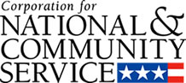

Corporation for National and Community Service

General Program Overview
AmeriCorps provides resources, both human and financial, to organizations that engage Americans in intensive service to meet our country’s critical needs.
Grantees use the funding to support AmeriCorps members for intensive service in their community. AmeriCorps grants partially cover the expense of operating an AmeriCorps program and do not cover general organizational expenses. A cash and in-kind match is required.

The main website can be accessed here: http://www.nationalservice.gov

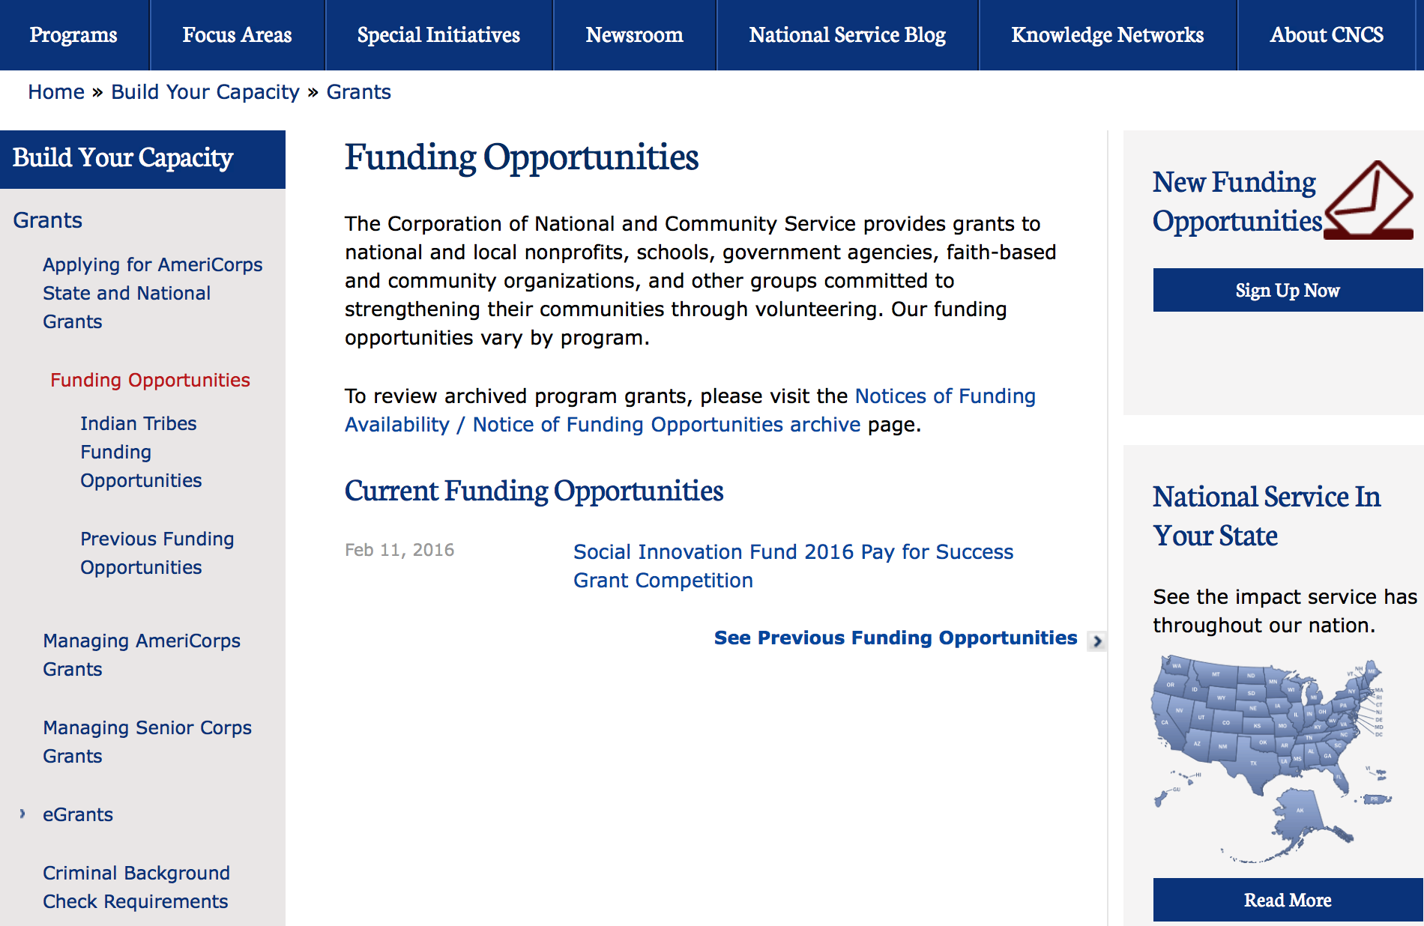

For access to further funding information: click here

http://www.nationalservice.gov/build-your-capacity/grants/funding-opportunities

Programs:

Round 2: FY 2016 Social Innovation Fund Pay for Success Cooperative Agreement
Synopsis 1

Document Type: | Grants Notice
Funding Opportunity Number: | CNCS-08-09-2016
Funding Opportunity Title: | Round 2: FY 2016 Social Innovation Fund Pay for Success Cooperative Agreement
Opportunity Category: | Discretionary
Opportunity Category Explanation:
Funding Instrument Type: | Grant
Category of Funding Activity: | Health  Other (see text field entitled "Explanation of Other Category of Funding Activity" for clarification)
Category Explanation: | Economic Opportunity Youth Development
Expected Number of Awards: | 4
CFDA Number(s): | 94.024 -- Social Innovation Fund Pay for Success
Cost Sharing or Matching Requirement: | Yes
Version: | Synopsis 1
Posted Date: | Aug 09, 2016
Last Updated Date: | Aug 09, 2016
Original Closing Date for Applications: | Sep 20, 2016
Current Closing Date for Applications: | Sep 20, 2016
Archive Date: | Oct 20, 2016
Estimated Total Program Funding:
Award Ceiling: | $7,300,000
Award Floor: | $350,000
Eligible Applicants: | Others (see text field entitled "Additional Information on Eligibility" for clarification)  Native American tribal governments (Federally recognized)  County governments  Private institutions of higher education  City or township governments  Nonprofits having a 501(c)(3) status with the IRS, other than institutions of higher education  Public and State controlled institutions of higher education  State governments
Additional Information on Eligibility: | Faith based organizations
Agency Name: | Corporation for National and Community Service
Description: | Pay for Success (PFS) is an innovative model that ties funding for an intervention to its impact in the community. PFS offers a way to catalyze philanthropic and private sector investments to deliver better outcomes, enabling government or other Payors (for example, school districts or hospitals) to pay only for outcomes achieved – that is, to pay only for what works. PFS increases investments in effective social interventions by changing the way government allocates and invests its resources. Learn more about Pay for Success at: https://www.whitehouse.gov/sites/default/files/omb/budget/fy2017/assets/fact_sheets/improving-outcomes-through-pay-for-success_0.pdf
Link to Additional Information: | http://www.nationalservice.gov/build-your-capacity/grants/funding-opportunities/2016/round-2-fy-2016-social-innovation-fund-pay
Grantor Contact Information: | If you have difficulty accessing the full announcement electronically, please contact:  SIF office  SIF Office

http://www.grants.gov/web/grants/view-opportunity.html?oppId=287193

2017 AmeriCorps State and National Grants
Synopsis 1
Document Type: | Grants Notice
Funding Opportunity Number: | CNCS-8-17-2017
Funding Opportunity Title: | 2017 AmeriCorps State and National Grants
Opportunity Category: | Discretionary
Opportunity Category Explanation:
Funding Instrument Type: | Grant
Category of Funding Activity: | Agriculture  Arts (see "Cultural Affairs" in CFDA)  Community Development  Disaster Prevention and Relief  Education  Employment, Labor and Training  Energy  Environment  Food and Nutrition  Health  Housing  Income Security and Social Services  Law, Justice and Legal Services  Natural Resources  Regional Development
Category Explanation:
Expected Number of Awards:
CFDA Number(s): | 94.006 -- AmeriCorps
Cost Sharing or Matching Requirement: | Yes
Version: | Synopsis 1
Posted Date: | Aug 17, 2016
Last Updated Date: | Aug 17, 2016
Current Closing Date for Applications: | Jan 18, 2017 Notification of Intent to Apply: Applicants are strongly encouraged to submit a Notification of Intent to Apply for this competition. Notifications of Intent to Apply should be filed by Wednesday, December 7, 2016. Single-State applicants should provide this information directly to the Commission in the state in which the applicant intends to operate the program, not CNCS. The State Commissions’ deadlines are earlier than this deadline. See Types of Applicants section of the Notice for definitions of National Direct and Single-State applicants. Deadline: Applications are due Wednesday, January 18, 2017 at 5:00 p.m. Eastern Time to CNCS. Single-state applicant deadlines to State and Territory Commissions may be significantly before the CNCS deadlines, so prospective state applicants should contact the commission in the state or territory where they intend to apply as early as possible
Eligible Applicants: | State governments  Nonprofits having a 501(c)(3) status with the IRS, other than institutions of higher education  City or township governments  Private institutions of higher education  Public and State controlled institutions of higher education  Public housing authorities/Indian housing authorities  County governments  Native American tribal organizations (other than Federally recognized tribal governments)  Native American tribal governments (Federally recognized)  Nonprofits that do not have a 501(c)(3) status with the IRS, other than institutions of higher education  Special district governments  Independent school districts
Additional Information on Eligibility: | Eligible Applicants The following Non-Federal entities (as defined in 2 C.F.R. §200.69) who have DUNS numbers and are registered in System for Award Management (SAM) are eligible to apply: • Indian Tribes (2 C.F.R. §200.54) • Institutions of higher education (2 C. F.R. §200.54) • Local governments (2 C.F.R. §200.64) • Nonprofit organizations (2 C.F.R. §200.70) • States (2 C.F.R. §200.90) Previously receiving funds from CNCS or another federal agency is not a prerequisite to apply to this Notice. CNCS encourages organizations that have not received prior funding from CNCS to apply. The general practice is to award at least 20 member positions (slots) but no more than 50 member positions (slots) to organizations receiving an AmeriCorps grant for the first time. Continuation Applicants Organizations that have current AmeriCorps awards that do not end in FY17 must submit an application in order to be eligible to receive funding for the following year.
Agency Name: | Corporation for National and Community Service
Description: | AmeriCorps grants are awarded to eligible organizations proposing to engage AmeriCorps members in evidence-based or evidence-informed interventions to strengthen communities. An AmeriCorps member is an individual who engages in community service through an approved national service position. Members may receive a living allowance and other benefits while serving. Upon successful completion of their service, members earn a Segal AmeriCorps Education Award from the National Service Trust that members can use to pay for higher education expenses or apply to qualified student loans. Grant awards generally have two components: operating funds and AmeriCorps member positions. Grant award amounts vary – both in the level of operating funds and in the type and amount of AmeriCorps member positions. Unless otherwise specified, the grant generally covers a three-year project period. In approving a multi-year project period, CNCS generally makes an initial award for the first year of operation. In most cases, the application is submitted with a one-year budget. Continuation funding is not guaranteed.
Link to Additional Information: | Funding Opportunity Webpage
Grantor Contact Information: | If you have difficulty accessing the full announcement electronically, please contact:  AmeriCorps Program Office 202-606-7508  AmeriCorps Program Office Email

http://www.grants.gov/web/grants/view-opportunity.html?oppId=287588

Reminders:

National Service In Hawaii
National Service in Your State - Hawaii
2015-2016

Meeting Community Needs in Hawaii: More than 3,100 people of all ages and backgrounds are helping to meet local needs, strengthen communities, and increase civic engagement through national service in Hawaii. Serving at more than 450 locations throughout the state, these citizens tutor and mentor children, support veterans and military families, provide health services, restore the environment, respond to disasters, increase economic opportunity, and recruit and manage volunteers. This year, the Corporation for National and Community Service (CNCS) will commit more than $6,260,000 to support Hawaii communities through national service initiatives. Through a unique public-private partnership, this federal investment will leverage an additional $9,060,000 in other resources to strengthen community impact, build local support, and increase return on taxpayer dollars. Nationwide, CNCS, its grantees, and project sponsors generated more than $1.25 billion in outside resources from businesses, foundations, public agencies, and other sources in FY 2015.

AmeriCorps
This year, AmeriCorps will provide more than 560 individuals the opportunity to provide intensive, results-driven service to meet education, environmental, health, economic, and other pressing needs in communities across Hawaii. Most AmeriCorps grant funding goes to the Hawaii Commission on National & Community Service, which in turn awards grants to nonprofit groups to respond to local needs. Most of the remainder of the grant funding is distributed by CNCS directly to multi-state and national organizations through a competitive grants process. Other individuals serve through AmeriCorps VISTA, whose members help bring individuals and communities out of poverty by serving full-time to fight illiteracy, improve health services, create businesses, and increase housing opportunities, and AmeriCorps NCCC (National Civilian Community Corps), a 10-month, full time residential program for men and women between the ages of 18 and 24. In exchange for their service, AmeriCorps members earn an education award that can be used to pay for college or to pay back qualified student loans. Since 1994, more than 5,900 Hawaii residents have served more than 6.4 million hours and have qualified for Segal AmeriCorps Education Awards totaling more than $14,980,000.
Download: AmeriCorps in Hawaii (PDF)
Senior Corps
More than 2,500 seniors in Hawaii contribute their time and talents in one of three Senior Corps programs. Foster Grandparents serve one-on-one as tutors and mentors to more than 310 young people who have special needs. Senior Companions help more than 220 homebound seniors and other adults maintain independence in their own homes. RSVP volunteers conduct safety patrols, renovate homes, protect the environment, tutor and mentor youth, respond to natural disasters, and provide other services through more than 250 groups across Hawaii.
Download: Senior Corps in Hawaii (PDF)

The Corporation for National and Community Service is a federal agency that improves lives, strengthens communities, and fosters civic engagement through service and volunteering. CNCS annually engages more than five million Americans in service to meet local needs through Senior Corps, AmeriCorps, and national days of service; improves communities through the Social Innovation Fund, and leads President Obama's national call to service initiative, United We Serve. To learn more visit NationalService.gov or Serve.gov or call 202-606-5000 or TTY 1-800-833-3722.

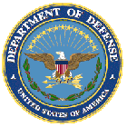

U.S. Department of Defense

Doing Business with the Department of Defense

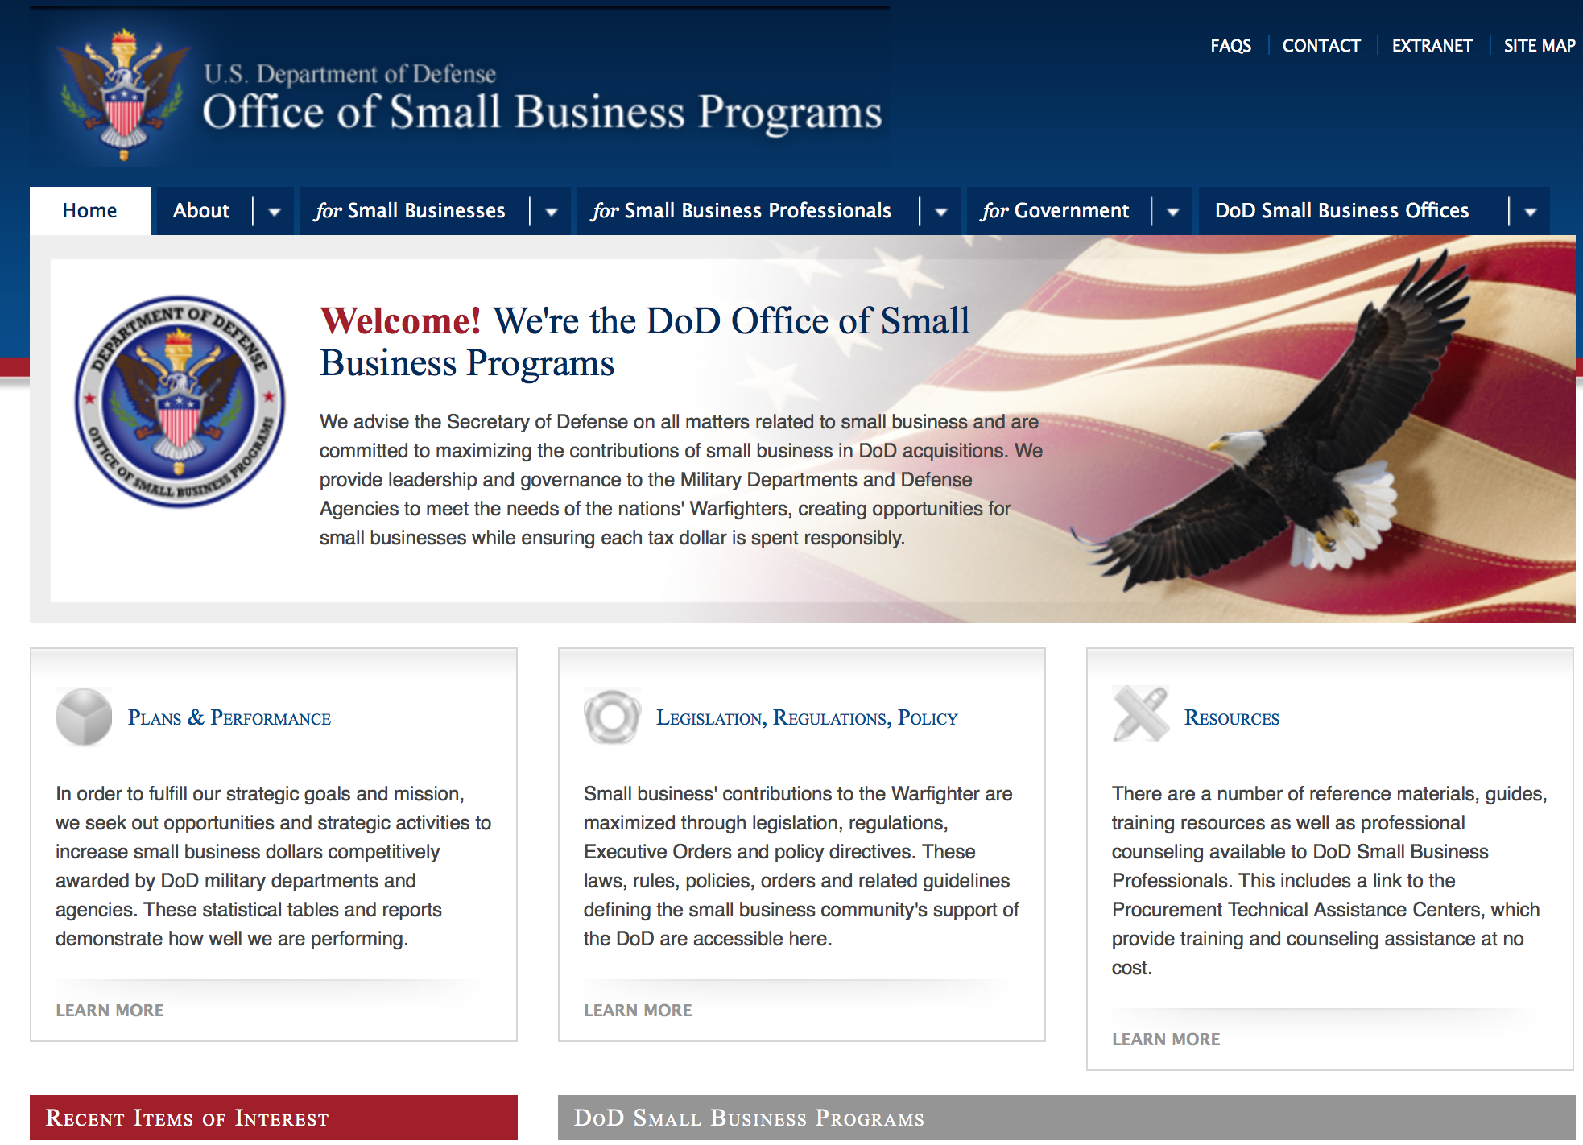

http://www.acq.osd.mil/osbp/

Doing Business with the DoD

Resources

Procurement Technical Assistance Centers (PTACs)

Procurement Technical Assistance Centers (PTACs) are charged with assisting businesses in learning how to do business with federal, state, and local governments. PTACs are a local resource available at no or nominal cost that can provide assistance to business firms in marketing their products and services. They offer training to businesses on how to research and bid on contracts, assist with registration requirements, provide bid-matching services, and assist with pre and post contracting issues.

Prime Contractors with Subcontracting Plans [xlsx]

Directory updated 4/19/11

This FY 2014 directory is intended for small business concerns seeking opportunities with DoD prime contractors. The directory is a listing of large business prime contractors who are required to establish subcontracting plans with goals. The report is generated from data contained in the Individual Subcontract Reports (ISRs) submitted in the Electronic Subcontracting Reporting System (eSRS) by contractors and from data contained in the Federal Procurement Data System (FPDS). The directory includes the name of the prime contractor; the major product/service code (PSC) provided to DoD; the major NAICS of the company; name, telephone number and email address of the company’s point of contact; contract number with the effective date and completion date, ultimate contract value and obligated dollars. In addition, many companies have websites with additional information which may be useful in your search for subcontracting opportunities or teaming arrangements.

Locate a Small Business Professional

Small Business Professionals serve as the primary liaison between private-sector small businesses seeking to do business with government agencies. Specialists advise small businesses regarding current acquisitions contracts available from the federal government.

Procurement Forecasts & the Department of Defense

The Department of Defense, due to its size and scope, does not have a single, comprehensive source for future procurements. Procurements are made locally and within the various services and agencies.

Business Intelligence, relative to future procurement planning, would be gathered at the local level.

For the purposes of forecasting, knowledge of past behavior is useful. Click here for a table of DoD acquisitions in FY10 summarized by NAICS code. The FY10 data has been validated but FPDS data is dynamic and changes continuously.

Non-Appropriated Fund Customers

Non-appropriated fund customers operate similar to non-profit organizations and include commissaries, exchanges, recreation and fitness centers, dining at officer/enlisted/civilian clubs, and barber/beauty services, just to name a few. For more information click here.

Research:

Dept of the Army -- Materiel Command
Internet of Battlefield Things (IoBT)
Synopsis 1
http://www.grants.gov/web/grants/view-opportunity.html?oppId=287895

DARPA - Biological Technologies Office
Engineered Living Materials (ELM)
Synopsis 1
http://www.grants.gov/web/grants/view-opportunity.html?oppId=287034

DARPA - Information Innovation Office
Explainable Artificial Intelligence (XAI)
Synopsis 1
http://www.grants.gov/web/grants/view-opportunity.html?oppId=287284

DARPA - Information Innovation Office
I2O Office-wide BAA
Synopsis 1
http://www.grants.gov/web/grants/view-opportunity.html?oppId=288122

DARPA - Defense Sciences Office
Extreme Optics and Imaging (EXTREME)
Synopsis 1
http://www.grants.gov/web/grants/view-opportunity.html?oppId=287909

Dept. of the Army -- USAMRAA
DoD Breast Cancer Breakthrough Award Levels 1 and 2
Synopsis 1
http://www.grants.gov/web/grants/view-opportunity.html?oppId=287712

Dept. of the Army -- USAMRAA
Peer Reviewed Orthopaedic Clinical Translational Research Award
Synopsis 2
http://www.grants.gov/web/grants/view-opportunity.html?oppId=287288

Dept. of the Army -- USAMRAA
DoD Reconstructive Transplant Investigator-Initiated Research Award
Synopsis 1
http://www.grants.gov/web/grants/view-opportunity.html?oppId=287363

Dept. of the Army -- USAMRAA
DoD Reconstructive Transplant Concept Award
Synopsis 1
http://www.grants.gov/web/grants/view-opportunity.html?oppId=287379

Office of Naval Research
FY2017 Office of Naval Research (ONR) Young Investigator Program (YIP)
Synopsis 1
http://www.grants.gov/web/grants/view-opportunity.html?oppId=286980

Naval Supply Systems Command
Funding Opportunity Announcement (FOA) for Research Initiatives at The Naval Postgraduate School
Synopsis 1
http://www.grants.gov/web/grants/view-opportunity.html?oppId=288093

NSWC Indian Head
Naval Engineering Education Consortium (NEEC)
Synopsis 1
http://www.grants.gov/web/grants/view-opportunity.html?oppId=287157

Modifications:

Dept. of the Army -- USAMRAA
DOD Parkinson’s Impact Award
Synopsis 2
http://www.grants.gov/web/grants/view-opportunity.html?oppId=286264

Naval Supply Systems Command
FY15 - FY16 Department of Defense HIV/AIDS Prevention Program: Military Specific HIV/AIDS Prevention, Care, and Treatment Program for PEPFAR (President's Emergency Plan for AIDS Relief) Funded Countries
Synopsis 25
http://www.grants.gov/web/grants/view-opportunity.html?oppId=270446

Uniformed Services Univ. of the Health Sciences
TriService Nursing Research Program "A Call"
Synopsis 1
http://www.grants.gov/web/grants/view-opportunity.html?oppId=288232

Uniformed Services Univ. of the Health Sciences
TriService Nursing Research Program "B Call"
Synopsis 1
http://www.grants.gov/web/grants/view-opportunity.html?oppId=288234

Uniformed Services Univ. of the Health Sciences
TriService Nursing Research Program "Open Call"
Synopsis 2
http://www.grants.gov/web/grants/view-opportunity.html?oppId=288216

Reminders:

Dept. of the Army -- Materiel Command
Army Research Office Broad Agency Announcement for Basic and Applied Scientific Research
Modification 8

Document Type: | Grants Notice
Funding Opportunity Number: | W911NF-12-R-0012
Funding Opportunity Title: | Army Research Office Broad Agency Announcement for Basic and Applied Scientific Research
Opportunity Category: | Discretionary
Funding Instrument Type: | Cooperative Agreement  Grant  Other  Procurement Contract
Category of Funding Activity: | Science and Technology and other Research and Development
Category Explanation:
Expected Number of Awards: | 1000
CFDA Number(s): | 12.431 -- Basic Scientific Research
Cost Sharing or Matching Requirement: | No
Posted Date: | Mar 27, 2015
Creation Date: | Mar 27, 2015
Original Closing Date for Applications: | Mar 31, 2017
Current Closing Date for Applications: | Mar 31, 2017
Archive Date: | Apr 30, 2017
Eligible Applicants: | Unrestricted (i.e., open to any type of entity above), subject to any clarification in text field entitled "Additional Information on Eligibility"
Agency Name: | Dept. of the Army -- Materiel Command
Description: | The purpose of this Broad Agency Announcement (BAA) is to solicit research proposals in the engineering, physical, life, and information sciences for submission to the Army Research Office (ARO) for consideration for possible funding. For ease of reference, this BAA is an extraction of the ARO sections of the Army Research Laboratory BAA. (www.arl.army.mil/www/default.cfm?page=8).
Link to Additional Information: | ARO CORE BAA-W911NF-12-R-0012-Mod 03
Contact Information: | If you have difficulty accessing the full announcement electronically, please contact:  ANDREW L. FISKE Procurement Analyst Army Contracting Command Aberdeen Proving Ground Research Triangle Park Division Phone: (919) 549-4338 FAX: (919) 549-4388 andrew.l.fiske.civ@mail.mil  Administrative POC

http://www.grants.gov/web/grants/view-opportunity.html?oppId=173593



Department of Education

Grant Programs Overview at the Department of Education

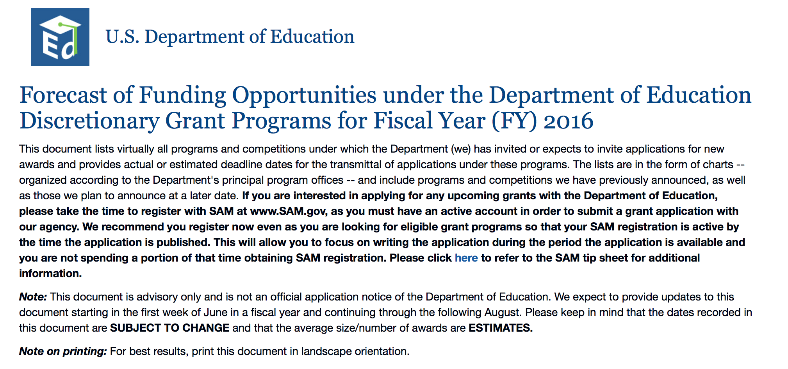To see the complete document click here: http://www2.ed.gov/fund/grant/find/edlite-forecast.html

The general information page for Education Grant funding is an excellent resource describing the three types of grants awarded by the Department of Education. See the screen shot of the Department of Education web page below:

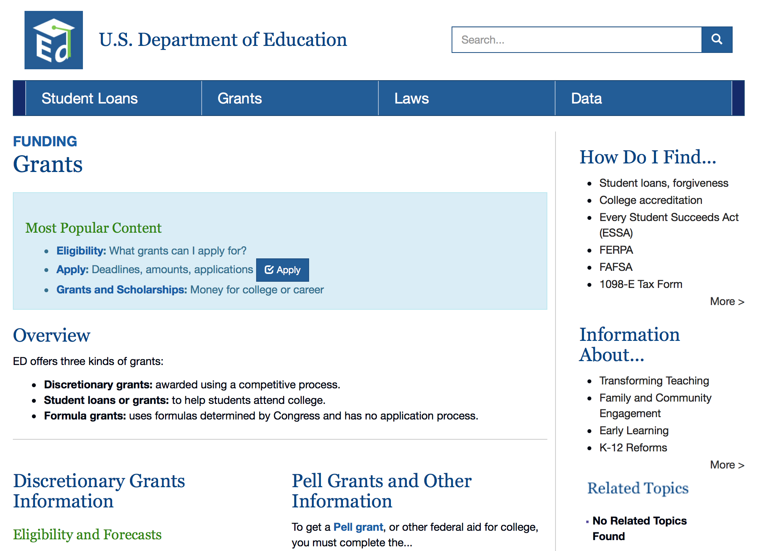

http://www.ed.gov/fund/grants-apply.html

Programs:

Office of Career, Technical, and Adult Education (OCTAE): Performance Partnership Pilots (P3) CFDA Number 84.420A
Synopsis 1

Document Type: | Grants Notice
Funding Opportunity Number: | ED-GRANTS-081516-001
Funding Opportunity Title: | Office of Career, Technical, and Adult Education (OCTAE): Performance Partnership Pilots (P3) CFDA Number 84.420A
Opportunity Category: | Discretionary
Opportunity Category Explanation:
Funding Instrument Type: | Cooperative Agreement
Category of Funding Activity: | Education
Category Explanation:
Expected Number of Awards: | 10
CFDA Number(s): | 84.420 -- Performance Partnership Pilots for Disconnected Youth
Cost Sharing or Matching Requirement: | No
Posted Date: | Aug 15, 2016
Last Updated Date: | Aug 15, 2016
Current Closing Date for Applications: | Oct 31, 2016 Applications Available: August 15, 2016. Deadline for Notice of Intent to Apply: September 29, 2016. Note: Submission of a notice of intent to apply is optional. We will be able to develop a more efficient process for reviewing applications if we know the approximate number of applicants that intend to apply under this competition. Therefore, we strongly encourage each potential applicant to notify us of the applicant's intent to apply by emailing to disconnectedyouth@ed.gov the following information: (1) The applicant organization's name and address and (2) the absolute priority the applicant intends to address. Applicants that do not submit a notice of intent to apply may still submit an application. Note: Submission of a notice of intent to apply is optional. Deadline for Transmittal of Applications: October 31, 2016.
Archive Date: | Nov 30, 2016
Estimated Total Program Funding: | $2,000,000
Eligible Applicants: | County governments  Others (see text field entitled "Additional Information on Eligibility" for clarification)  Special district governments  State governments  City or township governments  Native American tribal governments (Federally recognized)
Additional Information on Eligibility: | 1. Eligible Applicants: The lead applicant must be a State, local, or tribal government entity, represented by a Chief Executive, such as a governor, mayor, or other elected leader, or the head of a State, local, or tribal agency.
Agency Name: | Department of Education
Description: | Note: Each funding opportunity description is a synopsis of information in the Federal Register application notice. For specific information about eligibility, please see the official application notice. The official version of this document is the document published in the Federal Register. Free Internet access to the official edition of the Federal Register and the Code of Federal Regulations is available on GPO Access at: http://www.access.gpo.gov/nara/index.html. Please review the official application notice for pre-application and application requirements, application submission information, performance measures, priorities and program contact information. Purpose of Program: Performance Partnership Pilots (P3), first authorized by Congress for FY 2014 by the Consolidated Appropriations Act, 2014 (2014 Appropriations Act) and reauthorized for FY 2015 by the Consolidated and Further Continuing Appropriations Act, 2015 (2015 Appropriations Act) and for FY 2016 by the Consolidated Appropriations Act, 2016 (2016 Appropriations Act) (together, the Acts), enable pilot sites to test innovative, outcome-focused strategies to achieve significant improvements in educational, employment, and other key outcomes for disconnected youth using new flexibility to blend existing Federal funds and to seek waivers of associated program requirements. Catalog of Federal Domestic Assistance (CFDA) Number: 84.420A. Applications for grants under the P3 program, CFDA number 84.420A, must be submitted electronically using the Governmentwide Grants.gov Apply site at www.Grants.gov. Through this site, you will be able to download a copy of the application package, complete it offline, and then upload and submit your application. You may not email an electronic copy of a grant application to us. You may access the electronic grant application for P3 at www.Grants.gov. You must search for the downloadable application package for this competition by the CFDA number. Do not include the CFDA number's alpha suffix in your search (e.g., search for 84.420, not 84.420A).
Link to Additional Information: | Office of Career, Technical, and Adult Education (OCTAE): Performance Partnership Pilots (P3) CFDA Number 84.420A; Notice inviting applications for new awards for fiscal year (FY) 2016
Grantor Contact Information: | If you have difficulty accessing the full announcement electronically, please contact:  Julius Cotton ED Grants.gov FIND Systems Admin. Phone 202-245-6288 EducationGrantInquiries@ed.gov Program Manager: Braden Goetz, U.S. Department of Education, 400 Maryland Avenue SW., Room 11141, Potomac Center Plaza (PCP), Washington, DC 20202. Telephone: (202) 245-7405 or by email: disconnectedyouth@ed.gov.  e-Mail: Program Mailbox

http://www.grants.gov/web/grants/view-opportunity.html?oppId=287493

Office of Elementary and Secondary Education (OESE): Preschool Development Grants: Preschool Pay for Success Feasibility Pilot CFDA Number 84.419C
Synopsis 1

Document Type: | Grants Notice
Funding Opportunity Number: | ED-GRANTS-082216-001
Funding Opportunity Title: | Office of Elementary and Secondary Education (OESE): Preschool Development Grants: Preschool Pay for Success Feasibility Pilot CFDA Number 84.419C
Opportunity Category: | Discretionary
Opportunity Category Explanation:
Funding Instrument Type: | Grant
Category of Funding Activity: | Education
Category Explanation:
Expected Number of Awards: | 7
CFDA Number(s): | 84.419 -- Preschool Development Grants
Cost Sharing or Matching Requirement: | No
Posted Date: | Aug 22, 2016
Last Updated Date: | Aug 22, 2016
Current Closing Date for Applications: | Oct 06, 2016 Applications Available: August 22, 2016. Deadline for Notice of Intent to Apply: September 12, 2016. Questions with reference to The Notice of Intent To Apply should be directed to: Miriam Lund, U.S. Department of Education, 400 Maryland Avenue SW., Room 3E334, Washington, DC 20202-6200. Telephone: (202) 401-2871 or by email: PFS@ed.gov; Deadline for Transmittal of Applications: October 6, 2016.
Archive Date: | Nov 05, 2016
Estimated Total Program Funding: | $2,800,000
Award Ceiling: | $40,000
Eligible Applicants: | Special district governments  City or township governments  County governments  State governments  Native American tribal governments (Federally recognized)  Others (see text field entitled "Additional Information on Eligibility" for clarification)
Additional Information on Eligibility: | Eligible Applicants: An applicant must be a State, Local Government, or Tribal Government.
Agency Name: | Department of Education
Description: | Note: Each funding opportunity description is a synopsis of information in the Federal Register application notice. For specific information about eligibility, please see the official application notice. The official version of this document is the document published in the Federal Register. Free Internet access to the official edition of the Federal Register and the Code of Federal Regulations is available on GPO Access at: http://www.access.gpo.gov/nara/index.html. Please review the official application notice for pre-application and application requirements, application submission information, performance measures, priorities and program contact information. The purpose of this Preschool Pay For Success (PFS) Feasibility Pilot is to encourage State and local PFS activity for preschool programs by providing grants for Feasibility Studies.\1\ The Feasibility Studies will determine if PFS is a viable and appropriate strategy to implement preschool programs that are high-quality and yield meaningful results. The Department, in consultation with the Department of Health and Human Services (HHS), developed the Preschool PFS Feasibility Pilot. The ultimate aim of the Preschool PFS Feasibility Pilot is to improve early learning outcomes through a High-Quality Pay for Success Project by providing grants for Feasibility Studies. This pilot does not limit feasibility studies to programs that meet the definition of ``high-quality'' preschool used by the Preschool Development Grants program in its 2014 grant competition in order to allow the PFS demonstrations to demonstrate high-quality in different ways, including through the impacts that the pilots are able to achieve. In this way, such projects could further develop the evidence-base of programs that are demonstrated to be effective.\2\ However, the Preschool PFS Feasibility Pilot does not fund the implementation of preschool services. These Feasibility Studies will test the viability of PFS for preschool models designed to effectively serve the Target Population, and identify a broad range of potential Outcome Measures designed to both demonstrate improved student outcomes and result in potential cost savings to school districts, Local Governments, and States, as well as provide more general benefits to society. --------------------------------------------------------------------------- \1\ Defined terms are used throughout the document and are indicated by capitalization. \2\ As published in the Federal Register on August 18, 2014 (79 FR 48853 and 79 FR 48873). --------------------------------------------------------------------------- Catalog of Federal Domestic Assistance (CFDA) Number: 84.419C. Applications for grants under the Preschool PFS Feasibility Pilot, CFDA number 84.419C, must be submitted electronically using the Governmentwide Grants.gov Apply site at www.Grants.gov. Through this site, you will be able to download a copy of the application package, complete it offline, and then upload and submit your application. You may not email an electronic copy of a grant application to us. You may access the electronic grant application for Preschool PFS Feasibility Pilot at www.Grants.gov. You must search for the downloadable application package for this program by the CFDA number. Do not include the CFDA number's alpha suffix in your search (e.g., search for 84.419, not 84.419C).
Link to Additional Information: | Office of Elementary and Secondary Education (OESE): Preschool Development Grants: Preschool Pay for Success Feasibility Pilot CFDA Number 84.419C; Notice Inviting Applications for New Awards for Fiscal Year (FY) 2016
Grantor Contact Information: | If you have difficulty accessing the full announcement electronically, please contact:  Julius Cotton ED Grants.gov FIND Systems Admin. Phone 202-245-6288 EducationGrantInquiries@ed.gov Program Managers: Miriam Lund, U.S. Department of Education, 400 Maryland Avenue SW., Room 3E334, Washington, DC 20202-6200. Telephone: (202) 401-2871 or by email: PFS@ed.gov; or Mary Moran, U.S. Department of Education, 400 Maryland Avenue SW., Room 3E342, Washington, DC 20202-6200. Telephone: (202) 260-0940 or by email: PFS@ed.gov.  e-Mail: Program Mailbox

http://www.grants.gov/web/grants/view-opportunity.html?oppId=287829

Research:

Modifications:

Reminders:

Deleted:

ED-GRANTS-083116-001 - Office of Innovation and Improvement (OII): Promise Neighborhoods Program CFDA Number 84.215N
Deletion Comments: Opportunity deleted



U.S. Department of Energy
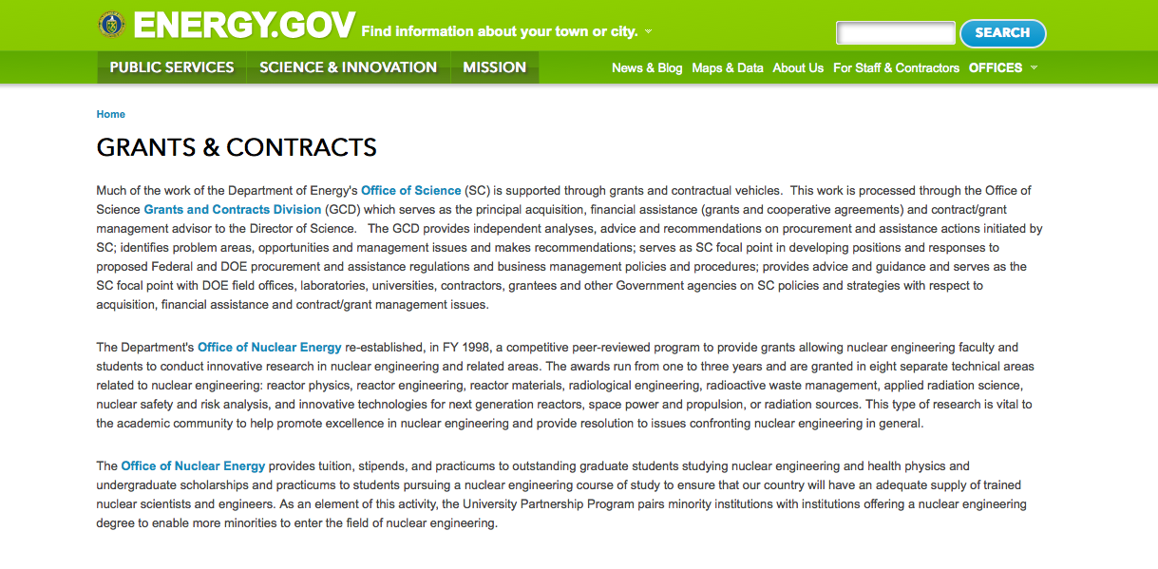
http://www.doe.gov/grants-contracts

Programs:

National Energy Technology Laboratory
Applications for Technologies Directed at Utilizing Carbon Dioxide from Coal Fired Power Plants
Synopsis 1 & 2
http://www.grants.gov/web/grants/view-opportunity.html?oppId=287159

Idaho Field Office
FY2017 Consolidated Innovative Nuclear Research Funding Opportunity Announcement
Synopsis 1
http://www.grants.gov/web/grants/view-opportunity.html?oppId=287261

Golden Field Office
DE-FOA- 0001419 Wave Energy Test Facility
Synopsis 1
http://www.grants.gov/web/grants/view-opportunity.html?oppId=287578

Golden Field Office
Request for Information - DE-FOA-0001635 - POTENTIAL TECHNICAL FOCUS AREAS FOR ADVANCED MANUFACTURING-RELATED TRAINEESHIPS
Synopsis 1
http://www.grants.gov/web/grants/view-opportunity.html?oppId=287593

Idaho Field Office
FY2017 Scientific Infrastructure Support for CINR Funding Opportunity Announcement
Synopsis 1
http://www.grants.gov/web/grants/view-opportunity.html?oppId=288293

Modifications:

Golden Field Office
RFI for Stakeholder Input on Outyear Marine and Hydrokinetic Program Strategy
Synopsis 2
http://www.grants.gov/web/grants/view-opportunity.html?oppId=282701

National Energy Technology Laboratory
Carbon Storage Assurance Facility Enterprise (CarbonSAFE): Storage Complex Facility
Synopsis 4
http://www.grants.gov/web/grants/view-opportunity.html?oppId=285360

National Energy Technology Laboratory
Production of Salable Rare Earth Element Materials from Coal and Coal Byproducts
Synopsis 3
http://www.grants.gov/web/grants/view-opportunity.html?oppId=286409

Idaho Field Office
FY2017 Consolidated Innovative Nuclear Research Funding Opportunity Announcement
Synopsis 2
http://www.grants.gov/web/grants/view-opportunity.html?oppId=287261

PAMS
Department of Energy - Office of Science
Office of Science
Research and Development for Next Generation Neutrinoless Double Beta Decay Technology (R&D NextGen NLDBD-TD)
Synopsis 1
http://www.grants.gov/web/grants/view-opportunity.html?oppId=288167

PAMS
Department of Energy - Office of Science
Office of Science
Atmospheric System Research Program
Synopsis 2
http://www.grants.gov/web/grants/view-opportunity.html?oppId=287722

Golden Field Office
Funding Opportunity Announcement (FOA) Number DE-FOA-0001461, Modification 000001: Co-Optimization of Fuels and Engines
Synopsis 3
http://www.grants.gov/web/grants/view-opportunity.html?oppId=286800

Golden Field Office
HydroNEXT Non-powered Dam Technology Development & Demonstration and North American Grid Integration
Synopsis 6
http://www.grants.gov/web/grants/view-opportunity.html?oppId=286561

Reminders:

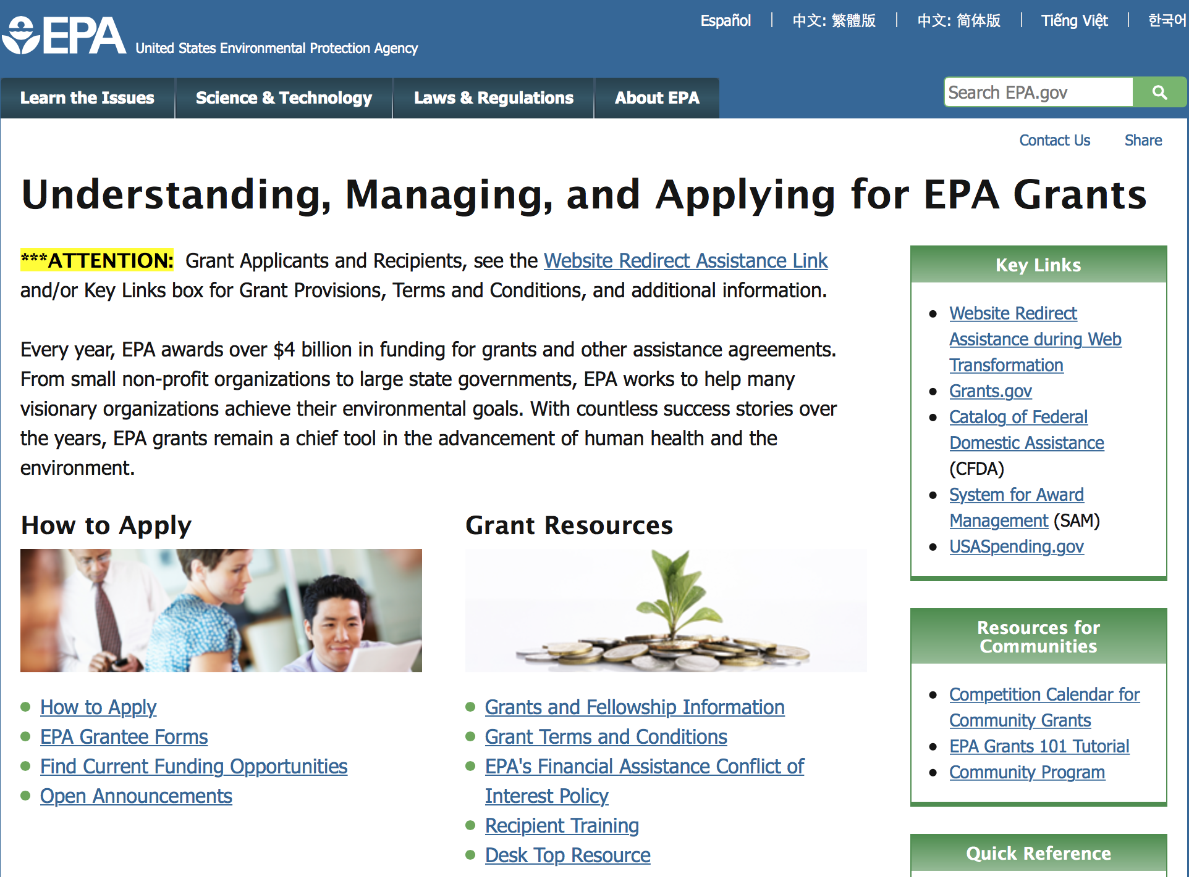

http://www.epa.gov/epahome/grants.htm

Programs:

Training and Technical Assistance to Improve Water Quality and Enable Small Public Water Systems to Provide Safe Drinking Water
Synopsis 1

Document Type: | Grants Notice
Funding Opportunity Number: | EPA-OW-OGWDW-16-02
Funding Opportunity Title: | Training and Technical Assistance to Improve Water Quality and Enable Small Public Water Systems to Provide Safe Drinking Water
Opportunity Category: | Discretionary
Opportunity Category Explanation:
Funding Instrument Type: | Cooperative Agreement
Category of Funding Activity: | Environment
Category Explanation:
Expected Number of Awards: | 9
CFDA Number(s): | 66.424 -- Surveys, Studies, Investigations, Demonstrations, and Training Grants - Section 1442 of the Safe Drinking Water Act  66.436 -- Surveys, Studies, Investigations, Demonstrations, and Training Grants and Cooperative Agreements - Section 104(b)(3) of
Cost Sharing or Matching Requirement: | Yes
Version: | Synopsis 1
Posted Date: | Aug 16, 2016
Last Updated Date: | Aug 16, 2016
Original Closing Date for Applications: | Sep 30, 2016 See the announcement including Section IV for additional submission information
Current Closing Date for Applications: | Sep 30, 2016 See the announcement including Section IV for additional submission information
Archive Date: | Oct 30, 2016
Estimated Total Program Funding: | $12,688,000
Award Ceiling: | $8,005,000
Eligible Applicants: | Others (see text field entitled "Additional Information on Eligibility" for clarification)
Additional Information on Eligibility: | See the announcement including Section III for additional eligibility information
Agency Name: | Environmental Protection Agency
Description: | The U.S. Environmental Protection Agency (EPA) is soliciting applications from eligible applicants as described in Section III.A to provide training and technical assistance for small public water systems to help such systems achieve and maintain compliance with the Safe Drinking Water Act (SDWA), and to provide training and technical assistance for small publicly owned wastewater systems, communities served by onsite/decentralized wastewater systems, and private well owners to improve water quality under the Clean Water Act (CWA). Training and technical assistance activities provided to these systems, communities and private well owners should be made available nationally in rural and urban communities and to personnel of tribally- owned and operated systems.
Link to Additional Information: | Training and Technical Assistance to Improve Water Quality and Enable Small Public Water Systems to Provide Safe Drinking Water
Grantor Contact Information: | If you have difficulty accessing the full announcement electronically, please contact:  Ellen Tarquinio 202-566-2267  Ellen Tarquinio

http://www.grants.gov/web/grants/view-opportunity.html?oppId=287556

Modifications:

Reminders:

Modeling of Climate Change Mitigation, Impacts and Adaptation

Document Type: | Grants Notice
Funding Opportunity Number: | EPA-OAR-OAP-16-07
Funding Opportunity Title: | Modeling of Climate Change Mitigation, Impacts and Adaptation
Opportunity Category: | Discretionary
Opportunity Category Explanation:
Funding Instrument Type: | Cooperative Agreement
Category of Funding Activity: | Environment
Category Explanation:
Expected Number of Awards: | 3
CFDA Number(s): | 66.034 -- Surveys, Studies, Research, Investigations, Demonstrations, and Special Purpose Activities Relating to the Clean Air Act
Cost Sharing or Matching Requirement: | No
Posted Date: | Jul 27, 2016
Last Updated Date: | Jul 27, 2016
Original Closing Date for Applications: | Sep 12, 2016 Please refer to the announcement, including Section IV, for additional information on submission methods and due dates.
Current Closing Date for Applications: | Sep 12, 2016 Please refer to the announcement, including Section IV, for additional information on submission methods and due dates.
Archive Date: | Oct 12, 2016
Estimated Total Program Funding: | $1,250,000
Award Ceiling: | $250,000
Award Floor: | $100,000
Eligible Applicants: | Others (see text field entitled "Additional Information on Eligibility" for clarification)
Additional Information on Eligibility: | See Section III of the announcement for additional eligibility information.
Agency Name: | Environmental Protection Agency
Description: | This notice announces the availability of funds and solicits proposals to advance the field of climate economic modeling to assist decision makers and the public in effectively responding to the challenges and opportunities posed by climate change. The work involved in this effort includes two distinct modeling capabilities. The first is computable general equilibrium (CGE) modeling of climate mitigation and impacts at the level of disaggregation of U.S. states. The second is integrated assessment modeling (IAM) and assessment of multiple greenhouse gases (GHGs) and air pollutants to enhance understanding of climate change impacts.
Link to Additional Information: | Modeling of Climate Change Mitigation, Impacts and Adaptation
Grantor Contact Information: | If you have difficulty accessing the full announcement electronically, please contact:  Eric Smith, Phone: 202-343-9200  Eric Smith

http://www.grants.gov/web/grants/view-opportunity.html?oppId=286601

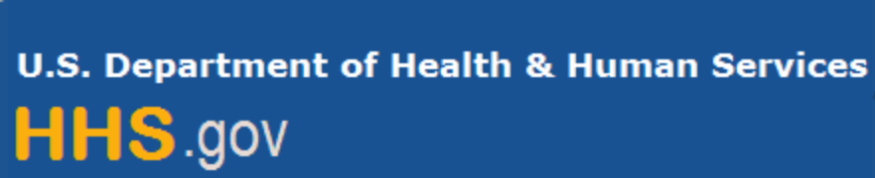

Department of Health and Human Services

Grants Forecast and Overview

The Department of Health and Human Services’ Grants Forecast is a database of planned grant opportunities proposed by its agencies. Each Forecast record contains actual or estimated dates and funding levels for grants that the agency intends to award during the fiscal year. Forecast opportunities are subject to change based on enactment of congressional appropriations. Go to the webpage below for more information.

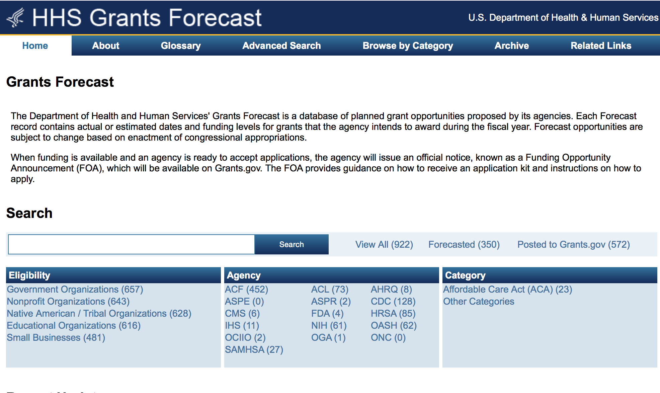
For more general information about HHS Grants and Funding go to the website below at: http://www.hhs.gov/grants/ .

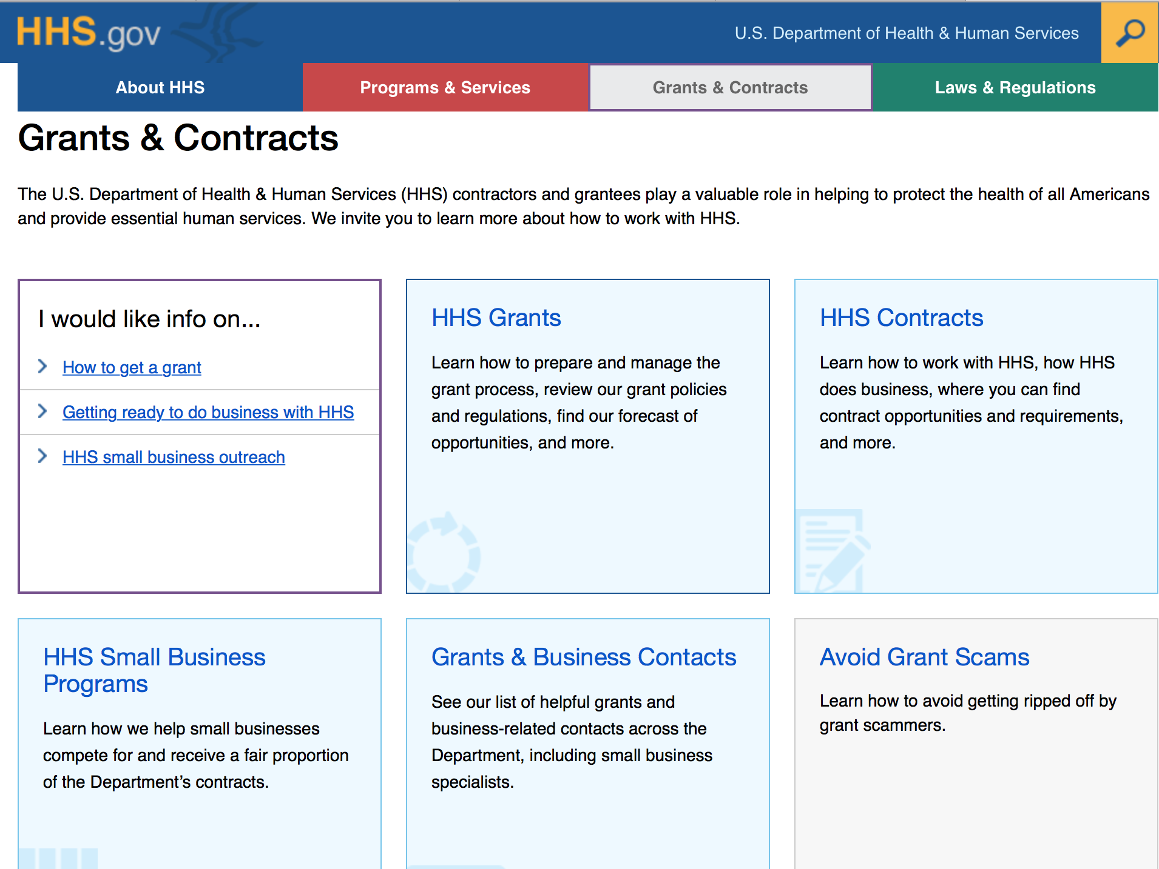

Programs:

Administration for Children and Families - ORR
Standing Announcement for Residential (Shelter) Services for Unaccompanied Children
Forecast 5
Document Type: | Grants Notice
Funding Opportunity Number: | HHS-2017-ACF-ORR-ZU-1132
Funding Opportunity Title: | Standing Announcement for Residential (Shelter) Services for Unaccompanied Children
Opportunity Category: | Discretionary
Opportunity Category Explanation:
Funding Instrument Type: | Cooperative Agreement
Category of Funding Activity: | Income Security and Social Services
Category Explanation:
Expected Number of Awards: | 10
CFDA Number(s): | 93.676 -- Unaccompanied Alien Children Program
Cost Sharing or Matching Requirement: | No
Version: | Synopsis 3
Posted Date: | May 31, 2016
Last Updated Date: | Aug 31, 2016
Original Closing Date for Applications: | Aug 01, 2016 Electronically submitted applications must be submitted no later than 11:59 p.m., ET, on the listed application due date.
Current Closing Date for Applications: | Oct 31, 2016 Electronically submitted applications must be submitted no later than 11:59 p.m., ET, on the listed application due date.
Archive Date: | Nov 30, 2016
Estimated Total Program Funding: | $100,000,000
Award Ceiling: | $45,000,000
Award Floor: | $600,000
Eligible Applicants: | City or township governments  Nonprofits having a 501(c)(3) status with the IRS, other than institutions of higher education  Public and State controlled institutions of higher education  Public housing authorities/Indian housing authorities  Private institutions of higher education  For profit organizations other than small businesses  Native American tribal governments (Federally recognized)  Unrestricted (i.e., open to any type of entity above), subject to any clarification in text field entitled "Additional Information on Eligibility"  Special district governments  Nonprofits that do not have a 501(c)(3) status with the IRS, other than institutions of higher education  Independent school districts  Small businesses  State governments  County governments  Native American tribal organizations (other than Federally recognized tribal governments)
Additional Information on Eligibility: | Care providers are required to be licensed or license eligible (temporary, provisional, or an equivalent license) with license being issued, by a state licensing agency, within 60 days of award to provide residential, group, or foster care services for dependent children. Faith-based and community organizations that meet the eligibility requirements are eligible to receive awards under this funding opportunity announcement. Faith-based organizations are encouraged to review the ACF Policy on Grants to Faith-Based Organizations at: http: //www.acf.hhs.gov/acf-policy-on-grants-to-faith-based-organizations. Applications from individuals (including sole proprietorships) and foreign entities are not eligible and will be disqualified from competitive review and from funding under this announcement.
Agency Name: | Administration for Children and Families - ORR
Description: | The Office of Refugee Resettlement/Division of Children's Services (ORR/DCS), within the Administration for Children and Families, provides temporary shelter care and other child welfare-related services to Unaccompanied Children (UC) in ORR custody. Residential care services begin once ORR accepts a UC for placement and ends when the minor is released from ORR custody, turns 18 years of age, or the minor's immigration case results in a final disposition of removal from the United States. Residential care and other child welfare-related services are provided by State-licensed residential care programs in the least restrictive setting appropriate for the UC's age and special needs. ORR is announcing this funding opportunity announcement (FOA) to seek shelter, to include group homes and transitional foster care, care providers. Residential care providers, operating a shelter facility, must be licensed by an appropriate State agency to provide residential, group, or foster care services for children. All entities, funded under this FOA, must also comply with the Flores Settlement Agreement, the Perez-Olano Settlement Agreement, Case No. CV05-3604 (C.D. Cal., Dec. 14, 2010), pertinent regulations, laws, and ORR policies, instructions, and procedures. ORR encourages applicants to review ORR's policies, instructions, and procedures at: http://www.acf.hhs.gov/programs/orr/resource/children-entering-the-united-states-unaccompanied as these will be critical to the overall program design.
Link to Additional Information: | https://ami.grantsolutions.gov/HHS-2017-ACF-ORR-ZU-1132
Grantor Contact Information: | If you have difficulty accessing the full announcement electronically, please contact:  ACF Applications Help Desk app_support@acf.hhs.gov  ACF Applications Help Desk

http://www.grants.gov/web/grants/view-opportunity.html?oppId=284278

Research:

Administration for Children and Families - ORR
Standing Announcement for Residential (Shelter) Services for Unaccompanied Children
Synopsis 3
http://www.grants.gov/web/grants/view-opportunity.html?oppId=284278

Administration for Children and Families - ORR
Refugee Microenterprise Development (MED) Program
Forecast 1
http://www.grants.gov/web/grants/view-opportunity.html?oppId=287953

Administration for Children and Families - OPRE
Early Care and Education Research Scholars: Child Care Research Scholars
Forecast 1
http://www.grants.gov/web/grants/view-opportunity.html?oppId=287555

Administration for Children and Families - OPRE
Early Care and Education Research Scholars: Head Start Graduate Student Research Grants
Forecast 1
http://www.grants.gov/web/grants/view-opportunity.html?oppId=287810

Administration for Children and Families - ORR
Refugee Career Pathways Program
Forecast 1
http://www.grants.gov/web/grants/view-opportunity.html?oppId=287809

Administration for Children and Families - ACYF/CB
Regional Partnership Grants to Increase the Well-Being of, and to Improve the Permanency Outcomes for, Children Affected by Substance Abuse
Forecast 1

http://www.grants.gov/web/grants/view-opportunity.html?oppId=288213

Centers for Disease Control and Prevention - ERA
Vector-Borne Diseases Regional Centers for Excellence
Forecast 1
http://www.grants.gov/web/grants/view-opportunity.html?oppId=287052

Health Resources and Services Administration
National Training and Technical Assistance Cooperative Agreements (NCAs)
Forecast 2
http://www.grants.gov/web/grants/view-opportunity.html?oppId=284908

Health Resources and Services Administration
Regional Hemophilia Network
Synopsis 1
http://www.grants.gov/web/grants/view-opportunity.html?oppId=286979

Health Resources and Services Administration
Universal Newborn Hearing Screening and Intervention Program
Synopsis 1
http://www.grants.gov/web/grants/view-opportunity.html?oppId=287487

Health Resources and Services Administration
Ryan White HIV/AIDS Program Part A HIV Emergency Relief Grant Program
Synopsis 1
http://www.grants.gov/web/grants/view-opportunity.html?oppId=287484

National Institutes of Health
NIDDK Inflammatory Bowel Disease Genetics Consortium (IBDGC) Genetic Research Centers (GRCs) (U01)
Synopsis 1
http://www.grants.gov/web/grants/view-opportunity.html?oppId=287599

National Institutes of Health
Kidney Precision Medicine Project Central Hub (U2C)
Synopsis 1
http://www.grants.gov/web/grants/view-opportunity.html?oppId=287587

National Institutes of Health
Identification of Mechanisms Mediating the Effects of Sleep on Diabetes-Related Metabolism in Humans (R01)
Synopsis 1
http://www.grants.gov/web/grants/view-opportunity.html?oppId=287579

National Institutes of Health
Wearable Alcohol Biosensors (R43/R44)
Synopsis 1
http://www.grants.gov/web/grants/view-opportunity.html?oppId=287581

National Institutes of Health
Kidney Precision Medicine Project Tissue Interrogation Sites (UG3/UH3)
Synopsis 1
http://www.grants.gov/web/grants/view-opportunity.html?oppId=287582

National Institutes of Health
Kidney Precision Medicine Project Recruitment Sites (UG3/UH3)
Synopsis 1
http://www.grants.gov/web/grants/view-opportunity.html?oppId=287600

National Institutes of Health
Planning Grant for Emerging Epidemic Virus Research Training for West African Countries with Widespread Transmission of Ebola- Guinea, Liberia, and Sierra Leone (D71)
Synopsis 1
http://www.grants.gov/web/grants/view-opportunity.html?oppId=287549

National Institutes of Health
NHLBI Program Project Applications (P01)
Synopsis 1
http://www.grants.gov/web/grants/view-opportunity.html?oppId=287485

National Institutes of Health
Human Heredity and Health in Africa (H3Africa): Research Projects (U01)
Synopsis 1
http://www.grants.gov/web/grants/view-opportunity.html?oppId=287230

National Institutes of Health
Human Heredity and Health in Africa (H3Africa): Ethical, Legal, and Societal Issues (ELSI) Collaborative Centers (U54)
Synopsis 1
http://www.grants.gov/web/grants/view-opportunity.html?oppId=287192

National Institutes of Health
Human Heredity and Health in Africa (H3Africa): Ethical, Legal, and Societal Issues (ELSI) Research Program (U01)
Synopsis 1
http://www.grants.gov/web/grants/view-opportunity.html?oppId=287194

National Institutes of Health
Human Heredity and Health in Africa (H3Africa): Global Health Bioinformatics Research Training Program (U2R)
Synopsis 1
http://www.grants.gov/web/grants/view-opportunity.html?oppId=287195

National Institutes of Health
NIH Big Data to Knowledge (BD2K) Enhancing Diversity in Biomedical Data Science (R25)
Synopsis 1
http://www.grants.gov/web/grants/view-opportunity.html?oppId=287129

National Institutes of Health
Human Heredity and Health in Africa (H3 Africa): Collaborative Centers (U54)
Synopsis 1
http://www.grants.gov/web/grants/view-opportunity.html?oppId=287140

National Institutes of Health
Secondary Analyses of Alcohol and Chronic Disease (R03)
Synopsis 1
http://www.grants.gov/web/grants/view-opportunity.html?oppId=287256

National Institutes of Health
Centers for HIV/AIDS-Related Structural Biology (P50)
Synopsis 1
http://www.grants.gov/web/grants/view-opportunity.html?oppId=287280

National Institutes of Health
Core Clinical Centers for the Blood and Marrow Transplant Clinical Trials Network (UG1)
Synopsis 1
http://www.grants.gov/web/grants/view-opportunity.html?oppId=287710

National Institutes of Health
Limited Competition: Data Coordinating Center for the Blood and Marrow Transplant Clinical Trials Network (U24)
Synopsis 1
http://www.grants.gov/web/grants/view-opportunity.html?oppId=287711

National Institutes of Health
Maximizing Investigator's Research Award for New and Early Stage Investigators (R35)
Synopsis 1
http://www.grants.gov/web/grants/view-opportunity.html?oppId=287729

National Institutes of Health
NICHD Laboratory of Developmental Biology (R24)
Synopsis 1
http://www.grants.gov/web/grants/view-opportunity.html?oppId=287295

National Institutes of Health
Engineering Next-Generation Human Nervous System Microphysiological Systems (R01)
Synopsis 1
http://www.grants.gov/web/grants/view-opportunity.html?oppId=287299

National Institutes of Health
Engineering Next-Generation Human Nervous System Microphysiological Systems (R21)
Synopsis 1
http://www.grants.gov/web/grants/view-opportunity.html?oppId=287300

National Institutes of Health
NCI Mentored Clinical Scientist Research Career Development Award to Promote Diversity (K08)
Synopsis 1
http://www.grants.gov/web/grants/view-opportunity.html?oppId=287303

National Institutes of Health
BRAIN Initiative: Development and Validation of Novel Tools to Analyze Cell-Specific and Circuit-Specific Processes in the Brain (R01)
Synopsis 1
http://www.grants.gov/web/grants/view-opportunity.html?oppId=287311

National Institutes of Health
Hypertension Outcomes for T4 Research within Lower Middle-Income Countries (Hy-TREC) (U01)
Synopsis 1
http://www.grants.gov/web/grants/view-opportunity.html?oppId=287372

National Institutes of Health
Single-Site Investigator-Initiated Clinical Trials (R61/R33)
Synopsis 1
http://www.grants.gov/web/grants/view-opportunity.html?oppId=287496

National Institutes of Health
Big Data to Knowledge (BD2K) Community-based Data and Metadata Standards Efforts (R24)
Synopsis 1
http://www.grants.gov/web/grants/view-opportunity.html?oppId=287532

National Institutes of Health
BRAIN Initiative: Foundations of Non-Invasive Functional Human Brain Imaging and Recording - Bridging Scales and Modalities (R01)
Synopsis 1
http://www.grants.gov/web/grants/view-opportunity.html?oppId=287497

National Institutes of Health
NLM Express Research Grants in Biomedical Informatics (R01)
Synopsis 1
http://www.grants.gov/web/grants/view-opportunity.html?oppId=287499

National Institutes of Health
Limited Competition: Additional Sequencing for the Alzheimer's Disease Sequencing Project (U01)
Synopsis 1
http://www.grants.gov/web/grants/view-opportunity.html?oppId=287494

National Institutes of Health
NIAID Resource-Related Research Projects (R24)
Synopsis 1
http://www.grants.gov/web/grants/view-opportunity.html?oppId=287651

National Institutes of Health
NIAID Investigator Initiated Program Project Applications (P01)
Synopsis 1
http://www.grants.gov/web/grants/view-opportunity.html?oppId=287659

National Institutes of Health
Understanding and Addressing the Multi-level Influences on Uptake and Adherence to HIV Prevention Strategies Among Adolescent Girls and Young Women in Sub-Saharan Africa (R21)
Synopsis 1
http://www.grants.gov/web/grants/view-opportunity.html?oppId=287479

National Institutes of Health
NCI Outstanding Investigator Award (R35)
Synopsis 1
http://www.grants.gov/web/grants/view-opportunity.html?oppId=287597

National Institutes of Health
Understanding and Addressing the Multi-level Influences on Uptake and Adherence to HIV Prevention Strategies Among Adolescent Girls and Young Women in Sub-Saharan Africa (R01)
Synopsis 1
http://www.grants.gov/web/grants/view-opportunity.html?oppId=287480

National Institutes of Health
Understanding and Addressing the Multi-level Influences on Uptake and Adherence to HIV Prevention Strategies Among Adolescent Girls and Young Women in Sub-Saharan Africa (R34)
Synopsis 1
http://www.grants.gov/web/grants/view-opportunity.html?oppId=287481

National Institutes of Health
NCI Mentored Patient-Oriented Research Career Development Award to Promote Diversity (K23)
Synopsis 1
http://www.grants.gov/web/grants/view-opportunity.html?oppId=287316

National Institutes of Health
NCI Mentored Research Scientist Development Award to Promote Diversity (K01)
Synopsis 1
http://www.grants.gov/web/grants/view-opportunity.html?oppId=287318

National Institutes of Health
Asthma and Allergic Diseases Cooperative Research Centers (U19)
Synopsis 1
http://www.grants.gov/web/grants/view-opportunity.html?oppId=287269

National Institutes of Health
BD2K Research Education Curriculum Development: Data Science Overview for Biomedical Scientists (R25)
Synopsis 1
http://www.grants.gov/web/grants/view-opportunity.html?oppId=287260

National Institutes of Health
Limited Competition for the Continuation of the Hepatitis B Research Network Clinical Centers (U01)
Synopsis 1
http://www.grants.gov/web/grants/view-opportunity.html?oppId=287639

National Institutes of Health
BRAIN Initiative: Non-Invasive Neuromodulation - New Tools and Techniques for Spatiotemporal Precision (R01)
Synopsis 1
http://www.grants.gov/web/grants/view-opportunity.html?oppId=287893

National Institutes of Health
U.S.-Russia Bilateral Collaborative Research Partnerships on Cancer (R21)
Synopsis 1
http://www.grants.gov/web/grants/view-opportunity.html?oppId=286978

National Institutes of Health
Oncology Co-Clinical Imaging Research Resources to Encourage Consensus on Quantitative Imaging Methods and Precision Medicine (U24)
Synopsis 1
http://www.grants.gov/web/grants/view-opportunity.html?oppId=287039

National Institutes of Health
Exploratory/Developmental Surgical Disparities Research (R21)
Synopsis 1
http://www.grants.gov/web/grants/view-opportunity.html?oppId=287053

National Institutes of Health
Research on Autism Spectrum Disorders (R03)
Synopsis 1
http://www.grants.gov/web/grants/view-opportunity.html?oppId=287037

National Institutes of Health
Research on Autism Spectrum Disorders (R21)
Synopsis 1
http://www.grants.gov/web/grants/view-opportunity.html?oppId=287065

National Institutes of Health
NIDA Program Project Grant Applications (P01)
Synopsis 1
http://www.grants.gov/web/grants/view-opportunity.html?oppId=287069

National Institutes of Health
NIMH Career Transition Award for Tenure-Track and Tenured Intramural Investigators (K22)
Synopsis 1
http://www.grants.gov/web/grants/view-opportunity.html?oppId=287057

National Institutes of Health
Research on Autism Spectrum Disorders (R01)
Synopsis 1
http://www.grants.gov/web/grants/view-opportunity.html?oppId=287059

National Institutes of Health
Novel Methods for Obtaining Molecular Information from Archived Tissue Samples (R43/R44)
Synopsis 1
http://www.grants.gov/web/grants/view-opportunity.html?oppId=287050

National Institutes of Health
NIBIB Trailblazer Award for New and Early Stage Investigators (R21)
Synopsis 1
http://www.grants.gov/web/grants/view-opportunity.html?oppId=287030

National Institutes of Health
Surgical Disparities Research (R01)
Synopsis 1
http://www.grants.gov/web/grants/view-opportunity.html?oppId=287032

National Institutes of Health
Understanding HIV Persistence in Infants (R01)
Synopsis 1
http://www.grants.gov/web/grants/view-opportunity.html?oppId=287033

National Institutes of Health
NINDS Morris K. Udall Centers of Excellence for Parkinson's Disease Research (P50)
Synopsis 1
http://www.grants.gov/web/grants/view-opportunity.html?oppId=287956

National Institutes of Health
NLM Information Resource Grants to Reduce Health Disparities (G08)
Synopsis 1
http://www.grants.gov/web/grants/view-opportunity.html?oppId=288096

National Institutes of Health
NCI Small Grants Program for Cancer Research (NCI Omnibus R03)
Synopsis 1
http://www.grants.gov/web/grants/view-opportunity.html?oppId=288036

National Institutes of Health
NLM Grants for Scholarly Works in Biomedicine and Health (G13)
Synopsis 1
http://www.grants.gov/web/grants/view-opportunity.html?oppId=288055

National Institutes of Health
Centers of Biomedical Research Excellence (COBRE) (P20)
Synopsis 1
http://www.grants.gov/web/grants/view-opportunity.html?oppId=287971

National Institutes of Health
Big Data to Knowledge (BD2K) Enhancing the Efficiency and Effectiveness of Digital Curation for Biomedical Big Data (U01)
Synopsis 1
http://www.grants.gov/web/grants/view-opportunity.html?oppId=287915

National Institutes of Health
Bench Testing Therapeutic/Indication Pairing Strategies (UH2/UH3)
Synopsis 1
http://www.grants.gov/web/grants/view-opportunity.html?oppId=287958

National Institutes of Health
Innovation Corps (I-Corps) at NIH Program for NIH and CDC Phase I Small Business Innovation Research (SBIR) and Small Business Technology Transfer (STTR) Grantees (Admin Supp )
Synopsis 1
http://www.grants.gov/web/grants/view-opportunity.html?oppId=287969

National Institutes of Health
Collaborative Initiative on Fetal Alcohol Spectrum Disorders (CIFASD) Informatics Research Resource (U24)
Synopsis 1
http://www.grants.gov/web/grants/view-opportunity.html?oppId=288098

National Institutes of Health
Collaborative Initiative on Fetal Alcohol Spectrum Disorders (CIFASD) Exploratory/Developmental Projects (UH2)
Synopsis 1
http://www.grants.gov/web/grants/view-opportunity.html?oppId=288114

National Institutes of Health
Collaborative Initiative on Fetal Alcohol Spectrum Disorders (CIFASD) Outreach/Dissemination Resource (U24)
Synopsis 1
http://www.grants.gov/web/grants/view-opportunity.html?oppId=288115

National Institutes of Health
Collaborative Initiative on Fetal Alcohol Spectrum Disorders (CIFASD) Administrative Resource (U24)
Synopsis 1
http://www.grants.gov/web/grants/view-opportunity.html?oppId=288116

National Institutes of Health
Collaborative Initiative on Fetal Alcohol Spectrum Disorders (CIFASD) Research Project (U01)
Synopsis 1
http://www.grants.gov/web/grants/view-opportunity.html?oppId=288117

National Institutes of Health
Maximizing the Scientific Value of the NHLBI Biorepository: Scientific Opportunities for Exploratory Research (R21)
Synopsis 1
http://www.grants.gov/web/grants/view-opportunity.html?oppId=288118

National Institutes of Health
Notice of Intent to Publish a Funding Opportunity Announcement for the Coordinating Center for Population-based Research to Optimize the Screening Process (PROSPR) Initiative
Forecast 1
http://www.grants.gov/web/grants/view-opportunity.html?oppId=288252

National Institutes of Health
Exploratory Clinical Trials and Studies of Natural Products in NCCIH High Priority Research Topics (R33)
Synopsis 1
http://www.grants.gov/web/grants/view-opportunity.html?oppId=288275

National Institutes of Health
Exploratory Clinical Trials and Studies of Natural Products in NCCIH High Priority Research Topics (R61/R33)
Synopsis 1
http://www.grants.gov/web/grants/view-opportunity.html?oppId=288276

Modifications:

Administration for Children and Families - OPRE
Early Care and Education Research Scholars: Child Care Research Scholars
Forecast 3
http://www.grants.gov/web/grants/view-opportunity.html?oppId=287555

Administration for Children and Families - OCS
Assets for Independence Demonstration Program
Synopsis 8 & 9
http://www.grants.gov/web/grants/view-opportunity.html?oppId=275744

Centers for Disease Control and Prevention - ERA
State Occupational Safety and Health Surveillance Program (SSP)
Synopsis 6
http://www.grants.gov/web/grants/view-opportunity.html?oppId=258990

Centers for Disease Control and Prevention - ERA
Cooperative Research Agreements Related to the World Trade Center Health Program (U01)
Synopsis 6
http://www.grants.gov/web/grants/view-opportunity.html?oppId=282342

Health Resources and Services Administration
State and Regional Primary Care Associations
Forecast 2
http://www.grants.gov/web/grants/view-opportunity.html?oppId=284907

National Institutes of Health
Maximizing Investigators' Research Award for Early Stage Investigators (R35)
Synopsis 2
http://www.grants.gov/web/grants/view-opportunity.html?oppId=287729

National Institutes of Health
Understanding HIV Persistence in Infants (R01)
Synopsis 2
http://www.grants.gov/web/grants/view-opportunity.html?oppId=287033

National Institutes of Health
Centers for HIV/AIDS-Related Structural Biology (P50)
Synopsis 2
http://www.grants.gov/web/grants/view-opportunity.html?oppId=287280

National Institutes of Health
Data Coordinating Center for Multi-Site Investigator-Initiated Clinical Trials (Collaborative U24)
Synopsis 3
http://www.grants.gov/web/grants/view-opportunity.html?oppId=284258

National Institutes of Health
Integrating Biospecimen Science into Clinical Assay Development (U01)
Synopsis 3
http://www.grants.gov/web/grants/view-opportunity.html?oppId=282768

National Institutes of Health
Human Heredity and Health in Africa (H3Africa): Ethical, Legal, and Societal Issues (ELSI) Research Program (U01)
Synopsis 2
http://www.grants.gov/web/grants/view-opportunity.html?oppId=287194

Reminders:

Deletions:

Centers for Disease Control - CGH
CDC-RFA-GH17-1715 - Assist the Ministry of Health to Provide Critical Human Resources for Health to Achieve HIV Epidemic Control in Malawi under the President's Emergency Plan for AIDS Relief (PEPFAR)
Deletion Comments: Opportunity deleted...Will be posted at a later date.

Centers for Disease Control - CGH
CDC-RFA-GH16-1659 - Accelerating Epidemic Control in Fort Portal region in the Republic of Uganda under the President's Emergency Plan for AIDS Relief(PEPFAR)
Deletion Comments: Opportunity deleted

Centers for Disease Control - CGH
CDC-RFA-GH16-1658 - Accelerating Epidemic Control in Arua region in the Republic of Uganda under the President's Emergency Plan for AIDS Relief (PEPFAR)
Deletion Comments: Opportunity deleted

Centers for Disease Control - CGH
CDC-RFA-GH17-1732 - Strengthening of Ghana National Health Management Systems in the Areas of Strategic Information Systems and Laboratory Capacity Building under the President's Emergency Plan for AIDS Relief (PEPFAR)
Deletion Comments: Opportunity deleted

Centers for Disease Control - CGH
CDC-RFA-GH15-15370201SUPP16 - Program Expansion Supplement: Technical Assistance to Provide High-Quality Voluntary Medical Male Circumcision (VMMC) Services to Programs Supported by the President's Emergency Plan for AIDS Relief (PEPFAR)
Deletion Comments: Opportunity deleted

Health Resources and Services Administration
HRSA-17-069 - Primary Care Training and Enhancement (PCTE)
Deletion Comments: Opportunity deleted

Department of Homeland Security

The Department of Homeland Security enhances the ability of states, local and tribal jurisdictions, and other regional authorities in the preparation, prevention, and response to terrorist attacks and other disasters, by distributing grant funds. Localities can use grants for planning, equipment, training and exercise needs.

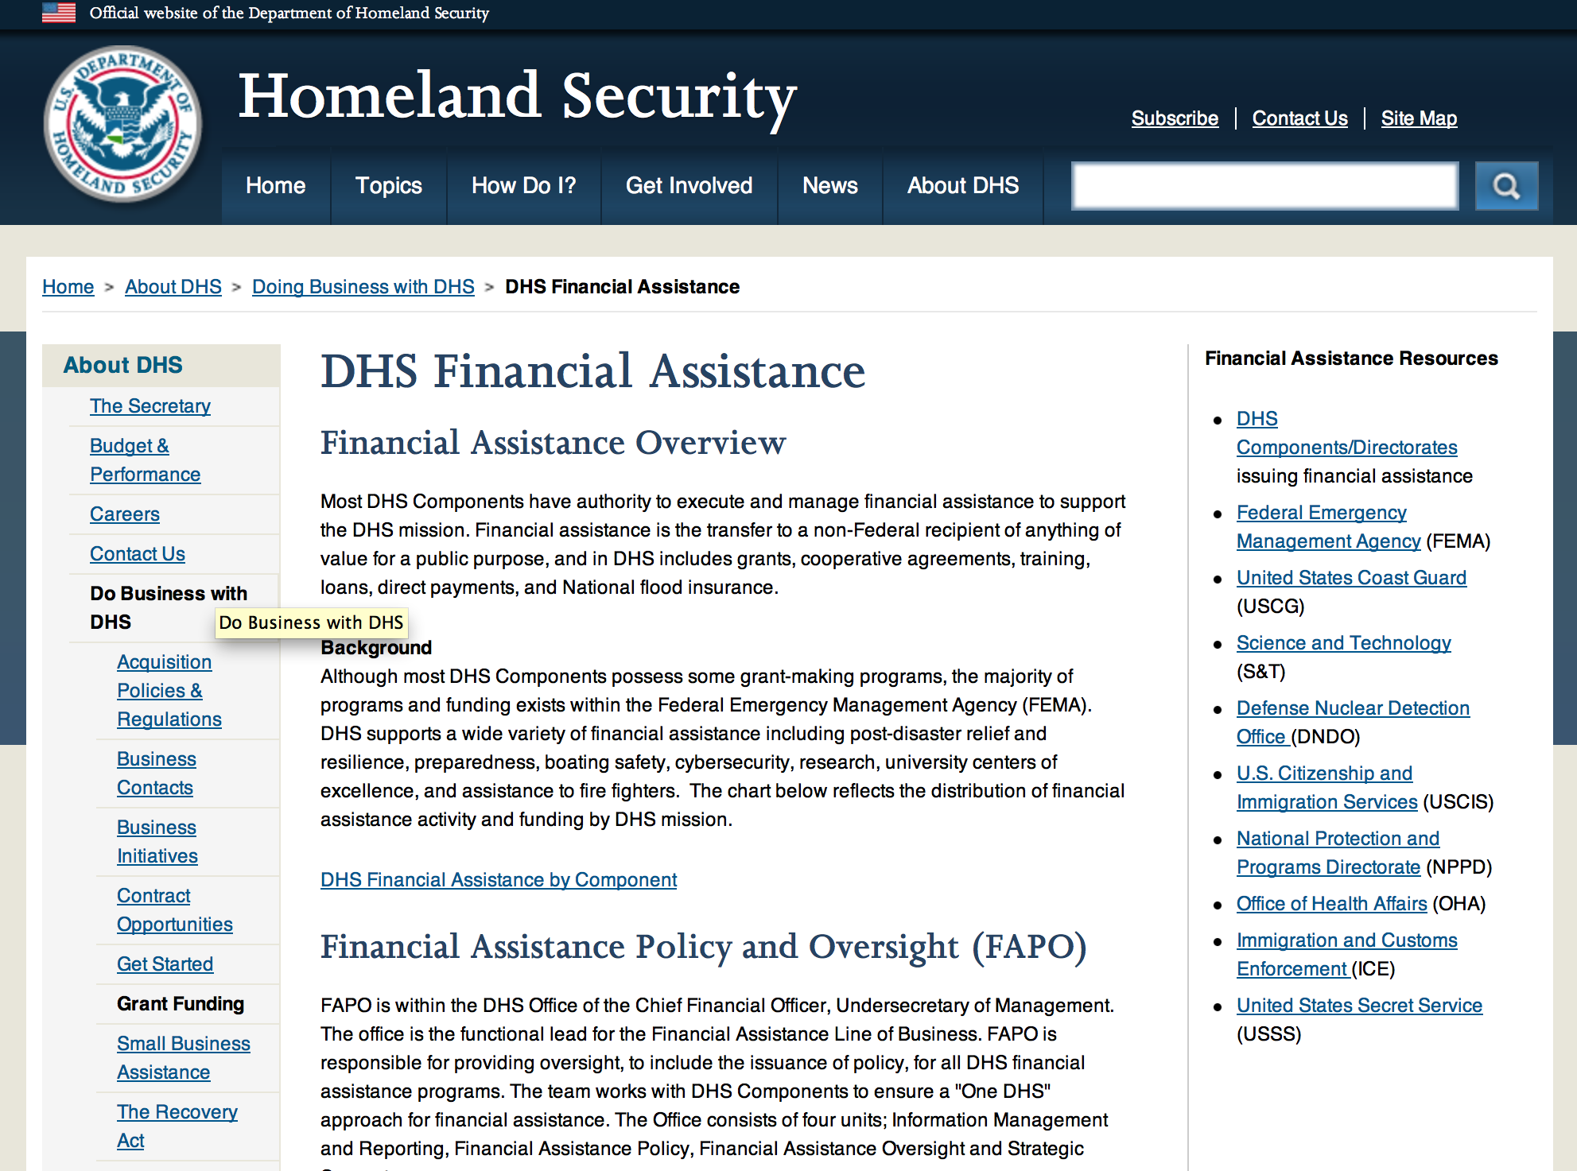

Webpage can be viewed at: http://www.dhs.gov/xopnbiz/grants/index.shtm#2

The FY 2016 Assistance to Firefighters Grants (AFG)
FY 2016 ASSISTANCE TO FIREFIGHTERS (AFG) GRANTS ANNOUNCEMENT
The FY 2016 AFG Open Application Period Dates Will Be As Follows: 8AM ET OCTOBER 11 through 5PM ET NOVEMBER 18
- FY 2016 Application Workshop Schedule
- FY 2016 AFG Application Guidance Materials The following documents are now available:
  - FY 2016 Notice of Funding Opportunity (NOFO) – Available Now
  - FY 2016 AFG Grant Application Get Ready Guide
  - FY 2016 AFG Narrative Get Ready Guide
  - FY 2016 AFG Self-Evaluation - Operations and Safety
  - FY 2016 AFG Self-Evaluation - Vehicle Acquisition
  - FY 2016 AFG Application Checklist
  - FY 2016 AFG Cost Share Calculator
FY 2016 AFG FAQs
For AFG program guidance materials, please visit our Documents page.

FY 2015 FIRE PREVENTION & SAFETY (FP&S) Grants
- FY 2015 Application Information Coming Soon
- FP&S Success Stories
FY 2014 FIRE PREVENTION & SAFETY (FP&S) Grants
- FY 2014 FP&S Award Announcements - View Awards List

FY 2015 STAFFING FOR ADEQUATE FIRE and EMERGENCY RESPONSE (SAFER) Grants
- FY 2015 Application Information Coming Soon
- SAFER Success Stories
FY 2014 STAFFING FOR ADEQUATE FIRE and EMERGENCY RESPONSE (SAFER) Grants
- FY 2014 FP&S Award Announcements - View Awards List
FP&S Success Stories

Resources

AFG Help Desk
Contact the AFG Program Help Desk toll-free at 866-274-0960, or email us at firegrants@dhs.gov.
The AFG Program has Fire Program Specialists in 10 federal regional centers. These Regional Fire Program Specialists respond to questions about the AFG program and carry out grant monitoring activities. View regional contacts

Popular AFG links
- AFG Workshop Schedule
- Assistance to Firefighters Grants (AFG)
- AFG Awards List
- AFG Success Stories
- Staffing for Adequate Fire & Emergency Response (SAFER) Grants (SAFER)
- SAFER Awards List
- SAFER Success Stories
- Fire Prevention & Safety (FP&S) Grants
- FP&S Awards List
- FP&S Success Stories
- Grant Closeout Tutorial
- Assistance to Firefighters Grant (AFG) Email Alert Archive
- Frequently Asked Questions
Contact Information For The Assistance to Firefighters Grant (AFG) Program and Help Desk

Federal Funding Alternative To AFG

State Administrative Agencies (SAA) apply for and administer Federal grants on behalf of their States, including FEMA Preparedness Grants. The SAA will work with eligible organizations to comply with the general requirements of grant programs or cooperative agreements. Contact your State’s SAA to find out what current Federal funding opportunities may be available to your organization. A listing of the SAAs and points of contact can be found at http://www.fema.gov/library/viewRecord.do?id=6363.

Programs:

Department of Homeland Security - FEMA
Assistance to Firefighters Grant (AFG)

Synopsis 1
Document Type: | Grants Notice
Funding Opportunity Number: | DHS-16-GPD-044-00-99
Funding Opportunity Title: | Assistance to Firefighters Grant (AFG)
Opportunity Category: | Discretionary
Opportunity Category Explanation:
Funding Instrument Type: | Grant
Category of Funding Activity: | Other (see text field entitled "Explanation of Other Category of Funding Activity" for clarification)
Category Explanation: | Firefighting and emergency medical service related equipment, training
Expected Number of Awards: | 2500
CFDA Number(s): | 97.044 -- Assistance to Firefighters Grant
Cost Sharing or Matching Requirement: | Yes
Posted Date: | Sep 01, 2016
Last Updated Date: | Sep 01, 2016
Original Closing Date for Applications: | Nov 18, 2016
Current Closing Date for Applications: | Nov 18, 2016
Archive Date: | Dec 18, 2016
Estimated Total Program Funding: | $310,500,000
Award Ceiling: | $3,450,000
Award Floor: | $0
Eligible Applicants: | Others (see text field entitled "Additional Information on Eligibility" for clarification)  City or township governments  County governments
Additional Information on Eligibility: | Fire Departments, nonaffiliated Emergency Medical Service (EMS) organizations, State Fire Training Academies.
Agency Name: | Department of Homeland Security - FEMA
Description: | The Department of Homeland Security (DHS) Federal Emergency Management Agency's (FEMA) Grant Programs Directorate implements and administers the Assistance to Firefighters Grant (AFG) program. The AFG program provides financial assistance to help fire departments, nonaffiliated Emergency Medical Service (EMS) organizations and State Fire Training Academies (SFTA); for critically needed resources to protect the public; to train emergency personnel, and to foster interoperability and support community resilience, as well as enhance through direct financial assistance, the safety of the public and to provide a continuum of support for emergency responders regarding fire, medical, and all hazard events.
Link to Additional Information: | Program Guidance
Grantor Contact Information: | If you have difficulty accessing the full announcement electronically, please contact:  AFG P&S Help Desk Phone: 8662740960 Email: firegrants@fema.gov  firegrants@fema.gov

http://www.grants.gov/web/grants/view-opportunity.html?oppId=288278

Modifications:

Office of Procurement Operations - Grants Division
2016 DHS Scientific Leadership Awards for Minority Serving Institutions (MSI) Granting Bachelor Degrees
Synopsis 2

Document Type: |  | Grants Notice
Funding Opportunity Number: |  | DHS-16-ST-062-001
Funding Opportunity Title: |  | 2016 DHS Scientific Leadership Awards for Minority Serving Institutions (MSI) Granting Bachelor Degrees
Opportunity Category: |  | Discretionary
Opportunity Category Explanation:
Funding Instrument Type: |  | Grant
Category of Funding Activity: |  | Education
Category Explanation:
Expected Number of Awards: |  | 6
CFDA Number(s): |  | 97.062 -- Scientific Leadership Awards
Cost Sharing or Matching Requirement: |  | No
Version: |  | Synopsis 2
Posted Date: |  | Aug 03, 2016
Last Updated Date: |  | Aug 05, 2016
Original Closing Date for Applications: |  | Oct 05, 2016
Current Closing Date for Applications: |  | Oct 05, 2016
Archive Date: |  | Nov 04, 2016
Estimated Total Program Funding: |  | $3,600,000
Award Ceiling: |  | $1,200,000
Award Floor: |  | $1,000,000
Eligible Applicants: |  | Private institutions of higher education  Public and State controlled institutions of higher education
Agency Name: | Office of Procurement Operations - Grants Division
Description: | The Science and Technology Directorate (S&T) is DHS’s primary research and development (R&D) arm. S&T manages science and technology research, from development through transition, for the department's operational components and the nation’s first responders. S&T’s engineers, scientists and researchers work closely with industry and academic partners to ensure R&D investments address the high-priority needs of today and the growing demands of the future. The DHS Scientific Leadership Awards (SLA) program is one of several programs administered by the S&T Office of University Programs. Through the SLA program, OUP seeks to build a diverse, highly capable, technical workforce for the homeland security enterprise. This NOFO is soliciting applications from Minority Serving Intuitions (MSIs) to establish programs that relevant to S&T’s mission within their institutions or MSI networks.
Link to Additional Information: | https://fpdi.adobeconnect.com/hsup/
Grantor Contact Information: | If you have difficulty accessing the full announcement electronically, please contact:  stephanie dawkins grants specialist Phone 202-447-0495  stephanie.dawkins@hq.dhs.gov

http://www.grants.gov/web/grants/view-opportunity.html?oppId=286814

Reminders:

Office of Procurement Operations - Grants Division
DHS S&T Center of Excellence for Homeland Security Quantitative Analysis – Center Partner
Synopsis 1

Document Type: |  | Grants Notice
Funding Opportunity Number: |  | DHS-16-ST-061-HSQA-PARTNER
Funding Opportunity Title: |  | DHS S&T Center of Excellence for Homeland Security Quantitative Analysis – Center Partner
Opportunity Category: |  | Discretionary
Opportunity Category Explanation:
Funding Instrument Type: |  | Cooperative Agreement
Category of Funding Activity: |  | Science and Technology and other Research and Development
Category Explanation:
Expected Number of Awards: |  | 3
CFDA Number(s): |  | 97.061 -- Centers for Homeland Security
Cost Sharing or Matching Requirement: |  | No
Posted Date: |  | Aug 01, 2016
Last Updated Date: |  | Aug 01, 2016
Original Closing Date for Applications: |  | Nov 01, 2016
Current Closing Date for Applications: |  | Nov 01, 2016
Archive Date: |  | Dec 01, 2016
Estimated Total Program Funding: |  | $500,000
Award Ceiling: |  | $500,000
Award Floor: |  | $100,000
Eligible Applicants: |  | Private institutions of higher education  Public and State controlled institutions of higher education
Agency Name: | Office of Procurement Operations - Grants Division
Description: | IMPORTANT: DHS will conduct an informational webinar for interested applicants on August 23, 2016 at 3:00pm [EST]. The Department of Homeland Security (DHS) Science and Technology Directorate (S&T) Office of University Programs (OUP) is requesting applications from U.S. colleges and universities to serve as a partner institution for the Center for Homeland Security Quantitative Analysis (CHSQA). OUP is also posting a separate NOFO for eligible applicants to submit lead proposals for consideration. Please see NOFO Number DHS-16-ST-061-HSQA-Partner or 97.061 on http://www.grants.gov for directions on how to submit single project proposals. DHS will select qualified individual projects from applications received for either the Center Lead NOFO or the Center Partner NOFO, regardless of the institution that is awarded as lead institution. Principal Investigators that are already Partners under a Center Lead application may not submit the same application under this Partner NOFO.
Link to Additional Information: | Webinar Sign-Up Link
Grantor Contact Information: | If you have difficulty accessing the full announcement electronically, please contact:  Shareef Prater Grants Specialist Phone 202-447-5903  DHS Contact

http://www.grants.gov/web/grants/view-opportunity.html?oppId=286806

Department of Housing and Urban Development

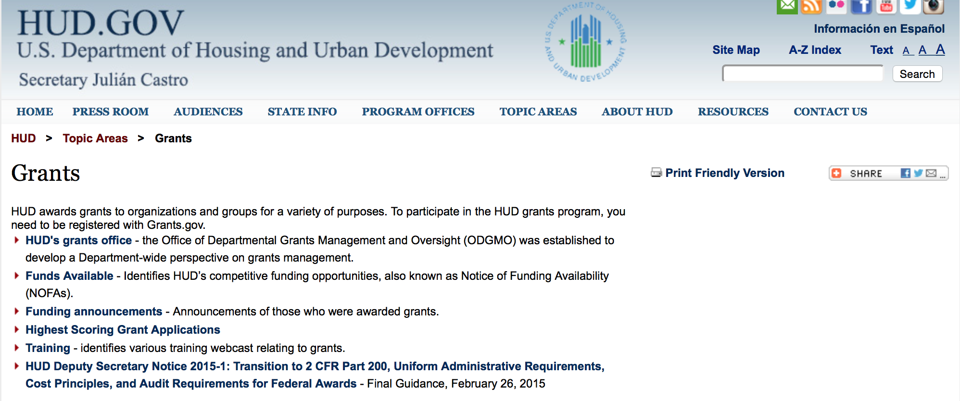

http://portal.hud.gov/hudportal/HUD?src=/topics/grants

HUD - Notice of Funds Available

For detailed information click here

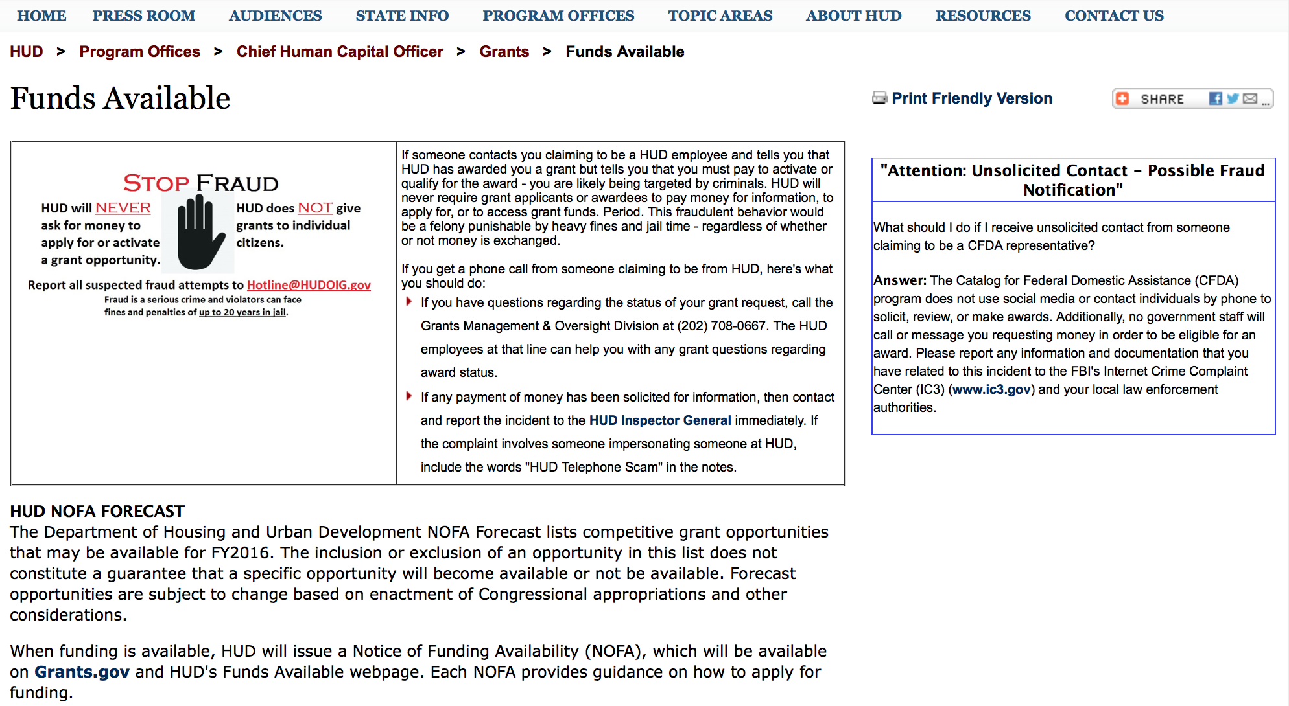

http://portal.hud.gov/hudportal/HUD?src=/program_offices/administration/grants/fundsavail

HUD NOFA FORECAST
The Department of Housing and Urban Development NOFA Forecast lists competitive grant opportunities that may be available for FY2016. The inclusion or exclusion of an opportunity in this list does not constitute a guarantee that a specific opportunity will become available or not be available. Forecast opportunities are subject to change based on enactment of Congressional appropriations and other considerations.
When funding is available, HUD will issue a Notice of Funding Availability (NOFA), which will be available on Grants.gov and HUD's Funds Available webpage. Each NOFA provides guidance on how to apply for funding.
Program Office | Funding Opportunity Title | Funding Opportunity Number | CFDA | Estimated Publication Date | Estimated Application Due Date
GMO | General Section to HUD's Fiscal Year 2016 Notice[s] of Funding Availability for Discretionary Programs (General Section) | FR-6000-N-01 | 14.506 | PUBLISHED | N/A
HSNG | Notice of Funding Availability (NOFA) for the Department's Fiscal Years 2016 and 2017 Comprehensive Housing Counseling Grant Program | FR-6000-N-33 | 14.169 | PUBLISHED | 4/4/2016
HSNG | NOFA for HUD's FY16-17 Housing Counseling Training Grant Program | FR-6000-N-30 | 14.316 | PUBLISHED | 4/4/2016
HSNG | Multifamily Energy and Water Conservation Pay For Success Pilot | FR-6000-N-36 | 14.157 | 9/14/2016 | 11/14/2016
OLHCHH | Lead Hazard Reduction Demonstration (LHRD) Grant Program | FR-6000-N-13 | 14.905 | PUBLISHED | 4/28/2016
OLHCHH | Lead-Based Paint Hazard Control (LBPHC) Grant Program | FR-6000-N-12 | 14.900 | PUBLISHED | 4/28/2016
OLHCHH | Healthy Homes Technical Studies Grant Program Pre and Full Application | FR-6000-N-15 | 14.906 | PUBLISHED | 6/1/2016
PIH | Resident Opportunity & Self-Sufficiency Program | FR-6000-N-05 | 14.870 | PUBLISHED | 5/16/2016
PIH | HOPE VI Main Street Grant Program | FR-6000-N-03 | 14.878 | PUBLISHED | 4/12/2016
PIH | Jobs Plus Initiative | FR-6000-N-14 | 14.895 | PUBLISHED | 6/13/2016
PIH | Family Self-Sufficiency Program | FR-6000-N-04 | 14.896 | PUBLISHED | 4/20/2016
PIH | Community Development Block Grant Program for Indian Tribes and Alaska Native Villages | FR-6000-N-23 | 14.862 | PUBLISHED | 6/14/2016
PIH | Choice Neighborhoods Implementation Grant Program | FR-6000-N-34 | 14.889 | PUBLISHED | 6/28/2016
PIH | Project SOAR | FR-6000-N-27 | 14.889 | 7/20/2016 | 9/19/2016
FHEO | Fair Housing Initiative Program - Private Enforcement Initiative | FR-6000-N-21C | 14.418 | PUBLISHED | 6/23/2016
FHEO | Fair Housing Initiative Program - Fair Housing Organization Initiative | FR-6000-N-21B | 14.417 | PUBLISHED | 6/23/2016
FHEO | Fair Housing Initiative Program - Education and Outreach Initiative | FR-6000-N-21A | 14.416 | PUBLISHED | 6/23/2016
PDR | Research and Evaluation, Demonstration, and Data Analysis and Utilization | FR-5900-N-29 | 14.536 | PUBLISHED | 6/6/2016
PDR | Research and Evaluation, Demonstration, and Data Analysis and Utilization | FR-6000-N-29 | 14.536 | 7/7/2016 | 8/23/2016
CPD | HUD Community Compass Technical Assistance and Capacity Building Program | FR-6000-N-06 | 14.259 | PUBLISHED | 7/19/2016
CPD | Capacity Building for Community Development and Affordable Housing Grants (Section 4) | FR-6000-N-07 | 14.252 | PUBLISHED | 8/9/2016
CPD | Building Capacity to End Youth Homelessness | FR-6000-N-37 | 14.270 | CANCELLED | CANCELLED
CPD | Youth Homelessness Demonstration Project | FR-6000-N-35 | 14.267 | 7/7/2016 | 9/1/2016
CPD | Continuum of Care Program Competition | FR-6000-N-25 | 14.276 | 6/30/2016 | 9/30/2016
CPD | Rural Capacity Building for Community Development and Affordable Housing Grants | FR-6000-N-08 | 14.265 | 7/8/2016 | 9/6/2016
CPD | Self-Help Homeownership Opportunity Program (SHOP) | FR-6000-N-19 | 14.247 | 10/12/2016 | 12/11/2016
- Updated 6/21/2016 General Section
- FONSI
- New Application Attachment Filename Requirement

Programs

Self-Help Homeownership Opportunity Program (SHOP)
Synopsis 1

Document Type: | Grants Notice
Funding Opportunity Number: | FR-6000-N-19
Funding Opportunity Title: | Self-Help Homeownership Opportunity Program (SHOP)
Opportunity Category: | Discretionary
Opportunity Category Explanation:
Funding Instrument Type: | Grant
Category of Funding Activity: | Housing
Category Explanation:
Expected Number of Awards: | 4
CFDA Number(s): | 14.247 -- Self-Help Homeownership Opportunity Program
Cost Sharing or Matching Requirement: | Yes
Version: | Synopsis 1
Posted Date: | Aug 10, 2016
Last Updated Date: | Aug 10, 2016
Original Closing Date for Applications: | Oct 12, 2016 Electronically submitted applications must be submitted no later than 11:59:59 p.m., ET, on the listed application due date.
Current Closing Date for Applications: | Oct 12, 2016 Electronically submitted applications must be submitted no later than 11:59:59 p.m., ET, on the listed application due date.
Archive Date: | Nov 11, 2016
Estimated Total Program Funding: | $10,000,000
Award Ceiling: | $10,000,000
Award Floor: | $450,000
Eligible Applicants: | Others (see text field entitled "Additional Information on Eligibility" for clarification)
Additional Information on Eligibility: | Applicants must be a public or private non-profit organization, or a consortium of public or private non-profit organizations, as defined below, that have the capacity and experience to provide or facilitate self-help homeownership housing opportunities on a national or regional basis. Applicants must propose to undertake eligible SHOP activities directly and/or enter into a written agreement with one or more non-profit affiliate organizations to carry out eligible SHOP activities. Individuals, foreign entities, and sole proprietorship organizations are not eligible to compete for, or receive, awards made under this announcement.
Agency Name: | Department of Housing and Urban Development
Description: | This NOFA announces the availability of $10,000,000 of FY2016 Self-Help Homeownership Opportunity Program (SHOP) grant funds. SHOP funding is intended to facilitate and encourage innovative homeownership opportunities on a national and geographically-diverse basis. The program supports self-help housing programs that require a significant amount of sweat equity by the homebuyer toward the construction or rehabilitation of his or her home. Volunteer labor is also required. Eligible applicants for SHOP funding include national and regional non-profit organizations and consortia with experience facilitating homeownership opportunities on a national, geographically-diverse basis through the provision of self-help homeownership housing programs. Applicants must propose to use a significant amount of SHOP grant funds in at least two states and may award SHOP grant funds to local non-profit affiliate organizations to carry out the Grantee's SHOP program. These affiliate organizations must be located within the Grantee's service area. Individuals are not eligible to apply for SHOP grant funds. SHOP grant funds must be used for land acquisition, infrastructure improvements, and for reasonable and necessary planning and administration costs (not to exceed 20 percent) with the maximum average SHOP investment for land acquisition and infrastructure not exceeding $15,000 per SHOP unit. The construction or rehabilitation costs of each SHOP unit must be funded with other leveraged public and private funds. SHOP units must be decent, safe, and sanitary non-luxury dwellings that comply with state and local codes, ordinances, and zoning requirements, and with all other SHOP requirements, including but not limited to, the requirements for energy-efficiency, water conservation and accessibility. The SHOP units must be sold to homebuyers at prices below the prevailing market price.
Link to Additional Information: | http://portal.hud.gov/hudportal/HUD?src=/program_offices/administration/grants/fundsavail
Grantor Contact Information: | If you have difficulty accessing the full announcement electronically, please contact:  Thann Young Thann.Young@hud.gov  Grants Policy

http://www.grants.gov/web/grants/view-opportunity.html?oppId=287279

Youth Homelessness Demonstration Program
Synopsis 1

Document Type: | Grants Notice
Funding Opportunity Number: | FR-6000-N-35
Funding Opportunity Title: | Youth Homelessness Demonstration Program
Opportunity Category: | Discretionary
Opportunity Category Explanation:
Funding Instrument Type: | Grant
Category of Funding Activity: | Community Development
Category Explanation:
Expected Number of Awards: | 10
CFDA Number(s): | 14.276 -- Youth Homelessness Demonstration Program
Cost Sharing or Matching Requirement: | Yes
Version: | Synopsis 1
Posted Date: | Aug 22, 2016
Last Updated Date: | Aug 22, 2016
Original Closing Date for Applications: | Nov 30, 2016 Electronically submitted applications must be submitted no later than 11:59:59 p.m., ET, on the listed application due date.
Current Closing Date for Applications: | Nov 30, 2016 Electronically submitted applications must be submitted no later than 11:59:59 p.m., ET, on the listed application due date.
Archive Date: | Dec 30, 2016
Estimated Total Program Funding: | $33,000,000
Award Ceiling: | $15,000,000
Award Floor: | $1,000,000
Eligible Applicants: | Nonprofits having a 501(c)(3) status with the IRS, other than institutions of higher education  City or township governments  State governments  County governments
Additional Information on Eligibility: | Community Selection application: Available to Collaborative Applicants designated by CoCs registered through the FY 2016 CoC Program Registration process. The Collaborative Applicant can apply for any community located within its CoC. The Collaborative Applicant can also apply for multiple communities located within its CoC. Project application: Project applicants that are designated during the application process by the Collaborative Applicant are eligible to apply for grant funds as well as be subrecipients of grant funds. The Collaborative Applicant may apply for projects under this Demonstration as well. For-profit entities are not eligible to apply for grants or to be sub recipients of grant funds. To be considered for funding, project applicants must complete the information required by HUD, in the manner required by HUD, and receive the approval of the CoC to apply for funding, as signed off on by the Collaborative Applicant. This NOFA is for applying for community selection only. Project application will occur after communities have been selected - requirements for applying for projects are detailed in Appendix A. Individuals, foreign entities, and sole proprietorship organizations are not eligible to compete for, or receive, awards made under this announcement.
Agency Name: | Department of Housing and Urban Development
Description: | NOFA Highlights: HUD will select up to 10 communities to participate in the Youth Homelessness Demonstration Program (YHDP) to develop and execute a coordinated community approach to preventing and ending youth homelessness. Four of the 10 selected communities will be rural communities. [Section I.A.1] Only CoC Collaborative Applicants may apply to this NOFA [Section III.A] Applications are submitted through grants.gov, and are due by November 30, 2016 Communities represented by the CoC Collaborative Applicant must include a youth advisory board, the local or state public child welfare agency, and a broad array of other partners [Sections III.C.1, III.C.3.b, and V.A] The rating and ranking criteria included in this NOFA will be used to competitively select the communities [Section V.A] The selection of the 10 communities will be announced in January of 2017 [Section V.C] Selected Communities Will: Develop and implement a Coordinated Community Plan to prevent and end youth homelessness [Section III.C.3.b] Apply for project funding up to an amount between $1 million and $15 million per community, based on each community's youth population size and poverty rate, for a total demonstration amount of up to $33 million [Section II.C] Request project funding on a rolling basis using a project application in the e-snaps grants management system beginning in early 2017 [Appendix A] Requests funding for all project types allowed under the CoC Program to support homeless and at risk youth, as well as innovative project types that may require a waiver of CoC Program requirements [Appendix A and Appendix B] Request funding for a 2-year grant term that will be eligible for renewal under the CoC Program, as long as the project meets statutory CoC Program requirements [Section II.B] Receive a dedicated team of technical assistance providers to advise the development and implementation of the Coordinated Community Plan [Section I.A] Participate in an evaluation that will inform the federal strategy for preventing and ending youth homelessness [Section I.A and VI.B.] NOFA Priority The purpose of the YHDP is to learn how communities can successfully approach the goal of preventing and ending youth homelessness by building comprehensive systems of care for young people rather than implementing individual or unconnected projects that serve this population. In order to effectively implement a system that addresses the needs of youth experiencing homelessness, Continuums of Care (CoCs) must understand the subgroups of unaccompanied youth; including pregnant and parenting, Lesbian, Gay, Bisexual, Transgender, and Questioning (LGBTQ), and minor age youth; experiencing homelessness and the unique challenges they face within their communities. Additionally, CoCs must ensure that the appropriate type of housing assistance and level of services that are effective in providing safe and stable housing are available within the community and must reach out and partner with a comprehensive set of traditional and non-traditional youth homelessness stakeholders that provide youth with resources and services, advocate for them, and set policy on their behalf. Finally, CoCs must incorporate the experiences of homeless or formerly homeless unaccompanied youth; which is vital to understanding the needs, strengths, and perspectives of the youth in the community; and incorporate those understandings into the YHDP coordinated community plan and awarded projects. All of this will require CoCs to use innovative practices to design better projects and strong comprehensive plans to prevent and end youth homelessness. Background In 2010, the United States Interagency Council on Homelessness (USICH) presented Opening Doors: The Federal Strategic Plan to Prevent and End Homelessness to the President and Congress, identifying youth as one of four special populations and articulating a goal of preventing and ending youth homelessness by 2020. A coordinated community approach lies at the heart of the strategies advocated by Opening Doors[1]. By engaging in a system-wide crisis response, communities can better understand their system level needs and assets, plan for and allocate new and existing resources, prevent and quickly divert youth from homelessness, and identify, engage, and respond to the needs of youth experiencing homelessness. These concepts are described in the 2012 release of the Framework to End Youth Homelessness[2], and Preventing and Ending Youth Homelessness: A Coordinated Community Response by USICH in December of 2015[3]. The 2015 release included a Preliminary Vision for a Community Response; and illustrates the general components believed necessary for each community to prevent and end youth homelessness. Federal partner agencies with a stake in preventing and ending youth homelessness, are working tirelessly together to build on that vision. This work together and a commitment to developing and supporting a coordinated community approach guides the Department of Housing and Urban Development's (HUD) effort to prevent and end youth homelessness, and serves as the cornerstone value for the Youth Homelessness Demonstration. [1] http://dev2.usich.gov/resources/uploads/asses_library/USICH_OpeningDoors_Amendment2015_FINAL.pdf [2] https://www.usich.gov/tools-for-action/framework-for-ending-youth-homelessness [3] https://www.usich.gov/resources/uploads/asset_library/Youth_Homelessness_Coordinated_Response.pdf
Link to Additional Information: | http://portal.hud.gov/hudportal/HUD?src=/program_offices/administration/grants/fundsavail
Grantor Contact Information: | If you have difficulty accessing the full announcement electronically, please contact:  Ebony Rankin Ebony.W.Rankin@hud.gov  Grants Policy

http://www.grants.gov/web/grants/view-opportunity.html?oppId=287815

Modifications:

FY2016 Continuum of Care
Synopsis 5

Document Type: | Grants Notice
Funding Opportunity Number: | FR-6000-N-25
Funding Opportunity Title: | FY2016 Continuum of Care
Opportunity Category: | Discretionary
Opportunity Category Explanation:
Funding Instrument Type: | Grant
Category of Funding Activity: | Housing
Category Explanation:
Expected Number of Awards: | 8000
CFDA Number(s): | 14.267 -- Continuum of Care Program
Cost Sharing or Matching Requirement: | Yes
Version: | Synopsis 5
Posted Date: | Jun 28, 2016
Last Updated Date: | Aug 15, 2016
Original Closing Date for Applications: | Sep 14, 2016
Current Closing Date for Applications: | Sep 14, 2016
Archive Date: | Oct 14, 2016
Estimated Total Program Funding: | $1,900,000,000
Award Ceiling: | $1,500,000
Award Floor: | $2,500
Eligible Applicants: | Nonprofits having a 501(c)(3) status with the IRS, other than institutions of higher education  County governments  City or township governments  Others (see text field entitled "Additional Information on Eligibility" for clarification)  State governments
Additional Information on Eligibility: | 24 CFR 578.15, eligible project applicants for the CoC Program Competition are nonprofit organizations, States, local governments, and instrumentalities of State and local governments. Public housing agencies, as such term is defined in 24 CFR 5.100, are eligible without limitation or exclusion. For-profit entities are not eligible to apply for grants or to be subrecipients of grant funds. Individuals, foreign entities, and sole proprietorship organizations are not eligible to compete for, or receive, awards made under this announcement.
Agency Name: | Department of Housing and Urban Development
Description: | The CoC Program (24 CFR part 578) is designed to promote a community-wide commitment to the goal of ending homelessness; to provide funding for efforts by nonprofit providers, States, and local governments to quickly re-house homeless individuals, families, persons fleeing domestic violence, and youth while minimizing the trauma and dislocation caused by homelessness; to promote access to and effective utilization of mainstream programs by homeless; and to optimize self-sufficiency among those experiencing homelessness.
Link to Additional Information: | HUD Funds Available Page
Grantor Contact Information: | If you have difficulty accessing the full announcement electronically, please contact:  HUD Staff  HUD Exchange AAQ help desk

http://www.grants.gov/web/grants/view-opportunity.html?oppId=285539

Notice of Funding Availability (NOFA) for the Fiscal Year (FY) 2016 Continuum of Care Program Competition TECHNICAL CORRECTION
Synopsis 2
http://www.grants.gov/web/grants/view-opportunity.html?oppId=287495

Reminders

Rural Capacity Building for Community Development and Affordable Housing Grants
Synopsis 1

Document Type: | Grants Notice
Funding Opportunity Number: | FR-6000-N-08
Funding Opportunity Title: | Rural Capacity Building for Community Development and Affordable Housing Grants
Opportunity Category: | Discretionary
Opportunity Category Explanation:
Funding Instrument Type: | Grant
Category of Funding Activity: | Community Development
Category Explanation:
Expected Number of Awards: | 5
CFDA Number(s): | 14.265 -- Rural Capacity Building for Community Development and Affordable Housing Grants
Cost Sharing or Matching Requirement: | Yes
Posted Date: | Jul 15, 2016
Last Updated Date: | Jul 15, 2016
Original Closing Date for Applications: | Sep 13, 2016 Electronically submitted applications must be submitted no later than 11:59:59 p.m., ET, on the listed application due date.
Current Closing Date for Applications: | Sep 13, 2016 Electronically submitted applications must be submitted no later than 11:59:59 p.m., ET, on the listed application due date.
Archive Date: | Dec 31, 2016
Estimated Total Program Funding: | $5,000,000
Award Ceiling: | $2,500,000
Award Floor: | $500,000
Eligible Applicants: | Others (see text field entitled "Additional Information on Eligibility" for clarification)  Nonprofits having a 501(c)(3) status with the IRS, other than institutions of higher education
Additional Information on Eligibility: | HUD awards grants under this NOFA to national organizations. A national organization is defined as a non-profit entity or consortium that has on-going experience in rural housing, including experience working with rural housing development organizations, community development corporations (CDCs), community housing development organizations (CHDOs), local governments, and Indian tribes, as evidenced by past and continuing work in one or more states in five or more of the Federal regions described on HUD's website at http://portal.hud.gov/hudportal/HUD?src=/localoffices/regions. Individuals, foreign entities, and sole proprietorship organizations are not eligible to compete for, or receive, awards made under this announcement.
Agency Name: | Department of Housing and Urban Development
Description: | The Rural Capacity Building program and the funding made available through this NOFA are authorized by the Consolidated Appropriations Act, 2016 (Public Law 114-113, approved December 18, 2015).
Link to Additional Information: | http://portal.hud.gov/hudportal/HUD?src=/program_offices/administration/grants/fundsavail
Grantor Contact Information: | If you have difficulty accessing the full announcement electronically, please contact:  Rudene Thomas Rudene.Thomas@hud.gov  Grants Policy

http://www.grants.gov/web/grants/view-opportunity.html?oppId=286174

ROSS for Education

Document Type: | Grants Notice
Funding Opportunity Number: | FR-6000-N-27
Funding Opportunity Title: | ROSS for Education
Opportunity Category: | Discretionary
Opportunity Category Explanation:
Funding Instrument Type: | Grant
Category of Funding Activity: | Housing
Category Explanation:
Expected Number of Awards: | 6
CFDA Number(s): | 14.898 -- ROSS Supportive Services Programs
Cost Sharing or Matching Requirement: | Yes
Posted Date: | Jul 29, 2016
Last Updated Date: | Jul 29, 2016
Original Closing Date for Applications: | Sep 28, 2016 Electronically submitted applications must be submitted no later than 11:59:59 p.m., ET, on the listed application due date.
Current Closing Date for Applications: | Sep 28, 2016 Electronically submitted applications must be submitted no later than 11:59:59 p.m., ET, on the listed application due date.
Archive Date: | Oct 28, 2016
Estimated Total Program Funding: | $2,000,000
Award Ceiling: | $452,000
Eligible Applicants: | Others (see text field entitled "Additional Information on Eligibility" for clarification)
Additional Information on Eligibility: | Eligible applicants are public housing authorities (PHAs) (including newly established consolidated PHAs) that have Annual Contribution Contract units. Non-profit organizations, resident associations, and for-profit organizations are not eligible to apply for funding under this NOFA. Individuals, foreign entities, and sole proprietorship organizations are not eligible to compete for, or receive, awards made under this announcement.
Agency Name: | Department of Housing and Urban Development
Description: | This NOFA announces the availability of approximately $2 million to provide grants to public housing authorities (PHAs) to deploy education navigators to provide individualized assistance to randomly selected public housing youth between the ages of 15-20 and their families in FAFSA completion, financial literacy and college readiness, postsecondary program applications and post-acceptance assistance.
Link to Additional Information: | http://portal.hud.gov/hudportal/HUD?src=/program_offices/administration/grants/fundsavail
Grantor Contact Information: | If you have difficulty accessing the full announcement electronically, please contact:  Maria Queen Maria-Lana.Queen@hud.gov  Grants Policy

http://www.grants.gov/web/grants/view-opportunity.html?oppId=286724

Funding Opportunity Number: FR-6000-N-25
FY2016 Continuum of Care
Modification 4
Modification Comments: This modification updates the Agency Contact URL.

Document Type: | Grants Notice
Funding Opportunity Number: | FR-6000-N-25
Funding Opportunity Title: | FY2016 Continuum of Care
Opportunity Category: | Discretionary
Opportunity Category Explanation:
Funding Instrument Type: | Grant
Category of Funding Activity: | Housing
Category Explanation:
Expected Number of Awards: | 8000
CFDA Number(s): | 14.267 -- Continuum of Care Program
Cost Sharing or Matching Requirement: | Yes
Version: | Synopsis 4
Posted Date: | Jun 28, 2016
Last Updated Date: | Jun 29, 2016
Original Closing Date for Applications: | Sep 14, 2016
Current Closing Date for Applications: | Sep 14, 2016
Archive Date: | Oct 14, 2016
Estimated Total Program Funding: | $1,900,000,000
Award Ceiling: | $1,500,000
Award Floor: | $2,500
Eligible Applicants: | City or township governments  State governments  County governments  Others (see text field entitled "Additional Information on Eligibility" for clarification)  Nonprofits having a 501(c)(3) status with the IRS, other than institutions of higher education
Additional Information on Eligibility: | 24 CFR 578.15, eligible project applicants for the CoC Program Competition are nonprofit organizations, States, local governments, and instrumentalities of State and local governments. Public housing agencies, as such term is defined in 24 CFR 5.100, are eligible without limitation or exclusion. For-profit entities are not eligible to apply for grants or to be subrecipients of grant funds. Individuals, foreign entities, and sole proprietorship organizations are not eligible to compete for, or receive, awards made under this announcement.
Agency Name: | Department of Housing and Urban Development
Description: | The CoC Program (24 CFR part 578) is designed to promote a community-wide commitment to the goal of ending homelessness; to provide funding for efforts by nonprofit providers, States, and local governments to quickly re-house homeless individuals, families, persons fleeing domestic violence, and youth while minimizing the trauma and dislocation caused by homelessness; to promote access to and effective utilization of mainstream programs by homeless; and to optimize self-sufficiency among those experiencing homelessness.
Link to Additional Information: | HUD Funds Available Page
Grantor Contact Information: | If you have difficulty accessing the full announcement electronically, please contact:  HUD Staff  HUD Exchange AAQ help desk

Link: http://www.grants.gov/web/grants/view-opportunity.html?oppId=285539

Technical Correction to the General Section to HUD's Fiscal Year 2016 Notice[s] of Funding Availability for Discretionary Programs
Modification 1

Document Type: | Grants Notice
Funding Opportunity Number: | FR-6000-N-01-C
Funding Opportunity Title: | Technical Correction to the General Section to HUD's Fiscal Year 2016 Notice[s] of Funding Availability for Discretionary Programs
Opportunity Category: | Discretionary
Opportunity Category Explanation:
Funding Instrument Type: | Grant
Category of Funding Activity: | Community Development
Category Explanation:
Expected Number of Awards: | 0
CFDA Number(s):
Cost Sharing or Matching Requirement: | No
Posted Date: | May 16, 2016
Last Updated Date: | May 16, 2016
Original Closing Date for Applications: | Dec 31, 2016 Electronically submitted applications to program NOFAs must be submitted no later than 11:59:59 p.m., ET, on the listed application due date. No applications are accepted in response to this Notice, which publishes policies and guidance only.
Current Closing Date for Applications: | Dec 31, 2016 Electronically submitted applications to program NOFAs must be submitted no later than 11:59:59 p.m., ET, on the listed application due date. No applications are accepted in response to this Notice, which publishes policies and guidance only.
Archive Date: | Jan 30, 2017
Estimated Total Program Funding: | $0
Award Ceiling: | $0
Award Floor: | $0
Eligible Applicants: | Public and State controlled institutions of higher education  Unrestricted (i.e., open to any type of entity above), subject to any clarification in text field entitled "Additional Information on Eligibility"  Nonprofits that do not have a 501(c)(3) status with the IRS, other than institutions of higher education  State governments  Private institutions of higher education  Public housing authorities/Indian housing authorities  County governments  Special district governments  City or township governments  Small businesses  Native American tribal governments (Federally recognized)  Independent school districts  Native American tribal organizations (other than Federally recognized tribal governments)  Individuals  Nonprofits having a 501(c)(3) status with the IRS, other than institutions of higher education  For profit organizations other than small businesses
Additional Information on Eligibility: | No applications will be accepted in response to this document. This Document is a policy document only. The individual program Notices of Funds Available (NOFA) will identify eligible applicants for each competition. Each Program NOFA will describe additional eligibility requirements for applicants. HUD does not provide direct services or products to individuals through its formula-based programs or its competitive Program NOFA process. Individuals seeking financial assistance should refer to www.GovBenefits.gov. Individuals, foreign entities, and sole proprietorship organizations are not eligible to compete for, or receive, awards made under this announcement.
Agency Name: | Department of Housing and Urban Development
Description: | HUD publishes a General Section each Fiscal Year (FY) that contains requirements for all of HUD’s competitive grant programs. Applications to HUD programs must meet all applicable requirements of the General Section and the requirements in the Program NOFA to be considered for funding. This updates paragraph V.C.8. Eminent Domain to reflect the 2016 Appropriations authority, and updates paragraph VI.A.1. Obtaining an Electronic Application.
Link to Additional Information: | http://portal.hud.gov/hudportal/HUD?src=/program_offices/administration/grants/fundsavail
Contact Information: | If you have difficulty accessing the full announcement electronically, please contact:  Loyd LaMois loyd.lamois@hud.gov  Grants Policy

http://www.grants.gov/web/grants/view-opportunity.html?oppId=283900

General Section to HUD's Fiscal Year 2016 Notice[s] of Funding Availability for Discretionary Programs (General Section)
Modification 1

Document Type: | Grants Notice
Funding Opportunity Number: | FR-6000-N-01
Funding Opportunity Title: | General Section to HUD's Fiscal Year 2016 Notice[s] of Funding Availability for Discretionary Programs (General Section)
Opportunity Category: | Discretionary
Funding Instrument Type: | Grant
Category of Funding Activity: | Community Development
Category Explanation:
Expected Number of Awards: | 0
CFDA Number(s):
Cost Sharing or Matching Requirement: | No
Posted Date: | Sep 24, 2015
Creation Date: | Sep 24, 2015
Original Closing Date for Applications: | Dec 30, 2016 Electronically submitted applications must be submitted no later than 11:59:59 p.m., ET, on the listed application due date published in the individual program NOFA.
Current Closing Date for Applications: | Dec 30, 2016 Electronically submitted applications must be submitted no later than 11:59:59 p.m., ET, on the listed application due date published in the individual program NOFA.
Archive Date: | Jan 29, 2017
Eligible Applicants: | Others (see text field entitled "Additional Information on Eligibility" for clarification)
Additional Information on Eligibility: | This Document is a policy document only. The individual program Notices of Funds Available (NOFA) will identify eligible applicants for each competition. Each Program NOFA will describe additional eligibility requirements for applicants. All applicants must have valid, active Registration in the System for Award Management (SAM) prior to submission of applications for financial assistance. HUD does not provide direct services or products to individuals through its formula-based programs or its competitive Program NOFA process. Individuals seeking financial assistance should refer to www.GovBenefits.gov. Individuals, foreign entities, and sole proprietorship organizations are not eligible to compete for, or receive, awards made under this announcement.
Agency Name: | Department of Housing and Urban Development
Description: | The General Section describes the requirements that are applicable to all HUD FY 2015 Program NOFAs. The General Section also provides information on HUD’s priorities and strategic goals. Each Program NOFA will describe additional applicable procedures and requirements, including a description of the eligible applicants, eligible activities, threshold requirements, cross-program requirements such as nondiscrimination, environmental protection, and any additional program requirements or limitations. To adequately address all of the application requirements for any program, please carefully read and respond to both this General Section and any applicable Program NOFA.
Link to Additional Information: | http://portal.hud.gov/hudportal/HUD?src=/program_offices/administration/grants/fundsavail
Contact Information: | If you have difficulty accessing the full announcement electronically, please contact:  Loyd LaMois loyd.lamois@hud.gov  Grants Policy

http://www.grants.gov/web/grants/view-opportunity.html?oppId=279206



Institute of Museum and Library Services

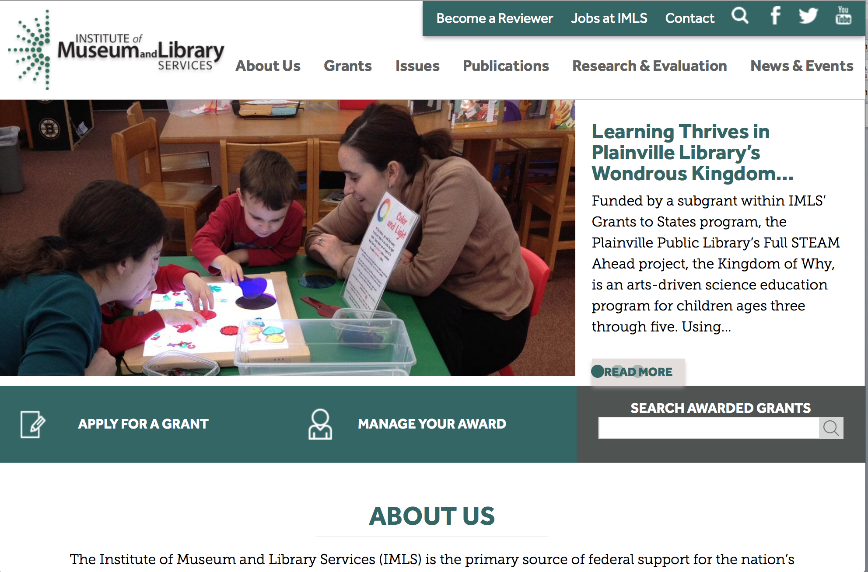

www.imls.gov

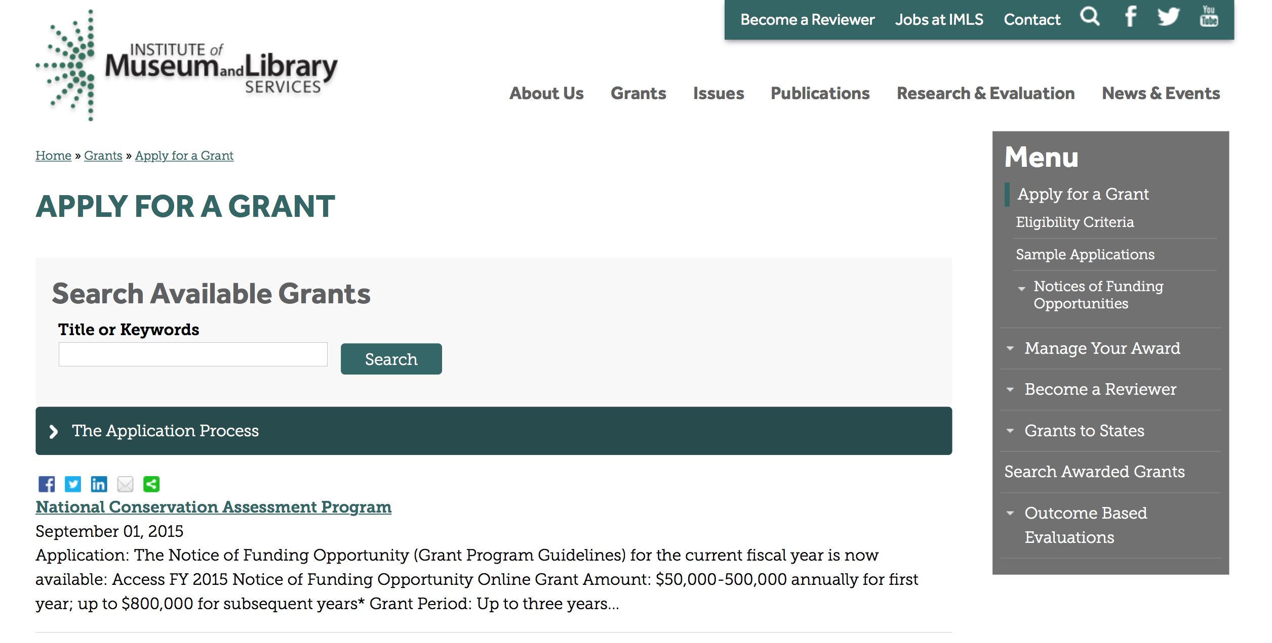
http://www.imls.gov/applicants/available_grants.aspx

Each grant program has specific eligibility requirements. The links below provide general eligibility criteria for museums, libraries, and tribal organizations, but please note that additional organizations may be eligible for grants under certain programs. Additionally, ineligible organizations may still be able to participate in grant programs through partnerships with eligible organizations. Please click on the links below to see general criteria and review Applications and Guidelines for specific information.
Museums Libraries

Institutions: Archives, Federally Recognized Native American Tribe, Historical Society, Library, Nonprofits that serve Native Hawaiians, Professional Association, Public or Private Non-profit Institutions of Higher Education, Regional Organization, State Library Administrative Agency, State or Local Government

Check out IMLS's Facebook page at:
https://www.facebook.com/USIMLS/

Modifications:

Reminders:

Deleted:

Department of the Interior
Working with Interior

The Interior Department provides assistance to the public, local governments and businesses through a number of programs. For a general overview see: http://www.doi.gov/index.cfm

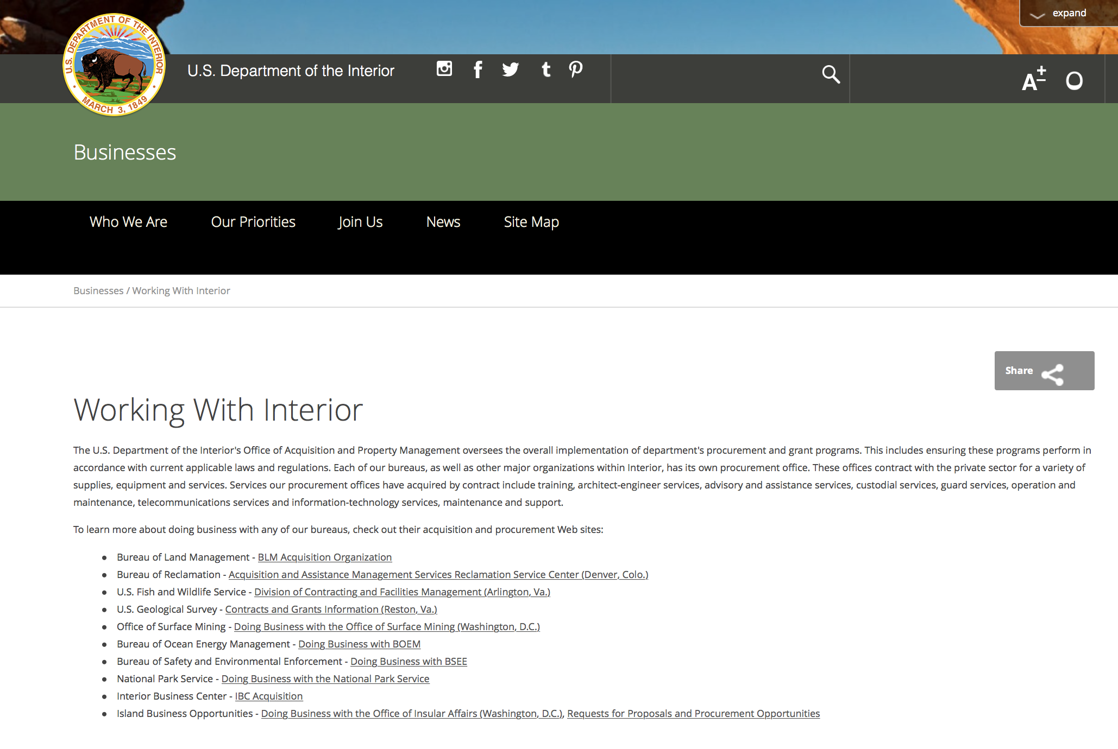

http://www.doi.gov/businesses/working-with-interior.cfm

Programs:

Modifications:

National Park Service
2017 Preservation Technology and Training Grants
Synopsis 3

Document Type: | Grants Notice
Funding Opportunity Number: | P16AS00579
Funding Opportunity Title: | 2017 Preservation Technology and Training Grants
Opportunity Category: | Discretionary
Opportunity Category Explanation:
Funding Instrument Type: | Grant
Category of Funding Activity: | Arts (see "Cultural Affairs" in CFDA)  Humanities (see "Cultural Affairs" in CFDA)  Other (see text field entitled "Explanation of Other Category of Funding Activity" for clarification)  Science and Technology and other Research and Development
Category Explanation: | Historic Preservation
Expected Number of Awards: | 10
CFDA Number(s): | 15.923 -- National Center for Preservation Technology and Training
Cost Sharing or Matching Requirement: | No
Posted Date: | Sep 02, 2016
Last Updated Date: | Sep 02, 2016
Original Closing Date for Applications: | Nov 03, 2016
Current Closing Date for Applications: | Nov 03, 2016
Archive Date: | Sep 02, 2017
Estimated Total Program Funding: | $300,000
Award Ceiling: | $40,000
Award Floor: | $5,000
Eligible Applicants: | Others (see text field entitled "Additional Information on Eligibility" for clarification)  Nonprofits having a 501(c)(3) status with the IRS, other than institutions of higher education  Native American tribal governments (Federally recognized)  Public and State controlled institutions of higher education  County governments  State governments  Private institutions of higher education  Special district governments  Native American tribal organizations (other than Federally recognized tribal governments)  City or township governments
Additional Information on Eligibility: | Federal Agencies
Agency Name: | National Park Service
Description: | 2017 Preservation Technology and Training Grants (PTT Grants) are intended to create better tools, better materials, and better approaches to conserving buildings, landscapes, sites, and collections. The PTT Grants are administered by the National Center for Preservation Technology and Training (NCPTT), the National Park Service's innovation center for the preservation community.The competitive grants program will provide funding to federal agencies, states, tribes, local governments, and non-profit organizations. PTT Grants will support the following activities: Innovative research that develops new technologies or adapts existing technologies to preserve cultural resources (typically $25,000 to $40,000)Specialized workshops or symposia that identify and address national preservation needs (typically $15,000 to $25,000)How-to videos, mobile applications, podcasts, best practices publications, or webinars that disseminate practical preservation methods or provide better tools for preservation practice (typically $5,000 to $15,000)The maximum grant award is $40,000. The actual grant award amount is dependent on the scope of the proposed activity. NCPTT does not fund "bricks and mortar" grants.
Link to Additional Information: | https://www.ncptt.nps.gov/grants/
Grantor Contact Information: | If you have difficulty accessing the full announcement electronically, please contact:  Chief, Materials Conservation Mary Striegel 318-356-7444 Mary_Striegel@nps.gov  Mary_striegel@nps.gov

http://www.grants.gov/web/grants/view-opportunity.html?oppId=288174

Fish and Wildlife Service
NAWCA U.S. Small Grants
Synopsis 2

Document Type: | Grants Notice
Funding Opportunity Number: | F16AS00445
Funding Opportunity Title: | NAWCA U.S. Small Grants
Opportunity Category: | Discretionary
Opportunity Category Explanation:
Funding Instrument Type: | Grant
Category of Funding Activity: | Natural Resources
Category Explanation:
Expected Number of Awards: | 50
CFDA Number(s): | 15.623 -- North American Wetlands Conservation Fund
Cost Sharing or Matching Requirement: | Yes
Version: | Synopsis 2
Posted Date: | Sep 01, 2016
Last Updated Date: | Aug 31, 2016
Original Closing Date for Applications: | Nov 03, 2016 4pm EST November 3, 2016 All applicants submit SF-424 in grants.gov. In the grants.gov package, lease budget table and project narrative forms blank but submit with SF-424. Email proposal & support docs: nawca_smallgrants@fws.gov
Current Closing Date for Applications: | Nov 03, 2016 4pm EST November 3, 2016 All applicants submit SF-424 in grants.gov. In the grants.gov package, lease budget table and project narrative forms blank but submit with SF-424. Email proposal & support docs: nawca_smallgrants@fws.gov
Archive Date: | Nov 04, 2016
Estimated Total Program Funding: | $3,000,000
Award Ceiling: | $100,000
Award Floor: | $1,000
Eligible Applicants: | Unrestricted (i.e., open to any type of entity above), subject to any clarification in text field entitled "Additional Information on Eligibility"
Agency Name: | Fish and Wildlife Service
Description: | The U.S. Small Grants Program is a competitive, matching grants program that supports public-private partnerships carrying out projects in the United States that further the goals of the North American Wetlands Conservation Act. These projects must involve long-term protection, restoration, enhancement and/or establishment of wetlands and associated uplands habitats for the benefit of all wetlands-associated migratory birds. A 1:1 match is required. Research funding is ineligible. In June 2016, U.S. Small Grants Program award ceiling increased from $75,000 to $100,000 by the North American Wetlands Conservation Council (NAWCC).
Link to Additional Information: | U.S. Small Grants Instructions and Proposal Outline
Grantor Contact Information: | If you have difficulty accessing the full announcement electronically, please contact:  Rodecia Mcknight 7033582266  U.S. Small Grant Coordinator

http://www.grants.gov/web/grants/view-opportunity.html?oppId=288249

Reminders:

Fish and Wildlife Service
Marine Turtle Conservation Fund
Synopsis 1

Document Type: | Grants Notice
Funding Opportunity Number: | F16AS00378
Funding Opportunity Title: | Marine Turtle Conservation Fund
Opportunity Category: | Discretionary
Opportunity Category Explanation:
Funding Instrument Type: | Cooperative Agreement  Grant
Category of Funding Activity: | Community Development  Education  Environment  Natural Resources  Other (see text field entitled "Explanation of Other Category of Funding Activity" for clarification)  Science and Technology and other Research and Development
Category Explanation: | Wildlife Conservation - proposed project work should occur within the species range, outside of the United States. If work is to be conducted outside of the species range, the proposal should show a clear relevance to its conservation.
Expected Number of Awards: | 40
CFDA Number(s): | 15.645 -- Marine Turtle Conservation Fund
Cost Sharing or Matching Requirement: | No
Posted Date: | Aug 02, 2016
Last Updated Date: | Aug 02, 2016
Original Closing Date for Applications: | Oct 02, 2016
Current Closing Date for Applications: | Oct 02, 2016
Archive Date: | Oct 04, 2016
Estimated Total Program Funding: | $1,500,000
Award Ceiling: | $80,000
Award Floor: | $10,000
Eligible Applicants: | Unrestricted (i.e., open to any type of entity above), subject to any clarification in text field entitled "Additional Information on Eligibility"
Agency Name: | Fish and Wildlife Service
Description: | The Marine Turtle Conservation Fund is soliciting proposals for the conservation of marine turtles (Chelonia mydas, Caretta caretta, Dermochelys coriacea, Eretmochelys imbricata, Lepidochelys olivacea, Lepidochelys kempii) throughout their range outside of the United States and its territories. The U.S. Government enacted the Marine Turtle Conservation Act (MTCA) of 2004 in response to the decline of many marine turtle populations worldwide and the serious threats to their long-term survival. The primary purpose of the Act is to provide financial support for projects that conserve nesting populations and habitat and address other threats to the survival of marine turtles in foreign countries. The goal of this program is to reduce threats to marine turtles in their natural habitat. Proposals should identify specific conservation actions that have a high likelihood of creating lasting benefits. Project activities that emphasize data collection and status assessment should describe a direct link to management action, and explain how lack of information has been a key limiting factor for management action in the past. Proposals that do not identify how actions will reduce threats or that do not demonstrate a strong link between data collection and management action will be disqualified. Proposed project work should occur within the species range, outside of the United States. If work is to be conducted outside of the species range, the proposal should show a clear relevance to its conservation. To the extent that it provides clear, direct support for the program objectives above, proposed work may also relate to climate change adaptation, mitigation and education.
Link to Additional Information: | https://www.fws.gov/international/grants-and-reporting/how-to-apply.html
Grantor Contact Information: | If you have difficulty accessing the full announcement electronically, please contact:  Forrest Miller 703-358-2259 forrest_miller@fws.gov  forrest_miller@fws.gov

http://www.grants.gov/web/grants/view-opportunity.html?oppId=286874

Deleted :

Fish and Wildlife Service
F16AS00324 - Service Training and Technical Assistance
Deletion Comments: Opportunity deleted

Department of Justice

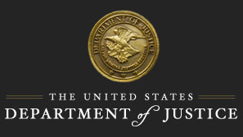

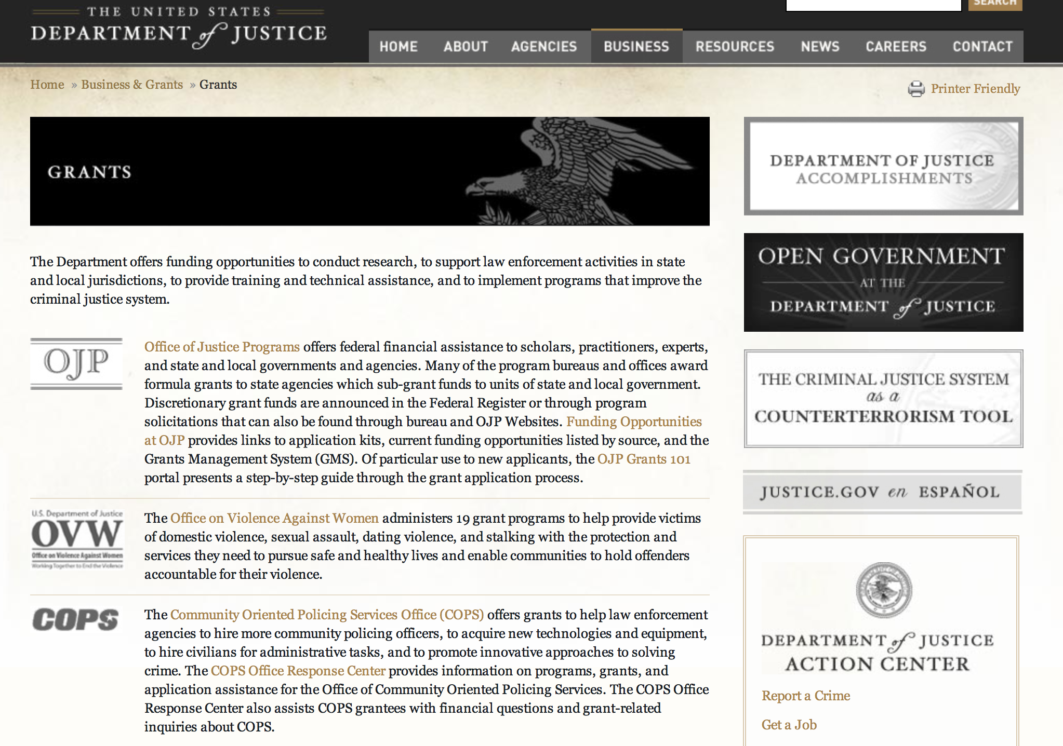

The DOJ agencies listed below also have sites that provide grant information specific to that agency. Examples of what can be found on these sites are programs, funding opportunities, application assistance, and other useful information.

Bureau of Justice Assistance (BJA)

Bureau of Justice Statistics (BJS)

National Criminal Justice Reference Service (NCJRS)

National Institute of Justice (NIJ)

Office of Juvenile Justice and Delinquency Prevention (OJJDP)

Office of Sex Offender Sentencing, Monitoring, Apprehending, Registering, and Tracking (SMART)

Office for Victims of Crime (OVC)

http://www.justice.gov/business/

Programs:

Research:

Modifications:

Reminders:

Deleted:



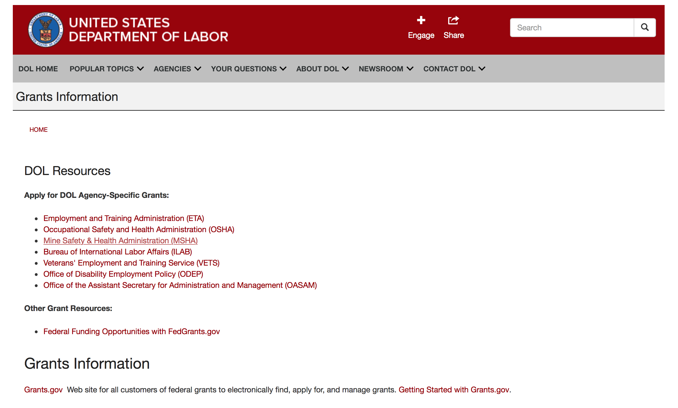

Agency Grants and Contract General Overview

DOL Resources
Apply for DOL Agency-Specific Grants:
- Employment and Training Administration (ETA)
- Occupational Safety and Health Administration (OSHA)
- Mine Safety & Health Administration (MSHA)
- Bureau of International Labor Affairs (ILAB)
- Veterans' Employment and Training Service (VETS)
- Office of Disability Employment Policy (ODEP)
- Office of the Assistant Secretary for Administration and Management (OASAM)

Other Grant Resources:
- Federal Funding Opportunities with FedGrants.gov
Grants Information
Grants.gov — Web site for all customers of federal grants to electronically find, apply for, and manage grants. Getting Started with Grants.gov.

DOL Resources and Instructions for Applying for a Grant
- DOL Guidance Clarifying the Effect of the Religious Freedom Restoration Act on Faith-Based Organizations
- Grant and Contract Information
- Contracting and Grant Program Overview
- Annual Acquisition Plan & Procurement Forecast
- Civil Rights Enforcement for Department of Labor Grant Recipients
- More Information About Grants
- Use of Contracts, Grants & Cooperative Agreements

Other Federal Government Grant Information
- List of Parties Excluded From Federal Procurement and Nonprocurement Programs (as created and maintained by GSA)
- Grant Opportunities (Catalog of Federal Domestic Assistance)

Department of Labor Grant Programs

- Bureau of International Labor Affairs (ILAB): provides grants (cooperative agreements) for the implementation of projects designed to assist developing countries combat the worse forms of child labor, forced labor, and human trafficking; and support worker rights and improve working conditions. http://www.dol.gov/general/business.
- Bureau of Labor Statistics (BLS): provides project grants (cooperative agreements) and the dissemination of technical statistical data and related information on labor force activities; provides data on prices (CPI) and cost of living; data on productivity and technology data; data on compensation and working conditions; data on employment projections.
- Employment and Training (ETA): ETA administers financial assistance programs pursuant to the Workforce Investment Act (WIA), administering State formula grant programs for youth, adults and dislocated workers, national emergency grants for workers affected by mass layoffs, plant closures, and disasters; grant programs for workers with disabilities, Indians and Native Americans, and for migrant and seasonal farmworkers. ETA also administers grant programs for older American workers, apprenticeship programs, Trade Adjustment Assistance (TAA) programs, and assistance for research and development of workforce programs. In addition, ETA is responsible for the operation and maintenance of a national system of public employment service offices and for the national unemployment insurance program.
- Mine Safety and Health (MSHA): provides grants for research, education and training programs to ensure an adequate and competent staff of trained inspectors; and assistance for establishing or improving State mine health and safety programs through technical assistance.
- Occupational Safety and Health (OSHA): provides grants to non-profit organizations to provide training, educational services, and technical assistance; assistance to states to administer and enforce state programs; assistance to states to provide occupational safety and health technical assistance and consultant services.
- Office of Disability Employment Policy (ODEP): The Office of Disability Employment Policy awards competitive grants establishing short-term pilot and technical assistance projects designed to identify, develop, test, evaluate, and disseminate policies to increase employment by expanding access to training, education, employment supports, assistive and systems technology, integrated employment, entrepreneurial development, and small business opportunities for adults and youth with disabilities. Current pilots projects focus on customized employment, Olmstead populations, and innovative demonstration youth grants, among others. Solicitations for grant applications are published in the Federal Register and announced at www.dol.gov/odep. ODEP grants are awarded by the OASAM grant office.
- Veterans' Employment and Training (VETS): provides special employment and training assistance for veterans through the Disabled Veterans' Outreach Program (DVOP) Solicitation for Grant Applications; the Local Veterans' Employment Representative Program (LVER); Veterans' Workforce Investment Program (VWIP); elaws Advisor on veterans' employment and reemployment rights; and the Homeless Veterans Reintegration Project (HVRP). VETS grants are awarded by the OASAM grant office.

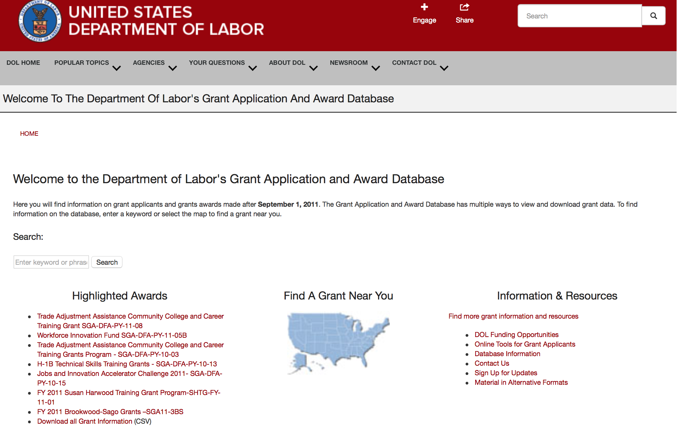

http://www.dol.gov/dol/grants/

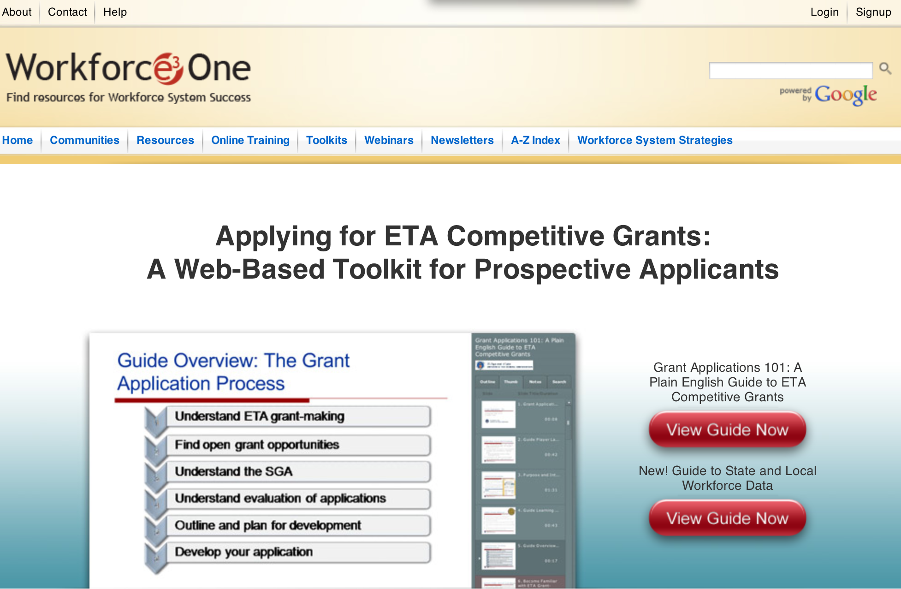

https://www.workforce3one.org/ws/www/pages/grants_toolkit.aspx?pparams=/

Programs

Modifications

Reminders

Mine Safety and Health Administration
Brookwood Sago Grant

Document Type: | Grants Notice
Funding Opportunity Number: | BS16-3BS
Funding Opportunity Title: | Brookwood Sago Grant
Opportunity Category: | Mandatory
Opportunity Category Explanation:
Funding Instrument Type: | Grant
Category of Funding Activity: | Education
Category Explanation:
Expected Number of Awards: | 20
CFDA Number(s): | 17.603 -- Brookwood-Sago Grant
Cost Sharing or Matching Requirement: | No
Posted Date: | Jul 28, 2016
Last Updated Date: | Jul 28, 2016
Original Closing Date for Applications: | Sep 09, 2016
Current Closing Date for Applications: | Sep 09, 2016
Archive Date: | Oct 09, 2016
Estimated Total Program Funding: | $1,000,000
Award Ceiling: | $250,000
Award Floor: | $50,000
Eligible Applicants: | Native American tribal governments (Federally recognized)  Nonprofits having a 501(c)(3) status with the IRS, other than institutions of higher education
Additional Information on Eligibility: | Applicants for the grants may be States and nonprofit (private or public) entities, including U.S. territories, Indian tribes, tribal organizations, Alaska Native entities, Indian-controlled organizations serving Indians, and Native Hawaiian organizations.
Agency Name: | Mine Safety and Health Administration
Description: | The U.S. Department of Labor (DOL), Mine Safety and Health Administration (MSHA), is making up to $1,000,000 available in grant funds for education and training programs to help identify, avoid, and prevent unsafe working conditions in and around mines. The focus of these grants for Fiscal Year (FY) 2016 will be on training and training materials for mine emergency preparedness and mine emergency prevention for all underground mines. Applicants for the grants may be States and nonprofit (private or public) entities, including U.S. territories, Indian tribes, tribal organizations, Alaska Native entities, Indian-controlled organizations serving Indians, and Native Hawaiian organizations. MSHA could award as many as 20 grants. The amount of each individual grant will be at least $50,000.00 and the maximum individual award will be $250,000. This notice contains all of the information needed to apply for grant funding. DATES: The closing date for applications will be September 9, 2016, (no later than 11:59 p.m. EDST). MSHA will award grants on or before September 30, 2016. ADDRESSES: Grant applications for this competition must be submitted electronically through the Grants.gov site at www.grants.gov. If applying online poses a hardship to any applicant, the MSHA Directorate of Educational Policy and Development will provide assistance to help applicants submit online.
Link to Additional Information:
Grantor Contact Information: | If you have difficulty accessing the full announcement electronically, please contact:  Janice Oates Grant Program Manager Phone 202-693-9573

http://www.grants.gov/web/grants/view-opportunity.html?oppId=286677



National Aeronautics and Space Administration

Research and Contracting Opportunities

NASA Research Opportunities Online

- Various NASA offices publish their research announcements over the Internet, broadening the opportunity for researchers to apply for funding. This site provides access to current research announcements along with their specific due dates.

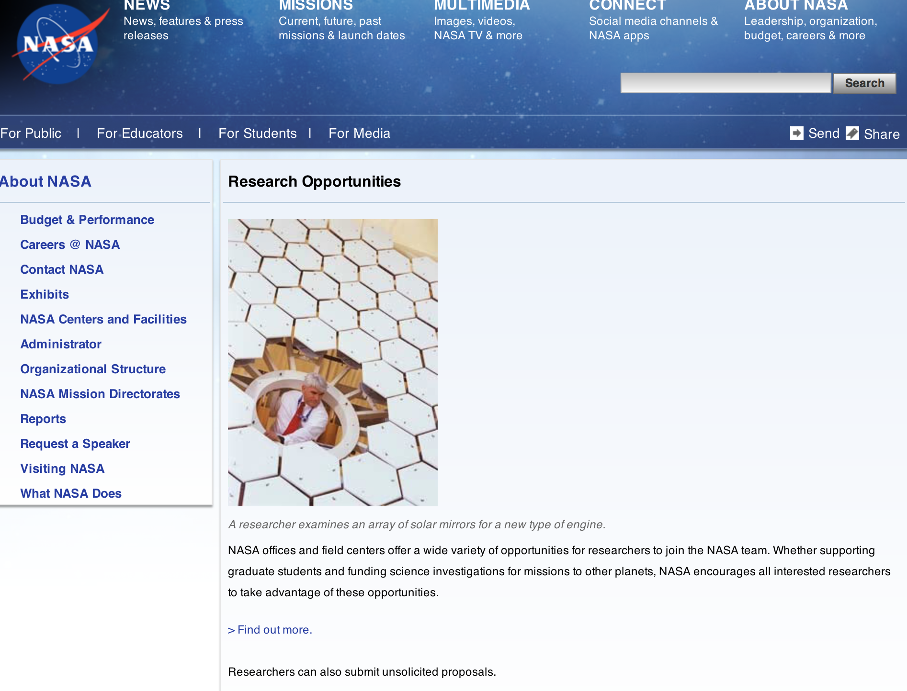

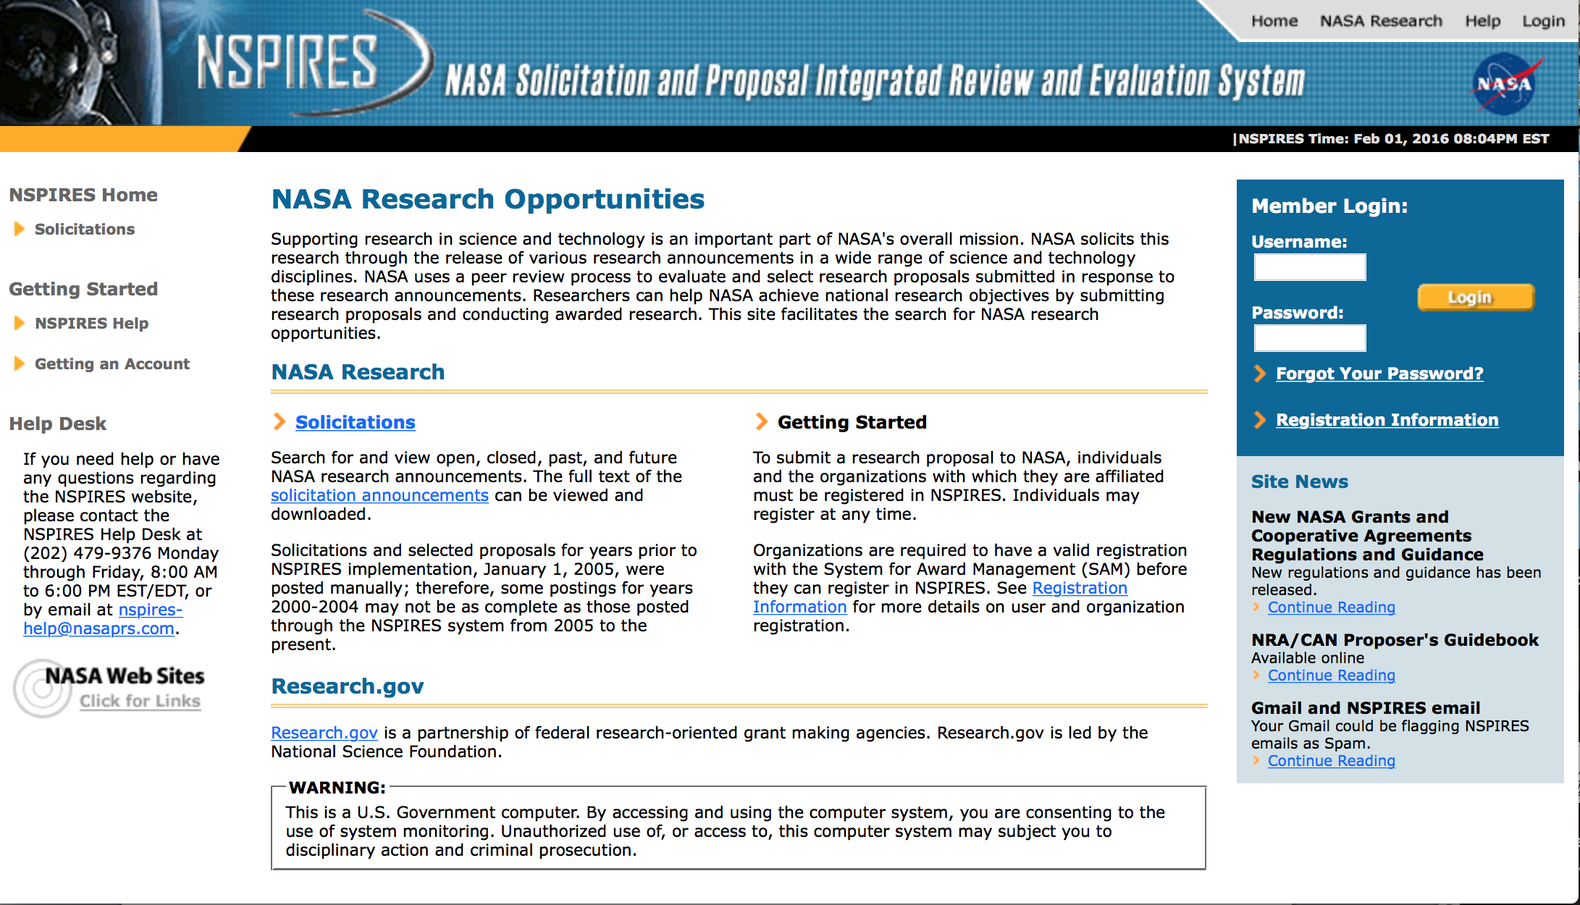

http://nspires.nasaprs.com/external/

Research Programs:

NASA Headquarters
ROSES 2016: Planetary Instrument Concepts for the Advancement of Solar System Observations
Synopsis 1
http://www.grants.gov/web/grants/view-opportunity.html?oppId=287136

NASA Headquarters
ROSES 2016: Astrophysics Probe Mission Concept Studies
Synopsis 1
http://www.grants.gov/web/grants/view-opportunity.html?oppId=287656

NASA Headquarters
ROSES 2016: Cloud and Aerosol Monsoonal Processes - Philippines Experiment
Synopsis 1
http://www.grants.gov/web/grants/view-opportunity.html?oppId=287315

NASA Headquarters
Solar System Exploration Research Virtual Institute - Cycle 2
Synopsis 1
http://www.grants.gov/web/grants/view-opportunity.html?oppId=288094

NASA Headquarters
ROSES 2016: Ocean Salinity Science Team
Synopsis 1
http://www.grants.gov/web/grants/view-opportunity.html?oppId=288270

NASA Headquarters
ROSES 2016: Sea Level Change Science Team
Synopsis 1
http://www.grants.gov/web/grants/view-opportunity.html?oppId=288271

Modifications:

NASA Headquarters
ROSES 2016: Heliophysics Grand Challenges Research
Synopsis 2
http://www.grants.gov/web/grants/view-opportunity.html?oppId=286873

NASA Headquarters
ROSES 2016: Planetary Science and Technology Through Analog Research
Synopsis 2
http://www.grants.gov/web/grants/view-opportunity.html?oppId=284424

NNH16ZCQ002K-ITP1 - ASTEROID REDIRECT MISSION UMBRELLA FOR PARTNERSHIPS (ARM-UP) APPENDIX B: INVESTIGATION TEAM PHASE 1
Deletion Comments: Opportunity deleted

National Archives and Records Administration

Grant Opportunities General Overview

To access the information below: click here

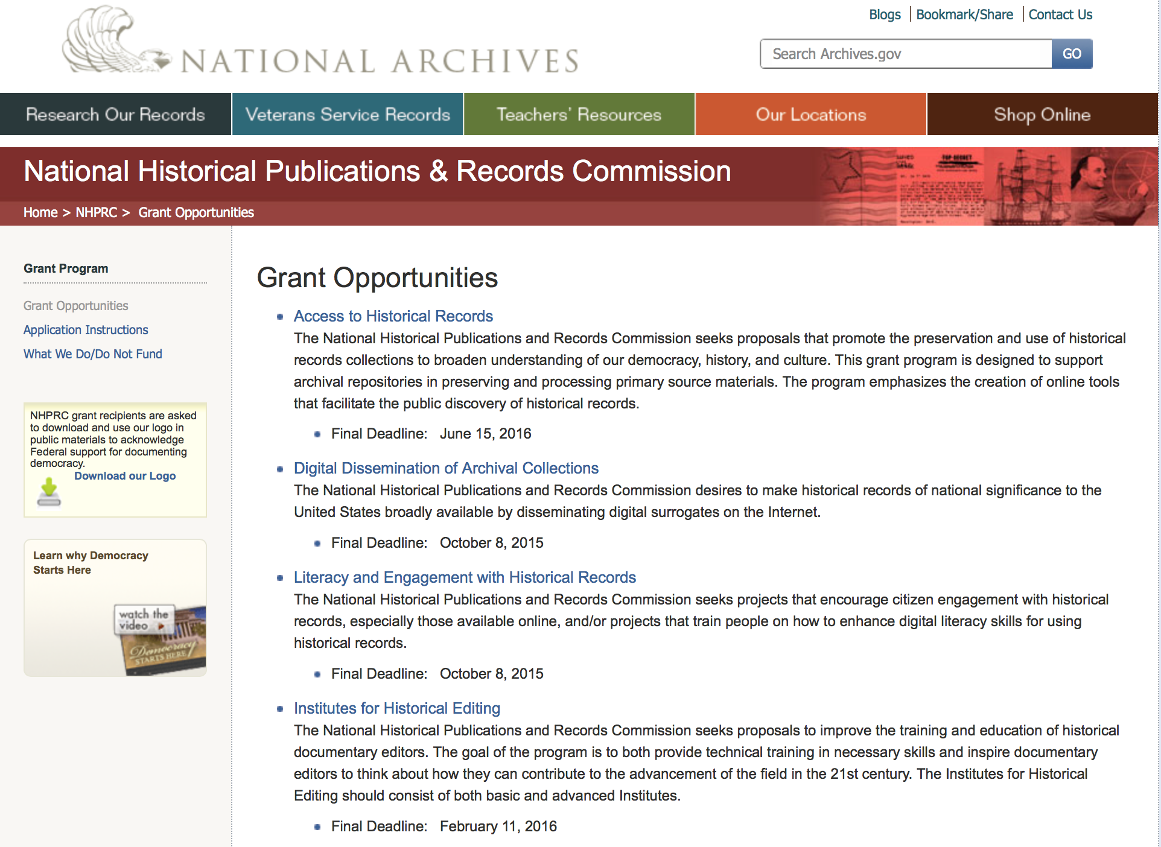

Reminders:

Access to Historical Records - Major Initiatives

Document Type: | Grants Notice
Funding Opportunity Number: | MAJOR-201707
Funding Opportunity Title: | Access to Historical Records - Major Initiatives
Opportunity Category: | Discretionary
Opportunity Category Explanation:
Funding Instrument Type: | Grant
Category of Funding Activity: | Humanities (see "Cultural Affairs" in CFDA)
Category Explanation:
Expected Number of Awards: | 5
CFDA Number(s): | 89.003 -- National Historical Publications and Records Grants
Cost Sharing or Matching Requirement: | Yes
Posted Date: | Jul 25, 2016
Last Updated Date: | Jul 25, 2016
Original Closing Date for Applications: | Jul 12, 2017
Current Closing Date for Applications: | Jul 12, 2017
Archive Date: | Aug 11, 2017
Estimated Total Program Funding: | $1,000,000
Award Ceiling: | $350,000
Award Floor: | $1
Eligible Applicants: | Private institutions of higher education  County governments  Native American tribal governments (Federally recognized)  Public and State controlled institutions of higher education  City or township governments  Nonprofits having a 501(c)(3) status with the IRS, other than institutions of higher education  State governments
Agency Name: | National Archives and Records Administration
Description: | The National Historical Publications and Records Commission seeks projects that will significantly improve public discovery and use of major historical records collections. All types of historical records are eligible, including documents, photographs, born-digital records, and analog audio and moving images. Projects may: • Digitize historical records collections, or related collections, held by a single institution and make them freely available online • Provide access to born-digital records • Create new freely-available virtual collections drawn from historical records held by multiple institutions • Create new tools and methods for users to access records The NHPRC welcomes collaborative projects, particularly for bringing together related records from multiple institutions. Projects that address significant needs in the field and result in replicable and scalable approaches will be more competitive. We also encourage organizations to actively engage the public in the work of the project. For a comprehensive list of Commission limitations on funding, please see “What we do and do not fund” (http://www.archives.gov/nhprc/apply/eligibility.html). Applications that consist entirely of ineligible activities will not be considered. Award Information A grant is for one to three years and for up to $350,000. We expect to make up to five grants in this category for a total of up to $1,000,000. Grants begin no earlier than January 1, 2018. Eligible applicants: • Nonprofit organizations or institutions • Colleges, universities, and other academic institutions • State or local government agencies • Federally-acknowledged or state-recognized Native American tribes or groups Cost Sharing The total costs of a project are shared between the NHPRC and the applicant organization. The Commission provides no more than 50 per cent of total project costs in the Access to Historical Records: Major Initiatives category. NHPRC grant recipients are not permitted to use grant funds for indirect costs (as indicated in 2 CFR 2600.101). Cost sharing is required. The applicant’s financial contribution may include both direct and indirect expenses, in-kind contributions, non-Federal third-party contributions, and any income earned directly by the project. Indirect costs must be listed under the applicant’s cost sharing contribution. Other Requirements Applicant organizations must be registered in the System for Award Management (SAM) prior to submitting an application, maintain SAM registration throughout the application and award process, and include a valid DUNS number in their application. Details on SAM registration and requesting a DUNS number can be found at the System for Award Management website at http://sam.gov. Please refer to the User Guides section and the Grants Registrations PDF. APPLICATION AND SUBMISSION INFORMATION You must use Grants.gov to submit a Full Proposal. All information necessary to apply is included in this announcement, the Application Instructions, and the forms on Grants.gov. If you need the information supplied in an alternative format, please call the NHPRC at 202-357-5010. Applying for the Access to Historical Records: Major Initiatives program is a two-phase process. Phase One All applicants must have submitted a five-page preliminary proposal and Application for Federal Domestic Assistance – Short Organizational form SF424 and the Budget Information for Non-Construction Projects form SF424A by January 19, 2017 using the preliminary proposal Major Initiatives grant announcement (insert link). Only those applicants who have successfully completed Phase One and who have been invited by the Commission to submit a full proposal to the Access to Historical Records: Major Initiatives program are eligible to participate in the second phase of the process. Phase Two Using this announcement, invited applicants will prepare and submit a complete application via Grants.gov by July 12, 2017. A complete application includes the Application for Federal Assistance (Standard Form 424), Assurances -- Non-Construction Programs (Standard Form 424B), a Project Narrative, Supplementary Materials, and Budget. Applications lacking any of these items will not be considered. Applicants may consult with the Director of the Access Program, Alex Lorch (alexander.lorch@nara.gov) during both the preliminary and full proposal project phases. In order to ensure eligibility, applicants should first review the rules and regulations governing NHPRC grants under the Administering an NHPRC Grant section.
Link to Additional Information: | Link to full grant announcement, including additional requirements
Grantor Contact Information: | If you have difficulty accessing the full announcement electronically, please contact:  Jeff de la Concepcion Grant Program Specialist Phone 202-357-5022  Grant Information Specialist

http://www.grants.gov/web/grants/view-opportunity.html?oppId=286436

Access to Historical Records – Archival Projects

Document Type: | Grants Notice
Funding Opportunity Number: | ARCHIVAL-201612
Funding Opportunity Title: | Access to Historical Records – Archival Projects
Opportunity Category: | Discretionary
Opportunity Category Explanation:
Funding Instrument Type: | Grant
Category of Funding Activity: | Humanities (see "Cultural Affairs" in CFDA)
Category Explanation:
Expected Number of Awards: | 10
CFDA Number(s): | 89.003 -- National Historical Publications and Records Grants
Cost Sharing or Matching Requirement: | No
Posted Date: | Jul 25, 2016
Last Updated Date: | Jul 25, 2016
Original Closing Date for Applications: | Dec 06, 2016
Current Closing Date for Applications: | Dec 06, 2016
Archive Date: | Jan 05, 2017
Estimated Total Program Funding: | $700,000
Award Ceiling: | $100,000
Award Floor: | $1
Eligible Applicants: | Private institutions of higher education  Nonprofits having a 501(c)(3) status with the IRS, other than institutions of higher education  State governments  City or township governments  Public and State controlled institutions of higher education  County governments  Native American tribal governments (Federally recognized)
Agency Name: | National Archives and Records Administration
Description: | The National Historical Publications and Records Commission seeks projects that ensure online public discovery and use of historical records collections. All types of historical records are eligible, including documents, photographs, born-digital records, and analog audio and moving images. Projects may preserve and process historical records to: • Create new online Finding Aids to collections • Digitize historical records collections and make them freely available online The NHPRC encourages organizations to actively engage the public in the work of the project. For a comprehensive list of Commission limitations on funding, please see “What we do and do not fund” (http://www.archives.gov/nhprc/apply/eligibility.html). Applications that consist entirely of ineligible activities will not be considered. Award Information A grant is for one to two years and for up to $100,000. The Commission expects to make up to 10 grants in this category for a total of up to $700,000. Grants begin no earlier than July 1, 2017. The Commission requires that grant recipients acknowledge NHPRC grant assistance in all publicity, publications, and other products that result from its support. Eligibility Information Eligible applicants: • Nonprofit organizations or institutions • Colleges, universities, and other academic institutions • State or local government agencies • Federally-acknowledged or state-recognized Native American tribes or groups Cost Sharing The total costs of a project are shared between the NHPRC and the applicant organization. The Commission provides no more than 75 per cent of total project costs in the Access to Historical Records – Archival Projects category. NHPRC grant recipients are not permitted to use grant funds for indirect costs (as indicated in 2 CFR 2600.101). Cost sharing is required. The applicant’s financial contribution may include both direct and indirect expenses, in-kind contributions, non-Federal third-party contributions, and any income earned directly by the project. Indirect costs must be listed under the applicant’s cost sharing contribution. Other Requirements Applicant organizations must be registered in the System for Award Management (SAM) prior to submitting an application, maintain SAM registration throughout the application and award process, and include a valid DUNS number in their application. Details on SAM registration and requesting a DUNS number can be found at the System for Award Management website at http://sam.gov. Please refer to the User Guides section and the Grants Registrations PDF. A complete application includes the Application for Federal Assistance (Standard Form 424), Assurances -- Non-Construction Programs (Standard Form 424B), a Project Narrative, Summary, Supplementary Materials, and Budget. Applications lacking any of these items will not be considered. Ineligible applications will not be reviewed.
Link to Additional Information: | Link to full grant announcement, including additional requirements
Grantor Contact Information: | If you have difficulty accessing the full announcement electronically, please contact:  Jeff de la Concepcion Grant Program Specialist Phone 202-357-5022  Grant Information Specialist

http://www.grants.gov/web/grants/view-opportunity.html?oppId=286450

Public Engagement with Historical Records Grant

Document Type: | Grants Notice
Funding Opportunity Number: | ENGAGEMENT-201610
Funding Opportunity Title: | Public Engagement with Historical Records
Opportunity Category: | Discretionary
Opportunity Category Explanation:
Funding Instrument Type: | Grant
Category of Funding Activity: | Humanities (see "Cultural Affairs" in CFDA)
Category Explanation:
Expected Number of Awards: | 3
CFDA Number(s): | 89.003 -- National Historical Publications and Records Grants
Cost Sharing or Matching Requirement: | Yes
Posted Date: | Jun 06, 2016
Last Updated Date: | Jun 06, 2016
Original Closing Date for Applications: | Oct 06, 2016
Current Closing Date for Applications: | Oct 06, 2016
Archive Date:
Estimated Total Program Funding: | $275,000
Award Ceiling: | $150,000
Award Floor: | $50,000
Eligible Applicants: | State governments  Public and State controlled institutions of higher education  City or township governments  Nonprofits having a 501(c)(3) status with the IRS, other than institutions of higher education  Private institutions of higher education  County governments  Native American tribal governments (Federally recognized)
Agency Name: | National Archives and Records Administration
Description: | The National Historical Publications and Records Commission seeks projects that encourage public engagement with historical records, including the development of new tools that enable people to engage online. The NHPRC is looking for projects that create models and technologies that other institutions can freely adopt. In general, collaborations between archivists, documentary editors, historians, educators, and/or community-based individuals are more likely to create a competitive proposal. Projects might create and develop programs to engage people in the study and use of historical records for institutional, educational or personal reasons. For example, an applicant can: • Enlist volunteer “citizen archivists” in projects to accelerate access to historical records, especially those online. This may include, but is not limited to, efforts to identify, tag, transcribe, annotate, or otherwise enhance digitized historical records. • Develop educational programs for K-16 students or community members that encourage them to engage with historical records already in repositories or that are collected as part of the project. For a comprehensive list of the Commission’s limitations on funding, please see “What we do and do not fund” (http://www.archives.gov/nhprc/apply/eligibility.html). Applications that consist entirely of ineligible activities will not be considered. Award Information A grant normally is for one to three years. The Commission expects to make up to three grants of between $50,000 and $150,000. The total amount allocated for this program is up to $275,000. Grants begin no earlier than July 1, 2017. The Commission requires that grant recipients acknowledge NHPRC grant assistance in all publications and other products that result from its support. Eligibility Information Eligible applicants: • Nonprofit organizations or institutions • Colleges, universities, and other academic institutions • State or local government agencies • Federally-acknowledged or state-recognized Native American tribes or groups Cost Sharing The total costs of a project are shared between the NHPRC and the applicant organization. The Commission provides no more than 50 per cent of total direct project costs in the Public Engagement with Historical Records category. NHPRC grant recipients are not permitted to use grant funds for indirect costs (as indicated in 2 CFR 2600.101). The applicant’s financial contribution may include both direct and indirect expenses, in-kind contributions, non-Federal third-party contributions, and any income earned directly by the project. Indirect costs must be listed under the applicant’s cost sharing contribution. Other Requirements Applicant organizations must be registered in the System for Award Management (SAM) prior to submitting an application, maintain SAM registration throughout the application and award process, and include a valid DUNS number in their application. Details on SAM registration and requesting a DUNS number can be found at the System for Award Management website at www.sam.gov. Please refer to the User Guides section and the Grants Registrations PDF. A complete application includes the Application for Federal Assistance (Standard Form 424), Assurances -- Non-Construction Programs (Standard Form 424B), a Project Narrative, Summary, Supplementary Materials, and Budget. Applications lacking these items will not be considered. Ineligible applications will not be reviewed.
Link to Additional Information: | Link to full grant announcement, including additional requirements
Grantor Contact Information: | If you have difficulty accessing the full announcement electronically, please contact:  Jeff de la Concepcion Jeff.delaconcepcion@nara.gov  Grant Information Specialist

http://www.grants.gov/web/grants/view-opportunity.html?oppId=284376

Publishing Historical Records in Documentary Editions Grant

Document Type: | Grants Notice
Funding Opportunity Number: | EDITIONS-201610
Funding Opportunity Title: | Publishing Historical Records in Documentary Editions
Opportunity Category: | Discretionary
Funding Instrument Type: | Grant
Category of Funding Activity: | Humanities (see "Cultural Affairs" in CFDA)
Category Explanation:
Expected Number of Awards: | 25
CFDA Number(s): | 89.003 -- National Historical Publications and Records Grants
Cost Sharing or Matching Requirement: | Yes
Posted Date: | Nov 24, 2015
Creation Date: | Nov 23, 2015
Original Closing Date for Applications: | Oct 6, 2016
Current Closing Date for Applications: | Oct 6, 2016
Archive Date: | Nov 4, 2016
Estimated Total Program Funding: | $2,500,000
Award Ceiling: | $200,000
Award Floor: | $0
Eligible Applicants: | Private institutions of higher education  County governments  City or township governments  Public and State controlled institutions of higher education  Native American tribal governments (Federally recognized)  Nonprofits having a 501(c)(3) status with the IRS, other than institutions of higher education  State governments
Agency Name: | National Archives and Records Administration
Description: | The National Historical Publications and Records Commission seeks proposals to publish documentary editions of historical records. Projects may focus on the papers of major figures from American history or cover broad historical movements in politics, military, business, social reform, the arts, and other aspects of the national experience. The historical value of the records and their expected usefulness to broad audiences must justify the costs of the project. The goal of this program is to provide access to, and editorial context for, the historical documents and records that tell the American story. The NHPRC encourages projects, whenever possible and appropriate, to provide access to these materials in a free and open online environment, without precluding other forms of publication. Applicants should demonstrate familiarity with the best practices recommended by the Association for Documentary Editing or the Modern Language Association Committee on Scholarly Editions. Projects may also prepare print editions as part of their overall publishing plan. However, projects that do not have definitive plans for digital dissemination and preservation in place at the time of application will not be considered. It is also expected that the contents of any print volumes produced will be made available online within a reasonable period of time following print publication. Grants are awarded for collecting, describing, preserving, compiling, transcribing, annotating, editing, encoding, and publishing documentary source materials in print and online. Because of the focus on documentary sources, grants do not support preparation of critical editions of published works unless such works are just a small portion of the larger project. All applicants should be aware that the application process is highly competitive. Ongoing projects: Applicants from ongoing projects must demonstrate that they have successfully achieved the performance objectives associated with previous NHPRC awards; provide updated, current information, including a description of the new activities as well as description and significance of the specific materials to be edited during the proposed grant period; show progress towards completing the edition; and justify costs in a new budget. For a comprehensive list of Commission's limitations on funding, please see What We Do and Do Not Fund. Applications that consist entirely of ineligible activities will not be considered. Award Information A grant is for one year and for up to $200,000. The Commission expects to make up to 25 grants in this category for a total of up to $2,500,000. Grants begin no earlier than January 1, 2017. The Commission requires that grant recipients acknowledge NHPRC grant assistance in all publications and other products that result from its support. Eligibility U.S. nonprofit organizations or institutions U.S. colleges, universities, and other academic institutions State or local government agencies Federally-acknowledged or state-recognized Native American tribes or groups Cost Sharing The total costs of a project are shared between the NHPRC and the applicant organization. The Commission provides no more than 50 per cent of total direct project costs in the Publishing Historical Records in Documentary Editions category. NHPRC grant recipients are not permitted to use grant funds for indirect costs (as indicated in 2 CFR 2600.101). Cost sharing is required. The applicant’s financial contribution may include both direct and indirect expenses, in-kind contributions, non-Federal third-party contributions, and any income earned directly by the project. Indirect costs must be listed under the applicant’s cost sharing contribution. Other Requirements Applicant organizations must be registered in the System for Award Management (SAM) prior to submitting an application, maintain SAM registration throughout the application and award process, and include a valid DUNS number in their application. Details on SAM registration and requesting a DUNS number can be found at the System for Award Management website at https://sam.gov. Please refer to the User Guides section and the Grants Registrations PDF. A complete application includes the Application for Federal Assistance (Standard Form 424), Assurances -- Non-Construction Programs (Standard Form 424B), a Project Narrative, Summary, Supplementary Materials, and Budget. Applications lacking these items will not be considered. Ineligible applications will not be reviewed.
Link to Additional Information: | Link to full grant announcement, including additional requirements
Contact Information: | If you have difficulty accessing the full announcement electronically, please contact:  Jeff de la Concepcion Grant Program Specialist Phone 202-357-5022  Grant Program Specialist

http://www.grants.gov/web/grants/view-opportunity.html?oppId=280202

National Endowment for the Arts

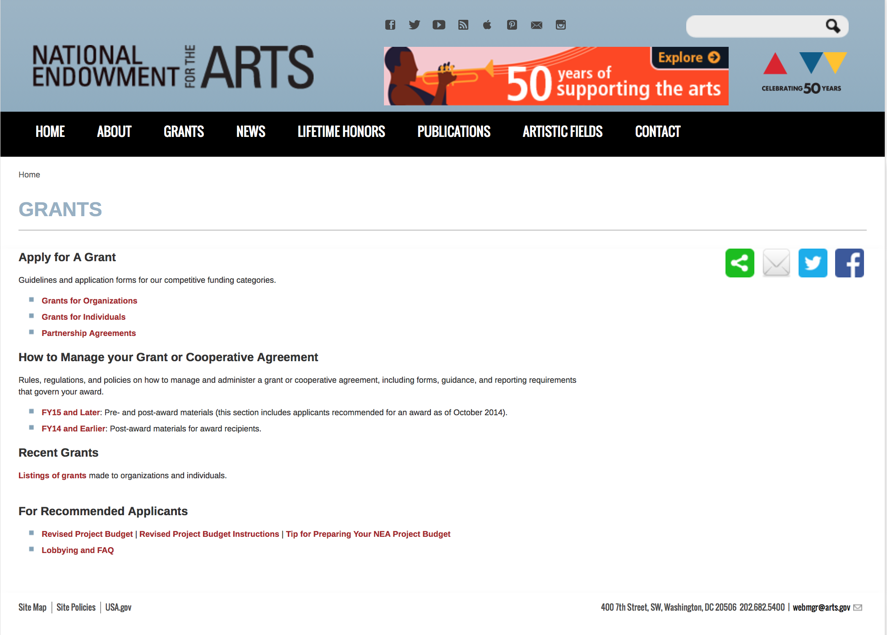

http://arts.gov/grants

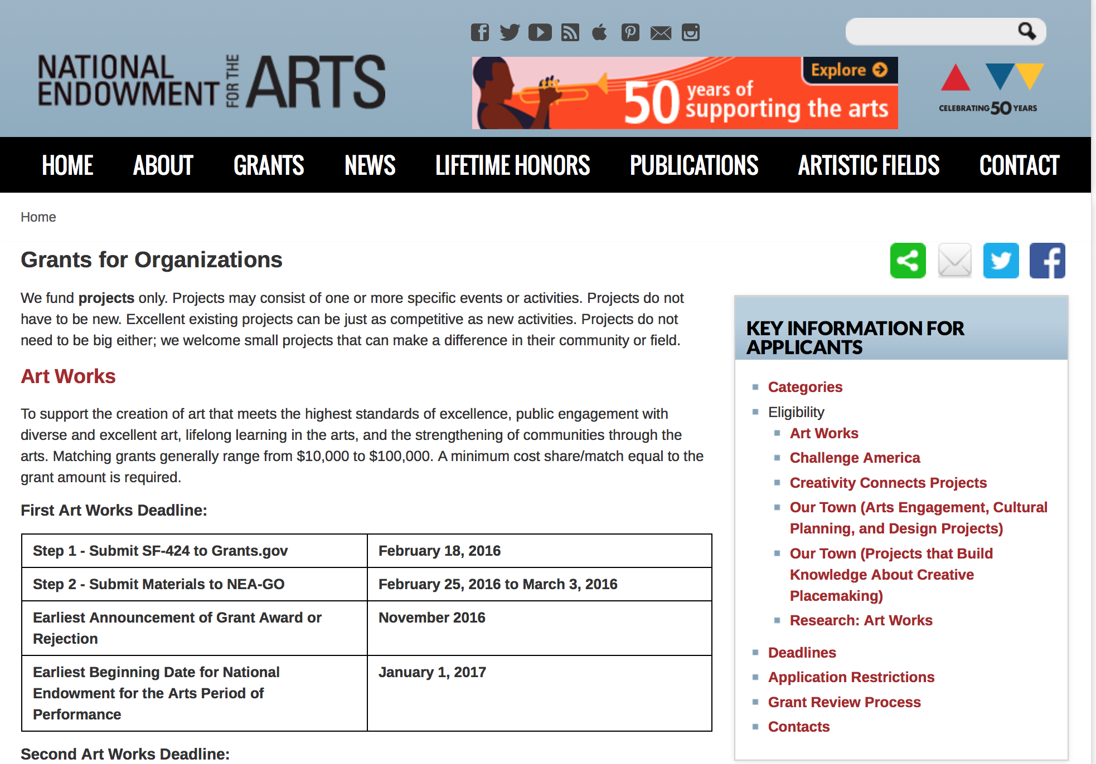
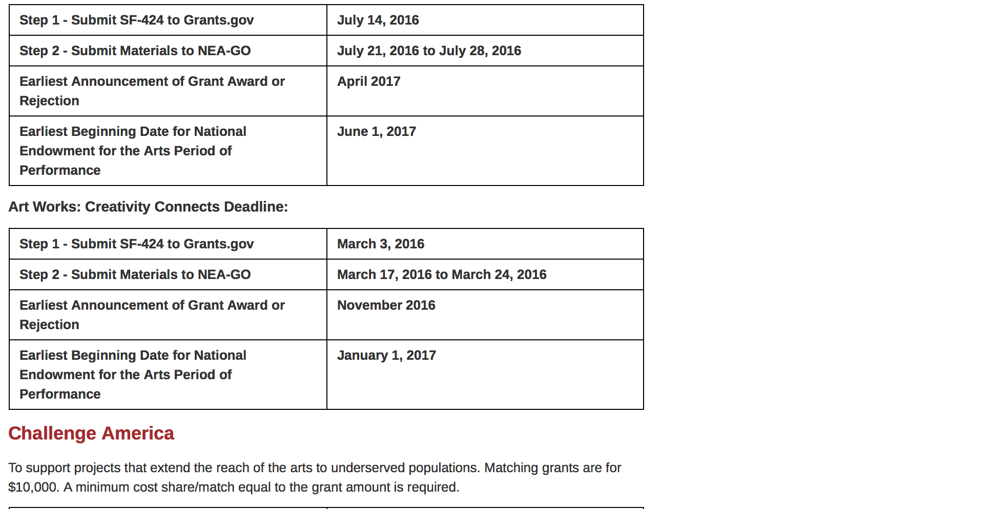
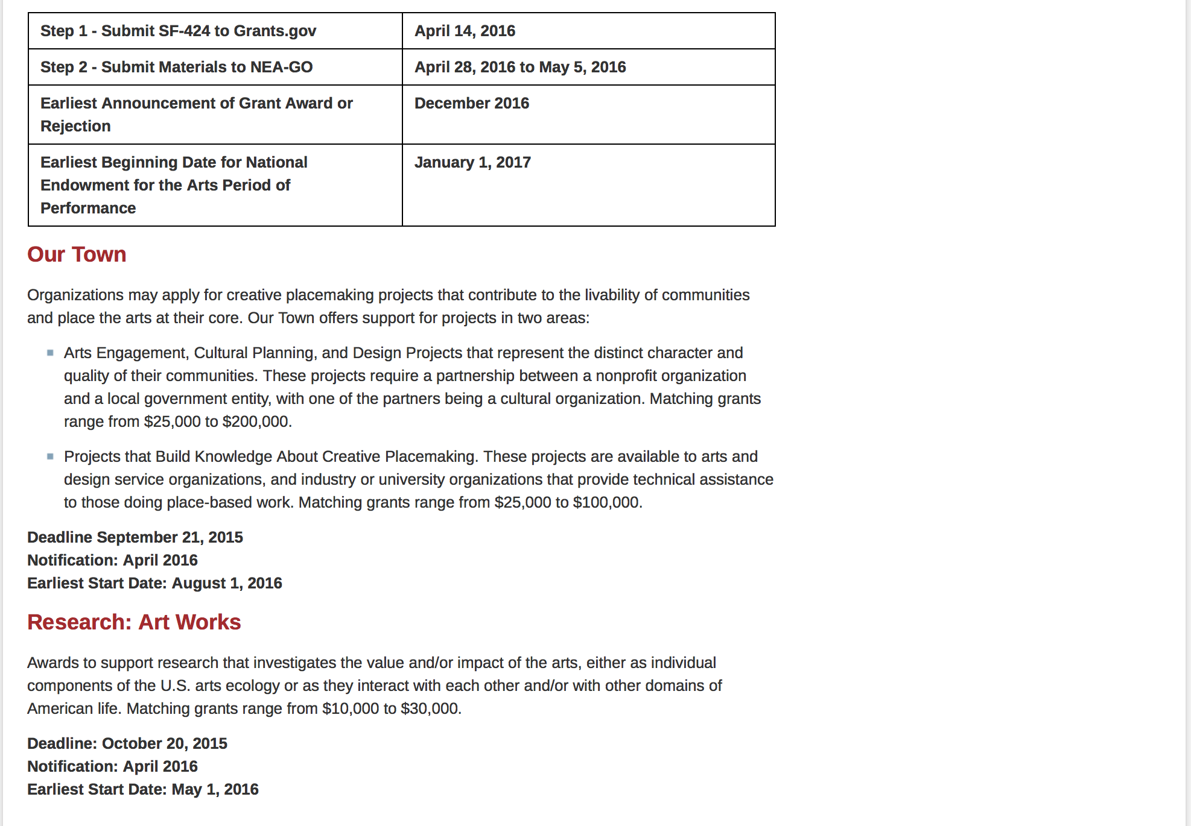
See more at: https://www.arts.gov/grants/apply-grant/grants-organizations

Programs:

NEA Literature Fellowships: Translation Projects, FY 2018
Synopsis 1

Document Type: | Grants Notice
Funding Opportunity Number: | 2017NEA03LFTP
Funding Opportunity Title: | NEA Literature Fellowships: Translation Projects, FY 2018
Opportunity Category: | Discretionary
Opportunity Category Explanation:
Funding Instrument Type: | Grant
Category of Funding Activity: | Arts (see "Cultural Affairs" in CFDA)
Category Explanation:
Expected Number of Awards:
CFDA Number(s): | 45.024 -- Promotion of the Arts Grants to Organizations and Individuals
Cost Sharing or Matching Requirement: | No
Posted Date: | Aug 16, 2016
Last Updated Date: | Aug 16, 2016
Original Closing Date for Applications: | Dec 06, 2016 The Grants.gov system must receive your validated and accepted application no later than 11:59 p.m., Eastern Time, on December 6, 2016.
Current Closing Date for Applications: | Dec 06, 2016 The Grants.gov system must receive your validated and accepted application no later than 11:59 p.m., Eastern Time, on December 6, 2016.
Archive Date: | Jan 05, 2017
Estimated Total Program Funding:
Award Ceiling: | $25,000
Award Floor: | $12,500
Eligible Applicants: | Individuals
Additional Information on Eligibility: | An individual may submit only one application for FY 2018 funding. You may not apply for both a Translation Project under this deadline (December 6, 2016) and a Literature Fellowship (in prose or poetry) under the 2017 deadline (when fellowships in prose are offered). The Arts Endowment’s support of a project may begin any time between November 1, 2017, and November 1, 2018, and extend for up to two years. Applicant Eligibility Individual translators who meet the publication requirements that are listed below are eligible to apply. Applicants must be citizens or permanent residents of the United States. See "How to Prepare and Submit an Application" LINK for the documentation that is required to demonstrate eligibility. Ineligible applications will be rejected without panel review. An individual may submit only one application for FY 2018 funding. You may not apply for both a Translation Project under this deadline (December 6, 2016) and a Literature Fellowship (in prose or poetry) under the 2017 deadline (when fellowships in prose are offered). See Literature Fellowships LINK for more information. You are not eligible to apply if you have received three or more Fellowships (in poetry, prose, or for translation) from the National Endowment for the Arts. In addition, you may not apply in Translation if you have received any National Endowment for the Arts Literature Fellowships (in prose or poetry) or Translation Fellowship on or after October 1, 2013 (FY 2014). Finally, you may not apply in Translation with the same project for more than three consecutive years. Former grantees must have submitted acceptable Final Report packages by the due date(s) for all National Endowment for the Arts award(s) previously received.
Agency Name: | National Endowment for the Arts
Description: | An individual may submit only one application for FY 2018 funding. You may not apply for both a Translation Project under this deadline (December 6, 2016) and a Literature Fellowship (in prose or poetry) under the 2017 deadline (when fellowships in prose are offered). The Arts Endowment’s support of a project may begin any time between November 1, 2017, and November 1, 2018, and extend for up to two years. Grant Program Description Through fellowships to published translators, the National Endowment for the Arts supports projects for the translation of specific works of prose, poetry, or drama from other languages into English. We encourage translations of writers and of work that are not well represented in English translation. All proposed projects must be for creative translations of literary material into English. The work to be translated should be of interest for its literary excellence and value. Priority will be given to projects that involve work that has not previously been translated into English. Competition for fellowships is rigorous. Potential applicants should consider carefully whether their work will be competitive at the national level.
Link to Additional Information: | NEA Complete Website Announcement
Grantor Contact Information: | If you have difficulty accessing the full announcement electronically, please contact:  NEA Web Manager  NEA Web Manager

http://www.grants.gov/web/grants/view-opportunity.html?oppId=287530

Modifications:

Reminders:

NEA Research: Art Works Application, FY 2017

Document Type: | Grants Notice
Funding Opportunity Number: | 2017NEAORA
Funding Opportunity Title: | NEA Research: Art Works Application, FY 2017
Opportunity Category: | Discretionary
Opportunity Category Explanation:
Funding Instrument Type: | Grant
Category of Funding Activity: | Arts (see "Cultural Affairs" in CFDA)
Category Explanation:
Expected Number of Awards:
CFDA Number(s): | 45.024 -- Promotion of the Arts Grants to Organizations and Individuals
Cost Sharing or Matching Requirement: | Yes
Posted Date: | Jul 20, 2016
Last Updated Date: | Jul 20, 2016
Original Closing Date for Applications: | Oct 11, 2016 The Grants.gov system must receive your validated and accepted application no later than 11:59 p.m., Eastern Time, on October 11, 2016. Submit your SF-424 no later than October 1, 2016 to give yourself ample time to resolve any problems you might encounter. You take a significant risk by waiting until the day of the deadline to submit.
Current Closing Date for Applications: | Oct 11, 2016 The Grants.gov system must receive your validated and accepted application no later than 11:59 p.m., Eastern Time, on October 11, 2016. Submit your SF-424 no later than October 1, 2016 to give yourself ample time to resolve any problems you might encounter. You take a significant risk by waiting until the day of the deadline to submit.
Archive Date: | Nov 10, 2016
Estimated Total Program Funding:
Award Ceiling: | $100,000
Award Floor: | $10,000
Eligible Applicants: | City or township governments  Native American tribal governments (Federally recognized)  Public and State controlled institutions of higher education  Private institutions of higher education  State governments  Independent school districts  Special district governments  Nonprofits having a 501(c)(3) status with the IRS, other than institutions of higher education  County governments
Additional Information on Eligibility: | The Arts Endowment’s support of a project may start on May 1, 2017, or any time thereafter. Grants generally may cover a period of performance of up to two years, with an exception for projects that include primary data collection as part of the proposed activity. Projects that include primary data collection may request up to three years. Projects that extend beyond one year will be required to submit an annual progress report. A grantee may not receive more than one National Endowment for the Arts grant for the same project during the same period of performance. Official applicant organizations must be nonprofit, tax-exempt 501(c)(3), U.S. organizations; units of state or local government; or federally recognized tribal communities or tribes. This may include, but is not limited to, colleges and universities. For projects that involve multiple organizations, one organization that meets the eligibility requirements below must act as the official applicant, submit the application, and assume full responsibility for the grant. Partnering organizations are not required to meet the same eligibility requirements as the official applicant organization.
Agency Name: | National Endowment for the Arts
Description: | The Arts Endowment’s support of a project may start on May 1, 2017, or any time thereafter. Grants generally may cover a period of performance of up to two years, with an exception for projects that include primary data collection as part of the proposed activity. Projects that include primary data collection may request up to three years. Projects that extend beyond one year will be required to submit an annual progress report. A grantee may not receive more than one National Endowment for the Arts grant for the same project during the same period of performance. Program Description The National Endowment for the Arts’ Office of Research & Analysis makes awards to support research that investigates the value and/or impact of the arts, either as individual components of the U.S. arts ecology or as they interact with each other and/or with other domains of American life. In past years, the Research: Art Works category has invited researchers to propose studies that examine topics related to any area(s) on the How Art Works system map (see Grant Program Description). These projects have used quantitative, qualitative, or mixed-methods approaches, and have relied on primary and/or secondary data for analysis. Examples of previously funded research can be found via the "Grant Search" engine or by viewing Research: Art Works Grants Final Papers. This year, Research: Art Works offers support for projects in two areas: • Track One: Value and Impact. These research projects aim to examine the value and/or impact of the arts in any topic area(s) by using data and methods appropriate to the proposed research questions. Matching grants range from $10,000-$30,000. o Projects relying primarily on experimental/quasi-experimental design methods are not eligible under this Track and should apply to Track Two. • Track Two: Experimental and Quasi-Experimental Designs. These research projects aim to test the causal or inferred-causal impact of the arts on individual or cohort outcomes by using experimental or quasi-experimental design methods appropriate to the proposed research questions. Matching grants range from $30,000-$100,000. o This Track is only for projects relying primarily on experimental or quasi-experimental research methods.
Link to Additional Information: | NEA Web Site Announcement
Grantor Contact Information: | If you have difficulty accessing the full announcement electronically, please contact:  NEA Web Manager  NEA Web Manager

http://www.grants.gov/web/grants/view-opportunity.html?oppId=286351

Our Town FY 17 Grant

Document Type: | Grants Notice
Funding Opportunity Number: | 2016NEA01OT
Funding Opportunity Title: | Our Town FY 17
Opportunity Category: | Discretionary
Opportunity Category Explanation: | Category Explanation
Funding Instrument Type: | Grant
Category of Funding Activity: | Arts (see "Cultural Affairs" in CFDA)
Category Explanation:
Expected Number of Awards:
CFDA Number(s): | 45.024 -- Promotion of the Arts Grants to Organizations and Individuals
Cost Sharing or Matching Requirement: | Yes
Posted Date: | May 09, 2016
Last Updated Date: | May 09, 2016
Original Closing Date for Applications: | Sep 12, 2016 Applications must be received by September 12, 2016, 11:59 p.m., Eastern Time
Current Closing Date for Applications: | Sep 12, 2016 Applications must be received by September 12, 2016, 11:59 p.m., Eastern Time
Archive Date: | Oct 12, 2016
Estimated Total Program Funding:
Award Ceiling: | $200,000
Award Floor: | $25,000
Eligible Applicants: | State governments  Special district governments  Private institutions of higher education  Public and State controlled institutions of higher education  County governments  Nonprofits having a 501(c)(3) status with the IRS, other than institutions of higher education  Independent school districts  City or township governments  Native American tribal governments (Federally recognized)
Agency Name: | National Endowment for the Arts
Description: | Organizations may apply for creative placemaking projects that contribute to the livability of communities and place the arts at their core. Our Town offers support for projects in two areas: • Arts Engagement, Cultural Planning, and Design Projects that represent the distinct character and quality of their communities. These projects require a partnership between a nonprofit organization and a local government entity, with one of the partners being a cultural organization. Matching grants range from $25,000 to $200,000. • Projects that Build Knowledge About Creative Placemaking. These projects are available to arts and design service organizations, and industry, policy, or university organizations that provide technical assistance to those doing place-based work. Matching grants range from $25,000 to $100,000.
Link to Additional Information: | Our Town Guidelines
Contact Information: | If you have difficulty accessing the full announcement electronically, please contact:  Web Manager  Web manager's email address

http://www.grants.gov/web/grants/view-opportunity.html?oppId=283652

National Endowment for the Humanities

Grant Overview -

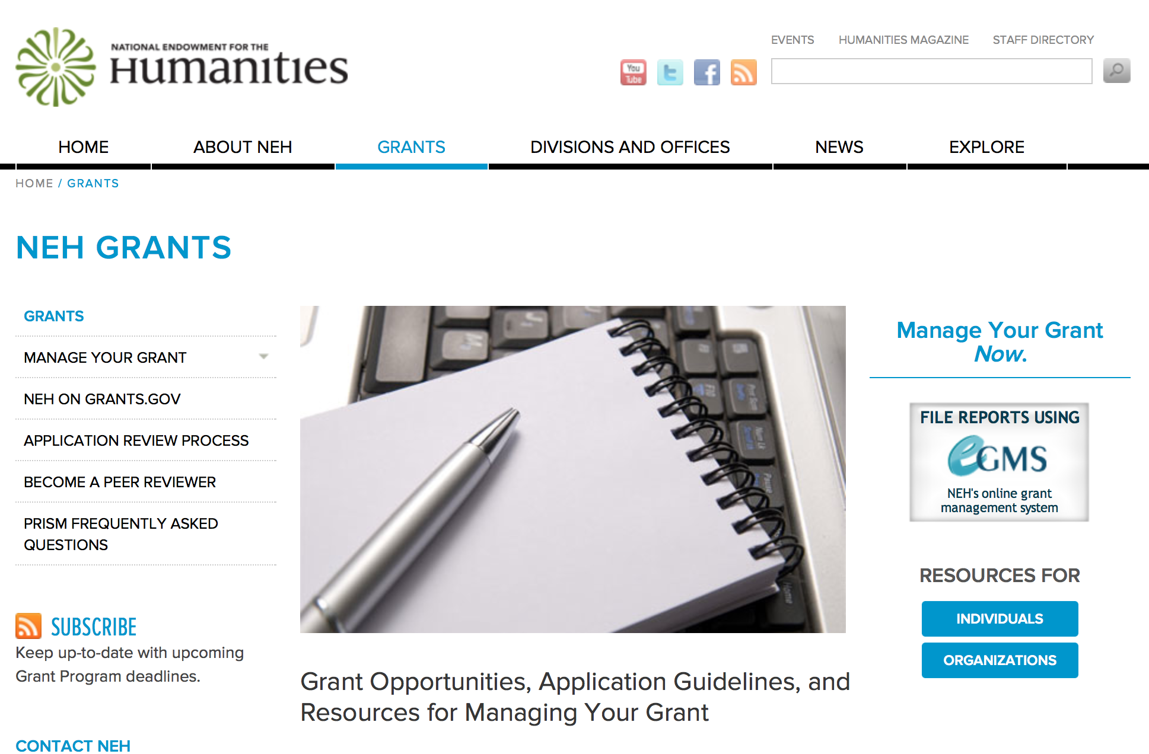

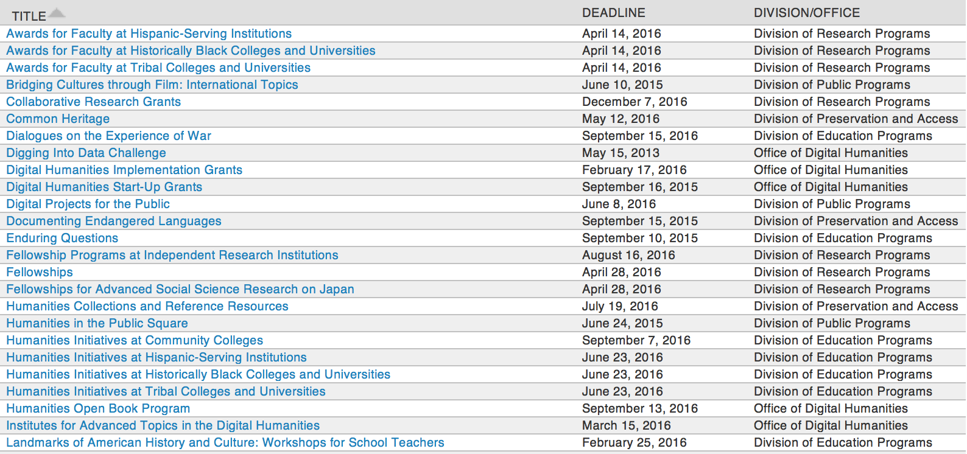

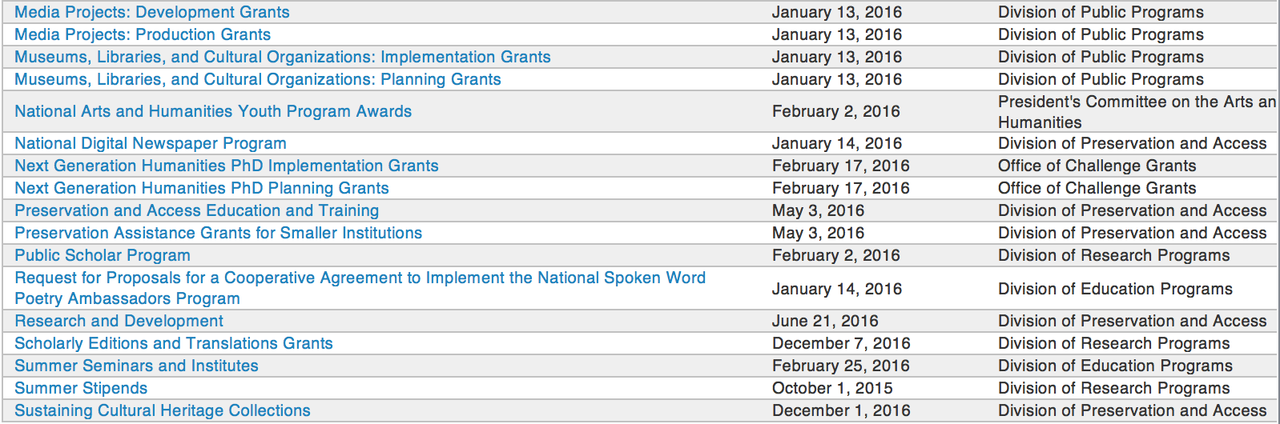

http://www.neh.gov/grants/grantsbydivision.html

Programs:

Dialogues on the Experience of War
Synopsis 1

Document Type: | Grants Notice
Funding Opportunity Number: | 20161102-AV
Funding Opportunity Title: | Dialogues on the Experience of War
Opportunity Category: | Discretionary
Opportunity Category Explanation:
Funding Instrument Type: | Grant
Category of Funding Activity: | Humanities (see "Cultural Affairs" in CFDA)
Category Explanation:
Expected Number of Awards:
CFDA Number(s): | 45.163 -- Promotion of the Humanities Professional Development
Cost Sharing or Matching Requirement: | No
Posted Date: | Sep 02, 2016
Last Updated Date: | Sep 02, 2016
Original Closing Date for Applications: | Nov 02, 2016
Current Closing Date for Applications: | Nov 02, 2016
Archive Date:
Estimated Total Program Funding:
Award Ceiling: | $100,000
Award Floor: | $1
Eligible Applicants: | City or township governments  Special district governments  Nonprofits having a 501(c)(3) status with the IRS, other than institutions of higher education  Nonprofits that do not have a 501(c)(3) status with the IRS, other than institutions of higher education  State governments  Public and State controlled institutions of higher education  Native American tribal governments (Federally recognized)  Private institutions of higher education  County governments
Agency Name: | National Endowment for the Humanities
Description: | As a part of its current initiative, Standing Together: The Humanities and the Experience of War, the National Endowment for the Humanities offers the Dialogues on the Experience of War program. The program supports the study and discussion of important humanities sources about war, in the belief that these sources can help U.S. military veterans and others to think more deeply about the issues raised by war and military service. The humanities sources can be drawn from history, philosophy, literature, and film—and they may and should be supplemented by testimonials from those who have served. The discussions are intended to promote serious exploration of important questions about the nature of duty, heroism, suffering, loyalty, and patriotism. The program awards grants of up to $100,000 that will support 1. the recruitment and training of discussion leaders; and 2. following the training program, the convening of at least two discussion programs. The discussion programs can take place on college and university campuses, in veterans’ centers, at public libraries and museums, and at other community venues. Most of the participants in the discussion programs should be military veterans; others, such as men and women in active service, military families, and interested members of the public, may participate as well.
Link to Additional Information: | http://www.neh.gov/grants/education/dialogues-the-experience-war
Grantor Contact Information: | If you have difficulty accessing the full announcement electronically, please contact:  Division of Education Programs National Endowment for the Humanities 400 Seventh Street, SW Washington, DC 20506 202-606-8471 dew@neh.gov dew@neh.gov  dew@neh.gov

http://www.grants.gov/web/grants/view-opportunity.html?oppId=288369

Modifications:

Reminders:

Funding Opportunity Number: 20170112-AE
Humanities Initiatives at Community Colleges

Posted Date: Jul 05, 2016
Document Type: | Grants Notice
Funding Opportunity Number: | 20170112-AE
Funding Opportunity Title: | Humanities Initiatives at Community Colleges
Opportunity Category: | Discretionary
Opportunity Category Explanation:
Funding Instrument Type: | Grant
Category of Funding Activity: | Humanities (see "Cultural Affairs" in CFDA)
Category Explanation:
Expected Number of Awards:
CFDA Number(s): | 45.162 -- Promotion of the Humanities Teaching and Learning Resources and Curriculum Development
Cost Sharing or Matching Requirement: | No
Posted Date: | Jul 05, 2016
Last Updated Date: | Jul 05, 2016
Original Closing Date for Applications: | Jan 12, 2017
Current Closing Date for Applications: | Jan 12, 2017
Archive Date:
Estimated Total Program Funding:
Award Ceiling: | $100,000
Award Floor: | $1
Eligible Applicants: | Others (see text field entitled "Additional Information on Eligibility" for clarification)
Additional Information on Eligibility: | The only eligible applicants are U.S. nonprofit tax-exempt two-year colleges.
Agency Name: | National Endowment for the Humanities
Description: | The humanities can play a vital role at community colleges by expanding students’ intellectual horizons and by increasing their capacity to read, write, and think analytically. By effecting these changes, the humanities can help prepare students for careers and for lives as engaged citizens. Humanities Initiatives at Community Colleges support community colleges’ commitment to educating students on a variety of educational and career paths. The program funds curricular and faculty development projects that help strengthen humanities programs and/or incorporate humanistic approaches in fields outside the humanities. Each project must be organized around a core topic or set of themes, drawn from subjects such as history, philosophy, and literature. Each project must also incorporate a broader institutional vision for the humanities at a community college. NEH Humanities Initiatives may • develop bridge programs for at-risk and nontraditional students; • integrate substantial humanities content or texts in required or developmental courses that focus on close reading, analytical writing, and/or effective speaking; • support new humanities programs (which may include but are not limited to new humanities minors, first-year seminars, and capstone courses) and enhance existing ones; • infuse humanistic learning into professional training (in such fields as business, law, engineering, technology, hospitality, and nursing and medicine); • create or improve curricular pathways towards graduation and/or transfer to four-year institutions; • create opportunities for faculty members to study together, in order to improve their capacity to teach the humanities; and • support collaborative projects in the humanities between the applicant institution and another institution, such as a college or university, a school or school system, a museum or library, or a historical or cultural society. Applicants are encouraged to draw on the knowledge of outside scholars who would contribute expertise and fresh insights to the project.
Link to Additional Information: | http://www.neh.gov/grants/education/humanities-initiatives-community-colleges
Grantor Contact Information: | If you have difficulty accessing the full announcement electronically, please contact:  Division of Education Programs National Endowment for the Humanities 400 Seventh Street, SW Washington, DC 20506 202-606-8471 hi@neh.gov hi@neh.gov  hi@neh.gov

Link: http://www.grants.gov/web/grants/view-opportunity.html?oppId=285749

Summer Stipends Grant

Document Type: | Grants Notice
Funding Opportunity Number: | 20160929-FT
Funding Opportunity Title: | Summer Stipends
Opportunity Category: | Discretionary
Opportunity Category Explanation:
Funding Instrument Type: | Grant
Category of Funding Activity: | Humanities (see "Cultural Affairs" in CFDA)
Category Explanation:
Expected Number of Awards:
CFDA Number(s): | 45.160 -- Promotion of the Humanities Fellowships and Stipends
Cost Sharing or Matching Requirement: | No
Posted Date: | May 05, 2016
Last Updated Date: | May 05, 2016
Original Closing Date for Applications: | Sep 29, 2016
Current Closing Date for Applications: | Sep 29, 2016
Archive Date:
Estimated Total Program Funding:
Award Ceiling: | $6,000
Award Floor: | $6,000
Eligible Applicants: | Others (see text field entitled "Additional Information on Eligibility" for clarification)
Additional Information on Eligibility: | The only eligible applicants are individuals. Individuals who teach full-time at colleges or universities must be nominated by their institutions to be eligible.
Agency Name: | National Endowment for the Humanities
Description: | Summer Stipends support individuals pursuing advanced research that is of value to humanities scholars, general audiences, or both. Eligible projects usually result in articles, monographs, books, digital materials and publications, archaeological site reports, translations, editions, or other scholarly resources. Summer Stipends support continuous full-time work on a humanities project for a period of two consecutive months. Summer Stipends support projects at any stage of development.
Link to Additional Information: | http://www.neh.gov/grants/research/summer-stipends
Contact Information: | If you have difficulty accessing the full announcement electronically, please contact:  Division of Research Programs National Endowment for the Humanities 400 Seventh Street, SW Washington, D.C. 20506 202-606-8200 stipends@neh.gov stipends@neh.gov  stipends@neh.gov

http://www.grants.gov/web/grants/view-opportunity.html?oppId=283530

Humanities Connections Grant

Document Type: | Grants Notice
Funding Opportunity Number: | 20161005-AK
Funding Opportunity Title: | Humanities Connections
Opportunity Category: | Discretionary
Opportunity Category Explanation:
Funding Instrument Type: | Grant
Category of Funding Activity: | Humanities (see "Cultural Affairs" in CFDA)
Category Explanation:
Expected Number of Awards:
CFDA Number(s): | 45.162 -- Promotion of the Humanities Teaching and Learning Resources and Curriculum Development
Cost Sharing or Matching Requirement: | No
Posted Date: | Apr 19, 2016
Last Updated Date: | Apr 19, 2016
Original Closing Date for Applications: | Oct 05, 2016
Current Closing Date for Applications: | Oct 05, 2016
Archive Date:
Estimated Total Program Funding:
Award Ceiling: | $100,000
Award Floor: | $1
Eligible Applicants: | Public and State controlled institutions of higher education  Private institutions of higher education
Agency Name: | National Endowment for the Humanities
Description: | Humanities Connections grants seek to expand the role of the humanities in the undergraduate curriculum at two- and four-year institutions, offering students in all academic fields new opportunities to develop the intellectual skills and habits of mind that the humanities cultivate. Grant projects focus on connecting the resources and perspectives of the humanities to students’ broader educational and professional goals, regardless of their path of study. Through this new grant program, NEH invites proposals that reflect innovative and imaginative approaches to preparing students for their roles as engaged citizens and productive professionals in a rapidly changing and interdependent world. Grants support the development and implementation of an integrated set of courses and student engagement activities focusing on significant humanities content. A common topic, theme, or compelling issue or question must link the courses and activities. The linked courses (a minimum of three) may fulfill general education or core curriculum requirements but could also be designed primarily for students in a particular major or course of study. The Humanities Connections program gives special encouragement to projects that foster collaboration between humanities faculty and their counterparts in the social and natural sciences and pre-service or professional programs in business, engineering, health sciences, law, computer science, and other non-humanities fields. Humanities Connections projects have two core features: 1. faculty from at least two separate departments or schools at a single institution must collaborate to devise new curricular arrangements; and 2. projects must include provisions for high-impact student engagement activities that relate directly to the topic(s) of the linked courses. These activities could include individual or collaborative undergraduate research projects; opportunities for civic engagement; or a structured experience with community-based, project-based, or site-based learning. Community organizations and cultural institutions can play key roles in this regard.
Link to Additional Information: | http://www.neh.gov/grants/education/humanities-connections
Contact Information: | If you have difficulty accessing the full announcement electronically, please contact:  Humanities Connections Division of Education Programs National Endowment for the Humanities 400 Seventh Street, SW Washington, DC 20506 202-606-8500  humanitiesconnections@neh.gov

http://www.grants.gov/web/grants/view-opportunity.html?oppId=283098

Humanities Open Book Program Grant

Document Type: | Grants Notice
Funding Opportunity Number: | 20160913-HZ
Funding Opportunity Title: | Humanities Open Book Program
Opportunity Category: | Discretionary
Opportunity Category Explanation:
Funding Instrument Type: | Grant
Category of Funding Activity: | Humanities (see "Cultural Affairs" in CFDA)
Category Explanation:
Expected Number of Awards:
CFDA Number(s): | 45.169 -- Promotion of the Humanities Office of Digital Humanities
Cost Sharing or Matching Requirement: | No
Posted Date: | Mar 22, 2016
Last Updated Date: | Mar 22, 2016
Original Closing Date for Applications: | Sep 13, 2016
Current Closing Date for Applications: | Sep 13, 2016
Archive Date:
Estimated Total Program Funding:
Award Ceiling: | $100,000
Award Floor: | $50,000
Eligible Applicants: | Native American tribal governments (Federally recognized)  Special district governments  Public and State controlled institutions of higher education  City or township governments  Private institutions of higher education  County governments  Nonprofits having a 501(c)(3) status with the IRS, other than institutions of higher education  Nonprofits that do not have a 501(c)(3) status with the IRS, other than institutions of higher education  State governments
Agency Name: | National Endowment for the Humanities
Description: | The Humanities Open Book Program is designed to make outstanding out-of-print humanities books available to a wide audience. By taking advantage of low-cost “ebook” technology, the program will allow teachers, students, scholars, and the public to read humanities books that have long been out of print. Humanities Open Book is jointly sponsored by NEH and the Andrew W. Mellon Foundation. Traditionally, printed books have been the primary medium for expressing, communicating, and debating humanistic ideas. However, the vast majority of humanities books sell a small number of copies and then quickly go out of print. Most scholarly books printed since 1923 are not in the public domain and are not easily available to the general public. As a result, there is a huge, mostly untapped resource of remarkable scholarship going back decades that is largely unused by today’s scholars, teachers, students, and members of the public, many of whom turn first to the Internet when looking for information. Modern ebook technology can make these books far more accessible than they are today. NEH and Mellon are soliciting proposals from academic presses, scholarly societies, museums, and other institutions that publish books in the humanities to participate in the Humanities Open Book Program. Applicants will provide a list of previously published humanities books along with brief descriptions of the books and their intellectual significance. Depending on the length and topics of the books, the number to be digitized may vary. However, NEH and Mellon anticipate that applicants may propose to digitize a total that ranges from less than fifty to more than one hundred books. Awards will be given to digitize these books and make them available as Creative Commons-licensed “ebooks” that can be read by the public at no charge on computers, mobile devices, and ebook readers. The final ebook files must be in EPUB version 3.0.1 (or later) format, to ensure that the text is fully searchable and reflowable and that fonts are resizable on any e-reading device.
Link to Additional Information: | http://www.neh.gov/grants/odh/humanities-open-book-program
Contact Information: | If you have difficulty accessing the full announcement electronically, please contact:  If you have questions about the program, contact the ODH staff at odh@neh.gov. Applicants wishing to speak to a staff member by telephone should provide in an e-mail message a telephone number and a preferred time to call. odh@neh.gov  odh@neh.gov

http://www.grants.gov/web/grants/view-opportunity.html?oppId=282404



National Science Foundation

General Funding Overview

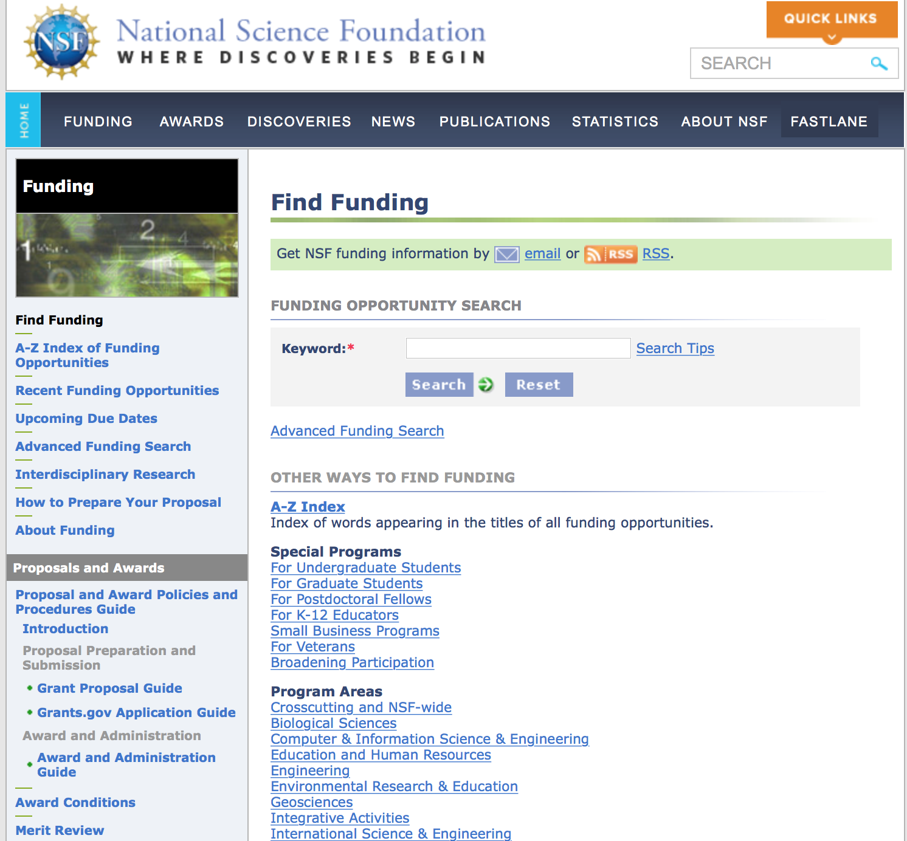
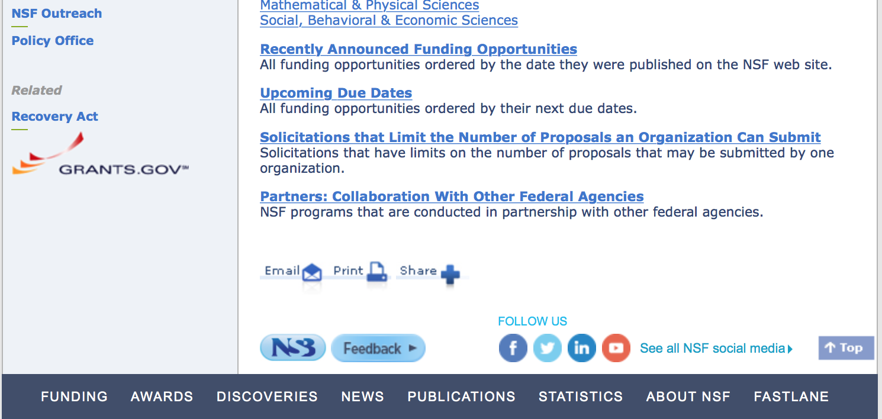

For assistance in finding funding: http://nsf.gov/funding/index.jsp - areas

The National Science Foundation funds research and education in most fields of science and engineering. It does this through grants, and cooperative agreements to more than 2,000 colleges, universities, K-12 school systems, businesses, informal science organizations and other research organizations throughout the United States. The Foundation accounts for about one-fourth of federal support to academic institutions for basic research.
NSF receives approximately 40,000 proposals each year for research, education and training projects, of which approximately 11,000 are funded. In addition, the Foundation receives several thousand applications for graduate and postdoctoral fellowships.
The agency operates no laboratories itself but does support National Research Centers, user facilities, certain oceanographic vessels and Antarctic research stations. The Foundation also supports cooperative research between universities and industry, US participation in international scientific and engineering efforts, and educational activities at every academic level.

For details on active funding deadline dates: http://nsf.gov/funding/pgm_list.jsp?org=NSF&ord=date

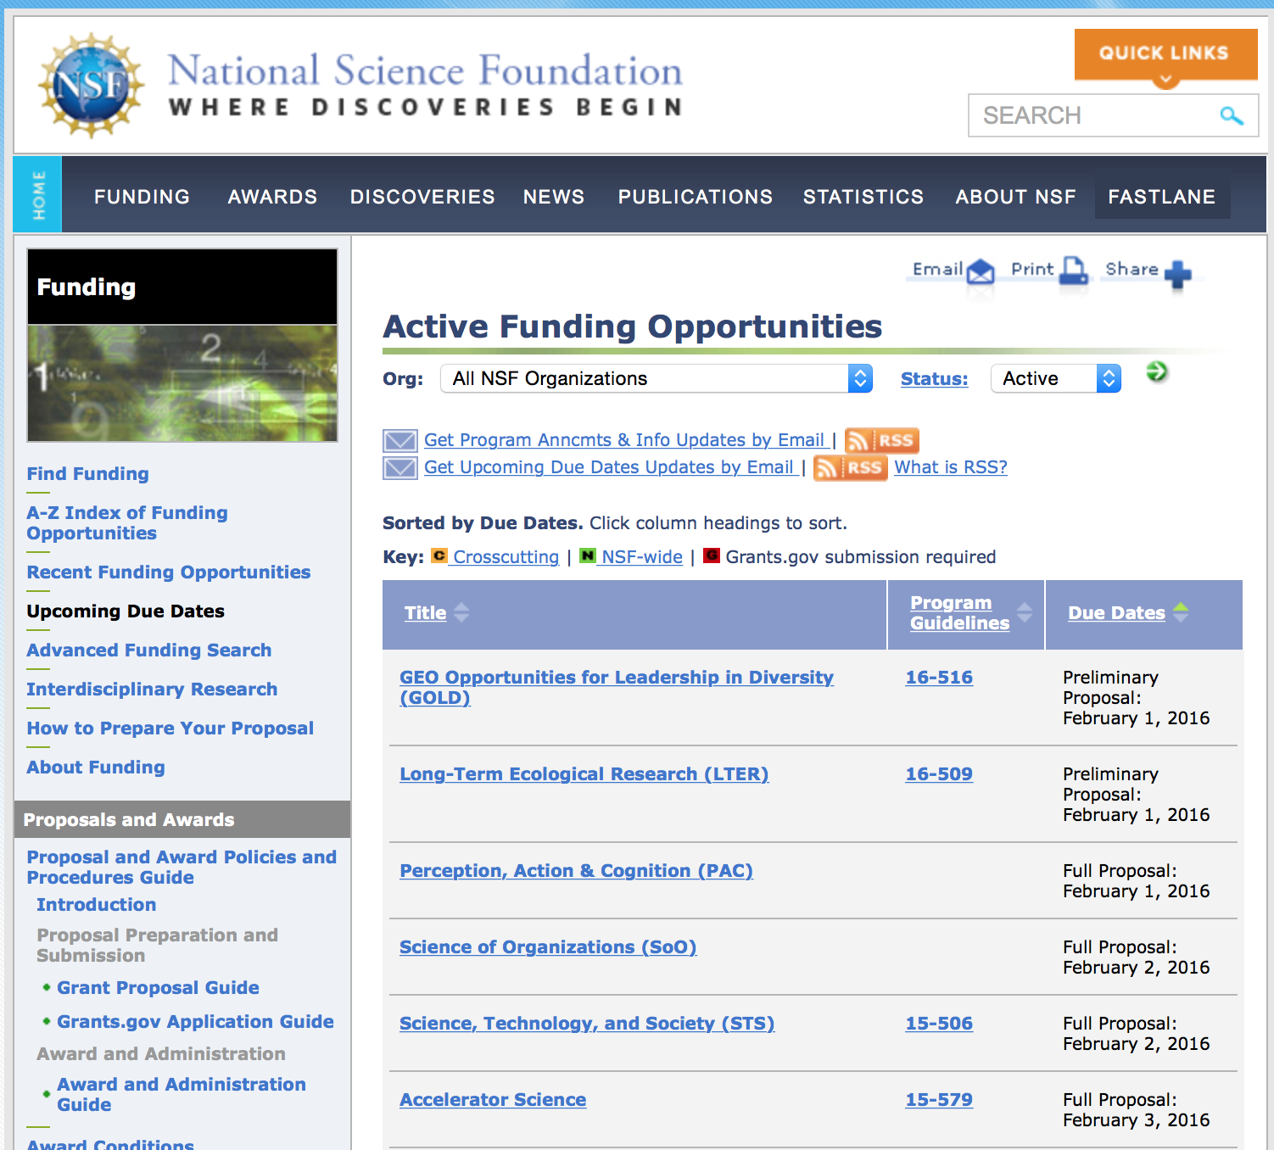

Research and Program Grants:

ADVANCE: Increasing the Participation and Advancement of Women in Academic Science and Engineering Careers
Synopsis 1
http://www.grants.gov/web/grants/view-opportunity.html?oppId=288065

Arctic Research Opportunities
Synopsis 1
http://www.grants.gov/web/grants/view-opportunity.html?oppId=288129

Biomedical Engineering (BME)
Synopsis 1
http://www.grants.gov/web/grants/view-opportunity.html?oppId=287249

Biotechnology and Biochemical Engineering
Synopsis 1
http://www.grants.gov/web/grants/view-opportunity.html?oppId=287291

Biological and Environmental Interactions of Nanoscale Materials
Synopsis 1
http://www.grants.gov/web/grants/view-opportunity.html?oppId=287292

Biomedical Engineering (BME)
Synopsis 1
http://www.grants.gov/web/grants/view-opportunity.html?oppId=287249

Biological and Environmental Interactions of Nanoscale Materials
Synopsis 1
http://www.grants.gov/web/grants/view-opportunity.html?oppId=287292

Biophotonics
Synopsis 1
http://www.grants.gov/web/grants/view-opportunity.html?oppId=287189

Biotechnology and Biochemical Engineering
Synopsis 1
http://www.grants.gov/web/grants/view-opportunity.html?oppId=287291

Catalysis
Synopsis 1
http://www.grants.gov/web/grants/view-opportunity.html?oppId=287293

Ceramics
Synopsis 1
http://www.grants.gov/web/grants/view-opportunity.html?oppId=288259

Condensed Matter and Materials Theory
Synopsis 1
http://www.grants.gov/web/grants/view-opportunity.html?oppId=288258

Chemical and Biological Separations
Synopsis 1
http://www.grants.gov/web/grants/view-opportunity.html?oppId=287251

Combustion and Fire Systems
Synopsis 1
http://www.grants.gov/web/grants/view-opportunity.html?oppId=287250

Condensed Matter and Materials Theory
Synopsis 1
http://www.grants.gov/web/grants/view-opportunity.html?oppId=288258

Ecology and Evolution of Infectious Diseases
Synopsis 1
http://www.grants.gov/web/grants/view-opportunity.html?oppId=287690

Energy for Sustainability
Synopsis 1
http://www.grants.gov/web/grants/view-opportunity.html?oppId=287290

Environmental Engineering
Synopsis 1
http://www.grants.gov/web/grants/view-opportunity.html?oppId=287356

Environmental Sustainability
Synopsis 1
http://www.grants.gov/web/grants/view-opportunity.html?oppId=287190

Fluid Dynamics
Synopsis 1
http://www.grants.gov/web/grants/view-opportunity.html?oppId=287691

General & Age-Related Disabilities Engineering (GARDE)
Synopsis 1
http://www.grants.gov/web/grants/view-opportunity.html?oppId=287209

Geophysics
Synopsis 1
http://www.grants.gov/web/grants/view-opportunity.html?oppId=288260

Integrated Earth Systems
Synopsis 1
http://www.grants.gov/web/grants/view-opportunity.html?oppId=287370

Mathematical Biology
Synopsis 1
http://www.grants.gov/web/grants/view-opportunity.html?oppId=288066

Network for Computational Nanotechnology (NCN)
Synopsis 1
http://www.grants.gov/web/grants/view-opportunity.html?oppId=287952

Office of Cross-Cutting Activities in Materials Research
Synopsis 1
http://www.grants.gov/web/grants/view-opportunity.html?oppId=287409

Particulate and Multiphase Processes
Synopsis 1
http://www.grants.gov/web/grants/view-opportunity.html?oppId=287211

Partnerships for Innovation: Building Innovation Capacity
Synopsis 1
http://www.grants.gov/web/grants/view-opportunity.html?oppId=287689

Process Systems, Reaction Engineering and Molecular Thermodynamics
Synopsis 1
http://www.grants.gov/web/grants/view-opportunity.html?oppId=287210

SBE Postdoctoral Research Fellowships
Synopsis 1

http://www.grants.gov/web/grants/view-opportunity.html?oppId=287629

Modifications:

14-584 - Arctic Research Opportunities
Deletion Comments: Opportunity deleted

PD-15-5345 - Biomedical Engineering (BME)
Deletion Comments: Opportunity deleted

PD-15-7236 - Biophotonics
Deletion Comments: Opportunity deleted

PD-15-1491 - Biotechnology and Biochemical Engineering
Deletion Comments: Opportunity deleted

PD-15-1401 - Catalysis and Biocatalysis
Deletion Comments: Opportunity deleted

PD-15-1417 - Chemical and Biological Separations
Deletion Comments: Opportunity deleted

PD-15-1407 - Combustion and Fire Systems
Deletion Comments: Opportunity deleted

14-592 - Ecology and Evolution of Infectious Diseases
Deletion Comments: Opportunity deleted

PD-15-1440 - Environmental Engineering
Deletion Comments: Opportunity deleted

PD-15-7643 - Environmental Sustainability
Deletion Comments: Opportunity deleted

PD-15-7644 - Energy for Sustainability
Deletion Comments: Opportunity deleted

PD-15-1440 - Environmental Engineering
Deletion Comments: Opportunity deleted

PD-15-1443 - Fluid Dynamics
Deletion Comments: Opportunity deleted

PD- 15-600 - Integrated Earth Systems
Deletion Comments: Opportunity deleted

PD-15-5342 - General & Age-Related Disabilities Engineering
Deletion Comments: Opportunity deleted

PD-12-7334 - Mathematical Biology
Deletion Comments: Opportunity deleted

PD-15-1179 - Nano-Bio Phenomena and Processes in the Environment
Deletion Comments: Opportunity deleted

PD-14-7222 - Office of Special Programs in Materials Research
Deletion Comments: Opportunity deleted

PD-15-1415 - Particulate and Multiphase Processes
Deletion Comments: Opportunity deleted

PD-15-1403 - Process Systems, Reaction Engineering and Molecular Thermodynamics
Deletion Comments: Opportunity deleted

PD -14-595 - SBE Postdoctoral Research Fellowships
Deletion Comments: Opportunity deleted

Reminders:

Deleted:

PD-15-1774 - Ceramics
Deletion Comments: Opportunity deleted

12-598 - Geophysics
Deletion Comments: Opportunity deleted

16-516 - GEO Opportunities for Leadership in Diversity
Deletion Comments: Opportunity deleted

Nuclear Regulatory Commission

U.S. Nuclear Regulatory Commission Funding Opportunity Announcement (FOA), Scholarship and Fellowship Education Grant, Faculty Development Grant, and Trade School and Community College Scholarship Grant, Fiscal Year (FY) 2017.
Synopsis 1

Document Type: | Grants Notice
Funding Opportunity Number: | NRC-HQ-60-17-FOA-0001
Funding Opportunity Title: | U.S. Nuclear Regulatory Commission Funding Opportunity Announcement (FOA), Scholarship and Fellowship Education Grant, Faculty Development Grant, and Trade School and Community College Scholarship Grant, Fiscal Year (FY) 2017.
Opportunity Category: | Discretionary
Opportunity Category Explanation:
Funding Instrument Type: | Grant
Category of Funding Activity: | Education
Category Explanation:
Expected Number of Awards: | 50
CFDA Number(s): | 77.008 -- U.S. Nuclear Regulatory Commission Scholarship and Fellowship Program
Cost Sharing or Matching Requirement: | No
Posted Date: | Aug 12, 2016
Last Updated Date: | Aug 11, 2016
Original Closing Date for Applications: | Oct 14, 2016
Current Closing Date for Applications: | Oct 14, 2016
Archive Date: | Nov 13, 2016
Estimated Total Program Funding: | $15,000,000
Award Ceiling: | $450,000
Award Floor: | $100,000
Eligible Applicants: | Public and State controlled institutions of higher education  Private institutions of higher education  Others (see text field entitled "Additional Information on Eligibility" for clarification)
Additional Information on Eligibility: | •Public/State Controlled Institutions of Higher Education • Private Institutions of Higher Education • Hispanic-Serving Institutions (HSIs) • Historically Black Colleges and Universities (HBCUs) • Tribally Controlled Colleges and Universities (TCCUs) • Alaska Native and Native Hawaiian Serving Institutions • Predominately Black Institutions (PBIs) • Asian American and Native American Pacific Islander Serving Institutions (AAPIs)
Agency Name: | Nuclear Regulatory Commission
Description: | • Scholarship - The primary objective is to support scholarships for nuclear science, engineering, technology and related disciplines to develop a workforce capable of supporting the design, construction, operation, and regulation of nuclear facilities and the safe handling of nuclear materials. The nuclear-related discipline supported by this funding is intended to benefit nuclear safety and security sector broadly. • Fellowship - The primary objective is to support fellowships for nuclear science, engineering, technology and related disciplines to develop a workforce capable of supporting the design, construction, operation, and regulation of nuclear facilities and the safe handling of nuclear materials. The nuclear related discipline supported by this funding is intended to benefit the nuclear sector broadly. • Faculty Development - The primary objective is to support faculty development for nuclear science, engineering, technology and related disciplines to develop a workforce capable of supporting the design, construction, operation, and regulation of nuclear facilities and the safe handling of nuclear materials. Proposed faculty can be supported for up to one 3 year period. The objectives are to attract and retain highly-qualified individuals in academic teaching careers. The grants specifically target probationary, tenure-track faculty during the first 6 years of their career and new faculty hires in the following academic areas: Nuclear, Mechanical, Civil, Environmental, Electrical, Fire Protection, and Materials Sciences Engineering as well as Health Physics. The NRC has interest in topics including but not limited to Fuels, Neutronics, Thermal-hydraulics, Accident-Progression (e.g., performance of safety relief valves), Consequence, Emergency Preparedness, and Radiation Protection Analysis; Radiochemistry, Probabilistic Risk Assessment, Seismology, Fire Risk Analysis, advanced reactor (non-light water reactor), safety systems and other related disciplines. Grants may include support for developing applications for new research or continuing research projects in their areas of expertise. The program provides support to enable newer faculty to enhance their careers as professors and researchers in the university department where employed. The research supported by this announcement is intended to benefit the nuclear sector broadly. • Trade School and Community College Scholarships - The primary objective is to support scholarships for nuclear science, engineering, technology, and related disciplines to develop a workforce capable of supporting the design, construction, operation, and regulation of nuclear facilities and the safe handling of nuclear materials. The nuclear-related discipline supported by this funding is intended to benefit the nuclear sector broadly.
Link to Additional Information:
Grantor Contact Information: | If you have difficulty accessing the full announcement electronically, please contact:  M`Lita Carr Grant Specialist Phone 301-415-6869  E-Mail

http://www.grants.gov/web/grants/view-opportunity.html?oppId=287302

Reminders:



Small Business Administration

General Overview Finding Loans & Grants

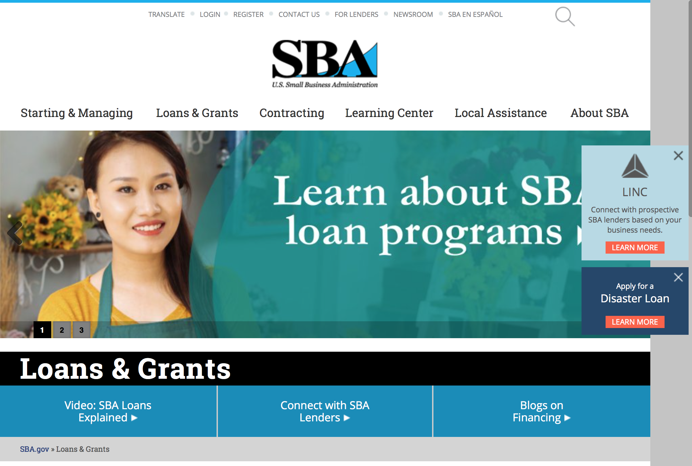
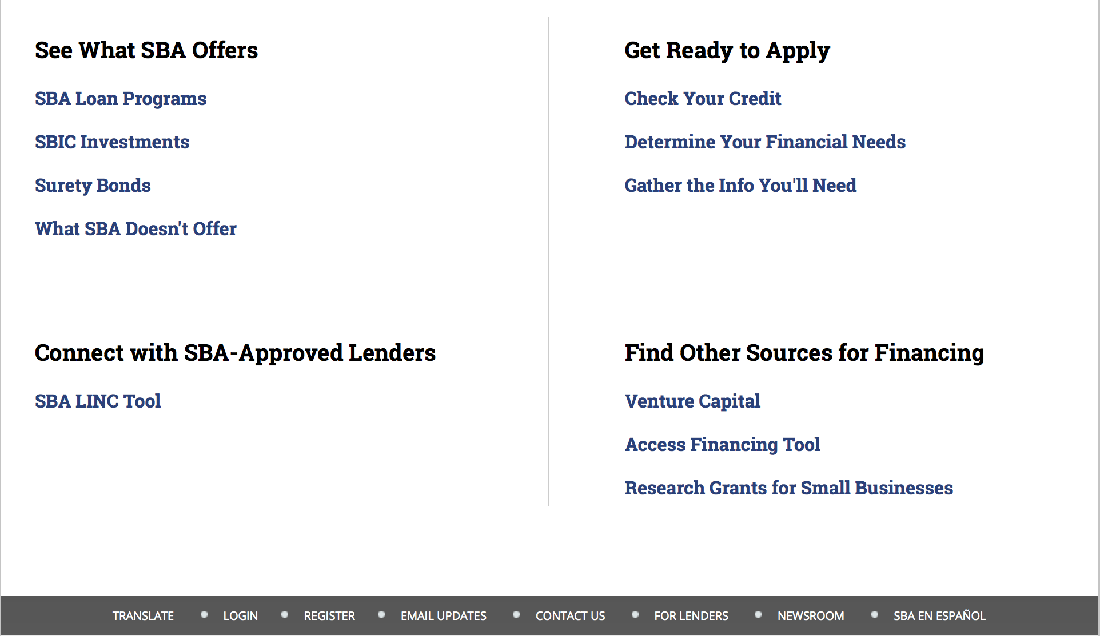

https://www.sba.gov/category/navigation-structure/loans-grants
Federal, state and local governments offer a wide range of financing programs to help small businesses start and grow their operations. These programs include low-interest loans, venture capital, and scientific and economic development grants.

Use SBA.gov's Loans and Grants Search Tool to get a list of financing programs for which you may qualify, or visit the resources below to learn more about small business financing programs. 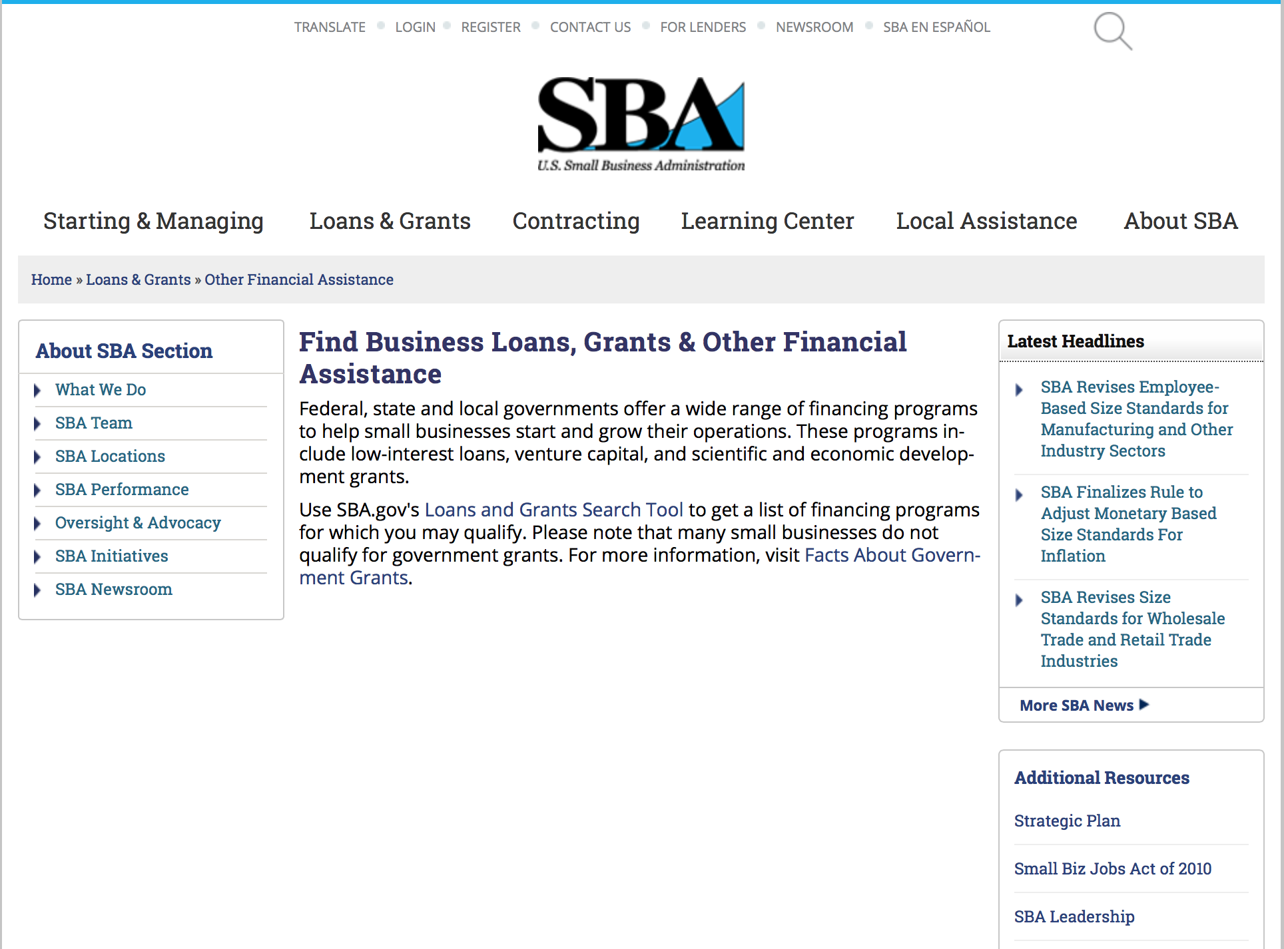
To get to the main SBA.gov funding page click here
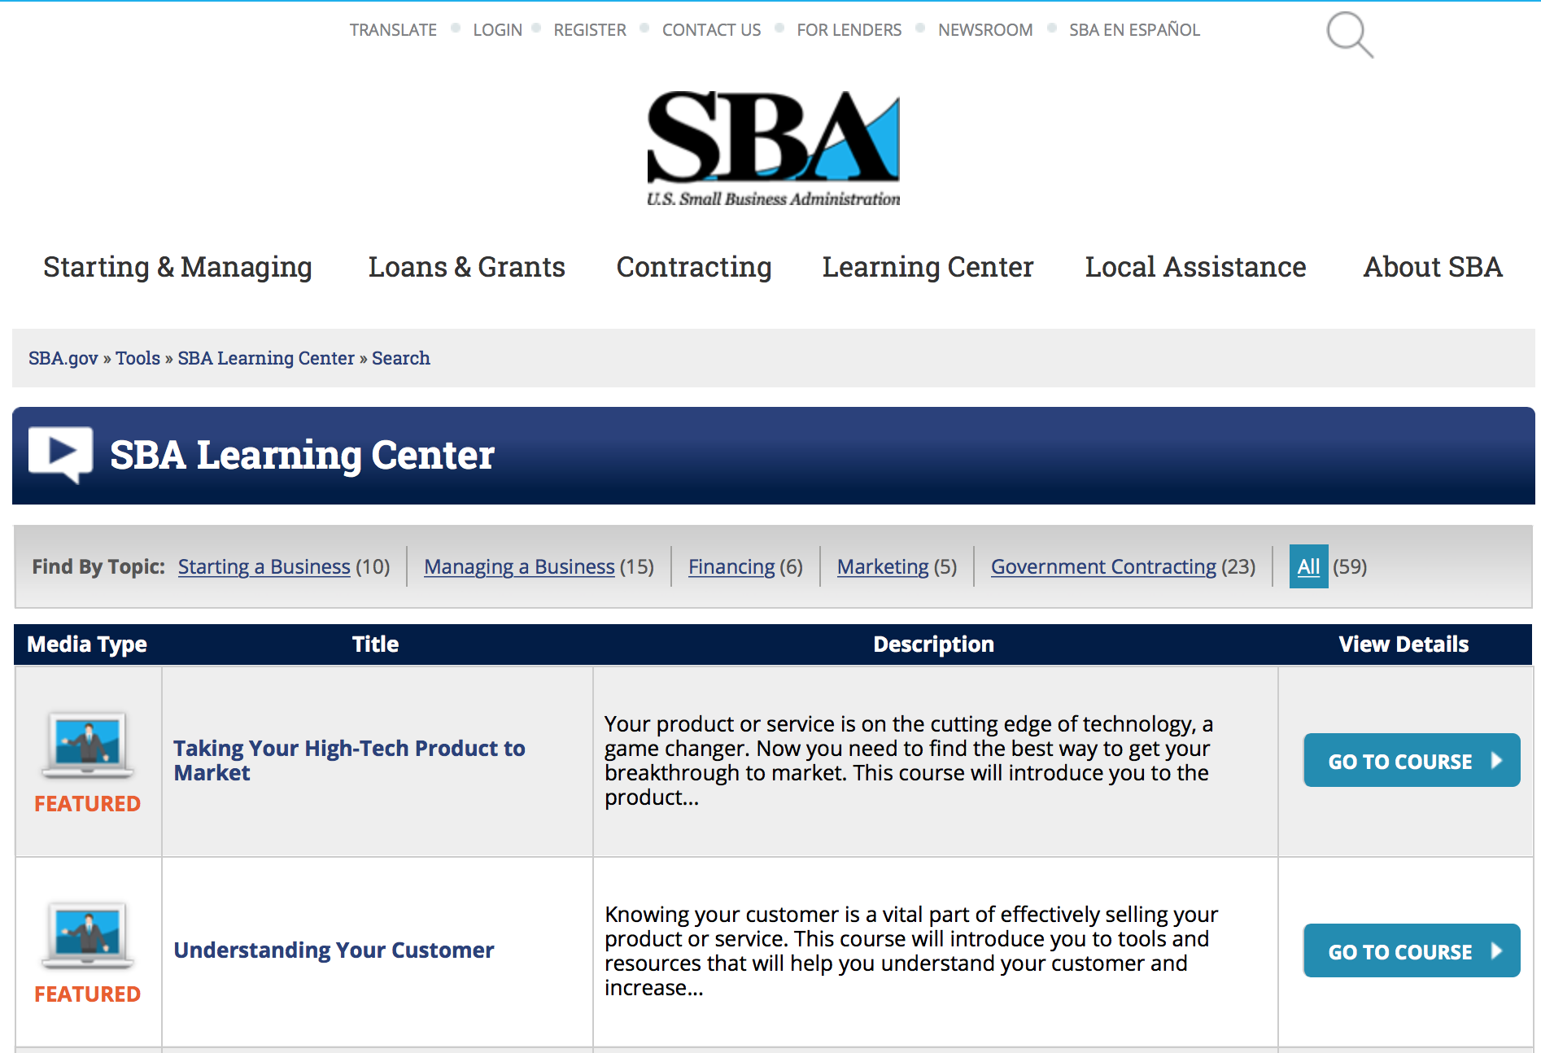
https://www.sba.gov/tools/sba-learning-center/search/training
Programs:

Reminders:

SBA Trainings

Contracting Opportunities for Veteran Entrepreneurs
This self-paced training exercise is an introduction to Federal contracting opportunities for Veterans.
Topics include basic information about Veteran-owned businesses and opportunities, services available to small Veteran-owned businesses, small business incentives, and government procurement methods.
Duration: 00:30:00

http://www.sba.gov/tools/sba-learning-center/training/contracting-opportunities-veteran-entrepreneurs

Interested in Exporting? These Four Resources Can Help
Did you know that two-thirds of the world’s purchasing power is in foreign countries? As the numbers show, the international marketplace is a big one. So if you’re interested in exploring the world of exporting – or have gotten started but could use some guidance – check out these resources to help.
- Read more

Upcoming Trainings: Check out SBA's Online Training!
- Financing Options for Small Businesses
How to Prepare Government Contract Proposals
Getting Started With Exporting: Training and Educational Resources
Exporting represents a big opportunity to tap in to new markets, expand your customer base and grow your business. But getting started with exporting can sometimes feel like a maze of regulations, policies, and other barriers. Here are some free training and educational resources to help.
- Read more

For Specific Information in Hawaii see the following links:
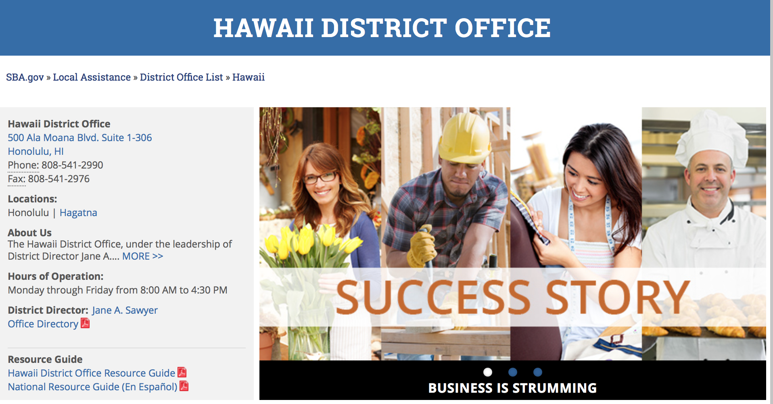

https://www.sba.gov/offices/district/hi/Honolulu

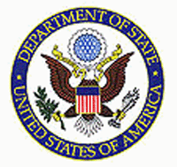

State Department General Overview and Resources for Program Administrators

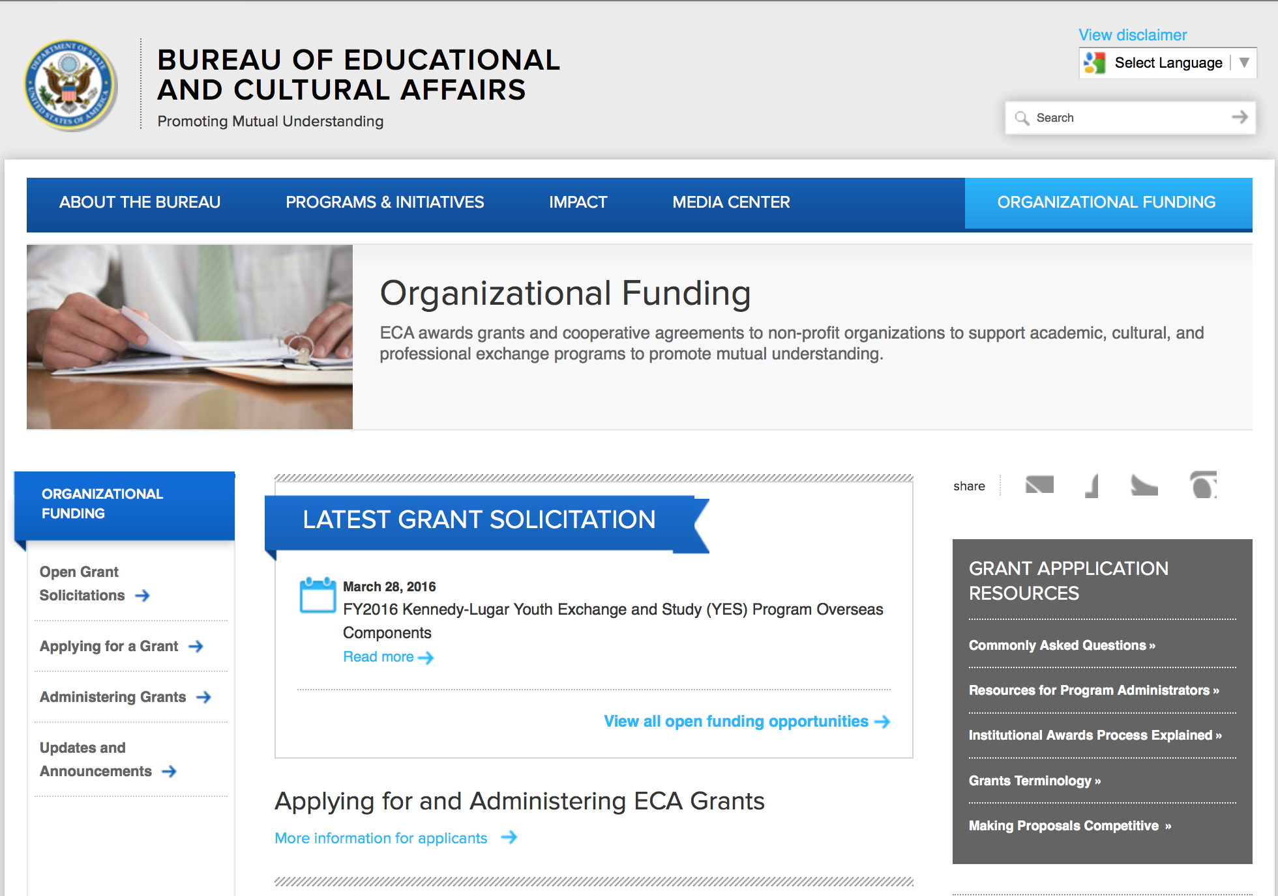
http://eca.state.gov/search/solr/grants?search_referrer=node/237
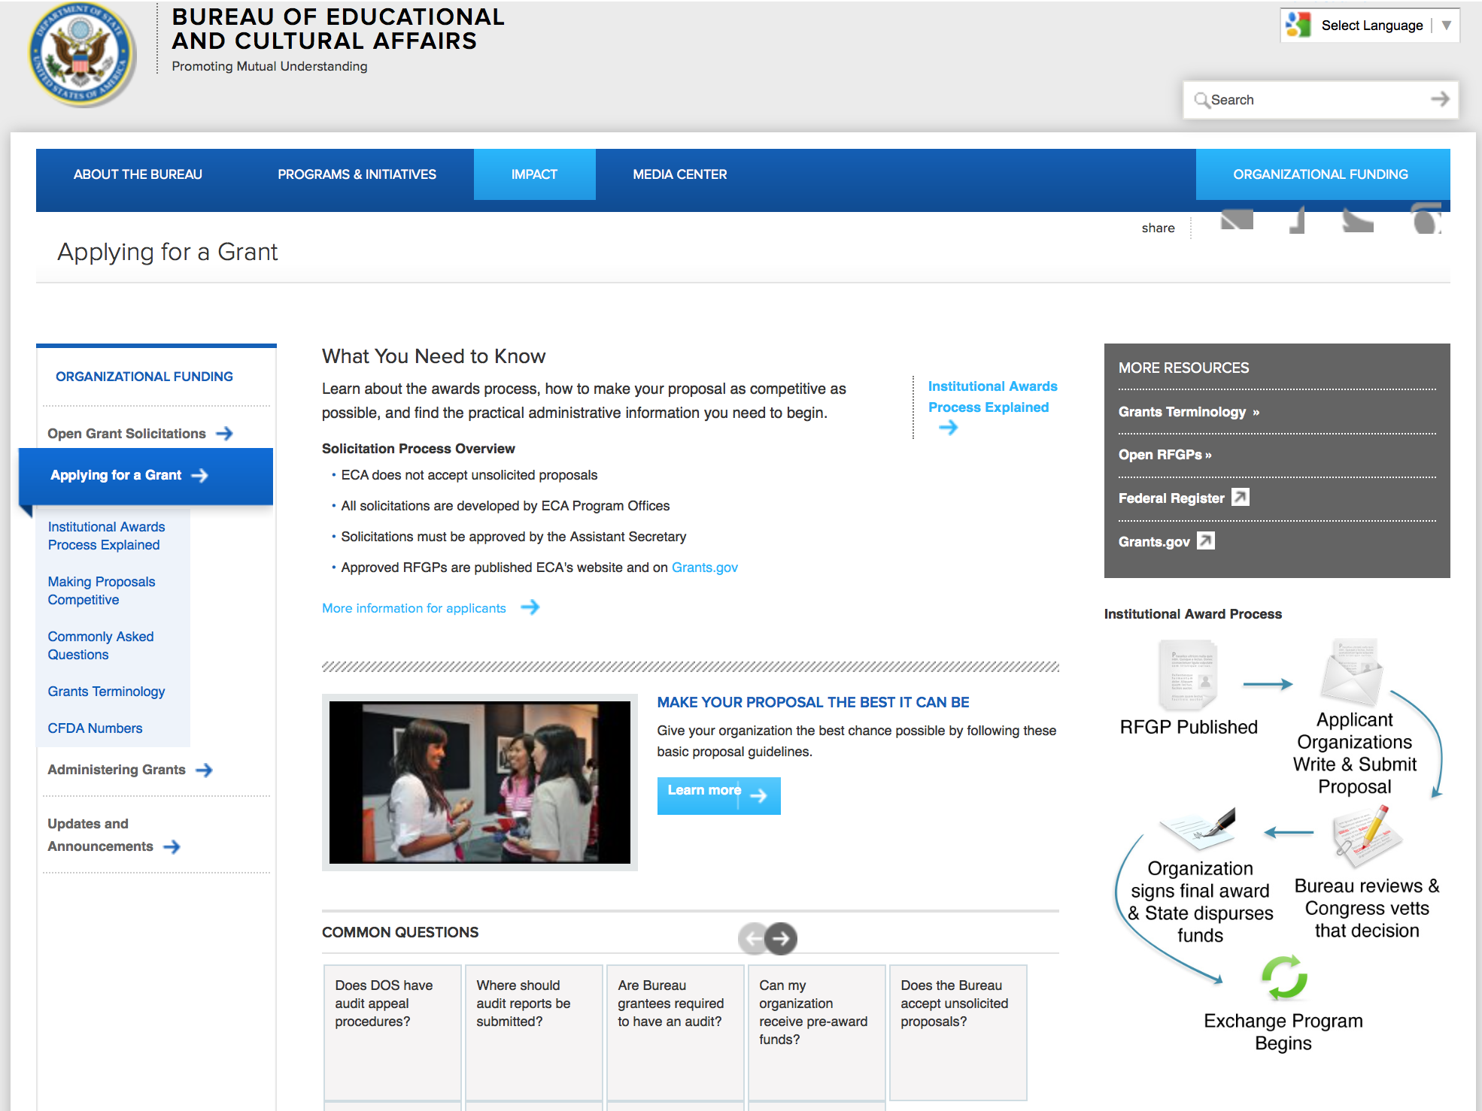

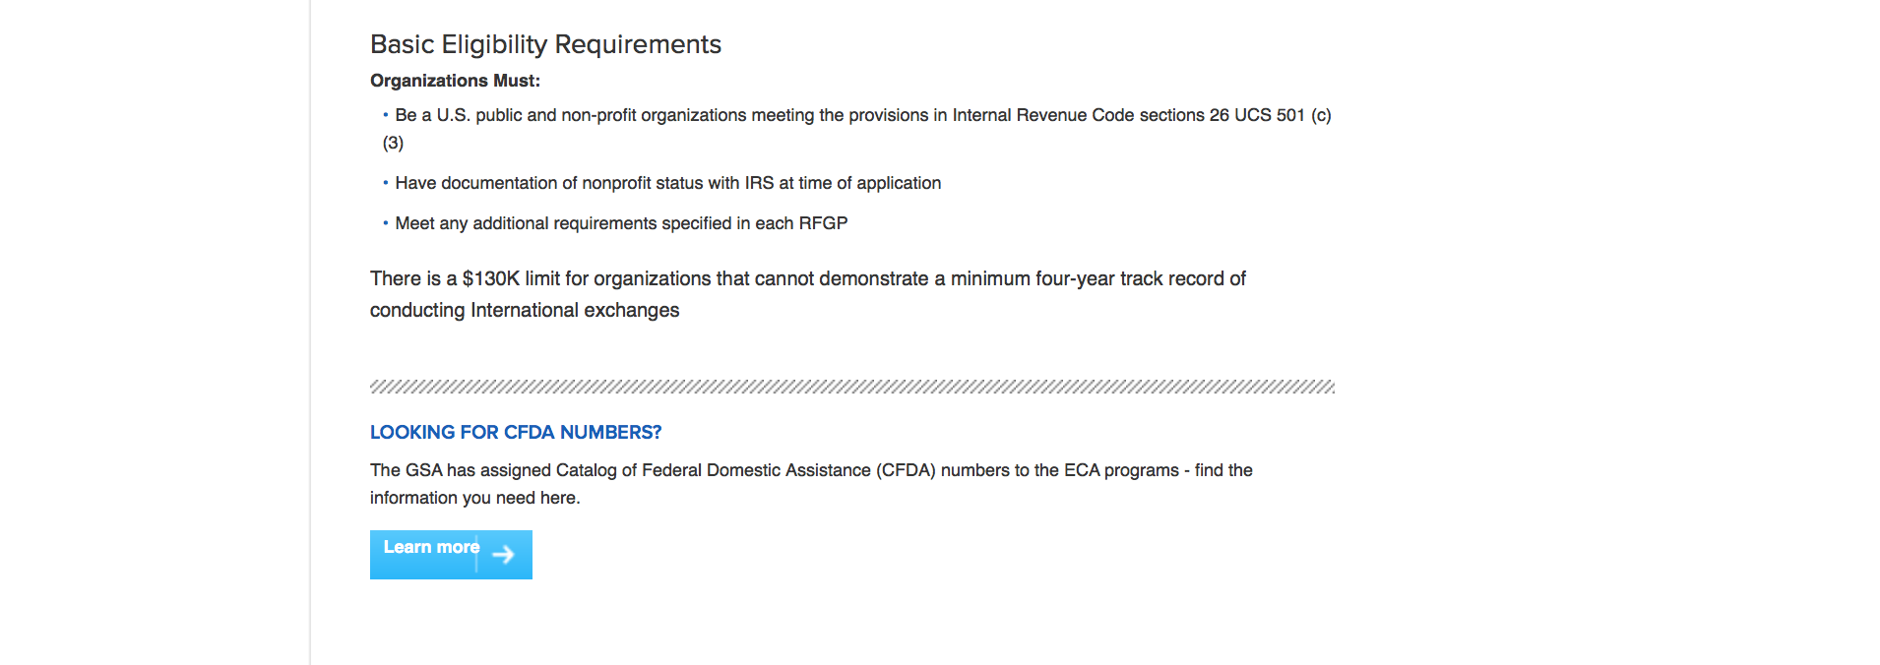
http://eca.state.gov/organizational-funding/applying-grant

General Information:
- Bureau of Educational and Cultural Affairs Grants Division
- Open Grant Opportunities (Requests for Grant Proposals)

For General Information click here

Program Grants:

Bureau of Democracy, Human Rights and Labor
Bureau of Democracy, Human Rights and Labor Request for Statements of Interest: China Programs
Synopsis 1
http://www.grants.gov/web/grants/view-opportunity.html?oppId=287535

Bureau of Democracy, Human Rights and Labor
DRL Global Religious Freedom Programs
Synopsis 1
http://www.grants.gov/web/grants/view-opportunity.html?oppId=288041

Bureau of Democracy, Human Rights and Labor
Religious Freedom and Rule of Law
Synopsis 1
http://www.grants.gov/web/grants/view-opportunity.html?oppId=288063

International Narcotics and Law Enforcement Affair
Morocco Justice Sector Management Training
Synopsis 1
http://www.grants.gov/web/grants/view-opportunity.html?oppId=287334

U.S. Mission to the United Kingdom
U.S.-UK CVE Community Leaders Two-way Exchange
Synopsis 1
http://www.grants.gov/web/grants/view-opportunity.html?oppId=287715

U.S. Mission to Turkmenistan
The Public Affairs Section of the U.S. Embassy in Ashgabat, Turkmenistan
Synopsis 1
http://www.grants.gov/web/grants/view-opportunity.html?oppId=287049

Modifications:

NEA Office of Press and Public Diplomacy
FY 2017 Safeguarding the Heritage of the Near East Initiative Collaborative Services Award
Synopsis 9
http://www.grants.gov/web/grants/view-opportunity.html?oppId=287635

U.S. Mission to Saudi Arabia
Saudi American Educational and Cultural Initiative Grant
Synopsis 2
http://www.grants.gov/web/grants/view-opportunity.html?oppId=236513

S Bureau Grants Offices
Prime Recipients for Key Populations Investment Fund (KPIF)
Synopsis 2
http://www.grants.gov/web/grants/view-opportunity.html?oppId=287874

Reminders:

Deleted:

Department of Transportation

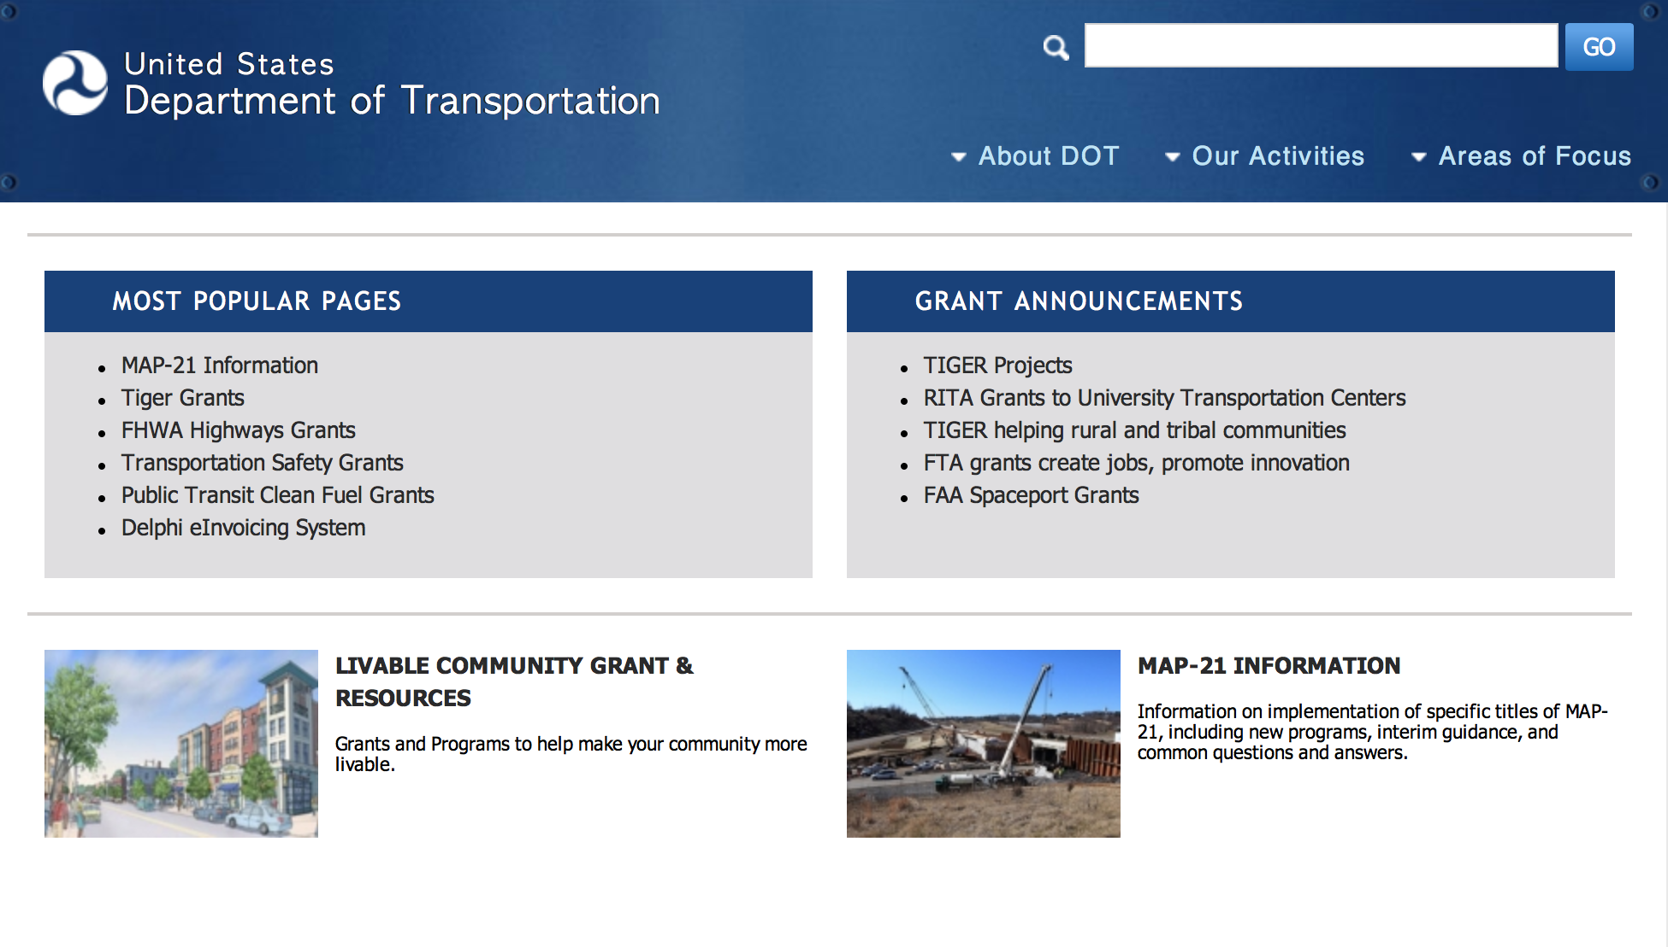
General Grant Program Overview https://www.transportation.gov/grants

Programs:

Modifications:

Reminders:

DOT/Federal Railroad Administration
FY 2017 Positive Train Control Grant Funds

Document Type: | Grants Notice
Funding Opportunity Number: | FR-TEC-16-002
Funding Opportunity Title: | FY 2017 Positive Train Control Grant Funds
Opportunity Category: | Discretionary
Opportunity Category Explanation:
Funding Instrument Type: | Grant
Category of Funding Activity: | Transportation
Category Explanation:
Expected Number of Awards:
CFDA Number(s): | 20.321 -- Railroad Safety Technology Grants
Cost Sharing or Matching Requirement: | Yes
Posted Date: | Jul 29, 2016
Last Updated Date: | Jul 29, 2016
Original Closing Date for Applications: | Sep 27, 2016 No Explanation
Current Closing Date for Applications: | Sep 27, 2016 No Explanation
Archive Date: | Oct 27, 2016
Estimated Total Program Funding:
Award Ceiling: | $197,010,000
Award Floor: | $0
Eligible Applicants: | State governments  Others (see text field entitled "Additional Information on Eligibility" for clarification)  City or township governments  County governments
Additional Information on Eligibility: | Entities that are recipients of funds under 49 U.S.C. Ch. 53, including public transit agencies operating commuter railroads.
Agency Name: | DOT/Federal Railroad Administration
Description: | The purpose of these funds is to award grants for eligible positive train control (PTC) projects. The funding available under this solicitation, $197.01 million, is authorized by section 3028 of the Fixing America's Surface Transportation (FAST) Act (Public Law No. 114-94), and subject to the availability of appropriated funds. Projects eligible under this NOFO must help install PTC systems required under 49 U.S.C. 20157.
Link to Additional Information: | FY 2017 Positive Train Control Grant Funds
Grantor Contact Information: | If you have difficulty accessing the full announcement electronically, please contact:  Grants.gov Contact Center Phone Number: 1-800-518-4726 Hours of operation are 24 hours a day, 7 days a week. The contact center is closed on federal holidays. support@grants.gov  Grants.gov Customer Support

http://www.grants.gov/web/grants/view-opportunity.html?oppId=286710

DOT Federal Aviation Administration
DOT - FAA Aviation Research Grants
FAA Aviation Research and Development Grants
Modifications 3 & 4

Document Type: | Grants Notice
Funding Opportunity Number: | 12-01
Funding Opportunity Title: | FAA Aviation Research and Development Grants
Opportunity Category: | Discretionary
Opportunity Category Explanation:
Funding Instrument Type: | Grant
Category of Funding Activity: | Transportation
Category Explanation:
Expected Number of Awards:
CFDA Number(s): | 20.108 -- Aviation Research Grants
Cost Sharing or Matching Requirement: | No
Version: | Synopsis 5
Posted Date: | Jan 01, 2012
Last Updated Date: | Jun 09, 2016
Original Closing Date for Applications: | Dec 31, 2019
Current Closing Date for Applications: | Dec 31, 2019
Archive Date: | Jan 30, 2020
Estimated Total Program Funding:
Award Ceiling: | $5,000,000
Eligible Applicants: | Nonprofits having a 501(c)(3) status with the IRS, other than institutions of higher education  Private institutions of higher education  Public and State controlled institutions of higher education
Agency Name: | DOT - FAA Aviation Research Grants
Description: | The FAA is soliciting proposals for research grants and cooperative agreements to pursue the long-term growth and short-term technical needs of civil aviation. In order to streamline the application process, it is recommended that all prospective grantees submit a white paper (letter of intent) for agency technical review before complete proposal submission. Please be sure to identify the specific area of interest (Solicitation FAA-12-01 – Chapter I. FAA Research Grants Program, Technical Areas of Research #1-#9). The white paper shall be no longer than three (3) pages and shall detail overall research objectives.
Link to Additional Information:
Grantor Contact Information: | If you have difficulty accessing the full announcement electronically, please contact:  Debra Monzo Grants Officer Phone 609-485-4962  business

http://www.grants.gov/web/grants/view-opportunity.html?oppId=134953

Deleted:

Maritime Administration
DTMA91O1600003 - ELECTRO CHEMICAL BALLAST WATER TREATMENT SYSTEM
Deletion Comments: Opportunity deleted

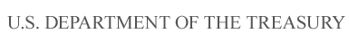

Department of the Treasury

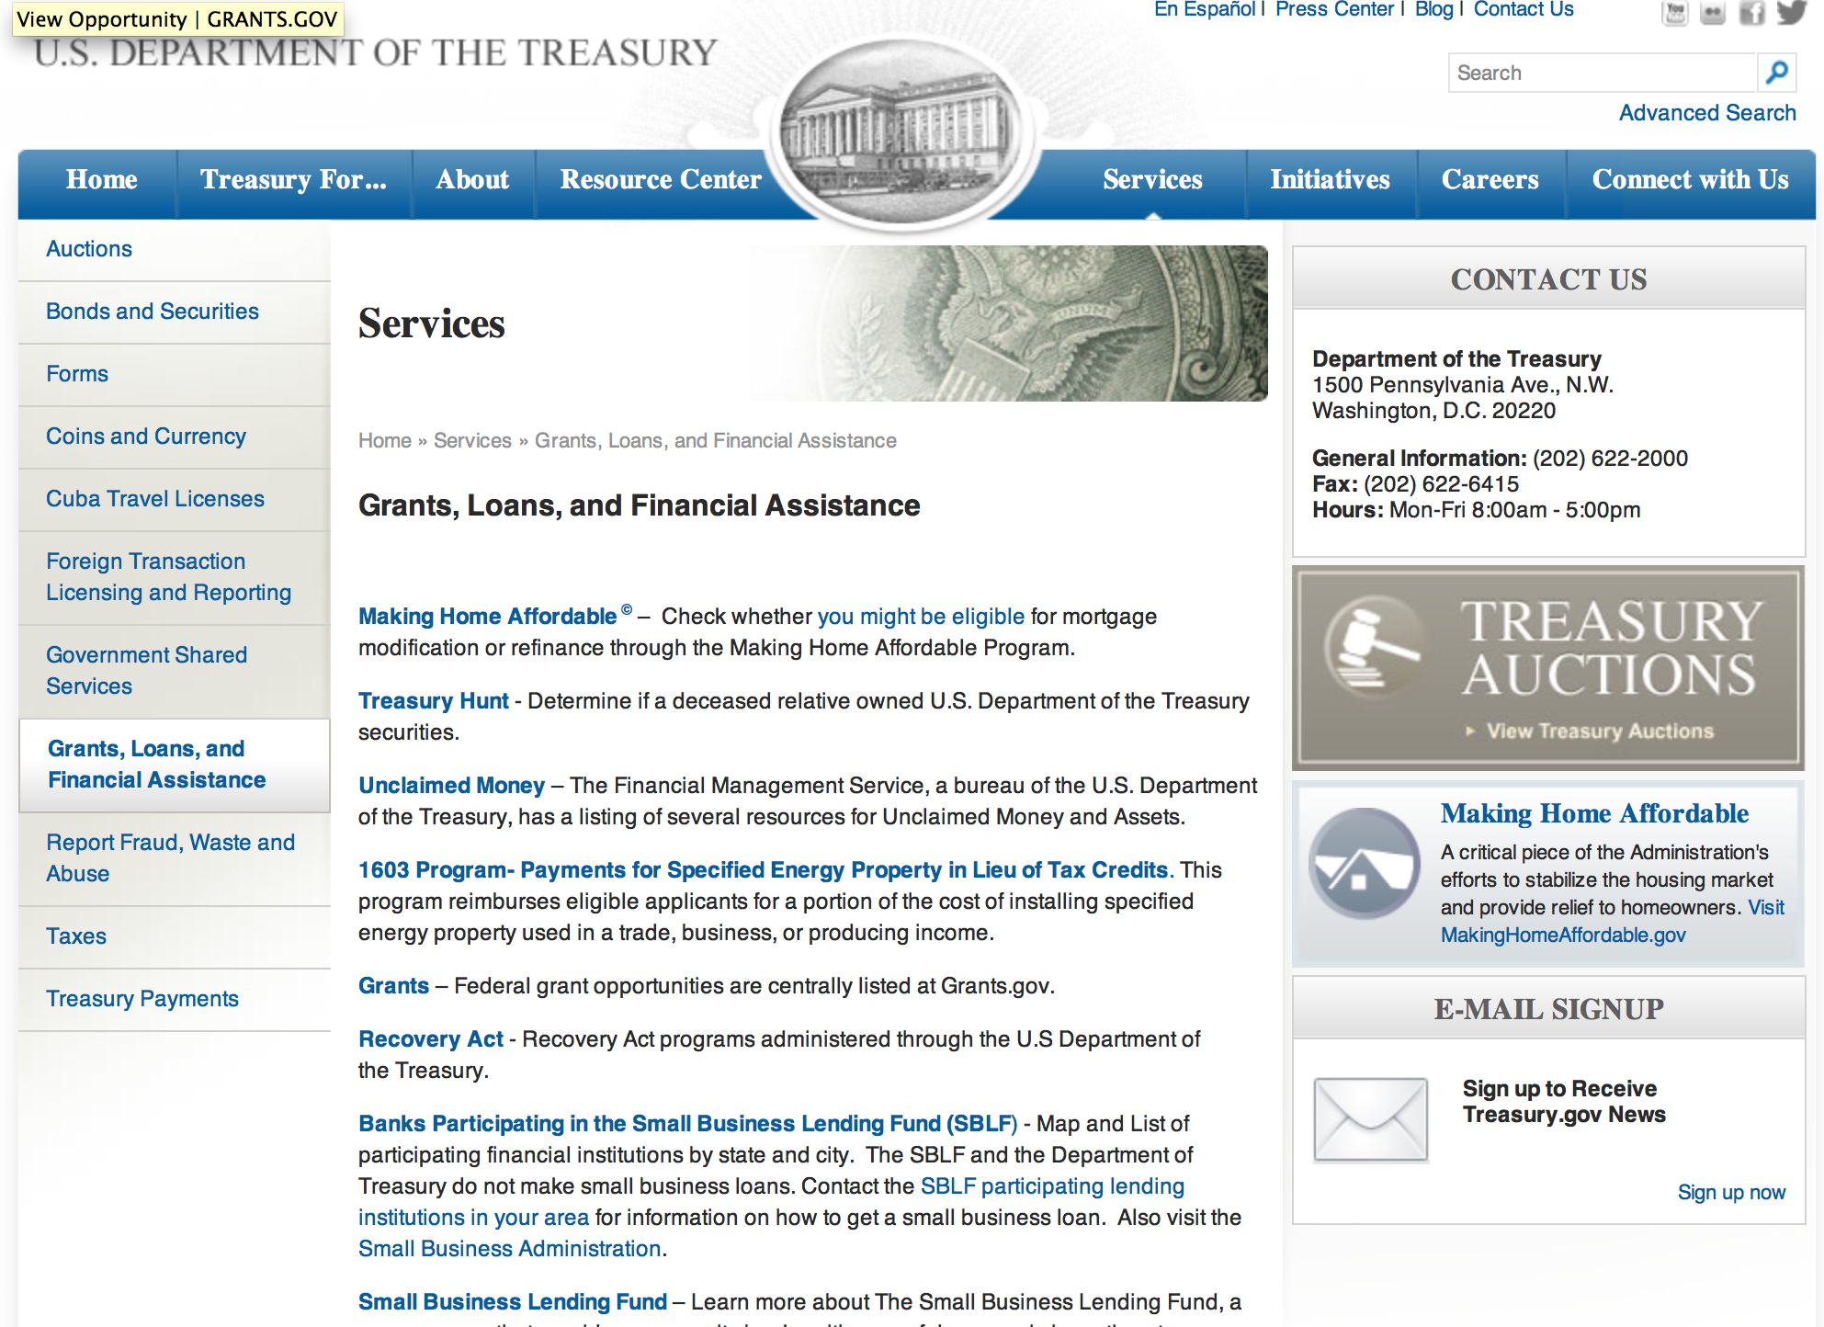

http://www.treasury.gov/services/Pages/Grants-Loans-and-Financial-Assistance.aspx

Programs:

Modifications:

Reminders:

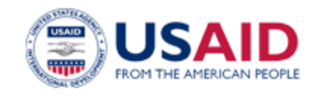

U.S. Agency for International Development

www.usaid.gov

General Overview Funding Opportunities

USAID has working relationships with thousands of American companies and hundreds of U.S.-based private voluntary organizations. For more information on our business and procurement opportunities, please visit our Business section.

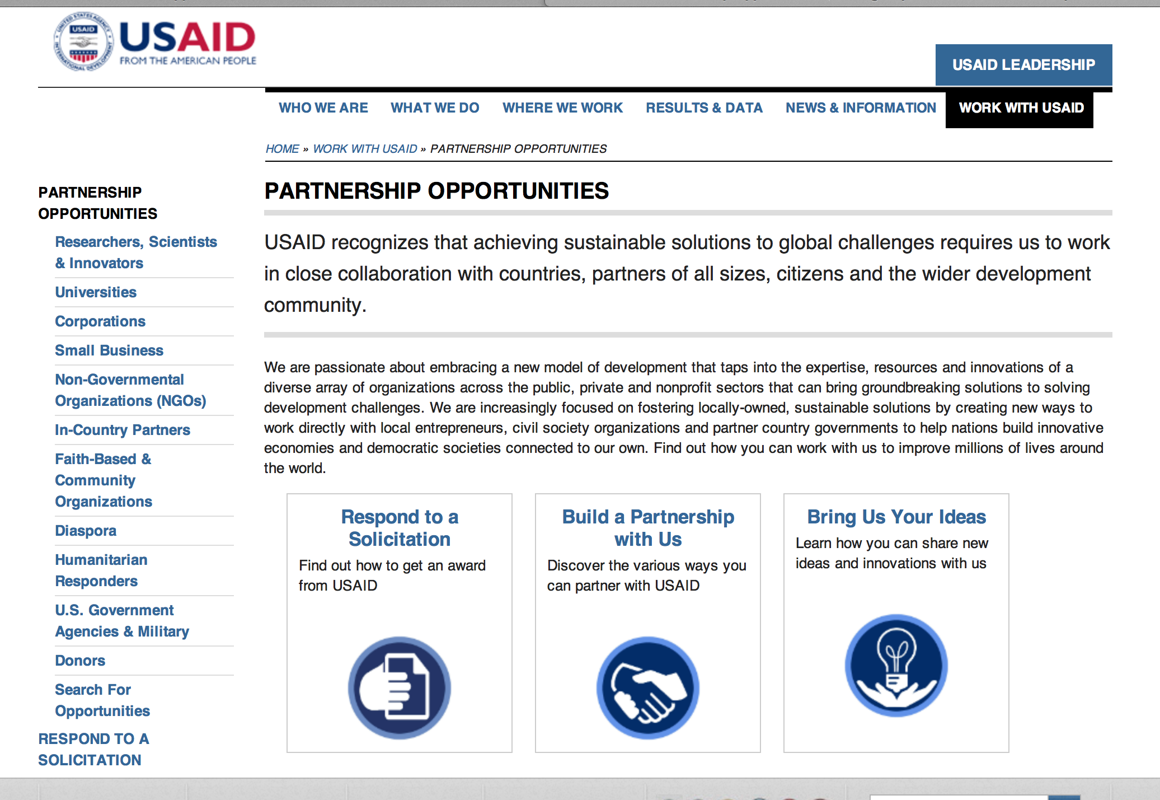
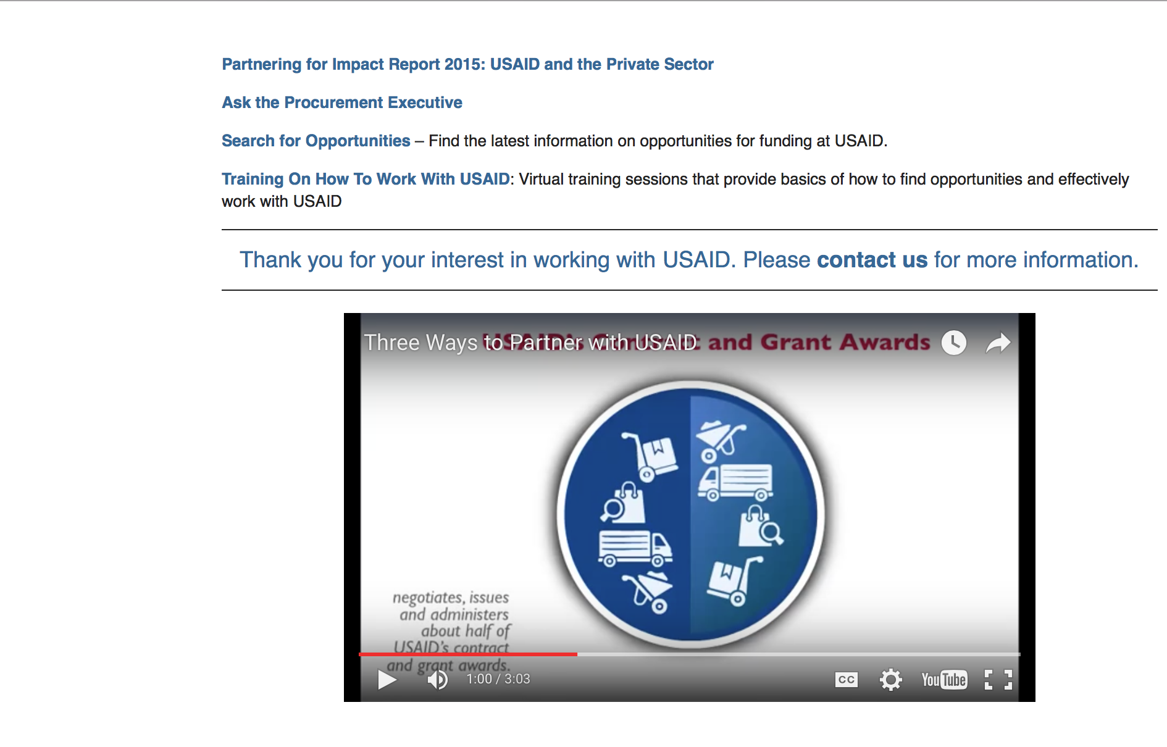

http://www.usaid.gov/partnerships

Programs:

Thailand USAID-Bangkok
Counter Trafficking in Persons (CTIP)
Synopsis 1
http://www.grants.gov/web/grants/view-opportunity.html?oppId=287529

Securing Water for Food (SWFF) - Round 4
Synopsis 1
http://www.grants.gov/web/grants/view-opportunity.html?oppId=287360

Dominican Republic USAID-Santo Domingo
USAID/Eastern and Southern Caribbean Science, Technology, Innovations, and Partnerships
Synopsis 1
http://www.grants.gov/web/grants/view-opportunity.html?oppId=288059

Thailand USAID-Bangkok
Counter Trafficking in Persons (CTIP)
Synopsis 2
http://www.grants.gov/web/grants/view-opportunity.html?oppId=287529

Pakistan USAID-Islamabad
Health System Strengthening and Service Delivery
Synopsis 1
http://www.grants.gov/web/grants/view-opportunity.html?oppId=288189

Modifications:

Mali USAID -Bamako
Education for deaf and blind Children in Mali
Synopsis 3 & 5
http://www.grants.gov/web/grants/view-opportunity.html?oppId=286603

The USAID Global Health Challenge BAA
Synopsis 3 & 4
http://www.grants.gov/web/grants/view-opportunity.html?oppId=282988Deleted:

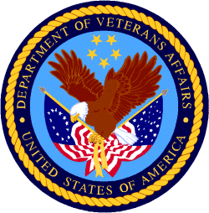

Department of Veterans Affairs

