Senator Mazie Hirono

Grants Assistance Information Newsletter

SEPTEMBER 2017

G.A.I.N. INDEX

Click on Index Links below to read summaries of the announcements by agency in this document. Once you reach the item, if you cannot open the links for further information, copy the selected URL website address into your browser.

Modified sections from previous listings are shown in a GREY background

Notices is Teal are items with immediate deadline dates.

Notices in Yellow are of special interest.

Notices is Green are items of special interest with immediate deadline dates.

Items in this type color are aimed at Small Businesses

Items in this type color have a Faith-Based Organization component

Special Federal Program Notices

Grant Writing Resources

SAM and Grants.Gov Information

SBIR – Small Business Innovation Research

Programs specific to Hawaii

Current Notices

Department of Interior
Bureau of Land Management
Joint Fire Science Program FY 2018 Potential Topics

Reminders

See Individual Departments for information and webpages representing the best and most accessible information on the agency funding opportunities

Federal Grant and Cooperative Agreement Program Summaries

U.S. Department of Agriculture

Grants and Loans Overview

Programs

National Institute of Food and Agriculture
Food and Agricultural Sciences National Needs Graduate and Postgraduate Fellowship (NNF) Grants Program

Research

National Institute of Food and Agriculture
Family Advocacy Program (FAP)

National Institute of Food and Agriculture
Air Force Mental Health Research Project

Modifications

Business and Cooperative Programs
VALUE ADDED PRODUCER GRANT

Reminders

National Institute of Food and Agriculture
Small Business Innovation Research Program - Phase I

Agricultural Marketing Service
USDA-AMS-TM-SCMP-G-17-0005

Fish and Wildlife Service
2017 National Fish Habitat Action Plan

Deleted:

Department of Commerce

Grants at Commerce

Programs

FY18 Saltonstall Kennedy Competition

FY18 Marine Debris Removal

FY 2018 Marine Fisheries Initiative (MARFIN)

Fiscal Year 2018 NOAA Gulf of Mexico Bay-Watershed Education and Training (B-WET) Program

FY18-19 CRCP International Coral Reef Conservation Cooperative Agreements

Modifications

FY2018 Marine Debris Prevention

Research

Reminders

John H. Prescott Marine Mammal Rescue Assistance Grant Program (Prescott Grant Program) for Fiscal Year 2018

FY18 Cooperative Research Program (CRP)

Ocean Exploration FY 2018 Funding Opportunity

Economic Development Administration
FY 2017 Economic Development Assistance Programs ­ Application submission and program requirements for EDA’s Public Works and Economic Adjustment Assistance programs.

National Institute of Standards and Technology
Embedding MEP in Manufacturing USA Institutes Pilot Projects – Round 3

National Institute of Standards and Technology
Measurement Science and Engineering (MSE) Research Grant Programs

National Sea Grant College Program 2016-17 Special Projects Grant

FY 2016 – FY 2019 EDA Planning Program and Local Technical Assistance Program Grant

Economic Development Administration
Planning Program and Local Technical Assistance Program Grant

Deleted

Corporation for National and Community Service

General Program Overview

Programs

AmeriCorps State and National Grants FY2018

Reminders

National Service in Hawaii

Department of Defense

Doing Business with the Department of Defense

DoD Small Business Opportunities and Forecasting

Research Grants

Modifications

Deleted

Reminders

Department of Education

Grant Programs Overview

Programs

Research

Modifications

The Office of Elementary and Secondary Education (OESE): Impact Aid Discretionary Construction Grant Program CFDA Number 84.041C

Reminders

Deleted

US Department of Energy

Grants Overview

Research

Modifications

Reminders

PAMS
Department of Energy - Office of Science
Office of Science
FY 2017 Continuation of Solicitation for the Office of Science Financial Assistance Program
Synopsis 2

Environmental Protection Agency

Grants and Contracts Overview

Programs

2017 Targeted Air Shed Grant Program

Modifications

Research

Reminders

Department of Health and Human Services

Grants Overview

Program

Research Grants

Modifications

Deleted

Reminders

Department of Homeland Security
Grants Overview

Programs

Modifications

Reminders

Department of Homeland Security - FEMA
FY17 Flood Mitigation Assistance

Department of Homeland Security - FEMA
FY17 Pre-Disaster Mitigation

Department of Housing and Urban Development

HUD - Notice of Funds Available

Programs

Fair Housing Initiatives Program - Private Enforcement Initiative

Choice Neighborhoods Implementation Grant Program

Resident Opportunity & Self-Sufficiency Program

Modifications

HUD Community Compass Technical Assistance and Capacity Building Program

Family Self-Sufficiency Program

Fair Housing Initiative Program - Education and Outreach Initiative

Notice of Funding Availability (NOFA) for the Fiscal Year (FY) 2017 Continuum of Care Program Competition
Deleted

Reminders

Institute of Museum and Library Services

Grants Overview

IMLS is on Facebook!

Programs

Modifications

Reminders

Deleted

Department of Interior

Grants and Contract Overview

Programs

National Park Service
African American Civil Rights (AACR) Preservation Grants

National Park Service
African American Civil Rights (AACR) History Grants

Modifications

Geological Survey
3D Elevation Program (3DEP)

Reminders

National Fish Passage Program

Fish and Wildlife Service
Partners for Fish and Wildlife

Fish and Wildlife Service
Coastal Program

Deleted

Department of Justice

Grants and Contract Overview

Programs

Research

Modifications

Deleted

Reminders

________________________________________________________________________

Department of Labor

Grants and Contract General Overview

Programs

Modifications

Reminders

National Aeronautics and Space Administration

Research Grant and Contract General Overview

Programs

Modifications

_______________________________________________________________
National Archives and Records Administration

Grant Opportunities General Overview

Programs

Reminders

Access to Historical Records: Major Initiatives (Preliminary)

Access to Historical Records: Major Initiatives

Access to Historical Records: Archival Projects

EDITIONS-201710 for Publishing Historical Records in Documentary Editions

_______________________________________________________________
National Endowment for the Arts

Grant Opportunities General Overview

Programs

NEA Research: Art Works, FY2018

Modifications

NEA Research: Art Works, FY2018

NEA Our Town Application, FY2018

Reminders

NEA Literature Fellowships: Translation Projects, FY2019
_______________________________________________________________

National Endowment for the Humanities

Grant Opportunities General Overview

Programs

National Endowment for the Humanities
Dialogues on the Experience of War

Humanities Connections

Reminders

Humanities Open Book Program

Summer Stipends

_______________________________________________________________
National Science Foundation

Grant Opportunities General Overview

Research and Program Grants

Modifications

Reminders

Deleted

Nuclear Regulatory Commission

U.S. Nuclear Regulatory Commission Funding Opportunity Announcement (FOA), Scholarship and Fellowship Education Grant, Faculty Development Grant, and Trade School and Community College Scholarship Grant, Fiscal Year (FY) 2018

Reminders

Small Business Administration

General Overview Finding Loans & Grants

Programs

Modifications

Reminders

Deleted

Upcoming Trainings

Links Specific to Hawaii

State Department

General Overview and Resources for Program Administrators

Programs

Modifications

Reminders

U.S. Department of Transportation

General Grant Program Overview

Programs

INFRA Grants

Research

Modifications

Reminders

DOT Federal Aviation Administration
DOT - FAA Aviation Research Grants
FAA Aviation Research and Development Grants
Modifications 3 & 4

Deleted

Department of the Treasury

Programs

Modifications

Reminders

US Agency for International Development

General Funding Opportunity Overview

Programs
Modifications

Deleted

Department of Veterans Affairs

Special Federal Program Notices

Grant Writing Resources

The following links are a great resource for faith-based non-profits and other community organizations :

- Center for Faith-Based and Community Initiatives (link is external) , U.S. Department of Labor

- http://www.usaid.gov/partnership-opportunities/fbci. U.S. Agency for International Development

- Faith-Based and Other Community Initiatives (link is external) , Corporation for National Community Service

- Task Force for Faith-Based and Community Initiatives (link is external) , U.S. Department of Justice

- Proposal Writing Short Course (link is external) Foundation Center.
- General Tips on Writing a Competitive Grant Proposal (link is external) U.S. Environmental Protection Agency.
- How to Write a Grant Proposal (link is external) Appalachian Regional Commission.
- A Guide to Funding Resources USDA Rural Information Center.

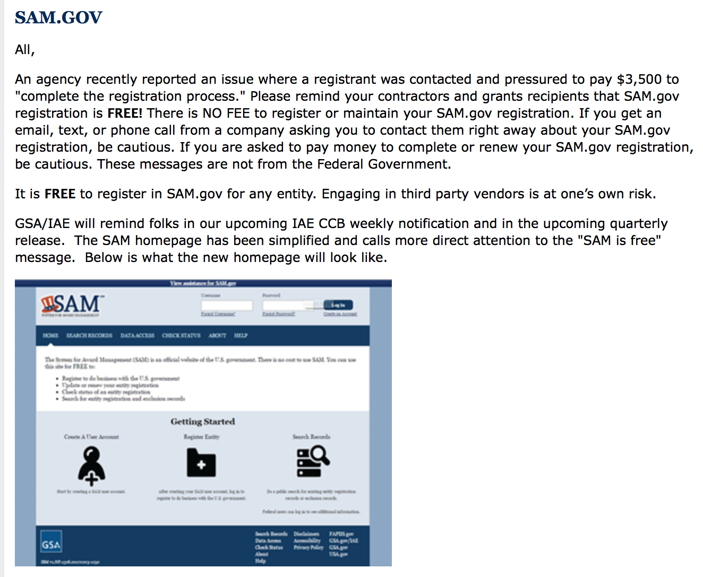

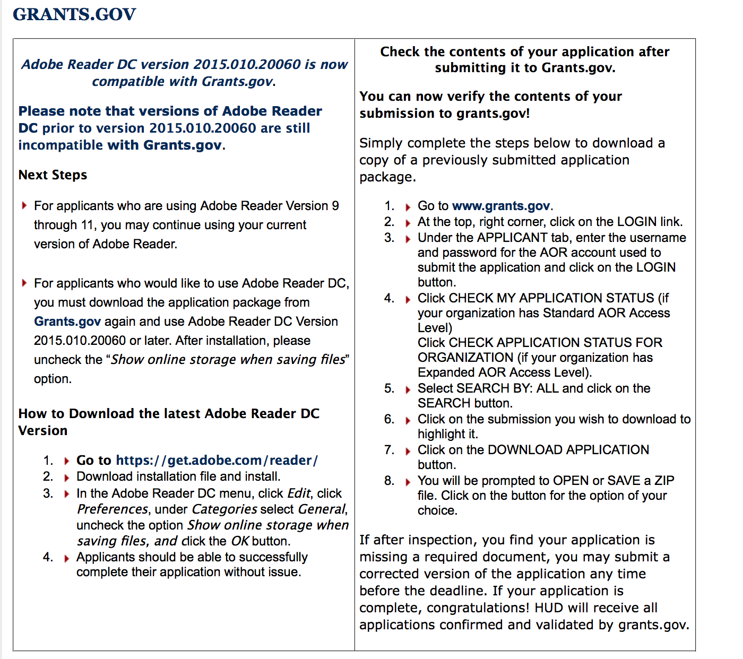

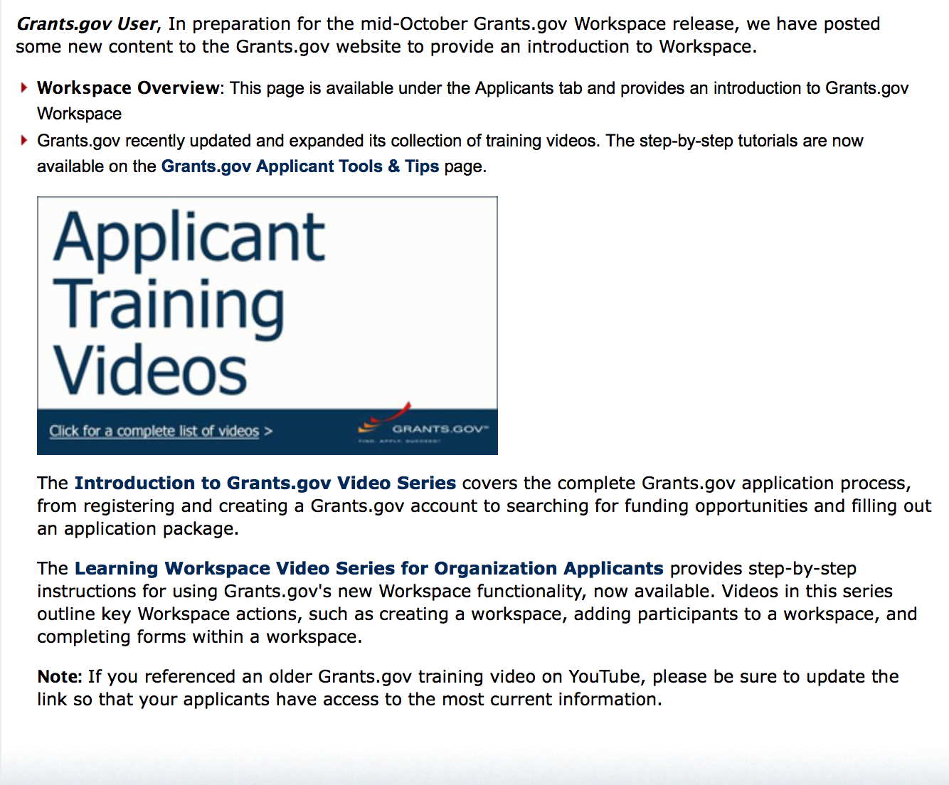
https://portal.hud.gov/hudportal/HUD?src=/program_offices/administration/grants/fundsavail

The Small Business Innovative Research Program - SBIR Program

The Small Business Innovation Research (SBIR) program is a highly competitive program that encourages domestic small businesses to engage in Federal Research/Research and Development (R/R&D) that has the potential for commercialization. Through a competitive awards-based program, SBIR enables small businesses to explore their technological potential and provides the incentive to profit from its commercialization. By including qualified small businesses in the nation's R&D arena, high-tech innovation is stimulated and the United States gains entrepreneurial spirit as it meets its specific research and development needs.

SBIR Mission and Program Goals
The mission of the SBIR program is to support scientific excellence and technological innovation through the investment of Federal research funds in critical American priorities to build a strong national economy.
The program’s goals are four-fold:
- Stimulate technological innovation
- Meet Federal research and development needs.
- Foster and encourage participation in innovation and entrepreneurship by socially and economically disadvantaged persons.
- Increase private-sector commercialization of innovations derived from Federal research and development funding.

SBIR-Participating Agencies
Each year, Federal agencies with extramural research and development (R&D) budgets that exceed $100 million are required to allocate 2.5 percent of their R&D budget to these programs. Currently, eleven Federal agencies participate in the program:
- Department of Agriculture
- Department of Commerce - National Institute of Standards and Technology
- Department of Commerce - National Oceanic and Atmospheric Administration
- Department of Defense
- Department of Education
- Department of Energy
- Department of Health and Human Services
- Department of Homeland Security
- Department of Transportation
- Environmental Protection Agency
- National Aeronautics and Space Administration
- National Science Foundation
Each agency administers its own individual program within guidelines established by Congress. These agencies designate R&D topics in their solicitations and accept proposals from small businesses. Awards are made on a competitive basis after proposal evaluation.

Three-Phase Program
The SBIR Program is structured in three phases:
Phase I. The objective of Phase I is to establish the technical merit, feasibility, and commercial potential of the proposed R/R&D efforts and to determine the quality of performance of the small business awardee organization prior to providing further Federal support in Phase II. SBIR Phase I awards normally do not exceed $150,000 total costs for 6 months.
Phase II. The objective of Phase II is to continue the R/R&D efforts initiated in Phase I. Funding is based on the results achieved in Phase I and the scientific and technical merit and commercial potential of the project proposed in Phase II. Only Phase I awardees are eligible for a Phase II award. SBIR Phase II awards normally do not exceed $1,000,000 total costs for 2 years.
Phase III. The objective of Phase III, where appropriate, is for the small business to pursue commercialization objectives resulting from the Phase I/II R/R&D activities. The SBIR program does not fund Phase III. Some Federal agencies, Phase III may involve follow-on non-SBIR funded R&D or production contracts for products, processes or services intended for use by the U.S. Government
SBIR NewsLetter

- SBIR Newsletter
Sign up for e-mail updates

HAWAII APPLICANTS ENCOURAGED

Current Notices:

Department of Interior
Bureau of Land Management
Joint Fire Science Program FY 2018 Potential Topics
Synopsis 1
Document Type: | Grants Notice
Funding Opportunity Number: | L17JFSP0001
Funding Opportunity Title: | Joint Fire Science Program FY 2018 Potential Topics
Opportunity Category: | Discretionary
Opportunity Category Explanation:
Funding Instrument Type: | Cooperative Agreement
Category of Funding Activity: | Science and Technology and other Research and Development
Category Explanation:
Expected Number of Awards: | 0
CFDA Number(s): | 15.232 -- Wildland Fire Research and Studies
Cost Sharing or Matching Requirement: | No
Version: | Synopsis 1
Posted Date: | Jul 12, 2017
Last Updated Date: | Jul 12, 2017
Original Closing Date for Applications: | Aug 31, 2017
Current Closing Date for Applications: | Aug 31, 2017
Archive Date: | Sep 30, 2017
Eligible Applicants: | Unrestricted (i.e., open to any type of entity above), subject to any clarification in text field entitled "Additional Information on Eligibility"
Agency Name: | Bureau of Land Management
Description: | The interagency Joint Fire Science Program (JFSP) intends to request proposals through one or more formal Funding Opportunity Notice (FON) announcements beginning approximately September 8, 2017 and remaining open through November 16, 2017 for FONs 1 and 2 and December 14, 2017 for FON 3. The intent of this notice is to provide an early alert to investigators interested in the topics listed below so that they can begin considering responsive ideas with potential partners and collaborators.
Link to Additional Information:
Grantor Contact Information: | If you have difficulty accessing the full announcement electronically, please contact:  BLM_FA_JFSP@blm.gov  general e-mail address

http://www.grants.gov/web/grants/view-opportunity.html?oppId=295462

Reminders:

Please review each department’s General Grant and Funding Overview. These overviews are the key web pages on each departmental website dedicated to the agency’s funding opportunities. Check back often to note the department updates and use these sources to assist you in your planning.

Federal Grant and Cooperative Agreement Program Summaries

U.S. Department of Agriculture

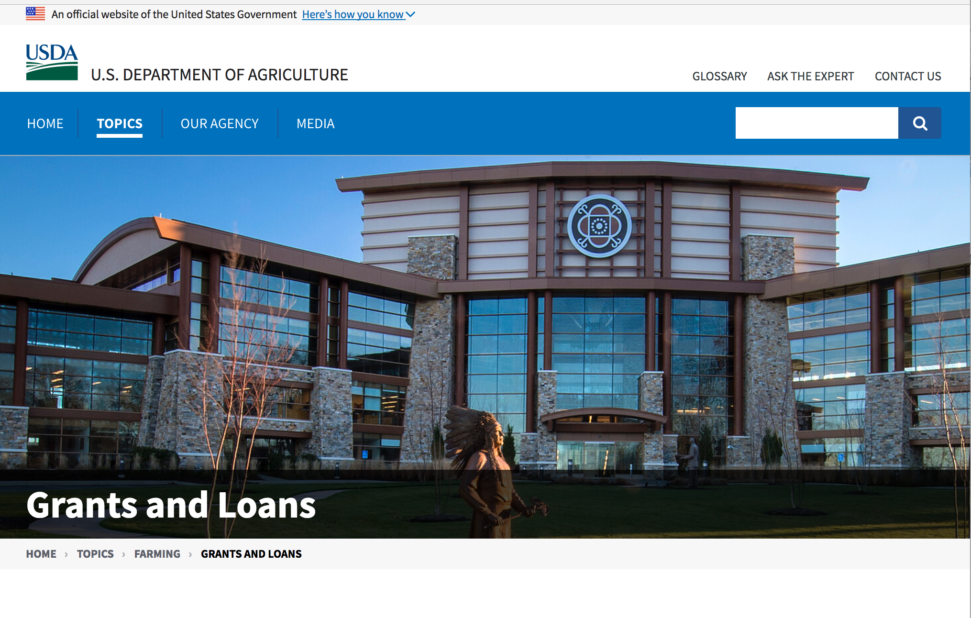

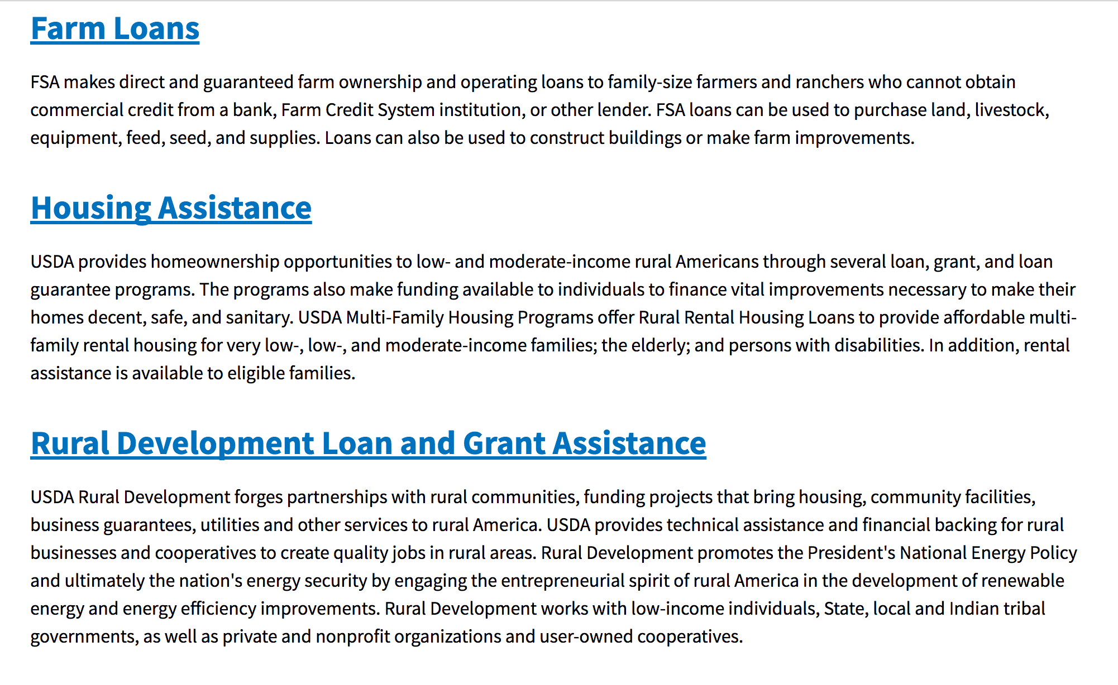

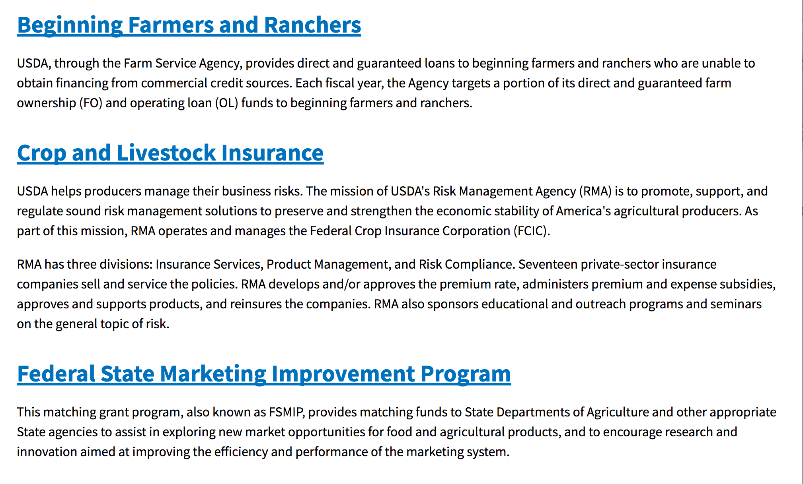
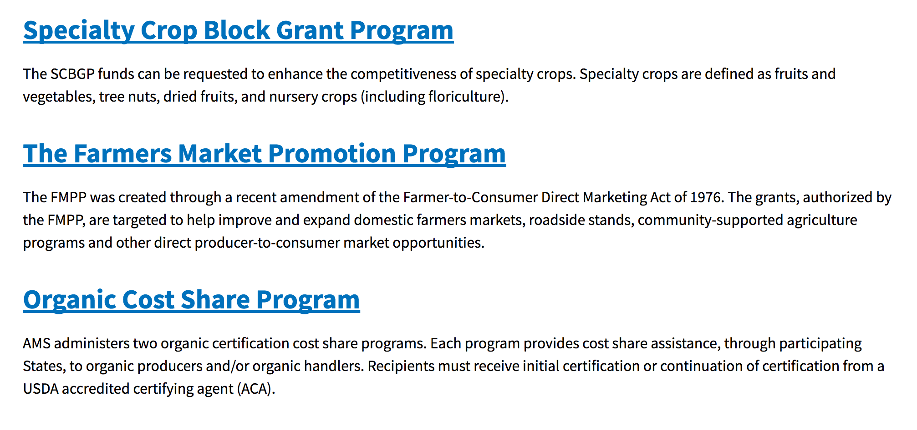
https://www.usda.gov/topics/farming/grants-and-loans

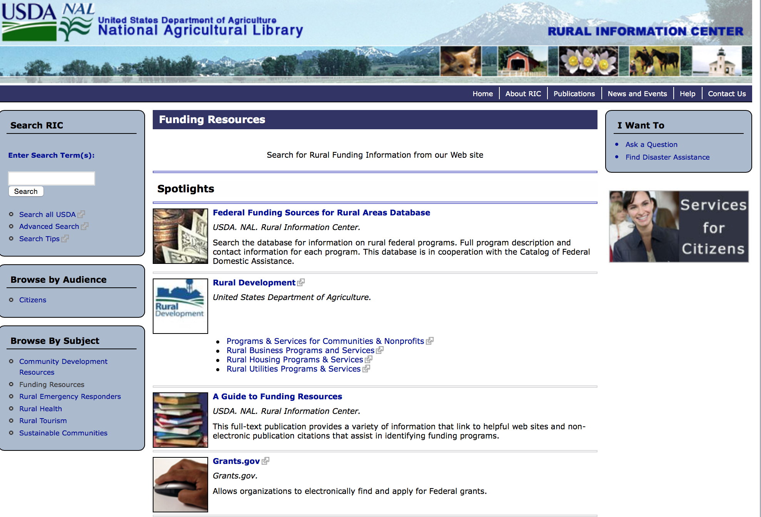

http://ric.nal.usda.gov/funding-resources

Programs:

National Institute of Food and Agriculture
Food and Agricultural Sciences National Needs Graduate and Postgraduate Fellowship (NNF) Grants Program
Synopsis 1 and 2
Document Type: | Grants Notice
Funding Opportunity Number: | USDA-NIFA-HEP-006390
Funding Opportunity Title: | Food and Agricultural Sciences National Needs Graduate and Postgraduate Fellowship (NNF) Grants Program
Opportunity Category: | Discretionary
Opportunity Category Explanation:
Funding Instrument Type: | Grant
Category of Funding Activity: | Agriculture
Category Explanation:
Expected Number of Awards:
CFDA Number(s): | 10.210 -- Higher Education � Graduate Fellowships Grant Program
Cost Sharing or Matching Requirement: | No
Version: | Synopsis 1
Posted Date: | Sep 01, 2017
Last Updated Date: | Sep 01, 2017
Original Closing Date for Applications: | Oct 31, 2017
Current Closing Date for Applications: | Oct 31, 2017
Archive Date: | Nov 30, 2017
Estimated Total Program Funding: | $3,100,000
Award Ceiling: | $262,500
Award Floor: | $4,500
Eligible Applicants: | Others (see text field entitled "Additional Information on Eligibility" for clarification)
Additional Information on Eligibility: | Pursuant to section 1417 of the NARETPA of 1977 (7 U.S.C. 3152), and administrative provisions that can be found in 7 CFR 3402 applications may be submitted by:(1) Land-grant institutions (1862, 1890 and 1994 Institutions);(2) Colleges and universities having significant minority enrollments and a demonstrable capacity to carry out the teaching of food and agricultural sciences; and (3) Other colleges and universities having a demonstrable capacity to carry out the teaching of food, and agricultural sciences.
Agency Name: | National Institute of Food and Agriculture
Description: | This grant program supports: (1) training students for Master's and doctoral degrees in food, agricultural and natural resource sciences, and; (2) Special International Study or Thesis/Dissertation Research Travel Allowances (IRTA) for eligible USDA NNF beneficiaries. Awards are specifically intended to support traineeship programs that engage outstanding students to pursue and complete their degrees in USDA mission areas. Applicants provide clarity about the philosophy of their graduate training, and relevance to USDA mission sciences, NIFA priorities and national science education policies and statistics. Applications are being solicited from institutions that confer a graduate degree in at least one of the following Targeted Expertise Shortage Areas: 1) animal and plant production; 2) forest resources; 3) agricultural educators and communicators; 4) agricultural management and economics; 5) food science and human nutrition; 6) sciences for agricultural biosecurity; and 7) training in integrative biosciences for sustainable food and agricultural systems.
Link to Additional Information: | Food and Agricultural Sciences National Needs Graduate and Postgraduate Fellowship (NNF) Grants Program
Grantor Contact Information: | If you have difficulty accessing the full announcement electronically, please contact:  NIFA Help Desk Phone: 202-401-5048 Business hours are M-F, 7:00 am -5:00 pm ET, excluding Federal holidays  If you have any questions related to preparing application content

http://www.grants.gov/web/grants/view-opportunity.html?oppId=297013

Research:

National Institute of Food and Agriculture
Family Advocacy Program (FAP)
Synopsis 1
http://www.grants.gov/web/grants/view-opportunity.html?oppId=296916

National Institute of Food and Agriculture
Air Force Mental Health Research Project
Synopsis 2
http://www.grants.gov/web/grants/view-opportunity.html?oppId=296931

Modifications:

Business and Cooperative Programs
VALUE ADDED PRODUCER GRANT
Synopsis 3
Document Type: | Grants Notice
Funding Opportunity Number: | RDBCP-VAPG-2017
Funding Opportunity Title: | VALUE ADDED PRODUCER GRANT
Opportunity Category: | Discretionary
Opportunity Category Explanation:
Funding Instrument Type: | Grant
Category of Funding Activity: | Agriculture
Category Explanation:
Expected Number of Awards: | 200
CFDA Number(s): | 10.352 -- Value-Added Producer Grants
Cost Sharing or Matching Requirement: | Yes
Version: | Synopsis 3
Posted Date: | Aug 29, 2017
Last Updated Date: | Aug 29, 2017
Original Closing Date for Applications: | Jan 31, 2018
Current Closing Date for Applications: | Jan 24, 2018
Archive Date: | Mar 02, 2018
Estimated Total Program Funding:
Award Ceiling: | $250,000
Eligible Applicants: | Others (see text field entitled "Additional Information on Eligibility" for clarification)
Additional Information on Eligibility: | Independent Producers, Agricultural Producer Groups, Farmer or Rancher Cooperatives, or Majority-Controlled Producer-Based Business
Agency Name: | Business and Cooperative Programs
Description: | This Notice announces that the Rural Business-Cooperative Service (Agency) is accepting applications for the Value-Added Producer Grant (VAPG) program. Approximately $18 million is currently available. The Agency may also utilize any funding that become available after publishing this notice. Enactment of a continuing resolution or an appropriations act may affect the availability or level of funding for this program. The Agency will publish the program funding level on the Rural Development website (https://www.rd.usda.gov/programs-services/value-added-producer-grants ). Section VII also announces solicitation of non-Federal independent grant reviewers to evaluate and score applications submitted under this Notice.
Link to Additional Information: | Link to Federal Register
Grantor Contact Information: | If you have difficulty accessing the full announcement electronically, please contact:  Shantelle Gordon Management Analyst Phone 2026901374  CPGrants@wdc.usda.gov

http://www.grants.gov/web/grants/view-opportunity.html?oppId=296903

Reminders:

National Institute of Food and Agriculture
Small Business Innovation Research Program - Phase I
Synopsis 1

Document Type: | Grants Notice
Funding Opportunity Number: | USDA-NIFA-SBIR-006365
Funding Opportunity Title: | Small Business Innovation Research Program - Phase I
Opportunity Category: | Discretionary
Opportunity Category Explanation:
Funding Instrument Type: | Grant
Category of Funding Activity: | Agriculture  Science and Technology and other Research and Development
Category Explanation:
Expected Number of Awards:
CFDA Number(s): | 10.212 -- Small Business Innovation Research
Cost Sharing or Matching Requirement: | No
Version: | Synopsis 1
Posted Date: | Jul 05, 2017
Last Updated Date: | Jul 05, 2017
Original Closing Date for Applications: | Oct 05, 2017
Current Closing Date for Applications: | Oct 05, 2017
Archive Date: | Nov 04, 2017
Eligible Applicants: | Others (see text field entitled "Additional Information on Eligibility" for clarification)
Additional Information on Eligibility: | See Part III, A. of the RFA for eligibility information.
Agency Name: | National Institute of Food and Agriculture
Description: | Proposed Phase I projects should prove the scientific or technical feasibility of the approach or concept. Projects dealing with agriculturally related manufacturing and alternative and renewable energy technologies are encouraged across all SBIR topic areas. USDA SBIR's flexible research areas ensure innovative projects consistent with USDA's vision of a healthy and productive nation in harmony with the land, air, and water. USDA SBIR Program has awarded over 2000 research and development projects since 1983, allowing hundreds of small businesses to explore their technological potential, and providing an incentive to profit from the commercialization of innovative ideas.
Link to Additional Information: | Small Business Innovation Research Program - Phase I
Grantor Contact Information: | If you have difficulty accessing the full announcement electronically, please contact:  NIFA Help Desk Phone: 202-401-5048 Business hours are M-F, 7:00 am -5:00 pm ET, excluding Federal holidays  If you have any questions related to preparing application content

http://www.grants.gov/web/grants/view-opportunity.html?oppId=295181

Agricultural Marketing Service
USDA-AMS-TM-SCMP-G-17-0005
Synopsis 2
Document Type: | Grants Notice
Funding Opportunity Number: | USDA-AMS-TM-SCMP-G-17-0005
Funding Opportunity Title: | USDA-AMS-TM-SCMP-G-17-0005
Opportunity Category: | Discretionary
Opportunity Category Explanation:
Funding Instrument Type: | Grant
Category of Funding Activity: | Agriculture
Category Explanation:
Expected Number of Awards: | 10
CFDA Number(s): | 10.170 -- Specialty Crop Block Grant Program - Farm Bill
Cost Sharing or Matching Requirement: | No
Version: | Synopsis 2
Posted Date: | Jun 26, 2017
Last Updated Date: | Jun 26, 2017
Original Closing Date for Applications: | Oct 24, 2017
Current Closing Date for Applications: | Oct 24, 2017
Archive Date: | Nov 23, 2017
Estimated Total Program Funding: | $7,000,000
Award Ceiling: | $1,000,000
Award Floor: | $250,000
Eligible Applicants: | Public and State controlled institutions of higher education
Agency Name: | Agricultural Marketing Service
Description: | The Agricultural Marketing Service (AMS) announces the availability of approximately $7 million in competitive grant funds to solely enhance the competitiveness of specialty crops through collaborative, multi-state projects that address the following regional or national level specialty crop issues: food safety; plant pests and disease; research; crop-specific common issues; and marketing and promotion. Specialty crops are defined as fruits and vegetables, dried fruit, tree nuts, horticulture and nursery crops, including floriculture. States are encouraged to submit projects that bring together multi-state teams of partners to research and develop solutions to practical problems that cross state boundaries and address the needs of specialty crop growers. Applications are due October 24, 2017.
Link to Additional Information: | SCMP website
Grantor Contact Information: | If you have difficulty accessing the full announcement electronically, please contact:  Martin Rosier Grants Manager Phone 2022608449  SCMP Office

http://www.grants.gov/web/grants/view-opportunity.html?oppId=295033

Fish and Wildlife Service
2017 National Fish Habitat Action Plan
Synopsis 1

Document Type: | Grants Notice
Funding Opportunity Number: | F17AS00016
Funding Opportunity Title: | 2017 National Fish Habitat Action Plan
Opportunity Category: | Discretionary
Opportunity Category Explanation:
Funding Instrument Type: | Cooperative Agreement  Grant
Category of Funding Activity: | Natural Resources
Category Explanation:
Expected Number of Awards: | 70
CFDA Number(s): | 15.608 -- Fish and Wildlife Management Assistance
Cost Sharing or Matching Requirement: | No
Posted Date: | Nov 08, 2016
Last Updated Date: | Nov 08, 2016
Original Closing Date for Applications: | Applications are accepted on a rolling basis.
Current Closing Date for Applications: | Applications are accepted on a rolling basis.
Archive Date: | May 31, 2017
Estimated Total Program Funding: | $0
Award Ceiling: | $300,000
Award Floor: | $5,000
Eligible Applicants: | Unrestricted (i.e., open to any type of entity above), subject to any clarification in text field entitled "Additional Information on Eligibility"
Additional Information on Eligibility: | Applications are accepted on a rolling basis.
Agency Name: | Fish and Wildlife Service
Description: | The National Fish Habitat Action Plan is a national investment strategy to leverage federal and privately raised funds to protect, restore, and enhance the nation's fish and aquatic habitats through partnerships that foster fish habitat conservation. Funds appropriated to the U.S. Fish and Wildlife Service's (Service) Fish and Aquatic Conservation (FAC) Program specifically to implement the Action Plan will be utilized in collaboration with the National Fish Habitat Board and Fish Habitat Partnerships. Fish Habitat Partnerships are the primary work units of the Action Plan, formed around distinct geographic areas, "keystone" fish species, or system types (e.g. large lakes, impoundments, estuaries). Funds will support national and regional science and coordination activities to protect, restore, or enhance fish habitats. All or a portion or project funds may be transferred to partner organizations if the Service lacks the capability to implement a project. Projects must protect, restore, or enhance fish and aquatic habitats or otherwise directly support habitat-related priorities of Fish Habitat Partnerships or the National Fish Habitat Board. Every project must be identified in the Fisheries Operational Needs System (FONS), a database that identifies the operational needs of FAC field stations, including fish habitat project needs. FAC field offices will work with Fish Habitat Partnerships to identify fish habitat projects, and enter them into the FONS. Entities that seek to propose a fish habitat conservation project for consideration should contact a local or regional office of the Service FAC Program.
Link to Additional Information: | http://www.grants.gov
Grantor Contact Information: | If you have difficulty accessing the full announcement electronically, please contact:  Cecilia Lewis 703-358-2102 Cecilia_Lewis@fws.gov  Fish Biologist

http://www.grants.gov/web/grants/view-opportunity.html?oppId=289987

Deleted:

Department of Commerce

Grants, Contracting, and Trade Opportunities at Commerce
Learn more information about grants, contracting and trade opportunities at the Department of Commerce using the information below.

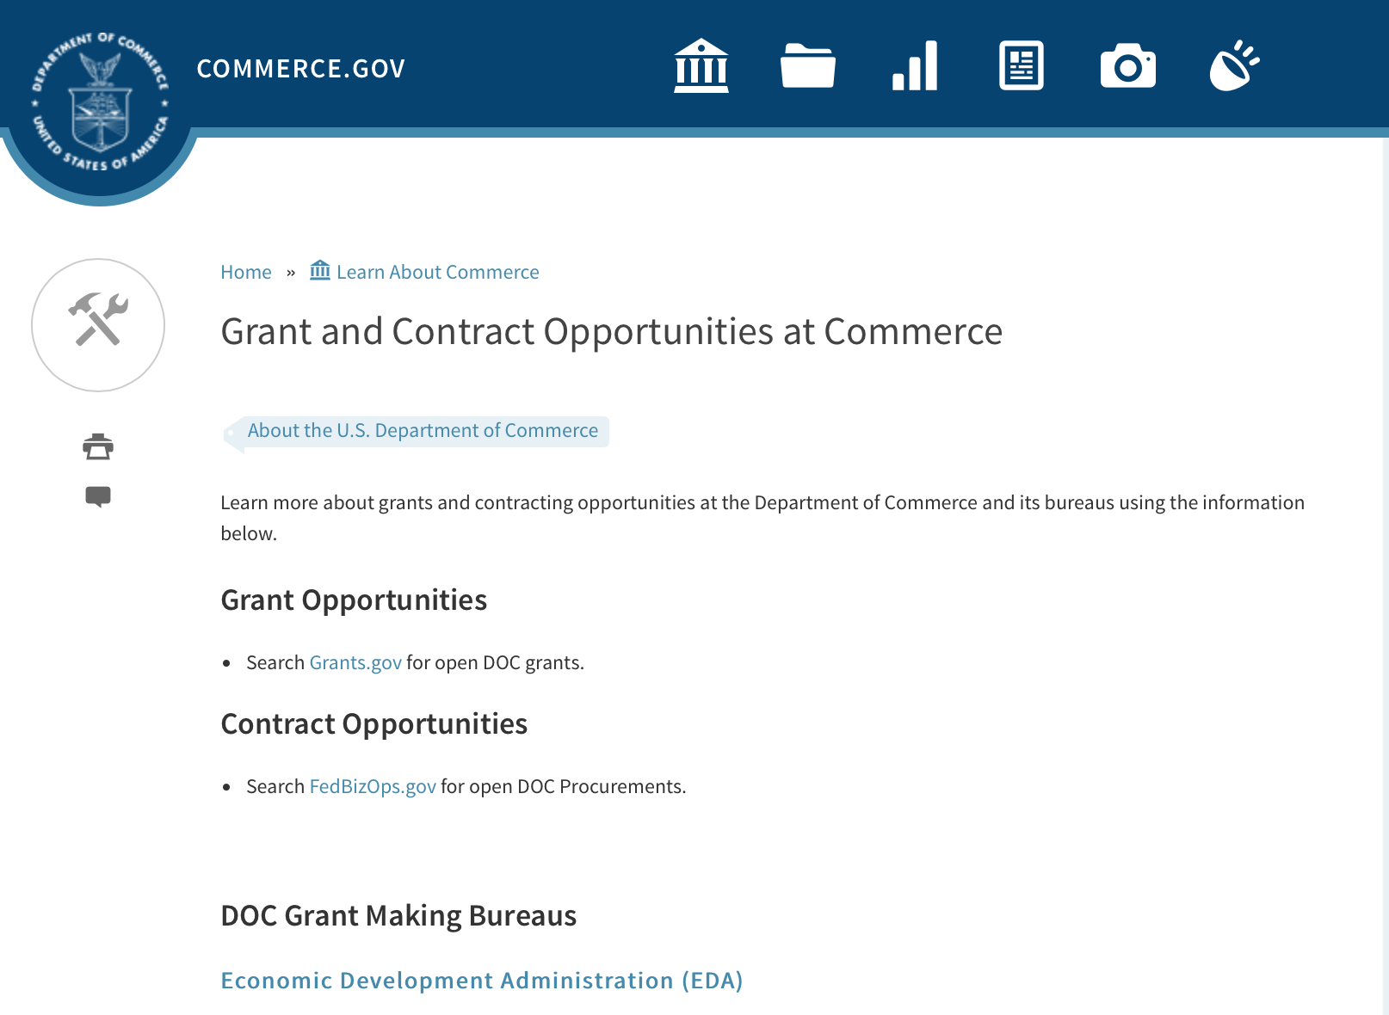
Grants at Commerce
DOC Grant Making Bureaus
Economic Development Administration (EDA)
International Trade Administration (ITA)
- Market Development Cooperator Program
- Special American Business Internship Training Program (SABIT). A technical assistance initiative of the International Trade Administration of the U.S. Department of Commerce, SABIT offers organizations competitive grants and an opportunity to host industry-specific delegations. SABIT serves as an initial entry point for U.S. businesses seeking funding to establish long-term relationships with potential customers, distributors, or partners in the former Soviet Union. The program trains Eurasian managers and scientists in commonly accepted business practices as a means of facilitating cross border relationships. In turn, these personal relationships serve as a basis for business development and reduce market access barriers for U.S. businesses
National Institute of Standards & Technology (NIST)
- Funding Opportunities
National Telecommunications & Information Administration (NTIA)
- Telecommunications Grants
National Oceanic & Atmospheric Administration (NOAA)
- Coastal Ocean Program Grant Information
- Fisheries Saltonstall Kennedy Grant Program
- National Undersea Research Program Funding Opportunities
- Grants Management Division
- Fisheries Grants Program
- National Sea Grant
- Office of Global Programs
Contracting Resources for Contractors
- Office of Small and Disadvantaged Business Utilization (OSDBU) - he Office of Small and Disadvantaged Business Utilization (OSDBU) is an advocacy and advisory office responsible for promoting the use of small, small disadvantaged, 8(a), women-owned, veteran-owned, service-disabled veteran-owned, and HUBZone small businesses within the U.S. Department of Commerce's (DOC) acquisition process.
- Business.USA.gov's Find Opportunities Wizard where in a few quick steps, it will guide you towards federal government contracting programs and opportunities for your business!
- Planned Acquisitions: the Department of Commerce's search tool for our planned acquisitions over $100,000. As requirements change, these acquisition plans are updated by department personnel and this search tool is automatically updated.
- Small Business Administration's Contracting section of their web site where you can learn about how to "Get Started" and "Contracting Support for Small Business"
- The General Services Administration (GSA) has implemented a system for vendors doing business with the Federal Government to manage their entity information in one central location. This new database is the System for Award Management (SAM).

DOC Contracting Offices
- Patent and Trademark Office (PTO)
  - Office of Procurement
- National Institute of Standards & Technology (NIST)
NIST Acquisition Management Group
Contracting Opportunities with Commerce
Trade Opportunities through Commerce
http://www.commerce.gov/about-commerce/grants-contracting-trade-opportunities

Programs:

FY18 Saltonstall Kennedy Competition
Synopsis 1
Document Type: | Grants Notice
Funding Opportunity Number: | NOAA-NMFS-FHQ-2018-2005332
Funding Opportunity Title: | FY18 Saltonstall Kennedy Competition
Opportunity Category: | Discretionary
Opportunity Category Explanation:
Funding Instrument Type: | Cooperative Agreement  Grant
Category of Funding Activity: | Environment  Natural Resources  Science and Technology and other Research and Development
Category Explanation:
Expected Number of Awards: | 50
CFDA Number(s): | 11.427 -- Fisheries Development and Utilization Research and Development Grants and Cooperative Agreements Program
Cost Sharing or Matching Requirement: | No
Version: | Synopsis 1
Posted Date: | Aug 11, 2017
Last Updated Date: | Aug 11, 2017
Original Closing Date for Applications: | Oct 10, 2017
Current Closing Date for Applications: | Oct 10, 2017
Archive Date: | Nov 09, 2017
Estimated Total Program Funding: | $10,000,000
Award Ceiling: | $300,000
Award Floor: | $25,000
Eligible Applicants: | Others (see text field entitled "Additional Information on Eligibility" for clarification)
Additional Information on Eligibility: | You are eligible to apply for a grant or a cooperative agreement under the Saltonstall-Kennedy Grant Program if: 1. You are a citizen or national of the United States; 2. You represent an entity that is a corporation, partnership, association, or other non-Federal entity, non-profit or otherwise (including Indian tribes), if such entity is a citizen of the United States within the meaning of section 2 of the Shipping Act, 1916, as amended (46 U.S.C. app. 802); or 3. You are a citizen of the Republic of the Marshall Islands, Republic of Palau, or the Federated States of Micronesia. We recognize the interest of the Secretaries of Commerce and Interior in defining appropriate fisheries policies and programs that meet the needs of the U.S. insular areas, so we encourage applications from individuals, government entities, and businesses in U.S. insular areas. We support cultural and gender diversity in our programs and encourage women and minority individuals and groups to submit applications. We are also committed to broadening the participation of Minority Serving Institutions (MSIs), which include Historically Black Colleges and Universities, Hispanic Serving Institutions, and Tribal Colleges and Universities, in our grant programs. To find out more about MSIs go to http://www2.ed.gov/about/offices/list/ocr/edlite-minorityinst.html. We encourage applications from members of the fishing community and applications that involve fishing community cooperation and participation. We will consider the extent of fishing community involvement when evaluating the potential benefit of funding a proposal. Eligible Applicants must submit a pre-proposal that meets the submission requirements listing in this FFO by the established due date. Full proposals will not be reviewed or evaluated if a pre-proposal was not received on time and ranked. Non Eligible Applicants You are not eligible to submit an application under this program if you are an employee of any Federal agency; a Regional Fishery Management Council (Council); or an employee of a Council. However, Council members who are not Federal employees can submit an application to the S-K Program.
Agency Name: | Department of Commerce
Description: | The Saltonstall-Kennedy Act established a fund (known as the S-K fund) used by the Secretary of Commerce to provide grants or cooperative agreements for fisheries research and development projects addressing aspects of U.S. fisheries, including, but not limited to, harvesting, processing, marketing, and associated business infrastructures. Under this authority, grants and cooperative agreements are made on a competitive basis (subject to availability of funding) to assist in carrying out projects related to U.S. commercial and recreational fisheries. The term “fisheries” encompasses wild capture, marine aquaculture and recreational fishing. The objective of the S-K Grant Program is to address the needs of the fisheries and fishing communities in optimizing economic benefits by building and maintaining sustainable fisheries and practices, dealing with the impacts of conservation and management measures, and increasing other opportunities to use existing infrastructure to support keeping working waterfronts viable. U.S. fisheries include any fishery, commercial or recreational, that is, or may be, engaged in by citizens or nationals of the United States. Proposals submitted to this competition must address at least one of the following priorities: Marine Aquaculture; Adapting to Environmental Change and Other Long Term Ecosystem Change; Promotion, Development and Marketing; or Territorial Science. This Federal Funding Opportunity includes information on application and criteria for research proposals requesting a maximum of $300,000 in Federal funding for up to a two-year period. Matching funds are not required, nor will they be considered during the evaluation process. Awards are anticipated to start no earlier than September 1, 2018. Grant awards are dependent on the availability of Federal funding as provided in enacted Appropriations Acts. This FFO is being released prior to final appropriations due to award process time frames. While the FY 2018 President's budget proposed $0 for this program, final Congressional direction has not been determined. Applicants are not guaranteed any level of funding. Should funds not be available in FY2018 submitted applications may be carried over to subsequent fiscal year for review and obligation should funds be available and the Agency deems this the most appropriate administrative process.
Link to Additional Information:
Grantor Contact Information: | If you have difficulty accessing the full announcement electronically, please contact:  Daniel Namur, telephone (301) 427-8730 email: Dan.Namur@noaa.gov  Work

http://www.grants.gov/web/grants/view-opportunity.html?oppId=296392

FY18 Marine Debris Removal
Synopsis 1
Document Type: | Grants Notice
Funding Opportunity Number: | NOAA-NOS-ORR-2018-2005335
Funding Opportunity Title: | FY18 Marine Debris Removal
Opportunity Category: | Discretionary
Opportunity Category Explanation:
Funding Instrument Type: | Cooperative Agreement
Category of Funding Activity: | Environment  Natural Resources  Science and Technology and other Research and Development
Category Explanation:
Expected Number of Awards: | 15
CFDA Number(s): | 11.999 -- Marine Debris Program
Cost Sharing or Matching Requirement: | Yes
Version: | Synopsis 1
Posted Date: | Aug 23, 2017
Last Updated Date: | Aug 23, 2017
Original Closing Date for Applications: | Nov 01, 2017
Current Closing Date for Applications: | Nov 01, 2017
Archive Date: | Dec 01, 2017
Estimated Total Program Funding: | $2,000,000
Award Ceiling: | $150,000
Award Floor: | $50,000
Eligible Applicants: | Others (see text field entitled "Additional Information on Eligibility" for clarification)
Additional Information on Eligibility: | In accordance with the Marine Debris Act, eligible applicants are state, local, and tribal governments whose activities affect research or regulation of marine debris and any institution of higher education, nonprofit organization, or commercial (for-profit) organization with expertise in a field related to marine debris. Applications from federal agencies or employees of federal agencies will not be considered. Interested federal agencies may collaborate with eligible applicants but may not receive funds through this competition. All projects must take place within the United States or territories or their respective waterways. Foreign organizations and foreign public entities are not eligible to apply as the primary applicant but can be listed as a sub-awardee or contractor. NOAA is strongly committed to broadening the participation of veterans, minority-serving institutions, and entities that work in underserved areas. The NOAA MDP encourages proposals from, or involving any of the above types of institutions. Applications that have been submitted to other NOAA grant programs or as part of another NOAA grant may be considered under this solicitation.
Agency Name: | Department of Commerce
Description: | The NOAA Marine Debris Program, authorized in the Marine Debris Research, Prevention, and Reduction Act, codified at 33 U.S.C. 1951-1958, supports the development and implementation of locally-driven, marine debris prevention, assessment, and removal projects that benefit coastal habitat, waterways, and NOAA trust resources. Projects awarded through this grant competition will create long-term, quantifiable ecological habitat improvements for NOAA trust resources through on-the-ground marine debris removal activities, with priority for those targeting derelict fishing gear and other medium- and large-scale debris. Projects should also foster awareness of the effects of marine debris to further the conservation of living marine resource habitats, and contribute to the understanding of marine debris composition, distribution and impacts. Successful proposals through this solicitation will be funded through cooperative agreements. Funding of up to $2,000,000 is expected to be available for Community-based Marine Debris Removal Project Grants in Fiscal Year 2018. Typical awards will range from $50,000 to $150,000. Funding for this grant competition comes through the NOAA Marine Debris Program as appropriations to the Office of Response and Restoration, National Ocean Service.
Link to Additional Information:
Grantor Contact Information: | If you have difficulty accessing the full announcement electronically, please contact:  Tom Barry, tom.barry@noaa.gov, 240-533-0425  Work

http://www.grants.gov/web/grants/view-opportunity.html?oppId=296757

FY 2018 Marine Fisheries Initiative (MARFIN)
Synopsis 1
Document Type: | Grants Notice
Funding Opportunity Number: | NOAA-NMFS-SE-2018-2005326
Funding Opportunity Title: | FY 2018 Marine Fisheries Initiative (MARFIN)
Opportunity Category: | Discretionary
Opportunity Category Explanation:
Funding Instrument Type: | Cooperative Agreement  Grant
Category of Funding Activity: | Environment  Natural Resources  Science and Technology and other Research and Development
Category Explanation:
Expected Number of Awards: | 10
CFDA Number(s): | 11.433 -- Marine Fisheries Initiative
Cost Sharing or Matching Requirement: | No
Version: | Synopsis 1
Posted Date: | Aug 24, 2017
Last Updated Date: | Aug 24, 2017
Original Closing Date for Applications: | Oct 31, 2017
Current Closing Date for Applications: | Oct 31, 2017
Archive Date: | Nov 30, 2017
Estimated Total Program Funding: | $525,000
Award Ceiling: | $175,000
Award Floor: | $1
Eligible Applicants: | Others (see text field entitled "Additional Information on Eligibility" for clarification)
Additional Information on Eligibility: | Eligible applicants may be institutions of higher education, nonprofits, individuals, and state, local, and Indian tribal governments. Federal agencies or institutions are not eligible. Foreign governments, organizations under the jurisdiction of foreign governments, and international organizations are excluded for purposes of this solicitation since the objective of the MARFIN program is to optimize research and development benefits from U.S. marine fishery resources.
Agency Name: | Department of Commerce
Description: | The National Marine Fisheries Service (NMFS), Southeast Region, is seeking proposals under the Marine Fisheries Initiative Program (MARFIN), for research and development projects that optimize the use of fisheries in the Gulf of Mexico, Puerto Rico, the U.S. Virgin Islands, and off the South Atlantic states of North Carolina, South Carolina, Georgia, and Florida, involving the U.S. fishing industry (recreational and commercial), including fishery biology, resources assessment, socio-economic assessment, management and conservation, selected harvesting methods, and fish handling and processing. This program addresses NOAA's mission goal "Healthy Oceans."
Link to Additional Information:
Grantor Contact Information: | If you have difficulty accessing the full announcement electronically, please contact:  Kelly Donnelly Grants Management Branch (727) 551-5731  work email

http://www.grants.gov/web/grants/view-opportunity.html?oppId=296795

Fiscal Year 2018 NOAA Gulf of Mexico Bay-Watershed Education and Training (B-WET) Program
Synopsis 1
Document Type: | Grants Notice
Funding Opportunity Number: | NOAA-NMFS-SE-2018-2005331
Funding Opportunity Title: | Fiscal Year 2018 NOAA Gulf of Mexico Bay-Watershed Education and Training (B-WET) Program
Opportunity Category: | Discretionary
Opportunity Category Explanation:
Funding Instrument Type: | Cooperative Agreement  Grant
Category of Funding Activity: | Environment  Natural Resources  Science and Technology and other Research and Development
Category Explanation:
Expected Number of Awards: | 7
CFDA Number(s): | 11.008 -- NOAA Mission-Related Education Awards
Cost Sharing or Matching Requirement: | No
Version: | Synopsis 1
Posted Date: | Aug 24, 2017
Last Updated Date: | Aug 24, 2017
Original Closing Date for Applications: | Nov 03, 2017
Current Closing Date for Applications: | Nov 03, 2017
Archive Date: | Dec 03, 2017
Estimated Total Program Funding: | $600,000
Award Ceiling: | $100,000
Award Floor: | $25,000
Eligible Applicants: | Others (see text field entitled "Additional Information on Eligibility" for clarification)
Additional Information on Eligibility: | Eligible applicants are K-12 public and independent schools and school systems, institutions of higher education, nonprofit organizations, state or local government agencies, interstate agencies, and Indian tribal governments. Federal agencies are not allowed to receive funds under this announcement but may serve as collaborative project partners and may contribute services in kind. Applicants may be physically located in any U.S. state; however, education projects must target teachers and/or students in Gulf of Mexico coastal counties, which are listed on page 48-49 of the following document: National Ocean Service, NOAA. 2011. The Gulf of Mexico at a Glance: A Second Glance. Washington, DC: U.S. Department of Commerce, http://goo.gl/HQ5IDg. Additionally, priority will be given to applicants who 1) show prior experience in working in the Gulf of Mexico region, 2) show prior experience with Gulf of Mexico regional issues, or 3) demonstrate partnerships with local organizations in the Gulf of Mexico region on proposed projects. The Department of Commerce/NOAA is strongly committed to broadening the participation of historically black colleges and universities, Hispanic serving institutions, tribal colleges and universities, and institutions that work in underserved areas. The NOAA B-WET program encourages proposals involving any of the above institutions as well as other organizations that work with underserved or underrepresented audiences.
Agency Name: | Department of Commerce
Description: | The National Marine Fisheries Service Southeast Regional Office (Fisheries Southeast Regional Office) is seeking proposals under the Gulf of Mexico B-WET Program (http://sero.nmfs.noaa.gov/outreach_education/gulf_b_wet/). The Gulf of Mexico B-WET program is a competitive, environmental education, grants program that promotes locally relevant, experiential learning in the K-12 environment. Funded projects provide Meaningful Watershed Educational Experiences (MWEEs) for students, related professional development for teachers, and help to support regional education and environmental priorities in the Gulf of Mexico. This program addresses NOAA's Long-Term Goal of "Healthy Oceans: Marine fisheries, habitats, and biodiversity are sustained within healthy and productive ecosystems" and "NOAA's Engagement Enterprise Objective for An engaged and educated public with an improved capacity to make scientifically informed environmental decisions".
Link to Additional Information:
Grantor Contact Information: | If you have difficulty accessing the full announcement electronically, please contact:  Amy Clark Gulf of Mexico B-WET Program Manager Amy.Clark@noaa.gov (228) 688-1520  Work

http://www.grants.gov/web/grants/view-opportunity.html?oppId=296792

FY18-19 CRCP International Coral Reef Conservation Cooperative Agreements
Synopsis 1

Document Type: | Grants Notice
Funding Opportunity Number: | NOAA-NOS-OCM-2018-2005319
Funding Opportunity Title: | FY18-19 CRCP International Coral Reef Conservation Cooperative Agreements
Opportunity Category: | Discretionary
Opportunity Category Explanation:
Funding Instrument Type: | Cooperative Agreement
Category of Funding Activity: | Environment  Natural Resources  Science and Technology and other Research and Development
Category Explanation:
Expected Number of Awards: | 10
CFDA Number(s): | 11.482 -- Coral Reef Conservation Program
Cost Sharing or Matching Requirement: | Yes
Version: | Synopsis 1
Posted Date: | Aug 30, 2017
Last Updated Date: | Aug 30, 2017
Original Closing Date for Applications: | Feb 15, 2018
Current Closing Date for Applications: | Feb 15, 2018
Archive Date: | Mar 17, 2018
Estimated Total Program Funding: | $600,000
Award Ceiling: | $300,000
Award Floor: | $75,000
Eligible Applicants: | Others (see text field entitled "Additional Information on Eligibility" for clarification)
Additional Information on Eligibility: | Eligible applicants are institutions of higher education, non-profit organizations, non-U.S. government natural resource management agencies, foreign public entities and foreign organizations, and for-profit organizations. An eligible organization may include proposed sub-recipients, contractors, or other collaborators, which may include governmental authorities, effectively forming a team. Federal agencies and employees may participate in projects as collaborative project partners at the agency’s expense, as this announcement does not cover their funding. Federal agencies’ and employees’ in-kind services and equipment are generally not allowed as part of an applicant’s match on shared costs. If an applicant proposes federal agency collaborators, applicants should provide detail on the expected level of federal engagement in the application. Examples might include, but are not limited to partnership services; serving in a review capacity; or participating in priority task teams, working groups, or leadership teams. Proposals are expected to target the following specific countries: 1) For proposals that address the NOAA-GCFI Assessment, projects must be conducted in at least two of the following Non-US countries and territories of the Wider Caribbean: Bahamas, Belize, British Virgin Islands, Grenada, Honduras, Mexico, Saba and St. Eustatius, St. Lucia, St. Vincent and the Grenadines, and Turks and Caicos Islands. For eligible MPA sites in each country please refer to the above Section B., Program Priorities. 2) Proposals for the South East Asia and South Pacific regions must be conducted in one or more of the following countries: Cook Islands, Federated States of Micronesia, Fiji, Indonesia, Kiribati, Malaysia, Nauru, Niue, Palau, Papua New Guinea, Philippines, Republic of the Marshall Islands, Samoa, Solomon Islands, Timor-Leste, Tonga, Tuvalu, and Vanuatu. 3) For Micronesia proposals, the project must only be conducted in all of the following independent countries under compacts of free association with the United States: the Republic of the Marshall Islands; the Republic of Palau; and the Federated States of Micronesia.
Agency Name: | Department of Commerce
Description: | The NOAA Coral Reef Conservation Program (CRCP) provides matching grants for international coral reef conservation projects. CRCP solicits proposals that will support the NOAA Coral Reef Conservation Program’s International Strategy 2010-2015 (International Strategy). The International Strategy focuses on supporting existing regional efforts in four priority regions based on their interconnections with U.S. reef ecosystems and existing initiatives and partnerships. The following three priority regions will be considered under this Federal Funding Opportunity: the Wider Caribbean, South East Asia and South Pacific, and Micronesia. Funding for the Fiscal Year 2018 competition is subject to the availability of Congressional appropriations and is expected to be approximately $600,000. NOAA expects each applicant will request between $75,000 and $300,000 annually for an award with a project period up to two years. Funding after the first year generally depends on future Congressional appropriations, NOAA/CRCP priorities, and recipient performance in the first year(s) of the award.
Link to Additional Information:
Grantor Contact Information: | If you have difficulty accessing the full announcement electronically, please contact:  Scot Frew NOAA/OCM Corel Reef Program 1305 East West Highway 10th Floor, N/OCM6 Silver Spring, MD 20910 (240) 533-0774  Work email

http://www.grants.gov/web/grants/view-opportunity.html?oppId=296927

Modifications:

FY2018 Marine Debris Prevention
Synopsis 2 & 3

Document Type: | Grants Notice
Funding Opportunity Number: | NOAA-NOS-ORR-2018-2005333
Funding Opportunity Title: | FY2018 Marine Debris Prevention
Opportunity Category: | Discretionary
Opportunity Category Explanation:
Funding Instrument Type: | Cooperative Agreement
Category of Funding Activity: | Environment  Natural Resources  Science and Technology and other Research and Development
Category Explanation:
Expected Number of Awards: | 10
CFDA Number(s): | 11.999 -- Marine Debris Program
Cost Sharing or Matching Requirement: | Yes
Version: | Synopsis 3
Posted Date: | Aug 23, 2017
Last Updated Date: | Aug 29, 2017
Original Closing Date for Applications: | Dec 16, 2017
Current Closing Date for Applications: | Dec 16, 2017
Archive Date: | Jan 15, 2018
Estimated Total Program Funding: | $1,500,000
Award Ceiling: | $250,000
Award Floor: | $50,000
Eligible Applicants: | Others (see text field entitled "Additional Information on Eligibility" for clarification)
Additional Information on Eligibility: | Please note: to apply for marine debris prevention funding through this opportunity, applicants must first submit a Letter of Intent (LOI), via email, to grants.marinedebris@noaa.gov, in accordance with the guidelines described in Section IV.B. of the funding opportunity announcement. The deadline for LOI submission is September 28, 2017. After NOAA reviews all submitted LOIs, only those invited to submit a full proposal will be considered for funding. Applicants will be notified by November 1, 2017 if they have been invited to submit a full proposal. In accordance with the Marine Debris Act, eligible applicants are state, local, and tribal governments whose activities affect research or regulation of marine debris and any institution of higher education, nonprofit organization, or commercial (for-profit) organization with expertise in a field related to marine debris. Applications from federal agencies or employees of federal agencies will not be considered. Interested federal agencies may collaborate with eligible applicants but may not receive funds through this competition. All projects must take place within the United States or territories or their respective waterways. Foreign organizations and foreign public entities are not eligible to apply as the primary applicant but can be listed as a sub-awardee or contractor. NOAA is strongly committed to broadening the participation of veterans, minority-serving institutions, and entities that work in underserved areas. The NOAA MDP encourages proposals from, or involving any of the above types of institutions Applications that have been submitted to other NOAA grant programs or as part of another NOAA grant may be considered under this solicitation.
Agency Name: | Department of Commerce
Description: | The NOAA Marine Debris Program, authorized in the Marine Debris Act (33 U.S.C. 1951-1958), provides funding to prevent the introduction of marine debris into the marine and coastal environment. Projects awarded through this grant competition will encourage changes in behavior of a target audience (such as students, teachers, industries, or the public) to address a specific marine debris issue, and will actively engage these groups in hands-on personal participation. Successful proposals through this solicitation will be funded through cooperative agreements. Funding of up to $1,500,000 is expected to be available for Marine Debris Prevention grants in FY2018. Typical awards will range from $50,000 - $150,000. Funding for this purpose comes through the NOAA Marine Debris Program as appropriations to the Office of Response and Restoration, National Ocean Service. This solicitation is focused on efforts to prevent marine debris from entering the environment through targeted behavior change. It is not intended for large-scale debris removal projects, deployment of catchment basins, or scientific research.
Link to Additional Information:
Grantor Contact Information: | If you have difficulty accessing the full announcement electronically, please contact:  Tom Barry (tom.barry@noaa.gov, 240-533-0425).  Work

http://www.grants.gov/web/grants/view-opportunity.html?oppId=296756

Research:

Reminders:

John H. Prescott Marine Mammal Rescue Assistance Grant Program (Prescott Grant Program) for Fiscal Year 2018
Synopsis 1

Document Type: | Grants Notice
Funding Opportunity Number: | NOAA-NMFS-PRPO-2018-2005309
Funding Opportunity Title: | John H. Prescott Marine Mammal Rescue Assistance Grant Program (Prescott Grant Program) for Fiscal Year 2018
Opportunity Category: | Discretionary
Opportunity Category Explanation:
Funding Instrument Type: | Cooperative Agreement  Grant
Category of Funding Activity: | Environment  Natural Resources  Science and Technology and other Research and Development
Category Explanation:
Expected Number of Awards: | 40
CFDA Number(s): | 11.439 -- Marine Mammal Data Program
Cost Sharing or Matching Requirement: | Yes
Version: | Synopsis 1
Posted Date: | Jul 24, 2017
Last Updated Date: | Jul 24, 2017
Original Closing Date for Applications: | Oct 17, 2017
Current Closing Date for Applications: | Oct 17, 2017
Archive Date: | Nov 16, 2017
Estimated Total Program Funding: | $4,000,000
Award Ceiling: | $100,000
Award Floor: | $0
Eligible Applicants: | Others (see text field entitled "Additional Information on Eligibility" for clarification)
Additional Information on Eligibility: | : All eligible applicants must currently be an active, authorized participant or researcher in the National Marine Mammal Stranding Network. Eligible applicants must be: 1) Stranding Agreement (SA) holders or their designee organizations recognized by the applicable NMFS Region; or 2) Holders of researcher authorization letters issued by a NMFS Regional Administrator and/or an MMPA and/or ESA scientific research or enhancement permit (when applicable) including Co-Investigator authorization; or 3) An eligible Federal, state, or local government personnel or tribal personnel (pursuant to Section 109(h) of the MMPA (16 U.S.C. 1379(h)); or 4) Diagnostic or service organizations performing services for the stranding network. Federal agencies in the DOC or Department of the Interior (DOI) are not eligible to receive Federal assistance under this notice. 1. "In Good Standing Criteria". All eligible applicants must meet the following "in good standing" criteria: a. If the applicant is a designated Principal Investigator on a MMPA and/or ESA scientific research or enhancement permit or a Co-Investigator on the MMHSRP's MMPA/ESA scientific research and enhancement permit (permit No. 18786-01), the applicant must have fulfilled all permit requirements. The applicant must not have any pending or outstanding enforcement actions under the MMPA or ESA. b. The applicant must have complied with the terms and responsibilities of the appropriate SA, MMPA Section 109(h) authorization, or researcher authorization letter. This includes, but is not limited to: 1) completion of all reporting requirements; 2) cooperation with state, local, and federal officials; 3) cooperation with state and local officials in the disposition of stranded marine mammals; and 4) cooperation with stranding network participants. c. The applicant must have cooperated in a timely manner with NMFS in collecting and submitting Level B and Level C data and samples, when requested. d. The applicant must not have any current enforcement investigations for the take of marine mammals contrary to MMPA or ESA regulations. e. The applicant must not have any pending NMFS notice of violation(s) regarding the policies governing the goals and operations of the Stranding Network and SA, if applicable (e.g., probation, suspension, or termination). 2. Category Specific Criteria. Organizations and individuals must meet all of the following eligibility criteria specific to their category of participation in order for a proposal to be considered for funding: a. SA Holder Participant or SA Designee Participant - SA participants must hold a current, active SA for stranding response and/or rehabilitation from a NMFS Regional Administrator or the Assistant Administrator. SA Designee participants must be holding a current, active letter of designation from a NMFS SA holder authorized by NMFS. Designees cannot request authorization for activities beyond the scope of what is authorized by the SA to the agreement holder. b. Researcher Participant - Researcher participants must hold a current, active authorizing letter for the proposed award period from the appropriate NMFS Regional Administrator or the Assistant Administrator to salvage stranded marine mammal specimens, parts and samples for the purpose of utilization in scientific research (50 CFR 216.22). Researchers who are authorized under a MMPA/ESA scientific research or enhancement permit must still obtain an authorizing letter from the Regional Stranding Coordinator in order to use parts or specimens from stranded animals. Researcher participants that would not require an authorizing letter from the NMFS Regional Administrator (i.e., they will be working with data only and not possessing samples or specimens) must still provide a letter of eligibility from the Regional Stranding Coordinator (see section III.A.3. of this FFO). Researcher participants must also have designated Co-Investigator(s) that are active NMFS authorized Stranding Network participants in good standing, and provide documentation to this effect. c. State, Local, Federal Government Employees or Tribal Participants - State and local government officials or employees participating pursuant to Section 109(h) of the MMPA (16 U.S.C. 1379(h)) for marine mammal species not listed under the ESA must fulfill reporting obligations outlined in 50 CFR § 216.22. d. Diagnostic Laboratories – While diagnostic laboratories performing analyses for Stranding Network members do not need authorization from NMFS to receive and possess samples or specimens from stranded marine mammals (50 CFR § 216.22(c)(8)), diagnostic laboratory applicants must still provide a letter of eligibility from the MMHSRP at NMFS Headquarters (see section IV.B.7.a. of this FFO). When requesting a letter of eligibility, laboratories should submit examples of their diagnostic capabilities, diagnostic services proposed and their testing turn-around time to the MMHSRP (see section VII of this FFO for contact information). e. Service Organizations – Organizations without an existing SA that are receiving parts from the stranding network to perform analyses that are not diagnostic analyses (see Section VIII for definitions) must have a valid transfer authorization letter issued by the applicable NMFS Region. Organizations working with carcasses or live stranded animals in coordination with a stranding network member may or may not require additional authorization depending upon the service. All service organizations must provide a letter of eligibility from the MMHSRP at NMFS Headquarters (see section IV.B.7.a of this FFO). When requesting a letter of eligibility, service organizations should submit examples of their capabilities, services proposed, and their turn-around time (if applicable) to the MMHSRP (see section VII of this FFO for contact information). 3. Letter of Eligibility. All applicants must submit a letter of eligibility issued by the appropriate NMFS Regional Stranding Coordinator or the MMHSRP at NMFS Headquarters. This letter is required in order to be considered for an award in this funding cycle. The letter of eligibility states that you are: 1) an eligible Stranding Network participant, diagnostic laboratory, service organization, or permitted researcher at the time of the application submission and during the award period; 2) in good standing; 3) have a history of participation in/with the Stranding Network or that your organization is from a local area with no pre-existing stranding response and/or rehabilitation capabilities or your organization provides diagnostic or other services. A copy of your SA or research authorization will not be considered as proof of eligibility. Any proposal that does not provide a letter of eligibility from the NMFS Regional Stranding Coordinator (or NMFS Headquarters) will not be considered eligible and will not be considered for further review. Contact the NMFS Regional Stranding Coordinators (http://www.nmfs.noaa.gov/pr/health/coordinators.htm) or the Prescott Grant Program at the address in the Agency Contacts, Section VII of this FFO to request this letter. Federal agencies in the DOC or DOI are not eligible to receive Federal assistance under this notice. In addition, federal employees shall not provide assistance in writing any application, writing letters of support for any application, or otherwise confer any unfair advantage on a particular application. However, for activities involving collaboration with current NOAA programs, NOAA employees can write a letter verifying that they are collaborating with the project. This collaboration letter cannot support or endorse the applicant or project. MMHSRP staff and other Federal Program Officers can provide guidance on application procedures and proper completion of required forms. Applications encompassing activities conducted under the authority of a MMPA/ESA scientific research or enhancement permit issued to the DOC or DOI should include a copy of the permit and a letter from the Principal Investigator (DOC/DOI employee) verifying that the work is being conducted with their approval. Federal employee travel costs or salaries are not allowable costs under this program. Refer any questions about potential collaboration or support by non-DOC/DOI Federal employees to the official listed in Agency Contacts, Section VII. of this FFO.
Agency Name: | Department of Commerce
Description: | NOAA NMFS' Marine Mammal Health and Stranding Response Program is directed under the Marine Mammal Protection Act (MMPA) to facilitate the collection and dissemination of reference data on stranded marine mammals and health trends of marine mammal populations in the wild. The John H. Prescott Marine Mammal Rescue Assistance Grant Program is administered by NOAA to provide Federal assistance to eligible members of the National Marine Mammal Stranding Network to: 1) support basic needs of organizations for response, treatment, and data collection from living and dead stranded marine mammals, 2) fund scientific research objectives designed to answer questions about marine mammal strandings, health, or rehabilitation techniques utilizing data from living and dead stranded marine mammals, and 3) support facility operations directly related to the recovery, treatment, and data collection from living and dead stranded marine mammals. This document describes how to submit proposals for funding in fiscal year (FY) 2018 and how NMFS will determine which proposals may be funded. This announcement should be read in its entirety, as some information has changed from the previous year.
Link to Additional Information:
Grantor Contact Information: | If you have difficulty accessing the full announcement electronically, please contact:  Jaclyn Taylor Prescott Grant Program NOAA/NMFS/Office of Protected Resources (F/PR) 1315 East-West Highway, Room 13622 Silver Spring, MD 20910 Phone: (301) 427-8402 e-mail at Jaclyn.Taylor@noaa.gov  Work

http://www.grants.gov/web/grants/view-opportunity.html?oppId=295831

FY18 Cooperative Research Program (CRP)
Synopsis 1
Document Type: | Grants Notice
Funding Opportunity Number: | NOAA-NMFS-SE-2018-2005311
Funding Opportunity Title: | FY18 Cooperative Research Program (CRP)
Opportunity Category: | Discretionary
Opportunity Category Explanation:
Funding Instrument Type: | Cooperative Agreement
Category of Funding Activity: | Environment  Natural Resources  Science and Technology and other Research and Development
Category Explanation:
Expected Number of Awards: | 25
CFDA Number(s): | 11.454 -- Unallied Management Projects
Cost Sharing or Matching Requirement: | No
Version: | Synopsis 1
Posted Date: | Jul 14, 2017
Last Updated Date: | Jul 14, 2017
Original Closing Date for Applications: | Sep 22, 2017
Current Closing Date for Applications: | Sep 22, 2017
Archive Date: | Oct 22, 2017
Estimated Total Program Funding: | $2,000,000
Award Ceiling: | $250,000
Award Floor: | $25,000
Eligible Applicants: | Others (see text field entitled "Additional Information on Eligibility" for clarification)
Additional Information on Eligibility: | Eligible applicants may be institutions of higher education, nonprofits, commercial organizations, individuals, and state, local, and Indian tribal governments. Federal agencies or institutions are not eligible. Foreign governments, organizations under the jurisdiction of foreign governments, and international organizations are excluded for purposes of this solicitation since the objective of the CRP is to optimize research and development benefits from U.S. marine fishery resources. Applicants who are not commercial or recreational fisherman must have commercial or recreational fishermen participating in their project. There must be a written agreement with a fisherman describing the involvement in the project activity and the estimated dollar amount to be provided to that fisherman in compensation for his involvement.
Agency Name: | Department of Commerce
Description: | The Cooperative Research Program (CRP) provides opportunity to compete for financial assistance for projects seeking to improve and strengthen the relationship between fisheries researchers from NMFS, state fishery agencies, and universities and the U.S. fishing industry (recreational and commercial) in the Gulf of Mexico (FL, AL, MS, LA, TX), South Atlantic (FL, NC, SC, GA) and Caribbean (USVI and Puerto Rico). The program bolsters partnerships by providing a way for involving commercial and recreational fishermen in the collection of fundamental fisheries information in support of management and regulatory options. This program addresses NOAA's mission to "Protect, Restore, and Manage the Use of Coastal and Ocean Resources through an Ecosystem Approach to Management."
Link to Additional Information:
Grantor Contact Information: | If you have difficulty accessing the full announcement electronically, please contact:  Dax Ruiz, State/Federal Liaison Branch, (727) 824-5324, or Dax.Ruiz@noaa.gov.  Work

http://www.grants.gov/web/grants/view-opportunity.html?oppId=295524

Ocean Exploration FY 2018 Funding Opportunity
Synopsis 1 & 2
Document Type: | Grants Notice
Funding Opportunity Number: | NOAA-OAR-OER-2018-2005296
Funding Opportunity Title: | Ocean Exploration FY 2018 Funding Opportunity
Opportunity Category: | Discretionary
Opportunity Category Explanation:
Funding Instrument Type: | Cooperative Agreement  Grant
Category of Funding Activity: | Environment  Natural Resources  Science and Technology and other Research and Development
Category Explanation:
Expected Number of Awards: | 10
CFDA Number(s): | 11.011 -- Ocean Exploration
Cost Sharing or Matching Requirement: | No
Version: | Synopsis 2
Posted Date: | Jul 12, 2017
Last Updated Date: | Jul 14, 2017
Original Closing Date for Applications: | Dec 08, 2017
Current Closing Date for Applications: | Dec 08, 2017
Archive Date: | Jan 07, 2018
Estimated Total Program Funding: | $3,000,000
Award Ceiling: | $750,000
Award Floor: | $10,000
Eligible Applicants: | Others (see text field entitled "Additional Information on Eligibility" for clarification)
Additional Information on Eligibility: | Eligible applicants are institutions of higher education; non-profit institutions; state, local, and tribal governments; for-profit organizations; and U.S. territories that possess the statutory authority to accept funding for this type of work.
Agency Name: | Department of Commerce
Description: | NOAA’s Office of Ocean Exploration & Research (OER) seeks to enhance ocean exploration and scientific knowledge of the unknown or poorly known areas of the ocean. This entails identifying, describing and creating baseline characterizations of new ocean habitats, marine resources and/or processes. In this Announcement, OER is seeking proposals focused on three topics including: 1. Exploration of the deep marine environments in the US EEZ and US Outer Continental Shelf (OCS) of the Gulf of Mexico; 2. Discovery and exploration of prehistorically and historically significant submerged marine heritage sites in the Gulf of Mexico within the US EEZ and the US Outer Continental Shelf (OCS); and 3. Novel or innovative technologies and methodologies that could increase the pace and scope of ocean exploration, especially exploration of deep environments including the water column and archaeological sites. For themes 1 and 2, OER will not entertain proposals outside the US EEZ and the US Outer Continental Shelf (OCS) in the Gulf of Mexico. Proposals that combine more than one of these exploration topics are encouraged. All correspondence regarding this FFO must be sent to the email: oer.ffo2018@noaa.gov Applicants are required to submit pre-proposals and, ultimately, full proposals that support OER’s exploration mission. OER’s overarching objective is to investigate and document poorly known and unknown ocean areas through interdisciplinary exploration, and to advance and disseminate knowledge of the ocean’s physical, geological, chemical, biological, and archaeological environments. OER’s mission is compliant with NOAA’s Next Generation Strategic Plan (http://www.performance.noaa.gov/ngsp/) which outlines NOAA goals of Science, Service and Stewardship. Findings from projects and expeditions are anticipated to result in new baseline characterizations; provide better scientific understanding of the processes on US continental margins; offer new insights into climate variability and marine ecosystems; reveal new or unconventional energy, mineral, biological, and/or archaeological resources; help identify hazards resulting from extreme events such as submarine volcanic eruptions, earthquakes and tsunamis; and deliver technology advancements (platforms, sensors, methodologies, etc.) that will increase observational capabilities of the ocean. In FY18, OER anticipates availability of approximately $3,000,000 for this Funding Opportunity (this amount includes of costs for any required ship and/or submersible assets). Note: Ship time on the NOAA Ship Okeanos Explorer will not be funded through this announcement. Background information on how to apply and other informational documents are accessible through the OER Office Website: http://oceanexplorer.noaa.gov/about/what-we-do/funding-opportunities.html. Eligible applicants are institutions of higher education; non-profit institutions; for-profit organizations; state, local, and tribal governments, as well as U.S. territories that possess the statutory authority to accept funding for this type of work. Federal agencies that possess the statutory authority to accept funding for this type of work may also apply and must agree to take FY2018 funding for proposed projects. Federal and state agencies are strongly encouraged to collaborate with partners from a non-federal/non-state eligible entity. For the purpose of this opportunity, the buying of ship time and/or other ocean data collection platform support (remotely operated vehicles, autonomous underwater vehicles, etc.) is considered a rental cost and therefore not included in Modified Total Direct Cost (MTDC). OER funding will not be provided to hire and/or fund the salaries and associated overhead costs of any permanent federal or state government employee. OER will not pay Facilities and Administrative (F&A or "overhead") fees to federal and state agencies for subawards such as ship time or other ocean data collection platform support. Federal and state award recipients may use funding to cover travel, equipment, supplies, and contractual personnel costs associated with the proposed work. Foreign researchers may participate by submitting a subaward through collaboration with an eligible U.S. entity. The DOC and NOAA support cultural and gender diversity and encourage women and minority individuals and groups to submit applications to this Announcement of Federal Funding Opportunity. In addition, DOC/NOAA is strongly committed to broadening the participation of historically black colleges and universities, Hispanic serving institutions, tribal colleges and universities, and institutions that work in underserved areas. DOC/NOAA encourages applications involving any of the above institutions to apply.
Link to Additional Information:
Grantor Contact Information: | If you have difficulty accessing the full announcement electronically, please contact:  NOAA Office of Ocean Exploration and Research OER FFO 2018, SSMC3, Rm 10316, 1315 East West Highway, Silver Spring, Maryland 20910 (301) 734-1014  OER Group email

http://www.grants.gov/web/grants/view-opportunity.html?oppId=295442

Economic Development Administration
FY 2017 Economic Development Assistance Programs ­ Application submission and program requirements for EDA’s Public Works and Economic Adjustment Assistance programs.
Synopsis 1
Document Type: | Grants Notice
Funding Opportunity Number: | EDAP-2017
Funding Opportunity Title: | FY 2017 Economic Development Assistance Programs Application submission and program requirements for EDA’s Public Works and Economic Adjustment Assistance programs.
Opportunity Category: | Discretionary
Opportunity Category Explanation:
Funding Instrument Type: | Cooperative Agreement  Grant
Category of Funding Activity: | Other (see text field entitled "Explanation of Other Category of Funding Activity" for clarification)
Category Explanation: | The Economic Development Administration's (EDA's) mission is to lead the Federal economic development agenda by promoting innovation and competitiveness, preparing American regions for economic growth and success in the worldwide economy. EDA fulfills this mission through strategic investments and partnerships that create the regional economic ecosystems required to foster globally competitive regions throughout the United States. EDA supports development in economically distressed areas of the United States by fostering job creation and attracting private investment. Specifically, under the Economic Development Assistance programs (EDAP) Notice of Funding Availability (NOFA), EDA will make construction, non-construction, and revolving loan fund investments under the Public Works and Economic Adjustment Assistance (EAA) Programs. Through this NOFA, EDA will also designate a portion of its EAA funding to support communities and regions that have been negatively impacted by changes in the coal economy (Assistance to Coal Communities, or ACC 2017). Grants made under these programs will leverage regional assets to support the implementation of regional economic development strategies designed to create jobs, leverage private capital, encourage economic development, and strengthen America's ability to compete in the global marketplace. Through the EDAP NOFA, EDA solicits applications from rural and urban communities to develop initiatives that advance new ideas and creative approaches to address rapidly evolving economic conditions.
Expected Number of Awards:
CFDA Number(s): | 11.300 -- Investments for Public Works and Economic Development Facilities  11.307 -- Economic Adjustment Assistance
Cost Sharing or Matching Requirement: | Yes
Version: | Synopsis 1
Posted Date: | Jun 19, 2017
Last Updated Date: | Jun 19, 2017
Original Closing Date for Applications: | There are no submission deadlines under this opportunity. Proposals and applications will be accepted on an ongoing basis until the publication of a new EDAP NOFA.
Current Closing Date for Applications: | There are no submission deadlines under this opportunity. Proposals and applications will be accepted on an ongoing basis until the publication of a new EDAP NOFA.
Archive Date:
Estimated Total Program Funding:
Award Ceiling: | $3,000,000
Award Floor: | $100,000
Eligible Applicants: | Native American tribal organizations (other than Federally recognized tribal governments)  Special district governments  Others (see text field entitled "Additional Information on Eligibility" for clarification)  Private institutions of higher education  County governments  Native American tribal governments (Federally recognized)  City or township governments  Nonprofits that do not have a 501(c)(3) status with the IRS, other than institutions of higher education  State governments  Nonprofits having a 501(c)(3) status with the IRS, other than institutions of higher education  Public and State controlled institutions of higher education
Additional Information on Eligibility: | Eligible applicants for EDA financial assistance under the Public Works and EAA programs (including ACC 2017 funding) include a(n): (i) District Organization of a designated Economic Development District; (ii) Indian Tribe or a consortium of Indian Tribes; (iii) State, county, city, or other political subdivision of a State, including a special purpose unit of a State or local government engaged in economic or infrastructure development activities, or a consortium of political subdivisions; (iv) institution of higher education or a consortium of institutions of higher education; or (v) public or private non-profit organization or association acting in cooperation with officials of a political subdivision of a State. See Section 3 of the Public Works and Economic Development Act of 1965 (PWEDA) (42 U.S.C. § 3122) and 13 C.F.R. § 300.3. EDA is not authorized to provide grants or cooperative agreements to individuals or to for profit entities. Requests from such entities will not be considered for funding. For ACC 2017 funding, projects must be located within and targeted to communities or regions that have been impacted, or can reasonably demonstrate that they will be impacted, by coal mining or coal power plant employment loss, or employment loss in the supply chain industries of either.
Agency Name: | Economic Development Administration
Description: | Under this NOFA, EDA solicits applications from applicants in rural and urban areas to provide investments that support construction, non-construction, technical assistance, and revolving loan fund projects under EDA’s Public Works and EAA programs. Grants and cooperative agreements made under these programs are designed to leverage existing regional assets and support the implementation of economic development strategies that advance new ideas and creative approaches to advance economic prosperity in distressed communities, including communities and regions that have been impacted, or can reasonably demonstrate that they will be impacted, by coal mining or coal power plant employment loss, or employment loss in the supply chain industries of either. EDA provides strategic investments on a competitive- merit-basis to support economic development, foster job creation, and attract private investment in economically distressed areas of the United States. This EDAP NOFA supersedes the EDAP Federal Funding Opportunity dated December 23, 2016.
Link to Additional Information: | Economic Development Administration
Grantor Contact Information: | If you have difficulty accessing the full announcement electronically, please contact:  If you have difficulty accessing the full announcement electronically, please contact: the EDA representative for your state. A complete list of EDA representatives is available on EDA's website at http://www.eda.gov/contact/  http://www.eda.gov/contact/

http://www.grants.gov/web/grants/view-opportunity.html?oppId=294771

National Institute of Standards and Technology
Measurement Science and Engineering (MSE) Research Grant Programs

Document Type: | Grants Notice
Funding Opportunity Number: | 2016-NIST-MSE-01
Funding Opportunity Title: | Measurement Science and Engineering (MSE) Research Grant Programs
Opportunity Category: | Discretionary
Opportunity Category Explanation:
Funding Instrument Type: | Cooperative Agreement  Grant
Category of Funding Activity: | Science and Technology and other Research and Development
Category Explanation:
Expected Number of Awards:
CFDA Number(s):
Cost Sharing or Matching Requirement: | No
Posted Date: | Feb 19, 2016
Last Updated Date: | Feb 19, 2016
Original Closing Date for Applications: | Applications will be accepted and considered on a rolling basis as they are received. See Section IV.4. in the text of the Full Announcement/FFO document. Applications may be submitted by paper or electronically through Grants.gov. Carefully read Section IV. of the Full Announcement/FFO document for details applying to electronic submissions and to paper submissions.
Current Closing Date for Applications: | Applications will be accepted and considered on a rolling basis as they are received. See Section IV.4. in the text of the Full Announcement/FFO document. Applications may be submitted by paper or electronically through Grants.gov. Carefully read Section IV. of the Full Announcement/FFO document for details applying to electronic submissions and to paper submissions.
Eligible Applicants: | Others (see text field entitled "Additional Information on Eligibility" for clarification)
Additional Information on Eligibility: | Eligibility for all programs listed in this FFO is open to all non-Federal entities. Eligible applicants include institutions of higher education, non-profit organizations, for-profit organizations, state and local governments, Indian tribes, hospitals, foreign public entities, and foreign governments. Applicants selected for awards under 15 U.S.C. § 278g-1 are encouraged, but not required, to select underrepresented minorities for participation. In addition, NIST is not able to accept an application from an individual unaffiliated with a sponsoring applicant organization.
Agency Name: | National Institute of Standards and Technology
Description: | NIST is soliciting applications for financial assistance for Fiscal Year 2016 (FY16) within the following NIST Laboratory grant programs: (1) the Material Measurement Laboratory (MML) Grant Program; (2) the Physical Measurement Laboratory (PML) Grant Program; (3) the Engineering Laboratory (EL) Grant Program; (4) the Fire Research (FR) Grant Program; (5) the Information Technology Laboratory (ITL) Grant Program; (6) the Communications Technology Laboratory (CTL) Grant Program; (7) the NIST Center for Neutron Research (NCNR) Grant Program; (8) the Center for Nanoscale Science and Technology (CNST) Grant Program; (9) the Special Programs Office (SPO) Grant Program; (10) the Standards Coordination Office (SCO) Grant Program; (11) the International and Academic Affairs Office (IAAO) Grant Program; and (12) the Associate Director for Laboratory Programs (ADLP) Grant Program.
Link to Additional Information: | 2016-NIST-MSE-01 Full Announcement/FFO document
Contact Information: | If you have difficulty accessing the full announcement electronically, please contact:  Christopher Hunton Management and Program Analyst Phone 301-975-5718  Agency Contact

http://www.grants.gov/web/grants/view-opportunity.html?oppId=281689

National Sea Grant College Program 2016-17 Special Projects Grant

Document Type: | Grants Notice
Funding Opportunity Number: | NOAA-OAR-SG-2016-2004772
Funding Opportunity Title: | National Sea Grant College Program 2016-17 Special Projects
Opportunity Category: | Discretionary
Funding Instrument Type: | Cooperative Agreement  Grant
Category of Funding Activity: | Environment  Natural Resources  Science and Technology and other Research and Development
Category Explanation:
Expected Number of Awards: | 30
CFDA Number(s): | 11.417 -- Sea Grant Support
Cost Sharing or Matching Requirement: | Yes
Posted Date: | Jan 7, 2016
Creation Date: | Jan 7, 2016
Original Closing Date for Applications: | Sep 30, 2017
Current Closing Date for Applications: | Sep 30, 2017
Archive Date: | Oct 30, 2017
Estimated Total Program Funding: | $4,000,000
Award Ceiling: | $1,000,000
Award Floor: | $1
Eligible Applicants: | Others (see text field entitled "Additional Information on Eligibility" for clarification)
Additional Information on Eligibility: | Sea Grant Programs (Sea Grant Colleges, Institutions, or Coherent Area Programs), the National Sea Grant Law Center, and the National Sea Grant Library.
Agency Name: | Department of Commerce
Description: | The purpose of this notice is to request proposals for special projects associated with the National Sea Grant College Program’s (Sea Grant) strategic focus areas, and to provide the general public with information and guidelines on how Sea Grant will select proposals and administer Federal assistance under this announcement. This announcement is a mechanism to encourage research or other projects that are not normally funded through Sea Grant national competitions. This opportunity is open only to Sea Grant Programs. Section III of this announcement describes eligibility requirements in more detail. Funding has not yet been made available to support applications submitted to this Federal Funding Opportunity (FFO), but such funding may become available during the year. Section II.A. below describes individual competition announcements that will be used to announce when funding is available; any restrictions or requirements on such funding, such as matching funds; and other funding details. Awards will be made under this FFO only if funds have been announced as provided in this FFO.
Link to Additional Information:
Contact Information: | If you have difficulty accessing the full announcement electronically, please contact:  Special Projects Competition Manager, NOAA R/SG National Sea Grant Office 1315 East-West Highway, Rm 11839 Silver Spring, MD 20910 301-734-1066  work

http://www.grants.gov/web/grants/view-opportunity.html?oppId=280846

FY 2016 – FY 2019 EDA Planning Program and Local Technical Assistance Program Grant

Document Type: | Grants Notice
Funding Opportunity Number: | EDA-HDQ-TA-HDQ-2016-2004759
Funding Opportunity Title: | FY 2016 – FY 2019 EDA Planning Program and Local Technical Assistance Program
Opportunity Category: | Discretionary
Funding Instrument Type: | Cooperative Agreement  Grant
Category of Funding Activity: | Other (see text field entitled "Explanation of Other Category of Funding Activity" for clarification)  Regional Development
Category Explanation: | Regional planning and local technical assistance
Expected Number of Awards:
CFDA Number(s): | 11.302 -- Economic Development Support for Planning Organizations  11.303 -- Economic Development Technical Assistance
Cost Sharing or Matching Requirement: | No
Posted Date: | Dec 10, 2015
Creation Date: | Dec 10, 2015
Original Closing Date for Applications: | Applications are accepted on a continuing basis and processed as received. This Planning and Local Technical Assistance opportunity will remain in effect until superseded by a future announcement.
Current Closing Date for Applications: | Applications are accepted on a continuing basis and processed as received. This Planning and Local Technical Assistance opportunity will remain in effect until superseded by a future announcement.
Archive Date:
Estimated Total Program Funding:
Award Ceiling: | $300,000
Award Floor: | $0
Eligible Applicants: | Nonprofits having a 501(c)(3) status with the IRS, other than institutions of higher education  City or township governments  Nonprofits that do not have a 501(c)(3) status with the IRS, other than institutions of higher education  Others (see text field entitled "Additional Information on Eligibility" for clarification)  Private institutions of higher education  Native American tribal governments (Federally recognized)  Public and State controlled institutions of higher education  State governments  Special district governments  County governments
Additional Information on Eligibility: | Pursuant to section 3 of the Public Works and Economic Development Act of 1965 (42 U.S.C. § 3122) (PWEDA) and EDA’s regulation at 13 C.F.R. § 300.3, the following types of entities are eligible to receive funding assistance from EDA: 1. District Organizations (as defined in 13 C.F.R. § 300.3); 2. Indian Tribes or a consortium of Indian Tribes; 3. States, cities, or other political subdivisions of a State, including a special purpose unit of a State or local government engaged in economic or infrastructure development activities, or a consortium of political subdivisions; 4. Institutions of higher education or a consortium of institutions of higher education; or 5. Public or private non-profit organizations or associations acting in cooperation with officials of a political subdivision of a State.
Agency Name: | Department of Commerce
Description: | Pursuant to PWEDA, EDA announces general policies and application procedures for grant-based investments under the Planning and Local Technical Assistance programs. Under the Planning program EDA assists eligible recipients in creating regional economic development plans designed to build capacity and guide the economic prosperity and resiliency of an area or region. As part of this program, EDA supports Partnership Planning investments to facilitate the development, implementation, revision, or replacement of Comprehensive Economic Development Strategies (CEDS), which articulate and prioritize the strategic economic goals of recipients’ respective regions. In general, EDA provides Partnership Planning grants to the designated planning organization (e.g., District Organization) serving EDA designated Economic Development Districts to enable these organizations to develop and implement relevant CEDS. In addition, EDA provides Partnership Planning grants to Indian Tribes to help develop and implement CEDS and associated economic development activities. The Planning program also helps support organizations, including District Organizations, Indian Tribes, and other eligible recipients, with Short Term and State Planning investments designed to guide the eventual creation and retention of high-quality jobs, particularly for the unemployed and underemployed in the Nation’s most economically distressed regions. The Local Technical Assistance program strengthens the capacity of local or State organizations, institutions of higher education, and other eligible recipients to undertake and promote effective economic development programs through projects such as feasibility analyses and impact studies.
Link to Additional Information: | www.eda.gov
Contact Information: | If you have difficulty accessing the full announcement electronically, please contact:  The EDA representative for your state. A complete list of EDA representatives is available on EDA's website at http://www.eda.gov/contact/

http://www.grants.gov/web/grants/view-opportunity.html?oppId=280447

Economic Development Administration
Planning Program and Local Technical Assistance Program Grant

Document Type: | Grants Notice
Funding Opportunity Number: | EDAPLANNING2012
Opportunity Category: | Discretionary
Posted Date: | Aug 03, 2012
Creation Date: | Aug 03, 2012
Original Closing Date for Applications: | Applications are accepted on a continuing basis and processed as received. This Planning and Local Technical Assistance opportunity will remain in effect until superseded by a future announcement.
Current Closing Date for Applications: | Applications are accepted on a continuing basis and processed as received. This Planning and Local Technical Assistance opportunity will remain in effect until superseded by a future announcement.
Archive Date:
Funding Instrument Type: | Cooperative Agreement  Grant
Category of Funding Activity: | Other (see text field entitled "Explanation of Other Category of Funding Activity" for clarification)  Regional Development
Category Explanation: | Regional planning and local technical assistance
Expected Number of Awards: | 425
Estimated Total Program Funding:
Award Ceiling: | $100,000
Award Floor:
CFDA Number(s): | 11.302 -- Economic Development Support for Planning Organizations
 | 11.303 -- Economic Development Technical Assistance
Cost Sharing or Matching Requirement: | Yes

Eligible Applicants
State governments
County governments
City or township governments
Public and State controlled institutions of higher education
Native American tribal governments (Federally recognized)
Nonprofits having a 501(c)(3) status with the IRS, other than institutions of higher education
Nonprofits that do not have a 501(c)(3) status with the IRS, other than institutions of higher education
Private institutions of higher education
Others (see text field entitled "Additional Information on Eligibility" for clarification)

Additional Information on Eligibility:
Pursuant to section 3 of the Public Works and Economic Development Act of 1965 (42 U.S.C. § 3122) (PWEDA) and EDA’s regulation at 13 C.F.R. § 300.3, the following types of entities are eligible to receive funding assistance from EDA: 1. District Organizations (as defined in 13 C.F.R. § 300.3); 2. Indian Tribes or a consortium of Indian Tribes; 3. States, cities, or other political subdivisions of a State, including a special purpose unit of a State or local government engaged in economic or infrastructure development activities, or a consortium of political subdivisions; 4. Institutions of higher education or a consortium of institutions of higher education; or 5. Public or private non-profit organizations or associations acting in cooperation with officials of a political subdivision of a State.

Agency Name
Economic Development Administration

Description
Pursuant to PWEDA, EDA announces general policies and application procedures for grant-based investments under the Planning and Local Technical Assistance programs. Under the Planning program EDA assists eligible recipients in creating regional economic development plans designed to stimulate and guide the economic development efforts of a community or region. As part of this program, EDA supports Partnership Planning investments to facilitate the development, implementation, revision, or replacement of Comprehensive Economic Development Strategies (CEDS), which articulate and prioritize the strategic economic goals of recipients' respective regions. In general, EDA provides Partnership Planning grants to the designated planning organization (e.g., District Organization) serving EDA-designated Economic Development Districts to enable these organizations to develop and implement relevant CEDS. In addition, EDA provides Partnership Planning grants to Indian Tribes to help develop and implement CEDS and associated economic development activities. The Planning program also helps support planning organizations, including District Organizations, Indian Tribes, and other eligible Recipients, with Short Term and State Planning investments designed to guide the eventual creation and retention of higher-skill, higher-wage jobs, particularly for the unemployed and underemployed in the Nation’s most economically distressed regions. The Local Technical Assistance program strengthens the capacity of local or State organizations, institutions of higher education, and other eligible recipients to undertake and promote effective economic development programs through projects such as feasibility analyses and impact studies.

Link to Additional Information

If you have difficulty accessing the full announcement electronically, please contact:
David Ives Planning and Local TA email

http://www.grants.gov/web/grants/view-opportunity.html?oppId=189193

Deleted:

ITA-INA-OPCM-2017-2004912 - Market Development Cooperator Program 2017
Deletion Comments: Opportunity deleted. Per the Program Officer email dated 3/22/17 this FFO is being deleted.

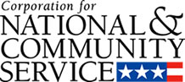

Corporation for National and Community Service

General Program Overview
AmeriCorps provides resources, both human and financial, to organizations that engage Americans in intensive service to meet our country’s critical needs.
Grantees use the funding to support AmeriCorps members for intensive service in their community. AmeriCorps grants partially cover the expense of operating an AmeriCorps program and do not cover general organizational expenses. A cash and in-kind match is required.

The main website can be accessed here: http://www.nationalservice.gov

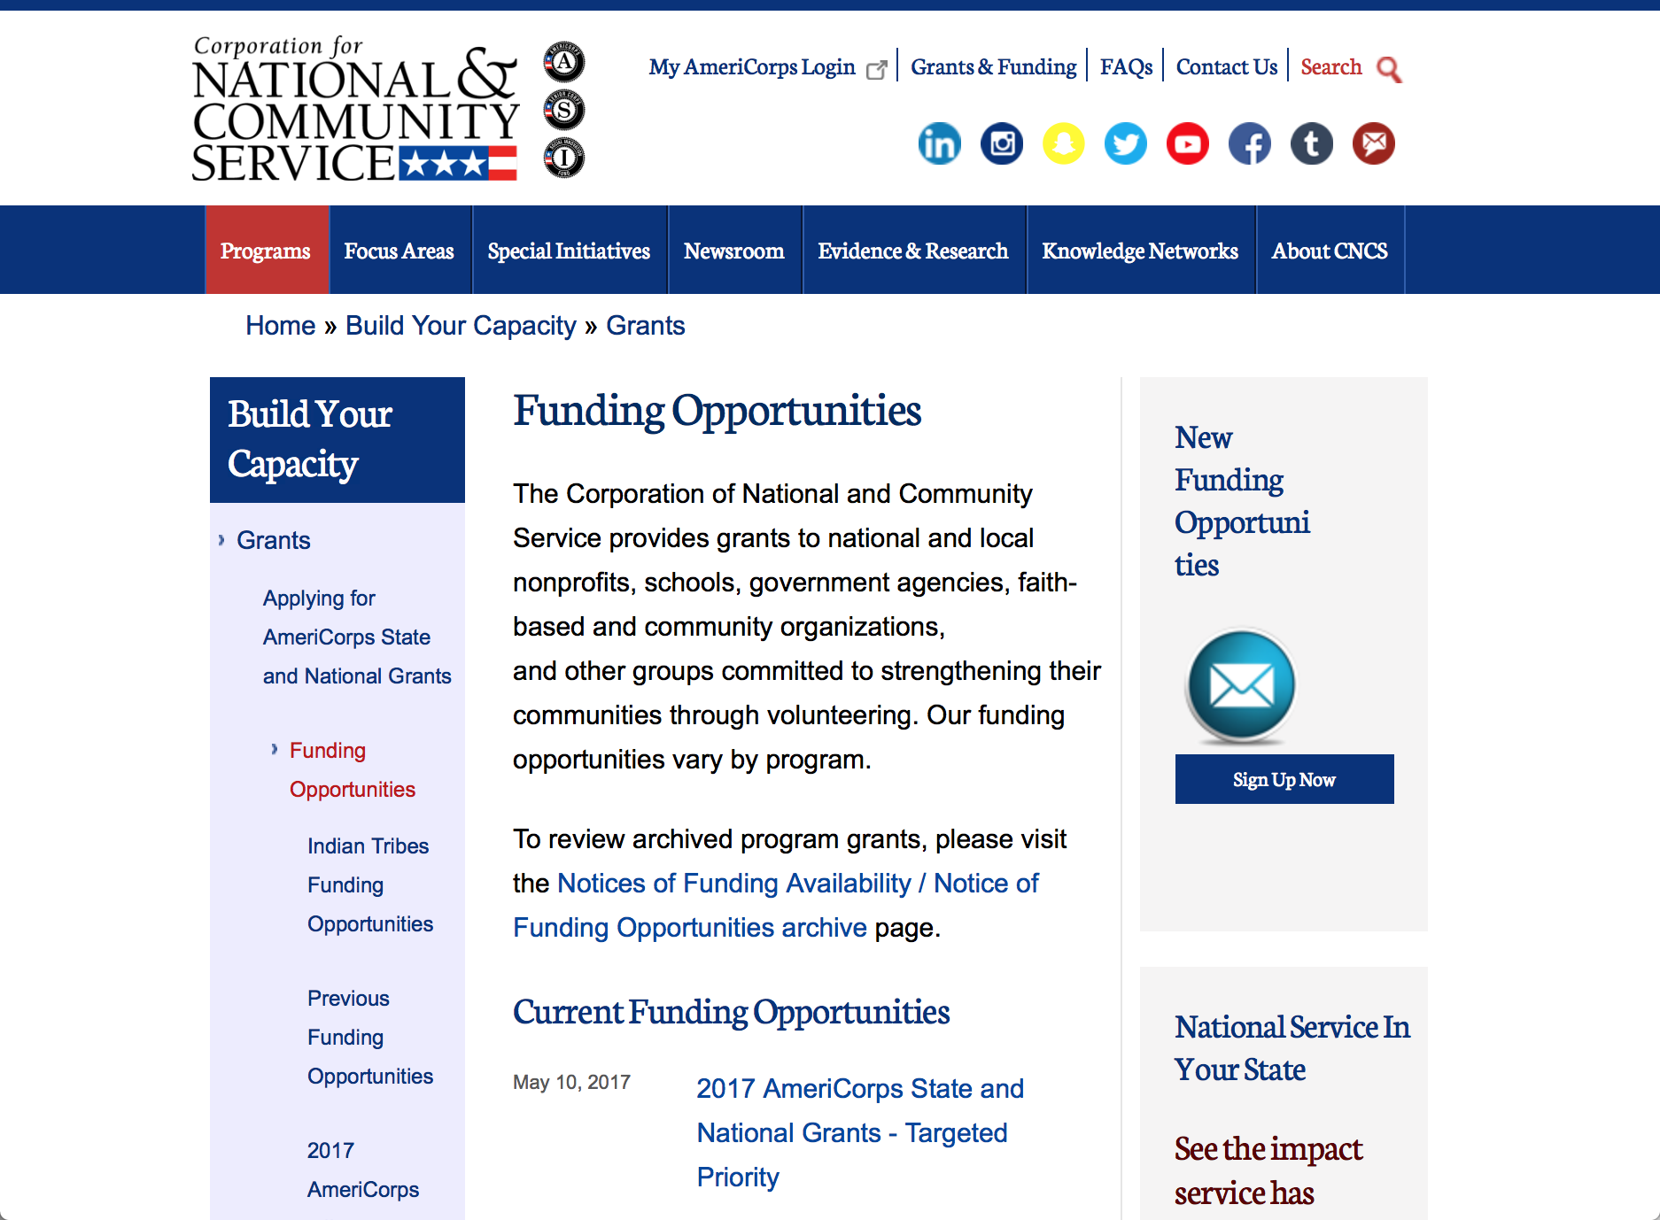

Current Funding Opportunities
There are no current funding opportunities.

For access to further funding information: click here

http://www.nationalservice.gov/build-your-capacity/grants/funding-opportunities

Programs:

AmeriCorps State and National Grants FY2018
Synopsis 1
Document Type: | Grants Notice
Funding Opportunity Number: | CNCS-08-24-17
Funding Opportunity Title: | AmeriCorps State and National Grants FY2018
Opportunity Category: | Discretionary
Opportunity Category Explanation:
Funding Instrument Type: | Grant
Category of Funding Activity: | Community Development  Disaster Prevention and Relief  Education  Employment, Labor and Training  Environment  Food and Nutrition  Health  Housing  Natural Resources
Category Explanation:
Expected Number of Awards:
CFDA Number(s): | 94.006 -- AmeriCorps
Cost Sharing or Matching Requirement: | Yes
Version: | Synopsis 1
Posted Date: | Aug 24, 2017
Last Updated Date: | Aug 24, 2017
Original Closing Date for Applications: | Jan 17, 2018
Current Closing Date for Applications: | Jan 17, 2018
Archive Date: | Jan 18, 2018
Eligible Applicants: | Private institutions of higher education  City or township governments  State governments  Nonprofits that do not have a 501(c)(3) status with the IRS, other than institutions of higher education  Nonprofits having a 501(c)(3) status with the IRS, other than institutions of higher education  Native American tribal organizations (other than Federally recognized tribal governments)  Public housing authorities/Indian housing authorities  Public and State controlled institutions of higher education  Native American tribal governments (Federally recognized)  County governments  Special district governments  Independent school districts
Additional Information on Eligibility:
Agency Name: | Corporation for National and Community Service
Description: | AmeriCorps grants are awarded to eligible organizations proposing to engage AmeriCorps members in evidence-based or evidence-informed interventions to strengthen communities. An AmeriCorps member is an individual who engages in community service through an approved national service position. Members may receive a living allowance and other benefits while serving. Upon successful completion of their service, members earn a Segal AmeriCorps Education Award from the National Service Trust that members can use to pay for higher education expenses or apply to qualified student loans.
Link to Additional Information: | Full competition information and resources.
Grantor Contact Information: | If you have difficulty accessing the full announcement electronically, please contact:  (202) 606-7508  Competition inbox

http://www.grants.gov/web/grants/view-opportunity.html?oppId=296773

Research:

Reminders:

National Service In Hawaii
National Service in Your State - Hawaii
2015-2016

Meeting Community Needs in Hawaii: More than 3,100 people of all ages and backgrounds are helping to meet local needs, strengthen communities, and increase civic engagement through national service in Hawaii. Serving at more than 450 locations throughout the state, these citizens tutor and mentor children, support veterans and military families, provide health services, restore the environment, respond to disasters, increase economic opportunity, and recruit and manage volunteers. This year, the Corporation for National and Community Service (CNCS) will commit more than $6,260,000 to support Hawaii communities through national service initiatives. Through a unique public-private partnership, this federal investment will leverage an additional $9,060,000 in other resources to strengthen community impact, build local support, and increase return on taxpayer dollars. Nationwide, CNCS, its grantees, and project sponsors generated more than $1.25 billion in outside resources from businesses, foundations, public agencies, and other sources in FY 2015.

AmeriCorps
This year, AmeriCorps will provide more than 560 individuals the opportunity to provide intensive, results-driven service to meet education, environmental, health, economic, and other pressing needs in communities across Hawaii. Most AmeriCorps grant funding goes to the Hawaii Commission on National & Community Service, which in turn awards grants to nonprofit groups to respond to local needs. Most of the remainder of the grant funding is distributed by CNCS directly to multi-state and national organizations through a competitive grants process. Other individuals serve through AmeriCorps VISTA, whose members help bring individuals and communities out of poverty by serving full-time to fight illiteracy, improve health services, create businesses, and increase housing opportunities, and AmeriCorps NCCC (National Civilian Community Corps), a 10-month, full time residential program for men and women between the ages of 18 and 24. In exchange for their service, AmeriCorps members earn an education award that can be used to pay for college or to pay back qualified student loans. Since 1994, more than 5,900 Hawaii residents have served more than 6.4 million hours and have qualified for Segal AmeriCorps Education Awards totaling more than $14,980,000.
Download: AmeriCorps in Hawaii (PDF)
Senior Corps
More than 2,500 seniors in Hawaii contribute their time and talents in one of three Senior Corps programs. Foster Grandparents serve one-on-one as tutors and mentors to more than 310 young people who have special needs. Senior Companions help more than 220 homebound seniors and other adults maintain independence in their own homes. RSVP volunteers conduct safety patrols, renovate homes, protect the environment, tutor and mentor youth, respond to natural disasters, and provide other services through more than 250 groups across Hawaii.
Download: Senior Corps in Hawaii (PDF)

The Corporation for National and Community Service is a federal agency that improves lives, strengthens communities, and fosters civic engagement through service and volunteering. CNCS annually engages more than five million Americans in service to meet local needs through Senior Corps, AmeriCorps, and national days of service; improves communities through the Social Innovation Fund, and leads President Obama's national call to service initiative, United We Serve. To learn more visit NationalService.gov or Serve.gov or call 202-606-5000 or TTY 1-800-833-3722.

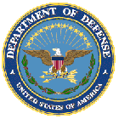

U.S. Department of Defense

Doing Business with the Department of Defense

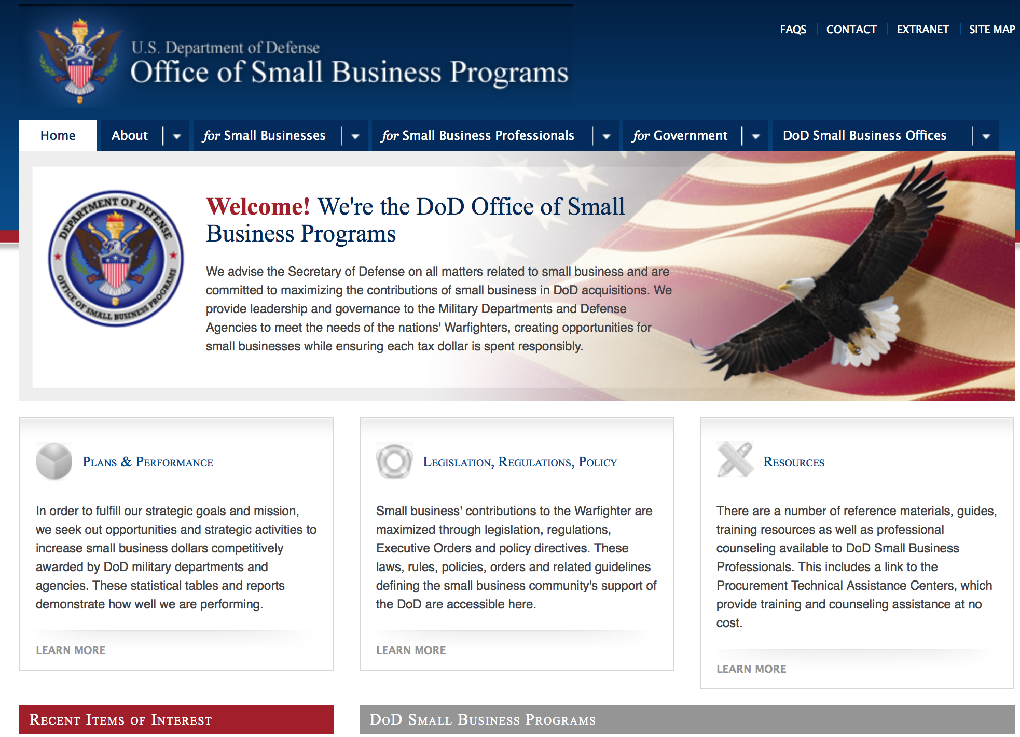
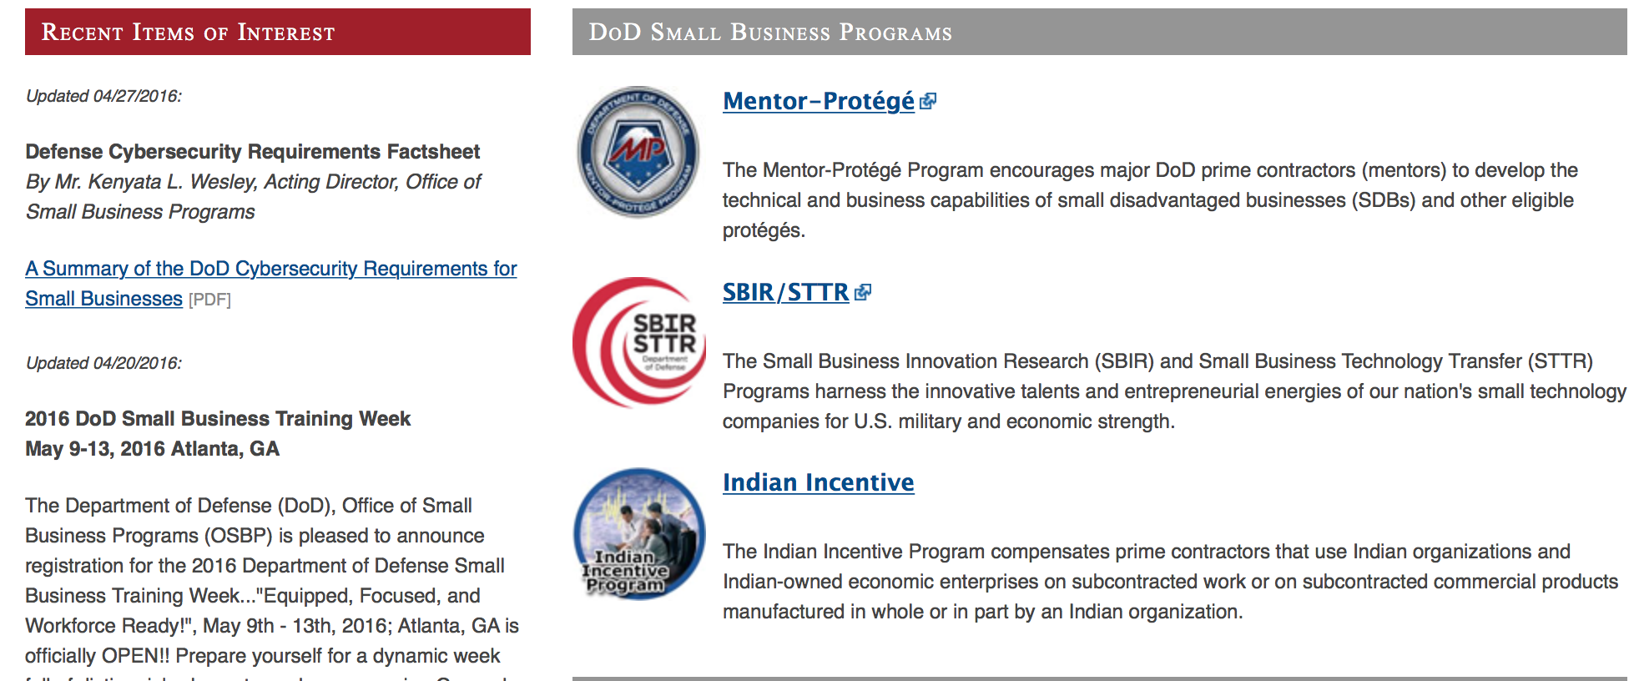

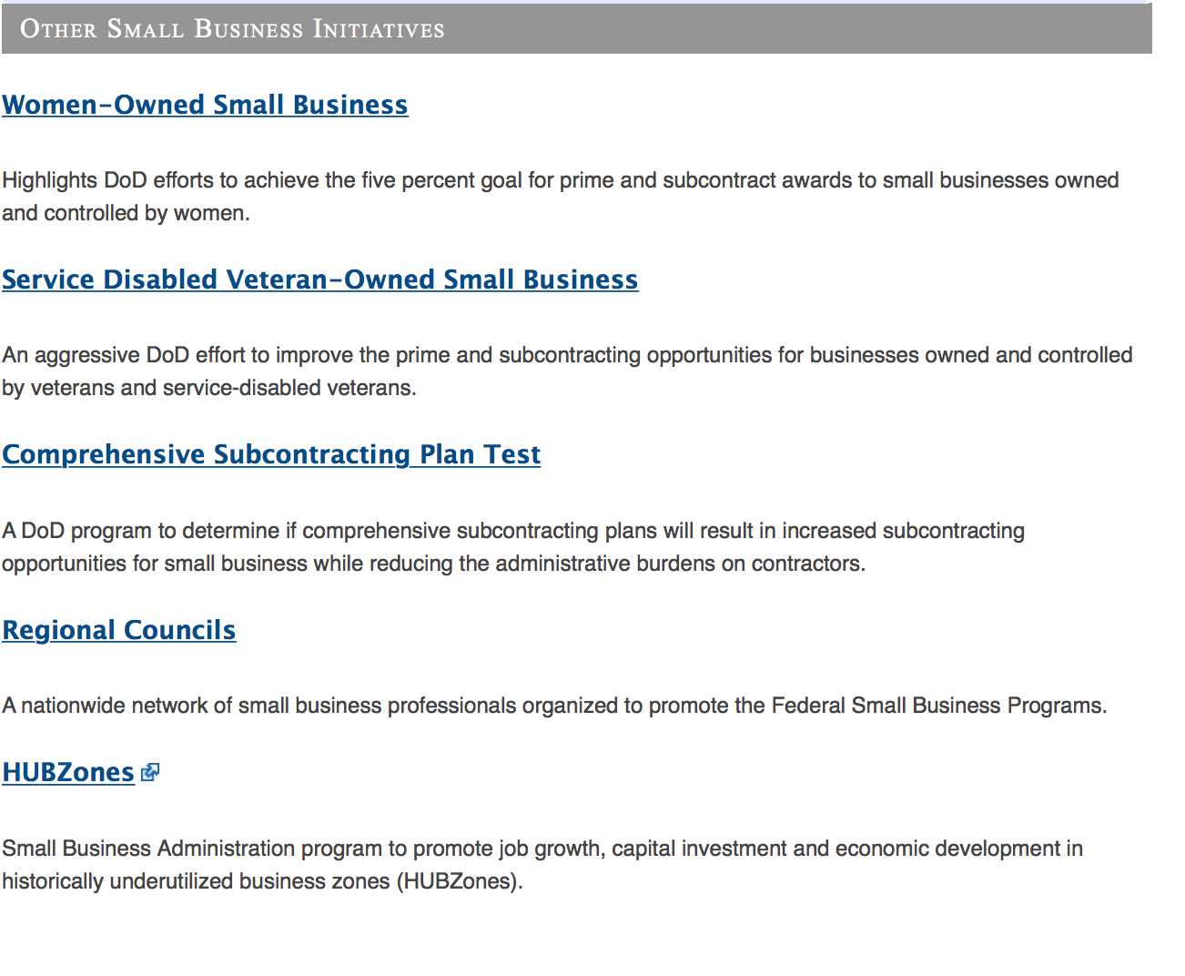
http://www.acq.osd.mil/osbp/

Doing Business with the DoD

Resources

Procurement Technical Assistance Centers (PTACs)

Procurement Technical Assistance Centers (PTACs) are charged with assisting businesses in learning how to do business with federal, state, and local governments. PTACs are a local resource available at no or nominal cost that can provide assistance to business firms in marketing their products and services. They offer training to businesses on how to research and bid on contracts, assist with registration requirements, provide bid-matching services, and assist with pre and post contracting issues.

Prime Contractors with Subcontracting Plans [xlsx]

Directory last updated 6/2017

This FY 2014 directory is intended for small business concerns seeking opportunities with DoD prime contractors. The directory is a listing of large business prime contractors who are required to establish subcontracting plans with goals. The report is generated from data contained in the Individual Subcontract Reports (ISRs) submitted in the Electronic Subcontracting Reporting System (eSRS) by contractors and from data contained in the Federal Procurement Data System (FPDS). The directory includes the name of the prime contractor; the major product/service code (PSC) provided to DoD; the major NAICS of the company; name, telephone number and email address of the company’s point of contact; contract number with the effective date and completion date, ultimate contract value and obligated dollars. In addition, many companies have websites with additional information which may be useful in your search for subcontracting opportunities or teaming arrangements.

Locate a Small Business Professional

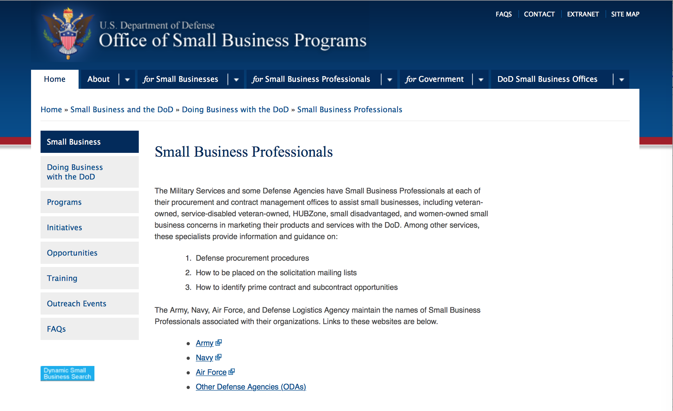

Non-Appropriated Fund Customers

Non-appropriated fund customers operate similar to non-profit organizations and include commissaries, exchanges, recreation and fitness centers, dining at officer/enlisted/civilian clubs, and barber/beauty services, just to name a few.

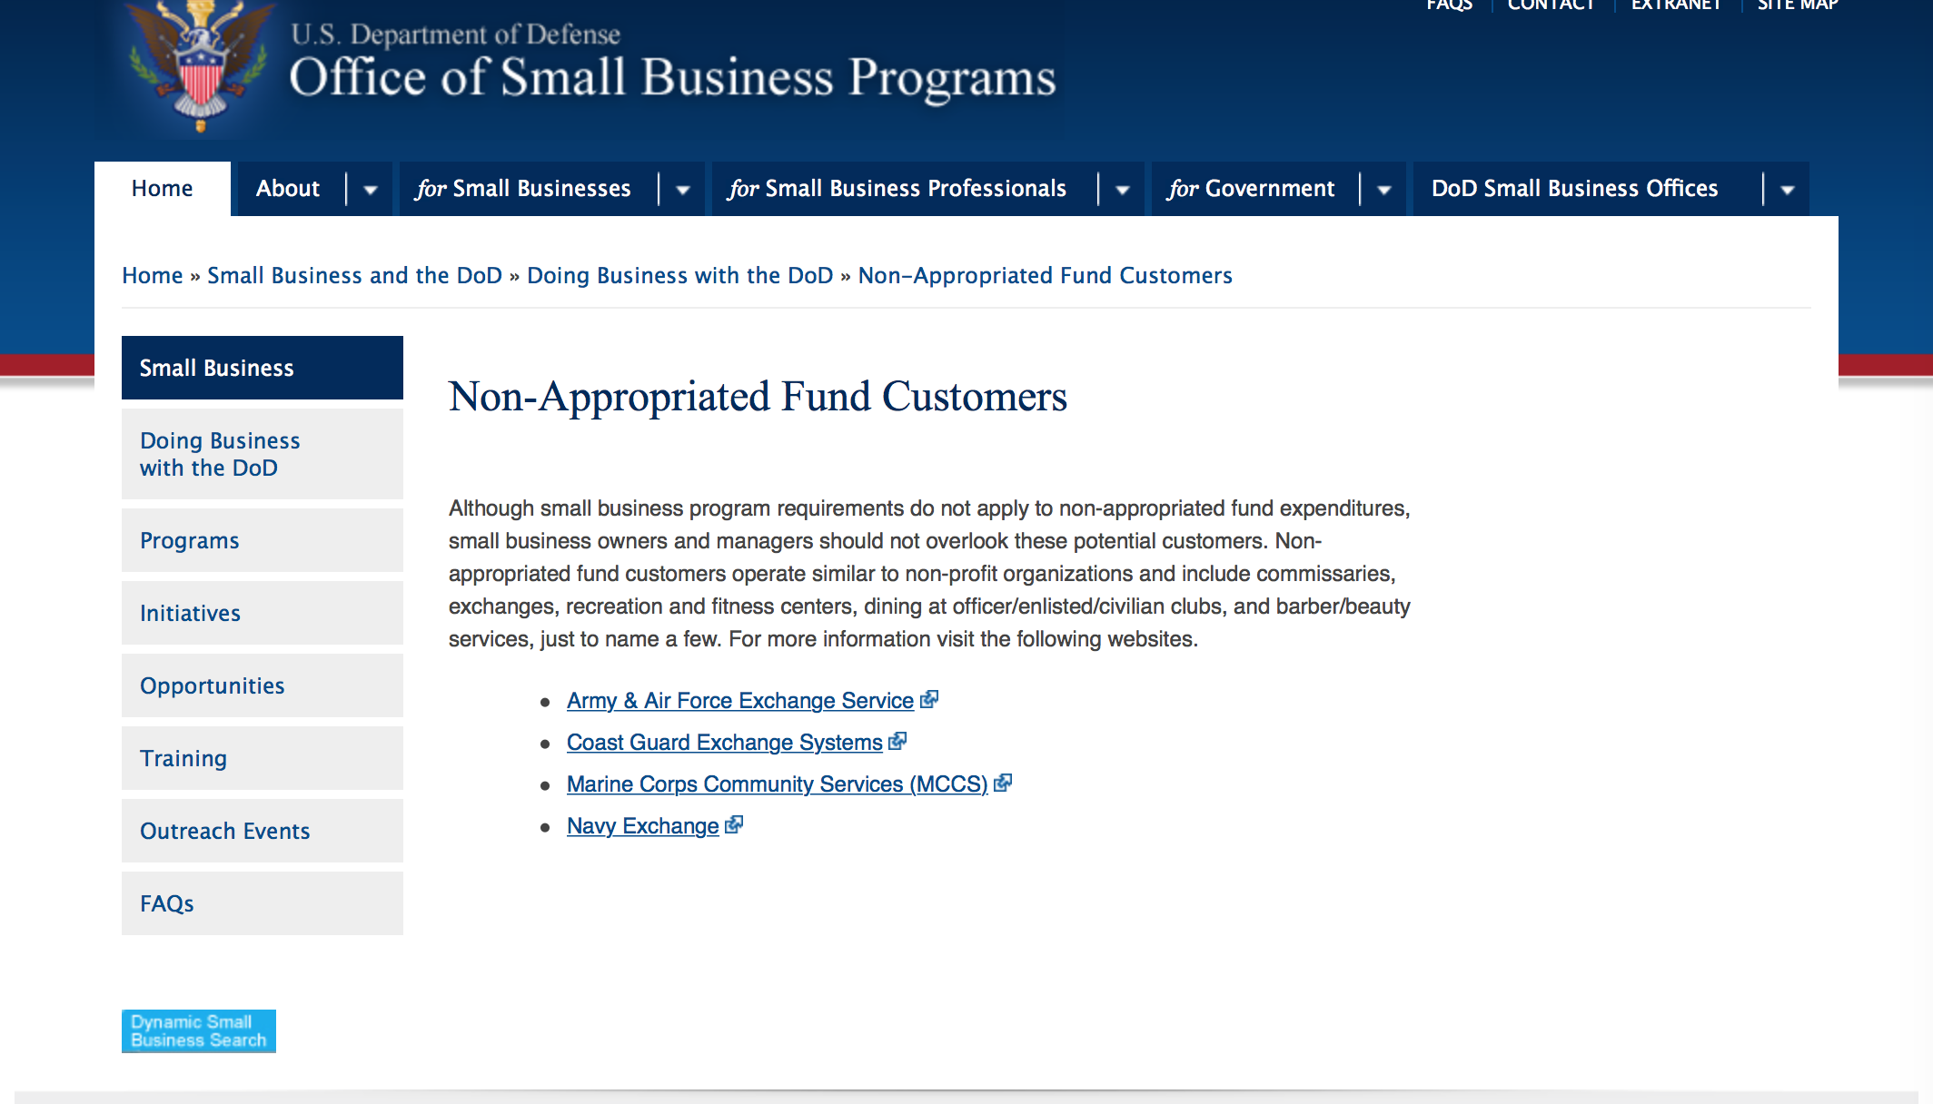

For more information click here.

Research:

DARPA - Information Innovation Office
I2O Office‐wide BAA
Synopsis 1
http://www.grants.gov/web/grants/view-opportunity.html?oppId=297028

Dept. of the Army -- USAMRAA
DoD Orthotics and Prosthetics Outcomes Research Award
Synopsis 1
http://www.grants.gov/web/grants/view-opportunity.html?oppId=297071

Dept. of the Army -- USAMRAA
DoD Breast Cancer, Breakthrough Fellowship Award
Synopsis 1
http://www.grants.gov/web/grants/view-opportunity.html?oppId=296271

Dept. of the Army -- USAMRAA
DoD Breast Cancer, Breakthrough Award Levels 1 & 2
Synopsis 1
http://www.grants.gov/web/grants/view-opportunity.html?oppId=296272

Dept. of the Army -- USAMRAA
DOD Reconstructive Transplant Research Program, Concept Award
Synopsis 1
http://www.grants.gov/web/grants/view-opportunity.html?oppId=296335

NSWC Indian Head
Naval Engineering Education Consortium (NEEC) Broad Agency Announcement for FY17
Synopsis 1
http://www.grants.gov/web/grants/view-opportunity.html?oppId=296758

Modifications:

Dept. of the Army -- USAMRAA
DoD Peer Reviewed Alzheimer's, New Investigator Research Award
Synopsis 2
http://www.grants.gov/web/grants/view-opportunity.html?oppId=295758

DoD Epilepsy, Epilepsy Risk Factors Award
Synopsis 2
http://www.grants.gov/web/grants/view-opportunity.html?oppId=295755

Dept. of the Army -- USAMRAA
DoD Epilepsy, Idea Development Award
Synopsis 3
http://www.grants.gov/web/grants/view-opportunity.html?oppId=295756

Dept. of the Army -- USAMRAA
DoD, Peer Reviewed Alzheimer's
Synopsis 3
http://www.grants.gov/web/grants/view-opportunity.html?oppId=295757

Dept. of the Army -- USAMRAA
DoD Peer Reviewed Alzheimer's, New Investigator Research Award
Synopsis 3
http://www.grants.gov/web/grants/view-opportunity.html?oppId=295758

Dept. of the Army -- USAMRAA
DoD Peer Reviewed Alzheimer's, Quality of Life Research Award
Synopsis 2
http://www.grants.gov/web/grants/view-opportunity.html?oppId=295761

Naval Supply Systems Command
Funding Opportunity Announcement (FOA) for Research Initiatives at The Naval Postgraduate School
Synopsis 2
http://www.grants.gov/web/grants/view-opportunity.html?oppId=288093

Deleted:

Air Force Academy
USAFA-FOA-2017-1 - STARBASE Hanscom
Deletion Comments: Opportunity deleted. Opportunity has been cancelled with no award made at this time. Please monitor grants.gov for future opportunities for STARBASE

H98210-BAA-17-0002 - Office of People Analytics (OPA) Research Fellowship Program
Deletion Comments: Opportunity deleted

H98210-BAA017-0001 - Yellow Ribbon Reintegration Program events and activities
Deletion Comments: Opportunity cancelled; Will be re advertised at a later date.

National Geospatial Intelligence Agency
HM1582-09-BAA-0001 - FY 2009 IC POSTDOCTORAL RESEARCH FELLOWSHIP PROGRAM - COMBINED
Deletion Comments: Opportunity deleted

National Geospatial Intelligence Agency
HM1582-09-BAA-0004 - IC CAE Program
Deletion Comments: Opportunity deleted

National Geospatial Intelligence Agency
HM1582-09-BAA-0002 - HBCU/MI ERI
Deletion Comments: Opportunity deleted

National Geospatial Intelligence Agency
HM1582-09-BAA-A103 - 2009 NGA University Research Initiatives (NURI) BAA
Deletion Comments: Opportunity deleted

National Geospatial Intelligence Agency
HM1582-10-BAA-0002 - National Geospatial-Intelligence Agency 2010 University Research Initiatives (NURI)
Deletion Comments: Opportunity deleted

National Geospatial Intelligence Agency
HM1582-11-BAA-0001 - IC CAE Program
Deletion Comments: Opportunity deleted

National Geospatial Intelligence Agency
HM0177-12-BAA-0001 - National Geospatial-Intelligence Agency Academic Research Program
Deletion Comments: Opportunity deleted

Reminders:



Department of Education
Grant Programs Overview at the Department of Education

The general information page for Education Grant funding is an excellent resource describing the three types of grants awarded by the Department of Education. See the screen shot of the Department of Education web page below:

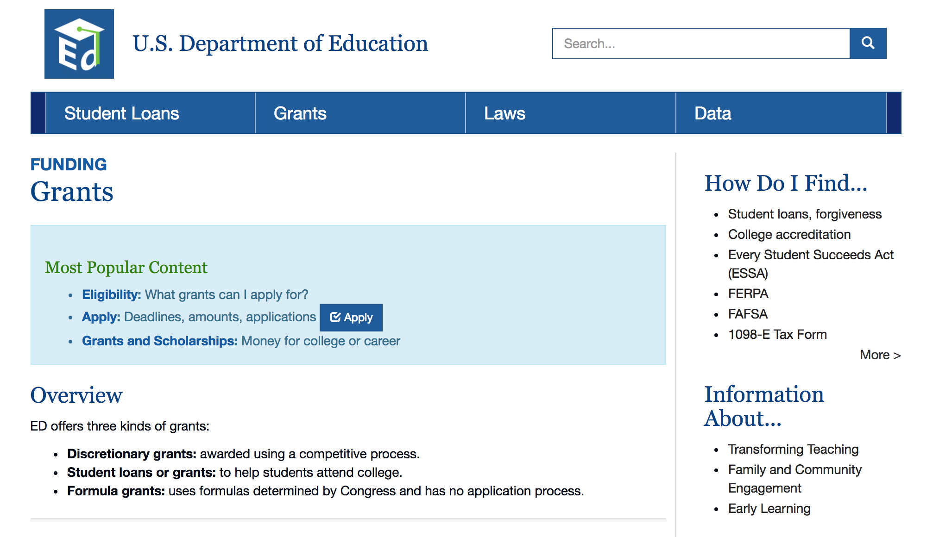
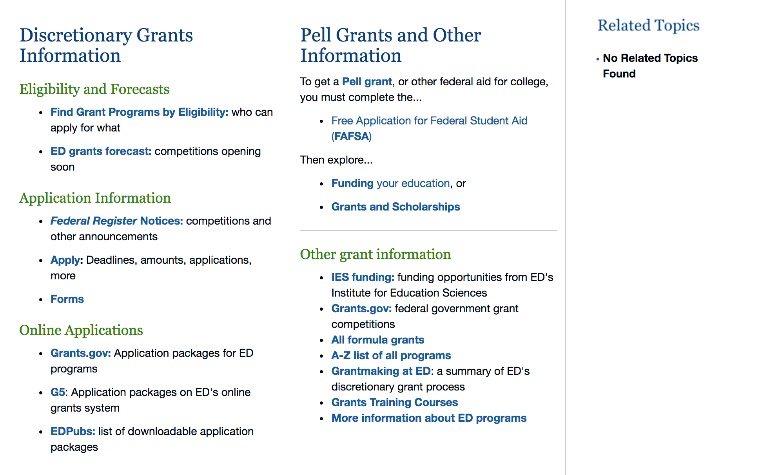

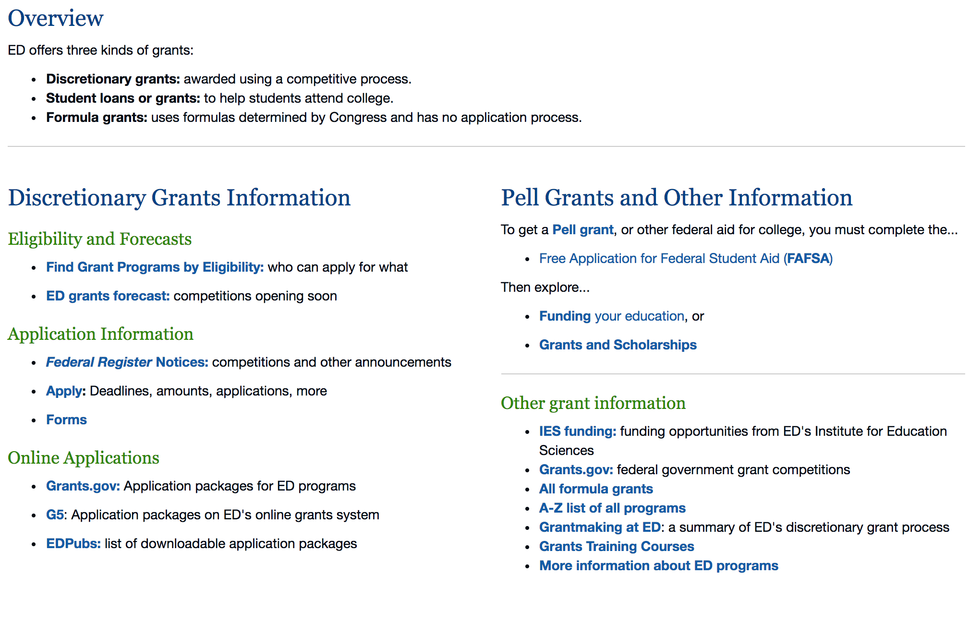

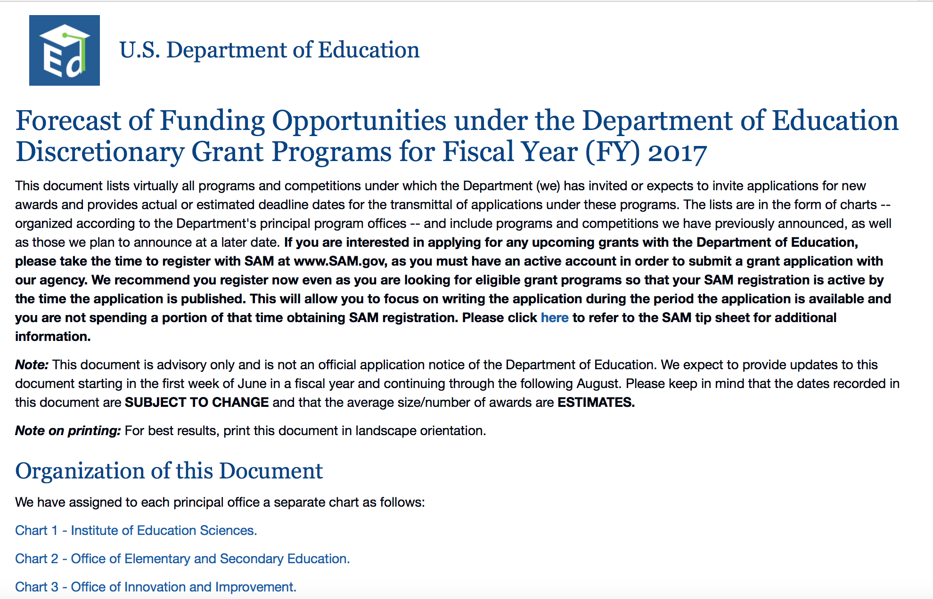
https://www2.ed.gov/fund/grants-apply.html?src=pn

Programs:

Research:

Modifications:

The Office of Elementary and Secondary Education (OESE): Impact Aid Discretionary Construction Grant Program CFDA Number 84.041C
Synopsis 2

Document Type: | Grants Notice
Funding Opportunity Number: | ED-GRANTS-072117-002
Funding Opportunity Title: | The Office of Elementary and Secondary Education (OESE): Impact Aid Discretionary Construction Grant Program CFDA Number 84.041C
Opportunity Category: | Discretionary
Opportunity Category Explanation:
Funding Instrument Type: | Grant
Category of Funding Activity: | Education
Category Explanation:
Expected Number of Awards: | 8
CFDA Number(s): | 84.041 -- Impact Aid
Cost Sharing or Matching Requirement: | Yes
Version: | Synopsis 2
Posted Date: | Jul 21, 2017
Last Updated Date: | Aug 02, 2017
Original Closing Date for Applications: | Sep 15, 2017 Applications Available: July 21, 2017. Deadline for Transmittal of Applications: September 15, 2017.
Current Closing Date for Applications: | Sep 15, 2017 Applications Available: July 21, 2017.Deadline for Transmittal of Applications: September 15, 2017.
Archive Date: | Oct 15, 2017
Estimated Total Program Funding: | $17,400,000
Award Ceiling:
Award Floor:
Eligible Applicants: | Others (see text field entitled "Additional Information on Eligibility" for clarification)
Additional Information on Eligibility: | Eligible Applicants: An LEA must meet the absolute priority in this notice. An LEA is eligible to receive an emergency grant under the priority if it-- (a) Is eligible to receive formula construction funds for the fiscal year under section 7007(a) of the Act (20 U.S.C. 7707(a)) because it enrolls a high percentage (at least 50 percent) of federally connected children in average daily attendance (ADA) who either reside on Indian lands or who have a parent on active duty in the U.S. uniformed services. (b)(1) Has no practical capacity to issue bonds (as defined in 34 CFR 222.176); (2) Has minimal capacity to issue bonds (as defined in 34 CFR 222.176) and has used at least 75 percent of its bond limit; or (3) Is eligible to receive funds for the fiscal year for heavily impacted districts under section 7003(b)(2) of the Act (20 U.S.C. 7703(b)(2)); and (c) Has a school facility emergency that the Secretary has determined, consistent with 34 CFR 222.172(a) and 222.173, poses a health or safety hazard to students and school personnel.
Agency Name: | Department of Education
Description: | Purpose of Program: The Impact Aid Discretionary Construction Grant Program provides grants for emergency repairs and modernization of school facilities to certain local educational agencies (LEAs) that receive Impact Aid formula funds. Applications for grants under the Impact Aid Discretionary Construction Grant Program, CFDA number 84.041C, must be submitted electronically using the G5 system, accessible through the Department's G5 site at: www.G5.gov.
Link to Additional Information: | The Office of Elementary and Secondary Education (OESE): Impact Aid Discretionary Construction Grant Program CFDA Number 84.041C
Grantor Contact Information: | If you have difficulty accessing the full announcement electronically, please contact:  Joyce Mays Management Analyst Phone 202-245-6122 joyce.mays@ed.gov Program Manager Amanda Ognibene Impact Aid Program, U.S. Department of Education, 400 Maryland Avenue SW., Room 3C129, Washington, DC 20202-6244. Telephone: 202-260-3858 or by email: Amanda.Ognibene@ed.gov.  Program Manager: email

http://www.grants.gov/web/grants/view-opportunity.html?oppId=295737

Reminders:

Deleted:

U.S. Department of Energy

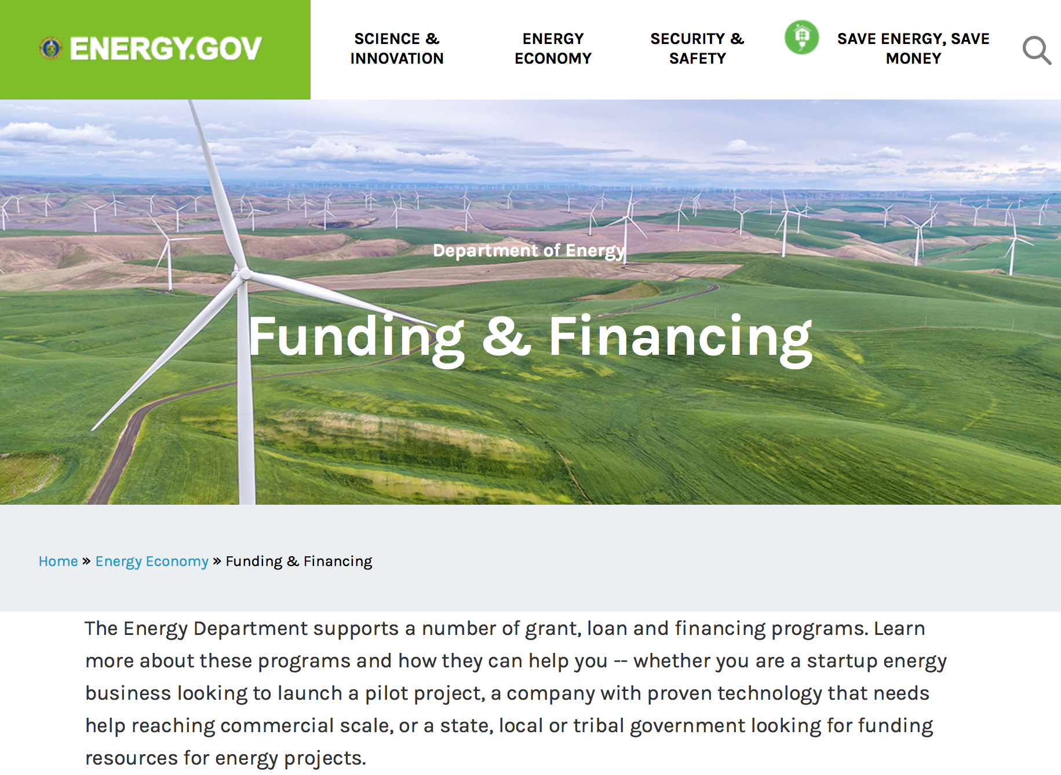
https://www.energy.gov/energy-economy/funding-financing

Research:

National Energy Technology Laboratory
Fossil Fuel Large-Scale Pilots
Synopsis 1
http://www.grants.gov/web/grants/view-opportunity.html?oppId=296746

Golden Field Office
Notice of Intent to Issue DE-FOA-0001662: Innovative Solutions for Fish Passage at Hydropower Dams
Synopsis 1

http://www.grants.gov/web/grants/view-opportunity.html?oppId=296760

NNSA
Nonproliferation & Arms Control Program Studies, Training, & Outreach
Synopsis 1
http://www.grants.gov/web/grants/view-opportunity.html?oppId=296911

Office of Science
High-Energy-Density Laboratory Plasma Science
Synopsis 1
http://www.grants.gov/web/grants/view-opportunity.html?oppId=296243

Reminders:

PAMS
Department of Energy - Office of Science
Office of Science
FY 2017 Continuation of Solicitation for the Office of Science Financial Assistance Program
Synopsis 2

Document Type: | Grants Notice
Funding Opportunity Number: | DE-FOA-0001664
Funding Opportunity Title: | FY 2017 Continuation of Solicitation for the Office of Science Financial Assistance Program
Opportunity Category: | Discretionary
Opportunity Category Explanation:
Funding Instrument Type: | Cooperative Agreement  Grant
Category of Funding Activity: | Science and Technology and other Research and Development
Category Explanation:
Expected Number of Awards: | 200
CFDA Number(s): | 81.049 -- Office of Science Financial Assistance Program
Cost Sharing or Matching Requirement: | No
Version: | Synopsis 2
Posted Date: | Sep 30, 2016
Last Updated Date: | Oct 04, 2016
Original Closing Date for Applications: | Sep 30, 2017
Current Closing Date for Applications: | Sep 30, 2017
Archive Date: | Oct 30, 2017
Estimated Total Program Funding:
Award Ceiling: | $4,000,000
Award Floor: | $2,000
Eligible Applicants: | Unrestricted (i.e., open to any type of entity above), subject to any clarification in text field entitled "Additional Information on Eligibility"
Agency Name: | Office of Science
Description: | The Office of Science (SC) of the Department of Energy hereby announces its continuing interest in receiving grant applications for support of work in the following program areas: Advanced Scientific Computing Research, Basic Energy Sciences, Biological and Environmental Research, Fusion Energy Sciences, High Energy Physics, and Nuclear Physics. On September 3, 1992, DOE published in the Federal Register the Office of Energy Research Financial Assistance Program (now called the Office of Science Financial Assistance Program), 10 CFR 605, as a Final Rule, which contained a solicitation for this program. Information about submission of applications, eligibility, limitations, evaluation and selection processes and other policies and procedures are specified in 10 CFR 605.
Link to Additional Information: | http://science.energy.gov/~/media/grants/pdf/foas/2017/SC_FOA_0001664.pdf
Grantor Contact Information: | If you have difficulty accessing the full announcement electronically, please contact:  Kimberlie Laing Grant Analyst Phone 301-903-3026  kim.laing@science.doe.gov

http://www.grants.gov/web/grants/view-opportunity.html?oppId=289281

Environmental Protection Agency

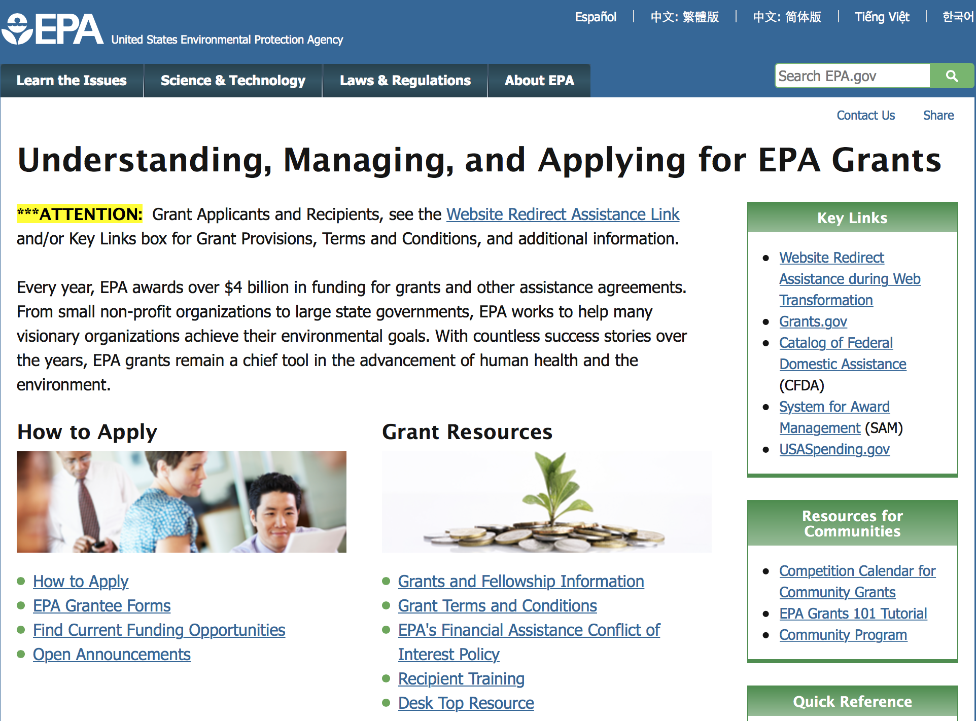

http://www.epa.gov/epahome/grants.htm

Programs:

Research:

Modifications:

Reminders:

2017 Targeted Air Shed Grant Program
Synopsis 1
Document Type: | Grants Notice
Funding Opportunity Number: | EPA-OAR-OAQPS-17-06
Funding Opportunity Title: | 2017 Targeted Air Shed Grant Program
Opportunity Category: | Discretionary
Opportunity Category Explanation:
Funding Instrument Type: | Cooperative Agreement  Grant
Category of Funding Activity: | Environment
Category Explanation:
Expected Number of Awards: | 7
CFDA Number(s): | 66.202 -- Congressionally Mandated Projects
Cost Sharing or Matching Requirement: | No
Version: | Synopsis 1
Posted Date: | Jul 19, 2017
Last Updated Date: | Jul 19, 2017
Original Closing Date for Applications: | Oct 18, 2017 Please see the announcement including Section IV for additional submission information.
Current Closing Date for Applications: | Oct 18, 2017 Please see the announcement including Section IV for additional submission information.
Archive Date: | Nov 17, 2017
Estimated Total Program Funding: | $30,000,000
Award Ceiling: | $4,000,000
Award Floor: | $0
Eligible Applicants: | Others (see text field entitled "Additional Information on Eligibility" for clarification)
Additional Information on Eligibility: | Please see the announcement including Section III for additional eligibility information.
Agency Name: | Environmental Protection Agency
Description: | This notice announces the availability of funds and solicits applications from eligible entities to compete for financial assistance through the Targeted Air Shed Grant Program. This program will assist local, state and/or tribal air pollution control agencies in developing plans, conducting demonstrations, and implementing projects to reduce air pollution in nonattainment areas that EPA determines are the top five most polluted areas relative to ozone (O3), annual average fine particulate matter (PM2.5), or 24-hour PM2.5 National Ambient Air Quality Standards (NAAQS). The overall goal of the Targeted Air Shed Grant program is to reduce air pollution in the Nation’s areas with the highest levels of ozone and PM2.5 ambient air concentrations.
Link to Additional Information: | 2017 Targeted Air Shed Grant Program
Grantor Contact Information: | If you have difficulty accessing the full announcement electronically, please contact:  Gary Blais, 919-541-3223  Gary Blais

http://www.grants.gov/web/grants/view-opportunity.html?oppId=295677

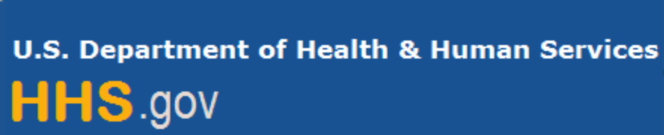

Department of Health and Human Services

Grants Forecast and Overview

The Department of Health and Human Services’ Grants Forecast is a database of planned grant opportunities proposed by its agencies. Each Forecast record contains actual or estimated dates and funding levels for grants that the agency intends to award during the fiscal year. Forecast opportunities are subject to change based on enactment of congressional appropriations.

For more general information about HHS Grants and Funding go to the website below at:

https://www.hhs.gov/grants/grants/index.html

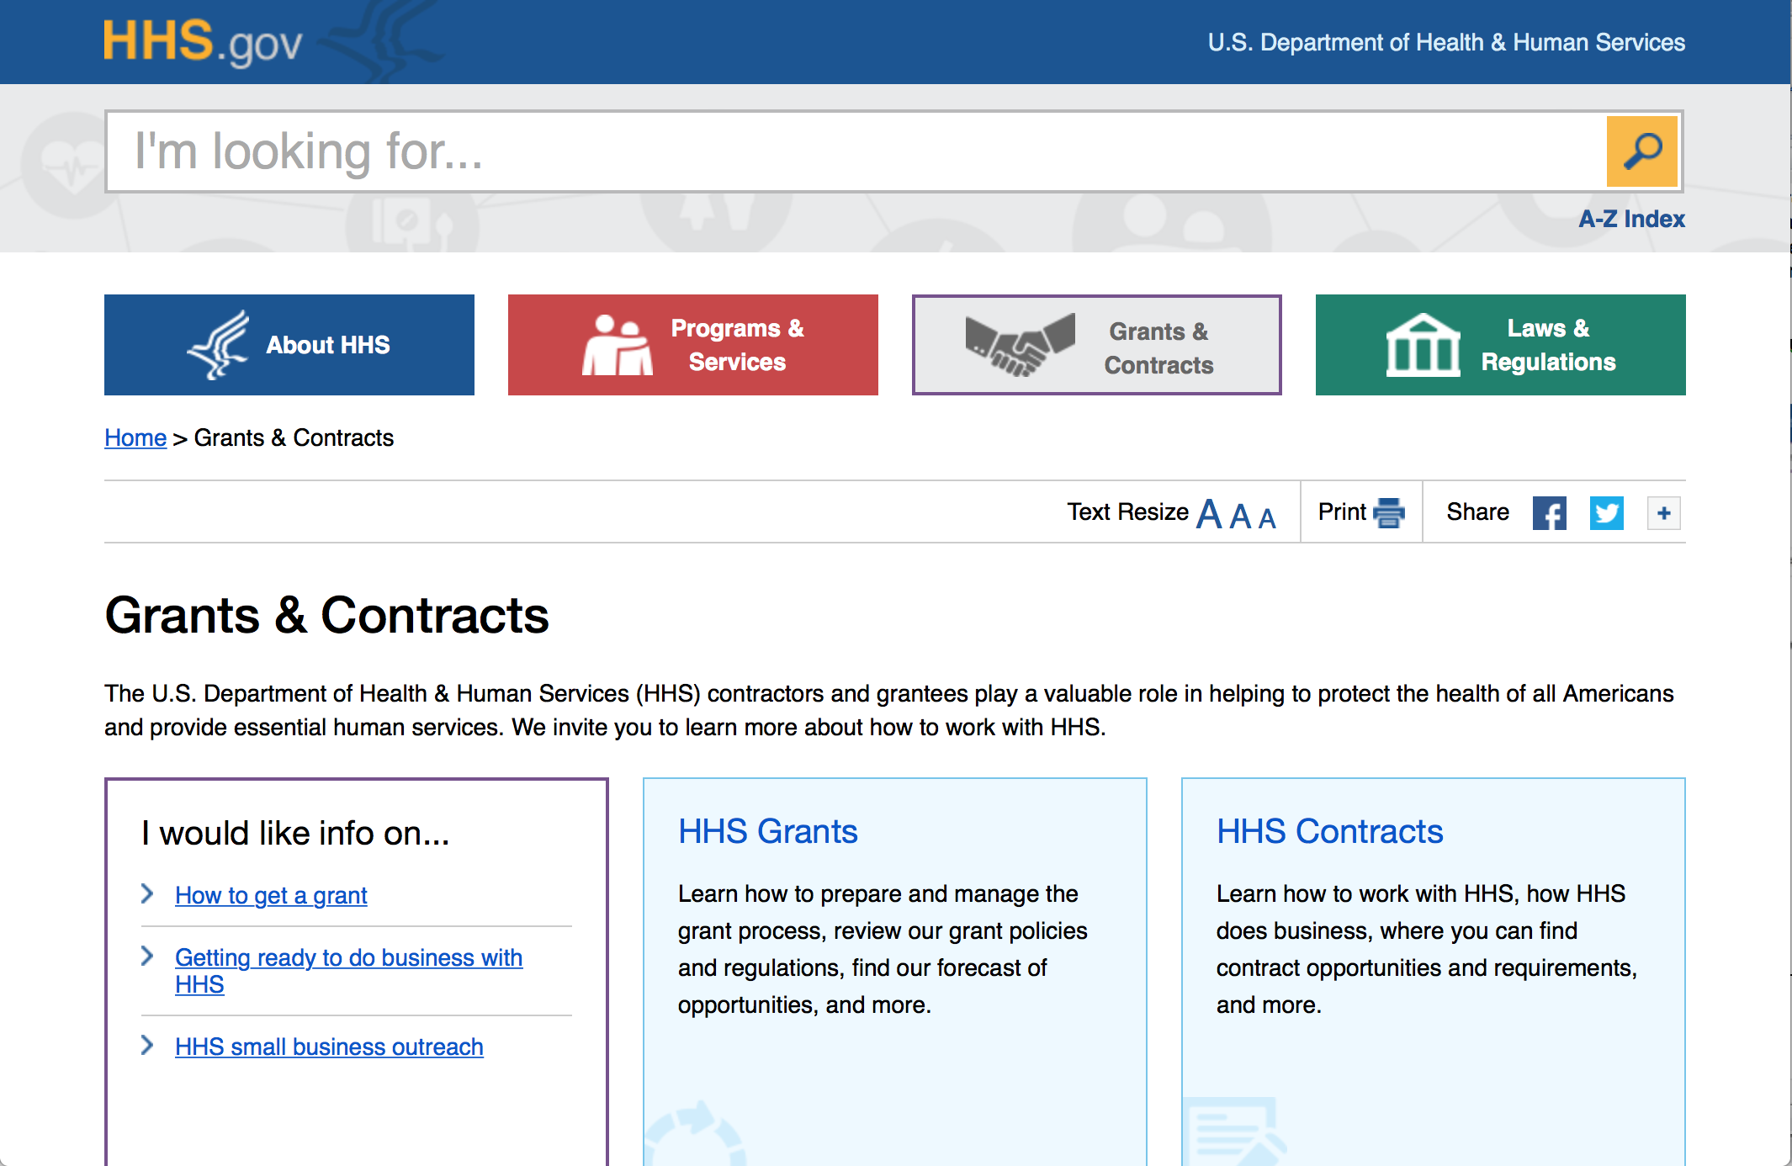

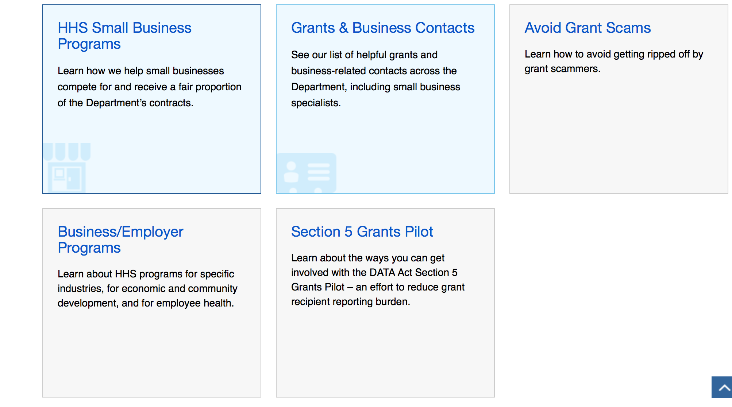

Programs:

Research:

Agency for Health Care Research and Quality
Agency for Healthcare Research and Quality and Patient-Centered Outcomes Research Institute Learning Health Systems Mentored Career Development Program (K12)
Synopsis 1
http://www.grants.gov/web/grants/view-opportunity.html?oppId=297101

Centers for Disease Control - NCIRD
Immunization Information Systems Sentinel Site Project
Forecast 1
http://www.grants.gov/web/grants/view-opportunity.html?oppId=296983

Centers for Disease Control - CGH
Conduct National Population-based HIV Impact Assessment (PHIA) in Nigeria under the President's Emergency Plan for AIDS Relief (PEPFAR)
Synopsis 1
http://www.grants.gov/web/grants/view-opportunity.html?oppId=293431

Centers for Disease Control - CGH
Polio Eradication and Emergency Response in Priority Countries, Center for Global Health Immunization Division
Synopsis 1
http://www.grants.gov/web/grants/view-opportunity.html?oppId=296326

Centers for Disease Control - NCHHSTP
Accelerating the Prevention and Control of HIV, Viral Hepatitis, STDs and TB in the U.S.-Affiliated Pacific Islands
Synopsis 1
http://www.grants.gov/web/grants/view-opportunity.html?oppId=290383

Health Resources and Services Administration
Ryan White HIV/AIDS Program Part A HIV Emergency Relief Grant Program
Synopsis 1
http://www.grants.gov/web/grants/view-opportunity.html?oppId=295203

Health Resources and Services Administration
Service Area Competition
Synopsis 1
http://www.grants.gov/web/grants/view-opportunity.html?oppId=295215

National Institutes of Health
Approaches to Identify and Care for Individuals with Inherited Cancer Syndromes (U01)
Synopsis 1
http://www.grants.gov/web/grants/view-opportunity.html?oppId=297017

National Institutes of Health
Organotypic Culture Models developed from Experimental Animals for Chemical Toxicity Screening (R43)
Synopsis 1
http://www.grants.gov/web/grants/view-opportunity.html?oppId=297097

National Institutes of Health
Understanding and Modifying Temporal Dynamics of Coordinated Neural Activity (R01)
Synopsis 1
http://www.grants.gov/web/grants/view-opportunity.html?oppId=296963

National Institutes of Health
Understanding and Modifying Temporal Dynamics of Coordinated Neural Activity (R21)
Synopsis 1
http://www.grants.gov/web/grants/view-opportunity.html?oppId=296988

National Institutes of Health
Reducing Stigma to Improve HIV/AIDS Prevention, Treatment and Care in Low and Middle- Income Countries (R21)
Synopsis 1
http://www.grants.gov/web/grants/view-opportunity.html?oppId=296999

National Institutes of Health
Electronic Nicotine Delivery Systems (ENDS): Population, Clinical and Applied Prevention Research (R21)
Synopsis 1
http://www.grants.gov/web/grants/view-opportunity.html?oppId=297014

National Institutes of Health
Electronic Nicotine Delivery Systems (ENDS): Population, Clinical and Applied Prevention Research (R01)
Synopsis 1
http://www.grants.gov/web/grants/view-opportunity.html?oppId=297015

National Institutes of Health
NHLBI Research Career Development Program in HIV-Related Heart, Lung, Blood and Sleep Research (K12)
Synopsis 1
http://www.grants.gov/web/grants/view-opportunity.html?oppId=296928

National Institutes of Health
BRAIN Initiative: Tools to Facilitate High-Throughput Microconnectivity Analysis (R01)
Synopsis 1
http://www.grants.gov/web/grants/view-opportunity.html?oppId=296951

National Institutes of Health
Clinical and Epidemiological Research on Chronic Disease in the Caribbean (R01)
Synopsis 1
http://www.grants.gov/web/grants/view-opportunity.html?oppId=296777

National Institutes of Health
Detection of HIV for Self-Testing (R61/R33)
Synopsis 1
http://www.grants.gov/web/grants/view-opportunity.html?oppId=296778

National Institutes of Health
BRAIN Initiative: Research on the Ethical Implications of Advancements in Neurotechnology and Brain Science (R01)
Synopsis 1
http://www.grants.gov/web/grants/view-opportunity.html?oppId=296799

National Institutes of Health
Research Centers in Minority Institutions (RCMI) (U54)
Synopsis 1
http://www.grants.gov/web/grants/view-opportunity.html?oppId=296779

National Institutes of Health
Stimulating Access to Research in Residency (StARR) (R38)
Synopsis 1
http://www.grants.gov/web/grants/view-opportunity.html?oppId=296752

National Institutes of Health
Alcoholic Hepatitis Clinical and Translational Network Clinical Pilot Trials (U01)
Synopsis 1
http://www.grants.gov/web/grants/view-opportunity.html?oppId=296738

National Institutes of Health
NIH Blueprint for Neuroscience Research: Dynamic Neuroimmune Interactions in the Transition from Normal CNS Function to Disorders (R01)
Synopsis 1
http://www.grants.gov/web/grants/view-opportunity.html?oppId=296732

National Institutes of Health
Alcoholic Hepatitis Clinical and Translational Network Late Phase Clinical Trials and Observational Studies (Collaborative U01)
Synopsis 1
http://www.grants.gov/web/grants/view-opportunity.html?oppId=296725

National Institutes of Health
Alcoholic Hepatitis Clinical and Translational Network Translational Research (U01)
Synopsis 1
http://www.grants.gov/web/grants/view-opportunity.html?oppId=296726

National Institutes of Health
Secondary Analyses of Existing Alcohol Research Data (R01)
Synopsis 1
http://www.grants.gov/web/grants/view-opportunity.html?oppId=296740

National Institutes of Health
Secondary Analyses of Existing Alcohol Research Data (R03)
Synopsis 1
http://www.grants.gov/web/grants/view-opportunity.html?oppId=296741

National Institutes of Health
Limited Competition: Lasker Clinical Research Scholars Transition Award (R00)
Synopsis 1
http://www.grants.gov/web/grants/view-opportunity.html?oppId=296250

National Institutes of Health
Systems Developmental Biology for Understanding Embryonic Development and the Ontogeny of Structural Birth Defects (R01)
Synopsis 1
http://www.grants.gov/web/grants/view-opportunity.html?oppId=296287

National Institutes of Health
Notice of Intent to Reissue the Funding Opportunity Announcement for BRAIN Initiative: Development of Next Generation Human Brain Imaging Tools and Technologies (U01)
Forecast 1
http://www.grants.gov/web/grants/view-opportunity.html?oppId=296260

National Institutes of Health
Notice of Intent to Publish a Funding Opportunity Announcement for NHLBI Program Project Applications (P01)
Forecast 1
http://www.grants.gov/web/grants/view-opportunity.html?oppId=296262

National Institutes of Health
Notice of Intent to Reissue the Funding Opportunity Announcement for the NIH Blueprint Diversity Specialized Predoctoral to Postdoctoral Advancement in Neuroscience (D-SPAN) Award (F99/K00)
Forecast 1
http://www.grants.gov/web/grants/view-opportunity.html?oppId=296263

National Institutes of Health
Notice of Intent to Publish a Funding Opportunity Announcement for NIH Science Education Partnership Award (SEPA) (R25)
Forecast 1
http://www.grants.gov/web/grants/view-opportunity.html?oppId=296264

National Institutes of Health
Notice of Intent to Reissue the Funding Opportunity Announcement for BRAIN Initiative: Proof of Concept Development of Early Stage Next Generation Human Brain Imaging (R01)
Forecast 1
http://www.grants.gov/web/grants/view-opportunity.html?oppId=296265

National Institutes of Health
The Interplay of Cell Death Pathways in Cancer Cell Survival and Resistance to Therapy (R01)
Synopsis 1
http://www.grants.gov/web/grants/view-opportunity.html?oppId=296153

National Institutes of Health
Biology of Lung, and Head and Neck Preneoplasias (R21)
Synopsis 1
http://www.grants.gov/web/grants/view-opportunity.html?oppId=296553

National Institutes of Health
Metabolomics Core for the Undiagnosed Diseases Network (UDN) Phase II (U01)
Synopsis 1
http://www.grants.gov/web/grants/view-opportunity.html?oppId=296494

National Institutes of Health
Symptom Cluster Characterization in Chronic Conditions (R01)
Synopsis 1
http://www.grants.gov/web/grants/view-opportunity.html?oppId=296528

National Institutes of Health
Population Assessment of Tobacco and Health (PATH) Biospecimen Access (X01)
Synopsis 1
http://www.grants.gov/web/grants/view-opportunity.html?oppId=296506

National Institutes of Health
Biology of Lung, and Head and Neck Preneoplasias (R01)
Synopsis 1
http://www.grants.gov/web/grants/view-opportunity.html?oppId=296507

National Institutes of Health
Model Organisms Screening Center for the Undiagnosed Diseases Network (UDN) Phase II (U54)
Synopsis 1
http://www.grants.gov/web/grants/view-opportunity.html?oppId=296516

National Institutes of Health
Sequencing Core(s) for the Undiagnosed Diseases Network (UDN) Phase II (U01)
Synopsis 1
http://www.grants.gov/web/grants/view-opportunity.html?oppId=296514

National Institutes of Health
Coordinating Center for the Undiagnosed Diseases Network (UDN) Phase II (U01)
Synopsis 1
http://www.grants.gov/web/grants/view-opportunity.html?oppId=296517

National Institutes of Health
Limited Competition for the Continuation of the Drug Induced Liver Injury Network (DILIN) Clinical Centers (U01)
Synopsis 1
http://www.grants.gov/web/grants/view-opportunity.html?oppId=296478

National Institutes of Health
Clinical Sites for the Undiagnosed Diseases Network (UDN) Phase II (U01)
Synopsis 1
http://www.grants.gov/web/grants/view-opportunity.html?oppId=296519

National Institutes of Health
NINDS CREATE Bio Optimization Track for Biologics (U01)
Synopsis 1
http://www.grants.gov/web/grants/view-opportunity.html?oppId=296484

National Institutes of Health
NIBIB Exploratory/Developmental Research Grant Program (R21)
Synopsis 1
http://www.grants.gov/web/grants/view-opportunity.html?oppId=296171

National Institutes of Health
The Interplay of Cell Death Pathways in Cancer Cell Survival and Resistance to Therapy (R21)
Synopsis 1
http://www.grants.gov/web/grants/view-opportunity.html?oppId=296172

National Institutes of Health
Collaborative Research Network for Fusion Oncoproteins in Childhood Cancers (U54)
Synopsis 1
http://www.grants.gov/web/grants/view-opportunity.html?oppId=296175

National Institutes of Health
Pregnancy in Women with Disabilities (R03)
Synopsis 1
http://www.grants.gov/web/grants/view-opportunity.html?oppId=296089

National Institutes of Health
Pregnancy in Women with Disabilities (R01)
Synopsis 1
http://www.grants.gov/web/grants/view-opportunity.html?oppId=296112

National Institutes of Health
Point of Care Technologies Research Network: Point of Care Centers (U54)
Synopsis 1
http://www.grants.gov/web/grants/view-opportunity.html?oppId=296133

National Institutes of Health
Pharmacogenomics of Anti-retroviral Therapy in People Who Inject Drugs (R01)
Synopsis 1
http://www.grants.gov/web/grants/view-opportunity.html?oppId=296135

National Institutes of Health
HIV-associated neuropathic pain and opioid interaction (R01)
Synopsis 1
http://www.grants.gov/web/grants/view-opportunity.html?oppId=296136

National Institutes of Health
NINR Center of Excellence (P30)
Synopsis 1
http://www.grants.gov/web/grants/view-opportunity.html?oppId=296070

National Institutes of Health
NINR Exploratory Center (P20)
Synopsis 1
http://www.grants.gov/web/grants/view-opportunity.html?oppId=296073

National Institutes of Health
Metabolomic Data Analysis and Interpretation Tools (U01)
Synopsis 1
http://www.grants.gov/web/grants/view-opportunity.html?oppId=296039

National Institutes of Health
Precompetitive Collaboration on Liquid Biopsy for Early Cancer Assessment (U01)
Synopsis 1
http://www.grants.gov/web/grants/view-opportunity.html?oppId=296096

National Institutes of Health
Compound Identification Development Cores (U2C)
Synopsis 1
http://www.grants.gov/web/grants/view-opportunity.html?oppId=296040

National Institutes of Health
Ethical, Legal, and Social Implications (ELSI) of Genomics Small Research Grant Program (R03)
Synopsis 1
http://www.grants.gov/web/grants/view-opportunity.html?oppId=296041

National Institutes of Health
NIAID Research Education Program (R25)
Synopsis 1
http://www.grants.gov/web/grants/view-opportunity.html?oppId=296344

National Institutes of Health
NINDS CREATE Bio Optimization Track for Biologics (U44)
Synopsis 1
http://www.grants.gov/web/grants/view-opportunity.html?oppId=296366

National Institutes of Health
Administrative supplements for validation studies of analytical methods for dietary supplements and natural products (Admin. Suppl.)
Synopsis 1
http://www.grants.gov/web/grants/view-opportunity.html?oppId=296034

National Institutes of Health
Typical and Atypical Patterns of Language and Literacy in Dual Language Learners (R01)
Synopsis 1
http://www.grants.gov/web/grants/view-opportunity.html?oppId=296036

National Institutes of Health
Cardiovascular and Pulmonary Research on E-Cigarettes (R01)
Synopsis 1
http://www.grants.gov/web/grants/view-opportunity.html?oppId=296028

National Institutes of Health
Ethical, Legal, and Social Implications (ELSI) of Genomics Research Project Grant Program (R01)
Synopsis 1
http://www.grants.gov/web/grants/view-opportunity.html?oppId=296056

National Institutes of Health
Ethical, Legal, and Social Implications (ELSI) of Genomics Exploratory/Developmental Research Grant Program (R21)
Synopsis 1
http://www.grants.gov/web/grants/view-opportunity.html?oppId=296057

National Institutes of Health
Stakeholder Engagement and Program Coordination Center (SEPCC) (U2C)
Synopsis 1
http://www.grants.gov/web/grants/view-opportunity.html?oppId=296054

National Institutes of Health
National Metabolomics Data Repository (NMDR) (U2C)
Synopsis 1
http://www.grants.gov/web/grants/view-opportunity.html?oppId=296053

National Institutes of Health
Typical and Atypical Patterns of Language and Literacy in Dual Language Learners (R21)
Synopsis 1
http://www.grants.gov/web/grants/view-opportunity.html?oppId=296051

National Institutes of Health
HHS-NIH11 RFA-DK-17-506
Limited Competition for the Continuation of the Chronic Renal Insufficiency Cohort Scientific and Data Coordinating Center (U24)
Version: Synopsis 1
Link: http://www.grants.gov/web/grants/view-opportunity.html?oppId=296605

National Institutes of Health
RFA-DK-17-505
Limited Competition for the Continuation of the Chronic Renal Insufficiency Cohort (CRIC) Clinical Centers (U01)
Version: Synopsis 1
Link: http://www.grants.gov/web/grants/view-opportunity.html?oppId=296606

National Institutes of Health: HHS-NIH11
RFA-AI-17-026
Partnerships for Countermeasures Against Select Pathogens (R01)
Version: Synopsis 1
Link: http://www.grants.gov/web/grants/view-opportunity.html?oppId=296654

National Institutes of Health: HHS-NIH11
RFA-CA-17-025
Consortium on Translational Research in Early Detection of Liver Cancer (Clinical and Research Centers (U01)
Version: Synopsis 1
Link: http://www.grants.gov/web/grants/view-opportunity.html?oppId=296677

National Institutes of Health: HHS-NIH11
PAR-17-465
Bench Testing Therapeutic/Indication Pairing Strategies (UG3/UH3)
Version: Synopsis 1
Link: http://www.grants.gov/web/grants/view-opportunity.html?oppId=296680

Modifications:

Centers for Disease Control and Prevention - ERA
Cooperative Research Agreements Related to the World Trade Center Health Program (U01)
Synopsis 10
http://www.grants.gov/web/grants/view-opportunity.html?oppId=282342

Centers for Disease Control - CGH
CDC-RFA-GH18-1840
Strengthening Implementation and Use of Effective Health Information Systems through Improved Governance, Design, Planning, Capacity Development, and Technical Implementation under the President's Emergency Plan for AIDS Relief (PEPFAR)
Version: Synopsis 2
Modification Comments: This modification is to correct the contact information and upload Full Announcement.
http://www.grants.gov/web/grants/view-opportunity.html?oppId=293340

Centers for Medicare & Medicaid Services
Medicare Access and CHIP Reauthorization Act (MACRA) Funding Opportunity: Measure Development for the Quality Payment Program
Forecast 3
http://www.grants.gov/web/grants/view-opportunity.html?oppId=293852

National Institutes of Health
Common Mechanisms and Interactions Among Neurodegenerative Diseases (R01)
Synopsis 2
http://www.grants.gov/web/grants/view-opportunity.html?oppId=289659

National Institutes of Health
Cellular and Molecular Biology of Complex Brain Disorders (R21)
Synopsis 2
http://www.grants.gov/web/grants/view-opportunity.html?oppId=294576

National Institutes of Health
NeuroNEXT Infrastructure Resource Access (X01)
Synopsis 2
http://www.grants.gov/web/grants/view-opportunity.html?oppId=276217

National Institutes of Health
Epidemiology and Prevention in Alcohol Research (R03)
Synopsis 2
http://www.grants.gov/web/grants/view-opportunity.html?oppId=254261

National Institutes of Health
Epidemiology and Prevention in Alcohol Research (R21)
Synopsis 2
http://www.grants.gov/web/grants/view-opportunity.html?oppId=254260

National Institutes of Health
Epidemiology and Prevention in Alcohol Research (R01)
Synopsis 2
http://www.grants.gov/web/grants/view-opportunity.html?oppId=254262

National Institutes of Health
Extracellular Vesicles and Substance Use Disorders (R21)
Synopsis 2
http://www.grants.gov/web/grants/view-opportunity.html?oppId=292968

National Institutes of Health
NIDCR Behavioral or Social Intervention Clinical Trial Planning Grant (R34)
Synopsis 2
http://www.grants.gov/web/grants/view-opportunity.html?oppId=266028

National Institutes of Health
Novel Tools for Investigating Brain-derived GPCRs in Mental Health Research (R41/R42)
Synopsis 4
http://www.grants.gov/web/grants/view-opportunity.html?oppId=253463

National Institutes of Health
Novel Tools for Investigating Brain-derived GPCRs in Mental Health Research (R43/R44)
Synopsis 4
http://www.grants.gov/web/grants/view-opportunity.html?oppId=253464

National Institutes of Health
Discovery of Small Molecule Immunomodulators for Cancer Therapy (R01)
Synopsis 2
http://www.grants.gov/web/grants/view-opportunity.html?oppId=295725

National Institutes of Health
Assay development and screening for discovery of chemical probes or therapeutic agents (R01)
Synopsis 2
http://www.grants.gov/web/grants/view-opportunity.html?oppId=295905

National Institutes of Health
Synthetic Biology for Engineering Applications (R01)
Synopsis 2
http://www.grants.gov/web/grants/view-opportunity.html?oppId=295813

National Institutes of Health
HHS-NIH11 - RFA-HD-18-009
Re-Competition of Global Network for Womens and Childrens Health Research (UG1)
Posted Date: Jul 18, 2017
Version: Synopsis 2
Modification Comments: Updated eligibility in accordance with NOT-HD-17-017
Link: http://www.grants.gov/web/grants/view-opportunity.html?oppId=295636

Deleted:

Centers for Medicare & Medicaid Services
TESTCMSFOA123 - This is a test please do not apply 123456
Deletion Comments: Opportunity deleted

Reminders:

Department of Homeland Security

The Department of Homeland Security enhances the ability of states, local and tribal jurisdictions, and other regional authorities in the preparation, prevention, and response to terrorist attacks and other disasters, by distributing grant funds. Localities can use grants for planning, equipment, training and exercise needs.

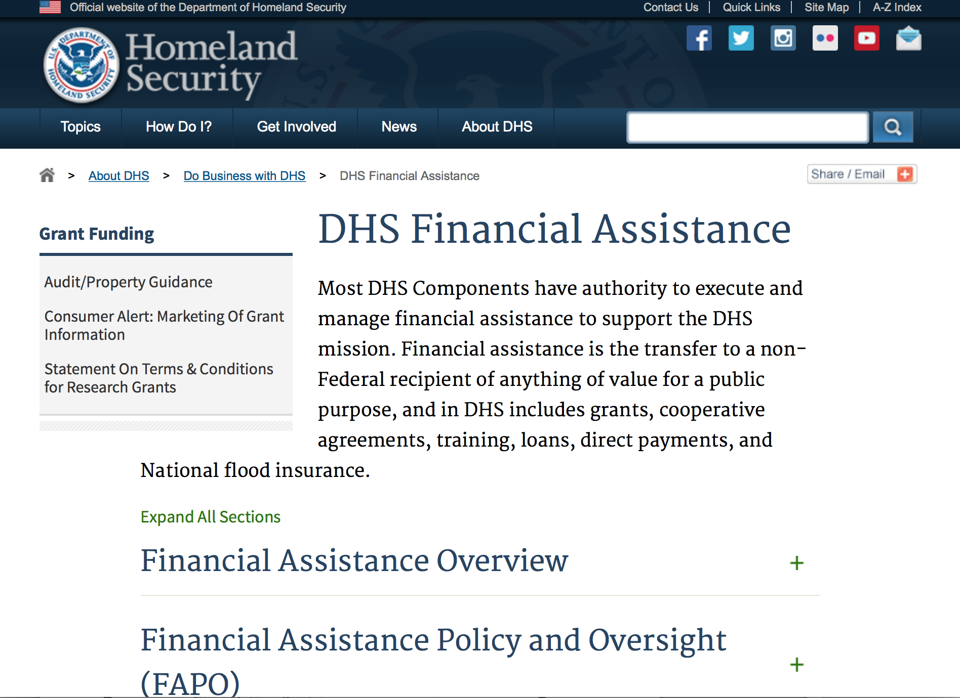
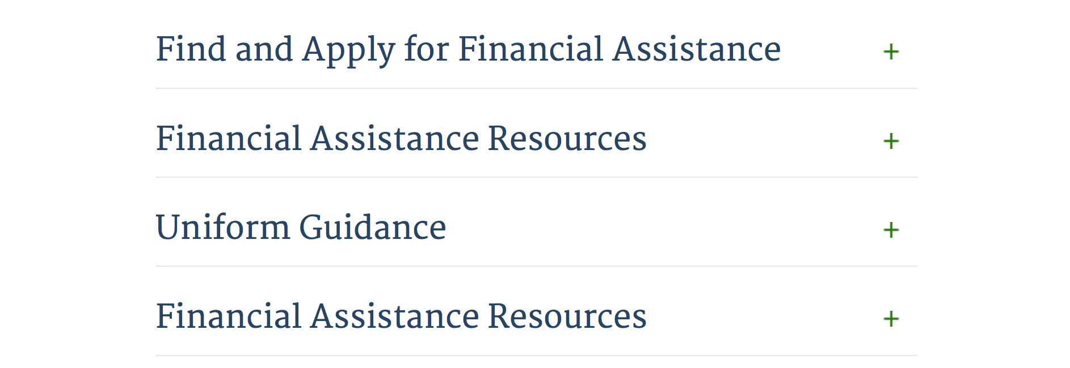

Webpage can be viewed at: http://www.dhs.gov/xopnbiz/grants/index.shtm#2

Information about 2016 for reference only
The FY 2016 Assistance to Firefighters Grants (AFG)
FY 2016 ASSISTANCE TO FIREFIGHTERS (AFG) GRANTS IS CLOSED AT THIS TIME
- FY 2016 Application Workshop Schedule
- FY 2016 AFG Application Guidance Materials The following documents are now available:
  - FY 2016 Notice of Funding Opportunity (NOFO) – Available Now
  - FY 2016 AFG Grant Application Get Ready Guide
  - FY 2016 AFG Narrative Get Ready Guide
  - FY 2016 AFG Self-Evaluation - Operations and Safety
  - FY 2016 AFG Self-Evaluation - Vehicle Acquisition
  - FY 2016 AFG Application Checklist
  - FY 2016 AFG Cost Share Calculator
FY 2016 AFG FAQs
For AFG program guidance materials, please visit our Documents page.

Resources

AFG Help Desk
Contact the AFG Program Help Desk toll-free at 866-274-0960, or email us at firegrants@dhs.gov.
The AFG Program has Fire Program Specialists in 10 federal regional centers. These Regional Fire Program Specialists respond to questions about the AFG program and carry out grant monitoring activities. View regional contacts

Popular AFG links
- AFG Workshop Schedule
- Assistance to Firefighters Grants (AFG)
- AFG Awards List
- AFG Success Stories
- Staffing for Adequate Fire & Emergency Response (SAFER) Grants (SAFER)
- SAFER Awards List
- SAFER Success Stories
- Fire Prevention & Safety (FP&S) Grants
- FP&S Awards List
- FP&S Success Stories
- Grant Closeout Tutorial
- Assistance to Firefighters Grant (AFG) Email Alert Archive
- Frequently Asked Questions
Contact Information For The Assistance to Firefighters Grant (AFG) Program and Help Desk

Federal Funding Alternative To AFG

State Administrative Agencies (SAA) apply for and administer Federal grants on behalf of their States, including FEMA Preparedness Grants. The SAA will work with eligible organizations to comply with the general requirements of grant programs or cooperative agreements. Contact your State’s SAA to find out what current Federal funding opportunities may be available to your organization. A listing of the SAAs and points of contact can be found at http://www.fema.gov/library/viewRecord.do?id=6363.

Programs:

Modifications:

Reminders:

Department of Homeland Security - FEMA
FY17 Flood Mitigation Assistance
Synopsis 1
Document Type: | Grants Notice
Funding Opportunity Number: | DHS-17-MT-029-000-99
Funding Opportunity Title: | FY17 Flood Mitigation Assistance
Opportunity Category: | Discretionary
Opportunity Category Explanation:
Funding Instrument Type: | Grant
Category of Funding Activity: | Other (see text field entitled "Explanation of Other Category of Funding Activity" for clarification)
Category Explanation: | The Flood Mitigation Assistance (FMA) Program makes available Federal funds to State, Local and Tribal Governments to reduce or eliminate the risk of repetitive flood damage to buildings and structures insured under the National Flood Insurance Program (NFIP).
Expected Number of Awards: | 200
CFDA Number(s): | 97.029 -- Flood Mitigation Assistance
Cost Sharing or Matching Requirement:

Version: | Synopsis 1
Posted Date: | Jul 10, 2017
Last Updated Date: | Jul 10, 2017
Original Closing Date for Applications: | Nov 14, 2017
Current Closing Date for Applications: | Nov 14, 2017
Archive Date: | Dec 14, 2017
Estimated Total Program Funding: | $160,000,000
Eligible Applicants: | State governments  Others (see text field entitled "Additional Information on Eligibility" for clarification)  Native American tribal governments (Federally recognized)
Additional Information on Eligibility: | District of Columbia; U.S. Territories. Local governments must apply through their state.
Agency Name: | Department of Homeland Security - FEMA
Description: | The Flood Mitigation Assistance (FMA) Program makes available Federal funds to State, Local and Tribal Governments to reduce or eliminate the risk of repetitive flood damage to buildings and structures insured under the National Flood Insurance Program (NFIP). In FY17, the FMA Program will prioritize proposals that address community flood risk by setting aside $70 million for this purpose. FEMA will seek to fund two types of community flood mitigation activities: Advance Assistance for flood mitigation design and development of community flood mitigation projects and mitigation projects that address community flood risk for the purpose of reducing NFIP flood claim payments. The remaining funding, at least $90,000,000, will be used for FMA technical assistance, mitigation planning, and mitigation projects reducing risk to severe repetitive loss (SRL) and repetitive loss (RL) properties. Applicants must submit applications via the Mitigation eGrants system on the FEMA Grants Portal: https://portal.fema.gov. Applicants may submit a maximum of 1 advanced assistance and 1 community mitigation project sub-application.
Link to Additional Information:
Grantor Contact Information: | If you have difficulty accessing the full announcement electronically, please contact:  Mitigation eGrants System Helpdesk Phone: 1-855-228-3362  MTeGrants@fema.dhs.gov

http://www.grants.gov/web/grants/view-opportunity.html?oppId=295313

Department of Homeland Security - FEMA
FY17 Pre-Disaster Mitigation
Synopsis 1

Document Type: | Grants Notice
Funding Opportunity Number: | DHS-17-MT-047-000-99
Funding Opportunity Title: | FY17 Pre-Disaster Mitigation
Opportunity Category: | Discretionary
Opportunity Category Explanation:
Funding Instrument Type: | Grant
Category of Funding Activity: | Other (see text field entitled "Explanation of Other Category of Funding Activity" for clarification)
Category Explanation: | The Robert T. Stafford Disaster Relief and Emergency Assistance Act, Public Law 93-288, as amended, (42 U.S.C. 5133), Section 203 authorizes FEMA to make grants for the purpose of implementing a sustained pre-disaster natural hazard mitigation program to reduce overall risk to the population and structures from future hazard events, while also reducing reliance on Federal funding from future disasters.
Expected Number of Awards: | 250
CFDA Number(s): | 97.047 -- Pre-Disaster Mitigation
Cost Sharing or Matching Requirement: | No
Version: | Synopsis 1
Posted Date: | Jul 10, 2017
Last Updated Date: | Jul 10, 2017
Original Closing Date for Applications: | Nov 14, 2017
Current Closing Date for Applications: | Nov 14, 2017
Archive Date: | Dec 14, 2017
Estimated Total Program Funding: | $90,000,000
Award Ceiling: | $15,000,000
Eligible Applicants: | State governments  Native American tribal governments (Federally recognized)  Others (see text field entitled "Additional Information on Eligibility" for clarification)
Additional Information on Eligibility: | District of Columbia; U.S. Territories. Local governments must apply through their state.
Agency Name: | Department of Homeland Security - FEMA
Description: | The Pre-Disaster Mitigation (PDM) program makes available Federal funds to State, Local and Tribal Governments to implement and sustain cost-effective measures designed to reduce the risk to individuals and property from natural hazards, while also reducing reliance on Federal funding from future disasters. FEMA will provide allocations of $575,000 as required by the Stafford Act to states and territories; and a tribal set aside of $10 million for allocations up to $575,000 for Native American Indian tribal governments to support overall mitigation planning and projects. The remaining PDM funds will be awarded on a competitive basis with a focus on multi-state/tribal mitigation initiatives. Applicants must submit applications via the Mitigation eGrants system on the FEMA Grants Portal: https://portal.fema.gov. Applicants may submit a maximum of 9 project sub-applications notwithstanding any project(s) submitted for the state/territory allocation or tribal set aside. In addition, any state or tribe willing to serve as the applicant for a multi-state or tribal activity may submit one additional plan or project subapplication.
Link to Additional Information:
Grantor Contact Information: | If you have difficulty accessing the full announcement electronically, please contact:  Mitigation eGrants System Helpdesk Phone: 1-855-228-3362  MTeGrants@fema.dhs.gov

http://www.grants.gov/web/grants/view-opportunity.html?oppId=295314

Department of Housing and Urban Development

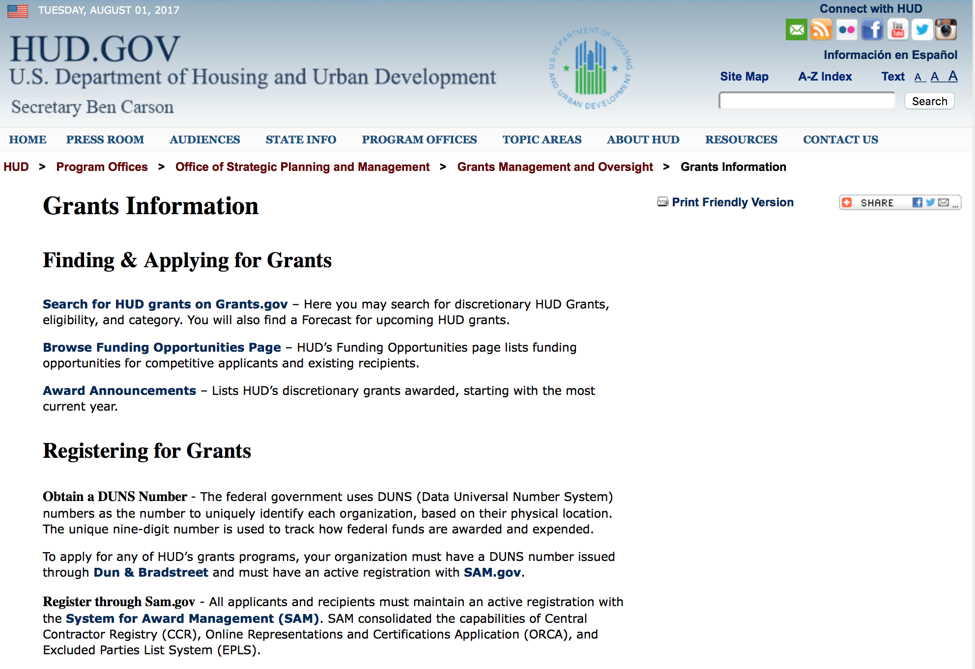

http://portal.hud.gov/hudportal/HUD?src=/topics/grants

HUD - Notice of Funds Available
For detailed information click here

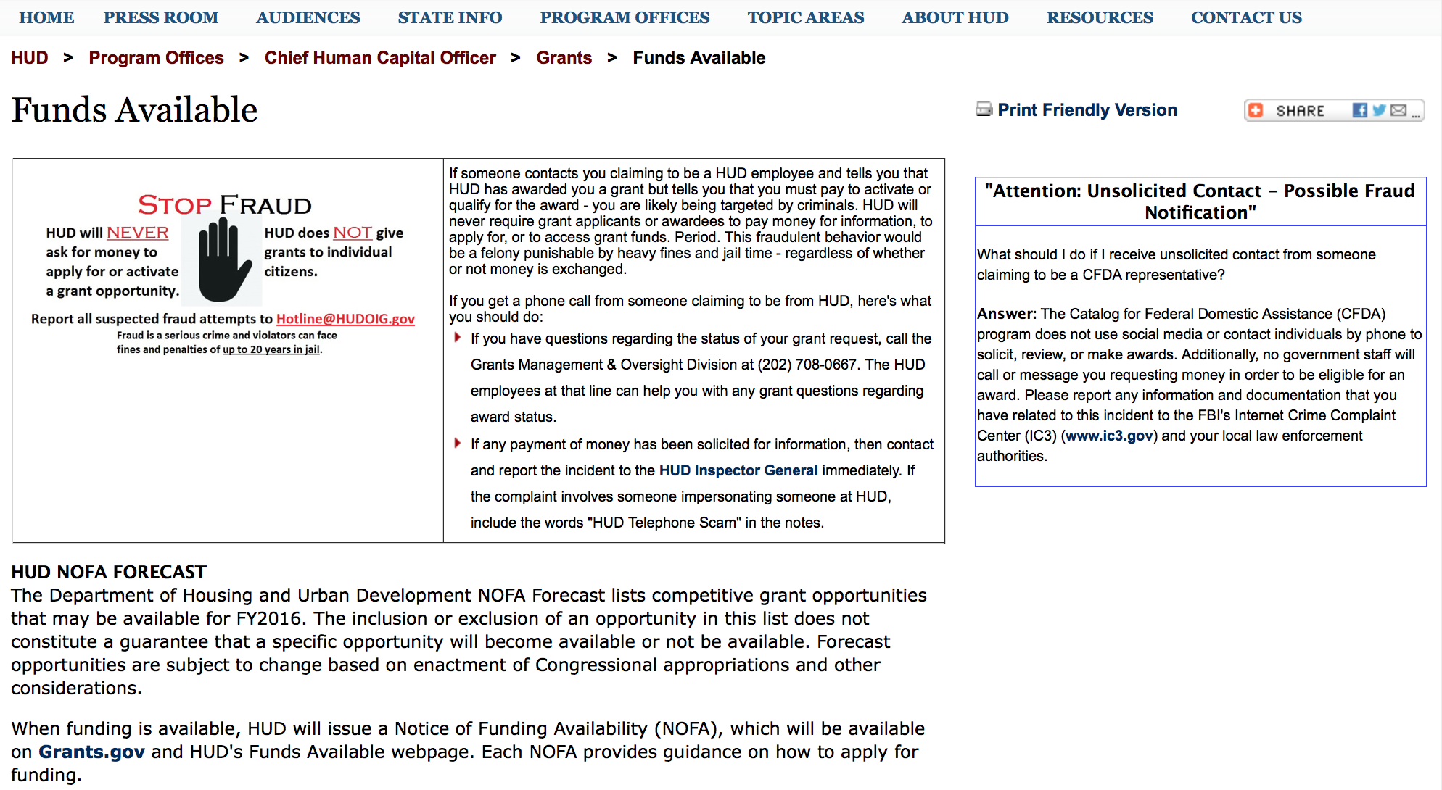

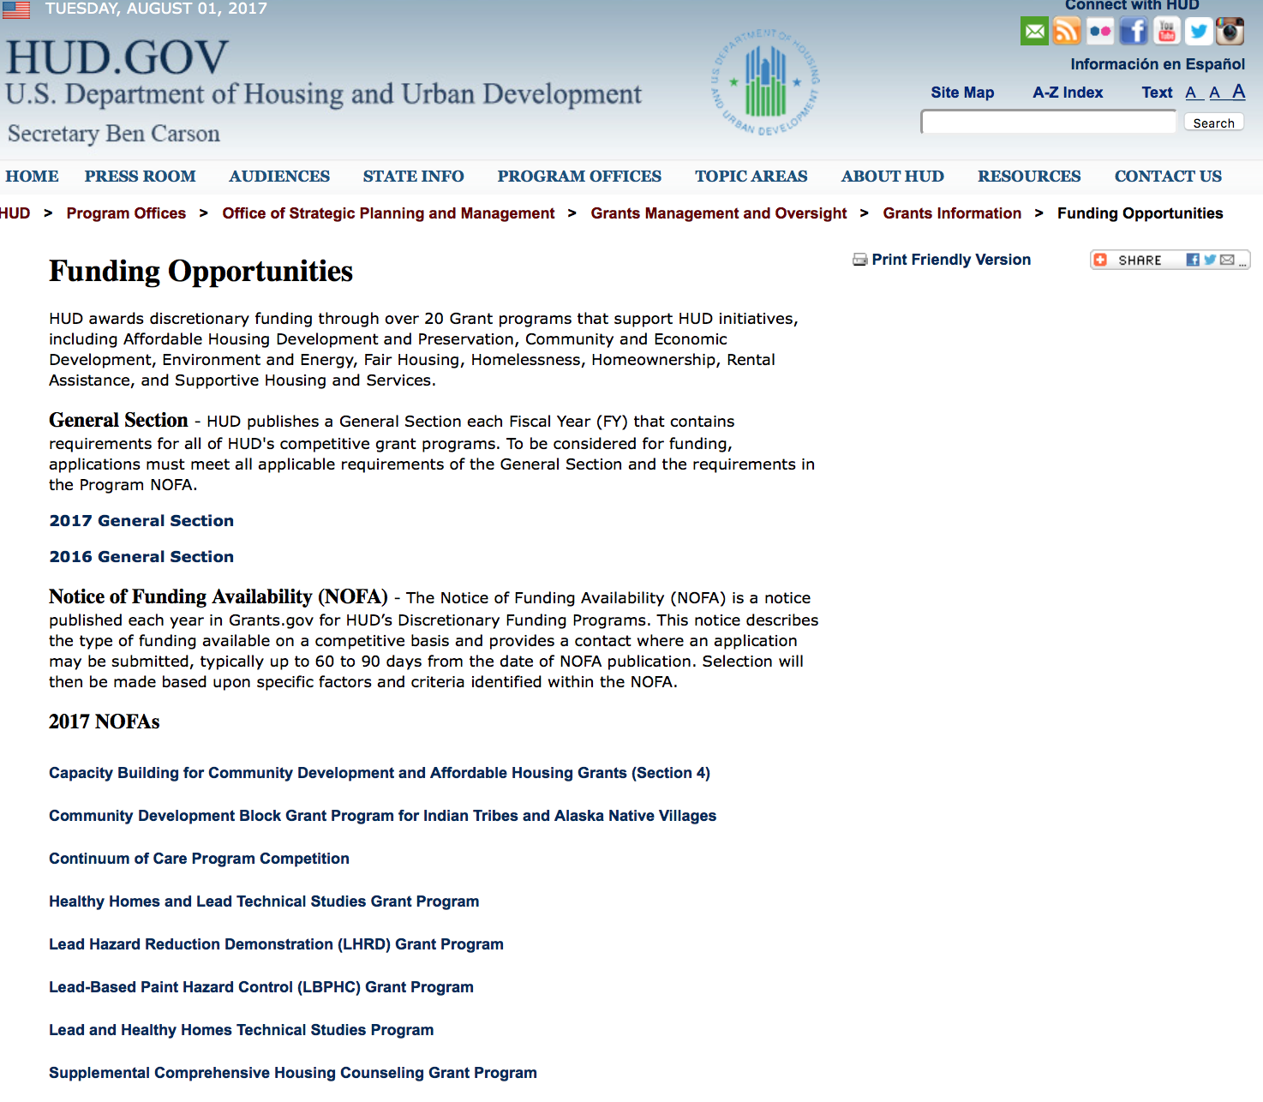

http://portal.hud.gov/hudportal/HUD?src=/program_offices/administration/grants/fundsavail

HUD NOFA FORECAST
The Department of Housing and Urban Development NOFA Forecast lists competitive grant opportunities that may be available for FY2016. The inclusion or exclusion of an opportunity in this list does not constitute a guarantee that a specific opportunity will become available or not be available. Forecast opportunities are subject to change based on enactment of Congressional appropriations and other considerations.
When funding is available, HUD will issue a Notice of Funding Availability (NOFA), which will be available on Grants.gov

Programs:

Fair Housing Initiatives Program - Private Enforcement Initiative
Synopsis 1
Document Type: | Grants Notice
Funding Opportunity Number: | FR-6100-N-21C
Funding Opportunity Title: | Fair Housing Initiatives Program - Private Enforcement Initiative
Opportunity Category: | Discretionary
Opportunity Category Explanation:
Funding Instrument Type: | Grant
Category of Funding Activity: | Housing
Category Explanation:
Expected Number of Awards: | 53
CFDA Number(s): | 14.418 -- Private Enforcement Initiatives
Cost Sharing or Matching Requirement: | No
Version: | Synopsis 1
Posted Date: | Aug 01, 2017
Last Updated Date: | Aug 01, 2017
Original Closing Date for Applications: | Sep 18, 2017 Electronically submitted applications must be submitted no later than 11:59 p.m., ET, on the listed application due date.
Current Closing Date for Applications: | Sep 18, 2017 Electronically submitted applications must be submitted no later than 11:59 p.m., ET, on the listed application due date.
Archive Date: | Oct 18, 2017
Estimated Total Program Funding: | $15,830,816
Award Ceiling: | $300,000
Award Floor: | $300,000
Eligible Applicants: | Others (see text field entitled "Additional Information on Eligibility" for clarification)
Additional Information on Eligibility: | Under this NOFA, eligible applicants must be Qualified Fair Housing Enforcement Organizations (QFHOs) or Fair Housing Enforcement Organizations (FHOs), or the organization is ineligible. Applicants must complete the Appendix B, "Certification for PEI Applicants" to confirm QFHO or FHO stuatus. If an organization does not currently have sufficient experience to qualify as a FHO or QFHO (see 24 CFR part 125.103 and 125.401), then the organization may be eligible to apply under FHIP's Education and Outreach Initiative (FR-6100-21A) and/or Fair Housing Organizations Initiative (FR-6100-21B) NOFAs. Please see those NOFAs for specific eligibility requirements. Individuals, foreign entities, and sole proprietorship organizations are not eligible to compete for, or receive, awards made under this announcement.
Agency Name: | Department of Housing and Urban Development
Description: | HUD is making available through this PEI NOFA $30,350,000 for Fair Housing Initiative Programs. Additional funds may become available for award under this NOFA as a result of HUD's efforts to recapture unused funds, use carryover funds, or because of the availability of additional appropriated funds. Use of these funds will be subject to statutory constraints. All awards are subject to the applicable funding restrictions described in the General Section and to those contained in this NOFA. Funding for additional years beyond FY2017 is subject to the availability of appropriations. FHIP funds are used to increase compliance with the Fair Housing Act. This year, funding is available under three Initiatives: Private Enforcement (PEI), Fair Housing Organization (FHOI) and Education and Outreach (EOI) Initiatives. However, for FY2017, funding for each initiative is listed under a separate NOFA. Applicants must apply under the correct NOFA to be considered for funding. Additionally, if an applicant is eligible and applying for funding under separate initiatives and/or components, the applicant must submit a separate application under the correct NOFA for each component the applicant applies. This NOFA will consider applicants applying under PEI only. The following is a general description of PEI (see chart in section III. A. for all eligibility requirements ): Private Enforcement Initiative (PEI). This Initiative provides funding to private, non-profit fair housing enforcement organizations that meet statutory requirements to conduct investigation and enforcement of alleged violations of the Fair Housing Act. PEI applicants may be funded under the following Initiative based on eligibility: Private Enforcement Initiative (PEI) - $14,519,184 (1) Multi-Year Funding Component (PEI-MYFC) Total PEI Multi-Year Funding (PEI-MYFC) is $30,350,000 ($14,519,184 of this total is set aside based upon appropriations for FY 2015 and FY 2016 Multi-year grantees. The remaining $15,830,816 will fund FY2017 grantees). Applicants may apply for funding under each FHIP NOFA as long as the applicant meets the specific eligibility requirements for each Initiative/Component
Link to Additional Information: | http://portal.hud.gov/hudportal/HUD?src=/program_offices/administration/grants/fundsavail
Grantor Contact Information: | If you have difficulty accessing the full announcement electronically, please contact:  Myron Newry Myron.P.Newry@hud.gov  Grants Policy

http://www.grants.gov/web/grants/view-opportunity.html?oppId=296064

Choice Neighborhoods Implementation Grant Program
Synopsis 1
Document Type: | Grants Notice
Funding Opportunity Number: | FR-6100-N-34
Funding Opportunity Title: | Choice Neighborhoods Implementation Grant Program
Opportunity Category: | Discretionary
Opportunity Category Explanation:
Funding Instrument Type: | Grant
Category of Funding Activity: | Housing
Category Explanation:
Expected Number of Awards: | 5
CFDA Number(s): | 14.889 -- Choice Neighborhoods Implementation Grants
Cost Sharing or Matching Requirement: | Yes
Version: | Synopsis 1
Posted Date: | Aug 24, 2017
Last Updated Date: | Aug 24, 2017
Original Closing Date for Applications: | Nov 22, 2017 Electronically submitted applications must be submitted no later than 11:59 p.m., ET, on the listed application due date.
Current Closing Date for Applications: | Nov 22, 2017 Electronically submitted applications must be submitted no later than 11:59 p.m., ET, on the listed application due date.
Archive Date: | Dec 22, 2017
Estimated Total Program Funding: | $132,000,000
Award Ceiling: | $30,000,000
Award Floor: | $1
Eligible Applicants: | Others (see text field entitled "Additional Information on Eligibility" for clarification)
Additional Information on Eligibility: | The Lead Applicant must be a Public Housing Agency (PHA), a local government, or a tribal entity. If there is also a Co-Applicant, it must be a PHA, a local government, a tribal entity, a nonprofit, or a for-profit developer. Individuals, foreign entities, and sole proprietorship organizations are not eligible to compete for, or receive, awards made under this announcement.
Agency Name: | Department of Housing and Urban Development
Description: | Choice Neighborhoods Implementation Grants support the implementation of comprehensive neighborhood revitalization plans that are expected to achieve the following three core goals: 1. Housing: Replace distressed public and assisted housing with high-quality mixed-income housing that is well-managed and responsive to the needs of the surrounding neighborhood; 2. People: Improve intergenerational mobility with a focus on children and families'; employment, health, and education outcomes; and 3. Neighborhood: Create the conditions necessary for public and private reinvestment in distressed neighborhoods to offer the kinds of amenities and assets, including safety, good schools, and commercial activity, that are important to families'; choices about their community.
Link to Additional Information: | http://portal.hud.gov/hudportal/HUD?src=/program_offices/spm/gmomgmt/grantsinfo/fundingopps
Grantor Contact Information: | If you have difficulty accessing the full announcement electronically, please contact:  Choice Neighborhoods office ChoiceNeighborhoods@hud.gov  Grants Policy

http://www.grants.gov/web/grants/view-opportunity.html?oppId=296794

Resident Opportunity & Self-Sufficiency Program
Synopsis 1
Document Type: | Grants Notice
Funding Opportunity Number: | FR-6100-N-05
Funding Opportunity Title: | Resident Opportunity & Self-Sufficiency Program
Opportunity Category: | Discretionary
Opportunity Category Explanation:
Funding Instrument Type: | Grant
Category of Funding Activity: | Housing
Category Explanation:
Expected Number of Awards: | 110
CFDA Number(s): | 14.870 -- Resident Opportunity and Supportive Services - Service Coordinators
Cost Sharing or Matching Requirement: | Yes
Version: | Synopsis 2
Posted Date: | Aug 24, 2017
Last Updated Date: | Aug 28, 2017
Original Closing Date for Applications: | Oct 23, 2017 Electronically submitted applications must be submitted no later than 11:59 p.m., ET, on the listed application due date.
Current Closing Date for Applications: | Oct 23, 2017 Electronically submitted applications must be submitted no later than 11:59 p.m., ET, on the listed application due date.
Archive Date: | Nov 22, 2017
Estimated Total Program Funding: | $35,000,000
Award Ceiling: | $738,000
Award Floor: | $0
Eligible Applicants: | Public housing authorities/Indian housing authorities  Nonprofits having a 501(c)(3) status with the IRS, other than institutions of higher education  Nonprofits that do not have a 501(c)(3) status with the IRS, other than institutions of higher education  Native American tribal governments (Federally recognized)
Additional Information on Eligibility: | The following entities are eligible to apply for FY17 ROSS-SC Funding: Native American tribal governments (federally recognized)Indian Housing Authorities/ Tribally Designated Housing Entities (TDHEs)Public Housing Agencies (PHAs)Nonprofits, including Resident Associations (RAs), having a 501(c)(3) status with the IRS, other than institutions of higher education Nonprofits, including Resident Associations (RAs), locally incorporated without 501(c)(3) status with the IRS, other than institutions of higher education. All applicants should see Section III.C " Threshold Requirements" and Section IV.B "Content and Form of Application Submission" for more information on eligibility for funding requirements. EDSC Provision: PHAs that are currently eligible to receive annual funding under the Elderly/Disabled Service Coordinator (EDSC) program from the Public Housing Operating Fund that apply to serve elderly/disabled resident through this NOFA will forgo all future eligibility for EDSC funding through the Operating Fund. If you are receiving EDSC funds, you may apply to serve families only on the HUD-52768 to not risk your EDSC funding. To confirm if your PHA is affected by this EDSC provision, please see the list of PHAs that are eligible to receive EDSC funding (http://portal.hud.gov/hudportal/documents/huddoc?id=EDSC-FY16-ROSS-AWARDS.xls). Individuals, foreign entities, and sole proprietorship organizations are not eligible to compete for, or receive, awards made under this announcement.
Agency Name: | Department of Housing and Urban Development
Description: | Program Overview: The Resident Opportunity & Self Sufficiency (ROSS) Service Coordinator (SC) program funds eligible applicants to hire Service Coordinators to coordinate use of assistance under the Public Housing program with public and private resources, for supportive services and resident empowerment activities. Service Coordinators assess the needs of public and Indian housing residents and link them to supportive services that enable participants to increase earned income, reduce or eliminate the need for welfare assistance, and make progress toward achieving economic independence and housing self-sufficiency. In the case of elderly/disabled residents, the Service Coordinator links participants to supportive services, which enable them to age/remain, in-place thereby avoiding costlier forms of care. Funds awarded to applicants may be used for (1)service coordinator functions, (2) training and travel related to professional and/or program development, (3) and administration cost.
Link to Additional Information: | http://portal.hud.gov/hudportal/HUD?src=/program_offices/administration/grants/fundsavail
Grantor Contact Information: | If you have difficulty accessing the full announcement electronically, please contact:  ROSS-PIH@hud.gov  Grants Policy

http://www.grants.gov/web/grants/view-opportunity.html?oppId=296791

Modifications:

HUD Community Compass Technical Assistance and Capacity Building Program
Synopsis 2
Document Type: | Grants Notice
Funding Opportunity Number: | FR-6100-N-06
Funding Opportunity Title: | HUD Community Compass Technical Assistance and Capacity Building Program
Opportunity Category: | Discretionary
Opportunity Category Explanation:
Funding Instrument Type: | Cooperative Agreement
Category of Funding Activity: | Housing
Category Explanation:
Expected Number of Awards: | 20
CFDA Number(s): | 14.259 -- Community Compass Technical Assistance and Capacity Building
Cost Sharing or Matching Requirement: | No
Version: | Synopsis 3
Posted Date: | Aug 14, 2017
Last Updated Date: | Aug 16, 2017
Original Closing Date for Applications: | Sep 28, 2017 Electronically submitted applications must be submitted no later than 11:59 p.m., ET, on the listed application due date.
Current Closing Date for Applications: | Sep 28, 2017 Electronically submitted applications must be submitted no later than 11:59 p.m., ET, on the listed application due date.
Archive Date: | Oct 28, 2017
Estimated Total Program Funding: | $56,000,000
Award Ceiling: | $20,000,000
Award Floor: | $250,000
Eligible Applicants: | Private institutions of higher education  Nonprofits having a 501(c)(3) status with the IRS, other than institutions of higher education  County governments  State governments  City or township governments  Public and State controlled institutions of higher education  Special district governments  For profit organizations other than small businesses  Nonprofits that do not have a 501(c)(3) status with the IRS, other than institutions of higher education  Public housing authorities/Indian housing authorities  Small businesses  Others (see text field entitled "Additional Information on Eligibility" for clarification)
Additional Information on Eligibility: | In addition to the list above, eligible applicants include: NAHASDA-eligible Indian tribes as defined at Section 4(13) of NAHASDA; tribally-designated housing entities (TDHEs) as defined at Section 4(22) of the NAHASDA; and national or regional organizations representing Native American housing interests Metropolitan Planning Organizations (MPOs), Councils of Government (COGs), or other regional planning entities See section V.B. "Rules that affect applicants' eligibility to receive an award from HUD" of the FY 2017 General Section for more information on eligibility. See also Section IV.B of this NOFA ("Content and Form of Application Submission") for necessary form and content information. Individuals, foreign entities, and sole proprietorship organizations are not eligible to compete for, or receive, awards made under this announcement.
Agency Name: | Department of Housing and Urban Development
Description: | Through this NOFA, HUD is announcing the availability of approximately $56 million for its Community Compass Technical Assistance and Capacity Building Program (Community Compass), HUD's integrated technical assistance and capacity building initiative. Community Compass is designed to help HUD's customers navigate complex housing and community development challenges by equipping them with the knowledge, skills, tools, capacity, and systems to implement HUD programs and policies successfully and provide effective administrative and managerial oversight of HUD funding. The goal of Community Compass is to empower communities by providing effective technical assistance and capacity building so that successful program implementation is sustained. HUD recognizes that its customers often interact with a variety of HUD programs as they deliver housing or community development services. Community Compass brings together technical assistance investments from across HUD program offices, including the offices of Community Planning and Development, Fair Housing and Equal Opportunity, Housing, and Public and Indian Housing. This cross-funding approach allows technical assistance to address the needs of grantees and subgrantees across multiple HUD programs, often within the same engagement, as well as address cross-agency issues. Applicants are encouraged to procure subcontractors and consultants to demonstrate expertise across a wide variety of HUD programs, as well as in specific skill and policy areas. Community Compass is centrally managed by HUD Headquarters with involvement of the HUD Regional, Field, and Area Offices. a. TA Focus Areas - Table of Categories, Programs and Topics, and Funding Sources HUD expects to focus its technical assistance (TA) efforts and available funding on the programs and topics listed for each category in the table below. The table also notes the funding source(s) for each category. HUD recognizes that overlap often occurs among these categories, programs, and topics. Applicants are encouraged to establish their experience working across categories, as applicable. TA assignments may include programs and topics not currently listed in the table. HUD may direct successful applicants to provide TA related to additional HUD programmatic or policy areas, based on emerging priorities and the identified needs of HUD's customers. Table of Categories, Programs and Topics, and Funding Sources CATEGORY PROGRAMS AND TOPICSTA FUNDING SOURCEAFFORDABLE HOUSING, MIXED FINANCE DEVELOPMENT, AND HOMEOWNERSHIPHOME Investment Partnerships Program (HOME), including reporting requirements in the Integrated Disbursement and Information System (IDIS) and financial management of HOME grants Recapitalization and preservation of affordable rental housing, including the Rental Assistance Demonstration (RAD)Choice Neighborhoods and HOPE VI Housing counseling grant requirements, oversight, and agency capacity building Housing Trust Fund Leveraging additional funding and subsidy layering Departmental TACOMMUNITY AND ECONOMIC DEVELOPMENT, DISASTER RESILIENCE Community Development Block Grant (CDBG)CDBG tools and products to assist grantees design and conduct local income surveys. Limited pilot testing of new tools and products. CDBG Disaster Recovery (CDBG-DR) launch, program management, and capacity building TA, including National Disaster Resilience (CDBG-NDR) project implementation TA Section 108 Loan Guarantee Program TA Community and regional planning, including consolidated plans and the use of the e-con Planning Suite Comprehensive neighborhood revitalization, including innovative practices and collaborations to provide workforce and business development services, health and human services, internet access and community infrastructure, and other improvements or services, and leverage state and local resources, federal resources from agencies other than HUD, and private resources Rural and tribal community and economic development practices and resources Economic development Disaster resilience Green infrastructure Vulnerability analysis/hazard risk assessment Innovative financing methods for infrastructure and disaster resilience (e.g., green bonds, catastrophe bonds, and value capture)Grant systems, including IDIS, DRGR, and e-snaps Infrastructure design that addresses systemic shocks and stresses, delivers multiple benefits, and achieves resilience Assessment of Fair Housing (AFH)Departmental TAHOMELESSNESS Continuum of Care (CoC) program, including CoC governance and CoC systems performance measurement Emergency Solutions Grants (ESG) program Centralized or coordinated entry system Data reporting, analysis, and management, including use of a Homeless Management Information System (HMIS)Homeless subpopulations: Chronic homeless, veterans, families with children, youth, and victims of domestic violence Strategic resource allocation and removing barriers to CoC resources for persons experiencing homelessness and/or entering the CoC system Quickly rehousing homeless individuals and families; promoting access to, and effective use of, mainstream programs; and/or optimizing self-sufficiency among individuals and families experiencing homelessness Using a Housing First approach, including retooling transitional housing and rapid rehousing Under-performing CoC Program recipient, sub-recipient, or project Disaster preparedness to help McKinney-Vento recipients address the needs of program participants and people experiencing homelessness during disasters, along with recovery efforts for McKinney-Vento funded projects and how to conduct rehousing efforts for CoC program participants e-snaps McKinney-Vento TA, Departmental TANATIONAL HOMELESS DATA ANALYSIS PROJECT Analysis, management, and reporting of data critical for measuring and meeting HUD's Strategic Objectives related to homelessness and the goals of Opening Doors Homeless Management Information System (HMIS), including operation of the HMIS Data Lab Data reporting, analysis, and management, including use of a Homeless Management Information System (HMIS)Disaster preparedness and recovery assistance &; Helping McKinney grantees identify HMIS needs pre-disaster and post-disaster, including, but not limited to, review of HMIS data to understand demographics and needs; use of information from HMIS to understand the needs and risks faced by people experiencing homelessness; strategies for outreach efforts to unsheltered populations based on location and number of individuals; tracking both the impact on homeless residents and those that become homeless due to the event; tracking eligibility for disaster compensation and other disaster related resources; and connecting individuals and families Preparation of AHAR Part 1 and 2Redesign of AHAR collection and technology upgrades Development of HMIS lead and system administrator training curriculum and rollout plan McKinney-Vento National Homeless Data Analysis Project, Departmental TAPUBLIC HOUSING OPERATIONS AND PROGRAMS Financial management, which may include procurement protocols Governance of PHAs, including board and management practices, effective use of partnerships, and potential organization restructuring Information Resource Center Asset management Development methods and capital improvements Low-cost, high-speed internet access Energy Performance Contracts Housing Choice Vouchers Physical Needs Assessments Public Housing Agency (PHA) repositioning/regional planning Recovery and prevention of at-risk or troubled PHAs, including asset repositioning, program operations, internal controls, financial and governance training, and development assistance Operating funds and Capital funds grant Self-Sufficiency Programs PHA plans Moving to Work (MTW)Disaster resilience Green development Physical inspections Mixed finance Assessment of Fair Housing (AFH)Departmental TA Recovery of PHAs in HUD Administrative Receivership PHA Administrative Receivership & Recovery TANATIVE AMERICAN HOUSING AND COMMUNITY DEVELOPMENT Indian Housing Block Grant (IHBG)Native American Housing Assistance and Self-Determination Act (NAHASDA)NAHASDA TA Indian Housing Block Grant (IHBG)Native American Housing Assistance and Self-Determination Act (NAHASDA)Negotiated Rulemaking Committee and Consultation support NAHASDA allocation formula administration Title VI Loan Leveraging Section 184 Loan Guarantee Tribal HUD-VASH Indian Community Development Block Grant (ICDBG)Native American Housing and Community Development TASUPPORTIVE HOUSING AND SERVICESHUD-VASH, including VASH data collection Housing Opportunities for Persons With AIDS (HOPWA)Section 202 Supportive Housing for the Elderly, including documenting capital needs backlog in the 202 portfolio Senior Project Rental Assistance Program Section 811 Supportive Housing for Persons with Disabilities and Section 811 Project Rental Assistance Homeless Preference in Project-based Section 8Multifamily Housing Service Coordinator Family Self Sufficiency (FSS) programs with ROSS-SC Jobs Plus Initiative Workforce Innovation and Opportunity Act (WIOA) implementation Regional mobility programs Departmental TAPOLICY DEVELOPMENT AND RESEARCH Data collection and quality for LIHTC tenants and projects Departmental TAFAIR HOUSING, ENERGY AND ENVIRONMENT, RELOCATION, AND OTHER CROSS-CUTTING REQUIREMENTS Violence Against Women Act (VAWA) implementation Section 3 of the Housing and Urban Development Act of 1968Compliance with Section 504 and ADA/UFAS requirements Uniform Relocation Assistance and Real Property Acquisition Policies Act of 1970 (URA), and Section 104 (d) of the Housing and Community Development Act of 1974Departmental priorities Environmental reviews for the National Environmental Policy Act (NEPA) and related federal environmental laws and authorities, including, but not limited to, the National Historic Preservation Act, Executive Order 11988 on Floodplain Management, and contamination policies Benchmarking and utility data analysis for multifamily buildings, including use of the Energy Star Portfolio Manager tool Energy efficiency and high performance building retrofits for assisted housing properties Green operations and maintenance Activities that assist grantees with implementing new federal rules, regulations, Notices, and program requirements Knowledge management via HUD Exchange Smoke-free housing RAD Notice Regarding Fair Housing and Civil Rights Requirements and Relocation Requirements Applicable to RAD First Component &; Public Housing Conversions (H 2016-17 / PIH 2016-17), the Fair Housing Act, and Title VI of the Civil Rights Act Affirmatively Furthering Fair Housing, including, but not limited to, requirements under the AFFH rule at 24 C.F.R. &sect;&sect; 5.150 et seq. Departmental TA
Link to Additional Information: | http://portal.hud.gov/hudportal/HUD?src=/program_offices/administration/grants/fundsavail
Grantor Contact Information: | If you have difficulty accessing the full announcement electronically, please contact:  communitycompass@hud.gov  Grants Policy

http://www.grants.gov/web/grants/view-opportunity.html?oppId=296470

Family Self-Sufficiency Program
Synopsis 2
Document Type: | Grants Notice
Funding Opportunity Number: | FR-6100-N-04
Funding Opportunity Title: | Family Self-Sufficiency Program
Opportunity Category: | Discretionary
Opportunity Category Explanation:
Funding Instrument Type: | Grant
Category of Funding Activity: | Housing
Category Explanation:
Expected Number of Awards: | 700
CFDA Number(s): | 14.896 -- Family Self-Sufficiency Program
Cost Sharing or Matching Requirement: | No
Version: | Synopsis 2
Posted Date: | Aug 15, 2017
Last Updated Date: | Aug 15, 2017
Original Closing Date for Applications: | Sep 15, 2017 Electronically submitted applications must be submitted no later than 11:59 p.m., ET, on the listed application due date.
Current Closing Date for Applications: | Sep 15, 2017 Electronically submitted applications must be submitted no later than 11:59 p.m., ET, on the listed application due date.
Archive Date: | Oct 15, 2017
Estimated Total Program Funding: | $75,000,000
Award Ceiling: | $72,000
Award Floor: | $0
Eligible Applicants: | Public housing authorities/Indian housing authorities
Additional Information on Eligibility: | 1. Eligible applicants. PHAs (including MTW PHAs) and Indian tribes/TDHEs currently administering an FSS program, that have served at least the minimum number of families required by this NOFA (as described in Section III.E.3. and have met all other funding requirements. Due to the level of funding under this NOFA, applicants will only be eligible for funding if they meet one of the following criteria: &bull; the applicant was funded under any of the FY14, FY15, and/or FY16 FSS NOFAs, or &bull; the applicant received an FSS program through a transfer or consolidation from a PHA that was funded under such NOFAs. Appendix D provides a list of applicants who meet the criteria set forth in the bullet points above. If you are not listed in Appendix D, but you believe you meet the criteria set forth in the bullet points above, you may request a review of eligibility from HUD by following the steps described in Section III.A.2 below. As required in the Code of Federal Regulations (CFR) at 2 CFR 25.200 and 24 CFR Part 5 Subpart K, all applicants for financial assistance must have an active Data Universal Numbering System (DUNS) number (http://fedgov.dnb.com/webform) and have an active registration in the System for Award Management (SAM) (www.sam.gov) before submitting an application. See Section V.B.3 of this NOFA for more information on how funding will be distributed among eligible applicants. See also Section IV.B.1 for necessary form and content information. 2. Request for Review of Eligibility. In advance of submitting this grant application, applicants who are not listed in Appendix D but who believe they meet the eligibility criteria in the Section above (Section III.A.1 of this NOFA) must submit a Request for Review of Eligibility via email to fss@hud.gov. The subject line should be "2017 Review of FSS Eligibility." The email must include the applicant's name, PHA number (in the format found in Appendix D), and a brief explanation of why the applicant believes they are eligible. HUD will review and respond within five working days of receipt of the request. That response will be an eligibility approval, eligibility disapproval, or a request for more information. If more information is requested, HUD will respond within five working days upon receipt of the additional information. All initial Requests for Review of Eligibility must be received no later than 20 calendar days prior to the due date of this NOFA. Individuals, foreign entities, and sole proprietorship organizations are not eligible to compete for, or receive, awards made under this announcement.
Agency Name: | Department of Housing and Urban Development
Description: | The FSS program supports the Department's strategic goal of utilizing housing as a platform for improving quality of life by helping HUD-assisted renters increase their economic security and self-sufficiency. The FSS program promotes the development of local strategies to coordinate the use of assistance under the HCV and PH programs with public and private resources to enable participating families to increase earned income and financial literacy, reduce or eliminate the need for welfare assistance, and make progress toward economic independence and self-sufficiency. PHAs or tribes/Tribally Designated Housing Entities (TDHEs) that administer FSS programs enter into five-year contracts with new families on an ongoing basis. The FSS contract spells out the terms and conditions governing participation and the responsibilities of both the PHA (or tribe/TDHE) and the family. PHAs are not permitted to limit FSS participation to those families most likely to succeed because of current education level or job history.
Link to Additional Information: | https://portal.hud.gov/hudportal/HUD?src=/program_offices/spm/gmomgmt/grantsinfo/fundingopps
Grantor Contact Information: | If you have difficulty accessing the full announcement electronically, please contact:  Tremayne Youmans fss@hud.gov  Grants Policy

http://www.grants.gov/web/grants/view-opportunity.html?oppId=296505

Fair Housing Initiative Program - Education and Outreach Initiative
Synopsis 3
Document Type: | Grants Notice
Funding Opportunity Number: | FR-6100-N-21-A
Funding Opportunity Title: | Fair Housing Initiative Program - Education and Outreach Initiative
Opportunity Category: | Discretionary
Opportunity Category Explanation:
Funding Instrument Type: | Grant
Category of Funding Activity: | Housing
Category Explanation:
Expected Number of Awards: | 53
CFDA Number(s): | 14.416 -- Education and Outreach Initiatives
Cost Sharing or Matching Requirement: | No
Version: | Synopsis 3
Posted Date: | Aug 01, 2017
Last Updated Date: | Aug 01, 2017
Original Closing Date for Applications: | Sep 18, 2017 Electronically submitted applications must be submitted no later than 11:59:59 p.m., ET, on the listed application due date.
Current Closing Date for Applications: | Sep 18, 2017 Electronically submitted applications must be submitted no later than 11:59:59 p.m., ET, on the listed application due date.
Archive Date: | Oct 18, 2017
Estimated Total Program Funding: | $7,450,000
Award Ceiling: | $1,000,000
Award Floor: | $125,000
Eligible Applicants: | Others (see text field entitled "Additional Information on Eligibility" for clarification)
Additional Information on Eligibility: | Eligible applicants may be Qualified Fair Housing Enforcement Organizations (QFHOs) and Fair Housing Enforcement Organizations (FHOs), public or private not-for-profit organizations or institutions, and other public or private entities that are formulating or carrying out programs to prevent or eliminate discriminatory housing practices; agencies of State or local governments; and agencies that participate in the Fair Housing Assistance Program (FHAP). All applicants are required to complete Appendix B, EOI Eligibility Certification and submit as a part of your application. Individuals, foreign entities, and sole proprietorship organizations are not eligible to compete for, or receive, awards made under this announcement.
Agency Name: | Department of Housing and Urban Development
Description: | HUD is making available through this NOFA $7,450,000 for Fair Housing Initiatives Program Education and Outreach Initiative. Additional funds may become available for award under this NOFA as a result of HUD's efforts to recapture unused funds, use carryover funds, or because of the availability of additional appropriated funds. Use of these funds will be subject to statutory constraints. All awards are subject to the applicable funding restrictions described in the General Section and to those contained in this NOFA. FHIP funds are used to increase compliance with the Fair Housing Act. This year, funding is available under three Initiatives: Private Enforcement (PEI), Fair Housing Organization (FHOI) and Education and Outreach (EOI) Initiatives. Multi-year awards beyond FY2017 funding are subject to appropriations and the availability of funds. For FY2017, funding for each initiative is listed under a separate NOFA, therefore, applicants must apply under the correct NOFA to be considered for funding. Additionally, if an applicant is eligible and applies for funding under separate initiatives and/or components, the applicant must submit a separate application under the correct NOFA for each component the applicant applies. This NOFA will consider applicants applying under EOI only. The following is a general description of the Education and Outreach Initiative (see chart in section III. A. for all eligibility requirements and a listing of related components): Education and Outreach Initiative (EOI). This Initiative provides funding to organizations that inform the general public about their rights and obligations under the Fair Housing Act. EOI applicants may be funded under the following components based on eligibility: 1. Education and Outreach Initiative (EOI) - $7,450,000 a. National-Based Programs - National Media Campaign Component (EOI-NMCC) - $1,000,000 b. Regional/Local/Community Based Program - General Component (EOI-G) - $6,450,000 Under the EOI NOFA, applicants may apply for funding under multiple components as long as the applicant meets the specific eligibility requirements for each component (see eligibility chart in Section III.A.1). Applicants will be funded in accordance with the funding restrictions listed under Section IV.F.5. In addition, applicants may apply for funding under multiple Initiatives, as long as the applicant applies under the correct NOFA and in accordance with the funding restrictions listed for each NOFA.
Link to Additional Information: | http://portal.hud.gov/hudportal/HUD?src=/program_offices/administration/grants/fundsavail
Grantor Contact Information: | If you have difficulty accessing the full announcement electronically, please contact:  Myron Newry Myron.P.Newry@hud.gov  Grants Policy

http://www.grants.gov/web/grants/view-opportunity.html?oppId=296061

Notice of Funding Availability (NOFA) for the Fiscal Year (FY) 2017 Continuum of Care Program Competition
Synopsis 4
Document Type: | Grants Notice
Funding Opportunity Number: | FR-6100-N-25
Funding Opportunity Title: | Notice of Funding Availability (NOFA) for the Fiscal Year (FY) 2017 Continuum of Care Program Competition
Opportunity Category: | Discretionary
Opportunity Category Explanation:
Funding Instrument Type: | Grant
Category of Funding Activity: | Housing
Category Explanation:
Expected Number of Awards: | 8000
CFDA Number(s): | 14.267 -- Continuum of Care Program
Cost Sharing or Matching Requirement: | Yes
Version: | Synopsis 4
Posted Date: | Jul 14, 2017
Last Updated Date: | Aug 17, 2017
Original Closing Date for Applications: | Sep 28, 2017 Electronically submitted applications must be submitted no later than 8:00 p.m., ET, on the listed application due date.
Current Closing Date for Applications: | Sep 28, 2017 Electronically submitted applications must be submitted no later than 8:00 p.m., ET, on the listed application due date.
Archive Date: | Oct 30, 2017
Estimated Total Program Funding: | $1,900,000,000
Award Ceiling: | $3,500,000
Award Floor: | $2,500
Eligible Applicants: | Nonprofits having a 501(c)(3) status with the IRS, other than institutions of higher education  County governments  City or township governments  State governments
Additional Information on Eligibility: | 24 CFR 578.15, eligible project applicants for the CoC Program Competition are nonprofit organizations, States, local governments, and instrumentalities of State and local governments, and public housing agencies, as such term is defined in 24 CFR 5.100, without limitation or exclusion. For-profit entities are not eligible to apply for grants or to be subrecipients of grant funds. Individuals, foreign entities, and sole proprietorship organizations are not eligible to compete for, or receive, awards made under this announcement.
Agency Name: | Department of Housing and Urban Development
Description: | The CoC Program (24 CFR part 578) is designed to promote a community-wide commitment to the goal of ending homelessness; to provide funding for efforts by nonprofit providers, States, and local governments to quickly re-house homeless individuals, families, persons fleeing domestic violence, and youth while minimizing the trauma and dislocation caused by homelessness; to promote access to and effective utilization of mainstream programs by homeless; and to optimize self-sufficiency among those experiencing homelessness.
Link to Additional Information:
Grantor Contact Information: | If you have difficulty accessing the full announcement electronically, please contact:  Sherri Boyd Sherri.L.Boyd@hud.gov  Grants Policy

http://www.grants.gov/web/grants/view-opportunity.html?oppId=295502

Deleted:

Reminders:

Institute of Museum and Library Services

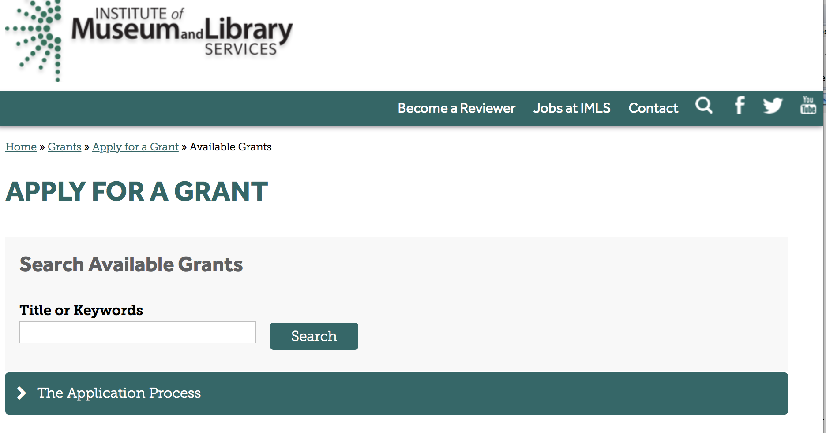

https://www.imls.gov/grants/apply-grant/available-grants

Each grant program has specific eligibility requirements. The links below provide general eligibility criteria for museums, libraries, and tribal organizations, but please note that additional organizations may be eligible for grants under certain programs. Additionally, ineligible organizations may still be able to participate in grant programs through partnerships with eligible organizations. Please click on the links below to see general criteria and review Applications and Guidelines for specific information.
Museums Libraries

Institutions: Archives, Federally Recognized Native American Tribe, Historical Society, Library, Nonprofits that serve Native Hawaiians, Professional Association, Public or Private Non-profit Institutions of Higher Education, Regional Organization, State Library Administrative Agency, State or Local Government

Check out IMLS's Facebook page at:
https://www.facebook.com/USIMLS/

Programs:

Modifications:

Reminders:

Deleted:

Department of the Interior
Working with Interior

The Interior Department provides assistance to the public, local governments and businesses through a number of programs. For a general overview see: http://www.doi.gov/index.cfm

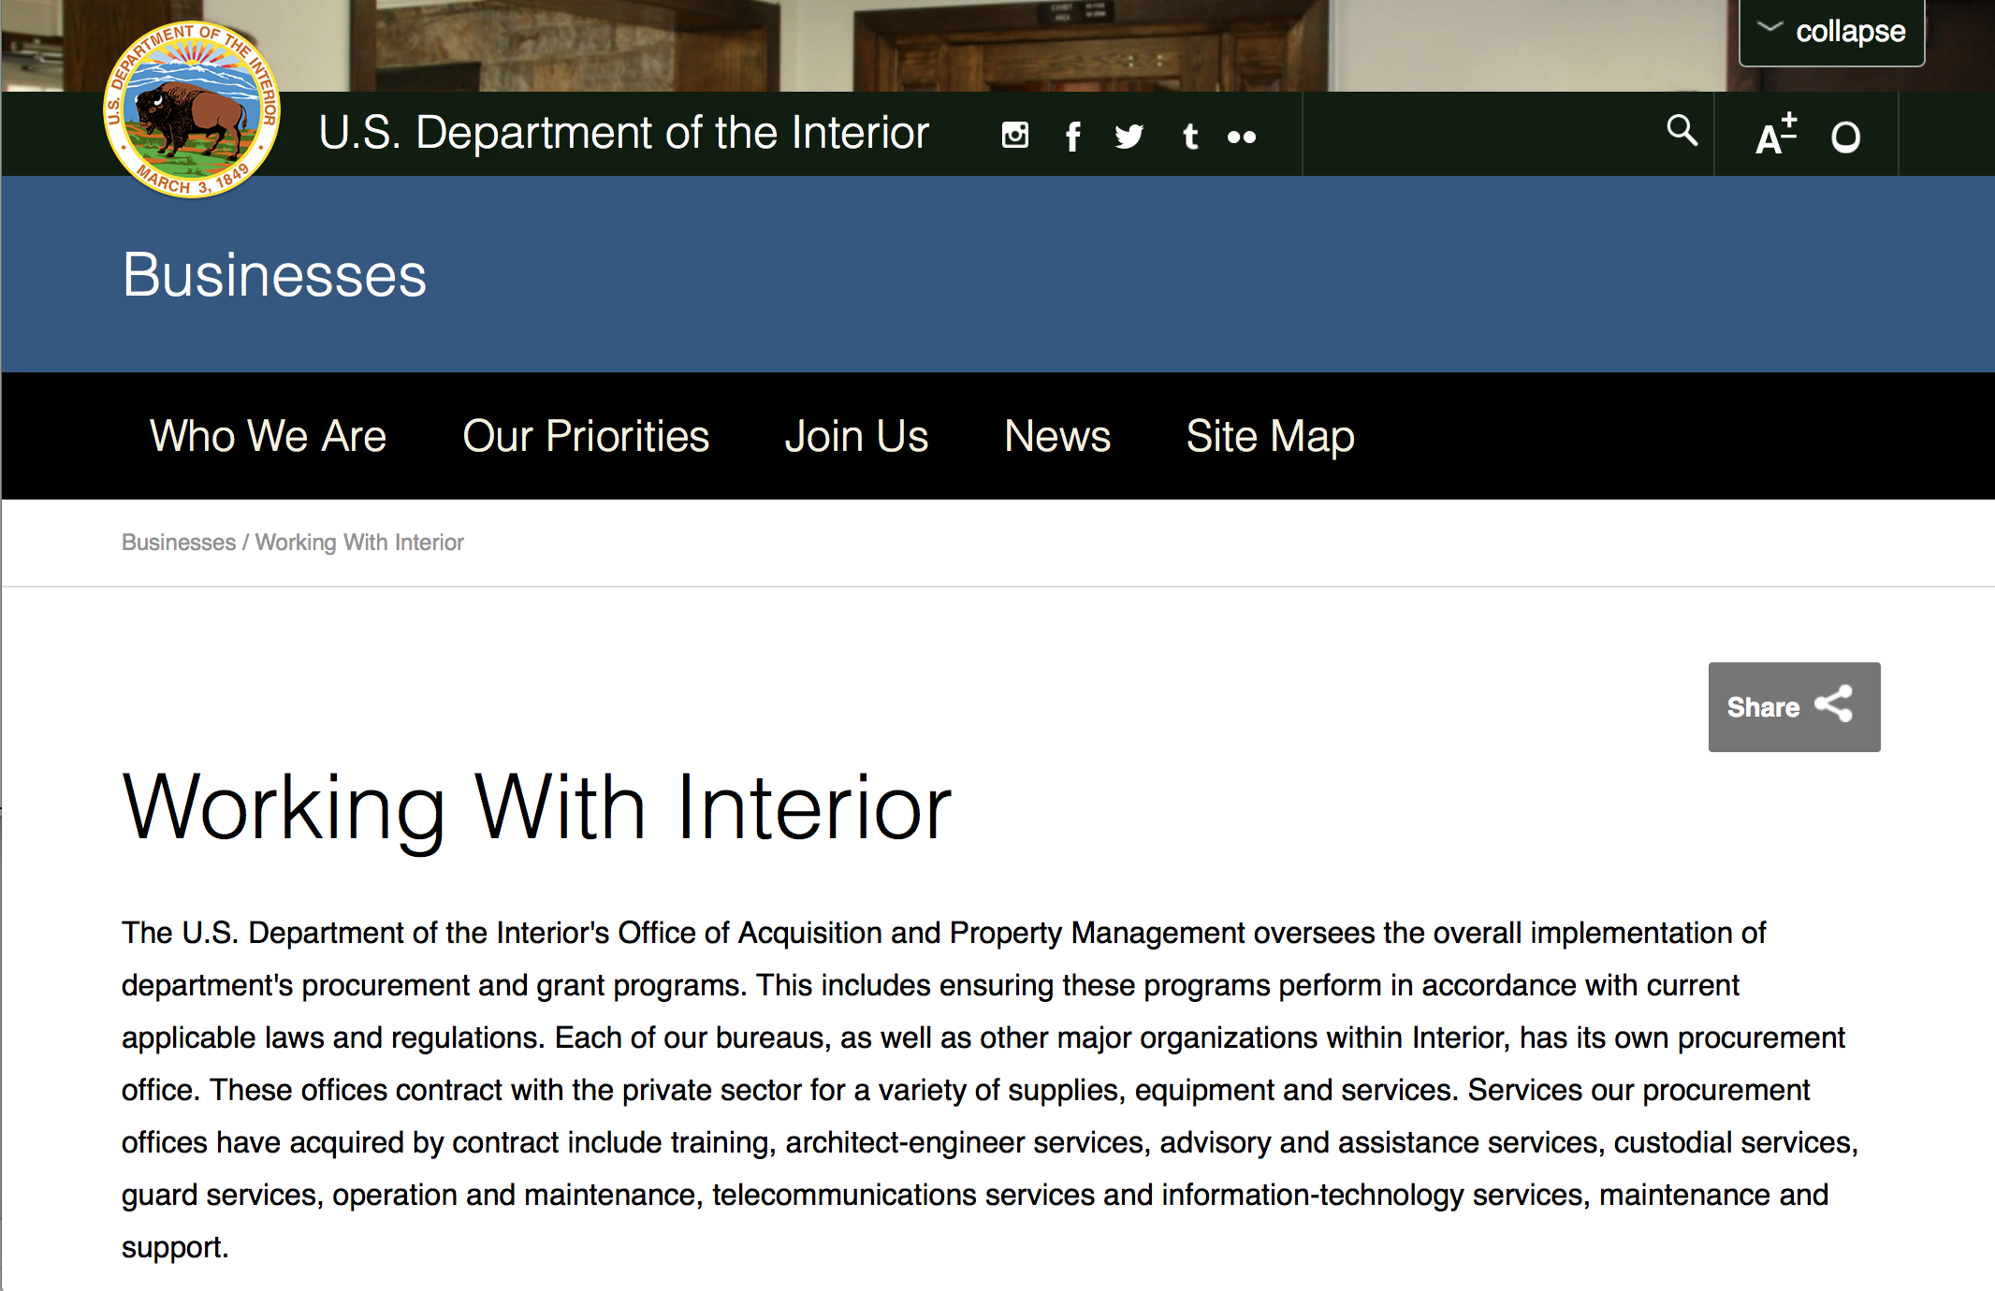

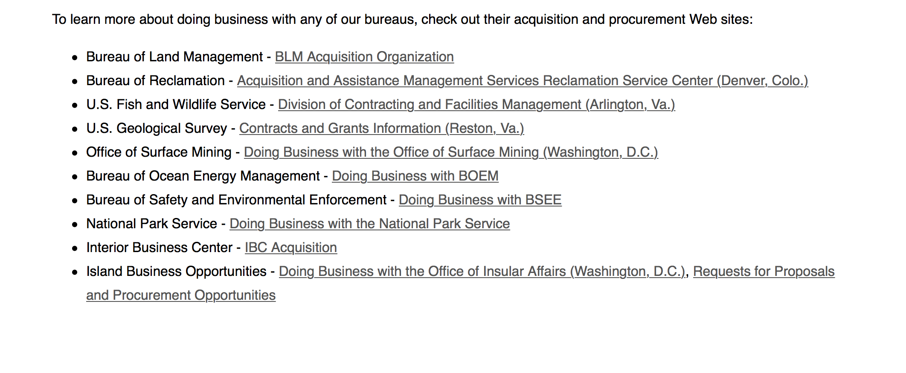
http://www.doi.gov/businesses/working-with-interior.cfm

Programs:

National Park Service
African American Civil Rights (AACR) Preservation Grants
Synopsis 1

Document Type: | Grants Notice
Funding Opportunity Number: | P17AS00578
Funding Opportunity Title: | African American Civil Rights (AACR) Preservation Grants
Opportunity Category: | Discretionary
Opportunity Category Explanation:
Funding Instrument Type: | Grant
Category of Funding Activity: | Arts (see "Cultural Affairs" in CFDA)  Community Development  Humanities (see "Cultural Affairs" in CFDA)  Other (see text field entitled "Explanation of Other Category of Funding Activity" for clarification)
Category Explanation: | Historic Preservation and Cultural Resources
Expected Number of Awards: | 17
CFDA Number(s): | 15.904 -- Historic Preservation Fund Grants-In-Aid
Cost Sharing or Matching Requirement: | No
Version: | Synopsis 1
Posted Date: | Aug 01, 2017
Last Updated Date: | Aug 01, 2017
Original Closing Date for Applications: | Sep 29, 2017 11:59 Pacific Daylight Time
Current Closing Date for Applications: | Sep 29, 2017 11:59 Pacific Daylight Time
Archive Date: | Dec 31, 2017
Estimated Total Program Funding: | $8,400,000
Award Ceiling: | $500,000
Award Floor: | $75,000
Eligible Applicants: | Public and State controlled institutions of higher education  City or township governments  Others (see text field entitled "Additional Information on Eligibility" for clarification)  Nonprofits that do not have a 501(c)(3) status with the IRS, other than institutions of higher education  County governments  Native American tribal governments (Federally recognized)  State governments  Nonprofits having a 501(c)(3) status with the IRS, other than institutions of higher education
Additional Information on Eligibility: | In accordance with the National Historic Preservation Act as amended, 54 USC Â§300101, this funding opportunity is limited to States, Territories, Federally-recognized Tribes, Alaska Natives, and Native Hawaiian Organizations, as defined by 54 USC Â§ 300300, local governments including Certified Local Governments, and non-profit organizations, including non-profit Historically Black College and Universities (HBCUs). Note that HBCUs that do not have a non-profit status should apply in partnership with eligible recipients. A list of CLGs can be found at nps.gov/clg.
Agency Name: | National Park Service
Description: | The National Park Service's (NPS) FY 2017 African American Civil Rights Grant Program (AACR) will document, interpret, and preserve the sites related to the African American struggle to gain equal rights as citizens in the 20th Century. The NPS 2008 report, "Civil Rights in America, A Framework for Identifying Significant Sites," will serve as the reference document in determining the appropriateness of proposed projects and properties. AACR Grants are funded by the Historic Preservation Fund (HPF), administered by the NPS, and will fund a broad range of preservation projects for historic sites including: architectural services, historic structure reports, preservation plans, and physical preservation to structures. Grants are awarded through a competitive process and do not require non-Federal match. ***There are separate funding announcements for physical preservation projects and for historical research/documentation projects. Funding announcement P17AS00578 is for physical projects only.***
Link to Additional Information: | https://www.nps.gov/preservation-grants/civil-rights/
Grantor Contact Information: | If you have difficulty accessing the full announcement electronically, please contact:  Grants Management Specialist Seth Tinkham 202-354-2020 preservation_grants_info@nps.gov  Email preferred.

http://www.grants.gov/web/grants/view-opportunity.html?oppId=296035

National Park Service
African American Civil Rights (AACR) History Grants
Synopsis 1
Document Type: | Grants Notice
Funding Opportunity Number: | P17AS00577
Funding Opportunity Title: | African American Civil Rights (AACR) History Grants
Opportunity Category: | Discretionary
Opportunity Category Explanation:
Funding Instrument Type: | Grant
Category of Funding Activity: | Arts (see "Cultural Affairs" in CFDA)  Community Development  Humanities (see "Cultural Affairs" in CFDA)  Other (see text field entitled "Explanation of Other Category of Funding Activity" for clarification)
Category Explanation: | Cultural Heritage and Historic Preservation
Expected Number of Awards: | 50
CFDA Number(s): | 15.904 -- Historic Preservation Fund Grants-In-Aid
Cost Sharing or Matching Requirement: | No
Version: | Synopsis 1
Posted Date: | Aug 01, 2017
Last Updated Date: | Aug 01, 2017
Original Closing Date for Applications: | Sep 29, 2017 Applications must be received through grants.gov by 11:59 pm Pacific Daylight Time or they will not be considered for funding.
Current Closing Date for Applications: | Sep 29, 2017 Applications must be received through grants.gov by 11:59 pm Pacific Daylight Time or they will not be considered for funding.
Archive Date: | Dec 31, 2017
Estimated Total Program Funding: | $4,210,000
Award Ceiling: | $50,000
Award Floor: | $15,000
Eligible Applicants: | Nonprofits having a 501(c)(3) status with the IRS, other than institutions of higher education  County governments  Others (see text field entitled "Additional Information on Eligibility" for clarification)  City or township governments  State governments  Native American tribal governments (Federally recognized)  Nonprofits that do not have a 501(c)(3) status with the IRS, other than institutions of higher education
Additional Information on Eligibility: | In accordance with the National Historic Preservation Act as amended, 54 USC Â§300101, this funding opportunity is limited to States, Territories, Federally-recognized Tribes, Alaska Natives, and Native Hawaiian Organizations, as defined by 54 USC Â§ 300300, local governments including Certified Local Governments, and non-profit organizations, including non-profit Historically Black College and Universities (HBCUs). Note that HBCUs that do not have a non-profit status should apply in partnership with eligible recipients. A listing of Certified Local Governments may be found at nps.gov/clg.
Agency Name: | National Park Service
Description: | The National Park Service's (NPS) FY 2017 African American Civil Rights Grant Program (AACR) will document, interpret, and preserve the sites related to the African American struggle to gain equal rights as citizens in the 20th Century. The NPS 2008 report, "Civil Rights in America, A Framework for Identifying Significant Sites," will serve as the reference document in determining the appropriateness of proposed projects and properties. AACR Grants are funded by the Historic Preservation Fund (HPF) administered by the NPS. Grants will fund a broad range of planning and research projects for historic sites including: survey, inventory, documentation, interpretation, and education. Grants are awarded through a competitive process and do not require non-Federal match. ***There are separate funding announcements for physical preservation projects and for historical research/documentation projects. Funding announcement P17AS00577 is for historical research/documentation projects only.***
Link to Additional Information: | https://www.nps.gov/preservation-grants/civil-rights/
Grantor Contact Information: | If you have difficulty accessing the full announcement electronically, please contact:  Grants Management Specialist Seth Tinkham 202-354-2020 preservation_grants_info@nps.gov  Email preferred for questions.

http://www.grants.gov/web/grants/view-opportunity.html?oppId=296029

Modifications:

Geological Survey
3D Elevation Program (3DEP)
Synopsis 2
Document Type: | Grants Notice
Funding Opportunity Number: | G17AS00116
Funding Opportunity Title: | 3D Elevation Program (3DEP)
Opportunity Category: | Discretionary
Opportunity Category Explanation:
Funding Instrument Type: | Cooperative Agreement  Grant  Procurement Contract
Category of Funding Activity: | Environment  Natural Resources  Science and Technology and other Research and Development
Category Explanation:
Expected Number of Awards: | 0
CFDA Number(s): | 15.817 -- National Geospatial Program: Building The National Map
Cost Sharing or Matching Requirement: | Yes
Version: | Synopsis 2
Posted Date: | Aug 16, 2017
Last Updated Date: | Aug 16, 2017
Original Closing Date for Applications: | Sep 30, 2018 Proposals for lidar acquisition are due by 5:00PM ET on 20 October, 2017. The BAA will remain open and proposals received after the initial due date will be considered for review until 30 September 2018.
Current Closing Date for Applications: | Sep 30, 2018 Proposals for lidar acquisition are due by 5:00PM ET on 20 October, 2017. The BAA will remain open and proposals received after the initial due date will be considered for review until 30 September 2018 or until such time as the BAA is cancelled through an amendment or another BAA is issued; additional selections will be made depending on availability of funding and evaluation of proposals consistent with the evaluation criteria provided herein.
Archive Date: | Oct 31, 2018
Estimated Total Program Funding: | $0
Award Ceiling:
Award Floor: | $0
Eligible Applicants: | Independent school districts  Native American tribal governments (Federally recognized)  State governments  Small businesses  Individuals  City or township governments  County governments  Special district governments  Private institutions of higher education  Nonprofits that do not have a 501(c)(3) status with the IRS, other than institutions of higher education  Public and State controlled institutions of higher education  Native American tribal organizations (other than Federally recognized tribal governments)  Nonprofits having a 501(c)(3) status with the IRS, other than institutions of higher education  For profit organizations other than small businesses
Additional Information on Eligibility: | Single entities or teams from Federal agencies, state and local governments, tribes, academic institutions and the private sector are eligible to submit proposals. Historically Black Colleges and Universities (HBCU), Minority Institutions (MI), Small Business concerns, Small Disadvantaged Business concerns, Women-Owned Small Business concerns, Veteran-Owned Small Business concerns, Service-Disabled Veteran-Owned Small Business concerns, and HUB Zone Small Business concerns are encouraged to submit proposals and to join other entities as team members in submitting proposals.
Agency Name: | Geological Survey
Description: | 3DEP was developed to respond to needs for high-quality topographic data and for a wide range of other three-dimensional representations of the Nation's natural and constructed features. This Broad Agency Announcement (BAA) is issued to facilitate the collection of lidar and derived elevation data for the 3D Elevation Program (3DEP). The BAA continues the USGS's long-standing approach to elevation data acquisition through a combination of contracting through the USGS Geospatial Products and Services Contracts (GPSC) and partner acquisitions. The BAA is meant to provide increased visibility to these existing processes for data acquisition partnerships to the broadest stakeholder community possible.
Link to Additional Information: | https://www.grants.gov/
Grantor Contact Information: | If you have difficulty accessing the full announcement electronically, please contact:  gs_baa@usgs.gov  USGS Contact

http://www.grants.gov/web/grants/view-opportunity.html?oppId=296530

Reminders:

National Fish Passage Program
Synopsis 1

Document Type: | Grants Notice
Funding Opportunity Number: | F17AS00030
Funding Opportunity Title: | National Fish Passage Program
Opportunity Category: | Discretionary
Opportunity Category Explanation:
Funding Instrument Type: | Cooperative Agreement  Grant
Category of Funding Activity: | Natural Resources
Category Explanation:
Expected Number of Awards: | 0
CFDA Number(s): | 15.608 -- Fish and Wildlife Management Assistance
Cost Sharing or Matching Requirement: | Yes
Posted Date: | Nov 23, 2016
Last Updated Date: | Nov 23, 2016
Original Closing Date for Applications: | Sep 30, 2017
Current Closing Date for Applications: | Sep 30, 2017
Archive Date: | Oct 02, 2017
Estimated Total Program Funding: | $0
Award Ceiling: | $2,000,000
Award Floor: | $500
Eligible Applicants: | Unrestricted (i.e., open to any type of entity above), subject to any clarification in text field entitled "Additional Information on Eligibility"
Additional Information on Eligibility: | To receive funding, NFPP projects must be implemented in coordination with FAC staff. Applicants can be, but not limited to: state and federal agencies, private lands, tribes, local municipalities, and non-governmental organizations.
Agency Name: | Fish and Wildlife Service
Description: | The National Fish Passage Program (NFPP) is a voluntary program that provides direct technical assistance and financial assistance in the form of cooperative agreements and grants to partners to provide fish (and other aquatic organisms) passage and restore aquatic connectivity for the benefit of federal trust resources. The NFPP is delivered through more than 65 Fisheries and Aquatic Conservation (FAC) Field Offices across all States and territories. FAC staff coordinates with project partners, stakeholders and other Service programs to identify and collaboratively implement projects within Regional priority areas. Project work plans are developed strategically, in coordination with partners, and with substantial involvement from FAC staff. Projects must advance our mission, promote biological diversity, and be based upon sound scientific biological principles. FAC and Fish and Wildlife Service (FWS) strategic plans inform the types of projects funded under this opportunity. Applicants seeking funding under this program should review the program strategic plan and also contact the regional NFPP Coordinator for local FAC contacts prior to submitting an application for funding.
Link to Additional Information: | http://www.grants.gov
Grantor Contact Information: | If you have difficulty accessing the full announcement electronically, please contact:  Susan Wells 703-358-2523 Susan_Wells@fws.gov  Fish Passage Coordinator

http://www.grants.gov/web/grants/view-opportunity.html?oppId=290297

Fish and Wildlife Service
Partners for Fish and Wildlife
Synopsis 1

Document Type: | Grants Notice
Funding Opportunity Number: | F17AS00015
Funding Opportunity Title: | Partners for Fish and Wildlife
Opportunity Category: | Discretionary
Opportunity Category Explanation:
Funding Instrument Type: | Cooperative Agreement
Category of Funding Activity: | Community Development  Education  Environment  Natural Resources
Category Explanation:
Expected Number of Awards: | 5000
CFDA Number(s): | 15.631 -- Partners for Fish and Wildlife
Cost Sharing or Matching Requirement: | No
Posted Date: | Nov 03, 2016
Last Updated Date: | Nov 03, 2016
Original Closing Date for Applications: | Sep 30, 2017
Current Closing Date for Applications: | Sep 30, 2017
Archive Date: | Oct 07, 2017
Estimated Total Program Funding: | $52,000,000
Award Ceiling: | $500,000
Award Floor: | $1
Eligible Applicants: | For profit organizations other than small businesses  Nonprofits having a 501(c)(3) status with the IRS, other than institutions of higher education  City or township governments  Native American tribal organizations (other than Federally recognized tribal governments)  State governments  Individuals  Small businesses  Public and State controlled institutions of higher education  Nonprofits that do not have a 501(c)(3) status with the IRS, other than institutions of higher education  Native American tribal governments (Federally recognized)  County governments  Private institutions of higher education
Agency Name: | Fish and Wildlife Service
Description: | The Partners for Fish and Wildlife (PFW) Program is a voluntary, incentive-based program that provides direct technical assistance and financial assistance in the form of cooperative agreements to private landowners to restore and conserve fish and wildlife habitat for the benefit of federal trust resources. The PFW Program is delivered through more than 250 full-time staff, active in all 50 States and territories. Partners for Fish and Wildlife Program staff coordinate with project partners, stakeholders and other Service programs to identify geographic focus areas and develop habitat conservation priorities within these focus areas. Geographic focus areas are where the PFW Program directs resources to conserve habitat for federal trust species. Project work plans are developed strategically, in coordination with partners, and with substantial involvement from Service field staff. Projects must advance our mission, promote biological diversity, and be based upon sound scientific biological principles. Program strategic plans inform the types of projects funded under this opportunity. Applicants seeking funding under this program should review the program strategic plan and also contact the regional PFW Program office prior to submitting an application for funding. Authorizing statutes include Partners for Fish and Wildlife Act of 2006, 16 U.S.C. 3771-3774; Fish and Wildlife Act of 1956; 16 U.S.C. 742a-c, 742e-j; Fish and Wildlife Coordination Act of 1958, 16 U.S.C. 661-667(e).
Link to Additional Information: | http://www.grants.gov
Grantor Contact Information: | If you have difficulty accessing the full announcement electronically, please contact:  Matthew Filsinger 703-358-2011 matthew_filsinger@fws.gov  Project Officer

http://www.grants.gov/web/grants/view-opportunity.html?oppId=289882

Fish and Wildlife Service
Coastal Program
Synopsis 1

Document Type: | Grants Notice
Funding Opportunity Number: | F17AS00014
Funding Opportunity Title: | Coastal Program
Opportunity Category: | Discretionary
Opportunity Category Explanation:
Funding Instrument Type: | Cooperative Agreement
Category of Funding Activity: | Community Development  Education  Environment  Natural Resources
Category Explanation:
Expected Number of Awards: | 500
CFDA Number(s): | 15.630 -- Coastal
Cost Sharing or Matching Requirement: | No
Posted Date: | Nov 03, 2016
Last Updated Date: | Nov 03, 2016
Original Closing Date for Applications: | Sep 30, 2017
Current Closing Date for Applications: | Sep 30, 2017
Archive Date: | Oct 07, 2017
Estimated Total Program Funding: | $14,000,000
Award Ceiling: | $500,000
Award Floor: | $1
Eligible Applicants: | County governments  Nonprofits having a 501(c)(3) status with the IRS, other than institutions of higher education  City or township governments  Special district governments  Native American tribal governments (Federally recognized)  Private institutions of higher education  Native American tribal organizations (other than Federally recognized tribal governments)  For profit organizations other than small businesses  State governments  Small businesses  Public and State controlled institutions of higher education  Individuals  Nonprofits that do not have a 501(c)(3) status with the IRS, other than institutions of higher education
Agency Name: | Fish and Wildlife Service
Description: | The Coastal Program is a voluntary, incentive-based program that provides direct technical assistance and financial assistance in the form of cooperative agreements to coastal communities and landowners to restore and protect fish and wildlife habitat on public and private lands. Coastal Program staff coordinate with project partners, stakeholders and other Service programs to identify geographic focus areas and develop habitat conservation priorities within these focus areas. Geographic focus areas are where the Coastal Program directs resources to conserve habitat for federal trust species. Project work plans are developed strategically, in coordination with partners, and with substantial involvement from Service field staff. Projects must advance our mission, promote biological diversity, and be based upon sound scientific biological principles. Program strategic plans inform the types of projects funded under this opportunity. Applicants seeking funding under this program should review the program strategic plan and also contact the regional Coastal Program office prior to submitting an application for funding. Authorizing statues include Fish and Wildlife Act of 1956, 16 U.S.C. 742a-c, 747e-742j; and Fish and Wildlife Coordination Act of 1958, 16 U.S.C. 661 667(e).
Link to Additional Information: | http://www.grants.gov
Grantor Contact Information: | If you have difficulty accessing the full announcement electronically, please contact:  Chris Darnell 703-358-2236 chris_darnell@fws.gov  Project Officer

http://www.grants.gov/web/grants/view-opportunity.html?oppId=289863

Deleted:

Department of Justice

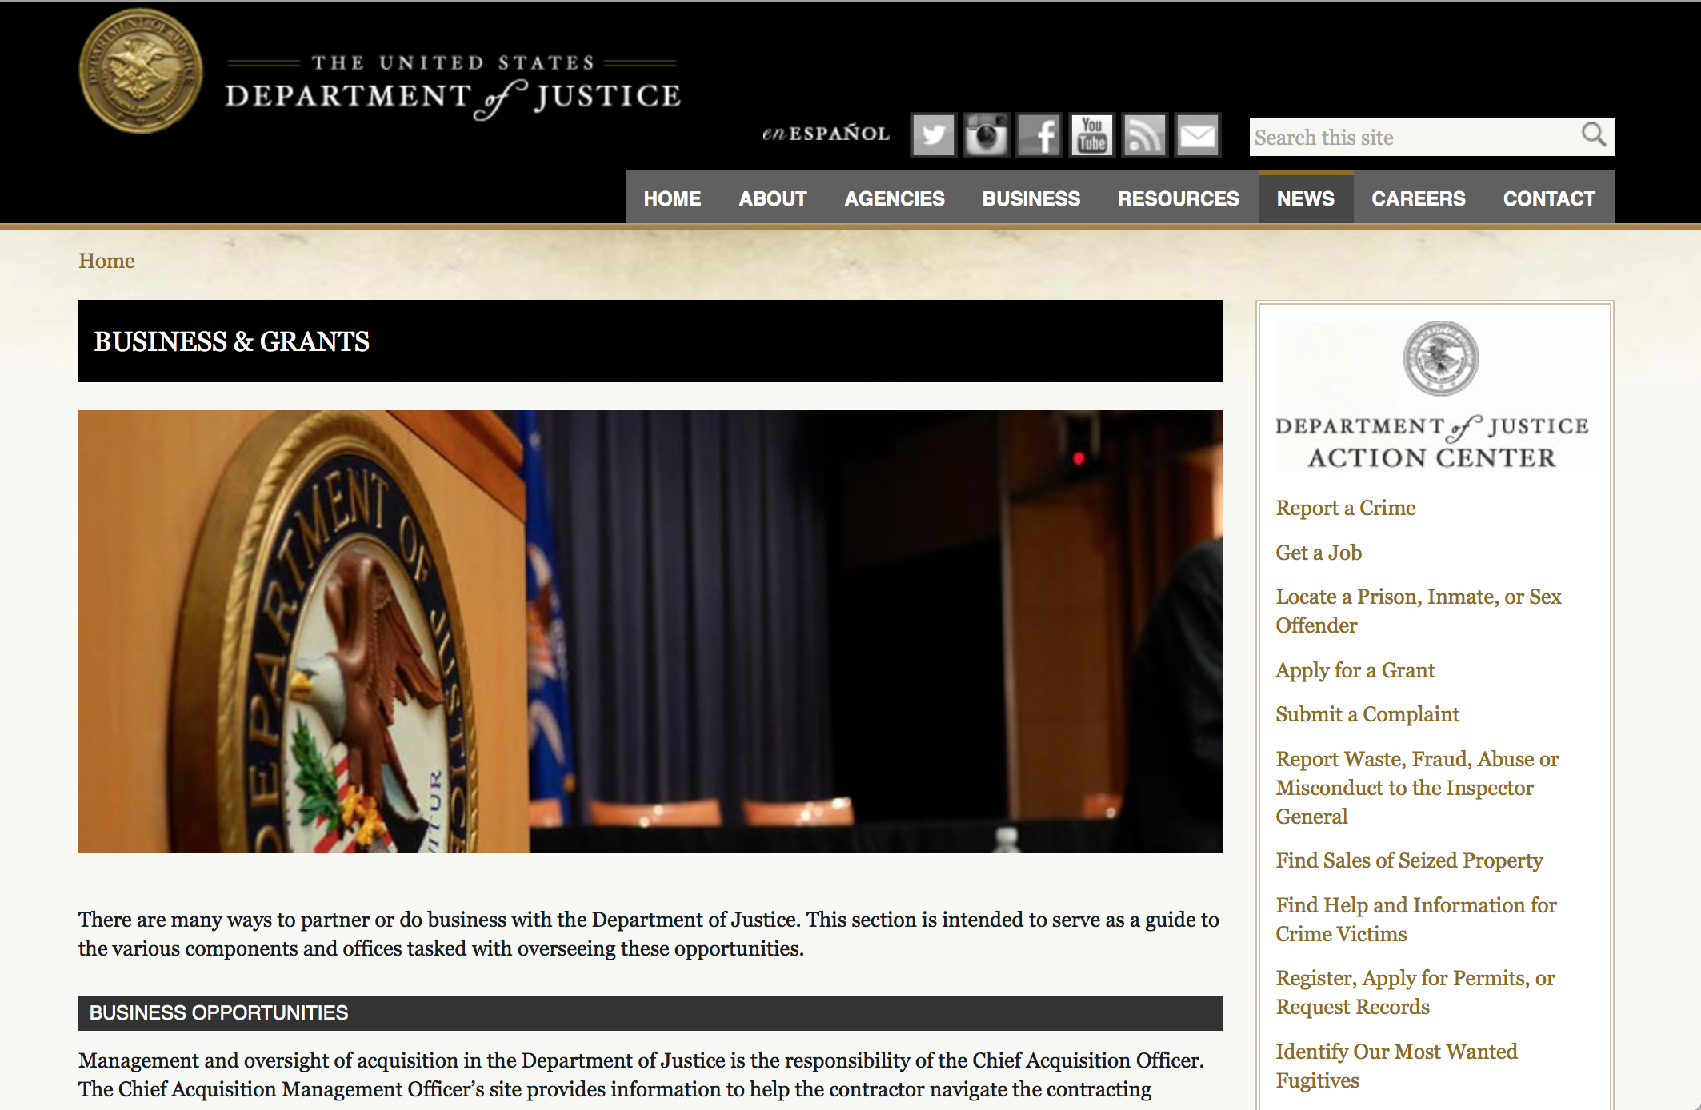

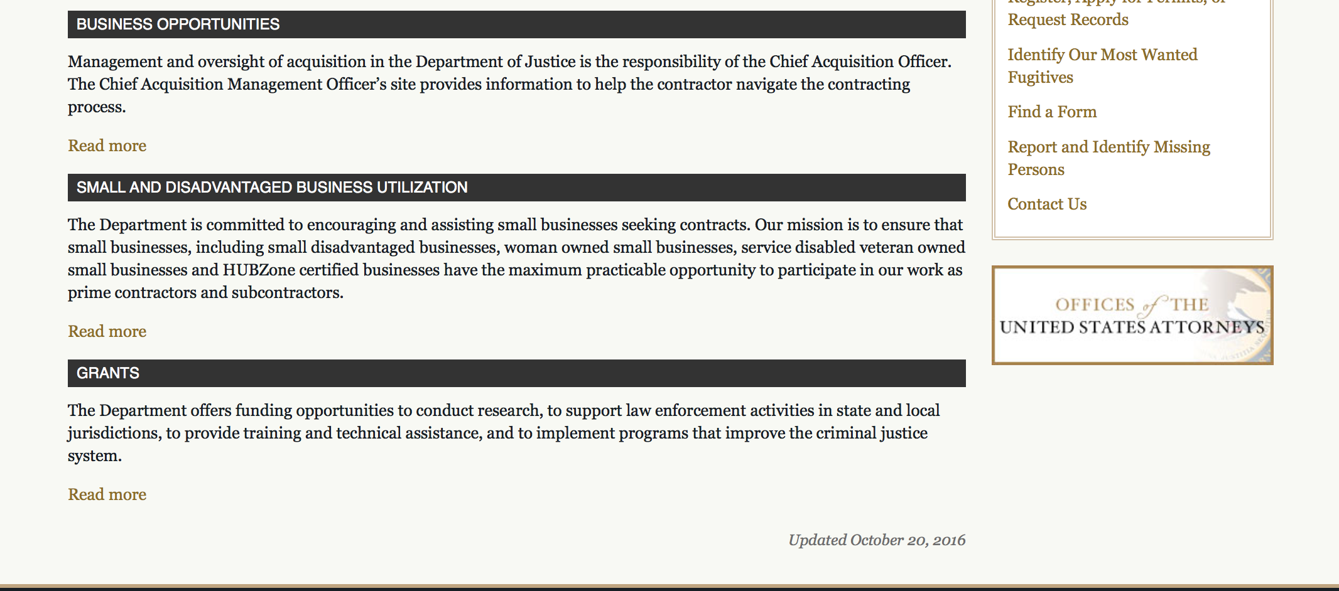

The DOJ agencies listed below also have sites that provide grant information specific to that agency. Examples of what can be found on these sites are programs, funding opportunities, application assistance, and other useful information.

Bureau of Justice Assistance (BJA)

Bureau of Justice Statistics (BJS)

National Criminal Justice Reference Service (NCJRS)

National Institute of Justice (NIJ)

Office of Sex Offender Sentencing, Monitoring, Apprehending, Registering, and Tracking (SMART)

http://www.justice.gov/business/

Programs:

Research:

Modifications:

Deleted:

Reminders:



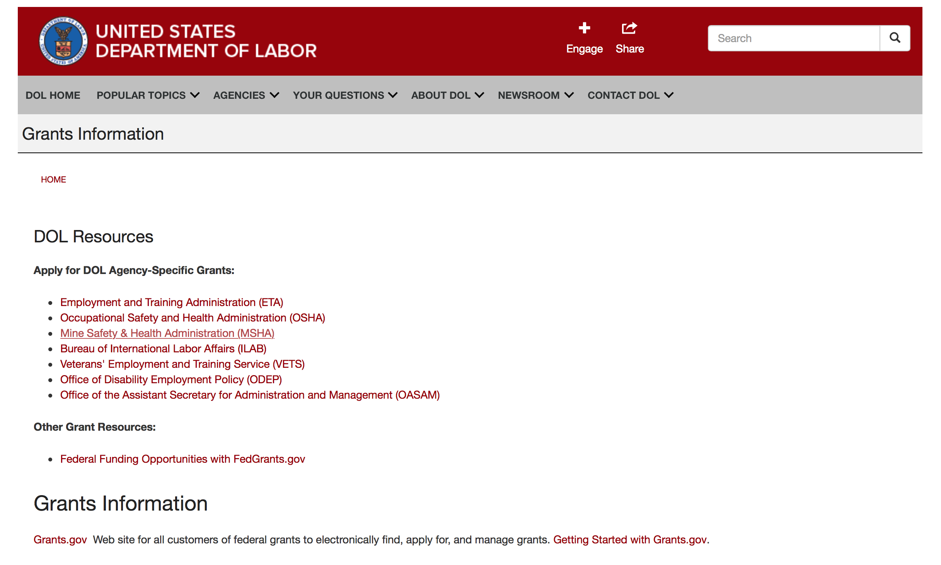

Agency Grants and Contract General Overview

DOL Resources
Apply for DOL Agency-Specific Grants:
- Employment and Training Administration (ETA)
- Occupational Safety and Health Administration (OSHA)
- Mine Safety & Health Administration (MSHA)
- Bureau of International Labor Affairs (ILAB)
- Veterans' Employment and Training Service (VETS)
- Office of Disability Employment Policy (ODEP)
- Office of the Assistant Secretary for Administration and Management (OASAM)

Other Grant Resources:
- Federal Funding Opportunities with FedGrants.gov
Grants Information
Grants.gov — Web site for all customers of federal grants to electronically find, apply for, and manage grants. Getting Started with Grants.gov.

DOL Resources and Instructions for Applying for a Grant
- DOL Guidance Clarifying the Effect of the Religious Freedom Restoration Act on Faith-Based Organizations
- Grant and Contract Information
- Contracting and Grant Program Overview
- Civil Rights Enforcement for Department of Labor Grant Recipients
- More Information About Grants
- Use of Contracts, Grants & Cooperative Agreements

Other Federal Government Grant Information
- Grant Opportunities (Catalog of Federal Domestic Assistance)

Department of Labor Grant Programs

- Bureau of International Labor Affairs (ILAB): provides grants (cooperative agreements) for the implementation of projects designed to assist developing countries combat the worse forms of child labor, forced labor, and human trafficking; and support worker rights and improve working conditions. http://www.dol.gov/general/business.
- Bureau of Labor Statistics (BLS): provides project grants (cooperative agreements) and the dissemination of technical statistical data and related information on labor force activities; provides data on prices (CPI) and cost of living; data on productivity and technology data; data on compensation and working conditions; data on employment projections.
- Employment and Training (ETA): ETA administers financial assistance programs pursuant to the Workforce Investment Act (WIA), administering State formula grant programs for youth, adults and dislocated workers, national emergency grants for workers affected by mass layoffs, plant closures, and disasters; grant programs for workers with disabilities, Indians and Native Americans, and for migrant and seasonal farmworkers. ETA also administers grant programs for older American workers, apprenticeship programs, Trade Adjustment Assistance (TAA) programs, and assistance for research and development of workforce programs. In addition, ETA is responsible for the operation and maintenance of a national system of public employment service offices and for the national unemployment insurance program.
- Mine Safety and Health (MSHA): provides grants for research, education and training programs to ensure an adequate and competent staff of trained inspectors; and assistance for establishing or improving State mine health and safety programs through technical assistance.
- Occupational Safety and Health (OSHA): provides grants to non-profit organizations to provide training, educational services, and technical assistance; assistance to states to administer and enforce state programs; assistance to states to provide occupational safety and health technical assistance and consultant services.
- Office of Disability Employment Policy (ODEP): The Office of Disability Employment Policy awards competitive grants establishing short-term pilot and technical assistance projects designed to identify, develop, test, evaluate, and disseminate policies to increase employment by expanding access to training, education, employment supports, assistive and systems technology, integrated employment, entrepreneurial development, and small business opportunities for adults and youth with disabilities. Current pilots projects focus on customized employment, Olmstead populations, and innovative demonstration youth grants, among others. Solicitations for grant applications are published in the Federal Register and announced at www.dol.gov/odep. ODEP grants are awarded by the OASAM grant office.
- Veterans' Employment and Training (VETS): provides special employment and training assistance for veterans through the Disabled Veterans' Outreach Program (DVOP) Solicitation for Grant Applications; the Local Veterans' Employment Representative Program (LVER); Veterans' Workforce Investment Program (VWIP); elaws Advisor on veterans' employment and reemployment rights; and the Homeless Veterans Reintegration Project (HVRP). VETS grants are awarded by the OASAM grant office.

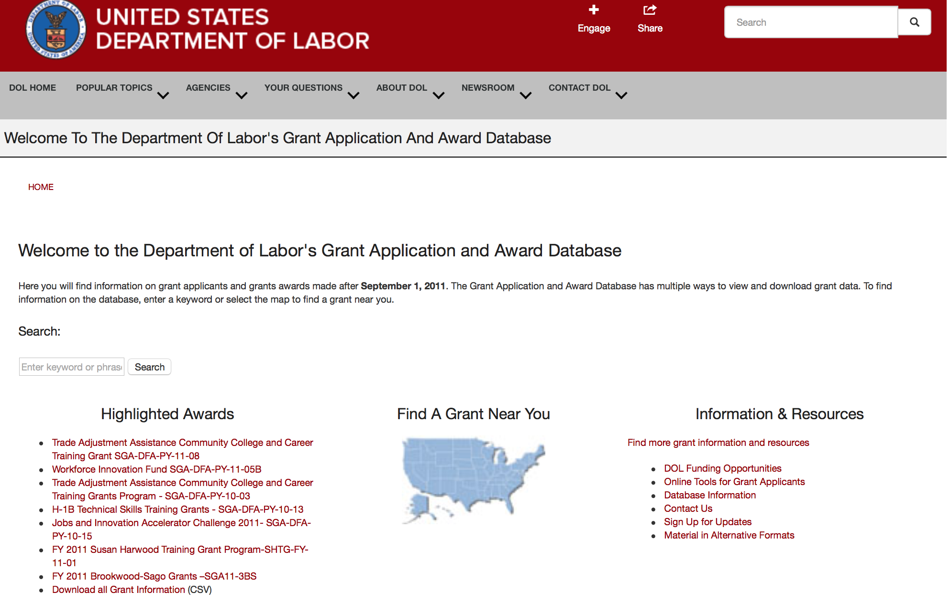

http://www.dol.gov/dol/grants/

Programs

Modifications

Reminders



National Aeronautics and Space Administration

Research and Contracting Opportunities

NASA Research Opportunities Online

- Various NASA offices publish their research announcements over the Internet, broadening the opportunity for researchers to apply for funding. This site provides access to current research announcements along with their specific due dates.

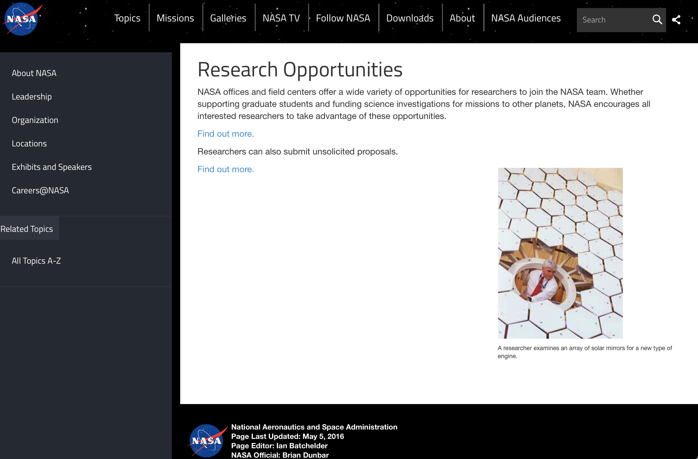

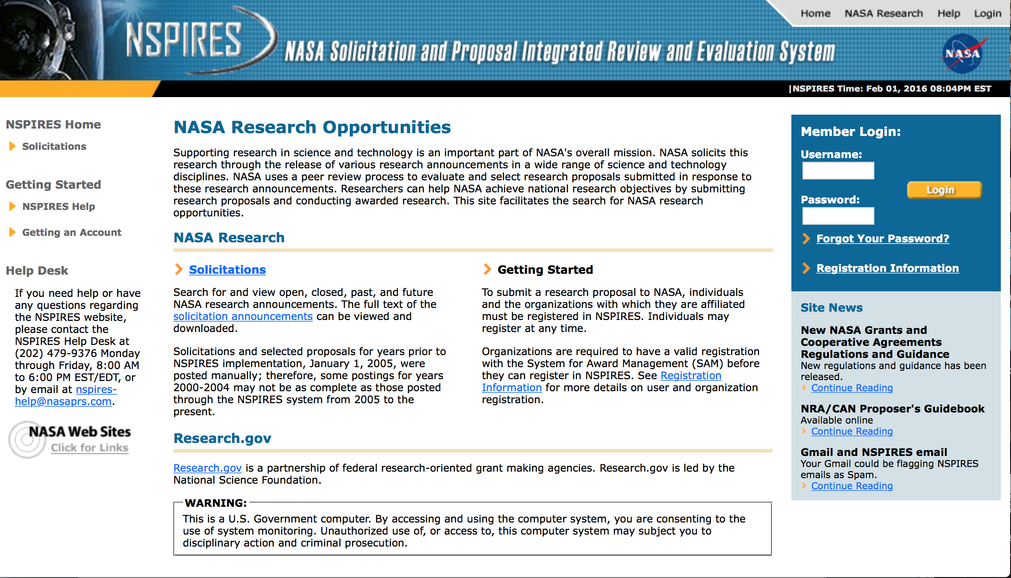
http://nspires.nasaprs.com/external/

Research Programs:

NASA Headquarters
Use of the NASA Physical Sciences Informatics System - Appendix D
Synopsis 1
http://www.grants.gov/web/grants/view-opportunity.html?oppId=297032

NASA Headquarters
ROSES 2017: Ocean Vector Winds Science Team
Synopsis 1
http://www.grants.gov/web/grants/view-opportunity.html?oppId=296984

NASA Johnson Space Center
Appendix A: NASA Research and Technology Development to Support Crew Health and Performance in Space Exploration Missions
Synopsis 1
http://www.grants.gov/web/grants/view-opportunity.html?oppId=296078

NASA Headquarters
ROSES 2017: Earth Science Applications: Health and Air Quality
Synopsis 1
http://www.grants.gov/web/grants/view-opportunity.html?oppId=296313

NASA Headquarters
ROSES 2017: SAGE III/ISS Science Team
Synopsis 1
http://www.grants.gov/web/grants/view-opportunity.html?oppId=296294

NASA Headquarters
ROSES 2017: CYGNSS Competed Science Team
Synopsis 1
http://www.grants.gov/web/grants/view-opportunity.html?oppId=296369

NASA Headquarters
ROSBio Appendix D: Solicitation of Proposals to Conduct Research Using Microgravity Simulation Devices
Synopsis 1
http://www.grants.gov/web/grants/view-opportunity.html?oppId=296545

NASA Headquarters
ROSBio Appendix E: Solicitation of Proposals to Conduct Research In Parabolic and Suborbital Flights
Synopsis 1
http://www.grants.gov/web/grants/view-opportunity.html?oppId=296546

NASA Headquarters
ROSES 2017: Planetary Instrument Concepts for the Advancement of Solar System Observations
Synopsis 1
http://www.grants.gov/web/grants/view-opportunity.html?oppId=296248

NASA Headquarters
ROSBio Appendix F: Solicitation of Proposals to Conduct Research on Antarctic Balloon Flights
Synopsis 1
http://www.grants.gov/web/grants/view-opportunity.html?oppId=296548

Modifications:

NASA Headquarters
ROSES 2017: Discovery Data Analysis Program
Synopsis 2
http://www.grants.gov/web/grants/view-opportunity.html?oppId=296349

NASA Headquarters
ROSES 2017: Rosetta Data Analysis Program
Synopsis 2
http://www.grants.gov/web/grants/view-opportunity.html?oppId=296371

NASA Headquarters
ROSES 2017: Science Team for the OCO Missions
Synopsis 2
http://www.grants.gov/web/grants/view-opportunity.html?oppId=295593

NASA Headquarters
ROSES 2017: Planetary Protection Research
Synopsis 2
http://www.grants.gov/web/grants/view-opportunity.html?oppId=296176

NASA Headquarters
ROSES 2017: Ocean Salinity Science Team
Synopsis 2
http://www.grants.gov/web/grants/view-opportunity.html?oppId=296314

NASA Headquarters
ROSES 2017: New (Early Career) Investigator Program
Synopsis 3
http://www.grants.gov/web/grants/view-opportunity.html?oppId=293790

NASA Headquarters
ROSES 2017: Heliophysics Supporting Research
Synopsis 3
http://www.grants.gov/web/grants/view-opportunity.html?oppId=294198

NASA Headquarters
ROSES 2017: Planetary Science and Technology Through Analog Research
Synopsis 2
http://www.grants.gov/web/grants/view-opportunity.html?oppId=294955

NASA Headquarters
ROSBio Appendix C: Solicitation of Proposals for Possible Inclusion in a Russian Bion-M2 Mission
Synopsis 3 & 5
http://www.grants.gov/web/grants/view-opportunity.html?oppId=295500

NASA Headquarters
SpaceTech-REDDI-2017 Appendix E1: Smallsat Technology Partnerships
Synopsis 2
http://www.grants.gov/web/grants/view-opportunity.html?oppId=295623

NASA Johnson Space Center
2017 Human Exploration Research Opportunities (HERO)
Synopsis 6
http://www.grants.gov/web/grants/view-opportunity.html?oppId=295274

NASA Johnson Space Center
EXPLORATION TECHNOLOGY DEMONSTRATION AND NATIONAL LAB UTILIZATION ENHANCEMENTS
Synopsis 9
http://www.grants.gov/web/grants/view-opportunity.html?oppId=207073

NASA Headquarters
SpaceTech-REDDI-2017 Appendix E1: Smallsat Technology Partnerships
Synopsis 3
http://www.grants.gov/web/grants/view-opportunity.html?oppId=295623

NASA Headquarters
ROSBio Appendix C: Solicitation of Proposals for Possible Inclusion in a Russian Bion-M2 Mission
Synopsis 4
http://www.grants.gov/web/grants/view-opportunity.html?oppId=295500

National Archives and Records Administration

Grant Opportunities General Overview

To access the information below: click here

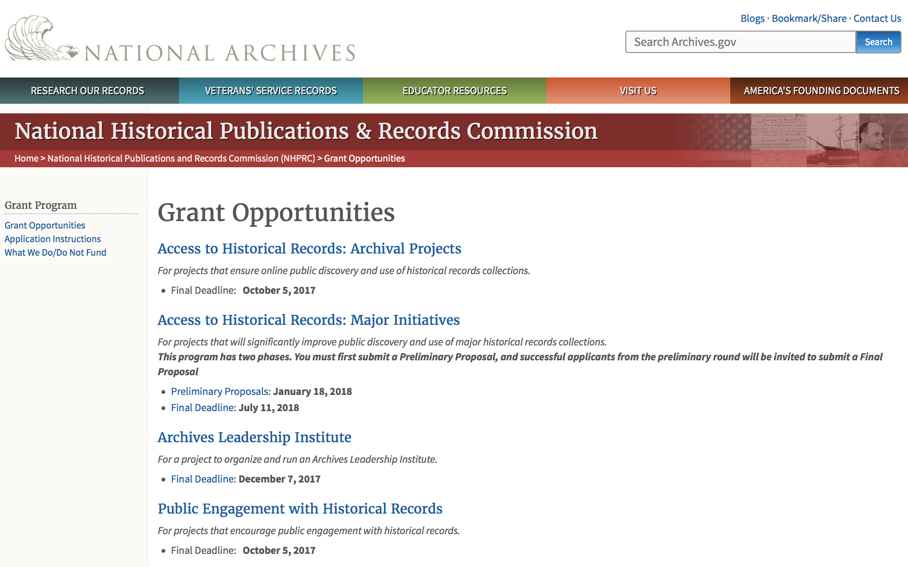

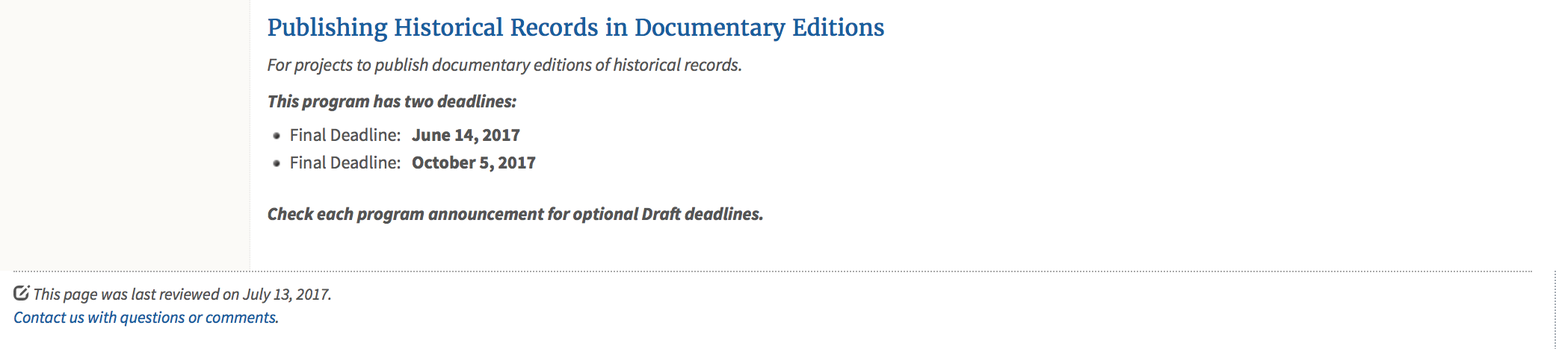
https://www.archives.gov/nhprc/announcement

Programs:

Reminders:

Access to Historical Records: Major Initiatives (Preliminary)
Synopsis 1

Document Type: | Grants Notice
Funding Opportunity Number: | PRELIM-201801
Funding Opportunity Title: | Access to Historical Records: Major Initiatives (Preliminary)
Opportunity Category: | Discretionary
Opportunity Category Explanation:
Funding Instrument Type: | Grant
Category of Funding Activity: | Humanities (see "Cultural Affairs" in CFDA)
Category Explanation:
Expected Number of Awards: | 5
CFDA Number(s): | 89.003 -- National Historical Publications and Records Grants
Cost Sharing or Matching Requirement: | Yes
Version: | Synopsis 3
Posted Date: | Jul 14, 2017
Last Updated Date: | Jul 24, 2017
Original Closing Date for Applications: | Jan 18, 2018
Current Closing Date for Applications: | Jan 18, 2018
Archive Date:
Estimated Total Program Funding: | $1,000,000
Award Ceiling: | $350,000
Award Floor: | $100,000
Eligible Applicants: | State governments  County governments  Nonprofits having a 501(c)(3) status with the IRS, other than institutions of higher education  Private institutions of higher education  Native American tribal governments (Federally recognized)  Public and State controlled institutions of higher education  City or township governments
Agency Name: | National Archives and Records Administration
Description: | The National Historical Publications and Records Commission seeks projects that will significantly improve public discovery and use of major historical records collections. All types of historical records are eligible, including documents, photographs, born-digital records, and analog audio and moving images. Projects may: • Digitize historical records collections, or related collections, held by a single institution and make them freely available online• Provide access to born-digital records• Create new freely-available virtual collections drawn from historical records held by multiple institutions• Create new tools and methods for users to access records The NHPRC welcomes collaborative projects, particularly for bringing together related records from multiple institutions. Projects that address significant needs in the field and result in replicable and scalable approaches will be more competitive. We also encourage organizations to actively engage the public in the work of the project. Applicants should also consult Access to Historical Records: Archival Projects program, which has different requirements and award amounts. For a comprehensive list of Commission limitations on funding, please see: "What we do and do not fund" (http://www.archives.gov/nhprc/apply/eligibility.html). Applications that consist entirely of ineligible activities will not be considered. Award Information A grant is for one to three years and for between $100,000 and $350,000. We expect to make up to five grants in this category for a total of up to $1,000,000. Grants begin no earlier than January 1, 2019.The Commission requires that grant recipients acknowledge NHPRC grant assistance in all publications and other products that result from its support. Eligibility Eligible applicants:• Nonprofit organizations or institutions• Colleges, universities, and other academic institutions• State or local government agencies• Federally-acknowledged or state-recognized Native American tribes or groups Cost Sharing The total costs of a project are shared between the NHPRC and the applicant organization. The Commission provides no more than 50 per cent of total project costs in the Access to Historical Records: Major Initiatives category. NHPRC grant recipients are not permitted to use grant funds for indirect costs (as indicated in 2 CFR 2600.101).Cost sharing is required. The applicant's financial contribution may include both direct and indirect expenses, in-kind contributions, non-Federal third-party contributions, and any income earned directly by the project. Indirect costs must be listed under the applicant's cost sharing contribution. Other Requirements Applicant organizations must be registered in the System for Award Management (SAM) prior to submitting an application, maintain SAM registration throughout the application and award process, and include a valid DUNS number in their application. Details on SAM registration and requesting a DUNS number can be found at the System for Award Management website at https://sam.gov. Please refer to the User Guides section and the Grants Registrations PDF. Application Information You must use Grants.gov to submit a Preliminary Proposal. All information necessary to apply is included in this announcement, the Application Instructions, and the forms on Grants.gov. If you need the information supplied in an alternative format, please call the NHPRC at 202-357-5010.In order to ensure eligibility, applicants should first review the rules and regulations governing NHPRC grants under the Administering an NHPRC Grant section. Applying to the Access to Historical Records: Major Initiatives program is a two-phase process. Phase One• Using this announcement, all applicants must submit an Application Package that includes the Application for Federal Domestic Assistance Form SF424, a completed NHPRC Budget, and five-page Project Narrative via Grants.gov by January 18, 2018.• Preliminary proposals will then undergo peer and staff review. Based on those reviews, a selection of promising applicants will be invited by April 16, 2018 to participate in the second phase of the process. Phase Two• Invited applicants will then prepare and submit a complete application to the full Major Initiatives grant announcement via Grants.gov by July 11, 2018. • Applicants may consult with the Director of the Access Program, Alex Lorch (alexander.lorch@nara.gov), or with the Director for Technology Initiatives, Nancy Melley (nancy.melley@nara.gov), during both the preliminary and full proposal project phases. • In order to ensure eligibility, applicants should first review the rules and regulations governing NHPRC grants under the Administering an NHPRC Grant section.
Link to Additional Information: | Link to full grant announcement, including additional requirements
Grantor Contact Information: | If you have difficulty accessing the full announcement electronically, please contact:  Jeff de la Concepcion Jeff.delaconcepcion@Nara.gov  Grant Information Specialist

http://www.grants.gov/web/grants/view-opportunity.html?oppId=295495

Access to Historical Records: Major Initiatives
Synopsis 1

Document Type: | Grants Notice
Funding Opportunity Number: | MAJOR-201807
Funding Opportunity Title: | Access to Historical Records: Major Initiatives
Opportunity Category: | Discretionary
Opportunity Category Explanation:
Funding Instrument Type: | Grant
Category of Funding Activity: | Humanities (see "Cultural Affairs" in CFDA)
Category Explanation:
Expected Number of Awards: | 5
CFDA Number(s): | 89.003 -- National Historical Publications and Records Grants
Cost Sharing or Matching Requirement: | Yes
Version: | Synopsis 1
Posted Date: | Jul 14, 2017
Last Updated Date: | Jul 14, 2017
Original Closing Date for Applications: | Jul 11, 2018
Current Closing Date for Applications: | Jul 11, 2018
Archive Date:
Estimated Total Program Funding: | $1,000,000
Award Ceiling: | $350,000
Award Floor: | $100,000
Eligible Applicants: | Public and State controlled institutions of higher education  County governments  Nonprofits having a 501(c)(3) status with the IRS, other than institutions of higher education  State governments  City or township governments  Private institutions of higher education  Native American tribal governments (Federally recognized)
Agency Name: | National Archives and Records Administration
Description: | The National Historical Publications and Records Commission seeks projects that will significantly improve public discovery and use of major historical records collections. All types of historical records are eligible, including documents, photographs, born-digital records, and analog audio and moving images. Projects may: • Digitize historical records collections, or related collections, held by a single institution and make them freely available online • Provide access to born-digital records • Create new freely-available virtual collections drawn from historical records held by multiple institutions • Create new tools and methods for users to access records The NHPRC welcomes collaborative projects, particularly for bringing together related records from multiple institutions. Projects that address significant needs in the field and result in replicable and scalable approaches will be more competitive. We also encourage organizations to actively engage the public in the work of the project. Applicants should also consult Access to Historical Records: Archival Projects program, which has different requirements and award amounts. For a comprehensive list of Commission limitations on funding, please see: "What we do and do not fund" (http://www.archives.gov/nhprc/apply/eligibility.html). Applications that consist entirely of ineligible activities will not be considered. Award Information A grant is for one to three years and between $100,000 and $350,000. We expect to make up to five grants in this category for a total of up to $1,000,000. Grants begin no earlier than January 1, 2019. The Commission requires that grant recipients acknowledge NHPRC grant assistance in all publicity, publications, and other products that result from its support. Eligibility Eligible applicants: • U.S. nonprofit organizations or institutions • U.S. colleges, universities, and other academic institutions • State or local government agencies • Federally-acknowledged or state-recognized Native American tribes or groups Cost Sharing The total costs of a project are shared between the NHPRC and the applicant organization. The Commission provides no more than 50 per cent of total project costs in the Access to Historical Records: Major Initiatives category. NHPRC grant recipients are not permitted to use grant funds for indirect costs (as indicated in 2 CFR 2600.101). Cost sharing is required. The applicant's financial contribution may include both direct and indirect expenses, in-kind contributions, non-Federal third-party contributions, and any income earned directly by the project. Indirect costs must be listed under the applicant's cost sharing contribution. Other Requirements Applicant organizations must be registered in the System for Award Management (SAM) prior to submitting an application, maintain SAM registration throughout the application and award process, and include a valid DUNS number in their application. Details on SAM registration and requesting a DUNS number can be found at the System for Award Management website at https://sam.gov. Please refer to the User Guides section and the Grants Registrations PDF. Application Information You must use Grants.gov to submit your Full Proposal. All information necessary to apply is included in this announcement, the Application Instructions, and the forms on Grants.gov. If you need the information supplied in an alternative format, please call the NHPRC at 202-357-5010. In order to ensure eligibility, applicants should first review the rules and regulations governing NHPRC grants under the Administering an NHPRC Grant section. Applying to the Access to Historical Records: Major Initiatives program is a two-phase process. Phase One • All applicants must have submitted a Preliminary Proposal by January 18, 2018. • Only those applicants who have successfully completed Phase One and who have been invited by the Commission to submit a full proposal to the Access to Historical Records: Major Initiatives program are eligible to participate in the second phase of the process. Phase Two • If you have been invited, prepare and submit a complete application to the full Major Initiatives grant announcement via Grants.gov by July 11, 2018. • Applicants may consult with the Director of the Access Program, Alex Lorch (alexander.lorch@nara.gov), or with the Director for Technology Initiatives, Nancy Melley (nancy.melley@nara.gov), during both the preliminary and full proposal project phases.
Link to Additional Information: | Link to full grant announcement, including additional requirements
Grantor Contact Information: | If you have difficulty accessing the full announcement electronically, please contact:  Jeff de la Concepcion Jeff.delaconcepcion@nara.gov  Grant Information Specialist

http://www.grants.gov/web/grants/view-opportunity.html?oppId=295496

Access to Historical Records: Archival Projects
Synopsis 1
Document Type: | Grants Notice
Funding Opportunity Number: | ARCHIVAL-201710
Funding Opportunity Title: | Access to Historical Records: Archival Projects
Opportunity Category: | Discretionary
Opportunity Category Explanation:
Funding Instrument Type: | Grant
Category of Funding Activity: | Humanities (see "Cultural Affairs" in CFDA)
Category Explanation:
Expected Number of Awards: | 10
CFDA Number(s): | 89.003 -- National Historical Publications and Records Grants
Cost Sharing or Matching Requirement: | Yes
Version: | Synopsis 1
Posted Date: | Jun 09, 2017
Last Updated Date: | Jun 09, 2017
Original Closing Date for Applications: | Oct 05, 2017
Current Closing Date for Applications: | Oct 05, 2017
Archive Date:
Estimated Total Program Funding: | $700,000
Award Ceiling: | $100,000
Award Floor: | $1
Eligible Applicants: | Private institutions of higher education  Public and State controlled institutions of higher education  City or township governments  County governments  Nonprofits having a 501(c)(3) status with the IRS, other than institutions of higher education  Native American tribal governments (Federally recognized)  State governments
Agency Name: | National Archives and Records Administration
Description: | The National Historical Publications and Records Commission seeks projects that ensure online public discovery and use of historical records collections. All types of historical records are eligible, including documents, photographs, born-digital records, and analog audio and moving images. Projects may preserve and process historical records to: • Create new online Finding Aids to collections • Digitize historical records collections and make them freely available online The NHPRC encourages organizations to actively engage the public in the work of the project. For a comprehensive list of Commission limitations on funding, please see: "What we do and do not fund" (http://www.archives.gov/nhprc/apply/eligibility.html). Applications that consist entirely of ineligible activities will not be considered. Award Information A grant is for one or two years and for up to $100,000. The Commission expects to make up to 10 grants in this category for a total of up to $700,000. Grants begin no earlier than July 1, 2018. The Commission requires that grant recipients acknowledge NHPRC grant assistance in all publicity, publications, and other products that result from its support. Eligibility Eligible applicants: • Nonprofit organizations or institutions • Colleges, universities, and other academic institutions • State or local government agencies • Federally-acknowledged or state-recognized Native American tribes or groups Cost Sharing The total costs of a project are shared between the NHPRC and the applicant organization. The Commission provides no more than 75 per cent of total project costs in the Access to Historical Records: Archival Projects category. NHPRC grant recipients are not permitted to use grant funds for indirect costs (as indicated in 2 CFR 2600.101). Cost sharing is required. The applicant's financial contribution may include both direct and indirect expenses, in-kind contributions, non-Federal third-party contributions, and any income earned directly by the project. Indirect costs must be listed under the applicant's cost sharing contribution. Other Requirements Applicant organizations must be registered in the System for Award Management (SAM) prior to submitting an application, maintain SAM registration throughout the application and award process, and include a valid DUNS number in their application. Details on SAM registration and requesting a DUNS number can be found at the System for Award Management website at https://sam.gov. Please refer to the User Guides section and the Grants Registrations PDF. Ineligible applications will not be reviewed.
Link to Additional Information: | Link to full grant announcement, including additional requirements
Grantor Contact Information: | If you have difficulty accessing the full announcement electronically, please contact:  Jeff de la Concepcion Jeff.delaconcepcion@nara.gov  Grant Information Specialist

http://www.grants.gov/web/grants/view-opportunity.html?oppId=294522

EDITIONS-201710 for Publishing Historical Records in Documentary Editions
Synopsis 1

Document Type: | Grants Notice
Funding Opportunity Number: | EDITIONS-201710
Funding Opportunity Title: | For Publishing Historical Records in Documentary Editions
Opportunity Category: | Discretionary
Opportunity Category Explanation:
Funding Instrument Type: | Grant
Category of Funding Activity: | Humanities (see "Cultural Affairs" in CFDA)
Category Explanation:
Expected Number of Awards: | 25
CFDA Number(s): | 89.003 -- National Historical Publications and Records Grants
Cost Sharing or Matching Requirement: | Yes
Version: | Synopsis 1
Posted Date: | Dec 09, 2016
Last Updated Date: | Dec 09, 2016
Original Closing Date for Applications: | Oct 05, 2017
Current Closing Date for Applications: | Oct 05, 2017
Archive Date:
Estimated Total Program Funding: | $2,500,000
Award Ceiling: | $200,000
Award Floor: | $1
Eligible Applicants: | County governments  Nonprofits having a 501(c)(3) status with the IRS, other than institutions of higher education  Native American tribal governments (Federally recognized)  City or township governments  Public and State controlled institutions of higher education  State governments  Private institutions of higher education
Agency Name: | National Archives and Records Administration
Description: | The National Historical Publications and Records Commission seeks proposals to publish documentary editions of historical records. Projects may focus on the papers of major figures from American history or cover broad historical movements in politics, military, business, social reform, the arts, and other aspects of the national experience. The historical value of the records and their expected usefulness to broad audiences must justify the costs of the project. The goal of this program is to provide access to, and editorial context for, the historical documents and records that tell the American story. The NHPRC encourages projects, whenever possible and appropriate, to provide free access to these materials in an open online environment, without precluding other forms of publication. Applicants should demonstrate familiarity with the best practices recommended by the Association for Documentary Editing or the Modern Language Association Committee on Scholarly Editions. Projects may also prepare print editions as part of their overall publishing plan. However, projects that do not have definitive plans for digital dissemination and preservation in place at the time of application will not be considered. It is also expected that the contents of any print volumes produced will be made available online within a reasonable period of time following print publication. Grants are awarded for collecting, describing, preserving, compiling, transcribing, annotating, editing, encoding, and publishing documentary source materials online and in print. Because of the focus on documentary sources, grants do not support preparation of critical editions of published works unless such works are just a small portion of the larger project. All applicants should be aware that the application process is highly competitive. For a comprehensive list of Commission's limitations on funding, please see What We Do and Do Not Fund. Applications that consist entirely of ineligible activities will not be considered. Ongoing projects: Applicants from ongoing projects must demonstrate that they have successfully achieved the performance objectives associated with previous NHPRC awards; provide updated, current information, including a description of the new activities; describe the content and historical significance of the specific materials to be edited during the proposed grant period; show progress towards completing the edition; and justify costs in a new budget. Award Information A grant is for one year and for up to $200,000. The Commission expects to make up to 25 grants in this category for a total of up to $2,500,000. Grants begin no earlier than January 1, 2018. The Commission requires that grant recipients acknowledge NHPRC grant assistance in all publications, publicity, and other products that result from its support. Eligibility • U.S. nonprofit organizations or institutions • U.S. colleges, universities, and other academic institutions • State or local government agencies • Federally-acknowledged or state-recognized Native American tribes or groups Cost Sharing The total costs of a project are shared between the NHPRC and the applicant organization. The Commission provides no more than 50 per cent of total direct project costs in the Publishing Historical Records in Documentary Editions category. NHPRC grant recipients are not permitted to use grant funds for indirect costs (as indicated in 2 CFR 2600.101). Cost sharing is required. The applicant’s financial contribution may include both direct and indirect expenses, in-kind contributions, non-Federal third-party contributions, and any income earned directly by the project. Indirect costs must be listed under the applicant’s cost sharing contribution. Other Requirements Applicant organizations must be registered in the System for Award Management (SAM) prior to submitting an application, maintain SAM registration throughout the application and award process, and include a valid DUNS number in their application. Details on SAM registration and requesting a DUNS number can be found at the System for Award Management website at https://sam.gov. Please refer to the User Guides section and the Grants Registrations PDF. A complete application includes the Application for Federal Assistance (Standard Form 424), Assurances -- Non-Construction Programs (Standard Form 424B), a Project Narrative, Summary, Supplementary Materials, and Budget. Applications lacking these items will not be considered. Ineligible applications will not be reviewed.
Link to Additional Information: | Link to full grant announcement, including additional requirements
Grantor Contact Information: | If you have difficulty accessing the full announcement electronically, please contact:  Jeff de la Concepcion Jeff.delaConcepcion@nara.gov  Grant Information Specialist

http://www.grants.gov/web/grants/view-opportunity.html?oppId=290564

National Endowment for the Arts

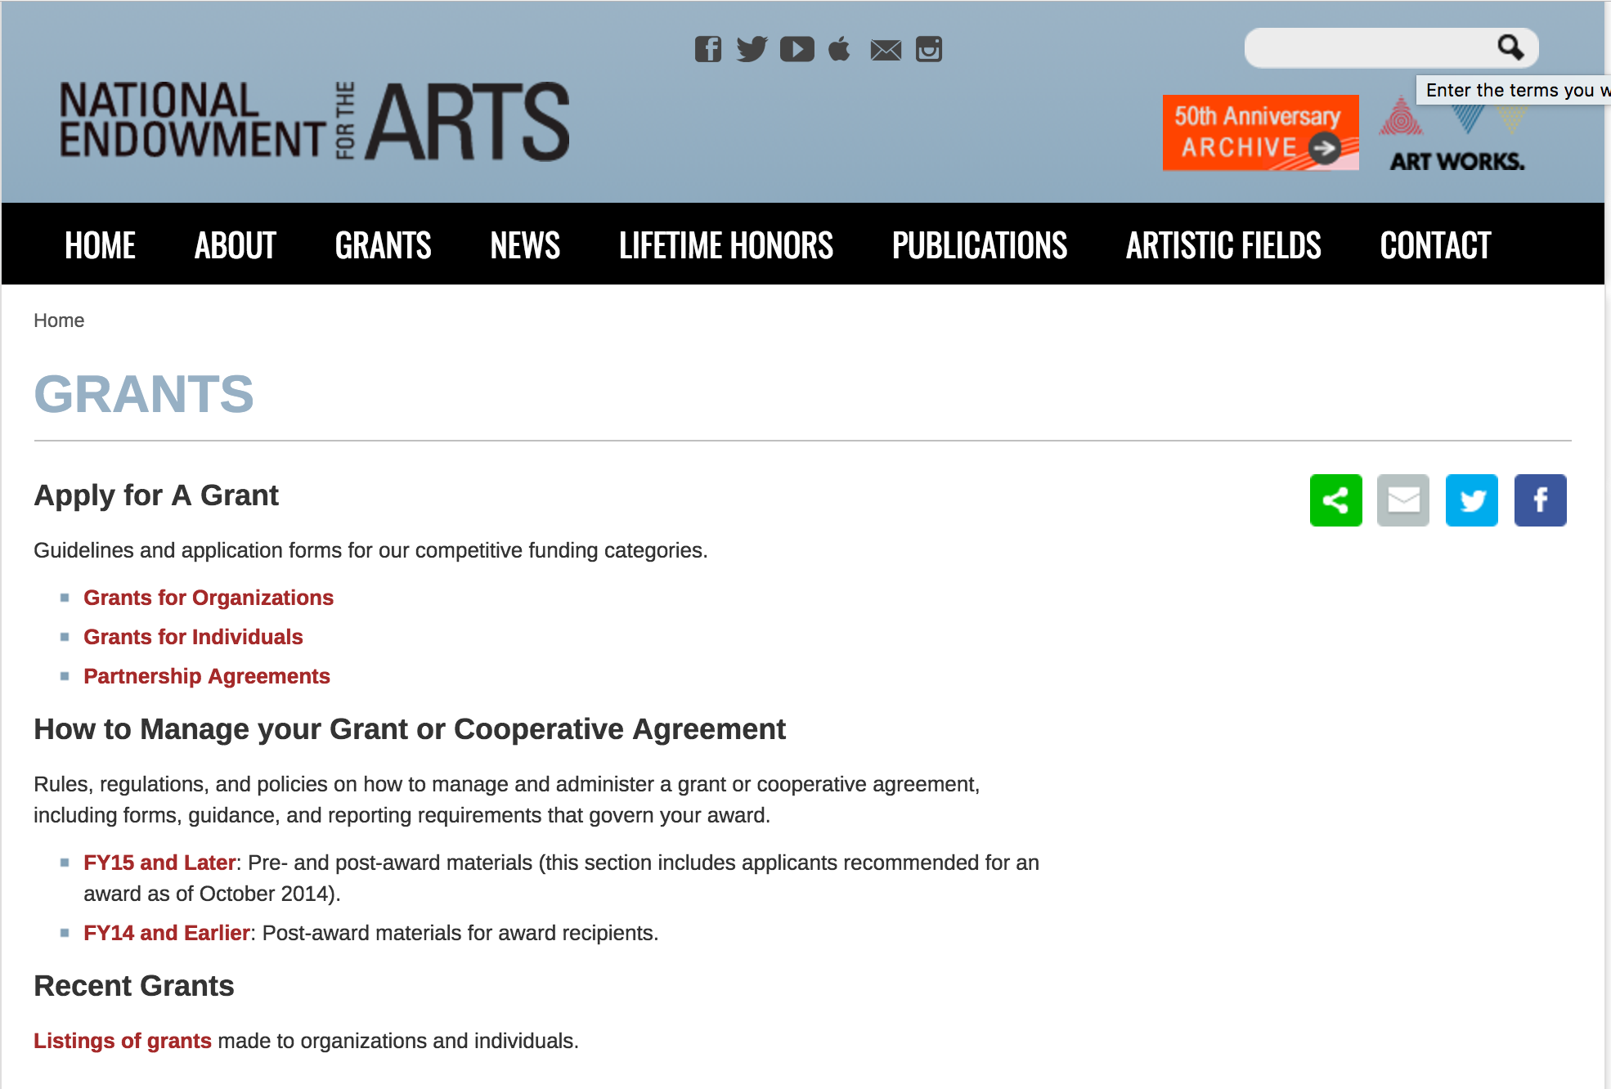

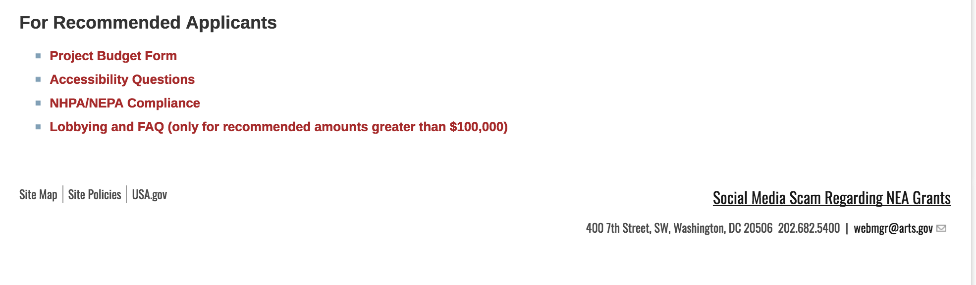
See more at: https://www.arts.gov/grants

Programs:

NEA Research: Art Works, FY2018
Synopsis 1
Document Type: | Grants Notice
Funding Opportunity Number: | 2018NEAORA
Funding Opportunity Title: | NEA Research: Art Works, FY2018
Opportunity Category: | Discretionary
Opportunity Category Explanation:
Funding Instrument Type: | Grant
Category of Funding Activity: | Arts (see "Cultural Affairs" in CFDA)
Category Explanation:
Expected Number of Awards:
CFDA Number(s): | 45.024 -- Promotion of the Arts Grants to Organizations and Individuals
Cost Sharing or Matching Requirement: | Yes
Version: | Synopsis 1
Posted Date: | Aug 04, 2017
Last Updated Date: | Aug 04, 2017
Original Closing Date for Applications: | Oct 10, 2017
Current Closing Date for Applications: | Oct 10, 2017
Archive Date:
Estimated Total Program Funding:
Award Ceiling: | $100,000
Award Floor: | $10,000
Eligible Applicants: | Nonprofits having a 501(c)(3) status with the IRS, other than institutions of higher education  Independent school districts  Special district governments  Public and State controlled institutions of higher education  State governments  Private institutions of higher education  County governments  Native American tribal governments (Federally recognized)  City or township governments
Agency Name: | National Endowment for the Arts
Description: | The Arts Endowment’s support of a project may start on May 1, 2018, or any time thereafter. Grants generally may cover a period of performance of up to two years, with an exception for projects that include primary data collection as part of the proposed activity. Projects that include primary data collection may request up to three years. Projects that extend beyond one year will be required to submit an annual progress report. A grantee may not receive more than one National Endowment for the Arts grant for the same project during the same period of performance. Program Description In September 2012, the National Endowment for the Arts' (NEA) Office of Research & Analysis published a five-year research agenda, supported by a system map and measurement model. Titled How Art Works, the report offers a framework for studying research topics critical to a broader public understanding of the arts' value and/or impact for individuals and communities. In December 2016, the NEA’s research office updated its five-year agenda for 2017-2021, which reflects a tighter focus on Arts Participation and Arts/Cultural Assets as essential research topics. Arts Participation, in the new agenda, remains inclusive of various modes of participation and specific arts activities. These modes are: attending arts events; reading literature; creating or performing art; consuming art via electronic media; and learning in the arts. Arts/Cultural Assets denotes artists and arts workers, arts venues and platforms, and arts organizations and industries. The NEA is interested in research seeking to identify and to examine: • Factors that enhance or inhibit Arts Participation or Arts/Cultural Assets; • Detailed characteristics of Arts Participation or Arts Cultural/Assets, and their interrelationships; • Individual-level outcomes of Arts Participation, including those corresponding with the following domains: social and emotional well-being creativity, cognition, and learning physiological processes of health and healing; and • Societal or community-level outcomes, including those corresponding with the following domains: civic and corporate innovation attraction for neighborhoods and businesses national and/or state-level economic growth.
Link to Additional Information: | NEA Website Announcement
Grantor Contact Information: | If you have difficulty accessing the full announcement electronically, please contact:  NEA Web Manager webmgr@arts.gov  NEA Web Manager

http://www.grants.gov/web/grants/view-opportunity.html?oppId=296130

Modifications:

NEA Research: Art Works, FY2018
Synopsis 2
Document Type: | Grants Notice
Funding Opportunity Number: | 2018NEAORA
Funding Opportunity Title: | NEA Research: Art Works, FY2018
Opportunity Category: | Discretionary
Opportunity Category Explanation:
Funding Instrument Type: | Grant
Category of Funding Activity: | Arts (see "Cultural Affairs" in CFDA)
Category Explanation:
Expected Number of Awards:
CFDA Number(s): | 45.024 -- Promotion of the Arts Grants to Organizations and Individuals
Cost Sharing or Matching Requirement: | Yes
Version: | Synopsis 2
Posted Date: | Aug 04, 2017
Last Updated Date: | Aug 31, 2017
Original Closing Date for Applications: | Oct 10, 2017
Current Closing Date for Applications: | Oct 17, 2017 NOTICE: The Research: Art Works application deadline has been extended due to Hurricane Harvey.
Archive Date:
Estimated Total Program Funding:
Award Ceiling: | $100,000
Award Floor: | $10,000
Eligible Applicants: | Private institutions of higher education  Nonprofits having a 501(c)(3) status with the IRS, other than institutions of higher education  Native American tribal governments (Federally recognized)  City or township governments  County governments  Special district governments  State governments  Independent school districts  Public and State controlled institutions of higher education
Agency Name: | National Endowment for the Arts
Description: | The Arts Endowment’s support of a project may start on May 1, 2018, or any time thereafter. Grants generally may cover a period of performance of up to two years, with an exception for projects that include primary data collection as part of the proposed activity. Projects that include primary data collection may request up to three years. Projects that extend beyond one year will be required to submit an annual progress report. A grantee may not receive more than one National Endowment for the Arts grant for the same project during the same period of performance. Program Description In September 2012, the National Endowment for the Arts' (NEA) Office of Research & Analysis published a five-year research agenda, supported by a system map and measurement model. Titled How Art Works, the report offers a framework for studying research topics critical to a broader public understanding of the arts' value and/or impact for individuals and communities. In December 2016, the NEA’s research office updated its five-year agenda for 2017-2021, which reflects a tighter focus on Arts Participation and Arts/Cultural Assets as essential research topics. Arts Participation, in the new agenda, remains inclusive of various modes of participation and specific arts activities. These modes are: attending arts events; reading literature; creating or performing art; consuming art via electronic media; and learning in the arts. Arts/Cultural Assets denotes artists and arts workers, arts venues and platforms, and arts organizations and industries. The NEA is interested in research seeking to identify and to examine:• Factors that enhance or inhibit Arts Participation or Arts/Cultural Assets;• Detailed characteristics of Arts Participation or Arts Cultural/Assets, and their interrelationships;• Individual-level outcomes of Arts Participation, including those corresponding with the following domains: social and emotional well-being creativity, cognition, and learning physiological processes of health and healing; and• Societal or community-level outcomes, including those corresponding with the following domains: civic and corporate innovation attraction for neighborhoods and businesses national and/or state-level economic growth
Link to Additional Information: | NEA Website Announcement
Grantor Contact Information: | If you have difficulty accessing the full announcement electronically, please contact:  NEA Web Manager webmgr@arts.gov  NEA Web Manager

http://www.grants.gov/web/grants/view-opportunity.html?oppId=296130

NEA Our Town Application, FY2018
Synopsis 3

Document Type: | Grants Notice
Funding Opportunity Number: | 2017NEA01OT
Funding Opportunity Title: | NEA Our Town Application, FY2018
Opportunity Category: | Discretionary
Opportunity Category Explanation:
Funding Instrument Type: | Grant
Category of Funding Activity: | Arts (see "Cultural Affairs" in CFDA)
Category Explanation:
Expected Number of Awards:
CFDA Number(s): | 45.024 -- Promotion of the Arts Grants to Organizations and Individuals
Cost Sharing or Matching Requirement: | Yes
Version: | Synopsis 3
Posted Date: | May 18, 2017
Last Updated Date: | Aug 31, 2017
Original Closing Date for Applications: | Sep 11, 2017
Current Closing Date for Applications: | Sep 18, 2017 The Our Town application deadline has been extended due to Hurricane Harvey.
Archive Date:
Estimated Total Program Funding:
Award Ceiling: | $200,000
Award Floor: | $25,000
Eligible Applicants: | Native American tribal governments (Federally recognized)  Public and State controlled institutions of higher education  Private institutions of higher education  City or township governments  Nonprofits having a 501(c)(3) status with the IRS, other than institutions of higher education  Special district governments  County governments  Independent school districts  State governments
Agency Name: | National Endowment for the Arts
Description: | The Our Town grant program supports creative placemaking projects that help to transform communities into lively, beautiful, and resilient places – achieving these community goals through strategies that incorporate arts, culture, and/or design. Creative placemaking is when artists, arts organizations, and community development practitioners deliberately integrate arts and culture into community revitalization work - placing arts at the table with land-use, transportation, economic development, education, housing, infrastructure, and public safety strategies. This funding supports local efforts to enhance quality of life and opportunity for existing residents, increase creative activity, and create or preserve a distinct sense of place. Through Our Town, subject to the availability of funding, the National Endowment for the Arts will provide a limited number of grants for creative placemaking. Our Town requires partnerships between arts organizations and government, other nonprofit organizations, and private entities to achieve livability goals for communities. Our Town offers support for projects in two areas:• Arts Engagement, Cultural Planning, and Design Projects. These projects represent the distinct character and quality of their communities. These projects require a partnership between a nonprofit organization and a local government entity, with one of the partners being a cultural organization. Matching grants range from $25,000 to $200,000. • Projects that Build Knowledge About Creative Placemaking. These projects are available to arts and design service organizations, and industry, policy, or university organizations that provide technical assistance to those doing place-based work. Matching grants range from $25,000 to $100,000.• Through Our Town projects, the National Endowment for the Arts intends to achieve the following objective: Livability: American communities are strengthened through the arts.
Link to Additional Information: | NEA Website Announcement
Grantor Contact Information: | If you have difficulty accessing the full announcement electronically, please contact:  NEA Web Manager webmgr@arts.gov  NEA Web Manager

http://www.grants.gov/web/grants/view-opportunity.html?oppId=293915

Reminders:

NEA Literature Fellowships: Translation Projects, FY2019
Synopsis 1
Document Type: | Grants Notice
Funding Opportunity Number: | 2018NEA03LFTP
Funding Opportunity Title: | NEA Literature Fellowships: Translation Projects, FY2019
Opportunity Category: | Discretionary
Opportunity Category Explanation:
Funding Instrument Type: | Grant
Category of Funding Activity: | Arts (see "Cultural Affairs" in CFDA)
Category Explanation:
Expected Number of Awards:
CFDA Number(s): | 45.024 -- Promotion of the Arts Grants to Organizations and Individuals
Cost Sharing or Matching Requirement: | No
Version: | Synopsis 1
Posted Date: | Jul 25, 2017
Last Updated Date: | Jul 25, 2017
Original Closing Date for Applications: | Dec 05, 2017
Current Closing Date for Applications: | Dec 05, 2017
Archive Date:
Estimated Total Program Funding:
Award Ceiling: | $25,000
Award Floor: | $12,500
Eligible Applicants: | Individuals
Agency Name: | National Endowment for the Arts
Description: | An individual may submit only one application for FY 2019 funding. You may not apply for both a Translation Project under this deadline (December 5, 2017) and a Literature Fellowship (in prose or poetry) under the 2018 deadline (when fellowships in prose are offered). The Arts Endowment’s support of a project may begin any time between November 1, 2018, and November 1, 2019, and extend for up to two years. Program Description Through fellowships to published translators, the National Endowment for the Arts supports projects for the translation of specific works of prose, poetry, or drama from other languages into English. We encourage translations of writers and of work that are not well represented in English translation. All proposed projects must be for creative translations of literary material into English. The work to be translated should be of interest for its literary excellence and value. Priority will be given to projects that involve work that has not previously been translated into English. Competition for fellowships is rigorous. Potential applicants should consider carefully whether their work will be competitive at the national level.
Link to Additional Information: | NEA Website Announcement
Grantor Contact Information: | If you have difficulty accessing the full announcement electronically, please contact:  NEA Web Manager webmgr@arts.gov  NEA Web Manager

http://www.grants.gov/web/grants/view-opportunity.html?oppId=295826

National Endowment for the Humanities

Grant Overview -

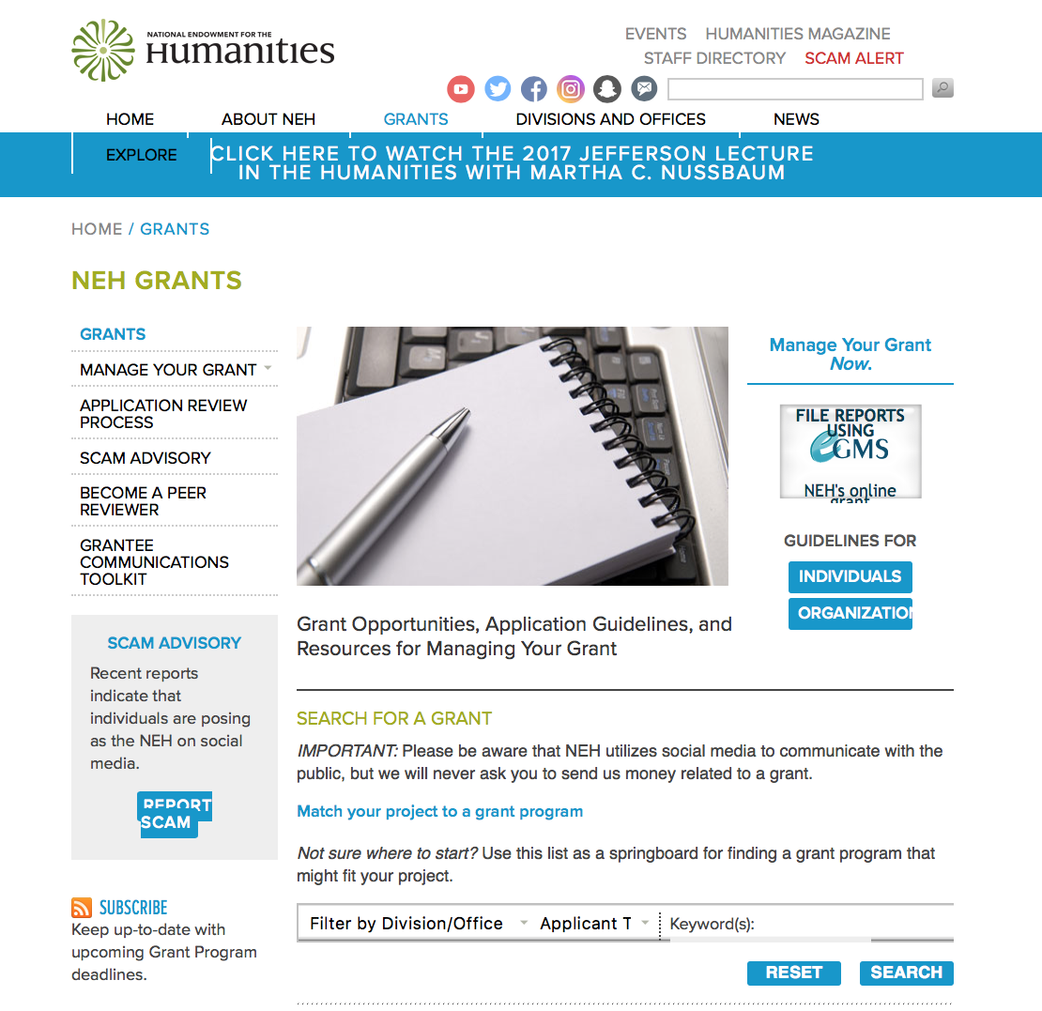

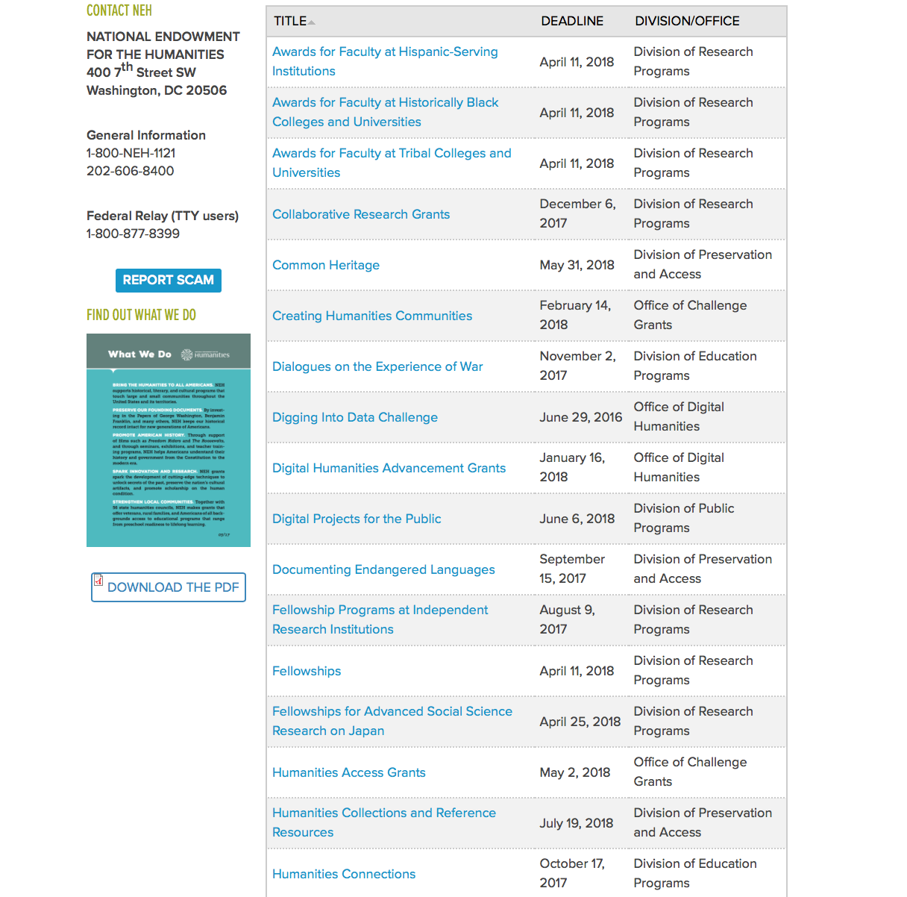

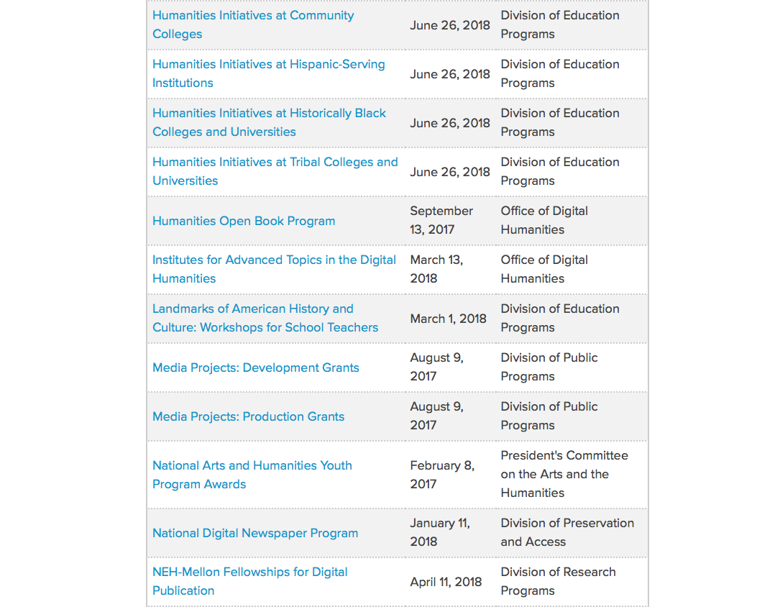

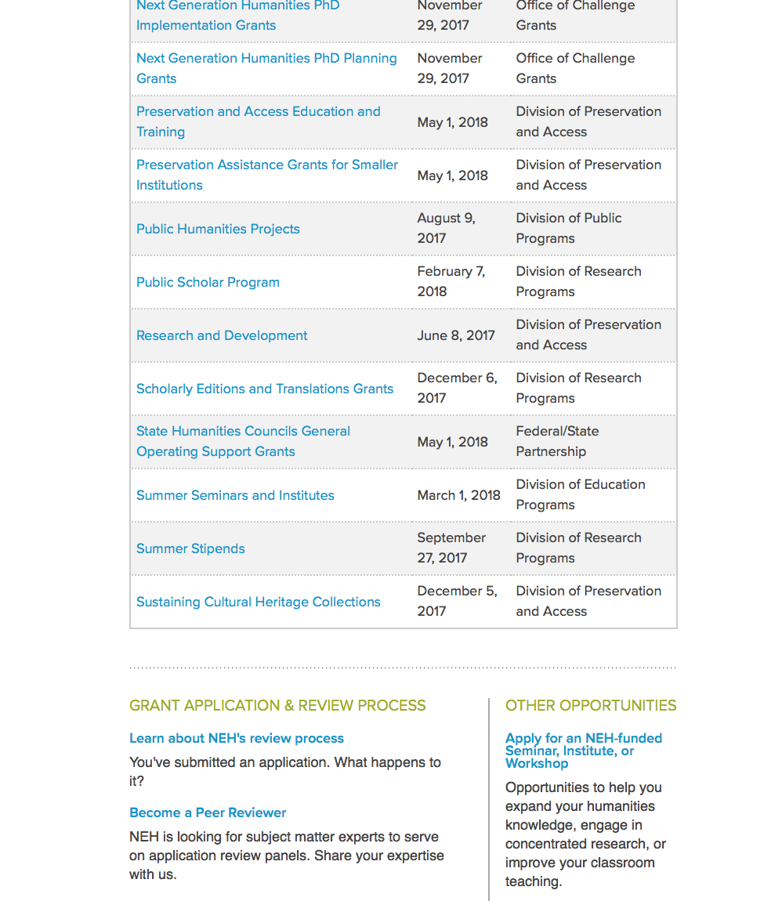

https://www.neh.gov/grants

Programs:

National Endowment for the Humanities
Dialogues on the Experience of War
Synopsis 1
Document Type: | Grants Notice
Funding Opportunity Number: | 20171102-AV
Funding Opportunity Title: | Dialogues on the Experience of War
Opportunity Category: | Discretionary
Opportunity Category Explanation:
Funding Instrument Type: | Grant
Category of Funding Activity: | Humanities (see "Cultural Affairs" in CFDA)
Category Explanation:
Expected Number of Awards:
CFDA Number(s): | 45.163 -- Promotion of the Humanities Professional Development
Cost Sharing or Matching Requirement: | No
Version: | Synopsis 1
Posted Date: | Sep 01, 2017
Last Updated Date: | Sep 01, 2017
Original Closing Date for Applications: | Nov 02, 2017
Current Closing Date for Applications: | Nov 02, 2017
Archive Date:
Estimated Total Program Funding:
Award Ceiling: | $100,000
Award Floor: | $1
Eligible Applicants: | County governments  Public and State controlled institutions of higher education  Native American tribal governments (Federally recognized)  Private institutions of higher education  Nonprofits having a 501(c)(3) status with the IRS, other than institutions of higher education  City or township governments  State governments  Special district governments
Agency Name: | National Endowment for the Humanities
Description: | The National Endowment for the Humanities offers the Dialogues on the Experience of War program as part of its current initiative, Standing Together: The Humanities and the Experience of War. The program supports the study and discussion of important humanities sources about war, in the belief that these sources can help U.S. military veterans and others think more deeply about the issues raised by war and military service. Although the program is primarily designed to reach military veterans, men and women in active service, military families, and interested members of the public may also participate. The program awards grants of up to $100,000 that will support • the convening of at least two discussion programs for no fewer than fifteen participants; and • the creation of a preparatory program to recruit and train program discussion leaders (NEH Discussion Leaders). Discussion programs may take place on college and university campuses, in veterans’ centers, at public libraries and museums, and at other community venues.
Link to Additional Information: | https://www.neh.gov/grants/education/dialogues-the-experience-war
Grantor Contact Information: | If you have difficulty accessing the full announcement electronically, please contact:  Division of Education Programs National Endowment for the Humanities 400 Seventh Street, SW Washington, DC 20506 202-606-8337 dew@neh.gov dew@neh.gov  dew@neh.gov

http://www.grants.gov/web/grants/view-opportunity.html?oppId=296998

Humanities Connections
Synopsis 1

Document Type: | Grants Notice
Funding Opportunity Number: | 20171017-AKA
Funding Opportunity Title: | Humanities Connections
Opportunity Category: | Discretionary
Opportunity Category Explanation:
Funding Instrument Type: | Grant
Category of Funding Activity: | Humanities (see "Cultural Affairs" in CFDA)
Category Explanation:
Expected Number of Awards:
CFDA Number(s): | 45.162 -- Promotion of the Humanities Teaching and Learning Resources and Curriculum Development
Cost Sharing or Matching Requirement: | No
Version: | Synopsis 1
Posted Date: | Aug 17, 2017
Last Updated Date: | Aug 17, 2017
Original Closing Date for Applications: | Oct 17, 2017
Current Closing Date for Applications: | Oct 17, 2017
Archive Date:
Estimated Total Program Funding:
Award Ceiling: | $100,000
Award Floor: | $1
Eligible Applicants: | Others (see text field entitled "Additional Information on Eligibility" for clarification)
Additional Information on Eligibility: | The only eligible applicants are U.S. two- or four-year colleges or universities with 501(c)(3) tax-exempt status.
Agency Name: | National Endowment for the Humanities
Description: | The Humanities Connections grant program seeks to expand the role of the humanities in undergraduate education at two- and four-year institutions. Grants will support innovative curricular approaches that foster productive partnerships among humanities faculty and their counterparts in the social and natural sciences and in pre-service or professional programs (such as business, engineering, health sciences, law, computer science, and other technology-driven fields). Competitive applications will demonstrate • that the proposed curricular projects address significant and compelling topics or issues in undergraduate education at the applicant institution(s); • that these projects engage the intellectual skills and habits of mind cultivated by the humanities; and • that faculty and students will benefit from meaningful collaborations in teaching and learning across disciplines as a result of the project. Humanities Connections projects have four core features: 1. integration of the subject matter, perspectives, and goals of two or more disciplines (with a minimum of one in and one outside of the humanities); 2. collaboration between faculty from two or more separate departments or schools at one or more institutions; 3. experiential learning as an intrinsic part of the curricular plan; and 4. long-term institutional support for the proposed curriculum innovation(s). If the project addresses core or general education requirements, or requirements for specific pathways or pre-professional programs, it must incorporate a fresh approach in doing so. Humanities Connections grants are funded at two levels: Planning and Implementation. Planning Grants (up to twelve months) support the interdisciplinary collaboration of faculty from two or more separate departments or schools (a minimum of one in and one outside of the humanities), with the goal of designing a new, coherent curricular program or initiative. The grant gives the institution(s) the opportunity to create a firm foundation for implementing the program. Planning goals will include identifying the members of a planning committee and organizing the planning process; defining the rationale, design, and structure that would undergird a comprehensive and institutionally sustainable effort; and establishing potential scenarios for curriculum development. Institutions may draw on current short-term initiatives or curricular programs run by individual departments in this effort. The outcome of a successful planning phase should be a project in, or ready for, the implementation stage. Implementation grants (up to three years) support the interdisciplinary collaboration of faculty from two or more separate departments or schools (a minimum of one in and one outside of the humanities), with the implementation of a sustainable curricular program or initiative as the outcome. Implementation grant proposals must show unambiguous evidence of preceding planning work and present a defined rationale with clear intellectual and logistical objectives that are supported by institutional commitment. The grant gives applicants the opportunity to build on faculty/administrative or institutional partnerships and to develop and refine the project’s intellectual content, design, and scope. For example, the applicant should be able to demonstrate potential commitments of any partners or collaborators; outline preferred approaches to curriculum building/consolidation; and explain outreach strategies that will be employed to attract students to the new educational opportunity.
Link to Additional Information: | https://www.neh.gov/grants/humanities-connections
Grantor Contact Information: | If you have difficulty accessing the full announcement electronically, please contact:  Humanities Connections Division of Education Programs National Endowment for the Humanities 400 Seventh Street, SW Washington, DC 20506 202-606-8337 humanitiesconnections@neh.gov humanitiesconnections@neh.gov  humanitiesconnections@neh.gov

http://www.grants.gov/web/grants/view-opportunity.html?oppId=296563

Modifications:

Reminders:

Humanities Open Book Program
Synopsis 1
Document Type: | Grants Notice
Funding Opportunity Number: | 20170913-HZ
Funding Opportunity Title: | Humanities Open Book Program
Opportunity Category: | Discretionary
Opportunity Category Explanation:
Funding Instrument Type: | Grant
Category of Funding Activity: | Humanities (see "Cultural Affairs" in CFDA)
Category Explanation:
Expected Number of Awards:
CFDA Number(s): | 45.169 -- Promotion of the Humanities Office of Digital Humanities
Cost Sharing or Matching Requirement: | No
Version: | Synopsis 1
Posted Date: | Jun 22, 2017
Last Updated Date: | Jun 22, 2017
Original Closing Date for Applications: | Sep 13, 2017
Current Closing Date for Applications: | Sep 13, 2017
Archive Date:
Estimated Total Program Funding:
Award Ceiling: | $200,000
Award Floor: | $1
Eligible Applicants: | State governments  Native American tribal governments (Federally recognized)  Special district governments  Private institutions of higher education  Nonprofits having a 501(c)(3) status with the IRS, other than institutions of higher education  City or township governments  Public and State controlled institutions of higher education  County governments
Agency Name: | National Endowment for the Humanities
Description: | The Humanities Open Book Program is designed to make outstanding out-of-print humanities books available to a wide audience. By taking advantage of low-cost “ebook” technology, the program will allow teachers, students, scholars, and the public to read humanities books that have long been out of print. The Humanities Open Book Program is jointly sponsored by NEH and the Andrew W. Mellon Foundation. Traditionally, printed books have been the primary medium for expressing, communicating, and debating humanistic ideas. However, the vast majority of humanities books sell a small number of copies and then quickly go out of print. Most scholarly books printed since 1923 are not in the public domain and are not easily available to the general public. As a result, there is a huge, mostly untapped resource of remarkable scholarship going back decades that is largely unused by today’s scholars, teachers, students, and members of the public, many of whom turn first to the Internet when looking for information. Modern ebook technology can make these books far more accessible than they are today. NEH and Mellon are soliciting proposals from academic presses, scholarly societies, museums, and other institutions that publish books in the humanities to participate in the Humanities Open Book Program. Applicants will provide a list of previously published humanities books along with brief descriptions of the books and their intellectual significance. Depending on the length and topics of the books, the number to be digitized may vary. However, NEH and Mellon anticipate that applicants may propose to digitize a total that ranges from less than fifty to more than one hundred books. Awards will be given to digitize these books and make them available as Creative Commons-licensed “ebooks” that can be read by the public at no charge on computers, mobile devices, and ebook readers. The final ebook files must be in EPUB version 3.0.1 (or later) format, to ensure that the text is fully searchable and reflowable and that fonts are resizable on any e-reading device.
Link to Additional Information: | https://www.neh.gov/grants/odh/humanities-open-book-program
Grantor Contact Information: | If you have difficulty accessing the full announcement electronically, please contact:  If you have questions about the program, contact the Office of Digital Humanities staff at odh@neh.gov. Applicants wishing to speak to a staff member by telephone should provide in an e-mail message a telephone number and a preferred time to call. odh@neh.gov  odh@neh.gov

http://www.grants.gov/web/grants/view-opportunity.html?oppId=294921

Summer Stipends
Synopsis 1

Document Type: | Grants Notice
Funding Opportunity Number: | 20170927-FT
Funding Opportunity Title: | Summer Stipends
Opportunity Category: | Discretionary
Opportunity Category Explanation:
Funding Instrument Type: | Grant
Category of Funding Activity: | Humanities (see "Cultural Affairs" in CFDA)
Category Explanation:
Expected Number of Awards:
CFDA Number(s): | 45.160 -- Promotion of the Humanities Fellowships and Stipends
Cost Sharing or Matching Requirement: | No
Version: | Synopsis 1
Posted Date: | May 19, 2017
Last Updated Date: | May 19, 2017
Original Closing Date for Applications: | Sep 27, 2017
Current Closing Date for Applications: | Sep 27, 2017
Archive Date:
Estimated Total Program Funding:
Award Ceiling: | $6,000
Award Floor: | $6,000
Eligible Applicants: | Others (see text field entitled "Additional Information on Eligibility" for clarification)
Additional Information on Eligibility: | The only eligible applicants are individuals. Individuals who teach full-time at colleges or universities must be nominated by their institutions to be eligible.
Agency Name: | National Endowment for the Humanities
Description: | Summer Stipends support individuals pursuing advanced research that is of value to humanities scholars, general audiences, or both. Eligible projects usually result in articles, monographs, books, digital materials and publications, archaeological site reports, translations, or editions. Projects must not result solely in the collection of data; instead they must also incorporate analysis and interpretation. Summer Stipends support continuous full-time work on a humanities project for a period of two consecutive months. Summer Stipends support projects at any stage of development.
Link to Additional Information: | https://www.neh.gov/grants/research/summer-stipends
Grantor Contact Information: | If you have difficulty accessing the full announcement electronically, please contact:  Division of Research Programs National Endowment for the Humanities 400 Seventh Street, SW Washington, D.C. 20506 202-606-8200 stipends@neh.gov stipends@neh.gov  stipends@neh.gov

http://www.grants.gov/web/grants/view-opportunity.html?oppId=293973



National Science Foundation

General Funding Overview

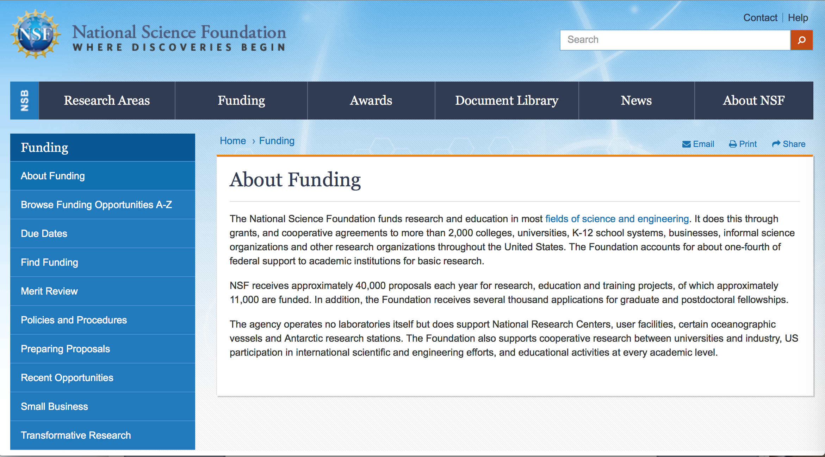

For assistance: https://nsf.gov/funding/aboutfunding.jsp

The National Science Foundation funds research and education in most fields of science and engineering. It does this through grants, and cooperative agreements to more than 2,000 colleges, universities, K-12 school systems, businesses, informal science organizations and other research organizations throughout the United States. The Foundation accounts for about one-fourth of federal support to academic institutions for basic research.
NSF receives approximately 40,000 proposals each year for research, education and training projects, of which approximately 11,000 are funded. In addition, the Foundation receives several thousand applications for graduate and postdoctoral fellowships.
The agency operates no laboratories itself but does support National Research Centers, user facilities, certain oceanographic vessels and Antarctic research stations. The Foundation also supports cooperative research between universities and industry, US participation in international scientific and engineering efforts, and educational activities at every academic level.

For details on active funding deadline dates: http://nsf.gov/funding/pgm_list.jsp?org=NSF&ord=date

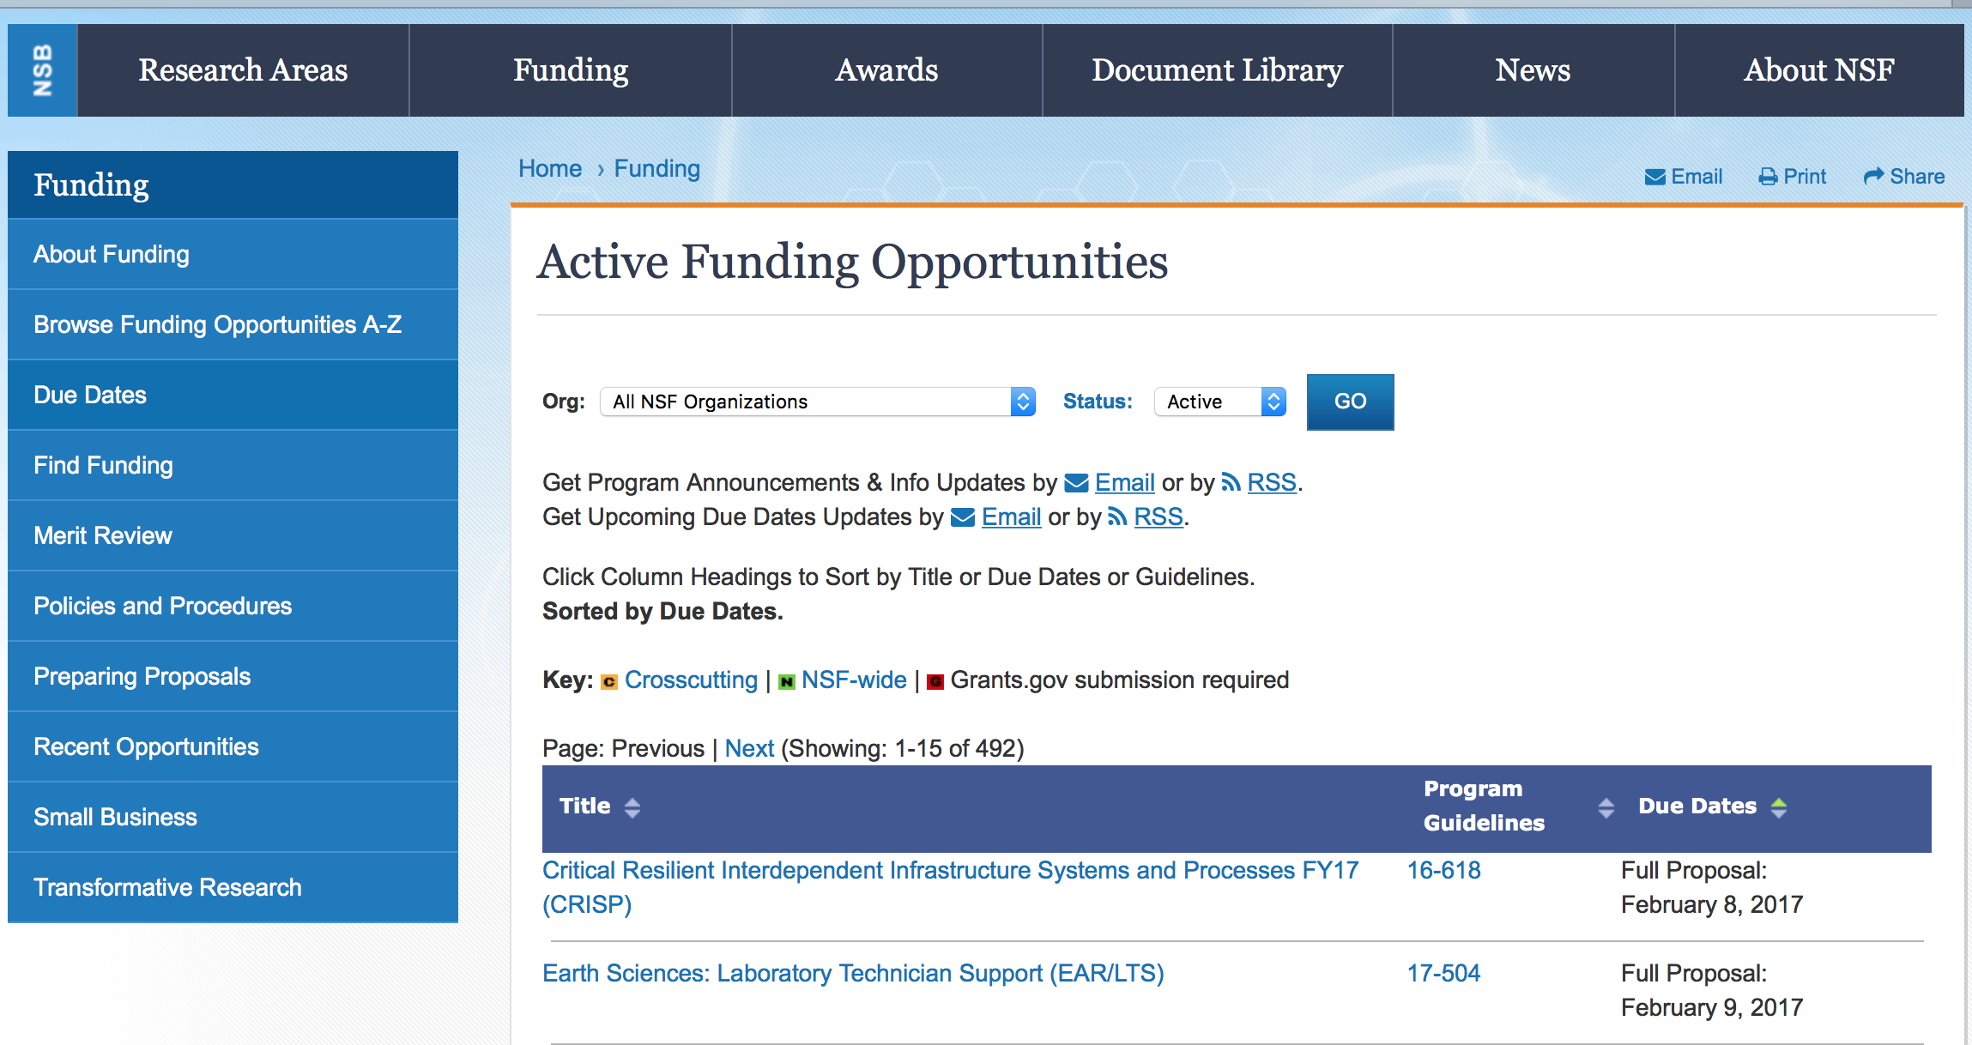

Combustion and Fire Systems
Synopsis 1
http://www.grants.gov/web/grants/view-opportunity.html?oppId=296150

Division of Molecular and Cellular Biosciences: Investigator-Initiated Research Projects
Synopsis 1
http://www.grants.gov/web/grants/view-opportunity.html?oppId=296572

Improving Undergraduate STEM Education: Education and Human Resources
Synopsis 1
http://www.grants.gov/web/grants/view-opportunity.html?oppId=296684

Inclusion across the Nation of Communities of Learners of Underrepresented Discoverers in Engineering and Science
Synopsis 1
http://www.grants.gov/web/grants/view-opportunity.html?oppId=296685

Long-Term Ecological Research
Synopsis 1
http://www.grants.gov/web/grants/view-opportunity.html?oppId=296912

Mid-Scale Innovations Program
Synopsis 1
http://www.grants.gov/web/grants/view-opportunity.html?oppId=296745

Process Separations
Synopsis 1
http://www.grants.gov/web/grants/view-opportunity.html?oppId=296149

Research Coordination Networks (RCN)
Synopsis 1

http://www.grants.gov/web/grants/view-opportunity.html?oppId=296913

SBE Postdoctoral Research Fellowships
Synopsis 1
http://www.grants.gov/web/grants/view-opportunity.html?oppId=296182

Modifications:

Reminders:

Deleted:

13-510 - Division of Molecular and Cellular Biosciences: Investigator-Initiated Research Projects
Deletion Comments: Opportunity deleted

15-527 - Research Coordination Networks (RCN)
Deletion Comments: Opportunity deleted

16-590 - SBE Postdoctoral Research Fellowships
Deletion Comments: Opportunity deleted

17-522 - Inclusion across the Nation of Communities of Learners of Underrepresented Discoverers in Engineering and Science
Deletion Comments: Opportunity deleted

17-534 - Critical Techniques, Technologies and Methodologies for Advancing Foundations and Applications of Big Data Sciences and Engineering
Deletion Comments: Opportunity deleted

17-538 - Management and Operations of the Arecibo Observatory
Deletion Comments: Opportunity deleted

17-540 - Tomorrow's Internet Project Office
Deletion Comments: Opportunity deleted

17-543 - Antarctic Research
Deletion Comments: Opportunity deleted

PD-17-1407 - Combustion and Fire Systems
Deletion Comments: Opportunity deleted

PD-17-1417 - Process Separations
Deletion Comments: Opportunity deleted

PD-98-1620 - Marine Geology and Geophysics
Deletion Comments: Opportunity deleted

Nuclear Regulatory Commission

U.S. Nuclear Regulatory Commission Funding Opportunity Announcement (FOA), Scholarship and Fellowship Education Grant, Faculty Development Grant, and Trade School and Community College Scholarship Grant, Fiscal Year (FY) 2018
Synopsis 1
Document Type: | Grants Notice
Funding Opportunity Number: | NRC-HQ-60-17-FOA-0002
Funding Opportunity Title: | U.S. Nuclear Regulatory Commission Funding Opportunity Announcement (FOA), Scholarship and Fellowship Education Grant, Faculty Development Grant, and Trade School and Community College Scholarship Grant, Fiscal Year (FY) 2018
Opportunity Category: | Discretionary
Opportunity Category Explanation:
Funding Instrument Type: | Grant
Category of Funding Activity: | Education
Category Explanation:
Expected Number of Awards: | 50
CFDA Number(s): | 77.008 -- U.S. Nuclear Regulatory Commission Scholarship and Fellowship Program
Cost Sharing or Matching Requirement: | No
Version: | Synopsis 1
Posted Date: | Aug 30, 2017
Last Updated Date: | Aug 30, 2017
Original Closing Date for Applications: | Oct 30, 2017
Current Closing Date for Applications: | Oct 30, 2017
Archive Date: | Nov 29, 2017
Estimated Total Program Funding: | $15,000,000
Award Ceiling: | $450,000
Award Floor: | $100,000
Eligible Applicants: | Public and State controlled institutions of higher education  Others (see text field entitled "Additional Information on Eligibility" for clarification)  Private institutions of higher education
Additional Information on Eligibility: | • Public/State Controlled Institutions of Higher Education • Private Institutions of Higher Education • Hispanic-Serving Institutions (HSIs) • Historically Black Colleges and Universities (HBCUs) • Tribally Controlled Colleges and Universities (TCCUs) • Alaska Native and Native Hawaiian Serving Institutions • Predominately Black Institutions (PBIs) • Asian American and Native American Pacific Islander Serving Institutions (AAPIs)
Agency Name: | Nuclear Regulatory Commission
Description: | •Scholarship The primary objective is to support scholarships for nuclear science, engineering, technology and related disciplines to develop a workforce capable of supporting the design, construction, operation, and regulation of nuclear facilities and the safe handling of nuclear materials. The nuclear-related discipline supported by this funding is intended to benefit nuclear safety and security sector broadly. •Fellowship The primary objective is to support fellowships for nuclear science, engineering, technology and related disciplines to develop a workforce capable of supporting the design, construction, operation, and regulation of nuclear facilities and the safe handling of nuclear materials. The nuclear related discipline supported by this funding is intended to benefit the nuclear sector broadly. •Faculty Development The primary objective is to support faculty development for nuclear science, engineering, technology and related disciplines to develop a workforce capable of supporting the design, construction, operation, and regulation of nuclear facilities and the safe handling of nuclear materials. Proposed faculty can be supported for up to one 3-year period. The objectives are to attract and retain highly-qualified individuals in academic teaching careers. The grants specifically target probationary, tenure-track faculty during the first 6 years of their career and new faculty hires in the following academic areas: Nuclear, Mechanical, Civil, Environmental, Electrical, Fire Protection, Geotechnical, Structural and Materials Sciences Engineering as well as Health Physics. The NRC has interest in topics including but not limited to Fuels, Neutronics, Thermal-hydraulics, Accident-Progression (e.g., performance of safety relief valves), Consequence, Emergency Preparedness, and Radiation Protection Analysis; Radiochemistry, Probabilistic Risk Assessment, Seismology, Fire Risk Analysis, advanced reactor (non-light water reactor), safety systems and other related disciplines. Grants may include support for developing applications for new research or continuing research projects in their areas of expertise. The program provides support to enable newer faculty to enhance their careers as professors and researchers in the university department where employed. The research supported by this announcement is intended to benefit the nuclear sector broadly. •Trade School and Community College Scholarships The primary objective is to support scholarships for nuclear science, engineering, technology, and related disciplines to develop a workforce capable of supporting the design, construction, operation, and regulation of nuclear facilities and the safe handling of nuclear materials. The nuclear-related discipline supported by this funding is intended to benefit the nuclear sector broadly.
Link to Additional Information:
Grantor Contact Information: | If you have difficulty accessing the full announcement electronically, please contact:  M`Lita Carr Grant and Contract Specialist Phone 301-415-6869  Office

http://www.grants.gov/web/grants/view-opportunity.html?oppId=296930

Reminders:

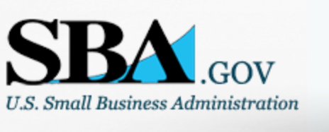

Small Business Administration

General Overview Finding Loans & Grants

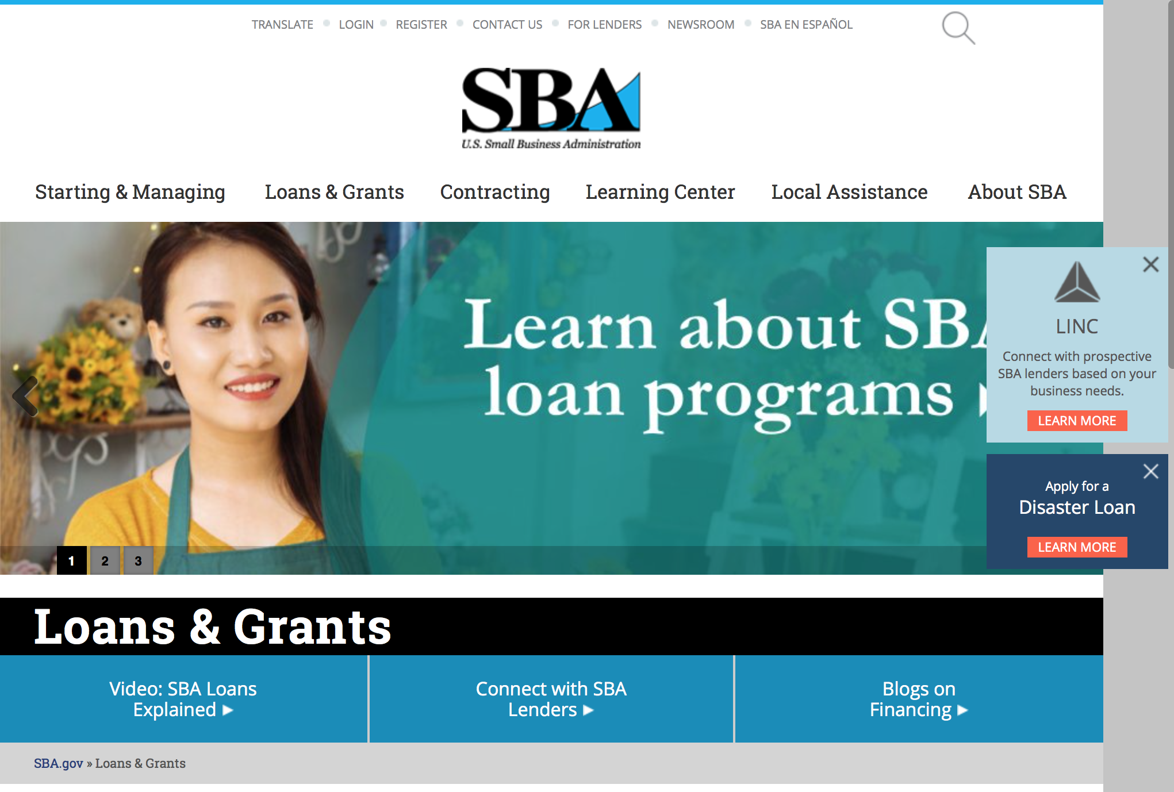
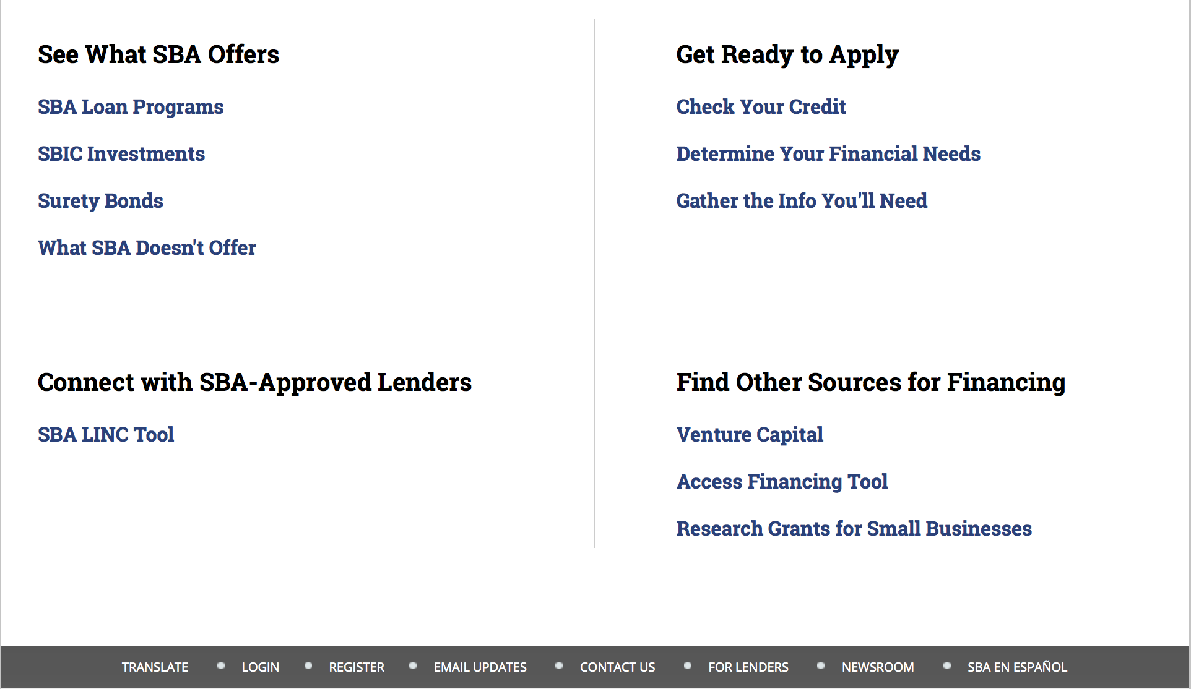

https://www.sba.gov/category/navigation-structure/loans-grants
Federal, state and local governments offer a wide range of financing programs to help small businesses start and grow their operations. These programs include low-interest loans, venture capital, and scientific and economic development grants.
Use SBA.gov's Loans and Grants Search Tool to get a list of financing programs for which you may qualify, or visit the resources below to learn more about small business financing programs.
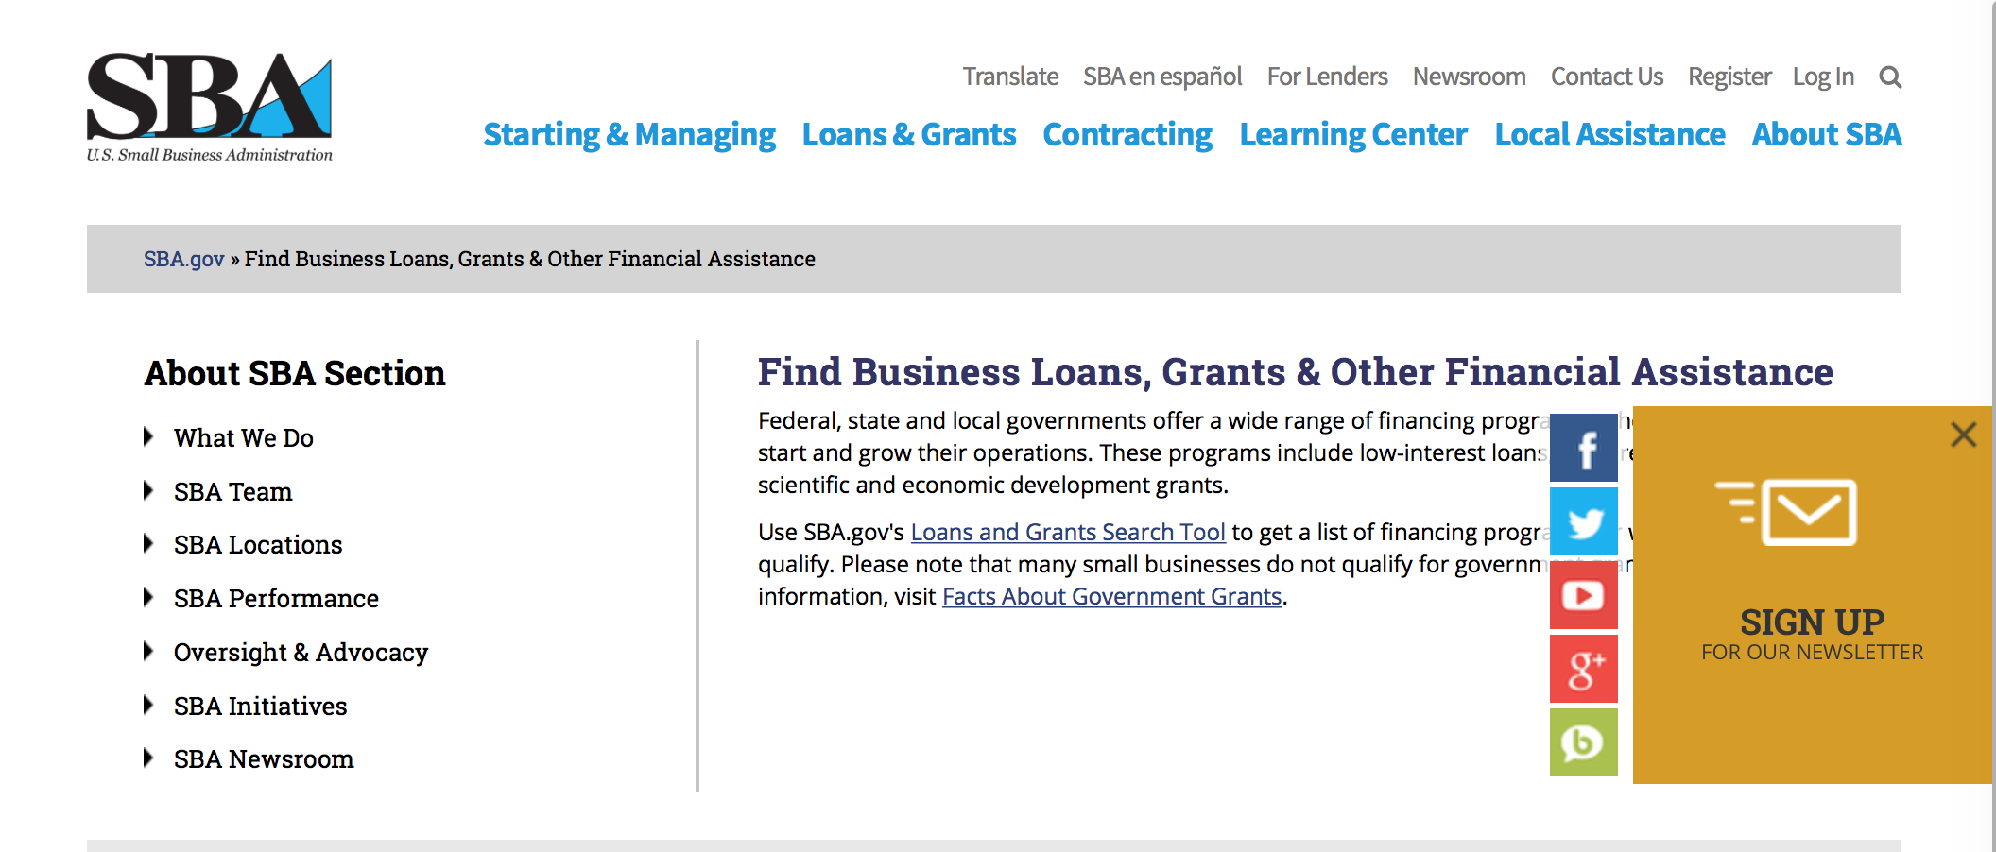
To get to the main SBA.gov funding page click here
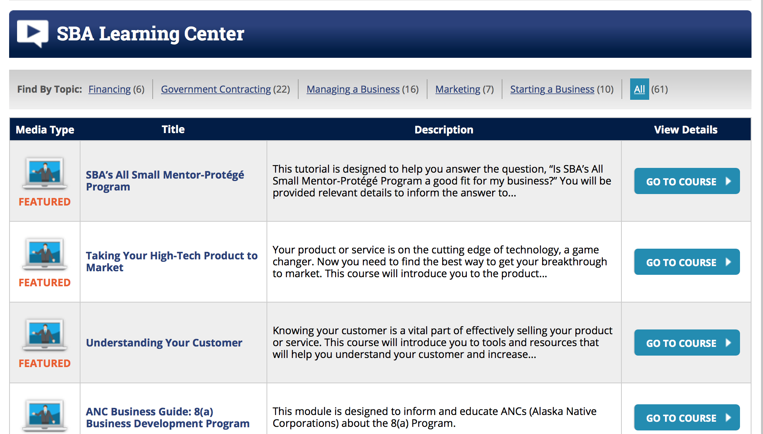
https://www.sba.gov/tools/sba-learning-center/search/training

Programs:

Modifications

Reminders:

Deleted:

SBA Trainings

Contracting Opportunities for Veteran Entrepreneurs
This self-paced training exercise is an introduction to Federal contracting opportunities for Veterans.
Topics include basic information about Veteran-owned businesses and opportunities, services available to small Veteran-owned businesses, small business incentives, and government procurement methods.
Duration: 00:30:00

http://www.sba.gov/tools/sba-learning-center/training/contracting-opportunities-veteran-entrepreneurs

Interested in Exporting? These Four Resources Can Help
Did you know that two-thirds of the world’s purchasing power is in foreign countries? As the numbers show, the international marketplace is a big one. So if you’re interested in exploring the world of exporting – or have gotten started but could use some guidance – check out these resources to help.
- Read more

Upcoming Trainings: Check out SBA's Online Training!
- Financing Options for Small Businesses
How to Prepare Government Contract Proposals
Getting Started With Exporting: Training and Educational Resources
Exporting represents a big opportunity to tap in to new markets, expand your customer base and grow your business. But getting started with exporting can sometimes feel like a maze of regulations, policies, and other barriers. Here are some free training and educational resources to help.
- Read more

For Specific Information in Hawaii see the following links:
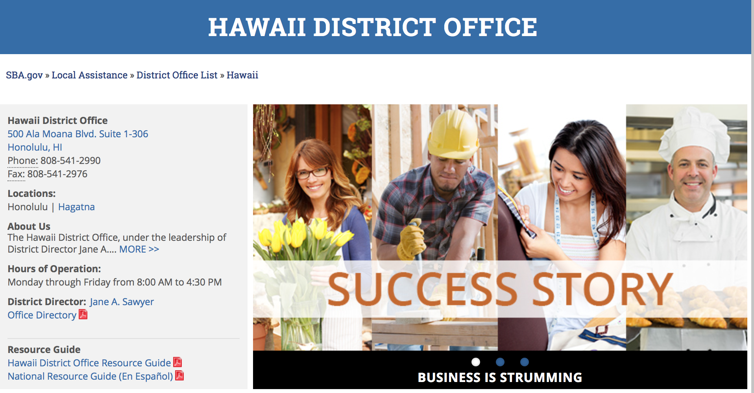

https://www.sba.gov/offices/district/hi/Honolulu

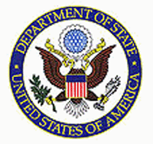

State Department General Overview and Resources for Program Administrators

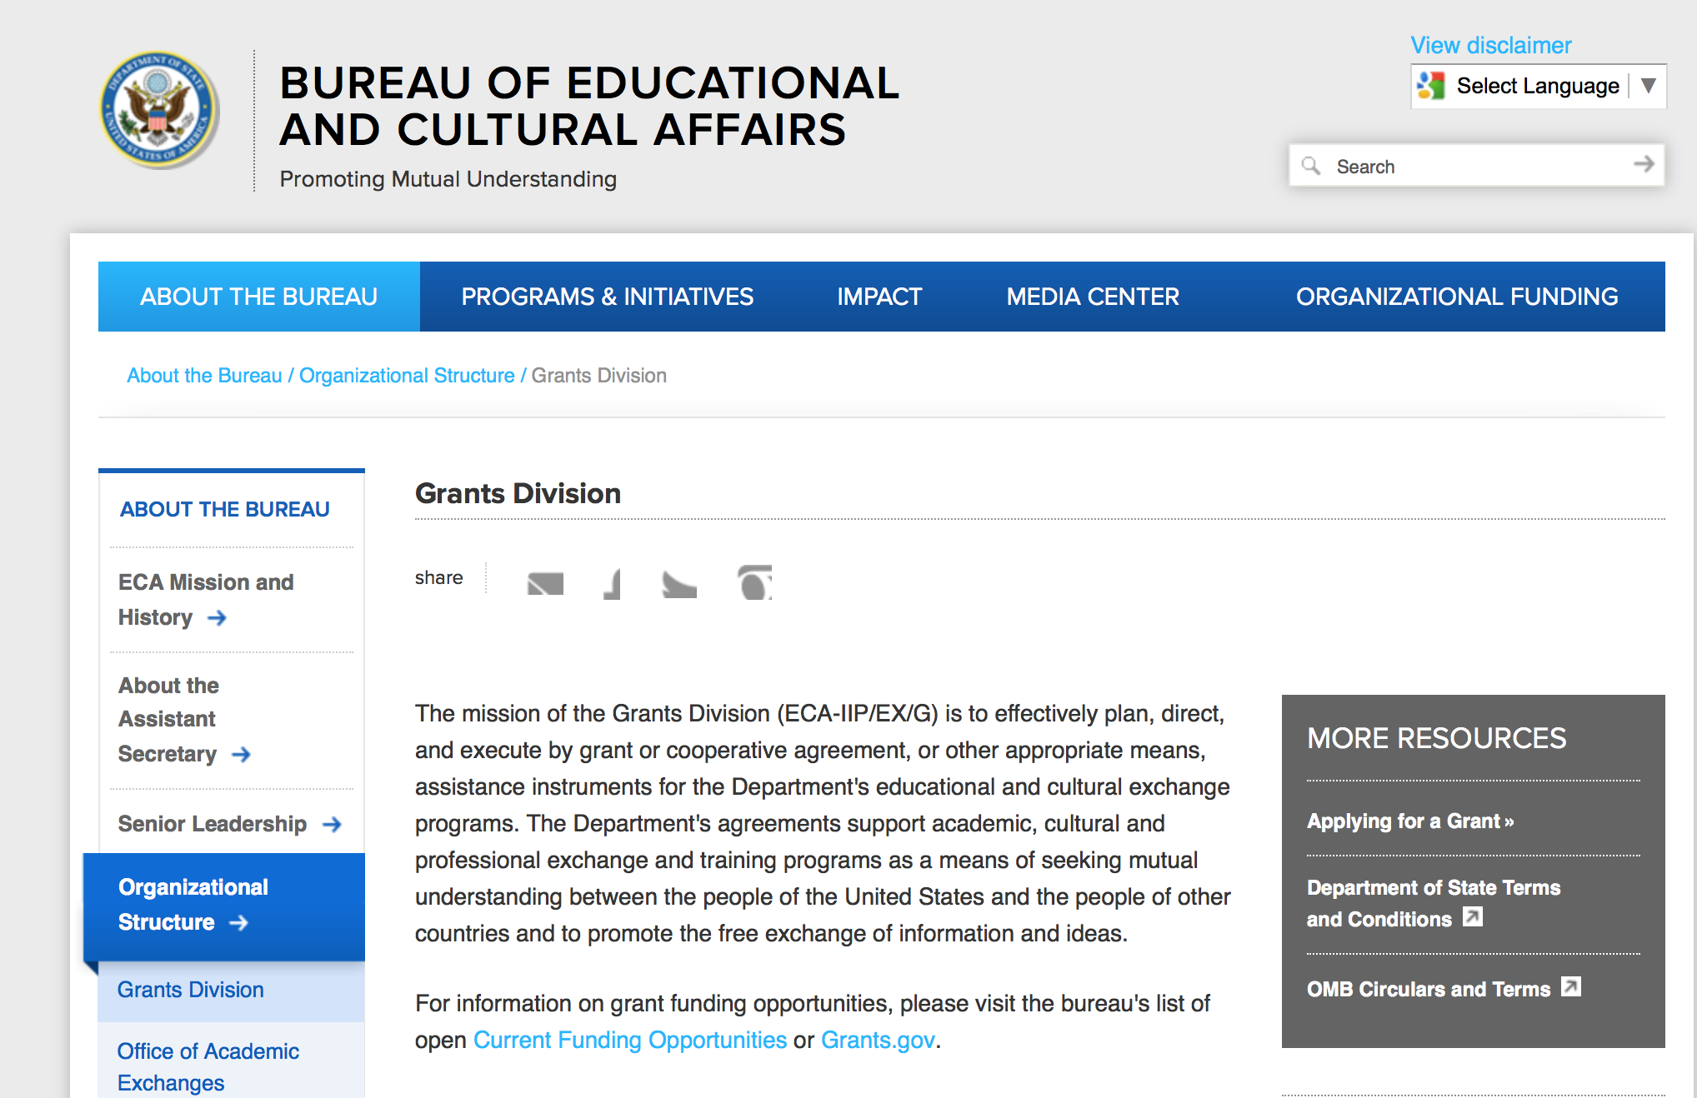

https://eca.state.gov/about-bureau/organizational-structure/grants-division

http://eca.state.gov/search/solr/grants?search_referrer=node/237

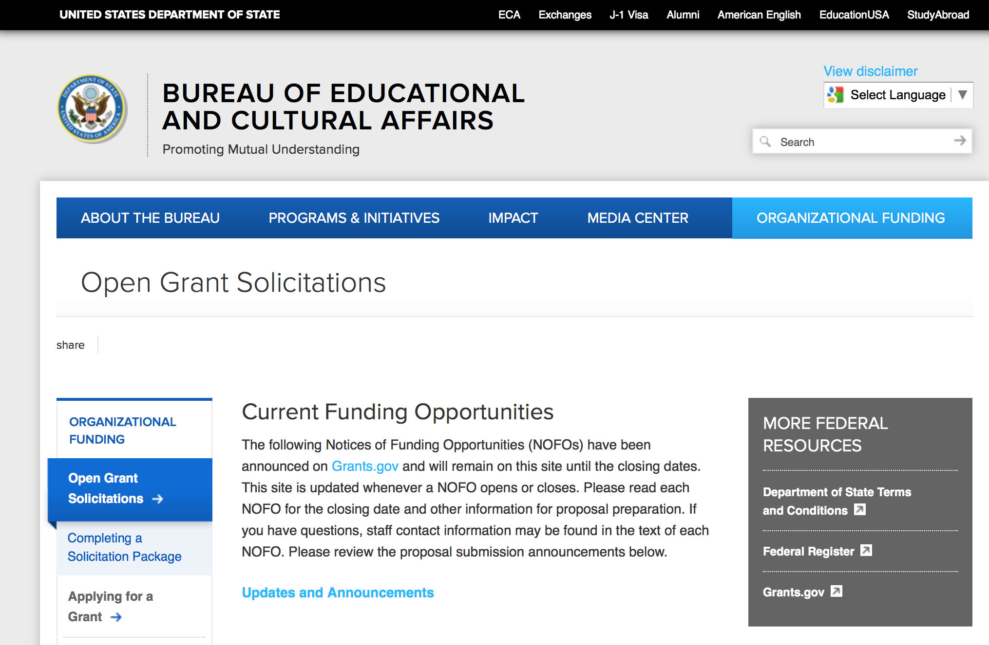
https://eca.state.gov/organizational-funding/open-grant-solicitations

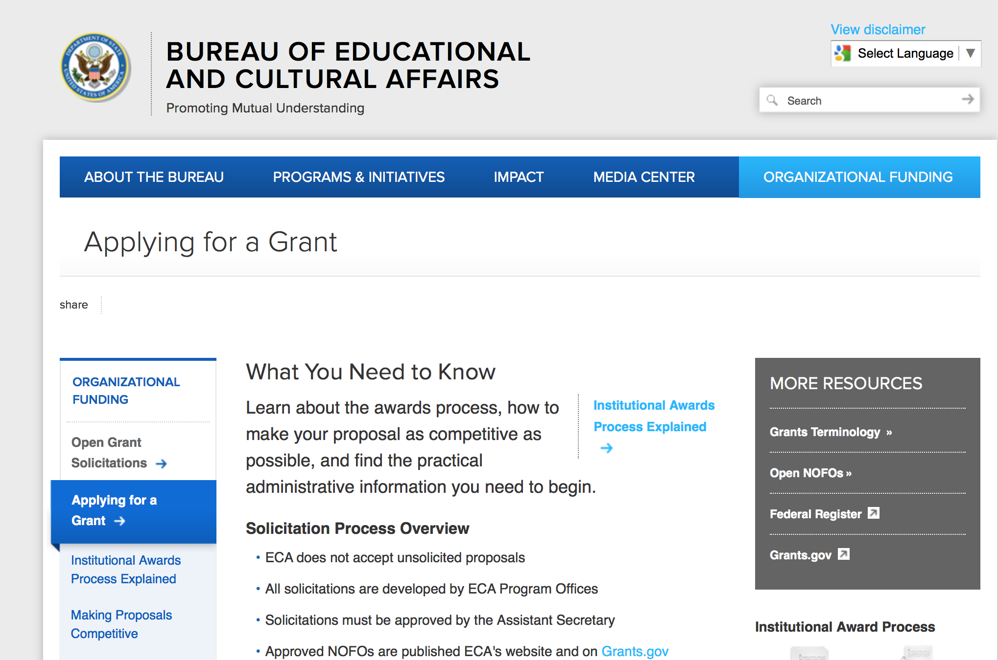
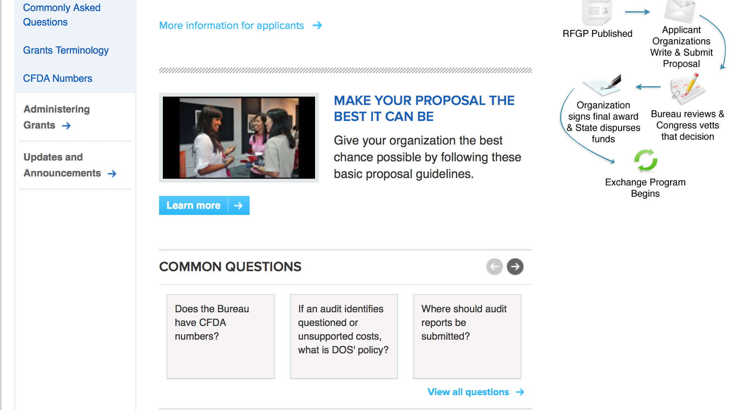
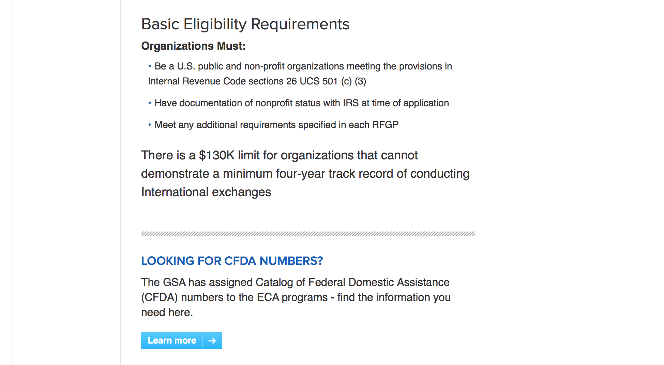
http://eca.state.gov/organizational-funding/applying-grant

General Information:
- Bureau of Educational and Cultural Affairs Grants Division
- Open Grant Opportunities (Requests for Grant Proposals)

For General Information click here

Program Grants:

Bureau of International Security-Nonproliferation
Kosovo Licensing and End User Data Storage System
Synopsis 1
http://www.grants.gov/web/grants/view-opportunity.html?oppId=296487

Modifications:

Bureau of International Security-Nonproliferation
Seminar on Controlling Arms Transfers for Serbia
Synopsis 2
http://www.grants.gov/web/grants/view-opportunity.html?oppId=296376

Bureau of International Security-Nonproliferation
Strategic Trade Control Assistance for Albania
Synopsis 2
http://www.grants.gov/web/grants/view-opportunity.html?oppId=296377

PM Weapons Removal and Abatement
17.PMWRA.Colombia.HMA.NOFO
Synopsis 2
http://www.grants.gov/web/grants/view-opportunity.html?oppId=295915

U.S. Mission to Vietnam
The 2018 YSEALI Regional Workshop: Protecting the Mekong Delta Environment
Synopsis 1, 2 & 3
http://www.grants.gov/web/grants/view-opportunity.html?oppId=296341

U.S. Mission to Thailand
Creating Thinking in Classrooms for the Young Southeast Asian Leaders Initiative
Synopsis 3
http://www.grants.gov/web/grants/view-opportunity.html?oppId=296490

Bureau of International Narcotics-Law Enforcement
Network of International Corrections Experts (NICE)
Synopsis 2
http://www.grants.gov/web/grants/view-opportunity.html?oppId=294568

Reminders:

Deleted:

Bureau of International Security-Nonproliferation
SFOP0002241 - Seminar on Controlling Arms Transfers for Serbia
Deletion Comments: The NOFO has a wrong application due date. The correct date is September 11, 2017. The GO didn't complete the application kit.

Bureau of International Security-Nonproliferation
SFOP0002242 - Strategic Trade Control Assistance for Albania
Deletion Comments: The due date of the NOFO need to be changed to September 11, 2017

Bureau of International Security-Nonproliferation
SFOP0002266 - Strategic Trade Control Support: Tajikistan and Uzbekistan
Deletion Comments: Withdrawing to include SF documents

Bureau of International Security-Nonproliferation
SFOP0002242 - Strategic Trade Control Assistance for Albania
Deletion Comments: Withdrawing to include SF documents

Bureau of International Security-Nonproliferation
SFOP0002241 - Seminar on Controlling Arms Transfers for Serbia
Deletion Comments: Withdrawing to include SF documents

Bureau of International Security-Nonproliferation
SFOP0002241 - Seminar on Controlling Arms Transfers for Serbia
Deletion Comments: The kit application was not included

Bureau of International Security-Nonproliferation
SFOP0002242 - Strategic Trade Control Assistance for Albania
Deletion Comments: The application kit was not created.

Bureau of International Security-Nonproliferation
SFOP0002266 - Strategic Trade Control Support: Tajikistan and Uzbekistan
Deletion Comments: Withdrawing to include additional documents

Department of Transportation

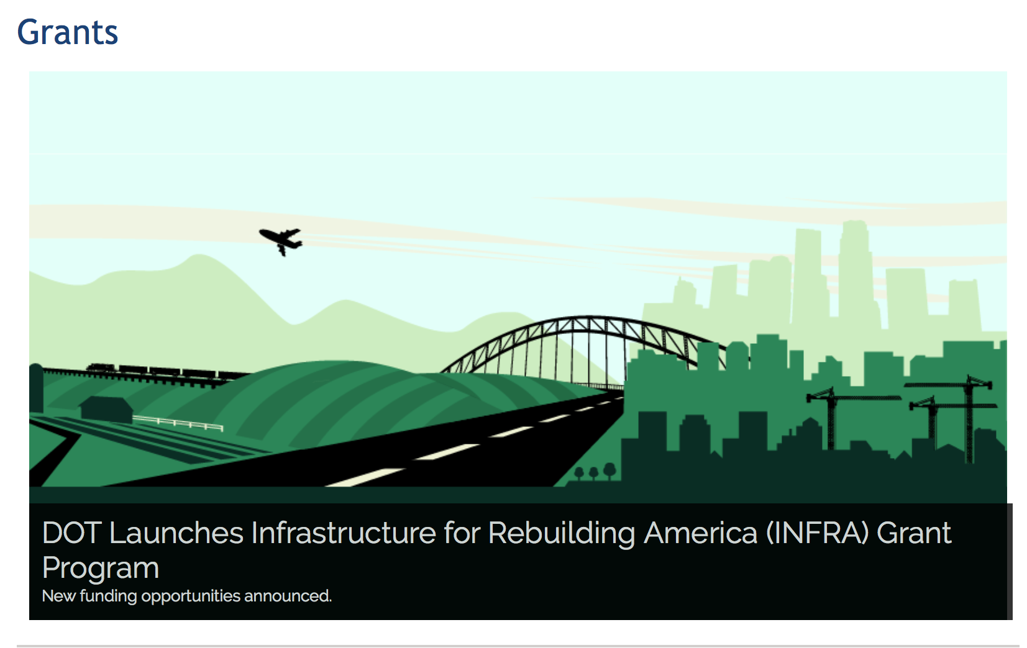

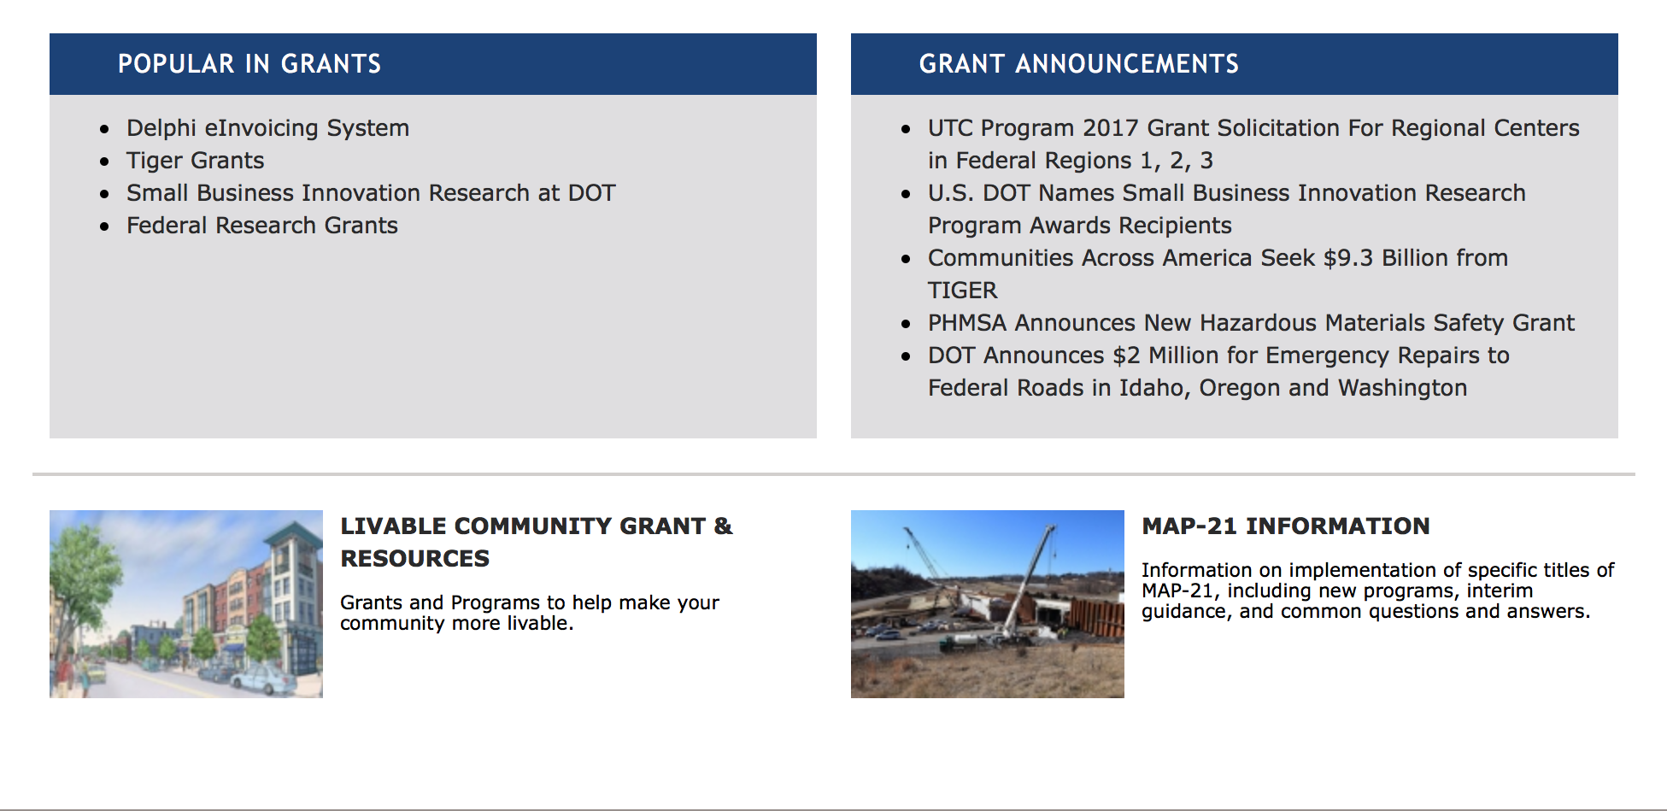

General Grant Program Overview https://www.transportation.gov/grants

Programs:

INFRA Grants
Synopsis 1
Document Type: | Grants Notice
Funding Opportunity Number: | NSFHP-17-18-INFRA
Funding Opportunity Title: | INFRA Grants
Opportunity Category: | Discretionary
Opportunity Category Explanation:
Funding Instrument Type: | Grant
Category of Funding Activity: | Transportation
Category Explanation:
Expected Number of Awards:
CFDA Number(s): | 20.934 -- Nationally Significant Freight and Highway Projects
Cost Sharing or Matching Requirement: | Yes
Version: | Synopsis 1
Posted Date: | Aug 02, 2017
Last Updated Date: | Aug 02, 2017
Original Closing Date for Applications: | Nov 02, 2017
Current Closing Date for Applications: | Nov 02, 2017
Archive Date: | Dec 02, 2017
Estimated Total Program Funding: | $1,560,000,000
Award Ceiling: | $1,400,000,000
Award Floor: | $5,000,000
Eligible Applicants: | Others (see text field entitled "Additional Information on Eligibility" for clarification)
Additional Information on Eligibility: | Eligible applicants for INFRA grants are 1) a State or group of States; 2) a metropolitan planning organization that serves an urbanized area (as defined by the Bureau of the Census) with a population of more than 200,000 individuals; 3) a unit of local government or group of local governments; 4) a political subdivision of a State or local government; 5) a special purpose district or public authority with a transportation function, including a port authority; 6) a Federal land management agency that applies jointly with a State or group of States; 7) a tribal government or a consortium of tribal governments; or 8) a multi-State or multi-jurisdictional group of public entities. Multiple States or jurisdictions that submit a joint application should identify a lead applicant as the primary point of contact. Each applicant in a joint application must be an Eligible Applicant. Joint applications must include a description of the roles and responsibilities of each applicant and must be signed by each applicant.
Agency Name: | Department of Transportation
Description: | The Nationally Significant Freight and Highway Projects (NSFHP) program provides Federal financial assistance to highway and freight projects of national or regional significance. The Department of Transportation is referring to this program as the Infrastructure for Rebuilding America (INFRA) program. This notice solicits applications for awards under the program’s FY 2017 and FY 2018 funding, subject to future appropriations.
Link to Additional Information: | INFRA Grants Website
Grantor Contact Information: | If you have difficulty accessing the full announcement electronically, please contact:  Robert Mariner Deputy Director, Office of Infrastructure Finance and Innovation Phone 202-366-8914  USDOT Contact

http://www.grants.gov/web/grants/view-opportunity.html?oppId=296083

Modifications:

Research:

Reminders:

DOT Federal Aviation Administration
DOT - FAA Aviation Research Grants
FAA Aviation Research and Development Grants
Modifications 3 & 4

Document Type: | Grants Notice
Funding Opportunity Number: | 12-01
Funding Opportunity Title: | FAA Aviation Research and Development Grants
Opportunity Category: | Discretionary
Opportunity Category Explanation:
Funding Instrument Type: | Grant
Category of Funding Activity: | Transportation
Category Explanation:
Expected Number of Awards:
CFDA Number(s): | 20.108 -- Aviation Research Grants
Cost Sharing or Matching Requirement: | No
Version: | Synopsis 5
Posted Date: | Jan 01, 2012
Last Updated Date: | Jun 09, 2016
Original Closing Date for Applications: | Dec 31, 2019
Current Closing Date for Applications: | Dec 31, 2019
Archive Date: | Jan 30, 2020
Estimated Total Program Funding:
Award Ceiling: | $5,000,000
Eligible Applicants: | Nonprofits having a 501(c)(3) status with the IRS, other than institutions of higher education  Private institutions of higher education  Public and State controlled institutions of higher education
Agency Name: | DOT - FAA Aviation Research Grants
Description: | The FAA is soliciting proposals for research grants and cooperative agreements to pursue the long-term growth and short-term technical needs of civil aviation. In order to streamline the application process, it is recommended that all prospective grantees submit a white paper (letter of intent) for agency technical review before complete proposal submission. Please be sure to identify the specific area of interest (Solicitation FAA-12-01 – Chapter I. FAA Research Grants Program, Technical Areas of Research #1-#9). The white paper shall be no longer than three (3) pages and shall detail overall research objectives.
Link to Additional Information:
Grantor Contact Information: | If you have difficulty accessing the full announcement electronically, please contact:  Debra Monzo Grants Officer Phone 609-485-4962  business

http://www.grants.gov/web/grants/view-opportunity.html?oppId=134953

Deleted:

Department of the Treasury

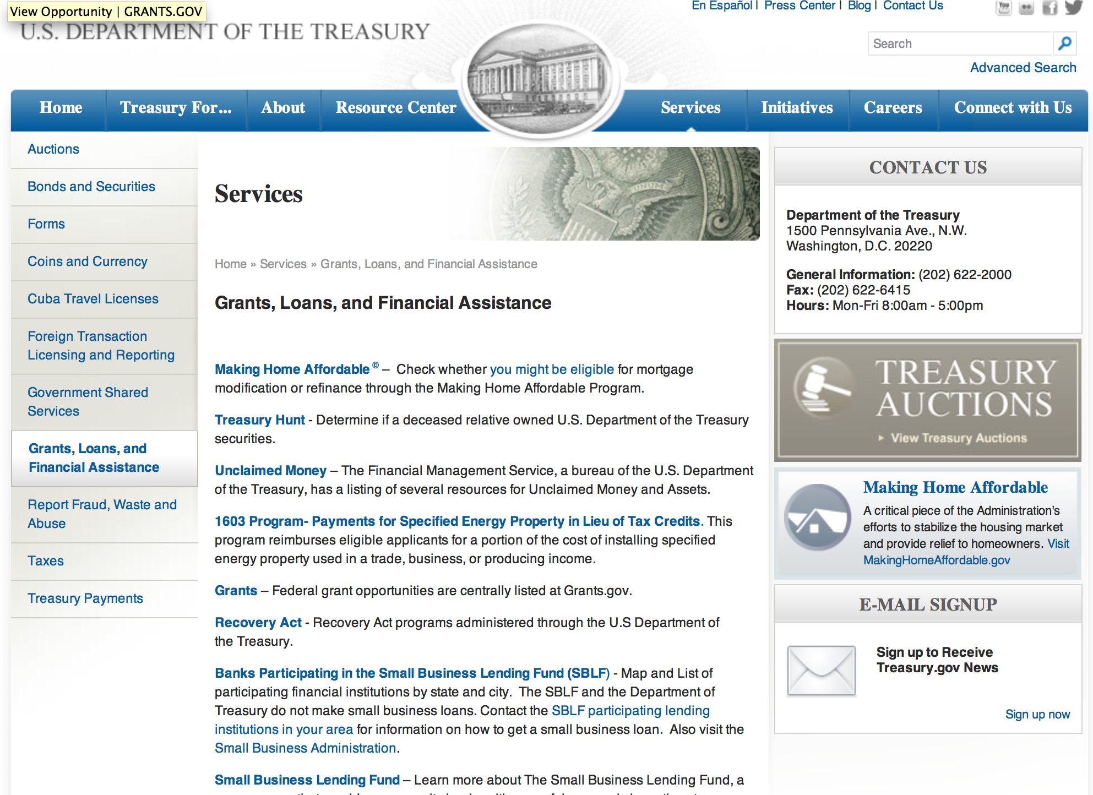

http://www.treasury.gov/services/Pages/Grants-Loans-and-Financial-Assistance.aspx

Programs:

Modifications:

Reminders:

U.S. Agency for International Development

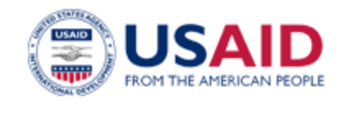

www.usaid.gov

General Overview Funding Opportunities

USAID has working relationships with thousands of American companies and hundreds of U.S.-based private voluntary organizations. For more information on our business and procurement opportunities, please visit our Business section.

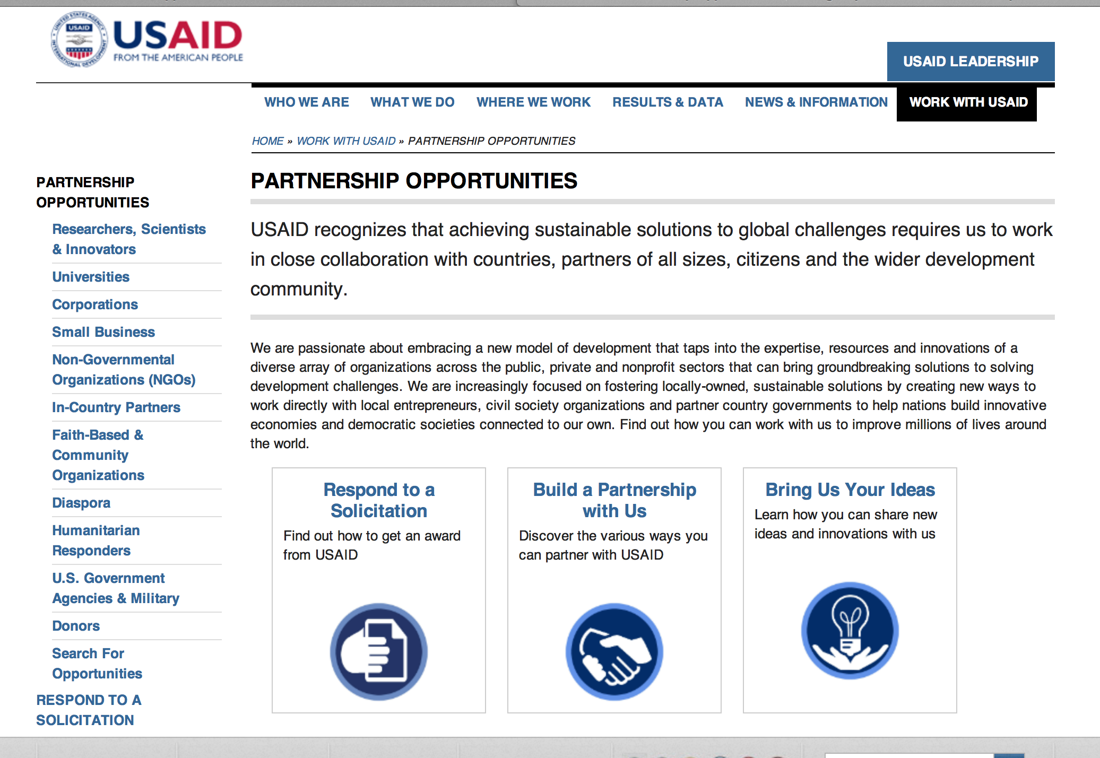
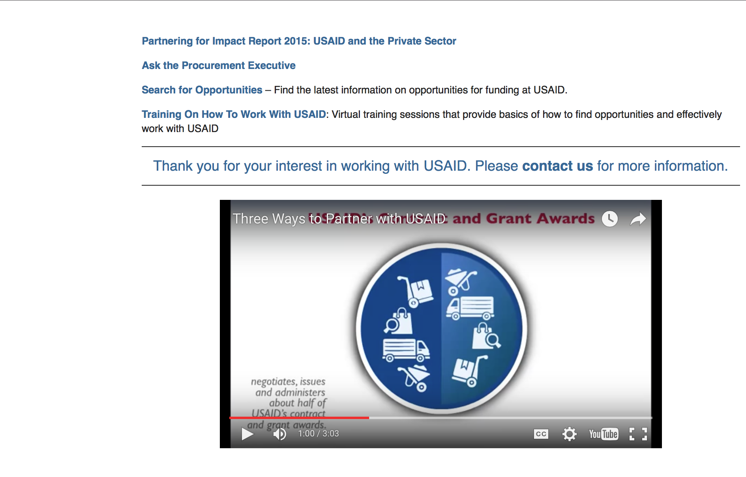

http://www.usaid.gov/partnerships

Programs:

Cambodia USAID-Phnom Penh
USAID/Cambodia - Enhancing Quality of Healthcare
Synopsis 1
http://www.grants.gov/web/grants/view-opportunity.html?oppId=296776

East Africa USAID-Kenya
USAID/KEA/ENV 1.1 Results Framework
Synopsis 1
http://www.grants.gov/web/grants/view-opportunity.html?oppId=296902

Volunteers for International Security and Prosperity (VISP)
Synopsis 1
http://www.grants.gov/web/grants/view-opportunity.html?oppId=296974

Modifications:

East Africa USAID-Kenya
USAID/KEA/ENV 1.1 Results Framework
Synopsis 2
http://www.grants.gov/web/grants/view-opportunity.html?oppId=296902

Zimbabwe USAID-Harare
The USAID/Zimbabwe Broad Agency Announcement (BAA) for Zimbabwe’s Development Challenges
Synopsis 2
http://www.grants.gov/web/grants/view-opportunity.html?oppId=296673

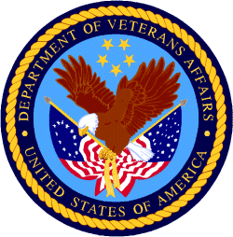

Department of Veterans Affairs

